REFERRAL FROM MINISTER FOR ADVICE ON A MONITORING SYSTEM FOR UPDATED OVERALL SURVIOVAL RESULTS FOR CANCER TRIALS

The Minister’s delegate referred to the PBAC the matter of developing a monitoring system for obtaining updated overall survival results for cancer trials used to support a PBS listing for advice.

At its meeting between 5 – 7 November 2025 the PBAC provided the following advice to the Minister (under section 101(3) of the National Health Act 1953).

9.03 Monitoring system for updated overall survival (OS) results for cancer trials
- Purpose of Item
That the PBAC:
  - COMMENT on the draft report, ‘Monitoring system for updated OS results for cancer trials’ (the Report), prepared by Monash University, including the criteria for the traffic light alert system and the composition of the case reports.
  - CONSIDER advice from the Economic Sub Committee (ESC) and PROVIDE ADVICE on whether the traffic light alert criteria are appropriate, including whether the value of 0.1 hazard ratio (HR) difference is an appropriate threshold for determining trials for further investigation.
  - PROVIDE ADVICE on any further actions or research that should be taken as a result of the Report, which might include:
    - Continuing the OS monitoring system, with reports prepared for the ESC and PBAC every 12-18 months, for a period of 2-3 years.
    - Prospectively designating trials for cancer medicines to enter the monitoring system at the point of a positive PBAC recommendation.
    - Further review of the cost-effectiveness of cancer medicines where the updated/final OS HR has worsened or does not align with PBAC expectations: for example, ELEVATE-TN for acalabrutinib and PRIMA for niraparib.
  - PROVIDE ADVICE on whether the Report and associated PBAC outcomes for this item should be published on the PBS website and provided to the Health Technology Assessment (HTA) Review Implementation Advisory Group.
- Background

Review of cancer related surrogate outcomes used for PBAC decision making
  - At the May 2022 PBAC Intracycle meeting, the PBAC supported a proposal for a research project on surrogate outcome measures in PBAC submissions for cancer medicines.
  - The Department contracted Monash University to collate a report on the surrogate measures included in PBAC submissions for cancer medicines between 2012 and 2021 (inclusive).
  - The ‘Review of cancer related surrogate outcomes used for PBAC decision making’ (Cancer Surrogates Report) found that for re/submissions that presented interim or immature OS trial data between January 2012 to May 2022, around 60% had not subsequently published final trial results (60/101 trials).
  - The ESC considered the Cancer Surrogates Report in June 2023. The ESC noted that OS results, where published, were generally consistent with interim results but expressed concern over potential publication bias in trials reporting final results. It was beyond the scope of the report to explore the reasons for final OS results not being published. The ESC advised the PBAC to consider recommending that the Department establish a monitoring system to report to the PBAC on the final OS data for trials where the PBAC made a recommendation for Pharmaceutical Benefits Scheme (PBS) listing based on interim or immature OS data.
  - The PBAC considered the Cancer Surrogates Report in July 2023, and in September 2023, the PBAC recommended the establishment of a monitoring system for final trial OS results for cancer medicines recommended for PBS listing.
  - The Cancer Surrogates Report and associated PBAC Minutes were published on the PBS website in September 2023. The Department wrote to relevant clinical and consumer groups, and health technology assessment (HTA) evaluation groups, to notify them of the publication.
  - In June 2023, the ESC suggested that reviews of the use of surrogate measures in the following conditions could be considered: cystic fibrosis; spinal muscular atrophy (considering updated trial compared to registry data); Alzheimer’s disease; pulmonary fibrosis and cardiac amyloidosis. The Department will seek PBAC’s advice on these recommended topics as part of future consideration of projects for the Post-market Review workplan, if/when resources are available to undertake this work.

Estimating OS in people receiving PBS-listed cancer medicines in Australian clinical practice
  - In September 2021, the Department contracted the Medicines Intelligence Centre of Research Excellence (MI-CRE) to undertake a separate research project on methods to estimate OS outcomes for cancer medicines using PBS/real-world data and compare these results to the OS results in the pivotal trial evidence considered by the PBAC at the time of listing.
  - The report provided information on ‘best-practice’ methods for using PBS data to derive estimates of the survival outcomes attributed to specific cancer medicines and included a pilot study of trastuzumab emtansine for the treatment of metastatic breast cancer.
  - This research was presented to the PBAC in May 2023. The PBAC supported applying the methods to other cancer medicines to allow a comparison of the incremental gain in survival outcomes based on the clinical trial data considered by the PBAC, with that observed in PBS data. The PBAC considered that there may be the potential to use PBS data linked to other clinical data in the future.
  - The report and associated PBAC Minutes have been published on the PBS website.
- Current Status – OS Monitoring System Draft Report
  - The Department contracted Monash University in June 2024 to create a monitoring system for final trial OS results for cancer medicines recommended PBAC and PBS listed-. The aim of this work was to highlight if final trial OS results were consistent, better, or worse than the interim/immature results considered by the PBAC at the time of recommendation, and any issues with publication bias or reasons for results not being available.
  - The PBAC noted the draft report, ‘Monitoring system for updated OS results for cancer trials’ (the Report).

Methods
Pilot study
  - Monash University conducted a pilot study to determine the feasibility of implementing an OS monitoring system. The pilot study used submissions (n=24) from January 2012 to May 2022, reviewed during the Cancer Surrogates Report, where immature/interim OS data were used to support PBS listing and the pivotal trials (n=25) had not yet reported their final OS data at that time.
  - The search of published literature, and a broader search for other potential information sources, for final OS data on the included pilot trials was conducted between 3 June and 1 July 2024. Publications presenting updated OS data were identified for 21/25 (84%) trials, of which 13 publications were described as final reports. The high proportion of trials reporting updated and final OS data after being recommended by the PBAC indicated that implementing a system to prospectively monitor trials for additional OS data would be feasible.
OS Monitoring System (June 2022-March 2024)
  - PSDs and/or PBAC Minutes for cancer medicines recommended by the PBAC between June 2022 and March 2024 (inclusive) were reviewed. Trials for cancer medicines were included in the OS monitoring system if: the clinical claim relied upon surrogate outcome(s); OS data were immature at the time of consideration; and the submission received a positive PBAC recommendation. Single-arm studies that were pivotal to the submissions’ clinical claims were also included; however, additional computation to assess comparative OS at later timepoints was beyond the scope of this report.
  - The relevant trial data (e.g. medicine name, indication, cancer type, PBAC meeting date, PBAC recommendation, key trial name, trial number, trial comparator, surrogate outcome, analysis dates, OS hazard ratio (HR), and confidence interval considered by the PBAC) were extracted from the PBAC submissions. The additional OS data were sought first from published literature. Clinical trial protocols and statistical analysis plans were checked for scheduled OS reporting timepoints for interim and final analyses and the trial definition of final OS. Any reported planned contamination points, such as crossover timepoints, in the trials were also identified. The searches included phase II/III trial results and any extended observational follow-ups from the included trials reporting OS outcomes. For trials that appeared to be completed but no final OS data were found, the Department requested this information from sponsors.
  - The monitoring system then compares the final or updated OS with the interim/immature OS data considered by the PBAC at the time of recommendation to confirm whether they align. A traffic light alert system was developed that indicates when further investigation of the evidence is required (red alert), when continued monitoring of the trial is recommended (amber alert) or when the trial can exit monitoring (green alert). The alerts include criteria for final OS HR, data maturity and PBAC expectations for the final/updated OS HR. Figure 1 provides a schematic of the project steps and Table 1 provides the alert system criteria.
  - Case reports are generated for each trial with a green or red alert for the PBAC to determine the next course of action.
Figure 1: Schematic of the project steps in the OS Monitoring System
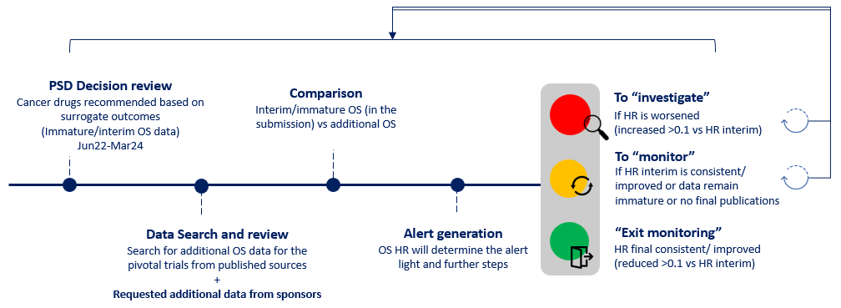
Source: Figure ES1, Monitoring system for updated OS results for cancer trials Report, page 5.
Abbreviation: HR=hazard ratio; OS=overall survival; PSD=Public Summary Document; RCT=randomised controlled trial.

Table 1: OS monitoring system alert criteria
Red alert - investigate | Amber alert - monitor | Green alert – exit monitoring
- {Final/updated HR is worsened (increased >0.1 vs HR interim), AND Final/updated OS HR does not align with PBAC expectations}  OR  - {No follow-up data identified, AND  - Trial registered end date has passed}  OR  - Trial terminated | - {Final/updated HR is consistent (≤0.1 difference vs HR interim), OR Final/updated HR is improved (reduced >0.1 vs HR interim)}  AND  - Final/updated OS HR aligns with PBAC expectations  AND  - {OS data remain immature, OR No final OS data available yet (i.e. registered end date not reached)} | - {Final HR is consistent (≤0.1 difference vs HR interim), OR Final HR is improved (reduced >0.1 vs HR interim)}  AND  - Final OS HR aligns with PBAC expectations  AND  - OS data are mature
Source: Table ES2, Monitoring system for updated OS results for cancer trials Report, page 6.
Abbreviations: HR=hazard ratio; OS=overall survival; PBAC=Pharmaceutical Benefits Advisory Committee.

Key Findings
  - From a total of 311 submissions with a PSD between June 2022 and March 2024 (inclusive), 18 submissions recommended by the PBAC relying on 21 trials (including 5 single-arm studies) reporting immature/interim OS data were included for further monitoring of OS data.
  - The literature search identified updated OS data for 9/16 (56%) trials and 4/5 (80%) single-arm studies.
  - Figure 2 shows the OS hazard ratios (HRs) reported at the time of PBAC consideration (June 2022 to March 2024) for each trial in the OS monitoring system and the most recent OS data identified from published literature. The trials are grouped by the alert system category allocation.
  - Three trials were identified for further investigation (red alert):
    - ELEVATE-TN for acalabrutinib and PRIMA for niraparib − showed worse OS HR (difference of >0.1 towards the null) at subsequent data analysis which was considered likely to impact the primary clinical and cost-effectiveness or cost-minimisation analysis relied on in the respective PBAC submissions.
    - COSMIC-311 for cabozantinib − no updated OS results were identified, and a 2024 publication (Capdevila 2024) claimed that further analyses on OS would not be conducted due to extensive crossover, hence, any future OS data are unlikely to be informative for decision-making purposes.
  - One trial was allocated to exit monitoring (green alert): SWOG 1500 trial for cabozantinib in renal cancer. The final OS analysis was mature (73%), and the OS HR was consistent with the interim result considered by the PBAC.
  - Of the five single-arm studies included in the monitoring system, 4 were allocated for continued monitoring (amber alert), and one (Study 101 for mobocertinib) was allocated for further investigation (red alert), but could exit the monitoring system as it was not PBS listed due to being withdrawn from the market.

Figure 2. OS HR at submission and at the most recent published timepoint (up to September 2024)

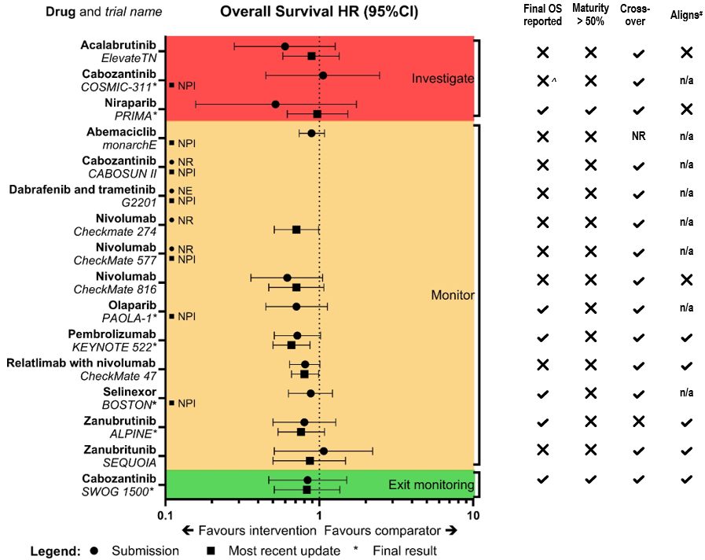
Source: Figure ES2, Monitoring system for updated OS results for cancer trials Report, page 7.
❌= no; ✔ = yes; n/a = not applicable (no updated data); CI=confidence interval; HR=hazard ratio; NE=not estimable; NPI=no publications identified in the public domain; NR=not reported; OS=overall survival; PBAC=Pharmaceutical Benefits Advisory Committee.
# Aligns with PBAC expectations
^ Since the primary endpoint was met, no updated OS analyses was conducted
* Final result = publication or trial protocol indicated OS analyses were final
NB Reported only where Overall Survival HRs were publicly available

Suggestions for further work
  - The Report makes several suggestions for further work including:
    - Re-evaluation of the clinical and cost-effectiveness analysis using updated OS data for trials identified as having significantly worse OS HR than expected at the time of PBAC recommendation.
    - Reviews of trials, registries, real-world observational studies, or the analysis of administrative data for any additional evidence on the long-term survival benefits of cancer drugs, where the final OS data remains immature, the trials have been terminated, or crossovers or subsequent treatments have contaminated long-term follow-up data.
    - Monitor how the listings of these cancer medicines have impacted survival in Australia by using linked administrative data, such as the Person Level Integrated Data Asset (PLIDA).
    - Measuring the strength of correlation between the surrogate outcome and OS between the interim and final analysis, given that the submissions included in the monitoring system relied on surrogate outcomes in the clinical claim or PBAC recommendation.
  - The PBAC noted that if the Committee recommended continuation of the monitoring system, this could be accommodated within the existing Post-market Review Workplan and budget, but the relative priority of this work in relation to other projects requested by the PBAC may need to be considered. The PBAC noted that the Committee could also consider alignment of this work with the HTA Review recommendations and implementation.
- Sponsor consultation
  - As part of this project, the Department wrote to the relevant sponsor to request any additional efficacy (particularly overall survival) and safety data for the ASCEND 5 trial of ceritinib in non-small cell lung cancer (NSCLC) (pilot study) and the G2201 trial of dabrafenib and trametinib in low-grade glioma (LGG) and high-grade glioma (HGG) (OS Monitoring System). Additional data were requested on these studies as they appeared to be completed as of September 2024, however, no evidence of the final OS data was found in the public domain. Redacted text.
  - Medicines Australia wrote to the Department in December 2024 to express concern that:
    - Final OS data provided by companies would be used to review the cost-effectiveness of medicines.
    - Sponsors had not agreed to provide later data cuts at the time of PBS listing of these medicines as a condition of listing.
    - That prices recommended by the PBAC are based on a comprehensive cost-effectiveness analysis that considers data maturity and uncertainty.
  - The Department responded in January 2025, providing clarification on the process for this work and agreeing to provide Medicines Australia with an opportunity to comment on the Report.
  - Department representatives met with Medicines Australia and sponsor company representatives on 2 September 2025, to respond to queries about the project and sponsor concerns about potential outcomes and confidentiality of any data provided.
  - Relevant sponsors and Medicines Australia were provided with a copy of the draft Report on 15 August 2025 and invited to provide pre-sub-committee responses (PSCRs) by 5 September 2025 (3-week consultation). A PSCR was received from Medicines Australia, as well as eleven sponsor companies (redacted text) by the due date.
  - Sponsors and Medicines Australia generally did not support introduction of the monitoring system, raising concerns about the proposed methods and administrative requirements. Some sponsors indicated in-principle support if the monitoring system allowed PBAC to adopt a less conservative approach when negotiating key assumptions in economic models, leading to faster PBS listings. Some sponsors suggested that the monitoring system would be time and resource intensive, and that it may disincentivise sponsors from making PBAC submissions or may lead to medicine delisting, impacting on patient access to medicines.
  - Sponsors also raised concerns about:
    - the use of a fixed HR threshold to trigger alerts
    - the potential for real-world data to be used to assess the long-term survival benefits of cancer medicines, which was considered a lower level of evidence than clinical trial results
    - how redaction policies would be applied to any unpublished data provided to the PBAC.
  - Several sponsors noted issues with crossover of patients and use of subsequent therapies causing confounding of OS results with long-term follow-up.
  - The PBAC noted that several sponsors provided updated trial data and some requested changes to the alert status of a trial/s.
  - The following errors of fact were identified in the draft Report via the PSCRs:
  - There were two incorrect study completion dates entered into Table 7 of the draft Report: for CheckMate 816, 11/8/2028 was entered rather than 8/11/2028, and for SEQUOIA, 9/1/2026 was entered rather than 9/2026.
  - The OS HR used in Table 7 of the draft Report for the ALPINE trial (OS HR: 0.76 [95% CI, 0.54-1.08]) was cited from the conference abstract for Browne 2023. The OS HR in the figure from the slides for the corresponding conference presentation and Table 3 of the PSCR was 0.75 [95% CI 0.54, 1.05].
  - The SEQUOIA trial allowed cross-over (marked as Not Reported (NR) in Figure 4 of the draft Report).
  - The draft Report states that ‘Two single-arm studies, LOXO-001 (NCT02122913) and NAVIGATE (NCT02576431), which investigated the efficacy of larotrectinib in a variety of solid tumours, were used to support the March 2024 submission for larotrectinib to treat lung cancer and soft tissue sarcoma’ [p.30 of the draft Report]. However, a third study, SCOUT, was also included in the pooled evidence for the submission. SCOUT was not included in the OS monitoring system because it was a paediatric study from which individual–level data from two participants who had reached 18 years of age were included in the pooled analysis. Monitoring OS results for the SCOUT study was not considered informative for the PBS population.
  - Relevant sponsors were provided with a copy of the ESC Advice and the PBAC Overview paper on 23 October 2025, with pre-PBAC responses due 30 October 2025 (1 week). The PBAC noted the pre-PBAC responses received from Medicines Australia, as well as nine sponsor companies (redacted text) by the due date.
- ESC Advice
  - The ESC considered the draft Report and PSCRs at the October 2025 meeting. The ESC considered that the main issues for PBAC consideration were:
  - The ESC considered that the Report supported the feasibility of a monitoring system for final trial OS results for cancer medicines recommended by the PBAC and PBS listed. ESC considered that the proposed monitoring system presents a systematic method to prospectively monitor clinical trials for additional OS data.
  - The ESC considered the traffic light alert criteria appropriate, apart from the value chosen for the hazard ratio (HR) metric. The ESC questioned the basis of the choice of a fixed HR difference of 0.1 between interim and final OS results. The ESC considered that PBAC would need to confirm whether a value of 0.1 is an appropriate threshold for determining clinical significance.
  - The ESC suggested the monitoring system could be expanded to other therapeutic areas where PBAC recommends medicine subsidy based on surrogate outcomes.
  - The ESC advised that a routine annual literature search for new publications and additional OS reports for all trials for cancer medicines in the monitoring system would be reasonable, dependent on the Department’s and PBAC’s view of the feasibility and sustainability of implementing this system amongst other priorities for Post-market Reviews and research projects.
  - The ESC noted that a large number of trials were likely to remain in the continued monitoring (amber) category for an extended period, such as those for indolent cancers with delayed OS outcomes that may not be available for up to ten years. Noting the potential for the number of trials classified as amber to keep increasing and the associated issue of the appropriate length of time to continue monitoring trials in this category, the ESC questioned whether allocation of resources to implement an ongoing monitoring system was sustainable and the eventual outcomes delivered to be meaningful.
  - The ESC questioned how, in the event of a listed medicine being flagged for investigation (red), the sponsor could be compelled to renegotiate the price in good faith. The ESC noted that without this guarantee, there would be little value in identifying these medicines.
  - The ESC advised that before an ongoing commitment to establish active monitoring for final trial OS results was made, or the pilot was expanded or repeated, thought could be given to those health conditions where such a system would have most impact for re-evaluation, and the development of criteria which would make most meaningful change.
- PBAC Outcome
  - The PBAC considered that the traffic light system used in the Report, including the 0.1 hazard ratio (HR) threshold difference, was useful as a signal for further consideration or investigation by the PBAC and noted that this was not intended as an automatic trigger to reconsider PBS listing.
  - The PBAC considered that it may be beneficial to incorporate European Society for Medical Oncology-Magnitude of Clinical Benefit Scale (ESMO-MCBS) scores into the system and monitor changes in these scores.
  - The PBAC considered that it would be worthwhile to continue the monitoring system for a further 2-3 years before evaluating the merits of the system. The PBAC considered that following up on trial results to ensure that they aligned with the Committee’s expectations at the time of a positive recommendation was an important aspect of stewardship of the PBS and ensuring that PBS listings remained cost-effective. The PBAC noted that further work on this project, and its priority compared to other potential post-market monitoring projects, could be considered by the PBAC when reviewing the Post-market Review (PMR) Workplan at a future meeting. The PBAC considered that if the monitoring system were continued for an additional period, that sponsors would be informed through an update to the published PMR Workplan and would continue to be consulted on the project following standard PBAC processes and timelines.
  - The PBAC agreed that if the monitoring system were continued, it would be ideal for the Committee to prospectively designate trials to enter the monitoring system at the time of a positive recommendation for PBS listing, if the recommendation was based on immature OS data or a surrogate outcome. The PBAC could request sponsors provide additional OS data when available and this could be documented in the Minutes. The sponsor would then be responsible for providing the updated/final trial results to the PBAC.
  - The PBAC considered that in cases where the updated or final OS had worsened or did not align with PBAC’s expectations, this should provide an opportunity for the PBAC to request that the sponsor justify or revise the current price and/or cost-effectiveness of the PBS listing, if there is a suitable mechanism to do so. The PBAC noted that, conversely, sponsors are currently able to request price increases through PBAC submission processes, where new evidence supports improved cost--effectiveness of a listed medicine.
  - The PBAC considered that the monitoring system may not produce many actionable outcomes, as in many cases there may be reasonable justifications as to why the updated or final OS results for a trial were worse than expected based on interim/immature data, such as unexpected crossover with other therapies. The PBAC further noted that consumers may be deriving other benefits from medicines in these circumstances, such a quality-of-life benefits from progression-free survival.
  - For trials allocated a red (further investigation) alert status, the PBAC considered that the relevant sponsors could be requested to provide further justification to support the current PBS listings, if not adequately justified in the pre-sub-committee or pre-PBAC responses.
  - The PBAC supported publication of the Report (with revisions or an addendum to address any errors of fact) and associated PBAC Minutes on the PBS website and agreed that the Report should be provided to the HTA Review Implementation Advisory Group (IAG).

Outcome
Advice provided.

Department of Health and Aged Care, Review of cancer related surrogate outcomes used for Pharmaceutical Benefits Advisory Committee (PBAC) decision making, updates 8 September 2023, accessed 9 May 2025.
Department of Health and Aged Care, Estimating overall survival in people receiving PBS-listed cancer medicines in Australian clinical practice, updated 18 August 2023, accessed 9 May 2025.

