Utilisation analysis of PBS-listed disease modifying therapies for relapsing-remitting multiple sclerosis

Drug utilisation sub-committee (DUSC)
June 2025

Abstract

Purpose
That the Drug Utilisation Sub-Committee (DUSC) consider the utilisation of Pharmaceutical Benefits Scheme (PBS)-listed disease modifying therapies (DMTs) for relapsing-remitting multiple sclerosis (RRMS).

Data Source / methodology
Data was extracted from the PBS database maintained by the Department of Health and Aged Care, processed by Services Australia, from between 1 January 2019 to 31 December 2024. The data was extracted based on the date of supply using the PBS item codes at Attachment 1. Data were extracted based on the date of supply. A three-year lookback period to 1 January 2016 was used to identify incident (initiating) patients from 1 January 2019.

Key findings

Prescription utilisation trends
- The number of prescriptions for PBS-listed DMTs for RRMS increased from 168,891 in 2019 to 187,037 in 2024 (an increase of 10.7%).
- The number of prescriptions supplied for fingolimod has decreased over time from 59,114 prescriptions in 2019 to 35,331 in 2024 (40.2% decrease).
- The benefits paid for PBS-listed DMTs for RRMS based on published prices increased from $448,814,609 in 2019 to $508,595,516 in 2024 (an increase of 13.3%). The benefits paid based on effective prices decreased from $326,119,635 in 2019 to $279,256,048 in 2024 (a decrease of 14.4%).
- [REDACTED TEXT] were the PBS-listed DMTs for RRMS that incurred the highest cost to the PBS in 2024, based on effective prices.
- Based on PBS benefits paid (effective prices) [REACTED TEXT] had the greatest market share in 2024 ([REDACTED TEXT]), followed by [REDACTED TEXT]. The high efficacy DMTs represented 91% of the market for RRMS ($253,223,411 benefits paid), while moderate efficacy DMTs represented 9% ($23,032,637 benefits paid).

Patient utilisation trends
- The number of prevalent patients to a PBS-listed DMT for RRMS increased from 19,612 in 2019 to 24,310 in 2024 (an increase of 23.9%). The number of patients initiating (incident) a PBS-listed DMT for RRMS declined from 2,550 in 2019 to 1,862 in 2024 (a decrease of 26.9%).
- In terms of prevalent patients, ocrelizumab (7,753 prevalent patients), natalizumab (3,799 prevalent patients) and ofatumumab (3,549 prevalent patients) were the PBS-listed DMRs for RRMS with the highest utilisation in 2024.
- In terms of incident (initiating) patients, ocrelizumab (545 incident patients), ofatumumab (489 incident patients) and natalizumab (349 incident patients) were the PBS-listed DMT for RRMS with the highest utilisation in 2024.
- Ocrelizumab was the most utilised PBS-listed DMT for RRMS for females, with utilisation peaking at 40-44 years of age. Natalizumab was the second most utilised PBS-listed DMT for RRMS in females, with utilisation peaking at 35-39 years of age. Ocrelizumab was the most utilised PBS-listed DMT for RRMS for males, with utilisation peaking at 50-54 years of age. Fingolimod was the second most utilised PBS-listed DMT for RRMS for males, with utilisation peaking at 50-54 years of age.
- Monotherapy with ocrelizumab, ofatumumab and natalizumab were the three most utilised drug sequences. For drug initiation sequences consisting of two or more RRMS medicines, ‘natalizumab to ocrelizumab,’ ‘natalizumab to ofatumumab’ and ‘ocrelizumab to ofatumumab’ were the three most utilised treatment initiation sequences.

Background
In September 2024, the Pharmaceutical Benefits Advisory Committee (PBAC) considered the Post-market Review (PMR) workplan and considered proposed topics for future research, which included a proposed utilisation analysis of treatments for RRMS.
Fingolimod was the first oral drug for the treatment of RRMS listed on the PBS. Other high-efficacy disease-modifying therapies for the treatment of RRMS (apart from alemtuzumab and natalizumab) have been recommended for a PBS listing on a cost-minimisation basis to fingolimod. All PBS-listed DMTs for RRMS are available as first-line treatment options with similar restrictions to fingolimod.
In December 2022, the PBS price of fingolimod reduced by 25% following the listing of a first new brand. The PBAC noted that on 1 October 2024, fingolimod was reduced by a further 12.75% price disclosure price reduction. The PBAC noted that fingolimod is now less expensive than other high-efficacy DMTs for RRMS that were recommended for PBS listing on a cost-minimisation basis to fingolimod.
The PBAC noted that the PBS prices of high-efficacy DMTs for RRMS have diverged since the price reduction of fingolimod on 1 December 2022. The PBAC recalled that there is currently no PBS requirement for patients to trial less costly medicines for RRMS before moving to more expensive therapies. The PBAC noted that an analysis of the PBS market for RRMS medicines has not been undertaken for some time and advised that a utilisation analysis of the current market for PBS-listed medicines for RRMS, including information around the market share of fingolimod, would be informative.

Disease
Multiple sclerosis (MS) is an inflammatory disease of the central nervous system (CNS). During the early stages of MS, discrete demyelinating lesions cause axonal and neuronal damage. Later, diffuse inflammatory processes and neurodegeneration exacerbate CNS dysfunction. MS is characterised by a complex range of symptoms including visual disturbance, fatigue, pain, reduced mobility and coordination, cognitive impairment and mood changes. The result is progressive disability.
The prevalence of MS appears to have increased over time, which is likely the result of earlier detection and diagnosis, improved disease management and life expectancy, and improvements in data quality and accuracy. It affects approximately 25,000 Australians (0.1% in 2019) and two million people worldwide. The peak age of onset is 30-49, so the illness in this age group results in high costs for medical care and lost productivity in the workforce. RRMS is the most common form of MS and approximately 85% of people with MS are diagnosed with RRMS. It is caused by flare ups or exacerbations of the neurological symptoms of MS, also known as relapses, followed by periods of recovery or remission. RRMS is not curable but DMTs reduce relapse rates and slow the progression of the disease, thereby delaying disability.

Treatment guidelines
The Australian Therapeutic Guidelines recommend immunotherapy as a treatment option for patients with relapsing forms of MS and active disease. Historically, when starting immunotherapy, the approach has been to start therapy with the safest drugs, before scaling up to more potent drugs that have a higher risk of adverse effects. This approach requires careful monitoring to ensure that the disease does not progress and cause damage. Increasingly, the approach to therapy is to give highly effective treatment early, so the patient achieves a target called ‘no evidence of disease activity’ (NEDA), where the patient is clinically stable, has no relapses and no new lesions on magnetic resonance imaging (MRI). Patients at high risk of disability start early on more potent but higher risk therapies.

DMTs are assessed in trials for their effect on annualised relapse rate (ARR), disability worsening, radiological lesion load and brain volume measurements. Consensus opinion is to consider a DMT early in the course of the disease, particularly when there is clinical or MRI evidence of active inflammatory disease. There are limited direct comparative trials, particularly between the newer drugs and, as clinical trial populations differ, comparative efficacy can be difficult to establish. Whilst DMTs may be broadly classified as those with high efficacy (alemtuzumab, cladribine, fingolimod, natalizumab, ocrelizumab, ofatumumab and siponimod) or moderate efficacy (interferons, glatiramer acetate, teriflunomide, diroximel fumarate and dimethyl-fumarate), the choice of drug depends on individual patient factors such as clinical history and severity of MS, the route of administration and adverse effects.

Previous PBAC considerations
Table 1 provides a summary of PBAC considerations to list higher efficacy tier DMTs on the PBS for RRMS.
Table 1: Submissions to the PBAC to list high efficacy tier DMTs on the PBS for RRMS
PBAC meeting | Purpose | Medicine/Form | Comparator | Outcome
November 2007 | The submission sought a Section 100 (HSD) listing for initial and continuing treatment, by neurologists, of clinically definite RRMS in ambulatory patients eighteen years of age or older. | Natalizumab IV 300 mg/ 15 mL | Interferon beta-1b. | Recommended  The PBAC recommended the listing of natalizumab based on interferon beta-1b as the main comparator. Noting a high but acceptable cost-effectiveness ratio compared with interferon beta-1b.
March 2011 | The submission sought an Authority Required listing for the initial and continuing treatment of clinically RRMS. | Fingolimod | Interferon beta-1a | Recommended  At the time of the submission the PBAC deferred making a recommendation due to the base case ICER being unacceptably high to recommend listing. The sponsor therefore offered a further price reduction. The PBAC recommended an out-of-session listing fingolimod on the PBS on the basis of an acceptable cost-effectiveness ratio compared with interferon beta-1a.
July 2014 | Authority Required listing of alemtuzumab for the treatment of RRMS. | Alemtuzumab IV 12 mg/1.2 mL | Fingolimod and natalizumab. | Recommended  The PBAC recommended the Authority Required Section 100 (HSD program) listing of alemtuzumab for the treatment of RRMS, on the basis of non-inferior effectiveness and a different safety profile to fingolimod and natalizumab.
July 2017 | The submission requested a Section 100 (Highly Specialised Drugs Program) PBS  listing for ocrelizumab for the treatment of RRMS. | Ocrelizumab IV 300 mg/10 mL | Fingolimod | Recommended  The PBAC recommended the listing of ocrelizumab for the treatment of RRMS on a cost-minimisation basis with fingolimod. The PBAC considered that ocrelizumab was non-inferior to fingolimod.
July 2018 | The resubmission requested a general schedule listing for cladribine tablets  for the treatment of patients with RRMS. | Cladribine Oral 10 mg | Fingolimod* | Recommended  The PBAC’s recommendation for listing was based on, amongst other matters, its assessment than the cost-effectiveness of cladribine would be acceptable if it were cost minimised against fingolimod based on a claim that two years of cladribine treatment is non-inferior in efficacy to two years’ of fingolimod treatment.
March 2020 | The submission requested an Authority Required listing for ozanimod for the  treatment of clinically definite RRMS. | Ozanimod Oral 920 mcg,230 mcg and 460 mcg | Fingolimod | Recommended  The PBAC recommended, out of session, the General Schedule, Authority Required  (STREAMLINED) listing of ozanimod for the treatment of RRMS on a cost minimisation basis with fingolimod.
July 2020 | The resubmission requested a General Schedule, Authority Required (STREAMLINED)  listing for siponimod for the treatment of relapse-onset phenotypes of MS. | Siponimod Oral 2mg | Fingolimod | Recommended  The PBAC considered fingolimod (as a point of reference for other DMTs, noting that cladribine, ocrelizumab and alemtuzumab were all listed on the basis of similar efficacy and safety compared to fingolimod) was a reasonable comparator. The recommendation was made on a cost minimisation basis versus fingolimod in the  group of patients who would otherwise be treated with fingolimod. The requested listing would permit use in patients with RRMS or secondary progressive MS.
March 2024 | The submission requested separating the current higher efficacy DMT tier into two distinct efficacy tiers. | Ofatumumab IV 20 mg/0.4 mL | Fingolimod | Not recommended  Overall, the PBAC considered that the claim that ofatumumab is superior to fingolimod in terms of clinical effectiveness was not adequately supported by the data. The PBAC recalled that ofatumumab was recommended (in March 2021) for listing on the basis of non-inferiority versus fingolimod and considered that the additional analyses presented in the submission were not sufficient to support a change to this previous conclusion.
Abbreviations: HSD = Highly Specialised Drug; ICER = incremental cost-effectiveness ratio; MS = multiple sclerosis; PBAC = Pharmaceutical Benefits Advisory Committee; PBS = Pharmaceutical Benefits Scheme; RRMS = relapsing-remitting multiple sclerosis.
* The PBAC accepted fingolimod as the appropriate main comparator, however, considered that cladribine may replace or displace all PBS listed RRMS treatments to some extent due to oral administration.

Current status

Comparator
Fingolimod has been used as a comparator to many PBS-listed high-efficacy DMTs because fingolimod is used in the same subset of the PBS population and was considered to have non-inferior comparative effectiveness.

Registration status of fingolimod
Fingolimod was the first Therapeutic Goods Administration (TGA)-approved oral drug, for the treatment of RRMS. It was shown to be highly effective in reducing the relapse rate of MS. On 1 February 2011, fingolimod 500 microgram capsules were registered by the TGA for “the treatment of relapsing remitting multiple sclerosis and secondary progressive multiple sclerosis with superimposed relapses to delay the progression of physical disability and reduce the frequency of relapse”. In April 2019, this indication was extended to explicitly include both adult and paediatric patients. On 12 April 2019, fingolimod 250 microgram capsules were registered by the TGA for “the treatment of adult and paediatric patients of 10 years of age and above with relapsing forms of MS to reduce the frequency of relapses and to delay the progression of disability.”

PBS listing of fingolimod
The PBS restrictions for fingolimod as of May 2025 are provided at Table 2.

Table 2: PBS restrictions for fingolimod (250 mcg and 500 mcg) for therapy initiation and continuation
Authority required (Streamlined)
Multiple sclerosis
Treatment Phase: Initial treatment
Clinical criteria:
The condition must be diagnosed as clinically definite relapsing-remitting multiple sclerosis by magnetic resonance imaging of the brain and/or spinal cord; OR
The condition must be diagnosed as clinically definite relapsing-remitting multiple sclerosis by accompanying written certification provided by a radiologist that a magnetic resonance imaging scan is contraindicated because of the risk of physical (not psychological) injury to the patient,
AND
The treatment must be the sole PBS-subsidised disease modifying therapy for this condition,
AND
Patient must have experienced at least 2 documented attacks of neurological dysfunction, believed to be due to multiple sclerosis, in the preceding 2 years of commencing a PBS-subsidised disease modifying therapy for this condition,
AND
Patient must be ambulatory (without assistance or support).
Where applicable, the date of the magnetic resonance imaging scan must be recorded in the patient's medical records.
Treatment Phase: Continuing treatment
Additional clinical criteria:
AND
Patient must have previously received PBS-subsidised treatment with this drug for this condition,
AND
Patient must not show continuing progression of disability while on treatment with this drug,
AND
Patient must have demonstrated compliance with, and an ability to tolerate this therapy.

PBS listings of DMTs
All PBS-listed DMTs for RRMS are available as first-line treatment options and it is up to physicians to determine the course of treatment for patients. The PBS restrictions for other DMTs are similar to the restrictions for fingolimod, with some medicines having the additional requirement that patients must be treated by a neurologist. While the course of treatment is often determined by disease progression, some patients may switch from one treatment to another due to compliance issues, patient preference, pregnancy status and adverse events.
PBS-listed DMTs for RRMS as of May 2025 are shown in Table 3.

Table 3: PBS-listed DMTs for RRMS (as of 14 May 2025)
- High efficacy tier DMTs
Drug | Class of drug | Strength | Administration route and dosing | Basis for PBS listing | PBS Schedule | PBS Item | Published DPMQ
Alemtuzumab* | Monoclonal antibody | 12 mg/1.2 mL | IV  Infusion daily, short course once a year | Listed based on non-inferior effectiveness and a different safety profile to fingolimod and natalizumab | S100 HSD | 10228H  10232M  10243D  10246G | $51415.45  $30849.27  $51464.12  $30897.93
Natalizumab | Monoclonal antibody | 150 mg/mL  300 mg/15 mL | SC  IV  Every 4 weeks | Listed based on cost-effectiveness compared with interferon beta-1a | S100 HSD | 13820J  13825P  9505G  9624M | $983.46  $937.30  $937.30  $983.46
Ocrelizumab* | Monoclonal antibody | 300 mg/10 mL | IV  Every 6 months | Listed on a cost-minimisation basis with fingolimod | S100 HSD | 11237K  11242Q | $16705.03  $16656.36
Ozanimod* | Sphingosine 1-phosphate receptor modulators | 920 mcg  230 mcg  460 mcg | Oral  Daily | Listed on a cost-minimisation basis with fingolimod | General | 12271W  12278F  13251K | $2220.89  $589.39  $589.39
Ofatumumab* | Monoclonal antibody | 20 mg/0.4 mL | IV  Once a month (after initial load) | Listed on a cost-minimisation basis with fingolimod and as a reference comparator for the nominated comparators fingolimod, cladribine, ocrelizumab, and natalizumab. | General | 12641H  12642J | $2184.80  $6337.47
Fingolimod | Sphingosine 1-phosphate receptor modulator | 250 mcg  500 mcg | Oral  Daily | Listed based on cost-effectiveness compared with interferon beta-1a. | General | 11818B  5262Y | $1063.91  $936.59
Cladribine* | Purine antimetabolite | 10 mg | Oral  2 courses 12 months apart | Listed on a cost-minimisation basis with fingolimod | General | 11603Q  11604R  11611D | $3803.99  $29293.73  $22010.94
Siponimod*  (Secondary progressive MS) | Sphingosine 1-phosphate receptor modulator | 2 mg | Oral  Daily | Listed on a cost minimisation basis versus fingolimod in the group of patients who would otherwise be treated with fingolimod | General | 12158X | $2220.89
* A special pricing arrangement exists for this medicine.
- Moderate efficacy tier DMTs
Drug | Class of drug | Strength | Route of administration/ dose regimen | Basis for PBS listing | PBS Schedule | PBS Item | Published DPMQ
Teriflunomide | Pyrimidine synthesis inhibitor | 14 mg | Oral  Daily | Listed on a cost-minimisation basis to interferon β-1a and interferon β-1b. | General | 2898M | $117.41
Peginterferon beta 1a | Interferons | 125 mcg /0.5 mL | SC  Every 2 weeks | Listed on a cost-minimisation basis to interferon β-1b. | General | 10212L  10218T  10220X | $635.56  $635.56  $635.56
Interferon beta 1b | Interferons | 250 mcg | SC  Alternate days | Listed on a cost-effectiveness basis versus placebo | General | 8101J | $763.54
Glatiramer acetate | Immunomodulator | 40 mg/mL | SC  3 times a week | Listed on a cost-minimisation basis to interferon beta-1a and interferon beta-1b. | General | 13110B  10416F | $598.86  $563.52
Dimethyl fumarate | Immunomodulator | 120 mg | Oral  Twice daily | Listed on a cost-minimisation basis to intramuscular interferon beta-1a, subcutaneous interferon beta-1a, interferon beta-1b and glatiramer acetate | General | 2896K  2943X  2966D | $267.27  $267.27  $451.93
Diroximel fumarate | Immunomodulator | 231 mg | Oral  Twice daily | Listed on a cost-minimisation basis to dimethyl fumarate | General | 13059H | $715.73

Special pricing arrangements for DMTs
As of 4 December 2024, the following DMTs for RRMS have a special pricing arrangement: alemtuzumab, ocrelizumab, ozanimod, ofatumumab, cladribine and siponimod (see Table 4 below).
Table 4. Special pricing arrangements for DMTs for RRMS (as of 1 December 2024)
Drug | LI form description | Pricing Quantity | Published ex-manufacturer prices | Effective ex-manufacturer prices
Alemtuzumab | Solution concentrate for I.V. infusion 12 mg in 1.2 mL | 1 | $10,824.30 | [REDACTED TEXT]
Ocrelizumab | Solution concentrate for I.V. infusion 300 mg in 10 mL | 1 | $8,328.18 | [REDACTED TEXT]
Ozanimod | Capsule 920 micrograms | 28 | $2,058.29 | [REDACTED TEXT]
Ozanimod | Pack containing 4 capsules 230 micrograms and 3 capsules 460 micrograms | 1 | $514.57 | [REDACTED TEXT]
Ofatumumab | Solution for injection 20 mg in 0.4 mL pre-filled pen | 1 | $2,058.29 | [REDACTED TEXT]
Cladribine | Tablet 10 mg | 1 | $3,641.39 | [REDACTED TEXT]
Siponimod | Tablet 2 mg | 28 | $2,058.29 | [REDACTED TEXT]

Methods
The data used for this analysis included all prescriptions supplied for PBS-listed DMTs for the treatment of RRMS from 1 January 2019 to 31 December 2024, using the PBS item codes at Attachment 1. A three-year lookback period to 1 January 2016 was used to identify incident (initiating) patients from 1 January 2019.
Analyses by age were based on the age of the patient at the time of the R/PBS supply.
The transition between the supply of medicines was examined in patients who first initiated on a R/PBS listing from 1 January 2019 with follow-up to 31 December 2024.
The Kaplan-Meier method was used to analyse time on treatment. All claims from the first ever listing of a RRMS medicine in 1996 to 31 December 2024 were included in the analysis. Patients were censored if they were identified as continuing treatment. The median time between supplies for each medicine was obtained. A patient was assumed to be continuing treatment if their last supply was within three times of the median time between supplies (i.e. 93 days = 3 x 31 standard coverage days). The exceptions to this method were alemtuzumab and ocrelizumab. Because Alemtuzumab is administered yearly, it was assumed that a patient was continuing alemtuzumab treatment if their last supply was within 365 days of the analysis end period (31 December 2024). Ocrelizumab is administered at 6 monthly intervals, therefore patients on this medicine were assumed to be continuing treatment if their last supply was within 182 days of the analysis end period.
A patient was assumed to have a break in treatment if there was more than three times the median time between supplies (i.e. 93 days = 3 x 31 standard coverage days). Different assumptions were applied to alemtuzumab and ocrelizumab to allow for their administration frequency. A patient was assumed to have a break from alemtuzumab if there was more than 365 days between supplies. A patient was assumed to have a break from ocrelizumab if there was more than 182 days between supplies.
Time on treatment was analysed for patients supplied any drug (allowing for switching between drugs). A further analysis was done for the time on the first episode of treatment with an individual drug.

Results

Prescription utilisation trends
Figure 1 shows the total number of prescriptions for PBS-listed DMTs for RRMS supplied from 2019 to 2024. The number of prescriptions increased from 168,891 in 2019 to 187,037 in 2024 (an increase of 10.7%).
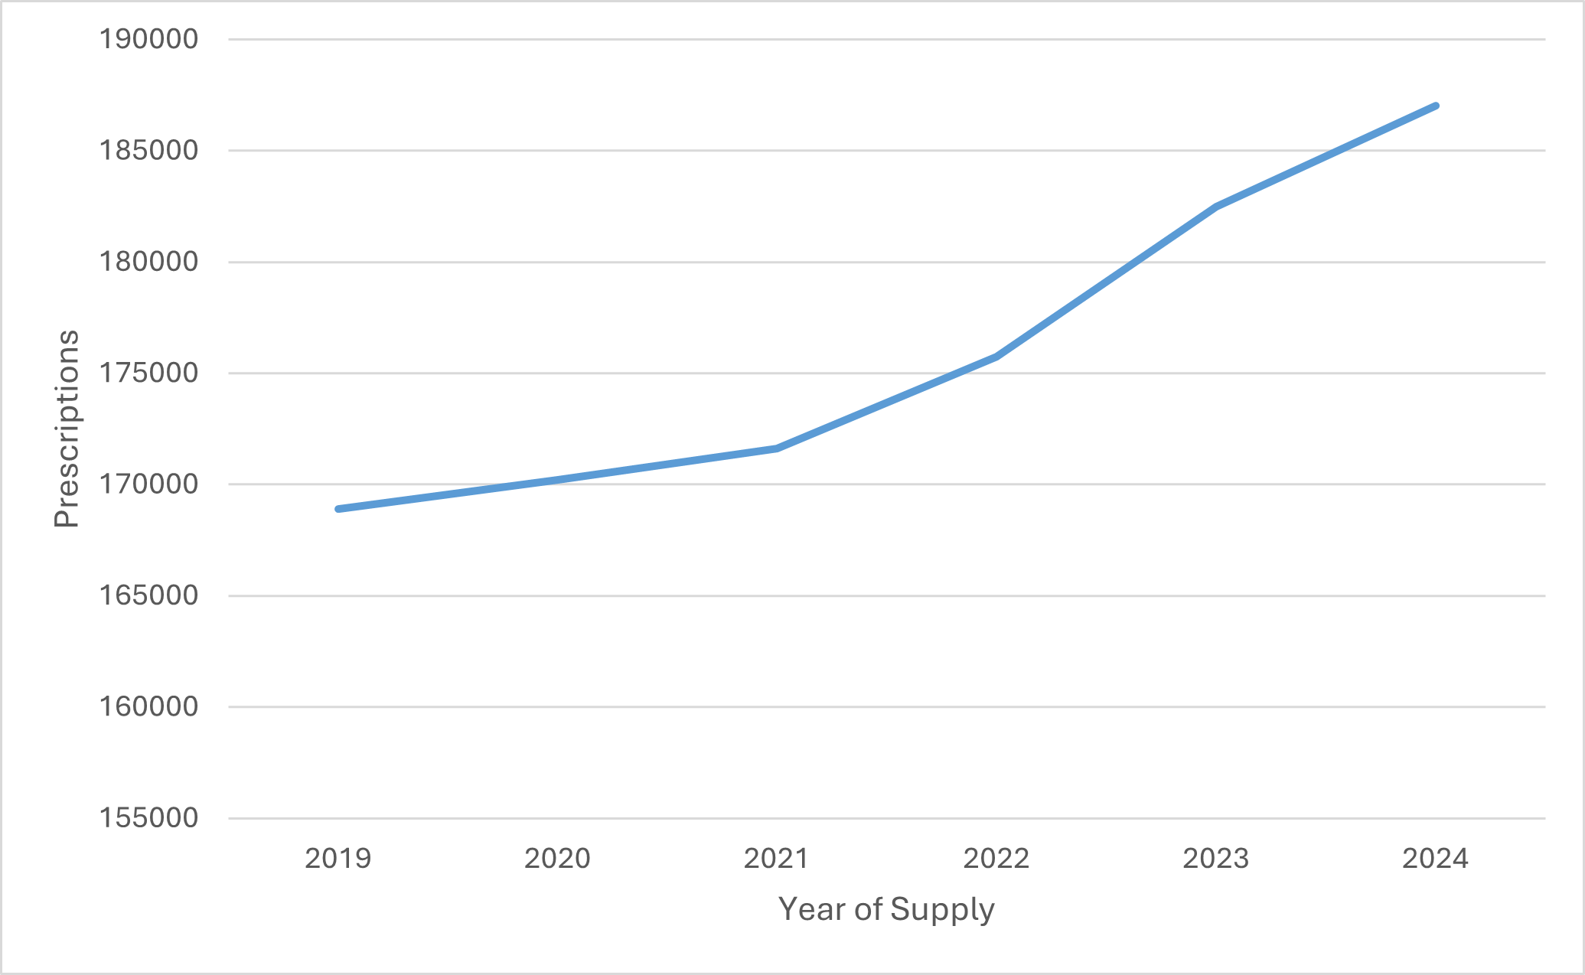
Figure 1: Number of prescriptions supplied for PBS-listed DMTs for RRMS (2019-2024)

Figure 2 shows the number prescriptions supplied for PBS-listed DMTs for RRMS by drug from 2019 to 2024. It should be noted that differences in the route of administration and dosage regimes between DMTs will impact the number of prescriptions. For example, ocrelizumab is administered intravenously every 6 months (requiring only 2 prescriptions per year) while fingolimod is administered orally daily (dispensed in packs of 28 units). The numbers of prescriptions supplied for fingolimod has decreased over time from 59,114 prescriptions in 2019 to 35,331 in 2024 (40.2% decrease).

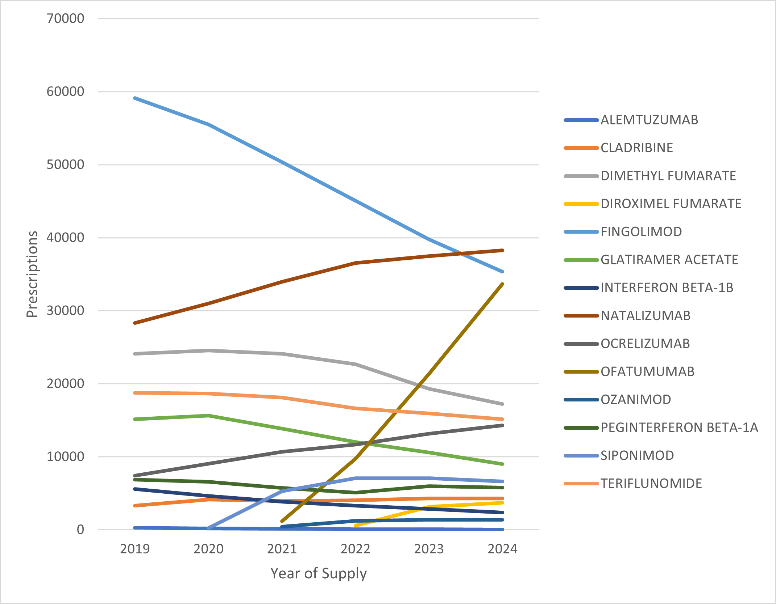 Figure 2: Number of prescriptions supplied for PBS-listed DMTs by drug (2019-2024)

Figure 3 shows the number of prescriptions supplied for PBS-listed DMTs for RRMS in the high efficacy tier (see Table 3). The total number of prescriptions supplied for the high efficacy group increased from 98,470 prescriptions in 2019 to 133,862 prescriptions in 2024 (an increase of 35.9%). Natalizumab had the greatest number of prescriptions supplied in 2024 (38,271 prescriptions), followed by fingolimod (35,331 prescriptions) and ofatumumab (33,669 prescriptions).
Figure 4 shows the number of prescriptions supplied for PBS-listed DMTs for RRMS in the moderate efficacy tier (see Table 3). The total number of prescriptions supplied for the moderate efficacy group decreased from 70,421 prescriptions in 2019 to 53,175 prescriptions in 2024 (a decrease of 24.4%). Dimethyl fumurate had the greatest number of prescriptions supplied in 2024 (17,204), followed by teriflunomide (15,116).
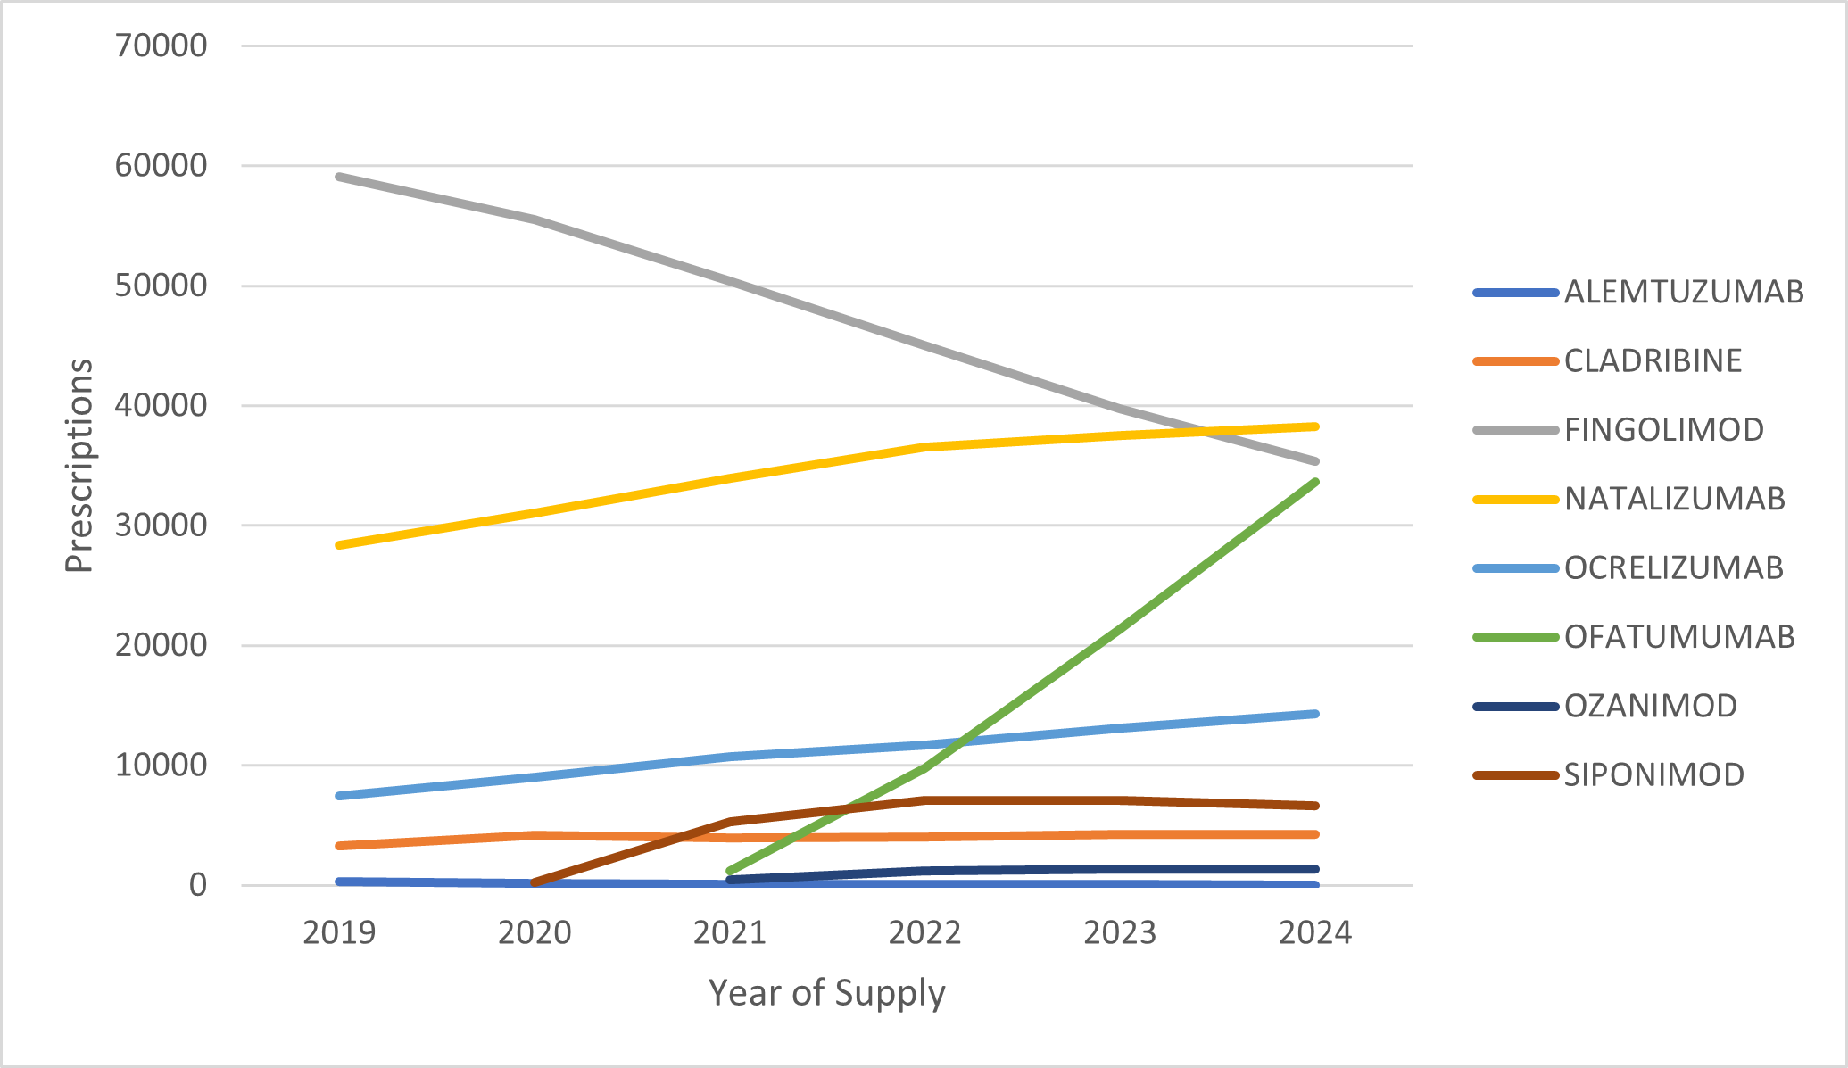Figure 3: Number of prescriptions supplied for PBS-listed DMTs for RRMS in the high efficacy tier by drug (2019-2024)
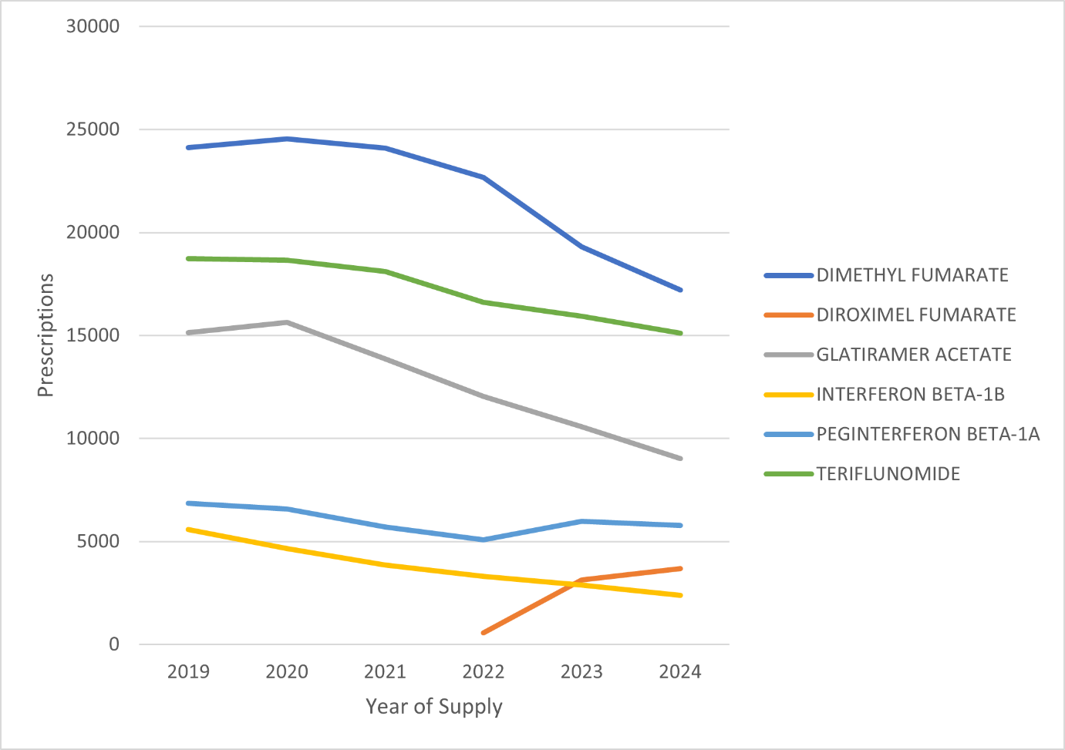Figure 4: Number of prescriptions supplied for PBS-listed DMTs for RRMS in the moderate efficacy tier by drug (2019-2024)

Figure 5 and Figure 6 shows the total benefits paid for PBS-listed DMTs for RRMS supplied from 2019 to 2024 based on published and effective prices respectively.
The benefits paid based on published prices increased from $448,814,609 in 2019 to $508,595,516 in 2024 (an increase of 13.3%). However, the benefits paid based on effective prices decreased from $326,119,635 in 2019 to $279,256,048 in 2024 (a decrease of 14.4%).
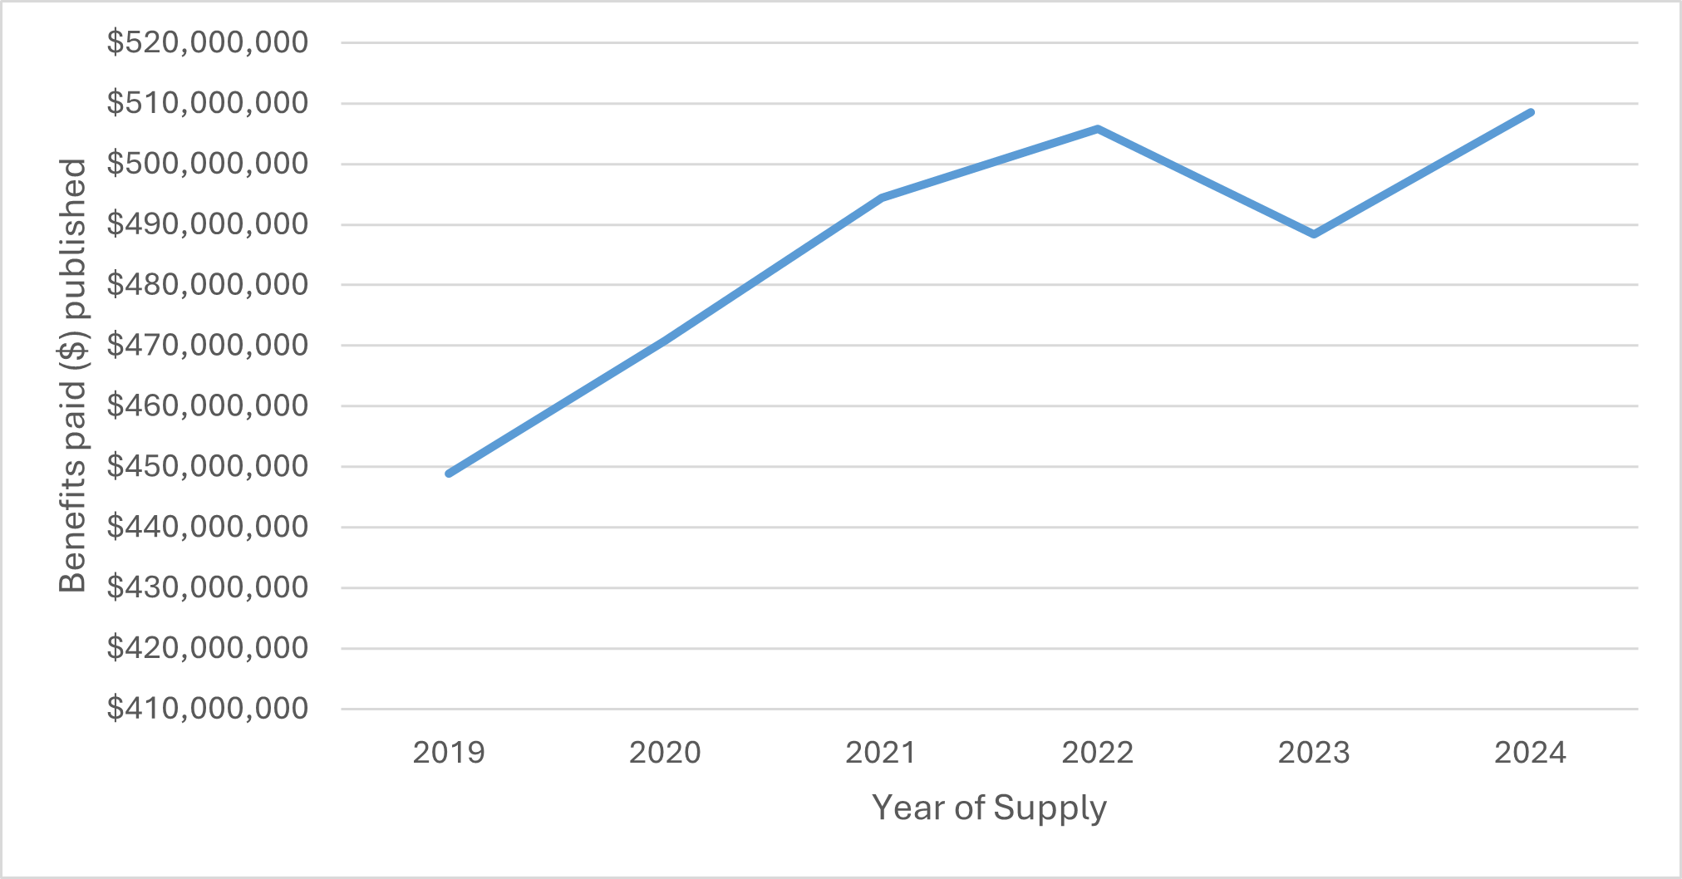
Figure 5: PBS benefits paid for PBS-listed DMTs for RRMS (2019-2024) [published prices]
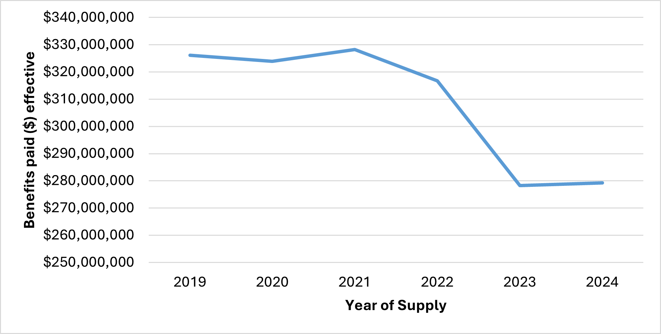
Figure 6: PBS benefits paid for PBS-listed DMTs for RRMS (2019-2024) [effective prices]
Figure 7 shows the PBS benefits paid (based on effective prices) for PBS-listed DMTs for RRMS by drug from 2019 to 2024. [REDACTED TEXT] were the PBS-listed DMTs for RRMS that incurred the highest cost to the PBS in 2024.

Figure 7: [DIAGRAM REDACTED] PBS benefits paid for PBS-listed DMTs for RRMS by drug (2019-2024) [effective prices]
Figure 8 shows the market share based on PBS benefits paid (effective prices) for PBS-listed DMTs for RRMS by drug in 2024. Based on effective prices, [REDACTED TEXT] had the greatest market share in 2024 ([REDACTED TEXT]), followed by [REDACTED TEXT]. Alemtuzumab ($[REDACTED TEXT]) benefits paid in 2024) and Interferon Beta-1B ($[REDACTED TEXT]) benefits paid in 2024) have a market share of [REDACTED TEXT]. The high efficacy DMTs accounted for 91% of the market for RRMS ($253,223,411 benefits paid), while moderate efficacy DMTs represented 9% ($23,032,637 benefits paid).

Figure 8: [REDACTED DIAGRAM] Market share based on PBS benefits paid for PBS-listed DMTs for RRMS by drug (2024) [effective prices]

Figure 9 shows the PBS benefits paid (based on effective prices) for PBS-listed DMTs in the high efficacy tier by drug from 2019 to 2024.
Based on effective prices, the PBS benefits paid for DMTs for RRMS in the high efficacy tier has increased by 3.1%; from $245,479,012 in 2019 to $253,223,411 in 2024. [REDACTED TEXT] were the PBS-listed DMTs for RRMS that incurred the highest cost to the PBS in 2024. PBS benefits paid for fingolimod decreased from $129,002,015 in 2019 to 35,733,249 in 2024 (a decrease of 72.3%).
Figure 10 shows the PBS benefits paid (based on effective prices) for PBS-listed DMTs for RRMS in the moderate efficacy tier by drug from 2019 to 2024. [REDACTED TEXT] were the PBS-listed DMTs for RRMS that incurred the highest cost to the PBS in 2024.
Based on effective prices, the PBS benefits paid for DMTs for RRMS in the moderate efficacy tier has decreased by 67.7%; from $80,640,623 in 2019 to $26,032,637 in 2024. The PBS benefits paid for all DMTs in the moderate efficacy tier have decreased over time except for diroximel fumarate which increased from $382,213 in 2022 to $2,544,687 in 2024.

Figure 9: [REDACTED DIAGRAM] PBS benefits paid for PBS-listed DMTs for RRMS in the high efficacy tier by drug (2019-2024) [effective prices]
Figure 10: [REDACTED DIAGRAM] PBS benefits paid for PBS-listed DMTs for RRMS in the moderate efficacy tier by drug (2019-2024) [effective prices]

Patient utilisation trends

Prevalence, incidence and patient demographics
Figure 11 shows the number of prevalent and incident (initiating) patients to PBS-listed DMTs for RRMS by year of supply from 2019 to 2024. A three-year lookback period to 1 January 2016 was used to identify first incident patients from 1 January 2019.
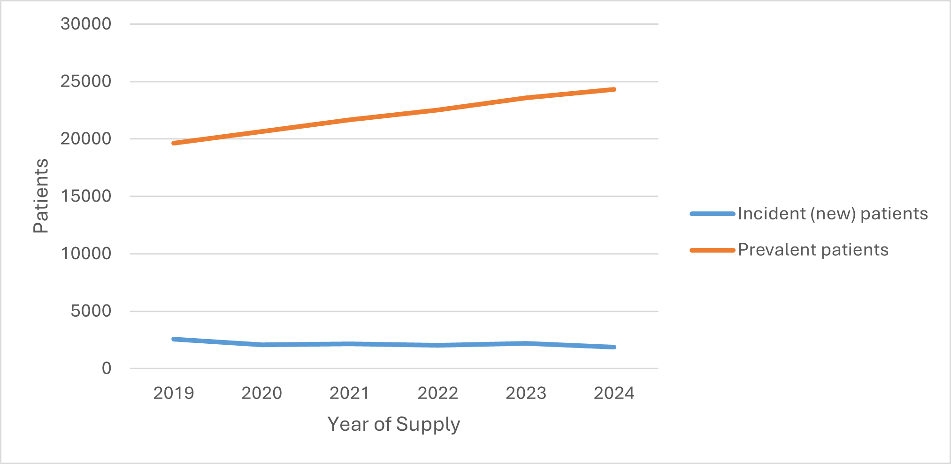
Figure 11: Prevalent and incident patients to PBS-listed DMTs for RRMS (2019-2024)

As shown in Figure 11, the number of prevalent patients to a PBS-listed DMTs for RRMS increased from 19,612 in 2019 to 24,310 in 2024 (an increase of 23.9%) whilst the number of incident patients declined from 2,550 in 2019 to 1,862 in 2024 (a decrease of 26.9%).
Figure 12 shows the number of prevalent patients to PBS-listed DMTs for RRMS by drug from 2019 to 2024. In 2024, ocrelizumab (7,753 prevalent patients), natalizumab (3,799 prevalent patients) and ofatumumab (3,549 prevalent patients) were the PBS-listed DMTs with the highest utilisation.
Figure 13 shows the number of incident (initiating) patients to PBS-listed DMTs for RRMS by drug from 2019 to 2024. Ocrelizumab (545 incident patients), ofatumumab (489 incident patients) and natalizumab (349 incident patients) were the PBS-listed DMTs with the highest utilisation in 2024.
Note: If the number of patients was below five in any given year for a medicine, this data was confidentialised to reduce the risk of patient re-identification, and the data point presented as zero.

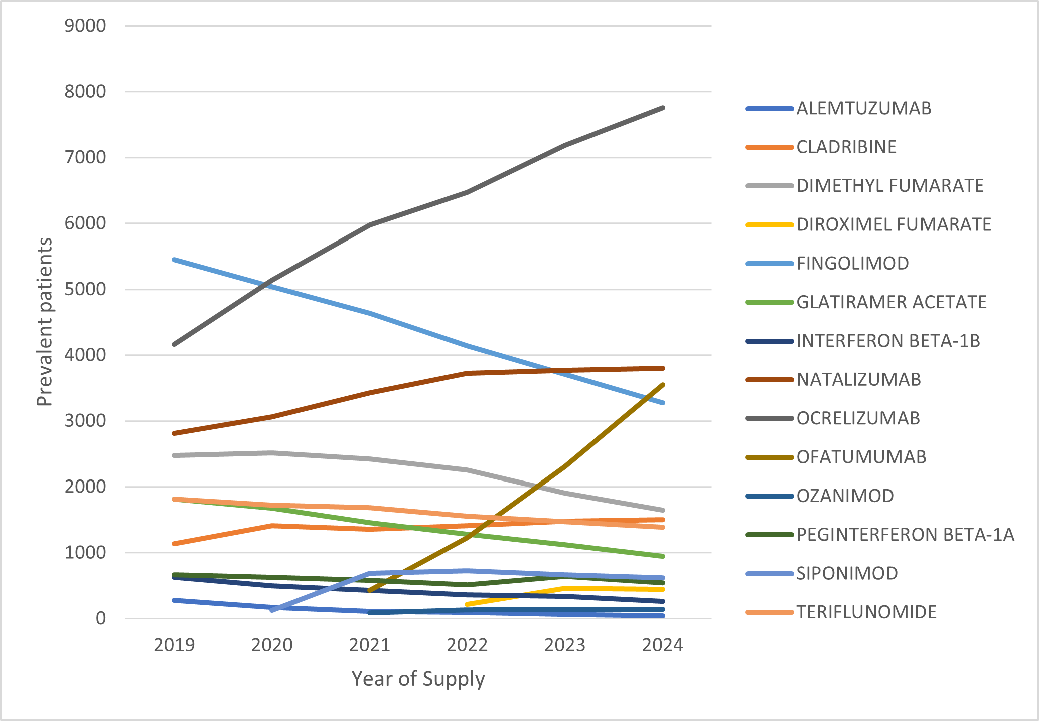
Figure 12: Prevalent patients to PBS-listed DMTs for RRMS by drug (2019-2024)
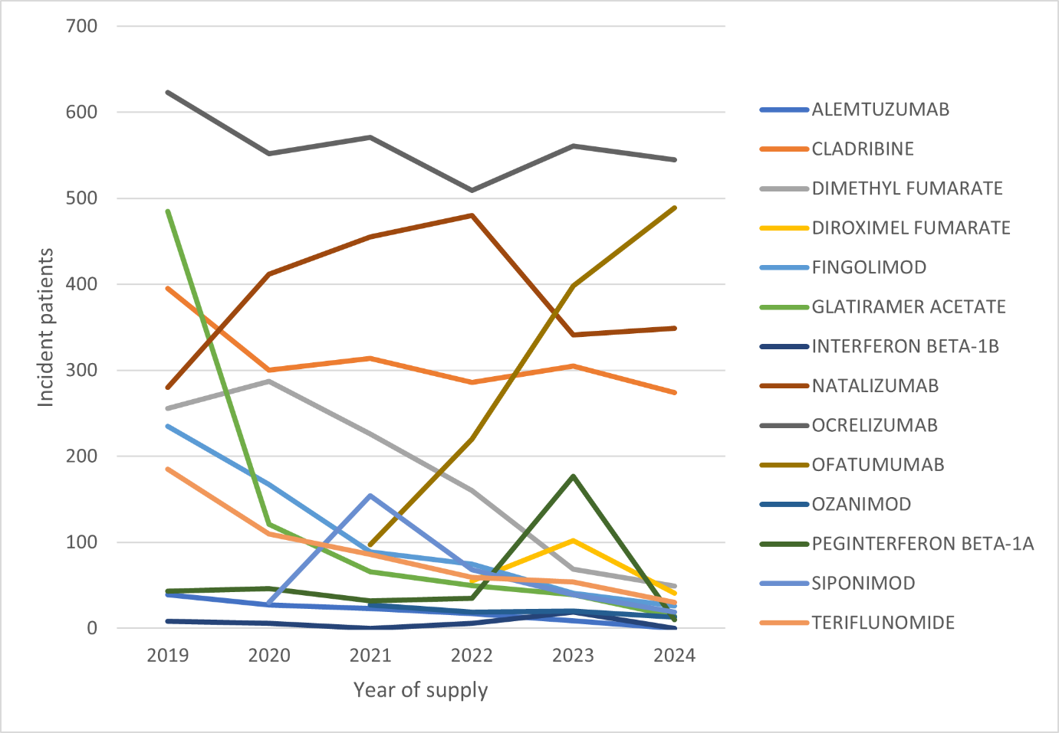
Figure 13: Incident patients to PBS-listed DMTs for RRMS by drug (2019-2024)
Figure 14 shows the number of prevalent patients to PBS-listed DMTs for RRMS in the high efficacy tier by drug from 2019 to 2024. The number of prevalent patients increased from 13,842 in 2019 to 20,679 in 2024 (an increase of 49.3%) and ocrelizumab, natalizumab and ofatumumab were the PBS-listed DMTs for RRMS with the highest utilisation.
Figure 15 shows the number of incident patients to PBS-listed DMTs for RRMS in the high efficacy tier by drug from 2019 to 2024. The number of incident patients increased from 1,572 in 2019 to 1,715 in 2024 (an increase of 9%) and ocrelizumab, ofatumumab and natalizumab were the PBS-listed DMTs with the highest utilisation.

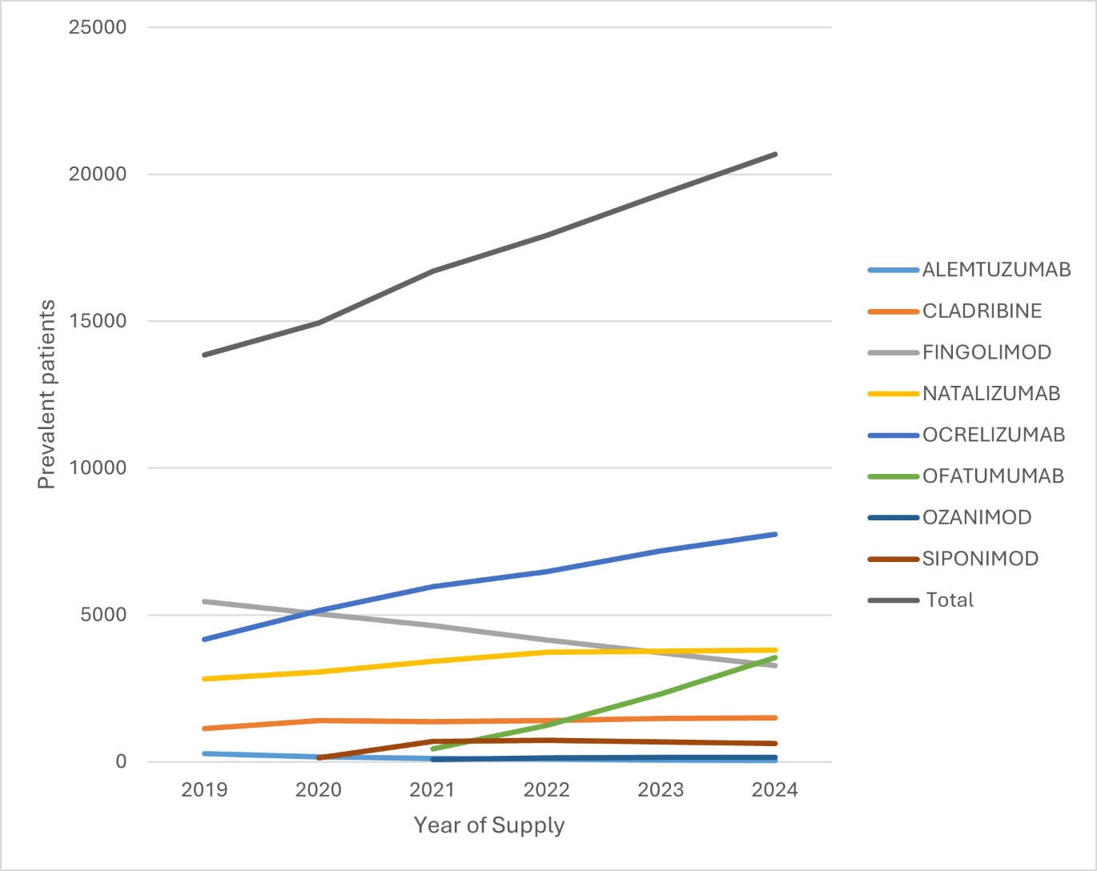
Figure 14: Prevalent patients to PBS-listed DMTs for RRMS in the high efficacy tier by drug (2019-2024)
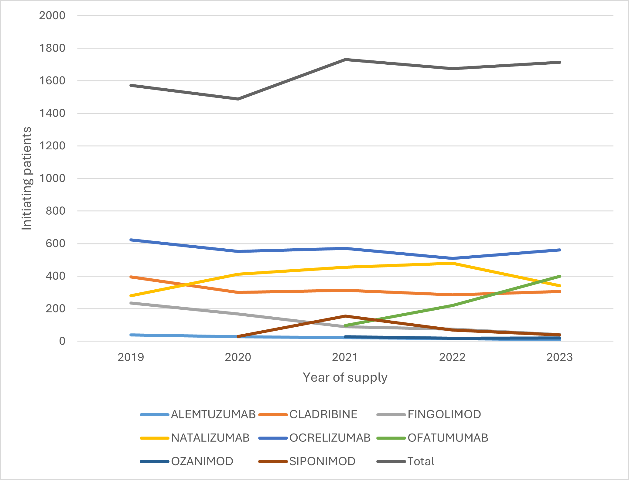
Figure 15: Initiating (incident) patients to PBS-listed DMTs for RRMS in the high efficacy tier by drug (2019-2024)

Figure 16 shows the number of prevalent patients to PBS-listed DMTs for RRMS in the moderate efficacy tier by drug from 2019 to 2024. The number of prevalent patients decreased from 7,388 in 2019 to 5,225 in 2024 (a decrease of 29.2%) and dimethyl fumurate (1,645 prevalent patients), teriflunomide (1,385 prevalent patients) and glatiramer acetate (543 prevalent patients) were the PBS-listed DMTs for RRMS with the highest utilisation in 2024. The number of prevalent patients to DMTs for RRMS in the moderate efficacy tier decreased for all medicines between 2019 and 2024 except for diroximel fumurate (increased from 219 in 2022 to 445 in 2024).
Figure 17 shows the number of incident patients to PBS-listed DMTs for RRMS in the moderate efficacy tier by drug from 2019 to 2024. The number of incident patients decreased from 977 in 2019 to 144 in 2024 (a decrease of 85.2%). Dimethyl fumurate (49 incident patients), diroximel fumurate (41 incident patients) and teriflunomide (30 incident patients) were the PBS-listed DMTs for RRMS with the highest utilisation in 2024. The number of incident patients to DMTs in the moderate efficacy tier has been decreasing over time.
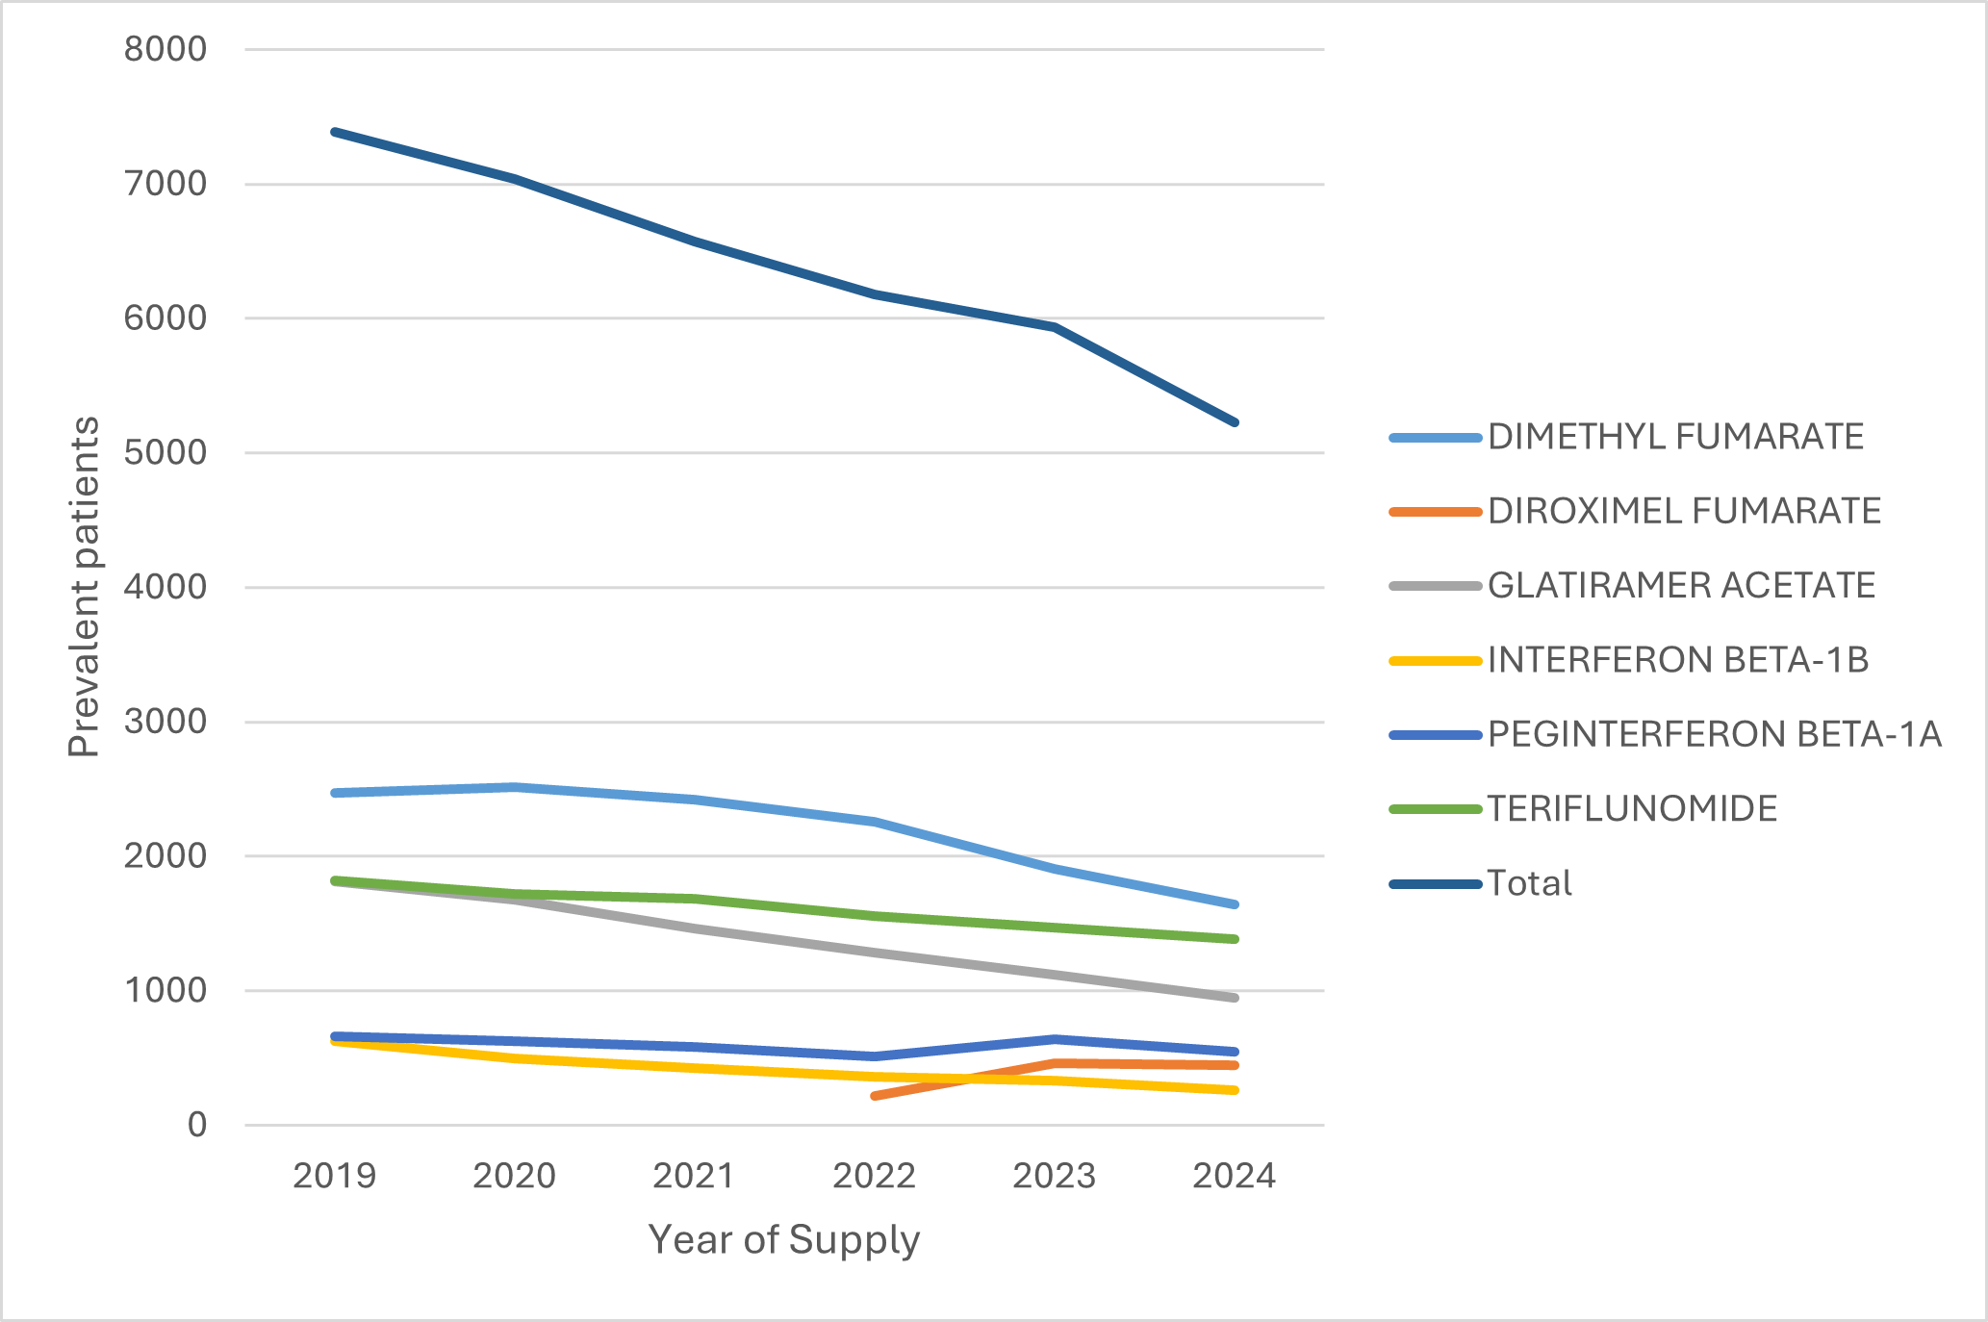
Figure 16: Prevalent patients to PBS-listed DMTs for RRMS in the moderate efficacy tier by drug (2019-2024)

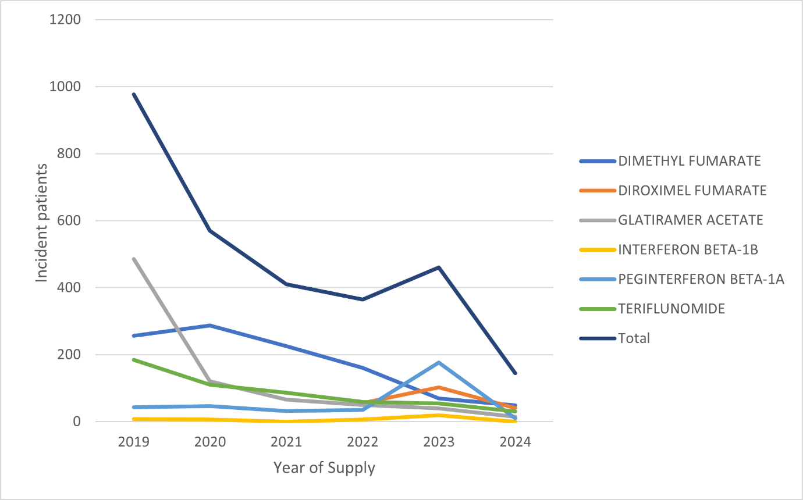
Figure 17: Initiating (incident) patients to PBS-listed DMTs for RRMS in the moderate efficacy tier by drug (2019-2024)

Patient demographics
Figure 18 shows the number of prevalent patients to PBS-listed DMTs for RRMS by age and gender in 2024.
Note: Age and gender data was based on the patient details at the time of the R/PBS supply. Gender was unknown for patients in the 0-4 year age group. If the number of patients was below five in any group, this data has been confidentialised to reduce the risk of patient re-identification, and the data point presented as zero.
As shown in Figure 18, there were more females (20,355 patients) than males (7,172 patients) supplied PBS-listed DMTs for RRMS in 2024, and utilisation peaks at 50-54 years for both females and males.
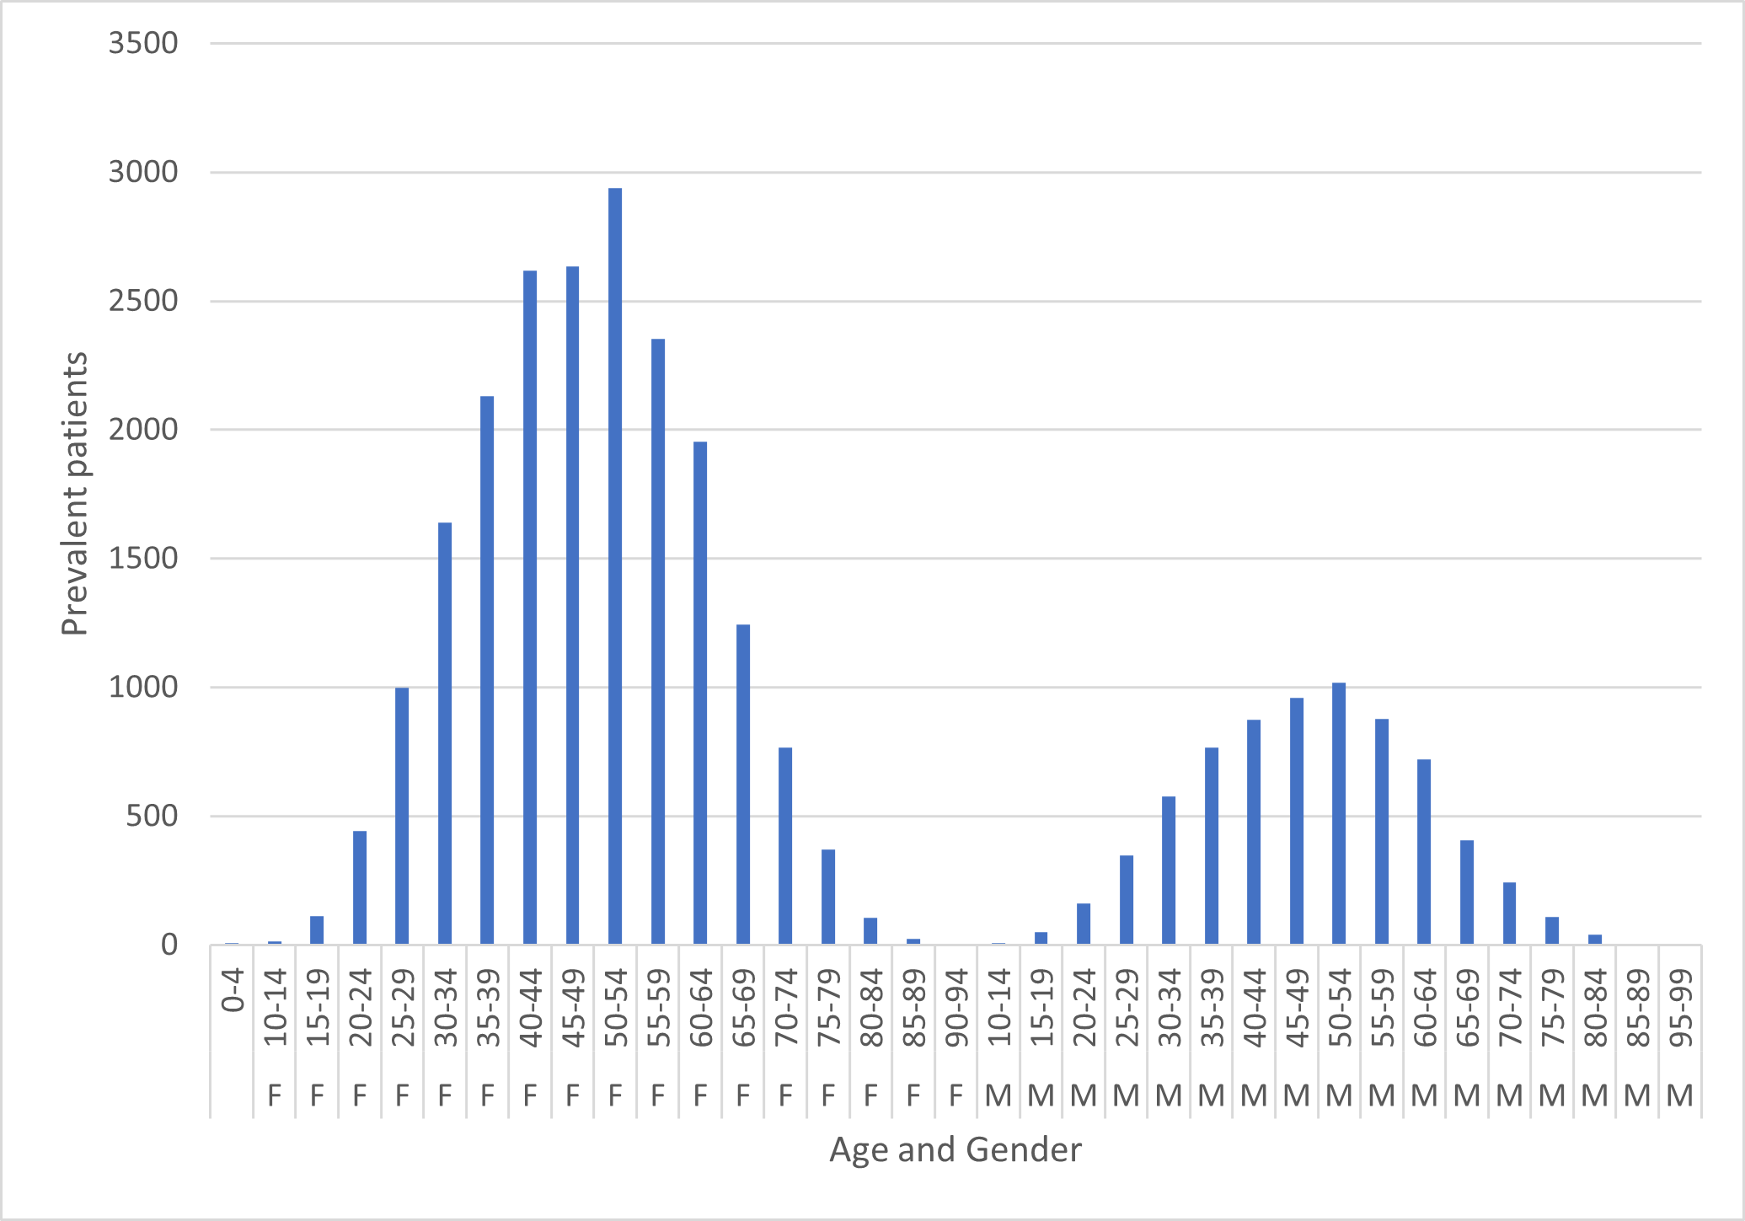
Figure 18: Prevalent patients to PBS-listed DMTs for RRMS by age and gender (2024)
Figure 19 shows the number of prevalent patients to PBS-listed DMTs for RRMS by age, gender and drug in 2024. As noted above, gender was unknown for patients in the 0-4 year age group. Data for patients with an unknown gender had five or less patients in each age category, and this data has been confidentialised to reduce the risk of patient re-identification, and the data point presented as zero.
Ocrelizumab was the most utilised PBS-listed DMT for RRMS for females, with utilisation peaking at 40-44 years of age. Natalizumab was the second most utilised PBS listed DMT for RRMS in females, with highest use at 35-39 years of age. Ocrelizumab was the most utilised PBS-listed DMT for RRMS for males, with utilisation peaking at 50-54 years of age. Fingolimod was the second most utilised PBS-listed DMT for RRMS for males, with highest use at 50-54 years of age.

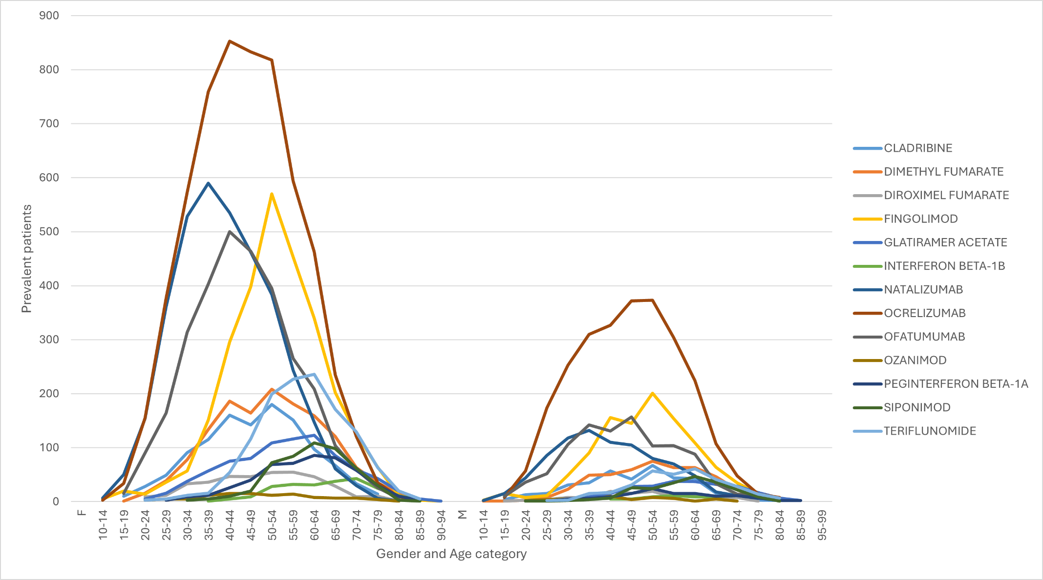
Figure 19: Prevalent patients to PBS-listed DMTs for RRMS by age, gender and drug (2024)

Drug sequence analysis
Table 5 shows the drug sequences for PBS-listed DMTs for RRMS supplied to patients first initiating from 1 January 2021 with follow up to 31 December 2024.
As shown in Table 5, monotherapy with ocrelizumab, ofatumumab and natalizumab were the three most common drug sequences. For drug initiation sequences consisting of two or more DMTs, ‘natalizumab to ocrelizumab,’ ‘natalizumab to ofatumumab’ and ‘ocrelizumab to ofatumumab’ were the three most common treatment initiation sequences.
Table 5: Drug sequences for PBS-listed DMTs for RRMS
Drug sequences | Patients | Percent
OCRELIZUMAB | 2019 | 24.6
OFATUMUMAB | 1137 | 13.8
NATALIZUMAB | 1096 | 13.3
CLADRIBINE | 1090 | 13.3
DIMETHYL FUMARATE | 295 | 3.6
NATALIZUMAB to OCRELIZUMAB | 285 | 3.5
SIPONIMOD | 251 | 3.1
PEGINTERFERON BETA-1A | 205 | 2.5
TERIFLUNOMIDE | 162 | 2.0
FINGOLIMOD | 159 | 1.9
NATALIZUMAB to OFATUMUMAB | 146 | 1.8
DIROXIMEL FUMARATE | 138 | 1.7
OCRELIZUMAB to OFATUMUMAB | 108 | 1.3
GLATIRAMER ACETATE | 99 | 1.2
OZANIMOD | 66 | 0.8
DIMETHYL FUMARATE to OFATUMUMAB | 49 | 0.6
ALEMTUZUMAB | 47 | 0.6
NATALIZUMAB to CLADRIBINE | 37 | 0.5
DIMETHYL FUMARATE to OCRELIZUMAB | 33 | 0.4
CLADRIBINE to OCRELIZUMAB | 30 | 0.4
CLADRIBINE to OFATUMUMAB | 25 | 0.3
DIMETHYL FUMARATE to DIROXIMEL FUMARATE | 25 | 0.3
OFATUMUMAB to OCRELIZUMAB | 25 | 0.3
OCRELIZUMAB to NATALIZUMAB | 24 | 0.3
DIMETHYL FUMARATE to CLADRIBINE | 20 | 0.2
DIMETHYL FUMARATE to NATALIZUMAB | 20 | 0.2
OCRELIZUMAB to CLADRIBINE | 20 | 0.2
INTERFERON BETA-1B | 19 | 0.2
OFATUMUMAB to NATALIZUMAB | 19 | 0.2
CLADRIBINE to NATALIZUMAB | 18 | 0.2
FINGOLIMOD to OCRELIZUMAB | 18 | 0.2
FINGOLIMOD to NATALIZUMAB | 17 | 0.2
TERIFLUNOMIDE to CLADRIBINE | 17 | 0.2
DIROXIMEL FUMARATE to OFATUMUMAB | 16 | 0.2
FINGOLIMOD to OFATUMUMAB | 14 | 0.2
NATALIZUMAB to OCRELIZUMAB to OFATUMUMAB | 14 | 0.2
PEGINTERFERON BETA-1A to CLADRIBINE | 14 | 0.2
DIROXIMEL FUMARATE to CLADRIBINE | 13 | 0.2
SIPONIMOD to OCRELIZUMAB | 12 | 0.1
TERIFLUNOMIDE to OFATUMUMAB | 12 | 0.1
GLATIRAMER ACETATE to OFATUMUMAB | 11 | 0.1
PEGINTERFERON BETA-1A to OFATUMUMAB | 11 | 0.1
[REDACTED TEXT] | [REDACTED] | [REDACTED]
[REDACTED TEXT] | [REDACTED] | [REDACTED]
[REDACTED TEXT] | [REDACTED] | [REDACTED]
[REDACTED TEXT] | [REDACTED] | [REDACTED]
[REDACTED TEXT] | [REDACTED] | [REDACTED]
[REDACTED TEXT] | [REDACTED] | [REDACTED]
[REDACTED TEXT] | [REDACTED] | [REDACTED]
[REDACTED TEXT] | [REDACTED] | [REDACTED]
[REDACTED TEXT] | [REDACTED] | [REDACTED]
[REDACTED TEXT] | [REDACTED] | [REDACTED]
[REDACTED TEXT] | [REDACTED] | [REDACTED]
[REDACTED TEXT] | [REDACTED] | [REDACTED]
[REDACTED TEXT] | [REDACTED] | [REDACTED]
Other (5 or less patients): | 286 | 3.5

Time on treatment
Figure 20 shows the time on treatment for patients supplied any PBS-listed DMTs for RRMS (i.e. this allowed for switching between drugs). The median time on treatment excluding breaks was 8,045 days (22 years) (95% CI 7,262 - 8610 days). The median time on treatment including breaks was 4,612 days (12.6 years) (95%ci 4,514-4743 days).
Figure 21 shows the time of supply by the first episode of treatment with an individual PBS listed DMT for RRMS. The DMT with the longest median time on treatment was fingolimod (1744 days [95%CI 1700-1866 days]). Data were still immature to assess median time on treatment for diroximel fumerate, ocrelizumab and ofatumumab

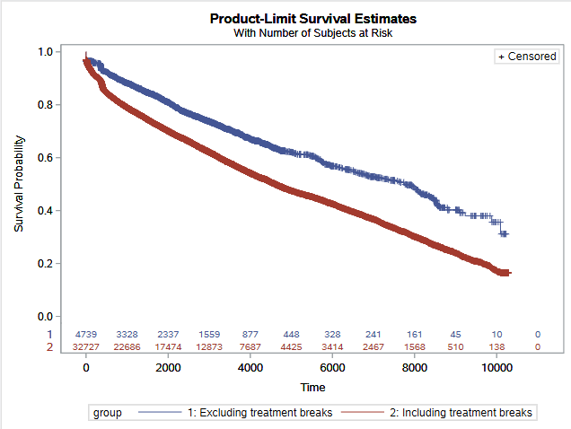
Figure 20. Time on treatment (days) for patients supplied any PBS-listed DMT for RRMS
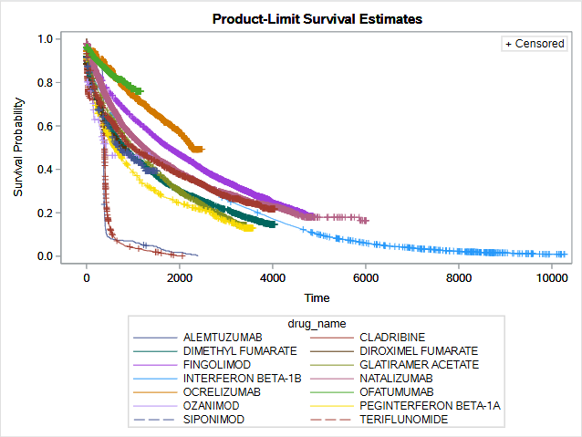
Figure 21. Time on treatment (days) by the first episode of treatment with an individual PBS-listed DMT for RRMS.

DUSC consideration
DUSC noted the number of prescriptions dispensed for PBS-listed DMTs for RRMS increased from 168,891 in 2019 to 187,037 in 2024. However, DUSC noted that the differing dosage regimen and routes of administration for DMTs made it inappropriate to compare them through number of prescriptions.
DUSC noted that in December 2022, the PBS price of fingolimod was reduced by 25% following the listing of a first new brand and on 1 October 2024, fingolimod was reduced by a further 12.75% price disclosure price reduction. DUSC noted the benefits paid for fingolimod decreased from $129,002,015 in 2019 to $35,733,249 in 2024. The number of prescriptions for fingolimod had also decreased over time from 59,114 prescriptions in 2019 to 35,331 in 2024.
DUSC noted the benefits paid for PBS-listed DMTs for RRMS based on published prices increased from $448,814,609 in 2019 to $508,595,516 in 2024 (an increase of 13.3%). However, the benefits paid based on effective prices decreased from $326,119,635 in 2019 to $279,256,048 in 2024 (a decrease of 14.4%).
DUSC noted that [REDACTED TEXT] were the PBS-listed DMTs for RRMS that incurred the highest cost to the PBS in 2024, based on effective prices.
DUSC noted that the high efficacy DMTs accounted for 91% of the market for RRMS ($253,223,411 benefits paid), while moderate efficacy DMTs represented 9% ($23,032,637 benefits paid). DUSC noted that based on effective prices in 2024 [REDACTED TEXT] had the greatest market share in 2024 ([REDACTED TEXT]), followed by [REDACTED TEXT].
DUSC noted the number of prevalent patients to a PBS-listed DMT for RRMS increased from 19,612 in 2019 to 24,310 in 2024. DUSC considered prevalence to be increasing at a 4.4% annualised rate, which is higher than would be expected from population growth alone. The DMTs with the highest number of prevalent patients were ocrelizumab (7,753 prevalent patients), natalizumab (3,799 prevalent patients) and ofatumumab (3,549 prevalent patients) in 2024.
DUSC noted that the number of patients initiating a PBS-listed DMT for RRMS declined from 2,550 in 2019 to 1,862 in 2024. DUSC considered a data linkage process may lead to useful insights on why incident patients were declining in this cohort.
DUSC considered that the increasing use of newer generation DMTs such as ocrelizumab, ofatumumab and natalizumab were replacing older DMTs such as fingolimod and moderate efficacy DMTs. DUSC considered this use to be in line with current clinical practice.
DUSC noted that the increasing market share of newer generation DMTs had not increased the overall benefits paid (based on effective prices) for PBS-listed DMTs.

DUSC Actions
DUSC requested that the findings be provided to the PBAC for consideration. The findings were presented to the PBAC at its July 2025 meeting and no further actions were requested by the PBAC.

Context for analysis
The DUSC is a Sub Committee of the Pharmaceutical Benefits Advisory Committee (PBAC). The DUSC assesses estimates on projected usage and financial cost of medicines.
The DUSC also analyses data on actual use of medicines, including the utilisation of PBS listed medicines, and provides advice to the PBAC on these matters. This may include outlining how the current utilisation of PBS medicines compares with the use as recommended by the PBAC.
The DUSC operates in accordance with the quality use of medicines objective of the National Medicines Policy and considers that the DUSC utilisation analyses will assist consumers and health professionals to better understand the costs, benefits and risks of medicines.
The utilisation analysis report was provided to the pharmaceutical sponsors of each drug and comments on the report were provided to DUSC prior to its consideration of the analysis.

Sponsors’ comments
Alphapharm Pty Ltd: The sponsor has no comment.
Apotex Pty Ltd: The sponsor has no comment.
Arrotex Pharmaceuticals Pty Ltd: The sponsor has no comment.
Arrow Pharmaceuticals Pty Ltd: The sponsor has no comment.
Bayer Australia Pty Ltd: The sponsor has no comment.
Biogen Australia Pty Ltd: The sponsor has no comment.
Bristol-Myers Squibb Australia Pty Ltd: The sponsor has no comment.
Dr Reddy's Laboratories (Australia) Pty Ltd: The sponsor has no comment.
Generic Health Pty Ltd: The sponsor has no comment.
Juno Pharmaceuticals Pty Ltd: The sponsor has no comment.
Merck Healthcare Pty Ltd: The sponsor has no comment.
Novartis Pharmaceuticals Australia Pty Ltd: The sponsor has no comment.
Pharmacor Pty Ltd: The sponsor has no comment.
Roche Products Pty Ltd: Roche believes this report underscores the profound benefit of having a wide range of effective treatment options readily available on the PBS in the first-line, rather than a limited few. This comprehensive access supports personalised treatment pathways, which are essential for optimising long-term patient outcomes in the Australian MS community.
Sandoz Pty Ltd: The sponsor has no comment.
Sanofi-Aventis Australia Pty Ltd: The sponsor has no comment.
Sun Pharma ANZ Pty Ltd: The sponsor has no comment.
Teva Pharma Australia Pty Ltd: The sponsor has no comment.

Disclaimer
The information provided in this report does not constitute medical advice and is not intended to take the place of professional medical advice or care. It is not intended to define what constitutes reasonable, appropriate or best care for any individual for any given health issue. The information should not be used as a substitute for the judgement and skill of a medical practitioner.
The Department of Health, Disability and Ageing has made all reasonable efforts to ensure that information provided in this report is accurate. The information provided in this report was up-to-date when it was considered by the Drug Utilisation Sub-committee of the Pharmaceutical Benefits Advisory Committee. The context for that information may have changed since publication.
To the extent provided by law, the Department of Health, Disability and Ageing makes no warranties or representations as to accuracy or completeness of information contained in this report.
To the fullest extent permitted by law, neither the Department of Health, Disability and Ageing nor any Department of Health, Disability and Ageing employee is liable for any liability, loss, claim, damage, expense, injury or personal injury (including death), whether direct or indirect (including consequential loss and loss of profits) and however incurred (including in tort), caused or contributed to by any person’s use or misuse of the information available from this report or contained on any third party website referred to in this report.

Attachment 1: PBS listings included in the data extraction
Note: All listings have a restriction level of Authority required (STREAMLINED).
Drug | Form, strength & pack size | Schedule | PBS code | Treatment phase | ATC code
Alemtuzumab* | 12 mg/1.2 mL injection, 1.2 mL vial | S100 HSD Public | 10228H | Initial | L04AG
Alemtuzumab* | 12 mg/1.2 mL injection, 1.2 mL vial | S100 HSD Public | 10232M | Continuing | L04AG
Alemtuzumab* | 12 mg/1.2 mL injection, 1.2 mL vial | S100 HSD Private | 10243D | Initial | L04AG
Alemtuzumab* | 12 mg/1.2 mL injection, 1.2 mL vial | S100 HSD Private | 10246G | Continuing | L04AG
Natalizumab | 300 mg/15 mL injection, 15 mL vial | S100 HSD Public | 9505G | N/A | L04AG
Natalizumab | 300 mg/15 mL injection, 15 mL vial | S100 HSD Private | 9624M | N/A | L04AG
Natalizumab | 150 mg/mL injection, 2 x 1 mL syringes | S100 HSD Private | 13820J | N/A | L04AG
Natalizumab | 150 mg/mL injection, 2 x 1 mL syringes | S100 HSD Public | 13825P | N/A | L04AG
Ocrelizumab* | 300 mg/10 mL injection, 10 mL vial | S100 HSD Private | 11237K | Initial & Continuing | L04AG
Ocrelizumab* | 300 mg/10 mL injection, 10 mL vial | S100 HSD Public | 11242Q | Initial & Continuing | L04AG
Ozanimod* | 920 microgram capsule, 28 | General | 12271W | Initial & Continuing | L04AE
Ozanimod* | 230 microgram capsule [4] (&) 460 microgram capsule [3], 7 | General | 12278F | Initial & Continuing | L04AE
Ofatumumab* | 20 mg/0.4 mL injection, 0.4 mL pen device | General | 12641H | Continuing | L04AG
Ofatumumab* | 20 mg/0.4 mL injection, 0.4 mL pen device | General | 12642J | Initial | L04AG
Fingolimod | 500 microgram capsule, 28 | General | 5262Y | Initial & Continuing | L04AE
Fingolimod | 250 microgram capsule, 28 | General | 11818B | Initial & Continuing | L04AE
Cladribine* | 10 mg tablet, 1 | General | 11603Q | Initial & Continuing | L01BB
Cladribine* | 10 mg tablet, 4 | General | 11604R | Initial & Continuing | L01BB
Cladribine* | 10 mg tablet, 6 | General | 11611D | Initial & Continuing | L01BB
Siponimod* | 250 microgram tablet, 12 | General | 12172P | Initial & Continuing (including recommencement) | L04AE
Siponimod* | 250 microgram tablet, 120 | General | 12160B | Initial & Continuing (including recommencement) | L04AE
Siponimod* | 2 mg tablet, 28 | General | 12158X | Initial & Continuing (including recommencement) | L04AE
Siponimod* | 1 mg tablet, 28 | General | 14607T | Initial & Continuing (including recommencement) | L04AE
Teriflunomide | 14 mg tablet, 28 | General | 2898M | Initial & Continuing | L04AK
Peginterferon beta-1a | 125 microgram/0.5 mL injection, 2 x 0.5 mL pen devices | General | 10212L | Initial | L03AB
Peginterferon beta-1a | 63 microgram/0.5 mL injection [0.5 mL pen device] (&) 94 microgram/0.5 mL injection [0.5 mL pen device], 1 pack | General | 10218T | Initial | L03AB
Peginterferon beta-1a | 125 microgram/0.5 mL injection, 2 x 0.5 mL pen devices | General | 10220X | Continuing | L03AB
Interferon beta-1b | 8 million units (250 microgram) injection [15 vials] (&) inert substance diluent [15 x 1.2 mL syringes], 1 pack | General | 8101J | Initial & Continuing | L03AB
Glatiramer acetate | 40 mg/mL injection, 12 x 1 mL syringes | General | 10416F | Initial & Continuing | L03AX
Glatiramer acetate | 40 mg/mL injection, 12 x 1 mL pen devices | General | 13110B | Initial & Continuing | L03AX
Dimethyl fumarate | 120 mg enteric capsule, 14 | General | 2896K | Initial | L04AX
Dimethyl fumarate | 120 mg enteric capsule, 14 | General | 2943X | Continuing | L04AX
Dimethyl fumarate | 240 mg enteric capsule, 56 | General | 2966D | Continuing | L04AX
Diroximel fumarate | 231 mg enteric capsule, 120 | General | 13059H | Initial & Continuing | L04AX
* A special pricing arrangement is in place for this medicine.

Lane, J., Ng, H. S., Poyser, C., Lucas, R. M., & Tremlett, H. (2022). Multiple sclerosis incidence: a systematic review of change over time by geographical region. Multiple Sclerosis and Related Disorders, 63, 103932.
Browne, P., Chandraratna, D., Angood, C., Tremlett, H., Baker, C., Taylor, B. V., & Thompson, A. J. (2014). Atlas of multiple sclerosis 2013: a growing global problem with widespread inequity. Neurology, 83(11), 1022-1024.
Goudarzi, M. H., Eadie, M. J., & Hollingworth, S. A. (2021). Disease modifying therapies for relapsing-remitting multiple sclerosis: use and costs in Australia (1996-2019). Multiple Sclerosis and Related Disorders, 50, 102835.
Perrone, V., Veronesi, C., Giacomini, E., Citraro, R., Dell'Orco, S., Lena, F., Paciello, A., Resta, A. M., Nica, M., Ritrovato, D., & Degli Esposti, L. (2022). The Epidemiology, Treatment Patterns and Economic Burden of Different Phenotypes of Multiple Sclerosis in Italy: Relapsing-Remitting Multiple Sclerosis and Secondary Progressive Multiple Sclerosis. Clinical epidemiology, 14, 1327–1337. https://doi.org/10.2147/CLEP.S376005
Multiple Sclerosis [published 2023 August]. In: Therapeutic Guidelines. Melbourne: Therapeutic Guidelines Limited; accessed {5 August 2024}. https://www.tg.org.au
Travers, B. S., Tsang, B. K., & Barton, J. L. (2022). Multiple sclerosis: Diagnosis, disease-modifying therapy and prognosis. Australian journal of general practice, 51(4), 199-206.
Australian Medicines Handbook. (2024). Multiple sclerosis. In Australian Medicines Handbook. Retrieved August 5, 2024, from Multiple sclerosis - Australian Medicines Handbook (amh.net.au)

