# Clarity on Price Disclosure Reduction Thresholds and Designated Brands – Fact Sheet

The [*National Health Amendment (Technical Changes to Averaging Price Disclosure Threshold and Other Matters) Act 2024*](https://www.legislation.gov.au/C2024A00088/asmade/text)(**the 2024 Amendment Act**) (Royal Assent received on 26 September 2024, effective from 1 July 2022) amends Part VII of the [*National Health Act 1953*](https://www.legislation.gov.au/C1953A00095/latest/text) (**the Act**) to clarify the operation of certain provisions relating to pricing and supply arrangements for older and low-cost medicines referred to in the Act as ‘designated brands’.

## Designated brands

The 2024 Amendment Act clarifies provisions which were introduced through the [*National Health Amendment (Enhancing the Pharmaceutical Benefits Scheme) Act 2021*](https://www.legislation.gov.au/C2021A00139/asmade/text) (**the 2021 Amendment Act**) to provide improved pricing arrangements and more reliable supply for older and low-cost medicines that can be more susceptible to medicine shortages. The provisions established designated brands (s99ADHC) which are subject to:

* protective price disclosure thresholds – of 30% or a lower price disclosure threshold of 10% where the 12.5% average test (set out in s99ADH(6)) is met;
* floor price protections – no price reductions apply to designated brands with an approved ex-manufacturer price (**AEMP**) of $4 or less. For designated brands with an AEMP more than $4, price reductions are capped at a floor price of $4;
* adjusted net revenue calculations – any discounts or incentives in relation to sales of a designated brand with an AEMP of $4 or less will be apportioned through Step 3A of the price disclosure calculations to other brands of the Responsible Person (**RP**). The Minister also has powers under Division 3CA that they can choose to utilise if an RP is offering discounts or incentives for designated brands with an AEMP of $4 or less; and
* minimum stockholding requirements – RPs must keep in stock in Australia at least the applicable quantity of the brand, which is generally determined by reference to the usual demand of that brand (Division 3CAA of the Act).

The 2024 Amendment Act clarifies the operation of the 12.5% average test (in s99ADH(6)), and the timing of when a brand becomes a designated brand under s99ADHC. It includes technical amendments only, which were made for the avoidance of doubt and do not alter the operation of the provisions which have been in effect since 1 July 2022. The amendments apply retrospectively effective from 1 July 2022.

The following sections of this Fact Sheet provide an outline of the amendments. For the full text of the amendments, see the [2024 Amendment Act](https://www.legislation.gov.au/C2024A00088/asmade/text). The [Explanatory Memorandum](https://parlinfo.aph.gov.au/parlInfo/search/display/display.w3p;query=Id%3A%22legislation%2Fems%2Fr7235_ems_2f758b1f-1b97-4299-bab8-d936ca595660%22) for the 2024 Amendment Act provides further details of the effect of each individual amendment.

Additional information regarding the changes made by the 2021 Amendment Act is available in the [Price Disclosure Reforms under the new Strategic Agreement Fact Sheet](https://www.pbs.gov.au/industry/pricing/designated-brands/Price-Disclosure-Reforms-under-the-New-Strategic-Agreement-Fact-Sheet.pdf). Additional information is also available on the [Designated Brands](https://www.pbs.gov.au/info/industry/pricing/designated-brands) page of the PBS website and in the [Price Disclosure Guidelines](https://www.pbs.gov.au/info/industry/pricing/price-disclosure-spd/price-disclosure-guidelines).

## Amendments to clarify the operation of the 12.5% average unadjusted price reduction test

Section 99ADH of the Act is the mechanism through which price disclosure price reductions occur and provides the thresholds which must be met for a price reduction to occur in relation to data from a particular data collection period.

Amendments to section 99ADH of the Act clarify the operation of the 12.5% average unadjusted price reduction test (**12.5% average test**) reflecting the policy intent outlined in the [Explanatory Memorandum for the 2021 Amendment Act](https://parlinfo.aph.gov.au/parlInfo/download/legislation/ems/r6799_ems_8812668a-6b85-4028-8a69-034fe4858fad/upload_pdf/JC003895.pdf), which states in relation to designated brands with an AEMP greater than $4:

*…there will be no further price reductions under the Act unless, over a period of three consecutive data collection periods (1.5 years), the brand is discounted on average by 12.5% or more without taking a price reduction, or if the brand is discounted by more than 30% in any one price disclosure cycle.*

The amendments clarify paragraph (b) of section 99ADH(6), which states:

*For the purposes of this section, a brand of a pharmaceutical item passes the 12.5% average unadjusted price reduction test if there have been 3 consecutive data collection periods in respect of which a weighted average disclosed price has been determined for any brand of the pharmaceutical item, where:*

*(a) the percentage obtained by dividing the total of the unadjusted price reductions for a brand of the pharmaceutical item in respect of each of those data collection periods by 3 is at least 12.5%; and*

***(b) this section did not apply to the brand of the pharmaceutical item in relation to any of those data collection periods;*** *and*

*(c) those data collection periods include the data collection period mentioned in paragraph (1)(a).*

Paragraph (b) means that for a brand to pass the 12.5% average test, a price reduction cannot have already occurred as a result of calculations using data from any of the 3 consecutive data collection periods used in the test. Each data collection period is 6 months in duration, therefore three consecutive data collection periods result in a period of 1.5 years between possible price reductions for designated brands that have discounted on average by 12.5% or more in those periods.

Data collection periods occur on a rolling basis each year from 1 April to 30 September and 1 October to 31 March. Each 6-month data collection period is, in practice, followed by a subsequent 6-month processing period where the data collected from the data collection period is analysed and a Weighted Average Disclosed Price (**WADP**) is determined, for each listed brand which disclosed data, for that data collection period. The reduction day that typically applies to those data collection periods consequently occurs six months following the end of that period. For a data collection period running from 1 April to 30 September, the reduction day typically occurs on 1 April the following year. For the data collection period running from 1 October to 31 March, the reduction day typically occurs on 1 October the following year.

Due to this cyclical nature of price disclosure, and the time lag between data being collected, processed and a price reduction occurring, the 12.5% average test is a backward-looking test which is passed (or not passed) prior to the corresponding reduction day of the third data collection period which is examined by the test. This means that:

* prior to that reduction day, a price reduction cannot have occurred as a result of calculations using data from any of the 3 consecutive data collection periods used in the test.
* if data from any of the 3 consecutive data collection periods examined by the 12.5% average test has resulted in a price reduction under section 99ADH, then the test would not be passed.
* a price reduction occurring on a reduction day that falls within the date range spanned by the 3 consecutive data collection periods will not prevent the test being passed unless the price reduction occurred as a result of calculations using data from one of the 3 consecutive data collection periods.

|  |
| --- |
| For example, if the 12.5% average test is passed using data from the data collection periods 1 April 2022 to 30 September 2022, 1 October 2022 to 31 March 2023, and 1 April 2023 to 30 September 2023, a consequent price reduction could occur on 1 April 2024 if the 10% threshold is then met with respect to the data collection period 1 April 2023 to 30 September 2023.  Following this, the next reduction day for which the 12.5% average test could be passed would be 1 October 2025 using data from the data collection periods of 1 October 2023 to 31 March 2024, 1 April 2024 to 30 September 2024, and 1 October 2024 to 31 March 2025. The data collection periods prior to these were used for the 1 April 2024 price reduction and could not therefore contribute to any future 12.5% average test.  The next reduction day for which the 12.5% average test could be passed would also be 1 October 2025 if the 1 April 2024 price reduction had instead resulted from the 30% threshold in section 99ADHC(1)(c)(ii) of the Act being met, that is, using the data from the data collection period of 1 April 2023 to 30 September 2023 only. |

Refer to **Appendix, Figure 1** for illustrative examples.

These amendments have been made for the avoidance of doubt and reflect how the provision has operated since 1 July 2022.

## Amendments to clarify the timing for a brand to become a designated brand

Section 99ADHC of the Act sets out the criteria that must be met for a brand to be a designated brand and as a result, be subject to a range of more protective pricing and supply provisions as outlined above. Designated brands must meet one of the following criteria:

1. the drug/manner of administration (**MoA**) of the brand’s pharmaceutical item has been on F2 for at least 42 months and at least 30 months must have passed since the first price disclosure price reduction for any brand of the same drug/MoA (**42-month clock**) (s99ADHC(1)(a)). A drug/MoA will be taken to have been on F2 for at least 42 months if at the end of the **previous data collection period**, the drug/MoA has been on F2 for at least 42 months, and on a day at least 42 months before the end of the previous data collection period, the drug/MoA was multi-branded (s99ADHC(6)); or
2. the AEMP of the brand is $4 or less (s99ADHC(1)(b)); or
3. the AEMP of the brand has been increased on and after 1 July 2022 through a new price agreement and a determination[1] is in force under s99ADHC(2) in relation to the brand (s99ADHC(1)(c)); or
4. the AEMP of the brand was increased on 1 October 2022 under s104B of the Act (s99ADHC(1)(d)).

To assist RPs in understanding when a brand may meet the conditions outlined under **a)**, the 2024 Amendment Act provides a definition of ‘**previous data collection period**’ under a new section of the Act (section 99ADHD). This definition makes clear, for the avoidance of doubt, which data collection period the ‘previous data collection period’ refers to and is used when determining whether or not the criteria outlined under a) is met. This definition in turn ensures it is clear that each of the operative provisions associated with a designated brand are effective from the same date on which a brand becomes a designated brand.

The new definition provides that the previous data collection period for the brand of the pharmaceutical item is the data collection period that immediately preceded the corresponding data collection period for the brand of the pharmaceutical item in the immediately preceding year.

|  |
| --- |
| For example, for the 1 October reduction day, data is processed for the data collection period 1 October in the previous year to 31 March in the current year and the previous data collection period is the data collection period prior to that period, being between 1 April and 30 September of the previous year. For the 1 April reduction day, data is processed for the data collection period 1 April to 30 September in the previous year and the previous data collection period is the data collection period prior to that period, being the period ending on 31 March in the previous year. A brand will be a designated brand on 1 October in the current year, if the 42- and 30-month clocks are both met by the end of the data collection period which ran from 1 April to 30 September in the previous year. A brand will be a designated brand on 1 April in the current year, if the 42- and 30-month clocks are both met by the end of the data collection period which ended on 31 March in the previous year. |

Refer to **Appendix, Figure 2** for illustrative examples.

The new section also provides clarification for newly listed brands, defining the ‘previous data collection period’ as being the same as the previous data collection period for related brands (brands that have the same drug and MoA). This is because related brands meet the ‘42- and 30-month clocks’ at the same point in time and are subject to the same price disclosure thresholds under section 99ADH of the Act.

|  |
| --- |
| For example, a new brand is listed on 1 July 2024 and its first data collection period ends on 30 September 2024. The immediately following data collection period ends on 31 March 2025. This means that:  (a) on any day between 1 July 2024 and 30 September 2024, the corresponding data collection period for any related brand is the data collection period between 1 April 2023 and 30 September 2023, and the previous data collection period for the related brand (and the new brand) is the data collection period between 1 October 2022 and 31 March 2023; and  (b) on any day between 1 October 2024 and 31 March 2025, the corresponding data collection period for any related brand is the data collection period between 1 October 2023 and 31 March 2024 and the previous data collection period for the related brand (and the new brand) is the data collection period between 1 April 2023 and 30 September 2023. |

Again, these amendments are for the avoidance of doubt and reflect how the provision has operated since 1 July 2022. The price disclosure price reduction provisions which applied prior to 1 July 2022 also utilised the term ‘previous data collection period’ with respect to those brands which were subject to a more protective price reduction threshold (the previous 30% threshold test). The definition included in the 2024 Amendment Act is consistent with how the previous data collection period operated under the previous 30% threshold test.

**Appendix, Figure 3** outlines the application of s99ADHC(1)(a) of the Act for two groups of related brands with a drug (Asclepius) which is common to both groups but with different manners of administration (Oral and Injection). The diagram indicates the trigger events which start time running against both parts of the 42-month clock in s99ADHC(1)(a)(i) and (6) of the Act, and against the   
30-month clock in s99ADHC(1)(a)(ii) of the Act. The diagram indicates the interval after which the relevant period of time has elapsed against each clock for each drug and manner of administration (**MoA**) (Asclepius/Oral and Asclepius/Injection), as well as the timing for when brands in each group of related brands will become designated brands once s99ADHC(1)(a) is satisfied.

|  |  |  |
| --- | --- | --- |
| For example, starting from a notional date of 1 April 2022 for the drug Asclepius to move to F2, the table below provides dates for each trigger event in Figure 3, and the date from which brands with each drug/MoA would become designated brands. | | |
| ***Trigger event/criteria satisfied*** | ***Date (for the drug/MoA Asclepius/Oral)*** | ***Date (for the drug/MoA Asclepius/Injection)*** |
| F2 movement | 1 April 2022 | 1 April 2022 |
| First date on which multi-branded | 1 April 2022 | 1 October 2023 |
| First PD price reduction | 1 April 2023 | 1 April 2025 |
| 42 months since F2 movement satisfied at end of DCP ending | 30 September 2025 | 30 September 2025 |
| Multi-branded on a day at least 42 months earlier at end of DCP ending | 30 September 2025 | 31 March 2027 |
| 30 months since first PD price reduction at end of DCP ending | 30 September 2025 | 30 September 2027 |
| **Brands with the relevant drug/MoA will each be a designated brand effective from** | **1 October 2026** | **1 October 2028** |

## Appendix

## Figure 1 – Application of 12.5% average test under different scenarios

The diagrams on the following pages illustrate the application of the price reduction thresholds in s99ADH of the Act for a number of sequential reduction days 6 months apart. Where the 30% threshold is met in relation to a data collection period (**DCP**) for a reduction to occur on a particular reduction day, it is not necessary to consider/apply the 12.5% average test for that reduction day. If the 30% threshold is not met, the second scenario under each reduction day below illustrates whether it is possible for the 12.5% average test to be passed or not. If the data from one of the three DCPs examined by the 12.5% average test has resulted in a PD reduction, the 12.5% average test cannot be passed.

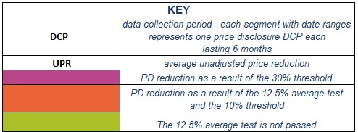

Click link to return to Fact Sheet

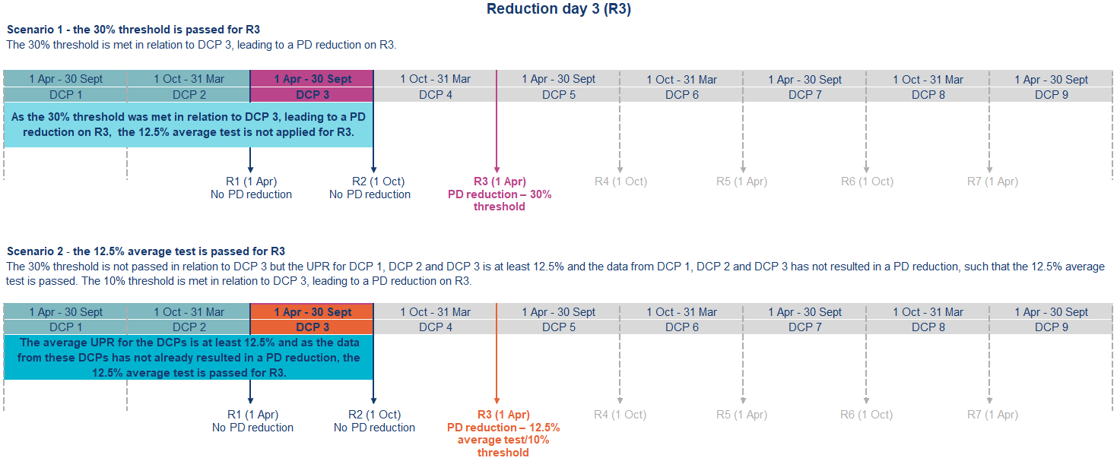

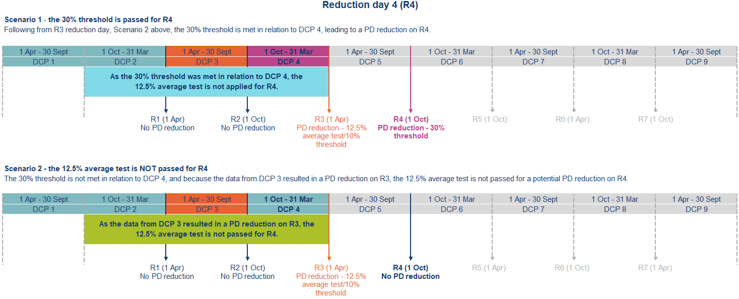

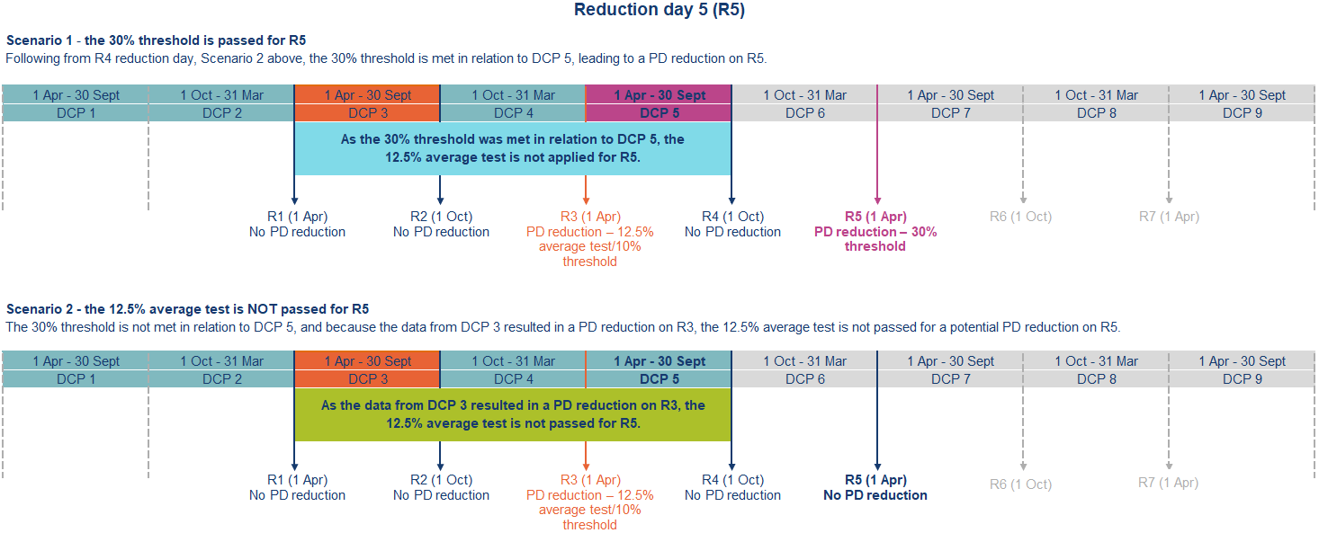

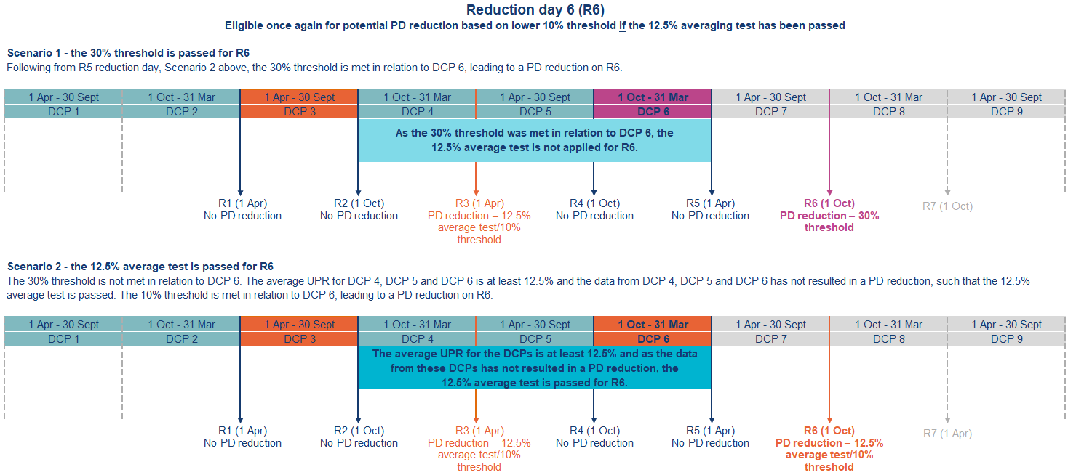

Click link to return to Fact Sheet

## Figure 2 – Application of s99ADHD – definition of previous data collection period

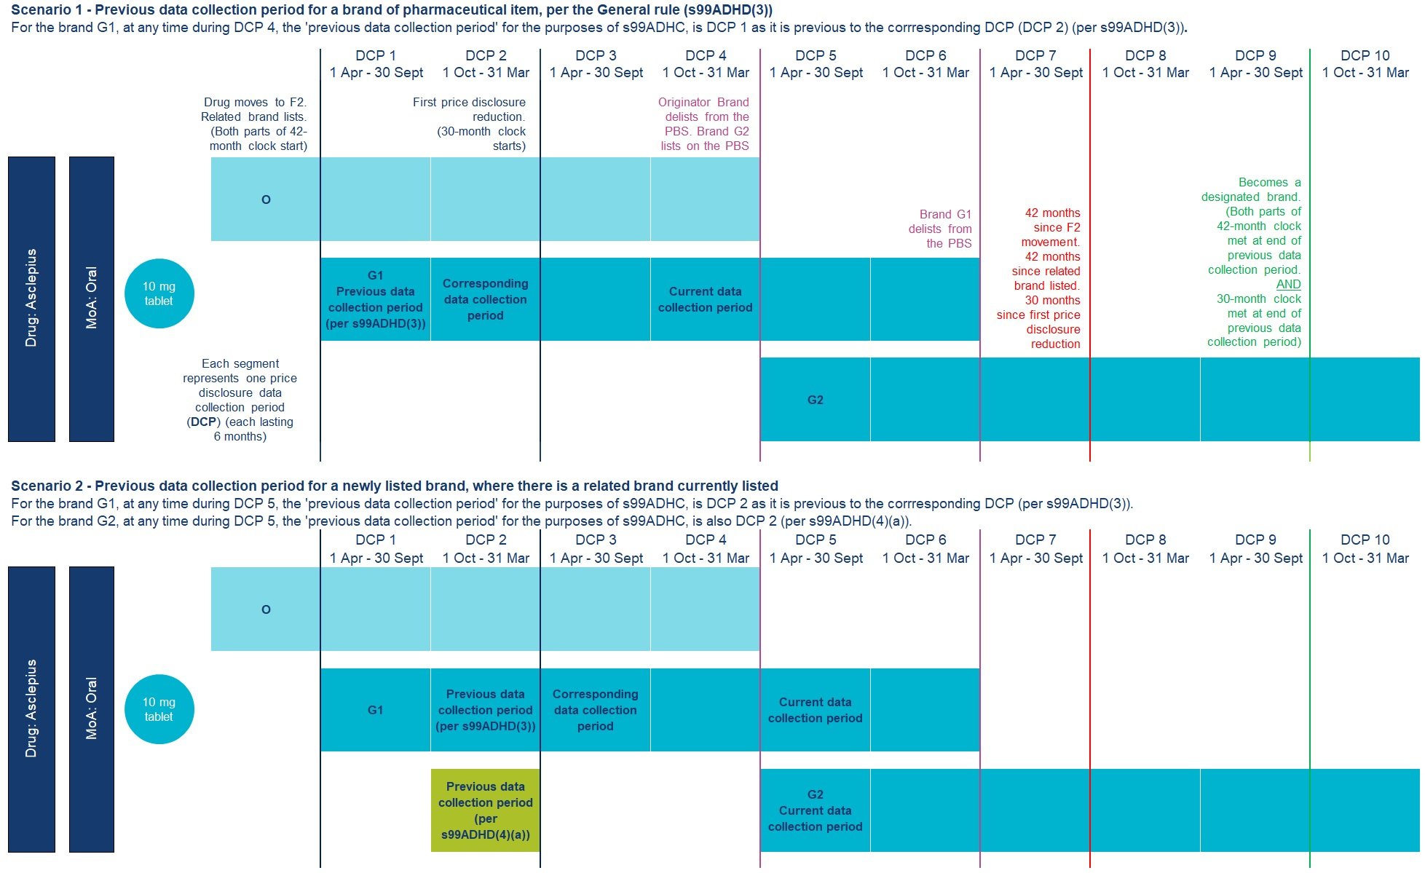

Click link to return to Fact Sheet

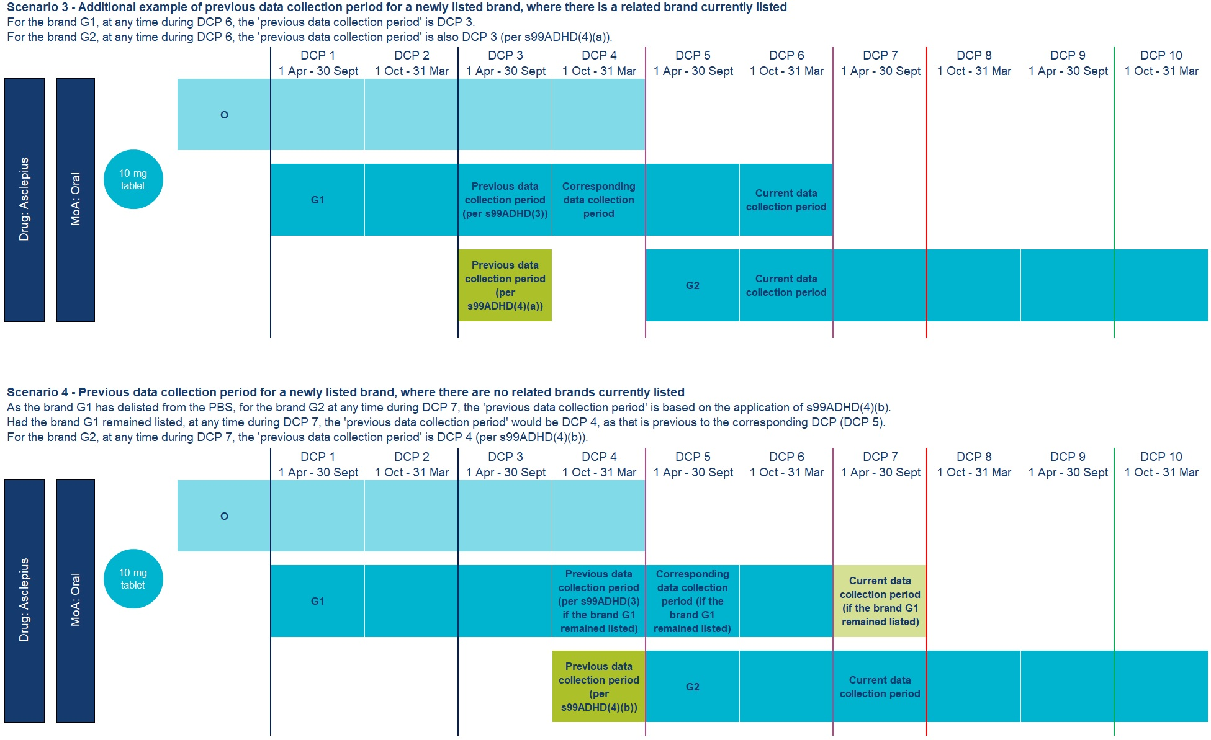

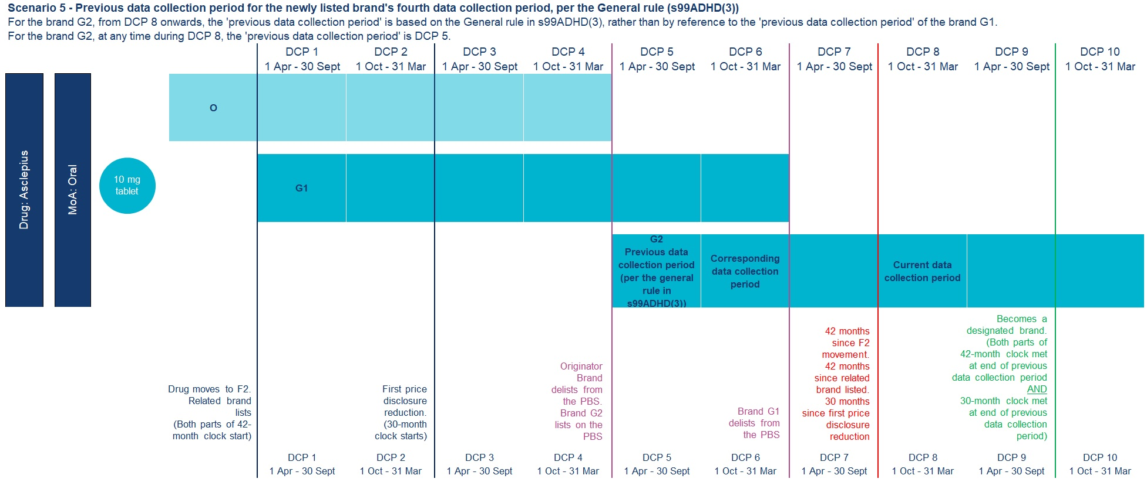

Click link to return to Fact Sheet

## Figure 3 – Application of s99ADHC(1)(a) – timing for brands to become designated brands once relevant clocks are satisfied

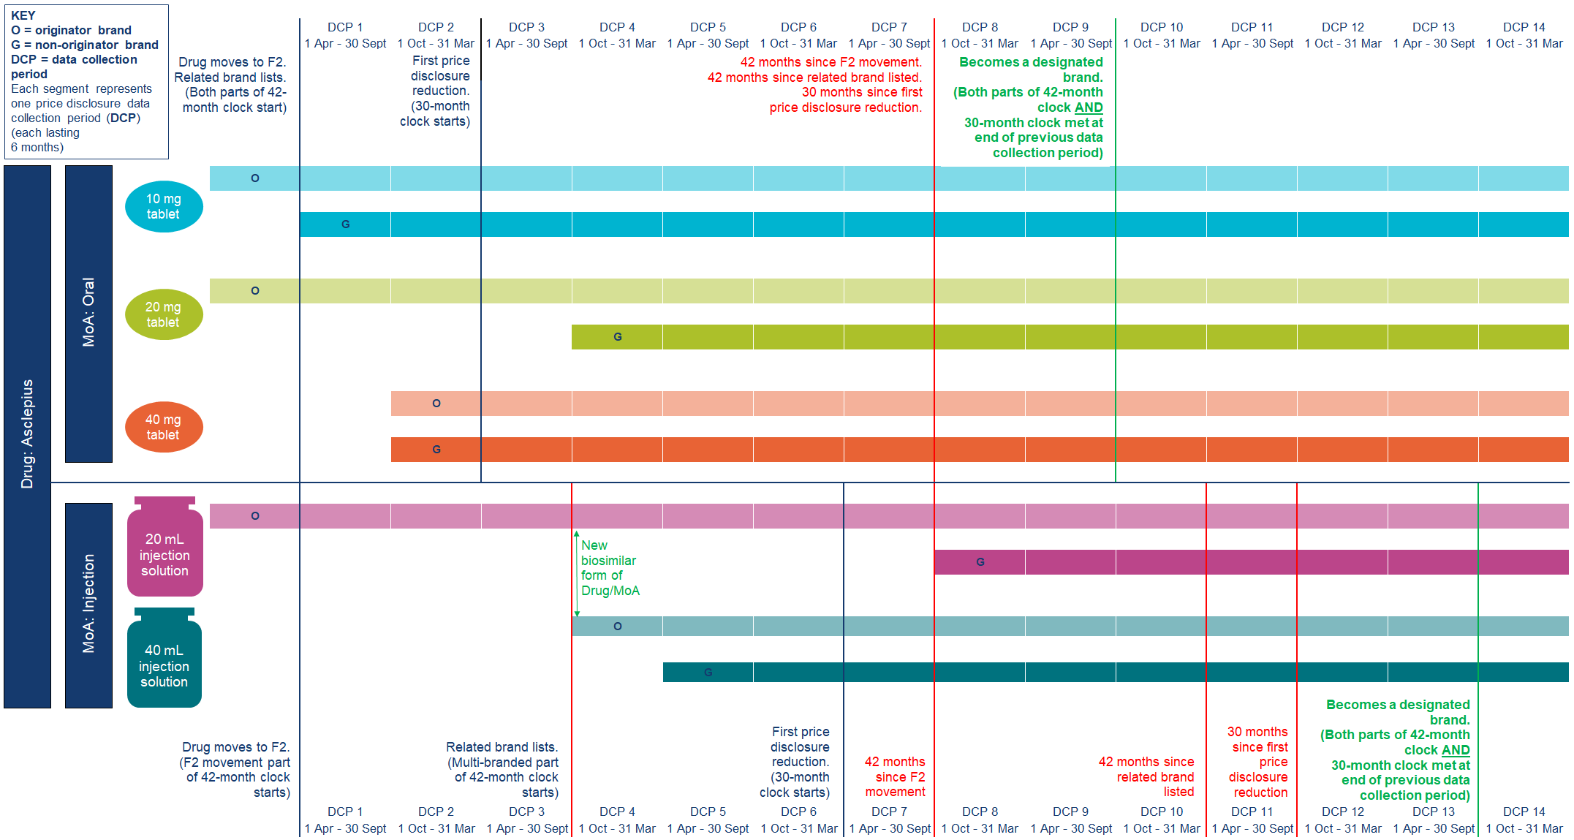

Click link to return to Fact Sheet

1. The Minister may make this determination under s99ADHC(2) by notifiable instrument.