Fact Sheet – Quantity of stock to be held
Last updated: 4 March 2025

Purpose
This Factsheet outlines how the quantity of stock to be held by Responsible Persons for the purposes of the minimum stockholding requirement (MSR) is calculated under Division 3CAA of Part VII of the National Health Act 1953 (the Act) and section 85B of the National Health (Pharmaceutical Benefits) Regulations 2017 (the Regulations).

The Requirements
Under section 99AEKB of the Act, the Responsible Person for a designated brand must keep in stock in Australia at least the applicable quantity of the designated brand.

Applicable quantity
The applicable quantity for a designated brand will be:
  - 6 months of ‘usual demand’ - if the approved ex-manufacturer price (AEMP) of the designated brand has increased on or after 1 July 2022;
  - 4 months of ‘usual demand’ - if the AEMP of the designated brand has not increased on or after 1 July 2022; or
  - another quantity – another quantity determined by the Minister under section 99AEKC(2) in relation to the designated brand (and whether or not the AEMP has increased on or after 1 July 2022).
The Department publishes an updated list of designated brands and the applicable quantities on 1 April and 1 October each year on the designated brands webpage.

Usual Demand
‘Usual demand’ is the average number of packs of the brand supplied during the price disclosure (PD) ‘reference period’ The reference period is the corresponding six-month period in the prior year (refer to Figure 1) and accounts for seasonal variation. Usual demand is based on PD data where available.
Usual demand is updated every six months in line with PD reference periods, being the periods from 1 April to 30 September and 1 October to 31 March. Updated usual demand figures are provided to Responsible Persons by the Price Disclosure Data Administrator (PDDA) by 7 June and 7 December for the reference period most recently ended.

Usual PBS Demand
Where PD data is unavailable (e.g., if the brand is not subject to PD), the Minister may make a determination ascertaining ‘another quantity’. In doing so, the Minister will have regard to ‘usual PBS demand’. This is based on PBS prescription volume data for the reference period and calculated the same way as usual demand.
Usual PBS demand is updated every six months in line with PD reference periods. Updated usual PBS demand figures are provided to Responsible Persons by the Department by 7 June and 7 December for the reference period most recently ended.
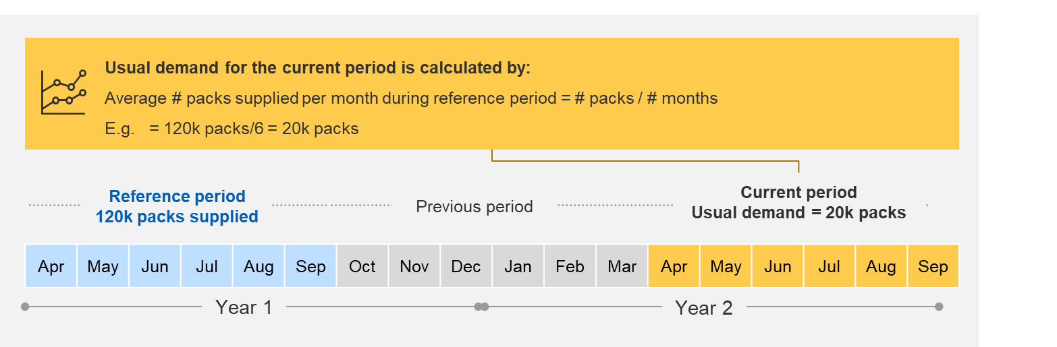
Example: If the brand was subject to an applicable quantity of 4 months of usual demand, during the current period of April – September of Year 2, the Responsible Person would be required to hold 80,000 packs of the brand (4 months x 20,000 packs).

Figure 1: Usual demand calculation

Demand Variation

Usual demand in the reference period may be different to the Responsible Person’s forecasted sales for the stockholding period. This may occur for a variety of reasons including:
- Inflated demand in the reference period due to a competitor being out-of-stock
- Reduced demand in the stockholding period due to loss of a significant supply contract
- Reduced demand in the reference period due to a medicine shortage
Under section 99AEKB of the Act, the Responsible Person must comply with the applicable quantity calculated under the Act and Regulations despite this being different from forecasted sales.
If a medicine has short shelf-life or the magnitude of demand variation is large enough, the Responsible Person might waste stock (that wouldn’t otherwise occur) if it complied with the MSR. If a Responsible Person anticipates the MSR will result in wastage, it should notify the Department, and include the following information to facilitate assessment by the Minister of whether the reasons for any likely breach of the MSR are reasonable:
- The cause for inflated demand in the reference period or for reduced demand in the stockholding period
- Shelf-life of the brand
- Forecasted demand expressed as a number of packs per month
- The forecasted quantity of wastage if the minimum stockholding requirement were complied with
- Details of the quantity of stock that can be held in the stockholding period without inducing wastage
Responsible Persons are encouraged to contact the Department (pbsstockholding@health.gov.au) if they are, or will be, impacted by major changes to the Responsible Person’s forecasted demand, such as a contract loss that impacts their entire portfolio of brands.
Key Resources
- National Health Act 1953 (Cth)
- National Health (Pharmaceutical Benefits) Regulations 2017 (Cth)
- PBS Stockholding Guidelines
- Minimum Stockholding Requirement Webpage
- Compliance with the Minimum Stockholding Requirements – Fact Sheet
- Determinations of Another Quantity – Fact Sheet
- Likely and Actual breach notifications – Fact Sheet
- Executive Summary of the MSR Review
- pbsstockholding@health.gov.au for questions regarding this Fact Sheet.

See: Section 6. Ministerial determination of ‘another quantity’ of the PBS Minimum Stockholding Guidelines (the Guidelines) for more information about Ministerial determinations of another quantity – including how to apply.
s85B of the National Health (Pharmaceutical Benefits) Regulations 2017 (the Regulations).

