Pharmaceutical Benefits Scheme
Minimum Stockholding Guidelines

Introduction
These guidelines support the implementation of minimum stockholding requirements to help secure the supply of medicines in Australia
Increasingly, global medicine shortages are interrupting supply of medicines that are the mainstay of treatment for some of the most prevalent health conditions in the Australian community. In 2019 and 2020, medicines supplied by manufacturers for $4 or less per pack were the most susceptible to shortages.
Amendments made to the National Health Act 1953 (the Act) by the National Health Amendment (Enhancing the Pharmaceutical Benefits Scheme) Act 2021 (the Amendment Act) give effect to the commitments in the new Strategic Agreements with the medicines industry, which includes minimum stockholding requirements. The minimum stockholding requirements are designed to help protect Australian patients, pharmacists, and prescribers from the impact of global medicines shortages. While these measures will not prevent shortages that are outside of the control of Australian companies, they will help to ensure that Australian manufacturers are better placed to continue supply when global disruptions occur. Greater buffers will allow time for supply disruptions to be resolved and ensure better continuity of supply for Australians, including through identifying alternative sources of supply (where possible).
From 1 July 2023, the Act imposes a requirement for Responsible Persons (RPs) to keep in stock in Australia, 4 or 6 months of ‘usual demand’ for brands which meet one of the criteria in s99ADHC of the Act. Details of the legal requirements are specified in the Act and in the National Health (Pharmaceutical Benefits) Regulations 2017 (Regulations).
The investment by the medicines industry in managing supply chain risk through the minimum stockholding requirements is supported by the Australian Government through one-off price increases on 1 October 2022 and floor price protections for low-cost medicines.

The purpose of this guideline document is to assist RPs to comply with the minimum stockholding requirements outlined in Part VII, Division 3CAA of the Act, which commences on 1 July 2023.
These guidelines summarise compliance requirements for RPs and provide additional supporting detail. Specifically:
  - Section 2: Scope of minimum stockholding requirements describes the criteria that determine which brands will be subject to the requirements.
  - Section 3 Keeping a brand in stock in Australia details what types of stock will count towards satisfying the minimum stockholding requirements.
  - Section 4 Quantity of stock required to be kept describes how minimum stockholding requirements are determined with reference to usual demand or via Ministerial determination of ‘another quantity’.
  - Section 5 Lead times discusses the timelines under which RPs will prepare to meet minimum stockholding requirements and stockholding disclosure requirements.
  - Section 6 Ministerial determination of ‘another quantity’ describes how RPs can request a Ministerial determination for another stockholding quantity for a particular brand, including the matters the Minister may consider relevant.
  - Section 7 Reporting and monitoring describes the disclosure of stockholding levels and the notifications that RPs are required to provide regarding likely or actual breaches of stockholding requirements.
  - Section 8 Management of breaches describes what RPs are required to do if minimum stockholding and reporting requirements have been breached, and the measures and penalties that may apply.
These Guidelines are intended to provide general guidance to RPs in relation to the minimum stockholding requirements under the Act and Regulations. The Guidelines are not intended to be, and should not be treated as, legal or professional advice, and RPs should seek their own legal and professional advice where appropriate. Nothing in the Guidelines in any way limits the operation of the Act or Regulations or affects or fetters any function or power of the Minister or any other person or body under the Act and Regulations.

Scope of minimum stockholding requirements

Criteria for designated brands to be subject to stockholding requirements
A brand of a pharmaceutical item is a ‘designated brand’ (s99ADHC) and will be subject to the minimum stockholding requirements (s99AEKA) from the date that it meets one or more of the criteria set out in s99ADHC(1) of the Act.
The criteria are:
- the drug and manner of administration (drug/MoA) of the pharmaceutical item has been on Formulary 2 (F2) for at least 42 months (defined in s99ADHC(6)) and at least 30 months must have passed since the first price disclosure price reduction for any brand of the same drug/MoA (42-month clock) (s99ADHC(1)(a)). A drug/MoA will be taken to have been on F2 for at least 42 months if at the end of the previous data collection period, the drug/MoA has been on F2 for at least 42 months, and on a day at least 42 months before the end of the previous data collection period, the drug/MoA was multi-branded (s99ADHC(6)); or
- the approved ex-manufacturer price (AEMP) of the brand is $4 or less (s99ADHC(1)(b)); or
- the AEMP of the brand has been increased on or after 1 July 2022 through a new price agreement and a determination is in force in relation to the brand under s99ADHC(2) (designated brand determination)(s99ADHC(1)(c)); or
- the AEMP of the brand has received a price increase on 1 October 2022 under s104B of the Act (i.e., before 1 October 2022 the drug was on F2, and the brand of pharmaceutical item had an AEMP less than $3.50 (s99ADHC(1)(d)).
Brands that meet at least one of the criteria above are referred to as ‘designated brands’.
Regardless of whether it meets any of the above criteria, a brand will not be a designated brand and will not be subject to the minimum stockholding requirements if:
- the drug in the pharmaceutical item is included in Schedule 2 of the current Poisons Standard by reference to a quantity or amount of the drug; and
- the quantity or amount of the drug in a pack of the brand is equal to or greater than the quantity or amount specified in Schedule 2.
A brand which receives temporary approval under s19A of the Therapeutic Goods Act 1989 will be subject to the minimum stockholding requirement and stockholding disclosure requirements if the brand otherwise meets the criteria in s99ADHC.

Minimum stockholding requirements defined by reference to ‘usual demand’
The volume of stock required to be held by RPs to satisfy minimum stockholding requirements is determined as follows:
- If the AEMP of a designated brand has not been increased on or after 1 July 2022, its minimum stockholding requirement will be 4 months of ‘usual demand’; or
- if the AEMP of a designated brand has been increased on or after 1 July 2022, its minimum stockholding requirement is 6 months of ‘usual demand’; or
- if the Minister determines ‘another quantity’ under s99AEKC(2) (minimum stockholding determination), the minimum stockholding requirement will be that quantity (see Section 6).
‘Usual demand’ calculations are based on price disclosure data where available. See Section 4 below for further detail as to how ‘usual demand’ is calculated.

Lists of designated brands subject to minimum stockholding requirements published biannually
On 1 July 2022, the Department published a projected list of ‘designated brands’ that will be subject to minimum stockholding requirements from 1 July 2023. That list will be updated on 1 October 2022 and 1 April 2023 in advance of the new provisions coming into effect.
After 1 July 2023, the Department will publish two lists on 1 April and 1 October of each year, in line with Price Disclosure (PD) data collection periods:
- Current list of designated brands: This list will identify brands subject to stockholding requirements as at the date of publishing, and their required minimum stockholding level (i.e., 4 months or 6 months of ‘usual demand’ or an amount determined by a minimum stockholding determination).
- Projected list of designated brands: This list will identify brands that will meet the 42-month clock criteria (s99ADHC(1)(a) of the Act) and be subject to stockholding requirements in 12 months, i.e., from the following 1 April or 1 October. The list will also include the required minimum stockholding level (i.e., 4 months or 6 months of ‘usual demand’).
The projected list of designated brands may not be a comprehensive forward view of brands that will meet the other criteria of a ‘designated brand’ and be subject to minimum stockholding requirements in 12 months. It may not, for example, include all brands with a price increase after 1 July 2023 by agreement, brands subject to statutory price reductions which bring their AEMP to $4 or less, or the newly listed brands of existing pharmaceutical items, for which the Department will not have 12 months of forward visibility. For further detail on the timelines of publication of these two lists, please see Exhibit 1. For further detail on notice of stockholding requirements, please see Exhibit 11.
Exhibit 1: The Department will publish lists of designated brands subject to minimum stockholding requirements biannually
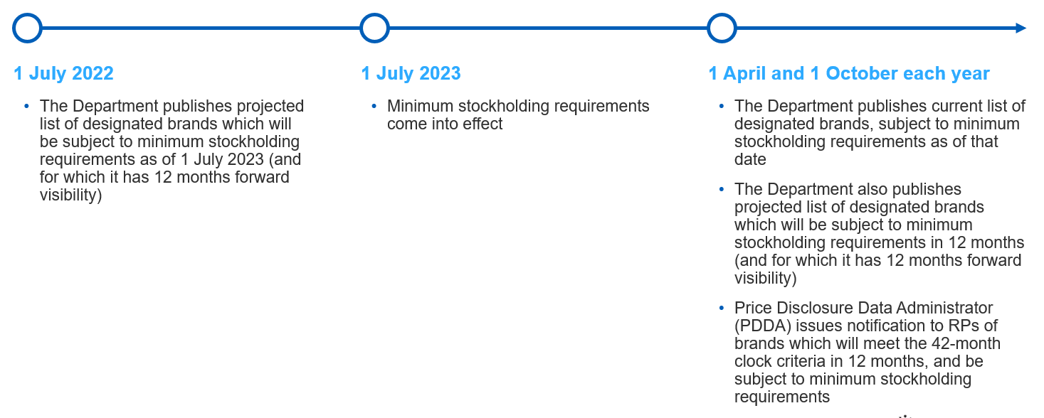

Notices to be provided by the Department/Price Disclosure Data Administrator (PDDA)
In addition to the publication by the Department of the lists referred to above, notices will be sent to RPs for designated brands as follows:
- 12 months prior to a brand meeting the s99ADHC(1)(a) criteria, the PDDA will notify the RP that the brand is approaching the 42-month clock and will be subject to minimum stockholding requirements once that criteria is met.
- Following a price increase (ss99ADHC(1)(c) or 99ADHC(1)(d) of the Act), the Department will initially advise the RP of stockholding requirements which will be effective 6 months from the date the price increase takes effect (i.e. when designated brand determination is effective, as well as any minimum stockholding determination).
The PDDA will also send routine notifications of future stockholding requirements for the brand as follows:
- By 7 June and 7 December, a forward notification to the RP advising the quantity calculated as ‘usual demand’ for the reference period just ended, in respect of each brand of a pharmaceutical item subject to price disclosure and minimum stockholding requirements. The Department’s intention is that this notification should simply serve as a confirmation for the RP, as using their own reported volumes in accordance with PD requirements, the RP is able to calculate what this amount will be prior to the notification.
(For example by 7 December 2023 the RP will be provided with a forward notification of a brand’s minimum stockholding requirement for the period 1 April 2024 to 30 September 2024 (based on ‘usual demand’ in the reference period 1 April 2023 to 30 September 2023).)
- On the last business day of each reporting period, an initial reminder email to the RP confirming which brands are designated brands for the reporting period which is ending, and the quantity of ‘usual demand’ which was required to be kept for each designated brand during that period.

Keeping a brand in stock in Australia
To meet the minimum stockholding requirement the RP for the brand must keep in stock in Australia at least the applicable quantity of the brand. If a quantity of the brand is not available for sale in Australia by the RP, that quantity of the brand is taken not to be kept in stock.
The minimum stockholding requirement is an ongoing obligation once a brand is a designated brand. Although disclosure is made of stock levels on the last day of each month (see Section 7.1 below), the minimum stockholding requirement must be met at all times.
The Department considers that for the brand to be both kept in stock in Australia, and available for sale in Australia by the RP, it must satisfy the following criteria:
- The stock is physically located onshore in Australia. This excludes stock which is currently in transit to Australia.
- The stock has cleared customs in Australia.
- The stock is in saleable form. This requires all manufacturing, quality control, packaging, release for supply, and any other pre-sale checks to be complete, with no further modifications necessary before sale.
- No permission, release, or other intervention from someone other than the RP is required before the stock can be sold.
Stock sold to wholesalers
If stock has been sold to a wholesaler, it will not be considered to be ‘available for sale in Australia by the Responsible Person’ because it is subject to release or other intervention by the wholesaler before the stock can be sold to another entity. The stock cannot be simultaneously available for sale by the wholesaler and the RP, and cannot be sold again by the RP until an arrangement is made with the wholesaler to make it ‘available for sale’ again by the RP.
If stock remains in the possession of an RP but:
- has been ordered by a wholesaler; and
- is under a commercial sale agreement between the RP and the wholesaler; and
- cannot be released from the commercial sale agreement and sold to another entity without the permission, release or other intervention by the wholesaler;
then the stock would also not be considered to be ‘available for sale in Australia by the Responsible Person’ and as a result will not count towards the minimum stockholding requirements.
Stock sold on consignment
If stock is sold by an RP to a wholesaler on consignment (i.e., where the RP is the consignor and the wholesaler is the consignee), the stock would not be considered to be ‘available for sale in Australia by the Responsible Person’ if the permission, release or intervention from the wholesaler (or someone other than the RP) is required before the stock can be sold to another entity. As a result, in these circumstances, the stock will not count towards the minimum stockholding requirements. If the wholesaler (as consignee) has agreed a standing permission for the RP to move stock around and remove it from sale by the consignee, stock will not become available for sale by the RP until the RP has exercised that right with respect to particular stock.
If the RP holds stock that is being sold on consignment (i.e., the RP is the consignee), this stock may count towards the RP’s minimum stockholding requirement so long as they meet the other required criteria.
Stock held by third-party logistics providers
Stock which is kept by the RP at a third-party logistics provider’s premises and/or orders fulfilled through a third-party logistics provider will count towards the RP’s minimum stockholding requirement for the brand, where it otherwise meets the criteria above. Stock will not fall outside the criteria just because action needs to be taken by a third-party logistics provider to fulfil a purchase order placed with the RP.
Multi-branded pharmaceutical items kept by the same RP
A RP which has multiple brands of the same pharmaceutical item must satisfy the minimum stockholding requirements for each brand and cannot count stock of one brand towards meeting the minimum stockholding requirement for another brand.
Brands kept in multiple packaging types
Where a RP has a brand of pharmaceutical item which is packaged using different packaging types (e.g., blister packs and bottles), both types of packaging can be counted towards meeting the RP’s minimum stockholding requirement if the packaged stock meets the criteria otherwise to be counted. The RP will have to disclose the number of packs in stock and the number or quantity of units in a pack for each of the different packaging types (e.g., 200 packets containing 20 capsules in each pack, and 100 bottles containing 30 capsules in each bottle).

Quantity of stock required to be kept
As discussed in Section 2.2, the quantity of stock that is required to be kept by a RP is set by reference to the ‘usual demand’ for the brand of pharmaceutical item. ‘Usual demand’ is defined in s85B of the Regulations (which commences on 1 July 2023) as follows:
[T]he usual demand for a brand of a pharmaceutical item for a month in a data collection period for that brand is the number of packs of the brand supplied during the data collection period (the reference period) before the previous data collection period for the brand, divided by the number of months in the reference period.
From 1 July 2023, for brands of pharmaceutical items subject to minimum stockholding requirements, RPs are required to keep in stock 4 or 6 months’ ‘usual demand’, depending on whether the AEMP of the brand has been increased on or after 1 July 2022 (s99AEKC of the Act).
‘Usual demand’ calculations are based on price disclosure data where available, unless there is a minimum stockholding determination of a different amount. This Section expands on how ‘usual demand’ should be calculated in various circumstances, including:
- changes in pricing quantity between the reference period and the current period (Section 4.1);
- variations in the length of the reference period and associated availability of PD data (Section 4.2);
- determination of ‘another quantity’ in instances where reference period data is not available (Section 4.3);
- when a brand is approved to be de-listed (Section 4.4); and
- when a brand subsequently re-lists following de-listing (Section 4.5).

Calculation of ‘usual demand’ when pricing quantity changes between the reference period and current period
Where the pricing quantity changes between the start of the reference period and the commencement of the period in which stock is required to be held, for the purposes of calculating ‘usual demand’ the number of packs is adjusted in proportion to the change in pack size (see Exhibit 2).
Exhibit 2: Calculation of ‘usual demand’ when pricing quantity changes
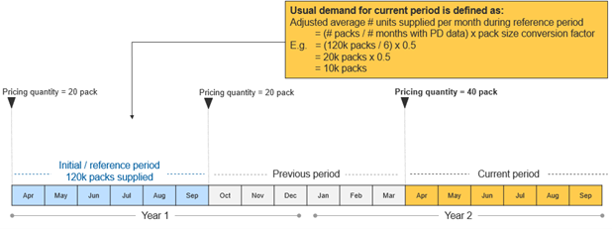

Calculation of ‘usual demand’ when there are variations in the length of the reference period and associated availability of PD data
In practice, there may be variations in the availability of PD data from the reference period to determine ‘usual demand’. The following four scenarios describe how the Department will use reference period PD data to determine ‘usual demand’ for a given brand:
- Scenario 1 – no PD data is available for the reference period: For a brand which was not listed on the PBS during the reference period (e.g. a new generic brand), the ‘usual demand’ for the brand is taken to be zero (under s85B(3) of the Regulations). The brand will have a minimum stockholding requirement once there is a reference period in which the brand was listed, and so ‘usual demand’ can be calculated for that reference period (see Exhibit 3).
- Scenario 2 – 6 months of PD data is available for the reference period: ‘Usual demand’ is the average number of packs of the brand supplied per month in the reference period (see Exhibit 4).
- Scenario 3 – less than 6 months of PD data is available for the reference period: ‘Usual demand’ is the average number of packs of the brand supplied per month in the shortened reference period. This may apply, for example, if a brand became subject to price disclosure after the start of a given data collection period, or a brand has previously exited the market and then re-listed during the reference period (see Exhibit 5).
- Scenario 4 – more than 6 months of PD data is available for the reference period: ‘Usual demand’ is the average number of packs of the brand supplied per month in the longer reference period. This may apply, for example, if a brand has moved to F2 and has an initial data collection period longer than 6 months, or if a brand is newly listed on F2 and there are already other brands of the same drug/MoA) (related brands) on F2 which are in an initial data collection period longer than 6 months. The brand’s initial data collection period will end when the data collection period of the related brands ends. Therefore, the initial data collection period, and first reference period, could be greater than 6 months (see Exhibit 6). ‘Usual demand’ will be calculated once there have been subsequent data collection periods and the completed initial data collection period is the data collection period before the previous data collection period (i.e., the reference period).
Further information regarding initial data collection periods is available in Section 5.5 of the Price Disclosure Guidelines.
Where, for any reason, ‘usual demand’ cannot be calculated using PD data, the Minister may make a minimum stockholding determination (see Section 4.3 and Section 6).
Where a brand is supplied under a s19A temporary approval and is PBS listed, it may be a designated brand and subject to minimum stockholding requirements if it meets one of the criteria to be a designated brand. A s19A product will not have ‘usual demand’ able to be calculated until there is PD data available in the reference period. This means that the quantity required to be kept in stock by the RP of the s19A brand will be taken to be zero until there is sufficient PD data for ‘usual demand’ to be calculated in the reference period. It will generally take between 7 – 12 months from the date of PBS listing for PD data to be available for a s19A product to have ‘usual demand’ calculated for it to be subject to a stockholding. RPs of s19A products are able to request that a stockholding determination of zero is made up to four months prior to the s19A approval expires and the product delists from the PBS (see Section 4.4).
Exhibit 3: Usual demand cannot be calculated when PD data is not available for the reference period
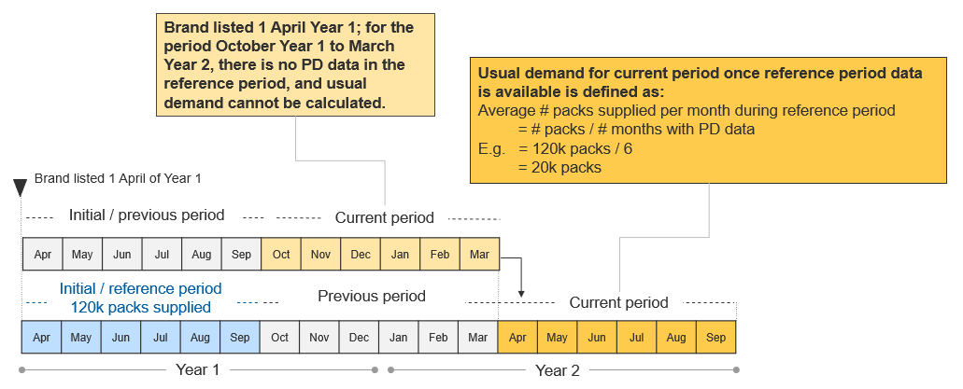
Exhibit 4: Calculation of ‘usual demand’ when 6 months of PD data is available for the reference period
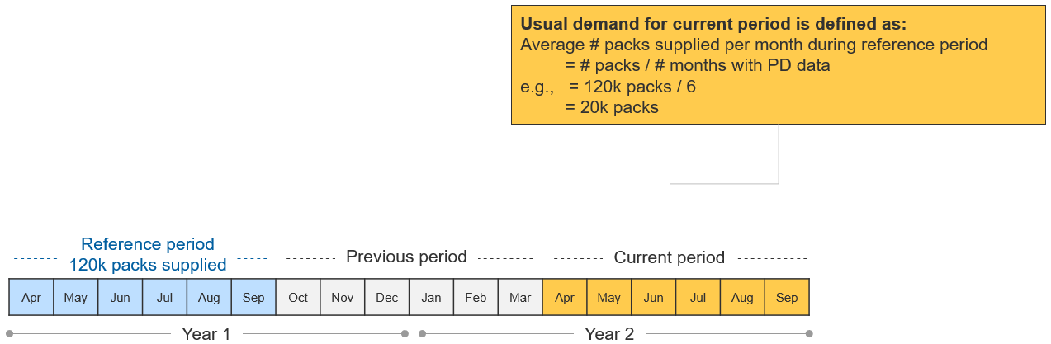
Exhibit 5: Calculation of ‘usual demand’ when less than 6 months of PD data is available for the reference period
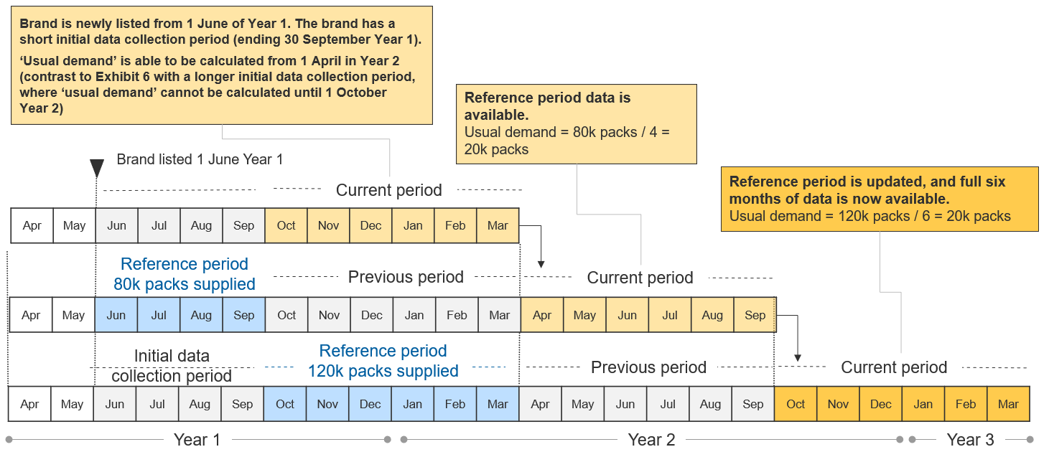

Exhibit 5 (continued): Calculation of ‘usual demand’ when less than 6 months of PD data is available for the reference period
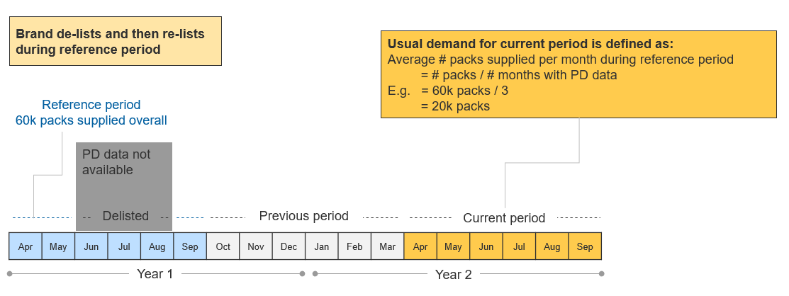
Exhibit 6: Calculation of ‘usual demand’ when more than 6 months of PD data is available for the reference period
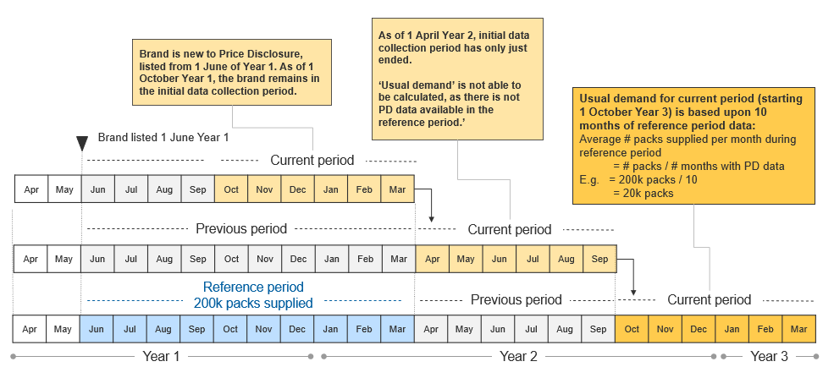

Determination of ‘another quantity’ where PD data for the reference period is not available
Where PD data for the reference period is not available to calculate ‘usual demand’ (e.g., because the brand is not subject to price disclosure), the Minister may make a minimum stockholding determination (s99AEKC(2) of the Act; see Section 6 of these Guidelines). This may apply, for example, when a designated brand is listed on Formulary 1 (F1), or a brand is on F2 but exempt from PD. In making such a determination, the Minister may take into account PBS prescription volume data (based on the date of supply) for the reference period and adopt a similar methodology to that used to calculate ‘usual demand’. See Exhibit 7 for details. Prior to the Minister making a minimum stockholding determination, the Department will provide RPs with details of the determination to be made and the basis for any calculations, and provide RPs with the opportunity to seek clarification.
Once there is PD data available to calculate ‘usual demand’, the determination may be revoked and the RP will be required to hold stock of the ‘usual demand’ calculated in accordance with Section 4.2 above and the transition diagram in Exhibit 8 below. This may apply, for example, when a designated brand has recently moved from F1 to F2 or a brand on F2 that is exempt from PD ceases to be exempt.
Exhibit 7: Minimum stockholding determination based on PBS prescription volume data
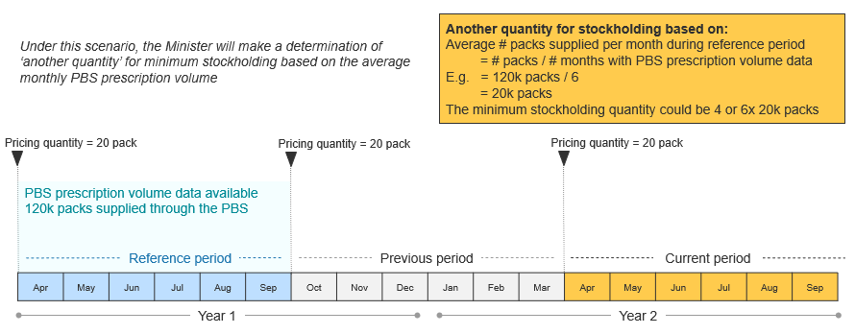

Exhibit 8: Transition from minimum stockholding determination to calculation of ‘usual demand’
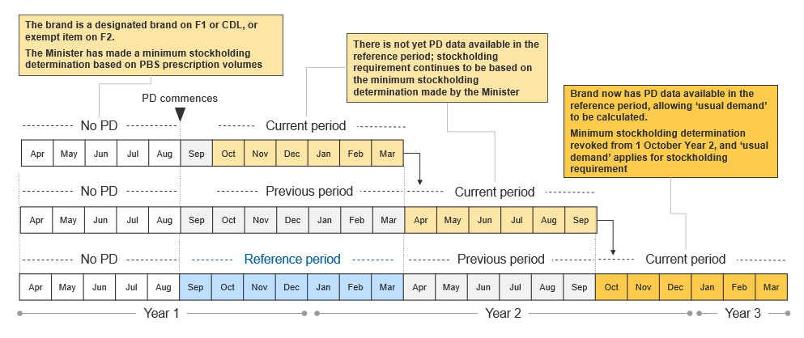
When the Minister makes a minimum stockholding determination the determination will be effective from a future date which provides the RP with time to prepare to hold the required quantity of stock (see
Section 5.2).
Designated brands listed on F1 or which are exempt items on F2 will usually have PBS prescription volume data in the reference period to assist the Minister in making a minimum stockholding determination as outlined above. For a brand for which there is no PD data or PBS prescription volume data for the reference period (e.g., a new generic brand), ‘usual demand’ cannot be calculated and the quantity required to be kept in stock by the RP will be taken to be zero until there is sufficient PD data for the ‘usual demand’ to be calculated for the reference period. This will be the case for new generic brand listings.

Minimum stockholding requirements following de-listing
An application by a RP for a brand to be de-listed may arise under two scenarios:
- Brand deletion: If the brand is one of several brands of the pharmaceutical item listed, then Pharmaceutical Benefits Advisory Committee (PBAC) advice is not required for the de-listing request.
- Item deletion: If the brand is the only brand of the pharmaceutical item listed, PBAC advice is generally required before the brand is de-listed.
More detail is available on the PBS website regarding these two scenarios. Note that if a brand delists, the RP is required to provide PD data up to date of delisting.
For a brand deletion, the Minister will make a minimum stockholding determination that specifies that the applicable quantity is zero as soon as possible after the date that the de-listing application is received by the Department (however any determination will not be effective any earlier than 6 months prior to the proposed delisting date). For an item deletion (in the circumstances above), the Minister will await the PBAC advice (where applicable) and the outcome of the de-listing application before making a minimum stockholding determination for the brand. When an item is approved to de-list from the PBS, the Minister will make a minimum stockholding determination that specifies that the applicable quantity is zero, effective from as soon as possible after the date approval is given to de-list (see Exhibit 9).
Exhibit 9: De-listing of a brand resulting in minimum stockholding determination specifying applicable quantity of zero
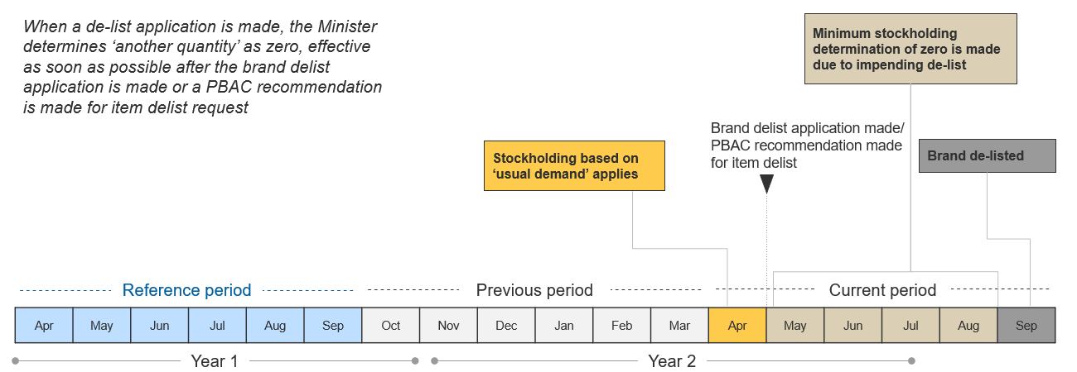

‘Usual demand’ calculated when a brand subsequently re-lists following de-listing
If a brand de-lists as stated in Section 4.4 a RP may apply for the brand to be re-listed at a later date.
‘Usual demand’ for a brand in this scenario is determined based upon any available PD data for the brand from the relevant reference period (see Exhibit 10).
Note that the Minister may make a minimum stockholding determination for re-listed brands where, for any reason, ‘usual demand’ cannot be calculated. Prior to the Minister making a minimum stockholding determination, the Department will provide RPs with details of the determination to be made, the basis for any calculations, and the opportunity to seek clarification.
Exhibit 10: Calculation of ‘usual demand’ based on reference period data when a brand de-lists and then re-lists
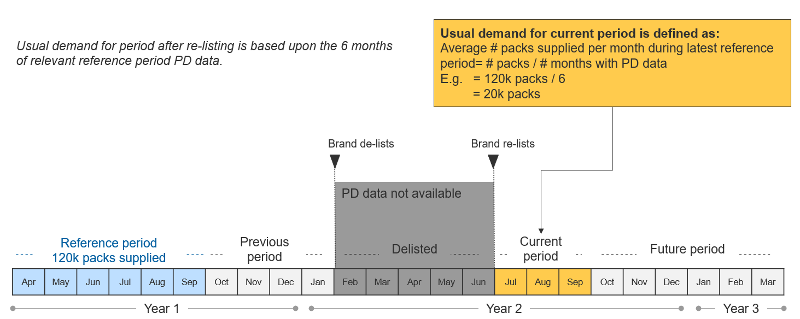

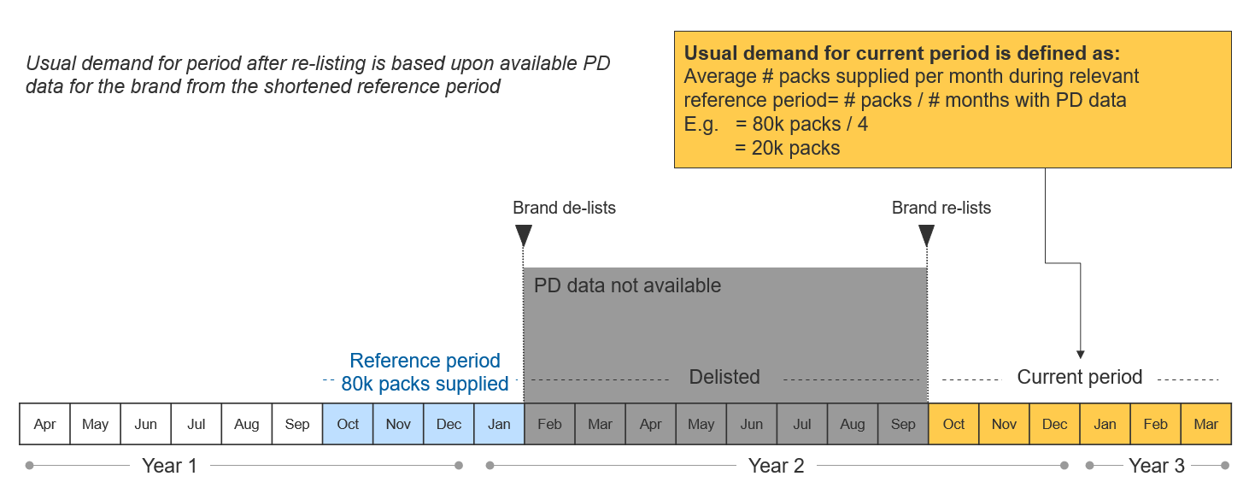

Exhibit 10 (continued): Calculation of ‘usual demand’ based on reference period data when a brand de-lists and then re-lists
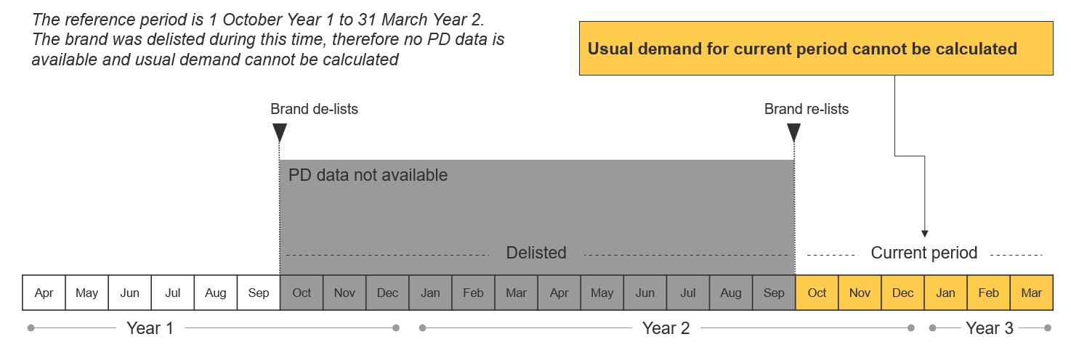

Lead times
The Department recognises the need for RPs to have time to prepare for and implement the minimum stockholding requirements. Where possible and appropriate, the Department will provide RPs with advance notice that brands will be subject to the minimum stockholding requirement and the applicable quantity that must be kept in stock to satisfy the minimum stockholding requirement (such as via the projected list of designated brands; see Section 2.3).
Designated brands will be subject to the minimum stockholding requirement and the stockholding disclosure requirements from 1 July 2023. A brand that becomes a designated brand after 1 July 2023 will be subject to the minimum stockholding requirement and stockholding disclosure requirements from the date that it becomes a designated brand. In some cases, RPs will have lead times before they are subject to the minimum stockholding requirement and stockholding disclosure requirements. The remainder of this Section provides details of indicative lead times in different scenarios (summarised in Exhibit 11).

Lead time for designated brands with an AEMP of $4 or less
If the AEMP of a brand is $4 or less as at 1 July 2022, the brand will be included on the advance notice designated brand list published by the Department on 1 July 2022. The designated brand will be subject to minimum stockholding and stockholding disclosure requirements from 1 July 2023.
The AEMP of a brand could reduce to $4 or less as a result of a statutory price reduction (e.g. an anniversary price reduction, first new brand price reduction or a combination flow-on price reduction), or a PD price reduction. A brand will be a designated brand from the date the AEMP is reduced to $4 or less.
For PD price reductions, indicative outcomes are published on the PBS pricing website in late June for 1 October price reductions and in late December for 1 April price reductions. RPs of a brand which becomes a designated brand as a result of a PD price reduction will be required to comply with stockholding disclosure requirements from the date it becomes a designated brand, and will be required to comply with minimum stockholding requirements as follows:
- where PD data is available for the relevant reference period, the RP for the designated brand will be required to hold 4 months of ‘usual demand’ from the date the price reduction is effective;
- if PD data for the reference period is not available, ‘usual demand’ cannot be calculated. The RP for the designated brand will be required to hold 4 months stock of ‘usual demand’ once PD data is available in the reference period to calculate ‘usual demand’ (see Section 4.1 above) or may be required to hold ‘another quantity’ determined by the Minister.
Where the RP is unable to meet the minimum stockholding requirement for a brand’s first stockholding period following a short-lead time after a PD price reduction, these circumstances may be considered when the Minister assesses the breach of minimum stockholding requirements.
This might be the case for example where a brand with PD data available in the reference period is subject to a PD price reduction which is notified in late June for a 1 October reduction date and the brand’s RP would be required to hold 4 months of ‘usual demand’ from 1 October. If the brand had a lead time which required 4 months for the RP to bring additional stock into Australia, the RP might be non-compliant for the month of October, but compliant from November onwards. However, if the brand did not yet have PD data available in the reference period, the RP would have additional time to prepare and the lead-time should not impact on the RP’s ability to comply once ‘usual demand’ could be calculated.
Any efforts made to become compliant as soon as possible with minimum stockholding requirements may also be considered. Further information on the assessment can be found in Section 8. The RP must comply with the usual requirements (see Section 7.2) to provide notification of a likely breach of the minimum stockholding requirement as well as any actual breach.
Where applicable, anniversary price reductions occur annually on 1 April for drugs on F1, and indicative AEMPs are published on the PBS website on 1 August in the previous year. If an anniversary price reduction would reduce the AEMP of a pharmaceutical item having a drug on F1 to $4 or less, the RP for the designated brand will be required to comply with stockholding disclosure requirements from the date the brand becomes a designated brand. As drugs in F1 are not subject to price disclosure, PD data for the reference period will not be available, but the Minister may make a minimum stockholding determination for another quantity based on PBS prescription volumes for that period.
If a first new brand price reduction reduces the AEMP of a pharmaceutical item to $4 or less, the RP of the existing brand which will be affected by a reduction will be notified by the Department within five business days from the Department receiving the application to list the new brand. As PD data for the reference period will not be available (because the existing brand was previously on F1), the Minister may make a minimum stockholding determination for another quantity based on PBS prescription volumes for that period. Any such determination will be effective from a future date which allows 6 months’ notice to be given of the quantity of stock the RP must hold.

Lead time for designated brands as a result of a price increase
The application and approval process for a price increase to a PBS-listed product is described on the PBS website (‘Requesting a change to an existing price’).
Where a price increase is agreed on or after 1 July 2022, any designated brand determination (s99ADHC(1)(c)(ii) and (2) of the Act) that is made will be effective from 6 months after the date the price increase is effective. A minimum stockholding determination may also be made if required (e.g., where PD data is not available for the reference period to calculate ‘usual demand’), see Section 4.3 above and Section 6 below.

Lead times in other circumstances
As ‘usual demand’ is calculated based upon PD data submitted during the reference period, which is the ‘data collection period before the previous data collection period’, outside of the above scenarios, RPs for designated brands will have the opportunity in the usual course to prepare for the minimum stockholding requirements.
For example:
- Where a new generic brand lists on F2 and immediately meets the 42-month clock criteria (s99ADHC(1)(a) of the Act), it will be a designated brand with stockholding disclosure and minimum stockholding requirements. As ‘usual demand’ is based upon PD data submitted in the ‘data collection period before the previous data collection period’, the brand will have a period of at least 7 months before there is data available for ‘usual demand’ to be calculated. This provides lead time for the RP to prepare for compliance with the quantity it will be required to keep in stock in the future once ‘usual demand’ can be calculated based on reference period disclosure (though the brand will be subject to the stockholding disclosure requirements immediately). Similarly, a s19A product will not have ‘usual demand’ able to be calculated until there is PD data available in the reference period, so will have 7-12 months to prepare for compliance.
- Where there is variation in ‘usual demand’, the RP will have at least 6 months of forward visibility over changes to the quantity it will be required to keep in stock, due to the 6-month lag between the end of the reference period and the beginning of the current period.
Exhibit 11: When brands become subject to the minimum stockholding requirement and stockholding disclosure requirements, RPs will have lead times to prepare
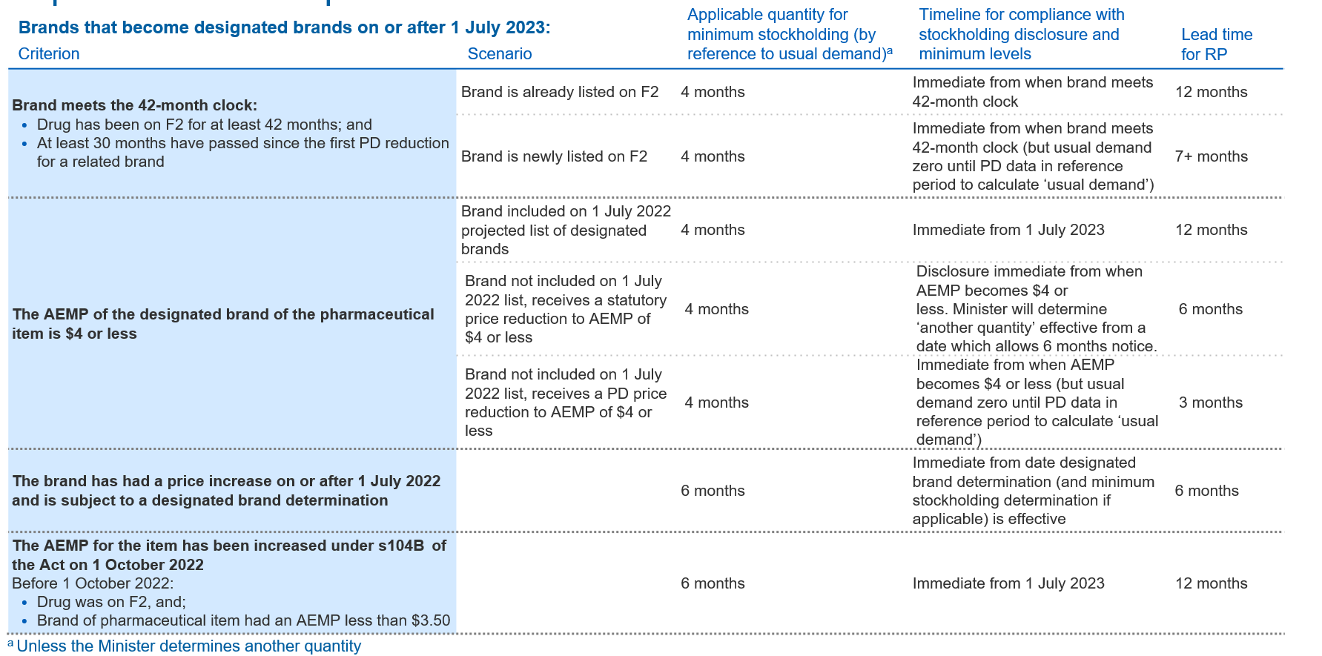

Ministerial determination of ‘another quantity’
Section 99AEKC(2) of the Act provides that the Minister may make a minimum stockholding determination specifying ‘another quantity’ that RPs must keep in stock to satisfy the minimum stockholding requirements. A minimum stockholding determination is made at the discretion of the Minister, and may be made of the Minister’s own volition, or in response to an application made by a RP. The quantity in a minimum stockholding determination may be a specified number of months stock by reference to the ‘usual demand’ for the brand, or other parameters.
It is a matter for the Minister to determine whether it is appropriate in the circumstances to make a minimum stockholding determination and what quantity is determined. As noted at Section 4.3 above, prior to the Minister making a minimum stockholding determination of their own volition, the Department will provide RPs with details of the determination to be made and the basis for any calculations, and provide RPs with the opportunity to seek clarification.
This Section provides detail on the process by which RPs may submit a request for a determination to be made, and guidance on the matters the Minister may consider relevant when considering a request made by a RP. This Section also provides details of the process for a RP to be notified of the outcome of their Ministerial determination application.

RPs can request the Minister make a determination of ‘another quantity’
RPs may submit a request for a minimum stockholding determination under one of three request timelines (see also: Exhibit 12 to Exhibit 14):
- Designated brands which are subject to the minimum stockholding requirement as of 1 July 2023 can submit a request from 21 October 2022 after the publication of the designated brand list on 1 July 2022 (see Exhibit 12). Designated brands on the projected list of designated brands published on 14 October 2022 (which will be subject to the minimum stockholding requirement from 1 October 2023) can also submit a request from 21 October 2022 to be processed in the initial round of Ministerial determination applications.
- The process for subsequent requests will open biannually on 1 April and 1 October, following the publication of the projected list of designated brands (i.e. 12 months in advance of the minimum stockholding requirements commencing) (see Section 2.3 and Exhibit 13).
- Brands that receive a price increase or price reduction which satisfies the criteria specified in s99ADHC(1)(b) and (c) of the Act (see Section 2.1) or brands that are a new generic brand listing, will be subject to the timeframes outlined in Exhibit 14.
Minimum stockholding determination requests in the initial round opening on 21 October 2022, and the subsequent round opening on 1 April 2023, must be submitted via email to pbsstockholding@health.gov.au. RPs must complete the application form available on the PBS website, and submit it via email together with any supporting documents. From 1 July 2023, requests are to be submitted through the Health Products Portal (HPP).
Exhibit 12: Requests for minimum stockholding determinations for brands published on designated brands list on 1 July 2022, and the projected list of designated brands published on 14 October 2022, open on 21 October 2022 and close on 18 November 2022
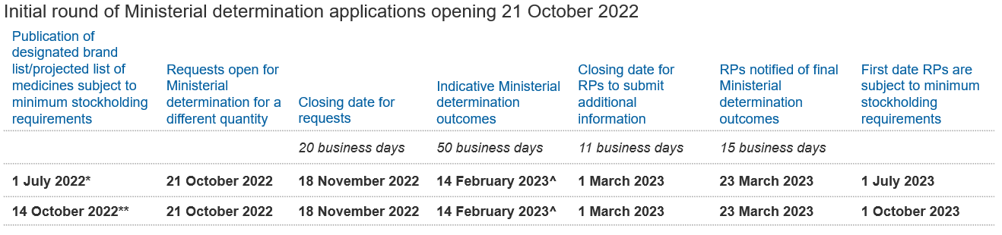
*Designated brand list published on 1 July 2022 for brands which will be subject to minimum stockholding requirements from 1 July 2023.
**Projected list of designated brands list published on 14 October 2022 for brands which will meet the s99ADHC(1)(a) criteria and be subject to minimum stockholding requirements from 1 October 2023.
^This date takes into account Departmental shutdown and reduced activity period over the Christmas/New Year period from 23 December 2022 to 8 January 2023.
Exhibit 13: Ongoing requests for minimum stockholding determinations will open biannually on 1 April and 1 October
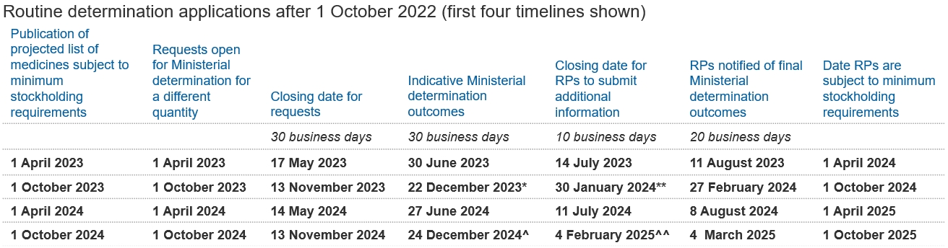
*29 business days – to ensure indicative outcome provided prior to Christmas/New Year close-down.
**10 business days from Monday 15 January 2024 to account for Christmas/New Year close-down and anticipated reduced activity period for RPs.
^29 business days – to ensure indicative outcome provided prior to Christmas/New Year close-down.
^^10 business days from Monday 20 January 2025 to account for Christmas/New Year close-down and anticipated reduced activity period for RPs.
Exhibit 14: Requests for Ministerial determinations for brands which receive a price increase (s99ADHC(1)(b)), a price reduction (s99ADHC(1)(c)) or a new generic brand listing after 1 July 2023
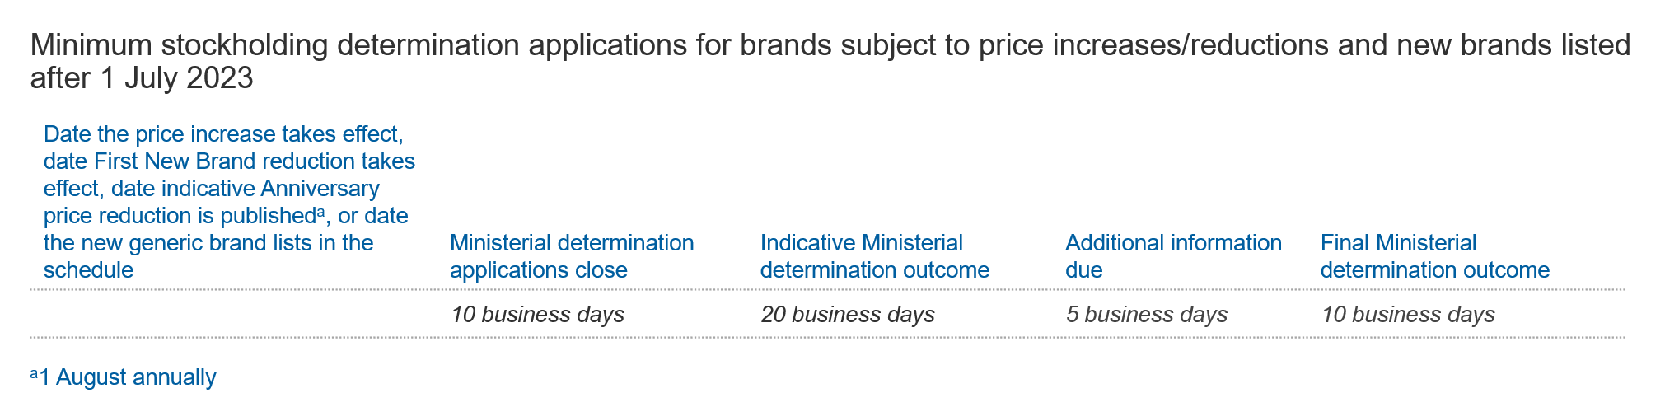
The Department has responsibility for managing all aspects of processing requests made to the Minister. The Department will provide the Minister with any submissions together with a summary of the request and a recommendation in relation to the exercise of discretion. All submissions, documents and information provided for requests for Ministerial determinations will be handled consistently with the National Health Act 1953 and the Privacy Act 1988. Giving false or misleading information is a serious offence. Providing false or misleading documents is also an offence.
Applications for Ministerial determinations will be cost recovered under the National Health (Pharmaceuticals and Vaccines—Cost Recovery) Regulations 2022.
In the event that the s19A medicine is listed for a long enough period for a minimum stockholding quantity based on ‘usual demand’ to be calculated from PD data in the reference period, s19A medicines do not have any cost recovery fees applicable and there is no fee for the RP of a s19A medicine to make an application for a Ministerial determination. (See Section 4.2 in relation to ‘usual demand’ for s19A medicines).

The Minister may consider a range of matters in regard to determinations
This Section provides guidance on the types of information and matters that might be considered relevant to the Minister’s exercise of discretion to make a minimum stockholding determination. The Minister has discretion to consider any matters that they consider relevant. This guidance does not limit the Minister’s powers, nor fetter the Minister’s discretion, under the Act.
One of the matters the Minister may consider relevant is the shelf-life of the brand and the Minister’s assessment of the feasibility for the RP to ensure that the brand has a viable shelf-life remaining when on-sold from the RP to wholesalers/retailers and/or consumers.
For example, the Minister may determine that a brand with a shelf-life of 18 months or less should receive a determination of another quantity, such as 2 months of ‘usual demand’ (rather than 4 months or 6 months)
When submitting a request for the Minister to make a minimum stockholding determination, RPs should specify the quantity they are seeking to be determined as the applicable quantity. This amount can be a specified number of months of stock by reference to ‘usual demand’, or by reference to a number of packs of the brand.

RPs should provide supporting evidence
RPs should provide a comprehensive and complete explanation of their reasons for requesting a minimum stockholding determination, including why they cannot comply with the minimum stockholding requirement that would apply in the absence of a minimum stockholding determination. RPs should provide evidence and documentation that supports their request, including details of any factors and assumptions underpinning their reasons for requesting a minimum stockholding determination, why it is appropriate for the Minister to make a minimum stockholding determination and why the proposed reduced stockholding level is appropriate. Potential information and documentation could include, but is not limited to:
- manufacturer reports and/or Therapeutic Goods Administration (TGA) reports outlining characteristics of the pharmaceutical item, including its shelf-life;
- wholesaler/retailer contracts specifying shelf-life contractual obligations;
- internal reports and analysis on manufacturing performance and outlook;
- third-party correspondence on supply chain conditions (e.g., availability assessment of shipping/air freight);
- analysis or reports outlining typical supply chain steps and lead-time for that RP and the brand;
- reports outlining a brand’s packaging arrangements including contracts with local/offshore third parties;
- any other reports outlining feasibility of meeting minimum stockholding requirements whilst maintaining viable shelf-life; and
- details of how the RP will ensure continuity of supply based on an alternative stockholding level.
RPs should not omit any matters without which the information provided would be misleading. As noted above, giving false or misleading information, and producing false or misleading documents, is an offence.
It is not necessary for all matters listed above to be addressed in a request for a minimum stockholding determination, nor is it necessary for the Minister to consider all of these matters when deciding whether or not to make such a determination, or the quantity to determine. It remains open to RPs to submit any other reasons why the Minister should make a determination and determine a specific quantity, where that matter is not listed above.

Opportunity to provide additional information before final outcome; determinations may apply to all brands of an item
- Release of assessment outcome
In response to an application for the Minister to make a minimum stockholding determination the Department will, in accordance with the timeframes outlined in Exhibit 12, Exhibit 13 and Exhibit 14:
- notify the RP of the indicative decision initially via email or HPP (depending on submission method);
- where the indicative Ministerial decision is not to make a minimum stockholding determination, or to make a minimum stockholding determination in a different quantity to that sought by the RP, provide a summary of reasons for the indicative decision and give the RP an opportunity to provide further information to the Minister before a final decision is made; and
- notify the RP of the final outcome.
As noted, a minimum stockholding determination is a decision made by the Minister. Until such a determination is made, no statements by the Department should be interpreted as a guarantee that a request for a minimum stockholding determination will be approved, or that a particular quantity will be determined.
If a minimum stockholding determination is not made following an application by an RP (or the determination is made in a different quantity to that sought by the RP), then ‘usual demand’ or ‘another quantity’ determined by the Minister will be the applicable quantity of stock which the RP is required to hold.
The fact that an application has been made by the RP previously does not alter the requirement for the RP to hold the applicable quantity of stock to comply with their minimum stockholding requirement, or to notify the Department of a likely or actual breach of the minimum stockholding requirements.
- Application of minimum stockholding determination to other brands of the same pharmaceutical item
If another quantity is determined for one brand, the Minister may of their own volition and at their discretion make a minimum stockholding determination for other brands of the same pharmaceutical item, which are also subject to minimum stockholding requirements. For example, the Minister may do so where they consider that the reasons for making their determination for the first brand are applicable at a pharmaceutical item level and it is appropriate for a minimum stockholding determination to be made for all brands of the pharmaceutical item. Relevant RPs will be notified via email in advance of such a determination being made in those circumstances.

Reporting and monitoring
RPs subject to stockholding requirements are subject to separate disclosure and notification requirements. Stockholding disclosures must be made biannually in accordance with s99AEKF of the Act and s85C of the Regulations. In the event of a breach or a likely breach of the minimum stockholding requirements, the RP must comply with the notification requirements set out in s99AEKD of the Act. Disclosure and notification requirements are discussed in greater detail in this section whilst management of occurrences where disclosure and/or reporting requirements are breached is discussed in Section 8.

Stockholding disclosure requirements
RPs for designated brands subject to the minimum stockholding requirement are required to comply with the stockholding disclosure requirements set out in s99AEKF of the Act and s85C of the Regulations. Section 85C of the Regulations outlines the information required to be disclosed and timeframe in which disclosure must be made. This disclosure assists the Minister to ensure compliance with the minimum stockholding requirement.
The Act makes the RP responsible for complying with the stockholding disclosure requirements. All submissions, documents and information provided for stockholding disclosures will be handled consistently with the National Health Act 1953 and the Privacy Act 1988.
- Required information from Responsible Persons
For each brand of a pharmaceutical item which is subject to the minimum stockholding requirement, RPs must report biannually on the quantity of the brand of pharmaceutical item kept in stock in Australia. Disclosure is provided for the periods 1 April to 30 September and for 1 October to 31 March (s85C of the Regulations).
Disclosure must be provided for each period that a brand is a designated brand, regardless of whether the brand was only a designated brand for part of that period described above.
RPs must provide the following information in relation to the quantity of the brand kept in stock in Australia:
        - start and end dates of the period to which the information relates;
        - name of the brand;
        - name of the RP;
        - name of the drug in the pharmaceutical item;
        - form of the drug, including its strength;
        - manner of administration of the form of the drug;
        - number or quantity of units in a pack (the number of tablets in a pack, for example); and
        - number of packs held in stock at the end of each month in the period.
The RP should ensure the quantities reported as held in stock capture only the stock that counts towards meeting the RP’s minimum stockholding requirement (see Section 3).
Where a s14 consent is provided under the Therapeutic Goods Act 1989, if there is no change in the trade name under which the pharmaceutical item is supplied, then the stock may be counted towards the RP’s minimum stockholding requirement where it otherwise meets the criteria in s99AEKB. If there is a change of trade name, the differently branded stock will not be reported for disclosure purposes and is not counted towards the RP meeting their minimum stockholding requirement. In assessing any technical breach of the minimum stockholding requirement in those circumstances, the Minister may take into account the combined stockholding kept by the RP including the differently branded stock covered by the s14 consent, and whether the combined stockholding was to a level which would otherwise have met the minimum stockholding requirement.
RPs are expected to have robust systems in place, including an inventory management system that is able to provide an accurate report as at the end of each month, and ensures that the amount of stock recorded in the system accurately reflects the physical stock on hand. RPs’ systems should be able to distinguish stock which is considered to be kept in stock in Australia – and therefore counts towards the RP’s applicable quantity for their minimum stockholding requirement – from stock which does not meet the stockholding definition.
All methodologies, detailed transactional records, analyses and any other documents relating to stockholding disclosure, must be kept for two years from the end of the stockholding period to which those records relate. For example, records relating to the reference period 1 April 2024 to 30 September 2024 on which ‘usual demand’ is calculated for the stockholding period 1 April 2025 to 30 September 2025 must be retained until 30 September 2027.
- Mandatory disclosure timeframes for RPs
RPs are required to provide the required information by the following deadlines:
        - for the period 1 April – 30 September: by 11 November; and
        - for the period 1 October – 31 March: by 12 May.
For brands that become subject to the minimum stockholding requirement during these windows RPs are required to make disclosures by the next reporting deadline. For example, for a brand that becomes subject to the minimum stockholding requirement on 23 July, its RP is required to make disclosures by 11 November of that year.
Where 11 November or 12 May fall on a day that is not a business day, the deadline for the disclosure will be the next business day.

- Submitting a report
The required information must be submitted to the PDDA through the Price Disclosure Submission Utility (PDSU). RPs will have access to the PDSU through the existing price disclosure processes or will be provided with access to the PDSU prior to the first reporting window in which they are required to meet the stockholding disclosure requirements. The stockholding disclosure requirements must be met for all brands subject to the minimum stockholding requirement, regardless of whether the brand remains subject to the minimum stockholding requirement at the time the disclosures are required to be made.
- Failure to comply with the stockholding disclosure requirements
Failure to fully comply with the stockholding disclosure requirements is an offence under s99AEKF of the Act. RPs will breach the stockholding disclosure requirements where, for example, they submit information late, submit incomplete data, or fail to submit the required information for any period the brand was subject to the stockholding disclosure requirements. Assessment of and penalties for breaches of the stockholding disclosure requirements are discussed in Section 8.
If, before or after the submission deadline, the RP becomes aware that it will act or has acted in a non-compliant manner then it should advise the PDDA and the Department immediately in writing. If verbal notification is provided, it should immediately be followed by written confirmation. The Department or the PDDA (acting on behalf of the Department) will then advise the RP as to the course of action the RP and Department will need to take to minimise the impact of the non-compliance.

Minister to be notified of likely or actual breach of minimum stockholding requirements
The RP for a designated brand subject to the minimum stockholding requirement is required to notify the Minister of a likely or actual breach of the minimum stockholding requirements in accordance with s99AEKD of the Act.
Notifications are the sole responsibility of the RP and must be submitted to the PBS Stockholding inbox pbsstockholding@health.gov.au. A pro-forma template for the submission of notifications will be published on the Medicines Supply Security Guarantee web page prior to 1 July 2023. All submissions, documents and information provided for notifications of likely and actual breaches will be handled consistently with the National Health Act 1953 and the Privacy Act 1988.
- Circumstances when Responsible Persons must notify the Minister
A RP subject to the minimum stockholding requirement must report an actual or likely breach of the minimum stockholding requirement 'as soon as practicable' after:
- in the case of a likely breach, they form the belief they are likely to breach the minimum stockholding requirement in relation to a designated brand; or
- in the case of an actual breach, they breach the minimum stockholding requirement in relation to a designated brand.
A ‘likely breach’ does not require that a breach is inevitable, simply that a breach is likely.
For each ‘likely breach’ the RP must provide a separate notification. The RP may form the belief that they are likely to breach the minimum stockholding requirement based on one or several cumulative or alternative events. If the RP makes a notification and then a separate event subsequently occurs which may also cause a ‘likely breach’, a further notification is required. For example, if a supply disruption such as a delayed shipment occurs (which required notification to be made), and then a month later a batch failure occurs, both incidents would be reported as separate ‘likely breach’ notifications if each event was likely to cause a breach of the minimum stockholding requirement.
Where a notification has been made of a ‘likely breach’, and the breach eventuates, the RP will have made a notification of the likely breach and in addition will submit a further notification for the actual breach.
If a RP has a stock level which is moving above and below the minimum stockholding requirement (for example the RP is in the process of rectifying a breach but has not yet been able to secure reliable ongoing supply), the RP must provide separate notifications for each instance of a likely breach or actual breach, but can refer to and update information previously provided to avoid duplication.
Conversely, if a RP has a stock level which does not meet minimum stockholding requirements for a prolonged period, the single notification of likely breach, followed by a single notification of actual breach will suffice, although the RP should provide updated information to the Department if there are further developments or to correct any inaccuracy in the initial notifications, for example an early estimate of time to restore supply is no longer accurate.
- Required information from Responsible Persons
To facilitate notification being made ‘as soon as practicable’, the RP may submit a notification in two parts with information readily available provided first followed by a second part of further information which may take longer to gather. The RP may submit the first part of a notification whilst they are in the process of attempting to mitigate a supply disruption, or whilst they are gathering further information, but the notification must be provided ‘as soon as practicable’ and should not be delayed whilst further action, investigation or information-gathering is completed.
In the first part of a notification, the RP must provide the Minister written notice that:
- informs the Minister of the belief they are likely to breach or the breach (as appropriate); and
- sets out the RP’s reasons for that belief or the breach (as appropriate).
Either as a supplementary second part of a notification or together with the first part of a notification, the RP must provide sufficient information to allow the Department to assess whether the notification has been made ‘as soon as practicable’.
To satisfy this requirement in the case of a likely breach, the RP should include information about when and how the RP became aware of any matters on which the belief was formed (e.g., notification of a significant supply disruption). This could include a timeline of events and the RP’s belief over time regarding their ability to maintain compliance with their minimum stockholding requirements. Potential evidence that may be provided in support includes, but is not limited to:
- dated internal communication notifying of breach/causative factor to breach or likely breach;
- dated third-party communication to RPs notifying of causative factor to breach or likely breach; and
- dated third-party reports assessing causative factors for breach or likely breach.
To satisfy this requirement in the case of an actual breach, the RP should specify the date on which the breach occurred. Potential evidence that may be provided in support includes, but is not limited to:
- dated internal communications notifying of the breach; and
- stock records indicating the minimum stockholding requirement was satisfied up to the date of breach.
Some additional information that should be included in each report (where relevant) is:
- basic details of the brand, including:
- name of the brand;
- name of the RP;
- name of the drug in the pharmaceutical item;
- form of the drug, including its strength;
- manner of administration of the form of the drug; and
- number or quantity of units in a pack (the number of tablets in a pack, for example);
- current and anticipated stockholding, including:
- number of packs held in stock currently and at the end of each month for the prior 6 months;
- nature of the shortage (current or anticipated); and
- likely duration of stock being below required volume;
- corrective actions taken by the RP, including:
- what actions are and/or were being taken to maintain or restore stock to the required level (Exhibit 15 provides examples of actions RPs could take); and
- outcomes of any investigations into cause of breach/likely breach and evidence of corrective actions taken thus far;
- suitability of RP’s existing business activities:
- existing processes the RP takes to forecast demand;
- existing processes the RP takes to manage and monitor supply chain and storage facilities; and
- any prior risk assessment made of supply chain and any applicable steps taken to mitigate those risks.
RPs are required to report any instance of a likely breach to minimum stockholding requirements, this should be performed at the same time or prior to any mitigating activities to improve stock levels or respond to a supply disruption if the RP has formed a belief of a ‘likely breach’. A RP may be able to avoid a likely breach eventuating in an actual breach, and this may mean that a RP submits a number of notifications for a ‘likely’ breach to minimum stockholding requirements that do not result in any ‘actual’ breaches.
RPs should provide a complete explanation of their reasons for the breach or belief of a likely breach (as appropriate). RPs should not omit any matters without which the information provided is misleading. As noted above giving false or misleading information and producing false or misleading documents is an offence.
Information which is provided with a notification of a likely breach and/or an actual breach may be taken into account by the Minister in deciding what action to take following an actual breach arising from the circumstances the subject of the notification. The information which is provided may inform the Minister’s consideration of:
a) the RP’s reasons for the breach and whether those are in the Minister’s opinion reasonable (s99AEKE(3)(a)); and
b) whether, in the Minister’s opinion, the RP will consistently maintain adequate stock levels of the brand of the pharmaceutical item in the future (s99AEKE(3)(b)).
Information which is provided may also be taken into account by the Minister in deciding what action to take following any future breaches arising in other circumstances. The information which is provided may inform the Minister’s consideration of:
a) whether, in the Minister’s opinion, the RP will consistently maintain adequate stock levels of the brand of the pharmaceutical item in the future (s99AEKE(3)(b)); and
b) the RP’s reasons for any previous breach(es) and whether those reasons were, in the Minister’s opinion, reasonable (s99AEKE(3)(d)).
- Examples of circumstances when RPs must notify the Minister
Examples of instances that may lead a RP to form a belief that they are likely to breach their minimum stockholding requirement include, but are not limited to:
- disruption to the production of an active ingredient;
- a market competitor, with significant market share, goes out of stock for an extended period of time and the RP subsequently absorbs a significant amount of additional demand. Due to the amount of the market short-fall and the period of time available to acquire additional stock to meet demand, the RP is required to draw down upon their stockholding to continue supply to Australian consumers. In these circumstances, the Minister would expect to be notified of a likely breach as soon as the RP became aware of increased demand for their brand due to a competitor going out of stock (i.e., the RP is expected to notify the Minister at the point they have indication of increased demand on their brand e.g., increased number of purchase orders to RP from wholesaler);
- where (ii) arises, the RP may be subject to a temporary period of inflated demand which will lead to their minimum stockholding requirement being elevated significantly above their usual requirement. The RP should provide notification of any expected challenges they face in meeting the future increased minimum stockholding requirement. Information provided may include the length of time the competitor was out of stock, changes in market share and the degree to which ‘usual demand’ has increased. The Minister would expect to be notified of a likely breach by the end of the reference period with the increased ‘usual demand’ figures (e.g., by 11 November for the period 1 April to 30 September or by 12 May for the period 1 October to 31 March). In most instances notification of future difficulty meeting the minimum stockholding requirement would be a separate notification to the notification which is made at the time of the likely breach referred to in (ii). If the RP has been able to maintain their minimum stockholding whilst responding to the shortage so has not made a notification as outlined in (ii), they may still submit a notification with respect to their future difficulty meeting their minimum stockholding requirement due to the temporary period of inflated demand.
- Submitting a report
Reports are the sole responsibility of the RP and must be submitted to the PBS Stockholding inbox pbsstockholding@health.gov.au. A pro-forma template for the submission of notifications will be published on the Medicines Supply Security Guarantee web page prior to 1 July 2023. If a RP has simultaneously reported a medicine shortage to the Therapeutic Goods Administration, the RP may provide a copy of that report and refer to it for additional information, but must complete basic information on the pro-forma provided.
Where the RP provides a notification to the Department, the RP remains responsible for separately complying with any notification requirements to the TGA, and compliance with the TGA’s regulatory requirements.
In the event a RP has multiple brands with a likely breach or an actual breach required to be notified, the RP must submit a report for each brand with a likely or actual breach.
The originals of any documents which are provided as supporting evidence for a notification or relied upon in providing a notification, must be kept for two years from when the notification is made. The RP must also keep all methodologies, detailed transactional records, analyses and any other documents relating to the notification for two years from when the notification is made.
Information provided by a RP under s99AEKD(1) or s99AEKD(2) may be disclosed to the TGA. Sharing of this information with the TGA (which, while operating independently is part of the Department), will assist in the proactive management of potential shortages of medicines by the Department and the TGA, and will assist in assessment of policies and procedures.
The Department may use reports for other purposes, including for future education and/or policy assessment purposes. Where the Department uses a report for such other purposes that involves sharing with third parties (for example peak bodies), the Department will remove all identifying information from the report before doing so or comply with the requirements in the Act if a report is to be shared with a third party without redaction.

- Actual breach following a likely breach notification
A RP who has submitted a notification of a likely breach is also required to submit a separate notification in the event of an actual breach subsequently occurring (see Section 7.2(b)).
- Failure to comply with the stockholding breach notification requirements
Failure to fully comply with the notification requirements in s99AEKD of the Act is an offence. RPs will breach the notification requirements where they fail to notify the Minister of a likely or actual breach, provide notification late or provide an incomplete notification. Assessment and penalties for breaches of the notification requirements are discussed in Section 8.

Exhibit 15: Best practice includes preventative, reporting and mitigation actions before and during a breach
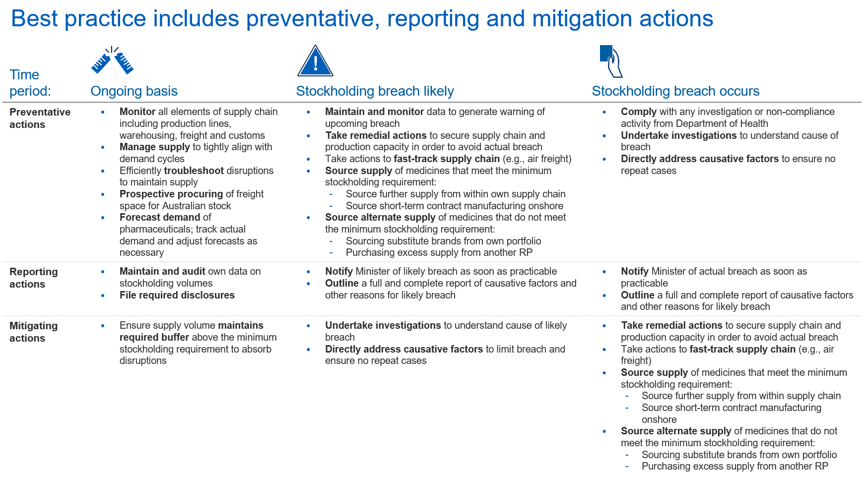

Management of breaches
This Section discusses three possible breaches of the Act:
- Breach of minimum stockholding requirements (s99AEKE(1));
- Breach of requirement to notify the Minister of an actual or likely breach (s99AEKD(3)); and
- Breach of the stockholding disclosure requirements (s99AEKF(3)).
Criminal penalties may apply for breach of the notification requirements and the stockholding disclosure requirements.
In the event of a breach of the minimum stockholding requirement, the Minister may assess the breach and take such action(s) as they consider appropriate.
This Section provides recommendations for actions that RPs may take to avoid these breaches, and outlines the factors considered when assessing each breach, the types of evidence that may be considered and the actions available to the Minister in the event of a breach of the minimum stockholding requirement.

Suggested actions for Responsible Persons to achieve compliance with legislation
Exhibit 15 outlines the actions RPs could take to ensure they meet their obligations under the Act. They are intended as a guide only, and do not contain all aspects of good business practice. The actions suggested do not guarantee adherence to the legislated requirements. Suggested actions are shown for application on an ongoing basis, when a stockholding breach is likely and when a stockholding breach occurs. It is expected that RPs will assess and monitor their supply chain and stock levels on an ongoing basis to allow them to meet their minimum stockholding requirements, receive timely notification of any supply chain disruptions, and take prompt and effective action to respond to supply disruptions if they occur.
In the event of a likely breach, a RP is required to provide notification as soon as practicable in accordance with s99AEKD(1), and is expected to take action to assess the causative factors for the likely breach and respond appropriately. This should include addressing any causative factors which contribute to the risk of future breaches of the minimum stockholding requirement.
The suggested actions in the event of a likely breach or an actual breach are also expected to mitigate the impact of any breach (i.e., the duration of any out-of-stock and/or period of reduced supply).

Failure to comply with the minimum stockholding requirement
If a RP breaches the minimum stockholding requirement, s99AEKE of the Act applies. Breaches to the minimum stockholding requirement may be assessed and managed by the Minister. RPs may be asked to comply with investigations and/or to consider reasonable compliance actions designed to assist RPs to comply with regulation and to support the maintenance of access to pharmaceutical stock for Australian consumers.
This Section describes the factors the Minister must and may consider when assessing a breach and determining whether to exercise their powers under s99AEKE(2) of the Act. Guidance is provided on the types of information that a RP can provide, and which the Department or the Minister may request when assessing breaches of the minimum stockholding requirement. The Minister may also take into account any other matter that they consider relevant. This guidance does not limit the Minister’s powers, nor fetter the Minister’s discretion, under the Act.
- Minister’s powers under s99AEKE
If a RP breaches the minimum stockholding requirement, the Minister may:
      - de-list from the PBS the brand(s) which do not comply with the minimum stockholding requirement (s99AEKE(2)(a)) and/or any other listed brands of the RP (s99AEKE(2)(b)); and/or
      - refuse to list new brands of the same Responsible Person (s99AEKE(2)(c)); and/or
      - if the only listed brand would be a brand of the RP, refuse to make declarations or determinations under ss85(2), (3) or (5) in relation to the pharmaceutical item (s99AEKE(2)(d)).
- Factors the Minister must consider
When assessing a breach of the minimum stockholding requirements and determining whether to exercise their powers under s99AEKE(2), the Minister must consider:
      - the RP’s reason for the breach and whether those reasons are, in the opinion of the Minister, reasonable;
      - whether, in the Minister’s opinion, the RP will consistently maintain adequate stock of the brand in the future;
      - whether the RP has offered discounts or incentives in relation to sales of the brand;
      - whether the RP has previously breached the minimum stockholding requirement in relation to any brands for which they are the RP and if so, the reasons for the breach(es) and whether those reasons are, in the opinion of the Minister, reasonable;
      - whether the RPs for other brands of the same pharmaceutical item have breached the minimum stockholding requirements in relation to those other brands; and
      - any other matter the Minister thinks relevant.
- Factors the Minister may consider:
When assessing a breach of the minimum stockholding requirements, the Minister may consider:
      - whether the RP has fully complied with the breach notification requirements under s99AEKD at the time of likely breach as well as when the breach occurred;
      - the volume of stock below required minimum stockholding level;
      - the length of time the RP did not comply with the brand’s minimum stockholding requirement;
      - the number of different items from the RP’s portfolio involved in breach;
      - whether there has been a shortage of another medicine which has resulted in significant demand shift to the RP’s brand (this includes but is not limited to medicine substitution through a Serious Scarcity Substitution Instrument (SSSI));
      - any corrective actions taken by the RP to limit the impact of and/or resolve the breach;
      - the volume of stock held by wholesalers or other customers of the RP, may be taken into account to determine whether there is sufficient stock in the whole of the supply chain to ensure adequate supply to patients while the RP takes all reasonable steps to replenish its own stockholdings; and
      - the impact of any significant unexpected order(s) by wholesalers or other customers of the RP on the RP’s stockholding, which were not foreseeable nor projected by the RP and which occurred inside the lead-time for the RP to obtain additional stock to maintain minimum stockholdings.
- Evidence the Minister may consider
RPs should ensure that they provide a complete explanation, having regard to the factors the Minister must consider when assessing a breach and determining whether to exercise their power under s99AEKE(2). RPs should provide all evidence and documentation required to support any claims they make in relation to these factors, including full details in relation to those factors and assumptions underpinning their reasons. An explanation will not necessarily be extensive (depending upon the circumstances) but should nonetheless be complete and be supported by appropriate evidence.
The Minister may consider the following documentation and information in relation to each factor:
- the RP’s reason for the breach and whether those reasons are reasonable:
- dated internal communication notifying of breach/causative factor to breach or likely breach;
- dated third-party communication to the RP notifying of causative factors for breach or likely breach;
- dated third-party reports assessing causative factors for breach or likely breach;
- third-party correspondence on supply chain conditions (e.g., availability assessment of shipping/air freight);
- analysis outlining supply chain disruptions from usual performance;
- internal reports and analysis on manufacturing performance and outlook;
- market reports outlining the RP’s exits from relevant market;
- market reports outlining the market shares of RPs for a given pharmaceutical item;
- evidence of prolonged supply chain lead-times which interfere with compliance with stockholding requirements in initial stockholding period, or substantially interfere with the RP responding to demand variation such as following an OOS by another RP;
- TGA Medicine Shortage reports for competitor brands; and
- correspondence and/or contractual evidence which shows a loss of a significant supply contract for the RP.
- whether the RP will consistently maintain adequate stock levels in the future:
- evidence of the required stock being held by the RP but not in a form that meets the stockholding definition (e.g., bulk storage with sufficient packaging materials on hand and packaging facilities to quickly release bulk product in retail form);
- stock records indicating the minimum stockholding requirement was satisfied up to the date of breach;
- assessment of the causative factors of a breach and the outcomes of any investigation into the cause of the breach;
- evidence of corrective actions which are designed to address the cause of a breach;
- whether the RP has an action plan to avoid future breaches;
- adherence to an existing action plan;
- evidence of suitable resources to maintain required stock levels;
- evidence of suitable systems to monitor all elements of the supply chain including production lines, warehousing, freight and customs;
- evidence of ability to accurately forecast demand for brands; and
- evidence of pre-booked freight capacity to Australia and within Australia.
- whether the RP has offered discounts or incentives in relation to sales of the brand during the reporting period:
- discounts and incentives offered for the brand; and
- contracts with wholesalers.
- whether the RP has previously breached the minimum stockholding requirement and if so, the reasons for the breach(es) and whether those reasons are reasonable:
- stock records indicating the minimum stockholding requirement was satisfied up to the date of breach;
- notifications and evidence provided with respect to previous breach(es); and
- any additional information and evidence provided by the RP with respect to previous breach(es).

- whether an RP for other brands of the same item has breached the minimum stockholding requirement in relation to those other brands:
- the Department does not expect RPs to provide any additional information or documentation on this point. The Department will provide the Minister with details of any actual breach notifications which it receives for other brands of the same pharmaceutical item.
If the Minister considers the impact of significant unexpected order(s) by wholesalers or other customers of the RP (see Section 8.2(c)(vii) above), the following may assist the Minister in considering that factor:
- Details of the usual ordering patterns of the customer who placed the unexpected order, and evidence that orders by that customer leading to the breach were significantly outside of the usual ordering pattern and of a magnitude which was causative of the breach;
- Details of the RP’s anticipated sales projections and any variance from those projections as a result of the unexpected order;
- If the order was part of a tender or other prior contractual arrangement, details of when the RP first responded to the tender, or commenced contract negotiations with the customer, and details of whether the unexpected order was foreshadowed in the tender, contractual arrangements and/or negotiations;
- Evidence that the significant unexpected order was made inside of the lead time of the brand;
- Details of the supply chain lead time for the brand;
- Details of actions taken by the RP to procure additional stock (within or outside of the usual lead time of the brand) and/or improve supply chain timing in order to maintain minimum stockholdings;
- Details of the RP’s planned replenishment schedule and anticipated and actual stock levels for 12 months prior to the breach, clearly indicating the impact of the significant unexpected order(s).
Any previous notifications and supporting documents which have been provided by the RP (whether for the brand which is in breach, or relating to a previous breach or likely breach), will be available for consideration by the Minister in deciding whether to exercise their power in response to a breach of the minimum stockholding requirement.

Breach of requirement to notify the Minister of a likely or actual breach
As discussed in Section 7.2, RPs are required to notify the Minister regarding likely or actual breaches of the minimum stockholding requirement.
Breaches of the notification requirements may be assessed and managed by the Department. RPs may be requested to participate in a breach investigation. The instances when a breach occurs and potential penalties that may apply are as follows:
- RPs are required to notify the Minister of likely and actual breaches
A RP commits an offence if they are subject to the minimum stockholding requirement and fail to give the Minister written notice which:
        - informs the Minister that they believe they are likely to breach or that they have breached the minimum stockholding requirement for a particular brand of a pharmaceutical item;
        - sets out the reasons for that belief or breach; and
        - is given as soon as practicable after the RP forms the belief or the breach,
A notification is required if a likely breach is identified. If that likely breach eventuates in an actual breach, a separate notification must be made. Separate notifications are also required for likely breaches arising in different circumstances or at different times. Where there is an ongoing supply disruption and the RP has periods of breach followed by compliance, notifications are required for each breach even if the breaches arise from the single initial instigating event. Where a RP remains in breach for a period of time, the single notification of likely breach, followed by a single notification of actual breach will suffice but may be updated as necessary (see Section 7.2 above).
Further information on notification requirements is covered in Section 7.2, including the information and evidence that may be appropriate to submit to show that the notification which is given is compliant.
- Penalties may apply in the event of breaches of the breach notification requirements
The criminal penalty for failing to comply with the breach notification requirements is 60 penalty units (s99AEKD(3) of the Act). Depending upon the circumstances of a breach, the Department will consider whether it is appropriate to refer the matter to the Commonwealth Director of Public Prosecutions.

Breach of stockholding disclosure requirements
As discussed in Section 7.1, RPs are required under s99AEKF of the Act to disclose the quantity of the brand kept in stock in Australia for each designated brand. Breaches to disclosure requirements may be assessed and managed by the Department. RPs may be requested to participate in a breach investigation.
The instances when a breach occurs and the penalties that may apply are as follows:
- RPs are required to disclose complete and accurate information
A RP commits an offence if they are required to provide stockholding disclosure and fail to:
- submit the information; and/or
- provide all required information; and/or
- provide the required information within the legislated timeline under s85C of the Regulations.
As noted above giving false or misleading information and producing false or misleading documents is an offence.
Further information on stockholding disclosure requirements is covered in Section 7.1.
- Penalties may apply in the event of breaches of stockholding disclosure requirements
The criminal penalty for failing to comply with the stockholding disclosure requirements is 60 penalty units (s99AEKF(3) of the Act). Depending upon the circumstances of a breach, the Department will consider whether it is appropriate to refer the matter to the Commonwealth Director of Public Prosecutions.

As amended by the National Health (Pharmaceutical Benefits) Amendment (2021 Measures No. 1) Regulations 2021.
The s99ADHC(1)(a) criteria is met by brands for which the drug and manner of administration of the brand’s pharmaceutical item has been on F2 for at least 42 months and at least 30 months have passed since the first price disclosure price reduction for any brand with the same drug and manner of administration (see section 2.1 above).
‘Usual demand’ for a brand is calculated in accordance with s85B of the Regulations. If RPs have any questions about the calculation of the ‘usual demand’ they can enquire with the PDDA or the Department. If RPs dispute the PD volume data that is used to calculate ‘usual demand’ they can raise a dispute through the PD Dispute Resolution Administrative Process. Note that ‘usual demand’ may be subject to change as a result of a dispute outcome.
If a s19A product has a six-month minimum stockholding requirement, the RP would be able to request that a stockholding determination of zero is made up to six months prior to the s19A approval expiry and the product delisting from the PBS.
For example, a brand which has been on F2 since 1 July 2020 and has a price reduction to $4.00 effective 1 April 2024, will have PD data available for the reference period 1 April 2023 to 30 September 2024 and will be required to hold 4 months of ‘usual demand’ effective 1 April 2024.
Section 99ADHC(1)(b): the approved ex-manufacturer price (AEMP) of the brand is $4 or less; s99ADHC(1)(c): the AEMP of the brand has been increased on or after 1 July 2022 through a new price agreement and a determination is in force in relation to the brand under s99ADHC(2) (designated brand determination)
Where the new brand listing is for a drug/MoA which meets the s99ADHC(1)(a) criteria, the new generic brand which listed will be a designated brand immediately on listing, but ‘usual demand’ for the 4-month minimum stockholding requirement cannot be calculated until there is PD data available in the reference period. (see Section 4.2 above).
The Minister may, at their discretion, accept applications after the closing date. If this occurs, the Minister may notify RPs of request outcomes after the notification date in Exhibit 12.
Fields (i) to (vii) are prepopulated in the PDSU for each brand a RP is required to report for, and these pre-populated fields are presented to the RP following the end of a data collection period. The RP is required to provide the number of packs held in stock at the end of each month in the period; and confirm that the complete data including prepopulated information is true and correct. Where the brand is sold in packs of other sizes, the RP will be able to separately enter the pack size and number of packs held in stock at the end of each month in the period, for any other pack sizes.
Under s84 of the Act, ‘brand’ of a pharmaceutical item means: (a) the trade name under which the person who is or will be the responsible person supplies the pharmaceutical item; or (b) if there is no trade name – the name of the person who is or will be the responsible person.
Business day means a day other than a Saturday, Sunday or a public holiday.
Where this factor is cited by the RP, the Department notes the expectation that RPs plan their supply chain and stockholding levels to comply with their minimum stockholding requirements, and to account for some disruptions in the market. In considering whether an ‘out-of-stock’ is a reasonable reason for a breach, the Minister may consider whether the out-of-stock episode was of a significant market share, for a long period of time.
While it is a matter for the Minister to form a view about, the Department would expect the Minister to consider that a RP will consistently maintain ‘adequate stock’ in the future if the RP will meet the minimum stockholding requirement. In some circumstances the Minister may consider that ‘adequate stock’ is maintained for a period of time even if the minimum stockholding requirement is not met.

