An addendum has been included at the end of the document.

6.12 SELPERCATINIB,
Capsule 40 mg,

Tablet 40 mg,

Capsule 80 mg,

Tablet 80 mg,

Retevmo®,
Eli Lilly Australia Pty Ltd
- Purpose of submission
  - The Category 1 integrated codependent submission requested MBS listing of testing of tumour tissue to detect RET proto-oncogene (RET) variants and PBS listing of selpercatinib for the targeted treatment of locally advanced or metastatic medullary thyroid cancer (MTC) in patients who have evidence of RET variants.
  - Listing was requested on the basis of a cost effectiveness analysis vs best supportive care (BSC) as the primary comparator and cabozantinib or vandetanib as the secondary comparators.
Table 1: Key components of the clinical issue addressed by the submission
Component | Description
Population | Test: MTC patients without germline variants  Drug: Patients with histologically and cytologically confirmed advanced or metastatic MTC with a RET alteration (somatic or germline) and (WHO) ECOG PS ≤2
Intervention | Test: Testing of somatic tumour tissue using commercially available platforms or laboratory accredited in house tests.  Drug: Selpercatinib orally administered in RET alteration MTC patients until disease progression. In patients with bodyweight ≥50 kg, the recommended dose of selpercatinib is 160 mg twice daily (BID). In patients with body <50 kg, the recommended dose of selpercatinib is 120 mg BID
Comparator | Test: No testing for somatic RET alteration  Primary: Best supportive care  Secondary: Standard of care (cabozantinib 140 mg/day or vandetanib 300 mg/day)
Outcomes | Progression free survival, treatment failure free survival, overall survival, overall response, duration of response, safety, and health related quality of life
Clinical claim | In treatment naïve patients with RET alteration advanced or metastatic MTC, selpercatinib is superior to placebo in terms of efficacy and has an inferior, but clinically manageable, safety profile.
Source: Table 1-1, p29 of the submission
BID = twice daily; ECOG = Eastern Cooperative Oncology Group; MTC = medullary thyroid cancer; PS = performance status; RET = RET proto-oncogene; WHO = World Health Organisation
  - The populations eligible for testing and treatment were inconsistently defined throughout the submission. The ESCs agreed with the evaluation that it was appropriate that:
- The population eligible for testing were patients with a confirmed histological diagnosis of MTC, who have not already undergone testing of tumour tissue for clinically significant RET variants and do not have a known germline RET variant
- The population eligible for treatment were RET variant locally advanced or metastatic MTC patients with unresectable disease and documented disease progression as per the LIBRETTO-531 trial.
- Background

Registration status
  - Selpercatinib was included in the Australian Register of Therapeutic Goods in November 2025 for the treatment of adult and adolescent (12 years of age and older) patients with advanced or metastatic RET-mutant MTC who require systemic therapy.
  - The PBAC noted selpercatinib is approved by the Food and Drug Administration in the United States for (i) adult and adolescent patients with advanced or metastatic thyroid cancer with a RET gene fusion who require systemic therapy and who are radioactive iodine-refractory and (ii) adult patients with locally advanced or metastatic solid tumours with a RET gene fusion that have progressed on or following prior systemic therapy or who have no satisfactory alternative treatment options.
  - Additionally, the PBAC noted that selpercatinib has been recommended by the National Institute for Health and Care Excellence in the United Kingdom for (i) advanced RET fusion-positive thyroid cancer that is refractory to radioactive iodine (if radioactive iodine is appropriate), and (ii) advanced RET-mutant medullary thyroid cancer; not treated with a targeted cancer drug.

Previous PBAC consideration
  - Selpercatinib was recommended for the treatment of advanced or metastatic RET fusion positive non-small cell lung cancer (NSCLC) in July 2024 and was PBS listed on the 1 February 2025.
- Requested listing
  - Secretariat suggested additions to the proposed listing are in italics and deletions are in strikethrough.

MEDICINAL PRODUCT  medicinal product pack | Dispensed Price for Max. Qty | Max. qty packs | Max. qty units | №.of  Rpts | Available brands
RETEVMO
Selpercatinib, capsule, 80 mg | $8,062.94 | 2 | 112 56 | 5 | RETEVMO®, Eli Lilly Australia Pty Ltd
Selpercatinib, capsule, 40 mg | $2,137.93 | 1 | 56 | 5 | RETEVMO®, Eli Lilly Australia Pty Ltd
Selpercatinib, tablet, 80 mg | $8,062.94 | 2 | 112 56 | 5 | RETEVMO®, Eli Lilly Australia Pty Ltd
Selpercatinib, tablet, 40 mg | $2,137.93 | 1 | 56 | 5 | RETEVMO®, Eli Lilly Australia Pty Ltd

Restriction Summary [new] / Treatment of Concept: [new]
Category / Program: GENERAL - General Schedule (Code GE)
Prescriber type: Medical Practitioners
Restriction type: Authority Required (Streamlined) [new code]
Administrative Advice: No increase in the maximum quantity or number of units may be authorised
Administrative Advice: No increase in the maximum number of repeats may be authorised
Administrative Advice: Pharmaceutical benefits that have the form selpercatinib 40 mg capsule and selpercatinib 40 mg tablet are equivalent for the purposes of substitution
Administrative Advice: Pharmaceutical benefits that have the form selpercatinib 80 mg capsule and selpercatinib 80 mg tablet are equivalent for the purposes of substitution
Severity: Advanced or metastatic
Condition: Medullary Thyroid Cancer
Indication: Advanced or metastatic medullary thyroid cancer
Treatment Phase: Initial treatment
Clinical criteria:
The condition must have evidence of rearranged during transfection (RET gene variant mutant in tumour material mutation – this evidence has been obtained prior to commencing treatment with this drug
AND
Clinical criteria:
Patient must have a World Health Organisation (WHO) Eastern Cooperative Oncology Group (ECOG) performance status score of no higher than 2 at treatment initiation
AND
Clinical criteria:
The treatment must be the sole PBS-subsidised systemic anti-cancer therapy for this PBS indication.
AND
Clinical criteria Treatment criteria:
Patient must be initiating undergoing initial treatment with this drug; or
Patient must be undergoing continuing treatment with this drug, with an absence of further disease progression while being treated with this drug since the last prescription
Prescribing Instructions: Medical practitioners must prescribe the appropriate quantities of appropriate strength(s) to provide sufficient drug, based on the weight of the patient, adequate for 4 weeks per dispensing, according to the specified dosage in the approved Therapeutic Goods Administration (TGA) Product Information (PI). A separate authority prescription form must be completed for each strength requested.
Prescribing Instructions: Medical practitioners may prescribe selpercatinib 80 mg with a quantity of up to 56 units where the dose does not exceed 120 mg twice daily (i.e., in combination with selpercatinib 40 mg). Selpercatinib 80 mg with a quantity of 112 units must be prescribed only where the dose is 160 mg twice daily to provide 28 days of treatment per dispensing. Prescribers should refer to the TGA PI for dosing and dose adjustments regimens.

  - No special pricing arrangements (SPA) were proposed. The requested approved ex-manufacturer price (AEMP) was $3,950.00 for the 80 mg strength and $1,975.00 for the 40 mg strength (56 pack) (equivalent to the published price for NSCLC).
  - The requested restriction for initial treatment with selpercatinib in patients with locally advanced or metastatic MTC with a RET variant was broader than the TGA indication, clinical evidence, economic model, and financial estimates because it did not specify unresectable or progressive disease and would have allowed patients with indolent disease to access treatment.
  - In the Pre-Subcommittee Response (PSCR), the sponsor corrected an omission of ‘unresectable disease and documented disease progression’ (as per the LIBRETTO-531 trial).
  - The ESCs noted inconsistency between the proposed PBS restriction and MBS test population, with MBS item specifying “MTC patients without germline variants”, whereas the proposed PBS listing specified MTC patients “with a RET alteration (somatic or germline)…”. The ESCs considered that the MBS item should specify patients who “do not have a known germline variant”, as patients with a known germline variant would already be eligible under the PBS restriction. The ESCs further considered that both the MBS item descriptor and the PBS restriction should consistently use the gene’s abbreviation, ‘RET’ (rather than the full term), and refer to ‘activating RET variants’, with an explanatory note included alongside the MBS item to define activating RET variants.
For more detail on PBAC’s view, see section 7 PBAC outcome.
- Population and disease
  - MTC is a neuroendocrine tumour arising from parafollicular C cells within the thyroid, and accounts for 4% of thyroid cancers. There are two subtypes of MTC:
- (i) Sporadic MTC (75-80% of MTC cases), predominantly affecting patients in their fifth or sixth decade of life.
- (ii) Hereditary MTC (20-25% of all MTC cases), which is primarily due to germline variants in the RET gene , with onset typically within a patient’s third decade of life.
  - The submission stated that clinically significant RET variants were present in 70% of all MTC patients (98% of hereditary and 50-60% of sporadic MTC) and may be higher in patients with locally advanced or metastatic disease (94%).
  - Approximately half of MTC patients present with stage III/IV MTC, of whom 10-20% may present with distant metastases in the brain, bones, lungs and liver. Papachristos 2023 (N=235) investigated MTC patients who underwent surgery at the Royal North Shore Hospital in Sydney, Australia and reported 45% and 9% had locally advanced and metastatic MTC at presentation, respectively. Kesby 2022 reported that of the MTC patients who experienced disease recurrence or progression (92/154), 28% (26/92) had locally advanced recurrence and 52% (48/92) had distant metastases.
  - The disease behaviour of MTC can range from indolent to aggressive. Santillan 2025 considered MTC as a relatively slow growing tumour with favourable long-term outcomes, including in patients with known metastatic disease. Kesby 2022 reported the 5 and 10 year survival in locally advanced disease as 86-92% and 76-77% compared to 66% and 53% in metastatic disease, over a median follow up of 7.5 years. The median overall survival (OS) in locally advanced or metastatic MTC patients was 18.8 to 19.3 years and 11.8 years in the subset of patients with metastatic MTC. However, the long-term survival of patients with locally advanced or metastatic MTC with a RET variant and unresectable and progressive disease is uncertain.
  - Patients with radiographic evidence of disease progression have tumours considered more aggressive with worse disease burden and survival outcomes.
  - MTC may be suspected following clinical examination, imaging, and blood tests, and confirmed only after histopathological assessment of surgical or biopsy specimen. The PICO Advisory Sub Committee (PASC) “noted advice from the applicant’s clinical experts that confirmation of MTC would only occur after surgical resection (if feasible), so RET testing (either somatic or germline) would occur after this” (p4, Ratified PICO Confirmation 1804).
  - For patients with unresectable disease, BSC involving palliative care and symptomatic management as well as systemic therapy with kinase inhibitors are recommended (e.g., multikinase inhibitors [MKIs] such as cabozantinib and vandetanib, or selective RET inhibitors such as selpercatinib in RET variant MTC). The NCCN guidelines did not consider kinase inhibitor therapies were appropriate for patients with indolent disease, given these patients present with more favourable outcomes, and systemic therapies may offer low benefit to risk ratio.
  - Selpercatinib is an orally available, highly potent, highly selective, small molecule inhibitor of the RET receptor tyrosine kinase. The submission noted that selpercatinib has shown >250-fold selectivity for RET kinase compared to non-RET kinases when tested in a large in vitro screening which supported the biological rationale for targeting RET.

For more detail on PBAC’s view, see section 7 PBAC outcome.
- Comparator
  - The submission nominated BSC as the main comparator for selpercatinib, which included symptom control (e.g., diarrhoea) or palliative care (e.g., pain management).
  - Cabozantinib and vandetanib are MKIs that were nominated as secondary comparators. Cabozantinib inhibits VEGFR2, MET and RET, and vandetanib inhibits VEGFR2, EGFR, and RET. The primary therapeutic target of MKIs is VEGFR2 to inhibit angiogenesis, limiting tumour growth and are used to treat MTC regardless of RET variant status (pp14-5, Ratified PICO Confirmation 1804). While the submission considered cabozantinib and vandetanib as the current standard of care (SOC), the NCCN and ESMO guidelines noted preference for selective RET inhibitors in RET variant MTC (e.g., selpercatinib or pralsetinib). The ESCs noted that chemotherapy may also be considered, rarely, for MTC
  - The evaluation and the ESCs considered that the nominated comparators were reasonable, noting that access to MKIs for the treatment of MTC in Australia was limited (cabozantinib is not TGA approved for MTC, and vandetanib is TGA approved for patients with symptomatic or progressive MTC with unresectable locally advanced or metastatic disease but is not PBS listed). According to the Australian sample from Papachristos 2023, treatment with kinase inhibitors was only reported in 30/235 (12.8%) MTC patients, of which 20/235 (8.5%) had cabozantinib or vandetanib.
For more detail on PBAC’s view, see section 7 PBAC outcome.
- Consideration of the evidence

Sponsor hearing
  - There was no hearing for this item.

Consumer input
  - The PBAC noted and welcomed the input from individuals (8), health care professionals (2) and consumer organisations (1) via the Office of Health Technology Assessment Consultation Hub. Consumers described MTC as a rare and life‑threatening disease associated with profound impacts on physical functioning, independence, emotional wellbeing and the ability to work. Input highlighted limited and poorly tolerated existing treatment options, with many patients reporting inadequate responses to chemotherapy and significant side effects from cabozantinib (which is not PBS listed for MTC). Consumers using selpercatinib described it as a highly effective targeted therapy offering substantial clinical benefits, including long‑term disease stability, and meaningful functional recovery. Consumers reported that selpercatinib generally has typically mild side effects and is better tolerated than current alternatives, enabling improved quality of life and restoration of normal daily activities. Health professionals described selpercatinib as the standard of care internationally, noting it was effective and well tolerated and can lead to many years of disease control which is particularly important for younger patients with metastatic MTC. The advantage of oral treatment enabling treatment at home was noted with cost being the main barrier to access
  - The PBAC noted the advice from Rare Cancers Australia, which highlighted the significant unmet need for effective targeted therapies in this population and the distress caused when patients cannot access recommended treatments. The organisation advised that selpercatinib offers meaningful improvements in symptoms, function and wellbeing for people with RET‑positive MTC.
  - The PBAC considered that the consumer input indicated that the most important clinical need is for an effective systemic therapy with a favourable tolerability profile.

Overview of the evidence base
  - The submission presented linked evidence to support the contention that targeting clinically significant RET gene variants in patients with advanced or metastatic MTC with selpercatinib will lead to improved health outcomes including PFS and OS (Table 2).
Table 2: Summary of the linked evidence approach
 | Type of evidence supplied | Extent of evidence supplied | Overall risk of bias in clinical trials | Used in economic model
Accuracy and performance of the test (cross sectional accuracy) | The submission did not present test validity evidence. | ☒ k=0 n=NA | NA | No
Prognostic evidence (longitudinal accuracy) | Elisei 2008 was a 10 year retrospective study that investigated the prognostic impact of somatic RET variants compared to RET wildtype in patients with MTC (N=100). | ☒ k=1 n=100 | Low to moderate risk | No
Change in patient management | Local and international clinical management guidelines (Gild 2023; ESMO [Filetti 2022] and NCCN [Haddad 2022]). | ☒ k=3 n=NA | NA | NA
Treatment effect (enriched) | A single pairwise Bucher ITC of selpercatinib from LIBRETTO-531 and placebo from EXAM informed the primary clinical claim of selpercatinib vs BSC in the RET variant population.  LIBRETTO-531 was a phase III open label randomised controlled trial of selpercatinib (n=193) vs physician’s choice of cabozantinib or vandetanib (n=98) in patients with advanced or metastatic MTC who had a RET variant (determined by NGS or PCR), with unresectable disease, documented disease progression per RECIST v1.1, and were treatment naïve to kinase inhibitors.  EXAM was a phase III double blinded, randomised control trial of cabozantinib (n=219) vs placebo (n=111) in advanced or metastatic MTC patients irrespective of RET variant status (determined by PCR), with unresectable disease, documented disease progression per mRECIST, and were treatment exposed to kinase inhibitors. The RET variant subgroup informed the ITC. | ☒ k=2 n=621 | LIBRETTO-531 low to moderate risk  EXAM moderate risk | Yes
Source: Sections 2A to 2D of the submission
BSC = best supportive care; ESMO = European Society for Medical Oncology; k=number of studies; mRECIST = modified Response Evaluation Criteria in Solid Tumours; MTC = medullary thyroid cancer; n=number of patients; NA = not applicable; NATA = National Association of Testing Authorities; NCCN = National Comprehensive Cancer Network; NGS = next generation sequencing; PCR = polymerase chain reaction; RECIST = Response Evaluation Criteria in Solid Tumours
  - The available evidence is presented in Table 3.
Table 3: Data availability to inform comparisons
 | Selpercatinib | Best supportive care
Biomarker test variant | LIBRETTO-531 | EXAM
Biomarker test wildtype | Not available/presented | EXAM
Source: Section 2A to 2D of the submission
  - The submission only presented evidence of selpercatinib in the RET variant population (LIBRETTO-531) and did not present evidence of selpercatinib in the RET wildtype population. It was acknowledged that evidence of selpercatinib in RET wildtype was limited (discussed further in paragraphs 6.41 - 6.42).

Clinical trials on the safety/effectiveness of selpercatinib
  - No head-to-head trials for the comparison of selpercatinib and BSC were available. Instead, the submission was informed by a pairwise Bucher indirect treatment comparison (ITC) of selpercatinib vs BSC based on the LIBRETTO-531 ITT cohort (i.e., RET variant; N=291) and the EXAM RET variant subgroup (n=169/330), using placebo as a proxy for BSC and cabozantinib or vandetanib as the common reference.
  - The ZETA trial (vandetanib vs placebo) was also identified by the submission but did not inform the clinical claim. The submission included ZETA in the ITC sensitivity analysis that informed efficacy in the BSC arm. However, noting that ZETA had reduced comparability with LIBRETTO-531 and EXAM, primarily since it did not require documented disease progression at enrolment, the evaluation considered that the exclusion of ZETA was reasonable.
  - Details of the trials presented in the submission are provided in Table 4.
Table 4: Trials and associated reports presented in the submission
Trial ID | Protocol title/ Publication title | Publication citation
Direct randomised trials used to inform the indirect comparison
LIBRETTO-531  NCT04211337 | A Multicenter, Randomized, Open label, Phase 3 Trial Comparing Selpercatinib to Physicians Choice of Cabozantinib or Vandetanib in Patients with Progressive, Advanced, Kinase Inhibitor Naïve, RET Mutant Medullary Thyroid Cancer (LIBRETTO-531) | CSR Interim analysis 22 May 2023  Updated analysis 11 March 2024
 | Hernando, J., Tarasova, V., Hu, M. I., et al. 2020. LIBRETTO-531: Selpercatinib in patients with treatment (Tx) naïve RET mutant medullary thyroid cancer (MTC). | Annals of Oncology, 31(Supplement 4), S1091.
 | Wirth, L. J., Brose, M. S., Elisei, R., et al. 2022. LIBRETTO-531: a phase III study of selpercatinib in multikinase inhibitor naïve RET mutant medullary thyroid cancer. | Future Oncol, 18, 3143 3150.
 | Hadoux, J., Elisei, R., Brose, M. S., et al. 2023. LBA3 Randomised phase III study of selpercatinib vs cabozantinib or vandetanib in advanced, kinase inhibitor naïve, RET mutant medullary thyroid cancer. | Annals of Oncology, 34(Supplement 2), S1338.
 | Hadoux, J., Elisei, R., Brose, M. S., et al. 2023. Phase 3 Trial of Selpercatinib in Advanced RET Mutant Medullary Thyroid Cancer. | N Engl J Med, 389, 1851 1861.
 | Brose, M. S., Robinson, B., Wirth, L. J., et al. 2024. Comparative patient reported tolerability (PRT): a multiplicity controlled analysis of LIBRETTO-531, a randomised controlled trial (RCT) in medullary thyroid cancer (MTC). | Journal of clinical oncology, Vol.42, 2024 05 31 to 2024 06 04.
 | Hadoux, J., Elisei, R., Brose, M., et al. 2024. Randomised phase 3 study of selpercatinib vs cabozantinib or vandetanib in advanced, kinase inhibitor naïve, RET mutant medullary thyroid cancer. | Oncology research and treatment, 47, 2024 02.
EXAM  NCT00704730 | An International, Randomised, Double Blinded, Phase 3 Efficacy Study of XL184 Vs Placebo in Subjects with Unresectable, Locally Advanced, or Metastatic Medullary Thyroid Cancer. | September 2020 Completed
 | Cohen, E. E. W., Elisei, R., Schlumberger, M. J., et al. 2012. Clinical Activity and Pharmacokinetics (PK) of Cabozantinib (XL184) in Patients with Progressive Medullary Thyroid Carcinoma (MTC). | Annals of Oncology, 23, ix154 ix155.
 | Elisei, R., Schlumberger, M. J., Müller, S. P., et al. 2013. Cabozantinib in progressive medullary thyroid cancer. | J Clin Oncol, 31, 3639 46.
 | Schlumberger, M., Elisei, R., Müller, S., et al. 2015. Final overall survival analysis of EXAM, an international, double blind, randomised, placebo controlled phase III trial of cabozantinib (Cabo) in medullary thyroid carcinoma (MTC) patients with documented RECIST progression at baseline. | Journal of Clinical Oncology, 33, 6012 6012.
 | Schlumberger, M., Elisei, R., Müller, S., et al. 2017. Overall survival analysis of EXAM, a phase III trial of cabozantinib in patients with radiographically progressive medullary thyroid carcinoma. | Annals of oncology: Official Journal Of The European Society For Medical Oncology, Vol.28, 2813 2819p.
 | Shah, M., Elisei, R., Muller, S., et al. 2012. Clinical activity of cabozantinib (xl184) in medullary thyroid carcinoma (MTC) patients (PTS): subgroup analysis in the phase 3 study (exam). | Thyroid, 22, A45.
 | Sherman, S. I., Clary, D. O., Elisei, R., et al. 2016. Correlative analyses of RET and RAS mutations in a phase 3 trial of cabozantinib in patients with progressive, metastatic medullary thyroid cancer. | Cancer, 122, 3856 3864.
 | Sherman, S. I., Cohen, E. E. W., Schoffski, P., et al. 2013. Efficacy of cabozantinib (Cabo) in medullary thyroid cancer (MTC) patients with RAS or RET mutations: Results from a phase III study. | Journal of Clinical Oncology, 31, 6000 6000.
Source: Table 2-3, pp62 4 of the submission

  - The key features of the randomised trials are summarised in Table 5.
Table 5: Key features of the included evidence
Trial | N | Design/duration | Patient population | Outcomes | Used in model
Selpercatinib vs cabozantinib or vandetanib
LIBRETTO-531 | SELP 193  CABO/VAND 98 | P3, R, OL, MC  Median follow up PFS 17 22 mths/OS 25 mths | Adult RET variant, unresectable LA/M MTC, ECOG PS 0 2, treatment naïve, with disease progression | PFS (RECIST v1.1), OS | Yes
Cabozantinib vs placebo
EXAM | CABO 219  PBO 111 | P3, R, DB, MC  Minimum follow up 42 mths | Adult RET variant, RET wildtype, and unknown, unresectable LA/M MTC, ECOG PS 0 2, with disease progression | PFS (mRECIST), OS | Yes
Source: Section 2D.3.1 of the submission
CABO = cabozantinib; DB=double blind; LA/M = locally advanced or metastatic; MC=multi centre; mRECIST = modified Response Evaluation Criteria In Solid Tumours; mths = months; MTC = medullary thyroid cancer; OL=open label; OS=overall survival; PBO = placebo; PFS=progression free survival; P3 = phase III; R=randomised; RECIST = Response Evaluation Criteria In Solid Tumours; SELP = selpercatinib; WHO = World Health Organisation.
Notes:
LIBRETTO-531 randomisation stratification factors were RET alteration status (M918T vs non M918T) and control treatment received (cabozantinib vs vandetanib).
EXAM randomisation stratification factors were age (≥65 or <65 years) and prior tyrosine kinase inhibitors (yes or no)
  - Locally advanced or metastatic MTC patients with unresectable MTC and documented disease progression within 14 months of enrolment were included in LIBRETTO-531 and EXAM. There was a substantial proportion of patients with metastatic disease enrolled in LIBRETTO-531, 141/193 (73.1%) in the selpercatinib arm and 83/98 (84.7%) in the cabozantinib or vandetanib arm; and in EXAM, 191/219 (87.2%) in the cabozantinib arm and 96/111 (86.5%) in the placebo arm. A lower proportion of patients had prior radiotherapy in the selpercatinib arm compared to the control arm, which was noted by the TGA Delegate to potentially favour PFS and ORR in the selpercatinib arm.
  - In LIBRETTO-531, after experiencing disease progression, 35/98 (35.7%) patients in the cabozantinib or vandetanib arm crossed over to selpercatinib, and 20/193 (10.4%) patients in the selpercatinib arm continued treatment beyond progression. The evaluation considered that both these treatment scenarios likely confounded OS estimates. In EXAM, crossover was not permitted, but patients in the placebo arm received subsequent therapies (predominantly MKIs including vandetanib (21.6% [24/111]) and cabozantinib (8.1% [9/111]). As the requested restriction required that patients discontinue treatment following disease progression, the evaluation and the ESCs considered that the OS benefit in LIBRETTO-531 was potentially overestimated relative to clinical practice.
  - Potentially important prognostic factors including serum calcitonin and CEA levels and doubling times, histological tumour grade (low vs high), and tumour grade (stage III vs IV) were not accounted for in randomisation stratification or subgroup analyses in LIBRETTO-531 or EXAM.

Comparative effectiveness
  - A summary of PFS and OS results from LIBRETTO-531 and EXAM as well as the ITC base case results of LIBRETTO-531 vs EXAM are presented in Table 6.
Table 6: Overview of PFS and OS in LIBRETTO-531 and EXAM and the ITC base case results of LIBRETTO-531 vs
EXAM
 | Intervention |  | Comparator |  | HR (95% CI); p value^{b}
 | Events n/N | Median, months (95% CI)ª | Events n/N | Median, months (95% CI)ª | HR (95% CI); p value^{b}
PFS: LIBRETTO-531 selpercatinib vs cabozantinib or vandetanib
ITT (RET variant) | 34/193 | Not reached (35.8, NE) | 47/98 | 13.9 (12.2, 19.5) | 0.202 (0.128, 0.320); <0.0001
PFS: EXAM cabozantinib vs placebo
ITT (any RET status) | 79/219 | 11.2 (NR, NR) | 60/111 | 4.0 (NR, NR) | 0.28 (0.19, 0.40); <0.0001
RET variant | NR/107 | 13.8 (NE, NE) | NR/62 | 4.6 (NE, NE) | 0.23 (0.14, 0.38); <0.0001
OS: LIBRETTO-531 selpercatinib vs cabozantinib/vandetanib
ITT (RET variant) | 10/193 | Not reached | 16/98 | Not reached | 0.275 (0.124, 0.608); 0.0007
OS: EXAM cabozantinib vs placebo
ITT (any RET status) | 141/219 | 26.6 (NR, NR) | 71/111 | 21.1 (NR, NR) | 0.85 (0.64, 1.12); 0.24
RET variant | NR/107 | NR (NR, NR) | NR/62 | NR (NR, NR) | 0.79 (0.54, 1.17); NR
Base case Bucher ITC: selpercatinib LIBRETTO-531 (ITT [RET variant]) vs placebo EXAM (RET variant subgroup)
Bucher ITC PFS HR |  |  |  |  | 0.05 (0.02, 0.09)
Bucher ITC OS HR |  |  |  |  | 0.22 (0.09, 0.53)
Source: Table 2-18, p85 of the submission (LIBRETTO-531); Table 14.2.2.1.2 Attachment 2.5 LIBRETTO-531 data tables May 2024; Table 1, Scherman 2016 (EXAM); Figure 1A and 2 pp4 5, Schlumberger 2017 (EXAM); Figure 3, p51, NICE TA516 Assessment Report
BICR = blinded independent central review; CI = confidence interval; HR = hazard ratio; ITC = indirect treatment comparison; ITT = intention to treat; n/N = number of events; NE = not evaluable; NR = not reported; OS = overall survival; PFS = progression free survival
ª EXAM reported median PFS in weeks (as per Table 1, Sherman 2016), thus for comparability with the other trials, these values were converted to months by dividing by 4.345
^{b} LIBRETTO-531 and EXAM reported stratified HRs based on the respective randomisation strata.
Notes:
Bold text indicates statistically significant threshold met. Only applied to outcomes included in statistical analysis hierarchy.
Grey shaded cells indicate patients that informed the indirect comparison.
PFS in LIBRETTO-531 was according to the RECIST v1.1 and in EXAM was according to the mRECIST
Data cutoff dates and median follow up duration:
- LIBRETTO-531 DCO March 2024, median follow up 17.4 22.1 months for PFS, median follow up 25 months for OS
- EXAM DCO June 2011, median follow up of 13.9 months for PFS, minimum 42 months follow up for OS
  - The PFS and OS Kaplan Meier (KM) curves from LIBRETTO-531 are shown in Figure 1 and Figure 2.

Figure 1: PFS per RECIST v1.1 assessed by BICR KM plot in LIBRETTO-531 trial ITT (DCO March 2024)
Source: Figure 14.2.1.1.2, Attachment “f_14_2_1_1_2” to the submission
BICR = blinded independent central review; CI = confidence interval; HR = hazard ratio; ITT = intention to treat; PFS = progression free survival; RECIST v1.1 = Response Evaluation Criteria In Solid Tumours version 1.1
ª HR – IWRS stratified HR from Cox proportional hazard model and 95% CI of selpercatinib vs cabozantinib or vandetanib
^{b} Log rank IWRS stratified p value (2 sided) for comparison of selpercatinib vs cabozantinib or vandetanib
Figure 2: OS KM plot in LIBRETTO-531 trial ITT
Source: Figure 14.2.2.1.2, Attachment “f_14_2_2_1_2” to the submission
CI = confidence interval; HR = hazard ratio; ITT = intention to treat; OS = overall survival
ª HR – IWRS stratified HR from Cox proportional hazard model and 95% CI of selpercatinib vs cabozantinib or vandetanib
^{b} Log rank IWRS stratified p value (2 sided) for comparison of selpercatinib vs cabozantinib or vandetanib
  - The PFS and OS KM curves from EXAM (intention to treat [ITT] and RET variant subgroups) are shown in Figure 3 and Figure 4.

Figure 3: PFS KM curves in EXAM ITT population (top left) and RET variant (top right), wildtype (bottom left) and unknown (bottom right) subgroups (DCO April 2011)
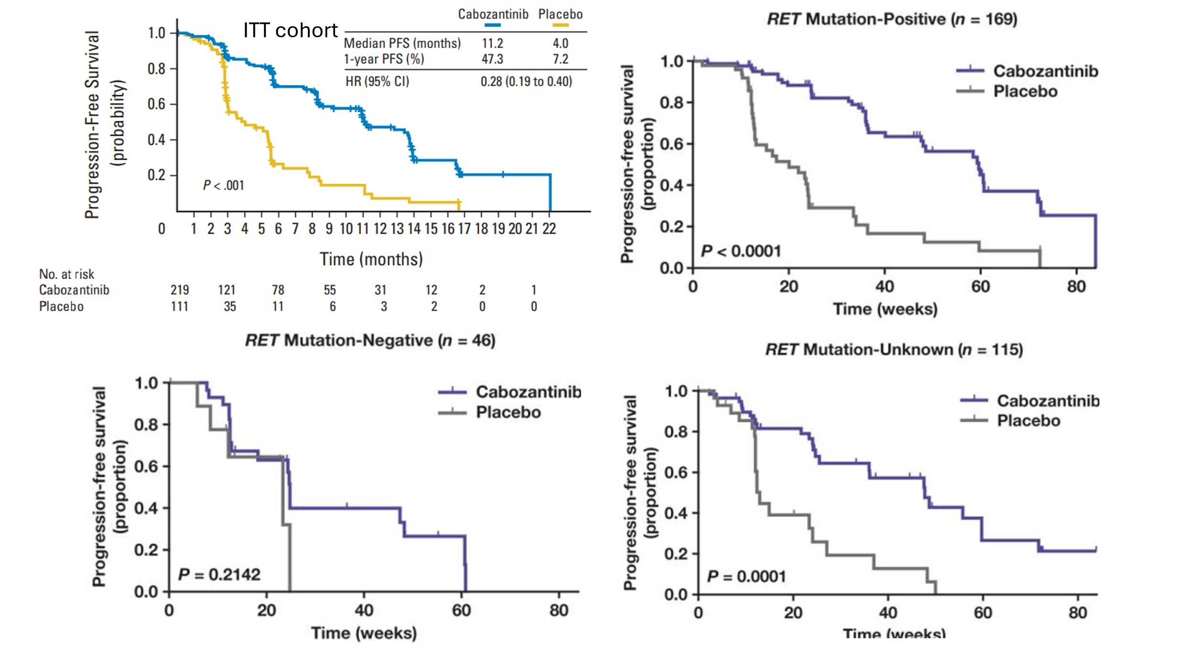
Source: Figure 2A, p5, Elisei 2013 (EXAM) and Figure 1, p5, Sherman 2016 (EXAM)
CI = confidence interval; HR = hazard ratio; ITT = intention to treat; KM = Kaplan Meier; n = number of patients; PFS = progression free survival
Figure 4: OS KM plot in EXAM ITT (DCO August 2014)
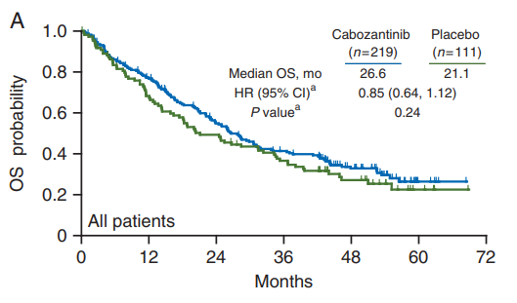
Source: Figure 1A, p3, Schlumbeger 2017
HR = hazard ratio; ITT = intention to treat; KM = Kaplan Meier; n = number of patients; OS = overall survival
ª Analyses were stratified by randomisation stratification factors
  - In LIBRETTO-531, selpercatinib demonstrated a significant PFS benefit over cabozantinib or vandetanib in the ITT (RET variant) population (hazard ratio [HR] = 0.202, 95% CI 0.128, 0.320, p<0.0001); and in EXAM cabozantinib demonstrated a significant PFS benefit over placebo in the ITT population (HR = 0.28, 95% CI 0.19, 0.40, p<0.0001) with a consistent trend observed in the RET variant subgroup (HR = 0.23, 95% CI 0.14, 0.38).
  - The observed HR for death from any cause in LIBRETTO-531 was 0.275 with wide confidence intervals (95%CI: 0.124, 0.608) due to low event rates. In EXAM, no significant OS difference was observed (ITT HR = 0.85, 95% CI 0.64, 1.12; RET variant subgroup: HR = 0.79, 95% CI 0.54, 1.17), however there was a trend in favour of the intervention arms.
  - In LIBRETTO-531, the overall response rate (ORR) was higher in the selpercatinib arm (159/193 [82.3%]) compared to the cabozantinib or vandetanib arm (43/98 [43.9%]; odds ratio [OR] = 6.0, 95% CI 3.5, 10.4); risk difference [RD] = 0.39, 95% CI 0.27, 0.50).
  - In the Bucher ITC using cabozantinib or vandetanib as the common reference, selpercatinib demonstrated improved PFS (HR = 0.05, 95% CI 0.02, 0.09) and OS (HR = 0.22, 95% CI 0.09, 0.53) compared to placebo. In EXAM, while the point estimate of the HRs for OS trended in favour of cabozantinib, a significant OS difference was not demonstrated against placebo. As such, the evaluation considered that a conservative approach of assuming no survival difference between cabozantinib/vandetanib and placebo (i.e., OS HR = 1) meant that for the indirect comparison of selpercatinib vs placebo, the OS HR would default to that observed in LIBRETTO-531 (i.e., OS HR = 0.275, 95% CI 0.124, 0.608).
  - The PSCR and Pre-PBAC response maintained that the ITC OS HR was appropriate to inform the comparative treatment effect of selpercatinib vs placebo, as there is likely a modest benefit of cabozantinib over placebo which EXAM was not powered to detect. Further, the PSCR noted that the assumption that the OS of cabozantinib is the same as placebo would disregard the ITC analysis, resulting in a naïve indirect comparison of selpercatinib to placebo. The ESCs considered that given the available evidence, the OS estimate from EXAM was uncertain and assuming a survival difference in EXAM to inform the ITC of selpercatinib vs placebo potentially overestimated the OS benefit of selpercatinib.
  - The evaluation and the ESCs considered the ITC results alongside transitivity concerns:
- The magnitude of benefit was potentially overestimated given that a higher proportion of patients from EXAM had metastatic disease (86.9% [287/330] vs 76.9% [224/291]), received prior systemic therapies (38.7% [128/330] vs 2.1% [6/291]) and prior radiotherapy (49.1% [162/330] vs 33.3% [97/291]) compared to LIBRETTO-531 (see paragraph 6.12).
- The issues pertaining to OS from LIBRETTO-531 carried through to the ITC results (i.e., immature OS data, crossover to selpercatinib, and continued treatment with selpercatinib beyond disease progression. See paragraphs 6.13 and 6.22).
  - LIBRETTO-531 and EXAM included more patients with metastatic disease compared to patients expected in clinical practice (76.9-86.9% in trials vs 9% at presentation [Papachristos 2023] and 52% at recurrence [Kesby 2022], see paragraph 4.3).

Comparative harms
  - A summary of safety results in LIBRETTO-531 and EXAM (safety analysis sets) is presented in Table 7.
Table 7: Summary of safety results LIBRETTO-531 and EXAM (SAS)
 | LIBRETTO-531 |  | EXAM
AE | SELP  (N=193) | CABO/VAND (N=97) | CABO  (N=214) | PBO  (N=109)
Any TEAE | 192 (99.5) | 96 (99.0) | 214 (100) | 104 (95)
Treatment related | 178 (92.2) | 95 (97.9) | NR | NR
Grade ≥3 TEAE | 119 (61.7) | 79 (81.4) | 167 (78) | 36 (33)
Treatment related | 84 (43.5) | 71 (73.2) | NR | NR
Any SAE | 59 (30.6) | 33 (34.0) | 113 (53) | 26 (24)
Treatment related | 18 (9.3) | 17 (17.5) | NR | NR
AE leading to treatment discontinuation | 11 (5.7) | 30 (30.9) | 49 (23) | 10 (9)
Treatment related | 5 (2.6) | 25 (25.8) | NR | NR
SAE leading to treatment discontinuation | 7 (3.6) | 10 (10.3) | NR | NR
Treatment related | 2 (1.0) | 6 (6.3) | NR | NR
Deaths | 10 (5.2) | 16 (16.5) | 141 (65.8) | 77 (70.6)
Deaths due to AE on treatment | 5 (2.6)ª | 3 (3.1)^{b} | NR^{c} | NR^{c}
Death due to study disease | 1 (0.5) | 3 (3.1) | NR | NR
Grade ≥3 TEAE
Hypertension | 41 (21.2) | 17 (17.5) | 19 (8.9) | 0 (0)
ALT increased | 21 (10.9) | 2 (2.1) | 11 (5.1) | 2 (1.8)
Electrocardiogram QT prolonged | 11 (5.7) | 3 (3.1) | NR | NR
AST increased | 10 (5.2) | 3 (3.1) | 4 (1.9) | 0 (0)
Fatigue | 7 (3.6) | 5 (5.2) | 21 (9.8) | 3 (2.8)
Diarrhoea | 6 (3.1) | 11 (11.3) | 46 (21.5) | 2 (1.8)
Hypocalcaemia | 3 (1.6) | 7 (7.2) | 23 (10.7) | 0 (0)
Hypokalaemia | 2 (1.0) | 6 (6.2) | NR | NR
Nausea | 2 (1.0) | 5 (5.2) | 4 (1.9) | 0 (0)
Weight decreased | 1 (0.5) | 6 (6.2) | 21 (9.8) | 0 (0)
Asthenia | 1 (0.5) | 5 (5.2) | 14 (6.5) | 2 (1.8)
Decreased appetite | 1 (0.5) | 5 (5.2) | 15 (7.0) | 1 (0.9)
Mucosal inflammation | 1 (0.5) | 12 (12.4) | 7 (3.3) | 0 (0)
Palmar-plantar erythrodysaesthesia syndrome | 0 | 8 (8.2) | 27 (12.6) | 0 (0)
Source: Table 2-24 and Table 2 25, p92 (LIBRETTO-531) and Table 2-28, p96 (EXAM) of the submission; Table 16, p58, Table 18, p51, Table 19, p51, Table 20, p63, NICE TA516 Assessment Report (EXAM); RD analyses conducted during the evaluation
AE = adverse event; ALT = alanine transaminase; CABO = cabozantinib; CI = confidence interval; n = number of participants reporting data; N = total participants in group; NE = not evaluable; NR = not reported; PBO = placebo; RD = risk difference; SAE = serious adverse event; SAS = safety analysis set; SELP = selpercatinib; TEAE = treatment emergent adverse event; VAND = vandetanib
ª 5 deaths in selpercatinib arm due to diabetic ketoacidosis (1), COVID 19 (1), multiple organ dysfunction syndrome (1), pneumonia (1) and sudden death (1). One death was related to treatment (not reported which one).
^{b} 3 deaths in cabozantinib/vandetanib arm due to cholangitis (1), haemorrhage (1), sudden death (1).
^{c} values not reported but the NICE TA516 Assessment Reported stated that “treatment related remaining at 4 5% for cabozantinib and 1% for placebo at both the interim and final analysis”
Note:
Grey shaded cells indicates the treatment arms used in the ITC of AEs
The AE for EXAM were from NICE TA516 as these were not reported in the publications. The NICE TA516 Assessment Report noted these were from the respective CSRs at the latest DCOs
The ITC of selpercatinib and placebo was based on the RD from LIBRETTO-531 (selpercatinib vs cabozantinib/vandetanib) compared to the RD from EXAM (placebo vs cabozantinib). A RD <0 favoured selpercatinib.
Data cutoff dates and median follow up duration
- LIBRETTO-531 DCO March 2024, median follow up for safety NR
- EXAM DCO August 2014, minimum follow up 42 months
  - The evaluation and the ESCs considered that selpercatinib appeared to have a more favourable safety profile compared to cabozantinib and vandetanib (62% vs 81% grade 3 AEs, respectively). The ESCs noted that selpercatinib toxicity was driven by hypertension and ALT increase, whereas cabozantinib/vandetanib toxicity was driven by diarrhoea. The ESCs considered that prolonged QT, associated with selpercatinib, is clinically significant (5.7% grade 3 AEs), but that can be monitored easily in practice.
  - The ESCs noted that selpercatinib had a less favourable safety profile compared to placebo (62% vs 33% grade 3 AEs, respectively).

Benefits/ harms
  - A summary of the comparative benefits and harms for selpercatinib vs cabozantinib or vandetanib based on direct evidence from LIBRETTO-531 is presented in Table 8. The ESCs noted that neither cabozantinib nor vandetanib are available on the PBS for this indication.

Table 8: Summary of comparative benefits and harms for selpercatinib and cabozantinib or vandetanib based on
direct evidence (LIBRETTO-531 ITT [RET variant])
Benefits
Event | Selpercatinib (N=193) | Cabozantinib or vandetanib (N=98) | Absolute Difference | HR (95% CI)
Progression free survival (median duration of follow up PFS 17ª – 22^{b} months)
Progressed or died, n (%) | 34 (17.6) | 47 (48.0) | - | 0.202  (0.128, 0.320)
Median PFS, months (95% CI) | Not reached (35.8, NE) | 13.9 (12.2, 19.5) | NE | 0.202  (0.128, 0.320)
% not progressed at 12 months (95% CI) | 90.5 (85.1, 94.0) | 63.9 (51.8, 73.7) | 27% | 0.202  (0.128, 0.320)
% not progressed at 24 months (95% CI) | 81.5 (74.0, 87.0) | 32.5 (20.6, 44.9) | 49% | 0.202  (0.128, 0.320)
Overall survival (median duration of follow up 25 months)
Deaths, n/N (%) | 10 (5.2) | 16 (16.3) | - | 0.275  (0.124, 0.608)
Median OS, months (95% CI) | Not reached | Not reached | NE | 0.275  (0.124, 0.608)
% Alive at 12 months (95% CI) | 97.9 (94.5,99.2) | 92.4 (84.8,96.3) | 5.5% | 0.275  (0.124, 0.608)
% Alive at 24 months (95% CI) | 95.2 (90.5,97.6) | 85.4 (75.4,91.5) | 9.8% | 0.275  (0.124, 0.608)
Harms
 | Selpercatinib  n/N | Cabozantinib or vandetanib n/N | Event rate/100 patients^{c} |  | RD  (95% CI)
 | Selpercatinib  n/N | Cabozantinib or vandetanib n/N | Selpercatinib | Cabozantinib or vandetanib | RD  (95% CI)
Grade ≥3 TEAE | 119/193 | 79/97 | 61.7 | 81.4 | -19.8 (-30.1, -9.4)
AE leading to treatment discontinuation | 11/193 | 30/97 | 30.6 | 73.2 | -25.2 (-35.0, -15.5)
ALT increase | 21/193 | 2/97 | 10.9 | 2.1 | 8.8 (3.6, 14.0)
Diarrhoea | 6/193 | 11/97 | 3.1 | 11.3 | -8.2 (-15.0, -1.5)
Source: Table 2-24, p92 of the submission (LIBRETTO-531)
AE = adverse event; ALT = alanine transaminase; CI = confidence interval; HR = hazard ratio; NE = not evaluable; OS = overall survival; PFS = progression free survival; RD = risk difference; TEAE = treatment emergent adverse event
ª Cabozantinib / vandetanib arm
^{b} Selpercatinib arm
^{c} Over trial period of 45 months (median safety follow up not reported)
Notes:
Only AEs that had RDs excluding zero were presented
RD calculations were based on indirect comparison of RDs using cabozantinib or vandetanib as the common reference
  - On the basis of direct evidence presented by the submission, for every 100 patients treated with selpercatinib in comparison with cabozantinib or vandetanib:
- Approximately 27 additional patients would be progression-free at 12 months.
- Approximately 49 additional patients would be progression-free at 24 months.
- Approximately 20 fewer patients would experience grade ≥3 TEAE.
- Approximately 25 fewer patients would experience an AE leading to discontinuation of treatment.
- Approximately 8 fewer patients would experience grade ≥3 diarrhoea.
- Approximately 9 additional patients would experience liver toxicity as measured by a grade ≥3 increase in ALT.
  - A benefits and harms table is not presented for the indirect comparison of selpercatinib (LIBRETTO-531) and placebo (EXAM).

Clinical claim
  - The submission’s primary clinical claim described selpercatinib as superior in terms of effectiveness and inferior but manageable in terms of safety compared to placebo (as a proxy for BSC) based on indirect evidence using cabozantinib or vandetanib as the common reference. This claim was predicated on the submission’s secondary clinical claim that described selpercatinib as superior in terms of effectiveness and noninferior in terms of safety against cabozantinib or vandetanib based on direct evidence from LIBRETTO-531.
  - The evaluation and the ESCs considered that the primary clinical claim of selpercatinib vs placebo (as a proxy for BSC) was adequately supported, but the magnitude of effect was overestimated, since:
- A less favourable OS HR was assumed for the placebo arm in the ITC despite the fact that cabozantinib did not demonstrate a significant OS difference against placebo in EXAM (see paragraph 6.21).
- EXAM included a higher proportion of patients with metastatic disease, prior systemic therapies, and prior radiotherapy compared to patients in LIBRETTO-531 (see paragraph 6.23).
- The selpercatinib PFS and OS HRs from LIBRETTO-531 were potentially overestimated since the cabozantinib or vandetanib arm included a higher proportion of patients with metastatic disease and prior radiotherapy compared to the selpercatinib arm (see paragraph 6.12).
- The selpercatinib OS HR from LIBRETTO-531 was confounded, as patients in the selpercatinib arm could continue treatment beyond disease progression, though this was considered alongside crossover from cabozantinib/ vandetanib to selpercatinib (paragraph 6.13). In addition, the interpretation of the OS HR was limited by immature data.
  - The ESCs noted that even with the PSCR-proposed changes to the requested PBS population to reflect the population from LIBRETTO-531 (i.e. documented disease progression), there may be reduced generalisability to Australian clinical practice, since there may be a lower proportion of patients with metastatic disease in practice (see paragraph 6.24).
  - The evaluation and the ESCs considered that the secondary effectiveness claim versus cabozantinib/ vandetanib was adequately supported based on the LIBRETTO-531 trial, noting that:
- A PFS benefit for selpercatinib vs cabozantinib/ vandetanib with a hazard ratio (HR) of 0.202 (95% confidence interval (CI): 0.128, 0.320).
- An OS benefit for selpercatinib (HR 0.275), with wide confidence intervals (95% CI: 0.124, 0.608) due to the data immaturity (<10% events), and considered the magnitude of the OS benefit was highly uncertain. The Pre-PBAC response noted that median OS is not expected to be reached in the selpercatinib arm for a number of years, and considered that it would be unethical to delay treatment during this time.
  - The evaluation and the ESCs considered the claim that selpercatinib was inferior in terms of safety compared to placebo, was reasonable.
  - The evaluation and the ESCs considered that the secondary claim that selpercatinib was noninferior in terms of safety compared to cabozantinib or vandetanib was also reasonable.
  - The PBAC considered that the claim of superior comparative effectiveness compared to placebo (as a proxy for BSC) was reasonable. The claim was adequately supported by the data for PFS (clinically meaningful improvement with moderate certainty) and OS, however the magnitude of OS benefit was highly uncertain.
  - The PBAC considered that the secondary claim of superior comparative effectiveness versus cabozantinib/ vandetanib was adequately supported based on the LIBRETTO-531 trial.
  - The PBAC considered that the claim of inferior comparative safety compared to BSC was reasonable. The PBAC considered that the term ‘manageable’ was not informative.
  - The PBAC considered that the secondary claim of noninferior comparative safety compared to cabozantinib or vandetanib was reasonable.

Claim of codependence
  - The prognostic evidence presented by the submission (Elisei 2008) suggested that RET variant was associated with lower OS (approximately 75% alive at 10 years in the RET variant group vs 100% in the RET wildtype group). A similar association was also observed in Ciampi 2019. However, the evaluation considered that this may also be related to the fact that RET variants were correlated with more advanced disease at diagnosis rather than poorer prognosis from baseline, but noted that the evidence to suggest RET variant patients had worse prognosis than RET wildtype at baseline was insufficient. With selective RET inhibitors and MKIs available in the current treatment landscape, any potential differences in survival between RET variants and its complement may be less apparent than in the past based on Shirali 2024. , ,
  - The evaluation noted there was evidence of improved efficacy with selpercatinib in advanced or metastatic MTC patients who have a documented RET variant when compared to cabozantinib or vandetanib (LIBRETTO-531) and BSC (LIBRETTO-531 vs EXAM). However, no evidence was presented in the submission and no trials were identified by the evaluation that examined efficacy (or safety) outcomes for selpercatinib treatment in patients with RET wildtype to inform whether RET variant was a treatment effect modifier. The evaluation and the ESCs considered that the claim of co-dependency was not directly supported by the presented evidence, but there may be a biological rationale for targeting RET with selpercatinib (see paragraph 4.7). Of note, the TGA approved selpercatinib for treatment in patients with a RET variant (see paragraph 2.1), and the NCCN and ESMO guidelines note preference for selective RET inhibitors in RET variant MTC (see paragraph 5.2).

Economic analysis
  - The submission presented a modelled economic evaluation, based on an indirect comparison of selpercatinib and BSC in a population of patients with advanced or metastatic MTC who have a confirmed RET variant.
  - The type of economic evaluation presented was a cost utility analysis (CUA).

Table 9: Summary of model structure, key inputs and rationale
Component | Description | Justification/comments
Comparison modelled | RET variant testing and treatment with selpercatinib compared to no RET variant testing and treatment with BSC in stage III/IV MTC patients with a RET variant. | It was acknowledged that testing costs were applied in this manner to represent the testing scenario in absence of test sensitivity/specificity parameters.
Outcomes | LYG, QALYs gained | Reasonable.
Time horizon | 25 years vs trial period of 45 months in LIBRETTO-531. | A time horizon of 25 years based on 45 months of trial data may not be reasonable.
Methods used to generate results | Partitioned survival model (PF, PD, and death) using Excel. | Reasonable.
Cycle length | Weekly cycle length
Test parameters | No test accuracy parameters were included in the base case. A once off cost of $1,189 per RET variant identified was applied in the selpercatinib arm based on the NNT (2.92) and proposed MBS fee ($400). NNT was estimated based on the proportion of MTC patients diagnosed or progressed to stage III/IV disease (85%), the proportion with progressive and symptomatic disease (57.22%) and the proportion of MTC with a RET variant (70%). | For consistency with the test population (patients diagnosed with MTC i.e., irrespective of stage of disease or progression status), the NNT should be estimated from the proportion of MTC expected to have a RET variant (i.e., 1/70% = 1.43). NNT was not a key driver in the model.
Implications of false positive and false wildtype results | Assumed 100% sensitivity and 100% specificity. | Test parameters were not considered in the model. The ESCs considered this was reasonable.
Allocation to health states | LIBRETTO-531 informed the transitions in the selpercatinib arm. A HR approach was adopted to inform the transitions in the BSC arm based on the ITC of LIBRETTO-531 (ITT; RET variant) and EXAM (RET variant subgroup). | The OS HR from the ITC was not appropriate since there was no significant OS difference observed between cabozantinib and placebo in the EXAM trial. The OS HR from LIBRETTO-531 was more appropriate but was also associated with uncertainties.
Extrapolation method | No KM data was used in the model. Parametric models were fitted to the selpercatinib arm to extrapolate PFS and OS based on visual fit, statistical fit, and clinical plausibility. OS extrapolation was selected based on an arbitrary decision that if survival at 25 years was >32% the extrapolation was not clinically plausibleª PFS was extrapolated using the Weibull function and OS was extrapolated using the Spline knot 3 function. ToT in the selpercatinib arm was assumed to equal PFS. BSC was modelled by applying the inverse PFS HR (0.05) and OS HR (0.22) derived from the ITC to the selpercatinib arm. No convergence was assumed. | OS, ToT, and PFS modelling were key drivers of the model.
Health related quality of life | Utility values for PF and PD health states were informed from LIBRETTO-531 EQ 5D 5L index score using Australian tariffs (Norman 2023). PF = 0.8839 and PD = 0.8672. | The PD utility (0.8672) was informed by 61/291 patients from LIBRETTO-531 and was potentially biased.
Selpercatinib costs | The submission assumed the following dose reductions for selpercatinib based on 141 patients:  - Tx cycle 1 = 98.45% 160 mg BID, 0.52% 120 mg BID, and 1.04% 80 mg BID  - Tx cycle 2 onwards = 4% 160 mg BID, 49.33% 120 mg BID, 41.33% 80 mg BID, and 5.33% 40 mg BID  Dose re-escalations and dose omissions were not incorporated. | Over 90% of patients had dose reductions after treatment cycle 2 in the model which was considerably greater than the dose reductions reported in LIBRETTO-531 (46%). This was corrected in the PSCR (see paragraph 6.66). Dose re-escalations were also not considered. Selpercatinib treatment costs were potentially underestimated, but this may be partially offset given the absence of dose omissions.
Source: Sections 3.2 to 3.5 of the submission
BID = twice daily; BSC = best supportive care; EQ 5D 5L = EuroQoL 5 Dimension 5 level; HR = hazard ratio; ICER = incremental cost effectiveness ratio; ITT = intention to treat; LYG = life year gained; MTC = medullary thyroid cancer; NNT = number needed to treat; OS = overall survival; PD = progressed disease; PF = progression free; PFS = progression free survival; QALY = quality adjusted life year gained; ToT = time on treatment; Tx = treatment
ª 32% was half of the general population survival after 25 years in patients aged 54 years

  - The submission adopted a 3-health state partition survival model: progression free (PF), progressed disease (PD), and death. Locally advanced or metastatic MTC patients with a RET variant initiated in the PF health state and received either selpercatinib or BSC. After each weekly cycle, patients either remained in the PF health state or transitioned to the PD health state as per RECIST v1.1 defined disease progression, or died based on the background all-cause mortality rate (absorbing health state). Patients in the PD health state either remained or died. Patients in the PF health state were assumed to have stable or not actively progressing disease, experienced PF utilities, and incurred treatment and disease management costs. Patients in the PD health state experienced PD utilities and incurred disease management costs. Terminal care costs were incurred upon death. AE management (grade ≥3) costs and disutilities were incurred in both treatment arms once off in the first cycle, and were informed by the LIBRETTO-531 and EXAM trials.
  - The modelled OS for the selpercatinib arm was extrapolated using the Spline knot 3 function, and the BSC arm was informed by adopting the HR approach and applying the inverse OS HR derived from the ITC to the selpercatinib arm (i.e., 1/0.22) (Figure 5).
Figure 5: Base case OS curve in selpercatinib (Spline knot 3) and BSC (OS HR = 0.22)
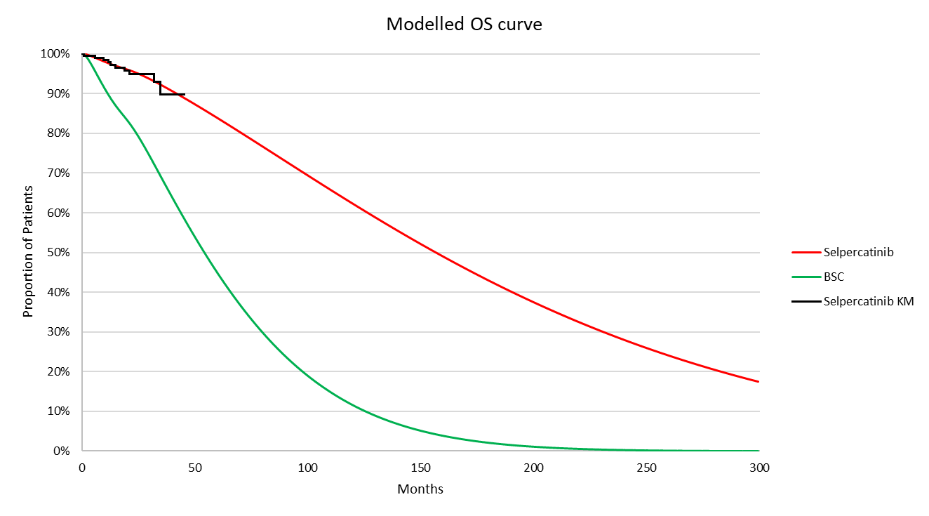
Source: ‘Survival’ worksheet from the economic model
BSC = best supportive care; HR = hazard ratio; KM = Kaplan Meier; OS = overall survival
Notes:
The inverse OS HR was applied in the model (i.e., 1/0.22 = 4.55).
  - The submission’s choice of extrapolation was primarily based on clinical plausibility. The submission stated that an extrapolation was not considered plausible if the proportion of patients alive at 25 years exceeded 32%, as this was half of the general population survival after 25 years given the average Australian patient age of 54 years (65%). The ESCs noted that the exponential curve was the best statistical fit (based on AIC/BIC), but implausibly resulted in 51% of patients alive after 25 years. Only the Gompertz, Spline knot 2, and Spline knot 3 functions fit this criterion of which the submission considered the Spline knot 3 was the most conservative and plausible estimate of survival at 25 years (Table 10). The ESCs noted there is very little KM data available to inform the appropriate extrapolation.
Figure 6: OS extrapolations – selpercatinib arm
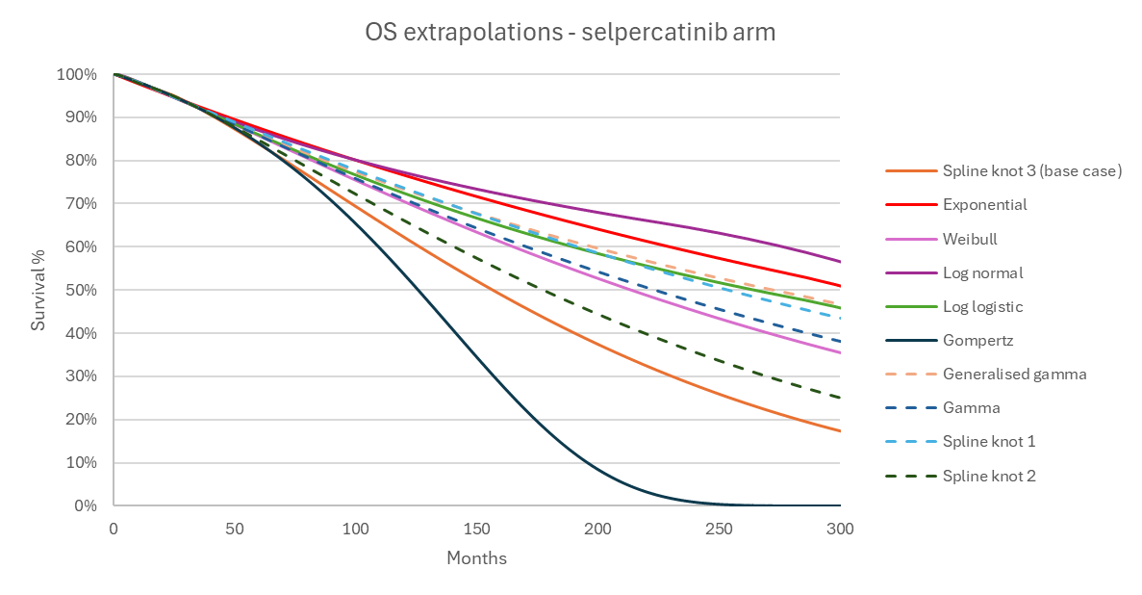Source: constructed during the evaluation
OS = overall survival
  - The evaluation considered that the submission’s arbitrary threshold for selecting clinically plausible extrapolations did not appear externally valid with survival estimates from the literature. The base case OS extrapolation (Spline knot 3) estimated there were 17% and 0% of patients alive at 25 years in the selpercatinib and the BSC arm, respectively (of note, all patients in the BSC arm died after approximately 17 years, or 200 months). This was considerably lower compared to estimates from local studies, for example, Kesby 2022 reported approximately 30% of stage III/IV MTC patients were alive after 25 years, acknowledging that this sample included a mixed cohort of indolent and progressive disease. These lower survival estimates were similarly observed even when the OS extrapolation was varied, which led to 25 year survival ranging from 0% to 57% in the selpercatinib arm and 0% and 10% in the BSC arm. The PSCR contended that the selection of clinically plausible extrapolations was based on the gilteritinib November 2021 PSD, which stated that the “economic model, from 2 years to 40 years, OS was informed by general population mortality adjusted using a standardised mortality rate of 2.0”. However, the ESC noted the 2021 PBAC consideration of gilteritinib was for the treatment of relapsed or refractory acute myeloid leukaemia (AML), and it was unclear how the standardised morality ratio (2) in AML was generalisable to the MTC setting.
  - The ESCs considered that while Spline knot 3 appeared to be a conservative extrapolation option, the low event rate (<10%) in the LIBRETTO-531 trial meant there was a very high risk that the available data will not predict future events.

Table 10: 25 year survival in the selpercatinib arm, and BSC arm varying the OS HR and OS extrapolation
OS extrapolation | % Alive at 25 years
OS extrapolation | Selpercatinib | BSC
OS extrapolation | Selpercatinib | OS HR = 0.22ª (base case) | OS HR = 0.275^{b} (LIBRETTO-531) | OS HR = 0.608^{c}  (Upper 95% CI LIBRETTO-531)
Exponential | 51% | 5% | 8.9% | 33.4%
Weibull | 36% | 1% | 2.3% | 18.3%
Log normal | 57% | 10% | 15.4% | 42.3%
Log logistic | 46% | 3% | 6.0% | 28.1%
Gompertz | 0% | 0% | 0% | 0%
Gamma | 47% | 3% | 0% | 20.5%
Generalised gamma | 38% | 1% | 6.4% | 28.8%
Spline/knot=1 | 44% | 2% | 4.9% | 25.5%
Spline/knot=2 | 25% | 0% | 0.7% | 10.3%
Spline/knot=3 | 17% | 0% | 0.2% | 5.6%
Source: constructed during the evaluation using Table 3-5 of the submission and the economic model
BSC = best supportive care; CI = confidence interval; HR = hazard ratio; OS = overall survival
ª the inverse HR was applied 1/0.22 = 4.55
^{b} the inverse HR was applied 1/0.275 = 3.64
^{c} the inverse HR was applied 1/0.608 = 1.64
Notes:
Bold text indicates the submission’s base case
Grey shaded cells indicate functions that generated 25 year survival estimates similar to Kesby 2022 (~30%)
  - The evaluation considered that assuming a more conservative OS HR to inform the BSC arm may improve the generalisability of survival estimates to the requested population. As presented in Table 10, the evaluation compared modelled survival estimates after 25 years assuming the OS HR was informed by:
- the base case (0.22);
- the LIBRETTO-531 OS HR point estimate (0.275). Applying the LIBRETO-531 point estimate OS HR (0.275, i.e., assuming that cabozantinib OS = placebo OS) increased the ICER by +redacted content% (maintained Spline Knot 3).
- the LIBRETTO-531 OS HR upper 95% CI (0.608). Noting that LIBRETTO-531 was not powered to detect a statistically significant difference in OS, the evaluation considered that the OS HR upper 95% CI (0.608) might be considered as a worst case scenario, and this increased the ICER by +redacted content% (maintained Spline Knot 3 OS extrapolation The PSCR argued that application of a “worst case” OS estimate based on the upper bound CI value is poorly justified and inconsistent with international standards for HTA methodologies.
  - Overall, the evaluation considered that the base case modelled OS using the ITC OS HR (0.22) was uncertain, since: the OS inputs to the ITC were not statistically significant; EXAM potentially included more patients with worse prognosis compared to LIBRETTO-531 (see paragraph 6.23); and the survival estimates lacked external validity to the requested population expected in clinical practice. As such, the evaluation considered that the incremental benefit of selpercatinib vs BSC was potentially overestimated in the model. The evaluation considered that assuming a conservative OS modelling approach (e.g., applying the LIBRETTO-531 OS HR upper 95% CI of 0.608) potentially improved the generalisability of survival estimates to the requested population. The OS HR was a key driver of the model.
  - The base case PFS curve for the selpercatinib arm was extrapolated using the Weibull function and the BSC arm was informed using the inverse ITC PFS HR of 0.05 (i.e., 1/0.05; Figure 7)
Figure 7: Base case PFS curve in selpercatinib (Weibull) and BSC (PFS HR = 0.05)
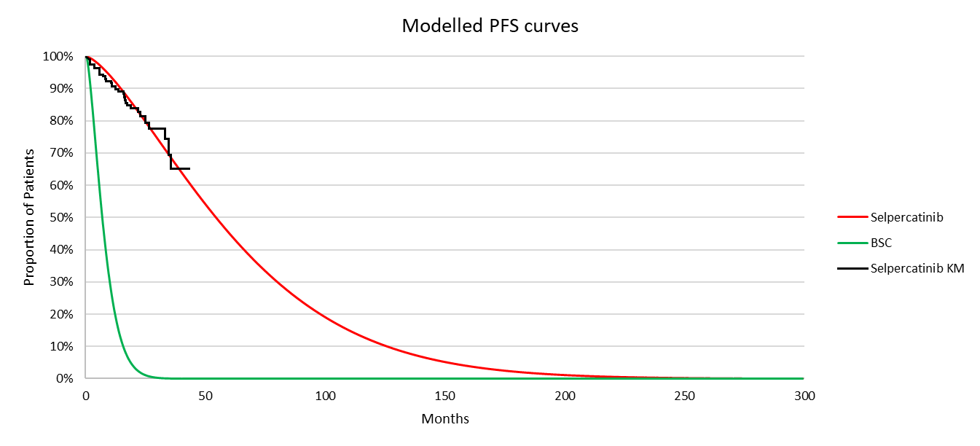
Source: ‘Survival’ worksheet from the economic model
BSC = best supportive care; HR = hazard ratio; KM = Kaplan Meier; PFS = progression free survival
Notes:
The inverse OS HR was applied in the model (i.e., 1/0.22 = 4.55)
  - The submission stated that the Weibull function was selected based on best statistical fit (lowest AIC/BIC value) and visual fit to the KM curve.
  - Patients in the BSC arm were modelled to rapidly progress (median PFS was 6.7 months, and all patients had effectively progressed by 24 months). This appeared more favourable compared to the placebo arm from EXAM (median PFS 4 months and most patients progressed by 12 months; see Figure 3), though this should be considered alongside a median follow up of 13.9 months in EXAM.
  - Varying PFS extrapolation had a moderate impact on the ICER (-redacted content% to +redacted content% changes in the ICER; see Table 15), but this was due to its indirect impact on ToT and selpercatinib treatment costs.
  - The PFS HR as informed from the ITC (0.05, 95% CI 0.02, 0.09) was potentially overestimated given that the placebo arm from EXAM had a potentially worse prognosis compared to selpercatinib in LIBRETTO-531 (see paragraph 6.23). Although, assuming a more conservative PFS HR had minimal impact on the ICER since changes to the PFS HR only impacted the BSC arm where the PF and PD utility values and costs in the BSC arm were not drivers of the model.
  - The model assumed that the ToT curve was equal to the modelled PFS curve to align with the proposed PBS listing for selpercatinib, where treatment is only continued until disease progression. The evaluation noted that in LIBRETTO-531 patients could continue treatment beyond progression if a clinical benefit was justified. The base case ToT curve (equal to the PFS extrapolated using Weibull function) is shown in Figure 8.
Figure 8: Base case ToT curve for selpercatinib (extrapolated curve was assumed equal to PFS [Weibull])
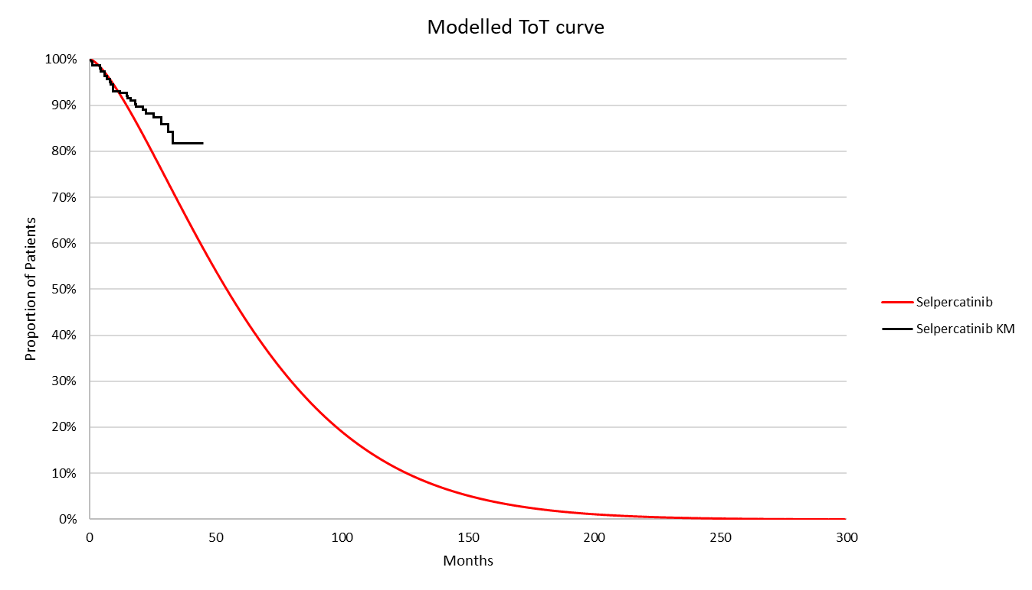
Source: ‘Survival’ worksheet from the economic model
KM = Kaplan Meier; PFS = progression free survival; ToT = time on treatment
Notes:
KM curve refers to ToT KM data from LIBRETTO-531
  - The base case estimated a mean treatment duration of 5.3 years.
  - Treatment duration in the model using different extrapolations under the assumption that ToT was dependent or independent to PFS are presented in Table 11.
Table 11: Treatment duration in the model assuming ToT dependent or independent to PFS over 25 years
Parametric model | ToT equalled PFS (years)ª | ToT independent of PFS (years)^{b}
Exponential | 8.7 | 12.4
Weibull | 5.3 (base case) | 11.7
Log normal | 8.2 | 12.2
Logistic | 7.0 | 11.7
Gompertz | 4.1 | 11.7
Gamma | 5.0 | 11.8
Generalised gamma | 4.1 | 13.0
Spline/knot=1 | 6.6 | 12.9
Spline/knot=2 | 7.0 | 13.1
Spline/knot=3 | 6.7 | 13.1
Source: extracted using ‘Survival’ and ‘Selpercatinib PartSM’ worksheets from the economic model
LY = life year; PF = progression free; PFS = progression free survival; ToT = time on treatment
ª varying PFS extrapolations
^{b} varying ToT extrapolations and assumed ToT was capped to OS to maintain plausible curves
  - Under the assumption that ToT was dependent on PFS (i.e., treated to disease progression), varying the PFS extrapolation led to mean treatment durations of 4.1 to 8.7 years (-redacted content% to +redacted content% changes in the ICER; see Table 15). However, no adjustments were made to the efficacy inputs from LIBRETTO-531, and the evaluation considered it possible that any additional survival benefit from patients who continued in the trial was maintained in the model. As such, the evaluation considered that the modelled survival was potentially overestimated relative to clinical practice. Varying the ToT extrapolations while ToT was dependent on PFS (i.e., PFS capping applied in the model) had a moderate and variable impact on the ICER (-redacted content% to +redacted content%). Alternatively, under the assumption that ToT was independent to PFS (i.e., PFS capping not applied in the model), varying the ToT extrapolation led to mean treatment durations of 11.7 to 13.1 years and increased the ICER by +redacted content% to +redacted content%. Regardless, given the applicability concerns discussed for the modelling of OS and PFS, the evaluation considered that the selpercatinib treatment duration as informed by either PFS or ToT from LIBRETTO-531 was potentially underestimated relative to the requested population. ToT was a key driver of the model due to its impact on selpercatinib treatment costs.
  - Overall, the evaluation and the ESCs considered that the modelled OS, PFS, and ToT based on LIBRETTO-531 has potentially overestimated the comparative benefit and underestimated comparative costs of selpercatinib vs BSC compared to clinical practice. The trial’s generalisability to the cohort of MTC patients with progressive and unresectable MTC in clinical practice remained unclear (see paragraph 4.5); there remained uncertainties in the OS HR estimate from LIBRETTO-531 (e.g., was not powered to detect a significant OS difference and allowed treatment beyond disease progression); and the placebo arm from EXAM had potentially worse prognosis compared to selpercatinib. As such the evaluation and the ESCs considered that the incremental benefit remained overestimated and costs underestimated but the magnitude uncertain.
  - Health state utilities were based on the EuroQoL 5 dimension 5 level (EQ 5D 5L) index score from LIBRETTO-531 mapped using Australian tariffs from Norman 2023. The submission also incorporated age-adjusted utilities based on the algorithm from Ara & Brazier 2010. Disutility due to AEs was applied once-off in the first cycle, based on AE frequencies from LIBRETTO-531 and EXAM.
  - The EQ 5D 5L questionnaire was administered to patients on day 1 of each 3 week treatment cycle prior to receiving study treatment in LIBRETTO-531. The PF health state utility was based on all patients with a post-baseline pre-progression assessment (n=275, mean utility = 0.8839) and the PD health state was based on all patients with a post-progression assessment (n=61, mean utility = 0.8672). The number of patients with post-progression assessments was relatively low (61/291 [21%]) compared to the pre-progression assessments (275/291 [95%]). The evaluation considered that this presented the potential for survivorship bias, where only patients who were well enough to complete assessments did so, and potentially explained the similarities in between the mean utility in the PD state (0.8672) and the PF state (0.8839).
  - In a hypothetical analysis that assumed the PD utility value was considerably lower (0.50) than the PF utility value (0.8839) the ICER increased by +redacted content%. This was due to favourable OS modelling of the selpercatinib arm compared to the BSC arm where there was a greater proportion of patients alive and occupying the PF and PD health states in the selpercatinib arm compared to the BSC arm. This was similarly observed when alternative utility values were applied from LIBRETTO-531 using UK tariffs (PF = 0.776, PD = 0.737; +redacted content% increase in the ICER) and Fordham 2015 (PF = 0.80, PD = 0.50; +redacted content% increase in the ICER). Fordham 2015 was a vignette study in radioactive iodine refractory differentiated thyroid cancer and was accepted in NICE TA1038 and TA1039 advanced or metastatic RET variant MTC population.
  - Selpercatinib drug costs were based on published AEMPs for the 80 mg and 40 mg strengths and the proportion of patients on each dosing regimen every 28 day treatment cycle. The model assumed that in the first treatment cycle, 98.44% of patients initiated at 160 mg twice daily (BID) (the recommended dose, see Table 1) while 0.52% and 1.04% initiated at 120 mg BID and 80 mg BID, respectively. From treatment cycle 2 onward, the submission assumed dose reductions were required to manage AEs, and that only 4.00% received 160 mg BID, 49.33% received 120 mg, 41.33% received 80 mg, and 5.33% received 40 mg (the proportions from treatment cycle 2 also informed the financial estimates; see Table 17). Treatment cycle 2 use was assumed constant until the end of the model.
  - The submission assumed that over 90% of patients had dose reductions to 120 mg, 80 mg, and 40 mg BID after treatment cycle 1, and remained constant thereafter. According to the Sponsor’s data on file provided during the evaluation, this was based on 141 patients from LIBRETTO-531. However, the evaluation could not reconcile these proportions with the other data pertaining to the dose adjustments from LIBRETTO-531, and were the proportions appeared considerably higher in comparison. In LIBRETTO-531, a total of 46.1% (89/193) patients had a dose reduction, 28% (54/193) had one dose reduction (120 mg), and 17.1% (33/193) had two dose reductions (80 mg), at the latest data cutoff (DCO) March 2024. The evaluation considered that it was not clear which proportion of dose reductions were the true values from LIBRETTO-531. The Sponsor acknowledged the dose reduction discrepancy in the PSCR, and corrected it in the economic and financial models as a revised base case (see paragraphs 6.70 and 6.91).
  - The evaluation considered that dose adjustments over time were not appropriately captured in the model, potentially underestimating selpercatinib drug costs, particularly at the early stages of the model. For example, the model assumed that most patients had dose reductions as early as 28 days after initiation of treatment, with lower dosing regimens maintained from 28 days to the 25 year time horizon. The evaluation considered this may not be reasonable, as it implies that most patients cannot tolerate the TGA recommended starting dose (160 mg BID). Furthermore, no dose re-escalations were considered, despite 10.4% (20/193) of patients doing so in LIBRETTO-531. This meant that lower treatment costs were assumed, while maintaining the benefit of treatment at higher doses from LIBRETTO-531.
  - The evaluation considered that some of this underestimation in treatment costs may be offset, given that dose omissions to manage AEs were also not considered in the model. In LIBRETTO-531, 67.9% (131/193) had a dose omission with a median duration of 21 days at the March 2024 DCO.
  - Assuming the dose reductions from treatment cycle 2+ according to LIBRETTO-531 increased the ICER by +redacted content%, and additionally assuming dose reductions occurred after 12 months increased the ICER by +redacted content%, (see Table 15). The model was not built to incorporate more gradual dose reductions over time, though the magnitude of dose reductions was a stronger driver of the ICER than the time at which it occurred.
  - The PSCR provided an updated economic analysis as a revised base case, with corrected dose-reduction assumptions from cycle 2+ based on LIBRETTO-531, resulting a redacted content% increase in the ICER ($95,000 to < $115,000/QALY gained).
  - The submission applied a once-off cost of $1,189 per RET variant patient identified to the selpercatinib arm in the first cycle. This was based on the proposed MBS fee of $400 per test, and NNT of 2.97, which was incorrectly calculated. The NNT of 2.97 assumed that testing was in MTC patients with stage III/IV MTC with progressive and symptomatic disease, but this did not capture the proposed test population (i.e., all patients diagnosed with MTC). Based on the submission’s inputs, the evaluation calculated the NNT as 2.92, resulting in a cost of $1,169 per RET variant identified.
  - The key drivers of the model are presented in Table 12.
Table 12: Key drivers of the model
Description | Method/Value | Impact  Base case: $redacted content¹/QALY gained
OS modelling | Base case extrapolated the selpercatinib arm using Spline knot 3 function and the BSC arm adopted the HR approach and applied the inverse ITC OS HR 0.22 to the selpercatinib arm.  The OS HR was uncertain and potentially overestimated in favour of selpercatinib (e.g., OS inputs into the ITC were not statistically significant, worse performing placebo arm in EXAM). In addition, the model as informed by LIBRETTO-531 did not generate survival estimates that were generalisable to the requested population. | High, favours selpercatinib  Assuming the OS HR informing the BSC arm was based on the OS HR from LIBRETTO-531 (0.275) and varying the OS extrapolation increased the ICER by +redacted content% to +redacted content%  Assuming the OS HR informing BSC arm was the OS HR upper 95% CI (0.608) from LIBRETTO-531 and varying the OS extrapolation increased the ICER by +redacted content% to +redacted content%.
ToT modelling | ToT assumed equal to the PFS curve (Weibull).  LIBRETTO-531 represented patients who progress and die faster than patients that would be eligible under the requested restriction hence potentially overestimated treatment discontinuation in the model. | High, favours selpercatinib  Varying the selpercatinib PFS extrapolation (which impacts ToT) led to -redacted content% to +redacted content% change in the ICER.  Assuming ToT was independent of PFS and varying the ToT extrapolations increased the ICER by +redacted content% to +redacted content%.
Source: Section 3.3 and Section 3.5 of the submission
BSC = best supportive care; BID = twice daily; HR = hazard ratio; ICER = incremental cost effectiveness ratio; ITC = indirect treatment comparison; OS = overall survival; PFS = progression free survival; QALY = quality adjusted life year; ToT = time on treatment.
The redacted value corresponds to the following range:
¹ $55,000 to < $75,000
  - The results from the stepped economic evaluation are presented in Table 13.
Table 13: Results of the stepped economic evaluation (discounted)
Step and component | Selpercatinib | BSC | Increment
Step 1: quasi trial based analysis per LY gained, 45 month time horizon
Costs | $redacted content | $21,191 | $redacted content
LYG | 3.259 | 2.771 | 0.488
Incremental cost/extra LY gained |  |  | $redacted content¹/LYG
Step 2: cost per LY gained over 25 year time horizon
Costs | $redacted content | $41,744 | $redacted content
LYG | 9.260 | 4.385 | 4.875
Incremental cost/extra LY gained |  |  | $redacted content²/LYG
Step 3: cost per QALY gained over 25 year time horizon
Costs | $redacted content | $41,744 | $redacted content
QALYs gained | 7.845 | 3.757 | 4.088
Incremental cost/extra QALY gained |  |  | $redacted content²/QALY gained
Revised in PSCR to correct dose reductions |  |  | $redacted content³/ QALY gained
Source: Table 3-22, p144 of the submission; ‘Deterministic Results’ worksheet from the economic model
BSC = best supportive care; LYG = life years gained; QALYs = quality adjusted life years
Notes:
Results are discounted
The redacted values correspond to the following ranges:
¹ $355,000 to < $455,000
² $55,000 to < $75,000
³ $95,000 to < $115,000

  - The disaggregated results are shown in Table 14:
Table 14: Disaggregated results (discounted), as presented in the submission
Resource item | Selpercatinib | BSC | Increment | % of total incremental
Costs
Drug acquisition | $redacted content | $0 | $redacted content | redacted content%
RET variant testing | $1,189 | $0 | $1,189 | 0%
Disease management | $11,836 | $5,686 | $6,150 | redacted content%
AE management | $3,210 | $1,035 | $2,175 | redacted content%
Terminal care | $22,142 | $35,022 | -$12,881 | -redacted content%
Total | $redacted content | $41,744 | $redacted content | 100%
LYG
PF | 4.433 | 0.644 | 3.789 | 78%
PD | 4.827 | 3.742 | 1.085 | 22%
Total | 9.260 | 4.385 | 4.875 | 100%
QALYs gained
PF | 3.857 | 0.566 | 3.290 | 80%
PD | 3.988 | 3.191 | 0.798 | 20%
Total | 7.845 | 3.757 | 4.088 | 100%
Source: ‘Deterministic Results’ worksheet from the economic model
AE = adverse event; BSC = best supportive care; LYG = life year gained; PD = progressed disease; PF = progression free; QALY = quality adjusted life year
  - The Markov traces for the selpercatinib and BSC arms are shown in Figure 9 and Figure 10.
Figure 9: Markov trace - selpercatinib
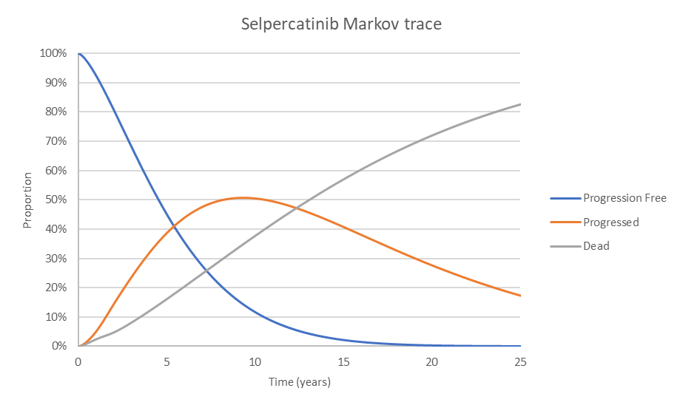
Source: ‘Markov trace’ worksheet from the economic model
Figure 10: Markov trace - BSC
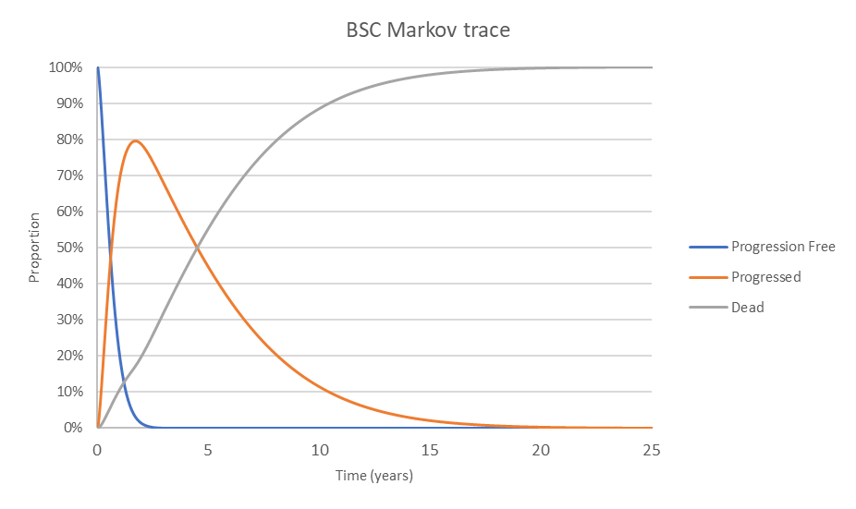
Source: ‘Markov trace’ worksheet from the economic model
BSC = best supportive care
  - The incremental benefits were driven by OS modelling that was favourable to the selpercatinib arm, where benefits were driven by extended occupation of both the PF (4.433 LYG, 3.857 QALYs gained) and PD states (4.827 LYG, 3.988 QALYs gained) over the 25 year time horizon. In comparison, most patients in the BSC arm experienced progression by year 2, and were modelled to die thereafter (PD state: 3.742 LYG, 3.191 QALYs gained; PF: 0.644 LYG, 0.566 QALYs gained). The model assumed selpercatinib continued to provide a survival benefit in the later stages of the model, despite the median modelled ToT being approximately 50 months (~4 years), which the evaluation considered was highly uncertain (undiscounted LYG of 8.5 years).
  - The incremental costs were driven by selpercatinib drug acquisition costs ($255,000 to < $355,000, as presented in the submission). RET variant testing costs as captured by the once-off cost per RET variant identified ($1,189) was not a driver in the model.
  - The results of key univariate and multivariate sensitivity analyses are summarised in Table 15. The ESCs considered that the wide ranging ICERs across the various scenarios illustrate the significant uncertainties and lack of robustness associated with the model.

Table 15: Sensitivity analyses
Analysis |  | Inc QALY | Inc cost ($) | ICER ($/QALY) | %Δª
Submission Base case |  | 4.088 | $redacted content | $redacted content¹ | -
Sensitivity and scenario analyses
 | Time horizon (base case: 25 years)
1 | 20 years | 3.796 | $redacted content | $redacted content² | +redacted content%
2 | 30 years | 4.232 | $redacted content | $redacted content¹ | -redacted content%
 | Discount rate (base case: 5%)
3 | 0% | 7.052 | $redacted content | $redacted content³ | -redacted content%
4 | 3.5% | 4.761 | $redacted content | $redacted content¹ | -redacted content%
 | ToT curves (base case: use PFS [Weibull])
5 | No PFS capping + ToT extrapolation = Weibull | 4.088 | $redacted content | $redacted content⁴ | +redacted content%
 | OS extrapolation in selpercatinib arm (base case: Spline knot 3)
6 | Log logistic | 4.590 | $redacted content | $redacted content¹ | -redacted content%
7 | Spline knot 2 | 4.295 | $redacted content | $redacted content¹ | -redacted content%
 | OS modelling in BSC arm (base case: OS HR = 0.22 and Spline knot 3)
8 | LIBRETTO-531 OS HR upper 95% CI = 0.608 | 1.456 | $redacted content | $redacted content⁵ | +redacted content%
9 | 8 + log logistic | 1.389 | $redacted content | $redacted content⁵ | +redacted content%
10 | 8+ Spline knot 2 | 1.462 | $redacted content | $redacted content⁵ | +redacted content%
 | ToT modelling: vary PFS extrapolations (base case = equal to PFS [Weibull])
11 | Exponential | 4.120 | $redacted content | $redacted content⁶ | +redacted content%
12 | Gen gamma | 4.086 | $redacted content | $redacted content¹ | -redacted content%
 | ToT modelling: assumed no PFS capping + vary ToT extrapolations (base case = equal to PFS [Weibull])
13 | Log logistic | 4.088 | $redacted content | $redacted content⁴ | +redacted content%
14 | Spline knot 3 | 4.088 | $redacted content | $redacted content⁴ | +redacted content%
 | Utilities (base case: LIBRETTO-531 Australian tariffs, PF = 0.8839; PD = 0.8672)
15 | Fordham 2015 PF = 0.80, PD = 0.50 | 3.438 | $redacted content | $redacted content² | +redacted content%
 | Terminal care costs (base case: $44,556 from Langton 2016)
16 | Exclude | 4.088 | $redacted content | $redacted content² | +redacted content%
 | Selpercatinib dose reductions (base case: see footnote)
17 | Dose reductions as per LIBRETTO-531 applied to treatment cycle 2+ (accepted in PSCR as revised base case) | 4.09 | $redacted content | $redacted content⁶ | +redacted content%
18 | #17 + LIBRETTO-531 OS HR upper 95% CI = 0.608 (#8) | 1.456 | $redacted content | $redacted content⁷ | +redacted content%
19 | #17 and NSCLC price | 4.09 | $redacted content | $redacted content¹ | -redacted content%
Source: Table 3-26, pp146 7 of the submission; additional analysis conducted during the evaluation
BSC = best supportive care; EMP = ex manufacturer price; HR = hazard ratio; ICER = incremental cost effectiveness ratio; Inc = incremental; ITC = indirect treatment comparison; NSCLC = non-small cell lung cancer; OS = overall survival; PD = progressed disease; PF = progression free; PFS = progression free survival; QALY = quality adjusted life year; SPA = special pricing arrangement; ToT = time on treatment;
tx = treatment
ª %Δ = percentage change from submission base case ICER
The redacted values correspond to the following ranges:
¹ $55,000 to < $75,000
² $75,000 to < $95,000
³ $45,000 to < $55,000
⁴ $115.000 to < $135,000
⁵ $155,000 to < $255,000
⁶ $95,000 to < $115,000
⁷ $255,000 to < $355,000

  - Overall, the evaluation considered that the base case incremental benefit was potentially overestimated and incremental costs underestimated, since:
- progressive metastatic MTC patients may be overrepresented in LIBRETTO-531 relative to clinical practice (even if the PBS population were restricted to progressive disease, as per the PSCR); and
- there remained uncertainties in the OS HR (i.e., LIBRETTO-531 allowed treatment beyond progression, and follow-up was limited, with only 10% of OS events occurring) and PFS (e.g., EXAM represented patients with a worse prognosis compared to LIBRETTO-531).
  - The ESCs noted the economic model did not structurally allow for converging risk over time. The ESCs considered that, given the uncertainties associated with the magnitude of the OS benefit over a 25 year time horizon, the ICER using the upper 95% CI of the OS HR from LIBRETTO-531 was informative. The ESCs noted that the ICER for this analysis was $255,000 to < $355,000 per QALY (with corrected dose reductions). The ESCs noted the undiscounted LYG for this sensitivity analysis was 3.3 years (compared to 8.5 years in the base case model).

Drug cost/patient/year and course
  - The drug cost per patient per year and per course in the submission and with corrected dosage assumptions is presented in Table 16. The ESC noted the cost per patient per month was very high, particularly in the context of a treatment that may continue for many years.
Table 16: Drug cost per patient for selpercatinib (no cost for BSC)
 | Trial | Model base case | Financials | With corrected dosage assumptions
Mean dose | 1,869.1 mg/week | NR | NR | NR
Mean duration | 24.2 months | 5.3 years or 63 months
Cost/patient/month | Tx cycle 1 = not used  Tx cycle 2 = $redacted contentª | Tx cycle 1 = $redacted content  Tx cycle 2+ = $redacted content |  | Tx cycle 1 = $redacted content  Tx cycle 2+ = $redacted content
Cost/patient/ year^{b} | $redacted content | $redacted content |  | $redacted content
Cost/patient/ course | $redacted content | $redacted content based on mean Tx duration  $redacted content based on model time horizon | $332,382 based on mean Tx duration | $redacted content based on Tx duration  $redacted content based on time horizon
Source: Table 3-21, p143 of the submission; Table 14.3.1.2.2, Attachment ‘t_14_3_1_2_2’ to the submission; ‘Selpercatinib PartSM’ and ‘Country Specific Data’ worksheets from the economic model
BID = twice daily; NA = not applicable; ToT = time on treatment; Tx = treatment
ª Assumed dose reductions from LIBRETTO: tx cycle 1 = 100% on 160 mg, tx cycle 2 = 54.92% on 160 mg, 27.98% on 120 mg, 17.10% on 80 mg, 0% on 40 mg. Still assumed that dose reductions occurred after tx cycle 1 for consistency with the model and financials.
^{b} Treatment cycle 2+ was applied.
^{c} Calculated as cost per patient per year multiplied by mean treatment duration (5.3 years). Patient discontinuation was captured in the mean treatment duration.
^{e} Assumed dose reductions from LIBRETTO-531 in treatment cycle 2+ corrected to: 53.9% on 160 mg, 28% on 120 mg, 17.10% on 80 mg, 1% on 40 mg. Applied to cells AZ91:AZ94 in ‘Country-Specific Data’ worksheet from the model.
^{g} Cost per patient extracted from the economic model
Notes:
Treatment cycle = 28 days
  - The drug costs in the model and financial estimates ($redacted content in submission, $redacted content with corrected dosage assumptions) were the same, noting that the same proportion of use at each dosing regimen and the same treatment durations were applied (5.3 years from the model).
  - The model drug cost over the 25 year time horizon was $redacted content in the submission ($redacted content with corrected dosage assumptions), and was slightly higher than the estimate based on mean treatment duration (see paragraph above). This was due to the impact of discontinuation on selpercatinib drug costs being applied every 4 weeks (i.e., selpercatinib drug costs were incurred once per 28 days), whereas the mean treatment duration accounted for discontinuation at every weekly cycle, hence potentially underestimating treatment duration.

Estimated PBS usage & financial implications
  - This submission was not considered by DUSC.
  - The submission adopted an epidemiological approach to estimating the financial impact.
  - The key inputs are summarised in Table 17.
Table 17: Key inputs for financial estimates
Parameter | Value applied and source | Comment
Eligible patients
Incident MTC | Assumed 4% of incident thyroid cancer cases from the AIHW applying a 4.35% annual growth rate. Source: Cancer Australia
  2026 | 2027 | 2028 | 2029 | 2030 | 2031
  189 | 197 | 206 | 215 | 224 | 234
Prevalent MTC | Only considered prevalent patients diagnosed with MTC stage I/II between 2021 and 2025 who later progressed to stage III/IV | Did not consider prevalent patients diagnosed with Stage III/IV MTC prior to 2026. This underestimated the prevalent cohort.
% Diagnosed with stage III/IV MTC | 54% from Papachristos 2023, an Australian study of MTC patients who had undergone surgery.
% Progressed to stage III/IV | Of patients diagnosed with Stage I/II disease, assumed 12% progressed to stage III each year in the first two years and 21% progressed to stage IV each year based on Papachristos 2023. | No adjustments to reflect yearly proportions which potentially overestimated progressed patients each year (see paragraph 6.88).
% With progressive and symptomatic disease | Assumed 57.2% of MTC had progressive and symptomatic disease based on Kreissl 2020. | The proportion of stage III/IV MTC patients with progressive and symptomatic disease was 55.6% (184/331) (Table 1, Kreissl 2020).
Prevalence of RET variants | 70% based on Wirth 2020.
Grandfathered | redacted content¹ grandfathered patients assumed to be included in the prevalent MTC cohort and not modelled separately. | Not appropriate to include in the prevalent test population since they would have received RET variant testing already.
Treatment utilisation
Uptake | redacted content% test and treatment uptake | Test uptake rate may be lower in the first year for prevalent patients diagnosed at earlier stages, given the indolent nature of MTC there may be less urgency. Treatment uptake rate was reasonable as previously considered by the PBAC and DUSC (para.7.13, selpercatinib PSD, July 2023 PBAC meeting).
Scripts dispensed | The proportion of use at each dosing regimen was based on the model (see Table 18). | As discussed in paragraph 6.66, the proportion of use at each dosing regimen in the model overestimated patients who had dose reductions (>90%) compared to LIBRETTO-531 (46%). This underestimated treatment costs. The ESCs noted this had been corrected in the PSCR.
  Dosing regimen | Form/strength | Units/ day | % use
  160 mg BID | 80 mg, 112 units | 4.0 | 4.00%
  120 /80 mg BID | 80 mg, 56 units | 2.0 | 90.67%
  120 /40 mg BID | 40 mg, 56 units | 2.0 | 54.67%
Persistence rate | Proportion on treatment was the same as the base case ToT (PFS) extrapolation in the model informed by the first 6 years.
Proposed drug | Cost at each strength based on published AEMP and DPMQ.
Copayment | The split and average copayment was 90.24% and $21.61 PBS and 9.76% and $2.48 RPBS.
MBS costs | Somatic RET variant testing proposed fee = $400  ECG monitoring MBS 11714 fee =$28.25 | 85% Medicare benefit should be assumed, i.e.:  ECG monitoring MBS 11714 fee
Source: Table 4-1, p149 of the submission; ‘Eligible population_all_stage’ worksheet from the financial workbook
AEMP = approved ex manufacturer price; AIHW = Australian Institute of Health and Welfare; BID = twice daily; cap/tab = capsule or tablet; DPMQ = dispensed price for maximum quantity; DUSC = Drug Utilisation Sub Committee; ECG = electrocardiogram; MBS = Medicare Benefits Schedule; MTC = medullary thyroid cancer; N = number; NSCLC = non-small cell lung cancer; PBS = Pharmaceutical Benefits Scheme; PSD = Public Summary Document; RPBS = Repatriation Pharmaceutical Benefits; SPA = special pricing arrangement; ToT = time on treatment.
The redacted values correspond to the following ranges:
¹ < 500

  - The submission did not capture MTC patients diagnosed with Stage III/IV disease prior to 2026 who may have unresectable and progressive disease and be eligible for treatment. Noting the indolent nature of MTC, the PBAC considered this may be a sizeable population.
  - The submission assumed 12% of patients diagnosed with Stage I/II disease progressed to stage III disease each year in the first two years and 21% progressed to stage IV each year based on Papachristos 2023. In Papachristos 2023, there was 12% who experienced local recurrence over 48 months and 21% who experienced distant recurrence over 72 months. The evaluation considered it would be more reasonable to apply the yearly proportion who experienced local and distant recurrence (i.e., 3% and 3.5%, respectively).
  - The estimated use and financial implications of RET variant testing (at diagnosis of MTC) and treatment with selpercatinib are presented in Table 18.
Table 18: Estimated use and financial implications (assumed testing at diagnosis of MTC) in the submission
 | Year 1 | Year 2 | Year 3 | Year 4 | Year 5 | Year 6
Estimated extent of use of somatic RET variant testing
Number of patients tested | redacted content¹ | redacted content¹ | redacted content¹ | redacted content¹ | redacted content¹ | redacted content¹
Number of patients likely to receive a positive test result | redacted content¹ | redacted content¹ | redacted content¹ | redacted content¹ | redacted content¹ | redacted content¹
Estimated extent of use of selpercatinib (not corrected for dosing error)
Number of initiating patients | redacted content¹ | redacted content¹ | redacted content¹ | redacted content¹ | redacted content¹ | redacted content¹
Number of scripts dispensed | redacted content² | redacted content² | redacted content² | redacted content² | redacted content³ | redacted content³
Estimated financial implications of the somatic RET variant to the MBS
Cost to the MBS less copayments | $redacted content⁴ | $redacted content⁴ | $redacted content⁴ | $redacted content⁴ | $redacted content⁴ | $redacted content⁴
Estimated financial implications of selpercatinib to the PBS/RPBS
Cost to PBS/RPBS less copayments | $redacted content⁴ | $redacted content⁴ | $redacted content⁵ | $redacted content⁵ | $redacted content⁵ | $redacted content⁶
Estimated financial implications for ECG monitoring to the MBS
Cost to MBS less copayments | $redacted content⁴ | $redacted content⁴ | $redacted content⁴ | $redacted content⁴ | $redacted content⁴ | $redacted content⁴
Net financial implications
Net cost to PBS/RPBS | $redacted content⁴ | $redacted content⁴ | $redacted content⁵ | $redacted content⁵ | $redacted content⁵ | $redacted content⁶
Net cost to MBS | $redacted content⁴ | $redacted content⁴ | $redacted content⁴ | $redacted content⁴ | $redacted content⁴ | $redacted content⁴
Net cost to health budget | $redacted content⁴ | $redacted content⁴ | $redacted content⁵ | $redacted content⁵ | $redacted content⁵ | $redacted content⁶
Source: Table 4-3, p151; Table 4 4, p154; Table 4 14, p160 of the submission; calculated during the evaluation using the financial workbook
MBS = Medicare Benefits Schedule; PBS = Pharmaceutical Benefits Scheme; RPBS = Repatriation Pharmaceutical Benefits Scheme
ª Accounted for GF patients in 2026 who already had testing
The redacted values correspond to the following ranges:
¹ < 500
² 500 to < 5,000
³ 5,000 to < 10,000
⁴ $0 to < $10 million
⁵ $10 million to < $20 million
⁶ $20 million to < $30 million

  - The submission estimated the total cost to the PBS/RPBS of listing selpercatinib was estimated to be $20 million to < $30 million in Year 6, and a total of $80 million to
< $90 million in the first 6 years of listing.
  - The PSCR acknowledged the dose reduction error and updated financial estimates accordingly. The revised financial estimates in the PSCR assumed dose adjustments were based on the LIBRETTO-531 study. This resulted in a net cost to the PBS/RPBS of $0 to < $10 million in Year 1, increasing to $20 million to < $30 million in Year 6, and a total of $100 million to < $200 million over 6 years.
  - The evaluation and the ESCs considered there remained uncertainty with the selpercatinib treatment duration expected in clinical practice (see paragraph 6.60).

Quality use of medicines
  - The Sponsor proposed ongoing educational activities for clinicians to support the quality use of medicines for selpercatinib. Any new safety concerns would be addressed via inclusion in the Australian PI and the TGA would be notified of any new safety signals through the PSUR. The submission stated there would be routine pharmacovigilance involving ongoing review of AE reports, including those originating from Australia.

Financial management – risk sharing arrangements
  - No risk sharing arrangement (RSA) was proposed in the submission. At the July 2024 PBAC Meeting, it was noted that due to uncertainty in the treatment duration of selpercatinib “the PBAC considered a risk sharing arrangement with expenditure caps based on the financial estimates (incorporating a revised price) with [redacted]% rebate over the caps would be reasonable to manage the risk that the duration of treatment is longer than estimated” (paragraph 7.14, selpercatinib NSCLC Public Summary Document [PSD], July 2024 PBAC Meeting). Noting that the number of patients eligible for selpercatinib as well as its treatment duration in clinical practice were key uncertainties in the submission, the evaluation suggested that an RSA may be considered.
  - The Pre-PBAC response indicated that ‘Risk of treatment beyond progression may be managed through a risk-share agreement (≤redacted content% rebate)’.
For more detail on PBAC’s view, see section 7 PBAC outcome.

- PBAC Outcome
  - The PBAC deferred making a recommendation for selpercatinib for the treatment of patients with unresectable and progressive locally advanced or metastatic medullary thyroid cancer (MTC) and evidence of RET variants. The PBAC deferred with a mind to recommend, pending MSAC consideration of the codependent test for RET variants. The PBAC considered there was a high clinical need for patients with progressive MTC not suited to local therapy, as there are no PBS-listed treatment options for this aggressive and rare disease. The PBAC accepted the significant progression free survival (PFS) benefit observed for selpercatinib compared to best supportive care but considered the magnitude of the overall survival (OS) benefit was highly uncertain. This uncertainty flowed through to the economic evaluation. The PBAC considered that the (corrected) ICER presented in the submission was highly uncertain and high, however selpercatinib would be cost effective with a price reduction. The PBAC considered the financial estimates presented in the submission required some amendments. The PBAC recommended a risk sharing arrangement (RSA) would be appropriate to manage the risk of initiation in patients with indolent disease that had not progressed and the uncertainties regarding treatment duration, with a rebate of at least redacted content% above expenditure caps.
  - The PBAC acknowledged and welcomed inputs received from individuals, health care professionals, and Rare Cancers Australia which highlighted the debilitating impacts of progressive MTC including significant emotional, physical and financial strain, and limited funded treatment options (see paragraphs 6.2 - 6.3). The PBAC noted that oral therapy with PBS subsidy would support access for rural and regional patients.
  - The PBAC recommended that the restrictions should:
- Include a clinical criterion that patients must have unresectable disease with documented disease progression, as per the LIBRETTO-531 trial, as clarified in the PSCR (see paragraph 3.4). Specify the gene’s abbreviation, ‘RET’ (rather than the full term), and refer to ‘activating RET variants’ (see paragraph 3.6).
- Be age agnostic and treatment phase agnostic, i.e. a combined initial, continuing and grandfather listings through the inclusion of the relevant treatment criteria.
- Remove the administrative note “No increase in the maximum quantity or number of units may be authorised” from the 40 mg listing to allow clinicians to prescribe sufficient quantity for dose titration, consistent with the PBS listing of selpercatinib 40 mg capsule for the treatment of NSCLC, which uses the same dosing as for MCC (p46, selpercatinib PSD, July 2024 PBAC meeting).
- Include appropriate Prescribing Instructions regarding appropriate quantities for weight-based dosing for the listings of selpercatinib 40 mg and 80 mg, consistent with the listings of selpercatinib 40 mg and 80 mg for the treatment of advanced or metastatic NSCLC.
- The PBAC advised, under Section 101 (4AACD) of the National Health Act, that selpercatinib tablet and selpercatinib capsule should be considered equivalent for the purposes of substitution (i.e. ‘a’ flagged in the Schedule with a NOTE stating PBS of one form and PBS of another form are equivalent for the purposes of substitution).
  - The PBAC noted that as an integrated codependent submission, the proposed MBS item for RET testing would be considered at the April 2026 MSAC meeting. The PBAC noted that evidence for selpercatinib was limited to the RET‑variant population with no evidence presented in RET‑wildtype patients. However, the PBAC considered there was a biological rationale for targeting RET with selpercatinib (see paragraph 6.42) and codependence was supported.
  - The PBAC considered that the proposed primary comparator of best supportive care (BSC), was appropriate, noting that chemotherapy is rarely used in this setting due to low response rates and a lack of durable benefit, and that multikinase inhibitors (MKIs) such as cabozantinib and vandetanib are of modest benefit, not widely available, and not PBS-reimbursed.
  - The PBAC noted that the clinical evidence for selpercatinib was from the LIBRETTO-531, a randomised, open-label trial comparing selpercatinib (n=193) to physician’s choice of cabozantinib or vandetanib (N=98). The trial enrolled patients with unresectable, progressive, locally advanced or metastatic MTC with a documented RET alteration. Treatment with selpercatinib resulted in a statistically significant benefit for progression free survival (PFS) with a hazard ratio (HR) of 0.202 (95% confidence interval (CI): 0.128, 0.320) compared to cabozantinib/ vandetanib. The PBAC noted 82% of patients treated with selpercatinib were progression free at 24 months, compared to 33% of patients who received cabozantinib/ vandetanib. The PBAC noted the HR for OS was 0.275 (95% CI: 0.12, 0.61), but this was based on a small number of events (10/193 in the selpercatinib arm and 16/98 in the cabozantinib/ vandetanib arm). The PBAC noted the results of LIBRETTO-531 are likely confounded by treatment beyond progression and crossover (see paragraph 6.13) but acknowledged the significant PFS benefit and promising OS benefit. Additionally, the PBAC agreed with the ESCs that the generalisability of the outcomes to the proposed PBS population may be reduced, as LIBRETTO-531 likely included a higher proportion of metastatic patients relative to the Australian treated population (see paragraph 6.33).
  - The submission presented an indirect treatment comparison (ITC) using LIBRETTO-531 and the EXAM trial to support the clinical claim versus BSC (with cabozantinib/ vandetanib as the common reference). EXAM was a randomised, double-blind trial comparing cabozantinib (n=219) to placebo (n=111) in patients with unresectable, progressive, locally advanced or metastatic MTC, regardless of RET alteration. The submission relied on clinical data from patients with RET variant MTC (n=107 for cabozantinib, n=62 for placebo). Treatment with cabozantinib resulted in a PFS HR of 0.23 (95% CI: 0.14, 0.38) and but the difference in OS was not statistically significant (HR of 0.79, 95%CI: 0.54, 1.17).
  - The PBAC noted the ITC resulted in a significant benefit for selpercatinib compared to BSC with a HR for PFS of 0.05 (95% CI: 0.02, 0.09) and for OS of 0.22 (95% CI; 0.09, 0.53). The PBAC considered the ITC was at moderate risk of bias due to transitivity issues between the LIBRETTO-531 and EXAM trials (see paragraph 6.23) and the interpretation of the ITC was also limited by the confounding in the LIBRETTO-531 trial (see paragraph 6.32).
  - The PBAC considered that the claim of inferior comparative safety for selpercatinib compared to BSC was reasonable. The PBAC noted that selpercatinib had a less favourable safety profile than BSC, and was associated with a higher incidence of Grade 3 adverse events (AEs) (62% vs 33%). The PBAC considered that the claim of noninferior safety compared to cabozantinib/ vandetanib was also reasonable.
  - The PBAC noted the submission presented a cost-utility analysis comparing selpercatinib with BSC, using a partitioned survival model with a time horizon of 25 years. The PBAC noted the incremental cost effectiveness ratio (ICER) was $95,000 to < $115,000 per quality adjusted life year (QALY) gained (with the error in dosage reductions corrected). The PBAC noted the modelled incremental OS gain was informed by 10 deaths in the selpercatinib arm of the LIBRETTO-531 trial extrapolated over a 25-year time horizon, and the application of a HR for OS of 0.22 from the ITC. In the context of the: (i) small number of deaths; (ii) uncertain HR; (iii) resulting relatively large (8.5 years, undiscounted) and potentially optimistic OS gain; and (iv) ICER being sensitive to the modelled OS gain, the PBAC considered that selpercatinib was not cost-effective at the price requested in the submission. The PBAC further considered given the limited (but promising) OS data, that it was not possible to reliably respecify the parameters for the economic model in a way that would substantially reduce the uncertainty associated with the ICER. However, the PBAC noted that the ICER reduced to approximately $55,000 to < $75,000 per QALY gained using the selpercatinib price for NSCLC and considered that selpercatinib would be cost-effective for the treatment of unresectable and progressive MTC at this price.
  - The PBAC advised the following amendments to the financials estimates would be required:
- Correction of dosing error (see paragraph 6.66);
- Inclusion of a prevalent population of patients diagnosed with Stage III/ IV prior to 2026 (see paragraph 6.87);
- Use of a yearly rate of progression (see paragraph 6.88);
- Update the proportion of patients with unresectable, progressive disease to 55.6% (see Table 17); and
- Update the price of selpercatinib to reflect the cost-effective price (see paragraph 7.10).
  - The PBAC considered that an RSA would be required to manage the risk of use in patients with indolent disease (for whom cost-effectiveness is unknown) and the uncertainties regarding treatment duration and that a rebate of at least 80% for usage beyond estimated expenditure would be appropriate.
Outcome:
Deferred
- Context for Decision
The PBAC helps decide whether and, if so, how medicines should be subsidised through the Pharmaceutical Benefits Scheme (PBS) in Australia. It considers applications regarding the listing of medicines on the PBS and provides advice about other matters relating to the operation of the PBS in this context. A PBAC decision in relation to PBS listings does not necessarily represent a final PBAC view about the merits of the medicine or the circumstances in which it should be made available through the PBS. The PBAC welcomes applications containing new information at any time.
- Sponsor’s Comment
The sponsor had no comment.

Addendum to the March 2026 Public Summary Document

OOS SELPERCATINIB,
Capsule 40 mg,
Tablet 40 mg,
Capsule 80 mg,
Tablet 80 mg
RETEVMO®,
Eli Lilly Australia Pty Ltd
- Background
  - At its March 2026 meeting, the PBAC deferred making a recommendation for selpercatinib for the treatment of patients with unresectable and progressive locally advanced or metastatic medullary thyroid cancer (MTC) and evidence of RET variants. The PBAC deferred with a mind to recommend, pending MSAC consideration of the codependent test for RET variants.
  - Subsequent to the March 2026 PBAC meeting, the MSAC supported public funding of testing to detect RET variants in patients with medullary thyroid cancer to determine eligibility for PBS subsidised selpercatinib treatment.
- PBAC Outcome
  - The PBAC recommended the listing of selpercatinib for the treatment of patients with unresectable and progressive locally advanced or metastatic medullary thyroid cancer (MTC) and evidence of RET variants. The PBAC noted MSAC was supportive of public funding of testing to detect RET variants.
  - The PBAC reaffirmed its advice regarding the acceptable cost-effectiveness parameters, PBS restriction, financial estimates and risk-sharing arrangements as outlined in Section 7.
  - The PBAC found that the criteria prescribed by the National Health (Pharmaceuticals and Vaccines – Cost Recovery) Regulations 2022 for Pricing Pathway A were met. Specifically the PBAC found that in the circumstances of its recommendation for selpercatinib:
- The treatment is expected to provide a substantial and clinically relevant improvement in efficacy, over alternative therapies, on the basis of the benefit observed in the LIBRETTO-531 trial for both progression free survival and overall survival (see paragraph 7.6);
- The treatment is expected to address a high and urgent unmet clinical need due to the lack of effective treatment options (see paragraph 7.5); and
- It would be in the public interest for the subsequent pricing application to be progressed under Pricing Pathway A on the basis of the preceding findings.
  - The PBAC noted that this submission is not eligible for an Independent Review as it received a positive recommendation.

Outcome:
Recommended
- Recommended listing
  - Add new item:

MEDICINAL PRODUCT  medicinal product pack |  |  | PBS item code | Max. qty packs | Max. qty units | №.of  Rpts | Available brands
SELPERCATINIB
selpercatinib 40 mg tablet, 56 |  |  | NEW | 1 | 56 | 5 | Retevmo
selpercatinib 40 mg capsule, 56 |  |  | NEW | 1 | 56 | 5 | Retevmo
selpercatinib 80 mg tablet, 56 |  |  | NEW | 2 | 112 | 5 | Retevmo
selpercatinib 80 mg capsule, 56 |  |  | NEW | 2 | 112 | 5 | Retevmo
 |  | Category / Program: GENERAL - General Schedule (Code GE)
 |  | Prescriber type: Medical Practitioners
 |  | Restriction type: Authority Required (Streamlined) [new code]
 |  | Administrative Advice: No increase in the maximum quantity or number of units may be authorised
 |  | Administrative Advice: No increase in the maximum number of repeats may be authorised
 |  | Administrative Advice: Pharmaceutical benefits that have the form selpercatinib 40 mg capsule and selpercatinib 40 mg tablet are equivalent for the purposes of substitution
 |  | Administrative Advice: Pharmaceutical benefits that have the form selpercatinib 80 mg capsule and selpercatinib 80 mg tablet are equivalent for the purposes of substitution
 |  | Severity: Advanced or metastatic
 |  | Condition: Medullary Thyroid Cancer
 |  | Indication: Advanced or metastatic medullary thyroid cancer
 |  | Clinical criteria:
 |  | The condition must be unresectable with documented disease progression prior to commencing treatment with this drug,
 |  | AND
 |  | Clinical criteria:
 |  | The condition must have evidence of activating RET variants in tumour material – this evidence has been obtained prior to commencing treatment with this drug
 |  | AND
 |  | Clinical criteria:
 |  | Patient must have a World Health Organisation (WHO) Eastern Cooperative Oncology Group (ECOG) performance status score of no higher than 2 at treatment initiation
 |  | AND
 |  | Clinical criteria:
 |  | The treatment must be the sole PBS-subsidised systemic anti-cancer therapy for this PBS indication
 |  | AND
 |  | Clinical criteria
 |  | Patient must be initiating treatment with this drug; or
 |  | Patient must be continuing treatment with this drug, with an absence of further disease progression while being treated with this drug
 |  | Prescribing Instructions: Medical practitioners must prescribe the appropriate quantities of appropriate strength(s) to provide sufficient drug, based on the weight of the patient, adequate for 4 weeks per dispensing, according to the specified dosage in the approved Therapeutic Goods Administration (TGA) Product Information (PI). A separate authority prescription form must be completed for each strength requested.
 |  | Prescribing Instructions: Medical practitioners may prescribe selpercatinib 80 mg with a quantity of up to 56 units where the dose does not exceed 120 mg twice daily (i.e., in combination with selpercatinib 40 mg). Selpercatinib 80 mg with a quantity of 112 units must be prescribed only where the dose is 160 mg twice daily to provide 28 days of treatment per dispensing. Prescribers should refer to the TGA PI for dosing and dose adjustments regimens.
These restrictions may be subject to further review. Should there be any changes made to the restrictions the sponsor will be informed.
- Context for Decision
The PBAC helps decide whether and, if so, how medicines should be subsidised through the Pharmaceutical Benefits Scheme (PBS) in Australia. It considers applications regarding the listing of medicines on the PBS and provides advice about other matters relating to the operation of the PBS in this context. A PBAC decision in relation to PBS listings does not necessarily represent a final PBAC view about the merits of the medicine or the circumstances in which it should be made available through the PBS. The PBAC welcomes applications containing new information at any time.
- Sponsor’s Comment
The sponsor had no comment.

Cancer Australia. Thyroid cancer in Australia statistics. URRL: https://www.canceraustralia.gov.au/cancer-types/thyroid-cancer/thyroid-cancer-australia-statistics
Romei, C, et al. (2016). New insights in the molecular signature of advanced medullary thyroid cancer: evidence of a bad outcome of cases with double RET mutations. J Med Genet. 2016 Nov;53(11):729-734. doi: 10.1136/jmedgenet-2016-103833. Epub 2016 Jul 28. PMID: 27468888.
Papachristos, AJ, et al. (2023). Management of Medullary Thyroid Cancer: Patterns of Recurrence and Outcomes of Reoperative Surgery, Oncologist, vol. 28, no. 12, Dec 11, pp. 1064-1071 10.1093/oncolo/oyad232
Santillan, MR, et al. (2025). Systemic Therapies for Advanced Medullary Thyroid Carcinoma. In: Raue, F., Frank-Raue, K. (eds) Medullary Thyroid Carcinoma. Recent Results in Cancer Research, vol 223. Springer, Cham. https://doi.org/10.1007/978-3-031-80396-3_12
The proportion who crossed over was reported at the latest data cutoff (March 2024; Table 14.1.1.2.9 Attachment to the submission), whereas the proportion who continued selpercatinib was only reported at the interim analysis (data cutoff May 2023; Table JZJB.8.33, LIBRETTO-531 CSR). These reported values were also not consistent with the subsequent anticancer therapies data from Table 14.1.4.1.5.1, Attachment to the submission (data cutoff March 2024).
Elisei, R, et al. (2019). Twenty-Five Years Experience on RET Genetic Screening on Hereditary MTC: An Update on The Prevalence of Germline RET Mutations. Genes (Basel). 2019 Sep 10;10(9):698. doi: 10.3390/genes10090698. PMID: 31510104; PMCID: PMC6771015.
Ciampi R, et al. (2019). Genetic Landscape of Somatic Mutations in a Large Cohort of Sporadic Medullary Thyroid Carcinomas Studied by Next-Generation Targeted Sequencing. iScience. 2019 Oct 25;20:324-336. doi: 10.1016/j.isci.2019.09.030. Epub 2019 Sep 26. PMID: 31605946; PMCID: PMC6817656.
Shirali, AS, et al. (2024). Next-Generation Sequencing in Sporadic Medullary Thyroid Cancer Patients: Mutation Profile and Disease Aggressiveness, Journal of the Endocrine Society, Volume 8, Issue 6, June 2024, bvae048, https://doi.org/10.1210/jendso/bvae048

