5.05 LONCASTUXIMAB TESIRINE,
Powder for I.V. infusion 10 mg,
Zynlonta®,
Swedish Orphan Biovitrum Pty Ltd.
- Purpose of submission
  - The Category 1 submission requested Section 100 Efficient Funding of Chemotherapy, Authority Required (Streamlined) listing for loncastuximab tesirine for the treatment of adult patients with relapsed or refractory (R/R) diffuse large B-cell lymphoma (DLBCL) who have received two or more prior lines of therapy.
  - Listing was requested on the basis of a cost-effectiveness analysis versus rituximab in combination with ifosfamide, carboplatin, and etoposide (R-ICE).
Table 1: Key components of the clinical issue addressed by the submission (as stated in the submission)
Component | Description
Population | Adults with relapsed or refractory DLBCL who have received 2 or more prior lines of therapy
Intervention | Loncastuximab tesirine
Comparator | R-ICE
Outcomes | Overall response  Overall survival  Progression-free survival  Duration of response  Relapse-free survival  HRQoL  Adverse events
Clinical claim | In adults with relapsed or refractory DLBCL who have had at least 2 or more prior systemic therapies, loncastuximab tesirine is superior to mixed chemoimmunotherapy in terms of effectiveness and superior in terms of safety.
Source: Table 1-1, p17 of the submission.
DLBCL=diffuse large B-cell lymphoma; HRQoL=health-related quality of life; R-ICE=Rituximab-ifosfamide, carboplatin, etoposide
- Background

Registration status
  - The submission was made under the TGA/PBAC Parallel Process. An application for loncastuximab tesirine was submitted to the TGA on 28 February 2025. At the time of evaluation for PBAC consideration, the clinical evaluation reports (round 1 and 2) were available. At the time of PBAC consideration, the TGA Delegate’s Overview was available. The Delegate stated that they proposed to provisionally approve registration for the indication:
- Loncastuximab tesirine is provisionally approved for the treatment of adult patients with relapsed or refractory diffuse large B-cell lymphoma after two or more lines of systemic therapy.
Loncastuximab tesirine is not indicated for patients with primary central nervous system lymphoma.
The decision to approve this indication has been granted on the results from an open-label, uncontrolled Phase 2 study based on the overall response rate. Continued approval of this indication depends on verification and description of benefit in confirmatory trials.
  - The Delegate stated that the sponsor must conduct studies as described in the clinical study plan and that study reports for ADCT-402-311 (LOTIS-5) should be submitted to the TGA for evaluation. LOTIS-5 is the confirmatory study proposed by the sponsor. It is a phase 3 randomised study of loncastuximab tesirine combined with rituximab versus rituximab, gemcitabine and oxaliplatin (R-GemOx). Patients in LOTIS-5 needed to have R/R DLBCL following at least one prior systemic therapy (patients in LOTIS-2 had received at least two prior systemic therapies). Table 12 of the Delegates Overview notes the estimated date for trial completion to be Q2 2026.
  - Loncastuximab tesirine was approved in the US, the UK and in Europe for the treatment of adult patients with R/R DLBCL and high-grade B-cell lymphoma (HGBL) after 2 or more lines of systemic therapy. The US Food and Drug Administration (FDA) continued approval for this indication may be contingent upon verification and description of clinical benefit in a confirmatory trial(s), while the European Medicines Agency (EMA) required the sponsor to provide further data on its long-term safety and on its safety and effectiveness in patients with B-cell lymphoma when used in combination with another cancer medicine.
For more detail on PBAC’s view, see section 7 PBAC outcome.
- Requested listing
  - Suggestions and additions proposed by the Secretariat are added in italics and suggested deletions are crossed out with strikethrough.

Initial (induction) treatment phase
MEDICINAL PRODUCT  Form |  |  | Dispensed Price Max. Amount | PBS item code | Max. Amount | №.of Rpts
LONCASTXIMAB TESIRINE  Injection |  |  | $redacted content private  $redacted content public | NEW (Public)  NEW (Private) | 20 mg | 2 1
Available brands
Zynlonta
loncastuximab tesirine 10 mg/2 mL, 2mL vial
Restriction Summary 16467 / Treatment of Concept: 16405
Concept ID (for internal Dept. use) |  | Category / Program: Section 100 – Efficient Funding of Chemotherapy Public/Private hospitals
 |  | Prescriber type: Medical Practitioners Optometrists
 |  | Restriction type: Authority Required (telephone/online PBS Authorities system)
Prescribing rule level |  | Administrative Advice: Applications for authorisation under this restriction may be made in real time using the Online PBS Authorities system (see www.servicesaustralia.gov.au/HPOS) or by telephone by contacting Services Australia on 1800 888 333.
Prescribing rule level |  | Administrative Advice: No increase in the maximum number of repeats may be authorised.
Prescribing rule level |  | Administrative Advice: Increased maximum amounts can be requested where a patient’s weight is greater than 135kg
 |  | Episodicity: [blank]
 |  | Severity: Relapsed or refractory
 |  | Condition: Diffuse large B-cell lymphoma (DLBCL)
 |  | Indication: Relapsed or refractory diffuse large B-cell lymphoma (DLBCL)
 |  | Treatment Phase: Initial Induction treatment
 |  | Treatment criteria:
 |  | Clinical criteria:
 |  | The condition must have relapsed, or be refractory to, at least two prior systemic therapies
 |  | AND
 |  | Clinical criteria:
 |  | Patient must have previously received treatment with chimeric antigen receptor-T (CAR-T) cell therapy for this condition; or
 |  | Patient must currently be unable to receive treatment with CAR-T cell therapy for this condition
 |  | AND
 |  | Clinical criteria:
 |  | Patient must not be eligible for stem cell transplantation
 |  | AND
 |  | Clinical criteria:
 |  | Patient must have previously received treatment with bi-specific T-cell engager for this condition; or
 |  | Patient must be unable to receive treatment with bi-specific T-cell engager for this condition
 |  | AND
 |  | Clinical criteria:
 |  | Patient must have a WHO performance status of no higher than 2
 |  | AND
 |  | Clinical criteria:
 |  | The treatment must be discontinued in patients who experience disease progression while on treatment
Prescribing Instructions:
Prior systemic therapy may include autologous stem cell transplant.
Prescribing Instructions:
Definition of patients unable to receive treatment with CAR-T cell therapy for this condition include geographical, psychosocial, clinical ineligibility or urgency.

Continuing treatment phase
MEDICINAL PRODUCT  Form |  |  | Dispensed Price Max. Amount | PBS item code | Max. Amount | №.of Rpts
LONCASTXIMAB TESIRINE  Injection |  |  | $redacted content public  $redacted content private | NEW (Public)  NEW (Private) | 10 mg | 3
Available brands
Zynlonta
loncastuximab tesirine 10 mg/2 mL, 2mL vial
Restriction Summary New / Treatment of Concept: New
Concept ID (for internal Dept. use) |  | Category / Program: Section 100 – Efficient Funding of Chemotherapy Public/Private hospitals
 |  | Prescriber type: Medical Practitioners
 |  | Restriction type: Authority Required (STREAMLINED)
PR rule level |  | Administrative Advice: No increase in the maximum number of repeats may be authorised.
PR rule level |  | Administrative Advice: Increased maximum amounts can be requested where a patient’s weight is greater than 135kg
 |  | Indication: Relapsed or refractory diffuse large B-cell lymphoma (DLBCL)
 |  | Treatment Phase: Continuing treatment
 |  | Population Criteria:
 |  | Adults only who have received a diagnosis of DLBCL, including high-grade B-cell lymphoma (HGBCL)
 |  | Treatment Criteria:
 |  | Clinical criteria:
 |  | Patient must have previously received PBS-subsidised treatment with this drug for this condition
 |  | AND
 |  | Clinical criteria:
 |  | The treatment must be discontinued in patients who experience disease progression while on treatment.

Grandfather treatment phase
MEDICINAL PRODUCT  Form |  |  | Dispensed Price Max. Amount | PBS item code | Max. Amount | №.of Rpts
LONCASTXIMAB TESIRINE  Injection |  |  | $redacted content public  $redacted content private | NEW (Public)  NEW (Private) | 10 mg | 3
Available brands
Zynlonta
loncastuximab tesirine 10 mg/2 mL, 2mL vial
Restriction Summary 16467 / Treatment of Concept: 16405
Concept ID (for internal Dept. use) |  | Category / Program: Section 100 – Efficient Funding of Chemotherapy Public/Private hospitals
 |  | Prescriber type: Medical Practitioners
 |  | Restriction type: Authority Required (STREAMLINED) (telephone/online PBS Authorities system)
Prescribing rule level |  | Administrative Advice: Applications for authorisation under this restriction may be made in real time using the Online PBS Authorities system (see www.servicesaustralia.gov.au/HPOS) or by telephone by contacting Services Australia on 1800 888 333.
Prescribing rule level |  | Administrative Advice: No increase in the maximum number of repeats may be authorised.
Prescribing rule level |  | Administrative Advice: Increased maximum amounts can be requested where a patient’s weight is greater than 135kg
 |  | Episodicity: [blank]
 |  | Severity: Relapsed or refractory
 |  | Condition: Diffuse large B-cell lymphoma (DLBCL)
 |  | Indication: Relapsed or refractory diffuse large B-cell lymphoma (DLBCL)
 |  | Treatment Phase: Transitioning from non-PBS to PBS-subsidised treatment - Grandfather arrangements
 |  | Population Criteria:
 |  | Adults only who have received a diagnosis of DLBCL, including high-grade B-cell lymphoma (HGBCL)
 |  | Treatment Criteria:
 |  | Clinical criteria:
 |  | Patient must have previously received non-PBS-subsidised treatment with this drug for this condition prior to [DATE]
 |  | AND
 |  | Clinical criteria:
 |  | The condition must have relapsed, or be refractory to, at least two prior systemic therapies, prior to commencing treatment with this drug
 |  | AND
 |  | Clinical criteria:
 |  | Patient must have had a WHO performance status of no higher than 2 prior to commencing treatment with this drug for this condition
 |  | AND
 |  | Clinical criteria:
 |  | Patient must have previously received treatment with chimeric antigen receptor-T (CAR-T) cell therapy for this condition; or
 |  | Patient must have been unable to receive treatment with CAR-T cell therapy for this condition
 |  | AND
 |  | Clinical criteria:
 |  | Patient must not be eligible for stem cell transplantation
 |  | AND
 |  | Clinical criteria:
 |  | Patient must have previously received treatment with bi-specific T-cell engager for this condition; or
 |  | Patient must be unable to receive treatment with bi-specific T-cell engager for this condition
 |  | AND
 |  | Clinical criteria:
 |  | The treatment must be discontinued in patients who experience disease progression while on treatment.
Prescribing Instructions:
Prior systemic therapy may include autologous stem cell transplant.
Prescribing Instructions:
Definition of patients unable to receive treatment with CAR-T cell therapy for this condition include geographical, psychosocial, clinical ineligibility or urgency.
Administrative Advice:
Patients may qualify for PBS-subsidised treatment under this restriction once only. For continuing PBS-subsidised treatment, a 'Grandfathered' patient must qualify under the 'Continuing treatment' criteria.
Administrative Advice:
This grandfather restriction will cease to operate from 12 months after the date specified in the clinical criteria.

  - The ex-manufacturer price proposed in the requested restrictions was $redacted content for a 10 mg vial. This differed from the ex-manufacturer price of $redacted content per 10 mg vial used in the economic and financial models. In addition, the public and private prices may have been swapped, as private prices include mark-ups and therefore should be higher than public prices. The Pre-Sub-Committee Response (PSCR) stated that the ex-manufacturer price proposed in the requested restriction incorrectly included the EFC preparation fee markup of $91.23. The PSCR stated the correct ex-manufacturer price is $redacted content, consistent with the economic and financial models. The pre-PBAC response proposed a revised ex-manufacturer price of $redacted content per 10 mg vial.
  - The submission requested a Section 100 Efficient Funding of Chemotherapy listing of loncastuximab tesirine 10 mg vial and 5mg/mL solution with a loading dose of 0.15mg/kg every 3 weeks for the first 2 cycles, and a dose of 0.075mg/kg every 3 weeks from the third cycle.
  - The proposed condition was inconsistent across the restrictions; the requested indication was DLBCL in the initial treatment phase, but expanded to DLBCL, including HGBL, in the continuing treatment and grandfathering restrictions. The PSCR acknowledged the inconsistencies in the wording used to define the eligible populations and stated that the intention was to request funding for R/R DLBCL, including subtypes HGBL and primary mediastinal B-cell lymphoma (PMBL). The Sub-Committees noted the LOTIS-2 trial included 10 patients with HGBL and 7 with PMBL. The Sub-Committees advised that until recently HGBL was considered DLBCL. HGBL is a small, likely more aggressive group with the Sub-Committees advising that such patients are still treated as if they have DLBCL. The Sub-Committees considered that exclusion of this group would create an equity issue as no clinical trials will be done specifically in this population. The Sub-Committees also considered that PMBL is a DLBCL and advised that both HGBL and PMBL be included in the eligible patient population. The Sub-Committees considered that it may be appropriate for the restriction indication to state Large B-cell lymphoma rather than DLBCL as the former is inclusive of HGBL and PMBL.
  - The proposed restrictions did not mention bispecific antibodies under the clinical criteria. This was inconsistent with the proposed clinical management algorithm, where patients eligible for 3L treatment with loncastuximab tesirine should not be eligible/suitable for bispecific antibodies. The evaluation considered the following should be added to the clinical criteria, similar to chimeric antigen receptor T-cell (CAR-T) therapy: “Patient must have previously received treatment with bi-specific T-cell engager for this condition; OR Patient must be unable to receive treatment with bi-specific T-cell engager for this condition”. The evaluation noted that without this inclusion, bispecific antibodies would be direct comparators to loncastuximab tesirine in 3L, and should therefore be included in the clinical evaluation and economic model. The Sub-Committees and PSCR agreed with the evaluation that the clinical criteria proposed should be included in the restriction. The Sub-Committees considered that further clarification as to the reasons for unsuitability for treatment with bispecific antibodies as suggested in the PSCR was not required.
  - The submission requested a grandfathered listing and noted that < 500 patients were currently receiving loncastuximab tesirine in Australia under a patient access program. The grandfathering restriction stated under administrative advice that “No increase in the maximum number of repeats may be authorised; AND Increased maximum amounts can be requested where a patient’s weight is greater than 135 kg”; however, this was missing from the initial and continuing restrictions.
For more detail on PBAC’s view, see section 7 PBAC outcome.
- Population and disease
  - DLBCL is the most common subtype of non-Hodgkin lymphoma (NHL), accounting for about 30% of all cases. Approximately 30-40% of patients experience relapse following remission, and 10-15% become refractory to treatment.
  - Patients with DLBCL commonly present with enlargement of lymph nodes due to accumulation of immature and functionally deficient B-lymphocytes. Systemic symptoms might include fever, night sweats, skin rashes, unexplained weight loss, fatigue, and pain in the chest, abdomen, or bones. Patients can develop anaemia, severe fatigue, and increased susceptibility to infections and bleeding when bone marrow is involved.
  - The submission described HGBL as an aggressive B-cell lymphoma, newly recognised by the WHO Classification of Haematolymphoid Tumours (WHO-HAEM), with clinical management almost identical to DLBCL but a poorer prognosis. According to the WHO-HAEM5, HGBL is a separate diagnostic group from DLCBL. The submission inconsistently presented HGBL as a DLBCL subtype in Table 1, restriction, the draft product information, and financial estimates. The submission justified that the inclusion of HGBL within DLBCL was based on the LOTIS trial data, recent changes in disease nomenclature, and for simplicity.
  - The submission explained that there are several subtypes of HGBL, including HGBL with MYC and B-cell lymphoma (BCL)2 gene rearrangements and HGBL not otherwise specified (NOS). The submission suggested that around 10% of cases resembling DLBCL would be re-classified as HGBL, based on the presence of MYC and BCL2 and/or BCL6 gene rearrangements (i.e., double-hit or triple-hit lymphoma). The evaluation considered this was appropriate, based on a recent study using next generation sequencing that reported 7% to 10% of DLBCL present with these genetic rearrangements. However, this is just one subtype of HGBL. There are three main subtypes of HGBL, separate from DLBCL:
- HGBL NOS: previously B-cell lymphoma, unclassifiable, with features intermediate between DLBCL and Burkitt lymphoma
- DLBCL/HGBL-MYC/BCL2: previously DLBCL with presence of MYC and BCL2 and/or BCL6 rearrangements
- HGBL-11q: previously Burkitt-like lymphoma with 11q aberration
  - Regarding the implied inclusion of HGBL patients in the restriction and consequently in the financial model, the evaluation considered the population targeted in the submission was poorly described and was inappropriate. The evaluation noted the submission did not present any details on the clinical presentation of HGBL, prognosis, or whether there are any differences from DLBCL signs and symptoms.
  - Furthermore, the submission included patients with primary mediastinal B-cell lymphoma (PMBL) in the financial model, but did not mention it as a target population in Table 1 or in the proposed restriction. PMBL is a subtype of large B-cell lymphoma but not a DLBCL subtype, according to WHO-HAEM5. The LOTIS trial included 10 patients with HGBL and 7 with PMBL. As outlined in paragraph 3.4, the Sub-Committees considered the inclusion of HGBL and PMBL patients appropriate.
  - The proposed algorithm (Figure 1) positioned loncastuximab tesirine in the third-line (3L) setting, as an alternative therapy to salvage chemotherapy for patients ineligible/post CAR-T therapy or unsuitable for bispecific treatment. The evaluation considered this was reasonable. However, the proposed clinical algorithm did not align with the requested restriction, which did not specify that patients need to be unsuitable/ineligible for bispecific antibodies. As outlined in paragraph 3.5, the Sub-Committees considered that additional criteria should be included in the restriction to specify that patients must have previously received or be unable to receive bispecific antibodies for this condition.
  - The clinical algorithm did not include polatuzumab vedotin, which was recently recommended by the PBAC for first-line (1L) treatment of DLBCL (para 7.1, polatuzumab vedotin, March 2025 PBAC meeting) but is not yet listed on the PBS.

Figure 1: Proposed clinical management algorithm
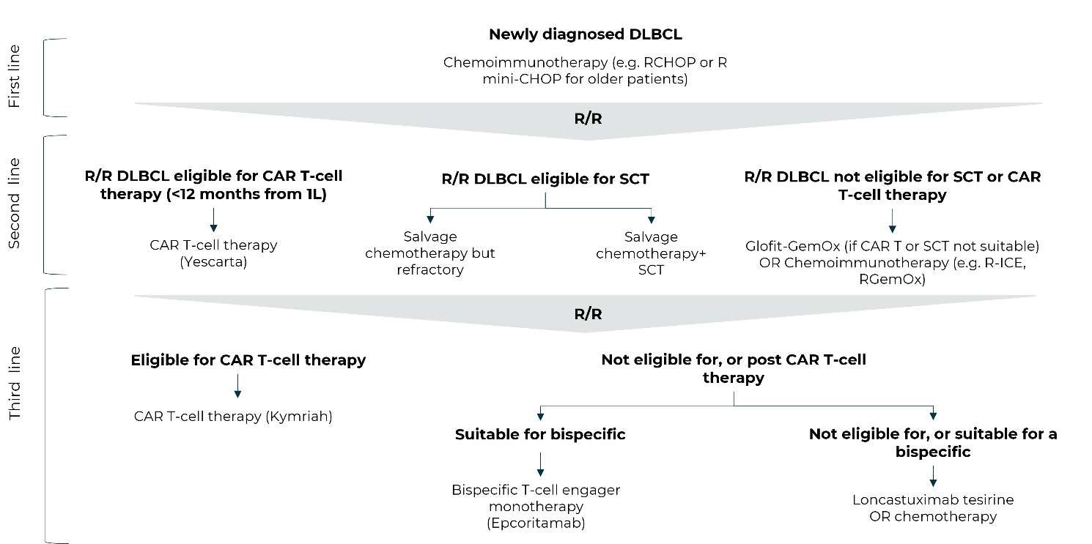
Source: Figure 1.6, p32 of the submission

  - Loncastuximab tesirine is an antibody-drug conjugate (ADC) comprising a humanised anti-CD19 antibody conjugated to the pyrrolobenzodiazepine (PBD) dimer cytotoxin SG3199. Loncastuximab tesirine is rapidly internalised by CD19-expressing B-cells, followed by release of SG3199 via proteolytic cleavage. The released SG3199 binds to the DNA minor groove and forms highly cytotoxic DNA interstrand crosslinks, inducing cell death.
For more detail on PBAC’s view, see section 7 PBAC outcome.
- Comparator
  - The submission appropriately nominated the chemoimmunotherapy regimen comprising rituximab in combination with ifosfamide, carboplatin and etoposide (R-ICE) as the main comparator, proxy for mixed chemoimmunotherapy. In November 2024, the ESC considered R-ICE was the most common second-line (2L) and 3L treatment (paragraph 5,3, selinexor, Public Summary Document [PSD], July 2021), and R-ICE may be used more frequently in the 3L setting if CAR-T replaces R-ICE in the 2L setting (paragraph 5.2, epcoritamab, PSD, Nov 2024 PBAC meeting). The Sub-Committees considered the nominated comparator appropriate.
  - 3L treatment options for R/R DLBCL listed in the submission also included CAR-T therapy, bispecific antibodies (epcoritamab or glofitamab), and salvage chemoimmunotherapy. CAR-T was (appropriately) not considered a comparator as the restriction limited loncastuximab tesirine treatment to patients who had previously received CAR-T or were unable to receive CAR-T. Similarly, the submission indicated that bispecifics would not be a relevant comparator because loncastuximab tesirine would be given to patients not eligible/suitable for a bispecific or those who had already been treated with a bispecific. However, this was not reflected in the requested restriction. Therefore, either the restriction should be amended to reflect prior bispecific treatment/unsuitability or bispecifics should be included as a potential comparator. As outlined in paragraph 3.5, the Sub-Committees advised that the restriction be amended to reflect that patients must have previously received or be unable to receive bispecific antibodies for this condition.
For more detail on PBAC’s view, see section 7 PBAC outcome.
- Consideration of the evidence

Sponsor hearing
  - The sponsor requested a hearing for this item. The clinician discussed the natural history of the disease, noting that a large proportion of patients will be cured with their first treatment, but for those who relapse the chance of cure becomes less likely across time. The clinician noted that many factors impact sequencing of treatments in R/R DLBCL including disease, healthcare facility, patient, geographic and socioeconomic factors. As such, not everyone will be suitable for currently available therapies such as CAR-T or bispecific antibodies. Furthermore, the clinician described how a proportion of patients will still relapse despite treatment with CAR-T or bispecific antibodies. The clinician stated that there was a need for effective, simpler, deliverable therapy for elderly/unfit patients, those with high risk/rapidly progressing disease or in patients ineligible or unable to access CAR-T or ineligible for bispecific antibodies. In response to the Committee’s questions the clinician outlined the patients most likely to receive treatment with loncastuximab tesirine and discussed the likelihood of cure. The PBAC considered that the hearing was informative as it provided a clinical perspective on treating this disease.

Consumer inputs
  - The PBAC noted and welcomed input from health care professionals (1) and organisations (2) via the Office of Health Technology Assessment Consultation Hub. Comments from a health care professional described reports of complete response, ongoing disease control and functional improvement in a patient with this condition treated with loncastuximab tesirine. The health care professional described loncastuximab tesirine as offering a crucial treatment option for patients with no remaining approved therapies or trial opportunities (especially for those patients with poor renal function). Rare Cancers Australia described the safety profile as consistent with that for other cancer treatments, with quality‑of‑life benefits attributed to the short, infrequent infusion schedule.
  - The PBAC noted the advice received from the Australian Leukaemia & Lymphoma Group (ALLG) and considered that it was comprehensive and informative. The advice provided an overview of current treatment options for DLBCL and the burden of relapse. The ALLG input described loncastuximab tesirine as an important off‑the‑shelf option for patients unsuitable for, or relapsing after, CAR‑T or bispecific therapies. Consistent with the other input received, the ALLG submission also emphasised access and equity considerations. These considerations were reported to arise due to patients needing to travel to major hospitals to receive CAR-T or larger hospitals to receive bispecific therapies as many smaller hospitals are not equipped to manage severe immunotherapy reactions if they arise. The ALLG input suggested that as loncastuximab tesirine is delivered as a short infusion every 3 weeks and has a toxicity profile that does not typically require ICU-level intervention it has the potential to be delivered in regional cancer centres, improving access outside of major cities.

Clinical studies
  - The submission was based on a single-arm study of loncastuximab tesirine in patients with R/R DLBCL who had received at least two prior systemic therapies (n=145) (LOTIS-2) and a matching adjusted indirect comparison (MAIC) of loncastuximab tesirine and chemoimmunotherapy, based on LOTIS-2 and pooled results from two published, observational extension studies of a randomised controlled trial (RCT) (CORAL).
  - Details of the studies presented in the submission are provided in Table 2.
Table 2: Studies and key associated reports presented in the submission
Study ID | Protocol title/ Publication title | Publication citation
LOTIS-2 (NCT03589469) | A Phase 2 Open-Label Single-Arm Study to Evaluate the Efficacy and Safety of Loncastuximab Tesirine in Patients with Relapsed or Refractory Diffuse Large B-Cell Lymphoma (DLBCL) | Clinical Study Report (Final) 11 April 2023.
 | A Phase 2 Open-Label Single-Arm Study to Evaluate the Efficacy and  Safety of Loncastuximab Tesirine in Patients with Relapsed or Refractory  Diffuse Large B-Cell Lymphoma (DLBCL) | Clinical Study Protocol (August 2020)
CORAL extension studies | Outcomes of diffuse large B-cell lymphoma patients relapsing after autologous stem cell transplantation: an analysis of patients included in the CORAL study. | Bone Marrow Transplant. 2017. 52(2): 216-221.
CORAL extension studies | Outcome of patients with relapsed diffuse large B-cell lymphoma who fail second-line salvage regimens in the International CORAL study. | Bone Marrow Transplant. 2016. 51(1): 51-57.
MAIC report | MAICs of loncastuximab tesirine versus relevant comparators for the treatment of R/R DLBCL after two or more lines of systemic therapy | Attachment 2.6 MAIC report. Version 5. 18 October 2023
Source: Compiled during the evaluation from Figure 2-1, p41, Table 2-2, pp43-45 and Attachments 2.3, 2.4 and 2.6 of the submission.

  - The key features of the studies are summarised in Table 3.
Table 3: Key features of the included evidence
Trial | N | Design/ duration | Risk of bias | Patient population | Outcome(s) | Use in modelled evaluation
Loncastuximab tesirine
LOTIS-2 | 145 | P2, single-arm, international MC, OL  Enrolled August 2018-September 2019: Last patient visit: August 2022  Median follow-up: 7.8 months [range 0.3, 42.6] | High | Adults with R/R DLBCL after ≥2 prior systemic therapies | Primary: ORR  Secondary: DOR, CR rate, RFS, PFS, OS, PROs, safety | Yes
Chemoimmunotherapy
CORAL studies
CORAL (NCT00137995) | 481 | P3, MC, R, OL  Enrolled 2003-2008 | Low | Adult DLBCL patients aged 18-65 years R/R to 1L therapy and eligible for ASCT | Response rate to 2L, PFS, EFS, OS, safety. | Safety
CORAL extension 1  (Van Den Neste 2017) | 75 | Retrospective, observational  Median follow-up: 32.8 months | Moderate | CORAL participants who relapsed after ASCT | Response/ORR to 3L, OS | Patient characteristics, HR from the MAIC used
CORAL extension 2  (Van Den Neste 2016) | 203 | Prospective, observational  Median follow-up: 30.1 months | Moderate | CORAL participants who did not proceed to ASCT | Response/ORR to 3L, OS | Patient characteristics, HR from the MAIC used
Source: Caimi 2024, Figure 2-3, p 49, Figure 2-4, p49, Van Den Neste 2016, Van Den Neste 2017.
1/2/3L = 1st / 2nd / 3rd line; ASCT = autologous stem cell transplant; CR = complete response; DB = double blind; DLBCL = diffuse large B-cell lymphoma; DOR = duration of response; EFS = event free survival; HR = hazard ratio; MAIC = matching=adjusted indirect comparison; MC = multi-centre; OL = open label; ORR = overall response rate; OS = overall survival; P = phase; PFS = progression-free survival; PROs = patient reported outcomes; R = randomised; RFS = relapse free survival; R/R = relapsed or refractory.
  - LOTIS-2 was an international, multicentre, single-arm, open-label study that enrolled adult patients with R/R DLBCL who had received at least 2 prior lines of systemic therapy. Patients were enrolled from August 1, 2018, to September 24, 2019, and the last patient visit occurred on August 9, 2022, with the database lock on September 15, 2022. The primary objective of the study was to evaluate the efficacy of loncastuximab tesirine as monotherapy in patients with R/R DLBCL, based on overall response rate (ORR) according to the Lugano classification (Cheson 2014) as determined by blinded independent central review. Key secondary endpoints were overall survival (OS), duration of response (DOR), complete response (CR) rate, relapse-free survival (RFS), progression-free survival (PFS) and safety. Patients received loncastuximab tesirine 0.15 mg/kg administered as an intravenous (IV) infusion on Day 1 of the first two 3-week cycles, then 0.075 mg/kg on Day 1 of every subsequent cycle for up to 1 year, or until disease progression, unacceptable toxicity or other discontinuation criteria were met. Patients who were still considered to be benefiting clinically at 1 year may have continued treatment after a case-by-case review with the sponsor. All patients, regardless of disease status, were followed every 12 weeks for up to 3 years, or until withdrawal of consent, loss to follow-up, or death, whichever occurred first.
  - The CORAL extension studies were observational studies that included patients enrolled in the CORAL RCT who subsequently underwent 3L therapy. CORAL was a 2-stage RCT that enrolled 481 patients aged 18 to 65 years who were R/R to 1L therapy for DLBCL and were eligible for autologous stem cell transplant (ASCT) between 2003 and 2008. The first stage compared the efficacy of two salvage chemoimmunotherapy regimens, R-ICE (rituximab, ifosfamide, carboplatin, and etoposide) and R-DHAP (rituximab, dexamethasone, high-dose cytarabine, and cisplatin). The second stage of CORAL evaluated the efficacy of rituximab as maintenance therapy compared to observation in 255 randomly assigned responders who received high-dose chemotherapy and ASCT per protocol. The results of CORAL demonstrated no significant difference in efficacy between R-ICE and R-DHAP as 2L salvage regimens, based on the outcomes of 3-year event free survival (EFS) and overall survival (OS) (Gisselbrecht 2010). The results of the CORAL second stage showed no difference in relapse rates between observation and rituximab maintenance therapy after ASCT (Gisselbrecht 2012).
  - CORAL extension study 1 included 75 patients who relapsed after achieving ASCT per CORAL protocol (Van Den Neste 2017). This included 37 (49%) patients who were randomised to rituximab maintenance, 34 (45%) who were randomised to observation and 4 (5%) who relapsed prior to randomisation to a maintenance arm. Following a protocol amendment, investigators were asked to retrospectively update their patients’ status, including patient characteristics at relapse, time between ASCT and failure, type of 3L regimen, response to 3L regimen, response by maintenance arm and OS. CORAL extension study 2 included 203 patients who failed to proceed to ASCT per CORAL protocol and were still enrolled in CORAL (Van Den Neste 2016). Following a protocol amendment, CORAL investigators prospectively recorded the date, reasons for withdrawal, site of disease and new treatments received by patients in 3L therapy. Aggregate data were extracted from both extension study publications.
  - The submission considered LOTIS-2 to be at low risk of bias, based on the JBI case series checklist; however, given the single-arm, open-label study design, the evaluation rated LOTIS-2 as high risk of bias. The submission considered the CORAL extension studies to be of ‘some risk of bias’. While the original CORAL RCT was considered to be at low risk of bias, the evaluation considered the extension studies to be of moderate risk of bias, based on the observational nature of the data and the clinical setting: patients received standard clinical care for 3L therapy with local assessments, rather than per protocol regimens with pre-determined, independently reviewed follow-up assessments as per a clinical trial.
  - There was also a high risk of bias in the MAIC. Key factors impacting the comparison between LOTIS-2 and CORAL include temporal and population differences:
- CORAL enrolled patients between 2003 and 2008, whereas LOTIS-2 enrolled patients between 2018 and 2019.
- CORAL spanned the pre-rituximab era: 38% of participants did not receive rituximab in 1L therapy, whereas most patients in LOTIS-2 would have received rituximab with chemotherapy as 1L therapy, with R-CHOP (rituximab, cyclophosphamide, doxorubicin, vincristine and prednisone) being the standard regimen for two decades (Barraclough 2023). All patients in CORAL received rituximab as 2L salvage therapy as part of the per protocol R-ICE or R-DHAP regimens. However, the CORAL extension studies did not report chemoimmunotherapy regimens separately from chemotherapy regimens; for example, patients reported as having received ‘ICE-type’ regimens could have had ICE or R-ICE. The use of immunotherapy in 3L therapy for the 75 patients who relapsed after ASCT (CORAL Extension 1) was not reported; however, it was reported in the study of 203 patients who did not proceed to ASCT (CORAL Extension 2). Of 172 patients in CORAL Extension 2 with available information, only 56 (32.6%) received third-line immunotherapy; however, no information was available on the specific regimens (Van Den Neste 2016). This may not reflect current clinical practice.
- In CORAL, disease status was classified according to the 1999 WHO classification and response was evaluated according to the International Working Group (IWG) Criteria (Cheson 1999) using computed tomography (CT) scans. In LOTIS-2, disease status was classified according to the 2016 WHO classification and response was evaluated according to the Lugano 2014 classification (Cheson 2014) using positron emission tomography-computed tomography (PET-CT) scans. PET-CT scans are more sensitive than CT scans. The PSCR acknowledged that two different assessment criteria were used to measure ORR outcomes between the trials, and maintained the view that the overall significance on the interpretation of the results was minimal.
- All patients in the CORAL extension studies received third-line therapy, whereas LOTIS-2 included patients undergoing third-line (n=63: 43.4%) and later-line therapy (n=82: 56.6%).
- All patients in the CORAL extension studies had been considered fit for ASCT in 2L and had received a treatment protocol aimed at achieving ASCT, with 75 (27.0%) patients in the CORAL extension studies having relapsed after achieving ASCT. The LOTIS-2 inclusion criteria were agnostic to prior multi-agent systemic treatment regimens, and the study included 24 (16.6%) patients who had undergone prior stem cell transplant (autologous or allogenic).
- CORAL enrolled patients aged 18 to 65 years, whereas LOTIS-2 did not apply an upper age limit to the selection criteria. The median ages in the CORAL extension studies were 56 (extension study 1) and 55 (extension study 2), whereas the median age in LOTIS-2 was 66 years.
  - Patients in CORAL were younger and fitter than those in LOTIS-2, potentially favouring R-ICE in the MAIC; however, patient outcomes have improved since the CORAL studies, due in part to improvements in imaging and diagnostic technologies, new treatment options and improved management of adverse events, favouring loncastuximab tesirine. The CORAL studies may not be representative of contemporary chemoimmunotherapy. The results from the MAIC are therefore considered to be at high risk of bias. The Sub-Committees acknowledged that the CORAL extension studies do not accurately reflect the current standard of care but advised that they are a reasonable representative of chemoimmunotherapy in this context. The Sub-Committees also considered that the R-GemOx (Rituximab, Gemcitabine, Oxaliplatin) arm of the STARGLO study is also a reasonable representation of chemoimmunotherapy.
  - The submission included a recent report from the Lymphoma and Related Diseases Registry (LaRDR) describing the characteristics, treatments, and outcomes of Australian DLBCL patients receiving 3L therapy (Wellard 2025). Patients in LOTIS-2 were similar to those in the LaRDR registry with respect to median age (66.0 vs 66.7 years), sex (male: 58.6% vs 61.7%), body weight (75.0 vs 76.6 kg) and the proportion with prior stem cell transplant (16.6% vs 18.1%). However, the LOTIS-2 population differed from the Australian population with respect to ethnicity, with 89.7% of LOTIS-2 participants being white/European and 2.1% Asian, and 0.7% Pacific Islander/Polynesian, whereas the Australian DLBCL population was 64.9% white/European, 22.8% Asian and 5.3% Pacific Islander/Polynesian. Due to the small sample size in LOTIS-2, it is unknown whether there are any differences in efficacy or safety by ethnicity.
  - Wellard 2025 included 154 patients who had received any 3L therapy, including salvage chemotherapy (42.8%), but did not include a breakdown of salvage chemotherapy regimens used in Australia. However, data from the LaRDR registry reported in the Epcoritamab PSD (November 2024 PBAC meeting) showed that ‘among 69 patients who did not receive an ASCT as part of third-line therapy, CAR-T cell therapy (22.1%), R-GemOx (Rituximab, Gemcitabine, Oxaliplatin) (11.8%), R-ICE (8.8%) and gemcitabine + vinorelbine (7.4%) were the most commonly used 3L therapies, out of approximately 20 different treatment regimens’. Wellard 2025 showed that Australian patients are accessing CAR-T (19.7%) and bispecific antibodies (7.9%) as 3L treatments, with uptake of these treatments likely to displace some of the use of salvage chemotherapy. The Sub-Committees considered the data from the LaRDR registry of interest but noted that the data capture was incomplete with not all Australian treatment centres providing input to the registry.
  - The common outcomes between LOTIS-2 and the CORAL extension studies were ORR and OS. The outcome definitions, methods and timing of assessment differed across the studies:
- Response in LOTIS-2 was independently assessed at regular intervals per protocol throughout the study, whereas patients in the CORAL extension studies received routine clinical care for 3L therapy, and response was assessed by investigators at non-specified time points. It is possible that response and disease progression may have been identified earlier in patients in LOTIS-2 compared to patients in the CORAL extension studies.
- OS for patients in LOTIS-2 was measured from the first day of active treatment, whereas for patients in the CORAL extension studies, OS was measured from the date of documented failure of induction therapy or relapse after ASCT, rather than the date patients began 3L therapy, and no information was available on the time between failure/relapse and initiation of 3L therapy. These different definitions potentially lead to artificially longer OS outcomes being recorded in the CORAL extension studies; however, patients who died or were deemed to progress during screening were excluded from LOTIS-2, whereas similar patients may have been included in the CORAL extension studies.

Comparative effectiveness
LOTIS-2 and CORAL extension studies, naïve comparisons prior to matching
  - Table 4 presents the response outcomes for LOTIS-2 and the CORAL Extension studies. Response outcomes for Australian patients in the LaRDR Registry who underwent 3L therapy for DLBCL are included for context.
Table 4: Response outcomes from LOTIS-2, CORAL extension studies and LaRDR patients who underwent 3L therapy
 | LOTIS-2  N=145 | CORAL Extension 1  (relapse after ASCT) N=75 | CORAL Extension 2 (no ASCT)  N=203 | Pooled CORAL Extension 1 and 2  N=278 | LaRDR  N=123ª
ORR, n/N (%) [95% CI] | 70/145 (48.3)  [39.9, 56.7] | 33/75 (44.0) | 79/203 (38.9) | 112/278 (40.3) | NR
ORR n/n evaluable (%) | 70/122 (57.4) | 33/67 (49.3) | 79/166 (47.6) | 112/233 (48.1) | 40/123 (32.5)
Best Overall Response, n/N (%)
CR | 36/145 (24.8) | 24/75 (32.0) | 55/203 (27.1) | 79 (28.4) | 32/123 (26.0)
PR | 34/145 (23.4) | 9/75 (12.0) | 24/203 (11.8) | 33 (11.9) | 8/123 (6.5)
Stable disease | 22/145 (15.2) | 34/75 (45.3) | 87/203 (42.9) | 121(43.5) | 4/123 (3.3)
PD | 30/145 (20.7) | 34/75 (45.3) | 87/203 (42.9) | 121(43.5) | 79/123 (64.2)
NE | 23/145 (15.9) | 8/75 (10.7) | 37/203 (18.2) | 45 (16.2) | NRª
Source: Table 2-16, p73, Table 2-17, p75 of the submission, Van Den Neste 2016, Van Den Neste 2017 and Table 2.3, Wellard 2025.
ASCT = autologous stem cell transplant; CI = confidence interval; CR = complete remission; HR = hazard ratio; LaRDR = Lymphoma and Related Diseases Registry; n = number of participants experiencing event; N = number of participants at risk; NE = not evaluable; NR = not reported; ORR = overall response rate; PD = progression of disease; PR = partial response.
ª The number not evaluable was not reported in Wellard 2025, and the discrepancy between the number undergoing third-line treatment (154) and the number of responses recorded (123) was not explained (e.g. not evaluable, still on treatment, death or not reported).

  - In the LOTIS-2 study, the ORR in patients treated with loncastuximab tesirine was 48.3% (95% CI: 39.9, 56.7), including 36 (24.8%) patients with CR. The ORR was slightly lower in the CORAL extension studies (pooled result: 40.3% including 28.4% with CR). When ORR is calculated using only evaluable patients, the ORR from LOTIS-2 remained higher than for CORAL Extension studies (57.4% vs 48.1%). However, ORR for Australian patients in the LaRDR Registry was lower than in either clinical study, 32.5%. This may reflect the demographic and clinical differences between patients enrolled in clinical trials/studies and those seen in clinical practice. For example, a recently published retrospective study of 187 patients from 21 US centres who received commercially available loncastuximab tesirine between April 2021 and December 2022 reported that patients receiving treatment had higher baseline risk factors compared to patients in LOTIS-2, including bulky disease (17% versus 0%, respectively), high-grade B-cell histology (22% versus 8%) and had received more prior lines of therapy (median 4 versus 3) (Zelikson 2025). Almost half of these patients (47%) would have been ineligible for LOTIS-2 on the basis of renal function, bulky disease, central nervous system involvement, CD19 status, or performance status. The median duration of treatment was similar to LOTIS-2 (42 versus 45 days), however patients in this study had lower CR rate (14% [95% CI: 10, 20]) and ORR (32% [95% CI: 26, 39]) than patients in LOTIS-2.
  - In subgroup analyses, ORRs were similar in patients aged ≥ 65 years compared to those aged < 65 years (47.5% vs 49.2%), between male and female patients (47.1% vs 50.0%), and for patients who had received 2, 3 or > 3 prior lines of therapy (47.6% vs 50.0% vs 47.9%). Patients who had relapsed after the most recent line of therapy had better ORR than those who were refractory (69.8% vs 34.8%). Patients with HGBL had a similar point estimate for ORR to those with DLBCL NOS, however, the confidence interval for HGBL was wide due to the small subgroup size (n=10) and the lower bound was below the pre-specified threshold for statistical significance (ORR 20%). Only 1 of the 7 patients with PMBL achieved a response.
  - Table 5 and Figure 2 present OS for LOTIS-2, CORAL Extension 1 and 2, and Australian patients in the LaRDR Registry who underwent 3L therapy.
Table 5: Overall survival from LOTIS-2, CORAL extension 1 and 2, and the LaRDR
 | LOTIS-2  N=145 | CORAL Extension 1  N=75 | CORAL Extension 2  N=203 | LaRDR  N=140
Median OS, months (95% CI) | 9.53 (6.74, 11.47) | 10.0 (6.6, 12.6) | 4.4 (3.4, 5.9) | 9.4 (6.3, 13.9)
Source: Figure 2-7, p75 of the submission, Table 2, Van Den Neste 2017, Table 3, Van Den Neste 2016, Figure 2.2, Wellard 2025.
CI = confidence interval; LaRDR = Lymphoma and Related Diseases Registry; OS = overall survival.

Figure 2: Overall survival curves for LOTIS-2, CORAL extension 1 and 2, and Australian LaRDR patients
A. LOTIS-2 |  | B. CORAL Extension 1 (relapse after ASCT)
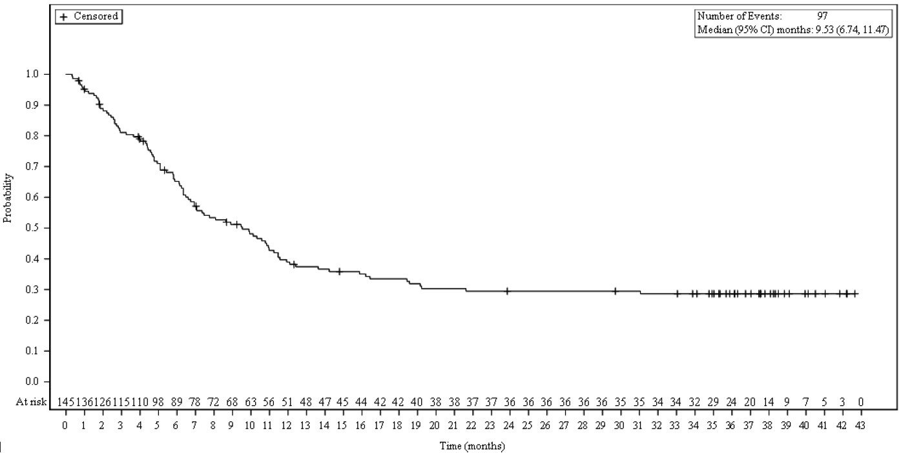 |  | 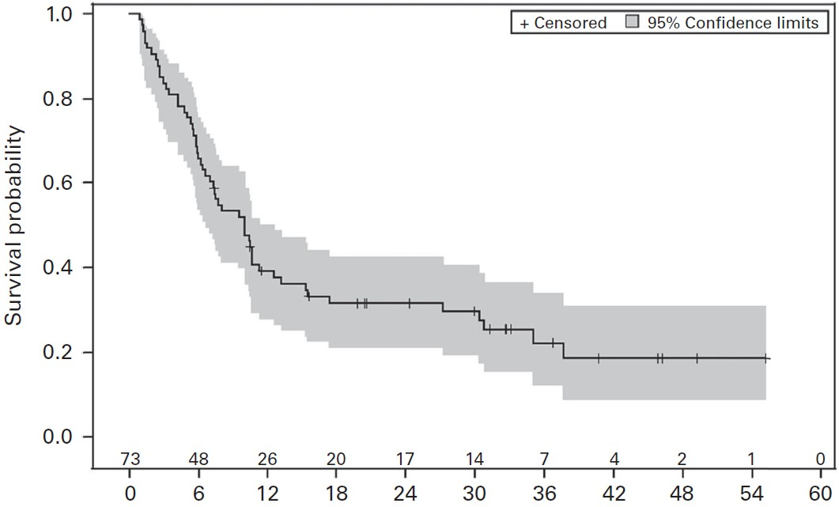
C. CORAL Extension 2 (no ASCT) |  | D. LaRDR patients
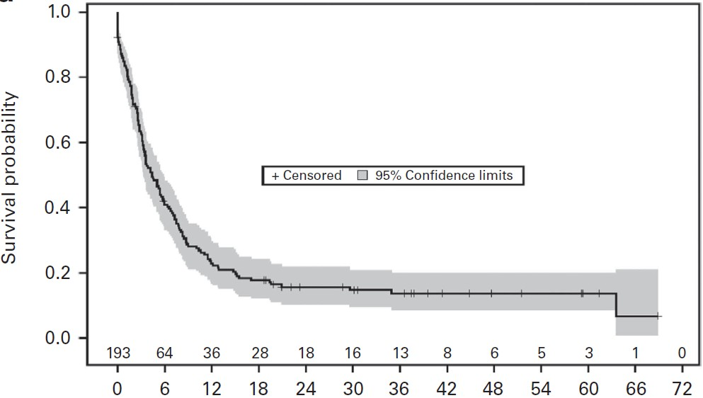 |  | 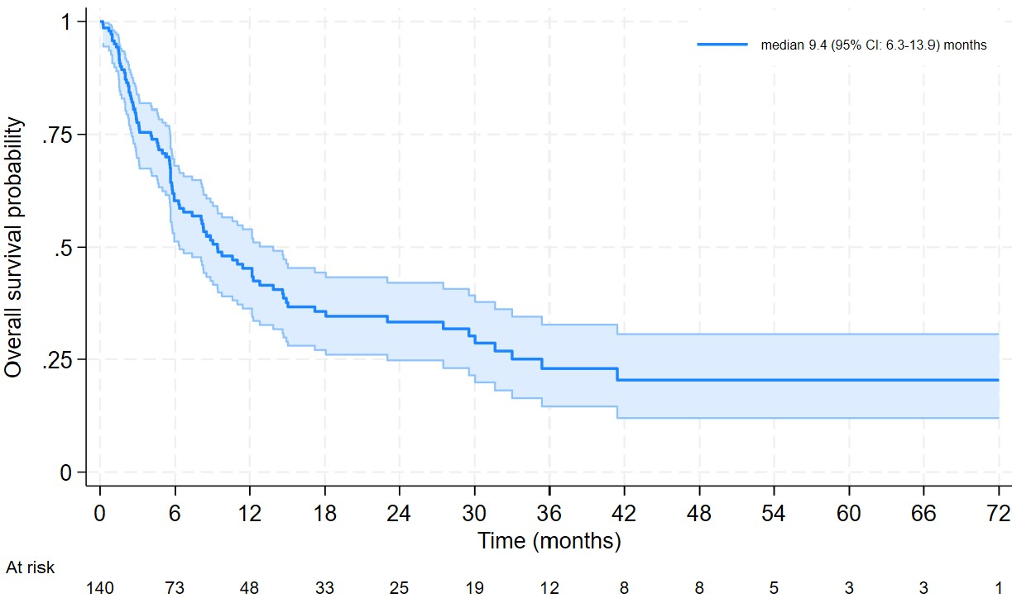
Source: Figure 2-7, p75 of the submission, Figure 2, Van Den Neste 2017, Figure 2a, Van Den Neste 2016 and Figure 2.2, Wellard 2025.
ASCT = autologous stem cell transplant; CI = confidence interval; LaRDR = Lymphoma and Related Diseases Registry.

  - The median OS for patients in LOTIS-2 was 9.53 months (95% CI: 6.75, 11.47), and 97/145 (66.9%) patients died during follow-up. Median OS was similar for LOTIS-2 and CORAL Extension 1 patients who had relapsed after achieving ASCT in 2L; however, the different baseline timepoints favour the CORAL extension studies. Median OS for patients in CORAL extension 2, who had not been able to proceed to the planned ASCT in 2L, was poor, at 4.4 months (95% CI: 3.4, 5.9). OS for patients in the LaRDR Registry as reported by Wellard 2025 was measured from commencement of 3L therapy, and median OS was comparable to LOTIS-2, at 9.4 months (95% CI: 6.3, 13.9).
  - The chemoimmunotherapy regimen R-GemOx was the comparator in the STARGLO RCT of glofitamab plus gemcitabine and oxaliplatin (GemOx) in patients with R/R DLBCL after at least one prior line of therapy and who were considered ineligible for ASCT. STARGLO was conducted in 2021 to 2023 and thus more closely resembles current clinical practice and patient outcomes than the CORAL extension studies. Patients in the R-GemOx arm of STARLGLO who were in third- or further lines of therapy had a median OS of 6.7 months, which was slightly lower than 9.53 months reported for loncastuximab tesirine in LOTIS-2, however, confidence intervals were not reported (Abramson 2024).
  - Table 6 presents PFS, DOR and RFS from LOTIS-2.
Table 6: PFS, DOR and RFS from LOTIS-2
 | PFS | DOR | RFS
Number of events, n/N (%) | 73/145 | 23/70 | 6/36
Median, months (95% CI) | 4.93 (2.89, 8.31) | 13.37 (6.87, NE) | Not reached
Rate, % without event (95% CI) | NR |  | NR
6 months | - | 67.3 (51.6, 78.9) | -
9 months | - | 64.4 (48.3, 76.6) | -
12 months | - | 54.7 (37.9, 68.8) | -
Source: Figure 2-8, p76, Table 2-19, p78 and Figure 2-10, p 78 of the submission.
CI = confidence interval; DOR = duration of response; KM = Kaplan-Meier; NE = not estimable; NR = not reported; PFS = progression-free survival; RFS = relapse free survival.
  - Median PFS for the LOTIS-2 population was 4.93 months (95% CI: 2.89, 8.31). In the 70 patients who achieved CR or PR, median DOR was 13.37 months (95% CI: 6.87, not estimable), and 54.7% of patients remained in response at 12 months. Of the 36 patients who achieved CR, 6 had an RFS event and median RFS was not reached.
  - Figure 3 presents an overlay of PFS and OS survival curves from LOTIS-2 and the LaRDR Registry constructed during the evaluation for comparison.

Figure 3: Comparison of Kaplan-Meier curves for OS and PFS between LOTIS-2 and Australian patients from the LaRDR Registry who received 3L therapy.
A. OS
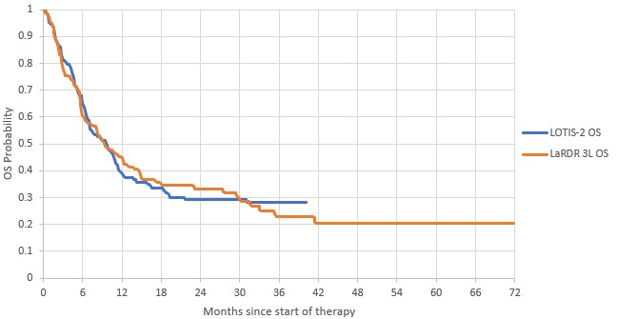
B. PFS
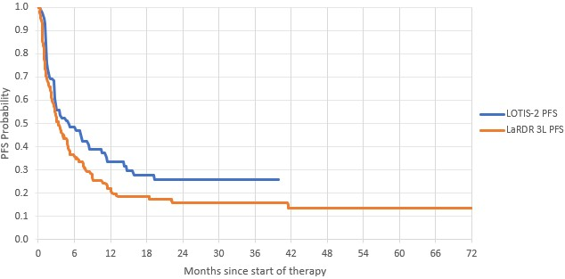
Source: Constructed during the evaluation from Figures 2.1 and 2.2, Wellard 2025, Attachment 2.7 to the submission and sheet ‘Model_Tx’ from Attachment 3.1 to the submission.
3L = third-line therapy; KM = Kaplan-Meier; LaRDR = Lymphoma and Related Diseases Registry; PFS = progression-free survival; OS = overall survival.
  - The naïve comparison of OS between LOTIS-2 and patients in the LaRDR who underwent 3L therapy shows that patients from LOTIS-2 had similar OS to Australian patients. However, differences in the populations and therapies received complicate the comparison. Over half of patients in LOTIS-2 (56.6%) were undergoing 4L and further lines of therapy, and median OS would be expected to reduce with each subsequent line of therapy. For context, patients treated with loncastuximab tesirine in US clinical centres had a median OS of 4.6 months, which was lower than in LOTIS-2, however, those patients were more heavily pre-treated than in LOTIS-2 (median 4 versus 3 prior therapies) (Zelikson 2025).
  - Only 42.8% of 3L patients in the LaRDR were treated with salvage chemotherapy, and the proportions treated with chemoimmunotherapy, the nominated comparator, were not reported. Notably, 19.7% were treated with CAR-T and 7.9% with a bispecific antibody. Considering patients having CAR-T and bispecific antibody therapies have higher expected OS compared to chemoimmunotherapy, inclusion of patients receiving these therapies would likely increase the median OS for all 3L patients in the Registry. Wellard 2025 did not report outcomes for the subgroup of patients treated with salvage chemoimmunotherapy despite the data being available in the Registry. Overall, it appeared that patients in 3L and further lines of therapy treated with loncastuximab tesirine had similar OS to the 3L Australian patient population.
  - PFS for the LOTIS-2 population was slightly better than the PFS for Australian patients in the LaRDR (median 4.9 months [95% CI: 2.9, 8.3] versus median 3.2 months [95% CI: 2.3, 4.7]). When the Kaplan-Meier curves for PFS from LOTIS-2 and all 3L patients in the LaRDR registry were overlaid, there appeared to be a separation of the curves after approximately 3 months, favouring loncastuximab tesirine. For context, patients from the R-GemOx arm of STARGLO who had third- or further lines of therapy had a median PFS of 2.0 months (Abramson 2024), and patients in the retrospective study of loncastuximab tesirine in US centres had a median event-free survival (EFS) (defined as time to progression or change in therapy; censored at death or last follow-up) of 2.1 months (Zelikson 2025).
  - Patient-reported outcomes (PROs) for health-related quality of life (HRQoL) were measured by the EuroQol – 5 Dimensions – 5 Levels questionnaire visual analogue scale (EQ-5D-5L VAS) and Functional Assessment of Cancer Therapy - Lymphoma (FACT-Lym) instruments, which were administered every three weeks from Day 1 of Cycle 1 until the end of treatment (EOT) visit. Figure 4 presents plots for the EQ-5D-5L VAS and the FACT-Lym subscale score change from baseline.

Figure 4: Patient-reported outcomes from LOTIS-2
A. EQ-5D-5L VAS scoreª | B. FACT-Lym lymphoma subscale scoreª
Source: Figure 2-11, p82 and Figure 2-12, p83 of the submission.
C = Cycle; D = day; EQ-5D-5L = European Quality of Life (EuroQol) – 5 Dimensions – 5 Levels; FACT-Lym = Functional Assessment of Cancer Therapy - Lymphoma; PRO = patient-reported outcome; SE = standard error; VAS = visual analogue scale.
Note: Red dotted lines indicate minimally important difference (MID) of ± 7 points.
ª Mean (SE) change from baseline (PRO population).
  - The EQ-5D-5L VAS score appeared to improve slightly until Cycle 12, then deteriorate; however, responses were largely within the minimally important difference (MID) until Cycle 9. FACT-Lym subscales reported in the CSR that showed slight improvement from baseline over time were physical wellbeing and emotional wellbeing. The social/family subscale well-being deteriorated from baseline over time. Similarly, to the EQ-5D-5L VAS, the FACT-Lym subscale scores for each cycle were mostly within the MID; however, scores appeared to improve slightly from baseline to Cycle 12, then deteriorated through to Cycle 15.
  - The PBAC noted a US observational study involving a retrospective medical chart review of 118 patients with R/R DLBCL who initiated loncastuximab tesirine monotherapy as their 3L or 4L treatment after progressing on 2L or 3L CAR-T therapy. Patients who received loncastuximab tesirine after 2L CAR-T therapy (n=95) had an ORR of 73% (CR rate of 34%) and OS at 12 months was 84%. Patients who received loncastuximab tesirine after 3L CAR-T therapy (n= 23) had an ORR of 78% (CR rate of 17%) and OS at 12 months was 95%.
MAIC of loncastuximab tesirine versus chemoimmunotherapy
  - As LOTIS-2 was a single-arm study, the submission conducted an unanchored MAIC to evaluate the comparative effectiveness and safety between loncastuximab tesirine and the nominated comparator, chemoimmunotherapy. Data were obtained from LOTIS-2 and the publications of the two CORAL extension studies (Van Den Neste 2016 and Van Den Neste 2017). Individual patient-level data (IPD) were available for LOTIS-2. Aggregate data from the two CORAL extension studies were pooled for the analysis.
  - Data were limited for the CORAL extension studies with only three characteristics available for data matching: male gender (%), previous ASCT (%) and International Prognostic Index (IPI) score (≤ 2 versus >2). The only outcomes available from the CORAL extension studies were ORR and OS. As discussed above, the definitions of these outcomes differed between LOTIS-2 and the CORAL extension studies (see paragraphs 6.11 and 6.15).
  - Before the weighting process, the IPD from LOTIS-2 was trimmed by excluding patients aged > 67.7 years, which was the maximum age of participants in the CORAL extension studies, resulting in 80 (55.2%) patients from LOTIS-2 being included in the analyses. Weights were assigned to patients in LOTIS-2 to adjust for their over- or underrepresentation relative to the average corresponding prognostic factors observed in the pooled CORAL extension studies. These weights were derived using a non-parametric likelihood re-weighting method.
  - Table 7 presents a comparison of baseline characteristics before and after matching.
Table 7: Comparison of baseline characteristics before and after matching
Covariates | Loncastuximab tesirine |  | Immunochemotherapy
 | Pre-matching (ESS=80) | Post-matching (ESS=78.1) | As reported (N=266)
Male, % | 66.2 | 63.0 | 63.0
Prior ASCT, % | 21.2 | 27.0 | 27.0
IPI >2, % | 38.8 | 39.0 | 39.0
Source: Table 2-30, p93 of the submission.
ASCT = autologous stem cell transplant; ESS = effective sample size; IPI = International Prognostic Index; N = number of participants.
  - After further matching, the effective sample size was decreased further by 2.4%, suggesting good overlap for the selected baseline characteristics prior to matching; however, due to the exclusion of patients aged > 67.7 years from the MAIC, these results may not be generalisable to older patients. Furthermore, all patients enrolled in CORAL had been considered for ASCT in 2L, with 75 (27.0%) patients in the CORAL extension studies having relapsed after achieving ASCT in the CORAL RCT, while LOTIS-2 included patients who were R/R after ≥ 2 prior lines of any systemic therapy. While the proportions of patients with prior ASCT were balanced in the weighting process for the MAIC, there may have been underlying differences in the clinical status of each study population. The Sub-Committees considered the approach taken to the trimming of the IPD from LOTIS-2 prior to weighting would likely favour loncastuximab tesirine if increasing age was associated with worse outcomes. However, the Sub-Committees considered that the age of a patient with DLBCL is less of a treatment effect modifier than it was previously as therapies such as CAR-T are being increasingly used in older patients. The Sub-Committees suggested that a sensitivity analysis, where the results of a MAIC where older patients are retained in the LOTIS-2 data set, may be informative if available. The pre-PBAC response did not provide an additional sensitivity analysis.
  - Table 8 presents the results of the MAIC and unadjusted results for ORR.
Table 8: Results of the MAIC and unadjusted results for ORRª
ORR analysis | Loncastuximab tesirine  (LOTIS-2)  n/N (%) | Chemoimmunotherapy  (CORAL extension studies)  n/N (%) | Absolute difference (%) | Loncastuximab tesirine vs chemoimmunotherapy  Odds ratio (95% CI)
Unadjusted | 41/80 (51.3) | 110/278 (39.6) | 11.7 | 1.51 (0.91, 2.50)
Adjusted, weighted GLM model^{b} | 40.7/79.1 (51.5) | 110/278 (39.6) | 11.9 | 1.53 (0.92, 2.53)
Adjusted, weighted sandwich estimator | 40.7/79.1 (51.5) | 110/278 (39.6) | 11.9 | 1.53 (0.91, 2.54)
Source: Table 2-31, p94 of the submission.
CI = confidence interval; n = number of participants with event; N = number at risk; GLM = generalised linear model; RD = risk difference; RR = relative risk; vs = versus.
ª ORR was assessed using the 1999 International Working Group response criteria in the pooled CORAL extension studies, and the 2014 Lugano Classification in the LOTIS-2 trial
^{b} Logistic regression
  - Based on the unanchored MAIC, more patients treated with loncastuximab tesirine achieved an objective response than patients treated with chemoimmunotherapy (51.5% versus 39.6%). While the point estimates of the odds ratios favoured loncastuximab tesirine, the results did not reach statistical significance in any of the analyses and confidence intervals were wide. Differences in the assessment of response between the studies may have impacted on the results; however, the direction of any impact remains unknown.
  - Table 9 presents the results of the MAIC and unadjusted results for OS.

Table 9: Results of the indirect comparison of overall survival (adjusted and unadjusted)
OS Analysis | Loncastuximab tesirine |  | Chemoimmunotherapy |  | Difference in median, months | Loncastuximab tesirine vs chemoimmunotherapy  HR (95% CI)
OS Analysis | n with event / N/ESS (%) | Median (95% CI) | n with event / N (%) | Median (95% CI) | Difference in median, months | Loncastuximab tesirine vs chemoimmunotherapy  HR (95% CI)
Naïve unadjusted (LOTIS-2) | 54/80 (67.5) | 10.12 (6.14, 12.09) | 201/266 (75.6) | 5.85 (4.80, 7.14) | 4.27 | 0.68 (0.50, 0.92)
Weighted (LOTIS-2) | 52/78.1 (66.6) | 10.12 (6.34, 13.63) | 201/266 (75.6) | 5.85 (4.80, 7.14) | 4.27 | Standard: 0.66 (0.49, 0.88)  Bootstrap: 0.66 (0.50, 0.85)
Bold type indicates statistically significant result.
Source: Table 2-32, p96 of the submission.
CI = confidence interval; ESS = effective sample size; HR = hazard ratio; n =number of participants with event; N = number of participants; OS = overall survival.
  - Figure 5 presents the Kaplan-Meier plots for OS for the MAIC populations.
Figure 5: Kaplan-Meier plots for OS for the MAIC populations
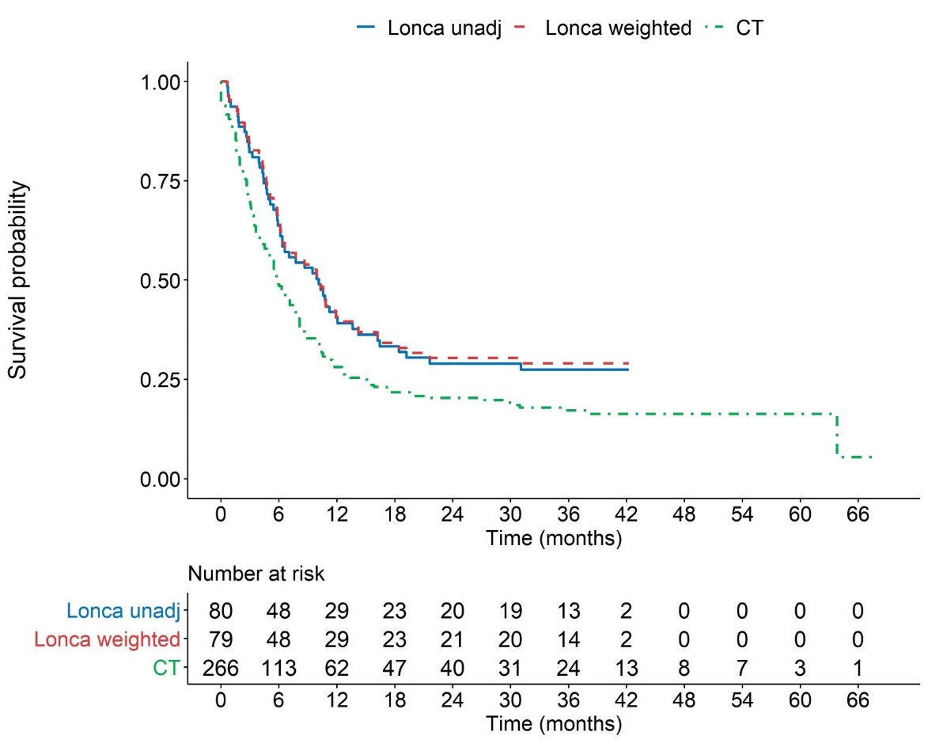
Source: Figures 2-13 and 2-14, p95 of the submission.
CI = confidence interval; CT = chemotherapy; HR = hazard ratio; Lonca = loncastuximab tesirine; OS = overall survival; unadj = unadjusted

  - The MAIC estimated that patients treated with loncastuximab tesirine gained a 4.27-month survival benefit over patients treated with chemoimmunotherapy (median OS: 10.23 months [95% CI: 6.34, 13.63] versus 5.85 months [95% CI: 4.80, 7.14]). The hazard ratios (HR)s were statistically significant, favouring loncastuximab tesirine in all analyses, with the adjusted analysis estimating a 34% reduced risk of death for patients treated with loncastuximab tesirine compared to patients receiving chemoimmunotherapy (HR 0.66 [95% CI: 0.49, 0.88]).
  - The Sub-Committees considered the results of the MAIC were uncertain. While all indirect OS estimates favoured loncastuximab tesirine over chemoimmunotherapy and were statistically significant, the significant differences between the source studies make the results difficult to interpret, specifically: (i) the improvements in clinical practice and patient outcomes over the decade between CORAL and LOTIS-2, and (ii) differences in the study populations, outcome definitions and assessments, introduce uncertainty in the interpretation of the results and generalisability to the proposed PBS population, particularly for older patients. Additionally, as no safety data were reported in the CORAL extension studies, no comparison was possible on safety.

Comparative harms
  - Based on a median treatment duration of 45 days, almost all patients (98.6%) had at least one treatment-emergent adverse event (TEAE) and 81.4% had an adverse event (AE) that was considered to be treatment-related. Men reported slightly more Grade ≥ 3 TEAEs than women (78.8% versus 66.7%, respectively), more serious adverse events (SAEs) (45.9% versus 30.0%) and more AEs resulting in death (6 versus 2); however, fewer males than females had a dose reduction or delay (48.2% versus 56.7%). AE rates were similar across age groups (< 65, 65-75 and ≥ 75 years). There were 8 (5.5%) AEs with a fatal outcome, none of which were considered to be treatment-related.
  - The most common TEAEs were gamma-glutamyl transferase (GGT) elevation (42.1%), neutropenia (40.0%), thrombocytopenia (33.1%), fatigue (27.6%), anaemia (26.2%), nausea (23.4%), cough (22.8%), increased blood alkaline phosphatase (20.0%), peripheral oedema (20.0%), pyrexia (19.3%), diarrhoea (17.2%), increased aspartate aminotransferase (AST) (15.9%), increased alanine aminotransferase (ALT) (15.2%), hypokalaemia (15.9%), hypophosphataemia (15.9%), decreased appetite (15.2%), leukopenia (14.5%), hypomagnesaemia (13.8%), rash (13.1%), vomiting (13.1%), pruritus (13.1%), constipation (11.7%), dyspnoea (11.7%), abdominal pain (11.7%), insomnia (11.0%), pleural effusion (11.0%), erythema (10.3%), headache (10.3%), and photosensitivity reaction (10.3%).
  - GGT elevation was the most common treatment-related adverse event (TRAE) leading to dose reduction (2.1%). The most common TRAEs leading to dose delay were GGT elevation (17.9%), neutropenia (11.7%) and thrombocytopenia (5.5%). The most common TRAEs leading to treatment discontinuation were GGT elevation (11.7%), peripheral oedema (2.8%) and localised oedema (2.1%).
  - Table 10 summarises the AEs of special interest reported in LOTIS-2.

Table 10: AEs of special interest in LOTIS-2
AE category | Pleural effusion  n (%) | Pericardial effusion n (%) | Peripheral oedema n (%) | Photosensitivity reaction n (%)
All TEAEs | 16 (11.0) | 4 (2.8) | 29 (20.0) | 15 (10.3)
TEAEs Grade ≥ 3 | 3 (2.1) | 3 (2.1) | 2 (1.4) | 3 (2.1)
SAE | 3 (2.1) | 2 (1.4) | 1 (0.7) | 0
TRAEs | 13 (9.0) | 4 (2.8) | 20 (13.8) | 15 (10.3)
TRAE Grade ≥ 3 | 3 (2.1) | 3 (2.1) | 2 (1.4) | 3 (2.1)
Treatment-related SAEs | 2 (1.4) | 2 (1.4) | 1 (0.7) | 0
Fatal TRAEs | 0 | 0 | 0 | 0
Source: Table 2-26, p88 of the submission.
AE = adverse event; n = number of participants reporting data; SAE = serious adverse event; TEAE = treatment-emergent adverse event; TRAE = treatment-related adverse event.
  - AEs to 3L therapies were not reported in the CORAL extension studies; however, key AEs reported in the CORAL RCT were summarised in Gisselbrecht 2010 and reported in the Epcoritamab 2024 PSD. As AE data from the CORAL studies were sparse, and related to a higher line of therapy, AE data reported for the R-GemOx arm of STARGLO were extracted during the evaluation from Abramson 2024 and the Glofitamab 2025 PSD, and presented below for added context. STARGLO reported limited data for patients receiving third- and further lines of therapy.
  - Table 11 presents a naïve comparison of AEs between loncastuximab tesirine and chemoimmunotherapy.
Table 11: Naïve comparison of AEs between loncastuximab tesirine and chemoimmunotherapy
 | Loncastuximab tesirine | Chemoimmunotherapy
AE category, n (%) | LOTIS-2  3L+  N=145 | R-ICE and R-DHAP  CORAL RCT  2L  N=388 | R-GemOx  STARGLO RCTª  2L+  N=88 | R-GemOx  STARGLO RCT  3L+ subgroup  n=33
Any TEAE | 143 (98.6) | NR | 84 (95.5) | 30 (90.9)
Grade ≥ 3 TEAE | 107 (73.8) | NR | 36 (40.1) | 13 (39.4)
Serious TEAE | 57 (39.3) | 126 (32.5) | 15 (17.0) | NR
TEAE leading to discontinuation | 36 (24.8) | NR | 11 (12.5) | NR
TEAE leading to death | 8 (5.5) | NR | 4 (4.5) | 3 (9.1)
Any TRAE | 118 (81.4) | NR | 58 (65.9) | NR
Grade ≥ 3 TRAE | 75 (51.7) | NR | 20 (22.7) | NR
Serious TRAE | 22 (15.2) | NR | 7 (8.0) | NR
TRAE leading to death | 0 | 4 (1.0) | 1 (1.1) | NR
Most common Grade ≥ 3 TEAEs
Thrombocytopenia | 26 (17.9) | NR | 6 (6.8) | NR
Any thrombocytopenia (Grade ≥ 1) | 48 (33.1) | 178 (45.9)* | 42 (47.7)^{b} | NR
Infection with neutropenia | NR | 64 (16.5) | NR | NR
Infection without neutropenia | NR | 26 (6.7) | NR | NR
Neutropenia | 38 (26.2) | NR | 6 (6.8) | NR
Any neutropenia (Grade ≥ 1) | 58 (40.0) | NR | 27 (30.7)^{c} | NR
Renal events | 1 (0.7) | 13 (3.4) | NR | NR
Source: Attachment 2.3 LOTIS-2 CSR, Table 12-6, p122, Table 14.3.3.4.13, page 459, Table 14.3.3.4.7, p 452, Table 14.3.3.4.5, pp448-450, Table 14.3.3.4.9, p 455; Table 14, Epcoritamab PSD November 2024, Table A4, Gisseblrecht 2010, Table 14; Glofitamab PSD July 2025, Table 7 and Abramson 2024^{d}, Table 3 and Table S11.
2L = second-line; 2L+ = second and further lines; 3L+ = third and further lines of therapy; AE = adverse event; n = number of participants in subgroup; N = number of participants reporting data; SAE = serious adverse event; RCT = randomised controlled trial; R-DHAP = rituximab, cisplatin, cytarabine, dexamethasone; R-GemOx = Rituximab, Gemcitabine, Oxaliplatin; R-ICE = rituximab, ifosfamide, cytarabine, etoposide; TEAE = treatment-emergent adverse event; TRAE = treatment-related adverse event.
Note: * reported as platelet transfusion
TEAE, treatment-emergent adverse event; TRAE, treatment-related adverse event; NR, not reported
ª STARGLO population was R/R DLBCL patients ineligible for ASCT after ≥ 1 prior line of systemic therapy
^{b} TEAE Thrombocytopenia including decreased platelet count
^{c} Defined as neutropenia and neutrophil count decrease
^{d} Abramson et al. 2024. Glofitamab plus gemcitabine and oxaliplatin (GemOx) versus rituximab-GemOx for relapsed or refractory diffuse large B-cell lymphoma (STARGLO): a global phase 3, randomised, open-label trial. The Lancet, Volume 404, Issue 10466, 1940 - 1954
  - LOTIS-2 patients treated with loncastuximab tesirine had higher rates of Grade ≥ 3 TEAEs compared to STARGLO patients treated with R-GemOx (73.8% versus 40.1%), and higher rates of SAEs compared to CORAL and STARGLO (39% versus 32% and 17%, respectively). More patients discontinued loncastuximab tesirine due to an AE than R-GemOx (24.8% versus 12.5%). Due to different definitions and reporting for some AEs, such as thrombocytopenia and neutropenia, comparisons are made with caution; however, patients treated with loncastuximab tesirine had lower overall rates of thrombocytopenia, but higher rates of Grade ≥ 3 thrombocytopenia, higher rates of neutropenia and lower rates of renal events compared to chemoimmunotherapy. Based on these results, the evaluation considered loncastuximab tesirine may have an inferior safety profile compared to chemoimmunotherapy.

Benefits/harms
  - The naïve indirect comparison and the MAIC presented in the submission did not allow for a quantitative comparison of the harms of loncastuximab tesirine and chemoimmunotherapy. Accordingly, a benefits/harms table has not been presented. The comparative benefits for loncastuximab tesirine versus chemotherapy in patients with R/R DLBCL after second line treatment however can be drawn from Table 9 above and are summarised below.
  - On the basis of the limited indirect evidence from the MAIC presented by the submission, the comparison of loncastuximab tesirine with chemoimmunotherapy resulted in:
- Approximately 34% reduction in risk of death, with an increase in median OS of 4.3 months after a median follow-up of 7.8 months for LOTIS-2 and > 30 months for the pooled CORAL extension studies. The submission did not indicate what difference in OS was considered to be clinically meaningful.

Clinical claim
  - The submission described loncastuximab tesirine as superior in terms of effectiveness compared to chemoimmunotherapy. The evaluation considered this claim was not adequately supported by evidence presented in the submission. The key issues were:
- The pivotal evidence presented for loncastuximab tesirine was derived from a small, single arm, open label study, LOTIS-2. While the efficacy evidence was promising, the lack of RCT evidence adds a degree of uncertainty around the magnitude of the benefit. The PSCR stated that the use of single-arm studies is well established in R/R DLBCL and noted that in the absence of head to head evidence a MAIC had been undertaken.
- While chemoimmunotherapy, represented by R-ICE, was considered an appropriate comparator, the evidence for chemoimmunotherapy was derived from two observational extension studies to an RCT conducted in 2003-2008, where patients received standard of care regimens, including ‘ICE-type’ (18%), with or without rituximab. Chemoimmunotherapy was not standard of care at the time, hence the CORAL extension studies were not representative of contemporary 3L therapies, including R-ICE. As outlined in paragraph 6.12, the Sub-Committees acknowledged that the CORAL extension studies may not accurately reflect the current standard of care but advised that they are a reasonable representative of chemoimmunotherapy in this context.
- The results of the MAIC included a statistically significant OS benefit and a higher point-estimate for ORR, however, the differences between LOTIS-2 and the CORAL extension studies introduce uncertainty to the magnitude of the benefit.
The Sub-Committees agreed with the evaluation that both the pivotal trial evidence and the MAIC presented in the submission were associated with significant uncertainty. However, acknowledging the limitations of the evidence, the Sub-Committees considered that an OS benefit was evident in this difficult to treat population. As such, the Sub-Committees considered the claim of superior efficacy was highly uncertain but likely appropriate.
  - The submission described loncastuximab tesirine as superior in terms of safety compared to chemoimmunotherapy. The evaluation considered this claim was not adequately supported. Even though the safety data presented for chemoimmunotherapy were limited, patients in LOTIS-2 reported higher rates of AEs, including Grade ≥ 3 AEs, SAEs, and AEs leading to discontinuation, than what has been reported for chemoimmunotherapy in the literature. The evaluation considered this suggests an inferior safety profile for loncastuximab tesirine compared to chemoimmunotherapy. The Sub-Committees agreed with the evaluation that a claim of superior safety was unable to be justified. Overall, the Sub-Committees considered that events appeared similar in frequency and magnitude compared to chemoimmunotherapy with some differences in the type of event. The Sub-Committees considered that a claim of non-inferior safety would be more appropriate.
  - The PBAC considered that the claim of superior comparative effectiveness was highly uncertain but likely reasonable.
  - The PBAC considered that the claim of superior comparative safety was not adequately supported by the data and advised that a claim of non-inferior safety was reasonable.

Economic analysis
  - The submission presented a stepped economic evaluation of loncastuximab tesirine versus chemoimmunotherapy (R-ICE as proxy for all rituximab-based chemoimmunotherapy), based on indirect evidence from LOTIS-2 and CORAL extension studies via the MAIC.
Table 12: Summary of model structure, key inputs and rationale
Component | Summary
Treatments | Loncastuximab tesirine vs chemoimmunotherapy (R-ICE as proxy)
Time horizon | 30 years in the model base case versus up to 40 months of follow-up in LOTIS-2.  The evaluation considered this was uncertain. Uncertainty in the comparative effectiveness evidence, which had been derived from an unanchored MAIC, was further exacerbated by the long extrapolation required for a 30-year time horizon.
Outcomes | LYG and QALYs.
Methods used to generate results | Partitioned survival analysis (PSA). While the evaluation considered PSA is appropriate for a cancer treatment, it is more restrictive under a cure assumption because it cannot explicitly separate cured patients from those still at risk (see Health States).
Health states | PF, PD, Cured and Dead.  The model included three main health states: “PF/Cured”, “PD” and “Dead”. In the “PF/Cured” state, patients were assumed to remain progression-free until the cure timepoint, after which they were considered cured.
Cycle length | One week with half-cycle correction for costs and outcomes. Half-cycle correction underestimated drug costs, with drug costs attributed to only 91% and 88% of loncastuximab tesirine and comparator patients in the first model cycle, respectively, where 100% of patients should have been treated. Given the short cycle lengths and the dosing schedules, the evaluation considered half-cycle correction may be unnecessary and inappropriate for drug costs. Excluding the half-cycle correction for costs increased the ICER to $redacted content¹ from an error-corrected base case* of $redacted content¹ per QALY gained. The Sub-Committees agreed with the evaluation that the half-cycle correction for costs should be excluded.
Cure assumptions | The model assumed all patients who remained progression-free after 2 years were cured.  The evaluation considered the assumed cure assumption may require consideration. In other HTA models for R/R DLBCL, cure points of 2 or 3 years have been used, while some applied no cure assumption, including the SMC evaluations of epcoritamab and loncastuximab tesirine. The loncastuximab tesirine evaluations for the NICE and epcoritamab evaluation for CDA instead nominated a 3-year cure point. The submission in this instance argued for a shorter 2-year cure assumption on the basis of greater maturity of the LOTIS-2 data. The PBAC had previously considered a cure point of 2 years for polatuzumab in previously untreated DLBCL (Nov 2022 submission) and three years for epcoritamab for 3L R/R DLBCL. For epcoritamab, the ESC considered that the assumption of a cure for all patients remaining PF at 3 years was highly uncertain and advised a respecified base case incorporating a 5-year cure point (epcoritamab PSD, November 2024 PBAC Meeting). This recommendation reflected the EPCORE NHL-1 study data, where there was no indication of plateauing of OS after a median follow-up of 25.5 months (Table 16, epcoritamab PSD, November 2024 PBAC Meeting).  The model was sensitive to the presence of a cure assumption (the ICER increasing to $redacted content² per QALY gained assuming no cure, from an error-corrected base case of $redacted content¹) but not to the variation between cure points of 2 to 5 years (ICER minimally increasing to $redacted content¹ per QALY gained assuming a cure point of 5 years).
Allocation to health states | Loncastuximab tesirine arm:  PFS, OS, ToT were based on LOTIS-2 KM estimates truncated at 7, 30 and 4 months with 47%, 29% and 24% of patients remaining at risk, respectively, based on Gebski 2018^{a.} While Gebski 2018 had been referenced in other PBAC submissions, the evaluation considered its application here may be inappropriate given the amount of data discarded. Using KM data until 10% of patients remain at risk (Pocock 2002) would extend to 19 months (PFS), 38 months (OS), and 28 months (ToT). The ICER, however, was relatively insensitive to truncation points.  Comparator arm:  All three curves (OS, PFS, ToT) for the comparator arm were derived under a proportional hazards assumption using a single OS HR from the unanchored MAIC. This meant the modelling approach depended entirely on this one estimate. The model was highly sensitive to the HR used (see further discussion below).
Extrapolation method | Parametric models were fitted to LOTIS-2 KM data for loncastuximab tesirine. The Gompertz function was selected in the base case for OS, PFS and ToT, despite poor visual fit and noticeable overestimation of OS compared to KM beyond 10 months. Most modelled outcomes (65-71% of QALYs) occurred in the extrapolated period. The model was highly sensitive to the choice of extrapolation; however, this sensitivity diminished when cured patients were assumed to follow background mortality (see paragraph 6.65).
Health related quality of life | PF utility = 0.693 mapped from the LOTIS-2 EQ-5D-5L data to EQ-5D-3L utility index scores using UK weights from Hernandez-Alava and Pudney (2022). However, given that an Australian EQ-5D-5L valuation algorithm is available (Norman 2023^{b}), the evaluation considered this would be the preferred weights for generating utility values for the Australian population.  PD utility = 0.637 derived from the difference in utility of -0.056 versus PF  Cured utility = 0.88 derived from the literature (Redwood 2024)  The model was moderately sensitive to the assumed utility for cured patients.
Loncastuximab tesirine costs | Dose: 0.15 mg/kg every 3 weeks for the first 2 cycles (initial treatment) and 0.075 mg/kg every 3 weeks thereafter (continuing treatment) as per the PI.  No vial sharing was assumed in the base case. Using individual patient-level weight data in LOTIS-2, and dose intensity of 98.1%, estimated weighted average doses were 16.8mg per dose (initial, using 2 x 10mg vials) and 10.1mg per dose (continuing, using a 10 mg vial). A scenario where vial sharing was allowed was presented in the submission. The Sub-Committees noted that the PBAC Guidelines v5 recommend to incorporate wastage in the model and noted that this was reaffirmed by the PBAC in the November 2023 consideration of sacituzumab govitecan (paragraphs 4.24 and 5.09, sacituzumab govitecan Public Summary Document, November 2023 PBAC Meeting).
R-ICE costs | The R-ICE treatment duration was assumed to follow the estimated ToT curve, which was inappropriate (see paragraph 6.67).
Costs of adverse events | The proportion of Grade 3+ TEAEs with an incidence of ≥ 5% was derived from the LOTIS-2 study. The submission did not report the source of Grade 3+ TEAEs incidence for the comparator arm, and these rates could not be verified.  The model assumed 60.4% and 63.5% of patients in the comparator arm experienced Grade 3+ neutropenia and thrombocytopenia, respectively. These assumptions contrasted with the STARGLO trial data for R-GemOx (a common chemoimmunotherapy in Australia), where only 6.8% of patients experienced neutropenia and thrombocytopenia (see Table 7, glofitamab PSD, July 2025 PBAC Meeting). The model was not sensitive to costs and disutilities of adverse events (ICER increased by redacted content% if removed).
Disease management costs | Disease management costs were applied by progression status (PF or PD) and whether PF patients were on or off treatment.  No disease management costs for cured patients.
Costs of terminal care | A one-off cost applied upon transitioning to the death health state was based on health system costs of Australian patients in the terminal phase of ‘head and neck cancer’ sourced from Goldsbury 2018.
Software | Microsoft Excel.
Source: Table 3-1, p107 of the submission.
3L = third line; AE = adverse event; CDA = Canada’s Drug Agency; EQ-5D-3L= EuroQol- 5 Dimension 3 level; EQ-5D-5L= EuroQol- 5 Dimension 5 level; HR = hazard ratio; KM = Kaplan-Meier; MAIC = matching adjusted indirect comparison; NICE = National Institute for Health and Care Excellence; LY = life years; OS = overall survival; PD = progressive disease; PF = progression free; PFS = progression free survival; PI = product information, R-GemOx = rituximab in combination with gemcitabine plus oxaliplatin; R-ICE = rituximab, ifosfamide, carboplatin, etoposide; SMC = Scottish Medicine Consortium; TEAE = treatment-emergent adverse events; ToT = time on treatment.
* A programming error omitting the disutility of AEs in the comparator arm (‘Model_Cx cell AQ5’) identified in the submitted Excel model was corrected.
ª The model base case was based on Gebski 2018 which determined the minimum number of patients at risk for reliable KM estimates using a one-sided 95% confidence criterion.
^{b} Norman R, Mulhern B, Lancsar E et al. The use of a discrete choice experiment including both duration and dead for the development of an EQ-5D-5L value set for Australia. Pharmacoeconomics 2023; 41: 427-438.
The redacted values correspond to the following ranges:
¹ $95,000 to < $115,000
² $115,000 to < $135,000
  - Although the model diagram in the submission showed four health states: progression-free (PF), progressed disease (PD), cured and death, the implementation followed a standard partitioned survival structure with three partitions (PF, PD and death). ‘Cured’ was not implemented as a separate partition; instead, patients deemed cured were incorporated within the PF partition, resulting in a combined ‘PF/cure’ state, with costs and QALYs for cured patients adjusted after the assumed cure timepoint.
  - The submission stated that, at the assumed cure time point of 2 years (base case), all patients in the PF partition were considered cured, with survival and utility values modelled using general population norms and no ongoing disease management costs. However, in the EXCEL economic model, only utilities were adjusted to general population values after cure, while life years continued to be determined by the extrapolated PFS and OS curves for all patients, irrespective of cure status. As a result, the model’s treatment of cure was inconsistent with the submission’s claim that cured patients returned to general-population mortality.
  - A programming error was identified in the submitted Excel model that affected the calculation of total QALYs. The disutility of AEs was omitted from the total QALY calculations for the comparator arm. The evaluation corrected this error, resulting in an error-corrected base case of $95,000 to < $115,000 per QALY gained, compared with $95,000 to < $115,000 per QALY gained, reported in the submission. The results of key sensitivity analyses were also corrected for this error in the evaluation.
  - The base case model used a 30-year time horizon, which the submission justified, citing the mean age of LOTIS-2 patients (62.7 years) and the need to capture lifetime costs and outcomes, particularly as a proportion of patients are assumed to achieve durable remission consistent with cure. While this rationale was not unreasonable, it needed to be weighed against the uncertainty introduced by long-term extrapolation, particularly given the poor expected survival of patients receiving 3L treatment for R/R DLBCL. This uncertainty was further amplified in the present submission due to limitations in the clinical evidence base: key data were derived from a single‑arm study; the MAIC was unlikely to have fully adjusted for systematic differences between LOTIS-2 and CORAL extension study populations; and all three comparator-arm curves (OS, PFS, ToT) were generated under a proportional hazards assumption using a single OS HR from the unanchored MAIC. In its November 2024 consideration of epcoritamab for 3L R/R DLBCL, the ESC advised that a 10-year time horizon was more appropriate than the 20-year time horizon used in the submission (paragraphs 6.68, 7.8, epcoritamab PSD, November 2024 PBAC Meeting). The epcoritamab pre-PBAC response subsequently provided a more conservative revised base case, adjusting the estimated treatment benefit but retaining the 20-year time horizon which was ultimately accepted by the PBAC (paragraphs 6.77, 7.9, epcoritamab PSD, November 2024 PBAC Meeting). The ICER was highly sensitive to the assumed time horizon. Reducing the time horizon to 20 and 10 years increased the ICER to $95,000 to < $115,000 and $155,000 to < $255,000 respectively, from an error-corrected base case of $95,000 to < $115,000 per QALY gained. The PSCR argued that a 30-year time horizon was appropriate but acknowledged the uncertainty associated with long-term extrapolation and presented additional analyses that used shorter time horizons of 15 and 20 years. The Sub-Committees considered that a 15 year time horizon in the base case would be more appropriate and noted that a 15 year time horizon increased the ICER to $115,000 to < $135,000 per QALY gained.
  - Based on the proportional hazards assumption, which was not violated based on the Schoenfeld test, the submission estimated OS, PFS and ToT for the comparator arm by applying the inverse of the MAIC-derived OS hazard ratio to the loncastuximab tesirine survival curves. The MAIC reported an adjusted OS HR of 0.66 (95%CI: 0.50-0.85; weighted bootstrap, or 95%CI: 0.49-0.88 standard weighting method) for loncastuximab tesirine versus chemoimmunotherapy; this was inverted to produce a HR of 1.515 for chemoimmunotherapy versus loncastuximab tesirine. The model was highly sensitive to the assumed HR; assuming a HR of 1.176 (i.e., inverse of HR=0.85, the upper 95% CI using weighted bootstrap) instead of 1.515 increased the ICER to $155,000 to < $255,000 from an error-corrected base case of $95,000 to < $115,000 per QALY gained. The PSCR stated that applying the OS HR was considered the best solution in the context of limited available evidence, avoiding the introduction of additional assumptions that could further bias results. The Sub-Committees agreed with the evaluation that the high uncertainty of the comparative evidence from the MAIC represented a key uncertainty in the economic evaluation.
  - The Sub-Committees noted the HR for OS was also applied to PFS and time-on-treatment (ToT), as chemoimmunotherapy PFS or ToT outcomes were not reported by the CORAL extension studies. The Sub-Committees agreed with the evaluation that this approach was problematic for several reasons:
- PFS: The relationship between OS and PFS is unlikely to be constant across treatment arms. For example, the STARGLO trial of glofitamab in combination with gemcitabine plus oxaliplatin (Glofit-GemOx) showed that PFS: OS ratio was 1.13 for the treatment arm compared to 1.04 for the comparator arm of rituximab-GemOx (Table 4, glofitamab PSD, July 2025 PBAC Meeting). Applying the OS HR to PFS, therefore, risks misrepresenting comparative disease control.
- ToT: It is also unlikely that the ToT curve for chemoimmunotherapy would follow the shape of the ToT curve for loncastuximab tesirine, given the distinct mechanisms of action, toxicity profiles, and treatment delivery patterns. A sensitivity analysis conducted during the evaluation, assuming that 100% of patients in the comparator arm received three cycles of R-ICE, reduced the ICER to $75,000 to < $95,000 from an error-corrected base case of $95,000 to < $115,000 per QALY gained.
The Sub-Committees considered that the model’s reliance on a single HR to determine all curves in the comparator arm (OS, PFS and ToT) resulted in a high degree of uncertainty in the modelled estimates. The Sub-Committees noted that an alternative approach may be to directly extrapolate the OS CORAL data, as was undertaken in the assessment of loncastuximab tesirine by NICE (TA947). However, the Sub-Committees considered that such an approach would likely constitute complex changes to the economic model that would require re-evaluation. The Committees also noted that uncertainty associated with the use of single arm data and the lack of PFS and ToT data for the comparator arm remained.
Figure 6: Extrapolations of OS, PFS and ToT for loncastuximab tesirine arm in the model
OS
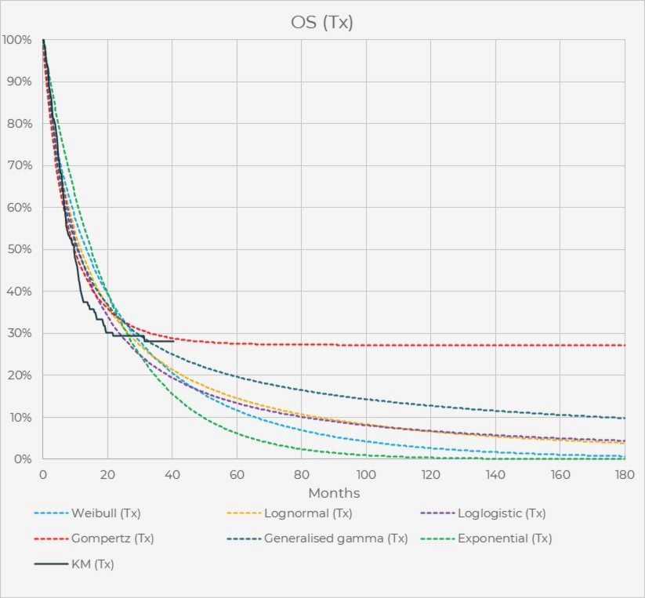
PFS
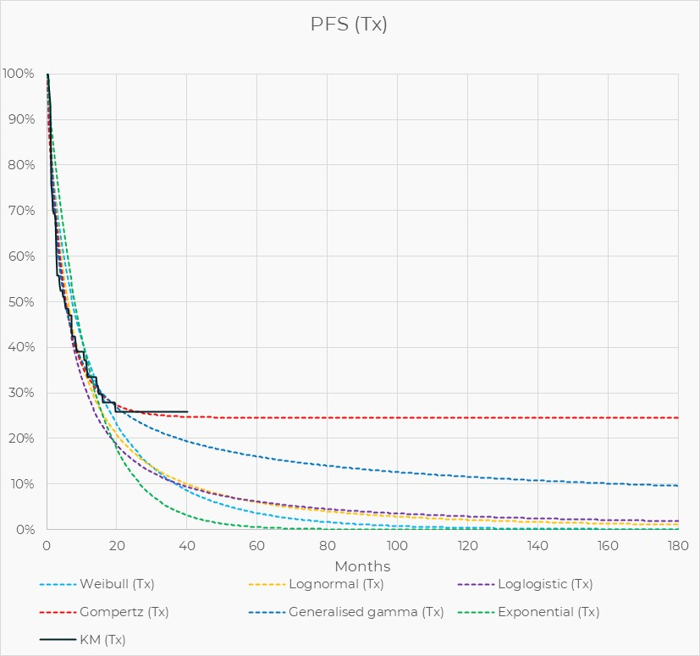
ToT
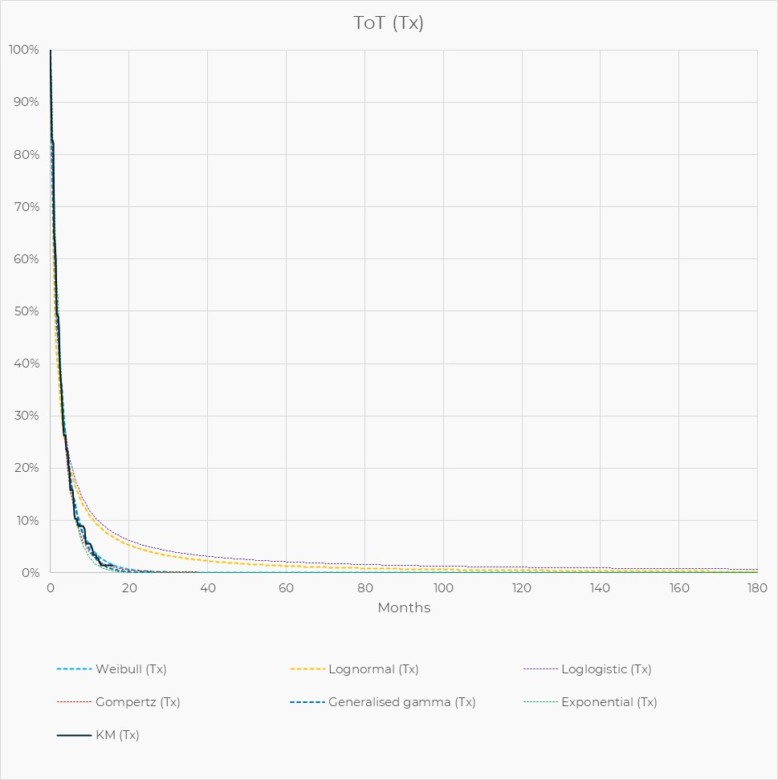
Source: Constructed during the evaluation, based on data from Attachment 3.1 cost effectiveness model EXCEL file.
OS = overall survival; PFS = progression-free survival; ToT = time on treatment; Tx = treatment.
  - The Gompertz function was selected in the base case for OS, PFS and ToT extrapolations.
  - For the OS curve, although the Gompertz distribution reported the lowest AIC/BIC values, visual inspection of Figure 7 indicated that none of the parametric functions provided a good fit for the LOTIS-2 OS KM data, particularly beyond month 10, and the Gompertz function noticeably overestimated survival after this point. Hazard plots were not provided in the submission to assist with assessing the underlying hazard. However, because the Gompertz distribution allows only monotonically increasing or decreasing hazards, its hazard pattern did not appear consistent with a cure assumption. In contrast, log-normal, log-logistic or generalised gamma distributions would have allowed hazards to change direction over time. The plateau seen in the Gompertz model may be overly optimistic, and the generalised gamma, log-normal or log-logistic models may represent a more realistic scenario.
  - For the PFS curve, the Gompertz distribution was selected based on visual fit to the KM data from LOTIS-2 and its perceived clinical plausibility, noting the “flattened” tail of the Gompertz curve aligned with the observed plateau in PFS. Although the generalised gamma function provided the best statistical fit, the submission considered the Gompertz function to be more clinically appropriate. Figure 6 showed that differences between the Gompertz function and generalised gamma curves arose primarily in the tail section between 20 and 40 months. As with OS, the Gompertz distribution imposes a strictly monotonic hazard (i.e., always increasing or always decreasing), which may not align with a cure assumption. This consideration is also relevant when selecting an appropriate distribution for PFS.
  - The Sub-Committees noted the ICER in the submitted model was very sensitive to the choice of parametric functions. However, as outlined in paragraph 6.57, the model’s treatment of cure was inconsistent with the submission’s claim that cured patients returned to general-population mortality. The Sub-Committees noted the evaluation constructed an analysis which corrected this, with PF patients modified so they follow background mortality after 2 years (see Table 16). Acknowledging the model structure (partitioned survival analysis) limited a full exploration of cure and mortality, the Sub-Committees noted that when the cure assumption was applied as intended, the sensitivity of the ICER to the selected parametric functions was substantially reduced. The Sub-Committees agreed with the evaluation that for this reason, it was appropriate to exclude extrapolations from the key model drivers in Table 14.
  - Health state utilities for PF and PD were estimated from the EQ-5D-5L data reported in the LOTIS-2 study. These EQ-5D-5L data were mapped to EQ-5D-3L utility index scores using UK country weights. For cured patients, the model assumed a utility of 0.88, sourced from Australian EQ-5D-5L population norm utility for the 65-74 age cohort from Redwood 2024. The Sub-Committees noted the mismatch between the utilities used in the PF and PD using UK preference weights, whereas the cure health state used utility values with Australian preference weights. The Sub-Committees noted that UK preference weights tend to underestimate those using Australian preference weights. A sensitivity analysis was undertaken testing a 10% increase in utility values for the progression free and progressed disease health states decreased the ICER from an error-corrected base case of $95,000 to < $115,000 per QALY gained to $75,000 to < $95,000 per QALY gained. Separately, the Sub-Committees noted that the ICER increased by approximately redacted content% to $95,000 to < $115,000 from an error-corrected base case of $95,000 to < $115,000 per QALY gained, when the utility value of ‘cure’ was decreased by 10% from 0.88 to 0.79.
  - A more appropriate approach to cost R-ICE in the model may be to assume a fixed treatment duration of 3 cycles for all patients in the comparator arm, rather than using the ToT curve for the comparator arm as done in the model. Another issue with costing R-ICE in the model was that the model erroneously applied 4 treatment cycles as the maximum duration of R-ICE treatment despite assuming a maximum treatment duration of 9 weeks, equating to 3 treatment cycles. The Sub-Committees agreed with the evaluation that it would be appropriate to assume 100% of patients in the comparator arm received R-ICE for 3 cycles and noted that this decreased the ICER from an error-corrected base case of $95,000 to < $115,000 per QALY gained to $75,000 to < $95,000 per QALY gained.
  - Model Markov traces are presented in Figure 7, for the base case analysis.
Figure 7: Markov traces – base case in submission
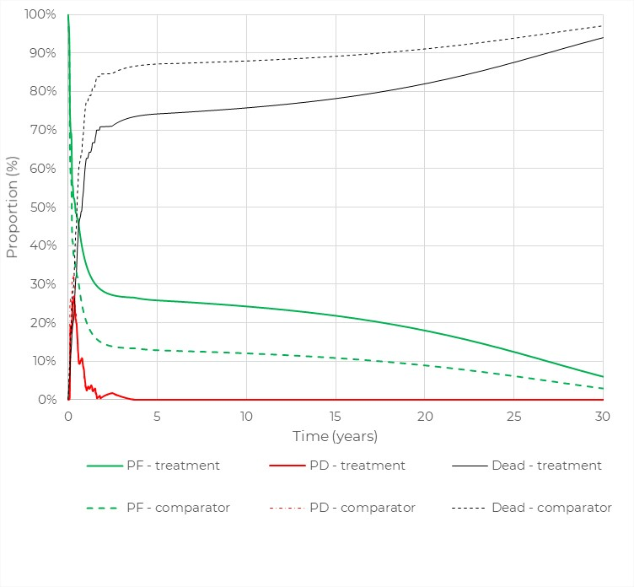
Source: constructed during the evaluation based on Figures 3-6 to 3-7, pp.127-128 of the submission and the submitted EXCEL economic model.
PD= progressive disease; PF = progression-free.
  - Approximately 28% and 15% of patients in the loncastuximab tesirine and comparator arms were estimated to have remained progression-free at 2 years in the model. At 2 years, approximately 71% of patients in the loncastuximab tesirine arm and 85% of patients in the comparator arm were estimated to have died. At 10 years, approximately 75% and 88% of patients in the loncastuximab tesirine and comparator arms have died, respectively. By 30 years, these proportions increased to 94% and 97% in the two arms, respectively.
  - A naïve “unadjusted” comparison of OS data from LOTIS-2 (including those who underwent 4L and further lines of therapy) versus LaRDR data from Wellard 2025 (including those who received CAR-T and bispecific therapies) conducted during the evaluation showed that the OS of loncastuximab tesirine patients from the model based on LOTIS-2 patients was similar to that of LaRDR patients. Although Wellard 2025 did not report outcomes for the subgroup of patients treated with salvage chemotherapy, such data would be available in LaRDR to provide a comparison of the likely effectiveness of loncastuximab tesirine in contemporary Australian clinical practice.
  - Table 13 presents the disaggregated summary of costs from the economic evaluation.
Table 13: Disaggregated summary of cost impacts in the economic evaluation
 | Loncastuximab tesirine | Comparator | Incremental cost | % of total incremental cost
Drug costs | $redacted content | $5,475.46 | $redacted content | redacted content%
Pre-medication costs | $79.93 | $1,160.91 | -$1,080.98 | -0.8%
Drug administration costs | $528.96 | $825.14 | -$296.17 | -0.2%
Subsequent therapy costs | $2,071.90 | $2,311.45 | -$239.55 | -0.2%
Disease management costs | $6,338.67 | $4,532.76 | $1,805.90 | 1.3%
Adverse event costs | $4,822.01 | $12,093.77 | -$7,271.76 | -5.1%
Terminal care costs | $58,498.67 | $65,267.46 | -$6,768.79 | -4.8%
Total | $redacted content | $91,666.95 | $redacted content | 100%
Source: Table 3-25, p131 of the submission.
  - Drug costs of loncastuximab tesirine were the largest contributor to the incremental costs (+redacted content%). Cost offsets, by comparison, had only a minimal impact on costs, with treatment of adverse events contributing -5.1% and terminal care costs - 4.8%. The Sub-Committees noted that the exclusion of terminal care costs increased the error-corrected base case ICER from $95,000 to < $115,000 per QALY gained to $95,000 to < $115,000 per QALY gained.
  - Table 14 presents a summary of the key drivers of the model.
Table 14: Key drivers of the model
Description | Method/Value | Impact (Error-Corrected Base Case:  $redacted content¹/QALY gained)
HR to derive survival curves (OS, PFS, ToT) for the comparator arm | The inverse of the HR of 0.66 (95% CI: 0.50, 0.85; weighted bootstrap), 1.515 was used in the base case and was derived from the MAIC comparing loncastuximab tesirine with chemoimmunotherapy. This estimate was highly uncertain as it was based on the unanchored MAIC, which was unlikely to adjust for systematic differences between the LOTIS-2 and CORAL extension studies. This single HR also determined all curves in the comparator arm (OS, PFS and ToT), meaning the modelling approach depended entirely on this one estimate. The PSCR acknowledged the uncertainty associated with the approach. The PSCR stated that in contemporary R/R DLBCL trials where both endpoints are reported, the relative treatment effect is often larger for PFS than OS, meaning that the PFS HR is typically lower than the OS HR and argued that the approach taken was conservative. The Sub-Committees noted the model was highly sensitive to the HR applied and agreed with the evaluation that the approach taken was a key source of uncertainty. | Very high, favoured loncastuximab tesirine.  Decreasing the HR used to 1.176 (i.e., inverse of HR of 0.85; the upper 95% CI using weighted bootstrap) increased the ICER redacted content% to $redacted content²/QALY gained.
Time horizon | The base case assumed a time horizon of 30 years. This was uncertain and further exacerbated the uncertainty from the HR used in modelling the treatment effect. The Sub-Committees considered that a 15 year time horizon in the base case would be more appropriate. | Very high, favoured loncastuximab tesirine  Assuming a time horizon of 10 years increased the ICER redacted content% to $redacted content²/QALY gained.
R-ICE drug costs | The base case applied the HR for OS to the ToT curve from LOTIS-2 to estimate the ToT curve for patients on R-ICE. The Sub-Committees agreed with the evaluation that a more appropriate approach might be to cost R-ICE by assuming a fixed treatment duration for all patients based on the dosing schedule. | Moderate, favoured chemoimmunotherapy.  Assuming 100% of patients in the comparator arm received R-ICE for 3 cycles decreased the ICER redacted content% to $redacted content³/QALY gained.
Utility for cured patients | The base case assumed a utility value of 0.88 for cured patients, based on Australian population norm utility. | Moderate, favoured loncastuximab tesirine.  Assuming a 10% decrease in utility for cured patients, increased the ICER redacted content% to $redacted content¹/QALY gained.
Source: compiled during the evaluation.
HR = hazard ratio; MAIC = matching adjusted indirect comparison; OS = overall survival; R-ICE = rituximab, ifosfamide, carboplatin, etoposide; ToT = time on treatment.
The redacted values correspond to the following ranges:
¹ $95,000 to < $115,000
² $155,000 to < $255,000
³ $75,000 to < $95,000
  - Table 15 presents the results of the stepped economic evaluation.
Table 15: Results of the stepped economic evaluation (discounted costs and outcomes)
Step and component | Loncastuximab tesirine | Comparator | Increment
Step 1: Trial-based costs and outcomes: time horizon of 3 years (discounted)
Costs | $redacted content | $9,661.18 | $redacted content
LYG | 1.219 | 0.86 | 0.359
Incremental cost/extra LYG gained |  |  | $redacted content¹
Step 2: time horizon extended to 30 years (discounted)
Costs | $redacted content | $9,772.95 | $redacted content
LYG | 3.971 | 2.239 | 1.732
Incremental cost/extra LYG gained |  |  | $redacted content²
Step 3: including costs of AEs, disease management and terminal care costs (discounted)
Costs | $redacted content | $91,666.95 | $redacted content
LYG | 3.971 | 2.239 | 1.732
Incremental cost/extra LYG gained |  |  | $redacted content²
Step 4: transformation into QALYs; utility weights applied (discounted)
Costs | $redacted content | $91,666.95 | $redacted content
QALYs | 3.300 | 1.822 submission  (1.816 error-correctedª) | 1.478 submission  (1.484 error-corrected)
Incremental cost/extra QALY gained (base case) |  |  | $redacted content³  ($redacted content³ error-corrected)
Source: Table 3-24, p131 of the submission.
ª An error was identified during the evaluation in summing QALYs, the disutility of AEs was excluded in calculating total QALYs for the comparator arm.
The redacted values correspond to the following ranges:
¹ $355,000 to < $455,000
² $75,000 to < $95,000
³ $95,000 to < $115,000
  - The results of key sensitivity analyses are summarised in Table 16.

Table 16: Sensitivity analyses
Analyses | Incremental cost | Incremental QALY | ICER | % change to ICER
Base case (submission) | $redacted content | 1.478 | $redacted content
Error-corrected Base Case ª | $redacted content | 1.484 | $redacted content | -
Time horizon (base case 30 years)
10 years | $redacted content | 0.847 | $redacted content | +redacted content%
15 years |  | 1.125 | $redacted content | +redacted content%
20 years | $redacted content | 1.315 | $redacted content | +redacted content%
Discount rate (base case: 5%)
0% | $redacted content | 2.571 | $redacted content | -redacted content%
3.5% | $redacted content | 1.721 | $redacted content | -redacted content%
Mortality for PF pts modified so they follow background mortality after cure timepoint 2 years* (base case determined by extrapolated survival curves) | $redacted content | 1.507 | $redacted content | -redacted content%
Cure assumptions (base case 2 years)
No cure | $redacted content | 1.206 | $redacted content | +redacted content%
3 years | $redacted content | 1.462 | $redacted content | +redacted content%
5 years | $redacted content | 1.422 | $redacted content | +redacted content%
Extrapolation of OS (base case Gompertz)
Generalised gamma extrapolation | $redacted content | 1.133 | $redacted content¹ | +redacted content%
Lognormal extrapolation | $redacted content | 0.845 | $redacted content² | +redacted content%
Loglogistic extrapolation | $redacted content | 0.896 | $redacted content² | +redacted content%
Extrapolation of PFS (base case Gompertz)
Generalised gamma extrapolation | $redacted content | 1.397 | $redacted content³ | +redacted content%
Lognormal extrapolation | $redacted content | 1.205 | $redacted content¹ | +redacted content%
Loglogistic extrapolation | $redacted content | 1.224 | $redacted content¹ | +redacted content%
HR for comparator survival curves (base case 1.515)
HR = 1.471 (inverse of naïve unadjusted HR 0.68) | $redacted content | 1.391 | $redacted content³ | +redacted content%
HR = 1.176 (upper 95% CI 0.85, weighted bootstrap) | $redacted content | 0.623 | $redacted content² | +redacted content%
HR = 1.136 (upper 95% 0.88, weighted standard) | $redacted content | 0.495 | $redacted content⁴ | +redacted content%
Utility of cured patients (base case 0.88)
10% decrease in utility i.e. cured utility 0.792 | $redacted content | 1.353 | $redacted content³ | +redacted content%
Utility values for PF and PD (base case PF 0.693*; PD 0.637)
Utility values for PF 0.763*; PD 0.706 (base case PF 0.693*; PD 0.637) | $redacted content | 1.501 | $redacted content⁵ | -redacted content%
Costs
LON vial sharing allowed (base case no sharing) | $redacted content | 1.484 | $redacted content^{b6} | -redacted content%
Comparator arm: 100% of pts receive R-ICE for 3 cycles (base case follow ToT; 4 cycles) | $redacted content | 1.484 | $redacted content⁵ | -redacted content%
Comparator R-GemOx (base case R-ICE) | $redacted content | 1.484 | $redacted content³ | +redacted content%
No half-cycle correction to costs (base case half-cycle correction to costs and outcomes) | $redacted content | 1.484 | $redacted content³ | +redacted content%
Exclude terminal care costs | $redacted content | 1.484 | $redacted content³ | +redacted content%
Multivariate analyses
(A)  PF pts follow background mortality after cure timepoint of 2 years* AND KM truncation points of 2 years for OS and PFS | $redacted content | 1.456 | $redacted content³ | +redacted content%
(B) =(A) + 100% of comparator pts receive 3 R-ICE cycles^{c} | $redacted content | 1.456 | $redacted content⁵ | -redacted content%
(C) = (B) +Time horizon of 20 years | $redacted content | 1.291 | $redacted content³ | +redacted content%
(D) = (C) + HR = 1.176 (upper 95% CI 0.85, weighted bootstrap) | $redacted content | 0.543 | $redacted content² | +redacted content%
(E) = (C) + HR = 1.136 (upper 95% CI 0.88, weighted standard) | $redacted content | 0.431 | $redacted content⁴ | +redacted content%
(F) = (B) + Time horizon of 15 years | $redacted content | 1.105 | $redacted content³ | +redacted content%
(G) = (F) + Utility values for PF 0.763**; PD 0.706 | $redacted content | 1.122 | $redacted content³ | +redacted content%
(H) = (G) + No half-cycle corrections to costs | $redacted content | 1.122 | $redacted content¹ | +redacted content%
(I) = (H) + Exclude terminal care costs | $redacted content | 1.122 | $redacted content¹ | +redacted content%
Source: constructed during the evaluation and during the preparation of Sub-Committee advice.HR = hazard ratio; KM = Kaplan-Meier; LON = loncastuximab tesirine; MAIC = matching adjusted indirect comparison; LY = life years; OS = overall survival; PD = progressive disease; PF = progression free; PFS = progression free survival; pts=patients; R-ICE = rituximab, ifosfamide, carboplatin, etoposide; ToT = time on treatment.
* The model structure (partitioned survival analysis) however limited a full exploration of cure and mortality. The scenario analysed during the evaluation was based on the submitted model with the following amendments:
- After the cure timepoint, patients in the PF health state can only exit due to background mortality.
- No adjustment was made to PD death, and the distance between OS and PFS curves was assumed to remain unchanged from the submitted model. Total deaths in the model were then the sum of deaths from both PF and PD patients.
In this analysis, a minor error in summing QALYs for the comparator arm was also corrected. Cell AQ5 in the ‘Model_Cx” worksheet should include cell AP5 in calculations.
** UK preference weights were used to estimate utility for PF and PD in the submission. Assumption made that the utility value for PF was increased by 10%, and the same disutility of PD vs PF was assumed.
ª Correcting error in summing QALYs for the comparator arm. The disutility of AEs was excluded in calculating total QALYs for the comparator arm. Cell AQ5 in the ‘Model_Cx’ worksheet should include cell AP5 in calculations.
^{b} Including assumed 98.1% dose intensity for loncastuximab dosing for all doses.
^{c} Changes made to column W of ‘Model_Cx’ worksheet and Cell D21 of ‘Settings and Results’ worksheet.
The redacted values correspond to the following ranges:
¹ $115,000 to < $135,000
² $155,000 to < $255,000
³ $95,000 to < $115,000
⁴ $255,000 to < $355,000
⁵ $75,000 to < $95,000
⁶ $45,000 to < $55,000

  - The Sub-Committees noted that the model was sensitive to the presence of a cure assumption (the ICER increasing to $115,000 to < $135,000 per QALY gained assuming no cure, from an error-corrected base case of $95,000 to < $115,000) but not to the variation between cure points of 2 to 5 years (ICER minimally increasing to $95,000 to < $115,000 per QALY gained assuming a cure point of 5 years). The Sub-Committees considered that the inclusion of a cure assumption was appropriate. However, the Sub-Committees noted that the model’s treatment of cure was inconsistent with the submission’s claim that cured patients returned to general-population mortality and accepted the evaluations approach to correct this by modifying PF patients so that they follow background mortality after 2 years, noting that this may overestimate life expectancy.
  - The Sub-Committees considered that there should be no half-cycle correction to costs, no terminal care costs, 100% of comparator patients should receive 3 R-ICE cycles, a time horizon of 15 years was appropriate and that the PF utility values should be increased by redacted content% with the same disutility of PD vs PF assumed. The Sub-Committees noted that correcting the models approach to cure and incorporating these inputs increased the ICER from the error-corrected base case of $95,000 to < $115,000 per QALY gained to $115,000 to < $135,000 per QALY gained. The Sub-Committees considered the ICER of $115,000 to < $135,000 per QALY gained remained highly uncertain due to the reliance on a single HR from the unanchored MAIC to inform all curves in the comparator arm.
  - The pre-PBAC response accepted the Sub-Committees recommendations for a 15 year time horizon, no half-cycle correction to costs, 100% of comparator patients receive 3 R-ICE cycles and that the PF utility values should be increased by 10% with the same disutility of PD vs PF assumed. However, the revised economic base case proposed in the pre-PBAC response did not modify PF patients so that they follow background mortality after 2 years. In addition, the pre-PBAC response revised base case did not exclude all terminal care costs as advised by the Sub-Committees. The pre-PBAC response instead excluded terminal care costs for deaths occurring after 5 years based on the assumption that most deaths within the first 5 years would be cancer related. Incorporating the price reduction proposed (see paragraph 3.2) the pre-PBAC response stated the revised base case returned an ICER of $75,000 to < $95,000 per QALY gained.

Drug cost/patient/cycle
  - The cost per patient for loncastuximab tesirine was $redacted content per cycle for the first two cycles (loading doses) in the model, with a dose of 0.15 mg/kg every 3 weeks, using individual patient-level weight data in LOTIS-2 and a dose intensity of 98.1%. The cost per patient on loncastuximab tesirine was $redacted content per cycle for subsequent doses, applying the dose of 0.075 mg/kg every 3 weeks, individual patient-level weight data in LOTIS-2 and a dose intensity of 98.1%. The average cost per patient on R-ICE was $2,508 per cycle.
Table 17: Drug cost per patient for loncastuximab tesirine (using price proposed in the submission)
 | Trial dose and duration | Model | Financial estimatesª
Dose regimen: | Initial: 0.15 mg/kg  Continuing: 0.075 mg/kg
Mean dose | 9.24 mg per cycle^{c} | Initial:16.8 mg  Continuing: 10.1 mg | 10 mg vial
Mean duration | 85.7 days (12.2 weeks) | 12.4 weeks^{b} | Initial: 6 weeks  Continuing: 6.79 weeks Grandfathered: 6.4 weeks
Average weighted cost | - | Initial: $redacted content  Continuing: $redacted content | Initial: $redacted content  Continuing: $redacted content Grandfathered: $redacted content
Source: compiled during the evaluation from economic and financial model assumptions.
ª The financial estimates assumed a 50:50 split for public: private scripts, compared to 75: 25 based on rituximab PBS use in the economic model.
^{b} Calculated during the evaluation (Gompertz extrapolation).
^{c} This dose was across all cycles.
  - The pre-PBAC response proposed a revised ex-manufacturer price of $redacted content per 10 mg vial.

Estimated PBS usage & financial implications
  - This submission was considered at the joint ESC-DUSC meeting.
  - The submission estimated the financial implications of the proposed listing using an epidemiological approach, based on four incident patient subpopulations of adults with DLBCL, PMBL or HGBL who failed or were ineligible to receive the following treatments:
- Patients who receive 3L CAR T-cell therapy but then are R/R and require 4L treatment
- Patients who receive 2L glofitamab but then are R/R and require 3L treatment
- Patients who are ineligible for, or do not receive epcoritamab in the 3L, and
- Patients who receive 3L epcoritamab but then are R/R and require 4L treatment
  - Table 18 summarises the key inputs and calculations of the number of patients likely to receive loncastuximab tesirine and number of scripts dispensed.

Table 18: Data sources and parameter values applied in the utilisation and financial estimates
Data | Value | Source | Comment
Eligible population
Incident patients |  | AIHW data from 2016-2021 extrapolated using an annual fixed rate:  DLBCL: 3.0%  PMBL: 8.8%  HGBL: -6.6% | The evaluation considered the inclusion of PMBL population was inconsistent with the restriction.  The submission used the population of AIHW data from a different diagnostic subgroup to estimate incident HGBL patients.  Applying a linear trend to AIHW data from 2010-2021 results in lower patient numbers for DLBCL and PMBL, and higher numbers for HGBL.  • DLBCL: redacted content¹ in Y1 to redacted content¹ in Y6.  • PMBL: redacted content in Y1 to redacted content in Y6.  • HGBL: redacted content in Y1 to redacted content in Y6.  The Sub-Committees noted that the current epidemiological model assumes patients are treated in the same year of diagnosis. The Sub-Committees considered a large proportion of patients would take longer than 12 months to progress through treatment options to be eligible for loncastuximab tesirine.
   | DLBCL | PMBL | HGBL | Total
  Yr 1 | redacted content¹ | redacted content² | redacted content² | redacted content¹
  Yr 2 | redacted content¹ | redacted content² | redacted content² | redacted content¹
  Yr 3 | redacted content¹ | redacted content² | redacted content² | redacted content¹
  Yr 4 | redacted content¹ | redacted content² | redacted content² | redacted content¹
  Yr 5 | redacted content¹ | redacted content² | redacted content² | redacted content¹
  Yr 6 | redacted content¹ | redacted content² | redacted content² | redacted content¹
Prevalent patients | 0 | The submission did not include prevalent patients. | There were 1867 prevalent DLBCL patients in 2021 in Australia (AIHW). Given access to CAR-T and bispecifics in 2L, some of these patients may be eligible to receive LT in 3L+.  The Sub-Committees considered that a prevalent pool consisting of relapsing patients in the weeks prior to listing on the PBS would need to be considered as part of the epidemiological model.  The Sub-Committees noted the treatment duration would differ between prevalent patients and grandfathered patients. The Sub-Committees considered that a prevalent population should be added using the full treatment duration estimate.
Total eligible patients (3L+) | Yr 1: redacted content²  Yr 2: redacted content²  Yr 3: redacted content¹  Yr 4: redacted content¹  Yr 5: redacted content¹  Yr 6: redacted content¹ | Estimated as 18.25% of incident patients entering 3L treatment, based on Kanas et al. 2022. | The evaluation considered these numbers may be underestimated. Kanas et al. 2022 based their estimates on physicians’ surveys conducted in 2018-2019 in US/Europe. This was much lower than the proportion of patients entering 3L (32%) reported by Wellard et al. 2025, based on current Australian registry data of patients with DLBCL. Given treatment changes since 2019 (e.g., CAR-T), the evaluation considered the 32% estimate seems more appropriate.  The Sub-Committees agreed with the evaluation that the 32% estimate using Australian registry data would be more appropriate.
Grandfathered patients | redacted content² grandfather patients requiring continuing prescriptions | Currently receiving ongoing compassionate access to LT in Australia | Scripts for these patients were added to the total number of scripts. The evaluation considered this was reasonable.
Treatment utilisation
Uptake rate | S1: Patients who received 3L CAR T-cell therapy but then are R/R and require 4L treatment  S2: Patients who received 2L glofitamab but then are R/R and require 3L treatment  S3: patients who are ineligible for, or do not receive epcoritamab in the 3L  S4: Patients who received 3L epcoritamab but then are R/R and require 4L treatment | Submission’s assumptions, based on uptake of epcoritamab in 3L. | The evaluation considered these rates were highly uncertain, but may be higher due to the lack of other treatment options.  The Sub-Committees agreed with the evaluation that uptake rates are likely underestimated due to the lack of other treatment options. The Sub-Committees considered that uptake would likely reach 50% for all subpopulations.
   | S1 | S2 | S3 | S4
  Yr 1 | redacted content% | redacted content% | redacted content% | redacted content%
  Yr 2 | redacted content% | redacted content% | redacted content% | redacted content%
  Yr 3 | redacted content% | redacted content% | redacted content% | redacted content%
  Yr 4 | redacted content% | redacted content% | redacted content% | redacted content%
  Yr 5 | redacted content% | redacted content% | redacted content% | redacted content%
  Yr 6 | redacted content% | redacted content% | redacted content% | redacted content%
Number treated | Calculations were based on patients entering 3L (18.5%), uptake rates above, and:  S1: 25% eligible for CAR-T, 50% R/R after 3L  S2: 66.5% eligible for glofitamab (1- 33.5%). The submission multiplied 67% eligible for 2L CAR-T and 50% for SCT = 33.5%; uptake of 2L glofitamab (80%-95%).  S3: 75% ineligible for CAR-T, no prior glofitamab (1 – [glofitamab eligible 66.5% * uptake of 2L glofitamab 80%-95%]), 12.5% not receiving epcoritamab  S4: no prior glofitamab, eligible for epcoritamab (87.50%= 1 – 12.5%), R/R to epcoritamab (79.62%). | Table 20, eporcoritamab PSD, Nov 2024;  Table 20, MSAC 1772.1;  Lewis and Cheah 2024  Karimi et al. 2025 | The evaluation considered these numbers were highly uncertain.  S1: CAR-T is now MBS-listed for 2L treatment, which would reduce CAR-T utilisation in 3L and affect all the other subpopulations.  S2: The submission multiplied the 2L CAR-T eligibility (67.5%) and SCT eligibility (50%) = 33.5%. This was not appropriate as CAR-T eligibility is not dependent on SCT eligibility, in fact, it may substitute for SCT.  S3: the epcoritamab PSD assumed rate for those not taking epcoritamab in 3L (12.5%) includes all bispecific-naïve patients (as glofitamab had not been listed at the time). Therefore, the evaluation considered that applying this rate on top of glofitamab’s uptake rate was not appropriate.  S4: This subpopulation did not include patients who would have failed CAR-T in 2L and are eligible to receive epcoritamab in 3L.  Furthermore, the evaluation considered that patients who are unable to receive CAR-T in 2L could receive glofitamab in 2L, and then become eligible to receive CAR-T in 3L as their disease status may have changed.
   | S1 | S2 | S3 | S4 | Total
  Yr 1 | redacted content² | redacted content² | redacted content² | redacted content² | redacted content²
  Yr 2 | redacted content² | redacted content² | redacted content² | redacted content² | redacted content²
  Yr 3 | redacted content² | redacted content² | redacted content² | redacted content² | redacted content²
  Yr 4 | redacted content² | redacted content² | redacted content² | redacted content² | redacted content²
  Yr 5 | redacted content² | redacted content² | redacted content² | redacted content² | redacted content²
  Yr 6 | redacted content² | redacted content² | redacted content² | redacted content² | redacted content²
Scripts dispensed |  | Number of scripts were based on the mean treatment duration:  • Initial: 6 weeks  • Continuing: 6.79 weeks  • Grandfathered: 6.4 weeks  Compliance: 98.10% | The submission stated that the average treatment duration was informed by the economic model, with an average of 12.79 weeks of treatment. The median time on treatment in the model did not reach 7 weeks and mean time on treatment was not reported. The mean time on treatment (calculated during the evaluation from the model ToT curve) was 12.37 weeks, similar to the mean treatment duration in the LOTIS 2 study (12.24 weeks).
   | Initial | Contn | GF | Total
  Yr 1 | redacted content² | redacted content² | redacted content² | redacted content¹
  Yr 2 | redacted content² | redacted content² | 0 | redacted content¹
  Yr 3 | redacted content² | redacted content² | 0 | redacted content¹
  Yr 4 | redacted content² | redacted content² | 0 | redacted content¹
  Yr 5 | redacted content² | redacted content² | 0 | redacted content¹
  Yr 6 | redacted content² | redacted content² | 0 | redacted content¹
Scripts displaced |  | Number of scripts based on treatment duration: 7.59 weeks. Source not provided.  Compliance: 100% | The evaluation considered the treatment duration was highly uncertain, and compliance was inconsistent with the superior safety claim for LT. The submission did not explain why this treatment duration and 100% compliance were used.
   | Rit | Eto | Cplt | Ifo | Total
  Yr 1 | redacted content² | redacted content² | redacted content² | redacted content² | redacted content¹
  Yr 2 | redacted content² | redacted content² | redacted content² | redacted content² | redacted content¹
  Yr 3 | redacted content² | redacted content² | redacted content² | redacted content² | redacted content¹
  Yr 4 | redacted content² | redacted content² | redacted content² | redacted content² | redacted content¹
  Yr 5 | redacted content¹ | redacted content¹ | redacted content¹ | redacted content¹ | redacted content¹
  Yr 6 | redacted content¹ | redacted content¹ | redacted content¹ | redacted content¹ | redacted content¹
PBS/RPBS Costs
PBS, RPBS split | PBS: 98.68%  RPBS: 1.32% | Based on PBS dispensing data for epcoritamab, pembrolizumab, and R-ICE. | The submission did not use this split to calculate the RPBS scripts and costs. All scripts and costs were inappropriately attributed to PBS.  Pembrolizumab is PBS-listed for R/R PMBL. Given the uncertain inclusion of this population, the use of pembrolizumab PBS data may not be appropriate.
Loncastuximab tesirine | DPMA was calculated by multiplying the AEMP ($redacted content) by the weighted number of vials (1.68 for initial treatment, 1.01 for continuing treatment) and the pharmacy markup (private); and adding fees for drug preparation and distribution. | The model used the published DPMA, as the submission did not propose any SPA, and the effective price is the same as the published price.  The weighted cost was calculated as a 50% split between public and private. | The DPMA used in the model differed to that proposed in other sections of the submission. The submission used a different public/private split in the economic analysis (75/25) and in the financial estimates (50/50). In the economic analysis, the 75/25 split was based on rituximab PBS use, whereas in the financial estimates, the submission assumed a 50/50 split, not based on utilisation data.  The Sub-Committees noted this was rectified in the PSCR.
  Dose:  10mg powder vial | Published DPMA
  Dose:  10mg powder vial | Public | Private | Weighted
  Initial | $redacted content | $redacted content | $redacted content
  Contn | $redacted content | $redacted content | $redacted content
  GF | $redacted content | $redacted content | $redacted content
R-ICE |  | PBS item numbers;  Rit: 13102N, 13109Y  Eto: 4428C, 7237X  Cplt: 4309T, 7222D  Ifo: 4448D, 7248L | PBS items were consistent with those applied in the economic model. However, the financial model incorrectly reported the following items were used for rituximab: 13095F, 13101M, 13088W, 13109Y, while only items 13102N and 13109Y were included.
  Dose | Published DPMA
  Dose | Public | Private | Weighted
  Rit 500/100mg | $393.88 | $434.91 | $414.40
  Eto 100mg | $1,434.69 | $1561.31 | $1498.00
  Cplt 450mg | $144.39 | $181.92 | $163.16
  Ifo 2000mg | $473.68 | $515.82 | $494.75
Patient copayment | PBS: $16.25; RPBS: $6.84 | PBS statistics | PBS statistics included Pembrolizumab, which is listed for PMBL (see above).
MBS costs | $126 | MBS item 13950: parenteral administration of antineoplastic agents. | MBS item 13950 was correctly applied to both LT and chemoimmunotherapy administration. However, an 85% benefit was used instead of the recommended 80% (PBAC Utilisation and Cost Model Workbook and User Manual).
Source: Compiled during the evaluation, based on Table 4.2-4.23, pp137-147 of the submission.
AIHW=Australian Institute of Health and Welfare; Eto=etoposide; contn=continuing; Cplt=carboplatin; GF=grandfathered; LT=loncastuximab tesirine; R-ICE=Rituximab + ifosfamide + carboplatin + etoposide; Rit=rituximab; SCT=stem cell transplant; ToT=time on treatment
The redacted values correspond to the following ranges:
¹ 500 to < 5,000
² < 500

  - Table 19 summarises the estimated net financial implications to the PBS/RPBS and the MBS for the proposed listing of loncastuximab tesirine over the first six years (assumed as 2026 to 2031).
Table 19: Estimated use and financial implications
 | 2026 | 2027 | 2028 | 2029 | 2030 | 2031 | Total
Estimation of number of patients (3L+ R/R DLBCL, PMBL, HGBL)
Incident patients | redacted content¹ | redacted content¹ | redacted content¹ | redacted content¹ | redacted content¹ | redacted content¹ | redacted content³
Eligible 3L+ | redacted content² | redacted content² | redacted content¹ | redacted content¹ | redacted content¹ | redacted content¹ | redacted content¹
Treated patients | redacted content² | redacted content² | redacted content² | redacted content² | redacted content² | redacted content² | redacted content¹
GF patients | redacted content² | - | - | - | - | - | redacted content²
Total scripts dispensed PBS
LT, scripts | redacted content¹ | redacted content¹ | redacted content¹ | redacted content¹ | redacted content¹ | redacted content¹ | redacted content¹
Loncastuximab tesirine Net Cost to PBS
PBS cost | $redacted content⁴ | $redacted content⁴ | $redacted content⁴ | $redacted content⁵ | $redacted content⁵ | $redacted content⁵ | $redacted content⁶
Copayments | -$redacted content⁷ | -$redacted content⁷ | -$redacted content⁷ | -$redacted content⁷ | -$redacted content⁷ | -$redacted content⁷ | -$redacted content⁷
Total net cost less copayments | $redacted content⁴ | $redacted content⁴ | $redacted content⁴ | $redacted content⁵ | $redacted content⁵ | $redacted content⁵ | $redacted content⁶
Estimation of changes in use and financial impact of currently listed treatments PBS
Scripts net change | -redacted content¹ | -redacted content¹ | -redacted content¹ | -redacted content¹ | -redacted content¹ | -redacted content¹ | -redacted content³
PBS cost | -$redacted content⁷ | -$redacted content⁷ | -$redacted content⁷ | -$redacted content⁷ | -$redacted content⁷ | -$redacted content⁷ | -$redacted content⁷
Copayments | $redacted content⁸ | $redacted content⁸ | $redacted content⁸ | $redacted content⁸ | $redacted content⁸ | $redacted content⁸ | $redacted content⁸
Total net cost less copayments | -$redacted content⁷ | -$redacted content⁷ | -$redacted content⁷ | -$redacted content⁷ | -$redacted content⁷ | -$redacted content⁷ | -$redacted content⁷
Net cost less copayments for:
Rituximab | -$redacted content⁷ | -$redacted content⁷ | -$redacted content⁷ | -$redacted content⁷ | -$redacted content⁷ | -$redacted content⁷ | -$redacted content⁷
Ifosfamide | -$redacted content⁷ | -$redacted content⁷ | -$redacted content⁷ | -$redacted content⁷ | -$redacted content⁷ | -$redacted content⁷ | -$redacted content⁷
Carboplatin | -$redacted content⁷ | -$redacted content⁷ | -$redacted content⁷ | -$redacted content⁷ | -$redacted content⁷ | -$redacted content⁷ | -$redacted content⁷
Etoposide | -$redacted content⁷ | -$redacted content⁷ | -$redacted content⁷ | -$redacted content⁷ | -$redacted content⁷ | -$redacted content⁷ | -$redacted content⁷
Estimated financial implications for the PBS and the health budget
PBS scripts, net change | -redacted content¹ | -redacted content¹ | -redacted content¹ | -redacted content¹ | -redacted content¹ | -redacted content¹ | -redacted content⁹
PBS authorities (telephone), net change | redacted content² | redacted content² | redacted content² | redacted content² | redacted content² | redacted content² | redacted content¹
Net cost to PBS | $redacted content⁴ | $redacted content⁴ | $redacted content⁴ | $redacted content⁵ | $redacted content⁵ | $redacted content⁵ | $redacted content⁶
Net cost MBS | $redacted content⁸ | $redacted content⁸ | $redacted content⁸ | $redacted content⁸ | $redacted content⁸ | $redacted content⁸ | $redacted content⁸
Net cost to federal government health budget (PBS/MBS) | $redacted content⁴ | $redacted content⁴ | $redacted content⁴ | $redacted content⁵ | $redacted content⁵ | $redacted content⁵ | $redacted content⁶
Source: Compiled during the evaluation based on pp137-150 of the submission.
3L=third line; GF = grandfathered; HGBL = high grade B-cell lymphoma; LT = loncastuximab tesirine; PMBL = primary mediastinal B-cell lymphoma; Y1-Y6 = year 1 to 6
The redacted values correspond to the following ranges:
¹ 500 to < 5,000
² < 500
³ 10,000 to < 20,000
⁴ $20 million to < $30 million
⁵ $30 million to < $40 million
⁶ $100 million to < $200 million
⁷ net cost saving
⁸ $0 to < $10 million
⁹ 5,000 to < 10,000
  - The total cost to the PBS/RPBS of listing loncastuximab tesirine was estimated to be $30 million to < $40 million by Year 6, and a total of $100 million to < $200 million in the first 6 years of listing.
  - These financial estimates were highly uncertain due to key issues summarised below:
- The financial impact model specified that the PBS indication was adults with R/R DLBCL, including PMBL and HGBL. PMBL and HGBL are separate subtypes of large B-cell lymphoma, but not DLBCL subtypes. The inclusion of these additional lymphoma subtypes in the financial model was inconsistent with the restriction and increased the number of patients with DLBCL. The PBAC considered that it was reasonable to include patients with HGBL and PMBL.
- The estimated proportion of incident patients entering 3L treatment was 18.25%, which was based on physician surveys conducted across the US and Europe in 2018-2019 (Kanas et al. 2022). The Sub-Committees agreed with the evaluation that Wellard et al. 2025 provided a more recent estimate for patients entering 3L treatment (32%), based on DLBCL registry data from Australia. Given the changes in the treatment landscape since 2019 (e.g., CAR-T), the submission may have underestimated the number of eligible patients.
  - The number of treated patients was highly uncertain due to:
- the recent introduction of CAR-T therapies in second line and potential impact on subsequent treatment lines, which the submission did not appropriately account for;
- uncertain proportion of patients eligible for CAR-T;
- uncertain eligibility and uptake rates for bispecifics. The Sub-Committees considered higher uptake rates would be likely and result in higher PBS expenditure (Table 20).
- The Sub-Committees considered a prevalent pool of patients should be included in the estimates.
  - The number of scripts was based on an average treatment duration of 12.79 weeks. The submission stated this was informed by the economic model, but the average treatment duration was not reported. The median time on treatment in the economic model did not reach seven weeks, and mean time on treatment using the time on treatment Gompertz extrapolation used in the model was 12.37 weeks (calculated during the evaluation), similar to the mean treatment duration in the LOTIS trial (12.24 weeks).
  - The submission did not provide the source for the treatment duration used to calculate R-ICE scripts (7.59 weeks). This value was not reported in the CORAL trial. Furthermore, compliance for R-ICE patients was 100% while compliance for loncastuximab tesirine was 98.10%. This is inconsistent with the superior safety claim by the submission, as compliance rates are lower with higher toxicity. Higher compliance rates increased the number of displaced R-ICE scripts, which would underestimate the financial estimates
  - The Sub-Committees considered that the financial implications were underestimated. The Sub-Committees suggested changes to the epidemiological model are presented in Table 20 and incorporate increased uptake rates, a prevalent pool and an increase in the proportion of incident patients entering 3L treatment. The pre-PBAC response stated that a substantial proportion of 3L patients continue to receive treatment through clinical trials, therefore the uptake rate proposed by the Sub-Committees is likely to reflect the upper limit of loncastuximab tesirine use on the PBS.

Table 20: Sensitivity analysis of estimated use and financial implications incorporating Sub-Committee advice
 | 2026 | 2027 | 2028 | 2029 | 2030 | 2031 | Total | Total % Difference
Estimation of number of patients (3L+ R/R DLBCL, PMBL, HGBL)
Incident patients | redacted content¹ | redacted content¹ | redacted content¹ | redacted content¹ | redacted content¹ | redacted content¹ | redacted content²
Proportion of patients who enter 3L | 32%
Eligible 3L+ª | redacted content¹ | redacted content¹ | redacted content¹ | redacted content¹ | redacted content¹ | redacted content¹ | redacted content³ | +83%
Initiating patients | redacted content⁴ | redacted content⁴ | redacted content⁴ | redacted content⁴ | redacted content⁴ | redacted content¹ | redacted content¹ | +115%
Prevalent Patients^{b} | redacted content⁴ | - | - | - | - | - | redacted content⁴ | +44%
Total scripts dispensed PBS
LT, scripts | redacted content¹ | redacted content¹ | redacted content¹ | redacted content¹ | redacted content¹ | redacted content¹ | redacted content¹ | +115%
Estimated financial implications for the PBS/RPBS
Net cost to PBS/RPBS | $redacted content  ⁵ | $redacted content  ⁵ | $redacted content  ⁶ | $redacted content  ⁷ | $redacted content  ⁸ | $redacted content  ⁹ | $redacted content  ¹⁰ | +106.5%
Source: Based on pp137-150 of the submission.
3L=third line; GF = grandfathered; HGBL = high grade B-cell lymphoma; LT = loncastuximab tesirine; PMBL = primary mediastinal B-cell lymphoma.
ª Uptake rates were changed to the following from Years 1 to 5 for patients who are R/R to 3L CAR T-cell therapy as well as people who received 3L epcoritamab but are R/R and require 4L treatment: redacted content%, redacted content%, redacted content% redacted content%, redacted content%, redacted content%.
^{b} Includes < 500 prevalent patients and < 500 grandfathered patients as noted in the financial workbook.
The redacted values correspond to the following ranges:
¹ 500 to < 5,000
² 10,000 to < 20,000
³ 5,000 to < 10,000
⁴ < 500
⁵ $40 million to < $50 million
⁶ $50 million to < $60 million
⁷ $60 million to < $70 million
⁸ $70 million to < $80 million
⁹ $80 million to < $90 million
¹⁰ $300 million to < $400 million

  - The pre-PBAC response reported that incorporating the changes proposed by the Sub-Committee and the price reduction offered in the response the net cost to the PBS/RPBS reduced from $300 million to < $400 million to $200 million to < $300 million over 6 years.

Quality Use of Medicines
  - The submission mentioned the following activities to support the quality use of loncastuximab tesirine:
- A dedicated medical information service and adverse event reporting capabilities with a free toll number and email;
- Capacity to handle dissemination of risk management plan materials nationally;
- Several ongoing post-marketing surveillance studies for loncastuximab tesirine; in particular, an ongoing retrospective real-world evidence study evaluating the use of single-agent loncastuximab tesirine in the 3L setting.

Financial Management – Risk Sharing Arrangements
  - The submission acknowledged the expected uptake rate of loncastuximab tesirine in the 3L setting is uncertain, and indicated the Sponsor is willing to work with the Department of Health to manage uncertainty of listing for loncastuximab tesirine and closely monitor PBS usage data and pharmacovigilance activities post-listing to better understand real-world uptake and utilisation patterns.
For more detail on PBAC’s view, see section 7 PBAC outcome.
- PBAC Outcome
  - The PBAC did not recommend loncastuximab tesirine for the treatment of adult patients with relapsed or refractory (R/R) diffuse large B-cell lymphoma (DLBCL) who have received two or more prior lines of therapy. Due to limitations in the evidence the PBAC considered the claim of superior comparative effectiveness was highly uncertain but likely reasonable. The PBAC noted that the limitations with the clinical evidence resulted in the incremental cost-effectiveness ratio (ICER) being highly uncertain, and considered that the ICER incorporating the price reduction offered in the pre-PBAC response remained unacceptably high. In addition, the PBAC noted the revisions to the financial estimates proposed by its Sub-Committees increased the estimated financial implications for the Government. The PBAC considered a Risk Sharing Agreement (RSA) based on the estimated number of patients treated as per the submission would be required.
  - The PBAC considered the primary reason for this outcome was due to the economic evaluation provided.
  - The PBAC noted the consumer input from a health care professional, Rare Cancers Australia and the Australian Leukaemia & Lymphoma Group which described the need for additional treatment options for patients unsuitable for, or relapsing after chimeric antigen receptor T-cell (CAR-T) therapy or bispecific therapies. The PBAC acknowledged the high unmet clinical need in the subgroup of R/R DLBCL patients specified in the submission noting that they have a very poor prognosis.
  - In terms of the proposed restriction, the PBAC considered that an Authority Required (Telephone/Electronic) listing for initial and grandfathering treatment phases was appropriate with an Authority Required (Streamlined) listing for continuing treatment. The PBAC considered the initial treatment phase should have 1 repeat with 3 repeats for the continuing and grandfathering treatment phases. The PBAC agreed with the Sub-Committees that patients eligible for treatment with loncastuximab tesirine should have previously received or be unable to receive treatment with bispecific antibodies. As such, the PBAC considered the clinical criteria outlined in paragraph 3.5 should be included in the restriction. The PBAC also agreed with the Sub-Committees that it was reasonable to include patients with high-grade B-cell lymphoma (HGBL) and primary mediastinal B-cell lymphoma (PMBL) in the eligible population covered by the proposed restriction. The PBAC considered the Sub-Committees advice for the restriction indication to state Large B-cell lymphoma rather than DLBCL to incorporate HGBL and PMBL was reasonable. The PBAC advised that, consistent with the LOTIS-2 trial, treatment should be limited to a maximum of 12 months.
  - The PBAC advised that loncastuximab tesirine is likely to be used as a further line of therapy post-CAR-T and post-bispecific antibodies or in patients ineligible or unable to access such treatments. The PBAC considered that with the inclusion of additional clinical criteria in the restriction regarding bispecific antibodies (see paragraph 3.5), the clinical place proposed for loncastuximab tesirine was appropriate.
  - The PBAC noted the submission nominated rituximab in combination with ifosfamide, carboplatin and etoposide (R-ICE) as the main comparator. The PBAC acknowledged that R-ICE is generally used for fit transplant-eligible patients but considered its nomination as the main comparator was appropriate as a proxy for mixed chemoimmunotherapy. The PBAC also noted the Sub-Committees advice that rituximab in combination with gemcitabine and oxaliplatin (R-GemOx) may also be appropriate as a proxy for mixed chemoimmunotherapy. The PBAC noted that the population proposed by the submission will include patients who have relapsed after glofitamab plus gemcitabine and oxaliplatin.
  - The pivotal evidence for loncastuximab tesirine was derived from the LOTIS-2 study, a small (n=145), Phase 2, single-arm, open-label study that enrolled adult patients with R/R DLBCL who had received at least 2 prior lines of systemic therapy. The PBAC noted that the overall response rate (ORR) among patients treated with loncastuximab tesirine was 48.3% (95% CI: 39.9, 56.7), including 36 (24.8%) patients with complete remission (CR). In addition, the PBAC noted median progression-free survival (PFS) for the LOTIS-2 population was 4.93 months (95% CI: 2.89, 8.31) with median overall survival (OS) 9.53 months (95% CI: 6.75, 11.47).
  - The evidence for chemoimmunotherapy was from two observational extension studies of a randomised controlled trial (RCT)(CORAL). The extension studies included patients enrolled in the CORAL RCT who subsequently underwent 3L therapy. The PBAC acknowledged the concerns raised by the evaluation that chemoimmunotherapy was not standard of care at the time the CORAL extension studies were conducted and hence may not accurately reflect current standard of care. However, the PBAC agreed with the Sub-Committees that they are a reasonable representation of chemoimmunotherapy in this context. The PBAC noted that pooled data from the CORAL extension studies reported an ORR of 40.3% and a CR of 28.4%. Median OS in CORAL Extension 1 patients who had relapsed after achieving ASCT in 2L was 10.0 months (95% CI: 6.6, 12.6) and 4.4 months (95% CI: 3.4, 5.9) for patients in CORAL extension 2, who had not been able to proceed to the planned ASCT in 2L.
  - The submission conducted an unanchored matching adjusted indirect comparison (MAIC) to evaluate the comparative effectiveness between loncastuximab tesirine and chemoimmunotherapy. The PBAC noted the MAIC estimated that patients treated with loncastuximab tesirine gained a 4.27-month survival benefit over patients treated with chemoimmunotherapy (median OS: 10.23 months [95% CI: 6.34, 13.63] versus 5.85 months [95% CI: 4.80, 7.14]). However, the PBAC considered that the differences between LOTIS-2 and the CORAL extension studies, such as changes in diagnostic and assessment criteria over the decade between CORAL and LOTIS-2, and differences in study populations, introduce a high level of uncertainty to the magnitude of the benefit. The PBAC considered the results of a retrospective observational study on the efficacy of loncastuximab tesirine post CAR-T therapy provided additional information regarding the effectiveness of this agent (see paragraph 6.30). Overall, the PBAC considered the claim of superior comparative effectiveness was highly uncertain but likely reasonable.
  - The submission described loncastuximab tesirine as superior in terms of safety compared to chemoimmunotherapy. The PBAC acknowledged the safety data presented for chemoimmunotherapy were limited but noted that patients in LOTIS-2 reported higher rates of adverse events (AEs), including Grade ≥ 3 AEs, serious AEs, and AEs leading to discontinuation. As such, the PBAC considered this claim was not adequately supported. The PBAC agreed with the Sub-Committees that a claim of non-inferior safety was appropriate.
  - The submission presented a cost-utility analysis to determine the cost effectiveness of loncastuximab tesirine with the error corrected base case reporting an ICER of $95,000 to < $115,000 per QALY gained. The PBAC noted the Sub-Committees proposed a revised base case that modified the approach taken to progression-free (PF) patients so that they follow background mortality after 2 years and removed terminal care costs. In addition, the Sub-Committee revised base case removed the half-cycle correction to costs, incorporated a 15 year time horizon, required 100% of comparator patients to receive 3 R-ICE cycles and increased the PF utility value by 10% with the same disutility of progressed disease (PD) versus PF assumed. The PBAC noted that these amendments increased the ICER to $115,000 to < $135,000 per QALY gained. The pre-PBAC accepted the amendments proposed by the Sub-Committee except for the approach taken to PF patients and the removal of terminal care costs (see paragraph 6.78). The PBAC considered the revisions proposed by the Sub-Committees were appropriate. However, the PBAC noted the model continued to rely on the OS hazard ratio (HR) from the MAIC of loncastuximab versus chemoimmunotherapy with this same HR applied to progression‑free survival (PFS) and time on treatment (ToT). The PBAC agreed with the Sub-Committees that this introduced significant uncertainty into the model results, given the high uncertainty surrounding the comparative evidence from the MAIC. As such, the PBAC considered that the ICER was high and highly uncertain and considered that this was not adequately resolved with incorporation of the price reduction offered in the pre-PBAC response.
  - The PBAC noted that an epidemiological approach was used to estimate the extent of use and financial implications of listing loncastuximab tesirine, which was reasonable. The PBAC noted the Sub-Committee considered that the financial implications were underestimated and suggested changes to incorporate increased uptake rates, a prevalent pool of patients and an increase in the proportion of incident patients entering 3L treatment (see Table 20). The PBAC acknowledged the pre-PBAC response argument that a substantial proportion of 3L patients continue to receive treatment through clinical trials and hence the uptake rate proposed by the Sub-Committees was likely to reflect the upper limit of loncastuximab tesirine use (see paragraph 6.90). The PBAC noted that revisions to the financial estimates proposed by its Sub-Committees increased the estimated financial implications for the Government.
  - The PBAC considered the outstanding issues could be easily resolved in a simple resubmission for loncastuximab tesirine using the early re-entry pathway. If the sponsor accepts this pathway, the following changes may address the outstanding issues without requiring further re-evaluation:
- Use of the Sub-Committees revised base case economic evaluation with a price reduction to achieve an ICER of up to $55,000 to < $75,000 per QALY gained.
- An RSA informed by the financial estimates included in the submissions i.e. approximately 500 to < 5,000 patients treated over the first 6 years (Table 19). The PBAC considered, based on the price reduction and number of patients treated, the RSA should ensure the PBS expenditure for loncastuximab does not exceed approximately $100 million over 6 years (compared with $100 million to < $200 million in the submission as per Table 19).
The PBAC considered any available results from the confirmatory randomised LOTIS-5 trial should be included in the early re-entry resubmission. The PBAC noted that patients received loncastuximab as an earlier line of treatment in LOTIS-5, however considered that the results would be informative in the context of the high level of uncertainty associated with the clinical comparison based on the LOTIS-2 study and the corresponding high level of uncertainty for the economic evaluation.
The early re-entry resubmission must be lodged by week 7 of the current PBAC cycle or the next cycle. If the issues cannot be addressed by the sponsor in a simple resubmission and the early re-entry timing is not acceptable, a standard re-entry pathway is available.
  - Noting the Sub-Committees advice that the R-GemOx arm of the STARGLO study is also a reasonable representation of chemoimmunotherapy the PBAC considered that and alternative to the approach proposed in paragraph 7.13 would be for any resubmission to consider using R-GemOx as a comparator. However, the PBAC considered that such a proposal would require re-evaluation via the standard re-entry pathway.
  - The PBAC noted that this submission is eligible for an Independent Review.
Outcome:
Not recommended

8 Context for Decision
The PBAC helps decide whether and, if so, how medicines should be subsidised through the Pharmaceutical Benefits Scheme (PBS) in Australia. It considers applications regarding the listing of medicines on the PBS and provides advice about other matters relating to the operation of the PBS in this context. A PBAC decision in relation to PBS listings does not necessarily represent a final PBAC view about the merits of the medicine or the circumstances in which it should be made available through the PBS. The PBAC welcomes applications containing new information at any time.

9 Sponsor’s Comment
The sponsor had no comment.

Alaggio R. et al. The 5th edition of the World Health Organization Classification of Haematolymphoid Tumours: Lymphoid Neoplasms. Leukemia. 2022 Jul;36(7):1720-1748
Zeng Y et al. Characteristics and Clinical Value of MYC, BCL2, and BCL6 Rearrangement Detected by Next-generation Sequencing in DLBCL. Am J Surg Pathol. 2024 Aug 1;48(8):919-929.
Gisselbrecht C, et al. Salvage regimens with autologous transplantation for relapsed large B-cell lymphoma in the rituximab era. J Clin Oncol. 2010 Sep 20;28(27):4184-90. doi: 10.1200/JCO.2010.28.1618.
Gisselbrecht C, et al. Rituximab maintenance therapy after autologous stem-cell transplantation in patients with relapsed CD20(+) diffuse large B-cell lymphoma: final analysis of the collaborative trial in relapsed aggressive lymphoma. J Clin Oncol. 2012 Dec 20;30(36):4462-9. doi: 10.1200/JCO.2012.41.9416.
Barraclough, A, et al. (2024). Diffuse large B‐cell lymphoma. Hematological Oncology, 42(6), e3202-n/a. DOI: 10.1002/hon.3202
Zelikson V, et al. Loncastuximab in high-risk and heavily pretreated relapsed/refractory diffuse large B-cell lymphoma: a realworld analysis from 21 US centers. Haematologica 2025;110(3):706-714; https://doi.org/10.3324/haematol.2024.285977.
Abramson et al. 2024. Glofitamab plus gemcitabine and oxaliplatin (GemOx) versus rituximab-GemOx for relapsed or refractory diffuse large B-cell lymphoma (STARGLO): a global phase 3, randomised, open-label trial. The Lancet, Volume 404, Issue 10466, 1940 - 1954
Epperla et. al. 2024. Outcomes with loncastuximab tesirine following CAR T-cell therapy in patients with relapsed or refractory diffuse large B-cell lymphoma. Blood cancer journal, 14(1), 210. https://doi.org/10.1038/s41408-024-01195-4
Polatuzumab vedotin PBAC submission (November 2022).
NICE loncastuximab tesirine evaluation; epcoritamab PBAC submission (November 2024); epcoritamab evaluation for NICE https://www.nice.org.uk/guidance/ta954/evidence/final-guidance-committee-papers-pdf-13314642590; epcoritamab evaluation for CDA.
https://scottishmedicines.org.uk/media/8387/epcoritamab-tepkinly-final-may-2024-amended-050624-for-website.pdf
https://scottishmedicines.org.uk/media/8110/loncastuximab-tesirine-zynlonta-final-jan-2024-for-website.pdf
https://www.nice.org.uk/guidance/ta947/resources/loncastuximab-tesirine-for-treating-relapsed-or-refractory-diffuse-large-bcell-lymphoma-and-highgrade-bcell-lymphoma-after-2-or-more-systemic-treatments-pdf-82615673574853
https://www.cda-amc.ca/sites/default/files/DRR/2024/PC0334-Combined_Review.pdf
https://www.pbs.gov.au/industry/listing/elements/pbac-meetings/psd/2022-11/files/polatuzumab-vedotin-psd-11-2022.pdf
https://www.pbs.gov.au/industry/listing/elements/pbac-meetings/psd/2024-11/files/epcoritamab-psd-nov-2024.pdf
AIHW Cancer Data in Australia 2025. Book 11a- Blood cancer incidence by histology. Access date: 12/12/2025. https://www.aihw.gov.au/reports/cancer/cancer-data-in-australia/data
AIHW Cancer Data in Australia 2025. Book 11i- Blood cancer prevalence. Access date: 12/12/2025. https://www.aihw.gov.au/reports/cancer/cancer-data-in-australia/data
Kanas et al. Epidemiology of diffuse large B-cell lymphoma (DLBCL) and follicular lymphoma (FL) in the United States and Western Europe: population-level projections for 2020-2025. Leuk Lymphoma. 2022 Jan;63(1):54-63.
Lewis and Cheah. The value of bispecific antibodies in relapsed and refractory DLBCL. Leuk Lymphoma. 2024 Jun;65(6):720-735.
Karimi et al. Novel analysis of 3-y results from the pivotal EPCORE NHL-1 study: Outcomes in patients (pts) with relapsed/refractory large B-cell lymphoma (R/R LBCL) and complete response (CR) at 2 y with epcoritamab (epcor) monotherapy. J Clin Oncol 2025; 43, 7043-7043.

