7.01 ENZALUTAMIDE,
Capsule 40 mg,
XTANDI®,
Astellas Pharma Australia Pty Ltd.
- Purpose of submission
  - The standard re-entry submission requested Authority Required (telephone/online) listing of enzalutamide with androgen deprivation therapy (ADT) for treatment of patients who have non-metastatic hormone sensitive prostate cancer (m0HSPC) with high-risk biochemical recurrence (BCR). This was the second submission for enzalutamide with ADT in this treatment setting. The first submission, for enzalutamide with or without ADT, was considered by the PBAC at the November 2024 meeting. If recommended, enzalutamide would become the first novel hormonal agent (NHA) available on the PBS for m0HSPC.
  - Consistent with the November 2024 submission, the listing was requested on the basis of a cost-utility analysis versus ADT. Table 1 summarises the components of the overall clinical claim addressed by the resubmission.
Table 1: Key components of the clinical issue addressed by the resubmission
Component | Description
Population | Non-metastatic hormone sensitive carcinoma of the prostate (m0HSPC)
Intervention | Enzalutamide with ADTª
Comparator | ADT (Leuprorelin + Placebo in EMBARK)
Outcomes | - Metastasis-free survival (MFS) – primary endpoint  - Overall survival (OS)  - Time to PSA progression  - Time to first use of new antineoplastic therapy  - Time to first symptomatic skeletal event  - Time to distant metastasis  - Time to resumption of hormonal therapy  - Time to castration resistance  - Time to symptomatic progression  - Quality of life (QoL): Functional Assessment of Cancer Therapy–Prostate (FACT-P) total score, European Quality of Life 5 Dimensions 5 Levels Health Questionnaire (EQ 5D 5L), Quality of Life  - Questionnaire Prostate 25 (QLQ PR25) module  - Safety
Clinical claim | Enzalutamide with ADT is superior in terms of efficacy compared to ADT and with a known and manageable safety profile compared to ADT.
Blue shading indicates data previously seen by the PBAC.
Source: Table 1.1.2, p48 of the resubmission.
ADT=androgen deprivation therapy; m0HSPC=non-metastatic hormone sensitive prostate cancer.
ª Listing was not requested in the resubmission for enzalutamide monotherapy, unless intolerant or contraindicated to ADT
- Background

Registration status
  - Enzalutamide was registered by the TGA on 31 December 2024, for the following indication: “the treatment of patients with m0HSPC with high-risk BCR”, in addition to the previously approved indications in prostate cancer (i.e., metastatic hormone sensitive prostate cancer [mHSPC], non-metastatic castration-resistant prostate cancer [m0CRPC], and metastatic castration-resistant prostate cancer [mCRPC]).

Previous PBAC consideration
  - Table 2 summarises the key concerns identified in the November 2024 submission and the response taken by this resubmission.
Table 2: Summary of key matters of concern
Component | Matter of concern raised (Nov24 PBAC meeting) | How the resubmission addresses it
Intervention | ENZA monotherapy should be reserved for use in patients who are intolerant or contraindicated to ADT (para 7.1 ENZA PSD, Nov. 2024). | The proposed restriction has been amended to reserve ENZA monotherapy for use in patients who are intolerant or contraindicated to ADT.
Restriction | The restriction did not require patients to have prior primary curative treatment. | The sponsor proposed the inclusion of RP/RT to the restriction, as clinical criteria for high risk m0HSPC.
Restriction | The ESC and DUSC considered that the proposed initial supply restriction did not align with EMBARK, as it defined high-risk BCR solely by PSADT≤ 9 months without incorporating EMBARK-consistent PSA thresholds, and it also lacked explicit requirements for treatment suspension when PSA became undetectable and guidance on treatment re-initiation (para 3.6, ENZA PSD, Nov 2024). | The sponsor proposed not including fixed PSA thresholds in the initial supply restriction and adopting imaging-agnostic wording requiring no evidence of metastatic disease, with documentation of imaging used, consistent with the enzalutamide PI. The sponsor argued that fixed PSA cut points could delay appropriate PSMA PET staging and select patients already likely to be PSMA PET positive.
Clinical evidence & clinical claim | The PBAC noted that the OS data were immature, with few events at the interim analysis. The PBAC further noted that the difference in OS in EMBARK was not statistically significant (paras 7.8 and 7.10, and 7.13 ENZA PSD, Nov. 2024). | Updated OS results from the final EMBARK data cut (27 May 2025), with a median follow-up of 94 months and statistically significant OS in ENZA+ADT arm was presented.
Clinical evidence & clinical claim | The PBAC considered that the applicability of the trial results was uncertain as EMBARK potentially included a proportion of patients with metastatic disease on PSMA PET (para 7.7, ENZ PSD, Nov. 2024). | There was no way to exclude patients with metastatic disease on PSMA PET from the clinical data due to the design of EMBARK. The resubmission stated that the updated proposed restriction does not specify the type of imaging and the restriction includes m0HSPC and mHSPC patients.
- Economic evaluation | The economic model used a combined partitioned survival and Markov model approach which PBAC considered had structural uncertainties including: the Markov approach double counting progression and mortality; and modelling of the transitions in progressed health states ARCHES was unlikely to reflect progressed patients from EMBARK, as ARCHES included newly diagnosed mHSPC patients (66.7%). PBAC concluded that the economic model likely overestimated treatment effect for ENZA+ADT over ADT, and the modelled survival gain (2.03 discounted LYG, 3.77 undiscounted LYG) was optimistic given the size of the gain observed in EMBARK (paras 6.46, 7.1, 7.13, 7.14, ENZA PSD, Nov. 2024). | The resubmission used a partitioned survival model, with all-cause mortality informed by the final OS in EMBARK. The m0CRPC health state was removed. Progression from mHSPC to mCRPC and subsequent treatment in mHSPC was informed by ARASENS. ARASENS enrolled a much higher proportion of patients of newly diagnosed mHSPC patients than ARCHES (86.1% versus 66.7%) and hence did not address this concern. LYG remained high. At 30 years (i.e., the time horizon in the Nov 2024 base case) ENZA+ADT resulted in an additional 1.95 (10.59 vs 8.64) discounted LYs gained and 4.11 (15.85 vs 11.73) undiscounted LYs gained.
- Economic evaluation | PBAC considered the time horizon long and recalled that it had previously accepted a time horizon of 10 years in the mHSPC and m0CRPC settings (para 7.14, ENZA PSD, Nov. 2024). | Time horizon was reduced to 20 years. The time horizon of 20 years was reasonable, supported by additional follow-up data in EMBARK.
- Economic evaluation | PBAC noted the utility values applied were high compared to Australian general population values (para 7.14, ENZA PSD, Nov. 2024). | The source of utility values remained unchanged, but the resubmission adjusted the utility values to ensure that they did not exceed the AU general population utility for a 65–74-year-old male (0.89). The downward adjustment of utility values for progressed health states was poorly justified.
Financial impact | - The financial estimates were uncertain due to the underestimation of treatment duration, exclusion of the prevalent patient pool, overestimation of the uptake rate (assumed at redacted content%), overestimation of the BCR rate (33.33%), overestimation of the proportion of m0HSPC patients by assuming that all diagnosed patients underwent RP or RT, and the exclusion of MBS costs (paras 6.66, 7.15, and 7.16, ENZA PSD, Nov. 2024 PBAC meeting) | - The financial estimates were revised, incorporating TTD estimates from the economic model. The BCR rate was reduced from 33.3% to 30%, which remained an overestimation and was higher than what was used in the prevalence-based approach (≈ 18%). The proportion of patients undergoing RP/RT was appropriately revised from 100% to 84.47%. MBS administration costs were included, but other MBS costs remained excluded.
RSA | - The PBAC advised that the proposed MAP was unlikely to protect the Commonwealth Government (para 6.75, ENZA PSD, Nov. 2024). | - The MAP was no longer proposed in the resubmission. The resubmission proposed an RSA, which combines m0HSPC with the currently existing mHSPC restriction.
Blue shading indicates data previously seen by the PBAC.
Source: Compiled during the evaluation from Table 1.1.1, pp37-41 and Table 3.1, pp122-125, and Table 4.1, pp199-201 of the resubmission.
ADT=androgen deprivation therapy; BCR=biochemical recurrence; DCO=data cut-off; ENZA=enzalutamide; KM=Kaplan-Meier; MAP=managed access program; m0=non-metastatic; m0HSPC=non-metastatic hormone sensitive prostate cancer; mHSPC= metastatic hormone sensitive prostate cancer; MFS=metastasis-free survival; MOGA=medical oncology group of Australia; OS=overall; survival; PS=product information; PSA=prostate-specific antigen; PSADT=PSA doubling time; RSA=risk-sharing arrangement; RP=radical prostatectomy, RT=radiation therapy; QUM=quality use of medicine.

For more detail on PBAC’s view, see section 7 PBAC outcome.
- Requested listing
  - The proposed restriction is presented below with Secretariat additions in italics and deletions in strikethrough.
MEDICINAL PRODUCT  medicinal product pack | PBS item code | Max. qty packs | Max. qty units | №. of  Rpts | Available brands
ENZALUTAMIDE
Enzalutamide 40 mg capsule, 112 | 13353T | 1 | 112 | 5 | XTANDI
Restriction Summary [new1] / Treatment of Concept: [new1A]
Category / Program: GENERAL - General Schedule (Code GE)
Prescriber type: Medical Practitioners Nurse Practitioners
Restriction type: Authority Required (telephone/online)
Administrative Advice: No increase in the maximum quantity or number of units may be authorised.
Administrative Advice: No increase in the maximum number of repeats may be authorised.
Administrative Advice: Special Pricing Arrangements apply.
Administrative Advice: Care must be taken to comply with the provisions of State/Territory law when prescribing this drug.
Episodicity: N/A
Severity: [Blank]
Condition: [Blank]
Indication: Hormone resistant sensitive carcinoma of the prostate
Treatment Phase: Initial and continuing [Blank]
Clinical criteria:
The treatment must be for metastatic disease be/have been initiated within 6 months of treatment initiation with androgen deprivation therapy if metastatic unless contraindicated or intolerant to androgen deprivation therapy; OR
Patients must have a baseline PSA doubling time (PSADT) of 9 months or less with no evidence of metastases AND patient must have previous treatment with either radical prostatectomy, and/or radiation therapy (unless contraindicated)
The treatment must be for non-metastatic disease where a baseline PSA doubling time (PSADT) of 9 months or less was observed, and the patient has undergone:
(i) radical prostatectomy,
(ii) radiation therapy,
(iii) neither of the above as both therapies were contraindicated
AND
Clinical criteria:
Patient must not receive PBS subsidised treatment with this drug if progressive disease develops while on this drug
AND
Clinical criteria:
Patient must only receive subsidy for one novel hormonal drug per lifetime for prostate cancer (i.e. subsidy cannot occur across different treatment settings regardless of whether a drug was subsidised under a metastatic/non metastatic indication); or
Patient must only receive subsidy for a subsequent novel hormonal drug where there has been a severe intolerance to another novel hormonal drug leading to permanent treatment cessation.
AND
Treatment Clinical criteria:
Patient must be undergoing concurrent androgen deprivation therapy unless contraindicated or intolerant.
AND
Treatment criteria:
Must be treated by a medical practitioner; or
Must be treated by a nurse practitioner where both of the following are occurring: (i) patient care is being shared with a medical practitioner, (ii) the prescription continues existing therapy with this medicine.
Prescribing Instructions:
No increase in the maximum quantity or number of units may be authorised
No increase in the maximum number of repeats may be authorised
Notes:
Special Pricing Arrangements apply
Prescribing Instructions:
Applies to patients who are being treated for non-metastatic disease:
Patients with no evidence of metastases at treatment initiation should cease treatment after 36 weeks if PSA is less than 0.2ng/mL unless continued treatment is clinically indicated and the patient remains free of metastases
Patients who have no evidence of metastases at treatment initiation and who ceased treatment after meeting the suspension criteria (PSA <0.2ng/mL after 36 weeks) should resume treatment if PSA levels increase to ≥2.0 ng/mL for patients who had undergone radical prostatectomy, or ≥5.0 ng/mL for those without prior prostatectomy, provided there is no evidence of metastatic disease

  - The resubmission proposed a new combined restriction encompassing both m0HSPC (current resubmission) and mHSPC (PBS Item 13353T) under a single hormone-sensitive prostate cancer (HSPC) listing for enzalutamide, claiming that they share pathophysiology, eligibility rules, and response to the same therapies. The ESC noted that the requested effective ex-manufacturer price (EMP) for the new combined listing is the same as that for the current mHSPC listing ($redacted content, resulting in an effective DPMQ of $redacted content). Due to a 5% statutory price reduction to enzalutamide (including the mHSPC indication) in April 2025 the proposed effective price in the resubmission was 5% less than the proposed effective price in the November 2024 submission.
  - The resubmission also proposed other changes to the restriction for patients with m0HSPC, which the ESC considered reasonable:
- Treatment criteria were revised, requiring that the “patient must be undergoing concurrent ADT unless contraindicated or intolerant”.
- Clinical criteria were revised, requiring that the “patient must have previous treatment with either radical prostatectomy (RP), and/or radiation therapy (RT) (unless contraindicated)”.
- The clinical criteria were revised, requiring that the patients with a PSA doubling time (PSADT) of 9 months or less (i.e., high-risk BCR) have “no evidence of metastases”.
- The clinical criteria were revised, removing the requirement that patients must have an Eastern Cooperative Oncology Group (ECOG) performance status score ≤1 prior to treatment initiation.
- The prescribing “notes” were updated with clinical guidance for treatment suspension when PSA became undetectable unless continued treatment is clinically indicated, and instructions for re-initiation when PSA level increases.
  - At the November 2024 meeting, the PBAC had noted that given the range of current and potential future PBS listings for NHAs for prostate cancer, as well as the potential overlap in the patient populations, it may be possible for the restriction to be combined and simplified (paragraph 2.21, enzalutamide Public Summary Document [PSD], November 2024 PBAC meeting). The ESC considered that the new combined restriction did not achieve the goal of simplifying the restriction, as the criteria were mostly unchanged and unique criteria for m0HSPC and mHSPC still applied via “OR” statements.
  - The PBAC had also considered that any future restriction for m0HSPC should: (i) require that enzalutamide is combined with ADT unless patients are contraindicated or intolerant to ADT; (ii) align with EMBARK in terms of PSA inclusion criteria, BCR after prior local therapy and candidacy for salvage radiotherapy; (iii) not define the type of imaging required, but include a statement specifying that treatment under the indication is only in patients with no evidence of metastases; and (iv) allow treatment suspension and provide information on when treatment suspension and treatment re-initiation should occur (paragraph 7.19, enzalutamide PSD, November 2024 PBAC meeting). The changes proposed in the resubmission mostly addressed this advice, with two exceptions. First, the restriction did not define a PSA threshold at initiation, although this was likely reasonable given the imaging agnostic approach adopted, because PSMA PET can identify metastases in patients with low PSA levels. Second, the removal of the ECOG performance status criteria was not suggested by the PBAC and no justification for its’ removal was provided in the resubmission. The ESC considered that these changes were reasonable.
  - The resubmission advised that approximately 100 patients would access enzalutamide in the m0HSPC setting via a Patient Assistance Program (PAP). The PSCR advised that patients entering the PAP had the same initiating criteria as the proposed PBS restriction, thus a grandfather restriction would not be required.
For more detail on PBAC’s view, see section 7 PBAC outcome.
- Population and disease
  - m0HSPC describes an early stage of prostate cancer, characterised by localised disease with no evidence of distant spread (i.e. no metastasis, m0), and has either not yet been treated with ADT or is sensitive/responds to hormone-targeting treatments such as ADT. After primary curative treatment of radical prostatectomy (RP) or radiation therapy (RT) with or without ADT, patients have a risk of disease recurrence and progression. Patients with ‘high risk BCR - defined as a PSA doubling time (PSAD) of ≤ 9 months - have an increased risk of rapid disease progression and prostate cancer related mortality. Under the proposed listing, enzalutamide with ADT would become an alternative treatment to ADT in patients with high-risk BCR.
For more detail on PBAC’s view, see section 7 PBAC outcome.
- Comparator
  - Consistent with the November 2024 submission, the resubmission nominated ADT (placebo with ADT in EMBARK) as the main comparator for enzalutamide with ADT. ADT is comprised of either surgical ADT (i.e. orchiectomy) or luteinizing hormone-releasing hormone (LHRH) agonist or antagonist. The PBAC had previously considered ADT was an appropriate comparator (paragraph 7.5, enzalutamide PSD, November 2024 PBAC meeting.
For more detail on PBAC’s view, see section 7 PBAC outcome.
- Consideration of the evidence

Sponsor hearing
  - There was no hearing for this item.

Consumer input
  - The PBAC noted and welcomed the input from individuals (7), health care professionals (1) and organisations (3) via the Office of Health Technology Assessment Consultation Hub. Individual contributors stated that the diagnosis and related treatment of high risk, aggressive prostate cancer resulted in anxiety, uncertainty and emotional burden. The individuals also reported insomnia, isolation and an inability to work due to cancer-related distress. The comments stated that access to enzalutamide in the non-metastatic stage offers the potential for life extension, delayed disease progression and improved quality of life by reducing uncertainty and giving a sense of control. Individuals acknowledged that enzalutamide could cause potential adverse effects; however, stated that the ability to choose treatment is essential.
  - The health professional stated that the addition of enzalutamide to ADT for patients with poor prognosis m0HSPC prolongs survival and provides a meaningful improvement in quality of life.
  - The PBAC noted input received from the Peter MacCallum Cancer Centre which strongly supported the resubmission, stating that the combination of enzalutamide plus ADT was now the standard of care for patients with high-risk BCR. The input stated that this combination treatment results in a large improvement in overall survival and maintained quality of life.
  - Input was also received from the Prostate Cancer Foundation of Australia and Port Macquarie Prostate Cancer Support Group. The inputs noted that the proposed listing can be expected to provide major improvements in outcomes compared with ADT alone including reduced PSA progression and reduced need for subsequent antineoplastic therapy, supporting the conclusion that it materially delays progression to advanced disease states. The groups stated enzalutamide plus ADT is offered as standard of care in international guidelines and this treatment could provide a meaningful improvement in quality of life, in terms of enabling greater socialisation and participation in work and family life and community and represents an important treatment option for Australian men with this condition.
  - The PBAC noted that the advice was supportive of the evidence provided in the submission.

Clinical trials
  - Consistent with the November 2024 submission, the resubmission was based on one head-to-head randomised trial (EMBARK), comparing enzalutamide with ADT and enzalutamide monotherapy to placebo with ADT in patients with m0HSPC and high-risk BCR after prostatectomy or radiotherapy or both who were not candidates for salvage radiotherapy. ADT treatment was leuprorelin (also known as leuprolide acetate) administered intramuscularly or subcutaneously.
  - The resubmission presented updated clinical evidence from EMBARK at the most recent data cut off (DCO): 27 May 2025 clinical study report (CSR). Updated results were presented for overall survival (OS), first use of antineoplastic therapy, symptomatic skeletal event, progression-free survival on first subsequent therapy (PFS2), time to resumption of any hormonal therapy, and treatment-emergent adverse events (TEAEs). No new data were available on metastatic free survival (MFS), the primary outcome of EMBARK. Updated clinical data were also reported in the 27 May 2025 CSR for treatment duration/suspension/re-initiation and the type of subsequent antineoplastic therapies (presented below).
  - Table 3 summarises the key features of EMBARK. Data from the enzalutamide monotherapy arm were not presented in the resubmission.
Table 3: Key features of the included evidence
Trial | N | Design/ duration | Bias | Treatment arms# | Population | Outcome(s) | Modelled evaluation
EMBARK | 1068 # | MC, R, DB/OL, PC 98 mths, OL 5 years | Low | ENZA 4x40mg daily + ADT, Placebo daily + ADT | m0HSPC, high-risk BCR, ECOG ≤1 | 1°: MFS, 2°: OS, PSA progression | MFS, OS, TTD, Tx Suspension
Blue shading indicates data previously seen by the PBAC.
Source: Compiled during the evaluation.
ADT=androgen deprivation therapy; DB=double blind; BCR= biochemical recurrence; ECOG=Eastern Cooperative Oncology Group; ENZA=enzalutamide; MC=multi-centre; MFS=metastases-free survival; m0HSPC=non-metastatic hormone sensitive prostate cancer; MRI=magnetic resonance imaging; mths=months; OL=open label; OS=overall survival; PC=placebo-controlled; PSA=prostate-specific antigen; R=randomised; TTD=time to treatment discontinuation; Tx=treatment.
# N=355 for ENZA+ADT, N=358 for PBO+ADT, and N=355 for ENZA monotherapy. Data for ENZA monotherapy were not presented in the resubmission.
  - EMBARK was a randomised, multicentre trial where patients received either enzalutamide plus ADT (double-blind), or placebo plus ADT (double-blind) that enrolled ADT-naïve patients with m0HSPC (defined by no evidence of distant metastases using conventional imaging) Treatment in EMBARK was suspended at Week 37 if the PSA level was undetectable (≤0.2 ng/mL) and was restarted when the PSA level rose to ≥ 2.0 ng/mL (if the patient had a prior radical prostatectomy) or ≥ 5.0 ng/mL (if the patient had not had a previous radical prostatectomy). Participants with detectable PSA values at Week 36 continued treatment without suspension until permanent treatment discontinuation criteria were met.
  - Table 4 summarises the treatment duration and duration of treatment suspension in EMBARK.
Table 4: Interventions compared in EMBARK (safety population)
Treatment arm and data cut off |  | Tx duration ª (mths);  mean (SD) / median (range) | Tx suspension duration (mths); n (%) pts,  mean (SD) /  median (range) | Modified Tx duration ^{b} (mths); mean (SD) / median (range) | Follow-up (mths); median (range) | Tx re-initiation duration (mths); n (%) pts,  mean (SD) /  median (range) ^{c}
ENZA + ADT ^{d} (N=353) | 31 Jan 2023 | 51.9 (26.25) /  60.6 (0.1, 90.4) | 321 (90.9%) of patients,  29.9 (20.61) /  20.2 (5.7, 87.9) | 32.5 (22.31) /  32.4 (0.1, 83.4) | 60.7 (NR) | 241 (68.3%) of patients,  34.0 (17.78) /  35.5 (0.3, 70.8)
ENZA + ADT ^{d} (N=353) | 27 May 2025 | 64.7 (37.0) /  80.1 (0.1, 118.2) | 321 (90.9%) of patients,  29.6 (25.10)/  19.3 (1.4, 109.0) | 44.4 (32.15) /  44.3 (0.1, 111.3) | NR ^{e} | 254 (71.9%) of patients,  48.5 (26.95) /  52.2 (0, 98.6)
PBO + ADT ^{f} (N=354) | 31 Jan 2023 | 47.8 (24.74) /  55.6 (0.7, 94.1) | 240 (67.8%) of patients,  24.4 (18.68) /  16.8 (3.4, 83.0) | 35.2 (21.46) /  35.4 (0.7, 85.7) | 60.6 (NR) | 203 (57.3%) of patients,  32.0 (16.3) /  33.1 (0, 69.5)
PBO + ADT ^{f} (N=354) | 27 May 2025 | 56.0 (34.1) /  55.8 (0.7, 121.9) | 240 (67.8%) of patients,  23.3 (20.60)/  16.6 (3.4, 110.9) | 43.8 (29.44) /  40.7 (0.7, 111.1) | NR ^{e} | 207 (58.5%) of patients,  43.3 (24.84) /  43.5 (0, 96.7)
Blue shading indicates data previously seen by the PBAC.
Source: Compiled during the evaluation from Table 4, enzalutamide PSD, November 2024 PBAC meeting, Table 10, pp66-69 of EMBARK CSR (DCO: 31 Jan 2023) and Table 10, pp48-50 of EMBARK CSR (DCO: 27 May 2025).
ADT=androgen deprivation therapy; ENZA=enzalutamide; mths=months; NR=not reported; PBO=placebo; pts=patients; Tx=treatment.
ª Treatment duration, including the period of treatment suspension (if applicable).
^{b} Modified treatment duration, excluding treatment suspension: “Treatment duration - Treatment suspension duration + 1 for patients who suspended treatment and reinitiated”.
^{c} Date of last dose of study drug - First dose after suspension + 1
^{d} Enzalutamide 160mg (4 x 40 mg) oral capsules once daily + ADT (leuprorelin 22.5 mg IM or SC every 12 weeks)
^{e} The median follow-up time based on reverse Kaplan-Meier estimates was not reported in the updated CSR; however, the median follow-up time of OS was reported to be 93.9 months for enzalutamide with leuprolide, 93.3 months for placebo with leuprolide, and 93.0 months for enzalutamide monotherapy.
^{f} Placebo oral capsule + ADT (leuprorelin 22.5 mg IM or SC every 12 weeks). Placebo capsules were identical in appearance to enzalutamide capsules and administered in the same manner as enzalutamide
  - At the 27 May 2025 DCO, the median treatment duration, including the period of treatment suspension, was 80.1 months for the enzalutamide with ADT arm and 55.8 months for the ADT arm. Treatment was reinitiated after suspension in 79.1% (254/321) of participants in the enzalutamide with ADT group and 86.2% (207/240) in the ADT arm. The average time on treatment, excluding the period of treatment suspension (i.e., modified treatment duration), was 44.4 months in the enzalutamide with ADT arm and 43.8 months in the ADT arm.
  - At the 27 May 2025 DCO, a total of 23.1% (82/355) participants in the enzalutamide with ADT arm, 48.0% (172/358) participants in the ADT arm initiated new antineoplastic therapy for prostate cancer. The median (95% CI) time to first use of new antineoplastic therapy was not reached in the enzalutamide with ADT arm compared with 85.1 months (95% CI: 71.3, 96.2) in the ADT arm. The most frequent subsequent therapies were endocrine (hormonal) treatments, including leuprorelin, triptorelin, goserelin, enzalutamide, abiraterone, darolutamide and apalutamide.

Comparative effectiveness
  - Table 5 and Figure 1 presents the result of MFS and OS in EMBARK for the ITT population.
Table 5: MFS and OS in EMBARK (ITT)
Outcome | DCO: 31 Jan 2023 |  | DCO: 27 May 2025
Outcome | ENZA+ADT (N=355) | PBO+ADT (N=358) | ENZA+ADT (N=355) | PBO+ADT (N=358)
MFS (ITT)
Events, n (%) | 45 (12.7) | 92 (25.7) | NE | NE
Median MFS (95%CI), months | NR (NR, NR) | NR (85.1, NR) | NE | NE
Median follow-up (95%CI), months | 60.7 (60.6, 60.8) | 60.6 (55.8, 60.7) | NE | NE
HR (95%CI) vs PBO+ADT | 0.42 (0.3, 0.61) | - | NE | -
OS (ITT)
Dead, n (%) | 33 (9.3) | 55 (15.4) | 73 (20.6) | 111 (31.0)
Median OS (95%CI), months | NR (NR, NR) | NR (NR, NR) | NR (NR, NR) | 117.5 (109.8, NR)
Median follow-up (95%CI), months | 65.0 (63.5, 66.3) | 66.2 (63.5, 67) | 94.2 (93.2, 96.6) | 94.0 (92.8, 97.0)
HR (95%CI) vs PBO+ADT | 0.59 (0.38, 0.91) | - | 0.60 (0.44, 0.80) | -
Blue shading indicates data previously seen by the PBAC. Bold text indicates statistical significance at p<0.05 level.
Source: Table 2.6.2, p81 and Table 2.6.6, p88 of the resubmission and Table 11, pp54-55 of EMBARK CSR (DCO: 27 May 2025).
ADT=androgen deprivation therapy; CI=confidence intervals; ENZA=enzalutamide; DCO=data cut-off; HR=hazard ratio; ITT=intention-to-treat; MFS=metastasis-free survival; NE=not estimated; NR=not reached; OS=overall survival; PBO=placebo.

Figure 1: Kaplan-Meier plots of MFS and OS in EMBARK (ITT)
MFS (DCO: 31 Jan 2023) | OS (DCOs: 31 Jan 2023 and 27 May 2025)
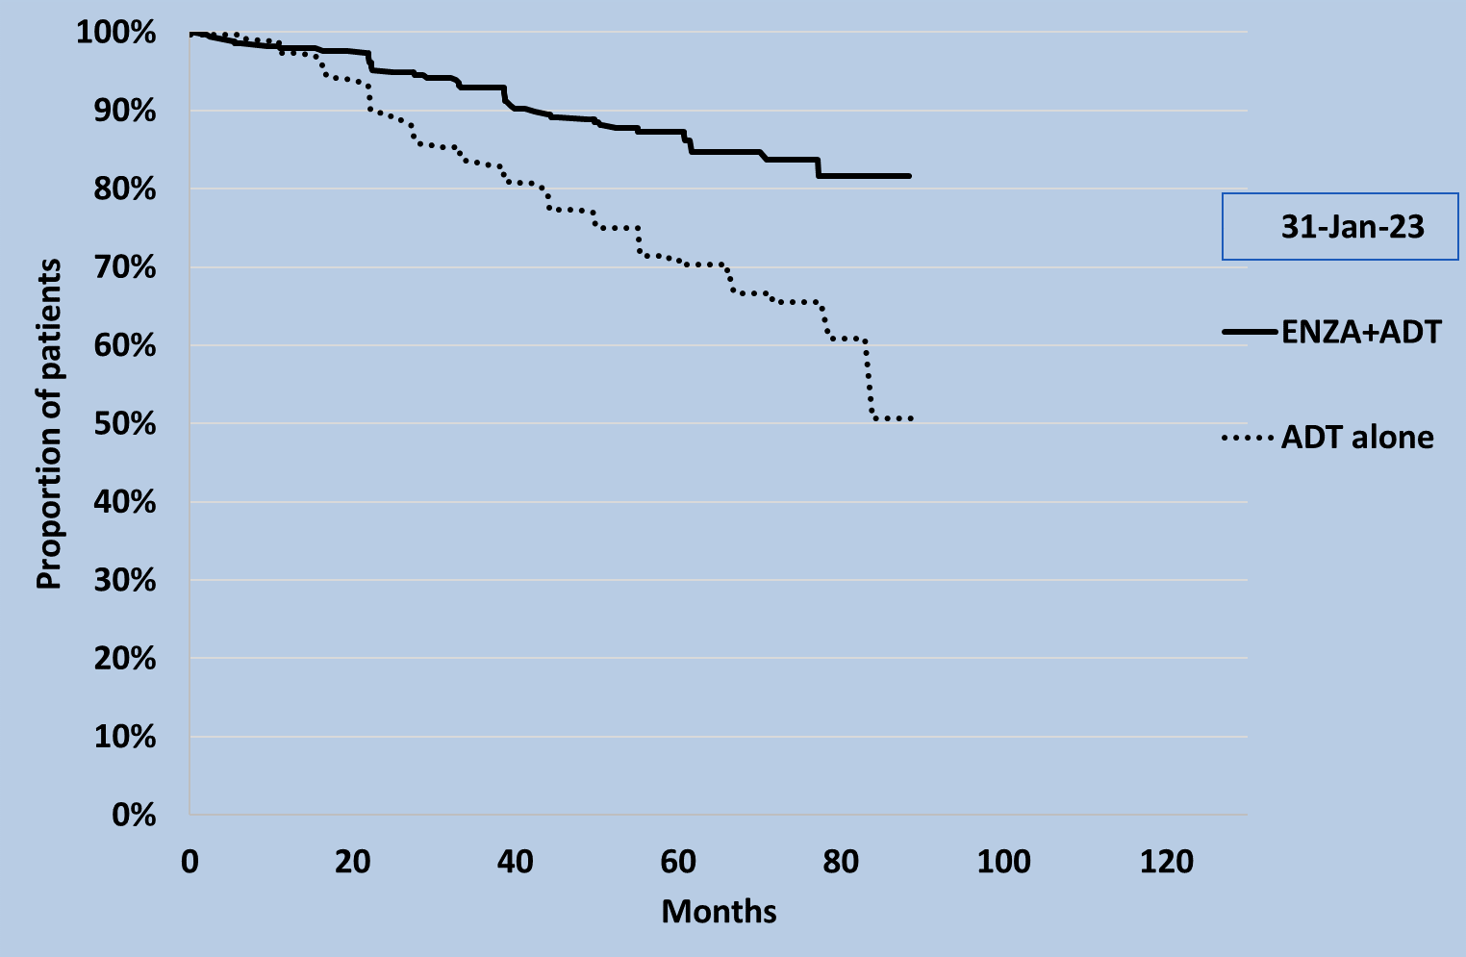 | 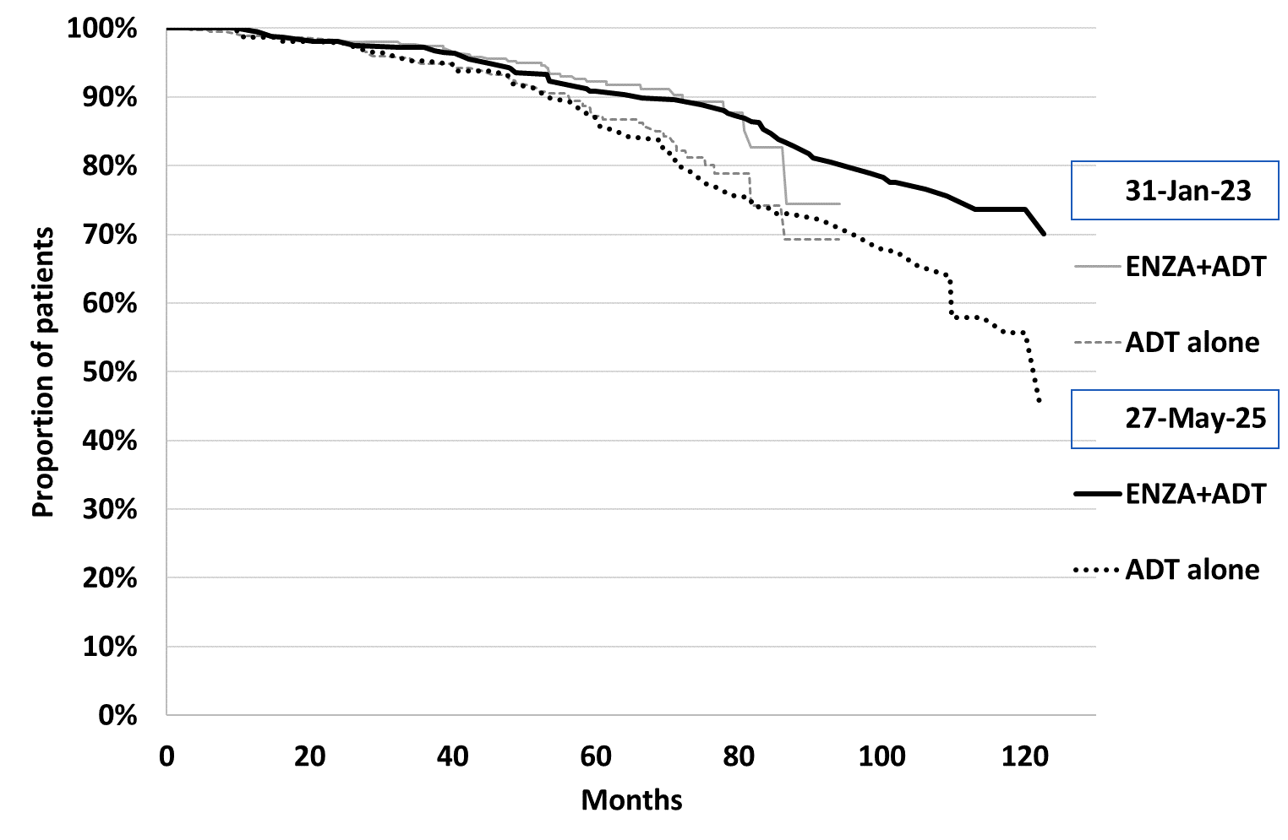
Figure 2.6.6, p89 of the resubmission.
ADT=androgen deprivation therapy; DCO=data cut-off; ENZA=enzalutamide; ITT=intention-to-treat; MFS=metastasis-free survival; NR=not reached; OS=overall survival; PBO=placebo
  - At the 31 January 2023 DCO, MFS was significantly longer for patients treated with enzalutamide with ADT compared to ADT, with a statistically significant 57.6% reduction in the risk of MFS event (HR = 0.42; 95% CI: 0.30, 0.61). The majority of patients (81.3%) had not experienced an MFS event, and the median MFS was not reached in any treatment group. MFS was not reported at the 27 May 2025 DCO.
  - At the 27 May 2025 DCO, OS was significantly longer for patients treated with enzalutamide with ADT compared to ADT (HR = 0.60; 95% CI: 0.44, 0.80). Median OS was not reached in the enzalutamide with ADT arm and was reported as 117.5 months in the ADT arm, although most participants were alive at censoring (79.4% in the enzalutamide with ADT arm and 69.0% in the ADT arm). The hazard ratio was consistent with the interim analysis reported at the 31 January 2023 DCO (HR = 0.589; 95% CI: 0.382, 0.908).
  - The OS Kaplan-Meier curves indicated that approximately 10% of patients who died within the first four to five years of treatment experienced no survival benefit. For the remaining 90%, the absolute survival benefit was maintained to the end of the study period (median follow-up 7.8 years). Without cause-specific mortality, it was unable to be determined whether the overlapping survival curves in the first four to five years represented a lack of treatment effect or simply patients dying from age-related or other non-cancer causes.
  - Table 6 summarises secondary outcomes in EMBARK reported at the 27 May 2025 DCO. No new data was reported for other secondary outcomes, including PSA progression, distant metastasis, castration resistance, symptomatic progression, patients with undetectable PSA at week 36, treatment free at two years after suspension and undetectable PSA two years after suspension. Overall, the results across most secondary and exploratory outcomes either numerically or statistically favoured enzalutamide with ADT compared to ADT.

Table 6: Summary of time-to-event outcomes in EMBARK (ITT)
Outcome | DCO: 31 Jan 2023 |  | DCO: 27 May 2025
Outcome | ENZA + ADT (N=355) | PBO + ADT (N=358) | ENZA + ADT (N=355) | PBO + ADT (N=358)
First use of antineoplastic therapy
Events, n (%) | 58 (16.3) | 140 (39.1) | 82 (23.1) | 173 (48.3)
Median (95%CI), months | NR (NR, NR) | 76.2 (71.3, NR) | NR (NR, NR) | 85.1(71.3, 96.2)
HR (95%CI) vs PBO+ADT | 0.36 (0.26, 0.49) | - | 0.37 (0.29, 0.49) | -
Symptomatic skeletal event
Events, n (%) ^{b} | 9 (2.5) | 32 (8.9) | 19 (5.3) | 37 (10.3)
Median (95%CI), months | NR (NR, NR) | NR (NR, NR) | NR (NR, NR) | NR (NR, NR)
HR (95%CI) vs PBO+ADT | 0.26 (0.13, 0.55) | - | 0.40 (0.22, 0.72) | -
PFS2 ^{c}
Events, n (%) | 36 (10.1) | 63 (17.6) | 75 (21.1) | 118 (33.0)
Median (95%CI), months | NR (NR, NR) | NR (NR, NR) | NR (113.1, NR) | 109.6 (101.7, NR)
HR (95%CI) vs PBO+ADT | 0.52 (0.35, 0.79) | - | 0.56 (0.42, 0.76) | -
Time to resumption of any hormonal therapy ^{d}
Patients with treatment suspension, n (%) | 321 (90.4) | 240 (67.0) | 321 (90.4) | 240 (67.0)
Events, n (% of patients with Tx suspension) ^{e} | 256 (79.8) | 217 (90.4) | 254 (79.1) | 207 (86.3)
Median (95%CI), months | 19.6 (17.2, 22.3) | 16.8 (14.3, 17.1) | 19.9 (17.4, 22.5) | 16.8 (14.3, 17.3)
HR (95%CI) vs PBO+ADT^{f} | 0.69 (0.58, 0.83) | - | 0.74 (0.61, 0.89) | -
Blue shading indicates data previously seen by the PBAC. Bold text indicates statistical significance at p<0.05 level.
Source: Table 2.6.4, p87, Table 2.6.5, p88, Table 2.6.7, p91, Table 2.6.12, p95, Table 2.6.13, p96, Table 2.6.14, p97, Table 2.6.16, p100 of the resubmission and Table 24, p119 of EMBARK CSR (DCO: 31 Jan 2023).
ADT=androgen deprivation therapy; CI=confidence intervals; ENZA=enzalutamide; HR=hazard ratio; ITT=intention-to-treat; NE=not estimated; NR=not reached; OS=overall survival; PBO=placebo; PFS2=progression-free survival on first subsequent therapy; PSA=prostate specific antigen; Tx=treatment.
ª Based on the earliest contributing event (skeletal related event, new systemic antineoplastic therapy, opiate use, surgical intervention, or radiation therapy).
^{b} Based on first symptomatic skeletal event (radiation therapy to bone, surgery to bone, pathological bone fracture, spinal cord compression, initiation/change to antineoplastic therapy to treat bone pain, opiate use due to bone pain).
^{c} Exploratory endpoint. Based on the earliest contributing event after first progressive disease (investigator assessed clinical progression, radiographic progression, or PSA progression) or death due to any cause, whichever occurred first.
^{d} The median time to resumption of any hormonal therapy and the reported HR at 27 May 2025 data cut-off were not found in the updated CSR; therefore, cannot be validated.
^{e} Based on the hormonal therapy restarted after treatment suspension at week 37 due to undetectable PSA.
^{f} Two-sided P value is based on a stratified log rank test by screening PSA, PSA doubling time, and prior hormonal therapy. Hazard ratio is based on a Cox regression model stratified by factors defined above and is relative to PBO+LA with <1 favouring ENZA+ADT and PBO+ADT with <1 favouring ENZA.

Comparative harms
  - Table 7 summarises adverse events (AEs) reported in EMBARK (including during treatment suspension, if applicable).
Table 7: TEAEs, common AEs and AEs of special interest in EMBARK (safety population)
 | DCO: 31 Jan 2023 |  |  | DCO: 27 May 2025
AEs, n (%) | ENZA + ADT (N=355) | PBO + ADT (N=358) | RD (95% CI) * | ENZA + ADT (N=355) | PBO + ADT (N=358) | RD (95% CI) *
Any TEAEs | 343 (97.3) | 345 (97.5) | -0.00 (-0.03, 0.02) | 346 (98.0) | 347 (98.0) | 0.01 (−0.02, 0.03)
TEAE leading to discontinuation | 73 (20.7) | 36 (10.2) | 0.11 (0.05, 0.16) | 97 (27.5) | 45 (12.7) | 0.15 (0.09, 0.21)
TEAE leading to dose reduction of ENZA or PBO | 25 (7.1) | 16 (4.5) | 0.03 (-0.01, 0.06) | 29 (8.2) | 17 (4.8) | 0.03 (−0.00, 0.07)
TEAE leading to death # | 6 (1.7) | 3 (0.8) | 0.01 (-0.01, 0.03) | 10 (2.8) | 5 (1.4) | 0.01 (−0.01, 0.04)
TEAE (Grade 3+) | 164 (46.5) | 151 (42.7) | 0.04 (-0.04, 0.11) | 185 (52.4) | 175 (49.4) | 0.03 (−0.04, 0.11)
TEAE study drug-related | 305 (86.4) | 283 (79.9) | 0.06 (0.01, 0.12) | 307 (87) | 286 (80.8) | 0.07 (0.01, 0.12)
Serious TEAE | 123 (34.8) | 112 (31.6) | 0.03 (-0.04, 0.10) | 143 (40.5) | 133 (37.6) | 0.03 (−0.04, 0.10)
Blue shading indicates data previously seen by the PBAC. Bold text indicates statistical significance at p<0.05 level.
Source: Compiled during the evaluation using Table 2.6.21, pp111-112, Table 2.6.24, pp115-116 of the resubmission, Table 15 of EMBARK CSR (DCO: 27 May 2025), Table 30, p138 [Dyspnoea, Pollakiuria], Table 51, p210 [Syncope], Table 43, p189 [Amnesia] of EMBARK CSR (DCO: 31 Jan 2023), and estimated during the evaluation.
ADT=androgen deprivation therapy; AE=adverse event; ENZA=enzalutamide; PBO=placebo; TEAE=Treatment emergent AE.
* Calculated during the evaluation using RevMan v5.3.
# Adverse events leading to death were grade 5 adverse events; none were considered by the investigator to be related to treatment.
  - At the 27 May 2025 DCO, the incidence of any TEAEs, AEs leading to death, and serious AEs was similar across the treatment groups. TEAEs leading to death occurred in 10 (2.8%) patients treated with enzalutamide with ADT and 5 (1.4%) patients in the placebo with ADT group. In the enzalutamide with ADT, there was a higher incidence of TEAEs leading to discontinuation, Grade 3+ TEAEs, and drug-related TEAEs compared to ADT. The most frequent TEAEs included hot flush, fatigue, arthralgia, hypertension, falls, and back pain. The safety data reported at the 27 May 2025 DCO were consistent with data reported at the 31 Jan 2023 DCO, and the established safety profiles of enzalutamide and ADT.

Benefits/harms
  - Table 8 presents a summary of the comparative benefits and harms for enzalutamide with ADT versus placebo with ADT for m0HSPC.
Table 8: Summary of comparative benefits and harms of enzalutamide with ADT vs and placebo with ADT (ITT)
Benefits
 | DCO: 31 Jan 2023 ª |  |  | DCO: 27 May 2025 ^{b}
Event | ENZA + ADT  N=355 | PBO + ADT  N=358 | Difference | ENZA+ADT  N=355 | PBO + ADT  N=358 | Difference
Event | ENZA + ADT  N=355 | PBO + ADT  N=358 | ENZA + ADT vs  PBO + ADT | ENZA+ADT  N=355 | PBO + ADT  N=358 | ENZA + ADT vs PBO + ADT
Metastasis-free survival (MFS)
Events, n (%) | 45 (12.7) | 92 (25.7) | HR: 0.42 (0.3, 0.61) | NE | NE | -
Median MFS, mths (95% CI) | NR (NR, NR) | NR (85.1, NR) | - | NE | NE | -
% Event-free at 60.7 mths (95% CI) | 87.3 | 71.4 | 15.9 | NE | NE | -
Overall survival (OS)
Deaths, n/N (%) | 33 (9.3) | 55 (15.4) | HR: 0.59 (0.38, 0.91) ^{c} | 73 (20.6) | 111 (31.0) | HR: 0.60 (0.44, 0.80)
Median OS, months (95% CI) | NR (NR, NR) | NR (NR, NR) | - | NR (NR, NR) | 117.5 (109.8, NR) | -
% Alive at follow-up (95% CI) | 92.2 | 87.2 | 5.0 | 80.1 | 71.0 | 9.1
Harms
 | Event rate/ 100 patients |  | RR* (95% CI) | RD (95% CI) | Event rate/ 100 patients |  | RR (95% CI) | RD (95% CI)
TEAEs | ENZA + ADT | PBO | ENZA + ADT vs PBO + ADT | ENZA + ADT vs PBO + ADT | ENZA + ADT | PBO | ENZA+ADT vs PBO+ADT | ENZA+ADT vs PBO+ADT
Selected common TEAEs (≥5% patients)
Hot flush | 69 | 57 | 1.20 (1.07, 1.34) | 0.11 (0.04, 0.18) | 70 | 58 | 1.20 (1.08, 1.34) | 0.12 (0.05, 0.19)
Fatigue | 43 | 33 | 1.31 (1.08, 1.58) | 0.10 (0.03, 0.17) | 44 | 34 | 1.30 (1.07, 1.58) | 0.10 (0.03, 0.17)
Arthralgia | 28 | 21 | 1.30 (1.00, 1.69) | 0.06 (-0.00, 0.13) | 29 | 21 | 1.40 (1.10, 1.78) | 0.08 (0.02, 0.15)
Fall | 21 | 14 | 1.46 (1.05, 2.01) | 0.07 (0.01, 0.12) | 29 | 17 | 1.75 (1.34, 2.29) | 0.13 (0.06, 0.19)
Asthenia | 11 | 6 | 1.86 (1.12, 3.10) | 0.05 (0.01, 0.09) | 12 | 6 | 2.03 (1.24, 3.33) | 0.06 (0.02, 0.10)
Weight decreased | 7 | 3 | 2.01 (1.02, 3.95) | 0.03 (0.00, 0.07) | 8 | 4 | 2.02 (1.10, 3.71) | 0.04 (0.01, 0.07)
Osteoporosis | NR | NR | - | - | 7 | 1 | 6.06 (2.14, 17.16) | 0.06 (0.03, 0.08)
Source: Table 2-10, p55, Table 2-12, p61, Table 2-29, pp103-405 and Table 2-32, p110 of the submission.
ADT=androgen deprivation therapy; AE=adverse event; ENZA=enzalutamide; HR=hazard ratio; MFS=metastasis-free survival; NR=not reached; OS=overall survival; PBO=placebo; RD=risk difference; RR=risk ratio; TEAE=Treatment emergent AE
Note: RRs and RDs were calculated during the evaluation using RevMan v5.3.
ª Median duration of follow-up in EMBARK DCO: 31 Jan 2023, was 60.7 months.
^{b} Median duration of follow-up in EMBARK DCO: 27 May 2025, was 94.2 months.
^{c} For the interim analysis, an O'Brien-Fleming stopping boundary will be used. The prespecified efficacy boundary (P ≤ 0.0001) was not crossed at this interim OS analysis and the results were not statistically significant.
  - On the basis of evidence from EMBARK presented in the resubmission, for every 100 patients treated with enzalutamide with ADT in comparison to placebo with ADT:
    - Approximately 16 additional patients treated with enzalutamide with ADT will remain metastasis-free after 60.7 months (5.06 years).
    - Approximately 9 additional patients treated with enzalutamide with ADT will remain alive after 94.2 months (7.85 years).
  - On the basis of evidence from EMBARK presented by the resubmission, for every 100 patients treated with enzalutamide with ADT in comparison to placebo with ADT, after 94.2 months (7.85 years):
    - Approximately 12 additional patients treated with enzalutamide with ADT will experience hot flush.
    - Approximately 11 additional patients treated with enzalutamide with ADT will experience fatigue.
    - Approximately 8 additional patients treated with enzalutamide with ADT will experience arthralgia.
    - Approximately 12 additional patients treated with enzalutamide with ADT will experience fall.
    - Approximately 6 additional patients treated with enzalutamide with ADT will experience asthenia.
    - Approximately 4 additional patients treated with enzalutamide with ADT will experience weight loss.
    - Approximately 6 additional patients treated with enzalutamide with ADT will experience osteoporosis.

Clinical claim
  - Consistent with the November 2024 submission, the resubmission described enzalutamide with ADT as superior in terms of effectiveness and inferior (but manageable) in terms of safety compared to placebo with ADT for the treatment of patients with high-risk m0HSPC after definitive local therapy.
  - At the November 2024 PBAC meeting, the PBAC considered that the clinical claim of superior efficacy compared to the nominated comparator of ADT was reasonable in terms of MFS, but the magnitude of benefit and applicability to the clinical practice setting were uncertain. The PBAC noted that the EMBARK trial potentially included a sizeable proportion of patients with metastatic disease on PSMA-PET imaging (i.e. mHSPC), the extent and duration of treatment suspension in clinical practice is unknown, and the OS data (at the 31 January 2023 DCO) were immature (paragraphs 7.1, 7.7 and 7.8, enzalutamide PSD, November 2024 PBAC meeting). In terms of safety, the PBAC considered enzalutamide with ADT to be inferior to ADT but noted that the adverse event profile of enzalutamide was known to clinicians (paragraph 7.11, enzalutamide PSD, November 2024 PBAC meeting).
  - The ESC noted that the updated OS data (pre-specified final OS analysis of EMBARK) presented in the resubmission showed improved survival with enzalutamide with ADT compared to ADT. Although the incremental benefit for the truly m0HSPC population (i.e., PSMA-PET metastatic negative) remained unknown due to the trial design, the submission proposed a combined restriction for m0HSPC and mHSPC, which more closely aligns with the true EMBARK population. Similarly, the proposed PBS restriction presented in the resubmission included a prescribing note to encourage treatment suspension in practice for patients without metastases, based on the EMBARK trial protocol.
  - The PBAC considered that the claim of superior comparative effectiveness was reasonable.
  - The PBAC considered that the claim of inferior comparative safety was again reasonable.

Economic analysis
  - The resubmission presented an updated modelled economic evaluation comparing enzalutamide with ADT to ADT. At the November 2024 PBAC meeting, concerns were raised about structural uncertainties in the modelling approach, which manufactured a large treatment benefit and survival gain for enzalutamide with ADT over ADT. The PBAC’s key concerns (paragraphs 7.13 and 7.14, enzalutamide PSD, November 2024 PBAC meeting) and how the resubmission addressed them are summarised in Table 9.
Table 9: Key components of the economic evaluation
Component | November 2024 submission | March 2026 resubmission | Justification/comments
Type of analysis | Cost-utility | Unchanged | -
Outcomes | LYs, QALYs | Unchanged | -
Time horizon | 30 years vs median follow up 60.7 months in EMBARK. The PBAC noted that 10 years had been accepted in mHSPC and m0CRPC settings (para 7.14, ENZA PSD, Nov. 2024). | 20 years vs median follow up 94.2 months in EMBARK | In EMBARK, the mean age at baseline was 69.1 years and 80% of patients remained alive in the enzalutamide with ADT arm at the median follow-up (7.8 years). The ESC considered that a 20-year time horizon was reasonable.
Methods used to generate results | Semi-Markov cohort model. The PBAC noted that the Semi-Markov cohort model resulted in structurally increasing the survival benefit of ENZA, which may not be reasonable (para 6.35, ENZA PSD, Nov. 2024). | Hybrid Model, Partition Survival Model | The updated model was a partition survival model that used EMBARK data to inform both MFS and OS. External data was only used to inform subsequent progression. The ESC considered that the revised structure of the model was reasonable.
Health states | m0HSPC (on Tx, Tx suspension, on Tx post suspension); mHSPC; m0CRPC; mCRPC; Death. m0CRPC had low patient occupancy and a small impact on the ICER (Table 13, ENZ PSD, Nov24). | m0HSPC (on Tx, Tx suspension, on Tx post suspension); mHSPC; mCRPC; Death. | Removal of the m0CRPC reduced model complexity and reliance on external data and had a negligible impact on the ICER. The ESC considered that this was a reasonable simplification.
Cycle length | 1 month | Unchanged | -.
Transition probabilities | MFS: EMBARK, 31 Jan 2023, Gamma extrapolation.  OS: EMBARK, 31 Jan 2023, Weibull extrapolation, with general pop mortality from Yr 6.5.  TTD: EMBARK, 31 Jan 2023, Log-Normal extrapolation.  TTD RI: EMBARK, 31 Jan 2023, Exponential (ENZA+ADT) /Gamma (ADT) extrapolation.  Transitions for progressed health states (mHSPC, m0CRPC, mCRPC): ARCHES, PROSPER, and PREVAIL, weighted by subsequent treatment mix. | MFS: EMBARK, 31 Jan 2023, Gamma extrapolation.  OS: EMBARK, 27 May 2025, Weibull extrapolation, with general pop mortality from Yr 6.5.  TTD: EMBARK, 31 Jan 2023, Log-Normal extrapolation.  TTD RI: EMBARK, 27 May 2025, Exponential (ENZA+ADT) /Weibull (ADT) extrapolation.  TTmCRPC: ARASENS. | The use of the updated OS data from EMBARK and the removal of OS adjustments in the progressed health states were appropriate. There were uncertainties with the extrapolation function chosen for OS and MFS, these are discussed in paragraphs 6.36 and 6.37. Treatment time was applied inconsistently in the estimation of costs and QALYs (see paragraphs 6.40 to 1.1). The use of ARASENS data for progression from mHSPC to mCRPC may not be appropriate (see paragraph 6.44).
Software | Excel 2016 | Unchanged | -
Blue shading represents information previously considered by the PBAC.
Source: Compiled during the evaluation from Table 3-1 of the November 2024 submission and Table 3.2.1, p128 of the resubmission.
ADT=androgen deprivation therapy; ENZA=enzalutamide; ICER=incremental cost effectiveness ratio; m0HSPC=non- metastatic hormone sensitive prostate cancer; mHSPC=metastatic hormone sensitive prostate cancer; m0CRPC=non- metastatic castrate resistant prostate cancer; mCRPC=metastatic castrate resistant prostate cancer; Tx=treatment; MFS=metastases free survival; NHA=novel hormonal agent; mono=monotherapy; OS=overall survival; QALY=quality adjusted life year; ToT=time on treatment; TTD=time to treatment discontinuation; TTD RI=time to treatment discontinuation after reinitiation; TTmCRPC= time to mCRPC.
  - Table 10 summarises the univariate impact of each change to the modelled economic evaluation presented in the resubmission compared to the base case presented in the November 2024 submission, with the combined impact of the changes leading to a 22.6% increase in the incremental cost-effectiveness ratio (ICER).
Table 10: Model changes and their univariate impact on the ICER compared to the November 2024 submission
Model change | Incremental cost | Incremental QALY | ICER ($/QALY) | % ∆
November 2024 submission base case | $redacted content | 2.26 | $redacted content¹ | ref.
Changes (univariate) in March 2026 submission (vs Nov 2024 base case)
Updated EMBARK OS and TTD post-reinitiation data, median follow up 94.2mths (vs 60.7mths) ª | $redacted content | 2.10 | $redacted content¹ | redacted content%
Mortality adjustment removed from progressed disease states (vs mortality adjustment based on subsequent treatments) ^{b} | $redacted content | 2.05 | $redacted content¹ | -redacted content%
Treatment suspension duration and proportion reinitiating updated ^{c} | $redacted content | 2.26 | $redacted content² | redacted content%
Time horizon 20 yrs (vs 30 yrs) | $redacted content | 2.13 | $redacted content¹ | -redacted content%
Remove m0CRPC health state (vs included) | $redacted content | 2.33 | redacted content¹ | -redacted content%
Adjust all health state utilities for Australian general population (vs could exceed general population mortality) | $redacted content | 2.11 | $redacted content¹ | redacted content%
mHSPC treatments: 100% docetaxel+ADT in ENZA+ADT arm, 100% DARO+docetaxel+ADT in ADT arm ^{d} (vs ADT monotherapy for 80% ENZA+ADT arm and 56% ADT arm) | $redacted content | 2.24 | $redacted content¹ | -redacted content%
General population mortality ABS life tables 2021-2023 (vs 2020-2022) | $redacted content | 2.25 | $redacted content¹ | redacted content%
Costs updated to 2025 (vs 2024) | $redacted content | 2.26 | $redacted content¹ | redacted content%
ENZA effective price $1,021.70 (Nov 2024 $1,075.47) | $redacted content | 2.26 | $redacted content¹ | -redacted content%
Model approach updated, including parametric survival approach informed by EMBARK MFS and OS, no m0CRPC, no additional mortality for progressed health states, mHSPC therapy and transition to mCRPC informed by ARASENS ^{e} | $redacted content | 2.13 | $redacted content¹ | -redacted content%
March 2026 base case (all changes applied) | $redacted content | 1.77 | $redacted content² | redacted content%
Source: Compiled during the evaluation
ADT=androgen deprivation therapy, DARO=darolutamide, ICER=incremental cost-effectiveness ratio, ENZA=enzalutamide, m0CRPC= non metastatic castrate resistant prostate cancer, mHSPC=metastatic hormone sensitive prostate cancer, OS=overall survival, QALY=quality adjusted life year, TTD= time to treatment discontinuation.
ª Treatment suspension duration in the resubmission could not be validated, and proportion reinitiating appeared to be estimated conditional on the number of patients who suspended treatment.
^{b} This was previously reported in the PSCR. The uncertainty regarding the MFS remains, as MFS may have been underestimated in both arms comparted to the KM data, particularly for the ADT arm.
^{c} November 2024 ENZA+ADT arm: 68.3% reinitiated after 29.9 months treatment suspension, ADT arm: 57.3% reinitiated after 24.4 months treatment suspension, March 2026 ENZA+ADT arm: 79.1% reinitiated after 36.4 months treatment suspension, ADT arm: 86.3% reinitiated after 29.6 months treatment suspension.
^{d} Survival and progression was based on ARCHES in the November 2024 submission. In the resubmission, the subsequent treatment mix in mHSPC was updated based on the data from ARASENS trial. This only affected the costs (and not outcomes) in the economic model.
^{e} Proportion of mHSPC treatment costs and transitions to mCRPC were based on ARASENS, with the assumption that 100% patients in ENZA+ADT arm received docetaxel+ADT in mHSPC and 100% patients in the ADT arm received DARO+docetaxel+ADT in mHSPC. Altering mHSPC treatment split in the new model approach only affected costs. In comparison, the November 2024 submission allowed subsequent treatment to affect both life years and costs.
The redacted values correspond to the following ranges:
¹ $15,000 to < $25,000
² $25,000 to < $35,000
  - The new model structure was based on a partition survival approach, compared to a Markov model approach in the November 2024 submission (see Figure 2).
Figure 2: Model structure with efficacy endpoints informing transition
November 2024 submission | March 2026 Resubmission
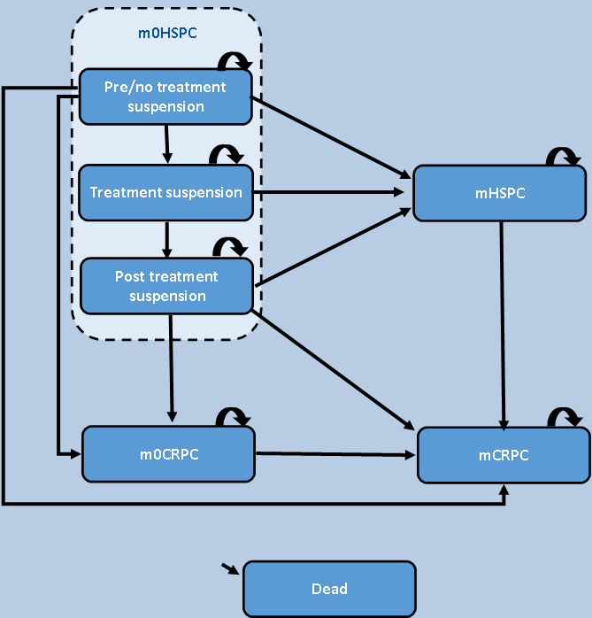 | 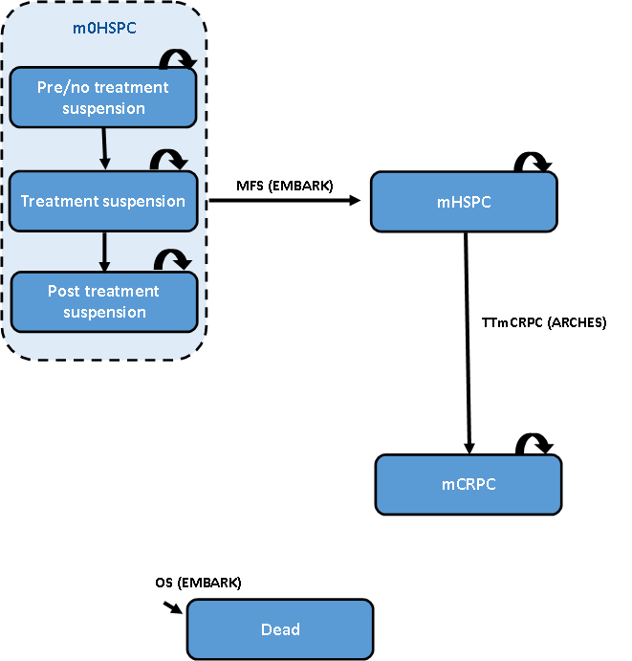
Blue shading represents information previously considered by the PBAC.
Source: paragraph 6.35, enzalutamide PSD, November 2024 PBAC meeting, and constructed during the evaluation.
m0HSPC=non-Metastatic Hormone-Sensitive Prostate Cancer; mCRPC=Metastatic Castration‑Resistant Prostate Cancer; MFS=metastasis-free survival; mHSPC=Metastatic Hormone-Sensitive Prostate Cancer; TTmCRPC=time to mCRPC; OS=overall survival.
  - In the new partition survival model, transitions from m0HSPC to disease progression (mHSPC being the first disease progression health state) were modelled using MFS in EMBARK (DCO: 31 Jan 2023), and transitions from all health states to Dead were modelled using OS in EMBARK (DCO: 27 May 2025). Patients in the m0HSPC health state were distributed across three sub-states (on-treatment, treatment suspension, on-treatment post-suspension), modelled using TTD and treatment suspension data in EMBARK. Patients in the mHSPC state could experience a second disease progression and transition to the mCRPC health state. This was modelled using time to mCRPC (TTmCRPC) in ARASENS. The mHSPC health state was modelled as a tunnel state to capture the time spent in the mHSPC and to calculate the probability of progressing to mCRPC each cycle.
  - Figure 3 presents EMBARK KM data for MFS, OS and TTD, which were used to model patient transitions up to the point at which 10% of patients remained at risk, with outcomes extrapolated beyond this point.
Figure 3: EMBARK KM data used in the model
OS, MFS, TTD (from Time 0)
November 2024 submission | March 2026 resubmission
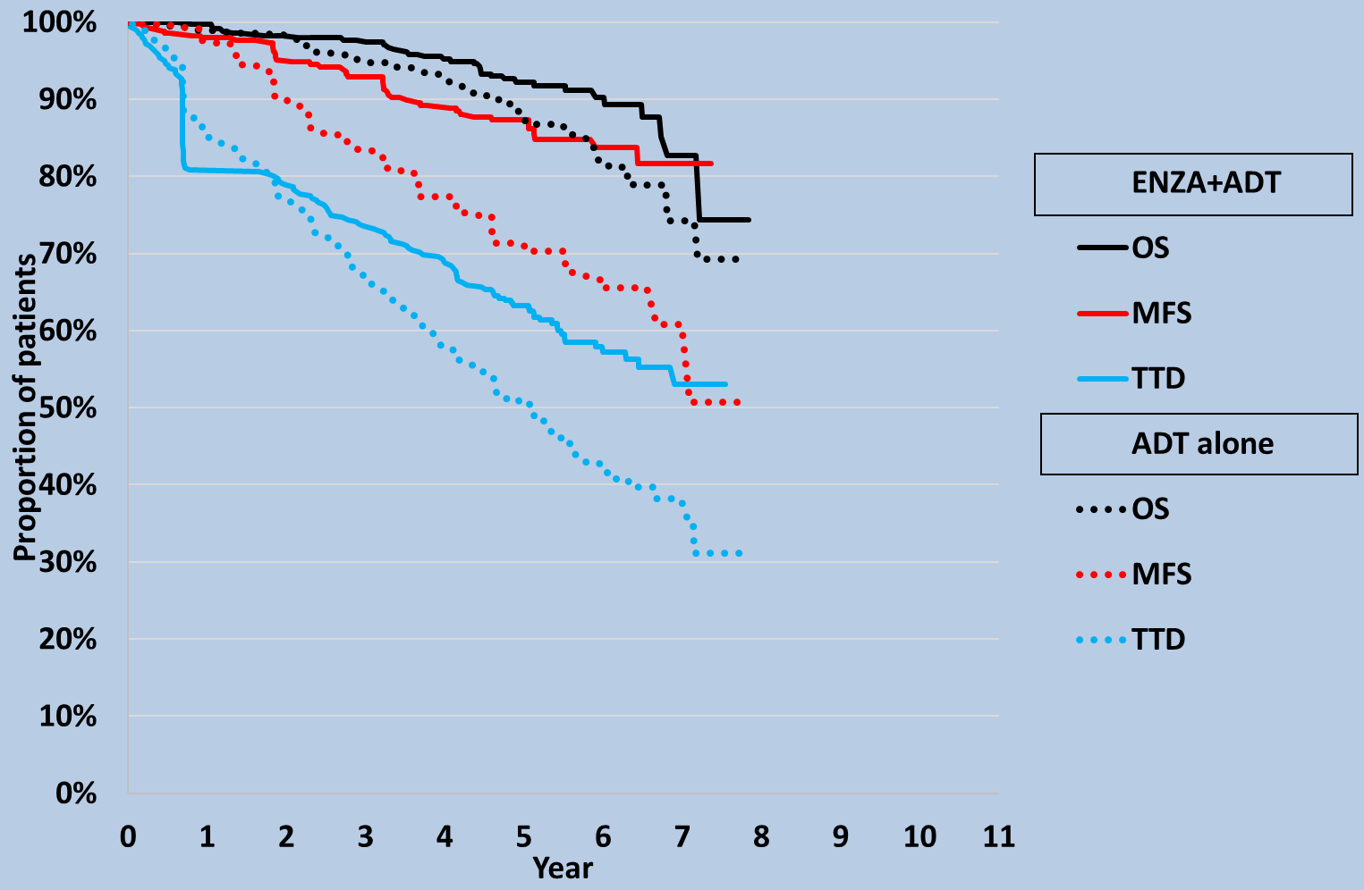 | redacted content
Source: Paragraph 6.40, enzalutamide PSD, November 2024 PBAC meeting, and Constructed during the evaluation from the Excel file ‘Attachment 08 – XTANDI nmHSPC_CEM_v10.xlsm’
ADT=androgen deprivation therapy, ENZA=enzalutamide, MFS=metastases free survival, OS=overall survival, TTD=time to treatment discontinuation; TTD RI= time to treatment discontinuation after reinitiation.
Note: TTD curve informed the time on treatment for patients who did not experience treatment suspension. TTD after reinitiation (TTD RI) informed the time on treatment for patients reinitiating treatment post treatment suspension and is shown in Figure 4.
  - As noted in the November 2024 submission, MFS and OS in the enzalutamide with ADT arm of EMBARK cross at the 31 January 2023 DCO (or converge when comparing MFS at the 31 January 2023 DCO and OS at the 27 May 2025), which should not be possible and has implications for the modelled extrapolations (see below). The sponsor attributed this to the small numbers of patients remaining at risk (paragraph 6.40, enzalutamide PSD, November 2024 PBAC meeting). Similarly, divergence between TTD and MFS in the KM data meant the extrapolated model estimated many m0HSPC patients would be off treatment at the end of the time horizon. This did not appear clinically plausible for patients at ‘high risk’ of disease progression. Over the 20-year time horizon, patients spent on average 3.86 years in the m0HSPC health state off treatment in the enzalutamide with ADT arm and 1.74 years in the ADT arm.
  - Extrapolations of EMBARK KM data are presented in Figure 4. The resubmission stated that the base case parametric functions were selected using a combination of goodness of fit statistics (the Akaike information criterion [AIC] and Bayesian information criterion [BIC]), visual inspection, clinical plausibility, and consistency with other extrapolations.
Figure 4: Extrapolations of EMBARK KM data (enzalutamide with ADT vs ADT)
November 2024 submission | March 2026 resubmission
MFS (EMBARK KM DCO: 31 Jan 2023) | MFS (EMBARK KM DCO: 31 Jan 2023, unchanged)
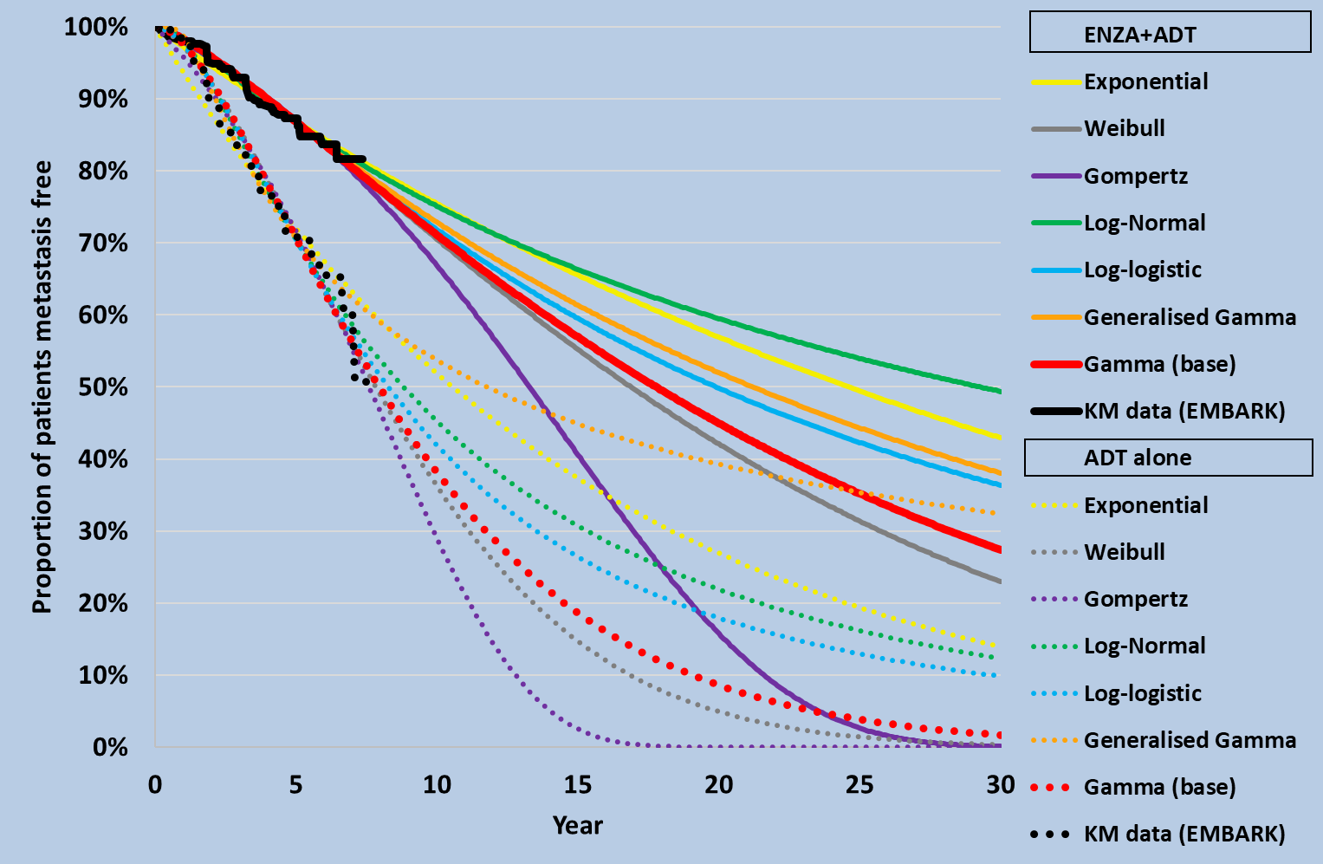 | Unchanged.
OS (EMBARK KM DCO: 31 Jan 2023) | OS (EMBARK KM DCO: 27 May 2025, updated)
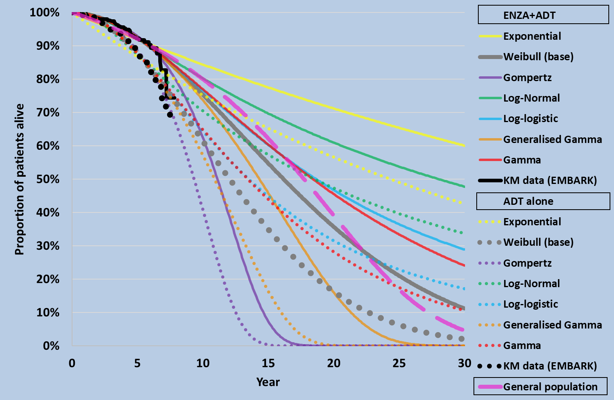 | 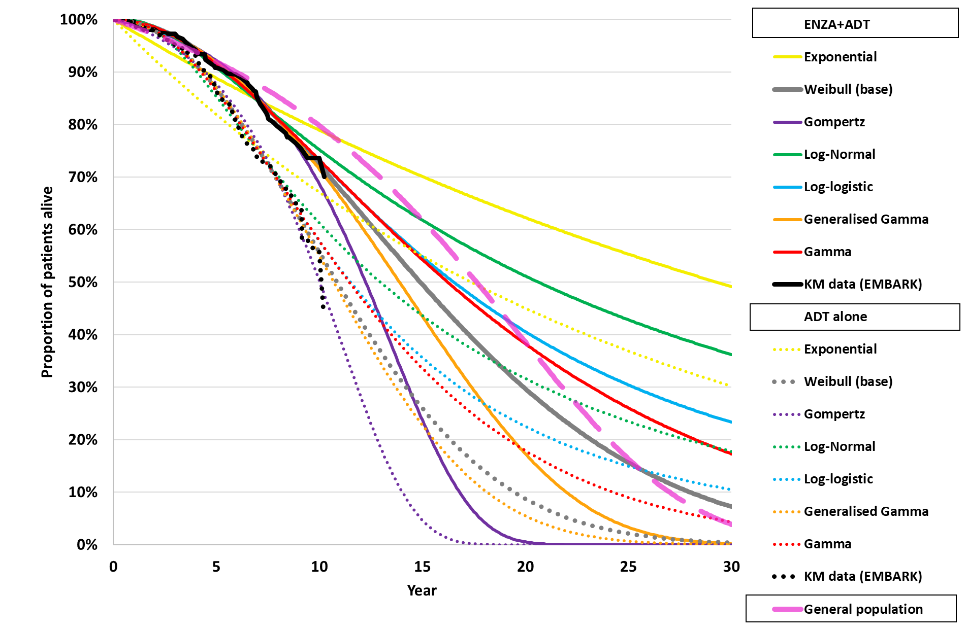
TTD (from t0, EMBARK KM DCO: 31 Jan 2023) | TTD (from t0, EMBARK KM DCO: 31 Jan 2023, unchanged)
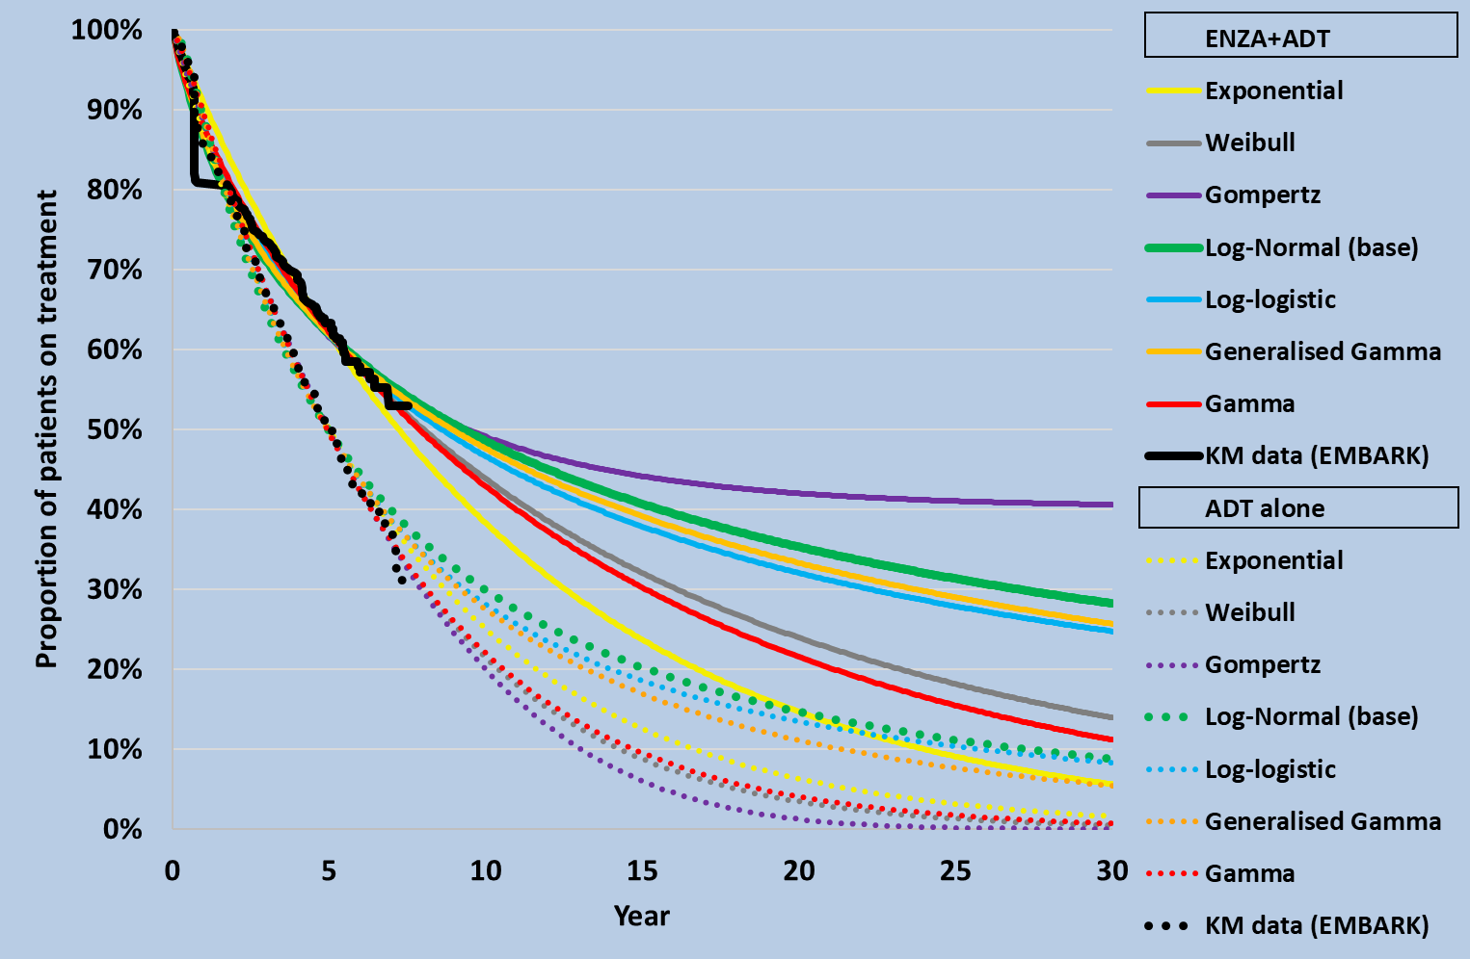 | Unchanged.
TTD RI (EMBARK KM DCO: 31 Jan 2023) | TTD RI (EMBARK KM DCO: 27 May 2025, updated) ª
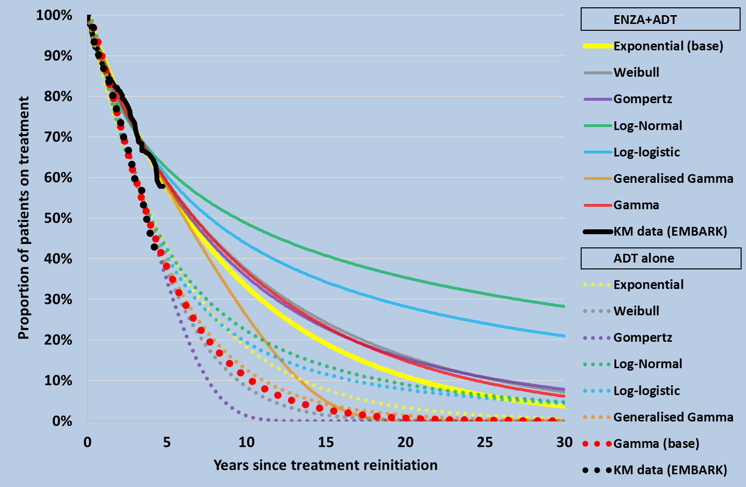 | 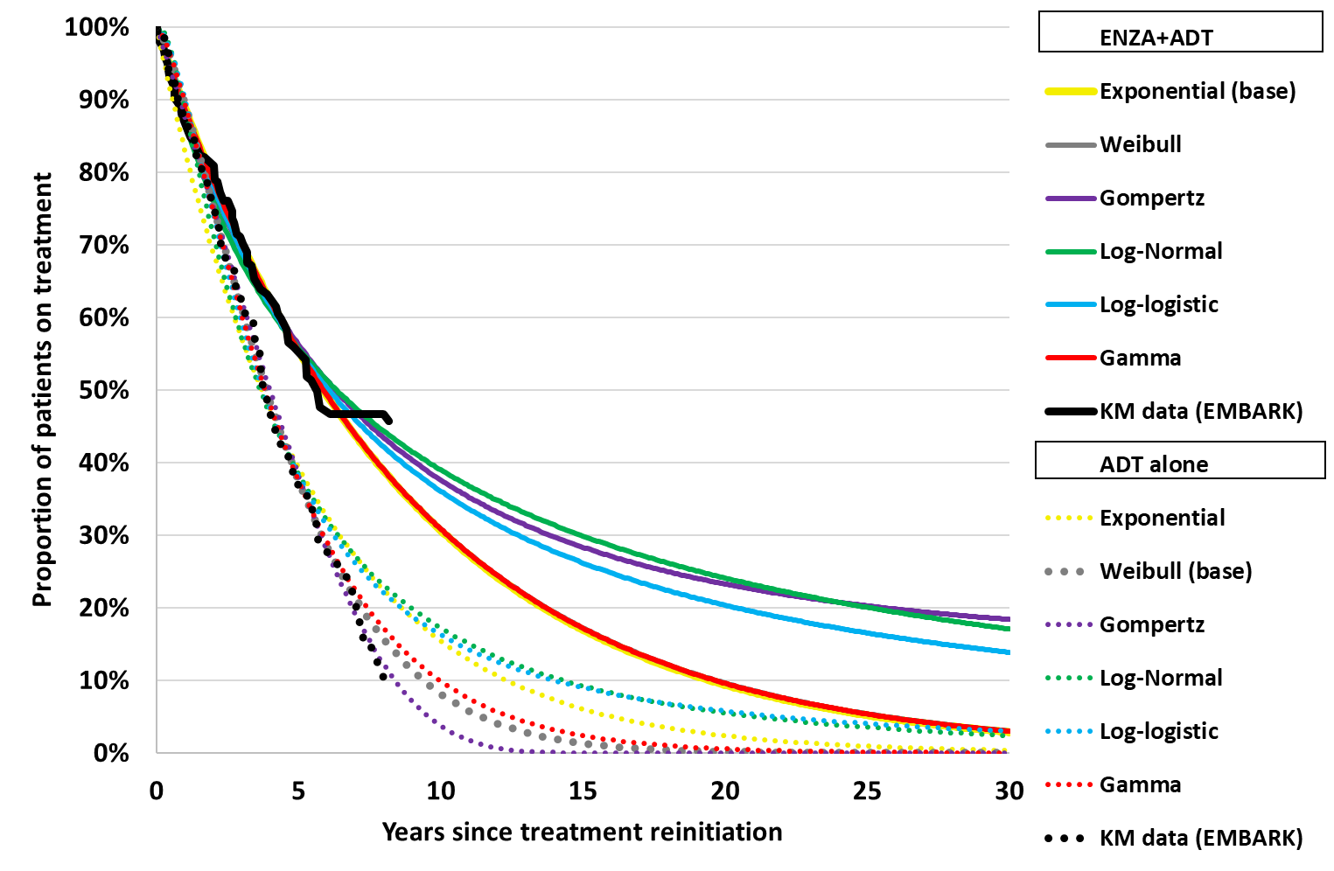
TTmCRPC (ARASENS KM, base case)
Not reported | 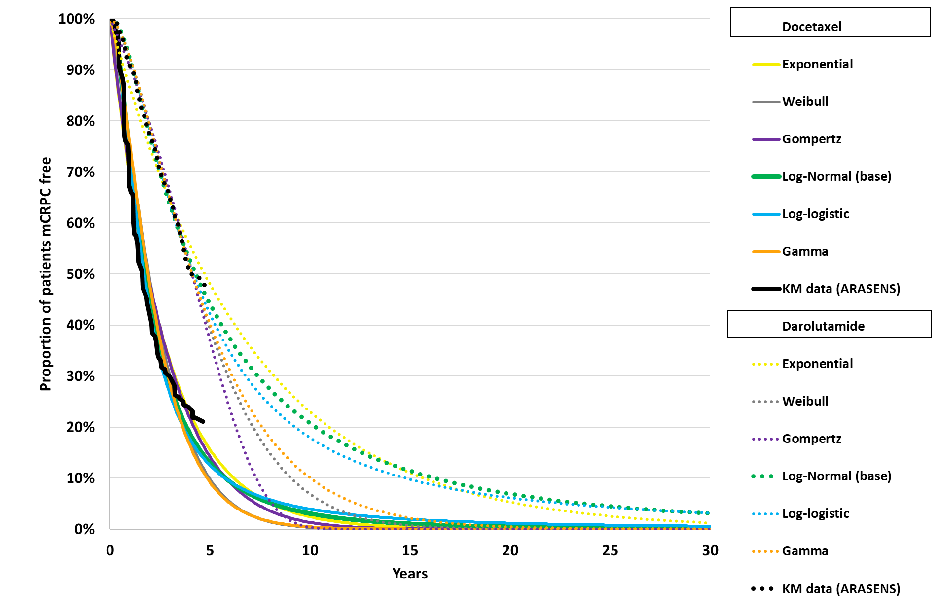
Source: Constructed during the evaluation from the Excel file ‘Attachment 08 – XTANDI nmHSPC_CEM_v10.24_rev_v6_dsa_hybrid.xlsm’
ADT=androgen deprivation therapy, ENZA=enzalutamide, MFS=metastases free survival, OS=overall survival, TTD=time to treatment discontinuation; TTD RI=time to treatment discontinuation after reinitiation; TTmCRPC=time to metastatic castration-resistant prostate cancer.
ª Note: An error was identified in the TTD RI extrapolation functions. The Gompertz and Generalised Gamma models for the enzalutamide with ADT arm were incorrect, as was the Generalised Gamma model for the ADT arm alone. During the evaluation, a correct Gompertz extrapolation was developed using EMBARK data in STATA. The evaluators were unable to construct a corrected Generalised Gamma extrapolation
  - Consistent with the November 2024 submission, the resubmission extrapolated OS using a Weibull distribution, which provided the lowest combined AIC+BIC for both treatment arms and was the most plausible for long-term extrapolation. However, the Weibull curve exceeded age adjusted general population mortality during the first three years of the model and predicted a relatively high proportion of patients remaining alive after 20 years despite entering the model at age 69.1 years (32% in the enzalutamide with ADT arm, 10% in the ADT arm). In contrast, the generalised Gamma distribution produced a more conservative and clinically plausible extrapolation, with fewer patients surviving at 20 years (20% in the enzalutamide with ADT arm, 7% in the ADT arm). The model was relatively sensitive to the choice of OS extrapolation function (see sensitivity analyses). The PSCR stated that the Generalised Gamma was not the best fitted distribution statistically. The PSCR also stated that the concern regarding long-term extrapolated OS approaching or exceeding general population survival was addressed through implementation of a general population mortality cap and therefore, the OS was not overestimated. The ESC considered based on the modelled proportion alive at 20 years that the use of the Weibull distribution may be reasonable.
  - The MFS extrapolations were unchanged from the November 2023 submission, with the Gamma distribution once again selected as the most plausible long-term function for the base case. However, the Gamma was the worst-fitting function in the enzalutamide with ADT arm and among the worst-fitting functions in the ADT arm. In addition, the Gamma distribution was inconsistent with the chosen OS function, as the extrapolated MFS curves crossed the extrapolated OS curves in both model arms (see below). The widespread variation across the parametric functions in both arms indicated uncertainty in long-term MFS extrapolations. The model was also relatively sensitive to the function chosen (see sensitivity analyses). The PSCR acknowledged the convergence between MFS and OS curves and stated that this pattern was consistent with the observed Kaplan Meier data. It noted that for the enzalutamide arm, the OS and MFS curves are trending toward convergence at 5 years and reach convergence at approximately 7 years of follow-up (KM risks estimated at 5 years: OS = 91%, MFS = 87%; 7 years: OS =82%, MFS = 82%; Figures 2-3 and 2-8 of submission). The PSCR noted that as most prostate cancer deaths occur after metastatic progression, this limits the number of patients who subsequently enter a prolonged post-metastatic survival phase before dying from prostate cancer. The PSCR stated that from an extrapolation perspective, the gap between MFS and OS, representing survival after metastasis, was expected to narrow over time as fewer patients remain alive and competing all-cause mortality increases with age.
  - The ESC noted that whilst convergence may be expected between MFS and OS in this setting due to deaths from competing risks prior to disease progression, the estimated point of that convergence (and hence proportion of patients affected) may be biased due to differences in the follow-up periods for MFS (data cut: 31 Jan 2023) and OS (data cut: 27 May 2025). The high degree of censoring in the tail of the MFS data increased the uncertainty of the extrapolated curves and the tail of the MFS curve may not remain as ‘flat’ over time if more patients develop disease progression. The ESC noted that the model implied that enzalutamide is a ‘cure’ for approximately 68% of patients who never develop disease progression over their lifetime (despite stopping treatment years earlier based on the TTD assumptions). Thus, the ESC considered it remained unclear whether this is a clinically plausible outcome for ‘high risk’ disease. The ESC further noted that MFS was the main driver of the incremental benefits associated with enzalutamide and considered that more conservative extrapolations of MFS should be explored. Figure 5 compares the MFS and OS functions used in the model base case, and alternative extrapolations used in two sensitivity analyses conducted during the evaluation. The figure illustrates that the base case functions (Weibull for OS and Gamma for MFS) lead to MFS exceeding OS by Year 12 in enzalutamide with ADT arm and by Year 19 in the ADT arm. In contrast, the alternative extrapolations used for the sensitivity analyses did not lead to MFS clearly exceeding OS and were likely more clinically plausible given the uncertainty in the data.
Figure 5: EMBARK OS and MFS KM data plus parametric function (enzalutamide with ADT vs ADT)
Resubmission’s base case | MVSA1: OS: Generalised Gamma (both arms), MFS: Gompertz (both arms) | MVSA2: OS: Generalised Gamma (both arms), MFS: Gompertz (ENZA+ADT), Weibull (ADT)
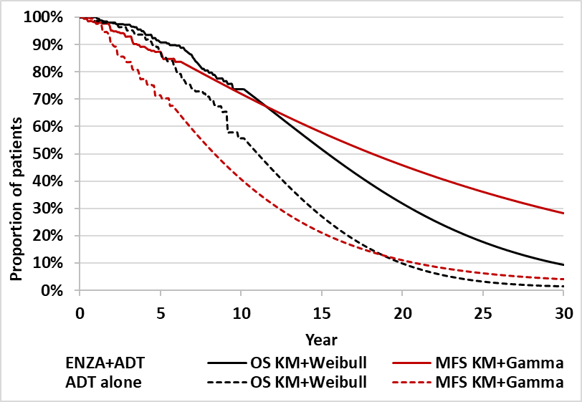 | 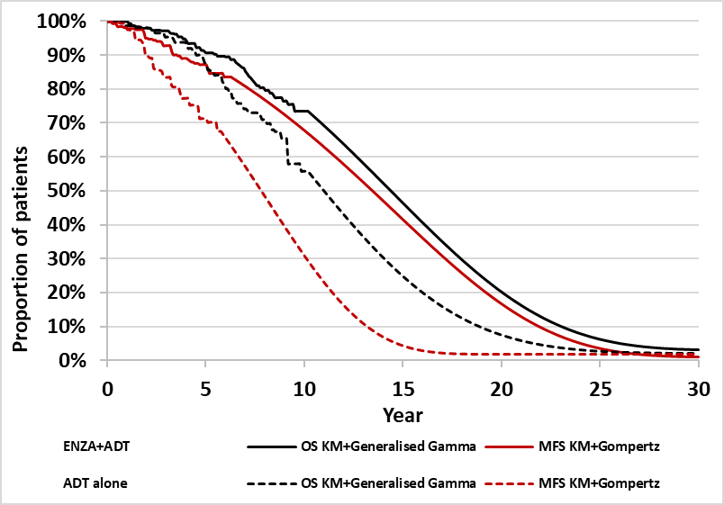 | 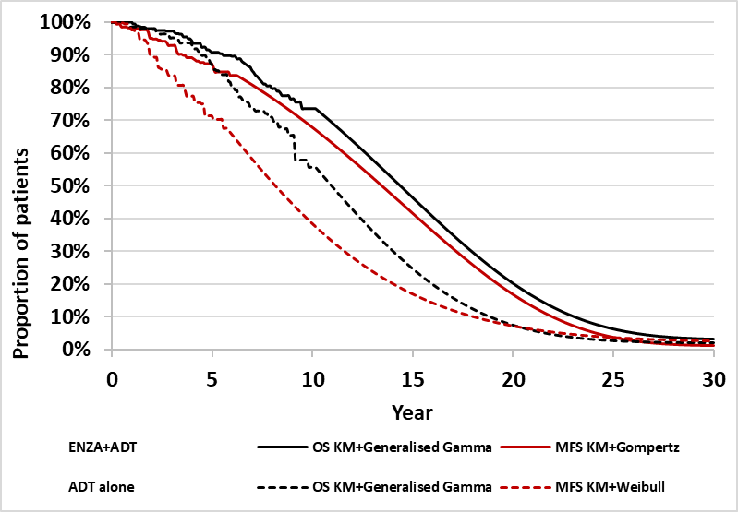
Source: Constructed during the evaluation from the Excel file ‘Attachment 08 – XTANDI nmHSPC_CEM_v10.24_rev_v6_dsa_hybrid.xlsm’
ADT=androgen deprivation therapy, ENZA=enzalutamide, MFS=metastases free survival, OS=overall survival; MVSA=multivariate sensitivity analysis.
  - The resubmission estimated time “on treatment” using different approaches for costs and QALYs, summarised in Table 11.
Table 11: Time on treatment approaches applied in the economic model
 | “On treatment” for QoL | “On treatment” for costs | Impact
Probability of staying on-Tx for all patients prior to C9 | MFS KM (i.e., all patients in the m0HSPC health state). | TTD KM (i.e., all patients on-treatment, using the TTD KM curve from EMBARK 31 Jan 2023) | On-Tx proportions for QoL based on MFS were higher than the corresponding on-Tx proportions for costs (from TTD curve). For example, in C5 of the ENZA+ADT arm, 95.5% of patients were on Tx based on the TTD curve, compared with 99.4% based on the MFS curve.
Probability of Tx suspension (after C9) | ENZA+ADT arm: 89.6%, at C9.  ADT arm: 67.4%, at C9.  The model assumed all patients who suspend treatment would do so in C9. After C9, patients could have reinitiated using treatment suspension duration and probability of Tx reinitiation (row below). | The proportion remaining on treatment post C9 was derived from the TTD curve and adjusted for cycle-to-cycle treatment discontinuation, weighted by the Tx suspension substate used for QALY estimation (probability of suspension: one minus this value). This adjusted TTD may have included discontinuation for reasons other than suspension. | Resulted in different on-treatment proportions between the two estimates. For example, in Cycle 9 of the ENZA+ADT arm, 8.93% of patients were considered on treatment for QoL purposes compared with 3.17% for cost purposes.
Probability of Tx re-initiation, after Tx suspension | Fixed or dynamic probabilities applied to Cycle 10+ (EMBARK) | ENZA+ADT: C 10-45: 0%, C 46: 79.1%. ADT: C 10-37: 0%, C 38: 86.3%.  The model assumed that all patients who reinitiate would do so in the specified Cycle based on the mean duration of treatment suspension. Treatment reinitiation post suspension numbers could not be verified. The CSR DCO: 27 May 2025 reported 72.0% and 77.7% treatment reinitiation post suspension in ENZA+ADT and ADT arms, respectively. Applying these values decreased the ICER by redacted content% to $redacted content¹/QALY. | This resulted in different on-Tx proportions post-Tx suspension. For example, in Cycle 94, corresponding to EMBARK follow-up, a total of 51.2% of patients were considered on Tx for cost purposes (2.0% never suspended plus 49.2% reinitiated), compared with 61.1% for QALY purposes (7.1% on treatment pre-suspension and 54.0% reinitiated.
  Cycle | ENZA +  ADT | ADT
  Dynamic probs (base case)
  C10-15 | 0.1% | 0.35%
  C16-21 | 3.63% | 4.58%
  C22-33 | 2.80% | 3.19%
  C34-45 | 0.88% | 1.08%
  C46-57 | 0.55% | 0.1%
  C58-69 | 0.13% | 0.14%
  C70+ | 0.03% | 0%
  Fixed probs (scenario)
  C10+ | 3.53% | 4.09%
TTD in post re-initiation | TTD RI (EMBARK 27 May 2025) | TTD RI (EMBARK 27 May 2025) | As the underlying on-Tx differed, the resulting estimates varied.
Final time on Tx | Time on treatment before suspension (from MFS minus Tx suspension) + on-Tx after reinitiation | Adjusted TTD, by summing up TTD for patients who never experienced suspension (from TTD curve, adjusted for Tx suspension) plus on-Tx after suspension | In a 20-year time horizon, the half-cycle corrected mean time on treatment for QALYs vs costs were 119.6 vs 84.8 months in ENZA+ADT and 93.0 vs 72.6 in the ADT arm.
Source: Compiled during the evaluation.
ADT=androgen deprivation therapy, C=cycle; ENZA=enzalutamide; KM=Kaplan-Meier; MFS=metastasis free survival; mHSPC= metastatic hormone sensitive prostate cancer, Prob=probability; QoL=quality of life; TTD=time to treatment discontinuation; Tx=treatment. The redacted values correspond to the following ranges:
¹ $25,000 to < $35,000

  - The different approaches for estimating time ‘on treatment’ resulted in a substantial difference in the average time on treatment used for assigning costs (93.0 months for enzalutamide with ADT vs 72.6 months for ADT) and QALYs (119.6 months for enzalutamide with ADT; 84.8 months for ADT). In addition, neither approach provided estimates that perfectly aligned with the average time on treatment (pre- plus post-suspension) reported in EMBARK at a similar time point (see footnote in Table 16). Assigning costs and QALYs using the same approach as for TTD QALYs increased the ICER by redacted content%, from $25,000 to < $35,000 to $45,000 to < $55,000 per QALY gained (see Table 16).
  - The PSCR claimed that the different approaches applied for assigning costs and QALYs in the ‘on treatment’ phase were appropriate as ‘on treatment’ was defined differently for costing versus QALYs. The PSCR stated that costs were tied to drug exposure (TTD), whereas QALYs were tied to time in m0HSPC with utility values reflecting whether patients were on active treatment versus in protocol-defined suspension. The PSCR further stated that using the TTD-based QALYs applied in the sensitivity analysis was not a valid approach for costing because m0HSPC drug costs are applied to model patients who are not on treatment. Regarding QALYs, the observed utilities from EMBARK for m0HSPC were stratified with a higher utility applied only to patients who achieve PSA-driven suspension (0.89), while patients who discontinue for non-suspension reasons or those who continue to take medication receive a lower utility (0.875), reflecting ongoing symptoms and/or treatment-related sequelae that contributed to cessation.
  - The ESC noted that the explanation provided in the PSCR implied the ‘on treatment’ QALYs followed the TTD KM data reported in EMBARK, which reported time to final cessation (accounting for the treatment holiday). However, the methodology for constructing the ‘on treatment’ QALYs curve combined the TTD and MFS data, and the derivation of ‘on treatment’ costs was constructed using multiple inputs (TTD prior to treatment holiday, % who initiated a treatment holiday, average treatment holiday duration, and TTD post treatment holiday). Overall, the time ‘on treatment’ was underestimated compared to the trial data. The ESC considered different definitions of treatment exposure for costs (related to treatment use excluding the treatment break) and QALYs (related to exposure including the treatment break) to be reasonable, however noted the evaluators’ concern regarding the number of patients contributing to each outcome. The ESC noted that there was no reason why the patient numbers ‘on treatment’ should differ for the purposes of assigning costs or QALYs in the same health state (see the TTD (costs) vs TTD (QALYs) curves in Figure 7). The ESC further noted the uncertainty around how treatment suspension will be implemented in real-world practice (see paragraph 6.42), and that the application of TTD QALYs, explored in the sensitivity analyses, provides a conservative approach to estimate the number of patients on treatment. The pre-PBAC response reiterated that the different approaches were appropriate and reflected that ‘on treatment’ serves different purposes for costing and QALY estimation. The response states that costs only accrue while patients receive active therapy and that two types of cessations have been accounted for in the TTD calculations, (i) protocol-defined suspension following achievement of undetectable PSA (from cycle 9); and (ii) discontinuation for other reasons (e.g. toxicity or patient choice). This means that the probability of being on treatment can legitimately be less than the probability of being in m0HSPC. In contrast, the pre-PBAC response stated that QALYs are entirely linked to the time spent in the m0HSPC health state, whether they remain on active therapy or have suspended treatment.
  - In November 2024, the PBAC noted that the application of the treatment suspension in clinical practice would likely differ from how it was mandated in EMBARK, and this was likely to have a significant effect on the cost-effectiveness of enzalutamide with ADT (paragraph 6.38, enzalutamide PSD, November 2024 PBAC meeting). It remained uncertain whether real-world adherence would reflect the trial-based implementation, and to what extent this might affect treatment duration and overall cost-effectiveness. Additionally, the ESC noted that the proposed PBS restriction does not mandate a treatment break and it is unlikely that all patients in practice would comply with same treatment protocol enforced in the trial. The ESC noted that although treatment suspension is predicted for patients receiving enzalutamide with ADT, it was unlikely that approximately 35% and 15% of patients would remain in the m0HSPC state off-treatment (due to treatment suspension or for other discontinuations, as determined by the TTD curve) for 10 and 20 years, respectively, in the enzalutamide with ADT arm (see Figure 7, difference between the light and dark green areas).
  - The resubmission estimated transitions from mHSPC to mCRPC using a Log-Normal parametric function fitted to radiographic progression in ARASENS (darolutamide with ADT vs ADT in NHA naïve mHSPC), rather than ARCHES (enzalutamide with ADT versus ADT in NHA naïve mHSPC) used in the November 2024 submission. It was noted previously that ARCHES was unlikely to reflect patients who had progressed from EMBARK, as ARCHES included newly diagnosed mHSPC patients (66.7%), with <30% patients having had prior prostatectomy or radiotherapy, and less than half had any prior ADT (paragraph 6.46, enzalutamide PSD, November 2024 PBAC meeting). However, ARASENS included more patients with newly diagnosed mHSPC, suggesting that patients enrolled in ARASENS were potentially less representative of patients with disease progression in EMBARK than in ARCHES. Applying ARCHES data to inform time to mCRPC increased the ICER by redacted content%, from $25,000 to < $35,000 to $25,000 to < $35,000 per QALY gained (see Table 16).
  - The resubmission updated the subsequent treatment mix in mHSPC based on ARASENS, with all enzalutamide with ADT patients receiving docetaxel with ADT, and all ADT patients receiving darolutamide with docetaxel with ADT. The average per cycle discontinuation probability was 2.6% and 1.7% in the enzalutamide with ADT and the ADT arms, respectively. Subsequent treatments in mCRPC were unchanged. Unlike the November 2024 submission, subsequent treatment mixes affected costs only, as OS was no longer adjusted in progressed health states.
  - The ESC noted that compared to the November 2024 submission, the utilities were adjusted in the resubmission to ensure the values were no higher than the Australian general population (Table 12).
Table 12: Utility values used in the economic evaluation
Health state | Utility | Nature of estimate/translations | Source | Adjusted utility estimate
m0HSPC, on-treatment | 0.934 | EQ-5D-5L pooled arms, Australian preference weights | EMBARK | 0.890*(1-((0.950-0.934)/0.950)) = 0.875
m0HSPC, Treatment suspension | 0.950 | EQ-5D-5L pooled results Australian preference weights | EMBARK | 0.890 (reference)
mHSPC | 0.817 | EQ-5D-5L pooled baseline values, converted to EQ-5D-3L with Van Hout algorithm, UK preference weights | ARCHES | 0.890*(1-((0.950-0.817)/0.950)) = 0.765
mCRPC | 0.706 | Mean of ARCHES (EQ-5D-5L with Van Hout algorithm UK tariff) and AFFIRM (EQ-5D-3L pooled baseline values, UK preference weights) | ARCHES, AFFIRM | 0.890*(1-((0.950-0.706)/0.950)) = 0.661
End of life (last 3 mths) | -0.457 | ARCHES, Last pre-death assessment | ARCHES | 0.890*(1-((0.950+0.457)/ 0.950)) = -0.428
Blue shading indicates data previously seen by the PBAC.
Source: Tables 3.6.1, p167 of the resubmission and compiled during the evaluation.
m0HSPC=non- metastatic hormone sensitive prostate cancer, mHSPC=metastatic hormone sensitive prostate cancer, m0CRPC=non- metastatic castrate resistant prostate cancer, mCRPC=metastatic castrate resistant prostate cancer; mths=months.
  - The utility adjustment to the m0HSPC health state was generally justified, given the high utilities estimated in EMBARK. Applying the same proportional reduction to progressed states may not be reasonable and likely underestimated utilities in those states. The resulting utility values for mHSPC (0.765) and mCRPC (0.661) were lower than the values from ARCHES and AFFIRM, which had been used in other prostate cancer models and were accepted by the PBAC. Restricting the adjustment to m0HSPC state increased the ICER by redacted content% to $25,000 to < $35,000, from a base case of $25,000 to < $35,000 per QALY gained (see Table 16).
  - Health state utilities were further adjusted for patient age, end-of-life, and adverse events over the course of the model, consistent with the November 2024 submission. The age adjustment and adverse event utility decrements had minimal impact on ICER. The model was sensitive to the end-of-life utility decrement given the modelled survival difference between the arms. Excluding the end-of-life utility decrement increased the ICER by redacted content% to $25,000 to < $35,000 per QALY (see Table 16). The ESC noted that inclusion of an end-of-life adjustment to utilities was not a usual approach and that the decrement in utility appeared large.
  - Health state allocation plots are presented in Figure 6.
Figure 6: Health state allocation (base case)
November 2024 submission | Resubmission
Enzalutamide + ADT
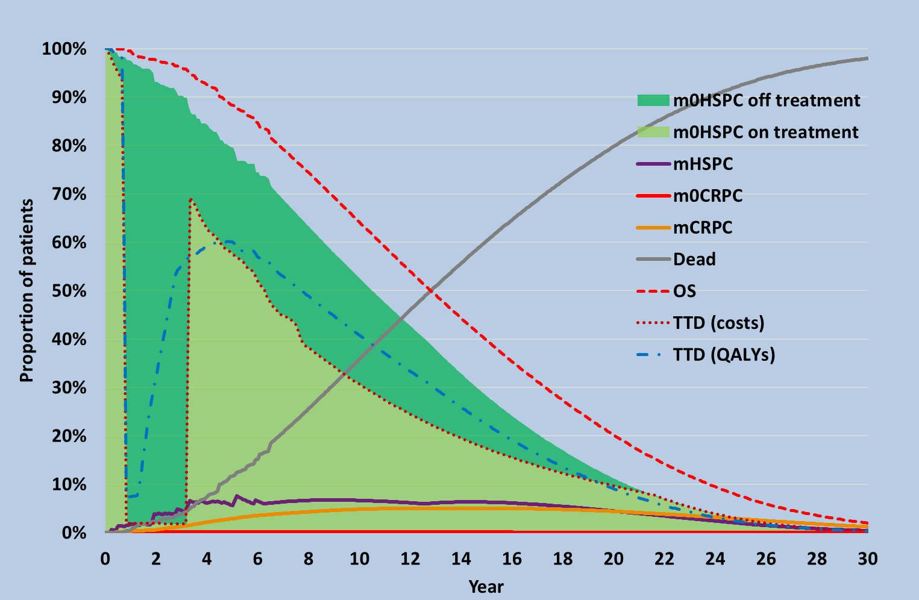 | 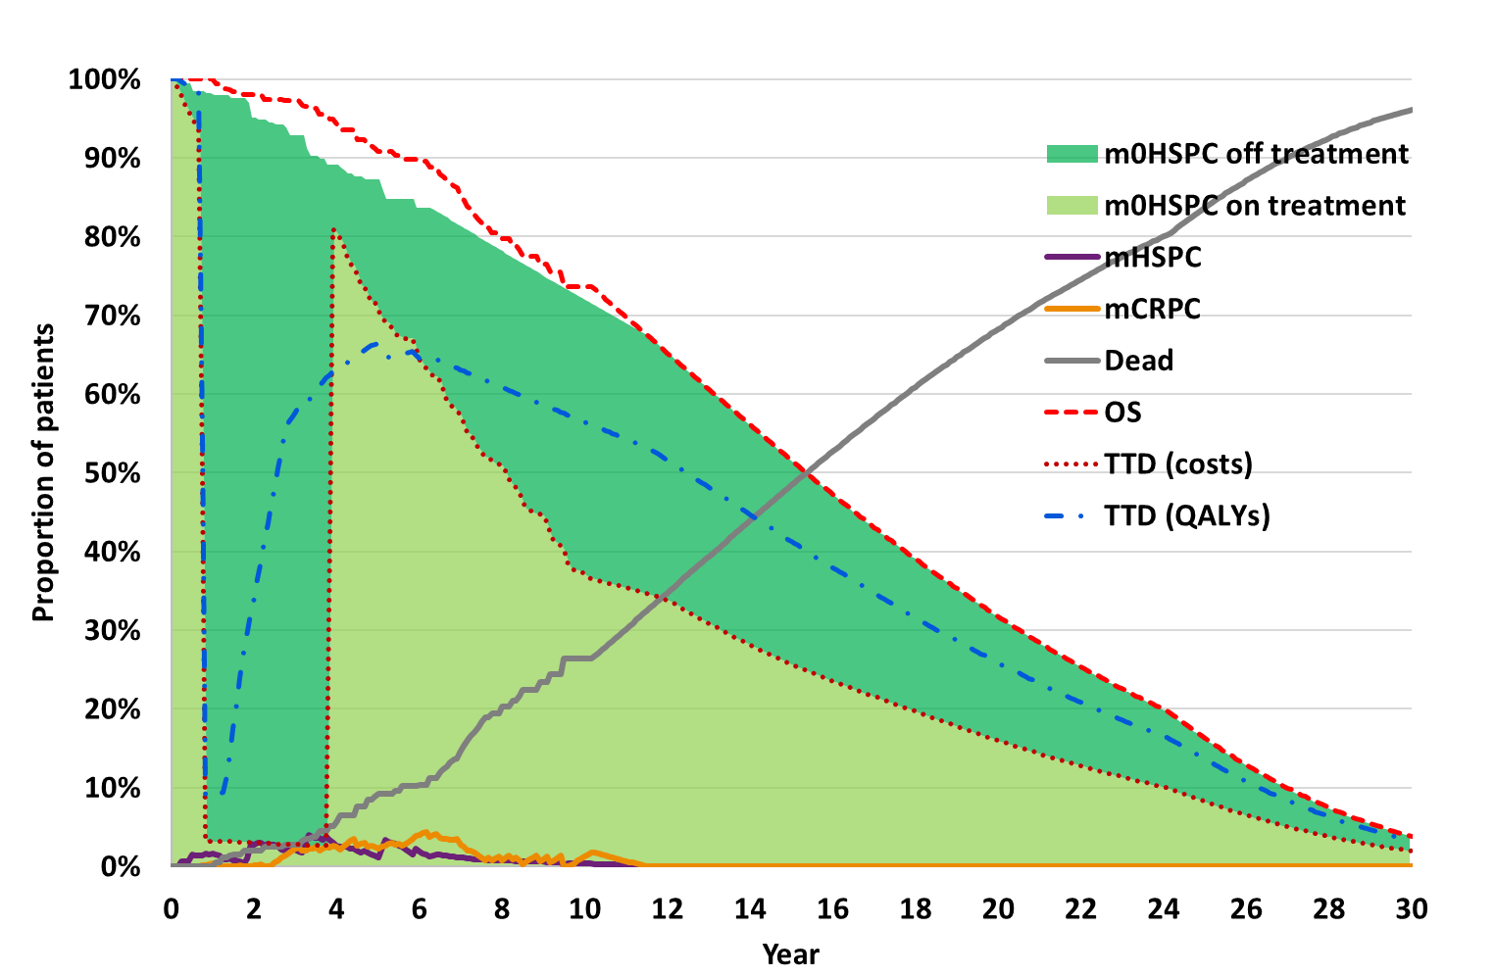
ADT
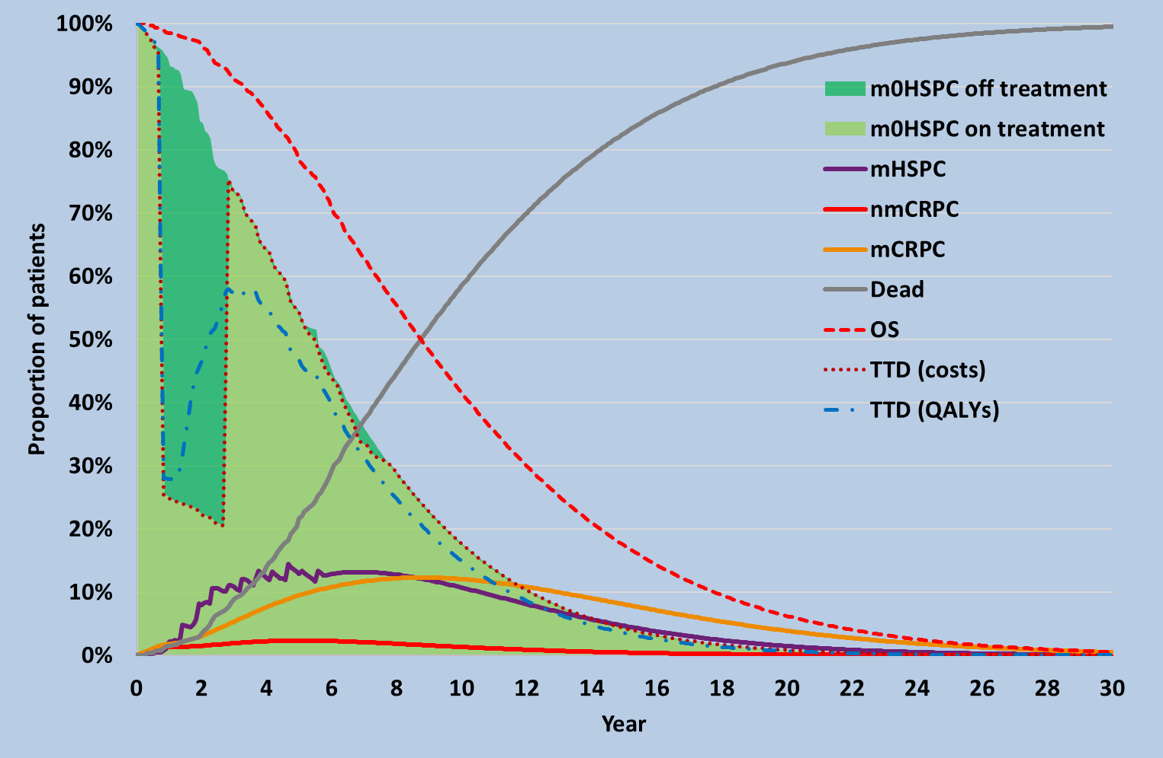 | redacted content
Blue shading indicates data previously seen by the PBAC.
Source: Constructed during the evaluation
ADT=androgen deprivation therapy, m0HSPC=non- metastatic hormone sensitive prostate cancer, mHSPC=metastatic hormone sensitive prostate cancer, m0CRPC=non- metastatic castrate resistant prostate cancer, mCRPC=metastatic castrate resistant prostate cancer; MFS=metastatic free survival; OS=overall survival; QALY=quality adjusted life years; TTD=time to treatment discontinuation.
  - Overall, transition assumptions in the resubmission’s economic model resulted in health state allocations that were uncertain:
- The MFS extrapolations crossed the OS curve at approximately Year 12 in the enzalutamide with ADT arm and Year 19 in the ADT arm, with MFS≡OS in the model beyond these time points. Hence, very few patients progressed to mHSPC or mCRPC over time (an issue also reported in the November 2024 submission), with most patients dying directly from the m0HSPC health state.
- A high proportion of patients were in the m0HSPC health state off-treatment over the time horizon, particularly in the enzalutamide with ADT arm.
- The differential approach to estimating the proportion of patients “on treatment” for costs and QALYs resulted in some patients being considered “off treatment” for cost purposes, whilst assigned a QALY benefit for being “on treatment” and vice versa. On average, patients spent less time “on treatment” when costs were assigned, and more time “on treatment” when QALYs were assigned.
  - A summary of the key drivers of the model is presented in Table 13.
Table 13: Key drivers of the model
Description | Method/Value | Impact  ENZA+ADT vs ADT, ICER: $redacted content¹/QALY
Treatment suspension | Inconsistent application of cost and QALY estimates may have led to an underestimation of costs, and the real-world implementation of treatment suspension was uncertain. | High favoured ENZA+ADT. Assigning costs to patients considered “on treatment” for the purposes of assigning QALYs (i.e., assigning costs and QALYs consistently), increased the ICER by redacted content% to $redacted content² per QALY gained.
Extrapolation | Trial data had relatively incomplete follow-up, with median MFS and OS (in the ENZA+ADT arm) not reached. The long-term extrapolation (20 years) and the selected extrapolation functions for OS and MFS were uncertain. | High favoured ENZA+ADT. Applying the Gompertz function for MFS in the ENZA+ADT arm and the Weibull function in the ADT arm, and Generalised Gamma for OS (both arms), increased the ICER by redacted content% to $redacted content¹ per QALY gained.
Time horizon | Time horizon was 20 years in the base case compared with 7.85 years (94.2 months) follow-up in the trial. | High favoured ENZA+ADT. Applying a 15-year time horizon increased the ICER by redacted content% to $redacted content¹ per QALY gained.
Subsequent treatments | Subsequent treatment assumptions were informed by ARASENS (mHSPC) and PBS 10% sample (mCRPC). All patients were assumed to have received NHA prior to mCRPC, though 38.5% of patients in the ADT arm received a further NHA in mCRPC. This was inconsistent with the current once/life NHA restriction. | High favoured ENZA+ADT. Setting the ADT arm to have the same treatment split in mCRPC as the ENZA+ADT arm increased the ICER by redacted content% to $redacted content¹ per QALY gained.
Source: compiled during the evaluation
ADT=androgen deprivation therapy, ENZA=enzalutamide, m0HSPC=non- metastatic hormone sensitive prostate cancer, MFS=metastases free survival, OS=overall survival, TTD=time to treatment discontinuation, QALY=quality adjusted life year
The redacted values correspond to the following ranges:
¹ $25,000 to < $35,000
² $45,000 to < $55,000
  - Results of the stepped economic analysis are presented in Table 14. The base case ICER was $25,000 to < $35,000 per QALY gained compared to $15,000 to < $25,000 per QALY gained in the November 2024 submission, with the steps differing mainly due to the use of a partitioned survival model.
Table 14: Results of the stepped economic evaluation
 | November 2024 submission |  |  | Resubmission
Step and component | ENZA+ADT | ADT | Increment | ENZA+ADT | ADT | Increment
Step 1: time horizon 75 months, constant per cycle transitions, undiscounted drug and admin costs in m0HSPC only, undiscounted LYs in m0HSPC and total LYs. |  |  |  | Differences with Nov.24 sub: partitioned survivals, updated OS
Costs | $redacted content | $11,168 | $redacted content | $redacted content | $12,170 | $redacted content
m0HSPC LYs | 5.57 | 4.59 | 0.97 | 5.148 | 4.684 | 0.464
LYs | 5.94 | 5.60 | 0.34 | 5.344 | 5.225 | 0.119
Incremental cost/extra m0HSPC LYG |  |  | $redacted content¹ |  |  | $redacted content²
Incremental cost/extra LYG |  |  | $redacted content³ |  |  | $redacted content⁴
Step 2: time horizon 75 months, constant per cycle transitions, undiscounted costs for AEs, concomitant, and treatment monitoring across all health states. |  |  |  | Differences with Nov.24 sub: Above + updated costs
Costs | $redacted content | $14,750 | $redacted content | $redacted content | $14,788 | $redacted content
m0HSPC LYs | 5.57 | 4.59 | 0.97 | 5.148 | 4.684 | 4.684
LYs | 5.94 | 5.60 | 0.34 | 5.344 | 5.225 | 5.225
Incremental cost/extra m0HSPC LYG |  |  | $redacted content¹ |  |  | $redacted content⁵
Incremental cost/extra LYG |  |  | $redacted content³ |  |  | $redacted content⁴
Step 3: time horizon 75 months, constant per cycle transition probabilities, undiscounted costs for AEs, concomitant, and treatment monitoring across all health states, QALYs in m0HSPC and total QALYs (no AE-related QALY loss) |  |  |  | Differences with Nov.24 sub: Above + updated utilities
Costs | $redacted content | $14,750 | $redacted content | $redacted content | $14,788 | $redacted content
m0HSPC QALYs | 4.91 | 4.05 | 0.86 | 4.49 | 4.082 | 0.408
QALYs | 5.21 | 4.84 | 0.37 | 4.629 | 4.468 | 0.161
Incremental cost/extra m0HSPC QALY |  |  | $redacted content¹ |  |  | $redacted content⁵
Incremental cost/extra QALY gained |  |  | $redacted content³ |  |  | $redacted content⁶
Step 4: Modelled economic evaluation: time horizon 30 years, KM data and parametric functions utilised in transition prob abilities, adverse event disutilities, all costs, 5% annual discounting of costs and benefits |  |  |  | Differences with Nov.24 sub: Above + time horizon of 20 years
Costs | $redacted content | $59,401 | $redacted content | $redacted content | $61,141 | $redacted content
LYs | 9.52 | 7.49 | 2.03 | 10.051 | 8.507 | 1.543
QALYs | 8.01 | 5.76 | 2.26 | 8.318 | 6.550 | 1.768
Incremental cost/extra LYG |  |  | $redacted content⁷ |  |  | $redacted content⁷
Incremental cost/extra QALY gained |  |  | $redacted content⁸ |  |  | $redacted content⁷
Blue shading indicates data previously seen by the PBAC.
Source: Compiled during the evaluation
ADT=androgen deprivation therapy, ENZA=enzalutamide, EoL=end of life, KM=Kaplan-Meier, LYG=life years gained, QALY=quality adjusted life year, m0HSPC=non- metastatic hormone sensitive prostate cancer.
The redacted values correspond to the following ranges:
¹ $35,000 to < $45,000
² $55,000 to < $75,000
³ $95,000 to < $115,000
⁴ $255,000 to < $355,000
⁵ $75,000 to < $95,000
⁶ $155,000 to < $255,000
⁷ $25,000 to < $35,000
⁸ $15,000 to < $25,000

  - Treatment in m0HSPC was the largest contributor (increment = $redacted content, 146%) to the incremental costs of enzalutamide with ADT versus ADT. The largest cost offsets versus ADT were the subsequent treatment costs in mHSPC (increment = -$14,140, -29%) and in mCRPC (increment = -$5,092, -10%), resulting from the higher subsequent treatment costs in the ADT arm.
  - Nearly all incremental benefits for the enzalutamide with ADT arm compared to ADT were accrued in the m0HSPC setting. The ADT arm accrued more life years and QALYs in the progressed disease health states than the enzalutamide with ADT arm. The incremental QALYs were similar to incremental life years gained, suggesting that life years gained were driving the incremental QALYs.
  - The results of key sensitivity analyses are summarised in Table 15.
Table 15: Results of sensitivity analyses
Analyses | Inc. cost | Inc. QALY | ICER | %change
Resubmission’s base case | $redacted content | 1.77 | $redacted content¹
November 2024 submission base case | $redacted content | 2.26 | $redacted content² | -redacted content%
Discount rate (base case: 5% costs and outcomes)
- 0% costs and outcomes | $redacted content | 3.11 | $redacted content² | -redacted content%
- 3.5% costs and outcomes | $redacted content | 2.08 | $redacted content¹ | -redacted content%
Time horizon (base case: 20 years)
- 15 years | $redacted content | 1.31 | $redacted content¹ | redacted content%
- 30 years | $56,161 | 2.06 | $redacted content¹ | -redacted content%
OS extrapolation approach (base: KM + independent parametric [Weibull in both arms])
- Extrapolation using Generalised Gamma in both arms | $redacted content | 1.57 | $redacted content¹ | redacted content%
MFS extrapolation approach (base: KM + independent parametric [Gamma in both arms])
- Best fitted function for ENZA+ADT (exponential) | $redacted content | 1.77 | $redacted content¹ | redacted content%
- Conservative function for ENZA+ADT (Gompertz) | $redacted content | 1.67 | $redacted content¹ | redacted content%
- Most conservative function for ADT (Weibull) | $redacted content | 1.81 | $redacted content¹ | -redacted content%
- Gompertz for both arms | $redacted content | 1.83 | $redacted content² | -redacted content%
- Gompertz for ENZA+ADT and Weibull for ADT | $redacted content | 1.71 | $redacted content¹ | redacted content%
OS and MFS extrapolation approaches (base: OS: Weibull and MFS: Gamma in both arms)
- Gompertz MFS, and Generalised Gamma OS (both arms) | $redacted content | 1.67 | $redacted content¹ | -redacted content%
- Gompertz for MFS in ENZA+ADT and Weibull for ADT, and Generalised Gamma for OS (both arms) | $redacted content | 1.55 | $redacted content¹ | redacted content%
Treatment re-initiation after suspension (base case: 79% [36.4 months] in ENZA+ADT, and 86% [29.6 months] in ADT)
- CSR 27May25: 72.0% in ENZA+ADT, 77.7% in ADT arm | $redacted content | 1.77 | $redacted content¹ | -redacted content%
TTmCRPC (base case source: ARASENS, extrapolation: Log-Normal in both arms)
- TTmCRPC based on ARCHES | $redacted content | 1.78 | $redacted content¹ | redacted content%
Treatment suspension' estimation for EMBARK arms (base case: dynamic probabilities)
- Using fixed probabilities | $redacted content | 1.75 | $redacted content¹ | redacted content%
- Using TTD QALYs to estimate costs | $redacted content | 1.77 | $redacted content¹ | redacted content%
Utilities, base case: 0.875 in m0HSPC, 0.890 in m0HSPC Tx suspension, 0.765 in mHSPC, 0.661 in mCRPC [all adjusted for General Australian Population utility values]. Further utility adjustments: EoL, age, and AEs).
- No adjustment to Australian population norms | $redacted content | 1.89 | $redacted content¹ | -redacted content%
- Adjustment to Australian population norms only for m0HSPC | $redacted content | 1.73 | $redacted content¹ | redacted content%
- Excluding EoL utility decrement | $redacted content | 1.56 | $redacted content¹ | redacted content%
Costs (the ICER was generally not sensitive to model costs [see Table 3.2]).
- Palliative care costs (base case: $29,110.70) excluded | $redacted content | 1.77 | $redacted content¹ | redacted content%
Subsequent treatment mix in mCRPC
- Setting the ADT arm to split in the ENZA+ADT arm | $redacted content | 1.77 | $redacted content¹ | redacted content%
MVSA1
- 1: Using TTD QALYs to estimate costs | $redacted content | 1.77 | $redacted content³ | redacted content%
- 2: 1 + Utility adjustment limited to the m0HSPC state | $redacted content | 1.73 | $redacted content³ | redacted content%
- 3: 2 + setting the ADT arm to have same treatment split in mCRPC as the ENZA+ADT arm | $redacted content | 1.73 | $redacted content³ | redacted content%
- 4: 3 + OS KM + Generalised Gamma in both arms | $redacted content | 1.53 | $redacted content³ | redacted content%
- 5: 4 + MFS (Gompertz for both arms) | $redacted content | 1.61 | $redacted content³ | redacted content%
MVSA2
- 1-4 from MVSA1 plus: | $redacted content | 1.53 | $redacted content³ | redacted content%
- 5: MFS (Gompertz for ENZA+ADT and Weibull for ADT) | $redacted content | 1.52 | $redacted content³ | redacted content%
ESC requested MVSA3  - 1: Utility adjustment limited to the m0HSPC state  - 2: 1+ setting the ADT arm to have same treatment split in mCRPC as the ENZA+ADT arm | $redacted content  $redacted content | 1.73  1.73 | $redacted content¹  $redacted content¹ | redacted content%  redacted content%
ESC requested MVSA4  - 1: Using TTD QALYs to estimate costs  - 2: 1+ Utility adjustment limited to the m0HSPC state  - 3: 2+ setting the ADT arm to have same treatment split in mCRPC as the ENZA+ADT arm | $redacted content  $redacted content  $redacted content | 1.77  1.73  1.73 | $redacted content³  $redacted content³  $redacted content³ | redacted content%  redacted content%  redacted content%
ESC requested MVSA5  - 1-3 from MVSA4, plus:  - 4: MFS (Gompertz for ENZA+ADT and Weibull for ADT) | $redacted content  $redacted content | 1.73  1.68 | $redacted content³  $redacted content³ | redacted content%  redacted content%
ESC requested MVSA6  - 1-4 from MVSA5, plus;  - 5: 1-4 + Removal of EoL utility decrement  - 6: 1-5 + Exclusion of palliative care costs | $redacted content  $redacted content  $redacted content | 1.68  1.48  1.46 | $redacted content³  $redacted content³  $redacted content⁴ | redacted content%  redacted content%  redacted content%
Blue shading indicates data previously seen by the PBAC.
Source: Tables 3.11.2, pp193-195 of the resubmission, and compiled during the evaluation.
ADT=androgen deprivation therapy, AE=adverse event; ENZA=enzalutamide, EoL=end of life; Inc=incremental; m0HSPC=non- metastatic hormone sensitive prostate cancer, mHSPC=metastatic hormone sensitive prostate cancer, m0CRPC=non- metastatic castrate resistant prostate cancer, mCRPC=metastatic castrate resistant prostate cancer, Tx=treatment, MFS=metastases free survival, OS=overall survival, TTD=time to treatment discontinuation, TTmCRPC=time to radiographic progression to mCRPC, MVSA=multivariate analysis, QALY=quality adjusted life year.
Note: Fit rankings (best, second best, etc.) were determined using the combined sum of AIC and BIC.
The redacted values correspond to the following ranges:
¹ $25,000 to < $35,000
² $15,000 to < $25,000
³ $45,000 to < $55,000
⁴ $55,000 to < $75,000

  - The ICER was most sensitive to time horizon, OS extrapolation, time on treatment, MFS extrapolation, subsequent treatment choice, and utility adjustments. The ESC requested 4 additional multivariate sensitivity analyses (MVSA):
- MVSA3: (i) limiting the utility adjustment to the m0HSPC health state, and (ii) setting the ADT arm to have same treatment split in mCRPC as the enzalutamide with ADT arm. This increased the ICER by redacted content% to $25,000 to < $35,000per QALY, from a base case of $25,000 to < $35,000 per QALY gained.
- MVSA4: applying TTD QALYs to estimate costs in addition to the changes specified in MVSA3. This increased the ICER by redacted content% to $45,000 to < $55,000 per QALY, compared with a base case of $25,000 to < $35,000 per QALY gained.
- MVSA5: applying Gompertz function for MFS extrapolation in the ENZA + ADT arm and Weibull for the ADT arm to the changes specified in MVSA4. This increased the ICER by redacted content% to $45,000 to < $55,000 per QALY, compared with a base case of $25,000 to < $35,000 per QALY gained.
- MVSA6: applying removal of the end of life utility decrement to the changes specified in MVSA5 increased the ICER by redacted content% to $45,000 to < $55,000 per QALY, from a base case of $25,000 to < $35,000 per QALY gained. Removing palliative care costs further increased the ICER to $45,000 to < $55,000 per QALY.

Enzalutamide cost/patient/year
  - A summary of the drug cost is presented in Table 16.
Table 16: Drug cost per patient for proposed and comparator drugs
 | ENZA+ADT |  |  | ADT
 | Trial | Economic model | Financials | Trial | Economic model | Financials
Regimen
ENZA | 160 mg/day | 160 mg/day | 160 mg/day | - | - | -
Leuprorelin | 22.5 mg/12 wks | 22.5 mg/ 3mths | - | 22.5 mg/12 wks | 22.5mg/3 mths | -
Degarelix | - | (240mg) + 80mg/mth | - | - | (240mg) + 80mg/mth | -
Mean dose (mg/day)
ENZA | 147.4 | 160 | 160 | - | - | -
Leuprorelin | NR | 0.2 ª | - | NR | 0.2 ª | -
Degarelix | - | (0.9) +0.3 ^{b} | - | - | (0.9) +0.3 ^{b} | -
Mean duration (mths) | 44.4  (27 May 2025 DCO) | 119.6 (QALYs),  84.8 (costs) ^{cd} | 84.8 ^{e} | 43.8  (27 May 2025 DCO) | 93.0 (QALYs),  72.6 (costs) ^{cd} | 72.6 ^{e}
Cost per patient ^{f}
per month | - | $redacted content ^{gh} | $redacted content ^{gh} | - | $287 ^{g} | $287 ^{g}
per year | - | $redacted content ^{i} | $redacted content ^{j} | - | $2,644 | $2,644 ^{j}
Total cost (undisc.) | - | $redacted content ^{kl} | - | - | $20,566 ^{k} | -
Source: Compiled during the evaluation.
ADT=androgen deprivation therapy; DCO=data cut-off; mth=month; NR=not reported; QALY=quality adjusted life years; TTD=time to treatment discontinuation; undisc=undiscounted; wk=week.
ª (22.5mg / 91.3 days) x 88.02% patients received leuprorelin
^{b} (([240mg loading dose] +80mg maintenance dose) / 30.4 days) x 11.65% patients received degarelix
^{c} The resubmission applied TTD inconsistently in the estimation of costs and QALYs, with costs based on an adjusted TTD (TTD costs), while QALYs were derived by summing on-treatment time before and after treatment suspension (TTD QALYs).
^{d} Over the trial follow-up duration of 94 months, the mean treatment estimated in the economic evaluation model was 54.8 (TTD QALY) and 42.0 (TTD costs) in the ENZA+ADT arm, and 57.9 (TTD QALY) and 53.4 (TTD costs) in the ADT arm.
^{e} The financial implication analysis used the TTD costs for both the intervention and comparator arms.
^{f} ADT model cost includes administration cost and cost of orchiectomy for 0.34% patients.
^{g} Month 2 onwards. Month 1 ADT = $295.
^{h} ENZA: $redacted content + ADT: $295 (month 1), $287 (month 2+).
^{i} ENZA $redacted content + ADT: $2,388 in the resubmission.
^{j} The financial estimates used the final adjusted TTD (TTD costs) from the economic evaluation to estimate costs.
^{k} Undiscounted costs, in a 20-year time horizon.
^{l} ENZA: $redacted content, ADT: $24,060.
  - The average cost of treatment in the financial estimates, for both enzalutamide with ADT and ADT, was consistent with the average cost of treatment in the economic model (because the same TTD assumptions were applied) but differed from the average doses received in EMBARK in two ways. First, the mean dose in EMBARK was 147.4 mg per day, but the economic model and financials assumed a mean dose of 160 mg per day. Second, the TTD assumptions applied in the economic model appeared to underestimate the average time on treatment in the enzalutamide with ADT arm and overestimate the average time on treatment in the ADT arm of EMBARK. The mean time on treatment in EMBARK was 44.4 months in the enzalutamide with ADT arm and 43.8 months in the ADT arm at censoring (median follow-up ~94 months). At the same time point in the economic model (and financials), the mean time on treatment was 42.0 months in the enzalutamide with ADT arm and 53.4 months in the ADT arm.

Estimated PBS usage & financial implications
  - This resubmission was not considered by DUSC. The resubmission used an epidemiological approach to estimate the financial impact of listing enzalutamide on the PBS, accounting for incident cases only. The incidence-based approach was consistent with the approach presented in the November 2024 submission, but the following parameters were updated:
- population estimates and prostate cancer incidence rates were updated;
- the proportion of m0HSPC patients treated with RT/PR was included (i.e., reduced from 100% implied to 84.5%);
- the proportion of patients experiencing BCR following RP/RT (i.e., reduced from 33.3% to 30.0%);
- the proportion of m0HSPC confirmed non-metastatic using PSMA-PET was included (i.e., reduced from 100% implied to 54.0%);
- the uptake rate was updated (decreased from redacted content% to redacted content%-redacted content%);
- approach to estimating time on treatment and use of subsequent treatment was updated (using TTD, MFS, and OS, and TTmCRPC from the economic model); and
- administration costs were included.
  - Table 17 summarises the sources of data and assumptions used in the base case analysis, including changes versus the November 2024 submission.
Table 17: Key inputs for financial estimates in the incidence-based approach (base case)
Data | Nov 2024 sub | Mar 2026 Resub & source | Comment
Parameters to estimate the eligible population
Australian pop, males 18+ | 9.87 million in 2025 to 10.67 million in 2030 | 10.75 million in 2026 to 11.60 million in 2031 | ABS pop. stats for 2012-2035 was appropriately used to estimate population in years 2026-2031.
Prostate cancer incidence rate | 24% | 25%  Cancer Australia incidence 2024 divided by the # of 18+ males in 2026: 26,368/ 10,750,512 = 0.25%, multiplied by AUS pop +18. | The resubmission calculated the incidence rate using data from different years (2024 and 2026), and the incidence count (26,368) used in the model did not match the counts for 2024 (26,398) in the resubmission. However, using the AIHW incidence count projections for 2026 (CDiA-2025 Book 1e) derived a similar but slightly higher, PC incidence (29,512/ 10,750,512 = 0.27%).
Proportion m0HSPC | 95.72% | Unchanged | -
Proportion that receive RP/RT | Not included | 84.47%. Based on Bensley et al. 2025 (9108/10,782). | The ESC noted that these numbers could not be found/verified in Bensley et al. 2025.
Proportion with BCR following RP/RT | 33.3% | 30%  Based on Roberts et al. 2024 (DIPPER trial protocol). | The underlying data for this parameter was uncertain; however, overall, the ESC considered that the proportion was likely reasonable.
Proportion of BCR that is high risk BCR | 37.5% | Unchanged | Parameter based on 379 patients who underwent RP at Johns Hopkins Hospital, April 1982 and October 2000. The ESC noted that this input was based on old data and that it should be updated based on more recent information. The PBAC noted that an abstract, Falagario et al, 2025, reported that the 10-year cumulative incidence of high risk BCR using the definition provided in the EMBARK trial was 4% following RP and 10% following RT, resulting in a weighted proportion with high risk BCR of 5.9%. Given it is assumed that 30% of patients have BCR, then 19.7% (5.9%/30%) of patients with BCR are at high risk.
Proportion who are m0 with PSMA-PET | Not included. | 54%  Holzgreve et al. 2025 | Holzgreve 2025 reported that PSMA-PET detected metastatic disease in 46% of high-risk m0HSPC patients according to the EMBARK enrolment criteria. The ESC considered that this input was reasonable.
Uptake rate and treatment utilisation
Incident approach: pts,  uptake,  proportion on-treatment | * Uptake rate was assumed to be 100%. | * Uptake rate was assumed.  TTD was derived from the economic model. | The ESC considered that the uptake rate of redacted content%, based on internal market research that there would be a delayed, but accelerated adoption pattern, in the second and third year may be a overestimation. The PBAC agreed, noting that elderly patients with significant comorbidities would likely not receive treatment. ToT was updated from weighted mean treatment durations in the Nov 24 submission to the adjusted TTD (EMBARK), including Tx suspension and reinitiation. For patients who initiated treatment in the first year, the revised financial model estimated an average of 2.43 years on treatment over the first six years (compared to 1.38 yrs in the Nov 24 submission).
  Y | Eligible / treated pts* | On Tx (mean ToT)
  1 | redacted content¹ | redacted content¹
  2 | redacted content¹ | redacted content¹
  3 | redacted content¹ | redacted content¹
  4 | redacted content¹ | redacted content¹
  5 | redacted content¹ | redacted content¹
  6 | redacted content | redacted content¹
  Y | Eligible pts * | Uptake |  | On Tx (TTD)
  Y | Eligible pts * | % | N | On Tx (TTD)
  1 | 1,295 | redacted content% | redacted content¹ | redacted content¹
  2 | 1,317 | redacted content% | redacted content¹ | redacted content¹
  3 | 1,338 | redacted content% | redacted content¹ | redacted content¹
  4 | 1,358 | redacted content% | redacted content¹ | redacted content¹
  5 | 1,378 | redacted content% | redacted content¹ | redacted content¹
  6 | 1,397 | redacted content% | redacted content¹ | redacted content¹
Grandfathered patients | redacted content¹ (first year only) | redacted content² (first year only)  Assumed | -
Compliance rate and scripts dispensed per year | 4x40mg per day, 100% compliance, pack size 112= 13.04 scripts per year | Unchanged | -
Subsequent treatment use (mHSPC, mCRPC)
Number of patients who progressed |  |  | The number of progressed patients was estimated from MFS, OS & TTD in EMBARK and TTmCRPC in ARASENS and was consistent with the economic evaluation.
  Yr | Pts on sub Tx
  1 | 0
  2 | 0
  3 | 0
  4 | 0
  5 | 1,451
  6 | 2,650
  Yr | mHSPC | mCRPC
  1 | 0 | 0
  2 | 24 | 0
  3 | 83 | 2
  4 | 190 | 11
  5 | 346 | 36
  6 | 522 | 87
Subsequent treatment mix in mHSPC and  mCRPC |  |  | Different from what was used in the resubmission’s economic model for mHSPC, which was sourced from ARASENS (100% use of DTX + ADT in ENZA+ADT arm and 100% use of DARO+ DTX+ADT in ADT arm). Changing the proportions consistent with ARASENS in the base case (Inc. approach) reduced the net cost to PBS/RPBS by 2.1%.
  Source: 10% PBS sample | mHSPC |  | mCRPC
  Source: 10% PBS sample | ENZA+ADT | ADT | ENZA+ADT | ADT
  ADT | 79.7% | 55.7% | 90.6% | 55.7%
  DTX/ADT/Pred | 20.3% | 14.2% | 6.7% | 4.1%
  ENZA/ ADT | 0% | 10.3% | 0% | 24.9%
  APT/ADT | 0% | 10.1% | 0% | 0%
  DARO/ DTX/ADT | 0% | 9.5% | 0% | 0%
  ABI/ADT | 0% | 0.1% | 0% | 13.6%
  CBZ/ADT/Pred | 0% | 0% | 2.1% | 1.3%
  OLA/ ADT | 0% | 0% | 0.5% | 0.3%
Costs (DPMQ)
ENZA | $redacted content | $redacted content | -
Patient split and co-payment | PBS/RPBS split 97.8%/2.2%,  Co-payments: PBS: $16.64 RPBS: $5.09. | PBS/RPBS split 97.95%/2.05%,  Co-payments: PBS: $14.17 RPBS: $5.15 (based on ADT) | -
Subsequent treatments’ DPMQs | NHAs: $1,194.55, Assumed equal to cost of enzalutamide in m0HSPC  DTX: Public $156.83  Private $202.44  Pred 5mg: $16.91 | NHAs: $1,138.42 (equal to ENZA),  ADT: $714.89 (equal to Leuprorelin),  DTX: Public $157.93, private: $204.53,  CBZ: Public $179.90, private: $226.81,  Pred 5mg: $17.33 ^{b,}  OLA: $6,632.44 ^{c} | Public/private shares were consistent with the economic model: CBZ: 39.4%/60.6% and DTX: 40.5%/59.5%.
MBS costs | Not included | Parenteral administration for docetaxel and cabazitaxel ($126.00 per administration). MBS item: 13950 | Including parenteral administration costs for DTX and CBZ was appropriate; however, the financial estimates still do not adequately capture the relevant MBS costs associated with monitoring and AE management.
Blue shading indicates data previously seen by the PBAC.
Source: Compiled during the evaluation from Table 15, enzalutamide PSD, November 2024 PBAC meeting and Table 4.2.1, pp204-205, Table 4.2.5, p209, Table 4.2.9, p212, Table 4.3.1, p214, Table 4.3.3, p215, Table 4.3.6, p217; Tables 4.4.1 and 4.4.2, p227, Table 4.4.3, p208, and Table 4.6.3, p238 of the resubmission.
ABI=abiraterone; ADT=androgen deviation therapy; AE=adverse event; APT=apalutamide; BCR=biochemical recurrence; CBZ=cabazitaxel; DARO=darolutamide; DTX=docetaxel; ENZA=enzalutamide; Inc=incident; GF=grandfathered (patients); m0=non-metastatic; mHSPC=metastatic hormone sensitive prostate cancer; m0CRPC=non- metastatic castrate resistant prostate cancer; mCRPC=metastatic castrate resistant prostate cancer; mth=month; NHA=novel hormonal agent; OLA=olaparib; pop=population; Pred=prednisolone; prev=prevalent; PC=prostate cancer; pred=prednisolone; pt=patient; RP=radical prostatectomy; RT=radiotherapy;ToT=time on treatment; TTD=time to treatment discontinuation; Tx=treatment; Y=year
ª The proportional use of ADT monotherapy following progression of ENZA+ADT was reported incorrectly in the submission but was used correctly in the financial mode.
^{b} Prednisolone 5mg DPMQ was incorrectly used. The DPMQ, consistent with the economic model, was $17.49.
^{c} The resubmission used the published olaparib DPMQ for both published and effective analyses, which was not appropriate. The estimated effective price for olaparib in section 3 was $3,397.68.
The redacted values correspond to the following ranges:
¹ 500 to < 5,000
² < 500
  - Table 18 summarises the estimated net financial implications for the PBS/RPBS for the requested listing of enzalutamide. Revised estimates based on the PBAC recommendations (i.e. reduced uptake and changes to the proportion of BRC patients that are high risk) are also presented.
Table 18: Estimated use and financial implications (Incidence-based approach, year0:2025)
 | Year 1 | Year 2 | Year 3 | Year 4 | Year 5 | Year 6 | Total
Number of high risk BCR m0HSPC patients, eligible for enzalutamide + ADT
m0HSPC, m0 with PSMA PET | redacted content¹ | redacted content¹ | redacted content¹ | redacted content¹ | redacted content¹ | redacted content¹ | redacted content²
Treated patients
Incident patient | redacted content¹ | redacted content¹ | redacted content¹ | redacted content¹ | redacted content¹ | redacted content¹ | redacted content²
Grandfathered | redacted content⁴ | 0 | 0 | 0 | 0 | 0 | redacted content⁴
Total patents | redacted content¹ | redacted content¹ | redacted content¹ | redacted content¹ | redacted content¹ | redacted content¹ | redacted content²
Estimated use and net cost of enzalutamide to PBS/RPBS
Scripts | redacted content³ | redacted content³ | redacted content³ | redacted content³ | redacted content⁵ | redacted content⁶ | redacted content⁷
Cost to PBS/RPBS | $redacted content⁸ | $redacted content⁸ | $redacted content⁸ | $redacted content⁸ | $redacted content⁹ | $redacted content¹⁰ | $redacted content¹¹
Less co-payments | -$redacted content¹² | -$redacted content¹² | -$redacted content¹² | -$redacted content¹² | -$redacted content¹² | -$redacted content¹² | -$redacted content¹²
Total cost PBS/RPBS | $redacted content⁸ | $redacted content⁸ | $redacted content⁸ | $redacted content⁸ | $redacted content⁹ | $redacted content¹⁰ | $redacted content¹¹
Estimated changes in use and financial impact of currently listed treatments
Net change in scripts | redacted content⁴ | redacted content⁴ | redacted content¹ | redacted content¹ | redacted content¹ | redacted content¹ | redacted content²
Total cost offsets to PBS/RPBS^{b} | $redacted content¹³ | $redacted content¹³ | $redacted content¹³ | $redacted content¹³ | $redacted content¹³ | $redacted content¹³ | $redacted content¹³
Net financial implications to government
Net cost PBS/ RPBS | $redacted content⁸ | $redacted content⁸ | $redacted content⁸ | $redacted content⁸ | $redacted content⁹ | $redacted content¹⁰ | $redacted content¹¹
Net cost to MBS | $redacted content¹³ | $redacted content¹³ | $redacted content¹³ | $redacted content¹³ | $redacted content¹³ | $redacted content¹³ | $redacted content¹³
Net cost to PBS/RPBS/MBS | $redacted content⁸ | $redacted content⁸ | $redacted content⁸ | $redacted content⁸ | $redacted content⁹ | $redacted content¹⁰ | $redacted content¹¹
PBAC revised estimates (% of patients with BRC that is high risk = 19.7%; uptake = redacted content%, redacted content%, redacted content%, redacted content%, redacted content%, 90%)
Total patients | redacted content^{a1} | redacted content¹ | redacted content¹ | redacted content¹ | redacted content¹ | redacted content¹ | redacted content¹
Total cost of ENZA to PBS/RPBS | $redacted content¹³ | $redacted content¹³ | $redacted content¹³ | $redacted content¹³ | $redacted content¹⁵ | $redacted content¹⁵ | $redacted content¹⁶
Cost offsetsª | $redacted content¹³ | $redacted content¹³ | $redacted content¹³ | $redacted content¹³ | $redacted content¹³ | $redacted content¹³ | $redacted content¹³
Net cost to PBS/RPBS | $redacted content¹³ | $redacted content¹³ | $redacted content¹³ | $redacted content¹³ | $redacted content¹⁵ | $redacted content¹⁵ | $redacted content¹⁶
November 2024 submission
ENZA patients | redacted content¹ | redacted content¹ | redacted content¹ | redacted content¹ | redacted content¹ | redacted content¹ | redacted content³
ENZA scripts | redacted content⁵ | redacted content⁵ | redacted content⁵ | redacted content⁶ | redacted content¹⁷ | redacted content¹⁷ | redacted content¹⁸
Total cost to PBS/RPBS of ENZA | $redacted content⁹ | $redacted content⁹ | $redacted content⁹ | $redacted content¹⁰ | $redacted content¹⁶ | $redacted content¹⁶ | $redacted content¹⁹
Cost offsets PBS/RPBS | redacted content | redacted content | redacted content | redacted content | $redacted content¹⁵ | $redacted content⁹ | -$redacted content¹²
Total net cost PBS/RPBS | $redacted content⁹ | $redacted content⁹ | $redacted content⁹ | $redacted content¹⁰ | $redacted content¹⁰ | $redacted content⁹ | $redacted content¹⁹
Blue shading represents information previously considered by the PBAC.
Source: Compiled during the evaluation from Table 4.2.4, p208, Table 4.3.5, p126, Table 4.3.6, p127, Table 4.3.7, pp217-218, Table 4.6.4, p237, Table 4.6.5, p239 of the resubmission.
BCR=biochemical recurrence; m0=non-metastatic; HSPC= hormone sensitive prostate cancer; pop=population; pt=patient; yr=year.
a Cost offsets are positive due to use of effective prices and increases in ADT use as background therapy continues
b Includes < 500 grandfather patients
The redacted values correspond to the following ranges:
¹ 500 to < 5,000
² 5,000 to < 10,000
³ 10,000 to < 20,000
⁴ < 500
⁵ 20,000 to < 30,000
⁶ 30,000 to < 40,000
⁷ 100,000 to < 200,000
⁸ $10 million to < $20 million
⁹ $30 million to < $40 million
¹⁰ $40 million to < $50 million
¹¹ $100 million to < $200 million
¹² net cost saving
¹³ $0 to < $10 million
¹⁴ $10 million to < $20 million
¹⁵ $20 million to < $30 million
¹⁶ $60 million to < $70 million
¹⁷ 50,000 to < 60,000
¹⁸ 200,000 to < 300,000
¹⁹ $200 million to < $300 million

  - The total estimated net cost to PBS/RPBS over the first six years of listing decreased from $200 million to < $300 million in the November 2024 submission to $100 million to < $200 million in the resubmission. MBS costs were not included in the November 2024 submission and were $0 to < $10 million in the resubmission. The 35% reduction in the total incremental cost to the PBS/RPBS was mostly driven by the 57% reduction in the total number of eligible patients in the resubmission, which now excluded patients with m0HSPC who do not undergo curative treatment (RP or RT) and patients who would have been metastatic, confirmed by PSMA PET. Although slightly fewer eligible patients were assumed to initiate treatment in the resubmission, patients were assumed to remain on treatment longer.
  - The financial impact remained uncertain, largely due to the assumptions and parameters used to estimate the number of eligible patients under the incidence-based approach. The ESC noted that although the DUSC previously noted that there was likely a large prevalent population who had been diagnosed with m0HSPC in the 12 or more months prior to enzalutamide listing that would be eligible for treatment (Table 15, enzalutamide PSD, November 2024 PBAC meeting), prevalent patients were again excluded from the incidence-based approach’s base case in Year 1 which resulted in lower RSA financial caps. The pre-PBAC response stated that the population modelled was defined by progression risk, rather than being fixed at a single timepoint and that as cohorts accumulated over successive years, prevalent treated patients are inherently captured within the forward estimates. In addition, the ESC noted that the estimated time on treatment in the financial model was informed by the ‘final adjusted TTD curve’, which was used to estimate costs in the economic model. As described above (paragraph 6.58), the resubmission’s approach to estimating time on treatment appeared to underestimate costs for enzalutamide with ADT and overestimate costs for ADT compared to the trial evidence. The financial estimates were sensitive to time on treatment.

Quality Use of Medicines
  - The resubmission proposed activities to support the quality use of medicines, including the provision of educational materials and programs for clinicians, enhanced educational activities during the first 12 months of listing, and safety monitoring through routine pharmacovigilance activities and real-world evidence collection.

Financial Management – Risk Sharing Arrangements
  - The resubmission proposed a risk sharing arrangement (RSA) that combined the existing mHSPC RSA (currently shared with abiraterone and methylprednisolone (Yonsa Mpred), apalutamide and darolutamide) with new subsidisation caps incorporating forecasts for the m0HSPC indication. To estimate the baseline subsidisation caps for mHSPC enzalutamide, the resubmission apportioned 27.4% of the current combined mHSPC RSA according to the 2024–25 utilisation share for enzalutamide (and then extrapolated). The subsidisation caps for m0HSPC enzalutamide were drawn from the financial impact estimates plus an additional redacted content% to reflect the uncertainty in the estimated m0HSPC population size and uptake. The mHSPC and m0HSPC estimates were then summed to form a combined RSA for enzalutamide in HSPC. The submission proposed that an redacted content% rebate apply to expenditure exceeding the combined cap.
  - Table 19 shows the proposed caps for mHSPC indication for enzalutamide.
Table 19: Proposed caps for mHSPC indication for enzalutamide
Year | Current mHSPC ENZA cap | m0HSPC estimates ª | m0HSPC estimates + redacted content% | Proposed combined cap for HSPC  (defined as current mHSPC cap plus redacted content% of m0HSPC expenditure)
Jun 26 – May 27 | $redacted content | $redacted content | $redacted content | $redacted content
Jun 27 – May 28 | $redacted content | $redacted content | $redacted content | $redacted content
Jun 28 – May 29 | $redacted content | $redacted content | $redacted content | $redacted content
Jun 29 – May 30 | $redacted content | $redacted content | $redacted content | $redacted content
Jun 30 – May 31 | $redacted content | $redacted content | $redacted content | $redacted content
Source: Table 4.7.2, p245 of the resubmission.
ENZA=enzalutamide; mHSPC=Metastatic Hormone-Sensitive Prostate Cancer; m0HSPC=non-Metastatic Hormone-Sensitive Prostate Cancer; PBS=Pharmaceutical Benefits Scheme, RPBS=Repatriation Pharmaceutical Benefits Scheme.
ª This was consistent with the total net cost of enzalutamide to PBS/ RPBS in m0HSPC (Table 18).
  - The ESC noted that the proposed approach, which consisted of removing enzalutamide from the current mHSPC RSA (which also includes apalutamide, darolutamide and abiraterone and methylprednisolone) and creating a new HSPC RSA for enzalutamide has not been adequately justified as the purpose of a shared RSA is to manage the financial risk across the same intended population.
  - The ESC noted that, over time, the effective treatment of m0HSPC patients is intended to prevent progression to the mHSPC stage and the reduction in the number of patients requiring treatment in this later stage should be accounted for in the RSA expenditure caps. Therefore, the application of a linear extrapolation to determine the share of the current mHSPC cap was not reasonable. Further, the ESC considered that the proposed addition of redacted content% to the estimated expenditure of the m0HSPC estimates was not reasonable and the expenditure caps should be based on the proposed utilisation estimates.
  - The ESC advised that an alternative approach could be for the m0HSPC population to join the existing mHSPC RSA. As noted above, the reduced number of patients requiring treatment in the mHSPC stage should be accounted for in the RSA expenditure caps.
  - The pre-PBAC response stated that the RSA structure proposed in the resubmission provides ongoing, capped expenditure and represents a pragmatic, transparent and equitable framework.
For more detail on PBAC’s view, see section 7 PBAC outcome.
- PBAC Outcome
  - The PBAC recommended the PBS listing of enzalutamide, in combination with androgen deprivation therapy (ADT), for the treatment of patients who have non-metastatic hormone sensitive prostate cancer (m0HSPC) with high-risk biochemical recurrence (BCR). The PBAC considered that enzalutamide plus ADT was superior compared to the nominated comparator of ADT in terms of metastases free survival (MFS) and overall survival (OS). The PBAC considered that the revised economic model for enzalutamide plus ADT was reasonable and accepted that enzalutamide was cost effective at the price proposed in the resubmission. The PBAC considered that the revised financial estimates, especially beyond year 4, remained uncertain. The PBAC advised that enzalutamide for the treatment of m0HSPC should join the current metastatic hormone sensitive prostate cancer (mHSPC) risk sharing arrangement (RSA) with an increase to the expenditure caps.
  - The PBAC acknowledged the input received from individuals, health care professionals and organisations in support of the resubmission, noting that the input highlighted the survival benefit associated with early treatment of prostate cancer. The PBAC also noted that enzalutamide plus ADT was the recommended treatment for m0HSPC in the NCCN and ESMO clinical guidelines.
  - The PBAC considered that the restriction, which combined both the m0HSPC and mHSPC populations under a single hormone sensitive prostate cancer (HSPC) listing, was reasonable. The PBAC considered that patients must be undergoing concurrent androgen deprivation therapy (ADT) unless contraindicated to reduce the risk of patients receiving monotherapy unless absolutely necessary due to contraindications to ADT only. The PBAC also considered that inclusion of a Prescribing Instruction was required to prompt a treatment break after 36 weeks of therapy in patients with for m0HSPC if they met the specified prostate specific antigen levels.
  - The PBAC noted that the resubmission presented updated data from the EMBARK trial. The PBAC recalled that it had previously considered that enzalutamide plus ADT was superior compared to ADT alone in terms of MFS (HR = 0.42; 95% CI: 0.30, 0.61), but that the magnitude of the treatment effect was uncertain as the data were immature. The PBAC also noted in November 2024, that the OS data, although immature and not statistically significant based on the prespecified efficacy boundary (p ≤ 0.0001), favoured enzalutamide plus ADT (HR = 0.59; 95% CI: 0.38, 0.91). The PBAC noted that the resubmission presented updated data and after a median follow up of 94 months the improvement in OS was statistically significant (HR = 0.60; 95% CI: 0.44, 0.80; p = 0.0006; efficacy boundary p ≤ 0.0499). Overall, the PBAC considered that enzalutamide plus ADT was superior to ADT alone in terms of efficacy, but noted that the magnitude of the benefit in the proposed PBS population may be smaller than that in the EMBARK trial as the trial used conventional imaging techniques only to identify eligible patients, and therefore likely included some patients with mHSPC on PSMA-PET imaging.
  - The PBAC noted the updated safety data presented in the resubmission. The PBAC again considered that enzalutamide plus ADT was inferior compared to ADT alone but noted that the adverse event profile of enzalutamide was known to clinicians.
  - The PBAC noted that the economic model presented in the resubmission addressed the key concerns raised in November 2024, including:
  - a less complex model structure which was based on a partitioned survival model approach and modelled MFS and OS directly from the EMBARK trial;
  - reducing the time horizon from 30 to 20 years; and
  - adjusting the utility values to ensure that the values were no higher than the Australian general population.
  - The PBAC noted that some uncertainties remained with the economic model, including the extrapolation of the MFS curves, the application of costs and quality-adjusted life year (QALY) estimates during the treatment suspension phase, the application of subsequent treatments and the adjustment of the end-of-life utilities. The ESC noted that the incremental cost effectiveness ratio (ICER) was sensitive to changes in these inputs, with the majority of sensitivity analyses resulting in increases to the ICER. However, noting the base case ICER was $25,000 to < $35,000 per QALY gained, and that the ICER remained below $55,000 to < $75,000 per QALY gained for all of the multivariate sensitivity analyses suggested by the ESC, the PBAC considered enzalutamide to be cost-effective at the price proposed in the resubmission.
  - The PBAC noted that the utilisation and financial estimates were updated as per paragraph 6.59 and Table 17. The PBAC noted that the estimated number of patients receiving treatment was significantly reduced compared to the November 2024 submission primarily due to excluding patients who would have been metastatic, confirmed by PSMA PET, and hence eligible for treatment through the existing mHSPC PBS listings. The PBAC considered the assumptions regarding treatment suspension and reinitiation of treatment were very uncertain and contributed to a relatively large increase in the number of patients on treatment in Years 5 and 6 (from 500 to < 5,000 in Year 4 to 500 to < 5,000 in Year 5 and 500 to < 5,000 in Year 6). The PBAC noted that the proportion of patients with high risk BCR following radical prostatectomy (RP) or radiotherapy (RT) was high (30% x 37.5% = 11.3%). Further, the PBAC noted that the proportion with high risk BCR (37.5%) was based on old data. The PBAC noted that when the high risk BCR definition from the EMBARK trial was applied to a population in Sweden, the 10-year cumulative incidence of high risk BCR was 4% following RP and 10% following RT, resulting in a weighted average of 5.9%. Using this result the PBAC noted that the proportion of BCR patients at high risk of recurrence following RP/RT was 19.7% (5.9% ÷ 30%). The PBAC also considered that the treatment uptake rate was overestimated and did not account for elderly patients with significant comorbidities who would not receive treatment. The PBAC considered that uptake should be reduced to redacted content% in Year 1, increasing to a maximum of redacted content%.
  - The PBAC noted that the resubmission proposed an RSA which consisted of removing enzalutamide from the existing mHSPC RSA (which includes apalutamide, darolutamide and abiraterone with methylprednisolone) and creating a new RSA for enzalutamide only for the m0HSPC and mHSPC populations. It was further proposed that an additional 25% be added to the financial estimates to reflect the uncertainty in the estimated size of the m0HSPC population. The PBAC considered the 25% uplift to the financial estimates to be inappropriate and that the RSA caps should reflect the utilisation estimates. The PBAC further noted that there were several issues with extracting enzalutamide from the mHSPC RSA, including significant uncertainties in forecasting utilisation of enzalutamide in the mHSPC setting at a time when the market is not stable and enzalutamide’s market share may even be decreasing, and undermining the robustness of the mHSPC RSA across the broader market. The PBAC considered that enzalutamide for the treatment of m0HSPC should join the existing mHSPC RSA given a single RSA is consistent with the positioning that patients can receive one novel hormonal agent per lifetime. Further, although the financial estimates accounted for the fact that the use of enzalutamide earlier in the treatment algorithm for m0HSPC should result in a reduction in the number of patients requiring treatment in the later mHSPC stage, the PBAC noted that these estimates were based on the extrapolations from the economic model, which remained uncertain (see paragraph 7.7 and Table 15) and may occur faster in clinical practice.
  - As noted above, the PBAC considered the financial estimates beyond Year 4 to be uncertain due to assumptions regarding suspension and reinitiation of enzalutamide treatment, and the reduced use of NHAs for the treatment of mHSPC. In this context, the PBAC advised that the expenditure caps for the current mHSPC RSA be increased per year by the average estimated PBS/RPBS expenditure over the first 3 years, once revised as per paragraph 7.7 and Table 18, to account for the m0HSPC listing, with review of the expenditure caps 24 months after the m0HSPC listing.
  - The PBAC advised that in terms of the quality use of medicines, prescribers should be educated about the suspension of enzalutamide when PSA levels are undetectable and when to reinitiate treatment.
  - The PBAC again noted that given the range of current PBS listings for NHAs for prostate cancer (mCRPC, m0CRPC, mHSPC and m0HSPC), as well as the potential overlap in the patient populations, that it may be possible for the restrictions to be combined and simplified in the future.
  - The PBAC advised that enzalutamide should not be exempt from the Early Supply Rule.
  - The PBAC advised that enzalutamide is suitable for prescribing by nurse practitioners in the continuation phase only.
  - The PBAC found that the criteria prescribed by the National Health (Pharmaceuticals and Vaccines – Cost Recovery) Regulations 2022 for Pricing Pathway A were not met. Specifically, the PBAC found that in the circumstances of its recommendation for enzalutamide:
  - The treatment is not expected to provide a substantial and clinically relevant improvement in efficacy, or reduction in toxicity, on the basis of the results from the EMBARK trial;
  - The treatment is not expected to address a high and urgent unmet clinical need as other treatments are available in the mHSPC setting;
  - It was not necessary to make a finding in relation to whether it would be in the public interest for the subsequent pricing application to be progressed under Pricing Pathway A because one or more of the preceding tests had failed.
  - The PBAC noted that this submission is not eligible for an Independent Review as it received a positive recommendation.
Outcome:
Recommended

- Recommended listing
  - Amend existing listing by replacing the current listings with the new combined restrictions as follows (additions are in italics and deletions are in strikethrough):

MEDICINAL PRODUCT  medicinal product pack |  |  | PBS item code | Max. qty packs | Max. qty units | №. of  Rpts | Available brands
ENZALUTAMIDE
Enzalutamide 40 mg capsule, 112 |  |  | 13353T | 1 | 112 | 5 | XTANDI
Concept ID (for internal Dept. use) |  | Category / Program: GENERAL - General Schedule (Code GE)
 |  | Prescriber type: Medical Practitioners Nurse Practitioners
 |  | Restriction type: Authority Required (telephone/online)
Prescribing rule level |  | Administrative Advice: No increase in the maximum quantity or number of units may be authorised.
Prescribing rule level |  | Administrative Advice: No increase in the maximum number of repeats may be authorised.
Prescribing rule level |  | Administrative Advice: Special Pricing Arrangements apply.
Prescribing rule level |  | Administrative Advice:  Where the term 'novel hormonal drug' appears in this restriction, it refers to: (i) abiraterone, (ii) abiraterone and methylprednisolone, (iii) abiraterone and prednisolone, (iv) apalutamide, (v) darolutamide, (vi) enzalutamide.
Prescribing rule level |  | Administrative Advice:  Applications for authorisation under this restriction may be made in real time using the Online PBS Authorities system (see www.servicesaustralia.gov.au/HPOS) or by telephone by contacting Services Australia on 1800 888 333.
Prescribing rule level |  | Administrative Advice: Care must be taken to comply with the provisions of State/Territory law when prescribing this drug.
Restriction Summary 17810 / ToC: 17877: Authority Required
 |  | Indication: Metastatic castration sensitive carcinoma of the prostate
 |  | Clinical criteria:
 |  | The treatment must be/have been initiated within 6 months of treatment initiation with androgen deprivation therapy
 |  | AND
 |  | Clinical criteria:
 |  | Patient must only receive subsidy for one novel hormonal drug per lifetime for prostate cancer (regardless of whether a drug was subsidised under a metastatic/non-metastatic indication); or
 |  | Patient must only receive subsidy for a subsequent novel hormonal drug where there has been a severe intolerance to another novel hormonal drug leading to permanent treatment cessation
 |  | AND
 |  | Clinical criteria:
 |  | Patient must not receive PBS-subsidised treatment with this drug if progressive disease develops while on this drug
 |  | Treatment criteria:
 |  | Patient must be undergoing concurrent androgen deprivation therapy
 |  | AND
 |  | Treatment criteria:
 |  | Must be treated by a medical practitioner; or
 |  | Must be treated by a nurse practitioner where both of the following are occurring: (i) patient care is being shared with a medical practitioner, (ii) the prescription continues existing therapy with this medicine
Restriction Summary [new1] / Treatment of Concept: [new1A]
 |  | Episodicity: N/A
 |  | Severity: [Blank]
 |  | Condition: [Blank]
 |  | Indication: Hormone sensitive carcinoma of the prostate
 |  | Treatment Phase: [Blank]
 |  | Clinical criteria:
 |  | The treatment must be for metastatic disease initiated within 6 months of treatment initiation with androgen deprivation therapy unless contraindicated to androgen deprivation therapy; OR
The treatment must be for non-metastatic disease where a baseline PSA doubling time (PSADT) of 9 months or less was observed, and the patient has undergone:
(i) radical prostatectomy,
(ii) radiation therapy,
(iii) neither of the above as both therapies were contraindicated
 |  | AND
 |  | Clinical criteria:
 |  | Patient must not receive PBS subsidised treatment with this drug if progressive disease develops while on this drug
 |  | AND
 |  | Clinical criteria:
 |  | Patient must only receive subsidy for one novel hormonal drug per lifetime for prostate cancer (i.e. subsidy cannot occur across different treatment settings; OR
 |  | Patient must only receive subsidy for a subsequent novel hormonal drug where there has been a severe intolerance to another novel hormonal drug leading to permanent treatment cessation.
 |  | AND
 |  | Clinical criteria:
 |  | Patient must be undergoing concurrent androgen deprivation therapy unless contraindicated.
 |  | AND
 |  | Treatment criteria:
 |  | Must be treated by a medical practitioner; or
 |  | Must be treated by a nurse practitioner where both of the following are occurring: (i) patient care is being shared with a medical practitioner, (ii) the prescription continues existing therapy with this medicine.
Prescribing Instructions:
Applies to patients who are being treated for non-metastatic disease:
Patients should cease treatment after 36 weeks if PSA is less than 0.2 ng/mL unless continued treatment is clinically indicated and the patient remains free of metastases
Patients who ceased treatment after meeting the suspension criteria (PSA <0. 2ng/mL after 36 weeks) should resume treatment if PSA levels increase to greater than or equal to 2.0 ng/mL for patients who had undergone radical prostatectomy, or greater than or equal to 5.0 ng/mL for those without prior prostatectomy, provided there is no evidence of metastatic disease

These restrictions may be subject to further review. Should there be any changes made to the restriction the sponsor will be informed.

9 Context for Decision
The PBAC helps decide whether and, if so, how medicines should be subsidised through the Pharmaceutical Benefits Scheme (PBS) in Australia. It considers applications regarding the listing of medicines on the PBS and provides advice about other matters relating to the operation of the PBS in this context. A PBAC decision in relation to PBS listings does not necessarily represent a final PBAC view about the merits of the medicine or the circumstances in which it should be made available through the PBS. The PBAC welcomes applications containing new information at any time.

10 Sponsor’s Comment
Astellas Pharma Australia thanks the PBAC for the recommendation and looks forward to the PBS Listing, so relevant patients can benefit from access to enzalutamide.

Note hormone sensitive prostate cancer (HSPC) is also referred to in the literature as castration sensitive prostate cancer (CSPC). To be consistent with the submission, the commentary will use the terminology HSPC.
Bensley J, et al. Prostate Cancer Across Australia and New Zealand PCOR ANZ Annual Report 2024, September 2025.
Roberts MJ, et al., Australian and New Zealand Urogenital and Prostate Cancer Trials Group (ANZUP). The Dedicated Imaging Post-Prostatectomy for Enhanced Radiotherapy outcomes (DIPPER) trial protocol: a multicentre, randomised trial of salvage radiotherapy versus surveillance for low-risk biochemical recurrence after radical prostatectomy. BJU Int. 2024 Feb;133 Suppl 3:39-47.
Falagario UG, et al. Incidence of EMBARK and EAU high-risk biochemical recurrence and prostate cancer mortality: A real-life population-based study
Holzgreve A, et al. PSMA PET/CT Findings in Patients with High Risk Biochemically Recurrent Prostate Cancer with No Metastatic Disease by Conventional Imaging. JAMA Netw Open. 2025 Jan 2;8(1): e2452971. doi: 10.1001/jamanetworkopen.2024.52971. PMID: 39752157; PMCID: PMC11699533.
Falagario UG, et al. Incidence of EMBARK and EAU high-risk biochemical recurrence and prostate cancer mortality: A real-life population-based study

