5.16 TOFERSEN,
Solution for intrathecal injection 100 mg in 15 mL,
Qalsody®,
BIOGEN AUSTRALIA PTY LTD.
- Purpose of submission
  - The Category 1 submission requested Section 100 (Highly Specialised Drugs Program) Authority Required (telephone/electronic) listing of tofersen solution for intrathecal (IT) injection as adjunct treatment to best supportive care (BSC) with or without (±) riluzole in patients with amyotrophic lateral sclerosis (ALS) who have a superoxide dismutase 1 (SOD1) gene pathogenic variant (i.e. SOD1-ALS).
  - Listing was requested on the basis of a cost-utility analysis versus BSC ± riluzole.
Table 1: Key components of the clinical issue addressed by the submission
Component | Description
Population | People with amyotrophic lateral sclerosis (ALS) who have a superoxide dismutase 1 (SOD1) gene pathogenic variant, i.e. SOD1-ALS.
Intervention | Tofersen in addition to best supportive care with or without riluzole.  Tofersen is administered at a dose of 100 mg (15 mL) via intrathecal injection: 3 loading doses at 14-day intervals (day 0, 14, 28) and maintenance doses every 28 days thereafter.
Comparator | Placebo, as a proxy for best supportive care (BSC) with or without riluzole.
Outcomes | VALOR (Phase 3, Study 101, Part C) - 28 weeks  - change from baseline in ALS Functional Rating Scale-Revised (ALSFRS-R) total score (primary)  - change from baseline in total SOD1 protein concentration in CSF  - change from baseline in total plasma neurofilament light chain (NfL)  - change from baseline in percent predicted slow vital capacity (SVC)  - change from baseline in handheld dynamometry (HHD) megascore to assess muscle strength  - time to death or permanent ventilation (PV) (≥22 hours of mechanical ventilation [invasive or non-invasive] per day for ≥21 consecutive days)  - time to death  - quality of life (change from baseline in ALSAQ-5, EQ-5D-5L, Fatigue severity scale (FSS))  VALOR open label extension (Study 102) - up to 104 weeks  AEs and SAEs (in patients completing Part A/B/C of Study 101) (primary)  Integrated efficacy analysis comparing early-tofersen vs delayed -tofersen (patient completing Part C, Study 101) - all outcomes listed above
Clinical claim | In people with SOD1-ALS, tofersen is superior in terms of efficacy and inferior in terms of comparative safety, compared to best supportive care with or without riluzole.
Source: Table 1.1, p3 of the submission.
AE=adverse event; ALS=amyotrophic lateral sclerosis; CSF=cerebrospinal fluid; NfL=neurofilament light chain; SAE=serious adverse event; SOD1=superoxide dismutase 1; SVC=slow vital capacity;
- Background

Registration status
  - Tofersen was granted orphan drug designation by the TGA on 5 July 2024. The submission for provisional approval was made under the PBAC/TGA parallel process.
  - At the time of consideration by the PBAC, the TGA Clinical Evaluation Reports (CER) round 1 (30 May 2025) and round 2 (1 September 2025) were available. The CER round 2 report recommended provisional approval based on “the totality of evidence in respiratory function, muscle strength and survival in patients with SOD1-ALS treated with tofersen, in the context of a cohort of patients with a rare progressive, ultimately fatal, neurodegenerative disease, short median survival, poor outcomes and limited treatment options. &&&& &&&& &&&& &&&& &&&& &&&& &&&& &&&& &&&& &&&& &&&& &&&& &&&& &&&& &&&&.” The CER round 2 also noted “the timeline of and anticipated further data to support the clinical efficacy of tofersen should be factored into the decision process”. The pre-PBAC response noted that the &&&& &&&& &&&& &&&& &&&& &&&& &&&& &&&& &&&& &&&& &&&& &&&& &&&& &&&& &&&& &&&& &&&& &&&& &&&& &&&& &&&& &&&& &&&& &&&& &&&& As such, the Delegate’s Overview was not available at the time of consideration by the PBAC.
  - The TGA CER round 2 recommended provisional approval for the following indication: “the treatment of adults ≥ 18 years of age with amyotrophic lateral sclerosis (ALS) associated with a mutation in the superoxide dismutase 1 (SOD1) gene”.

Previous PBAC consideration
  - The PBAC has not previously considered tofersen for the treatment of ALS. Current treatments on the PBS for ALS include riluzole (listed July 2003) and edaravone (listed May 2025).
For more detail on PBAC’s view, see section 7 PBAC outcome.

- Requested listing
  - The proposed listing, with changes suggested by the Secretariat, is shown below.

MEDICINAL PRODUCT  medicinal product pack | DPMQ ª | Max. qty packs | Max. qty units | №. of  Rpts | Available brands
TOFERSEN
T tofersen, 100 mg/ 15 mL injection, 15 mL vial | Published  Public: $&&&&  Private: $&&&&  Effective  Public: $&&&&  Private: $&&&& | 1 | 1 3 | 5 0 | Qalsody
Category / Program: Section 100 – Highly Specialised Drugs Program – Public (Code HB) / Private (Code HS)
Prescriber type: Medical Practitioners
Benefit type: Authority Required (Telephone/ Online PBS Authorities System)
Prescribing rule level:
Administrative Advice:
No increase in the maximum quantity or number of units may be authorised.
Administrative Advice:
No increase in the maximum number of repeats may be authorised.
Administrative Advice:
Special Pricing Arrangements apply.
Administrative Advice:
Applications for authorisation under this restriction may be made in real time using the Online PBS Authorities system (see www.servicesaustralia.gov.au/HPOS) or by telephone by contacting Services Australia on 1800 888 333.
Restriction Summary [new1] / Treatment of Concept: [new1A]
Indication: Amyotrophic lateral sclerosis (ALS)
Treatment Phase: Initial treatment – loading doses of ALS
Clinical criteria:
The patient must have a clinical symptom(s) of ALS,
Patient must have/have had a clinical symptom(s) of amyotrophic lateral sclerosis prior to commencing treatment with this drug
AND
Clinical criteria:
The condition must be/have been diagnosed by a neurologist,
AND
Clinical criteria:
The patient must have a confirmed mutation in the superoxide dismutase 1 (SOD1) gene (pathogenic/ or likely pathogenic),
The condition must have a confirmed pathogenic (class 5) or likely pathogenic (class 4) superoxide dismutase 1 (SOD1) gene variant.
AND
Clinical criteria:
The patient must not have undergone a tracheostomy; or be receiving permanent non-invasive ventilation (NIV),
Patient must not have undergone a tracheostomy; or
AND
Clinical criteria:
Patient must not have experienced respiratory failure.
AND
Clinical criteria:
The treatment must be given concomitantly with best supportive care (including riluzole where appropriate) for this condition,
AND
Clinical criteria:
The treatment must not be given concomitantly with edaravone for this condition
Patient must not be receiving concomitant treatment with edaravone for this condition.
Treatment criteria:
Must be treated by a specialist with expertise medical practitioner experienced in the diagnosis and management of amyotrophic lateral sclerosis; or
Must be treated by medical practitioners in consultation with physicians with experience in the management of patients with amyotrophic lateral sclerosis.
Prescribing Instructions:
The following must be documented in the patient’s medical records:
- Genetic diagnostic report confirming the presence of the SOD1 gene mutation.

The date and details of the patient’s genetic testing confirming the presence of the SOD1 gene variant, must be documented in the patient’s medical record.
ª DPMQ as stated is for 1 unit

MEDICINAL PRODUCT  medicinal product pack | DPMQ | Max. qty packs | Max. qty units | №.of  Rpts | Available brands
TOFERSEN
T tofersen, 100 mg/ 15 mL injection, 15 mL vial | Published  Public: $&&&&  Private: $&&&&  Effective  Public: $&&&&  Private: $&&&& | 1 | 1 | 5 | Qalsody
Category / Program: Section 100 – Highly Specialised Drugs Program – Public (Code HB) / Private (Code HS)
Prescriber type: Medical Practitioners
Benefit type: Authority Required (Telephone/ Online PBS Authorities System)
Prescribing rule level:
Administrative Advice:
No increase in the maximum quantity or number of units may be authorised.
Administrative Advice:
No increase in the maximum number of repeats may be authorised.
Administrative Advice:
Special Pricing Arrangements apply.
Administrative Advice:
Applications for authorisation under this restriction may be made in real time using the Online PBS Authorities system (see www.servicesaustralia.gov.au/HPOS) or by telephone by contacting Services Australia on 1800 888 333.
Restriction Summary [new2] / Treatment of Concept: [new2A]
Indication: Amyotrophic lateral sclerosis (ALS)
Treatment Phase: Continuing treatment of ALS
Clinical criteria:
The p Patient must have previously received PBS-subsidised treatment with this drug for this condition,
AND
Clinical criteria:
The p Patient must not have experienced respiratory failure,
AND
Clinical criteria:
The p Patient must not be receiving palliative care (end of life supportive care),
AND
Clinical criteria:
The treatment must be given concomitantly with best supportive care (including riluzole where appropriate) for this condition,
AND
Clinical criteria:
The treatment must not be given concomitantly with edaravone for this condition
Patient must not be receiving concomitant treatment with edaravone for this condition.
Treatment criteria:
Must be treated by a physician with expertise specialist with expertise medical practitioner experienced in the diagnosis and management of amyotrophic lateral sclerosis; or
Must be treated by a medical practitioners in consultation with a specialist physicians with expertise experience in the management of patients with amyotrophic lateral sclerosis.
Prescribing Instructions:
The following must be documented in the patient’s medical records:
- Genetic diagnostic report confirming the presence of the SOD1 gene mutation.

  - Each dispensed pack contains one vial for one injection. The initial loading dose is tofersen 100 mg/15 mL administered as IT injection at 14-day intervals (day 0, 14, 28) followed by a maintenance dose once every 4 weeks.
  - The submission requested a Special Pricing Arrangement (SPA) for tofersen, consisting of an effective ex-manufacturer price (EMP) of $&&&&.
  - The requested PBS restriction criteria permit use of tofersen in patients with genetically confirmed SOD1-ALS who have not undergone tracheostomy or are receiving permanent non-invasive ventilation. Patients must be receiving best supportive care, but treatment must not be used in combination with edaravone. The latter may have flow on implications for the current edaravone restriction, which is silent with respect to concomitant treatment. Patients must cease treatment following respiratory failure or commencing palliative (end of life) care, which is similar to the PBS discontinuation criteria for edaravone and riluzole. In addition, the submission requested a grandfathering restriction for approximately < 500 patients with SOD1-ALS receiving treatment in an early access program (ongoing since 2021). However, with the amended wording in the initial restriction a separate grandfathering restriction will not be required.
  - Aside from being limited to patients with the SOD1 gene, the proposed initial treatment criteria for tofersen were otherwise broader than the current PBS criteria for riluzole and edaravone. For example, the proposed criteria does not (i) stipulate the timing of treatment initiation from symptom onset (e.g. ≤5 years for riluzole and ≤2 years for edaravone), (ii) define a minimum respiratory function (e.g. ≥80% predicted forced vital capacity (FVC) or slow vital capacity (SVC) for edaravone, and ≥80% predicted FVC for riluzole), (iii) define a minimum score on the ALS Functional Rating Scale-Revised (ALSFRS-R) (e.g. ≥2 points on each item for edaravone), or (iv) stipulate any ambulatory requirements (e.g. patient must not require assistance with eating or ambulation for edaravone, or patient must be ambulatory or able to use upper limbs and be able to swallow for riluzole). The ESC considered that the broader proposed initial treatment criteria were reasonable as they are consistent with the patient populations included in the pivotal trials for tofersen, which differed from the populations included in the clinical evidence for edaravone and riluzole. In addition, the requirement for confirmation of SOD1-ALS via genetic testing would appropriately define the population for treatment with tofersen.
For more detail on PBAC’s view, see section 7 PBAC outcome.
- Population and disease
  - ALS is the most common form of motor neuron disease (MND), which causes progressive loss of upper and lower motor neurons, leading to muscle weakness, paralysis and ultimately death, usually from respiratory failure within 3-5 years of symptom onset. The age of diagnosis is typically 40-70 years, with patients commonly requiring mobility, feeding and respiratory supports as the disease progresses. Approximately 5% of patients with ALS have pathogenic variations in the SOD1 gene, which leads to the production and accumulation of neurotoxic aggregates of misfolded SOD1 protein. Genetic testing is required to confirm SOD1-ALS. The presence of this protein is thought to drive axonal injury and neuronal degeneration with subsequent leakage of neurofilament into the cerebrospinal fluid (CSF) and blood. SOD1-ALS is predominantly a lower motor neurons (LMN) disease, presenting with lower limb onset and little to no cognitive involvement. The median survival for patients with SOD1-ALS is shorter than the general ALS population.
  - Diagnosis of ALS is based on clinical signs, symptoms and the exclusion of other potential conditions, with an average diagnostic delay of 6-12 months due to symptom variability and overlap with other neurological disorders. The submission stated that genetic testing for ALS-associated genes, including SOD1, is a component of routine clinical practice in Australia.
  - There is growing consensus to offer genetic testing to all people with ALS to provide prognostic information and eligibility for clinical trials of gene-specific therapies (European Academy of Neurology (EAN) guideline 2024). The Pre-Sub-Committee Response (PSCR) stated that in specialist ALS clinics genetic testing is standard clinical practice and prioritised. The ESC agreed with the PSCR and noted that although there can be delays in the reporting of genetic test results, where they may lead to a change in clinical management the results are prioritised, and delays are minimised.
  - Multiple clinical staging systems exist to classify ALS progression and guide treatment decisions, including King’s staging, Milano Torino Staging (MiToS) and Fine till 9 (FT9) staging. The modelled economic evaluation presented in the submission defined health states according to the MiToS system. The MiToS system combines different parts of the ALSFRS-R to assess functional burden and defines the progressive loss of independence in functional domains: movement (walking/self-care), swallowing, communicating, and breathing. MiToS stage 0 consists of no functional domains lost, while stages 1–4 consist of loss of 1 to 4 functional domains, respectively. Stage 5 is death.
  - Neurofilaments are neuronal cytoskeletal proteins that control neuron shape and are released into the extracellular space following axonal damage and normal aging. The submission argued neurofilament light chain (NfL) levels was a biomarker correlated to ALS progression and survival. Some studies indicate that higher NfL levels (measured in the blood or CSF) are correlated with more severe symptoms assessed by ALSFRS-R and disease progression (Shahim 2024, Irwin 2024). There are discrepancies among findings with other studies reporting inverse correlation with ALSFRS-R (Irwin 2024). Since there is currently no published evidence that NfL is a substitute for a direct measure of how patients with clinically manifest ALS feel or function, or how long they survive, NfL cannot yet be considered a validated surrogate endpoint (Benatar 2022). See paragraphs 6.15 and 6.16.
  - Treatment of ALS requires multidisciplinary care, including general practitioners, neurologists, gastroenterologists, rehabilitation and/or palliative care physicians, nurses, physiotherapists, psychologists, speech pathologists and occupational therapists. Symptomatic management of ALS includes management of respiratory symptoms, nutrition, dysarthria, dysphagia, functional decline and psychosocial issues. Depending on the symptoms, a mix of non-pharmacological and pharmacological management may be provided. Non-pharmacological therapies of ALS include physiotherapy, orthotics, ventilatory support (e.g. non-invasive ventilation), counselling, and nutritional support (e.g. gastrostomy feeding tube or percutaneous endoscopic gastrostomy). Pharmacological treatments include disease-modifying medications (riluzole and edaravone), and medications to manage symptoms such as spasticity (baclofen; clonazepam, botulinum toxin injections), respiratory dysfunction (benzodiazepines, morphine), pain (e.g. analgesics, opioids and anti-inflammatory drugs) and mood disorder (anxiolytics and antidepressants).
  - Tofersen is an antisense oligonucleotide (ASO) designed to induce RNase-H-mediated degradation of SOD1 memory (mRNA) to reduce the synthesis of SOD1 protein, which is thought to drive axonal injury and neuronal degeneration, thus leading to the preservation of motor neuron integrity and prevention of motor neuron degeneration. The submission proposed tofersen as an adjunct (add-on) treatment to current treatments, but it would not be used concomitantly with edaravone under the proposed PBS listing.
  - Guidelines generally recommend treatment with riluzole be initiated as early as possible following diagnosis to manage disease progression. However, across the guidelines, there were differences in the recommendations with regard to edaravone and tofersen. The European guideline (EAN 2024) recommended tofersen for patients with progressive SOD1-ALS as first-line treatment, and edaravone (IV or oral) was not recommended outside the context of clinical trials, pending ongoing trial results. Edaravone is currently not available in Europe or the UK. Tofersen is approved by the EMA under exceptional authorisation, whereas, in February 2023, the American Academy of Neurology (AAN 2009) Guideline was reaffirmed without changes to its recommendation and did not mention tofersen or edaravone, despite FDA approval in 2023 and 2017, respectively.
  - The ESC noted that there has been a push for development of ALS drugs and that there are currently 35 phase I, II and II clinical trials that are currently recruiting. The ESC noted that the ALS research community has formed the HEALY ALS Platform, which is a master protocol platform with the goals of reducing the cost, speeding up enrolment and encouraging more patient participation in clinical trials. Further, multiple treatments are being tested simultaneously in an effort to streamline clinical research and accelerate drug development.
For more detail on PBAC’s view, see section 7 PBAC outcome.
- Comparator
  - The submission nominated BSC with or without riluzole as the main comparator. The submission argued that edaravone was not a relevant comparator, because patients with SOD1-ALS would be treated with tofersen as add-on to BSC ± riluzole, whereas patients with ALS who do not have SOD1-ALS would be treated with edaravone as add-on to BSC ± riluzole. The ESC noted that this argument did not exclude edaravone as a comparator as patients with SOD1-ALS could be treated with edaravone in the absence of tofersen.
  - The VALOR trial enrolled patients with concomitant use of edaravone, as investigators did not want to deny patients from an approved treatment, as it became available in different countries. Approximately 8% of the enrolled population were using edaravone at baseline. The submission stated that the proposed PBS restriction for tofersen would not permit concomitant use of tofersen and edaravone, and it was unlikely that patients with SOD1-ALS would want to use tofersen and edaravone in combination due to the treatment burden (i.e. 13 IT injections per year with tofersen and 104 IV infusions per year with edaravone).
  - The evaluation considered that in the absence of tofersen, patients with SOD1-ALS would likely receive BSC ± riluzole ± edaravone, and therefore edaravone was a relevant comparator. The evaluation stated that BSC ± riluzole would be the appropriate comparator for patients who did not meet the PBS criteria for edaravone. In addition, if patients experience a delay between ALS diagnosis and genetic testing confirming a SOD1 variant, patients may initiate treatment with BSC ± riluzole ± edaravone before switching to BSC ± riluzole ± tofersen after SOD1-ALS confirmation.
  - The PSCR stated that in most cases, clinicians would seek genetic diagnosis before initiating add-on treatment to riluzole. The PSCR also stated that for patients who had elected treatment with edaravone and subsequently had their SOD1 status confirmed, tofersen would not be displacing edaravone. Instead, treatment with tofersen after edaravone would be prompted by new information (SOD1 status). The PSCR further stated that tofersen is the only available treatment for the population with SOD1-ALS and edaravone is not a targeted therapy and there is no evidence that it modulates NfL levels.
  - The ESC noted that in the absence of tofersen, patients with SOD1-ALS who meet the edaravone restriction criteria could choose to receive BSC ± riluzole ± edaravone as the PBS restriction does not preclude treatment of patients with a SOD1 variant. However, the ESC noted that the dosing schedule of edaravone was frequent and time-consuming (initial treatment consists of 1 hour intravenous infusions daily for 14 days, followed by 14 days drug free; continuing treatment is daily dosing for 10 days out of 14, followed by 14 days drug free). The ESC advised that the dosing schedule of edaravone is a barrier to uptake for many patients, whereas uptake for tofersen is expected to be high in patients with SOD1-ALS as it is a targeted treatment and dosing is less frequent and, as such, few SOD1-ALS patients would have been treated with edaravone in the absence of tofersen. The ESC therefore considered that edaravone may not be the appropriate main comparator, although the PBAC’s previous consideration of edaravone provides context for the claims included in this submission.
  - The submission did not present any evidence comparing tofersen versus edaravone.
For more detail on PBAC’s view, see section 7 PBAC outcome.
- Consideration of the evidence

Sponsor hearing
  - The sponsor requested a hearing for this item. The clinician presented clinical case studies, including ALSFRS-R scores in four patients, at various disease stages, who had received tofersen for between 30 and 60 treatment cycles. Although the results varied, two patients had received 60 doses of tofersen and had experienced stabilisation of disease. The clinician also discussed the natural history of the disease and how the drug would be used in practice, highlighting the need to carefully curate and support patients due to the large number of lumbar punctures that are required. The clinician addressed other matters in response to the Committee’s questions. The PBAC noted that the information provided indicated that biomarkers are not routinely monitored in clinical practice and that ALSFRS-R is a relatively crude scale, though it is routinely used in clinical trials for ALS.

Consumer comments
  - The PBAC noted and welcomed the input from individuals (33), health care professionals (1) and organisations (1) via the Office of Health Technology Assessment Consultation Hub. The comments from individuals described the symptoms of SOD1-ALS, the progressive nature of the disease and noted that current standard of care focused on managing symptoms of disease. The comments noted that tofersen was the first gene-targeted therapy which delayed disease and symptom progression and presented the ability to maintain independence and one individual noted that the PBS listing of tofersen would set a positive precedent for future gene-targeted therapies. The ESC noted that input indicated that consumers considered the availability of a genetically targeted treatment with potentially disease-modifying effects was a significant advancement, providing hope, even for patients with subtypes other than SOD1-ALS.
  - The comments noted tofersen was associated with some adverse events following lumbar puncture (e.g. postural headaches), but that these were far outweighed by the quality of life improvements. Although one individual stated that there were no issues in accessing tofersen via hospital-administered lumbar puncture, another stated that they would be unwilling to receive monthly lumbar punctures.
  - The health professional described the positive impacts of tofersen observed in a sole patient provided with compassionate access, stating that disease progression appeared to stabilise. The clinician also stated that the administration via lumbar puncture could result in potential challenges regarding the cost and health system capacity.
  - The PBAC also noted the advice received from the consumer support group, Motor Neuron Disease Australia which included patient and carer testimonials which described the fear that non-symptomatic family members experience when a relative is diagnosed with this genetic disease and the hope that tofersen provides. The input also described the effects of tofersen on patients with SOD1-ALS, including meaningful and sustained preservation of function. The high cost of tofersen was highlighted, as was the need for PBS listing to improve equity of access.

Clinical trials
  - The submission was based on (i) one randomised control trial (RCT) comparing tofersen versus placebo (Study 101 – Part C ‘VALOR’) and (ii) an ongoing open-label extension (Study 102 – ‘VALOR OLE’). Study 101 was a three-part trial, in which VALOR was a component (Part C) evaluating tofersen 100 mg versus placebo. Part A (SAD) and Part B (MAD) of Study 101, were dose-finding studies, which informed the tofersen dose in VALOR. VALOR did not enrol patients who were enrolled in Parts A and B. Patients who completed Study 101 could enrol in the ongoing open-label extension Study 102 (OLE). The submission presented data from the OLE for the patients who completed VALOR and enrolled in the OLE i.e. VALOR-OLE. The submission described VALOR and VALOR-OLE as the pivotal evidence in the proposed PBS population with SOD1-ALS.
  - Details of the trials presented in the submission are provided in Table 2 below.
Table 2: Trials and associated reports presented in the submission
Trial ID |  | Protocol title/ Publication title | Publication citation
Study 101  NCT02623699 | Part A: SAD  Part B: MAD | VALOR Part A and B final Clinical study report | 17 August 2021
Study 101  NCT02623699 | Part A: SAD  Part B: MAD | Miller T, M Cudkowicz, PJ Shaw, PM Andersen, N Atassi, RC Bucelli, A Genge, J Glass, S Ladha, AL Ludolph, NJ Maragakis, CJ McDermott, A Pestronk, J Ravits, F Salachas, R Trudell, P Van Damme, L Zinman, CF Bennett, R Lane, A Sandrock, H Runz, D Graham, H Houshyar, A McCampbell, I Nestorov, I Chang, M McNeill, L Fanning, S Fradette and TA Ferguson. Phase 1-2 Trial of Antisense Oligonucleotide Tofersen for SOD1 ALS. | NEJM. 2020. 383(2): 109-119
Study 101  NCT02623699 | Part C: VALOR | VALOR Part C final Clinical study report | 16 March 2022; 12 April 2022
Study 101  NCT02623699 | Part C: VALOR | Miller TM, ME Cudkowicz, A Genge, PJ Shaw, G Sobue, RC Bucelli, A Chio, P Van Damme, AC Ludolph, JD Glass, JA Andrews, S Babu, M Benatar, CJ McDermott, T Cochrane, S Chary, S Chew, H Zhu, F Wu, I Nestorov, D Graham, P Sun, M McNeill, L Fanning, TA Ferguson and S Fradette. Trial of Antisense Oligonucleotide Tofersen for SOD1 ALS. | The New NEJM. 2022. 387(12): 1099-1110
Study 102  NCT03070119 |  | OLE CSR interim 1 (DCO 16 July 2021) | -
 |  | OLE CSR interim 2 (DCO 16 Jan 2022) | 09 May 2022
 |  | OLE Clinical Overview Addendum (DCO 28 Feb 2023) | 05 July 2023
Source: Table 2.3, p78 of the submission.
  - The submission identified six real-world studies (Meyer 2024, Sabatelli 2024, Simonini 2025, Smith 2025, Weishaupt 2024 and Wiesenfarth 2024) in which patients received tofersen as part of an ongoing expanded access program (EAP), and an independent systematic review by Hamad 2025, which included data from Study 101 (SAD, MAD and VALOR), four of the real-world studies as part of the EAP and an additional six observational/real-world studies. The real-world studies were described as supplementary evidence and were only briefly described in the submission.
  - Overall, the real-world studies and systematic review found patients treated with tofersen experienced reductions in SOD1 protein in the CSF and plasma NfL levels, improvement in ALSFRS-R and SVC, and a reduction in ALS-progression. The evaluation considered the results of the systematic review were highly uncertain due to methodological limitations of the studies including very small sample sizes and differences in design (i.e. RCTs, cohort studies, case-series and case reports), follow-up (6 to 21 months) and patient characteristics. There were also overlapping patients across the included studies (one patient in VALOR was also described in a case report, and three patients appeared in two observational studies). The results were driven by Study 101, in which few patients in Parts A and B (n=10) received the therapeutic dose of tofersen recommended in the draft PI.
  - The key features of the included trials are summarised in Table 3.
Table 3: Key features of the included evidence
Trial | N | Design/ duration | Bias | Treatment | Population | Outcome(s) | S3
VALOR | 108ª | MC, R, DB, PC, 24 wks (+4-8 wks) | Unclear | Tofersen 100 mg IT  PBO | SOD1-ALS | 1°: ALSFRS-R  2°: SVC, death or permanent ventilation  Other: CSF SOD1, NfLe
VALOR-OLE | 95^{b} | MC, OL (blinded loading dose^{c}) up to 3-7 years^{d};  February 2023 DCO: median 3.4 years f-up from VALOR baseline | Unclear | Tofersen 100 mg IT | As in VALOR | 1°: safety  2°: ALSFRS-R, SVC, death or permanent ventilation, NfLe
Source: Sections 2.3.1-2.3.2, pp80-106 of the submission.
ALS=amyotrophic lateral sclerosis; ALSFRS-R=ALS Functional Rating Scale–Revised; CSF=cerebrospinal fluid; DB=double blind; IT=intrathecal; ITT=intention-to-treat; mITT=modified ITT; MC=multi-centre; NfL=neurofilament light chain; OL=open label; PBO=placebo; PC=placebo controlled; R=randomised; SOD1=superoxide dismutase 1; SVC=slow vital capacity; wk=week;
a All patients enrolled in VALOR who were randomised and received ≥1 dose of study drug was included in ITT. However, the primary analysis was in the mITT (n=60), comprising a subset of the ITT who met prognostic enrichment criteria for faster disease progression.
b Patients who completed VALOR could enter open-label extension, while remaining unaware of their trial-group assignment in VALOR.
c To maintain the blind from VALOR, patients who received PBO in VALOR initiated 3 loading doses of tofersen 100 mg, once every 2 weeks; patients who received tofersen in VALOR received 2 doses of tofersen 100 mg, on Days 1 and 29, and PBO on Day 15.
d The extension study is ongoing, and analysis is planned when all patients have completed at least 3.5 years of follow-up.
e Change from baseline in plasma NfL was assessed as a biomarker endpoint.
  - VALOR was a multi-centre (no patients in Australia), double-blind, randomised, placebo-controlled trial in which patients with SOD1-ALS received either placebo (n=36) or tofersen 100 mg (n=72) via IT injection for 24 weeks. Patients who completed VALOR could enter the ongoing open-label extension (VALOR-OLE), while remaining unaware of their trial-group assignment in VALOR. Patients treated with tofersen in VALOR and continued on tofersen in VALOR-OLE (n=63) were referred as “early-start”, and patients treated with placebo in VALOR who initiate on tofersen in VALOR-OLE (n=32) were referred as “delayed start patients”. The submission presented data from VALOR-OLE from the second interim analysis (DCO 16 January 2022) and third interim analysis (DCO 28 February 2023); the median follow-up durations were not reported, but based on enrolment dates, the maximum follow-ups (from the start of VALOR) were approximately 2.3 years and 3.9 years respectively.
  - Overall, the evaluation considered the risk of bias in VALOR and VALOR-OLE was unclear due to trial amendments likely favouring tofersen:
- In VALOR, the primary analysis population was the “enriched” modified intent to treat (mITT) subgroup of the ITT (fast progressing based on ALSFRS-R slope decline or SOD1 variant). The submission presented post hoc analyses on the treatment difference in the ITT and non-mITT populations. The EMA noted that “it is not considered appropriate to create ITT subgroups in a population [i.e. SOD1-ALS] which is already a proportion of ALS patients. However, due to the heterogeneity of the SOD1 ALS population it can be justified, as long as it is pre-specified”.
- There were major amendments to the trial protocol and statistical plan. In particular, there were changes in the analysis plan to focus on NfL levels. The EMA noted that although the NfL analyses were post hoc for VALOR, they were specified before the analysis of VALOR-OLE. The changes were made in the knowledge of results from the ongoing study because the OLE extension study was not independent from VALOR.
  - In VALOR, the baseline characteristics were generally similar between treatment groups, with the exception of small differences in terms of pre-randomisation ALSFRS-R slope (higher in the tofersen group) and plasma NfL level (higher in the tofersen group) for the ITT and non-mITT, proportion with disease severity as MiToS Stage 0 in the mITT (higher in the tofersen group) and non-mITT (fewer in tofersen group), and proportion with lower limb onset in the non-mITT (fewer in tofersen group). As expected, there were differences in the baseline characteristics for the ITT population, mITT and non-mITT subgroups, due mainly to differences in the prognostic enrichment criteria for the subgroups. Baseline characteristics for patients enrolled in VALOR-OLE were broadly consistent with the VALOR ITT in terms of age, race and site of disease onset. However, there were other baseline characteristics that showed notable differences between early-start and delayed-start. Patients in the early-start group had lower plasma NfL levels, lower CSF SOD1 protein, lower %SVC and greater rate of decline in ALSFRS-R slope at baseline. The median time since symptom onset for the enrolled patients ranged from 2 months to 146 months.

Comparative effectiveness
  - The primary outcome in VALOR was change from baseline in ALSFRS-R at Week 28 in the mITT subgroup. The submission presented post hoc analyses in the ITT and non-mITT populations at Week 28 of VALOR. Post hoc analyses were also conducted on all outcomes adjusting for baseline plasma NfL as continuous covariate instead of disease duration since symptom onset. The integrated statistical analysis plan of VALOR-OLE was consistent with the post hoc efficacy analysis of VALOR ITT.
  - The submission presented a report (Attachment 17.1 – QALSODY_Translating comparative treatment effects of proposed surrogate measures to target clinical outcomes) summarising epidemiological and observational studies to support the biological relationship between NfL and the target clinical outcomes of disease progression as measured by decline in ALSFRS-R, permanent assisted ventilation and death. The report also included a statistical model using a causal inference framework informed by data from VALOR and VALOR-OLE delayed-start patients (DCO: 16 January 2022). The model compared the observed treatment effect with tofersen and the predicted treatment trajectory without tofersen and found reduction in plasma NfL with tofersen treatment at Week 16 was associated with reduction in worsening of function (ALSFRS-R at Week 28) and prolonged event-free survival/overall survival over time.
  - While the report suggested a decrease in NfL corresponds to an improvement in ALSFRS-R scores, it also noted that the extent of the relationship between plasma NfL and ALSFRS-R was difficult to quantify based on the included trial evidence (including tofersen trials), due to the small improvements observed in functional status and quality of life after treatment. These results should be interpreted with caution given none of the studies showed statistically significant results. Further, there were differences across the trials which limited the analysis of the comparative treatment effect on NfL (the proposed surrogate measure) on the target clinical outcomes of disease progression. Additionally, the statistical model included in the report to estimate risk was based on data from the VALOR and VALOR-OLE trials only, in which a small number of events were observed.

Trial results
  - Table 4 and Table 5 present the results of the primary and key secondary outcomes from baseline to Week 28 in VALOR and Week 104 in VALOR-OLE, in the ITT, mITT and non-mITT populations. The ESC considered that the ITT population was the most relevant, consistent with the requested PBS population. The submission also presented results for Week 52 of VALOR-OLE (DCO: 16 January 2022), which were generally consistent with Week 104.
Table 4: Change from baseline in ALSFRS-R, %SVC, HDD, CSF SOD1, plasma NfL at Week 28 (VALOR, completed 16 July 2021)
Outcome^{a,b} | ITT |  | mITT |  |  | Non-mITT
Outcome^{a,b} | TOF (N=72) | PBO (N=36) | TOF (N=39) |  | PBO (N=21) | TOF (N=33) |  | PBO (N=15)
ALSFRS-R score: change from VALOR baseline to Week 28
Covariates: baseline disease duration, baseline ALSFRS-R score, and riluzole/edaravone use
Adjusted LS mean (SE) | -4.5 (NR) | -5.8 (NR) | -6.98 (NR) |  | -8.14 (NR) | -1.33 (NR) |  | -2.73 (NR)
Difference (95%CI) v PBO | 1.4 (-1.34, 4.09) |  | 1.2 (-3.2, 5.5) |  |  | 1.4 (-1.1, 3.9)
p-value JRT+MI | 0.9130^{f} |  | 0.9689^{d} |  |  | NR
p-value ANCOVA+MI | 0.3218^{f} |  | 0.5998^{g} |  |  | 0.2726^{f}
Covariates: baseline plasma NfL, baseline ALSFRS-R score, and riluzole/edaravone use
Adjusted LS mean (SE) | -4.1 (NR) | -6.2 (NR) | NR |  | NR | NR |  | NR
Difference (95%CI) v PBO | 2.1 (-0.33, 4.54) |  | 2.2 (-1.82, 6.16) |  |  | NR
p-value JRT+MI | 0.5015^{f} |  | 0.5842^{f} |  |  | NR
p-value ANCOVA+MI | 0.0904^{f} |  | 0.2858^{f} |  |  | NR
%SVC: change from VALOR baseline to Week 28
Covariates: baseline disease duration, baseline %SVC, baseline ALSFRS-R score, and riluzole/edaravone use
Adjusted LS mean (SE) | -7.94 (NR) | -14.82 (NR) | -14.31 (3.6) | -22.20 (4.8) |  | -0.26 (NR) | -4.90 (NR)
Difference (95%CI) v PBO | 6.9 (-0.07, 13.83) |  | 7.9 (-3.5, 19.3) |  |  | 4.6 (-1.2, 10.5)
p-value JRT+MI^{d} | 0.1517^{f} |  | 0.3233 |  |  | NR
Covariates: baseline plasma NfL, baseline %SVC, and riluzole/edaravone use
Adjusted LS mean (SE) | -7.34 (NR) | -15.82 (NR) | NR | NR |  | NR | NR
Difference (95%CI) v PBO | 8.5 (1.81, 15.15) |  | NR |  |  | NR
p-value JRT+MI^{d} | 0.0689^{f} |  | NR |  |  | NR
HHD megascore change from VALOR baseline to Week 28
Covariates: baseline disease duration, baseline HHD megascore, and riluzole/edaravone use
Adjusted LS mean (SE) | -0.23 (NR) | -0.29 (NR) | -0.34 (0.1) | -0.37 (0.1) |  | -0.09 (NR) | -0.18 (NR)
Difference (95%CI) v PBO | 0.06 (-0.09, 0.21) |  | 0.02 (-0.21, 0.26) |  |  | 0.09 (-0.08, 0.26)
p-value ANCOVA+MI | 0.4416^{f} |  | 0.8390 |  |  | 0.2832^{f}
Covariates: baseline plasma NfL, baseline HHD megascore, and riluzole/edaravone use
Adjusted LS mean (SE) | -0.23 (NR) | -0.32 (NR) | NR | NR |  | NR | NR
Difference (95%CI) v PBO | 0.10 (-0.04,0.23) |  | NR |  |  | NR
p-value ANCOVA+MI | 0.1547^{f} |  | NR |  |  | NR
CSF SOD1 protein geometric mean ratio Week 28 to VALOR baseline
Covariates: baseline disease duration, baseline CSF SOD1 protein, and riluzole/edaravone use
Adjusted LS GMR^{c} (95%CI) | NR | NR | 0.71 (0.62,0.83) |  | 1.16 (0.96, 1.40) | 0.60 (NR) |  | 0.81 (NR)
Difference (95%CI) v PBO | 0.66 (NR) |  | 0.62 (0.49, 0.78) |  |  | 0.74 (0.63, 0.88)
p-value ANCOVA+MI | <0.0001^{f} |  | <0.0001 |  |  | <0.0001^{f}
Plasma NfL geometric mean ratio Week 28 to VALOR baseline
Covariates: baseline disease duration, baseline plasma NfL, and riluzole/edaravone use
Adjusted LS GMR^{c} (95%CI) | 0.45 (NR) | 1.12 (NR) | 0.40 (0.33, 0.48) |  | 1.20 (0.94, 1.52) | 0.50 (NR) |  | 0.95 (NR)
Difference (95%CI) v PBO | 0.40 (0.33, 0.49) |  | 0.33 (0.25, 0.45) |  |  | 0.52 (0.43, 0.63)
p-value ANCOVA+MI | <0.0001^{f} |  | <0.0001^{f} |  |  | <0.0001^{f}
Bold text indicates statistical significance.
Source: Table 2.28, p155, Table 2.29, p158, Table 2.30, p160, Table 2.31, p161, Tables 2.32 and 2.33, pp167-168, Tables 2.34 and 2.35, pp171-172 of the submission, Figure 7, p96, Table 21, p103, Section 11.3.2.1, p105 of Attachment 1_233AS101 Part C Closeout Full V1 Sections 1, 3-15 Final 12Apr2022.docx.
ALS=amyotrophic lateral sclerosis; ALSFRS-R=ALS Functional Rating Scale–Revised; ANCOVA=analysis of covariance; CI=confidence interval; CSF=cerebrospinal fluid; GMR=geometric mean ratio; HHD=handheld dynamometry; ITT=intention-to-treat; mITT=modified ITT; JRT=joint rank test; LS=least square; MI=multiple imputation; NfL=neurofilament light chain; NR=not reported; SD=standard deviation; SOD1=superoxide dismutase 1; %SVC=% predicted slow vital capacity;
a MI model included treatment group, baseline disease duration since symptom onset, relevant baseline score, and riluzole or edaravone use. Analyses adjusting for baseline plasma NfL included baseline plasma NfL in the MI model.
b Adjusted means, ratios to baseline, treatment differences (or ratios) and 95%CIs and nominal p-values were obtained from the ANCOVA model for change from baseline. JRT p-values obtained from the ANCOVA model for ranked scores where deaths were ranked lowest, in conjunction with MI for handling missing data due to withdrawals other than death.
c log-transformed data used for GMR
d %SVC JRT p-value calculated from ANCOVA model for ranked score with the following covariates: baseline disease duration since symptom onset, baseline percent predicted SVC, baseline ALSFRS-R total score, and use of riluzole or edaravone.
e primary outcome.
f post hoc analysis.
g sensitivity analysis.

Table 5: Change from baseline in ALSFRS-R, %SCV, HDD, CSF SOD1, plasma NfL at Week 104 (VALOR-OLE, DCO 28 February 2023)
Outcome^{a,b} |  | ITT |  | mITT |  |  |  | Non-mITT
 |  | Early-start  N=72 | Delayed-start  N=36 | Early-start  N=39 | Delayed-start  N=21 |  |  | Early-start  N=33 |  | Delayed-start  N=15
ALSFRS-R score: change from VALOR baseline to Week 104
Covariates: baseline disease duration, baseline ALSFRS-R score, and riluzole/edaravone use
Adjusted LS mean (SE) |  | NR | NR | NR | NR |  |  | NR |  | NR
Difference (95%CI) |  | 2.2 (-2.65,7.03) |  | 1.1 (-6.94, 9.19) |  |  |  | 3.1 (-1.82, 8.10)
p-value JRT+MI^{c} |  | 0.2829 |  | 0.9025 |  |  |  | NR
p-value ANCOVA+MI |  | 0.3745 |  | 0.7840 |  |  |  | 0.2143
Covariates: baseline plasma NfL, baseline ALSFRS-R score, and riluzole/edaravone use
Adjusted LS mean (SE) |  | -9.5 | -13.2 | NR | NR |  |  | NR |  | NR
Difference (95%CI) |  | 3.7 (-0.7, 8.2) |  | 3.4 (-4.59, 11.33) |  |  |  | 3.4 (-1.36, 8.12)
p-value JRT+MI^{c} |  | 0.0835 |  | 0.6503 |  |  |  | NR
p-value ANCOVA+MI |  | 0.1004 |  | 0.4064 |  |  |  | 0.1626
ALSFRS-R responder (change from baseline >0) by Week 104
Covariates: baseline plasma NfL, baseline ALSFRS-R score, and riluzole/edaravone use
%Improvement |  | 15.99% | 9.31% | NR | NR |  |  | NR |  | NR
%Stabilisation/improvement |  | 23.48% | 16.61% | NR | NR |  |  | NR |  | NR
%SVC: change from VALOR baseline to Week 104
Covariates: baseline disease duration, baseline %SVC, baseline ALSFRS-R score, and riluzole/edaravone use
Adjusted LS mean (SE) | NR |  | NR | NR |  | NR | NR |  | NR
Difference (95%CI) | 6.5 (-4.26, 17.23) |  |  | 0.2 (-16.73, 17.20) |  |  | 9.1 (-2.38, 20.51)
p-value ANCOVA+MI | 0.2363 |  |  | 0.9782 |  |  | 0.1202
Covariates: baseline plasma NfL, baseline %SVC, baseline ALSFRS-R score, and riluzole/edaravone use
Adjusted LS mean (SE) | -14.5 |  | -24.2 | NR |  | NR | NR |  | NR
Difference (95%CI) | 9.7 (-0.80, 20.22) |  |  | 2.8 (-14.62, 20.27) |  |  | 9.1 (-2.01, 20.14)
p-value ANCOVA+MI | 0.0702 |  |  | 0.7505 |  |  | 0.1086
HHD megascore change from VALOR baseline to Week 104
Covariates: baseline disease duration, baseline HHD megascore, and riluzole/edaravone use
Adjusted LS mean (SE) | NR |  | NR | NR |  | NR | NR |  | NR
Difference (95%CI) | 0.1 (-0.15, 0.43) |  |  | 0.0 (-0.41, 0.44) |  |  | 0.0 (-0.32, 0.37)
p-value ANCOVA+MI | 0.3605 |  |  | 0.9398 |  |  | 0.8775
Covariates: baseline plasma NfL, baseline HHD megascore, and riluzole/edaravone use
Adjusted LS mean (SE) | -0.39 |  | -0.58 | NR |  | NR | NR |  | NR
Difference (95%CI) | 0.19 (-0.097, 0.474) |  |  | 0.2 (-0.34, 0.68) |  |  | 0.1 (-0.23, 0.37)
p-value ANCOVA+MI | 0.1946 |  |  | 0.5063 |  |  | 0.6403
CSF SOD1 protein geometric mean ratio Week 104 to VALOR baseline
Covariates: baseline disease duration, baseline CSF SOD1 protein, and riluzole/edaravone use
Adjusted LS GMR (95%CI) |  | 0.73 (0.64, 0.83) | 0.81 (0.69, 0.97) | NR | NR |  |  | NR |  | NR
Difference (95%CI) |  | 0.90 (0.74, 1.08) |  | NR |  |  |  | NR
p-value ANCOVA+MI |  | 0.2611 |  | NR |  |  |  | NR
Plasma NfL geometric mean ratio Week 104 to VALOR baseline
Covariates: baseline disease duration, baseline plasma NfL, and riluzole/edaravone use
Adjusted LS GMR (95%CI) |  | 0.34 (0.27, 0.42) | 0.40 (0.30, 0.54) | NR | NR |  |  | NR |  | NR
Difference (95%CI) |  | NR |  | NR |  |  |  | NR
p-value ANCOVA+MI |  | NR |  | NR |  |  |  | NR
Source: Table 2.41, p181, Tables 2.42 and 2.43, pp183-184, Table 2.44, p186, Table 2.46, p189, Table 2.48, p192 of the submission, Figures 3 to 5, pp14-19 of Attachment 9_2.5 Clinical Overview Addendum 2023 Final 05Jul2023.pdf.
ALS=amyotrophic lateral sclerosis; ALSFRS-R=ALS Functional Rating Scale–Revised; ANCOVA=analysis of covariance; CI=confidence interval; CSF=cerebrospinal fluid; DCO=data cut-off; GMR=geometric mean ratio; HHD=handheld dynamometry; ITT=intention-to-treat; mITT=modified ITT; JRT=joint rank test; MI=multiple imputation; NfL=neurofilament light chain; NR=not reported; SD=standard deviation; SOD1= superoxide dismutase 1; %SVC=% predicted slow vital capacity;
a MI model included treatment group, baseline disease duration since symptom onset, relevant baseline score, postbaseline values, and riluzole or edaravone use. Analyses adjusting for baseline plasma NfL included baseline plasma NfL in the MI model.
b Adjusted means, ratios to baseline, treatment differences (or ratios) and 95%CIs and nominal p-values were obtained from the ANCOVA model for change from baseline. JRT p-values obtained from the ANCOVA model for ranked scores where deaths were ranked lowest, in conjunction with MI for handling missing data due to withdrawals other than death.
c post hoc analysis.
  - At the end of VALOR (DCO: 16 August 2021) median time to death could not be estimated as only one person had died in the tofersen group of the mITT population and none in placebo. There was no difference between the tofersen and placebo groups in the proportion of patients who died or required permanent ventilation (10%, 4/39 vs 9.5%, 2/21; hazard ratio (HR) = 1.39, 95% CI: 0.22, 8.80). The median time to death or permanent ventilation could not be estimated due to the small number of events to Week 28.
  - The ESC noted there was a difference in the change from baseline ALSFRS-R of 2.2-3.7 for early vs late starters at Week 104 and that a difference of 3.24 points in the ALSFRS-R has been considered a minimally important difference based on a clinical cohort study (Fourier 2023; paragraph 6.14, edaravone Public Summary Document [PSD] November 2023 PBAC meeting). However, ESC also noted that ALSFRS-R is a clinical scale, where items and scores are designed to capture clinically meaningful changes in patient disability. Given that ALSFRS-R is also not linearly weighted, it was noted that one-point changes have a different meaning depending on the baseline disability and on the domain involved (Vazquez-Costa 2023). The ESC noted recent publications suggesting that transformation of ALSFRS-R raw scores to interval level data was more informative in interpreting ALSFRS-R outcomes, and considered this exploratory analysis may help to better understand these outcomes.
  - Figure 1 presents the change from VALOR baseline in ALSFRS-R, %SVC, CSF SOD1 protein, plasma NfL and time-to-event outcomes in VALOR-OLE ITT to Week 104.
Figure 1: Change from VALOR baseline in ALSFRS-R, %SVC, CSF SOD1 protein, plasma NfL and time-to-event outcomes (death and dead or permanent ventilation) across VALOR-OLE (ITT, Week 104)
- ALSFRS-R total scoreª  DCO: 28 Feb 2023 | - %SVC predictedª  DCO: 28 Feb 2023
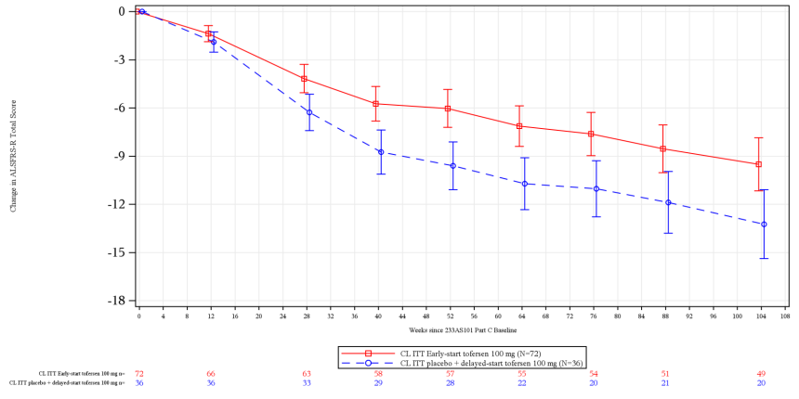 | 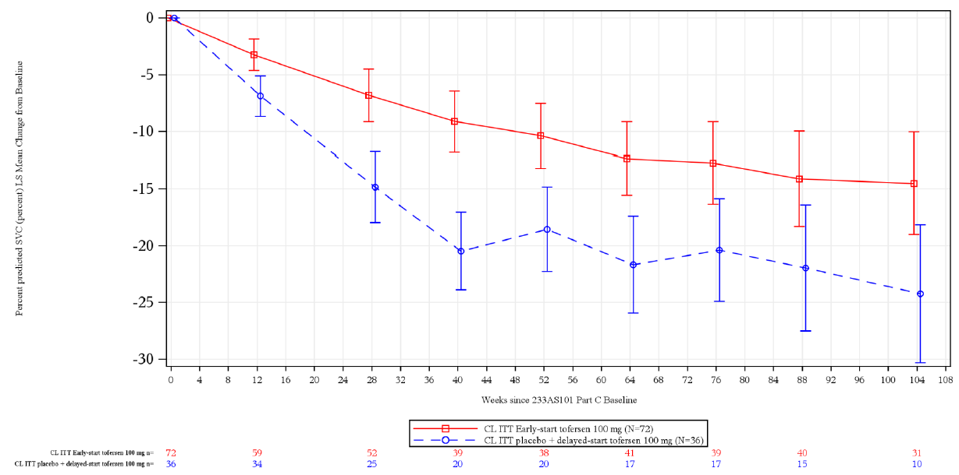
- CSF SOD1 GMR^{b}  DCO: 28 Feb 2023 | - Plasma NfL GMR^{b}  DCO: 28 Feb 2023
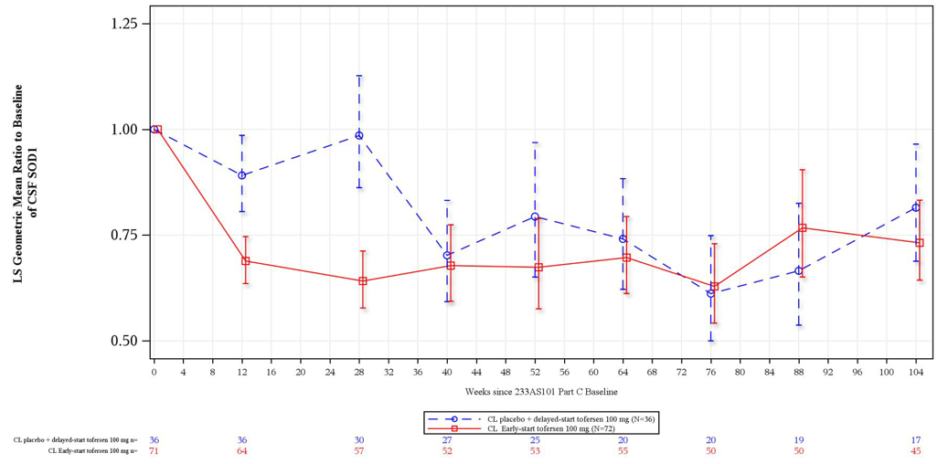 | 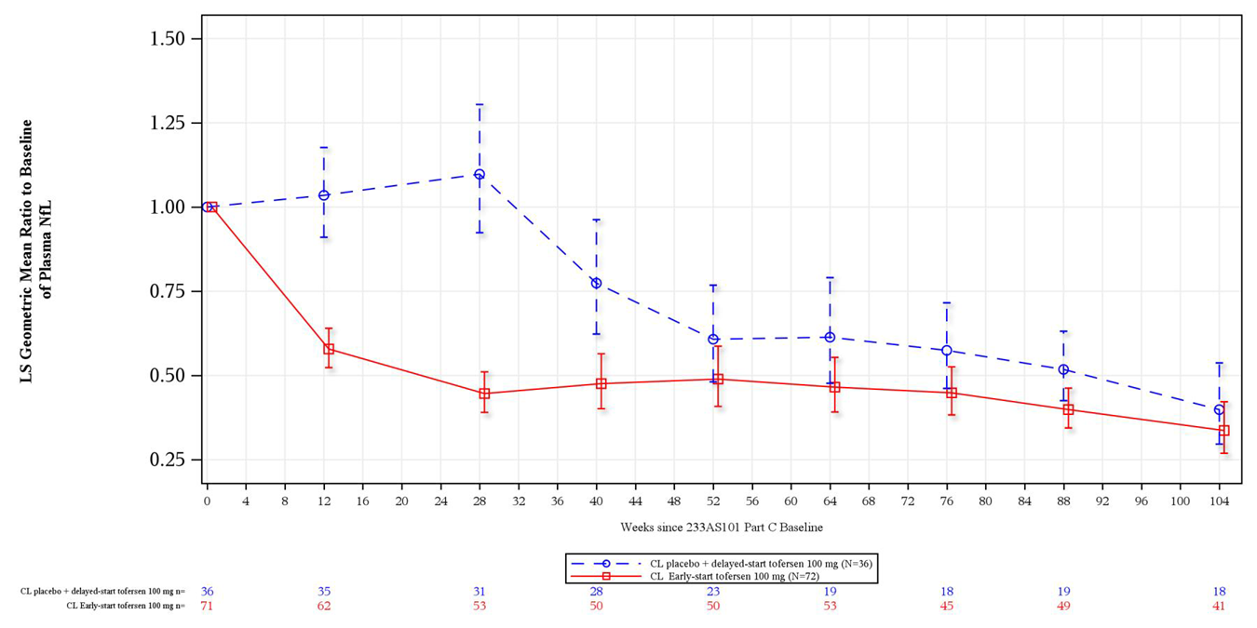
- Time to death or permanent ventilation  DCO: 28 Feb 2023 | - Time to death  DCO: 28 Feb 2023
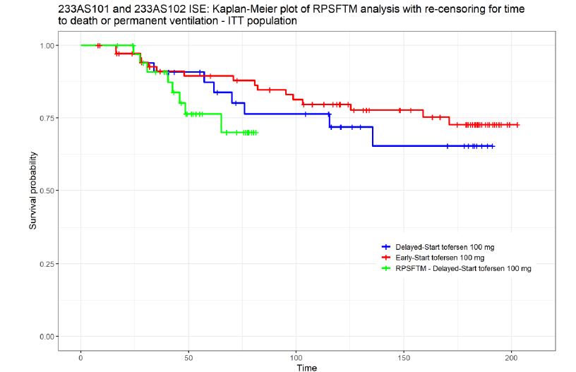 | 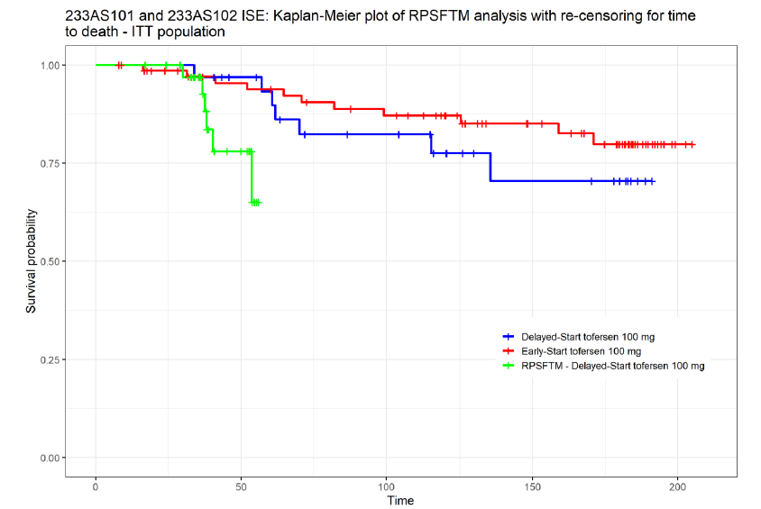
Source: Figure 2.20, p182, Figure 2.22, p185, Figure 2.24, p187, Figures 2.30 and 2.31, pp198-199, Figure 3.13, p249 of the submission.
ALS=amyotrophic lateral sclerosis; ALSFRS-R=ALS Functional Rating Scale–Revised; CSF=cerebrospinal fluid; DCO=data cut-off; GMR=geometric mean ratio; ITT=intention-to-treat; mITT=modified ITT; NfL=neurofilament light chain; RPSFTM=rank preserving structural failure time model; SOD1=superoxide dismutase 1; %SVC=% predicted slow vital capacity;
Blue curves=delayed-start tofersen, Red curves=early-start tofersen group, green curves=RPSFTM delayed-start tofersen.
a analysis based on the ANCOVA model with corresponding baseline value, baseline plasma NfL, and use of riluzole or edaravone.
b analysis is based on ANCOVA model with corresponding baseline value and use of riluzole or edaravone.
  - The results of VALOR and VALOR-OLE demonstrated that in patients with ALS and confirmed SOD1 pathogenic variant:
- Function: there was no difference between tofersen and placebo groups in the change from baseline in ALSFRS-R score, and other functional outcomes (%SVC and HDD) at Week 28. The post hoc analyses by subgroups and statistical analysis adjusting for covariates including baseline plasma NfL were consistent with the pre-specified analysis, but the results generally favoured tofersen after adjustments. There was also no difference between early-start and delayed-start tofersen patients at Week 104 for the ITT population. However, patients treated with early-start tofersen showed a trend towards slower decline in ALSFRS-R score, %SVC and HDD from VALOR baseline compared to patients with delayed-start tofersen. The pre-PBAC response noted that long term follow up in VALOR OLE showed a continued difference between early and late starters in ALSFRS-R at 52 weeks (3.5 points), 104 weeks (3.7 points) and 148 weeks (3.6 points).
- Time to death and permanent ventilation: there was no difference between the tofersen and placebo groups in the time to death or permanent ventilation, or time to death at Week 28. The median times could not be estimated due to the small number of events observed. There was also no difference between early-start and delayed-start tofersen patients in time to death or permanent ventilation, or time to death. Adjusting for treatment switching in the delayed-start group using rank preserving structural failure time model (RPSFTM) showed a numerical trend in favour of early-start tofersen. However, the results were uncertain due to the small number of events, immature data and assumptions of the adjustment.
- Biomarker outcomes: there was greater reduction in CSF SOD1 protein (p<0.0001) and plasma NfL (p<0.0001) for patients treated with tofersen compared placebo at Week 28. For the early-start tofersen patients the reduction in CSF SOD1 protein and plasma NfL was maintained to Week 104. Delayed-start tofersen patients also achieved similar reductions in CSF SOD1 protein and plasma NfL at Week 104.
- Patient reported outcomes: there was no difference between tofersen and placebo for quality-of-life measures including ALSAQ-5, FSS and SF-36 at Week 28. While improvement in EQ-5D-5L utility scale favoured tofersen compared to placebo (p=0.0029), no difference was observed on the EQ-5D-5L VAS (p=0.0803). However, delayed-start tofersen patients continued to have greater decline in quality of life as measured on EQ-5D-5L compared to early-start tofersen patients at Week 52 (p<0.0001) and Week 104 (p=0.0131).

Time to death across DCOs in VALOR-OLE
  - At the time of VALOR-OLE second interim DCO: 16 January 2022, 11.1% (8/72) patients in early-start tofersen group and 16.7% (6/36) patients in delayed-start tofersen group had died. The submission estimated multiple hazard ratios for time to death from VALOR baseline. See Table 6.
Table 6: Time to death from VALOR baseline
Outcome | ITT, VALOR OLE  DCO:16 Jan 2022 |  | ITT, VALOR OLE  DCO:28 Feb 2023
Outcome | Early  N=72 | Delayed  N=36 | Early  N=72 | Delayed  N=36
Median time to event (95%CI) | NR | NR | NR | NR
Between group comparison
Log-rank test  Cox PH, with covariates | 0.0879  0.0313 |  | 0.1224ª  0.0538^{b}
Hazard ratio (95%CI)
With covariates | 0.27 (0.08, 0.89)^{b} |  | 0.36 (0.13, 1.02)^{b}
RPSFTM no re-censoring | 0.10 (0.01, 0.81)^{b} |  | 0.12 (0.014, 1.035)^{b,c,d}
RPSFTM re-censoring | NR |  | 0.08 (0.006, 1.042)^{b,c,e}
Without covariates | 0.54 (0.19, 1.56) |  | NR
RPSFTM no re-censoring | 0.28 (0.03, 2.47) |  | NR
Source: Table 2.37, p176, Table 2.49, p195, Table 2.50, p197 of the submission, Tables 1, 2 and 3, pp16-18 of Attachment 9 - Comprehensive stats report to support ALS pharmacoeconomic model_2023_Sep_14.docx, Table 2, p18 of Attachment 4_2.7.3 Summary of Clinical Efficacy Addendum Final 04Jul2023.pdf
CI=confidence interval; DCO=data cut-off; ITT=intention-to-treat; PH=proportional hazards; NE=not estimable; NR=not reported; NfL=neurofilament light chain; RPSFTM=rank preserving structural failure time model; SD=standard deviation;
a test stratified by riluzole or edaravone use.
b Cox PH model adjusted for baseline NfL plasma, and riluzole or edaravone use.
c Adjusted 95%CI based on distribution of log HR retaining Cox regression p-value from ITT analysis back transformed to original scale.
d Unadjusted 95%CI: 0.033, 0.43.
e Unadjusted 95%CI: 0.02, 0.37.
  - The ESC noted that the submission applied the most favourable of HRs, adjusting for treatment switching and baseline NfL plasma, and riluzole or edaravone use from the second interim analysis (0.10), in the modelled economic evaluation. In general, HRs increased or had wider 95% CIs at the third interim DCO compared to the second interim DCO, e.g., the analysis used to estimate the HR applied in the model (treatment switching using RPSFTM without re-censoring and adjusting for baseline NfL plasma, and riluzole or edaravone use) resulted in HR = 0.12 (95% CI: 0.014, 1.035) at DCO: 28 February 2023 compared to HR = 0.10 (95% CI: 0.01, 0.81) at DCO: 16 January 2022.
  - Figure 2 presents a comparison of the time to death across the January 2022 and February 2023 DCOs in VALOR-OLE. The difference between the Kaplan-Meier curves narrowed between the second and the third-interim data cuts, driven by lower survival in the early-start tofersen arm at the later cut. Noting the high level of uncertainty with small patient numbers, this pattern may reflect difference in average survival between patients randomised to tofersen early versus later in the VALOR recruitment window. Overall, the effect of tofersen on mortality is unclear, noting that no additional comparative data are expected.
Figure 2: Time to death (comparison of DCOs) across VALOR-OLE (ITT)
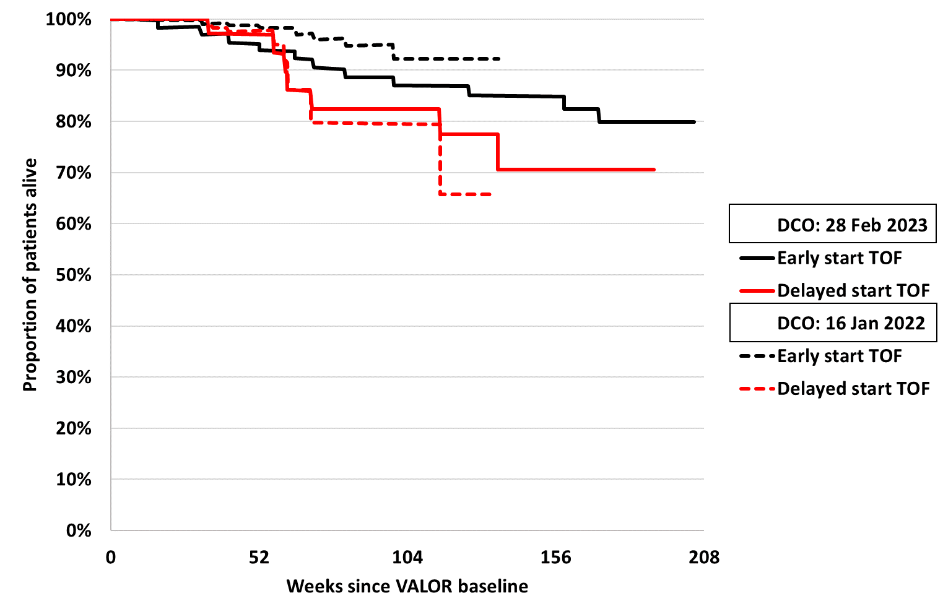
Source: Figures 2.31 and 3.13 of the submission digitised using IPDfromKM (Liu 2020).
DCO=data cut-off; ITT=intention-to-treat; RPSFTM=rank preserving structural failure time model;

Time to later disease stage
  - The submission conducted a post hoc analysis on the time to later MiToS stage, which was used to distribute patients into health states in the modelled economic evaluation. Figure 3 presents the result of the time to later MiToS stage (excluding death) across VALOR-OLE (DCO: 16 January 2022).
Figure 3: Time to later MiToS stage (excluding death) across VALOR-OLE (ITT, DCO: 16 Jan 2022)
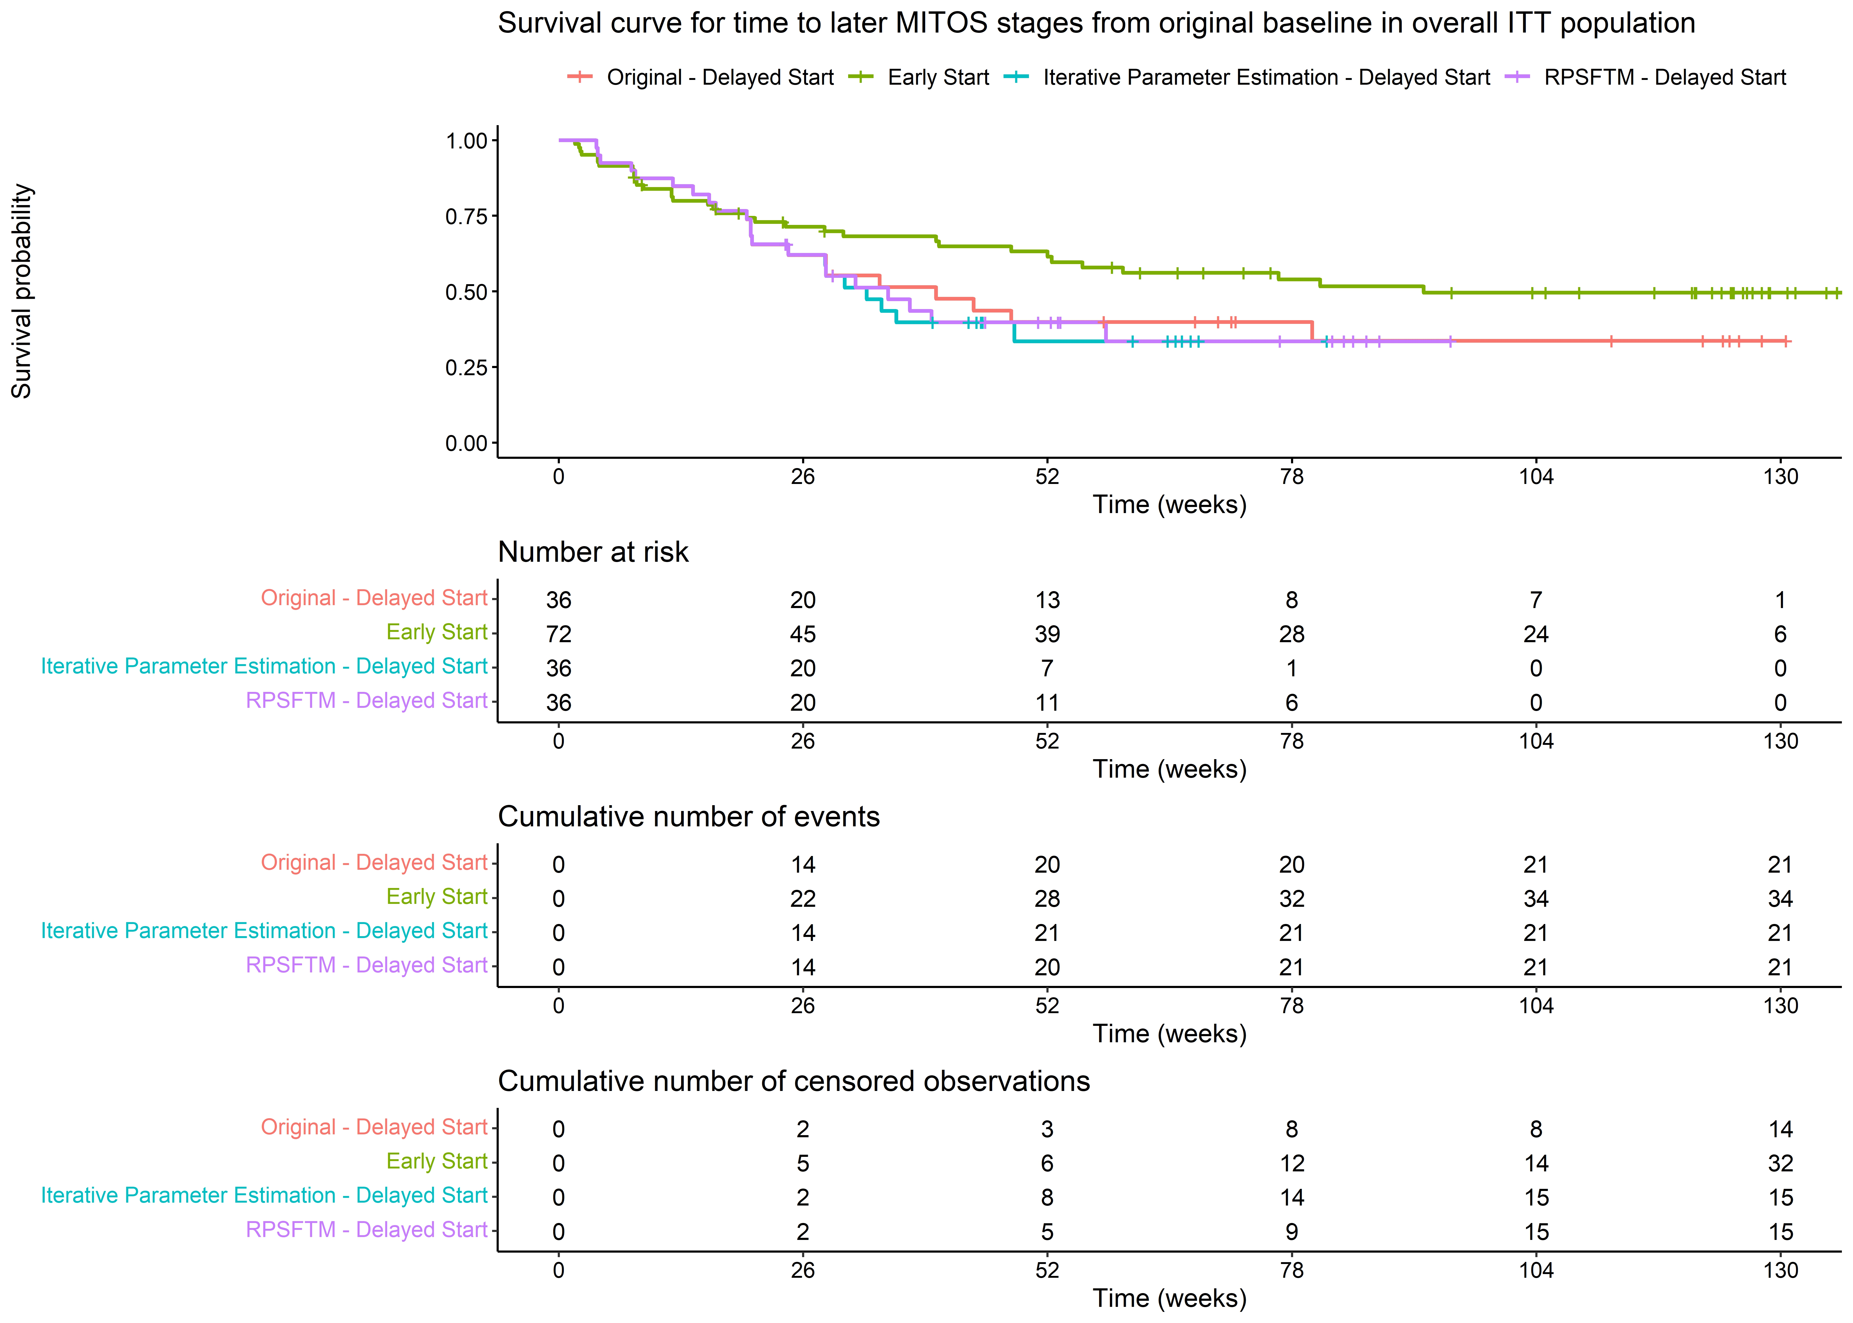

Source: Figure 3.13, p249 of the submission.
DCO=data cut-off; ITT=intention-to-treat; MiToS=Milano-Torino functional staging system; RPSFTM=rank preserving structural failure time model;
  - At the time of the VALOR-OLE second interim DCO: 16 January 2022, 47.2% (34/72) patients in the early-start tofersen group and 58.3% (21/36) patients in delayed-start tofersen experienced a worsening in their MiToS stage (HR = 0.74, 95% CI: 0.43, 1.29, without adjusting for covariates; HR = 0.69, 95% CI: 0.1, 1.2, adjusting for baseline NfL plasma and riluzole/edaravone use; HR = 0.61, 95% CI: 0.29, 1.27, adjusting for covariates and treatment switching). The time to later disease stage was dependent on the starting stage and did not account for the magnitude of the disease progression, making these results difficult to interpret. The submission applied the most favourable HR (0.61) in the modelled economic evaluation, despite no statistically significant difference. The submission also estimated the time to later King’s stage, for which there was no difference between the early and delayed-start tofersen arms, regardless of the analysis approach taken. Overall, there was little evidence that tofersen decreased time to disease progression by clinical stage.
Updated data from VALOR OLE at Week 148
  - The PSCR provided updated data from the final data cut of VALOR OLE at 148 weeks. This showed a sustained reduction in NfL level, a trend towards slower decline in ALSFRS-R score, %SVC and HDD from VALOR baseline (25% of patients experienced recovery of function and/or strength) and numerical reduction in the risk of death or permanent ventilation and risk of death for the early-start tofersen group. At the completion of VALOR OLE there was a total of 46 patients (34 early-start and 12 delayed-start) with ≥ 3.5 years follow-up.
  - The ESC noted that the results from Week 148 were consistent with those presented at Week 104. The ESC noted that there was no difference between early-start and delayed-start tofersen patients at Week 148 in the improvement from baseline in function and survival. Reduction in NfL was also similar between early-start and delayed-start patients at Week 148. The ESC agreed that there was a trend towards slower decline in ALSFRS-R score, %SVC and HDD.

Comparative harms
  - Table 7 summarises the key safety outcomes to Week 28 in VALOR and Week 104 in VALOR-OLE for the ITT.
Table 7: Summary of key adverse events (AEs) to Week 28 in VALOR and Week 104 in VALOR-OLE (ITT)
Patients with AEs, n (%) | VALOR |  | VALOR-OLE
Patients with AEs, n (%) | Tofersen (N=72) | Placebo (N=36) | Tofersen (N=104)
Any AEs | 69 (95.8) | 34 (94.4) | 103 (99.0)
AEs related to treatment | 28 (38.9) | 2 (5.6) | 66 (63.5)
AEs related to lumbar puncture | 58 (80.6) | 29 (80.6) | 87 (83.7)
Serious AE | 13 (18.1) | 5 (13.9) | 48 (46.2)
AEs leading to treatment discontinuation | 4 (5.6) | 0 | 23 (22.1)
AEs leading to hospitalisation | 13 (18.1) | 4 (11.1) | 41 (39.4)
Deaths | 1 (1.4) | 0 | 18 (17.3)
Adverse drug reactions:
Pain | 30 (41.7) | 8 (22.2) | 66 (63.5)
Fatigue | 12 (16.7) | 2 (5.6) | 30 (28.8)
Arthralgia | 10 (13.9) | 2 (5.6) | 35 (33.7)
Myalgia | 10 (13.9) | 2 (5.6) | 21 (20.2)
CSF white blood cell increased | 10 (13.9) | 0 (0) | 32 (30.8)
CSF protein increased | 6 (8.3) | 1 (2.8) | 28 (26.9)
Musculoskeletal stiffness | 4 (5.6) | 0 (0) | 7 (6.7)
Neuralgia | 4 (5.6) | 0 (0) | 6 (5.8)
Pyrexia | 3 (4.2) | 1 (2.8) | 19 (18.3)
Myelitis | 2 (2.8) | 0 (0) | 2 (1.9)
Radiculitis | 1 (1.4) | 0 (0) | 2 (1.9)
Aseptic meningitis | 1 (1.4) | 0 (0) | 4 (3.8)
Papilloedema | 0 (0) | 0 (0) | 6 (5.8)
Source: Table 2.53, p202, Table 2.56, p206, Table 2.58, p208 of the submission.
  - In VALOR ITT, the incidence of any AEs was similar between groups to Week 28; however, patients treated with tofersen experienced higher incidences of drug-related AEs, serious AEs, AEs leading to discontinuation and AEs leading to hospitalisation compared to placebo. Commonly reported AEs (> 15% patients) in tofersen vs placebo group included procedural pain (56.9% vs 58.3%), headache (45.8% vs 44.4%), pain in extremity (26.4% vs 16.7%), fall (23.6% vs 41.7%), back pain (20.8% vs 5.6%), post-lumbar puncture syndrome (18.1% vs 30.6%), and fatigue (16.7% vs 5.6%). Most AEs were mild to moderate in severity. The overall incidence of AEs was similar between the mITT and non-mITT subgroups for both the tofersen and placebo groups. There was one death in the tofersen group (congestive cardiac failure); the patient was in the enriched mITT subgroup. While the safety data showed similar incidences of AEs related to lumbar puncture between groups, these safety results reflected trial conditions where patients were administered sham lumbar punctures in the placebo arm. In clinical practice additional reactions associated with IT administration are expected for tofersen versus BSC only.
  - In the ongoing extension VALOR-OLE study (104 weeks, DCO: 28 February 2023), 99% of patients receiving tofersen treatment reported any AEs at Week 104. There were 18 deaths; however, none were related to tofersen treatment. Across VALOR and VALOR-OLE, non-serious treatment-related AEs (i.e. adverse drug reactions) due to tofersen included pain (back and in extremity), fatigue, arthralgia, myalgia, increased CSF white blood cell, increased CSF protein concentration, muscle stiffness, neuralgia and pyrexia. These AEs were generally mild to moderate in severity. Serious ADRs included myelitis, papilloedema, radiculitis and aseptic meningitis.

Benefits/harms
  - A benefits and harms table was not presented as the direct evidence from VALOR trial did not demonstrate a statistically significant difference in patient relevant outcomes. While there were greater reductions in CSF SOD1 protein and plasma NfL levels for patients treated with tofersen compared placebo, there is uncertainty regarding the extent to which these biomarker improvements translate to a clinical benefit.
  - However, on the basis of the direct evidence, for every 100 patients treated with tofersen lumbar puncture versus placebo lumbar puncture over 28 weeks:
- Approximately 33 additional patients would experience treatment related AEs.
- Approximately 19 additional patients would experience pain (adverse drug reaction).
- Approximately 14 additional patients would experience CSF abnormalities with CSF white blood cell increased (adverse drug reaction).

Clinical claim
  - The submission described tofersen as superior in terms of effectiveness and inferior in terms of safety compared to BSC in patients with ALS and confirmed SOD1 pathogenic variant. The submission stated that the claim was based on the totality of the evidence presented and that tofersen is expected to provide a long-term clinical benefit in terms of ALSFRS-R, other measures of disease progression (i.e. time to death and permanent ventilation) and survival due to reductions in plasma NfL levels as a biomarker for neurodegeneration.
  - The evaluation considered the clinical claim of superior efficacy versus BSC was not adequately supported by the evidence presented in the submission. The ESC noted that the clinical evidence was limited by the small patient population and the short duration of the comparative phase of the trial and that more conclusive evidence in this patient cohort for this medicine was not likely to become available. However, on balance, the ESC considered that tofersen is likely to have a clinically meaningful benefit over BSC, noting that many of the point estimates in the VALOR trial favoured tofersen, biochemical markers were supportive of a possible disease-modifying effect, and real-world data were supportive of a meaningful treatment effect. However, the ESC considered that the magnitude of the benefit was uncertain as:
- The VALOR trial did not demonstrate a statistically significant difference between the tofersen and placebo groups in the improvement from baseline in ALSFRS-R score and other functional outcomes (%SVC and HDD) at Week 28. There was also no difference between tofersen and placebo in the time to death or permanent ventilation or time to death. Although long-term data from VALOR-OLE showed no difference in terms of improvement in function and survival between early-start and delayed-start tofersen patients, patients treated with early-start tofersen showed a trend towards slower decline in ALSFRS-R score, %SVC and HDD from VALOR baseline compared to patients with delayed-start tofersen.
- While the results showed greater reduction in CSF SOD1 protein and plasma NfL for patients treated with tofersen compared placebo, there is uncertainty that these biomarker improvements translate to a clinical benefit.
- The risk of bias in VALOR and VALOR-OLE was considered unclear due to trial amendments likely favouring tofersen.
  - The ESC considered that the claim of inferior safety versus BSC was reasonable. The incidence of any AEs was similar between tofersen and placebo to Week 28; however, patients treated with tofersen experienced higher incidence of drug-related AEs, serious AEs, AEs leading to discontinuation and AEs leading to hospitalisation compared to placebo. In clinical practice, additional reactions associated with IT administration are expected for tofersen.
  - The PBAC considered that the claim of superior comparative effectiveness was not well-supported by the data, which was limited by the small patient population and the short duration of the comparative phase of the trial. However, on balance, the PBAC agreed with the ESC that tofersen was likely to provide a clinically meaningful benefit to some patients, but that the magnitude of the benefit and longer-term effects were uncertain.
  - The PBAC considered that the claim of inferior comparative safety was reasonable.

Economic analysis
  - The submission presented a Markov cohort, cost-utility analysis comparing tofersen plus BSC with or without riluzole (tofersen arm) to BSC with or without riluzole alone (BSC arm) for SOD1-ALS, based on the clinical claim of superior effectiveness for tofersen plus BSC versus BSC. However, the evaluation considered the modelled economic evaluation presented in the submission was largely uninformative for decision-making, as the clinical claim of long-term clinical benefit from tofersen compared to placebo was not adequately supported by the evidence presented in the submission. In particular, the economic analysis utilised time to MiToS stage progression and time to death, neither of which were statistically significant at the latest available DCOs (16 Jan 2022 for MiToS stage progression, 28 Feb 2023 for survival), even when controlling for treatment switching. Additionally, as all patients in VALOR OLE received tofersen, no comparative data versus placebo were available beyond 28 weeks.
  - The ESC considered, notwithstanding the differences in the populations eligible for treatment with edaravone and tofersen, that a comparison of the costs and outcomes of edaravone and tofersen may be informative for PBAC decision-making in the context of the limitations of the economic evaluation for tofersen.
  - The PSCR stated that the MiToS system is preferred for modelling a mixed population of prevalent and incident patients across all disease stages and provides a sound framework to inform the model structure.
  - A summary of the model structure and key inputs is presented in Table 8.
Table 8: Summary of model structure, key inputs and rationale
Component | Summary
Treatments | Tofersen plus BSC with or without riluzole (tofersen arm) vs BSC with or without riluzole alone (BSC arm).
Time horizon | 10 years in the model base case vs. 2 years in VALOR plus VALOR OLE (28 weeks for placebo only), and 2 years in Thakore 2018 (combined trial and observational data from the US based PRO-ACT registry). Studies informing the model had a maximum of 2 years of data, including data from the second interim DCO of VALOR OLE (16 Jan 2022, maximum 2.3 years follow up). The submission argued that patients with SOD1-ALS are likely to have worse survival than the overall ALS population. The ESC considered that a 10-year time horizon was reasonable, noting that it was previously accepted for edaravone (edaravone PSD March 2024), and that the ICER was not sensitive to use of a shorter time horizon as most patients in both treatment arms were modelled to have died by 6 years (<10% alive in the tofersen arm, 0% in the PBS arm).
Outcomes | Life years gained, quality-adjusted life years, which was appropriate.
Methods used to generate results | Markov cohort model. The submission did not present a trial-based analysis followed by extrapolation, instead implementing transition probabilities from Time 0. The ESC considered that the application of constant transition probabilities across the time horizon from Month 12 was not appropriate and likely favoured tofersen.
Health states | MiToS stage 0, stage 1, stage 2, stage 3, stage 4, Dead. Stage number referred to number of domains with loss of independence, estimated from score 0 or 1 items of the ALSFRS-R related to four domains: communication (items 1 and 4), movement (items 6 or 8), swallowing (item 3), breathing (items 10 or 12). The ESC noted that the model structure was complex with a large number of possible transitions, and that data were sourced from external studies.  The submission justified the choice of MiToS staging for disease health states over King’s staging (King’s staging was accepted in the edaravone PSD March 2024) stating that MiToS stage is directly calculated from the ALSFRS-R, and disease progression is sequential. No benefit from tofersen was observed in time to later King’s stage in VALOR/VALOR OLE. While MiToS stages demonstrate progression in individual patients, they may be heterogeneous at a cohort level as the stages account only for the number of regions a patient has loss of independence in, not the regions themselves. The stages also do not account for mild to moderate loss of function in each of the four domains.
Cycle length | 28 days with half cycle correction. Cycle length was reasonable. It may have been more appropriate to apply tofersen costs at the start of each cycle given the dosing schedule (i.e. every 28 days).
Transition probabilities | Transition between health states:  BSC arm (and tofersen arm off-treatment): published transition probabilities from Thakore 2018, based on the PRO-ACT database, with post-Month 12 calibration adjustment for all transitions and SOD1-ALS adjustment applied to progression to later stage or death (HR 1.3 from Opie-Martin 2022, applied to annual rates and then converted back to transition probabilities). The ESC considered that the adjustments were complex and poorly justified.  Tofersen arm on treatment: BSC arm in first 3 cycles (12 weeks, to capture the delay in treatment effect onset), then HRs applied to BSC arm annual rates of progression to later stage or death, based on Cox models for time to later MiToS stage (without death) and time to death from RPSFTM adjusted VALOR/VALOR OLE data. These annual rates were converted back to transition probabilities by adjusting the proportion of patients remaining in each stage. The ESC noted that the adjustments resulted in HRs that differed considerably from the raw data (e.g. HR for mortality reduced from 0.27 to 0.10). Additionally, the ESC considered that the application of constant HRs over the 10 year time horizon was optimistic.  Transition probabilities were highly uncertain, with differences in input sources and analyses, e.g.,  - Thakore 2018 did not control for patient characteristics, Opie-Martin 2022 controlled for age, site of onset and gender; and VALOR controlled for baseline plasma NfL and riluzole/edaravone use.  - Opie-Martin 2022 measured survival from symptom onset, Thakore 2018 and VALOR baselines were post-diagnosis.  - Riluzole use was 62% patients in VALOR, 81% in the model, NR for Thakore 2018 or Opie-Martin 2022. 8% of patients across both arms of VALOR used edaravone in addition to riluzole, compared to 0% in the model.  The ESC noted that some of the transitions may not be clinically plausible, e.g.,  - The application of SOD1-ALS and treatment effect HRs to disease progression and death required changing the per cycle likelihood of remaining in state to keep probabilities summing to 1.  - The submission allowed for transitions to better health states. While not explicitly modelled, this implicitly resulted in additional life years gained from reversing disease trajectory to a greater extent in the tofersen arm.
Transition probabilities | TTD:  All patients receive BSC in Stages 0 to 3, with 81% receiving riluzole based on Australian data (Talman 2016). Tofersen was assumed to have a discontinuation rate of 1.02% per model cycle (based on discontinuation at Week 28 in VALOR) plus a stopping rule upon entry to MiToS stage 4. The ESC considered that it was not reasonable to assume a constant discontinuation rate based on first 6 months of treatment (i.e. the VALOR trial).
Health related quality of life | MiToS stage 0: 0.71, stage 1: 0.48, stage 2: 0.36, stage 3: 0.33, stage 4: 0.25 (Moore 2019), adjusted for age-based population utility (Redwood 2024). The utility estimates from Moore 2019 were based on a postal survey of UK ALS patients, using EQ-5D-5L and UK preference weightings and therefore required patients to be able to independently complete and return the questionnaires. As such the utility values may not represent patients in worse health nor the specific experience of SOD1-ALS patients.  Total per cycle adverse event disutility -0.0058 on tofersen plus BSC, -0.0018 on BSC only, based on incidence from VALOR and Paganoni 2020. There were several concerns with adverse events in the model, but adverse events were not a significant driver of the ICER.  No caregiver utilities in the base case, but assumed additional utility gains for one caregiver per patient in a sensitivity analysis.
Resource use | Tofersen cost was based on the per vial AEMP ($&&&&) with July 2025 dispensing mark-ups and assuming 50% private patients and 93.8% compliance (from VALOR mITT). This resulted in a cost of $&&&& in the first cycle and $&&&& thereafter. The approach to costing tofersen was reasonable; however, the full 3 loading doses were spread across 2 cycles, and compliance was uncertain and applied constantly over time. VALOR and VALOR OLE reported different compliance according to population and time point: VALOR ITT tofersen arm reported 95.2% compliance, whereas VALOR OLE ITT early-start tofersen arm reported 89.4% compliance.  Tofersen was also associated with an administration cost (MBS item 18216) and monitoring costs (MBS items 69333, 65070, 65120) every 3 months.  In both arms, 81% of patients in stage 0-3 were assumed to receive riluzole at a dose of 100 mg per day. Riluzole costs were $136.70 for 56x50 mg tablets (PBS item 8664B), updated from $136.37 in the submission. No patients were assumed to receive 60-day supply or riluzole in liquid form. The costing of riluzole did not have a significant effect on the ICER.  Total per cycle health state costs in both arms were equal to $429 in stage 0, $1,109 in stage 1, $1,893 in stage 2, $2,122 in stage 3, $2,305 in stage 4. These were based on Moore 2019 and an Australian costing study (Deloitte 2015); and unit costs included MBS items, ambulance Victoria, AR-DRG and emergency care diagnosis group (ECDG) codes, Farag et al., 2013, and the NDIS support catalogue (2024). The submission also included one-off costs based on Deloitte 2015 equal to $20,005 upon progression to stage 2 and $40,009 upon progression to stages 3 or 4. Given the memoryless nature of Markov models, these costs were applied when maximum health state allocation occurred.  The model estimated that the annual cost in the BSC arm was $26,755 (total cost of $34,659 over 1.3 years). It was not possible to disaggregate all costs in the model, but excluding tofersen drug and administration costs, the model estimated annual BSC related costs in the tofersen arm equal to $&&&& (total cost $&&&& over 2.9 years). In comparison, Deloitte 2015 estimated health system costs >$35,000 per year and total economic costs (including carer costs, productivity costs and other financial costs) >$200,000 per year. Health state costs were likely underestimated in the model compared to costs in practice, which favoured the tofersen arm, where increased survival resulted in increased health state costs.  End of life costs ($7,437) were applied to the proportion of patients who died each cycle. This was based on the AIHW Palliative Care Services 2023, with 50% of patients assumed to access palliative care from Runacres 2023. Palliative care costs were not a significant driver of the ICER.
Source: compiled during the evaluation.
BSC=best supportive care with or without riluzole, HR=hazard ratio, RPSFTM=rank preserving structural failure time model, TTD=time to treatment discontinuation, ALS=amyotrophic lateral sclerosis, MiToS=Milano-Torino staging, NR=not reported

  - A summary of the model structure is presented in Figure 4.
Figure 4: Model structure
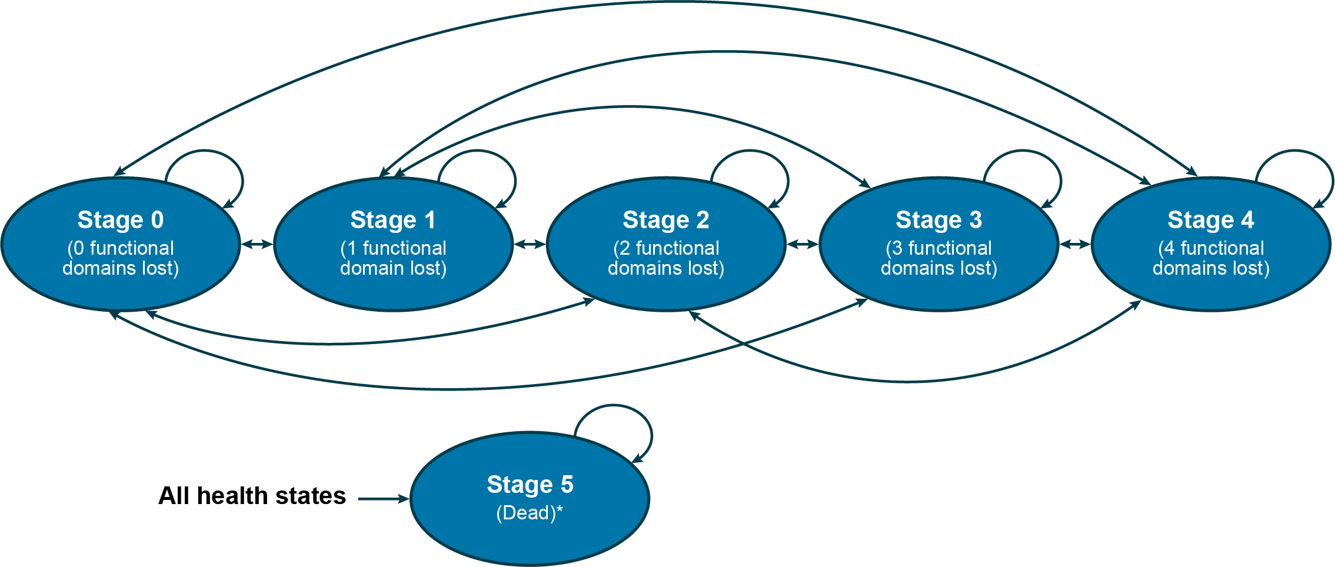
Source: Table 3.3, p237 of the submission
  - Patients entered the model according to baseline MiToS stage from VALOR (stage 0: 75.0%, stage 1: 21.3%, stage 2: 2.8%, stage 3: 0.9%, stage 4: 0%) and could move to any other stage (MiToS stage could worsen or improve) or remain in the same stage each cycle. The primary source of the transition probabilities (Thakore 2018) did observe and allow for movement into less advanced disease. However, it may not be reasonable to allow for improvement in MiToS stage as ALS is a progressive disease for which there is no cure, and this was not observed in the VALOR data presented in the submission.
  - Transitions in the BSC arm were based on Thakore 2018, but as Thakore 2018 modelled probabilities did not predict well beyond the first year (paragraph 6.39 edaravone PSD, November 2023 PBAC meeting) the submission performed a calibration of the transition probabilities in the second year to better fit the underlying Thakore 2018 data. A further adjustment was made to estimate the worse prognosis for SOD1-ALS patients by applying a hazard ratio of 1.3 from Opie-Martin 2022 to annual probabilities of worsening disease stage or death, converted to 28-day probabilities. The PSCR stated that this was reasonable as patients with SOD1-ALS have a shorter average survival of 2.3 to 2.7 years, as compared to 3 to 5 years for the general ALS population. As the SOD1-ALS population tends to be younger and with fewer patients presenting with bulbar onset compared to the overall ALS population, the adjusted survival is unlikely to represent survival for the SOD1-ALS population. The ESC considered that the adjustments and calibrations were complex and poorly justified, but that removing them reduced the ICER compared to the base case.
  - Transition probabilities in the tofersen arm were estimated by applying hazard ratios to the BSC arm. Hazard ratios for stage progression (0.61) and mortality (0.10) while receiving tofersen were based on an analysis of combined VALOR and VALOR OLE data (DCO 16 January 2022) adjusted for baseline plasma NfL and edaravone/riluzole use and the placebo/delayed-start tofersen arm adjusted for treatment switching with RPSFTM. The PSCR stated that adjustment was required considering the cross-over design of VALOR and VALOR OLE which was expected to underestimate the effect of treatment on ALSFRS-R and survival compared to a true placebo and reiterated that the use of the RPSFTM approach was appropriate. The ESC noted that the adjustments resulted in HRs that differed considerably from the raw data; the unadjusted HRs were 0.69 for stage progression and 0.27 for death. In addition to the HRs assuming benefits which were not supported by the clinical evidence, the ESC considered that the application of constant HRs over the 10 year time horizon may have been optimistic and overestimated the benefits of treatment with tofersen. Further, it may not reflect the typically non-linear course of ALS. The ESC considered that it would also have been reasonable to assume treatment waning.
  - The submission also made several assumptions about transition probabilities in the tofersen arm. Firstly, to capture the delay in treatment effect onset, no benefits were assumed for patients receiving tofersen in the first 12 weeks. Secondly, patients who stopped receiving tofersen had transition probabilities equal to the BSC arm applied from the cycle after they discontinued tofersen. It was not possible to alter the time to treatment effect in the model.
  - The submission assumed both tofersen and riluzole would be discontinued upon entry to MiToS stage 4. The submission also assumed a discontinuation rate for tofersen of 1.02% per cycle based on the rate in VALOR, which excluded discontinuation due to death or disease progression. The ESC, noting that there may be more barriers to treatment in practice compared to the clinical trial setting and that long term tofersen treatment represents a significant treatment burden and risk of adverse events, considered that the application of a constant discontinuation rate of 1.02% per cycle, which was based on the first 6 months of treatment in VALOR, may not be reasonable. The ESC noted that a discontinuation rate of 30% every 3 months was applied in the model for edaravone.
  - Patients were assumed to receive two intrathecal injections of 100 mg tofersen in the first model cycle and one every subsequent model cycle. Tofersen cost was based on the per vial EMP ($&&&&) and 93.8% compliance (from VALOR mITT), which resulted in a cost of $&&&& in the first cycle, $&&&& thereafter. It was unclear why mITT compliance was chosen for the base case, rather than the ITT population of VALOR. It was also not reasonable to assume compliance of 93.8% for the initial dose, as 100% patients should receive at least one dose. The submission assumed a cost of $216.35 (MBS item 18216, current cost $221.55) for each intrathecal bolus injection required to administer tofersen. The submission assumed that patients receiving tofersen would accrue a cost of $27.12 per model cycle due to 3-monthly drug monitoring through urinalysis (MBS item 69333), platelet count (MBS item 65070) and coagulation tests (MBS item 65120).
  - Health state resource use was based on Moore 2019 and Deloitte 2015, including primary and secondary care; prognostic tests; and community costs. Unit costs were based on MBS items, ambulance Victoria fee, AR-DRG and emergency care diagnosis group (ECDG) codes, Farag 2013, and the NDIS support catalogue (2024). In general, BSC costs appear to be underestimated. Deloitte 2015 estimated health system costs in excess of $35,000 per year and total economic costs (including carer costs, productivity costs and other financial costs) over $200,000 per year.
  - Health state allocation plots were reproduced during the evaluation to extend to the full 10-year time horizon and highlight time on and off tofersen (Figure 5).
Figure 5: Health state allocation (base case)
Tofersen arm | BSC arm
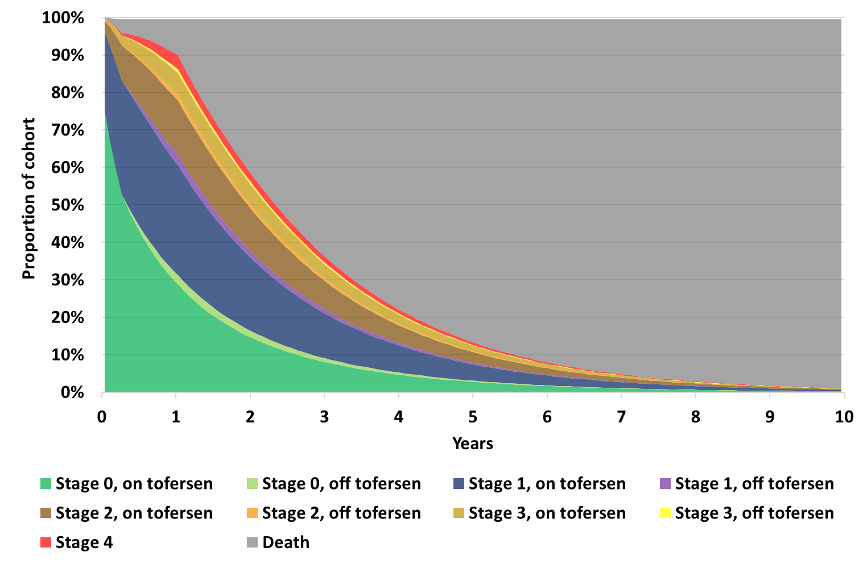 | 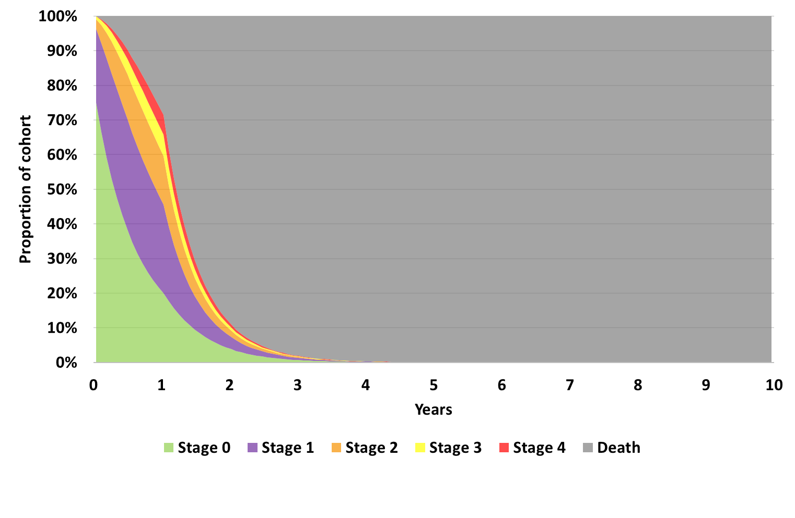
Incremental health state allocation over time, tofersen vs BSC arms
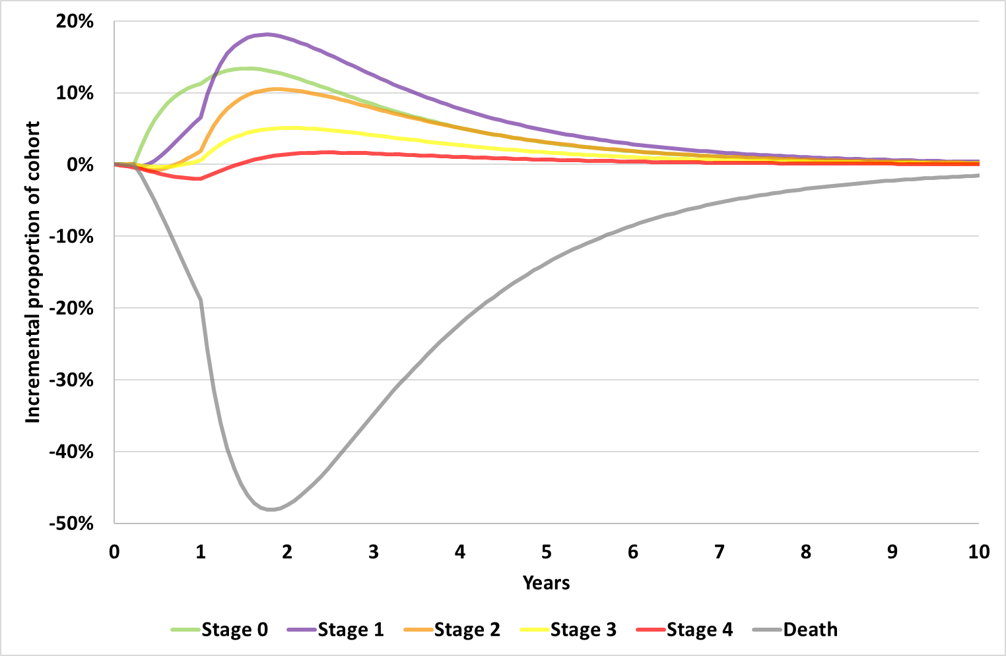
Source: compiled during the evaluation from Excel workbook ‘Attachment 8 – QALSODY Cost utility analysis (CUA) (Section 3).xlsm’
BSC=best supportive care with or without riluzole
All patients in stages 0-3 receive best supportive care with 81% receiving riluzole. The incremental health state allocation plot was calculated from all patients in stage, regardless of treatment received
  - In both arms, patients spent the most time in stage 0, followed by stage 1. Tofersen patients spent more time in all stages overall, a result of the increased survival and reduction in transition out of each state. By the end of the 10 year time horizon no patients in the BSC arm and 1% of patients in the tofersen arm were alive.
  - In general, the modelled BSC arm appeared to have worse survival than reported in the underlying data, although the baselines were not necessarily comparable (Spargo 2023 presented survival from symptom onset, compared to Thakore 2018 and VALOR which were from time of study baseline). The model estimated significantly worse survival for tofersen compared to the early-start tofersen arm in VALOR OLE. Overall, the long-term survival of SOD1-ALS patients is uncertain.
  - Key drivers of the model are presented in Table 9.
Table 9: Key drivers of the model
Description | Method/Value | Impact  Corrected base case: $&&&&¹/QALY gained.
Tofersen treatment effect | A HR of 0.61 was applied to MiToS stage progression and a HR of 0.10 was applied to death. However, no statistical evidence of a survival benefit was demonstrated in VALOR OLE even after adjusting for treatment switching, and no statistically significant benefit for disease progression was observed for MiToS or King’s staging. | High, favoured tofersen.  Although removal of a direct mortality benefit (i.e., mortality HR set equal to 1) still resulted in some mortality benefit (0.14 incremental discounted life years vs 1.39 in the base case), the ICER increased to $&&&&²/QALY.
Tofersen discontinuation | The submission applied a constant per cycle discontinuation rate of 1.02%, which was sourced from the VALOR trial. Given the high treatment burden and accessibility of intrathecal injections every 28 days, the discontinuation rate may not be reasonable in practice. | High, favoured tofersen.  Small increases to the discontinuation rate resulted in relatively large increases in the ICER, e.g., if discontinuation was increased to 2.05% per cycle (double the base case), the ICER increased to $&&&&²/QALY. If discontinuation was similar to that reported for edaravone (30% every 3 months, para 4.15 edaravone PSD March 2024) the ICER increased to $&&&&²/QALY.
Utility source | Utilities were based on Moore 2019 and were for the wider ALS population. Therefore, they may not capture the experience of SOD1-ALS patients. Further, the values were based on a postal survey of UK ALS patients and thus, there may be selection bias towards a fitter population who could complete and return the survey. | High, favoured tofersen.  VALOR reported utility estimates lower than those reported by Moore 2019. Using the VALOR utilities, the ICER increased to $&&&&²/QALY.
Source: compiled during the evaluation.
HR=hazard ratio, ICER=incremental cost-effectiveness ratio, QALY=quality-adjusted life-year
The redacted values correspond to the following ranges:
¹ $955,000 to < $1,055,000
² > $1,055,000
  - The stepped cost effectiveness results are presented in Table 10.
Table 10: Results of the corrected stepped economic evaluation
Step and component | Tofersen | BSC | Increment
Step 1: Time horizon 52 weeks, undiscounted, no utilities
Costs | $&&&& | $20,748 | $&&&&
Lys | 0.98 | 0.92 | 0.07
Incremental cost/extra LY gained |  |  | $&&&&¹
Step 2: Time horizon 10 year, undiscounted, no utilities
Costs | $&&&& | $34,659 | $&&&&
Lys | 2.87 | 1.30 | 1.57
Incremental cost/extra LY gained |  |  | $&&&&²
Step 3: Time horizon 10 year, undiscounted, utilities included
Costs | $&&&& | $34,659 | $&&&&
QALYs | 1.49 | 0.70 | 0.79
Incremental cost/extra QALY gained |  |  | $&&&&³
Step 4: Time horizon 10 year, 5% discounting costs and benefits, utilities included (base case)
Costs | $&&&& | $33,901 | $&&&&
Lys | 2.66 | 1.27 | 1.39
QALYs | 1.39 | 0.69 | 0.70
Incremental cost/extra LY gained |  |  | $&&&&²
Incremental cost/extra QALY gained |  |  | $&&&&³
Source: Table 3.43 of the submission and compiled during the evaluation
BSC=best supportive care, LY=life year, QALY= quality adjusted life year
The redacted values correspond to the following ranges:
¹ > $1,055,000
² $455,000 to < $555,000
³ $955,000 to < $1,055,000
  - The base case ICER was $955,000 to < $1,055,000 per QALY gained. The life year gain (1.39 years, discounted) drove the QALY gain of 0.70 years (discounted). The largest contributor to the incremental costs was the cost of tofersen, equating to 95.6% of the overall incremental cost in the base case.
  - The submission assumed no caregiver utilities in the base case but applied additional utility gains for one caregiver per patient in a sensitivity analysis, which resulted in an ICER of $355,000 to < $455,000 per QALY gained. The source of these utilities could not be verified. Including caregiver utilities resulted in 1.34 incremental undiscounted QALYs gained compared to 0.79 in the corrected undiscounted base case, suggesting that for every QALY gained by patients on average, 0.69 QALYs were gained by caregivers.

Tofersen cost/patient/course
Table 11: Drug cost per patient for proposed drug
 | Trial dose and duration | Model (corrected) | Financial estimates
Mean dose | VALOR ITT: 95.2 mg/doseª | 93.8 mg/dose^{c} | 93.8 mg/dose^{c}
Mean duration | VALOR ITT: 6.2 months  VALOR OLE: 26.7 months^{b} | 30.8 months^{d} | 52.9 months^{e}
Cost/patient/month^{h} | - | $&&&& | $&&&&
Cost/patient/year^{h} | - | $&&&& | $&&&&
Cost/patient/course | - | $&&&&^{f} | $&&&&^{g}
Source: compiled during the evaluation from Table 14 of 1_233AS101 Part C CSR Closeout Full V1 Sections 1, 3-15 Final 12Apr2022.docx, Table 4 of 5_2.7.4 Summary of Clinical Safety Addendum Final 30Jun2023.pdf, and Excel workbooks ‘Attachment 8 – QALSODY Cost utility analysis (CUA) (Section 3).xlsm’, and ‘Attachment 13 - QALSODY Utilisation and cost model (Section 4).xlsx’
a 100 mg/dose adjusted for 95.2% compliance
b VALOR ITT for tofersen arm, VALOR OLE (DCO 28 Feb 2023) combined early and delayed start tofersen (likely underestimate for early start tofersen)
c 100 mg/dose adjusted for 93.8% compliance. Dosing occurred on Day 1, 15, 29 and every 28 days thereafter
d Estimated over 10 year time horizon, not adjusted for half cycle correction.
e Estimated over first 6 years. Financial estimates assumed 51% of patients still on treatment in Year 6
f Excluding administration, monitoring, AE and riluzole costs. Total intervention costs $&&&&
g Over first 6 years. Excluding administration, monitoring, AE and riluzole costs. Submission presented cost with administration and AE to give total per patient cost $&&&& over first 6 years.
h Cost per month/year estimated from total cost divided by months/years on treatment. In practice, first month and year of costs will be more costly than subsequent months/years, reflecting the 3 initial loading doses.
  - Total per patient cost of tofersen differed greatly between the model ($&&&&) and financial estimates ($&&&&), given the much longer time on treatment expected in the financial estimates (52.9 months versus 30.8 months in the economic model). The cost per month was similar: $&&&& in the model, $&&&& in the financial estimates.

Estimated PBS usage & financial implications
  - This submission was considered by DUSC.
  - The submission adopted a prevalence based epidemiological approach to estimate the financial implications of the proposed tofersen listing. The evaluators stated that this was not reasonable due to the high mortality rate of patients with SOD1-ALS and likely underestimated the number of patients eligible to initiate tofersen in later years of the financial estimates. This structural assumption of the financial estimates made it difficult to characterise the uncertainty associated with other parameters. The PSCR noted, “To date, there is no published Australian data on the incidence of SOD1-ALS. As such, the submission adopted a prevalence-based epidemiological approach to estimate the SOD1-ALS population. While the proposed model is based on prevalence, available data suggest that ALS incidence and mortality rates in Australia are closely aligned, resulting in a near net-off effect. This near net-off between incidence and mortality also indicates that the ALS population remains relatively stable over time, aligned with the proposed prevalence-based approach.” The DUSC considered the prevalence approach applied in the submission did not appropriately model the duration of treatment and the extension of survival related to tofersen. The DUSC considered that it was not plausible that the total patients receiving tofersen would decline over the period 2027-2031 if incidence remains stable while both the population and the duration of survival increase. The DUSC considered that a combined prevalence- incidence approach would be more reasonable.
  - Table 12 summarises the parameters and data sources applied in the financial analysis. The submission assumed no substitution of tofersen for currently available treatments (riluzole, edaravone), nor any increase in riluzole use associated with the estimated increase in survival.
Table 12: Key inputs for financial estimates
Parameter | Value applied and source | Comment
Prevalent population | Yr 1: &&&&¹, Yr 2: &&&&¹, Yr 3: &&&&¹, Yr 4: &&&&¹, Yr 5: &&&&¹, Yr 6: &&&&  Australian population 2026-2031 (28,372,315- 30,314,335) x ALS prevalence 6.22 per 100,000 population (Brown 2021), x by SOD1-ALS proportion 4.2% (average from Battistini 2010, Brown 2021, Gromicho 2018, McCann 2017, Mrkela 2024, Van Es 2010, Zou 2017  Minus grandfathered patients and patients who commenced treatment in earlier years. | Likely underestimated. Table 13 of edaravone PSD November 2023 reported ALS incidence rate of 2.9 per 100,000 from Vucic 2020 which, assuming 4.2% SOD1-ALS, would give < 500-< 500 newly eligible SOD1-ALS patients each year, far exceeding the < 500-< 500 estimated in Years 2-6 of the submission. The DUSC noted that the estimates were highly sensitive to the proportion of ALS patients with a variation in the SOD1 gene and that there was substantial geographic heterogeneity in this proportion. The DUSC suggested that it would be desirable to obtain an Australian estimate for this. The PSCR noted that there was no published data on the incidence of SOD1-ALS in Australia.
Grandfathered patients | Yr 1: &&&&¹. Biogen early access program | Appropriately removed from prevalent population
Uptake rate | &&&&% in Year 1 increasing to &&&&% in Year 6. Based on high unmet need. | The DUSC considered that the treatment uptake rate may be underestimated in early years of listing as many patients will be motivated to initiate treatment with tofersen.
Continuation rate | Yrs 1-6: 87.5%. Applied at end of each year, i.e., all patients costed for a year of treatment.  Based on 28 week follow up from VALOR. | As the continuation rate was applied at the end of each year, 100% of patients were assumed to receive at least 1 year of treatment.  The DUSC noted given the VALOR-OLE study was ongoing, it was unclear what the true survival benefit of tofersen was and, as such, the continuation rate may be overestimated.  Additionally, DUSC considered Voluntary Assisted Dying may affect discontinuation rate.
Compliance to scripts | 93.8% per script, VALOR mITT compliance | Compliance in the ITT population of VALOR was 95.2% and reduced to 89.4% in VALOR OLE. In practice patients would have to receive 3 loading doses to continue treatment.
Tofersen cost | $&&&&. Weighted DPMQ for 1x100 mg vial at EMP $&&&& | With July 2025 mark-ups the weighted cost was $&&&&
Public/private split | 50%/50%. Assumed | Consistent with the economic model.
PBS/RPBS split | 100%/0%  Nusinersen scripts (PBS items 13045N, 13052Y, 13068T) for 2024 | Nusinersen was chosen based on similar administration of treatment; however, it would have been more appropriate to match patient population and therefore riluzole and edaravone may have been more plausible options.
Patient copayment | $22.04 Based on PBS copayment for nusinersen
MBS costs | $216.35 tofersen admin MBS item 18216  $49.75 adverse event 0.33 x MBS item 105  80% rebate applied | Current MBS costs $221.55 (item 18216), $50.95 (item 105).  Adverse events were applied to 15.2% patients in the economic analysis.  The rate of adverse events was attributed to Miller 2022, in which the percentage of AEs related to tofersen was reported to be 39% across 28 weeks. Therefore, 0.33 AEs per tofersen dose could not be verified.  No drug monitoring costs were included.  The DUSC noted that the submission did not account for SOD1-ALS testing (MBS item 73434 or 73422).
Source: Table 4.1, p284; Section 4.21. pp288-289, Section 4.2.3, p291 of the submission
The redacted values correspond to the following ranges:
¹ < 500

  - Table 13 summarises the estimated net financial implications to the PBS for the proposed listing of tofersen for SOD1-ALS over the first six years (assumed 2026-2031) of listing.
Table 13: Estimated use and financial implications
 | 2026 | 2027 | 2028 | 2029 | 2030 | 2031
Estimation of number of treated patients
Prevalent population
Prevalent ALS population | &&&&¹ | &&&&¹ | &&&&¹ | &&&&¹ | &&&&¹ | &&&&¹
Total SOD1-ALS population | &&&&² | &&&&² | &&&&² | &&&&² | &&&&² | &&&&²
Total prevalent patients initiate with tofersen (minus grandfathered) | &&&&² | &&&&² | &&&&² | &&&&² | &&&&² | &&&&²
Total prevalent patients continue with tofersen (minus grandfathered) | &&&&² | &&&&² | &&&&² | &&&&² | &&&&² | &&&&²
Grandfathered population on treatment | &&&&² | &&&&² | &&&&² | &&&&² | &&&&² | &&&&²
Total patients receiving tofersen | &&&&² | &&&&² | &&&&² | &&&&² | &&&&² | &&&&²
Estimated number of tofersen scripts (PBS/RPBS)
Prevalent | &&&&² | &&&&² | &&&&² | &&&&² | &&&&² | &&&&²
Grandfathered | &&&&² | &&&&² | &&&&² | &&&&² | &&&&² | &&&&²
Total tofersen scripts | &&&&¹ | &&&&¹ | &&&&¹ | &&&&¹ | &&&&¹ | &&&&¹
Estimated effective cost of tofersen to PBS/RPBS
Total cost of tofersen | $&&&&³ | $&&&&³ | $&&&&³ | $&&&&³ | $&&&&³ | $&&&&³
PBS copayments | -$&&&&⁴ | -$&&&&⁴ | -$&&&&⁴ | -$&&&&⁴ | -$&&&&⁴ | -$&&&&⁴
Net cost to PBS/RPBS (excluding copayments) | $&&&&³ | $&&&&³ | $&&&&³ | $&&&&³ | $&&&&³ | $&&&&³
Number of MBS services
Item 18216 | &&&&¹ | &&&&¹ | &&&&¹ | &&&&¹ | &&&&¹ | &&&&¹
Item 34530 | &&&&² | &&&&² | &&&&² | &&&&² | &&&&² | &&&&²
Total cost to MBS | $&&&&⁴ | $&&&&⁴ | $&&&&⁴ | $&&&&⁴ | $&&&&⁴ | $&&&&⁴
Net cost to PBS/RPBS/MBS | $&&&&³ | $&&&&³ | $&&&&³ | $&&&&³ | $&&&&³ | $&&&&³
Source: Tables 4.6, 4.7, 4.11, 4.12, 4.14 of the submission
ª Net change in authorities likely underestimated. Submission assumed 5 repeats for both initial loading and subsequent doses. Initial loading dose should have 2 repeats.
The redacted values correspond to the following ranges:
¹ 500 to < 5,000
² < 500
³ $10 million to < $20 million
⁴ $0 to < $10 million
  - The total cost to the PBS/RPBS of listing tofersen was estimated to be $10 million to < $20 million in Year 6, and a total of $90 million to < $100 million in the first 6 years of listing.
  - The financial estimates were uncertain as:
- The prevalent population was uncertain, with global estimates of SOD1-ALS incidence ranging from 1-20% of ALS cases (submission applied a rate of 4.2%). The submission assumed 100% patients with SOD1-ALS know their status, and were eligible for treatment (i.e., no patients were receiving permanent ventilation). Assuming 4.2% are diagnosed with SOD1-ALS, would result in < 500-< 500 newly eligible SOD1-ALS patients each year, far exceeding the < 500-< 500 estimated in Years 2-6 of the submission. The DUSC noted that there is substantial geographic heterogeneity in the proportion of patients with a SOD1 variation.
- The financial estimates modelled time on treatment inconsistently to the economic model (which accounted for disease progression and mortality). As such time on treatment was 52.9 months for patients initiating tofersen in Year 1 of the financial estimates (with 51% of patients still on treatment in Year 6), compared to mean time on treatment of 30.8 months in the economic model (with 7% of patients still on treatment in Year 6). The DUSC considered that the economic and financial models should align.
- The submission did not account for additional drug monitoring costs; nor the increased resource use (including riluzole use) associated with the estimated 1.57 years (undiscounted) of survival benefit in the economic analysis. The submission also did not account for any substitution of currently available treatments such as edaravone.
- The DUSC considered that, despite the high treatment burden and other barriers to access, treatment uptake might be underestimated in Years 1 and 2 of the submission (&&&&% and &&&&% respectively) as many patients will be motivated to initiate treatment. The DUSC noted that compliance (93.8% per tofersen dose) and discontinuation (12.5% per year) were based on 28 weeks of data from VALOR and therefore may not reflect the long-term treatment burden in patients with worsening ALS. High treatment burden and other barriers to access are likely to result in lower uptake in practice, as is demonstrated by the discrepancy in the usage of riluzole (low treatment burden) compared to edaravone (high treatment burden). Between May 2025 and July 2025, 3,108 riluzole scripts (PBS items 11662T, 14429K, 14393M, 8664B) were processed compared to 18 edaravone scripts (PBS items 14804E, 14805F, 14806G).
  - The pre-PBAC response maintained that the prevalence approach was reasonable, but also applied estimates of the utilisation of riluzole to estimate the prevalence and incidence of ALS in Australia. The pre-PBAC response indicated that calculations of patient numbers based on this approach resulted in a similar total number of SOD1-ALS patients in year 1 as in the submission (< 500 compared with < 500 in the submission; < 500 incident patients and < 500 prevalent patients). However, the financial estimates were not revised to apply a mixed incidence and prevalence approach and so the pre-PBAC response did not address the issues identified with the prevalence approach, which did not appropriately account for the additional loading doses for incident patients, and did not model the duration of treatment or the extension of survival related to tofersen.

Quality Use of Medicines
  - The submission stated that tofersen was generally safe and required no additional monitoring apart from standard post-lumbar puncture care. Myelitis, radiculitis, papilloedema were noted as potential adverse events. The submission did not expect tofersen to be used outside of its restriction as it requires a genetic test. The submission stated that the sponsor employs “routine pharmacovigilance activities”.
  - The DUSC noted the following from the second round TGA Clinical Evaluator Report:
- Safety concerns with tofersen include the risk of recurrent lumbar puncture and neuro-inflammatory adverse drug reactions of lumbar radiculopathy, myelitis transverse, myelitis, chemical meningitis and papilloedema.
- The risks with tofersen are not negligible but considered acceptable in the context of the severe, debilitating, and fatal disease affecting this population.

Financial Management – Risk Sharing Arrangements
  - The submission proposed a risk sharing arrangement based on estimated expenditure caps in Table 14, with &&&&% rebate above the cap in Years 1-3 and &&&&% rebate in Years 4-6. The uncertainty in the uptake and long-term compliance to tofersen, the underestimate of initiating patients in Years 2-6, and &&&& &&&& &&&& &&&& &&&& &&&& &&&& &&&& &&&&, suggest the proposed risk sharing arrangement is unlikely to address the uncertainty associated with the estimated costs.
Table 14: Proposed risk share arrangement
Year | Year 1 | Year 2 | Year 3 | Year 4 | Year 5 | Year 6
PBS expenditure cap | $&&&& | $&&&& | $&&&& | $&&&& | $&&&& | $&&&&
Rebate – for utilisation above the caps | &&&&% | &&&&% | &&&&% | &&&&% | &&&&% | &&&&%
Source: Table 4.18, p299 of the submission
  - The submission noted that the sponsor is open to discussing options that may address residual clinical uncertainty through a Managed Access Program (MAP) framework. Clinical outcomes proposed as measures were; ALSFRS-R, SVC, permanent ventilation, survival, NfL (surrogate biomarker), ALSAQ-5 - condition-specific measure of health status (PROM). The submission noted that coverage with evidence development is limited by the fact that there are no new studies planned for tofersen in symptomatic SOD1-ALS and data collection through local registries (i.e. MiNDAUS, SALSA) are cost prohibitive. Observational registry data from the planned 401 study could be a source of future evidence. The submission noted the sponsor proposed potential approaches: &&&& &&&& &&&& &&&& &&&& &&&& &&&& &&&& &&&& &&&& &&&& &&&& &&&& &&&& &&&& &&&& &&&& &&&& &&&& &&&& &&&& &&&& &&&& &&&& &&&& &&&& &&&& &&&& &&&& &&&& &&&& &&&& &&&& &&&&

For more detail on PBAC’s view, see section 7 PBAC outcome.
- PBAC Outcome
  - The PBAC did not recommend tofersen for the treatment of patients with amyotrophic lateral sclerosis (ALS) who have a superoxide dismutase 1 (SOD1) gene pathogenic variant. The PBAC acknowledged the high unmet need for targeted treatments for this rare subtype of ALS. The PBAC considered that tofersen was likely to be associated with a meaningful clinical benefit (maintaining function for longer and increasing overall survival) compared with best supportive care (BSC), with or without riluzole; however, the clinical trial only demonstrated statistically significant improvements in surrogate outcomes. The PBAC considered that the incremental cost-effectiveness (ICER) was very high and that the economic model was not sufficiently reliable for decision-making due to the limited clinical data informing the model. The PBAC also noted that the cost per patient per year of tofersen was substantially higher than that for previously recommended treatments for rare diseases funded on the PBS with benefits which are likely similar in terms of clinical impact. The PBAC considered that the financial estimates required revision to appropriately reflect the incident and prevalent patient populations and the likely duration of treatment. In addition, the PBAC advised a risk sharing arrangement (RSA) would be required to manage uncertainty associated with the long-term clinical benefit for tofersen and the uncertain duration of therapy. The PBAC also advised that the feasibility of ongoing collection of patient data to monitor the long-term clinical benefit of tofersen and suitability of a managed access program should be considered to address uncertainty in the cost-effectiveness of tofersen. The PBAC advised that these issues could be addressed in an early re-entry submission.
  - The PBAC recognised the high and urgent clinical need for treatments for SOD1-ALS, noting that this rare disease results in progressive loss of upper and lower motor neurons, leading to muscle weakness, paralysis and ultimately death. The PBAC noted that patients with the SOD1 subtype have a life expectancy of approximately 2.5 years and that this genetic disease has very substantial impacts on quality of life (QoL) for patients and their families and carers. The PBAC also noted the sponsor hearing and consumer input descriptions of the disease and considered that any slowing of disease progression and retention of functional capacities was a crucial factor in improving patient QoL.
  - The PBAC noted that the TGA Delegate’s Overview was not yet available, however the clinical evaluation report (CER2) recommended provisional approval based on “the totality of evidence in respiratory function, muscle strength and survival in patients with SOD1-ALS treated with tofersen, in the context of a cohort of patients with a rare progressive, ultimately fatal, neurodegenerative disease, short median survival, poor outcomes and limited treatment options”. The PBAC noted that the sponsor provided additional data from the VALOR open label extension study to the TGA in &&&& &&&& &&&& &&&& &&&& &&&& &&&& &&&& &&&& &&&& &&&& &&&& &&&& &&&& &&&& &&&& &&&&.
  - The PBAC considered that the nomination of best supportive care (BSC), with or without riluzole, as the main comparator was reasonable. The PBAC noted that edaravone was recently PBS listed for the treatment of ALS but considered that the time-consuming dosing schedule for edaravone (see paragraph 5.5) was likely to be a barrier to uptake.
  - The PBAC noted that the submission was based on the results of a randomised comparative trial, VALOR, which compared tofersen with placebo over 24 weeks and its open-label extension study VALOR-OLE which had a median follow up of 3.4 years, with 6 observational studies, in patients receiving tofersen as part of access program, presented as supporting evidence. The PBAC noted that the primary outcome in VALOR was change from baseline in ALS functional rating scale-revised (ALSFRS-R) at Week 28. Other functional outcomes included % predicted slow vital capacity (%SVC) and handheld dynamometry (HHD), as well as time to permanent ventilation and overall survival. Biochemical outcomes included changes from baseline in cerebrospinal fluid SOD1 (CSF SOD1) protein and plasma neurofilament light chain (NfL) levels.
  - The PBAC noted that the clinical evidence was limited by the small patient population, the short duration of the comparative phase of the trial and individual variation in symptoms but accepted that more conclusive evidence in this patient cohort for this drug was not likely to become available. On balance, the PBAC considered that tofersen was likely to have a clinically meaningful benefit over BSC, noting that the point estimates for many of the functional outcomes (ALSFRS-R, %SVC and HHD) in the VALOR trial favoured tofersen (see Table 4 and Table 5). In addition, the PBAC noted that the observational studies were supportive of a meaningful treatment effect. Further, although there was a lack of statistically significant improvements in functional outcomes, the PBAC noted the input from the sponsor hearing and consumers that highlighted delays in progression of disease that were not captured in the 28 week comparative trial.
  - The PBAC accepted that tofersen was effective at reducing the biochemical markers (CSF SOD1 protein and plasma NfL) of SOD1-ALS. The PBAC noted that the relationship between the changes in the biomarkers and long-term patient-relevant outcomes was currently unknown but considered that they were supportive of a possible disease-modifying effect.
  - Overall, the PBAC considered the clinical effectiveness data were difficult to interpret. However, noting the challenges of obtaining further robust data and the clinical stabilisation of disease achieved by some patients whilst on treatment, the PBAC considered it was reasonable to conclude that tofersen provided some clinical benefit to patients, but that the magnitude of the benefit was uncertain.
  - With respect to safety, the PBAC noted that patients treated with tofersen experienced a higher incidence of drug-related adverse events (AEs), serious AEs, AEs leading to discontinuation and AEs leading to hospitalisation compared to placebo; however, the majority of AEs were mild to moderate in nature and were related to the lumbar puncture. Overall, the PBAC considered that the claim of inferior comparative safety compared to BSC was appropriate.
  - The PBAC considered that the modelled economic evaluation presented in the submission was largely uninformative for decision making due to the limited comparative clinical evidence, which required adjustment to account for treatment switching and extrapolation over an extended period of time. In addition, there was limited information available regarding treatment discontinuation and compliance in clinical practice and some model inputs being informed by various disparate sources and did not appear to be clinically plausible.
  - The PBAC considered that the uncertain inputs, combined with the very high treatment cost, cumulated in the resultant incremental cost effectiveness ratio (ICER; base case = $955,000 to < $1,055,000 per quality adjusted life year; QALY) being very high and unreliable and despite the limitations of the modelled economic evaluation the PBAC considered that it was clear the tofersen was not cost-effective at the requested price. The PBAC considered that the value proposition was difficult to assess given the uncertainty in the ICER which reflected the limited clinical data, the small number of patients included in the studies and the individualised nature of ALS-SOD1 progression. The PBAC considered that the uncertainty in the ICER was unlikely to be adequately resolved with further revision to the model structure and inputs.
  - In the context this rare subtype and life-limiting disease with very substantial impacts on patient and carer quality of life, the PBAC considered that tofersen would be considered acceptably cost-effective with a price reduction that would result in an acceptable cost per patient per year, in line with other treatments for rare diseases funded on the PBS, accounting for clinical need, available evidence, nature of the benefits and size of the patient population. The PBAC noted that the cost of treatment per year was approximately $&&&& (see Table 11) and considered that a substantial reduction in the cost of tofersen would be required for it to be considered cost effective.
  - The PBAC noted that the estimated ALS-SOD1 population was somewhat uncertain as the incidence of SOD1-ALS varies geographically and Australian estimates are not available. The PBAC noted that the financial estimates presented in the submission were based on a prevalence approach, without incorporating incident patients in each year. The PSCR and pre-PBAC response argued that the mortality rate approaches the point of off-setting incidence, resulting in a stable population. However, the PBAC noted that the prevalence approach applied in the submission did not account for the fact that newly diagnosed patients would initiate treatment in each year and the estimates did not appropriately model the duration of treatment, the extension of survival related to tofersen, or account for the additional loading doses for incident patients. The PBAC advised that the financial estimates required revision to appropriately reflect the incident and prevalent populations. The PBAC noted comments at the sponsor hearing that patients are carefully curated to ensure that they are suitable for ongoing lumbar punctures, which would limit uptake, and the Committee also considered that the uptake rate may be limited by geographical access to treatment centres. Thus, the PBAC considered that some patients will elect not to receive treatment and that the uptake rates assumed in the submission may be overestimated. The PBAC considered the duration of treatment in patients who respond to treatment was uncertain. The PBAC noted that the compliance and discontinuation rates of tofersen in clinical practice would be affected by response to treatment, especially as administration was via lumbar puncture.
  - The submission proposed a risk sharing arrangement based on the financial estimates, with &&&&% rebate above the cap in Years 1-3 and &&&& &&&& &&&& &&&& &&&&. The PBAC considered that an RSA with financial caps would be required to manage the uncertainty associated with the uptake, duration of treatment, and the long-term clinical benefit of tofersen. The PBAC considered that revised financial estimates as per paragraph 7.13 are required to inform the RSA and higher rebate levels over the Deed term &&&& &&&& &&&& &&&& &&&& are appropriate given the high level of uncertainty in the cost-effective use of tofersen.
  - The submission stated that the sponsor is open to discussing options that may address residual clinical uncertainty through a Managed Access Program (MAP) framework. The sponsor proposed &&&& &&&& &&&& &&&& &&&& &&&& &&&& &&&& &&&& &&&& &&&& &&&& &&&& &&&& &&&& &&&& &&&& &&&& &&&& &&&& &&&&. The submission noted that coverage with evidence development is limited by the fact that there are no new studies planned for tofersen in symptomatic SOD1-ALS and data collection through local registries (i.e. MiNDAUS, SALSA) are cost prohibitive. The PBAC noted that the information provided at the sponsor hearing indicated that biomarkers are not routinely monitored in clinical practice and that ALSFRS-R is a relatively crude scale. The PBAC advised that the feasibility of ongoing collection of patient data to monitor the long-term clinical benefit of tofersen and suitability of a managed access program should be considered in any resubmission to address uncertainty in the cost-effectiveness of tofersen. The PBAC considered that that survival at the patient level is likely to be the most practical and relevant outcome for collection. The PBAC considered that the TGA registration (&&&& &&&& &&&&) and any conditions of registration were also likely to be relevant to any MAP framework.
  - In terms of the restriction, the PBAC advised that consideration should be given to limiting treatment to registered specialist clinics equipped to adequately support patients and manage ongoing lumbar punctures. The PBAC also advised that other wording changes suggested by the Secretariat should be adopted. The PBAC considered that the initial supply restriction should be amended to 3 vials with 0 repeats to cater for the loading doses. Continuing supply could remain as 1 vial with 5 repeats.
  - The PBAC considered the outstanding issues could be easily resolved in a simple resubmission for tofersen using the early re-entry pathway. If the sponsor accepts this pathway, the following changes may address these outstanding issues without requiring further re-evaluation:
  - A pricing proposal that results in a substantial reduction to the cost of treatment per year (see paragraph 7.12), accounting for the available comparative evidence for tofersen, which is limited to reduction in biochemical markers of SOD1-ALS;
  - Revised financial estimates which include the changes outlined in paragraph 7.13 and Table 12 and the reduced tofersen price;
  - A proposed RSA (see paragraph 7.14);
  - A proposed managed access program if considered feasible (see paragraph 7.15), including outcomes measured and implications of outcomes not meeting agreed expected levels; and
  - A revised restriction that includes the changes outlined in paragraph 7.16.
The early re-entry resubmission must be lodged by week 7 of the current PBAC cycle or the next cycle. If the issues cannot be addressed by the sponsor in a simple resubmission and the early re-entry timing is not acceptable, a standard re-entry pathway is available.
  - The PBAC noted that this submission is eligible for an Independent Review.
Outcome:
Not recommended

9 Context for Decision
The PBAC helps decide whether and, if so, how medicines should be subsidised through the Pharmaceutical Benefits Scheme (PBS) in Australia. It considers applications regarding the listing of medicines on the PBS and provides advice about other matters relating to the operation of the PBS in this context. A PBAC decision in relation to PBS listings does not necessarily represent a final PBAC view about the merits of the medicine or the circumstances in which it should be made available through the PBS. The PBAC welcomes applications containing new information at any time.

10 Sponsor’s Comment

Biogen welcomes that the PBAC has recognised the high and urgent unmet need for treatments for people with amyotrophic lateral sclerosis (ALS) who have a superoxide dismutase 1 (SOD1) mutation, and that on balance, tofersen is likely to provide a meaningful benefit compared with best supportive care, including maintaining function for longer and increasing overall survival.

Biogen will continue to work collaboratively with the PBAC to deliver equitable access to tofersen for people with this rare condition in a timely manner. Biogen would like to take this opportunity to thank the ALS community and healthcare professionals who supported the submission.

Van Damme P, Al-Chalabi A, Andersen PM, et al. European Academy of Neurology (EAN) guideline on the management of amyotrophic lateral sclerosis in collaboration with European Reference Network for Neuromuscular Diseases (ERN EURO-NMD). Eur J Neurol. 2024. 31(6):e16264. doi: 10.1111/ene.16264.
Shahim P, Norato G, Sinaii N, et al. Neurofilaments in Sporadic and Familial Amyotrophic Lateral Sclerosis: A Systematic Review and Meta-Analysis. Genes (Basel). 2024. 5(4):496. doi: 10.3390/genes15040496.
Irwin KE, Sheth U, Wong PC, Gendron TF. Fluid biomarkers for amyotrophic lateral sclerosis: a review. Mol Neurodegener. 2024. 19(1):9. doi: 10.1186/s13024-023-00685-6.
Benatar M, Wuu J, Turner MR. Neurofilament light chain in drug development for amyotrophic lateral sclerosis: a critical appraisal. Brain. 2023. 146(7):2711-2716.
European Medicines Agency (EMA). Radicava: Withdrawal of the marketing authorisation application. May 2919. Available from: https://www.ema.europa.eu/en/medicines/human/withdrawn-applications/radicava. [Accessed 11/08/2025].
Miller RG, Jackson CE, Kasarskis EJ, et al. Quality Standards Subcommittee of the American Academy of Neurology. Practice parameter update: the care of the patient with amyotrophic lateral sclerosis: drug, nutritional, and respiratory therapies (an evidence-based review): report of the Quality Standards Subcommittee of the American Academy of Neurology. Neurology. 2009.73(15):1218-26.
Bradford D, Rodgers KE. Advancements and challenges in amyotrophic lateral sclerosis. Front. Neurosci. 2024;18.
Meyer T, Schumann P, Weydt P, et al. Clinical and patient-reported outcomes and neurofilament response during tofersen treatment in SOD1-related ALS-A multicenter observational study over 18 months. Muscle Nerve. 2024. 70(3):333-345.
Sabatelli M, F Cerri, R Zuccarino, et al. Long-term treatment of SOD1 ALS with tofersen: a multicentre experience in 17 patients. Journal of neurology. 2024. 271(8): 5177-5186.
Simonini C, Zucchi E, Martinelli I, et al. Neurodegenerative and neuroinflammatory changes in SOD1-ALS patients receiving tofersen. Scientific reports. 2025. 15(1), 11034.
Smith SE, McCoy-Gross K, Malcolm A, et al. Tofersen treatment leads to sustained stabilization of disease in SOD1 ALS in a "real-world" setting. Ann Clin Transl Neurol. 2025. 12(2):311-319.
Weishaupt JH, Körtvélyessy P, Schumann P, et al. Tofersen decreases neurofilament levels supporting the pathogenesis of the SOD1 p.D91A variant in amyotrophic lateral sclerosis patients. Commun Med (Lond). 2024. 4(1):150. doi: 10.1038/s43856-024-00573-0.
Wiesenfarth M, Forouhideh-Wiesenfarth Y, Elmas Z, et al. Correction: Clinical characterization of common pathogenic variants of SOD1-ALS in Germany. J Neurol. 2025 Mar 8;272(4):259. doi: 10.1007/s00415-025-12952-1. Erratum for: J Neurol. 2024. 271(10):6667-6679.
Hamad AA, Alkhawaldeh IM, Nashwan AJ, et al. Tofersen for SOD1 amyotrophic lateral sclerosis: a systematic review and meta-analysis. Neurol Sci. 2025. 46(5):1977-1985.
Fournier CN, James V, Glass JD. Clinically meaningful change: evaluation of the Rasch-built Overall Amyotrophic Lateral Sclerosis Disability Scale (ROADS) and the ALSFRS-R. Amyotroph Lateral Scler Frontotemporal Degener. 2023. 24(3-4):311-316.
Vázquez-Costa JF. Do we really need to calculate a minimal important difference for ALSFRS-R?: A letter in response to 'Clinically meaningful change: evaluation of the Rasch-built Overall Amyotrophic Lateral Sclerosis Disability Scale (ROADS) and the ALSFRS-R' published in Vol. 24(3-4), pp. 311-316. Amyotroph Lateral Scler Frontotemporal Degener. 2024. 25(1-2):214-215. doi: 10.1080/21678421.2023.2248199.
Young CA, Chaouch A, Mcdermott CJ, et al. Improving the measurement properties of the Amyotrophic Lateral Sclerosis Functional Rating Scale-Revised (ALSFRS-R): deriving a valid measurement total for the calculation of change. Amyotroph Lateral Scler Frontotemporal Degener. 2024 May;25(3-4):400-409. doi: 10.1080/21678421.2024.2322539. Epub 2024 Mar 1. PMID: 38426231; PMCID: PMC11262430. https://pmc.ncbi.nlm.nih.gov/articles/PMC11262430/
Boddy SL, Simpson RM, Walters SJ, et al. PROSEC3 STUDY GROUP. Estimating the minimum important difference in the ALSFRS-R-instrument in people living with MND. Amyotroph Lateral Scler Frontotemporal Degener. 2025 May;26(3-4):249-258. doi: 10.1080/21678421.2024.2447916. Epub 2025 Feb 3. PMID: 39898446; PMCID: PMC12011019. https://pmc.ncbi.nlm.nih.gov/articles/PMC12011019/
Farag I, Sherrington C, Ferreira M, Howard K. A systematic review of the unit costs of allied health and community services used by older people in Australia. BMC Health Serv Res. 2013 Feb 20;13:69. doi: 10.1186/1472-6963-13-69. PMID: 23421756; PMCID: PMC3586358.
Thakore NJ, Lapin BR, Kinzy TG, Pioro EP. Deconstructing progression of amyotrophic lateral sclerosis in stages: a Markov modelling approach. Amyotroph Lateral Scler Frontotemporal Degener. 2018 Nov;19(7-8):483-494. doi: 10.1080/21678421.2018.1484925. Epub 2018 Jul 12. PMID: 30001159.
Opie-Martin S, Iacoangeli A, Topp SD, et al. The SOD1-mediated ALS phenotype shows a decoupling between age of symptom onset and disease duration. Nat Commun. 2022 Nov 12;13(1):6901. doi: 10.1038/s41467-022-34620-y. Erratum in: Nat Commun. 2024 Jul 2;15(1):5560. doi: 10.1038/s41467-024-49938-y. PMID: 36371497; PMCID: PMC9653399.
Deloitte Access Economics. Economic analysis of motor neurone disease in Australia. Motor Neurone Disease Australia. November 2015
Farag I, Sherrington C, Ferreira M, Howard K. A systematic review of the unit costs of allied health and community services used by older people in Australia. BMC Health Serv Res. 2013 Feb 20;13:69. doi: 10.1186/1472-6963-13-69. PMID: 23421756; PMCID: PMC3586358.
Huang, M., Liu, Y.U., Yao, X. et al. Variability in SOD1-associated amyotrophic lateral sclerosis: geographic patterns, clinical heterogeneity, molecular alterations, and therapeutic implications. Transl Neurodegener 13, 28 (2024). https://doi.org/10.1186/s40035-024-00416-x

