6.06 NIVOLUMAB,
Injection concentrate for I.V. infusion 40 mg in 4 mL,
Injection concentrate for I.V. infusion 100 mg in 10 mL,
OPDIVO® ,
IPILIMUMAB ,
Injection concentrate for I.V. infusion 50 mg in 10 mL,
Yervoy®,
Bristol-Myers Squibb Australia Pty Ltd
- Purpose of submission
  - The Category 2 submission requested a Section 100 (Efficient Funding of Chemotherapy Program), Authority Required (STREAMLINED) listing for nivolumab plus ipilimumab for the first line treatment of microsatellite instability high (MSI-H) or mismatch repair deficient (dMMR) unresectable or metastatic colorectal cancer (mCRC).
  - Listing was requested on the basis of a cost-effectiveness analysis versus pembrolizumab. The key components of the clinical issues addressed by the submission are presented in Table 1.
Table 1: Key components of the clinical issue addressed by the submission (as stated in the submission)
Component | Description
Population | Patients with microsatellite instability high (MSI-H) or mismatch repair deficient (dMMR) metastatic colorectal cancer (mCRC)
Intervention | Nivolumab in combination with ipilimumab
Comparator | Pembrolizumab
Outcomes | Progression-free survival (PFS), health-related quality of life, safety and tolerability
Clinical claim | Nivolumab in combination with ipilimumab has superior efficacy and an inferior but manageable safety profile compared with pembrolizumab.
Source: Table 1, p17 of the submission.
MSI-H=microsatellite instability high, dMMR=deficient mismatch repair, mCRC=metastatic colorectal cancer, PFS=progression free survival
- Background

Registration status
  - The submission was made under the TGA/PBAC Parallel Process. At the time of PBAC consideration, the TGA clinical evaluation report and Delegate’s overview was available. TGA approval was granted 14 May 2025.
  - The approved TGA indications are:
“(Nivolumab) in combination with ipilimumab is indicated for the treatment of adult patients with unresectable or metastatic colorectal cancer (CRC) that is MSI-H or dMMR as determined by a validated test.”

“(Ipilimumab) in combination with nivolumab is indicated for the treatment of adult patients with unresectable or metastatic colorectal cancer (CRC) that is MSI-H or dMMR as determined by a validated test.”

Previous PBAC consideration
  - Nivolumab is approved for various lines of treatment and subsets of patients with gastro-oesophageal cancers, melanoma, mesothelioma, non-small cell lung cancer, urothelial carcinoma, head and neck squamous cell carcinoma and renal cell carcinoma. Nivolumab in combination with ipilimumab is approved for various lines of treatment and subsets of patients with mesothelioma, melanoma, non-small cell lung cancer, and renal cell carcinoma.
  - Nivolumab plus ipilimumab has not been previously considered by the PBAC for first-line treatment of mCRC.
  - Pembrolizumab (200 mg every 3 weeks) for the first-line treatment of unresectable or metastatic (Stage IV) dMMR mCRC was recommended at the March 2021 PBAC meeting. At the July 2022 PBAC meeting, the PBAC further recommended the listing of a new treatment regimen (pembrolizumab 400 mg every 6 weeks) for the treatment of various conditions, including colorectal cancer.
- Requested listing
MEDICINAL PRODUCT  Form | Dispensed Price Max Amt | Max. Amount | №.of Rpts
Nivolumab, injection (initial) | $|||| effective price (Public)  $|||| effective price (Private) | 240 mg | 3
Nivolumab, injection (continuing) | $|||| effective price (Public)  $|||| effective price (Private) | 480 mg | 11
Available brands
Opdivo (nivolumab 40 mg/4 mL injection, 4 mL vial)
Opdivo (nivolumab 100 mg/10 mL injection, 10 mL vial)
Category / Program: Section 100 – Efficient Funding of Chemotherapy
Prescriber type: Dental Medical Practitioners Nurse practitioners Optometrists
Restriction type: Authority Required (STREAMLINED)
Indication: Microsatellite instability high or mismatch repair deficient unresectable or metastatic colorectal cancer
Treatment Phase: Initial treatment
Clinical criteria:
Patient must have a WHO performance status of 0 or 1.
AND
Clinical criteria:
Patient must not have previously received PBS-subsidised therapy for this indication.
AND
Clinical criteria:
Patient must not have received prior PBS-subsidised treatment with a programmed cell death-1 (PD-1) inhibitor or a programmed cell death ligand-1 (PD-L1) inhibitor for this condition.
AND
Clinical criteria:
The treatment must be initiated in combination with ipilimumab.
AND
Clinical criteria:
Patient must have mismatch repair deficient (dMMR) or microsatellite instability high (MSI-H) colorectal cancer, as determined by a validated test.
Treatment criteria:
Patients must only receive a maximum of 240 mg every three weeks for a maximum of four doses.
Prescribing Instructions: In the first few months after start of immunotherapy, some patients can have a transient tumour flare with subsequent disease response. When progression is suspected, this should be confirmed through a confirmatory scan, taken at least 4 weeks later.
Administrative Advice: No increase in the maximum number of repeats may be authorised.
Caution: Combination treatment with ipilimumab and nivolumab is associated with an increased incidence and severity of immune-related adverse reactions compared with monotherapy with these agents. Monitoring at least prior to each dose is recommended.
Category / Program: Section 100 – Efficient Funding of Chemotherapy
Prescriber type: Dental Medical Practitioners Nurse practitioners Optometrists
Restriction type: Authority Required (STREAMLINED)
Indication: Microsatellite instability high or mismatch repair deficient unresectable or metastatic colorectal cancer
Treatment Phase: Continuing treatment
Clinical criteria:
Patient must have previously received PBS-subsidised treatment with this drug for this condition.
AND
Clinical criteria:
Patient must have prescriber-assessed clinical benefit and must be tolerating treatment.
AND
Clinical criteria:
The treatment must be the sole PBS-subsidised therapy for this condition
Treatment criteria:
Patients must only receive a maximum of 240 mg every two weeks or 480 mg every four weeks under a weight based or flat dosing regimen.
AND
Treatment criteria:
Patient must not be undergoing continuing PBS-subsidised treatment where this benefit is extending treatment beyond 24 cumulative months from the first administered dose.
Administrative Advice: No increase in the maximum number of repeats may be authorised.

MEDICINAL PRODUCT  Form | Dispensed Price Max Amt | Max. Amount | №.of Rpts
Ipilimumab, injection | $|||| effective price (Public)  $|||| effective price (Private) | 120 mg | 3
Available brands
Yervoy (ipilimumab 50 mg/10 mL injection, 10 mL vial)
Category / Program: Section 100 – Efficient Funding of Chemotherapy
Prescriber type: Dental Medical Practitioners Nurse practitioners Optometrists
Restriction type: Authority Required (STREAMLINED)
Indication: Microsatellite instability high or mismatch repair deficient unresectable or metastatic colorectal cancer
Treatment Phase: Initial treatment
Clinical criteria:
Patient must have a WHO performance status of 0 or 1.
AND
Clinical criteria:
Patient must not have previously received PBS-subsidised therapy for this indication.
AND
Clinical criteria:
Patient must have mismatch repair deficient (dMMR) or microsatellite instability high (MSI-H) colorectal cancer, as determined by a validated test.
AND
Clinical criteria:
The treatment must be initiated in combination with nivolumab.
Treatment criteria:
Induction treatment with ipilimumab must not exceed a total of 4 doses at a maximum dose of 1 mg per kg every 3 weeks.
The patient's body weight must be documented in the patient's medical records at the time treatment is initiated.
Prescribing Instructions: In the first few months after start of immunotherapy, some patients can have a transient tumour flare with subsequent disease response. When progression is suspected, this should be confirmed through a confirmatory scan, taken at least 4 weeks later.
Administrative Advice: No increase in the maximum number of repeats may be authorised.
Caution: Combination treatment with ipilimumab and nivolumab is associated with an increased incidence and severity of immune-related adverse reactions compared with monotherapy with these agents. Monitoring at least prior to each dose is recommended.
  - The submission proposed an effective ex-manufacturer price (EMP) of $||| ||| per 40 mg vial of nivolumab and $||| ||| per 100 mg vial of nivolumab and an EMP of $||| ||| per 50 mg vial for ipilimumab. The submission requested a ||| |||(40 mg $789.13, 100 mg $1,972.83) for nivolumab. Ipilimumab was ||| |||. The submission | | | | special pricing arrangement; however, it was noted that if the PBAC recommended price | | | | the current published price, a special pricing arrangement will be requested.
  - The initiation treatment phase includes a 240 mg dose of nivolumab plus ipilimumab at a dose of 1 mg/kg intravenously every 3 weeks for a maximum of four doses. This is followed by the continuation phase of nivolumab monotherapy given as one of three options: (i) 3 mg/kg every 2 weeks; (ii) 240 mg every 2 weeks; (iii) 480 mg every 4 weeks. A maximum treatment duration of 24 months was proposed.
  - The submission stated that the proposed number of repeats for nivolumab was to match the maximum 4 ipilimumab doses in the initial period (3 repeats) and to facilitate 12 months of treatment in the continuing period (11 repeats).
  - In addition to the maximum 24 months of treatment stopping rule for continuing treatment (with nivolumab monotherapy), the proposed continuing restriction included a clinical criterion stating that patients must have ‘prescriber-assessed clinical benefit and must be tolerating treatment’. This could allow treatment beyond disease progression. The evaluation noted that no evidence of a benefit of continuing treatment beyond disease progression was presented in the submission as patients in the key trial (CM-8HW) discontinued treatment upon disease progression. The ESC considered that the PBS continuing restriction for nivolumab plus ipilimumab should align with the restriction for pembrolizumab, which states that patients ‘must not have progressive disease’. The Pre-PBAC Response maintained that the proposed wording for the continuing restriction is appropriate and noted that treatment beyond progression was permitted in the key trial under specific circumstances (Clinical Protocol, p143).
  - The proposed restrictions included the clinical criteria “Patient must have mismatch repair deficient (dMMR) or microsatellite instability high (MSI-H) colorectal cancer, as determined by a validated test”. This is aligned with the approved TGA indication and the CM-8HW trial enrolment criteria. The testing for dMMR in CRC is routine clinical practice in Australia and is currently reimbursed under a general MBS item number for immunohistochemical (IHC) staining. However, there is currently no MBS funded test to determine MSI-H. For the previous considerations of pembrolizumab in mCRC, while TGA indicated for both MSI-H and dMMR, the proposed populations were for dMMR mCRC only (pembrolizumab Public Summary Documents [PSD], March 2019 and March 2021 PBAC meetings). The current pembrolizumab PBS listing requires dMMR to be determined by an immunohistochemistry test. The ESC considered the inclusion of MSI-H in the restriction was likely reasonable. However, an MSAC discussion paper (January 2020) notes that while the tests for dMMR and MSI-H are highly concordant, they are not interchangeable (also see paragraph 4.5). Therefore, the inclusion of MSI-H CRC in the restriction may require a submission to MSAC. The Pre-PBAC Response stated that in Australia, MMR testing via IHC staining is standard for all CRC diagnoses and consistent with the Royal College of Pathologists of Australasia (RCPA) guidelines. The Response also stated that advisory board discussions indicated that MSI testing is mainly used when MMR results are indeterminate to ensure the eligible patient population can be accurately identified. The Response also noted that the costs for MSI testing vary, with some public patients receiving MSI testing at no cost through state hospital funding. Other funding sources include hospital/research budgets and platforms such as OMICO/Cancer Screening Program.
  - The proposed restrictions in the submission contained the clinical criteria “Patient must not have received prior PBS-subsidised treatment with a programmed cell death-1 (PD-1) inhibitor or a programmed cell death ligand-1 (PD-L1) inhibitor for this condition”. The ESC considered that the restriction should also require once in a lifetime use, as is stated in the treatment criteria for pembrolizumab.
For more detail on PBAC’s view, see section 7 PBAC outcome.
- Population and disease
  - CRC is the fourth most common cancer type in Australia and the second leading cause of cancer death. Men are 1.4 times more likely to be diagnosed with CRC and 1.3 times more likely to die from CRC. In Australia, 17.7% of CRC cases are diagnosed with metastases. mCRC is considered incurable.
  - The mismatch repair (MMR) system is composed of four proteins (MLH1, MSH2, MSH6, and PMS2) interacting together to recognise any deoxyribonucleic acid (DNA) mismatches during replication. dMMR can be sporadic or hereditary in nature and results in a cancer with a 10- to 100-fold increase in the mutation rate, leading to the accumulation of frameshift mutations in microsatellites, leading to genetic instability, the MSI-H phenotype. dMMR tumours exhibit significant gene upregulation of immune checkpoint proteins, including PD-L1, which enables them to survive the immune response. Evidence suggests that dMMR is a predictive biomarker for the efficacy of immunotherapy treatment regimens, including programmed cell death-1 (PD-1) inhibitors (nivolumab, pembrolizumab, dostarlimab) and CTLA-4 inhibitors (ipilimumab, though recommended only in combination with nivolumab). MSI-H/dMMR mCRC are also generally less responsive to conventional chemotherapy than patients with microsatellite stable (MSS)/ proficient mismatch repair (pMMR) mCRC. Prior to the availability of immunotherapies, median survival for MSI-H/dMMR mCRC in Australia was less than 2 years (10.1 to 17.3 months).
  - For the subset of patients with hereditary MSI-H/dMMR mCRC, this usually arises from Lynch syndrome, an autosomal dominant disorder which results in an increased risk of developing colorectal and other cancers. Lynch syndrome patients tend to differ in characteristics from sporadic MSI-H/dMMR patients, being diagnosed with CRC at a younger age, having a similar distribution of right and left-sided tumours (sporadic MSI cancers are predominantly found in the right side of the colon) and being less likely to have BRAF mutations. The difference in these characteristics potentially results in different prognoses and responses to treatment for Lynch syndrome patients compared to sporadic MSI-H/dMMR.
  - The percentage of mCRC that are dMMR is uncertain, with estimates ranging between 3.5% to 7%. Testing in the CM-8HW clinical trial was done using heterogeneous, local standard-of-care testing and included Australian sites. In Australia, MMR status testing is recommended for all CRC tumours, and 83% of patients in the Treatment of Recurrent and Advanced Colorectal Cancer (TRACC) registry have known MMR status (Wong et al., 2024).
  - MMR status is typically confirmed by IHC staining, which can detect variants in MLH1, MSH2, MSH6, and PMS2. In Australia, this is funded through the MBS (item number 73354). While most tumours with MSI-H can be identified through dMMR, some MSI-H patients may show normal protein expression (pMMR) and will not be identified through IHC staining. MSI-H can also be detected through polymerase chain reaction (PCR) testing, and there have been developments in next-generation sequencing (NGS) for both MSI-H and dMMR. MSI-H PCR testing and NGS are not routinely funded on the MBS, and usage in Australia is unclear. Concordance between MSI-H and dMMR testing has been shown to vary in colorectal cancer, with some published concordance rates ranging from 82% to 99% depending upon the type of tests conducted^{,7}.
  - Nivolumab is a fully human immunoglobulin G4 (IgG4) monoclonal antibody which binds to the PD-1 receptor and blocks its interaction with PD-L1 and PD-L2. The PD-1 receptor is a negative regulator of T-cell activity and has been shown to play a role in controlling T-cell immune responses. Engagement of PD-1 with the ligands PD-L1 and PD-L2, which are expressed in antigen presenting cells, results in inhibition of T-cell proliferation and cytokine secretion. Nivolumab potentiates T-cell responses, including anti-tumour responses, by blocking PD-1 from binding to PD-L1 and PD-L2 ligands and restoring the immune response against the tumour.
  - Ipilimumab is a fully human monoclonal antibody which binds to the cytotoxic T lymphocyte-associated antigen 4 (CTLA-4). CTLA-4 is a regulator of T-cell activity. By blocking T-cell inhibitory signals induced by the CTLA-4 pathway, ipilimumab increases the number of tumour reactive T effector cells able to mount a direct T-cell immune attack against tumour cells. Nivolumab and ipilimumab may enhance the immune response against tumours through complementary mechanisms of action.
  - The National Comprehensive Cancer Network (NCCN) 2025 Guidelines for Colon Cancer recommends immune check point inhibitors including pembrolizumab and nivolumab with or without ipilimumab, for first line treatment of MSI-H/dMMR mCRC. The Guideline states “combination of PD-L1/CTLA-4 blockade has been associated with improved survival in unresectable or metastatic CRC but also higher toxicity”.
For more detail on PBAC’s view, see section 7 PBAC outcome.
- Comparator
  - The submission nominated pembrolizumab as the main comparator. Pembrolizumab is PBS listed as a first-line therapy for dMMR unresectable or metastatic CRC. The ESC considered this appropriate.
For more detail on PBAC’s view, see section 7 PBAC outcome.
- Consideration of the evidence

Sponsor hearing
  - There was no hearing for this item.

Consumer comments
  - The PBAC noted and welcomed the input from health professionals (3), individuals (8) and consumer (2) and medical (1) organisations, including Rare Cancers Australia, Bowel Cancer Australia, and the Medical Oncology Group Australia (MOGA), via the Consumer Comments facility on the PBS website.
  - The PBAC acknowledged input from health care professionals discussing the current treatment of MSI-H or dMMR metastatic or unresectable CRC with single agent pembrolizumab, however noted that patients continue to experience high rates of disease recurrence within 2 years and a poor response to therapy, and discussed the importance of additional treatment options. The input noted the increased risk of immunotherapy related toxicity associated with the combination of nivolumab plus ipilimumab versus single agent immunotherapy, however considered that the regimen would be well tolerated with reduced dosing of ipilimumab and would overall result in meaningful clinical benefits for patients. Input from one health professional expressed their support for broad access of nivolumab plus ipilimumab across all types of unresectable advanced and metastatic cancer (not organ-specific).
  - The PBAC also appreciated comments from individuals wanting access to nivolumab plus ipilimumab that described experiencing several side effects from current therapies, particularly chemotherapy, and emphasised the need for additional treatment options in the advanced setting. Individuals also described the significant emotional and psychological challenges associated with a CRC diagnosis and noted that nivolumab plus ipilimumab had the potential to extend and improve their quality of life. The PBAC noted one individual with experience of taking nivolumab plus ipilimumab for metastatic CRC, highlighted the significant survival advantage of treatment, noting no major tolerability concerns. The individual also noted the high cost of therapy. The PBAC also acknowledged comments from carers and other individuals, noting the significant side effects experienced from chemotherapy and the continued incidence of disease recurrence in patients following therapy, and considered that the improved efficacy and tolerability of immunotherapy would have significant clinical and quality of life benefits for patients with CRC.
  - The PBAC noted advice received from consumer organisations supporting this listing of nivolumab plus ipilimumab. The input highlighted the need for additional therapies for these patients and the positive results of the CM-8HW trial showing a progression free survival benefit compared with chemotherapy for this patient group. Input noted possible side effects, however stated that patients reported these to be manageable and do not outweigh the potential benefits of treatment. Patient comments accompanied the input from Bowel Cancer Australia, which discussed the devastating physical and mental impact of a CRC diagnosis and the difficult side effects associated with initial treatment with chemotherapy. One individual described their experience of taking nivolumab with ipilimumab for metastatic CRC, as part of a clinical trial, and emphasised the extended survival experienced and reporting having a complete metabolic response to treatment.
  - The MOGA also expressed its strong support for the nivolumab plus ipilimumab submission, categorising it as one of the therapies of “Highest Priority” on the basis of the CM-8HW trial. The PBAC noted that the MOGA presented a European Society for Medical Oncology Magnitude of Clinical Benefit Scale (ESMO-MCBS) for nivolumab in combination with ipilimumab, which was limited to 4 (out of a maximum of 5, where 5 and 4 represent the grades with substantial improvement), based on a comparison with chemotherapy.

Clinical studies
  - No head-to-head trials comparing nivolumab plus ipilimumab with pembrolizumab were identified. The submission was based on two clinical trials in MSI-H/dMMR mCRC and conducted Bucher and matching-adjusted indirect treatment comparisons (ITCs) between nivolumab plus ipilimumab and pembrolizumab, using chemotherapy as the common comparator. The clinical trials included:
- CheckMate 8HW (CM-8HW) was a Phase III, randomised, open-label clinical trial comparing the efficacy and safety of nivolumab plus ipilimumab, nivolumab monotherapy and chemotherapy in first and subsequent lines of treatment in patients with MSI-H/dMMR mCRC. The main results reported in the submission were from those requiring first line treatment, comparing nivolumab plus ipilimumab versus chemotherapy, and
- KEYNOTE 177 (KN-177) was a Phase III, randomised, open-label clinical trial comparing the efficacy and safety of pembrolizumab and chemotherapy in first line therapy for MSI-H/dMMR mCRC. This trial formed the basis of the PBAC recommendation for pembrolizumab in unresectable dMMR mCRC in March 2021.
  - Supplementary evidence was also presented from CheckMate 142 (CM-142), a Phase II, open-label, non-comparative study of nivolumab (both as monotherapy and in combination with other therapies, including ipilimumab) in first and subsequent lines of treatment of MSI-H/dMMR mCRC. Only CM-142 Cohort 3 data (first-line treatment with nivolumab plus ipilimumab) were presented in the clinical evaluation of the submission, and no formal comparison between the CM-142 Cohort 3 data and pembrolizumab was presented.
  - Details of the studies presented in the submission are provided in Table 2.
Table 2: Studies and associated reports presented in the submission
Trial ID | Protocol title/ Publication title | Publication citation
CheckMate 8HW  (NCT04008030) | A Phase 3 Randomized Clinical Trial of Nivolumab Alone, Nivolumab in Combination with Ipilimumab, or Investigator’s Choice Chemotherapy in Participants With Microsatellite Instability High (MSI-H) Or Mismatch Repair Deficient (dMMR) Metastatic Colorectal Cancer. Interim Clinical Study Report for Study CA2098HW | 7th February 2024
 | A Phase 3 Randomized Clinical Trial of Nivolumab Alone, Nivolumab in Combination with Ipilimumab, or Investigator’s Choice Chemotherapy in Participants With Microsatellite Instability High (MSI-H) Or Mismatch Repair Deficient (dMMR) Metastatic Colorectal Cancer. Primary Clinical Study Report for Study CA2098HW | 6th December 2024
 | André, Thierry, et al. Nivolumab plus Ipilimumab in Microsatellite-Instability–High Metastatic Colorectal Cancer. | NEJM 2024a; 391(21):2014-2026
 | Lonardi, S. et al. Health-related quality of life (HRQoL) with first-line (1L) nivolumab (NIVO) plus ipilimumab (IPI) vs chemotherapy (chemo) in patients (pts) with microsatellite instability-high (MSI-H)/mismatch repair-deficient (dMMR) metastatic colorectal cancer (mCRC): CheckMate 8HW | Annals of Oncology 2024, 35(S1):S1-S2
 | André, Thierry, et al. Nivolumab plus ipilimumab versus nivolumab in microsatellite instability-high metastatic colorectal cancer (CheckMate 8HW): a randomised, open-label, phase 3 trial. | The Lancet 2025; 405(10476):383-395
CheckMate 142 (NCT04008030)  Cohort 3 | Lenz, Heinz-Josef, et al. First-line nivolumab plus low-dose ipilimumab for microsatellite instability-high/mismatch repair-deficient metastatic colorectal cancer: the phase II CheckMate 142 study. | Journal of Clinical Oncology 2022; 40(2): 161-170
 | Lenz, Heinz-Josef, et al. First-line (1L) nivolumab (NIVO) + ipilimumab (IPI) in patients (pts) with microsatellite instability-high/mismatch repair deficient (MSI-H/dMMR) metastatic colorectal cancer (mCRC): 64-month (mo) follow-up from CheckMate 142. ª | Journal of Clinical Oncology 2023; 41(16 supp): 3550-3550.
KEYNOTE 177 (NCT02563002) | André, Thierry, et al. Pembrolizumab in microsatellite-instability–high advanced colorectal cancer. | NEJM 2020; 383(23): 2207-2218
 | André, T., et al. Pembrolizumab versus chemotherapy in microsatellite instability-high or mismatch repair-deficient metastatic colorectal cancer: 5-year follow-up from the randomized phase III KEYNOTE-177 study. | Annals of Oncology 2024b; 36(3):277-284
 | Diaz, Luis A., et al. Pembrolizumab versus chemotherapy for microsatellite instability-high or mismatch repair-deficient metastatic colorectal cancer (KEYNOTE-177): final analysis of a randomised, open-label, phase 3 study. | The Lancet Oncology 2022; 23(5):659-670.
 | Andre T, Amonkar M, Norquist JM, Shiu KK, Kim TW, Jensen BV, Jensen LH, Punt CJA, Smith D, Garcia-Carbonero R, Sevilla I, De La Fouchardiere C, Rivera F, Elez E, Diaz LA Jr, Yoshino T, Van Cutsem E, Yang P, Farooqui M, Le DT. Health-related quality of life in patients with microsatellite instability-high or mismatch repair deficient metastatic colorectal cancer treated with first-line pembrolizumab versus chemotherapy (KEYNOTE-177): an open-label, randomised, phase 3 trial. Lancet Oncol. 2021 May;22(5):665-677 ª | The Lancet Oncology 2021; 22(5):665-677.
Source: Table 16, pp45-46 of the submission and identified during the evaluation
  - The key features of the studies/included evidence are summarised in Table 3.
Table 3: Key features of the included evidence
Trial | N | Design/ duration | Bias | Treatment arms | Patient population | Outcome(s) | Use in modelled evaluation
Nivolumab plus ipilimumab vs nivolumab monotherapy vs standard chemotherapy
CM-8HW | 1L 303ª  1L+: 839^{b} | R, OL, MC  1L: 31.5 mths (DCO:12/10/2023^{c})  1L+: 47.0 mths (DCO: 28/8/2024) | High | - NIVO 240 mg plus IPI 1mg/kg Q3W for 4 doses, then NIVO 480 mg Q4W  - NIVO 240 mg Q2W for 6 doses, then 480 mg Q4W  - Chemotherapy | 1L and 1L+ MSI-H/dMMR mCRC^{d} | PFS*, OS, ORR, HRQoL | Data from the 1L population were primarily used in the model.
Nivolumab plus ipilimumab single arm
CM-142  Cohort 3e | 45 | OL, MC  29.0 mths^{f}  (DCO: Oct 2019) | High | - NIVO 3mg/kg Q2W plus IPI 1mg/kg Q6W | 1L MSI-H mCRC | ORR*, PFS, OS, HRQoL | This was combined with data from Cohort 2^{g} of CM-142 (N=119) to identify a subset of patients who received NIVO+IPI and experienced progression (n=57). This was used to estimate mortality post-progression in the model.
Pembrolizumab vs standard chemotherapy
KN-177 | 307 | R, OL  73.3 mths  (DCO: 17/7/2023) | High | - Pembrolizumab 200 mg Q3W  - Chemotherapy | 1L MSI-H/dMMR mCRC | PFS*, OS*. ORR, HRQoL | Indirectly used to inform PFS HRs.
Source: Table 16, pp45-46, Table 19, p50 of the submission and compiled during the evaluation
1L=first line untreated, 1L+ =any line of treatment (i.e., first line or later line), DCO=data cut off, HRQoL=Health Related Quality of Life, HR=hazard ratio, IPI=ipilimumab, MC=multi-centre, NIVO=nivolumab, OL=open label, ORR=overall response rate, OS=overall survival, PFS=progression-free survival, R=randomised.
* Primary outcome of the study.
ª 202 NIVO+IPI, 101 patients receiving chemotherapy. Number of patients for NIVO not available at time of submission.
^{b} 353 NIVO+IPI, 354 patients receiving NIVO, 132 patients receiving chemotherapy. Only the NIVO+IPI and NIVO patients have outcomes available
^{c} The data cut-off used in the indirect comparison and economic evaluation appeared to the August 2024 DCO.
^{d} Patients with up to 1 line of prior therapy in mCRC were randomised 2:2:1 nivolumab plus ipilimumab:nivolumab monotherapy:chemotherapy; Patients with at least 2 lines of prior therapy in mCRC were randomised 1:1 nivolumab plus ipilimumab:nivolumab monotherapy
^{e} CM-142 has 6 parallel cohorts. Cohort 3 (NIVO+IPI 1L) was added at protocol amendment 4, 10 Aug 2016. CM-142 also included cohort who received NIVO monotherapy 1L+ (reported in Overman 2017); NIVO+IPI 1L+ (reported in Overman 2018 1 patient 1L, 2L+ in Andre 2022); NIVO+IPI+cobimetinib; NIVO+ BMS-986016; NIVO+daratumumab (identified from redacted CM-142 Clinical Protocol approved v8.0, Lenz 2021 Supplementary appendix; and ClinicalTrials.gov)
^{f} Median 29 months reported in submission and Lenz 2021. However, 64 month follow up is available (presented as poster at ASCO 2023: Lenz 2023 available as abstract)
^{g} The submission identified Cohort 2 as patients receiving NIVO+IPI second line or later (i.e., as per Andre et al., 2022).
  - CM-8HW was initially a single arm study of nivolumab monotherapy for any line of treatment, later revised to a randomised controlled trial (RCT) which also included a first line nivolumab plus ipilimumab arm and a chemotherapy arm. The submission referred to the period of time where patients were enrolled for any line of treatment, as trial recruitment Part 1. A second part (Part 2) enrolled only patients for first line treatment of metastatic disease. Randomisation across Part 1 and Part 2 occurred between 16 August 2019 and 10 April 2023 (CM-8HW Primary Clinical Study Report, p33).
  - The submission’s main analysis consisted of first line patients from both Part 1 and Part 2 of CM-8HW (henceforth CM-8HW 1L). The submission presented CM-8HW 1L data for the nivolumab plus ipilimumab and chemotherapy arms, with a median follow up of 31.5 months (data cut off [DCO]: 12 October 2023). The ESC noted that first line data for the nivolumab monotherapy arm was not presented in the submission and considered that this limited potentially informative comparisons of nivolumab plus ipilimumab against nivolumab monotherapy in the first line setting.
  - The Bucher indirect comparison presented in the submission was based on the
12 October 2023 data cut. At this data cut, the median progression free survival (PFS) had not been reached in the nivolumab plus ipilimumab arm. Therefore, conclusions based on this data cut, including the Bucher indirect comparison, were based on immature data.
  - The matching adjusted indirect comparisons (MAICs) and the data used to inform the economic evaluation were based on a later data cut with a median follow up of 47.0 months (DCO: 28 August 2024).
  - The submission also presented data for any line of treatment from the combined Part 1 and Part 2 of CM-8HW (henceforth CM-8HW 1L+) for the nivolumab plus ipilimumab and nivolumab monotherapy arms, with median follow up of 47.0 months (DCO:
28 August 2024).
  - A visual summary of the CM-8HW data presented in the submission is summarised in Figure 1.
Figure 1: CM-8HW data presented in the submission
Source: compiled during the evaluation
NIVO=nivolumab monotherapy arm, NIVO+IPI= nivolumab plus ipilimumab arm, chemotherapy= chemotherapy arm, CM-8HW 1L= first line patients from both Part 1 and Part 2 of CM-8HW, CM-8HW 1L+= complete CM-8HW population (i.e., Part 1 and Part2, first and subsequent line treatment).
Where CM-8HW 1L+ data were reported, it was not possible to identify the CM-8HW 1L population relevant to the requested PBS restriction.
  - The submission also presented CM-142 Cohort 3 data (as reported by Lenz et al., 2022) with a median follow up of 29 months, though 64 months follow up was available (Lenz et al 2023, abstract only).
  - The most recent data from KN-177 (DCO: 17 July 2023, median follow-up 73 months, Andre et al., 2024) were included in the submission, along with the final analysis (DCO: 19 February 2021, median follow-up 44.5 months, Diaz et al., 2022) and interim analysis 2 (DCO: 19 February 2020, median follow-up 32.4 months, Andre at al. 2020). For completeness, the PFS and overall survival (OS) results from the pembrolizumab PSD, March 2021 PBAC Meeting were also extracted during the evaluation. The Pre Sub-Committee Response (PSCR) noted that more recent data for pembrolizumab had also been published (Andre et al., 2024).
  - All studies were open-label, so there was a high risk of bias, particularly for investigator-assessed outcomes, including PFS and response rates. The ESC considered that the open-label design may have affected treatment uptake and trial discontinuation rates as a higher proportion of patients in the chemotherapy arms of CM-8HW and KN-177 did not receive the randomised treatment (12.9% CM-8HW 1L; 7.1% KN-177) compared to those in the intervention arms (1.0% CM-8HW; 0% KN-177). The ESC also noted that the open-label study design may have impacted discontinuations due to study drug related adverse event (see paragraph 6.58).
  - The studies attempted to mitigate investigator bias by including blinded central reviewed (BICR) outcomes for PFS in CM-8HW and KN-177. Reporting bias would also be minimised for objective outcomes such as OS (CM-142 and KN-177). However, no OS data was reported for CM-8HW in the submission. During the evaluation, it was noted that OS data had been provided to NICE to assist with their evaluation. The PSCR stated that the clinical cut-off for the final analysis of CM-8HW and assessment of OS is likely to occur during the second half of 2025. The Response also stated that the sponsor did not have access to the analysis of immature OS data provided to NICE. All three studies required discontinuation of treatment upon disease progression, but permitted subsequent treatment with PD(L)1-inhibitors. In CM-8HW and KN-177, crossover from the chemotherapy to the intervention arm was permitted. As such, unadjusted OS in KN-177 favoured the chemotherapy arm over pembrolizumab. OS data from CM-8HW is likely to be similarly impacted by crossover.
  - Across the studies, particularly comparing the nivolumab plus ipilimumab arm of CM-8HW and the pembrolizumab arm of KN-177, differences were identified during the evaluation regarding:
- Age: patients were younger in CM-8HW (1L: 42%, 1L+:44% under 65 years) compared to 48% under 65 years in the pembrolizumab arm of KN-177, potentially favouring nivolumab plus ipilimumab in an unanchored comparison.
- Ethnicity: A higher proportion of patients were identified as Asian in KN-177 (16% of pembrolizumab arm, 17% of the chemotherapy arm) compared to CM-8HW 1L (9% in the nivolumab plus ipilimumab arm, 13% in the chemotherapy arm) as more patients were enrolled from Asia in KN-177. This may affect patient prognosis, particularly as treatments may differ by region.
- Eastern Cooperative Oncology Group (ECOG) performance status: A higher proportion of patients in the nivolumab plus ipilimumab arm of CM-8HW 1L (55%) had an ECOG score of 0 compared to the pembrolizumab arm of KN-177 (49%). Poor performance status is linked to poorer patient outcomes.
- BRAF, KRAS/NRAS mutation status: 27% of participants were of unknown mutation status in the nivolumab plus ipilimumab arm of CM-8HW 1L compared to 34% of the pembrolizumab arm of KN-177. Of those known, 43% of nivolumab plus ipilimumab patients had KRAS/NRAS mutation in CM-8HW 1L, compared to 33% of pembrolizumab arm of KN-177. Mutation status is a prognostic factor and affects downstream treatment decisions.
- Metastases at initial diagnosis: the proportion of patients with metastases at initial diagnosis was lower for the first line nivolumab plus ipilimumab evidence (42% in CM-8HW 1L) compared to the pembrolizumab evidence (48% in KN-177). Synchronous disease is a prognostic factor for poorer outcomes.
- Clinical history of Lynch syndrome: There was a higher rate of unknown Lynch status in CM-8HW 1L (22% in the nivolumab plus ipilimumab arm) compared to 7% in the pembrolizumab arm of KN-177. In CM-8HW 1L population, 11% of the nivolumab plus ipilimumab arm had Lynch syndrome, and 18% in the pembrolizumab arm of KN-177. It was unclear if the Lynch syndrome testing algorithm was the same in all studies. The ESC noted that lynch syndrome patients tend to differ in characteristics to sporadic MSI-H/dMMR patients, which may result in different prognoses and responses to treatment.
- Confirmation of MSI-H/dMMR: Patients were eligible to enrol in CM-8HW or KN-177 if their MSI-H/dMMR had been confirmed by a locally available test (i.e., locally confirmed). However, in CM-8HW MSI-H/dMMR status was then confirmed by a central lab through IHC staining and PCR testing. If either the central IHC or PCR testing indicated MSI-H/dMMR, patients were considered to have centrally confirmed MSI-H/dMMR. The centrally confirmed population of CM-8HW likely resulted in a subgroup of patients with fewer false positives than the intention to treat (ITT) population. In total, 31/202 patients receiving nivolumab plus ipilimumab were excluded from the centrally confirmed subgroup of CM-8HW 1L (i.e., 15%). Given that MSI-H/dMMR status is a predictor of the effectiveness of immune checkpoint inhibitors, the centrally confirmed subgroup of CM-8HW 1L may be expected to have better prognosis than the locally confirmed population of KN-177.
The ESC also noted that it was likely that the therapies provided to patients in the chemotherapy arms of CM-8HW and KN-177 would be different, given the timing of the trials (KN-177: 2016−18, CM-8HW: 2019−23).
  - The evaluation noted that there were several potentially important prognostic factors that could not be compared between CM-8HW and KN-177, including: resection of primary tumour, resection of metastases, number of metastasis sites, tumour differentiation, lactate dehydrogenase, alkaline phosphatase, carcinoembryonic antigen, albumin, platelet count, initially resectable metastatic disease, lung-only disease, peritoneal disease, number of metastases, comorbidity, weight/BMI, weight loss, symptomatic disease.
  - A comparison of the nivolumab plus ipilimumab arms of CM-8HW 1L and CM-142 Cohort 3 also suggested there were potentially significant differences in the populations, particularly concerning BRAF, KRAS/NRAS mutation status, age, and primary tumour location. The evaluation considered that these differences suggest it may not be reasonable to use CM-142 Cohort 3 data in place of CM-8HW 1L data.
  - The submission claimed that despite differences between CM-8HW and Australian population in age, gender, tumour location, BRAF/KRAS mutations status (based on data from 62 South Australian MSI-H/dMMR patients in Chong et al., 2019) these factors were not treatment effect modifiers based on subgroup analyses of nivolumab plus ipilimumab versus chemotherapy. However, subgroup analyses for nivolumab plus ipilimumab versus pembrolizumab were not presented in the submission; and subgroup analyses were limited to progression free survival (PFS). Baseline characteristics, particularly BRAF and KRAS/NRAS mutation status, patient fitness and age, inform subsequent treatment choices and their effectiveness, and are therefore likely to affect overall survival benefit.

Comparative effectiveness
  - The submission presented results for the ITT populations of CM-8HW (locally confirmed MSI-H/dMMR mCRC) and the subgroup with centrally confirmed MSI-H/dMMR. Results for KN-177 and CM-142 Cohort 3 were presented only for locally confirmed MSI-H/dMMR patients.
  - The primary endpoint of CM-8HW, PFS, was for the subgroup with centrally confirmed MSI-H/dMMR. However, as this was not the ITT population, patients were not randomised based on centrally confirmed MSI-H/dMMR, potentially leading to a loss of randomisation when selecting this subgroup. To maintain comparability with the other studies, the modelled economic evaluation, and the ITCs, this document focuses on the results of the ITT population with locally confirmed MSI-H/dMMR. The PBAC previously accepted that the heterogeneous, locally performed standard-of-care testing in KN-177 (including Australian sites) was applicable to Australian practice (paragraph 4.2, pembrolizumab PSD, March 2021 PBAC Meeting). Therefore, it may be reasonable to assume the same for the locally confirmed population of CM-8HW. The ESC considered that the CM-8HW locally confirmed MSI-H/dMMR ITT population was likely applicable to the proposed PBS population.

Progression free survival
  - The main outcome presented in the submission was PFS. PFS results from the included studies are presented in Table 4, with Kaplan-Meier (KM) curves presented in Figure 2. Table 4 includes PFS data for nivolumab plus ipilimumab from: i) CM-8HW 1L versus chemotherapy (DCO: 12 October 2023 and 28 August 2024); ii) CM-8HW 1L+ versus nivolumab monotherapy (DCO: 28 August 2024); and iii) CM-142 Cohort 3 (Lenz et al. 2023). Also presented are PFS data for pembrolizumab versus chemotherapy from all reported follow ups. While the locally confirmed CM-8HW 1L comparison of nivolumab plus ipilimumab to chemotherapy were presented only for DCO 12 October 2023 in the main trial results from the submission, data from DCO 28 August 2024 were available and were used in the MAIC and economic analysis.
Table 4: Results across the studies progression free survival
Trial ID | n with event N (%) | Median mths to event (95% CI) | n with event  N (%) | Median mths to event (95% CI) | Absolute diff, mths | HR (95% CI)
CM-8HW 1L | NIVO+IPI |  | Chemotherapy
DCO: 12 October 2023ª
Locally confirmed, BICR | 72/202 (36%) | NE (34.3, NE) | 62/101 (61%) | 6.2 (4.7, 9.0) | NE | 0.32 (0.23,0.46)
Centrally confirmed, BICR* | 48/171 (28%) | NE (38.4, NE) | 52/84 (62%) | 5.9 (4.4, 7.8) | NE | 0.21 (0.14, 0.32)
Centrally confirmed, INV | 48/171 (28%) | NE (38.4, NE) | 55/84 (66%) | 7.7 (4.2, 9.0) | NE | 0.20 (0.14, 0.31)
Centrally confirmed, PFS2^{b} INV | 29/171 (17%) | NE (NE, NE) | 40/84 (48%) | 29.9 (14.5, NE) | NE | 0.27 (0.17, 0.44)
DCO: 28 August 2024^{c}
Centrally confirmed, BICRª | NR | 54.1 (54.1, NE) | NR | 5.9 (4.4, 7.8) | 48.2 | 0.21 (0.14, 0.32)
CM-8HW 1L+ | NIVO+IPI |  | NIVO
DCO: 28 August 2024^{c}
Locally confirmed, BICR | 148/354 (42%) | 54.1 (44.0, NE) | 196/353 (56%) | 18.4 (9.2 28.2) | 35.7 | 0.64 (0.52, 0.79)
Centrally confirmed BICR* | 101/296 (34%) | NE (53.8, NE) | 136/286 (48%) | 39.3 (22.1, NE) | NE | 0.62 (0.48, 0.81)
CM-142 Cohort 3 | NIVO+IPI |  | -
DCO: NR^{d}
Locally confirmed INV* | NR | NE (28.8, NE) | - | - | - | -
KN-177  Locally confirmed, BICR* | Pembrolizumab |  | Chemotherapy
DCO: 19 February 2020e | 82/153 (54%) | 16.5 (5.4, 32.4) | 113/154 (73%) | 8.2 (6.1, 10.2) | 8.3 | 0.60 (0.45, 0.80)
DCO: 19 February 2021^{g} | NR | 16.5 (5.4, 38.1) | NR | 8.2 (6.1, 10.3) | 8.3 | 0.59 (0.45, 0.79)
DCO 17 July 2023 | 94/153 (61%) | 16.5 (5.4, 38.1) | 122/154 (79%) | 8.2 (6.2, 10.3) | 8.3 | 0.60 (0.45, 0.79)
Blue highlight indicates results previously seen by the PBAC. Orange highlight indicates comparison to nivolumab monotherapy. Purple highlight indicates results used to inform the indirect comparisons.
HR<1 favoured intervention arm.
Source: Tables 42,43,44, 46, 52 of the submission, Table 6 of Attachment 1 of the submission and compiled during the evaluation from pembrolizumab PSD March 2021 PBAC meeting; and Lenz et al. First-line (1L) nivolumab (NIVO) + ipilimumab (IPI) in patients (pts) with microsatellite instability-high/mismatch repair deficient (MSI-H/dMMR) metastatic colorectal cancer (mCRC): 64-month (mo) follow-up from CheckMate 142.JCO 41, 3550-3550 (2023) (abstract only)
BICR= blinded independent central review, CI = confidence interval, DCO = data cut off; diff = difference, HR = hazard ratio, INV = investigator assessed, IPI = ipilimumab, mth = months, n = number of participants reporting data, N = total participants in group, NE = not evaluable, NIVO = nivolumab, NR = not reported, PFS = progression free survival
* Primary efficacy outcome of the study
ª median follow up: 31.5 mths (interim analysis CSR, Andre et al., 2024)
^{b} PFS2= investigator-defined documented disease progression per RECIST 1.1 after the start of next line of therapy, start of second next line therapy or death from any cause, whichever occurred first
^{c} median follow up: 47.0 mths (primary analysis CSR, Andre et al., 2024)
^{d} median follow up: 64.2 mths (Lenz et al., 2023). Submission reported only from Lenz 2022
^{e} median follow up 32.4 mths (Andre et al., 2020), data also from pembrolizumab PSD, March 2021 PBAC meeting
^{f} median follow up: 44.5 mths (Diaz et al., 2022)
^{g} median follow up: 73.3 mths (Andre et al., 2024b)
Figure 2: PFS Kaplan-Meier data presented in the submission (all locally confirmed MSI-H/dMMR)
A: CM-8HW 1Lª  NIVO+IPI vs chemotherapy  (DCO: 12 October 2023) | B: KN-177ª  Pembrolizumab vs chemotherapy  (DCO: 17 July 2023)
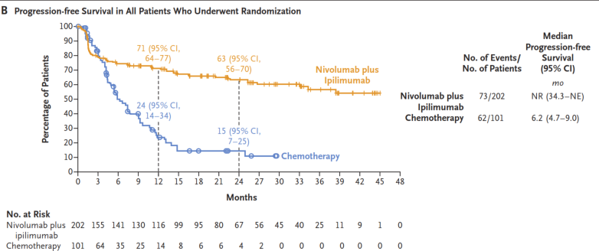 | 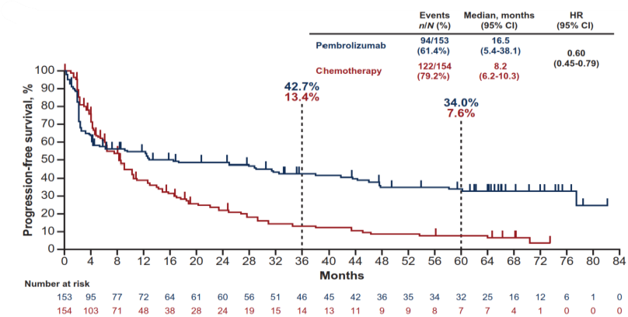
C: CM-8HW 1L+ª  NIVO+IPI vs NIVO  (DCO: 28 August 2024) | D: CM-142 Cohort 3^{b}  NIVO+IPI  (DCO: October 2019)
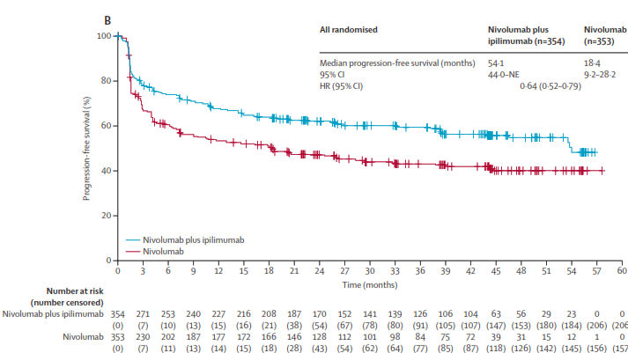 | 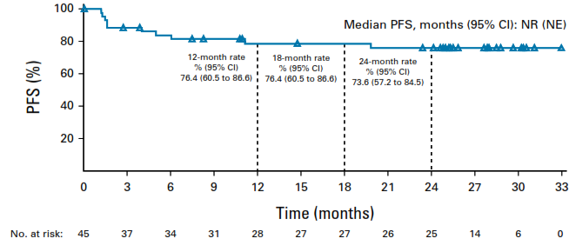
Source: Figure 7, p72; Figure 14, p82, Figure 17, p84 of the submission and Figure 2, p12 of ‘Attachment 1 - NIVO Mono Supplementary Clinical Evaluation.docx’ of the submission
CI = confidence interval, DCO=data cut-off, HR = hazard ratio, IPI=ipilimumab, NE = not evaluable, NIVO=nivolumab, NR = not reported, PFS = progression free survival
ª blinded independent central review
^{b} investigator assessed
  - Nivolumab plus ipilimumab was associated with a statistically significant improvement in PFS compared to chemotherapy (hazard ratio [HR]: 0.32, 95% confidence interval [CI]: 0.23, 0.46) based on the locally confirmed MSI-H/dMMR cohort of CM-8HW 1L. The centrally confirmed population exhibited a greater improvement in PFS (HR: 0.21, 95% CI: 0.14, 0.32).
  - The ESC noted that the PFS was still immature with median PFS not reached in the nivolumab plus ipilimumab arm of CM-8HW 1L at the DCO of 12 October 2023 (median PFS was 6.2 months in the chemotherapy arm for the locally BICR population). Median PFS in the nivolumab plus ipilimumab arm of centrally confirmed MSI-H/dMMR subgroup of arm CM-8HW 1L at DCO 28 August 2024 was 54.1 months compared to 5.9 months in the chemotherapy arm.
  - The PFS KM curve for CM-142 Cohort 3 (Panel D, Figure 2) shows that median PFS was not reached by the end of follow-up, with more than 70% of patients not progressed after 2 years with nivolumab plus ipilimumab in first line treatment. However, the evaluation considered that this estimate was likely to be uncertain given it was a single arm study with investigator assessed PFS.
  - Median PFS was reached in both arms of KN-177. The PFS HR was 0.60 (95%CI: 0.45, 0.79). A comparison of the CM-8HW 1L and KN-177 BICR PFS HR point estimates for the locally confirmed populations in Table 4 suggests that nivolumab plus ipilimumab may have a greater benefit compared to chemotherapy than pembrolizumab, as there was very little overlap in the 95% CIs.
  - The comparison of nivolumab plus ipilimumab to nivolumab monotherapy in CM-8HW 1L+ showed a statistically significant difference in PFS in favour of nivolumab plus ipilimumab (HR 0.64, 95%CI 0.52, 0.79). The ESC considered that this could suggest evidence of a benefit for combination treatment over anti-PD(L)1 monotherapies (such as pembrolizumab), however, equal effectiveness of nivolumab compared to pembrolizumab monotherapy has not been established; and the results may not be generalisable to a first line setting (35% of patients in nivolumab plus ipilimumab arm and 39% of the nivolumab monotherapy arm of CM-8HW 1L+ had at least one prior line of therapy for mCRC).
  - As observed in Figure 2 (panels A, B and C), the PFS KM curves intersected in each comparison. This indicated that the comparisons likely did not meet the proportional hazards assumption. Consequently, the presented hazard ratios in Table 4 should be interpreted with caution. The submission acknowledges this issue in the modelled economic evaluation by applying time-varying hazard ratios.
  - The ESC noted that based on subgroup analyses conducted for patients with centrally confirmed MSI-H/dMMR, PFS was less favourable for nivolumab plus ipilimumab for some subgroups (Figure 3), including for the subgroup of patients with Lynch syndrome. The ESC considered that it was possible that patients with Lynch syndrome respond more favourably to single agent immunotherapy.

Figure 3: Progression-free survival by blinded independent central review in key subgroups of patients with centrally confirmed microsatellite instability high or mismatch repair-deficient status
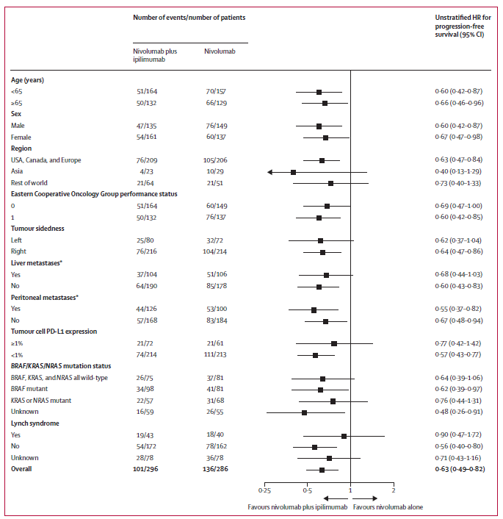
Source: Figure 3, p8: André T et al. Nivolumab plus ipilimumab versus nivolumab in microsatellite instability-high metastatic colorectal cancer (CheckMate 8HW): a randomised, open-label, phase 3 trial. Lancet. 2025 Feb 1;405(10476):383-395.

Overall survival
  - The ESC noted that no comparative OS data were presented in the submission. OS data from CM-8HW were also not reported. OS data were presented from CM-142 Cohort 3 (DCO: October 2019, median follow up 29 months) and KN-177 (DCO: 17 July 2023, median follow up 73 months). The submission did not present a formal comparison of OS and did not include the latest data from CM-142. A naïve comparison of the latest OS data available showed that 69% nivolumab plus ipilimumab patients remained alive from CM-142 Cohort 3 after a median follow up of 64 months (14/45 patients had died) compared to 53% pembrolizumab patients remaining alive from KN-177 after a median follow up of 73 months (72/153 patients had died).

Response rates
  - The submission presented the most recent response rates from CM-142 Cohort 3 (DCO: October 2019, median follow up 29 months) and KN-177 (DCOs: 17 July 2023, median follow up 73 months), plus earlier published estimates of response rates from KN-177. Published response rates were available for the centrally confirmed MSI-H/dMMR population from CM-8HW 1L+ (DCO: 28 August 2024, median follow up 47 months) but was not presented in the submission.
  - Overall response rates (ORR) and complete response (CR) rates assessed by BICR were similar for nivolumab plus ipilimumab in CM-8HW 1L+ (ORR: 63%, CR: 28%) and CM-142 Cohort 3 (ORR: 62%, CR: 24%). Response rates for the nivolumab monotherapy arm of CM-8HW 1L+ were similar to pembrolizumab monotherapy from KN-177 (ORR: 49% versus 46%), but CR was slightly higher in the nivolumab monotherapy patients (23% versus 18%).
  - A comparison of CM-8HW 1L+, CM-142 Cohort 3 and KN-177 published response rates suggested that response rates were higher for nivolumab plus ipilimumab than for pembrolizumab, however, this should be interpreted with caution given the small number of patients in CM-142 Cohort 3, the different lengths of follow up, and the difference in population characteristics.

Patient reported outcomes
  - All included studies collected health-related quality of life (HRQoL) data. As all studies were open label, this may have biased the patient reported outcomes in favour of patients receiving the interventions. Only HRQoL data from CM-8HW 1L was presented in the submission. HRQoL for CM-142 Cohort 3 (Lenz et al., 2022) and KN-177 (Andre et al., 2021) were extracted during the evaluation.
  - The HRQoL data from the CM-8HW 1L locally confirmed population indicated that treatment with nivolumab plus ipilimumab patients was associated with improved HRQoL over time, trending towards a meaningful increase from baseline (≥ 10 points, for EQ-5D-3L VAS 7 points and for EQ-5D-3L utility scores a difference of 0.08) by Week 53. In comparison, patients treated with chemotherapy experienced a decline in HRQoL from Week 7, after an initial improvement from baseline, with the lowest quality of life reported around Week 29. Patients treated with chemotherapy did not observe a meaningful difference from baseline in EORTC QLQ-C30 or EQ-5D-3L VAS, but a meaningful reduction in ED-5D-3L utility score was observed at Week 29. It should be noted that the response rate was low for HRQoL data in the chemotherapy arm, with only 32 patients (less than 50% of the 88 who received chemotherapy) included by Week 21. The results for centrally confirmed subgroup of CM-8HW 1L were similar.
  - No meaningful difference in HRQoL from baseline by the EORTC QLQ-C30 or EQ-5D-3L VAS or utility scores was observed for patients receiving nivolumab plus ipilimumab in CM-142 Cohort 3. These measures were uncertain due to the small number of patients (41/45 reported at baseline).
  - For KN-177, the EORTC QLQ-C30 global score over time had a maximum follow up of 45 weeks. In general, pembrolizumab showed an improvement from baseline and chemotherapy showed a decrease from baseline, but neither arm appeared to reach a meaningful difference of 10+ points. Time to EORTC QLQ-C30 deterioration was shown to be longer for the pembrolizumab arm than the chemotherapy arm (HR 0.61, 95%CI 0.38, 0.98). EQ-5D-3L VAS and utility scores were reported at Week 18, and were generally similar to the EORTC QLQ-C30 results, showing an increase from baseline in the pembrolizumab arm and a decrease in the chemotherapy arm, neither arm appeared to reach a meaningful difference from baseline.

Indirect comparison of nivolumab plus ipilimumab versus pembrolizumab
  - The submission proposed that both CM-8HW and CM-142 Cohort 3 could be used in indirect comparisons of PFS to pembrolizumab, however only CM-8HW 1L was used. Given the treatment regimen in CM-142 Cohort 3 differed from the proposed PBS restriction, it may be reasonable that CM-142 data was excluded from the indirect comparison.

Figure 4: Network diagram of trials included to inform an indirect comparison of NIVO + IPI and pembrolizumab
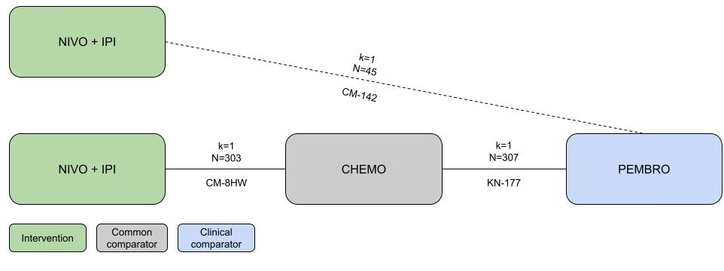
Note: Solid line represents potential adjusted comparison; dashed line represents potential unadjusted comparison
NIVO=nivolumab, IPI=ipilimumab, PEMBRO=pembrolizumab, CHEMO=chemotherapy.

  - Two approaches to indirect comparisons were presented in the submission: Bucher and an anchored and unanchored MAIC of the locally confirmed MSI-H/dMMR patients from KN-177 and CM-8HW. Both approaches utilised data from the 17 July 2023 DCO of KN-177, but different DCOs of CM-8HW 1L were used for each method. The Bucher indirect comparison was performed on CM-8HW 1L data for the DCO 12 October 2023 (median follow up 31.5 months), and the matching-adjusted indirect comparisons used CM-8HW 1L data from DCO 28 August 2024 (median follow up
47.0 months). The approach to indirect comparison differed from the base case approach presented in the NICE evaluation. There, a fractional polynomial network meta-analysis (FPNMA) was used, which used fixed effects models to compare nivolumab plus ipilimumab to pembrolizumab via the common comparator arm and considered time-varying hazard ratios. It was not possible to compare the output of the FPNMA to the indirect comparisons presented in the current submission.
  - The Bucher method demonstrated a significant PFS benefit for nivolumab plus ipilimumab compared to pembrolizumab (HR 0.53, 95% CI 0.34, 0.83). As there were some differences in baseline characteristics of CM-8HW 1L and KN-177 (see paragraph 6.21), transitivity assumptions may not be reasonable and therefore the evaluation considered that the Bucher method of comparison may not be the most appropriate method.
  - An anchored MAIC was chosen by the submission as a methodology for ITC as it allows for an adjustment in treatment effect modifiers. Furthermore, as the proportional hazards assumption was found to be violated, a time-varying approach was also used. To assess the impact of matching on the ITC results, a sensitivity analysis was conducted, using data from CM-8HW patients without re-weighting/matching. Furthermore, an additional analysis was explored using an unanchored methodology, i.e. matching the nivolumab with ipilimumab arm to the pembrolizumab arm and estimating the relative efficacy without the common comparator of chemotherapy. The PSCR noted that the unanchored MAIC was not impacted by the PFS KM curves from CM-8HW and KN-177 intersecting the chemotherapy arms, as the chemotherapy arms were not included in the analysis.
  - Logistic propensity score models were used to estimate weights that adjust individual patient data (IPD) to match the baseline characteristics of a comparator trial's aggregate population. The logistic propensity score models included variables where IPD were available from CM- 8HW 1L (anchored N= 303, i.e., nivolumab plus ipilimumab and chemotherapy arms; unanchored N=202, i.e., nivolumab plus ipilimumab only) and aggregate data was available from KN-177 (anchored N= 307, i.e., pembrolizumab and chemotherapy arms; unanchored N=153, i.e., pembrolizumab arm only).
  - The patient related factors for the anchored analysis included:
- Median age;
- ECOG performance status equal to 0 (%);
- BRAF/KRAS/NRAS mutation status, i.e., all wild-type (WT), KRAS/NRAS mutant, BRAF mutant, not evaluable (%);
- Primary tumour on the left (%);
- Liver metastasis per BICR assessment (%);
- Liver or lung metastasis per BICR assessment (%); and
- Region, i.e., Asia, Western Europe/North America, rest of the world (%).
  - The patient related factors for the unanchored analysis include the above, plus:
- Prior chemotherapy, adjuvant or neoadjuvant (%);
- synchronous/metachronous metastases, i.e., recurrent metachronous, newly diagnosed with metastatic disease, unknown (%); and
- Liver or lung metastasis per BICR assessment (%).
  - A summary of the matched and unmatched patient characteristics in the anchored and unanchored MAICs is presented in Table 5.
Table 5: Covariate matching for CM-8HW to KN-177
 | Anchored MAIC |  |  | Unanchored MAIC
Identified prognostic variable | KN-177  (N=307) | CM-8HW 1L  (N=303)  unadjusted | CM-8HW 1L  (ESS=228.7)  matched | KN-177 Pembrolizumab  (N=153) | CM-8HW 1L NIVO+IPI  (N=202)  unadjusted | CM-8HW 1L NIVO+IPI  (ESS=127.65)  matched
Age, in years [median, range] | 63 (24 – 93) | 63 (21 – 87) | 63 (21 – 87) | 63 (24 – 93) | 62 (21 – 86) | 63 (21 – 86)
ECOG performance status = 0 | 159 (52%) | 163 (54%) | 118.5 (52%) | 75 (49%) | 111 (55%) | 62.6 (49%)
BRAF/KRAS/NRAS mutation statusª
BRAF, KRAS, NRAS all wild type | 69 (22%) | 74 (24%) | 51.4 (22%) | 34 (22%) | 49 (24%) | 28.4 (22%)
KRAS or NRAS mutant | 74 (24%) | 76 (25%) | 55.1 (24%) | 33 (22%) | 50 (25%) | 27.5 (22%)
BRAF mutant | 77 (25%) | 87 (29%) | 57.4 (25%) | 34 (22%) | 60 (30%) | 28.4 (22%)
Could not be evaluated | 90 (29%) | 75 (25%) | 67.0 (29%) | 52 (34%) | 50 (25%) | 43.4 (34%)
Site of primary tumour (sidedness)
Right | 219 (71%) | 205 (68%) | 163.2 (71%) | 107 (70%) | 137 (68%) | 89.3 (70%)
Left | 88 (29%) | 98 (32%) | 65.6 (29%) | 46 (30%) | 65 (32%) | 38.4 (30%)
Liver metastasis | 125 (41%) | 117 (39%) | 93.1 (41%) | 71 (46%) | 75 (37%) | 59.2 (46%)
Liver or lung metastasis | 159 (52%) | 155 (51%) | 118.5 (52%) | 36 (24%) | 44 (22%) | 30.0 (24%)
Region^{b}
Asia | 48 (16%) | 30 (10%) | 35.8 (16%) | 22 (14%) | 19 (9%) | 18.4 (14%)
Western Europe/North America | 222 (72%) | 178 (59%) | 165.4 (72%) | 109 (71%) | 115 (57%) | 90.9 (71%)
Rest of the world | 37 (12%) | 95 (31%) | 27.6 (12%) | 22 (14%) | 68 (34%) | 18.4 (14%)
Prior chemotherapy (adjuvant or neoadjuvant) | - | - | - | 38 (25%) | 66 (33%) | 31.7 (25%)
Synchronous/metachronous metastases
Recurrent metachronous | - | - | - | 80 (52%) | 116 (58%) | 66.8 (52%)
Newly diagnosed with metastatic disease | - | - | - | 73 (48%) | 85 (42%) | 60.9 (48%)
Not reported/missing | - | - | - | 0 (0%) | 1 (0%) | 0 (0%)
Source: Tables 4 and 11 of Attachment 9 of the submission
ESS=effective sample size, NIVO=nivolumab, IPI=ipilimumab, MAIC=matching adjusted indirect comparison, ECOG=Eastern Cooperative Oncology Group; N = total participants in group
ª 3 patients in KN-177 and 9 in CM-8HW had KRAS/NRAS AND BRAF mutations.
^{b} CM-8HW classified reclassified patients from Czech Republic and Romania to “rest of the world”
  - Results for the MAICs are presented below. Parametric survival functions (exponential, generalised gamma, log-logistic, Weibull, Gamma, Gompertz, log-normal) were fitted to the weighted KM curves. Based on visual and statistical fit (measured by Akaike Information Criterion, AIC; and Bayesian Information Criterion, BIC), generalised gamma distributions were chosen (Figure 5). These functions were then used to estimate time-varying HRs for nivolumab plus ipilimumab versus pembrolizumab (Table 6). A similar approach was applied in the economic analysis using time to progression data from CM-8HW 1L.
Figure 5: MAIC inputs and results
Anchored MAIC | Unanchored MAIC
Comparison of CM-8HW KM curves before and after matching | Comparison of CM-8HW KM curves before and after matching
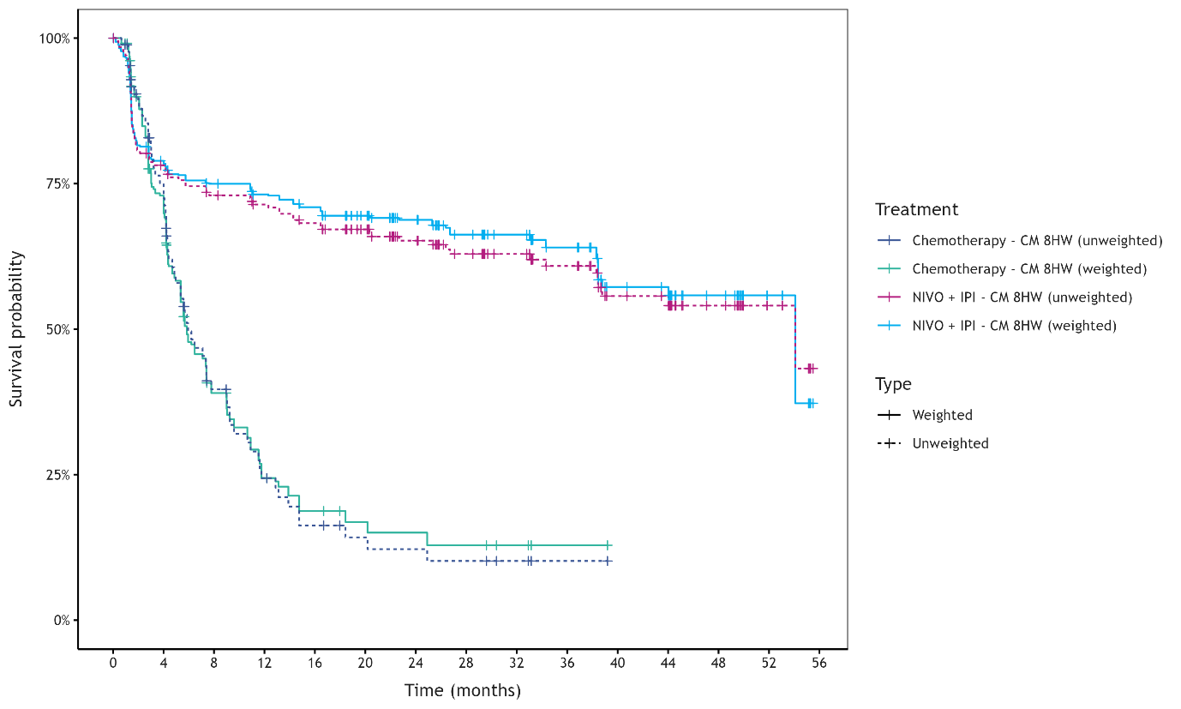 | 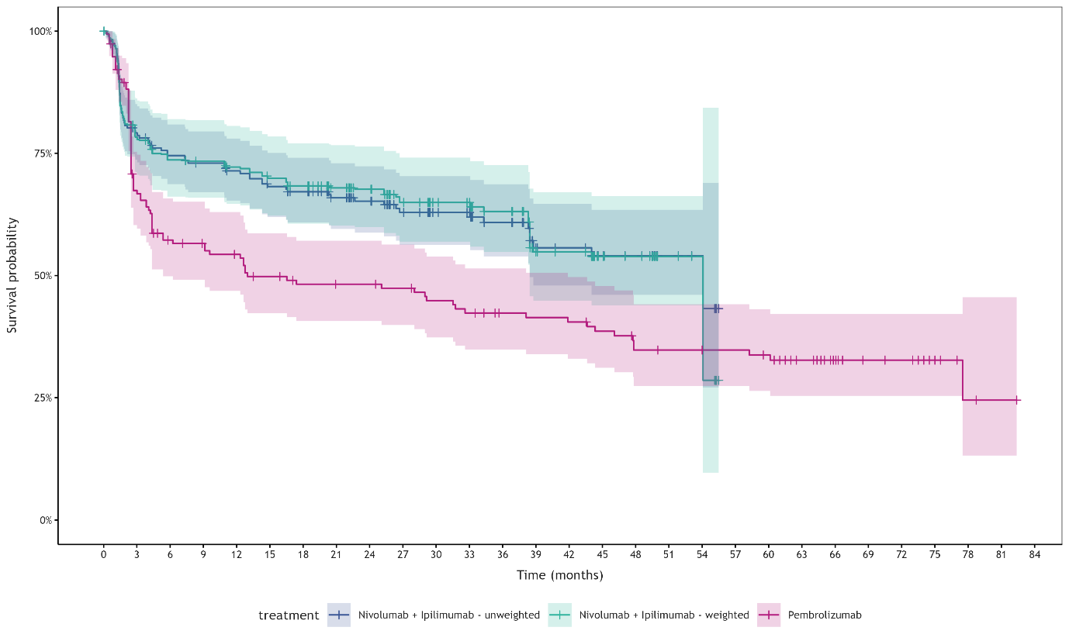
KM and chosen parametric fit (generalised gamma) | KM and chosen parametric fit (generalised gamma)
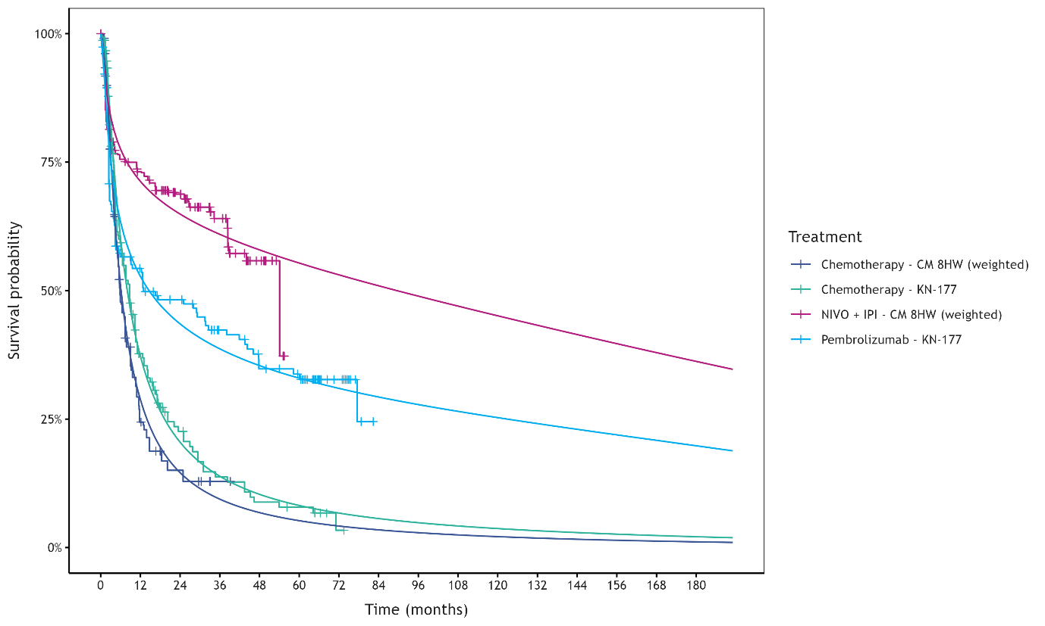 | 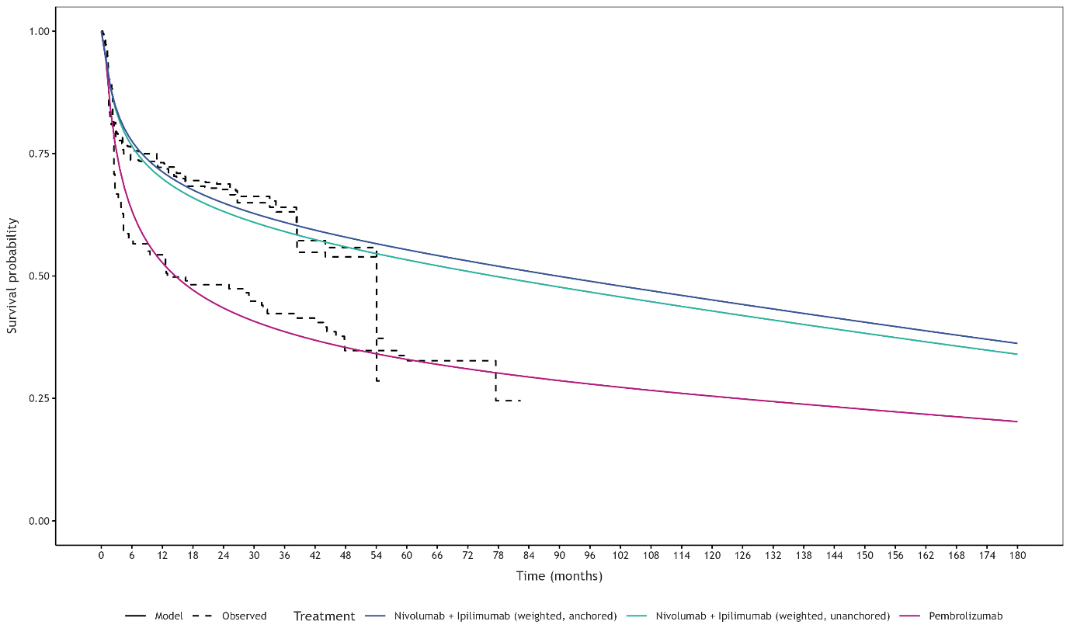
Source: Figures 3, 9, 13, 16 of Attachment 9 of the submission
KM=Kaplan-Meier, MAIC=matching adjusted indirect comparison, NIVO=nivolumab, IPI=ipilimumab
The submission referred to unadjusted curves as unweighted, matched curves as weighted.
Table 6: Time-varying hazard ratios (nivolumab plus ipilimumab versus pembrolizumab)
Time (months) | Anchored MAIC |  | Unanchored MAIC
 | HR | 95% CI | HR | 95% CI
1 | 0.39 | (0.11, 1.36) | 0.65 | (0.41, 1.04)
12 | 0.41 | (0.22, 0.74) | 0.51 | (0.34, 0.76)
24 | 0.45 | (0.22, 0.94) | 0.55 | (0.37, 0.82)
36 | 0.5 | (0.22, 1.12) | 0.6 | (0.41, 0.88)
48 | 0.55 | (0.23, 1.29) | 0.65 | (0.46, 0.93)
60 | 0.59 | (0.24, 1.44) | 0.71 | (0.51, 0.98)
72 | 0.63 | (0.25, 1.58) | 0.76 | (0.56, 1.03)
84 | 0.67 | (0.27, 1.7) | 0.81 | (0.61, 1.07)
96 | 0.71 | (0.28, 1.82) | 0.86 | (0.67, 1.12)
108 | 0.74 | (0.29, 1.88) | 0.9 | (0.71, 1.14)
120 | 0.75 | (0.3, 1.92) | 0.92 | (0.74, 1.15)
Source: Tables 8 and 14 of Attachment 9 of the submission
HR=hazard ratio, MAIC=matching adjusted indirect comparison, CI=confidence interval
HR<1 favoured nivolumab plus ipilimumab
  - In the anchored MAIC, the time-varying hazard ratio point estimates ranged from 0.39 in Month 1 to 0.75 in Month 120, but only at Month 12 and Month 24 did the 95 % CIs do not include 1, suggesting there was high uncertainty in these estimates. In comparison, the time-varying hazard ratio point estimates ranged from 0.51 in Month 12 to 0.92 in Month 120 in the unanchored MAIC, but the 95% CIs did not include 1 from Month 12 to Month 60. There was a high degree of overlap in the hazard ratios at each time point between the two approaches.
  - The submission noted that the anchored analysis was unable to properly match the chemotherapy comparator arms across studies, with the chemotherapy arm of CM-8HW displaying a poorer PFS than the KN-177 chemotherapy arm, even after matching. The submission stated that if matching does not lead to a ‘common comparator’ the anchored analysis results would be biased and lead to more optimistic results for nivolumab plus ipilimumab. For this reason, the submission preferred the unanchored MAIC and was presented as the more conservative estimate.
  - The evaluation considered that although the point estimates of the unanchored MAIC were more conservative, the narrower intervals compared to the anchored MAIC assumed a higher confidence in these estimates, which may be unreasonable given that randomisation is no longer preserved and that the effective sample size (ESS) was smaller than the anchored MAIC.
  - The results of the MAIC were unlikely to be robust due to important limitations, including:
- The submission preferred the unanchored MAIC, which required the acceptance of the strong assumption that absolute outcomes can be predicted from the covariates; that is, it assumed that all effect modifiers and prognostic factors were accounted for. This was unlikely to have been met as there were several factors that could not be included (unknown for the KN-177 population) (see paragraph 0).
- The ESC noted that the submission did not consider the median length of follow up (47.0 months in CM-8HW 1L, 73.3 months in KN-177) or Lynch syndrome as other potential covariates. The ESC noted that the earlier follow-up may benefit nivolumab plus ipilimumab as data for the long-term extrapolation was limited and appeared optimistic. The ESC also considered that a higher proportion of patients with Lynch syndrome in the trial may bias against nivolumab plus ipilimumab, given that these patients typically respond well to single agent therapy. The ESC considered that the consideration of BRAF/KRAS/NRAS mutation status would partially also account for lynch syndrome status, given that patients without the BRAF mutation are more likely to have lynch syndrome.
- By matching nivolumab plus ipilimumab IPD to pembrolizumab aggregate data, another implicit assumption was that the target population was closer to that represented in the KN-177 than in CM-8HW, which may not be true.

Comparative harms
  - The key adverse events (AEs) from all studies and immune-mediated AEs (IMAE) occurring in the CM-8HW or KN-177 are summarised in Table 7 and Table 8, respectively. In all included studies, the safety analysis cohorts included all-treated study participants who received at least one dose of the study drug.
Table 7: Summary of adverse events in the studies
AE | CM-8HW 1L |  | KN-177 |  | CM-8HW 1L+ |  | CM-142 Cohort 3
 | NIVO+IPI  N=200 | Chemo  N=88 | Pembro  N=153 | Chemo  N=143 | NIVO+IPI  N=352 | NIVO  N=351 | NIVO+IPI  N=45
Any AE | 197 (99%) | 86 (98%) | 149 (97%) | 142 (90%) | 349 (99%) | 336 (96%) | NR
Study drug related | 160 (80%) | 83 (94%) | 122 (80%) | 141 (99%) | 285 (81%) | 249 (71%) | 36 (80%)
≥Grade 3 | 96 (48%) | 59 (67%) | NR | NR | 184 (52%) | 161 (46%) | NR
≥Grade 3 drug related | 46 (23%) | 42 (48%) | 33 (22%) | 96 (67%) | 78 (22%) | 50 (14%) | NR
AE resulting in treatment discontinuation | 40 (20%) | 35 (40%) | NR | NR | 66 (19%) | 45 (13%) | 11 (24%)
Study drug related | 33 (17%) | 28 (38%) | 15 (10%) | 10 (7%) | 47 (13%) | 31 (9%) | 6 (13%)
Deaths due to study drug toxicity | 2 (1%) | 1 (1%) | 0 (0%) | 0 (0%) | 2 (<1%) | 1 (<1%) | 0 (0%)
Source: Table 55, p87; Table 58, p90, Table 60, p91, of the submission and compiled from Lenz 2021 (including appendix),
IPI=ipilimumab; n = number of participants reporting data; N = total participants in group; NIVO=nivolumab; pembro=pembrolizumab; NR=not reported
Table 8: Immune mediated adverse events in CM-8HW and KN-177
AE | Grade | CM-8HW 1L |  | KN-177 |  | CM-8HW 1L+
AE | Grade | NIVO+IPI  N=200 | Chemo  N=88 | Pembro  N=153 | Chemo  N=143 | NIVO+IPI  N=352 | NIVO  N=351
Hypothyroidism | Any | 33 (17%) | 1 (1%) | 19 (12%) | 4 (3%) | 62 (18%)ª | 33 (9%)ª
Hypothyroidism | 3-4 | 2 (1%) | 0 (0%) | 0 (0%) | 0 (0%) | 3 (1%)ª | 0 (0%)ª
Adrenal insufficiency | Any | 21 (11%) | 0 (0%) | 4 (3%) | 0 (0%) | 35 (10%) | 12 (3%)
Adrenal insufficiency | 3-4 | 7 (4%) | 0 (0%) | 2 (1%) | 0 (0%) | 10 (3%) | 3 (<1%)
Hyperthyroidism | Any | 18 (9%) | 1 (1%) | 6 (4%) | 0 (0%) | 42 (12%) | 16 (5%)
Hyperthyroidism | 3-4 | 0 (0%) | 0 (0%) | 0 (0%) | 0 (0%) | 0 (0%) | 0 (0%)
Diarrhoea/colitis | Any | 13 (7%) | 1 (1%) | 10 (7%) | 1 (<1%) | 21 (6%) | 13 (4%)
Diarrhoea/colitis | 3-4 | 9 (5%) | 0 (0%) | 5 (3%) | 0 (0%) | 12 (3%) | 8 (2%)
Hepatitis | Any | 11 (6%) | 0 (0%) | 4 (3%) | 0 (0%) | 13 (4%) | 4 (1%)
Hepatitis | 3-4 | 6 (3%) | 0 (0%) | 4 (3%) | 0 (0%) | 6 (2%) | 3 (<1%)
Rash | Any | 11 (6%) | 0 (0%) | NR | NR | 23 (7%) | 20 (6%)
Rash | 3-4 | 3 (2%) | 0 (0%) | NR | NR | 5 (1%) | 3 (<1%)
Hypophysitis | Any | 10 (5%) | 0 (0%) | NR | NR | 23 (7%) | 4 (1%)
Hypophysitis | 3-4 | 5 (3%) | 0 (0%) | NR | NR | 11 (3%) | 4 (1%)
Pneumonitis | Any | 4 (2%) | 0 (0%) | 6 (4%) | 2 (1%) | 7 (2%) | 7 (2%)
Pneumonitis | 3-4 | 3 (2%) | 0 (0%) | 0 (0%) | 0 (0%) | 4 (1%) | 4 (1%)
Thyroiditis | Any | 3 (2%) | 0 (0%) | 2 (1%) | 0 (0%) | NRª | NRª
Thyroiditis | 3-4 | 1 (<1%) | 0 (0%) | 0 (0%) | 0 (0%) | NRª | NRª
Diabetes mellitus | Any | 2 (1%) | 0 (0%) | 1 (<1%) | 0 (0%) | 4 (1%) | 2 (<1%)
Diabetes mellitus | 3-4 | 0 (0%) | 0 (0%) | 1 (<1%) | 0 (0%) | 2 (<1%) | 1 (<1%)
Nephritis and renal dysfunction | Any | 2 (1%) | 0 (0%) | 1 (<1%) | 0 (0%) | 6 (2%) | 1 (<1%)
Nephritis and renal dysfunction | 3-4 | 1 (<1%) | 0 (0%) | 0 (0%) | 0 (0%) | 2 (<1%) | 1 (<1%)
Hypersensitivity | Any | 0 (0%) | 1 (1%) | NR | NR | 0 (0%) | 3 (<1%)
Hypersensitivity | 3-4 | 0 (0%) | 1 (1%) | NR | NR | 0 (0%) | 0 (0%)
Sources Table 57, p89, Table 62, p94 and compiled from Tables 8.6.2-1, 8.6.2-2, pp90-91 CM-8HW Primary CSR
chemo=chemotherapy, IPI=ipilimumab; n = number of participants reporting data; N = total participants in group; NIVO=nivolumab; NR=not reported; pembro=pembrolizumab;
ª reported only as combined outcome hypothyroidism/thyroiditis
  - The incidence of adverse events was high across all arms of all studies, with at least 90% of patients reporting any adverse event. For CM-8HW 1L two deaths occurred in the nivolumab plus ipilimumab arm, one in the chemotherapy arm and one in the nivolumab arm due to study drug toxicity. There were no deaths due to study drug toxicity in KN-177.
  - Treatment discontinuation as a result of a study drug related adverse event was higher for nivolumab plus ipilimumab in CM-8HW 1L, 17%, compared to 10% for pembrolizumab in KN-177. The ESC noted that the chemotherapy arms of CM-8HW 1L and KN-177 had very different discontinuations due to study drug related adverse events, 38% and 7% respectively. The ESC considered that it was possible that the open label study design may have led to an increased proportion of patients crossing over to the intervention arm in CM-8HW versus KN-177, given that there was a better understanding of the clinical improvement associated with immunotherapy at the time that CM-8HW was conducted.
  - The most common Grade 3-4 immune mediated adverse events (IMAEs) for nivolumab plus ipilimumab in CM-8HW 1L were diarrhoea/colitis (5% of patients) and adrenal insufficiency (4% of patients). The most common Grade 3-4 IMAEs for pembrolizumab were diarrhoea/colitis and hepatitis (both occurring in 3% of patients).

Benefits/harms
  - The indirect comparisons presented in the submission did not allow for a quantitative comparison of the benefits and harms of nivolumab plus ipilimumab that would not replicate Table 4 and Table 6. Accordingly, a benefits/harms table has not been presented.

Clinical claim
  - The submission described nivolumab plus ipilimumab as superior in terms of effectiveness compared with pembrolizumab. The ESC considered that this claim was adequately supported for PFS, however agreed with the evaluation that the magnitude of the benefit remained uncertain due to limitations associated with the indirect comparisons presented in the submission, including:
  - transitivity issues related to differences in baseline characteristics between CM-8HW 1L and KN-177. Furthermore, there were several potentially important prognostic factors that could not be compared between the trials;
  - the PFS data from CM-8HW 1L cohort were immature (36% of patients had experienced an event at the 12 October 2023 data cut); and
  - the PFS KM curves intersected in every comparison, indicating that the proportional hazards assumptions for each comparison were likely not met (and therefore the constant hazard ratios should also be interpreted with caution).
  - The PSCR acknowledged that there was uncertainty related to the presented ITCs, however noted that the submission had sought to minimise uncertainty with an unanchored MAIC, which adjusted data to match baseline characteristics of the trials and was not impacted by the curves from CM-8HW and KN-177 intersecting, as the analysis does not include the chemotherapy arm from either trial. The PSCR also noted that the time-varying hazard ratios presented also addressed the violation of the proportion hazards assumption.
  - The ESC noted the time-varying hazard ratios from the anchored MAIC were associated with wide confidence intervals and were not significant from Year 3 and the unanchored MAIC appeared to not be statistically significant from Year 6. The point estimates of the unanchored MAIC were favoured by the submission and had narrower confidence intervals, but may also lack robustness due to the loss of randomisation and the reduction in effective sample size (ESS), which may have compromised the reliability of the results. For these reasons, the ESC considered the magnitude of PFS benefit remained uncertain.
  - The Pre-PBAC Response noted the consistency in the results reported across the Bucher and MAIC methods presented in the submission, and considered that based on these results, the clinical claim that nivolumab plus ipilimumab has superior efficacy compared with pembrolizumab had been adequately supported.
  - No comparative OS data were presented in the submission. Moreover, OS data for nivolumab plus ipilimumab from the main trial population (CM-8HW 1L) was not presented. The ESC noted that the PSCR referenced a study reporting on the association between PFS and OS in patients treated with nivolumab plus ipilimumab in CM-142 (Roodhart et al., 2024). The ESC noted that the Spearman’s rank correlation coefficient between PFS and OS was 0.92 (95% CI: 0.78, 0.98), indicating a strong correlation between PFS and OS for patients treated with nivolumab plus ipilimumab. Overall, the ESC considered that the PFS benefit observed for nivolumab with ipilimumab patients was likely to translate into a survival benefit.
  - The ESC considered that based on the available evidence, nivolumab plus ipilimumab had inferior safety compared to pembrolizumab.
  - The PBAC considered that the claim of superior comparative effectiveness, on the basis of PFS, was reasonable.
  - The PBAC considered that a claim of inferior comparative safety was reasonable.

Economic analysis
  - The submission presented a modelled cost-utility analysis of nivolumab plus ipilimumab versus pembrolizumab for first line treatment of MSI-H/dMMR mCRC based on an indirect comparison of randomised trials CM-8HW 1L and KN-177 and further informed by CM-142 patients who received nivolumab plus ipilimumab. All data from CM-8HW 1L in the base case appeared to be from the locally-confirmed MSI-H/dMMR population. The key components of the economic evaluation are presented in Table 9.
Table 9: Summary of model structure, key inputs and rationale
Component | Summary
Treatments | Nivolumab plus ipilimumab versus pembrolizumab.
Baseline characteristics | CM-8HW 1L NIVO+IPI and chemotherapy arms combined.
Time horizon | 20 years in the model base case vs. a median follow up of 47.0 months in CM-8HW and 73.3 months in KN-177. The model appeared to use data from locally confirmed MSI-H/dMMR patients of CM-8HW 1L at DCO 28 August 2024. These data were not presented in the CM-8HW primary CSR or any publications but appeared to be the same population included in the MAIC.
Outcomes | Life years gained, quality-adjusted life years.
Methods used to generate results | Semi-Markov cohort model.
Health states | Progression free, progressed disease, dead. Time on treatment was modelled separately.
Cycle length | 28 days with half cycle correction.  Half cycle correction was applied from Time 0, and therefore, 4.3% patients in the NIVO+IPI arm and 1.8% patients in the pembrolizumab arm received no treatment.
Transition probabilities | PF to PD NIVO+IPI: generalised gamma extrapolation of CM-8HW 1L TTP KM data. Pembrolizumab: NIVO+IPI arm with time-varying HR applied, estimated from generalised gamma extrapolations of pembrolizumab PFS KM data from KN-177 and NIVO+IPI TTP KM data from the unanchored MAIC weighting of CM-8HW 1L. The TTP KM data from CM-8HW 1L and corresponding generalised gamma extrapolations had not previously been presented in the submission.  PF to death, both arms: age-based general population mortality.  PD to death, both arms: Loglogistic extrapolation of CM-142 Cohort 2 and 3 progressed patients.  TTDª: NIVO+IPI: TTD KM data CM-8HW (not stated in the submission but appeared to be the 1L+ cohort), capped at 2 years. Pembrolizumab: equal to PFS capped at 2 years.  84% of incremental QALYs (and 2% of incremental costs) occurred in the extrapolated period.
Health related quality of life | PF: 0.801 EQ-5D-3L with Australian preference weights CM-8HW 1L NIVO+IPI arm  PD: 0.745 EQ-5D-3L with Australian preference weights CM-8HW 1L NIVO+IPI and chemotherapy arms  Age adjustment based on general population utility (Clemens 2014) at age in cycle divided by utility at age 55.  One-off QALY decrements due to AEs were estimated by multiplying the incidence of an AE for a specific treatment with the associated disutility. Total QALY decrements for each treatment were then applied in the first model cycle:
  Adverse event | Disutility | Duration (in months [28 days])
  Hepatitis | -0.2 | 0.25
  Diarrhoea/ colitis | -0.09 | 0.25
  Adrenal insufficiency | -0.2 | 3.8575
  Hypophysitis | -0.2 | 3.8575
  Asthenia | -0.08 | 0.25
  Hypertension | -0.069 | 0.25
  Pneumonia | -0.195 | 0.25
Costs | Costs were modelled in 2025 Australian dollars. Assuming a ||||/||||% public/private split (for all medicine costs based on pembrolizumab utilisation in mCRC (PBS items 12615Y and 12605K).  Drug costs: Nivolumab $|||| per initial dose (maximum 4 doses), $|||| per dose thereafter. Ipilimumab $|||| per dose. The cost of ipilimumab was not adjusted for the weight-based dosing (1mg/kg), so dose intensity and drug wastage were assumed to be 100%.  Pembrolizumab was costed at 50% of the published AEMP, i.e., the effective price of pembrolizumab was assumed to be $1,911.88 per 100mg vial.  The submission also included subsequent treatment, administration, health state resource use, adverse event (one-off) and terminal care costs.  Terminal care cost: $33,533.46 based on Langton et al., 2016 ($23,215 in 2009 AUD inflated to 2023/24).
Source: Table 75, p110, Table 77 pp120-121 of the submission and Excel workbook ‘Attachment 10 – Nivo+Ipi 1L Economic Evaluation.xlsm’
NIVO=nivolumab, IPI=ipilimumab, PF=progression free, LY=life-year, TTP=time to progression, PFS=progression free survival, HR=hazard ratio, OS=overall survival, KM=Kaplan-Meier, 1L= first line, 1L+= any line, PFLY=progression free life year
ª The submission stated that treatment duration was based on mean number of doses of NIVO+IPI in CM-8HW (cohort unspecified) and median time on treatment for pembrolizumab from KN-177 (Andre et al., 2020), but this was incorrect. This treatment duration is presented as a scenario analysis in the evaluation
  - The submission applied a 20-year time horizon in the model base case. The median follow-up of CM-8HW was 47.0 months and 73.3 months for KN-177. The evaluation considered that a 20-year time horizon was likely not appropriate, given that there was less than 4 years of follow up for nivolumab plus ipilimumab, the uncertainty related to the indirect comparison to pembrolizumab, and no OS data was available to inform the model. The PBAC previously considered a time horizon of 7.5 years to be more appropriate (para 6.45, pembrolizumab PSD, March 2021). When the time horizon was reduced from 20 years to 7.5 years, the incremental cost-effectiveness ratio (ICER) increased from $75,000 to < $95,000 to $155,000 to
< $255,000 per quality adjusted life year (QALY) gained. The ESC noted justifications made in the PSCR for a longer time horizon, including that when pembrolizumab was considered by the PBAC in March 2021 the data was immature with a median follow-up of 32.4 months. The PSCR noted that this was a shorter trial follow-up compared to CM-8HW (47 months). The PSCR also noted that pembrolizumab had demonstrated a median OS of 77.5 months and a 5-year OS rate of 54.8% (Andre et al., 2024). Comparatively, nivolumab plus ipilimumab was associated with an OS rate of 71% at 4 years (CM-182). However, the ESC considered that due to the uncertainty related to the indirect comparisons, a shorter time horizon remained appropriate. Based on the available evidence, the ESC considered a time horizon of 10−15 years would be appropriate. The Pre-PBAC Response maintained that a 20-year time horizon was well supported by the available evidence.
  - The baseline characteristics of the modelled population were based on the CM-8HW 1L nivolumab plus ipilimumab and chemotherapy arms combined. This was inconsistent with the data informing the transition probabilities, which was based on the CM-8HW 1L nivolumab plus ipilimumab arm only. Furthermore, there were some differences between this population and the Australian population, which tended to be older (median 69.1 years versus mean 60.9 years in CM-8HW 1L combined nivolumab plus ipilimumab and chemotherapy arms) and more likely to be male (51.6% versus 46.2% in CM-8HW 1L combined nivolumab plus ipilimumab and chemotherapy arms). Not all characteristics could be altered in the model. When age and the proportion that are men were based on South Australian data (Chong 2019), the ICER increased to $75,000 to < $95,000/QALY gained.
  - The economic model presented in the submission used a semi-Markov cohort structure with three health states: alive without progression (progression free, PF), alive following progression (progressed disease, PD), and dead. Patients entered the model in the PF health state. The model diagram is presented in Figure 6.
Figure 6: Model diagram in the submission
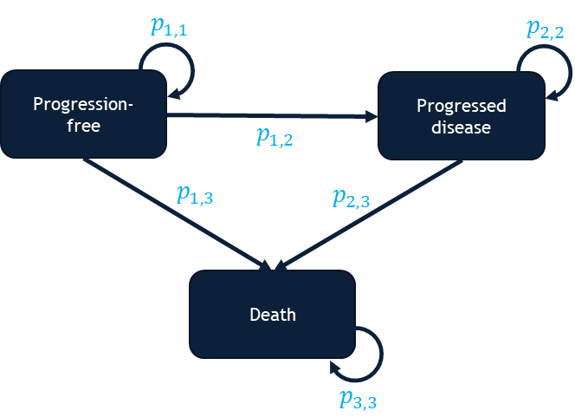
Source: Figure 21, p118 of the submission
p_{x,y}= transition probability
  - The ESC noted that the modelling approach was complex with multiple data sources, time-varying PF hazard ratios, and the model followed time in progressed disease. Therefore, the transitions between states were calculated in the background of the model via Visual Basic for Applications (VBA). While the inclusion of sojourn time typically allows for more accurate model transitions, the ESC noted that it was not possible to comprehensively error check the transitions during the evaluation. The ESC also noted that apart from the pembrolizumab PFS KM data, no data that had been used to create the model base case could be verified.
  - Transition probabilities in the model were informed by extrapolated time to progression (TTP) data and post progression mortality data for nivolumab plus ipilimumab and estimated for pembrolizumab using time varying HRs. PFS mortality was estimated using age-based general population mortality (Australian Bureau of Statistics life table 2021-2023). A summary of how transitions were modelled is presented in Table 10.
Table 10: Summary of how data is extrapolated and applied in the model base case
Arm | PF to PD | PF to death | PD to death | TTD
NIVO+IPI | Generalised gamma extrapolation of TTP from CM-8HW 1L (unweighted) from Time 0. | General population mortality. | Time from progression to death from CM-142. Cohort 2 and 3 combined (NIVO+IPI any line). | KM data from CM-8HW to maximum 2 years
Pembrolizumab | Time varying HRs applied to NIVO+IPI arm.  HRs based on comparison, i.e., generalised gamma extrapolations of TTP from CM-8HW 1L weighted for unanchored MAIC, compared to PFS from KN-177. | General population mortality. | Time from progression to death from CM-142. Cohort 2 and 3 combined (NIVO+IPI any line). | PFS to maximum 2 years
Source: compiled during the evaluation from Section 3.4.1.3 to 3.4.1.5, pp126-138 of the submission
HR=hazard ratio, TTP=time to progression (PF to PD), PF=progression free, PD=progressed diseased, TTD=time to treatment discontinuation, NIVO=nivolumab, IPI=ipilimumab, PFS=progression free survival, KM=Kaplan-Meier, MAIC=matching adjusted indirect comparison
  - TTP and post-progression mortality extrapolations were based on IPD from the nivolumab plus ipilimumab arms of CM-8HW 1L and CM-142, respectively.
  - Parametric survival curves (generalised gamma, exponential, Weibull, log-logistic, log-normal, Gompertz and gamma) were fitted to:
- TTP data (from CM-8HW 1L unweighted, and weighted to KN-177); and
- Post-progression survival (using data from CM-142 Cohorts 2 and 3, i.e., 1L+ population). Only extrapolations for the unweighted CM-8HW 1L TTP data were presented in the submission. Editable versions of the alternative extrapolations for the weighted CM-8HW 1L TTP data were not presented in the submission and therefore it was not possible to construct all possible extrapolations for CM-8HW 1L TTP data weighted to KN-177 during the evaluation.
  - The extrapolations are presented in Figure 7.
Figure 7: KM data and extrapolations presented in the economic evaluation
PF to PD, CM-8HW 1L (unweighted)ª  NIVO+IPI | PD to death, CM-142 Cohort 2 and 3^{b}  NIVO+IPI
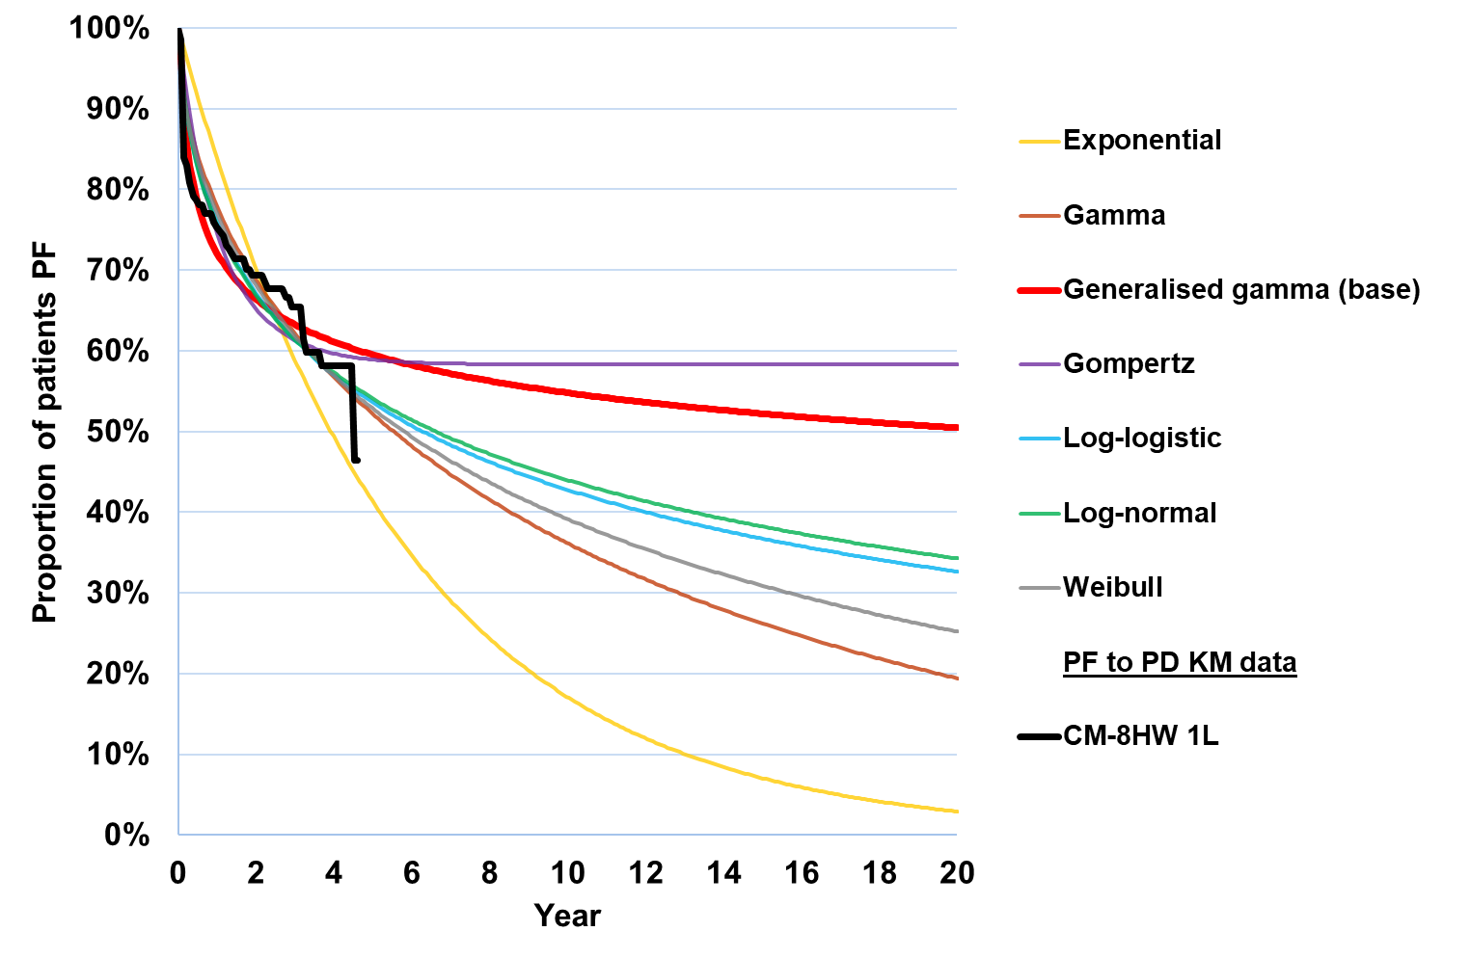 | 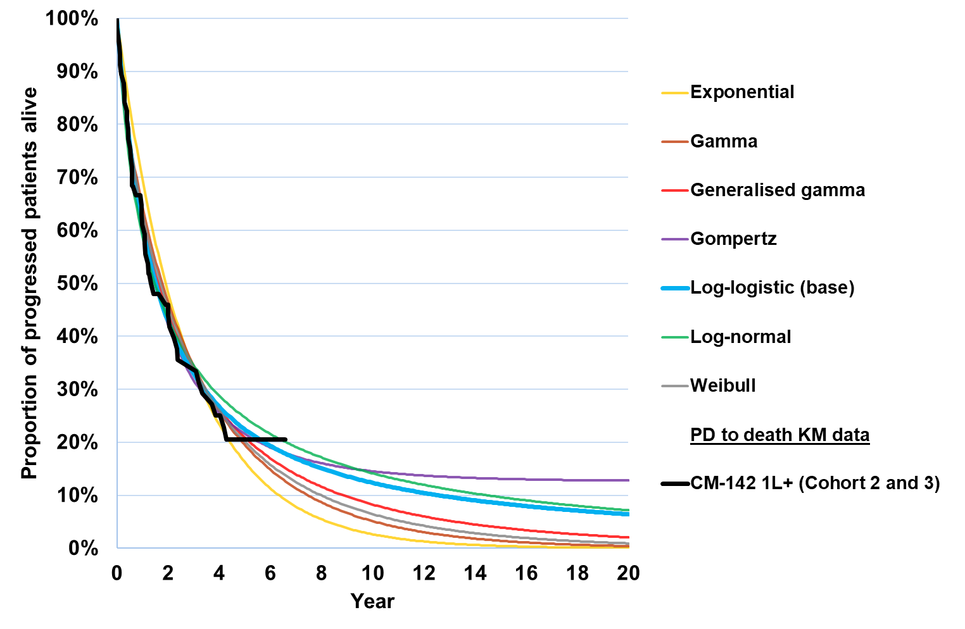
Source: compiled during the evaluation from Excel workbook ‘Attachment 10 – Nivo+Ipi 1L mCRC Economic Evaluation.xlsm’
NIVO+IPI=nivolumab plus ipilimumab, PF=progression free, PD=progressed disease
ª PF to PD based on CM-8HW 1L NIVO+IPI population n=202 (DCO: 28 August 2024).
^{b} Cohort 2 and 3 patients (NIVO+IPI 1L+) who experience progression were combined, n=57
  - For the nivolumab plus ipilimumab arm, the submission selected generalised gamma for the transition of PF to PD and log-logistic for the transition of PD to death. The extrapolation of PF to PD (weighted or unweighted) tended to overestimate the tail of the KM data, favouring the nivolumab plus ipilimumab arm. Both extrapolations chosen for these transitions in the base case (shown in Figure 7) appeared to give optimistic long-term extrapolation of the KM data, based on visual inspection. The model predicted median PFS in the nivolumab plus ipilimumab arm to be over
10 years. In contrast, median PFS for nivolumab plus ipilimumab was reached at Year 4.5 in CM-8HW 1L KM data (DCO: 28 August 2024). The ICER was not sensitive to the choice of extrapolation for PF to PD or PD to death in the nivolumab plus ipilimumab arm, as neither were significant drivers of the clinical benefit. However, it was not possible to explore all the uncertainty of the underlying clinical data, which may have some effect on the ICER.
  - Separately, the model presented generalised gamma extrapolations of nivolumab plus ipilimumab time to progression (i.e., PF to PD) from CM-8HW 1L weighted to the PFS of the pembrolizumab arm of KN-177 using the unanchored MAIC previously described (see Table 5). The extrapolations were used to estimate hazard ratios between the two model arms that varied per cycle from 0.59 in Cycle 2 to 0.45 at Year 5 and remained constant toward the end of the time horizon. These hazard ratios were applied to the nivolumab plus ipilimumab unweighted extrapolated TTP for nivolumab plus ipilimumab to estimate the PF to PD transitions in the pembrolizumab arm. None of the alternate extrapolations for estimating these time-varying HRs were presented in the submission and therefore could not be explored during the evaluation. The time-varying HRs appeared to be overestimated as they favour nivolumab plus ipilimumab more than the HRs reported in the comparative effectiveness indirection comparison (Table 6), which the evaluation considered could not be entirely attributed to the removal of mortality from the CM-8HW 1L TTP data. When using the constant mean HR (0.63 [95% CI= 0.44, 0.90]) the ICER increased from $75,000 to < $95,000 to $95,000 to < $115,000 per QALY gained. The ICER varied substantially based on the 95% CI of the HR ($55,000 to < $75,000−$355,000 to < $455,000).
  - The PSCR provided an updated economic model which included alternative extrapolations to be selected to estimate the time varying HRs. In the new model changing the distribution choice for the time-varying HR necessitated changing the distribution choice for the PF to PD as well. The KM data which informed the extrapolations (KN-177 PFS KM data and CM-8HW 1L TTP KM data adjusted for unanchored MAIC in the base case), were not presented in the PSCR. The AIC/BIC statistics for the nivolumab plus ipilimumab TTP KM data were also not reported in the PSCR.
  - A visual comparison of the extrapolations used to inform the PF to PD time-varying hazard ratios against KN-177 PFS KM data (extracted during the evaluation) and CM-8HW 1L TTP KM data (unadjusted) is provided in Figure 8. Sensitivity analyses for select extrapolations are provided in Table 15.
Figure 8: Extrapolations of CM-8HW 1L and KN-177 to estimate PF to PD time varying HRs
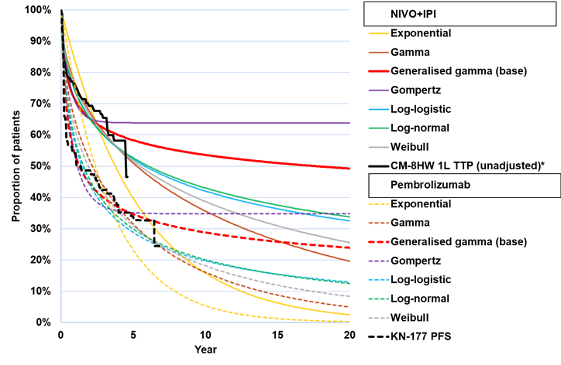
Source: compiled from Excel workbook ‘Pre-ESC – Nivo plus Ipi 1L mCRC Economic Evaluation.xlsm’
NIVO=nivolumab, IPI=ipilimumab, PD=progressed disease, PF=progression free, PFS=progression free survival, TTP=time to progression (no mortality), HR=hazard ratio
* NIVO+IPI extrapolations were based on CM-8HW 1L TTP KM data weighted for the unanchored MAIC, but this data was not provided in the model. However, unadjusted CM-8HW 1L TTP KM data is likely similar and is presented for reference.
  - Due to a lack of OS data, mortality in the PFS state was modelled using age-based general population mortality. The evaluation considered that applying general population mortality to the PF health state may have overestimated survival for mCRC patients, as it would be expected that a patient with mCRC would have a higher mortality rate compared to the general population, even in the PF state. PD mortality was based on the duration in PD and extrapolated from data on 57 patients treated with nivolumab plus ipilimumab at any line from CM-142.
  - The evaluation considered that time on treatment was modelled inconsistently. Time to treatment discontinuation (TTD) was used for the nivolumab plus ipilimumab arm (not stated in the submission but appeared to be the 1L+ cohort), capped at 2 years. For pembrolizumab, PFS was used (also capped at 2 years). This led to similar treatment durations despite significant PFS differences, favouring nivolumab plus ipilimumab. The evaluation also considered that time on treatment was likely overestimated for the pembrolizumab arm, as patients often discontinue therapy for reasons unrelated to disease progression, such as adverse events. If the mean doses from the trials are applied to the model (nivolumab: 3.7 doses of 240 mg in initiation and 13.6 doses of 480 mg in maintenance, ipilimumab: 3.7 doses and pembrolizumab 19.2 doses of pembrolizumab), the ICER increases from $75,000 to < $95,000 to $75,000 to < $95,000 per QALY gained. The PSCR noted that TTD data was not available for pembrolizumab from KN-177 and therefore could not be applied to the model. The PSCR provided an updated economic model with two additional scenarios to estimate time on treatment for the pembrolizumab arm based on: 1) nivolumab plus ipilimumab TTD and 2) nivolumab monotherapy (CM-8HW all lines of therapy) TTD. However, these examples did not address the issue that time on treatment was likely overestimated in the pembrolizumab arm. When time on pembrolizumab was set equal to time on nivolumab plus ipilimumab, it increased time on pembrolizumab compared to the base case and resulted in patients receiving pembrolizumab in progressed disease. Setting time on pembrolizumab to nivolumab monotherapy did not substantially change the time spent on treatment.
  - PFS benefit was the key driver of the ICER and served as a surrogate for OS. The model predicted that for every progression free life-year gained in the nivolumab plus ipilimumab versus pembrolizumab, patients gained 0.77 life-years (LYs). While PFS improvements may translate to OS benefit, the size of this benefit remains unproven, particularly in combination immune checkpoint inhibitors compared to monotherapy.
  - The submission applied health state utilities to PF (0.801) and PD (0.745), which did not differ by treatment received. These were sourced from linear mixed models for repeated measures of CM-8HW 1L EQ-5D-3L data (DCO: 12 October 2023) pre- and post-progression, mapped to Australian preference weights using Viney et al., 2011. The PF utility estimate was based on a linear mixed model that compared the nivolumab plus ipilimumab and chemotherapy arms, and the PD utility estimate was based on a linear mixed model that combined the nivolumab plus ipilimumab and chemotherapy arms.
  - Given the additional toxicity of ipilimumab in combination with nivolumab there may be an additional utility decrement compared to pembrolizumab. While one-off AE disutilities were included in the model, it was unclear whether these adequately captured the additional toxicity of ipilimumab. Utility data from the nivolumab monotherapy arm of CM-8HW 1L may be informative to quantify the additional toxicity of ipilimumab when added to immune checkpoint inhibitor monotherapy.
  - Utility values were also adjusted for age, using general population utilities reported in Clemens et al., 2014 (5,555 Queensland participants surveyed in 2011) to estimate a multiplying factor according to patient age, centred on age 55 years. The age adjustment had little impact on the ICER.
  - The submission included a terminal care cost of $33,533 based on Langton et al., 2016 ($23,215 2009 AUD inflated to 2023/24). The terminal care cost included diagnostic procedures, specialist visits, and pathology costs accrued in the last 6 months of life, some of which were likely already captured in the health state costs. The ICER was moderately sensitive to the terminal care cost. The ESC agreed with the evaluation that this may not be appropriate given the submission did not present comparative OS data for nivolumab plus ipilimumab.
  - One-off costs and disutilities for adverse events were included in the first model cycle based on the relevant incidence of Grade 3-4 adverse events occurring in ≥2% of patients from CM-8HW 1L+ and KN-177, disutilities from previous NICE technology assessments (mCRC and other disease areas), and event costs were based on AR-DRG codes, weighted for public and private use. Adverse events were not a key driver of the ICER.
  - Modelled PFS and OS was compared to the PFS and OS KM data from multiple sources for validation during the evaluation (Figure 9). These data were extracted using Liu et al. 2020.
Figure 9: Submission base case compared to studies
PFS  NIVO+IPI arm | PFS  Pembrolizumab arm
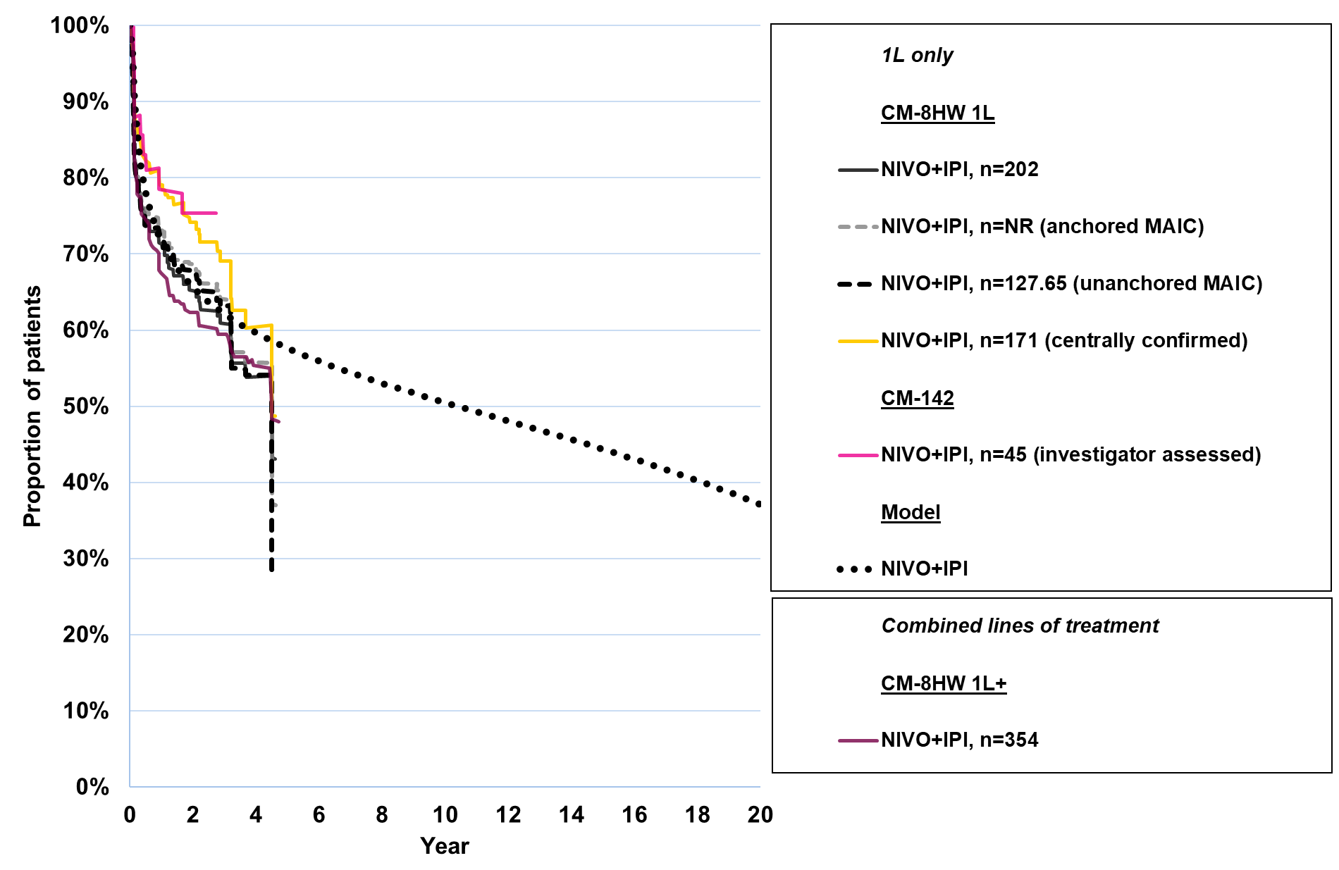 | 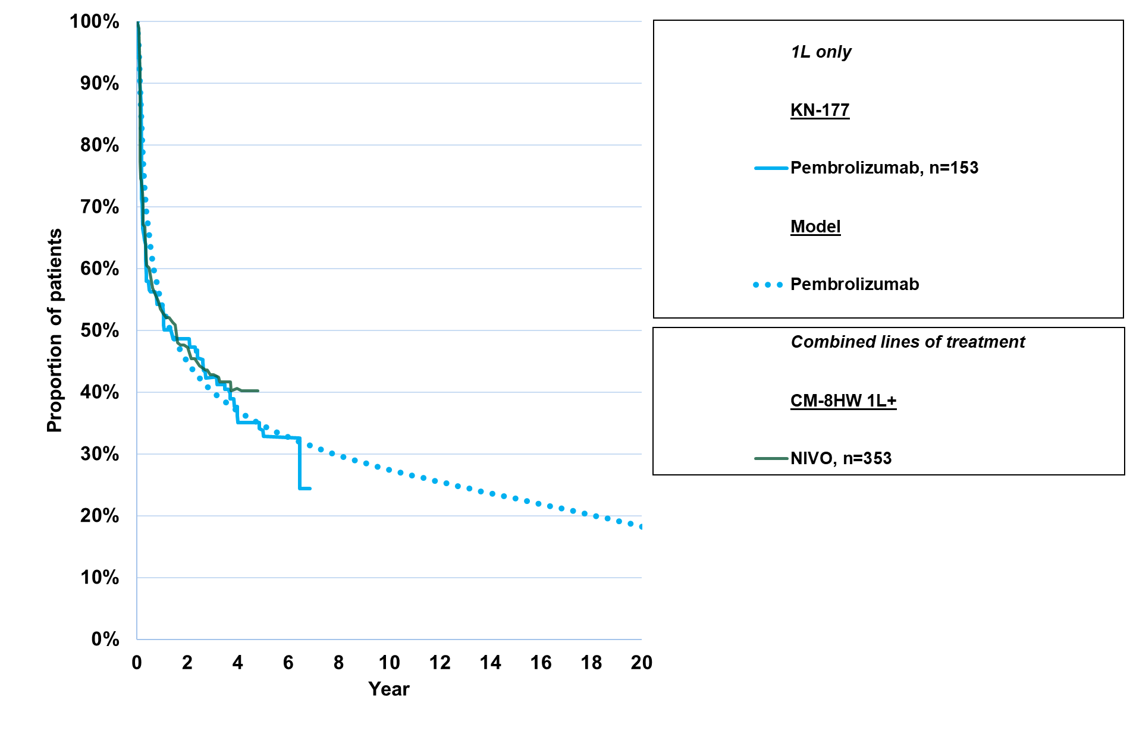
OS
Both arms
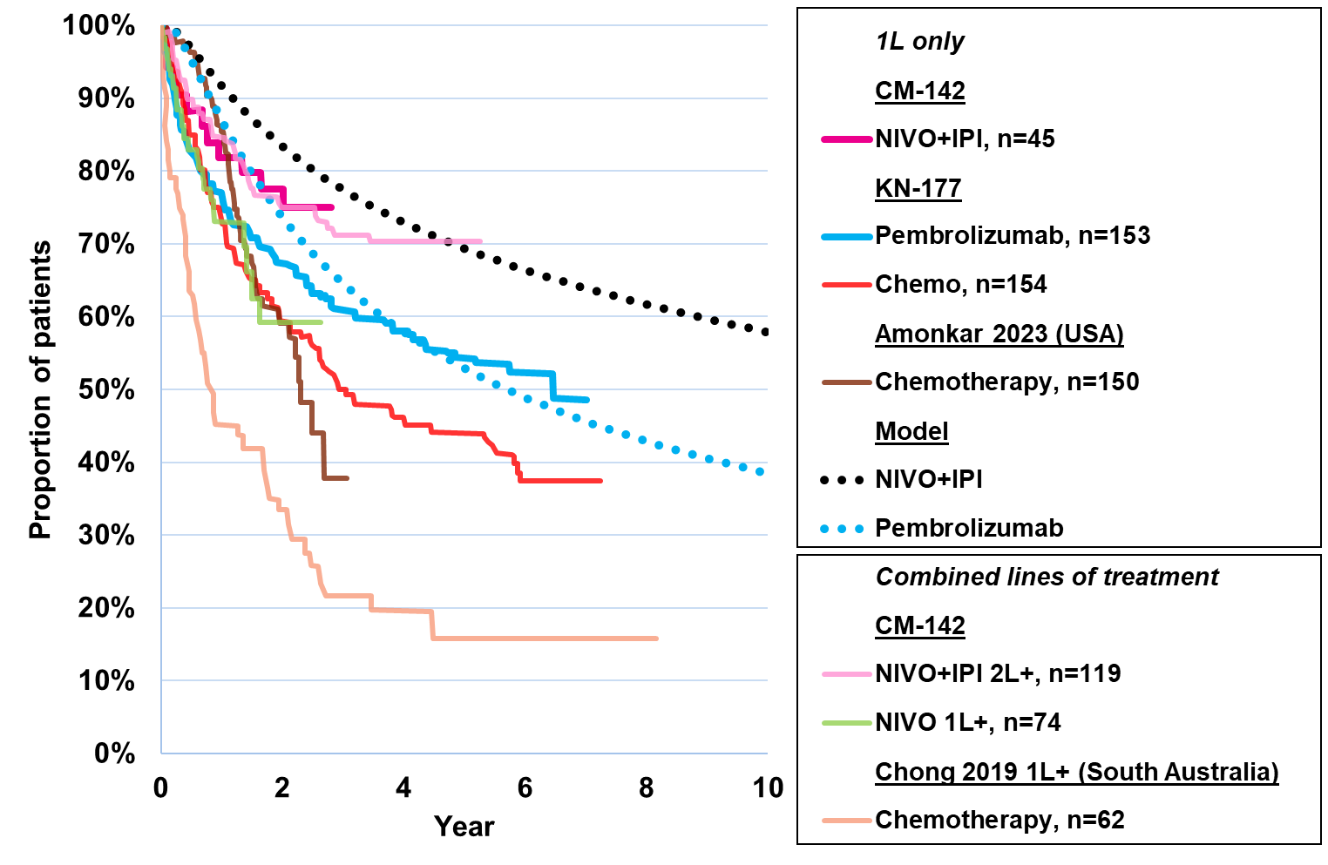
Source: Compiled during the evaluation Excel workbook ‘Attachment 10 – Nivo+Ipi 1L mCRC Economic Evaluation.xlsm’ and KM data extracted from: CM-8HW 1L from Attachment 9 of the submission (i.e. data cut-off August 2024); CM-8HW 1L+ from the CM-8HW Primary CSR; CM-142 1L from Figure 14 and Figure, p82 of the submission; CM-142 2L+ from André et al 2022; CM-142 nivolumab monotherapy 1L+ from Overman et al 2017; KN-177 from Figure 17 and 18 (p84 and 86) of the submission; Chemotherapy without immune checkpoint inhibitors from: Amonkar et al 2023 and Chong et al 2019
  - The ESC noted that the modelled PFS generally fitted the pembrolizumab PFS KM data from KN-177 well and fitted the weighted and unweighted nivolumab plus ipilimumab 1L PFS KM data from CM-8HW 1L well until around Year 3. The ESC noted that the modelled OS did not fit the pembrolizumab KM data from KN-177 nor the nivolumab plus ipilimumab KM data from CM-142 (1L or 2L+), tending to overestimate both until about Year 5. The ESC agreed with the evaluation that the extrapolation beyond this was uncertain.
  - Modelled health state allocation is presented in Figure 10.
Figure 10: Health state allocation in the base case
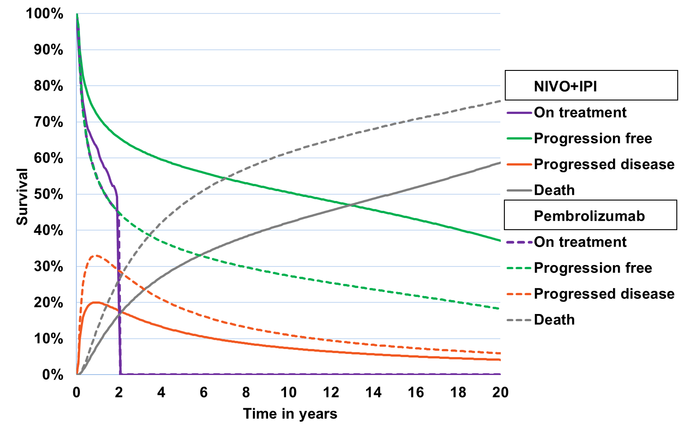
Source: compiled during the evaluation using Sheet ‘Patient distribution’ of Excel workbook ‘Attachment 10 – Nivo+Ipi 1L mCRC Economic Evaluation.xlsm’
NIVO+IPI=nivolumab plus ipilimumab
  - The evaluation considered that at 20 years, the modelled results appeared optimistic, with 41% of patients alive (37% progression free) in the nivolumab plus ipilimumab arm and 24% of patients alive (18% progression free) in the pembrolizumab arm. The PFS and OS benefit for nivolumab plus ipilimumab over pembrolizumab continued across the time horizon, with slight convergence occurring from Year 15 onwards.
  - A summary of the key drivers of the model is presented in Table 11.
Table 11: Key drivers of the model
Description | Method/Value | Impact:  Base case: $||||¹/QALY gained
Time horizon | 20 years in the model base case vs. a median follow up of 47.0 months in CM-8HW and 73.3 months in KN-177.  The PBAC has previously considered a time horizon of 7.5 years to be more appropriate (para 6.45, pembrolizumab PSD, March 2021). | High, favoured NIVO+IPI.  When the time horizon was reduced to 7.5 years, the ICER increased to $||||²/QALY gained.
PF to PD HR | The pembrolizumab transitions from PF to PD were modelled by applying time varying HRs to the NIVO+IPI arm that varied per cycle from 0.59 in Cycle 2 to 0.45 at Year 5 and remained constant toward the end of the time horizon. HRs were based on the unanchored MAIC from the indirect comparison. | High, favoured NIVO+IPI. If HR=1 from the end of the trial period (Month 47), the ICER increased to $||||³/QALY gained.
PF mortality | General population mortality in both arms. This may overestimate survival for mCRC patients, even if they are progression free. | High, favoured NIVO+IPI.  If PF mortality was instead modelled using the CM-142 Cohort 2 and 3 data, the mortality increased in both arms and the ICER increased to $||||³/QALY gained.
Time on treatment | NIVO+IPI: TTD KM data CM-8HW (not stated in the submission but appeared to be the 1L+ cohort), capped at 2 years.  Pembrolizumab: equal to PFS capped at 2 years.  Time on treatment was likely overestimated for the pembrolizumab arm. | High, favoured NIVO+IPI.  If both arms assumed the maximum number of doses over 2 yearsª, the ICER increased to $||||⁴ per QALY gained.
Baseline characteristics | The population in the model was based on the CM-8HWL 1L trial population. There were some differences between this population and the Australian population and in particular, age affected background mortality each cycle. Not all characteristics could be altered in the model. | High, favoured NIVO+IPI.  When age and proportion male were based on South Australian data, the ICER increased to $||||³/QALY gained.
Utility source | PF: 0.801, based on CM-8HW 1L NIVO+IPI arm  PD: 0.745, based on CM-8HW 1L NIVO+IPI and chemotherapy arms | Moderate, favoured pembrolizumab.  If utilities were sourced from KN-177 (PF 0.852, PD 0.730), the ICER decreased to $||||¹/QALY gained.
Terminal care cost | One-off terminal care costs $33,533.46 applied for the proportion of patients who died every cycle. This may double count some of the resource use cost. | Moderate, favoured NIVO+IPI.  If terminal care costs were removed from the model, the ICER increased to $||||¹ per QALY gained.
Source: compiled during the evaluation
HR=hazard ratio, ICER=incremental cost-effectiveness ratio; IPI=ipilimumab, KM=Kaplan-Meier, mCRC=metastatic colorectal cancer; NIVO=nivolumab, PD=progressed disease, PF=progression free, QALY=quality adjusted life year; TTD=time to treatment discontinuation,
a The model rounded down to nearest model cycle resulting in maximum doses: NIVO 26.4 doses, IPI 4 doses, pembrolizumab 34.8 doses. Maximum dosing based on treatment schedules would be: NIVO 27 doses (4x 240 mg initial, 23x480 mg maintenance), IPI 4 doses, pembrolizumab 35 doses
The redacted values correspond to the following ranges:
¹ $55,000 to < $75,000
² $155,000 to < $255,000
³ $75,000 to < $95,000
⁴ $95,000 to < $115,000

  - A summary of the economic evaluation is presented in Table 12. No formal stepped evaluation was provided in the submission, but in Step 1 the time horizon was set to 47.01 months to match median follow up from CM-8HW 1L. The base case ICER for nivolumab plus ipilimumab versus pembrolizumab was $75,000 to < $95,000 per QALY gained.
Table 12: Results of the economic evaluation
Step and component | NIVO+IPI | Pembrolizumab | Increment
Step 1: time horizon 47.01 months (all costs, utilities and 5% discounting costs and benefits)
Costs | $|||| | $|||| | $||||
PFLY | 2.50 | 1.83 | 0.67
LY | 3.10 | 2.79 | 0.30
QALY | 2.44 | 2.18 | 0.26
Incremental cost/extra LY gained |  |  | $||||¹
Incremental cost/extra QALY gained |  |  | $||||¹
Step 2: time horizon extended to 20 years
Costs | $|||| | $|||| | $||||
LY | 8.33 | 6.34 | 1.99
QALY | 6.43 | 4.85 | 1.58
Incremental cost/extra LY gained |  |  | $||||²
Incremental cost/extra QALY gained (base case) |  |  | $||||³
Source: Table 111, p 161 of the submission and compiled during the evaluation.
LY=life year, NIVO+IPI=nivolumab plus ipilimumab, PFLY=progression free life year, QALY=quality adjusted life year
The redacted values correspond to the following ranges:
¹ $355,000 to < $455,000
² $55,000 to < $75,000
³ $75,000 to < $95,000

  - These results were based on the published price of the comparator with an assumed 50% discount.
  - The majority of costs in both arms were accrued in the first 47.01 months, due to the cost of first line treatment. The majority of the benefits were accrued in the extrapolated period (1.58 discounted incremental QALYs compared to 0.26 discounted incremental QALYs at the 47.01 months).
  - Undiscounted disaggregated costs and effects are presented in Table 13 and Table 14.
Table 13: Health care resource items: disaggregated summary of cost impacts (undiscounted)
Resource item | NIVO+IPI | Pembrolizumab | Incremental cost | % of total incremental cost
First line costs
Nivolumab | $|||| | $0 | $|||| | ||||%
Ipilimumab | $|||| | $0 | $|||| | ||||%
Pembrolizumab | $0 | $81,472 | -$81,472 | -65.3%
IV drug administration 1L | $2,142 | $2,519 | -$377 | -0.3%
Adverse events | $690 | $442 | $248 | 0.2%
Total | $|||| | $84,433 | $|||| | ||||%
Subsequent treatment costs
Drug acquisition | $2,515 | $3,876 | -$1,361 | -1.1%
IV drug administration 2L+ | $128 | $197 | -$69 | -0.1%
Total | $2,643 | $4,073 | -$1,430 | -1.1%
Other costs
Health state resource use | $51,379 | $41,988 | $9,391 | 7.5%
Terminal care | $14,862 | $22,751 | -$7,889 | -6.3%
Overall total | $|||| | $153,246 | $|||| | 100%
Source: compiled during the evaluation
IV=intravenous, NIVO+IPI=nivolumab plus ipilimumab,
Table 14: Disaggregated summary of health outcomes included in the economic evaluation (undiscounted)
Outcome | Outcome for proposed medicine | Outcome for comparator | Incremental outcome | % of total incremental outcome
LYs
PF | 10.43 | 6.16 | 4.28 | 129.3%
PD | 1.79 | 2.76 | -0.97 | -29.3%
Total | 12.22 | 8.92 | 3.31 | 100%
QALYs
PF | 8.10 | 4.79 | 3.30 | 127.3%
PD | 1.30 | 2.01 | -0.71 | -27.2%
AEs | -0.004 | -0.001 | -0.003 | -0.1%
Total | 9.39 | 6.80 | 2.60 | 100%
Source: Table 108, p161 and compiled during the evaluation
NIVO+IPI=nivolumab plus ipilimumab, LY=life year, PD=progressed disease, PF=progression free, QALY=quality adjusted life year
  - Incremental LYs and QALYs (undiscounted 3.30 LYs, 2.60 QALYs) were driven by the increase in LYs in the progression free health state (4.28 undiscounted LYs, 3.30 undiscounted QALYs, 129.3% and 127.3% of the incremental LYs and QALYs respectively).
  - The results of key sensitivity analyses are summarised in Table 15. The ICER was most sensitive to time horizon, PFS and OS benefit, time on treatment, and baseline population characteristics when they affected survival. The PSCR provided an updated economic model which included alternative extrapolations to be selected to estimate the time varying HRs. Sensitivity analyses for selected extrapolations are provided below.
  - The ESC did not suggest a revised base case, as it considered that it would not resolve the high level of uncertainty related to the indirect comparisons and structure of the model.
Table 15: Sensitivity analyses
Analyses | Incremental cost | Incremental QALY | ICER | % change
Base case | $|||| | 1.58 | $||||¹ | -
Discount rate (base case 5% costs and outcomes)
- 0% costs and outcomes | $|||| | 2.60 | $||||² | -||||%
- 3.5% costs and outcomes | $|||| | 1.81 | $||||³ | -||||%
Time horizon (base case 20 years)
- 7.5 years | $|||| | 0.62 | $||||⁴ | ||||%
- 10 years | $|||| | 0.87 | $||||⁵ | ||||%
- 15 years | $|||| | 1.28 | $||||⁶ | ||||%
PF to PD HR approach (base case time varying HR based on comparison of CM-8HW 1L TTP and KN-177 PFS data weighted via unanchored MAIC)
Comparing CM-8HW 1L TTP and KN-177 PFS
- Time-varying, adjusted anchored MAIC | $|||| | 2.23 | $||||³ | -||||%
- Time-varying, unweighted anchored MAIC | $|||| | 2.20 | $||||³ | -||||%
- Time-varying, unanchored MAIC, converge from Month 47 (HR=1) (end of trial) | $|||| | 1.41 | $||||¹ | ||||%
Comparing CM-8HW 1L PFS and KN-177 PFS
- Time-varying, unanchored MAIC | $|||| | 0.88 | $||||⁷ | ||||%
- Constantª, unanchored MAIC mean HR=0.63 | $|||| | 1.05 | $||||⁸ | ||||%
- Constant, unanchored MAIC lower 95%CI=0.44 | $|||| | 1.91 | $||||³ | -||||%
- Constant, unanchored MAIC upper 95%CI=0.90 | $|||| | 0.23 | $||||⁹ | ||||%
Time-varying HR extrapolation and PF to PD extrapolations in both arms (base case: generalised gamma)
- Gamma | $|||| | 1.11 | $||||⁶ | ||||%
- Log-logistic | $|||| | 1.38 | $||||¹ | ||||%
- Log-normal | $|||| | 1.40 | $||||¹ | ||||%
- Weibull | $|||| | 1.19 | $||||¹ | ||||%
PF to death informed by CM-142 (base case general population mortality) | $|||| | 1.41 | $||||¹ | ||||%
Utility source (base case PF=0.801 CM-8HW 1L NIVO+IPI, PD=0.745 CM-8HW 1L NIVO+IPI and chemotherapy with age adjustment)
- PF=0.772 and PD=0.745 CM-8HW 1L NIVO+IPI and chemotherapy | $|||| | 1.50 | $||||¹ | ||||%
- PF=0.852 and PD=0.730 KN-177 | $|||| | 1.72 | $||||³ | -||||%
Treatment costs (base case NIVO+IPI=CM-8HW TTD, pembrolizumab=PFS max 2 years of 200 mg every 3 weeks with 50% rebate)
- NIVO+IPI=CM-8HW mean doses (17.3 NIVO, 3.7 IPI), pembrolizumab KN-177 median time on treatment 11.1 months (16.1 doses)^{c} | $|||| | 1.58 | $||||¹ | ||||%
- NIVO+IPI=CM-8HW mean doses (17.3 NIVO, 3.7 IPI), pembrolizumab PSD March 2021 (19.2 doses) ^{c} | $|||| | 1.58 | $||||¹ | ||||%
- Per protocol (NIVO 20.3 doses, IPI 3.7 doses, pembrolizumab 20.5 doses) ^{c,d} | $|||| | 1.58 | $||||¹ | ||||%
- Maximum 2 years (NIVO 26.4 doses, IPI 4 doses, pembrolizumab 34.8 doses)^{c} | $|||| | 1.58 | $||||⁸ | ||||%
No terminal care cost (base case $33,533 per death) | $|||| | 1.58 | $||||¹ | ||||%
Population characteristics (base case CM-8HW 1L NIVO+IPI and chemotherapy arms combined)
Chong 2019 (South Australia MSI-H population) | $|||| | 1.33 | $||||¹ | ||||%
Centrally confirmed MSI-H/dMMR subgroup (base case locally confirmed)^{e} | $|||| | 1.15 | $||||¹ | ||||%
Italics indicate additional sensitivity analyses conducted during the evaluation.
Source: Table 113 of the submission and compiled during the evaluation from ‘Excel workbook ‘Attachment 10 – Nivo+Ipi 1L mCRC Economic Evaluation.xlsm’
HR=hazard ratio, ICER=incremental cost-effectiveness ratio, IPI=ipilimumab, LY=life year, MAIC=matching adjusted indirect comparison, NIVO=nivolumab, PD=progressed disease, PF=progression free, PFS=progression free survival, QALY=quality adjusted life year, TTP=time to progression (PF to PD), TTD=time to treatment discontinuation
ª only the mean value for the constant HR from the unanchored MAIC was presented as a scenario analysis in submission and appeared to be based on the PFS HR of nivolumab plus ipilimumab versus pembrolizumab presented in the submission, rather than a constant HR based on TTP of nivolumab plus ipilimumab versus PFS of pembrolizumab used to estimate the time-varying HRs in the model base case.
^{b} The model Sheet ‘Direct costs’ recommended setting resource use to treatment specific (rather than treatment agnostic) for this analysis, but this appeared to set resource use costs to $0 in PF. Resource use may be lower for pembrolizumab 6-weekly regimen compared to 3-weekly and therefore ICER may be slightly overestimated, but this was unlikely to be a significant increase.
^{c} The model appeared to round down the time on pembrolizumab to the nearest model cycle, as such when mean values were used, the costs were slightly underestimated. As these did not have a significant effect on the ICER they have not been corrected during the submission.
^{d} It was unclear what the submission meant by per protocol, as number of doses did not appear to be the maximum allowed
^{e} This subgroup analysis included multiple model changes, including baseline patient characteristics, extrapolation of TTP from CM-8HW 1L, extrapolation of post-progression survival from CM-152 Cohort 2. PF to PD time-varying HRs, PF to death transitions, TTD for NIVO+IPI, utilities were unchanged from the base case.
The redacted values correspond to the following ranges:
¹ $75,000 to < $95,000
² $45,000 to < $55,000
³ $55,000 to < $75,000
⁴ $155,000 to < $255,000
⁵ $135,000 to < $155,000
⁶ $75,000 to < $95,000
⁷ $115,000 to < $135,000
⁸ $95,000 to < $115,000
⁹ $355,000 to < $455,000
  - The ESC considered the uncertainty of the clinical inputs, that were based on the unanchored MAIC, were compounded by the lack of transparency of the modelled results due to the model structure, meaning the modelled results were unreliable for decision making. The ESC considered that if a more transparent version of the semi-Markov model could not be provided in a resubmission, then a simpler model structure with more transparent results would be more informative. With the aim to improve the transparency of the model, the Pre-PBAC Response provided a revised workbook, with the transition probability matrices and patient distributions included for both arms of the model; however, the PBAC noted this was not evaluated.

Nivolumab plus ipilimumab cost/patient/course
Table 16: Drug cost per patient for proposed and comparator drugs
 | Nivolumab plus ipilimumab |  |  | Pembrolizumab
 | CM-8HW 1L+ | CM-8HW 1L | Model | KN-177  dose and duration | Model
Mean cumulative dose | NIVO: 7,586 mg  IPI: 3.67 mg/kg | NIVO: 6,569 mg  IPI: 3.63 mg/kg | NIVO: 7,504 mgª  IPI: 5.04 mg/kg^{b} | NR (dose regimen 200 mg Q3W) | 4,095mg^{c}
Mean duration (no. doses) | NIVO: 17.7  IPI: 3.7 | NIVO: 15.5  IPI: 3.6 | NIVO: 17.4  IPI: 3.6 | 19.2 | 20.5
Mean duration (mths) | NIVO: 15.2  IPI: 2.0 | NIVO: 13.3  IPI: 2.0 | NIVO: 14.5  IPI: 1.8 | 13.3 | 13.4
Cost/patient/course | - | - | $||||^{d} | - | $81,472e
Source: compiled during the evaluation from ‘Excel workbook ‘Attachment 10 – Nivo+Ipi 1L mCRC Economic Evaluation.xlsm’, CM-8HW primary and interim CSR and Tables 13 and 14 of pembrolizumab PSD March 2021 PBAC Meeting
NIVO=nivolumab, IPI=ipilimumab, Q3W=every 3 weeks, no.=number
ª Calculated as 3.56 doses of 240 mg followed by 13.85 doses of 480 mg nivolumab
^{b} Calculated as 3.56 doses of 100mg ipilimumab divided by average weight of patient 70.5kg
^{c} Calculated as 20.5 doses of 200 mg pembrolizumab
^{d} Initial doses: NIVO $| | + IPI $| |, maintenance doses: NIVO $| |
^{e} assumed 50% reduction in AEMP for pembrolizumab
  - Cost of a course of nivolumab plus ipilimumab was estimated to be $||| ||| in the submission compared to $81,472 for pembrolizumab. Financial estimates for each treatment could not be calculated as costs were based on a market share approach.
  - Modelled dose and duration of nivolumab was similar to CM-8HW 1L+, with the slight underestimate resulting from capping nivolumab use at 2 years. Ipilimumab cumulative dose was overestimated as it was cost as a fixed 100 mg dose (i.e., assumed full vial wastage) rather than weight-based dosing at 1mg/kg.
  - Number of doses of pembrolizumab was slightly overestimated compared to KN-177.

Estimated PBS usage & financial implications
  - This submission was not considered by DUSC. The submission stated that a market share approach was used to estimate the financial implications to the health budget for the proposed listing of nivolumab plus ipilimumab. The effective price of pembrolizumab was assumed to be 50% of the published AEMP. Table 17 summarises the inputs used for the financial estimates.
Table 17: Key inputs for financial estimates
Data | Value, Source, Comment
Current market, market growth, forecast market (without nivolumab plus ipilimumab) and market share | The submission estimated an annual growth rate by fitting a linear trend to monthly script data for pembrolizumab (PBS item numbers: 12605K and 12615Y) from Medicare Australia claims from Jan 2023 to Dec 2024 (2 years inclusive). The estimated growth rate was then applied to script data for pembrolizumab (Medicare Australia claims) accumulated in calendar year 2024 to establish the size of the market over the first six years of the proposed listing (2025 to 2030).  To predict the annual growth rate, the submission stated that the above two-year timeframe was selected as it allowed the market to stabilise after the PBS listing of pembrolizumab in August 2021.  The submission assumed pembrolizumab has 100% market share.  Forecast market without nivolumab plus ipilimumab
   | 2024 (Yr0) | 2025 (Yr1) | 2026 (Yr2) | 2027 (Yr3) | 2028 (Yr4) | 2029 (Yr5) | 2030 (Yr6)
  Scripts | 4368 | 4759 | 5162 | 5565 | 5968 | 6370 | 6773
  % change (linear prediction) | -- | 8.95% | 8.47% | 7.81% | 7.24% | 6.75% | 6.32%
Treatment duration | Initiation  Nivolumab + ipilimumab = 3.75 doses (CM-8HW)  Continuation  Nivolumab = 14.99 doses (CM-8HW)  Pembrolizumab = 16.09 doses (Andre et al, 2020)  The treatment doses assumed for nivolumab + ipilimumab could not be verified during the evaluation. The PSCR provided updated financial estimates with the mean duration of treatment amended to align with the economic model (3.7 doses for initiation; 13.6 doses for continuing therapy).
Substitution | The submission assumed ||||% of pembrolizumab scripts will be substituted for nivolumab plus ipilimumab scripts. This was based on predicted market share responses from eight Australian oncologists who comprised an Advisory. The ESC considered that ||||−||||% may be more reasonable.
Script equivalence | To estimate the number of nivolumab plus ipilimumab scripts, the submission first estimated the reduction in pembrolizumab scripts using the calculated substitution rate (||||%) then estimated the corresponding number of nivolumab and ipilimumab scripts based on script equivalence between nivolumab plus ipilimumab and pembrolizumab during a one-year timeframe.
  Treatment phase | Pembrolizumab | Nivolumab | Ipilimumab | Script equivalence
  Initiating | Every 3 weeks | Every 3 weeks | Every 3 weeks | 1 : 1
  Continuing | Every 3 weeks | Every 2 weeks | -- | 1 : 1.5
  Continuing | Every 6 weeks | Every 4 weeks | -- | 1 : 1.5
Final substitution rates | Nivolumab 240 mg Q3W + ipilimumab 1mg/kg Q3W: 20.01%  Nivolumab 480 mg Q4W: 79.99%  Calculation based on the proportion of the initiating and continuing CM-8HW regimen respectively  Split use:  nivolumab Q2W 10% : nivolumab Q4W 90%  pembrolizumab Q3W 10% : pembrolizumab Q6W 90%  To ensure consistency with existing PBS listings for nivolumab and pembrolizumab and in line with previous PBAC decisions.  Final substitution rates:  Initiating: nivolumab + ipilimumab Q3W substitutes for pembrolizumab Q3W  Continuing: Split of use applied such that nivolumab Q2W substitutes for pembrolizumab Q3W and nivolumab Q4W substitutes for pembrolizumab Q6W.
   | pembrolizumab Q3W | pembrolizumab Q6W
  nivolumab + ipilimumab Q3W | 20.01% | NA
  nivolumab Q2W | 8.00% | NA
  nivolumab Q4W | NA | 71.99%
Nivolumab plus ipilimumab | To estimate the net cost to the PBS/RPBS, the submission used the following weighted (public/private) costs:  Nivolumab 240 mg: $||||  Nivolumab 480 mg: $||||  Ipilimumab 100 mg: $||||
Pembrolizumab | Weighted (public/private) cost of $3,979.48 for 200 mg. This was based on the published price with an assumed 50% rebate.
Patient copayment | Copayment PBS: $16.02; RPBS: $7.59, calculated using copayment values in the Excel workbook template and pembrolizumab scripts dispensed in 2024 for unresectable or metastatic deficient mismatch repair colorectal cancer on the PBS (98.33%) and RPBS (1.67%) by patient category. The evaluation considered this was reasonable.
MBS costs | The submission indicated that nivolumab and ipilimumab requires one MBS-funded administration per infusion and costed these services using MBS item 13950 for parenteral administration, at 80% benefit ($98.44). It appears that the combination of nivolumab plus ipilimumab (for the first 4 cycles) can be administered under this MBS item number and only incur one cost to deliver both drugs. The MBS administration cost was applied at a rate of 1.5 times the rate used to cost pembrolizumab for the maintenance period, where treatment with 240 mg nivolumab Q2W replaced 200 mg pembrolizumab Q3W; and 480 mg nivolumab Q4W replaced 400 mg pembrolizumab Q6W.
Source: Tables 114-117 pp168-170 of the submission and text from throughout Section 4.
BICR = blinded independent central review; MBS=Medical Benefits Schedule; R/PBS = Repatriation / Pharmaceutical Benefits Schedule; Q2W = every two weeks; Q3W = every three weeks; Q4W = every four weeks; Q6W = every six weeks.
  - To estimate the size of the current market over the first six years of the proposed listing, the submission first estimated an annual growth rate by fitting a linear trend to monthly script data for pembrolizumab (PBS item numbers: 12605K and 12615Y) from Medicare Australia claims from Jan 2023 to Dec 2024 (2 years inclusive). The estimated growth rate was then applied to script data for pembrolizumab (Medicare Australia claims) accumulated in calendar year 2024 to establish the size of the market over the first six years of the proposed listing (2025 to 2030). To predict the annual growth rate, the submission stated that the above two-year timeframe was selected as it allowed the market to stabilise after the PBS listing of pembrolizumab in
August 2021.
  - The submission assumed a 1:1 script equivalence in the initiating phase. It was assumed that the nivolumab 240 mg Q2W dose would be used in place of the pembrolizumab 200 mg Q3W dose and that the nivolumab 480 mg Q4W dose would be used in place of the pembrolizumab 400 mg Q6W. It was assumed in the continuing phase that 1.5 nivolumab scripts would be required to account for the longer duration of the pembrolizumab scripts across both of the nivolumab Q2W and Q4W regimens.
  - The submission assumed ||| |||% of pembrolizumab scripts would be substituted for nivolumab plus ipilimumab scripts. This was based on predicted market share responses from eight Australian oncologists who comprised an Advisory board assembled by the Sponsor. The oncologists were asked ‘what proportion of patients would be treated with nivolumab plus ipilimumab instead of pembrolizumab?’ The substitution rate was calculated by taking the mean of their responses (||| |||%). Oncologists were aware of the headline hazard ratio (0.62) from the CM-8HW trial (NIVO+IPI vs NIVO in the CM-8HW IL+ population, centrally confirmed and BICR) when considering their responses. Overall, it was assumed the market share for nivolumab plus ipilimumab would remain constant over the first six years of proposed listing. The evaluation considered that while the substitution rate appeared high, the real substitution rate is unknown particularly as OS data from CM-8HW is yet to be reported. The submission conducted a sensitivity analysis by reducing the substitution rate to ||| |||% which reduced the overall net impact to the health budget over the first six years of listing by $100 million to < $200 million (-||| |||%). While the reported HR was not for the first-line population nor a comparison with pembrolizumab, the HR was similar to those estimated for nivolumab plus ipilimumab vs pembrolizumab via indirect comparison. The Advisory board did not appear to be informed of the time-varying HRs which converge over time. The ESC considered a lower substitution rate than that considered in the base case was appropriate, noting the increased toxicity associated with nivolumab plus ipilimumab, however considered a substitution rate of ||| |||% was likely too low. The ESC considered that ||| |||% may be more appropriate.
  - To estimate the number of nivolumab plus ipilimumab scripts, the submission first estimated the reduction in pembrolizumab scripts using the calculated substitution rate (||| |||%) then estimated the corresponding number of nivolumab and ipilimumab scripts based on script equivalence between nivolumab plus ipilimumab and pembrolizumab during a one-year timeframe. The following steps were then undertaken to ‘convert’ pembrolizumab scripts to nivolumab plus ipilimumab scripts:
- The split of 240 mg and 480 mg nivolumab scripts were estimated at 20.01% and 79.99% respectively, by dividing 3.75 mean doses of nivolumab 240 mg by the total mean doses of both nivolumab strengths for initial and continuing treatment phases (3.75 doses of 240 mg plus 14.99 doses of 480 mg). The evaluation considered that it was unclear why the submission used 3.75 and 14.99 doses for this calculation as the interim and primary trial analyses cited different mean doses, hence the evaluation could not verify the reference for these numbers. The PSCR provided updated financial estimates with the mean duration of treatment amended to align with the economic model (3.7 doses for initiation; 13.6 doses for continuing therapy).
- For the 79.99% of continuing scripts attributed nivolumab 480 mg from the above calculation, the submission further split this into 240 mg and 480 mg continuing doses (i.e.: Q2W vs Q4W dosing) at a rate of 10% and 90%, respectively, to provide a proxy for the number of pembrolizumab scripts at 3-weekly vs 6-weekly dosing intervals, resulting in the substitution rates outlined in the table above.
- The cost offsets for pembrolizumab appeared to have only costed 200 mg scripts, excluding the 400 mg scripts. As such, the cost of pembrolizumab was likely underestimated in the financial estimates.
  - The estimated script numbers and costs for the PBS listing of nivolumab plus ipilimumab for the treatment of first-line mCRC are provided in Table 18.
  - The PSCR provided an updated model with the mean duration of treatment amended to align with the economic model (3.7 doses for initiation; 13.6 doses for continuing therapy). The change in mean time on treatment altered the proportional split of nivolumab and ipilimumab scripts each year (nivolumab 240 mg initial = 21.39%; nivolumab 240 mg continuing = 7.86%; nivolumab 480 mg continuing = 70.75%; ipilimumab 100 mg initial = 21.39%).
Table 18: Estimated use and financial implications
 | Year 1 | Year 2 | Year 3 | Year 4 | Year 5 | Year 6
Estimation of the use and financial impact of nivolumab plus ipilimumab
Nivolumab plus ipilimumab, scripts
Nivolumab, initial | ||||¹ | ||||¹ | ||||¹ | ||||¹ | ||||¹ | ||||¹
Ipilimumab, initial | ||||¹ | ||||¹ | ||||¹ | ||||¹ | ||||¹ | ||||¹
Nivolumab, continuing  (240 mg Q2W) | ||||¹ | ||||¹ | ||||¹ | ||||¹ | ||||¹ | ||||¹
Nivolumab, continuing  (480 mg Q2W) | ||||¹ | ||||¹ | ||||² | ||||² | ||||² | ||||²
NIVO-IPI, net cost to PBS/RPBS | $||||³ | $||||⁴ | $||||⁴ | $||||⁵ | $||||⁵ | $||||⁶
Estimation of changes in use and financial impact of affected medicines
Scripts
Pembrolizumab | -||||¹ | -||||¹ | -||||¹ | -||||² | -||||² | -||||²
Net cost to PBS/RPBS
Pembrolizumab, net cost to PBS/RPBS | -$||||⁷ | -$||||⁷ | -$||||⁷ | -$||||⁸ | -$||||⁸ | -$||||⁸
Estimated financial implications for the PBS/RPBS and the health budget
Net change in scripts | ||||¹ | ||||¹ | ||||¹ | ||||¹ | ||||¹ | ||||¹
Net cost to MBS | $||||⁹ | $||||⁹ | $||||⁹ | $||||⁹ | $||||⁹ | $||||⁹
Net cost to PBS/RPBS (at the effective price) | $||||¹⁰ | $||||¹¹ | $||||¹¹ | $||||³ | $||||³ | $||||³
Net cost to health budget | $||||¹¹ | $||||¹¹ | $||||¹¹ | $||||³ | $||||³ | $||||⁴
Estimated financial implications for the PBS/RPBS and the health budget (PSCR)
Net change in scripts | ||||¹|||| | ||||¹ | ||||¹|||| | ||||¹|||| | ||||¹|||| | ||||¹||||
Net cost to MBS | $||||⁹ | $||||⁹ | $||||⁹ | $||||⁹ | $||||⁹ | $||||⁹
Net cost to PBS/RPBS | $||||¹⁰ | $||||¹¹ | $||||¹¹ | $||||³ | $||||³ | $||||³
Net cost to health budget | $||||¹¹ | $||||¹¹ | $||||¹¹ | $||||³ | $||||³ | $||||⁴
Source: Tables 124, 126, 127, 128, 129, pp174-177 of the submission. PSCR, ‘Pre-ESC - Nivo plus Ipi 1L mCRC Utilisation and Cost Model.xlsm’
The redacted values correspond to the following ranges:
¹ 500 to < 5,000
² 5,000 to < 10,000
³ $60 million to < $70 million
⁴ $70 million to < $80 million
⁵ $80 million to < $90 million
⁶ $90 million to < $100 million
⁷ $10 million to < $20 million
⁸ $20 million to < $30 million
⁹ $0 to < $10 million
¹⁰ $40 million to < $50 million
¹¹ $50 million to < $60 million
  - The total cost to the PBS/RPBS of listing nivolumab plus ipilimumab was estimated to be $60 million to < $70 million in Year 6, and a total of $300 million to
< $400 million in the first 6 years of listing, based on assumed effective DPMAs.
  - The evaluation noted the different regimens made it difficult to convert pembrolizumab scripts to nivolumab and ipilimumab scripts. Specifically:
- PBS item numbers for pembrolizumab do not differentiate between initial and continuing scripts nor between 3- or 6-weekly dosing regimens, and
- Pembrolizumab is dosed in consistent cycle lengths across a two-year time frame, whereas nivolumab and ipilimumab is dosed using ‘initiating’ and ‘continuing’ doses (also across a two-year time frame) but which there is a difference in cycle lengths between ‘initiating’ and ‘continuing’ phases.
Given this, an epidemiological approach may have been more appropriate for estimating the health budget impacts. The Pre-PBAC Response argued that a market-share approach was aligned with the PBAC guidelines (Version 5.0, p103), however acknowledged that a mixed model may be required to account for the complexity and assumptions included as part of the financial impact model presented in the submission.
  - Overall, the evaluation considered that the estimated net costs to the PBS/RPBS were unreliable for the following reasons:
- The submission stated that a market share approach was used but this was confused with a ‘patient-based’ approach when pembrolizumab script numbers were substituted based on percentages derived from mean doses of initial and continuing treatment phases for nivolumab plus ipilimumab.
- Scripts were estimated in one-year intervals, hence the 2-year treatment duration of either pembrolizumab or nivolumab plus ipilimumab was not accounted for.
- Initial nivolumab plus ipilimumab scripts were underestimated for year 1 (proportion based on 2 years of treatment applied to one year) and the same proportion of initiating scripts were assumed each year, even though in the subsequent years, there would likely be a higher proportion of maintenance scripts (patients in second year of therapy as well as those commencing treatment). It was unclear whether this would over or underestimate the budget impact.
- The treatment duration was longer for nivolumab and ipilimumab vs pembrolizumab given the longer PFS observed for nivolumab and ipilimumab, however this was not accounted for in the financial estimates, resulting in underestimated costs for nivolumab plus ipilimumab.

Quality Use of Medicines
  - The sponsor intends to engage in a range of activities supporting the quality use of nivolumab plus ipilimumab in the treatment of first-line mCRC. These include physician, nursing and pharmacy education in the appropriate use of the medicine. Safety concerns for nivolumab plus ipilimumab are outlined in a risk management plan and there is a commitment to an ongoing pharmacovigilance program.

Financial Management – Risk Sharing Arrangements
  - The submission did not propose a Risk Sharing Arrangement (RSA). The PBAC previously recommended an RSA with expenditure caps would be appropriate for pembrolizumab (paragraph 7.10, pembrolizumab PSD, March 2021 PBAC meeting).
For more detail on PBAC’s view, see section 7 PBAC outcome.
- PBAC Outcome
  - The PBAC did not recommend nivolumab plus ipilimumab for the first line treatment of microsatellite instability high (MSI-H) or mismatch repair deficient (dMMR) unresectable or metastatic colorectal cancer (mCRC). The PBAC considered that the clinical evidence, which was based on indirect treatment comparisons, was supportive of superior effectiveness, based on progression free survival (PFS), however the magnitude of benefit was uncertain. The PBAC considered that the cost-effectiveness model did not provide a good basis for decision making, particularly due to the uncertain extrapolation of clinical benefits and underlying structural limitations. The PBAC also considered that the financial estimates were uncertain and likely overestimated and would likely require revision with an epidemiological or mixed model approach.
  - The PBAC considered the primary reason for this outcome was due to the economic evaluation.
  - The Committee acknowledged the input from health professionals, individuals, and consumer and medical organisations, including Rare Cancers Australia, Bowel Cancer Australia, and the Medical Oncology Group Australia (MOGA). The PBAC noted the input emphasising the high risk of disease progression for this population and the need for additional therapies. The input noted the positive results of the CM-8HW trial showing a PFS benefit compared with chemotherapy. The input also noted the serious side effects of current therapies, particularly chemotherapy. In addition, the PBAC noted the MOGA’s support for the submission.
  - The PBAC noted that single agent immunotherapy is currently available on the PBS for this patient group, and based on the KEYNOTE 177 trial, is associated with statistically significant improvements in PFS versus chemotherapy. However, the PBAC noted that the overall response rate to treatment is relatively low (ORR = 46%) and accepted there remained a clinical need for additional effective treatment options to improve treatment response rates and overall survival for this patient group.
  - With regards to the requested restriction, the PBAC advised that it would be reasonable to include a clinical criterion stating that patients must have dMMR colorectal cancer (CRC), as determined by a validated test, with a Prescribing Instruction stating that a validated test may include immunohistochemical (IHC) staining, a polymerase chain reaction (PCR) test or next-generation sequencing (NGS), which may be for MSI-H or dMMR. The PBAC noted that MMR status is typically confirmed by IHC staining, which is funded through the MBS. The PBAC noted that while there is currently no MBS funded test to determine MSI-H, MSI-H and MMR testing are highly concordant, and given that an uninterpretable MMR IHC is rare, separate MSI-H testing is not often conducted in clinical practice. The PBAC noted that there have also been developments in NGS for both MSI-H and dMMR.
  - The PBAC advised that the restriction should include a continuation criterion specifying that patients must not have progressive disease while receiving PBS-subsidised treatment with nivolumab with ipilimumab for this condition. The PBAC noted the reasoning provided in the Pre-PBAC Response for the proposed continuing restriction allowing treatment beyond disease progression if a patient had prescriber-assessed clinical benefit and was tolerating treatment. However, the PBAC considered that the long-term risk-benefit and cost-effectiveness of treatment under these circumstances was uncertain and for this reason advised that a discontinuation rule upon progression remained appropriate.
  - The PBAC considered the nominated comparator, pembrolizumab, was reasonable.
  - The PBAC noted that the submission was based on two clinical trials in MSI-H/dMMR mCRC: CheckMate 8HW (CM-8HW), a Phase III, randomised, open-label clinical trial comparing the efficacy and safety of nivolumab plus ipilimumab, nivolumab monotherapy and chemotherapy; and KEYNOTE 177 (KN-177), a Phase III, randomised, open-label clinical trial comparing the efficacy and safety of pembrolizumab and chemotherapy. The PBAC considered that there was a potential risk of bias in these trials due to their open-label design. The PBAC noted that the chemotherapy arms of CM-8HW 1L and KN-177 had very different discontinuations due to study drug related adverse events, 38% and 7% respectively. The PBAC agreed with the ESC that it was possible that the open-label design may have led to an increased proportion of patients crossing over to the intervention arm in CM-8HW versus KN-177, given that there was a better understanding of the clinical improvement associated with immunotherapy at the time that CM-8HW was conducted.
  - The PBAC noted nivolumab plus ipilimumab demonstrated a greater improvement in PFS relative to chemotherapy (hazard ratio [HR]: 0.32, 95% confidence interval [CI]: 0.23, 0.46, locally confirmed MSI-H/dMMR cohort of CM-8HW 1L), compared to the improvement observed with pembrolizumab (HR: 0.60, 95% CI: 0.45, 0.79). However, the PBAC noted that the PFS from CM-8HW was still immature with median PFS not reached in the nivolumab plus ipilimumab arm of CM-8HW 1L at the data cut off (DCO) of 12 October 2023.
  - The PBAC noted that a Bucher and matching-adjusted indirect treatment comparisons (ITCs) were presented in the submission to compare nivolumab plus ipilimumab with pembrolizumab, using chemotherapy as the common comparator. The PBAC noted the limitations associated with these comparisons (paragraphs 6.55, 6.61, 6.63) and the submission’s preference for the unanchored matching adjusted indirect comparison (MAIC) due to issues related to poor matching of the chemotherapy arms across the studies in the anchored analysis (paragraph 6.53). The PBAC noted that the time-varying hazard ratio point estimates from the unanchored MAIC suggested a favourable PFS benefit for nivolumab plus ipilimumab compared with pembrolizumab ranging from 0.51 in Month 12 to 0.92 in Month 120. However, the PBAC noted that for this analysis, the 95% CIs crossed 1 prior to Month 12 and after Month 60, indicating an uncertain treatment effect over time. The PBAC also noted the loss of randomisation and reduced effective sample size (ESS) for this analysis. Overall, the PBAC considered that based on the clinical evidence presented in the submission, the claim of superior comparative effectiveness for nivolumab plus ipilimumab over pembrolizumab was supported for PFS. Though due to the limitations of the ITCs, the magnitude of benefit was uncertain. The PBAC considered that while no comparative overall survival (OS) data were presented in the submission, the PFS benefit observed for nivolumab with ipilimumab patients was likely to translate into a survival benefit.
  - The PBAC considered that based on the evidence presented in the submission, a claim of inferior safety for nivolumab plus ipilimumab versus pembrolizumab was reasonable. The PBAC noted the most common Grade 3−4 immune mediated adverse events (IMAEs) for nivolumab plus ipilimumab in CM-8HW 1L were diarrhoea/colitis (5% of patients) and adrenal insufficiency (4% of patients).
  - The PBAC noted that the economic model was complex and lacked transparency with multiple data sources, time-varying progression free HRs, and the model followed time in progressed disease.
  - The PBAC noted that the submission applied a 20-year time horizon in the model base case. However, the Committee considered that due to the high degree of uncertainty related to the ITC informing the PFS in the model and there being no comparative OS data to inform long-term projections, a 15-year time horizon would be more appropriate. The PBAC noted that the progression free HRs favoured nivolumab plus ipilimumab more than the HRs reported in the ITC and the reason for this difference could not be verified during the evaluation (paragraph 6.79). The PBAC also noted that the modelled OS did not fit the pembrolizumab KM data from KN-177 nor the nivolumab plus ipilimumab KM data from CM-142 (1L or 2L+), tending to overestimate both until Year 5. The PBAC agreed with the ESC that the extrapolation beyond this was highly uncertain and appeared optimistic. The PBAC also considered that an undiscounted benefit of 3.3 life years for nivolumab plus ipilimumab versus pembrolizumab was likely overestimated.
  - The PBAC noted that the submission used a ‘market-share’ approach to estimate the financial impact of nivolumab plus ipilimumab based on pembrolizumab script numbers. The PBAC noted that the assumptions used to convert pembrolizumab scripts to nivolumab plus ipilimumab scripts based on patient numbers were uncertain and could not be verified during the evaluation. For this reason, the PBAC considered that an epidemiological or mixed-model approach may have been more appropriate.
  - The PBAC also noted that the submission assumed ||| |||% of pembrolizumab scripts would be substituted for nivolumab plus ipilimumab scripts. The PBAC agreed with the ESC and considered that the assumed substitution rate appeared high. Noting the increased toxicity associated with nivolumab plus ipilimumab and the magnitude of survival benefit remained uncertain, the PBAC considered that a substitution rate of 80% may be more appropriate.
  - The PBAC considered a resubmission for nivolumab plus ipilimumab should address the following issues:
- Revise the proposed restriction, addressing issues noted in paragraphs 7.5 and 7.6;
- For the economic evaluation, provide a more transparent version of the semi-Markov model or a simpler model structure with more transparent results and address concerns related to the time horizon and an optimistic extrapolation (paragraph 7.13); and
- Provide revised financial estimates adopting either an epidemiological or mixed-model approach, with amendments to substitution rates as noted in paragraph 7.15.
  - The PBAC noted that this submission is eligible for an Independent Review.
Outcome:

Not recommended
- Context for Decision
The PBAC helps decide whether and, if so, how medicines should be subsidised through the Pharmaceutical Benefits Scheme (PBS) in Australia. It considers applications regarding the listing of medicines on the PBS and provides advice about other matters relating to the operation of the PBS in this context. A PBAC decision in relation to PBS listings does not necessarily represent a final PBAC view about the merits of the medicine or the circumstances in which it should be made available through the PBS. The PBAC welcomes applications containing new information at any time.
- Sponsor’s Comment
Bristol Myers Squibb Australia is committed to working with the Department of Health, Disability and Ageing and the PBAC to bring this important treatment advancement to Australian patients with microsatellite instability high (MSI H) or mismatch repair deficient (dMMR) unresectable or metastatic colorectal cancer (mCRC).

Medical Services Advisory Committee. Available at: https://www.msac.gov.au/sites/default/files/2024-10/discussion-paper-on-pan-tumour-biomarker-testing-to-determine-eligibility-for-targeted-treatment.pdf
Colorectal Cancer Structured Reporting Protocol (4th Edition 2020). Available at: https://www.rcpa.edu.au/Library/Practising-Pathology/Structured-Pathology-Reporting-of-Cancer/Cancer-Protocols/Gastrointestinal/Protocol-colorectal-cancer.aspx
Australian Government Cancer Australia. Bowel cancer. Available at: https://www.canceraustralia.gov.au/cancer-types/bowelcancer/statistics
Sung H, Ferlay J, Siegel RL, Laversanne M, Soerjomataram I, Jemal A, Bray F. Global Cancer Statistics 2020: GLOBOCAN Estimates of Incidence and Mortality Worldwide for 36 Cancers in 185 Countries. CA Cancer J Clin. 2021 May;71(3):209-249
Australian Institute of Health and Welfare (2022). Cancer data in Australia
MSAC, 2016. 1452 – Pembrolizumab (MK-3475) in Mismatch Repair Deficient (dMMR) Stage IV Colorectal Carcinoma [WWW Document]. URL https://www.msac.gov.au/applications/1452
Dudley JC, Lin M-T, Le DT, Eshleman JR. Microsatellite instability as a biomarker for PD-1 blockade. Clinical Cancer Research. 2016;22(4):813-20
Cervantes, A., Candia Montero, L., Pentheroudakis, G., Martinelli, E., 2024. ESMO Metastatic Colorectal Cancer Living Guideline v1.2 [WWW Document]. URL https://www.esmo.org/living-guidelines/esmo-metastatic-colorectalcancer-living-guideline
Leclerc, J., Vermaut, C., & Buisine, P. (2021). Diagnosis of Lynch Syndrome and Strategies to Distinguish Lynch-Related Tumors from Sporadic MSI/dMMR Tumors. Cancers, 13(3), 467.
Koinuma K, Shitoh K, Miyakura Y, Furukawa T, Yamashita Y, Ota J, Ohki R, Choi YL, Wada T, Konishi F, Nagai H, Mano H. Mutations of BRAF are associated with extensive hMLH1 promoter methylation in sporadic colorectal carcinomas. Int J Cancer. 2004 Jan 10;108(2):237-42.
Venderbosch S, Nagtegaal ID, Maughan TS, Smith CG, Cheadle JP, Fisher D, et al. Mismatch repair status and BRAF mutation status in metastatic colorectal cancer patients: a pooled analysis of the CAIRO, CAIRO2, COIN and FOCUS studies. Clinical Cancer Research. 2014:clincanres. 0332.2014
Wong, V., Loft, M., Kosmider, S., Wong, R., Shapiro, J.D., Hong, W., Jennens, R., Tie, J., Caird, S., Steel, S.A., Lee, B., Nott, L.M., Khattak, A., Lim, S.H.-S., Chong, G., Hayes, T.M., Underhill, C.R., McLachlan, S.-A., Rainey, N., Gibbs, P., 2024. Real world impact of pembrolizumab availability for deficient mismatch repair metastatic colorectal cancer
Scott P (2020) A review of the current testing methodologies for the detection of mismatch repair deficiency in tumours. Medex Consulting. Available from https://www.msac.gov.au/resources/2019-review-current-testing-methodologies-detection-mismatch-repair-deficiency-tumours
Nádorvári ML, Lotz G, Kulka J, Kiss A and Tímár J (2024), Microsatellite instability and mismatch repair protein deficiency:equal predictive markers?Pathol.Oncol.Res.30:1611719
NCCN Guidelines Version 3.2025 for Colon Cancer, available from https://www.nccn.org/professionals/physician_gls/pdf/colon.pdf, accessed 20/5/2025.
Cherny NI, Dafni U, Bogaerts J, et al: ESMO-Magnitude of Clinical Benefit Scale version 1.1. Annals of Oncology 28:2340-2366, 2017.
Heinz-Josef Lenz et al. First-Line Nivolumab Plus Low-Dose Ipilimumab for Microsatellite Instability-High/Mismatch Repair-Deficient Metastatic Colorectal Cancer: The Phase II CheckMate 142 Study. JCO 40, 161-170(2022).
presented at the 2023 ASCO Annual Meeting; Heinz-Josef Lenz et al. First-line (1L) nivolumab (NIVO) + ipilimumab (IPI) in patients (pts) with microsatellite instability-high/mismatch repair deficient (MSI-H/dMMR) metastatic colorectal cancer (mCRC): 64-month (mo) follow-up from CheckMate 142. JCO 41, 3550-3550(2023).
André T, Shiu KK, Kim TW, Jensen BV, Jensen LH, Punt CJA, Smith D, Garcia-Carbonero R, Alcaide-Garcia J, Gibbs P, de la Fouchardiere C, Rivera F, Elez E, Le DT, Yoshino T, Zuo Y, Fogelman D, Adelberg D, Diaz LA. Pembrolizumab versus chemotherapy in microsatellite instability-high or mismatch repair-deficient metastatic colorectal cancer: 5-year follow-up from the randomized phase III KEYNOTE-177 study. Ann Oncol. 2025 Mar;36(3):277-284
Diaz LA Jr, Shiu KK, Kim TW, Jensen BV, Jensen LH, Punt C, Smith D, Garcia-Carbonero R, Benavides M, Gibbs P, de la Fourchardiere C, Rivera F, Elez E, Le DT, Yoshino T, Zhong WY, Fogelman D, Marinello P, Andre T; KEYNOTE-177 Investigators. Pembrolizumab versus chemotherapy for microsatellite instability-high or mismatch repair-deficient metastatic colorectal cancer (KEYNOTE-177): final analysis of a randomised, open-label, phase 3 study. Lancet Oncol. 2022 May;23(5):659-670.
André T, Shiu KK, Kim TW, Jensen BV, Jensen LH, Punt C, Smith D, Garcia-Carbonero R, Benavides M, Gibbs P, de la Fouchardiere C, Rivera F, Elez E, Bendell J, Le DT, Yoshino T, Van Cutsem E, Yang P, Farooqui MZH, Marinello P, Diaz LA Jr; KEYNOTE-177 Investigators. Pembrolizumab in Microsatellite-Instability-High Advanced Colorectal Cancer. N Engl J Med. 2020 Dec 3;383(23):2207-2218.
Nivolumab with ipilimumab for untreated metastatic colorectal cancer with high microsatellite instability or mismatch repair deficiency [ID1136] available from https://www.nice.org.uk/guidance/indevelopment/gid-ta10165
Chong LC, Townsend AR, Young J, Roy A, Piantadosi C, Hardingham JE, Roder D, Karapetis C, Padbury R, Maddern G, Moore J, Price TJ. Outcomes for Metastatic Colorectal Cancer Based on Microsatellite Instability: Results from the South Australian Metastatic Colorectal Cancer Registry. Target Oncol. 2019 Feb;14(1):85-91.
André T et al. Nivolumab plus ipilimumab versus nivolumab in microsatellite instability-high metastatic colorectal cancer (CheckMate 8HW): a randomised, open-label, phase 3 trial. Lancet. 2025 Feb 1;405(10476):383-395.
Roodhart et al 2024. Evaluating the patient-level association between progression-free survival and overall survival in microsatellite instability high/mismatch repair-deficient metastatic colorectal cancer (MSI-H/dMMR mCRC) treated with immune checkpoint inhibitors. 2024. European Society for Medical Oncology (ESMO) Gastrointestinal Cancers Annual Congress; June 26–29; Munich, Germany
André, T., Shiu, K.-K., Kim, T.W., Jensen, B.V., Jensen, L.H., Punt, C.J.A., Smith, D., Garcia-Carbonero, R., Alcaide-Garcia, J., Gibbs, P., de la Fouchardiere, C., Rivera, F., Elez, E., Le, D.T., Yoshino, T., Zuo, Y., Fogelman, D., Adelberg, D., Diaz, L.A., 2024. Pembrolizumab versus chemotherapy in microsatellite instability-high or mismatch repair-deficient metastatic colorectal cancer: 5-year follow-up from the randomized phase III KEYNOTE-177 study. Ann Oncol S0923-7534(24)04949–4.
Chong LC, Townsend AR, Young J, Roy A, Piantadosi C, Hardingham JE, Roder D, Karapetis C, Padbury R, Maddern G, Moore J, Price TJ. Outcomes for Metastatic Colorectal Cancer Based on Microsatellite Instability: Results from the South Australian Metastatic Colorectal Cancer Registry. Target Oncol. 2019 Feb;14(1):85-91.
Viney R, Norman R, King MT, Cronin P, Street DJ, Knox S, Ratcliffe J. Time trade-off derived EQ-5D weights for Australia. Value Health. 2011 Sep-Oct;14(6):928-36. doi: 10.1016/j.jval.2011.04.009. Epub 2011 Aug 4.
Clemens S, Begum N, Harper C, Whitty JA, Scuffham PA. A comparison of EQ-5D-3L population norms in Queensland, Australia, estimated using utility value sets from Australia, the UK and USA. Qual Life Res. 2014 Oct;23(8):2375-81. doi: 10.1007/s11136-014-0676-x. Epub 2014 Mar 28. PMID: 24676898.
Liu, N., Zhou Y., Lee, J. J (2020). IPDfromKM: Reconstruct Individual Patient Data from Published Kaplan-Meier Survival Curves (submitted).

