5.05 GLOFITAMAB,
Solution concentrate for I.V. infusion 2.5 mg in
2.5 mL,
Solution concentrate for I.V. infusion 10 mg in 10 mL,
Columvi®,
Roche Products Pty Ltd
- Purpose of submission
  - The Category 2 submission requested Section 100 Efficient Funding of Chemotherapy, Authority Required (Streamlined) listing for glofitamab in combination with gemcitabine plus oxaliplatin (Glofit-GemOx) for the treatment of relapsed or refractory (R/R) diffuse large B-cell lymphoma (DLBCL) after one or more lines of systemic therapy, in patients who are ineligible for autologous stem cell transplant (ASCT). The PBAC had not previously considered glofitamab for this indication.
  - Listing was requested on the basis of a cost-effectiveness analysis versus rituximab in combination with gemcitabine plus oxaliplatin (R-GemOx) administered over 21-day cycles for 8 cycles.
Table 1: Key components of the clinical issue addressed by the submission (as stated in the submission)
Component | Description
Population | Adult patients with relapsed or refractory DLBCL after one or more lines of systemic therapy, who are ineligible for ASCT.
Intervention | Glofit-GemOx treatment regimen, consisting of eight cycles of glofitamab in combination with gemcitabine plus oxaliplatin, plus four cycles of glofitamab monotherapy (21-day cycles). The regimen also includes treatment with obinutuzumab on day 1 of cycle 1 to mitigate the risk of cytokine release syndrome.
Comparator | R-GemOx treatment regimen, consisting of eight cycles of rituximab in combination with gemcitabine plus oxaliplatin (21-day cycles).
Outcomes | Primary endpoint: overall survival  Secondary endpoints:  - Progression-free survival  - Event-free survival  - Response rates, including complete response, partial response, progressive disease, stable disease, overall response rate  - Duration of response, including duration of complete response and duration of response  - AEs  - HRQoL
Clinical claim | In patients with relapsed or refractory DLBCL after one or more lines of systemic therapy, who are ineligible for ASCT, Glofit-GemOx is superior to R-GemOx in terms of efficacy (OS, PFS and CR) and non-inferior with respect to safety.
Source: Table 1.1.1, p47 of the submission.
DLBDL=diffuse large B-cell lymphoma; ASCT=autologous stem cell transplant; Glofit-GemOx=glofitamab in combination with gemcitabine and oxaliplatin; R-GemOx=rituximab in combination with gemcitabine and oxaliplatin; OS=overall survival; PFS=progression-free survival; CR=complete response.
- Background

Registration status
  - TGA status at time of PBAC consideration: not registered. The TGA Clinical Evaluation Report (CER), Delegate’s Overview and Advisory Committee on Medicines (ACM) advice were available at time of PBAC consideration. The TGA CER stated that the proposed TGA indication in the first round ||| ||| The Sponsor subsequently updated the proposed TGA indication in the second round to: ‘COLUMVI in combination with gemcitabine and oxaliplatin with obinutuzumab pretreatment is indicated for the treatment of adult patients with relapsed or refractory diffuse large B-cell lymphoma not otherwise specified (DLBCL NOS) who are not candidates for autologous stem cell transplant (ASCT). COLUMVI is not indicated for the treatment of patients with primary central nervous system lymphoma,’ which was considered satisfactory (TGA CER).
  - The TGA Delegate’s Overview stated that the Delegate was inclined to recommend approval of the updated indication, but advice was sought from the ACM on the following issues:
- There were concerning trends identified in post-hoc subgroup analysis of STARGLO, which suggested an adverse survival impact in North America and Europe. Though extensive additional descriptive analyses suggested that multiple factors within the subpopulations may have confounded the results, the Delegate ||| ||| The pre-PBAC response) noted that ||| |||
- The sponsor proposed ||| |||. The Delegate was concerned ||| |||. The PBAC noted ||| |||but G-CSF was administered to all patients in STARGLO for two cycles, with further doses at investigator discretion.
- Patients in the comparator arm of STARGLO (R-GemOx administered over 3 weekly cycles) received a lower dose of R-GemOx than recommended in Australian guidelines (R-GemOx administered over 2 weekly cycles). ||| |||The pre-PBAC response stated that ||| |||
  - Glofitamab monotherapy (including obinutuzumab pre-treatment) was provisionally registered on the ARTG on 9 August 2023 for the treatment of R/R DLBCL after two or more lines of systemic therapy (i.e. the third-line setting for DLBCL), based on the complete response and overall response rate data from the NP30179 study (an uncontrolled, open label phase I/II study). The indication stipulates that continued approval of this indication depends on verification and description of benefit in confirmatory trials.
For more detail on PBAC’s view, see section 7 PBAC outcome.
- Requested listing
  - Suggestions and additions proposed by the Secretariat are added in italics and suggested deletions are crossed out with strikethrough.
Obinutuzumab – single pre-treatment dose
MEDICINAL PRODUCT  Form |  | PBS item code | Max. Amount | №.of Rpts
OBINUTUZUMAB  Injection |  | NEW (Public)  NEW (Private) | 1000 mg | 0
Available brands
Gazyva
obinutuzumab 1 g/40 mL injection, 40 mL vial
Concept ID (for internal Dept. use) | Category / Program: Section 100 – Efficient Funding of Chemotherapy Public/Private hospitals
Concept ID (for internal Dept. use) | Prescriber type: Medical Practitioners
Concept ID (for internal Dept. use) | Restriction type: Authority Required (telephone/online PBS Authorities system)
 | Episodicity: [blank]
 | Severity: Relapsed or refractory
 | Condition: Diffuse large b-cell lymphoma (DLBCL)
Restriction Summary [new1] / Treatment of Concept: [new1A]
 | Indication: Relapsed or refractory Diffuse large b-cell lymphoma (DLBCL)
 | Treatment Phase: Pre-treatment prior to initiation of glofitamab
 | Clinical criteria:
 | Patient must be eligible to receive treatment under the PBS listing criteria for glofitamab.
Prescribing Instructions:
Patient is intended to receive a single dose of Obinutuzumab 1000 mg 7 days prior to initiating glofitamab treatment (Cycle 1 Day 1).

Initial – Cycle 1, Day 8
MEDICINAL PRODUCT  Form |  | Dispensed Price for Max Amount | PBS item code | Max. Amount | №.of Rpts
GLOFITAMAB  Injection |  | Published  Public: $1,407.08  Private: $1,470.19  Effective  Public: $||||  Private: $|| || | NEW (Public)  NEW (Private) | 2.5 10 mg | 0
Available brands
Columvi
Glofitamab 2.5 mg injection, 1 vial
Columvi
Glofitamab 10 mg injection, 1 vial
Restriction Summary [new2] / Treatment of Concept: [new2A]
Concept ID (for internal Dept. use) | Category / Program: Section 100 – Efficient Funding of Chemotherapy Public/Private hospitals
Concept ID (for internal Dept. use) | Prescriber type: Medical Practitioners
Concept ID (for internal Dept. use) | Restriction type: Authority Required (telephone/online PBS Authorities system)
 | Episodicity: [blank]
 | Severity: Relapsed or refractory
 | Condition: Diffuse large b-cell lymphoma (DLBCL)
 | Indication: Relapsed or refractory Diffuse large b-cell lymphoma (DLBCL)
 | Treatment Phase: Initial treatment (cycle 1 – day 8)
 | Clinical criteria:
 | The Patient must have relapsed or become refractory to at least one prior systemic therapy.
 | AND
 | Clinical criteria:
 | Patient must be unsuitable for stem cell transplant.
 | AND
 | Clinical criteria:
 | Patient must have a WHO performance status of 2 or less.
 | AND
 | Clinical criteria:
 | Patient must have a received/intend to receive a single pre-treatment dose of obinutuzumab for this indication
 | AND
 | Treatment Clinical criteria:
 | The treatment must is intended to be given in combination with GemOx gemcitabine and oxaliplatin for the first 8 cycles.
Prescribing Instructions:
Patient is intended to receive a single dose of Obinutuzumab 1000 mg 7 days prior to initiating glofitamab treatment (Cycle 1 Day 1).
AND
Glofitamab should be administered as an intravenous infusion according to the dose step-up schedule in cycle 1 (2.5 mg on Day 8 and 10 mg on Day 15) leading to the recommended dosage of 30 mg on Day 1 of cycles 2-12. Refer to the Columvi TGA approved Product information.
Administrative Advice:
No increase in the maximum amount or number of units may be authorised.
 | Administrative Advice: No increase in the maximum number of repeats may be authorised.
 | Administrative Advice: Special Pricing Arrangements apply.
 | Administrative Advice: Applications for authorisation under this restriction may be made in real time using the Online PBS Authorities system (see www.servicesaustralia.gov.au/HPOS) or by telephone by contacting Services Australia on 1800 888 333.

Initial – Cycle 1, Day 15
MEDICINAL PRODUCT  Form |  | Dispensed Price for Max Amount | PBS item code | Max. Amount | №.of Rpts
GLOFITAMAB  Injection |  | Published  Public: $5,356.23  Private: $5,474.63  Effective  Public: $||||  Private: $|| || | NEW (Public)  NEW (Private) | 10 mg | 0
Available brands
Columvi
Glofitamab 10 mg injection, 1 vial
Restriction Summary [new3] / Treatment of Concept: [new3A]
Concept ID (for internal Dept. use) | Category / Program: Section 100 – Efficient Funding of Chemotherapy Public/Private hospitals
Concept ID (for internal Dept. use) | Prescriber type: Medical Practitioners
Concept ID (for internal Dept. use) | Restriction type: Authority Required (telephone/online PBS Authorities system)
 | Episodicity: [blank]
 | Severity: Relapsed or refractory
 | Condition: Diffuse large b-cell lymphoma (DLBCL)
 | Indication: Relapsed or refractory Diffuse large b-cell lymphoma (DLBCL)
 | Treatment Phase: Initial treatment (cycle 1 – day 15)
 | Clinical criteria:
 | Patient must have previously received PBS-subsidised treatment with this drug for this condition.
 | AND
 | Clinical criteria:
 | The treatment is intended to be given in combination with gemcitabine and oxaliplatin for the first 8 cycles.
Prescribing Instructions:
Glofitamab should be administered as an intravenous infusion according to the dose step-up schedule in cycle 1 (2.5 mg on Day 8 and 10 mg on Day 15) leading to the recommended dosage of 30 mg on Day 1 of cycles 2-12. Refer to the TGA approved Product information.
Administrative Advice:
No increase in the maximum amount or number of units may be authorised.
 | Administrative Advice: No increase in the maximum number of repeats may be authorised.
 | Administrative Advice: Special Pricing Arrangements apply.
 | Administrative Advice: Applications for authorisation under this restriction may be made in real time using the Online PBS Authorities system (see www.servicesaustralia.gov.au/HPOS) or by telephone by contacting Services Australia on 1800 888 333.

Continuing (cycles 2-8)
MEDICINAL PRODUCT  Form |  | Dispensed Price for Max Amount | PBS item code | Max. Amount | №.of Rpts
GLOFITAMAB  Injection |  | Published  Public: $15,888.43  Private: $16,154.28  Effective  Public: $||||  Private: $|| || | NEW (Public)  NEW (Private) | 30 mg | 5 6
Available brands
Columvi
Glofitamab 10 mg injection, 1 vial
Concept ID (for internal Dept. use) | Category / Program: Section 100 – Efficient Funding of Chemotherapy Public/Private hospitals
Concept ID (for internal Dept. use) | Prescriber type: Medical Practitioners
Concept ID (for internal Dept. use) | Restriction type: Authority Required (telephone/online PBS Authorities system)
 | Episodicity: [blank]
 | Severity: Relapsed or refractory
 | Condition: Diffuse large b-cell lymphoma (DLBCL)
Restriction Summary [new4] / Treatment of Concept: [new4A]
 | Indication: Relapsed or refractory Diffuse large b-cell lymphoma (DLBCL)
 | Treatment Phase: Continuing treatment (cycles 2-8)
 | Clinical criteria:
 | Patient must have previously received PBS-subsidised treatment with this drug for this condition.
 | AND
 | Treatment Clinical criteria:
 | The treatment must be is intended to be given in combination with GemOx gemcitabine and oxaliplatin for the first 8 cycles.
 | AND
 | Clinical criteria:
 | Patient must not have developed disease progression while being treated with this drug for this condition.
 | Treatment Clinical criteria:
 | The treatment must not exceed a total of 12 cycles of this drug for this indication, regardless of whether treatment was non-PBS or PBS-subsidised treatment under this restriction.
Prescribing Instructions:
Patients will require two prescriptions of this Item to meet their intended treatment duration of 12 cycles.
Administrative Advice:
No increase in the maximum amount or number of units may be authorised.
 | Administrative Advice: No increase in the maximum number of repeats may be authorised.
 | Administrative Advice: Special Pricing Arrangements apply.
 | Administrative Advice: Applications for authorisation under this restriction may be made in real time using the Online PBS Authorities system (see www.servicesaustralia.gov.au/HPOS) or by telephone by contacting Services Australia on 1800 888 333.

Continuing (cycles 9-12)
MEDICINAL PRODUCT  Form |  | Dispensed Price for Max Amount | PBS item code | Max. Amount | №.of Rpts
GLOFITAMAB  Injection |  | Published  Public: $15,888.43  Private: $16,154.28  Effective  Public: $||||  Private: $|| || | NEW (Public)  NEW (Private) | 30 mg | 3
Available brands
Columvi
Glofitamab 10 mg injection, 1 vial
Concept ID (for internal Dept. use) | Category / Program: Section 100 – Efficient Funding of Chemotherapy Public/Private hospitals
Concept ID (for internal Dept. use) | Prescriber type: Medical Practitioners
Concept ID (for internal Dept. use) | Restriction type: Authority Required (telephone/online PBS Authorities system)
 | Episodicity: [blank]
 | Severity: Relapsed or refractory
 | Condition: Diffuse large b-cell lymphoma (DLBCL)
Restriction Summary [new5] / Treatment of Concept: [new5A]
 | Indication: Relapsed or refractory Diffuse large b-cell lymphoma (DLBCL)
 | Treatment Phase: Continuing treatment (cycles 9-12)
 | Clinical criteria:
 | Patient must have previously received PBS-subsidised treatment with this drug for this condition.
 | AND
 | Clinical criteria:
 | Patient must not have developed disease progression while being treated with this drug for this condition.
 | AND
 | Clinical criteria:
 | The treatment must not exceed a total of 12 cycles of this drug for this indication, regardless of whether treatment was non-PBS or PBS-subsidised
Administrative Advice:
No increase in the maximum amount or number of units may be authorised.
 | Administrative Advice: No increase in the maximum number of repeats may be authorised.
 | Administrative Advice: Special Pricing Arrangements apply.
 | Administrative Advice: Applications for authorisation under this restriction may be made in real time using the Online PBS Authorities system (see www.servicesaustralia.gov.au/HPOS) or by telephone by contacting Services Australia on 1800 888 333.

Grandfather
Restriction Summary [new6] / Treatment of Concept: [new6A]
Indication: Relapsed or refractory Diffuse large b-cell lymphoma (DLBCL)
Treatment Phase: Grandfathering treatment
Clinical criteria:
Patient must have received non-PBS subsidised treatment with this drug for this PBS condition prior to [PBS listing date].
AND
Clinical criteria:
Patient must have relapsed or become refractory to at least one prior systemic therapy prior to commencing treatment with this drug for this condition.
AND
Clinical criteria:
Patient must be unsuitable for stem cell transplant prior to commencing treatment with this drug for this condition.
AND
Clinical criteria:
Patient must have a WHO performance status of 2 or less prior to commencing treatment with this drug for this condition.
AND
Clinical criteria:
Patient must not have developed disease progression while being treated with this drug for this condition.
AND
Treatment Clinical criteria:
The treatment must is intended to be given in combination with GemOx gemcitabine and oxaliplatin for if treatment falls within the first 8 cycles
AND
Treatment Clinical criteria:
The treatment must not exceed a total of 12 cycles of this drug for this condition, regardless of whether treatment was non-PBS or PBS-subsidised treatment under this restriction.
AND
Treatment criteria:
Patient must be undergoing treatment with this drug in cycles 2-8 – prescribe up to 6 repeats; or
Patient must be undergoing treatment with this drug in cycles 9-12 – prescribe up to 3 repeats
Administrative Advice: Patients may qualify for PBS-subsidised treatment under this restriction once only. For continuing PBS-subsidised treatment, a 'Grandfathered' patient must qualify under the 'Continuing treatment' criteria.
Administrative Advice: This grandfather restriction will cease to operate from 12 months after the date specified in the clinical criteria.
Administrative Advice: No increase in the maximum amount or number of units may be authorised.
Administrative Advice: Special Pricing Arrangements apply.
Administrative Advice: Applications for authorisation under this restriction may be made in real time using the Online PBS Authorities system (see www.servicesaustralia.gov.au/HPOS) or by telephone by contacting Services Australia on 1800 888 333.

  - The submission proposed a Special Pricing Arrangement (SPA) with an effective EMP of $||| ||| for the 2.5 mg vial and $||| ||| for the 10 mg vial, corresponding to an effective public hospital DPMA of $||| ||| for the initial treatment listing with a maximum amount of 10 mg (published public hospital DPMA price: $5,356.23) and $||| ||| for the continuing treatment listing (published public hospital DPMA price: $15,888.43).
  - The submission requested a Section 100 Efficient Funding of Chemotherapy listing of glofitamab 2.5 mg vial and 10 mg vial for initial treatment (1 repeat), and glofitamab 10 mg vial for continuing treatment (5 repeats). The submission proposed that the initial treatment listing would provide for the step-up dosing in the first cycle (i.e. 2.5 mg on Day 8 and 10 mg on Day 15 in Cycle 1) and the continuing treatment listing would provide for doses in subsequent cycles (i.e. 30 mg on Day 1 in Cycles 2 to 12). The Secretariat advised that the variance in dosing in the first cycle (i.e. a step-up from 2.5 mg to 10 mg) was beyond what was allowed in the Efficient Funding of Chemotherapy and hence a prescription with one repeat would not be compatible with listing under this program. As such, the Secretariat proposed breaking up the initial treatment listing into two prescriptions (maximum amount of 2.5 mg for Cycle 1 – Day 8 with no repeats and maximum amount of 10 mg for Cycle 1 – Day 15 with no repeats). The Secretariat noted that one continuing listing of 5 repeats could potentially allow for an extra cycle (i.e. 13 total cycles instead of 12 total cycles). The Secretariat proposed either breaking up the continuing listing (i.e. 6 repeats for Cycles 2-8 and 3 repeats for Cycles 9 – 12) or allowing the full number of repeats for Cycles 2-12 (i.e. one continuing listing with 10 repeats). The pre-PBAC response supported the Secretariat proposal for a continuing listing with 10 repeats.
  - Noting that a 2.5mg vial is requested, the Secretariat advised that the description of doses in the maximum listed amount would need to be changed from milligrams to micrograms due to Efficient Funding of Chemotherapy algorithm limitations. The Secretariat noted that this would be in line with past Efficient Funding of Chemotherapy listings where the vial strength involved a decimal point (e.g. bortezomib).
  - The submission requested PBS/RPBS restriction criteria that would limit the use of glofitamab (in combination with gemcitabine and oxaliplatin for the first 8 cycles) to patients with R/R DLBCL (i.e. second-line plus setting for DLBCL), who are unsuitable for stem cell transplant (undefined) and have a WHO performance status of 2 or less.
  - The proposed restriction was generally consistent with the selection criteria of the STARGLO trial. However, the proposed clinical management algorithm, based on current practice guidelines, positioned Glofit-GemOx in the second-line setting for patients unsuitable for ASCT or chimeric antigen receptor-T (CAR-T) cell therapy, or in the third-line setting after prior ASCT or CAR-T cell therapy (refer to Figure 1). While the restriction included wording regarding ASCT suitability it was silent with respect to CAR-T cell therapy. The submission argued that the proposed clinical criterion “patient must be unsuitable for stem cell transplant” would also likely exclude patients suitable for CAR-T cell therapy, but this is not true for all patients (see paragraph 5.5). Hence, to better align the requested PBS restriction with the proposed treatment algorithm, it may be appropriate to add clinical criteria explicitly excluding patients suitable or currently able to receive CAR-T cell therapy. The PBS listing for epcoritamab, which is restricted to a third-line setting, includes clinical criteria that patients must “not be eligible for stem cell transplantation” and “must have previously received treatment with CAR-T cell therapy… or must be currently unable to receive treatment with CAR-T cell therapy” (p50 Epcoritamab Public Summary Document (PSD), November 2024 PBAC Meeting). The ESC considered that the wording of the epcoritamab restriction stating that the ‘Patient must be currently unable to receive treatment with CAR-T cell therapy for this condition’ was appropriate for the glofitamab restriction.
  - Compared to the updated TGA indication, the requested PBS restriction is narrower in that it imposed additional criteria not present in the TGA indication, specifically requiring a WHO performance status of 2 or less and specifying that the patient must have relapsed or become refractory “to at least one prior systemic therapy” (noting that this may be somewhat redundant given first-line treatment for DLBCL is systemic). Conversely, it was broader in that it did not exclude patients with central nervous system (CNS) lymphoma, a group explicitly excluded under the TGA indication (who were excluded from the STARGLO trial). The ESC agreed with the evaluation that the clinical criterion stating the patient must have relapsed or become refractory to at least one prior systemic therapy was redundant and could be removed as the indication includes reference to the condition being relapsed or refractory and all first-line treatment for DLBCL is systemic.
  - The pre-PBAC response raised concerns regarding the Secretariat proposal to change the wording from ‘intended’ to ‘must’ be given in combination. The pre-PBAC response argued that this alteration may not be clinically appropriate as it does not adequately account for the variability in individual patient safety and tolerability during chemotherapy treatment. The pre-PBAC response noted that data from the Glofit-GemOx arm of the STARGLO trial reported that a significant number of patients required de-escalation (discontinuation, dose reduction or treatment breaks) for one or both chemotherapy components.
  - A grandfathering restriction was also requested for patients who would already be receiving treatment through a patient access program. The submission stated approximately 52 patients will be eligible for grandfathered treatment at the time of PBS listing. The proposed PBS restriction for grandfathering treatment was for continuing treatment only, as grandfathered patients would have already undergone step-up dosing in Cycle 1 during the patient access program. The submission did not provide any details of the patient access program’s eligibility criteria.
  - In addition to the requested listing for glofitamab, the submission also requested listing of obinutuzumab (1 g/40 mL injection, 40 mL vial) on the PBS for R/R DLBCL to allow for the pre-treatment dose in the Glofit-GemOx treatment regimen, which is required to reduce the risk of cytokine release syndrome (CRS). Obinutuzumab is currently listed on the PBS for the treatment of several haematological malignancies, but there is no existing PBS listing that could enable the prescription of obinutuzumab for DLBCL. The submission proposed a new listing for R/R DLBCL restricting obinutuzumab to pre-treatment prior to initiation of glofitamab in patients eligible to receive PBS subsidised glofitamab. The ESC agreed with the evaluation that this was reasonable.
  - The ESC noted that the use of epcoritamab in the third-line setting is presumed to be for patients naïve to bispecific monoclonal antibodies as there is currently no data available for sequential use. As such, the ESC advised that amendments to the epcoritamab restriction would be required to exclude use after second-line glofitamab.
For more detail on PBAC’s view, see section 7 PBAC outcome.
- Population and disease
  - DLBCL is an aggressive type of non-Hodgkin lymphoma (NHL) that develops from the B-cells in the lymphatic system and has heterogeneous clinicopathology. DLBCL may occur de novo or arise from an underlying known or occult low-grade B-cell lymphoma. The incidence of DLBCL increases with age. Median age at diagnosis of DLBCL is mid-60s; 30% of patients are older than 75 years of age, but it may also occur in children or young adults. DLBCL affects a slightly higher proportion of males than females. Elderly patients with DLBCL have a poorer prognosis and inferior outcomes compared with younger patients with DLBCL, even with similar treatment. Without treatment, the median survival for DLBCL is approximately 6 months.
  - Patients with DLBCL commonly present with swelling of the lymph nodes or with disease in affected organs such as the stomach, bowel, skin and lungs, which can cause swelling and discomfort. Symptoms vary based on the location of affected lymph nodes and the presence of disease outside the lymphatic system. Patients may experience systemic symptoms including fever, night sweats, skin rashes, unexplained weight loss, fatigue, and pain in the chest, abdomen, or bones. When bone marrow is involved, symptoms can include anaemia, severe fatigue, and increased susceptibility to infections and bleeding.
  - While DLBCL is often curable with standard first-line chemoimmunotherapy, 30-40% of patients are either refractory to treatment or subsequently relapse. The submission highlighted two recent changes to publicly funded treatment options for patients with R/R DLBCL in Australia:
- Following a positive recommendation by the PBAC in November 2024, the Sponsor anticipated that epcoritamab – a bispecific monoclonal antibody similar to glofitamab – would be listed on the PBS in 2025 for the treatment of patients with R/R DLBCL after ≥2 lines of systemic therapy (i.e. as a third-line treatment for DLBCL), who have previously received or are currently unable to receive CAR-T cell therapy (Epcoritamab PSD, November 2024 PBAC Meeting). Epcoritamab was listed on the PBS for this indication in May 2025.
- Following a positive recommendation by the MSAC in April 2024, the Sponsor anticipated that the CAR-T cell therapy axicabtagene ciloleucel (Yescarta) would be funded on the Highly Specialised Therapies (HST) program under the National Health Reform Agreement (NHRA) for patients with R/R DLBCL, as a second-line treatment for DLBCL, in addition to the current funding in the third-line setting. Axicabtagene ciloleucel was made available as a second-line treatment through the HST in December 2024.
  - Figure 1 presents the proposed clinical management algorithm presented in the submission, based on the 2025 National Comprehensive Cancer Network (NCCN) guidelines for B-cell Lymphomas and the treatment algorithm published by Westin and Sehn (2022). After failure of first-line treatment, the choice of second-line treatment depends on the refractoriness and timing of relapse, and whether the patient is a candidate for ASCT or CAR-T cell therapy: (i) Patients with primary refractory disease or relapse ≤12 months (early relapse) would receive second-line CAR-T if eligible; (ii) patients with relapsed disease >12 months (late relapse) would receive second-line ASCT if eligible; and (iii) patients ineligible for both CAR-T and ASCT would receive second-line Glofit-GemOx or other treatment (including R-GemOx or salvage chemotherapy). Third-line treatments include CAR-T cell therapy (if not given previously), Glofit-GemOx (if not given previously), epcoritamab (if glofitamab not given previously) or salvage chemotherapy. The submission noted that the use of glofitamab or epcoritamab in the third-line setting is presumed to be for patients naïve to bispecific monoclonal antibodies as there is currently no data available for sequential use.

Figure 1: Proposed clinical management algorithm
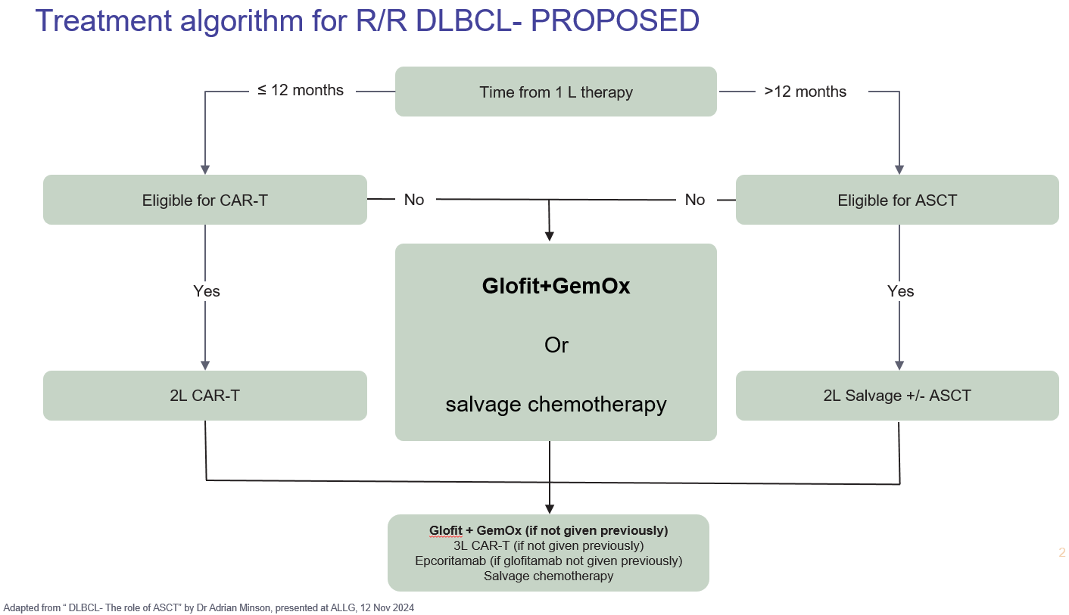
Source: Figure 1.6, p18 of the submission
  - Glofitamab is a T-cell engaging bispecific (TCB) monoclonal antibody with a 2:1 (CD20:CD3) format for bivalent binding to CD20 on the surface of B cells (including malignant and non-malignant B-cells) and monovalent binding to CD3 on T cells, which induces the formation of an immunologic synapse between these cells, resulting in direct activation of the T-cell response and lysis of CD20-expressing B-cells. Glofit-GemOx is administered intravenously for up to 12 cycles, which includes eight cycles of glofitamab in combination with gemcitabine plus oxaliplatin plus four cycles of glofitamab monotherapy. Each cycle is 21-days. To mitigate the risk of CRS, the draft product information (PI) recommends all patients receive a single IV dose of obinutuzumab 1000mg on day 1 of cycle 1 (7 days before first glofitamab dose) and a step-up dose schedule as follows: 2.5mg on Day 8 and 10mg on Day 15 of Cycle 1, then 30mg on Day 1 of Cycles 2 to 12.
For more detail on PBAC’s view, see section 7 PBAC outcome.
- Comparator
  - The submission appropriately nominated rituximab in combination with gemcitabine plus oxaliplatin (R-GemOx) as the main comparator. The submission stated that R-GemOx is commonly administered second line in patients ineligible for ASCT or who have relapsed after ASCT and would be the treatment most likely to be replaced by Glofit-GemOx. The R-GemOx 21-day cycle length was used in STARGLO to align with the Glofit-GemOx 21-day cycle length, instead of the usual 14-day cycle length recommended in practice for NHL. The Pre-PBAC Response provided the ratified ACM advice, which stated the ACM agreed that 3-weekly R-GemOx cycles were reasonable for patients with relapsed/refractory DLBCL who are not eligible for ASCT.
  - The nomination of R-GemOx as the main comparator was reasonable, however, other chemotherapy regimens would also likely be replaced in practice such as R-ICE (rituximab + ifosfamide + carboplatin + etoposide), R-DHAC (rituximab + dexamethasone cytarabine carboplatin) and R-CHOP 21 (rituximab + cyclophosphamide + hydroxydaunorubicin + vincristine + prednisolone). Data from the Lymphoma and Related Diseases Registry reported the use of R-GemOx as a second-line treatment in 22% (20/91) of non-transplanted patients (Chen et al., 2022). The PBAC had previously accepted R-GemOx (14-day cycle length) as an acceptable comparator for epcoritamab in the third-line setting (paragraph 5.2, epcoritamab PSD, November 2024).
  - The submission appropriately nominated epcoritamab as a ‘near market’ comparator in the third-line setting, given the positive recommendation by the PBAC in November 2024 for patients after ≥2 lines of systemic therapy. The submission stated that a small group of patients may become eligible for either Glofit-GemOx or epcoritamab, after second-line treatment with either ASCT, CAR-T cell therapy or other second-line chemotherapy. As noted above, epcoritamab was listed on the PBS in May 2025. The submission presented an unanchored - comparison and cost per course analysis between Glofit-GemOx versus epcoritamab as supplementary analyses.
  - The submission argued that CAR-T cell therapy was not an appropriate comparator, with particular reference to the second-line setting, on the basis of insufficient overlap between patients eligible for CAR-T and patients eligible for Glofit-GemOx in the clinical trial evidence. The submission noted that the recommendation to fund axicabtagene ciloleucel (Yescarta) in the second-line setting was based on the ZUMA-7 trial, which enrolled patients ‘eligible’ for ASCT. In contrast, the proposed listing for Glofit-GemOx in the second-line setting was based on the STARGLO trial, which enrolled patients ‘ineligible’ for ASCT.
  - The submission’s argument as to why CAR-T cell therapy would not be a potentially relevant comparator, at least for some patients, requires consideration:
- Under the current wording of the requested PBS restriction, Glofit-GemOx would be an alternative second-line treatment to CAR-T cell therapy for some patients. The submission argued that the proposed clinical criterion, “patients must be ineligible for ASCT” would also exclude patients eligible for CAR-T cell therapy, but this may not be true in all cases. In practice, there are likely a number of circumstances where patients may be ineligible for ASCT but remain eligible for CAR-T cell therapy. For example, patient age >70 years is often a barrier to ASCT but not necessarily a barrier for CAR-T if the patient is otherwise fit. Other factors (such as poor stem cell mobilisation, poor bone marrow reserve, worse organ dysfunction) may also exclude ASCT but not necessarily exclude CAR-T on a case-by-case basis. Indeed, some patients enrolled in the STARGLO trial who were ‘ineligible’ for ASCT at baseline subsequently received CAR-T as 3L therapy (e.g. 13.2% in the R-GemOx arm). Similarly, the 2025 NCCN clinical guidelines recommend CAR-T cell therapy (if eligible) as the preferred second-line treatment option in patients when there is “no intention to proceed to transplant”. The ESC acknowledged that in clinical practice the definition of ASCT eligibility and CAR-T cell therapy suitability are a clinical decision and flexible. As such, the ESC considered that in practice CAR-T cell therapy may have a wider population than those who are ASCT eligible. However, the ESC agreed with the Pre-Sub-Committee Response (PSCR) that the number of patients who could be considered ineligible for ASCT but eligible for CAR-T cell therapy would likely be small. The ESC considered that amendment of the proposed restriction to include reference to CAR-T cell therapy suitability further clarified the intended eligible PBS population.
- Whether Glofit-GemOx would actually substitute for CAR-T in practice is another question. Should some patients, who would otherwise be eligible for CAR-T, choose to undergo treatment with Glofit-GemOx instead of CAR-T due to patient preferences, then CAR-T (i.e. axicabtagene ciloleucel) may be considered as an appropriate comparator in those patients. The delivery of CAR-T cell therapy in Australia is currently via six accredited tertiary hospital treatment centres, of which four are located in capital cities. The PBAC had previously heard clinician and consumer comments highlighting the current barriers to access at the November 2024 PBAC Meeting and acknowledged the high clinical need for additional treatments for this condition that has a very poor prognosis (paragraph 7.2, epcoritamab PSD, November 2024). The ESC acknowledged the evaluators concern that glofitamab may be used in preference to CAR-T cell therapy in some situations and that this may have implications for the comparator but, as outlined above, considered that this would only be relevant for a small number of patients.
For more detail on PBAC’s view, see section 7 PBAC outcome.
- Consideration of the evidence

Sponsor hearing
  - The Sponsor requested a hearing for this item. The clinician discussed the Australian cohort of the pivotal STARGLO trial and the results reported for both for the Australian subgroup and the whole trial population. The clinician also addressed questions in relation to the anticipated uptake of glofitamab and the relative place of CAR-T cell therapy and glofitamab in practice.

Consumer comments
  - The PBAC noted and welcomed the input from health care professionals (2) and organisations (4) via the Consumer Comments facility on the PBS website. The PBAC noted the input from health care professionals outlined the efficacy rates of first line treatment for DLBCL, and the high need for additional treatment options in later lines, especially for individuals who are not suitable for ASCT or CAR-T cell therapy. The input described the efficacy of glofitamab based on the results of the STARGLO trial. The health care professionals also noted the risk of CRS identified in the trial and described this as manageable but acknowledged there was an additional burden of care due to the need to remain in the care setting for an extended duration on the day of treatment.
  - The input from Rare Cancers Australia highlighted the impact on individuals of ASCT,
CAR-T cell therapy and current chemoimmunotherapy options. The input discussed the benefits of glofitamab for those who are frail and cannot handle the harsh side effects of other treatment options. The input also discussed the side effects of glofitamab and how these will be managed in practice.
  - The input from the Leukaemia Foundation discussed current standard of care and emphasised the need for additional treatment options for individuals who are not suitable for ASCT or CAR-T cell therapy. The input also shared comments from individuals living with DLBCL which described the stress associated with the condition and its impact on their quality of life. The feedback from individuals living with DLBCL highlighted concerns around the effects of current chemoimmunotherapy treatment and about the potential toxicity of future treatments as they have become refractory to their current therapy.
  - The input from Lymphoma Australia discussed how the DLBCL treatment landscape has changed for individuals with relapsed/refractory disease with CAR-T cell therapy, but highlighted variability in access to treatment across different jurisdictions. The input described the need for additional treatments option for individuals who can't receive or access CAR-T cell therapy.
  - The input from the Australasian Leukaemia & Lymphoma group highlighted the difference in overall survival observed in the STARGLO trial and suggested the Glofit-GemOx regimen would prevent deaths as well as the need for subsequent high-cost therapies. The input stated that the efficacy benefits were achieved with a tolerable rate of toxicity in the investigational arm. The input highlighted the clinical need for glofitamab in individuals who are transplant ineligible or unable to access CAR-T cell therapy for either clinical or non-clinical (e.g. living in a rural or remote location) reasons.

Clinical trials
  - The submission was based on one head-to-head trial comparing Glofit-GemOx to R- GemOx in patients with R/R DLBCL after at least one prior line of therapy and who were considered ineligible for ASCT (STARGLO).
  - Details of the STARGLO trial presented in the submission are provided in Table 2.
Table 2: Trials and associated reports presented in the submission
Trial ID | Protocol title/ Publication title | Publication citation
GO41944  (STARGLO)  NCT04408638 | Study GO41944 (STARGLO) – A Phase III, Open-Label, Multicenter, Randomized Study Evaluating The Efficacy And Safety Of Glofitamab In Combination With Gemcitabine Plus Oxaliplatin Versus Rituximab In Combination With Gemcitabine And Oxaliplatin In Patients With Relapsed/Refractory Diffuse Large B Cell Lymphoma. | Primary CSR March 2023
GO41944  (STARGLO)  NCT04408638 | Study GO41944: A Phase III, Open-Label, Multicenter, Randomized  Study Evaluating The Efficacy And Safety Of Glofitamab In Combination With Gemcitabine Plus Oxaliplatin Versus Rituximab In Combination With Gemcitabine And Oxaliplatin In Patients With Relapsed/Refractory Diffuse Large B Cell Lymphoma. | Updated CSR February 2024
GO41944  (STARGLO)  NCT04408638 | Abramson JS, Ku M, Hertzberg M et al. Glofitamab plus gemcitabine and oxaliplatin (GemOx) versus rituximab-GemOx for relapsed or refractory diffuse large B-cell lymphoma (STARGLO): a global phase 3, randomised, open-label trial | Lancet 2024; 404:1940-54
GO41944  (STARGLO)  NCT04408638 | Hertzberg M et al. A phase III trial of glofitamab plus gemcitabine and oxaliplatin (GEMOX) vs rituximab plus GemOx for relapsed/refractory diffuse large B-cell lymphoma. | J Clin Oncol 2021 39(15 suppl)
GO41944  (STARGLO)  NCT04408638 | Hertzberg Mark et al. A phase III trial evaluating glofitamab in combination with gemcitabine plus oxaliplatin versus rituximab in combination with gemcitabine and oxaliplatin in patients with relapsed/refractory (R/R) diffuse large B-cell lymphoma (DLBCL). | Hematological Oncology 2021  39(S2): 344-345
Source: Table 2.3, p35 of the submission.
  - The key features of the STARGLO trial are summarised in Table 3. The Phase III open-label trial randomised eligible patients 2:1 to Glofit-GemOx or R-GemOx, stratified by 1 versus ≥2 previous lines of therapy and by relapsed versus refractory status.
Table 3: Key features of the STARGLO trial
Trial | N | Design / duration | Risk of bias | Patient population | Outcome(s) | Use in modelled evaluation
Glofit-GemOxª vs. R-GemOx^{b}
STARGLO | 274  Enrolled Feb 2021-Mar 2023 | P3, MC, R, OL  Median follow up 11.3 months (primary analysis), 20.7 months (updated analysis)  Ongoing longer-term follow up | Low | ASCT ineligible R/R DLBCL after ≥1 systemic therapy, ECOG performance status of 0–2. | OS, PFS, CR, DOCR, ORR, DOR, HRQoL, AEs | PFS and OS
Source: Figure, p37 of the submission.
Glofit-Gemox=glofitamab + gemcitabine + oxaliplatin; R-GemOx=rituximab + gemcitabine + oxaliplatin; DB=double blind; MC=multi-centre; OL=open label; P3=phase 3; R=randomised; ASCT=autologous stem cell transplant; R/R=relapsed or refractory; DLBCL=diffuse large B-cell lymphoma; ECOG=Eastern Cooperative Oncology Group; OS=overall survival; PFS=progression-free survival; CR=complete response; DOCR=duration of complete response; ORR=objective response rate; DOR=duration of response; HRQoL=health-related quality of life; AE=adverse event.
ª Regimen for Glofit-Gemox includes 8 cycles of glofitamab + gemcitabine + oxaliplatin followed by 4 cycles of glofitamab monotherapy.
^{b} Regimen for R-GemOx includes 8 cycles of rituximab + gemcitabine + oxaliplatin.
  - STARGLO enrolled patients with R/R DLBCL after ≥1 prior systematic therapy, who were ineligible for ASCT. The trial had two pre-specified enrolment caps to ensure the study population did not entirely comprise patients with poor prognosis. Enrolment of patients with platinum-based refractory disease was limited to 20% of all randomised patients to minimise the risk of enriching the study population with patients that may not sufficiently respond to oxaliplatin, a platinum-based treatment. In addition, enrolment of patients who had ≥ 2 lines of prior systemic therapy was limited to 65% of all randomised patients to ensure the study enrolled an adequate number of patients with only 1 prior line of therapy (who were ineligible for ASCT).
  - Patients who had failed only one prior line of therapy were required to be unsuitable for ASCT by meeting one of the following criteria: left ventricular ejection fraction ≤40%, creatinine clearance or glomerular filtration rate ≤45 mL/min, Eastern Cooperative Oncology Group (ECOG) performance status of ≥2, age ≥70 years, patient refused high-dose chemotherapy and/or transplant, patient had insufficient response to pre-transplant chemotherapy to be able to proceed to transplant, or other comorbidities or criteria that precluded the use of transplant based on local practice standards or in the investigator’s opinion. The most common reasons for ASCT ineligibility were patient refusal of transplant (Glofit-GemOx: 35.5%; R-GemOx: 33.0%) followed by age (Glofit-GemOx: 34.4%; R-GemOx; 27.5%). The ESC noted that differences in levels of patient refusal of transplant were seen between countries with the pooled rate of transplant-refusal in Europe, North America and Australia reported as 7.1% (10/141, none of which were Australian patients), compared to 64.6% (84/130) in Asian countries.
  - An interim efficacy analysis of STARGLO was planned when enrolment was completed and at approximately 70% of overall survival events (97 deaths). As the primary endpoint was met at the interim analysis (March 29, 2023 data cut), the interim analysis was considered the primary analysis. The data were subsequently made available to the Sponsor for the formal reporting of results at the recommendation of the Independent Data Monitoring Committee (IDMC). However, the Sponsor opted to continue the trial until all participants had completed treatment, to allow for data maturation (33 patients in the Glofit-GemOx arm and seven patients in the R-GemOx arm remained on active treatment at the interim/primary analysis). To minimise the introduction of bias, investigators and participants were not informed of the results of the interim/primary analysis and no aggregate analyses were undertaken on accumulating data. An updated analysis (16 February 2024 data cut) was undertaken after all patients had completed trial therapy.
  - Overall, the risk of bias was low for the STARGLO ITT population for the primary analysis (clinical cut-off date 29 March 2023) and updated analysis (clinical cut-off date 16 February 2024). To minimise bias of the open-label design, an Independent Review Committee (IRC) was masked/blinded to treatment assignment when evaluating response-based endpoints. The submission stated that response assessments performed by investigators (INV) at the study sites were also blinded, but this statement could not be verified from the STARGLO Clinical Study Report or publications.
  - Randomisation appeared successful, however the ESC noted numerical differences were noted for Ann Arbor stages, bulky disease, ECOG PS, IPI risk factors and double-expressor lymphoma, which may have indicated overall better prognosis in Glofit-GemOx vs R- GemOx, as well as a difference in race (lower proportion were Asian; higher proportion were White in Glofit-GemOx). One of the two enrolment caps also had an imbalance: a lower proportion of patients in Glofit-GemOx demonstrated platinum-based refractory disease (17.5% vs 23.1%) which could also suggest the Glofit-GemOx group had a better prognosis.
  - The primary outcome in STARGLO was overall survival (OS). Key secondary endpoints were IRC and INV assessed: progression-free survival (PFS), complete response (CR), duration of complete response (DOCR), overall response rate (ORR), duration of response (DOR) and, patient-reported time to deterioration in physical functioning and in lymphoma symptoms using the EORTC QLQ-C30 and FACT-Lym LymS, respectively.

Comparative effectiveness
  - Table 4 and Figure 2 summarises the results of OS and PFS in STARGLO for the ITT population at the primary analysis (median follow-up 11.3 months) and the updated analysis (median follow-up 20.7 months).
Table 4: Overall survival and progression-free survival results in STARGLO (ITT)
Outcome | Primary analysis;  Clinical data cut-off: March 29, 2023 |  | Updated analysis;  Clinical data cut-off: February 16, 2024
Outcome | Glofit-GemOx | R-GemOx | Glofit-GemOx | R-GemOx
Overall survival (OS)ª
Events n/N (%) | 61/183 (33.3) | 40/91 (44.0) | 80/183 (43.7) | 52/91 (57.1)
Median TTE (95% CI) | NE (13.8, NE) | 9.0 (7.3, 14.4) | 25.5 (18.3, NE) | 12.9 (7.9, 18.5)
HR (95%) | 0.59 (0.40, 0.89) |  | 0.62 (0.43, 0.88)
Progression-free survival (PFS): IRC assessed^{a,b}
Events n/N (%) | 68/183 (37.2) | 44/91 (48.4) | 90/183 (49.2) | 54/91 (59.3)
Median TTE (95% CI) | 12.1 (6.8, 18.3) | 3.3 (2.5, 5.6) | 13.8 (8.7, 20.5) | 3.6 (2.5, 7.1)
HR (95%) | 0.37 (0.25, 0.55) |  | 0.40 (0.28, 0.57)
Progression-free survival (PFS): INV assessedª
Events n/N (%) | 71/183 (38.8) | 60/91 (65.9) | 89/183 (48.6) | 64/91 (70.3)
Median TTE (95% CI) | 17.0 (8.7, NE) | 2.7 (2.0, 5.3) | 14.4 (9.2, 24.6) | 2.7 (2.2, 5.3)
HR (95%) | 0.31 (0.22, 0.45) |  | 0.32 (0.23, 0.45)
Source: Tables 2.12 to 2.15, pp53-65 of the submission.
CI=confidence interval; n=number of participants with event; N=total participants in group; IRC=Independent Review Committee; INV=Investigator; TTE=time-to-event; HR=hazard ratio; NE=not evaluable. Bold indicates statistically significant results.
ª Analysis was stratified by randomisation stratification factors: number of previous lines of therapy (1 vs ≥2) and outcome of last systemic therapy (relapsed vs refractory).
^{b} Key secondary endpoint hierarchically tested.
Figure 2: Kaplan-Meier curves for overall survival and progression free survival in STARGLO (ITT); the red line reflects Glofit-GemOx and the blue line reflects R-GemOx.

 | OS | PFS (IRC assessed)
Primary analysis  (March 29, 2023 data cut off)) | 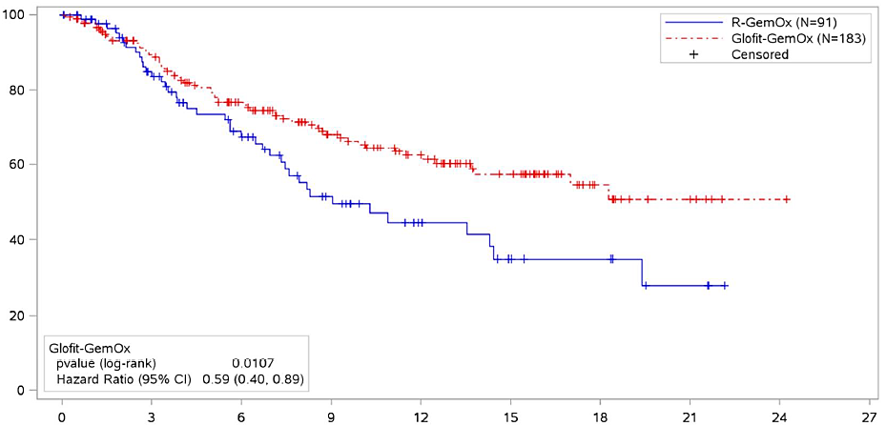 | 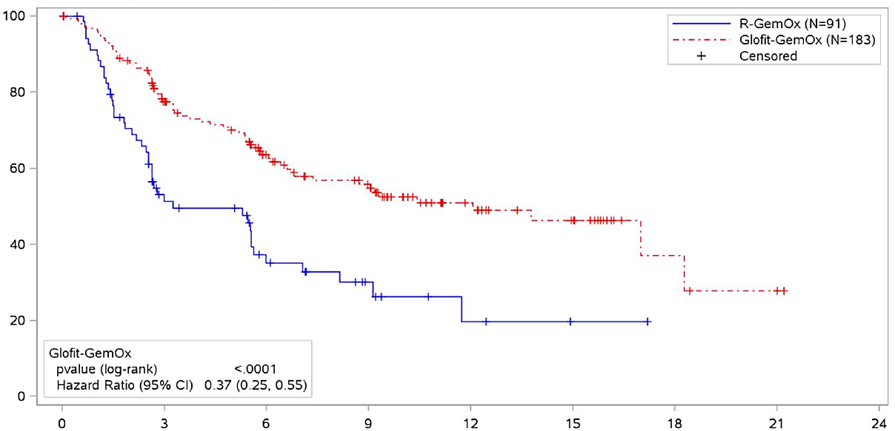
Updated analysis  (February 15, 2024 data cut off) | 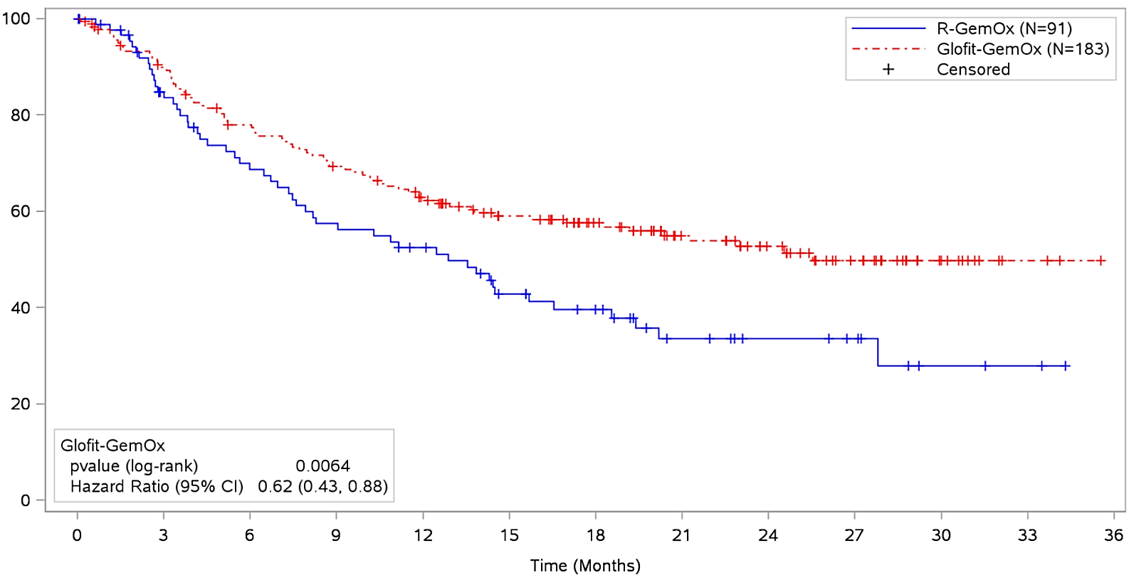 | 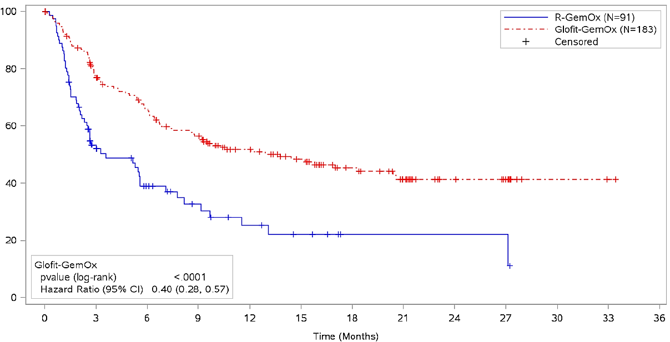
Source: Figures 2.7 (p54), 2.8 (p55), 2.13 (p62) and 2.16 (p65) of the submission.
OS = overall survival; PFS = progression-free survival; IRC=Independent Review Committee; ITT = intention to treat; Glofit-GemOx = glofitamab + gemcitabine + oxaliplatin; R-GemOx = rituximab + gemcitabine + oxaliplatin.
  - Results of the primary analysis (ITT population) showed that both OS and PFS were significantly longer for patients randomised to the Glofit-GemOx, with a statistically significant reduction in the risk of death (stratified HR=0.59, 95% CI: 0.40, 0.89) and risk of progression (stratified HR=0.37, 95% CI: 0.25, 0.55). The results of the updated analysis were consistent with the primary analysis, which reported a similar reduction in the risk of death (stratified HR=0.62, 95% CI: 0.43, 0.88) and risk of progression (stratified HR=0.40, 95% CI: 0.28, 0.57). At the updated analysis, median OS was 25.5 months for Glofit-GemOx compared to 12.9 months, and median PFS was 13.8 for Glofit-GemOx compared to 3.6 months for R-GemOx.
  - The submission noted that the OS numerically favoured R-GemOx in the first 90 days (illustrated by the Kaplan-Meier curve), which was attributed to additional COVID-19 in the Glofit-GemOx treatment arm. The STARGLO trial was conducted during the COVID-19 pandemic, and the trial recorded seven deaths due to COVID-19 in the Glofit-GemOx arm prior to a protocol modification which required patients with COVID-19 to permanently discontinue treatment and prevented patients with active or recent infection from commencing treatment. The submission stated there were no further COVID-19 deaths after the amendment and sensitivity analyses censoring patients with COVID-19 showed the OS benefit was consistent with the primary analysis.
  - Results of the primary analysis (ITT population) also showed a significant improvement favouring Glofit-GemOx for other secondary endpoints, CR (RD=28.3%, 95% CI: 16.3%, 40.3%) and ORR (RD=33.2%, 95% CI: 20.9%, 45.5%), but no difference for DOCR (HR=0.59, 95% CI: 0.19, 1.83). The results of the updated analysis were similarly consistent with the primary analysis for these secondary outcomes.
  - Results of unstratified exploratory subgroup analyses demonstrated no difference in OS between Glofit-GemOx and R- GemOx (HRs favouring R-GemOx) for patients in the following subgroups: White race (n=115), Europe (n=88), North America (n=25), ECOG PS ≥2 (n=27) and prior CAR-T cell therapy (n=21). The submission stated that STARGLO was not designed to detect differences by subgroups, some subgroups included very small numbers, and there was no biological underpinning for differences in results between races. The submission argued that differences by race were most likely driven by the different racial subgroups enrolled according to geographical regions. The TGA clinical evaluator considered that multiple factors within subpopulations may have confounded results, but the benefit of glofitamab on efficacy was accepted and the STARGLO ITT results were considered most likely applicable to the Australian population (the TGA CER). The ESC considered that, whilst there were differences in the prespecified subgroups in STARGLO, particularly with regards to racial differences, the study was not powered to detect a difference in primary or secondary outcomes in these groups.
  - Table 5 presents results of patient-reported outcomes for the ITT population at the primary analysis and updated analysis. No difference was observed between treatment arms for time to deterioration in physical functioning, fatigue or lymphoma-specific symptoms.
Table 5: Results for patient-reported outcomes in STARGLO (ITT population)
Patient-reported outcome | Primary analysis;  Clinical data cut-off: March 29, 2023 |  | Updated analysis;  Clinical data cut-off: February 16, 2024
Patient-reported outcome | Glofit-GemOx | R-GemOx | Glofit-GemOx | R-GemOx
Time to Confirmed Deterioration in Physical Functioning (using EORTC QLQ-C30)
Median, months (95% CI) | NE (10.1, NE) | 16.4 (16.4, NE) | 23.0 (10.3, NE) | 18.0 (8.6, NE)
Stratified HR (95% CI) | 0.95 (0.58, 1.55) |  | 0.93 (0.59, 1.48)
Time to Confirmed Deterioration in Fatigue (using EORTC QLQ-C30)
Median, months (95% CI) | 1.6 (1.4, 3.1) | 1.4 (1.0, 4.2) | 1.6 (1.4, 3.1) | 1.4 (1.0, 4.2)
Stratified HR (95% CI) | 0.95 (0.67, 1.36) |  | 0.93 (0.67, 1.30)
Time to Confirmed Deterioration in Lymphoma-Specific Symptoms (FACT-Lym LymS)
Median, months (95% CI) | 6.2 (3.2, 9.4) | 4.3 (2.4, 10.7) | 6.2 (3.3, 8.3) | 4.5 (3.0, 12.5)
Stratified HR (95% CI) | 0.96 (0.66, 1.41) |  | 1.02 (0.71, 1.45)
CI=confidence interval; EORTC QLQ-C30 = European Organisation for Research and Treatment of Cancer Quality of Life-Core 30 questionnaire; FACT-Lym LymS = Functional Assessment of Cancer Therapy-Lymphoma Lymphoma Subscale; Glofit-GemOx = Glofitamab in combination with gemcitabine plus oxaliplatin; R-GemOx = rituximab in combination with gemcitabine plus oxaliplatin; HR = hazard ratio; NE = not evaluable.
  - The submission did not report results of the EQ-5D-5L data collected in STARGLO. The STARGLO CSR ( STARGLO CSR, 16 February 2024) stated there were no changes from baseline in the median EQ-5D-5L scores at all cycles during treatment and long-term follow-up at timepoints with ≥ 10 patients in either treatment population completing the questionnaire, indicating maintenance of health status levels reported at baseline. Compliance for completing at least 50% of the questions in the EQ-5D-5L questionnaire was 100% at baseline and remained high (93.8%-100%) up to Cycle 7 Day 1. Thereafter, compliance rates in the Glofit-GemOx and R-GemOx populations were 74.7% and 80.8% at treatment completion/early, respectively, and 54.7%-86.8% at the long-term follow-up (month 18), respectively.
  - The submission also presented an unanchored comparison of Glofit-GemOx versus epcoritamab in the third-line setting as a supplementary analysis (Table 6). The comparison relied on subgroup data from STARGLO (≥ 2 prior systemic therapies) and EPCORE NHL-1 (a Phase I/II, open-label, single-arm, dose escalation and dose expansion study of epcoritamab monotherapy in patients with R/R LBCL after ≥2 lines of prior therapy). For completeness, comparable data for glofitamab monotherapy in the third-line setting were extracted from Phase II of Study NP30179 (a Phase I/II, open-label, single arm study) in patients with R/R DLBCL ≥ 2 prior systemic therapies.
Table 6: Unanchored comparison of results from STARGLO (subgroup: ≥ 2 prior systemic therapies), EPCORE NHL-1 and Study NP30179
Outcome | Glofit-GemOx | Epcoritamab | Glofitamab
Outcome | STARGLO  (≥ 2 prior systemic therapiesª)  N=68 | EPCORE NHL-1  N=157^{d} | Study NP30179  N=155^{b,c,f}
Median follow up, months (range) | 23.7 (20.4, 26.2) | 25.1 (24.0, 26.0) | 39.3 (31.7, 42.3)^{e}
Overall survival (OS)
Median OS, months (95% CI) | 18.3 (11.5, NE) | 18.5 (11.7, 27.7) | 12.6 (7.9, 17.8)
Estimated OS rate at 12 months (%) (95% CI) | 59.6 (47.5, 71.6) | 58.0 (49.7, 65.4) | 50.8 (42.7, 59.0)
Progression-free survival (PFS): IRC assessed
Median PFS, months (95% CI) | 9.2 (5.4, 17.0) | 4.4 (3.0, 8.8) | 4.9 (3.4, 7.8)
Estimated PFS rate at 12 months (%) (95% CI) | 46.0 (33.3, 58.7) | 39.9 (31.8–47.8) | 36.7 (28.6, 44.8)
Duration of response (DOR): IRC assessed
Responders | 42 (61.8%) | 99 (63.1%) | N/R
Duration of response months, median (95% CI) | 17.9 (11.8, NE) | 17.3 (9.7, 26.5) | 22.0 (12.6, 29.8)
Duration of complete response (DOCR): IRC assessed
Complete response n (%) | 34 (50.0%) | 63 (40.1%) | N/R
Duration of complete response months, median (95% CI) | NE (14.4, NE) | NE | 29.8 (22.0, NE)
Treatment-emergent AE in ≥20% of patients, n (%)
CRS | 25 (36.8%) | 80 (51.0%) | 103 (66.9%)
Neutropenia | 13 (19.1%) | 37 (23.6%) | 59 (38.3%)
Anaemia | 32 (47.1%) | 33 (21.0%) | 46 (29.9%)
Infections, n (%)
COVID-19 | 12 (17.6%) | 30 (19.1%) | 5 (3.2%)
Pneumonia | 5 (7.4%) | 13 (8.3%) | 2 (1.3%)
Sepsis | 1 (1.5%) | 5 (3.2%) | 6 (3.9%)
Source: Table 1.3, p11 and Table 1.5, p13 of Supplementary Appendix 1 of the submission, Table 2, p2656 of Thieblemont et al. (2024), Table 1.8, p16 and Table 1.10, p21, Table 1.11, p22 of Attachment 1 (study NP30179) of the submission.
OS=overall survival; PFS=progression-free survival; DOR=duration of response; DOCR=duration of complete response; N/A=not applicable; N/R=not reported; CRS=cytokine release syndrome.
ª Results were from the updated analysis with the clinical cut-off date of February 16, 2024.
^{b} Results based on second updated analysis with clinical cut-off date of 17 May 2024.
^{c} 110/155 (71.4%) of patients had a diagnosis of DLBCL NOS
^{d} 139/157 (88.5%) of patients had a diagnosis of DLBCL NOS
^{e} Median duration of follow-up for IRC-assessed PFS. Note that it is longer than the median follow-up for STARGLO & EPCORE NHL-1.
^{f} Primary outcome of Study NP30179 was complete response (CR).

  - The submission concluded that Glofit-GemOx was superior to epcoritamab (in the 3L+ setting) in terms of efficacy as demonstrated by greater PFS and CR, and superior in terms of safety with fewer serious adverse events (AEs) and lower incidence of CRS. The results of the unanchored comparison should be interpreted with caution given the simple side-by-side comparison of trial results does not control for any differences in the baseline characteristics among groups being compared, as well as the small / exploratory nature of the STARGLO subgroup. The ESC agreed with the evaluation that on face value, it appears that the efficacy of Glofit-GemOx may be comparable to epcoritamab in the third-line setting, but based on the available evidence, a claim of superiority cannot be supported.

Comparative harms
  - Table 7 summarises the AEs in STARGLO for the safety population (clinical cut-off date 16 Feb 2024), including AEs of special interest.
Table 7: Key adverse events reported in STARGLO (safety population)
Outcome | Glofit-GemOx  N=172 | R-GemOx  N=88
Any AE | 149 (86.6%) | 58 (65.9%)
Any Grade 3-5 AE | 85 (49.4%) | 20 (22.7%)
Any SAE | 62 (36.0%) | 7 (8.0%)
AE leading to treatment discontinuationª | 13 (7.6%) | 3 (3.4%)
AE leading to dose interruptionª | 43 (25.0%) | 9 (10.2%)
AE resulting in death | 12 (7.0%) | 4 (4.5%)
Adverse events with ≥10% increase in Glofit-GemOx vs R-GemOx
CRS | 76 (44.2%) | 0 (0%)
Anaemia | 71 (41.3%) | 19 (21.6%)
Increased AST | 59 (34.3%) | 17 (19.3%)
Reduced neutrophil count | 51 (29.7%) | 18 (20.5%)
Pyrexia | 42 (24.4%) | 5 (5.7%)
Grade 3-5 adverse events occurring in ≥ 5% of patients
Anaemia | 29 (16.9%) | 8 (9.1%)
Neutropenia | 25 (14.5%) | 6 (6.8%)
Thrombocytopenia | 18 (10.5%) | 6 (6.8%)
Pneumonia | 10 (5.8%) | 4 (4.5%)
Adverse events of special interest
CRS | 76 (44.2%) | 0 (0%)
Grade 1 | 54 (31.4%) | 0 (0%)
Grade 2 | 18 (10.5%) | 0 (0%)
Grade 3 | 4 (2.3%) | 0 (0%)
Grade 4 / fatal CRS | 0 (0.0%) | 0 (0%)
TF | 4 (2.3%) | 1 (1.1%)
TLS | 3 (1.7%) | 3 (3.4%)
Serious infections | 39 (22.7%) | 11 (12.5%)
Febrile neutropenia | 5 (2.9%) | 1 (1.1%)
ICANS | 4 (2.3%) | 0 (0%)
Neurological adverse event (grade ≥2) | 52 (30.2%) | 11 (12.5%)
AE=adverse event; SAE=serious adverse event; CRS=cytokine release syndrome; TF=tumour flare; TLS=tumour lysis syndrome; ICANS= Immune effector cell-associated neurotoxicity syndrome; Glofit-GemOx=glofitamab + gemcitabine + oxaliplatin; R-GemOx=rituximab + gemcitabine + oxaliplatin; CI = confidence interval; N = total participants in group; RR = relative risk
Source: Table 2.22, p72 and Table 2.26, p77 of the submission, Table 59, p186 and Table 63, p209 of the Updated glofitamab CSR.
ª AE is related to glofitamab/rituximab which led to the withdrawal from glofitamab/ rituximab.
  - Patients treated with Glofit-GemOx experienced a higher incidence of AEs compared to patients treated with R-GemOx. This was evident for any AEs, SAEs, Grade 3-5 AEs, AEs of special interest and AEs leading to treatment discontinuation or dose interruption. Common AEs occurring more frequently in the Glofit-GemOx arm included CRS, anaemia, increased AST, reduced neutrophil count and pyrexia. CRS occurred exclusively in the Glofit-GemOx arm, with the majority of cases being Grade 1 or 2. Other AEs of special interest occurring more frequently in the Glofit-GemOx arm were serious infections and neurological adverse events (Grade ≥2).
  - The submission noted that treatment exposure differed considerably across the treatment arms, with patients randomised to the Glofit-GemOx arm receiving more treatment cycles of (i) glofitamab compared to rituximab (mean of 8.5 vs 4.4), (ii) gemcitabine (mean of 6.3 vs 4.4), and (iii) oxaliplatin (mean 6.2 vs 4.4). After adjusting for exposure, the submission stated that adverse event rates were similar between the treatment groups. Although the exposure-adjusted rate of AEs was similar, patients treated with Glofit-GemOx received substantially more treatment cycles, and more AEs overall.

Benefits/harms
  - A summary of the comparative benefits and harms for Glofit-GemOx versus R-GemOx is presented in Table 8.
Table 8: Summary of comparative benefits and harms for Glofit-GemOx and R-GemOx: ITT / safety population
Event | Glofit-GemOx | R-GemOx | Absolute Difference | HR (95% CI)
Benefits
Overall survival (median duration of follow up 20.7 months)
Deaths, n/N (%) | 80/183 (43.7) | 52/91 (57.1) | -13.4% | 0.62 (0.43, 0.88)
Median OS, months (95% CI) | 25.5 (18.3, NE) | 12.9 (7.9, 18.5) | 12.6 months | 0.62 (0.43, 0.88)
OS at 12 months, % (95% CI) | 62.9 (55.7, 70.0) | 52.5 (41.6, 63.3) | 10.4 (-2.61, 23.4) | 0.62 (0.43, 0.88)
OS at 24 months, % (95% CI) | 52.8 (44.8, 60.7) | 33.5 (22.2, 44.9) | 19.2 (5.38, 33.05) | 0.62 (0.43, 0.88)
Progression-free survival (median duration of follow up 20.7 months)
Progressed, n/N (%) | 90/183 (49.2) | 54/91 (59.3) | -10.1% | 0.40 (0.28, 0.57)
Median PFS, months (95% CI) | 13.8 (8.7, 20.5) | 3.6 (2.5, 7.1) | 10.2 months | 0.40 (0.28, 0.57)
PFS at 12 months, % (95% CI) | 51.7 (44.0, 59.4) | 25.2 (13.6, 36.9) | 26.5 (12.5, 40.5) | 0.40 (0.28, 0.57)
PFS at 24 months, % (95% CI) | 41.3 (32.7, 49.9) | 22.1 (10.35, 33.8) | 19.2 (4.69, 33.8) | 0.40 (0.28, 0.57)
Harms
 | Glofit-GemOx | R-GemOx | RR (95% CI) | Event rate/100 patients |  | RD (95% CI)
 |  |  |  | Glofit-GemOx | R-GemOx | RD (95% CI)
CRS, n/N (%) | 76/172 (44.2%) | 0/88 (0%) | 78.7 (4.93, 1255) | 44 | 0 | 44 (37, 52)
Serious infections, n/N (%) | 39/172 (22.7%) | 11/88 (12.5%) | 1.81 (0.98, 3.36) | 23 | 12.5 | 10 (0.8, 20)
AE leading to dose interruption, n/N (%) | 43/172 (25.0%) | 9/88 (10.2%) | 2.44 (1.25, 4.78) | 25 | 10.2 | 15 (5, 24)
Source: Table 2.13, p54, Table 2.14, p62, Table 2.21, p72, Table 2.22, p73 of the submission and text on p310 of updated glofitamab CSR.
HR = hazard ratio; RD = risk difference; RR = risk ratio; CI = confidence interval; Glofit-GemOx = glofitamab plus gemcitabine and oxaliplatin; R-GemOx = rituximab plus gemcitabine and oxaliplatin; CRS=cytokine release syndrome.
  - On the basis of direct evidence presented by the submission, for every 100 patients treated with Glofit-GemOx in comparison to R-GemOx:
- Approximately 19 additional patients will be alive at 24-months follow-up;
- Approximately 19 additional patients will remain progression-free at 24-months follow-up;
- Approximately 44 additional patients will experience cytokine release syndrome;
- Approximately 10 additional patients will experience a serious infection;
- Approximately 15 additional patients will experience adverse event that leads to a dose interruption

Clinical claim
  - The submission described Glofit-GemOx as superior in terms of effectiveness and non-inferior in terms of safety compared to R-GemOx.
  - The clinical evidence presented in the submission reasonably supported the claim of superior effectiveness for patients with R/R DLBCL after one or more lines of prior therapy and who are considered transplant ineligible. The STARGLO trial met its’ primary endpoint at the interim analysis demonstrating statistically significant improvements in OS, PFS and CR with Glofit-GemOx compared to R-GemOx. Despite inconsistent findings across some unstratified exploratory subgroup analyses (notably by race and geographic region for enrolment), multiple factors likely confounded these results and the TGA evaluator concluded that the ITT results were most likely applicable to the Australian population. It was also unclear whether the same magnitude of effect would be observed in clinical practice, given the changing landscape of CAR-T cell therapy in Australia and other potential applicability issues of the STARGLO trial (such as the impact of the enrolment caps, the 14-day versus 21-day dosing of R-GemOx, and the high proportion of patients who were considered ineligible for ASCT due to patient refusal). The ESC considered that the clinical claim for efficacy had been met, although there was uncertainty regarding the magnitude of benefit. The ESC acknowledged the concern about the racial differences in the subgroup analyses but advised that the subgroup analyses were not powered to detect a difference in outcomes. In addition, the ESC considered that the post-trial treatments likely contributed to the differences in the outcomes reported in the racial groups. Noting that advice from ACM was being sought on the issue the ESC considered that the ITT results were most likely applicable to the Australian population. The pre-PBAC response noted that the ACM held the view that the efficacy data were adequate to support use in the Australian population.
  - The evaluation considered the clinical evidence did not support the claim of non-inferior safety. There was strong evidence of higher incidence of AEs, SAEs, Grade 3-5 AEs, AEs of special interest and AEs leading to treatment discontinuation or dose interruption in the Glofit-GemOx arm compared to R-GemOx. The evaluation considered this would likely lead to increased patient burden and substantially increased healthcare expenditures through additional treatments, extended hospital stays, and follow-up care requirements. The ESC considered that the safety of Glofit-GemOx was inferior to R-GemOx.
  - The PBAC considered that the claim of superior comparative effectiveness was reasonable.
  - The PBAC considered that the claim of non-inferior comparative safety was not adequately supported by the data. The PBAC agreed with the ESC that the comparative safety of Glofit-GemOx was inferior to R-GemOx.

Economic analysis
  - The submission presented a stepped cost-utility analysis comparing Glofit-GemOx versus R-GemOx, informed by efficacy and utility outcomes data from STARGLO.
Table 9: Key components of the economic evaluation
Component | Description | Justification/comments
Type of analysis | Cost-utility analysis | This was appropriate.
Outcomes | LYG, QALY | This was appropriate.
Time horizon | 20 years | This was generally appropriate based on the mean age of participants in STARGLO (65 years); however, the mean age of patients with R/R DLBCL in Australian registry data was slightly older at the start of second-line treatment (68 years) and survival was shorter, suggesting a slightly shorter time horizon may be more reasonable for an Australia population. The ESC considered a 15-year time horizon would be more reasonable given the expected mean age of eligible patients.
Methods used to generate results | Partitioned survival analysis | This was appropriate.
Health states | PFS (split into patients on treatment and off treatment), PD, Death | This was appropriate.
Cycle length | One week, with half-cycle correction | The one-week cycle length was appropriate, but the need for a half-cycle correction was unclear given the short cycle length assumed and negligible impact on results. The ESC noted the half-cycle correction was removed in the revised economic model provided by the PSCR and considered that this was appropriate.
Transition probabilities | PFS, OS and TTOT transition probabilities were adopted from STARGLO (DCO: 16 Feb. 2024) | The model used the PFS and OS KM data up to the shortest maximum follow-up in the trial as a truncation point, and extrapolated thereafter. This approach was poorly justified and produced unrealistic survival functions. The ESC considered that the common practice of using KM data until about 10% of patients remain at risk would be a more robust approach.
Utility values | PFS ‘on treatment’: 0.716, PFS ‘off treatment’: 0.713, & PD= 0.630, estimated from EQ-5D-5L data in STARGLO | The submission did not present the EQ-5D-5L data or any details of the analysis. The results showed minimal difference in quality of life for patients in PFS on vs. off treatment, despite the high incidence of TEAEs and expected utility decrements from treatment administration. It was also unclear why the PFS state was split by treatment status, given the aim was to apply different utility weights and treatment costs were accounted for separately. Given the uncertainty around the treatment-related quality of life benefit, and relatively minor differences between treatment arms, the ESC advised that adoption of a combined PFS health state in the model, with a pooled utility value, would be more appropriate.
Software package | Excel | This was appropriate.
Source: Table 3.2, p91 of the submission.
DLBCL= Diffuse large B-cell lymphoma; KM=Kaplan-Meier; LYG=life years gained; OS=overall survival; PFS=Progression-free survival; PD=progressive disease; QALY=quality adjusted life years; TEAE=treatment-emergent adverse event; R/R=Relapse/Refractory; TTOT=total time on treatment.
  - The submission used a partitioned survival analytic cohort model to evaluate the cost-effectiveness of Glofit-GemOx compared to R-GemOx in patients with transplant-ineligible, R/R DLBCL (2L+). The model included four health states: PFS (on treatment), PFS (off treatment), progressive disease (PD) and death. The PFS health state was split into patients ‘on treatment’ and patients ‘off treatment’ to account for different quality of life on or off treatment (treatment discontinuation was costed separately from the ‘on treatment’ health state). The proportion of patients in the PFS (on or off treatment), PD and death health states each cycle was derived from the PFS and OS Kaplan-Meier curves in STARGLO. The proportion of patients in the PFS health state who were on and off treatment was derived from treatment exposure data in STARGLO.
  - The modelled base-case assumed a 20-year time horizon, given (i) a mean starting age for the cohort of 65 years (based on STARGLO), (ii) the expected survival in NHL (five-year survival after diagnosis: 75.9% for all forms), and (iii) the observed survival benefits in STARGLO. The submission also argued that the 20-year time horizon was conservative for R/R DLBCL in the 2L setting, given the MSAC had accepted a 30-year time horizon for axicabtagene ciloleucel in the 2L setting (para 13, axicabtagene ciloleucel, MSAC PSD, April 2024), and the PBAC had accepted a 20-year time horizon for epcoritamab in the 3L setting (paragraph 7.9, epcoritamab PSD, November 2024 PBAC Meeting).
  - The evaluation considered a shorter time horizon may be more reasonable for an Australian population, given the mean age of patients with R/R DLBCL at the start of second-line treatment (68 years) and expected survival (approximately 15% survival at two years post second-line therapy) reported in the Australian Lymphoma and Related Diseases Registry. However, consideration should also be given to recent changes in the clinical management algorithm in terms of second-line CAR-T cell therapy use, and how this might impact patients likely to receive Glofit-GemOx in practice. As the STARGLO trial did not explicitly exclude CAR-T cell therapy eligible patients and second-line CAR-T cell therapy was not available for historical patients in the Australian Lymphoma and Related Diseases Registry, neither population may reliably inform the expected prognosis of treated and untreated future patients. The ESC considered a 15-year time horizon would be more reasonable given the expected mean age of eligible patients.
  - For the base case analysis, the model used the PFS and OS KM data reported in STARGLO to inform the proportion of patients in each health state until 27.2 and 34.3 months, respectively, and independent log-normal parametric extrapolations thereafter in both treatment arms. The submission argued that for both OS and PFS, the log-normal parametric function provided the most clinically plausible extrapolations and the second-best fit to the data based on the AIC and BIC (the Gompertz had the best fit statistics but produced a clinically unrealistic horizontal ‘cured-like’ function). The nominated truncation points for the KM data corresponded to the maximum follow-up time for PFS (27.2 month) and OS (34.3 month) in the R- GemOx treatment arm of STARGLO (DCO: 16 February 2024). Overall, the log-normal parametric functions appeared to provide a reasonable fit to the data; however, the ESC noted that the model was sensitive to the parametric functions chosen, particularly to functions that produced a steeper tail distribution for OS (e.g. Weibull and exponential). The ESC considered that the use of a more conservative extrapolation function would be appropriate given that uncertainty remained in the longer-term outcomes. The ESC considered the use of the Weibull function for both PFS and OS would be appropriate.
Figure 3: PFS and OS extrapolation functions in Glofit-GemOx and R-GemOx arms
PFS | OS
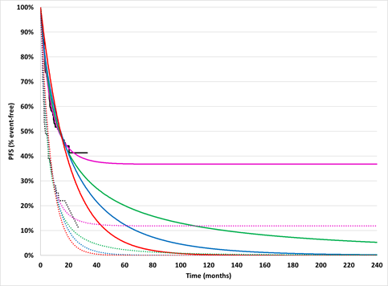 | 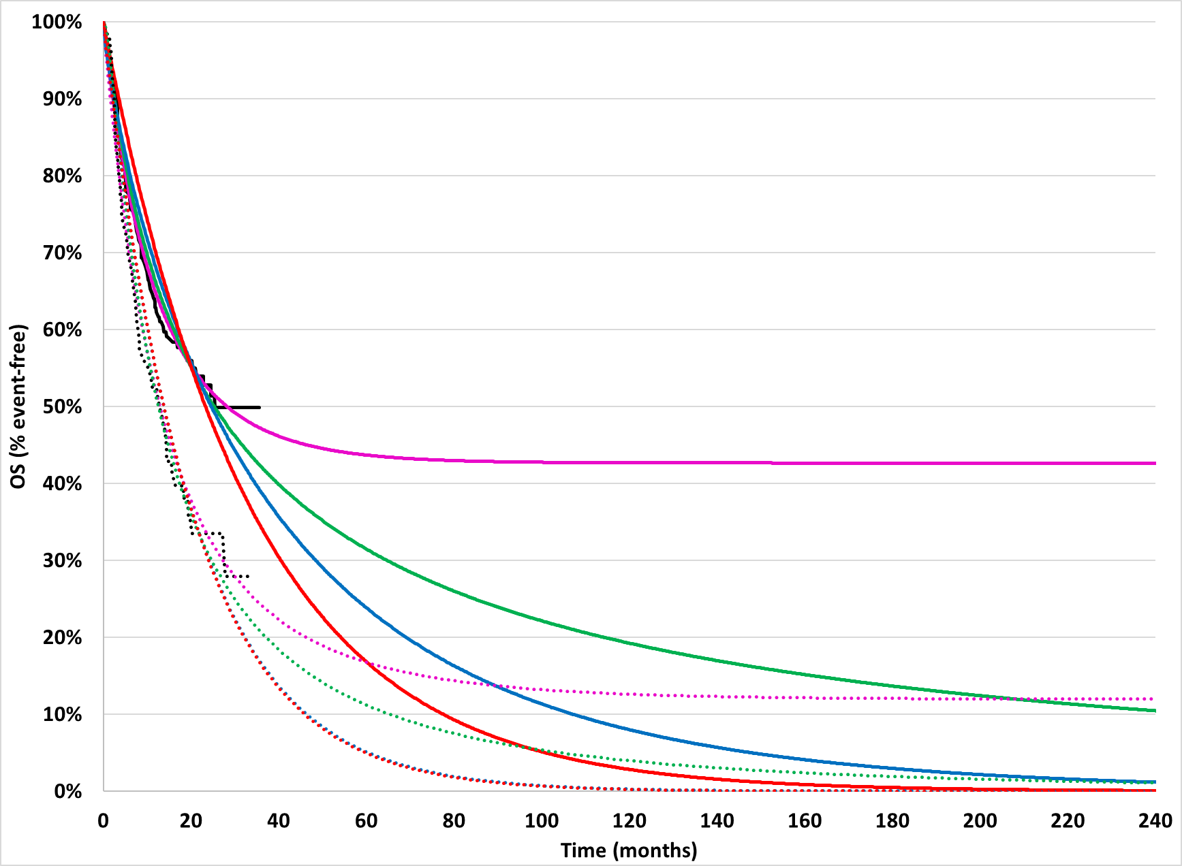
Source: Constructed during the evaluation from “Glofit-GemOx” and “R-GemOx” worksheets of the Economic Evaluation_glofit.xlsx.
Glofit-GemOx=glofitamab, gemcitabine and oxaliplatin; KM=Kaplan-Meier; OS=overall survival; PFS=progression-free survival; R-GemOx=rituximab, gemcitabine and oxaliplatin.
  - The submission’s approach for defining the KM data truncation point was poorly justified and produced unrealistic survival functions – regardless of the parametric function chosen – in the base case analysis (see Figure 4, panels A and B). Rather, it is common practice to use KM data until about 10% of patients remain at risk or another similar point, beyond which estimates become less reliable (more uncertain) due to data scarcity and high censoring. For a sensitivity analysis, the submission defined the truncation point based on the average follow-up on the combined treatment arms, which was likely more reliable (see Figure 4, panels C and D). However, it was also unclear why a common truncation point, based on the combined treatment arms, was necessary when there was much longer average follow-up for Glofit-GemOx compared to R-GemOx, especially for PFS (16.3 months in Glofit-GemOx versus 8.6 months in R- GemOx). An alternative sensitivity analysis was conducted during the evaluation, assuming different truncation points for each treatment arm based on the average follow-up of each arm reported in STARGLO (see Figure 4, panels E and F). The incremental cost effectiveness ratio (ICER) was sensitive to the assumed truncation points (see Table 13). The PSCR presented OS and PFS truncation time points calculated using the minimum n satisfying ‘Criterion 2’ from Gebski (2018) and the cut-off point of 10% of patients remaining at risk with the Pocock (2002) methodology. On review of the modelled survival functions using these two approaches to determining the OS and PFS truncation time points (Figures not presented) the ESC considered the application of the 10% rule using the Pocock (2002) methodology produced survival functions that were more clinically plausible than using the Gebski ‘Criterion 2’ methodology.
Figure 4: Extrapolation of PFS and OS for Glofit-GemOx and R-GemOx arms
PFS | OS
[A] Base case: Using maximum of shortest PFS KM curves (27.2 months) as truncation point | [B] Base case: Using Max of shortest OS KM curves (34.3 months) as truncation point
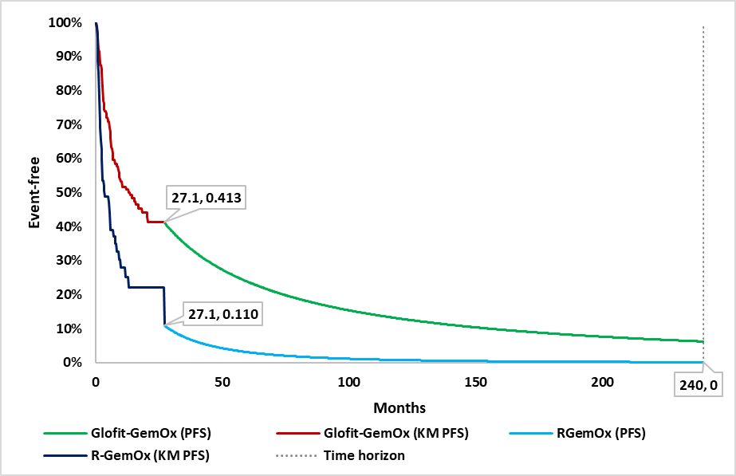 | 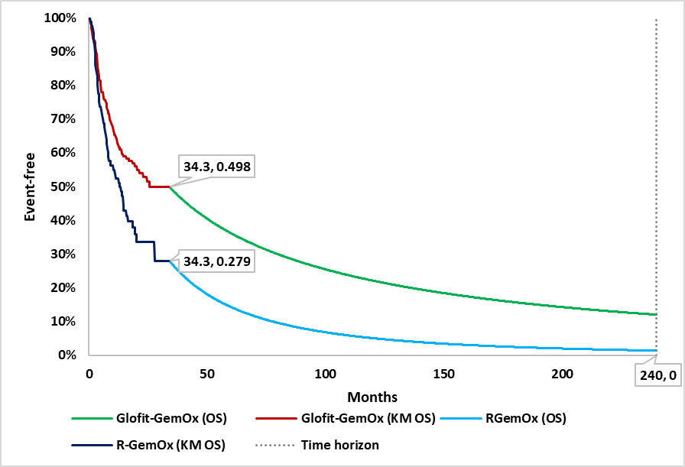
[C] Sensitivity analysis: Using overall mean follow-up of 15.7 months as truncation point (ICER increases by ||||%) | [D] Sensitivity analysis: Using mean follow-up of 20.7 months as truncation point (ICER increases by ||||%)
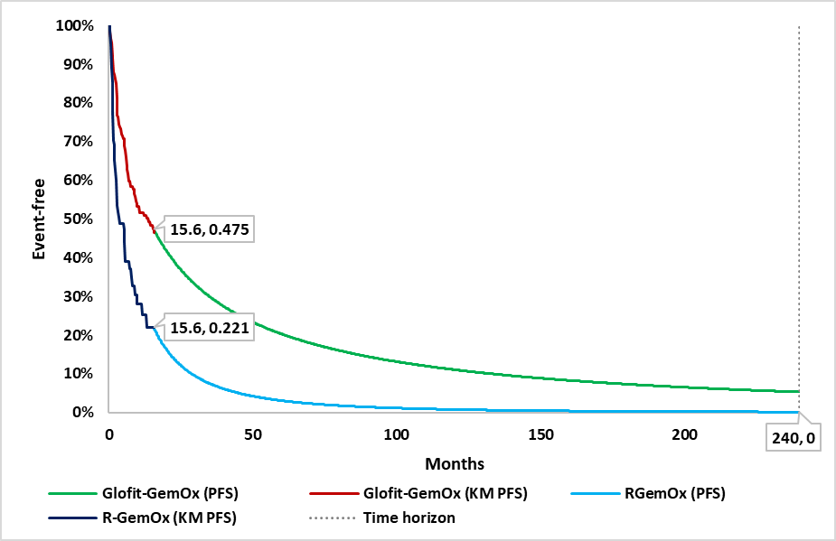 | 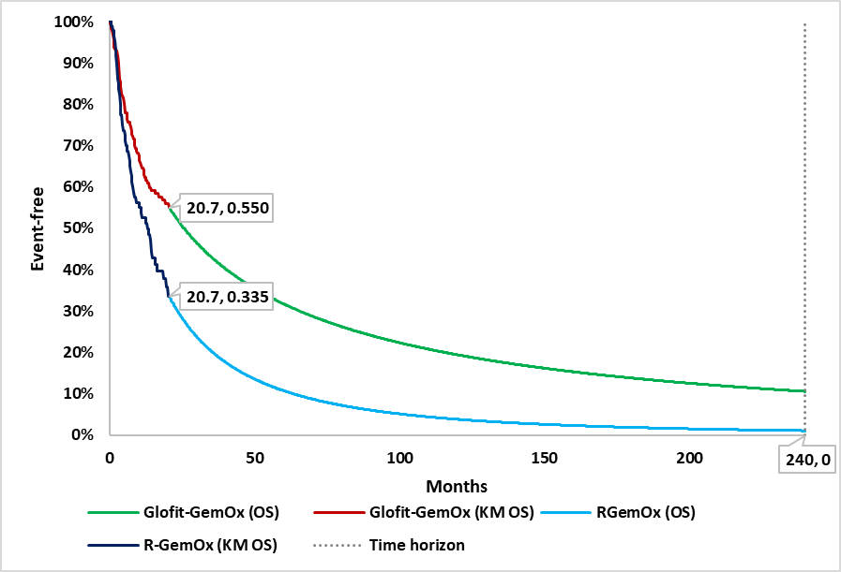
[E] Sensitivity analysis: Using treatment-specific mean follow-up of 16.3 months for Glofit-GemOx and 8.6 months for R-GemOx (ICER increases by ||||%) | [F] Sensitivity analysis: Using treatment-specific mean follow-up of 22.5 months for Glofit-GemOx and 19.7 months for R-GemOx (ICER increases by ||||%)
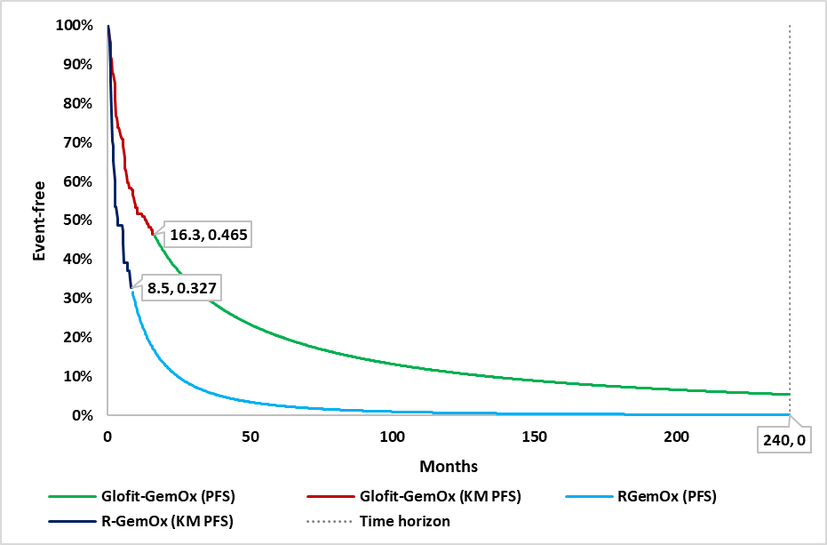 | 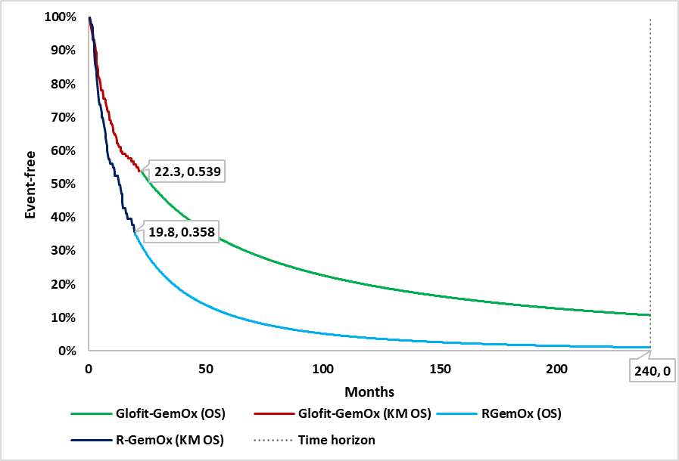
Source: Constructed during the evaluation from “Glofit-GemOx” and “R-GemOx” worksheets of the Economic Evaluation_glofit.xlsx.
Glofit-GemOx=glofitamab, gemcitabine and oxaliplatin; ICER=incremental cost-effectiveness ratio; KM=Kaplan-Meier; OS=overall survival; PFS=progression-free survival; R-GemOx=rituximab, gemcitabine and oxaliplatin

  - The proportion of patients in the PFS health state who were ‘on treatment’ and ‘off treatment’ in each cycle − for the purposes of applying different utility weights − was estimated from total time on treatment (TTOT) data at the start of each 7-day model cycle and PFS data in STARGLO (assuming PFS ‘on treatment’ could not exceed PFS). Treatment costs were calculated separately, based on the proportion of patients estimated to be on treatment at the start of each 21-day treatment-cycle in the model based on the TTOT data in STARGLO. Overall, the submission’s approach for determining when patients discontinued treatment was internally inconsistent and resulted in an underestimate in the time spent on treatment and costs assigned to treatment compared to STARGLO. Figure 5 illustrates the differences between (i) the proportion of patients in the PFS ‘on treatment’ health state in the model used to assign utilities (green line), (ii) the proportion of patients assigned treatment costs (for glofitamab and rituximab) at the start of each 21-day treatment cycle (red dots), and (iii) the KM data for TTOT reported in STARGLO (failure defined the day after their last dose).
- In estimating the proportion of patients in the PFS ‘on treatment’ health state each cycle, the submission multiplied the TTOT curve by the PFS curve, which appeared to be an error. Rather, the proportion of patients in PFS ‘on treatment’ should equal the TTOT curve given patients must have PFS to remain on treatment. This led to an underestimation of the proportion of patients in the PFS ‘on treatment’ health state; however, the model was not sensitive to this error given the utility weights for PFS ‘on treatment’ and PFS ‘off treatment’ were nearly identical and the average time on treatment was relatively short.
- In estimating the proportion of patients assigned treatment costs each 21-day treatment cycle, the submission appeared to obtain (‘read off’) values directly from the TTOT curve every 21 days, which ignored the patients who received delayed doses (the blue dot in between the red dots). As a consequence, the model estimated a lower mean number of treatment cycles per patient compared to STARGLO (refer to Table 10). There was also a minor programming error which delayed when the costs of Glofit-GemOx were applied by one model cycle (which is why the red dots and blue line do not perfectly align). The model was sensitive to the average number of glofitamab cycles in the Glofit-GemOx treatment regimen (see Table 13).
The PSCR acknowledged the internal inconsistency in determining when patients discontinued treatment to calculate costs and QALYs and provided a revised economic model. The PSCR stated the economic model was revised to explicitly determine patient discontinuation based on KM TTOT data. In addition, the PSCR stated that the model corrected errors in calculating the public/private split for rituximab and gemcitabine, in estimating the proportion of patients in the PFS ‘on treatment’ health state and the programming error which delayed when the costs of Glofit-GemOx were applied by one model cycle. The PSCR stated that the use of the KM curves for TTOT may slightly underestimate the mean if the KM data are immature or if conservative extrapolation methods are used. As such, the PSCR argued that modelled mean of 8.1 cycles compared to the trial-reported 8.5 cycles was reasonable. The ESC disagreed with the PSCR noting that all patients in the STARGLO trial had completed treatment and hence there should not be any differences in mean doses between the trial and model due to censoring or extrapolation.
Figure 5: TTOT KM, patients receiving treatment, and PFS ‘on treatment’ curve (model) for Glofit-GemOx and R-GemOx for the submission base case
[A] Glofitamab KM TTOT + modeled TTOT & PFS ‘on treatment’ | [B] Rituximab KM TTOT + modeled TTOT & PFS ‘on treatment’
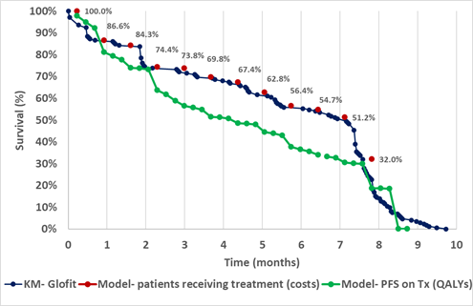 | 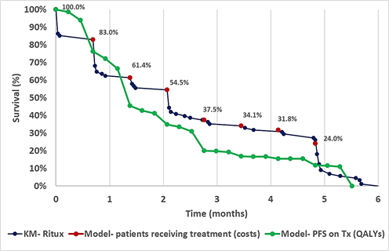
Source: Constructed during the evaluation using data from the STARGLO_statistical appendix.xlsx.
Glofit=glofitamab; KM=Kaplan-Meier; PFS=progression-free survival; R=rituximab; TTOT=total time on treatment.
Note: One data point (0, 100%) was added to the KM curves during graph construction to reflect that 100% of the exposed population received the treatment at time zero.
Table 10: Average treatment cycles in the submission model (used to assign costs) and reported in STARGLO
Treatment | Glofit-GemOx |  |  | R-GemOx
Treatment | Glofitamabª | Gemcitabine^{b} | Oxaliplatin^{c} | Rituximab^{d} | Gemcitabine^{b} | Oxaliplatin^{c}
Number of treatment cycles in the modelled economic evaluation
Mean | 8.1 | 5.9 | 5.8 | 4.3 | 3.9 | 3.6
Number of treatment cycles in STARGLO (DCO: 16 February 2024)
Mean | 8.5 | 6.3 | 6.2 | 4.4 | 4.4 | 4.4
Median | 11 | 8.0 | 8.0 | 4.0 | 4.0 | 4.0
Source: Compiled during the evaluation from “Patients receiving treatment” worksheet, Economic Evaluation_glofit.xlsx and Summary of Exposure, Safety-Evaluable Patients, STARGLO Updated CSR (DCO: 16 February 2024).
GemOx=gemcitabine + oxaliplatin; Glofit=glofitamab; R=rituximab.
ª Patients receive 12.5 mg of glofitamab in the first cycle (cost/cycle= $| |) and 30.0 mg from cycle 2-12 (cost/cycle= $| |).
^{b} Patients receive 1,783 mg of gemcitabine in cycles 1-8 (cost/cycle: $143).
^{c} Patients receive 178 mg of oxaliplatin in cycles 1-8 (cost/cycle: $149).
^{d} Patients receive 669 mg of rituximab in cycles 1-8 (cost/cycle: $149).
  - The submission estimated utility weights for the modelled health states from the EQ- 5D- 5L data reported in STARGLO ITT population, mapped to EQ-5D-3L index values based on Australian tariffs: PFS ‘on-treatment’ (0.716), PFS ‘off-treatment’ (0.713), and PD (0.630). The submission did not provide the EQ-5D-5L data or any further details of this analysis. It was unclear why the submission did not use the Australian value set for the EQ-5D-5L, noting that mapping from the EQ-5D-5L to the EQ-5D-3L can introduce a floor effect, potentially inflating utility values. The ESC advised that the EQ-5D-5L Australian value set should be applied. The results of the analysis also suggested no difference between quality of life for patients with PFS irrespective of treatment, contrary to expectations given the high incidence of TEAEs and likely administration-related utility decrements. This raises two questions. First, whether the findings reflected the true impact of immunochemotherapy on quality of life or whether results were impacted by study design / other factors (e.g., sensitivity issues with the EQ-5D-5L, small sample size, timing of measurements, etc). Second, if the findings are true, then it was unclear why it was necessary to add additional complexity to the model by splitting the PFS health state by ‘on treatment’ and ‘off treatment’ when treatment costs were assigned separately. Sensitivity analyses were conducted assuming alternative utility weights from the literature, which showed that the model was sensitive to the utility weights assumed (see Table 13). Given the uncertainty around treatment-related quality of life benefits, and the relatively minor difference between treatment arms, the ESC advised that adoption of a combined PFS health state in the model, with pooled utility values, would be more appropriate.
  - The economic model included costs for (i) drug costs for the index treatment (Glofit-GemOx and R-GemOx); (ii) associated premedication costs (including obinutuzumab costs); (iii) management of adverse events (including CRS and ICANS with Glofit-GemOx); (iv) monitoring while on treatment (CT scans, specialist visits, hematology and serum chemistry, blood chemistry and urinary test); (v) subsequent therapy costs (including CAR-T cell therapy, ASCT, radiotherapy, other systemic therapy, and bispecific monoclonal antibody therapy); and (vi) terminal care costs. The derivation of unit costs and average resource use was generally reasonable with the following exceptions:
- As described above, the submission’s approach to assigning drug costs for the index treatments based on TTOT data every 21-days underestimated the average cycles and hence treatment costs, in the model compared to the STARGLO trial (refer to Table 10). The ESC considered the STARGLO-reported mean TTOT (treatment cycles) should be used to calculate treatment costs for all components of both arms.
- The submission assumed (i) no G-CSF costs and (ii) no hospitalisation/monitoring for patients treated with Glofit-GemOx on the first infusion or for patients who experienced CRS from the previous treatment cycle at their next treatment administration. This differed from the STARGLO protocol (Protocol G041944, Version 4, Investigational Medicinal Products). The PBAC noted ||| |||.

- The submission costed subsequent treatments based on the proportional use in each treatment arm reported in STARGLO. This resulted in a considerable cost offset associated with reduced CAR-T therapies in the Glofit-GemOx arm. The evaluation considered the use of subsequent CAR-T reported in STARGLO may not translate to practice given the proposed place in therapy was for patients who are ineligible for ASCT and CAR-T. The evaluation noted the STARGLO trial did not exclude patients who were ineligible for CAR-T cell therapy and was conducted prior to recent changes to the clinical management algorithm related to the use of second-line CAR-T cell therapy. The ESC considered that if Glofit-GemOx was listed in the second-line setting in a ASCT and CAR-T cell therapy ineligible population it was foreseeable that some patients would still use CAR-T cell therapy in the third-line setting due to differences in CAR-T cell therapy eligibility in each treatment line. However, the ESC noted that there were uncertainties related to the cost of CAR-T cell therapy (assumed to equal $500,000 per patient). In addition, there are uncertainties regarding the assignment of subsequent treatment costs given the cohort model cannot accurately track when patients progress (the model costs were assigned based on a positive change in the proportion of patients in the PD health state, which is imprecise and may not provide a reliable estimate of the proportion of newly progressed patients in that interval). The ESC noted the model was highly sensitive to this assumption.
  - The submission did not provide any external validation of the model. Figure 6 was constructed during the evaluation, providing a comparison between OS and PFS in the R-GemOx treatment arm of the model with comparable patients with R/R DLBCL therapy in the Australia Lymphoma and Related Diseases Registry who initiated a second-line therapy (LaRDR, 2022 report) and those who initiated a third-line (paragraph 6.67, epcoritamab PSD, November 2024 PBAC Meeting).
Figure 6: R-GemOx survival curves (modelled in the submission base case) compared with observational data (LaRDR, 2022)
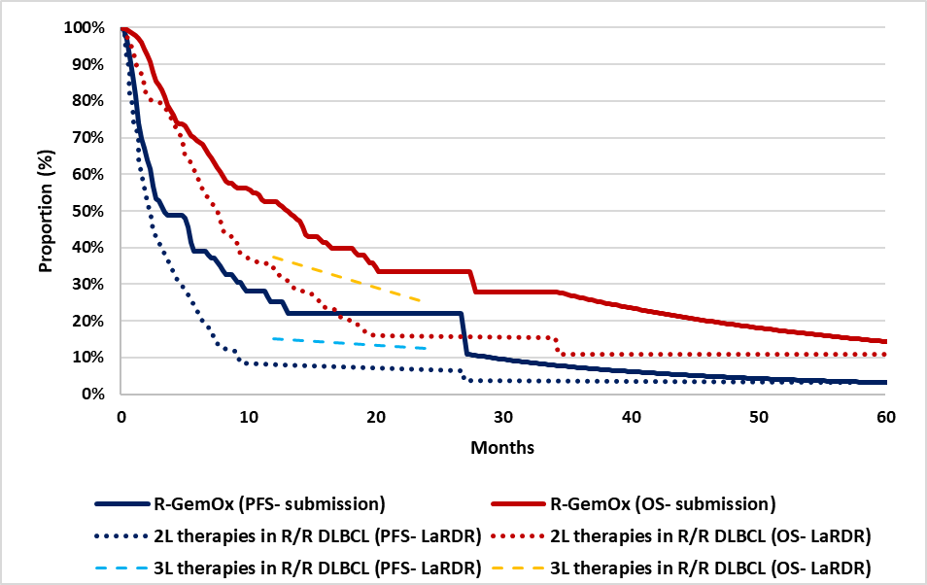 Source: Constructed during the evaluation from “Glofit-GemOx” and “R-GemOx” worksheets of the Economic Evaluation_glofit.xlsx and Australian Observational Study of the Management of Diffuse Large B-Cell Lymphoma Patients in First and Later Lines – 2 (ASTOUND-2)15th August 2022 for 2L, and data points reported in paragraph 6.67, epcoritamab PSD, November 2024 PBAC Meeting, for 3L.
2L=second line; 3L=third line; GemOx=gemcitabine + oxaliplatin; Glofit=glofitamab; R=rituximab; OS=overall survival; PFS=progression-free survival; R/R DLBCL=Relapse/Refractory Diffuse large B-cell lymphoma.
Note: 3L survival curves were generated using the data points reported in epcoritamab PSD: “Data provided by the Australian Lymphoma and Related Diseases Registry (Wellard et al., 2024) on progression-free survival from the commencement of third-line therapy indicated that approximately 15% of patients remain progression-free at 1 year and 12.5% at 2 years; with overall survival from the commencement of third-line therapy of 37.5% at 1 year and 25% at 2 years”.
  - Based on this comparison, both OS and PFS were longer in the model / STARGLO trial compared to similar patients in the Australia Lymphoma and Related Diseases Registry. However, these differences may be due to several factors, such as slight differences in the time-zero, the second-line therapies received, the patients included (e.g., characteristics) and the use of subsequent treatments. For example, the baseline in the model was the start of ‘second-line plus’ treatment in the STARGLO trial, compared to the start of second-line treatment or start of third-line treatment in the Australian registry. Similarly, all patients in the R-GemOx arm of the model received R- GemOx, whereas second-line treatments in the registry data included a mix of treatment (22% R-GemOx, 20% R-ICE, 8% R-CHOP21, 8% R-GDP, 42% other). There were also likely differences in terms of patients recruited into the STARGLO trial and patients treated in practice due to the selection criteria of the trial as well as potential differences in access to subsequent treatment. There were limited baseline data for comparison, but mean age was higher in the LaRDR registry data (68 years) compared to the STARGLO trial (65 years) and hence we might expect higher mortality rates in practice.
  - The key drivers of the model are reported in Table 11.
Table 11: Key drivers of the submission model base case
Description | Method/Value | Impact  Base case: $||||¹/QALY gained
Time horizon | The time horizon was 20 years extrapolated from the maximum PFS and OS follow-up in STARGLO. The proposed 20-year time horizon was generally reasonable based on the mean age of STARGLO (65 years); however, the mean age of patients with R/R DLBCL in the Australian LaRDR was slightly older at the start of second-line treatment (68 years). All else equal, this would suggest a shorter time horizon may be more reasonable for an Australian population. The ESC considered a 15-year time horizon would be more reasonable given the expected mean age of eligible patients. | High, favoured Glofit-GemOx. Applying a 15-year time horizon increased the ICER to $||||²per QALY (||||% increase).
Extrapolation approach | The analysis initially used KM data up to the shortest available KM curve, corresponding to 27.2 months for PFS and 34.3 months for OS. The ESC agreed with the evaluation that submission’s approach for defining the KM data truncation point, based on the maximum follow-up in the trial evidence for the treatment arm with the shortest follow-up period, was poorly justified and produced unrealistic survival functions. | High, favoured Glofit-GemOx. Applying treatment-specific mean follow-up times for PFS and OS as the truncation points increased the ICER to $||||²/QALY (||||% increase).
Treatment acquisition costs | Drug acquisition costs were calculated based on the proportion of use in each treatment cycle based on TTOT survival estimates from STARGLO. The model did not account for patients who may have received treatment between cycles, which could lead to an underestimation of the proportion of patients receiving treatment and consequently treatment costs. The average number of treatment cycles per patient in the glofitamab arm used in the submission was 8.1, compared to the mean and median treatment cycles of 8.5 and 11.0, respectively, reported in STARGLO. | High, favoured Glofit-GemOx. When assuming the mean and median treatment cycles reported in STARGLO (for all components of Glofit-GemOx and R-GemOx), the ICER to $||||² per QALY (||||% increase) and $||||³ per QALY (||||% increase), respectively.
Subsequent therapies | The ICER was highly sensitive to the cost of subsequent treatments, particularly CAR-T cell therapy, which was used by 13.2% of patients in the Glofit-GemOx arm and 4.4% in the R-GemOx arm. This was subjected to considerable uncertainty given (i) uncertainty about whether trial data on subsequent therapy use reflect current Australian practice, (ii) the lack of a verifiable CAR-T cost, (iii) the inclusion of subsequent treatment costs without corresponding benefit estimates, and (iv) the uncertainties regarding the methodology used in applying subsequent therapy costs as a positive increment to PD patient population in each cycle, which may not provide a reliable estimate of the newly progressed patients. As outlined in paragraph 6.43, the ESC advised it was foreseeable that some patients who may have been CAR-T cell therapy ineligible in the second-line setting may receive it in the third-line setting due to differences in eligibility at different treatment stages. The ESC noted that the PSCR argued that the proportions of 3L CAR-T cell therapy use in the STARGLO trial were appropriate estimates of likely Australian practice but considered that this remained a source of uncertainty. | High, favoured Glofit-GemOx. Excluding CAR-T costs increased the ICER to $||||³ per QALY (||||% increase).
Source: Compiled during the evaluation.
CAR-T=Chimeric antigen receptor T-cell; GemOx=gemcitabine+oxaliplatin; Glofit=glofitamab; ICER=incremental cost-effectiveness ratio; KM=Kaplan-Meier; QALY=quality adjusted life years; LaRDR=Lymphoma and Related Diseases Registry; OS=overall survival; PFS=progression-free survival; R=rituximab; R/R DLBCL=Relapse/Refractory Diffuse large B-cell lymphoma; TTOT=total time on treatment.
The redacted values correspond to the following ranges:
¹ $35,000 to < $45,000
² $45,000 to < $55,000
³ $55,000 to < $75,000
  - The base case results of the stepped economic evaluation are presented in Table 12.
Table 12: Results of the stepped economic evaluation (base case)
Parameter | Glofit-GemOx | R-GemOx | Incremental
Step 1: Trial-based evaluation
Incremental costs | $|||| | $3,378 | $||||
Incremental LYG | 1.460 | 1.182 | 0.278
Incremental QALYs | 1.022 | 0.806 | 0.216
Incremental cost/QALY |  |  | $||||¹
Step 2: Extrapolated economic evaluation
Incremental costs | $|||| | $3,378 | $||||
Incremental LYG | 4.356 | 2.156 | 2.200
Incremental QALYs | 3.005 | 1.438 | 1.567
Incremental cost/ QALY |  |  | $||||²
Step 3: Inclusion of MRU costs
Incremental costs | $|||| | $4,993 | $||||
Incremental LYG | 4.356 | 2.156 | 2.200
Incremental QALYs | 3.005 | 1.438 | 1.567
Incremental cost/ QALY |  |  | $||||²
Step 4: Inclusion of AE-related costs
Incremental costs | $|||| | $7,550 | $||||
Incremental LYG | 4.356 | 2.156 | 2.200
Incremental QALYs | 3.005 | 1.438 | 1.567
Incremental cost/ QALY |  |  | $||||²
Step 5: Inclusion of subsequent therapy costs
Incremental costs | $|||| | $49,705 | $||||
Incremental LYG | 4.356 | 2.156 | 2.200
Incremental QALYs | 3.005 | 1.438 | 1.567
Incremental cost/ QALY |  |  | $||||³
Step 6: Inclusion of end-of-life costs
Incremental costs | $|||| | $56,209 | $||||
Incremental LYG | 4.356 | 2.156 | 2.200
Incremental QALYs | 3.005 | 1.438 | 1.567
Incremental cost/ QALY |  |  | $||||³
Step 7: Incorporation of the proposed SPA rebate
Incremental costs | $|||| | $56,209 | ||||
Incremental LYG | 4.356 | 2.156 | 2.200
Incremental QALYs | 3.005 | 1.438 | 1.567
Incremental cost/ QALY |  |  | $||||⁴
Step 8: Inclusion of utilities (pseudo-step already applied in Steps 1-7)
Incremental costs | $|||| | $|||| | $||||
Incremental LYG | 4.356 | 2.156 | 2.200
Incremental QALYs | 3.005 | 1.438 | 1.567
Incremental cost/ QALY |  |  | $||||⁴
Source: Compiled during the evaluation from Table 3.33, p134, Table 3.34, p134, Table 3.35, p136, Table 3.36, p137, Table 3.37, p137, Table 3.38, p137, Table 3.39, p138, Table 3.40, p138, and Table 3.41, p139 of the submission.
AE=adverse event; GemOx=gemcitabine + oxaliplatin; Glofit=glofitamab; LYG=life years gained; MRU=medical resource use; QALY=quality adjusted life years; R=rituximab; SPA=special pricing arrangement.
The redacted values correspond to the following ranges:
¹ $555,000 to < $655,000
² $75,000 to < $95,000
³ $55,000 to < $75,000
⁴ $35,000 to < $45,000

  - The base case ICER was $35,000 to < $45,000per QALY gained (refer to the CIC for the ICER based on the effective price of epcoritamab). Life-years and QALY gains were largely attributed to prolonging the time patients remained in the PFS health state in the Glofit-GemOx treatment arm. Additionally, the main contributors to incremental costs were drug acquisition and subsequent therapy cost offsets (driven by subsequent CAR-T cell therapy).
  - Table 13 presents key sensitivity analyses presented in the submission and additional analyses conducted during the evaluation including multivariate analyses.
Table 13: Results of model sensitivity analyses
Analyses | Incremental cost | Incremental QALY | ICER | % Change
Base case | $|||| | 1.567 | $||||¹ | -
Time horizon (base case 20 years)
- 15 years | $|||| | 1.389 | $||||² | ||||%
Discount rates (base case 5%)
- 0% | $|||| | 2.282 | $||||³ | -||||%
- 3.5% | $|||| | 1.739 | $||||¹ | -||||%
Extrapolations (base case log-normal PFS and OS)
- Log-logistic extrapolation for PFS | $|||| | 1.559 | $||||¹ | ||||%
- Weibull extrapolation for PFS | $|||| | 1.509 | $||||² | ||||%
- Log-logistic extrapolation for OS | $|||| | 1.415 | $||||² | ||||%
- Weibull extrapolation for OS | $|||| | 1.190 | $||||⁴ | ||||0%
- Log-logistic extrapolation of PFS and OS | $|||| | 1.407 | $||||² | ||||5%
- Weibull extrapolation of PFS and OS | $|||| | 1.132 | $||||⁴ | ||||%
- Exponential extrapolation of PFS and OS | $|||| | 0.801 | $||||⁵ | ||||%
Time points for Kaplan-Meier truncation (base case: maximum follow-up in shortest arm)
- Mean overall follow-up for PFS (15.7) & OS (20.7) | $|||| | 1.489 | $||||² | ||||%
- Mean overall follow-up for PFS (15.7) | $|||| | 1.548 | $||||² | ||||%
- Mean treatment-specific follow-up for PFS (16.3 for Glofit-GemOx and 8.6 months for R-GemOx) | $|||| | 1.554 | $||||² | ||||%
- Mean overall follow-up for OS (20.7) | $|||| | 1.508 | $||||² | ||||%
- Mean treatment-specific follow-up for OS (22.5 for Glofit-GemOx and 19.7 months for R-GemOx) | $|||| | 1.517 | $||||² | ||||%
Utility (base case, PFS-on treatment: 0.716, PFS-off treatment: 0.713, PD: 0.630)
- NICE, 2020 : PFS-on treatment: 0.720, PFS-off treatment: 0.650, PD: 0.630 | $|||| | 1.448 | $||||² | ||||%
- NICE, 2018 , : PFS-on treatment: 0.720, PFS-off treatment: 0.680, PD: 0.650 | $|||| | 1.506 | $||||² | ||||%
- Roth, 2018 : PFS-on treatment: 0.720, PFS-off treatment: 0.650, PD: 0.630 | $|||| | 1.675 | $||||¹ | -||||6%
- Wang 2018 EQ-5D-5L: PFS-on treatment: 0.630, PFS-off treatment: 0.760, PD: 0.710 | $|||| | 1.648 | $||||¹ | -||||%
- Wang 2018 EQ-5D-3L: PFS-on treatment: 0.530, PFS-off treatment: 0.640, PD: 0.390 | $|||| | 1.370 | $||||² | ||||%
- MSAC 2024 EQ-5D-5L: PFS-on treatment: 0.883, PFS-off treatment: 0.891, PD: 0.818. | $|||| | 1.954 | $||||¹ | -||||1%
Glofitamab cycles of treatment (base case: 8.13 ª)
- Using mean TTD for glofit (8.5) | $|||| | 1.567 | $||||² | ||||%
- Using median TTD for glofit (11) | $|||| | 1.567 | $||||⁴ | ||||%
CAR-T cost (base case: $500,000)
- $300,000 CAR-T | $|||| | 1.567 | $||||² | ||||%
- $700,000 CAR-T | $|||| | 1.567 | $||||¹ | -||||%
- Excluding CAR-T as a subsequent treatment, and redistributing the STARGLO CAR-T users to other subsequent treatment arms | $|||| | 1.567 | $||||⁴ | ||||%
Source: Compiled during the evaluation from Table 3.42, p140, Table 3.43, p141, Table 3.44, p141, Table 3.45, p141, Table 3.46 and 3.47, p142, Table 3.48, p142, and Table 3.49, p143 of the submission.
CAR-T=Chimeric antigen receptor T-cell; GemOx=gemcitabine + oxaliplatin; Glofit=glofitamab; ICER=incremental cost-effectiveness ratio; LYG=life years gained; OS=overall survival; PFS=progression-free survival; PD=progressive disease; QALY=quality adjusted life years; R=rituximab; TTOT=total time on treatment.
ª The number of glofitamab treatment cycles in the model was calculated using the reported, hard coded, proportions for glofitamab use in the “Patients receiving treatment” worksheet in the Economic Evauation_glofit.xlsx file.
The redacted values correspond to the following ranges:
¹ $35,000 to < $45,000
² $45,000 to < $55,000
³ $25,000 to < $35,000
⁴ $55,000 to < $75,000
⁵ $75,000 to < $95,000
  - As outlined in paragraph 6.41, the PSCR provided a revised economic model that corrected the internal inconsistency in determining when patients discontinued treatment to calculate costs and QALYs and a small number of errors. The revised economic model also removed the half-cycle correction. The revised economic model provided in the PSCR decreased the ICER from $35,000 to < $45,000per QALY gained to $35,000 to < $45,000per QALY gained (See Table 14).

Table 14 PSCR revised base case and sensitivity analyses
 | Incremental cost ($) | Incremental QALY | ICER | % Change
Submission’s base case | || || | 1.567 | || ||¹ | Base
i) submission’s base case + removed half-cycle correction | || || | 1.566 | || ||¹ | -|| ||%
ii) i + fixed programming error regarding the delayed costs for glofitamab | || || | 1.566 | || ||¹ | -|| ||%
iii) ii+ fixed error in public/private split in calculating the price of rituximab and gemcitabine in PFS state | || || | 1.566 | || ||¹ | -|| ||%
iv) iii + consistent use of TTOT KM data for estimating QALYs (on-treatment) | || || | 1.588 | || ||¹ | -|| ||%
v) iv + fixed error in public/private split in calculating the price of subsequent therapies (ifosfamide, etoposide, gemcitabine and rituximab) | || || | 1.588 | || ||¹ | -|| ||
PSCR base case | || || | 1.588 | || ||¹ | Base
Univariate sensitivity analysis
Time horizon: 15 years | || || | 1.410 | || ||² | || ||%
Time horizon: 10 years | || || | 1.121 | || ||³ | || ||%
Mean treatment-specific follow-up (STARGLO) truncation points for PFS/OS | || || | 1.525 | || ||² | || ||%
Gebski criteria 2 treatment specific, as truncation points for PFS/OS | || || | 1.580 | || ||¹ | || ||8%
10% treatment specific, as truncation points for PFS/OS | || || | 1.569 | || ||² | || ||%
KM until shortest of maximum follow-up + Weibull extrapolation tail | || || | 1.153 | || ||³ | || ||%
KM until Pocock’s rule 10% (treatment specific) + Weibull extrapolation tail | || || | 1.144 | || ||³ | || ||%
One utility for PFS (on-treatment = off-treatment = 0.713) | || || | 1.587 | || ||¹ | || ||%
One utility for PFS (on-treatment = off-treatment = 0.716) | || || | 1.594 | || ||¹ | || ||%
Excluding CAR-T & redistributing patients to other subsequent treatments | || || | 1.588 | || ||³ | || ||%
Reducing CAR-T cost to $300,000 | || || | 1.588 | || ||² | || ||%
Multivariate sensitivity analysis (MVSA)
MVSA 1: ESC-requested MVSA
i) 10% rule criteria (treatment-specific), as truncation points for PFS and OS | || || | 1.569 | || ||² | || ||%
ii) i + using the STARGLO-reported mean total time on treatment (treatment cycles) to calculate treatment costs for all components in both arms | || || | 1.569 | || ||² | || ||%
iii) ii + Combine PFS health states with a pooled utility value (utility of ‘on-treatment’ = ‘off-treatment’ = 0.713) | || || | 1.569 | || ||² | || ||%
iv) iii + 15-year time horizon | || || | 1.405 | || ||³ | || ||%
v) iv + use of Weibull extrapolation for PFS and OS | || || | 1.114 | || ||³ | || ||%
MVSA 2:  MVSA 1 +  setting CAR-T costs to $300,000 | || || | 1.114 | || ||⁴ | || ||%
MVSA 3:  MVSA 1 +  exclusion of CAR-T costs | || || | 1.114 | || ||⁴ | || ||%
MVSA 5:  MVSA 1 +  exclusion of CAR-T costs +  PFS and OS extrapolation functions back to Log-normal | || || | 1.405 | || ||³ | || ||%
MVSA 6:  MVSA 1 +  20 year time horizon | || || | 1.144 | || ||³ | || ||%
The redacted values correspond to the following ranges:
¹ $35,000 to < $45,000
² $45,000 to < $55,000
³ $55,000 to < $75,000
⁴ $75,000 to < $95,000

  - The ESC accepted the corrections made in the revised economic model provided in the PSCR. However, the ESC considered that additional changes to the economic model were required and proposed a revised base case that incorporated the following:
- a 15-year time horizon;
- application of the 10% rule using the Pocock (2002) methodology to determine treatment specific truncation points for PFS and OS;
- use of the STARGLO-reported mean TTOT (treatment cycles) to calculate treatment costs for all components of both arms;
- combining of the PFS health states with a pooled utility value (utility of ‘on treatment’ = ‘off treatment’ = 0.713)
- use of Weibull extrapolation for PFS and OS.
The ESC noted that the revised base case increased the ICER provided in the PSCR from $35,000 to < $45,000per QALY gained to $55,000 to < $75,000 per QALY gained. The ESC also noted that if the cost of CAR-T was reduced from $500,000 to $300,000 the ICER would increase further to $75,000 to < $95,000per QALY gained.
  - The pre-PBAC response accepted the ESC proposal to combine the PFS health states with a pooled utility value. However, the pre-PBAC response argued that the Gebski (2018) approach should be used in preference to the application of the 10% rule for OS and PFS truncation points, that the log-normal extrapolation demonstrated a better visual and statistical fit to the observed STARGLO trial data for both OS and PFS compared to the Weibull model, and that the modelled mean of 8.1 cycles should be used to calculate treatment costs. In addition, the pre-PBAC response reiterated its previous arguments (see paragraph 6.37) that a 20-year time horizon was appropriate. As such, the pre-PBAC response provided a revised economic model which maintained a 20-year time horizon, a log-normal extrapolation and modelled TTOT, but incorporated truncation points as determined by the Gebski (2018) methodology and adopted a pooled utility value of 0.713 for the PFS health states. The pre-PBAC response noted that the revised economic model resulted in an ICER of $35,000 to < $45,000per QALY gained.
  - In addition to the modelled economic evaluation, the submission presented a cost-comparison of Glofit-GemOx versus epcoritamab (to mimic the third-line setting) as a supplementary analysis (Table 15). The analysis assumed patients would receive 12 cycles of Glofit-GemOx (i.e., the maximum treatment duration) and 16 cycles of epcoritamab (the average treatment duration, estimated using PFS rates from EPCORE NHL-1 at 12- and 24-month follow-ups). The unit costs for Glofit-GemOx were consistent with the modelled economic evaluation (i.e., the proposed effective price), whereas the unit cost for epcoritamab (i.e., estimated effective price) was estimated assuming a 20% discount applied to the proposed published price in the epcoritamab PSD (paragraph 3.1, epcoritamab PSD, November 2024 PBAC Meeting). The submission concluded that Glofit-GemOx would result in a 45% cost savings compared to epcoritamab, based on the estimated-effective price of epcoritamab, for the treatment of 3L R/R DLBCL patients (see Table 15).

Table 15: Cost comparison, including the cost of obinutuzumab and administration (weighted average DPMQ/DPMA)
Item | Glofit-GemOx [12 cycles] |  | Epcoritamab [16 cycles]
Item | Proposed published price | Proposed effective price | Proposed published price ª | Estimated- effective price ª
Drug acquisition cost per course | $188,382.77 | $|||| | $275,431.00 | $221,086.86
Difference in drug cost per course (Glofit-GemOx vs epcoritamab) |  |  | -$||||  (-||||%) | -$||||  (-||||%)
Source: Table 2.7, p19 pf Supp Appendix and compiled during the evaluation.
Glofit-GemOx=glofitamab + gemcitabine + oxaliplatin.
ª The submission i) derived the published prices (DPMQs) from the epcoritamab PSD (paragraph 3.1, epcoritamab PSD, November 2024 PBAC meeting), ii) estimated the published AEMPs, and iii) assumed a 20% SPA to estimate the effective price. The estimated published AEMPs were $769.23 and $9,230.77 for 4mg and 48mg vials, respectively. The estimated effective AEMPs were $615.38 and $7,384.62 for 4mg and 48mg vials, respectively.
  - The cost analysis presented in the submission inappropriately excluded several relevant costs, including pre-treatment costs for obinutuzumab recommended in the Glofit-GemOx treatment regimen, other pre-medications costs for both treatments (i.e., methylprednisolone, acetaminophen/paracetamol, and diphenhydramine), as well as costs related to the administration of antineoplastic agents and patient monitoring. However, accounting for these additional costs may not have a considerable impact on the results, given that the additional cost of pre-treatment with obinutuzumab would be offset (at least partially) by lower administration costs (14 administrations with Glofit-GemOx versus 31 with epcoritamab), and other premedication costs are relatively inexpensive.

Glofit-GemOx cost/patient/course
  - The recommended dose of glofitamab is 2.5 mg (1x 2.5 mg vial) on Day 8 in Treatment Cycle 1, 10 mg (1x 10 mg vial) on Day 15 in Treatment Cycle 1, and 30 mg (3x 10 mg vials) on Day 1 in Treatment Cycles 2 to 12. Based on the proposed effective EMP of glofitamab, the average cost per administration is shown in Table 16.
Table 16: Drug acquisition cost of glofitamab (at effective prices)
Dose/ schedule | 2.5 mg vial (Cycle 1 Day 8) |  | 10 mg vial (Cycle 1 Day 15) |  | 3 x 10 mg vial (Cycle 2-12)
Hospital setting | Public | Private | Public | Private | Public | Private
Proposed ex-manufacturer price | $|||| |  | $|||| |  | $||||
Fees and mark-ups | $90.13 | $149.55 | $90.13 | $193.78 | $90.13 | $311.74^{g}
Dispensed price | $|||| | $|||| | $|||| | $|||| | $|||| | $||||
Proportion supplied | 33.91% | 66.09% | 33.91% | 66.09% | 33.91% | 66.09%
Average weighted cost / administration | $|||| |  | $|||| |  | $||||
Source: Table 3.14, p122 of the submission.
  - Table 17 outlines the drug cost per patient for Glofit-GemOx and R-GemOx across the model and the financial estimates. The economic model and financial estimates aligned on the cost per patient per treatment cycle but differed in the mean number of treatment cycles initiated. The economic model derived a mean number of treatment cycles from TTOT data (which was lower than the trial-reported mean; see Table 10), whereas the financial estimates applied the maximum number of treatment cycles specified in the Product Information.
Table 17: Drug cost per patient for Glofit-GemOx and R-GemOx (based on effective prices)
Treatment | Glofit-GemOx |  |  | R-GemOx
Treatment | Trial | Model | Financials | Trial | Model | Financials
Mean dose | Glofitamab, Cycle 1: 12.5 mg and Cycles 2-12: 30 mg  Gemcitabine, Cycles 1-8: 1000 mg/m², 1,783 mg/ admin (1× 2000 mg vial)  Oxaliplatin, Cycles 1-8: 100 mg/m², 178 mg/admin (1× 200 mg vial) |  | Glofitamab, Cycle 1: 12.5 mg and  Cycles 2-12: 30 mg | Rituximab, Cycles 1-8: 375 mg/m², 669 mg/admin (2×100 mg+ 1×500mg vial)  Gemcitabine, Cycles 1-8: 1000 mg/m², 1,783 mg/ admin (1× 2000 mg vial)  Oxaliplatin, Cycles 1-8: 100 mg/m², 178 mg/admin (1× 200 mg vial) |  | Rituximab, Cycles 1-8: 375 mg/m², 669 mg/admin (2×100 mg+ 1×500mg vial)
Mean duration (number of treatment cycles) | 8.5 | 8.1 | 12.0 | 4.4 | 4.3 | 8.0
Compliance rate | 100% | 100% | 100% | 100% | 100% | 100%
Cost/patient/cycle (in a three-weekly cycle) ª | NR | Glofitamab, Cycle 1: $||||  Glofitamab, Cycles 2-12: $||||  Gemcitabine: $143.43 ^{b}  Oxaliplatin: $149.29  Total costs, first Cycle: $||||  Total costs, subsequent cycles (with GemOx): $||||  Total costs, subsequent cycles (without GemOx): $|||| |  | NR | Rituximab: $409.80 ^{c}  Gemcitabine: $143.43 ^{b}  Oxaliplatin: $149.29  Total costs in Cycles 1-8: $702.52
Cost/patient/course | NR | Glofitamab: $||||  Gemcitabine: $841.48  Oxaliplatin: $868.36  Total: $|||| ^{d} | Glofitamab: $||||  Gemcitabine: $1,147.48  Oxaliplatin: $1,194.30  Total: $|||| ^{e} | NR | Rituximab: $1,746.90  Gemcitabine: $564.97  Oxaliplatin: $536.61  Total: $2,848.68 ^{d} | Rituximab: $3,278.41  Gemcitabine: $1,147.48  Oxaliplatin: $1,194.30  Total: $5,620.20 ^{e}
Source: compiled during the evaluation.
GemOx=gemcitabine + oxaliplatin; Glofit=glofitamab; NA=not applicable, NR=not reported; R=rituximab.
ª Assuming 100% of patients receive 100% of the administered dose.
^{b} The public and private shares of rituximab prescriptions were 34.78% and 65.22%, respectively. An error was identified during the evaluation: the submission had incorrectly reversed these shares, assigning the public share to private and vice versa. As a result, the value of $409.80 was incorrectly calculated and applied in the base case. The correct value was $424.69.
^{c} The public and private shares of gemcitabine prescriptions were 32.22% and 67.78%, respectively. An error was identified during the evaluation: the submission had incorrectly reversed these shares, assigning the public share to private and vice versa. As a result, the value of $143.43 was incorrectly calculated and applied in the base case. The correct value was $159.52.
^{d} This was compiled from the 'Results' worksheet of Economic Evaluation_glofit.xlsx and calculated by applying the proportion of patients receiving each treatment in each cycle (see Figure 5, red dots).
^{e} This estimate was based on the maximum number of treatment cycles per arm and the cost per patient per cycle, assuming all patients received the full dose in each cycle.

Estimated PBS usage & financial implications
  - This submission was not considered by DUSC.
  - The submission estimated the financial implications of the proposed listing using an epidemiological approach, including only incident patients, given the aggressive nature of DLBCL (i.e., relatively short duration from diagnosis to first-line treatment).
  - Table 18 summarises the calculation of the number of patients likely to receive Glofit-GemOx, number of scripts dispensed, and costs to the PBS/RPBS.
Table 18: Data sources and parameter values applied in the utilisation and financial estimates
Data | Value | Comment
Eligible population
NHL | Source: AIHW cancer data, 2024 | Appropriate.
  Yr | 2025 | 2026 | 2027 | 2028 | 2029 | 2030
   | 6,967 | 7,156 | 7,351 | 7,546 | 7,719 | 7,893
DLBCL | 35%, sourced from AIHW CDiA, 2024 (assuming constant rates from 2011-2020) | Potential overestimate. DUSC had previously advised that DLBCL account for 25% - 35% of NHL (para 6.49, polatuzumab PSD, Nov. 2022 PBAC meeting). The PSCR noted that the PBAC accepted this input in its March 2025 considerations of polatuzumab vedotin (para 7.13, polatuzumab vedotin Minutes, March 2025 PBAC meeting).
% fit to receive 1L | 96%, sourced from Sponsor’s market research | Potential overestimate, as other studies reported lower proportions (Bair et al., 2023: 86%, and Morrison et al., 2020: 61.8%). The PBAC previously recommended 82% as the proportion of DLBCL patients who were fit enough for 1L treatment (para 6.49, polatuzumab PSD, Nov. 2022 PBAC meeting). The PSCR (Table 4) noted that the 82% utilised in the polatuzumab vedotin Nov 2022 evaluation was specific to the proportion of 1L patients who receive R-CHOP. The PSCR stated that extremely few Australian patients would not receive 1L therapy of any kind following a diagnosis of DLBCL.
% R/R DLBCL post 1L | 40%, estimated from the literature: Tan et al, 2024 [reporting 30%-40%] and Sarkozy & Sehn 2018 [reporting 40%] . | The share of R/R patients was reported to be 30%-40% in Tan 2024 study and was consistent with Sarkozy 2018. The lower interval was used in the sensitivity analysis.
% ineligible/ unsuitable for 2L ASCT/ CAR-T | 50%, estimated from the literature. Metis; Sehn & Salles 2021 (reporting 50%); Friedberg 2011 (reporting 50%) | Potential underestimate, given the references only included ineligibility for ASCT whereas the parameter refers to the proportion ineligible for ASCT/CAR-T. Estimates for the proportion of patients who were ineligible for CAR-T varies across the literature, e.g. 62% in ZUMA-1, 32-63% in Sarkozy. The PSCR (Table 4) stated that, in the absence of market data, an upper limit of 60% may be reasonable.
% fit to receive 2L chemotherapy / immunotherapy │ineligible/unsuitable for 2L ASCT/CAR-T | 89%, sourced from Sponsor’s market research | The source could not be verified.
% requiring 3L treatment, post 2L ASCT/ CAR-T | 40%, estimated from the literature: Westin, 2022. | Potential overestimate. Could not be verified from the cited reference. The cited reference (Figure 2) indicated 28-38% of patients post ASCT/CAR-T were not cured. The PSCR (Table 4) stated it was reasonable to assume that all patients who are not cured following ASCT/CAR-T cell therapy would require further treatment. The PSCR noted that whether a patient is sufficiently fit to proceed to treatment is considered in the next step.
% fit to receive 3L chemotherapy/ immunotherapy │ 2L ASCT/CAR-T | 53%, estimated from the literature: Kanas 2021. | The estimate from Kanas 2021 was not conditional on prior ASCT/ CAR-T.
Grandfathered patients | |||| ¹ grandfather patients requiring continuing prescriptions from treatment cycle 2 onwards, assumed. | Grandfathered patients were estimated as ||||% of 2025 incident population in 2L (i.e., ||||¹) and 3L (i.e., 10¹). This was uncertain and subject to double-counting.
Treatment utilisation
Uptake rate (2L, 3L) | Uptake of ||||% to ||||% in 6 years of listing, assumed due to the significant OS benefits. | The submission assumed the same uptake rates for patients receiving 2L and 3L therapy, which may not be reasonable. Uptake rate in grandfathered patient was assumed to be ||||%.
Affected patients in other lines of therapy, with the uptake of Glofit-GemOx in 2L and 3L | In 2L, for 1 patient treated with glofitamab:  – 1 less treated with 2L rituximab,  – 0.165 less treated with 3L epcoritamab,  – 1 treated with obinutuzumab.  In 3L, for 1 patient treated with glofitamab:  – 1 less treated with 3L epcoritamab,  – 1 patient treated with obinutuzumab. | The submission assumed, based on STARGLO, that using Glofit-GemOx in 2L would substitute rituximab (2L) 1:1 and result in less use of epcoritamab (3L) 1:0.165. This was appropriate.
Scripts/units dispensed
Glofitamab 2.5mg and 10mg vials | The submission assumed all patients would complete 12 cycles of glofitamab at recommended doses: 1 × 2.5 mg vial + 1 × 10 mg vial + 11 × 3 × 10 mg vial), and did not cost GemOx separately, claiming that no change was expected compared to R-GemOx. | Assuming all patients received 12 cycles of glofitamab likely overestimated its per-patient cost, as STARGLO patients averaged 8.5 cycles. However, excluding GemOx costs likely underestimated glofitamab listing costs because (1) cost offsets were overestimated due to fewer GemOx doses in the R-GemOx arm, and (2) Glofit- GemOx does not replace R-GemOx in third-line treatment. The ESC considered the average number of glofitamab cycles from the STARGLO trial should be used (i.e. 8.5 cycles).
Affected medicines | R-GemOx: patients were assumed to need 8 cycles of rituximab (8 × 500 mg and 16 × 100 mg vials), with no GemOx included. Epcoritamab: patients were assumed to need 16 cycles of treatment (2 × 4 mg and 29 × 48 mg vials of epcoritamab). | GemOx component was not costed and assumed to be unchanged in the financial analysis. This was not appropriate and may have led to underestimation of the incremental cost of GemOx, as stated above.
PBS/RPBS Costs
Glofitamab (DPMQ- public/private weighted) | 2.5mg: effective: $||||  10 mg: effective: $|||| | Consistent with the economic analysis. The proportion dispensed in public and private settings were 34.78% to 65.22%, based on rituximab scripts.
Affected medicines (DPMQ- public/private weighted) | – Obinutuzumab: $4,687.05  – Rituximab100 mg/ 10ml: $424.71  – Epcoritamab 4 mg, estimated effective: $611.40  – Epcoritamab 48 mg, estimated effective: $6,024.85 | Overall consistent with the economic analysis, except for epcoritamab, where estimated effective price was 20% lower in the financial estimates compared to the economic evaluation. The financial estimates were sensitive to this difference.
MBS Costs
Administration and follow up specialist consultation | MBS items 13950 and 105, 80% benefit was assumed. | Whether savings to the health budget associated with fewer consultations would be realised in practice is uncertain.
Other Costs (Health Budget, NHRA-HST Fund)
CAR-T | It was assumed that for 1 patient treated with glofitamab in 2L, 0.088 less patients will be treated with 3L CAR-T.  The cost was assumed to be $500,000 per patient (based on Lymphoma Australia ) | The evaluation considered whether 2L Glofit- GemOx would lead to reduced 3L CAR-T was highly uncertain, given patients treated with 2L Glofit- GemOx were assumed to be CAR-T ineligible patients in the financial estimates. Additionally, the assumed CAR-T price was uncertain.
Source: compiled during the evaluation based on pp.200-211 of the submission.
1L=first line; 2L=second line; ASCT=autologous stem cell transplant; CAR-T=Chimeric antigen receptor T-cell; DLBCL= Diffuse large B-cell lymphoma; Elig.=eligible; GemOx=gemcitabine + oxaliplatin; Glofit=glofitamab; MBS=Medicare Benefits Schedule; PBS=Pharmaceutical Benefits Scheme; R/R=Relapse/Refractory; SPA=special pricing arrangement; Yr=year. │=conditional on.
The redacted values correspond to the following ranges:
¹ < 500

  - Table 19 summarises the estimated net financial implications to the PBS/RPBS and the MBS for the proposed listing of Glofit-GemOx over the first six years (assumed as 2025 to 2030). As outlined in Table 18, the financial implications outlined in Table 19 use an estimated effective price for epcoritamab.
Table 19: Estimated use and financial implications
 | 2025 | 2026 | 2027 | 2028 | 2029 | 2030 | Total
Estimation of number of patients (2L R/R DLBCL, ineligible for ASCT/CAR-T and 3L R/R DLBCL, after ASCT/CAR-T)
Eligible patients | ||||¹ | ||||¹ | ||||¹ | ||||¹ | ||||¹ | ||||¹ | ||||¹
Second-line | ||||² | ||||² | ||||² | ||||² | ||||² | ||||² | ||||¹
Third-line | ||||² | ||||² | ||||² | ||||² | ||||² | ||||² | ||||¹
Treated patients | ||||² | ||||¹ | ||||¹ | ||||¹ | ||||¹ | ||||¹ | ||||¹ + ||||²
Second-line | ||||² | ||||² | ||||² | ||||² | ||||² | ||||² | ||||¹
Third-line | ||||² | ||||² | ||||² | ||||² | ||||² | ||||² | ||||¹
GF (patient-year) | ||||² | ||||² | ||||² | ||||² | ||||² | ||||² | ||||²
Total scripts dispensed
Glofitamab, PBS/RPBS scripts | ||||³ | ||||³ | ||||³ | ||||³ | ||||³ | ||||³ | ||||⁴
PBS | ||||³ | ||||³ | ||||³ | ||||³ | ||||³ | ||||³ | ||||⁴
RPBS | ||||² | ||||² | ||||² | ||||² | ||||² | ||||² | ||||¹
Glofitamab cost to PBS/RPBS
Glofitamab, cost to PBS/RPBS | ||||⁵ | ||||⁵ | ||||⁵ | ||||⁶ | ||||⁶ | ||||⁶ | ||||⁷
PBS | ||||⁵ | ||||⁵ | ||||⁵ | ||||⁵ | ||||⁶ | ||||⁶ | ||||⁷
RPBS | ||||⁸ | ||||⁸ | ||||⁸ | ||||⁸ | ||||⁸ | ||||⁸ | ||||⁸
Estimation of changes in use and financial impact of currently listed treatments (PBS/RPBS)
Other meds, cost to PBS/RPBS | ||||⁹ | ||||⁹ | ||||⁹ | ||||⁹ | ||||⁹ | ||||⁹ | ||||⁹
Obinutuzumab | ||||⁸ | ||||⁸ | ||||⁸ | ||||⁸ | ||||⁸ | ||||⁸ | ||||¹⁰
Rituximab | ||||⁹ | ||||⁹ | ||||⁹ | ||||⁹ | ||||⁹ | ||||⁹ | ||||⁹
Epcoritamab | ||||⁹ | ||||⁹ | ||||⁹ | ||||⁹ | ||||⁹ | ||||⁹ | ||||⁹
Estimated financial implications for the PBS/RPBS and the health budget
Net cost to PBS/RPBS | ||||¹¹ | ||||¹¹ | ||||¹¹ | ||||¹² | ||||¹² | ||||¹² | ||||¹³
PBS | ||||¹¹ | ||||¹¹ | ||||¹¹ | ||||¹¹ | ||||¹² | ||||¹² | ||||¹³
RPBS | ||||⁸ | ||||⁸ | ||||⁸ | ||||⁸ | ||||⁸ | ||||⁸ | ||||⁸
Net cost to MBS | ||||⁸ | ||||⁸ | ||||⁸ | ||||⁸ | ||||⁸ | ||||⁸ | ||||⁸
Administration | ||||⁸ | ||||⁸ | ||||⁸ | ||||⁸ | ||||⁸ | ||||⁸ | ||||⁸
Consultations | ||||⁸ | ||||⁸ | ||||⁸ | ||||⁸ | ||||⁸ | ||||⁸ | ||||⁸
Net cost to PBS/RPBS/MBS | ||||¹¹ | ||||¹¹ | ||||¹¹ | ||||¹² | ||||¹² | ||||¹² | ||||¹³
Estimated financial implications including other costs (CAR-T)
CAR-T, net cost to NHRA HST | ||||⁹ | ||||⁹ | ||||⁹ | ||||⁹ | ||||⁹ | ||||⁹ | ||||⁹
Net cost to PBS/RPBS/MBS/HST | ||||¹⁴ | ||||¹⁵ | ||||¹⁴ | ||||¹⁴ | ||||¹⁴ | ||||¹⁴ | ||||¹⁶
Source: Compiled during the evaluation based on pp153-171 of the submission.
2L=second line; 3L=third line; CAR-T=Chimeric antigen receptor T-cell; DLBCL=Diffuse large B-cell lymphoma; GemOx=gemcitabine + oxaliplatin; GF=grandfathered patients, Glofit=glofitamab; HST= highly specialised therapies; MBS=Medicare Benefits Schedule; med=medicine; NHRA= National Health Reform Agreement; PBS=Pharmaceutical Benefits Scheme; R/R=Relapse/Refractory; SPA=special pricing arrangement.
ª Glofitamab in combination with GemOx was assumed to be listed on the PBS/RPBS with an ‘Authority Required – Telephone/Online’ restriction. The same restriction applied to obinutuzumab and epcoritamab, while no restriction was assumed for rituximab.
The redacted values correspond to the following ranges:
¹ 500 to < 5,000
² < 500
³ 5,000 to < 10,000
⁴ 40,000 to < 50,000
⁵ $70 million to < $80 million
⁶ $80 million to < $90 million
⁷ $400 million to < $500 million
⁸ $0 to < $10 million
⁹ net cost saving
¹⁰ $10 million to < $20 million
¹¹ $40 million to < $50 million
¹² $50 million to < $60 million
¹³ $200 million to < $300 million
¹⁴ $30 million to < $40 million
¹⁵ $20 million to < $30 million
¹⁶ $100 million to < $200 million
  - The net cost to the PBS/RPBS was $40 million to < $50 million in Year 1 increasing to $50 million to < $60 million in Year 6, a total of $200 million to < $300 million over the first six years of listing of glofitamab (in combination with gemcitabine and oxaliplatin) in 2L and 3L of R/R DLBCL. The submission also estimated cost-offsets to the health budget associated with a reduction in CAR-T, which was highly uncertain and should not be included when considering the financial impact on the PBS/RPBS and MBS.
  - The net cost to the PBS/RPBS presented in the submission was uncertain, as some parameters may have overestimated the costs while others may have underestimated the costs. Overall, the evaluation considered the net cost was likely overestimated:
- The submission may have overestimated the proportion of patients with DLBCL, the proportion of patients fit for receiving first line therapy, and the proportion of patients who are R/R after first line therapy. The ESC accepted the PSCR argument outlined in Table 18 that the proportion of patients with DLBCL and the proportion of patients fit for receiving first line therapy were appropriate. The ESC noted a lower interval for the proportion of patients who are R/R after first line therapy was tested in a sensitivity analysis.
- The submission may have underestimated the proportion of patients who were ineligible for ASCT/CAR-T (used to estimate patient numbers in both 2L and 3L). The PSCR (Table 4) stated that, in the absence of market data, an upper limit of 60% may be reasonable.
- The cost of glofitamab treatment may have been overestimated, as it was based on the maximum number of cycles (12), rather than the median (11) or mean (8.5) number of cycles reported in STARGLO. The ESC considered the mean number of glofitamab cycles from the STARGLO trial should be used to estimate the cost of treatment.
- The submission underestimated the incremental cost of GemOx with the proposed listing of Glofit-GemOx (i.e., the submission assumed no change in GemOx), given patients treated with Glofit-GemOx received substantially more cycles of GemOx compared to patients treated with R-GemOx in STARGLO, and the submission inappropriately ignored the incremental use of GemOx with Glofit-GemOx when substituting for epcoritamab (monotherapy) in the third-line setting.
  - The PBAC noted ||| ||| (see paragraph 2.2). The PBAC noted the first dose of Glofit-GemOx would not be PBS-subsidised if it was administered to an in-patient in a public hospital setting and considered that the financial estimates should be amended accordingly ||| |||

Quality Use of Medicines
  - The submission stated that given the associated risks, such as CRS and neurotoxicity (ICANS), the Sponsor has implemented a range of measures to support safe use. These include a Risk Management Plan (RMP) with patient cards provided to healthcare professionals, educational partnerships with leading institutions like Peter MacCallum Cancer Centre, ongoing nurse training webinars, and a practical CRS management guide developed with expert input. These resources are available both online and in print to assist healthcare professionals in safely administering glofitamab.

Financial Management – Risk Sharing Arrangements
  - The submission indicated that the Sponsor is willing to enter into a risk sharing arrangement with the Department of Health in the form of expenditure caps aligned to the eligible population (transplant-ineligible R/R DLBCL after ≥ 1 prior systemic therapy) if deemed necessary by the PBAC.
For more detail on PBAC’s view, see section 7 PBAC outcome.
- PBAC Outcome
  - The PBAC recommended the Section 100 Efficient Funding of Chemotherapy, Authority Required (Telephone/Online) listing of glofitamab, in combination with gemcitabine plus oxaliplatin (Glofit-GemOx), for the treatment of patients with relapsed or refractory diffuse large B-cell lymphoma (DLBCL) after one or more lines of systemic therapy and who are unable to receive autologous stem cell transplant (ASCT) or chimeric antigen receptor T-cell (CAR-T) cell therapy. In making this recommendation, the PBAC acknowledged there was an unmet clinical need for the proposed patient population. The PBAC was satisfied that Glofit-GemOx provides, for some patients, a significant improvement in efficacy, both in terms of overall survival (OS) and progression-free survival (PFS) over rituximab in combination with gemcitabine plus oxaliplatin (R-GemOx). The PBAC considered the listing would be cost effective with a price reduction to achieve an ICER of up to $55,000 to < $75,000 per QALY gained, based on a revised economic model using inputs suggested by the ESC and a 20-year model time horizon. The PBAC considered a risk sharing arrangement would be appropriate to address any residual uncertainty regarding estimated patient numbers.
  - The PBAC noted the input from health care professionals, Rare Cancers Australia, Leukaemia Foundation, Lymphoma Australia and the Australasian Leukaemia and Lymphoma group supporting the listing. The PBAC noted the input highlighted the need for additional treatment options for patients who are not suitable for ASCT and ineligible or can’t access CAR-T cell therapy.
  - With regard to the proposed restriction, the PBAC advised that:
- An Authority Required (Telephone/Online PBS Authorities system) listing was appropriate for the initial, continuing and grandfathering treatment listings of glofitamab.
- The maximum amounts should be specified in micrograms (see paragraph 3.4).
- The initial treatment restriction should be divided into two prescriptions with no repeats to accommodate the variance in dosing in Cycle 1 (see paragraph 3.3). The continuing treatment restriction should be amended to have 10 repeats to allow the remaining doses from Cycle 2 to Cycle 12 to be provided.
- Clinical criterion stating that the ‘Patient must be currently unable to receive treatment with chimeric antigen receptor-T (CAR-T) cell therapy for this condition’ should be included in the initial and grandfathering treatment restrictions to clarify the intended eligible patient population.
- The clinical criterion specifying that ‘Patient must have relapsed or become refractory to at least one prior systemic therapy’ should be removed (see paragraph 3.7).
- Given the Advisory Committee on Medicines (ACM) advice that ||| ||| (see paragraph 2.2), the following prescribing instruction ‘This drug is not PBS-subsidised if it is administered to an in-patient in a public hospital setting’ should be included in the Initial treatment (cycle 1 – day 8) restriction.
- Clinical criteria should be included in the glofitamab restrictions to allow for de-escalation where appropriate of one or both chemotherapy components.
- Clinical criterion specifying patients must not have developed disease progression should be included in the continuing and grandfathering treatment restrictions.
- A grandfathering restriction would be required for patients currently accessing glofitamab through an existing access program.
- An Authority Required (Streamlined) Section 100 Efficient Funding of Chemotherapy listing was appropriate for the ‘Pre-treatment prior to initiation of glofitamab’ listing of obinutuzumab as the risk of use outside of the intended indication was low.
- Flow on changes to the current epcoritamab listing would be required to exclude use after second-line glofitamab.
  - The PBAC considered that amendment of the proposed restriction to include reference to CAR-T cell therapy suitability clarified the intended eligible PBS population and agreed with the ESC that R-GemOx as the main comparator was appropriate.
  - The PBAC noted the submission was supported by the STARGLO trial, a Phase III randomised, open label trial comparing Glofit-GemOx with R-GemOx. The PBAC noted concerns raised during the evaluation that patient in the comparator arm of STARGLO (R-GemOx administered over 21-day cycles) received a lower dose of R-GemOx than recommended in Australian guidelines (R-GemOx administered over 14-day cycles). The PBAC agreed with the ESC and ACM that tolerability issues meant that 21-day R-GemOx cycles were common in Australian clinical practice (see paragraph 2.2 and 5.1) and considered that it was unlikely that there was any practical difference between 21-day and 14-day cycles in this instance. In addition, the Committee noted that the ACM held the view that the efficacy data from the intention-to-treat analyses of the STARGLO trial were adequate to support use in the Australian population.
  - The PBAC noted the results of the STARGLO trial showed Glofit-GemOx was associated with improved outcomes in terms of OS and PFS over R-GemOx. The PBAC noted that, consistent with the primary analysis, the updated analysis (February 15, 2024 data cut) reported a statistically significant reduction in the risk of death (stratified HR=0.62, 95% CI: 0.43, 0.88) and risk of progression (stratified HR=0.40, 95% CI: 0.28, 0.57). The PBAC noted that at the updated analysis, the absolute difference in OS at 24 months was 19.2% (95% CI: 5.38, 33.05) and in PFS at 24 months was 19.2% (95% CI: 4.69, 33.8). The PBAC considered the STARGLO results were both statistically and clinically significant and therefore the claim of superior comparative effectiveness to R-GemOx was adequately supported.
  - With respect to the claim of non-inferior comparative safety, the PBAC considered this was not supported as the Glofit-GemOx arm of the STARGLO trial showed an increased risk of cytokine release syndrome (44.2% in the Glofit-GemOx arm vs 0% in the R-GemOx arm) and serious infections (22.7% vs 12.5%), as well as numerically higher rates of severe adverse events (AEs) and Grade 3-5 AEs. The PBAC agreed with the ESC that the comparative safety of Glofit-GemOx was inferior to R-GemOx.
  - The submission presented a cost-utility analysis comparing Glofit-GemOx versus R-GemOx with the base case reporting an ICER of $35,000 to < $45,000per QALY gained. The PBAC noted the PSCR provided a revised economic model that removed the half-cycle correction and addressed a small number of errors (see paragraph 6.50). The PBAC noted the ESC accepted the PSCR amendments but considered additional changes were required to the economic model.
  - The PBAC noted the ESC provided a revised base case that, in addition to the PSCR economic model changes, incorporated: combining PFS health states with a pooled utility value; application of the 10% rule using the Pocock (2002) methodology to determine treatment specific truncation points for PFS and OS; use of the STARGLO-reported mean total time on treatment (TTOT) for treatment costs; use of the Weibull extrapolation for PFS and OS; and a 15-year time horizon (see paragraph 6.51). The PBAC noted that the ESC revised base case increased the ICER to $55,000 to < $75,000 per QALY gained or $75,000 to < $95,000 per QALY gained when the cost of CAR-T cell therapy was assumed to be $500,000 or $300,000 respectively. The PBAC noted the pre-PBAC response accepted combining the PFS health states with a pooled utility value but the pre-PBAC response argued against the remaining changes proposed by the ESC. The PBAC did not accept the pre-PBAC response proposal to use the Gebski (2018) approach to determine truncation points, noting ESC advice that application of the 10% rule produced survival functions that were more clinically plausible (see paragraph 6.40). The PBAC also agreed with the ESC that the use of the STARGLO-reported mean TOTT was appropriate given all patients in the trial had completed treatment, and that the use of the more conservative Weibull function for both PFS and OS should be incorporated (see paragraphs 6.39 and 6.41). However, the PBAC did accept the pre-PBAC argument that a 20-year time horizon would be appropriate and considered this was reasonable in the context of the use of the more conservative extrapolation function. In addition, the PBAC noted that this would be consistent with that accepted for epcoritamab for 3L relapsed or refractory DLBCL (paragraph 7.9, epcoritamab PSD, November 2024 PBAC meeting).
  - Overall, the PBAC accepted a revised economic model using the inputs proposed by the ESC and a 20-year model time horizon. The PBAC advised that the effective price for epcoritamab and the estimated average cost for CAR-T cell therapy should be included in the economic model. The PBAC considered that glofitamab would be acceptably cost effective under these parameters at an ICER of up to $55,000 to < $75,000 per QALY, and noted that a price reduction from that requested in the submission would be required.
  - In terms of the financial estimates, the PBAC accepted the PSCR proposal to increase the proportion of patients who were ineligible/unsuitable for ASCT or CAR-T cell therapy from 50% to 60%. The PBAC also agreed with the ESC that the cost of treatment should be based on the mean number of glofitamab cycles from the STARGLO trial and that GemOx costs should be included in the estimates (see paragraph 6.62). The PBAC noted the first dose of Glofit-GemOx would not be PBS-subsidised if it was administered to an in-patient in a public hospital setting and considered that the financial estimates should be amended accordingly. The PBAC advised that once updated with these amendments, with the outcome of the price reduction in paragraph 7.10 incorporated, it would be reasonable to accept the financial estimates as the basis of a risk sharing arrangement.
  - While accepting the financial estimates, the PBAC considered some uncertainty remained regarding the size of the population who are ineligible/unsuitable for ASCT or CAR-T cell therapy given such decisions are a matter of clinical decision-making. The PBAC considered a risk sharing arrangement would be appropriate to address any residual uncertainty regarding estimated patient numbers. The PBAC considered a rebate of less than ||| |||% for use above the expenditure caps may be appropriate, however any rebate would need to require the sponsor to rebate the majority of the cost of use outside of the defined risk sharing arrangement cap to mitigate the potential impact to the Commonwealth.
  - The PBAC advised that glofitamab should not be treated as interchangeable with any other drugs.
  - The PBAC advised that glofitamab is not suitable for prescribing by nurse practitioners.
  - The PBAC recommended that the Early Supply Rule should not apply.
  - The PBAC found that the criteria prescribed by the National Health (Pharmaceuticals and Vaccines – Cost Recovery) Regulations 2022 for Pricing Pathway A were not met. Specifically, the PBAC found that in the circumstances of its recommendation for glofitamab:
  - The treatment is expected to provide a substantial and clinically relevant improvement in efficacy, over alternative therapies, on the basis of the results of the STARGLO trial;
  - The treatment is not expected to address a high and urgent unmet clinical need, as while the PBAC acknowledged there was an unmet need it was not considered high and urgent due to the availability of other therapies;
  - It was not necessary to make a finding in relation to whether it would be in the public interest for the subsequent pricing application to be progressed under Pricing Pathway A because one or more of the preceding tests had failed.
  - The PBAC advised that this submission would not be eligible for an Independent Review as it received a positive recommendation.
Outcome:
Recommended
- Recommended listing
  - Add new item:

Obinutuzumab – single pre-treatment dose
MEDICINAL PRODUCT  Form |  | PBS item code | Max. Amount | №.of Rpts
OBINUTUZUMAB  Injection |  | NEW (Public)  NEW (Private) | 1000 mg | 0
Available brands
Gazyva
obinutuzumab 1 g/40 mL injection, 40 mL vial
Concept ID (for internal Dept. use) | Category / Program: Section 100 – Efficient Funding of Chemotherapy Public/Private hospitals
Concept ID (for internal Dept. use) | Prescriber type: Medical Practitioners
Concept ID (for internal Dept. use) | Restriction type: Authority Required (Streamlined)
 | Episodicity: [blank]
 | Severity: Relapsed or refractory
 | Condition: Diffuse large b-cell lymphoma (DLBCL)
Restriction Summary [new1] / Treatment of Concept: [new1A]
 | Indication: Relapsed or refractory Diffuse large b-cell lymphoma (DLBCL)
 | Treatment Phase: Pre-treatment prior to initiation of glofitamab
 | Clinical criteria:
 | Patient must be eligible to receive treatment under the PBS listing criteria for glofitamab.
Prescribing Instructions:
Patient is intended to receive a single dose of Obinutuzumab 1000 mg 7 days prior to initiating glofitamab treatment (Cycle 1 Day 1).

Initial – Cycle 1, Day 8
MEDICINAL PRODUCT  Form |  | PBS item code | Max. Amount | №.of Rpts
GLOFITAMAB  Injection |  | NEW (Public)  NEW (Private) | 2,500 mcg | 0
Available brands
Columvi
Glofitamab 2.5 mg injection, 1 vial
Restriction Summary [new2] / Treatment of Concept: [new2A]
Concept ID (for internal Dept. use) | Category / Program: Section 100 – Efficient Funding of Chemotherapy Public/Private hospitals
Concept ID (for internal Dept. use) | Prescriber type: Medical Practitioners
Concept ID (for internal Dept. use) | Restriction type: Authority Required (telephone/online PBS Authorities system)
 | Episodicity: [blank]
 | Severity: Relapsed or refractory
 | Condition: Diffuse large b-cell lymphoma (DLBCL)
 | Indication: Relapsed or refractory Diffuse large b-cell lymphoma (DLBCL)
 | Treatment Phase: Initial treatment (cycle 1 – day 8)
 | Clinical criteria:
 | Patient must be currently unable to receive treatment with CAR-T cell therapy for this condition.
 | AND
 | Clinical criteria:
 | Patient must be unsuitable for stem cell transplant.
 | AND
 | Clinical criteria:
 | Patient must have a WHO performance status of 2 or less.
 | AND
 | Clinical criteria:
 | Patient must have received or intend to receive a single pre-treatment dose of obinutuzumab for this indication
 | AND
 | Clinical criteria:
 | The treatment must be given in combination with gemcitabine and oxaliplatin for the first 8 cycles unless the patient develops a toxicity necessitating treatment discontinuation
Prescribing Instructions:
Definition of patients unable to receive treatment with CAR-T cell therapy for this condition include geographical, psychosocial, clinical ineligibility or urgency.
Prescribing Instructions:
Glofitamab should be administered as an intravenous infusion according to the dose step-up schedule in cycle 1 (2.5 mg on Day 8 and 10 mg on Day 15) leading to the recommended dosage of 30 mg on Day 1 of cycles 2-12. Refer to the TGA approved Product information.
Prescribing Instructions:
This drug is not PBS-subsidised if it is administered to an in-patient in a public hospital setting.
 | Administrative Advice: No increase in the maximum amount or number of units may be authorised.
 | Administrative Advice: No increase in the maximum number of repeats may be authorised.
 | Administrative Advice: Special Pricing Arrangements apply.
 | Administrative Advice: Applications for authorisation under this restriction may be made in real time using the Online PBS Authorities system (see www.servicesaustralia.gov.au/HPOS) or by telephone by contacting Services Australia on 1800 888 333.

Initial – Cycle 1, Day 15
MEDICINAL PRODUCT  Form |  | PBS item code | Max. Amount | №.of Rpts
GLOFITAMAB  Injection |  | NEW (Public)  NEW (Private) | 10,000 mcg | 0
Available brands
Columvi
Glofitamab 10 mg injection, 1 vial
Restriction Summary [new3] / Treatment of Concept: [new3A]
Concept ID (for internal Dept. use) | Category / Program: Section 100 – Efficient Funding of Chemotherapy Public/Private hospitals
Concept ID (for internal Dept. use) | Prescriber type: Medical Practitioners
Concept ID (for internal Dept. use) | Restriction type: Authority Required (telephone/online PBS Authorities system)
 | Episodicity: [blank]
 | Severity: Relapsed or refractory
 | Condition: Diffuse large b-cell lymphoma (DLBCL)
 | Indication: Relapsed or refractory Diffuse large b-cell lymphoma (DLBCL)
 | Treatment Phase: Initial treatment (cycle 1 – day 15)
 | Clinical criteria:
 | Patient must be currently unable to receive treatment with CAR-T cell therapy for this condition.
 | AND
 | Clinical criteria:
 | Patient must be unsuitable for stem cell transplant.
 | AND
 | Clinical criteria:
 | Patient must have a WHO performance status of 2 or less.
 | AND
 | Clinical criteria:
 | Patient must have received or intend to receive a cycle 1 – day 8 dose of glofitamab for this indication.
 | AND
 | Clinical criteria:
 | The treatment is intended to be given in combination with gemcitabine and oxaliplatin for the first 8 cycles unless the patient develops a toxicity necessitating treatment discontinuation.
Prescribing Instructions:
Glofitamab should be administered as an intravenous infusion according to the dose step-up schedule in cycle 1 (2.5 mg on Day 8 and 10 mg on Day 15) leading to the recommended dosage of 30 mg on Day 1 of cycles 2-12. Refer to the TGA approved Product information.
 | Administrative Advice: No increase in the maximum amount or number of units may be authorised.
 | Administrative Advice: No increase in the maximum number of repeats may be authorised.
 | Administrative Advice: Special Pricing Arrangements apply.
 | Administrative Advice: Applications for authorisation under this restriction may be made in real time using the Online PBS Authorities system (see www.servicesaustralia.gov.au/HPOS) or by telephone by contacting Services Australia on 1800 888 333.

Continuing (cycles 2-12)
MEDICINAL PRODUCT  Form |  |  | PBS item code | Max. Amount | №.of Rpts
GLOFITAMAB  Injection |  |  | NEW (Public)  NEW (Private) | 30,000 mcg | 10
Available brands
Columvi
Glofitamab 10 mg injection, 1 vial
Concept ID (for internal Dept. use) |  | Category / Program: Section 100 – Efficient Funding of Chemotherapy Public/Private hospitals
 |  | Prescriber type: Medical Practitioners
 |  | Restriction type: Authority Required (telephone/online PBS Authorities system)
 |  | Episodicity: [blank]
 |  | Severity: Relapsed or refractory
 |  | Condition: Diffuse large b-cell lymphoma (DLBCL)
Restriction Summary [new4] / Treatment of Concept: [new4A]
 |  | Indication: Relapsed or refractory Diffuse large b-cell lymphoma (DLBCL)
 |  | Treatment Phase: Continuing treatment (cycles 2-12)
 |  | Clinical criteria:
 |  | Patient must have previously received PBS-subsidised treatment with this drug for this condition.
 |  | AND
 |  | Clinical criteria:
 |  | The treatment must be in combination with gemcitabine and oxaliplatin for the first 8 cycles unless the patient develops a toxicity necessitating treatment discontinuation.
 |  | AND
 |  | Clinical criteria:
 |  | Patient must not have developed disease progression while being treated with this drug for this condition.
 |  | Clinical criteria:
 |  | The treatment must not exceed a total of 12 cycles of this drug for this indication, regardless of whether treatment was non-PBS or PBS-subsidised
 |  | Administrative Advice: Applications for authorisation under this restriction may be made in real time using the Online PBS Authorities system (see www.servicesaustralia.gov.au/HPOS) or by telephone by contacting Services Australia on 1800 888 333.
 |  | Administrative Advice: No increase in the maximum amount or number of units may be authorised.
 |  | Administrative Advice: No increase in the maximum number of repeats may be authorised.
 |  | Administrative Advice: Special Pricing Arrangements apply.

Grandfather
Restriction Summary [new5] / Treatment of Concept: [new5A]
Indication: Relapsed or refractory Diffuse large b-cell lymphoma (DLBCL)
Treatment Phase: Grandfathering treatment
Clinical criteria:
Patient must have received non-PBS subsidised treatment with this drug for this PBS condition prior to [PBS listing date].
AND
Clinical criteria:
Patient must have been unable to receive treatment with CAR-T cell therapy prior to commencing treatment with this drug for this condition.
AND
Clinical criteria:
Patient must have been unsuitable for stem cell transplant prior to commencing treatment with this drug for this condition.
AND
Clinical criteria:
Patient must have had a WHO performance status of 2 or less prior to commencing treatment with this drug for this condition.
AND
Clinical criteria:
Patient must not have developed disease progression while being treated with this drug for this condition.
AND
Clinical criteria:
The treatment must be given in combination with gemcitabine and oxaliplatinin for the first 8 cycles unless the patient develops a toxicity necessitating treatment discontinuation
AND
Clinical criteria:
The treatment must not exceed a total of 12 cycles of this drug for this condition, regardless of whether treatment was non-PBS or PBS-subsidised
Administrative Advice: Patients may qualify for PBS-subsidised treatment under this restriction once only. For continuing PBS-subsidised treatment, a 'Grandfathered' patient must qualify under the 'Continuing treatment' criteria.
Administrative Advice: This grandfather restriction will cease to operate from 12 months after the date specified in the clinical criteria.
Administrative Advice: No increase in the maximum amount or number of units may be authorised.
Administrative Advice: No increase in the maximum number of repeats may be authorised.
Administrative Advice: Special Pricing Arrangements apply.
Administrative Advice: Applications for authorisation under this restriction may be made in real time using the Online PBS Authorities system (see www.servicesaustralia.gov.au/HPOS) or by telephone by contacting Services Australia on 1800 888 333.

Epcoritamab flow-on changes
Suggested additions are in italics and deletions are in strikethrough.
MEDICINAL PRODUCT  medicinal product pack |  | PBS item code | Max. qty packs | Max. qty units | №.of  Rpts | Available brands
EPCORITAMAB
epcoritamab 4 mg/0.8 mL injection, 0.8 mL vial |  | 14803D (CT) | 1 | 1 | 1 | Epkinly
epcoritamab 4 mg/0.8 mL injection, 0.8 mL vial |  | 14792M (GE) | 1 | 1 | 1 | Epkinly
Restriction Summary 16467 / Treatment of Concept: 16405
Concept ID (for internal Dept. use) | Category / Program:  Section 100 – Efficient Funding of Chemotherapy – Related Benefits (Code CT)  General Schedule (Code GE)
Concept ID (for internal Dept. use) | Prescriber type: Medical Practitioners
Concept ID (for internal Dept. use) | Benefit type: Authority Required (immediate assessment): Telephone/Online
 | Indication: Relapsed or refractory Diffuse large B-cell lymphoma (DLBCL)
 | Treatment Phase: Induction treatment
 | Clinical criteria:
 | The condition must have relapsed, or be refractory to, at least two prior systemic therapies,
 | AND
 | Clinical criteria:
 | Patient must have a WHO performance status no higher than 2
 | AND
 | Clinical criteria:
 | Patient must have previously received treatment with chimeric antigen receptor-T (CAR-T) cell therapy for this condition; OR
 | Patient must be currently unable to receive treatment with CAR-T cell therapy for this condition.
 | AND
 | Clinical criteria:
 | Patient must not have received prior treatment with a PBS-subsidised bispecific monoclonal antibody
 | AND
 | Clinical criteria:
 | Patient must not be eligible for stem cell transplantation
 | AND
 | Clinical criteria:
 | The treatment must be discontinued in patients who experience disease progression whilst on treatment.
Prescribing Instructions:
Prior systemic therapy may include autologous stem cell transplant.
Prescribing Instructions:
Definition of patients unable to receive treatment with CAR-T cell therapy for this condition include geographical, psychosocial, clinical ineligibility or urgency.
 | Administrative Advice: A dose of 0.16 mg to be administered on Day 1 with initial 4 mg vial. A dose of 0.8 mg to be administered on Day 8 with the repeat 4 mg vial. Refer to the epcoritamab Therapeutic Goods Administration (TGA) approved Product Information.

These restrictions may be subject to further review. Should there be any changes made to the restriction the sponsor will be informed.
- Context for Decision
The PBAC helps decide whether and, if so, how medicines should be subsidised through the Pharmaceutical Benefits Scheme (PBS) in Australia. It considers applications regarding the listing of medicines on the PBS and provides advice about other matters relating to the operation of the PBS in this context. A PBAC decision in relation to PBS listings does not necessarily represent a final PBAC view about the merits of the medicine or the circumstances in which it should be made available through the PBS. The PBAC welcomes applications containing new information at any time.
- Sponsor’s Comment
The sponsor had no comment.

eviQ Cancer Treatments Online: Non-Hodgkin lymphoma R-GemOX (rituximab gemcitabine oxaliplatin), Cancer Institute NSW, viewed March 2025.
Pocock, S. J., Clayton, T. C., & Altman, D. G. (2002). Survival plots of time-to-event outcomes in clinical trials: Good practice and pitfalls. The Lancet, 359(9318), 1686–1689
Australian Institute of Health and Welfare. (2024a). Cancer data in Australia. Retrieved from Canberra: https://www.aihw.gov.au/reports/cancer/cancer-data-in-australia/contents/survival.
Norman R. et al. The Use of a Discrete Choice Experiment Including Both Duration and Dead for the Development of an EQ-5D-5L Value Set for Australia. Pharmacoeconomics. 2023 Apr;41(4):427-38.
Interim value sets for the EQ-5D-5L. 2017. Accessed on 01/08/2023: https://euroqol.org/wp-content/uploads/2017/02/EQ-5D-5L_Crosswalk_model_and__methodology.pdf
Lymphoma and Related Diseases Registry (LaRDR). (2022) Australian Observational Study of the Management of Diffuse Large B-Cell Lymphoma Patients in First and Later Lines - 2 (ASTOUND-2).
NICE (2020). National Institute for Health and Care Excellence. Polatuzumab vedotin with rituximab and bendamustine for treating relapsed or refractory diffuse large B-cell lymphoma.
NICE (2018a). National Institute for Health and Care Excellence. Tisagenlecleucel-T for treating relapsed or refractory diffuse large B-cell lymphoma [ID1166].
NICE (2018b). National Institute for Health and Care Excellence. Axicabtagene ciloleucel for treating diffuse large B-cell lymphoma and primary mediastinal B-cell lymphoma after 2 or more systemic therapies [ID1115].
Roth JA, Sullivan SD, Lin VW, et al. Cost-effectiveness of axicabtagene ciloleucel for adult patients with relapsed or refractory large B-cell lymphoma in the United States. J Med Econ. 2018;21(12):1238-45.
Wang H, Manca A, Crouch S, et al. Health-state utility values in Diffulse Large B-Cell Lymphoma. Value in Health. 2018;21:S74.
AIHW Cancer Data in Australia 2024 - Book 1e Long-term incidence projections for selected cancers, Table S1e.1. URL: https://www.aihw.gov.au/getmedia/af7ec578-8d8f-4b53-bb8a-da736d38a9dd/cdia-2024-book-1e-long-term-cancer-incidence-projections.xlsx. Access date: 08/04/2025.
AIHW CDiA 2024 Book 11c1 Blood cancer incidence by histology-ICD10. URL: https://www.aihw.gov.au/reports/cancer/cancer-data-in-australia/contents/blood-cancer-incidence-and-survival-by-histology-e. Access date: 08/04/2025.
Steven M. Bair, Mayur Narkhede, Zachary AK Frosch, Elise A. Chong, Daniel A. Ermann, Iris Isufi, Farrukh T. Awan, Julio C Chavez, Grace N Bosma, Diana Abbott; Treatment Intensity and Outcomes in Elderly Patients with DLBCL Receiving First Line Therapy. Blood 2023; 142 (Supplement 1): 68.
Morrison, Vicki A. et al. (2020). Treatment approaches for older and oldest patients with diffuse large B-cell lymphoma – Use of non-R-CHOP alternative therapies and impact of comorbidities on treatment choices and outcome: A Humedica database retrospective cohort analysis, 2007–2015. Journal of Geriatric Oncology, Volume 11, Issue 1, 41 – 54.
Tan D, Chan JY, Wudhikarn K, et al. (2024) Unmet Needs in the First-Line Treatment of Diffuse Large B-cell Lymphoma: Expert Recommendations From the Asia-Pacific Region With a Focus on the Challenging Subtypes. Clin Lymphoma Myeloma Leuk 24: e320-e328.
Sarkozy C and Sehn LH. (2018) Management of relapsed/refractory DLBCL. Best Pract Res Clin Haematol 31: 209-216.
Friedberg J. (2011) Relapsed/Refractory Diffuse Large B-Cell Lymphoma. Hematology Am Soc Hematol Educ Program: 498-505.
Sehn LH and Salles G. (2021) Diffuse Large B-Cell Lymphoma. N Engl J Med 384: 842-858.
Westin J and Sehn LH. (2022) CAR T cells as a second-line therapy for large B-cell lymphoma: a paradigm shift? Blood 139: 2737-2746.
Kanas G, Ge W, Quek RGW, et al. (2022) Epidemiology of diffuse large B-cell lymphoma (DLBCL) and follicular lymphoma (FL) in the United States and Western Europe: population-level projections for 2020-2025. Leuk Lymphoma 63: 54-63.
Lymphoma Australia. (2022). Chimeric antigen receptor (CAR) T-cell therapy. Available at https://www.lymphoma.org.au/lymphoma/treatments/chimeric-antigen-receptor-car-t-cell-therapy/ (last accessed 22 April 2025).

