5.03 DONANEMAB
Solution concentrate for I.V. infusion 350 mg in 20 mL
Kisunla®
Eli Lilly Australia Pty Ltd
- Purpose of submission
  - The integrated codependent submission requested a Pharmaceutical Benefits Scheme (PBS) Section 100 (Highly Specialised Drugs Program) Authority Required (Telephone) listing of donanemab for the treatment of patients with early symptomatic Alzheimer’s disease (AD), defined as mild cognitive impairment (MCI) due to AD or Mild Alzheimer’s dementia.
  - The following requests have been made to MSAC:
- Medicare Benefits Schedule (MBS) funding for apolipoprotein E (APOE) genotyping prior to amyloid-beta (Aβ) pathology testing and treatment with donanemab; and
- MBS listing of two tests that can be used to detect the presence of Aβ pathology in patients with a clinical diagnosis of early symptomatic Alzheimer’s Disease (AD), defined as mild cognitive impairment (MCI) due to AD or mild AD, to determine eligibility for PBS-subsidised treatment with donanemab:
  - Amyloid-beta Positron Emission Tomography (Aβ-PET)
  - Cerebrospinal Fluid (CSF) AD biomarker testing, which requires lumbar puncture
  - The submission has requested that Aβ testing for eligibility for treatment with donanemab be available for patients with early AD (MCI due to AD and mild AD) who have been confirmed as being APOE4 heterozygous or non-carriers (i.e., excludes APOE4 homozygotes) and Aβ-positive. This population aligns with the TGA indication and is appropriate due to the higher likelihood of having an amyloid related imaging abnormalities (ARIA) event in patients who are homozygous for the APOE4 allele.
  - The submission noted that Magnetic Resonance Imaging (MRI) criteria to assess radiological severity of ARIA events and timing of MRI scans are provided in the Product Information (PI) for donanemab. MRIs are required to exclude patients not eligible for donanemab, to monitor for asymptomatic ARIA during treatment, and to minimise the risk of advancing to symptomatic or severe ARIA.
  - Listing was requested on the basis of a cost-utility analysis comparing Aβ testing followed by treatment with donanemab plus standard of care (SoC) to no testing plus SoC in patients with early symptomatic AD.
  - SoC encompasses non-pharmaceutical interventions (observation/monitoring and brain health optimisation which includes supplemental nutrition, exercise, mentally challenging activities, and social engagement) and may also include symptomatic treatments such as acetylcholinesterase inhibitors (AChEIs). The key components of the clinical issue addressed by the submission are summarised in Table 1.
Table 1: Key components of the clinical issue addressed by the submission
Component | Description
Population | Test: Patients with a clinical diagnosis of early symptomatic AD (comprising MCI due to AD and mild AD) will receive APOE genotyping, those who do not have, or are heterozygous for, the APOE4 allele will then be eligible for Aβ pathology testing.  Drug: Patients (aged 60 years or older) with early symptomatic AD who are not homozygous for the APOE4 allele and with evidence of Aβ pathology as confirmed by either Aβ-PET or CSF AD protein biomarker testing.
Intervention | Test: APOE genotyping, AND  Test 1: Brain Aβ-PET scan OR Test 2: CSF AD protein biomarker testing  Drug: Donanemab + SOC until Aβ plaque clearance has been achieved, up to a maximum of 18 months
Comparator | Test: No testing for APOE genotype and no testing for Aβ pathology  Drug: SOC (current practice)
Outcomes | Tests: Concordance between Aβ-PET and the evidentiary standard  Concordance between CSF AD biomarker testing and the evidentiary standard  Concordance between CSF AD biomarker testing and Aβ-PET  Safety associated with testing  - safety of exposure to radiation during Aβ-PET  - AEs related to lumbar puncture for CSF testing  Change in management  Clinical effectiveness of the intervention  Cognitive and functional evaluation, assessed using the following scales:  - iADRS, CDR-SB, ADAS-Cog13, CDR-G, ADCS-iADL, MMSE  Amyloid Clearance  Safety of the intervention:  Treatment emergent adverse events:  Treatment-related ARIA-E and ARIA-H events.  Healthcare system:  Utilisation  Healthcare costs  Cost effectiveness analysis between Aβ-PET and CSF AD biomarker immunoassay  Total cost to MBS and PBS
Clinical claim | In patients with early symptomatic AD, amyloid testing (Aβ-PET or CSF AD protein biomarker testing) followed by treatment with donanemab + SOC in patients with evidence of Aβ pathology is superior to no amyloid testing and treatment with SOC in terms of effectiveness and has an inferior but manageable safety profile.
Source: Table 1-1, p16 of the submission.
Aβ=amyloid beta; Aβ-PET=amyloid beta positron emission tomography; AD=Alzheimer’s disease; ADCS-iADL=Alzheimer’s Disease Cooperative Study - Activities of Daily Living for Mild Cognitive Impairment; ADAS-Cog13=Alzheimer’s Disease Assessment – Cognitive subscale; AE=adverse events; ARIA-E=amyloid-related imaging abnormality-(o) edema; ARIA-H=amyloid-related imaging abnormality haemorrhage; CDR-SB=Clinical Dementia Ratings Scale – Sum of Boxes; CDR-G=Clinical Dementia Ratings Scale – Global Score; CSF=cerebrospinal fluid; iADRS=Integrated Alzheimer’s Disease Rating Scale; MBS=Medicare Benefits Schedule; MCI=mild cognitive impairment; MMSE=Mini-Mental State Examination; PBS=Pharmaceutical Benefits Scheme; SOC=standard of care (encompasses non-pharmaceutical interventions (including encouragement of physical activity, social engagement, maintenance of cognitive stimulation and good nutrition) for MCI due to AD and mild AD patients, and for patients with mild AD may also include treatment with symptomatic treatments including acetylcholinesterase inhibitors (AChEIs).
- Background

Registration status
  - The submission was made under the TGA/PBAC Parallel Process. The Delegate’s Overview and Advisory Committee on Medicines (ACM) outcome were provided during evaluation and donanemab was registered on the ARTG on 21 May 2025 for:
“The treatment of patients with MCI due to AD and mild Alzheimer’s dementia (early symptomatic AD) that are apolipoprotein E ԑ4 (APOE4) heterozygotes or non-carriers. Beta amyloid evidence consistent with AD should be confirmed using a validated test prior to initiating treatment.”
  - The PBAC noted that the ACM advised that donanemab was associated with a negative risk-benefit balance, but the TGA Delegate concluded that benefit-risk balance is favourable in a small, tightly circumscribed population.
  - APOE4 homozygotes are excluded from the proposed TGA indication and testing for APOE4 carrier status is required prior to initiation of treatment.
  - Additional contraindications to donanemab included in the PI include baseline MRI findings of intracerebral haemorrhage greater than 1 cm, more than 2 microhaemorrhages, superficial siderosis or vasogenic oedema (amyloid related imaging abnormalities - oedema [ARIA-E]) suggestive of cerebral amyloid angiopathy (CAA), severe white matter disease and any finding that could prevent a satisfactory MRI evaluation for safety monitoring.
  - Treatment with donanemab should be initiated by a physician experienced in the diagnosis and treatment of AD and treatment should be administered in specialised centres under the supervision of a multidisciplinary team trained in the detection, monitoring and management of ARIAs and experienced in detecting and managing infusion related reactions.
  - Donanemab has been approved overseas by five regulatory bodies including the United States (US) Food and Drugs Administration (FDA) and the United Kingdom (UK) Medicines and Healthcare products Regulatory Agency (MHRA).
  - On 28 March 2025, the European Medicines Agency (EMA) refused marketing authorisation for donanemab. The EMA noted that the benefits of donanemab were not large enough to outweigh the risks of potentially fatal events due to ARIA, even in the small group of people who do not carry copies of APOE4 (non-carriers). The sponsor has requested a re-examination of this decision, which was underway at the time of PBAC consideration.
For more detail on PBAC’s view, see section 7 PBAC outcome.
- Requested listing
Name, restriction, manner of administration, form | Treatment phase | Maximum quantity (packs) | Maximum quantity (units) | No. of repeats | DPMQ | Proprietary  name and manufacturer
DONANEMAB, 350 mg / 20 mL (17.5 mg / mL), vial for intravenous infusion | Initial | 4 | 4 | 5 | Public: $||||  Private: $|||| | KISUNLA  Eli Lilly Australia Pty Ltd
 | First continuation | 4 | 4 | 6 | Public: $||||  Private: $|||| | KISUNLA  Eli Lilly Australia Pty Ltd
 | Second continuation | 4 | 4 | 5 | Public: $||||  Private: $|||| | KISUNLA  Eli Lilly Australia Pty Ltd
 | Grandfather arrangements | 4 | 4 | 6 | Public: $||||  Private: $|||| | KISUNLA  Eli Lilly Australia Pty Ltd
Category / Program:
Section 100 – Highly Specialised Drugs Program
Prescriber type: Dental Medical Practitioners Nurse practitioners Optometrists Midwives
Restriction Type – assessment time by Services Australia – Method of obtaining authority approval (if Authority Required)
Authority Required – immediate/real time assessment by Services Australia (telephone/online application avenues)
Condition: Mild Cognitive Impairment due to Alzheimer’s disease and mild Alzheimer’s disease
Treatment Phase: Initial
Clinical criteria:
Patient must have a baseline Mini-Mental State Examination (MMSE) or Standardised Mini-Mental State Examination (SMMSE) score of 20 or more
AND
The condition must have the presence of beta-amyloid positivity in the brain as identified by one of the following:
Beta-amyloid positron emission tomography of the brain, or
Analysis of amyloid and tau proteins in cerebrospinal fluid by immunoassay methodology
AND
Patient must not be contraindicated to treatment with this drug on the basis of magnetic resonance imaging (MRI) scanning
AND
Patient must be apolipoprotein E ε4 (ApoE ε4) heterozygotes or non-carriers
Treatment criteria:
Must be treated by a neurologist, geriatrician, or psychiatrist.
Prescribing Instructions:
The authority application must include the result of the baseline MMSE or SMMSE. If this score is 25 - 30 points, the result of an alternative cognitive assessment tool at baseline may also be specified.

The method for assessment of beta-amyloid positivity and date of the test must be documented in the patient’s medical records.

Contraindication to magnetic resonance imaging (MRI) may include claustrophobia or the presence of
contraindicated metal (ferromagnetic) implants/cardiac pacemaker. An MRI scan within 6 months of this application must be available and must demonstrate the absence of:
prior intracerebral haemorrhage greater than 1 cm
more than 2 microhaemorrhages
superficial siderosis or vasogenic oedema (ARIA-E)
severe white matter disease any finding that could prevent a satisfactory MRI evaluation for safety monitoring
The date of the MRI scan must be documented in the patient’s medical records.
Treatment Phase: First Continuation
Clinical criteria:
Patient must have received this drug under the Initial treatment restriction; OR
Patient must have received this drug under the Transitioning from non-PBS to PBS-subsidised supply - Grandfather arrangements
AND
Patient must have confirmed evidence of beta-amyloid positivity in the brain, as assessed by beta-amyloid positron emission tomography (PET), after six months of treatment with this drug; OR
Patient must not have undergone beta-amyloid PET during the previous six months of treatment with donanemab
Treatment criteria:
Must be treated by a neurologist; geriatrician or psychiatrist
Prescribing Instructions:
For continued treatment the patient must demonstrate compliance with, and an ability to tolerate, this drug.
The date of the beta-amyloid PET (if performed) must be documented in the patient’s medical record.
Treatment Phase: Second Continuation
Clinical criteria:
Patient must have received this drug under the First Continuation treatment restriction; OR
Patient must have received this drug under the Transitioning from non-PBS to PBS-subsidised supply - Grandfather arrangements
AND
Patient must have confirmed evidence of beta-amyloid positivity in the brain, as assessed by beta-amyloid positron emission tomography (PET), after twelve months of treatment with this drug; OR
Patient must not have undergone beta-amyloid PET during the previous six months of treatment with donanemab
Treatment criteria:
Must be treated by a neurologist, geriatrician, or psychiatrist.
Prescribing Instructions:
For continued treatment the patient must demonstrate compliance with, and an ability to tolerate, this drug.
The date of the beta-amyloid PET (if performed) must be documented in the patient’s medical record.
Treatment Phase: Transitioning from non-PBS to PBS-subsidised supply - Grandfather arrangements
Clinical criteria:
Patient must have received non-PBS-subsidised treatment with this drug for this PBS indication prior to [date of PBS launch]
AND
Clinical criteria
Patient must have a documented baseline Mini-Mental State Examination (MMSE) or Standardised Mini-Mental State Examination score of 20 or more prior to commencing non-PBS subsidised treatment with this drug
AND
Clinical criteria
The condition must have the presence of beta-amyloid positivity in the brain, prior to commencing non-PBS subsidised treatment with this drug, as identified by one of the following:
Beta-amyloid positron emission tomography of the brain, or
Analysis of amyloid and tau proteins in cerebrospinal fluid by immunoassay methodology
AND
Clinical criteria
Patient must not be contraindicated to treatment with this drug on the basis of magnetic resonance imaging (MRI) scanning
AND
Clinical criteria
Patient must be apolipoprotein E ε4 (ApoE ε4) heterozygotes or non-carriers
Treatment criteria:
Must be treated by a neurologist, geriatrician, or psychiatrist.
Prescribing Instructions:
The authority application must include the result of the baseline MMSE or SMMSE. If this score is 25 - 30 points, the result of an alternative cognitive assessment tool at baseline may also be specified.

The method for assessment of beta-amyloid positivity and date of the test must be documented in the patient’s medical records.

Contraindication to magnetic resonance imaging (MRI) may include claustrophobia or the presence of
contraindicated metal (ferromagnetic) implants/cardiac pacemaker. An MRI scan within 6 months of this application must be available and must demonstrate the absence of:
prior intracerebral haemorrhage greater than 1 cm
more than 2 microhaemorrhages,
superficial siderosis or vasogenic oedema (ARIA-E)
severe white matter disease any finding that could prevent a satisfactory MRI evaluation for safety monitoring
The date of the MRI scan must be documented in the patient’s medical records.
Tables 1-18, 1-21 - 1-24, pp59-66 of the submission.
DPMQ=Dispensed Price for Maximum Quantity
  - The requested ex-manufacturer price per vial (EMP) was $||| ||| and the dispensed prices for maximum quantity (DPMQ) (4 vials) were $||| ||| for public hospital and $||| ||| for private hospital.
  - The submission requested an Authority Required benefit on the PBS Highly Specialised Drugs Program [Section 100 (S100)]. A S100 listing was considered appropriate in the submission given the assessment and monitoring requirements associated with treatment.
  - The recommended dosing regimen in the TGA approved Product Information is 350 mg at Week 0, 700 mg at Week 4, 1,050 mg at Week 8, followed by 1,400 mg every four weeks (Q4W) thereafter. This regimen, which is referred to here as the enhanced regimen, was based on findings from the TB-6 trial which showed the incidence of ARIA-E was lower compared with the regimen from the TB-2 trial (700 mg Q4W for the first 3 doses, followed by 1,400 mg Q4W thereafter, referred to as the standard regimen).
  - The submission noted that treatment with donanemab is recommended to be maintained until amyloid plaques are cleared as assessed with a validated method, up to a maximum of 18 months treatment as part of the ‘treat-to-clearance’ strategy. If assessment of amyloid clearance was not possible, treatment should be continued for up to 18 months.
  - The enhanced titration dose regimen, and monitoring schedule for donanemab, is presented in Table 2.
Table 2: Donanemab treatment and monitoring schedule
Week | 0 | 4 | 8 | 12 | 16 | 20 | 24 | 28 | 32 | 36 | 40 | 44 | 48 | 52 | 56 | 60 | 64 | 68 | 72
Infusion # | 1 | 2 | 3 | 4 | 5 | 6 | 7 | 8 | 9 | 10 | 11 | 12 | 13 | 14 | 15 | 16 | 17 | 18 | 19
Enhanced titration regimen (escalating doses of 350 mg, 700 mg and 1,050 mg Q4W for the first 3 doses, followed by 1,400 mg Q4W)
350 mg vials | 1 | 2 | 3 | 4 | 4 | 4 | 4 | 4 | 4 | 4 | 4 | 4 | 4 | 4 | 4 | 4 | 4 | 4 | 4
Total vials | 1 | 3 | 6 | 10 | 14 | 18 | 22 | 26 | 30 | 34 | 38 | 42 | 46 | 50 | 54 | 58 | 62 | 66 | 70
Proposed Aß PET monitoring protocolª |  |  |  |  |  |  | ü |  |  |  |  |  |  | ü
MRI schedule (per draft PI)ª | üª | ü | ü | ü |  |  | ü
Proposed treatment phases in PBS listing | Initial |  |  |  |  |  | Continuation 1 |  |  |  |  |  |  | Continuation 2
Source: Table 1-19, p60 of the submission.
Aß PET=Amyloid beta Positron Emission Tomography; MRI=Magnetic Resonance Imaging; PI=Product Information; Q4W=every 4 weeks.
ªPET and MRI services to be performed prior of the corresponding infusion.
^{b}Baseline MRI to be performed within 6 months of first infusion of donanemab
  - Overall, the submission proposed three treatment phases in the requested restriction, which would align with the assessment points for potential treatment cessation associated with plaque clearance. The three treatment phases proposed in the submission apply to both the ‘treat-to-clearance’ and 18-month fixed treatment strategies. The submission stated that this approach provides consistency in treatment phases across the two treatment strategies which ‘would also support future expansion of Aß PET capacity and accessibility’.
  - It is unclear whether the continuation restriction should stipulate the timing for Aß PET monitoring as proposed in the submission (every 6 months, see paragraph 3.8) or whether the restriction should allow the clinician to test for amyloid plaque clearance at the most appropriate time, as considered necessary. Of note, is that this would be inconsistent with the fixed treatment duration strategy proposed in the submission where patients would not be required to provide evidence based on Aß PET. Over 18 months of treatment, a patient would receive 19 infusions of donanemab. For patients treated via a treat-to-clearance approach, the submission proposed that the 6-month Aß PET scan is performed prior to 7th infusion, with treatment cessation ahead of the 7th infusion if amyloid clearance is achieved. Similarly, the 12-month Aß PET scan is proposed to occur ahead of the 14th infusion, with treatment cessation ahead of the 14th infusion if amyloid clearance is achieved.
  - The restriction should specify a maximum treatment duration of 18 months. It is also uncertain whether patients and clinicians would want to cease donanemab treatment before they reached the full 18-month duration limit if receiving the treat-to clearance strategy. As a consequence, the DUSC considered that there may be significant additional costs beyond those being proposed in the submission.
  - The restriction should clearly state whether the 18 months is elapsed time from treatment initiation or the sum of active time on treatment (i.e. 18 months on active treatment, with dose interruptions removed). Additionally, the ESCs considered that the restriction should state that treatment with donanemab is once per lifetime as there is no data to support retreatment.
  - The submission also requested a Grandfathering restriction for patients who initiate non-PBS subsidised treatment with donanemab prior to the PBS-listing date, conditional on these patients meeting PBS restriction criteria at the start of their non-PBS subsidised treatment, with supporting evidence provided in their medical records
  - The submission proposed that patients must have a minimum Mini Mental State Examination (MMSE) or standardised Mini Mental State Examination (SMMSE) of 20 to be eligible for treatment in alignment with the inclusion criteria of TB-2, which used MMSE. Enrolment into the TB-2 trial required patients to have a MMSE score of 20-28 at first visit. The submission did not propose an upper threshold for MMSE/SMMSE noting that this measure may not be sensitive to milder levels of cognitive impairment. The proposed prescribing instructions in the requested restriction note that an alternative cognitive assessment tool may also be specified if the patient’s MMSE/SMMSE score is >25.
  - The ESCs noted that an SMMSE score of 20+ is not an accurate way to identify the patient group with mild cognitive disease or mild dementia. Further, the DUSC considered factors such as a timing of baseline assessment or repeat testing in order to achieve a relevant score could impact use within recommended restrictions. Donanemab is expected to have limited clinical benefit in more severe disease (i.e. SMMSE of <21). The study rationale for the choice of a patient population with early AD in the TB-2 trial protocol (p8) is that there is a growing consensus that it may be necessary to initiate effective treatment that changes the underlying pathology of the disease, earlier in the course of the disease. Early in the disease, the presence of brain amyloid appears to increase the risk of conversion from MCI to AD dementia. This strategy is based on the amyloid hypothesis of AD, which postulates that the production and deposition of Aβ is an early and necessary event in the pathogenesis of AD, . The Pre-Sub-Committee Response (PSCR) stated that the proposed restriction did not propose an upper limit to MMSE due to feedback from clinical advisors that some patients demonstrate a convincing history of cognitive decline despite achieving MMSE scores above 28. The DUSC noted that the restriction only indicated presence of MCI based on MMSE without requirement for AD or mild AD. The PBAC considered that the Standardised Mini Mental State Examination (SMMSE) score was not an accurate way to identify patients with early AD and that the cause of MCI in patients with an SMMSE score above 20 may be due to many causes other than dementia.
  - The ESCs and DUSC noted that there are numerous causes of MCI, and many patients presenting with MCI in clinical practice do not progress to AD dementia. MCI is not always associated with AD and may resolve in many cases without progressing to dementia due to AD. As such, an incorrect diagnosis of these patients could lead to inappropriate use of donanemab.
  - The DUSC noted that the proposed continuation criteria were not based on a clinically meaningful response to treatment. There was no clinical evidence to suggest patients will notice an improvement in their condition, rather they will continue to decline at a potentially slower rate than without treatment. Patients whose amyloid burden has been substantially reduced or have become ‘amyloid negative’ may not benefit further from donanemab, and this criterion may represent a rational basis for treatment cessation to avoid unnecessary ARIA risk associated with continued treatment.
  - A specific centiloid (CL) threshold for stopping donanemab treatment has not been proposed in the requested continuation criteria. Notably, although there was some overlap between amyloid clearance and reduction to placebo (i.e. donanemab treatment cessation) criteria in TB-2, the specified CL thresholds were not identical:
- Reduction to placebo criteria: patients should meet either one of the following criteria at Week 24, 52, or 76: i) amyloid level was <11 CL at any single amyloid PET scan, or ii) amyloid level was ≥11 to <25 CL in two consecutive amyloid PET scans.
- Amyloid clearance criterion: amyloid plaque level of less than 24.1 CL.
  - The DUSC and PBAC noted that the requested restriction may require clear stopping rules to aid clinicians’ discussion with carers and patients about ceasing treatment with donanemab. The DUSC considered that it might be appropriate to include more specific criteria based on response or cessation of treatment upon progression to a severe disease stage (or a stopping rule for patients who no longer have 'early' AD) are required. The PSCR stated that as donanemab is not indicated in patients who have progressed beyond mild AD, it is assumed that clinicians will cease treatment in patients who progress to moderate AD. Additionally, the PSCR stated that patients with an amyloid clearance < 24.1 CL should also discontinue treatment. The PBAC advised the benefit-risk of treatment should be reassessed at regular intervals on an individual basis and if the patient progresses to moderate Alzheimer’s disease.
  - The TB-2 trial enrolled patients who were 60–85 years of age (inclusive). The submission did not propose a lower (or upper) age limit in the requested restriction. The justification provided in the submission was that clinical advice received from the sponsor’s Advisory Board indicated that there were ethical concerns regarding an age criterion given the lack of available treatments, and that the proportion of eligible patients below the age of 60 years is only around 10%. The DUSC noted that the efficacy in patients aged <60 is unknown. Trial subgroup analysis showed some benefit (not significant) in the 60-65 years subgroup.
  - In the TGA Delegate’s Overview for donanemab, the sponsor noted that the relative percent slowing of disease progression associated with donanemab was lower in the high tau population likely because of downstream pathological processes that have already been initiated. The sponsor also stated that ||| ||| ||| ||| ||| ||| ||| ||| ||| ||| ||| ||| ||| ||| ||| ||| ||| ||| ||| ||| ||| ||| ||| ||| ||| ||| ||| ||| ||| ||| ||| ||| ||| ||| ||| ||| ||| ||| ||| ||| ||| ||| ||| ||| ||| ||| ||| ||| ||| ||| ||| ||| ||| ||| ||| ||| ||| ||| ||| ||| ||| ||| ||| ||| ||| ||| ||| ||| ||| ||| ||| ||| ||| ||| ||| ||| ||| ||| ||| ||| ||| ||| ||| ||| ||| ||| ||| ||| ||| ||| ||| ||| ||| ||| ||| ||| ||| ||| ||| ||| ||| ||| ||| ||| ||| ||| ||| ||| ||| ||| ||| ||| ||| ||| ||| ||| ||| ||| ||| |||.
  - The requested restriction specifies that the patient must be treated by a neurologist, geriatrician, or psychiatrist. This is reasonable given the nature of the diagnostic testing, monitoring requirements, administration of donanemab and it being a novel therapy. Donanemab should be administered in specialised centres under the supervision of a multidisciplinary team trained in detection, monitoring and management of ARIA, and experienced in detecting and managing infusion related reactions.
For more detail on PBAC’s view, see section 7 PBAC outcome.
- Population and disease
  - The target population in this codependent submission is patients with a clinical diagnosis of MCI due to AD or mild AD dementia that are subsequently confirmed as being APOE4 heterozygous or non-carriers, Aß-positive, and with no evidence of superficial siderosis or the presence of more than 2 microhaemorrhages. The requested target population in this submission aligns with the proposed TGA indication. In the key TB-2 trial, 80% (1,395 patients) of the overall population (N=1,736) met the targeted population criteria.
  - The definitions of MCI due to AD or mild AD dementia are largely based on the National Institute on Aging and Alzheimer’s Association (NIA-AA) and International Working Group (IWG) guidelines, which recommend core criteria for AD, clinical assessments, and structural imaging of the brain. There have been recent updates of the previous 2018 research framework for these guidelines in response to several recent developments.
  - AD is a progressive neurodegenerative brain disease affecting cognition (memory, language, executive function e.g., problem-solving), and visuospatial function. Changes in behaviour (mood and personality), along with decreased or poor judgment and sleep disturbances, also occur.
  - AD has been associated with several risk factors including non-modifiable risk factors such as age and genetics. However, in most cases, AD is influenced by multiple genes in combination with lifestyle and environmental factors. The APOE4 allele is the most significant genetic risk factor for late-onset AD and is associated with an increased risk of developing the disease. Up to 25% of the population and approximately 60-75% of AD patients in clinical studies are APOE4 carriers. Heterozygous carriers of APOE4 have a 3–4-fold increased risk of developing late-onset AD, while homozygous carriers have a 9–15-fold higher risk, compared with having the APOE ԑ3 (APOE3) allele.
  - AD is identified by the accumulation of Aβ in senile plaques within the brain parenchyma, alongside the buildup of phosphorylated tau in neurofibrillary tangles found in cerebral neurons. Development of Aβ plaques and neurofibrillary tangles, made up of hyperphosphorylated tau, within the grey matter occurs in a preclinical phase of AD,. In turn, this triggers an inflammatory response that activates microglia and astrocytes to release cytokines and other inflammatory agents.
  - Whilst there is a link between the presence of Aβ plaques and the development of AD, the ESCs noted that it is not absolute. Not all individuals with Aβ plaques will develop AD. Additionally, Aβ plaques are present for many years prior to symptom development, suggesting that long-term damage to the brain may have already occurred by the time AD is diagnosed. The long term trajectory of disease after removal of Aβ plaques from the brain has yet to be established.
  - AD is the second leading cause of death in Australia, most commonly due to secondary infections such as aspiration pneumonia. The AD continuum ranges from preclinical brain changes to changes that negatively impact memory and eventually physical functioning. On this continuum, there are five broad phases: Preclinical AD, MCI due to AD, Mild Dementia due to AD, Moderate Dementia due to AD, and Severe Dementia due to AD. Moderate and then Severe AD dementia ultimately result in the complete inability to communicate, inability to live unassisted, and deterioration in physical abilities. Figure 1 depicts the broad clinical stages of AD.
Figure 1: Broad clinical stages of the AD continuum
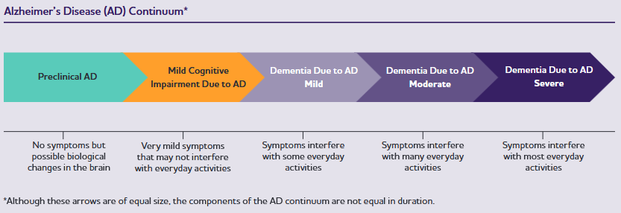Source: Figure 1, p1602, Better, MA (2023)
  - The symptoms of MCI can be subtle and therefore MCI can be difficult to diagnose. The ESCs noted that many people with MCI will improve, and most will not progress to dementia. Managing co-morbidities and exercising are likely to be the best treatment options. With limited evidence for effective interventions and uncertainty as to the prognostic value of the condition, the benefit of diagnosing MCI remains unclear (Wang et al 2021). As there are numerous causes of MCI, and many patients presenting with MCI in clinical practice do not progress to AD dementia, the ESCs noted that an incorrect diagnosis of these patients could lead to unnecessary testing and imaging and inappropriate use of donanemab.
  - The severity of cognitive impairment or dementia can be staged using several clinical cognitive or neuropsychological assessments, including (non-exhaustive) Mini Mental State Examination or Standardised MMSE (SMMSE), clinical dementia rating (global) (CDR-G), the Montreal Cognitive Assessment (MoCA), General Practitioner Assessment of Cognition (GPCOG), and the Clock Drawing tool (CDT).
  - The submission reported that in Australia, the number of people with AD, including both MCI and Alzheimer’s dementia, is expected to double from approximately 600,000 in 2024 to 1,200,000 by 2050 as a result of an ageing and a growing population.
  - The submission proposed the use of two alternative diagnostic modalities to test for the presence of Aß pathology and determine eligibility for PBS-subsidised donanemab treatment, Aß PET or CSF AD protein biomarker testing (with CSF sampling requiring lumbar puncture).
  - PET imaging biomarker such as Aβ-PET can be used to confirm the accumulation of Aβ plaque in the brain. Similarly, different core CSF AD biomarkers such as CSF Aβ42, t-tau and p-tau can also allow detection of preclinical AD before the onset of clinical symptoms; however, tau testing is not available in Australia.
  - There are currently no other registered agents in this therapeutic class in Australia, but other agents have been developed with the intent of removing amyloid and/or reducing amyloid deposition from the brain of patients with AD. These include other anti-amyloid mAbs, such as aducanumab, lecanemab and solanezumab, as well as a variety of small-molecule agents targeting the biochemistry of amyloid formation.
For more detail on PBAC’s view, see section 7 PBAC outcome.
- Comparator
  - The ESC considered that the nominated comparator, standard of care (SoC) alone, was reasonable. SoC encompasses non-pharmaceutical brain health optimisation strategies including exercise, nutrition, mentally challenging activities, social engagement, and symptomatic treatments. It was unclear whether the key trial, TB-2, included non-pharmaceutical strategies. Symptomatic treatments for AD are limited to those focussed on providing relief, including AChEIs and memantine. In Australia, AChEIs are PBS reimbursed for the treatment of mild to moderately severe AD and memantine is reimbursed for moderately severe AD. The submission noted that market research indicated that AChEIs are prescribed in 72% of mild AD patients and 15% of MCI patients, and use of memantine was reported in 2% of both MCI and mild AD patients.
  - As donanemab would be prescribed concurrently with SoC, the appropriate comparator is no active therapy added to SoC. In the key head-to-head TB-2 trial, placebo represents a proxy for no active therapy.
- Consideration of the evidence

Sponsor hearing
  - The sponsor requested a hearing for this item. The clinician supported the hypothesis that amyloid reduction improves the symptoms of MCI and mild AD, stating that the totality of the data for amyloid-reduction therapies suggests the more a drug can lower amyloid, the greater the cognitive change will be. The clinician noted that improvements in symptoms are difficult to measure but highlighted that a 25% reduction in cognitive decline is frequently cited as an appropriate benchmark for clinical meaningfulness and a difference of 2 points on the CDR-SB scale was clinically significant. The clinician highlighted that any delay in progression should be considered in the context that the median time to death following diagnosis is 4 years and that the goal of treatment is to maximise independence and time with minimal dysfunction. The PBAC confirmed that there was no long-term evidence available and that the meaningfulness of any delay in progression was based on modelling.

Consumer comments
  - The PBAC noted and welcomed the input from individuals (12) and organisations (3) via the Consumer Comments facility on the PBS website. The comments described the high unmet need for efficacious therapies, the impacts of AD on patients and their families and the hope offered by donanemab to potentially enable individuals to sustain their contribution to society, remain independent and have more time to enjoy activities with family and friends. Some comments focussed on the perceived benefits of the drug, noting that that by delaying disease progression, donanemab would potentially improve the quality of life experienced by patients and their families and carers. Some contributors were concerned about the potential side effects of treatment with one noting the severity of the risks associated with treatment may outweigh the benefits. Others emphasised the importance of medical professionals being clear with patients about the severity of some side effects, and one individual suggested that people with dementia may not wish to take the drug, preferring to wait until further studies clarified and potentially mitigated the side effects.
  - The PBAC noted the advice received from the Australian Dementia Network (ADNet) highlighted the clinical value and public health importance of ensuring equitable access to treatments such as donanemab. ADNet highlighted the results of the TB-2 trial and noted that there are now practical ways to manage ARIA and other adverse events. ADNET also offered assistance with roll out and monitoring of the disease modifying therapies. Dementia Australia also supported the submission, noting that there are currently limited treatment options available. Dementia Australia also highlighted that the benefits of donanemab will only be realised if people can access it in a timely and equitable way and this requires access to appropriate diagnostic testing and affordable access to the treatment itself through the PBS. Further, Dementia Australia noted that access must be designed to ensure that people in rural and remote areas, Aboriginal and Torres Strait Islander communities, culturally and linguistically diverse groups, and people with younger onset dementia are not excluded due to cost, geography, or complexity of access pathways. Professionals with Alzheimer’s and related diseases (PALZ) highlighted the progressive symptoms of AD and the burden placed on caregivers.
  - The PBAC acknowledged the inputs emphasised the devastating impacts of dementia and the high unmet need for efficacious therapies. The PBAC also noted that several inputs perceived the treatment efficacy of donanemab as exceeding what the trial data would suggest.

Overview of the evidence base
  - The populations and tests are mostly transferable across the linked evidence. Table 3 summarises the linked evidence approach taken in the submission.
Table 3: Summary of the linked evidence approach
Criterion | Type of evidence supplied | Extent of evidence supplied | Overall risk of bias in evidence base | Used in modelled evaluation
Accuracy and performance of the test (cross-sectional accuracy) | 4 NHMRC level III-2 studies provided DA evidence for FMM-Aβ-PET versus the clinical utility standard.  21 NHMRC level III-2 studies provided DA evidence for FMM-Aβ-PET and the clinical utility standard versus clinical diagnosis.  11 NHMRC level III-3 studies provided concordance between CSF testing and Aβ-PET  10 NHMRC level III-2 (k=8) and level III-3 (k=2) studies provided DA evidence the accuracy of APOE genotyping by PCR to detect the APOE4 variant  6 studies provided inter-rater reliability evidence on MRI detection of ARIA. | ☒ k=4 n=602  ☒ k=21 n=1,377  ☒ k=6 n=2,185  ☒ k=10 n=3,279  ☒ k=6 n=455 | High for patient selection, low for tests and timing  Not assessed  Low risk of bias  Not assessed  Not assessed | Not modelled.
Prognostic evidence (longitudinal accuracy) | 25 studies provided prognostic evidence.  1 SR  17 were NHMRC level II studies.  7 was NHMRC level III-3 studies | ☒ k=25 n=9,928 | Not assessed | Not modelled.
Change in patient management | 2 studies provided evidence for a change in management  1 cross-sectional survey  1 prospective cohort study | ☒ k=2 n=215 centres, 99 patients | Not assessed | Not modelled.
Health outcomes (clinical utility) | No evidence presented | ☐ k= n=
Predictive effect (treatment effect variation) | No evidence presented | ☐ k= n=
Treatment effect (enriched) | 1 key randomised controlled trial of drug vs placebo in patients that are test positive in both arms | ☒ k=1 n=1,736 | Uncertainª | Modelled.
Other | 20 studies provided DA evidence for plasma AD biomarker testing and CSF AD biomarker testing versus Aβ-PET | ☒ k=20 n=6,060 | Not assessed | Not modelled.
NHMRC levels of evidence: URL: https://www.mja.com.au/sites/default/files/NHMRC.levels.of.evidence.2008-09.pdf
Diagnostic accuracy levels of evidence: level III-1 = a study of test accuracy with an independent, blinded comparison with a valid reference standard, among non-consecutive persons with a defined clinical presentation; level III-2 = a comparison with reference standard that does not meet the criteria required for Level II and III-1 evidence; level III-3 = a diagnostic case-control study.
Prognostic studies: level II = a prospective cohort study; level III-3 = a retrospective cohort study; level IV = a case series, or cohort study of persons at different stages of disease.
ª As assessed by the evaluators
Source: constructed during evaluation
Aβ-PET = amyloid-beta positron emission tomography; ARIA = amyloid-related imaging abnormalities; DA = diagnostic accuracy; CSF = cerebrospinal fluid; k=number of studies, MRI = magnetic resonance imaging; n=number of patients; NHMRC = National Health and Medical Research Council; SR = systematic review
  - No evidence has been provided on the performance of the drug in a test negative population. This is acceptable as the mechanism of the proposed medicine is to reduce the biomarker brain amyloid.
Table 4: Data availability to inform comparisons
 | Donanemab plus standard of care | Standard of care
Biomarker test positive | TB-2
Biomarker test negative | No evidence presented | No evidence presented
Source: Main body of the submission

Clinical trials
  - The key evidence in the submission was based on one head-to-head multicentre, randomised, double-blind, controlled 18-month Phase III trial (TRAILBLAZER-ALZ 2 [herein referred to as TB-2]) comparing the efficacy and safety of donanemab (700 mg Q4W for the first 3 doses, and 1,400 mg Q4W thereafter) with placebo in 1,736 patients with early symptomatic AD (MCI/mild dementia).
  - The TB-2 trial enrolled patients aged 60 to 85 years, who had self-reported or informant-reported gradual and progressive change in memory function for ≥ 6 months, MMSE score of 20-28 at first visit (screening), evidence of intermediate (low/medium tau) or high brain tau burden, and evidence of brain amyloid burden at screening. The rationale for categorising by tau levels is that the population with high tau pathology is hypothesised to be more difficult to treat due to more advanced disease.
  - The mean MMSE score at baseline in the overall population was 22.3. In the overall population at baseline the results were as follows: MCI (MMSE ≥ 27): n=283 (16.3%); Mild AD (MMSE = 20-26): n=1,451 (83.6%); Moderate AD (MMSE < 20): n=1 (0.1%).
  - The primary objective of the TB-2 trial was to assess the effectiveness of donanemab in slowing progression or reducing decline of AD over 76 weeks compared to placebo. The primary efficacy outcome was the change from baseline in iADRS score (range, 0-144; lower scores indicate greater impairment). The iADRS measures the impact of cognitive loss on the ability to conduct everyday activities and provides a measure of global AD severity across the AD continuum as a single summary score. The composite iADRS score comprises two underlying domains: cognitive ability and functional ability. The actual scales administered to participants in the trial were the ADAS-Cog13 (Alzheimer’s Disease Assessment Scale-Cognitive subscale) and the ADCS-ADL (Alzheimer’s Disease Cooperative Study-Instrumental Activities). All items of the ADAS-Cog13 and ADCS-iADL were included without additional weighting of items, via the following formula iADRS = ADCS-iADL score-ADAS-Cog13 score + 85.
  - The pre-specified primary analysis sets in TB-2 were the intermediate (low/medium tau) brain tau pathology subgroup and the overall population (intermediate plus high brain tau pathology).
  - Secondary outcomes included the change from baseline through Week 76 in Clinical Dementia Rating-Sum of Boxes (CDR-SB; used in the economic evaluation), Alzheimer’s Disease Assessment Scale-Cognitive subscale (ADAS Cog13), Alzheimer’s Disease Cooperative Study – Instrumental Activities (ADCS-iADL), Clinical Dementia Rating (CDR-G), and MMSE scores. Additional assessments included brain amyloid plaque, brain tau deposition levels, and other biomarker and safety outcomes.
  - There were limited data on quality of life (QoL) of patients captured in TB-2. QoL was collected in a relatively small subset of patients (N=315 in the donanemab arm). QoL data were also not collected for caregivers. This highlights an important limitation of the trial as the expected aim of treatment is to improve the QoL of patients and their care givers. The submission noted that no mapping techniques were employed as part of the cost-effectiveness analysis as it was not appropriate to attempt to map the QoL data.
  - Of the overall TB-2 population (N=1,736), 1,395 patients (80%) met the eligibility criteria for the proposed TGA population (i.e. excludes APOE4 homozygotes and those with superficial siderosis and the presence of more than 2 microhaemorrhages). Results of the efficacy outcomes for the TGA population were reasonably comparable (as expected) to those of the overall patient population. Efficacy analyses for the complement to the TGA subgroup were not presented in the submission.
  - The submission also included two additional supportive studies as outlined below:
- TRAILBLAZER-ALZ (herein referred to as TB) was a Phase II trial comparing donanemab with placebo in 257 patients with early symptomatic AD. The objective of the TB trial was to inform the Phase III TB-2 trial. A key difference between the TB and key TB-2 trial was that in TB, patients were required to have evidence of tau deposition below a specific upper threshold, whilst in TB-2, there was no upper threshold for exclusion based on tau criteria. Additionally, there were some differences in donanemab dosing once patients met treatment cessation criteria based on amyloid clearance.
- TRAILBLAZER-ALZ 6 (TB-6) assessed the impact of different dose regimens of donanemab (including the standard and enhanced dose regimens) on the rates of ARIA-E and on amyloid clearance in adults with early symptomatic AD. There was no placebo comparator arm in TB-6 and no clinical effectiveness outcomes were assessed in the trial.
  - Ongoing studies of donanemab include the TB EXT (NCT04640077) study (follow-on extension of the TB-2 trial) and the TB-5 trial. TB-5 is an ongoing phase III double-blind placebo-controlled trial in patients with early symptomatic AD. The eligibility criteria appear consistent with those of TB-2. The estimated study completion date of TB-5 is in April 2027.
  - Details of the studies presented in the submission are provided in Table 5 below.
Table 5: Trials and associated reports presented in the submission
Trial ID | Protocol title/ Publication title | Publication citation
Key trial
TRAILBLAZER-ALZ-2 (NCT04437511) | Clinical Study Report (CSR): Study Number I5T-MC-AACI - A Phase 3, double-blind, placebo-controlled study to evaluate the safety and efficacy of N3pG antibody (donanemab) in patients with early symptomatic Alzheimer’s disease (AD) (mild cognitive impairment and mild dementia due to AD) with the presence of brain amyloid and tau pathology over 76 weeks of the double-blind period. Data cutoff 28 April 2023. | Assessment of Safety, Tolerability, and Efficacy of Donanemab in Early Symptomatic Alzheimer’s Disease. Main CSR (Current version 2024)
TRAILBLAZER-ALZ-2 (NCT04437511) | CSR (Addendum 9): Study I5T-MC-AACI Safety addendum. Open-label extension period. Data cutoff 08 August 2023. | Open-label exposure and safety data in participants with early symptomatic Alzheimer’s disease who had proof of amyloid pathology and received donanemab.
TRAILBLAZER-ALZ-2 (NCT04437511) | Mintun M., Ritchie C, et al. Donanemab in early symptomatic Alzheimer's Disease: Efficacy and safety in TRAILBLAZER-ALZ 2, Phase 3 Randomized Clinical Trial. 53(S1): i30-i31. | Age and Ageing. 2024; 53(S1): i30-i31.
TRAILBLAZER-ALZ-2 (NCT04437511) | Sims, J. R., Zimmer J.A., et al. Donanemab in Early Symptomatic Alzheimer Disease: the TRAILBLAZER-ALZ 2 Randomized Clinical Trial. | JAMA. 2023; 330(6): 512-527.
TRAILBLAZER-ALZ-2 (NCT04437511) | Zimmer J.A, et al. TRAILBLAZER-ALZ 2: A Phase 3 Study to Assess Safety and Efficacy of Donanemab in Early Symptomatic Alzheimer's Disease. | Neurology. 2022; 98(S18)
TRAILBLAZER-ALZ-2 (NCT04437511) | Mullins G., et al. Donanemab: characterizing infusion related reactions from TRAILBLAZER-ALZ & TRAILBLAZER-ALZ 2. | J Prev Alzheimers Dis. 2023; 10(S1): S99-S100
TRAILBLAZER-ALZ-2 (NCT04437511) | Gueorguieva I., Willis B.A., et al. Donanemab Population Pharmacokinetics, Amyloid Plaque Reduction, and Safety in Participants with Alzheimer's Disease. | Clin Pharmacol Ther. 2023; 113(6): 1258-1267.
Supportive trial
TRAILBLAZER-ALZ (NCT03367403) | Dickson S.P., et al. ‘Time Saved' As a Demonstration of Clinical Meaningfulness and Illustrated Using the Donanemab TRAILBLAZER-ALZ Study Findings. | J Prev Alzheimers Dis. 2023; 10(3): 595-599.
TRAILBLAZER-ALZ (NCT03367403) | Mintun M., Lo A.C., et al. Donanemab in early symptomatic Alzheimer's Disease. | N Engl J Med 384(18). 2021; 1691-1704.
TRAILBLAZER-ALZ (NCT03367403) | Shcherbinin S., Evans, C.D., et al. Association of Amyloid Reduction After Donanemab Treatment With Tau Pathology and Clinical Outcomes: The TRAILBLAZER-ALZ Randomized Clinical Trial. | JAMA Neurol. 2022; 79(10): 1015-1024.
TRAILBLAZER-ALZ (NCT03367403) | Shcherbinin S., Andersen, S.W., et al. TRAILBLAZER-ALZ Study: Dynamics of amyloid reduction after donanemab treatment. | Alzheimer's and Dementia. 2021; 17(S9): e057492.
TRAILBLAZER-ALZ (NCT03367403) | Shcherbinin S., Lu, M., et al. Flortaucipir in the trailblazer-ALZ trial. | Journal of Prevention of Alzheimer's Disease. 2021; 8(1): S22-S23
Source: Table 2-35, pp158-9 of the submission

  - The key features of the TB-2 trial are summarised in Table 6.
Table 6: Key features of the TB-2 trial
N | Design/ duration | Patient population | Outcomes | Overall risk of bias | Use in modelled evaluation
Donanemab 700 mg every 4 weeks (Q4W) for the first 3 doses, followed by 1,400 mg Q4W thereafter, versus placebo (as a proxy for no active therapy)
1,736 | R, MC, DB, 18 months.  Stratification factors at randomisation were investigative site and tau pathology (intermediate versus high)ª. | Patients with MCI due to AD or mild AD, aged 60 to 85 years. Reported gradual and progressive change in memory function for ≥ six months.  MMSE score of 20-28, evidence of intermediate or high brain tau burden (requiring SUVr ≥1.10), and evidence of brain amyloid burden on PET scan | Primary  iADRS change from baseline at 18 months.  Secondary/other  CDR-SB  ADAS-Cog  ADCS-ADL  Amyloid and tau PET levels  Safety | Uncertain | HR of clinical progression as per CDR-SB. Proportion of patients in each AD stage (as per CDR-SB) at baseline in the trial.
Source: Sections 2D 3 and 2D 4 of the submission
AD=Alzheimer’s disease; ADAS-Cog=Alzheimer’s Disease Assessment Scale – Cognitive Subscale; ADCS-ADL=Alzheimer’s Disease Cooperative Study – Activities of Daily Living Inventory; CDR-SB=Clinical Dementia Rating – Sum of Boxes; DB=double blind; iADRS=integrated Alzheimer’s Disease Rating Scale; MC=multi-centre; MCI=mild cognitive impairment; PET=positron emission tomography; Q4W=every four weeks; R=randomised; SUVr=standardised uptake value ratio
ªIntermediate tau included participants with baseline Standardised Uptake Value Ratio (SUVr) ≤1.46 and a topographic deposition pattern consistent with advanced AD (AD++) or 1.10 ≤ SUVr ≤1.46 and a topographic deposition pattern consistent with moderate AD (AD+). High tau included participants with baseline SUVr >1.46 and a topographic deposition pattern consistent with either moderate (AD+) or advanced AD (AD++).
  - The overall risk of bias in the TB-2 trial was considered to be uncertain. Randomisation appeared successful as baseline demographic and disease characteristics were equally distributed between the donanemab and placebo arms. However, there are concerns that improvements observed in trials of anti-amyloid therapies may reflect “functional unblinding” due to the increased risk of ARIAs in the intervention arm, and that this may have been the case for the TB-2 trial. It was noted that the TB-2 trial investigators assessing subjective cognitive and functional outcomes were blinded to treatment allocation. However, the increased risk of ARIAs could also unblind the trial patients and their carers who respond to these surveys and thus directly introduce performance bias. The risk of functional unblinding may not be overcome by using blinded raters, particularly when patients learned they are on treatment for side effects for ARIAs. However, it remains uncertain as to what extent unblinding may have impacted the overall trial findings.
  - There was a high rate of screening failures (79%) in TB-2 which may affect the applicability of the trial. A total of 8,240 patients were screened for entry into the TB-2 trial and only 1,736 (21%) patients were randomised to either donanemab or placebo. The most common reasons for exclusion at screening were failure to meet inclusion criteria for amyloid PET (25% of patients), tau PET (25% of patients), and MMSE (23% of patients). A higher percentage of patients in the donanemab arm compared to the placebo arm discontinued treatment due to an adverse event (AE; 11.4% versus 3.2%, respectively), and discontinued the study due to an AE (5.8% versus 2.4%, respectively). Discontinuations from the study due to various other factors (such as withdrawal of consent, progressive disease, or clinician decision) was balanced between the donanemab and placebo arms.
  - Notably, the TB-2 trial effectively excluded a significant proportion of patients with concomitant medical conditions that are typical of the elderly population with AD, thereby potentially limiting the generalisability of the study data. Patients were excluded if they had any significant neurological conditions, any primary psychiatric diagnosis/symptoms other than AD, contraindications to MRI or PET, MRI demonstrating presence of ARIA-E, more than four cerebral microhaemorrhages, more than one area of superficial siderosis, any microhaemorrhage or severe white matter disease at screening, and abnormal vital signs or other clinical laboratory test results. The underlying premises for these exclusions were to mitigate safety risks to the trial population (specifically regarding ARIA events), and to minimise the risk of confounding symptomatology from a concurrent condition. It was not clear how many patients with mixed dementia (e.g. concomitant vascular dementia pathology) were included.

Comparative effectiveness
  - A summary of the TB-2 trial results for the primary outcome of iADRS in the overall population is presented in Table 7. Figure 2 presents the adjusted mean change (95% CI) in iADRS from baseline over time up to Week 76.
Table 7: TB-2: Results of the primary outcome of change from baseline in iADRSª (EES) - Overall population (NCS2)
Time point | Donanemab  Mean change from baseline (SE) | Placebo  Mean change from baseline (SE) | Mean difference  Donanemab minus Placebo (95% CI)  p-value | % reduction (slowing) in decline.  Donanemab versus Placebo  (95% CI)
Week 12 | n=752  -0.81 (0.12) | n=805  -1.41 (0.11) | 0.60 (0.28, 0.92)  p<0.01 | 42.3  (18.7, 66.0)
Week 24 | n=712  -1.64 (0.23) | n=767  -2.83 (0.23) | 1.19 (0.55, 1.83)  p<0.01 | 42.2  (18.7, 65.7)
Week 36 | n=665  -2.74 (0.33) | n=738  -4.48 (0.32) | 1.74 (0.84, 2.64)  p<0.01 | 38.8  (18.1, 59.6)
Week 52 | n=636  -5.39 (0.39) | n=693  -7.66 (0.38) | 2.27 (0.55, 3.09)  p<0.01 | 29.6  (15.5, 43.8)
Week 64 | n=579  -7.79 (0.45) | n=651  -10.38 (0.43) | 2.59 (1.39, 3.80)  p<0.001 | 25.0  (13.2, 36.8)
Week 76 | n=583  -10.19 (0.53) | n=653  -13.11 (0.50) | 2.92 (1.51, 4.33)  p<0.001 | 22.3  (11.4, 33.2)
Source: Table 2-53, p188 of the submission and Table AACI.5.3, pp108-109 of the TB-2 Clinical Study Report.
AD=Alzheimer’s disease; ADAS-Cog13=Alzheimer’s Disease Assessment Scale (Cognitive subscale); ADCS-iADL=Alzheimer’s Disease Cooperative Study – Instrumental Activities CI=confidence interval; EES=Evaluable Efficacy Set; iADRS=Integrated Alzheimer’s Disease Rating Scale; NCS2=natural cubic spline; SE=standard error.
Baseline least squares mean score (SE) was similar between the donanemab and placebo arms: 103.95 (0.44).
ª The iADRS assesses the impact of cognitive loss on the ability to conduct everyday activities and provides a measure of global AD severity across the AD continuum as a single summary score. The composite score comprises two underlying domains: cognitive ability and functional ability. The actual scales administered to participants in the trial were the ADAS Cog13 and the ADCS-ADL.
Lower scores on the iADRS indicate greater impairment; iADRS scores range from 0 to 144. All items of the ADAS-Cog13 and ADCS-iADL are included without additional weighting of items.
^{b}A Natural Cubic Spline (NCS) model with 2 degrees of freedom (NCS2) was used to assess the difference between treatment groups in iADRS at Week 76.
Figure 2: iADRS change from baseline to 76 weeks in the overall population (NCS2)
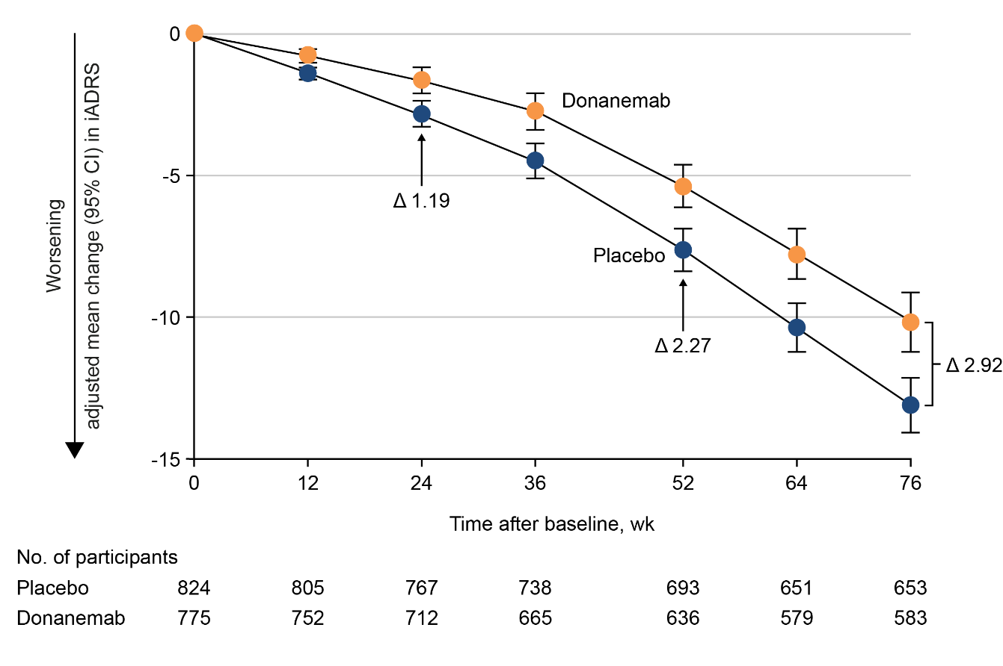
Source: Figure 2-23, p193 of the submission.
CI=confidence interval; iADRS=Integrated Alzheimer’s Disease Rating Scale; NCS=natural cubic spline model
  - Mean baseline scores were similar between the donanemab and placebo arms (Least squares [LS] mean of 103.95). The LS mean (± standard error [SE]) change from baseline in iADRS score (range 0 to 144) at Week 76 in the overall population (intermediate or high levels of brain tau at screening) was -13.11 (±0.50) in the placebo arm and -10.19 (±0.53) in the donanemab arm, with a mean difference (95% CI) between the arms of 2.92 (95% CI: 1.51, 4.33; p<0.001), favouring donanemab. This difference corresponded to 22.3% reduction of disease decline under donanemab or 77.7% of the decline under placebo (100*(13.11 – 2.92)/13.11). Separation of donanemab from placebo was detected by Week 12, which was nominally statistically significant, and was maintained through to Week 76. The ESC considered that, although the difference in iADRS was statistically significant, the clinical significance of the change and whether it would result in a noticeable benefit to patients and caregivers was highly uncertain. The pre-PBAC response stated that the 3 point change should be interpreted in the context that at baseline 80% of patients had a score within a 36 point range.
  - The ESC noted that the submission claimed that a difference between groups of ≥20% slowing of disease on the iADRS scale is considered clinically meaningful. One of the cited references in the submission to support this claim was the key publication of the TB-2 trial by Sims et al (2023) who stated that donanemab treatment resulted in clinically meaningful benefit (considered to be >20% slowing of clinical progression) on the iADRS scale. However, the ESC noted that there was no clear evidence provided in Sims et al (2023) to support a >20% threshold for slowing of clinical progression, as a clinically meaningful difference between treatment groups. The PSCR stated that Petersen et al (2023) also stated that a 20% or greater slowing of AD between treatment groups was clinically meaningful. The ESCs noted that Petersen et al (2023) stated that in AD, where current technology allows us to detect evidence of its onset one to two decades before death, a 20% to 30% slowing of the disease initiated in the earlier stages of the disease could mean more time in the less impaired and more functional stages of the disease, as well as a delay in the onset of a later stage (i.e., severe) decline.
  - The submission noted that a meaningful change (or meaningful worsening) for the iADRS is a 5-point decrease from baseline for patients with baseline clinical status as MCI, or a 9 point-decrease from baseline for patients with baseline clinical status as mild AD. These threshold criteria for meaningful change are specifically intended to evaluate within-patient changes and are not intended to assess the magnitude and meaningfulness of differences between group-level changes over time. The published minimal clinically meaningful differences (MCIDs) in the literature for iADRS also represent individual, within‐patient changes and are different from between‐group treatment effects. There is lack of consensus on MCIDs for between group comparisons in AD trials of anti-amyloid therapies. Various suggested MCIDs represent within patient changes and are not applicable to a between group comparison. The ESCs noted that there was no clearly established MCID in the published literature or consensus on what constitutes a clinically meaningful difference in treatment effect between groups. Based on an iADRS score range of 0 to 144, the ESCs noted that the observed adjusted mean treatment difference between donanemab versus placebo appears modest.
  - A time-progression model for repeated measures (PMRM) analysis was conducted to quantify the time delay in disease progression on the iADRS associated with donanemab compared with placebo. The results are summarised in Table 8.
Table 8: TB-2: Delay in disease progression as measured by iADRS change from baseline at 76 weeks in the overall population
Delayed disease progression at 76 weeks as measured by iADRS
Months saved versus placebo (95% CI) | 1.38 (0.46, 2.30)
p-value versus placebo | 0.004
Source: Table 2-57, p204 of the submission.
iADRS=Integrated Alzheimer’s Disease Rating Scale; CI=confidence interval
Analysis not prespecified as gated (adjusted for multiplicity) in the TB-2 statistical analysis plan.
  - The estimated time saved (delay in progression) with donanemab compared with placebo was 1.38 months (95% CI: 0.46, 2.3; p=0.004) in the overall population over the 18-month treatment period. The ESCs considered that the magnitude of time delay in progression was small, and that the clinical meaningfulness of the delay was highly uncertain. The submission noted that the observed delay in disease progression with donanemab compared with placebo should be interpreted within the context of the 18-month period and that placebo patients were mostly (~60%) receiving standard-of-care therapy for AD (i.e., on a background of AChEIs and/or memantine). However, a similar percentage of patients in the donanemab arm were also on concomitant medications consisting of AChEIs and/or memantine. It remains uncertain whether the estimated time saved with donanemab would increase when projected over subsequent years.
  - Figure 3 depicts the hazard of progression or clinical worsening for the donanemab and placebo arms on the iADRS in the TB-2 overall population.
Figure 3: TB-2: Hazard of disease progression to MCID on the iADRS in the overall population (Cox proportional hazards model)
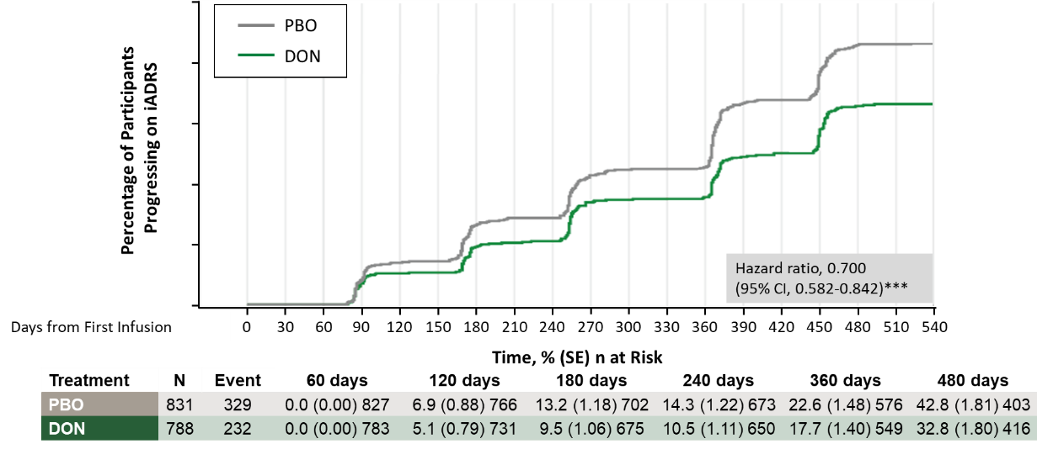
Source: Figure 2-30, p203 of the submission and p658 of the TB-2 CSR.
AD=Alzheimer’s disease; CI=confidence interval; DON=donanemab; iADRS=integrated Alzheimer’s Disease Rating Scale; MCI=mild cognitive impairment; MCID=minimal clinically important difference (within patient change); PBO=placebo; SE=standard error.
Increasing values in Y-axis for percentage of patients progressing on iADRS correspond to 0%, 10%, 20%, 30%, 40%, and 50%, respectively.
MCID was defined in the Clinical Study Report as iADRS change ≥5 points for MCI due to AD and ≥9 points for mild dementia due to AD at 2 consecutive study visits. MCIDs represent within patient changes and not between group differences.
  - 29% of patients in the donanemab arm compared with 40% of patients in the placebo arm reached the MCID for a clinical worsening event (≥5-point or ≥9-point decrease in the iADRS score for MCI or mild AD, respectively). The reduction in hazard of progression associated with donanemab on the iADRS scale was 30% (HR = 0.70; 95% CI: 0.58, 0.84).
  - Table 9 summarises results for the key secondary outcomes in the overall population of TB-2.
Table 9: TB-2: Results of the key secondary endpointsª in the overall population (EES)
Donanemab |  |  | Placebo |  |  | LSM difference:  donanemab vs placebo  (95% CI)  p-value | % reduction (slowing) in decline:  donanemab vs placebo  (95% CI)^{b}
Mean (SD) |  | LSM change from baseline  (95% CI) | Mean (SD) |  | LSM change from baseline  (95% CI) | LSM difference:  donanemab vs placebo  (95% CI)  p-value
Baseline | W76 | LSM change from baseline  (95% CI) | Baseline | W76 | LSM change from baseline  (95% CI) | LSM difference:  donanemab vs placebo  (95% CI)  p-value
CDR-SB
n=794 | n=598 |  | n=838 | n=672
3.92  (2.06) | 5.25  (3.21) | 1.66  (1.48, 1.83) | 3.89  (2.03) | 5.80  (3.22) | 2.33  (2.16, 2.50) | −0.67  (−0.92, −0.43)  <0.001 | 28.9  (18.3, 39.5)
ADCS-iADL
n=780 | n=591 |  | n=826 | n=661
47.96  (7.85) | 44.53 (11.06) | −4.42  (−5.05, −3.80) | 47.98  (7.70) | 43.30 (10.61) | −6.13  (−6.72, −5.53) | 1.70  (0.84, 2.57)  p=0.0001 | 27.8  (13.5, 42.1)
ADAS-Cog13
n=797 | n=607 |  | n=841 | n=677
28.53  (8.78) | 32.72 (12.44) | 5.46  (4.91, 6.01) | 29.16  (8.85) | 34.53 (12.00) | 6.79  (6.26, 7.32) | −1.33  (−2.09, −0.57)  p=0.0006 | 19.5  (8.2, 30.8)
MMSE
n=796 | n=600 |  | n=841 | n=679
22.52  (3.84) | 20.71 (5.52) | −2.47  (−2.73, −2.20) | 22.20  (3.90) | 19.79  (5.51) | −2.94  (−3.20, −2.69) | 0.47  (0.10, 0.84)  p=0.012 | 16.1  (3.5, 28.7)
Source: Table 2-54, p195 of the submission and Section 5.1, TB-2 Clinical Study Report.
ADAS Cog13=13-Item Alzheimer’s Disease Assessment Scale – Cognitive Subscale; ADCS-iADL=Alzheimer’s Disease Cooperative Study–Instrumental Activities of Daily Living; CDR-SB=sum of boxes of the Clinical Dementia Rating Scale; CI=confidence interval; EES=evaluable efficacy set; LSM=least squares mean; MMSE=Mini-Mental State Examination; NCS2=natural cubic spline with 2 degrees of freedom; W76=Week 76.
ª ADAS Cog13 scores range from 0 to 85, with higher scores indicating greater overall cognition deficit; ADCS-iADL scores range from 0 to 59, with lower scores indicating greater impairment in daily function; CDR-SB scores range from 0 to 18, with higher scores indicating greater clinical impairment, and MMSE scores ranges from 0 to 30, with lower scores indicating greater level of impairment.
^{b} The percentage of slowing of clinical progression was calculated by dividing the LSM change from baseline treatment differences at 76 weeks by the LSM change from baseline with placebo at 76 weeks and multiplying by 100. The CI was estimated using the Delta method
  - For CDR-SB, treatment with donanemab was associated with a statistically significant reduction in disease decline on change from baseline at 76 weeks compared to placebo in the overall population (LSM difference = -0.67 [28.9% reduction in decline], p<0.001). Separation of the donanemab arm from the placebo arm was apparent by Week 12 (LSM difference = -0.16; 95% CI: -0.29, -0.04), which was nominally statistically significant and was maintained through to Week 76 (see Figure 4).
Figure 4: TB-2: CDR-SB change from baseline to 76 weeks in the overall population (MMRM)
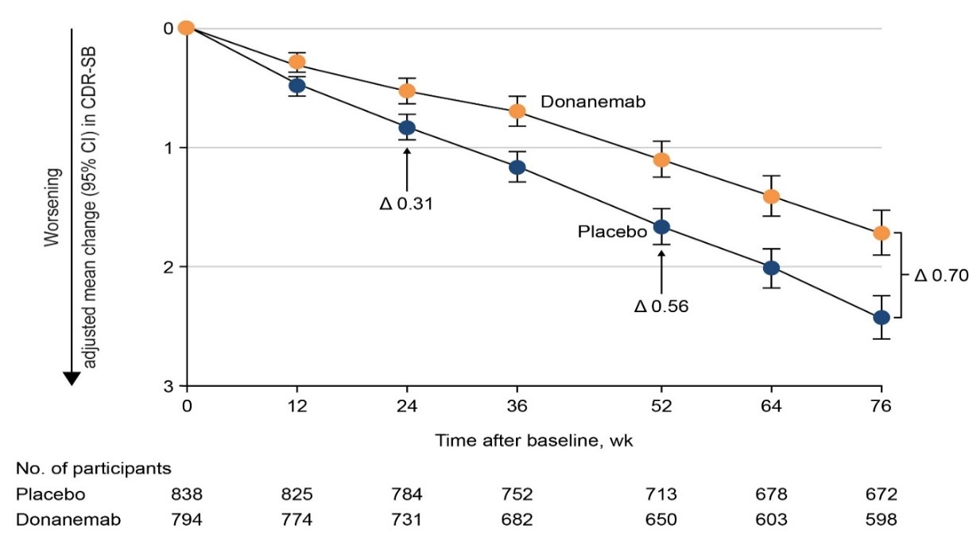
Source: Figure 2-24, p197 of the submission.
CDR-SB=Clinical Dementia Rating – Sum of Boxes; CI=confidence interval; MMRM=Mixed Model for Repeated Measures
  - An exploratory analysis of CDR-SB by domain type is depicted in Figure 5.
Figure 5: TB-2: Treatment effect of donanemab across individual CDR-SB domains in the overall population at 76 weeks
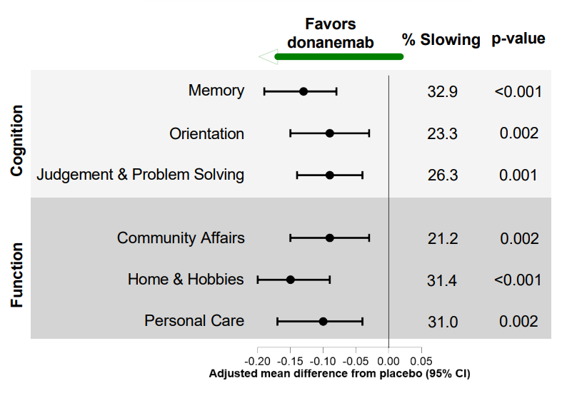
Source: Figure 2-25, p197 of the submission
CDR-SB=Clinical Dementia Rating Scale – Sum of Boxes; CI=confidence interval
  - The reduction in the CDR-SB score at Week 76 observed in donanemab-treated patients in the overall population was statistically significant (p ≤ 0.002) across all 6 CDR-SB domains (memory, orientation, judgement/problem solving, community affairs, home/hobbies, and personal care). The percent reduction in decline associated with donanemab versus placebo varied from 21.2% in the Community (Function) domain to 32.9% for Memory (Cognitive) domain.
  - Figure 6 depicts the hazard of progression in the donanemab and placebo arms as measured by CDR-SB in the overall population.
Figure 6: TB-2: Hazard of disease progression by treatment arm based on CDR-SB change in the overall population (Cox proportional hazards model)
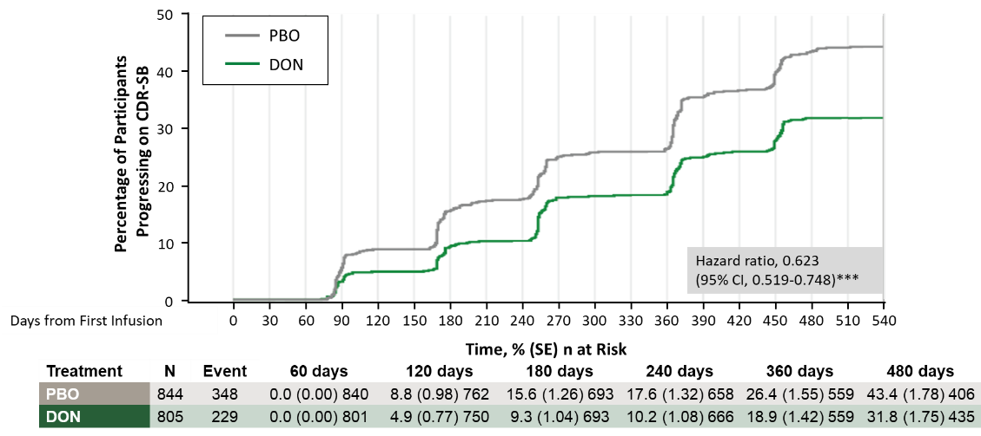
Source: Figure 2-31, p202 of the submission.
CDR-SB=Clinical Dementia Rating Scale–Sum of Boxes; CI=confidence interval; DON=donanemab; PBO=placebo; MCI=mild cognitive impairment; SE=standard error.
*** p<.001
Note: CDR-SB range from 0 to 18, with higher scores indicating greater clinical impairment. Meaningful within person change in progression on CDR-SB was defined in the Clinical Study Report as a change ≥1 point for patients with MCI, and ≥2 points for patients with mild dementia due to AD at 2 consecutive study visits.
  - There was a 38% statistically significant reduction in the hazard of disease progression, as measured by an increase in the CDR-SB, associated with the donanemab arm compared to the placebo arm in the overall population (HR = 0.62; 95% CI: 0.52, 0.75; p<.001). Meaningful decline (within patient) was observed in 229 (28%) donanemab-treated patients and in 348 (41%) placebo-treated participants.
  - A time-progression model for repeated measures analysis indicated that the time saved or time delay in progression associated with donanemab compared to placebo was 5.44 months (95% CI: 3.90, 6.98) over the 18-month period in TB-2.
  - The ESCs noted that iADRS score (the primary outcome) is a composite score comprising of functional ability/clinical progression and cognitive ability (see paragraph 6.10), both of which were secondary outcomes of the TB-2 trial. Functional ability/clinical progression was measured using the ADCS-iADL scale which ranged from 0 to 59, with lower scores indicating greater impairment of function. Cognitive ability was measured using the ADAC-Cog13 scale, which ranged from 0 to 85, with higher scores indicating greater overall cognition deficit (i.e. improved cognition from baseline results in a negative value). The iADRS was calculated as follows: ADCR-iADL – ADAS-Cog13 + 85.
  - Figure 7 presents the change from baseline for the ADCS-iADL and ADAS-Cog13 scores to Week 76.
Figure 7: Change from baseline in ADCS-iADL (functional ability; LEFT) and ADAS-Cog13 (cognitive ability; RIGHT) to week 76 in the overall population (NCS2)
Source: Figures AACI.5.8 and AACI.5.10, pp133 and 141 of the TRAILBLASER-ALZ 2 CSR
ADAS-Cog13=Alzheimer’s Disease Assessment Scale – 13-item Cognitive subscale; ADCS-iADL =Alzheimer’s Disease Cooperative Study – instrumental Activities of Daily Living subscale; LS=least squares, NCS2=natural cubic spline model with 2 degrees of freedom; SE=standard error
  - The ESCs noted that at Week 76 donanemab-treated patients had statistically significantly less decline in functional ability compared to placebo-treated patients (LS mean change ± SE = 1.70 points ± 0.44; p=0.0001), which corresponded to a 28% slowing of decline in functional ability. For cognition, donanemab-treated patients also had statistically significantly less decline compared with placebo-treated patients (LS mean change ± SE = -1.33 points ± 0.39 (p=0.0006), which corresponded to a 20% slowing of decline in cognitive function. The ESCs considered that, although the differences in functional and cognitive function were statistically significant, the differences may not be clinical meaningful.
  - For the functional ADCS-iADL scale, items such as Outdoor Activities (Shopping [treatment difference = -1.12] and Get Around Outside Home [treatment difference = -0.49]), did not result in a treatment benefit for donanemab over placebo.
  - For cognitive ability, the percent reduction in decline at Week 76 was statistically significant across most items in the Episodic Memory domain except for Delayed Word Recall (14.7% slowing; p=0.121). The percent reduction associated with donanemab was not statistically significant across all items in the Language (% slowing ranged from 3.5% for Naming Objects and Fingers’ to 20.4% for Spoken Language Ability) and Praxis (4.1% for Constructional Praxis to 10.4% for Ideational Praxis) domains.
  - The TB-2 trial also assessed the hazard of advancing to the next stage of disease. Progression to the next stage of disease was measured using the CDR-G score, with clinical worsening defined as any per patient increase in CDR-G score from baseline at two consecutive visits. It was noted that CDR-G was a tertiary/exploratory endpoint of the TB-2 trial, and the results were only available as conference presentations^{35, 36}.
  - Figure 8 describes progression to the next AD stage based on ‘shifts’ (change in score from baseline at two consecutive visits) in the CDR-G score.
Figure 8: Stages of AD by CDR-G score.
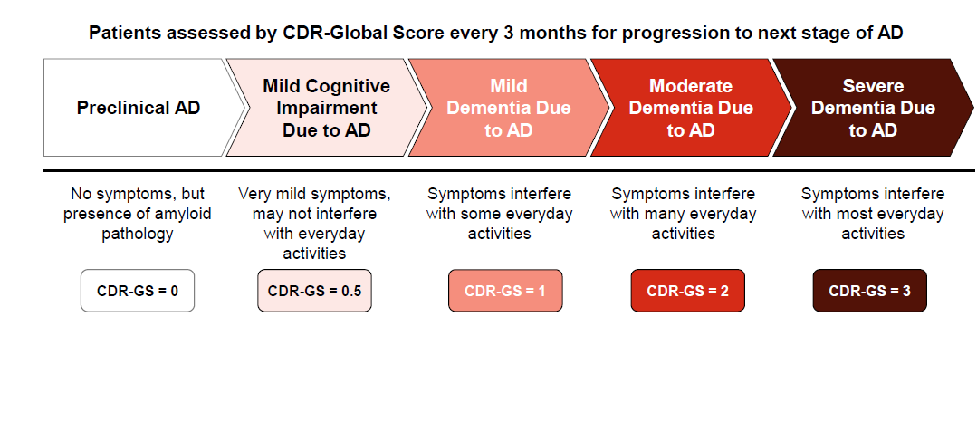
Source: p10, Zimmer et al (2024)
AD=Alzheimer’s Disease; CDR-G=Clinical Dementia Rating Scale-Global score.
  - Table 10 presents the percentage of patients advancing to the next stage of disease by CDR-G shift from baseline. These data were sourced from Zimmer et al (2024); however, time delay in progression to next clinical stage could not be identified in Zimmer et al (2024).
Table 10: TB-2: Patients progressing to the next clinical stage of AD
CDR-G shiftª from baseline | Donanemab | Placebo | Donanemab versus placebo difference (%) (nominal p-value)
CDR-G shiftª from baseline | Patients progressing to the next clinical stage, n/N (%) | Patients progressing to the next clinical stage, n/N (%) | Donanemab versus placebo difference (%) (nominal p-value)
From 0 to 0.5  (preclinical AD to MCI) | 1/2 (50.0) | 3/4 (75.0) | -25%  p=1.0
From 0.5 to 1  (MCI to Mild AD Dementia) | 134/502 (26.7) | 202/521 (38.8) | -12.1%  p<0.0001
From 1 to 2  (Mild AD Dementia to Moderate AD Dementia) | 51/292 (17.5) | 82/302 (27.2) | -9.7%  p=0.0057
From 2 to 3  (Moderate AD Dementia to Severe AD Dementia | 0/23 | 1/24 (4) | p=1.0
Source: Zimmer et al (2024)
AD=Alzheimer’s disease; CDR-G=Clinical Dementia Rating-Global score; MCI-Mild Cognitive Impairment.
ª Shift represents change in CDR-G from baseline at two consecutive visits. Dropouts not accounted for in the analysis.
Italicised differences calculated during the evaluation. and no formal statistical analysis was conducted. p-values were sourced from Zimmer et al (2024)
  - Results for shifts in CDR-G from a baseline score of 0 to 0.5 (preclinical to MCI) and from 2 to 3 (moderate AD to severe AD) at 76 weeks were imprecise due to small patient numbers. At 76 weeks, the difference between the donanemab and placebo arms in the percentage of patients progressing from MCI to mild AD was -12.1%, and from mild AD to moderate AD dementia was -9.7%.
  - Figure 9 summarises the hazard of progression to any later disease stage as measured by CDR-G in the overall population.
Figure 9: TB-2: Hazard of progression to a later clinical stage as measured by CDR-G in the overall population (Cox proportional hazards model)
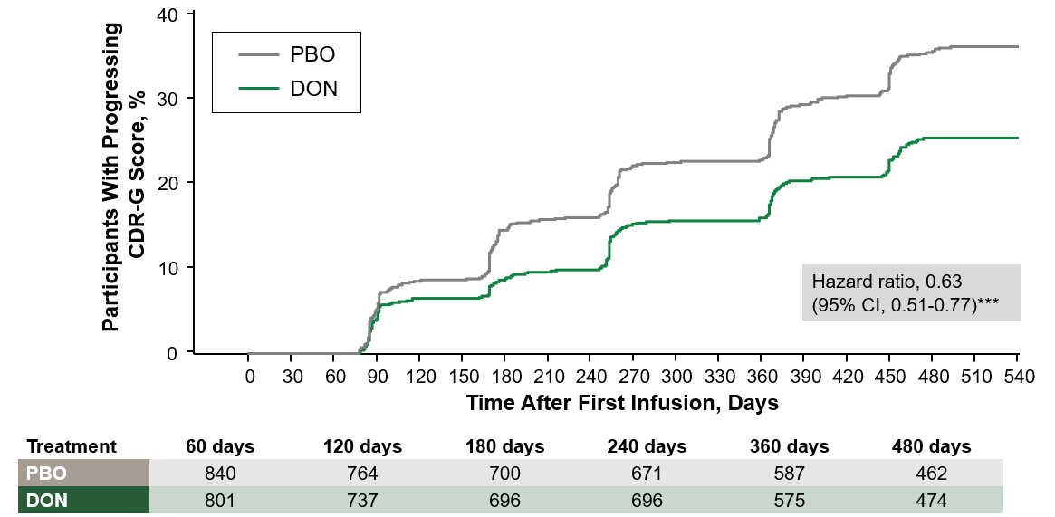
Source: Figure 2-28, p200 of the submission.
CDR-G=Clinical Dementia Rating-Global Score; CI=confidence interval; DON=donanemab; PBO=placebo
Note: ***p<0.001 vs placebo
Log cumulative hazards and Schoenfeld residual plots were not presented in the submission.
  - A total of 186 (23%) donanemab-treated patients and 288 (34%) placebo-treated patients experienced disease progression to a later stage. Patients treated with donanemab had a 37% lower hazard of progression to the next stage of the disease as measured by the CDR-G shift (HR = 0.63; 95% CI: 0.51, 0.77; p<0.0001) through to Week 76.
  - Figure 10 summarises the hazard of progression by a CDR-G shift of ≥2 (progression to at least moderate AD).
Figure 10: TB-2: Hazard of progression to at least moderate AD: CDR-G shift of ≥2 (overall population)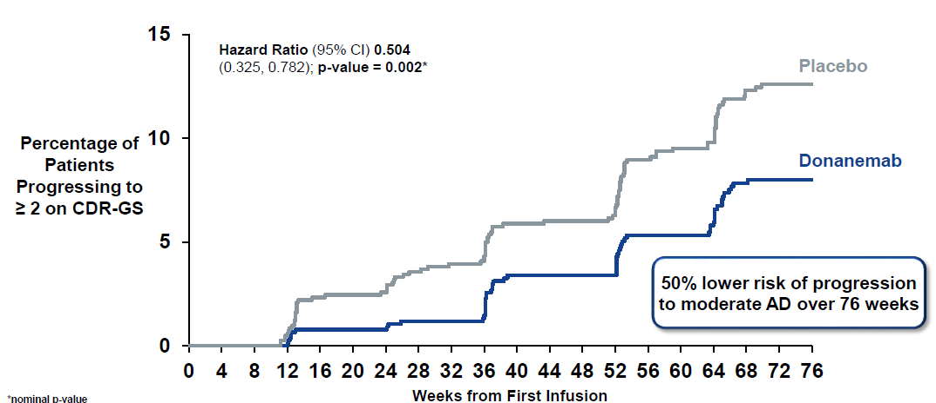
Source: p10, Zimmer et al (2024)
AD=Alzheimer’s disease; CDR-G=Clinical Dementia Rating-Global Score; CI=confidence interval
*Nominal p-value
  - Patients treated with donanemab had a 50% lower hazard of progression to at least the moderate AD stage as measured by the CDR-G shift of ≥2 from baseline (HR = 0.504; 95% CI: 0.325, 0.782; p=0.002) over 76 weeks.
  - Table 11 summarises the percentage of patients in the donanemab arm who had amyloid clearance at post-baseline visit in the overall population. The percentage of patients who met the reduction to placebo criteria is also included in the table.
Table 11: TB-2: Proportion of donanemab-treated patients who were amyloid-negative at post-baseline visit with PET scan schedules (overall population, EES)
Time point | Overall  n/N (%)
Week 24
Amyloid clearance (%), n/N | 29.7 (226/761) (p<0.0001)
Met the reduction to placebo criteria (%), n/N | 17.1 (130/761a)
Week 52
Amyloid clearance (%), n/N | 66.1 (443/670) (p<0.0001)
Met the reduction to placebo criteria (%), n/N | 46.6 (313/672a)
Week 76
Amyloid clearance (%), n/N | 76.4 (469/614) (p<0.0001)
Met the reduction to placebo criteria (%), n/N | 69.2 (429/620a)
Source: Table 2-59, p204 of the submission.
EES=Evaluable Efficacy Set; PET=positron emission tomography.
Notes:
Amyloid clearance was defined as an amyloid level of less than 24.1 Centiloids which is indicative of clinical clearance of amyloid plaque in the brain tissue.
Reduction to placebo criteria (eligible to cease donanemab treatment): If amyloid plaque level was <11 Centiloids on any single PET scan or <25 but ≥11 Centiloids on 2 consecutive PET scans, patients could complete treatment and step down from donanemab to placebo, in a double-blinded process.
^{b}Included participants from unscheduled visits at each time point.
  - At Week 76, 76.4% (95% CI: 72.87, 79.57) of patients treated with donanemab achieved amyloid clearance compared to 0.3% (95% CI: 0.08, 1.05) of patients treated with placebo. Amyloid levels continued to decrease but slowed between Week 24 and Week 76. The submission noted that this observation supports the proposed maximum treatment duration of 18 months.
  - Although it has been noted that there is no clinical consensus on whether amyloid-beta removal translates into a slower decline of cognitive ability, the PSCR stated that the relationship between reduction in amyloid burden and reduction in cognitive decline had been established. The ESCs noted that although 76.4% of patients in the donanemab arm achieved amyloid clearance compared to 0.3% in the placebo arm after 76 weeks, the difference in iADRS between the arms was modest. Thus, the ESCs considered that the effect of amyloid clearance on the clinical effects and progression of AD remained uncertain.
  - The PSCR presented preliminary results from the 36-month TB-2 long term extension study for the CDR-SB outcome, which the PSCR stated supported that the treatment effect of donanemab is maintained, see Figure 11. In the extension study, patients in the donanemab arm who met treatment cessation criteria by Week 76 switched to placebo, whereas patients who did not meet the criteria continued to receive donanemab Q4W. All patients in the placebo arm switched to donanemab.
  - Given the lack of true placebo comparator, the PSCR stated that data from the Alzheimer’s Disease Neuroimaging Initiative (ADNI) were used to model the disease trajectory of untreated patients. The propensity score weighting method was used to create an external control arm matching the placebo trajectory of the 18 month data observed in TB-2.
Figure 11: Long term extension study results for CDR-SB from the TB-2 trial
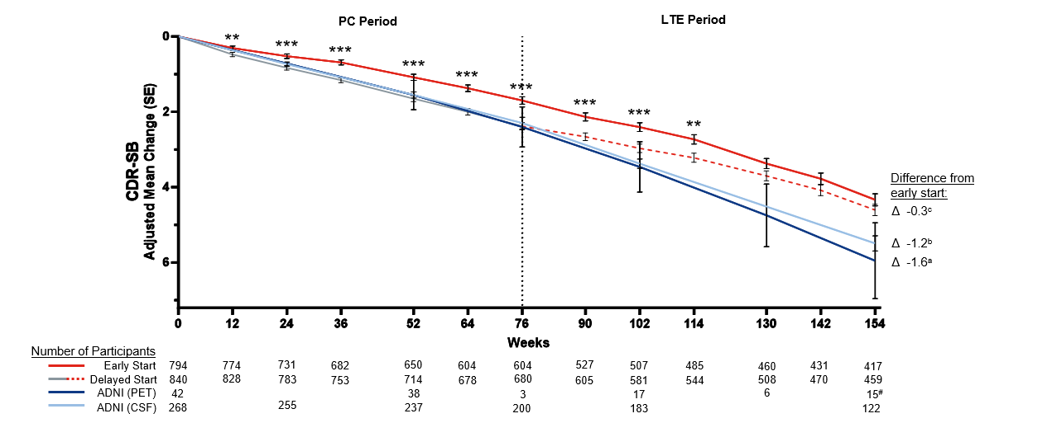
Source: Figure 3, p19 of the PSCR
ADNI = Alzheimer’s Disease Neuroimaging Initiative; CDR-SB = Clinical Dementia Rating – Sum of Boxes; CSF = cerebrospinal fluid; LTE = long term extension; MMRM = mixed model for repeated measures; PC = placebo controlled; PET = Positron Emission Tomography
* Includes 9 observations past 154 weeks
** P-values of Early vs Delayed start < 0.01
*** P-values of Early vs Delayed start < 0.001
ª Differences from early start were estimated using differences between MMRM model point estimates from LTE and random-coefficient spline model point estimates
^{b} Models were adjusted to identical baseline CDR-SB levels using the MMRM model and propensity score weighting
^{c} Models were adjusted to identical baseline CDR-SB levels using prespecified MMRM
  - The PSCR stated that patients who had received placebo in TB-2 experience a slowing of disease progression once they switched to donanemab and that patients who had received donanemab had a -1.2 to -1.6 difference in mean CDR-SB score change compared with the propensity score matched external control arm of untreated patients.
  - The ESCs noted the longer-term data, but also noted that no detail on the statistical approach used to construct the artificial control arm, including the covariates that were adjusted, were provided.
  - The pre-PBAC response presented graphs comparing individual patient responses for amyloid clearance alongside clinical outcomes (iADRS and CDR-SB) – see Figure 12
Figure 12: LS mean change in iADRS (Left) and CDR-SB (Right) correlation with amyloid value (centaloids)
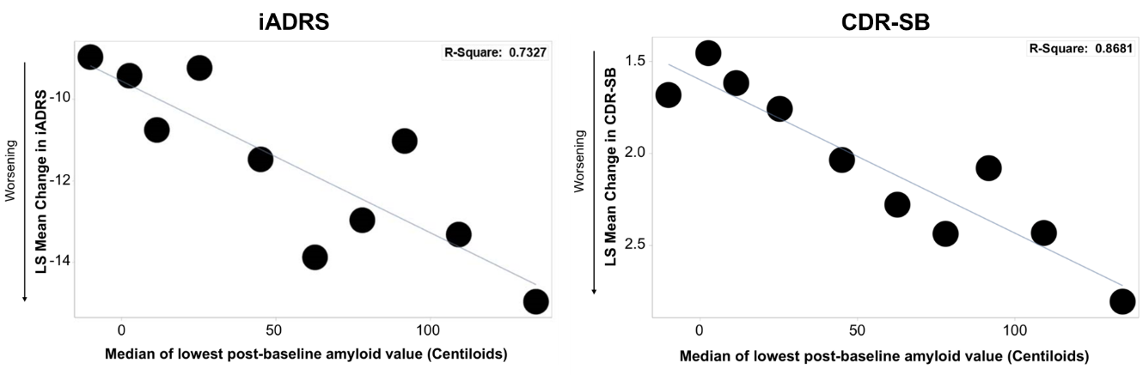
Source: Figure 1, p1 of the pre-PBAC response
CDR-SB: Clinical Dementia Rating Scale-Sum of Boxes; iADRS: Integrated Alzheimer’s Disease Rating Scale; LS: least-square.
  - The pre-PBAC response stated that the analysis from the TB-2 trial demonstrated a strong correlation between lower amyloid levels and improved outcomes on both the iADRS and CDR-SB scales.
Subgroup analyses: proposed TGA population
  - Subgroup analyses were presented in the submission for the proposed TGA population (i.e. excludes patients who are APOE4 homozygotes and those with superficial siderosis and the presence of more than 2 microhaemorrhages). 1,395 patients of the overall population (N=1,736) in TB-2 met the eligibility criteria for the proposed TGA subgroup analysis. This subgroup makes up 80% of the overall population and the results for the majority of the efficacy outcomes were reasonably comparable to those of the overall patient population. Efficacy analyses of the complement subgroup were not presented in the submission.
  - Results for the primary outcome of iADRS change from baseline for the two treatment arms are summarised in Table 12 and depicted in Figure 13.
Table 12: TB-2: Results of the primary outcome of change from baseline in iADRS – Proposed TGA population in TB-2 (EES)
 | Donanemab  Mean change from baseline (SE) | Placebo  Mean change from baseline (SE) | Adjusted mean difference  Donanemab minus Placebo  (95% CI)  p-value | % difference  Donanemab minus Placebo  (95% CI)
Week 12 | n=615  -0.80 (0.13) | n=636  -1.50 (0.13) | 0.70 (0.35, 1.06)  p<0.001 | 46.8  (21.86, 71.72)
Week 24 | n=583  -1.60 (0.26) | n=605  -3.00 (0.25) | 1.4 (0.69, 2.11)  p<0.001 | 46.6  (21.83, 71.44)
Week 36 | n=541  -2.71 (0.36) | n=579  -4.74 (0.36) | 2.04 (1.04, 3.04)  p<0.001 | 42.9  (20.99, 64.90)
Week 52 | n=525  -5.41 (0.43) | n=545  -8.04 (0.42) | 2.63 (1.44, 3.82)  p<0.001 | 32.7  (17.58, 47.87)
Week 64 | n=479  -7.86 (0.50) | n=514  -10.85 (0.48) | 2.99 (1.63, 4.34)  p<0.001 | 27.5  (14.83, 40.21)
Week 76 | n=475  -10.33 (0.59) | n=510  -13.67 (0.57) | 3.34 (1.75, 4.93)  p<0.001 | 24.4  (12.66, 36.21)
Source: Attachment 2.21 (Attachment 8) to the submission (TB-2 restricted label population analyses)
CI=confidence interval; EES=Evaluable Efficacy Set; iADRS=Integrated Alzheimer’s Disease Rating Scale; SE=standard error; TGA=Therapeutic Goods Administration.
Analysis using natural cubic spline model.
Figure 131: TB-2: iADRS change from baseline to 76 weeks in the proposed TGA population
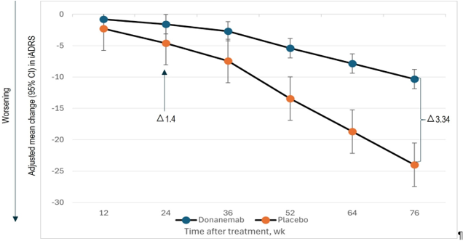
Source: Figure 2-40, p221 of the submission.
CI=confidence interval; iADRS=Integrated Alzheimer’s Disease Rating Scale; NCS2=natural cubic spline; TGA=Therapeutic Goods Administration; wk=week
  - The difference between the donanemab and placebo treatment arms in iADRS change from baseline to Week 76 was similar between the proposed TGA subgroup
(-3.34 [24.4% relative reduction in decline]) and the overall population (-2.92 [22.3% relative reduction in decline]). A difference in iADRS change between donanemab-treated patients and placebo-treated patients was observed from Week 12 and this treatment effect widened over time.
  - Analysis of time saved (delay) associated with donanemab compared with placebo was also conducted for the proposed TGA population. The results indicated that treatment with donanemab was associated with a delay in disease progression of 2.90 months based on iADRS change (1.38 months in the overall population) and 5.82 months based on CDR-SB change (5.44 months in the overall population) compared with placebo.
  - Consistent with the overall population, the percent reduction in decline compared with placebo was 31.5%, 27.2%, and 24.2% for the CDR-SB, ADCS-iADL, and ADAS-Cog13 endpoints, respectively.
  - Time to clinical worsening or progression to the next stage of disease was assessed using the MCID score for iADRS, CDR-SB, and CDR-G. These MCIDs apply to within patient changes and not to between group differences. Summarises results of the Cox proportional hazards analysis for iADRS, CDR-SB, and CDR-G.
Table 13: Cox proportional hazards analysis of the hazard of progression to an MCID (within patient) – decline based on iADRS, CDR-SB and CDR-G (TGA subgroup, EES)
Endpoint | Donanemab  Eventª n/N (%) | Placebo  Eventª n/N (%) | Difference in eventª rate  Donanemab minus Placebo | HR (95% CI) | p-value
iADRS | 195/643(30.3) | 269/660 (40.8) | -10.5% | 0.68 (0.55, 0.83) | p=0.0002
CDR-SB | 191/656(29.1) | 276/671(41.1) | -12.0% | 0.64 (0.52, 0.79) | <0.0001
CDR-G | 151/656(23.0) | 234/671(34.9) | -11.9% | 0.60 (0.48, 0.76) | <0.0001
Source: TB-2 restricted population analyses, Tables 2, 3, and 4, Attachment 2.21 accompanying the submission.
CDR-G=Clinical Dementia Rating Global scale; CDR-SB=Clinical Dementia Rating – Sum of Boxes; CI=confidence interval; EES=evaluable efficacy set; HR=hazard ratio; iADRS=Integrated Alzheimer’s Disease Rating Scale; TGA=Therapeutic Goods Administration
Notes
HR, 95% CI, and p-value are calculated using Cox proportional hazards model. The model included these covariates: baseline age, baseline value, baseline symptomatic treatments use and stratified by pooled investigator and baseline tau level.
Event: progression to MCID.
MCID for CDR-Global was defined as any increase in CDR-Global score for two consecutive visits.
MCID for CDR-SB was defined as 1 point or more increase for MCI patients and 2 point or more increase for mild AD
Patients, respectively, at two consecutive visits
MCID for iADRS was defined as 5 iADRS points or greater decrease for MCI patients and 9 iADRS points or greater decrease for mild AD patients, respectively, at two consecutive visits
  - Compared to the placebo arm, patients in the donanemab arm had a 32.8% reduction in the hazard of experiencing a meaningful decline in iADRS score (HR = 0.68; 95% CI: 0.55, 0.83; p=0.0002), a 36.0% reduction in the hazard of experiencing a meaningful decline in CDR-SB score (HR = 0.64; 95% CI: 0.52, 0.79; p<0.0001), and a 40% reduction in the hazard of experiencing a meaningful decline in CDR-G score (HR = 0.60; 95% CI: 0.48, 0.76; p<0.0001). The corresponding differences in event rate between the donanemab and placebo arms did not appear large for the iADRS (-10.5%), CDR-SB (-12.0%), and CDR-G (-11.9%) scales.
Subgroup analyses: by tau burden and other patient characteristics
  - Figure 14 summarises results of subgroup analyses by baseline characteristics.
Figure 142: TB-2: Subgroup analyses by baseline characteristics for the iADRS change from baseline at Week 76 in the overall population
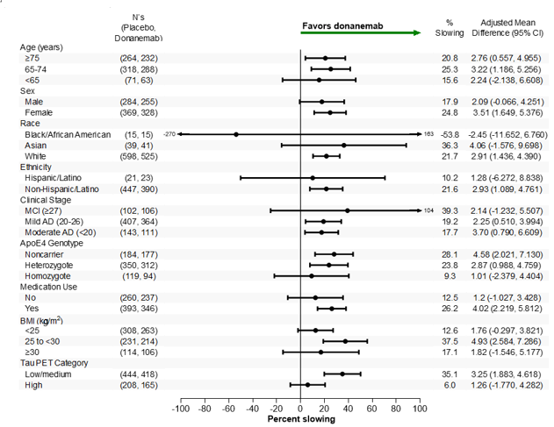
Source: Figure 243, p229 of the submission
AD=Alzheimer’s disease; Apoe4=apolipoprotein E allele 4; BMI=body mass index; CI=confidence interval; LS=least squares; iADRS=integrated Alzheimer’s Disease Rating Scale; MCI=mild cognitive impairment
  - Patients enrolled in TB-2 were required to have confirmed presence of both amyloid and tau pathology. Randomisation was stratified by tau pathology (Intermediate versus High). Analysis of the Intermediate tau (low/medium tau) population, in addition to analysis of the overall population, was a prespecified primary objective of the TB-2 trial. At Week 76, the mean (±SE) change from baseline in iADRS score in the intermediate tau population was -6.02 (±0.50) for the donanemab arm and -9.27 (±0.49) for the placebo arm, with a mean difference between the arms of 3.25 (95% CI: 1.88, 4.62; p<0.001). This corresponded to a 35.1% (95% CI: 19.9, 50.2) reduction in disease decline in donanemab-treated patients compared with placebo-treated patients.
  - For the high tau population, recognising the smaller number of patients in this subgroup, the mean difference between the donanemab and placebo arms was 1.26 (95% CI: -1.77, 4.28) which corresponds to a modest 6% reduction in disease decline in donanemab-treated patients compared with placebo-treated patients. The lower result in the high tau patients was likely due to downstream pathological processes that had already been initiated. Although the efficacy of donanemab in patients with higher brain tau concentrations remains uncertain, this observation, together with donanemab-related safety concerns, require the careful selection of patients for treatment in clinical practice.
  - The PSCR stated that the TB-2 study was not powered to precisely estimate the effective size withing the smaller-sized tau subgroup, and thus, no formal statistical efficacy comparisons can be made between the Intermediate and High tau populations.
  - In the TGA Delegate’s Overview, the sponsor noted that while a similar mean difference was observed in the low-medium and high tau populations, the relative percent slowing is lower in the high tau population, likely because of downstream pathological processes that have already been initiated. The sponsor further stated that ||| ||| ||| ||| ||| ||| ||| ||| ||| ||| ||| ||| ||| ||| ||| ||| ||| ||| ||| ||| ||| ||| ||| ||| ||| ||| ||| ||| ||| ||| ||| ||| ||| ||| ||| ||| ||| ||| ||| ||| ||| ||| ||| ||| ||| ||| ||| ||| ||| ||| ||| ||| ||| ||| ||| ||| ||| ||| ||| ||| ||| ||| ||| ||| ||| ||| ||| ||| ||| ||| ||| ||| ||| ||| ||| ||| ||| ||| ||| ||| ||| ||| ||| ||| ||| ||| ||| ||| ||| ||| ||| ||| ||| ||| ||| ||| ||| ||| ||| ||| ||| ||| ||| ||| ||| ||| ||| |||.
  - Additional subgroup analyses were presented to evaluate clinical progression among patients in the overall population who achieved early amyloid clearance (defined as <24.1 CL) at 24 weeks or at 54 weeks, and who switched to placebo. Figure 15 summarises the results. A comparison with patients who did not achieve early amyloid clearance at 24 weeks is presented in Figure 16.
Figure 153: Change from baseline to Week 76 in patients who achieved early amyloid clearance (<24.1 CL) at Weeks 24 or 52, and who switched to placebo as measured by (A) iADRS and (B) CDR-SB
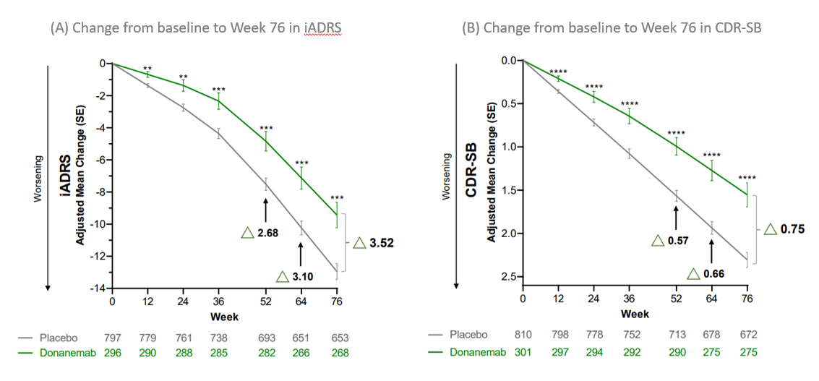
Source: Figure 2-46, p232 of the submission
Nominal **p<0.01; ***p<0.001, ****p<0.0001 vs placebo. CDR-SB=Clinical Dementia Rating Scale–Sum of Boxes; CL=Centiloid; EC=early clearance; iADRS=integrated Alzheimer’s Disease Rating Scale; LS=least squares; SE=standard error
Figure 164: TB-2 – Change from baseline to Week 76 in iADRS: patients who achieved early amyloid clearance (<24.1 CL) at Week 24 and switched to placebo compared with patients who did not achieve early amyloid clearance at Week 24 (NCS2)
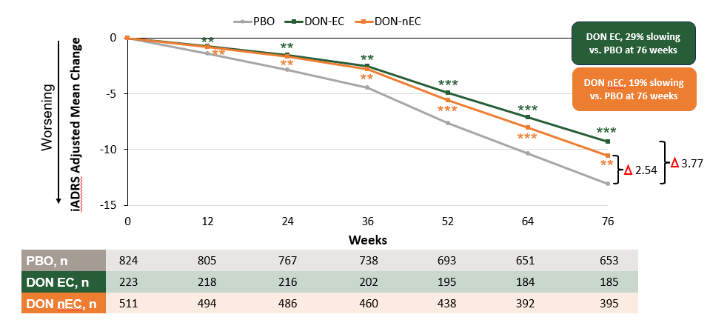
Source: Figure 2-46, p233 of the submission
CDR-SB=Clinical Dementia Rating Scale–Sum of Boxes; DON=donanemab; EC=amyloid early complete clearance (<24.1CL at week 24); iADRS=Integrated Alzheimer’s Disease Rating Scale; nEC=not amyloid early complete clearance (≥24.1CL at week 24); NCS2=Natural Cubic Spline Model with 2 Degrees of Freedom; PBO=placebo
Note: Nominal **p<0.01; ***p<0.001 vs placebo
  - The median time prior to placebo switch was 47 weeks. There was separation favouring donanemab over placebo up to 76 weeks in donanemab-treated patients who switched to placebo at 24 or 52 weeks (Figure 12).
  - The submission noted that donanemab-treated patients who achieved early amyloid clearance at Week 24 and who switched to placebo experienced a slowing of disease progression, as measured by the iADRS, which was comparable to that observed in patients who did not achieve early clearance and continued treatment after 24 weeks. The submission concluded that collectively, ‘the data in early completers support the assertion that stopping donanemab treatment at Week 24, or whenever amyloid plaque clearance is achieved, could represent a viable clinical approach’.

Comparative harms
  - The safety data were derived primarily from the TB-2 trial (Safety Analysis Set) and the combined placebo-controlled (PC) trials which included TB-2 and the Phase II TB trial (herein referred to as ‘Dona-PC’ [integrated set]).
  - Table 14 presents an overview of adverse events (AEs) in the PC trials.
Table 14: Summary of adverse events in TB-2 and DONA-PC integrated set
AE category | TB-2 (SAS) |  | DONA-PC (integrated set)
AE category | Donanemab  N=853 | Placebo  N=874 | Donanemab  N=984 | Placebo  N=999
AE category | n, (%)
TEAEs | 759 (89.0) | 718 (82.2) | 878 (89.2) | 831 (83.2)
Treatment-related TEAEs^{c} | 410 (48.1) | 173 (19.8) | 472 (48.0) | 198 (19.8)
TEAEs leading to treatment discontinuation | 112 (13.1) | 38 (4.3) | 152 (15.4) | 47 (4.7)
TEAEs leading to study discontinuation | 69 (8.1) | 32 (3.7) | NR | NR
SAEs | 148 (17.4) | 138 (15.8) | 168 (17.1) | 153 (15.3)
Deaths^{a,b} | 16 (1.9) | 10 (1.1) | 17 (1.7)^{b} | 12 (1.2)a
Source: Modified from Table 2-60, p208 of the submission and Table AACI.5.23, p188 of the TB-2 Clinical Study Report.
AE=adverse event; NR=not reported; SAE=serious adverse event; SAS=safety analysis set; TEAE=treatment emergent adverse event (defined as events that first occurred or worsened after the treatment initiation date).
Notes
AEs reported for placebo-controlled periods.
ª Deaths are also included as serious adverse events (SAE) and discontinuations due to AEs.
^{b} One death occurred in the Dona-PC analysis set after the database lock and is not included in this safety summary
  - Overall safety data were similar across the TB-2 and Dona-PC datasets. In TB-2, the frequency of treatment emergent adverse events (TEAEs) was increased in the donanemab arm versus the placebo arm for overall TEAEs (89.0% vs. 82.2%), treatment-related TEAEs (48.1% vs. 19.8%), TEAEs leading to study drug discontinuation (13.1% vs. 4.3%), TEAEs leading to study discontinuation (8.1% vs. 3.7%), serious TEAEs (SAE: 17.4% vs. 15.8%), and deaths (1.9% vs. 1.1%).
  - The TGA Delegate’s Overview provided a description of deaths in the DONA-PC dataset. There were 17 (1.7%) deaths in the donanemab arm and 12 (1.2%) deaths in the placebo arm. Causes of death in two or more patients in either treatment arm were:
- Placebo arm: pneumonia (two patients).
- Donanemab arm: ARIA (three patients), completed suicide (two patients), COVID-19 (two patients), and pulmonary embolism (two patients). Of the three patients in the donanemab arm who reported a serious ARIA and subsequently died, one (0.1%) death was attributed to ARIA-E, one (0.1%) death to ARIA-H, and the third death (0.1%) was attributed to both ARIA-E and ARIA-H.
  - The Delegate noted that among all the reports, five deaths (four in the donanemab-treated and one in the placebo-treated participants) were considered related to study treatment.
  - AEs of special interest (AESI) included ARIA-E, ARIA-H, infusion-related reactions, and other hypersensitivity reactions.
  - A higher frequency of treatment-emergent Immediate Hypersensitivity, Anaphylactic, and Infusion-Related Reactions in the donanemab arm (n = 89; 10.4%) compared to the placebo arm (n = 8; 0.9%).
  - Table 15 summarises ARIA and macrohaemorrhage events in the TB-2 and DONA-PC safety datasets.
Table 15: Summary of ARIA and macrohaemorrhage events in in TB-2 and Dona-PC
ARIA events | TB-2 (SAS) |  | DONA-PC (Integrated set)
ARIA events | Donanemab  N=853  (n, %) | Placebo  N=874  (n, %) | Donanemab  N=984  (n, %) | Placebo  N=999  (n, %)
Any ARIA (-E or -H) | 314 (36.8) | 130 (14.9) | 364 (37.0) | 142 (14.2)
Serious ARIA (-E, or -H) | 14 (1.6) | 0 (0.0) | 16 (1.6) | 0 (0.0)
ARIA-Eª | 205 (24.0) | 18 (2.1) | 240 (24.4) | 19 (1.9)
ARIA-E (MRI) | 202 (23.7) | 17 (1.9) | 237 (24.1) | 18 (1.8)
Deaths^{b} | 1 (0.1) | 0 (0.0) | 1 (0.1) | 0 (0.0)
Symptomatic | 52 (6.1) | 1 (0.1)c | 54 (5.5) | 1 (0.1)^{c}
Serious ARIA-E | 13 (1.5) | 0 (0.0) | 15 (1.5) | 0 (0.0)
Treatment discontinuations | 21 (2.5) | 3 (0.3) | 28 (2.8) | 4 (0.4)
ARIA-Hª | 268 (31.4) | 119 (13.6) | 308 (31.3) | 130 (13.0)
ARIA-H (MRI) | 267 (31.3) | 115 (13.2) | 307 (31.2) | 124 (12.4)
Deaths^{b} | 1 (0.1) | 0 (0.0) | 1 (0.1) | 0 (0.0)
Serious ARIA-H | 4 (0.5) | 0 (0.0) | 4 (0.4) | 0 (0.0)
Treatment discontinuations | 20 (2.3) | 6 (0.7) | 22 (2.2) | 4 (0.4)
Concurrent ARIA-E and ARIA-H^{d} | 47 (17.5) | 2 (0.7) | 161 (16.4) | 6 (0.6)
Macrohaemorrhage^{e} | 3 (0.4) | 2 (0.2) | 3 (0.3) | 2 (0.2)
Source: Table 2-65, p211 of the submission.
ARIA (-E or -H)=amyloid-related imaging abnormalities (oedema or haemorrhage);MRI=magnetic resonance imaging; SAS=safety analysis set
Notes
ARIA was based on MRI and TEAE clusters.
ª ARIA-H includes brain microhemorrhage and superficial siderosis (ARIA-H SS). ARIA-H SS occurred more frequently in donanemab-treated patients (16.0%) compared with placebo-treated patients (3%) across both datasets. ARIA-H microhaemorrhage also occurred more frequently in donanemab-treated patients (28%) compared with placebo-treated patients (13%).
^{b} Deaths are also included in serious ARIA and discontinuations due to an AE.
^{c} One placebo-treated patient had ARIA-E during the placebo-controlled period; however, the participant developed symptoms during the long-term extension (LTE) period.
^{d}Concurrent ARIA-E and ARIA-H were observed on the same MRI
^{e} Intracerebral haemorrhage greater than 1 cm
  - ARIA is an important marker of blood–brain barrier alteration and reflects adverse drug reaction to anti-amyloid therapies. When left undetected or unmanaged, ARIA may result in serious clinical consequences. Rare serious or severe neurological symptoms may require hospitalisation and specific monitoring and management, .
  - The frequency of ARIA events was similar across the TB-2 and DONA-PC datasets. Most ARIA events were asymptomatic and therefore only detected on scheduled MRI.
  - In the TB-2 trial, 36.8% of patients receiving donanemab and 14.9% of patients receiving placebo experienced one or more ARIA events, as assessed by MRI and/or AE reports/ARIA case report forms.
  - ARIA-E events occurred more often in the donanemab arm compared with the placebo arm (24.0% vs 2.1%), and 6.1% of patients in the donanemab arm versus 0.1% in the placebo arm experienced symptomatic ARIA-E (e.g., headache, confusional state, dizziness, nausea, and seizure). Of the 52 donanemab-treated patients who experienced symptomatic ARIA-E, approximately 85% had resolution of symptoms associated with ARIA-E. Serious ARIA-E occurred in 13 patients (1.5%) in the donanemab arm and none occurred in the placebo arm. One death in the donanemab arm and none in the placebo arm was due to ARIA-E.
  - Study drug infusion was temporarily withheld in 62.9% and permanently discontinued in 8.0% of donanemab-treated participants experiencing a first ARIA-E episode. Based on MRI, a total of 198 of 202 (98.0%) first ARIA-E episodes had complete resolution, with a mean time to resolution of 72.4 days.
  - ARIA-H events occurred more often in the donanemab arm compared with the placebo arm (31.4% vs 13.6%). Four patients (0.5%) in the donanemab arm and none in the placebo arm experienced a serious ARIA-H event. The TB-2 CSR (p214) noted that two patients with a serious ARIA-H event subsequently died. The frequency of ARIA-H was higher in the donanemab arm versus the placebo arm for superficial siderosis (16.0% vs. 2.8%) and for microhaemorrhage (25.0% vs. 10.9%). Study drug was temporarily withheld in 33.6% of patients and permanently discontinued in 6.5% of donanemab-treated patients.
  - The proposed TGA and PBS target population excludes patients who are APOE4 homozygotes. ARIA safety data by APOE4 carrier status was therefore considered informative in assessing the impact of excluding these patients who are at a higher risk of ARIA. The safety data have been sourced from the TB-2 CSR and are summarised in Table 16.
Table 16: TB-2: Frequency of ARIA by APOE4 carrier status (based on MRI) – placebo-controlled period
ARIA Category.  Patients having: | Donanemab  APOE4 carrier statusª |  |  | Placebo  APOE4 carrier statusª
ARIA Category.  Patients having: | Hetero  N=452  n, (%)  (included in the PBS target population) | Homo  N=143  n, (%)  (excluded from the PBS target population) | Non-carrier  N=255  n, (%)  (included in the PBS target population) | Hetero  N=474  n, (%) | Homo  N=146  n, (%) | Non-carrier  N=250  n, (%)
≥ one ARIA-E event | 103 (22.8) | 58 (40.6) | 40 (15.7) | 9 (1.9) | 5 (3.4) | 2 (0.8)
≥ one serious ARIA-E event | 4 (0.9) | 3 (2.1) | 1 (0.4) | 0 (0.0) | 0 (0.0) | 0 (0.0)
≥ one ARIA-H event | 146 (32.3) | 72 (50.3) | 48 (18.8) | 57 (12.0) | 30 (20.5) | 28 (11.2)
≥ one serious ARIA-H event | 0 (0.0) | 2 (1.4) | 0 (0.0) | 0 (0.0) | 0 (0.0) | 0 (0.0)
≥ one ARIA-H microhaemorrhage | 121 (26.8) | 59 (41.3) | 39 (15.3) | 50 (10.5) | 26 (17.8) | 27 (10.8)
≥ one ARIA-H superficial siderosis | 75 (16.6) | 40 (28.0) | 19 (7.5) | 12 (2.5) | 10 (6.8) | 3 (1.2)
Source: Table AACI.8.192, pp1840-1841, TB-2 Clinical Study Report.
APOE4=apolipoprotein E4; ARIA-E or -H=amyloid related imaging abnormality – oedema or haemorrhage; Hetero=heterozygotes; Homo=homozygotes.
Events occurred up to either the first visit date of long-term extension phase (LTE) – 1 day or end of treatment period in double
blinded phase + 57 days, whichever occurred first are included in this table.
ª Patients with missing APOE4 carrier status are excluded.
^{b} Treatment-emergent microhaemorrhage is based on new incidents of microhaemorrhages. Treatment-emergent superficial siderosis is based on new or worsening superficial siderosis.
  - Overall, a higher frequency of ARIA-E and ARIA-H events was observed for the APOE4 homozygotes compared to heterozygotes and non-carriers, with non-carriers having the lowest frequency of ARIA events.
  - However, the frequency of ARIA in TB-2 was substantially higher in the donanemab arm versus the placebo arm regardless of APOE4 carrier status. The percentage of APOE4 heterozygotes and non-carrier patients (included in the proposed PBS target population), who experienced at least one ARIA event, was approximately 14 fold in the donanemab arm versus the placebo arm for ARIA-E (38.5% [22.8% + 15.7%] vs. 2.7% [1.9% + 0.8%]), more than two fold for ARIA-H (51.1% [32.3% + 18.8%] vs. 23.2% [12.0% + 11.2%]), with approximately two fold for ARIA-H microhaemorrhage (42.1% [26.8% + 15.3%] vs. 21.3% [10.5% + 10.8%]) and seven fold for ARIA-H superficial siderosis (24.1% [16.6% + 7.5%] vs. 3.7% [2.5% + 1.2%]).
  - A concern is also raised regarding the significant percentage of ARIA events in the subgroup of non-carriers that have the lowest risk of ARIA events. In non-carriers, the frequency of ARIA-E was approximately 16% and that of ARIA-H was approximately 19%.
  - The safety data should be interpreted in the context that several measures were taken in the TB trials to mitigate the risk of ARIA which included the exclusion of patients with pre-existing ARIA, >4 microhaemorrhages; >1 area of superficial siderosis; any macrohaemorrhage; or severe white matter disease, the conduct of regular MRI scans as per protocol-based Schedule of Activities, performance of unscheduled MRIs at the investigator’s discretion, and provision of guidance on the prompt management of an ARIA event.
  - The submission presented supplementary safety-related information on the enhanced titration dosing regimen. At Week 24 of the TB-6 study, the enhanced titration dosing regimen met the primary safety endpoint showing a reduction in risk in ARIA-E frequency compared to the standard dosing regimen. The proportion of participants with ARIA-E by 24 weeks was greater in the standard dosing group compared to the enhanced titration dosing arm (23.7% vs. 13.7%), and the absolute difference of 10.0% was statistically significant (p=0.012).

Benefits/ harms
  - A summary of the comparative benefits and harms for donanemab versus placebo at 18 months in the key TB-2 trial is presented in Table 17 below.

Table 17: TB-2: Summary of comparative benefits and harms for donanemab (700 mg Q4W for the first three doses, followed thereafter by 1,400 mg Q4W) compared with placebo (overall population) – 76 weeks follow-up
Outcome |  |  | Donanemab |  | Placebo
Benefits (Evaluable Efficacy Set)
Primary outcome of iADRSª change from baseline at 76 weeks |  |  | N=583 |  | N=653
Mean change from baseline |  |  | -10.19 |  | -13.11
Difference in mean change donanemab minus placebo (95% CI) |  |  | 2.93 (1.51, 4.33)  p<0.001
% reduction (slowing) in disease decline, donanemab vs. placebo (delay in decline) |  |  | 22.3% (1.38 months delay)
Secondary outcome of CDR-SB change from baseline at 76 weeks |  |  | N=598 |  | N=672
Mean change from baseline |  |  | 1.66 |  | 2.33
Difference in mean change donanemab minus placebo (95% CI) |  |  | -0.67 (-0.92, -0.43)
% reduction (slowing) in disease decline, donanemab vs. placebo (delay in decline) |  |  | 28.9% (5.44 months delay)
CDR-G^{b} Shift from baseline (progression to a later stage)
From 0.5 to 1  (MCI to Mild AD Dementia), n/N (%) |  |  | N=502  134/502 (27%) |  | N=521  202/521 (39%)
Difference donanemab minus placebo |  |  | -12.1%
From 1 to 2  (Mild AD Dementia to Moderate AD Dementia), n/N (%) |  |  | N=292  51/292 (17.5%) |  | N=302  82/302 (27.2%)
Difference donanemab minus placebo |  |  | -9.7%
Harms (Safety Analysis Set)
TEAEs | Donanemab | Placebo | Event rate/100 patients |  | Risk difference
TEAEs | Donanemab | Placebo | Donanemab | Placebo | Risk difference
ARIA-E, n/N  Overall population | 205/853 | 18/874 | 24.0 | 2.1 | 21.9
ARIA-E, n/N  TGA population excluding APOE4 homozygous carriers | 139/689 | 11/692 | 20.2 | 1.6 | 18.6
ARIA-H, n/N  Overall population | 268/853 | 119/874 | 31.4 | 13.6 | 17.8
ARIA-H, n/N  TGA population excluding APOE4 homozygous carriers | 184/689 | 75/692 | 26.7 | 10.8 | 15.9
Microhaemorrhage | 159/689 | 72/692 | 23.1 | 10.4 | 12.7
Infusion-related reactions, n/N | 74/853 | 4/874 | 8.7 | 0.5 | 8.2
Source: Sections 2.D.5 and 2D.6 of the submission, the TB-2 Clinical Study Report (ARIA safety data by APOE4 carrier status), Zimmer et al (2024) (CDR-G shifts), and the FDA Clinical Review of donanemab (Infusion-related reactions in TB-2)
AD=Alzheimer’s disease; ADAS-Cog13=Alzheimer’s Disease Assessment Scale (Cognitive subscale); ADCS-iADL=Alzheimer’s Disease Cooperative Study – Instrumental Activities; APOE4=apolipoprotein epsilon 4; CDR-SB=Clinical Dementia Rating scale Sum of Boxes (values range from 0 to 18, with higher scores indicating greater impairment); CDR-G=Clinical Dementia Rating-Global score; CI=confidence interval; iADRS=Integrated Alzheimer’s Disease Rating Scale; MCI=Mild Cognitive Impairment
ª The iADRS assesses the impact of cognitive loss on the ability to conduct everyday activities and provides a measure of global AD severity across the AD continuum as a single summary score. The composite score comprises two underlying domains: cognitive ability and functional ability. The actual scales administered to participants in the trial were the ADAS Cog13 and the ADCS-ADL.
Lower scores on the iADRS indicate greater impairment; iADRS scores range from 0 to 144. All items of the ADAS-Cog13 and ADCS-iADL are included without additional weighting of items.
^{b} CDR-G Shift represents change in CDR-G from baseline at two consecutive visits. Only shifts from MCI to Mild AD and from Mild AD to Moderate AD are included in table. Other shifts were imprecise.
  - On the basis of the key TB-2 trial presented in the submission,
- Donanemab was associated with a 2.92 point improvement at 76 weeks compared with placebo, as measured on the 0-144 score range of the Integrated Alzheimer’s Disease Rating Scale. The delay in decline with donanemab compared with placebo was 1.38 months (approximately 6 weeks).
- Donanemab was associated with a 0.67 point improvement at 76 weeks compared with placebo, as measured on the 0-18 score range of the Clinical Dementia Rating Sum of Boxes scale. The delay in decline with donanemab compared with placebo was 5.44 months (approximately 24 weeks).
- Of 100 patients treated with donanemab in comparison to placebo over a study period of 76 weeks, 12 fewer patients will progress from MCI to Mild AD dementia and 10 fewer patients will progress from Mild AD dementia to Moderate AD dementia. All patients will eventually progress to a later disease stage.
- For every 100 patients treated with donanemab in comparison to no active treatment over a study period of 76 weeks,
  - 22 additional patients will experience some swelling in the brain (ARIA-E), noting this risk is particularly increased in APOE4 homozygotes who are excluded from the target population.
  - 18 additional patients will experience some bleeding in the brain (ARIA-H), noting this risk is particularly increased in APOE4 homozygotes who are excluded from the target population.
  - 8 additional patients will experience infusion-related reactions.

Clinical claim
  - The submission described donanemab + SoC as superior in terms of effectiveness compared with current SoC and having an inferior but manageable safety profile, in patients with early symptomatic AD with evidence of Aß pathology, who are not APOE4 homozygotes and who do not have a baseline presence of superficial siderosis and more than 2 microhemorrhages.
  - In terms of comparative effectiveness, the ESCs considered that, although in patients with a clinical diagnosis of MCI due to AD or mild AD dementia who are not APOE4 homozygotes, and who do not have evidence of superficial siderosis and more than 2 microhemorrhages, donanemab ± SoC was statistically significantly superior to no active therapy ± SoC in the rate of decline (slowing) of clinical disease progression in cognitive and functional scales at 76 weeks, the clinical significance and long-term effects of donanemab treatment were highly uncertain as:
- In the TB-2 overall population, for the primary outcome of iADRS with a score range of 0 to 144, the iADRs score worsened from baseline to Week 76 by 10 points in patients who received donanemab and by 13 points in those given placebo. This corresponded to a statistically significant difference of 2.92 (95% CI: 1.51, 4.33; p<0.001) favouring donanemab over placebo (22.3% relative reduction in decline of progression). The estimated delay in disease progression associated with donanemab on the iADRS was approximately 6 weeks (1.38 months; 95% CI: 0.46, 2.30). The ESCs considered that the estimated differences were modest. The ESCs considered that it was highly uncertain if the degree of slowing in clinical progression was clinically meaningful and if it would produce a noticeable benefit to patients and caregivers.
- For the secondary outcome of CDR-SB (score range of 0-18) change from baseline to Week 76 in the overall population, the mean difference between donanemab and placebo was statistically significant (-0.67; 95% CI: -0.92, -0.43). This difference corresponded to a 28.9% relative reduction in decline associated with donanemab and a delay in progression of 5.44 months (95% CI: 3.90, 6.98) over the 76-week trial period. The ESCs considered that the estimated differences were modest. The ESCs considered that it was uncertain if the degree of slowing in clinical progression was clinically meaningful and if it would produce a noticeable benefit to patients and caregivers.
- Based on CDR-G shifts from baseline, fewer patients in the donanemab arm compared with the placebo arm progressed to the next clinical stage (first CDR-G clinical worsening). Patients treated with donanemab had a 37% lower hazard of progression to the next stage of the disease as measured by the CDR-G shift (HR = 0.63; 95% CI: 0.51, 0.77; p<0.0001) through to Week 76. However, the ESCs noted that the differences between the donanemab and placebo arms in the percentage of patients progressing from MCI to mild AD dementia (-12.1%), and from mild AD dementia to moderate AD dementia (-9.7%) were modest.
- For the proposed TGA population (i.e. excludes patients who are APOE4 homozygotes or those with evidence of superficial siderosis/more than 2 microhemorrhages), which made up 80% of the overall TB-2 trial population, the effectiveness results were generally similar to those of the overall population for the majority of the outcomes. The difference between the donanemab and placebo treatment arms in iADRS change from baseline to Week 76 was -3.34 corresponding to a 24.4% relative reduction in decline.
  - The ESCs also noted the following additional clinical issues when interpreting the TB-2 data:
- Although 76.4% of patients in the donanemab arm achieved amyloid clearance compared to 0.3% in the placebo arm after 76 weeks, the difference in iADRS between the arms was modest. Thus, the ESCs considered that the effect of amyloid clearance on the clinical effects and progression of AD remained uncertain.
- The duration of clinical benefit beyond the trial period was unclear, in relation to re-accumulation of amyloid plaques and in relation to any sustained treatment effect beyond 18 months.
- Tau levels informed the inclusion criteria of the TB-2 trial. Noting that testing for tau in clinical practice is unavailable in Australia, the ESCs noted that the evidence of benefit appeared better supported in patients with lower tau burden (Intermediate tau subgroup; 35.1% reduction in disease decline associated with donanemab), with a smaller potential clinical advantage in patients with higher tau burden (High tau subgroup; 6% reduction in disease decline) who have more progressed disease. The ESCs noted that this issue complicates the careful selection of patients who are most likely to benefit from donanemab.
- No reliable health related QoL data were captured in the key TB-2 trial. QoL data were based on a small subset of patients and were not deemed reasonably adequate to capture and inform on the impact of donanemab in improving the QoL of patients and their care givers. However, QoL is an important consideration in AD because of the devastating impact of this progressive and incurable disease on patients and caregivers.
- The primary and secondary cognitive and functional outcomes are subjective in nature and potential unblinding due to the high risk of donanemab-related ARIA could have introduced performance bias or functional unblinding impacting patient and carer responses.
- The TB-2 trial excluded a significant proportion of patients with concomitant medical conditions that are typical of the elderly population with AD, thereby potentially limiting the generalisability of the study results. Overall, the TB-2 trial patients represent a selected healthy and minimally co-morbid early AD population unlikely to be representative of the real-world target population.
  - The ESCs considered that the claim of inferior safety was supported by the evidence presented in the submission. The submission also claimed that the AEs associated with donanemab were manageable. The ESCs considered that this was uncertain, noting that this should be interpreted within the context that ARIA events represent significant risks for which there is no evidence-based treatment and careful patient selection is required. Additionally, in terms of safety, the ESCs noted that:
        - The proposed target population excludes patients who are APOE4 homozygotes. These patients represent those with the highest risk of ARIA compared to heterozygotes and non-carriers. However, a concern is raised regarding the significant percentage of patients in the donanemab arm who experienced ARIA-E and ARIA-H in TB-2, particularly in the non-carriers (ARIA-E 16%; ARIA-H 19%) who are at the lowest risk of ARIA. .
        - Safety assessment in a closely monitored trial is also expected to be more efficient compared to clinical practice where there is limited access to MRIs and other required tests.
  - The ESCs noted that additional data collection would not resolve many of the uncertainties raised. Overall, whilst donanemab may provide a modest benefit for some individuals with early symptomatic AD, it may also introduce additional risk and burden to a potentially significant proportion of patients who will experience minimal or no benefit in slowing disease decline. This may also impact clinicians and healthcare systems.
  - The PBAC considered that the claim of superior comparative effectiveness was reasonable in terms of achieving amyloid clearance, but that the effect of this on the clinical effects and progression of AD was very modest and not likely to be clinically meaningful.
  - The PBAC considered that the claim of inferior comparative safety was reasonable.

Claim of codependence
  - Amyloid plaques are implicated in the pathophysiology of AD. Both Aβ-PET and Aβ42 concentration in the CSF appear to be predictive of amyloid status.
  - There is a clear interaction between the drug and the biomarker, as donanemab binds to a truncated form of Aβ that is present only in established Aβ plaques, and aids in their removal from the brain via microglial-mediated phagocytosis. There was a statistically significant reduction in abnormal amyloid pathology as detected by Aβ-PET in participants in the donanemab arm compared to those in the placebo arm; at 18 months 76.4% of participants receiving donanemab had clearance of Aβ plaques (p<0.001). Clearance was defined as an Aβ-PET level of <24.1 Centiloids (CL).
  - However, the ESCs considered that it was uncertain if the reduction in Aβ burden, as measured by Aβ-PET, was associated with a meaningful slowing in cognitive and functional decline in early AD. The ESCs noted that there was a 22.3% slowing of disease progression associated with donanemab in the TB-2 trial, a difference that appears modest as it equates to an estimated delay in progression of 1.38 months (approximately 6 weeks) over a 76-week period of treatment, compared to placebo.
  - The ESCs recognised that slowing of disease progression early in the disease course might be of the most benefit to patients and their carers in terms of their quality of life and ability to plan for the remainder of the disease course. However, the ESCs were unsure if 6 weeks of delayed progression was considered clinically meaningful.

Economic analysis
  - The submission presented a modelled economic evaluation based on the treatment effect observed in the TB-2 trial which compared donanemab treatment to SOC in patients with early AD with a positive amyloid-beta biomarker test and who were not APOE4 homozygotes. The type of economic evaluation presented was a cost-utility analysis. Key components of the model are summarised in Table 18.
Table 18: Summary of model structure, key inputs and rationale
Component | Summary
Comparison | Donanemab with amyloid and APOE4 testing versus SOC.
Outcomes | QALYs.
Time horizon | Lifetime (26 years) in the model base case (versus 18 months in the key trial). A shorter time horizon would be adequate to capture the differences between the arms. The majority of the modelled benefit was accrued during the extrapolated period. The duration of effect for donanemab was unknown.
Methods used to generate results | State-transition Markov model.
Health states | 9 health states in two settings: MCI due to AD, mild AD, moderate AD and severe AD in the community and institutional setting and dead.
Cycle length | Six months.
Test parameters | Patients enter the model at the point of treatment initiation and each patient incurs the testing costs associated with the number required to identify one treated patient with donanemab, thus testing costs for all patients considered for the medicine are included in the model.
Implications of false positive and false negative results | Not considered in the economic evaluation. While this was reasonable for PET scans (as these were used in the trial and would have the same performance in practice), CSF assays, which were not used in the trial and can be used in practice, have a 6 – 28% false positive rate when compared to PET. The submission has not considered that in clinical practice a proportion of patients with false positive CSF assays would be eligible for donanemab treatment which would affect the overall treatment effect of donanemab.
Transition probabilities | In the SOC arm, for the entire duration of the model, transition probabilities were informed by natural history data from the NACC database. In the donanemab arm, a treatment effect was applied to the natural history transition probabilities (discussed below). These transition probabilities were not able to be verified during the evaluation.  Mortality was modelled through the ABS life tables, adjusted for an additional risk of death due to AD sourced from the UK ONS. The ESCs noted that this was not reasonable as a single HR (2.55) for patients in the mild, moderate and severe AD health states was applied and the literature indicates increased mortality risk with worsening symptoms of AD.  Institutionalisation risks were derived from the prevalence of institutionalised dementia patients reported by the AIHW. The approach used to convert institutionalisation prevalence to incidence was not appropriate for the model as it was based on a fixed duration of institutionalisation which was different to the duration applied in the model.
Donanemab treatment effect | The donanemab treatment effect was applied as a HR (0.64) for patients in the MCI due to AD, mild and moderate AD health states. The HR was derived from the secondary outcome, CDR-SB for the subgroup of patients were not APOE4 homozygous. The ESCs considered that the use of a hazard ratio from a subgroup analysis of a secondary outcome to inform the transition probabilities was inappropriate and was not adequately justified in the submission. The ESCs considered that the iADRS outcome for the overall population, which was the primary outcome of the trial, should have been applied. The ESCs noted that the model did not allow for changing of the hazard ratio. Further, the ESCs noted that the inclusion of a treatment effect for moderate AD patients was not justified given that these patients were not included in the proposed restriction.  For patients who complete the full treatment course (18 months) or cease treatment early due to amyloid clearance, the full treatment effect was applied until Year 5.5, after this it was assumed to wane linearly over 9.5 years based on amyloid removal and re-accumulation rates. The submission has not robustly established a link between amyloid removal and AD progression. Additionally, the ESCs considered that the assumption that a 1.38 month delay in disease progression, as measured with the iADRS, after 76 weeks of treatment would result in a modelled treatment benefit at 15 years was highly implausible. The treatment effect of donanemab vs SOC beyond the trial duration is unknown.  For patients who discontinue donanemab due to AEs in the first six months (13% of patients based on the TB-2 trial), the full treatment effect was applied until Year 1 and then assumed to wane over 2.5 years. Given these patients discontinue treatment within six months it is unlikely they will sustain any treatment effect beyond their treatment period.
Health related quality of life | Patient health state utility values were not treatment-arm specific and were not dependent on whether patients were institutionalised or in the community. The utility values were sourced from Landeiro et al: MCI due to AD: 0.86; Mild AD: 0.74; Moderate AD: 0.59 and Severe AD: 0.36. AE disutilities for ARIA events and anaphylactic reactions were also included.  Carer utilities were included in the base case for 50% of patients. The inclusion of carer utilities in the base case analysis was inappropriate and inconsistent with the PBAC guidelines which stipulate to only include outcomes associated with the patient.
Costs | Costs include donanemab diagnostic, acquisition, administration and monitoring costs as well as costs associated with AE, disease management, institutional residency and terminal care costs. The entire aged care residential fee (which was based on the total cost for aged care residents in Australia) may fall outside of the scope of the economic evaluation as specified in the PBAC guidelines (as many aged care costs may not be direct medical costs).
Source: Constructed during the evaluation from the “3.3_Donanemab cost effectiveness model” attachment provided with the submission.
ABS = Australian Bureau of Statistics; AD = Alzheimer’s Disease; AE = adverse events; AIHW = Australian Institute for Health and Welfare; APOE = Apolipoprotein E gene; ARIA = amyloid-related imaging abnormalities; HR = hazard ratio; MCI = mild cognitive impairment; MRI = magnetic resonance imaging; NACC = National Alzheimer’s Coordinating Center; ONS = Office for National Statistics; PBAC = Pharmaceutical Benefits Advisory Committee; QALY = qualify-adjusted life year; SOC = Standard of Care; TB-2 = TRAILBLAZER-2; UK = United Kingdom.
  - The Markov state-transition model adopts a lifetime (26 year) time horizon and incorporates two settings (community and institutional) and four health states (MCI due to AD, mild, moderate and severe AD) in each setting based on AD disease severity (as per CDR-SB) and a dead health state. Patients enter the model at the point of treatment initiation and testing costs (for amyloid and APOE4) are applied at model entry, weighted by the number of patients who would test per treated patient.
  - The submission assumed that 61% and 91% of patients with MCI due to AD and mild AD would be Aβ positive and calculated a weighted positivity rate of 85% (weighted by the proportion of MCI versus mild patients at model entry). The calculated number of Aβ tests per treated patient was 1.18 (1/85%). A similar approach was taken for APOE4 tests. A non-APOE4 homozygote prevalence rate of 64% was assumed, equating to 1.57 APOE4 tests per treated patient. The sources of both these prevalence rates (Aβ and APOE4) were not able to be verified during the evaluation.
  - Patients enter the model in the MCI due to AD or mild AD health state in the community setting (21% MCI due to AD and 79% mild AD as per the baseline characteristics of patients in TB-2). The same transition probabilities were applied to each health state in the community and institutional settings and patients and each model cycle (six months) patients could remain within their health state, progress to any worsening health or die. In the SOC arm, transition probabilities for all health states were informed by an analysis of the National Alzheimer’s Coordinating Center (NACC) database. However, these transition probabilities could not be verified. The submission also provided natural history transition probabilities reported in Potashman et al. which appeared to be relatively similar to those applied in the base case. Applying the Potashman et al. transition probabilities increased the ICER by ||| |||% (from $35,000 to < $45,000 per quality-adjusted life year (QALY) gained to $35,000 to < $45,000 per QALY gained).
  - In the intervention arm, a hazard ratio of 0.64 was applied to the SOC transition probabilities to estimate transitions to worsening health states for patients in the MCI due to AD, mild and moderate AD health states. The hazard ratio was derived from a survival analysis of patients having clinical progression as per the secondary outcome, CDR-SB, in the TB-2 trial for the subgroup of patients who were not APOE4 homozygotes. The ESCs noted that no cohort level evidence was provided to support the implicit claim that CDR-SB (or any other the TB-2 outcome instrument) is a reliable proposed surrogate measure (see Appendix 5 of the PBAC Guidelines) for the natural history of AD . Similarly, no comparative cohort level evidence was provided for the key implied relationship between the MCID of CDR-SB (predefined by its perceptibility to a patient as a within-patient change rather than as a between-group assessment) as being a reliable surrogate threshold effect for a change in the level of severity of AD. Therefore, the ESCs considered that there was no evidence to support the application of the hazard ratio of time to an MCID change in the CDR-SB as the basis for assuming the same hazard ratio would predict quantified changes in the times to progression across AD health states in the economic model.
  - Furthermore, the ESCs considered that not using the iADRS outcome for the overall population, which was the primary outcome of the trial was not justified. Other outcomes and subgroup populations could have also been presented as sensitivity analyses. The ESCs further noted that the application of a treatment effect for moderate AD patients was not reasonable given insufficient trial evidence. Removal of the treatment effect for moderate AD patients increased the ICER by ||| |||% (from $35,000 to < $45,000 per QALY gained to $45,000 to < $55,000 per QALY gained).
  - Different treatment effect maintenance and waning assumptions were applied to donanemab patients depending on if they (1) achieved amyloid clearance early or completed the full treatment course (18 months) or (2) discontinued treatment prematurely due to AEs after 6 months of treatment (13% of donanemab patients). For patients who discontinued due to AEs it was assumed that they retained the full treatment effect for six months after discontinuation (until Year 1) and then that the treatment effect would linearly wane over 2.5 years, until the HR equalled 1. Six months’ worth of treatment may not be sufficient to warrant any treatment effect beyond the treatment period. Removing all treatment effect immediately upon treatment cessation for these patients increased the ICER by ||| |||% (from $35,000 to < $45,000 per QALY gained to $35,000 to < $45,000 per QALY gained).
  - For patients who achieve amyloid clearance or complete the full treatment course, the full treatment effect was applied until Year 5.5 (four years after the maximum treatment duration) and then it was assumed to linearly wane over 9.5 years (until Year 15) until the HR equalled 1. The submission justified the long treatment effect on the basis of amyloid clearance and re-accumulation rates. No evidence was provided in the submission that would robustly estimate the magnitude of the effect associated with amyloid removal or its re-accumulation and disease progression. A number of different treatment waning assumptions were explored during the evaluation (see Figure 17). Although these resulted in small differences in health state membership, they had a large impact on the ICER (see Table 22). These analyses increased the ICER by ||| |||% to ||| |||% (from $35,000 to < $45,000 per QALY gained to $45,000 to < $55,000 to $75,000 to < $95,000 per QALY gained). The ESCs considered that the assumption that a 1.38 month delay in disease progression, as measured with the iADRS, after 76 weeks of treatment would result in a treatment benefit of the magnitude produced by the model at 15 years was highly implausible.
Figure 175: The effect of different treatment waning assumptions on the MCI due to AD and mild AD health state membership
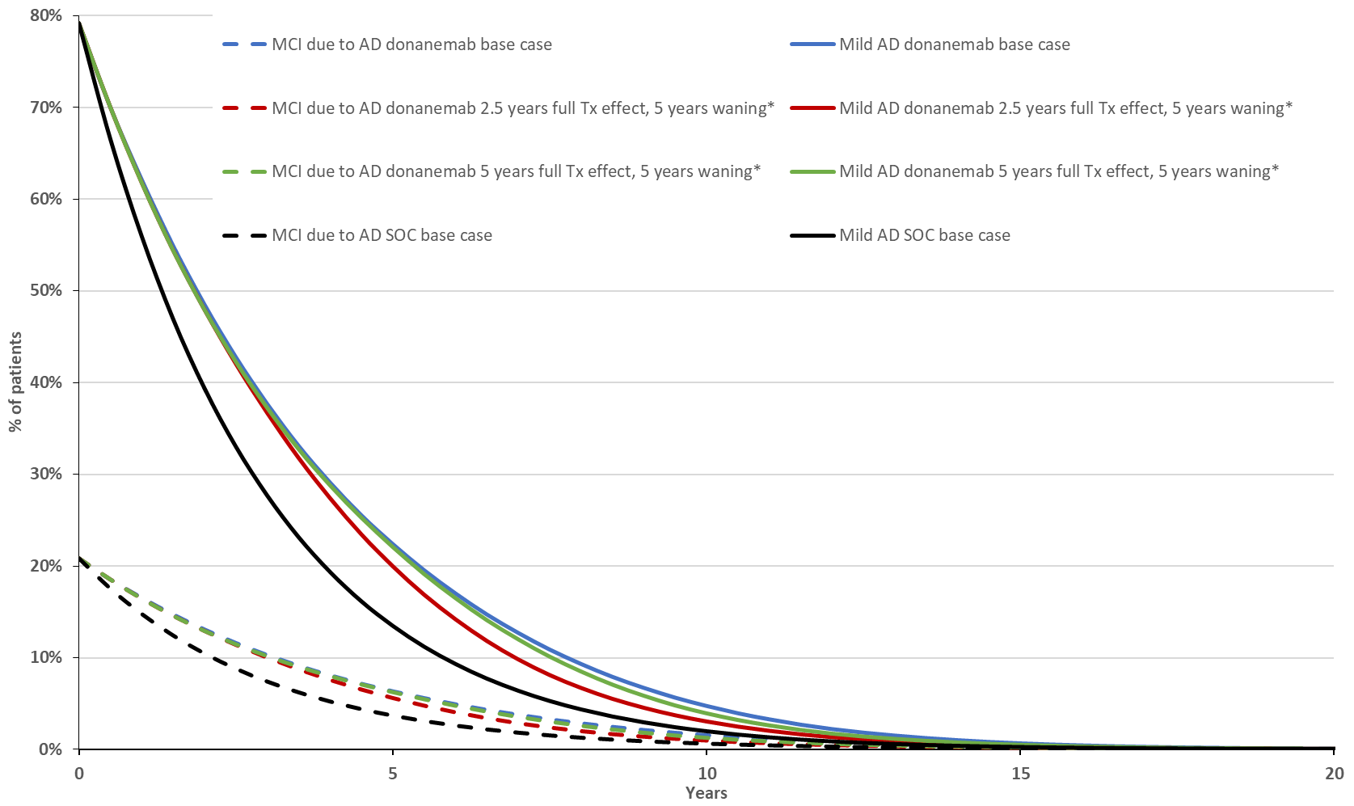
Source: Constructed during the evaluation from the “3.3_Donanemab cost effectiveness model” attachment provided with the submission.
AD = Alzheimer’s Disease; AE = adverse events; MCI = mild cognitive impairment; SOC = standard of care; Tx = treatment.
* Treatment effect assumptions applied for patients who complete the full 18-month treatment course or those who cease early due to amyloid clearance in the MCI due to AD or mild AD health state. Patients who cease treatment due to AEs are assumed to have no treatment effect after stopping treatment in these analyses.
  - Mortality was modelled though hazard ratios being applied to background mortality (Australian Bureau of Statistics [ABS] lifetables). In the MCI due to AD health state, a hazard ratio of 1 was applied (i.e. no additional risk of death due to AD). However, for the mild, moderate and severe AD health state, the same hazard ratio (2.55) was applied for all of these health states sourced from a UK Office of National Statistics (ONS) analysis of dementia versus non-dementia deaths in the UK from 2020 to 2022. The submission considered this was appropriate as there was a lack of evidence to suggest the presence of a survival benefit associated with amyloid targeting therapies and the application of health state specific hazard ratios would imply a survival benefit as donanemab slows disease progression. This assumption may not be reasonable and contradicts the large body of evidence which indicates increased mortality risk with worsening symptoms of AD. Crowell et al. (2023) estimated mortality hazard ratios of 2.43, 3.77 and 8.53 for mild, moderate and severe AD patients (using the CDR-SB), respectively. Applying these hazard ratios in the economic model decreased the mean life expectancy for modelled patients from 84.5 years in both arms to 82.2 and 81.6 years in the donanemab and SOC arms, respectively. This resulted in a ||| |||% increase in the ICER (from $35,000 to < $45,000 per QALY gained to $75,000 to < $95,000 per QALY gained). The PSCR stated that Crowell et al. (2023) likely included other forms of dementia with higher mortality risks compared to AD. The ESCs noted that patients in the Crowell et al. (2023) study were required to have a presumptive primary etiologic diagnosis of AD at index and no record of a non-AD etiologic diagnosis potentially causing cognitive impairment before or at index. In contrast, the ONS data included patients with a dementia diagnosis (i.e. not restricted to AD). Hence, the Crowell et al. study population was likely more representative of the intended treated population than the ONS data.
  - Patients in the mild, moderate and severe AD health states who entered the model in the community setting could be institutionalised, and once they were, they could no longer return to the community setting. The risk of institutionalisation (which was health state specific) was derived from the 2012 Dementia in Australia Australian Institute of Health and Welfare (AIHW) report which outlined the number of dementia patients by severity in community or in care settings. The proportion of patients within each severity type (mild, moderate, severe) that were institutionalised (at a single time point) were then divided by the average length of stay in residential care (2.3 years as estimated by the AIHW in 2024) to calculate an annual incidence of institutionalisation. This approach was not appropriate for the model as it was based on a fixed duration which differed from the duration of institutionalisation in the model. Applying different institutionalisation rates from the literature: Knapp et al. (estimated for the UK setting) and Belger et al. (estimated across the UK, France and Germany) resulted in a ||| |||% and ||| |||% increase in the ICER, respectively (from $35,000 to < $45,000 per QALY gained to $75,000 to < $95,000 and $95,000 to < $115,000 per QALY gained, respectively).
  - As the TB-2 trial did not collect EQ-5D data, the submission drew on published studies to estimate utility values for patients. For the MCI due to AD health state, a utility value of 0.859 was applied based on the background utility of Australian patients, adjusted for age and sex (sourced from Redwood et al.). Utility values of 0.740, 0.590 and 0.360 were applied to the mild, moderate and severe AD health state sourced from Landeiro et al. These were not dependent on if patients were in the community or institutional setting.
  - The submission also included carer utilities for 50% of patients (based on Brown 2017). Utilities for spouse and child carers for patients in the MCI due to AD health state were sourced from general population utilities, using the age and gender distribution of the carers were sourced from Reed 2014. Carer utilities for the mild, moderate and severe AD health states were sourced from two vignette time trade-off utility studies. When patients were in the community setting, carer utilities were sourced from Matza 2024. Patients in the mild AD health state but institutionalised, carers received the same utilities as if the patients were in the mild AD community health state. When patients were institutionalised in the moderate and severe AD health states, carer utilities were sourced from Belger 2022. Inclusion of carer utilities in the base case was not appropriate as the PBAC guidelines state that the base case economic evaluation should only include outcomes “associated with the patient”. However, given the nature of AD and its impact on family members, it is reasonable to consider the impact on carers in a supplementary analysis. Excluding carer QALYs from the base case analysis increased the ICER by ||| |||% (from $35,000 to < $45,000 per QALY gained to $45,000 to < $55,000 per QALY gained).
  - The economic model included costs for donanemab diagnosis, acquisition, administration, monitoring and adverse events as well as costs associated with disease management, institutional residency and terminal care costs. A number of costing issues were identified during the evaluation:
- The submission assumed 40% of donanemab patients would undergo the treat to clear treatment strategy where patients would monitor amyloid levels at 6 and 12 months and cease treatment if amyloid clearance was observed. The rate of screening for amyloid during treatment applied in the model was not supported by data. Amyloid monitoring at 6 and 12 months occurred as a part of the TB-2 protocol; however, in clinical practice it may not be as common as in TB-2. Based on the non-APOE4 homozygotes enrolled in TB-2 trial, 32% and 37% of modelled treat to clear donanemab patients would cease treatment at 6 and 12 months respectively. As the treatment cessation rate due to amyloid clearance may be considerably different in the Australian setting and the main effect of treatment cessation is to lower the cost of treatment, modelling treatment cessation for amyloid clearance represents an applicability issue. Alternative values were explored in sensitivity analyses (see Table 22).
- Institutionalisation costs ($105,434 per year, regardless of AD stage) were based on the outdated Aged Care Funding Instrument and basic subsidy rates for dementia patients in Australia, reported by Gnanamanickam et al. The entire aged care residential fee may not constitute direct medical costs (as specified in the PBAC guidelines). A more reasonable approach would be to apply the Australian National Aged Care Classification funding, excluding the fixed component (which are fixed costs shared across all residents, i.e. basic living costs) and the fixed, once-off entry cost for new residents. This leaves only the variable component cost which, among other factors, differs based on the residents’ level of cognition. This approach increased the ICER by ||| |||% (from $35,000 to < $45,000 per QALY gained to $5,000 to < $95,000 per QALY gained). The PSCR disagreed, stating that the costing of residential care should include the variable component and the basic daily care fee. The ESCs considered that regardless of whether the variable component was included or not, the cost of institutionalisation should be based on disease stage, rather than an average cost applied for all patients.
  - The key model drivers are presented in Table 19.
Table 19: Key drivers of the model
Description | Method/Value | Impact  Base case: $||||¹/QALY gained
Institutionalisation rate | Derived from the prevalence of institutionalised dementia patients reported by the AIHW. The approach used to convert institutionalisation prevalence to incidence was not appropriate for the model as it was based on a fixed duration of institutionalisation which was different to the duration applied in the model. | High, favours donanemab. Using institutionalisation rates derived from Belger et al. increased the ICER to $||||²/QALY gained.
Mortality modelling | Mortality was modelled through the ABS life tables, adjusted for an additional risk of death due to AD (in the mild, moderate and severe AD health state) sourced from the UK ONS. This was not reasonable as a single hazard ratio (2.55) for patients in the mild, moderate and severe AD health states was applied whereas the literature indicates increased mortality risk with worsening symptoms of AD. | High, favours donanemab. Using health state specific mortality hazard ratios, sourced from Crowell et al. increased the ICER to $||||³/QALY gained.
Treatment waning | For patients who achieve amyloid clearance or complete the full treatment course, the full treatment effect was applied until Year 5.5 (four years after the maximum treatment duration followed by linear waning over 9.5 years until the hazard ratio is equal to 1. The submission justified the long-term treatment effect on the basis of amyloid removal and accumulation. No evidence was provided that would robustly estimate the magnitude of the effect associated with amyloid removal or its re-accumulation and disease progression. The ESCs considered that the assumption that a 1.38 month delay in iADRS after 76 weeks would result in a modelled treatment benefit at 15 years was highly implausible. | High, favours donanemab. Assuming the full treatment effect is applied until Year 2.5, followed by linear waning over five years increased the ICER to $||||³/QALY gained.
Institutionalisation cost | Institutionalisation costs ($105,434 per year, regardless of AD stage) were based on the Aged Care Funding Instrument and basic subsidy rates for dementia patients in Australia. The entire aged care residential fee may not constitute direct medical costs (as specified in the PBAC guidelines). The variable component of the AN-ACC, which differs based on the level of the residents’ cognition may be a more reasonable cost. | High, favours donanemab. Applying the variable component of the AN-ACC to different institutionalised health states increased the ICER to $||||³/QALY gained.
Source: Constructed during the evaluation.
ABS = Australian Bureau of Statistics; AD = Alzheimer’s Disease; AN-ACC = Australian National Aged Care Classification; AIHW = Australian Institute of Health and Welfare; HR = hazard ratio; ICER = incremental cost-effectiveness ratio; ONS = Office of National Statistics; PBAC = Pharmaceutical Benefits Advisory Committee; QALY = qualify-adjusted life year; UK = United Kingdom
The redacted values correspond to the following ranges:
¹ $35,000 to < $45,000
² 95,000 to < $115,000
³ $75,000 to < $95,000
  - The submission presented a stepped economic analysis. As the institutionalisation rates were substantially uncertain, these have been incorporated into the last step of the analysis along with carer QALYs (which fall outside the scope of a base case analysis) to allow their effect to be clearly observed see Table 20. Incorporation of institutionalisation reduced the incremental costs by $45,000 to < $55,000, whereas the inclusion of carer QALYs increased the incremental QALYs by 0.08.
Table 20: Results of the stepped economic evaluation, performed during the evaluation
Step and component | Donanemab | SOC | Increment
Step 1: Trial based outcomes and costs (18-month time horizon)
Costsª | $|||| | $619 | $||||
% of patients with MCI due to AD^{b} | 73% | 61% | 12%
% of patients with mild AD^{c} | 83% | 73% | 10%
Incremental cost per MCI progression avoided |  |  | $||||
Incremental cost per mild progression avoided |  |  | $||||
Step 2: Time horizon extended to 30 years and adding disease management costs
Costs | $|||| | $103,238 | $||||
LYs gained | 10.77 | 10.75 | 0.02
Incremental cost/extra LYG gained |  |  | $||||¹
Step 3: Transformation to QALYs, 5% p.a. discounting
Costs | $|||| | $70,298 | $||||
QALY gained | 4.48 | 4.14 | 0.34
Incremental cost/extra QALY gained |  |  | $||||²
Step 4: Incorporation of institutionalisation costs
Costs | $|||| | $414,477 | $||||
QALYs gained | 4.48 | 4.14 | 0.34
Incremental cost/extra QALY gained |  |  | $||||³
Step 5: Incorporation of carer QALYs
Costs | $|||| | $414,477 | $||||
QALY gained | 3.70 | 3.28 | 0.42
Incremental cost/extra QALY gained (base case) |  |  | $||||⁴
Source: Constructed during the evaluation from the “3.3_Donanemab cost effectiveness model” attachment provided with the submission.
AD = Alzheimer’s Disease; CDR = clinical dementia rating; LYs = life years; MCI = mild cognitive impairment; p.a. = per annum; QALYs = quality adjusted life years; SOC = standard of care.
ª Costs include donanemab diagnostic, acquisition, administration and monitoring costs, symptomatic treatment and adverse event costs.
^{b} Proportion of MCI due to AD patients at baseline remaining as MCI due to AD at the end of the 18-month trial period as per CDR score reported in Zimmer et al.
^{c} Proportion of mild AD patients at baseline remaining as mild AD at the end of the 18-month trial period as per CDR score reported in Zimmer et al.
The redacted values correspond to the following ranges:
¹ >$1,055,000
² $155,000 to < $255,000
³ $45,000 to < $55,000
⁴ $35,000 to < $45,000

  - Based on a 5.82 month delay in progression observed in the TB-2 trial for secondary outcome, CDR-SB in the proposed TGA population (see paragraph 6.62) at 76 weeks, over the 26 year time horizon, the economic model estimates, on average, 12 more months spent in the MCI and mild health states and 12 less months spent in the moderate and severe health states (undiscounted), and corresponds to delaying institutionalisation by eight months (equating to a cost saving of $71,414).
  - Traces of health state membership were constructed during the evaluation; this is presented in Figure 18 (with community and institutional health states pooled together). The traces of health state membership indicate major incremental differences in the mild and severe AD health state between the two arms. Both differences are driven by the treatment effect of donanemab; however, the lower health state membership in the severe AD health state for the donanemab is primarily due to a donanemab treatment effect being applied to moderate AD patients. There is almost no difference between the proportion of patients dying between the two arms as the model did not employ health state specific mortality risks (for the mild, moderate and severe AD health states). The ESCs noted that the traces indicated that model resulted in an implausibly large incremental differences in health state membership of MCI due to AD and mild AD between patients treated with donanemab and placebo. The ESCs also noted that there were no trial data to inform the large differences between the arms in numbers of patients with moderate and severe AD. Further, the ESCs noted that donanemab appeared to result in a reduction in the number of cases of moderate and severe AD, rather than a modest delay in disease progression, as demonstrated in the trial. Overall, the ESCs considered that the modelled outputs were highly optimistic.
Figure 186: Health state membership over the time horizon
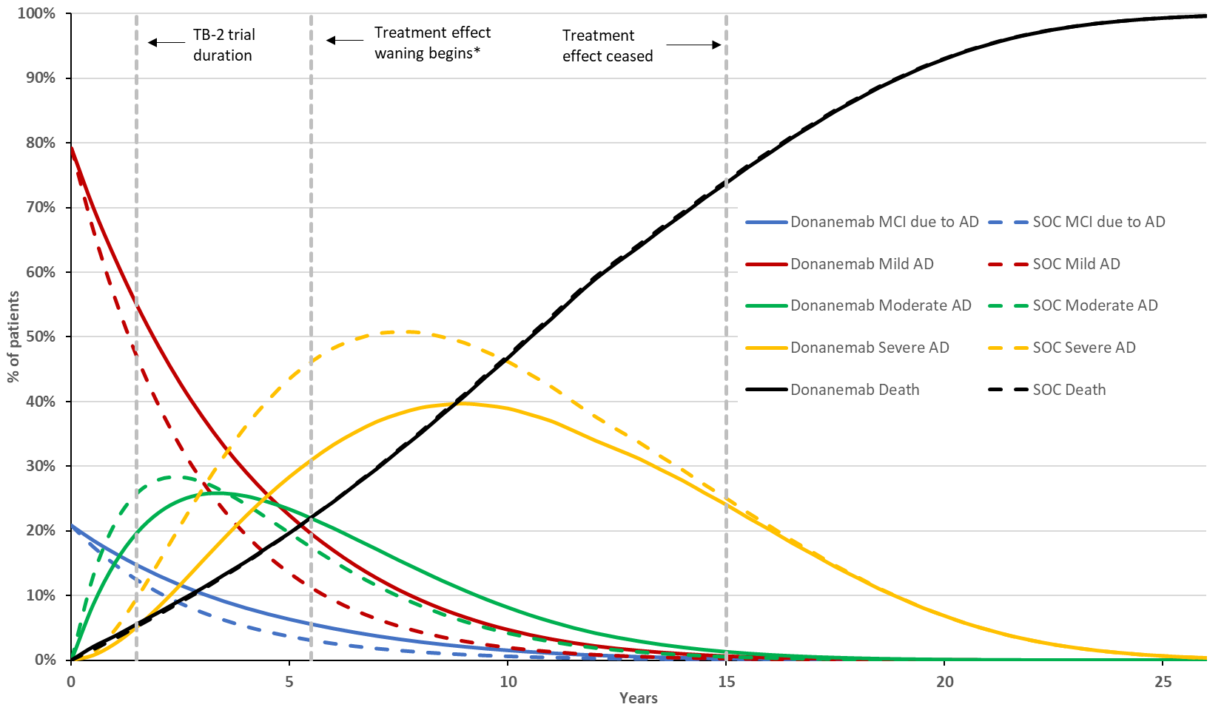
Source: Constructed during the evaluation from the “3.3_Donanemab cost effectiveness model” attachment provided with the submission.
AD = Alzheimer’s Disease; HR = hazard ratio; MCI = mild cognitive impairment; SOC = standard of care.
Note: community and institutional health states have been pooled together.
*Treatment effect is waned linearly over 9.5 years until the HR = 1.
  - Disaggregate costs and outcomes are presented in Table 21. The majority of incremental costs are attributable to donanemab acquisition and administration. The majority of cost savings are the result of delayed or prevented institutionalisation; however, the institutionalisation rates are substantially uncertain, and the costs may be overestimated. On average, the model estimates four and five years spent institutionalised with severe AD before death. This appears implausible as the average length of stay for residential care for dementia patients in Australia was reported to be 2.3 years (see paragraph 6.117).
Table 21: Health care resource items: disaggregated summary of cost and outcome impacts
Resource item/  Health state |  | Donanemab | SOC | Incremental cost/outcome | % of total incremental cost/outcome
Donanemab treatment costs (discounted)
Diagnostic costs |  | $2,130 | $0 | $2,130 | ||||%
Acquisition |  | $|||| | $0 | $|||| | ||||%
Administration |  | $1,274 | $0 | $1,274 | ||||%
Monitoring |  | $3,151 | $0 | $3,151 | ||||%
Total |  | $|||| | $0 | $|||| | ||||%
Disease management costs (discounted)
Symptomatic medication |  | $1,423 | $1,408 | $15 | 0%
Disease management |  | $37,672 | $39,142 | -$1,471 | -10%
Institutionalisation |  | $318,996 | $369,024 | -$50,028 | -329%
Terminal care costs |  | $4,899 | $4,903 | -$3 | -0%
Total |  | $362,991 | $414,477 | -$51,486 | -338%
Management of adverse events (discounted)
Total |  | $293 | $0 | $293 | 2%
Overall total cost (discounted) |  | $|||| | $414,477 | $|||| | 100%
Life years (undiscounted)
Community | MCI due to AD | 0.83 | 0.60 | 0.23 | 928%
Community | Mild AD | 2.86 | 2.15 | 0.71 | 2846%
Community | Moderate AD | 1.18 | 1.13 | 0.04 | 181%
Community | Severe AD | 0.95 | 1.23 | -0.28 | -1132%
Community | Total | 5.82 | 5.12 | 0.70 | 2822%
Institutional | MCI due to AD | 0.00 | 0.00 | 0.00 | 0%
Institutional | Mild AD | 0.12 | 0.07 | 0.05 | 199%
Institutional | Moderate AD | 0.84 | 0.63 | 0.21 | 847%
Institutional | Severe AD | 4.00 | 4.94 | -0.94 | -3769%
Institutional | Total | 4.95 | 5.63 | -0.68 | -2722%
Overall total life years |  | 10.77 | 10.75 | 0.02 | 100%
QALYs (discounted)
Community | MCI due to AD | 0.60 | 0.45 | 0.15 | 36%
Community | Mild AD | 1.82 | 1.41 | 0.41 | 97%
Community | Moderate AD | 0.55 | 0.56 | 0.00 | -1%
Community | Severe AD | 0.24 | 0.33 | -0.09 | -20%
Community | Total | 3.22 | 2.75 | 0.47 | 111%
Institutional | MCI due to AD | 0.00 | 0.00 | 0.00 | 0%
Institutional | Mild AD | 0.07 | 0.04 | 0.03 | 6%
Institutional | Moderate AD | 0.36 | 0.28 | 0.08 | 18%
Institutional | Severe AD | 0.84 | 1.07 | -0.23 | -55%
Institutional | Total | 1.26 | 1.39 | -0.13 | -30%
AE QALY decrement |  | -0.00 | 0 | -0.00 | -1%
Total patient QALYs |  | 4.48 | 4.14 | 0.34 | 80%
Carer QALY decrement |  | -0.78 | -0.86 | 0.08 | 20%
Overall total QALYs |  | 3.70 | 3.28 | 0.42 | 100%
Source: Constructed during the evaluation from the “3.3_Donanemab cost effectiveness model” attachment provided with the submission.
AD = Alzheimer’s Disease; AE = adverse event; MCI = mild cognitive impairment; QALY = qualify-adjusted life year; SOC = standard of care.
  - Key sensitivity analyses conducted during the evaluation are presented in Table 22.
Table 22: Key sensitivity analyses
Analyses | Inc. costs | Inc. QALYs | ICER | % change
Base case | $|||| | 0.42 | $||||¹ | 0%
Carer QALYs (base case: included)
- Excluded #1 | $|||| | 0.34 | $||||² | ||||%
Discount rate (base case: 5%)
- 3.5% | $|||| | 0.46 | $||||³ | -||||%
- 0% | -$|||| | 0.57 | Dominant | -||||%
SOC transition probabilities (base case: NACC analysis)
- Sourced from Potashman et al. | $|||| | 0.42 | $||||¹ | ||||%
Population modelled (base case: proposed TGA population, HR of 0.64)
- ITT of TB-2 (HR of 0.62) | $|||| | 0.45 | $||||⁴ | -||||%
Treatment effect applied to patients in the moderate AD health state (base case: applied)
- Not applied #3 | $|||| | 0.34 | $||||² | ||||%
Treatment effect waning for patients who cease treatment due to AE in the first six months (base case: retain full treatment effect for six months after cessation followed by linear treatment waning over 2.5 years)
- Loss of all treatment effect immediately after treatment cessation for AEs #4 | $|||| | 0.41 | $||||¹ | ||||%
Treatment effect waning for patients who complete the full treatment course or cease treatment early due to amyloid clearance (base case: retain full treatment effect for four years after cessation followed by linear treatment waning over 9.5 years)
- All treatment effect lost after maximum treatment duration #8 | $|||| | 0.10 | $||||⁵ | ||||%
- Full treatment effect for one year after cessation followed by five years of linear waning #7 | $|||| | 0.30 | $||||⁶ | ||||%
- Full treatment effect for two years after cessation followed by five years of linear waning | $|||| | 0.34 | $||||⁷ | ||||%
Risk of institutionalisation (base case: calculated from prevalence of institutionalisation among Australian dementia patients)
- Sourced from Knapp et al. | $|||| | 0.43 | $||||⁶ | ||||%
- Sourced from Belger et al. #6 | $|||| | 0.45 | $||||⁸ | ||||%
Mortality modelling approach (base case: same risk of death (HR of 2.55) for patients in the mild, moderate and severe AD health state)
- Health state specific mortality HRs sourced from Crowell et al. #2 | $|||| | 0.52 | $||||⁶ | ||||%
Donanemab patients undergoing treat to clear strategy (base case: 40%)
- 60% | $|||| | 0.42 | $||||⁴ | -||||%
- 25% | $|||| | 0.42 | $||||¹ | ||||%
Donanemab dosing strategy (base case: standard)
- Enhanced titration regimen | $|||| | 0.42 | $||||¹ | ||||%
Institutionalisation costs (base case: based on ACFI and basic subsidy rates)
- AN-ACC variable component applied to different health states #5 | $|||| | 0.42 | $||||⁶ | ||||%
Multivariate Analyses
#1, #2 | $|||| | 0.48 | $||||⁸ | ||||%
#1, #2, #3 | $|||| | 0.38 | $||||⁸ | ||||%
#1, #2, #3, #4 | $|||| | 0.37 | $||||⁸ | ||||%
#1, #2, #3, #4, #5 | $|||| | 0.37 | $||||⁹ | ||||%
#1, #2, #3, #4, #5, #6 | $|||| | 0.37 | $||||¹⁰ | ||||%
#1, #2, #3, #4, #5, #6, #7 | $|||| | 0.27 | $||||¹⁰ | ||||%
#1, #2, #3, #4, #5, #6, #8 | $|||| | 0.09 | $||||¹¹ | ||||%
Source: Constructed during the evaluation from the “3.3_Donanemab cost effectiveness model” attachment provided with the submission.
ACFI = Aged Care Funding Instrument; AD = Alzheimer’s Disease; AE = adverse event; AN-ACC = Australian National Aged Care Classification; HR = hazard ratio; ICER = incremental cost-effectiveness ratio; Inc = incremental; MCI = mild cognitive impairment; NACC = National Alzheimer’s Coordinating Center; QALY = qualify-adjusted life year; SOC = standard of care.
The redacted values correspond to the following ranges:
¹ $35,000 to < $45,000
² $45,000 to < $55,000
³ $15,000 to < $25,000
⁴ $25,000 to < $35,000
⁵ $455,000 to < $555,000
⁶ $75,000 to < $95,000
⁷ $55,000 to < $75,000
⁸ $95,000 to < $115,000
⁹ $135,000 to < $155,000
¹⁰ $155,000 to < $255,000
¹¹ $655,000 to < $755,000

  - Multivariate analyses #1 - #6 resulted in a substantial increase in the base case ICER, however these do not address the uncertainty of the ongoing modelled donanemab treatment effect beyond the maximum treatment duration and trial period. Noting the submission did not provide evidence to robustly support an ongoing treatment effect, more conservative assumptions were explored during the evaluation. For patients who complete the full treatment course or cease early due to amyloid clearance, analysis #7 assumes the full treatment effect is applied until Year 2.5 followed by linear waning over 5 years whereas #8 assumes no treatment effect beyond the 18 months (the maximum treatment duration). Both analyses assume donanemab patients return to SOC transition probabilities after treatment waning and hence the distribution of patients across AD severity can never catch up with the SOC arm (i.e. a difference in the proportion in more severe health states will continue to the end of the model).
  - Modelled outputs for donanemab treatment based on the 5.82 month delay in progression observed in the subgroup analysis of the secondary outcome, CBR-SD, from the TB-2 trial at 76 weeks for the base case and the evaluation’s multivariate analyses are presented in Table 23. As noted in paragraph 6.123, the ESCs considered that the modelled outputs were highly optimistic.
Table 23: Model outputs under different analyses (undiscounted)
Output | Analyses
Output | Base case | MV #1 to #7ª | MV #1 to #6 and #8ª
Additional time in MCI due to AD/mild AD | 11.86 months | 8.63 months | 3.10 months
Less time in moderate/severe AD | -11.56 months | -4.96 months | -2.03 months
Less time institutionalised | 8.13 months | 0.21 months | 0.25 months
Cost savings for delayed institutionalisation | $71,414 | $803 | $963
Source: Constructed during the evaluation from the “3.3_Donanemab cost effectiveness model” attachment provided with the submission.
AD = Alzheimer’s Disease; MCI = mild cognitive impairment; MV = multivariate analyses.
ª See for explanation of analyses.
  - Following confirmation that the TGA had recommended the enhanced dosing regimen based on the results of the TB-6 trial, the PSCR presented a revised economic model which was updated to reflect the corresponding ARIA rates and relative dose intensity. The PSCR stated that the revised model resulted in a ||| |||% reduction of the base case ICER from $35,000 to < $45,000 per QALY to $15,000 to < $25,000 per QALY. The ESCs noted that the revised economic model had other changes aside from those mentioned above. The alternative inputs relating to ARIA rates and relative dose intensity of the enhanced titration regimen resulted in a ||| |||% decrease in the original base case ICER. The additional decrease in the PSCR’s modelled ICER appeared to be the result of a different approach used to model the proportion of patients on treatment. This new approach was complex and introduced new worksheets into the excel workbook and hence, could not be validated. Additionally, the ESCs noted that the use of the enhanced titration regimen assumes that the TB-6 trial was exchangeable with the TB-2 trial in terms of both efficacy and safety. The TB-6 trial did not have a placebo comparator arm, nor did it assess efficacy.

Drug cost/patient/course
  - The drug costs per patient per course are presented in Table 24.
Table 24: Donanemab costs per patient
 | TB-2 trial | Economics | Financial estimates
Mean dose per administration | Assumed ª:  First three months: 672 mg  Four months +: 1,344 mg | First three months: 672 mg  Four months+: 1,344 mg | 700 mg (I)  1400 mg (C)
Mean duration | 12 months | Overall mean: 14 months  Full treatment duration (18 months): 59%  Amyloid clearance at 6 months: 13%  Amyloid clearance at 12 months: 15% Discontinuation due to AEs at 6 months: 13% | 12 months ^{b}  15 months ^{c}
Cost/patient/month | First three months: $||||  Four months+: $|||| |  | $|||| ^{d}
Cost/patient/course | $|||| | $|||| | $|||| ^{b}  $|||| ^{c}
Source: Constructed during the evaluation from the “3.3_Donanemab cost effectiveness model” attachment provided with the submission.
Aβ = amyloid beta; AE = adverse events; CSR = clinical study report; TB-2 = TRAILBLAZER – 2
ª Mean dose not reported in the CSR, assumed to be RDI (96%) × standard dose as per the economics
^{b} Mean treatment duration for patients who monitor for Aβ and cease treatment due to clearance.
^{c} Mean treatment duration for patients with no monitoring for Aβ clearance.
^{d} Financial estimates have the same maximum quantity in both initial and continuing treatment, hence the same cost per patient per cycle. The financial estimates accounts for the reduced dosing by halving the number of scripts required for initial treatment.

Estimated PBS usage & financial implications
  - This submission was considered by DUSC. The submission used an epidemiological approach to calculate script and service volumes. The patient population was derived from the system capacity to assess potential patients. The foundation of this derivation was the number of treating facilities, the number of clinics held and the number of patients a clinic can treat in a working week. A growth rate in the number of facilities and patient treatment days was then applied across the six years of the model. The submission assumed that the private facilities were able to see twice as many patients each day as public facilities, based on the reported waiting times in each type of facility.
Table 25: Key inputs for financial estimates
Parameter | Value applied and source | Comments
Incidence | Based on capacity of memory and cognition assessment service in public and private settings | The population is based on multiple assumptions that make the result highly uncertain.
Prevalence of patients who are APOE4 non-carriers or heterozygotes | 89.1%, based on frequency of APOE4 homozygosity of 10.9% | Data from the Australian Imaging, Biomarkers and Lifestyle Flagship Study of Ageing (AIBL) demonstrated the frequency of APOE4 homozygosity to be 6.0% in patients with MCI and 5.6% in patients with severe AD. This would result in a significantly larger population being available for treatment with donanemab.  The PSCR (p5) argued that a 10.9% prevalence rate, as informed by the TB-2 trial, was appropriate.
Incident patients  Treat to Clear | Yr 1: ||||¹  Yr 2: ||||¹  Yr 3: ||||¹  Yr 4: ||||¹  Yr 5: ||||²  Yr 6: ||||²  40% of eligible patients  Sponsor assumption | The DUSC considered that the fixed duration population is likely to be higher due to limitations in the access to testing to determine plaque clearance or willingness to test. The submission assumed access to PET scans (assumption of 1.38 PET scans per person per year in treat-to-clear only) for monitoring would not be impacted by demand for eligibility testing.  The DUSC noted that varying the ratio of treat-to-clear strategy compared to fixed treatment duration does not lead to substantial variations in total costs. However, a higher proportion of patients following a treat-to-clear strategy will incur higher MBS costs (and lower PBS cost if treatment is discontinued), while a higher proportion of patients following a fixed dose strategy will incur higher PBS cost (and lower MBS costs).
Incident patients  Full duration | Yr 1: ||||¹  Yr 2: ||||¹  Yr 3: ||||²  Yr 4: ||||²  Yr 5: ||||³  Yr 6: ||||³  60% of eligible patients  Sponsor assumption
Total patients | Yr 1: ||||²  Yr 2: ||||²  Yr 3: ||||³  Yr 4: ||||⁴  Yr 5: ||||⁵  Yr 6: ||||⁶ | The submission assumed a constant 8% growth in number of patients per clinic/day rate, 6.4% growth in number of new clinics constant over time, and constant split between public/private (47%:53%) patients. The DUSC considered estimates of growth could be underestimated if private clinics are established in the future.  Further, the DUSC advised the assumption of the public vs. private split may have a large impact on numbers of eligible patients and pathology testing stage.  The DUSC considered that overall, the number of eligible patients may be underestimated, as the submission did not consider potential for multiple tests per patient over time to test for MCI eligibility, which would inflate the numbers.
Uptake rate | ||||% across all years | The DUSC considered that an uptake of ||||% was overestimated as it assumes that eligibility and uptake are the same thing. It does not account for patients who may be eligible but for a variety of reasons do not commence treatment.
Compliance rate | Not explicitly stated | The compliance rate has been included in the calculation of the mean duration of treatment in both modes of treatment.
Grandfathered patients | Nil | No grandfathered patients were included in the population as they are assumed to be included in the incident population.
Dose / duration | Treat to clearance – Q4W for 12.1 months  Full duration treatment – Q4W 15.4 months | The submission uses months and Q4W interchangeably which results in the underestimate of the number of administrations required by each patient.
Scripts dispensed | Yr 1: ||||⁷  Yr 2: ||||⁸  Yr 3: ||||⁹  Yr 4: ||||¹⁰  Yr 5: ||||¹¹  Yr 6: ||||¹² | The submission applied dosing frequencies of monthly and Q4W interchangeably, resulting in a different number of scripts/infusions (Q4W results in 13 scripts/infusions compared 12 scripts/infusions per year). The DUSC noted the evaluation presented a revised dosing frequency of 1 script per month and revised the modelling of the treatment phases to initial and continuing resulting in cost reduction of $|||| billion.
Offsets | Nil | The comparator for this submission is SoC, hence there are no offsetting medicines.
MBS items | Proposed APOE4 test - $159.95  Proposed Aß-PET scan - $2,200.00  Proposed CSF AD biomarker testing - $400.00  MBS item 116 Professional attendance - $87.30  MBS item 39000 Lumbar puncture - $85.75  MBS item 56223 CT scan - $263.75  MBS item 61505 CT scan with Aß-PET - $100.00  MBS item 63004 MRI (head) - $441.45 | The proposed MBS items are appropriate. However, the submission did not include several services associated with lumbar puncture. The proportion of Aß-PET scan and CSF AD biomarker test is uncertain and will depend on patient locality and service availability. This will consequentially change the rate of utilisation of the associated services.
Source: Financial estimates workbook provided with the submission.
The redacted values correspond to the following ranges:
¹ 10,000 to < 20,000
² 20,000 to < 30,000
³ 30,000 to < 40,000
⁴ 40,000 to < 50,000
⁵ 50,000 to < 60,000
⁶ 60,000 to < 70,000
⁷ 200,000 to < 300,000
⁸ 300,000 to < 400,000
⁹ 400,000 to < 500,000
¹⁰ 500,000 to < 600,000
¹¹ 600,000 to < 700,000
¹² 700,000 to < 800,000
Table 26: Patient estimates
 | Year 1 | Year 2 | Year 3 | Year 4 | Year 5 | Year 6
Estimated case capacity
Number of new patients that could be assessed | ||||¹ | ||||² | ||||³ | ||||⁴ | ||||⁴ | ||||⁴
- MCI (37%) | ||||⁵ | ||||⁵ | ||||⁶ | ||||⁶ | ||||⁷ | ||||⁸
- Dementia (63%) | ||||⁷ | ||||⁸ | ||||⁸ | ||||⁹ | ||||¹ | ||||²
Estimated patients eligible for APOE4 genotyping
Number of patients appropriate for testing | ||||⁶ | ||||⁷ | ||||⁸ | ||||⁹ | ||||¹ | ||||²
- MCI¹ | ||||⁹ | ||||⁹ | ||||⁹ | ||||⁵ | ||||⁵ | ||||⁵
- Dementia² | ||||⁵ | ||||⁵ | ||||⁶ | ||||⁶ | ||||⁷ | ||||⁸
- Cases assessed x 62% with AD x 95% with MMSE> 20 x 89% meet MRI criteria
- Cases assessed x 74% with AD x 75% to 90% with MMSE > 20 x 89% meet MRI criteria
The redacted values correspond to the following ranges:
¹ 70,000 to < 80,000
² 80,000 to < 90,000
³ 90,000 to < 100,000
⁴ 100,000 to < 200,000
⁵ 20,000 to < 30,000
⁶ 30,000 to < 40,000
⁷ 40,000 to < 50,000
⁸ 50,000 to < 60,000
⁹ 10,000 to < 20,000
Table 27: Estimated use and financial implications
 | Year 1 | Year 2 | Year 3 | Year 4 | Year 5 | Year 6
Estimated extent of use of APOE4 genotyping
Number of tests | ||||¹ | ||||² | ||||³ | ||||⁴ | ||||⁵ | ||||⁶
Estimated extent of use of Aß-PET scan (eligibility and monitoring)
Number of tests | ||||⁷ | ||||¹ | ||||² | ||||³ | ||||⁴ | ||||⁵
Estimated extent of use of CSF AD biomarker testing
Number of tests | ||||⁸ | ||||⁸ | ||||⁷ | ||||⁷ | ||||¹ | ||||¹
Estimated extent of use of donanemab
Number of patients likely to be treated with proposed drug | ||||¹ | ||||¹ | ||||¹ | ||||² | ||||³ | ||||⁴
Number of scripts dispensed ª | ||||⁹ | ||||¹⁰ | ||||¹¹ | ||||¹² | ||||¹³ | ||||¹⁴
Estimated financial implications of the APOE4 genotyping to the MBS
Cost to the MBS | $||||¹⁵ | $||||¹⁵ | $||||¹⁵ | $||||¹⁵ | $||||¹⁵ | $||||¹⁶
Estimated financial implications of the Aß-PET scan to the MBS
Cost to the MBS | $||||¹⁷ | $||||¹⁸ | $||||¹⁹ | $||||²⁰ | $||||²¹ | $||||²¹
Estimated financial implications of the CSF AD biomarker testing to the MBS
Cost to the MBS | $||||¹⁵ | $||||¹⁵ | $||||¹⁵ | $||||¹⁵ | $||||¹⁶ | $||||¹⁶
Estimated financial implications of donanemab to the PBS/RPBS
Cost to PBS/RPBS less copayments | $||||  ²² | $||||  ²² | $||||  ²² | $||||  ²² | $||||  ²² | $||||  ²²
Estimated financial implications for additional services to the MBS
MRI scans – ARIA | $||||²³ | $||||²⁴ | $||||¹⁷ | $||||¹⁸ | $||||¹⁹ | $||||²⁰
CT scan with PET scan | $||||¹⁵ | $||||¹⁵ | $||||¹⁵ | $||||¹⁵ | $||||¹⁵ | $||||¹⁵
Lumbar puncture | $||||¹⁵ | $||||¹⁵ | $||||¹⁵ | $||||¹⁵ | $||||¹⁵ | $||||¹⁵
CT scan with LP | $||||¹⁵ | $||||¹⁵ | $||||¹⁵ | $||||¹⁵ | $||||¹⁵ | $||||¹⁵
Attendance | $||||²⁵ | $||||²⁵ | $||||²³ | $||||²⁴ | $||||¹⁷ | $||||¹⁷
Net financial implications
Net cost to PBS/RPBS | $||||  ²² | $||||  ²² | $||||  ²² | $||||  ²² | $||||  ²² | $||||  ²²
Net cost to MBS | $||||²¹ | $||||²¹ | $||||²¹ | $||||²⁶ | $||||²⁶ | $||||²⁷
Net cost to PBS/RPBS/MBS | $||||  ²² | $||||  ²² | $||||  ²² | $||||  ²² | $||||  ²² | $||||  ²²
ª Assuming 12.1 scripts per course of treatment (treat to clearance) or 15.4 scripts per course of treatment (full duration treatment) as estimated by the submission.
Source: Table 4.22 – Table 4.29, pp317-320 of the resubmission
The redacted values correspond to the following ranges per year:
¹ 30,000 to < 40,000
² 40,000 to < 50,000
³ 50,000 to < 60,000⁴ 60,000 to < 70,000
⁵ 70,000 to < 80,000⁶ 80,000 to < 90,000⁷ 20,000 to < 30,000
⁸ 10,000 to < 20,000
⁹ 200,000 to < 300,000
¹⁰ 300,000 to < 400,000
¹¹ 400,000 to < 500,000
¹² 500,000 to < 600,000
¹³ 600,000 to < 700,000
¹⁴ 700,000 to < 800,000
¹⁵ $0 to < $10 million
¹⁶ $10 million to < $20 million
¹⁷ $50 million to < $60 million
¹⁸ $60 million to < $70 million
¹⁹ $70 million to < $80 million
²⁰ $90 million to < $100 million
²¹ $100 million to < $200 million
²² > $1 billion
²³ $30 million to < $40 million
²⁴ $40 million to < $50 million
²⁵ $20 million to < $30 million
²⁶ $200 million to < $300 million
²⁷ $300 million to < $400 million

  - The total cost to the PBS/RPBS of listing donanemab was estimated to be > $1 billion in Year 6, and a total of > $1 billion in the first 6 years of listing.
  - The DUSC noted that the calculation of PBS/RPBS impact was uncertain as it was distorted by three key factors: overestimation of the patient population, overestimation of the medicine cost in the initial phase of treatment, underestimation of the number of scripts required for treatment.
  - The submission used an epidemiological approach to calculate script and service volumes. The patient population was derived from the estimated system capacity to assess potential patients. The foundation of this derivation was the number of treating facilities, the number of clinics held and the number of patients a clinic can treat in a working week. A growth rate in the number of facilities and patient treatment days was then applied across the six years of the model. The submission assumed that private facilities were able to see twice as many patients each day as public facilities, based on the reported waiting times in each type of clinic.
  - In a resource constrained system, it is reasonable to apply the constraint as a rate limiting step in system throughput. However, the DUSC noted that the results do not appear to be plausible for the number of facilities or the treatment days provided by private facilities.
  - The growth rate in the number of facilities is assumed to be the same as the growth rate in the number of neurologists and geriatricians. This is only valid if practitioners are sole practitioners in individual facilities or the “clinics” referred to in the submission are individual practitioners. The submission did not provide any evidence to support this assumption.
  - The assumption that private facilities can see twice as many patients as public facilities coupled with an assumed 8% annual growth rate in daily patient consultations results in private facilities devoting more than 92% of their available time to assessing these patients by the model’s sixth year. This would effectively leave no time for the on-going management of existing patients and the impossibility of treating any patient with an alternative condition. The DUSC considered that the assumptions surrounding the capacity of private clinics was likely overestimated and the estimates of growth in memory clinic capacity over time likely underestimated. The DUSC also noted that while system capacity restraints were used to inform capacity for MMSE testing, system capacity constraints were not considered for eligibility testing or for monitoring tests.
  - The script volume provided by the submission assumes three treatment phases: initial, continuing 1 and continuing 2. The submission proposed these phases to align with the potential treatment cessation points in the treat to clear treatment algorithm. Using these parameters, in the first three dispensing of the initial phase of treatment, twice as much medication is dispensed as is required. This significantly overestimates the cost to the PBS/RPBS.

Quality use of medicines
  - The submission indicated that the sponsor would implement a range of activities supporting the quality use of medicines with the listing of donanemab. These include online medical education modules, scientific meetings, health education symposia held in conjunction with relevant national conferences.
  - The evaluators considered that there were issues of significant financial impact for rural and remote patients. The PSCR stated that ‘it is important to note that it is likely that less than 2% of patients will be impacted by remoteness, given PET, MRI and APOE genotyping are available in all major cities, inner regional centres and the majority of outer regional centres. It is also important to acknowledge the economic burden associated with managing AD that is imposed on patients and caregivers, which is likely to have a greater impact on people who live in remote communities.’ The DUSC considered equity of access due to system capacity for anti-Aβ immunotherapies relating to testing, monitoring (safety and continuation of treatment), and administration could present a significant QUM issue. The DUSC noted that there are only limited numbers of PET machines in Australia and limited facilities capable of processing CSF Aβ. The DUSC considered that this, along with the potential need for genetic testing, has the potential for placing a large financial burden on rural and remote Australians increasing the equity of access issues already raised with regards to memory clinic and specialist access.

Financial management – risk sharing arrangements
  - The submission did not propose a risk sharing arrangement for the listing donanemab. Noting the high overall cost of the listing of donanemab, the ESCs and DUSC noted a risk sharing arrangement should be considered to manage:
- the uncertain patient population
- risk of use beyond disease progression
  - The DUSC noted that a risk sharing arrangement will only manage the financial risk for the PBS but is unable to provide the same protection to the MBS.
For more detail on PBAC’s view, see section 7 PBAC outcome.
- PBAC Outcome
  - The PBAC did not recommend donanemab for the treatment of patients with early symptomatic Alzheimer’s disease (AD), defined as mild cognitive impairment (MCI) due to AD or mild Alzheimer’s dementia (referred collectively to as early AD). The PBAC noted that as an integrated codependent submission, the proposed MBS items for apolipoprotein E (APOE) genotyping, amyloid-beta Positron Emission Tomography (Aβ-PET), and Cerebrospinal Fluid (CSF) AD biomarker testing would be considered at the July 2025 MSAC meeting. The PBAC acknowledged the high need for effective disease modifying treatments in early stages of AD to extend quality of life for patients, families and carers. However, the PBAC considered the very small short-term benefit demonstrated in the key trial of donanemab did not justify the extensive burden on patients for the various diagnostic and treatment interventions required, the risk of serious adverse events, and the substantial pressures its listing would place on the healthcare system. The PBAC considered that the economic model was overly optimistic, and the listing would not be cost effective at the requested price. Furthermore, the PBAC considered that pharmacotherapy was only one aspect of the public health response to AD, and that the proposed donanemab listing would require an extremely high investment in the PBS without regard for the broader health and aged care budgets. Overall, the PBAC concluded that the high burden of treatment on both patients and the health system, combined with the risks and modest clinical impact, makes the drug unsuitable for PBS subsidy.
  - The PBAC considered that the primary reason for this outcome was the comparative clinical evidence.
  - The PBAC acknowledged the consumer comments from individuals and organisations, ADNet, PALZ and Dementia Australia, which were generally supportive of the submission and highlighted the need for effective treatments which would allow for an extended quality of life. The PBAC noted that several inputs were cognisant of access and safety issues associated with donanemab. The PBAC also noted that several inputs perceived the treatment efficacy as exceeding what the trial data would suggest (as opposed to the demonstrated short-term benefits being perceived as clinically meaningful). The PBAC welcomed the comments from the clinical expert in the sponsor hearing, which emphasised the translation of the short-term evidence into long-term, meaningful delays in disease progression through modelled data. The PBAC considered that it remained highly uncertain if the degree of slowing in clinical progression was clinically meaningful and if it would produce a noticeable benefit to patients and caregivers.
  - The PBAC noted the high patient burden in terms of the time and discomfort involved in the tests and interventions required to meet the eligibility criteria prior to receiving donanemab and also associated with the treatment and monitoring regimen once patients are receiving donanemab. The PBAC noted that donanemab was indicated for patients who were apolipoprotein E ԑ4 (APOE4) heterozygous or non-carriers, which is determined via genetic testing. The PBAC noted that many patients with early AD would be subject to initial genetic testing and not gain access to treatment. For patients that were APOE4 heterozygous or non-carriers, the PBAC noted that patients would require further testing, either a positron emission tomography (PET) scan or an assay of cerebrospinal fluid (requiring a lumbar puncture) to demonstrate brain beta amyloid burden. In addition, patients must have a Magnetic Resonance Imaging (MRI) scan at baseline (within the 6 months preceding treatment) to rule out intracerebral haemorrhage greater than 1 cm, more than 2 microhaemorrhages, superficial siderosis or vasogenic oedema (amyloid related imaging abnormalities – oedema; ARIA-E) suggestive of cerebral amyloid angiopathy, severe white matter disease, or any finding that could prevent a satisfactory MRI evaluation for safety monitoring. If eligible for treatment, the PBAC noted that patients would require an intravenous infusion every 4 weeks in specialised centres under the supervision of a multidisciplinary team trained in detection, monitoring and management of ARIA and experienced in detecting and managing infusion related reactions. Multiple brain MRI scans are also required to rule out amyloid-related imaging abnormalities (ARIA), urgent MRI scans may be required to investigate symptoms of ARIA if they arise and follow-up PET scans may be used to determine whether donanemab is reducing brain amyloid. The PBAC noted that some procedures such as lumbar puncture are uncomfortable (sometimes requiring sedation) and not without risk of complications. The PBAC also considered that collectively, given the large number of people with symptoms of early AD, there could be a significant increase in demand for these tests and procedures, with an associated risk of inequitable access (e.g. people in rural or remote areas may have less access to some of these investigations) and a diversion of these facilities from patients with other conditions.
  - The PBAC also noted that the symptoms of MCI can be subtle and that many people with MCI will improve, and most will not progress to dementia (see paragraph 4.8). The PBAC noted that incorrect diagnosis of these patients could lead to unreasonable distress to patients and families, unnecessary testing and imaging and inappropriate use of donanemab.
  - The PBAC considered that standard of care (SOC) alone, which consisted of non-pharmaceutical brain health optimisation strategies (e.g. exercise, nutrition, mentally challenging activities and social engagement) and symptomatic treatments (e.g. memantine and ACHEIs), as the comparator was reasonable. The PBAC noted that it was unclear whether the key trial, TRAILBLAZER-ALZ 2 (TB-2) included non-pharmaceutical strategies.
  - The PBAC noted that the submission was based primarily on the results of the TB-2 trial, which was a randomised controlled trial of 1,736 patients with early AD comparing the efficacy and safety of donanemab with placebo.
  - The PBAC noted that donanemab reduced brain beta amyloid burden with 76.4% of patients in the donanemab arm of the TB-2 trial achieving amyloid clearance compared to 0.3% in the placebo arm after 76 weeks of treatment.
  - However, the PBAC considered that any possible mechanisms linking reduction in brain beta amyloid burden and slowing of decline in a person’s cognition and functional status remain to be fully elucidated.
  - The PBAC considered that donanemab had a very modest impact on the measures of cognition and function. The PBAC noted that the primary endpoint of the TB-2 trial was change from baseline in integrated Alzheimer’s Disease Rating Scale (iADRS), a composite measure of cognition and function with a score range of 0 to 144. The PBAC noted that there was no evidence that use of donanemab reversed or halted the disease progress. Instead, compared to patients who received placebo, patients who received donanemab had ‘slower progression’ of their AD based on the iADRS after 76 weeks of treatment. The iADRS worsened from baseline by an average of 10.19 points in those who received donanemab and by 13.11 points in those who received placebo. Although this corresponded to a statistically significant difference of 2.92 points (95% CI: 1.51, 4.33) favouring donanemab, the PBAC noted that the estimated delay in disease progression was approximately 6 weeks. The PBAC considered that it was highly uncertain if the degree of slowing in clinical progression was clinically meaningful or if it would produce a noticeable benefit to patients and caregivers. A further concern of the PBAC was the lack of longer term evidence about the trajectory of the disease once patients had ceased treatment relating to re-accumulation of amyloid plaques and sustained treatment benefit. The PBAC noted the pre-PBAC response emphasised the expectation of persistent treatment effects and divergence between treated and untreated groups is expected to widen.
  - Overall, the PBAC considered that although donanemab was superior compared to SOC at achieving amyloid clearance, the effect amyloid clearance has on the clinical outcomes and progression of early AD was very modest. Further, the PBAC considered that the clinical meaningfulness of the differences in clinical outcomes was unclear, with limited consensus in the literature.
  - The PBAC also noted the significant safety risks associated with donanemab, specifically, the risk of ARIA, which can result in serious intracerebral haemorrhage. The PBAC acknowledged efforts to mitigate this risk for individuals on donanemab, including use of MRI safety monitoring and exclusion of people who are homozygous for APOE4. The PBAC also noted the initial treatment phase recommended in the TGA approved Product Information (350 mg in Week 0, 700 mg in Week 4 and 1,050 mg in Week 8) that was based on the TRAILBLAZER-ALZ-6 trial which demonstrated a lower risk of ARIA compared to the TB-2 trial (700 mg every 4 weeks for the initial 3 doses). Although this reduced the incidence of any ARIA from 36.8% in the donanemab arm of the TB-2 trial to 23.6% in the TB-6 trial, mainly due to a reduction in ARIA-E, the PBAC considered that the risk of ARIA remained high.
  - The PBAC considered that donanemab was inferior compared to SOC in terms of comparative safety.
  - The PBAC noted that there were a number of issues with the economic model, including that the:
  - modelled improvements in AD were driven by the assumption that the full donanemab treatment effect would be maintained until Year 5.5, followed by linear waning until Year 15 (see paragraph 6.114). The PBAC, noting that no long-term efficacy data were presented in the submission, considered that the assumption that donanemab would result in a treatment benefit after 15 years highly implausible
  - hazard ratio applied to inform the donanemab treatment effect was derived from a subgroup of the secondary outcome, CDR-SB (see paragraphs 6.111 and 6.112). The PBAC considered that use of a secondary endpoint from the trial was not adequately supported
  - model resulted in large incremental differences between the number of patients with early and moderate and moderate and severe AD (see paragraph 6.123). The PBAC considered that the very modest delay in disease progression from the trial would not result in a reduction in the number of more severe AD cases
  - model assumed a constant risk of mortality for all stages of AD (see paragraph 6.115). The PBAC considered that mortality risk would increase with worsening symptoms of AD.
  - The PBAC considered that the cost utility analysis presented in the submission was uncertain and highly optimistic, noting that the majority of sensitivity analyses resulted in a significant increase to the incremental cost-effectiveness ratio (ICER; see Table 22).
  - In terms of the financial impact, the PBAC noted that the submission had proposed an average annual expenditure of > $1 billion over the first six years of PBS listing. The PBAC noted the DUSC’s advice that the patient estimates, derived using a system capacity approach, were uncertain. The PBAC noted that the submission did not propose a Risk Sharing Arrangement and considered that expenditure of > $1 billion over 6 years represented a substantial opportunity cost for the PBS and health budgets. Although the submission had suggested that the cost be interpreted in the context of the current substantial expenditure of managing AD, it was not clear that any offsets would be realised, and there was potential that there would be inadequate funding available for other aspects of AD treatment, which may mean that the proposed benefits of donanemab are not realised in practice, given that donanemab – and indeed pharmacotherapy generally – is only one component of the public health response to AD.
  - The PBAC noted that there were a number of issues with the proposed restrictions, as outlined above in 3. Requested listing, which remain unresolved.
  - The PBAC noted that this submission is eligible for an Independent Review.
Outcome:
Not recommended
- Context for Decision
The PBAC helps decide whether and, if so, how medicines should be subsidised through the Pharmaceutical Benefits Scheme (PBS) in Australia. It considers applications regarding the listing of medicines on the PBS and provides advice about other matters relating to the operation of the PBS in this context. A PBAC decision in relation to PBS listings does not necessarily represent a final PBAC view about the merits of the medicine or the circumstances in which it should be made available through the PBS. The PBAC welcomes applications containing new information at any time.

9 Sponsor’s Comment
Lilly wishes to thank all of the healthcare professionals, professional societies, leadership bodies, patient organisations and consumers for supporting the donanemab (Kisunla®) submission. We are disappointed by the PBAC’s decision not to recommend the PBS listing and remain concerned that the interpretation of the clinical data and its meaningfulness does not fully reflect the true value of donanemab – the first disease-modifying therapy available for Australians with early symptomatic Alzheimer’s disease.

Allele subtype 4 of the gene coding for apolipoprotein class E
AusPAR 'Conclusion' (https://www.tga.gov.au/resources/auspar/auspar-kisunla)
https://www.ema.europa.eu/en/documents/smop-initial/questions-answers-refusal-marketing-authorisation-kisunla-donanemab_en.pdf
The MMSE is used as a screening test for evaluating cognitive impairment in older adults. The SMMSE is considered to provide scoring instructions and clear and unambiguous guidelines for administration of the MMSE tool, in order to increase reliability and reduce variability. The MMSE/SMME is available for download from the Independent Hospital Pricing Authority website: https://www.ihpa.gov.au/what-we-do/standardised-mini-mental-state-examination-smmse.
Doraiswamy PM et al. Amyloid-β assessed by florbetapir F 18 PET and 18-month cognitive decline: a multicenter study. Neurology 2012, Vol. 79, Issue 16; pp1636-1644.
Selkoe, DJ. The origins of Alzheimer disease: a is for amyloid. JAMA 2000, Vol. 283, Issue 12, pp1615-1617.
Cummings et al. Appropriate use recommendations. The Journal of Prevention of Alzheimer's Disease, 2023; pp1-16
Jack Jr, CR, et al. (2024). Revised criteria for diagnosis and staging of Alzheimer's disease: Alzheimer's Association Workgroup. Alzheimer's & Dementia 20(8): pp5143-5169.
Mertaş, B et al. The Role of Genetic, Environmental, and Dietary Factors in Alzheimer's Disease: A Narrative Review. Int J Mol Sci 2025; 26(3).
Matsuda, H et al. Neuroimaging of Alzheimer’s disease: focus on amyloid and tau PET. Japanese Journal of Radiology 2019; 37(11): 735-749.
Islam, S et al. Multi-functional role of apolipoprotein E in neurodegenerative diseases. Front Aging Neurosci 2025; 17: 1535280.
Ahn, EH et al. Molecular Mechanisms of Alzheimer's Disease Induced by Amyloid-β and Tau Phosphorylation Along with RhoA Activity: Perspective of RhoA/Rho-Associated Protein Kinase Inhibitors for Neuronal Therapy. Cells 2025; 14(2).
Ashraf, F et al. Targeting Beta-Amyloid Protein with Monoclonal Antibodies: A New Hope for Alzheimer's Treatment. Ann Neurosci 2024; 31(4): 243-245.
Reddi Sree, R et al. Newer Therapeutic Approaches in Treating Alzheimer's Disease: A Comprehensive Review. ACS Omega 2025; 10(6): 5148-5171.
Better, M. A. (2023). Alzheimer’s disease facts and figures. Alzheimers Dement 19(4): pp1598-1695.
Dementia Australia. https://www.dementia.org.au/brain-health/mild-cognitive-impairment-mci#does-mild-cognitive-impairment-lead-to-dementia.
Wang KN, Page AT, Etherton-Beer CD. Mild cognitive impairment: To diagnose or not to diagnose. Australas J Ageing. 2021;40(2):111-115. doi:10.1111/ajag.12913
Evohealth (2024). Diagnosis to dignity: A vision for Alzheimer’s disease in Australia. Evohealth. Canberra.
1. Petersen RC, Aisen PS, Andrews JS, et al. Expectations and clinical meaningfulness of randomized controlled trials. Alzheimers Dement. 2023 Jun;19(6):2730-2736. 2. Brück CC, Mooldijk SS, Kuiper LM, et al. Time to nursing home admission and death in people with dementia: systematic review and meta-analysis. BMJ. 2025 Jan 8;388:e080636.
Low/medium tau: standardized uptake value ratio (SUVR) ≤1.46 and a topographic deposition pattern consistent with advanced AD or 1.10≤ SUVR ≤1.46 and a topographic deposition consistent with moderate AD. High tau: SUVR >1.46 and a topographic deposition pattern consistent with either moderate or advanced AD.
CDR-SB assesses three domains of cognition (memory, orientation, judgment/problem-solving) and three domains of function (community affairs, home/hobbies, personal care) based on an interview with the patient or caregiver. The six domains are assigned a severity score ranging from 0 (no performance disability) to 3 (severe performance disability) and summed for a total possible score that ranges from 0 to 18. Higher scores suggest greater disease severity with scores between 0.5-4.0 indicate questionable cognitive impairment, 4.5-9 mild dementia, 9.5-15.5 indicate moderate dementia, and 16.0-18.0 indicate severe dementia.
ADAS Cog13 scores range from 0 to 85, with higher scores indicating greater overall cognition deficit
ADCS-iADL scores range from 0 to 59, with lower scores indicating greater impairment in daily function
A global CDR score (CDR-G [ranging from 0 to 3]) is derived by a weighted calculation of the scores on each of the 6 domains. The risk or hazard of progressing to the next stage of AD, as measured using the CDR-G score, is considered a clinically important outcome. Clinical worsening was defined as any per patient increase in CDR-G score from baseline at two consecutive visits. Time to clinical worsening using the CDR-G was a prespecified and gated (adjusted for multiplicity) endpoint in the TB-2 trial.
MMSE scores range from 0 to 30, with lower scores indicating greater level of impairment
In TB, a standardized uptake value ratio (SUVr) of >1.46 were considered to have a high tau level and were excluded from the study. Participants with minimal tau were also excluded unless they had a visual read pattern consistent with Alzheimer’s disease.
Van Gool et al. Unblinding in the lecanemab trial in Alzheimer’s disease. Brain; 2023 (Vol. 146); Issue 11, pp e100-e100.
Hastie TJ. Generalized Additive Models. In: Chambers JM, Hastie TJ, editors. Statistical Models in S. Taylor & Francis Group; 1992: chapter 7; p272.
Sims, JR. et al. (2023). Donanemab in Early Symptomatic Alzheimer Disease: The TRAILBLAZER-ALZ 2 Randomized Clinical Trial. JAMA 330(6): 512-527
Petersen, R. et al (2012) Expectations and clinical meaningfulness of randomized controlled trials. Alzheimers Dement 19(6):2730-2736
5 points decrease in iADRS for patients with MMSE at screening of 27-30 or 9 points decrease for subjects with MMSE at screening of 20-26.
Lansdall, CJ., et al. (2023). Establishing clinically meaningful change on outcome assessments frequently used in trials of mild cognitive impairment due to Alzheimer’s disease. The Journal of Prevention of Alzheimer's Disease 10(1): 9-18.
US Food and Drug Administration. Patient‐Focused Drug Development Guidance Public Workshop. Incorporating Clinical Outcome Assessments into Endpoints for Regulatory Decision‐Making. Accessed March 22, 2025: https://www.fda.gov/regulatory-information/search-fda-guidance-documents/patient-focused-drug-development-incorporating-clinical-outcome-assessments-endpoints-regulatory.
1 point or more increase in CDR-SB from baseline for participants with screening clinical status of MCI, or 2 points increase from baseline for participants with screening clinical status of mild AD. The clinical status at screening was defined as participants with mild AD (MMSE score of 20 to 26) and MCI (MMSE score 27 to 28). A clinical worsening event is defined as meeting the criteria at 2 consecutive visits for each of the clinical endpoints.
Zimmer, JA (2024). Insights from TRAILBLAZER-ALZ 2 (Donanemab): Clinical Efficacy. Alzheimer's Association International Conference, ALZ. Philadelphia, USA, and Online. July 28 – August 1, 2024.
Zimmer, JA (2024). Insights from TRAILBLAZER-ALZ 2 (Donanemab): Clinical Efficacy. Alzheimer's Association International Conference, ALZ. Philadelphia, USA, and Online. July 28 – August 1, 2024.
Zimmer, JA (2024). Insights from TRAILBLAZER-ALZ 2 (Donanemab): Clinical Efficacy. Alzheimer's Association International Conference, ALZ. Philadelphia, USA, and Online. July 28 – August 1, 2024.
For iADRS, MCID was defined as 5 points or greater decrease for MCI and 9 points or greater decrease for mild AD patients.
MCID for CDR-SB was defined as 1 point or more increase for MCI and 2 point or more increase for mild AD, respectively, at 2 consecutive visits.
MCID for CDR-G was defined as any increase in score from baseline for 2 consecutive visits
Intermediate tau included participants with baseline Standardised Uptake Value Ratio (SUVr) ≤1.46 and a topographic deposition pattern consistent with advanced AD (AD++) or 1.10 ≤ SUVr ≤1.46 and a topographic deposition pattern consistent with moderate AD (AD+). High tau included participants with baseline SUVr >1.46 and a topographic deposition pattern consistent with either moderate (AD+) or advanced AD (AD++).
Cummings J et al. Lecanemab: Appropriate Use Recommendations. The Journal of Prevention of Alzheimer's Disease. 2023 2023/09/01;10(3):362-77.
Filippi M et al. Amyloid-related imaging abnormalities and beta-amyloid-targeting antibodies: A systematic review. JAMA Neurol . 2022 ;79 :291–304
Progression to the next stage of disease was measured using the CDR-G score, with clinical worsening defined as any per patient increase in CDR-G score from baseline at two consecutive visits.
Office for National Statistics (ONS) Dementia and all-cause mortality and deaths involving coronavirus (COVID-19), England: 24 January 2020 to 31 December 2022. 2023.
Landeiro F, Mughal S, Walsh K, Nye E, Morton J, Williams H, et al. Health-related quality of life in people with predementia Alzheimer’s disease, mild cognitive impairment or dementia measured with preference-based instruments: a systematic literature review. Alzheimer's Research & Therapy. 2020;12(1):154.
Potashman M, Buessing M, Levitchi Benea M, Cummings J, Borson S, Pemberton-Ross P, Epstein AJ. Estimating Progression Rates Across the Spectrum of Alzheimer's Disease for Amyloid-Positive Individuals Using National Alzheimer's Coordinating Center Data. Neurol Ther. 2021;10(2):941-53.
Crowell V, Reyes A, Zhou SQ, Vassilaki M, Gsteiger S, Gustavsson A. Disease severity and mortality in Alzheimer's disease: an analysis using the U.S. National Alzheimer’s Coordinating Center Uniform Data Set. BMC Neurology. 2023;23(1):302.
Australian Institute for Health and Welfare (AIHW) (2012). Dementia in Australia 2012. https://www.aihw.gov.au/reports/dementia/dementia-in-australia
AIHW (2024). Dementia in Australia. https://www.aihw.gov.au/reports/dementia/dementia-in-aus
Knapp M, Chua K-C, Broadbent M, Chang C-K, Fernandez J-L, Milea D, et al. Predictors of care home and hospital admissions and their costs for older people with Alzheimer's disease: findings from a large London case register. BMJ Open. 2016;6(11):e013591.
Belger M, Haro JM, Reed C, Happich M, Argimon JM, Bruno G, et al. Determinants of time to institutionalisation and related healthcare and societal costs in a community-based cohort of patients with Alzheimer's disease dementia. Eur J Health Econ. 2019;20(3):343-55.
Redwood et al. (2024) Australian population norms for health-related quality of life measured using the EQ-5D–5L, and relationships with sociodemographic characteristics. Quality of Life Research. 2024;33(3):721-33.
Brown L, Hansnata E, La HA. Economic cost of dementia in Australia 2016-2056. 2017.
Reed C, Belger M, Dell'agnello G, Wimo A, Argimon JM, Bruno G, et al. Caregiver Burden in Alzheimer's Disease: Differential Associations in Adult-Child and Spousal Caregivers in the GERAS Observational Study. Dement Geriatr Cogn Dis Extra. 2014;4(1):51-64. Epub 20140219.
Matza LS, Howell TA, Belger M, Ritchie C, Delio PR, Johnston JA, Tockhorn-Heidenreich A. PCR294 Assessment of Health State Utilities Associated With Being a Caregiver for a Person With Alzheimer's Disease With Mild Cognitive Impairment or Dementia. Value in Health. 2024;27(12):S565
Belger M, Dell’Agnello G, Enstone A, Wyn R, Tockhorn-Heidenreich A. PCR24 The Impact of Informal Caregiving in Alzheimer’s Disease Dementia: A Health Utility Study in the UK. Value in Health. 2022;25(7):S545.
Gnanamanickam et al. (2018). Direct health and residential care costs of people living with dementia in Australian residential aged care. Int J Geriatr Psychiatry. 2018;33(7):859-66.
Australian Government Department of Health and Aged Care (2025). The Australian National Aged Care Classification (AN-ACC) Funding Guide. https://www.health.gov.au/sites/default/files/2025-02/the-australian-national-aged-care-classification-an-acc-funding-guide_0.pdf

