5.15 SOTATERCEPT,
Powder for subcutaneous injection 45 mg (50 mg per mL),

Powder for subcutaneous injection 60 mg (50 mg per mL),
Winrevair®,
MERCK SHARP & DOHME (AUSTRALIA) PTY LTD.
- |Purpose of submission
  - The Category 1 submission requested Section 100 – Highly Specialised Drugs Program (Public and Private Hospitals), Authority Required (Telephone/Online) listing as add-on therapy for the treatment of patients with Group 1 pulmonary arterial hypertension (PAH).
  - Listing was requested on the basis of a (i) cost-utility analysis versus placebo and (ii) price parity versus selexipag for a proportion of the patients. Table 1 summarises the components of the clinical claim addressed by the submission.
Table 1: Key components of the clinical issue addressed by the submission (as stated in the submission)
Component | Description
Population | Adult patients with PAH WHO FC IIª or III who have been on stable PAH therapy for at least 90 days
Intervention | Sotatercept SC every 21 days, 0.3 mg/kg at first dose and 0.7 mg/kg from second dose onwards.
Comparator | Primary: placebo; secondary: selexipag. The submission assumed that ||||% of sotatercept’s PBS utilisation would be as add-on therapy to mono, dual or triple PAH therapy and ||||% of sotatercept use was assumed to replace selexipag as the third PAH therapy when added to dual therapy.
Outcomes | 6MWD, MCI, Change in PVR, Change in NT-proBNP/BNP, WHO FC improvement, TTCW, French Risk score, PAH-SYMPACT.
Clinical claim | In adult patients with PAH WHO FC IIª or III who have been on stable PAH therapy for at least 90 days:  Primary comparator: sotatercept is superior in terms of efficacy and inferior in terms of safety to placebo  Secondary comparator: sotatercept is superior in terms of efficacy and has different but manageable safety to selexipag
Source: Table 1.1-1, p16 of the submission.
BNP=B-type natriuretic peptide; FC=functional class; IV PCA=intravenous prostacyclin; kg=kilogram; MCI=multicomponent improvement; mg=milligram; NT-proBNP=N-terminal pro-type natriuretic peptide; PAH=pulmonary arterial hypertension; PVR=pulmonary vascular resistance; SC=subcutaneous; TTCW=time to clinical worsening; WHO=World Health Organisation; 6MWD=6-minute walk distance.
ª WHO FC II patients with NT-proBNP ≥650 ng/L (BNP ≥200 ng/L).
- Background

Registration status
  - Sotatercept was TGA registered on 8 November 2024 for “the treatment of adults with pulmonary arterial hypertension (PAH) World Health Organisation (WHO) Functional Class (FC) II or III, in combination with standard therapy. Efficacy has been shown in idiopathic and heritable PAH, PAH associated with connective tissue disease, drug or toxin-induced PAH and PAH associated with congenital heart disease with repaired shunts.”
  - The Pre-Sub-Committee Response (PSCR) stated that the PI would be updated with interim results from the ZENITH trial, which included high-risk patients (WHO FC III/IV) on maximum background therapy.

Previous PBAC and MSAC consideration
  - The most recent submission for PAH therapy considered by PBAC was selexipag in July 2020. Selexipag was recommended as triple therapy in combination with an endothelin receptor antagonist (ERA) and a phosphodiesterase-5 inhibitor (PDE5i), with an exception permitting dual therapy in combination with an ERA or PDE5i in patients who are intolerant or contraindicated to one of these classes of therapies.
  - The PBAC’s recommendation for listing was based on, among other matters, its assessment that the cost-effectiveness of selexipag would be acceptable if the incremental cost effectiveness ratio (ICER) was less than $75,000 to < $95,000 per quality adjusted life year (QALY) gained for a revised economic model scenario, which was re-specified by the PBAC with respect to:
  - The proportion of patients receiving IV epoprostenol upon disease progression;
  - The utility decrement associated with the use of IV epoprostenol; and
  - The number of PAH-related hospitalisations.
The Public Summary Document [PSD] noted that, although the time horizon was 20 years, the economic model only demonstrated minimal sensitivity to time horizons of more than 10 years and an assumption of disease progression being constant over 20 years was not deemed clinically plausible (selexipag PSD, July 2020 PBAC meeting).
  - Laboratory-based testing of brain natriuretic peptide (BNP) or N-terminal pro-BNP (NT-proBNP) for ongoing risk assessment in patients previously diagnosed with PAH was listed on the Medicare Benefits Schedule (MBS; item 66586) from 1 July 2024. Patients can access a maximum of four tests in a 12-month period. In its advice to the Minister, MSAC noted that BNP/NT-proBNP testing is recommended by most recent international clinical guidelines as a component of a 4-stratum risk classification tool, to help doctors determine the risk of disease progression within the next year and guide management for patients with PAH. The Medicare Services Advisory Committee (MSAC) noted that, although there is currently a lack of evidence that NT-proBNP testing leads to a change in patient management, this may be attributable to reduced compliance with guidelines rather than the utility of the test (Application 1689.1, July 2023 MSAC meeting).
- Requested listing
  - The requested listing for sotatercept is provided below. Secretariat suggestions and additions proposed are shown in italics and deletions are in strikethrough.
MEDICINAL PRODUCT  medicinal product pack |  |  | PBS item code | Max. qty packs | Max. qty units | №.of  Rpts | Available brands
SOTATERCEPT
sotatercept 45mg injection, 1 vial |  |  | NEW HSD (Public)  NEW HSD (Private)  MP | 1 | 1 | 7 | Winrevair®  MSD Australia PTY LTD
sotatercept 45mg injection, 2 vials |  |  | NEW HSD (Public)  NEW HSD (Private)  MP | 1 | 2 | 7 | Winrevair®  MSD Australia PTY LTD
sotatercept 60mg injection, 1 vial |  |  | NEW HSD (Public)  NEW HSD (Private)  MP | 1 | 1 | 7 | Winrevair®  MSD Australia PTY LTD
sotatercept 60mg injection, 2 vials |  |  | NEW HSD (Public)  NEW HSD (Private)  MP | 1 | 2 | 7 | Winrevair®  MSD Australia PTY LTD
Restriction Summary [new1] / Treatment of Concept: [new1A]
Concept ID (for internal Dept. use) |  | Category / Program: Section 100 – Highly Specialised Drugs Program – Public (Code HB) / Private (Code HS)
 |  | Prescriber type: Medical Practitioners
 |  | Restriction type: Authority Required ((Immediate assessment) (telephone/Online PBS Authorities system))
 |  | Authority type: Complex Authority Required (CAR)
Prescribing rule level |  | Administrative Advice:  No increase in the maximum quantity or number of units may be authorised.
Prescribing rule level |  | Administrative Advice:  No increase in the maximum number of repeats may be authorised.
Prescribing rule level |  | Administrative Advice:  Special Pricing Arrangements apply.
 |  | Indication: Pulmonary Arterial Hypertension (PAH)
 |  | Treatment Phase: Initial treatment
 |  | Clinical criteria:
 |  | Patient must have WHO Functional Class II PAH at treatment initiation with this drug with an NT-proBNP test result of at least 650 ng/L (or BNP ≥ 200ng/L) at most recent follow up visit;
 |  | OR
 |  | Patient must have WHO Functional Class III PAH at treatment initiation with this drug,
 |  | AND
 |  | Clinical criteria:
 |  | The treatment must form part of dual combination therapy consisting of either: (i) sotatercept with one endothelin receptor antagonist, or (ii) sotatercept with one phosphodiesterase-5 inhibitor; OR
 |  | The treatment must form part of triple combination therapy consisting of: (i) one endothelin receptor antagonist, (ii) one phosphodiesterase-5 inhibitor, (iii) sotatercept (referred to as 'triple therapy'); OR
 |  | The treatment must form part of quadruple combination therapy consisting of: (i) one endothelin receptor antagonist, (ii) one phosphodiesterase-5 inhibitor, (iii) selexipag or a prostanoid prostacyclin analogue, (iv) sotatercept (referred to as ‘quad therapy').
 |  | AND
 |  | Clinical criteria:
 |  | The pre-existing therapy The patient must currently be treated with a at stable doses of a PAH agent, where a patient-specific dose goal for each current therapy has already been achieved with a 10% dose adjustment allowable for epoprostenol, for at least 90 days prior to initiating PBS-subsidised treatment with this drug.
 |  | AND
 |  | Clinical criteria:
 |  | The treatment must not be as monotherapy
 |  | AND
 |  | Treatment criteria:
 |  | Must be treated by a physician with expertise in the management of PAH, with this authority application to be completed by the physician with expertise in PAH
 |  | AND
 |  | Treatment criteria:
 |  | Treatment must be started at an initial dose of 0.3mg/kg for 1 cycle and then 0.7mg/kg from cycle 2 onwards.
 |  | Population criteria:
 |  | Patient must have had at least one PBS-subsidised PAH agent prior to this authority application.
 |  | Population criteria:
 |  | Patient must be at least 18 years of age
Prescribing Instructions:
For the purposes of PBS subsidy, an endothelin receptor antagonist is one of: (a) ambrisentan, (b) bosentan, (c) macitentan; a phosphodiesterase-5 inhibitor is one of: (d) sildenafil, (e) tadalafil.
Prescribing Instructions:
A prior PAH agent is any of: ambrisentan, bosentan, macitentan, sildenafil, tadalafil, epoprostenol, iloprost, riociguat, selexipag.
Prescribing Instructions:
PAH (WHO Group I pulmonary hypertension) is defined as follows:
(i) mean pulmonary artery pressure (mPAP) greater than or equal to 20 mmHg at rest and pulmonary artery wedge pressure (PAWP) less than or equal to 15 mmHg; or
(ii) where a right heart catheter (RHC) cannot be performed on clinical grounds, right ventricular systolic pressure (RVSP), assessed by echocardiography (ECHO), greater than 40 mmHg with normal left ventricular function.
Prescribing Instructions:
PAH agents are not PBS-subsidised for patients with pulmonary hypertension secondary to interstitial lung disease associated with connective tissue disease, where the total lung capacity is less than 70% of predicted.
Prescribing Instructions:
At the time of the authority application, medical practitioners should request the appropriate number of vials, based on the patient's weight, to provide sufficient for both the single target and maintenance dose, as per the Product Information. A separate authority approval is required for each strength requested.
Administrative Advice:
PAH (WHO Group 1 pulmonary hypertension) currently includes the following subtypes:
• Idiopathic PAH
• Heritable PAH
  - BMPR2 mutation
  - ALK-1, ENG, SMAD9, CAV1, KCNK3 mutations
  - Other mutations
• Drugs and toxins induced PAH
• PAH associated with:
  - Connective tissue disease
  - Human immunodeficiency virus (HIV) infection
  - Portal hypertension
  - Congenital heart disease
  - Schistosomiasis
Administrative Advice:
Applications for authorisation under this restriction may be made in real time using the Online PBS Authorities system (see www.servicesaustralia.gov.au/HPOS) or by telephone by contacting Services Australia on 1800 888 333.
Administrative Advice:
Applications for authorisation under this restriction may be made in real time using the Online PBS Authorities system (see www.servicesaustralia.gov.au/HPOS) or by telephone by contacting Services Australia on 1800 700 270 (hours of operation 8 a.m. to 5 p.m. Monday to Friday).
 |  | Caution: This drug is a Category D drug and must not be given to pregnant women. If this drug is taken during pregnancy, a teratogenic effect in humans cannot be ruled out.
Restriction Summary [new2] / Treatment of Concept: [new2A]
 |  | Category / Program: Section 100 – Highly Specialised Drugs Program – Public (Code HB) / Private (Code HS)
 |  | Prescriber type: Medical Practitioners
 |  | Restriction type: Authority Required ((Immediate assessment) (telephone/Online PBS Authorities system))
 |  | Authority type: Complex Authority Required (CAR)
 |  | Indication: Pulmonary Arterial Hypertension (PAH)
 |  | Treatment Phase: Continuing treatment
 |  | Clinical criteria:
 |  | Patient must have previously received PBS-subsidised treatment with this drug for this condition
 |  | AND
 |  | Clinical criteria:
 |  | The treatment must form part of dual combination therapy consisting of either: (i) sotatercept with one endothelin receptor antagonist or (ii) sotatercept with one phosphodiesterase-5 inhibitor; OR
 |  | The treatment must form part of triple combination therapy consisting of: (i) one endothelin receptor antagonist, (ii) one phosphodiesterase-5 inhibitor, (iii) sotatercept (referred to as 'triple therapy'); OR
 |  | The treatment must form part of quadruple combination therapy consisting of: (i) one endothelin receptor antagonist, (ii) one phosphodiesterase-5 inhibitor, (iii) selexipag or a prostanoid prostacyclin analogue, (iv) sotatercept (referred to as ‘quad therapy').
 |  | AND
 |  | Clinical criteria:
 |  | The treatment must not be as monotherapy
 |  | AND
 |  | Treatment criteria:
 |  | Must be treated by a physician with expertise in the management of PAH, with this authority application to be completed by the physician with expertise in PAH
Prescribing Instructions:
For the purposes of PBS subsidy, an endothelin receptor antagonist is one of: (a) ambrisentan, (b) bosentan, (c) macitentan; a phosphodiesterase-5 inhibitor is one of: (d) sildenafil, (e) tadalafil.
Prescribing Instructions:
A prior PAH agent is any of: ambrisentan, bosentan, macitentan, sildenafil, tadalafil, epoprostenol, iloprost, riociguat, selexipag.
Administrative Advice:
Applications for authorisation under this restriction may be made in real time using the Online PBS Authorities system (see www.servicesaustralia.gov.au/HPOS) or by telephone by contacting Services Australia on 1800 888 333.
Administrative Advice:
Applications for authorisation under this restriction may be made in real time using the Online PBS Authorities system (see www.servicesaustralia.gov.au/HPOS) or by telephone by contacting Services Australia on 1800 700 270 (hours of operation 8 a.m. to 5 p.m. Monday to Friday).
 |  | Caution: This drug is a Category D drug and must not be given to pregnant women. If this drug is taken during pregnancy, a teratogenic effect in humans cannot be ruled out.
Restriction Summary [new3] / Treatment of Concept: [new3A]
Concept ID (for internal Dept. use) |  | Category / Program: Section 100 – Highly Specialised Drugs Program – Public (Code HB) / Private (Code HS)
 |  | Prescriber type: Medical Practitioners
 |  | Restriction type: Authority Required ((Immediate assessment) (telephone/Online PBS Authorities system))
 |  | Authority type: Complex Authority Required (CAR)
 |  | Indication: Pulmonary Arterial Hypertension (PAH)
 |  | Treatment Phase: Transitioning from non-PBS to PBS-subsidised supply - Grandfather arrangements
 |  | Clinical criteria:
 |  | Patient must have received non-PBS-subsidised treatment with this drug for this PBS indication prior [date of PBS listing]
 |  | AND
 |  | Clinical criteria:
 |  | The treatment must form part of dual combination therapy consisting of either: (i) sotatercept with one endothelin receptor antagonist or (ii) sotatercept with one phosphodiesterase-5 inhibitor; OR
 |  | The treatment must form part of triple combination therapy consisting of: (i) one endothelin receptor antagonist, (ii) one phosphodiesterase-5 inhibitor, (iii) sotatercept (referred to as 'triple therapy'); OR
 |  | The treatment must form part of quadruple combination therapy consisting of: (i) one endothelin receptor antagonist, (ii) one phosphodiesterase-5 inhibitor, (iii) selexipag or a prostanoid prostacyclin analogue, (iv) sotatercept (referred to as ‘quad therapy').
 |  | AND
 |  | Clinical criteria:
 |  | Patient must currently have WHO Functional Class II PAH or WHO Functional Class III PAH
 |  | Clinical criteria:
 |  | The treatment must not be as monotherapy
 |  | AND
 |  | Treatment criteria:
 |  | Must be treated by a physician with expertise in the management of PAH, with this authority application to be completed by the physician with expertise in PAH
Prescribing Instructions:
For the purposes of PBS subsidy, an endothelin receptor antagonist is one of: (a) ambrisentan, (b) bosentan, (c) macitentan; a phosphodiesterase-5 inhibitor is one of: (d) sildenafil, (e) tadalafil.
Prescribing Instructions:
A prior PAH agent is any of: ambrisentan, bosentan, macitentan, sildenafil, tadalafil, epoprostenol, iloprost, riociguat, selexipag.
Administrative Advice:
Applications for authorisation under this restriction may be made in real time using the Online PBS Authorities system (see www.servicesaustralia.gov.au/HPOS) or by telephone by contacting Services Australia on 1800 888 333.
Administrative Advice:
Applications for authorisation under this restriction may be made in real time using the Online PBS Authorities system (see www.servicesaustralia.gov.au/HPOS) or by telephone by contacting Services Australia on 1800 700 270 (hours of operation 8 a.m. to 5 p.m. Monday to Friday).
 |  | Administrative Advice: Patients may qualify for PBS-subsidised treatment under this restriction once only. For continuing PBS-subsidised treatment, a 'Grandfathered' patient must qualify under the 'Continuing treatment' criteria.
 |  | Administrative Advice: This grandfather restriction will cease to operate from 12 months after the date specified in the clinical criteria.
 |  | Caution: This drug is a Category D drug and must not be given to pregnant women. If this drug is taken during pregnancy, a teratogenic effect in humans cannot be ruled out.
  - The submission requested a Special Pricing Arrangement (SPA).
  - The requested restriction was generally consistent with the TGA indication, which allows for sotatercept treatment in combination with standard therapy in patients with WHO FC II or III PAH. Patients are required to be on stable doses of background therapy (at least 90 days) prior to initiating treatment. However, comparing the requested restriction to the current PBS listings of PAH treatments (see Table 2 below) and clinical and economic evidence, the following points were noted by the evaluation and the Economics Sub Committee (ESC):
- The clinical criteria for initiating sotatercept in FC II requires an NT-proBNP ≥650 ng/L (or BNP ≥200 ng/L) at the most recent follow-up visit. In contrast, current PBS restrictions for PAH treatment are based only on WHO FC status, while the inclusion criteria of the trials presented in the submission were based on both FC and the 6-minute walk distance (6MWD).
- The modelled economic evaluation was based on a reduction in risk measured by the COMPERA 2.0 risk score. The submission indicated that patients meeting these two criteria (FC II and natriuretic peptides [i.e. BNP/NT-proBNP] thresholds) would not be low risk according to the COMPERA 2.0 Risk Score or Simplified French Risk Score calculators, regardless of the scores of the other prognostic risk variable (6MWD) (see Table 3 below).
  - International guidelines for PAH recommend therapy based on an assessment of patient risk, with the objective of achieving low risk status, and suggest that dual therapy be used in all patients with low or intermediate-low risk PAH, including patients with FC I/II PAH. There are differences between the requested restriction, the existing PBS listings for PAH treatments, and these international treatment guidelines.
- The requested restriction allows for sotatercept to be added to monotherapy in patients with FC II PAH (and NT-proBNP ≥650 ng/L or BNP ≥200 ng/L);
- The PBS currently permits the FC II population to be treated with monotherapy (ERA or PDE5i) only;
- International guidelines recommend sotatercept be added to dual or triple therapy.
  - Notably, the submission did not present any comparative evidence comparing add-on sotatercept versus add-on PDE5i or ERA in dual therapy and, more generally, clinical evidence in the submission did not compare the addition of sotatercept versus the addition of any other PAH therapy (except for an indirect comparison versus selexipag).
  - The PSCR stated that it is inequitable for PAH patients at intermediate risk to be denied access to combination treatment due to a subjective assessment of their ability to undertake day-to-day activities that may vary on a daily basis; rather, an objective marker of risk (the NT-proBNP test) should be used to allow patients with FC II PAH to access combination treatment.
  - The requested restriction included sotatercept treatment in quadruple therapy (i.e. ERA + PDE5i + selexipag or IV epoprostenol + sotatercept). Guidelines recommend quadruple therapy for patients with persistent intermediate-high or high-risk (i.e. FC III/IV) PAH. Therefore, PBS quadruple therapy may be desired for patients with FC IV PAH. However, FC IV patients were not included in the main trial evidence and the requested restrictions for sotatercept stipulated treatment is only for those with FC II and FC III (consistent with sotatercept’s TGA indication). The submission stated that the PBAC may wish to consider permitting add-on sotatercept treatment for patients with FC IV. At the time of submission of the dossier, 24 patients with FC IV had initiated sotatercept in the open-label extension SOTERIA trial. The PSCR stated that access to sotatercept for FC IV patients was not explicitly requested (rather access for quadruple therapy including sotatercept). The PSCR also stated the ZENITH trial included high risk FC III/IV patients, and these patients will be included in an updated PI as soon as possible. The ZENITH trial results were not available at the time of the PBAC consideration. The ESC also noted that clinicians would be highly unlikely to want to stop sotatercept if progression from FC II/III to FC IV occurred whilst on sotatercept, but would rather escalate therapy (e.g. change from selexipag to a non-oral prostanoid). Similarly, the ESC felt that clinicians would want to commence sotatercept in FC IV patients who had not previously commenced it when in FC II/III status.
  - For patients accessing sotatercept in dual or triple therapy regimens, changes to PBS restrictions for other PAH therapies may be necessary to ensure uninterrupted treatment when escalating to triple or quadruple therapy due to disease progression. Since the continuing treatment phase restriction for sotatercept does not specify a time period for having received PBS-subsidised treatment, patients could switch sotatercept for another PAH therapy and then immediately reinitiate sotatercept. However, it was unclear whether this would cause some treatment interruption in meeting PBS criteria.
  - The requested restriction defined WHO Group 1 PAH as having a mean pulmonary artery pressure (mPAP) ≥20 mmHg at rest, consistent with international guidelines (Simonneau et al., 2019), whereas the current PBS restriction for PAH treatments require mPAP ≥25 mmHg at rest.
For more detail on PBAC’s view, see section 7 PBAC outcome.
- Population and disease
  - PAH is a rare, intractable and progressive disease characterised by elevated pressure in the pulmonary arteries, which causes symptoms including breathlessness, exercise intolerance and fatigue and often results in right heart failure and premature death; patients with PAH experience a high co-morbidity burden and negative impacts on quality of life.
  - Nine drugs belonging to four drug classes are available on the PBS for PAH: PDE5i, ERA, prostacyclin pathway agent (PPA), and soluble guanylate cyclase stimulator (sGCS). If recommended, sotatercept will be the first activin-signalling inhibitor (ASI) treatment available on the PBS for PAH. Sotatercept inhibits activin signalling, rebalancing growth-promoting activin receptor type IIA (ActRIIA) and growth-inhibiting bone morphogenetic protein receptor II (BMPRII) signalling to modulate vascular proliferation. Table 2 summarises the PAH therapies available on the PBS and utilisation from 10% PBS data (June 2024).
Table 2: PAH therapies available on PBS
Drug Class |  | Drugs on PBS | Regimens on PBS | PBS utilisation (June 2024)
 |  | Drugs on PBS | Regimens on PBS | Mono | Dual | Triple
ERA |  | PO: ambrisentan, bosentan, macitentan | Mono: FC II, III or IV  Dual/triple: FC III or IV | 20% | ERA+PDE-5i: 42.0%  ERA+selexipag: 1.8%  ERA+epoprostenol: 0.3% | ERA+PDE-5i+selexipag: 13.6%  ERA+PDE-5i+epoprostenol: 2.1%  ERA+PDE-5i+iloprost:0.3%
PDE-5i |  | PO: sildenafil, tadalafil | Mono: FC II, III  Dual/triple: FC III or IV | 19.3%
PPA | Prostacyclin | PO: selexipag | Dual/triple: FC III or IV | 0.6%
PPA | Prostanoid | Inhaled: iloprost  IV: epoprostenol | Dual/triple: FC III or IV | 0.6%
sGCS |  | PO: riociguat | Monoª: FC III or IV | - | - | -
Source: Compiled during the evaluation and from Table 1.1-7, p26 of the submission.
ASI=activin signalling inhibitor; ERA=endothelin-1 receptor antagonist; IV=intravenous; PAH=pulmonary arterial hypertension; PDE5i=phosphodiesterase-5 inhibitor; FC=World Health Organization Functional Class; PPA=prostacyclin pathway agent; PO=oral; SC=subcutaneous; sGCS=soluble guanylyl cyclase stimulator.
ª The sGCS agent (riociguat) is PBS-listed as monotherapy. However, patient must not have had a prior PAH agent (i.e. ambrisentan, bosentan, macitentan, sildenafil, tadalafil, epoprostenol, iloprost, riociguat).
  - Risk stratification is used to predict outcomes and guide treatment of PAH, with the current goal of PAH therapy being to achieve a low-risk status. The risk assessment uses a validated risk calculator featuring WHO FC, 6MWD and natriuretic peptides (i.e. BNP or NT-proBNP). These parameters are clinically relevant and are associated with long-term survival. However, despite their high prognostic value, these parameters have inherent limitations that must be considered when used to guide treatment decisions. The WHO FC involves the physician’s subjective, non-standardised evaluation of the patient’s functional limitations, which may be influenced by patient factors (e.g. age, comorbidities and fitness). Similarly, 6MWD may also be influenced by these patient factors unrelated to PAH, irrespective of haemodynamic changes. In contrast, NT-proBNP testing is a more objective measure for risk assessment.
  - The updated ESC/ERS 2022 guidelines classify patients into four risk strata (low, intermediate-low, intermediate-high and high risk), estimated from 1-year mortality rates. Commonly used risk calculators include those developed from the US-based Registry to Evaluate Early and Long-Term Pulmonary Arterial Hypertension Disease Management (REVEAL) registry, known as REVEAL 2.0 and REVEAL Lite 2, and ESC/ERS (COMPERA) registry, known as COMPERA 2.0. In addition, the French Pulmonary Hypertension Registry (FPHR) was used to develop and validate the Simplified French Risk Score.
  - Table 3 summarises the key prognostic variables and risk stratification calculators used in PAH risk assessment.
Table 3: Key prognostic variables used in PAH risk assessment
Prognostic variable | Description
WHO FC | A well-established independent predictor of prognosis that has been used to guide treatment management decisions. Physicians assess patients and assign them to one of four groups based on symptoms.
  WHO FC | Description of symptoms
  1 (I) | No symptoms of PAH during physical activity or when at rest.
  2 (II) | Symptoms occur during normal physical activity but not when at rest.
  3 (III) | Symptoms occur during normal and minor physical activity but not when at rest.
  4 (IV) | Symptoms occur with any physical activity and when at rest.
6MWD | Evaluated using a 6-minute walk test, a simple, safe, inexpensive, submaximal exercise test, widely used to measure exercise capacity and assess “how a patient functions”. The 6MWD result is not a valid surrogate end-point for outcome; however, changes in 6MWD are associated with changes in quality of life.
BNP/NT-proBNP | Prognostic biomarkers that reflect right heart overload or dysfunction and are correlated with haemodynamics, 6MWD and survival in patients with PAH. The NT-proBNP biomarker assay is MBS listed for ongoing risk assessment in patients with previously diagnosed PAH.
Risk stratification calculator
COMPERA 2.0 | The COMPERA 2.0 risk calculator grades each prognostic variable between 1 and 4. The mean score is calculated (i.e. the sum of the prognostic variable grades, divided by the number of prognostic variables) and then rounded to the nearest integer. The risk category is then assigned as follows: 1=low risk, 2=intermediate-low risk, 3=intermediate-high risk, and 4=high risk.  Risk Stratification Criteria for COMPERA 2.0  Source: Table 1.1-4, p22 of the submission.
  Risk category | Low | Intermediate-low | Intermediate-high | High
  Points | 1 | 2 | 3 | 4
  WHO FC | I or II | - | III | IV
  6MWD | > 440 m | 320-440 m | 165-319 m | < 165 m
  BNP or  NT-proBNP | < 50 ng/I  < 300 ng/L | 50-199  300-649 | 200-800 ng/L  650-1,100 ng/L | > 800 ng/L  > 1,100 ng/L
Simplified French Risk Score | The Simplified French Score classifies patients according to the number of low-risk criteria they meet. To achieve low-risk status using this risk calculator, each of the low-risk criterion must be met. The Simplified French Risk (low-risk) criteria is presented below.  Simplified French Risk (low-risk) criteria  Source: Figure 2, p8, Dardi et al (2024).
   | Low risk
  WHO FC | I or II
  6MWD | > 440 m
  BNP or  NT-proBNP | < 50 ng/I  < 300 ng/L
Source: Table 1.1-2, p17 of the submission
6MWD=6-minute walk distance; BNP=B-type natriuretic peptide; NT-proBNP=N-terminal pro-BNP; FC=functional class; ng=nanogram; PAH=pulmonary arterial hypertension; PSD=public summary document; WHO=World Health Organization; m=metres.
  - Each prognostic variable has an equal weighting in the COMPERA 2.0 risk calculator. An outlier score for one prognostic variable may have a significant impact on the overall risk assessment. For example, a patient with WHO FC I (low risk=1 point), 6MWD of 500 m (low risk=1 point) and NT-proBNP of 700 ng/L (intermediate-high risk=3 points) has a mean score of 1.6, or rounded to the nearest integer, 2, putting them at intermediate-low risk. However, COMPERA 2.0 is less sensitive than the Simplified French Risk Score for the low-risk categorisation. Using COMPERA 2.0, a patient can be low risk in two prognostic variables and intermediate-low risk in the third, and still be classified as low risk overall.
  - Recent international treatment guidelines recommend the use of risk assessment tools at diagnosis to support treatment decisions, targeting achievement or maintenance of low-risk status. While many models for risk stratification have been proposed, not all are routinely or consistently used. Further, it was noted that regulatory approvals are based substantially on WHO FC and clinical trials have generally not included risk assessment as an outcome to assess treatment efficacy.
  - The submission’s requested PBS restriction requires patients to have WHO FC II and III and BNP/NT-proBNP levels that classify patients as not at low risk on COMPERA 2.0. This is in contrast to the main trial evidence (STELLAR) in the submission, which enrolled patients with WHO FC II and III and 6MWD (150-500m) and used the Simplified French Risk Score from the 2015 ESC/ERS Guidelines to analyse the proportion of patients who maintained or achieved a low-risk score. The submission’s modelled economic evaluation was informed using the four strata risk stratification defined by COMPERA 2.0.
  - Management of PAH is evolving with advances in diagnosis and treatment options. Recent international treatment guidelines recommend the use of risk assessment tools at diagnosis to support treatment decisions, targeting achievement or maintenance of low-risk status.
  - In Australia, diagnosis and treatment decisions are guided by clinical risk assessments and the PBS restrictions, that are based upon WHO FC status. Based on current PBS restrictions for PAH treatments, newly diagnosed patients with FC II would be treated with monotherapy (either ERA or PDE5i) and patients with FC III and IV could be treated with monotherapy or combination dual or triple therapy. However, international treatment guidelines recommend that all patients commence with combination therapy (including patients with low or intermediate-low risk, encompassing FC I/II) (see paragraph 3.3 above, paragraph 4.14 below and Figure 1 below (initial risk assessment)). Similarly, Therapeutic Guidelines Australia 2023 indicate that combination therapy can be started at the point of diagnosis or added sequentially to improve patient response, depending on the risk assessment undertaken by the PAH specialist. The choice of drug and the timing of combination therapy depends on the disease severity, patient factors and prescriber preference.
  - The submission presented an analysis of the 10% PBS population (Table 2), suggesting that, as of June 2024, there were approximately 3310 patients on treatment in Australia. Of these, 40%, 44% and 16% are on PBS subsidised mono, dual and triple therapies, respectively. The majority of patients (42%) are using PBS-listed dual therapy with ERA + PDE5i, followed by ERA (20%) and PDE5i (19.3%) monotherapy. This was similar to utilisation trends seen in the PHSANZ Registry analysis from December 2021, which showed that 42% of patients were on monotherapy and 58% on dual or triple therapy (PBAC 2022). However, analysis performed on four Centres of Excellence (COEs) within the PHSANZ registry showed a higher proportion of patients were on triple therapy (25.3%) and a lower proportion on monotherapy (29.4%). This may represent differences in the risk status of the patients between centres, different treatment patterns between centres, or may reflect non-PBS usage of dual therapy (e.g. PBS subsidised ERA and non-PBS PDE5i dual therapy in FC II).
  - Figure 1 presents the 7th World Symposium on Pulmonary Hypertension (WSPH) (Chin 2024) treatment algorithm. Initial treatment is guided based on stratification of patients as high risk versus not high risk. All patients, regardless of initial risk assessment, initiate combination therapy with a minimum of dual therapy (ERA and PDE5i), with severe PAH patients (classified as high risk) initiating combination triple (ERA, PDE5i and IV/SC PPA) therapy. At follow-up, add-on treatment is done in a stepwise approach guided by the four risk strata (low, intermediate-low, intermediate-high and high). The 7th WSPC (Chin 2024) treatment algorithm incorporated add-on ASI (sotatercept) [or PPA] for patients who are not at low risk from the first follow-up. The ESC noted that patients assessed initially as not high risk and commenced on dual therapy, and who remain low risk, remain on dual therapy. The ESC also noted that monotherapy is not recommended for any level of risk assessment.
Figure 1: Treatment algorithm for PAH presented at the 7th World Symposium in Pulmonary Hypertension, 2024
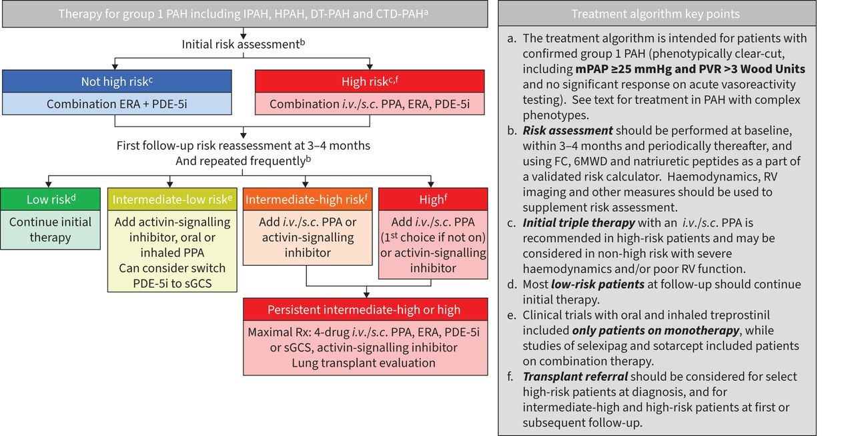
Source: Figure 1.2-1, p32 of the submission.
CTD=connective tissue disease; DT=drug and toxin; ERA=endothelin-1 receptor antagonist; FC=functional class; HPAH=hereditary PAH; IPAH=idiopathic PAH; i.v.=intravenous; mPAP=mean pulmonary artery pressure; PAH=pulmonary arterial hypertension; PDE5i=phosphodiesterase-5 inhibitor; PPA=prostacyclin pathway agent; PVR=pulmonary vascular resistance; RV=right ventricle; Rx=prescription; s.c.=subcutaneous; sGCS=soluble guanylyl cyclase stimulator; 6MWD=6-minute walk distance.
  - Table 4 presents the current and proposed treatment regimens on the PBS and in international guidelines by WHO FC and risk status.
Table 4: Current and proposed treatment regimens on the PBS and in guidelines by WHO FC and risk status (ESC/ERS 4-strata)
ESC/ERS 4-risk strata | Low-risk |  | Intermediate-low risk |  | Intermediate-high risk | High-risk
1-year estimated mortality | 0-3% |  | 2-7% |  | 9-19% | >20%
Majority WHO FCª | II |  | III |  | III | IV
Risk assessment determinants of prognosis (COMPERA 2.0)
WHO FC | I or II |  | - |  | III | IV
6MWD, m | >440 |  | 320-440 |  | 165-319 | <165
NT-proBNP, ng/L | <300 |  | 300-649 |  | 650-1100 | >1100
International treatment guideline
Initial therapy | Dual  ERA + PDE-5i |  | Dual  ERA + PDE-5i |  | Dual  ERA + PDE-5i | Triple  ERA + PDE-5i + IV/SC PPA
After assessment | Dual  Continue initial therapy |  | Dual/triple  Add SOTA or PO/inhaled PPA  Consider switching PDE-5i to sGCS |  | Triple/quadruple  Add SOTA or IV/SC PPA – both if persistent | Triple/quadruple  Add IV/SC PPA (first line) or SOTA – both if persistent
PBS – current and proposed
Treatment population  WHO FC | I | II | II | III | III | IV
NT-proBNP, ng/L^{b} | Any | <650 | ≥650 | Any | Any | Any
Current therapies on PBS | Nil | Mono | Mono | Mono/Dual/Triple | Mono/Dual/triple | Mono/Dual/Triple
Requested PBS restriction for sotatercept | Nil | Nil | Dual | Dual/triple | Dual/triple/quadruple | Nil^{c}
Trial evidence
STELLAR population
Eligible criteria | ✗ | ✓ | ✓ | ✓ | ✓ | ✗
Enrolled actual (by FC) | Nil | 48.6^{d} |  | 51.4%^{d} |  | Nil
Source: Table 1.2-1, p33; Figures 1.2-2 and 1.2-3, pp34-35 of the submission; Table 18, p3659, Humbert et al (2022); Figure 1, p2, Chin et al (2024).
6MWD=6-minute walk distance; ESC/ERS=European Society of Cardiology and the European Respiratory Society; ERA=endothelin-1 receptor antagonist; IV=intravenous; PDE-5i=phosphodiesterase-5 inhibitor; m=metres; ng/L=nanogram per litre; NT-proBNP=N-terminal prohormone of brain natriuretic peptide; PPA=prostacyclin pathway agent; PO=oral; SC=subcutaneous; sGCS=soluble guanylyl cyclase stimulator; SOTA=sotatercept; WHO FC=World Health Organization Functional Class.
ª COMPERA registry analysis, Table 1.2-1, p33 of the submission.
^{b} Proposed clinical criteria in the requested PBS restriction for sotatercept.
^{c} The Sponsor included this possibility in the proposed clinical algorithm but has not included the FC IV population in the proposed PBS restriction since it is outside the likely TGA label.
^{d} Unable to verify STELLAR baseline COMPERA 2.0 risk strata status.
  - The proposed clinical management algorithm positioned sotatercept as an add-on treatment for patients with inadequate control on initial mono, dual and triple therapies, with eligibility determined by WHO FC and BNP/NT-proBNP at follow-up. Specifically, patients could add on sotatercept to background therapies if they have WHO FC II (and NT-proBNP ≥650 ng/L or BNP ≥200 ng/L), FC III (and potentially also FC IV), representing patients potentially at intermediate−low risk, intermediate−high risk and high−risk PAH according to COMPERA 2.0 risk calculator. The proposed algorithm attempted to align PAH treatment on the PBS with international guidelines. However, the following issues were noted:
  - The proposed dual therapy (with sotatercept) for patients with FC II (and NT-proBNP ≥650 ng/L or BNP ≥200 ng/L), if listed, may affect the PBS listing of other PAH therapies for FC II PAH, given that currently only monotherapy (with either an ERA or a PDE5i) is approved on the PBS.
  - The proposed algorithm positioning sotatercept as an add-on to monotherapy (i.e. forms part of dual therapy with ERA or PDE5i) in patients with FC II (and NT-proBNP ≥650 ng/L or BNP ≥200 ng/L) was inconsistent with international guidelines. Guidelines position sotatercept as an add-on to dual therapy or triple therapy (i.e. sotatercept forms part of triple therapy or quadruple therapy) in patients with intermediate-low, intermediate-high and high risk (i.e. encompassing FC II/III/IV) PAH. The ESC noted that this was a consequence of the current PBS restriction in FC II patients.
  - The submission proposed that patients with FC III PAH may be treated with add-on sotatercept in quadruple therapy (ERA + PDE5i + PPA + sotatercept). The 7th WSPH treatment algorithm recommended quadruple therapy in persistent intermediate-high or high risk patients, including FC III/IV. The submission stated that the PBAC may also wish to consider sotatercept treatment in FC IV. Use in FC IV would be outside of sotatercept’s TGA registration, given its trial evidence provided at the time was limited to patients with FC II or FC III PAH. Of note, in patients with FC IV, adding PPA (IV epoprostenol) was recommended preferentially to sotatercept.
  - People living with PAH can experience significant symptom burden and impaired quality of life. The submission presented qualitative evidence on the patient experience in Australia, from one-on-one interviews with 12 patients, and two patient input forums (one in-person and one virtual) with patients and caregivers conducted in March 2024. The themes and representative quotes from the qualitative evidence are shown in Table 5. Patients were aged between 29 and 72 and were living in metropolitan and rural areas of Australia. They were diagnosed with PAH between the ages of 2 and 66, with an average age of diagnosis of 32 years old. The qualitative evidence was not reported according to the Consolidated criteria for reporting qualitative research (COREQ) checklist, as the submission did not provide details such as the research team and reflexivity, the sampling and recruitment, and how the data were analysed and themes derived. All of the themes identified were present in a thematic synthesis of qualitative studies on adults’ experiences of living with pulmonary hypertension by Rawlings 2020, which also identified additional themes such as diagnosis, coping, and the transitional nature of PAH.
Table 5: Patient experience themes and representative quotations
Theme | Example of a representative quotation
Physical, mental and treatment burden of PAH | “Living in the unknown where you don’t know what’s around the corner, it’s hard to commit to something that’s going to take a bit of commitment. Me and my wife would have had another child if we’d known I’d still be here today.“ (Patient 11, aged 45)
Management of daily living with PAH | “That was a big adjustment because that’s six times a day. You’ve got to have your medications charged and with you… So, if you want to go and do something; you’re really got to be organised for it.” (Patient 10, aged 29)
Financial burden of PAH on patients and their families | “My husband lost his job due to my health in the beginning. He was having a lot of time off, having to look after me, he’d leave work at the drop of a hat.” (Patient 12, aged 47)
Lack of awareness of PAH amongst the public and in the healthcare system | “I’ve had an incident where I’ve been at hospital for a different matter in a different section and the doctor wasn’t aware of the condition. I needed to take my meds, but it’s illegal to take your own meds into hospital which I didn’t know. I took my meds knowing that they were very rare, and they were taken from me. So, my care for my PAH was jeopardised.” (Patient 8, aged 40)
Source: pp217-229 of the submission.
For more detail on PBAC’s view, see section 7 PBAC outcome.
- Comparator
  - The submission nominated (i) placebo as the primary comparator and (ii) selexipag as the secondary comparator, weighted ||| |||% : ||| |||% based on PBS treatment utilisation (10% PBS data). This assumed that for population (i), a proportion of patients with WHO FC II/III would be eligible for add-on sotatercept treatment (to mono, dual, or triple therapy), and that for population (ii), sotatercept would displace/replace PPA (selexipag or epoprostenol) treatment in triple therapy. The evaluation noted that the submission provided few details of the methodology for calculating the weighted comparator, including assumptions about the eligible patients. Further, the estimated proportion of eligible patients was inconsistent with the presented financial estimates.
  - The submission assumed the eligible population consisted of three groups of patients (PHSANZ registry) based on PBS treatment utilisation (10% PBS data) and the following points were noted by the evaluation:
    - Current monotherapy — 18.4% of patients with WHO FC II/III and on monotherapy (ERA or PDE5i) would add on treatment with sotatercept to step up to dual therapy. The submission assumed most (39.7%) patients on monotherapy eligible for add-on sotatercept have WHO FC III (based on the PHSANZ registry), and a small proportion (5.6%) have WHO FC II and high BNP/NT-proBNP. The ESC noted the limitations of the 10% PBS data in assessing patients on non-PBS dual or triple therapy. These assumptions were also inconsistent with the submission’s clinical evidence and financial estimates. In the main trials (STELLAR and PULSAR), 4−9% of enrolled patients with FC II/III had concomitant background treatment in the form of monotherapy. The financial estimates assumed eligible monotherapy patients included 4% of patients with FC II and high BNP/NT-proBNP and none with FC III.
    - Current dual therapy — 26.1% of patients with FC III on dual therapy (23.8% on ERA + PDE5i and 2.3% on ERA/PDE5i + selexipag) would add on sotatercept to step up to triple therapy. Further, of the patients on ERA + PDE5i dual therapy, the submission assumed 23.8% would add on selexipag and 6.5% would add on IV epoprostenol.
    - Current triple therapy — 20.6% of patients with FC III on triple therapy (17.5% on ERA + PDE5i + selexipag and 3.1% on ERA + PDE5i + PPA) would add on sotatercept to step up to quadruple therapy. However, the financial estimates assumed (based on PHSANZ registry) that 50.4% of patients on triple therapy would be eligible for add-on sotatercept at an uptake rate of 90%.
  - The following points were noted by the evaluation with regard to the nominated placebo/selexipag comparator:
    - Potential dual therapy including sotatercept — The evaluation and ESC considered that placebo may not be the appropriate comparator for patients stepping up from monotherapy. The submission proposed sotatercept as an add-on to monotherapy (ERA or PDE5i) resulting in dual therapy including sotatercept in patients with FC II (and NT-proBNP ≥650 ng/L) or FC III, which is inconsistent with guidelines and current PBS restrictions for PAH treatment. As shown in Table 4, for patients with FC II, current PBS restrictions allow PAH therapies as monotherapy (ERA or PDE5i) only. Further, guidelines do not recommend sotatercept as an add-on to monotherapy for PAH patients; rather, sotatercept is recommended as an add-on to dual therapy or triple therapy for PAH patients at intermediate-low, intermediate-high, and high risk (predominantly FC III/IV). The ESC considered that it is difficult to provide advice about the appropriate comparison to be presented in this population given the differences between the guidelines, current PBS restrictions, clinical trial results and the submission’s proposed restriction for sotatercept. The PBAC may wish to consider whether additional consideration is required in this patient group more broadly than just considering sotatercept in isolation, whilst recognising the difficulty in comparing dual therapy regimens in the population of FC II patients with elevated naturetic peptides.
    - Potential triple therapy including sotatercept — The submission nominated selexipag as the main comparator in patients stepping up from dual therapy (ERA + PDE5i) to triple therapy, noting that the weighted selexipag comparator represented selexipag and all prostacyclin. The evaluation considered that this was appropriate.
    - Potential quadruple therapy including sotatercept — The evaluation considered that the nomination of placebo as comparator was appropriate in patients stepping up from triple therapy. For patients with intermediate-high or high risk, maximal medical therapy is a four-drug therapy including sotatercept (i.e. PPA + ERA + PDE-5i + sotatercept). In the sotatercept trials, most patients received background triple therapy (50.8% on ERA + PPA + PDE5i and 10.8% on ERA + PPA + sGCS). The ESC noted that sGCS (riociguat) is PBS restricted for monotherapy only in PAH or for Chronic Thromboembolic Pulmonary Hypertension (CTEPH).
For more detail on PBAC’s view, see section 7 PBAC outcome.
- Consideration of the evidence

Sponsor hearing
  - There was no hearing for this item.

Consumer comments
  - The PBAC noted and welcomed the input from individuals (154), health care professionals (4) and organisations (2) via the Consumer Comments facility on the PBS website.
  - Lung Foundation Australia wrote in support of sotatercept being listed on the PBS for PAH, noting the negative physical and mental impacts of PAH, as well as the inability of patients to work or study. The organisation also noted the impact of patients financing medications for their lung condition. The letter referred to personal stories emphasising the challenges faced by PAH patients.
  - The Australian Scleroderma Interest Group (ASIG) described PAH as a devastating complication of scleroderma that leads to shortness of breath, fatigue, and reduced exercise capacity. ASIG stated that patients with scleroderma-PAH have a worse prognosis than those with idiopathic PAH, with a high mortality rate and significant impacts on quality of life. ASIG noted the unmet need for effective treatments in scleroderma-PAH.
  - The health care professionals (HCPs) commented that current therapies provide those with mild PAH stabilisation and good function, however those with more severe PAH continue to experience high symptom burden. The HCPs stated that sotatercept is the first medicine to target the underlying inflammation causing PAH and is likely to be disease modifying. The HCPs expected the side-effect profile of sotatercept to be readily manageable for those undergoing treatment. The HCPs described sotatercept as addressing an unmet clinical need in a rare but life-threatening condition.
  - The individuals who commented comprised a sotatercept patient, those who would like to use sotatercept for PAH (57), a parent/partner of a current/potential sotatercept patient (23), and other interested individuals (73). The consumer input emphasised that PAH is a very limiting disease, with acute shortness of breath and overwhelming tiredness impacting on physical, mental and financial health, and quality of life. The comments described the disturbing and confronting nature of PAH as a terminal illness. Sotatercept was described by contributors as potentially reversing damage, lowering the risk of death, and offering another option before parenteral or inhaled therapy or transplant surgery.

Clinical trials
  - For the comparison versus placebo, the submission was based on two randomised controlled trials (RCTs) comparing sotatercept to placebo (STELLAR and PULSAR) and two open-label studies of sotatercept treatment (SPECTRA and SOTERIA). The submission described STELLAR as the pivotal trial and PULSAR as supportive evidence in PAH patients with WHO FC II or FC III. Additional supportive evidence included SPECTRA, a single-arm study of sotatercept in patients with WHO FC III and SOTERIA, a long-term follow-up (LTFU) study of sotatercept treatment in patients who completed previous sotatercept trials including STELLAR (double-blind and long-term blinded period), PULSAR (double-blind and long-term open-label period) and SPECTRA (open-label with extension period) as well as two other trials ZENITH and HYPERION, which were not considered as part of this submission. For the indirect comparison versus selexipag, the submission relied on two additional trials for selexipag, GRIPHON and TRACE.
  - Details of the trials presented in the submission are provided in Table 6.
Table 6: Trials and associated reports presented in the submission
Trial ID | Protocol title/ Publication title | Publication citation
Sotatercept trials
STELLAR  (NCT04576988) | A Phase 3, Randomized, Double-Blind, Placebo-Controlled Study to Compare the Efficacy and Safety of Sotatercept Versus Placebo When Added to Background Pulmonary Arterial Hypertension (PAH) Therapy for the Treatment of PAH (STELLAR). Clinical Study Report (CSR) v03 [STELLAR]. | January 2023.
STELLAR  (NCT04576988) | A Phase 3, Randomized, Double-Blind, Placebo-Controlled Study to Compare the Efficacy and Safety of Sotatercept Versus Placebo When Added to Background Pulmonary Arterial Hypertension (PAH) Therapy for the Treatment of PAH (STELLAR). Clinical Study Report (CSR) v01 [STELLAR v01]. | September 2022.
STELLAR  (NCT04576988) | Hoeper MM, Badesch DB, Ghofrani HA, Gibbs JSR, Gomberg-Maitland M, McLaughlin VV, et al. Phase 3 Trial of Sotatercept for Treatment of Pulmonary Arterial Hypertension. | NEJM. 2023;388(16):1478-90.
 | Souza R, Badesch DB, Ghofrani HA, Gibbs JRS, Gomberg-Maitland M, McLaughlin VV, et al. Effects of sotatercept on haemodynamics and right heart function: analysis of the STELLAR trial. | Eur Respir J. 2023;62(3).
PULSAR  (NCT03496207) | A Phase 2, Double-Blind, Placebo-Controlled, Randomized Study to Compare the Efficacy and Safety of Sotatercept (ACE-011) Versus Placebo When Added to Standard of Care for the Treatment of Pulmonary Arterial Hypertension (PAH). Clinical Study Report (CSR) [PULSAR]. | April 2022.
PULSAR  (NCT03496207) | Humbert M, McLaughlin V, Gibbs JRS, Gomberg-Maitland M, Hoeper MM, Preston IR, et al. Sotatercept for the treatment of pulmonary arterial hypertension: PULSAR open-label extension. | Eur Respir J. 2023;61(1).
PULSAR  (NCT03496207) | Humbert M, McLaughlin V, Gibbs JSR, Gomberg-Maitland M, Hoeper MM, Preston IR, et al. Sotatercept for the Treatment of Pulmonary Arterial Hypertension. | NEJM. 2021;384(13):1204-15.
SPECTRA  (NCT03738150) | A Phase 2a Single-Arm, Open-Label, Multicenter Exploratory Study to Assess the Effects of Sotatercept (ACE-011) for the Treatment of Pulmonary Arterial Hypertension Clinical Study Report (CSR) [SPECTRA]. | April 2022.
SOTERIA  (NCT04796337) | Preston I. et al. SOTERIA: A long-term follow-up study of sotatercept from pulmonary arterial hypertension. Data cutoff: 08 November 2023. | Pulmonary Vascular Research Institute meeting (PVRI); January 31-February 3, 2024; London 2024.
Selexipag trials
GRIPHON (NCT01106014) | Sitbon O, Channick R, Chin KM, Frey A, Gaine S, Galiè N, et al. GRIPHON Investigators. Selexipag for the Treatment of Pulmonary Arterial Hypertension. | N Engl J Med. 2015;373(26):2522-33
TRACE (NCT03078907) | Howard LS, Rosenkranz S, Frantz RP, Hemnes AR, Pfister T, Hsu Schmitz SF et al. Assessing Daily Life Physical Activity by Actigraphy in Pulmonary Arterial Hypertension: Insights From the Randomized Controlled Study With Selexipag (TRACE). | Chest. 2023;163(2):407-418.
Source: Tables 2.2-2, 2.2-3, and 2.2-5 pp51-54 of the submission.

  - The key features of the included evidence for sotatercept are summarised in Table 7.
Table 7: Key features of the included evidence for sotatercept
Trial | N | Design/ duration | bias | Treatment | Population | Outcome(s) | MEE
Sotatercept vs placebo
STELLAR | 323 | PIII, MC, R, DB, PC (24 wks), followed by LTDB (72 wks)ª | Low | SOTA (0.3 mg/kg at Visit 1 then 0.7 mg/kg Q3W)  PBO | WHO Group I PAH, WHO FC II/III, stable PAH therapy for 90 days | 1º: 6MWD  2º: PVR, NT-proBNP, WHO FC, EQ-5D-5L | ✓
PULSAR | 106 | PII, MC, R, DB, PC (24 wks) followed by OL extension (30 mo)^{b} | Low | SOTA 0.3 mg/kg Q3W  SOTA 0.7 mg/kg Q3W  PBO | WHO Group I PAH, WHO FC II/III, stable PAH therapy for 90 days | 1º: PVR  2º: 6MWD, NT-proBNP | -
Supportive evidence
SPECTRA | 21 | PII, MC, NC, OL (24 wks), followed by OL extension (18 mo)^{b} | Unclear | SOTA (0.3 mg/kg at Visit 1 then 0.7 mg/kg Q3W) | WHO Group I PAH, WHO FC III, PAH combination therapy | 1º: VO₂ Max  2°: 6MWD, NT-proBNP, WHO FC | -
SOTERIA | 426 | PIII, MC, OL follow-up (4 yrs). DCO 08 Nov 2023 median (range) cumulative exposure 652.5 (21, 1972) days | Unclear | SOTA 0.3 mg/kg Q3W  SOTA 0.7 mg/kg Q3W  SOTA (current dose) Q3W | WHO Group I PAH, WHO FC I-IV,  Patients from STELLAR, PULSAR, SPECTRA, ZENITH, and HYPERION | 1°: Safety  2°: 6MWD, NT-proBNP, WHO FC, OS | ✓
Source: Table 2.2-1, p51 of the submission; Table 2.2-4, p53 of the submission; Clinicaltrials.gov (SPECTRA).
6MWD=6-minute walk distance; DB=double blind; EQ-5D-5L=discrete choice instrument-3 EuroQol 5 Dimensions-5 Level; FC=Functional Class; LTDB=long-term double blind; LTFU=long-term follow-up; MC=multi-centre; MEE=modelled economic evaluation; mo=months; NC=non-comparative single arm study; NT-proBNP=N-terminal pro-type natriuretic peptide; OL=open label; PAH=pulmonary arterial hypertension; PBO=placebo; PII=Phase II; PIII=Phase III; PVR=pulmonary vascular resistance; R=randomised; WHO=World Health Organization; SOTA=sotatercept; wks=weeks; Q3W=every 3 weeks.
a Patients who completed the DB treatment period (24w) and were on treatment (sotatercept or placebo) in the LTDB treatment period (72w) were eligible to enter a separate, LTFU study (SOTERIA).
b Patients who completed OL extension period were eligible to enter a separate, LTFU study (SOTERIA).
  - STELLAR and PULSAR were multicentre (including sites in Australia), randomised double-blind, placebo-controlled trials where patients received either add-on sotatercept or placebo in addition to background PAH monotherapy or combination therapy for 24 weeks. Both trials consisted of two treatment periods. In STELLAR, patients who completed the double-blind placebo-controlled treatment period (24 weeks) entered the long-term double-blind (LTDB) to 72 weeks. In PULSAR, patients who completed the double-blind placebo-controlled treatment period (24 weeks) could continue in the open-label extension, during which patients in the sotatercept arms continued their assigned treatment and patients in the placebo arm were rerandomized to receive either fixed dose sotatercept 0.3 mg/kg or sotatercept 0.7 mg/kg. SPECTRA was a small (N=21) open-label single-arm study of add-on sotatercept treatment to combination PAH therapy for 24 weeks, followed by an extension period for 18 months. Patients on background monotherapy were not eligible for the study. In SOTERIA, eligible patients received open-label add-on sotatercept treatment to background PAH therapy for up to 4 years (or 7 years including parent studies).
  - For the nominated secondary comparator, selexipag, the submission presented an indirect comparison for sotatercept (STELLAR) vs selexipag (GRIPHON and TRACE) via placebo as the common reference. GRIPHON compared selexipag to placebo in patients with FC I to IV who were treatment naïve or stable on PAH therapy. TRACE was a small study comparing selexipag to placebo in patients with FC II or FC III with stable PAH therapy of ERA +/- PDE5i. Data from GRIPHON was previously presented in the selexipag submission and considered in the March 2016, March 2017 and July 2020 PBAC meetings.
  - The evaluation identified a recent network meta-analysis by Pitre 2024, of the comparative effectiveness of add-on sotatercept treatment in PAH patients with established background treatment. The review included 18 studies (including two studies of sotatercept, STELLAR and PULSAR). No additional relevant trials of sotatercept were identified from the Pitre 2024 review. The Pitre 2024 review reported that sotatercept showed modest benefits compared to other therapies, such as ERA or oral prostanoid, in improving 6MWD; noting that the treatment effect did not exceed the minimal clinically important difference (MCID) of 33 metres in patients with PAH. While the analysis showed that add-on sotatercept resulted in improvement in the outcomes of clinical worsening and 6MWD compared to ERA, PDE5i and oral or inhaled PPA, there was a high level of uncertainty in the analysis of mortality outcomes and serious adverse events.
  - Overall, the risk of bias in the STELLAR and PULSAR trials was considered low by the evaluation. The other studies (SPECTRA and SOTERIA) were considered to be at unclear risk of bias due to the nature of the study design being small, single-arm or non-comparative. Further, while functional haemodynamic changes (e.g. NT-proBNP and pulmonary vascular resistance (PVR)) are objective outcomes, other patient outcomes such as 6MWD and WHO FC may be subject to variation between clinicians/studies with an associated higher risk of bias, particularly given there were no comparative control arms in these studies.
  - During the double-blind treatment period, the rate of discontinuation varied across the treatment arms in STELLAR and PULSAR. In STELLAR, over the double-blind and extended double-blind period, fewer patients discontinued in the sotatercept treatment arm compared to placebo (6.1% vs 25.0%). More patients in the sotatercept treatment arm discontinued due to AEs, and more patients in the placebo arm discontinued due to clinical worsening. In the PULSAR double-blind placebo-controlled period, more patients discontinued in the sotatercept 0.7 mg/kg (14.3%) treatment arm than in the sotatercept 0.3 mg/kg (3.1%) and placebo (6.3%) arms, respectively. The most common reason for treatment discontinuation was AEs.
  - The trials enrolled patients aged ≥18 years with WHO Group 1 PAH and WHO FC II or FC III on stable background PAH therapy (mono- or combination therapy in STELLAR and PULSAR, and combination therapy in SPECTRA), except for SOTERIA, which enrolled a broader population from five sotatercept trials including patients with WHO FC I to FC IV. Across the primary trials (STELLAR, PULSAR and SPECTRA), there were differences in some baseline characteristics, owing mainly to differences in eligibility criteria.
  - According to the proposed clinical criteria (WHO PAH Group 1, WHO FC II and NT-proBNP ≥650 ng/L or WHO FC III), the PBS population differs from the enrolled trial populations. The eligible PBS population included patients with all WHO PAH Group 1 subtypes, whereas the trials excluded PAH associated with HIV and portal hypertension (or liver disease). The ESC considered that this would be unlikely to affect the outcomes. However, the trials enrolled patients with FC II irrespective of naturetic peptide levels, whereas the proposed PBS population is only for FC II with elevated naturetic peptides representing a higher risk population than in the clinical trials. The proportion of trial patients meeting the other PBS eligibility criteria and whether any differences may have impacted the estimated treatment effects was also unclear. For example, only 4% of the enrolled patients with FC II/III were on background PAH monotherapy, whereas in practice on the PBS, patients with FC II are treated with monotherapy, and FC III can be treated with monotherapy or combination (dual and triple) therapy.

Comparative effectiveness
Comparison of sotatercept versus placebo
  - All trials presented 6MWD as the primary or secondary outcome after 24 weeks. Additional secondary outcomes included changes in WHO FC, NT-proBNP levels and time to death or clinical worsening.
  - In the March 2016 consideration of selexipag for the treatment of PAH, the PBAC considered that the time to first morbidity or mortality event was a more patient-relevant outcome than the 6MWD (paragraph 6.8 selexipag PSD, March 2016 and paragraph 5.11 macitentan PSD, March 2014). However, the PBAC also stated that the use of a composite outcome where, for example, death has the same clinical relevance as hospitalisation, made the results more difficult to interpret. The PBAC stated that a translation of the time to first morbidity or mortality event to life-years gained or quality-adjusted life-years (QALYs) would be more informative (paragraph 5.11 selexipag PSD, March 2016).
  - The submission proposed a minimal clinically important difference (MCID) in 6MWD of 33 metres to represent a clinically meaningful change in patient physical capacity. The MCID was previously validated by Mathai 2012 and Moutchia 2023 in patients with PAH. No MCID for NT-proBNP is reported in the submission. When applied in the COMPERA 2.0 risk calculator, threshold values NT-proBNP of <300 ng/L, 300-649 ng/L, 650-1100 ng/L, and >1100 ng/L are used for low, intermediate low, intermediate high and high-risk PAH, respectively.
  - Table 8 summarises change from baseline in 6MWD, NT-proBNP, and time to death or clinical worsening in the STELLAR, PULSAR, and SPECTRA trials. The submission did not present any post hoc subgroup analysis of the trials reflecting the proposed PBS population, i.e. FC II (+ elevated NT-proBNP) + FC III, rather than the overall FC II/III population.
Table 8: Results of 6MWD, NT-proBNP, and clinical worsening or death events in STELLAR, PULSAR and SPECTRA
Trial | STELLAR |  | PULSAR |  |  | SPECTRA
Treatment | SOTA^  (N=163) | PBO  (N=160) | SOTA  0.3 mg/kg  (N=32) | SOTA  0.7 mg/kg  (N=42) | PBO  (N=32) | SOTA^  N=21
6MWD (metres) at Week 24
Mean (SD) at baseline (metres) | 397.6 (84.3) | 404.7 (80.6) | 385.9 (88.67) | 397.6 (91.6) | 409.1 (63.9) | 390.3 (76.2)
Median (min, max) change from baseline ª | 34.4  (32.5, 35.5) | 1.0  (-1.0, 5.0) | 54.3 | 33.7 | 14.5 | 46.3
HLLS Difference vs PBO (95% CI) ^{b} | 40.8 (27.5, 54.1) |  | 39.9 (16.1, 63.8) | 27.8 (3.8, 51.9) |  | NR
NT-proBNP (pg/mL) at Week 24
Mean (SD) at baseline (pg/mL) | 1037.5  (2498.6) | 1207.8  (2694.4) | 998.5  (1267.1) | 870.5  (1608.7) | 870.2  (1213.3) | 733.6 (868.6)
Median (Min, Max) change from baseline | -230.3  (-236.0, -223.0) | 58.6  (44.0, 73.0) | -176.7 | -87.7 | -8.3 | -328.85
LS Mean (SE) change | -715.9  (401.4) | 1809.0  (415.2) | -630.7  (146.8) | -417.3  (127.8) | 292.1  (141.8) | -577.2  (171.7) [mean-SD]
LS mean difference vs PBO (95% CI) | -2524.9  (-3640.6, -1409.1) |  | -922.8  (-1328.2, -517.4) | -709.4  (-1088.1, -330.8) |  | -
HLLS Difference (95% CI) vs PBO ^{b} | -441.6, (-573.5, -309.6) |  | -595.0  (-1154.0,-196.0) | -238.0 (-649.0, -85.0) |  | -
Time to first clinical worsening or death to Week 84 (STELLAR)^{c}, Week 24 (PULSAR) and 24 months (SPECTRA)
≥one event, n (%) | 11 (6.7) | 42 (26.3) | 0 | 1 (2.4) | 2 (6.3) | 1 (4.8)
Total number of events | 11 | 45 | 0 | 1 | 2 | 1
HR vs PBO (95% CI) | 0.2 (0.1, 0.4) |  | 0 | 0.4 (0.0, 4.2) |  | -
Death | 2 (1.2) | 6 (3.8) | 0 | 1 (2.4) | 0 | -
Worsening-related listing for lung and/or heart transplant | 1 (0.6) | 1 (0.6) | 0 | 0 | 0
Rescue therapy or increase prostacyclin infusion ≥10% | 2 (1.2) | 17 (10.6) | 0 | 0 | 0
Atrial septostomy | 0 | 0 | 0 | 0 | 0 | -
PAH-specific hospitalisation (≥24 hrs) | 1 (0.6) | 7 (4.4) | 0 | 0 | 1 (3.1) | -
Deterioration of PAH ^{d} | 5 (3.1) | 15 (9.4) | 0 | 0 | 2 (6.3) | 1 (4.8)
Bold= statistically significant
Source: Compiled during the evaluation from Table 2.5-2, p105, Table 2.5-3, p106 and Table 2.5-4, p108 of the submission, Table 14.2.2, p200 of STELLAR CSR (Sep 22) and Table 11-4, p104, Table 14.2.2.1.6, p 305, Table 14.2.2.1.8, p312 and Table 14.2.2.1.2a, p299 of PULSAR CSR (April 22) and Table 14.2.6.1.2, pp282-3 of SPECTRA CSR (2022) [for 6MWD], Table 2.5.11, p119 of the submission, Table 11-4, p57 and Table 14.2.12, p227 of STELLAR CSR (DCO: Sep 22) and Table 14.2.2.2.6, pp329-30 of PULSAR CSR (DCO: Aril22) and Table 14.2.11.1.2, p375 and Table 14.2.11.1.2.1, p376 of SPECTRA CSR (2022) [for NT-proBNP], and Table 2.5-5, p109 of the submission, Table 14.2.4, p122 of STELLAR CSR (Jan23), Table 14.2.8, p629 of PULSAR CSR (2022), and Table 14.2.8.2, p346 of SPECTRA CSR (2022) [for clinical worsening/death].
6MWD=6-Minute Walk Distance; ASE=asymptotic standard error; CI=confidence interval; DCO=data cut-off; FAS=full analysis set; HLLS=Hodges-Lehmann Location Shift; HR=hazard ratio; LS= Least Square; Min=minimum; Max=maximum; N=total participants in group; NR=not reported; NT-proBNP; N-terminal prohormone of brain natriuretic peptide; PBO; placebo; SOTA=sotatercept.
^ Sotatercept 0.3 mg/kg at Visit 1 then 0.7 mg/kg every 3 weeks
a Change from baseline in 6MWD at Week 24 for subjects who died was assigned a value of -2000 metres to receive the worst rank. Change from baseline in 6MWD at Week 24 for subjects who have missing data due to a non-fatal clinical worsening event was imputed to -1000 metres to receive the next worst-rank.
b Hodges-Lehmann location shift from placebo estimate (median of all paired differences). Wilcoxon p-value refers to p-value from the aligned rank stratified Wilcoxon test with randomisation factors as strata.
c Values represent the cumulative results from the double-blind placebo-controlled and the long-term double-blind periods.
d Deterioration of PAH was defined by both of the following events occurring at any time, even if they began at different times, as compared to baseline values: (a) Worsened WHO functional class (II to III, III to IV, II to IV, etc), (b) Decrease in 6MWD by ≥ 15% (confirmed by two 6MWTs at least 4 hours apart but no more than one week).
  - Figure 2 presents the changes in 6MWD and NT-proBNP from baseline in the double-blind placebo-controlled treatment period to Week 24 (STELLAR and PULSAR) and the extended follow-up to 84 weeks (STELLAR) and 18-24 months (PULSAR).
Figure 2. Change from Baseline in 6MWD (metres) and NT-proBNP (pg/mL) over time in STELLAR (84 weeks) and PULSAR (18-24 months)
STELLAR
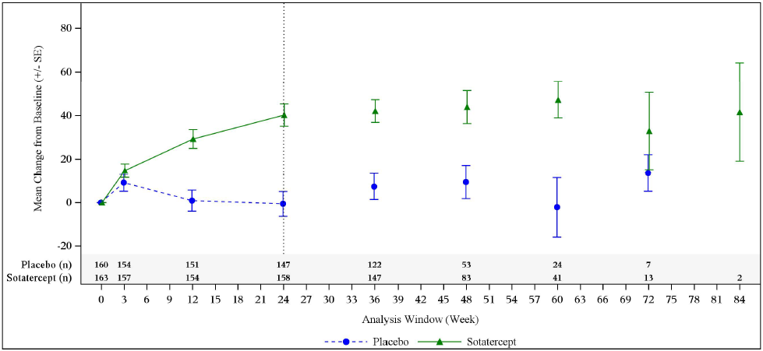
PULSAR ^{a, b}
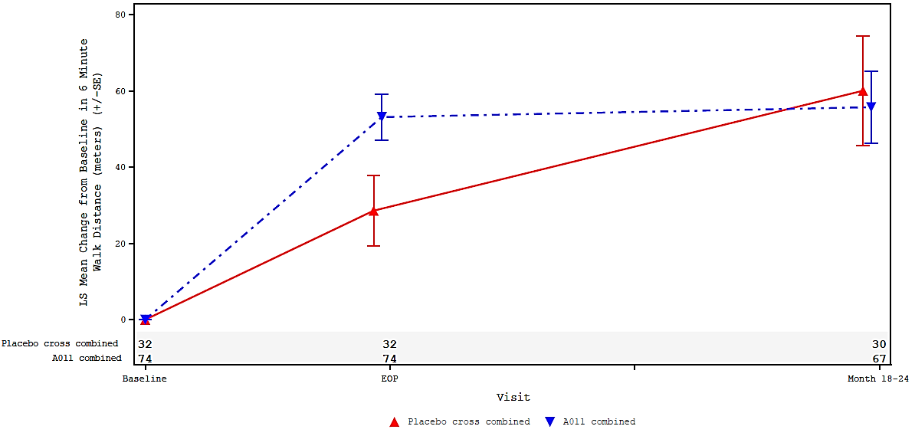 | 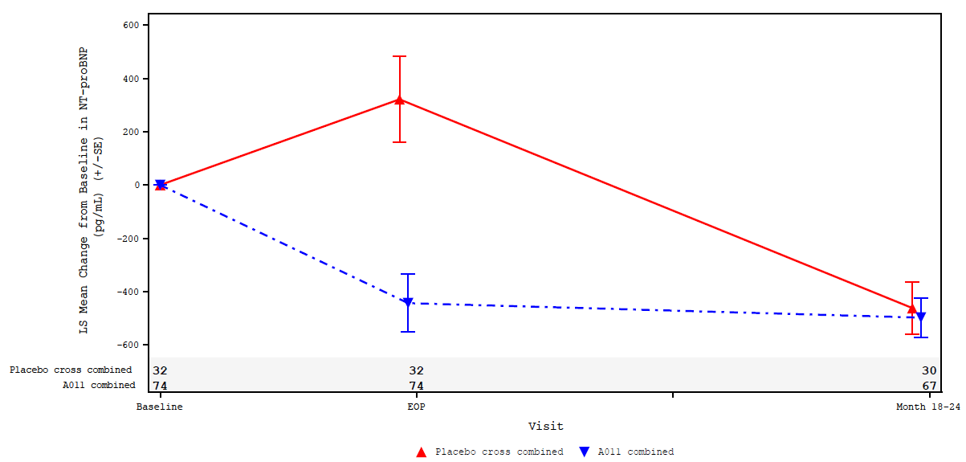
Source: Figure 2.5-6, p117 of the submission, Figure 14.2.1, p146 of the STELLAR CSR (Jan23) and Figure 14e.2.4.1.21, p957 and Figure 14e.2.2.1.6, p764 of PULSAR CSR.
6MWD=6-Minute Walk Distance; DCO=data cut-off; FAS=full analysis set; NT-proBNP=N-terminal pro-type natriuretic peptide; N=total participants in group; SE=standard error.
a EOP is defined as End of placebo-controlled treatment period.
b Values in sotatercept arm represent the combined results of the two dosing schedules (0.3 mg/kg and 0.7 mg/kg).
  - The results demonstrated:
- There was improvement from baseline in 6MWD and NT-proBNP across all treatment groups at Week 24 and this was generally maintained during treatment extension to Week 84 (STELLAR) and 18-24 months (PULSAR and SPECTRA). The mean changes from baseline in 6MWD and NT-proBNP at Week 24 for the sotatercept arms were broadly consistent across the STELLAR, PULSAR and SPECTRA trials.
- In STELLAR, the median treatment difference (Hodges-Lehmann location shift) was statistically significantly greater for sotatercept compared to placebo for the change from baseline in 6MWD (40.8 metres, 95%CI: 27.5, 54.1) and NT-proBNP (-441.6 pg/mL, 95%CI: -573.5, -309.6) at Week 24. The difference between groups in 6MWD at Week 24 may potentially be clinically relevant given the point estimates were higher than the estimated MCID for 6MWD of 33 metres in patients with PAH. The proportion of patients with 6MWD ≥33 metres was also higher in sotatercept treatment arm compared to placebo (50.3% vs 21.4%, p<0.001).
- Across the trials, the proportions of patients with death or clinical worsening events were low. In STELLAR, cumulative results from the double-blind placebo-controlled treatment period and long-term double-blind period (DCO: January 2023) showed that fewer patients in the sotatercept group experienced death or at least one clinical worsening event compared to the placebo group after 24 weeks (i.e., 6.7% vs 26.3%, HR: 0.18, 95% CI: 0.09, 0.38). Only one additional patient in the sotatercept group experienced a confirmed clinical worsening event (PAH deterioration) since the initial DCO (26 August 2022). A modified analysis, excluding "rescue therapy initiation" and "increase in prostacyclin dose by ≥10%", showed similar results (HR: 0.18, 95% CI: 0.075, 0.44). The reported events were also mainly for deterioration of PAH or PAH-related hospitalisation, with only two and six deaths reported in the sotatercept and placebo arms, respectively.
  - Table 9 shows the improvement in WHO FC at Week 24 in STELLAR and PULSAR.
Table 9: WHO Functional Class Improvement by Week 24 (across STELLAR and PULSAR FAS population)
 |  | Sotatercept |  |  |  | Placebo
STELLAR, FAS, DCO: Jan 2023
Baseline  n/N (%) |  | N | FC II | FC III | Total | N | FC II | FC III | Total
 |  | 163 | 80 (49.1) | 83 (50.9) | 163 (100) | 160 | 78 (48.8) | 82 (51.3) | 160 (100)
Week 24 | FC I | 159 | 8 (5.0) | 1 (0.6) | 9 (5.7) | 147 | 3 (2.0) | 1 (0.7) | 4 (2.7)
Week 24 | FC II | 159 | 67 (42.1) | 39 (24.5) | 106 (66.7) | 147 | 60 (40.8) | 18 (12.2) | 78 (53.1)
Week 24 | FC III | 159 | 5 (3.1) | 37 (23.3) | 42 (26.4) | 147 | 11 (7.5) | 46 (31.3) | 57 (38.8)
Week 24 | FC IV | 159 | 0 (0.0) | 2 (1.3) | 2 (1.3) | 147 | 1 (0.7) | 7 (4.8) | 8 (5.4)
Week 24 | Total | 159 | 80 (50.3) | 79 (49.7) | 159 (100) | 147 | 75 (51.0) | 72 (49.0) | 147 (100)
Week 24 | 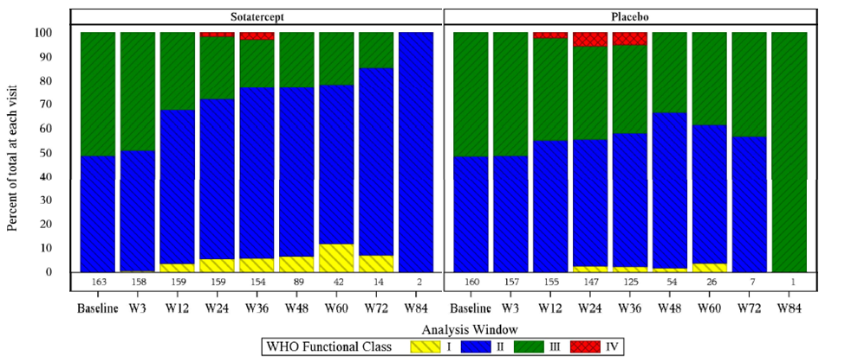
PULSAR, FAS, DCO: April 2022 ª
Baseline  n/N (%) |  | N | FC II | FC III | Total | N | FC II | FC III | Total
 |  | 42 | 27 (64.3) | 15 (35.7) | 42 (100) | 32 | 18 (56.0) | 14 (43.8) | 32 (100)
Week 24 | FC I | 36 | 2 (5.6) | 0 | 2 (5.6) | 30 | 1 (3.3) | 0 | 1 (3.3)
Week 24 | FC II | 36 | 22 (61.1) | 5 (13.9) | 27 (75.0) | 30 | 16 (53.3) | 3 (10.0) | 19 (63.3)
Week 24 | FC III | 36 | 1 (2.8) | 6 (16.7) | 7 (19.4) | 30 | 1 (3.3) | 9 (30.0) | 10 (33.3)
Week 24 | Total | 36 | 25 (69.4) | 11 (30.6) | 36 (100) | 30 | 18 (60.0) | 12 (40.0) | 30 (100)
Week 24 | 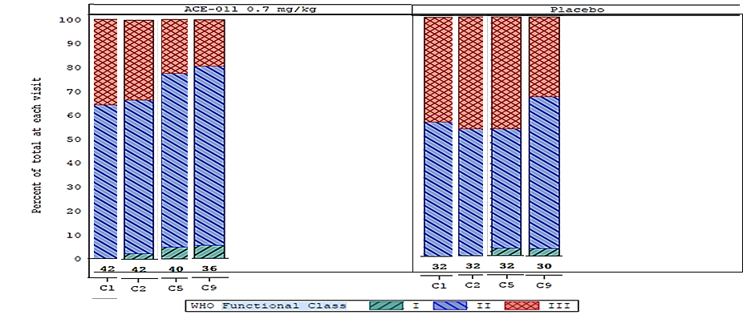
Source: Compiled during evaluation from Figure 2.5-8, p117 of the submission, Table 14.2.16 pp229-232 of STELLAR CSR (Jan23), Table 14.2.4.2.1, pp501-7, and Figure 14.2.4.1.1, p484 of PULSAR CSR (April 22).
DCO=data cut-off, FAS=full analysis set; FC=functional class; WHO=world health organisation.
a C1 refers to Cycle 1, Day 1 (baseline), while C9 refers to Cycle 9, Day 1, corresponding to Week 24.
  - In STELLAR, the results demonstrated that significantly more patients treated with sotatercept had improvement from baseline in WHO FC at Week 24 compared to placebo (29.4% vs 13.8%, p<0.001). The proportion of patients transitioning from baseline to Week 24 was as follows for the sotatercept arm versus placebo: WHO FC II to FC I (5% vs. 2%), WHO FC III to FC I (0.6% vs. 0.7%), and WHO FC III to FC II (24.5% vs. 12.2%). Similarly, in PULSAR, numerically more patients treated with sotatercept 0.3 mg/kg and 0.7 mg/kg had improvement from baseline in WHO FC at Week 12 compared to placebo (31.3% and 16.7% vs 12.5%).
  - Table 10 presents the proportions of patients classified as low risk according to the French Risk Score calculator, as well as the proportions of patients in the STELLAR sotatercept arm who maintained or improved their risk status upon enrolment in SOTERIA, as assessed by the COMPERA 2.0 risk score.
Table 10: French and COMPERA Risk Scores by visit across trials
 | French risk score [low risk score n/N (%)] |  | COMPERA risk score [risk status improvement or maintenance relative to STELLAR baseline n/N (%)]
 | SOTA | PBO | SOTA
STELLAR, FAS, DCO: Jan23 |  |  | STELLAR DCO: Dec22, SOTERIA DCO: Nov23 ª
Baseline | 28/163 (17.2) | 27/159 (17.0) | NR
Week 24 | 65/154 (42.2) | 31/145 (21.4) | 137/140 (97.9)
Week 36 | 64/147 (43.5) | 27/123 (22.0) | 136/140 (97.1)
Week 48 | 40/85 (47.1) | 15/54 (27.8) | -
Week 52 | - | - | 74/75 (98.7)
Week 72 (Year 1) | 5/13 (38.5) | 1/7 (14.3) | -
Week 108 (Year 2) | - | - | 29/30 (96.7)
Maintain or achieve a low risk score vs baseline at Week 24 ^{b} | 64/162 (39.5) | 29/159 (18.2) | -
PULSAR, FAS, DCO: Apr 2022
Maintain or achieve a low risk score vs baseline at Week 24 ^{c} | 21/42 (50.0) | 8/32 (25.0) | -
Bold=statistically significant
Source: Compiled during the evaluation from Table 2.5-6, p111 of the submission, Table 11-7, p62 of STELLAR CSR (Sep22), and Table 14.2.9, p631 of PULSAR CSR for French Risk values and Table 2.5-8, p112 of the submission for the COMPERA values.
DCO=data cut-off; FAS=full analysis set; n = proportion with event; N = total participants in FAS; PBO; placebo; SOTA=sotatercept.
a 154 patients from the STELLAR sotatercept arm enrolled in the SOTERIA study, with 153 continuing to receive sotatercept after one participant discontinued prior to the first dose. Endpoint assessments were based on participants with non-missing data at both the specified timepoints and the STELLAR baseline, with row percentages calculated accordingly.
b Comparison of sotatercept group with placebo using Cochran-Mantel-Haenszel (CMH) method stratified by randomisation factors: P-value: <0.001.
c Comparison of sotatercept 0.7 mg/kg group with placebo using Cochran-Mantel-Haenszel (CMH) method with baseline WHO Functional class as a stratification factor: P-value=0.0330.
  - In STELLAR, more patients achieved or maintained a low risk status (French Risk Score) relative to baseline, which was significant at Week 24 compared to the placebo (42.2% vs. 21.4%, p<0.001). The proportion of patients with low risk status was maintained in the extended follow-up to Week 72, however there was high attrition in patient numbers from Week 48, due to patients in the second period of STELLAR crossing over to SOTERIA and receiving open label sotatercept. Similarly, in PULSAR, more patients achieved all three criteria for low risk score at Week 24 in the sotatercept 0.3 mg/kg and 0.7 mg/kg groups compared to placebo (34.4% and 50.0% vs 25%) which was maintained to 18-24 months.
  - The COMPERA results indicated that in patients who continued sotatercept treatment in SOTERIA from STELLAR, the proportion with improvement or maintenance of risk status after at least 24 months was consistent with those seen after 24 weeks of treatment. However, the analysis was post-hoc and should be interpreted with caution due to small patient numbers, noting that patients with missing data at both the specified timepoints and the STELLAR baseline (82% of the initial 163 randomised to sotatercept in STELLAR) were excluded, so the analysis was informed by data from just 30 patients. A breakdown of reasons for missing data was not provided in the submission.
  - Long-term follow-up data from SOTERIA (DCO 08 November 2023) showed that the mean change (SD) from baseline (i.e. last measurement in parent study) in 6MWD, NT-proBNP, WHO FC and French low risk score at 24 weeks and one year was consistent with the primary STELLAR trial results for all patients treated with sotatercept. The mean changes (SD) from baseline at Week 24 were maintained at 1 year for 6MWD (20.2 (66.5) metres and 10.9 (73.6) metres, respectively) and NT-proBNP (−374.9 (1479.4) pg/mL and −227.2 (1580.1) pg/mL, respectively). Additionally, the proportion of patients with improved or maintained WHO-FC II from baseline at Week 24 was similar to that at 1 year (77.2% and 76.3%, respectively), and the proportion who achieved low French risk score (WHO-FC I/II, 6MWD >440 m, NT-proBNP <300 pg/mL) was also similar at Week 24 and at 1 year (30.1% and 37.4%, respectively).
  - The submission presented results for other outcomes. The multi-component outcome (6MWD of at least 30 metres, a decrease in NT-proBNP of at least 30%, or NT-proBNP < 300 pg/mL) in STELLAR showed that more patients treated with sotatercept achieved a response on all three components at Week 24 compared to placebo (p<0.001). Similarly, in PULSAR, more patients treated with sotatercept (both doses) responded on all three components at Week 24 compared to placebo (p<0.0001 and p=0.0055, respectively). In SPECTRA, a similar proportion of patients on sotatercept achieved a response on all three components of the multicomponent outcome.
  - In STELLAR, the results for other outcomes showed sotatercept treated patients had improvement in PVR (−234.6, 95% CI: −288.4, −180.8) and multi-component outcome (6MWD≥ 30m, NT-proBNP ≥30% or NT-proBNP <300ng/L and improved WHO FC or maintain FC II) (p<0.001) at Week 24 compared to placebo.
  - The submission presented results of patient-reported outcomes including Pulmonary Arterial Hypertension - Symptoms and Impact (PAH-SYMPACT) index and EQ-5D-5L. In STELLAR, patients treated with sotatercept improved from baseline in the physical (p=0.010) and cardiopulmonary symptoms (p=0.028) domains of PAH-SYMPACT compared to placebo at Week 24. While there was an increase in the EQ-5D-5L VAS score for sotatercept group compared to placebo (LS mean difference: 5.2; 95% CI: 0.52, 9.93), there were no differences between groups in the EQ-5D-5L index score at Week 24.
Additional analysis
  - Table 11 presents the post hoc analysis of overall survival using data from the STELLAR and SOTERIA trials, which was used in the modelled economic evaluation.
Table 11: Analysis of overall survival, treatment period in STELLAR and SOTERIA (STELLAR FAS)
Treatment | Number of Events (%) | Person-Weeks | Event Rate/ 100 Person- Weeks (%) | Median OS ª (Week) (95% CI)
Placebo | 11/160 (6.9) | 14633.3 | 0.08 | Not Reached
Placebo (RPSFT Adjusted) ^{b} | 11/160 (6.9) | 7571.5 | 0.15 | Not Reached
Sotatercept | 3/163 (1.8) | 15680.4 | 0.02 | Not Reached
Hazard Ratio ^{c}  (95% CI)^{d, e} | Without adjustment for treatment switching:  0.26 (0.07; 0.92) |  | After adjustment for treatment switching:  0.17 (0.03, 0.90)
Kaplan-Meier curves (STELLAR FAS) | 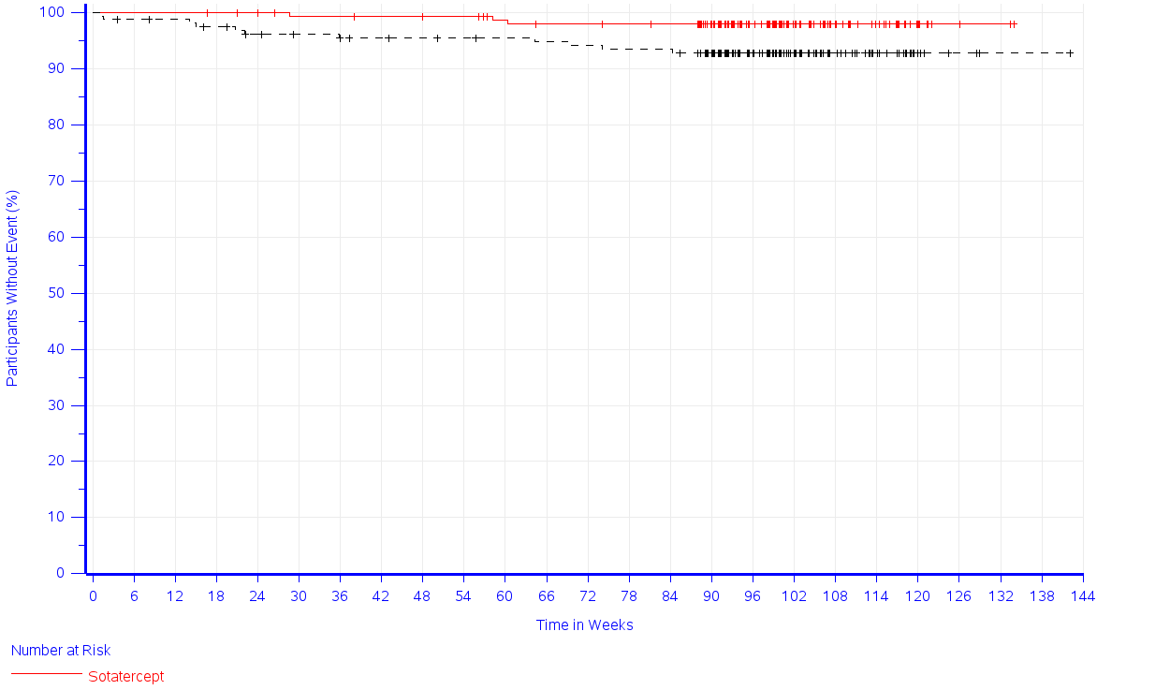 |  | 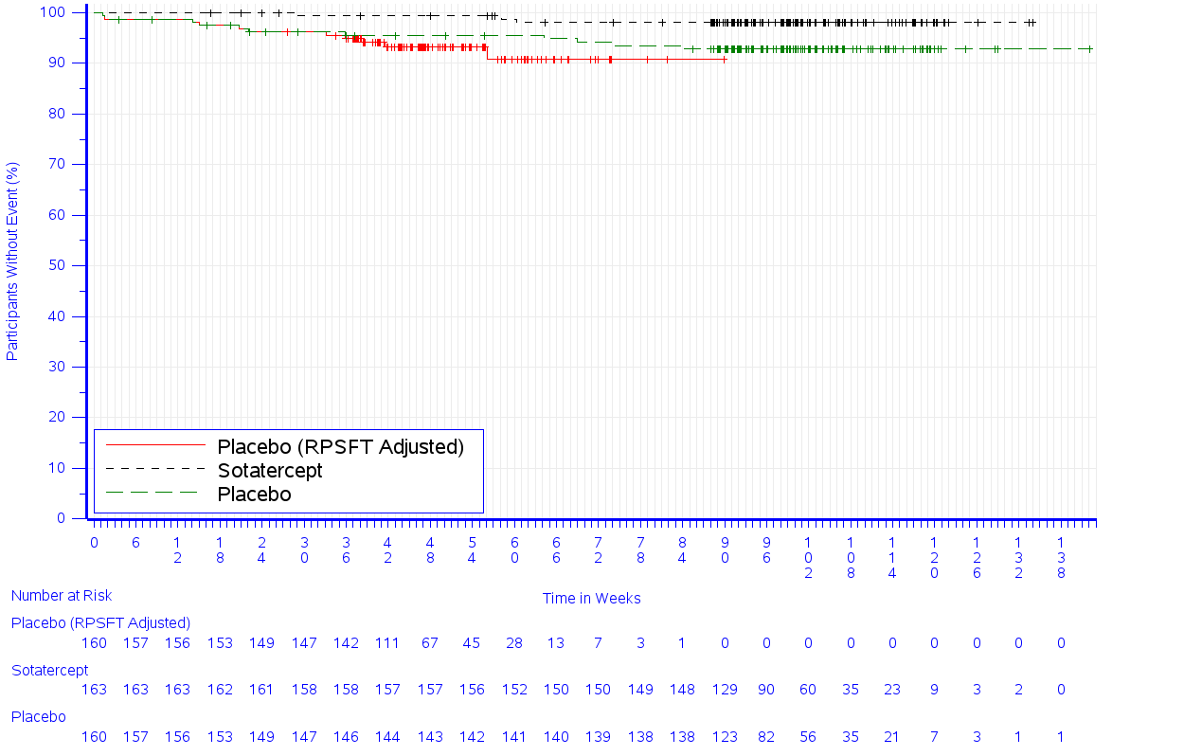
Bold=statistically significant.
Source: Compiled during the evaluation from Table 2, p20 and Table 3, p22, Figure 5, p22 and Figure 6, p23 of Attachment 11 of the submission (Database Cutoff Date: STELLAR (MK-7962-003) - 06DEC2022/SOTERIA (MK-7962-004) - 08NOV2023)
Adj=adjustment for treatment switching; DCO=data cut-off; FAS=full analysis set; OS=overall survival.
Note 2: Participants alive and who did not enrol to SOTERIA were censored at the date of last contact in STELLAR. Participants in the STELLAR sotatercept arm alive and enrolled to SOTERIA were censored at the date of last contact in SOTERIA. Participants in the STELLAR placebo arm alive and enrolled to SOTERIA were censored at the date of last contact in SOTERIA but adjusted for the date they switched from placebo in STELLAR to sotatercept in SOTERIA
a From product-limit (Kaplan-Meier) method for censored data
b Rank-preserving structural failure time (RPSFT) model was used to adjust for the effect of cross-over from placebo in STELLAR to sotatercept in SOTERIA.
c Based on Cox regression model corrected by RPSFT with treatment as a covariate stratified by the following covariates: WHO functional class (class II vs. III) and background PAH therapy (mono/double vs. triple therapy)
d Obtained by inflating the standard error of the log-hazard ratio to preserve the full analysis set population p-value from the Cox model.
e Two-sided p-value using Wald test.
  - The post hoc analysis showed that there was a survival benefit for sotatercept compared to placebo, with and without adjusting for treatment switching in the placebo arm (p=0.037). However, the evaluation considered that the result should be interpreted with caution, given the small sample size, immaturity of data, and the short follow-up period.
Indirect treatment comparison of sotatercept versus selexipag
  - The submission presented an unadjusted indirect treatment comparison (ITC) between sotatercept (STELLAR) versus selexipag (GRIPHON and TRACE), using placebo as the common reference. The submission conducted the ITC using the Bucher method as it (i) included the total population in STELLAR and (ii) was a conservative approach given the differences between trials.
  - Patients enrolled in STELLAR and TRACE were treatment-experienced patients, whereas GRIPHON enrolled both treatment-naïve and treatment-experienced patients. In addition, there were differences across the trials in terms of baseline WHO Group 1 PAH subtypes (more idiopathic PAH in TRACE), WHO FC (more patients with FC II in TRACE and a small proportion of patients with FC I and FC IV in GRIPHON), duration of disease (longer in STELLAR) and background PAH therapy (most patients on dual therapy in TRACE and none on triple therapy in TRACE and GRIPHON).
  - Table 12 summarises the result of the ITC of sotatercept (STELLAR, 24 Weeks) and selexipag (GRIPHON and TRACE, 24–26 Weeks).
Table 12: Summary of results of the indirect comparison (sotatercept vs selexipag)
Outcome (base case) ª | Trial | SOTA n/N (%) | BGT ^{b} n/N (%) | SLX n/N (%) | RR (95% CI) | OR (95% CI)
WHO FC improvement | STELLAR | 48/159 (30) | 22/147 (15) | - | 2.02 (1.28, 3.17) | 2.46 (1.40, 4.33)
WHO FC improvement | GRIPHON | - | 48/456 (11) | 75/471 (16) | 1.51 (1.08, 2.12) | 1.61 (1.09, 2.37)
WHO FC improvement | TRACE | - | 10/55 (18) | 9/52 (17) | 0.95 (0.42, 2.15) | 0.94 (0.35, 2.54)
WHO FC improvement | Bucher ITC, fixed effect |  |  |  | 1.43 (0.82, 2.47) | 1.64 (0.84, 3.21)
WHO FC improvement | Bucher ITC, random effect |  |  |  | 1.44 (0.80, 2.58) | 1.64 (0.84, 3.21)
WHO FC worsening | STELLAR | 7/159 (4) | 19/147 (13) | - | 0.34 (0.15, 0.79) | 0.31 (0.13, 0.76)
WHO FC worsening | GRIPHON | - | 30/456 (7) | 31/471 (7) | 1.00 (0.62, 1.63) | 1.00 (0.60, 1.68)
WHO FC worsening | TRACE | - | 1/55 (2) | 4/52 (8) | 4.23 (0.49, 36.62) | 4.50 (0.49, 41.7)
WHO FC worsening | Bucher ITC, fixed effect |  |  |  | 0.32 (0.12, 0.83) | 0.29 (0.10, 0.80)
WHO FC worsening | Bucher ITC, random effect |  |  |  | 0.25 (0.04, 1.66) | 0.22 (0.03, 1.65)
Outcome ^{c} | Trial | SOTA | BGT | SLX | Difference (95% CI)
Change in 6MWD (metre) | STELLAR | - | - | - | 40.40 (27.28, 53.53)
Change in 6MWD (metre) | GRIPHON | - | - | - | 12.0 (1.0, 24.0)
Change in 6MWD (metre) | Bucher ITC |  |  |  | 28.4 (12.6, 44.2)
Change in NT-proBNP (pg/mL) | STELLAR | - | - | - | -438.90 (-569.64, -308.19)
Change in NT-proBNP (pg/mL) | GRIPHON | - | - | - | -123 (-175, -78)
Change in NT-proBNP (pg/mL) | Bucher ITC |  |  |  | -315.9 (-455.3, -176.5)
Outcome ^{d} | Trial | SOTA | BGT | SLX | Difference (95% CI)
Change in 6MWD (metre) | STELLAR | - | - | - | 39.80 (24.82, 54.78)
Change in 6MWD (metre) | TRACE | - | - | - | 8.4 (–14.2, 31.0)
Change in 6MWD (metre) | Bucher ITC |  |  |  | 31.4 (4.3, 58.5)
Change in NT-proBNP (ng/L) | STELLAR | - | - | - | 0.28 (0.23, 0.34)
Change in NT-proBNP (ng/L) | TRACE | - | - | - | 0.9 (0.7, 1.2)
Change in NT-proBNP (ng/L) | Bucher ITC |  |  |  | -0.6 (-0.9, -0.4)
Time to event outcomes | Trial | SOTA | BGT | SLX | HR (95% CI)
Time to death or non-fatal clinical worsening | STELLAR^{e} | 11/163 (7) | 42/160 (26) |  | 0.23 (0.12, 0.44)
Time to death or non-fatal clinical worsening | GRIPHON^{f} | - | 242/582 (42) | 155/574 (27) | 0.60 (0.46, 0.78)
Time to death or non-fatal clinical worsening | Bucher ITC |  |  |  | 0.38 (0.19, 0.76)
Time to death | STELLAR | 2/163 (1) | 7/160 (4) | - | 0.25 (0.05, 1.19)
Time to death | GRIPHON | - | 105/582 (18) | 100/574 (17) | 0.97 (0.74, 1.28)
Time to death | Bucher ITC |  |  |  | 0.26 (0.05, 1.29)
Time to PAH-related death | STELLAR | 2/163 (1) | 6/160 (4) | - | 0.28 (0.06, 1.41)
Time to PAH-related death | GRIPHON | - | 83/582 (14) | 70/574 (12) | 0.86 (0.63, 1.18)
Time to PAH-related death | Bucher ITC |  |  |  | 0.33 (0.07, 1.63)
Time to first PAH hospitalisation | STELLAR | 1/163 (0.6) | 11/160 (7) |  | 0.08 (0.01, 0.62)
Time to first PAH hospitalisation | GRIPHON | - | 123/582 (21) | 86/574 (15) | 0.67 (0.46, 0.98)
Time to first PAH hospitalisation | Bucher ITC |  |  |  | 0.12 (0.01, 0.96)
Bold=statistically significant.
Source: Table 2.6-3, p142, Table 2.6-4, p143, Table 2.6-5, p144, Table 2.6-6, p145 and Table 2.6-7, p146 of the submission.
6MWD=6-minute walking distance; BGT=background therapy; CI=confidence interval; FC=functional class; HR=hazard ratio; ITC=indirect treatment comparison; NT-proBNP=N-terminal pro-brain natriuretic peptide; NR=not reported; RR=risk ratio; OR=odds ratio; SOTA=sotatercept; SLX=selexipag.
a Background therapy was the common comparator in this ITC.
b In the setting of complete case analysis, patients with missing FC data were excluded from the denominator of the analyses. In contrast, in the setting of non-responder imputation, patients with missing FC data due to non-COVID-19 reason were categorized as “FC worsening.” One patient in the background therapy alone arm that has missing data at week 24 due to COVID-19 was excluded from the analysis set.
c Change in 6MWD and change in NT-proBNP are presented as Hodges-Lehmann median estimates.
d Change in NT-proBNP is calculated as the geometric least squares mean ratio using an analysis of covariance model with baseline value (log scale) as covariate.
e In STELLAR, time to death or nonfatal clinical worsening was defined as “death from any cause or specified nonfatal clinical worsening events (worsening-related listing for lung or heart–lung transplantation, initiation or rescue therapy with an approved background treatment or increase in the prostacyclin dose by ≥10%, atrial septostomy, hospitalization [≥24 hours] for worsening of pulmonary arterial hypertension, or worsening of pulmonary arterial hypertension relative to baseline as defined by both a worsened WHO functional class and a decrease in 6-minute walk distance by ≥15% [confirmed by two tests ≥4 hours but ≤1 week apart].”
f In GRIPHON, time to death or nonfatal clinical worsening was defined as a “composite of death or a complication related to pulmonary arterial hypertension, whichever occurred first, up to the end of the treatment period. Complications related to pulmonary arterial hypertension were disease progression or worsening of pulmonary arterial hypertension that resulted in hospitalization, initiation of parenteral prostanoid therapy or long-term oxygen therapy, or the need for lung transplantation or balloon atrial septostomy as judged by the physician. (Placement on a transplant waiting list represented an acute measure, as confirmed by the critical-event committee, and an actual lung transplantation would also meet this criterion.) Disease progression was defined as a decrease from baseline of at least 15% in the 6-minute walk distance (confirmed by means of a second test on a different day) accompanied by a worsening in WHO functional class (for the patients with WHO functional class II or III at baseline) or the need for additional treatment of pulmonary arterial hypertension (for the patients with WHO functional class III or IV at baseline).”
  - The ITC found that results favoured sotatercept over selexipag for WHO FC worsening, 6MWD, NT-proBNP, time to death or non-fatal clinical worsening, and time to first PAH-related hospitalisation. However, the evaluation noted the following:
- The difference in 6MWD may not be clinically meaningful given the point estimates (28.4-31.4) did not meet the proposed MCID for 6MWD of 33 metres.
- There were differences between the trials in the measurement of time to death and non-fatal clinical worsening outcome.
  - These results should be interpreted with caution given the selexipag study population may have more severe disease with greater underlying risk of death, hospitalisation and disease progression

Comparative harms
  - The key AEs to Week 24 (STELLAR and PULSAR) are summarised in Table 13.
Table 13: Summary of key adverse events to Week 24 in STELLAR and PULSAR
Patients with TEAEs, n (%) | STELLAR |  | PULSAR
Patients with TEAEs, n (%) | SOTAª  (N=163) | PBO  (N=160) | SOTA  0.3 mg/kg  (N=32) | SOTA  0.7 mg/kg (N=42) | PBO  (N=32)
Any TEAEs | 138 (84.7) | 140 (87.5) | 29 (90.6) | 35 (83.3) | 29 (90.6)
TEAEs related to treatment | 67 (41.1) | 41 (25.6) | 15 (46.9) | 22 (52.4) | 9 (28.1)
TEAE of special interest | 17 (10.4) | 5 (3.1) | 5 (15.6) | 8 (19.0) | 1 (3.1)
TEAEs leading to treatment discontinuation | 3 (1.8) | 10 (6.3) | 1 (3.1) | 5 (11.9) | 1 (3.1)
TEAEs leading to death | 0 | 6 (3.8) | 0 | 1 (2.4) | 0
Severe TEAEs | 13 (8.0) | 21 (13.1) | 3 (9.4)^{b} | 11 (26.2)^{b} | 5 (15.6)^{b}
Serious TEAEs | 23 (14.1) | 36 (22.5) | 2 (6.3) | 10 (23.8) | 3 (9.4)
Source: Compiled during the evaluation from Table 12-1, p69 of STELLAR CSR-2023 (Database lock Sept 22), and Table 14.3.2.1, pp1422-1425 of PULSAR CSR (2022).
CI=confidence interval; DCO=data cut-off; FAS=full analysis set; n=number of participants reporting data; N=total participants in group; TEAE=Treatment-Emergent adverse event.
a Sotatercept 0.3 mg/kg at Visit 1 then 0.7 mg/kg every 3 weeks
b reported as TEAEs of Grade ≥3 severity
  - The key AEs to Week 84 (STELLAR), 18-24 months (PULSAR, SPECTRA and SOTERIA) are summarised in Table 14.
Table 14: Summary of key adverse events to Week 84 (STELLAR) and 18-24 months (PULSAR, SPECTRA and SOTERIA)
 | STELLAR |  | PULSAR |  | SPECTRA | SOTERIA
Number of subjects with any events [n (%)] | SOTA^  (N=163) | PBO  (N=160) | Combined SOTA  0.3 mg/kg  (N=47) | Combined SOTA  0.7 mg/kg  (N=57) | SOTA^  (N=21) | PBO-crossed  (N=143) | Continued SOTA  (N=259) | All  (N=426)
Any TEAEs | 151 (92.6) | 149 (93.1) | 46 (97.9) | 57 (100.0) | 21 (100) | 131 (91.6) | 240 (92.7) | 387 (90.8)
TEAEs related to treatment | 83 (50.9) | 45 (28.1) | 30 (63.8) | 45 (78.9) | 9 (42.9) | 79 (55.2) | 126 (48.6) | 210 (49.3)
TEAE of special interest | 27 (16.6) | 7 (4.4) | 18 (38.3) | 16 (28.1) | 5 (23.8) | NR | NR | NR
TEAEs leading to treatment discontinuation | 6 (3.7) | 11 (6.9) | 3 (6.4) | 8 (14.0) | 1 (4.8) | 2 (1.4) | 12 (4.6) | 15 (3.5)
TEAEs leading to death | 2 (1.2) | 7 (4.4) | 2 (4.3) | 3 (5.3) | 0 | NR | NR | NR
Severe TEAEs | 24 (14.7) | 33 (20.6) | 20 (42.6)ª | 29 (50.9)ª | 4 (19.0)ª | NR | NR | NR
Serious TEAEs | 40 (24.5) | 47 (29.4) | 16 (34.0) | 23 (40.4) | 5 (23.8) | 41 (28.7) | 80 (30.9) | 129 (30.3)
Common TEAEs ≥5%
Headache | 40 (24.5) | 28 (17.5) | 17 (36.2) | 19 (33.3) | 9 (42.9) | NR | NR | NR
Epistaxis | 36 (22.1) | 3 (1.9) | 11 (23.4) | 12 (21.1) | 6 (28.6) | 47 (32.9) | 45 (17.4) | 94 (22.1)
Telangiectasia | 27 (16.6) | 7 (4.4) | 9 (19.1) | 12 (21.1) | NR | 37 (25.9) | 34 (13.1) | 74 (17.4)
Thrombocytopenia | 16 (9.8) | 3 (1.9) | 8 (17.0) | 7 (12.3) | 1 (4.8) | 13 (9.1) | 13 (5.0) | 26 (6.1)
Haemoglobin increase | 10 (6.1) | 0 | 2 (4.3) | 14 (24.6) | 1 (4.8) | 23 (16.1) | 38 (14.7) | 61 (14.3)
Nasal congestion | 10 (6.1) | 0 | 4 (8.5) | 4 (7.0) | 3 (14.3) | NR | NR | NR
Injection site pain | 11 (6.7) | 11 (6.9) | 2 (4.3) | 5 (8.8) | 1 (4.8) | NR | NR | NR
TEAEs of special interest
Telangiectasia | 27 (16.6) | 7 (4.4) | 9 (19.1) | 12 (21.1) | NR | 37 (25.9) | 34 (13.1) | 74 (17.4)
Bleeding events: Epistaxis | 36 (22.1) | 3 (1.9) | 11 (23.4) | 12 (21.1) | 6 (28.6) | 47 (32.9) | 45 (17.4) | 94 (22.1)
Bleeding events: Gingival bleeding | 7 (4.3) | 1 (0.6) | 1 (2.1) | 0 | 2 (9.5) | NR | NR | NR
Increased blood pressure | 5 (3.1) | 1 (0.6) | 1 (2.1) | 0 | NR | NR | NR | NR
Increased haemoglobin | 10 (6.1) | 0 | 2 (4.3) | 14 (24.6) | 1 (4.8) | 23 (16.1) | 38 (14.7) | 61 (14.3)
Thrombocytopenia | 16 (9.8) | 3 (1.9) | 8 (17.0) | 7 (12.3) | 1 (4.8) | 13 (9.1) | 13 (5.0) | 26 (6.1)
Bold= Statistically significant.
Source: Compiled during the evaluation from Table 2.5-15, p124, Table 2.5-16, p125, and Table 2.5-21, p130 of the submission and Table 2-3, p13, Table 14.3.1.1, p1377, Table 12.4, p149, Table 14o.3.1.2a, p2348, and Table 14o.3.1.2, p2322 of PULSAR CSR, Table 12-1, p49, Table 14.3.1.2, pp417-424, Table 14.3.1.3, p428, Table 14.3.1.6, pp434-7 of SPECTRA CSR (2022), and Table A 1.6-1, p16 of Appendix C (SPECTRA & SOTERIA) and Preston_SOTERIA_PVRI_2024_Oral_Presentation_Locked [for SOTERIA results].
CI=confidence interval; FAS=full analysis set; NR=not reported; TEAE=Treatment-Emergent adverse event.
^ Sotatercept 0.3 mg/kg at Visit 1 then 0.7 mg/kg every 3 weeks
a reported as TEAEs of Grade ≥3 severity
  - Overall, the incidence of AEs was similar between the sotatercept and placebo groups in the double-blind placebo-controlled treatment period to Week 24 in STELLAR and PULSAR. There were more treatment-related AEs and AEs of special interest in the sotatercept group compared to placebo. However, there were fewer discontinuations due to AEs, severe AEs, serious AEs and AEs leading to death.
  - Safety outcomes in the extension of STELLAR, PULSAR, SPECTRA and the long-term follow-up study of SOTERIA were generally consistent with the double-blind treatment period to Week 24. In STELLAR, there were nine deaths due to AEs (two in the sotatercept group and seven in placebo). The most frequently reported AEs with higher incidences in the sotatercept group included epistaxis, telangiectasia, dizziness, nasal congestion, thrombocytopenia, and haemoglobin increased. AEs of interest included telangiectasia, increased haemoglobin, increased blood pressure, thrombocytopenia, and bleeding events (mainly epistasis). In the sotatercept group, one patient discontinued the study drug due to epistaxis, two thrombocytopenia events and three patients with elevated haemoglobin which also interrupted the study drug. None of the telangiectasia or blood pressure AEs were serious or severe.
  - While the safety data showed similar infusion/injection site reactions between groups, these safety results reflected trial conditions where patients were administered sham injections in the placebo arm. In clinical practice, however, additional injection site reactions are expected for sotatercept versus placebo (no treatment).
  - A comparison of the safety profile between sotatercept and selexipag was not presented in the submission. Sotatercept requires subcutaneous injection and thus may be associated with injection site reactions, whereas selexipag is an oral therapy which requires cautious dose titration to minimise the risk of development of prostanoid adverse events (esp. vasodilatation).

Benefits/harms
  - A summary of the comparative benefits and harms for sotatercept versus no treatment is presented in Table 15.
Table 15: Summary of comparative benefits and harms for sotatercept and placebo (STELLAR)
Benefits
Change from baseline in 6MWD and NT-ProBNP at Week 24
STELLAR (FAS) | Sotatercept |  |  |  |  | Placebo |  |  |  |  |  | Difference:  Sotatercept vs placebo  (95% CI)
STELLAR (FAS) | N |  | ∆ from baseline |  | SD | N |  | ∆ from baseline |  | SD
6MWD (mean, metres) | 163 |  | 40.1 |  | 64.3 | 160 |  | -1.4 |  | 72.0 |  | 41.5 (26.6, 56.4 ª)
NT- proBNP (LS mean pg/mL) | 163 |  | -715.9 |  | 401.4 (SE) | 160 |  | 1809.0 |  | 415.2 (SE) |  | -2524.9 (-3640.6, -1409.1)  [LS mean difference]
NT- proBNP (median pg/mL) | 163 |  | -230.3 |  | NR | 160 |  | 58.6 |  | NR |  | -441.6, (-573.5, -309.6)  [HLLS difference]
WHO FC improvement and maintaining or achieving a low risk score versus baseline at Week 24
STELLAR (FAS) |  | Sotatercept n/N |  | Placebo  n/N |  |  | RR (95% CI) ª |  | Event rate/100 patients |  |  |  | RD (95% CI) ª
 |  |  |  |  |  |  |  |  | Sotatercept |  | Placebo |  | RD (95% CI) ª
WHO FC improvement |  | 48/163 |  | 22/160 |  |  | 2.1 (1.4, 3.4) |  | 29.4 |  | 13.8 |  | 15.7 (6.9, 24.5)
Maintain or achieve a low risk score versus baseline at Week 24 ^{b} |  | 64/162 |  | 29/159 |  |  | 2.2 (1.5, 3.2) |  | 39.5 |  | 18.2 |  | 21.3 (11.6, 30.9)
Harms
STELLAR (Safety set) |  |  | Sotatercept n/N |  | Placebo  n/N |  | RR (95% CI) ª |  | Event rate/100 patients |  |  |  | RD (95% CI)
 |  |  |  |  |  |  |  |  | Sotatercept |  | Placebo |  | RD (95% CI)
Drug related TEAE |  |  | 83/163 |  | 45/160 |  | 1.8 (1.3, 2.4) |  | 50.9 |  | 28.1 |  | 22.8 (12.4, 33.2) ª
TEAE of special interest |  |  | 27/163 |  | 7/160 |  | 3.8 (1.7, 8.4) |  | 16.6 |  | 4.4 |  | 12.2 (5.7, 18.7) ª
Epistaxis |  |  | 36/163 |  | 3/160 |  | 11.8 (3.7, 37.5) |  | 22.1 |  | 1.9 |  | 20.2 (13.9, 27.4)
Telangiectasia |  |  | 27/163 |  | 7/160 |  | 3.8 (1.7, 8.4) |  | 16.6 |  | 4.4 |  | 12.2 (5.8, 19.2)
Thrombocytopenia |  |  | 16/163 |  | 3/160 |  | 5.2 (1.6, 17.6) |  | 9.8 |  | 1.9 |  | 7.9 (3.1, 13.7)
Haemoglobin increase |  |  | 10/163 |  | 0/160 |  | 20.6 (1.2, 348.9) |  | 6.1 |  | 0.0 |  | 6.1 (3.4, 10.9 ^{b})
Bold= statistically significant.
Source: Benefits were compiled during the evaluation from Table 2.5-2, p105, Table 2.5-3, p106 and Table 2.5-4, p108 of the submission, Table 14.2.2, p200 of STELLAR CSR (Sep 22) [for 6MWD], Table 2.5.11, p119 of the submission, Table 11-4, p57 and Table 14.2.12, p227 of STELLAR CSR (Sep 22) [for NT-PRoBNP], Table 11-5, p59 of STELLAR CSR (Sep22), and Table 11-7, p62 of STELLAR CSR (Sep22) [for Risk score]. Harms were compiled during the evaluation from Table 2.5-15, p124, Table 2.5-16, p125, and Table 2.5-21, p130 of the submission.
6MWD=6-minute walking distance; CI=confidence interval; FC=functional class; HR=hazard ratio; NT-proBNP=N-terminal pro-brain natriuretic peptide; RD=risk difference; RR=risk ratio.
a Calculated during the evaluation using RevMan 5.4.1.
b The RD 95% CI provided in the submission was inconsistent with the calculated range of 2.3 to 10.0 during evaluation using RevMan.
  - On the basis of direct evidence presented by the submission in patients with PAH and WHO FC II/III, for every 100 patients treated with sotatercept versus placebo, added to background therapy, would result in:
            - Approximately a 41.5-metre improvement in 6MWD at Week 24. The mean difference is clinically relevant given the estimate was higher than the MCID for 6MWD of 33 metres for patients with PAH .
            - Approximately a -441.6 pg/mL decrease in NT-proBNP level at Week 24 (calculated by HLLS difference). However, it was not known whether this difference in NT-proBNP level is clinically meaningful.
            - Approximately 16 more patients improved WHO FC status at Week 24.
            - Approximately 21 more patients maintained or achieved a low risk score (Simplified French Risk) at Week 24.
            - Approximately 20 fewer patients experiencing clinical worsening or death over 24 weeks.
            - Approximately 23 more patients experiencing drug-related TEAEs over 24 weeks.
            - Approximately 20 more patients experiencing epistaxis (nosebleed) over 24 weeks.
            - Approximately 12 more patients experiencing telangiectasia (visibly dilated blood vessels) over 24 weeks.
            - Approximately 8 more patients experiencing thrombocytopenia (decreased platelet count) over 24 weeks.
            - Approximately 6 more patients experiencing increased haemoglobin over 24 weeks.
  - A summary of the comparative benefits for sotatercept versus selexipag is presented in Table 16.
Table 16. Summary of comparative benefits for sotatercept and selexipag (ITC, with BGT as the common comparator)
Benefits
Change from baseline in 6MWD and NT-ProBNP at Week 24
STELLAR vs GRIPHON ª | Sotatercept |  |  |  | Selexipag |  |  |  |  | Mean difference:  Sotatercept vs selexipag  (95% CI)
STELLAR vs GRIPHON ª | N | Mean ∆ baseline 6MWD | 95% CI |  | N | Mean ∆ baseline 6MWD |  | SD/SE
6MWD (metres) | 163 | 40.4 | 27.3, 53.5 |  | NR | 12.0 |  | 1.0, 24.0 |  | 28.4 (12.6, 44.2)
NT- proBNP (pg/mL) | 163 | -438.9 | -569.6, -308.2 |  | 460 | -123 |  | -175, -78 |  | -315.9 (-455.3, -176.5)
STELLAR vs TRACE^{b} | Sotatercept |  |  |  | Selexipag |  |  |  |  | Mean difference:  Sotatercept vs selexipag  (95% CI)
STELLAR vs TRACE^{b} | N | Mean ∆ baseline 6MWD | 95% CI |  | N | Mean ∆ baseline 6MWD |  | SD/SE
6MWD (metres) | 163 | 39.8 | 24.8, 54.8 |  | 50 | 8.4 |  | –14.2, 31.0 |  | 31.4 (4.3, 58.5)
NT- proBNP (pg/mL) | 163 | 0.3 | 0.2, 0.3 |  | 51 | 0.9 |  | 0.7, 1.2 |  | -0.6 (-0.9, -0.4)
WHO FC improvement and WHO FC worsening at Week 24
STELLAR vs  GRIPHON & TRACE |  | Sotatercept n/N | Selexipag n/N | RR (95% CI) |  |  | Event rate/100 patients |  |  |  | RD (95% CI)
 |  |  |  |  |  |  | Sotatercept |  | Selexipag |  | RD (95% CI)
WHO FC improvement (FE) |  | 48/159 | GRIPHON: 75/471 | 1.4 (0.8, 2.5) |  |  | 30 |  | GRIPHON: 16, TRACE: 17 |  | vs GRIPHON: 14 (NR)  vs TRACE: 13 (NR)
 |  | 48/159 | TRACE:  9/52
WHO FC worsening (FE) |  | 7/159 | GRIPHON: 31/471 | 0.3 (0.1, 0.8) |  |  | 4 |  | GRIPHON: 7, TRACE: 8 |  | vs GRIPHON: 3 (NR), vs TRACE: 4 (NR)
 |  | 7/159 | TRACE:  4/52
Bold= statistically significant
Source: Compiled during the evaluation from Table 2.6-3, p142, Table 2.6-4, p143, Table 2.6-5, p144, Table 2.6-6, p145 and Table 2.6-7, p146 of the submission.
6MWD=6-minute walking distance; BGT=background therapy; CI=confidence interval; FC=functional class; FE=fixed effect; HR=hazard ratio; ITC=indirect treatment comparison; NT-proBNP=N-terminal pro-brain natriuretic peptide; RD=risk difference; RR=risk ratio.
a Change in 6MWD and change in NT-proBNP are presented as Hodges-Lehmann median estimates.
b Change in NT-proBNP is calculated as the geometric least squares mean ratio using an analysis of covariance model with baseline value (log scale) as covariate.
  - On the basis of indirect evidence presented by the submission in patients with PAH and WHO FC II/III, for every 100 patients treated with sotatercept instead of selexipag, added to background therapy, would result in:
- Approximately a 28.4- and 31.4-metre improvement in 6MWD at Week 24 comparing to the data from GRIPHON and TRACE, respectively. The mean difference may not be clinically relevant, given the estimates were lower than the MCID for 6MWD of 33 metres for patients with PAH.
- Approximately a -315.9 pg/mL and -0.6 pg/mL decrease in NT-proBNP level at Week 24 comparing to the data from GRIPHON and TRACE, respectively. However, it was not known whether these differences in NT-proBNP level are clinically meaningful.
- Approximately 13−14 more patients improved WHO FC status at Week 24.
- Approximately 3−4 less patients worsened WHO FC status at Week 24.

Clinical claim
Comparison of sotatercept versus placebo
  - For the primary comparator, the submission described sotatercept as superior in terms of effectiveness and inferior, but manageable, in terms of safety compared to placebo in patients with WHO FC II/III.
  - The ESC considered that the clinical claim of superior effectiveness of sotatercept vs placebo (in 70% of the requested population) is supported for patients adding sotatercept to existing dual or triple background therapy. However, there was insufficient data on the addition of sotatercept to monotherapy. In STELLAR, only 4% of the patients were on background PAH monotherapy at enrolment thus the trial results may have limited applicability in this setting. There was also limited long term comparative data beyond 72 weeks. The PSCR stated that the clinical claim for patients adding sotatercept to monotherapy is relevant for patients who cannot currently tolerate two vasodilators or who are on non-PBS sildenafil; however, the submission did not present clinical evidence for sotatercept in this patient group. The PBAC agreed with the ESC that the superiority claim was supported for add-on to dual or triple therapy, but acknowledged the lack of evidence to support superiority as add-on to monotherapy.
  - The PBAC agreed with the ESC that the clinical claim of inferior safety vs placebo was appropriate. While the overall incidence of AEs was similar between groups, there were higher incidences of AEs of interest in the sotatercept group, including telangiectasia, increased haemoglobin, increased blood pressure, thrombocytopenia, and bleeding events (mainly epistaxes). There were also injection site AEs. The PBAC did not consider that there were significant safety concerns associated with sotatercept.
Indirect treatment comparison of sotatercept versus selexipag
  - For the secondary comparator, the submission described sotatercept as superior in effectiveness when added to dual therapy with ERA + PDE-5i (i.e. compared to selexipag) with different but manageable safety compared to selexipag in patients with WHO FC I–IV.
  - The claim of superior effectiveness of sotatercept vs selexipag (in ||| |||% of the requested population) was uncertain. The key issues were:
    - The result of the indirect comparison favoured sotatercept over selexipag for WHO FC worsening, 6-minute walk distance (6MWD), NT-proBNP and time to death or non-fatal clinical worsening at Week 24-26. Although the mean difference in 6MWD at Week 24-26 was statistically significant for sotatercept compared to selexipag, the point estimates (28.4 to 31.4) did not meet the MCID of 33 metres.
    - There was heterogeneity in the trial populations and outcome assessment in STELLAR, GRIPHON and TRACE, including for potential treatment effect modifiers such as WHO Group 1 PAH subtypes, WHO FC, disease duration and background PAH therapy, as well as differences in the measurement of time to clinical worsening outcome, making comparisons difficult.
    - There was limited evidence comparing the long-term treatment effect of sotatercept and selexipag.
The submission acknowledged the uncertainty associated with the claim of superior effectiveness based on an ITC against selexipag, and therefore proposed an overall weighted price of sotatercept, with ||| |||% of the sotatercept price at parity to selexipag.
  - The PBAC agreed with the evaluation and the ESC that the clinical claim of superior effectiveness of sotatercept vs selexipag is potentially supported but the magnitude of the benefit is uncertain due to the short term data, the transitivity issues between the trials, and the result for 6MWD being marginally outside the MCID. The PBAC noted the submission’s proposal of an overall weighted price of sotatercept, with ||| ||| of the sotatercept price at parity to selexipag, although it did not agree with the methodology used to calculate the weighted price.
  - The claim of different but manageable safety vs selexipag was not adequately supported as the submission did not present a comparison of the safety profile between sotatercept and selexipag. The PSCR presented a Bucher unadjusted ITC for safety outcomes for the STELLAR, GRIPHON and/or TRACE trials. The sponsor maintained the claim of a different, but manageable safety profile for sotatercept compared to selexipag, noting that the safety ITC showed that sotatercept patients had significantly fewer AEs leading to discontinuation, with less nausea but more dizziness compared to selexipag. However, the comparative safety of sotatercept and selexipag was unclear in terms of AEs of interest, including telangiectasia, increased haemoglobin, increased blood pressure, thrombocytopenia, and bleeding events. Sotatercept also requires subcutaneous injection and thus may be associated with injection site reactions, whereas selexipag is an oral therapy. Conversely, the ESC noted that selexipag requires careful dose titration to minimise vasodilatory AEs. Overall, the PBAC concluded that the claim of different but manageable safety vs selexipag was uncertain due to the lack of comparative data, but that sotatercept was unlikely to be inferior to selexipag.

Economic analysis
  - The submission proposed a weighted effective price for sotatercept. The submission assumed that ||| |||% of sotatercept’s PBS utilisation would be as add-on therapy to mono, dual or triple PAH therapy, with the comparator being placebo. Given the clinical claim, the submission presented a cost-utility analysis (CUA) of sotatercept plus background PAH therapy (BGT) versus BGT alone for this proportion of the population. The remaining 30% of use was assumed to replace selexipag (as the third PAH therapy in triple therapy with ERA and PDE5i), for which the submission requested a price for sotatercept equivalent to selexipag. While the ESC agreed that a weighted approach was appropriate, it was noted that the submission had applied the price weighting before the calculation of the ICER in the cost-utility model. This meant that the results of the cost-utility analysis do not represent the actual cost-effectiveness of sotatercept compared to placebo in this population, which is the purpose of this part of the economic evaluation. The ESC agreed with the evaluation that the appropriate approach would be to present an ICER calculated using the ‘full’ price of sotatercept (i.e. without the weighting for price parity to selexipag for ||| |||% of the population), to inform the cost-effectiveness of sotatercept compared to placebo in the add-on proportion of the population. The weighting to account for price parity in the remaining ||| |||% of use could then be applied to give the proposed weighted price of sotatercept for the PBS listing. The evaluation presented sensitivity analyses using this approach (SA #1).

Cost-effectiveness analysis
  - Table 17 summarises the key aspects of the cost utility analysis presented in the submission.
Table 17: Summary of model structure, key inputs and rationale
Component | Summary
Treatments | Sotatercept + BGT vs BGT alone
Time horizon | 20 years in the model base case versus 24 weeks in the key trial  The model assumed that the treatment effect of sotatercept observed from weeks 12−24 in the trial would persist over the 20-year time horizon. This may not be reasonable.
Outcomes | QALYs
Methods used to generate results | Markov model
Health states | 6 health states based on ESC/ERS 4-strata risk assessment for PAH (COMPERA 2.0):  - Low risk  - Intermediate−low risk  - Intermediate−high risk  - High risk  - Post lung/heart transplant  - Death
Cycle length | 3 weeks (first cycle); 9 weeks (second cycle); 12 weeks for subsequent cycles
Transition probabilities across risk strata | - Transition probabilities across the risk strata (low risk, intermediate−low risk, intermediate−high risk, high risk): STELLAR.  Long-term probabilities of moving between risk strata after Week 24 were based on Week 12−24 STELLAR data and maintained for 20 years in the model. In particular, the model assumed no disease progression after Week 3 for intermediate-high risk patients in the sotatercept+BGT arm; this was based on data for a small number of patients from STELLAR, but the evaluation considered this was likely unrealistic and uncertain in the long term, given the progressive nature of the disease.
Probabilities of death | - Probabilities of death by risk strata: COMPERA database - Rosenkranz 2023  The base case survival curves from Rosenkranz 2023 were inappropriately derived from the subgroup of patients with no comorbidities. Applying the Kaplan-Meier survival curves for patients without comorbidities in the model resulted in a larger difference in survival for risk strata transitions compared to those with comorbidities.
HR – mortality treatment effect: | - HR mortality treatment effect sotatercept+BGT versus BGT: STELLAR.  The submission did not present any evidence to substantiate the effect of sotatercept on mortality that is separately mediated from its effect on lowering PAH risk status.
Other transition probabilities | - Intermediate-high risk / High risk to Post lung/heart transplant: Merck data on file (2023) COMPERA.
Other transition probabilities | - Post lung/heart transplant to Death: literature-based
Other transition probabilities | - Hospitalisation for PAH: Merck data on file (2023) COMPERA.
Other transition probabilities | - HR of hospitalisation for sotatercept+BGT versus BGT: Merck data on file (2023) STELLAR.
Extrapolation method for survival curves | Parametric model fitted to Kaplan-Meier survival curves for each risk strata (assessed by the ESC/ERS 4-strata model); derived from Rosenkranz (2023) and applied to comparator (BGT alone) arm with Gompertz distribution selected in base case for all survival curves. The submission did not report why the Gompertz distribution was chosen in the base case.  57% and 18% of QALYs in the treatment and comparator arms (and 56% and 19% of costs in the treatment and comparator arms respectively) occur in the extrapolated periodª.
Health related quality of life | Utilities by risk strata: STELLAR (Low risk = 0.84; Intermediate-low risk = 0.70; Intermediate-high risk = 0.58; High risk = 0.60 (corrected to 0.474 during the evaluation)  Disutilities of IV infusion: (0.1535) from the selexipag July 2020 PBAC model  Disutilities of hospitalisation and transplant: (0.105) from the literature.
Costs | - Drug costs of sotatercept  The proposed prices of sotatercept used in the model assumed ||||% at cost parity to selexipag. This was inappropriate, given the model was aiming to estimate the cost-effectiveness of the other ||||% of its use. The appropriate price of sotatercept for the cost utility analysis should be where sotatercept is used as an add-on therapy to existing BGT.  - Drug costs of BGT (ERAs, PDE5i and prostacyclin analogues): treatment utilisation sourced from PBS data  - Costs of IV infusion  The model assumed zero costs for sotatercept SC injections. Noting that sotatercept powder for injection requires reconstitution before administration, this would be beyond the expertise of many patients. Thus, a large proportion of the patients will likely require assisted administration.  - Routine care costs for PAH: literature-based  - Costs of hospitalisation for PAH and lung/heart transplant hospitalisation  - End of life costs
Source: Table 3.1-1, p154 of the submission.
BGT = background therapy; DCE3 EQ-5D-5L= discrete choice instrument-3 EuroQol 5 Dimensions-5 Level; ED = emergency department; ERA = endothelin receptor antagonists (bosentan, ambrisentan, macitentan); ESC = European Society of Cardiology; ERS = European Respiratory Society; HR = hazard ratio; IV = intravenous; PAH = pulmonary arterial hypertension; PCA = prostacyclin-analogue; PDE5i = phosphodiesterase type 5 inhibitors (sildenafil citrate; tadalafil); prostacyclin = epoprostenol, iloprost, selexipag; RR = relative risk; SC = subcutaneous; WHO FC = World Health Organization Functional Class.
a Assumed extrapolated period for survival extrapolation was from 6 to 20 years. The maximum observed time was 6 years for patients with no comorbidities in Rosenkranz 2023 (source of survival curves). The median observed time was 3.6 years for patients with no comorbidities.

  - The PSCR provided two corrections to the inputs used in the model. Firstly, the PSCR advised that the Global approved effective price for sotatercept has increased to $||| |||/mg, rather than $||| |||/mg as provided in the submission. The PSCR also agreed with the evaluation that the correct utility value for the high-risk patients health state in the model was 0.474, rather than the 0.60 originally applied in the submission. The model results presented below have not all been updated for these corrections, given the other issues identified by the evaluation and the ESC, but some key results have been updated and are presented in Table 21. The PSCR provided an updated ICER for the submission’s base case of $255,000 to < $355,000.
  - A diagram of the Markov model structure is presented in Figure 3.
Figure 3: The submission’s Markov model structure
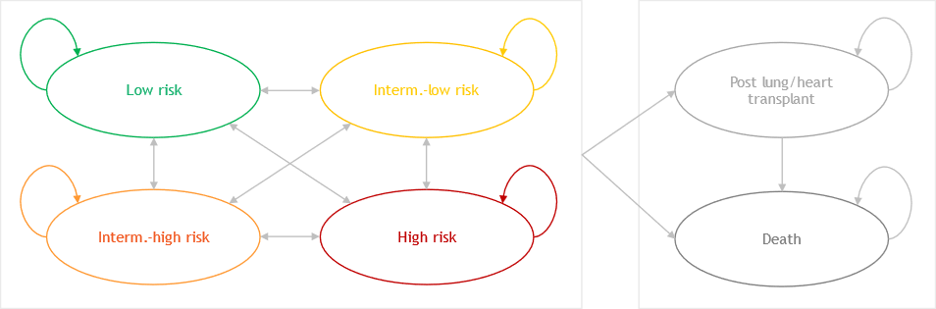
Source: Figure 3.2-1, p161 of the submission.
  - Patients entered the model in one of the four risk strata health states. Each cycle, patients in the four risk strata health states can transition between risk strata health states according to transition probabilities from STELLAR, progress to the post lung / heart transplant state, die, or stay in the same health state.
  - The submission stated that the risk-based classification was validated by multiple PAH registries and is recommended in clinical guidelines for its prognostic relevance. The four risk strata health states were based on ESC/ERS 2022 guidelines (COMPERA 2.0), which recommend the four-strata assessment, including multiple PAH-related prognostic indicators (WHO FC, 6MWD, and NT-proBNP level) be used after the initial risk assessment. The submission argued that the WHO classification approach is more subjective and only based on the New York Heart Association (NYHA) assessment. Based on the COMPERA 2.0 four-risk strata calculator and baseline WHO FC, 6MWD and NT-proBNP, STELLAR trial patients were mostly low risk, intermediate-low or intermediate-high risk, and this was applied at model entry; however, the exact proportions used could not be verified during the evaluation. The PBAC noted that the STELLAR trial included WHO FC II patients regardless of NT-proBNP level, and thus the economic model reflects this whole WHO FC II population, and not the subgroup requested. The requested PBS population included only those WHO FC II patients with elevated naturetic peptides, and which may represent a higher risk group than the trial population.
  - Patients transitioned across the four risk strata health states (low risk, intermediate-low risk, intermediate-high risk and high risk) according to observed patient transition counts in STELLAR (Sponsor data on file, 2023). The data source quoted in the submission was not able to be independently verified, however the numbers appeared consistent with the publication sourced during the evaluation (McLaughlin 2024), which conducted a similar model to the submission. Post-Week 24 transition probabilities were assumed to be the same as the observed data from Weeks 12 to 24 (using the last observation carried forward approach). The submission justified this assumption, citing the long-term results for STELLAR sotatercept-treated patients from the SOTERIA extension study. The submission presented that by Week 108 (i.e., 2 years), 29/30 (96.7%) of participants with non-missing endpoint assessment and STELLAR baseline data continued to improve or maintain their risk status. However, 123/163 (82%) of participants initially assigned to sotatercept in STELLAR had missing data and were excluded from this analysis and thus the evaluation considered that this estimate was unlikely to be robust. If all patients with missing data were instead assumed to be non-responders, the estimated proportion with continued response would only be 18%. A scenario analysis conducted during the evaluation assuming that patients cannot improve or worsen in risk strata after Week 24 (i.e. assuming patients remain in the same risk strata from Week 24, unless experiencing a transplant or death event), increased the ICER substantially to $355,000 to < $455,000 per QALY from a base case of $155,000 to < $255,000 per QALY gained.
  - In the base case, patient survival was assumed to worsen by increasing PAH risk based on long-term real-world data from the COMPERA database, a European pulmonary hypertension registry (Rosenkranz 2023). Overall Survival (OS) was reported for each risk strata for patients with and without comorbidities (including arterial hypertension, diabetes mellitus, coronary heart disease, and obesity). This is presented in Figure 4.
Figure 4: Mortality risk assessed by the ESC/ERS 4-strata model for PAH patients (Rosenkranz et al 2023)
No comorbidities (base case) | 1-2 comorbidities | 3-4 comorbidities
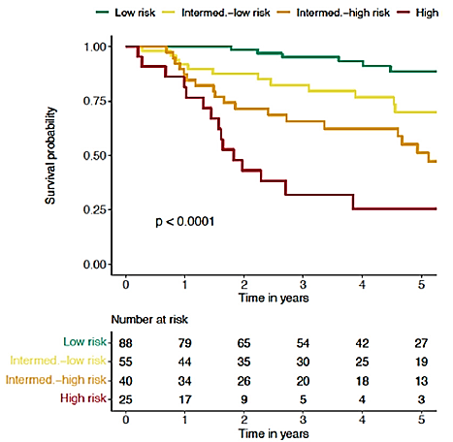 | 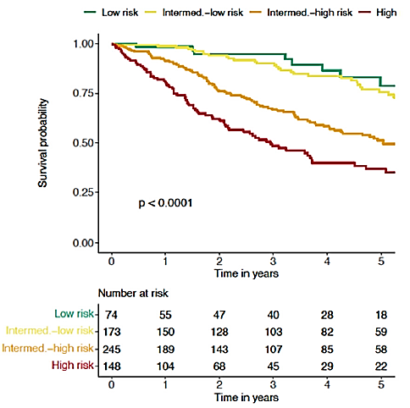 | 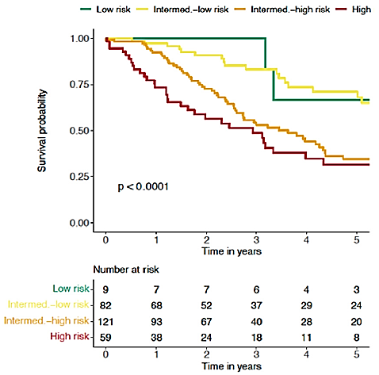
Source: Figures 5(A), 5(B) and 5(C)of Rosenkranz et al 2023
Green line = low risk; yellow line = int-low risk; orange line = int-high risk; red line = high risk.
  - OS results for patients without comorbidities were used in the model. This was not appropriate given that a large proportion of the PAH population is likely to have comorbidities (mean age 60 years in the expected PBS population). In STELLAR, 44% of patients reported cardiac disorders, 27% endocrine disorders and 44.3% metabolism and nutrition disorders. Compared to those without comorbidities, the Kaplan-Meier (KM) survival curves for patients with comorbidities show closer OS curves for low and intermediate−low risk, and intermediate−high and high−risk groups. The model also used survival curves from the first follow-up visit (3−12 months from baseline) instead of baseline, without justification. Additional sensitivity analyses conducted during the evaluation found that the ICER was not sensitive to assuming the survival curve of low risk was the same as survival for intermediate-low risk, increasing the ICER to $255,000 to < $355,000 per QALY gained from a base case of $155,000 to < $255,000. Assuming the survival curve of high risk was the same as survival for intermediate-high risk, increased the ICER to $255,000 to < $355,000 per QALY gained from a base case of $155,000 to < $255,000. Combining these two scenarios increased the ICER to $255,000 to < $355,000 per QALY gained from a base case of $155,000 to < $255,000.
  - In addition to PAH risk-associated mortality, the submission assumed treatment with sotatercept + BGT is associated with additional reductions in mortality compared to those treated with BGT alone (HR of 0.25, 95% CI: 0.05 to 1.22 based on STELLAR).
This was not able to be independently verified during the evaluation. More importantly, there was likely a double counting of OS benefits. The submission did not present any evidence to substantiate the effect of sotatercept on mortality, which is separately mediated from its effect on lowering PAH risk status. Equally, the submission did not justify the assumed additional treatment effect for sotatercept + BGT versus BGT alone on reducing the risk of hospitalisation and prostacyclin infusions over and above those already incorporated with a reduction in PAH risk status (see Table 8). The PSCR stated that it was appropriate to model additional reductions in mortality in addition to PAH risk-associated mortality, as sotatercept leads to improvement in mortality beyond reductions in risk strata. The PSCR stated that PVR is not included in the assessment of risk strata and is a strong independent predictor of mortality in patients with PAH. However, it is not clear how strongly PVR independently predicts mortality in PAH patients, and PVR is only one amongst other clinical outcomes contributing to mortality (6MWD, NT-proBNP level, WHO FC), which are captured in risk strata transition probabilities. The ESC agreed with the evaluation that this approach is likely double counting OS benefits in the model.
  - The submission applied EQ-5D-5L data from the STELLAR trial calculated using an Australian-specific discrete choice instrument-3 (DCE3) Direct Value Algorithm and value set (Norman 2023).
  - The proposed prices of sotatercept used in the model assumed 30% at cost parity to selexipag. The ESC agreed with the evaluation that this was inappropriate, given the model was aiming to estimate the cost-effectiveness of the other 70% of its use. The appropriate price of sotatercept for the cost utility analysis should be where sotatercept is used as an add-on therapy to existing BGT. Using these higher sotatercept prices ((i.e. without price parity to selexipag for 30% of the population)) increased the ICER by 28.6% to $255,000 to < $355,000 per QALY gained from a base case of $155,000 to < $255,000 (uncorrected, see Table 20). The PSCR maintained that that the economic evaluation estimated the cost-effectiveness of ||| |||% of the proposed use of sotatercept, including as a third therapy added to ERA and PDE5i (i.e. replacing selexipag). However, the comparator for the economic model was background therapy, not selexipag. Selexipag was costed as part of background therapy in the cost-utility model, and selexipag use did not differ between the two arms of the model, hence sotatercept was not replacing selexipag but used as add-on therapy to background therapy. The cost-utility model was hence applicable to 70% of the overall population, and not 100% of the population. (see paragraph 6.56 for more information).
  - Table 18 presents the disaggregated summary of outcomes from the economic evaluation. It shows that most QALY gains for sotatercept+BGT versus BGT were from patient transitions to the low-risk stratum. The model assumed lifetime improvement in risk, and a high proportion of patients improved in risk over time (54.5% and 12.0% from intermediate−high risk to intermediate−low risk, 29.2% and 11.7% from intermediate−low risk to low risk, and once in the low-risk stratum, 94.5% and 87.5% remained there, for sotatercept+BGT and BGT, respectively).
Table 18: Disaggregated summary of outcomes included in the economic evaluation
 | Sotatercept + BGT | BGT | Incremental | % of total incremental QALYs
QALYs (discounted)
Health state gains | 9.092 | 2.884 | 6.209 | 98.8%
- Low risk | 7.347 | 0.749 | 6.599 | -
- Intermediate−low risk | 1.441 | 0.687 | 0.753 | -
- Intermediate−high risk | 0.235 | 0.490 | -0.255 | -
- High risk | 0.064 | 0.930 | -0.866 | -
- Post transplant | 0.005 | 0.028 | -0.023 | -
Non-oral administration gains/losses | 0.006 | 0.001 | 0.005 | 0.1%
Losses due to hospitalisation | -0.009 | -0.077 | 0.068 | 1.1%
Losses due to transplant | -0.0001 | -0.001 | 0.001 | 0.008%
Total QALYs | 9.089 | 2.807 | 6.282 | 100%
Source: Table 3.8-4, p193 of the submission.
BGT = background therapy.
  - Markov traces extracted during the evaluation are presented in Figure 5.
Figure 5: Markov traces – base case analysis (including additional mortality benefit) and sensitivity analyses excluding treatment effect on mortality (HR=1)
 | SoT +BGT | BGT
Base case | 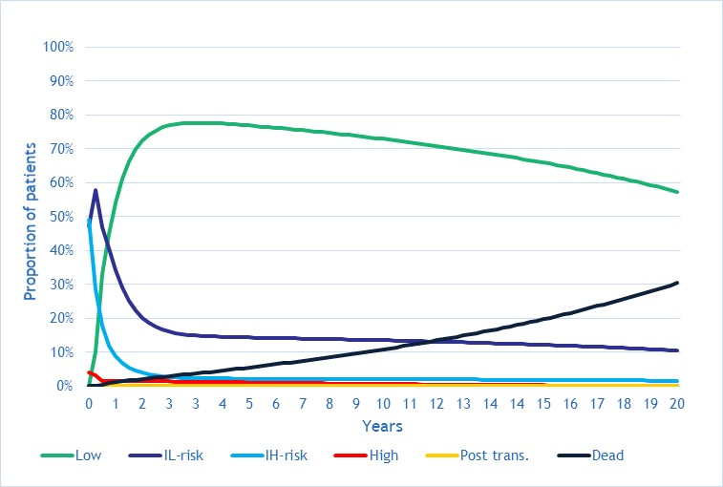 | 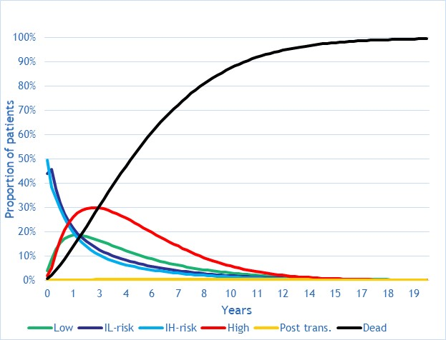
Sensitivity (1):no additional mortality benefit i.e. no treatment effect mortality | 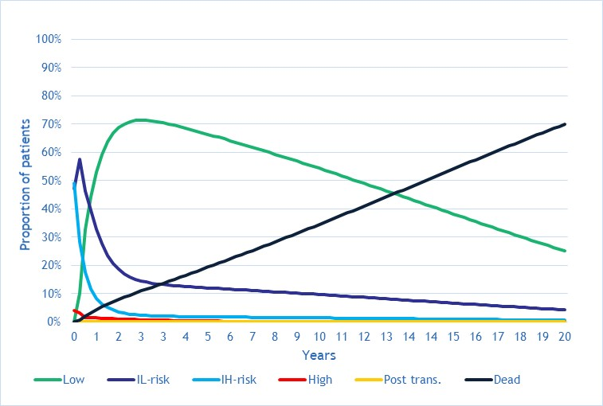 | 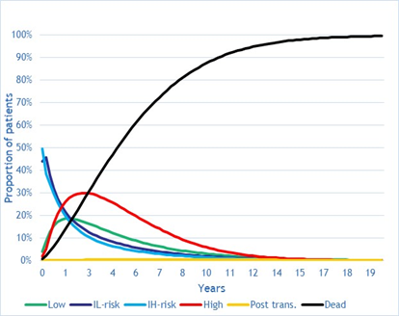
Sensitivity (1) AND assuming patients remain in risk strata from Week 24 | 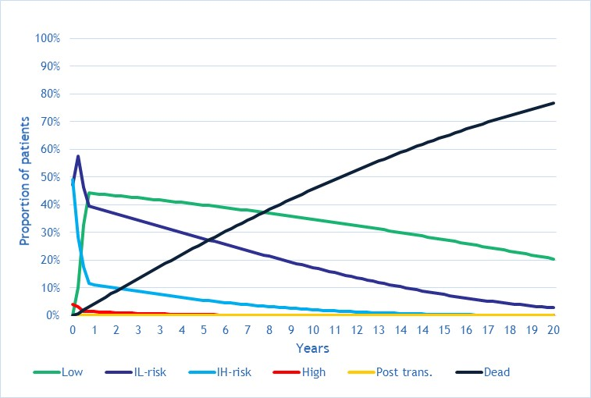 | 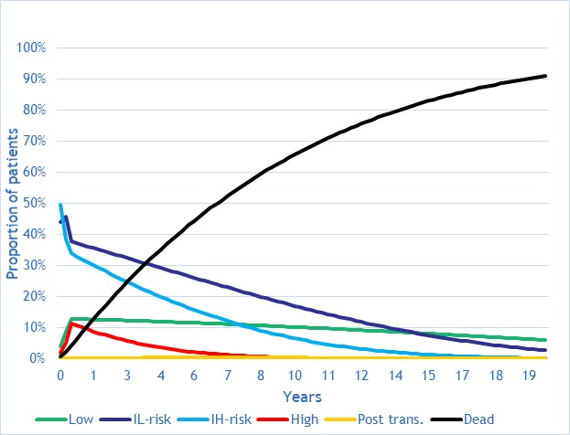
Source: independently extracted during the evaluation.
BGT = background therapy; SoT = sotatercept.
  - Markov traces extracted during the evaluation showed implausibly low death rates in the model’s base case where 70% of the sotatercept+BGT arm were still alive after 20 years with a mean age of 80 years, and 33% were still alive at age 90 years (refer cells R96 and R140 of ‘Patient distr’ worksheet). Sensitivity analysis assuming no additional mortality benefit (HR=1.0 for treatment effect of mortality for sotatercept+BGT versus BGT) showed a more plausible scenario: around 30% alive in the sotatercept + BGT arm by age 80 years and 6% alive by age 90 years (after 30 years in the model). This also increased the ICER to $255,000 to < $355,000 per QALY gained from a base case of $155,000 to < $255,000.
  - The Markov traces show that a greater proportion of patients in the sotatercept+BGT arm of the model transited into the low-risk stratum health state while those in the BGT arm spent more time in the high-risk stratum. The ESC considered that the assumption that Weeks 12−24 transitions would persist unchanged for 20 years was highly questionable and exacerbated other uncertainties in the model. For example, the post hoc analysis of STELLAR suggested that intermediate−high risk patients treated with sotatercept + BGT would not worsen beyond Week 3 in the model; despite being derived from small patient numbers. This was inconsistent with the inherently progressive nature of PAH. Relying on the last observation carried forward further amplified this extrapolation uncertainty.
  - A summary of the key drivers of the economic model is given in Table 19.
Table 19: Key drivers of the model
Description | Method/Value | Impact  Base case: ||||¹/QALY gained.
Lifetime improvements in risk status | The model in the submission assumed lifetime improvements in risk status, compared to contrasting assumptions in models in the literature. | High, favoured sotatercept. Assuming all patients remain in the respective risk strata from Week 24 until model end (unless experiencing a transplant or death event), increased the ICER to ||||²/QALY gained.
Sotatercept prices | The proposed prices of sotatercept that were used in the model were derived from a weighted average cost per year. This was based on ||||% of the population having price parity to selexipagª and ||% of the population cost-effectiveness analysis versus placebo. The evaluation considered the use of these prices to be inappropriate. The appropriate price of sotatercept for the CUA should be the price reflective of use when sotatercept is used as add-on therapy to existing BGT. | High, favoured sotatercept.  Using the higher sotatercept prices which did not account for the price reductions for 30% of usage to be cost-minimised to selexipag, increased the ICER to ||²/QALY gained.
Treatment effect on mortality | The model in the submission applied an additional mortality benefit for sotatercept + BGT versus BGT alone (HR=0.25 for mortality in the base case), after modelling a reduction in patient risk status. | Moderately high, favoured sotatercept. Assuming HR=1 for mortality, increased the ICER to ||||||||||||||||||||||||||||||||||||||||||||||||||||||²/QALY gained.
Time horizon | In the base case, the model assumed a time horizon of 20 years (lifetime). | High, favoured sotatercept.  Reducing the time horizon to 10 years increased the ICER to ||||²/QALY gained.
Source: compiled during the evaluation.
BGT=background therapy; CUA=cost utility analysis; HR=hazard ratio; ICER=incremental cost effectiveness ratio; QALY=quality adjusted life year.
ª The submission used a | |% reduction from the published selexipag DPMQ as an approximation for the effective selexipag price (p153 of the submission states: "Assuming a dose of 2 tablets per day and a | |% SPA rebate, the annual cost of selexipag per patient was calculated in the model to be $| | per year").
The redacted values correspond to the following ranges:
1 $155,000 to < $255,000
2 $255,000 to < $355,000

  - A summary of the results of the stepped economic evaluation is presented in Table 20.
Table 20: Results of the stepped economic evaluation
Step and component | Sotatercept + BGT | BGT | Increment
Step 1: Trial-based incremental cost per hospitalisation avoided; time horizon of 24 weeks; drug costs of sotatercept and BGT; drug administration costs; routine care costs; hospitalisation costs (STELLAR patient characteristics, health state distributions and BGT utilisation)
Costs | $|||| | $29,314 | $||||
Hospitalisation | 0.0040 | 0.0588 | 0.0548
Incremental cost/hospitalisation avoided |  |  | $||||¹
Step 2: Including Australian patient characteristics, health state distributions, and BGT utilisation (time horizon of 24 weeks)ª
Costs | $|||| | $18,210 | $||||a
Hospitalisation | 0.0047 | 0.0701 | 0.0654ª
Incremental cost/hospitalisation avoided |  |  | $||||²
Step 3: Modelled; time horizon of 20 years; cost per LYG (excluding treatment effect on mortality)
Costs | $|||| | $240,670 | $||||
LYG | 12.82 | 5.19 | 7.63
Incremental cost/extra LYG gained |  |  | $||||³
Step 4: Cost per LYG and including treatment effect on mortality
Costs | $|||| | $240,670 | $||||
LYG | 17.35 | 5.19 | 10.56
Incremental cost/extra LYG gained |  |  | $||||³
Step 5: Applied utility values to estimate cost per QALY
Costs | $|||| | $240,670 | $||||
QALYs | 13.95 | 3.39 | 10.56
Incremental cost/extra QALY gained |  |  | $||||³
Step 6: Applied discounting
Costs | $|||| | $198,348 | $||||
QALYs | 9.09 | 2.81 | 6.28
Incremental cost/extra QALY gained (base case) |  |  | $||||^{3b}  ($||||⁴)^{c}
Some results reported in the submission were not able to be independently verified.
Source: Table 3.8-2, p194 of the submission.
BGT= background therapy
ª Step 2 results were derived by applying Australian patient characteristics, health state distributions and BGT utilisation to the Step 1 model.
^{b} Selexipag is part of background therapy in both arms of the model. Whilst the published selexipag prices (less | |%) are used in the model, it is not a driver of the model results.
^{c} The PSCR corrected two errors [(i) effective sotatercept price per mg corrected from $| |/mg to $| |/mg (EMP) and (ii) utility value used for high-risk patients corrected from 0.60 to 0.474] to generate a revised base case ICER of $255,000 to < $355,000 per QALY.
The redacted values correspond to the following ranges:
1 $955,000 to < $1,055,000
2 $755,000 to < $855,000
3 $155,000 to < $255,000
4 $255,000 to < $355,000
  - The results of key sensitivity analyses are summarised in Table 21. The results were most sensitive to time horizon, transition probabilities across risk strata, price of sotatercept prior to consideration of cost-minimisation to selexipag, and the additional mortality benefit assumed for sotatercept. The base case incremental cost effectiveness ratio (ICER) versus placebo was $255,000 to < $355,000 per QALY gained, but increased to $355,000 to < $455,000 if correcting for the price of sotatercept used in the model and removing the mortality benefit for sotatercept independent of a change in WHO FC risk status. The ESC considered that this was the most relevant analysis to inform decision making. The PBAC, in its previous consideration for selexipag, had considered an ICER greater than $75,000 to < $95,000 per QALY gained was unacceptable in PAH.
Table 21: Sensitivity analyses results
Analyses | Incremental  cost ($) | Incremental QALY | ICER | % change to ICER
Base case | |||| | 6.282 | ||||¹ | -
Time horizon (base case 20 years)
10 years | |||| | 3.228 | ||||² | +||||%
5 years | |||| | 1.206 | ||||³ | +||||%
Discount rate (base case: 5%)
0% | |||| | 10.562 | ||||¹ | -||||%
3.5% | |||| | 7.276 | ||||¹ | -||||%
Transition probabilities for risk strata
Assuming all patients remain in the respective risk strata from Week 24 until model end (unless experiencing a transplant or death event) (#2) | || | 4.082 | ||||³ | +||||%
Adjusting probabilities for intermediate−high risk to assume all patients progress in disease over time horizonª | || | 5.936 | ||||² | +||||%
Mortality
No additional reduction in mortality i.e. treatment effect of sotatercept on mortality (HR=1.0 for sotatercept+BGT vs BGT) (base case 0.25) (#3) | || | 4.285 | ||||² | +||||%
Hospitalisation
Assuming HR for PAH hospitalisation = 1 for sotatercept+BGT vs BGT (base case 0.08) (#4) | || | 6.181 | ||||² | +||||%
Costs
Assuming higher sotatercept prices without price parity to selexipag for 30% of the population^{b} (#1) | || | 6.282 | ||||² | +||||%
RR for infused PCA escalation =1 for sotatercept vs pbo (base case 0.33) (#5) | || | 6.283 | ||||¹ | +||||%
Multivariate analyses
- Assuming higher sotatercept prices without price parity to selexipag for 30% of the population^{b} AND  Assuming all patients remain in their respective risk strata from Week 24 (#1+#2) | || | 4.082 | ||||⁴ | +||||%
- Assuming higher sotatercept prices without price parity to selexipag for ||% of the population^{b} AND  Assuming all patients remain in their respective risk strata from Week 24 AND  No additional mortality benefit (#1+#2+#3) | || | 2.026 | ||||⁵ | +||||%
- Assuming higher sotatercept prices without price parity to selexipag for 30% of the population^{b} AND  HR for mortality = 1 (no additional mortality benefit) AND  RR for infused PCA escalation =1 AND  HR for PAH hospitalisation = 1 (#1+#3+#4+#5) | || | 4.207 | ||||³ | +||||%
Key analyses updated to account for corrected price provided in PSCR
Base case (updated sotatercept price and correcting utility for high risk) | |||| | 6.458 | ||||² | -
Assuming higher sotatercept prices without cost-minimising to selexipag for ||% of the population (#1) | || | 6.458 | ||||² | +||||%
No additional reduction in mortality i.e. treatment effect of sotatercept on mortality (HR=1.0 for sotatercept+BGT vs BGT) (base case 0.25) (#3) | || | 4.468 | ||||² | +||||%
Multivariate analyses
#1 AND #3 | |||| | 4.468 | $||||³ | +||||%
Source: Tables 3.9-3 to 3.9-4, pp.196-198 of the submission and compiled during the evaluation.
BGT=background therapy; HR=hazard ratio; IV=intravenous; SC=subcutaneous; RR=relative risk; PAH=pulmonary arterial hypertension; PCA=prostacyclin-analogue.
ª Sensitivity analysis applying the following changes to the sotatercept arm: probabilities of moving from Intermediate-High risk to High Risk assumed to be 8.3% for Week 24 onwards, adjusting the % remaining in Intermediate-High to compensate for this (i.e. 45.5% - 8.3%).
^{b} Refer to Table 3.6-3, p178 of the submission for the higher sotatercept prices prior to considering | |% cost-minimised to selexipag.
The redacted values correspond to the following ranges:
1 $155,000 to < $255,000
2 $255,000 to < $355,000
3 $355,000 to < $455,000
4 $455,000 to < $555,000
5 $655,000 to < $755,000

Price parity analysis
  - The submission estimated that approximately ||| |||% of sotatercept use would replace selexipag as the third PAH therapy when added to an ERA or PDE5i. The submission requested a price for sotatercept equivalent to selexipag for 30% of the population, however, a price parity analysis was not presented; this was performed during the evaluation.
  - Sotatercept SC has weight-based dosing. The PI recommended starting dose of sotatercept is 0.3 mg/kg before escalation to a maintenance dose of 0.7 mg/kg delivered via SC injection once every 21 days. The PI recommended starting dose of selexipag is 200 mcg twice daily. The maximum tolerated dose is 1.6 mg twice daily.
  - Table 22 shows the price parity analysis performed during the evaluation of selexipag and sotatercept, when sotatercept is used in the same population as selexipag on the PBS. The analysis shown in Table 22 used the published prices of selexipag and incorporates an assumed estimated 30% reduction to account for the selexipag SPA.
Table 22: Price parity analysis versus selexipag in the same population as selexipag on the PBS
Component | Selexipag | Sotatercept
PBS item (max qty) | 1.6 mg tablets (60) | 45 mg, 60 mg, 2 x 45 mg and 2x60 mg vials
DPMQ | $3,450.00 (public);  $3,498.67 (private) | Refer weighted average DPMQs (across public and private hospitals)^{b}
Weighted average DPMQ | $3,460.77 (77.9% publicª)
  Pack size | % for each pack size^{c} | DPMQs
  45 mg | 30.0% | $||||
  60 mg | 44.1% | $||||
  45 mg x 2 | 24.0% | $||||
  60 mg x 2 | 1.9% | $||||
Weighted average DPMQ | $|||| (assumed ||||% SPA reduction i.e. rebate for the published DPMQ)^{d}
Dosing | 2 tablets per day | Once every 3 weeks
Units /12-week model cycle | 168 (2 x 7 x 12) | 4
Drug cost /12-week model cycle | $|||| | $||||
Drug cost / year | $|||| | $||||
Source: constructed during the evaluation as a price parity analysis was not presented in the submission.
SPA = special pricing arrangement.
ª Utilisation of Section 100 selexipag 1.6 mg tablets public and private hospital scripts dispensed during 2023 was used to calculate the weighted DPMQ of selexipag.
^{b} Public and private DPMQs have not been back-calculated from the estimated weighted average DPMQs (row below). Utilisation of all Section 100 public hospital and private hospital PAH scripts dispensed during 2023 was used to calculate weighted (public/private) DPMQ for sotatercept (| |% public; | |% private) in the submission.
^{c} Weight data from the PHSANZ registry was used to estimate the overall utilisation of each pack size of sotatercept.
^{d} The evaluation used a | |% reduction from the published selexipag DPMQ as an approximation for the effective price, consistent with the method used by the sponsor to estimate the effective selexipag price in the cost-effectiveness analysis (applying to | |% of the population).

Drug cost/patient/year
  - Table 23 presents the submission’s calculations of the overall weighted effective price for sotatercept. The annual cost per patient replacing selexipag (an estimated ||| |||% of the requested population) was estimated to be $||| ||| per year, based on price parity with selexipag that incorporated an estimated ||| |||% DPMQ price reduction to account for the selexipag SPA. In contrast, the annual cost per patient adding sotatercept to their existing regimens (an estimated 70% of the requested population) was estimated to be $||| ||| per year. This resulted in a weighted average effective price for sotatercept of $||| ||| per year.
Table 23: Derivation of overall weighted drug cost per patient per year in overall population
Component | Price parity versus selexipag (including ||||% rebate for published DPMQ) | Cost-effectiveness versus placebo
% of proposed population | ||||% | ||||%
Drug cost /12-week model cycle | $|||| | $||||
Drug cost / year | $|||| | $||||  (before consideration of 30% selexipag price parity)
Weighted average cost / year | $||||  (||||% vs selexipag; ||||% vs placebo)
Proposed prices of sotatercept based on the weighted price
  Pack sizes | Effective DPMQs
  Pack sizes | Public | Private | Weightedª
  45 mg | $|||| | |||| | $||||
  60 mg | $|||| | $|||| | $||||
  45 mg x 2 | $|||| | $|||| | $||||
  60 mg x 2 | $|||| | $|||| | $||||
Source: Table 3.6-5 to 3.6-6; pp. 180-181 of the submission; constructed during the evaluation.
DPMQ = dispensed price for maximum quantity.
ª Utilisation of all Section 100 public hospital and private hospital PAH scripts dispensed during 2023 was used to calculate weighted (public/private) DPMQ for sotatercept (| |% public).

  - The weighted average price of sotatercept was used in the cost-utility analysis to generate the ICER. Applying this drug cost instead in the 70% population gives an average weighted cost of sotatercept per year of $||| |||.
  - The submission estimated an average cost per patient for sotatercept of $||| ||| for each 12-week cycle and $||| ||| per year assuming maintenance dosing and 30.0%, 44.1%, 24.0% and 1.9% on 45 mg, 60 mg, 90 mg and 120 mg respectively, based on PHSANZ registry data.
  - Table 24 compares the drug cost for sotatercept across the economic evaluation and the financial analysis versus doses and treatment duration in the trial.
Table 24: Drug cost per patient for sotatercept
 | Sotatercept trial dose and duration | Sotatercept model | Sotatercept financial estimates
Mean dose | 353.7mg  (cumulative dose at 24 wks) | Weight-dependent dosing based on PHSANZ registry  (weighted average mean dose 63.8 mg every 21 days)
Mean duration | 166.3 days | Ongoing treatmentª | Ongoing treatment
Cost/patient/year | - | $||||^{b,c} | $||||^{c}
Source: compiled during the evaluation from economic and financial models. PHSANZ = Pulmonary Hypertension Society of Australia and New Zealand.
ª No discontinuations from treatment were assumed. In the economic model, all patients (aside from patients who had transplant or died) were assumed to continue sotatercept treatment. Markov traces extracted during the evaluation show that the median survival for the sotatercept arm had not been reached at the end of the 20-year model duration.
^{b} The sotatercept drug costs in the cost-utility analysis were based on proposed prices assuming | |% at cost parity to selexipag, which applies to the overall population. This was inappropriate, given the economic model was estimating the cost-effectiveness of the other ||| |||% of its use.
^{c} These were estimated from the economic and financial models. The same costing assumptions were applied, minor differences expected to be due to rounding differences between models.

  - The PSCR stated that the submission contained an error in the effective pricing proposed in the submission. It stated that the global approved effective price for sotatercept is $||| |||/mg (AEMP), but it was erroneously included in the submission as $||| |||/mg. The corrected effective vial prices are shown in Table 25. The corrected prices have not been incorporated into the calculations in this document apart from the recalculated base case ICER in Table 20.
Table 25: Updated pack prices for sotatercept using $117.01/mg (AEMP)
Pack size (mg) | AEMP – effective ($) | DPMQ – effective (public) ($) | DPMQ – effective (private) ($) | DMPQ – effective (weighted) ($)
45mg | |||| | |||| | |||| | ||||
60mg | |||| | |||| | |||| | ||||
90mg | |||| | |||| | |||| | ||||
120mg | |||| | |||| | |||| | ||||

Estimated PBS usage & financial implications
  - This submission was considered by the DUSC.
  - The submission estimated the financial implications of the proposed listing using a quasi-epidemiological approach based on current PBS patients on monotherapy, dual therapy or triple therapy. A market share approach was used to account for replacement/displacement of selexipag, based on current PBS script numbers for selexipag.
Table 26: Key inputs for financial estimates
Parameter | Value applied and source | Evaluator comment
Patients on monotherapy, dual therapy and triple therapy | *triple therapy is defined as ERA + PDE5i + selexipag or IV epoprostenol  Sourced from 10% PBS sample up to June 2024 (Attachments 9A & 9b of submission) | The submission did not provide details on assumptions used in extrapolating data beyond 2024. However, the extrapolations appeared reasonable based on trends from Attachment 9a of the submission.
   | Mono | Dual | Triple*
  2022 | 1,412 | 1,248 | 398
  2023 | 1,320 | 1,411 | 504
  2024 | 1,259 | 1,490 | 563
  2025 | 1,221 | 1,526 | 644
  2026 | 1,250 | 1,493 | 729
  2027 | 1,243 | 1,528 | 782
  2028 | 1,198 | 1,598 | 835
  2029 | 1,185 | 1,629 | 889
  2030 | 1,133 | 1,662 | 982
Proportion inadequately controlled on monotherapy | 41.2%  PHSANZ registry data, Table 4 of Attachment 7 of submission. | The submission based the estimate on PHSANZ registry data that was derived from a snapshot of 463 patients from 4 centres in Australia, although it did not clearly outline how this % was derived based on the reference provided. The evaluation considered the proportion may be an overestimate. The pre-PBAC response clarified that the PHSANZ registry data showed that 41.2% of patients on monotherapy were in FC III (39.7%) or FC IV (1.5%), and they can be assumed to be inadequately controlled on monotherapy.
Proportion on monotherapy with FC II and NT-pro-BNP ≥ 650 ng/L (or BNP ≥ 200ng/L) | 9.7%  PHSANZ registry data;  Table 5 of Attachment 7 of submission | It was uncertain how the submission inferred this % from the reference provided. The submission assumed 5.6% of patients on monotherapy with WHO FC II would have high BNP/NT-proBNP (meet biomarker cutoff), but this could not be verified. The pre-PBAC response clarified that the PHSANZ registry data showed that 9.7% of patients were either intermediate-high (6.5%) or high risk (3.2%). An assumption was made that most of the FC II patients would be on monotherapy.
Proportion inadequately controlled on dual therapy | 51.2%  PHSANZ registry data; Table 4 of Attachment 7 of submission. | The submission did not clearly outline how this % was derived based on the cited reference. The evaluation considered the proportion may be an overestimate. The pre-PBAC response clarified that the PHSANZ registry data showed that 51.2% of patients on dual therapy were in FC III (47.7%) or FC IV (3.5%), and they can be assumed to be inadequately controlled on dual therapy.
Proportion inadequately controlled on triple therapy | 57.2%  PHSANZ registry data; Table 4 of Attachment 7 of submission. | The submission did not clearly outline how this % was derived based on the cited reference. The evaluation considered the proportion may be an overestimate. The pre-PBAC response clarified that the PHSANZ registry data showed that 57.2% of patients on triple therapy were in FC III (50.4%) or FC IV (6.8%), and they can be assumed to be inadequately controlled on triple therapy.
Proportion on triple therapy with FC III | 50.4% | It was uncertain how the submission inferred this. The pre-PBAC response stated that the PHSANZ registry data showed that 57.2% of patients taking triple therapy were in FC III/IV and of these, 88.11% of patients were in FC III, giving 50.4% FC III patients on triple therapy.
Number of grandfathered patients | ||¹ patients.  Assumption: |||| ¹patients (dual therapy) + ||||¹ patients (triple therapy) | Given that the submission adopted a prevalence approach to estimate patient numbers, grandfathered patients would already be captured in the eligible population estimates.
Uptake rate | ||% in Years 1 to 6.  Based on Sponsor Clinician Advisory Board. | Cannot be verified, but given the high proportion assumed this may be an overestimate.
Proportion of proposed population substituting selexipag (replacement) | ||% | The methodology used to calculate the weighted comparator was presented in Table 1.1-9, p29 of the submission.
Offsets for selexipag | Selexipag script numbers | The submission assumed that ||||% of selexipag use would be replaced in this population. This was not consistent with other sections of the submission where it was assumed that ||% of sotatercept’s use will be in the selexipag market.
Source: compiled during the evaluation based on pp.200-211 of the submission.
BNP=B-type natriuretic peptide; ERA=endothelin receptor antagonists (bosentan, ambrisentan, macitentan); FC=functional class; IV=intravenous; NT-proBNP=N-terminal pro-type natriuretic peptide; PDE5i=phosphodiesterase type 5 inhibitors (sildenafil citrate; tadalafil); PHSANZ=Pulmonary Hypertension Society of Australia and New Zealand; SC=subcutaneous; WSPH=World Symposium on Pulmonary Hypertension.
The redacted values correspond to the following ranges:
1 < 500

Table 27: Estimated use and financial implications
 | Year 1 | Year 2 | Year 3 | Year 4 | Year 5 | Year 6
Estimated extent of use
Number of patients treated | ||¹ | ||¹ | ||¹ | ||¹ | ||¹ | ||¹
Number of scripts dispensedª | ||² | ||² | ||² | ||² | ||² | ||³
Estimated financial implications of sotatercept
Cost to PBS/RPBS less copayments | ||⁴ | ||⁴ | ||⁴ | ||⁴ | ||⁴ | ||⁴
Estimated financial implications for selexipag
Cost to PBS/RPBS less copayments | ||⁵ | ||⁵ | ||⁵ | ||⁵ | ||⁵ | ||⁵
Net financial implications
Net cost to PBS/RPBS | ||⁴ | ||⁴ | ||⁴ | ||⁴ | ||⁴ | ||⁴
Source: Tables 4.2-1, 4.5-1, of the submission.
ª Assuming 17.32 scripts per year as estimated by the submission.
The redacted values correspond to the following ranges:
¹ 500 to < 5,000
² 10,000 to < 20,000
³ 20,000 to < 30,000
⁴ $100 million to < $200 million
⁵ net cost saving
  - The total cost to the PBS/RPBS of listing sotatercept was estimated to be $100 million to < $200 million in Year 6, and a total of $700 million to < $800 million in the first 6 years of listing.
  - Overall, the financial estimates were likely to be overestimated. The main uncertainties were:
- The majority of inputs used in deriving financial estimates, such as proportions of patients inadequately controlled on treatment (monotherapy, dual or triple therapy) may be overestimated and were significantly higher than estimates reported in the literature.
- The proportion on monotherapy not meeting the BNP/NT-proBNP cutoff i.e., not low risk, and the proportion of patients on triple therapy with WHO FC III could not be verified during the evaluation. This was addressed in the pre-PBAC response (Table 26).
- The assumed uptake of ||| |||% in years 1 to 6 of listing was likely an overestimate given a recent network meta-analysis (Pitre 2024) reported that sotatercept showed only modest benefits compared to other therapies such as ERA or oral prostanoid, in improving 6MWD and may have no effect compared with add-on riociguat and PDE5i. The PBAC noted that clinicians may initiate sotatercept for patients’ prognostic benefit as well as symptom improvement.
- Selexipag cost offsets in the submission’s financial model appeared to be underestimated and inappropriately derived as ||| |||% of selexipag PBS utilisation instead of ||| |||% of the estimated sotatercept scripts. Selexipag is PBS listed for WHO FC III/IV patients, representing a smaller group than the requested population with WHO FC II/III for sotatercept.
- Given that the submission adopted a prevalence approach to estimate patient numbers, the <500 grandfathered patients would already be captured in the eligible population estimates.

  - The DUSC considered the estimates presented in the submission to be uncertain and overestimated. The main issues are:
- DUSC considered that the uptake rate of sotatercept (||| |||% in years 1 to 6) is uncertain. Sotatercept is a novel agent for this patient population with potential disease-modifying activity, whereas other available therapies all act as pulmonary vasodilators; this may result in additional early adoption of sotatercept.
- DUSC agreed with the commentary that there were inconsistencies between the requested restriction, the existing PBS listings for PAH treatments and international treatment guidelines, and that subsequently it was unclear whether placebo was the appropriate comparator for dual therapy use in patients with FC II.
- DUSC considered that there was a very high risk of use outside the restriction to WHO FC IV patients, and also potential risk of leakage to WHO FC II patients without an NT-proBNP test result of ≥ 650 ng/L (or BNP ≥ 200ng/L).
- DUSC agreed with the commentary that the proportions of patients inadequately controlled on monotherapy and triple therapy, the proportion of patients on monotherapy with FC II and NT-proBNP ≥ 650 ng/L (or BNP ≥ 200ng/L), and the proportion of patients on triple therapy with FC III, were likely overestimated.
- DUSC noted that it was unclear how the prevalent population estimates had been derived from the PHSANZ registry data and noted that neither the commentary nor DUSC could reproduce these estimates. This was addressed in the pre-PBAC response (see Table 26).

Quality Use of Medicines
  - The submission stated that the following initiatives are planned: medical education, engagement with clinicians and nurses, nurse education on administration of the subcutaneous injection including demonstration kits, access and distribution of education materials, third party provision of support services and adverse event reporting.
  - The DUSC considered that QUM issues were likely to be manageable given patient management would be supervised by specialised PAH treatment centres. However, the DUSC noted existing inequity of access to PAH treatment in rural and regional areas.

Financial Management – Risk Sharing Arrangements
  - The submission indicated that the sponsor is willing to enter into a risk sharing arrangement (RSA) with the Commonwealth to manage risks to the overall cost to the PBS. No specific proposal was made in the submission, but the submission indicated that the sponsor is committed to working with the Commonwealth to finalise parameters such as the rebate proportion.
For more detail on PBAC’s view, see section 7 PBAC outcome.
- PBAC Outcome
  - The PBAC did not recommend the Section 100 (Highly Specialised Drugs Program) listing of sotatercept as add-on therapy for the treatment of patients with Group 1 pulmonary arterial hypertension (PAH). Listing was requested on the basis of a (i) cost-utility analysis versus placebo and (ii) price parity versus selexipag for a proportion of the patients. The PBAC considered that the incremental cost-effectiveness ratio (ICER) for sotatercept was high and uncertain, especially for WHO FC II patients stepping up to dual therapy with sotatercept, as minimal clinical data are available for sotatercept added to monotherapy and the relevant comparator is likely dual therapy with ERA + PDE5i, not placebo. The PBAC noted the uncertain and overestimated financial estimates.
  - The PBAC considered the primary reason for this outcome was due to the economic analysis provided in the submission. The PBAC also considered that the proposed PBS population was unclear in terms of the choice of comparator and the applicability of the clinical trial data.
  - The PBAC noted that there is a clinical need for more effective therapies for PAH, given the challenges faced by PAH patients to manage their symptomatic disease and the confronting nature of a potentially life-threatening condition. The PBAC commented that the goal of therapy is to achieve and maintain low risk PAH status, and acknowledged that sotatercept is a first in class, effective and potentially disease modifying agent. The PBAC acknowledged the unmet clinical need described in the Consumer Comments from organisations, health care professionals, and individuals.
  - The PBAC noted that the requested listing (for sotatercept treatment in combination with standard therapy in patients with WHO FC II or III PAH) raised several disconnections in terms of currently available PAH medicines on the PBS and international guidelines for the treatment of PAH, which in turn informs the potential clinical place of sotatercept on the PBS. The requested restriction allows for sotatercept to be added to monotherapy in patients with FC II PAH (and NT-proBNP ≥650 ng/L or BNP ≥200 ng/L); however, the PBS currently requires the FC II newly diagnosed population to be treated with monotherapy (ERA or PDE5i) only, with functional class being the only determinant of when combination therapy is initiated. In contrast to current PBS restrictions for PAH treatment, international guidelines recommend that all patients commence with combination therapy, with the specific drugs/drug classes contained in combination therapy (Figure 1) determined by risk stratification based on more than functional class. The PBAC requested that the Department undertake a review of the restrictions for currently listed PAH medicines with regard to the consistency with international PAH treatment guidelines.
  - The requested restriction also included sotatercept treatment in quadruple therapy (i.e. ERA + PDE5i + sotatercept + a prostanoid) in FC IV patients, yet no clinical data was presented in FC IV patients and use in this population is outside the TGA indication. It was noted that the ZENITH trial of add-on sotatercept in high risk FC III/IV patients who were receiving the maximum tolerated dose of background therapy was not published at the time of the PBAC meeting and so this data could not be considered. However, the PBAC noted that that there are differences between PBS restrictions and TGA indications for other agents for PAH in FC IV PAH. International guidelines recommend quadruple therapy for patients with persistent intermediate-high or high risk PAH (i.e. FC III/IV).
  - The submission nominated (i) placebo as the primary comparator and (ii) selexipag as the secondary comparator, weighted ||| |||% : ||| |||% based on PBS treatment utilisation (10% PBS data). This assumed that for population (i), a proportion of patients with WHO FC II/III would be eligible for add-on sotatercept treatment (to mono, dual, or triple therapy), and that for population (ii), sotatercept would displace/replace PPA (selexipag or epoprostenol) treatment in triple therapy. The PBAC considered that different comparators are relevant to patients grouped by FCs and existing therapies:
- If sotatercept is used as add-on therapy to monotherapy, placebo may not be the appropriate comparator; the PBAC advised that additional consideration is required in this patient group more broadly (i.e. access to dual therapy on the PBS using an ERA and PDE5i) rather than just considering sotatercept in a dual therapy combination for which there is minimal clinical evidence.
- If sotatercept is used as add-on therapy to dual therapy, selexipag is the appropriate comparator (noting that the assumed ||| |||% substitution for selexipag was likely underestimated).
- If sotatercept is used as add-on therapy to triple therapy, placebo is the appropriate comparator, as the triple therapy combination would consist of an ERA, PDE5i and a prostanoid (most likely an inhaled or parenteral agent rather than oral selexipag).
  - For the direct treatment comparison against placebo (representing 70% of the PBS population), the clinical evidence base comprised two RCTs comparing sotatercept to placebo (STELLAR and PULSAR) and two open-label studies of sotatercept treatment (SPECTRA and SOTERIA). The submission described STELLAR as the pivotal trial and PULSAR as supportive evidence in PAH patients with WHO FC II or FC III. The PBAC considered that the clinical claim of superior effectiveness of sotatercept vs placebo is supported for patients adding sotatercept to existing dual or triple background therapy, and possibly supported for those adding sotatercept to monotherapy, albeit acknowledging the lack of evidence to support this latter group. In STELLAR, only 4% of the patients were on background PAH monotherapy at enrolment and the trial included all stable WHO FC II patients, not just those with elevated BNP; thus the trial results may have limited applicability in this setting because the STELLAR population does not match the proposed PBS population. Further, the PBAC noted that placebo may not be the appropriate comparator for adding sotatercept to monotherapy (paragraph 7.6). There was also limited long term comparative data beyond 72 weeks.
  - For the indirect treatment comparison versus selexipag (representing ||| |||% of the PBS population), the submission relied on two additional trials for selexipag, GRIPHON and TRACE, and compared them to sotatercept (STELLAR) via placebo as the common reference. GRIPHON compared selexipag to placebo in patients with WHO FC I to IV who were treatment naïve or stable on PAH therapy. TRACE was a small study comparing selexipag to placebo in patients with WHO FC II or FC III with stable PAH therapy of ERA +/- PDE5i. On balance, the PBAC considered that the clinical claim of superior effectiveness of sotatercept vs selexipag is potentially supported, but the magnitude of the benefit is uncertain due to the short term data, the transitivity issues between the trials, and the result for 6MWD being marginally outside the MCID. The PBAC noted the submission’s acknowledgement of this uncertainty in its proposal of an overall weighted price of sotatercept, with ||| |||% of the sotatercept price at parity to selexipag, although the PBAC did not agree with the methodology used to calculate the weighted price (see paragraph 7.10 below).
  - The PBAC considered that the clinical claim of inferior safety vs placebo was appropriate given that there were higher incidences of AEs of interest with sotatercept, although it did not consider that there were any significant safety concerns associated with the treatment. The PBAC considered the claim of different but manageable safety of sotatercept vs selexipag was not supported due to the lack of comparative data, but considered that sotatercept was unlikely to be inferior to selexipag with respect to safety.
  - The submission proposed a weighted effective price for sotatercept. The submission assumed that ||| |||% of sotatercept’s PBS utilisation would be as add-on therapy to mono, dual or triple PAH therapy, with the comparator being placebo. The submission presented a CUA of sotatercept plus background PAH therapy versus background therapy alone for this proportion of the population. The remaining ||| |||% of use was assumed to replace selexipag, for which the submission requested a price for sotatercept equivalent to selexipag. While the PBAC considered that a weighted approach was likely appropriate, it did not support applying the price weighting before the calculation of the ICER in the cost-utility model.
  - The PBAC considered that the base case ICER presented in the submission $255,000 to < $355,000 per QALY gained, PSCR corrected) was very high and uncertain and exceeded the prior PBAC recommendation for selexipag in PAH of below $75,000 to < $95,000 per QALY gained. When the corrected price of sotatercept was used in the model, the ICER increased by 30% (Table 21). The PBAC also noted the model in the submission applied an additional mortality benefit for sotatercept after modelling a reduction in patient risk status, which favoured sotatercept. When the independent mortality benefit for sotatercept was removed, the ICER increased by 10%. Overall, the PBAC considered sotatercept was not cost-effective at the price proposed in the submission.
  - The PBAC noted that the financial estimates for sotatercept were uncertain and likely overestimated. The PBAC noted that patient numbers and the uptake rate were considered by the evaluation and DUSC to be overestimated, and the selexipag cost offsets were underestimated. The submission also inappropriately counted grandfathered patients as a separate cohort, when these patients would have already been captured by the prevalence approach. The PBAC noted that there is a high risk of use outside the restriction to WHO FC IV patients.
  - The PBAC considered any resubmission for sotatercept should address the issues raised in the minutes. The resubmission may be lodged at any future standard due date for PBAC submissions using the standard re-entry pathway.
  - The PBAC noted that this submission is eligible for an Independent Review.
Outcome:
Not recommended
- Context for Decision
The PBAC helps decide whether and, if so, how medicines should be subsidised through the Pharmaceutical Benefits Scheme (PBS) in Australia. It considers applications regarding the listing of medicines on the PBS and provides advice about other matters relating to the operation of the PBS in this context. A PBAC decision in relation to PBS listings does not necessarily represent a final PBAC view about the merits of the medicine or the circumstances in which it should be made available through the PBS. The PBAC welcomes applications containing new information at any time.
- Sponsor’s Comment
MSD is committed to working with the PBAC to bring this new treatment to Australian PAH patients as soon as possible.

PAH is classified into five groups by the WHO, based on the underlying causes. Group 1 PAH currently includes the following subtypes: idiopathic PAH; heritable PAH (BMPR2 mutation, ALK-1, ENG, SMAD9, CAV1, KCNK3 mutations, other mutations); drugs and toxins induced PAH; PAH associated with connective tissue disease, HIV infection, portal hypertension, congenital heart disease, schistosomiasis. These subtypes are defined in the administrative advice of the requested restriction for sotatercept.
Humbert et al. 2022 ESC/ERS Guidelines for the diagnosis and treatment of pulmonary hypertension. European Heart Journal (2022) 43, 3618–3731.
Dardi et al. Risk stratification and treatment goals in pulmonary arterial hypertension. Eur Respir J 2024; 64: 2401323.
Dardi et al. Risk stratification and treatment goals in pulmonary arterial hypertension. Eur Respir J 2024; 64: 2401323.
Therapeutic Guidelines Australia (eTG). ‘Specific therapies for pulmonary hypertension’. Therapeutic Guidelines Limited 2023. Available from: www.tg.org.au/. Accessed on 17/12/2024.
Allison Tong, Peter Sainsbury, Jonathan Craig, Consolidated criteria for reporting qualitative research (COREQ): a 32-item checklist for interviews and focus groups, International Journal for Quality in Health Care, Volume 19, Issue 6, December 2007, Pages 349–357, https://doi.org/10.1093/intqhc/mzm042
Rawlings GH, et al. Adults' experiences of living with pulmonary hypertension: a thematic synthesis of qualitative studies. BMJ Open. 2020 Dec 7;10(12):e041428. doi: 10.1136/bmjopen-2020-041428.
Pitre T, Desai K, Mah J, Zeraatkar D, Humbert M. Comparative Effectiveness of Sotatercept and Approved Add-On Pulmonary Arterial Hypertension Therapies: A Systematic Review and Network Meta-Analysis. Ann Am Thorac Soc. 2024. 21(8):1194-1203. doi: 10.1513/AnnalsATS.202311-942OC.
Mathai, S. C., et al. (2012). The minimal important difference in the 6-minute walk test for patients with pulmonary arterial hypertension. Am J Respir Crit Care Med, 186(5), 428-433.
Moutchia J. et al. (2023). Minimal Clinically Important Difference in the 6-minute-walk Distance for Patients with Pulmonary Arterial Hypertension. Am J Respir Crit Care Med, 207(8):1070-1079.
Mathai, S. C., et al. (2012). The minimal important difference in the 6-minute walk test for patients with pulmonary arterial hypertension. Am J Respir Crit Care Med, 186(5), 428-433.
McLaughlin V, Alsumali A, Liu R et al. Population health model predicting the long-term impact of sotatercept on morbidity and mortality in patients with pulmonary arterial hypertension (PAH). Adv Ther 2024; 41: 130-151.

