5.08 FEZOLINETANT,
Tablet 45 mg,
Veoza®,
ASTELLAS PHARMA AUSTRALIA PTY LTD.
- Purpose of submission
  - The Category 1 submission requested Authority Required (Streamlined) listing for fezolinetant (Veoza®) 45 mg for the treatment of moderate to severe vasomotor symptoms (VMS) associated with menopause in patients unsuitable for menopausal hormone therapy (MHT).
  - If recommended, fezolinetant will be the first non-hormonal Neurokinin 3 (NK3) receptor antagonist treatment available on the PBS for VMS associated with menopause.
  - The basis of the requested listing was a cost-utility analysis versus placebo (no treatment). Table 1 summarises the components of the overall clinical claim addressed by the submission.
Table 1: Key components of the clinical issue addressed by the submission (as stated in the submission)
Component | Description
Population | Patients experiencing moderate to severe VMS associated with menopause who are unsuitable for MHT
Intervention | Fezolinetant 45 mg film-coated tablet administered orally
Comparator | No treatment, represented by placebo in the key clinical trial as the proposed relevant comparator
Outcomes | Key clinical outcomes:  - Mean change in the frequency of moderate to severe VMS associated with menopause compared to placebo at Week 24  - Mean change in the severity of moderate to severe VMS associated with menopause compared to placebo at Week 24  Patient-reported outcomes:  - Patient-reported Outcomes Measurement Information System Sleep Disturbance – Short Form 8b (PROMIS SD SF 8b)  - Patient Global Impression of Severity in Sleep Disturbance (PGI-S SD)  - Patient Global Impression of Change in Vasomotor Symptoms (PGI-C VMS)  - Menopause-specific Quality of Life (MENQOL)  - Work Productivity and Activity Impairment for Vasomotor Symptoms (WPAI-VMS) Domain Scores  - Euro-Qol-5D-5L (EQ-5D-5L)  - Female Sexual Function Index (FSFI)  - Patient Health Questionnaire for Anxiety and Depression (PHQ-4)  Safety outcomes:  - Treatment-emergent adverse event (TEAE)
Clinical claim | Fezolinetant (45 mg) is superior in terms of effectiveness compared with placebo and has a manageable side effect profile, based on the results of the DAYLIGHT, SKYLIGHT-1, SKYLIGHT-2, and SKYLIGHT-4 trials.
Source: Table 1.1-1, pp28-29 of the submission.
MHT=menopausal hormone therapy; VMS=vasomotor symptoms;
- Background

Registration status
  - Fezolinetant 45 mg was registered by the TGA on 26 February 2024 for the following indication:
“VEOZA is indicated for the treatment of moderate to severe vasomotor symptoms (VMS) associated with menopause.”
For more detail on PBAC’s view, see section 7 PBAC outcome.
- Requested listing
MEDICINAL PRODUCT  medicinal product pack | Dispensed Price for Max. Qty | Max. qty packs | Max. qty units | №.of  Rpts | Available brands
Fezolinetant
Fezolinetant 45 mg, film-coated tablet 30 | $| | 1 | 30 | 5 | VEOZA
Category / Program: General Schedule
Restriction type: Authority Required (STREAMLINED)
Indication: Moderate to severe menopause-related vasomotor symptoms in patients unsuitable for menopausal hormone therapy
Treatment Phase: Initial and continuing (All)
Clinical criteria:
Participant must be seeking treatment or relief for vasomotor symptoms associated with menopause
AND
Clinical criteria:
Patient has vasomotor symptoms and is unsuitable to receive menopausal hormone therapy due to the following:
Patient must have a condition for which menopausal hormone therapy is contraindicated (refer relevant menopausal hormone therapy Product Information for conditions for which therapy is contraindicated)
OR
Patients must have discontinued menopausal hormone therapy due to side effects of the medicine or through lack of efficacy
OR
Patient must be unwilling to take menopausal hormone therapy following education of the benefits and risks of treatment
Note: For prescribing by nurse practitioners as continuing therapy only, where the treatment of, and prescribing of medicine for, a patient has been initiated by a medical practitioner.
Treatment Phase: Grandfather treatment (transition from non-PBS-subsidised treatment)
Clinical criteria:
Patient must have received non-PBS-subsidised treatment with this drug for this condition prior to (TBD: insert date of PBS listing)
AND
Clinical criteria:
The patient must meet the clinical criteria as specified in the “Initial and continuing” treatment criteria
Note: This grandfather restriction will cease to operate from 12 months after the date specified in the clinical criteria
Note: For prescribing by nurse practitioners as continuing therapy only, where the treatment of, and prescribing of medicine for, a patient has been initiated by a medical practitioner.
Source: Tables 1.4-1 and 1.4-2, pp47-49 of the submission.
  - Secretariat suggested wording for the restriction is below. Suggested additions are in italics and deletions are in strikethrough.
MEDICINAL PRODUCT  medicinal product pack | PBS item code | Max. qty packs | Max. qty units | №.of  Rpts | Available brands
FEZOLINETANT
fezolinetant 45 mg tablet, 30 | NEW | 1 | 30 | 5 | Veoza
Restriction Summary [new1A] / Treatment of Concept: [new1]
Category / Program: GENERAL - General Schedule (Code GE)
Prescriber type: Medical Practitioners Nurse Practitioners
Restriction type:
Initial: Authority Required (Streamlined written/telephone) [new code]
Continuing: Authority Required (Streamlined) [new code]
Administrative Advice:
No increase in the maximum number of repeats may be authorised
Administrative Advice:
No increase in the maximum quantity or number of units may be authorised.
Episodicity: [blank]
Severity: Moderate to severe
Condition: Menopause-related vasomotor symptoms (VMS)
Indication: Moderate to severe menopause-related vasomotor symptoms (VMS) in patients unsuitable for menopausal hormone therapy
Treatment Phase: Initial and continuing (All)
Clinical criteria:
Participant must be seeking treatment or relief for vasomotor symptoms associated with menopause
AND
Clinical criteria:
Patient has vasomotor symptoms and is unsuitable to receive menopausal hormone therapy due to the following:
Patient must have a condition for which menopausal hormone therapy is contraindicated (refer relevant menopausal hormone therapy Product Information for conditions for which therapy is contraindicated) OR
Patients must have discontinued menopausal hormone therapy due to side effects of the medicine or through lack of efficacy OR
Patient must be unwilling to take menopausal hormone therapy following education of the benefits and risks of treatment
Patient must be unsuitable to receive menopausal hormone therapy due to experiencing at least one of the following:
- has a condition for which menopausal hormone therapy is contraindicated, or
- has discontinued menopausal hormone therapy due to side effects of the medicine or lack of efficacy
- is unwilling to take menopausal hormone therapy following education of the benefits and risks of treatment
Administrative Advice:
For prescribing by nurse practitioners as continuing therapy only, where the treatment of, and prescribing of medicine for, a patient has been initiated by a medical practitioner.

Authority Required (STREAMLINED)
Indication: Moderate to severe menopause-related vasomotor symptoms in patients unsuitable for menopausal hormone therapy
Treatment Phase: Grandfather treatment (transition from non-PBS-subsidised treatment)
Clinical criteria
Patient must have received non-PBS-subsidised treatment with this drug for this condition prior to (TBD: insert date of PBS listing)
AND
Clinical criteria
The patient must meet the clinical criteria as specified in the “Initial and continuing” treatment criteria
Note: This grandfather restriction will cease to operate from 12 months after the date specified in the clinical criteria
Note: For prescribing by nurse practitioners as continuing therapy only, where the treatment of, and prescribing of medicine for, a patient has been initiated by a medical practitioner.

  - The submission requested a Section 85 (General Schedule) Authority Required (STREAMLINED) listing. DUSC considered that as fezolinetant is first in class drug, an Authority Required (Written) or Authority Required (Telephone) may be more appropriate.
  - At the recommended dose of one tablet per day, the requested maximum quantity and number of repeats would provide six months of treatment for fezolinetant. In the 24-week DAYLIGHT trial, treatment compliance was high; 66.8% of patients had exposure to fezolinetant for ≥168 days.| |
  - The requested dispensed price for maximum quantity (DPMQ) for fezolinetant is $| | (AEMP $| |). Cost-minimisation analysis conducted during the evaluation found that the proposed DPMQ for fezolinetant was | |% higher than some of the most expensive MHTs available (i.e., oestradiol 50 microgram/24 hours patch [4] (&) oestradiol 50 microgram/24 hours + norethisterone acetate 250 microgram/24 hours patch [4], with a DPMQ of $43.29). The private cost for fezolinetant is approximately $70.
  - The pre-subcommittee response (PSCR) agreed with the secretariat’s proposed simplification of the indication to “Moderate to severe vasomotor symptoms (VMS) associated with menopause”, with restrictions limiting treatment to patients who are unsuitable for MHT included in the proposed clinical criteria.
  - The submission proposed a clinical criterion that ‘Participant must be seeking treatment or relief for vasomotor symptoms associated with menopause’. The Secretariat and DUSC considered that this wording is redundant.
  - The submission requested a grandfathering restriction for patients who are treated with fezolinetant privately since it became available in the private market in April 2024. The submission expected 20,000 to < 30,000 grandfathered patients to be eligible for treatment on the PBS. It was unclear the rationale for a separate grandfather listing given these patients would be eligible under the requested restriction. In the financial estimates, the submission assumed grandfathered patients would receive treatment for only six months in the private market before transitioning to PBS use.
  - The requested indication was for moderate to severe menopause-related vasomotor symptoms in patients unsuitable for menopausal hormone therapy. The ESC noted that menopause is defined retrospectively, as the last menstrual period. The ESC queried whether the proposed restriction would exclude women in perimenopause, noting that women in the perimenopause phase also frequently experience VMS. However, the ESC noted that the key trials included only post-menopausal women (excluding perimenopausal women) and therefore the evidence is lacking in this group.
  - The requested restriction would not limit treatment to patients with contraindications to MHT, or for whom MHT is not effective, resulting in a very broad population being eligible for fezolinetant. The requested restriction would allow patients to access fezolinetant based on an unwillingness (i.e. preference not) to take MHT. This was consistent with clinical treatment guidelines (which list “personal wish not to use hormones” as a contraindication), and with the clinical trial population, the economic evaluation, and financial estimates. However, the evaluation and the ESC considered it uncertain whether it was appropriate that restrictions allow use of fezolinetant as a first-line treatment over MHT, noting that the availability of an alternative treatment is likely to impact on patient preferences regarding MHT.
  - The ESC considered that it may be preferable for the requested restriction to specify patients unwilling to use MHT must also have an MHT caution. These may include patients who have underlying medical conditions (e.g. high risk of breast cancer, high cholesterol or triglycerides, migraine, diabetes) that require assessment of these risks (i.e. MHT caution) for treatment of VMS.
  - The PSCR presented an alternate option for the restriction wording to better align with the clinical trial:
“patients must be unsuitable to receive MHT due to experiencing at least one of the following:
(i) has a condition for which menopausal hormone therapy is contraindicated, or
(ii) has discontinued menopausal hormone therapy due to side effects of the medicine or lack of efficacy
(iii) has been cautioned of the risks of menopausal hormone therapy based on medical history by a medical practitioner
(iv) has made an informed choice not to use menopausal hormone therapy after discussion about the benefit and risks of menopausal hormone therapy with a medical practitioner.”
However, the ESC and the DUSC considered that these revisions did not address the concern that inclusion of patients who are unwilling to receive MHT may result in treatment of a very broad and large population, including first-line treatment of patients who could otherwise be safely and effectively treated with MHT. The ESC considered it uncertain whether patients without a MHT caution or contraindication should be eligible for (first-line) fezolinetant treatment, and that is important for the restriction to be explicit about eligibility. The pre-PBAC response maintained that the sponsor considers that all patients unsuitable for MHT (including those with a preference not to take MHT) should have access to fezolinetant.
  - The definition of MHT contraindicated (based on the product information (PI)), and MHT discontinued was inconsistent with the proposed clinical management algorithm and the fezolinetant trial populations. For example, in the requested PBS criteria and the DAYLIGHT trial, MHT contraindications included porphyria (a rare disease that results in a build-up of porphyrins in the body), whereas in the SKYLIGHT 1 and SKYLIGHT 2 trials, active liver disease or liver function tests that failed to return to normal were included instead. The ESC and the DUSC considered that contraindication to MHT needs to be more tightly defined, as a contraindication to one particular MHT does not necessarily mean contraindications to all MHTs. Rather than stating ‘refer relevant menopausal hormone therapy Product Information for conditions for which therapy is contraindicated)’, the ESC considered that it may be appropriate to align wording with the Australian Therapeutic Guidelines (2024) for contraindication to all systemic MHT, i.e.:
- “Age 60 years or older (note 1) Previous venous thromboembolism
- Previous transient ischaemic attack, stroke, or acute myocardial infarction
- Uncontrolled hypertension
- Estrogen dependent cancer (eg endometrial or breast cancer)
- Significant liver disease
- Porphyria or SLE (may be exacerbated by estrogen)”.
  - Table 2 summarises the population defined as MHT unsuitable in the requested PBS restriction, the submission’s proposed clinical algorithm and the main trials (DAYLIGHT, SKYLIGHT 1 and SKYLIGHT 2).
Table 2. Definition of MHT unsuitable in the requested fezolinetant PBS restriction, clinical algorithm and main trials (DAYLIGHT, SKYLIGHT 1 and 2):
MHT unsuitable category | Proposed PBS restriction | Proposed clinical algorithm (Practitioner’s Toolkit 2023) | DAYLIGHT trial | Pooled SKYLIGHT 1 & 2 trial (post-hoc subgroup)
MHT contraindicated | Refer to PI of MHTª:  - Known, past or suspected breast cancer  - Known, past or suspected endometrial cancer  - Undiagnosed abnormal vaginal bleeding  - Severe hepatic impairment  - Active VTE^{b}  - Known hypersensitivity to medicine  - Known or suspected pregnancy or breast feeding | - Estrogen dependent cancer  - Active VTE disease/ thrombophilia  - Personal wish not to use hormones  - Undiagnosed genital bleeding  - Severe active liver disease  - Untreated/ uncontrolled CVD | - History of breast cancer or estrogen dependent tumours  - Undiagnosed vaginal bleeding^{c}  - Arterial thromboembolic disease (e.g., angina, myocardial infarction, cerebrovascular accident, transient ischemic attack, venous thrombophilic disorder [e.g. deep vein thrombosis, pulmonary embolism])  - Hypersensitivity to estrogen and progesterone therapy or excipients  - Porphyria | - Undiagnosed abnormal genital bleeding  - Known/suspected or history of breast cancer or estrogen dependent tumours  - Arterial/ venous thromboembolic disease or other thrombophilic disorder  - Acute liver disease or LFTs abnormal  - Known/suspected pregnancy  - Hypersensitivity to estrogen or progesterone therapy
MHT stopper / ceased MHT | Discontinued MHT due to side effects or lack of efficacy | Ceases taking MHT due to clinical reasons, excluding cessation of VMS symptoms following trial of MHT treatment options in Toolkit (Davis 2023) | Discontinued MHT due to lack of efficacy, MHT-related side effects, advised by healthcare provider to stop due to length of time on MHT or due to age ≥ 60 years | Stopped MHT for medical concerns
MHT caution | - | - High breast cancer risk  - Indications for non-oral estrogen:  - Hypertriglyceridemia  - Hepatobiliary disease  - Migraine (with aura^{e})  - Age >65 years & no prior MHT  - Established CVD  - Past VTE  - Diabetes | - History of diabetes mellitus  - Hyperlipidemia  - Smoking (current)  - Migraine  - Obesity (BMI > 29.9 kg/m2)  - Systemic lupus erythematosus  - Epilepsy  - Family history of breast cancer^{d} | - Advised by healthcare professional not to take MHT or have medical conditions that warrants cardiovascular or breast cancer assessment  - Diabetes mellitus  - Hyperlipidemia  - Smoker  - Obesity  - Migraine  - Lupus  - Epilepsy  - Family history of breast cancer^{d}
MHT averse | Unwilling to take MHT following education of the benefits and risks of treatment | Unwilling to take MHT following receipt of education about benefits and risks of MHT | Choice to not take MHT after consultation about benefit risks of MHT | Averse
Source: Compiled during the evaluation from Table 1.4-2, p48 of the submission, Davis 2023 (Practitioner’s Toolkit for Managing Menopause), Table in Santoro 2023 (post-hoc pooled SKYLIGHT 1 and 2 trials), Table S1, Shudig 2024 (DAYLIGHT trial).
BMI=body mass index; LFT=liver function test; MHT=menopausal hormone therapy; PI=product information; VTE=venous thromboembolism;
a The requested restriction stated to refer to the PI for relevant menopausal hormone therapy(ies) for conditions for which therapy is contraindicated.
b Active VTE (e.g. deep venous thrombosis, pulmonary embolism), known thrombophilic or thromboembolic disorders (e.g. thrombophlebitis), arterial thromboembolic disease (e.g. coronary heart disease, stroke), or history of these conditions.
c Patients with undiagnosed vaginal bleeding allowed in the study after appropriate assessment performed at the investigator’s discretion.
d Family history of breast cancer in first degree relative or have mutation of BRCA1 and 2.
e Migraine with aura requires early review to ensure no increase in migraine symptoms.
  - The submission stated that the prescribing physicians should reassess patients every six months to consider if treatment should be continued. The PI recommends a baseline and subsequent periodic evaluation of liver function (at least once within the first three months of treatment) to inform the individual benefit-risk assessment of fezolinetant treatment. The PSCR noted that the sponsor will be updating the approved PI with a recommendation for follow-up monitoring of liver function: “Follow-up evaluation of hepatic function is recommended monthly for the first three months of initiating VEOZA and thereafter periodically based on clinical judgement.” However, the submission proposed a single treatment phase listing, encompassing both the initial and continuing scripts, and did not propose any continuation criteria for fezolinetant, or cautions regarding monitoring of liver functioning, which the evaluation considered may not be appropriate. Limited long-term follow-up data were presented in the clinical studies to determine the long-term benefit of fezolinetant beyond 52 weeks. The Therapeutic Guidelines Australia 2023 recommend a review of the use of non-hormonal drugs for VMS every 6 to 12 months. The PBAC considered that the required liver function tests were potentially onerous, but were important for patient safety.
For more detail on PBAC’s view, see section 7 PBAC outcome.
- Population and disease
  - Menopause occurs when ovulatory and related functions end. This natural process is associated with a decrease in reproductive hormone (e.g. ovarian estrogen) production. Menopause onset is traditionally defined as the time of the last menstrual period, which the ESC noted is therefore a retrospective diagnosis. In Australia, the median age at which menopause occurs is 51 years, with a normal range of 45 to 55 years. The hormonal changes at menopause have systemic effects, increasing the risk of cardiovascular disease (CVD), diabetes mellitus, cancers associated with central adiposity, reduced neurological health, bone loss and fragility fracture. VMS (hot flushes and night sweats) are the most common symptoms of menopause. Other symptoms may include urogenital symptoms (e.g. vaginal dryness, dyspareunia, dysuria, nocturia) or sleep disturbance, fatigue, musculoskeletal symptoms or psychological symptoms (e.g. memory/concentration problems, anxiety) (Davis 2023b).
  - The pathophysiology of VMS is unclear; however, the onset of VMS is thought to be related to the narrowing of the thermoregulatory system, which maintains the core body temperature. The thermoregulatory dysfunction at the level of the hypothalamus results in rapid, exaggerated and potentially unnecessary activation of heat dissipation response, including sweating, skin reddening and increased heart rate. The onset of VMS coincides with the fluctuation and progressive decline of estrogen and progesterone during the perimenopausal period and post-menopause.
  - The ESC noted that Food and Drug Administration (FDA) and key studies defined VMS severity based on the sensations of heat, sweating and interruption of activity (Center for Drug Evaluation and Research (CDER) 2003):
- Mild – sensation of heat without sweating
- Moderate – sensation of heat with sweating, able to continue activity
- Severe – sensation of heat with sweating, causing cessation of activity.
  - Symptom severity is calculated as a weighted average of individual episode severities over a specified period (i.e. one week). Moderate to severe VMS are associated with impaired sleep, concentration, psychological and general wellbeing and overall quality of life. A hot flush typically lasts 3 to 5 minutes, but can be longer than 20 minutes in some women. The perceived intensity of the flush can also vary widely, from severely disruptive to mild (Lee 2011). Some women may have hot flushes 20 or more times every day, whereas others may experience only one or two per week. The median duration of menopausal VMS varied by race and ethnicity, and ranges from 6.5 to 10.1 years (Davis 2023b). The ESC considered that it is not straightforward attempting to measure, or rank burden/disutility associated with VMS, as:
- it is difficult to compare whether ‘mild’ hot flushes lasting for 5 minutes every hour, are better or worse than ‘severe’ hot flushes lasting 10 minutes, every 4 hours;
- sweating propensity may be influenced by environmental factors (eg temperature, humidity);
- ability to continue activity will be heavily dependent on the activity.
  - Fezolinetant is a non-hormonal selective NK3 receptor antagonist that blocks neurokinin B (NKB) binding on KNDy neurons to modulate neuronal activity in the thermoregulatory centre. The recommended dose of fezolinetant is 45 mg once daily at about the same time each day. The PI also recommends that in the case of acute liver function test abnormalities, temporary or permanent discontinuation of fezolinetant may be required.
  - DUSC considered that there is a clinical need for effective non-hormonal therapy for patients unsuitable for MHT.
For more detail on PBAC’s view, see section 7 PBAC outcome.
- Comparator
  - The submission nominated no treatment (represented by placebo in the clinical trials) as the main comparator for fezolinetant.
  - The evaluation and the ESC considered that the nomination of no treatment as the main comparator was appropriate for the requested PBS patients who are contraindicated to MHT or who discontinued MHT due to lack of efficacy or adverse effects (AEs).
  - Guidelines generally support the use of non-hormonal drugs for patients who have contraindications to MHT. However, available non-hormonal drugs are comparable to, or less effective than MHT in treating VMS, and do not confer the other benefits associated with MHT such as bone or cardiovascular-protective benefits. The evaluation noted that evidence regarding non-hormonal treatments for VMS is very limited, as comparative studies for MHT and non-hormonal treatments are lacking and evidence from indirect comparisons is mixed and evidence for non-hormonal treatments is usually limited to short-term studies. A recent network meta-analysis (Morga 2024a) suggested that the effect of fezolinetant on VMS frequency was generally not different from the MHT regimens studied, with the exception of tibolone, which was significantly more effective than fezolinetant. The data also suggested that fezolinetant was more effective in reducing VMS frequency than other non-hormonal options (desvenlafaxine, paroxetine and gabapentin) in women with contraindications for MHT or who wish not to use MHT. Based on a naïve indirect comparison, a recent report by the independent US Institute for Clinical and Economic Review (ICER 2023) considered fezolinetant to be less effective than MHT for treating VMS (frequency and severity), and considered MHT might provide additional benefits for sleep, vaginal dryness, and fracture prevention.
  - The evaluation and the ESC considered that if recommended, fezolinetant would likely replace various non-hormonal treatments for VMS currently used outside of the PBS. The evaluation noted that:
- Choice of non-hormonal therapy primarily depends on concurrent symptoms (e.g. mood disorder, disrupted sleep, pain, urinary symptoms) as well as the pattern of VMS, comorbidities, concurrent medications, safety profile of treatment and patient preference (Therapeutic Guidelines Australia 2023).
- With the exception of clonidine, non-hormonal treatments for this indication can only be accessed outside of the PBS and used “off-label” for VMS. These include selective serotonin reuptake inhibitors (SSRIs) and serotonin-norepinephrine reuptake inhibitors (SNRIs), gabapentin, pregabalin and oxybutynin. The ESC noted that some of these treatments may be available for patients who meet other indications in addition to having VMS symptoms (e.g. anti-depressants for patients with mood disorders associated with menopause).
- While clonidine is TGA indicated for treatment of hot flushes, the submission considered it less effective than other non-hormonal drugs, noting that guidelines do not consistently recommend the use of clonidine for VMS. Therefore, the submission did not consider clonidine as a comparator. The Practitioner’s Toolkit (Davis 2023a) suggests clonidine for patients who cannot take estrogen at doses of 100-150 mcg/day. Therapeutic Guidelines Australia 2023 recommends clonidine for patients with hot flushes who require migraine prevention, noting potential adverse effects (e.g. dry mouth, difficulty urinating) with clonidine treatment.
  - The PBAC considered that a number of the available non-hormonal therapies are currently used off-label by patients who cannot take MHT (e.g. oxybutynin is used regularly in breast cancer patients with VMS). The submission did not provide any comparative evidence versus non-hormonal therapies. The PBAC considered that although these off-label therapies are not PBS-subsidised for this indication, they are an alternative treatment choice for patients unable to receive MHT, and are also less costly than fezolinetant. | |The submission acknowledged that MHT is the most effective and current mainstay treatment for VMS and other symptoms associated with menopause, consistently supported by guidelines (Davis 2023a), and “recommends that patients experiencing VMS explore MHT as the first therapeutic option”. The evaluation noted that the benefits of MHT are considered to outweigh its risks, particularly given its effects on bone loss prevention and fracture risk reduction, in most symptomatic women aged <60 years (or within 10 years of menopause onset) without a medical contraindication. The ESC noted that MHT is considered first-line because it is effective for menopause symptoms (not limited to VMS), is protective in terms of bone loss and preventing cardiovascular disease, and is generally safe because it replaces hormones (eg estrogen) lost around the time of menopause (Davis 2023a, Hickey 2024, Magraith 2023).
  - However, the proposed clinical management algorithm positioned fezolinetant as an alternative treatment to MHT, determined by patients’ suitability for MHT. The submission proposed criteria of “unsuitability” to MHT included contraindication to MHT, caution against administration of MHT, ceased MHT (MHT stopper) due to medical concerns, or unwilling to take MHT (MHT averse). The proposed algorithm indicated that patients determined as unsuitable for MHT would then be assessed for suitability for fezolinetant (based on the PI). The efficacy and safety of fezolinetant in the following patient populations is unknown: aged >65 years; current or previous breast cancer or other estrogen-dependent tumours; pharmacologically induced menopause, or in peri-menopause. The ESC noted that guidelines state that MHT is safe to use for most peri- and post-menopausal individuals (younger than 60yrs /10yrs after onset of menopause ), whereas the long term safety and efficacy of fezolinetant for peri-menopausal women has not been well-established.
  - The evaluation, and the ESC considered that “no treatment” is not an appropriate comparator where MHT is a valid option and patients do not have medical reasons to avoid MHT. The PSCR reiterated the sponsor’s consideration that the nomination of no treatment was the appropriate comparator for all patients who are ‘unsuitable to receive MHT’, including those with a preference not to take MHT. The ESC noted this is consistent with the Practitioner’s Toolkit (Davis 2023a) which refers to “personal wish not to use hormones” as a contraindication to systemic MHT, but considered that MHT would be the appropriate comparator in such instances. A number of TGA-registered MHTs (estrogens and progestogens either alone or in combination) are available on the PBS and are less costly than fezolinetant. See also paragraphs for discussion of the cost-minimisation approach conducted during the evaluation. Factors affecting choice of MHT include menopausal stage (perimenopause or post-menopause), contraindications, risks versus benefits of treatment, indication (e.g. hysterectomy) or preferences for specific formulations (Therapeutic guidelines Australia 2023, Davis 2023a).
For more detail on PBAC’s view, see section 7 PBAC outcome.
- Consideration of the evidence

Sponsor hearing
  - The sponsor requested a hearing for this item. The clinician provided a written statement discussing the natural history of the disease, variability in severity and persistence of VMS between communities (eg 4-5 year duration in Japanese and Chinese patients, and 10+ years in African Americans), current treatments, clinical trial evidence, and how fezolinetant would be used in practice. The clinician stated that the most effective treatment for menopausal vasomotor symptoms is MHT, but despite the best efforts of clinicians, many women remain anxious regarding the risks they perceive are associated with MHT. The clinician noted that current alternatives to MHT include selective serotonin reuptake inhibitors, gabapentin, clonidine and oxybutynin, but considered that none are as effective as MHT and, apart from paroxetine, are prescribed ‘off label’ to treat VMS. In addition, many women try complimentary medicines for which there is a lack of evidence for efficacy. The clinician considered it would be reasonable to include allow fezolinetant to be used in women who, after due consideration, choose not to take MHT, given the lack of alternative PBS-listed non-MHT options.

Consumer comments
  - The PBAC noted and welcomed the input from individuals (5), health care professionals (19) and organisations (4) via the Consumer Comments facility on the PBS website. The comments described the debilitating effects of VMS in some women, and noted a range of benefits of treatment with fezolinetant including suitability for use in cancer patients, women with complex medical conditions, older women, and women who chose not to take MHT. Comments considered that fezolinetant had good tolerability by the majority of users, fast onset of benefits (usually ≤ 2 weeks), and reduced absences from work and other VMS impacts on quality of life (including cognition, sleep, anxiety, and interpersonal relationships). Health professionals noted the benefits in having a PBS-listed therapy available for women who cannot use MHT, as well as those who choose not to take MHT. Health professionals noted that the side effect profile is generally manageable, and studies are underway to assess the safety of fezolinetant for VMS in patients with previous or current breast cancer who are contraindicated to MHT. Many respondents commented that fezolinetant is a much needed non-hormonal alternative to treat VMS.
  - The PBAC noted the advice received from the Endocrine Society of Australia, Inherited Cancers Australia, Breast Cancer Network Australia (BCNA), and Jean Hailes for Women's Health clarifying the likely use of fezolinetant in clinical practice. The PBAC specifically noted the advice that the use of fezolinetant may provide a treatment option for patients who are contraindicated to MHT (particularly those with breast or ovarian cancer, or patients at high risk of ovarian cancer who undergo risk-reducing surgeries who are impacted by treatment-induced menopause). Jean Hailes for Women’s Health also stated that “many of the patients who will not take MHT are making their decision based on misinformation; nevertheless, they need and deserve a treatment option that is palatable to them”. Comments noted a lack of other PBS-listed non-hormonal treatments.

Clinical trials
  - The submission was based on four randomised controlled trials (RCTs) comparing fezolinetant versus placebo (DAYLIGHT, SKYLIGHT 1, SKYLIGHT 2 and SKYLIGHT 4) for treatment of moderate to severe VMS. Details of the trials presented in the submission are provided in Table 3 below.
Table 3: Trials and associated reports presented in the submission
Trial ID | Protocol title/ Publication title | Publication citation
DAYLIGHT  (NCT05033886) | A Phase 3b, Randomised, Double-blind, Placebo-controlled, 24-week Study to Assess the Efficacy and Safety of Fezolinetant in Menopausal Women Suffering from Moderate to Severe Vasomotor Symptoms (Hot Flashes) and Considered Unsuitable for Hormone Replacement Therapy. | 27 Jun 2024
DAYLIGHT  (NCT05033886) | Schaudig K, Wang X, Bouchard C, Hirschberg AL, Cano A, Shapiro CMM, Stute P, Wu X, Miyazki K, Scrine L, Nappi RE. Efficacy and safety of fezolinetant for moderate-severe vasomotor symptoms associated with menopause in individuals unsuitable for hormone therapy: phase 3b randomised controlled trial | BMJ 2024; 387:e079525
SKYLIGHT 1  (NCT04003155) | A Phase 3, Randomised, Placebo-controlled, 12-week Double-blind Study, followed by a Non-Controlled Extension Treatment Period, to Assess the Efficacy and Safety of Fezolinetant in Women Suffering from Moderate to Severe Vasomotor Symptoms (Hot Flashes) Associated with Menopause. | 24 Feb 2022
SKYLIGHT 1  (NCT04003155) | Lederman S, Ottery FD, Cano A, Santoro N, Shapiro M, Stute P, Thurston RC, English M, Franklin C, Lee M, Neal-Perry G. Fezolinetant for treatment of moderate-to-severe vasomotor symptoms associated with menopause (SKYLIGHT 1): a phase 3 randomised controlled study. | Lancet. 2023; 401(10382):1091-1102
SKYLIGHT 2  (NCT04003142) | A Phase 3, Randomised, Placebo-controlled, 12-week Double-blind Study, followed by a Non-Controlled Extension Treatment Period, to Assess the Efficacy and Safety of Fezolinetant in Women Suffering from Moderate to Severe Vasomotor Symptoms (Hot Flashes) Associated with Menopause. | 23 Feb 2022
SKYLIGHT 2  (NCT04003142) | Johnson KA, Martin N, Nappi RE, Neal-Perry G, Shapiro M, Stute P, Thurston RC, Wolfman W, English M, Franklin C, Lee M, Santoro N. Efficacy and Safety of Fezolinetant in Moderate to Severe Vasomotor Symptoms Associated With Menopause: A Phase 3 RCT. | J Clin Endocrinol Metab. 2023; 108(8):1981-1997
SKYLIGHT 4  (NCT04003389) | A Randomised, Placebo-Controlled, Double-Blind Phase 3 Clinical Study to Investigate the Long-Term Safety of Fezolinetant in Women Suffering From Vasomotor Symptoms (Hot Flashes) Associated with Menopause. | 16 May 2022
SKYLIGHT 4  (NCT04003389) | Neal-Perry G, Cano A, Lederman S, Nappi RE, Santoro N, Wolfman W, English M, Franklin C, Valluri U, Ottery FD. Safety of fezolinetant for vasomotor symptoms associated with menopause: a randomised controlled trial. | Obstetrics & Gynecology. 2023; 141(4):737-747
Source: Table 2.2-1, pp56-58 of the submission.
  - The key features of the included trials are summarised in Table 4.
Table 4: Key features of the included evidence
Trial | N | Design/ duration | Bias | Treatment | Population | Outcome(s) | S3
Fezolinetant vs PBO
DAYLIGHT | 452 | P3, MC, R, DB, PC,  24 wks | Low | Fezolinetant 45 mg^{c}  PBO | Aged 40-65,  Moderate-severe VMS,  MHT unsuitableª | 1°: VMS frequency  2°: VMS severity, sleep disturbance | ✓
SKYLIGHT 1 | 522 | P3, MC, R, DB, PC,  12 wks / 40 wks active extension^{b} | Low | Fezolinetant 30 mg  Fezolinetant 45 mg^{c}  PBO | Aged 40-65,  Moderate-severe VMS | 1°: VMS frequency, VMS severity  2°: sleep disturbance | -
SKYLIGHT 2 | 500 | P3, MC, R, DB, PC,  12 wks / 40 wks active extension^{b} | Low | Fezolinetant 30 mg  Fezolinetant 45 mg^{c}  PBO | Aged 40-65,  Moderate-severe VMS | 1°: VMS frequency, VMS severity  2°: sleep disturbance | -
SKYLIGHT 4 | 1830 | P3, MC, R, DB, PC,  52 wks | Low | Fezolinetant 30 mg  Fezolinetant 45 mg^{c}  PBO | Aged 40-65,  Menopausal VMS | 1°: safety | -
Source: Table 2.4-1, p63 of the submission.
DB=double blind; MC=multi-centre; MHT=menopausal hormone therapy; OL=open label; PBO=placebo; PC=placebo controlled; P3=Phase 3; R = randomised; S3=Section 3 (Economic Evaluation); wks = weeks.
a Categories for MHT unsuitability defined based on contraindicated; caution (based on medical history); stoppers (previous discontinuation of hormone therapy owing to lack of efficacy, side effects, or medical advice); or averse (informed choice not to use hormone therapy after discussion with a clinician).
b After completing 12 weeks of treatment, patients in placebo were re-randomised to fezolinetant 30 mg or 45 mg in the active treatment extension period (without placebo control) through end of study. Patients already on an active treatment continued their assigned dose for the remaining 40 weeks of treatment. The extension period remained blinded to the site personnel and patients.
c Fezolinetant 45mg comprised of one 30 mg and one 15 mg tablet.
  - DAYLIGHT, SKYLIGHT 1, SKYLIGHT 2 and SKYLIGHT 4 were all RCTs that were multicentre (none in Australia), double-blind and placebo-controlled, where patients received either fezolinetant or placebo for treatment of VMS. DAYLIGHT randomised eligible patients to fezolinetant 45 mg or placebo for 24 weeks. In SKYLIGHT 1 and SKYLIGHT 2, patients were randomised to fezolinetant 45 mg, fezolinetant 30 mg, or placebo for the first 12-week double-blind period. After completing 12-weeks of treatment, patients in the placebo arm were re-randomised to fezolinetant 45 mg or 30 mg for a further 40-week double-blind extension (i.e. 52 week total treatment period). Patients treated with fezolinetant in the 12-week double-blind period continued to receive their randomised dose during the 40-week extension period. SKYLIGHT 4 was a long-term safety study in which patients received either fezolinetant 45 mg, fezolinetant 30 mg or placebo for 52 weeks. The submission is seeking PBS listing for fezolinetant 45 mg, which is the dosage registered with the TGA for treatment of VMS. Therefore only results for fezolinetant 45 mg treatment arm are presented.
  - With the exception of SKYLIGHT 4, patients in the included trials were all menopausal women aged 40-65 years who experienced moderate to severe VMS associated with menopause. SKYLIGHT 4, enrolled menopausal patients aged 40-65 years who were seeking treatment for VMS associated with menopause (unspecified severity).
  - Overall the evaluation considered the risk of bias was low for all four RCTs during double-blind period. The rate of discontinuation varied between trials, however generally there was higher rate of discontinuation in the placebo group (9.6%-32.8%) compared to fezolinetant 45 mg (7.2%-27.1%) and fezolinetant 30 mg (8.4%-26.2%). A higher rate of discontinuation were observed in the long-term SKYLIGHT 4 trial. The most common reason for discontinuation was “withdrawal by subject”.
  - Baseline characteristics were generally balanced between treatment arms in the included trials, except for i) in DAYLIGHT, more patients in the fezolinetant arm had prior hysterectomy compared to placebo (18.6% vs 9.7%) and ii) across the four trials, fewer patients who had previously been treated with MHT in the fezolinetant 45 mg arm, or stopped previous MHT treatment due to lack of efficacy (19.8-30%) compared to placebo (32.3-39.4%).
  - Across the trials, while patients’ baseline characteristics were broadly similar, some differences were noted by the evaluation, including:
- Race: more Caucasian patients in DAYLIGHT (96.0-97.3%) compared to other trials (78.8-85.5%)
- VMS (hot flush) onset: shorter time since VMS onset in DAYLIGHT (62.4-64.4 months) compared to other trials (71.9-81.9 months)
- Medical history of hysterectomy and oophorectomy: more patients in SKYLIGHT 1 and SKYLIGHT2 had previous hysterectomy (29.1-35.1%) and oophorectomy (20.5-22.8%) compared to DAYLIGHT (9.7-18.6% hysterectomy, 8.4-10.2% oophorectomy) and SKYLIGHT 4 (16.4-20.8% hysterectomy, 12.3-14.1% oophorectomy)
- Prior MHT for VMS: more patients in DAYLIGHT (26.5-28.8%) compared to other trials (15.3-23.3%)
- Naïve to MHT and willing to take MHT for VMS: fewer patients in DAYLIGHT (3-6.8%) compared to other trials (32.3-52.5%)
  - The submission presented post-hoc analyses of the pooled population who were MHT unsuitable from SKYLIGHT 1, SKYLIGHT 2, and from DAYLIGHT. In the post-hoc pooled analysis of SKYLIGHT 1 and SKYLIGHT 2 (Santoro 2023), MHT history subgroups were mutually exclusive and categorised using the following hierarchy: contraindicated; caution; stopped for medical concerns; averse; naïve/willing. While the total DAYLIGHT trial population were MHT unsuitable (including contraindicated, caution, stoppers or averse), the post-hoc pooled population of SKYLIGHT 1 and SKYLIGHT 2 identified 86% of patients as MHT unsuitable and a small proportion (11.5%) as MHT naïve/willing. Approximately 3% of the pooled population could not be accounted for by the five mutually exclusive MHT subgroups. There were differences between DAYLIGHT and the post-hoc analysis of SKYLIGHT 1 and SKYLIGHT 2 in the proportion and definition of the MHT subgroups included as MHT unsuitable. For example, in DAYLIGHT, the MHT stopper subgroup was broadly defined as patients who discontinued MHT due to lack of efficacy, MHT-related side effects, advised by healthcare providers to stop due to length of time on MHT or due to age ≥ 60 years. In the post-hoc analysis of SKYLIGHT 1 and SKYLIGHT 2, the MHT unsuitable patients only included those who stopped MHT due to medical concerns (undefined; without contraindication/caution). In DAYLIGHT, MHT unsuitable patients comprised: 10.2-11.9% contraindicated, 32.7-40.3% caution, 14.2-16.4% stopper and 33.2-41.2% averse. In SKYLIGHT 1 and SKYLIGHT 2, MHT unsuitable comprised: 15.8-16.7% contraindicated, 45.5-47.8% caution, 3.5-4.7% stopped for medical concerns and 17.3-19.9% averse.
  - The baseline demographic and disease characteristics of the pooled post-hoc SKYLIGHT 1 and SKYLIGHT 2 MHT unsuitable subgroup were broadly similar to those of the pooled SKYLIGHT 1 and SKYLIGHT 2 overall population, in terms of age, medical history and time since the onset of VMS (hot flushes).
  - The ESC noted that the populations included in the trials included a substantial proportion of MHT “averse” patients (17%-41%). The ESC also noted that the populations included in the trials were potentially older than those who may be treated in clinical practice, as they were required to be menopausal (not peri-menopausal) and the time since VMS onset was long given that patients typically experience symptoms for 5-10 years (62-82 months – i.e. approximately 5-7 years).

Comparative effectiveness
  - With the exception of SKYLIGHT 4, all trials presented changes in frequency and severity of moderate to severe VMS (based on the definition in the FDA draft guidance 2023) as the primary or secondary outcome after 12/24 weeks of treatment. The primary outcome of SKYLIGHT 4 was the long-term safety of fezolinetant to Week 52.
  - The submission presented a Discrete Choice Experiment (DCE) study of patient preferences for the attributes of treatment for moderate to severe VMS. The attributes used were: frequency of VMS (reduced by at least half); severity of VMS (number of days reduced with severe and interrupting hot flushes); sleep disturbance (no longer have poor sleep); and the adverse effects of treatment (chance of mild side effect e.g. fatigue, headache or insomnia). These attributes were informed from the clinical outcomes in the pooled DAYLIGHT, SKYLIGHT 1 and SKYLIGHT 2 MHT unsuitable population over 12 weeks. The DCE target population sample was Australian women (N=120) aged 40-65 years with menopause and current or previous episodes of moderate to severe VMS (≥7 hot flushes, sensations of heat with sweating over a 24-hour period).
  - The DCE found that improvements in the symptoms/attributes studied were associated with significantly increased odds of choosing a therapy as follows:
- The improvement in moderate to severe VMS frequency is the most important factor for preference, with odds ratio (OR): 2.82 to 4.25 for 40% to 80% VMS response rates, respectively.
- VMS severity improvement was less important for preference, OR: 1.54 to 2.47 for 44% to 70% of days without severe VMS, respectively.
- Sleep disturbance improvement was similar in importance to VMS severity, OR: 1.54 to 2.17 for 60% to 80% with sleep improvement, respectively.
- The risk of side effects appeared to be the least important factor for preference, with OR: 1.56 for the 11% risk level.
  - While the attributes were informed from the pooled trial population from DAYLIGHT, SKYLIGHT 1 and SKYLIGHT 2 who were MHT unsuitable, the DCE study did not sample women based on the criteria for MHT unsuitable. Further, the submission claimed that in the trial, the attribute to describe VMS severity was an improvement (reduction) in the number of days with severe and interrupting hot flushes. However, this attribute (improvement in number of days with VMS) also relates to the change in VMS frequency, and so was inconsistent with the trial definition for change in VMS severity. In the trials, VMS frequency was defined as the change from baseline in the average daily number of moderate or severe VMS, and VMS severity was defined as the weighted average of the daily number of VMS by severity (mild, moderate and severe) over a total daily number of VMS.
  - The submission did not nominate a minimally clinically important difference (MCID). In previous studies of MHT using an anchor-based approach, the MCID for reduction of moderate to severe VMS frequency was defined as >25 VMS weekly (or >3.57 episodes per day) (Constantine 2019). The MCID for reduction in VMS severity was >0.225 points at Week 12 on a three-point scale from 1 (mild) to 3 (severe) (Constantine 2020). The pre-PBAC response noted that other regulatory agencies have applied different MCIDs; the FDA and EMA identified a clinically meaningful reduction as a difference of 2 VMS episodes per day.

Trial results
  - Table 5 and Figure 1 present the change from baseline in VMS (frequency and severity) at Week 12/24 (double-blind) to Week 52 (active extension) in the fezolinetant trials for the fezolinetant 45 mg and placebo arms.
Table 5: Change from baseline in moderate to severe VMS (frequency and severity) at Week 12/24 in the included fezolinetant trials (double-blind period)
Outcome | FEZ 45 mg | PBO | Difference (95%CI) ^{j}
LS mean (SE) change from baseline in mean frequency of moderate-severe VMS per 24h^{h}
SKYLIGHT 1, ITTª, Wk 12^{g} | -6.44 (0.31) | -3.90 (0.31) | -2.55 (-3.40, -1.70)
SKYLIGHT 2, ITTª, Wk 12^{g} | -7.50 (0.39) | -4.97 (0.39) | -2.53 (-3.60, -1.46)
SKYLIGHT 1 & 2 pooled, ITTª, Wk 12 ^{j} | NR | NR | -2.51 (-3.20, -1.82)
DAYLIGHT, FEZ 45 v PBO, MHT unsuitable^{b}, Wk 12 ^{j} | -7.65 (0.25) | -5.69 (0.25) | -1.96 (0.35)^{d}
DAYLIGHT, MHT unsuitable^{b}, Wk 24^{g} | -6.20 (0.26) | -8.13 (0.25) | -1.93 (0.36)^{d}
SKYLIGHT 1 & 2 pooled, MHT unsuitable^{c}, Wk 12 (post-hoc) | -6.97 (0.27) | -4.42 (0.27) | -2.55 (-3.29, -1.80)
DAYLIGHT, SKYLIGHT 1 & 2 pooled, MHT unsuitable, Wk 12 (post-hoc) | -7.16 (4.56)^{e} | -4.89 (4.39)^{e} | -2.27 (-2.82, -1.72)^{f}
LS mean (SE) change from baseline in mean severity of moderate-severe VMS^{i} per 24h^{h}
SKYLIGHT 1, ITTª, Wk 12^{g j} | -0.57 (0.05) | -0.37 (0.05) | -0.20 (-0.35, -0.06)
SKYLIGHT 2, ITTª, Wk 12^{g j} | -0.77 (0.06) | -0.48 (0.06) | -0.29 (-0.45, -0.13)
SKYLIGHT 1 & 2 pooled, ITTª, Wk 12 ^{j} | NR | NR | -0.24 (-0.35, -0.13)
DAYLIGHT, MHT unsuitable^{b}, Wk 12 ^{j} | -0.87 (0.05) | -0.57 (0.06) | -0.30 (0.08)^{d}
DAYLIGHT, MHT unsuitable^{b}, Wk 24 | -1.01 (0.06) | -0.62 (0.06) | -0.39 (0.09)^{d}
SKYLIGHT 1 & 2 pooled, MHT unsuitable^{c}, Wk 12 (post-hoc) | -0.71 (0.04) | -0.43 (0.04) | -0.27 (-0.39, -0.15)
DAYLIGHT, SKYLIGHT 1 & 2 pooled, MHT unsuitable, Wk 12 (post-hoc) | -0.81 (0.93)^{e} | -0.46 (0.79)^{e} | -0.35 (-0.47, -0.23)^{f}
Bold indicates statistically significant results. .
Source: Table 2.5-1, p89, Table 2.5-2, pp90-91, Table 2.5-11, p102, Table 2.5-13, p104, Table 2.6-1, pp121-122, Table 2.6-3, pp122-123 of the submission, Attachment 05 – VEOZA Pooled Analysis, SKYLIGHT 1 and 2 Pooled analysis.pdf, Fig 1 and Supplemental Fig 1 of Santoro 2024 (SKYLIGHT 1 and SKYLIGHT 2 pooled).
CI=confidence interval; FEZ=fezolinetant; LS=least squares; MHT=menopausal hormone therapy; NR=not reported; PBO=placebo; SE=standard error; VMS=vasomotor symptoms; Wk=week;
a In SKYLIGHT 1 and SKYLIGHT 2 patients were not enrolled based on criteria for suitability/unsuitability to receive MHT. Eligible patients had moderate to severe VMS associated with menopause seeking treatment for VMS.
b In DAYLIGHT, enrolled patients were MHT unsuitable defined as contraindicated; caution (based on medical history); stoppers (previous discontinuation due to lack of efficacy, side effects or medical advice); or averse (choice not to use MHT after discussion with clinician).
c In the post-hoc analysis of SKYLIGHT 1 and SKYLIGHT 2, MHT history subgroups were mutually exclusive and categorized with the following hierarchy: contraindicated; caution; stopped for medical concerns; averse; naïve/willing. MHT unsuitable group comprised of the following subgroups: contraindicated, caution, stopped for medical concerns or averse.
d Reported as LS mean (SE) change from baseline.
e Reported as mean (SD) change from baseline.
f Mean difference calculated during the evaluation using RevMan v5.3. LS mean difference was not reported in the submission.
g Primary outcome
h A negative change indicates a reduction/improvement from baseline.
i FDA defined VMS severity: Mild – sensation of heat without sweating; Moderate – sensation of heat with sweating, able to continue activity; and Severe – sensation of heat with sweating, causing cessation of activity
j .results extracted during the evaluation.

Figure 1: Change from baseline in moderate to severe VMS (frequency and severity) to Week 12/24 (double-blind) to Week 52 (active extension) in the included fezolinetant trials
A. DAYLIGHT: VMS frequency to Wk 24 | B. DAYLIGHT: VMS severity to Wk 24
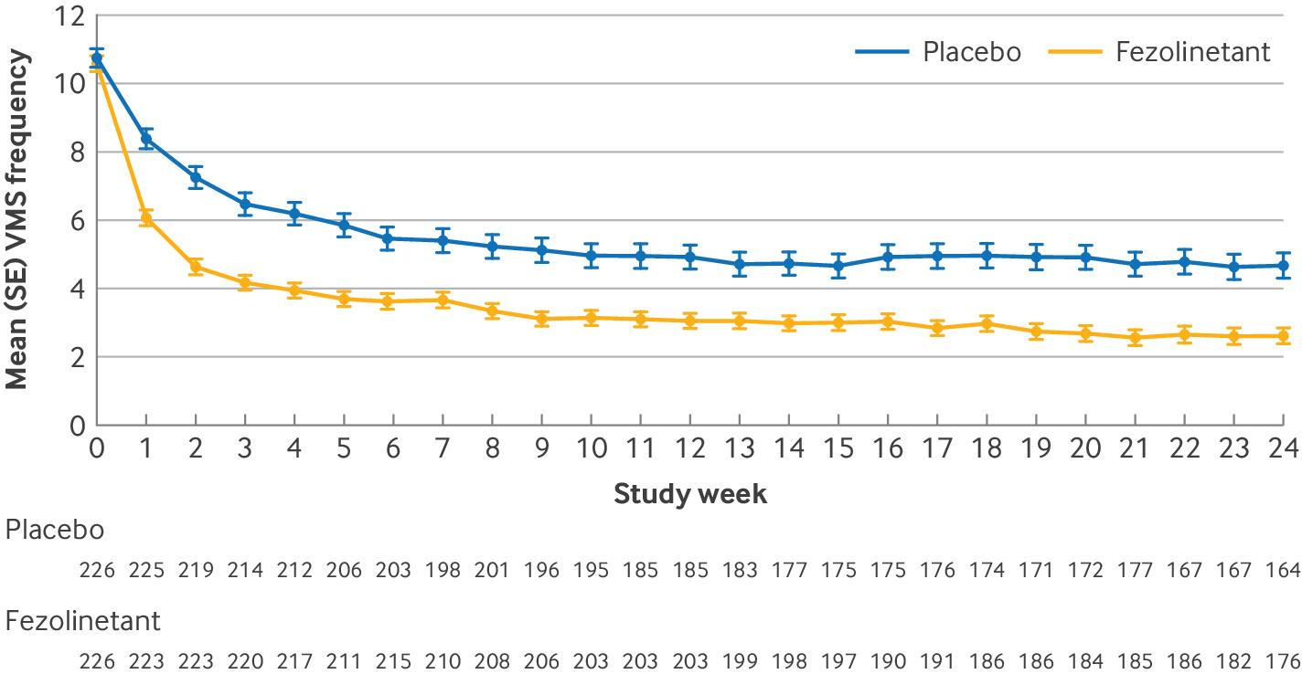 | 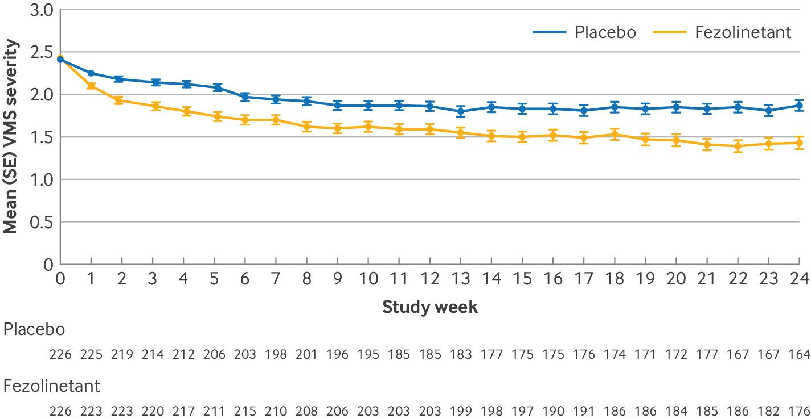
C. SKYLIGHT 1: VMS frequency to Wk 52 | D. SKYLIGHT 1: VMS severity to Wk 52
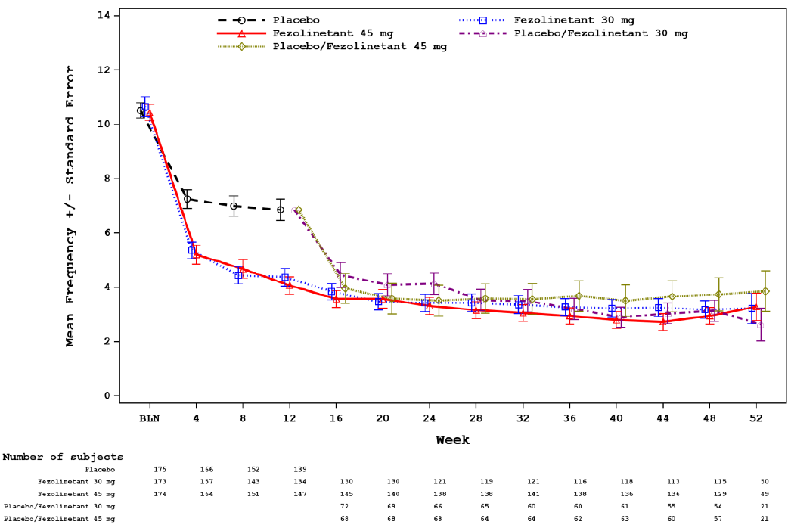 | 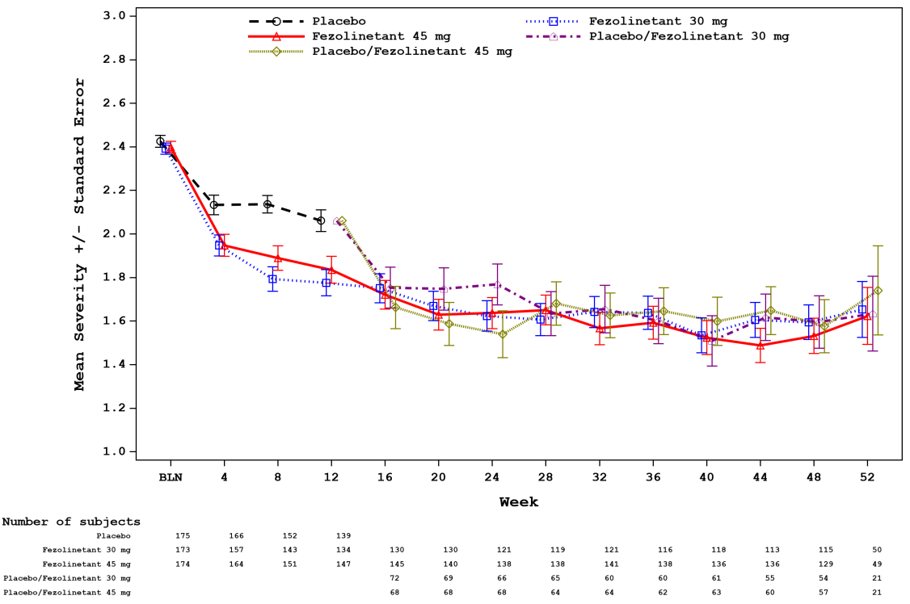
E. SKYLIGHT 2: VMS severity to Wk 52 | F. SKYLIGHT 2: VMS severity to Wk 52
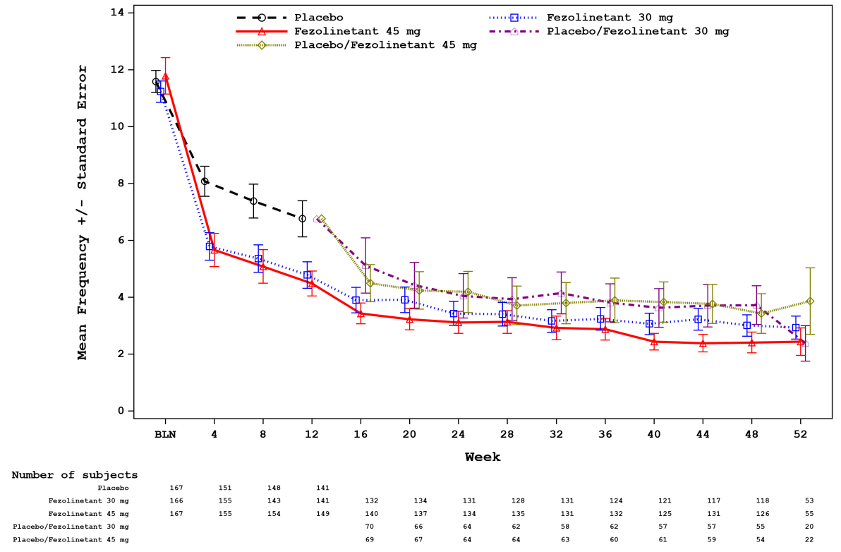 | 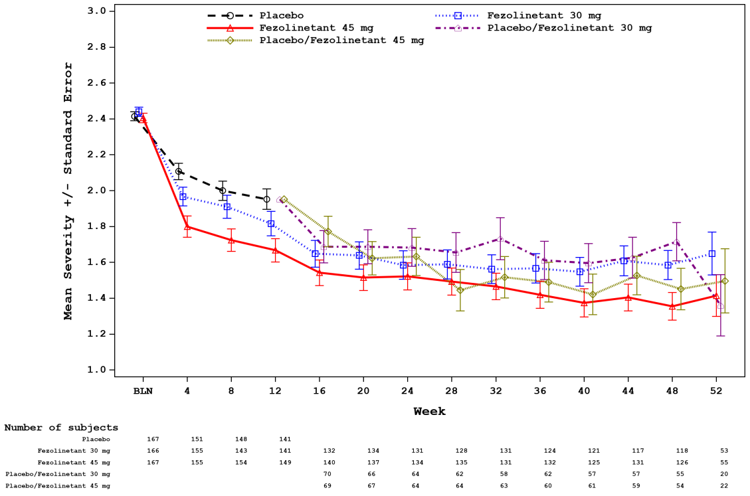
Source: Figures 2 and 3 Schaudig et al (2024), Figure 7, p66 and Figure 8, p67 of SKYLIGHT 1 CSR.pdf, Figure 7, p66 and Figure 8, p67 of SKYLIGHT 2 CSR.
VMS=vasomotor symptoms; wk=week
Note the figures for DAYLIGHT provided in the submission showed the change from baseline on the y axis whereas those for SKYLIGHT show the mean frequency on the y axis. Figures from DAYLIGHT have been sourced from the publication (Schaudig et al 2024) for consistency.

  - Table 6 presents the responder analysis of change from baseline in moderate to severe VMS frequency to Week 12/24 in the fezolinetant trials.
Table 6: VMS frequency response at Week 12/24 in the included fezolinetant trials (double-blind period)
Outcome | FEZ 45mg | PBO | OR (95%CI)
Responders of ≥50% reduction from baseline in mean frequency of moderate-severe VMS per 24h
SKYLIGHT 1, ITTª, Wk 12 ^{d} | 99/174 (56.9) | 52/175 (29.7) | 3.156 (2.035, 4.944)
SKYLIGHT 2, ITTª, Wk 12 ^{d} | 101/167 (60.5) | 71/167 (42.5) | 2.090 (1.351, 3.252)
SKYLIGHT 1 & 2 pooled, ITTª, Wk 12 ^{d} | 200/341 (58.7) | 123/342 (36.0) | 2.542 (1.868, 3.472)
DAYLIGHT, MHT unsuitable^{b}, Wk 12 ^{d} | 154/226 (68.1) | 106/226 (46.9) | 2.422 (1.649, 3.556)
DAYLIGHT, MHT unsuitable^{b}, Wk 24 | 137/226 (60.6) | 104/226 (46.0) | 1.815 (1.249, 2.647)
SKYLIGHT 1 & 2 pooled, MHT unsuitable^{c}, Wk 12 (post-hoc) | 174/287 (60.6) | 106/297 (35.7) | 2.781 (1.991, 3.904)
DAYLIGHT, SKYLIGHT 1 & 2 pooled, MHT unsuitable, Wk 12 (post-hoc) | 328/513 (63.9) | 212/523 (40.5) | 2.623 (2.034, 3.384)
Responders of ≥75% reduction from baseline in mean frequency of moderate-severe VMS per 24h
SKYLIGHT 1, ITTª, Wk 12 ^{d} | 60/174 (34.5) | 23/175 (13.1) | 3.477 (2.054, 6.055)
SKYLIGHT 2, ITTª, Wk 12 ^{d} | 66/167 (39.5) | 35/167 (21.0) | 2.482 (1.527, 4.089)
SKYLIGHT 1 & 2 pooled, ITTª, Wk 12 | 126/341 (37.0) | 58/342 (17.0) | 2.892 (2.026, 4.167)
DAYLIGHT, MHT unsuitable^{b}, Wk 12 | 110/226 (48.7) | 66/226 (29.2) | 2.298 (1.559, 3.389)
DAYLIGHT, MHT unsuitable^{b}, Wk 24 | 106/226 (46.9) | 67/226 (29.6) | 2.099 (1.427, 3.103)
SKYLIGHT 1 & 2 pooled, MHT unsuitable^{c}, Wk 12 (post-hoc) | 113/287 (39.4) | 53/297 (17.8) | 2.984 (2.046, 4.397)
DAYLIGHT, SKYLIGHT 1 & 2 pooled, MHT unsuitable, Wk 12 (post-hoc) | 223/513 (43.5) | 119/523 (22.8) | 2.618 (1.988, 3.447)
Responders of 100% reduction from baseline in mean frequency of moderate-severe VMS per 24h
SKYLIGHT 1, ITTª, Wk 12 ^{d} | 18/174 (10.3) | 6/175 (3.4) | 3.262 (1.329, 9.194)
SKYLIGHT 2, ITTª, Wk 12 ^{d} | 25/167 (15.0) | 9/167 (5.4) | 3.049 (1.420, 7.125)
SKYLIGHT 1 & 2 pooled, ITTª, Wk 12 ^{d} | 42/341 (12.6) | 15/342 (4.4) | 3.138 (1.742, 5.953)
DAYLIGHT, MHT unsuitable^{b}, Wk 12 ^{d} | 49/226 (21.7) | 22/226 (9.7) | 2.562 (1.488, 4.412)
DAYLIGHT, MHT unsuitable^{b}, Wk 24 | 50/226 (22.1) | 24/226 (10.6) | 2.385 (1.422, 4.098)
SKYLIGHT 1 & 2 pooled, MHT unsuitable^{c}, Wk 12 (post-hoc) | 37/287 (12.9) | 14/297 (4.7) | 2.962 (1.596, 5.795)
DAYLIGHT, SKYLIGHT 1 & 2 pooled, MHT unsuitable, Wk 12 (post-hoc) | 86/513 (16.8) | 36/523 (6.9) | 2.710 (1.788, 4.107)
Bold indicates statistically significant results. .
Source: Table 2.5-12, p103 of the submission, Table 26, pp56-58 of DAYLIGHT CSR.pdf, Table 18, pp55-56 of SKYLIGHT 1 CSR.pdf, Fig 1 of Nappi 2024 (pooled SKYLIGHT 1 and SKYLIGHT 2)
FEZ=fezolinetant; MHT=menopausal hormone therapy; NR=not reported; OR=odds ratio; PBO=placebo; VMS=vasomotor symptoms; wk=week;
a In SKYLIGHT 1 and SKYLIGHT 2 patients were not enrolled based on criteria for suitability/unsuitability to receive MHT. Eligible patients had moderate to severe VMS associated with menopause seeking treatment for VMS.
b In DAYLIGHT, enrolled patients were MHT unsuitable defined based on contraindicated; caution (based on medical history); stoppers (previous discontinuation of MHT due to lack of efficacy, side effects or medical advice); or averse (choice not to use MHT after discussion with clinician).
c In the post-hoc analysis of SKYLIGHT 1 and SKYLIGHT 2, MHT history subgroups were mutually exclusive and categorized with the following hierarchy: contraindicated; caution; stopped for medical concerns; averse; naïve/willing. MHT unsuitable group comprised of the following subgroups: contraindicated, caution, stopped for medical concerns or averse.
d results extracted during the evaluation

  - The results demonstrated that:
- In DAYLIGHT, SKYLIGHT 1 and SKYLIGHT 2, there was an improvement (reduction) from baseline in the frequency and severity of moderate to severe VMS at Week 12 and Week 24, across treatment arms. The improvement (reduction) in VMS frequency and severity was maintained to Week 52 in SKYLIGHT 1 and SKYLIGHT 2 active extension period, for both arms. The evaluation and the ESC noted that the treatment effect in the placebo arm was high in all trials. This may be due to the natural progression of menopause or regression to the mean, given the cyclical nature of menopausal symptoms, and time since symptom onset, which would have affected both treatment arms.
- In DAYLIGHT, SKYLIGHT 1 and SKYLIGHT 2, the least squares (LS) mean change from baseline in moderate to severe VMS frequency and severity was statistically significantly greater for patients treated with fezolinetant 45 mg than placebo. In SKYLIGHT 1 and SKYLIGHT 2, the treatment effect in the fezolinetant 30 mg arm was similar but numerically smaller than for fezolinetant 45 mg. The ESC noted that there were no comparative efficacy data beyond 24 weeks (from DAYLIGHT) as patients randomised to placebo in the SKYLIGHT trials were switched to fezolinetant after 12 weeks.
- In DAYLIGHT, pre-specified analyses in the overall MHT unsuitable population showed a numerically smaller LS mean difference between fezolinetant 45 mg and placebo in the reduction of moderate to severe VMS frequency, but numerically larger LS mean difference for the reduction in VMS severity at Week 12 and Week 24 compared to the post-hoc analysis in the pooled SKYLIGHT 1 and SKYLIGHT 2 subgroup categorised as MHT unsuitable at Week 12. The evaluation considered this could potentially be due to the greater placebo response observed in DAYLIGHT. However, the post-hoc analyses in the pooled DAYLIGHT, SKYLIGHT 1 and SKYLIGHT 2 (MHT unsuitable) and pooled SKYLIGHT 1 and SKYLIGHT 2 (MHT unsuitable) subgroups were generally consistent with results in the overall population in SKYLIGHT 1 and SKYLIGHT 2 at Week 12.
- The proportion of responders in terms of VMS frequency (≥50%, ≥75% and ≥100% reduction from baseline in VMS frequency) was significantly higher in the fezolinetant treatment arm compared to placebo to Week 12 (DAYLIGHT, SKYLIGHT 1 and SKYLIGHT 2) and Week 24 (DAYLIGHT). In DAYLIGHT, the time to achieve response (≥ 50%, ≥75% and ≥100% reduction) was shorter in the fezolinetant 45 mg arm (median (95%CI): 6 (5, 8) days, 18 (14, 25) days, and 131 (80, 165) days, respectively) compared to placebo (17 (13, 21) days, 56 (42, 79) days, and not estimable, respectively). Across the trials, few patients achieved a response of 100% reduction in VMS frequency. Odds ratios (ORs) for all response levels favoured fezolinetant treatment over placebo. In SKYLIGHT 1 and SKYLIGHT 2, the proportion of responders was numerically higher with the fezolinetant 45 mg dose than fezolinetant 30 mg.
  - Although patients treated with fezolinetant 45 mg showed significantly greater reduction from baseline in VMS frequency compared to placebo at Week 12 and Week 24, the evaluation considered that the difference may not be clinically meaningful, given the point estimates for the overall population (including MHT unsuitable and MHT suitable patients) and the MHT unsuitable subgroup (-1.93 to -2.55) did not meet the MCID for reduction in frequency (>3.57 VMS per day). However,
- for patients treated with fezolinetant 45 mg, the mean difference versus placebo in the reduction of VMS severity for the overall population (-0.24 to -0.29) and MHT unsuitable patients (-0.27 to -0.39) exceeded the MCID for reduction in severity (>0.225 points at Week 12).
- The PSCR and pre-PBAC response stated that within-patient MCID thresholds to assess individual patients achieving meaningful change from baseline were met based on responder analyses (as per Table 6 above).
- The PSCR and pre-PBAC response noted that the results also met the clinically meaningful reduction as identified by the FDA guidance of 2 hot flushes per day versus placebo, and the EMA guidance of ≥2 VMS episodes over 24 hours.
As discussed in paragraph 4.4, the ESC considered that clinical meaningfulness for VMS severity and frequency is not straightforward, as the mean reduction does not take into account the impact of VMS severity and frequency on an individual’s quality of life, which will be dependent on the individual, environmental factors, and the activity being undertaken.
  - Additional post-hoc subgroup analyses of the pooled SKYLIGHT 1 and SKYLIGHT 2 population by MHT history, categorised as contraindicated, caution, stopped for medical reasons, averse and naïve/willing, indicated that there was greater improvement (reduction) from baseline in the frequency of moderate-to-severe VMS for patients treated with fezolinetant compared to placebo across all MHT subgroups at Week 12. The results were broadly consistent with the MHT unsuitable subgroup (contraindicated, caution, stopped for medical reasons and averse) and the overall population. There was also greater improvement from baseline in the severity of VMS in the fezolinetant group compared to placebo at Week 12 in some MHT subgroups (caution, stopper or stopped for medical concerns) but not for others (contraindicated, averse and naïve/willing). Given these were not a priori defined subgroups, the evaluation considered all statistically significant differences are exploratory, and should be interpreted with caution.
  - The submission presented results of other patient-reported outcomes from DAYLIGHT, SKYLIGHT 1 and SKYLIGHT 2. In DAYLIGHT, MHT unsuitable patients treated with fezolinetant 45 mg showed improvement from baseline in measures assessing sleep disturbance, VMS and menopausal quality of life (PROMIS SD SF 8b, PGI, MENQOL) compared to placebo at Week 24. There was also greater improvement in the fezolinetant 45 mg group in VMS-related work productivity (WPAI-VAM all domain, except for absenteeism domain) compared to placebo at Week 24. However, there were no differences between groups in terms of general quality of life (EQ-5D-5L), sexual functioning (FSFI) or mental health (PHQ-4). Similar results were observed in the pooled SKYLIGHT 1 and SKYLIGHT 2 overall population and post-hoc MHT unsuitable subgroup as well as the pooled DAYLIGHT, SKYLIGHT 1 and SKYLIGHT 2 post-hoc MHT unsuitable subgroup.

Comparative harms
  - Table 7 summarises the adverse events (AEs) from the included trials.
Table 7: Summary adverse events in the included trials (double-blind)
AEs, n(%) | DAYLIGHT (24w)^{c} |  | SKYLIGHT 1 (12w)^{d} |  | SKYLIGHT 2 (12w)^{d} |  | SKYLIGHT 4 (52w)^{e}
AEs, n(%) | FEZ 45mg  N=226 | PBO  N=226 | FEZ 45mg  N=173 | PBO  N=175 | FEZ 45mg  N=167 | PBO  N=167 | FEZ 45mg  N=609 | PBO  N=610
Any TEAE | 147 (65.0) | 138 (61.1) | 75 (43.4) | 78 (44.6) | 60 (35.9) | 54 (32.3) | 389 (63.9) | 391 (64.1)
Drug-related TEAEª | 39 (17.3) | 25 (11.1) | 13 (7.5) | 22 (12.6) | 25 (15.0) | 11 (6.6) | 110 (18.1) | 106 (17.4)
Serious TEAE | 10 (4.4) | 8 (3.5) | 2 (1.2) | 1 (0.6) | 2 (1.2) | 0 | 23 (3.8) | 14 (2.3)
Drug-related serious TEAE | 1 (0.4) | 0 | 0 | 0 | 0 | 0 | 3 (0.5) | 1 (0.2)
TEAE leading to discontinuation | 11 (4.9) | 14 (6.2) | 4 (2.3) | 9 (5.1) | 5 (3.0) | 1 (0.6) | 28 (4.6) | 26 (4.3)
Death^{b} | 0 | 0 | 0 | 0 | 0 | 0 | 0 | 0
Common TEAEs
COVID-19 | 30 (13.3) | 29 (12.8) | - | - | - | - | 32 (5.3) | 38 (6.2)
Headache | 20 (8.8) | 21 (9.3) | 11 (6.4) | 13 (7.4) | 6 (3.6) | 4 (2.4) | 55 (9.0) | 56 (9.2)
Fatigue | 13 (5.8) | 1 (0.4) | 3 (1.7) | 3 (1.7) | 1 (0.6) | 2 (1.2) | 16 (2.6) | 17 (2.8)
Nasopharyngitis | 9 (4.0) | 11 (4.9) | 1 (0.6) | 2 (1.1) | 0 | 4 (2.4) | 15 (2.5) | 18 (3.0)
Nausea | 6 (2.7) | 4 (1.8) | 2 (1.2) | 4 (2.2) | 4 (2.4) | 0 | 19 (3.1) | 15 (2.5)
Diarrhoea | 6 (2.7) | 3 (1.3) | - | - | 2 (1.2) | 4 (2.4) | 24 (3.9) | 16 (2.6)
Upper respiratory tract infection | 6 (2.7) | 4 (1.8) | 2 (1.2) | 3 (1.7) | 5 (3.0) | 7 (4.2) | 18 (3.0) | 20 (3.3)
Insomnia | 6 (2.7) | 1 (0.4) | - | - | - | - | 11 (1.8) | 24 (3.9)
Anxiety | 6 (2.7) | 2 (0.9) | - | - | - | - | 8 (1.3) | 11 (1.8)
Weight increase | 5 (2.2) | 1 (0.4) | - | - | 1 (0.6) | 1 (0.6) | - | -
Back pain | - | - | - | - | - | - | 18 (3.0) | 13 (2.1)
TEAEs of special interest
Abnormal liver test | 10 (4.4) | 6 (2.7) | 7 (4.0) | 5 (2.9) | 3 (1.8) | 0 | 32 (5.3) | 30 (4.9)
ALT increased | 4 (1.8) | 1 (0.4) | 3 (1.7) | 4 (2.2) | 3 (1.8) | 0 | 12 (2.0) | 5 (0.8)
γ-glutamyltransferase increased | 3 (1.3) | 4 (1.8) | 2 (1.2) | 4 (2.2) | 1 (0.6) | 0 | 8 (1.3) | 8 (1.3)
Uterine bleeding | 6 (2.7) | 10 (4.4) | 2 (1.2) | 2 (1.1) | 1 (0.6) | 1 (0.6) | 19 (3.1) | 30 (4.9)
Vaginal haemorrhage | 4 (1.8) | 6 (2.7) | 0 | 0 | 0 | 0 | - | -
Endometrial hyperplasia, cancer, or disordered proliferative endometrium | 1 (0.4) | 2 (0.9) | 0 | 0 | 0 | 0 | 6 (1.0) | 2 (0.3)
Bone fractures | - | - | 1 (0.6) | 0 | 0 | 1 (0.6) | 10 (1.6) | 10 (1.6)
Thrombocytopenia | 1 (0.4) | 0 | 1 (0.6) | 1 (0.6) | 0 | 0 | 1 (0.2) | 1 (0.2)
Depression | - | - | 3 (1.7) | 2 (1.1) | 1 (0.6) | 4 (2.4) | 11 (1.8) | 13 (2.1)
Source: Tables 2.5-23 and 2.5-24, pp112-113, Tables 2.5-27 and 2.5-28, pp114-115, Tables 2.5-29 and 2.5-30, p116, Tables 2.5-32 and 2.5-33, pp117-118 of the submission.
AE=adverse event; ALT=alanine aminotransferase; FEZ=fezolinetant; PBO=placebo; TEAE=treatment emergent AE;
a Any TEAE with causal relationship assessed by the investigator. If relationship was missing, then it was considered drug-related.
b All reported deaths after the first study intervention administration.
c In DAYLIGHT, enrolled patients were MHT unsuitable defined as contraindicated; caution (based on medical history); stoppers (previous discontinuation due to lack of efficacy, side effects or medical advice); or averse (choice not to use MHT after discussion with clinician).
d In SKYLIGHT 1 and SKYLIGHT 2 patients were not enrolled based on criteria for suitability/unsuitability to receive MHT. Eligible patients had moderate to severe VMS associated with menopause seeking treatment for VMS.
e In DAYLIGHT 4, patients were enrolled with VMS associated with menopause.
  - The incidence of any AEs, drug-related AEs, serious AEs and AEs leading to discontinuation were similar between fezolinetant and placebo treatment arms in SKYLIGHT 1 and SKYLIGHT 2 overall population with moderate to severe VMS to Week 12, DAYLIGHT MHT unsuitable population with moderate to severe VMS to Week 24 and SKYLIGHT 4 patients with VMS to Week 52. The most common AEs reported included Covid-19, headaches and fatigue. AEs of special interest included increases in abnormal liver function tests, uterine bleeding, endometrial hyperplasia, cancer, disordered proliferative endometrium, bone fractures, thrombocytopenia and depression. There was generally no difference between groups in the incidence of common AEs and AEs of special interest. In SKYLIGHT 1 and SKYLIGHT 2, the incidences of AEs during the active extension period to Week 52 were consistent with the double-blind period. Across the trials, there were no treatment related deaths.
  - In SKYLIGHT 4, assessment of bone health showed no difference between groups in the change from baseline in BMD and a low incidence of bone fractures was reported to Week 52.
  - The Periodic Safety Update Report (July 2024) noted that fezolinetant was associated with symptomatic hepatotoxicity i.e., alanine aminotransferase (AST) increased was considered as an adverse drug reaction (ADR). The PSCR noted that the sponsor will be updating the approved PI with a recommendation for follow-up monitoring of liver function, ie “Follow-up evaluation of hepatic function is recommended monthly for the first three months of initiating VEOZA and thereafter periodically based on clinical judgement.” The ESC considered that regular LFT monitoring should be undertaken for patients taking fezolinetant. The ESC considered the risk of symptomatic hepatotoxicity for patients on fezolinetant was of concern, particularly as safety data are limited to 52 weeks and treatment is likely to be ongoing for many patients.

Benefits/harms
  - A summary of the comparative benefits and harms of fezolinetant versus placebo is presented in Table 8 below.
Table 8: Summary of comparative benefits and harms of fezolinetant and placebo (MHT unsuitable)
Benefits
LS mean change from baseline in VMS frequency and severity
 |  | FEZ 45 mg |  |  |  | PBO |  |  |  | Mean difference  (95% CI)
 |  | N | Mean ∆ baseline |  | SE | N | Mean ∆ baseline |  | SE
Moderate to severe VMS frequency per 24hª
DAYLIGHT, FEZ 45 v PBO, MHT unsuitable, Wk 12 ^{e} |  | 226 | -7.65 ^{e} |  | 0.25 | 226 | -5.69 |  | 0.25 | -1.96 (0.35)^{b}
DAYLIGHT, MHT unsuitable, Wk 24 |  | 226 | -6.20 |  | 0.26 | 226 | -8.13 |  | 0.25 | -1.93 (0.36)^{b}
SKYLIGHT 1 & 2 pooled, MHT unsuitable, Wk 12 (post-hoc) |  | 287 | -6.97 |  | 0.27 | 297 | -4.42 |  | 0.27 | -2.55 (-3.29, -1.80)
DAYLIGHT, SKYLIGHT 1 & 2 pooled, MHT unsuitable, Wk 12 (post-hoc) |  | 513 | -7.16 |  | 4.56e | 523 | -4.89 |  | 4.39e | -2.27 (-2.82, -1.72)^{d e}
Moderate to severe VMS severity per 24hª
DAYLIGHT, FEZ 45 v PBO, MHT unsuitable, Wk 12 e |  | 226 | -0.87 |  | 0.05 | 226 | -0.57 |  | 0.06 | -0.30 (0.08)^{b}
DAYLIGHT, MHT unsuitable, Wk 24 |  | 226 | -1.01 |  | 0.06 | 226 | -0.62 |  | 0.06 | -0.39 (0.09)^{b}
SKYLIGHT 1 & 2 pooled, MHT unsuitable, Wk 12 (post-hoc) |  | 287 | -0.71 |  | 0.04 | 297 | -0.43 |  | 0.04 | -0.27 (-0.39, -0.15) ^{e}
DAYLIGHT, SKYLIGHT 1 & 2 pooled, MHT unsuitable, Wk 12 (post-hoc) |  | 513 | -0.81 |  | 0.93^{c} | 523 | -0.46 |  | 0.79^{c} | -0.35 (-0.47, -0.23)^{d, e}
Responders (12 weeks)
DAYLIGHT, SKYLIGHT 1 & 2 pooled, MHT unsuitable, Wk 12 (post-hoc) | FEZ 45 mg  n/N | PBO  n/N | RR  (95% CI) | Event rate/100 patients* |  | RD  (95% CI)
 |  |  |  | FEZ 45 | PBO | RD  (95% CI)
Responders of ≥75% reduction from baseline in mean frequency of moderate-severe VMS per 24h | 328/513 | 212/523 | NR | 63.9 | 40.5 | 23 (NR, NR)
Responders of ≥50% reduction from baseline in mean frequency of moderate-severe VMS per 24h | 223/513 | 119/523 | NR | 43.5 | 22.8 | 21 (NR, NR)

Harms (24 weeks)
DAYLIGHT | FEZ 45 mg  n/N | PBO  n/N |  | RR  (95% CI)^{e} |  |  | Event rate/100 patients* |  |  |  | RD  (95% CI)^{e}
 |  |  |  |  |  |  | FEZ 45 | PBO |  |  | RD  (95% CI)^{e}
Any TEAEs | 147/226 | 138/226 |  | 1.07 (0.92, 1.23) |  |  | 65.0 | 61.1 |  |  | 0.04 (-0.05, 0.13)
Drug related TEAE | 39/226 | 25/226 |  | 1.56 (0.98, 2.49) |  |  | 17.3 | 11.1 |  |  | 0.06 (-0.00, 0.13)
Serious TEAE | 10/226 | 8/226 |  | 1.25 [0.50, 3.11] |  |  | 4.4 | 3.5 |  |  | 0.01 (-0.03, 0.04)
TEAE leading to discontinuation | 11/226 | 14/226 |  | 0.79 (0.36, 1.69) |  |  | 4.9 | 6.2 |  |  | -0.01 (-0.06, 0.03)
Headache | 20/226 | 21/226 |  | 0.95 (0.53, 1.71) |  |  | 8.8 | 9.3 |  |  | -0.00 (-0.06, 0.05)
Fatigue | 13/226 | 1/226 |  | 13.0 (1.71, 98.55) |  |  | 5.8 | 0.4 |  |  | 0.05 (0.02, 0.08)
Liver test elevations | 10/226 | 6/226 |  | 1.67 (0.62, 4.51) |  |  | 4.4 | 2.7 |  |  | 0.02 (-0.02, 0.05)
Bold indicates statistically significant results. .
Source: Table 2.5-1, p89, Table 2.5-2, pp90-91, Table 2.5-11, p102, Table 2.5-13, p104, Table 2.6-1, pp121-122, Table 2.6-3, pp122-123, Tables 2.5-23 and 2.5-24, pp112-113, of the submission, Attachment 05 – VEOZA Pooled Analysis, SKYLIGHT 1 and 2 Pooled analysis.pdf, Fig 1 and Supplemental Fig 1 of Santoro 2024 (SKYLIGHT 1 and SKYLIGHT 2 pooled).
AE=adverse event; FEZ=fezolinetant; LS=least squares; MHT=menopausal hormone therapy; NR=not reported; PBO=placebo; TEAE=treatment emergent AE; VMS=vasomotor symptoms; wk=week;
a A negative change indicates a reduction/improvement from baseline.
b Reported as LS mean (SE) change from baseline.
c Reported as mean (SD) change from baseline.
d Mean difference calculated during the evaluation using RevMan v5.3. LS mean difference was not reported in the submission.
e results extracted/calculated during the evaluation
  - On the basis of direct evidence presented in the submission in MHT unsuitable patients, for patients treated with fezolinetant in comparison with placebo:
- On average, patients would experience approximately 2 to 3 fewer moderate to severe VMS per 24h at Week 12/24. These differences may not be clinically meaningful given the estimates did not meet the MCID for reduction in frequency (>3.57 VMS per 24h).
  - On the basis of direct evidence presented in the submission in MHT unsuitable patients, for every 100 patients treated with fezolinetant in comparison with placebo, after 12 weeks of treatment:
- Approximately 23 additional patients would experience at least 50% reduction in the frequency of moderate to severe VMS episodes.
- Approximately 21 additional patients would experience at least 75% reduction in the frequency of moderate to severe VMS episodes.
  - On the basis of direct evidence presented in the submission in MHT unsuitable patients, for every 100 patients treated with fezolinetant in comparison with placebo:
- Approximately 4 more patients would experience any TEAE over 24 weeks.
- Approximately 6 more patients would experience a drug-related TEAE over 24 weeks.
- Approximately 5 more patients would experience fatigue over 24 weeks.
- Approximately 2 more patients would experience abnormal liver tests over 24 weeks.

Clinical claim
  - In patients with moderate to severe VMS associated with menopause and unsuitable for MHT, the submission described fezolinetant 45 mg as superior in terms of effectiveness compared with no treatment (placebo) and manageable (non-inferior) safety compared to no treatment (placebo).
  - The evaluation and the ESC considered that the clinical claim of superior effectiveness of fezolinetant versus placebo was generally supported by the evidence presented. However there were limited long-term comparative data beyond 24 weeks. The PSCR acknowledged the limited availability of long-term comparative data, but considered that the (52 week) open-label extension results provide strong indicative evidence of long-term benefit of fezolinetant, and the consistency of VMS reductions over time without evidence of decrease in response, along with the maintenance of a favourable safety profile, supports the long-term use of fezolinetant in clinical practice. The ESC considered that the long-term safety and effectiveness of fezolinetant is uncertain, and no comparative efficacy data were available beyond 24 weeks.
  - Although the incidence of AEs was generally similar between fezolinetant and placebo at Weeks 24 and 52, given the lack of longer term randomised safety data for fezolinetant and the potential for AST liver enzyme increases, the ESC considered it was reasonable to accept inferior but manageable safety for fezolinetant.
  - The ESC noted that for patients in whom there is no medical reason to avoid MHT, MHT is the most appropriate comparator. Although this group of patients was included in the PBS population under the proposed restrictions, the submission did not present any assessment of the comparative efficacy or safety of fezolinetant with MHT. The ESC noted that a recent network meta-analysis (Morga 2024a) suggested that the effect of fezolinetant on VMS frequency was generally not different from the MHT regimens studied, with the exception of tibolone, which was significantly more effective than fezolinetant, but noted that fezolinetant does not confer the other benefits associated with MHT such as bone or cardiovascular-protective benefits.
  - The PBAC considered that the claim of superior comparative effectiveness compared to placebo was reasonable, however placebo was not the appropriate comparator for many patients who would be eligible for fezolinetant under the proposed restriction criteria.
  - The PBAC considered that the claim of manageable non-inferior comparative safety compared to placebo was not adequately supported by the data, given the risks of hepatotoxicity associated with fezolinetant and lack of long-term data.

Economic analysis
  - The submission presented a stepped economic evaluation versus no treatment, based on DAYLIGHT (100% unsuitable for MHT) in the primary analysis, and based on the post-hoc pooled MHT unsuitable subgroup from SKYLIGHT 1 and 2 plus DAYLIGHT in the secondary analysis. The evaluation considered that the use of DAYLIGHT in the primary analysis was appropriate and consistent with the requested restrictions. As discussed in the clinical trials section, despite this consistency, the evaluation and the ESC considered it uncertain whether it was clinically appropriate to allow first-line treatment with fezolinetant over MHTs without medical rationale (i.e. the MHT-averse population identified in the submission), and noted that MHT was a more appropriate comparator for these patients than placebo. A CMA versus MHTs was conducted during the evaluation and presented as a scenario analysis to inform the cost differences between fezolinetant and MHT treatments. However the ESC noted that for a medicine to be recommended on a cost-minimisation basis, the PBAC would need to be satisfied that it is noninferior to the alternative treatment. The ESC noted that the submission did not provide a comparison of safety and efficacy between fezolinetant and MHT.
  - The model structure is shown in Figure 2.
Figure 2. Structure of the economic model
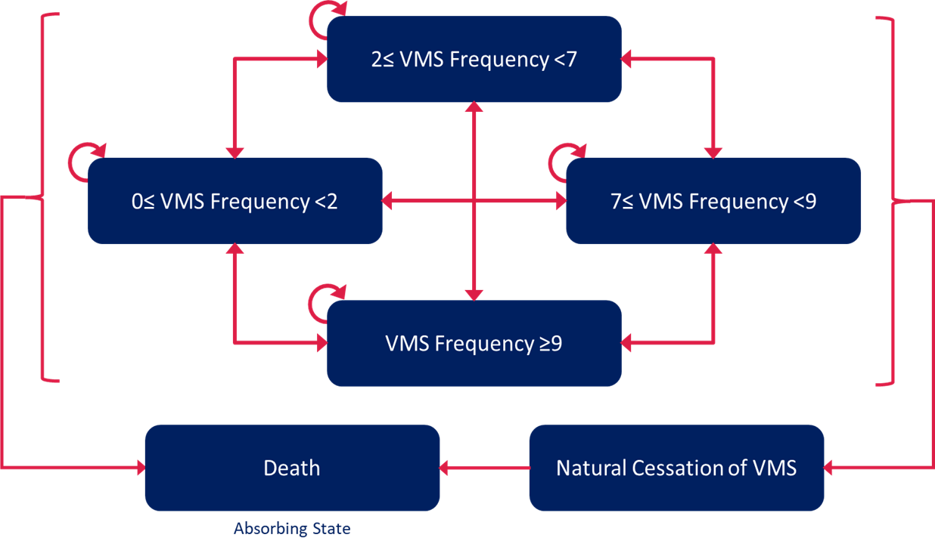
Source: Figure 3.2-1, p150 of the submission.
VMS=vasomotor symptoms
  - Table 9 provides a summary of the model components.
Table 9: Summary of model structure, key inputs and rationale
Component | Summary
Treatments | Fezolinetant vs no treatment
Time horizon | 10 years in the model base case versus 24 weeks in DAYLIGHT
Outcomes | Quality-adjusted life years
Methods used to generate results | Markov model
Health states | - 0 ≤ VMS frequency < 2  - 2≤ VMS frequency <7  - 7≤ VMS frequency <9  - VMS frequency ≥9  - Natural cessation of VMS  - Death
Cycle length | 4 weeks, with half cycle correction
Transition probabilities or  Allocation to health states (if partitioned survival model) | Primary data source: DAYLIGHT clinical trial  Secondary: DAYLIGHT + SKYLIGHT 1 & 2 trials
Extrapolation method | The submission extrapolated transition probabilities derived from DAYLIGHT (weeks 0-24) over the 10-year model duration. The transition probabilities observed from week 0 to 24 were applied, with the assumption that the probabilities observed during the last four weeks of the trial (weeks 20-24) would remain constant from week 24 onwards for the remainder of the model’s time horizon.
Health related quality of life | Trial-based (DAYLIGHT):  - 0 ≤ VMS frequency < 2= 0.833  - 2≤ VMS frequency <7= 0.793  - 7≤ VMS frequency <9= 0.785  - VMS frequency ≥9= 0.747  - Natural cessation of VMS= 0.843
Source: Table 3.1-1, p144 of the submission and compiled during the evaluation.
VMS= vasomotor symptoms (per day)
  - The submission adopted a granular, VMS frequency-based health state model to represent the health effects and costs of fezolinetant compared to no treatment in moderate to severe VMS, based on clinician input. The discrete health states (i.e., VMS<2, 2≤VMS<7, 7≤VMS<9, and VMS≥9) were determined based on a post hoc analysis of DAYLIGHT to group VMS frequencies per day by EQ-5D utility values. Notably this differed from the recently published model by the Institute for Clinical and Economic Review’s Midwest Public Advisory Council, (ICER model), that used three health states (on treatment, off treatment due to symptom resolution, and all-cause death) rather than health states based on VMS frequency. However, the pre-PBAC response noted that the selected health states align with FDA trial criteria.
  - Figure 3 illustrates the distribution of average daily moderate to severe VMS frequencies per day (0-14+) from DAYLIGHT. The associated EQ-5D utility values are presented in Table 10.
Figure 3. VMS frequency distributions at baseline, Week 12, and Week 24, fezolinetant 45 mg and placebo:
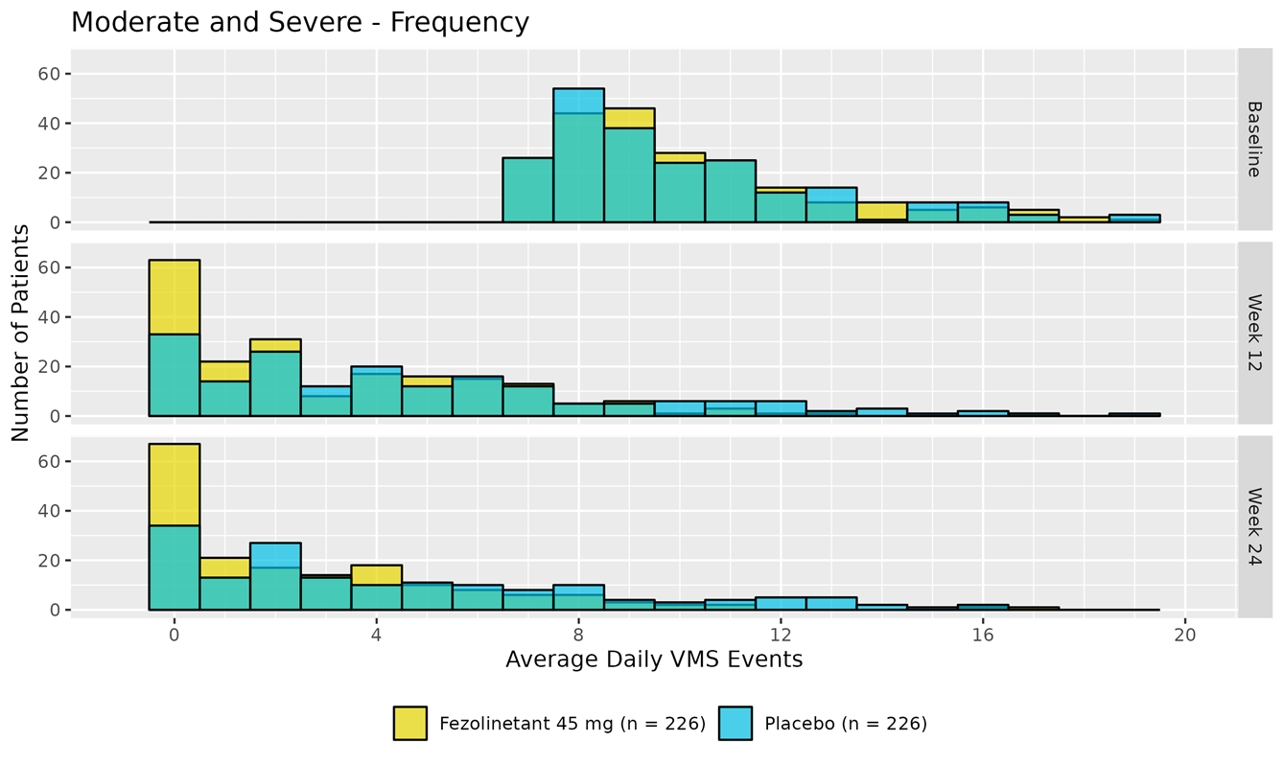
Source: Figure 3.2-2, p152 of the submission.
VMS=vasomotor symptoms (per day).
Note: This figure was not found in either the DAYLIGHT clinical study report or its associated publication, and therefore, could not be verified during evaluation.
Note: The green areas likely represent where data for the yellow (fezolinetant 45 mg) and blue (placebo) bars overlap (forming the green colour).
Table 10. Mean EQ-5D utility values by VMS frequency based on UK tariffs and estimates using GEE models accounting for repeated measures characteristics used in model
VMS frequency per day | EQ-5D utility mean | EQ-5D utility 95% CI | Number of EQ-5D observations | EQ-5D utility mean value of VMS health states (95% CI)
0 to <1 | 0.848 | (0.817, 0.878) | 146 | 0.833 (0.814,0.852)  n=319
1 to <2 | 0.824 | (0.803, 0.846) | 173 | 0.833 (0.814,0.852)  n=319
2 to <3 | 0.806 | (0.781, 0.830) | 145 | 0.793 (0.774, 0.812) ª  n=497
3 to <4 | 0.793 | (0.765, 0.821) | 115 | 0.793 (0.774, 0.812) ª  n=497
4 to <5 | 0.795 | (0.770, 0.821) | 129 | 0.793 (0.774, 0.812) ª  n=497
5 to <6 | 0.787 | (0.758, 0.816) | 113 | 0.793 (0.774, 0.812) ª  n=497
6 to <7 | 0.775 | (0.749, 0.801) | 97 | 0.793 (0.774, 0.812) ª  n=497
7 to <8 | 0.784 | (0.759, 0.809) | 171 | 0.785 (0.763, 0.806)  n=186
8 to <9 | 0.785 | (0.759, 0.810) | 153 | 0.785 (0.763, 0.806)  n=186
9 to <10 | 0.747 | (0.712, 0.781) | 104 | 0.747 (0.725, 0.770) ª  n=419
10 to <11 | 0.746 | (0.710, 0.782) | 69 | 0.747 (0.725, 0.770) ª  n=419
11 to <12 | 0.755 | (0.722, 0.788) | 72 | 0.747 (0.725, 0.770) ª  n=419
12 to <13 | 0.742 | (0.703, 0.782) | 47 | 0.747 (0.725, 0.770) ª  n=419
13 to <14 | 0.786 | (0.733, 0.839) | 32 | 0.747 (0.725, 0.770) ª  n=419
≥14 | 0.724 | (0.682, 0.767) | 95 | 0.747 (0.725, 0.770) ª  n=419
Bold: used in the base case.
Source: Table 3.2-3, p153 of the submission.
GEE=generalised estimating equation, SE=standard error, UK=United Kingdom, VMS=vasomotor symptoms (per day).
- Indicates a significant difference in EQ-5D in the VMS frequency category compared with the previous category (p<0.05).
  - The submission applied a statistical testing approach to group VMS frequency (per day) categories based on EQ-5D utility values. Adjacent categories with no significant differences in utility (p > 0.05) were merged into broader groups, while significant differences (p < 0.05) informed thresholds for distinguishing groups. Clinical and trial-specific considerations (e.g., baseline scores and inclusion criteria) were also used to define thresholds:
- Lower Threshold of 2: Categories 0, >0 to <1, and 1 to <2 were combined into 0 to <2 due to no significant differences. This broader group was statistically different from 2 to <7, setting 2 as a cut-off.
- Threshold of 2-7: Categories 3 to <4, 4 to <5, 5 to <6, and 6 to <7 were statistically similar and combined into 3 to <7. The 2 to <3 group was merged with 3 to <7 due to no difference. The threshold of 7 was not based on statistical testing but selected to reflect the inclusion criteria of DAYLIGHT.
- Threshold of 7-9: Categories 7 to <8 and 8 to <9 showed no significant difference and were combined into 7 to <9. A significant decrease in utility from ≥9 supported this as a cut-off for higher severity.
- Upper Threshold of 9: Categories 9 to <10, 10 to <11, 11 to <12, and 12 to <13 were statistically similar and combined into ≥9 due to a decrease in utility starting at 9 and practical issues with sample size for 14+.
  - The range of the resultant four VMS frequency health states varied from relatively few VMS frequency counts (e.g. 2 counts per day in the 0 to <2 or 7 to <9 health states) to many counts (e.g., 5 counts per day in the 2 to <7 health state). Given the threshold of 7 was selected based on DAYLIGHT trial entry criteria rather than statistical testing, the estimated mean utilities for the 2 to <7 and 7 to <9 health states were not significantly different from each other, with a mean difference of only 0.009. The submission did not present any alternative analyses, such as latent class analysis to validate the final VMS frequency groupings; any differences in model results due to differences in VMS frequency groupings were not explored by the submission. A sensitivity analysis conducted during the evaluation, assuming similar utility values for the 2 to <7 and 7 to <9 health states, showed that the ICER was, however, relatively insensitive to this assumption, with changes ranging from 2% (when both states are assigned the utility of the 7 to <9 state) to 5% (when both states are assigned the utility of the 2 to <7 state) (see Table 14). The ESC noted that there was a clear drop in mean utility at 9 daily VMS episodes which suggested this cut point was reasonable, however the other utility categories appeared somewhat arbitrary. The ESC noted that it was not possible to test the effect of using different threshold categories in the model.
  - The submission argued that the model structure and the VMS frequency health states are valid and endorsed by clinicians consulted by the sponsor. The submission further emphasised that the clinicians considered VMS frequency an objective measure of treatment effect. The model’s approach however deviated from the results of the DCE presented in the clinical trial Section (see para 6.16), which indicated that patients valued a relative 50% reduction in VMS frequency from baseline (worded as “reduced by at least half” in the DCE); given the model’s structural assumptions, the impact of this alternative measure of response was not explored in the submission. Additionally, it differed from the Constantine 2019 study, which employed an anchor-based approach to define the MCID for a reduction in moderate to severe VMS frequency as more than 25 episodes per week (or over 3.57 episodes per day).
  - VMS severity was not considered in the submission’s analysis. The evaluation considered that this omission was not appropriate, as symptom severity is also a critical factor influencing health outcomes and patient preferences, as highlighted by clinicians consulted by the sponsor on key model inputs. However, as fezolinetant also reported a benefit in reducing VMS severity compared to no treatment in DAYLIGHT the evaluation considered that including severity in the analysis would likely produce an effect in the same direction as VMS frequency, favouring fezolinetant. The PSCR noted that the choice of VMS frequency as the focus of the model was driven by the objectivity of frequency and presented analyses demonstrating the correlation between VMS frequency and severity. The ESC considered that use of VMS frequency alone was likely to be reasonable as frequency is a more objective measure, is likely to be correlated with severity, and including both severity and frequency in the model would likely result in substantial double-counting of the benefit.
  - The base-case model time horizon was 10 years. Patients started in the model with a mean age of 54.36 years. Sensitivity analyses also considered alternative time horizons of 5 and 7 years. The submission claimed that a 10-year time horizon was considered appropriate by clinical experts consulted by the sponsor, who indicated that while VMS duration of 7 years is more commonly cited in the literature, durations can vary among women of different ethnicity, with about one in five women experiencing VMS lasting longer than 7 years (up to 10–15 years) in clinical practice. The submission also noted that in a 2017 systematic review of cost-effectiveness evaluations on menopausal VMS, the economic evaluations included had adopted time horizons of either lifetime or 9 years. Data were, however, only available up to 24 weeks in DAYLIGHT and beyond 24 weeks, treatment effects in the model were extrapolated based on the assumption of maintaining the same benefit whilst on treatment. The ESC considered that this introduces uncertainty and is overly optimistic, also noting the natural cessation of symptoms would be expected to reduce the difference in response over time. Reducing the time horizon to 5 years increased the ICER 11.49% to $45,000 to < $55,000 per QALY gained from a base case of $35,000 to < $45,000.
  - The submission indicated that the base-case modelled median treatment duration for fezolinetant was approximately 28.5 months (2.4 years). The mean treatment duration (half cycle-corrected) of fezolinetant over 130 cycles (9.97 years) was calculated to be 26.4 months (2.2 years). Input from one UK and one Canadian health economist for the model suggested that the time horizon should align with the typical duration of VMS before natural cessation, with a median duration of 7.4 years. The ESC noted that while Avis 2015 assumes a median duration of symptoms of 7.4 years, Politi 2008 suggests a shorter duration (4 years), and hence a higher cessation rate. The mean treatment duration of fezolinetant in the 24-week (168 days) DAYLIGHT trial was 157.4 days. The pre-PBAC response noted that the model estimates only ~12.5% of patients are still on fezolinetant treatment by 7.5 years given the impact of modelled discontinuation and VMS cessation.
  - The submission applied non-treatment specific health state utilities from EQ-5D-5L data collected in the pivotal DAYLIGHT trial. Utility values for each moderate to severe VMS frequency health state were estimated using a generalised estimating equation (GEE) model to account for repeated measures. In the regression model, the dependent variable was the utility index score derived from EQ-5D-5L data, and the independent variable was the VMS frequency health states. Due to the inclusion criteria of the DAYLIGHT trial, only women with a mean daily frequency of VMS of at least 7 episodes per day were included, utility values were not estimable for the 0 ≤ VMS Frequency < 2 and 2 ≤ VMS Frequency < 7 health states at baseline. Therefore, post-baseline measures were used to estimate utility values for the 0 ≤ VMS Frequency < 2 and 2 ≤ VMS Frequency < 7 and health states. Utility values for VMS cessation were calculated from the average EQ-5D-5L utility scores whenever women reported a VMS frequency of zero, in the clinical data. No further adjustment was made in the analysis to account for repeated measurements.
  - The submission used the EQ-5D-5L to EQ-5D-3L mapping value set developed by the NICE Decision Support Unit (Hernandez-Alava 2023). The evaluation considered that this may not be appropriate, given EuroQoL noted that mapping EQ-5D-5L to EQ-5D-3L places an artificial floor effect on the values of EQ-5D-5L, and EQ-5D-5L when valued directly, might in fact be lower than when compared to the EQ-5D-3L level system. Moreover, the Australian value set for the EQ-5D-5L could have been used. The ESC considered that it would be useful to see the Australian value set applied directly to the 5L data in the sensitivity analyses, although it is unlikely to have a substantial impact on the ICER. The pre-PBAC response noted that reducing the utility values by 10% for all VMS states, increased the ICER by | |% to $45,000 to < $55,000.
  - The model assumed an age-dependent annual adjustment factor to account for the expected decline in health utility with increasing age, using data from Hernandez-Alava et al., (2022). A sensitivity analysis removing age-dependent disutility showed a | |% reduction in the ICER, decreasing it to $35,000 to < $45,000 from the base case of $35,000 to < $45,000 per QALY gained.
  - The evaluation considered that healthcare resource use costs, including general physician and specialist visits in each VMS frequency health state were reasonably estimated based on the results of a general practitioner survey (N=12) conducted for the submission. The PSCR noted that the fezolinetant PI will be updated with a recommendation for monitoring of liver function after initiating therapy, and noted that the sponsor proposes to update the economic and financial models to reflect this additional testing in time for the pre-PBAC response, but considered that the impact is likely to be minimal to both the ICER and the overall financial estimates. The pre-PBAC response did not provide updated economic or financial models to assess the impact of liver function test (LFT) costs.
  - The model included an option to account for indirect costs, including productivity loss and travel expenses as a sensitivity analysis. Productivity loss for both absenteeism and presenteeism, for each VMS frequency health state as well as employment rates, were informed by the results of a US survey in women aged 40-75 on the effect of VMS severity with sleep and work impairments reported by DePree et al (2023). Absenteeism captured productivity loss during the time women with VMS are not at work, while presenteeism captured the productivity loss when they are at work but are not productive. Costs related to productivity loss (earnings per day) were informed by Employee Earnings and Hours, Australia, May 2023. The evaluation considered it appropriate that in the base case, these costs were excluded. Adopting a societal perspective and including indirect costs resulted in a 144% decrease in the base case ICER, leading to a dominant ICER of dominant per QALY gained.
  - Figure 4 illustrates the Markov traces for each treatment arm, which visually demonstrates the changes in proportions of patients in different health states over time.
Figure 4. Markov traces for ‘fezolinetant’ and ‘no treatment’ arms of the model
- Fezolinetant, 45 years | - No Treatment, 45 years
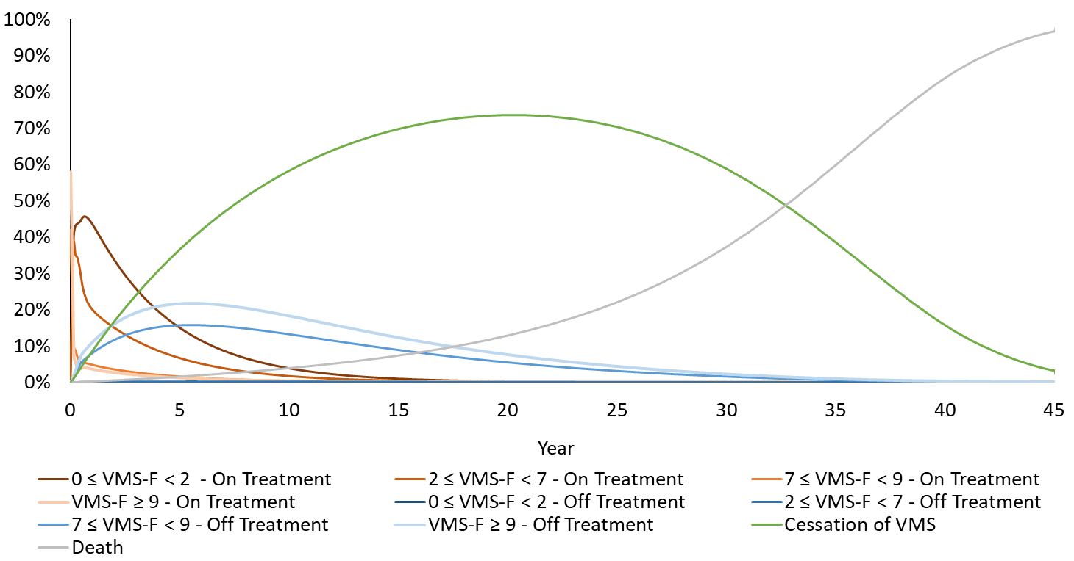 | 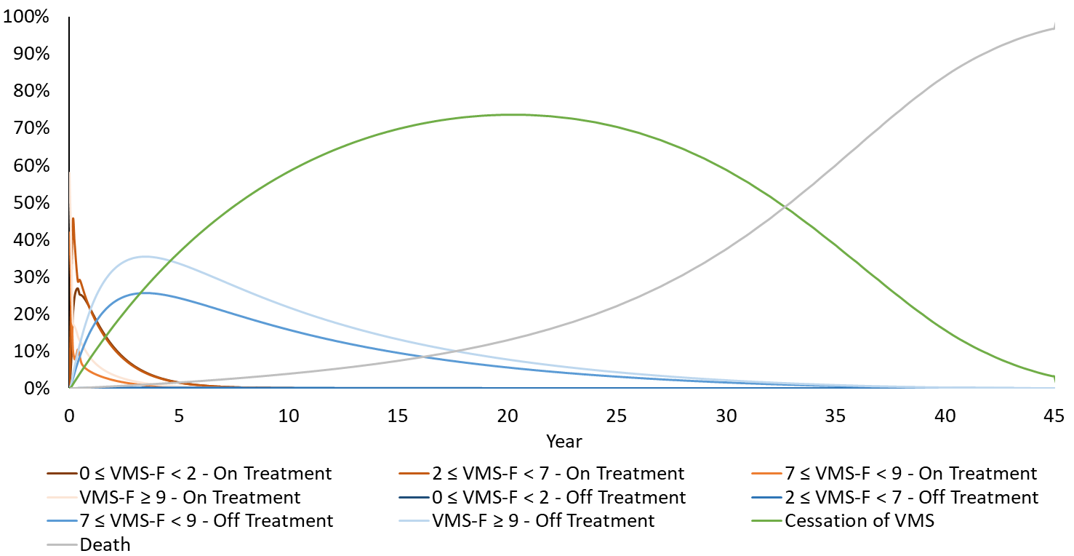
- Fezolinetant, 10 years (base case model time horizon) | - No treatment, 10 years (base case model time horizon)
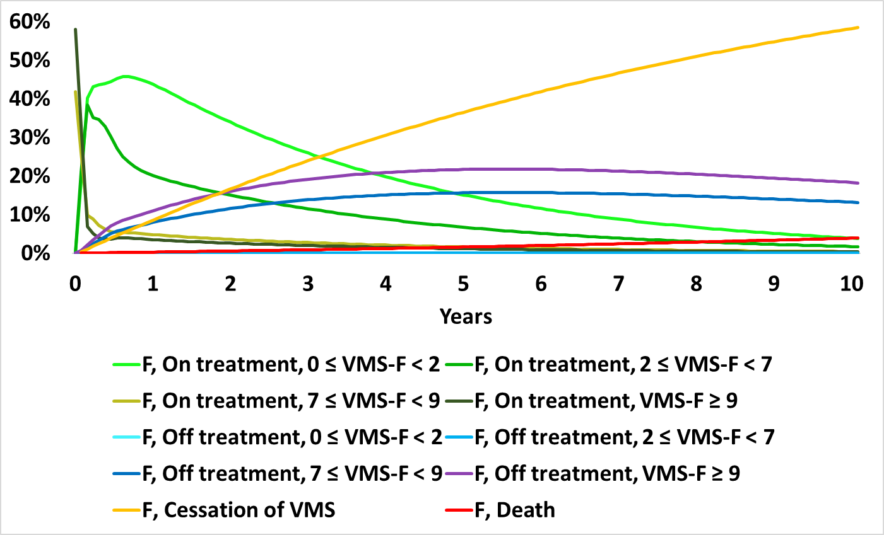 | 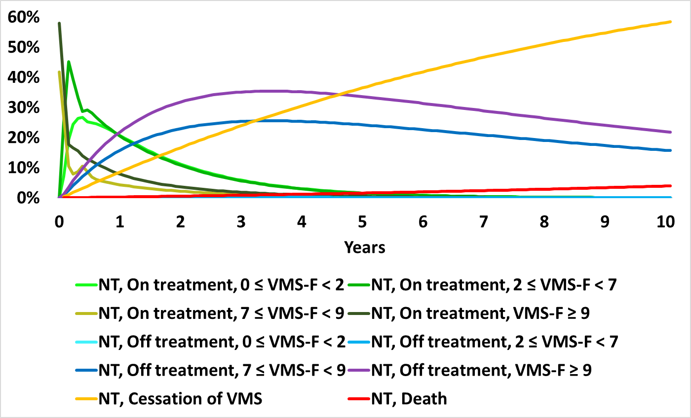
Source: Attachment 11 – VEOZA MR VMS Section 3 CEA, Base Case Results worksheet (A & B) and compiled during the evaluation (C&D).
F=fezolinetant, NT=no treatment, VMS=vasomotor symptoms
  - The Markov traces indicate that differences between the two treatment arms were primarily driven by greater numbers of patients in the fezolinetant arm transitioning to lower VMS frequency health states and staying there during the model duration. VMS cessation and survival were similar between the two arms. This is further illustrated in Figure 5, which shows the proportion of patients in each health state (either on or off treatment in each model arm) over the model time horizon (10 years).
  - The ESC noted that treatment discontinuation was sourced from DAYLIGHT and SKYLIGHT1 and 2 for fezolinetant, and from DAYLIGHT for the no treatment arm (see Table 11). At discontinuation, the model assumed that the patient returns to baseline event frequency. The ESC considered use of higher discontinuation rates for patients in the no treatment arm may result in double-counting of discontinuation for no treatment, as women in the no treatment arm are more likely to transition to higher frequency groups, and are also more likely to discontinue (at which point they return to baseline, high frequency). A responder in the no treatment arm is therefore more likely to discontinue (rather than simply see diminishing response) relative to a fezolinetant responder, an assumption that is not likely to be reasonable. The ESC considered that the assumption that treatment discontinuation is lower in the fezolinetant arm may be reasonable, however the current model appears to double-count return to baseline in the no treatment arm, hence biasing the ICER in favour of fezolinetant. The ESC noted the possibility of modelling trial discontinuation based on event frequency, and then to apply those rates to both arms equally. The ESC requested that the sponsor provide sensitivity analyses assessing discontinuation rates in the pre-PBAC response. The pre-PBAC response (table 2) included a sensitivity analysis exploring decreasing the rate for no treatment arm and increasing the discontinuation rate for fezolinetant arm by 20%, varied the ICER varied by <10% for all scenarios. However, in all scenarios discontinuation rates were different between treatment arms, and a sensitivity analysis exploring modelling trial discontinuation based on event frequency alone was not provided.
  - The ESC noted a scenario analysis was presented in the submission, assuming an equal distribution across ≤0 VMS < 2, 2 ≤ VMS < 7, 7 ≤ VMS < 9, and VMS ≥ 9 states following treatment discontinuations. This decreased the ICER by | |%, lowering it to $0 to < $5,000 compared to the base case of $35,000 to < $45,000 per QALY gained. However, the ESC considered this was unlikely a reasonable scenario and if reversion to baseline is gradual or partial the analysis would be biased in favour of fezolinetant.
Table 11: Treatment discontinuation rates in the economic model
Treatment | Timepoint | Per-cycle probability of discontinuation | Source
Fezolinetant 45 mg | Week 0 to 24 | 2.43% | DAYLIGHT
Fezolinetant 45 mg | Week 24 onwards | 1.32% | Pooled SKYLIGHT 1 and 2
No treatment | Week 0 to 24 | 4.17% | DAYLIGHT
No treatment | Week 24 onwards | 4.17% | DAYLIGHT
Source: Tables 3.4-3, p162 of the submission.

Figure 5. Health state occupancy at baseline, week 12, week 24 and year 10, comparing daily VMS frequency in the economic model and in DAYLIGHT
 | Economic model | DAYLIGHT
Baseline | 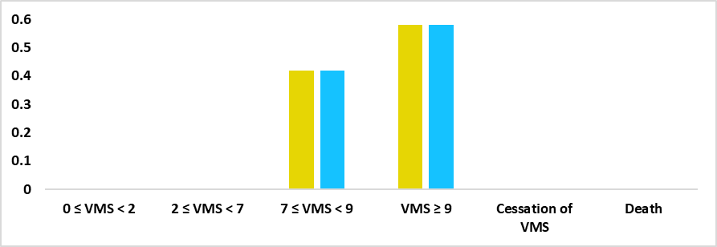 | 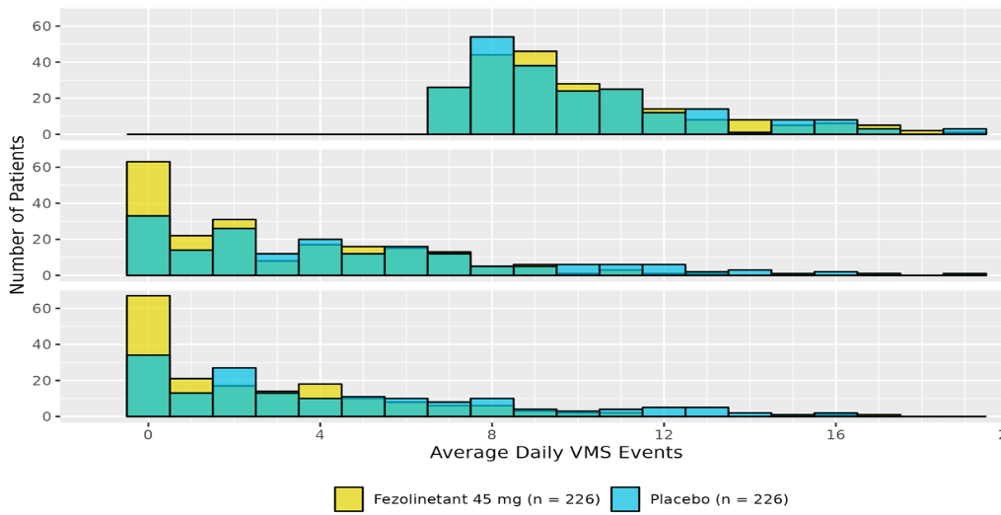
Week 12 | 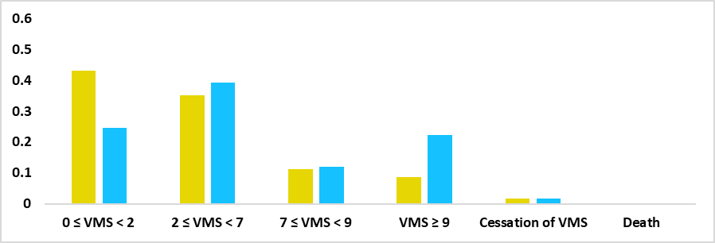
Week 24 | 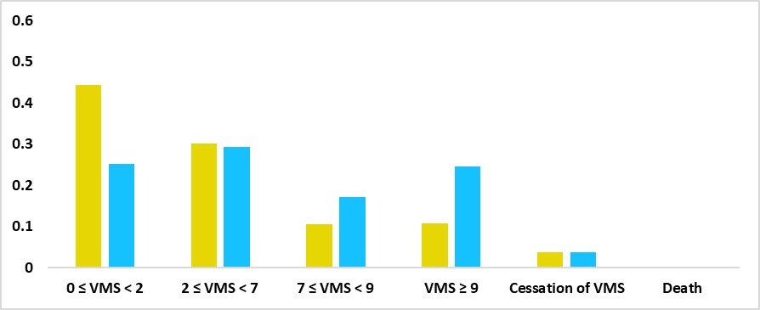
Year 10 | 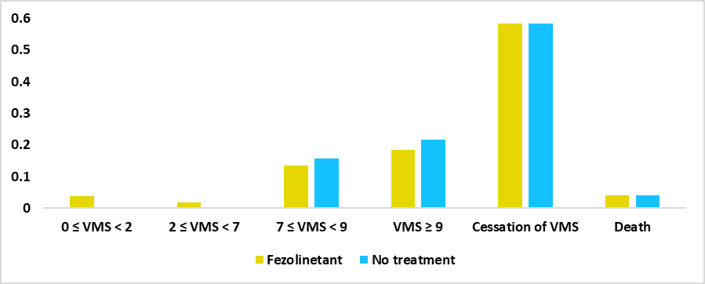 | Nil
Source: Compiled during the evaluation, using Attachment 11 (CEA model) and Figure 3.2-2, p152 of the submission.
VMS=vasomotor symptoms (daily).
Note: The total proportion across all health states in each treatment arm sums to 100%.
  - Key drivers of the model are described in Table 12.
Table 12: Key drivers of the model
Description | Method/Value | Impact  Base case: $|||²/QALY gained
Model structure | Model structure was based on daily VMS frequency. The final four health states adopted in the submission may not be entirely appropriate given mean utilities did not significantly differ between patients with 2≤ VMS frequency <7’ and ‘7 ≤VMS frequency <9’ based on DAYLIGHT. Additionally, VMS severity was not considered when determining the health states. | Unclear, can’t be tested.
Time horizon | Base case time horizon was 10 years. Data were only available for up to 24 weeks in DAYLIGHT. Beyond 24 weeks, treatment effects in the model were extrapolated based on the assumption of maintaining the same benefit whilst on treatment. | Moderate, favours fezolinetant. Reducing the time horizon to 5 years increased the ICER 11.49% to $||||¹ per QALY gained from a base case of $||||².
Utilities | Mapping of EQ-5D-5L to UK-5D-3L values, instead of using the EQ-5D-5L Australian value set may have resulted in overestimated utility values. | Low, using lower interval mean values favours no treatment. The pre-PBAC response reduced utility values by 10% for all VMS states, increasing the ICER by 11% to $||||¹.
Source: compiled during the evaluation.
DCE= discrete choice experiment, VMS=vasomotor symptoms, ICER=incremental cost-effectiveness ratio, QALYs=quality-adjusted life-years
The redacted values correspond to the following ranges:
¹ $45,000 to < $55,000
²$35,000 to < $45,000
  - The results of the stepped analysis are presented in Table 13.
Table 13: Results of the stepped economic evaluation
Step and component | Fezolinetant | No treatment | Increment
Step 1: Trial-based analysis, 24 weeks data from the DAYLIGHT trial (costs=drug costs, outcome = VMS frequency)
Costs: drug acquisition | |||| | $0.00 | ||||
Outcome: patient proportion in VMS<7 state (mild) | 66.18% | 51.04% | 15.14%
Incremental cost per extra ‘patients in the mild state’ gained |  |  | ||||¹
Step 2: Trial-based analysis, 24 weeks data from the DAYLIGHT trial (costs=drug costs + resource utilisation, outcome = VMS frequency)
Costs: drug acquisition + resource use | |||| | $149.70 | ||||
Outcome: patient proportion in VMS<7 state (mild) | 66.18% | 51.04% | 15.14%
Incremental cost per extra ‘patients in the mild state’ gained |  |  | ||||¹
Step 3: Trial-based analysis from Step 2, adding QALYs based on utility estimate by VMS frequency
Costs: drug acquisition + resource use | |||| | $149.70 | ||||
Outcome: QALYs | 0.368 | 0.362 | 0.006
Incremental cost/extra QALYs gained |  |  | ||||²
Step 4: Model-based analysis with 10-year time horizon, discounting of costs and outcomes
Costs: drug acquisition + resource use | |||| | $896.18 | ||||
Outcome: QALYs | 6.278 | 6.187 | 0.091
Incremental cost/extra QALY gained (base case) |  |  | ||||³
Source: Table 3.9-1, p176 of the submission.
VMS=vasomotor symptoms, QALYs=quality-adjusted life-years.
The redacted values correspond to the following ranges:
¹ $0 to < $5,000
² $95,000 to < $115,000
³$35,000 to < $45,000
  - The estimated base case ICER for the proposed scenario (fezolinetant) versus the current scenario (no treatment) was $35,000 to < $45,000 per QALY gained. The ESC noted that disaggregated costs show drug acquisition is the key driver, due to very small offsets.
  - The ESC considered the ICER was driven by assumptions around ongoing effect and although fairly robust to the inputs tested, was uncertain because of assumptions in the model structure that could not be tested, extrapolation of treatment effect beyond the trial, assuming no waning of effect, and mapping of EQ-5D-5L to UK-5D-3L values.
  - The results of key univariate and multivariate sensitivity analyses are summarised in Table 14.
Table 14: Sensitivity analyses
Analyses | Inc. cost | Inc. QALY | ICER | % Change in ICER
Base case | || | 0.09 | | ¹ | -
Discount rate (base case 5% costs and outcomes)
0% costs and outcomes | | | 0.11 | | ¹ | -|%
3.5% costs and outcomes | | | 0.10 | | ¹ | -|%
Time horizon (base case 10 years)
5 years | | | 0.07 | | | +|%
7 years | | | 0.08 | | ¹ | +|%
15 years | | | 0.10 | | ¹ | -|%
Starting age (base case UK DAYLIGHT: 54.5 years)
Median age of menopause onset in Australia: 51.0 years | | | 0.09 | | ¹ | -|%
Efficacy after trial period or weeks 24+ (base case: DAYLIGHT 20-24)
Week 24+: DAYLIGHT 0-24 average, both arms | | | 0.09 | | ¹ | -|%
Week 24+: DAYLIGHT 12-24 average, both arms | | | 0.09 | | ¹ | +|%
Week 24+: SKYLIGHT 24-52 average, only Tx arm | | | 0.09 | | ¹ | -|%
Week 24-52: SKYLIGHT 24-52 per cycle and week 52+: SKYLIGHT 24-52 average, only Tx arm | | | 0.09 | | ¹ | -|%
Distribution following treatment discontinuation (base case: baseline distribution, 42% to 7≤VMS<9, 58% to VMS≥9)
Equally between VMS-frequency states (25% each) | | | 1.28 | | ² | -|%
Utility (base case: UK DAYLIGHT [Cessation of VMS: 0.843, 0≤VMS<2: 0.833, 2≤VMS<7: 0.793, 7≤VMS<9: 0.785, VMS>9: 0.747], adjusted for age-dependant disutility)
Whiteley et al., (2013): [Cessation of VMS: 0.860, 0≤VMS<2: 0.850, 2≤VMS<7: 0.850, 7≤VMS<9: 0.820, VMS>9: 0.770] | | | 0.09 | | ¹ | +|%
UK clinical estimates: [Cessation of VMS: 0.843, 0≤VMS<2: 0.810, 2≤VMS<7: 0.793, 7≤VMS<9: 0.746, VMS>9: 0.710] | | | 0.12 | | ³ | -|%
Excluding age-dependent disutility | | | 0.09 | | ¹ | -|%
DAYLIGHT- lower interval [Cessation of VMS: 0.820, 0≤VMS<2: 0.814, 2≤VMS<7: 0.774, 7≤VMS<9: 0.763, VMS>9: 0.724] | | | 0.10 | | ¹ | -|%
Utility (base case: VMS frequency 2 to <7: 0.793 and 7 to <9: 0.785, non-significant difference (p<0.05))
Both States Set to 0.793 | | | 0.09 | | ¹ | +|%
Both States Set to 0.785 | | | 0.09 | | ¹ | +|%
Natural VMS cessation (base case: Avis 2015, 7.4 years)
Politi et al., (2008): 4 years | | | 0.07 | | ⁴ | +|%
Clinicians: 4 in 5 = 7ys & 1 in 5 =10ys, Av.=7.6ys | | | 0.09 | | ¹ | -|%
Perspective (base case: payer)
Societal perspective | -|| | 0.09 | - | ⁵ | -|%
Healthcare resource use (base case: Australian clinicians estimate)
Whiteley et al., (2013) | | | 0.09 | | ¹ | +|%
Sarrel et al., (2015) | | | 0.09 | | ¹ | -|%
Multivariate analyses
Multivariate scenario analysis using pooled data from DAYLIGHT, SKYLIGHT 1 & 2 trials (baseline distribution, starting age, efficacy, and discontinuation) | | | 0.10 | | ¹ | -|%
Source: Table 3.10-2, p179, Table 3.10-3, p180 of the submission and compiled during the evaluation.
Av=average, ICER=incremental cost-effectiveness ration, QALYs=Quality adjusted life-years, Tx=treatment, VMS=vasomotor symptoms. The redacted values correspond to the following ranges:
¹$35,000 to < $45,000
² $0 to < $5,000
³ $25,000 to < $35,000
⁴ $45,000 to < $55,000
⁵ Dominant
  - The ESC noted that the model was most sensitive to changes in assumptions regarding health state utility estimates, time horizon, but considered that the model was reasonably robust to parameter uncertainty, but included some structural uncertainty in relation to modelling of VMS frequency instead of severity and the choice of health states.
  - During the evaluation, a CMA was also conducted to compare fezolinetant to MHTs. This was based on the premise that fezolinetant may substitute for MHT in women who are not otherwise considered medically unsuitable for MHT. The evaluation considered that a CMA was also justified based on a 2023 network meta-analysis (NMA) that found no significant differences in VMS frequency reduction between fezolinetant 45 mg/day and 27 MHT regimens. However, fezolinetant was reported to be less effective than certain MHTs, such as tibolone 2.5 mg in reducing VMS severity (see paragraph 5.3). MHTs also have additional benefits including improved sleep, reduced vaginal dryness, and fracture prevention. The short-term safety and tolerability between the regimens were also comparable but uncertain due to significant trial heterogeneity. The ESC considered that the clinical claim of non-inferior efficacy and safety required for acceptance of a cost-minimisation approach was not sufficiently demonstrated, however an indicative CMA was conducted during the evaluation against PBS listed MHTs.
  - Table 15 summarises the key components and assumptions of the CMA .
Table 15: Key components and assumptions of the cost-minimisation approach:
Component | Claim or assumption
Therapeutic claim: effectiveness | Non-inferior (VMS frequency)
Therapeutic claim: safety | Non-inferior (assumption)
Evidence base | Morga A. et al., 2023 (network meta-analysis)
Equi-effective doses | Fezolinetant: 45 mg/day, MHT: varies (see Table 16)
Treatment duration | One month (DPMQ-length)
Direct medicine costs (DPMQ) | Fezolinetant: $||||, for a maximum quantity of 30 tablets  MHT: $29.56, as the weighted average DPMQ of MHTs (see Table 16)
Other costs or cost offsets | No other costs were included.
Source: compiled during the evaluation.
MHT=Menopausal hormone therapy, VMS=vasomotor symptoms.
  - Table 16 lists MHTs that were used in the submission to estimate a weighted average copayment for PBS-listed MHTs. The identified MHTs are all unrestricted benefits on PBS. The PBS dispensing volume weighted average DMPQ for PBS-listed MHTs was estimated in the evaluation to be $29.56.
Table 16: MHTs included in the weighted average DPMQ calculation:
Medicine (alphabetic order) | Unit/ pack | Item code | DPMQ | Service volume ª | Service share ^{a, b}
estradiol 0.1% (1 mg/g) gel, 28 x 1 g sachets | 28 | 8286D | $25.63 | 2,456,239 | 4%
estradiol 1 mg tablet [14] (&) estradiol 1 mg + dydrogesterone 10 mg tablet [14] | 28 | 10146B | $24.19 | 600,781 | 1%
estradiol 10 microgram modified release pessary | 18 | 10203B | $30.02 | 30,316,379 | 50%
estradiol 100 microgram/24 hours patch | 8 | 8312L | $26.82 | 310,578 | 0.5%
estradiol 100 microgram/24 hours patch | 4 | 8126Q | NA | 372,393 | 0% ^{b}
estradiol 100 microgram/24 hours patch | 8 | 8765H | $28.84 | 1,388,057 | 2%
estradiol 2 mg tablet | 56 | 8274L | $19.66 | 1,255,947 | 2%
estradiol 2 mg tablet [14] (&) estradiol 2 mg + dydrogesterone 10 mg tablet [14] | 28 | 8244X | $24.19 | 555,928 | 1%
estradiol 25 microgram/24 hours patch | 8 | 8311K | $24.99 | 967,042 | 2%
estradiol 25 microgram/24 hours patch | 4 | 8485N | NA | 852,696 | 0% ^{b}
estradiol 25 microgram/24 hours patch | 8 | 8761D | $28.93 | 1,137,934 | 2%
estradiol 37.5 microgram/24 hours patch | 8 | 8762E | $30.28 | 752,742 | 1%
estradiol 50 microgram/24 hours + norethisterone acetate 140 microgram/24 hours patch | 8 | 8427M | $33.73 | 2,354,437 | 4%
estradiol 50 microgram/24 hours + norethisterone acetate 250 microgram/24 hours patch | 8 | 8428N | $34.73 | 1,051,871 | 2%
estradiol 50 microgram/24 hours patch | 4 | 8125P | NA | 1,037,328 | 0% ^{b}
estradiol 50 microgram/24 hours patch | 8 | 8140K | $24.99 | 718,506 | 1%
estradiol 50 microgram/24 hours patch | 8 | 8763F | $28.19 | 2,177,075 | 4%
estradiol 50 microgram/24 hours patch [4] (&) estradiol 50 microgram/24 hours + norethisterone acetate 140 microgram/24 hours patch [4] | 8 | 8425K | $41.14 | 810,871 | 1%
estradiol 50 microgram/24 hours patch [4] (&) estradiol 50 microgram/24 hours + norethisterone acetate 250 microgram/24 hours patch [4] | 8 | 8426L | $43.29 | 410,709 | 1%
estradiol 75 microgram/24 hours patch | 4 | 8486P | NA | 401,860 | 0% ^{b}
estradiol 75 microgram/24 hours patch | 8 | 8764G | $29.45 | 810,486 | 1%
estradiol valerate 1 mg tablet | 56 | 1663M | $16.59 | 1,080,449 | 2%
estradiol valerate 2 mg tablet | 56 | 1664N | $17.91 | 1,366,836 | 2%
estriol 500 microgram pessary | 15 | 1771F | $26.27 | 1,559,923 | 3%
medroxyprogesterone acetate 10 mg tablet | 30 | 2321E | $20.33 | 420,437 | 1%
medroxyprogesterone acetate 5 mg tablet | 56 | 2323G | $18.94 | 894,520 | 1%
norethisterone 5 mg tablet ^{c} | 30 | 2993M | $35.67 | 7,406,608 | 12%
Weighted average DPMQ |  |  | $29.56
Source: Table 4.2-9, p194 and compiled during the evaluation (PBS access date: 21/11/2024).
MHT=Menopausal hormone therapy, NA=not available (in PBS website), NC=not calculatable.
- The total PBS+RPBS service volume was used to calculate the weighted average cost of MHT.
- Items that were not available on the PBS website (DPMQ is marked as "NA") were excluded from the calculation of the weighted average price.
- Service volume of norethisterone 5 mg tablet, 30 (PBS item: 2993M) was double counted in “2e- Scripts – market” worksheet of Attachment 4 of the Submission (Financial Model).
  - Table 17 shows the results of the CMA conducted during the evaluation.
Table 17: Results of the cost-minimisation analysis vs MHT
 | Treatments |  | Sources
Drug | Fezolinetant | MHT | Respective components
Daily dose (mg) | 45 | Varies | Respective PI
Treatment duration (days) | One month | One month | Assumption, DPMQ-length
DPMQ per pack | $ | | $29.56 | Fezolinetant: sponsor, MHT: calculated as a weighted average
Source: Compiled during the evaluation.
MHT=Menopausal hormone therapy
  - The CMA, assuming comparable efficacy and safety between fezolinetant and MHTs, found that the weighted average DPMQ of MHTs (providing roughly 30 days of treatment at approximately $29.56) was | |% lower than that requested for fezolinetant ($| |). Additionally, the proposed DPMQ for fezolinetant was | |% higher than the most expensive MHTs included in the analysis (i.e., estradiol 50 microgram/24 hours patch [4] (&) estradiol 50 microgram/24 hours + norethisterone acetate 250 microgram/24 hours patch [4], with a DPMQ of $43.29).

Drug cost/patient/year
  - Table 18 outlines the drug cost per patient for fezolinetant across the model and the financial estimates.
Table 18: Drug cost per patient for fezolinetant
Treatment ª | Fezolinetant, trial dose and duration | Fezolinetant, model | Fezolinetant, financial estimates
Mean dose | 45 mg/day | 45 mg/day | 45 mg/day
Mean duration | 157.4 days (5.2 months) ^{b} | 803.0 days (26.4 months) ^{c}  (Median: 866.9 days (28.5 months)) | NR ^{d}
Compliance rate | 68.1% ^{e} | 100% ^{f} | 72.6% ^{g}
Cost/patient/month | NR | $| ^{h} | $| ^{i}
Cost/patient/year or course | NR | $| ^{j} | $| ^{k}
Source: compiled during the evaluation from Table 3.9-2, p176 of the submission and Tables 9, 9.1.1.3.2 and 9.2.1.1.1 of DAYLIGHT CSR.
NA=not applicable, NR=not reported.
- The comparator was no treatment, with no associated costs; therefore, was not presented in this table.
- Mean treatment duration was 144.3 and 157.4 days in placebo and fezolinetant arms, respectively. Median treatment duration was 168.0 days in both arms (Table 9.2.1.1.1, DAYLIGHT CSR). The median trial duration was 24 weeks plus three weeks safety follow-up.
- The half-cycle corrected mean treatment duration was calculated using the economic model, Fezolinetant Trace worksheet, based on 130 cycles (9.97 years).
- Patients were assumed to remain on treatment for 12 months during the six-year forecast period, with a compliance rate of 72.6% applied to account for discontinuations.
- The proportion of patients with at least 24 weeks of treatment were 68.1% for fezolinetant 45 mg and 65.5% for placebo (Table 9, p29 of DAYLIGHT CSR)
- The economic evaluation did not consider compliance rates, and the submission did not provide a rationale for this omission.
- Compliance rate of 72.6% projected annual discontinuation rate. This was derived from a 13.72% discontinuation rate observed over 24 weeks in the DAYLIGHT trial, extrapolated to a 52-week period, for the 45 mg once-daily fezolinetant treatment (equivalent to 8.84 × 30-tablet scripts per year).
- Calculated as: per tab cost ($| |) × month length (30.42 days).
- Calculated as 8.843 × 30-tablet scripts per year, accounting for compliance rate, divided by 12 to represent monthly cost of treatment.
- Cost per patient per course of treatment in a 10-year time horizon was calculated using the CEA model with discount rates set to zero.
- Cost per patient per year was calculated as 8.843 × 30-tablet scripts per year, accounting for compliance rate.

Estimated PBS usage & financial implications
  - This submission was considered by DUSC.
  - The submission used an epidemiological approach based on Australian survey-based studies to estimate the number of patients with moderate to severe VMS unsuitable for MHT therapy. Table 19 summarises the key parameters and data sources applied in the financial analysis.
Table 19: Key inputs for financial estimates
Parameter | Value applied and source | Comment
Eligible population
Prevalent population, in each age bracket in the first year (2026) |  | The submission calculated the average prevalence of menopause and M-S VMS as weighted averages based on the number of Australian women in each age bracket, in 2026. This approach was uncertain, as the pattern of use may change over time, i.e. initially, prevalent patients are likely older and have had menopause for longer, but over time as incident patients get treated the average age of patients starting treatment may get younger. Minor disparities (~2%) were identified in the number of AU females aged 40-79 years between the submission and ABS. Additionally, 100% of women were assumed to be post-menopausal by age 60. It was unclear whether the women aged 40–79 in the ABS population accurately represent the intended patient cohort for treatment.
  Age | Females  aged 40-79 years (2026) | Menopause prevalence (%) | M-S VMS prevalence (%)
  40-44 | ||||¹ | 4.34% | 28.50%
  45-49 | ||||² | 10.80% | 28.50%
  50-54 | ||||² | 52.95% | 28.50%
  55-59 | ||||² | 95.32% | 15.10%
  60-64 | ||||³ | 100% | 6.50%
  65-69 | ||||³ | 100% | 4.30%
  70-74 | ||||⁴ | 100% | 3.20%
  75-79 | ||||⁵ | 100% | 2.00%
  Weighted average |  | 65.4% | 9.8%
Eligible population: Australian females aged 40–79 years with M-S VMS, unsuitable for MHT |  | The submission stated that it applied a prevalent approach to estimate patient numbers, estimating at a population level the expected number of patients each year that would be MHT unsuitable. However, all eligibility criteria in the model did not vary over time and therefore were not used to adjust the prevalent pool to account for patients who start and remain on treatment. While a discontinuation rate was applied as an annual compliance rate, affecting script volumes, it did not prevent patients from returning to treatment the following year. The submission also did not account for the proportion of women who would seek medical advice and consequently receive medication (i.e., 60%, based on Todorova et al., 2023). DUSC noted some patients may cease the medication early due to AEs or to determine whether VMS have resolved. Proportion of women unsuitable for MHT and having M-S VMS (i.e., 75%) could not be verified and was likely overestimated.
  Population criteria | Assumption
  Age | 40-79 years
  Having menopause | 65.4%
  Having M-S VMS | 9.80%
  MHT unsuitable | 75.0%
Treatment utilisation
Initiating patients | - This is a total of || ¹² prevalent patients, minus |¹³ GF pts.  - The submission assumed that ||¹³ GF patients would transition from private treatment to PBS in mid-2026 and receive the PBS-listed treatment for only six months (|¹³ patients × 0.5 year). This was based on Astellas private market forecast (Assumption). | The evaluation considered that uptake rates were likely underestimated. GF patient numbers were hard coded with no supporting evidence or rationale provided. They appeared to be patient-level forecasts; however, it was not possible to validate these numbers. GF were correctly removed from the “prevalent/eligible population”. DUSC considered it unclear why the submission assumed GF patients would receive treatment for only 6 months in private market before transitioning to PBS. The pre-PBAC response indicated that the uptake rates incorporate women who choose not to seek treatment.
   | Eligible pop | Uptake rate | New patients | Grand-fathered patients | Total
  Y1 | ||||⁶ | 31% | ||||^{7a} | ||||⁸ ^{b} | ||||⁹
  Y2 | ||||⁶ | 38% | ||||¹⁰ | 0 | ||||¹⁰
  Y3 | ||||¹¹ | 43% | ||||¹⁰ | 0 | ||||¹⁰
  Y4 | ||||¹¹ | 50% | ||||¹⁰ | 0 | ||||¹⁰
  Y5 | ||||¹¹ | 58% | ||||¹⁰ | 0 | ||||¹⁰
  Y6 | ||||¹¹ | | 65% | ||||⁶ | 0 | ||||⁶
Compliance rate | A compliance rate of 72.6% projected the annual discontinuation rate. This was derived from a 13.72% discontinuation rate observed over 24 weeks in the DAYLIGHT trial, extrapolated to a 52-week period, for the 45 mg once-daily fezolinetant treatment (equivalent to 8.84 × 30-tablet scripts per year). | The evaluation and DUSC considered this was not appropriate and may have underestimated the script volume. The submission’s approach would not prevent patients returning to treatment in the following year.
Dose/duration | 45 mg once daily, for one continuing year | Consistent with the dose/duration in the economic evaluation. As the treatment is daily, duration should be changed from months to days in the model.
Changes in the market | Not included. The submission reported that displacement of non-MHTs were excluded due to their small utilisation (<1%) amongst Australian women experiencing VMS associated with menopause (Worsley et. al., 2016). The submission did not include potential MHT substitution. | The evaluation and DUSC considered that excluding MHT substitution may not be entirely appropriate for the proposed population. MHT-averse group defined in the submission do not have any medical contraindication or caution against using MHT and these patients will be substituting away from MHT to fezolinetant in practice.
MBS items (GP and specialist visits) | The total number of GP and specialist visits per patient per year was calculated based on the number of visits for each VMS frequency-based health state (based on an Australian GP survey) and the average time spent in each treatment arm within that state during the first year (informed by economic model results). | MBS items 23 (GP visit) and 36 (specialist visits) should not be included in the calculation for savings in MBS given any reductions in demand will be met by other patients and thus will not results in savings to the MBS. DUSC considered demand from menopause patients for consults may increase due to follow up appointments required to monitor liver function and longer initial consults.
PBS/RPBS split and patient co-payment | The script data for MHTs were taken from the PBS Item Reports, and the scripts from the calendar years 2022 and 2023 were used to estimate the co-payment and PBS/RPBS split percentage for MHT in Australia.  PBS/RPBS split: PBS: 98.95% / RPBS: 1.05%  Patient co-payment: PBS: $7.08 / RPBS: $5.33 | A duplication error was identified in the calculation of the service volume for norethisterone 5 mg tablets (PBS item: 2993M). This duplication may have overstated the PBS proportion and the PBS co-payment. Additionally, many of the included medicines were under the general co-payment, therefore their script volumes would not be included in the Medicare data. This may have distorted the co-payment calculations.
Source: Table 4.1-1, p186, Tables 4.2-1 & 4.2-2, p190, Table 4.2-3, p191, Table 4.2-4, p192, Table 4.2-5, p192, Table 4.2-6, p193, Table 4.2-8, p194, Table 4.2-9, pp194-196, Table 4.2-10, p196, Table 4.5-3, p201 of the submission.
ABS= Australian bureau of statistics, AEs = adverse events, GF=grandfathered, GP=general physician, MBS=Medicare Benefits Schedule; MHT=Menopausal hormone therapy, M-S VMS=moderate to severe vasomotor symptoms, PBS=Pharmaceutical Benefits Scheme; pts=patients, RPBS=Repatriation Schedule of Pharmaceutical Benefits, VMS=vasomotor symptoms, y=year.
The redacted values correspond to the following ranges:
¹ 900,000 to < 1,000,000
² 800,000 to < 900,000
³ 700,000 to < 800,000
⁴ 600,000 to < 700,000
⁵ 500,000 to < 600,000
⁶ 200,000 to < 300,000
⁷ 60,000 to < 70,000
⁸ 10,000 to < 20,000
⁹ 70,000 to < 80,000
¹⁰ 100,000 to < 200,000
¹¹ 300,000 to < 400,000
¹² 90,000 to < 100,000
13 20,000 to < 30,000
  - Table 20 presents the estimated use and financial impact of fezolinetant.
Table 20: Estimated use and financial implications
 | 2026 | 2027 | 2028 | 2029 | 2030 | 2031 | Total
Estimation of number of treated patients
Australian females 40-79 ys | | ¹ | | ¹ | | ¹ | | ¹ | | ¹ | | ¹ | -
Post-menopausal | | ² | | ² | | ² | | ² | | ² | | ² | -
Experiencing M-S VMS | | ³ | | ³ | | ⁴ | | ⁴ | | ⁴ | | ⁴ | -
Unsuitable for MHT | | ⁵ | | ⁵ | | ³ | | ³ | | ³ | | ³ | -
Women electing treatment | | ⁶ ª | | ⁷ | | ⁷ | | ⁷ | | ⁷ | | ⁵ | -
GF patients (patient-year) ^{b} | | ⁸ | | ⁹ | | ⁹ | | ⁹ | | ⁹ | | ⁹ | -
Total patients on fezolinetant | | ¹⁰ | | ⁷ | | ⁷ | | ⁷ | | ⁷ | | ⁵ | -
Fezolinetant scripts (PBS) | | ¹¹ | | ¹² | | ¹³ | | ¹³ | | ¹³ | | ¹³ | | ¹⁴
Fezolinetant scripts (RPBS) | | ¹⁵ | | ⁸ | | ⁸ | | ⁸ | | ⁸ | | ⁸ | | ¹⁶
Total fezolinetant scripts (PBS/RPBS) ^{c} | | ¹¹ | | ¹³ | | ¹³ | | ¹³ | | ¹³ | | ¹³ | | ¹⁴
Net cost of fezolinetant to PBS | | ¹⁷ | | ¹⁸ | | ¹⁸ | | ¹⁸ | | ¹⁸ | | ¹⁸ | | ¹⁹
Net cost of fezolinetant to RPBS | | ²⁰ | | ²⁰ | | ²⁰ | | ²⁰ | | ²⁰ | | ²⁰ | | ²⁰
Total net cost of fezolinetant to PBS/RPBS | | ¹⁷ | | ¹⁸ | | ¹⁸ | | ¹⁸ | | ¹⁸ | | ²¹ | | ¹⁹
Estimation changes in use and financial impact of currently listed treatments (PBS/RPBS)
Net financial impact of changes in listing ^{d} | | ²⁰ | | ²⁰ | | ²⁰ | | ²⁰ | | ²⁰ | | ²⁰ | | ²⁰
Estimated financial implications for the PBS/RPBS and the health budget
Net changes in scripts | | ¹⁰ | | ¹³ | | ¹³ | | ¹³ | | ¹³ | | ¹³ | | ¹⁴
Net change in authorities processed ^{e} | | ⁹ | | ⁹ | | ⁹ | | ⁹ | | ⁹ | | ⁹ | |⁹
Net cost to PBS/RPBS | | ¹⁷ | | ¹⁸ | | ¹⁸ | | ¹⁸ | | ¹⁸ | | ²¹ | | ¹⁹
Net cost to MBS | | ²² | | ²² | | ²² | | ²² | | ²² | | ²² | | ²²
Net change to health budget | | ¹⁷ | | ¹⁸ | | ¹⁸ | | ¹⁸ | | ¹⁸ | | ¹⁸ | | ¹⁹
Source: Table 4.2-2, p190, Table 4.2-3, p191, Table 4.2-4, p192, Table 4.2-5, p192, Table 4.2-6, p193, Table 4.2-8, p194, Table 4.5-1, p200, Table 4.5-4, p202 and Table 4.5-5, p203 of the submission.
GF=grandfathered, MBS=Medicare Benefits Schedule; MHT=Menopausal hormone therapy, M-S VMS=moderate to severe vasomotor symptoms, PBS=Pharmaceutical Benefits Scheme; RPBS=Repatriation Schedule of Pharmaceutical Benefits, VMS=vasomotor symptoms.
- This is a total of 91,767 prevalent patients, minus 29,313 grandfathered patients.
- The submission assumed that 29,313 GF patients would transition from private treatment to PBS in mid-2026 and receive the PBS-listed treatment for only six months (29,313 patients × 0.5 year).
- Assuming 8.84 × 30-tablet scripts per year, accounting for the compliance rate, as estimated by the submission.
- The submission did not include hormonal and non-hormonal therapies that could potentially be replaced by fezolinetant. Non-hormonal therapies were excluded due to their low utilisation rates. The submission did not provide a rationale for excluding MHTs in MHT-averse patients who might be willing to switch from MHT to fezolinetant.
- Net changes to the Services Australia were not included. Given the large script volume, this was not appropriate.
The redacted values correspond to the following ranges:
¹ 6,000,000 to < 7,000,000
² 4,000,000 to < 6,000,000
³ 300,000 to < 400,000
⁴ 400,000 to < 500,000
⁵ 200,000 to < 300,000
⁶ 60,000 to < 70,000
⁷ 100,000 to < 200,000
⁸ 10,000 to < 20,000
⁹ < 500
¹⁰ 70,000 to < 80,000
¹¹ 600,000 to < 700,000
¹² 900,000 to < 1,000,000
¹³ 1,000,000 to < 2,000,000
¹⁴ 7,000,000 to < 8,000,000
¹⁵ 5,000 to < 10,000
¹⁶ 80,000 to < 90,000
¹⁷ $70 million to < $80 million
¹⁸ $100 million to < $200 million
¹⁹ $800 million to < $900 million
²⁰ $0 to < $10 million
²¹ $200 million to < $300 million
²² net cost saving
  - The total cost to the PBS/RPBS of listing fezolinetant was estimated to be $200 million to < $300 million in Year 6, and a total of $800 million to < $900 million in the first 6 years of listing.
  - The DUSC agreed with the evaluation that the financial estimates are uncertain due to the following factors:
- The number of patients eligible for treatment was uncertain and will depend on the final wording of the PBS restrictions, and whether the listing would allow treatment of MHT-averse patients using fezolinetant as first-line therapy. The PSCR and pre-PBAC response asserted that the number of patients was not uncertain as the restriction is intended to encompass all patients ‘unsuitable’ to have MHT (including those unwilling/adverse), which it argued was appropriate as these patients are not currently being treated by MHT on the PBS. However, the DUSC and the ESCs agreed with the evaluation that the number of patients eligible for treatment is uncertain and overestimated.
- The population did not start treatment and then track across time with the discontinuation being applied to them. The discontinuation rate has been applied as an annual compliance rate, which the DUSC and the evaluation considered is not appropriate.
- The submission did not account for post-menopausal patients with moderate-to-severe VMS who may not wish to be treated. The pre-PBAC argued that this was incorporated into the proposed uptake rates; however, this was not explicitly addressed in the submission.
- The assumed proportion of women unsuitable for MHT of 75% appeared high and could not be verified. The PSCR and pre-PBAC response noted that this figure was derived from a study by Todorova et al. (2023)⁸ which found that 64.1% of women were ‘MHT cautious’, 21.2% were ‘MHT averse’, 4.6% as ‘MHT contraindicated’, and 6.3% (n = 120) as ‘MHT stoppers’. However the PBAC noted that ‘MHT cautious’ does not align with any of the sponsor’s proposed eligibility categories, the categories were not mutually exclusive, and it was unclear whether patients in this study reflect the overall prevalent population of patients with moderate to severe VMS associated with menopause.
- Substitution of MHTs and the market implications were not considered in the submission’s analysis. The PSCR and pre-PBAC response claimed that fezolinetant is not expected to substitute for MHTs, maintaining the view the MHTs are not an appropriate comparator, and therefore asserted that it was appropriate that potential market implications were not included in the estimates. However, DUSC agreed with the evaluation that there may be some substitution of fezolinetant for MHTs and that this needs to be reflected in financial estimates.
  - Overall, the DUSC agreed with the evaluation that the net costs associated with the PBS listing of fezolinetant were uncertain and most likely overestimated.
  - DUSC considered the utilisation and financial estimates presented in the submission were complex as fezolinetant is a novel drug where the place in therapy is unclear with no established treatment algorithm and the treatment setting is unclear, and require substantial changes as the modelling approach is inconsistent with the proposed, or expected treatment algorithm.
  - The pre-PBAC response disputed the above points, however the PBAC considered that was no appropriate or reasonable proposals to address the issues raised in the evaluation and DUSC advice.

Quality Use of Medicines
  - The submission outlined activities to support the quality use of medicines, including: (i) presenting educational materials and activities in compliance with the Medicines Australia Code of Conduct, (ii) providing patient brochures with QR codes on the packaging to direct patients to the Consumer Medicines Information, and (iii) ensuring that the packaging aligns with the approved PI and TGA requirements.
  - DUSC considered the suggested QUM activities in the submission needed to be expanded considering fezolinetant is a first in class drug with potential severe side effects. DUSC noted the Periodic Safety Update Report (July 2024) stating that fezolinetant was associated with symptomatic hepatotoxicity i.e., increase in serum aspartate aminotransferase (AST) and/or alanine aminotransferase (ALT) was considered as an adverse drug reaction. DUSC noted regular liver function tests and safety, and monitoring of adverse effects will be required.
  - DUSC noted that through social media there is increasing awareness of the menopause products and devices available, which could lead to an increased demand for medicines such as fezolinetant.

Financial Management – Risk Sharing Arrangements
  - The submission did not include a proposal for a risk-sharing arrangement (RSA) for fezolinetant therapy in post-menopausal women with moderate to severe VMS who are unsuitable for MHT. However, it expressed openness to any RSAs recommended by the PBAC and indicated a willingness to work with the Department to implement such arrangements. In the Pre-PBAC response the sponsor expressed openness to an RSA and proposed caps with tiered rebates.
For more detail on PBAC’s view, see section 7 PBAC outcome.
- PBAC Outcome
  - The PBAC did not recommend fezolinetant for the treatment of moderate to severe menopause-related VMS. The PBAC considered that there is a clinical need for non-hormonal treatments for VMS associated with menopause, and potentially perimenopause, in a small proportion of patients contraindicated to MHT. The PBAC considered that the clinical place for fezolinetant was not well-defined in the submission and the proposed population eligible for fezolinetant was broader than is clinically appropriate, including patients who could be treated with MHT. The PBAC noted the increasing safety concern of drug induced liver disease with the use of fezolinetant since TGA approval in May 2024, and that this had not been adequately addressed in the submission. The PBAC noted that MHT, which is less costly than fezolinetant, is the most effective and current mainstay treatment for VMS and other symptoms associated with menopause. The PBAC also noted a number of viable (off-label) non-hormonal treatments that reduce menopause-related VMS, are less costly than fezolinetant, and are in established use for women with contraindications to estrogen based MHT are available but were not considered by the submission.
  - The PBAC considered that the clinical place for fezolinetant as proposed in the submission was inappropriate, and the population eligible for fezolinetant would need to be more appropriately and tightly defined. The PBAC considered that there is a high clinical need for non-hormonal treatments for VMS associated with menopause in patients who are contraindicated to MHT (“MHT contraindicated”). However, the PBAC noted that fezolinetant has not been studied in a number of “MHT contraindicated” groups, including: patients with severe hepatic impairment, patients with current or previous breast cancer or estrogen-dependant tumours, and pharmacologically induced menopause (which the PBAC considered to be a sub-population of greatest clinical need). The PBAC considered that there may also be a clinical place for fezolinetant in patients who discontinue MHT due to serious AEs and in some patients with cautions to using MHT (“MHT caution”), noting that some of these patients might still elect to be treated with MHT based on individual views regarding risks and benefits. Importantly, the PBAC considered that as MHT, which is less costly than fezolinetant, is the most effective treatment for menopausal symptoms and the recommended first-line treatment for VMS.
  - The PBAC noted the increasing safety signals internationally concerning drug induced liver disease with the use of fezolinetant since TGA approval in May 2024. This has resulted in both the FDA (USA) and Medicines and Healthcare products Regulation Agency (MHPRA, United Kingdom) adding boxed warnings (USA in December 2024 and UK in April 2025), with the FDA recommending liver function tests at baseline, 1, 2, 3, 6, 9 months and MHPRA at baseline, 1, 2, 3 and then based on clinical judgement. The PBAC noted that the cost of these tests and care provision was not adequately considered in the submission. The PBAC noted that the risks of and mitigation for inadequate surveillance had not been considered.
  - The PBAC considered that the requested restriction would not limit first-line access to patients with medical reasons to avoid MHT. Rather, it would potentially allow for fezolinetant to as be used first-line treatment over MHT based on patient preference, which is not appropriate as it is contrary to the current clinical treatment guidelines for VMS and the relative effectiveness and cost-effectiveness of fezolinetant has not been evaluated against MHT. This is compounded by the liver function test surveillance required. The PBAC considered it would be essential to more clearly articulate sub-populations ‘unsuitable for MHT’ in order to exclude patients without a medical reason to avoid MHT. The PBAC considered that definitions for “MHT caution” and “MHT contraindication” should be explicit (e.g. as defined in the Toolkit and Guidelines), rather than referring to product information (PIs) for MHT. The PBAC considered that it may be preferable for the requested restriction to clearly define “MHT caution” in terms of underlying medical conditions (e.g. high risk of breast cancer, high cholesterol or triglycerides, migraine, diabetes) that require an assessment of the risk of MHT treatment. The PBAC noted that the cautions other than high risk of breast or endometrial cancer are related to oral, rather than transdermal estrogen, and queried the extent to which MHT cautions and contraindications noted in the submission were based on risks associated with oral estrogen. The PBAC considered that the population and listing may require further refinement, but it may be appropriate to include:
- First-line treatment for moderate to severe menopause-related VMS in patients with a MHT contraindication.
- Treatment for patients who have discontinued MHT due to side effects.
- Treatment for patients with high risk of breast or endometrial cancer.
- Second-line treatment after at least 3 months trial of transdermal MHT if comorbidities have been exacerbated by MHT.
  - The PBAC made the following additional comments with regard to the restrictions:
- The PBAC noted that some perimenopausal women also experience VMS, but that these patients were excluded from clinical trials, and considered that it is was unclear if the proposed restriction would exclude these patients.
- The PBAC considered that it would be appropriate to define moderate to severe VMS in the restriction, consistent with definitions in guidelines.
- The PBAC considered that it would be appropriate to add a caution to the restriction regarding hepatotoxicity and recommended LFT.
- The submission requested an Authority Required (STREAMLINED) listing, however the PBAC considered that a written or telephone authority required listing may be more appropriate for initial treatment to ensure that treatment is limited to the intended population.
  - The PBAC considered that the nomination of ‘no treatment’ as the main comparator is not appropriate for requested PBS patients who are contraindicated to MHT, or who have discontinued MHT due to adverse effects (AEs). The PBAC noted that there are a number of non-hormonal medicines currently used off-label in Australian clinical practice for treatment of menopause-related VMS (e.g. oxybutynin, gabapentin, propranolol, clonidine, SSRIs), however the submission did not present any evidence for fezolinetant compared to these alternative treatments. The PBAC considered it important to better understand what treatments, if any, are currently used in Australian clinical practice by subpopulations of patients with menopause related VMS. The PBAC also considered that ‘no treatment’ is not an appropriate comparator where MHT is a clinically appropriate option and patients do not have a medical reason to avoid MHT, even where some patients in this category may choose not to receive MHT in the absence of an alternative. The PBAC considered that while there may be a place for fezolinetant in some “MHT caution” patients, MHT should still be considered as a valid comparator to fezolinetant, as the risks and benefits of MHT in these patients would need to be considered against the risks and benefits of using fezolinetant.
  - The PBAC noted that the submission was based on four multicentre randomised controlled trials (RCTs) comparing fezolinetant (45 or 30 mg) versus placebo (DAYLIGHT n=542, SKYLIGHT 1 n=522, SKYLIGHT 2 n=500 and SKYLIGHT 4 n=1830) for treatment of moderate to severe VMS. SKYLIGHT 1 and SKYLIGHT 2 included an extension where patients in the placebo-controlled arm received fezolinetant (45 mg or 30 mg) after the initial 12-week double-blind period. The PBAC noted that the risk of bias was low for all four RCTs during the double-blind period, and baseline characteristics were generally balanced between treatment arms. The submission also presented post-hoc analyses of the pooled population who were MHT unsuitable from SKYLIGHT 1, SKYLIGHT 2, and from DAYLIGHT. The PBAC noted that the submission did not nominate a minimally clinically important difference (MCID) for improvement in VMS, however the evaluation cited MCID values reported in previous studies of MHT for VMS (>3.57 VMS per day) and the PSCR noted different MCID values as used by the FDA and EMA (>2 VMS per day).
  - The PBAC noted that the mean differences in reductions in frequency and severity of moderate to severe VMS were statistically significant at Weeks 12 and 24 for fezolinetant compared to placebo. The improvement in VMS frequency and severity was maintained to Week 52 in SKYLIGHT 1 and SKYLIGHT 2 active extension period, for both arms (patients randomised to fezolinetant and those switching from placebo to fezolinetant after 12 weeks). The proportion of responders in terms of VMS frequency (≥50%, ≥75% and ≥100% reduction from baseline in VMS frequency) was significantly higher in the fezolinetant treatment arm compared to placebo to Week 12 (DAYLIGHT, SKYLIGHT 1 and SKYLIGHT 2) and Week 24 (DAYLIGHT). The PBAC considered that the claim of superior effectiveness over no treatment was likely supported by the evidence, however the clinical significance is somewhat uncertain, noting reductions in VMS frequency met the MCID of >2 VMS per day, but not >3.57 VMS per day, and the impact of reductions in VMS severity and frequency is influenced by a number of factors specific to each individual and their circumstances (e.g. environment and activities being undertaken).
  - The PBAC considered that based on the evidence presented the safety of fezolinetant was inferior compared to placebo. The PBAC noted that the incidence of AEs was similar between fezolinetant and placebo, except for the risk of symptomatic hepatotoxicity (abnormal liver function test results) for patients on fezolinetant. The PBAC noted that the PSUR (July 2024) reported that fezolinetant was associated with symptomatic hepatotoxicity and the PSCR noted the sponsor will be updating the TGA approved PI with a recommendation for follow-up monitoring of liver function. The PBAC considered that symptomatic hepatotoxicity was a concern, particularly given the limited safety data beyond 52 weeks. The PBAC considered that monitoring of LFTs is potentially onerous for patients to comply with and some patients may avoid LFTs until symptomatic. As such, stronger regulation or Quality Use of Medicines activities may be needed. The PBAC considered that the benefit would need to be carefully considered against the risk for each patient due to concerns regarding hepatoxicity, which may appropriately limit the uptake of fezolinetant in practice.
  - The PBAC noted that the requested price for fezolinetant ($||| ||| DPMQ) was higher than the current private market price (~$| |, see paragraph 3.4).
  - The submission presented a stepped economic evaluation versus no treatment, based on outcomes from DAYLIGHT. The PBAC considered that the base case ICER presented in the submission of $35,000 to < $45,000/QALY was uncertain due to:
- The inappropriate comparator of “no treatment”.
- Assumptions in model structure, which used four health states based on VMS frequency, some of which were potentially arbitrary distinctions, and couldn’t be explored in sensitivity analyses.
- No waning of fezolinetant treatment effect was assumed over the 10-year time horizon, despite limited long-term data (based on 52 weeks of trial data) and an estimated natural VMS mean duration of approximately 7.4 years used in the model.
- The assumption of discontinuation rates independent of response, which likely biases in favour of fezolinetant.
- The use of the UK mapping algorithm (EQ-5D-5L to EQ-5D-3L) rather than the Australian EQ-5D-5L value set to value EQ-5D health states.
- Costs of LFT monitoring and significant AEs not included.
The PBAC considered that the ICER of $35,000 to < $45,000/QALY was unacceptably high given the level of uncertainty associated with the modelled outcomes and the potentially relatively large patient population. The PBAC considered that the price would need to be substantially reduced to realise an ICER in the range of $15,000 to < $25,000 to $15,000 to < $25,000 per QALY, which the PBAC considered would be more acceptable in the context of the uncertain benefit and the overall financial impact of listing fezolinetant in a revised patient population as per paragraph 7.3.
  - The PBAC noted the cost minimisation analysis (CMA) of fezolinetant against MHT conducted during the evaluation, which the PBAC considered was a more appropriate comparator for patients in the “MHT adverse” and “MHT caution” groups. The CMA indicated that the weighted average DPMQ of MHTs (providing roughly 30 days of treatment at approximately $29.56) was | |% lower than that requested for fezolinetant ($| |). However, the PBAC noted that clinical evidence was not presented in the submission comparing the efficacy and safety of fezolinetant and MHTs.
  - The PBAC considered the financial estimates of $800 million to < $900 million over 6 years to be uncertain, unacceptably high, and likely substantially overestimated for the requested population. The PBAC noted that test and care costs for liver damage surveillance were not adequately captured. The PBAC agreed with the DUSC that the utilisation and financial estimates were complex and required substantial changes, including:
- Revision of the patient population to align with a substantially more restricted population (see paragraph 7.4).
- The assumption of 75% of Australian women ‘unsuitable for MHT’ is substantially overestimated (even if the ‘MHT adverse’ category is included). The PBAC noted that for the data source relied on in the submission ‘MHT cautious’ does not align with any of the sponsor’s proposed eligibility categories, the categories were not mutually exclusive, and it was unclear whether patients in this study reflect the overall prevalent population of patients with moderate to severe VMS associated with menopause. The PBAC considered this value was not consistent with clinical practice and appeared to be significantly overestimated. The PBAC considered that the patient population with the highest need for non-hormonal treatments for VMS (cancer patients with pharmacologically induced menopause) is likely to be much smaller.
- The uptake rate for fezolinetant was uncertain, and likely to be overestimated given hepatoxicity concerns and the need for liver function monitoring.
- The discontinuation rate applied as an annual compliance rate in the submission was not appropriate and did not reflect patients discontinuing treatment being removed from the pool of prevalent patients.
- Substitution of fezolinetant for MHTs and its market implications were not considered in the submission. The PBAC considered that the availability of a PBS-listed non-hormonal may impact on treatment decisions regarding the risks and benefits of MHT and therefore fezolinetant would substitute for MHT for some patients.
- Additionally, PBAC considered tests and care costs should be included in the financial estimates.
  - The PBAC considered that a risk sharing arrangement (RSA) is likely to be essential to manage risks of usage outside the revised PBS restriction, usage beyond expectations (e.g. average treatment durations longer than those in the trials), and uncertainty around the percentage of Australian women eligible for treatment.
  - The PBAC considered any resubmission for fezolinetant should consider its appropriate place in therapy and role versus MHT and other available agents for the treatment of menopause-related VMS. Its defined clinical place will impact on the proposed restrictions, clinical evidence base, quality use of medicines, as well as economic and financial considerations.
  - The PBAC noted that this submission is eligible for an Independent Review.
Outcome:
Not recommended
- Context for Decision
The PBAC helps decide whether and, if so, how medicines should be subsidised through the Pharmaceutical Benefits Scheme (PBS) in Australia. It considers applications regarding the listing of medicines on the PBS and provides advice about other matters relating to the operation of the PBS in this context. A PBAC decision in relation to PBS listings does not necessarily represent a final PBAC view about the merits of the medicine or the circumstances in which it should be made available through the PBS. The PBAC welcomes applications containing new information at any time.
- Sponsor’s Comment
Astellas is surprised and disappointed that the PBAC did not recommend fezolinetant for treating moderate to severe menopause-related vasomotor symptoms (VMS) in patients unsuitable for menopausal hormone therapy (MHT), thus leaving an unmet clinical need in this population who cannot be treated with MHT. We acknowledge that MHT is the current mainstay treatment for VMS and other menopause-related symptoms. Astellas has undertaken several actions to assess the risk of liver toxicity seen in a very low proportion of the clinical trial patients and has a robust plan in place.

$69.99 at Chemist Warehouse - https://www.chemistwarehouse.com.au/search?searchtext=veoza&fh=1
Practitioner’s Toolkit for the Management of the Menopause, 2023.
If systemic menopausal hormone therapy (MHT) is already being used at age 60 years, it may be continued to manage menopausal symptoms, after reassessing the benefits and harms.
Source: Therapeutic Guidelines, 2024.
Therapeutic Guidelines Australia (eTG). ‘Nonhormonal drug therapy for vasomotor symptoms of menopause’. Therapeutic Guidelines Limited 2023. Available from: www.tg.org.au/. Accessed on 18/11/2024.
Davis SR, Pinkerton J, Santoro N, Simoncini T. Menopause-Biology, consequences, supportive care, and therapeutic options. Cell. 2023. 186(19):4038-4058.
Center for Drug Evaluation and Research (CDER). Guidance for Industry. Estrogen and Estrogen/Progestin Drug Products to Treat Vasomotor Symptoms and Vulvar and Vaginal Atrophy Symptoms — Recommendations for Clinical Evaluation. Food and Drug Administration (FDA), USA, 2003.
Lee KA and Moe KE, Chapter 140 Menopause - Principles and Practice of Sleep Medicine. Fifth Edition. 2011. Elsevier Inc.
Morga A, Ajmera M, Gao E, Patterson-Lomba O, Zhao A, Mancuso S, Siddiqui E, Kagan R. Systematic review and network meta-analysis comparing the efficacy of fezolinetant with hormone and nonhormone therapies for treatment of vasomotor symptoms due to menopause. Menopause. 2024. 31(1):68-76. DOI: 10.1097/GME.0000000000002281.
Institute for Clinical and Economic Review (ICER). Fezolinetant for Moderate to Severe Vasomotor Symptoms Associated with Menopause: Effectiveness and Value. Final Evidence Report2023. Access date: 13/11/2024. URL: https://icer.org/wpcontent/uploads/2024/02/ICER_Menopause_FinalReport_01232023_12MonthCheckUp.pdf.
Davis SR, Taylor S, Hemachandra C, Magraith K, Ebeling PR, Jane F, & Islam RM. The 2023 Practitioner’s Toolkit for Managing Menopause. Climacteric. 2023. 26(6):517-536.
Hickey M, LaCroix AZ, Doust J, Mishra GD, Sivakami M, Garlick D, Hunter MS. Menopause 1: An empowerment model for managing menopause. Lancet. 2024. 403(10430):947-57.
Magraith K, Jang C. Management of menopause. Aust Prescr. 2023. 46(3):48-53. doi: 10.18773/austprescr.2023.014.
Constantine GD, Revicki DA, Kagan R, Simon JA, Graham S, Bernick B, Mirkin S. Evaluation of clinical meaningfulness of estrogen plus progesterone oral capsule (TX-001HR) on moderate to severe vasomotor symptoms. Menopause. 2019. 26(5):513-519. doi: 10.1097/GME.0000000000001261.
Constantine GD, Simon JA, Kaunitz AM, Pickar JH, Revicki DA, Graham S, Bernick B, Mirkin S. TX-001HR is associated with a clinically meaningful effect on severity of moderate to severe vasomotor symptoms in the REPLENISH trial. Menopause. 2020. 27(11):1236-1241. doi: 10.1097/GME.0000000000001602.
Morga A, Ajmera M, Gao E, Patterson-Lomba O, Zhao A, Mancuso S, Siddiqui E, Kagan R. Systematic review and network meta-analysis comparing the efficacy of fezolinetant with hormone and nonhormone therapies for treatment of vasomotor symptoms due to menopause. Menopause. 2024. 31(1):68-76. DOI: 10.1097/GME.0000000000002281.
Wright AC. et al. The effectiveness and value of fezolinetant for moderate-to-severe vasomotor symptoms associated with menopause: A summary from the Institute for Clinical and Economic Review's Midwest Public Advisory Council. J Manag Care Spec Pharm. 2023 Jun;29(6):692-698.
Institute for Clinical and Economic Review (ICER). Fezolinetant for Moderate to Severe Vasomotor Symptoms Associated with Menopause: Effectiveness and Value. Final Evidence Report2023. Access date: 13/11/2024. URL: https://icer.org/wpcontent/uploads/2024/02/ICER_Menopause_FinalReport_01232023_12MonthCheckUp.pdf.
Velentzis, L.S. et al. Menopausal hormone therapy: a systematic review of cost-effectiveness evaluations. BMC Health Serv Res 17, 326 (2017).
Hernandez Alava, M., Pudney, S. & Wailoo, A. Estimating the Relationship Between EQ-5D-5L and EQ-5D-3L: Results from a UK Population Study. Pharmacoeconomics 41, 199-207 (2023). https://doi.org:10.1007/s40273-022-01218-7.
Interim value sets for the EQ-5D-5L. 2017. Accessed on 01/08/2023: https://euroqol.org/wp-content/uploads/2017/02/EQ-5D-5L_Crosswalk_model_and__methodology.pdf
Norman R. et al. The Use of a Discrete Choice Experiment Including Both Duration and Dead for the Development of an EQ-5D-5L Value Set for Australia. Pharmacoeconomics. 2023 Apr;41(4):427-38.
Hernandez Alava, M., et al. Estimating the Relationship Between EQ-5D-5L and EQ-5D-3L: Results from a UK Population Study. Pharmacoeconomics 41, 199-207 (2023). https://doi.org:10.1007/s40273-022-01218-7.
DePree, B. et al. Association of menopausal vasomotor symptom severity with sleep and work impairments: a US survey. Menopause 30, 887-897 (2023). https://doi.org:10.1097/gme.0000000000002237.
Morga A. et al. Systematic review and network meta-analysis comparing the efficacy of fezolinetant with hormone and nonhormone therapies for treatment of vasomotor symptoms due to menopause. Menopause. 2024 Jan 1;31(1):68-76.
Institute for Clinical and Economic Review (ICER). Fezolinetant for Moderate to Severe Vasomotor Symptoms Associated with Menopause: Effectiveness and Value. Final Evidence Report2023. Access date: 13/11/2024. URL: https://icer.org/wpcontent/uploads/2024/02/ICER_Menopause_FinalReport_01232023_12MonthCheckUp.pdf.
Morga A. et al. Systematic review and network meta-analysis comparing the efficacy of fezolinetant with hormone and nonhormone therapies for treatment of vasomotor symptoms due to menopause. Menopause. 2024 Jan 1;31(1):68-76.
Worsley R. et al. Low use of effective and safe therapies for moderate to severe menopausal symptoms: a cross-sectional community study of Australian women. Menopause. 2016 Jan;23(1):11-7.

