An addendum to this public summary document has been included at the end of the document.

5.07 DABRAFENIB
Capsule 50 mg (as mesilate)
Capsule 75 mg (as mesilate)
Tablet (dispersible) 10 mg
Tafinlar®
TRAMETINIB
Tablet 500 micrograms
Tablet 2 mg
Powder for oral solution 5 micrograms per mL (as dimethylsulfoxide), 97 mL
Mekinist®
NOVARTIS PHARMACEUTICALS AUSTRALIA PTY LIMITED
- Purpose of submission
  - The Category 2 submission requested General Schedule Authority Required (telephone/online) listing of dabrafenib and trametinib (D+T) for the treatment of paediatric patients with BRAF V600E mutation positive low-grade glioma (LGG) and high grade glioma (HGG), and to request new forms and strengths of dabrafenib and trametinib.
  - Listing was requested on the basis of a cost-utility analysis versus carboplatin and vincristine (C+V) in LGG and on the basis of a cost-utility analysis versus a basket of chemotherapy treatments in HGG.
Table 1: Key components of the clinical issue addressed by the submission
Component | Description
Population | - LGG: patients aged ≥ 12 months to < 18 years with BRAF V600E mutation positive LGG with progressive disease following surgical resection, or were not amenable to surgery, and have a risk of neurological impairment with progression  - HGG: patients aged ≥ 12 months to < 18 years with BRAF V600E mutation positive HGG who have relapsed or progressed following frontline therapy, or have failed to respond to frontline therapy
Interventionª | - Dabrafenib 5.25 mg/kg/day (≤ 12 years) or 4.5 mg/kg/day (> 12 years) orally in two divided doses PLUS  - Trametinib 0.032 mg/kg/day (< 6 years) or 0.025 mg/kg/day (≥ 6 years) orally once daily
Comparator | - LGG: carboplatin + vincristine  - HGG: Currently no standard of care. The comparator consists of a basket of medicines that are reimbursed on the PBS (either listed with a restriction that would allow use in HGG or medicines that have unrestricted PBS listings) which have been used in clinical studies of recurrent or refractory paediatric HGG.
Outcomes | ORR, PFS, and OS
Clinical claim | LGG  - Treatment with D+T leads to superior efficacy versus C+V based on ORR and PFS  - Treatment with D+T leads to superior safety versus C+V based on Grade ≥ 3 AEs and discontinuation due to AEs  HGG  - Treatment with D+T leads to superior efficacy versus the comparators based on ORR, PFS, and OS  - Treatment with D+T leads to superior safety versus the comparators as measured by grade 3 to 4 haematological toxicity.
Source: Table 1.1-1, p5 of the submission.
AE = adverse event; C+V = carboplatin + vincristine; D+T = dabrafenib + trametinib; HGG = high grade glioma; LGG = low grade glioma; ORR = overall response rate; OS = overall survival; PFS = progression free survival; SAE = serious adverse event
ª The dosing regimen presented was that used in the pivotal clinical trial for paediatric glioma, G2201. While the dosing regimen in G2201 was more specific than the approved TGA PIs, which recommended doses based on weight ranges, the dose per kg in G2201 was approximately equivalent to the doses by weight range in the TGA PIs.
- Background

Registration status
  - D+T was TGA registered on 6 December 2023 for the following indications:
- Dabrafenib in combination with trametinib is indicated for the treatment of paediatric patients 1 year of age and older with LGG with a BRAF V600E mutation who require systemic therapy; and
- Dabrafenib in combination with trametinib is indicated for the treatment of paediatric patients 1 year of age and older with HGG with a BRAF V600E mutation who have progressed following prior treatment and have no satisfactory alternative treatment options.
For more detail on PBAC’s view, see section 7 PBAC outcome.
- Requested listing
  - The requested restrictions for dabrafenib for LGG and HGG are presented below. The corresponding requested restrictions for trametinib are not presented as the clinical criteria are identical.

LGG
MEDICINAL PRODUCT  medicinal product pack | Max. qty packs | Max. qty units | №. of  Rpts | DPMQ | Available brands
Dabrafenib
Dabrafenib 75 mg capsule, 120 | 1 | 120 | 3 | Submission:  Effective: $ | Published: $7,525.53 | Tafinlar [NV]
Dabrafenib 50 mg capsule, 120 | 2 | 240 | 3 | Submission:  Effective: $ | Published: $9,980.01 | Tafinlar [NV]
Dabrafenib 10 mg dispersible tablet, 210 | 4 | 840 | 3 | Submission:  Effective: $ |  Published: $7,034.67 | Tafinlar [NV]
Trametinib
Trametinib 2 mg tablet, 30 | 1 | 30 | 3 | Submission:  Effective: $ | Published: $7,525.53 | Mekinist [NV]
Trametinib 500 mcg tablet, 30 | 4 | 120 | 3 | Submission:  Effective: $ |  Published: $7,525.55 | Mekinist [NV]
Trametinib 4.7 mg powder for solution, 1 bottle | 5 | 5 | 3 | Submission:  Effective: $ |  Published: $14,582.14 | Mekinist [NV]
Category / Program: General Schedule
Prescriber type: Dental Medical Practitioners Nurse practitioners Optometrists
Restriction type: Authority Required (telephone/online PBS Authorities system)
Condition: Paediatric low grade glioma
Indication: Paediatric low grade glioma
Treatment Phase: Initial
Clinical criteria:
The glioma must be of WHO grade I or II
AND
Clinical criteria:
The patient must have progressed following surgical excision; OR
The patient must not be amenable to surgery with risk of neurological impairment following progression
AND
Clinical criteria:
The condition must be positive for a BRAF V600E mutation
AND
Clinical criteria:
The patient must have a Karnofsky/Lansky performance score of ≥ 50%
Treatment criteria:
Must be used in combination with trametinib
Population criteria:
The patient must be between 12 months and 18 years of age
Treatment Phase: Continuing
Clinical criteria:
The glioma must be of WHO grade I or II
AND
Clinical criteria:
The patient must have progressed following surgical excision; OR
The patient must not be amenable to surgery with risk of neurological impairment following progression
AND
Clinical criteria:
The patient must have previously been issued with an authority prescription for this drug
AND
Clinical criteria:
The patient must have stable or responding disease based on the RANO criteria
Treatment criteria:
Must be used in combination with trametinib
Treatment Phase: Grandfathered
Clinical criteria
Patient must have previously received non PBS subsidised drug for this condition prior to [list date]
AND
Clinical criteria:
The glioma must be of WHO grade I or II
AND
Clinical criteria:
The patient must have progressed following surgical excision; OR
The patient must not be amenable to surgery with risk of neurological impairment following progression
AND
Clinical criteria:
The patient must have stable or responding disease based on the RANO criteria
Treatment criteria:
Must be used in combination with trametinib
Source: Table 1-4-2, 1.4-4, and 1.4-12, pp36-45 of the submission.

HGG
MEDICINAL PRODUCT  medicinal product pack | Max. qty packs | Max. qty units | №. of  Rpts | DPMQ | Available brands
Dabrafenib
Dabrafenib 75 mg capsule, 120 | 1 | 120 | 3 | Submission:  Effective: $2 |  Published: $7,525.53 | Tafinlar [NV]
Dabrafenib 50 mg capsule, 120 | 2 | 240 | 3 | Submission:  Effective: $ |  Published: $9,980.01 | Tafinlar [NV]
Dabrafenib 10 mg dispersible tablet, 210 | 4 | 840 | 3 | Submission:  Effective: $ |  Published: $7,034.67 | Tafinlar [NV]
Trametinib
Trametinib 2 mg tablet, 30 | 1 | 30 | 3 | Submission:  Effective: $ |  Published: $7,525.53 | Mekinist [NV]
Trametinib 500 mcg tablet, 30 | 4 | 120 | 3 | Submission:  Effective: $ |  Published: $7,525.55 | Mekinist [NV]
Trametinib 4.7 mg powder for solution, 1 bottle | 5 | 5 | 3 | Submission:  Effective: $ |  Published: $14,582.14 | Mekinist [NV]
Category / Program: General Schedule
Prescriber type: Dental Medical Practitioners Nurse practitioners Optometrists
Restriction type: Authority Required (telephone/online PBS Authorities system)
Condition: Paediatric high grade glioma
Indication: Paediatric high grade glioma
Treatment Phase: Initial
Clinical criteria:
The glioma must be of WHO grade III or IV
AND
Clinical criteria:
The patient must have progressed following frontline therapy; OR
The patient must have failed to respond to frontline therapy
AND
Clinical criteria:
The condition must be positive for a BRAF V600E mutation
AND
Clinical criteria:
The patient must have a Karnofsky/Lansky performance score of ≥ 50%
Treatment criteria:
Must be used in combination with trametinib
Population criteria:
The patient must be between 12 months and 18 years of age
Treatment Phase: Continuing
Clinical criteria:
The glioma must be of WHO grade III or IV
AND
Clinical criteria:
The patient must have progressed following frontline therapy; OR
The patient must have failed to respond to frontline therapy
AND
Clinical criteria:
The patient must have previously been issued with an authority prescription for this drug
AND
Clinical criteria:
The patient must have stable or responding disease based on the RANO criteria
Treatment criteria:
Must be used in combination with trametinib
Treatment Phase: Grandfathered
Clinical criteria
Patient must have previously received non PBS subsidised drug for this condition prior to [list date]
AND
Clinical criteria:
The glioma must be of WHO grade III or IV
AND
Clinical criteria:
The patient must have progressed following frontline therapy; OR
The patient must have failed to respond to frontline therapy
AND
Clinical criteria:
The patient must have stable or responding disease
Treatment criteria:
Must be used in combination with trametinib
Source: Tables 1.4-8, 1.4-10 and 1-4-14, pp41-46 of the submission.
Note: The proposed continuation criteria in HGG did not specify that response should be assessed with the RANO criteria. Later correspondence from the sponsor clarified that this was a typographical error and that RANO criteria are the criteria in both indications.
  - The submission presented published prices and effective prices and requested a special pricing arrangement. The pre-PBAC response proposed lower effective prices compared with the submission. The pre-PBAC response noted that a 5% statutory price reduction will apply to dabrafenib from 1 April 2024, and proposed effective prices for LGG and HGG equal to those that will be in place for dabrafenib and trametinib in melanoma from 1 April 2024 (as outlined in paragraphs 3.3 and 3.4).
  - The dabrafenib effective approved ex-manufacturer prices (AEMPs) for adjuvant melanoma and malignant melanoma (unresectable Stage III or metastatic Stage IV) are:
- Capsule 75 mg (as mesilate) = $| | (Pack quantity=120), as compared to $| | for glioma. Proposed AEMP for glioma of $| | from 1 April 2024.
- Capsule 50 mg (as mesilate) = $| | (Pack quantity=120), as compared to $| | for glioma. Proposed AEMP for glioma of $| | from 1 April 2024.
- Dabrafenib 10 mg dispersible tablet = not currently listed (Pack quantity = 210). Proposed AEMP for glioma of $| | from 1 April 2024.
  - The trametinib effective AEMPs for adjuvant melanoma and malignant melanoma (unresectable Stage III or metastatic Stage IV) are:
- Tablet 500 micrograms = $| | (Pack quantity=30), as compared to $| | for glioma
- Tablet 2 mg = $| | (Pack Quantity=30), as compared to $| | for glioma
- Trametinib 4.7 mg powder for solution = not currently listed (Pack quantity = 1 bottle). Proposed AEMP for glioma of $| | from 1 April 2024.
  - The PBAC noted that the prices for dabrafenib and trametinib quoted in paragraphs 3.3 and 3.4 were weighted prices based on cost-effective prices in adjuvant melanoma and malignant melanoma and expected use in each indication. The PBAC noted that the indication-specific prices for adjuvant melanoma were lower than those for the malignant melanoma setting.
  - Treatment for both LGG and HGG is to continue until disease progression or the development of unacceptable toxicity (Dabrafenib approved Product information (PI); Trametinib approved PI). Response in the proposed restrictions is aligned with the G2201 trial and is assessed using the Response Assessment for Neuro-Oncology (RANO) 2017 criteria.
  - The requested restrictions proposed that treatment initiation is in patients aged < 18 years. However, patients who achieve complete response (CR) or partial response (PR), or those with stable disease based on the RANO criteria may access continuing treatment after the age of 18 years. The submission stated that this was to ensure that patients who were past the age of 18 years would not be abruptly removed from treatment to which they were responding.
  - The LGG and HGG restrictions were consistent with the eligibility of the G2201 trial.
  - The submission requested that the ||| ||| LGG and ||| ||| HGG patients in the sponsor’s managed access program (MAP) who are receiving D+T for the treatment of BRAF V600E mutated LGG or HGG be grandfathered. Of the | | LGG patients in the MAP, | | patients are aged < 18 years, < 500 patient initiated treatment at 22 years of age, and < 500 patient is currently 22 years of age but the age at initiation is unknown.
For more detail on PBAC’s view, see section 7 PBAC outcome.
- Population and disease
  - Gliomas are tumours that are derived from the glial cells of the brain and spinal cord and are the most common cancer of the central nervous system (CNS) in children. Symptoms vary depending on the location of the tumour and patients might present with seizures or focal neurological deficits, vision loss, failure to thrive and symptoms arising from increased intracranial pressure, e.g., headache, nausea or vomiting. Many of these symptoms are non-specific, and children, especially the very young, may not be able to effectively present these symptoms.
  - In LGG, symptoms may develop even after complete or subtotal resection of the tumour, leading to poor quality of life (Armstrong 2011; Gnekow 2019). These symptoms may be attributable to disease progression or the use of cytotoxic chemotherapy and/or radiotherapy (Bell 2018). Patients with Grade 1 LGG have the best prognosis, while patients with Grade 2 LGG usually relapse and may progress to HGG (Yang 2022; Hossain 2021). Malignant progression is extremely rare, occurring in 2.9% to 6.7% of paediatric LGG patients, based on small numbers of case series, and is mostly associated with previous chemotherapy or radiotherapy (Greuter 2021; Funakoshi 2021). The 5-year survival rate for patients with LGG is above 90%, the 10-year survival rate is approximately 85% to 90%.
  - Symptoms in HGG are affected by the location of the tumour (Aggarwal 2022). Patients generally present with symptoms such as persistent headaches, behavioural changes, nausea, vomiting, visual disturbances and papilledema, due to raised intracranial pressure as a result of the presence of a brain tumour and can worsen with disease progression (Sim 2021; Fangusaro 2012). Children may also present with a failure to thrive, lethargy, cranial neuropathies, physical disability, cognitive impairment, personality changes, and depression (Sim 2021). Compared with LGG, the duration of symptoms prior to presentation is usually shorter. This might be due to the more rapid growth of the tumours in HGG leading to invasion of the surrounding normal brain tissue (Fangusaro 2012). The 5-year survival for patients with HGG is < 10% to 30% from the time of diagnosis (Blionas 2018; Warren 2012; MacDonald 2011) and the median overall survival (OS) is 14 to 20 months even after optimal therapy (Hatoum 2022). In patients with recurrent HGG, prognosis is even poorer, with a PFS of approximately 3.5 months and OS of approximately 5.6 months from the time of recurrence (Kline 2018).
  - D+T is proposed for patients with a BRAF V600E mutation. The BRAF V600E mutation, affecting the Mitogen-activated protein kinase (MAPK) pathway, is more common in paediatric patients with gliomas than in adults (Komori 2021; Andrews 2022). The BRAF V600E mutation is estimated to be present in 10 to 20% of patients with LGG (Nobre 2020; Ryall 2020; Lassaletta 2017) and 5% to 21% of patients with HGG (Mackay 2017; Frazão 2018; Guidi 2021; Hargrave 2023). The submission assumed presence of BRAF V600E mutation at rates of 17% and 15%, for LGG and HGG, respectively (see Table 31).
  - D+T is proposed for patients:
- with LGG who have progressed following surgical excision or patient who are not amenable to surgery with risk of neurological impairment following progression; or
- with HGG who have progressed following front-line therapy or those who have failed to respond to front line therapy. The submission refers to some or all of the requested HGG population as ‘recurrent’, ‘relapsed’, ‘refractory’ and/or ‘progressive’ HGG.
  - D+T is proposed for patients with a Karnofsky/Lansky performance score of ≥ 50%. A Karnofsky score of 50 (for patients ≥ 16 years of age) means that a patient requires considerable assistance and frequent medical care. A Lansky score of 50 (for patients < 16 years of age) corresponds to: gets dressed but lies around much of the day; no active play but able to participate in all quiet play and activities.
  - Dabrafenib is a selective inhibitor of BRAF kinase activity. Trametinib is a selective, allosteric inhibitor of mitogen-activated protein kinase 1 and 2 (MEK1 and MEK2).
For more detail on PBAC’s view, see section 7 PBAC outcome.
- Comparator

LGG
  - The submission nominated C+V as the main comparator in LGG. The main arguments provided in support of this nomination were that it is the chemotherapy of choice both internationally and in Australia. The submission also noted that in Australia single agent carboplatin or single agent vinblastine are also used in clinical practice. It was unclear what proportion of patients would be expected to be treated with carboplatin or vinblastine monotherapy relative to C+V, and if these would also be useful comparators.
  - The ESC considered that C+V was the medicine most likely to be replaced by D+T.
  - Further, given that the submission is claiming that D+T is superior in safety compared to C+V, there could be patients in whom active treatment with C+V was not considered due to safety or tolerability concerns and therefore would be under observation only, but for whom D+T would be a suitable treatment. In these patients, observation would be the appropriate comparator to D+T.

HGG
  - The submission stated that there is currently no standard of care for relapsed or refractory HGG (Perwein 2023; Kline 2018). However, the submission noted a consensus statement of European clinicians (Perwein 2023) that reported that there are many different treatment regimens that have been used in clinical practice in relapsed or refractory HGG. A publication describing contemporary management of glioblastoma (a type of HGG) reports that salvage options used in Australia include lomustine, bevacizumab, procarbazine, carboplatin and etoposide but does not further describe the treatment regimens (Sim 2021).
  - The submission noted that, of the treatments reported to be used in relapsed or refractory HGG:
- Carboplatin, vincristine, etoposide, temozolomide and irinotecan have unrestricted PBS listings;
- Carmustine has a restricted PBS listing for the treatment of glioblastoma multiforme (a type of HGG);
- Bevacizumab is available as an unrestricted PBS listing and is also TGA registered for the treatment of grade IV gliomas;
- Lomustine and procarbazine are not PBS listed nor TGA registered specifically for the treatment of gliomas but are listed in the EviQ guidelines for the treatment of gliomas. Lomustine is TGA registered for the treatment of brain tumours that encompasses gliomas.
  - The submission considered that the comparator consists of a basket of medicines that are reimbursed on the PBS with either a restriction that would allow use in HGG or an unrestricted PBS listing. The ESC considered that this was reasonable.
  - The submission noted that not all the potential comparator chemotherapies have published clinical data available that could be used in a comparison with D+T. Comparators included in the clinical evaluation were bevacizumab plus irinotecan, temozolomide, topotecan, irinotecan, paclitaxel, etoposide, carboplatin, cyclophosphamide, pemetrexed and oxaliplatin. The economic evaluation used only temozolomide costs as a proxy for the basket of chemotherapies.
For more detail on PBAC’s view, see section 7 PBAC outcome.
- Consideration of the evidence

Sponsor hearing
  - The sponsor requested a hearing for this item. The clinician considered that PBS listing of D+T would provide significant benefits for children with LGG and HGG and their families, compared with current treatment options. The clinician noted that current treatment for LGG with chemotherapy involves multiple hospital treatments over several years, in contrast to home-based oral treatment with D+T. The clinician stated that D+T has shown remarkable success in HGG in contrast to current treatment. In regard to the restriction, the clinician expressed a preference that the exclusion of patients with poor performance status (PS), as was applied in the G2201 clinical trial, should not be applied to eligibility criteria in the PBS restriction, because clinicians would consider treatment regardless of PS.
  - The hearing also contained a statement from parents of a child diagnosed with glioma at age 3 months who had been treated with cytotoxic chemotherapy prior to treatment with D+T. The parents described treatment with D+T, which was taken orally and enabled their son to attend a mainstream class, and compared this to the time and burden associated with chemotherapy treatments and necessary hospital visits. The PBAC considered that the hearing was informative as it conveyed information regarding both a substantial reduction in treatment burden and an effective therapy option.

Consumer comments
  - The PBAC noted and welcomed the input from the National Paediatric Medicines Forum (NPMF) via the Consumer Comments facility on the PBS website. The NPMF commented that the PBS listing of D+T will be beneficial to all relevant paediatric patients [with BRAF V600E mutation positive LGG or HGG]. The NPMF noted that brain tumours are the most common solid tumour in childhood, and that gliomas account for the largest proportion of these tumours. The NPMF stated that paediatric hospitals are increasingly receiving applications for oncology treatments based on gene profiling of tumours, including D+T and supported PBS listing for this treatment combination. It was reported that paediatric hospitals have treated 28 patients in last 12 months (Perth, Sydney, Adelaide, John Hunter, and Melbourne).

Clinical trials and studies
  - Both the LGG and HGG components of the submission relied on the G2201 trial to inform the efficacy of D+T.
  - The LGG component of the submission was based on the direct open label randomised controlled trial (RCT) conducted in the LGG cohort of the G2201 basket trial which compared D+T (n=73) with C+V (n=37). This LGG cohort was used to support the claims of superior efficacy and superior safety of D+T versus C+V.
  - The HGG component of the submission was based on an unanchored indirect comparison of a non-randomised, single arm, non-comparative, non-randomised cohort of HGG patients in the G2201 basket trial who relapsed, progressed, or failed to respond to frontline therapy and were treated with D+T (N = 41), and 17 comparator studies. The comparator studies included the following treatments: bevacizumab with irinotecan (n = 2 studies), temozolomide (n = 4), topotecan (n = 2), etoposide (n = 2), carboplatin (n = 2), and irinotecan, paclitaxel, cyclophosphamide, pemetrexed and oxaliplatin (n = 1 study each).
  - Details of the trials and studies presented in the submission are provided in Table 2.

Table 2: Trial and associated reports presented in the submission
Trial ID | Protocol title/ Publication title | Publication citation
LGG (and HGG)
G2201 (NCT02684058) | Clinical study report: Phase II open label global study to evaluate the effect of dabrafenib in combination with trametinib in children and adolescent patients with BRAF V600 mutation positive Low Grade Glioma (LGG) or relapsed or refractory High Grade Glioma (HGG) | 25 July 2022
G2201 (NCT02684058) | Protocol: Phase II open label global study to evaluate the effect of dabrafenib treatment in children and adolescent patients with BRAF V600 mutation positive relapsed or refractory High Grade Glioma (HGG) | 2 November 2015
 | Statistical analysis plan: Phase II open-label global study to evaluate the effect of dabrafenib in combination with trametinib in children and adolescent patients with BRAF V600 mutation positive Low Grade Glioma (LGG) or relapsed or refractory High Grade Glioma (HGG)  LGG: Bouffet E, Hansford JR, Garrè ML, et al. Dabrafenib plus Trametinib in Pediatric Glioma with BRAF V600 Mutations.  HGG: Hargrave DR, Terashima K, Hara J, et al. Phase II Trial of Dabrafenib Plus Trametinib in Relapsed/Refractory BRAF V600-Mutant Pediatric High-Grade Glioma. | 30 September 2021  N Engl J Med. 2023;389(12):1108-1120. doi:10.1056/NEJMoa2303815  J Clin Oncol. 2023;41(33):5174-5183. doi:10.1200/JCO.23.00558
HGG Comparator trials
Bevacizumab + Irinotecan
Gururangan et al. (2010)  NCT00381797 | Lack of efficacy of bevacizumab plus irinotecan in children with recurrent malignant glioma and diffuse brainstem glioma: a Pediatric Brain Tumor Consortium study. | J Clin Oncol 2010; 28 (18): 3069 75.
Narayana et al. (2010) | Bevacizumab in recurrent high-grade pediatric gliomas. | Neuro Oncol 2010; 12 (9): 985-90.
Temozolomide
Nicholson et al. (2007) | Phase 2 study of temozolomide in children and adolescents with recurrent central nervous system tumors: a report from the Children's Oncology Group. | Cancer 2007; 110 (7): 1542 50.
Ruggiero et al. (2006) | Phase II trial of temozolomide in children with recurrent high grade glioma. | J Neurooncol 2006; 77 (1): 89 94.
Verschuur et al. (2004) | Temozolomide in paediatric high grade glioma: a key for combination therapy? | Br J Cancer 2004; 91 (3): 425 9.
Lashford et al. (2002) | Temozolomide in malignant gliomas of childhood: a United Kingdom Children's Cancer Study Group and French Society for Pediatric Oncology Intergroup Study. | J Clin Oncol 2002; 20 (24): 4684 91.
Topotecan
Wagner et al. (2008) | Pegylated liposomal doxorubicin and oral topotecan in eight children with relapsed high grade malignant brain tumors. | J Neurooncol 2008; 86 (2): 175-81.
Wagner et al. (2004) | Oral topotecan in children with recurrent or progressive high grade glioma: a Phase I/II study by the German Society for Pediatric Oncology and Hematology. | Cancer 2004; 100 (8): 175-7.
Irinotecan
Turner et al. (2002) | Phase II study of irinotecan (CPT 11) in children with high risk malignant brain tumors: the Duke experience. | Neuro Oncol 2002; 4 (2): 10- 8.
Paclitaxel
Hurwitz et al. (2001) | Paclitaxel for the treatment of progressive or recurrent childhood brain tumors: a paediatric oncology phase II study. | J Pediatr Hematol Oncol.2001; 23 (5): 277-81.
Etoposide
Kobrinsky et al. (1999) | Etoposide with or without mannitol for the treatment of recurrent or primarily unresponsive brain tumors: a Children's Cancer Group Study, CCG 9881. | J Neurooncol 1999; 45 (1): 47-54.
Chamberlain (1997) | Recurrent supratentorial malignant gliomas in children. Long-term salvage therapy with oral etoposide. | Arch Neurol 1997; 54 (5): 554 8.
Carboplatin
Friedman et al. (1992) | Treatment of children with progressive or recurrent brain tumors with carboplatin or iproplatin: a Pediatric Oncology Group randomized phase II study. | J Clin Oncol 1992; 10 (2): 249 56.
Gaynon et al. (1990) | Carboplatin in childhood brain tumors. A Children's Cancer Study Group Phase II trial. | Cancer 1990; 66 (12): 2465 9
Cyclophosphamide
McCowage et al. (1998) | Activity of high dose cyclophosphamide in the treatment of childhood malignant gliomas. | Med Pediatr Oncol 1998; 30 (2): 75 80
Pemetrexed
Warwick et al. (2013)  NCT0520936 | Phase 2 trial of pemetrexed in children and adolescents with refractory solid tumors: a Children's Oncology Group study. | Pediatr Blood Cancer 2013; 60 (2): 237-41.
Oxaliplatin
Beaty et al. (2010) | A phase II trial and pharmacokinetic study of oxaliplatin in children with refractory solid tumors: a Children's Oncology Group study. | Pediatr Blood Cancer 2010; 55 (3): 440-5.
Source: Table 2.2-1, p54, Table 2.2-1, p54 and Table 2(a).2-1, p134-136 of the submission.
  - The key features of the G2201 trial and the comparator chemotherapy studies (for HGG) are summarised in Table 3.
Table 3: Key features of the included evidence
Trial | N | Design/duration | Risk of bias | Patient population ^{c} | Efficacy Outcome(s) | Use in modelled evaluation
LGG (direct comparison versus C+V)
G2201 (LGG cohort) | 110 | R, OL  2 years ª | Unclear ^{b} | BRAF V600E LGG | ORR, OS, PFS | Yes
HGG (unanchored indirect comparison of D+T versus basket of chemotherapy)
D+T
G2201 (HGG cohort) | 41 | OL, SAS ^{d} | High | BRAF V600 HGG | ORR, OS PFS | Yes
Bevacizumab + irinotecan
Gururangan 2010 | 18 | OL, SAS/ NR | High | Malignant glioma | ORR, PFS | No
Narayana 2010 | 12 | Retrospective analysis/ NR | High | HGG | ORR, PFS, OS | OS, PFS
Temozolomide
Nicholson 2007 | 23 | OL, SAS ^{e}/NR | High | High-grade astrocytoma | ORR, PFS | Safety
Ruggiero 2006 | 24 | OL, SAS ^{e}/NR | High | HGG | ORR, PFS, OS | Safety
Verschuur 2004 | 20 | OL, SAS/ NR | High | HGG | ORR, PFS, OS | OS, PFS, safety
Lashford 2002 | 34 | OL, SAS ^{e}/NR | High | High-grade astrocytoma | ORR, OS | No
Topotecan
Wagner 2008 | 5 | Retrospective chart review/ NR | High | Glioblastoma | ORR | Safety
Wagner 2004 | 32 | SAS/ NR | High | HGG | ORR, OS | Safety
Irinotecan
Turner 2002 | 5 | SAS/ NR | High | Glioblastoma multiforme | ORR | Safety
Paclitaxel
Hurwitz 2001 | 13 | SAS/ NR | High | Malignant glioma | ORR | No
Etoposide
Kobrinsky 1999 | 20 | OL, SAS ^{e}/NR | High | High grade astrocytoma | ORR, OS | OS
Chamberlain 1997 | 14 | OL, SAS/ NR | High | Supratentorial HGG | ORR, OS | Safety
Carboplatin
Friedman 1992 | 17 | OL, SAS/ NR | High | HGG | ORR | Safety
Gaynon 1990 | 15 | OL, SAS/ NR | High | High grade astrocytoma | ORR | No
Cyclophosphamide
McCowage 1998 | 7 | OL, SAS/ NR | High | Glioblastoma multiforme | ORR | No
Pemetrexed
Warwick 2013 | 10 | OL, SAS/ NR | High | Non-brainstem high-grade glioma | ORR | No
Oxaliplatin
Beaty 2010 | 10 | OL, SAS/ NR | High | High grade astrocytoma or glioblastoma multiforme | ORR | No
Source: pp51-62 of the submission, Table 2(a).2-2, p134-136 and Table, 2(a).3-2, p141, and Table 2(a).3.4, p144 of the submission and Appendix 15 to the submission.
BSG = brainstem glioma; DB = double blind; HGG = high grade glioma; LGG = low grade glioma; MC = multi-centre; NR = not reported; OL = open label; ORR = overall response rate; OS = overall survival; PFS = progression-free survival; PNET = primitive neuroectodermal tumour; R = randomised, SAS = single arm study
ª Ongoing study planned to have a minimum follow-up of 2 years. Median follow-up in most recent data cut was 18.9 months.
^{b} Unclear in LGG as, despite being properly randomised, the trial was open label, and 11% of randomised C+V patients did not receive the intervention, suggesting that there was a significant risk of bias.
^{c} Descriptions reflect relevant cohorts or subgroups used in the economic evaluation and not total study populations
^{d} The HGG arm was non-comparative, thus functions as a single arm study. The median follow-up at most recent data cut was 25.1 months.
^{e} SAS in this instance refers strictly to the cohort reported and relied on in the submission.
  - For the LGG component, although the G2201 trial was adequately randomised, the open label nature of the trial, and the fact that 11% of randomised C+V patients did not receive the intervention suggests there may be systematic differences between groups in withdrawals from the study. Overall, the risk of bias was considered unclear.
  - Patients in the C+V arm enrolled in the LGG cohort of the G2201 trial who experienced disease progression were able to crossover to D+T.
  - For the HGG component, although the HGG cohort was included in the G2201 trial, it was a non-randomised, non-comparative arm and consequently constitutes a single arm study. Overall, as a single arm open label study, the HGG cohort of G2201 had a high risk of bias.
  - The submission noted that all but one of the comparator studies (Kobrinksy 1999) were non-randomised studies. However, for its use in the clinical evaluation (an unanchored indirect comparison), the comparator arm of Kobrinksy 1999 was not used, and thus the results from Kobrinsky 1999 were effectively used as a single arm cohort study.
  - Of the remaining 16 chemotherapy studies, two were retrospective studies (Narayana 2010, Wagner 2008), and 14 were prospective, single arm studies. The submission evaluated the risk of bias of the studies included in the unanchored indirect comparison according to the ROBINS-1 tool (Sterne 2016) and identified the following.
- Bias in selection of participants due to substantial differences in the selection of participants between G2201 and the comparator trials. G2201 enrolled patients with BRAF V600 mutation, while there was no such requirement for the other studies, and there was inconsistent reporting of HGG tumours by Grade (3 or 4) in the comparator chemotherapy studies. Further, the comparator chemotherapy trials enrolled patients aged up to < 22 years whereas G2201 enrolled patients up to <18 years; and
- Potential bias due to deviations from intended interventions, as all patients in the comparator chemotherapy trials were treated with the study intervention, but protocol deviations were not reported in any of the studies. For example, it was not possible to evaluate whether the results of the chemotherapy trials were impacted by reduced chemotherapy doses or temporary cessation of therapy.
  - There were also differences between G2201 and the chemotherapy studies in terms of prior radiotherapy. Of the chemotherapy studies which reported prior radiotherapy use, the proportions were generally lower than in G2201. Given that prior radiotherapy use has been identified as an independent prognostic factor by Qu 2021 associated with increased survival time, this could bias results of any comparison against chemotherapy. Further, other key prognostic characteristics such as IDH mutation, 1p/19q status, MGMT methylation were not reported, and potential differences at baseline could lead to transitivity issues.
  - The comparator studies generally had small sample size, with the relevant cohorts or subgroups size ranging from 5 to 34, and with only two studies providing a sample size of over 24 patients (Lashford 2002: N=34; Wagner 2004: N = 32). Further, some of the comparator studies were over 20 years old, which may not reflect current clinical practices and represent a potential applicability issue.
  - In general, most HGG comparator studies enrolled patients aged < 22 years, which was broader than the requested restriction of <18 years and did not require patients to have BRAF V600E mutation. The ESC noted that although the prognostic value of BRAF V600E mutations in HGG is unproven, these mutations are predominantly seen in favourable histological subtypes and may compound the risk of bias towards D+T. The pre-PBAC response stated it was unclear if improved prognosis at the time of initial diagnosis (described in the publication cited by the ESC) would also be observed in the relapsed/refractory setting’.

Comparative effectiveness

LGG
  - The efficacy outcomes for the LGG cohort of G2201 presented in the submission were from the primary analysis with a data cut-off date of 23 August 2021 (median follow up 18.9 months). All patients had either completed at least 32 weeks of treatment or had discontinued earlier.
  - In the D+T arm, 46.6% of patients achieved an ORR by independent review compared with 10.8% of patients treated with C+V. This improvement in response was statistically significant with an odds ratio of 7.19 (95% CI: 2.3, 22.4) and a 1 sided p < 0.001. The primary outcome was met. A copy of the final CSR (dated 28-Sep-2023) was provided with the Pre-Sub-Committee Response (PSCR). The ORR results reported in the final CSR (based on a median follow-up of 39.0 months) were less favourable than those reported in the submission (OR = 6.26; 95% CI: 2.3, 16.8). ORR by investigator review was a secondary outcome. The results were consistent with that for ORR by independent review, with 54.8% of patients treated with D+T achieving an ORR compared with 13.5% of patients treated with C+V (OR = 7.76; 95% CI: 2.7, 22.2).
  - Clinical benefit rate (CBR) is the proportion of patients with a best overall response of CR or PR, or an overall lesion response of stable disease which lasts for a minimum time duration of at least 24 weeks. When assessed by independent review, the CBR for D+T was 86.3% compared with 45.9% in the C+V arm. The improvement in CBR was also statistically significant with an odds ratio of 7.41 (95% CI: 2.9, 18.8) and 1 sided p < 0.001. It should be noted that neither ORR by investigator review or CBR were part of the hierarchical testing and were not adjusted for multiplicity.
Table 4: Tumour response using RANO criteria: LGG cohort of G2201
Proportion of patients, n (%) | D+T  (N = 73) | C+V  (N = 37) | Odds ratio (95% CI),  1-sided p-value
ORR by independent review (primary outcome)
Overall response rate (CR + PR) | 34 (46.6) | 4 (10.8) | 7.19 (2.3, 22.4); p < 0.001
Clinical benefit rate (CR + PR + SD) | 63 (86.3) | 17 (45.9) | 7.41 (2.9, 18.8); p < 0.001
Best overall response
Complete response (CR) | 2 (2.7) | 1 (2.7) | -
Partial response (PR) | 32 (43.8) | 3 (8.1) | -
Stable disease (SD) | 30 (41.1) | 15 (40.5) | -
Progressive disease (PD) | 8 (11.0) | 12 (32.4) | -
Unknown | 1 (1.4) | 6 (16.2) | -
ORR per investigator assessment (secondary outcome)
Overall response rate (CR + PR) | 40 (54.8) | 5 (13.5) | 7.76 (2.7, 22.2); p < 0.001
Clinical benefit rate (CR + PR + SD) | 67 (91.8) | 22 (59.5) | 7.61 (2.6, 22.0); p < 0.001
Best overall response
Complete response (CR) | 3 (4.1) | 0 | -
Partial response (PR) | 37 (50.7) | 5 (13.5) | -
Stable disease (SD) | 28 (38.4) | 18 (48.6) | -
Progressive disease (PD) | 4 (5.5) | 7 (18.9) | -
Unknown | 1 (1.4) | 7 (18.9) | -
Source: Table 2.5-1, p79 of the submission.
C+V = carboplatin + vincristine; CI = confidence interval; D+T = dabrafenib + trametinib; RANO = response assessment in neuro-oncology
Note: Odds ratio (D+T vs C+V) and 95% CI are from a logistic regression with treatment as the only covariate. Odds ratio > 1 favours D+T.
The p-value is computed from chi-square test (Mantel-Haenszel) at a one-sided 2.5% level of significance
Text in bold indicate statistically significant differences (one sided p<0.025)
  - For the assessment of PFS, at the time of data cut off (18.9 months median follow-up), 41.1% of patients treated with D+T had experienced disease progression as assessed by independent review compared 59.5% in the C+V arm. There were no deaths that was a PFS event. The median PFS was 12.7 months longer in the D+T arm (median PFS: 20.1 months) compared with the C+V arm (7.4 months). The improvement in PFS was statistically significant (HR = 0.31; 95% CI: 0.17, 0.55; 1 sided p < 0.001). A copy of the final CSR (dated 28-Sep-2023) was provided with the PSCR. The PFS results reported in the final CSR (based on a median follow-up of 39.0 months) were less favourable than those reported in the submission (HR = 0.36; 95% CI: 0.22, 0.59). The pre-PBAC response considered that the hazard ratios were similar despite the increased follow-up time compared with the primary analysis.
Table 5: Progression-free survival: LGG cohort of G2201
 | D+T  (N = 73) | C+V  (N = 37) | Hazard ratio (95% CI),  1-sided p-value
Independent review
PFS events, n (%) | 30 (41.1) | 22 (59.5) | 0.31 (0.17, 0.55)  p < 0.001
Progression, n (%) | 30 (41.1) | 22 (59.5) | 0.31 (0.17, 0.55)  p < 0.001
Death, n (%) | 0 | 0 | 0.31 (0.17, 0.55)  p < 0.001
Number censored, n (%) | 43 (58.9) | 15 (40.5) | 0.31 (0.17, 0.55)  p < 0.001
Median PFS, months (95% CI) | 20.1 (12.8, NE) | 7.4 (3.6, 11.8) | 0.31 (0.17, 0.55)  p < 0.001
Difference in median PFS, months | 12.7 |  | 0.31 (0.17, 0.55)  p < 0.001
Investigator assessment
PFS events, n (%) | 9 (12.3) | 9 (24.3) | 0.37 (0.14, 0.93)
Progression, n (%) | 9 (12.3) | 9 (24.3) | 0.37 (0.14, 0.93)
Death, n (%) | 0 | 0 | 0.37 (0.14, 0.93)
Number censored, n (%) | 64 (87.7) | 28 (75.7) | 0.37 (0.14, 0.93)
Median PFS, months (95% CI) | NE (NE, NE) | NE (NE, NE) | 0.37 (0.14, 0.93)
Difference in median PFS, months | NE |  | 0.37 (0.14, 0.93)
Source: Table 2.5-3, p81 of the submission.
C+V = carboplatin + vincristine; CI = confidence interval; D+T = dabrafenib + trametinib; LGG = low-grade glioma; NE = not estimable; PFS = progression free survival
Text in bold indicate statistically significant differences (one sided p<0.025)
  - Figure 1 presents the Kaplan-Meier (KM) curves for PFS both independently assessed (a) and investigator assessed (b).
Figure 1: KM PFS G2201 (LGG cohort)
A: Independent review
B: Investigator assessment
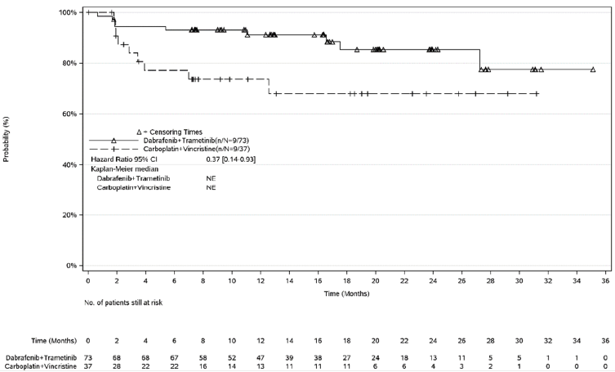
Source: Figure 2.5-1, p82 of the submission.
CI = confidence interval; NE = not estimable; PFS = progression free survival; RANO = response assessment in neuro-oncology
  - The submission stated that OS data were immature at the data cut off with no deaths in the D+T arm and one death in the C+V arm. The submission stated that as patients in the C+V arm who experienced disease progression were able to crossover to D+T, this may have biased the OS against D+T. This was unlikely given the low mortality in the trial and the generally low short-term mortality associated with LGG. The 5-year survival rate for patients with LGG is above 90% and the 10-year survival rate is approximately 85% to 90% (Ryall 2020; Bennet 2020).
  - At the primary analysis, OS was not statistically significantly different at the time of this primary analysis between the two arms (1 sided log rank p value 0.065).
  - A copy of the final CSR (dated 28-Sep-2023) was provided with the PSCR. The final CSR (based on a median follow-up of 39.0 months) reported there were no deaths in the period between the primary analysis and the final analysis in either arm.
  - OS results for the LGG cohort of G2201 are presented in Table 6.
Table 6: Overall survival: LGG cohort of G2201
 | D+T  (N = 73) | C+V  (N = 37) | Hazard ratio (95% CI),  1-sided p-value
OS events, n (%) | 0 (0) | 1 (2.7) | NE
Number censored, n (%) | 73 (100) | 36 (97.3) | NE
6 month OS (95% CI) | 100.0 | 100.0 | NE
12 month OS (95% CI) | 100.0 | 96.3 (76.5, 99.5) | NE
18 month OS (95% CI) | 100.0 | 96.3 (76.5, 99.5) | NE
24 month OS (95% CI) | 100.0 | 96.3 (76.5, 99.5) | NE
30 month OS (95% CI) | 100.0 | 96.3 (76.5, 99.5) | NE
Source: Table 14.2-3.4L, p626 of G2201 LGG CSR.
C+V = carboplatin + vincristine; CI = confidence interval; D+T = dabrafenib + trametinib; HR = hazard ratio; NE = not estimable; OS = overall survival
  - Figure 2 presents the KM curve for OS (LGG cohort of G2201).
Figure 2: KM curve for OS (LGG cohort of G2201)
Source: Figure 2.5-3, p86 of the submission.
CI = confidence interval; LGG = low-grade glioma; NE = not estimable; OS = overall survival
  - The LGG cohort of G2201 reported responses from the PROMIS Parent Proxy Global Health Score, in which a higher score indicates a worse quality of life. However, the outcomes were reported by parents and not patients, and results were collected only up until disease progression. The PSCR stated that due to the age of patients (median 9.5 years) and the neurological deficits associated with LGG, parents were best placed to report the patient’s quality of life. For global health scores, improvement was shown at most weeks for the D+T arm (global health score least square mean increased from 43.445 at baseline to 46.019 at Week 32) compared with worsening scores at most weeks for the C+V arm (global health score least square mean decreased from 40.176 at baseline to 38.880 at Week 32). Pain scores for both the D+T arm (Week 5: 50.32; Week 32: 49.15) and C+V (Week 5: 51.32; Week 32: 49.25) remained generally stable across the trial from Week 5 to 32. Fatigue scores in the D+T arm remained stable throughout the trial from Week 5 (53.61) to Week 32 (52.99). However, in the C+V arm, fatigue scores worsened from Week 5 (55.89) to Week 32 (57.49). It was unclear how meaningful this difference was.
  - The number of responders to the PROMIS Global Health score was small, with only 48/73 (65.7%) of patients randomised to D+T and 16/37 (43.2%) of patients randomised to C+V providing any responses at baseline, with subsequently fewer patients at each time point for C+V, which potentially increased attrition bias. Further, the proxy nature of responses and the open label nature of the LGG cohort in G2201 likely introduced significant bias into patient reported outcomes. Moreover, the results did not inform the incremental benefit (if any) between patients who were progression free and patients with progressed disease as the collection of quality of life data continued only until disease progression. The PSCR, noting that many of the symptoms of LGG including persistent headache, nausea, vomiting and visual disturbances are caused by the presence of and progression of a brain tumour, stated that it would be highly likely that quality of life parameters would be worse following disease progression. Therefore, D+T would improve patient’s quality of life by extending PFS compared with C+V.

HGG
G2201 results
  - In the HGG cohort of G2201, at the time of the data cut (median follow-up 25.1 months), 56.1% (23/41) of the patients treated with D+T achieved ORR by independent review and 58.5% (24/41) achieved ORR by investigator assessment. The CBR, defined as achievement of CR, PR or SD, was 65.9% determined by independent review and 73.2%; determined by investigator assessment. A copy of the final CSR (dated 28-Sep-2023) was provided with the PSCR. The ORR results reported in the final CSR (based on a median follow-up of 45.2 months) were similar to those reported in the submission (56.1% of the patients treated with D+T achieved ORR by independent review and 61.0% achieved ORR by investigator assessment. CBR was 75.6%; determined by investigator assessment).
  - ORR in the HGG cohort of G2201 is presented Table 7.
Table 7: ORR using RANO criteria (HGG cohort of G2201)
Best overall response | Independent review | Investigator assessment
 | N = 41 | N = 41
Complete response (CR), n (%) | 12 (29.3) | 10 (24.4)
Partial response (PR), n (%) | 11 (26.8) | 14 (34.1)
Stable disease (SD), n (%) | 5 (12.2) | 7 (17.1)
Progressive disease (PD), n (%) | 10 (24.4) | 9 (22.0)
Unknown (UNK), n (%) | 3 (7.3) | 1 (2.4)
Overall response rate (ORR: CR+PR), n (%) | 23 (56.1) | 24 (58.5)
95% CI | 39.7, 71.5 | 42.1, 73.7
Clinical benefit rate (CBR: CR+PR+SD), n (%) | 27 (65.9) | 30 (73.2)
95% CI | 49.4, 79.9 | 57.1, 85.8
Source: Table 2(a).5-1, p117 of the submission.
CI = confidence interval; NA = not applicable; RANO = response assessment in neuro-oncology
  - At the data cut for primary endpoint analysis (median follow-up 25.1 months), the median PFS was 9.0 months (95% CI: 5.3, 24.0) by independent review and 17.1 months (95% CI: 12.5, NE) by investigator assessment. A copy of the final CSR (dated 28-Sep-2023) was provided with the PSCR. The final CSR (based on a median follow-up of 45.2 months) reported that the median PFS by independent review of 9.0 months and by investigator review of 24.0 months.
  - Table 8 presents the PFS results for the HGG cohort of G2201.

Table 8: Kaplan-Meier estimates of PFS by RANO criteria in the HGG cohort of G2201
 | Independent review | Investigator assessment
 | N = 41 | N = 41
No. of PFS events, n (%) | 24 (58.5) | 20 (48.8)
Progression, n (%) | 21 (51.2) | 19 (46.3)
Death, n (%) | 3 (7.3) | 1 (2.4)
No. censored, n (%) | 17 (41.5) | 21 (51.2)
Percentiles for PFS, months (95% CI)
25th | 3.6 (1.7, 7.2) | 5.4 (1.6, 12.6)
50th | 9.0 (5.3, 24.0) | 17.1 (12.5, NE)
75th | NE (12.6, NE) | 28.5 (24.0, NE)
Kaplan-Meier event-free estimates (95% CI)
6 months | 66.8 (49.6, 79.2) | 72.7 (56.1, 83.9)
12 months | 44.1 (27.8, 59.3) | 67.4 (50.5, 79.7)
18 months | 40.1 (23.9, 55.8) | 49.8 (31.7, 65.6)
24 months | 34.4 (17.9, 51.6) | 49.8 (31.7, 65.6)
30 months | 27.5 (11.4, 46.5) | 21.4 (1.9, 54.9)
36 months | 27.5 (11.4, 46.5) | 21.4 (1.9, 54.9)
Source: Table 2(a).5.4, p179 of the submission.
CI = confidence interval; NE = not estimable; PFS = progression free survival; RANO = response assessment in neuro-oncology
  - Figure 3 presents the KM curve of PFS the HGG cohort of G2201.
Figure 3: Kaplan-Meier plots for PFS by independent review (A) or investigator assessment (B), HGG cohort of G2201
A Independent review
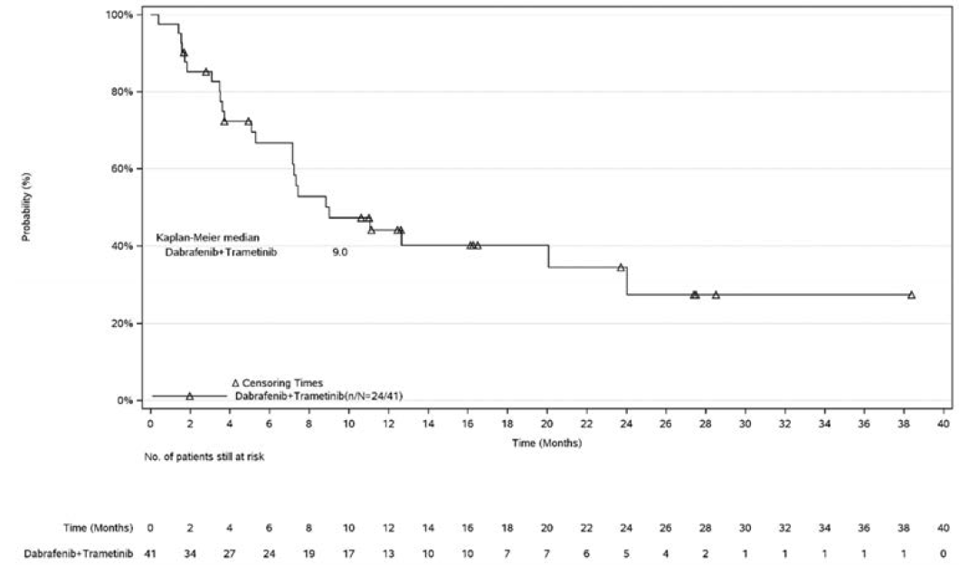
B Investigator assessment
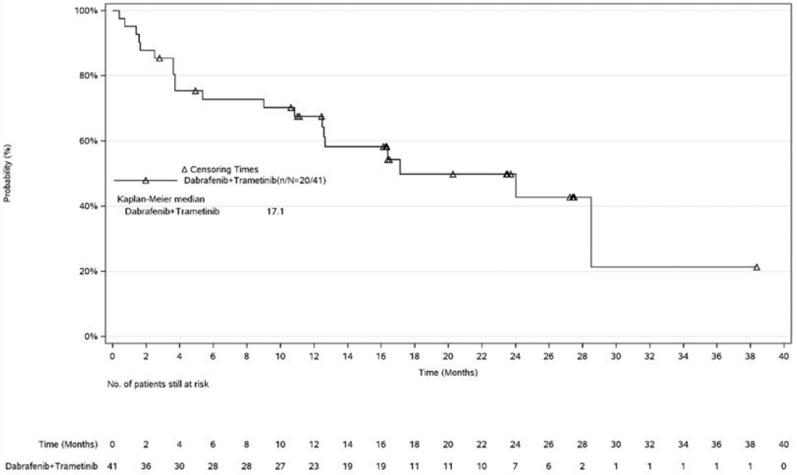
Source: Figure 2(a).5-1, p180 of the submission.
PFS = progression -free survival

  - At the data cut, 65.9% (27/41) of patients were censored and alive. The estimated survival rate was 76.3% at 12 months, 58.6% at 24 months, and 39.1% at 36 months. A copy of the final CSR (dated 28-Sep-2023) was provided with the PSCR. The final CSR (based on a median follow-up of 45.2 months) reported that the median OS was not evaluable. The CSR reported that of the 41 treated patients, 17 (41.5%) patients died, and 24 (58.5%) patients were censored.
Table 9: Kaplan-Meier estimates of OS in the HGG cohort of G2201
 | All patients
 | N = 41
No. of deaths, n (%) | 14 (34.1)
No. censored, n (%) | 27 (65.9)
Percentiles for OS, months (95% CI)
25th | 14.3 (5.5, 23.8)
50th | 32.8 (19.2, NE)
75th | NE (32.8, NE)
Kaplan-Meier estimates (95% CI)
6 months | 87.3 (72.0, 94.5)
12 months | 76.3 (59.3, 86.9)
18 months | 69.1 (50.6, 81.8)
24 months | 58.6 (37.6, 74.7)
30 months | 58.6 (37.6, 74.7)
36 months | 39.1 (9.5, 68.7)
Source: Table 2(a).5.5, p181 of the submission.
CI = confidence interval; NE = not estimable; OS = overall survival
  - Figure 4 presents the KM results for OS in the HGG cohort of G2201.
Figure 4: Kaplan-Meier plot for OS in the HGG cohort of G2201
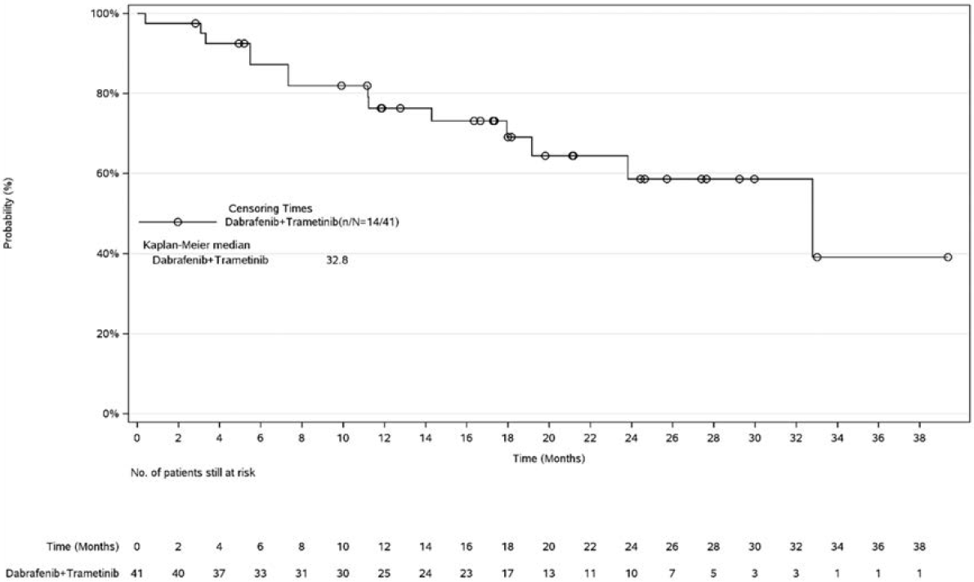
Source: Figure 2(a).5-2, p181 of the submission.
OS = overall survival
Chemotherapy study results
  - The base case analyses for the unanchored indirect comparisons between D+T (G2201) and chemotherapy for ORR are informed by the following studies:
- Independent review: Lashford 2002 (temozolomide), Warwick 2013 (pemetrexed) and Beaty 2010 (oxaliplatin); and
- Investigator assessment: Nicholson 2007 (temozolomide) and Verschuur 2004 (temozolomide).
  - The other chemotherapy studies were only included in sensitivity analyses because they either did not require changes to be sustained for at least 4 weeks, or there were additional criteria for response or no definition of tumour response. Further, the criteria used to assess response differed in each study and may not be comparable between studies, though this likely biased against D+T which was the only trial known to have been assessed using the RANO-HGG criteria.
  - The ORR results of the individual chemotherapy studies as well as the pooled results of the base case and sensitivity analysis are presented in Table 10.
  - In the submission base case of ORR by independent review, the ORR in the individual studies ranged from 0% in Warwick 2013 and Beaty 2010 to 12.0% in Lashford 2002, with an overall pooled ORR of 6.7%. For the base case analysis by investigator assessment, the ORR in the individual studies ranged from 4.3% in Nicholson 2007 to 20.0% in Verschuur 2004, with an overall pooled ORR of 11.6%.
  - For the sensitivity analysis (with more comparator studies included) of ORR by independent review, the ORR in the individual studies ranged from 0% in Warwick 2013 and Beaty 2010 to 21.4% in Chamberlain 1997, with an overall pooled ORR of 11.2%. For the sensitivity analysis by investigator assessment, the ORR in the individual studies ranged from 0% in Gaynon 1990, Gururangan 2010, McCowage 1998 and Ruggiero 2006 to 60.0% in Turner 2002, with an overall pooled ORR of 9.1%.
Table 10: Comparison of ORR reported in chemotherapy studies
 | Independent review |  | Investigator assessment
 | N | ORR - n (%) | N | ORR - n (%)
Base case
Lashford 2002 | 25 | 3 (12.0) | - | -
Warwick 2013 | 10 | 0 | - | -
Beaty 2010 | 10 | 0 | - | -
Nicholson 2007 | - | - | 23 | 1 (4.3)
Verschuur 2004 | - | - | 20 | 4 (20.0)
Pooled responses | 45 | 3 (6.7) | 43 | 5 (11.6)
Additional studies included in sensitivity analysis
Chamberlain 1997 | 14 | 3 (21.4) | - | -
Kobrinsky 1999 | 30 | 4 (13.3) | 41 | 4 (9.7)
Ruggiero 2006 | - | - | 24 | 0
Hurwitz 2001 | - | - | 13 | 1 (7.7)
Gaynon 1990 | - | - | 15 | 0
Gururangan 2010 | - | - | 18 | 0
Narayana 2010 | - | - | 12 | 2 (16.7)
Turner 2002 | - | - | 5 | 3 (60.0)
Wagner 2008 | - | - | 5 | 0
Wagner 2004 | - | - | 6 | 2 (33.3)
Friedman 1992 | - | - | 19 | 2 (10.5)
McCowage 1998 | - | - | 7 | 0
Pooled responses | 89 | 10 (11.2) | 208 | 19 (9.1)
Source: Table 2(a).6-2, p230 of the submission.
ORR = overall response rate
  - Overall, while the majority of ORR results from the comparator studies were inferior to those of G2201, (except for Turner 2002), there was substantial variation across the base case studies (ORR range: 4.3% - 20%) and extreme variation in the sensitivity analysis studies (ORR range: 0% - 60%). It was unclear what would constitute a plausible ORR associated with chemotherapy treatment in this population, noting that the sample sizes were small in the studies which reported the highest ORR.
  - The submission noted that four of the included chemotherapy studies reported PFS, but only Narayana 2010 and Verschuur 2004 presented KM curves for PFS (Gururangan 2010 and Ruggiero 2006 presented PFS as descriptive statistics). The PFS from both Narayana 2010 and Verschuur 2004 were assessed by study investigators. The PFS curves were pooled for an unanchored indirect comparison with the PFS curves of G2201 by investigator assessment (see Figure 5 below).
  - Table 11 presents the PFS results in the chemotherapy studies.
Table 11: PFS reported in all chemotherapy studies
Trial | Kaplan-Meier curve available | Evaluable patients | Median PFS (months) | 6-month PFS,  % (95% CI)
Bevacizumab + irinotecan
Gururangan 2010 | N | 18 | 4.2 | 41.8 (22.8, 76.6)
Narayana 2010 | Y | 12 | 2.25 | 18
Temozolomide
Ruggiero 2006 | N | 24 | 3 | 33.0 (23.4, 42.6)
Verschuur 2004 | Y | 20 | 2.0 | 20.3 *
Source: Table 2(a).6-3, p233 of the submission.
CI = confidence interval; N = no; PFS = progression free survival; Y = yes.
* Estimated from Kaplan-Meier curves
  - These estimates should be considered highly uncertain as the included chemotherapy studies had unknown prevalence of key prognostic factors (see paragraphs 6.11 and 6.12), and each of the studies had a small evaluable patient population (<25).
  - Table 12 presents the OS results of the chemotherapy studies (where reported). Three chemotherapy studies (Narayana 2010, Verschuur 2004 and Kobrinsky 1999) presented KM curves for OS, which was pooled by the submission to inform an unanchored indirect comparison (see Figure 6 below).
Table 12: OS reported in all chemotherapy studies
Trial | Kaplan-Meier curve available | Evaluable patients | Median OS (months) | 6-month OS, % (95% CI)
Bevacizumab + irinotecan
Narayana 2010 | Y | 12 | 6.25 | 58.3
Temozolomide
Ruggiero 2006 | N | 24 | 4 | 37.5
Verschuur 2004 | Y | 20 | 10 | 69.7 *
Lashford 2002 | N | 25 | 4.7 | NR
Topotecan
Wagner 2004 | N | 14 | 6.0 | 42.9
Etoposide
Kobrinsky 1999 | Y | 20 | 5 * | 33.3 *
Chamberlain 1997 | N | 14 | 5.5 | NR
Source: Table 2(a).6-4, p235 of the submission.
CI = confidence interval; N = no; NR = not reported; OS = overall survival; Y = yes.
* Estimated from Kaplan-Meier curves
Indirect treatment comparison
  - The basis of the evidence for the recurrent, refractory or progressive HGG cohort was an unanchored indirect comparison, where no adjustments have been made for imbalances in the patient populations. As such, the magnitude of the outcomes should be viewed as indicative, and the associated p-values are not informative. As noted by the indirect comparison working group, unanchored comparisons do not take into account between study variation and generate an invalidly narrow level of precision compared with alternative indirect comparison methodologies.
  - The results of the indirect comparison between D+T with the pooled chemotherapy studies for recurrent, refractory or progressive HGG for ORR are presented in Table 13.
Table 13: Indirect (unanchored) comparison between D+T with the pooled chemotherapy studies for recurrent, refractory or progressive HGG: ORR
 | D+T | Pooled chemotherapy | OR (95% CI)* | RR (95% CI)* | RD (95% CI)*
Base case
Independent review | N = 41  23 (56.1) | N = 45  3 (6.7) | 17.89 (4.76, 67.22);  p < 0.0001 | 8.41 (2.73, 25.95);  p = 0.0002 | 0.49 (0.33, 0.66);  p < 0.0001
Investigator assessment | N = 41  24 (58.5) | N = 43  5 (11.6) | 10.73 (3.50, 32.90);  p < 0.0001 | 5.03 (2.12, 11.94);  p = 0.0002 | 0.47 (0.29, 0.65);  p < 0.0001
Sensitivity analysis
Independent review | N = 41  23 (56.1) | N = 89  10 (11.2) | 10.09 (4.10, 24.87);  p < 0.0001 | 4.99 (2.62, 9.50);  p < 0.0001 | 0.45 (0.28, 0.61);  p < 0.0001
Investigator assessment | N = 41  24 (58.5) | N = 208  19 (9.1) | 14.04 (6.44, 30.64);  p < 0.0001 | 6.41 (3.89, 10.57);  p < 0.0001 | 0.49 (0.34, 0.65);  p < 0.0001
Source: Table 2(a).6-6, p239 of the submission
CI = confidence interval; D+T = dabrafenib + trametinib; OR = odds ratio; ORR = overall response rate; RD = risk difference; RR = relative risk
* Calculated using RevMan v5.3 for the purpose of this submission
  - Figure 5 presents a comparison of PFS KM curves by investigator assessment. The KM curve for PFS for chemotherapies was pooled from the KM curves of Narayana 2010 and Verschuur 2004.

Figure 5: PFS KM curves by investigator assessment., comparison of pooled chemotherapy studies and D+T in HGG

Source: Figure 3(a).4-1, p348 of the submission.
Dab = dabrafenib; PFS = progression free survival; Soc = standard of care; Tram = trametinib
  - The submission calculated that treatment with D+T led to a 75% reduction in the risk of disease progression or death compared with chemotherapy (HR = 0.25; 95% CI: 0.14, 0.45; p < 0.001). The submission reported that the KM curves separated at approximately 2 months, with median PFS for D+T at 24.0 months, and for chemotherapy at 2.0 months. These PFS KM curves were used to inform transitions in the economic model. These estimates of median PFS differed from those presented in the trial results and the clinical study report (See Table 8 and Figure 3 above) provided with the submission, in which median PFS by independent review of 9.0 months and by investigator review of 17.1 months were reported. The PSCR stated that the median PFS for D+T was 17.1 months; however, upon further review, the ESC noted that the source document for the calculation of the HR (HGG_PFS_INV.pdf) reported the median PFS by investigator review to be 24.0 months (as stated in the submission and commentary). The PFS results reported in the final CSR (based on a median follow-up of 45.2 months) indicated median PFS by independent review of 9.0 months and by investigator review of 24.0 months. Therefore, it appears that the response provided in the PSCR was incorrect, and the submission applied data corresponding to the final CSR for D+T in the indirect comparison of D+T compared with chemotherapy.

  - The submission stated that the median pooled PFS for chemotherapy (2.0 months) was consistent with that reported in the meta-analysis by Kline 2018 (3.5 months), which included other therapies that are not available for the treatment of HGG through the PBS. It may not be reasonable to claim that a median of 2.0 months was similar to 3.5 months, given this was a 75% increase.
  - The PFS results of the unanchored indirect comparison are presented in Table 14.
Table 14: Unanchored indirect comparison results- PFS
 | D+T | Chemotherapies
 | N = 41 | N = 32
Median PFS (IQR), months | 24.0 (5.4, 28.5)ª | 2.0 (1.7, 4.7)
D+T vs chemotherapies, HR (95% CI)^{b} | 0.25 (0.14, 0.45); p < 0.001
Source: Table 2(a).6-7, p241 of the submission.
CI = confidence interval; D+T = dabrafenib + trametinib; HR = hazard ratio; IQR = interquartile range; PFS = progression free survival
ª These estimates of median PFS sourced from final CSR, Table 11-16 and IQR from the file HGG_PFS_INV.
^{b} The estimated HR was sourced from the file HGG_PFS_INV.
  - The KM curve for OS for chemotherapies was pooled from the KM curves of Narayana 2010, Verschuur 2004 and Kobrinsky 1999. The results compared with the KM curve for D+T are presented in Figure 6.
Figure 6: OS KM curves, comparison of pooled chemotherapy studies and D+T in HGG
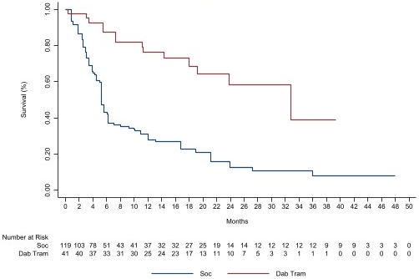
Source: Figure 2(a).6-4, p241 of the submission.
Dab = dabrafenib; Soc = standard of care; Tram = trametinib
  - The submission considered that treatment with D+T led to a 74% reduction in the risk of death compared with chemotherapy (HR = 0.26; 95% CI: 0.15, 0.45; p < 0.001). The Kaplan-Meier curves separated at approximately 2 months, with median OS for D+T at 32.8 months and for chemotherapy at 5.3 months. These OS KM curves were used to inform transitions in the economic model.
  - The OS results of the unanchored indirect comparison are presented in Table 15.
Table 15: OS results of unanchored indirect comparison
 | D+T | Chemotherapies
 | N = 41 | N = 119
Median OS (IQR), months | 32.8 (14.3, NR) | 5.3 (3.1, 16.8)
D+T vs chemotherapies, HR (95% CI) | 0.26 (0.15, 0.45); p < 0.001
Source: Table 2(a).6-8, p242 of the submission.
CI = confidence interval; D+T = dabrafenib + trametinib; HR = hazard ratio; IQR = interquartile range; OS = overall survival
  - Overall, the included evidence suggested that patients treated with D+T had superior PFS and OS outcomes compared to chemotherapy. However, given the nature of the unanchored indirect comparison leading to invalidly narrow levels of precision (see paragraph 6.43) and the transitivity issues of the included studies (see paragraphs 6.10 and 6.11) the estimated magnitude of effect was highly uncertain.

Comparative harms

LGG
  - Table 16 presents a summary of key safety outcomes in the LGG cohort of G2201.
Table 16: Overview of safety outcomes in the LGG cohort of G2201
 | D+T  N = 73 | C+V  N = 33 | RR (95%CI) *  p value | RD (95% CI)  p value
Adverse events | 73 (100.0) | 33 (100.0) | 1.0 (0.96, 1.05); p = 0.73 | 0.00 (-0.04, 0.04); p = 1.00
Grade ≥ 3 AE | 34 (46.6) | 31 (93.9) | 0.50 (0.38, 0.64); p < 0.0001 | -0.47 (-0.61, -0.33); p < 0.0001
Grade ≥ 3 treatment-related | 19 (26.0) | 29 (87.9) | 0.30 (0.20, 0.44); p < 0.0001 | -0.62 (-0.77, -0.47); p < 0.0001
AESIs
All grades
Bleeding events | 20 (27.4) | 4 (12.1) | 2.26 (0.84; 6.09); p = 0.11 | 0.15 (0.00; 0.30); p = 0.048
Hypertension | 0 | 1 (3.0) | 0.15 (0.01; 3.66); p = 0.25 | -0.03 (-0.10; 0.04); p = 0.41
Neutropenia | 18 (24.7) | 27 (81.8) | 0.30 (0.20; 0.46); p < 0.0001 | -0.57 (-0.74; -0.41); p < 0.0001
Pyrexia | 50 (68.5) | 7 (21.2) | 3.23 (1.64; 6.35); p = 0.0007 | 0.47 (0.30; 0.65); p < 0.0001
Skin toxicities | 53 (72.6) | 11 (33.3) | 2.18 (1.32; 3.60); p = 0.0024 | 0.39 (0.20; 0.58); p < 0.0001
Grade ≥3
Neutropenia | 10 (13.7) | 25 (75.8) | 0.18 (0.10; 0.33); p < 0.0001 | -0.62 (-0.79; -0.45); p < 0.0001
Pancreatitis | 1 (1.4) | 0 | 1.38 (0.06; 32.97); p = 0.84 | 0.01 (-0.04; 0.07); p = 0.60
Pyrexia | 6 (8.2) | 1 (3.0) | 2.71 (0.34; 21.64); p = 0.35 | 0.05 (-0.03; 0.14; p = 0.24
Source: Table 2.5-7, p91 of the submission. and Table 3, pp3-4, Appendix 10 to the submission.
AE = adverse event; AESI = adverse event of special interest; C+V = carboplatin + vincristine; CI = confidence interval; D+T = dabrafenib + trametinib; NE = not estimable; OR = odds ratio; RD = risk difference; RR = risk ratio; SAE = serious adverse event
Note: RR and RD were calculated in the submission using version 4.1.2 with Meta package version 4.20-2 (Schwarzer 2015)
  - Overall, the safety results from the LGG cohort of G2201 indicated that D+T was associated with fewer Grade 3 events compared to C+V. However, the treatments generally had different safety profiles with D+T associated with more pyrexia, skin toxicities, and bleeding events whereas C+V was associated with more neutropenia events.

HGG
  - The submission noted that there were limited safety outcomes reported in the included chemotherapy studies for HGG. Furthermore, the follow up times and treatment exposure were vastly different between the studies. The treatment exposure for G2201 (mean: 68.5 weeks; median: 72.7 weeks) was longer compared with the chemotherapy studies (mean: 51.9 weeks; median: 8.0-15.6 weeks).
  - Table 17 presents the unanchored indirect comparison of adverse events between D+T and chemotherapy in recurrent, refractory and progressive HGG.

Table 17: Indirect (unanchored) comparisons in recurrent, refractory and progressive HGG: Grade ≥ 3 safety outcomes
Proportion of patients, n (%) | D+T | Pooled chemotherapy | OR (95% CI) ^ | RR (95% CI) ^ | RD (95% CI) ^
Nausea | N = 41  0 | N = 116  1 (0.9) | 0.93 (0.04, 23.22); p = 0.96 | 0.93 (0.04, 22.35); p = 0.96 | -0.01 (-0.05, 0.03); p = 0.66
Vomiting | N = 41  2 (4.9) | N = 116  3 (2.6) | 1.93 (0.31, 11.99); p = 0.48 | 1.89 (0.33, 10.89); p = 0.48 | 0.02 (-0.05, 0.09); p = 0.53
Diarrhoea | N = 41  1 (2.4) | N = 49  1 (2.0) | 1.20 (0.07, 19.80); p = 0.90 | 1.20 (0.08, 18.52); p = 0.90 | 0.00 (-0.06, 0.07); p = 0.90
Pancreatitis | N = 41  1 (2.4) | N = 18  1 (5.6) | 0.42 (0.03, 7.20); p = 0.55 | 0.44 (0.03, 6.64); p = 0.55 | -0.03 (-0.15, 0.08); p = 0.60
Elevated AST | N = 41  1 (2.4) | N = 89  0 | 6.63 (0.26, 166.27); p = 0.25 | 6.43 (0.27, 154.52); p = 0.25 | 0.02 (-0.03, 0.08); p = 0.41
Elevated ALT | N = 41  1 (2.4) | N = 89  1 (1.1) | 2.20 (0.13, 36.07); p = 0.58 | 2.17 (0.14, 33.85); p = 0.58 | 0.01 (-0.04, 0.07); p = 0.62
Anaemia | N = 41  1 (2.4) | N = 46  7 (15.2) | 0.14 (0.02, 1.19); p = 0.07 | 0.16 (0.02, 1.25); p = 0.08 | -0.13 (-0.24, -0.01); p = 0.03
Leukopenia | N = 41  1 (2.4) | N = 8  2 (25.0) | 0.07 (0.01, 0.96); p = 0.05 | 0.10 (0.01, 0.95); p = 0.05 | -0.23 (-0.53, 0.08); p = 0.15
Neutropenia | N = 41  1 (2.4) | N = 168  41 (24.4) | 0.08 (0.01, 0.58); p = 0.01 | 0.10 (0.01, 0.71); p = 0.02 | -0.22 (-0.30, -0.14); p < 0.0001
Thrombocytopenia | N = 41  0 | N = 300  101 (33.7) | 0.02 (0.00, 0.39); p = 0.009 | 0.04 (0.00, 0.56); p = 0.02 | -0.34 (-0.40, -0.27); p < 0.0001
Cerebral ischaemia | N = 41  0 | N = 18  1 (5.6) | 0.14 (0.01, 3.62); p = 0.24 | 0.15 (0.01, 3.53); p = 0.24 | -0.06 (-0.18, 0.07); p = 0.39
Infection | N = 41  0 | N = 26  3 (11.5) | 0.08 (0.00, 1.63); p = 0.10 | 0.09 (0.00, 1.71); p = 0.11 | -0.12 (-0.25, 0.02); p = 0.08
Source: Table 2(a).6-10, p244 of the submission.
ALT = alanine aminotransferase; AST = aspartate aminotransferase; CI = confidence interval; D+T = dabrafenib plus trametinib; OR = odds ratio; RD = risk difference; RR = relative risk
^ Calculated using RevMan v5.3 for the purpose of this submission
  - Overall, it was difficult to draw meaningful conclusion from the indirect comparison presented given the inconsistent reporting of adverse events across studies, the inclusion of different chemotherapy regimens with different safety profiles that were unweighted by expected proportional use and the differences in follow-up across the studies. The adverse events which reported a p value of 0.05 or lower for the odds ratio (OR) (leukopenia, neutropenia and thrombocytopenia) were used in the economic evaluation.

Benefits/harms

LGG
  - A summary of the comparative benefits and harms for D+T versus C+V is presented in Table 18.
Table 18: Summary of comparative benefits and harms for D+T and C+V
Trial | D+T  n/N | C+V  n/N | RR  (95% CI) | Event rate/100 patients* |  | OR  (95% CI)
 |  |  |  | D+T | C+V | OR  (95% CI)
Benefits
ORR by independent review (CR+PR) | 34/73 | 4/37 | NR | 46.6 | 10.8 | 7.19 (2.3, 22.4);  p < 0.001
Progression free survival (median duration of follow up 18.9 months)
Event | D+T | C+V | Absolute Difference | HR (95% CI)
Progressed, n (%) | 30/73 (41.1) | 22/37 (59.5) | - | 0.31 (0.17, 0.55)  p < 0.001
Median PFS, months (95% CI) | 20.1 (12.8, NE) | 7.4 (3.6, 11.8) | 12.7 | -
% not progressed at 6 months (95% CI) | 87.4 (77.3, 93.3) | 57.9 (38.7, 73.1) | 29.5% | -
% not progressed at 12 months (95% CI) | 66.6 (53.2, 77.0) | 26.1 (9.9, 45.9) | 40.5% | -
% not progressed at 18 months (95% CI) | 50.1 (35.3, 63.1) | 9.8 (0.9, 32.2) | 40.3% | -
% not progressed at 24 months (95% CI) | 37.9 (20.0, 55.8) | NE (NE, NE) | - | -
% not progressed at 30 months (95% CI) | 37.9 (20.0, 55.8) | NE (NE, NE) | - | -
Harms
 | D+T  n/N | C+V  n/N | RR  (95% CI) | Event rate/100 patients* |  | RD  (95% CI)
 |  |  |  | D+T | C+V | RD  (95% CI)
Grade ≥ 3 neutropenia | 10/73 | 25/33 | 0.18 (0.10; 0.33) | 13.7 | 75.8 | -0.62 (-0.79; -0.45)
Bleeding events | 20/73 | 4/33 | 2.26 (0.84; 6.09) | 27.4 | 12.1 | 0.15 (0.00; 0.30)
Skin toxicities | 53/73 | 11/33 | 2.18 (1.32; 3.60);  p = 0.0024 | 72.6 | 33.3 | 0.39 (0.20; 0.58)
Source: Tables 2.5-1, p79 and 2.5-3, p81 of the submission and Table 11-5, pp146-147 and Table 14.2-3.4L, p626 of G2201 CSR.
CI = confidence interval; CR = complete response; C+V = carboplatin + vincristine; D+T = dabrafenib + trametinib; HR = hazard ratio; OR = odds ratio; ORR = overall response rate; OS = overall survival; PFS = progression free survival; PR = partial response; RD = risk difference; RR = risk ratio;
  - On the basis of direct evidence presented by the submission, for every 100 LGG patients treated with D+T in comparison with C+V:
- Approximately 40 additional patients will remain progression-free after 18 months; however, there would be no difference in overall survival with a high survival rate following both treatments.
  - On the basis of the direct evidence presented in the submission, for every 100 LGG patients treated with D+T in comparison with C+V, over a median follow up of 18.9 months:
- Approximately 36 additional patients will achieve an overall response.
- Approximately 62 fewer patients will experience severe neutropenia.
- Approximately 15 additional patients will experience bleeding events.
- Approximately 39 additional patients will experience skin toxicities.

HGG
  - The basis of the evidence in the submission was an unanchored indirect comparison. Therefore, the magnitude of the incremental benefit of D+T could not be quantified. Accordingly, a benefits/harms table has not been presented.

Clinical claim

LGG
  - The submission described D+T as superior in terms of effectiveness and safety compared with C+V in patients aged ≥12 months and <18 years of age with LGG.
  - Overall, the ESC considered that the claim of superior effectiveness was reasonable, and supported by direct RCT evidence which demonstrated an improved tumour response and longer PFS. The results from G2201 did not support any OS benefits or provide any estimates for the magnitude of quality of life benefit from delaying progression of disease. The ESC considered that it would be difficult to demonstrate an OS benefit in LGG due to the high rates of survival (85% to 90% at 10 years) and as crossover was allowed in the G2201 trial.
  - The ESC considered that the submission’s claim of superior safety was not supported. Although D+T resulted in fewer Grade ≥3 AEs, it was associated with increased rates of pyrexia, skin toxicities, and bleeding events compared to C+V. Overall, the ESC considered that D+T had a different, but non inferior, toxicity profile compared to C+V.
  - The PBAC considered that the claim of superior comparative effectiveness was reasonable.
  - The PBAC considered that the claim of superior comparative safety was not adequately supported by the data. The PBAC considered that D+T was non-inferior to C+V in terms of comparative safety.

HGG
  - The submission described D+T as superior in terms of effectiveness and safety compared with chemotherapy in paediatric patients with recurrent, refractory and/or progressive HGG.
  - The ESC considered that the therapeutic conclusion was supported by the consistent superior outcomes in the unanchored indirect comparisons of ORR, PFS and OS between G2201 and the relevant comparator chemotherapy studies. However, the risk of bias associated with single arm studies used for the unanchored indirect comparisons was high. In addition, there was inadequate reporting of key prognostic factors which may have affected transitivity. Consequently, it was unclear if the pooled estimates of ORR, PFS and OS associated with chemotherapy were plausible, and as such the ESC considered that the magnitude of incremental benefit associated with D+T was highly uncertain.
  - The ESC considered that the submission’s claim of superior safety was not assessable as the comparative data presented were of a poor quality and confounded by different lengths of follow-up across the studies, different safety profiles of the various included chemotherapies, and inconsistent reporting of AEs across the studies.
  - The PBAC considered that the claim of superior comparative effectiveness was reasonable, but there was a high risk of bias in the indirect comparisons.
  - The PBAC considered that the claim of superior comparative safety was not adequately supported by the data. The PBAC considered that comparative safety was difficult to assess based on the presented data, however the adverse effect profile of D+T was manageable.

Economic analysis
  - The submission presented two stepped economic evaluations:
- one based on G2201 (LGG cohort) comparing D+T versus C+V in LGG; and
- one based on G2201 (HGG cohort) and the pooled chemotherapy studies comparing D+T versus pooled chemotherapy in HGG.
  - Both were cost utility analyses using a three-state (progression free, progressed disease, death) partitioned survival model. The models were presented in Microsoft Excel.
  - In both models, patients initiated in the progression free state, and transitioned to progressed disease based on extrapolated PFS curves for D+T and the comparator arms. Patients in either the progression free or progressed disease state could transition to the death health state, based on the extrapolated OS curves for D+T and the comparator arms.
  - For both models, the submission also used PFS as a surrogate for assessing time to treatment discontinuation. The submission noted that few patients in G2201 discontinued treatment for reasons other than progressed disease. The ESC noted that the use of PFS as a surrogate for time to treatment discontinuation may underestimate D+T utilisation as patients in clinical practice may not be assessed for progression as frequently as in the clinical trial.
  - Table 19 presents a summary of the two economic evaluations.
Table 19: Summary of model structure, key inputs and rationale
Component | LGG | HGG
Treatments | D+T versus C+V | D+T versus basket of chemotherapies
Outcomes | PFS years and QALYs | LYs and QALYs
Time horizon | 30 years in the base case versus max of 35.3 months (median 18.9 months) of follow-up in G2201 trial. The ESC considered that a time horizon of 30 years was likely reasonable in the LGG setting. | 15 years in the base case versus up to 34 months in G2201 trial (median 25.1 months). The ESC considered that a time horizon of 15 years in the HGG setting was long, particularly considering that the median OS for children with HGG is 14 to 20 months following failure of optimal therapy.
Methods used to generate results | Partitioned survival model | Partitioned survival model
Health states | PFS, PD and dead | PFS, PD and dead
Cycle length | 3 months. Except for medicines, all other costs and outcomes were half cycle corrected. | 3 months. Except for medicines, all other costs and outcomes were half cycle corrected.
Transition probabilities | The Kaplan Meier estimates for PFS were derived directly from the G2201 trial for D+T and C+V. OS estimates were derived from published survival estimates for LGG. PFS also informed time to discontinuation of treatment.  Parametric survival distributions fitted to the observed Kaplan Meier estimate for PFS and OS and were used to derive the transition probabilities to extrapolate beyond the available clinical evidence to the 30-year time horizon. | The Kaplan Meier estimates for PFS and OS were derived directly from the HGG cohort of the G2201 study for D+T and a pooled analysis of published chemotherapy studies (see Figure 5 and Figure 6). PFS also informed time to discontinuation of treatment.  Parametric survival distributions fitted to the observed Kaplan Meier estimates are used to derive the transition probabilities for PFS and OS to extrapolate beyond the available clinical evidence to the 15-year time horizon.
Extrapolation method in base case | D+T PFS extrapolated from G2201 KM data starting at 24 months using an exponential curve.  C+V PFS extrapolated from G2201 starting at 22 months using an exponential curve.  At 24 months, only 7/73 patients in the D+T arm remained at risk of a PFS event. At 22 months, only 1/37 patient in the C+V arm remained at risk of a PFS event. Nonetheless, the chosen truncation points provided more conservative ICER estimates than using earlier truncation points so may be reasonable.  OS (both model arms) extrapolated from Gnekow 2012 starting at 200 months, using exponential curve. | D+T PFS extrapolated from G2201 starting at 20 months using an exponential curve.  Chemotherapy PFS extrapolated from the pooled analysis of two chemotherapy studies starting at 7 months using the generalised gamma curve.  Chemotherapy OS extrapolated from the pooled analysis of three chemotherapy studies using Weibull function starting at 20 months.  D+T OS extrapolated by applying HR from unanchored indirect comparison to extrapolated chemotherapy curve and then extrapolated dependently using the Weibull function starting at 26 months.
Health related quality of life | PFS (0.89) and PD (0.73) curves sourced from Garside 2007. TEAE disutilities applied. A disutility of 0.08 applied to PD to account for caregiver disutility. Caregiver disutility was excluded in the evaluation base case. | PFS (0.81) and PD (0.70) from Vera 2017. TEAE disutilities applied. No caregiver disutility applied.
Source: Table 3.1.1, p271 and Table 3(a).1.1, p340 of the submission.
C+V = carboplatin + vincristine; D+T = dabrafenib + trametinib; ICER = incremental cost effectiveness ratio; LYs: Life-years; OS: Overall survival; PD: progressive disease; PFS: progression free survival; QALYs: Quality adjusted life years; TEAE = treatment emergent adverse events

LGG
  - The extrapolation of PFS was a key area of uncertainty and driver of the LGG economic model. The submission tested whether an assumption of proportional hazards held by plotting the log(-log(S)) versus log(time) as well as Cox-Snell and Schoenfeld residuals. Based on the results of these tests, the submission concluded that the proportional hazards assumption may not hold, and the submission extrapolated PFS using independent parametric survival models. Setting the model to extrapolate PFS using dependently fitted curves had very little impact on the ICER.
  - The parametric curves fitted to the D+T and C+V arms of the LGG cohort of G2201 are presented in Figure 7.
Figure 7: Observed versus predicted PFS using single-fit independent models for D+T (A) and C+V (B) in LGG model
A | 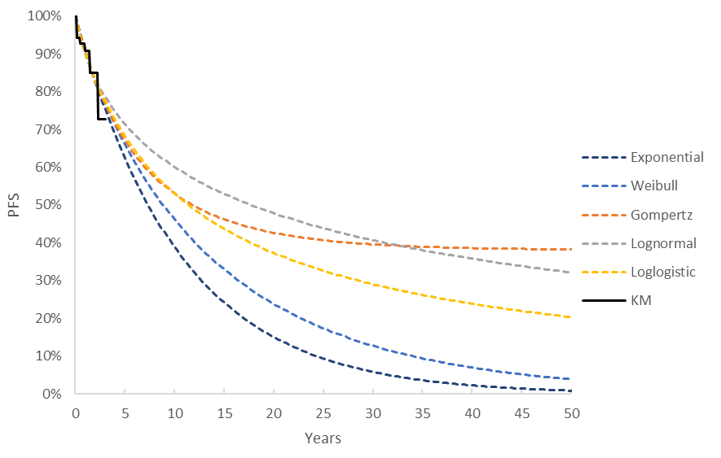
B | 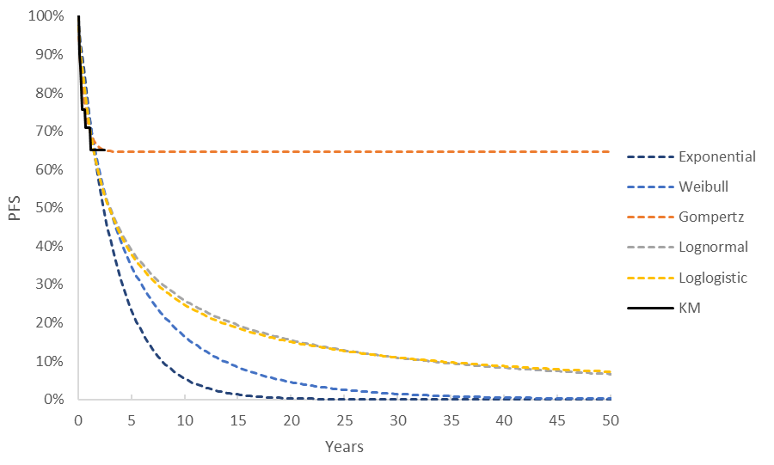

Source: Figure 3.4-3, p300 of the submission.
PFS = progression free survival
  - The submission considered that, based on the visual fit, the exponential distribution was aligned with Kaplan Meier data for D+T and was chosen for the extrapolation function in the base case. For C+V, while the Akaike information criterion (AIC) and Bayesian information criterion (BIC) statistics suggested that the Gompertz function had the best fit, this was rejected due to the implausibility of a plateau in PFS. Instead, the exponential function was chosen based on visual fit for C+V. The evaluation considered this was not reasonable. Based on visual inspection alone, all distributions were aligned with the KM data which was reasonably supported by the small differences in AIC and BIC between different functional forms. It may have been more appropriate to use the lognormal function, which was the second-best fitting function for C+V extrapolation based on the combined AIC and BIC. The pre-PBAC response stated there was no clinically plausible reason for selecting the lognormal function over the statistically best fitting exponential function, and use of the lognormal function resulted in the modelled C+V PFS curve crossing the modelled D+T PFS curve between approximately 12 and 15 years which it considered to be inconsistent with the PFS data from the G2201 study.
  - OS curves were also extrapolated, but it was assumed that there was no difference between treatments. The commentary considered this was reasonable and consistent with results from the LGG cohort of G2201 which did not demonstrate a survival benefit for D+T. Figure 8 presents the modelled PFS and OS over the 30-year time horizon in the LGG model.
Figure 8: Overall and Progression Free Survival (LGG model)
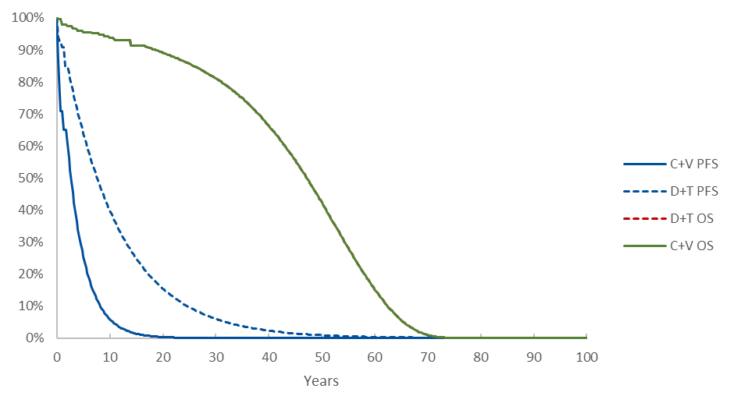
Source: ‘Results’ worksheet of LGG economic evaluation with the error “D$13” corrected to “$D13” in Column AC of the “Trace C+V” work sheet”
C+V = carboplatin + vincristine; D+T = dabrafenib + trametinib; OS = overall survival; PFS = progression free survival
Note: D+T OS does not appear as D+T and C+V OS are identical and completely overlapping.

  - Given the relatively high long-term survival of LGG patients, the ESC considered that a 30-year time horizon was likely reasonable. Appropriately, the model did not assume a survival benefit associated with treatment. However, the modelling of PFS, and the translation of PFS and PD into valid estimates of health state utility were highly uncertain due to the comparatively short follow-up in the LGG cohort of G2201 (median follow up = 18.9 months) and the concerns around the sources used for utility estimates.
  - Given that no survival benefit is modelled, the ESC noted that the utility values were critical to modelling benefit. The submission’s base case utility estimates were based on Garside 2007. Garside 2007 obtained utilities in HGG using the standard gamble technique from the NHS Value of Health Panel (VoHP), a select group of 93 members who were familiarised with the standard gamble method for preference elicitation and who expressed their preference for short descriptions of health states. Health state scenarios were developed based on a study by Osoba (1997) using the EORTC QLQ. As such, it is unclear to what extent the results from Garside 2007 appropriately captured the preferences for QOL for the proposed paediatric LGG population, and therefore these results may not be appropriate for use in the economic model.
  - A sensitivity analysis based on utilities from Vera 2018 was performed by the submission. Vera 2018 was a cross-sectional study of 100 patients (mean age: 50 years) with malignant glioma, of which 78% were diagnosed with grade IV glioma and 38% of patients had tumour recurrence. Therefore, similar to Garside 2007, the utilities from Vera 2018 may not be appropriate to capture the QOL implications in the paediatric LGG setting.
  - The PSCR stated that there were no published utility data for children with LGG and presented a comparison of the Garside 2007 values with utility values for children with other types of cancer. The PSCR stated that as the utility values reported in Garside 2007 were broadly consistent with those reported in other types of cancer, Garside 2007 was an acceptable proxy for the utility of children with LGG. The ESC considered that it may have been more appropriate to map the PROMIS scores collected in the trial to either the EQ-5D or HUI3 utility measures for use in the progression free health state. Alternatively, the ESC suggested that utility values for children with other forms of brain tumours might be available and might be more relevant, noting that the comparison presented in the PSCR included two publications from Barr (1999 and 2000) that assessed utilities in children who were CNS tumour survivors and neuroblastoma survivors respectively. Additionally, the ESC noted a meta-analysis of health utilities in paediatric cancer patients (Chen 2022) that included results for patients with brain tumours. The ESC considered that if it was not reasonable to apply alternative utility estimates as discussed in this paragraph, it may be appropriate to apply the more conservative utilities from Vera 2018 in the economic evaluations of LGG (which was consistent with the inputs used by the submission for HGG).
  - Overall, although disease progression was likely to be associated with increased morbidity and consequently reduced quality of life, it was unclear that the modelled decrement from 0.89 in the progression free state to 0.73 in the progressed disease state from Garside 2007 (or 0.81 to 0.70 in Vera 2018) would reflect a plausible decrement in paediatric LGG. The utility benefit remains a source of uncertainty in the LGG economic model. The PSCR noted that in the comparison between Garside 2007 and the utility data in children with other types of cancer, the decrements between the progression free and progressed disease health state utilities ranged from 0.08 to 0.18. The PSCR noted that these were not dissimilar to the decrements in Garside 2007 of 0.16 and Vera 2018 of 0.11. The ESC noted that the decrement in Barr (1999), which assessed CNS tumour survivors, was 0.08 (progression free = 0.89; progressed disease = 0.81).
  - The submission noted that parents experience significant stress, poorer mental and physical health whilst dealing with such a life-altering diagnosis for their child. The impact on parents is exacerbated by the presence or progression of symptoms described above (see paragraph 4.1) as well as co-morbidities such as multiple endocrine disorders, obesity, growth hormone deficiency and hypothyroidism. The submission considered that whilst the impact of progressed disease is not directly proportional to the impact on parents, it is used as a proxy to capture the impact in the CUA.
  - The submission therefore included additional caregiver disutilities in the base case of the LGG model, with a disutility of -0.08 (sourced from Wittenberg 2019), applied each year to patients who are alive with progressed disease, resulting in a net caregiver utility loss of -0.27 for D+T patients and -0.59 for C+V patients over the entire model horizon. This approach was not appropriate, favoured D+T and was not consistent with Section 3A.1.4 of the PBAC Guidelines for preparing a submission to the Pharmaceutical Benefits Advisory Committee v5.0 which state that relevant outcomes which are broader than the treated patient population (including caregivers) should be included as supplementary analyses. A revised base case has been adopted during the evaluation with caregiver disutilities removed. Although the PSCR reiterated that caregiver disutilities should be applied in the base case model, the ESC considered that the approach of including them as a sensitivity analysis was appropriate.
  - The ESC also noted that costs associated with disease monitoring and follow-up were only applied for the first 10 years of the model. The ESC stated that it was unclear why these costs would not continue to be accrued until the end of the model.
  - During the evaluation, an error was found in the economic model. The result of this error was that the submission did not discount C+V progression free life-years when converting to progression free QALYs, leading to an overestimation of QALYs gained in the C+V arm. Correcting this error resulted in a substantial decrease in the incremental cost-effectiveness ratio (ICER) from $355,000 to < $455,000per QALY in the submission base case compared to $255,000 to < $355,000per QALY after correction (or $355,000 to < $455,000per QALY with caregiver disutilities removed).
  - Table 20 presents the key drivers of the LGG model.
Table 20: Key drivers of the LGG model (evaluation base case)
Description | Method/Value | Impact  Base case: $|¹ per QALY gained
PFS extrapolation for C+V | C+V PFS extrapolated from G2201 starting at 22 months using an exponential curve | High, favoured D+T.  Use of lognormal curves for C+V (the second best fitting curve based on AIC and BIC, without a plateau) increased the ICER by ||||% to $||||² per QALY gained
Health state utilities | PF (0.89) and PD (0.73) health state utilities sourced from Garside 2007. Caregiver disutility was excluded in the evaluation base case. | High, uncertain, but likely favours D+T.  Use of the health state utilities from Vera 2018 increased the ICER by ||||% to $|||| ³ per QALY gained.
Source: Table 3.9-1, p332 of the submission and LGG economic evaluation with the typo “D$13” corrected to “$D13” in Column AC of the “Trace C+V” work sheet”
AIC = Akaike information criterion; BIC = Bayesian information criterion; C+V = carboplatin + vincristine; D+T = dabrafenib + trametinib; ICER = incremental cost-effectiveness ratio; KM = Kaplan Meier; PD = progressed disease; PF = progression free; QALY = quality adjusted life year
The redacted values correspond to the following ranges:
¹ $355,000 to < $455,000
² $655,000 to < $755,000
³ $455,000 to < $555,000
  - Table 21 presents the results of the economic evaluation for LGG. Step 4A reflects the submission base case with the discounting error corrected. Step 4B reflects the evaluation base case with caregiver disutility removed.
Table 21: Results of the stepped economic evaluation for LGG
Step and component | D+T | C+V | Increment
Step 1: study-based costs and outcomes
Costs | $| | $9,726 | $|
Progression free life year gained | 2.22 | 1.73 | 0.49
Incremental cost/extra PFLY gained |  |  | $|¹
Step 2: extrapolated to 30 years
Costs | $| | $9,726 | $|
Progression free life year gained | 7.17 | 3.08 | 4.09
Incremental cost/extra PFLY gained |  |  | $|²
Step 3: extrapolated to 30 years including all resource use
Costs | $| | $39,081 | $|
Progression free life year gained | 7.17 | 3.08 | 4.09
Incremental cost/extra PFLY gained |  |  | $|³
Step 4A: extrapolated to 30 years incl. all resource use and transformed QALYs (including caregiver disutility) – calculation error corrected during evaluation
Costs | $| | $39,081 | $|
QALYs | 11.79 | 10.62 | 1.17
Incremental cost/extra QALYs gained |  |  | $|⁴
Step 4B: Alternative base case – calculation error corrected and caregiver disutility removed during evaluation
Costs | $| | $39,081 | $|
QALYs | 12.06 | 11.21 | 0.85
Incremental cost/extra QALYs gained |  |  | $|⁵
Source: Table 3.8-1, p329 of the submission. LGG economic evaluation with the typo “D$13” corrected to “$D13” in Column AC of the “Trace C+V” work sheet”
PFLY = progression free life-year; QALY = quality-adjusted life year
The redacted values correspond to the following ranges:
¹ $155,000 to < $255,000
² $55,000 to < $75,000
³ $75,000 to < $95,000
⁴ $255,000 to < $355,000
⁵ $355,000 to < $455,000
  - Table 22 presents the undiscounted disaggregated health outcomes in the LGG economic evaluation.
Table 22: Disaggregated summary of health outcomes included in the LGG economic evaluation (undiscounted)
 | D+T | C+V | Incremental | % of total incremental
Submission base case
PFS | 9.00 | 3.14 | 5.87 | 357%
PD | 12.57 | 17.41 | -4.84 | -294%
Caregiver disutility | -0.35 | -0.75 | 0.40 | 24%
TEAEs | -0.04 | -0.25 | 0.21 | 13%
Total QALYs | 21.19 | 19.55 | 1.64 | 100%
Life years:
PFS | 10.15 | 3.53 | 6.61 | No LY increment
PD | 17.19 | 23.80 | -6.61 | No LY increment
Total: | 27.34 | 27.34 | 0 | No LY increment
Evaluation alternative base case (caregiver disutility removed)
PFS | 9.0 | 3.14 | 5.87 | 472%
PD | 12.57 | 17.41 | -4.84 | -389%
TEAEs | -0.04 | -0.25 | 0.21 | 17%
Total QALYs | 21.54 | 20.29 | 1.24 | 100%
Source: Table 3.8-3, p330 of the submission. LGG economic evaluation with the typo “D$13” corrected to “$D13” in Column AC of the “Trace C+V” work sheet”
C+V = carboplatin + vincristine; D+T = dabrafenib and trametinib; LY = life years, PD = progressed disease, PFS = progression free survival, QALY = quality adjusted life years; TEAE = treatment emergent adverse event
  - In both the submission base case and the evaluation base case, the model estimates no increment in life years gained. However, the model estimates that patients treated with D+T will spend an additional 6.61 years in the progression free health state. This was uncertain given the difference in median PFS (independent assessment) in G2201 was only 12.7 months (20.1 months for D+T and 7.4 months for C+V).
  - The results of key sensitivity analyses of the LGG economic model based on the evaluation corrected base case are summarised in Table 23.
Table 23: Results of evaluation alternative base case sensitivity analyses (corrected spreadsheet for LGG model)
 | Incremental costs ($) | Incremental outcomes | ICER | % Change
Base-case | | | 0.85 | ||||¹ | -
Time horizon (base case = 30 years) and discounting (base case = 5%)
Discount rate 3.5% | | | 0.94 | ||¹ | ||
Discount rate 0% | | | 1.24 | ||¹ | ||
Time horizon 25 years | | | 0.83 | ||¹ | ||
Time horizon 35 years | | | 0.86 | ||¹ | ||
Utilities (Base case = PF (0.89) and PD (0.73) curves sourced from Garside 2007)
PF: 0.81 Vera 2018 | | | 0.53 | ||² | ||
PD: 0.70 Vera 2018 | | | 0.98 | ||³ | -|||
PF and PD Vera 2018 | | | 0.66 | ||⁴ | ||
PF = 0.89 and PD = 0.81 from Barr 1999 | | | 0.53 | ||² | ||
Including caregiver disutility (base case = not included) | | | 1.17 | ||³ | -|||
Parametric models: D+T (Base case = exponential curve)
PFS: Independent Weibull | | | 0.99 | ||¹ | -|||
PFS: Independent Gompertz | | | 1.23 | ||¹ | -|||
PFS: Independent lognormal | | | 1.33 | ||¹ | -|||
PFS: Independent loglogistic | | | 1.17 | ||¹ | -|||
OS: All functional forms | | | 0.85 | ||¹ | ||
Parametric models: C+V (Base case = exponential curve)
PFS: Independent Weibull | | | 0.68 | ||⁴ | ||
PFS: Independent lognormal | | | 0.48 | ||⁵ | ||
PFS: Independent loglogistic | | | 0.50 | ||⁵ | ||
Evaluation multivariate analyses
C+V and D+T PFS independent Weibull | | | 0.82 | ||⁴ | ||
C+V and D+T PFS independent Lognormal | | | 0.96 | ||⁴ | ||
AEMP of D+T (base case DAB: 75 mg = $||||, 50 mg = $||||; TRAM: 500 mcg = $||||; 2 mg = $||||)
AEMPs as per those in melanoma (DAB: 75 mg = $1,511.19, 50 mg = $||||; TRAM: 500 mcg = $||||, 2 mg = $||||) | $| | 0.85 | ||³ | -|||
ESC Multivariate Sensitivity Analysis (MSA)
1. Utilities from Vera 2018 (PF=0.81, PD=0.70);  2. PFS Extrapolation C+V and D+T independent lognormal;  3. AEMPs as per those in melanoma (DAB: 75 mg = $1,511.19, 50 mg = $||||; TRAM: 500 mcg = $||||, 2 mg = $||||) | | | 0.74 | $||||⁴ | ||
Pre-PBAC response (in corrected model)ª
Including caregiver disutilities  1. Utilities from Vera 2018 (PF=0.81, PD=0.70);  2. AEMPs as per those in melanoma (DAB: 75 mg = $||||, 50 mg = $||||; TRAM: 500 mcg = $||||, 2 mg = $||||)  3. Caregivers disutilities included  Pre-PBAC response did not accept ESC advice on extrapolation. | | | 0.98 | ||||^{6b} | -|||
Excluding caregiver disutilities  1. Utilities from Vera 2018 (PF=0.81, PD=0.70);  2. AEMPs as per those in melanoma (DAB: 75 mg = $||||, 50 mg = $||||; TRAM: 500 mcg = $||||, 2 mg = $||||)  3. Caregivers disutilities excluded  Pre-PBAC response did not accept ESC advice on extrapolation. | | | 0.66 | ||||^{1c} | -|||
a. Results generated with corrected model provided with PSCR. b. Differs from result provided in pre-PBAC response model ($| |); c. Differs from result provided in pre-PBAC response model ($| |)
Source: Table 3.9-1 of submission and LGG model with typo “D$13” corrected to “$D13” in Column AC of “Trace C+V” work sheet”
D+T = dabrafenib and trametinib; C+V = carboplatin and vincristine; ICER = incremental cost effectiveness ratio; MBS = Medicare benefits scheme; PFS = progression free survival; OS = overall survival
The redacted values correspond to the following ranges:
¹ $355,000 to < $455,000
² $555,000 to < $655,000
³ $255,000 to < $355,000
⁴ $455,000 to < $555,000⁵ $655,000 to < $755,000
⁶ $155,000 to < $255,000
  - The ESC noted that the model was most sensitive to the choice of parametric function applied to the C+V arm and the choice of utility values applied. The ESC noted that a multivariate sensitivity analysis which applied utility values from Vera 2018, independent lognormal extrapolations to the D+T and C+V PFS arms and the prices of D+T from the melanoma setting increased the ICER by 28% to $455,000 to < $555,000per QALY gained.
  - A revised analysis was presented in the pre-PBAC response, in which the LGG model was updated based on the utility values in Vera et al 2018. The response stated that the submission provided a simplified model for LGG, that does not account for quality of life impacts and costs of treating lifelong sequalae of LGG. The response suggested the model was conservative, and it was likely that a more complex model that accounted for sequalae such as epilepsy, blindness or hearing loss would lower the ICER. The pre-PBAC response advocated for inclusion of caregiver disutility in the base case analysis, on the basis that LGG impacts a child’s ability to independently undertake activities of daily living and significantly impacts cognitive and physical functioning.

HGG
  - As previously discussed in paragraph 6.66, the evidence base for HGG was an unanchored indirect comparison in which the included trials may have had transitivity issues and the magnitude of benefit was uncertain. Of the 17 identified chemotherapy studies, only two studies (total of 32 patients) reported PFS KM curves and only three studies (total of 119 patients) reported OS KM curves. These curves were key inputs in the HGG economic model.
  - In the HGG model, similar to the LGG model, different parametric forms were fitted to the OS and PFS KM curves. For HGG, the submission considered that the assumption of proportional hazards did not hold, therefore D+T and C+V PFS KM curves were extrapolated separately. The submission assessed whether the proportional hazards assumption holds by plotting the log(-log(S)) versus log(time), Cox-Snell and Schoenfeld residuals. The submission noted that though the plot of the log(-log(S)) versus log(time) shows the curves for D+T and pooled chemotherapy did not cross and remained parallel, the Cox-Snell residual plot suggested that there may be some violation of the proportional hazards assumption. The submission also noted that the plot of the Schoenfeld residuals suggested that the proportional hazards assumption may be violated as it was not centred around zero. The submission therefore concluded that proportional hazards did not hold and that PFS should be modelled independently in each of the arms. The commentary considered this was reasonable.
  - However, the submission considered that there was no evidence that proportional hazards for OS was violated therefore OS was extrapolated using dependent parametric survival models. The submission considered that the plot of the log(-log(S)) versus log(time) suggests that there is no evidence that the proportional hazard assumption is violated as the curves did not cross and remained parallel. The Cox-Snell residuals plot suggested that the proportional hazard assumption was questionable, especially in the later parts of the curve. The plot of the Schoenfeld residuals suggested that there was no clear evidence that the proportional hazards assumption was violated. Based on the results of these tests, the submission concluded that it may be more appropriate to extrapolate OS using dependent parametric survival models. Modelling OS independently increases the ICER to $55,000 to < $75,000. Given the Cox Snell residuals suggested that the proportional hazard assumption was questionable, a more conservative choice would be to model the curves independently.
  - The OS and PFS extrapolations in the HGG model are presented in Figure 9.
Figure 9: OS and PFS extrapolations in HGG economic model for D+T (A) and pooled chemotherapy (B)
 | PFS | OS
A | 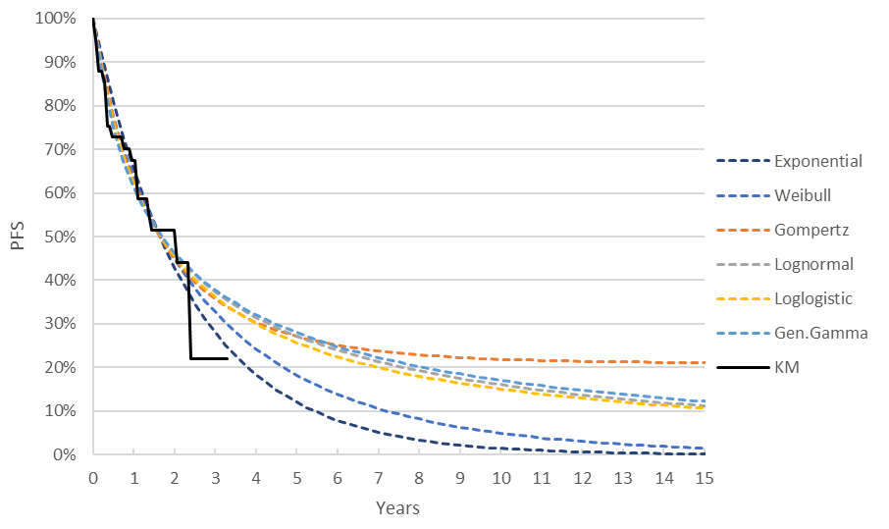 | 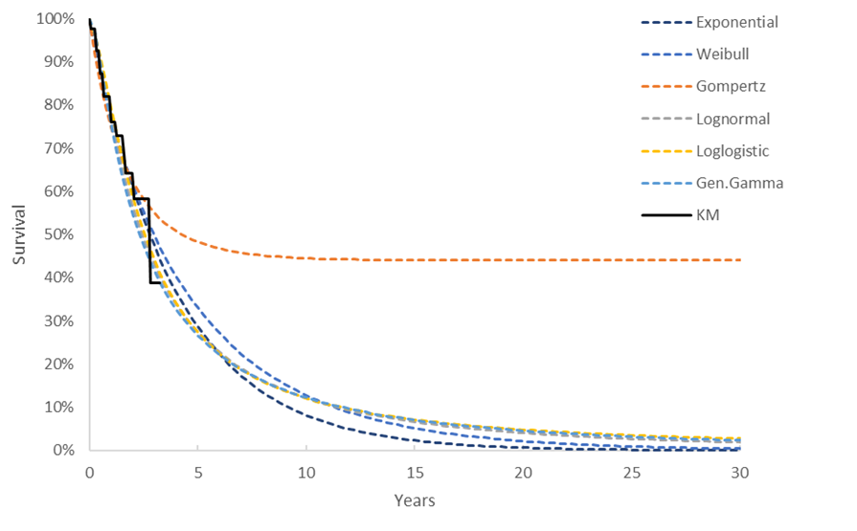
B | 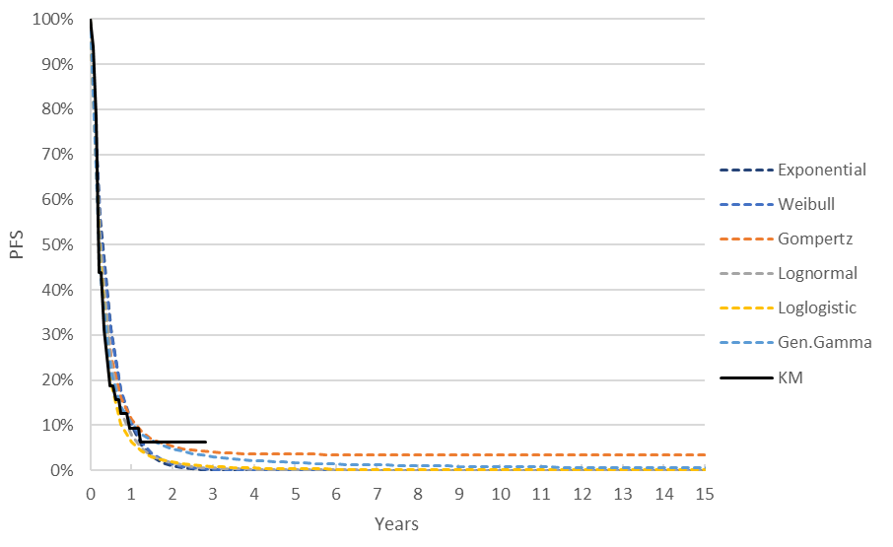 | 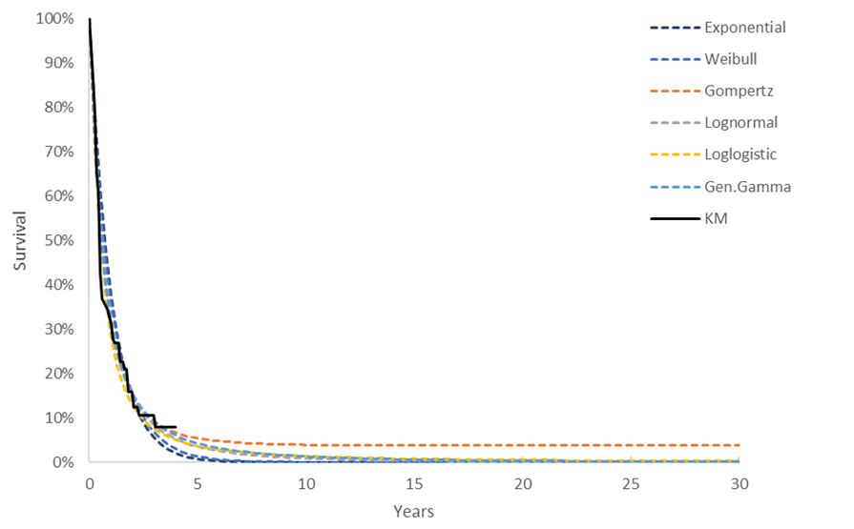
Source: Figure 3(a).4-1 and Figure 3(a).4-6 of the submission
Gen. Gamma: generalised gamma; OS = overall survival, PFS = progression free survival.
  - In the base case, the exponential function and generalised gamma function were chosen for the PFS extrapolations of D+T and pooled chemotherapy, respectively based on AIC/BIC criteria. The exponential function predicted the lowest long term PFS for D+T. For OS, a dependently fitted Weibull function was chosen in the base case. Although the loglogistic function provided the best statistical fit to the observed data, the submission considered that the long tail, which resulted in some D+T patients remaining alive until 112 years, was clinically implausible. The submission selected the Weibull function as it considered that the estimated survival of some D+T patients to 41 years was more plausible given the observed benefit in PFS.
  - The OS and PFS for D+T and the pooled chemotherapy comparator in the recurrent, refractory or progressive HGG model is presented in Figure 10.
Figure 10: Overall and Progression Free Survival (HGG model)
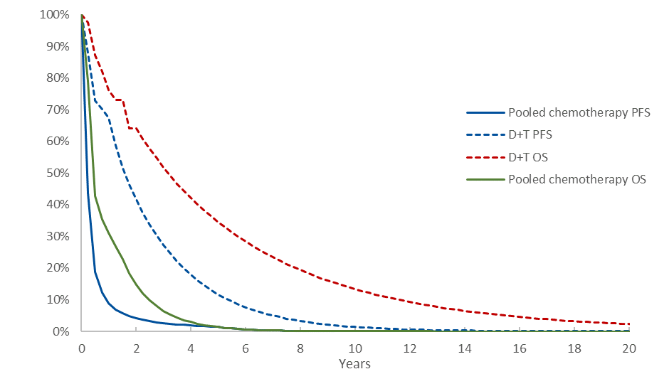
Source: Attached HGG economic model.
D+T = dabrafenib + trametinib; OS = overall survival; PFS = progression free survival
  - The ESC noted that the model estimated that approximately 10% of D+T patients would be alive at 15 years (the time horizon of the model) which was optimistic. In contrast, the 5 year survival for patients with HGG is < 10% to 30% from the time of diagnosis (Blionas 2018; Warren 2012; MacDonald 2011) and the median OS is 14 to 20 months even after optimal therapy (Hatoum 2022). OS from the time of recurrence is approximately 5.6 months (Kline 2018).
  - Similarly, the model estimated that 50% of patients treated with D+T would have experienced a PFS event after 2.42 years in the model. This may have been overestimated given that the median PFS in patients treated with D+T the HGG cohort of G2201 was only 17.1 months. However, this may be related to the discrepancy between the PFS values used in the unanchored indirect comparison with the PFS values reported in the HGG cohort of G2201 (see paragraph 6.48).
  - The submission for HGG included utilities from Vera 2018 in the base case with utilities from Garside 2007 applied in a sensitivity analysis (see paragraph 6.79). The submission did not clearly explain why Vera 2018 utilities were used in the base case as opposed to Garside 2007.
  - Of the 100 participants with malignant glioma in Vera 2018, 56% were receiving active treatment, 24% were in follow-up and 20% were newly diagnosed (after surgery but before additional cancer treatment). There were applicability issues with the utility values from Vera 2018 as they were elicited from an adult population, and there was a difference in the proportion with Grade IV glioma in Vera 2018 (78%) compared with the HGG cohort of G2201 (49%). Further, only 38% of patients in Vera 2018 had tumour recurrence compared to 100% in G2201. As such, it was unclear if the utilities reported in Vera 2018 would be a reliable estimate for paediatric recurrent, refractory or progressive HGG.
  - As per the LGG model, the ESC considered that it might have been more appropriate to apply utility values from the PROMIS scores collected during the trial or from literature that considered children with other forms of brain tumours.
  - The HGG economic evaluation differed from the LGG economic evaluation in that it did not include any subsequent treatment costs or caregiver disutilities, but did include palliative care costs. The palliative care costs were based on Reeve 2017, and a unit cost of $| | was applied to each patient who transitioned into the death health state.
  - The PBAC had previously considered that the applicability and accuracy of the cost estimates from Reeve 2017 were highly uncertain (paragraph 6.54, sacituzumab govitecan, Public Summary Document (PSD), March 2022 PBAC meeting). The pre-PBAC response by the sponsors of sacituzumab govitecan also proposed much lower terminal care costs of $6,050 terminal care costs, which the PBAC considered to be more appropriate (paragraph 6.56, sacituzumab govitecan, PSD, March 2022 PBAC meeting). More recently, in March 2023 in consideration of pembrolizumab for metastatic triple negative breast cancer (mTNBC), the ESC had considered terminal care costs based on Reeve 2017 to be overestimated (paragraph 6.64, pembrolizumab, PSD, March 2023 PBAC meeting). However, terminal care costs were not found to be a key driver of the HGG model.
  - In the HGG model, the cost of temozolomide was used as a proxy for the pooled chemotherapy comparator from the clinical comparison. This may not be an appropriate assumption. However, it was acknowledged that creating a weighted pooled comparator would require estimates of relative use in of each treatment in the population, which likely do not exist. The submission’s claim that costing temozolomide may underestimate the cost of treatment in the comparator arm was not supported by any evidence or further arguments. However, given that all of the used chemotherapy regimens in the pooled chemotherapy arm are low cost relative to D+T, this would not be a key driver in the model.
  - Table 24 presents the key drivers of the HGG model.
Table 24: Key drivers of the HGG model
Description | Method/Value | Impact  Base case: $|¹ per QALY gained
D+T PFS extrapolation | D+T PFS extrapolated from G2201 starting at 20 months using an exponential curve up to 15 years. PFS was also used to inform time to treatment discontinuation. | High, favoured D+T.  Using a generalised gamma extrapolation increased the ICER by ||||% to $|||| ² per QALY
Time horizon | The model applied a time horizon of 15 years despite the 5 year survival for patients with HGG being < 10% to 30%. | Moderate to high, favoured D+T.  Reducing the time horizon to 10 years resulted in an ICER of $|||| ³ per QALY gained.  A 5-year time horizon resulted in an ICER of $||||³ per QALY gained.
Overall survival HR | The base case exponential dependent extrapolation (assuming proportional hazards between D+T and chemotherapy) estimated a treatment coefficient analogous to the log of the HR estimated in the unanchored indirect comparison of OS. No treatment effect waning was assumed in the base case. | High, uncertain.  Use of the of the lower bound of the HR 95% CI increased the ICER by ||||% to $||||² per QALY gained.  Use of the upper bound of the HR 95% CI decreased the ICER by ||||% to $||||⁴ per QALY gained.  Treatment waning from 36 months onwards, such that OS HR was the same between arms at 60 months, increased the ICER by ||||% to $|||| ²per QALY gained.
Source: Table 3.9-1, p332 of the submission and Attached HGG economic model
CI = confidence interval; D+T = dabrafenib + trametinib; HR = hazard ratio; ICER = incremental cost-effectiveness ratio; KM = Kaplan Meier; PD = progressed disease; PFS = progression free survival; QALY = quality adjusted life year
The redacted values correspond to the following ranges:
¹ $35,000 to < $45,000
² $55,000 to < $75,000
³ $45,000 to < $55,000
⁴ $25,000 to < $35,000
  - Table 25 presents the results of the stepped economic evaluation (HGG).
Table 25: Results of the stepped economic evaluation of HGG
Step and component | D+T | Pooled chemo | Increment
Step 1: study-based costs and outcomes
Costs | $| | $1,362 | $|
Life year gained | 2.16 | 0.88 | 1.28
Incremental cost/extra LY gained |  |  | $|¹
Step 2: extrapolated to 15 years
Costs | $| | $1,362 | $|
Life year gained | 3.85 | 0.93 | 2.91
Incremental cost/extra LY gained |  |  | $|²
Step 3: extrapolated to 15 years including all resource use
Costs | $| | $42,786 | $|
Life year gained | 3.85 | 0.93 | 2.91
Incremental cost/extra LY gained |  |  | $|³
Step 4: extrapolated to 15 years incl. all resource use and transformed QALYs
Costs | $| | $42,786 | $|
QALYs | 2.92 | 0.68 | 2.24
Incremental cost/extra QALYs gained |  |  | $|²
Source: Table 3(a).8-1, p378 of the submission.
D+T = dabrafenib + trametinib; QALY = quality-adjusted life year
The redacted values correspond to the following ranges:
¹$55,000 to < $75,000
² $35,000 to < $45,000
³ $25,000 to < $35,000

  - Table 26 presents the undiscounted disaggregated health outcomes in the HGG economic evaluation.
Table 26: Disaggregated summary of health outcomes included in the HGG economic evaluation (undiscounted)
 | D+T | Pooled chemotherapy | Increment | % of total increment
QALYs
PFS | 1.86 | 0.38 | 1.47 | 53%
PD | 1.59 | 0.35 | 1.24 | 45%
TEAEs | 0.00 | -0.05 | 0.04 | 2%
Total QALYs | 3.44 | 0.68 | 2.76 | 100%
Life years
PFS | 2.29 | 0.47 | 1.82 | 51%
PD | 2.27 | 0.50 | 1.77 | 49%
Total | 4.56 | 0.97 | 3.59 | 100%
Source: Table 3(a).8-3, p379 of the submission as well as the attached HGG economic model.
D+T: dabrafenib and trametinib; PFS: progression free survival; PD: progressive disease; QALYs: quality-adjusted life years; TEAE: Treatment emergent adverse event
  - Table 27 presents sensitivity analyses of the HGG model.
Table 27: Results of sensitivity analyses of HGG model
Steps | Incremental costs ($) | Incremental QALYs | ICER | % Change
Base-case | | | 2.24 | | ¹ | -
Time horizon (base case =15 years) and discounting (base case = 5%)
Discount rate 3.5% | | | 2.37 | |¹ | - |
Discount rate 0% | | | 2.76 | |¹ | - |
Time horizon 10 years | | | 2.06 | |² | |
5 year time horizon | | | 1.49 | |² | |
Health state utilities (base case: PF=0.81 and PD=0.7 from Vera 2018)
PF: 0.86 - Garside et al., 2007 | | | 2.40 | |¹ | - |
PD: 0.73 - Garside et al., 2007 | | | 2.24 | |¹ | |
PF = 0.89 and PD = 0.81 from Barr 1999 | | | 2.51 | |¹ | - |
Parametric models PFS: D+T (base case = Exponential)
PFS: Independent Weibull | | | 2.28 | |² | |
PFS: Independent Gompertz | | | 2.35 | |³ | |
PFS: Independent lognormal | | | 2.35 | |³ | |
PFS: Independent loglogistic | | | 2.35 | |³ | |
PFS: Independent gen. gamma | | | 2.36 | |³ | |
Parametric models OS (base case = Weibull)
OS: Dependent exponential | | | 2.03 | |² | |
OS: Dependent Gompertz | | | 3.32 | |⁴ | - |
OS: Dependent lognormal | | | 2.04 | |² | |
OS: Dependent loglogistic | | | 1.93 | |² | |
OS: Dependent gen. gamma | | | 2.02 | |² | |
Evaluator sensitivity analyses
OS using lower 95% CI of HR ª | | | 1.66 | |³ | |
OS using upper 95% CI of HR ^{b} | | | 2.88 | |⁴ | - |
Palliative care costs removed | | | 2.24 | |² | |
Declining OS benefit 36 – 60 months ^{c} | | | 1.68 | |³ | |
Declining OS benefit 60 – 60 months ^{c} | | | 1.74 | |³ | |
AEMP of D+T (base case DAB: 75 mg = $||||, 50 mg = $||||; TRAM: 500 mcg = $||||; 2 mg = $||||)
AEMPs as per those in melanoma (DAB: 75 mg = $||||, 50 mg = $||||; TRAM: 500 mcg = $||||, 2 mg = $||||) | $|| | 2.24 | | ⁴ | -||
ESC Multivariate Sensitivity Analysis (MSA)
1. D+T PFS extrapolated using a generalised gamma;  2. Treatment waning from 36 months onwards, such that OS HR was the same between arms at 60 months^{d};  3. 5 year time horizon;  4. AEMPs as per those in melanoma (DAB: 75 mg = $||||, 50 mg = $||||; TRAM: 500 mcg = $||||, 2 mg = $||||) | | | 1.50 | | ² | ||
Pre-PBAC response (in corrected model)^{e}
1. AEMPs as per those in melanoma (DAB: 75 mg = $||||, 50 mg = $||||; TRAM: 500 mcg = $||||, 2 mg = $||||)  Pre-PBAC response did not accept ESC advice on extrapolation, treatment waning or time horizon. | | | 2.24 | | ^{4f} | -||
Source: Table 3(a).9-1, p381-383 of the submission and Attached HGG economic model.
D+T = dabrafenib and trametinib; ICER = incremental cost effectiveness ratio; MBS = Medicare Benefits Schedule; PFS = progression free survival; OS = overall survival
ª Calculated during the evaluation by entering -0.793807 in Cell J18 of the OS sheet of the HGG economic model.
^{b} Calculated during the evaluation by entering -1.907043 in Cell J18 of the OS sheet of the HGG economic model.
^{c} Calculated during the evaluation, treatment waning applied such that OS HR was the same between arms at 60 months.
^{d} For treatment waning: Update Setting sheet, to set Declining benefit (hazard)=Include in cell F48; and Start Month = 36 and Complete Month = 60 in cells F49 and F50, respectively.
^{e} Results generated with original model provided with submission.
^{f} Differs from result provided in pre-PBAC response model ($| |).
The redacted values correspond to the following ranges:
¹ $35,000 to < $45,000
² $45,000 to < $55,000
³ $55,000 to < $75,000
⁴ $25,000 to < $35,000
  - Overall, given that the model is based on an unanchored indirect comparison in which the magnitude of the incremental benefit was uncertain, the ESC considered that the ICER reported in the base case should be interpreted with caution.
  - The ESC noted that a multivariate sensitivity analysis that included a 5-year time horizon, convergence of the OS curves between months 36 to 60, the application of the generalised gamma function to the D+T PFS arm and the prices of D+T from the melanoma setting resulted in an ICER of $45,000 to < $55,000per QALY gained. The ESC considered, given the limitations of the clinical evidence, that the ICER remained uncertain.
  - A revised analysis was presented in the pre-PBAC response, in which the only change was to apply the melanoma prices for D+T. The lower price proposed for D + T for both HGG and LGG in the pre-PBAC response was in the context of a weighted ICER.

Combined Weighted ICER
  - The submission presented a weighted ICER for LGG and HGG. During the evaluation, the weighted ICER was recalculated using the evaluation base case for LGG and the base case for HGG. The evaluation weighted ICER is presented in Table 28.
  - The weighted ICER was based on the relative number of treated patients for LGG (193 patients: 75%) and HGG (64 patients (25%)) over the first six years of listing. These patient numbers were reflective of corrected financial estimates in the evaluation (see below). The PBAC noted the weighting should be based on the number of prescriptions rather than the number of patients to account for the different treatment durations in LGG and HGG, although this only changed the weighting marginally (74% LGG, 26% HGG). The PSCR stated that the weighted ICER should have been calculated as the ratio of weighted incremental costs to weighted incremental outcomes. The ESC agreed that the weighted ICER should be calculated by weighting costs and weighting benefits, before calculating the ratio which resulted in an ICER of $155,000 to < $255,000per QALY.
Table 28: Evaluation weighted ICER (by patient numbers)
 | D+T | Comparator | Increment
LGG
Costs | $| | $39,081 | $|
QALYS | 12.06 | 11.21 | 0.85
ICER |  |  | $|¹
HGG
Costs | $| | $42,786 | $|
QALYs | 2.92 | 0.68 | 2.24
ICER |  |  | $|²
Weighted ICERs
Evaluation ICER (weighted average ICER; LGG = 75%, HGG = 25%) |  |  | $|³
PSCR ICER (weighted average ICER; LGG = 75%, HGG = 25%) |  |  | $|4
Source: Calculated during the evaluation using the attached HGG and LGG economic models and corrected financial estimates from Section 4 of the commentary
D+T = dabrafenib + trametinib; HGG = high grade glioma; ICER = incremental cost effectiveness ratio; LGG = low grade glioma; QALY = quality-adjusted life year.
The redacted values correspond to the following ranges:
¹ $355,000 to < $455,000
² $35,000 to < $45,000³ $255,000 to < $355,000
⁴ $155,000 to < $255,000
  - The PBAC considered that calculation of a weighted ICER was not appropriate (see paragraph 7.10).

Drug cost/patient/course and year

LGG
  - Table 29 presents the drug cost per patient for D+T and C+V in LGG based on the prices requested in the submission.
Table 29: Drug cost per patient for D+T and C+V (LGG) based on the prices requested in the submission
 | D+T |  |  |  | C+V
 | Trial dose and duration |  | D+T model | Financial estimates ª | Trial and Model ^{b}
Packs/year (D+T) ^{c}  Number of admins (C+V) | Dab | Y1-2: 12.17 | Y1-2: 12.17  Y3+: 12.17 |  | Carb | 25.64
Packs/year (D+T) ^{c}  Number of admins (C+V) | Tram | Y1-2: 36.5 | Y1-2: 36.5  Y3+: 12.2 |  | Vin | 22.75
Cost/patient/year ($) | Dab | | | Y1-2: |  Y3+: | |  | -
Cost/patient/year ($) | Tram | | | Y1-2: |  Y3+: |
Cost/patient/year ($) | D+T | Y1-2: | | Y 1-2: |  Y3+: |
Mean duration | D+T | 75.99 weeks | 10.26 years | Up to 6 years for incident patients in Y1 | Carb | 37.64 weeks
 |  |  |  |  | Vin | 36.75 weeks
Cost/patient/course | D+T | $|^{d} | $|^{e} | - | C+V | $ |
Source: Table 2.4-5, pp66 - 67 of the submission and the attached economic and financial LGG models
C+V carboplatin + vincristine; Carb = carboplatin; Dab = dabrafenib; D+T = dabrafenib + trametinib; tram = trametinib; vin = vincristine; Y = year of treatment
ª The financial model relied on the same prices and same assumptions regarding daily and yearly use per patient as the economic model. However, the model estimated these in a different way. It is important to note that “Y” in this table refers to year of treatment per patient and not year of listing.
^{b} As the model relied on C+V dose and duration of treatment from G2201 without extrapolation the C+V costs are presented together. The submission did not estimate costs of C+V in the financial estimates
^{c} The model estimated baseline weight from the G2201 trial (mean of 43.27 kg) and then assumed yearly weight gain (from growth) based on WHO tables. The result was that patients in Year 1 and 2 were assumed to weigh between 38 and 50 kg, associated with a 200mg daily dose of dabrafenib and a 1.5mg daily dose of trametinib. In Year 3 and beyond, patients weighed 51 kg or more and consequently increased dosage of dabrafenib to 300mg daily, and of trametinib to 2mg daily. Packs per year were calculated from the pack sizes and recommended daily dose, and assumption of daily treatment.
^{d} Calculated by prorating Y1 cost to 75.99 weeks.
^{e} Calculated by adding Y1 costs to 9.26 times Y2+ costs.
Note: Treatment duration of 10.26 differs to time spent in PFS even though PFS used to inform time on treatment as medicines costs were not half cycle corrected in the model
  - Based on the prices requested in the submission, the cost per patient per course of D+T estimated in the economic model was $| | based on a mean treatment duration of 10.26 years and a yearly cost of D+T of $| | in first two years of treatment and of $| | for each subsequent year (as doses are weight based, the cost of treatment was assumed to increase as patients got older). The G2201 trial estimated a treatment duration of 75.99 weeks for D+T. This compared to 37.64 weeks of carboplatin treatment and 36.75 weeks of vincristine treatment with an estimated cost per course of C+V of $| |. The financial estimates did not include cost offsets for C+V use.

HGG
  - Table 30 presents the drug cost per patient of D+T and chemotherapy in HGG based on the prices requested in the submission.
Table 30: Drug cost per patient for D+T and comparator chemotherapy (HGG) based on the prices requested in the submission
 | D+T |  |  |  | Pooled chemotherapy
 | Trial dose and duration |  | D+T model | Financial estimates ª | Model ^{b}
Packs/year (D+T)^{c}  Number of admins (temozolomide) | Dab | Y1: 12.17 | Y1: 12.17  Y2+: 12.17 |  | 6^{d}
Packs/year (D+T)^{c}  Number of admins (temozolomide) | Tram | Y1: 36.5 | Y1: 36.5  Y2+: 12.2 |  | 6^{d}
Cost/patient/year | Dab | $| | Y 1: $|  Y2+: $| |  | -
Cost/patient/year | Tram | $| | Y1: $|  Y2+: $| |  | -
Cost/patient/year | D+T | Y1: $ | | Y1: $|; Y2+: $|ª |  | -
Mean duration | D+T | 68.1 weeks ^{e} | 2.42 years | Up to 6 years for incident patients in Y1 | 5.52 months ^{d}
Cost/patient/course | D+T | $|^{f} | $ | ^{g} | - | $|
Source: Table 2(A).4-1, p153 of the submission and the attached economic and financial HGG models.
Dab = dabrafenib; D+T = dabrafenib + trametinib; tram = trametinib; Y = year of treatment
ª The financial model relied on the same prices and same assumptions regarding daily and yearly use per patient as the economic model. However, the model estimated these in a different way. It is important to note that “Y” in this table refers to year of treatment per patient and not year of listing.
^{b} Chemotherapy comparator was not included in financial estimates and the cost of the basket of chemotherapy was not estimable in the clinical section as reporting of duration of treatment was inconsistent in the included single arm studies, and there was no basis to weight costs. In the economic evaluation, the submission used temozolomide as a proxy for these costs.
^{c} The model estimated baseline weight from the G2201 trial (mean of 49.82 kg) and then assumed yearly weight gain (from growth) based on WHO tables. The result was that patients in Year 1 were assumed to weigh between 38 and 50 kg, associated with a 200 mg daily dose of dabrafenib and a 1.5 mg daily dose of trametinib. In Year 2 and beyond, patients weighed 51 kg or more and consequently increased dosage of dabrafenib to 300 mg daily, and of trametinib to 2 mg daily. Packs per year were calculated from the pack sizes and recommended daily dose, and assumption of daily treatment.
^{d} The submission stated that temozolomide is recommended for the treatment of recurrent HGG with a recommended dosing regimen of 200 mg/m² temozolomide administered orally once a day on Days 1 to 5 of each 28-day treatment cycle for 6 cycles (eviQ; www.eviq.org.au).
^{e} In G2201 HGG cohort, there was a small difference in mean treatment duration between dabrafenib (68.5 weeks) and trametinib (68.1 weeks). For simplicity, costs assuming 68.1 weeks for both treatments are presented.
^{f} Calculated by prorating Y1 cost to 68.1 weeks.
^{g} Calculated by adding Y1 costs to 1.42 times Y2 + costs.
  - Based on the prices requested in the submission, the cost per patient per course of D+T estimated in the economic model was $| | based on a mean treatment duration of 2.42 years and a yearly cost of D+T of $| | in first year of treatment and of $| | for each subsequent year (as doses are weight based, the cost of treatment was assumed to increase as patients got older). The G2201 trial estimated a treatment duration of 68.1 weeks. This compared to six administrations of temozolomide every 28 days in the economic evaluation (or 5.52 months of treatment) with an estimated cost per course of $1,362. Temozolomide was used as a proxy for the pooled chemotherapy comparator from the clinical comparison and the financial estimates did not include cost offsets for comparator use.

Estimated PBS usage & financial implications
  - This submission was not considered by DUSC.
  - The submission used an epidemiological approach to estimate financial impact for both LGG and HGG.
  - Table 31 presents the key inputs relied on in the financial estimates.
Table 31: Variables and data sources used in the analysis
Variable | Value | Source
Epidemiology
Projected incidence rate of CNS cancers per million people | Average (2024-28 & 2029-33): 79.82 | Calculated from AIHW, Cancer in adolescents and young adults in Australia, 2023
Gliomas as a % of all CNS cancers in paediatric population | 70.4% | Youlden 2021. Applying this estimate may have led to underestimating the LGG and HGG populations as the submission also applied the proportion of LGG and HGG tumours as a proportion of CNS tumours to each of the populations.
LGG patient population
LGG tumours as a proportion of total CNS tumours | 41% | Calculated from the distribution of each glioma type by grade from Youlden 2021
% LGG patients with BRAF V600E mutation | 17% | Ryall 2020 The submission selected the rate of BRAF V600E in patients who harboured the NF-1 mutation in the base case, which may not be appropriate and may have underestimated the prevalence of the BRAF V600E mutation. For example, in Ryall 2020, the prevalence of BRAF V600E in patients without the NF-1 gene was 20% (79/397), and 18% (158/874) in the entire cohort of LGG patients.
% LGG patients not amenable to surgery | 55.6% (100 – 44.4%) | Lassaletta 2017
% LGG patients undergoing complete resection | 44.4% | Lassaletta 2017
% change in relapse rate of LGG patients with BRAF V600E mutation after complete resection | Year 1: 3%; Year 2: 3%; Year 3: 9%; Year 4: 0%; Year 5: 21%; Year 6: 0%; Year 7: 6%; Year 8: 7%; Year 9: 17%; Year 10: 0% | Lassaletta 2017. Incorrectly applied in submission (see paragraph 6.121)
HGG patient population
HGG tumours as a proportion of total CNS tumours | 19% | Calculated from the distribution of each glioma type by grade Youlden 2021
% HGG patients with BRAF V600E mutation | 15% | Simple average across identified studies (Mackay 2017; Guidi 2021; Frazão 2018) The sample size in Mackay was magnitudes greater than the other included studies. A weighted prevalence using the sample size as weights would provide a prevalence of 7.1%
% change in relapse or refractory rate of HGG patients after frontline treatment | Year 1: 43%; Year 2: 25%; Year 3: 23%; Year 4: 12%; Year 5: 14% | Cohen 2011. Incorrectly calculated by submission as these percentages sum up to 117%. Corrected during evaluation.
Body weight of incident and prevalent populations
LGG incident pop starting age and weight | 9.1 years; 43.27 kg | LGG cohort G2201
HGG incident population starting age and body weight | 12.12 years; 49.82 kg | HGG cohort G2201
Estimated utilisation of D+T
Uptake of D+T for incident and prevalent patients initiating treatment (%) | 100% each year | Assumed that all patients who are eligible will commence treatment with D+T. Reasonable.
Patients continuing treatment in Year 1 | LGG - PFS at 3 months: 94.1%  HGG - PFS at 3 months: 87.8% | PFS in G2201 for LGG/HGG cohort
Source: Table 4.1-1, pp386-390 of the submission.
AIHW = Australian Institute of Health and Welfare; CNS = Central Nervous System; D+T = dabrafenib + trametinib; HGG = high grade glioma; LGG = low grade glioma
  - The submissions’ estimations of the proportion of patients who relapse over time were incorrectly calculated. After Year 1, the submission estimated the proportion who relapse as a conditional probability (e.g. at Year 2, the proportion who relapse was 1- (PFS at Year 2/PFS at Year 1)) but erroneously applied this to the total population at baseline rather than to just the number of patients who remain at risk. As such, the proportion of LGG patients who relapse over time was overestimated. For example, the submission calculated that over 10 years, 66% of patients would have relapsed whereas in Lassaletta 2017, this was only 51%. It was estimated that 117% of newly diagnosed HGG patients would have recurrence, be refractory of have progressive HGG instead of 91% as reported in Cohen 2011. This was corrected during the evaluation.
  - Table 32 presents the corrected financial estimates of listing D+T for LGG and HGG. The pre-PBAC response provided revised estimates which included amendments as described in the Commentary, and made a correction to the number of patients with LGG or HGG based on the ESC advice that the submission’s estimates may be underestimated as it was assumed that that 40.8% and 18.6% of all gliomas (which represent 70.4% of all CNS cancers) were LGG and HGG, rather than of all CNS cancers (see paragraph 6.134). The estimates also incorporated the revised price offered in the pre-PBAC response as described in paragraphs 3.2 to 3.4.
Table 32: Estimated use and financial implications for LGG and HGG
 | Year 1 | Year 2 | Year 3 | Year 4 | Year 5 | Year 6
Submission Estimates (corrected during evaluation)
Estimated extent of use
Number of LGG patients treated | | ¹ | | ¹ | | ¹ | | ¹ | | ¹ | | ¹
Number of HGG patients treated | | ¹ | | ¹ | | ¹ | | ¹ | | ¹ | | ¹
Total patients treated | | ¹ | | ¹ | | ¹ | | ¹ | | ¹ | | ¹
Number of LGG scripts | | ² | | ² | | ² | | ² | | ² | | ²
Number of HGG scripts | | ¹ | | ¹ | | ¹ | | ¹ | | ¹ | | ¹
Number of scripts dispensed ª | | ² | | ² | | ² | | ² | | ² | | ²
Estimated financial implications of D+T
Cost to PBS/RPBS less copayments LGG | | ³ | | ³ | | ³ | | ³ | | ³ | | ³
Cost to PBS/RPBS less copayments HGG | | ³ | ||³||| | ||³||| | | ³ | | ³ | | ³
Cost to PBS/RPBS less copayments (combined) | | ³ | | ³ | | ³ | | ³ | | ³ | | ³
Net financial implications
Net cost to PBS/RPBS | | ³ | | ³ | | ³ | | ³ | | ³ | | ³
Net cost to MBS LGG | | ³ | | ³ | | ³ | | ³ | | ³ | | ³
Net cost to MBS HGG | | ³ | | ³ | | ³ | | ³ | | ³ | | ³
Net cost to MBS combined | | ³ | | ³ | | ³ | | ³ | | ³ | | ³
Net cost to PBS/RPBS/MBS combined | | ³ | | ³ | | ³ | | ³ | | ³ | | ³
Pre-PBAC response estimates
Number of LGG scripts | | ¹ | | ² | | ² | | ² | | ² | | ²
Cost to PBS/RPBS less copayments LGG | | ³ | ||³||| | | ³ | | ³³ | | | | ³
Net cost to MBS LGG | | ³ | | ³ | | ³ | | ³ | | ³ | | ³
Number of HGG scripts | | ¹ | | ¹ | | ² | | ² | | ² | | ²
Cost to PBS/RPBS less copayments HGG | | ³ | | ³ | | ³ | | ³ | | ³ | | ³
Net cost to MBS HGG | | ³ | | ³ | | ³ | | ³ | | ³ | | ³
Net cost to PBS/RPBS/MBS combined | | ³ | | ³ | | ³ | | ³ | | ³ | | ³
Source: Calculated during evaluation using respective financial estimate spreadsheets, Table 4.2-1, pp416-417. Table 4.2-2, p417, Table 4.2-7, p420, Table 4.4-2, p421 and Table 4.4-3, p422 of the submission; and respective financial estimate spreadsheets provided with pre-PBAC response.
ª. For LGG, the submission estimated 6.09 scripts of dabrafenib per year for first year of treatment and 12.18 for years 2 and beyond. The submission estimated 9.13 scripts of trametinib per year for the first 2 years of treatment, followed by 12.18 scripts per year for the following years. For HGG, the submission estimated the submission estimated 6.09 scripts of dabrafenib per year for first year of treatment and 12.18 for years 2 and beyond. The submission estimated 9.13 scripts of trametinib per year for the first year of treatment, followed by 12.18 scripts per year for the following years. Estimation of scripts for grandfathered patients was individualised based on age and weight category.
The redacted values correspond to the following ranges:
¹ < 500
² 500 to < 5,000
³ $0 to < $10 million
  - Using corrected numbers, it was estimated that a total of < 500 LGG patients would initiate treatment in Year 1, decreasing to < 500 in Year 6 (including < 500 grandfathered patients in Year 1 and < 500 in Year 6).
  - For HGG, it was estimated that there would be a total of < 500 patients initiating treatment in Year 1, decreasing to < 500 in Year 6 (including < 500 grandfathered patients in Year 1, decreasing to < 500 in Year 4 and < 500 thereafter).
  - While there were sources of potential overestimation, such as the estimation of incidence of paediatric CNS cancers including patients aged 0 and 19 and the conservative assumption of 100% uptake, it was more likely that the financial estimates were underestimated. The ESC noted this was due to the submission likely underestimating the number of patients with LGG or HGG by assuming that 40.8% and 18.6% of all gliomas (which represent 70.4% of all CNS cancers) were LGG and HGG, rather than of all CNS cancers, which was consistent with the calculations used to derive the proportions. Using PFS from G2201 to estimate time on treatment may also underestimate usage as patients in clinical practice may be reviewed less frequently than in clinical trials.
  - Further, it was also possible that the proportion of patients with BRAF V600E was slightly underestimated in LGG and overestimated in HGG.
  - Based on the estimates in the pre-PBAC response, the total cost to the PBS/RPBS/MBS was $0 to < $10 million in Year 1, increasing to $0 to < $10 million in Year 6 and totalling $20 million to < $30 million over the first six years of listing.
For more detail on PBAC’s view, see section 7 PBAC outcome.
- PBAC Outcome
  - The PBAC recommended the General Schedule PBS listing of dabrafenib in combination with trametinib for the treatment of paediatric patients with BRAF V600E mutation positive low grade glioma (LGG) or high grade glioma (HGG). The PBAC recognised a high clinical need in the proposed LGG and HGG populations and considered that treatment with dabrafenib and trametinib (D+T) offered high added therapeutic value for these patients. The PBAC was satisfied that D+T provides, for some patients, a significant improvement in efficacy over C+V in LGG, and over standard chemotherapy in HGG. The PBAC noted the high incremental cost-effectiveness ratio (ICER) in the LGG population and considered that cost effectiveness had not been demonstrated at the proposed prices. The PBAC advised that a price reduction would be required to achieve an incremental cost-effectiveness ratio (ICER) in the LGG population of approximately $95,000 to < $115,000 per QALY gained. The PBAC considered the ICER for the HGG population was very uncertain due to the underlying clinical evidence base which was an unanchored comparison of single arm studies. The PBAC considered that a lower ICER would be required to demonstrate acceptable cost-effectiveness in the HGG population, compared with the LGG population, in recognition of the high uncertainty of the incremental benefit associated with D+T compared with chemotherapy in HGG. The PBAC was satisfied that D+T could be considered cost-effective with an ICER for the HGG population of approximately $75,000 to < $95,000per QALY gained.
  - The PBAC noted the consumer comments relating to this submission as outlined in paragraph 6.2, which described the impact of LGG and HGG on patients and their families, and discussed benefits associated with D+T. The PBAC noted the comments from the sponsor hearing as described in paragraph 6.1, and considered it was informative as it conveyed information regarding a substantial reduction in treatment burden and an effective therapy option. The PBAC noted the impacts of the conditions on quality of life, and the treatment burden associated with chemotherapy administered by infusion, and considered these were significant to patients and caregivers.
  - The PBAC considered that the proposed place in therapy of D+T as set out by the submission for both proposed indications was reasonable. For LGG this was for treatment of patients diagnosed between 12 months to 18 years of age, with BRAF V600E mutation positive LGG with either 1) progressive disease following surgical resection, or 2) not amenable to surgery, and have risk of neurological impairment with progression. For HGG this was for patients diagnosed between 12 months to 18 years of age with BRAF V600E mutation positive HGG who have either 1) relapsed or progressed following frontline therapy, or 2) have failed to respond to frontline therapy.
  - The PBAC considered that the comparators nominated by the submission were reasonable, including C+V as the main comparator in LGG; and a basket of chemotherapy treatments as the main comparator in HGG.
  - The clinical evidence for the LGG component of the submission was based on the direct open label randomised controlled trial (RCT) conducted in the LGG cohort of the G2201 basket trial which compared D+T (n=73) with C+V (n=37). The PBAC noted that the median PFS was 12.7 months longer in the D+T arm (median PFS: 20.1 months) compared with the C+V arm (7.4 months) after 18.9 months median follow-up. The improvement in PFS was statistically significant (HR = 0.31; 95% CI: 0.17, 0.55; 1 sided p < 0.001). The result remained significant based on data from a longer follow-up period as reported in the final CSR (HR = 0.36; 95% CI: 0.22, 0.59) at 39.0 months median follow-up.
  - For LGG, the PBAC considered that a claim of superior effectiveness was supported based on direct RCT evidence from the G2201 trial, which demonstrated an improved tumour response and longer PFS for D+T compared with C+V. The PBAC noted that G2201 did not demonstrate a significant difference in OS, and considered this was due to the low number of events in the study (based on a median follow-up of 39.0 months, there were no deaths in D+T arm and 1 death in C+V arm), and the favourable 10-year survival for LGG with standard treatment. Although D+T resulted in fewer Grade ≥3 AEs, it was associated with increased rates of pyrexia, skin toxicities, and bleeding events compared to C+V. The PBAC considered that D+T had a different, but non-inferior, toxicity profile compared with C+V.
  - The clinical evidence for the HGG component of the submission was based on an unanchored indirect comparison of a non-randomised, single arm cohort of HGG patients in the G2201 basket trial who relapsed, progressed, or failed to respond to frontline therapy and were treated with D+T (n=41), and 17 comparator studies (studies of chemotherapy comparators, total n=320). The PBAC noted that for patients treated with D+T, the median PFS was 9.0 months (95% CI: 5.3, 24.0) by independent review and 17.1 months (95% CI: 12.5, NE) by investigator assessment, at the data cut for primary endpoint analysis (median follow-up 25.1 months). The final CSR (based on a median follow-up of 45.2 months) reported a median PFS by independent review of 9.0 months and by investigator assessment of 24.0 months. The results for D+T indicated significantly longer PFS compared with the submission’s estimates of PFS associated with chemotherapies, which ranged from 2.0 to 3.5 months. Similarly, for OS, the results indicated significantly longer OS for patients treated with D+T (32.8 months) compared with the submission’s estimates of OS associated with chemotherapies (5.3 months). The PBAC considered that the estimates of magnitude of benefit for D+T in recurrent, refractory or progressive HGG were highly uncertain due to the methodology of the comparison, and additional concerns outlined in paragraph 7.8.
  - For HGG, the submission described D+T as superior in terms of effectiveness and safety compared with chemotherapy. The PBAC considered that the claim of superior effectiveness was supported by the consistently superior outcomes in the unanchored indirect comparisons of ORR, PFS and OS between G2201 and the relevant comparator chemotherapy studies. However, the risk of bias associated with single arm studies used for the unanchored indirect comparisons was high. In addition, there was inadequate reporting of key prognostic factors which may have affected transitivity. The PBAC also noted that inputs favourable to D+T were chosen for inclusion in the sponsor’s indirect comparison, including use of investigator review data for PFS rather than independent review (see paragraph 6.48), and use of the median pooled PFS for chemotherapy (2.0 months) rather than the published meta-analysis (3.5 months; see paragraph 6.49). The PBAC considered that the magnitude of incremental benefit associated with D+T was highly uncertain. The PBAC considered that comparative safety was difficult to assess based on the presented data, however the adverse effect profile of D+T was manageable.
  - The PBAC noted the submission presented separate cost-effectiveness analyses for the LGG and HGG populations and a weighted incremental cost-effectiveness ratio (ICER) across the two populations. The PBAC did not consider the weighted ICER informative given the significant differences in disease characteristics and prognosis for the two populations, and the hence the different model inputs and outcomes used for each. Thus, the PBAC considered the cost-effectiveness of D + T in each population separately. The PBAC noted, even though separate PBS listings are required for each population, that it may be reasonable for the price for each listing to reflect a weighted price across the LGG and HGG populations. The PBAC noted the appropriate weighting would be 74% LGG and 26% HGG based on the number of prescriptions over the first six years of listing.
  - For LGG, the PBAC noted the incremental cost-effective ratio presented in the pre-PBAC response was $255,000 to < $355,000per QALY gained (Table 23). The PBAC noted the scenario presented in the pre-PBAC response was consistent with the ESC multivariate analysis in that the prices of dabrafenib and trametinib were reduced to be the same as those for melanoma and the utility values from Vera 2018 were used. The PBAC noted that the pre-PBAC response scenario differed from the ESC multivariate analysis in terms of the statistical function used to extrapolate PFS and the inclusion of caregiver disutilities.
  - The PBAC noted there were limited data to inform the PFS extrapolations and all tested distributions were consistent with the KM data. The PBAC noted the submission selected the exponential distribution, which resulted in the lowest PFS estimates for both D + T and C + V model arms, whereas the ESC multivariate analysis used the lognormal distribution, which resulted in the highest PFS estimates for both arms. The pre-PBAC response noted use of the lognormal function resulted in the modelled C+V PFS curve crossing the modelled D+T PFS curve between approximately 12 and 15 years which it considered to be inconsistent with the PFS data from the G2201 study. In the context of the use of the more conservative utility values from Vera 2018, and the lognormal extrapolations potentially not reflecting the expected PFS in the latter years of the model, the PBAC considered it reasonable for PFS to be extrapolated based on an exponential function.
  - The PBAC considered the impact of caregiver disutilities on the ICER informative noting the impact a more effective treatment would have on the children and their families, as well as the benefits associated with moving from an intravenous chemotherapy treatment (C+V), which requires regular hospital visits and is associated with toxicities, to an oral therapy (D+T) which can be administered at home.
  - The PBAC noted the ICER for LGG without caregiver disutilities was $355,000 to < $455,000 per QALY gained and that this reduced to $155,000 to < $255,000 per QALY gained when caregiver disutilities were included (Table 23). The PBAC considered on the basis of these ICERs, D+T was not cost-effective. The PBAC considered D+T would be cost-effective with an ICER of approximately $95,000 to < $115,000 per QALY gained for the scenario excluding caregiver disutilities. The PBAC noted this relatively high ICER reflected the clinical need, the impact of the disease and treatments on both the patients and their families, the economic model being potentially conservative due to not including longer term sequalae such as epilepsy, blindness or hearing loss, and the low financial estimates.
  - For HGG, the PBAC considered D + T was cost-effective at the price proposed in the submission. However, on the basis of the economic evaluation, a higher price may be supported, that could be used in the calculation of a weighted price across the LGG and HGG populations as described in paragraph 7.9. The PBAC noted that the base case ICER in the submission was $35,000 to < $45,000per QALY gained and that in sensitivity analyses the ICER increased to approximately $55,000 to < $75,000 per QALY gained. However, the PBAC noted the key uncertainty with the economic model related to the underlying clinical evidence base which was an unanchored indirect comparison of single arm studies and that this impacted on the reliability of all ICER estimates for HGG. In this context, the PBAC considered the ICER for HGG should be lower than that for LGG. The PBAC considered D+T would be cost-effective with an ICER of approximately $75,000 to < $95,000 per QALY gained for the scenario corresponding to the submission base case.
  - The PBAC considered the utilisation estimates presented in the pre-PBAC response to be reasonable. The PBAC noted the financial estimates would need to be recalculated with the weighted effective DPMQ based on cost-effective prices for D+T (see paragraphs 7.13 and 7.14).
  - The PBAC provided the following advice regarding the restriction:
- Clarify the restriction to indicate that the age range refers to the date of diagnosis of LGG or HGG, such that patients are able to receive treatment beyond this age if they were diagnosed before their 18th birthday.
- Administrative advice should be added to minimise switching between formulations. This has been added to the recommended listing in Section 8.
- The requirement for Karnofsky/Lansky performance score of ≥ 50% should be retained in the restriction, consistent with the clinical evidence supporting the listing. The PBAC noted that the pre-PBAC response, and the clinician at the sponsor hearing, requested to remove this requirement, however considered that the criterion was necessary to identify the appropriate patient population for treatment, noting that in the clinical trial, patients were required to have a performance status of at least 50 on either the Karnofsky scale (for patients ≥16 years of age) or the Lansky scale (for those <16 years of age).
- The PBAC agreed with the submission’s request that the < 500 LGG and < 500 HGG patients in the sponsor’s managed access program (MAP) who are receiving D+T for the treatment of BRAF V600E mutated LGG or HGG be grandfathered.
- For trametinib, the submission requested a maximum quantity of 5 bottles for the powder for oral solution for both LGG and HGG, however the PBAC noted that a maximum quantity of 13 bottles would be required to reflect the maximum recommended daily doses using the oral formulation. This has been corrected in the recommended listing in Section 8.
- LGG: For both dabrafenib and trametinib, the requested number of repeats for initial, continuing and grandfather restrictions in the LGG setting provide 4 months treatment at the maximum recommended daily doses. This would require assessment of LGG patients for ongoing treatment every four months, the PBAC considered this was reasonable.
- HGG: For both dabrafenib and trametinib, the requested number of repeats for initial restrictions in the HGG setting provide 2 months treatment at the maximum recommended daily doses. For continuing and grandfather restrictions in the HGG setting, the requested maximum quantities and number of repeats provide 4 months treatment at the maximum recommended daily doses. This would require assessment of HGG patients at two months after treatment initiation, and then every four months for consideration of ongoing treatment, the PBAC considered this was reasonable.
  - The submission proposed PBS listing of dispersible tablets (dabrafenib) and a powder for oral solution (trametinib) for children who cannot swallow tablets. The PBAC noted that these formulations were not modelled specifically in the economic evaluation or financial estimates, however this would have minimal impact on the results on the basis that the drug prices would be equivalent amongst each medicine on a per mg basis as proposed by the submission.
  - The PBAC found that the criteria prescribed by the National Health (Pharmaceuticals and Vaccines – Cost Recovery) Regulations 2022 for Pricing Pathway A were met. Specifically, the PBAC found that in the circumstances of its recommendation for D+T):
  - The treatment is expected to provide a substantial and clinically relevant improvement in efficacy, over alternative therapies, on the basis of results from the G2201 trial.
  - The treatment is expected to address a high and urgent unmet clinical need because of the severity and impact of LGG and HGG in the proposed paediatric populations. It was noted that for LGG the 10-year survival rate is approximately 85% to 90%; however, quality of life is poor with current therapies, due to either disease progression and/or the use of cytotoxic chemotherapy and radiotherapy. For HGG, the 5-year survival is less than 10% to 30% from the time of diagnosis.
  - It would be in the public interest for the subsequent pricing application to be progressed under Pricing Pathway A on the basis of the preceding findings.
  - The PBAC noted that this submission is not eligible for an Independent Review as it received a positive recommendation.
Outcome:
Recommended
- Recommended listing
Add new items:

LGG
Category/Program: GENERAL – General Schedule (Code GE) / GENERAL
MEDICINAL PRODUCT  medicinal product pack |  | PBS item code | Max. qty packs | Max. qty units | №. of  Rpts | Available brands
DABRAFENIB
Dabrafenib 75mg capsule, 120 |  | NEW  _{MP} | 1 | 120 | 3 | Tafinlar [NV]
Dabrafenib 50mg capsule, 120 |  | NEW  _{MP} | 2 | 240 | 3 | Tafinlar [NV]
Dabrafenib, 10mg dispersible tablet, 210 |  | NEW  _{MP} | 4 | 840 | 3 | Tafinlar [NV]
Restriction Summary [NEW] / Treatment of Concept: [NEW]: Authority Required (telephone/online)

 | Indication: Paediatric low grade glioma
 | Treatment Phase: Initial treatment
 | Clinical criteria:
 | The condition must be of World Health Organisation (WHO) grade 1 or 2
 | AND
 | Clinical Criteria:
 | The patient condition must have progressed following surgical excision; OR
 | The patient condition must not be amendable to surgery with risk of neurological impairment following progression
 | AND
 | Clinical Criteria
 | The condition must be positive for a BRAF V600E mutation.
 | AND
 | Clinical Criteria
 | The patient must have a either a (i) Karnofsky/, (ii) Lansky performance score of ≥ at least 50%
 | AND
 | Clinical Criteria
 | Must be used in combination with trametinib Patient must be receiving PBS-subsidised trametinib and dabrafenib concomitantly for this condition
 | Population criteria:
 | The patient must have been aged between 12 months to 18 years of age inclusive at diagnosis
 | Administrative Advice: Dabrafenib is available as capsules and dispersible tablets. Caution is advised when consideration is given to changing formulations as the formulations are not bioequivalent. Frequent switching between formulations is discouraged.
 | Administrative Advice: No increase in the maximum quantity or number of units may be authorised.
 | Administrative Advice: No increase in the maximum number of repeats may be authorised.
 | Administrative Advice: Applications for authorisation under this restriction may be made in real time using the Online PBS Authorities system (see www.servicesaustralia.gov.au/HPOS) or by telephone by contacting Services Australia on 1800 888 333.
Administrative Advice: A review and validation of the Karnofsky performance status scale can be found as a free access article here:
Mor, V., Laliberte, L., Morris, J.N. and Wiemann, M. (1984), The Karnofsky performance status scale: An examination of its reliability and validity in a research setting. Cancer, 53: 2002-2007. https://doi.org/10.1002/1097-0142(19840501)53:9<2002::AID-CNCR2820530933>3.0.CO;2-W
Administrative Advice: The original publication and validation of the Lansky performance status scale can be found as a free access article here:
Lansky, S.B., List, M.A., Lansky, L.L., Ritter-Sterr, C. and Miller, D.R. (1987), The measurement of performance in childhood cancer patients. Cancer, 60: 1651-1656. https://doi.org/10.1002/1097-0142(19871001)60:7<1651::AID-CNCR2820600738>3.0.CO;2-J
Restriction Summary [NEW] / Treatment of Concept: [NEW]: Authority Required (telephone/online)

 | Indication: Paediatric low grade glioma
 | Treatment Phase: Continuing treatment
 | Clinical criteria:
The glioma must be of WHO grade I or II at treatment initiation; AND

The patient must have progressed following surgical excision; OR
The patient must not be amenable to surgery with risk of neurological impairment following progression
 | The patient must have previously been issued with an authority prescription for this drug received PBS-subsidised treatment with this drug for this condition.
 | AND
 | Clinical Criteria
 | The patient must have either (i) stable, or (ii) responding disease based on the Response Assessment in Neuro-Oncology (RANO) criteria
 | AND
 | Clinical Criteria
 | Must be used in combination with trametinib Patient must be receiving PBS-subsidised trametinib and dabrafenib concomitantly for this condition
 | Administrative Advice: Dabrafenib is available as capsules and dispersible tablets. Caution is advised when consideration is given to changing formulations as the formulations are not bioequivalent. Frequent switching between formulations is discouraged.
 | Administrative Advice: No increase in the maximum quantity or number of units may be authorised.
 | Administrative Advice: No increase in the maximum number of repeats may be authorised.
 | Administrative Advice: Applications for authorisation under this restriction may be made in real time using the Online PBS Authorities system (see www.servicesaustralia.gov.au/HPOS) or by telephone by contacting Services Australia on 1800 888 333.
Administrative Advice: Response in the proposed restrictions is assessed using the Response Assessment for Neuro-Oncology (RANO) 2017 criteria:
Wen PY, Chang SM, Van den Bent MJ, Vogelbaum MA, Macdonald DR, Lee EQ. Response Assessment in Neuro-Oncology Clinical Trials. J Clin Oncol. 2017;35(21):2439-2449. doi:10.1200/JCO.2017.72.7511
Restriction Summary [NEW] / Treatment of Concept: [NEW]: Authority Required (telephone/online)

 | Indication: Paediatric low grade glioma
 | Treatment Phase: Transitioning from non-PBS to PBS-subsidised supply – ‘Grandfather’ arrangements
 | Clinical criteria:
 | Patient must have previously received non-PBS subsidised treatment with this drug for this condition prior to [list date]
 | AND
 | Clinical criteria:
 | The condition must be of have been World Health Organisation (WHO) grade 1 or 2 prior to commencing treatment with this therapy
 | AND
 | Clinical criteria:
 | The patient condition must have progressed following surgical excision prior to commencing treatment with this therapy; OR
 | The patient condition must not have been be amenable to surgery with risk of neurological impairment following progression prior to commencing treatment with this therapy
 | AND
 | Clinical Criteria
 | The condition must be positive for a BRAF V600 mutation.
 | AND
 | Clinical criteria:
 | The patient must have had either a (i) Karnofsky, (ii) Lansky performance score of at least 50% prior to commencing treatment with this therapy
 | AND
 | Clinical criteria:
 | The patient must have either (i) stable, or (ii) responding disease based on the Response Assessment in Neuro-Oncology (RANO) criteria
 | AND
 | Clinical Criteria
 | Must be used in combination with trametinib Patient must be receiving PBS-subsidised trametinib and dabrafenib concomitantly for this condition
 | Population criteria:
 | The patient must have been aged between 12 months to 18 years inclusive prior to commencing treatment with this therapy
 | Administrative Advice: Dabrafenib is available as capsules and dispersible tablets. Caution is advised when consideration is given to changing formulations as the formulations are not bioequivalent. Frequent switching between formulations is discouraged.
 | Administrative Advice: No increase in the maximum quantity or number of units may be authorised.
 | Administrative Advice: No increase in the maximum number of repeats may be authorised.
 | Administrative Advice: Applications for authorisation under this restriction may be made in real time using the Online PBS Authorities system (see www.servicesaustralia.gov.au/HPOS) or by telephone by contacting Services Australia on 1800 888 333.
Administrative Advice: A review and validation of the Karnofsky performance status scale can be found as a free access article here:
Mor, V., Laliberte, L., Morris, J.N. and Wiemann, M. (1984), The Karnofsky performance status scale: An examination of its reliability and validity in a research setting. Cancer, 53: 2002-2007. https://doi.org/10.1002/1097-0142(19840501)53:9<2002::AID-CNCR2820530933>3.0.CO;2-W

Administrative Advice: The original publication and validation of the Lansky performance status scale can be found as a free access article here:
Lansky, S.B., List, M.A., Lansky, L.L., Ritter-Sterr, C. and Miller, D.R. (1987), The measurement of performance in childhood cancer patients. Cancer, 60: 1651-1656. https://doi.org/10.1002/1097-0142(19871001)60:7<1651::AID-CNCR2820600738>3.0.CO;2-J
Administrative Advice: Response in the proposed restrictions is assessed using the Response Assessment for Neuro-Oncology (RANO) 2017 criteria:
Wen PY, Chang SM, Van den Bent MJ, Vogelbaum MA, Macdonald DR, Lee EQ. Response Assessment in Neuro-Oncology Clinical Trials. J Clin Oncol. 2017;35(21):2439-2449. doi:10.1200/JCO.2017.72.7511
Administrative Advice:
Patients may qualify for PBS-subsidised treatment under this restriction once only. For continuing PBS-subsidised treatment, a 'Grandfathered' patient must qualify under the Continuing treatment' criteria.
Administrative Advice:
This grandfather restriction will cease to operate from 12 months after the date specified in the clinical criteria.

Category/Program: GENERAL – General Schedule (Code GE) / GENERAL
MEDICINAL PRODUCT  medicinal product pack |  | PBS item code | Max. qty packs | Max. qty units | №. of  Rpts | Available brands
TRAMETINIB
Trametinib 2mg tablet, 30 |  | NEW  _{MP} | 1 | 30 | 3 | Mekinist [NV]
Trametinib 500mcg tablet, 30 |  | NEW  _{MP} | 4 | 120 | 3 | Mekinist [NV]
Trametinib 4.7mg powder for solution, 1 bottle |  | NEW  _{MP} | 13 | 13 | 3 | Mekinist [NV]
Restriction Summary [NEW] / Treatment of Concept: [NEW]: Authority Required (telephone/online)

 | Indication: Paediatric low grade glioma
 | Clinical Criteria
 | Patient must be receiving PBS-subsidised trametinib and dabrafenib concomitantly for this condition
 | Administrative Advice: Trametinib is available as tablets and oral solution. Caution is advised when consideration is given to changing formulations as the formulations are not bioequivalent. Frequent switching between formulations is discouraged.
 | Administrative Advice: No increase in the maximum quantity or number of units may be authorised.
 | Administrative Advice: No increase in the maximum number of repeats may be authorised.
 | Administrative Advice: Applications for authorisation under this restriction may be made in real time using the Online PBS Authorities system (see www.servicesaustralia.gov.au/HPOS) or by telephone by contacting Services Australia on 1800 888 333.

Category / Program: GENERAL - General Schedule (Code GE)
Prescriber type: Medical Practitioners
Restriction Type - assessment time by Services Australia - Method of obtaining authority approval (if Authority Required)
Authority Required - immediate/real time assessment by Services Australia (telephone/online application avenues)
Condition: Paediatric low grade glioma
Indication: Paediatric low grade glioma
Treatment Phase: Initial treatment
Clinical criteria:
The glioma must be of WHO grade I, II
AND
Clinical criteria:
The patient must have progressed following surgical excision; OR
The patient must not be amenable to surgery with risk of neurological impairment following progression
AND
Clinical criteria:
The condition must be positive for a BRAF V600E mutation
AND
Clinical criteria:
The patient must have a Karnofsky/Lansky performance score of ≥ 50%
AND
Treatment criteria:
Must be used in combination with dabrafenib
AND
Population criteria:
The patient must be between 12 months and 18 years of age

Treatment Phase: Continuing treatment
Clinical criteria:
The glioma must be of WHO grade I or II at treatment initiation; AND

The patient must have progressed following surgical excision; OR
The patient must not be amenable to surgery with risk of neurological impairment following progression
AND
The patient must have previously been issued with an authority prescription for this drug
AND
The patient must have either stable, or responding disease based on the RANO criteria
Treatment criteria:
Must be used in combination with dabrafenib

Treatment Phase: Grandfather patients
Clinical criteria:
Patient must have previously received non-PBS subsidised drug for this condition prior to [list date]
AND
Clinical criteria:
The glioma must be of WHO grade I, II
AND
Clinical criteria:
The patient must have progressed following surgical excision; OR
The patient must not be amenable to surgery with risk of neurological impairment following progression
AND
Clinical criteria:
The condition must be positive for a BRAF V600E mutation
AND
Clinical criteria:
The patient must have a Karnofsky/Lansky performance score of ≥ 50%
AND
Clinical criteria:
The patient must have either stable, or responding disease based on the RANO criteria
AND
Treatment criteria:
Must be used in combination with dabrafenib
AND
Population criteria:
The patient must be between 12 months and 18 years of age

HGG
Category/Program: GENERAL – General Schedule (Code GE) / GENERAL
MEDICINAL PRODUCT  medicinal product pack |  | PBS item code | Max. qty packs | Max. qty units | №. of  Rpts | Available brands
DABRAFENIB
Dabrafenib 75mg capsule, 120 |  | NEW  _{MP} | 1 | 120 | 1 | Tafinlar [NV]
Dabrafenib 50mg capsule, 120 |  | NEW  _{MP} | 2 | 240 | 1 | Tafinlar [NV]
Dabrafenib, 10mg dispersible tablet, 210 |  | NEW  _{MP} | 4 | 840 | 1 | Tafinlar [NV]
Restriction Summary [NEW] / Treatment of Concept: [NEW]: Authority Required (telephone/online)

This column – for Dept. use | Indication: Paediatric high grade glioma
 | Treatment Phase: Initial treatment
 | Clinical criteria:
 | The glioma condition must be of World Health Organisation (WHO) grade III or IV
 | AND
 | Clinical Criteria
 | The condition must be positive for a BRAF V600E mutation.
 | AND
 | Clinical Criteria
 | The patient must have a either a (i) Karnofsky/, (ii) Lansky performance score of at least 50%
 | AND
 | Clinical Criteria
 | The patient must have relapsed or progressed following frontline therapy; OR
 | The patient must have failed to respond to frontline therapy
 | AND
 | Clinical Criteria
 | Must be used in combination with trametinib Patient must be receiving PBS-subsidised trametinib and dabrafenib concomitantly for this condition
 | Population criteria:
 | The patient must have been aged between 12 months to 18 years of age inclusive at diagnosis
 | Administrative Advice: Trametinib is available as tablets and oral solution. Caution is advised when consideration is given to changing formulations as the formulations are not bioequivalent. Frequent switching between formulations is discouraged.
 | Administrative Advice: No increase in the maximum quantity or number of units may be authorised.
 | Administrative Advice: No increase in the maximum number of repeats may be authorised.
 | Administrative Advice: Applications for authorisation under this restriction may be made in real time using the Online PBS Authorities system (see www.servicesaustralia.gov.au/HPOS) or by telephone by contacting Services Australia on 1800 888 333.
Administrative Advice: A review and validation of the Karnofsky performance status scale can be found as a free access article here:
Mor, V., Laliberte, L., Morris, J.N. and Wiemann, M. (1984), The Karnofsky performance status scale: An examination of its reliability and validity in a research setting. Cancer, 53: 2002-2007. https://doi.org/10.1002/1097-0142(19840501)53:9<2002::AID-CNCR2820530933>3.0.CO;2-W
Administrative Advice: The original publication and validation of the Lansky performance status scale can be found as a free access article here:
Lansky, S.B., List, M.A., Lansky, L.L., Ritter-Sterr, C. and Miller, D.R. (1987), The measurement of performance in childhood cancer patients. Cancer, 60: 1651-1656. https://doi.org/10.1002/1097-0142(19871001)60:7<1651::AID-CNCR2820600738>3.0.CO;2-J

Category/Program: GENERAL – General Schedule (Code GE) / GENERAL
MEDICINAL PRODUCT  medicinal product pack |  | PBS item code | Max. qty packs | Max. qty units | №. of  Rpts | Available brands
DABRAFENIB
Dabrafenib 75mg capsule, 120 |  | NEW  _{MP} | 1 | 120 | 3 | Tafinlar [NV]
Dabrafenib 50mg capsule, 120 |  | NEW  _{MP} | 2 | 240 | 3 | Tafinlar [NV]
Dabrafenib, 10mg dispersible tablet, 210 |  | NEW  _{MP} | 4 | 840 | 3 | Tafinlar [NV]
Restriction Summary [NEW] / Treatment of Concept: [NEW]: Authority Required (telephone/online)

 | Indication: Paediatric high grade glioma
 | Treatment Phase: Continuing treatment
 | Clinical criteria:
The glioma must be of WHO grade III or IV; AND

The patient must have relapsed or progressed following frontline therapy; OR
The patient must have failed to respond to frontline therapy
 | The patient must have previously been issued with an authority prescription for this drug received PBS-subsidised treatment with this drug for this condition.
 | AND
 | Clinical criteria:
 | The patient must have either (i) stable, or (ii) responding disease based on the Response Assessment in Neuro-Oncology (RANO) criteria
 | AND
 | Clinical Criteria
 | Must be used in combination with trametinib Patient must be receiving PBS-subsidised trametinib and dabrafenib concomitantly for this condition
 | Administrative Advice: Trametinib is available as tablets and oral solution. Caution is advised when consideration is given to changing formulations as the formulations are not bioequivalent. Frequent switching between formulations is discouraged.
 | Administrative Advice: No increase in the maximum quantity or number of units may be authorised.
 | Administrative Advice: No increase in the maximum number of repeats may be authorised.
 | Administrative Advice: Applications for authorisation under this restriction may be made in real time using the Online PBS Authorities system (see www.servicesaustralia.gov.au/HPOS) or by telephone by contacting Services Australia on 1800 888 333.
Administrative Advice: Response in the proposed restrictions is assessed using the Response Assessment for Neuro-Oncology (RANO) 2017 criteria:
Wen PY, Chang SM, Van den Bent MJ, Vogelbaum MA, Macdonald DR, Lee EQ. Response Assessment in Neuro-Oncology Clinical Trials. J Clin Oncol. 2017;35(21):2439-2449. doi:10.1200/JCO.2017.72.7511
Restriction Summary [NEW] / Treatment of Concept: [NEW]: Authority Required (telephone/online)

 | Indication: Paediatric high grade glioma
 | Treatment Phase: Transitioning from non-PBS to PBS-subsidised supply – ‘Grandfather’ arrangements
 | Clinical criteria:
 | Patient must have previously received non-PBS subsidised treatment with this drug for this condition prior to [list date]
 | AND
 | Clinical criteria:
 | The glioma condition must have been be of World Health Organisation (WHO) grade III or IV II prior to commencing treatment with this therapy
 | AND
 | Clinical criteria:
 | The patient must have relapsed or progressed following frontline therapy prior to commencing treatment with this therapy; OR
 | The patient must have failed to respond to frontline therapy prior to commencing treatment with this therapy
 | AND
 | Clinical Criteria
 | The condition must be positive for a BRAF V600 mutation.
 | AND
 | Clinical Criteria
 | The patient must have a either a (i) Karnofsky, (ii) Lansky performance score of at least 50%
 | AND
 | Clinical criteria:
 | The patient must have either (i) stable, or (ii) responding disease based on the Response Assessment in Neuro-Oncology (RANO) criteria
 | AND
 | Clinical Criteria
 | Must be in combination with trametinib Patient must be receiving PBS-subsidised trametinib and dabrafenib concomitantly for this condition
 | Population criteria:
 | The patient must be aged between 12 months to 18 years inclusive prior to commencing treatment with this therapy
 | Administrative Advice: Trametinib is available as tablets and oral solution. Caution is advised when consideration is given to changing formulations as the formulations are not bioequivalent. Frequent switching between formulations is discouraged.
 | Administrative Advice: No increase in the maximum quantity or number of units may be authorised.
 | Administrative Advice: No increase in the maximum number of repeats may be authorised.
 | Administrative Advice: Applications for authorisation under this restriction may be made in real time using the Online PBS Authorities system (see www.servicesaustralia.gov.au/HPOS) or by telephone by contacting Services Australia on 1800 888 333.
Administrative Advice: A review and validation of the Karnofsky performance status scale can be found as a free access article here:
Mor, V., Laliberte, L., Morris, J.N. and Wiemann, M. (1984), The Karnofsky performance status scale: An examination of its reliability and validity in a research setting. Cancer, 53: 2002-2007. https://doi.org/10.1002/1097-0142(19840501)53:9<2002::AID-CNCR2820530933>3.0.CO;2-W
Administrative Advice: The original publication and validation of the Lansky performance status scale can be found as a free access article here:
Lansky, S.B., List, M.A., Lansky, L.L., Ritter-Sterr, C. and Miller, D.R. (1987), The measurement of performance in childhood cancer patients. Cancer, 60: 1651-1656. https://doi.org/10.1002/1097-0142(19871001)60:7<1651::AID-CNCR2820600738>3.0.CO;2-J
Administrative Advice: Response in the proposed restrictions is assessed using the Response Assessment for Neuro-Oncology (RANO) 2017 criteria:
Wen PY, Chang SM, Van den Bent MJ, Vogelbaum MA, Macdonald DR, Lee EQ. Response Assessment in Neuro-Oncology Clinical Trials. J Clin Oncol. 2017;35(21):2439-2449. doi:10.1200/JCO.2017.72.7511
 | Administrative Advice: Patients may qualify for PBS-subsidised treatment under this restriction once only. For continuing PBS-subsidised treatment, a 'Grandfathered' patient must qualify under the Continuing treatment' criteria.
Administrative Advice:
This grandfather restriction will cease to operate from 12 months after the date specified in the clinical criteria.

Category/Program: GENERAL – General Schedule (Code GE) / GENERAL
MEDICINAL PRODUCT  medicinal product pack |  | PBS item code | Max. qty packs | Max. qty units | №. of  Rpts | Available brands
TRAMETINIB
Trametinib 2mg tablet, 30 |  | NEW  _{MP} | 1 | 30 | 3 | Mekinist [NV]
Trametinib 500mcg tablet, 30 |  | NEW  _{MP} | 4 | 120 | 3 | Mekinist [NV]
Trametinib 4.7mg powder for solution, 1 bottle |  | NEW  _{MP} | 13 | 13 | 3 | Mekinist [NV]
Restriction Summary [NEW] / Treatment of Concept: [NEW]: Authority Required (telephone/online)

 | Indication: Paediatric high grade glioma
 | Clinical Criteria
 | Patient must be receiving PBS-subsidised trametinib and dabrafenib concomitantly for this condition
 | Administrative Advice: Trametinib is available as tablets and oral solution. Caution is advised when consideration is given to changing formulations as the formulations are not bioequivalent. Frequent switching between formulations is discouraged.
 | Administrative Advice: No increase in the maximum quantity or number of units may be authorised.
 | Administrative Advice: No increase in the maximum number of repeats may be authorised.
 | Administrative Advice: Applications for authorisation under this restriction may be made in real time using the Online PBS Authorities system (see www.servicesaustralia.gov.au/HPOS) or by telephone by contacting Services Australia on 1800 888 333.

This restriction may be subject to further review. Should there be any changes made to the restriction the sponsor will be informed.
- Context for Decision
The PBAC helps decide whether and, if so, how medicines should be subsidised through the Pharmaceutical Benefits Scheme (PBS) in Australia. It considers applications regarding the listing of medicines on the PBS and provides advice about other matters relating to the operation of the PBS in this context. A PBAC decision in relation to PBS listings does not necessarily represent a final PBAC view about the merits of the medicine or the circumstances in which it should be made available through the PBS. The PBAC welcomes applications containing new information at any time.
- Sponsor’s Comment
The sponsor had no comment.

Addendum to the March 2024 PBAC PSD:

14.01 DABRAFENIB
Capsule 50 mg (as mesilate)
Capsule 75 mg (as mesilate)
Tablet (dispersible) 10 mg
Tafinlar®
TRAMETINIB
Tablet 500 micrograms
Tablet 2 mg
Powder for oral solution 5 micrograms per mL (as dimethyl sulfoxide)
Mekinist®
NOVARTIS PHARMACEUTICALS AUSTRALIA PTY LIMITED
- Purpose
  - To seek the PBAC’s advice regarding the sponsor’s pricing proposal for the listing of dabrafenib in combination with trametinib (D+T) for the treatment of paediatric patients with BRAF V600E mutation positive low-grade glioma (LGG) or high-grade glioma (HGG).
  - The sponsor’s current proposal to the Department requests prices that result in a higher incremental cost-effectiveness ratio (ICER) than recommended by the PBAC in March 2024.
- Background
  - At its March 2024 meeting, the PBAC recommended the listing of D+T for the treatment of paediatric patients with BRAF V600E mutation positive LGG or HGG. The PBAC noted the high ICER in the LGG population and considered that cost effectiveness had not been demonstrated at the proposed prices. The PBAC advised that a price reduction would be required to achieve an ICER in the LGG population of approximately $95,000 to < $115,000 per QALY gained. The PBAC was satisfied that D+T could be considered cost-effective with an ICER for the HGG population of approximately $75,000 per QALY gained.
- Details of proposal
  - Following the March 2024 PBAC recommendation, the sponsor submitted a pricing proposal for D+T to the Department. Compared to the March 2024 pre-PBAC proposed price, the current proposal offers prices for the tablets reflecting a price reduction of 9.1%. No reduction is proposed to the dabrafenib dispersible tablet or trametinib powder for oral solution.
Table 33: Summary of weighted prices for dabrafenib and trametinib
 | Pre-PBAC | Original pricing proposal to Dept | Current pricing proposal | Prices consistent with March 2024 recommended ICERs | % reduction required to reach weighted prices consistent with March 2024 recommended ICERs

DABRAFENIB weighted AEMP
75 mg capsule, 120 | $| | $| | $| | $| | -4.12%
50mg capsule, 120 | $| | $| | $| | $| | -4.12%
10 mg dispersible tablet, 420 | $| | $| | $| | $| | -12.90%

TRAMETINIB weighted AEMP
0.5 mg tablet, 30 | $| | $| | $| | $| | -8.91%
2 mg tablet, 30 | $| | $| | $| | $| | -8.91%
4.7 mg powder | $| | $| | $| | $| | -17.26%
Source: compiled by PBAC Secretariat
  - The initial proposal requested effective prices essentially the same as those proposed in the March 2024 pre-PBAC response. This results in ICERs of $95,000 to < $115,000/QALY (versus approximately $95,000 to < $115,000/QALY) for LGG and $75,000 to < $95,000/QALY (versus approximately $75,000 to < $95,000/QALY) for HGG (see Table 34: Summary of pricing offers from sponsor).
  - The prices for the two paediatric formulations: dabrafenib tablet (dispersible) 10 mg and trametinib powder for oral solution 5 micrograms per mL (as dimethyl sulfoxide), (containing 4.7 mg trametinib), were to be calculated on an equivalent price per mg basis to their respective medicines at the weighted AEMP level (paragraph 7.17 PBAC March 2024 PSD, 5.07 dabrafenib and trametinib) (see Table 34: Summary of pricing offers from sponsor).
  - Following further negotiation, a second proposal was submitted by Novartis which consisted of revised prices for D+T based on an ICER of $95,000 to < $115,000/QALY and an ICER of $75,000 to < $95,000/QALY for LGG and HGG respectively, however this was only applied to the price of the tablet/capsule forms (Table 34: Summary of pricing offers from sponsor). Novartis has indicated that it is unable to lower the prices further as these are already lower than the listed melanoma prices.
  - The sponsor has also advised the prices for the paediatric formulations are floor prices and have remained unchanged from the first price offer i.e. based on ICERs of $95,000 to < $115,000/QALY for LGG and $75,000 to < $95,000/QALY for HGG (see Table 34: Summary of pricing offers from sponsor).
Table 34: Summary of pricing offers from sponsor
First price offer for D+T (received 16 October 2024)
 | AEMP – HGG (26% weighting) | AEMP – LGG (74% weighting) | Proposed Weighted AEMP
DAB
75 mg capsule | $| | $| | $|
50 mg capsule | $| | $| | $|
10 mg dispersible tablet | $| | $| | $|
TRAM
0.5 mg tablet | $| | $| | $|
2 mg tablet | $| | $| | $|
4.7 mg powder | $| | $| | $|
Table 4 – Latest price offer for D+T (received 22 November 2024)
 | AEMP – HGG (26% weighting) | AEMP – LGG (74% weighting) | Proposed Weighted EMP
DAB
75 mg capsule | $| | $| | $|
50 mg capsule | $| | $| | $|
10 mg dispersible tablet* | $| | $| | $|
TRAM
0.5 mg tablet | $| | $| | $|
2 mg tablet | $| | $| | $|
4.7 mg powder* | $| | $| | $|
- Estimated financial implications
  - The table below outlines the financial impact for the current pricing offer for D+T. The financial estimates model is based on the tablets/capsules and does not include separate costs for the two paediatric formulations of D+T (i.e. dabrafenib dispersible tablet and trametinib powder).
Table 35: Estimated financial implications of listing of D+T
 | 2025 | 2026 | 2027 | 2028 | 2029 | 2030 | Total Year 1-6
Based on prices in latest pricing offer (ICER of $105,000/QALY -LGG and $82,500/QALY - HGG)
LGG  net cost to PBS/RPBS | $ | ¹ | $|¹ | $|¹ | $|¹ | $ | ¹ | $ | ¹ | $|²
HGG  net cost to PBS/RPBS | $ | ¹ | $|¹ | $|¹ | $|¹ | $ | ¹ | $ | ¹ | $|¹
LGG + HGG net cost to PBS/RPBS | $ | ¹ | $|¹ | $|¹ | $|¹ | $ | ¹ | $ | ¹ | $|²
Based on March 2024 PBAC recommended prices (ICER of $100,000/QALY - LGG and $75,000/QALY - HGG)
LGG Net cost PBS / RPBS | $ | ¹ | $|¹ | $|¹ | $|¹ | $ | ¹ | $ | ¹ | $|²
HGG Net cost PBS / RPBS | $ | ¹ | $|¹ | $|¹ | $|¹ | $ | ¹ | $ | ¹ | $|¹
LGG + HGG Net cost PBS / RPBS | $ | ¹ | $|¹ | $|¹ | $|¹ | $ | ¹ | $ | ¹ | $|²
The redacted values correspond to the following ranges:
¹ $0 to < $10 million
² $10 million to < $20 million
- PBAC Outcome
  - The PBAC noted the sponsor’s pricing offer for the listing of D+T for the treatment of paediatric patients with BRAF V600E mutation positive LGG or HGG, which proposed a price reduction for the dabrafenib capsule and trametinib tablet forms only, and sought the same prices for the paediatric formulations (dabrafenib dispersible tablet and trametinib power for oral solution) as had been presented in the sponsor’s March 2024 submission pre-PBAC response.
  - The PBAC considered that while the proposal still resulted in ICERs higher than recommended in March 2024, the difference in the overall financial impact of the listing was relatively small, and noted that the price reduction for dabrafenib capsule and trametinib tablet resulted in ICERs closer to what had previously been considered acceptably cost-effective.
  - The PBAC noted that the financial estimates model was based on the tablet/capsule forms only and did not include the two paediatric formulations which would not be priced at the same price per mg basis. The PBAC noted that the paediatric formulations are intended for children who cannot swallow tablets and considered the impact on the total financial cost would likely be minimal.
  - Given the high clinical need and high added therapeutic value, relatively modest difference in financial impact, and the reduction in the prices offered for the dabrafenib capsule and trametinib tablet forms, the PBAC considered that the sponsor’s proposal was acceptable.
Outcome:
Advice provided
- Context for Decision
The PBAC helps decide whether and, if so, how medicines should be subsidised through the Pharmaceutical Benefits Scheme (PBS) in Australia. It considers applications regarding the listing of medicines on the PBS and provides advice about other matters relating to the operation of the PBS in this context. A PBAC decision in relation to PBS listings does not necessarily represent a final PBAC view about the merits of the medicine or the circumstances in which it should be made available through the PBS. The PBAC welcomes applications containing new information at any time.
- Sponsor’s Comment
The sponsor had no comment.

Shanqiang Qu, Ouwen Qiu, Zhicheng Hu. The prognostic factors and nomogram for patients with high-grade gliomas. Fundamental Research 1 (2021) 824–828
Hargrave D, et al. Phase II trial of dabrafenib plus trametinib in relapsed/refractory BRAF V600-mutant pediatric high-grade glioma. Journal of Clinical Oncology. 2023;41(33); https://doi.org/10.1200/JCO.23.00558
Hargrave D, et al. Phase II trial of dabrafenib plus trametinib in relapsed/refractory BRAF V600-mutant pediatric high-grade glioma. Journal of Clinical Oncology. 2023;41(33); https://doi.org/10.1200/JCO.23.00558
Indirect comparison working group (2008), Report of the Indirect Comparisons Working Group to the Pharmaceutical Benefits Advisory Committee: assessing indirect comparisons.
Osoba D, Aaronson NK, Muller M, Sneeuw K, Hsu MA, Yung WK, et al. Effect of neurological dysfunction on health-related quality of life in patients with high-grade glioma. J Neurooncol 1997;34:263–78.
Chen P et al. Health utilities in pediatric cancer patients and survivors: a systematic review and meta-analysis for clinical implementation. Quality of Life Research. 2022;31(2):343-74.

