6.03 ENZALUTAMIDE,
Capsule 40 mg,
Xtandi®,
Astellas Pharma Australia Pty Ltd.
- Purpose of submission
  - The Category 2 submission requested Authority Required (telephone/online) listing of enzalutamide with or without androgen deprivation therapy (ADT) for treatment of patients who have non-metastatic hormone sensitive prostate cancer (m0HSPC) with high-risk biochemical recurrence (BCR).
  - Listing of enzalutamide with or without ADT was requested on the basis of a cost-utility analysis versus ADT alone. Table 1 summarises the components of the overall clinical claim addressed by the submission.
Table 1: Key components of the clinical issue addressed by the submission
Component | Description
Population | Non-metastatic hormone sensitive carcinoma of the prostate (m0HSPC)
Intervention | Enzalutamide with or without androgen deprivation therapy
Comparator | For enzalutamide with ADT: ADT alone (Leuprorelin + Placebo in EMBARK)  For enzalutamide without ADT: ADT alone (Leuprorelin + Placebo in EMBARK)
Outcomes | Metastasis-free survival (MFS) – primary endpoint  Overall survival (OS)  Time to PSA progression  Time to first use of new antineoplastic therapy  Time to first symptomatic skeletal event  Time to distant metastasis  Time to resumption of hormonal therapy  Time to castration resistance  Time to symptomatic progression  Quality of life (QoL): Functional Assessment of Cancer Therapy–Prostate (FACT-P) total score, European Quality of Life 5 Dimensions 5 Levels Health Questionnaire (EQ 5D 5L), Quality of Life Questionnaire Prostate 25 (QLQ PR25) module  Safety
Clinical claim | Enzalutamide with or without ADT is superior in terms of efficacy with a known and manageable safety profile compared to ADT alone.
Source: Table 1-1, p2 of the submission.
ADT=androgen deprivation therapy; PSA=prostate-specific antigen
- Background

Registration status
  - The submission was made under the TGA/PBAC Parallel Process. The PBAC noted that the TGA Delegate’s Overview was not available prior to the PBAC meeting.
  - The proposed indication was for ‘the treatment of patients with non-metastatic hormone-sensitive prostate cancer with high-risk biochemical recurrence’.
  - At the date of the submission, enzalutamide was TGA registered for the treatment of patients with:
    - metastatic hormone-sensitive prostate cancer (mHSPC);
    - non-metastatic castration-resistant prostate cancer (m0CRPC);
    - metastatic castration-resistant prostate cancer (mCRPC) following failure of androgen deprivation therapy (ADT) in whom chemotherapy is not yet indicated;
    - metastatic castration-resistant prostate cancer (mCRPC) who have previously received docetaxel.

Previous PBAC consideration
  - This is the first submission to the PBAC for PBS listing of enzalutamide for m0HSPC. Enzalutamide is currently listed on the PBS for metastatic hormone sensitive prostate cancer (mHSPC) as well non-metastatic and metastatic castrate resistant prostate cancer (m0CRPC and mCRPC).
For more detail on PBAC’s view, see section 7 PBAC outcome.
- Requested listing
MEDICINAL PRODUCT  medicinal product pack | Dispensed Price for Max. Qty | Max. qty packs | Max. qty units | №.of  Rpts | Available brands
ENZALUTAMIDE
Oral capsule, 40 mg | $3,479.05 published  $|||| effective | 1 | 112 | 5 | XTANDI®, Astellas Australia Pty Ltd
Category / Program: GENERAL - General Schedule
Prescriber type: Medical Practitioners
Restriction type: Authority Required (telephone/online PBS Authorities system)
Condition: Non-metastatic hormone resistant carcinoma of the prostate
Indication: Carcinoma of the prostate
Treatment Phase: Initial and continuing
Clinical criteria:
Patients must have a baseline PSA doubling time (PSADT) of 9 months or less
AND
Clinical criteria:
The condition must have no evidence of distant metastases
AND
Clinical criteria:
Patient must have an Eastern Cooperative Oncology Group (ECOG) performance status score no higher than 1 prior to treatment initiation
AND
Clinical criteria:
Patient must not receive PBS-subsidised treatment with this drug if progressive disease develops while on this drug
AND
Patient must only receive subsidy for one novel hormonal drug per lifetime for prostate cancer (regardless of whether a drug was subsidised under a metastatic/non-metastatic indication);
OR
Patient must only receive subsidy for a subsequent novel hormonal drug where there has been a severe intolerance to another novel hormonal drug leading to permanent treatment cessation.
Treatment criteria:
Enzalutamide can be used with or without concurrent treatment with androgen deprivation therapy
Prescribing Instructions:
No increase in the maximum quantity or number of units may be authorised
No increase in the maximum number of repeats may be authorised
Note: Special Pricing Arrangements apply
Treatment Phase: Transitioning from non-PBS to PBS-subsidised supply – ‘Grandfather’ arrangements
Clinical criteria:
Patient must be each of: (i) currently receiving non-PBS subsidised treatment with this drug for non-metastatic hormone-sensitive disease, (ii) commenced on non-PBS subsidised treatment with this drug for non-metastatic hormone-sensitive disease prior to [insert listing date here]
Clinical criteria:
The treatment must commence within 6 months of treatment initiation with androgen deprivation therapy
AND
Clinical criteria:
Patient must be untreated with a novel hormonal agent prior to commencing non-PBS subsidised treatment with this drug for this condition in non-metastatic disease; or
Patient must have developed a severe intolerance to another novel hormonal agent
AND
Clinical criteria:
Patient must not have developed disease progression while receiving treatment with this drug for this condition.
Treatment criteria:
Patient must not be undergoing simultaneous treatment with this drug under another PBS-listing (apply under either listing type, but not both simultaneously)
Prescriber Instructions:
Novel hormonal agents include abiraterone, apalutamide, darolutamide and enzalutamide
Source: Tables 1-6 and 1-7, pp25-26 of the submission.
  - If enzalutamide was listed for m0HSPC, consistent with PBAC’s previous advice for other prostate cancer indications, sequential use of novel hormonal agents (NHAs; abiraterone, enzalutamide, apalutamide and darolutamide) will not be allowed on the PBS. Enzalutamide is not interchangeable with first generation antiandrogens, i.e., bicalutamide, nilutamide and flutamide.
  - The submission requested a grandfathering restriction for patients accessing a Patient Assistance Program (PAP) in m0HSPC intended for late 2024. The submission’s financial estimates it was assumed approximately 500 grandfathered patients will be initiating treatment through the PAP. No further details were provided in relation to the PAP, including patient eligibility.
  - The submission proposed a special pricing arrangement consistent with the current PBS listing for enzalutamide. The sponsor sought to retain the current published approved ex-manufacturer price (AEMP) of $3,316.45 (DPMQ = $3,479.05) as per the current prostate cancer listings. The submission proposed an effective AEMP of $| | (DPMQ = $| |), which is the same as the current effective AEMP for mHSPC and lower than the current effective price for m0CRPC (AEMP = $| |).
  - The sponsor proposed a Managed Access Program (MAP) to manage uncertainty related to metastasis-free survival (MFS) and overall survival (OS) in the modelled economic evaluation. The proposal would allow the PBAC to make a recommendation based on the interim OS data from EMBARK. Under the proposal, the sponsor would agree to revise the price of enzalutamide following the collection of final trial data. See Financial Management – Risk Sharing Arrangements, paragraphs 6.74 and 6.75.
  - The requested restriction for enzalutamide was for patients with m0HSPC (no distant metastases) who are at high-risk, defined by a prostate-specific antigen doubling time (PSADT) ≤9 months. Patients must also have an Eastern Cooperative Oncology Group (ECOG) score ≤1 prior to treatment initiation and must not receive PBS-subsidised treatment with this drug if progressive disease develops while on this drug. The requested restriction was silent with respect to the use of concomitant ADT, which the submission stated would permit enzalutamide monotherapy for patients who are intolerant or contraindicated to ADT. The Pre-Sub-Committee Response (PSCR) stated that enzalutamide monotherapy was an alternate treatment to enzalutamide plus ADT. The ESC and DUSC, noting that (i) the clinical and economic evidence suggested that enzalutamide plus ADT was the preferred treatment strategy; and (ii) only a small proportion of patients are likely to be intolerant or contraindicated to ADT, considered that enzalutamide should be given in combination with ADT. The pre-PBAC response stated that enzalutamide monotherapy provides an alternative for patient unable or unwilling to receive ADT (e.g. in those at risk of fractures or of decreased sexual activity).
  - The submission stated that the requested restriction for enzalutamide was intended to be aligned with the EMBARK trial. However, the requested restriction criteria would likely permit broader use of enzalutamide than the EMBARK trial. The following key issues were identified:
    - The restriction did not require patients to have prior primary curative treatment (i.e. radical prostatectomy or radiation therapy) and may potentially permit the use of enzalutamide in the primary setting rather than the salvage setting. EMBARK investigated the use of enzalutamide in the salvage setting, in patients with m0HSPC at high-risk BCR after definitive therapy (radical prostatectomy or radiation therapy). The enrolled patients who had prior prostatectomy were also not suitable for salvage radiation therapy. The ESC and DUSC considered that criteria should be added to the initial supply restriction requiring that patients must (i) have had a biochemical recurrence after prior local therapy, and (ii) not be candidates for salvage radiotherapy.
    - The restriction defined ‘high-risk’ BCR as PSADT ≤9 months only, whereas EMBARK defined high-risk BCR (after definitive therapy) based on PSADT ≤9 months and screening prostate-specific antigen (PSA) of (i) >1 ng/mL for patients with prior prostatectomy or (ii) >2 ng/mL above the nadir for patients with prior radiation therapy only. The ESC and DUSC considered that the initial supply restriction should align with the EMBARK trial in terms of defining PSA levels.
    - The restriction did not define the type of imaging (i.e. conventional or PSMA-PET) as evidence of no distant metastases in patients initiating treatment, or to determine disease progression, whereas the EMBARK trial used conventional imaging only. The PBAC had previously noted the availability of more sensitive screening, such as PSMA-PET scans, has resulted in more patients being classified as having metastatic disease and hence, being eligible for NHAs on the PBS (paragraph 5.8 abiraterone and enzalutamide PSD, March 2021). Current PBS listing of NHAs (apalutamide, darolutamide and enzalutamide) for m0CRPC include a clinical criterion specifying ‘The condition must have evidence of an absence of distant metastases on the most recently performed conventional medical imaging used to evaluate the condition’. The listings for mHSPC and mCRPC do not specify imaging requirements. The ESC considered that it was not necessary to define the type of imaging required.
    - The restriction did not require patients to undergo treatment suspension if patients responded to treatment, which was a key design feature of the EMBARK trial. The draft product information (PI) stated that treatment ‘can be suspended’ after Week 36 based on similar thresholds, whereas the modelled economic evaluation and financial estimates in the submission assumed 100% of patients with undetectable PSA levels at Week 36 would suspend their treatment based on EMBARK. The ESC and DUSC considered that treatment should be suspended if PSA levels became undetectable from Week 36 and that instructions regarding suspension and re-initiation of treatment should be included in the restrictions.
For more detail on PBAC’s view, see section 7 PBAC outcome.
- Population and disease
  - m0HSPC describes an early stage of prostate cancer, characterised by localised disease with no evidence of distant spread (i.e. no metastasis, m0), and has either not yet been treated with ADT or is sensitive/responds to hormone-targeting treatments such as ADT. After primary curative treatment of radical prostatectomy or radiation therapy with or without ADT, patients have a risk of disease recurrence and progression. Patients may experience disease progression where the cancer metastasises but remains responsive to hormonal therapy (i.e. mHSPC) or where the cancer may not have metastasised but becomes resistant to hormonal therapy (i.e. m0CRPC). Patients can further progress to mCRPC, when the cancer has metastasised and become resistant to ADT, which is associated with worse prognosis, quality of life and mortality risk. The goal of treatment is to delay progression to mCRPC to prolong survival and improve quality of life.
  - BCR following primary curative treatment for m0HSPC is defined by rising PSA without signs or evidence of metastatic disease, occurring in 27-53% of patients within 10 years of treatment (Van den Broeck 2020, Shore 2023). While BCR is associated with increased risk of developing distant metastases and death, this relationship also depends on other factors including disease stage, PSADT and interval to biochemical or PSA failure (EAU-EANM-ESTRO-ESUR-ISUP-SIOG 2024). The definition of ‘high risk’ BCR, in terms of PSADT and PSA thresholds, also differs across the guidelines and clinical trials. The EMBARK trial used the following definition for high-risk BCR: PSADT ≤9 months and screening PSA ≥1 ng/mL for patients who had prior prostatectomy with/without postoperative radiotherapy and ≥2 ng/mL above nadir for those who had prior radiotherapy only.
  - In the absence of Australian guidelines, international guidelines include the ASCO 2021 and 2023, AUA/SUO 2023, EAU-EANM-ESTRO-ESUR-ISUP-SIOG 2024, ESMO 2020 and NCCN 2024. These guidelines generally recommend that following primary curative treatment, patients with m0HSPC and BCR undergo observation or salvage therapy (salvage radiotherapy is the standard approach). Concurrent ADT and radiation therapy may be offered as clinical evidence have shown it improves survival. However, there are some differences across the guidelines in the approach to treatment, including (but not limited to):
    - The AUA/SUO 2023 guidance for patients who have BCR without metastatic disease include observation, enrolment in clinical trial or intermittent ADT.
    - The updated NCCN 2024 guideline incorporated the results of EMBARK and while it was supportive of hormonal therapy, including ADT alone or in certain circumstances, enzalutamide with or without leuprorelin (i.e. for patients who met the high-risk criteria of EMBARK), the preferred approach for patients with m0HSPC after primary curative treatment is monitoring until metastases are detected. For patients with m0HPSC and PSA recurrence after primary treatment, ADT options may be given as orchiectomy, LHRH analogues alone (or in combination with first-generation antiandrogen) or as adjuvant to salvage radiotherapy.
    - The recent EAU-EANM-ESTRO-ESUR-ISUP-SIOG 2024 guideline recommended that after primary curative treatment, the second-line therapy with local salvage treatment included salvage radical prostatectomy, salvage radiotherapy or systemic salvage treatment. Systemic salvage treatment includes either ADT (if patients have rapid PSADT ≤12 months) or enzalutamide with or without ADT. For non-metastatic patients with high-risk BCR (PSADT ≤9 months), enzalutamide with or without ADT is recommended after primary curative treatment with radiation therapy (PSA level ≥2ng/ml above nadir) or after radical prostatectomy (PSA ≥1 ng/ml) with or without postoperative radiation therapy, based on the EMBARK trial.
  - The clinical management algorithm presented in the submission indicated that patients with ‘intermediate to high risk’ m0HSPC are treated with primary definitive treatment (prostatectomy, radiation therapy, hormone therapy (ADT) or a combination of these), and patients with evidence of BCR would subsequently receive either orchiectomy (surgical ADT), an LHRH analogue (medical ADT), or both. The submission proposed the inclusion of combination enzalutamide plus ADT and enzalutamide monotherapy as alternative treatment options in patients who have m0HSPC and BCR (PSADT ≤9 months). The algorithm also indicated that use of enzalutamide for m0HSPC would preclude subsequent use of NHAs. The submission’s clinical management algorithm was simplistic and did not consider:
    - Curative salvage therapy (e.g. prostatectomy or radiation therapy) as alternate second-line therapy to ADT. Refer to paragraphs above. While EMBARK excluded patients eligible for salvage radiation therapy, in practice there are rarely patients who are poor candidates for salvage radiation therapy (Einstein 2024).
    - Differences in the population who would receive enzalutamide monotherapy from combination enzalutamide plus ADT treatment.
    - Treatment monitoring and treatment suspension/resumption for patients receiving enzalutamide with or without ADT. Refer to Requested listing.
  - In practice, PSMA-PET is increasingly being used, which allows for earlier detection of disease leading to stage migration and changes in treatment plans. For example, patients on conventional imaging staged without spread to lymph nodes or other tissues may be re-staged with nodal involvement or metastatic disease. In patients with BCR, PSMA-PET can often detect recurrence (often outside the prostate bed) at a lower PSA level. As such, potentially, a smaller number of patients would be defined as having a truly isolated BCR after definitive local therapy. The EAU-EANM-ESTRO-ESUR-ISUP-SIOG 2024 guidelines recommend PSMA-PET imaging for patients with recurrence after primary treatment with prostatectomy (if PSA >0.2 ng/mL and if the result will change subsequent treatment decisions) or after radiotherapy (in patients fit for curative salvage treatment).
  - If recommended, the PBS listing of enzalutamide for m0HSPC would have the effect of shifting NHA earlier in the treatment pathway with limited treatment options in later settings. While long-term outcomes may be better for early use of enzalutamide treatment in patients with a PSA-only recurrence, this may reflect the natural history of the disease, considering that high-risk BCR patients are potentially curable (Giunta 2024). Further, when faced with a patient with BCR and a relatively fast PSADT, EMBARK still does not answer the fundamental question of whether to recommend starting treatment, a question that could have been answered with a fourth arm involving a surveillance strategy and ADT plus enzalutamide at the time of metastases (Einstein 2024).
  - Treatment approaches for prostate cancer are continually evolving, with several trials investigating NHA use in earlier-stage non-metastatic prostate cancer. A recent systematic review by Shelan 2024 identified a number of studies exploring the use of enzalutamide in the primary setting as an alternate, in combination or neoadjuvant to curative treatment approach. There are also ongoing trials in patients with high-risk, localised or locally advanced prostate cancer without metastases (m0) that are evaluating treatment with adjuvant apalutamide after prostatectomy (ADAM, NCT04295447), apalutamide plus ADT prior to prostatectomy (PROTEUS, NCT03767244), apalutamide plus ADT added to radiotherapy (ATLAS, NCT02531516), as well as surgery with or without darolutamide (SUGAR, NCT05826509).
For more detail on PBAC’s view, see section 7 PBAC outcome.
- Comparator
  - The submission nominated ADT alone (referred to as placebo plus ADT in the clinical trial) as the main comparator for enzalutamide plus ADT and enzalutamide monotherapy. ADT comprised of either surgical ADT, i.e. orchiectomy, or LHRH agonist or antagonist.
  - The ESC considered that the nomination of placebo plus ADT alone as comparator was appropriate for the main comparison with enzalutamide plus ADT, where enzalutamide would be used in addition to ADT. ADT is generally recommended as initial hormonal treatment of advanced, recurrent or metastatic HSPC including patients with high-risk BCR after definitive therapy (EAU-EANM-ESTRO-ESUR-ISUP-SIOG 2024). The submission indicated that enzalutamide plus ADT is expected to be used for most patients in clinical practice.
  - In contrast, the nomination of ADT alone as a comparator to enzalutamide monotherapy requires consideration. The submission stated that enzalutamide monotherapy provides a cost-effective option for a small proportion of patients intolerant or contraindicated to ADT. It was unclear the proportion of patients with m0HSPC and high-risk BCR, who would be intolerant or contraindicated to ADT and would require enzalutamide monotherapy. The PSCR clarified that enzalutamide monotherapy was positioned in the submission as an alternative to enzalutamide + ADT. The guidelines also do not provide explicit guidance for patients with intolerance to ADT. Such patients likely receive ‘no treatment’ (i.e. observation), salvage therapy or orchiectomy (i.e. surgical ADT), assuming the intolerance or contraindication to ADT pertain to LHRH analogues only (i.e. medical ADT). The treatment effect or cost-effectiveness in patients who are intolerant or contraindicated to ADT was unknown. EMBARK excluded patients who have contraindications to LHRH analogues as ADT (e.g. leuprorelin) and a comparison versus ‘no treatment’ (i.e. no ADT) was not considered in the modelled economic evaluation. The PSCR stated that patients with m0HSPC and high risk BCR would have already been under observation, had salvage radiotherapy or orchiectomy. However, the ESC, noting that the clinical and economic evidence suggested that enzalutamide + ADT was the preferred treatment strategy, considered that enzalutamide should be given in combination with ADT.
  - Other NHAs with evidence in patients with m0HSPC and BCR after local therapy, including apalutamide and darolutamide, could be potential future comparators for enzalutamide.
For more detail on PBAC’s view, see section 7 PBAC outcome.
- Consideration of the evidence

Sponsor hearing
  - The sponsor requested a hearing for this item. The clinician provided a letter and PowerPoint presentation in support of the proposed listing in the m0HSPC setting. The clinician described the high risk BCR population, outlined the risk factors for BCR and described how BCR patients were identified. The clinician also discussed the role of enzalutamide monotherapy in the EMBARK trial.

Consumer comments
  - The PBAC noted and welcomed the input from Rare Cancers Australia and the Medical Oncology Group Australia (MOGA) via the Consumer Comments facility on the PBS website. Rare Cancers Australia supported the submission, stating that enzalutamide in the m0HSPC provides patients with an oral option for early treatment.
  - MOGA also expressed its strong support for the enzalutamide submission, categorising it as one of the therapies of “high priority for PBS listing” on the basis of the EMBARK trial. The PBAC noted that the MOGA presented a European Society for Medical Oncology Magnitude of Clinical Benefit Scale (ESMO-MCBS) for enzalutamide with or without ADT, which was limited to 3 (out of a maximum of 5, where 5 and 4 represent the grades with substantial improvement).

Clinical trial
  - The submission was based on one head-to-head randomised trial, EMBARK, comparing enzalutamide plus ADT and enzalutamide monotherapy to placebo plus ADT in patients with m0HSPC and high-risk BCR after prostatectomy or radiotherapy or both who were not candidates for salvage radiotherapy. ADT treatment was leuprorelin (also known as leuprolide acetate) administered as an intramuscular or subcutaneous injection.
Table 2: Trials and associated reports presented in the submission
Trial ID | Protocol title/ Publication title | Publication citation
EMBARK  NCT02319837 | Clinical Study Report (CSR). A Phase 3, Randomized, Efficacy and Safety Study of Enzalutamide Plus Leuprolide, Enzalutamide Monotherapy, and Placebo Plus Leuprolide in Men With High-Risk Nonmetastatic Prostate Cancer Progressing After Definitive Therapy. | 31 January 2023
EMBARK  NCT02319837 | Freedland SJ, de Almeida Luz M, De Giorgi U, et al. Improved Outcomes with Enzalutamide in Biochemically Recurrent Prostate Cancer. | N Engl J Med. 2023; 389(16):1453-1465.
Source: Table 2-3, pp34-35 of the submission.
  - Table 3 summarises the key features of EMBARK.
Table 3: Key features of the included evidence.
Trial | N | Design/ duration | Bias | Treatment arms | Population | Outcome(s) | Modelled evaluation
EMBARK | 1068 | MC, R, DB/OL^, PC 98 mths^{ab}, OL 5 years | Low | Enzalutamide 4x40mg daily plus ADT#  Enzalutamide 4x40mg daily  Placebo daily plus ADT# | m0HSPC | 1°: MFS^{c}  2°: OS, PSA progression, hormonal therapy | MFS, OS
Source: Section 2.3, p36 of the submission and Attachment 06 of the submission.
ADT=androgen deprivation therapy; DB=double blind; CT=computed tomography; MC=multi-centre; MFS=metastases-free survival; m0HSPC=non-metastatic hormone sensitive prostate cancer; MRI=magnetic resonance imaging; OL=open label; OS=overall survival; PC=placebo-controlled; PSA=prostate-specific antigen; R=randomised
# ADT was leuprorelin 22.5 mg given as a single intramuscular or subcutaneous injection (SC) once every 12 weeks
^ Treatment with enzalutamide and placebo was double-blind in combination with open-label ADT (leuprorelin). Treatment with enzalutamide monotherapy was open label.
a Median follow-up was 60.7 months. All patients who permanently discontinued study drug was to remain in the study, complete safety follow-up (30 days), and subsequently commence long-term follow-up (LTFU). LTFU data (survival status and skeletal related events and new prostate cancer therapies) will be collected up to at least 5 years after the last patient randomized or until the study median survival follow-up time from randomization is 5 years.
b At Week 37, study treatment was suspended if PSA was undetectable (<0.2 ng/mL) at Week 36. Treatment was reinitiated if subsequent PSA values increased (≥2.0 ng/mL for patients with prior prostatectomy or ≥5.0 ng/mL for patients without prostatectomy). Patients with detectable PSA values at Week 36 continued treatment without suspension until permanent treatment discontinuation.
c Assessments for the primary efficacy endpoint of MFS included radiographic assessment of disease and monitoring of survival status. Radiographic assessment included soft tissue disease on CT or MRI and bone disease on whole-body radionuclide bone scans.
  - EMBARK was a randomised, multicentre trial where patients received either enzalutamide plus ADT (double-blind), enzalutamide monotherapy (open label) or placebo plus ADT (double-blind). The trial enrolled ADT-naïve patients with m0HSPC (defined by no evidence of distant metastases using conventional imaging), ECOG score ≤1, and high-risk BCR following prior definitive treatment (defined as PSADT ≤9 months and (i) serum PSA ≥1 ng/mL if prior prostatectomy or (ii) ≥2 ng/mL above nadir if prior radiotherapy only). The trial included sites in Australia (11.6% of the enrolled patients were from Australia). Randomisation was stratified by PSA level at screening (≤10 or >10 ng/mL), PSADT (≤3 or >3 to ≤9 months) and previous hormonal therapy (yes or no).
  - The overall risk of bias was considered low, noting the potential increased risk of bias due to the open-label nature of the enzalutamide monotherapy arm and 51 patients (4.8%) reporting at least one major protocol deviation. However, given the use of conventional imaging for trial enrolment, the EMBARK trial potentially included a sizeable proportion of patients with metastatic disease on PSMA-PET imaging. A post-hoc analysis by Armstrong 2023 enrolled an ‘EMBARK-like’ cohort using conventional imaging and found that PSMA-PET imaging detected 40% of these patients had metastatic disease.
  - Treatment in EMBARK was suspended from Week 37 if the PSA level was undetectable (≤0.2 ng/mL) and was restarted when the PSA level rose to ≥ 2.0 ng/mL if the patient had prior radical prostatectomy or ≥ 5.0 ng/mL if the patient had not had previous radical prostatectomy. Treatment suspension was included in the design of the trial to minimise adverse effects associated with long-term continuous ADT/androgen receptor inhibition. It was unclear what proportion of patients would undergo treatment suspension in clinical practice, or the rationale for the PSA thresholds and timing adopted by the trial. At censoring, the mean duration of treatment suspension ranged from 18 months to 29.9 months across the arms, and 8.2% to 20.2% patients without disease progression had not yet reinitiated treatment.
  - Table 4 summarises the duration of treatment in EMBARK, including and excluding treatment suspension. The dosing regimen of enzalutamide in EMBARK was consistent with the draft PI.
Table 4: Interventions compared in the EMBARK trial
Treatment | Dosage regimen | Duration (months) of treatment (incl. suspension)#  Mean (sd) / median (range) | Duration (months) of treatment suspension  % patients, mean (sd) / median range) | Duration (months) of treatment (excl. suspension)  mean (sd) / median range) | Follow-up (months)  median (range)
ENZA + ADT | ENZA 160 mg (4 x 40 mg) oral capsules once daily + ADT (leuprorelin 22.5 mg IM or SC every 12 weeks) | 51.9 (26.25) /  60.6 (0.1, 90.4) | 90.9% patients,  29.9 (20.61) /  20.2 (5.7, 87.9) | 32.5 (22.31) /  32.4 (0.1, 83.4) | 60.7
ENZA | ENZA 160 mg (4 x 40 mg) oral capsules once daily | 53.0 (24.06) /  60.4 (0.4, 95.0) | 85.9% patients,  18.0 (18.14) /  11.1 (2.3, 84.9) | 41.2 (22.49) /  45.9 (0.4, 88.9) | 60.7
PBO + ADT | PBO oral capsule^ + ADT (leuprorelin 22.5 mg IM or SC every 12 weeks) | 47.8 (24.74) /  55.6 (0.7, 94.1) | 67.8% patients,  24.4 (18.68) /  16.8 (3.4, 83.0) | 35.2 (21.46) /  35.4 (0.7, 85.7) | 60.6
Source: Section 2.4.2, pp46-47 of the submission.
ADT=androgen deprivation therapy; ENZA=enzalutamide; IM=intramuscular; PBO=placebo; SC=subcutaneous; sd=standard deviation
^ Placebo capsules were identical in appearance to enzalutamide capsules and administered in the same manner as enzalutamide.
# Treatment duration including the period of treatment suspension (if applicable).
Note that results in Table 4 are derived from post-hoc analyses conducted by the applicant during the evaluation specifically for the purposes of informing the PBAC consideration. These analyses were not part of the pre-specified statistical plan from EMBARK study. Interpretation of the results and their application should therefore be limited to seeking to understand the basis for the PBAC outcome and should not be used for any other purpose.
  - At censoring, 58.3% in enzalutamide plus ADT group and 55.5% in enzalutamide monotherapy group and 42.7% in ADT group were continuing treatment. This included 5.7% (n=67) of patients on treatment suspension since Week 36 but had not re-initiated treatment. Similarly, 16.3% of patients randomised to enzalutamide plus ADT and 23.7% of patients randomised to enzalutamide monotherapy had initiated subsequent treatment, compared to 38.8% of patients randomised to ADT alone. The most frequently used subsequent therapy (in 15.8-36.9% of patients across the treatment arms) were hormonal treatments, including LHRH analogues and NHAs. The second most frequently used therapies (by 2.5-10.6% of patients across the treatment arms) were chemotherapy agents such as docetaxel, cabazitaxel and cyclophosphamide. Under the proposed PBS listing, subsequent treatment with NHAs after enzalutamide would not be permitted.
  - The data cut-off (31 January 2023; median follow-up 60.7 months) presented in the submission reported interim results for OS and final results for MFS (as well as other secondary outcomes). The primary outcome measure was MFS, comparing enzalutamide plus ADT versus ADT alone. MFS was defined as the duration (months) between randomisation and the earliest objective evidence of radiographic progression by central imaging or death from any cause, whichever occurred first. Radiographic assessment was determined by blinded independent central review (BICR) with the use of conventional CT or MRI for soft tissue disease and whole-body radionuclide bone scans for bone disease.
  - The submission argued that MFS is considered a surrogate outcome and proxy for OS in clinical trials and accepted by the FDA and EMA in prostate cancer under certain conditions. MFS was used as the main outcome in trials of NHAs (enzalutamide, apalutamide and darolutamide) for m0CRPC, which received regulatory approval from the FDA, EMA as well as recommendation for listing by the PBAC. The submission summarised findings of several studies (Mori 2019, Smith 2020, Xie 2017 and Xie 2024), which reported that the treatment effects for MFS and OS were positively correlated in m0CRPC. The minimum treatment effect required on the surrogate to predict a significant treatment effect on the true endpoint is estimated on the surrogate threshold effect (STE).
  - The submission suggested that the surrogate relationship between MFS and OS would be similar in the earlier stage m0HSPC as to m0CRPC, given the hazard ratios for both outcomes of enzalutamide plus ADT treatment in m0HSPC were similar to outcomes of apalutamide and darolutamide in m0CRPC. The evaluation considered that this comparison was not valid given the OS data in EMBARK were immature and there was no statistically significant difference in OS. While MFS has been validated as a surrogate for OS in m0CRPC, there are limited evidence of the surrogate relationship between MFS and OS in m0HSPC, and MFS may take many years to develop in patients with m0HSPC (Klassen 2022). Xie 2024 noted that the context (e.g. therapies and disease stage) in which MFS was validated as a surrogate for OS is important and MFS can only be considered a reliable surrogate for OS when metastatic events are observed using conventional imaging. While PSMA-PET is increasingly used in practice, it is uncertain whether detection of metastases on PSMA-PET that are not visualised on conventional imaging equates to an MFS event.
  - The (implied) relationship between incremental gains between MFS:OS in the modelled economic evaluation presented in the submission were 1:0.76 for enzalutamide plus ADT group vs ADT alone, 1:0.66 for enzalutamide monotherapy vs ADT alone group and 1:0.96 for enzalutamide plus ADT vs enzalutamide monotherapy. At the November 2018 meeting, the PBAC had considered apalutamide in m0CRPC and stated that ‘the use of MFS as a surrogate for OS in the model was not appropriate… and the estimated gains in OS in both the submission model and PSCR model were implausibly high given the SPARTAN trial did not demonstrate a statistically significant difference in OS’ (paragraph 7.10, apalutamide Public Summary Document (PSD), November 2018 PBAC meeting).
  - The PSCR and pre-PBAC response stated that MFS has been assessed in the literature as a surrogate outcome for OS in prostate cancer and that although the proposed indication is in an earlier setting, the plausibility of a surrogate relationship exists. The ESC noted that although MFS has been validated as a surrogate for OS in m0CRPC, there is limited evidence of the surrogate relationship between MFS and OS in m0HSPC, and metastases may take many years to develop in patients with m0HSPC. Further, a comparison of the hazard ratios for MFS and OS was not valid, given OS data in EMBARK were immature and there was no statistically significant difference in OS.

Comparative effectiveness
MFS and OS outcome
  - Table 5 and Figure 1 present the results of MFS and OS in EMBARK for the ITT population. Of note, the Kaplan-Meier curve of MFS overlapped with the OS curve for enzalutamide plus ADT at 84 months, which should be impossible provided the same patients and censoring rules were included in the analysis of both outcomes. The submission did not account for the drop in the survival curve below MFS but was likely due to differential censoring assumptions and low patient numbers at risk. The PSCR confirmed that the Kaplan-Meier estimates of MFS and OS in the last phase were affected by the very small numbers of patients remaining at risk.
Table 5: MFS and OS in EMBARK (ITT).
 | ENZA + ADT  N=355 | ENZA  N=355 | PBO + ADT  N=358
MFS (ITT)^
Eventsª, n (%) | 45 (12.7) | 63 (17.7) | 92 (25.7)
Median MFS (95% CI), months | NR (NR, NR) | NR (NR, NR) | NR (85.1, NR)
Median follow-up (95% CI), months | 60.7 (60.6, 60.8) | 60.7 (60.6, 60.8) | 60.6 (55.8, 60.7)
HR (95% CI) vs PBO+ADT | 0.42 (0.30, 0.61) | 0.63 (0.46, 0.87) | -
OS (ITT)
Dead, n (%) | 33 (9.3) | 42 (11.8) | 55 (15.4)
Median OS (95% CI), months | NR (NR, NR) | NR (NR, NR) | NR (NR, NR)
Median follow-up (95% CI), months | 65.0 (63.5, 66.3) | 63.7 (63.5, 66.3) | 66.2 (63.5, 67)
HR (95% CI) vs PBO+ADT^{b} | 0.59 (0.38, 0.91)^{c} | 0.78 (0.52, 1.17) | -
Source: Table 2-10, p55 and Table 2-12, p61 of the submission.
ADT=androgen deprivation therapy; CI=confidence intervals; ENZA=enzalutamide; HR=hazard ratio; ITT=intention-to-treat; MFS=metastasis-free survival; NR=not reached; OS=overall survival; PBO=placebo
^ Primary endpoint was MFS in the enzalutamide plus ADT group compared with the placebo plus ADT group.
a Based on the earliest contributing event (radiographic progression or death).
b Patients who were not known to have died at the analysis date were censored at date last known to be alive or data analysis cut-off date, whichever occurred first.
c For the interim analysis, an O'Brien-Fleming stopping boundary was used. The prespecified efficacy boundary (P ≤ 0.0001) was not crossed at this interim OS analysis and the results were not statistically significant.
Figure 1: Kaplan-Meier plot of MFS and OS in EMBARK (ITT).
A. MFS | B. OS
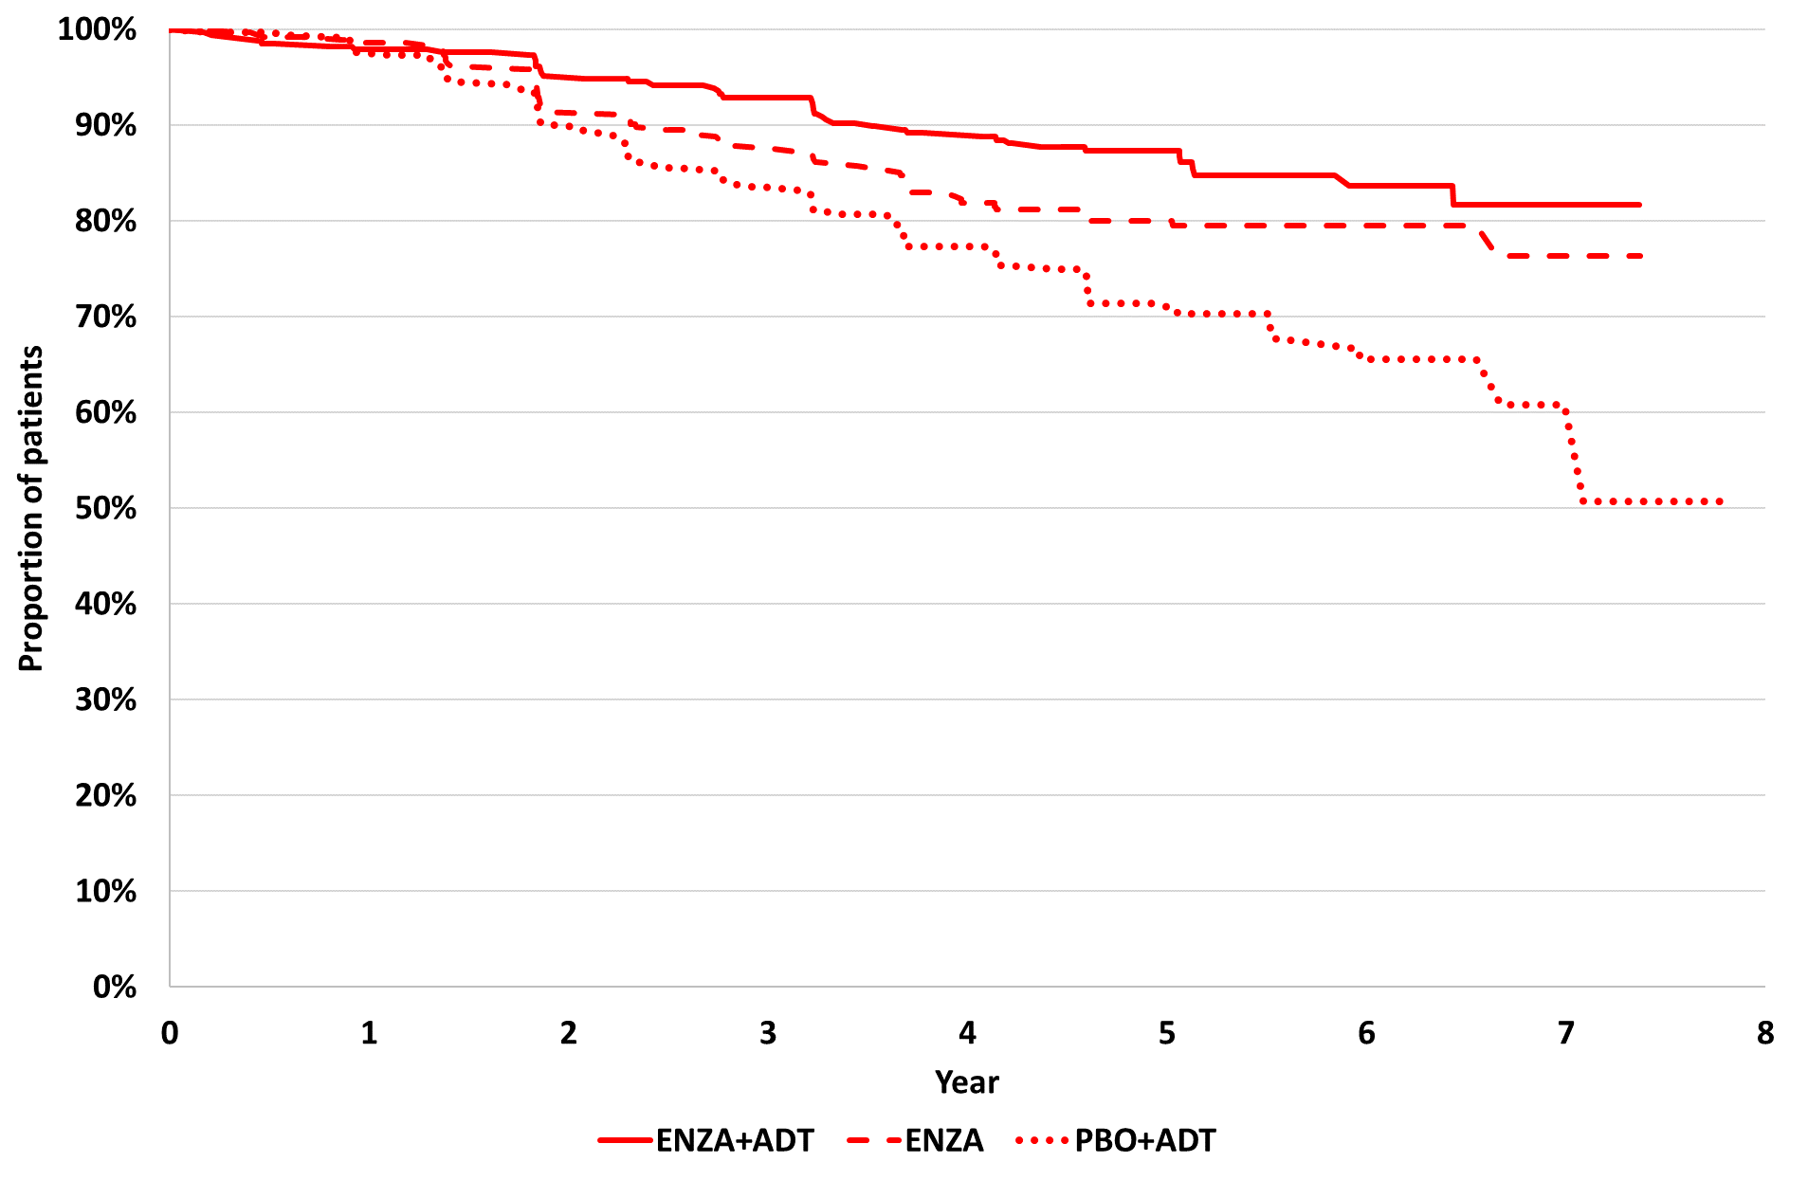 | 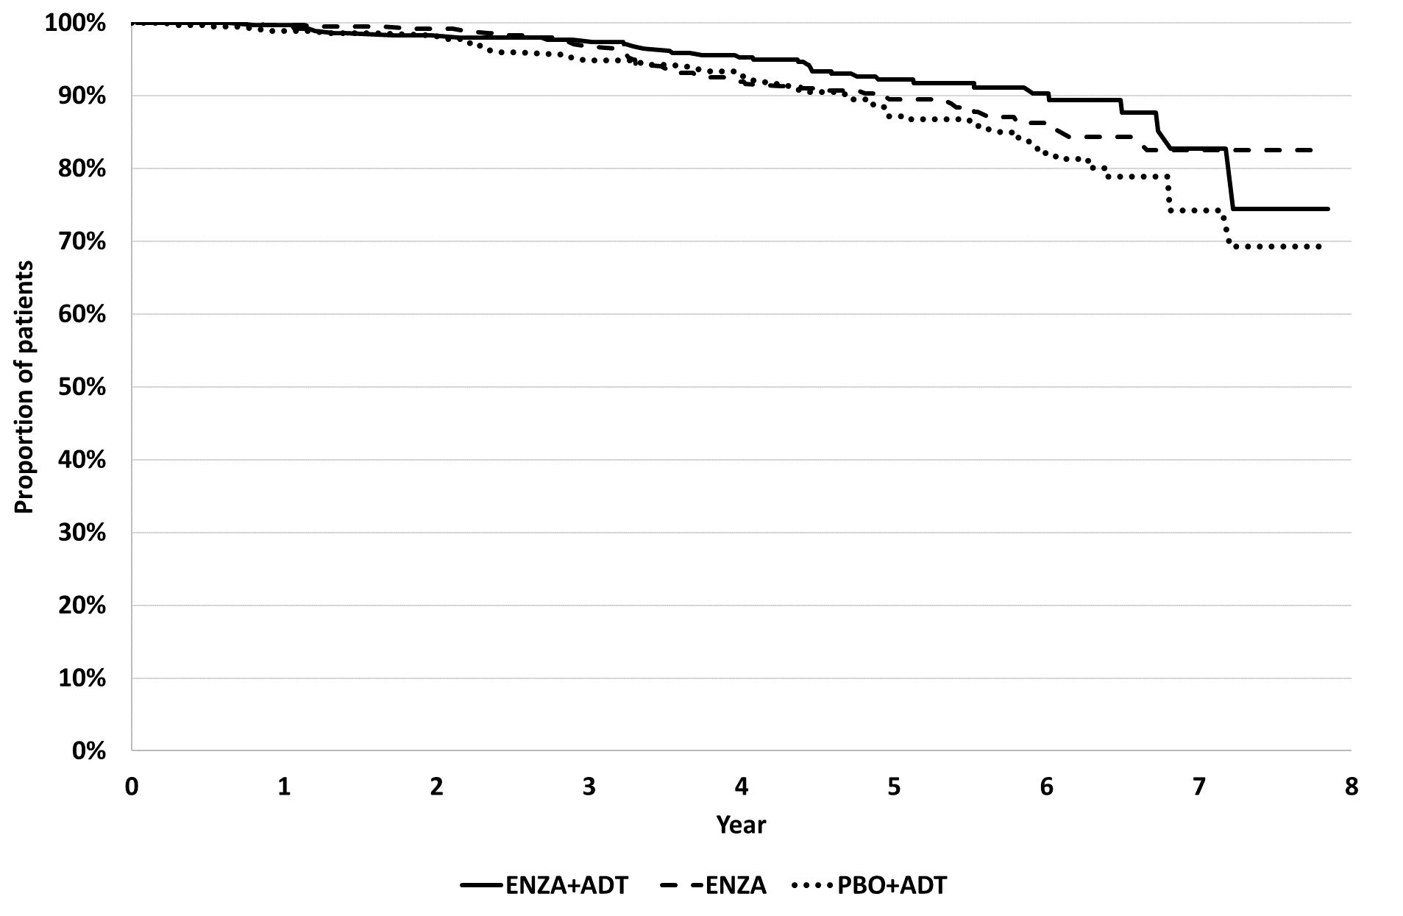
Source: Compiled during the evaluation from Figure 2-3, p55, Figure 2-6, p62, Figures 2-13 and 2-14, pp69-70 of the submission and Attachment 08 – XTANDI nmHSPC_CEM_v10.24.xlsm.
ADT=androgen deprivation therapy; ENZA=enzalutamide; ITT=intention-to-treat; MFS=metastasis-free survival; OS=overall survival; PBO=placebo
  - The results showed that MFS was significantly longer for patients treated with enzalutamide plus ADT compared to ADT alone, with statistically significant 57.6% reduction in the risk of MFS event i.e. radiographic progression or death without progression (HR=0.42, 95% CI: 0.30, 0.61). For patients treated with enzalutamide monotherapy compared to ADT alone, there was also a statistically significant 36.9% reduction in the risk of MFS event (HR=0.63, 95% CI: 0.46, 0.87). The results for MFS across most pre-specified subgroups were consistent with the ITT population, significantly favouring enzalutamide plus ADT and enzalutamide monotherapy over ADT alone. At censoring, the majority of patients (81.3%) had not experienced an MFS event and median MFS was not reached in any of the treatment groups.
  - Of note, the number of censored patients was high across treatment groups: 310 (87.3%) in enzalutamide plus ADT group, 292 (82.3%) in enzalutamide monotherapy and 266 (74.3%) in the ADT group. Most patients were censored due to no evidence of metastatic disease or death; however, 36 (10.1%) in enzalutamide plus ADT group and 44 (12.4%) in enzalutamide monotherapy compared to 67 (18.7%) were censored due to initiation of subsequent antineoplastic therapy. The imbalance in the censoring favoured enzalutamide (combination and monotherapy) treatment and suggests potential bias from informative censoring (EMA EPAR 2024). However, results were consistent across sensitivity analyses for MFS, including censoring regardless of initiation of subsequent antineoplastic therapy.
  - At the time of the interim analysis of OS, there was a trend in favour of the enzalutamide plus ADT compared ADT alone (HR=0.59, 95% CI: 0.38, 0.91, P=0.0153). The OS data were immature and the prespecified efficacy boundary (P ≤0.0001) was not crossed at this interim OS analysis, hence the results were not statistically significant. OS for the enzalutamide monotherapy group comparison was not formally tested at the interim analysis for OS, but also showed no difference to ADT (HR=0.78, 95% CI: 0.52, 1.17, P=0.2304). The protocol stated that the final analysis of OS will be conducted when 271 deaths have occurred across the three arms (compared to 130 deaths observed across the three arms at this interim analysis). At censoring, the majority of patients (87.8%) were alive, and median OS was not reached in any of the treatment groups.
Secondary outcomes
  - Table 6 summarises the secondary and other time-to-event outcomes in EMBARK. Overall, the results across most secondary and exploratory outcomes either numerically or statistically favoured enzalutamide (combination and monotherapy) compared to ADT alone; however, the treatment effects were numerically larger for patients treated with enzalutamide plus ADT combination than enzalutamide monotherapy. Median times to secondary events were also not reached for most outcomes across the treatment groups.
Table 6: Summary of time-to-event outcomes in EMBARK (ITT).
 | ENZA + ADT  N=355 | ENZA  N=355 | PBO + ADT  N=358
PSA progression
Events, n (%) | 8 (2.3) | 37 (10.4) | 93 (26.0)
Median (95% CI), months | NR (NR, NR) | NR (NR, NR) | NR (NR, NR)
HR (95% CI) vs PBO+ADT | 0.07 (0.03, 0.14) | 0.33 (0.23, 0.49) | -
First new antineoplastic therapy
Events, n (%) | 58 (16.3) | 84 (23.7) | 140 (39.1)
Median (95% CI), months | NR (NR, NR) | NR (NR, NR) | 76.2 (71.3, NR)
HR (95% CI) vs PBO+ADT | 0.36 (0.26, 0.49) | 0.54 (0.41, 0.71) | -
Distant metastasis (BICR)
Events, n (%) | 30 (8.5) | 40 (11.3) | 59 (16.5)
Median (95% CI), months | NR (NR, NR) | NR (NR, NR) | NR (85.1, NR)
HR (95% CI) vs PBO+ADT | 0.44 (0.28, 0.69) | 0.61 (0.41, 0.92) | -
Castration resistance
Events, n (%) | 14 (3.9) | - | 120 (33.5)
Median (95% CI), months | NR (NR, NR) | - | NR (NR, NR)
HR (95% CI) vs PBO+ADT | 0.09 (0.05, 0.16) | - | -
Symptomatic progression
Events, n (%)ª | 104 (29.3) | 117 (33.0) | 169 (47.2)
Median (95% CI), months | NR (NR, NR) | NR (83.6, NR) | 63.8 (56.4, 74.9)
HR (95% CI) vs PBO+ADT | 0.55 (0.43, 0.70) | 0.62 (0.49, 0.79) | -
Symptomatic skeletal event
Events, n (%)^{b} | 9 (2.5) | 14 (3.9) | 32 (8.9)
Median (95% CI), months | NR (NR, NR) | NR (NR, NR) | NR (NR, NR)
HR (95% CI) vs PBO+ADT | 0.26 (0.13, 0.55) | 0.42 (0.23, 0.79) | -
PFS2^{c}
Events, n (%) | 36 (10.1) | 48 (13.5) | 63 (17.6)
Median (95% CI), months | NR (NR, NR) | NR (NR, NR) | NR (NR, NR)
HR (95% CI) vs PBO+ADT | 0.52 (0.35, 0.79) | 0.74 (0.51, 1.08) | -
Source: Table 2-13, p65, Table 2-14, p67, Table 2-16, p73, Tables 2-21 and 2-22, pp80-81, Table 2-23, p83, Table 2-24, p86 of the submission.
ADT=androgen deprivation therapy; CI=confidence intervals; ENZA=enzalutamide; HR=hazard ratio; ITT=intention-to-treat; NR=not reached; OS=overall survival; PBO=placebo; PFS2=progression-free survival on first subsequent therapy; PSA=prostate specific antigen
Bold text indicates statistical significance at p<0.05 level.
a Based on the earliest contributing event (skeletal related event, new systemic antineoplastic therapy, opiate use, surgical intervention, or radiation therapy).
b Based on first symptomatic skeletal event (radiation therapy to bone, surgery to bone, pathological bone fracture, spinal cord compression, initiation/change to antineoplastic therapy to treat bone pain, opiate use due to bone pain).
c Exploratory endpoint. Based on the earliest contributing event after first progressive disease (investigator assessed clinical progression, radiographic progression, or PSA progression) or death due to any cause, whichever occurred first.
  - Table 7 summarises the results for treatment suspension from Week 37 and re-initiation of hormonal therapy in EMBARK.
Table 7: Results for treatment suspension and re-initiation in EMBARK (ITT).
 | ENZA + ADT  N=355 | ENZA  N=355 | PBO + ADT  N=358
Patients with PSA values at Wk 36, n (%) | 331 (93.2) | 337 (94.9) | 336 (93.9)
Patients with undetectable PSA at Wk 36, n (%) | 322 (97.3) | 304 (90.2) | 240 (71.4)
Proportion (95% CI)ª | 97.3 (94.9, 98.7) | 90.2 (86.5, 93.2) | 71.4 (66.3, 76.2)
Difference of proportion (95% CI)^{b} vs PBO+ADT | 25.9 (20.7, 31.0) | 18.8 (13.0, 24.6) | -
Patients with treatment suspension, n (%) | 321 (90.4) | 304 (85.6) | 240 (67.0)
Treatment free at 2 yrs after suspension, n (%) | 111 (34.6) | 43 (14.1) | 65 (27.1)
Proportion (95% CI)ª | 34.6 (29.4, 40.1) | 14.1 (10.4, 18.6) | 27.1 (21.6, 33.2)
Difference of proportion (95% CI)^{b} | 7.5 (-0.2, 15.2) | -12.9 (-19.8, -6.1) | -
Undetectable PSA at 2 yrs after suspension, n (%) | 54 (16.8) | 14 (4.6) | 23 (9.6)
Proportion (95% CI)ª | 16.8 (12.9, 21.4) | 4.6 (2.5, 7.6) | 9.6 (6.2, 14.0)
Difference of proportion (95% CI)^{b} | 7.2 (1.7, 12.8) | 5.0 (9.4, 0.6) | -
Time to resumption of hormonal any therapy
Events, n (%)^{c} | 256 (79.8) | 279 (91.8) | 217 (90.4)
Median (95% CI), months | 19.6 (17.2, 22.3) | 10.5 (8.9, 11.5) | 16.8 (14.3, 17.1)
HR (95% CI) vs PBO+ADT^{d} | 0.69 (0.58, 0.83) | 1.66 (1.38, 1.98) | -
Source: Tables 2-17 to 2-20, pp75-78 of the submission.
ADT=androgen deprivation therapy; CI=confidence intervals; ENZA=enzalutamide; HR=hazard ratio; ITT=intention-to-treat; NR=not reached; PBO=placebo; PSA=prostate specific antigen
Bold text indicates statistical significance at p<0.05 level.
a Clopper-Pearson exact binomial confidence interval.
b Proportion in ENZA+ADT group minus proportion in PBO+ADT, or proportion in ENZA arm minus proportion in PBO+ADT group. 95% CI is based on Wald type method.
c Based on the hormonal therapy restarted after treatment suspension at week 37 due to undetectable PSA.
d Two-sided P value is based on a stratified log rank test by screening PSA, PSA doubling time, and prior hormonal therapy. Hazard ratio is based on a Cox regression model stratified by factors defined above and is relative to PBO+LA with <1 favouring ENZA+ADT and PBO+ADT with <1 favouring ENZA.
  - Of the patients with treatment suspension from Week 37 due to undetectable PSA, treatment with enzalutamide plus ADT compared to ADT alone had a 31% reduction in the risk of re-initiation of hormonal therapy (HR=0.69, 95% CI: 0.58, 0.83). Whereas patients treated with enzalutamide monotherapy compared to ADT alone showed an increased risk of re-initiation of hormonal therapy (HR=1.66, 95% CI: 1.38, 1.98). The median time to resumption of hormonal therapy was longer in the enzalutamide plus ADT group (19.6 months) compared to ADT alone (16.8 months) and enzalutamide monotherapy group (10.5 months).
Patient reported QoL
  - The results for the EQ-5D-5L in EMBARK showed no difference between treatment groups in the time to first and clinically meaningful deterioration in EQ-5D-5L. Longitudinally, change from baseline in EQ-5D-5L VAS score was maintained to Week 205. The EQ-5D-5L VAS scores was maintained in over 60% of patients over time. There was no difference between enzalutamide plus ADT and enzalutamide monotherapy compared to ADT alone in the time to first and clinically meaningful deterioration in other QoL outcomes (BPI-SF worst pain, FACT-P total score) with the exception of QLQ-PR25 (favouring ADT versus enzalutamide plus ADT, and enzalutamide monotherapy versus ADT).

Comparative harms
  - Table 8 summarises the treatment emergent adverse events (TEAEs) and adverse events (AEs) of special interest in EMBARK over the duration of treatment (including the period of treatment suspension, if applicable).
Table 8: TEAEs, common AEs and AEs of special interest in EMBARK (safety population).
AEs, n (%) | ENZA + ADT | ENZA | PBO + ADT | RD (95% CI)*
AEs, n (%) | N=353 | N=354 | N=354 | ENZA + ADT v PBO + ADT | ENZA v PBO + ADT
Any TEAEs | 343 (97.3) | 347 (98.0) | 345 (97.5) | -0.00 (-0.03, 0.02) | 0.01 (-0.02, 0.03)
TEAE to discontinuation | 73 (20.7) | 63 (17.8) | 36 (10.2) | 0.11 (0.05, 0.16) | 0.08 (0.03, 0.13)
TEAE to dose reduction | 25 (7.1) | 56 (15.8) | 16 (4.5) | 0.03 (-0.01, 0.06) | 0.11 (0.07, 0.16)
TEAE to death# | 6 (1.7) | 8 (2.3) | 3 (0.8) | 0.01 (-0.01, 0.03) | 0.01 (-0.00, 0.03)
TEAE (Grade 3+) | 164 (46.5) | 177 (50.0) | 151 (42.7) | 0.04 (-0.04, 0.11) | 0.07 (0.00, 0.15)
TEAE treatment-related | 305 (86.4) | 312 (88.1) | 283 (79.9) | 0.06 (0.01, 0.12) | 0.08 (0.03, 0.14)
Serious TEAE | 123 (34.8) | 131 (37.0) | 112 (31.6) | 0.03 (-0.04, 0.10) | 0.05 (-0.02, 0.12)
Common TEAEs (≥5% patients)
Hot flush | 242 (68.6)^ | 77 (21.8)^ | 203 (57.3)^ | 0.11 (0.04, 0.18) | -0.36 (-0.42, -0.29)
Fatigue | 151 (42.8)^ | 165 (46.6)^ | 116 (32.8^) | 0.10 (0.03, 0.17) | 0.14 (0.07, 0.21)
Arthralgia | 97 (27.5) | 81 (22.9) | 75 (21.2) | 0.06 (-0.00, 0.13) | 0.02 (-0.04, 0.08)
Hypertension | 82 (23.2) | 67 (18.9) | 69 (19.5) | 0.04 (-0.02, 0.10) | -0.01 (-0.06, 0.05)
Fall | 74 (21.0) | 56 (15.8) | 51 (14.4) | 0.07 (0.01, 0.12) | 0.01 (-0.04, 0.07)
Back pain | 60 (17.0) | 62 (17.5) | 54 (15.3) | 0.02 (-0.04, 0.07) | 0.02 (-0.03, 0.08)
Diarrhea | 49 (13.9) | 46 (13.0) | 31 (8.8) | 0.05 (0.00, 0.10) | 0.04 (-0.00, 0.09)
Constipation | 46 (13.0) | 34 (9.6) | 31 (8.8) | 0.04 (-0.00, 0.09) | 0.01 (-0.03, 0.05)
Haematuria | 42 (11.9) | 45 (12.7) | 44 (12.4) | -0.01 (-0.05, 0.04) | 0.00 (-0.05, 0.05)
Insomnia | 42 (11.9) | 25 (7.1) | 37 (10.5) | 0.01 (-0.03, 0.06) | -0.03 (-0.08, 0.01)
Nausea | 42 (11.9) | 54 (15.3) | 29 (8.2) | 0.04 (-0.01, 0.08) | 0.07 (0.02, 0.12)
Pain in extremity | 41 (11.6) | 40 (11.3) | 36 (10.2) | 0.01 (-0.03, 0.06) | 0.01 (-0.03, 0.06)
Asthenia | 39 (11.0) | 39 (11.0) | 21 (5.9) | 0.05 (0.01, 0.09) | 0.05 (0.01, 0.09)
Dizziness | 39 (11.0) | 41 (11.6) | 37 (10.5) | 0.01 (-0.04, 0.05) | 0.01 (-0.03, 0.06)
Headache | 39 (11.0) | 41 (11.6) | 32 (9.0) | 0.02 (-0.02, 0.06) | 0.03 (-0.02, 0.07)
Urinary incontinence | 34 (9.6) | 36 (10.2) | 28 (7.9) | 0.02 (-0.02, 0.06) | 0.02 (-0.02, 0.06)
Gynecomastia | 29 (8.2) | 159 (44.9)^ | 32 (9.0) | -0.01 (-0.05, 0.03) | 0.36 (0.30, 0.42)
Peripheral oedema | 27 (7.6) | 31 (8.8) | 37 (10.5) | -0.03 (-0.07, 0.01) | -0.02 (-0.06, 0.03)
Urinary tract infection | 27 (7.6) | 37 (10.5) | 26 (7.3) | 0.00 (-0.04, 0.04) | 0.03 (-0.01, 0.07)
Weight decreased | 24 (6.8) | 39 (11.0) | 12 (3.4) | 0.03 (0.00, 0.07) | 0.08 (0.04, 0.11)
Nipple pain | 11 (3.1) | 54 (15.3) | 4 (1.1) | 0.02 (-0.00, 0.04) | 0.14 (0.10, 0.18)
Breast tenderness | 5 (1.4) | 51 (14.4) | 4 (1.1) | 0.00 (-0.01, 0.02) | 0.13 (0.09, 0.17)
Source: Table 2-29, pp103-405 and Table 2-32, p110 of the submission.
ADT=androgen deprivation therapy; AE=adverse event; ENZA=enzalutamide; PBO=placebo; RD=risk difference; TEAE=Treatment emergent AE
* Calculated during the evaluation using RevMan v5.3.
# Adverse events leading to death were grade 5 adverse events; none were considered by the investigator to be related to treatment.
^ These events were among the most common treatment-related adverse events (occurring in ≥30% of the patients).
  - Overall, the incidence of any TEAEs, AEs leading to death and serious AEs was similar across the three treatment groups. TEAEs leading to death occurred in 6 (1.7%) patients treated with enzalutamide plus ADT, 8 (2.3%) in the enzalutamide monotherapy group and 3 (0.8%) patients in the placebo plus ADT group. There was a higher incidence of TEAEs leading to discontinuation, Grade 3+ TEAEs, and drug-related TEAEs in the enzalutamide (combination and monotherapy) groups compared to ADT alone. Although the overall incidence of TEAEs were similar in all groups, the type of events differed between groups. The most frequent TEAEs (≥15% of patients in any group) included hot flush, fatigue, arthralgia, hypertension, fall, back pain, gynaecomastia, nausea and nipple pain. The most common TEAEs in the enzalutamide plus ADT combination group and ADT alone group were hot flushes and fatigue. Enzalutamide monotherapy group reported higher incidence of fatigue, gynaecomastia, weight decreased, nipple pain and breast tenderness than in enzalutamide plus ADT combination group and the ADT alone group.

Benefits/harms
  - Table 9 presents a summary of the comparative benefits and harms for enzalutamide plus ADT and enzalutamide monotherapy versus placebo plus ADT for m0HSPC.
Table 9: Summary of comparative benefits and harms of enzalutamide plus ADT and enzalutamide monotherapy vs and placebo plus ADT (ITT)
Benefits
Event | ENZA + ADT  N=355 | ENZA  N=355 | PBO + ADT  N=358 | Difference (95% CI)
 |  |  |  | ENZA + ADT vs  PBO + ADT | ENZA vs  PBO + ADT
Metastasis-free survival (MFS)
Events, n (%) | 45 (12.7) | 63 (17.7) | 92 (25.7) | HR: 0.42 (0.3, 0.61) | HR: 0.63 (0.46, 0.87)
Median MFS, months (95% CI) | NR (NR, NR) | NR (NR, NR) | NR (85.1, NR) | - | -
Event-free at 5 years (%) | 87.3 | 80.0 | 71.4 | 15.9 | 8.6
Overall survival (OS)
Deaths, n/N (%) | 33 (9.3) | 42 (11.8) | 55 (15.4) | HR: 0.59 (0.38, 0.91)ª | HR: 0.78 (0.52, 1.17)ª
Median OS, months (95% CI) | NR (NR, NR) | NR (NR, NR) | NR (NR, NR) | - | -
Alive at 5 years (%) | 92.2 | 89.5 | 87.2 | 5.0 | 2.3
Harms
 | Event rate/100 patients |  |  | RR* (95% CI) |  | RD (95% CI)
TEAEs | ENZA + ADT | ENZA | PBO | ENZA + ADT vs PBO + ADT | ENZA vs PBO + ADT | ENZA + ADT vs PBO + ADT | ENZA vs PBO + ADT
Selected common TEAEs (≥5% patients)
Hot flush | 69 | 22 | 57 | 1.20 (1.07, 1.34) | 0.38 (0.31, 0.47) | 0.11 (0.04, 0.18) | -0.36 (-0.42, -0.29)
Fatigue | 43 | 47 | 33 | 1.31 (1.08, 1.58) | 1.42 (1.18, 1.71) | 0.10 (0.03, 0.17) | 0.14 (0.07, 0.21)
Arthralgia | 28 | 23 | 21 | 1.30 (1.00, 1.69) | 1.08 (0.82, 1.43) | 0.06 (-0.00, 0.13) | 0.02 (-0.04, 0.08)
Fall | 21 | 16 | 14 | 1.46 (1.05, 2.01) | 1.10 (0.77, 1.56) | 0.07 (0.01, 0.12) | 0.01 (-0.04, 0.07)
Asthenia | 11 | 11 | 6 | 1.86 (1.12, 3.10) | 1.86 (1.12, 3.09) | 0.05 (0.01, 0.09) | 0.05 (0.01, 0.09)
Gynecomastia | 8 | 45 | 9 | 0.91 (0.56, 1.47) | 4.97 (3.50, 7.05) | -0.01 (-0.05, 0.03) | 0.36 (0.30, 0.42)
Weight decreased | 7 | 11 | 3 | 2.01 (1.02, 3.95) | 3.25 (1.73, 6.10) | 0.03 (0.00, 0.07) | 0.08 (0.04, 0.11)
Nipple pain | 3 | 15 | 1 | 2.76 (0.89, 8.58) | 13.50 (4.94, 36.88) | 0.02 (-0.00, 0.04) | 0.14 (0.10, 0.18)
Breast tenderness | 1 | 14 | 1 | 1.25 (0.34, 4.63) | 12.75 (4.66, 34.90) | 0.00 (-0.01, 0.02) | 0.13 (0.09, 0.17)
Source: Table 2-10, p55, Table 2-12, p61, Table 2-29, pp103-405 and Table 2-32, p110 of the submission.
ADT=androgen deprivation therapy; AE=adverse event; ENZA=enzalutamide; HR=hazard ratio; MFS=metastasis-free survival; NR=not reached; OS=overall survival; PBO=placebo; RD=risk difference; RR=risk ratio; TEAE=treatment emergent AE
* Median duration of follow-up in EMBARK was 60.7 months.
* Calculated during the evaluation using RevMan v5.3.
a For the interim analysis, an O'Brien-Fleming stopping boundary will be used. The prespecified efficacy boundary (P ≤ 0.0001) was not crossed at this interim OS analysis and the results were not statistically significant.
  - On the basis of evidence from the EMBARK trial presented by the submission, for every 100 patients treated with enzalutamide plus ADT or enzalutamide monotherapy in comparison to placebo plus ADT:
    - Approximately 16 additional patients treated with enzalutamide plus ADT and 9 additional patients treated with enzalutamide monotherapy will remain metastasis-free after 5 years.
    - Patients treated with enzalutamide plus ADT will experience an increased incidence of hot flush, fatigue, arthralgia, falls, asthenia, gynecomastia, weight loss, nipple pain and breast tenderness compared to patients receiving enzalutamide monotherapy.

Clinical claim
  - The submission described enzalutamide, with or without ADT, as superior in terms of effectiveness and inferior (but manageable) in terms of safety compared to placebo plus ADT for the treatment of patients with high-risk m0HSPC after definitive local therapy.
  - The ESC considered that the clinical claim for the effectiveness of enzalutamide plus ADT and enzalutamide monotherapy versus ADT alone was supported in terms of the MFS outcomes data reported in EMBARK. However, the ESC considered that the magnitude of the clinical treatment effect and the applicability to the practice setting was highly uncertain. The ESC noted the following issues:
    - EMBARK potentially included a sizeable proportion of patients with metastatic disease on PSMA-PET imaging (i.e. mHSPC), who would be eligible for current NHA treatment on the PBS. Under PSMA-PET testing a proportion of patients in the trial are likely to be mHSPC at baseline, therefore time to metastases is likely overestimated for the cohort from EMBARK, but underestimated for the true population with m0HSPC defined by PSMA-PET.
    - At the time of the data analysis cut-off date (median follow-up 60.7 months), the OS data were immature and despite a trend favouring enzalutamide plus ADT compared to ADT alone, the results were not statistically significant based on the statistical analysis plan. The follow-up was also relatively incomplete, as the majority of patients were alive (87.8%) and had not experienced metastatic progression (81.3%) at censoring. The ESC further noted that mature OS data would likely not be available at the final data cut, estimated in September 2026.
    - While MFS has been validated as a surrogate for OS in m0CRPC, there is limited evidence of the surrogate relationship between MFS and OS in m0HSPC, and MFS may take many years to develop in patients with m0HSPC.
    - The EMBARK trial was not designed to compare enzalutamide plus ADT versus enzalutamide monotherapy. Although the trial showed a significant difference between enzalutamide (combination and monotherapy) compared to ADT alone in terms of MFS and most secondary endpoints, the treatment effects were numerically larger for enzalutamide plus ADT combination than enzalutamide monotherapy.
    - The EMBARK trial protocol required all patients with undetectable PSA at Week 36 to suspend treatment until PSA levels increased beyond a certain threshold. It was unknown whether the same treatment suspension would be implemented in the same manner in the Australian practice setting.
  - The PBAC considered that the claim of superior comparative effectiveness was reasonable, noting that the magnitude of the benefit was uncertain due to the immaturity of the data.
  - The ESC considered that the claim of inferior safety was adequately supported by the evidence. Although the overall incidence of TEAEs was similar across the treatment groups, there was a higher incidence of TEAEs leading to discontinuation, Grade 3+ TEAEs, and drug-related TEAEs for enzalutamide with or without ADT compared to ADT alone. The ESC agreed that the safety profile of enzalutamide was known and manageable.
  - The PBAC considered that the claim of inferior comparative safety was reasonable.

Economic analysis
  - The submission presented stepped economic evaluations of enzalutamide therapies (enzalutamide plus ADT, and enzalutamide monotherapy), versus ADT alone for patients who have m0HSPC with high-risk BCR based on the EMBARK randomised trial.
  - The type of economic evaluations presented were cost-utility analyses using a semi-Markov model. The model used a combined partitioned survival and Markov model approach to estimate movement between seven health states: (i) m0HSPC prior to or without treatment suspension, (ii) m0HSPC during treatment suspension, (iii) m0HSPC post-treatment suspension, (iv) mHSPC, (v) m0CRPC, (vi) mCRPC and (vii) dead. A summary of the key components is presented in Table 10.
Table 10: Summary of model structure, key inputs and rationale
Component | Summary
Treatments | ENZA+ADT vs ADT alone; ENZA monotherapy vs ADT alone. ADT was expected to be 88.02% leuprorelin, 11.65% degarelix, 0.34% orchiectomy.
Time horizon | 30 years in the model base case vs. median 60.7 months in EMBARK for MFS and 63.7-66.2 months OS follow-up. Patients entered the model at age 69.
Outcomes | Life years gained (LYG), quality-adjusted life years (QALYs).
Methods used to generate results | Semi-Markov cohort model. The structure of the model appeared to exaggerate the benefit of enzalutamide, beyond what was observed in the clinical evidence. As such, the ESC considered that this approach may not be reasonable.
Health states | Each arm had 7 health states: m0HSPC (pre-/no treatment suspension, treatment suspension, post-treatment suspension); mHSPC; m0CRPC (one cycle); mCRPC; Dead.  Patients could be on or off treatment in every state and TTD was modelled separately, with the exception of patients in the treatment suspension who were, by definition, off treatment.
Cycle length | 1 month.
Allocation to health states | m0HSPC to mHSPC: variable probabilities each cycle based on MFS EMBARK KM data.  m0HSPC to m0CRPC or mCRPC: constant per cycle probabilities based on EMBARK data.  m0HSPC to death: variable probabilities each cycle based on OS in EMBARK KM data.  TTD was split between pre and post treatment suspension and based on EMBARK KM data. Further, the proportion of patients entering treatment suspension at Month 9 and time in treatment suspension was based on averages from EMBARK for each arm.  Per cycle probabilities for treatment progression or death from other health states were based on enzalutamide trials (ARCHES, PROSPER, and PREVAIL), weighted by subsequent therapies used in each health state by treatment arm. Time to subsequent treatment discontinuation was based on pooled median time on treatment from prostate cancer trials. General population mortality was introduced from Year 6.5.
Extrapolation method | Extrapolations of EMBARK data were based on independently fitted parametric survival curves for MFS, TTD from trial start, TTD from treatment reinitiation and OS. The submission selected the parametric functions for the base case using a combination of goodness of fit statistics (AIC/BIC), visual inspection, clinical plausibility and consistency with the other extrapolations.  MFS: Gamma extrapolations in all arms.  OS: Weibull extrapolations for ENZA+ADT and ADT alone, and Gamma extrapolation applied for ENZA monotherapy.  TTD from Time 0: log-normal extrapolations for all arms.  TTD post treatment reinitiation: exponential extrapolations for the enzalutamide arms and Gamma extrapolation for ADT alone.  The constant transition probabilities for the progressed disease health states (mHSPC, m0CRPC, mCRPC) were applied from Time 0.  In the comparison to ADT alone, ~81% of incremental QALYs from enzalutamide with or without ADT (and 11-26% of incremental costs) occurred beyond Month 75.
Health related quality of life | m0HSPC treatment suspension: 0.950,  m0HSPC otherwise: 0.934 from EMBARK (could not be verified). Utility values from EMBARK (0.934-0.95) were high compared to Australian general population  mHSPC: 0.817 from ARCHES, higher than 0.806 reported previously (para 6.46, enzalutamide PSD, March 2023).  m0CRPC: 0.852 from PROSPER.  mCRPC: 0.706 equals the PD2 utility reported for enzalutamide in mHSPC (para 6.46, enzalutamide PSD, March 2023).  Health state utilities were adjusted for age and adverse event utility loss. An end-of-life QALY loss was also incorrectly applied.
Subsequent treatments | Proportion of subsequent treatments in each health state were based on PBS 10% sample and included NHAs (enzalutamide, apalutamide, darolutamide, abiraterone), cabazitaxel/docetaxel, and ADT. Subsequent treatment modelling was complex and may not reflect actual patient experience.
Source: compiled during the evaluation
ADT=androgen deprivation therapy, ENZA=enzalutamide, KM=Kaplan Meier, m0HSPC=non-metastatic hormone sensitive prostate cancer, mHSPC=metastatic hormone sensitive prostate cancer, m0CRPC=non-metastatic castrate resistant prostate cancer, mCRPC=metastatic castrate resistant prostate cancer, MFS=metastases free survival, NHA=novel hormonal agent, OS=overall survival, QALY=quality adjusted life year; TTD=time to treatment discontinuation
  - The model structure is presented in Figure 2. The submission implemented a semi-Markov cohort model to estimate all costs and benefits of the three alternative treatments compared in EMBARK, over the trial period and beyond the trial follow-up. However, as no data from EMBARK was used to inform the progressed health state transitions, the estimates were pulled from multiple sources, and therefore, the transition probabilities were uncertain. Further, the ESC noted that the implementation of the approach resulted in structurally increasing the survival benefit of enzalutamide (with or without ADT) over ADT alone, which may not be reasonable.
Figure 2: Structure of the economic model
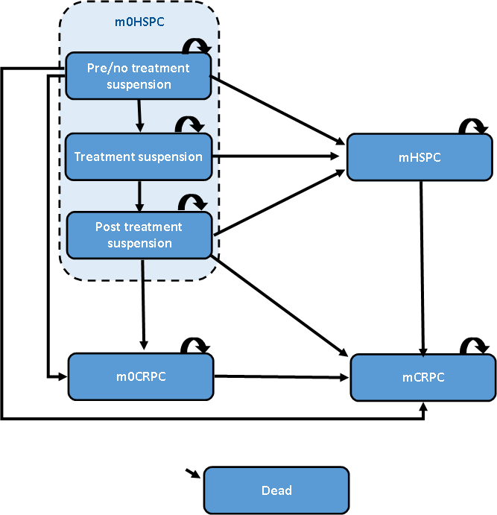
Source: compiled during the evaluation based on Figure 3-1, p123 of the submission
m0HSPC=non-metastatic hormone sensitive prostate cancer, mHSPC=metastatic hormone sensitive prostate cancer, m0CRPC=non- metastatic castrate resistant prostate cancer, mCRPC=metastatic castrate resistant prostate cancer.
In the pre/no treatment suspension, and post-treatment suspension health states of m0HSPC patients could be on or off treatment.
  - All patients entered the model in the m0HSPC health state. From m0HSPC, patients could develop metastatic disease progression (mHSPC), non-metastatic disease progression (m0CRPC) or die. A partitioned survival analysis, based on MFS and OS Kaplan Meier data from EMBARK extrapolated to 30 years, was used to estimate the proportion of patients in the m0HSPC, mHSPC and dead (from m0HSPC) each cycle. The transition from m0HSPC to mCRPC (or m0CRPC) was informed by a constant probability estimated as 50% the rate of mCRPC in EMBARK. Allocation within the m0HSPC health state to treatment suspension was based on proportions from EMBARK and the average duration of treatment suspension. Allocation from treatment suspension to mHSPC was stated as based on EMBARK, but the ESC noted that this could not be verified, and it was unclear why the probability was higher in enzalutamide arms (0.15% per cycle enzalutamide plus ADT, 0.27% enzalutamide monotherapy) than ADT alone (0.08% per cycle).
  - Time to further progression and death from progressed disease states (mHSPC, m0CRPC, mCRPC) used a Markov model approach. Monthly transition probabilities were based on treatment allocation upon entry to each progressed health state and the expected time to progression or death based upon enzalutamide trials in mHSPC, m0CRPC, mCRPC (ARCHES, PROSPER, PREVAIL).
  - Patients in all health states (except treatment suspension, who were off treatment by definition) could be on or off treatment. Time on treatment was modelled based on time to treatment discontinuation (TTD) Kaplan Meier data before and after treatment suspension in EMBARK extrapolated to 30 years. Treatment suspension occurred at Month 9 with a proportion of patients (90.9% enzalutamide plus ADT arm, 85.9% enzalutamide monotherapy arm, 67.8% ADT alone arm) suspending treatment, followed by 68.3% patients resuming treatment at Month 39 in the enzalutamide plus ADT arm, 76.3% patients resuming treatment at Month 27 in the enzalutamide monotherapy arm, and 57.3% at Month 33 in the ADT arm. The treatment suspension substates based on the trial may not reflect how enzalutamide will be used in practice, and the difference between treatment suspension, stoppage and intermittent treatment may be open to interpretation in practice. The ESC considered that the application of the treatment suspension in clinical practice would likely differ to how it was mandated in the EMBARK trial, and this was likely to have a significant effect on the cost effectiveness of enzalutamide + ADT. Time to subsequent treatment discontinuation in the progressed health states was based on pooled median time on treatment for available treatments from a range of sources, including ARCHES, TITAN, ARASENS, PROSPER, and PREVAIL. The pre-PBAC response stated that treatment suspension was protocol defined and should be considered as trial evidence rather than a bias in favour of the enzalutamide arms.
  - The model estimated costs and benefits over the lifetime, with a base case time horizon of 30 years (age of entry to the model was 69 years). While patients are expected to have long survival, the extrapolation was long compared to the trial follow up (median 60-67 months). PBAC has previously considered time horizons of 10 years in m0CRPC (paragraph 4.6, darolutamide PSD, July 2021 PBAC meeting) and mHSPC (paragraphs 7.15 and 7.16, apalutamide PSD, Nov 2021 PBAC meeting, paragraph 6.57-6.58, enzalutamide PSD, March 2023 PBAC meeting). The PSCR reiterated that 89% and 92% of patients in the enzalutamide monotherapy and enzalutamide + ADT arms respectively were alive after a 5 year follow up and stated that a 10-year time horizon in the early setting was unrealistic.
  - Kaplan Meier data from EMBARK are presented in Figure 3. In the base case, Kaplan Meier data were used to 69 months (ADT arm) and 75 months (enzalutamide arms) for PFS and TTD and 78 months (all arms) for OS, where 10% patients remained at risk, followed by extrapolation to 30 years. The choice of month cut-off was generally reasonable, although other model assumptions, discussed in the following paragraphs, meant that where Kaplan Meier data was applied, it was adjusted by other factors (usually related to mortality), and it may have been more reasonable to implement the parametric extrapolations for Time 0. Treatment reinitiation was modelled using a parametric function from the time of reinitiation. The submission did not explain why the Kaplan Meier curves of MFS and OS for the enzalutamide plus ADT arms crossed, which should be an impossibility. The PSCR stated that the Kaplan Meier estimates of MFS and OS in the last phase were affected by the very small numbers of patients remaining at risk. The submission also did not explain the severe drop in the TTD from Time 0 Kaplan Meier curve at ~Month 8, but this may have been the proportion of patients who suspended treatment and then never reinitiated.
Figure 3: EMBARK KM data used in the model
Time to treatment discontinuation, metastases, and death (from Time 0) | Time to treatment discontinuation after treatment reinitiation
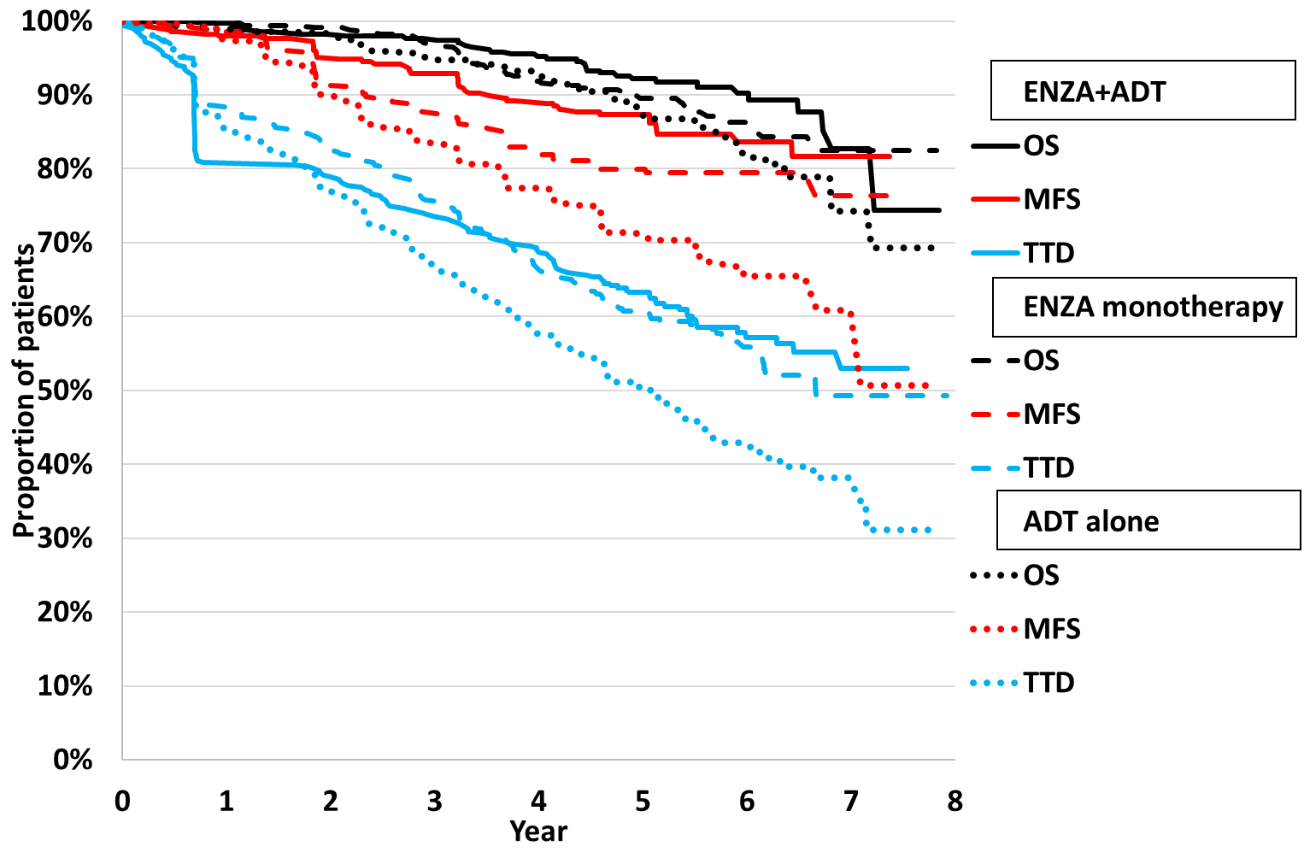 | 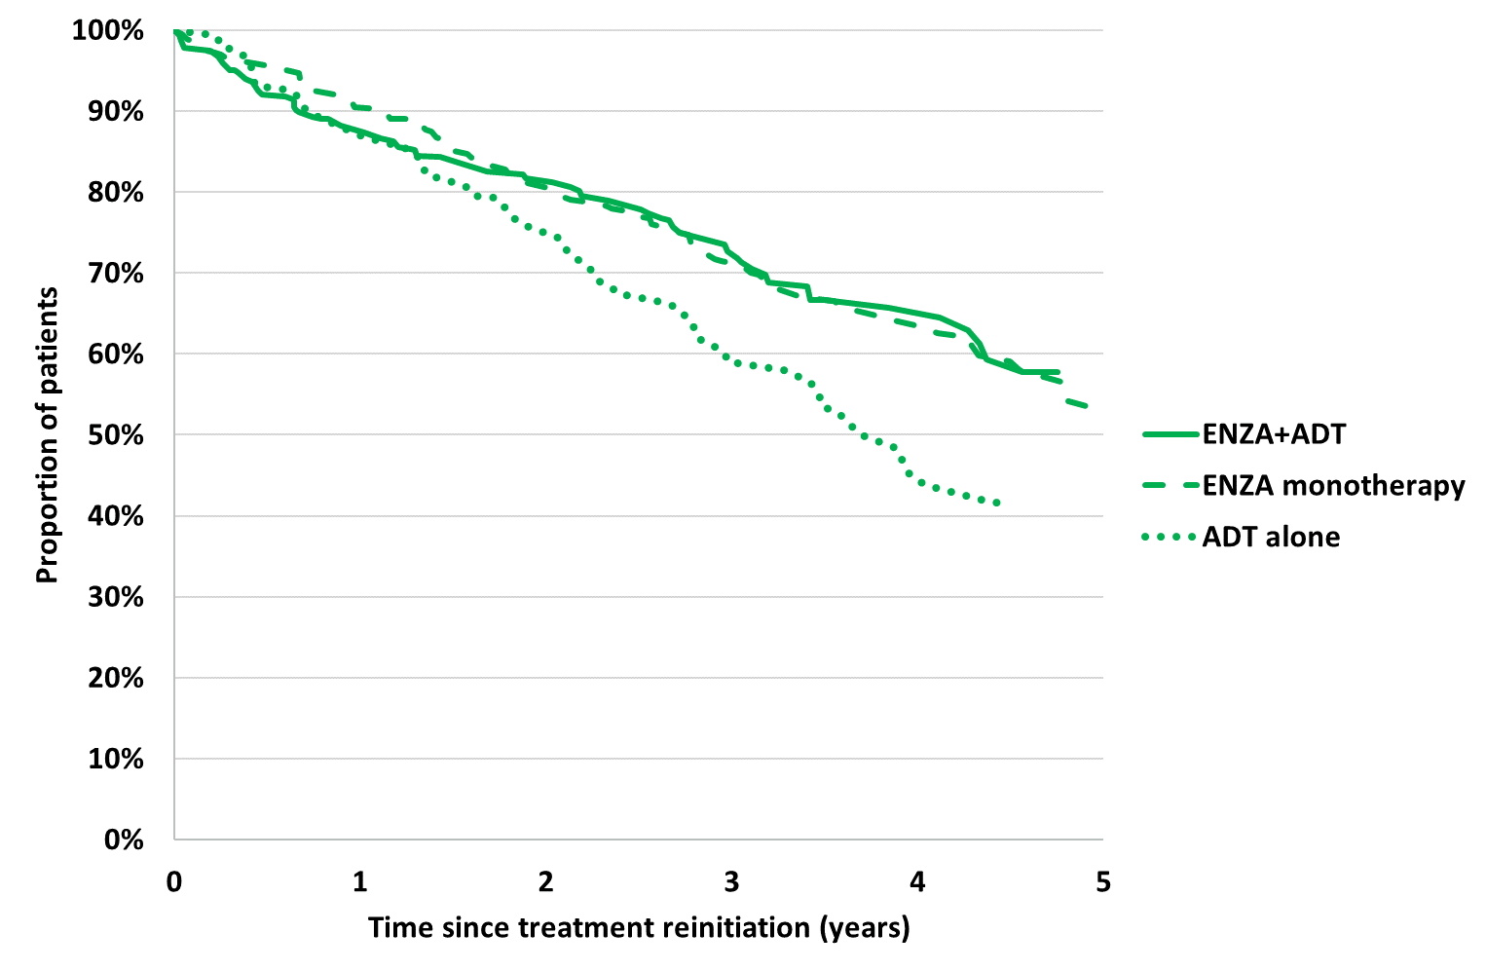
Source: compiled during the evaluation from the Excel file ‘Attachment 08 – XTANDI nmHSPC_CEM_v10.xlsm’
ADT=androgen deprivation therapy, ENZA=enzalutamide, MFS=metastases free survival, OS=overall survival, TTD=time to treatment discontinuation
  - Individual patient data (IPD) from EMBARK was used to fit parametric survival curves for MFS, TTD from trial start, TTD from treatment reinitiation and OS. The submission selected the parametric functions for the base case using a combination of goodness of fit statistics (the Akaike information criterion [AIC] and Bayesian information criterion [BIC]), visual inspection, clinical plausibility and consistency with the other extrapolations. The submission independently fitted all extrapolations, which was reasonable, although proportional hazards did not appear to have been tested and the proposed MAP described that the ICERs would be updated with revised hazard ratios for MFS and OS when final analysis for EMBARK was complete, inconsistent with the approach presented here.
  - Extrapolations based on EMBARK ITT are presented below.
Figure 4: Extrapolations of EMBARK KM data
Enzalutamide plus ADT vs ADT alone | Enzalutamide monotherapy vs ADT alone
Metastases free survival
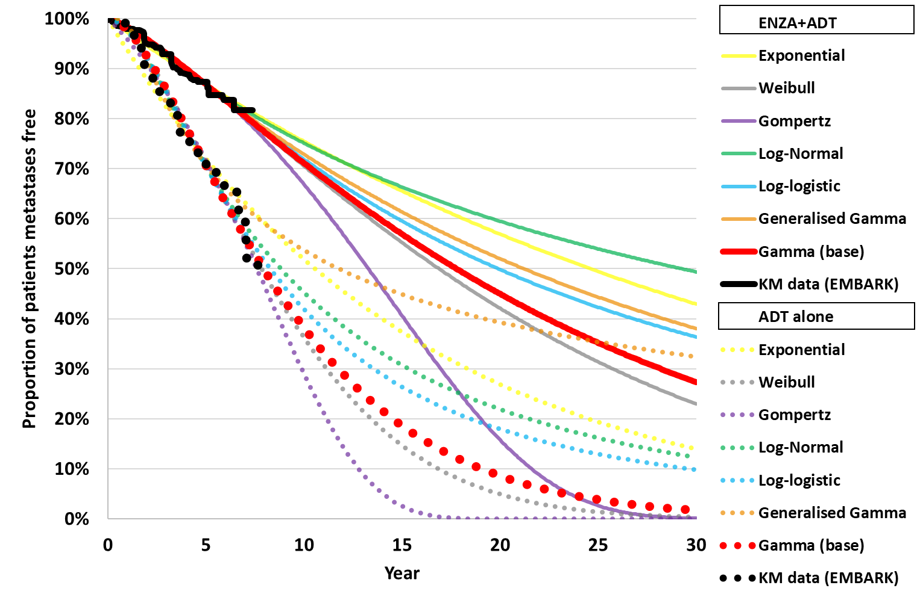 | 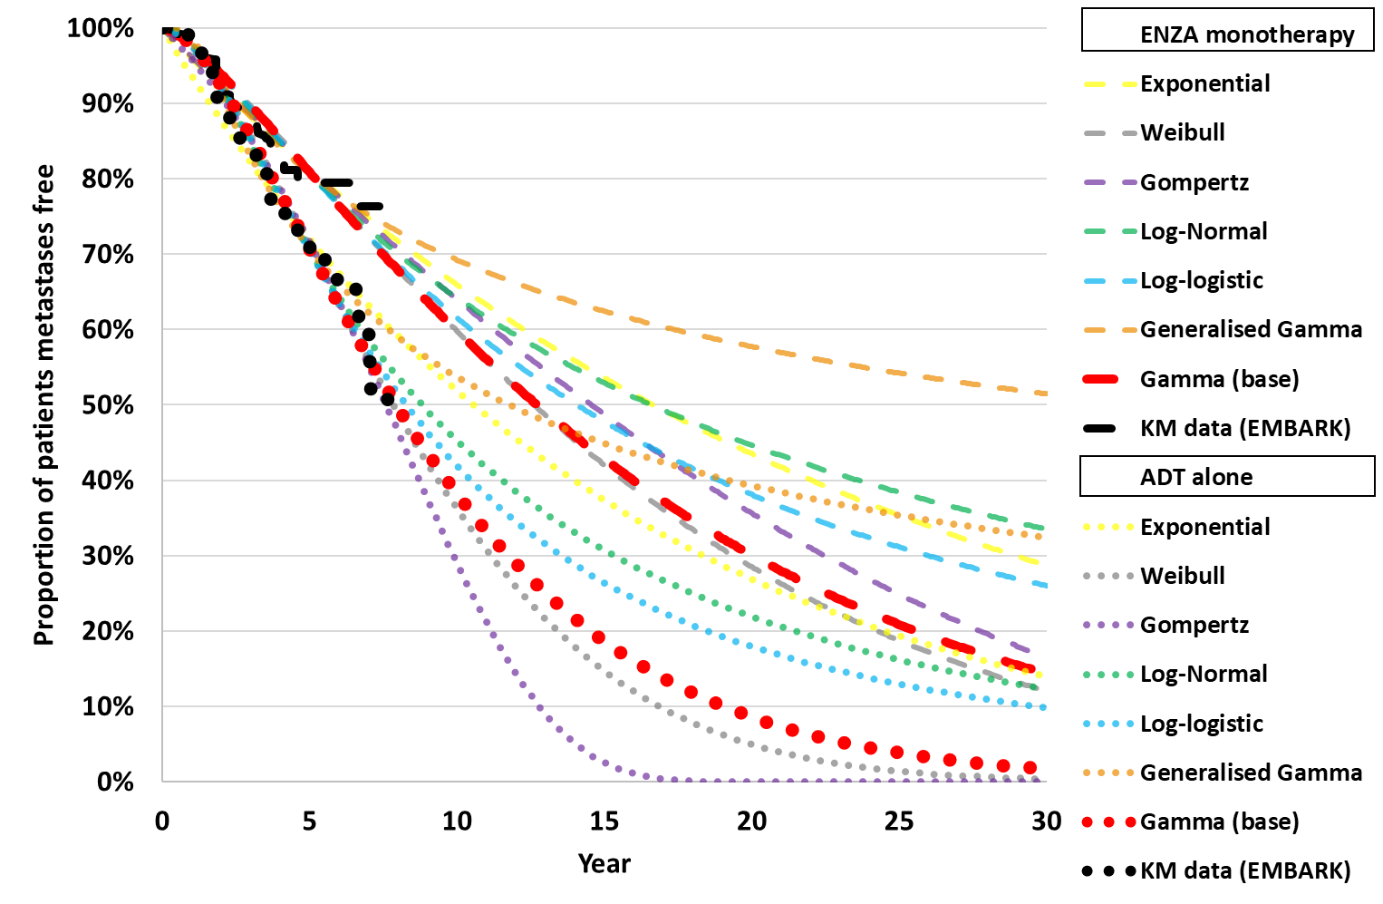
Overall Survival
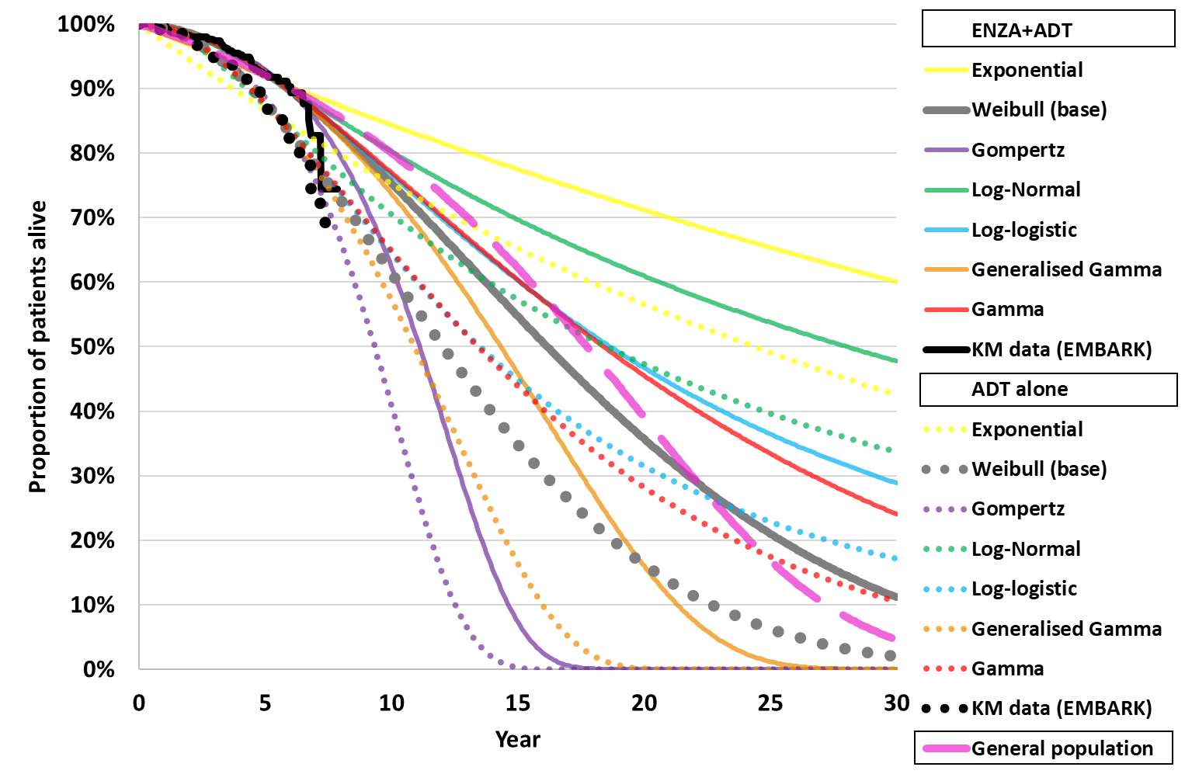 | 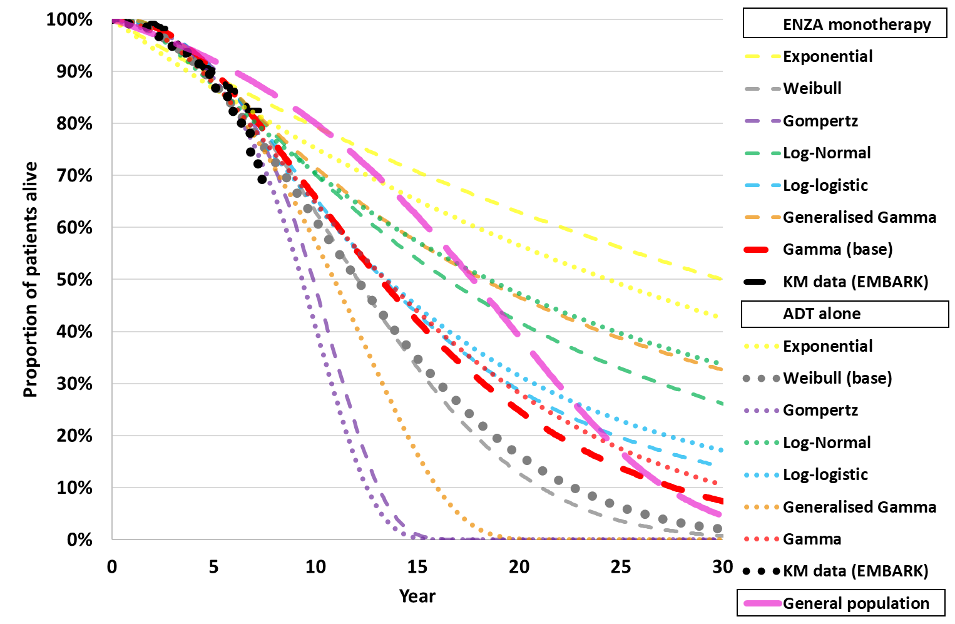
Time to treatment discontinuation (from Cycle 0)*
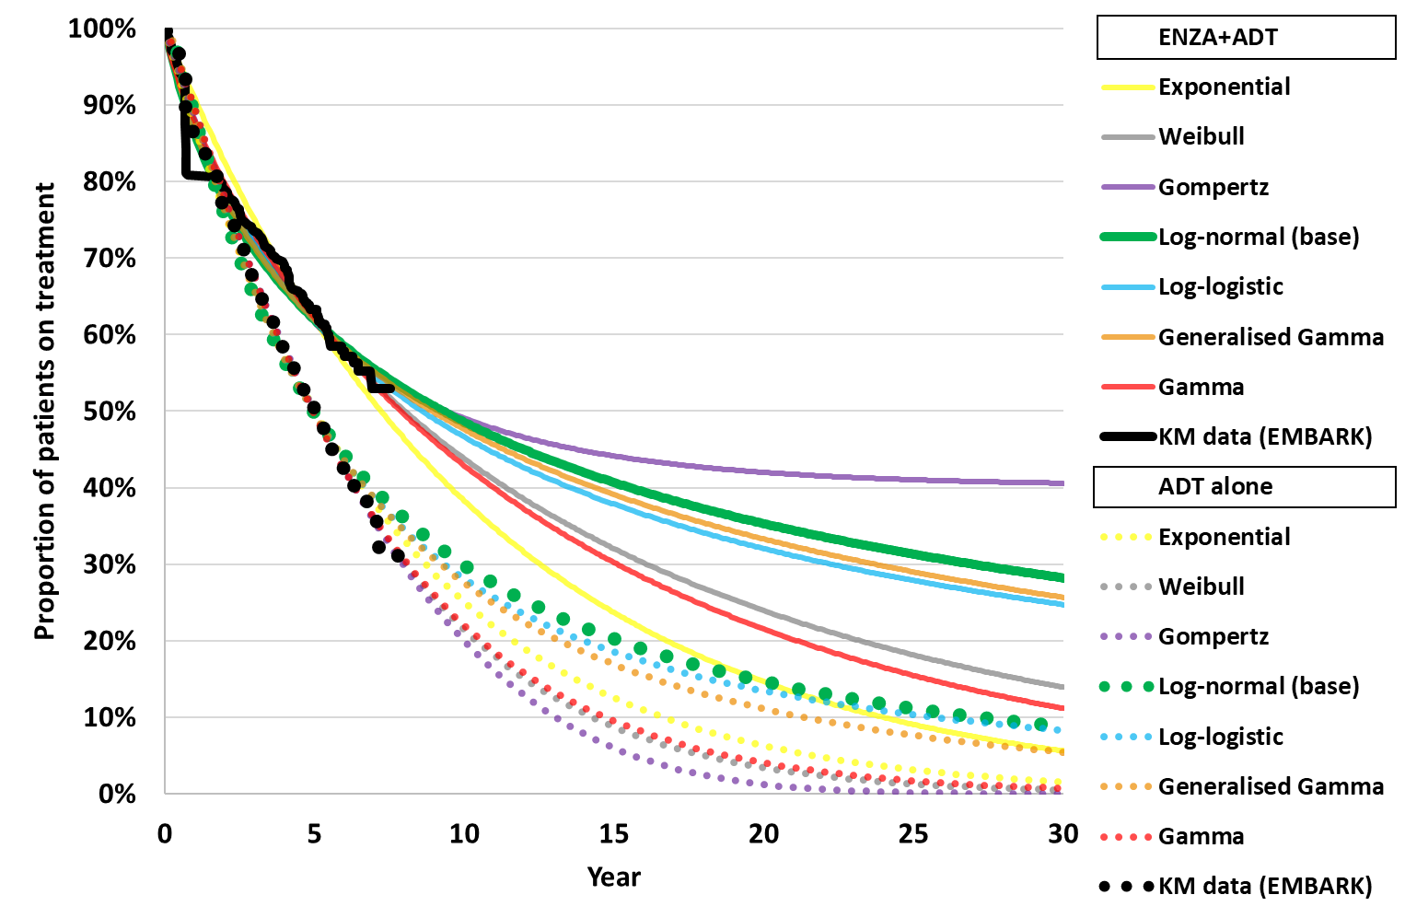 | 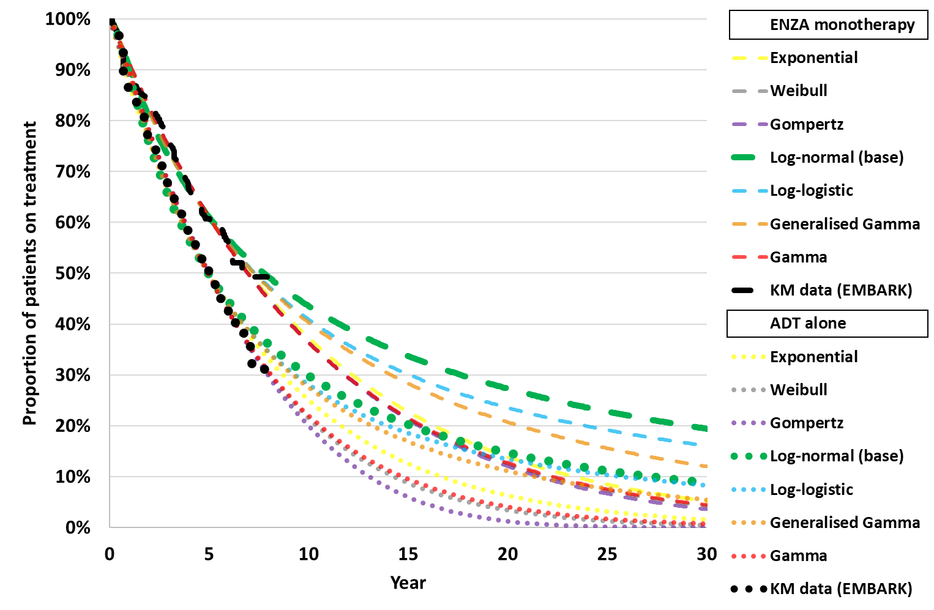
Time to treatment discontinuation (from treatment reinitiation)*
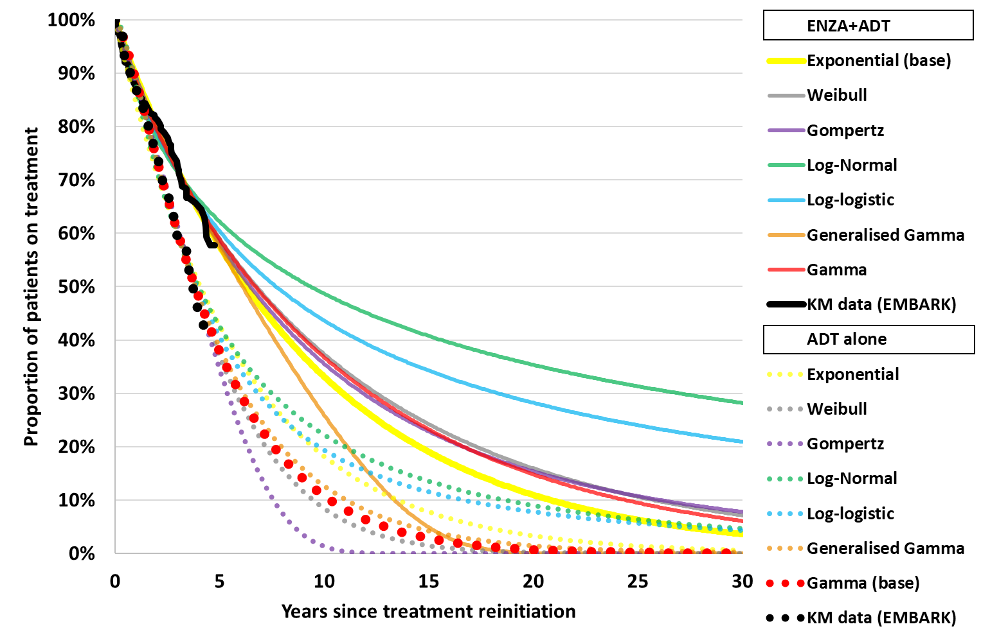 | 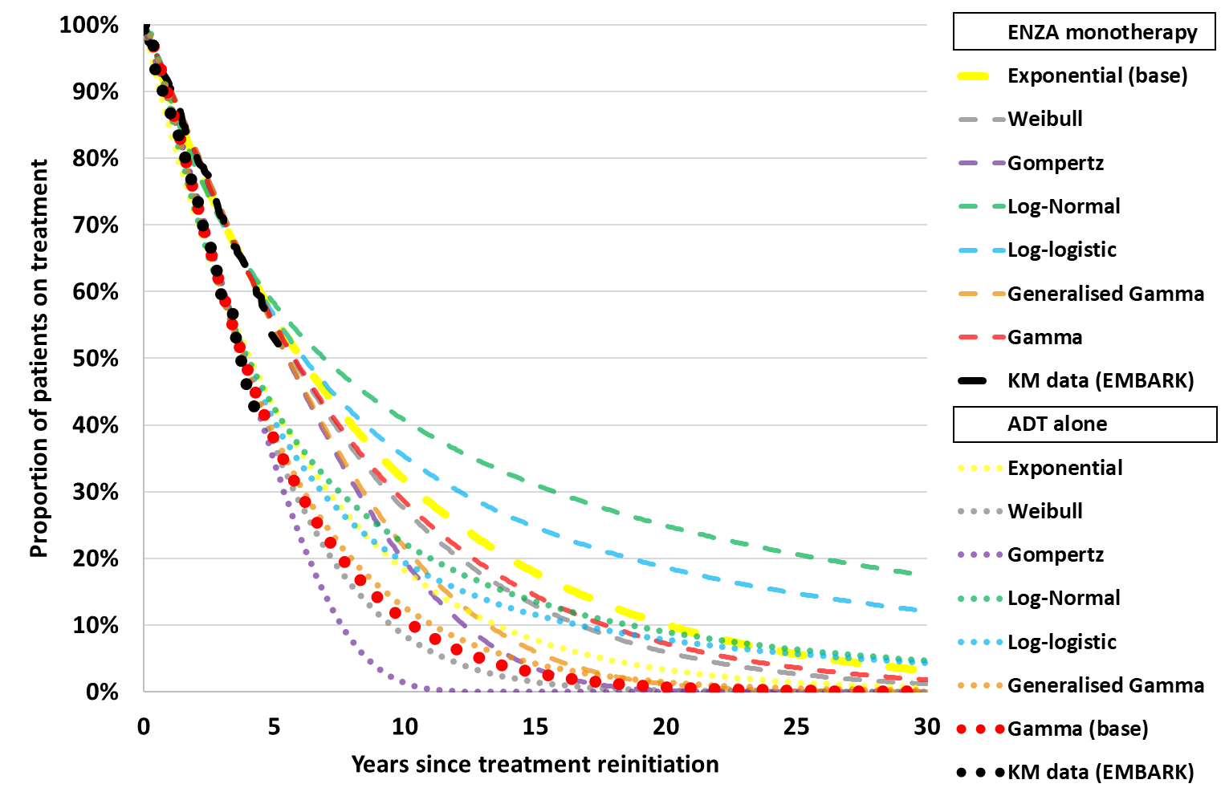
Source: compiled during the evaluation from the Excel file ‘Attachment 08 – XTANDI nmHSPC_CEM_v10.xlsm’
ADT=androgen deprivation therapy, ENZA=enzalutamide, MFS=metastases free survival, OS=overall survival, TTD=time to treatment discontinuation
Note that results in Figure 4 denoted by (*) for the time to treatment discontinuation are derived from post-hoc analyses conducted by the applicant during the evaluation specifically for the purposes of informing the PBAC consideration. These analyses were not part of the pre-specified statistical plan from EMBARK study. Interpretation of the results and their application should therefore be limited to seeking to understand the basis for the PBAC outcome and should not be used for any other purpose.
  - For OS, independent Weibull extrapolations were chosen as the base case in the enzalutamide plus ADT and ADT alone arms and gamma was the chosen extrapolation for the enzalutamide monotherapy arm. For MFS, Independent gamma distributions were chosen as the base case in each arm.
  - For OS and MFS, all extrapolations fit the data visually (with the exception of the exponential function for OS) to the time point where 10% patients remained at risk. Beyond this, extrapolations tended to exceed the Kaplan Meier data. The model assumed an OS benefit for enzalutamide with or without ADT over ADT alone despite no significant difference observed in EMBARK, and MFS and OS benefits in m0HSPC were assumed to persist across the time horizon. Further, the estimates of OS from EMBARK did not censor patients who died from progressed disease, despite the model estimating survival from progressed disease separately, resulting in double-counting of mortality (see model traces below). As MFS could not exceed total OS, modelled MFS was also adjusted by the modelled OS.
  - When patients entered a progressed disease state (i.e., mHSPC, m0CRPC or mCRPC) they were allocated to a subsequent treatment based on the reported median PFS (or time to next treatment) and OS from the enzalutamide trials ARCHES (mHSPC), PROSPER (m0CRPC), and PREVAIL (mCRPC), assuming transition probabilities to be equal across NHA and cabazitaxel/docetaxel-based regimens. Transition probabilities were hardcoded into the model and therefore calculations have not been verified.
  - The modelling of the progressed health states was unlikely to be accurate to the population of interest as: (i) NHA use in mHSPC was likely to increase in the future once treatments are established; (ii) ARCHES was unlikely to reflect progressed patients from EMBARK, as ARCHES included newly diagnosed mHSPC patients (66.7%), <30% patients with prior prostatectomy or radiotherapy and less than half had any prior ADT; and (iii) the OS transitions from ARCHES and PROSPER include death from mCRPC, despite death from mCRPC also being estimated, suggesting further double counting of mortality in the progressed disease states. This likely disadvantaged the ADT arm, which had a higher occupancy in the progressed disease states. Overall, the modelling of the progressed disease states was complex and likely to be highly uncertain and given the structure of the model, it was difficult to quantify this uncertainty in sensitivity analyses. The PSCR stated that although the ARCHES trial may have overestimated the treatment effect of NHA therapy for enrolled patients relative to EMBARK patients progressing to mHSPC, this would have biased in favour of the ADT arm as patients in this arm transition to NHA therapy (whereas patients in the enzalutamide arms did not).
  - Overall, the ESC noted that the transition assumptions in the economic model resulted in MFS and OS estimates that were much lower than observed in EMBARK (Figure 5), and OS less than previously reported in the literature (Oudard et al., 2019, Svensson et al, 2021). However, the model also appeared to overestimate the OS benefit (i.e., difference in OS) for enzalutamide with or without ADT versus ADT alone observed in EMBARK. Given the model structure, it was not possible to set the overall OS in the model equal across arms (from any time point). Therefore, the impact of the assumed survival benefit could not be explored in full. If no survival benefit was assumed, the ICERs would be expected to increase greatly. The ESC noted that the overestimated benefits were driven by the double counting of progression and mortality due to the Markov approach applied. The ESC noted that this was supported by the analysis presented in the PSCR in which extrapolation were based only on EMBARK Kaplan Meier data extrapolated to 30 years. In the absence of mortality adjustment in progressed disease the incremental life years gained in the enzalutamide + ADT model decreased (from 2.03 to 1.76) which demonstrated that there was a survival advantage in the enzalutamide arm. Further, the ESC noted that the analysis in the PSCR underestimated the modelled MFS for all arms and exaggerated the incremental difference in modelled MFS between the ADT alone and enzalutamide arms compared to the EMBARK Kaplan Meier data. An additional analysis was provided in the pre-PBAC response in which additional OS mortality effects were only applied to the enzalutamide plus ADT arm, with the ADT alone arm assigned the OS risk from EMBARK (i.e. all double counting is applied to the enzalutamide plus ADT arm which the pre-PBAC response described as highly conservative). This resulted in 0.51 incremental life years gained.
Figure 5: Comparison of model outcomes to EMBARK KM data
Metastases free survival | Overall survival
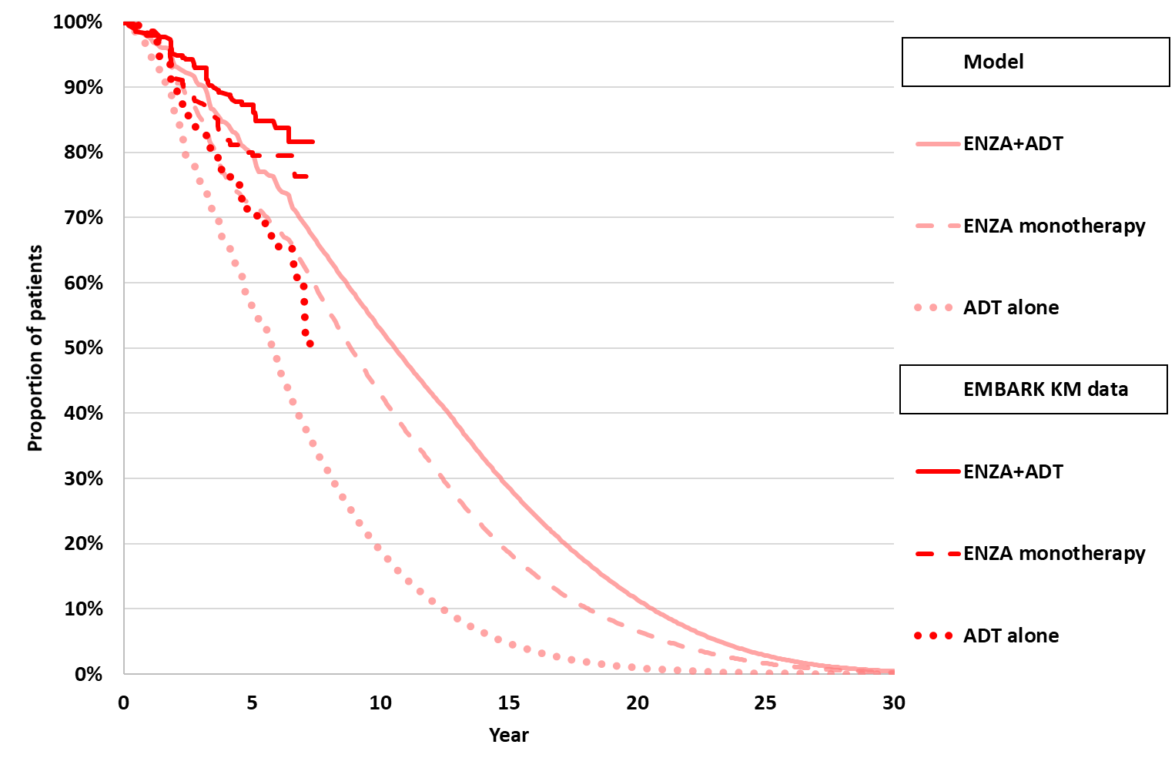 | 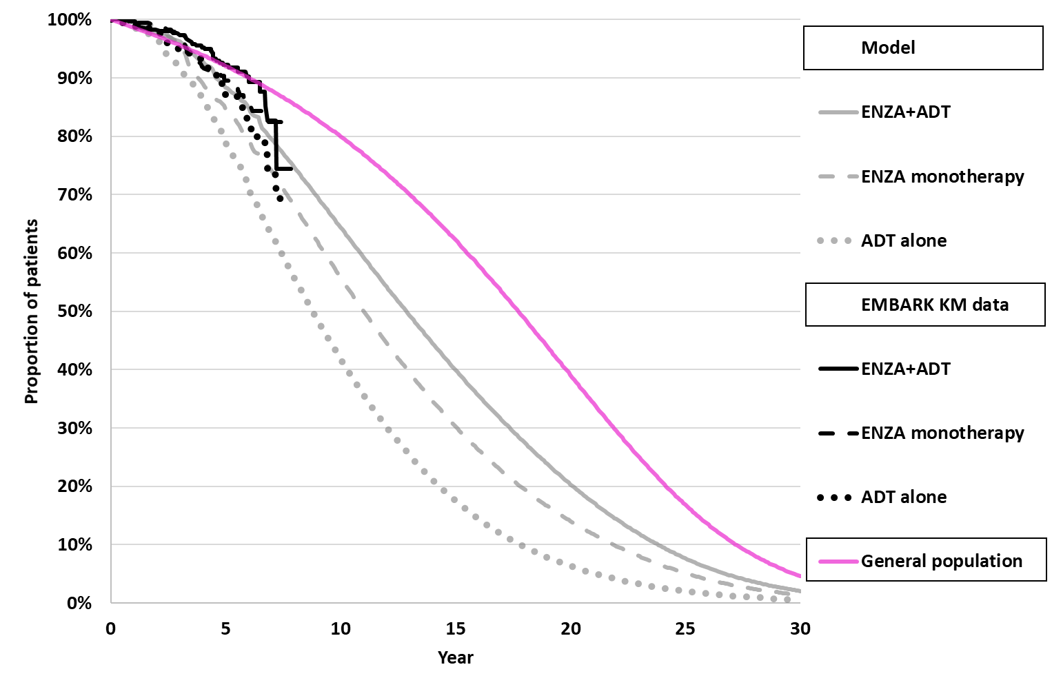
Time on treatment
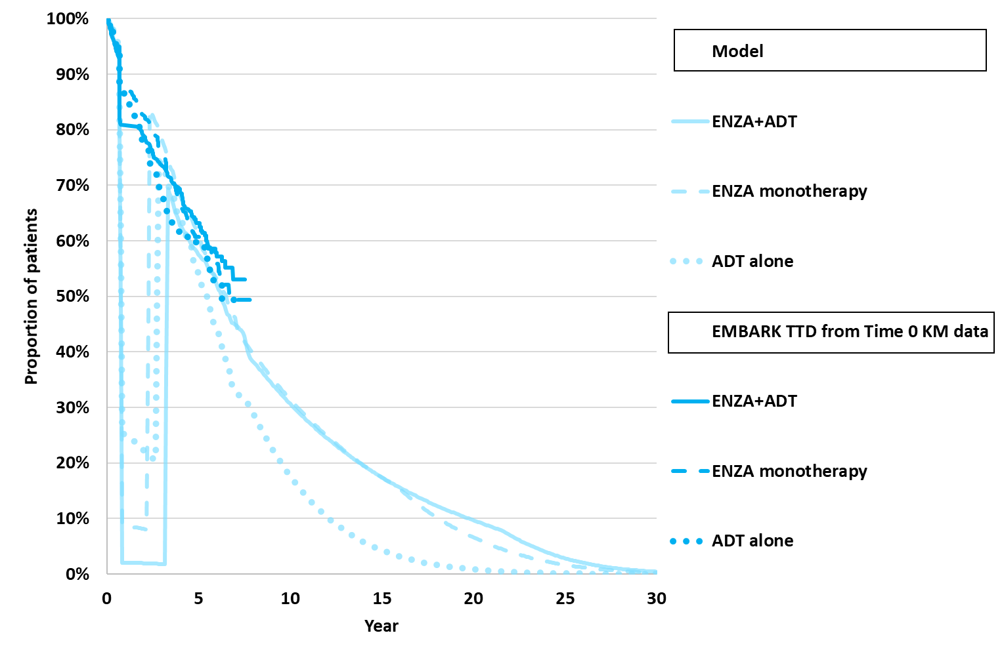
Source: compiled during the evaluation
ADT=androgen deprivation therapy, ENZA=enzalutamide, m0HSPC=non-metastatic hormone sensitive prostate cancer, mHSPC=metastatic hormone sensitive prostate cancer, m0CRPC=non-metastatic castrate resistant prostate cancer, mCRPC=metastatic castrate resistant prostate cancer
  - Health state allocation plots compiled during the evaluation are presented in Figure 6 to further validate the modelled transitions.
Figure 6: Health state allocation
Enzalutamide plus ADT | ADT alone
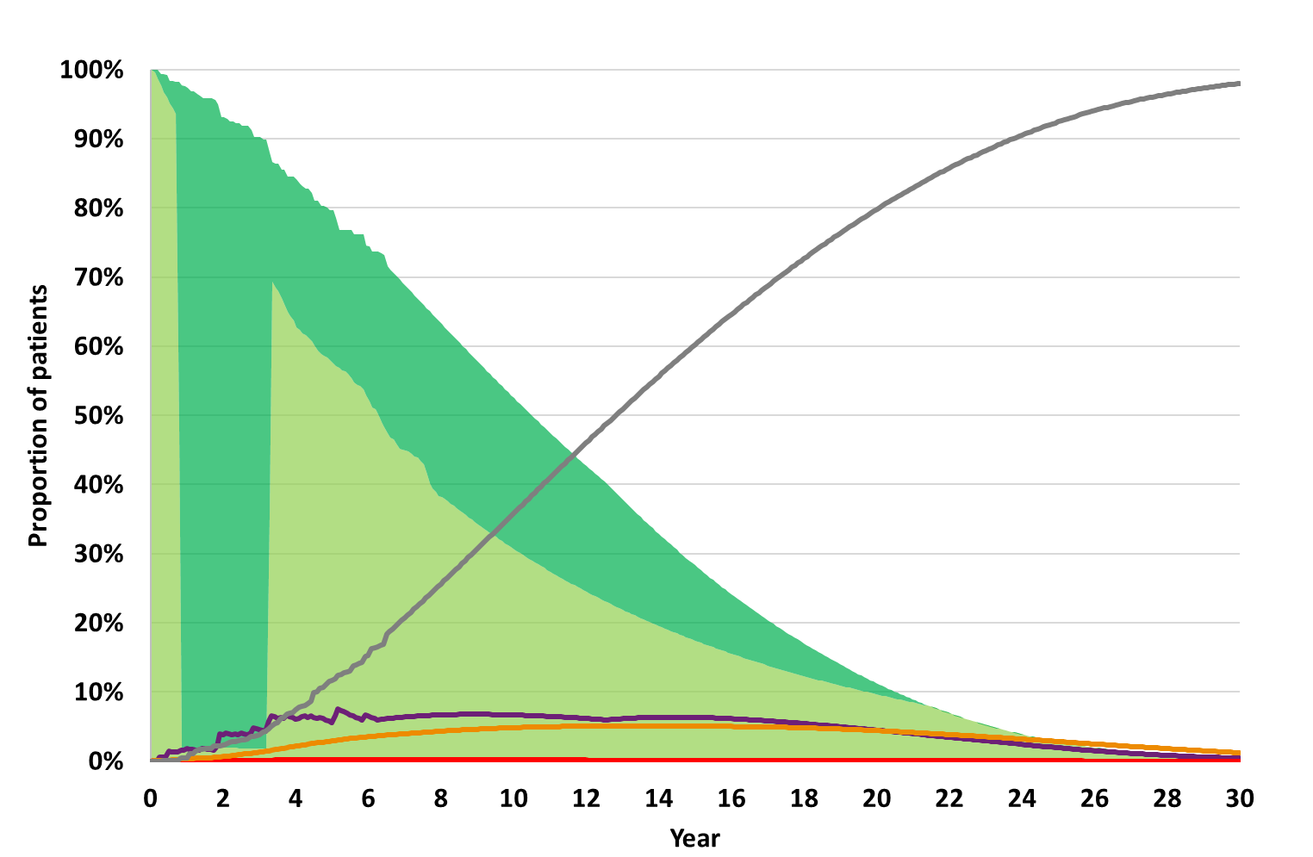 | 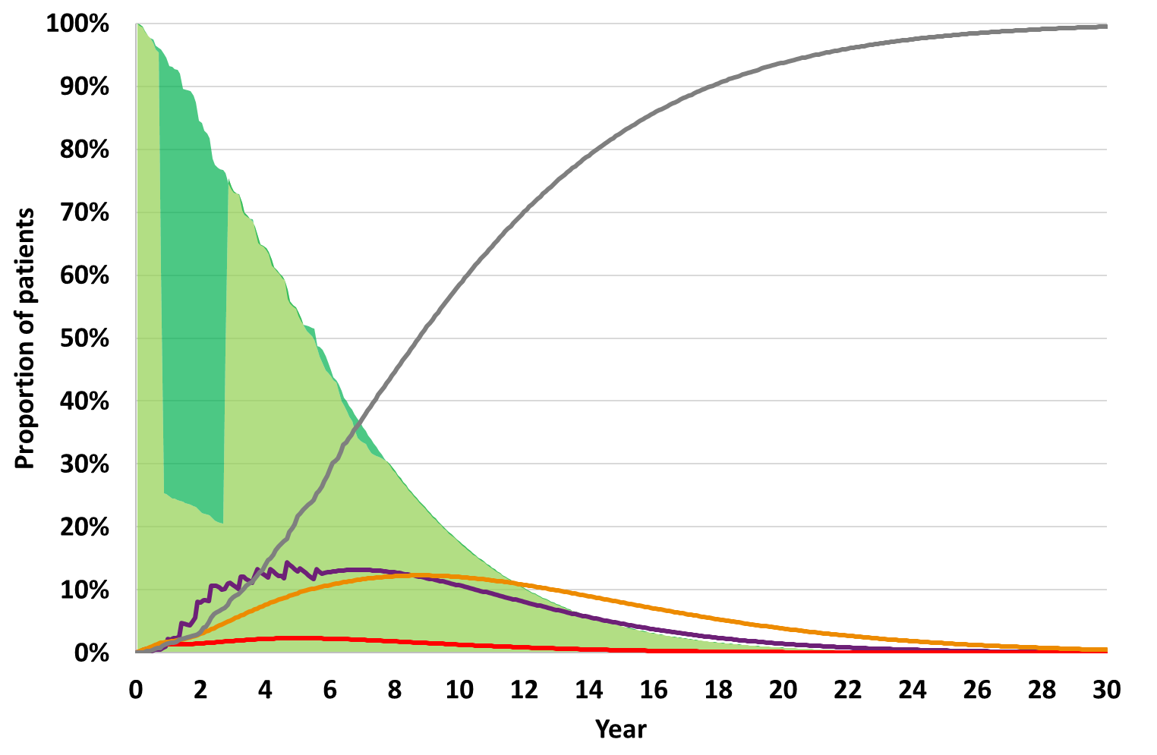
Enzalutamide monotherapy
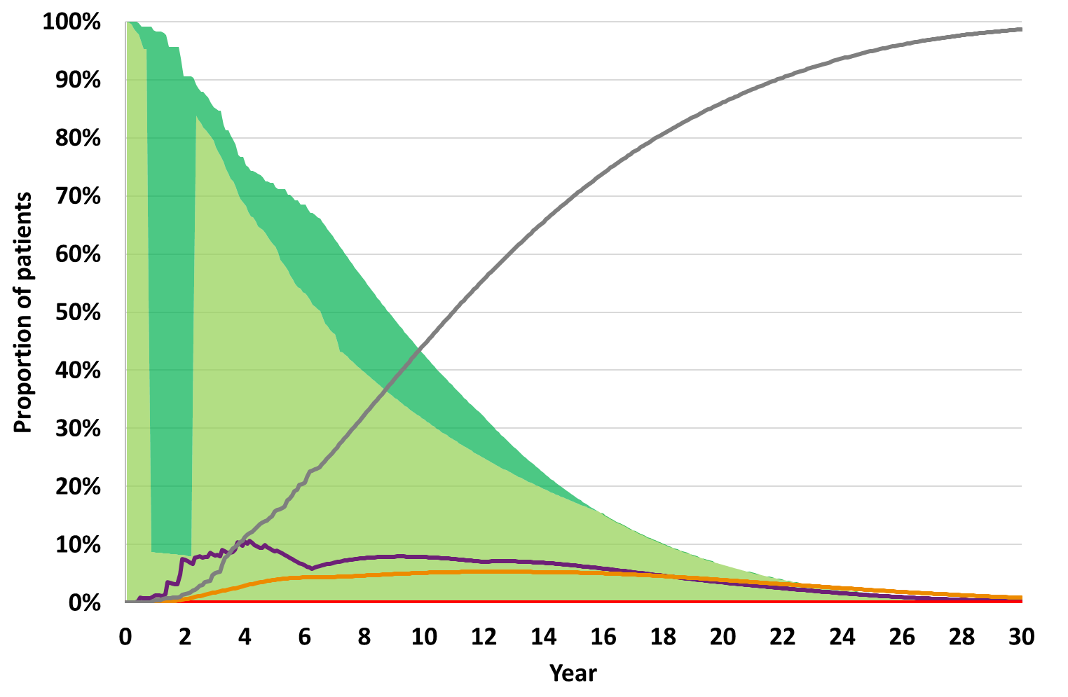 | 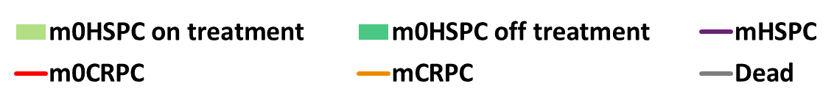
Source: compiled during the evaluation
ADT=androgen deprivation therapy, m0HSPC=non-metastatic hormone sensitive prostate cancer, mHSPC=metastatic hormone sensitive prostate cancer, m0CRPC=non-metastatic castrate resistant prostate cancer, mCRPC=metastatic castrate resistant prostate cancer
  - In the enzalutamide arms, the majority of alive patients remained in m0HSPC for more than 20 years in the model, compared to ~11 years of alive patients in the ADT alone arm. There was little allocation to the metastatic health states over the 30-year time horizon: the maximum proportion of patients in mHSPC or mCRPC at any time point was <10% for the enzalutamide arms and <15% for ADT alone arm. Nearly half of all deaths in the enzalutamide arms (50.0% patients in the enzalutamide plus ADT arm, 49.2% in the enzalutamide monotherapy arm) and 29.4% of deaths in the ADT alone arm occurred in the m0HSPC state. Patients who died without experiencing disease progression may be more likely to die from causes other than prostate cancer.
  - The health state allocation plots also demonstrate the impact of the treatment suspension on the number of patients receiving treatment in m0HSPC. Further, the enzalutamide arms, particularly the enzalutamide plus ADT arm, accrued time off treatment in m0HSPC after treatment reinitiation, whereas very few patients in the ADT arm stayed in m0HSPC once they discontinued treatment after reinitiation.
  - The submission included adverse events in all modelled health states. However, adverse event rates could not be verified and for m0HSPC did not appear to match previously reported safety information from EMBARK (no adverse events for the ADT alone arm, only hypertension accounted for in the enzalutamide arms: 6.8% enzalutamide plus ADT, 5.4% enzalutamide monotherapy). The ESC noted that the ICERs were not sensitive to adverse events (removing adverse event utility loss reduced ICERs by 0.0-0.1%).
  - The submission applied health care utilities to the m0HSPC (treatment suspension and otherwise), mHSPC, m0CRPC, and mCRPC health states, as well as an age adjustment, and disutilities for adverse events and at end of life. Utilities did not differ by treatment received in the base case.
- m0HSPC utility (during treatment suspension and otherwise) was sourced from EMBARK EQ-5D-5L with Australian preference weights. The details of the utility estimates were not included in the submission and so utility estimates could not be verified. Utility values from EMBARK (m0HSPC = 0.934, treatment suspension = 0.95) were high compared to recent Australian general population (0.89 for 69-year-old men) estimates. If m0HSPC utilities could not exceed general population (i.e., general population utility in treatment suspension 0.89, 0.89*0.934/0.95=0.875 otherwise) the ICERs increased to $15,000 to < $25,000 per QALY gained for enzalutamide plus ADT versus ADT alone and $35,000 to < $45,000 per QALY for enzalutamide monotherapy versus ADT alone (compared to $15,000 to < $25,000 and $35,000 to < $45,000 in the base case). The PSCR provided an analysis applying US preference weights (m0HSPC = 0.882, treatment suspension = 0.908) and which resulted in an ICER of $15,000 to < $25,000 per QALY gained in the enzalutamide + ADT versus ADT model. The ESC noted that the US weighted values remined high compared to the Australia general population.
- mHSPC utility was sourced from ARCHES ITT EQ-5D-5L baseline data, mapped to UK preference weights for the EQ-5D-3L, to give utility value of 0.817. This was higher than the mean mHSPC progression free utility of 0.806 reported previously (paragraph 6.46, enzalutamide Public Summary Document, March 2023, PBAC meeting).
- mCRPC utility was assumed to be 0.706, equal to the PD2 utility reported for enzalutamide in mHSPC (paragraph 6.46, enzalutamide Public Summary Document, March 2023, PBAC meeting).
  - Health state utilities were adjusted for patient age over the course of the model using Australian weighted EQ-5D-5L population data reported in Redwood et al., 2024. Redwood et al. 2024 found that utility increased with age, contrary to previous general population utility studies. Population level data collected at one time point does not necessarily reflect the experience of individuals or cohorts over time. By assuming that utility increased with age, the model predicted that utilities (within each health state) would increase over time, which is unlikely to be true of an aging cohort with prostate cancer. The age adjustment had little impact on the ICERs.
  - End of life utility in the last 3 months of life was estimated from the last pre-death assessment for patients in ARCHES and a disutility was estimated by subtracting the utility of the health state the patient died in within the model. This disutility was applied as a one off QALY decrement in the cycle the patient died, and was supposed to represent 3 months of disutility, but appeared to be applied for an equivalent 3 years rather than 3 months. The ESC noted that if end of life disutility was removed from the model ICERs increased 6.4-6.6% vs ADT $15,000 to < $25,000 per QALY gained enzalutamide plus ADT versus ADT alone, $35,000 to < $45,000 enzalutamide monotherapy versus ADT alone).
  - Enzalutamide was costed at a dose of 4x40mg once daily, with 100% compliance, based on a pack of 112x40mg capsules at $| | (requested effective DMPQ, based on AEMP $| |). The cost per month of enzalutamide was estimated at $| |. This cost was also implemented for subsequent enzalutamide use in mHSPC, m0CRPC and mCRPC, though currently listed prices are higher (AEMP $| | in m0CRPC, $| | in mCRPC), slightly advantaging the ADT arm.
  - Costs for ADT were based on PBS DPMQs and orchiectomy was assumed to be two of MBS item 30642 (unilateral orchiectomy), which was reasonable. The submission did not provide a source that could be verified for the split of ADT treatments (88.02% leuprorelin, 11.65% degarelix, 0.34% orchiectomy). The total cost of ADT (including one off cost of orchiectomy) was $| | for the first month and $| | thereafter in all health states. This was less than the cost of ADT estimated previously for mHSPC of $412.42 (paragraph 6.48, enzalutamide, Public Summary Document, March 2023 PBAC Meeting). The cost of ADT was not a significant driver of the ICER.
  - Patients were assumed to require subsequent treatment once they progress. Costs were based on PBS DPMQs, except for apalutamide, darolutamide and abiraterone plus methylprednisolone where a | |% discount to the AEMP was estimated, and olaparib where a | |% discount to the AEMP was estimated. Patients also accrued costs for concomitant therapies, treatment monitoring, disease monitoring, adverse events and palliative care. Subsequent treatments were the largest driver of cost-offsets in the model.
  - A summary of the key drivers of the model is presented in Table 11.
Table 11: Key drivers of the model
Description | Method/Value | Impact
Description | Method/Value | ENZA+ADT vs  ADT alone  Base $ | ¹/QALY | ENZA mono vs  ADT alone  Base $ | ²/QALY
Extrapolation | Treatment effect (MFS and OS benefit) continued beyond 75 month trial period for up to 30 years.  Trial evidence is immature (median MFS and OS not yet achieved) and confirmatory OS benefit was not demonstrated in EMBARK for ENZA+/-ADT over ADT alone. Mortality was not adjusted for patients dying in downstream health states. | High, favoured ENZA+ADT  It was not possible to converge the modelled OS. If MFS and OS hazards were equal to ADT arm from Year 10 ICER increased to $||||³/QALY. | High, favoured ENZA mono arm  It was not possible to converge the modelled OS. If MFS and OS hazards were equal to ADT arm from Year 10 ICER increased to $||||²/QALY.
Treatment suspension | At Month 9, a proportion of patients (90.9% ENZA+ADT, 85.9% ENZA mono, 67.8% ADT alone) suspended treatment, with patients resuming treatment: 68.3% at Month 39 in ENZA+ADT, 76.3% at Month 27 in ENZA mono, and 57.3% at Month 33 in ADT alone.  Implementation of treatment suspension in practice is uncertain. | High, favoured ENZA+ADT. If time on treatment was equal to time in m0HSPC, the ICER increased to $||||⁴/QALY. | High, favoured ENZA mono. If time on treatment was equal to time in m0HSPC, the ICER increased to $||||⁴/QALY.
Subsequent treatments | Subsequent treatment proportions were based on PBS 10% sample. Costs were based on median durations and effectiveness on MFS and OS reported in enzalutamide trials. Mortality from each source was not adjusted for patients dying in downstream health states. Therefore, NHA use in subsequent health states was unlikely to be cost-effective. | High, favoured ENZA+ADT. If 100% subsequent treatment ADT alone, the ICER increased to $||||³/QALY. | High, favoured ENZA mono. If 100% subsequent treatment ADT alone, the ICER increased to $||||²/QALY.
Utilities in m0HSPC | High values for model health states taken from EMBARK exceeded Australian general population utilities. | Moderate, favoured ENZA+ADT. If utilities could not exceed the general population (m0HSPC utilities reduced by 0.06), the ICER increased to $||||¹/QALY. | Moderate, favoured ENZA mono. If utilities could not exceed the general population (m0HSPC utilities reduced by 0.06), the ICER increased to $||||²/QALY.
Source: compiled during the evaluation
ADT=androgen deprivation therapy, ENZA=enzalutamide, ICER=incremental cost effectiveness ratio, m0HSPC=non- metastatic hormone sensitive prostate cancer, MFS=metastases free survival, NHA=novel hormonal agent, OS=overall survival, QALY=quality adjusted life year, TTD=time to treatment discontinuation
The redacted values correspond to the following ranges:
1 $15,000 to < $25,000
2 $35,000 to < $45,000
3 $25,000 to < $35,000
4 $55,000 to < $75,000
  - Results of the stepped economic analysis are presented in Table 12. For completeness, a cost-effectiveness plane is presented in Figure 7. While the evaluation was described as a stepped analysis, Step 4 did not build on the previous steps, with a different modelling approach used for the 75-month time horizon compared to the final base case. The ESC noted that it would have been more appropriate to present an actual trial-based analysis (data from EMBARK only) followed by the introduction of data from other sources, to demonstrate the effect of the assumptions of incorporating the additional data.
Table 12: Results of the stepped economic evaluation
Step and component | ENZA+ADT | ENZA mono | ADT alone | Increment
 |  |  |  | ENZA+ADT vs  ADT alone | ENZA mono vs  ADT alone
Step 1: time horizon 75 months, constant per cycle transition probabilities, undiscounted drug and administration costs in m0HSPC only, undiscounted life years in m0HSPC and total life years.
Costs ($) | | | | | | | | | |
m0HSPC LYs | 5.57 | 5.31 | 4.59 | 0.97 | 0.72
LYs | 5.94 | 5.82 | 5.60 | 0.34 | 0.22
Incremental cost/extra m0HSPC LY gained |  |  |  | |¹ | |²
Incremental cost/extra LY gained |  |  |  | |³ | |⁴
Step 2: time horizon 75 months, constant per cycle transition probabilities, undiscounted costs for AEs, concomitant and treatment monitoring across all health states (no terminal care, subsequent treatment drug/administration, disease costs), undiscounted life years in m0HSPC and total life years.
Costs ($) | | | | | | | | | |
m0HSPC LYs | 5.57 | 5.31 | 4.59 | 0.97 | 0.72
LYs | 5.94 | 5.82 | 5.60 | 0.34 | 0.22
Incremental cost/extra m0HSPC LY gained |  |  |  | |¹ | |²
Incremental cost/extra LY gained |  |  |  | |³ | |⁴
Step 3: time horizon 75 months, constant per cycle transition probabilities, undiscounted costs for AEs, concomitant and treatment monitoring across all health states (no terminal care, subsequent treatment drug/administration, disease costs), undiscounted QALYs in m0HSPC and total QALYs (no EoL QALY loss)
Costs ($) | | | | | | | | | |
m0HSPC QALYs | 4.91 | 4.66 | 4.05 | 0.86 | 0.61
QALYs | 5.21 | 5.07 | 4.84 | 0.37 | 0.23
Incremental cost/extra m0HSPC QALY gained |  |  |  | |¹ | |²
Incremental cost/extra QALY gained |  |  |  | |³ | |⁴
Step 4: Modelled economic evaluation: time horizon 30 years, KM data and parametric functions utilised in transition prob abilities, adverse event disutilities, all costs (i.e., addition of terminal care cost), 5% annual discounting of costs and benefits. (submitted base case)
Costs ($) | | | | | | | | | |
LYs | 9.52 | 8.72 | 7.49 | 2.03 | 1.22
QALYs | 8.01 | 7.15 | 5.76 | 2.26 | 1.40
Incremental cost/extra LY gained |  |  |  | |⁵ | |¹
Incremental cost/extra QALY gained |  |  |  | |⁶ | |¹
Source: Tables 3-70, 3-71 and compiled during the evaluation
ADT=androgen deprivation therapy, AE=adverse event, ENZA=enzalutamide, EoL=end of life, KM=Kaplan-Meier, LY=life year, mono=monotherapy, QALY=quality adjusted life year, m0HSPC=non-metastatic hormone sensitive prostate cancer, Dominates=intervention more effective and less costly than comparator.
The redacted values correspond to the following ranges:
1 $35,000 to < $45,000
- $55,000 to < $75,000
- $95,000 to < $115,000
- $155,000 to < $255,000
4 $155,000 to < $255,000
5 $25,000 to < $35,000
6 $15,000 to < $25,000
Figure 7: Cost-effectiveness plane versus ADT alone

Source: compiled during the evaluation
ADT=androgen deprivation therapy, ENZA=enzalutamide, QALY=quality adjusted life year, ICER=incremental cost-effectiveness ratio
  - The majority of the benefits of enzalutamide (with or without ADT) versus ADT alone were accrued in the extrapolation from 75 months to 30 years, compared to the majority of the incremental costs which occurred during the first 75 months. The submitted ICERs versus ADT alone were $15,000 to < $25,000 per QALY gained for enzalutamide plus ADT and $35,000 to < $45,000 per QALY gained for enzalutamide monotherapy. Further, at 75 months, enzalutamide plus ADT consistently dominated (it had more benefits and was less costly than) enzalutamide monotherapy.
  - The submission did not present individual treatment costs, so the costs for the enzalutamide and ADT components in m0HSPC of the enzalutamide plus ADT arm were estimated during the evaluation. When comparing undiscounted costs, enzalutamide in m0HSPC was the largest contributor to the incremental costs (119% enzalutamide plus ADT arm, an incremental cost of $| |; and 120% in the enzalutamide monotherapy arm, and incremental cost of $| |) versus ADT alone, with ADT in the enzalutamide plus ADT arm the second largest contributor (6%, incremental cost $| |) due to the longer time on treatment modelled for the enzalutamide plus ADT arm compared to the ADT arm. The largest cost offsets versus ADT alone (after ADT costs in m0HSPC for the comparison of enzalutamide monotherapy versus ADT alone, which were -24% of the incremental costs, -$| |) were the subsequent treatment costs in mCRPC (-14% of incremental costs for enzalutamide plus ADT, -$| |; -16% for enzalutamide monotherapy, -$| |), resulting from the higher costs of subsequent treatment in the ADT arm.
  - The results of key sensitivity analyses are summarised in Table 13. The ICERs were most sensitive to time horizon less than 15 years, OS extrapolation, time on treatment, MFS extrapolation, subsequent treatment choice, and utilities in m0HSPC. However, sensitivity analyses presented by the submission and conducted during the evaluation were unable to capture all uncertainty in the model. Many of the structural assumptions could not be tested. In particular, the double counting of mortality led to a substantial survival benefit for the enzalutamide arms over ADT alone in the model, despite no difference observed in EMBARK, but it was not possible to set OS equal across the arms to test the effect of this assumption. Further, given the complexity of the model, the one-way sensitivity analyses presented in the submission do not adequately capture the uncertainty in the parameters. A probabilistic sensitivity analysis should be conducted to explore parameter uncertainty further.
  - Overall, the ESC considered that the model was not suitable for decision making given the structural uncertainties associated with the modelling approach which manufactured a large treatment benefit for enzalutamide + ADT over ADT alone (2.26 QALYs). The ESC noted that the majority of this benefit (1.89 QALYs) was accrued in the extrapolation form 75 months to 30 years (i.e. Step 3 to Step 4 of the economic analysis – from 0.37 to 2.26) and was due to the sustained OS benefit, despite there being no confirmatory OS data from EMBARK, and the double counting of mortality in progressed disease which inflated the MFS benefit compared to EMBARK. Further, the ESC noted that the QALY gain for enzalutamide plus ADT over ADT in this setting was significantly larger than that accepted for apalutamide plus ADT in the mHSPC setting (0.56 QALYs, noting that the time horizon in that model was 10 years).
Table 13: Sensitivity analyses
Analyses | ENZA+ADT vs ADT alone |  | ENZA mono vs ADT alone
Analyses | ICER $/QALY | % change | ICER $/QALY | % change
Base case | |¹ | - | |² | -
Discount rate (base case 5% costs and outcomes)
0% | |¹ | -|% | |³ | -|%
3.5% | |¹ | -|% | |³ | -|%
Time horizon (base case 30 years)
10 | |³ | |% | |⁴ | |%
15 | |¹ | |% | |² | |%
20 | |¹ | -|% | |² | |%
OS extrapolation approach (base KM + independent parametric)
KM + proportional hazards | |¹ | |% | |² | |%
Parametric Time 0 | |¹ | |% | |² | |%
Constant probability | |¹ | -|% | |³ | -|%
OS hazard rates in each health state equal to ADT arm from Year (base treatment dependent)
0 | |² | |% | |⁴ | |%
10 | |³ | |% | |² | |%
OS extrapolation (base ENZA+ADT Weibull, ENZA mono Gamma, ADT alone Weibull)
Best fitª | |¹ | -|% | |³ | -|%
Second best fit^{b} | |¹ | -|% | |⁴ | |%
TTD extrapolation approach (base KM + independent parametric)
Median TTD | |⁵ | -|% | |¹ | -|%
Equal to time in m0HSPC | |⁶ | |% | |⁶ | |%
No m0CRPC state (base included) | |¹ | -|% | |³ | -|%
m0HSPC to mHSPC (base MFS KM + independent parametric)
Constant probability | |¹ | |% | |⁴ | |%
MFS hazard rate equal to ADT arm from Year (base treatment dependent)
0 | |⁷ | |% | |⁸ | |%
10 | |³ | |% | |² | |%
MFS extrapolation (base ENZA+ADT gamma, ENZA mono gamma, ADT alone gamma)
Best fit^{c} | |¹ | |% | |² | |%
Second best fit^{d} | |¹ | |% | |² | |%
Age related utility adjustment excluded (base included) | |¹ | |% | |² | |%
Subsequent ADT monotherapy in ADT arm (base 55.7% in each state)
No ADT monotherapy in m0CRPC and mHSPC | |¹ | -|% | |³ | -|%
100% ADT in all arms and all progressed states | |³ | |% | |² | |%
End of life QALY loss (base -1.37 QALYs per death)
None | |¹ | |% | |² | |%
Alternative utilities (base m0HSPC 0.934/ tx susp=0.950, mHSPC=0.816, m0CRPC=0.852, mCRPC=0.706)
m0HSPC 0.875/ tx susp=0.89^{i} | |¹ | |% | |² | |%
Sensitivity analyses presented in the PSCR
OS extrapolated from EMBARK KM data, i.e. no mortality adjustment in progressed disease states | |¹ | -|% | |² | |%
MFS, OS and TTD extrapolated from Time 0 | |¹ | |% | |² | |%
US utility values  m0HSPC: 0.882 (base case: 0.934)  Treatment suspension: 0.908 (base case: 0.95) | |¹ | |% | |² | |%
Sensitivity analysis presented in the pre-PBAC response
OS extrapolated from EMBARK KM data, + additional mortality for progressed health states applied to ENZA + ADT arm | |² | |% | - | -
Source: Tables 3-81, 3-82 and compiled during the evaluation
ADT=androgen deprivation therapy, ENZA=enzalutamide, ICER=incremental cost effectiveness ratio, KM=Kaplan Meier, m0HSPC=non-metastatic hormone sensitive prostate cancer, mHSPC=metastatic hormone sensitive prostate cancer, m0CRPC=non metastatic castrate resistant prostate cancer, mCRPC=metastatic castrate resistant prostate cancer, MFS=metastases free survival, OS=overall survival, QALY=quality adjusted life year, TTD=time to treatment discontinuation, ToT=time on treatment, tx=treatment
a ENZA+ADT log-logistic, ENZA monotherapy log-logistic, ADT alone Gompertz
b ENZA+ADT gamma, ENZA monotherapy Weibull, ADT alone log-logistic
c ENZA+ADT exponential, ENZA monotherapy log-normal, ADT alone generalised gamma
d ENZA+ADT Weibull, ENZA monotherapy generalised gamma, ADT alone log-normal
The redacted values correspond to the following ranges:
1 $15,000 to < $25,000
2 $35,000 to < $45,000
3 $25,000 to < $35,000
4 $45,000 to < $55,000
5 $5,000 to < $15,000
6 $55,000 to < $75,000
7 $75,000 to < $95,000
8 $255,000 to < $355,000

Enzalutamide cost/patient/year
  - A summary of the drug cost is presented in Table 14.
Table 14: Drug cost per patient for proposed and comparator drugs
 | Enzalutamide plus ADT |  |  | Enzalutamide monotherapy |  |  | ADT alone
 | Trial | Model | Financial | Trial | Model | Financial | Trial | Model | Financial
Regimen
Enzalutamide | 160mg/ day | 160mg/ day | 160mg/ day | 160mg/ day | 160mg/ day | 160mg/ day | - | - | -
Leuprorelin | 22.5mg/ 12 wks | 22.5mg/ 3 mths | - | - | - | - | 22.5mg/ 12 wks | 22.5mg/ 3 mths | -
Degarelix | - | (240mg) + 80mg/mth | - | - | - | - | - | (240mg) + 80mg/mth | -
Mean dose (mg/day)
Enzalutamide | 147.4 | 160 | 160 | 145.6 | 160 | 160 | - | - | -
Leuprorelin | NR | 0.2 | - | - | - | - | NR | 0.2 | -
Degarelix | - | (0.9)+0.3 | - | - | - | - | - | (0.9)+0.3 | -
Mean duration (mths) | 32.5 | 74.1 | 23.2^{h} | 41.2 | 83.8 | 23.2^{h} | 35.2 | 58.4 | -
Cost per patient^{c}
per month ($) | - | | | | | - | | | | | - | | | -
per year ($) | - | | | | | - | | | | | - | | | -
Total cost ($) |  | | | | |  | | | | |  | |
Source: Table 10 of ‘Attachment 06 XTANDI EMBARK CSR 23May2023.pdf’ and compiled during the evaluation.
ADT=androgen deprivation therapy, ENZA=enzalutamide, mth=month, NR=not reported, wk=week,
a 22.5mg x 91.3 days x 88.02% patients received leuprorelin,
b ((240mg loading dose)+80mg maintenance dose) x 30.4 days x 11.65% patients received degarelix)
c ADT model cost includes administration cost and cost of orchiectomy for 0.34% patients.
d Month 2 onwards. Month 1 ADT cost $| |
e ENZA: $| | + ADT: $| | (month1), $| | (month 2+)
f ENZA $| |2 + ADT: $| |
g ENZA: $| |, ADT: $| |
h Mean duration from financial estimates as implemented. Mean duration in submission (excluding treatment suspension) was 28.5 months (average 52.5 months with treatment suspension minus average 23.9 months of treatment suspension weighted according to patient numbers in EMBARK).
  - The estimated treatment costs in the submission differed between the economic evaluation and financial estimates in two ways. First, the economic analysis and financial estimates assumed 100% compliance for enzalutamide (i.e., mean dose 160 mg per day), whereas the trial observed a mean dose of 147 mg per day in the enzalutamide plus ADT arm and 146 mg per day in the enzalutamide monotherapy arm. Second, the treatment duration in the financial estimates was significantly less than treatment durations observed in EMBARK, which was not justified by the submission. In comparison, the treatment durations in the economic analysis were significantly longer than the treatment durations in EMBARK, which was reasonable as the economic analysis estimated the total time on treatment for the proportion of patients yet to discontinue treatment. As a result of the different treatment durations, the estimated total costs per patient differed greatly between the economic analysis and the financial estimates, though costs of enzalutamide per month and per year were the same.

Estimated PBS usage & financial implications
  - This submission was considered by DUSC. The submission adopted an epidemiological approach to estimate the financial implications of the requested enzalutamide listing (see Table 15). The financial estimates differed from the economic analysis in the following ways:
- No separate analyses for enzalutamide plus ADT and enzalutamide monotherapy, including no ADT cost offsets for enzalutamide monotherapy. This resulted in the financial estimates assuming 100% patients received enzalutamide plus ADT, although time on enzalutamide was estimated using both enzalutamide plus ADT and enzalutamide monotherapy data from EMABRK (described further below). The PSCR states that no ADT cost offsets would be expected for patients receiving enzalutamide monotherapy.
- Use of weighted mean treatment duration including time in treatment suspension from EMBARK (4.3 years for enzalutamide plus ADT, 4.4 years for enzalutamide monotherapy) rather than modelled mean treatment duration excluding time in treatment suspension (6.1 years for enzalutamide plus ADT, 6.99 years for enzalutamide monotherapy) which accounted for the fact that not all patients had yet concluded treatment in EMBARK. The financial estimates also weighted treatment duration by the proportion of patients in each arm of EMBARK (49.9% enzalutamide monotherapy, 50.1% enzalutamide plus ADT), which is unlikely to be representative of patients in practice.
- Approach to modelling treatment suspension. The economic model assumed a proportion of patients (90.9% enzalutamide plus ADT arm, 85.9% enzalutamide monotherapy arm) suspended treatment from Month 9 (0.75 years), with 68.3% patients resuming treatment at Month 39 (3.25 years) in the enzalutamide plus ADT arm, 76.3% patients resuming treatment at Month 27 (2.25 years) in the enzalutamide monotherapy arm. Patients who did not suspend treatment could discontinue treatment in line with patients in EMBARK. The financial analysis assumed that all patients discontinued treatment at Week 37 (0.71 years) and then 29% of those who initiated received treatment in Year 4 and 37% received treatment in Year 5. The PSCR stated that the differences in approach to costing the subsequent treatments between the economic model and the financial estimates would have minimal impact on the financial estimates.
- The cost-offsets in the financial estimates included downstream treatment in mHSPC and m0CRPC with apalutamide, darolutamide, enzalutamide, docetaxel, and prednisone, whereas the economic analysis also included abiraterone. The PSCR stated that abiraterone is only PBS listed for mCRPC. The economic model estimates that 3.5% of patients would have progressed to mCRPC by 6 years. As such, the PSCR states that the inclusion of abiraterone has a marginal impact on the analysis. Further, financial estimates assumed all patients (100%) who discontinued enzalutamide would be avoiding treatment with NHA. Instead, they would receive docetaxel plus prednisone, whereas only 33.5% of patients in mHSPC and m0CRPC in the ADT alone arm of economic analysis received treatment with NHA and 6.4% more patients in the enzalutamide arms of the model received docetaxel than the ADT alone arm (patients in the ADT arm could receive docetaxel in combination with ADT with or without darolutamide) in mHSPC and m0CRPC health states. The cost of subsequent NHA use was assumed to be equal to the AEMP of enzalutamide, whereas the cost-effectiveness analysis assumed a | |% discount to published rates. As such, both unit costs and the percentage of NHA use were higher in the financial estimates than in the economic analysis, and therefore, a larger cost-offset was assumed. The PSCR acknowledged that the financial impact should be consistent with the economic model and that a | |% discount rate should be applied. Overall, the DUSC considered that there would be limited cost-offsets as the average treatment duration of enzalutamide in m0HSPC was 4.3 years and as enzalutamide would be replaced with docetaxel or cabazitaxel. The pre-PBAC response noted that if the mean treatment is applied as per the economic model, then offsets would be observed earlier compared with Year 4 in the base case, and may be underestimated.
- No adverse events or treatment administration or monitoring costs were included in the financial analysis.
Table 15: Key inputs for financial estimates
Parameter | Value applied and source | Evaluator and DUSC comment
Eligible population
Australian population, males 18+ | Yr 1: 9,865,989  ABS population statistics for 2020-2025 | -
Prostate cancer incidence rate | Yrs 1-6: 0.24%  Cancer Australia incidence 2022/number of 18+ males in population in 2022: 24,217/10,185,789 | The DUSC noted the prevalent population was not considered. The pre-PBAC response states that a prevalence-based approach would substantially overestimate the patient population and over complicate the utilisation estimates.
Proportion m0HSPC | Yrs 1-6: 95.72%  AIHW cancer incidence by stage at diagnosis (stage I-III) 2011: 18,677/19,513 | Arithmetically correct. However, the analysis assumed 100% diagnosed m0HSPC underwent RP/RT. Up to 24% men who receive monitoring may never receive treatmentª.  The DUSC noted that this population was broader than the trial population.
Proportion with BCR following RP/RT | Yrs 1-6: 33.33%  Freedland 2021 referenced papers on BCR after RP^{b}  Average follow up of the studies ranged from 2-13 years.  5 yr BCR ranged from 16%-30%  10yr BCR ranged from 23%-41% | 33.33% appeared to be an overestimate for 5yr BCR based on the studies Freedland 2021 referenced. Further, 21% Australian patients in Beckmann 2017^{c} experienced BCR following RP (median follow up>6 years). No sources of BCR rates post radiotherapy was identified.  The DUSC noted that:  - the 33.33% did not include a reduction for prior prostatectomy or radiotherapy.  - the values from the source reference papers are uncertain. Further, the data is from 1990s populations.  - the largest study, (10,000 men diagnosed between 1979-2015) suggests a 34% biochemical recurrence at 10 years.  Overall, the DUSC considered that these values were likely overestimated at 5 years but may be reasonable at 10 years.
Proportion high risk BCR | Yrs 1-6: 37.5%  Freedland 2005 PSA doubling time <9months | Data from 379 patients who underwent RP at Johns Hopkins Hospital April 1982 and October 2000 so data may not be relevant.  The DUSC noted that the PSA doubling time was dependent on baseline measures and that higher baseline levels have less chance of doubling.
Incident patients | Yr 1: ||||¹ (+||||¹ grandfathered), Yr 2: ||||, ¹ Yr 3: ||||¹, Yr 4: ||||¹, Yr 5: ||||¹, Yr 6: ||||¹ | The DUSC noted that an incidence approach does not account for all people who would be eligible now due to the 5-year estimate to recurrence. As noted above, the DUSC considered that a prevalent approach should have been used, which increased the number of eligible patients by a factor of at least 5.
Prevalent patients | Yrs 1-6: 0 | This may not be reasonable: in Year 1 there may be a bigger prevalent pool of BCR without progression in 2025 (from people newly diagnosed prior to 2020).  The DUSC noted that the prevalent patients were significantly underestimated as there was a large prevalent population that would be eligible.
Uptake rate | Yrs 1-6: 100% | The DUSC considered a 100% uptake rate was overestimated, noting that the real world population was older, more frail, and would have more comorbidities. The DUSC considered that a rate of approximately 90% would be more likely.
Proportion of annual cohort on treatment (if starting Yr 1) | Yr 1: 71%, Yr 2: 0%, Yr 3: 0%, Yr 4: 29%, Yr 5: 37%, Yr 6: 0%.  Weighted mean treatment duration from EMBARK 49.9% x 4.4 years + 50.1% x 4.3 years= 4.4 years  Adjusted for treatment suspensions from 0.71 years to 2.71 years | The calculation appeared to be incorrect (treatment suspension lasted 3 years total: 29% first year, 100% years 2 and 3, 71% year 4). Further, mean treatment duration in the economic analysis was >6 years.  The PSCR (p6) stated that by applying the mean treatment duration from the economic model, treatment suspension is incorporated into the estimated financial impact analysis.  The DUSC noted that a treatment duration of 4.3 years (51.9 months) was applied in the financials, but that the modelled economic evaluation assumed 6 years.  The DUSC considered that the treatment duration was underestimated noting that:  - the median time MFS has not been reached after 96 months in the EMBARK trial, and the restriction is to treat patients until progression.  - persons in treatment suspension may not have been considered (as over 30% do not restart treatment).  The DUSC noted that the treatment suspension ranged from 2-85 months within the EMBARK trial.
Number treated (patient years) | Yr 1: ||||¹, Yr 2: ||||¹, Yr 3: ||||¹, Yr 4: ||||¹, Yr 5: ||||¹, Yr 6: ||||¹.
Subsequent treatment use following enzalutamide discontinuation (mHSPC, m0CRPC)
NHA use avoided | Assumed 100% (apalutamide=33.3%, darolutamide=33.3%, enzalutamide=33.3%) | The economic analysis estimated that 33.5% patients in mHSPC and m0CRPC currently receive NHA.  The DUSC considered that cost offsets would be unlikely to be realised in the six year forward estimates as median treatment duration has not yet been realised.
Increased docetaxel plus prednisone | Assumed 100% following enzalutamide discontinuation | The economic analysis estimated that enzalutamide in m0HSPC would result in 6.4% more patients using docetaxel
Costs
Enzalutamide | $|||| Requested price | Appropriate. Same as economic analysis
NHAs | $||||. Equal to enzalutamide | Reasonable, though different to the economic analysis which applied ||||% discount to published AEMPs
Docetaxel | Public $156.83, Private $202.44.  PBS items 10148D, 10158P | PBS items as economic analysis.
Prednisone | $16.91 PBS item 1935W | Economic analysis assumed $17.61 (PBS item 1917X)
Patient copayment | PBS: $16.64 RPBS: $5.09  PBS/RPBS split 97.8%/2.2%, based on ADT items 1454M, 8093Y, 11943N, 8707G, 8708H, 8709J, 8859G, 8875D, 8876E, 8877F, 5297T, 9378N, 9379P, 2784M, 2785N | Reasonable although list of ADT items was greater than leuprorelin (PBS item 8876E) and degarelix (PBS items 2785N, 2784M) utilised in the economic model.  The DUSC noted that the patient copayment was based on any ADT use, i.e. not ADT used in combination.
MBS costs | $0 No MBS items costed | No changes to adverse events, treatment administration or treatment monitoring were included, which may not be reasonable.
Source: Tables 4-2, 4-3, 4-4, 4-6, 4-7, 4-8, 4-13, 4-30 and compiled during the evaluation
ABS=Australian Bureau of Statistics, ADT=androgen deprivation therapy, AEMP=approved ex-manufacturer price, AIHW=Australian Institute of Health and Welfare, BCR=biochemical recurrence, m0HSPC=non-metastatic hormone sensitive prostate cancer, m0CRPC=non-metastatic castration-resistant prostate cancer, mHSPC =metastatic hormone sensitive prostate cancer, MFS=metastases free survival, NHA=novel hormonal agent, PSA=prostate-specific antigen, RP=radical prostatectomy, RT=radiotherapy, Yr=year
a Hamdy FC, Donovan JL, Lane JA, et al.: Fifteen-year outcomes after monitoring, surgery, or radiotherapy for prostate cancer. N Engl J Med. 2023, 388:1547-58. 10.1056/NEJMoa2214122
b Amling CL, Blute ML, Bergstralh EJ, Seay TM, Slezak J, Zincke H. Long-term hazard of progression after radical prostatectomy for clinically localized prostate cancer: continued risk of biochemical failure after 5 years. J Urol. 2000 Jul;164(1):101-5. PMID: 10840432.; Bianco FJ Jr, Scardino PT, Eastham JA. Radical prostatectomy: long-term cancer control and recovery of sexual and urinary function ("trifecta"). Urology. 2005 Nov;66(5 Suppl):83-94. doi: 10.1016/j.urology.2005.06.116. PMID: 16194712.; Chun FK, Graefen M, Zacharias M, Haese A, Steuber T, Schlomm T, Walz J, Karakiewicz PI, Huland H. Anatomic radical retropubic prostatectomy-long-term recurrence-free survival rates for localized prostate cancer. World J Urol. 2006 Aug;24(3):273-80. doi: 10.1007/s00345-006-0058-2. Epub 2006 Feb 28. PMID: 16506049.; Han M, Partin AW, Pound CR, Epstein JI, Walsh PC. Long-term biochemical disease-free and cancer-specific survival following anatomic radical retropubic prostatectomy. The 15-year Johns Hopkins experience. Urol Clin North Am. 2001 Aug;28(3):555-65. doi: 10.1016/s0094-0143(05)70163-4. PMID: 11590814.; Liesenfeld L, Kron M, Gschwend JE, Herkommer K. Prognostic Factors for Biochemical Recurrence More than 10 Years after Radical Prostatectomy. J Urol. 2017 Jan;197(1):143-148. doi: 10.1016/j.juro.2016.07.004. Epub 2016 Jul 11. PMID: 27418452.
c Beckmann K, O'Callaghan M, Vincent A, Roder D, Millar J, Evans S, McNeil J, Moretti K. Australian validation of the Cancer of the Prostate Risk Assessment Post-Surgical score to predict biochemical recurrence
after radical prostatectomy. ANZ J Surg. 2018 Mar;88(3):E183-E188. doi: 10.1111/ans.13954. Epub 2017 May 4. PMID: 28471003.
The redacted values correspond to the following ranges:
1 500 to < 5,000
  - Table 16 summarises the estimated net financial implications to the PBS/RPBS for the requested listing of enzalutamide.
Table 16: Estimated use and financial implications
 | Year 1 |  |  | Year 2 |  | Year 3 |  | Year 4 |  | Year 5 |  | Year 6 |  | Total
Number of eligible patients with mHSPC
Total patients HR-BCR m0HSPC | | ¹* |  |  | | ¹ |  | | ¹ |  | | ¹ |  | | ¹ |  | | ¹ |  | | ²
Estimated number of patients treated (patient years)
Incident patients |  | | ¹ | | ¹ |  | | ¹ |  | | ¹ |  | | ¹ |  | | ¹ |  | | ²
Grandfathered |  | | ³ | | ³ |  | | ³ |  | | ³ |  | | ³ |  | | ³ |  | | ¹
Total patients initiated on treatment |  | | ¹ | | ¹ |  | | ¹ |  | | ¹ |  | | ¹ |  | | ¹ |  | | ²
Total patients treated each yearª |  | | ¹ | | ¹ |  | | ¹ |  | | ¹ |  | | ¹ |  | | ¹ |  | | ²
Estimated use and net cost of enzalutamide to PBS/RPBS
Number of scripts | ||⁴ |  |  | | ⁴ |  | | ⁴ |  | ||⁵ |  | | ⁶ |  | | ⁶ |  | | ⁷
Cost PBS/RPBS | | ⁸ |  |  | | ⁸ |  | | ⁸ |  | | ⁹ |  | | ¹⁰ |  | | ¹⁰ |  | ||||¹¹
Less copayments | | ¹² |  |  | ||¹² |  | ||¹² |  | | ¹² |  | | ¹² |  | | ¹² |  | ||||¹²
Net cost^{b} PBS/RPBS | | ⁸ |  |  | ||⁸ |  | ||⁸ |  | | ⁹ |  | ||¹⁰ |  | | ¹⁰ |  | ||||¹¹
Estimated changes in use and financial impact of currently listed treatments
Apalutamide | | ³ |  |  | | ³ |  | | ³ |  | | ³ |  | - | ¹³ |  | - | ² |  | -|||| ²
Enzalutamide | | ³ |  |  | | ³ |  | | ³ |  | | ³ |  | - | ¹³ |  | - | ² |  | -|||| ²
Darolutamide | | ³ |  |  | | ³ |  | | ³ |  | | ³ |  | - | ¹³ |  | - | ² |  | -|||| ²
Docetaxel | | ³ |  |  | | ³ |  | | ³ |  | | ³ |  | | ³ |  | | ¹⁴ |  | ||||¹⁵
Prednisone | | ³ |  |  | | ³ |  | | ³ |  | | ³ |  | | ² |  | | ⁵ |  | ||||¹⁴
Total | ||||³ |  |  | ||³ |  | ||³ |  | | ³ |  | | ⁴ |  | | ¹⁴ |  | ||||¹⁵
Cost PBS/RPBS | | ¹⁶ |  |  | ||¹⁶ |  | ||¹⁶ |  | | ¹⁶ |  | | ¹² |  | | ¹² |  | ||||¹²
Less copayments | | ¹⁶ |  |  | ||¹⁶ |  | ||¹⁶ |  | | ¹⁶ |  | | ¹² |  | | ¹² |  | ||||¹²
Net cost^{b} PBS/RPBS | | ¹⁶ |  |  | ||¹⁶ |  | ||¹⁶ |  | | ¹⁶ |  | | ¹² |  | | ¹² |  | ||||¹²
Net financial implications to government
Total net cost PBS/RPBS | | ⁸ |  |  | ||⁸ |  | ||⁸ |  | | ⁹ |  | | ⁹ |  | | ⁸ |  | ||¹¹
Source: Table 4-3, 4-4,4-9,4-10,4-11,4-12, 4-16,4-18,4-31,4-38, 4-39 and Excel workbook Attachment 11 – Xtandi nmHSPC_Jul 2024 PBAC Section 4.xlsx’.
HR-BCR=high risk biochemical recurrence, m0HSPC=non-metastatic hormone sensitive prostate cancer.
* includes 500 grandfathered patients
a Based on the number of patients initiating treatment each year × the proportion on treatment each year.
b Net of patient copayments.
c No authority
The redacted values correspond to the following ranges:
1 500 to < 5,000
2 10,000 to < 20,000
3 < 500
4 20,000 to < 30,000
5 30,000 to < 40,000
6 50,000 to < 60,000
7 200,000 to < 300,000
8 $30 million to < $40 million
9 $40 million to < $50 million
10 $60 million to < $70 million
11 $200 million to < $300 million
12 net cost saving
13 5,000 to < 10,000
14 40,000 to < 50,000
15 60,000 to < 70,000
16 $0 to < $10 million
  - The total cost to the PBS/RPBS of listing enzalutamide was estimated to be $30 million to < $40 million in Year 6, and a total of $200 million to < $300 million in the first 6 years of listing. The DUSC considered that the financial estimates were likely to be underestimated:
- The population was likely underestimated in Year 1. Australian cancer statistics demonstrate that 99,845 patients diagnosed with prostate cancer between 2016 and 2020 were still alive in 2020, which, combined with the high annual patient numbers for ADT use indicated that there is likely a pool of prevalent patients in Year 1 who would be eligible for enzalutamide. Further, the DUSC noted that a lack of specificity in the restriction meant a large population of patients are potentially eligible for treatment, there was uncertainty regarding the impact of the PSA doubling criteria on patients with high baseline PSA levels and there was uncertainty regarding the proportion of patient with BCR and the timing of BCR. The pre-PBAC response stated that a prevalence approach would substantially overestimate the patient population and over complicate utilisation.
- Time on treatment was underestimated and inconsistent with the economic analysis. Mean treatment duration from EMBARK included patients who have not yet discontinued treatment, and therefore was significantly shorter than time on treatment estimated in the economic analysis. Further, the implementation of the treatment suspension appeared incorrect. It would be more appropriate to use either AUC from the model, or given the uncertainty of implementing the treatment suspension in practice, assume mean treatment duration from the model (>6 years) and ignore the timing of the treatment suspension (i.e., 100% of patients receive treatment every year). The pre-PBAC response agreed that the best approach is to use the mean time on treatment as per the economic model.
- Cost offsets were likely overestimated. 100% of patients were assumed to be avoiding subsequent NHA use, while PBS 10% sample numbers used in the economic analysis suggest only 33.5% of patients in mHSPC and m0CRPC currently receive a NHA. While this will likely increase as NHAs have only been listed in mHSPC since 2023, not all patients will be eligible for NHAs in mHSPC and m0CRPC. Furthermore, mean time in m0HSPC in the ADT alone arm of the economic analysis (i.e., the standard of care arm) was 6.2 years (undiscounted), suggesting that patients would not be eligible for downstream treatments for the lifetime of the financial analysis. It may be more appropriate to exclude downstream treatments from the financial estimates.
- The financial estimates did not include changes in MBS costs, e.g., docetaxel did not accrue an administration cost.
  - The financial estimates appeared sensitive to all inputs presented in the submission; and to additional sensitivity analyses conducted during the evaluation. The analyses conducted during the evaluation are presented in Table 17 and included: time on treatment equal to mean time on treatment from the economic analysis, ignoring treatment suspension (6.17 years, i.e. 100% patients on treatment Years 1-6 compared to base case proportion of annual cohort Year 1: 71%, Year 2: 0%, Year 3: 0%, Year 4: 29%, Year 5: 37%,Year 6: 0%); reducing the percentage of m0HSPC who have received prostatectomy or radiotherapy (73% as per PCOR-ANZ 2023, base case 100%); percentage of patients developing biochemical recurrence (21% as per South Australian Prostate Cancer Clinical Outcomes Collaborative Database, base case 33%); and no subsequent treatments.
Table 17: Net financial implications to PBS/RPBS: sensitivity analyses
 | Year 1 | Year 2 | Year 3 | Year 4 | Year 5 | Year 6 | Total | % change
Base case | | ¹ | | ¹ | | ¹ | | ² | | ² | | ¹ | | ³ | -
Time on treatment (base case proportion of annual cohort Yr1: 71%, Yr2: 0%, Yr3: 0%, Yr4: 29%, Yr5: 37%, Yr6: 0%)
Mean duration 6.17yrs | | ² | | ⁴ | | ⁵ | | ⁵ | | ³ | | ³ | | ⁶ | 337.8%
m0HSPC receive RP/RT (base case: 100%)
73% | | ⁷ | | ⁷ | | ⁷ | | ¹ | | ¹ | | ⁷ | | ⁵ | -26.2%
Proportion with BCR after RP/RT (base case: 33%)
21% | | ⁸ | | ⁸ | | ⁸ | | ⁷ | | ⁷ | | ⁸ | | ⁵ | -35.9%
Subsequent treatment (base case: 100% NHA avoided, 100% docetaxel increase)
None | | ¹ | | ¹ | | ¹ | | ² | | ⁹ | | ⁹ | | ³ | 23.5%
Source: compiled during the evaluation.
BCR=biochemical recurrence, m0HSPC=non-metastatic hormone sensitive prostate cancer, NHA=novel hormonal agent, RP=radical prostatectomy, RT=radiotherapy, Yr=year
The redacted values correspond to the following ranges:
1 $30 million to < $40 million
2 $40 million to < $50 million
3 $200 million to < $300 million
4 $80 million to < $90 million
5 $100 million to < $200 million
6 $900 million to < $1 billion
7 $20 million to < $30 million
8 $10 million to < $20 million
9 $60 million to < $70 million
  - The PSCR presented revised financial estimates based on the sensitivity analysis presented above but assuming the time on treatment for enzalutamide plus ADT was equal to the area under the curve (see Table 18). The PSCR did not provide the financial workbook for the estimates presented below and they have not been evaluated. It was noted that, as the uncertainty relating to the implementation of the treatment suspension implementation remained, the area under the curve method may not be the more appropriate method for estimating treatment duration. Further, the mean time on treatment analysis in Table 17 merely ignored the timing of the treatment suspension, and as such assumed no one discontinued treatment across the 6 years of the financial estimates (rather than applying 6.17 years of costs to all patients). While the estimates of radical prostatectomy/radiotherapy (RP/RT) and BCR were based on Australian data, these remain uncertain as BCR rates following RT have not been reported, and Australian rates of RP/RT only referred to the year following prostate cancer diagnosis. As such the financial estimates below likely still represent an underestimate.
Table 18: Net financial implications to PBS/RPBS: sensitivity analyses
 | Year 1 | Year 2 | Year 3 | Year 4 | Year 5 | Year 6 | Total
Base case | | ¹ | | ¹ | | ¹ | | ² | | ² | | ¹ | | ³
PSCR revised estimates (AUC = treatment duration; m0HSPC receive RP/RT = 73% and BCR after RP/RT = 21%)
+ subsequent treatment | | ⁴ | | ⁴ | | ⁴ | | ⁵ | | ² | | ⁶ | | ⁷
+ no subsequent treatment | | ⁴ | | ⁴ | | ⁴ | | ⁶ | | ⁸ | | ⁹ | | ³
Source: Table 4, p5 of the PSCR
AUC=area under the curve, BCR=biochemical recurrence, m0HSPC=non-metastatic hormone sensitive prostate cancer, RP=radical prostatectomy, RT=radiotherapy
The redacted values correspond to the following ranges:
1 $30 million to < $40 million
2 $40 million to < $50 million
3 $200 million to < $300 million
4 $10 million to < $20 million
5 $20 million to < $30 million
6 $70 million to < $80 million
7 $100 million to < $200 million
8 $50 million to < $60 million
9 $80 million to < $90 million

Quality Use of Medicines
  - The submission stated that educational material and activities would comply with the Medicines Australia Code of Conduct, and that enzalutamide patients receiving enzalutamide will be directed to the Consumer Medicines Information via a QR code on packaging. The submission stated that post-marketing surveillance was not applicable.
  - The submission did not provide further detail on quality of use of medicines.
  - The ESC and DUSC considered that the education of clinicians regarding treatment suspension when PSA levels become undetectable should be included in quality use of medicine activities. The pre-PBAC response stated that a comprehensive quality use of medicines program is being considered.

Financial Management – Risk Sharing Arrangements
  - The submission presented a managed access program (MAP) to account for the uncertainty in the interim results from EMBARK where median MFS and OS have not been reached in any treatment arm. The submission proposed that hazard ratios for MFS and OS from the final data cut of EMBARK would be applied to the economic model and any increases to the agreed ICER (determined by the Sponsor and PBAC) based on the interim data cut above $45,000 to < $55,000 per QALY gained would result in a price reduction to bring the ICER back to an agreed-upon base case. The proposed ICERs for comparison were $15,000 to < $25,000 per QALY gained for enzalutamide plus ADT versus ADT alone, $25,000 to < $35,000 per QALY gained for enzalutamide monotherapy versus ADT alone.
  - Overall, the ESC and DUSC considered that the MAP, as proposed, was unlikely to protect the Commonwealth Government from financial risk. Further, the ESC noted that there were several concerns with the proposed MAP:
    - The proposed ICERs could not be verified and do not reflect the base case ICERs from the economic analysis $15,000 to < $25,000 per QALY gained for enzalutamide plus ADT and $35,000 to < $45,000 per QALY gained for enzalutamide monotherapy versus ADT alone).
    - Much of the uncertainty in the ICERs from the economic analysis would not be resolved by further data from EMBARK, e.g., assumptions of mortality in subsequent health states (not informed by EMBARK), and how treatment suspension may be implemented in practice, as it was expected that the data would remain immature at the final data-cut, estimated for September 2026.
    - It is unclear how the single price of enzalutamide will be adjusted for two different analyses (i.e., two different ICERs). The submission was silent on the expected proportion of patients who may receive enzalutamide monotherapy instead of enzalutamide plus ADT, but the size of this proportion will have implications for the overall cost-effectiveness of enzalutamide in m0HSPC. The PSCR stated that approximately 67% of patients would use enzalutamide + ADT relative to enzalutamide monotherapy, and that a weighted single price for the two cost effectiveness analyses would be calculated. The ESC noted that these proportions could not be verified.
    - The economic model was not constructed using a proportional hazards approach and no testing of proportional hazards was presented. In the case of MFS, there is currently no option in the model for proportional hazards. Therefore, it is unclear how the Sponsor intends to adjust the economic analysis ICERs for updated hazard ratios, and, regardless, the submission had not demonstrated that proportional hazards would be appropriate.
  - The ESC recalled that there was an existing RSA for NHAs in the mHSPC setting. The ESC considered that given the cost effectiveness of enzalutamide in the m0HSPC relies on offsets in the mHSPC setting, it may be reasonable to have a combined RSA across both settings. The ESC further noted that which restriction patients are treated under (the m0HSPC restriction or the mHSPC restriction) may depend on the sensitivity of the imaging used. The ESC noted that the financial estimates, and any potential changes to the existing RSA resulting from any m0HSPC listing should not include patients who would be captured under the mHSPC listing (e.g. those with metastatic disease detected using PSMA PET imaging).
For more detail on PBAC’s view, see section 7 PBAC outcome.
- PBAC Outcome
  - The PBAC did not recommend enzalutamide, for use with or without androgen deprivation therapy (ADT), for the treatment of patients who have non-metastatic hormone sensitive prostate cancer (m0HSPC) with high-risk biochemical recurrence (BCR). Although the PBAC considered that the clinical claims of superior efficacy compared to the nominated comparator of ADT for both enzalutamide monotherapy and combination therapy were reasonable in terms of metastases free survival (MFS), the magnitude of benefit and applicability to the clinical practice setting was uncertain. The PBAC noted that the overall survival (OS) data were immature. Further, the PBAC considered that enzalutamide should be given in combination with ADT, rather than as monotherapy, due to improved efficacy. The PBAC considered that the economic model for enzalutamide plus ADT was unreliable, noting that the treatment benefit was likely substantially overestimated. In addition, the cost effectiveness relied on treatment being suspended if prostate-specific antigen (PSA) levels became undetectable and the extent and duration of treatment suspension in clinical practice is unknown. The PBAC considered that the financial estimates were uncertain, noting the treatment duration was likely underestimated, although difficult to estimate given treatment suspensions, and patients currently accessing treatment under the metastatic hormone sensitive prostate cancer (mHSPC) PBS listings were not removed.
  - The primary reason for this outcome was due to the economic evaluation.
  - The PBAC noted the support for the submission from Rare Cancers Australia and the Medical Oncology Group Australia (MOGA). Although MOGA categorised the submission as a high priority for PBS listing, the PBAC considered that the clinical need for treatments in the m0HSPC setting was low to moderate as novel hormonal agents (NHAs) are currently available on the PBS for the treatment of metastatic hormone sensitive and castration resistant disease. Further, the PBAC noted that the increased use of more sensitive PSMA-PET imaging would mean that a proportion of patients included in the pivotal trial (EMBARK) would currently have access to NHAs through the PBS listings for mHSPC. The PBAC noted that the use of NHAs earlier in the disease for the treatment of m0HSPC would limit treatment options in later line settings.
  - The PBAC noted that evidence for both enzalutamide in combination with ADT and enzalutamide monotherapy was presented. The PBAC, noting that there would be a very small proportion of patients who were intolerant or contraindicated to ADT, considered that enzalutamide should be given in combination with ADT due to the improved efficacy (see paragraph 7.10). Combination therapy was also considered to be consistent with the aim of intensifying early treatment.
  - The PBAC noted that the submission proposed ADT as the comparator for both enzalutamide plus ADT and enzalutamide monotherapy. The PBAC considered that ADT was an appropriate comparator for enzalutamide plus ADT. For enzalutamide monotherapy, the PBAC considered that medical ADT was a not reasonable comparator, noting monotherapy should be reserved for use in patients who are intolerant or contraindicated to ADT.
  - The PBAC noted that the submission was based on the EMBARK trial which compared enzalutamide plus ADT and enzalutamide monotherapy with ADT. The PBAC noted that the primary outcome was MFS, with OS presented as a secondary outcome. The PBAC noted that patients in the EMBARK trial suspended treatment if their PSA levels were undetectable (≤ 0.2 ng/mL) at Week 36 and treatment was restarted when the PSA level rose to ≥ 2.0 ng/mL if the patient has had a prior radical prostatectomy or ≥ 5.0 ng/mL if the patient had not had a previous radical prostatectomy. The PBAC considered that it was reasonable for treatment to be suspended if PSA levels were undetectable.
  - The PBAC noted that enzalutamide plus ADT was associated with statistically significant improvement in MFS (HR = 0.42; 95% CI: 0.30, 0.61) compared to ADT after a median follow-up of 60.7 months. The PBAC noted that enzalutamide monotherapy was also associated with a statistically significant improvement in MFS (HR = 0.63; 95% CI: 0.46, 0.87), although the magnitude of benefit was less than for enzalutamide plus ADT. The PBAC, noting that 81.3% of patients had not experienced a MFS event at censoring and as median MFS was not reached in any of the treatment groups, considered that the data were immature. The PBAC further considered that the applicability of the trial results to the incremental population of m0HSPC patients was uncertain noting the EMBARK trial potentially included a sizeable proportion of patients with metastatic disease on PSMA-PET imaging (i.e. mHSPC).
  - For OS, the PBAC noted that the results favoured enzalutamide plus ADT compared to ADT (HR = 0.59; 95% CI: 0.38, 0.91) and enzalutamide monotherapy compared to ADT (HR = 0.78; 95% CI: 0.52, 1.17), although the differences for both comparisons were not statistically significant based on the prespecified efficacy boundary (p ≤ 0.0001). The PBAC noted that the OS data were immature, with few events at the interim analysis (90.7% of patients in the enzalutamide plus ADT arm, 88.2% in the enzalutamide monotherapy arm and 84.6% in the ADT arm remained alive).
  - The PBAC noted that more patients in the enzalutamide plus ADT arm (97.3%) had undetectable PSA levels at Week 36 compared to the enzalutamide monotherapy (90.2%) and ADT (71.4%) arms. The PBAC also noted that the time to resumption of hormonal therapy was longer in the enzalutamide plus ADT arm (19.6 months) compared to the ADT arm (16.8 months); however, the time was shorter for the enzalutamide monotherapy arm (10.5 months) compared to the ADT arm (16.8 months).
  - Overall, the PBAC considered that enzalutamide plus ADT and enzalutamide monotherapy were superior compared to ADT alone in terms of MFS, but that the magnitude and applicability of the treatment effect were uncertain. The PBAC noted that enzalutamide plus ADT demonstrated a greater magnitude of benefit over ADT than enzalutamide monotherapy and therefore considered combination therapy to be the preferred treatment option.
  - In terms of safety, the PBAC considered enzalutamide with or without ADT was inferior to ADT but noted that the adverse event profile of enzalutamide was known to clinicians.
  - The PBAC noted that the submission presented two economics model, one for enzalutamide plus ADT versus ADT and one for enzalutamide monotherapy versus ADT. The PBAC considered that the model for enzalutamide monotherapy was not informative given the comparison with ADT (see paragraph 7.5). However, the PBAC noted that the modelled treatment duration was longer for enzalutamide monotherapy compared with enzalutamide plus ADT and hence, enzalutamide monotherapy was a more costly regimen in addition to being less effective. The PBAC considered this further supported the use of enzalutamide plus ADT over enzalutamide monotherapy.
  - The PBAC noted that the ESC considered that the economic model was not suitable for decision making given the structural uncertainties associated with the modelling approach which manufactured a large treatment benefit for enzalutamide plus ADT over ADT alone (2.26 discounted quality adjusted life years (QALYs), 3.83 undiscounted QALYs). Noting that MFS has been validated as a surrogate for OS in non-metastatic castration resistant prostate cancer (m0CRPC), the PBAC considered that it was plausible that MFS was a surrogate outcome for OS in the m0HSPC setting, although there was limited evidence to quantify the relationship. However, the PBAC considered that the modelled survival gain (2.03 discounted life years (LYs) gained, 3.77 undiscounted LYs gained) was highly optimistic given the size and uncertainty of the gain observed in the EMBARK trial. The PBAC noted that the difference in OS in EMBARK was not statistically significant and was not directly applicable to the incremental m0HSPC population given the once per lifetime use of NHAs. The PBAC further noted that for MFS and OS the model did not appear to replicate the trial results, with the modelled MFS and OS curves lower than those observed in EMBARK and the incremental OS benefit overestimated (see Figure 5 and paragraph 6.47). The PBAC noted that the PSCR and pre-PBAC response provided additional model scenarios addressing the double counting of mortality; however, the survival gain remained large in the PSCR scenario (1.75 discounted LYs gained) and, although substantially reduced in the pre-PBAC scenario (0.51 discounted LYs gained), relied on different modelling approaches across the treatment arms.
  - Overall, the PBAC agreed with ESC that the base case ICERs presented in the submission were highly uncertain as the economic models were not reliable for decision making. Specifically, the PBAC noted a number of issues with the modelling approach, including:
  - The time horizon of 30 years was long compared to the trial follow-up (63.7 to 66.2 months for OS) and the age of entry to the model (69 years). The PBAC recalled that it had previously accepted a time horizon of 10 years in the mHSPC and m0CRPC settings.
  - The complex structure of the model and associated uncertainties with the transition probabilities, including that:
  - the model used a combined partitioned survival and Markov model approach with the Markov approach double counting progression and mortality.
  - although EMBARK data were used to inform the m0HSPC-related health states, data to inform the progressed health states were from multiple other sources. The PBAC noted that the modelling of the progressed states was unlikely to be accurate due to differences in NHA use in later line settings following the PBS listing of NHAs in the mHSPC setting and the later line trials including newly diagnosed patients who had received fewer prior treatments.
  - the incorporation of treatment suspension. The PBAC noted that time on treatment for most patients was interrupted by treatment suspension from Week 37. Although the proportion of patients entering treatment suspension and the time in treatment suspension was based on the averages for each arm of the EMBARK trial, the PBAC noted that the trial data may not reflect how the treatment suspension would be implemented in clinical practice. The PBAC noted that this had a significant effect on the cost-effectiveness of enzalutamide.
  - The MFS, time to treatment discontinuation (TTD) and OS extrapolations were highly uncertain as they were based on the immature EMBARK data and a sustained OS benefit was modelled for the enzalutamide arms.
  - The utility values applied were high compared to Australian general population values.
  - The PBAC considered that the utilisation estimates provided in the submission and PSCR were highly uncertain, noting that the treatment duration was likely underestimated, and a potential prevalent pool of patients was not accounted for. The PBAC noted DUSC’s advice that a prevalent approach should be used to estimate patient numbers; however, considered this would likely complicate incorporating the impact of treatment suspension which would have a substantial impact on the financial estimates and should be accounted for. The PBAC considered that estimating the time on treatment was difficult due to the inclusion of the treatment suspension, which is likely to differ between the trial and clinical practice. Overall, the PBAC considered that the mean time on treatment in the financial estimates should align with the economic model.
  - The PBAC also noted that the financial estimates should consider the incremental population of patients not currently able to access a NHA under the existing PBS restrictions, noting that a sizable proportion of patients diagnosed with m0HSPC with conventional imaging have metastatic disease when PSMA-PET imaging is used.
  - The PBAC considered that other suggestions from DUSC, as outlined in Table 15, should be incorporated into any future financial estimates.
  - The PBAC considered that the proposed managed access plan (MAP) did not adequately manage the uncertainties associated with the economic modelling as it was expected that the OS data would remain immature at the final data-cut. Further, the PBAC noted that much of the uncertainty in the economic analysis would not be resolved by further data (e.g. assumptions of mortality in subsequent health states and how treatment suspension may be implemented in clinical practice). The PBAC recommended that any future submission should consider how treatment in the m0HSPC setting could join the current RSA for mHSPC for the reasons outlined in paragraph 6.76.
  - The PBAC considered that any future restrictions should:
  - require that enzalutamide is combined with ADT unless patients are contraindicated or intolerant to ADT;
  - align with the EMBARK trial in terms of PSA inclusion criteria, BCR after prior local therapy and candidacy for salvage radiotherapy;
  - not define the type of imaging required, but include a statement specifying that treatment under the indication is only in patients with no evidence of metastases; and
  - allow treatment suspension and provide information on when treatment suspension and treatment reinitiation should occur.
  - The PBAC considered that a resubmission for enzalutamide should address the issues relating to:
  - the economic model, as outlined in paragraphs 7.13 and 7.14;
  - the utilisation and financial impact estimates, as outlined in paragraphs 7.15, 7.16 and 7.17;
  - a proposed RSA, as outlined in paragraph 7.18; and
  - the proposed restriction, as outlined in paragraph 7.19.
The resubmission may be lodged at any future standard due date for PBAC submissions using the standard re-entry pathway.
  - The PBAC noted that given the range of current and potential future PBS listings for NHAs for prostate cancer (mCRPC, m0CRPC, mHSPC and m0HSPC), as well as the potential overlap in the patient populations, that it may be possible for the restrictions to be combined and simplified.
  - The PBAC noted that this submission is eligible for an Independent Review.
Outcome:
Not recommended
- Context for Decision
The PBAC helps decide whether and, if so, how medicines should be subsidised through the Pharmaceutical Benefits Scheme (PBS) in Australia. It considers applications regarding the listing of medicines on the PBS and provides advice about other matters relating to the operation of the PBS in this context. A PBAC decision in relation to PBS listings does not necessarily represent a final PBAC view about the merits of the medicine or the circumstances in which it should be made available through the PBS. The PBAC welcomes applications containing new information at any time.
- Sponsor’s Comment
Astellas Pharma Australia remains committed to gaining patient access for m0HSPC. We will continue to utilise our robust clinical data to seek a recommendation as soon as possible.

Note hormone sensitive prostate cancer (HSPC) is also referred to in the literature as castration sensitive prostate cancer (CSPC). To be consistent with the submission, the ESC Advice will use the terminology HSPC.
Van den Broeck T, van den Bergh RCN, Briers E, et al. Biochemical Recurrence in Prostate Cancer: The European Association of Urology Prostate Cancer Guidelines Panel Recommendations. Eur Urol Focus. 2020; 6(2):231-234
Shore ND, Moul JW, Pienta KJ, et al. Biochemical recurrence in patients with prostate cancer after primary definitive therapy: treatment based on risk stratification. Prostate Cancer Prostatic Dis. 2020; 27: 192–201.
Cornford P, Tilki D, van den Bergh RCN, et al. EAU-EANM-ESTRO-ESUR-ISUP-SIOG Guidelines on Prostate Cancer—2024. European Urology. 2024-04.
Einstein DJ, Regan MM, Stevens JS, et al. Metastasis-Free Survival Versus Treatment-Free Survival in Biochemically Recurrent Prostate Cancer: The EMBARK Trial. J Clin Oncol. 2024; JCO2400279. doi: 10.1200/JCO.24.00279.
Giunta EF, Gasperoni L, De Giorgi U. Enzalutamide and leuprolide acetate in non-metastatic hormone-sensitive prostate cancer: the sooner the better? Future Oncol. 2024; 20(4):163-166. doi: 10.2217/fon-2023-1019.
Aggarwal R, Alumkal JJ, Szmulewitz RZ, et al. Randomized, Open-Label Phase 2 Study of Apalutamide plus Androgen Deprivation Therapy versus Apalutamide Monotherapy versus Androgen Deprivation Monotherapy in Patients with Biochemically Recurrent Prostate Cancer. Prostate Cancer. 2022; 2022:5454727. doi: 10.1155/2022/5454727.
National Library of Medicines. Testing the Addition of Darolutamide to Hormonal Therapy (Androgen Deprivation Therapy [ADT]) After Surgery for Men With High-Risk Prostate Cancer, The ERADICATE Study. NCT04484818. https://clinicaltrials.gov/study/NCT04484818?cond=prostate%20cancer&intr=darolutamide&page=4&rank=35 [accessed 14 August 2024].
Cherny NI, Dafni U, Bogaerts J, et al: ESMO-Magnitude of Clinical Benefit Scale version 1.1. Annals of Oncology 28:2340-2366, 2017
Armstrong WR, Clark KJ, Smith CP, et al. PSMA PET findings in an “EMBARK-like” cohort of patients with high-risk non-metastatic hormone-sensitive prostate cancer: A single center post-hoc retrospective analysis. Journal of Clinical Oncology. 2023; 41:5091-5091. DOI:10.1200/JCO.2023.41.16_suppl.5091
Note that results are derived from post-hoc analyses conducted by the applicant during the evaluation specifically for the purposes of informing the PBAC consideration. These analyses were not part of the pre-specified statistical plan from EMBARK study. Interpretation of the results and their application should therefore be limited to seeking to understand the basis for the PBAC outcome and should not be used for any other purpose.
Note that results in are derived from post-hoc analyses conducted by the applicant during the evaluation specifically for the purposes of informing the PBAC consideration. These analyses were not part of the pre-specified statistical plan from EMBARK study. Interpretation of the results and their application should therefore be limited to seeking to understand the basis for the PBAC outcome and should not be used for any other purpose.
Mori A, Hashimoto K, Koroki Y, et al. The correlation between metastasis-free survival and overall survival in non-metastatic castration resistant prostate cancer patients from the Medical Data Vision claims database in Japan. Curr Med Res Opin. 2019; 35(10):1745-1750.
Smith MR, Mehra M, Nair S, et al. Relationship Between Metastasis-free Survival and Overall Survival in Patients With Nonmetastatic Castration-resistant Prostate Cancer. Clin Genitourin Cancer. 2020; 18(2):e180-e189.
Xie W, Regan MM, Buyse M, et al. Metastasis-Free Survival Is a Strong Surrogate of Overall Survival in Localized Prostate Cancer. J Clin Oncol. 2017; 35(27):3097-3104.
Xie W, Ravi P, Buyse M, et al. Validation of metastasis-free survival as a surrogate endpoint for overall survival in localized prostate cancer in the era of docetaxel for castration-resistant prostate cancer. Ann Oncol. 2024; 35(3):285-292.
Klaassen Z, Howard L, Wallis CJD, et al. Is time to castration resistant prostate cancer a potential intermediate end-point for time to metastasis among men initiating androgen deprivation therapy for non-metastatic prostate cancer with rapid PSA doubling time (<9 months)? Prostate Cancer Prostatic Dis. 2023 Mar;26(1):151-155. doi: 10.1038/s41391-022-00585-8.
Redwood L, Currow D, Kochovska S, Thomas SJ. Australian population norms for health-related quality of life measured using the EQ-5D-5L, and relationships with sociodemographic characteristics. Qual Life Res. 2024 Mar;33(3):721-733. doi: 10.1007/s11136-023-03558-z. Epub 2023 Dec 12. PMID: 38085452; PMCID: PMC10894099.
Oudard S, Latorzeff I, Caty A, et al. Effect of Adding Docetaxel to Androgen-Deprivation Therapy in Patients With High-Risk Prostate Cancer With Rising Prostate-Specific Antigen Levels After Primary Local Therapy: A Randomized Clinical Trial. JAMA Oncol. 2019 May 1;5(5):623-632. doi: 10.1001/jamaoncol.2018.6607. PMID: 30703190; PMCID: PMC6512307.
Svensson J, Lissbrant IF, Gauffin O, et al. Time spent in hormone-sensitive and castration-resistant disease states in men with advanced prostate cancer, and its health economic impact: registry-based study in Sweden. Scand J Urol. 2021 Feb;55(1):1-8. doi: 10.1080/21681805.2020.1851762. Epub 2020 Dec 10. PMID: 33300403.
Ong WL, Krishnaprasad K, Bensley J, et al. Prostate Cancer Across Australia and New Zealand PCOR-ANZ 2015-2021 Annual Report 2023, March 2024

