5.10 LINZAGOLIX,
Tablet 100 mg (as choline),
Tablet 200 mg (as choline),
Yselty®,
Theramex Australia Pty Ltd.
- Purpose of submission
  - The Category 2 submission requested a Section 85 General Schedule, Authority Required (telephone/online) listing of linzagolix for the treatment of symptomatic uterine fibroids in adult premenopausal women.
  - Listing was requested on the basis of a cost-utility analysis versus best supportive care (BSC).
Table 1: Key components of the clinical issue addressed by the submission (as stated in the submission)
Component | Description
Population | Women of reproductive age with symptomatic uterine fibroids of moderate severity, who are unsuitable for, or have had an inadequate response to prior hormonal therapies.
Intervention | Linzagolix 100 mg  Linzagolix 100 mg + ABT  Linzagolix 200 mg  Linzagolix 200 mg + ABT
Comparator | Best supportive care
Outcomes | - Reduced MBL  - Amenorrhea  - Number of days with uterine bleeding  - Haemoglobin/anaemia  - Pain  - Uterine volume  - Uterine fibroid volume  - Quality of life and symptom severity
Clinical claim | Linzagolix is superior to BSC in terms of effectiveness  Linzagolix is inferior to BSC in terms of safety
Source: Table 1, p32 of the submission.
ABT=add-back therapy; BSC=best supportive care; MBL=menstrual blood loss
  - The ESC noted the submission’s proposed target population included ‘women of reproductive age’, which would include women less than 18 years old. This was inconsistent with the proposed listing which restricts treatment to patients ‘at least 18 years and premenopausal’. The ESC advised further clarification with regards to the age of the proposed population was required from the sponsor.
- Background

Registration status
  - The submission was made under the TGA/PBAC Parallel Process. An application for linzagolix was submitted to the TGA in July 2023 via a Comparable overseas regulator approach B (COR-B) processing pathway. At the time of PBAC consideration the TGA Delegate’s Overview and Advisory Committee on Medicines (ACM) minutes were available. The Delegate concluded that whilst linzagolix with or without add-back therapy (ABT) results in reduced menstrual blood loss (MBL) in women with heavy menstrual bleeding in association with fibroids the potential for adverse events is significant and warrants consideration. The Delegate considered that the benefit risk in the Australian population was unclear and that for other possible fibroid related symptoms there was a lack of evidence for a positive risk benefit. The Delegate stated that the current risk benefit analysis for the use of linzagolix was uncertain and the delegate would seek advice from the ACM prior to making a decision. The PBAC noted that the ACM were of the view that linzagolix has an overall positive benefit-risk profile and the registration of linzagolix should be approved. Approval will also depend on satisfactory negotiation of the product information (PI), consumer medicines information (CMI) and the conditions of registration.
  - If approved the ACM’s recommended indication is:
YSELTY® is indicated for the management of heavy menstrual bleeding (HMB) associated with uterine fibroids.
For more detail on PBAC’s view, see section 7 PBAC outcome.
- Requested listing
  - The requested listing, with Secretariat proposed changes is below.
MEDICINAL PRODUCT  medicinal product pack | Dispensed Price for Max. Qty | Max. qty packs | Max. qty units | №.of  Rpts | Available brands
LINZAGOLIX, Initial treatment  Tablet, 100 mg, 28  Tablet, 200 mg, 28 | $| | 1 | 28 | 5 | Yselty
LINZAGOLIX, Continuing treatment  Tablet, 100 mg, 28  Tablet, 200 mg, 28 | $| | 1 | 28 | 5 | Yselty
Category / Program: Section 85 – General Schedule
Prescriber type: Medical Practitioners
Episodicity: Chronic
Severity: Moderate to severe
Condition: Symptomatic uterine fibroids
Indication: Moderate to severe symptomatic uterine fibroids
Treatment Phase: Initial
Restriction type: Authority Required (telephone)
Treatment criteria: Must be treated by a specialist obstetrician and gynaecologist, or a GP specialising in women’s health, OR
Must be treated by a medical practitioner in consultation with a specialist obstetrician and gynaecologist
Clinical criteria:
Patient must have at least 1 fibroid ≥at least 2 cm in diameter confirmed by ultrasound,
OR
Patient must have multiple fibroids confirmed by ultrasound
AND
Patient must have significant heavy menstrual bleeding that negatively affects quality of life
AND
Patient must be unsuitable for, or have had an inadequate response to prior hormonal therapies OR
Patient must have had an inadequate response to hormonal therapies.
Population criteria: Patient must be at least 18 years of age and premenopausal
Population criteria: Patient must be premenopausal
Note Administrative Advice: Hormonal therapies may include any of the following:
- Progestins (hormonal intrauterine systems and progestin-only pills)
- Progestin and estrogen combinations (combination birth control pills)
Treatment Phase: Continuing treatment
Restriction type: Streamlined
Clinical criteria:
Patient must have previously been issued with an authority prescription for this drug, and demonstrate an improvement in symptoms following treatment with linzagolix
Patient must have previously been treated with this drug for this condition
AND
Patient must have experienced clinical improvement as a result of treatment with this drug
Population criteria: Patient must be at least 18 years of age
Population criteria: Patient must be premenopausal
Source: Table 7, p49, Table 8, p51 and Table 9, p51 of the submission.
  - The recommended dose of linzagolix is one tablet (100 mg or 200 mg) taken daily with or without ABT. The ESC noted that the draft PI indicated that linzagolix 200 mg is intended to induce full suppression of serum estradiol (E2) and thus must be administered with ABT beyond 6 months, whereas linzagolix 100 mg causes only partial suppression of E2 so can be administered without ABT long term (> 6 months). The draft PI indicated linzagolix 200 mg alone is only considered suitable for short term treatment (< 6 months) when reduction in uterine and fibroid volume is desired (e.g., prior to surgery). The PBAC considered it would be appropriate to have separate restrictions for the doses given the differences in recommended treatment durations, to alert prescribers to the increased risk of bone mineral density (BMD) reductions.
  - ABT in the PRIMROSE trials consisted of 1 mg of estradiol and 0.5 mg of norethisterone in a capsule form. The submission stated that the choice of ABT is likely to be tailored to the individual needs of each patient by the clinicians in Australia. The ESC advised that further clarification of the role and form of ABT in the clinical algorithm was required to prevent confusion or prescribing errors, particularly for those ‘unsuitable’ for hormonal therapy. Furthermore, the ESC advised that the long term use of linzagolix 100 mg without ABT required further consideration as BMD loss was evident at this dose (see paragraphs 6.31−6.41), and therefore may not be appropriate.
  - A flat pricing structure was requested by the submission. A similar cost per day for the different dosages would only be achieved when ABT is not required (e.g. in those unsuitable for hormone therapy). Given linzagolix 200 mg must be administered with ABT beyond 6 months, it will have a higher cost per day compared to linzagolix 100 mg which can be taken with or without ABT.
  - Based on the requested restrictions, patients are able to continue PBS treatment as long as ‘an improvement in symptoms following treatment with linzagolix’ was observed, no objective criteria were proposed in the submission. The requested restrictions did not specify a maximum treatment duration, and trial data for long-term efficacy and safety of linzagolix was limited, with a maximum treatment duration of one year. As a class effect, long term use of gonadotropin releasing hormone (GnRH) analogues is associated with a loss of BMD. The ESC noted the Pre-Sub-Committee Response (PSCR) acknowledged that due to the chronic nature of the condition, many patients may require continued treatment with linzagolix for over 12 months. The PSCR claimed that BMD loss ‘can be accurately, and relatively inexpensively, monitored allowing patients and clinicians to make informed risk benefit treatment decisions over time’.
  - The draft PI recommended BMD monitoring with Dual-energy X-ray absorptiometry (DXA) scans both prior to the commencement of therapy in patients with risk factors for osteoporosis or bone loss and once yearly in all patients treated with linzagolix. The requested restrictions did not include a requirement for BMD testing either prior to treatment or with continued use. The sponsor acknowledged that a co-dependent application to MSAC may be required to expand the current MBS items to also include BMD testing for ongoing safety monitoring with linzagolix treatment and welcomes any advice from the PBAC and the Department of Health. In March 2024 the PBAC recommended relugolix fixed dose combination (Ryeqo®) for endometriosis on the PBS. Relugolix has a similar mechanism of action to linzagolix. In making its recommendation, the PBAC noted that there were significant safety concerns regarding BMD loss, particularly for younger women, and where patients receive ongoing treatment with GnRH therapy, including Ryeqo, for more than 1-2 years. With regards to relugolix, the PBAC noted this could be monitored for in at-risk patients using BMD testing.
  - The requested setting for linzagolix, following unsuitability or inadequate response to hormonal therapies represents use in the first- and second-line settings respectively. This deviated from the PRIMROSE 1 and 2 clinical trial evidence, where patients were recruited irrespective of prior treatments or suitability for hormone treatments. The evidence presented did not compare linzagolix against the comparator most likely to be used in Australian clinical practice in the second line setting (see paragraph 5.1) and only 16% of the trial populations had a history of prior uterine fibroid medications. The PSCR acknowledged that the PRIMROSE trials were primarily conducted in the first-line setting. However, claimed that since the mechanism of action of hormonal therapies and linzagolix differs, the lack of response to hormonal therapies would be unlikely to affect the response to linzagolix.
  - ‘Unsuitability’ for hormone therapies was left to clinician discretion in the restrictions. While this was not unreasonable, it is important to note there are also non-medical reasons why patients may prefer to avoid hormone therapies. The pre-PBAC response stated that the proposed restriction does not specify which conditions qualify a patient as ‘unsuitable’ for hormone therapy because the list of qualifying conditions is lengthy and patient-specific. The response stated that the list included undiagnosed vaginal bleeding or amenorrhea, history of thromboembolic or cerebral vascular accidents, severe cardiopathy or hypertension, hyperlipidaemia, hepatopathy, hormone-dependent cancer, pituitary tumours, porphyria, and severe mental problems (Serfaty, 2019). The pre-PBAC response considered it was more clinically appropriate to allow prescribers the discretion to establish ‘suitability’; however, if required, the sponsor noted it was willing to work with the PBAC Secretariat to develop more precise wording for the restriction.
  - The requested restriction was for women with moderate to severe uterine fibroids, however PRIMROSE 1 and 2 appeared to have excluded patients with the most severe fibroids, including:
- patients whose condition was so severe that they required surgery within 6 months, regardless of the treatment provided,
- patients with only subserosal fibroids (International Federation of Gynaecology and Obstetrics [FIGO] classification type 7),
- patients with the presence of clinically significant gynaecological conditions (i.e., large uterine polyps, calcified fibroids and/or uterus),
- patients with haemoglobin levels below 60 g/L, resulting from severe menstrual blood loss.
Contrary to the trials, the requested restrictions did not specifically preclude these patients from accessing linzagolix. The PSCR clarified that the proposed PBS restriction for ‘moderate to severe’ describes the severity of symptoms, which may not align with the FIGO classification that is based on fibroid location. The PSCR emphasised that patients with calcified fibroids are not necessarily ‘severe’ but were excluded from the trials as these fibroids are not typically responsive to medical therapy. Similarly, women with subserosal fibroids were excluded as these are located outside the uterus and less likely to cause HMB. The ESC considered additional criteria defining ‘moderate to severe’ symptoms may be required.
  - For patients with multiple fibroids, PRIMROSE 1 and 2 also required the combined uterine volume to be ≥ 200 cm³ (documented by pelvic ultrasound) and no single fibroid to be larger than 12 cm diameter. The requested restriction did not include these requirements.
  - The ESC considered the treatment criterion specifying that linzagolix must be treated by a gynaecologist, obstetrician or a general practitioner (GP) ‘specialising in women’s health’ was unclear as many GPs specialise in the health of women.
  - The ESC noted the clinical criterion specifying ‘patient must have significant heavy menstrual bleeding that negatively affects quality of life’ would exclude women with uterine fibroids experiencing symptoms, such as pain or bulk, but not HMB. While acknowledging such patients were not included in the PRIMROSE trials, the ESC noted these patients may also benefit from linzagolix treatment.
For more detail on PBAC’s view, see section 7 PBAC outcome.
- Population and disease
  - Uterine fibroids, or leiomyomas, are non-cancerous muscle tumours of the uterus, often attributed to hormonal imbalances. They are common among women of reproductive age, especially between ages 30 and 40 years but tend to regress after menopause. Risk factors include race, family history, obesity, nulliparity, and early menstruation. While many women are asymptomatic or manage symptoms with hormonal therapies, some experience severe symptoms, including HMB, pelvic pain, or impaired fertility. HMB significantly impacts quality of life, affecting social activities and intimate relationships,. The submission quoted NICE, 2022 and argued while reducing fibroid size may be an important clinical outcome, it is the reduction in MBL volume that people with uterine fibroids value more . Treatments therefore aim to also reduce MBL, improve patient quality of life, alleviate symptoms and avoid surgery.
  - Linzagolix, a GnRH antagonist, competitively binds to GnRH receptors at the pituitary gland, suppressing the release of luteinising hormone and follicle stimulating hormone. This leads to decreased production of estrogen and progesterone, key hormones in uterine fibroid growth. Linzagolix’s mechanism of action results in immediate suppression of hormone levels, reducing fibroid and uterine size and associated symptoms.
  - The submission indicated that the women most likely to be treated with linzagolix are those who have had an inadequate response (or are unsuitable for) treatment with hormonal therapies including progestins (progestin only pills or intrauterine systems) or progestin and estrogen combination pills. These women are also not likely to be considered immediate candidates for surgery, for a range of reasons including fertility preservation, complications arising from giving birth, and the avoidance of complications and long-term side effects. For this group of women, the submission argued there are currently no funded PBS treatments. Women may be unsuitable for hormone therapies due to absolute or relative contraindications including undiagnosed vaginal bleeding or amenorrhea, history of thromboembolic or cerebral vascular accidents, severe cardiopathy or hypertension, hyperlipidaemia, hepatopathy, hormone-dependent cancer, pituitary tumours, porphyria, and severe mental problems. Some women may wish to avoid hormone therapies for non-medical reasons. The submission estimated approximately 10.9% of women previously treated for uterine fibroids, would require further treatment. It was uncertain from the submission what proportion of the intended population would be unsuitable for hormone therapy.
  - The submission noted while the target population were not immediate candidates for surgery, they may eventually undergo surgery if medically necessary, or if the patient’s preferences around surgery change. Surgical options available include myomectomy, hysterectomy, or uterine artery embolism (UAE), however the submission highlighted the risks associated with surgery, such as fertility loss and surgical complications and women preferring non-surgical options for a benign tumour, , .
For more detail on PBAC’s view, see section 7 PBAC outcome.
- Comparator
  - The submission nominated BSC as the main comparator. The submission argued there are currently no PBS-funded options for women who are unsuitable for or have had an inadequate response to prior hormone treatments but are not immediate candidates for surgery. The submission argued that in this population BSC, including non-steroidal anti-inflammatory drugs (NSAIDs) and iron supplementation (for those with iron deficiency anaemia due to HMB), serves as the closest comparator. For women who are unsuitable for hormonal treatments, this nomination was reasonable. For women who can tolerate hormone therapies but have had inadequate response, the submission’s nomination was not reasonable, as BSC in this population would also include a hormonal agent. The evaluation considered that in both populations, tranexamic acid is also a treatment option via the PBS and thus should be part of BSC, its utilisation on PBS is however low. The PSCR argued that use of tranexamic acid in patients with HMB associated with uterine fibroids was not supported by the evidence. The ESC considered the utilisation of tranexamic acid is unclear. The PSCR also argued that in women who do not respond to first-line hormonal therapies, continuing or switching to an alternative hormone therapy is unlikely to be effective, and should not be included in the comparator arm. Despite this, the ESC considered that complete discontinuation was unlikely to reflect real-world practices, where patients with low to moderate responses may remain on hormonal treatment. The pre-PBAC response reiterated that tranexamic acid has limited evidence for use in women with HMB associated with uterine fibroids. The response argued that neither hormone therapies nor tranexamic acid reduce fibroid volume and only treat ‘bulk’ symptoms, such as pressure, pain and frequent urination.
  - The submission also nominated relugolix fixed dose combination therapy (relugolix + ABT), as a potential near market comparator, due to its similar mechanism of action and the presence of clinical trials in women with uterine fibroids (LIBERTY 1 and LIBERTY 2). The submission also presented a supportive indirect treatment comparison (ITC) between linzagolix ± ABT and relugolix combination therapy including ABT using placebo as common reference. Relugolix combination therapy was TGA approved in August 2022 for treating moderate to severe symptoms of uterine fibroids in adult women of reproductive age, with a maximum treatment duration of 24 months. Relugolix combination therapy was recommended in March 2024 for endometriosis but had not been considered by PBAC for uterine fibroids. The ESC also noted other GnRH antagonists currently PBS listed for endometriosis, including goserelin and nafarelin. The pre-PBAC response noted that GnRH agonists, such as goserelin, would be an appropriate comparator if PBS-listed for uterine fibroids. The response considered that GnRH agonists were usually positioned in the second-line setting (Makary, 2023) and may therefore provide a useful frame of reference for the likely cost-effectiveness of linzagolix in the same setting.
For more detail on PBAC’s view, see section 7 PBAC outcome.
- Consideration of the evidence

Sponsor hearing
  - The sponsor requested a hearing for this item. The clinician noted that linzagolix would provide an effective and non-invasive treatment option for patients with symptomatic uterine fibroids and outlined who would likely benefit from treatment. The clinician presented three patient profiles and discussed the likely use of linzagolix in these patients.
1. In a 30 year old patient experiencing symptoms of lower limb swelling, with HMB resulting in severe anaemia, linzagolix would provide a high chance of rapid reduction in HMB and optimise the chance of success for laparoscopic myomectomy.
2. In a 37 year old patient with HMB, linzagolix may reduce symptoms and allow the patient to avoid surgical treatment and conserve fertility.
3. In a 49 year old perimenopausal patient with quality of life severely impacted by HMB linzagolix would provide symptom control until menopause and avoid the need for a hysterectomy.
  - The clinician also noted there are patients with HMB who would not benefit from treatment with linzagolix, noting the side effect profile of linzagolix, contraindications and certain fibroid types unlikely to respond to linzagolix. The clinician also clarified that subserosal fibroids (located outside the uterus and excluded from the PRIMROSE trials) were hormone dependent and were likely to respond to linzagolix.
  - The clinician clarified that the length of treatment would likely depend on individual circumstances and the goals of treatment and may change from year-to-year and therefore would require dynamic management and ongoing clinical monitoring. The clinician stated that treatment would likely be shorter for women when the goal of treatment is to reduce fibroid volume prior to surgical intervention and would be longer when the goal of treatment is symptom control and the patient is seeking to avoid surgery. The clinician noted that ABT was important for ongoing treatment and BMD should be assessed periodically. Particularly for younger women, the dose should be minimised in women with risk factors for osteoporosis and surveillance should be every 12 months to determine an indication for ongoing treatment.
  - The PBAC considered that the hearing was informative as it provided a clinical perspective on how linzagolix is likely be used in clinical practice.

Consumer comments
  - The PBAC noted that no consumer comments were received for this item.

Clinical trials
  - The submission was based on two identically designed head-to-head trials comparing linzagolix to placebo, PRIMROSE 1 (n=574) and PRIMROSE 2 (n=535) and an extension safety study, PRIMROSE 3 (n=129).
  - The ESC noted that the clinical trial evidence presented in the submission did not inform the second line setting, as the trial comparator (placebo) did not reflect the treatment most likely to be replaced in practice, i.e., BSC that also includes hormonal agents (in those not considered unsuitable) and tranexamic acid. All patients in the PRIMROSE trials were required to cease any prior hormonal agents (including combined contraceptives and progestins, depot contraceptives and selective estrogen and progesterone receptor modulators) and tranexamic acid prior to trial entry and were not permitted these treatments during trial. The submission argued that the efficacy of linzagolix is unlikely to be affected by prior hormonal therapies. While this may be reasonable, any comparisons of linzagolix versus placebo from the PRIMROSE trials would favour linzagolix given hormone treatments, if administered in the comparator arm, would also have an effect on reducing menstrual bleeding (the trial primary outcome). The pre-PBAC response acknowledged that the PRIMROSE trials did not explicitly reflect the use of linzagolix in the second-line setting. However, considered that the lack of clinical evidence for linzagolix in the second-line setting should not present a substantial applicability issue and noted that the use of GnRH antagonists, after the failure of first-line hormonal therapies, is strongly supported by clinical experts and clinical practice guidelines (Makary, 2023). The response also noted that the majority of patients with moderate to severe uterine fibroids are successfully managed using first-line therapies and considered that the second-line population reflects a relatively small population with a high clinical need.
  - For the first line setting, the evaluation considered the results from linzagolix + ABT were not relevant to patients considered unsuitable for hormonal treatments, because by definition, these patients will not be receiving hormonal ABT. The PSCR noted that while COCs and ABT share a similar hormone pathway, COCs (typically containing ethinylestradiol) are higher strength than ABT (containing estradiol). The PSCR emphasised that COCs for therapeutic use and ABT to manage linzagolix’s side effects are distinct treatments with different safety profiles. Thus, the unsuitability of COCs in the first line therapeutic setting would not rule out the use of ABT with linzagolix for most patients. The ESC reiterated that further clarification of the role and form of ABT was required. The pre-PBAC response reiterated that the average therapeutic COC dose has 10 times the potency of an average ABT dose, and consequently a much greater risk of adverse events. Patients with the most severe uterine fibroids appeared to have been excluded, including those requiring surgery within 6 months, those with only subserosal fibroids (International Federation of Gynaecology and Obstetrics [FIGO] classification type 7), patients with the presence of clinically significant gynaecological conditions (i.e., large uterine polyps, calcified fibroids and/or uterus), and patients with haemoglobin levels below 60 g/L, resulting from severe menstrual blood loss. The trial population would also not reflect patients wanting to access linzagolix short term prior to surgery. These patients are also likely to be those with the most severe symptoms. The PSCR acknowledged that patients requiring surgery within 6 months were excluded from the trial to prevent confounding of the primary outcome, which was assessed at 6 months. Additionally, these patients were not included in the economic and financial analysis. However, the PSCR argued that this patient population would pose as a low risk in terms of safety and budget due to the short duration of therapy and considered there was potential that the effectiveness of treatment may lead to patient’s avoiding surgery. However, the ESC noted that there was no evidence-based data to support these claims.
  - The ESC noted that the only potentially relevant comparisons for the requested PBS population from the PRIMROSE 1 and 2 trials would be those of linzagolix 100 mg or 200 mg alone versus placebo as proxies for efficacy/safety in patients considered unsuitable for hormone treatments. These were proxies because the PRIMROSE trials did not specifically recruit patients who were intolerant or unsuitable for hormone therapy nor did the trials provide data for the most likely long-term regimen i.e., linzagolix 200 mg followed by linzagolix 100 mg after 6 months.
  - Details of the trials and the extension safety study presented in the submission are provided in Table 2.
Table 2: Trials, studies and associated reports presented in the submission
Trial ID | Protocol title/ Publication title | Publication citation
PRIMROSE 1  (NCT03070899) | Clinical study report: A Phase 3, Multicentre, Randomized, Double-Blind, Placebo-Controlled Study Investigating the Efficacy and Safety of Daily Oral Administration of OBE2109 Alone and in Combination with Add-Back Therapy for the Management of Heavy Menstrual Bleeding Associated with Uterine Fibroids in Premenopausal Women. | 22 Jun 2021 (week 24 results)  21 Jul 2021 (week 52 results)  10 Jun 2021 (week 76 results)
PRIMROSE 2  (NCT03070951) | Clinical study report: A Phase 3, Multicentre, Randomized, Double-Blind, Placebo-Controlled Study Investigating the Efficacy and Safety of Daily Oral Administration of OBE2109 Alone and in Combination with Add-Back Therapy for the Management of Heavy Menstrual Bleeding Associated with Uterine Fibroids in Premenopausal Women. | 26 May 2021 (week 52 results)  16 Mar 2021 (week 76 results)
PRIMROSE 1 and 2 Pooled Analysis | ObsEva 16-OBE2109-008 & 16-OBE2109-009 Pooled Analysis | Not reported.
PRIMROSE 1 and 2 Pooled Analysis | Donnez J, et al. Linzagolix with and without hormonal add-back therapy for the treatment of symptomatic uterine fibroids: two randomised, placebo-controlled, phase 3 trials. | The Lancet. 2022; 400 (10356):896-907.
PRIMROSE 1 and 2 Pooled Analysis | Donnez J, et al. Linzagolix With and Without Hormonal Add-Back Therapy for the Treatment of Symptomatic Uterine Fibroids: two Randomized, Placebo-Controlled, Phase 3 Trials. | Obstetrical & gynaecological survey; 2022; 77(12), 741‐742.
PRIMROSE 1 and 2 Pooled Analysis | Taylor H, et al. Long-term secondary efficacy of linzagolix for heavy menstrual bleeding (HMB) due to uterine fibroids (UF): 52-week results from two placebo-controlled, randomised, phase 3 trials. | Human Reproduction, 2021; 36(SUPPL 1), i59.
PRIMROSE 1 and 2 Pooled Analysis | Taylor H, et al. Post-treatment Efficacy and Safety Follow-up in Women with Uterine Fibroids Treated for 52 weeks With Linzagolix. | Obstetrics and Gynaecology, 2022; 139(SUPPL 1), 31S-32S.
PRIMROSE 3 | Clinical study report: A long-term follow-up study to assess bone mineral density in subjects with uterine fibroids completing the Phase 3 studies of linzagolix, PRIMROSE 1 or PRIMROSE 2. | 09 Mar 2023
Source: Table 12, pp57-60 of the submission.
ABT=add-back therapy; CSR=clinical study report; PBO=placebo.
  - The key features of the direct randomised trial(s) and the extension study are summarised in Table 3.
Table 3: Key features of the included evidence
Trial | N | Design/ duration | Risk of bias | Treatment arms | Patient population | Outcome(s) | S3
Linzagolix (± ABT) vs PBO
PRIMROSE 1 | 574 | P3, MC, R, DB, PC, 52 weeks treatment, 76 weeks follow up | Low | 5 treatment arms: linzagolix 100mg or 200mg ± ABT and PBO | moderate-severe uterine fibroids | 1°: reduced MBLª at w24^{b}, w52  2°: time to reduced MBL (w24), Proportion of subjects with amenorrhea (w24, w52), time to amenorrhea (w24), number of days of uterine bleeding (w24, w52), haemoglobin levels in anaemic subjects (w24), pain (w24, w52), uterine fibroid volume (w24, w52), uterine volume (w24, w52), symptom severity score (UFS-QoL, w24^{b}, w52), HRQoL total score (w24, w52), Quality of life EQ-5D-5L index value (w24, w52)
PRIMROSE 2 | 535 | P3, MC, R, DB, PC, 52 weeks treatment, 76 weeks follow up | Low | Linzagolix 100mg or 200mg ± ABT and PBO | moderate-severe uterine fibroids
PRIMROSE 3 | 129^{c} | P3, MC, unblinded, 24 months safety extension | High^{d} | No active study treatments. | From PRIMROSE 1 and 2 | Change in lumbar spine (L1-L4), femoral neck, and total hip BMD at 12, 18 and 24 months from the end of treatment in PRIMROSE 1 and 2 trials. | ×
Source: compiled during the evaluation.
ABT=add-back therapy (consisted of 1 mg of estradiol and 0.5 mg of norethisterone); AE=adverse event; BMD=bone mineral density; DB=double-blind; ITT=intention to treat; MBL=menstrual blood loss; MC=multi-centre; N=number; OL=open label; PBO=placebo; PC=placebo-controlled; P3=Phase 3; R=randomised; w=week; S3=Section 3 (economic evaluation) of the submission
ª Defined by MBL ≤80 mL and ≥50% reduction from baseline
^{b} Used in the economic model.
^{c} The submission reported outcomes from 129 patients; however, the safety analysis set based on PRIMROSE 3 CSR included 130 participants. This discrepancy may be relevant for one participant who remained on linzagolix 200 mg without ABT until the end of treatment duration (see Attachment 2.3, Figure A.2.3.1).^{d} The submission did not evaluate the risk of bias for PRIMROSE 3. However, due to the small sample size resulting from additional eligibility criteria (i.e., completion of ≥20 weeks of treatment) and the non-participation of all centres (due to international conflicts and the pandemic, as stated by the submission), the findings may not be fully representative of all participants from PRIMROSE 1 and 2.
  - PRIMROSE 1 (May 2017-April 2021, across 124 US sites) and PRIMROSE 2 (June 2017- October 2020, across 95 European and US sites) were identically designed trials with three distinct periods:
- 1st period: Day 1 to week 24. Primary outcome was reported up to week 24.
- 2nd period: week 24 to 52. At week 24 in PRIMROSE 1, half of the subjects from the placebo arm were switched to linzagolix 200 mg + ABT while the other half remained on placebo, and all subjects on linzagolix 200 mg alone were switched to linzagolix 200 mg + ABT. PRIMROSE 2 was identical except patients in the placebo arm in the first study period were all switched to linzagolix 200 mg + ABT.
- 3rd period: between week 52 to week 76. At week 52, all treatments were stopped. Participants who wanted to remain in the study were followed up for safety and certain efficacy endpoints (i.e., BMD decrease and recovery) up to week 76.
  - Across both trials, a total of 1,109 subjects were randomised 1:1:1:1:1 to one of five masked treatments: i) placebo, ii) 100 mg linzagolix per day alone, iii) 100 mg linzagolix per day with once per day hormonal ABT (1 mg oestradiol and 0.5 mg norethisterone acetate), iv) 200 mg linzagolix per day alone, or v) 200 mg linzagolix per day with once per day ABT (1 mg oestradiol and 0.5 mg norethisterone acetate). All participants were required to cease prior use of hormonal agents and /or tranexamic acid to participate in the trials.
  - Race was the sole randomisation stratification factor in PRIMROSE 1 and 2. Despite this, the trials were well balanced in terms of prior medicinal therapy and age at randomisation except for the proportion of patients with prior uterine fibroid surgery in PRIMROSE 2 which varied between 4.9%−15% across arms. Across the two trials however, differences in baseline patient demographics were noted, including age (patients were slightly older in PRIMROSE 2, 42.9 years versus 41.6 years), ethnicity (more African race participants in PRIMROSE 1, 63% versus 5%), symptom severity (higher baseline mean MBL in PRIMROSE 2: 193−244 mL versus 195−204 mL), prior medication use for uterine fibroids in PRIMROSE 1 (18−22% versus 7−15%), and higher patient fibroid and uterine volumes in PRIMROSE 1 (fibroid volume 90−127 cm³ versus 86−94 cm³). Overall, patients enrolled in PRIMROSE 1 appeared to have more severe disease but reported lower baseline MBL compared to those in PRIMROSE 2.
  - The primary endpoint was MBL response (defined as MBL ≤ 80 mL and ≥ 50% reduction from baseline) at week 24 for the Full Analysis Set (FAS) in women who received at least one dose of treatment and did not meet any exclusion criteria based on pre-dosing assessments. Attrition due to early discontinuations were 32% and 10% in PRIMROSE 1 and 2 respectively, however, as those who dropped out of the study were considered non-responders in the primary analysis this was unlikely to favour the active treatment arms. Beyond week 24, high attrition rates were reported in all treatment arms of PRIMROSE 1 and 2 (30−40%) and as the subsequent results were only reported for patients who did not discontinue treatment for various reasons (including at the subject's request, loss to follow-up, adverse events, lack of efficacy, protocol deviation, or pregnancy), the data reported at weeks 52 and 76 were difficult to interpret and unreliable.

Comparative effectiveness
  - Table 4 summarises MBL response at weeks 24 and 52 from the PRIMROSE 1 and 2 trials, including pooled PRIMROSE 1 and 2 results.
Table 4: Participants with MBL response at week 24 (primary outcome) and week 52 (FAS)
 | LGX 100 | LGX 100 + ABT | LGX 200→  LGX 200 + ABT ª | LGX 200 + ABT | PBO | PBO→  LGX 200 + ABT ^{b}
PRIMROSE 1
Week 24#
n/N | 53/94 | 71/107 | 75/105 | 77/102 | 36/103 | -
% (95% CI) | 56% (46, 67) | 66% (57, 75) | 71% (62, 80) | 75% (66, 83) | 35% (26, 45) | -
RD (95% CI)* | 0.2 (0.07, 0.3) | 0.3 (0.2, 0.4) | 0.4 (0.2, 0.5) | 0.4 (0.3, 0.5) | - | -
OR (95% CI)* | 2.4 (1, 4) | 3.6 (2, 6) | 4.7 (2, 8) | 5.6 (3, 10) | - | -
Week 52
N (%) continuing | 61 (65%) | 64 (60%) | 75 (71%) | 66 (65%) | 65 (63%)
n/N continuing with response | 35/61^{c} (57%) | 51/64 (80%) | 50/75 (67%) | 58/66 (88%) | 13/31^{c} (42%) | 23/34 (68%)
RD (95% CI)* ^ | 0.1 (-0.06, 0.04) | 0.4 (0.2, 0.6) | 0.2 (0.04, 0.4) | 0.5 (0.3, 0.6) | - | 0.3 (0.02, 0.5)
OR (95% CI)* ^ | 1.9 (0.8, 4.5) | 5.4 (2.1, 13.9) | 2.8 (1.2, 6.5) | 10.0 (3.6, 28.0) | - | 2.9 (1.1, 8.0)
PRIMROSE 2
Week 24#
n/N | 55/97 | 78/101 | 80/103 | 92/98 | 30/102
% (95% CI) | 57% (46, 67) | 77% (68, 85) | 78% (68, 85) | 94% (87, 98) | 29% (21, 39)
RD (95% CI)* | 0.3 (0.1, 0.4) | 0.5 (0.3, 0.6) | 0.5 (0.3, 0.6) | 0.6 (0.5, 0.7) | -
OR (95% CI)* | 3.1 (2, 6) | 9.7 (5, 19) | 7.9 (4, 15) | 35.1 (14, 88) | -
Week 52^{d}
N (%) continuing | 79 (81%) | 80 (79%) | 88 (85%) | 85% | - | 89 (87%)
n/N (%) continuing with response | 42/79 (53%) | 73/80 (91%) | 75/88 (85%) | 76/83 (92%) | - | 74/89 ^{d} (83%)
Pooled PRIMROSE 1 and PRIMROSE 2
Week 24
n/N | 108/191 | 149/208 | 155/208 | 169/200 | 66/205
% (95% CI) | 56% (49, 64) | 72% (65, 78) | 74% (68, 80) | 84% (79, 89) | 32% (26, 39)
RD (95% CI)* | 0.2 (0.1, 0.3) | 0.4 (0.3, 0.5) | 0.4 (0.3, 0.5) | 0.5 (0.4, 0.6) | -
OR (95% CI)* | 2.7 (2, 4) | 5.5 (4, 8) | 6.0 (4, 9) | 10.8 (7, 17) | -
Week 52
N (%) continuing | 140 (73%) | 144 (69%) | 163 (78%) | 149 (75%) | 65 (63%) | 123 (60%)
n/N (%) continuing with response | 77/140 (55%) | 124/144 (86%) | 125/163 (77%) | 134/149 (90%) | 13/31 (42%) | 97/123 (79%)
RD (95% CI)* ^ | 0.1 (-0.1, 0.3) | 0.4 (0.3, 0.6) | 0.4 (0.2, 0.5) | 0.5 (0.3, 0.7) | - | 0.4 (0.2, 0.6)
OR (95% CI)* ^ | 1.7 (0.8, 3.7) | 8.6 (3.6, 20.2) | 4.6 (2.0, 10.1) | 12.4 (5.1, 30.1) | - | 5.2 (2.2, 11.9)
Bold text=statistically significant
Source: Table 28, p102, Table 42, p134, Figure 24, p134 of the submission, Table 4, p125 of P2, W52 CSR, and compiled during evaluation
ABT=add-back therapy; CI=confidence intervals; FAS=full analysis set; LGX=linzagolix; MBL=menstrual blood loss; N=total number of participants in treatment arm; n=number of participants with reduced MBL; OR=odds ratio; PBO=placebo; RD=risk difference.
# Primary outcome of the trial, defined by MBL ≤80 mL and ≥50% reduction from baseline at week 24.
* Active treatment arm versus control arm (PBO).
^ RevMan v5.4 was used to generate results, during the evaluation.
ª 100% of patients in the linzagolix 200 mg treatment arm in PRIMROSE 1 and 2, switched to linzagolix 200 mg + ABT at week 24.
^{b} 50% and 100% of placebo patients in PRIMROSE 1 and PRIMROSE 2, respectively, transitioned to linzagolix 200 mg + ABT at week 24.
^{c} A discrepancy in patient counts was noted for the linzagolix 100 mg and placebo arms in the FAS. The submission (Table 16, p70) listed 62 participants for the linzagolix 100 mg arm and 32 for the placebo arm, while week 52 outcome report and the CSR indicate 61 and 31 patients in linzagolix 100 mg and placebo arms, respectively.
^{d} Week 52 full analysis set for PRIMROSE 2 trial was sourced from Table 4 of the P2, W52 CSR; and n was back-calculated.
  - At week 24, for the trial primary outcome, all active treatment arms in PRIMROSE 1 and 2 reported statistically significant higher proportions of patients with MBL response compared to placebo. The reported proportions of MBL responders in the active arms (highest to lowest) in PRIMROSE 1 and 2 were linzagolix 200 mg + ABT (75% and 94%), linzagolix 200 mg (71% and 78%), linzagolix 100 mg + ABT (66% and 77%) and linzagolix 100 mg (56% and 57%), respectively.
  - Placebo responses in both PRIMROSE 1 and 2 were high (29−35%). The submission claimed this biased against linzagolix and was likely due to patients failing to return soiled sanitary products for MBL measurement. In the PRIMROSE trials, any missing return of sanitary products was considered as ‘no bleeding’ and the submission stated that placebo group, where patients typically did not stop bleeding, were most likely to be non-compliant in returning their sanitary products. This may have led to a placebo response. The submission reported conducting a sensitivity analysis taking the eDiary data, rather than data on returned sanitary products, into account. CSR reports from PRIMROSE 1 and 2 at week 24 indicated that imputing bleeding based on eDiary in a sensitivity analysis reduced the placebo response from 35% to 24% in PRIMROSE 1 and from 29% to 24.5% in PRIMROSE 2. However, similar reductions in MBL response were also observed in active treatment arms. The submission’s claim was deemed only speculative; a higher placebo response could also plausibly be due to other reasons such as regression to the mean.
  - Comparatively, a higher difference in proportions of MBL responders for the active treatment arms versus placebo were observed in PRIMROSE 2 (risk difference [RD] versus placebo: 64% to 27% depending on treatment arm) compared to PRIMROSE 1 (RD versus placebo 41% to 21% depending on treatment arm), with a higher proportion of responders noted in the treatment arms of PRIMROSE 2. The submission argued this was likely due to variations in patient baseline characteristics (e.g., due to differences in race and body mass index [BMI]). Given the high proportion of African American patients in PRIMROSE 1, the submission also considered PRIMROSE 2 to be more applicable to the Australian context. Regardless of this, pooled results from PRIMROSE 1 and 2 were used in the base case economic evaluation and data from PRIMROSE 2 were used in a sensitivity analysis. Noted disparities in treatment effect between the PRIMROSE trials may also be due to higher MBL at baseline in PRIMROSE 2 and also greater baseline disease severity in PRIMROSE 1 (see paragraph 6.14). No subgroup analysis for MBL at baseline was reported by the submission. A subgroup analysis in patients with excessively heavy menstrual bleeding revealed a similar dose response across the various linzagolix treatments versus placebo as the primary analyses, although the differences in MBL responders for linzagolix 100 mg alone (PRIMROSE 1 and 2) and linzagolix 100 mg + ABT (PRIMROSE 2) were no longer statistically significant versus placebo. The submission only applied the results of linzagolix 200 mg + ABT versus placebo at week 24 in the economic evaluation.
  - Figure 1, constructed during the evaluation, illustrates the proportions of MBL responders at week 24 and week 52, based on PRIMROSE 1 and 2, as well as pooled data across the two trials.
Figure 1. Participants with reduced MBL at weeks 24 and 52 (FAS)
- PRIMROSE 1 | - PRIMROSE 2
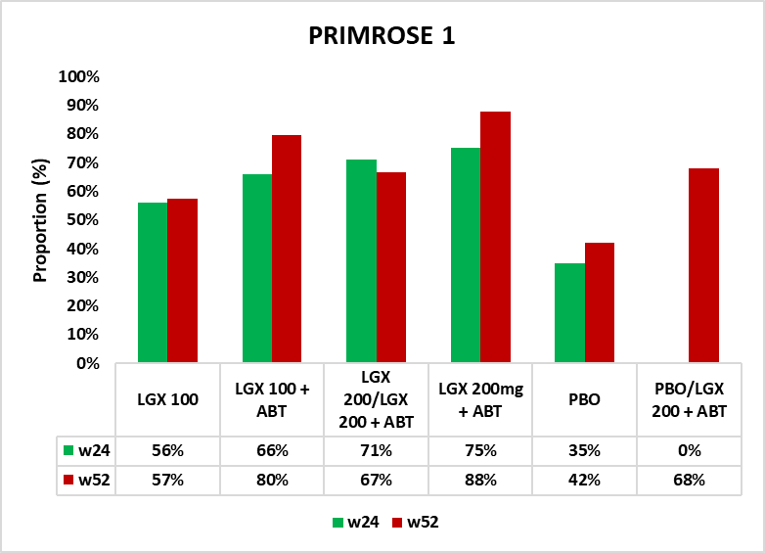 | 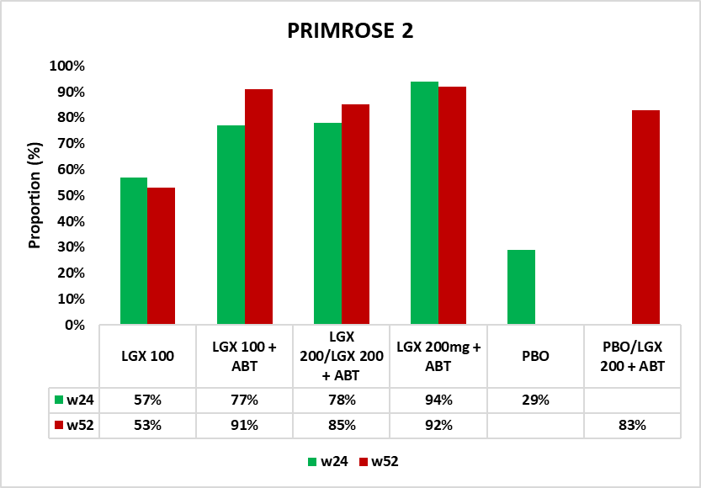
- Pooled analysis of PRIMROSE 1 and PRIMROSE 2
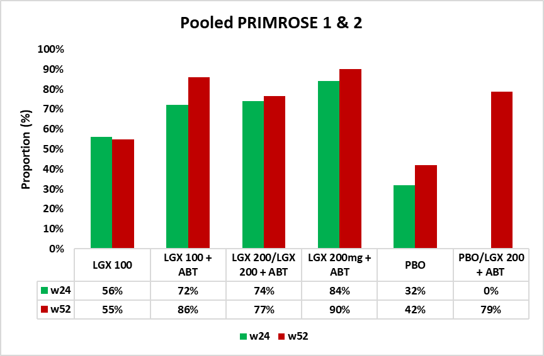
Source: compiled during the evaluation
ABT=add-back therapy; FAS=full analysis set; LGX 100=linzagolix 100 mg; LGX 200=linzagolix 200 mg; MBL=menstrual blood loss; PBO=placebo; w=week.
Note: The primary outcome of the trials was defined by MBL ≤80 mL and ≥50% reduction from baseline at week 24.
  - In patients who remained on treatment at week 52, there was a higher proportion of MBL responders at week 52 versus week 24 in most treatment arms, except for linzagolix 100 mg (in PRIMROSE 2 and the pooled data). However, this result is difficult to interpret and did not differentiate between continued response or new response that may have arisen after week 24.
  - Subgroup analyses for MBL response at week 24 varying patient demographics and clinical factors demonstrated consistent results compared to the FAS except for linzagolix 100 mg whose effects were smaller and no longer statistically significant compared to placebo in subgroups with BMI 25 to < 30, weight 77.6 kg to < 94.2 kg, or age < 39 years. This could be due to the smaller sample sizes of the subgroups analysed, however, overall, the subgroup analysis results indicated generally smaller effects for linzagolix 100 mg in terms of MBL response. Analysis by race revealed some variation, suggesting that the addition of ABT had less impact on African American women, though this finding lacked statistical power.
  - Table 5 summarises key secondary outcomes from PRIMROSE 1 and 2, including disease symptoms and health-related quality of life (HRQoL). Week 52 secondary outcomes were only reported in the submission for PRIMROSE 1.
Table 5. Secondary outcomes up to 24 and 52 weeks of treatment (FAS)
 | PRIMROSE 1 |  |  |  |  |  | PRIMROSE 2
 | LGX 100 | LGX 100 + ABT | LGX 200→  LGX 200 + ABT | LGX 200 + ABT | PBO→  LGX 200 + ABT | PBO | LGX 100 | LGX 100 + ABT | LGX 200→  LGX 200 + ABT | LGX 200 + ABT | PBO→  LGX 200 + ABT
N (w24) | 94 | 107 | 105 | 102 | 0 | 103 | 97 | 101 | 103 | 98 | 102
N (w52) | 61ª | 64 | 75 | 66 | 34 | 31 ª | 79 | 80 | 88 | 83 | 89
Pain change from baseline up to week 24
LS mean diff v PBO (CI), w24 | -1.6  (-2.6, - 0.7) | -2.0  (-3.0, - 1.1) | -2.8  (-3.7, - 1.9) | -2.6  (-3.6, - 1.7) | - | - | -1.2  (-1.9, -0.5) | -1.5  (-2.2, -0.8) | -2.1  (-2.8, -1.4) | -1.8  (-2.5, -1.1) | -
p-value, w24 | <0.001 | <0.001 | <0.001 | <0.001 | - | - | <0.001 | <0.001 | <0.001 | <0.001 | -
CFB (SD), w24 | -2.8 (3.4) | -3.5 (3.3) | -3.9 (3.7) | -3.7 (3.5) |  | -0.6 (2.6) | -2.2 (2.9) | -2.2 (2.9) | -3.1 (3.1) | -2.1 (3.4) | -0.6 (2.7)
CFB (SD), w52 | -3.3 (3.1) | -2.7 (3.2) | -2.6 (3.0) | -3.9 (3.2) | -2.3 (2.5) | -0.4 (2) | NR | NR | NR | NR | NR
Uterine fibroid volume change from baseline (mean mL) up to weeks 24 and 52
LS mean diff v PBO (CI), w24 | 0.8  (0.6, 1.0) | 1.0  (0.7, 1.4) | 0.6  (0.4, 0.8) | 0.9  (0.7, 1.3) | - | - | 0.8  (0.7, 1.0) | 0.9  (0.7, 1.1) | 0.5  (0.4, 0.6) | 0.8  (0.6, 0.9) | -
p-value, w24 | 0.151 | 0.840 | <0.001 | 0.622 | - | - | 0.057 | 0.331 | <0.001 | 0.011 | -
CFB (SD), w24 | -11.4 (66) | 3.0 (83) | -42.7 (92) | -0.1 (166) | - | 25 (98) | -16.2 (42) | -11.1 (47) | -46.5 (69) | -25.6 (46) | -0.8 (58)
CFB (SD), w52 | 9.4 (105) | 8.9 (164) | -31.2 (75) | -3.1 (67) | 21.9 (111) | -2.1 (78) | NR | NR | NR | NR | NR
Uterine volume change from baseline (mean mL) up to weeks 24 and 52
LS mean diff v PBO (CI), w24 | 0.8  (0.7, 0.97) | 1.0  (0.9, 1.2) | 0.7  (0.6, 0.8) | 0.9  (0.8, 1.1) | - | - | 0.8  (0.7, 0.9) | 0.8  (0.7, 0.9) | 0.5  (0.5, 0.6) | 0.8  (0.7, 0.9) | -
p-value, w24 | 0.015 | 0.663 | <0.001 | 0.209 | - | - | 0.001 | 0.005 | <0.001 | <0.001 | -
CFB (SD), w24 | -54.5 (221) | 45.8 (378) | -123 (207) | 3.5 (197) | - | 18 (193) | -38.6 (99) | -30.2 (90) | -124 (210) | -57.8 (136) | 2.6 (124)
CFB (SD), w52 | 8.0  (229) | -2.9 (229) | -25.3 (244) | 12.0 (162) | -78.7 (274) | 44.3 (107) | NR | NR | NR | NR | NR
Symptom severity score (UFS-QoL) change from baseline up to weeks 24 and 52
LS mean diff v PBO (CI), w24 | -11.6  (-19, -4) | -21.7  (-29, -14) | -23.4  (-31, -16) | -20.2  (-27, - 13) | - | - | -8.7  (-14, -3) | -14.2  (-19, -9) | -20.8  (-26, -16) | -22.7  (-28, -17) | -
p-value, w24 | 0.002 | <0.001 | <0.001 | <0.001 |  | - | <0.001 | <0.001 | <0.001 | <0.001 | -
CFB (SD), w24 | NR | NR | NR | NR | NR | - | NR | NR | NR | NR | NR
CFB (SD), w52 | -22.0 (26) | -31.6 (28) | -28.1 (29) | -35.4 (27) | -25.3 (29) | -13.1 (22) | NR | NR | NR | NR | NR
HRQoL total score (UFS-QoL) changes from baseline up to weeks 24 and 52
LS mean diff v PBO (CI), w24 | 10.6  (2, 19) | 21.7  (13, 30) | 19.9  (11, 28) | 18.7  (10, 27) | - | - | 10.3  (4, 17) | 12.6  (6, 19) | 19.8  (14, 26) | 20.3  (14, 27) | -
p-value, w24 | 0.017 | <0.001 | <0.001 | <0.001 | - | - | <0.001 | <0.001 | <0.001 | <0.001 | -
CFB (SD), w24 | 27.7 (24) | 39.2 (28) | 37.4 (33) | 31.5 (28) | - | 13 (23) | 19.0 (25) | 21.6 (24) | 29.9 (26) | 26.9 (25) | 8.0 (17)
CFB (SD), w52 | 25.0 (26) | 34.2 (30) | 29.7 (29) | 38.2 (29) | 25.22 (24.24) | 14.6 (24) | NR | NR | NR | NR | NR
Quality of life EQ-5D-5L index value change from baseline up to weeks 24 and 52
LS mean diff v PBO (CI), w24 | 0.02  (-0.01, 0.07) | 0.01  (-0.03, 0.06) | 0.004  (-0.03, 0.04) | 0.009  (-0.03, 0.05) | - | - | 0.02  (-0.03, 0.07) | -0.02  (-0.07, 0.03) | -0.001  (-0.05, 0.05) | 0.03  (-0.02, 0.08) | -
p- value, w24 | 0.243 | 0.542 | 0.830 | 0.667 | - | - | 0.542 | 0.361 | 0.970 | 0.215 | -
CFB (SD), w24 | 0.067 (0.2) | 0.061 (0.1) | 0.032 (0.1) | 0.030 (0.2) | - | 0.03 (0.1) | 0.068 (0.2) | 0.038 (0.2) | 0.090 (0.2) | 0.079 (0.2) | 0.1 (0.2)
CFB (SD), w52 | 0.058 (0.2) | 0.064 (0.1) | 0.030 (0.2) | 0.038 (0.1) | 0.037 (0.2) | -0.003 (0.1) | NR | NR | NR | NR | NR
Bold text=statistically significant.
Source: Table 34, p114, Table 35, p117, Table 36, p119, Table 37, p122, Table 38, p124, Table 39, p127, Table 41, p132, Table 46, p138, Table 47, p139, Table 48, p140, Table 49, p141, Table 51, p142, Figure 25, p135 of the submission and Table 7, p100 of P1, W52 CSR and Table 4, p125 , Table 23, p152, Table 28, p161 of the P2, W52 CSR.
ABT=add-back therapy; CFB=change from baseline (mean, SD); CI=95% confidence intervals; EQ-5D-5L=EuroQol health-related quality of life questionnaire; FAS=full analysis set; HRQoL=health related quality of life; LGX 100=linzagolix 100 mg; LGX 200= linzagolix 200 mg; LS=least squares; MBL=menstrual blood loss; N=total number of participants in treatment arm (FAS); n=number of participants; NR=not reported; PBO=placebo; SD=standard deviation; UFS-QoL=Uterine Fibroid Symptom-Quality of Life questionnaire.
ª A discrepancy in patient counts was noted for the linzagolix 100 mg and placebo arms in the FAS. The submission (Table 16, p70 of the submission) listed 62 participants for the linzagolix 100 mg arm and 32 for the placebo arm, while outcome reports for week 52 and the CSR indicated 61 and 31 patients, respectively.
^{b} Defined as having no data from the alkaline hematin method from the central laboratory or volume below the lower limit of quantification over at least a 35-day interval and without showing bleeding after this interval.
^{c} Full analysis set (FAS) numbers were used to calculate “n” during the evaluation.
  - Secondary outcomes in PRIMROSE 1 and 2 were largely consistent with the primary outcome. Menstrual bleeding related outcomes, including time to reduced MBL, proportion with and time to amenorrhea, haemoglobin levels in anaemic subjects, all showed significant improvements at week 24 compared to placebo across all treatment arms. In PRIMROSE 1, the only trial reporting data at week 52, similar trends were observed up to week 52. No statistical comparisons were provided as 50% of patients in the placebo arms of PRIMROSE 1 had switched to linzagolix 200 mg + ABT treatment after trial unblind at week 24.
  - Larger reductions in uterine fibroid volume from baseline were observed for all linzagolix treatment arms compared to placebo up to week 24. In PRIMROSE 1, this difference reached statistical significance for the linzagolix 200 mg treatment arm, and in PRIMROSE 2 this was statistically significant for both linzagolix 200 mg and linzagolix 200 mg + ABT arms. The reductions however did not appear to be maintained over time. By week 52, the extent of reductions from baseline were reduced for linzagolix 200 mg/ linzagolix 200 mg + ABT and fibroid volume had increased compared to baseline in the linzagolix 100 mg and linzagolix 100 mg + ABT arms. The only exception was for those randomised to the linzagolix 200 mg + ABT arm, which continued to show a higher reduction in fibroid volume from baseline.
  - HRQoL and symptom severity scores, assessed through the Uterine Fibroid Symptom-Quality of Life questionnaire (UFS-QoL), showed significant improvement across all linzagolix treatment arms versus placebo at week 24. Pain had also improved from baseline at both week 24 and week 52. However, HRQoL assessed through the EuroQol health-related quality of life questionnaire (EQ-5D) did not show significant changes in any arm. The submission suggested that the EQ-5D questionnaire may not accurately capture cyclical issues in women's quality of life due to its point-in-time assessment. In contrast, the UFS-QoL questionnaire, which is specific to the disease, employs a 3-month recall period for patient assessments, allowing for a better representation of women's cyclical changes. UFS-QoL was used to inform utility values in the economic model.

Comparative harms
  - Table 6 presents a summary of main safety outcomes in PRIMROSE 1 and 2 for the pooled linzagolix groups versus placebo, up to weeks 24 and 52.
Table 6: Summary of key adverse events in the trials
Trial ID | Linzagolix  n with event/N (%) | Placebo  n with event/N (%) | Odds Ratio  (95% CI) | Risk Difference^ (95% CI)
Pooled PRIMROSE 1 and 2 trials- week 24
Any TEAE | 470/828 (57%) | 103/209 (49%) | 1.35 (1.00, 1.83) | 0.07 (-0.00, 0.15)
Severe TEAE | 40/828 (5%) | 11/209 (5%) | 0.91 (0.46, 1.81) | -0.00 (-0.04, 0.03)
TEAE related to study treatment | 390/828 (47%) | 52/209 (25%) | 2.69 (1.91, 3.78) | 0.22 (0.15, 0.29)
Serious TEAE | 14/828 (2%) | 4/209 (2%) | 0.88 (0.29, 2.71) | -0.00 (-0.02, 0.02)
Serious TEAE related to treatment | 3/828 (0%) | 0/209 (0%) | 1.78 (0.09, 34.53) | 0.00 (-0.00, 0.01)
TEAE leading to discontinuation | 70/828 (8%) | 17/209 (8%) | 1.04 (0.60, 1.81) | 0.00 (-0.04, 0.04)
Fatal TEAE | 0/828 (0%) | 0/209 (0%) | Not estimable | 0.00 (-0.01, 0.01)
Pooled PRIMROSE 1 and 2 trials- week 52
Any TEAE | 260/745 (38%) | 12/31 (39%) | 0.85 (0.41, 1.78) | -0.04 (-0.21, 0.14)
Severe TEAE | 24/745 (3%) | 0/31 (0%) | 2.14 (0.13, 35.98) | 0.03 (-0.01, 0.08)
TEAE related to study treatment | 144/745 (19%) | 1/31 (3%) | 7.19 (0.97, 53.15) | 0.16 (0.09, 0.23)
Serious TEAE | 17/745 (2%) | 0/31 (0%) | 1.51 (0.09, 25.74) | 0.02 (-0.02, 0.07)
Serious TEAE related to treatment | 5/745 (1%) | 0/31 (0%) | 0.47 (0.03, 8.65) | 0.01 (-0.04, 0.05)
TEAE leading to discontinuation | 41/745 (6%) | 1/31 (3%) | 1.75 (0.23, 13.13) | 0.02 (-0.04, 0.09)
Fatal TEAE | 0/745 (0%) | 0/31 (0%) | Not estimable | 0.00 (-0.04, 0.04)
Bold text=statistically significant.
Source: Figure 32, p145 and Figure 34, p150 of the submission and compiled during the evaluation
ABT= add-back therapy; CI=confidence intervals; IMP=investigational medicinal product; LGX=linzagolix; n=number of participants reporting outcome; N=total participants in group; TEAE=treatment-emergent adverse event.
^ RevMan v5.4 was used to generate results, during the evaluation.
  - There were greater numbers of treatment-emergent adverse events (TEAEs) for linzagolix treated groups compared to placebo, with TEAEs related to study treatment reaching statistical significance. Most of the reported adverse events were mild to moderate, with 5% being severe across both treatment and placebo arms. Figure 2 summarises frequent (≥ 2%) TEAEs at week 24 for pooled linzagolix versus placebo.
Figure 2. Forest plot of pooled analysis TEAEs reported in ≥2% participants (linzagolix vs placebo) at week 24
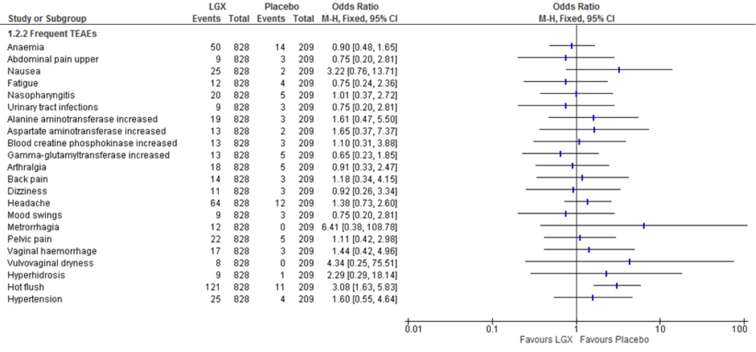Source: Figure 33, p146 of the submission
CI=confidence intervals; LGX=linzagolix; M-H=Mantel-Haenszel; TEAE=treatment-emergent adverse event
  - The most common TEAEs across the linzagolix arms were hot flushes (14.6%), headache (7.7%), and anaemia (6.0%). The incidence of hot flushes was higher in the linzagolix arms without ABT compared to those with ABT, indicating that the use of ABT helps alleviate estrogen suppression-related TEAEs. Moreover, headaches were more frequently reported in the linzagolix 200 mg group, suggesting a potential dose-exposure response concerning estradiol depletion. Anaemia was an anticipated TEAE in this patient cohort.
  - Results at week 52 were not precise enough for statistical comparison, as 27% of the Safety Analysis Set (SAF) had discontinued by week 52 due to various reasons including lack of efficacy. Additionally, only 31 patients from the SAF continued receiving placebo between weeks 24 and 52 (50% of PRIMROSE 1 placebo arm), which further decreased precision due to the small sample size in the comparator arm.
  - BMD change was reported as a safety outcome at weeks 24, 52 and 76 in PRIMROSE 1 and 2. Patients who completed at least 20 weeks of treatment in PRIMROSE 1 and 2 were also eligible to enter PRIMROSE 3 which was a safety extension study assessing long term impact of linzagolix on BMD up to 24 months (104 weeks).
  - Figure 3 summarises BMD mean change over time in PRIMROSE 1 and 2.
Figure 3. BMD mean change during treatment to week 52 in PRIMROSE 1 and 2
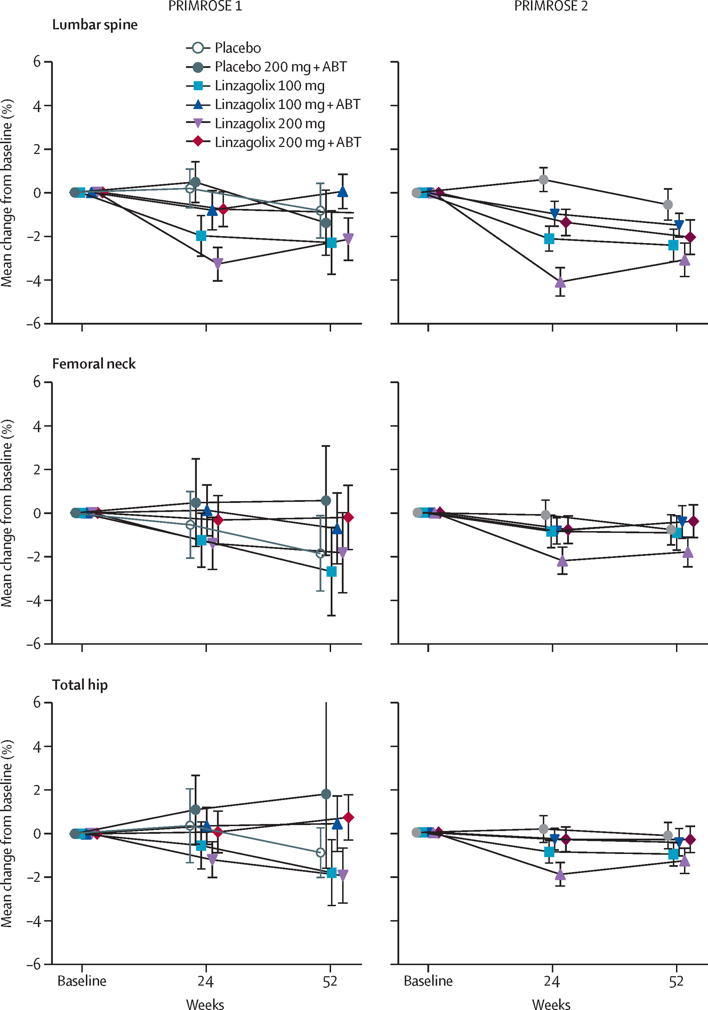
Source: extracted during evaluation from Figure 3, Donnez et al 2022
ABT=add-back therapy; BMD=bone marrow density.
  - The analysis of PRIMROSE 1 and 2 trials reported changes in BMD at all three anatomical sites (lumbar spine, femoral neck, and total hip) by weeks 24 and 52. At week 24, the most significant mean changes from baseline in BMD were observed in the lumbar spine, with linzagolix-treated groups experiencing decreases of 1.0% to 3.7% for different dosage combinations compared to a 0.4% increase in the placebo group. By week 52, percent decreases in lumbar spine BMD ranged from 1.0% to 2.6% in the linzagolix-treated groups, while stabilising in those receiving linzagolix 200 mg + ABT.
  - Z-scores for BMD at baseline were generally comparable across treatment groups in the pooled safety analysis set (SAF) (medians: 0.3-0.5 in the active arms and 0.6 in the placebo arm). Medians at week 24 were between -0.10 to 0.55 for the lumbar spine, from 0.20 to 0.30 for the femoral neck, and from 0.50 to 0.60 for the total hip. At week 24, median absolute changes from baseline in Z-scores for the lumbar spine were between -0.10 for linzagolix 200 mg + ABT to -0.40 for linzagolix 200 mg, versus 0.00 (range: -1.0, 0.9) for placebo. For the femoral neck, median absolute changes from baseline varied from 0.00 (range: -0.6, 1.1) for linzagolix 100 + ABT and placebo to -0.20 for linzagolix 200 mg. For the total hip, median absolute changes from baseline were -0.10 for linzagolix 200 mg, and 0.00 (range: -1.4, 1.1) for all other treatment groups. The medians and interquartile ranges of Z-scores remained relatively stable over time. Median absolute changes from baseline in Z-scores at week 52 in the treatment arms were between -0.1 to -0.3 for the lumbar spine and -0.1 to 0.00 for femoral neck and total hip. Medians at Week 52 were all above zero and ranged from 0.10 to 0.70 for the lumbar spine, from 0.10 to 0.35 for the femoral neck, and from 0.50 to 0.60 for the total hip. The submission suggested that BMD decreases stabilised by week 52 in linzagolix-treated patients compared to earlier periods. Although the rates of decline were slowed compared to the initial treatment period, large reductions in BMD, specifically in lumbar spine, were still observed in all linzagolix treatment arms at week 52 (especially those originally administered linzagolix 100 mg or 200 mg, alone).
  - At week 24, patients with more than 8% decrease in BMD from baseline or a Z-score ≤ -2.5 discontinued treatment. Discontinuations due to decreased BMD at week 24 ranged from 0.9% (linzagolix 200 mg + ABT) to 4.6% (linzagolix 100 mg + ABT) and from 1.0% (linzagolix 100 mg + ABT) to 6.7% (linzagolix 200 mg) in the linzagolix arms of PRIMROSE 1 and 2, respectively. The pooled average discontinuation rate across all linzagolix treatment arms due to BMD decrease at week 24 were 2.4% in PRIMROSE 1 and 3.2% in PRIMROSE 2. In comparison, the discontinuation rate in the placebo arms across both trials was 2.5%.
  - BMD decrease was the most frequent reason for permanent discontinuation due to any TEAEs between weeks 24 and 52 (10 of 42 discontinued cases). Additionally, the trial CSR for pooled PRIMROSE 1 and 2 indicated patients had ceased linzagolix due to bone loss (2 patients) and osteoporosis (2 patients) in the linzagolix treatment arms between week 24 and 52.
  - All treatments in the PRIMROSE 1 and 2 trials ceased at week 52. By week 76, some rebound in BMD was evident, especially in the lumbar spine, except for those in the linzagolix 100 mg + ABT arm of PRIMROSE 1, who experienced a larger decline of 0.98% from baseline at week 76 compared to a reduction of 0.05% at week 52. BMD recovery was slowest in patients not receiving ABT, as evidenced in PRIMROSE 2, where the linzagolix 100 mg (without ABT) treatment arm showed less BMD rebound from week 52 to week 76 compared to other treatment groups. Figure 4 shows BMD changes from baseline to week 76. BMD results at week 76 are not generalisable to any patients treated beyond one year.
Figure 4. BMD mean percentage change from baseline to week 76
PRIMROSE 1 | PRIMROSE 2
- Lumbar spine | - Lumbar spine
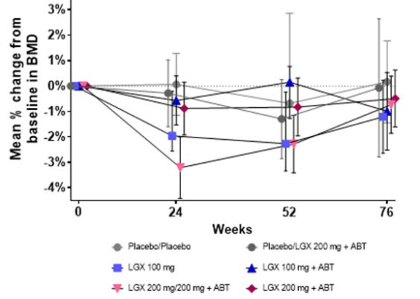 | 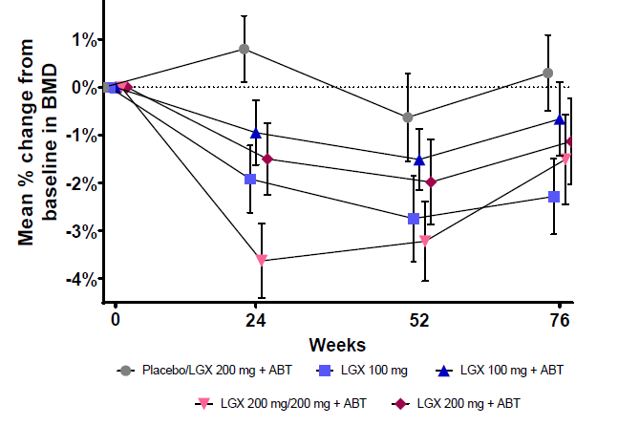
- Femoral neck | b. Femoral neck
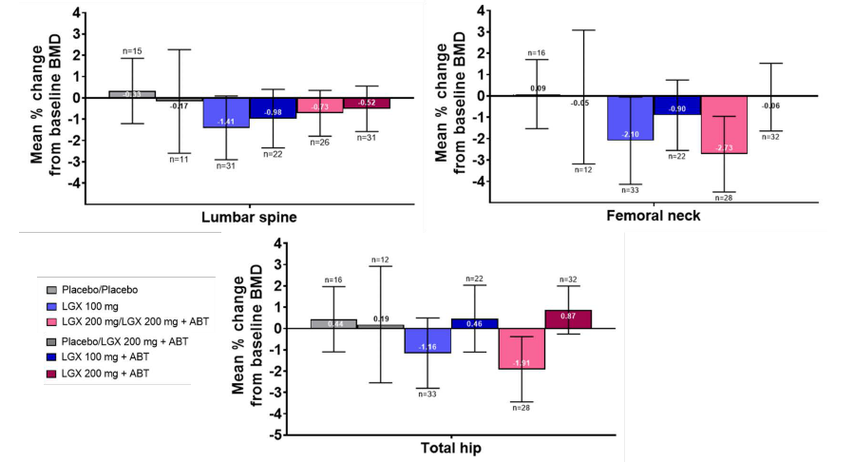 | 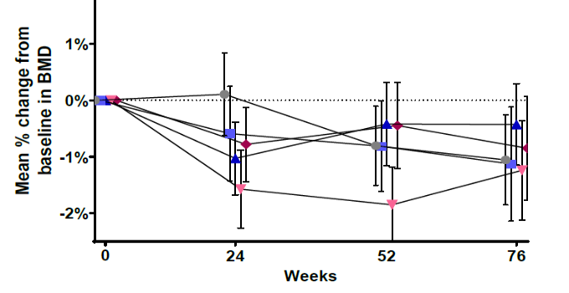
- Total hip | c. Total hip
 | 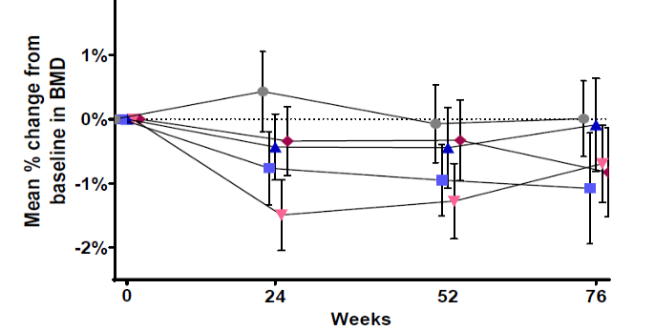

  - Based on PRIMROSE 3 results at week 104 regarding BMD decrease, some recovery in BMD was noted across treatment arms, particularly in the linzagolix 100 mg and linzagolix 200 mg to 200 mg + ABT arm. However, linzagolix 200 mg + ABT and linzagolix 100 mg + ABT showed further declines in BMD for certain sites. Increases in BMD were observed for the lumbar spine in the linzagolix 100 mg, 100 mg + ABT, and 200 mg switched to 200 mg + ABT arms, while reductions were seen in linzagolix 200 mg + ABT and placebo patients who switched to 200 mg + ABT.
  - Additionally, based on PRIMROSE 3 results regarding BMD recovery, the submission highlighted that by week 104, most participants showed partial or complete recovery of their BMD across various anatomical sites. Notably, over 50% of subjects achieved this recovery in the lumbar spine in all treatment groups. However, there were some variations among treatment arms, with the linzagolix 200 mg + ABT group showing lower recovery rates in the femoral neck compared to other arms. The linzagolix 100 mg treatment arm demonstrated the highest recovery in spinal BMD, while the arm switching to linzagolix 200 mg + ABT had the highest recovery in femoral neck and total hip BMDs.
  - BMD recovery status up to 24 months after ceasing treatment is summarised in Table 7.
Table 7. BMD recovery status 24 months after end of treatment (SAF)
 | PRIMROSE 3
 | LGX 100mg  (N=22) | LGX 100mg  + ABT  (N=23) | LGX 200mg/LGX 200mg + ABT  (N=30) | LGX 200mg  + ABT  (N=21) | PBO/LGX 200mg + ABT (N=26) | PBO  (N=7)
Anterior posterior lumbar spine
n (%) | 15 (68.2%) | 17 (73.9%) | 20 (66.7%) | 18 (85.7%) | 20 (76.9%) | 7 (100.0%)
Continued loss | 3 (20.0%) | 6 (35.3%) | 5 (23.8%) | 9 (50.0%) | 9 (45.0%) | 3 (42.9%)
Partially recovered | 5 (33.3%) | 3 (17.6%) | 6 (28.6%) | 4 (22.2%) | 5 (25.0%) | 1 (14.3%)
Completely recovered | 7 (46.7%) | 8 (47.1%) | 10 (47.6%) | 5 (27.78%) | 6 (30.0%) | 3 (42.9%)
Femoral neck
n (%) | 15 (68.2%) | 17 (73.9%) | 20 (66.7%) | 18 (85.7%) | 20 (76.9%) | 7 (100.0%)
Continued loss | 6 (40.0%) | 8 (47.1%) | 4 (20.0%) | 11 (61.1%) | 10 (50.0%) | 2 (28.6%)
Partially recovered | 4 (26.7%) | 2 (11.8%) | 2 (10.0%) | 4 (22.2%) | 2 (10.0%) | 1 (14.3%)
Completely recovered | 5 (33.3%) | 7 (41.2%) | 14 (70.0%) | 3 (16.7%) | 8 (40.0%) | 4 (57.1%)
Total hip
n (%) | 15 (68.2%) | 17 (73.9%) | 20 (66.7%) | 18 (85.7%) | 20 (76.9%) | 7 (100.0%)
Continued loss | 7 (46.7%) | 9 (52.9%) | 6 (30.0%) | 6 (33.3%) | 11 (55.0%) | 2 (28.6%)
Partially recovered | 3 (20.0%) | 2 (11.8%) | 2 (10.0%) | 0 (0.0%) | 0 (0.0%) | 0 (0.0%)
Completely recovered | 5 (33.3%) | 6 (35.3%) | 12 (60.0%) | 12 (66.7%) | 9 (45.0%) | 5 (71.4%)
Source: Table 73, p184 of the submission
ABT=add-back therapy; BMD=bone mineral density; LGX=linzagolix; n=number of participants with available data; N=total number of participants in treatment arm; PBO=placebo; SAF=safety analysis set
Note: Subjects were considered completely recovered if study visit assessment was greater than or equal to pre-treatment baseline BMD assessment; subjects were considered partially recovered if they were not completely recovered and study visit assessment was greater than or equal to the post-treatment baseline within analysis window; subjects continued to lose BMD if they were not completely recovered, and study visit assessment was less than the post-treatment baseline within analysis window.
  - BMD loss 24 months after end of treatment was reported for over 50% of subjects in PRIMROSE 3 despite all treatments ceasing at 52 weeks, including:
- Lumbar spine: In the linzagolix 200 mg + ABT group, 50% of participants continued to experience BMD loss.
- Femoral neck: continued BMD loss was observed in 61% of participants in the linzagolix 200 mg + ABT group and in 50% of participants in the placebo group who switched to linzagolix 200 mg + ABT.
- Total hip: BMD loss affected 55% of participants in the placebo group who switched to linzagolix 200 mg + ABT.
These findings raise concern regarding the safety of long term linzagolix treatment. Although a high risk of bias, specifically attrition bias, in PRIMROSE 3 study should be noted while interpreting the results. No data was provided in the submission to address safety of continuous linzagolix treatment beyond 52 weeks.
  - The PSCR stated that continued treatment with linzagolix will be required, and BMD loss over time can be accurately, and relatively inexpensively, monitored allowing patients and clinicians to make informed risk benefit treatment decisions over time. The PSCR also included the November 2023 Periodic Safety Update Report (PSUR), which showed no significant safety concerns regarding the use of linzagolix during the six-month reporting period. However, there was no post-marketing exposure to linzagolix during this reporting period as no products had been launched. Consequently, there remains no data available for cumulative post-marketing analysis. Overall, the ESC considered safety in long-term use of linzagolix remains unknown.

Benefits/harms
  - A summary of the comparative benefits and harms for linzagolix versus placebo is presented in Table 8|. As many benefits reported in the submission related to MBL benefits, estimates are focused on MBL response. Other benefits not included below are as presented in Table 6.
Table 8: Summary of comparative benefits and harms for linzagolix and placebo
Trial | n/N | OR^ (95% CI) | Event rate/100 patients |  | RD^ (95% CI)
Trial | n/N | OR^ (95% CI) | Linzagolix | PBO | RD^ (95% CI)
Benefits (FAS, pooled PRIMROSE 1 and 2)
MBL response*, vs PBO (n=66, N=205), at week 24
LGX 100 | 108/191 | 2.74 (1.82, 4.13) | 56 | 32 | 0.24 (0.15, 0.34)
LGX 100 + ABT | 149/208 | 5.32 (3.49, 8.10) | 72 | 32 | 0.39 (0.31, 0.48)
LGX 200 | 155/208 | 6.16 (4.02, 9.45) | 74 | 32 | 0.42 (0.34, 0.51)
LGX 200 + ABT | 169/200 | 11.48 (7.09, 18.6) | 84 | 32 | 0.52 (0.44, 0.60)
MBL response*, vs PBO (n=13, N=31), at week 52
LGX 100 | 77/140 | 1.69 (0.77, 3.72) | 55 | 42 | 0.13 (-0.06, 0.32)
LGX 100 + ABT | 124/144 | 8.58 (3.65, 20.20) | 86 | 42 | 0.44 (0.26, 0.62)
LGX 200→LGX 200 + ABT | 125/163 | 4.55 (2.05, 10.14) | 77 | 42 | 0.35 (0.16, 0.53)
LGX 200 + ABT | 134/149 | 12.37 (5.08, 30.15) | 90 | 42 | 0.48 (0.30, 0.66)
Harms (SAF, pooled PRIMROSE 1 and 2)
TEAEs | n/N | OR^ (95% CI) | Event rate/100 patients |  | RD^ (95% CI)
TEAEs | n/N | OR^ (95% CI) | Linzagolix | PBO | RD^ (95% CI)
TEAEs relevant to study treatment, vs PBO (n=52, N=209), up to week 24
LGX 100 | 78/199 | 1.95 (1.27, 2.97) | 39 | 25 | 0.14 (0.05, 0.23)
LGX 100 + ABT | 78/211 | 1.77 (1.16, 2.70) | 37 | 25 | 0.12 (0.03, 0.21)
LGX 200 | 137/210 | 5.67 (3.71, 8.65) | 65 | 25 | 0.40 (0.32, 0.49)
LGX 200 + ABT | 97/208 | 2.64 (1.74, 4.00) | 47 | 25 | 0.22 (0.13, 0.31)
Bold text=statistically significant.
Source: Table 28, p102, Figure 24, p134 and Table 52, p144 of the submission and compiled during evaluation.
ABT=add back therapy; CI=confidence interval; FAS=full analysis set; LGX=linzagolix; PBO =placebo; N=total number of participants in treatment arm; n=number of participants with the specified outcome; OR=odds ratio; RD = risk difference; SAF=safety analysis set; TEAE=treatment emergent adverse event.
^ RevMan v5.4 was used to generate results, during the evaluation.
* MBL response was defined by MBL ≤80 mL and ≥50% reduction from baseline.
  - On the basis of direct comparison presented by the submission, for every 100 patients treated with linzagolix in comparison with placebo:
- Approximately 24, 40, 42, and 52 additional patients in linzagolix 100 mg, 100 mg + ABT, 200 mg and 200 mg + ABT, respectively, will obtain MBL response (defined by MBL ≤80 mL and ≥50% reduction from baseline) after 24 weeks.
- Approximately 13, 44, 35, 48 and 37 additional patients in linzagolix 100 mg, 100 mg + ABT, 200 mg switched to 200 mg + ABT, 200 mg + ABT, and placebo switched to linzagolix 200 mg + ABT, respectively will have MBL response after 52 weeks.
- Approximately 14, 12, 40, and 22 additional patients in linzagolix 100 mg, 100 mg + ABT, 200 mg and 200 mg + ABT, respectively, will experience TEAEs after 24 weeks.

Clinical claim
  - The submission described linzagolix (100 mg or 200 mg) ± ABT as superior in terms of effectiveness compared to BSC (consisting of either NSAIDs and/or iron supplementation). The evaluation considered the claim may not be appropriate for patients who have had an inadequate response to prior hormone therapy as patients in the placebo arms of PRIMROSE 1 and 2 trials did not receive any hormone treatments or tranexamic acid, which are known to reduce MBL. The claim for patients unsuitable for hormone therapy may be reasonable if linzagolix’s treatment effect is not expected to vary based on hormone unsuitability. It is unknown what proportion of the requested patient population would be unsuitable for hormone therapy. The trial data is lacking for the most likely long-term treatment regimen in this patient population i.e. linzagolix 200 mg followed by linzagolix 100 mg after six months.
  - Overall, the ESC considered that for the patients enrolled in the trials, the evidence supported the claim that linzagolix was associated with a reduction in menstrual blood loss, haemoglobin/anaemia, pain and improvement to symptom severity compared with placebo. However, the ESC considered the benefit of linzagolix for the outcome of amenorrhoea was uncertain due to missing data (see paragraph 6.18) and also considered the benefit associated with uterine volume and uterine fibroid volume uncertain due to varied results across treatment arms of the trials. The ESC also noted no quality of life benefits were observed in the clinical trials. The ESC noted that the comparison with placebo did not necessarily represent BSC in Australia, which would include hormonal therapies and tranexamic acid.
  - The submission described linzagolix as inferior in terms of safety compared to BSC. The ESC considered this claim was supported by trial data for up to 52 weeks of treatment. However, the ESC noted that for longer-term treatment, safety is unknown.
  - The PBAC considered that the claim of superior comparative effectiveness was reasonable.
  - The PBAC considered that the claim of inferior comparative safety was reasonable.

Economic analysis
  - The submission presented a stepped economic evaluation of linzagolix versus BSC, based on results from the linzagolix 200 mg + ABT and placebo arms of pooled PRIMROSE 1 and 2 data plus external sources. As discussed, this was not an accurate representation of a second line setting in Australia which would also include hormone treatments as part of BSC with or without tranexamic acid, both of which were specifically excluded. The ESC considered that the lack of evidence for the requested second line listing could not be resolved with modelling. The PSCR maintained that the PRIMROSE study can be considered applicable to the second line setting, and the nomination of BSC (excluding hormonal therapies and tranexamic acid) is appropriate (see paragraph 5.1). It reiterated that linzagolix could be used with ABT in those who are unsuitable for hormone treatments (see paragraph 6.8).
Table 9. Summary of model structure, key inputs and rationale
Component | Description | Justification/comments
Type of analysis | Cost-utility analysis | Appropriate.
Treatments | LGX vs BSC | Appropriate.
Outcomes | Quality-adjusted life years | Appropriate.
Time horizon | 3 years to 21 years (based on cohort starting ages 35, 39, 43, 46 with percentages from PRIMROSE 2 and varying ages of menopause based on Australian study Xu 2020) vs. 52 weeks in the key trials. | The ESC considered that this was not reasonable. The model did not include patients younger than 35 years. If accounting for these patients (can be as young as 18 years), the time horizon will significantly increase given longer time to menopause. The ESC noted the time horizon was also closely linked to the assumed age at initiation.
Methods used to generate results | Markov model, with up-front decision tree to account for variation in start age and age at menopause. | Appropriate.
Health states | 17 health states:  - HMB (LGX; BSC)  - HMB remission (LGX; BSC)  - Waiting for surgery (HMB-LGX; HMB-BSC)  - Myomectomy (LGX; BSC)  - Abdominal hysterectomy (AH)  - Laparoscopic hysterectomy (LH)  - Post myomectomy (LGX; BSC)  - Post AH  - Post LH  - Menopause (no hysterectomy; post hysterectomy)  - Death | Overall, the ESC noted the model was fairly complex, but considered that the trial data informing the model was likely adequately robust to inform the transitions required. There were more health states in the model in the submission compared to the NICE models. While the two models tracked similar clinical events e.g., surgery and menopause, health states in the NICE model were combined across surgery types for patients on and off linzagolix treatment.  The submission’s model did not include uterine artery embolization (UAE) as a treatment option alongside hysterectomy and myomectomy. This did not reflect clinical practice.
Cycle length | One month | Appropriate.
Transition probabilities | - HMB to HMB remission health states: up to 24 weeks based on pooled PRIMROSE 1 and 2 MBL response (primary efficacy endpoint) for LGX 200mg + ABT and placebo as proxies for linzagolix and BSC in the base case; transition assumed to be 0% after 24 weeks in the model.  - HMB remission to HMB (loss of response) after 6 months: based on market research survey in six European countries  - HMB (LGX) to HMB (BSC): based on pooled PRIMROSE 1 and 2 discontinuations, plus a stopping rule (for non MBL responders at 24 weeks).  - HMB remission (LGX) to HMB remission (BSC): assumed to be 0% in base case  - HMB to surgery health states: based on pooled PRIMROSE 1 and 2; patient age at the time of surgery; duration until menopause; waiting time from AIHW 2023b; Wiser 2013.  - Myomectomy to HMB (recurrence): Radosa 2014.  - Myomectomy to Death: Yuk 2022  - Hysterectomy to Death: Wiser 2013  - Background mortality: ABS life tables. | The comparison of LGX 200 mg + ABT versus placebo as a proxy for linzagolix versus BSC was not appropriate, especially as ACM recommended an initial dose of 100 mg.  The use of survey data to model HMB remission to HMB (loss of response) also appeared to be inappropriate as trial data is available up to 52 weeks and would be a more robust source than survey data.  The submission assumed that no patients in the HMB remission (LGX) health state discontinued LGX treatment due to other reasons. This is inappropriate as patients in remission can discontinue treatment due to various reasons e.g., adverse events.
Health related quality of life | - PRIMROSE 1 and 2, mapped UFS-QoL to UK EQ-5D-3L (not adjusted for baseline):  - HMB 0.7159;  - HMB remission and menopause 0.8421  - NICE linzagolix model; Sculpher 2004:  - myomectomy 0.63;  - hysterectomy 0.71;  - disutility of abdominal hysterectomy -0.03. | The utility values for HMB and remission were not baseline-adjusted. This favoured linzagolix. Adjusting for baseline QoL with UFS-QoL to UK EQ-5D-3L value set increases ICER by 117%; adjusting for baseline QoL and using Australian EQ-5D-5L value set increases ICER by 694%.
Costs | - Drug costs (LGX and ABT)  - Costs of monitoring BMD  - Costs of managing AEs  - Costs of coronary artery disease (CAD)  - Surgery (hysterectomy and myomectomy) costs based on DRG costs for hysterectomy | No effect on BMD due to linzagolix treatment was assumed in the model. There was also a paucity of clinical data on effect of long term linzagolix treatment (>52 weeks) on BMD.
Perspective | Base case: health care  Sensitivity analysis: societal, excess productivity loss based on Hasselrot 2018. | Appropriate.
Software package | TreeAge Pro Suite | Appropriate.
Source: Table 77, p192 of the submission.
ABT = add-back therapy; AH = abdominal hysterectomy; BMD = bone mineral density; BSC = best supportive care; CAD = coronary artery disease; HMB = heavy menstrual bleeding; LGX = linzagolix; LH = laparoscopic hysterectomy; MBL = menstrual blood loss; UAE = uterine artery embolization.
  - Subsequent treatments in the model were limited to surgeries consisting of either laparoscopic/abdominal myomectomy or hysterectomy. The exclusion of uterine artery embolization (UAE) and other treatment options such as radiologic or ultrasound guided thermal ablation of the uterine fibroids may not be appropriate.
  - A simplified diagram of the Markov model structure is presented in Figure 5. The economic model was a Markov model with an upfront decision tree that sorted the cohort by age at treatment commencement and age at menopause. The data used, however, only accounted for women 35 years and over, whereas patients in PRIMROSE 2 varied in age from 20−58 years. Omitting younger patients favoured linzagolix as it reduced the time to menopause and thus treatment duration for any linzagolix responder. The PSCR claimed that women aged < 35 years made up a small proportion of women being diagnosed with uterine fibroids based on Lou 2023 and Zimmermann 2012. Data from Zimmermann 2012 suggested that the self-reported prevalence of uterine fibroids increased with age, however did not suggest that the proportion of women < 35 years was small (1.8% prevalence in patients aged 20−29 years, compared with 7.0% in patients aged 30−39 years). Similarly, Lou 2023 found that women aged 35−39 years had the highest incidence of uterine fibroids, which does not imply that women aged < 35 years comprise a small proportion of women with uterine fibroids. Conversely, based on these data, approximately half of the incidence of uterine fibroids is among women < 35 years. Overall, the ESC considered omitting younger patients from the economic model was not appropriate and favoured linzagolix. The ESC considered that the age distribution of the Australian population likely to be treated was uncertain and may be impacted by increasing awareness of the condition and treatments. The ESC considered that data or evidence regarding the age of patients likely to be treated in Australia would be informative. The pre-PBAC response maintained that women aged less than 35 years make up a small proportion of women diagnosed with uterine fibroids and represent a small proportion of women who have used linzagolix in markets where it is already available for this condition.
Figure 5. The submission’s Markov model structure (simplified diagram)
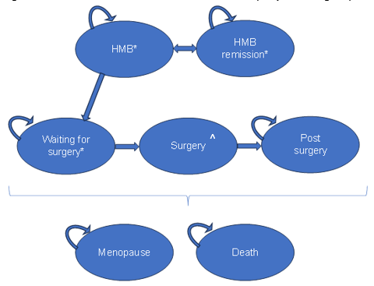
Source: Figure 46, p208 of the submission.
HMB = heavy menstrual bleeding.
* In each arm of the model, treatment is either linzagolix + best supportive care or best supportive care alone.
^ Surgery includes myomectomy, abdominal hysterectomy and laparoscopic hysterectomy.
  - All patients entered the model in the HMB (heavy menstrual bleeding) health states. Treatment with linzagolix could discontinue due to lack of response at week 24 or due to any reason (such as AEs) at other times. The model assumed that only women in the ‘HMB (LGX)’ health state are at risk of discontinuing linzagolix treatment for any reason. A patient in the ‘HMB remission (LGX)’ health state was at zero risk of discontinuing linzagolix in the base case. This was not reasonable as patients in remission can discontinue treatment due to various reasons e.g., adverse events. In effect, patients in the ‘HMB remission (LGX)’ health state can have ongoing linzagolix treatment, provided that they do not lose response (in which case they will move back to the ‘HMB (LGX)’ health state). The use of survey data to model loss of response also appeared to be inappropriate given trial data was available up to 52 weeks and would be a more robust source than survey data.
  - The model assumed that all women under the age of 40 years will only be treated with fertility-preserving surgeries (i.e., myomectomies), thus excluding hysterectomies. For women aged 40 years and over, the model assumed that there is no preference or need for fertility / uterus preservation and hysterectomies were undertaken instead. This assumption may not be appropriate as the choice between hysterectomy and myomectomy may be guided by patient preference to avoid ‘radical’ surgery such as hysterectomy, and desire to preserve fertility, rather than just patient age. The PSCR argued that in the context of a Markov model with already a large number of health states it is a reasonable simplification of clinical practice for a majority of patients. The PSCR also argued that the choice of surgery in the model does not have a large impact on the ICER.
  - The model Markov traces constructed during the evaluation are presented in Figure 6.
Figure 6: Markov traces
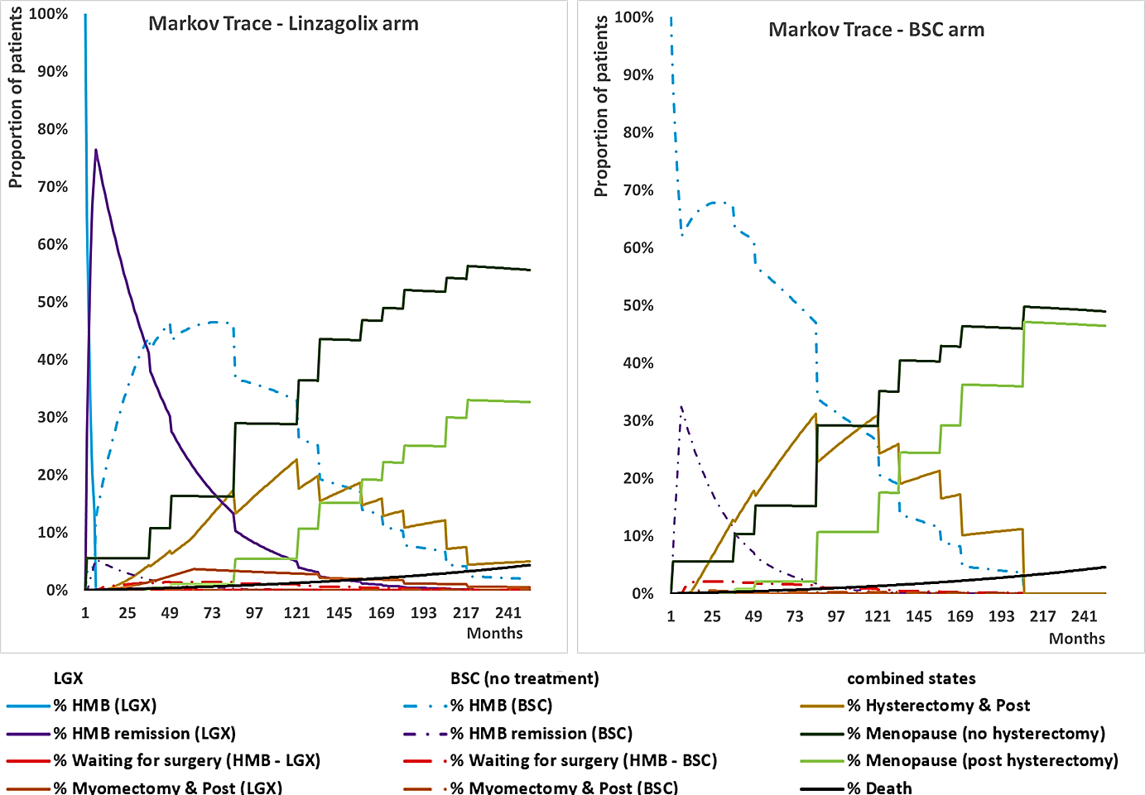
Source: independently reconstructed during the evaluation.
BSC = best supportive care; HMB = heavy menstrual bleeding; LGX = linzagolix.
A 21-year time horizon was assumed for all modelled patients to generate the graphs, the model base case assumed the model stops at the age of menopause, once patients reach menopause they would remain in the ‘menopause’ health state unless they die due to all-cause mortality.
  - A larger proportion of patients in the linzagolix arm in the model achieved remission compared to the BSC arm. This translated to fewer patients moving to the surgery health state in the linzagolix arm compared to BSC.
  - Disaggregated costs and outcomes are presented in Table 10 and Table 11, respectively.
Table 10: Health care resource items: disaggregated summary of cost impacts (discounted)
Resource use | LGX | BSC | Incremental cost | % of total incremental cost
Drug costs (intervention) | $| | $0.00 | $| | |%
Costs of ABT | $| | $0.00 | $| | |%
Costs of BMD monitoring | $306.93 | $0.00 | $306.93 | |%
Costs of abdominal hysterectomy | $4,511.17 | $5,814.13 | -$1,302.96 | -|%
Costs of laparoscopic hysterectomy | $586.42 | $743.92 | -$157.50 | -|%
Costs of myomectomy | $418.86 | $757.91 | -$339.05 | -|%
Costs of adverse events | $209.91 | $0.00 | $209.91 | |%
Costs of CAD | $153.97 | $156.63 | -$2.66 | -|%
Total Costs | $| | $7,472.60 | $| | 100.0%
Source: Table 105, p180 of the submission and compiled during the evaluation.
ABT = add-back therapy; BSC = best supportive care; BMD = bone mineral density; CAD = coronary artery disease; LGX = linzagolix.
Table 11: Disaggregated summary of health outcomes included in the economic evaluation
Outcome | LGX | BSC | Incremental outcome
QALYs (discounted) | 6.1928 | 6.0187 | 0.1741
Monthly cycles of LGX/ABT treatment (undiscounted) | 43.38 | 0.00 | 43.38
Myomectomies (undiscounted) | 0.0355 | 0.0631 | -0.0276
Abdominal hysterectomies (undiscounted) | 0.3183 | 0.3888 | -0.0705
Laparoscopic hysterectomies (undiscounted) | 0.0633 | 0.0763 | -0.013
Source: Table 106, p255 of the submission and compiled during the evaluation.
ABT = add-back therapy; BSC = best supportive care; LGX = linzagolix; QALY=quality adjusted life years.
  - Sensitivity analyses performed during the evaluation showed that the ICER was very sensitive to younger aged patients starting in the model due to the longer duration on linzagolix treatment for linzagolix responders. Assuming all patients in the model start at age 20 years, the ICER increased from a base case of $45,000 to < $55,000 to $135,000 to < $155,000 per QALY gained compared with assuming all patients start at 42 years with an ICER of $35,000 to < $45,000 per QALY gained. Including patients 20 years and older in the model (i.e., assuming even distribution 25% each in 20, 30, 40 and 50 starting age groups) increased the ICER to $75,000 to < $95,000/QALY gained. Figure 7 shows the range of ICERs assuming all patients start at 20 years ranging to 45 years. The PSCR provided a new sensitivity analysis which applied 20 years instead of 35 years as the lowest end of the assumed range of starting ages, which showed minimal impact on the ICER. This analysis could not be verified. Changing the lower cut off for the age groups 35+ to 20+ years, resulted in an ICER of $55,000 to < $75,000 per QALY gained. The pre-PBAC response stated that the ICER in the younger cohorts should be interpreted with caution as the model does not include the impact of surgical complications on, and/or preference for, fertility preservation.
Figure 7: ICER versus starting age in model (for all patients)
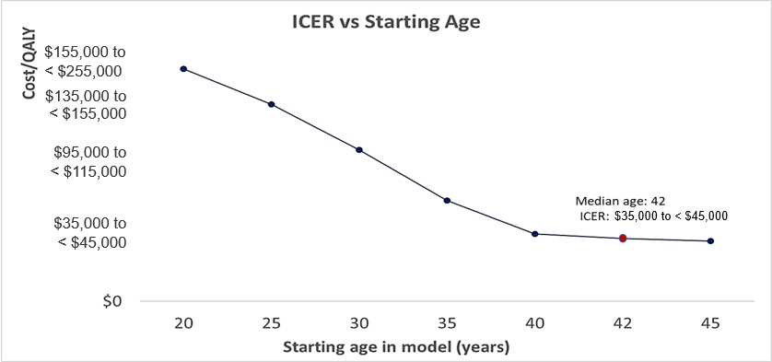
Source: independently generated during the evaluation based on submitted model.
  - Patients transitioned from the HMB health states to the HMB remission health states according to ‘response’ rates, which were derived from pooled PRIMROSE 1 and 2 trial data at week 24. Therefore, response in the model reflected a reduction in MBL to ≤ 80 mL and a ≥ 50% reduction from baseline at week 24, which is in line with the primary efficacy endpoint in the PRIMROSE trials.
  - The base case analysis applied 84.5% and 32.2% response at week 24 for linzagolix and BSC arms respectively, based on 200 mg linzagolix+ ABT and placebo treatment groups from pooled PRIMROSE 1 and 2 data. Sensitivity analyses using the response for linzagolix 200 mg and linzagolix 100 mg (instead of linzagolix 200 mg + ABT), applied up to week 24, increased the ICER from a base case of $45,000 to < $55,000 to $45,000 to < $55,000 and $55,000 to < $75,000 per QALY gained, respectively.
  - The model assumed a stopping rule with a maximum of 24 weeks of linzagolix treatment for patients in the ‘HMB (LGX)’ health state. After this time, those not in the ‘HMB remission (LGX)’ health state, must cease treatment, i.e. move to ‘HMB (BSC)’. The continuation criterion included in the proposed restriction is an ‘improvement in symptoms following treatment with linzagolix’, however the stopping rule in the model was applied to non-responders according to the definition in the trials (primary efficacy endpoint). The proposed continuation criterion was therefore broader than the definition of the primary efficacy endpoint in the PRIMROSE 1 and 2 trials. The model was sensitive to removal of the stopping rule, which increased the ICER from a base case of $45,000 to < $55,000 to $55,000 to < $75,000 per QALY gained.
  - Additionally, patients could also discontinue linzagolix for reasons other than response. In the base case, it was assumed that 4.39% would discontinue each cycle. This was estimated from the reported 22% discontinuation rate from the linzagolix 200 mg + ABT arms at week 24 from the pooled PRIMROSE 1 and 2 trials. This likely inflated discontinuation rates for non-responders compared to the trials given the reported discontinuation rate from PRIMROSE 1 and 2 was irrespective of response. The evaluation stated, conversely, patients in the ‘HMB remission (LGX)’ health state were assumed to have zero risk of discontinuing linzagolix treatment. This was inappropriate as patients in remission may discontinue linzagolix treatment for reasons other than response e.g., adverse events. The PSCR noted that patients in the HMB remission(LGX) health state could have recurrence and could then move to treatment discontinuation. Applying the same per cycle probability of discontinuing linzagolix treatment in the ‘HMB remission (LGX)’ health state as in the ‘HMB (LGX)’ health state (i.e., assume 4.39% transit to ‘HMB remission (BSC)’ per cycle) reduced the ICER from a base case of $45,000 to < $55,000 to $25,000 to < $35,000 per QALY gained. However, this likely favoured linzagolix given the PRIMROSE trials did not report discontinuations by response.
  - The proportion of patients assumed to progress to surgery from the ‘HMB’ health states was 60.2% based on pooled PRIMROSE 1 and 2 baseline patient assessment. This was the average proportion of patients considered suitable for at least one type of surgical intervention (hysterectomy, myomectomy, UAE, ablation, and others) across treatment arms at trial entry. However, in the model, this was only applied to hysterectomy and myomectomy, potentially resulting in an overestimation of surgery utilisation. The monthly transition probability of 0.76% per monthly cycle was calculated, based on the weighted average duration until menopause of approximately 10 years. Hysterectomy was assumed to be curative whilst myomectomy was associated with a risk of recurrence. Quality of life was assumed to improve post-surgery. The model estimated 0.42 and 0.53 surgeries (including both hysterectomies and myomectomies) for the linzagolix and BSC arms, respectively, 0.11 surgeries avoided with linzagolix (refer Table 11).
  - The submission also presented a sensitivity analysis adopting a societal perspective, including indirect costs associated with reduced work absenteeism. Proportions of working time missed due to symptoms related to menstruation was based on Hasselrot 2018, a Swedish case-control study of women seeking care for leiomyoma and heavy menstrual bleeding, which reported 7.6% of women with symptomatic leiomyoma missed working time due to menstrual problems, compared to 0.2% in healthy controls with self-perceived mild to normal menstruation. Work time missed was estimated to be equivalent to 2.8 hours missed per 38-hour working week, per menstrual cycle of 28 days. Indirect costs per monthly cycle was estimated to be $108.55, based on estimated average weekly total cash earnings. The inclusion of indirect costs reduced the ICER to $35,000 to < $45,000 from a base case of $45,000 to < $55,000 per QALY gained. The evaluation considered that there is high uncertainty associated with these estimates as not all absenteeism is associated with loss of income. The PSCR argued that productivity losses are an important consideration given that the population has a >80% labour force participation rate (ABS, 2024) and noted that the impact of uterine fibroids, particularly heavy menstrual bleeding, on productivity and patient out of pocket expenses is well documented (Hasselrot 2018; Knox 2023).
  - In the base case, the submission applied EQ-5D-3L utilities mapped using UK values set from UFS-QoL questionnaire data from the PRIMROSE trials for HMB and HMB remission health states. The model assumed that after 1-2 cycles post-surgery, women would recover from surgery and would no longer experience HMB; hence would assume the utility of patients in the remission health states. Patients who have had a myomectomy remained at risk of a future recurrence whereas hysterectomies were considered curative. The model assumed patients in the menopause health states would have the same utility as patients in the remission health states.
  - The base case utilities (mapped from UFS-QoL in the PRIMROSE trials) for uncontrolled and controlled bleeding were 0.7159 and 0.8421, respectively, resulting in a utility gain of 0.1262 for controlled HMB. Regression models were fitted to PRIMROSE trial data to estimate health state utility values. The method used was a linear mixed-effects model. It was noted that the utility values used in the base case were not adjusted for baseline utility. The technical report on the derivation of utilities, provided in the submission, concluded the regression model that adjusted for baseline utility was likely the most appropriate when considering model fit. Using the values adjusted for baseline utility resulted in a utility gain of only 0.0572 for controlled HMB. The ICER was sensitive to the assumed utility gain of remission / controlled HMB, using the baseline-adjusted values from UFS-QoL in the mapping to EQ-5D-3L, the ICER increased from a base case of $45,000 to < $55,000 to $95,000 to < $115,000 per QALY gained.
  - HRQoL was also assessed using the EQ-5D-5L questionnaires in the PRIMROSE trials. Utility values estimated using an Australian value set were used in sensitivity analysis. There was a smaller change in utility for the transition of HMB to remission based on EQ-5D-5L compared to UFS-QoL data. The submission argued a likely reason for this was that the UFS-QoL questionnaire is disease-specific, hence more relevant and sensitive, compared to a generic instrument such as EQ-5D-5L. The submission also stated that the UFS-QoL recall time is ‘the past 3 months’ which was considered more suitable than the recall time of ‘today’ in the EQ-5D-5L. The ICER was very sensitive to the application of the EQ-5D-5L (Australian value set) utility values, applying values adjusted for baseline utility, which increased the ICER from a base case of $45,000 to < $55,000 to $355,000 to < $455,000 per QALY gained.
  - The ESC noted that the PSCR provided an updated graph of Figure 60 of the submission, including the base line adjusted utility gains from UFS-QoL and EQ-5D-5L from the PRIMROSE trials, alongside the unadjusted values from UFS-QoL applied in the base case of the model compared with EQ-5D utility increments reported in the literature. Based on this the PSCR argued the UFS-QoL PRIMROSE utility values unadjusted for baseline utility were more representative of the spectrum of included studies from the literature. The utility gain for controlled HMB from the literature ranged widely from around 0.02 to 0.22. The ESC also noted these values were derived from a range of studies, e.g., patients suitable for myomectomy or UAE (Daniels 2022) and patients on ulipristal acetate (Whitaker 2023).
  - The PSCR and pre-PBAC response re-iterated that (i) more specific symptoms of uterine fibroids were captured in the UFS-QoL compared to generic measures from the EQ-5D, and (ii) the cyclical nature of uterine fibroids is unlikely to be captured by the EQ-5D. The pre-PBAC response also noted that based on the EQ-5D utility values and Australian value, there is only a 0.0135 utility gain from achieving remission which the response argued contradicts the fact that uterine fibroid associated HMB is a condition with a high, unmet clinical need that can lead to severe QoL impacts in affected women.
  - The ESC noted that the EQ-5D-5L (Australian value set) utility values, applying values adjusted for baseline utility, were lower than alternative values presented in the PSCR, but considered that they were within a plausible range.
  - A summary of the key drivers of the economic model is given in Table 12.
Table 12: Key drivers of the model
Description | Method/Value | Impact  Base case: $||||¹/QALY gained
Utilities (mapped from UFS-QoL) | In the base case, utility values for HMB and HMB Remission health states were based on EQ-5D-3L estimates mapped from UFS-QoL questionnaire data from the PRIMROSE trials. HRQoL was also assessed using the EQ-5D-5L questionnaires in PRIMROSE 1 and 2, and utility values derived from EQ-5D-5L using the Australian value set, were also used in sensitivity analysis. | Very High, favoured LGX.  Use of EQ-5D-5L (Australian value set) utilities (adjusted for baseline utility; i.e., 0.9184 and 0.9319 for HMB and remission health states, respectively) increased the ICER to $||||²/QALY gained.
Utilities (not adjusted for baseline utility) | In the base case, values for HMB and HMB Remission health states taken from EQ-5D-3L data mapped from UFS-QoL questionnaire data from the PRIMROSE trials. The base case utility for uncontrolled and controlled HMB was 0.7159 and 0.8421, respectively, when mapped from UFS-QoL (Table 11 of Attachment 6 of the submission; not adjusted for baseline utility); resulting in a utility gain of 0.1262 for controlled HMB. | High, favoured LGX.  Use of utilities adjusted for baseline utility (i.e., 0.7777 and 0.8349 for HMB and remission health states, respectively) increased the ICER to $||||³/QALY gained.
Starting age | The economic model was a Markov model with an upfront decision tree that sorts the cohort by age at treatment commencement and age at menopause. The data used only accounted for women 35 years and up. | Moderate, favoured LGX.  Assuming starting age at 10-year age bands from 20 years (25% each starting at 20, 30, 40 and 50 years) increased the ICER to $||||⁴/QALY gained.
Response for LGX | The base case analysis used 84.5% response at week 24 for the LGX arm of the model, based on 200 mg LGX + ABT. | Moderate, favoured LGX.  Use of response for LGX 200mg (without ABT) increased the ICER to $||||¹/QALY gained.  Use of response for LGX 100 mg (without ABT) increased the ICER to $||||⁵/QALY gained.
Source: compiled during the evaluation.
ABT = add-back therapy; BSC = best supportive care; HMB = heavy menstrual bleeding; LGX = linzagolix.
The redacted values correspond to the following ranges:
¹ $45,000 to < $55,000
² $355,000 to < $455,000
³ $95,000 to < $115,000
⁴ $75,000 to < $95,000
⁵ $55,000 to < $75,000
  - A summary of the results of the stepped economic evaluation is presented in Table 13. Around 93.5% of QALYs were estimated to be accumulated in the extrapolated period. The steps involved in the stepped economic evaluation were not sufficiently documented by the submission to enable accurate verification of the results of each step (except Step 1 and the base case). The EXCEL spreadsheet provided by the sponsor during the evaluation also did not link Steps 2 to 7 to help verify the in-between steps. The ESC noted that the PSCR did not address this issue.
Table 13: Results of the stepped economic evaluation
Step and component | LGX | BSC | Increment
Step 1: Trial-based (pooled PRIMROSE 1 and 2) analysis: incremental cost per additional patient with remission, time horizon of 24 weeks. Including drug costs of LGX only (excluding ABT)
Costs | $| | $0 | $|
Patients with remission | 0.845 | 0.322 | 0.523
Incremental cost/extra patient with remission |  |  | $|¹
Step 2: Modelled analysis: as per Step 1 and using a pooled treatment effect across the trialsª
Costs | NR | NR | $|
Patients with remission | 0.8139 | 0.2958 | 0.5181
Incremental cost/extra patient with remission |  |  | $|¹
Step 3: including costs of ABT ª
Costs | NR | NR | $|
Patients with remission | 0.8139 | 0.2958 | 0.5181
Incremental cost/extra patient with remission |  |  | $|¹
Step 4: transformation to QALYs ª
Costs | NR | NR | $|
QALYs | 0.3887 | 0.3649 | 0.0238
Incremental cost/extra QALY |  |  | $|²
Step 5: including AE treatment costs and BMD monitoring costs ª
Costs | NR | NR | $|
QALYs | 0.3887 | 0.3649 | 0.0238
Incremental cost/extra QALY |  |  | $|²
Step 6: extrapolate to variable 3-to-21 year time horizon ª
Costs | NR | NR | $|
QALYs | 6.0165 | 5.7667 | 0.2498
Incremental cost/extra QALY |  |  | $|³
Step 7: include LGX discontinuations
Costs | $| | $146.39 | $|
QALYs | 6.0165 | 5.7667 | 0.2498
Incremental cost/extra QALY |  |  | $|⁴
Step 8: include surgery and associated costs and mortality from surgery
Costs | $| | $7,472.58 | $|
QALYs | 6.1928 | 6.0187 | 0.1741
Incremental cost/extra QALY gained (base case) |  |  | $|³
Source: Table 104, p253 of the submission and complied during the evaluation.
ABT = add-back therapy; BMD = bone mineral density; LGX = linzagolix; NR = not reported in submission or EXCEL spreadsheet submitted.
ª This step could not be verified by the evaluation.
The redacted values correspond to the following ranges:
¹ $0 to < $5,000
² $55,000 to < $75,000
³ $45,000 to < $55,000
⁴ $35,000 to < $45,000
  - The results of key sensitivity analyses are summarised in Table 14. The results were most sensitive to the utility gain from remission (i.e., remission versus HMB), starting age of all patients and probability of surgery. A multivariate sensitivity analysis was also conducted during the evaluation to estimate results in a population that may be more aligned with the clinical evidence, using MBL response at week 24 from the linzagolix 200 mg versus placebo arms of pooled PRIMROSE 1 and 2 considered by the evaluation as more appropriate as proxies for results in a first line setting in patients unsuitable for hormone treatments. This sensitivity analysis also assumed utility values adjusted for baseline utility (UFS-QoL from pooled PRIMROSE trials to UK EQ-5D-3L values). The estimated ICER was increased to $95,000 to < $155,000/QALY gained from a base case of $45,000 to < $55,000/QALY gained.
Table 14: Key sensitivity analyses
Analyses | Incremental cost ($) | Incremental QALY | ICER ($) | % change to ICER
Base case | | | 0.1741 | | ¹ | -
Time horizon ª (base case 3-21 years)
21 years | | | 0.1743 | | ¹ | ||%
10 years | | | 0.1816 | | ² | -|||%
5 years | | | 0.1734 | | ² | -|||%
Discount rate (base case: 5%)
0% | | | 0.1863 | | ¹ | ||%
3.5% | | | 0.1779 | | ¹ | ||%
Starting age in model for all patients (base case: 35yrs 22.28%; 39yrs 25.17%; 43yrs 21.79%; 46yrs 30.76%)
42 years (median age in trials) | | | 0.1731 | | ² | -|||%
20 years | | | 0.1578 | | ³ | ||%
Patients assumed to start in the model at 10-year age bands from 20 years (25% each starting at 20, 30, 40 and 50 years) | | | 0.1451 | | ⁴ | ||%
Response at week 24 (base case: 84.5% for LGX 200 mg + ABT)
74.5% (LGX 200 mg without ABT) | | | 0.1451 | | ¹ | ||%
56.5% (LGX 100 mg without ABT) | | | 0.0936 | | ⁵ | ||%
Discontinuations for other reasons from HMB Remission (LGX) health state (base case: zero)
Discontinuations assumed to be the same as for HMB (LGX) health state | | | 0.1311 | | ⁶ | -|||%
Stopping rule for LGX treatment at 6 months
Remove stopping rule for non-responders (patients with no remission) | | | 0.1745 | | ⁵ | ||%
Surgery
Duration until menopause of one year for the purposes of calculating a monthly probability of surgery (base case 10 years until menopause)^{b} | | | 0.0652 | | ³ | ||%
Total probability of surgery zero (base case 60.2%) | | | 0.2498 | | ² | -|||%
Costs
Remove costs of ABT and costs of AEs associated with ABT | | | 0.1741 | | ¹ | -|||%
Indirect costs included based on Hasselrot 2018 | | | 0.1741 | | ² | -|||%
Utility of HMB Remission versus HMB (base case: HMB remission=0.8421; HMB=0.7159)
UFS-QoL from pooled PRIMROSE trials to UK EQ-5D-3L values, adjusted for baseline utility: HMB remission=0.8349; HMB=0.7777 | | | 0.0801 | | ⁷ | ||%
EQ-5D-5L Australian value set for pooled PRIMROSE trials, adjusted for baseline utility: HMB remission=0.9319; HMB=0.9184. | | | 0.0219 | | ⁸ | ||%
Multivariate analyses
(A) Assuming results for 200 mg dose without ABT for week 24 MBL response^{c} AND  (B) UFS-QoL to UK EQ-5D-3L values, adjusted for baseline utility | | | 0.0667 | | ⁷ | ||%
Source: Table 109, pp258-260 of the submission and compiled during the evaluation
ABT = add-back therapy; LGX = linzagolix; QALY = quality adjusted life year.
ª Starting ages have not been changed from the base case, in which women were sorted into different age groups at treatment commencement. The same time horizon has been applied to all women.
^{b} Per cycle probability of surgery increased by decreasing duration until menopause, keeping total probability of surgery fixed at 60.2%.
^{c} Probability of response 74.5% based on pooled PRIMROSE data for LGX 200 mg (without ABT); and remove costs of ABT and costs of AEs associated with ABT.
The redacted values correspond to the following ranges:
¹ $45,000 to < $55,000
² $35,000 to < $45,000
³ $135,000 to < $155,000
⁴ $75,000 to < $95,000
⁵ $55,000 to < $75,000
⁶ $25,000 to < $35,000
⁷ $95,000 to < $115,000
⁸ $355,000 to < $455,000
  - The pre-PBAC response noted that relugolix was a near-market comparator and that the PBAC’s recommendation for relugolix for the treatment of moderate to severe pain associated with endometriosis was based on its assessment that the cost-effectiveness of relugolix would be acceptable if it were no more costly than GnRH therapy (plus add-back therapy) as currently supplied through the PBS (relugolix with estradiol and with norethisterone acetate public summary document [PSD], March 2024). The pre-PBAC response suggested that the treatment algorithms for uterine fibroids and endometriosis were somewhat analogous, and therefore considered that an analogous approach to the cost-effectiveness of linzagolix may be informative. Based on this reasoning, the response proposed the price of linzagolix to be reduced to $| | DPMQ (compared to $| | in the submission’s base case; -21.4%). The response noted that this price was based on the PBS-listed GnRH agonist price ($| |/28 days) minus costs for ABT ($| |/28 days) and an annual DXA scan ($112.70) for all linzagolix patients.
  - The pre-PBAC response stated that the lower proposed price led to a reduction an ICER of $45,000 to < $55,000/QALY to $25,000 to < $35,000/QALY using unadjusted UFS-QoL utility values and $75,000 to < $95,000/QALY using baseline-adjusted UFS-QoL utility values.

Drug cost/patient/year
  - The submission estimated that the drug acquisition cost for linzagolix would be $| | per year, assuming an adherence rate of 98.7%. Flat pricing was proposed for the linzagolix 100 and 200 mg tablets. A comparison of the drug cost estimated in the economic evaluation and in the financial analysis is presented in Table 15.
  - The cost per patient per year, based on the reduced DPMQ proposed in the pre-PBAC response is $| | for the first year of treatment and $| | thereafter, assuming 98.7% adherence after the first 6 months.
Table 15: Drug cost per patient for LGX
 | Trials | Model | Financial estimates
Mean dose | 100 or 200 mg/day | 200 mg/day | 100 or 200 mg/day
Mean duration | ≈ 24 months  See Table 2.4.1 in Section 2ª | 43.38 months | NE^{b}
Cost/patient/year | - | $| | $ | per year (for first 6 months)  $ | per year after first 6 months^{b}
Source: compiled during the evaluation from Section 3 and financial models.
LGX = linzagolix; NE = not estimated.
ª The treatment duration at which the primary efficacy outcome was measured was 24 weeks. The maximum duration of treatment in the trials was 52 weeks.
^{b} The financial estimates assumed ongoing LGX treatment for responders at 6 months, and an annual discontinuation rate of 5% was applied to responders.
^{c} The financial model assumed 100% adherence in the first 6 months of LGX treatment and 98.7% adherence after the first 6 months.

Estimated PBS usage & financial implications
  - This submission was considered by DUSC.
  - The submission estimated the financial implications of the proposed listing using an epidemiological approach.
Table 16: Key inputs for financial estimates
Parameter | Value applied and source | Comment
Australian women aged 30-51 years | Yr 1 (2025): 4,199,477  Yr 2: 4,265,871  Yr 3: 4,336,832  Yr 4: 4,408,334  Yr 5: 4,480,742  Yr 6: 4,552,408  ABS 2023b | The evaluation and DUSC considered this was likely an underestimate, as the submission assumed only women aged 30-51 years would be eligible for treatment. The proposed TGA indication and the requested listing is for adult women (from 18 years) of reproductive age. In the PRIMROSE trials, women as young as 20 years were recruited. DUSC also noted that Australia has one of the highest hysterectomy rates in the world, with 50% due to fibroids, including younger patients. DUSC considered the need for patients to have trialled other treatments and the potential for use in fertility treatment should be considered with regard to the age of patients included in the estimates.
Proportion with moderate to severe symptoms of UFs | 8.35%  Mid-point prevalence  estimate from UK prevalence of 12.2% and 4.5%, from Downes 2010 and Zimmermann 2012, respectively. | The prevalence of UFs varied among different studies and countries, and across different racial/ethnic demographics. The prevalence of UFs ranged from 11.7% in France up to 23.6% in Italy from Table 1 of Downes 2010.  In considering the financial implications for ulipristal for UFs, DUSC considered the applicability of the prevalence of 7% to the Australian population was uncertain. (para 6.45, ulipristal acetate PSD, July 2016 PBAC Meeting).  The evaluation and DUSC considered in Australian the proportion could be higher than the 8.35% assumed in the financial estimates.  Additional sensitivity analysis assuming a 25% prevalence was conducted during the evaluation.
Proportion receiving treatment for UFs | 59.8%  Proportion of those with UFs having HMB from Zimmermann 2012. The submission assumed that all women with UFs who experience HMB receive treatment. Treatment includes drug or hormonal treatment, as well as surgery. | The evaluation and DUSC considered this was uncertain. Availability of a tablet formulation may result in more patients being treated. The DUSC noted that treatment could be intermittent.
Proportion failing treatment | 10.9%  Treatment failure or requirement of further treatment – women with LNG-IUS – 208 women from 2 RCTs from Cochrane systematic review by Rodriguez 2022. | The evaluation and DUSC considered this was uncertain. It was also uncertain whether the estimated proportions would also include patients who are unsuitable for hormonal therapies.  Additional sensitivity analysis conducted during the evaluation assumed 25% to have failed prior treatment.
Uptake rate of LGX  (additional uptake %s applied in the model) | Assumption. The financial analysis applied the additional uptake of 5% each year from Year 2 onwards, to the eligible population (removing patients already on treatment) and did not apply the cumulative uptake rates. | The evaluation and DUSC considered the assumed uptake of LGX of up to 45% of eligible patients in year 6 appeared low, given the submission claimed a high unmet need in the requested population. However, DUSC considered the uptake rate would be affected by PBD concerns, use in fertility treatment, significant side effects, clinician and patient preferences.
  Yr | Cumulative | Additional
  1 | 20% | 20%
  2 | 25% | 5%
  3 | 30% | 5%
  4 | 35% | 5%
  5 | 40% | 5%
  6 | 45% | 5%
LGX response rate – 24 weeks | 84.5%  Pooled PRIMROSE 1 and 2 efficacy data for LGX 200 mg + ABT | Likely overestimated due to applicability issues with the trial population.
Annual discontinuation rate for LGX (responders; after 6 months) | 5%  Assumption | The PRIMROSE trials reported a much higher rate of discontinuation. 20% of patients on LGX 200 mg arm had discontinued linzagolix treatment by week 24 in the trials. DUSC considered discontinuation rates are likely to be higher due to side effects, including BMD loss.
% having DXA scan | 5% initial  Assumption | It was uncertain whether all assumed DXA scans would be through the MBS. MBS item 12321 might be accessible if patients meet the condition (female hypogonadism lasting more than 6 months before the age of 45), MBS item 12306 might be accessible if for monitoring low BMD proven by DXA scan at least 12 months previously. DUSC considered 100% annually may be an overestimate as there is no clinical indication for ongoing annual DXA scans.
% having DXA scan | 100% annually  Product Information
Italics indicate results generated during the evaluation.
Source: compiled during the evaluation.
ABT = add-back therapy; BMD = bone mineral density; BSC = best supportive care; DXA = dual-energy x-ray absorptiometry; HMB = heavy menstrual bleeding; LGX = linzagolix; LNG-IUS = levonorgestrel-releasing intrauterine system; UFs = uterine fibroids.
  - The predicted use of linzagolix and financial implications associated with the proposed listing are summarised in Table 17.
Table 17: Estimated use and financial implications
 | Year 1 | Year 2 | Year 3 | Year 4 | Year 5 | Year 6
Estimated extent of use
Number of patients treated | | ¹ | | ¹ | | ² | | ² | | ² | | ²
Number of scripts dispensed ª | | ³ | | ³ | | ⁴ | | ⁵ | | ⁵ | | ⁶
Estimated financial implications of LGX
Cost to PBS/RPBS less co-payments | | ⁷ | | ⁷ | | ⁷ | | ⁷ | | ⁷ | | ⁷
Estimated financial implications for LGX and ABT
Cost to PBS/RPBS less co-payments | | ⁷ | | ⁷ | | ⁷ | | ⁷ | | ⁷ | | ⁷
Net financial implications
Net cost to PBS/RPBS | | ⁷ | | ⁷ | | ⁷ | | ⁷ | | ⁷ | | ⁷
Change in MBS costs | | ⁸ | | ⁸ | | ⁸ | | ⁸ | | ⁸ | | ⁸
Net cost to PBS/RPBS/MBS | | ⁷ | | ⁷ | | ⁷ | | ⁷ | | ⁷ | | ⁷
Net financial implications: pre-PBAC response
Net cost to PBS/RPBS | | ⁸ | | ⁸ | | ⁷ | | ⁷ | | ⁷ | | ⁷
Change in MBS costs | | ⁸ | | ⁸ | | ⁸ | | ⁸ | | ⁸ | | ⁸
Net cost to PBS/RPBS/MBS  Pre-PBAC response | | ⁸ | | ⁸ | | ⁷ | | ⁷ | | ⁷ | | ⁷
Source: Tables 114-118, pp.270-273 of the submission.
ABT = add=back therapy; LGX = linzagolix.
ª Assuming 13.04 LGX scripts per year as estimated by the submission, for the first six months of LGX treatment, assuming 100% adherence. After the first six months of treatment, 98.7% adherence was assumed.
The redacted values correspond to the following ranges:
¹ 500 to < 5,000
² 5,000 to < 10,000
³ 50,000 to < 60,000
⁴ 60,000 to < 70,000
⁵ 70,000 to < 80,000
⁶ 80,000 to < 90,000
⁷ $10 million to < $20 million
⁸ $0 to < $10 million
  - Based on the reduced price proposed in the pre-PBAC response the total cost to the PBS/RPBS of listing linzagolix was estimated to be $10 million to < $20 million in Year 6, and a total of $60 million to < $70 million in the first 6 years of listing.
  - Overall, the evaluation considered that the submission’s estimates were likely to be underestimated due to:
- Underestimation of the Australian population due to assuming a narrow age bracket of 30-51 years, excluding women below 30 years.
- Uncertain but likely underestimation of women with moderate to severe symptoms of uterine fibroids.
- Uncertain proportion assumed to fail prior treatment or unsuitable for treatment.
- Uncertain assumed uptake rate for linzagolix (from Year 2 onwards, an annual additional uptake of 5% was applied). Should the uptake be higher, the cost to PBS would be underestimated.
  - DUSC also considered the estimates presented in the submission to be underestimated. DUSC considered the main issues are:
- The eligible population is underestimated and the trial population does not reflect the Australian population.
- The uptake rate is uncertain. DUSC considered that the uptake rate will have the highest impact on financial estimates and the resulting cost.
- Safety issues, such as BMD loss, will likely impact uptake.
- Menopausal side effects and BMD reductions might cause higher discontinuation.
  - DUSC agreed with the evaluation that the costs for linzagolix were likely to be underestimated due to the assumed narrow age bracket of 30−51 years in the model and exclusion of women under 30 years in the financial estimates. There was also uncertain but likely underestimation of women with moderate symptoms of uterine fibroids and the proportion that have failed prior therapies. The application of a 5% uptake rate for LGX from Year 2 was also uncertain and likely an underestimate given the unmet need claimed in the submission. Should the uptake rates be higher, the cost to PBS would substantially increase.

Quality Use of Medicines
  - No quality use of medicine issues were identified in the submission. DUSC considered that there are significant BMD issues in the use of linzagolix, and that these side effects need to be conveyed to prescribers and patients. DUSC considered that BMD monitoring can be problematic and might not be possible for a large group of patients who would need this therapy.

Financial Management – Risk Sharing Arrangements
  - The Sponsor indicated willingness to work with the Department of Health and Aged Care on an appropriately formulated and structured RSA.
For more detail on PBAC’s view, see section 7 PBAC outcome.
- PBAC Outcome
  - The PBAC did not recommend the listing of linzagolix for the treatment of symptomatic uterine fibroids. The PBAC noted that there were safety concerns regarding bone mineral density (BMD) loss, particularly at the higher 200 mg dose without add back hormonal therapy (ABT), and that in the short term, ABT did not fully ameliorate that risk. The PBAC also noted that long-term safety data with ongoing linzagolix treatment is currently limited. The PBAC considered the age of patients likely to be treated, the treatment duration, and the treatment aims were uncertain and considered that the place in therapy for linzagolix required further consideration with respect to reducing the risks associated with BMD loss and to targeting treatment to patients with the highest clinical need. The PBAC also noted there were substantial issues with the cost-effectiveness model and advised the economic model should capture the benefit and risks associated with likely use, particularly among younger patients. The PBAC considered the financial estimates were dependent on the population likely to be treated in Australian clinical practice and were therefore highly uncertain.
  - The primary reason for this outcome was due to the economic evaluation.
  - The PBAC noted that the recommended dose of linzagolix is one tablet (100 mg or 200 mg) taken daily with or without ABT, and that the draft product information (PI) stated that linzagolix 200 mg is intended to induce full suppression of serum estradiol (E2) and thus must be administered with ABT beyond 6 months, whereas linzagolix 100 mg causes only partial suppression of E2 so can be administered without ABT long term (> 6 months).
  - The PBAC noted that the final advice from the TGA Delegate was pending. The PBAC noted that the Delegate stated that the potential for adverse events with linzagolix was significant and that the benefit risk in the Australian population was unclear. The PBAC noted the ACM advice to the TGA Delegate that the greatest risk would be BMD loss (3−4%) at the higher 200 mg dose without ABT. In the short term, ABT did not fully ameliorate the risk of BMD loss and long-term data are currently limited. The PBAC noted that the ACM concluded linzagolix has an overall positive-risk profile for the management of HMB associated with uterine fibroids.
  - The PBAC noted that the sponsor hearing outlined that there is a range of patient characteristics and treatment with linzagolix would have different goals and require different approaches to duration and dosing for individual patients. In addition, treatment with linzagolix would potentially provide different types of benefits to patients depending on the patient’s age and disease characteristics. For younger patients, treatment is likely to be of short duration, with a view to reducing fibroid volume in order to maximise the success of less invasive surgical therapy. For older patients, treatment with linzagolix is likely to reduce HMB and treatment may be maintained until menopause, potentially preventing the need for hysterectomy. The PBAC noted the clinical place of linzagolix required consideration with respect to reducing the risks associated with BMD loss and to targeting treatment to patients with the highest clinical need.
  - With respect to the restriction, the following issues were considered by the Committee:
- The indication should be revised to HMB associated with fibroids, in line with the ACM proposed TGA indication.
- The PBAC considered that given the known effectiveness and safety profiles of first-line therapy options (NSAIDs, COCs, and IUDs), these therapies were appropriate to be considered for patients in the first-line setting prior to linzagolix. The PBAC therefore considered the clinical criterion requiring patients to be unsuitable for or to have had inadequate response to prior hormonal therapies was appropriate. Although the PRIMROSE trials were primarily conducted in the first line setting the PBAC considered that it was reasonable that treatment with linzagolix should primarily be in the second line setting.
- The PBAC noted that the effectiveness of linzagolix in treating different types of fibroids, and the possible need for exclusions (e.g. calcified, subserosal), was complex and therefore prescribing should be restricted to practitioners who specialise in women’s health. The PBAC considered that for the prescribing of initial and continuing treatment, consultation with a specialist obstetrician/gynaecologist was essential to ensure appropriate use and monitoring of adverse events.
- The PBAC noted there were differences in patient characteristics and treatment length/concomitant ABT between the 100 mg dose and 200 mg dose and therefore considered a separate restriction specific to the treatment requirements for each dose would be appropriate and would help to alert prescribers to the risks associated with BMD loss.
- The PBAC noted that while the PRIMROSE trials excluded patients whose condition was so severe that they required surgery within 6 months there was likely value in providing linzagolix to patients prior to surgery to reduce fibroid volume and improve the likelihood for successful surgical outcomes. The PBAC therefore agreed with the submission’s proposed option to provide flexibility to the treating physician to determine whether patients with very severe disease or patients requiring immediate surgery would benefit from linzagolix.
- The PBAC noted there were several types of ABT and that ABT in the PRIMROSE trials was estradiol 1 mg and norethisterone acetate 0.5 mg tablet once daily. The PBAC considered that further clarification of the role and form of ABT in the clinical algorithm and restriction was required to prevent confusion or prescribing errors.
- The PBAC noted that linzagolix treatment would likely require BMD monitoring with DXA scans prior to the commencement of therapy in patients with risk factors for osteoporosis or bone loss and also for ongoing longer-term use. The PBAC therefore considered the inclusion of BMD monitoring for patients at high risk as a clinical criterion or Prescriber Instruction would be appropriate. The PBAC noted that the requirement for a streamlined codependent submission would depend on whether patients requiring monitoring are currently eligible under existing MBS items for DXA scan.
- The PBAC considered that a Restricted benefit listing of linzagolix was appropriate and would be consistent with other GnRH analogues for other indications currently on the PBS.
  - The PBAC noted the submission nominated best standard of care (BSC), including non-steroidal anti-inflammatory drugs (NSAIDs) and iron supplementation (for those with iron deficiency anaemia due to HMB) as the main comparator. The PBAC considered this comparator was appropriate for patients unsuitable for hormonal treatments. The PBAC noted that for patients who can tolerate hormone therapies but have an inadequate response, BSC could also include a hormone agent. The PBAC agreed that complete discontinuation of hormonal therapies for this population was unlikely to reflect real-world practices, where a proportion of patients with low to moderate responses may remain on treatment.
  - The PBAC noted the submission was based on two head-to-head trials comparing linzagolix to placebo, PRIMROSE 1 (n=574) and PRIMROSE 2 (n=535) and an extension safety study, PRIMROSE 3 (n=129). The PBAC considered it was reasonable to consider the pooled data from the PRIMROSE 1 and 2 trials as they were very similar in design. The PBAC noted the clinical trials did not reflect the second-line setting, as only 16% of the trial populations had a history of prior uterine fibroid medications and the trial comparator (placebo) did not reflect the treatment most likely to be replaced in practice, which would include use of hormonal agents. In addition, patients whose condition was so severe that they required surgery within 6 months were excluded from the PRIMROSE trials. The restrictions did not exclude patients requiring surgery within 6 months and linzagolix is likely to be used in patients requiring surgery with a view to reducing fibroid volume and maximising the chance of successful surgery. However, the PBAC noted that there was no evidence presented for use of linzagolix in this way, or for these patients.
  - The PBAC noted at week 24, for the trial primary outcome, all active treatment arms in PRIMROSE 1 and 2 reported statistically significant higher proportions of patients with menstrual blood loss (MBL) response compared to placebo. The PBAC noted there was a sizable proportion of patients who did not respond to linzagolix. The PBAC noted that MBL response was higher for the linzagolix 200 mg treatment groups and that response appeared to improve over time. The PBAC noted that the placebo responses in both PRIMROSE 1 and 2 were high (29−35%) which, to some extent, may be due to missing data. For the secondary outcome of uterine fibroid volume, larger reductions from baseline were observed for all linzagolix treatment arms compared to placebo up to week 24. However, the reductions did not appear to be maintained over time, except for those randomised to the linzagolix 200 mg + ABT arm, which continued to show a higher reduction in fibroid volume from baseline.
  - The PBAC noted there were significant safety concerns regarding BMD loss, particularly at the higher 200 mg dose without ABT. The PBAC noted that the PRIMROSE 1 and 2 trials reported changes in BMD at all three anatomical sites (lumbar spine, femoral neck, and total hip) by weeks 24 and 52. At week 24, the most significant mean changes from baseline in BMD were observed in the lumbar spine, with linzagolix-treated groups experiencing decreases of 1.0% to 3.7% compared to a 0.4% increase in the placebo group. The PBAC noted that all treatments in the PRIMROSE 1 and 2 trials ceased at week 52 and that based on PRIMROSE 3 results at week 104, some recovery in BMD was noted across treatment arms. However, linzagolix 200 mg + ABT and linzagolix 100 mg + ABT showed further declines in BMD for certain sites indicating that ABT did not fully ameliorate the risk of BMD loss. The PBAC considered these findings raise concern regarding the safety of long-term linzagolix treatment and trial data showing recovery of BMD after ceasing treatment would not be applicable to patients receiving ongoing therapy. The PBAC noted the ACM advice to the TGA Delegate that the lack of long-term safety data in the pivotal trials would mean a robust risk management plan would be of high importance.
  - The PBAC noted the submission presented a modelled economic evaluation of linzagolix versus BSC, based on results from the linzagolix 200 mg + ABT and placebo arms of pooled PRIMROSE 1 and 2 data. The PBAC noted that this evidence base was likely not fully representative of a second-line setting in Australia, which would also include hormone treatments as part of BSC. The PBAC considered the exclusion of hormone therapies from the comparator arm for patients in the second-line setting favoured linzagolix. The PBAC also noted that patients requiring surgery within 6 months were not captured in the trial evidence applied in the economic model and patients on the 100 mg dose were not represented in the model base case. The PBAC considered that the lack of evidence for the requested second-line listing could not be resolved with modelling.
  - The PBAC noted that the submission applied EQ-5D-3L utilities that were mapped using a UK value set from UFS-QoL questionnaire data from the PRIMROSE trials. It was further noted that the utility values used in the base case were not adjusted for baseline utility. The PBAC agreed with the ESC that utility estimates adjusted for baseline utility were more appropriate to apply to the economic model as they more accurately reflect the true treatment effect. The PBAC also considered that utilities should ideally be mapped to Australian values.
  - The PBAC noted that with the revised price the pre-PBAC response stated that the ICER was reduced from $45,000 to < $55,000/QALY to $25,000 to < $35,000/QALY using unadjusted UFS-QoL utility values and $75,000 to < $95,000/QALY using baseline-adjusted UFS-QoL utility values. The PBAC considered there were a number of remaining assumptions that formed the basis of the revised base case that were not appropriate (e.g. utility values) and the model did not account for the benefits and risks associated with likely use in clinical practice.
  - The PBAC noted that the economic model did not include patients younger than 35 years. The PBAC noted data reported by Lou 2023 reported a sizable proportion of patients aged younger than 35 years experience uterine fibroids, and therefore considered that it was not appropriate to exclude younger patients from the economic model. The PBAC noted the economic model was sensitive to the age of patients starting in the model due to the longer duration on linzagolix treatment for linzagolix responders. The PBAC noted that including patients 20 years and older in the model, and assuming an even distribution across 20, 30, 40 and 50 starting age groups, increased the incremental cost-effectiveness ratio (ICER) from $45,000 to < $55,000/QALY to $75,000 to < $95,000/QALY gained. The PBAC considered that for patients receiving ongoing treatment with linzagolix, the economic model should capture the harms of long-term use, particularly in younger women. The PBAC noted that the model assumes long term use of linzagolix, which may not represent how linzagolix is used in practice in younger patients and the model does not include the impact of surgical complications on, and/or preference for, fertility preservation. The PBAC noted that the model doesn’t capture the potential cost and benefit of short-term use of linzagolix prior to surgery in younger patients as these patients were not included in the trial.
  - Overall, the PBAC considered that it was difficult to interpret the model results as it potentially does not capture the benefits and harms for linzagolix as it would be used in clinical practice. The PBAC considered that reduction of fibroid size prior to surgery is potentially a clinically significant benefit for treatment with linzagolix, however this outcome was not sufficiently addressed in the submission or captured in the economic model. The PBAC considered that it was also difficult, from the model, to interpret the cost and potential benefit in older patients who would use linzagolix until menopause in order to avoid hysterectomy. The PBAC considered that it may be more informative for the model to focus on particular populations with high clinical need, to more clearly demonstrate the cost-effectiveness in these populations.
  - The PBAC noted the re-specified base case and price reduction proposed in the pre-PBAC response. The pre-PBAC response noted the PBAC’s recommendation for relugolix for the treatment of moderate to severe pain associated with endometriosis was based on its assessment that the cost-effectiveness of relugolix would be acceptable if it were no more costly than GnRH therapy (plus add-back therapy) as currently supplied through the PBS (relugolix with estradiol and with norethisterone acetate PSD, March 2024). The pre-PBAC response suggested that the treatment algorithms for uterine fibroids and endometriosis were somewhat analogous, and therefore considered that an analogous approach to the cost-effectiveness of linzagolix may be informative. The PBAC considered that HMB associated with uterine fibroids was not comparable to endometriosis as there are no PBS-listed GnRH antagonists for this indication.
  - The PBAC agreed with the DUSC that the financial estimates presented were overall likely to be underestimated, however the clinical place for linzagolix would have an impact on the eligible population, uptake and treatment duration. The PBAC considered that the age distribution of the Australian population likely to be treated and uptake, particularly among younger women, would likely also be impacted by increasing awareness of the condition and availability of linzagolix. The PBAC considered the cost of pre-screening blood tests, and testing for liver and baseline lipids (as recommended by ACM) should also be included in the financial estimates.
  - The PBAC considered a resubmission for linzagolix should more clearly define the clinical place of therapy and how linzagolix is intended to be used with respect to reducing the risks associated with BMD loss and to targeting treatment to patients with the highest clinical need. The PBAC considered a resubmission should address the following issues:
- Provide a revised restriction addressing issues raised in paragraph 7.5;
- Provide a revised economic model that applies appropriate quality of life values (paragraph 7.12) and for the specific populations likely to use linzagolix in clinical practice, captures the harms of long term use, benefits for reduced surgeries/surgical complications and fertility preservation, and costs for the doses and durations most likely to be used in clinical practice (paragraphs 7.13-7.15);
- Provide revised financial estimates that reflect the proposed clinical place for linzagolix and expected population and treatment duration.
The resubmission may be lodged at any future standard due date for PBAC submission using the standard re-entry pathway.
  - The PBAC noted that this submission is eligible for an Independent Review.
Outcome:
Not recommended
- Context for Decision
The PBAC helps decide whether and, if so, how medicines should be subsidised through the Pharmaceutical Benefits Scheme (PBS) in Australia. It considers applications regarding the listing of medicines on the PBS and provides advice about other matters relating to the operation of the PBS in this context. A PBAC decision in relation to PBS listings does not necessarily represent a final PBAC view about the merits of the medicine or the circumstances in which it should be made available through the PBS. The PBAC welcomes applications containing new information at any time.
- Sponsor’s Comment
Theramex continues to work with the PBAC to improve outcomes for women with heavy menstrual bleeding associated with uterine fibroids.

May-Tal Sauerbrun-Cutler, Ruben Alvero, (2019), ‘Short- and long-term impact of gonadotropin-releasing hormone analogue treatment on bone loss and fracture’, Fertil Steril, 112(5):799-803.
PBAC meeting outcomes, March 2024, available from: https://www.pbs.gov.au/industry/listing/elements/pbac-meetings/pbac-outcomes/2024-03/pbac-web-outcomes-03-2024.pdf [accessed 2/5/2024].
Serfaty D. 2019. Update on the contraceptive contraindications. Journal of Gynecology Obstetrics and Human Reproduction 48(5): 297-307.
Yang Q. et al., (2022), ‘Comprehensive Review of Uterine Fibroids: Developmental Origin, Pathogenesis, and Treatment’, Endocr Rev, 43(4): 678–719.
Wallace K. et al., (2022), ‘Anxiety, Depression, and Quality of Life After Procedural Intervention for Uterine Fibroids’, J Womens Health (Larchmt). 31(3):415-424.
Dutton B. et al., (2023), ‘Women’s experiences of heavy menstrual bleeding and medical treatment: a qualitative study in primary care’, Br J Gen Pract. 73(729): e294–e301.
National Institute for Health and Care Excellence (NICE), (2022), ‘Technology appraisal guidance [TA832]: Relugolix–estradiol–norethisterone acetate for treating moderate to severe symptoms of uterine fibroids’. Available at: https://www.nice.org.uk/guidance/ta832/history, accessed 4 May 2023.
Kaganov H and Ades A, (2016), ‘Uterine fibroids: Investigation and current management trends. Australian Journal for General Practitioners’, 45: 722-725. Available at: https://www.racgp.org.au/afp/2016/october/uterine-fibroids-investigation-and-current-managem.
Tezuka M. et al., (2022), ‘Pharmacological characterization of linzagolix, a novel, orally active, non-peptide antagonist of gonadotropin-releasing hormone receptors’, Clin Exp Pharmacol Physiol, 49(10):1082-1093.
Serfaty D, (2019), ‘Update on the contraceptive contraindications’, J Gynecol Obstet Hum Reprod., 48(5):297-307.
Higgins C. et al., (2022), ‘Indications and surgical route for hysterectomy for benign disorders: a retrospective analysis in a large Australian tertiary hospital network’, Archives of Gynecology and Obstetrics, 306(6): 2027-2033.
Garry R. et al., (2004), ‘The eVALuate study: two parallel randomised trials, one comparing laparoscopic with abdominal hysterectomy, the other comparing laparoscopic with vaginal hysterectomy’, BMJ, 328(7432): 129.
Radosa MP et al., (2014), ‘Long-term risk of fibroid recurrence after laparoscopic myomectomy’, European Journal of Obstetrics and Gynecology and Reproductive Biology, 180: 35-39.
TGA, ‘RYEQO PI’, URL: https://www.ebs.tga.gov.au/ebs/picmi/picmirepository.nsf/pdf?OpenAgent=&id=CP-2022-PI-01955-1&d=20240403172310101. Accessed: 03/04/2024.
Makary MS, Zane K, Hwang GL, Kim CY, Ahmed O, Koepsel EM, Monroe EJ, Scheidt MJ, Smolock AR, Stewart EA, Wasnik AP. ACR Appropriateness Criteria® Management of Uterine Fibroids: 2023 Update. Journal of the American College of Radiology. 2024 Jun 1;21(6):S203-18.
Makary MS, Zane K, Hwang GL, Kim CY, Ahmed O, Koepsel EM, Monroe EJ, Scheidt MJ, Smolock AR, Stewart EA, Wasnik AP. ACR Appropriateness Criteria® Management of Uterine Fibroids: 2023 Update. Journal of the American College of Radiology. 2024 Jun 1;21(6):S203-18.
A Z-score is the number of standard deviations the BMD is above or below the mean BMD value for a healthy, age and sex matched population. A Z-score of -2.0 or less generally indicates low BMD.
Lou Z, Huang Y, Li S, Luo Z, Li C, Chu K, Zhang T, Song P and Zhou J. 2023. Global, regional, and national time trends in incidence, prevalence, years lived with disability for uterine fibroids, 1990–2019: an age-period-cohort analysis for the global burden of disease 2019 study. BMC Public Health 23(1): 916.
Zimmermann A, Bernuit D, Gerlinger C, Schaefers M and Geppert K. 2012. Prevalence, symptoms and management of uterine fibroids: an international internet-based survey of 21,746 women. BMC Women's Health 12(1): 6.
Hasselrot K, Lindeberg M, Konings P and Kopp Kallner H. 2018. Investigating the loss of work productivity due to symptomatic leiomyoma. PLOS ONE 13(6): e0197958.
Knox C and Merryweather J. 2023. A Tough Period. Southbank. Available at: https://www.plan.org.au/wp-content/uploads/2023/05/A-Tough-Period-Australia-Report.pdf
Lou Z, Huang Y, Li S, Luo Z, Li C, Chu K, Zhang T, Song P and Zhou J. 2023. Global, regional, and national time trends in incidence, prevalence, years lived with disability for uterine fibroids, 1990–2019: an age-period-cohort analysis for the global burden of disease 2019 study. BMC Public Health 23(1): 916.

