Changes have been made to this item. Details of the corrigendum are at the end of this document.

5.02 BELZUTIFAN,
Tablet 40mg,
Welireg®,
Merck Sharp & Dohme (Australia) Pty Limited
- Purpose of submission
  - The Category 1 submission requested a General Schedule Authority Required (Telephone/Online) listing for the treatment of patients with von Hippel-Lindau (VHL) disease who require therapy for associated renal cell carcinoma (RCC), central nervous system haemangioblastomas (CNS Hb), or pancreatic neuroendocrine tumours (pNET), not requiring immediate surgery.
  - Listing was requested on the basis of a cost-utility analysis versus active surveillance. Table 1 summarises the components of the overall clinical claim addressed by the submission.
Table 1: Key components of the clinical issue addressed by the submission (as stated in the submission)
Component | Description
Population | Adult patients with VHL disease who require therapy for associated RCC, CNS Hb, or pNET, not requiring immediate surgery.
Intervention | Belzutifan 120mg orally once daily (as 3 x 40 mg tablets) + active surveillance
Comparator | Active surveillance
Outcomes | Objective response rate*, duration of response, time to response, progression-free survival, time to surgery, number of surgeries, linear growth rate, and adverse events.
Clinical claim | In adult patients with VHL disease who require therapy for associated RCC, CNS Hb, or pNET, not requiring immediate surgery, belzutifan + active surveillance is superior to active surveillance in terms of efficacy and inferior with respect to safety.
Source: Table 1.1-1, p15 of the submission.
*Objective response rate = complete response + partial response
CNS=central nervous system; Hb=haemangioblastomas; pNET=pancreatic neuroendocrine tumour; RCC=renal cell carcinoma; VHL=von Hippel-Lindau.
- Background

Registration status
  - Belzutifan was granted orphan drug designation by the TGA on 2nd February 2022 and subsequently granted full approval under Project Orbis on 22nd December 2022 for the following indication:
‘The treatment of adult patients with von Hippel-Lindau (VHL) disease who require therapy for associated renal cell carcinoma (RCC), central nervous system (CNS) haemangioblastomas, or pancreatic neuroendocrine tumours (pNET), not requiring immediate surgery.’
  - The approved TGA indication allows for the treatment of VHL-associated RCC, CNS Hb or pNETs, whereas all patients in the pivotal study LS-004 had VHL-associated non-metastatic RCC with or without concurrent CNS Hb or non-metastatic pNETs. The TGA was satisfied that belzutifan’s mechanism of action would be effective in a variety of VHL tumours, and recommended the broader indication based on tumour response data in LS-004 for patients with concurrent CNS Hb (n=50) or concurrent pNETs (n=22) (, TGA Delegate Overview).
  - The approved TGA indication is consistent with the approved indications in the United States of America (USA), Canada, and the European Union (EU). In contrast, the approved indication in the United Kingdom (UK) appears to position treatment later in the disease pathway when patients would usually become eligible for localised procedures (surgery and radiotherapy) after a period of active surveillance, but where localised procedures are unsuitable or undesirable due to potential organ loss. This means if a patient is suitable to have a localised procedure and the outcome is likely to be desirable, they should have one, and if not belzutifan could be an option (e.g. patients who have already had surgery and further surgery is unsuitable or undesirable). The submission stated that the disconnect between the approved indication in the UK and the use of belzutifan in the pivotal clinical evidence was one reason the National Institute for Health and Care Excellence (NICE) did not recommend the listing of belzutifan in England and Wales in their draft guidance. Canada’s Drug Agency (CDA-AMC, formerly CADTH) and Scottish Medicines Consortium (SMC) have recommended belzutifan with conditions.
For more detail on PBAC’s view, see section 7 PBAC outcome.
- Requested listing
MEDICINAL PRODUCT  medicinal product pack | Dispensed Price for Max. Qty | Max. qty packs | Max. qty units | №. of  Rpts | Available brands
BELZUTIFAN
[Initial treatment]  Belzutifan 40 mg tablet, 90 | $22,222.13 published price  $| effective price | 1 | 90 | 5 | Welireg
[Continuing treatment]  Belzutifan 40 mg tablet, 90 | $22,222.13 published price  $| effective price | 1 | 90 | 5 | Welireg
Category / Program: General Schedule
Prescriber type: Medical Practitioners
Restriction type: Authority Required (telephone/online PBS Authorities system)
Condition: Von Hippel-Lindau (VHL) disease
Indication: Von Hippel-Lindau (VHL) disease
Treatment Phase: Initial
Clinical criteria:
Patient must have a diagnosis of VHL disease based on:
(i) a germline VHL alteration OR
(ii) at least two manifestations highly characteristic of VHL disease OR
(iii) at least one manifestation highly characteristic of VHL disease AND a documented family history of VHL
AND
The condition must be at least one of the following:
(i) VHL-associated non-metastatic renal cell carcinoma (RCC) OR
(ii) VHL-associated central nervous system (CNS) haemangioblastoma, OR
(iii) VHL-associated non-metastatic pancreatic neuroendocrine tumour (pNET)
AND
Patient must not require immediate surgery
AND
Patient must be previously untreated with this drug for this disease
AND
Patient must have a WHO performance status of 0 or 1
AND
The treatment must be the sole PBS-subsidised therapy for this condition
Population criteria:
Patient must be 18 years of age or older
Treatment Phase: Continuing
Clinical criteria:
Patient must have previously received PBS-subsidised treatment with this drug for this condition.
AND
Patient must not have VHL-associated metastatic disease
AND
The treatment must be the sole PBS-subsidised therapy for this condition
AND
Patient must have disease control in at least:
(i) VHL-associated renal cell carcinoma (RCC) OR
(ii) VHL-associated central nervous system (CNS) haemangioblastoma, OR
(iii) VHL-associated pancreatic neuroendocrine tumour (pNET)
Treatment Phase: Transitioning from non-PBS to PBS subsided treatment – ‘Grandfather’ arrangements
Clinical criteria:
Patient must have received non-PBS treatment with this drug for this condition prior to [date of PBS listing]
AND
The condition must be at least one of the following:
(i) VHL-associated non-metastatic renal cell carcinoma (RCC) OR
(ii) VHL-associated central nervous system (CNS) haemangioblastoma, OR
(iii) VHL-associated non-metastatic pancreatic neuroendocrine tumour (pNET)
AND
Patient must not require immediate surgery.
AND
Patient must have a WHO performance status of 0 or 1 prior to initiation of non-PBS-subsidised treatment with this drug for this condition
AND
The treatment must be the sole PBS-subsidised therapy for this condition
AND
Population criteria:
Patient must be 18 years of age or older
Prescribing instruction:
A patient may qualify for PBS-subsidised treatment under this restriction once only. For continuing PBS-subsidised treatment, a Grandfathered patient must qualify under the Continuing treatment criteria
This grandfather restriction will cease to operate from 12 months after the date specified in the clinical criteria
  - The submission requested an Authority Required (telephone/electronic) listing of belzutifan for the treatment of adult patients with VHL-associated non-metastatic RCC, CNS Hb or non-metastatic pNETs. At the recommended dose of 120 mg daily (3 x 40 mg tablets), the requested maximum quantity and number of repeats would provide 180 days (or 6 months) of initial and continuing treatment. The submission also requested a ‘grandfather’ arrangement to allow patients from the sponsor’s access program to transition to PBS-subsidised treatment. The submission stated that there are an estimated < 500 patients who would be eligible for this arrangement. The requested grandfather restriction was similar to the requested restriction for initial treatment; however, it excludes the diagnostic criteria and does not consider response to treatment (‘disease control’) or whether a patient has developed metastatic disease.
  - The submission requested a Special Pricing Arrangement (SPA) for belzutifan. The submission proposed an effective ex-manufacturer price of $| | and a published ex-manufacturer price of $22,060.00 (40 mg tablet, 90). The submission stated the sponsor is willing to discuss a risk sharing arrangement (RSA) should it be needed.
  - The submission stated that 6 months of supply for initial and continuing treatment was an appropriate follow-up period, to assess patient tolerance (i.e. monitor haemoglobin) and clinical benefit. This duration also aligns with the frequency of testing recommended by the VHL Surveillance Consensus Statement for active surveillance of patients with a VHL-associated tumour (every 3 to 6 months). Anaemia was the most common adverse event reported in LS-004 (90% of patients over a median 37.7 months of treatment) and the exposure-adjusted event rate was highest during the first 3 months (42.09 per 100 person-months) and reduced considerably after 6 months of treatment (approximately 7 events per 100 person-months). The median time to tumour response in LS-004 ranged from 5.4 months for CNS Hb to 11.1 months for RCC.
  - The requested restriction does not require a genetic test to confirm a VHL diagnosis despite the inclusion criteria in LS-004 requiring all patients to have a germline VHL alteration. The submission stated that this criterion was based on advice from an expert panel that patients with a family history of VHL may be diagnosed solely based on clinical criteria and claimed that misdiagnosis based on clinical criteria was very unlikely for this population. The submission also stated that there might be many patients diagnosed with VHL prior to the availability of genetic testing. The submission did not provide any data on the sensitivity / specificity of clinical diagnosis compared to genetic diagnosis to support this criterion. It is estimated that genetic testing will detect a disease-causing mutation in 95−100% of individuals who have a clinical diagnosis of VHL. If the false positive rate from clinical diagnosis is more than zero, then there would be a risk of treating some patients who do not have VHL (with implications for costs and benefits). It was also unclear what proportion of the VHL population have a clinical diagnosis without genetic confirmation, particularly given genetic testing is available on the MBS and utilisation of the MBS items for VHL diagnostic purposes was significantly lower than estimated. MSAC noted, however, that MBS data may not be a reliable reflection of testing due to inconsistent MBS claiming due to funding arrangement differences across States (Report on utilisation of MBS items associated with Application 1153 Public Summary Document [PSD], November 2017 MSAC meeting).
  - The requested restriction allowed treatment for any disease manifestation of non-metastatic RCC, non-metastatic pNET or CNS Hb. This criterion was narrower than the TGA approved indication, which does not specify non-metastatic disease, but was broader than the inclusion criteria in LS-004, which enrolled patients with at least one measurable RCC less than 3.0 cm in diameter (with or without other VHL disease-associated tumours). The submission stated that a listing for a broader population than the clinical evidence was supported by response outcomes in the subgroup of patients in LS-004 with co-existing CNS Hb and pNETs, and expert advice sought by the sponsor that treatment response in one tumour (e.g. CNS Hb or pNETs) would not be dependent on the presence or absence of another tumour (e.g. RCC). It was noted by the evaluation that although the submission’s rationale for listing in a broader population than LS-004 was reasonable, this criterion would permit ‘incident’ patients to be treated at the first occurrence of any of these tumours, which differed to the mostly ‘prevalent’ patients enrolled in LS-004. At baseline, patients enrolled in LS-004 had multiple prior VHL-associated tumours and multiple past surgeries for VHL-associated tumours (median 5, range 1−15). The cost-effectiveness associated with earlier use (i.e. first tumour) vs later use (i.e. subsequent or multiple tumours) is unknown. The Pre-Sub-Committee Response (PSCR) stated that the proposed restriction was developed based on the approved TGA indication, the clinical evidence, and input from clinicians with expertise in treating VHL disease. The PSCR also stated that the proposed restriction was intended to provide flexibility for the treating clinician to determine the optimal timing and place in therapy to initiate, suspend and/or continue belzutifan. The Economic Sub-Committee (ESC) considered that it was likely reasonable to allow initiation based on the different tumour types specified and to allow treatment to be continued or reinitiated as appropriate to avoid future surgeries. However, the ESC noted that this would lead to applicability, economic and financial issues given this is broader than the clinical evidence base. The pre-PBAC response proposed to address remaining uncertainty related to applicability in the form of an RSA and suggested that a ‘maximum lifetime duration of therapy’ and/or ‘recommencement’ restriction may further mitigate areas of uncertainty (see paragraph 6.85).
  - For initial treatment, the requestion restriction stated that patients must be previously untreated with this drug for this disease. The proposed wording of this criterion in the restriction does not preclude re-treatment. For example, one VHL-associated tumour could be considered as a different disease compared to another VHL-associated tumour, given patients remain at lifelong risk of developing different tumour types and as well as recurrent tumours. In addition, the wording of the requested restriction for continuing treatment does not preclude patients who discontinue treatment for any reason other than development of metastatic disease from re-starting treatment under the continuation criteria at a later date for the same tumour or for a new manifestation. The ESC advised that while retreatment of belzutifan may be reasonable to avoid future surgeries, the economic model and financial estimates assume belzutifan is limited to once in a lifetime use and is therefore not consistent with the requested restriction (see paragraph 6.48 for further detail).
  - The requested restriction does not define ‘disease control’, and allows continuing therapy if patients have disease control in one of the eligible tumour types, despite disease progression in another (i.e. mixed response). The submission stated that the multi-organ and multi-focal nature of VHL makes treatment decisions in VHL extremely complex. LS-004 used the Response Evaluation Criteria in Solid Tumors (RECIST) 1.1 to assess disease progression, but patients were allowed to continue treatment despite disease progression (in any tumour type after protocol amendment 14; in a non-RCC tumour prior to amendment 14). The submission noted expert advice stated that disease progression should not be used to define a ‘stopping rule’ and patients should be able to continue for as long as the patient is experiencing a clinical benefit for any tumour type. The ESC noted that the proposed response criterion for ‘disease control’ in any tumour type would likely permit patients to remain on treatment indefinitely provided there was a perceived benefit of doing so, including after surgery, until the development of metastatic disease or unacceptable toxicity. The ESC considered that this was likely reasonable, however noted the economic model does not reflect long-term use and re-treatment.
  - The requested restriction does not limit the prescriber type to prescribers with knowledge of this highly specialised disease. The submission stated that allowing all prescriber types may be appropriate given the ad hoc nature of care coordination for VHL patients in much of Australia (see Population and disease). The submission identified nephrologists, medical oncologists and geneticists as the likely main prescribers of belzutifan. However, endocrinologists and neurologists may also care for people with VHL disease, depending on the nature of the tumour. The evaluation considered that limiting the prescriber type to VHL experts, at least for initial treatment, might reduce the ‘fragmented’ care in Australia by directing patients to these experts (see Comparator). The PSCR stated that the sponsor was supportive of limiting the prescriber type to clinicians with experience in the management of VHL disease. Other elements of the requested restriction also require consideration. For continuing treatment, patients must not have VHL-associated metastatic disease, but the restriction for initial treatment does not explicitly exclude all patients with malignant tumours. For example, a patient may be eligible for the treatment of CNS Hb despite having metastatic RCC. This differs to the selection criteria for LS-004, which excluded patients with metastatic disease. The requested restriction also states that belzutifan must be the sole PBS-subsidised therapy for this condition. The intention of this criterion was unclear given belzutifan would be the only PBS-subsidised treatment available for VHL disease. Other PBS-subsidised treatments may be used to treat patients with metastatic disease, but patients with metastatic disease would have presumably ceased belzutifan.
For more detail on PBAC’s view, see section 7 PBAC outcome.
- Population and disease
  - VHL disease is a rare autosomal dominant hereditary condition that affects approximately 1 in 48,000 people, corresponding to approximately 600 Australians. Approximately 80% of cases are hereditary and 20% of the cases are caused by de novo mutations without a family history of VHL. The disease predisposes patients to develop both benign and malignant tumours across a multitude of locations, including the kidney, eye, ear, central nervous system, pancreas, adrenal glands, and reproductive organs. These disease manifestations and tumours typically appear during young adulthood (mean 26 years), with almost all patients having developed symptoms by the age of 60 years. Mortality is mostly due to metastases of RCC and complications of CNS Hb. The mean life expectancy for male and female patients is 67 and 60 years, respectively.
  - Diagnosis of VHL disease can be on a clinical or genetic basis. For people with a family history of VHL, clinical diagnosis for VHL disease is made based on the identification of at least one tumour that is highly characteristic of VHL disease (i.e., CNS or retinal Hb). Individuals with no relevant family history must have two or more haemangioblastomas, or one haemangioblastoma and a visceral tumour (except epididymal and renal cysts, which are frequent in the general population), to meet the diagnostic criteria. A genetic diagnosis of VHL is made based on the identification of a heterozygous (or likely pathogenic) variant in the VHL on molecular genetic testing. Genetic testing can confirm a clinical diagnosis of VHL or be used to screen family members of patients diagnosed with VHL disease. A negative VHL genetic test would eliminate the requirement to undergo lifelong surveillance. Genetic testing for VHL disease is funded via the MBS under item codes 73333, 73334 and 73335.
  - The standard of care for patients with VHL disease is life-long active surveillance to detect the development of VHL-associated tumours as early as possible. Screening requires a multidisciplinary team approach, involving different specialists for each system/organ class, summarised in Table 2. Once a VHL-associated tumour is identified, more frequent surveillance is recommended until subsequent treatment (usually surgery) is required. The frequency of tumour-specific surveillance is determined by the tumour growth rate, lesion size, and symptoms. For example, RCCs < 3 cm diameter are recommended to be monitored using magnetic resonance imaging (MRI) every 3−6 months for the first year to determine the tumour growth rate. Tumours growing as expected between 2−4 mm per year are then to be imaged every 6 months for the next year, and annually thereafter. More frequent imaging is recommended if the growth rate is ≥ 5 mm per year. Surgical resection is undertaken for tumours with high symptom burden or those carrying a high risk of organ dysfunction or metastasis. Consequently, patients continue to undergo multiple lifelong surgeries, resulting in a cumulative burden of serious morbidity and mortality.
Table 2: Occurrence and active surveillance guidelines for clinical manifestations of von-Hippel Lindau disease
Lesion type | Occurrence of VHL disease manifestations |  |  | Active surveillance protocol for patients at risk of developing VHL-associated tumours
Lesion type | Range of age at diagnosis, yearsª | Mean age at diagnosis, years^{a,b} | Lifetime risk by age 70^{b} | Starting age, years | Screening type | Frequency
Retinal Hb | 1−68 | 25 | Up to 92% | 1 | Ophthalmologist | Annual
Phaeochromocytomas* | 5−58 | 24−27 | Up to 30%^ | 2 | Blood test, physical examination | Annual
Cerebellar Hb | 9−78 | 30−33 | Up to 85% | 8 | Brain and spine MRI | 2 years
Brainstem Hb | 12−46 | 32 | NR | 8 | Brain and spine MRI | 2 years
Spinal cord Hb | 11−66 | 33 | Up to 50% | 8 | Brain and spine MRI | 2 years
RCC or cysts | 13−70 | 39−40 | Up to 80% | 10 | Abdominal MRI alternating with abdominal ultrasound | Annual
pNET or pancreatic cyst | 5−70 | 35−36 | Up to 75% | 10 | Abdominal MRI alternating with abdominal ultrasound | Annual
Source: ªTable 3, Nielsen 2016; ^{b}https://www.eviq.org.au/cancer-genetics/adult/risk-management/397-vhl-von-hippel-lindau-disease-risk-managem; Table 1.2-1 of the submission; https://www.eviq.org.au/cancer-genetics/consumer-information/3444-facts-for-people-and-families-with-von-hippel; and compiled during the evaluation.
Hb=haemangioblastoma; MRI=Magnetic resonance imaging; pNET=Pancreatic neuroendocrine tumour; RCC=renal cell carcinoma; VHL=Von Hippel-Lindau.
* Includes the 20 percent of lesions that occur outside the adrenal gland, also called paragangliomas.
^ Frequency of phaeochromocytoma varies widely depending on genotype.
  - People living with VHL disease have significant disease burden. The submission presented qualitative evidence on the patient experience in Australia, consisting of 13 one-on-one interviews (12 patients and one carer) and one patient input forum, conducted between October and November 2023 in patients aged from 27 to 75 years living across metropolitan and regional areas of Australia. They were diagnosed with VHL between the ages of 1 and 39 years and experienced their first manifestation of the disease between 4 and 26 years old. Ten of the 12 patients were currently living with actively growing tumours, requiring surgical removal if their growth was not halted or slowed. Table 3 summarises the main patient experience themes identified, highlighting the significant disease burden on patients, family and carers.
Table 3: Patient experience themes and representative quotations
Theme | Example of a representative quotation
Impact of repeated surgery | “My son has had four major surgeries, brain and spine, and each time we’re prepared that he may not survive. We’ve signed the advanced health directive, we’ve done all that, and literally said goodbye to him, at 14 years of age.” (Mother/Carer of Patient 6)
Lack of care coordination for disease management that requires multiple appointments with different specialists | “Ophthalmology, I’m on three to six-monthly (appointments). MRIs are six-monthly of the brain and spine. Abdominal is usually 12 monthly and MRIs as well...I have to have bone scans yearly” (Patient 1, aged 37)
Mental burden on patients, carers and family | “I’ve gone from a ten-year gap (between tumours) to a three-year gap to a year gap to six months…Is it just going to keep at me and eventually just get me? It’s not my first rodeo, I’ve had eight of them. Do I have the fortitude in me to do another eight?” (Patient 9, aged 43)
Physical burden of multiple disabilities the disease and surgeries leave patients with | “It is frustrating letting the wife do the cooking, look after me, do the housework…I used to like doing a bit of cooking back in the two thousands but since becoming a paraplegic, I haven't been able to do that.” (Patient 10, aged 53)
Financial and career impact from out-of-pocket costs and the time burden associated with attending regular monitoring | “I did use some unpaid leave. I basically went through all of my sick leave…By the time I had the surgeries, I just used long service and unpaid leave… that was definitely stressful.” (Patient 12, aged 33)
Reduced sense of purpose from a VHL-associated inability to participate in activities that once brought joy and identity | “During all these surgeries, I lost my confidence. I lost my ability to plan. For a carpenter not to be able to plan is very, very hard…” (Patient 7, aged 74)
Family trauma and impact on family planning | “I’d like kids, but at the same time, I don't know if I want to put those kids through the stress. I'd do IVF and do it properly, but they've still got the stress of me potentially dying…” (Patient 6, aged 27)
Source: pp255-271 of the submission.
  - The qualitative evidence was not reported according to the Consolidated Criteria for Reporting Qualitative Research (COREQ) checklist. As such, the evaluation considered that there were elements of the research that were unclear, such as the research team and reflexivity, the sampling and recruitment, and how the data were analysed and themes derived. Many of the themes identified were consistent with the objectives described in the thematic analysis report. It was unclear if this was leading or if there were other potential themes that were not identified or given the chance to be identified. However, a similar qualitative study of lived experience and unmet needs of families affected by VHL (Kasparian et al., 2015) identified many of the same themes, and a number of additional themes, such as the variability of patients’ coping with VHL. The ESC considered the qualitative evidence on the patient experience highlighted the high clinical need for an effective therapy before surgery.
  - The target population in the submission was patients diagnosed with a VHL- associated RCC, CNS Hb or pNETs, who were undergoing surveillance but did not require immediate surgery.
- VHL-associated RCC often present around 40 years of age, with a lifetime risk of up to 80%. RCCs tend to be multifocal (two or more tumours in the same renal unit) and bilateral (both kidneys) and can arise de novo or in conjunction with renal cysts. RCCs represent the most frequent metastasising tumour, accounting for half of VHL deaths (life expectancy of VHL disease patients with RCC is 40 to 52 years of age). Regular monitoring of RCC and cysts is required to prevent metastasis, preserve organ function, and manage symptoms. Organ-sparing surgery (such as subtotal nephrectomy or cryosurgery), is recommended if feasible, based on tumour size (> 3 cm in diameter), tumour location, symptom burden or in patients deemed to have an increased risk of organ dysfunction or metastasis. The use of the 3 cm threshold is one of the main factors in determining the need for surgical intervention. Surgery inevitably leads to a progressive decrease in renal function, increasing the risk of chronic kidney disease, which in some cases may lead to dialysis or a renal transplant. For metastatic RCC, standard therapies are used (e.g., immunotherapy +/- tyrosine kinase inhibitors).
- VHL-associated CNS Hb often present in early adulthood with a lifetime risk of up to 84%. CNS Hb are capillary vessel-rich benign neoplasms that predominately arise in the cerebellum, brainstem and spinal cord. Whilst CNS Hb are ‘benign’ lesions that do not invade locally or metastasise, they are responsible for a high proportion of all deaths due to VHL disease and are often regarded as one of the most difficult manifestations to manage due to the highly sensitive structures these tumours typically invade. Depending on the localisation of the tumour, symptoms can vary in their presentation (headaches, gait or spinal ataxia, nausea/vomiting, vertigo, speech difficulties and dysmetria). Left untreated, however, these lesions can cause severe neurological deficits and mortality through the pressure they exert on adjacent structures or via a haemorrhage. Management is focused on avoiding treatment-related morbidity by minimising the frequency of surgical interventions. Surgical intervention is usually reserved for symptomatic patients or tumours with accelerated growth. There are no definitive clinical (e.g., age, sex, location), radiographic, or specific molecular markers (i.e., underlying pathogenic variants) that can predict the natural history of a given lesion.
- pNETs are a less common manifestation of VHL disease compared to RCC and CNS Hb, with a lifetime risk of up to 17%. These tumours are often multifocal and well-differentiated, and often metastasise to the liver. Many patients have asymptomatic disease at diagnosis despite the presence of significant radiologic disease. Upon symptoms occurring, patients often present with epigastric pain, weight loss, anorexia, jaundice, nausea, or haemorrhage, which typically warrant immediate evaluation and treatment. Organ preserving surgery is recommended based on tumour size (> 3cm in diameter in the body or tail of the pancreas and 2 cm for tumours at the head of the pancreas) and where there are other risk factors of metastasis (a rapid tumour doubling time, and those with VHL missense and/or exon three pathogenic or likely pathogenic variants). Whipple surgery is one of the most common procedures performed for pNETs that require surgical intervention. For metastatic pNETs, standard therapies are used (somatostatin, everolimus or sunitinib).
  - Belzutifan is a first-in-class, orally available, small-molecule inhibitor of HIF-2α. Belzutifan binds to HIF-2α and disrupts its hetero-dimerization and subsequent binding to DNA. This decreases transcription and expression of HIF-2α genes that regulate hypoxic signalling and promote tumour survival. The recommended dose is 120 mg (3 x 40 mg tablets) orally once daily, for the treatment of VHL-associated RCC, CNS Hb or pNETs in patients not requiring immediate surgery. The submission contended that belzutifan would be used in combination with active surveillance, after the VHL-associated tumour is identified but not requiring immediate surgery. The ESC noted that the submission’s proposed positioning of belzutifan was for the treatment of tumours found during patient surveillance and this positioning did not affect the current metastatic treatment algorithm. The ESC acknowledged there was currently a high clinical need for treatment options for patients with VHL-disease prior to the development of metastatic disease and noted the clinical benefit that would be associated with reducing the number of surgeries currently being experienced by patients with VHL-disease.
  - The submission did not provide any discussion on the optimal timing around when to start belzutifan for a disease with multiple tumour manifestations and recurrent tumours. The population included in the pivotal clinical evidence and the economic evaluation all had concomitant non-metastatic RCC plus a history of multiple prior VHL-associated tumours and surgeries. The ESC agreed with the evaluation that the cost-effectiveness would likely depend on when and how belzutifan would be used in practice.
For more detail on PBAC’s view, see section 7 PBAC outcome.
- Comparator
  - The submission nominated active surveillance as the comparator. The ESC considered that this was appropriate and that active surveillance would be ongoing if patients commenced belzutifan treatment. The main argument provided in support of this nomination was that belzutifan is the first systemic therapy for treating VHL-associated tumours. The submission stated that active surveillance was accepted as the most appropriate comparator by Australian clinicians, regulatory agencies including the TGA.
  - The submission stated that compliance with active surveillance as per the guidelines may vary considerably across Australia. Only New South Wales and Western Australia have centralised Genetic/Hereditary Cancer Centres which coordinate patient care and referrals through established networks of physicians with experience managing VHL-associated disease manifestations, led by a medical oncologist with case discussions amongst multidisciplinary teams. In other states and territories, surveillance of VHL patients is not coordinated by a centralised network and comprises of clinicians in different specialities who have an interest in VHL disease – mostly neurosurgeons, gastroenterologists and nephrologists. These clinicians follow patients from diagnosis through surveillance; however, the coordination of surveillance is likely ad hoc and ‘fragmented’. The economic analysis adjusted for this with ‘real-world’ data from a US claims database, discussed in the Economic analysis section.
For more detail on PBAC’s view, see section 7 PBAC outcome.
- Consideration of the evidence

Sponsor hearing
  - The sponsor requested a hearing for this item. The clinical and cancer geneticists invited by the sponsor described the overwhelming and lifelong impact of the disease on patients’ quality of life, given surgical or medical resolution of a tumour would not prevent future tumours, and patients will continue to deteriorate. The experience with belzutifan was described as revolutionary and provided patients with hope for longer and better quality of life, with patients potentially able to avoid surgeries. Clinicians expected treatment to be long-term as it is expected other tumours will respond if the primary tumour is resolved, and the incidence of severe toxicity was rare. The PBAC clarified with the clinical experts that the choice of drug therapy over surgery would depend on multidisciplinary meetings, consideration of the tumour growth pattern and whether surgical removal would be relatively straightforward; if multiple kidney or CNS tumours are present, drug therapy such as belzutifan may be the preferred option. The PBAC considered that the hearing was informative as it provided a clinical perspective on treating this uncommon disease.

Consumer comments
  - The PBAC noted and welcomed the input from individuals (516), health care professionals (10) and organisations (3) via the Consumer Comments facility on the PBS website. The comments described a range of benefits of treatment with belzutifan including reducing tumour size to potentially negate/reduce the need for further surgery. Clinicians, individuals and their carers and supporters described the burden of the effects of the disease itself and the additional burden of successive surgeries and the accumulated physical and psychological toll they placed with the associated complications and morbidity arising from repeated surgery. In addition to the benefits of avoiding surgery, it was expected that belzutifan would improve overall quality of life for patients and carers, providing improved psychological well-being. Benefits for RCC would include preserving remaining renal function, for CNS Hb avoiding/reducing surgeries for tumours that would risk significant co-morbidity, such as brainstem haemangioblastoma, optic nerve haemangioblastoma, large cervical spine haemangioblastoma, and for pNET reduction/stabilisation of rapidly growing tumours.
  - The PBAC noted and welcomed the input from the Medical Oncology Group of Australia (MOGA) via the Consumer Comments facility on the PBS website. The MOGA expressed strong support for belzutifan and listed it amongst its highest priority for PBS listing, to address significant unmet need in rare tumours.
  - The PBAC noted the advice received from Rare Cancers Australia (RCA) and Neuroendocrine Cancer Australia (NECA) clarifying the likely use of belzutifan in clinical practice. The PBAC specifically noted the advice that the use of belzutifan would improve psychological well-being and allow patients to fully engage in their daily lives, with manageable side effects. It was also highlighted that with current management of VHL, symptoms are only controlled temporarily and patients often face long-term disability. Overall, fewer surgeries and better quality of life were expected with belzutifan treatment.
  - The PBAC noted that the advice was supportive of the evidence provided in the submission and provided helpful perspectives on what patients and clinicians value most from treatment.

Clinical studies
  - The submission was based on one single-arm study of belzutifan in patients with VHL-associated RCC who did not require immediate surgery at baseline (LS-004), and one single centre retrospective observational study designed to understand the natural history of VHL disease and to assist in interpreting the results of LS-004 (the Von Hippel-Lindau Natural History Study, VHL-NHS). To inform the comparative effectiveness of belzutifan plus surveillance versus surveillance alone, the submission conducted a matching-adjusted indirect comparison (MAIC) using data from LS-004 and VHL-NHS. Given the available evidence and the lack of any planned randomised controlled trial (RCT), the evaluation considered that the MAIC was a reasonable approach but the assumptions of the MAIC presented in the submission were poorly justified and limited results were provided (see Comparative effectiveness).
  - Details of the studies presented in the submission are provided in Table 4.
Table 4: Studies and associated reports presented in the submission
Trial ID | Protocol title/ Publication title | Publication citation
Litespark-004 (LS-004)  NCT03401788 | An Open Label Phase 2 Study to Evaluate PT2977 for the Treatment of von Hippel Lindau Disease-Associated Renal Cell Carcinoma | Clinical Study Report – Interim analysis 4. March 2023.
Litespark-004 (LS-004)  NCT03401788 | Belzutifan for Renal Cell Carcinoma in von Hippel–Lindau Disease | N Engl J Med. 2021 Nov 25;385(22):2036-2046.
VHL-NHS | Von Hippel-Lindau Natural History Study | Clinical Study Report. January 2021.
Source: Table 2.2-2, of the submission.
  - The key features of the studies are summarised in Table 5.
Table 5: Key features of the included evidence
Trial | N | Design/ duration | Risk of bias | Patient population | Outcome(s) | Use in modelled evaluation
Belzutifan + Active Surveillance
LS-004 | N=61^{c} | P2, single arm, OL, MC  Enrolled from May 2018-March 2019. Median follow-up 37.7 monthsª  Median follow-up 49.7 months provided in pre-PBAC response. | High | Adult patients with ≥1 non-metastatic VHL-associated RCC not requiring immediate surgery | Primary: ORR (RCC)  Secondary: ORR (CNS Hb and pNET), DoR, TTR, PFS, TTS, Number of surgeries, LGR, Safety | ORR, TTS, Number of surgeries, LGR, Safety
Active Surveillance
VHL-NHS | LS-004-aligned population N=247^{d} | Retrospective, observational, SC  Study period July 2004-June 2020. Median follow-up 123.2 months | High | Patients with VHL who had ≥1 non-metastatic RCC not receiving immediate surgery | Primary: LGR (RCC)  Secondary: number of renal tumour reduction procedures, TTS, time between surgeries | TTS, Time to metastatic disease^{b}, OS^{b}
Source: Table 2.2-1 and Table 2.4-18 of the submission, VHL-NHS CSR, .
CNS = central nervous system; DoR = duration of response; Hb = haemangioblastoma; LGR = linear growth rate; LS-004 = Litespark-004; MC = multi-centre; NHS = natural history study; OL = open label; ORR = overall response rate; OS = overall survival; P2 = phase 2; PFS = progression-free survival; pNET = pancreatic neuroendocrine tumour; RCC = renal cell carcinoma; SC = single centre; TTR = time to response; TTS = time to surgery; VHL = von Hippel-Lindau disease.
ª Data cut-off 1 April, 2022. Data cut off 1 April, 2023 provided in the pre-PBAC response.
^{b} Not an outcome reported in VHL-NHS.
^{c} Including two key subgroups, RCC+CNS Hb (n=50) and RCC+pNET (n=22)
^{d} Identified as a subgroup from the primary study population (N = 308)
  - LS-004 was a phase 2, open label, multicentre, single-arm study evaluating the efficacy and safety of belzutifan in adult patients with VHL disease with at least 1 measurable RCC no larger than 3.0 cm that required immediate surgery (N=61). The study included patients with other coexisting VHL-associated tumours at screening (such as CNS Hb, pNETs, and retinal Hb), but excluded patients with evidence of metastatic disease. A maximum of five ‘target’ lesions and five ‘non-target’ lesions identified at baseline in each VHL-associated organ system were followed. Patients received belzutifan 120 mg orally, once daily, plus active surveillance, consisting of imaging every 12 weeks for the first 3 years, then every 24 weeks thereafter. The primary outcome was overall response rate based on organ-specific Response Evaluation Criteria in Solid Tumors (RECIST) 1.1 criteria for RCC. Secondary outcomes included overall response rates in coexisting CNS Hb and pNETs, time to response, duration of response, progression-free survival, time to surgery, number of surgeries, tumour linear growth rate before and after belzutifan, and safety. The study was still ongoing at the time of the submission, which presented data from Interim Analysis 4 (data cut-off date 1st April 2022) with a median follow-up of 37.7 months. The pre-PBAC response presented updated data from Interim Analysis 5 (data cut-off date 1st April 2023) (see paragraph 6.21).
  - The VHL-NHS was a retrospective, single centre observational study with patients and outcomes identified from existing medical records. The study (not published) was conducted by the sponsor to better understand the natural history of VHL disease and to assist in interpreting the results of clinical studies such as LS-004. The study used the ‘National Cancer Institute Urologic Oncology Branch VHL Hereditary Database’ (referred to as the Database hereafter), consisting of VHL patients managed and treated at the National Institutes of Health Clinical Center in Bethesda, Maryland, USA. The VHL-NHS included patients with at least 1 RCC tumour identified and measured between 31 July 2004 and 30 June 2020, with a patient-level index date defined as the earliest radiology report of a measurable RCC. Further selection criteria were applied – based on the LS-004 selection criteria – to identify the LS-004-aligned population (N=247). The study also defined a tumour-level index date as the first serial measurement of each unique tumour and applied additional tumour-level exclusion criteria for the primary outcome of linear growth rate of RCC tumours. Secondary outcomes included time to RCC surgery, type of RCC surgery and time between RCC surgeries.
  - The submission considered that the overall risk of bias in both studies was high, given LS-004 was a single arm non-randomised study and VHL-NHS was a single cohort retrospective observational study. The submission assessed risk of bias based on the Cochrane Collaboration’s tool for randomised controlled trials rather than an alternative tool for assessing risk of bias in non-randomised studies (such as the ROBINS-I tool recommended in the PBAC guidelines).
  - While acknowledging the rarity of VHL-disease may pose challenges in generating more robust comparative evidence, the ESC noted there was a high risk of bias associated with the comparison of results across both studies for the following reasons:
- Patients enrolled in the two studies likely differed at baseline. LS-004 prospectively enrolled a ‘prevalent’ population with RCC who met the pre-specified study selection criteria whereas VHL-NHS retrospectively identified an ‘incident’ population who met similar but not identical selection criteria (due to missing variables) at the time of their first RCC in the database (and tracked subsequent RCC lesions independently). The omitted selection criteria (e.g. Eastern Cooperative Oncology Group Performance Status [ECOG PS] score of 0 or 1, ≥18 years, adequate liver and kidney function, no prior radiotherapy within previous 4 weeks, no significant comorbidities and no history of major cardiovascular events within previous 6 months) meant some prognostic factors likely differed across the two populations. Based on available baseline data, the two populations differed in terms of disease subtype (a higher proportion with subtype 1 disease in LS-004), prevalence of non-RCC tumours (higher and lower proportions in LS-004, depending on the tumour type) and prior procedures (considerably more prior surgeries in LS-004). The extent of bias related to an imbalance of unobserved prognostic factors after matching on observed characteristics was unknown. The different baseline time points with respect to tumour diagnosis (e.g. LS-004 followed patients from enrolment, which was likely sometime after RCC diagnosis, whereas VHL-NHS followed patients from RCC diagnosis) also likely introduced bias for the comparison of outcomes, particularly time to surgery. The PSCR clarified that the patient level index date in the VHL-NHS was defined as the earliest radiology report of a measurable renal solid tumour during the VHL-NHS period, and this was not necessarily the time of VHL diagnosis. Patients may have had a record of this same tumour prior to the beginning of the study window or a record of other tumours that were surgically resected. The studies were conducted at different centres, in different countries and in different time periods. LS-004 enrolled patients at 11 centres across 4 countries (78.7% of patients were enrolled in centres in the USA) between May 2018 to March 2019 whereas VHL-NHS identified patients at 1 centre in the USA (although 21.3% of patients in LS-004 were enrolled at the same centre) between 31 July 2004 and 30 June 2020. The impact of these differences was unknown. The submission considered that Australian patients were broadly similar to patients enrolled in LS-004 and VHL-NHS, but treatment of patients in practice would likely differ. The submission adjusted the rates of surgery and metastases in the economic evaluation to account for the ‘best practice’ care received by patients in LS-004 and VHL-NHS. Overall, the generalisability of the results to the Australian population living with VHL disease was unknown. The PSCR argued that LS-004 is the largest prospective interventional study in a VHL population to date and the large sample size of the VHL-NHS (N=776) enabled the identification of a comparable patient population to LS-004 (inclusion/exclusion criteria). The PSCR acknowledged that Australian sites were not included in either LS-004 or VHL-NHS, however stated that the population and ethnic demographics of patients included in the studies were comparable.
- Active surveillance and the timing of outcome detection likely differed across the studies. Aside from potential differences in active surveillance related to the different time periods (i.e. improvements in imaging), patients in LS-004 were monitored every 12 weeks for three years and then every 24 weeks thereafter with outcomes determined by an independent review committee, whereas active surveillance in VHL-NHS was based on routine care at intervals determined by the treating physician with outcomes coded from available medical records at the single centre. These outcomes may not have included all tumours or lesions, and may not have been performed in a standardised manner. The PSCR acknowledged potential differences between LS-004 and VHL-NHS with respect to outcome timing and reporting. Specifically, the time to first surgery measured in VHL-NHS may be artificially longer than in a clinical trial due to more frequent scanning in LS-004. However, it was noted that Centres of Excellence (CoEs) were selected for VHL-NHS, which comply with VHL Alliance guidelines that recommend monitoring every 3−6 months for RCC tumours <3cm, which is a similar duration to LS-004 (every 12−24 weeks).
- The type of data available and the risk of missing data was likely different across the studies. There was minimal missing data in LS-004, whereas the extent of missing data, including missing or incomplete clinical records in VHL-NHS and treatments or procedures patients may have received at other clinical centres, was unknown. To mitigate against the risk of too few tumour diameter measurements in VHL-NHS leading to unstable estimates of linear growth rate, the VHL-NHS analysis was limited to patients with ≥3 serial measurements, which reduced the sample size from 247 to 114 (this potentially introduced further selection bias, however, the growth rates estimate in VHL-NHS were similar to the pre-study period in LS-004). The PSCR argued that to mitigate the impact of other outcomes, such as missing metastasis, subgroup analyses were conducted, e.g. including and excluding missing dates of metastasis, which demonstrated no substantial differences between these subgroups.
  - The PSCR argued that comparing the number of surgeries over similar follow-up periods is an informative way to better understand the impact of baseline characteristics on the rate of surgery. It stated that there was a similar proportion of patients who underwent a renal reduction surgery in approximately 2 years prior to belzutifan enrolment to a similar period of follow-up in the LS-004-aligned population from the VHL-NHS, and therefore despite the differences in the study design, there remains a high degree of transitivity between the studies. The ESC acknowledged the rarity of VHL-disease may pose challenges in generating more robust comparative evidence.
  - Overall survival and progression-free or metastatic-free survival are generally considered the most relevant outcomes in oncology trials. The submission stated comparing these outcomes for patients with non-metastatic VHL was not feasible due to the expected disease course of these patients. In LS-004, only one patient developed metastatic disease and only two patients died during the three years of follow-up. The submission argued that surgery-related outcomes (e.g. time to surgery, type of surgery) were considered to be more clinically important for these patients given current practice focuses on minimising the frequency of surgical interventions to avoid surgery-related morbidities. Patient interviews presented in the submission highlighted the mental and physical burden of repeated surgery, in addition to the burden associated with the anticipation of future surgery. The decision to perform surgery is largely determined by tumour size for RCC and pNET tumours to prevent the development of metastatic disease, or by the manifestation of symptoms (highly correlated with tumour size) for CNS Hb. Hence, other outcomes associated with the change in tumour size (including tumour growth rate, tumour response rate and progressive disease) were also considered to be relevant outcomes.
  - The only common outcomes reported in both LS-004 and VHL-NHS were linear growth rate and time-to-surgery for RCC tumours. Linear growth rate (mm/year) in target tumours was calculated at the tumour- and patient-level in both studies using a linear regression model of tumour size and time as a continuous variable. In LS-004, the linear growth rate was estimated for each treatment phase (before and after initiation of treatment) in patients with ≥ 3 scans including the screening scan. In VHL-NHS, a single linear growth rate was estimated in patients with ≥ 3 serial measurements from the tumour-index date until the end of the tumour follow-up period. Time-to-surgery was defined as the interval from baseline (LS-004) or the patient-level index date (VHL-NHS) to the first renal tumour reduction surgery – including partial nephrectomy, ablative procedures and tumour debulking surgeries but excluding radiation therapy.

Comparative effectiveness
LS-004 and VHL-NHS (LS-004-aligned population) data, prior to matching
  - Table 6 presents the estimated linear growth rate of RCC tumours in LS-004 and the LS-004-aligned population in VHL-NHS, at the patient-level. The results of LS-004 showed that RCC tumours were growing at a median 3.38 mm/year (range: -2.89, 12.79) prior to belzutifan treatment and -2.20 mm/year (range: -9.12, 2.47) after commencing belzutifan treatment. The median linear growth rate prior to belzutifan was similar to the median growth rate in LS-004-aligned patients in VHL-NHS of 3.54 mm/year (range: -2.32, 9.78). The submission stated that the similarity in these estimates suggests that the pre-treatment period in LS-004 accurately reflects the natural history of VHL-associated RCC tumour growth. The results by quartiles prior to belzutifan treatment in LS-004 also suggests that belzutifan is effective for both slow- and fast-growing tumours. Similar results were found in the tumour-level analysis.
Table 6: Results of patient-level linear growth rate (mm/year) for RCC (per investigator assessment)
 | LS-004 (N=61) |  | LS-004-aligned population in VHL-NHS ≥3 serial measurements
 | Before belzutifan | After belzutifan | LS-004-aligned population in VHL-NHS ≥3 serial measurements
 | N=60* | N=58* | N=114
LGR, median (range) | 3.38 (-2.89, 12.79) | -2.20 (-9.12, 2.47) | 3.54 (-2.32, 9.78)
LGRª, median (range), by quartile | Quartile of LGR before belzutifan |  | Quartile$
Q1 | 0.03 (-2.89, 1.60), n=15 | -2.19 (-9.12, 0.0), n=15 | 3.04 (2.19, 3.42), n=28
Q2 | 2.10 (1.74, 3.31), n=15 | -1.31 (-4.68, 2.47), n=15 | 3.56 (3.43, 3.73), n=29
Q3 | 4.12 (3.45, 5.63), n=15 | -1.92 (-4.82, 1.89), n=14 | 4.02 (3.75, 4.24), n=28
Q4 | 8.23 (5.74, 12.79), n=15 | -2.54 (-5.83, 2.05), n=14 | 4.50 (4.25, 7.36), n=29
Source: Table 2.5-6, of the submission, Tables 14.2-78, 14.2-79, 14.2-81, p397, 14.2-82, 14.2-84, 14.2-85, 14.2-89, and 14.2-90, of LS-004 CSR of LS-004 CSR, Tables 7-1, and7-2, of VHL-NHS CSR.
LGR = linear growth rate; LS-004 = Litespark-004; N=number in group; n = number evaluable in quartile*; Q=quartile; RCC = renal cell carcinoma; VHL-NHS = von Hippel-Lindau Natural History Study.
* patients with at least 3 before or after treatment scans
$ Quartile values in VHL-NHS were derived in multi-level modelling, then used as a range for each section.
ª Simple linear model: LGR derived as the regression coefficient of time (Section 14.2, LS-004 Study Protocol V1.1 26-Jun-2020).
  - Figure 1 presents the percentage change in the sum of target lesion size over time for RCC, CNS Hb and pNETs in LS-004, by tumour response. The figure illustrates that most patients had growing tumours before treatment with belzutifan followed by a reduction in tumour size after treatment started. Patients with a best overall response of complete response or partial response had a larger reduction in tumour size than patients with stable disease or progressing disease (according to the modified RECIST 1.1 criteria). Similar plots of absolute tumour size over time for RCC and pNET tumours (not presented below) showed patients who achieved a complete response had the smallest tumours at baseline.
Figure 1: Spider plots of tumour size before and after belzutifan
[A] Spider plot - Percentage Change in Total Sum of RCC Target Lesion Diameters from Baseline in Scan Before and After Treatment – IRC Efficacy Analysis Set
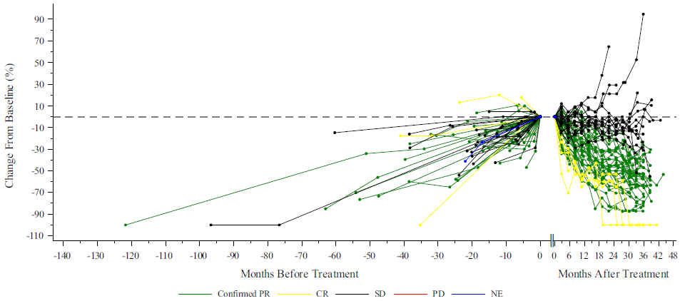
[B] Spider Plot - Percentage Change in Total Sum of CNS Hemangioblastoma Target Lesion Diameters from Baseline to Post-Baseline (RECIST 1.1) – IRC Efficacy Analysis Set
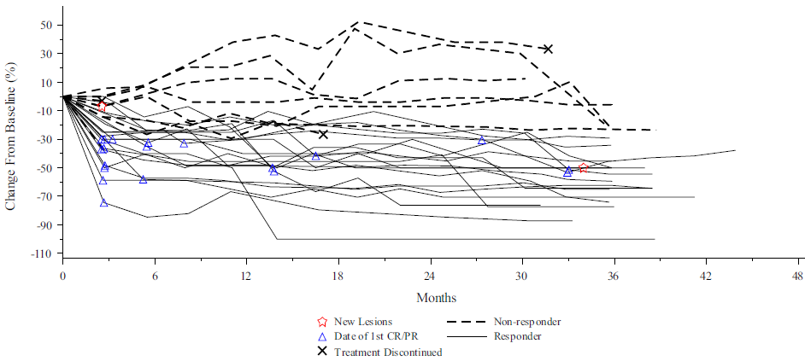
[C] Spider Plot - Percentage Change in Total Sum of Target Lesion Diameters for Pancreatic Neuroendocrine Tumors from Baseline in Scan Before and After Treatment – IRC Efficacy Analysis Set
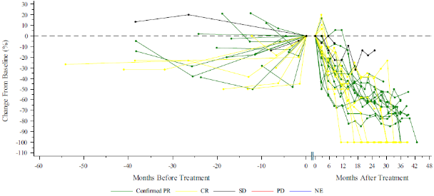
Source: A: Figure 14.2-45, LS-004 CSR; B: Figure 14.2-49 LS-004 CSR, C: Figure 14.2-54, of LS-004 CSR.
CNS Hb = central nervous system haemangioblastoma; CR = complete response; IRC = independent review committee; NE = not evaluable; pNETS = pancreatic neuroendocrine tumours; PD = progressive disease; PR = partial response; RCC = renal cell carcinoma; SD = stable disease.
Responder = patient with confirmed response of CR (disappearance of all target lesions) or PR (≥ 30% decrease in sum of target lesion diameters).
Note: CNS Hb were not assessed prior to baseline.
  - Figure 2 presents the Kaplan-Meier curves of time-to-surgery for RCC tumours in LS-004 and the LS-004-aligned population in VHL-NHS. The median time to renal reduction surgery was not reached in LS-004, with only 7 of 61 patients requiring surgery for a VHL-associated RCC tumour at the data cut-off. In contrast the median time to renal reduction surgery in the LS-004-aligned population in VHL-NHS was 46.5 months (95% confidence interval [CI] 38.2, 53.7). Notwithstanding the different time scale on the x-axes, the ESC considered that these results were supportive of a high treatment response rate associated with belzutifan.
Figure 2: Kaplan-Meier curves of time to first renal tumour reduction surgery in LS-004 and the LS-004-aligned population in VHL-NHS
LS-004:  ‘Time to surgery in RCC tumours’ | LS-004 aligned population in VHL-NHS:  ‘Time to first renal tumour reduction surgery’
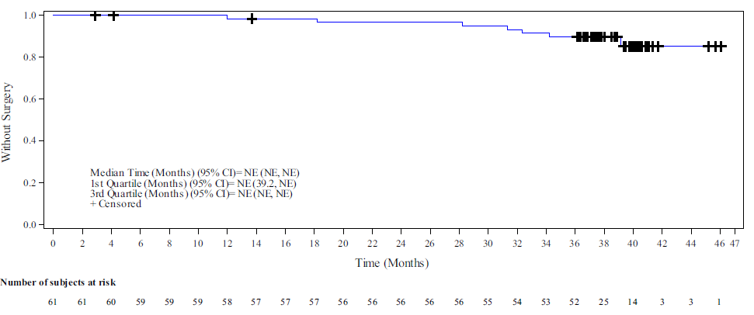 | 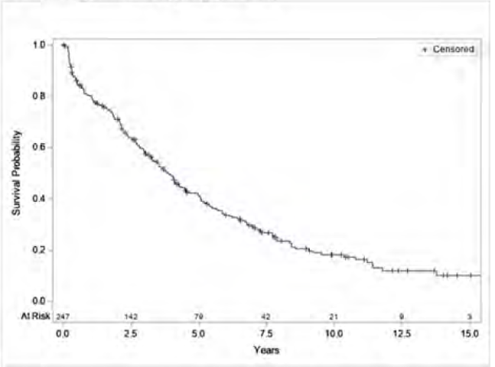
Source: Figure 14.2-9, of LS-004 CSR, Figure 7-6, VHL-NHS CSR.
LS-004 = Litespark-004; RCC = renal cell carcinoma; VHL-NHS = von Hippel-Lindau Natural History Study.
  - Figure 3 presents the distribution of VHL-associated tumour reduction procedures in patients enrolled in LS-004 before and after commencing belzutifan. The figure illustrates the considerable reduction in the number of surgeries across all VHL-associated manifestations. A total of 73 surgeries or procedures were conducted in 44 patients in the 3-year period before belzutifan compared to 11 surgeries or procedures performed in 9 patients in the 3-year period after treatment. The submission stated 4/61 (6.6%) of patients in LS-004 underwent renal surgery while on treatment with belzutifan over 37.3 months median follow-up, compared to 132/247 (53.4%) patients in VHL-NHS over 60 months of follow-up. The most common type of renal surgery in the VHL-NHS study was partial nephrectomy (94.1% of renal surgeries).
Figure 3: Tumour reduction procedures before and after belzutifan treatment^
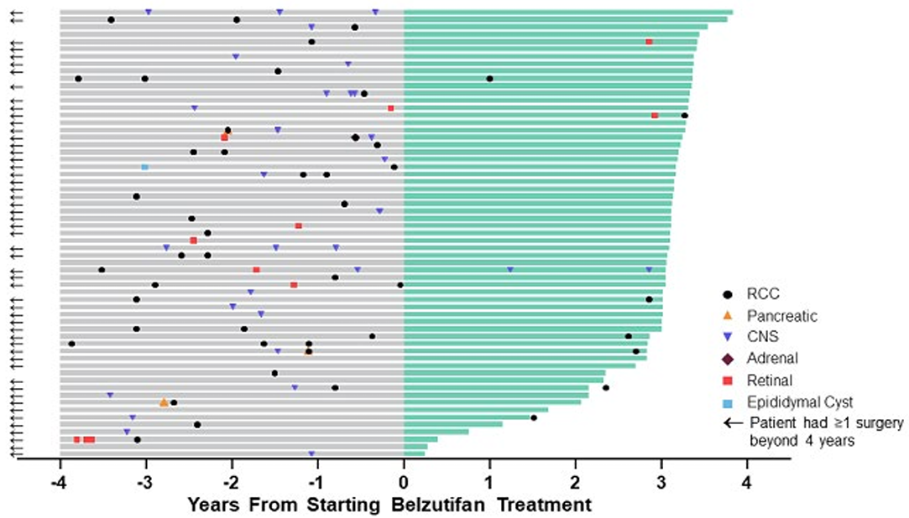
Source: Figure 2.5-13, of the submission, originally from Srinivasan 2022 (ESMO Conference poster)
^ Data cut-off April 1, 2022, median follow-up 37.8 months (range: 36.1−46.1).
  - Table 7 summarises other efficacy outcomes reported in LS-004 by tumour type. In summary:
- The overall response rate was 63.9% (39/61) in RCC, 44.0% (22/50) in CNS Hb and 90.9% (20/22) in pNETs. For RCC and CNS Hb, most patients had a best overall response of partial response or stable disease, whereas for pNETs, most patients had a best overall response or partial response or complete response.
- The median time to any response was 11.1 months in RCC, 5.4 months in CNS Hb and 8.2 months in pNETs. The results indicate a relatively delayed response time in all tumour types.
- The median duration of response was not reached in any of the tumour types, with a high proportion of responders maintaining response beyond 30 months (87% in RCC, 90% in CNS Hb, 100% in pNETs). The results are indicative of a durable response to treatment, given only 5 patients with response developed disease progression or died over the median 37.7 months of follow up.
- The median progression-free survival was 39.2 months in patients with RCC but may not be reliable given relatively few patients contributed data at the tail of the distribution (e.g. 2 patients at 40 months). The progression free survival rate was 86% at 36 months in patients with RCC and the median progression free survival time was not reached in the CNS Hb or pNET subgroups.
The ESC also noted the high disease control rates ranging between 90% and 100% across all three tumour types. The ESC considered these data in combination with the reported tumour growth data in the lead-up to belzutifan treatment were indicative of reduced tumour activity.
Table 7: Organ-specific tumour response outcomes and progression-free survival reported in LS-004, interim analysis 4 (IRC)
 | RCC  (N=61) | CNS Hb  (N=50) | pNETs  (N=22)
Best Overall Response, n (%)
Complete Response (CR)ª | 4 (6.6) | 4 (8.0) | 7 (31.8)
Partial Response (PR)^{b} | 35 (57.4) | 18 (36.0) | 13 (59.1)
Stable Disease (SD)^{c} | 21 (34.4) | 23 (46.0) | 2 (9.1)
Progressive Disease (PD)^{d} | 0 | 3 (6.0) | 0
Not evaluable (NE) | 1 (1.6) | 2 (4.0) | 0
Disease control rate**, n (%) [95% CI] | 60 (98.4)  [91.2 to 100.0] | 45 (90)  [78.2 to 96.7] | 22 (100)  [84.6 to 100.0]
Objective response rate*, n (%) [95% CI] | 39 (63.9)  [50.6 to 75.8] | 22 (44.0)  [30.0 to 58.7] | 20 (90.9)  [70.8 to 98.9]
Time to response, months, median (range) | 11.1 (2.7 to 30.5) | 5.4 (2.3 to 33.1) | 8.2 (2.5 to 16.4)
Duration of response, months, median (range) | NR (5.4+, to 35.8+) | NR (3.7+, 38.7+) | NR (11.0+, 37.3+)
Subjects who progressed or died, n (%) | 5 (12.8) | 4 (18.2) | 0 (0)
Response rate, n (%^)
≥6 months | 36 (100) | 19 (95.2) | 20 (100)
≥12 months | 35 (100) | 16 (90.2) | 19 (100)
≥18 months | 29 (93.5) | 14 (90.2) | 19 (100)
≥24 months | 22 (86.6) | 13 (90.2) | 15 (100)
≥30 months | 10 (86.6) | 12 (90.2) | 8 (100)
≥36 months | 0 (NR) | 2 (72.2) | 1 (100)
Progression-free survival, month, median (range) | 39.2 (38.5, NE) | NE (38.4, NE) | NE (NE, NE)
Subjects with events, n (%) | 11 (18.0) | 11 (22.0) | 0
Progressive disease, n (%) | 9 (14.8) | 9 (18.0) | 0
Death, n (%) | 2 (3.3) | 2 (4.0) | 0
Subjects censored, n (%) | 50 (82.0) | 39 (78.0) | 22 (100.0)
Progression-free survival rate, n (%^)
6 months | 98.3 (88.6, 99.8) | 93.4 (81.0, 97.8) | 100.0 (100.0, 100.0)
12 months | 98.3 (88.6, 99.8) | 86.7 (72.7, 93.8) | 100.0 (100.0, 100.0)
24 months | 94.6 (84.2, 98.2) | 84.3 (69.8, 92.2) | 100.0 (100.0, 100.0)
36 months | 86.3 (73.2, 93.3) | 78.8 (62.9, 88.4) | 100.0 (100.0, 100.0)
42 months | 47.5 (10.1, 78.5) | 67.9 (46.8, 82.1) | 100.0 (100.0, 100.0)
Source: Tables 2.5-2, 2.5-43 and 2.5-10, of the submission, Tables 11-2, p 73, 14.2-14, and 14.2-45, p311 of LS-004 CSR.
CI = confidence interval; CNS Hb = central nervous system haemangioblastoma; IRC = independent review committee; NE = not evaluable; NR = not reached; pNET = pancreatic neuroendocrine tumour; RCC = renal cell carcinoma
Note: Data cut-off date 1 April 2022
+ indicates there was no progressive disease by the time of last disease assessment.
^ % was calculated using the Kaplan-Meier method.
* Objective response rate = CR + PR; ** Disease control rate = CR + PR + SD
ª CR: the disappearance of all target and non-target lesions and normalisation of tumour marker level. Any pathological lymph nodes (whether target or non-target) must have reduction in short axis to <10 mm. For best overall response of CR, patient must have confirmed CR at a first and subsequent time point at least 4 weeks apart.
^{b} PR: ≥ 30% decrease in the sum of diameters of target lesions, and no progression in non-target lesions, taking as reference the baseline sum diameters. For best overall response of PR, patient must have either CR at first time point and PR at subsequent time point, or PR at first time point and CR or PR at subsequent time point.
^{c} SD: Neither sufficient shrinkage to qualify for PR nor sufficient increase to qualify for PD, taking as reference the smallest sum diameters while on study.
^{d} PD: ≥ 20% increase in the sum of diameters of target lesions with an absolute increase of at least 5 mm, or unequivocal progression of existing non-target lesions, taking as reference the smallest sum on study (this includes the baseline sum if that is the smallest on study), or the appearance of one or more new lesions.
  - The pre-PBAC response presented a comparison of updated data for the objective response rate (ORR) vs previous data cuts (Table 8). The pre-PBAC response noted that there have been five LS-004 data cuts, each increasing in magnitude of observed benefit.
Table 8 Objective response rate reported in LS-004, interim analysis 5 (IRC) (N=61)
 | IA1 | IA2 | IA3 | IA4 | IA5
Data cut off dates | 1 June 2020 | 1 December 2020 | 15 July 2021 | 1 April 2022 | 1 April 2023
Median follow-up | 15.8 months | 21.8 months | 29.3 months | 37.7 months | 49.7 months
Percentage of patients on treatment | 92% | 89% | 82% | 62% | 59%
ORR % * | 36% | 49% | 59% | 64% | 67%
Source: pre-PBAC response
* Objective response rate = Complete Response + Partial Response
LS-004 and VHL-NHS (LS-004-aligned population) data, after matching
  - To conduct the MAIC, comparing belzutifan plus surveillance versus surveillance alone, the submission identified a new LS-004-aligned population with RCC (N=260) in the VHL-NHS data, and two subgroup populations with a recorded history of CNS Hb (n=228) or pNET (n=94) prior to the patient-level index date. The submission then matched these three populations in the VHL-NHS data (RCC ± prior other manifestations, RCC + prior CNS Hb, RCC + prior pNETs) to the similar corresponding populations in LS-004 (RCC ± other concurrent manifestations, RCC + concurrent CNS Hb, RCC + concurrent pNETs) in terms of key population-level baseline characteristics, using an inverse propensity weighting method designed for use when individual patient data are not available for one or more studies (NICE 2016, Phillippo 2018). The characteristics chosen for matching were age at patient-level index date, sex, number of prior surgeries in the specific organ-system (e.g., RCC, CNS Hb or pNET, respectively) with therapeutic intent, and for the RCC population, size of the largest renal solid tumour at the patient-level index date.
  - The ESC noted that the submission did not adequately justify key assumptions of the MAIC or present adequate results to understand their implications on the results:
- It was unclear why the new LS-004-aligned population in VHL-NHS was used for the MAIC (N=260) and how it differed from the LS-004-aligned population reported in the VHL-NHS clinical study report (CSR) (N=247). The selection criteria appeared to be nearly identical, with the exception of the exclusion criteria related to metastases at baseline. Patients with ‘evidence of metastatic disease’ at the patient-level index date were excluded from the LS-004-aligned population in the clinical study report (CSR), whereas patients with evidence of ‘VHL-associated metastases’ at the patient-level index date were excluded from the LS-004-aligned population in the MAIC. The PSCR clarified that both samples were selected using analogous LS-004 inclusion and exclusion criteria and the difference in sample size was due to additional medical chart abstraction of metastasis data, which were applied to the MAIC sample but was not available at the time of the original analysis. However, the ESC considered that the PSCR did not adequately justify why this approach should differ, nor why analyses could not be conducted on the same set of patients across the clinical comparisons.
- It was unclear why individual patient data from LS-004 was not available for matching to the individual patient data from VHL-NHS. The submission’s approach of matching on population-level data from LS-004 is likely to introduce additional uncertainty into the indirect comparison compared to matching on individual-level data.
- The methodology pertaining to variable selection and implementation was poorly described. No sensitivity or robustness analyses appeared to have been conducted on the included confounders, such as removing or including additional characteristics, or altering the granularity on which continuous variables were matched. It was unclear whether the confounding variables were tested for correlations to other confounders.
- After matching, the effective sample sizes of the new LS-004-aligned populations in the VHL-NHS decreased considerably (by 65% for patients with RCC ± other concurrent manifestations, by 83% for patients with RCC + concurrent CNS Hb, by 36% for patients with RCC + concurrent pNETs), due to the disparity in the number of prior surgeries between the incident patients in the VHL-NHS and the prevalent patients in LS-004. The PSCR stated the sample size of VHL-NHS was sufficiently large to allow matching and accurate population alignment to LS-004. The PSCR argued the two patient populations were comparable, noting that the linear growth rates (LGRs) and number of prior RCC surgeries were similar prior to VHL-NHS enrolment and during the pre-treatment belzutifan period of LS-004.
- While the two populations matched in terms of population means for the selected variables, the submission did not present distributional comparisons of baseline characteristics for LS-004 or VHL-NHS unweighted or reweighted and therefore the true similarities of the reweighted characteristics cannot be verified.
  - Table 9 presents the results of the MAIC for the RCC population, in terms of RCC surgery rate and non-RCC surgery rate. Based on the absolute difference between event rates, patients in LS-004 had 85% reduction in renal surgeries and an 88% reduction in non-RCC VHL-related surgeries. The submission did not present any comparative statistical measure or confidence intervals for the estimated parameters. Though not explicitly calculated, the ratio of the event rates of time to surgery (i.e. hazard ratio of 0.147) was applied throughout the cost-effectiveness analysis to increase time to additional RCC surgeries and time to metastatic disease. The incidence rate of non-RCC surgeries was applied directly in the economic analysis to estimate the costs and disutilities associated with non-RCC surgeries.
Table 9: Results of the MAIC for the matched RCC population
Outcomes | VHL-NHS  (AS) | LS-004  (BEL+AS)
RCC outcomes | After matching  (Effective N=92.2) | N=61
Exponential rate parameter for the cause-specific hazards of pre-surgery → 1st surgery
Rate (events/person-week) | 0.00487 | 0.00071
Standard error | 0.00034 | 0.0003
Incidence of non-RCC VHL-related surgeries with therapeutic intent (events/person-week)
Number of VHL-related surgeries | 40.7 | 4*
Total person-weeks at risk | 11,822.27 | 9,817.57
Incidence rate (events/person-week) | 0.003442 | 0.000407
Source: Table 2.6-3, of the submission.
AS = active surveillance; BEL = belzutifan; LS-004 = Litespark-004; MAIC = matching-adjusted indirect comparison; NHS = natural history study; RCC = renal cell carcinoma; VHL = von Hippel-Lindau.
* non-RCC surgeries consisted of 2 CNS surgeries in the same patient and 2 retinal surgeries. No patients had pancreatic surgery.
  - The submission did not present any other results from the MAIC for the RCC population, or any results whatsoever for the other cohorts (e.g. CNS Hb or pNETs). The economic analysis cited Kaplan-Meier (KM) data from the MAIC - for the RCC, CNS Hb and pNET cohorts - as the key source of data to derive transition probabilities. These include transitions from pre-surgery to surgery, transitions from pre-surgery to metastatic disease, transitions from pre-surgery to dead, and transitions from post-surgery to subsequent surgery, and rates of non-RCC surgeries. The submission inappropriately did not present the KM data from the MAIC for these outcomes in the comparative effectiveness or the economic analysis. The PSCR presented KM data from the VHL-NHS MAIC analysis (unweighted and reweighted) which is discussed further in Economic analysis.

Comparative harms
  - Table 10 summarises adverse events (AEs) reported in LS-004 interim analysis 4 (data cut off 1st April 2022). Adverse events occurring up to 30 days after the last dose of belzutifan were included in safety analyses.
Table 10: Adverse event overview for LS-004ª
Event type | TEAE n (%) | TRAE^{b} n (%)
Summary of AEs
Any AE | 61 (100.0) | 61 (100.0)
≥ Grade 3 AE | 27 (44.3) | 11 (18.0)
SAE | 18 (29.5) | 4 (6.6)
Deaths | 2 (3.3) | 0 (0.0)
Discontinued belzutifan due to AE | 4 (6.6) | 2 (3.3)
Discontinued belzutifan due to SAE | 3 (4.9) | 1 (1.6)
Dose reduction due to AE | 10 (16.4) | 8 (13.1)
Dose interrupted due to AE | 26 (42.6) | 13 (21.3)
Most common AEs (≥20% of patients).
Anaemia | 55 (90.2) | 54 (88.5)
Fatigue | 45 (73.8) | 39 (63.9)
Headache | 29 (47.5) | 11 (18.0)
Dizziness | 28 (45.9) | 15 (24.6)
Nausea | 24 (39.3) | 15 (24.6)
Dyspnoea | 16 (26.2) | 11 (18.0)
Myalgia | 15 (24.6) | 8 (13.1)
Constipation | 14 (23.0) | 3 (4.9)
Arthralgia | 13 (21.3) | 5 (8.2)
Vision Blurred | 13 (21.3) | 5 (8.2)
Source: LS-004 CSR, Table 12-1, 8, Table 13.3-21and Table 14.3-33, of LS-004 CSR and Table 2.5-13, of the submission.
AE = adverse event; n = number of participants reporting data; SAE = serious adverse event; TEAE = treatment-emergent adverse event; TREA = treatment-related adverse event.
ª Data cut-off 1st April 2022.
^{b} Investigator assessed.
  - All patients in LS-004 experienced at least 1 AE and nearly half had a grade 3−5 AE, over the median 37.7 months of follow-up. The most common AEs were anaemia (90.2%) followed by fatigue (73.8%), headache (47.5%) and dizziness (45.9%). The incidence of adverse events was highest in the first 3 months of treatment (396 events at a rate of 216.48 events per 100 person-months), and reduced to 35.19 events per 100 person-months for those continuing treatment beyond 18 months.
  - Two patients died during the study period (1 suicide attempt and 1 of toxicity to various agents) but neither death was considered by investigators to be related to belzutifan. Most patients (82%) had a dose interruption during the study period. The most frequently reported AEs leading to treatment interruption were fatigue (11.5%), nausea (9.8%), headache (6.6%), dizziness (4.9%) and influenza-like illness (4.9%). The dose of belzutifan was reduced to 80 mg in 11 (18%) patients, and to 40 mg in 4 (6.6%) patients. The most frequently reported AEs leading to dose reduction were fatigue (8.2%) and anaemia (3.3%).
  - Belzutifan is associated with a high level of anaemia because HIF-2α inhibition reduces erythropoietin levels, leading to reduced haemoglobin levels. Most episodes of anaemia were classified as grade 1 or 2, and the median time to onset of the first episode of any grade anaemia was 30 days (range: 1 to 255). Anaemia led to a dose interruption in 2 patients, and 2 patients had a dose reduction. No episodes of anaemia resulted in discontinuation. While most patients (65.5%) did not require treatment for their anaemia, 14 (25.4%) patients received an erythropoiesis-stimulating agent with or without a blood transfusion and 1 patient received a blood transfusion only. The median time to an erythropoiesis-stimulating agent was 151 days (range: 59 to 886) and the median number of doses was 5 (range 1 to 35).
  - Overall, while noting that all patients in LS-004 experienced at least 1 AE and 50 patients (82.0%) required a dose interruption over the course of the study, the ESC noted that only 4 patients (6.6%) discontinued treatment due to a drug-related AE, and considered it was likely that belzutifan was relatively well tolerated.

Benefits/harms
  - The side-by-side comparison of outcomes in LS-004 and the VHL-NHS presented in the submission did not allow for a quantitative comparison of the benefits and harms of belzutifan + active surveillance and active surveillance. Accordingly, a benefits/harms table has not been presented. Based on the limited presented results from the MAIC, the comparison resulted in:
- Approximately an 85% reduction in the risk of renal surgery over a median duration of follow-up of 37.7 months for patients with VHL-associated RCC. The submission did not indicate what difference in surgery rate was considered to be clinically meaningful.
- Approximately an 88% reduction in the risk of surgery for other (non-renal) VHL-associated manifestations over a median duration of follow-up of 37.7 months for patient with VHL-associated RCC. The submission did not indicate what difference in surgery rate was considered to be clinically meaningful.

Clinical claim
  - The submission described belzutifan + active surveillance as superior in terms of effectiveness and inferior in terms of safety compared to active surveillance. The ESC considered that the clinical claim was supported by the evidence presented in LS-004 alone (e.g. tumour growth rates before and after belzutifan, number of surgeries before and after belzutifan, and tumour response rates). However, due to the small non-randomised nature of the evidence provided by LS-004 and the largely uninformative MAIC, there was a moderate to high degree of uncertainty around the magnitude of these treatment effects and the generalisability of the results to the Australian population living with VHL disease. In addition, whilst these outcomes may translate into improvements in quality of life and life expectancy – through a potential reduction in the cumulative morbidity associated with surgery and its complications in this life-long disease – the relationship between these intermediary and more final and long-term outcomes is unknown.
  - The PBAC considered that the claim of superior comparative effectiveness was reasonable.
  - The PBAC considered that the claim of inferior comparative safety was reasonable.

Economic analysis
  - The submission presented a modelled economic evaluation of belzutifan plus active surveillance (belzutifan arm, BEL+AS) compared to active surveillance (AS arm) for the treatment of VHL disease associated tumours; based on results from the MAIC using data from LS-004 and VHL-NHS (see Comparative effectiveness), non-randomised data from the pre-treatment period of LS-004 and real-world observational data from the Optum Clinformatics claims database (Optum CDM). The submission argued that the centres in LS-004 and VHL-NHS represented best practice for patients and therefore adjusted the model for real-world time to surgery and metastases from Optum CDM data.
  - Optum CDM was a retrospective study based on a US Claims database with administrative data of VHL patients (identified via an algorithm) between 2007 and 2020 that has previously been utilised in Wang 2023 (a cost-consequence study of belzutifan). As VHL diagnoses were not explicitly recorded in the database, patients were identified with an algorithm (Figure A.4-1 of the submission appendix 4) and the index date was the first observed tumour diagnosis. Separate but likely overlapping cohorts were identified for the RCC, CNS Hb and pNET models. The submission did not detail how the claims data was converted to transition probabilities and did not provide baseline patient characteristics for comparison with LS-004 or VHL-NHS. As no patient characteristics for the Optum CDM cohort were available, it was not possible to assess the applicability of the US claims data to an Australian cohort.
  - Separate modelled analyses were presented for each of the target tumour body systems identified in the requested restriction: RCC, CNS and pNETs. These are henceforth referred to as the RCC model, CNS Hb model and pNET model. A summary of the key model inputs is presented in Table 11.
Table 11: Summary of model structure, key inputs and rationale
Component | Summary
Treatments | Belzutifan plus active surveillance (BEL+AS) vs active surveillance alone (AS). The comparator was appropriate.
Time horizon / Starting age | 40 years in the model base case vs. 38.1 months (mean) in LS-004 and 112.0 months (mean) in VHL-NHS. Starting age was 41.0 years based of the mean age of the population in LS-004.  While VHL is a life-long condition, the extrapolated period far exceeds the length of the belzutifan study follow up and the majority of the belzutifan benefit was accrued beyond the study period. The model also did not utilise KM data directly, instead with extrapolations and summary transition probabilities implemented from the first cycle (i.e. Time 0). The starting age was reasonable in that it matched the clinical evidence, but may not represent the population who utilises belzutifan if preferred use is in CNS Hb, which first occurs at a younger age. No evidence was provided that could model a theoretical cohort of younger patients in either treatment arm.
Outcomes | Life years gained, quality-adjusted life years. The evaluation considered that these were reasonable, however as a clinical outcome of interest to patients is avoidance of surgeries, the number of surgeries would also be an informative outcome. The ESC noted that cost per responder would also be an informative outcome.
Methods used to generate results | Three Markov cohort models for RCC, CNS Hb and pNET populations. The ESC considered that while a Markov approach was reasonable, the models were overly complex and relied on multiple data sources and assumptions to populate the large number of health states, which included tunnel states to allow the model to memorise patient history in terms of number of surgeries.
Health states | 12 health states in the AS arm:  - Pre-surgery state  - 3 surgery tunnel states (1^{st,} 2nd or 3rd+ surgery)  - 3 EFS post-surgery (post 1^{st,} 2nd or 3rd+ surgery)  - 4 Metastatic disease states (by number of surgeries 0-3+), where metastatic disease referred to metastatic pNETs or RCC and could occur in all models.  - Dead  19 health states in the BEL+AS arm:  - 12 health states as AS arm, plus 7 on treatment (pre-surgery, surgery 1,2,3+, EFS post-surgery 1,2,3+)  Health states refer only to target tumour (tumour in model body system). The ESC noted that costs and disutilities for non-target tumour surgeries were modelled independently of health state transitions. The ESC considered that this was inappropriate and advised that non-target tumour surgeries should have been incorporated into the transition probabilities and model structure.  EFS post-surgery and metastatic states were modelled similarly regardless of entry state, but were included as separate states in the Markov trace sheets to allow the model to remember patient history. Metastatic and death states also had a first and subsequent cycle sub states to track event costs and disutilities.  Surgery states lasted 1 cycle (one week) and patients moved either to EFS post-surgery or to death in the next cycle.
Cycle length | 1 week with half cycle correction for some outcomes (i.e., not applied to drug costs). The evaluation considered that this was reasonable.
Transition probabilities | Transition probabilities in the AS arm were primarily sourced from the VHL-NHS cohorts reweighted in the MAIC (pre-surgery to surgery, RCC model; pre-surgery to metastases, all models; pre-surgery to dead, all models), LS-004 pre-treatment period (pre-surgery to surgery, CNS Hb and pNET models); and Optum CDM (applied to all models to adjust time to subsequent surgeries and time to metastases to ‘real world’). Time to surgeries and metastases from EFS post-surgery states were based on pre-surgery rates. Time to death from metastatic disease was based on multiple studies of first line treatment of metastatic RCC and pNETs. Death from surgery was derived from published literature (Johnson 2008, Lonser 2003 Krauss 2018).  Treatment benefit in the BEL+AS arm was based on time to surgery in LS-004 vs the AS arm, and the benefit applied to transition probabilities across the models: pre-surgery to surgery, EFS post-surgery to subsequent surgery; pre-surgery or EFS post-surgery to metastatic disease; and pre-surgery or EFS post-surgery to death (for a proportion of patients in each model assumed to have CNS Hb tumours).  The benefit applied for patients on treatment, plus discontinued patients up to Year 3.84, which the ESC considered was reasonable as the estimated benefit included discontinued patients to this time point. For discontinued patients, a linear treatment waning effect was applied between Year 3.84 and 6.55, and they were modelled with AS transition probabilities thereafter.  Time on belzutifan was based on LS-004.  Full details of the transition probabilities are provided in Table 12.  The ESC considered that there was a high level of uncertainty in the model transitions, based on the multiple data sources and assumptions for the benefit of belzutifan. Clinical evidence appeared to demonstrate a possible increase in time to surgery and reduction in linear growth rate for belzutifan compared to standard practice, but there was no evidence of how much this may increase time to metastases or improvement in overall survival.
Extrapolation method | Pre-surgery to surgery: exponential extrapolations were chosen from 7 distributions (exponential, Weibull, Gompertz, log-normal, log-logistic, generalised Gamma, Gamma) based on statistical and visual fit and clinical plausibility once inserted into the overall model (i.e., once all other transitions were decided). All other transitions were assumed to be constant probabilities. The submission did not provide the majority of the underlying KM data to verify the transition probabilities. The PSCR presented the KM data from the VHL-NHS MAIC analysis (unweighted and reweighted) for (i) time to first surgery, (ii) time between surgeries, (iii) time to metastatic disease (from pre-surgery) and (iv) time to death (from pre-surgery). However, the ESC noted the PSCR did not present KM data for time to surgery in the belzutifan arm of the CNS Hb model, nor the underlying KM data for time to metastases or death from EFS post-surgery in the RCC model, or the unweighted VHL-NHS data for the ‘other’ surgeries in each model, and therefore these transitions could not be validated.  Time on belzutifan: Weibull extrapolations were chosen from 7 distributions (exponential, Weibull, Gompertz, log-normal, log-logistic, generalised Gamma, Gamma) based on statistical and visual fit and clinical plausibility compared to the LS-004 KM data. No patient could receive belzutifan in the metastatic disease states. The ESC considered that time on belzutifan was underestimated compared to clinical practice where no other treatments are available. The significant treatment discontinuation from Year 3 was informed by a limited number of patients (less than 20% were at risk by Year 3.2).
Non-transition event-probabilities | ‘Other’ tumour surgeries (surgeries in body systems other than the primary tumour system, including RCC, CNS Hb, pNET, adrenal lesion, endolymphatic sac tumour, epididymal cystadenoma, and retinal Hb) was based on LS-004, VHL-NHS; adjusted for 36.8% patients without RCC (QoL Disease Burden Study 2022).  Probability of surgery complications: Optum CDM.  AEs were included in the belzutifan arms of the models: 11.5% anaemia and 4.9% fatigue based on LS-004.  Non-transition events did not affect survival or transitions through health states, but did contribute to the incremental costs and QALYs.  The evaluation considered that the models likely underestimated the effect of belzutifan AEs, 31.1% (19 patients) received treatment for anaemia during LS-004, compared to 11.5% in the model, and the models did not account for recurring AEs, however AE incidence was not a key driver of the ICERs.
Health related quality of life | Health state utilities pre-surgery, surgery and EFS post-surgery states were the same (0.728 in AS arms of all models; in the BEL+AS arms, 0.762 in the RCC model, 0.758 in the CNS Hb model, 0.790 in the pNET model) based on KEYNOTE-564 and QoL Disease Burden study weighted by treatment response in each arm. Treatment waning effect was applied to patients discontinuing belzutifan.  Metastatic disease states utilities (0.445 in the RCC model, 0.443 in the CNS Hb model, 0.441 in the pNET model) were based on weighted PFS: PD from 1st line treatment studies of RCC and pNETs and utilities from QoL Disease Burden Study.  Additional disutilities were included for short- and long-term complications from surgery (from the literature) and AEs (KEYNOTE-564)  No utility data was presented in LS-004 or VHL-NHS and no treatment utility benefit was established for BEL+AS vs AS in the clinical claim. The ESC advised that it was not appropriate to include this treatment benefit.  Surgery complications were a significant driver of the QALY gains, but the surgery disutilities were from a variety of sources and none specific to VHL. Disutilities were estimated and applied additively rather than multiplicatively potentially overestimating their effect. Further, health state utilities for the QoL Disease Burden study likely captured some of the ongoing disutility from surgeries which could have resulted in some double counting of the effect. Patients in the QoL Disease Burden study did however have fewer prior surgeries, so some additional surgery disutility may be reasonable.  A sensitivity analysis included carer disutilities, which was driven by utility loss to carer’s associated with premature death of the VHL patient (accrued over 19.2 years in the AS arm and 15.0 years in the BEL+AS arm of the RCC model), was not informed by VHL patient carers or an Australian population. However, ICERs were not sensitive to the inclusion of carer disutility.
Costs | The model included costs for drugs, surgeries, healthcare resource use, complications from surgery, and adverse events. The evaluation considered that costs sources were generally reasonable, mostly based on PBS, MBS and AR-DRG costs. The methodology of costs for metastatic treatments (for 10 drugs, 13 treatment regimens over 2 lines of treatment) and surgical complications (7 surgery types resulting in 24 different complications) were complex. Metastatic drug costs were large but the ICERs were not sensitive to them as they were the same across arms in the models (RCC model $||||, CNS Hb model $||||, pNET model $|||| applied upon entry to metastatic disease states). Each surgery had one off and ongoing costs as reported in the table below. The ICERs were not sensitive to long term complication costs but were moderately sensitive to the removal of costs for ‘other’ tumour surgeries.  Cost sensitivity analyses presented by the submission included the cost of productivity loss, either due to early death compared to general population (which decreased the ICERs in all models significantly compared to the base cases), or paid work productivity loss due to VHL while alive (which increased the ICERs slightly compared to the base cases). The cost of productivity loss was uncertain, and the long-term cost of early death may be overestimated.
  Surgery type | Costs
  Surgery type | Surgery (one-off) | Complications
  Surgery type | Surgery (one-off) | Short term (one-off) | Long term (per cycle)
  RCC surgery | $50,575.91 | $9,470.33 | $94.69
  CNS Hb surgery | $63,329.97 | $9,351.72 | $183.56
  pNET surgery | $52,764.83 | $17,131.97 | $72.16
  Retinal Hb surgery | $5,587.44 | $1,054.39 | $5.97
  Adrenal lesion surgery | $18,916.96 | $9,152.72 | $92.31
  Endolymphatic sac surgery | $14,134.18 | $5,898.69 | -
  Epididymal cystadenoma surgery | $7,844.01 | - | -
Source: compiled during the evaluation.
AE=adverse event; AR-DRG=Australian Refined Diagnosis Related Groups; AS=active surveillance; BEL=belzutifan; EFS=event free survival; ICER=incremental cost-effectiveness ratio; KM=Kaplan-Meier; MAIC=matched adjusted indirect comparison; MBS=Medicare Benefits Schedule; PBS=Pharmaceutical Benefits Scheme; PFS=progression free survival; PD=progressed disease; QALY=quality-adjusted life-year; QoL=quality of life; OS=overall survival.
  - A summary of the model structure has been reproduced in Figure 4.
Figure 4: Model structure
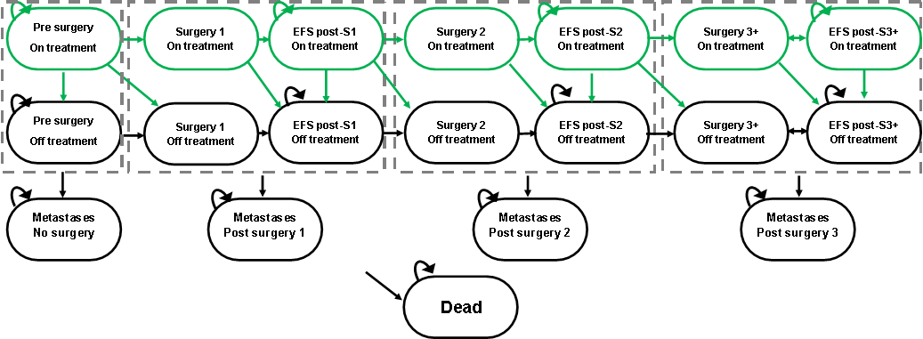
Source: compiled during the evaluation
EFS=event free survival, S=surgery
Green boxes and transitions were included in the belzutifan plus active surveillance arm only. Surgery states last only one cycle (one week). Patients in any pre-surgery, surgery or EFS post-surgery state (on/off treatment) can move to metastases post that (pre)surgery. Patients in EFS post-surgery 3+ could accrue further surgeries and return to the EFS post-surgery 3+ health state, until metastases or death. Metastases and death states are further divided in the model into a ‘first cycle’ and a ‘subsequent cycles’ states to allow for certain one-off costs (e.g. cost of metastatic treatment) and disutilities (e.g. sensitivity analysis including carer disutilities) to be applied, these substates are not depicted here.
  - Patients entered the models in a pre-surgery state (on treatment in the belzutifan arm, off treatment in the active surveillance arm) and could progress to surgery, metastases or death. Patients who received a specified body system tumour surgery (e.g., RCC surgery in the RCC model, CNS Hb surgery in the CNS Hb model) moved to event free survival (EFS) post-surgery the next cycle or progress to death. Patients in an EFS post-surgery state could stay in that state, move to death, metastases or further surgery. The models tracked patients up to 3 different surgeries for tumours of the specified body system in that model, though patients could accrue more than 3 surgeries (i.e., return to the surgery 3+ health state). Metastatic disease referred to RCC or pNET metastases (which patients in all models could develop at different rates) and from metastases patients could stay in the health state or die. Patients in the belzutifan arm could remain on treatment in any of the pre-surgery, surgery or EFS post-surgery states or move off treatment the following cycle. Discontinuation of belzutifan was not driven by health state allocation, except that no patients could receive belzutifan in the metastatic disease states, this was consistent with the requested PBS restriction. As such, patients in the pre-surgery, surgery, and EFS post-surgery states could be on or off treatment. Tumour surgeries in body systems not specific to the model (henceforth referred to as ‘other’ tumour surgeries) were modelled independently of health state allocation and had no impact on survival. The ESC considered that this was inappropriate and advised that ‘other’ tumour surgeries should have been incorporated into the transition probabilities and model structure (see paragraph 6.51).
  - Figure 5 summarises the KM data presented in the models from LS-004, LS-004 pre-treatment period, and VHL-NHS (MAIC, reweighted). However, the transition probabilities in the models were not based on this specific data (e.g., VHL-NHS KM data in the model was for time to surgery, metastases or death, whereas the extrapolations appeared to be based on KM data for time to surgery only), and instead the KM data in the model was used for validation of the overall model. Neither the VHL-NHS data in the CSR (used to assess clinical effectiveness) or unweighted VHL-NHS data in the MAIC (i.e. before matching) were provided for comparison with the reweighted VHL-NHS data in the MAIC (i.e. after matching). No other data were presented for transitions from other states. The PSCR presented the KM data from the VHL-NHS MAIC analysis (unweighted and reweighted) for (i) time to first surgery, (ii) time between surgeries, (iii) time to metastatic disease (from pre-surgery) and (iv) time to death (from pre-surgery). In all KM data other events were counted as censoring events, e.g., patients who had a surgery prior to death were censored for the time to death data. These data have been used to validate the active surveillance arms by comparing to the modelled transitions, and where appropriate, the different KM data in the model, and possible extrapolations. Overall, the unweighted and reweighted KM data presented in the PSCR was similar, particularly for time to next surgery and time to metastases and death from pre-surgery. The PSCR did not present KM data for time to surgery in the belzutifan arm of the CNS Hb model, nor the underlying KM data for time to metastases or death from EFS post-surgery in the RCC model, or the unweighted VHL-NHS data for the ‘other’ surgeries in each model, so these could not be validated.
Figure 5: KM data presented in the model for validation purposes.
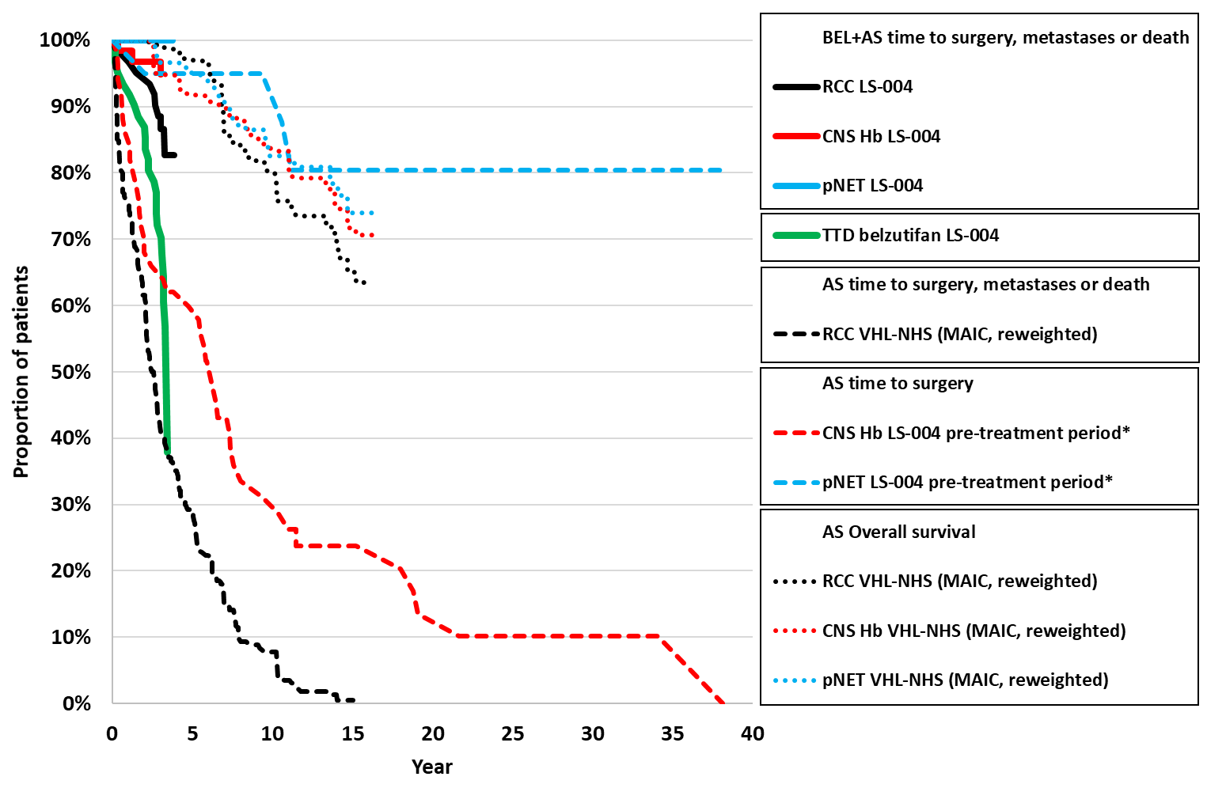
Source: compiled during the evaluation using Sheet ‘Raw_Observed KM curves’ of Excel Workbook ‘Attachment 7 (CUA).xlsm’
AS=active surveillance, BEL=belzutifan
* pre-treatment period set date of first belzutifan dose as Time 0 and looked backwards to the most recent CNS Hb/pNET surgery (i.e., 5 years in the LS-004 pre-treatment period is equal to 5 years prior to first belzutifan dose).
  - The data used to inform the transition probabilities in the models are summarised in Table 12.
Table 12: Transition probabilities (per week cycle) in the models
Transition | Model | AS | BEL+AS
Pre-surgery to surgery 1 | RCC | Exponential extrapolation from Time 0, VHL-NHS reweighted RCC surgery KM data. Transition probability each cycle adjusted for Optum CDM EFS- VHL-NHS EFS. | On treatment (and off treatment before Year 3.84): Exponential extrapolation of LS-004 KM data from Time 0. Treatment waningª for discontinued patients from Year 3.84 to 6.55.
Pre-surgery to surgery 1 | CNS Hb | Exponential extrapolation from Time 0, LS-004 pre-treatment CNS Hb surgery KM data - looking backwards from baseline to most recent prior CNS Hb surgery | On treatment (and off treatment before Year 3.84): Exponential extrapolation of LS-004 KM data from Time 0. Treatment waningª for discontinued patients from Year 3.84 to 6.55.
Pre-surgery to surgery 1 | pNET | Exponential extrapolation from Time 0, LS-004 pre-treatment pNET surgery KM data - looking backwards from baseline to most recent prior pNET surgery | On treatment (and off treatment before Year 3.84): HR 0.037 applied to AS curve (based on ratio of BEL+AS vs AS pre-surgery to 1st surgery transition probabilities from the RCC model multiplied by RCC ORR/pNET ORR from LS-004) Treatment waningª for discontinued patients from Year 3.84 to 6.55.
Pre-surgery to metastatic disease | RCC | Constant probability 0.0012  VHL-NHS pre-surgery to MD + (Optum CDM EFS- VHL-NHS EFS) | On treatment (and off treatment before Year 3.84): 0.0002 based on 0.147 HR applied to AS curve (HRs estimated from ratio of BEL+AS vs AS pre-surgery to 1st surgery exponential hazards in the RCC model)  Treatment waningª for discontinued patients from Year 3.84 to 6.55.
Pre-surgery to metastatic disease | CNS Hb | Constant probability 0.0011  VHL-NHS pre-surgery to MD + (Optum CDM RCC EFS- VHL-NHS RCC EFS)*VHL-NHS CNS Hb EFS/VHL-NHS RCC EFS | On treatment (and off treatment before Year 3.84): 0.0001 based on 0.049 HR applied to AS curve (HRs estimated from ratio of BEL+AS vs AS pre-surgery to 1st surgery exponential hazards in the CNS Hb model)  Treatment waningª for discontinued patients from Year 3.84 to 6.55.
Pre-surgery to metastatic disease | pNET | Constant probability 0.0027  VHL-NHS pre-surgery to MD + (Optum CDM RCC EFS- VHL-NHS RCC EFS)*VHL-NHS pNET EFS/VHL-NHS RCC EFS | On treatment (and off treatment before Year 3.84): 0.0001 based on 0.037 HR applied to AS curve (HRs estimated from ratio of BEL+AS vs AS pre-surgery to 1st surgery exponential hazards in the CNS Hb model)  Treatment waningª for discontinued patients from Year 3.84 to 6.55.
Pre-surgery to dead | RCC | Constant probability 0.0001  VHL-NHS reweighted RCC cohort | On treatment (and off treatment before Year 3.84): 0.00007 based on HR 0.049 applied to AS curve for % CNS deaths. AS curve otherwise. Treatment waningª for discontinued patients from Year 3.84 to 6.55.
Pre-surgery to dead | CNS Hb | Constant probability 0.0003  VHL-NHS reweighted CNS Hb cohort | On treatment (and off treatment before Year 3.84): 0.0001 based on HR 0.049 applied to AS curve for % CNS deaths. AS curve otherwise. Treatment waningª for discontinued patients from Year 3.84 to 6.55.
Pre-surgery to dead | pNET | Constant probability 0.0002  VHL-NHS reweighted pNET cohort | On treatment (and off treatment before Year 3.84): 0.0001 based on HR 0.049 applied to AS curve for % CNS deaths. AS curve otherwise. Treatment waningª for discontinued patients from Year 3.84 to 6.55.
Surgery to EFS post-surgery | RCC | Assumed 1 in absence of event | Assumed 1 in absence of event
Surgery to EFS post-surgery | CNS Hb | Assumed 1 in absence of event | Assumed 1 in absence of event
Surgery to EFS post-surgery | pNET | Assumed 1 in absence of event | Assumed 1 in absence of event
Surgery 1,2,3+ to dead | RCC | Constant probability 0.0196 (Johnson 2008) | Same as AS
Surgery 1,2,3+ to dead | CNS Hb | Constant probability 0.0182 (Lonser 2003) | Same as AS
Surgery 1,2,3+ to dead | pNET | Constant probability 0.0171 (Krauss 2018) | Same as AS
EFS 1,2,3+ to next surgery | RCC | Constant probability 0.0006 (Optum CDM) | On treatment (and off treatment before Year 3.84): 0.0001 based on 0.147 HR applied to AS curve (HR estimated from ratio of BEL+AS vs AS pre-surgery to 1st surgery exponential hazards in the RCC model).  Treatment waningª for discontinued patients from Year 3.84 to 6.55.
EFS 1,2,3+ to next surgery | CNS Hb | Constant probability 0.0020, equal to pre-surgery to surgery hazards | On treatment (and off treatment before Year 3.84): 0.0001 based on 0.049 HR applied to AS curve (HRs estimated from ratio of BEL+AS vs AS pre-surgery to 1st surgery exponential hazards in the CNS Hb model)  Treatment waningª for discontinued patients from Year 3.84 to 6.55.
EFS 1,2,3+ to next surgery | pNET | Constant probability 0.0002 equal to pre-surgery to surgery hazards | On treatment (and off treatment before Year 3.84): 0.00001 based on 0.037 HR applied to AS curve (HRs estimated from ratio of BEL+AS vs AS pre-surgery to 1st surgery exponential hazards in the CNS Hb model)  Treatment waningª for discontinued patients from Year 3.84 to 6.55.
EFS post-surgery 1,2,3+ to metastatic | RCC | Constant probability 0.0012 (Optum CDM) | On treatment (and off treatment before Year 3.84): 0.0002 based on 0.147 HR applied to AS curve (HR estimated from ratio of BEL+AS vs AS pre-surgery to 1st surgery exponential hazards in the RCC model).  Treatment waningª for discontinued patients from Year 3.84 to 6.55.
EFS post-surgery 1,2,3+ to metastatic | CNS Hb | Constant probability 0.0011 equal to pre-surgery to metastatic hazards | On treatment (and off treatment before Year 3.84): 0.0001 based on 0.049 HR applied to AS curve (HRs estimated from ratio of BEL+AS vs AS pre-surgery to 1st surgery exponential hazards in the CNS Hb model)  Treatment waningª for discontinued patients from Year 3.84 to 6.55.
EFS post-surgery 1,2,3+ to metastatic | pNET | Constant probability 0.0027 equal to pre-surgery to metastatic hazards | On treatment (and off treatment before Year 3.84): 0.0001 based on 0.037 HR applied to AS curve (HRs estimated from ratio of BEL+AS vs AS pre-surgery to 1st surgery exponential hazards in the CNS Hb model)  Treatment waningª for discontinued patients from Year 3.84 to 6.55.
EFS post-surgery 1,2,3+ to dead | RCC | Constant probability 0.0002 (VHL-NHS reweighted RCC cohort) | On treatment (and off treatment before Year 3.84): 0.0001 based on HR 0.049 applied to AS curve for % CNS Hb deaths. AS curve otherwise. Treatment waningª for discontinued patients from Year 3.84 to 6.55.
EFS post-surgery 1,2,3+ to dead | CNS Hb | EFS post-surgery 1 and 2 constant probability 0.0003 (VHL-NHS reweighted CNS Hb cohort)  EFS post-surgery 3+ constant probability 0.0001 equal to BEL+AS (likely an error) | On treatment (and off treatment before Year 3.84): 0.0001 based on HR 0.049 applied to AS curve for % CNS Hb deaths. AS curve otherwise Treatment waningª for discontinued patients from Year 3.84 to 6.55.  EFS Post-surgery 3+ rate estimated by applying 0.049 HR to post-surgery 2 AS rates.
EFS post-surgery 1,2,3+ to dead | pNET | Constant probability 0.0002 (VHL-NHS reweighted pNET cohort) | On treatment (and off treatment before Year 3.84): 0.0001 based on HR 0.049 applied to AS curve for % CNS deaths. AS curve otherwise. Treatment waningª for discontinued patients from Year 3.84 to 6.55.
Metastatic disease to dead | RCC | Constant probability 0.0030, based on proportion of RCC patients with metastatic RCC or pNETs (VHL-NHS reweighted) and first line treatment OS from the literature | Same as AS
Metastatic disease to dead | CNS Hb | Constant probability 0.0029, based on proportion of CNS Hb patients with metastatic RCC or pNETs (VHL-NHS reweighted) and first line treatment OS from the literature | Same as AS
Metastatic disease to dead | pNET | Constant probability 0.0028 based on proportion of pNET patients with metastatic RCC or pNETs (VHL-NHS reweighted) and first line treatment OS from the literature | Same as AS
Background mortality | RCC | Age based general population mortality applied to all states | Same as AS
Background mortality | CNS Hb | Age based general population mortality applied to all states | Same as AS
Background mortality | pNET | Age based general population mortality applied to all states | Same as AS
Source: compiled during the evaluation
AS=active surveillance, BEL=belzutifan, HR=hazard ratio
ª Treatment waning for belzutifan discontinued patients between Year 3.84 and 6.55: proportion (linear change by time point) of on treatment and AS curves, from Year 6.55: AS curve
  - For the RCC model, time to surgery was extrapolated from VHL-NHS reweighted data for the active surveillance arm and LS-004 data for the belzutifan arm. Similarly, in the CNS Hb model, time to surgery in the belzutifan arm was extrapolated from LS-004 data. For the CNS Hb and pNET models retrospective LS-004 data that looked backwards from treatment initiation to last prior surgery (i.e., time since last surgery prior to starting belzutifan) was used as a surrogate to time to CNS Hb and pNET surgery in the active surveillance arm. The evaluation considered that looking backwards to prior surgeries was unlikely to be the same as estimating time to next surgery. The PSCR argued that the approach for time to surgery in the active surveillance arms of the CNS Hb and pNET models was appropriate as it provided internal controls and minimised bias.
  - Exponential extrapolations were chosen for all arms of all models where KM data were available. Exponential extrapolations had the best statistical fit for the active surveillance arms of all 3 models, and given the limited data available, exponential distributions for the model may be a reasonable approach. However, the estimated hazards were uncertain, and if the 95% CIs of the exponential parameter inputs for both the belzutifan and the active surveillance arms were applied the incremental cost-effectiveness ratios (ICERs) in the RCC model ranged from $155,000 to < $255,000 to $255,000 to < $355,000 per QALY gained. Response rates to belzutifan for RCC and pNETs were used as a surrogate to estimate time to surgery in the belzutifan arm of the pNET model where no surgeries were observed during LS-004. The pNET model was less affected by the time to surgery benefit, as very few patients in either arm were expected to experience pNET surgery.
  - For downstream events where evidence of a belzutifan benefit had not been observed, the model utilised further surrogate outcomes in LS-004 and external data sources (including Optum CDM RCC data). For example, increase in time to first surgery since model entry (patients could have had a history of surgery prior to model entry) for the belzutifan arm compared to the active surveillance arm was used as a surrogate for increased time to metastases and time to death for patients with CNS Hb tumours in all models. The submission justified the use of these surrogates for metastases and survival based on evidence of reduced linear growth rates in LS-004, but the relationship between linear growth rate and metastases and death has not been quantified. Many of the downstream transitions were equal to or based on the transitions from pre-surgery (e.g., time to next surgery in the active surveillance arms of the CNS Hb and pNET models was assumed equal to time to first surgery).
  - The real-world adjustment for time to RCC surgeries and time to metastases in the active surveillance arm of the RCC model was calculated by taking the difference between the transition probabilities from the Optum CDM and the VHL-NHS reweighted data for the RCC post-surgery cohort, and adding it to the VHL-NHS reweighted transition probabilities in the RCC model (-0.001 added to time to next surgery, 0.001 to time to metastases from pre-surgery or EFS post-surgery). Time to metastases in the active surveillance arms of the CNS Hb and pNET models was adjusted similarly, with difference between the transition probabilities from the Optum CDM and the VHL-NHS reweighted data for the RCC post-surgery cohort adjusted for the difference in transition to metastases for the VHL-NHS CNS Hb and pNET cohorts compared to the NVHL-NHS RCC cohort. Time to subsequent surgeries in the CNS Hb and pNET models was not adjusted for the Optum CDM data. Overall, the real-world adjustment resulted in fewer subsequent surgeries in the RCC model, and increased rates of metastatic disease in all models. As an indirect consequence, the increased rates of metastatic disease increased mortality, resulting in reduced overall survival in all models. The evaluation considered that the real-world adjustment appeared to result in more reasonable overall survival in the models compared to the base cases (without it ~40−50% patients remained alive by the end of the 40-year time horizon), but applying the change in hazards through addition of the difference between Optum CDM and VHL-NHS was unlikely to be reasonable. Further, as the underlying Optum CDM data were not provided nor externally validated, and the baseline characteristics of the Optum CDM population were not provided, it was not possible to confirm the reasonableness of the approach.
  - Overall survival in the submission was calculated as the sum of death from pre-surgery, surgery, EFS post-surgery, and metastatic disease states, with real world adjustment. The active surveillance arm transition probabilities for time to death from pre-surgery were based on VHL-NHS data. Probability of death from EFS post-surgery states were based on Optum CDM data in the active surveillance arm of the RCC model and assumed equal to the death from pre-surgery state in the CNS Hb and pNET models. No underlying KM data for the Optum CDM data was presented and therefore this could not be validated.
  - Time on belzutifan was extrapolated by fitting 7 parametric distributions to the data (exponential, Weibull, Gompertz, log-normal, log-logistic, generalised gamma and gamma) to the time on belzutifan KM data for the whole LS-004 cohort (Figure 6). The Weibull distribution was chosen as it had second best statistical fit and yielded moderate time on treatment projections (‘Appendices LS-004 V1 Submission.docx’).
Figure 6: Time on belzutifan extrapolations
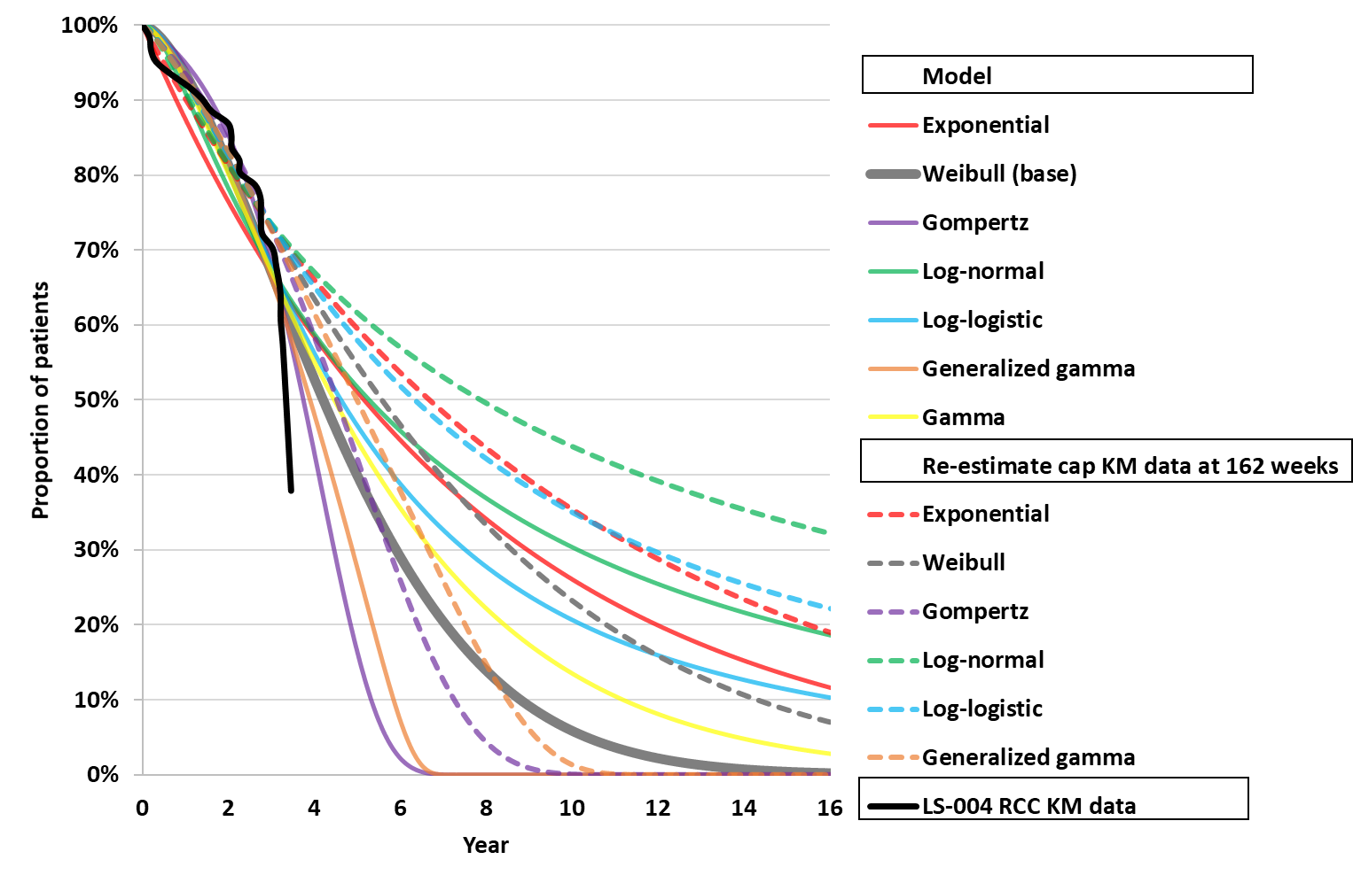
Source: compiled during the evaluation
KM=Kaplan-Meier
  - The ESC considered that time on treatment was likely underestimated in the model. The extrapolations in the submission utilised the whole of the follow up period from LS-004, but there was a significant decrease in patients remaining on treatment towards the end of the follow up period. If events beyond Week 162 were censored (e.g., the period where the number at risk is >50% of the total number patients in LS-004), the extrapolations resulted in a longer time on treatment (Figure 6). The resulting mean time on treatment in the models was 4.52−4.57 years, and assumed once in a lifetime treatment, however the current restriction allows patients to remain on treatment until metastatic disease. If treatment discontinuation occurred only when patients transitioned to the metastatic health states (i.e., no treatment discontinuation occurred in the pre-surgery, surgery or, event free survival post-surgery health states) the ICER increased to $355,000 to < $455,000, $255,000 to < $355,000, $255,000 to < $355,000 per QALY gained in the RCC, CNS Hb and pNET models respectively. As time on treatment and time in the health states were linked in the base case, this sensitivity analysis required the removal of the treatment waning effect and likely overestimated both mean time in non-metastatic disease and time on treatment (29.9 years in the RCC model, 32.2 years in the CNS Hb model, 31.5 years in the pNET model). The PSCR stated that retreatment was not modelled to limit complexity in the model structure and also claimed that time on treatment was not underestimated in the model and was reflective of practice in Australia. The ESC considered time on treatment in practice remains uncertain, particularly for a different population of patients (e.g. younger patients, patients without a history of surgery, patients with only CNS Hb or pNETs), for which no data exists. The ESC considered that patients in practice would likely remain on treatment indefinitely provided there was a perceived benefit of doing so, including after surgery, until the development of metastatic disease or unacceptable toxicity, and considered that this use was not reflected in the base case of the economic model. The pre-PBAC response provided a revised modelling analysis for PBAC consideration that included amendment to the time on treatment with treatment discontinuation only occurring once patients develop metastases. This revision was aligned with the sensitivity analysis undertaken by the evaluation. As stated above this extended the modelled time on treatment to between 29.9 to 32.2 years. The pre-PBAC response considered the extended treatment duration to be a biased overestimate.
  - In the belzutifan arms of every model, treatment waning was applied for discontinued patients beyond Year 3.84. Between Years 3.84 and 6.55 discontinued patients were assumed to have transitions equal to a weighted average of the on treatment and active surveillance arm transitions, with the weights changing linearly over time (e.g. at Year 3.84 100% discontinued patients were modelled as on treatment, 0% as the active surveillance arm; and at Year 6.55 0% discontinued patients were modelled as on treatment, 100% as the active surveillance arm). From Year 6.55 all discontinued patients were assumed to have transitions equal to the active surveillance arm. Year 3.84 was chosen as the start of the treatment waning period as it represented the length of LS-004 follow up and Year 6.55 was chosen as the end of the treatment waning period based on the estimated return to pre-belzutifan linear growth rates for RCC tumours. Treatment waning was applied throughout the models to time to surgery, time to metastases, time to death, utilities and ‘other’ tumour surgery probabilities. If no benefit was assumed for patients off treatment after the trial period the ICERs in all models increased ~15%, e.g., the RCC model ICER increased from $155,000 to < $255,000 in the base case to $255,000 to < $355,000 per QALY gained.
  - As well as transition probabilities, each model captured per cycle event probabilities for ’other’ tumour surgeries in the non-specified body system (i.e. surgery for CNS Hb, pNET, retinal Hb, adrenal lesion, endolymphatic sac, and epididymal cystadenoma in the RCC model), and two AEs for the belzutifan arm (one-off probabilities of 11.5% anaemia and 4.9% fatigue, based on LS-004 data serious adverse events [SAEs] grade 3-5). ‘Other’ tumour surgery probabilities each cycle were based on LS-004 (pre and post-treatment periods) and VHL-NHS reweighted RCC data, with the probabilities adjusted in the CNS Hb and pNET models for 36.8% of patients in the QoL Disease Burden Study who had CNS Hb or pNET but not RCC. Surgical complications were applied for both the model body system and ‘other’ tumours. The rate of short and long-term complications was based on Optum CDM 28 day (short-term) and 180 day (long-term) follow up, short-term complications applied for one cycle and long-term complications for the lifetime of the patients (or to the end of the time horizon). The effect of long-term complications was therefore extrapolated far beyond the 180 days of follow up from Optum CDM.
  - ‘Other’ tumour surgeries accounted for the largest number of surgeries in either arm of the model (in the RCC model 2.95 ‘other’ tumour surgeries occurred in the belzutifan arm, compared to 0.98 RCC surgeries; and similarly, 3.15 ’other’ tumour surgeries versus 1.01 RCC surgeries in the active surveillance arm). The ESC noted that in all models, reduction in ‘other’ tumour surgeries represented the majority of the overall reduction in tumour surgeries (89% in the RCC model, 62% in the CNS Hb model and 97.4% in the pNET model) and were a key driver of the model despite not directly affecting survival or transitions through the health states. The ESC considered that this was inappropriate and advised that ‘other’ tumour surgeries should be incorporated into the transition probabilities and model structure. If ‘other’ tumour surgeries were removed from the model, the ICER increased from $155,000 to < $255,000 per QALY gained in the RCC model base case to $255,000 to < $355,000 (CNS Hb model: $155,000 to < $255,000 to $255,000 to < $355,000 per QALY gained; pNET model: $155,000 to < $255,000 to $155,000 to < $255,000 per QALY gained). The pre-PBAC response argued that VHL disease causes the manifestation of multiple tumour types and removing non-target tumours from the economic model would bias against belzutifan and underestimate the incremental benefit.
  - Neither LS-004 or VHL-NHS reported quality of life data for patients. Instead, health state utilities by response were informed by the QoL Disease Burden Study (2022) (informing metastatic utilities and PR, SD, PD of non-metastatic disease) and KEYNOTE-564 (informing CR in non-metastatic disease). The ESC considered the direct utility benefit for belzutifan was not appropriate. No quality-of-life data was collected in LS-004 and response rates were based on best response over the length of LS-004 follow up. The model therefore did not take account of time to response (median 11.1, 5.4, 8.2 months in the RCC, CNS Hb and pNET cohorts respectively, with minimum time to response 2.3 months and maximum 33.1 months) or duration of the response. If the utility treatment benefit for belzutifan (in all non-metastatic health states), was removed from the models, i.e. the active surveillance arm utilities were applied to both arms, the ICER increased to $255,000 to < $355,000 per QALY gained in the RCC model ($155,000 to < $255,000 CNS Hb model, $155,000 to < $255,000 pNET model), from $155,000 to < $255,000 ($155,000 to < $255,000 CNS Hb model, $155,000 to < $255,000 pNET model) in the submitted base case.
  - In addition to the health state utilities, the model applied one-off QALY losses for short term surgical complications (calculated as 4 weeks of disutility multiplied by the probability of the complication) and recurring QALY losses for long term surgical complications applied every model cycle for patients who received at least one surgery, until the end of the time horizon (or death). The model did not allow for multiple long term disutilities for the same surgery type. The model also applied one-off QALY losses for AEs applied in the first cycle of the model. The disutilities for surgical complications were derived from multiple sources, with few sourced that were VHL or body system specific, and therefore their applicability to VHL-associated surgeries was uncertain. Disutilities were applied additively, which was likely to overestimate the impact of disutilities, particularly where similar long term disutilities (such as chronic pain) were applied for multiple surgery types. If long-term surgery complication disutilities for surgeries of ‘other’ tumours (e.g. non-RCC tumour surgeries in the RCC model) were excluded from the model, the ICERs increased to $255,000 to < $355,000 per QALY gained in the RCC model ($155,000 to < $255,000 CNS Hb model; $155,000 to < $255,000 pNET model), from $155,000 to < $255,000 in the base case ($155,000 to < $255,000 CNS Hb model; $155,000 to < $255,000 pNET model).
  - Belzutifan was costed as DPMQ $||| ||| for 90 x 40mg tablets. Cost per tablet was estimated to be $| |. With 120mg (3x40mg tablets) dose per day and 92.5% dose intensity, 77.7 tablets were assumed to be dispensed per 4-week period costing $| |. This was applied in the first week of every 4-week period up until treatment discontinuation as modelled. The pre-PBAC response offered a | |% price reduction with a new effective DPMQ of $| |.
  - The model included other costs for metastatic drugs, surgeries, healthcare resource use, complications from surgery, and adverse events. Costs were reported at 2023 prices and were based on Australian sources (MBS, PBS, AR-DRG codes) and published sources (Deloitte Access Economics 2023, Dewey 2003). The estimates for these costs were often complex, but none were significant drivers of the incremental costs in any of the models.
  - Figure 7 presents health state allocation plots conducted during the evaluation, with and without the real-world adjustment from the Optum CDM data. The health state allocation plots demonstrate the differences in the three models. In the RCC model, patients in the belzutifan arm spent most time (conditional on survival) in the EFS post-surgery states (similarly in the active surveillance arm), in the CNS Hb and pNET models patients in the belzutifan arm spent most time (conditional on survival) in the pre-surgery health state (similarly for the active surveillance arm in the pNET model, but active surveillance patients in the CNS Hb model spent most time in EFS post-surgery states). In the RCC and CNS Hb models ~10% patients were alive by Year 40, compared to ~3% in the pNET model. The evaluation considered that as starting age in the model was 41.0 years, this survival may be reasonable, although external validation conducted during the evaluation suggested that there is likely heterogeneity in the survival of VHL patients. This is discussed further in later paragraphs.
  - Without the real-world adjustment (fewer subsequent surgeries in the RCC model, increased rates of metastatic disease and mortality in all models), very few patients entered metastatic disease states, remaining alive and in either pre-surgery (pNETs model) or in EFS post-surgery states (RCC and CNS Hb models). Survival also increased with >40% of patients alive at Year 40 in all arms of all models, and >50% patients alive at the end of the time horizon for the belzutifan arm of the RCC model. This survival is likely less reasonable than the base case.
Figure 7: Health state allocation
Submitted base case | No real-world adjustment | Legend
RCC model |  | Legend
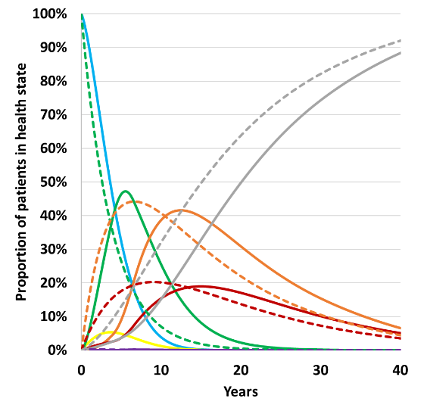 | 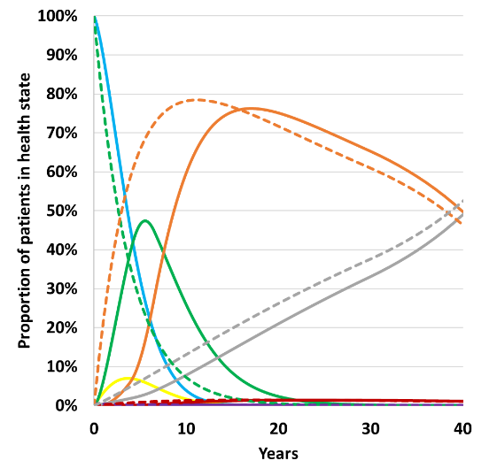 | 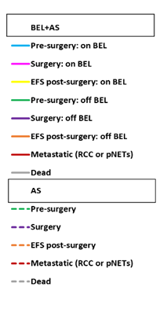
CNS Hb
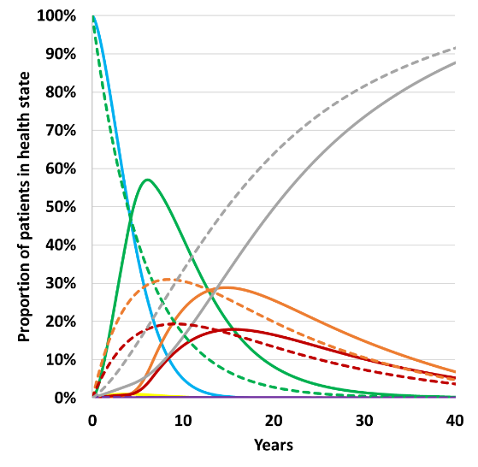 | 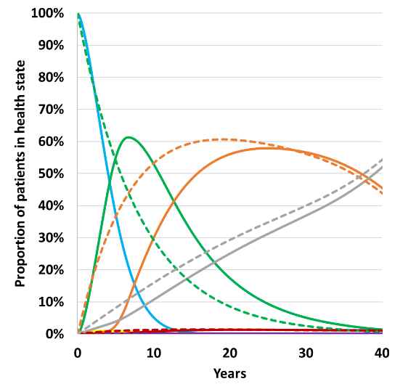
pNET model
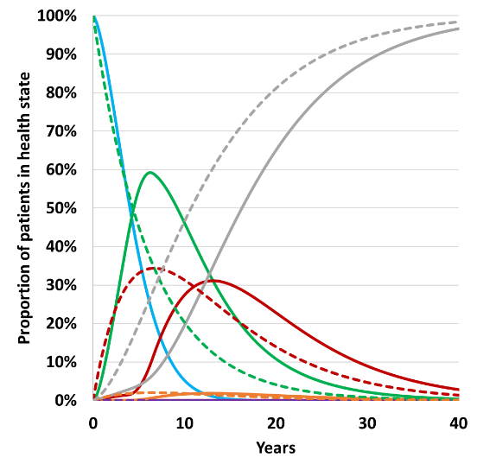 | 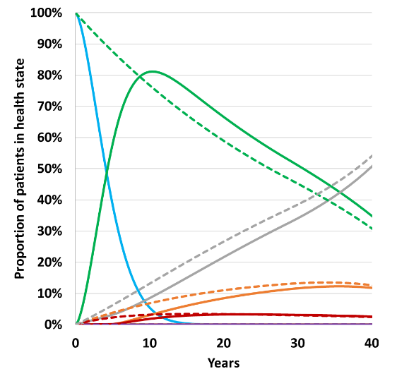
Source: compiled during the evaluation
EFS=event free survival, AS=active surveillance, BEL=belzutifan,
  - Figure 8 presents internal validation plots of the model. The submission provided internal validation of the time to surgery extrapolations for the RCC and CNS Hb model belzutifan arms and RCC model active surveillance arm, by assessing the extrapolations in the context of the model compared to the KM data for time to surgery, metastases or death both visually and statistically using mean squared error (MSE), and compared for clinical plausibility. The submission also presented overall survival validation against the VHL-NHS reweighted data (excluding the real-world adjustment). The evaluation considered that the modelled overall survival was a poor fit to the overall survival of RCC in VHL-NHS reweighted KM data.
  - The submission did not provide any external validation of the model results, but there was some evidence that the model underestimated survival. Total life expectancy estimated from the RCC model (starting age of 41.0 years plus undiscounted mean life years accrued) was 58.6 years in the AS arm (58.5 years CNS Hb model, 53.7 years pNETs model) and 62.7 years in the belzutifan arm (62.8 years CNS Hb model, 58.9 years pNETs model) compared to 60 years for females and 67 years for males in Binderup 2017. Overall, other published studies demonstrated that VHL patients are a heterogeneous population, and therefore the ICERs in the submission were likely to be highly uncertain.
  - One possible concern for future belzutifan use would be a different case mix of belzutifan patients. LS-004 and the VHL-NHS reweighted populations considered a prevalent population of patients with mean age 41.0 years and a mean number of prior surgeries of 2.4 in the RCC model, 2.8 in the CNS Hb model and 0.2 in the pNET populations. Currently it was unclear which tumours and at what life stage clinicians will prefer to use belzutifan, but potentially future cohorts of patients who are eligible for belzutifan will be younger and have had fewer tumours or surgeries.
Figure 8: Model validations in the submission
Time to surgery metastases, death | Overall survival
RCC
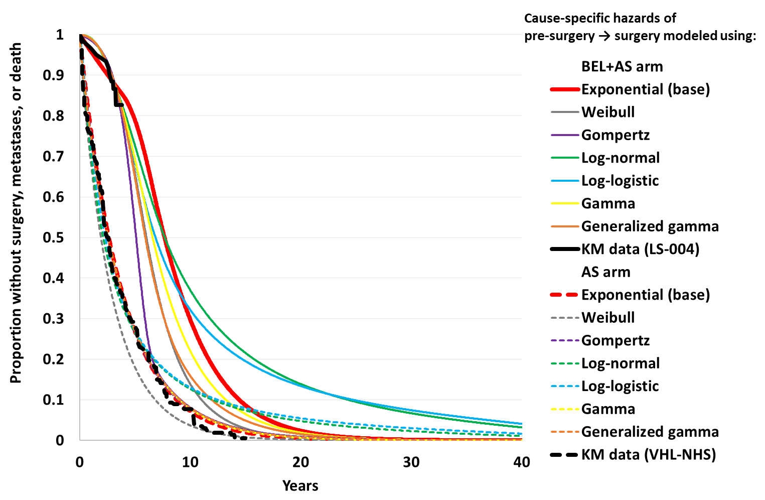 | 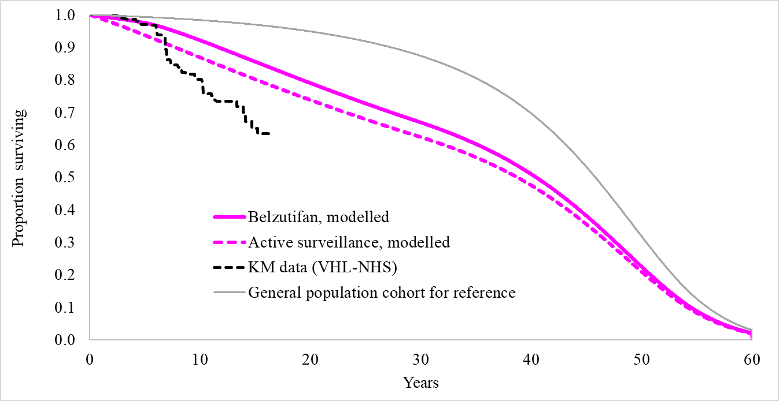
CNS Hb model
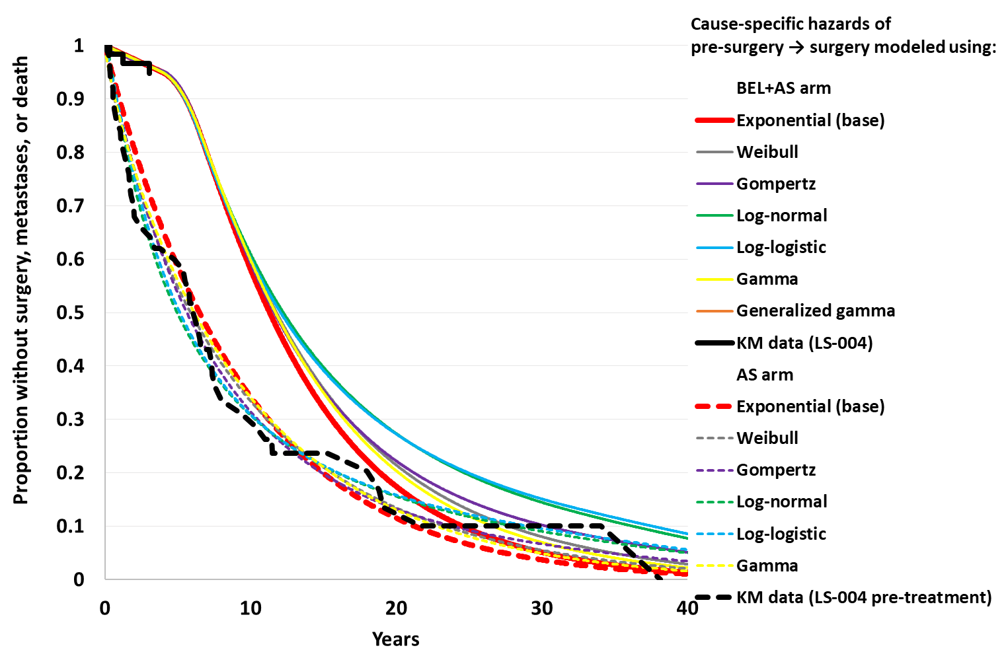 | 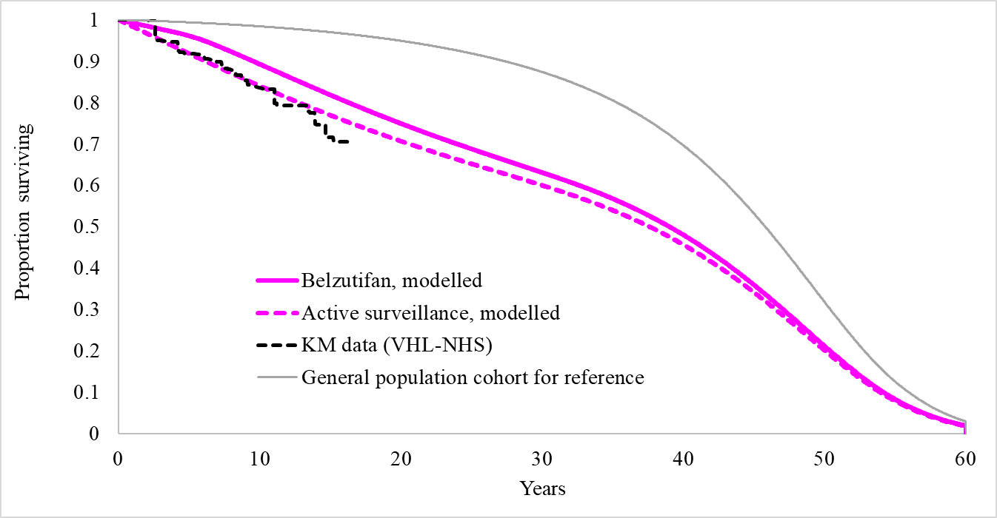
pNET model
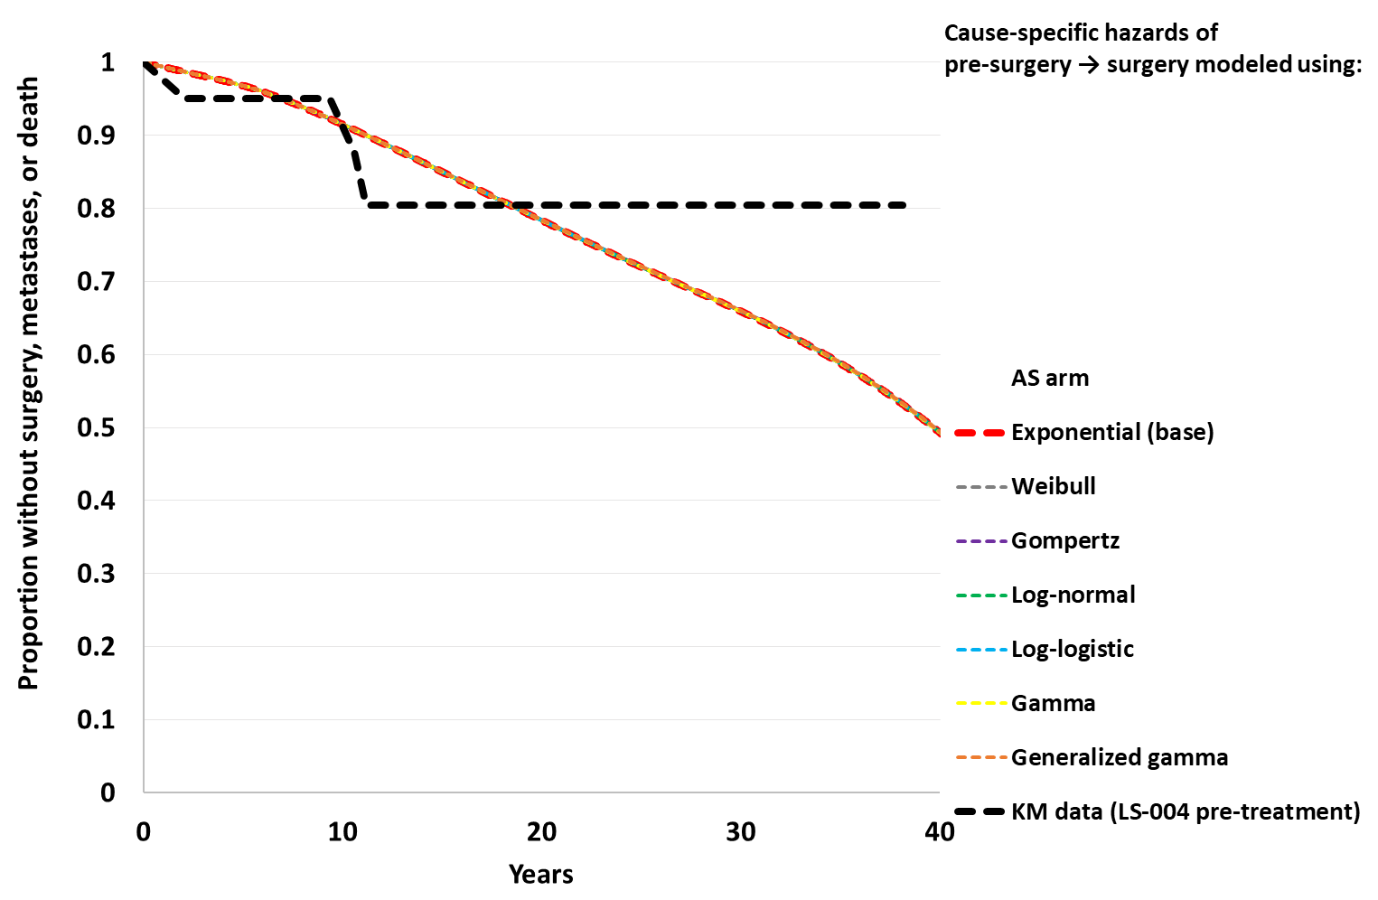 | 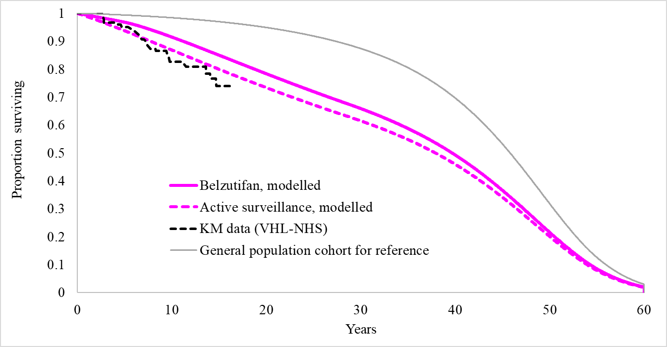
Source: compiled from Appendix A.7 and sheets ‘Effectiveness Validations_OS’, ‘Distrib Validations’ of Excel workbook Attachment 7 (CUA).xlsm
VHL-NHS refers to VHL-NHS reweighted data from the MAIC. Validation plots exclude real world adjustment.
  - A summary of the key model drivers is presented in Table 13.
Table 13: Key drivers of the model
Description | Method/Value | Impact  Base case:  $ | ¹/QALY RCC model  $ | ¹/QALY CNS Hb model  $ | ¹/QALY pNET model
Extrapolation period | The models extrapolated from Time 0 to 40 years compared to 38.1 months (mean) in LS-004 and 112.0 months (mean) in VHL-NHS. | High, favoured belzutifan. If the time horizon was restricted to 4 years (i.e. end of the data period) the ICER increased to $||||²/QALY RCC model; $||||²/QALY CNS Hb model; $||||³/QALY pNET model.
Pre-surgery to surgery extrapolation | In the base case pre-surgery to surgery was modelled with an exponential extrapolation in all arms of all models. While exponential curves fit the provided KM data well visually once they were incorporated into the overall models, exponential was not the best statistical fit for the belzutifan KM data (Gompertz had the smallest mean squared error). | High, favoured belzutifan in RCC and pNET models. Alternative distributions favoured belzutifan in the CNS Hb model. For example, if the best statistical fit was chosen for each arm in each model, the ICERs increased in the RCC and pNET models ($||||³/QALY and $||||¹/QALY respectively), but decreased for the CNS Hb model ($||||¹/QALY).
Real world adjustment | The submission stated that LS-004 and VHL-NHS represented patients receiving best practice care. As such, the models were adjusted using US claims data (Optum CDM). | High, favoured belzutifan. Without the Optum CDM adjustment the ICERs increased: $||||⁴/QALY RCC model; $||||⁴/QALY CNS Hb model; $||||⁴/QALY pNET model
Treatment waning | Up to Year 3.84, patients who discontinued belzutifan were still modelled equal to those still receiving treatment. Year 3.84 to Year 6.55 assumed a proportion (linear reduction over time) of discontinued patients would still be modelled equal to those receiving treatment, the remaining proportion were assumed to equal the active surveillance arm. From Year 6.55, discontinued patients were assumed equal to the active surveillance arm. The length of the treatment waning period was based on the changes in the RCC linear growth rate from LS-004. | High, length of effect favoured belzutifan. If convergence occurred at Year 3.84 for patients discontinuing belzutifan the ICERs increased: $||||⁴/QALY RCC model; $||||⁴/QALY CNS Hb model; $||||¹/QALY pNET model.
Time on belzutifan | Time on belzutifan was extrapolated from all follow up KM data from LS-004 using a Weibull distribution. Very few patients remained at risk from Year 3.2 (19 patients), which informed the shape of the extrapolation. | High, favoured belzutifan. If treatment discontinuation occurred only when patients developed metastases the ICERs increased: $||||³/QALY RCC model; $||||⁴/QALY CNS Hb model; $||||⁴/QALY pNET model.
Utilities | Health state utilities were calculated by response rates in each arm of each model and therefore included a direct utility benefit for belzutifan associated with complete response. Quality of life was not assessed in LS-004 nor VHL-NHS. | Moderate, favoured belzutifan. If no treatment benefit was assumed for belzutifan the ICERs increased: $||||⁴/QALY RCC model; $||||¹/QALY CNS Hb model; $||||¹/QALY pNET model. If non-metastatic utilities were reduced by ||||% the ICERs increased to $||||⁴/QALY RCC model; $||||⁴/QALY CNS Hb model; $||||¹/QALY pNET model
Long term surgery complications | The model estimated long term costs and disutilities for some VHL-associated tumour surgeries (RCC, CNS Hb, pNET, adrenal lesion, retinal Hb). These were applied for the lifetime of patients, or to the end of the time horizon. | High, favoured belzutifan. If long term surgery disutilities were removed from the model, the ICERs increased: $||||⁴/QALY RCC model; $||||⁴/QALY CNS Hb model; $||||¹/QALY pNET model.
Source: compiled during the evaluation
ICER=incremental cost-effectiveness ratio, KM=Kaplan-Meier, QALY=quality-adjusted life-year
The redacted values correspond to the following ranges:
1 $155,000 to < $255,000
2 $755,000 to < $855,000
3 $355,000 to < $455,000
4 $255,000 to < $355,000
  - The summary base case results are presented in Table 14. No stepped analysis was presented by the submission. Belzutifan was associated with ICERs of $155,000 to < $255,000per QALY gained ($255,000 to < $355,000 per life year gained) in the RCC model, $155,000 to < $255,000 per QALY gained ($255,000 to < $355,000 per life year gained) in the CNS Hb model, and $155,000 to < $255,000 per QALY gained ($155,000 to < $255,000 per life year gained) in the pNET model.
Table 14: Results of the economic evaluation (discounted)
Component | BEL+AS arm | AS arm | Increment
RCC model
Costs | $| | $| | $|
LYs | 12.67 | 10.75 | 1.93
QALYs | 7.39 | 5.18 | 2.21
Incremental cost/extra LY gained |  |  | $|^{1a}
Incremental cost/extra QALY gained |  |  | $|²
CNS Hb model
Costs | $| | $| | $|
LYs | 12.64 | 10.64 | 2.00
QALYs | 7.42 | 5.08 | 2.34
Incremental cost/extra LY gained |  |  | $|^{1a}
Incremental cost/extra QALY gained |  |  | $|²
pNET model
Costs | $| | $| | $|
LYs | 11.40 | 8.75 | 2.65
QALYs | 6.79 | 3.98 | 2.81
Incremental cost/extra LY gained |  |  | $| ^{2a}
Incremental cost/extra QALY gained |  |  | $|²
Source: Tables 3.8-9, 3.8-10, 3.8-11, 3.8-12, 3.8-13, 3.8-14 and compiled during the evaluation
AS=active surveillance, BEL=belzutifan, LY=life year, QALY=quality adjusted life year
ª Incremental cost per life year gained in the submission appeared to be estimated for published prices of belzutifan, rather than effective price. Effective price ICERs are reported in this table.
The redacted values correspond to the following ranges:
1 $255,000 to < $355,000
2 $155,000 to < $255,000
  - Incremental undiscounted costs (Table 15) were driven by the cost of belzutifan, which resulted in undiscounted total costs >$| | in all models, equal to | |%, | |%,| |% of incremental costs in the RCC, CNS Hb and pNET models, respectively. Surgery and surgical complication costs for ‘other’ tumours resulted in the largest cost offset in the RCC and CNS Hb models (-| |% and -| |% of their total incremental costs respectively) and metastatic drugs were the largest cost-offset in the pNET model (-| |% of the total incremental undiscounted cost). The disaggregated undiscounted costs demonstrated that the ICERs are not overly sensitive to cost-offsets.
Table 15: Health care resource items: disaggregated summary of cost impacts (undiscounted)
Resource item | RCC model |  | CNS Hb model |  | pNET model
Resource item | Incremental cost | % of total incremental cost | Incremental cost | % of total incremental cost | Incremental cost | % of total incremental cost
Belzutifan | $ | | | % | $ | | | % | $ | | | %
Metastatic drugs | -$8,888 | - | % | -$11,299 | - | % | -$6,456 | - | %
Metastatic drug administration | -$119 | - | % | -$195 | | % | -$135 | - | %
Adverse event costs | $505 | | % | $505 | | % | $505 | | %
Surgery and surgical complication costs for model specific tumour | -$5,454 | - | % | -$24,634 | - | % | -$325 | | %
Surgery and surgical complication costs for other tumours | -$23,549 | - | % | -$11,982 | - | % | -$4,316 | - | %
Disease management costs | $1,204 | | % | $63 | | % | $1,864 | | %
Terminal care costs | -$2,158 | - | % | -$2,277 | - | % | -$1,038 | - | %
Total | $|| | ||% | $|| | ||% | $|| | ||%
Source: compiled during the evaluation using Sheet ‘Disaggregated Base-Case Results’ of the Excel workbook ‘Attachment 7 (CUA).xlsm’]
Table 16: Disaggregated summary of health outcomes included in the economic evaluation (undiscounted)
Outcome | RCC model |  | CNS Hb model |  | pNET model
Outcome | Incremental outcome | % of total incremental outcome | Incremental outcome | % of total incremental outcome | Incremental outcome | % of total incremental outcome
LYs
Pre-surgery | 4.541 | 108.8% | 5.350 | 124.4% | 5.494 | 106.9%
Surgery | -0.001 | 0.0% | -0.002 | 0.0% | 0.000 | 0.0%
EFS post-surgery | -0.048 | -1.2% | -0.585 | -13.6% | -0.012 | -0.2%
Metastatic disease | -0.320 | -7.7% | -0.461 | -10.7% | -0.340 | -6.6%
Total | 4.172 | 100.0% | 4.302 | 100.0% | 5.142 | 100.0%
QALYs
Pre-surgery | 3.486 | 96.0% | 4.070 | 105.0% | 4.369 | 103.8%
Surgery | 0.000 | 0.0% | -0.001 | 0.0% | 0.000 | 0.0%
EFS post-surgery | -0.017 | -0.5% | -0.423 | -10.9% | -0.008 | -0.2%
Metastatic disease | -0.143 | -3.9% | -0.204 | -5.3% | -0.150 | -3.6%
Surgery and surgical complication costs for model specific tumour | 0.064 | 1.8% | 0.360 | 9.3% | 0.001 | 0.0%
Surgery and surgical complication costs for other tumours | 0.244 | 6.7% | 0.077 | 2.0% | -0.002 | 0.0%
AE-related disutility | -0.001 | 0.0% | -0.001 | 0.0% | -0.001 | 0.0%
Total | 3.633 | 100.0% | 3.878 | 100.0% | 4.209 | 100.0%
Number of surgeries
RCC | -0.026 | 11.4% | -0.092 | 35.4% | -0.032 | 37.2%
CNS Hb | -0.108 | 46.5% | -0.098 | 37.7% | -0.035 | 40.1%
pNET | -0.007 | 3.0% | -0.011 | 4.1% | -0.002 | 2.6%
Adrenal lesion | -0.052 | 22.2% | -0.005 | 2.1% | 0.000 | 0.0%
Endolymphatic sac tumour | -0.009 | 4.0% | 0.000 | 0.0% | 0.000 | 0.0%
Epididymal cystadenoma | 0.000 | 0.1% | -0.005 | 2.1% | 0.000 | 0.0%
Retinal Hb | -0.030 | 12.8% | -0.048 | 18.7% | -0.017 | 20.1%
Total | -0.232 | 100% | -0.260 | 100% | -0.087 | 100%
Source: compiled during the evaluation using Sheet ‘Disaggregated Base-Case Results’ of the Excel workbook ‘Attachment 7 (CUA).xlsm’
AE=adverse event, EFS=event free survival, LY=life-year, QALY=quality-adjusted life-year
  - Incremental undiscounted life years gained (Table 16) were driven by life years accrued in the pre-surgery health states in all models (>4.5 years in all models), equal to 108.8%, 124.4%, 106.94% of incremental life years gained in the RCC, CNS Hb and pNET models respectively. Most life year gain offsets were in the metastatic disease states in the RCC and pNET models (-0.32 and -0.34 incremental life years respectively, equivalent to -7.7% and -10.7% of the total of incremental life years gained). In comparison the CNS Hb model had the largest life year offset with -0.59 incremental life years in EFS post-surgery and -0.46 incremental life years in the metastatic disease states. A similar pattern was seen in incremental health state QALYs.
  - The ESC agreed with the evaluation and considered the models lacked face validity. Despite the relatively large life year gains, particularly in the pre-surgery health states, very few surgeries were avoided in the models. Further, very few surgeries in the target tumour body system compared with non-target tumour surgeries were predicted. The total number of surgeries per patient on average in the active surveillance arms were 4.16 in the RCC model (1.01 of which were RCC surgeries); 4.78 in the CNS Hb model (1.35 of which were CNS Hb surgeries); and 4.42 in the pNET model (0.06 of which were pNET surgeries). The incremental number of surgeries for belzutifan versus active surveillance were -0.23, -0.26, -0.09 in the RCC, CNS Hb and pNET models respectively (Table 16). Surgery breakdown differed by arm, but the largest reduction in surgeries was in ‘other’ tumour surgeries in all models. The PSCR disagreed that the number of modelled surgeries was too low based on the reporting of prior surgeries in LS-004, Australian VHL patients who participated in the Patient input Forum and published literature. The ESC considered that this was a misinterpretation of the concerns regarding face validity. As stated above, the primary concern was that the proposed clinical benefit of belzutifan (avoidance of surgeries in the target tumour body system) was not carried through to the model, where the majority of surgeries occurred not in the targeted body system (‘other’ surgeries) and the belzutifan arm resulted in <0.1 average reduction in the surgeries per patient to the target tumour body system in any of the three models.
  - Overall, the ESC considered that the ICERs were highly uncertain as the economic analysis was overly complex given the limited data available, the models were informed by large number of data sources, many of which could not be validated or were inappropriate, no external validation of the models was conducted, and the models were not consistently internally valid (e.g. OS in the RCC model, number of predicted surgeries).
  - The PSCR maintained the model structure was necessary to reflect the heterogeneity of VHL disease, capture all clinically relevant events and health outcomes, and appropriately inform decision-making by providing an ICER for each primary population. However, the ESC considered the PSCR did not address the primary concern that the analysis was too complex for the limited data available. The PSCR also maintained the inputs sourced to inform the model were appropriate and argued that the rarity of VHL disease poses challenges in generating evidence of a standard typical of more common diseases and stated that it is therefore appropriate to recognise real-world evidence and accepting a greater degree of uncertainty in data.
  - The ESC agreed with the evaluation that the model’s complexity, while attempting to capture important clinical features of VHL disease, led to high degree of uncertainty. The ESC noted the economic models developed for belzutifan and submitted to NICE (2023) and SMC (2023) were less complex and included five health states (pre-surgery, surgery [tunnel], event free after surgery, metastatic disease and death). While recognising an economic model for VHL disease would ideally capture the complexity associated with multiple and recurrent tumours, the ESC considered that there was insufficient data to inform a more granular and complex model, such as that presented in the submission. Further, the ESC considered the five health state model submitted to NICE and SMC was likely to be more appropriate and informative for decision making purposes. The ESC also suggested a stepped economic analysis be presented to assist decision making; this should include an incremental cost per surgery avoided, with interpretation of the value proposition supported by qualitative evidence of expected improvements in quality of life and life expectancy from surgeries avoided.
  - The pre-PBAC response suggested that an updated or alternative economic model structure was unlikely to be any more informative or robust. To address concerns raised by the evaluation, ESC, and DUSC, the sponsor proposed the following modelling scenario for PBAC consideration: treatment discontinuation only occurs once patients develop metastases; this assumes a modelled time on treatment of 29.9 to 32.2 years; a price reduction with an effective AEMP of $| | (DPMQ $| |). This scenario, without the price reduction, was presented in the evaluation (see paragraph 6.48) resulting in ICER increases to $355,000 to < $455,000, $255,000 to < $355,000, $255,000 to < $355,000 per QALY gained in the RCC, CNS Hb and pNET models respectively. The sponsor’s revised ICERs, incorporating the | |% price reduction, were RCC = $155,000 to < $255,000/QALY, CNS Hb = $155,000 to < $255,000/QALY, pNET = $155,000 to < $255,000/QALY.
  - The ESC also considered that the benefit of belzutifan was overestimated, as it assumed to not only apply to time to model specific tumour surgery (e.g. RCC surgery in the RCC model), but also to: time to surgeries of all VHL-associated tumours, including those not assessed in LS-004 (and for benefit to continue for subsequent surgeries); time to metastatic pNETs or RCC (in all models); time to death (for the proportion of patients in each model with CNS Hb tumours); and a utility benefit in the non-metastatic alive states of the models. No direct evidence of these benefits was observed in LS-004. The PSCR argued that belzutifan reduces the risks of surgeries and metastatic disease through the same mechanism (i.e. decreasing tumour size or stopping growth) and that there is a well-established link between the size of the largest renal tumour and risk of metastases in RCC. The PSCR also maintained that belzutifan is expected to reduce the risk of death, specifically for CNS Hb. Although CNS Hb are considered ‘benign’ due to their inability to metastasise, they are a major cause of morbidity and mortality due to the mass effect and pressure exerted on nearby sensitive CNS structures. The PSCR stated that as of the LS-004 April 2022 and later data cut off, there have been no deaths due to CNS Hb progression, and therefore considered the models assumptions conservative. However, the ESC maintained that the long-term benefits of belzutifan assumed in the economic model were uncertain as there was no direct evidence of such benefits observed in LS-004.
  - While the PSCR stated that the model does not assign any added utility benefit for CR or PR above and beyond the utility associated with SD, it was noted that the utility for CR was 0.868 compared to 0.754 for PR and SD. As utility in the pre-surgery, surgery and EFS-post-surgery health states was weighted by patients’ best response (not accounting for time to or duration of response), the models explicitly estimate a higher utility for patients receiving belzutifan (0.762 vs 0.728 in the RCC model, 0.758 vs 0.728 in the CNS Hb model, 0.790 vs 0.728 in the pNET model).The results of key sensitivity analyses are summarised in Table 17. The ICERs were most sensitive to the extrapolation period (time horizon), pre-surgery to surgery extrapolation choice, the assumed benefit of belzutifan beyond time to first surgery, the real-world adjustment, the treatment waning effect, time on belzutifan and long term disutilities after surgery. Specific scenario analyses relating to indirect costs and disutilities are discussed in paragraphs below.
  - Given the high level of uncertainty in the majority of model inputs and assumptions, a multivariate sensitivity analysis was not compiled during the evaluation, as it was considered unlikely to improve model certainty.
Table 17: Sensitivity analyses
Analyses | RCC model |  | CNS Hb model |  | pNET model
Analyses | ICER ($) | % change | ICER ($) | % change | ICER ($) | % change
Base case | |||¹ | - | |||¹ | - | |||¹ | -
Discount rate (costs and outcomes)
0.0% | ||¹ | -|||% | ||¹ | -|||% | ||¹ | -|||%
3.5% | ||¹ | -|||% | ||¹ | -|||% | ||¹ | -|||%
Time horizon (base case 40 years)
4 years (LS-004 follow up) | ||² | ||% | ||¹ | ||% | ||⁴ | ||%
10 years | ||³ | ||% | ||³ | ||% | ||¹ | ||%
20 years | ||³ | ||% | ||¹ | ||% | ||¹ | ||%
Distribution for pre-surgery to surgery (base case: exponential all arms, all models)ª
Gompertz^{b} | ||³ | ||% | ||¹ | -|||% | ||¹ | ||%
Log-normal^{c} | ||¹ | -|||% | ||¹ | -|||% | ||¹ | ||%
Each arm best stat fit^{d} | ||³ | ||% | ||¹ | -|||% | ||¹ | ||%
Exponential parameters for time to surgery (base case RCC model BEL+AS=0.0007, AS=0.0049; CNS Hb model BEL+AS=0.0001, AS=0.0020; pNET model AS=0.0002)
Upper 95%CIe | ||³ | ||% | ||¹ | ||% | ||¹ | ||%
Lower 95%CI^{f} | ||¹ | -|||% | ||¹ | -|||% | ||¹ | -|||%
Worst case^{g} | ||³ | ||% | ||³ | ||% | ||¹ | ||%
Best case^{h} | ||¹ | -|||% | ||¹ | -|||% | ||¹ | -|||%
Belzutifan benefit to event rates (base case benefit applied to time to 1st surgery, time to subsequent surgery, per cycle rate of ‘other’ tumour surgeries, time metastases from any state, time to death from CNS Hb in any state)
Time to first model surgery only | ||⁵ | ||% | ||¹⁰ | ||% | ||⁶ | ||%
Time to any surgery (including ‘other’ tumour surgeries) only | ||⁴ | ||% | ||⁴ | ||% | ||⁴ | ||%
Remove ‘other’ tumour surgeries from the model | ||³ | ||% | ||³ | ||% | ||¹ | ||%
Adjustment for surgery and metastases rates to account for real-world (base case: included)
Excluded | ||³ | ||% | ||³ | ||% | ||³ | ||%
Time on belzutifan (base case Weibull)
Gompertz | ||¹ | -|||% | ||¹ | -|||% | ||¹ | -|||%
Gamma | ||³ | ||% | ||¹ | ||% | ||¹ | ||%
Exponential | ||³ | ||% | ||¹ | ||% | ||¹ | ||%
Equal to time in non-metastatic disease^{i} | ||⁴ | ||% | ||³ | ||% | ||³ | ||%
Treatment waning (base case: convergence between belzutifan and AS arms between Year 3.84 and 6.55 for patients discontinuing treatment, belzutifan transitions, events and utilities equal to AS arm from Year 6.55)
Assume no treatment effect waning | ||⁷ | -|||% | ||⁷ | -|||% | ||⁸ | -|||%
Converge at Year 3.84 | ||³ | ||% | ||³ | ||% | ||⁹ | ||%
Relative dose intensity (base case 92.5%)
100% belzutifan | ||³ | ||% | ||³ | ||% | ||¹ | ||%
Surgery and surgical complications (base case short and long-term costs and disutilities for all surgeries)
No long-term disutilities | ||³ | ||% | ||³ | ||% | ||¹ | ||%
No long-term costs | ||³ | ||% | ||¹ | ||% | ||¹ | ||%
No ‘other’ tumour surgery and complication costs | ||³ | ||% | ||¹ | ||% | ||¹ | ||%
No ‘other’ tumour surgery and complication disutilities | ||³ | ||% | ||¹ | ||% | ||¹ | ||%
Health state utilities (base case: health state utilities by response and treatment)
No treatment benefit for belzutifan | ||³ | ||% | ||¹ | ||% | ||¹ | ||%
Adverse events (base case: SAE anaemia (11.5%) and fatigue (4.9%) from Table 12-4 p 104 LS-004 CSR)
Any anaemia or fatigue^{j} | ||¹ | ||% | ||¹ | ||% | ||¹ | ||%
Source: Table 3.9-1 of the submission and compiled during the evaluation
ICER=incremental cost-effectiveness ratio, SAE=serious adverse event, AS=active surveillance, BEL=belzutifan
a Note changing this distribution doesn’t change treatment benefit for further surgeries, metastases or death, which are always based on hazard ratio of the exponential distributions
b Gompertz was best statistical fit for BEL+AS KM data and 2nd/3rd best fit of AS KM data in RCC and CNS Hb models
c log normal lowest AIC for AS arm of CNS Hb model and 2nd lowest AIC/BIC for pNET model AS arm (but worst statistical fit for AS arm of RCC model)
d RCC model: BEL+AS=Gompertz, AS=exponential; CNS Hb model: BEL+AS=Gompertz, AS=exponential; pNET model: AS=exponential
e RCC model BEL+AS=0.0012, AS=0.0055; CNS Hb model BEL+AS=0.0003, AS=0.0026; pNET model AS=0.0004
f RCC model BEL+AS=0.0002, AS=0.0042; CNS Hb model BEL+AS=-0.0001, AS=0.0014; pNET model AS=0.0000
g Upper 95% CI for AS, lower 95%CI for BEL+AS arms
h Lower 95% CI for AS, upper 95%CI for BEL+AS arms
i Treatment waning must be excluded for this sensitivity analysis to run. Time in non-metastatic disease was equal to time in pre-surgery, surgery and EFS-post-surgery health states.
j 90.2% anaemia, 73.8% fatigue. This does not account for repeated events, nor difference in duration between SAEs and all AEs.
The redacted values correspond to the following ranges:
1 155,000 to < $255,000
2 $755,000 to < $855,000
3 $255,000 to < $355,000
4 $355,000 to < $455,0005 $955,000 to < $1,055,000
6 > $1,055,000
7 $55,000 to < $75,000
8 $45,000 to < $55,000
9 $155,000 to < $255,000
10 $555,000 to < $655,000
Sensitivity analyses accounting for indirect costs and disutilities
  - The submission presented further sensitivity analyses which included additional disutilities for carers of VHL patients, indirect costs associated with productivity loss resulting from premature death only in VHL patients (of the submission); and indirect costs associated with productivity loss resulting from work productivity during patient lifetime and premature death (Table 3.9-1 of the submission).
- The submission estimated carer disutilities by health state, plus a recurring disutility upon patient death for the estimated difference in survival between VHL patients and general population. None of the sources of carer disutility included carers of VHL patients, or an Australian population, and the disutilities between for the surgery and EFS post-surgery states were based on a linear increase in disutility from pre-surgery (-0.030) to metastatic disease (-0.100). The most significant disutility was the post-death disutility (-0.050) as it was applied for a long time (in the RCC model 19.2 years in the active surveillance arm, and 15.0 years in the belzutifan arm). The source of this disutility was a study of bereaved family members of cancer patients 6 months after death in Korea (Song 2012). This study was unlikely to represent Australian utility loss in carers for VHL-patients. Further, though a bereaved family would experience ongoing utility loss, this is not a factor that is accounted for in assessing cost-effectiveness of life limiting diseases and it has not been previously considered by the PBAC for other life limiting diseases. Therefore, the ESC agreed with the evaluation that the inclusion of this disutility may be inequitable to the assessment of therapies for patients with other life limiting diseases.
- The submission estimated the cost of productivity loss due to premature death as full-time work (38 hours) multiplied by median 2023 earnings ($40.50 for men, $38.20 for women; ABS hourly earnings August 2023) weighted by proportion of women in the model. This gave a weekly loss of $1,497.45 ($78,135 per year), applied every cycle to the additional patients who had died compared to the general population up to age 65 in the models (in the RCC model this resulted in 5.36 years of costs in the belzutifan arm and 8.40 years of costs in the active surveillance arm).
- The productivity loss during patient lifetime (due to paid work impairment) was estimated from the Work Productivity and Activity Impairment: Specific Health Problem (WPAI:SHP) administered in the QoL Disease Burden Study. Each health state resulted in an additional cost of productivity loss per cycle: $438.75 in pre-surgery and EF post-surgery states (29.3% productivity loss), $1,497.45 in surgery states (100% productivity loss), $607.96 in metastatic disease states (40.6% productivity loss). The WPAI:SHP has not been validated for VHL, and is not recommended for systemic diseases. In general, productivity loss may be partially captured by utility loss and therefore this additional cost may result in double counting of the impact. The use of national averages was also unlikely to represent productivity loss specific to VHL patients. Death of a VHL patient could also result in carers losing the patient’s income (including any disability or carer payments), but may be able to access more paid work due to the loss of caring responsibilities. The indirect costs did not account for any return to work, cover or replacement within the labour force (as described in Production changes, Appendix 6, PBAC guidelines, September 2016), and therefore assumed full loss of productivity. The ESC agreed with the evaluation that this was not justified by the submission and likely to overestimate the productivity losses in a societal context. In general, the approach to indirect costs appeared to be from the perspective of the patient and their family (interpreted as income loss) rather than societal productivity loss.
  - A summary of the results of the sensitivity analyses accounting for indirect costs and disutilities is presented in Table 18. The ICERs were sensitive to indirect costs associated with premature death, but were not sensitive to caregiver disutilities or indirect costs of work productivity loss while patients were alive.
Table 18: Sensitivity analyses accounting for indirect costs and disutilities
Analyses | RCC model |  | CNS Hb model |  | pNET model
Analyses | ICER ($) | % change | ICER ($) | % change | ICER ($) | % change
Base case | |||¹ | - | |||¹ | - | |||¹ | -
Non-surgical disutilities (base case one-off adverse event disutility only)
Apply caregiver disutility | ||¹ | -|||% | ||¹ | -|||% | ||¹ | -|||%
Indirect costs (base case: none)
Due to premature death | ||¹ | -||.7% | ||¹ | -|||% | ||² | -|||%
Due to work productivity impairment while alive | ||³ | ||% | ||¹ | ||% | ||¹ | ||%
Due to premature death and work productivity impairment | ||¹ | -|||% | ||¹ | -|||% | ||⁴ | -|||%
Source: Table 3.9-1 of the submission and compiled during the evaluation
ICER=incremental cost-effectiveness ratio
The redacted values correspond to the following ranges:
1 155,000 to < $255,000
2 $115,000 to < $135,000
3 $255,000 to < $355,000
4 $135,000 to < $155,000

Belzutifan $|||| ||||/patient/year
  - The value of $||| ||| was calculated using the proposed regimen (3x40mg tablets a day until discontinuation) with 92.5% dose intensity and 90 tablet pack cost of $| | (DPMQ at community pharmacy mark up of AEMP $| |). Both the models and financial estimates differed slightly from this value, as the economic models applied the cost at the start of every 4 weeks and the financial estimates calculated duration and regimen over weeks, round to the nearest 2 decimal places. Time on treatment in the financial estimates was over 6 months shorter than estimated in the economic models.
  - With the price reduction offered in the pre-PBAC response, the cost per patient per year is reduced to $| |.
Table 19: Drug cost per patient for belzutifan
 | LS-004 dose and duration | Models |  |  | Financial estimates
 | LS-004 dose and duration | RCC model | CNS Hb model | pNET model | Financial estimates
Mean dose | 112.3mg/dayª | 111.0mg/day | 111.0mg/day | 111.0mg/day | 111.0mg/day
Mean duration | 2.81 years | 4.52 years | 4.57 years | 4.55 years | 4.00 years
Cost/patient/year | - | $| | $| | $ | | $ |
Total cost/patient | - | $| | $| | $ | | $ |
Source: compiled during the evaluation from Table 10-6 of LS-004 Clinical Study Report, and Excel workbooks ‘Attachment 7 (CUA).xlsm’ ‘Attachment 8 (UCM).xlsx’
ª Cumulative mean dose 115124.6mg/mean duration 1025.1 days
^{b} Financial estimates calculated duration and regimen over weeks, round to the nearest 2 decimal places. If estimated on daily dose, the annual cost was $| |.

Estimated PBS usage & financial implications
  - The DUSC considered that the submission reasonably used an epidemiological approach to estimate the financial impact of belzutifan listing for patients with VHL-associated RCC, CNS Hb or pNETs who are not in need of immediate surgery. A summary of the data sources for the financial analysis are presented Table 20
Table 20: Key inputs for financial estimates
Data | Value | Source | Commentary on the submission | DUSC comments
Eligible population
Australian patients living with VHL disease  (undiagnosed & diagnosed) | Yr 1: ||||¹  Yr 2: ||||¹  Yr 3: ||||¹  Yr 4: ||||¹  Yr 5: ||||¹  Yr 6: ||||¹ | VHL prevalence of 2.1 per 100,000 population based on Binderup 2017, applied to ABS population data (total) for 2024-2029. | The VHL prevalence was applied to the ABS total Australian population projection. The source of the ABS population projection did not match Sheet ‘8. ABS population’. ABS population values should be restricted to 18+ at this stage of the analysis (rather than apply a subsequent parameter).  Binderup 2017 was a population-based study in Denmark using a national VHL research database and national health registers and was chosen as it restricted to after genetic testing was available and was nationwide rather than centre/region specific. This may be a reasonable source. However, the applicability to the Australian population is unknown and relatively small differences in the prevalence is expected to have a significant effect on the financial estimates. | DUSC commented this was a reasonable prevalence source for a rare disease, and that it was consistent with literature.
Grandfathered patients | Yr 1: ||||²  Yrs2−6: ||||² | Assumed | Grandfathered numbers should have been removed from the diagnosed adult VHL population rather than the overall population, but were otherwise correctly accounted for in the financial estimates. | DUSC agreed with the commentary.  The pre-PBAC response subtracted ||||² grandfathered patients from the diagnosed VHL population in Year 1. This was aligned with DUSC advice.
Diagnostic rate | Yr 1: ||||%  Yr 2: ||||%  Yr 3: ||||%  Yr 4: ||||%  Yr 5: ||||%  Yr 6: ||||% | The total diagnostic rate of 85% was estimated by the sponsor-convened expert panel. The expert panel, along with qualitative evidence of patient experience, suggested that there is a delay between symptom onset and underlying VHL disease identification and therefore diagnosis up to the total rate of 85% would be staggered over time. The yearly staggered percentages were an assumption. | The cumulative diagnostic rate spread across 6 years to 85%, when applied to the estimated prevalent population (undiagnosed or diagnosed) in year 1 was not appropriate and likely considerably underestimated the number of eligible patients in the first few years of the estimates. This approach is only appropriate for undiagnosed patients experiencing first symptom onset, and these patients will likely be a small minority compared to the combined prevalent cohort of patients who already have a diagnosis because of a history of VHL-associated lesions, family history of VHL, or those identified through familial screenings. It may therefore be more appropriate to have an average persistent diagnostic rate applied to all prevalent patients than a staggered diagnostic rate. | DUSC commented that the 85% diagnostic rate may be an overestimate and noted that Binderup 2017 found that 14% of patients in the studied cohort were asymptomatic or obligate VHL variant carriers without manifestations, and a further 25% had a missed diagnosis in spite of fulfilling the international diagnostic criteria. DUSC considered the diagnostic rate may be as low as 61%.  DUSC agreed with the commentary that that the estimated diagnostic rate of 85% has been applied incorrectly. DUSC considered that the proportion of the prevalent pool who already have a diagnosis (61-85% diagnostic rate) and would be eligible should be estimated first, and grandfathered patients should be subtracted from this estimate.  Then, the number of initiating patients from the untreated diagnosed prevalent pool should be estimated separately.  The pre-PBAC response applied an average persistent diagnostic rate of 61% to all prevalent patients in Years 1−6 and grandfathered patients were subtracted from this estimate in Year 1. Then the number of initiating patients in Year 1 was calculated based on the prevalent patients diagnosed in Year 1.  Patients initiating treatment over the 6 years were based only on the Year 1 prevalent population. A small number of additional patients in the prevalent patient pool in Years 2−6 were not considered in the financial estimates.
Number of patients diagnosed with VHL disease (excluding grandfathered) | Yr 1: ||||²  Yr 2: ||||²  Yr 3: ||||²  Yr 4: ||||²  Yr 5: ||||²  Yr 6: ||||² | The diagnostic rate was applied to the Australian Patients living with VHL disease (undiagnosed & diagnosed) excluding ||||² grandfathered patients each year. | This approach (effectively) estimated an incident population each year, who were not carried forward into future years. As such diagnosed patients who were ineligible or declined belzutifan in their diagnosis year could never receive belzutifan, which was not reasonable. | DUSC agreed with the commentary and noted that this was likely to result in an under-estimation. DUSC considered that a proportion of newly diagnosed patients will opt for monitoring rather than initiating treatment.  The pre-PBAC response applied an average persistent diagnostic rate of 61% to all prevalent patients in Years 1−6 and grandfathered patients were subtracted from this estimate in Year 1. However, a small number of new patients in Year 2−6 were not considered in the financial estimates:  Yr 1: ||||² – |||| ²grandfathered patients =||||²  Yr 2: ||||²||||Yr 3: ||||²  Yr 4: ||||²  Yr 5: ||||²  Yr 6: ||||²||||
Number of patients diagnosed with VHL disease who are ≥18 years old | Yr 1: ||||²  Yr 2: ||||²  Yr 3: ||||²  Yr 4: ||||²  Yr 5: ||||²  Yr 6: ||||² | 77% of diagnosed VHL patients (excluding the grandfathered patients) assumed to be at least 18 years old from ABS 2023 Intergenerational report | The grandfathered patients should be removed from the population of diagnosed adults rather than the overall cohort and then number of diagnosed adult calculated. Further, ABS population values should be restricted to 18+ on outset rather than applying the eligibility criterion for Age 18+ here. | DUSC agreed with the commentary.  The pre-PBAC response restricted ABS population values to 18+ on onset.  Although the PBAC considered an age agnostic listing would be appropriate, it was also considered reasonable for this step to remain as it was expected there would be few patients under 18 years of age commencing treatment.
VHL population with RCC, CNS Hb or pNET | Yr 1: ||||²  Yr 2: ||||²  Yr 3: ||||²  Yr 4: ||||²  Yr 5: ||||²  Yr 6: ||||² | A proportion of 85% having a disease manifestation of RCC, CNS Hb or pNET was estimated by the sponsor-convened expert panel, considering literature with individualised patient data to identify disease manifestation that had estimates ranging between 63-89%. | The proportion (85%) was based on clinical opinion, supported by published literature identified from Canada, Brazil, Denmark, and USA. The applicability to the Australian population is unknown. | DUSC commented that this was reasonable across the subtypes of VHL, and considered these sources likely to be applicable to the Australian population.
Not requiring immediate surgery | Yr 1: ||||²  Yr 2: ||||²  Yr 3: ||||²  Yr 4: ||||²  Yr 5: ||||²  Yr 6: ||||² | A proportion of 85% having a disease manifestation of RCC, CNS Hb or pNET and not requiring immediate surgery was estimated by the sponsor-convened expert panel. | No literature was identified to support this proportion. From Optum CDM data a combined VHL population with RCC, CNS Hb or pNET, not requiring immediate surgery was 89%, compared to the 72%=85%x85% presented as the base case. | DUSC agreed with the commentary.
With ECOG 0-1 | Yr 1: ||||²  Yr 2: ||||²  Yr 3: ||||²  Yr 4: ||||²  Yr 5: ||||²  Yr 6: ||||² | A proportion of 90% having a disease manifestation of RCC, CNS Hb or pNET, not requiring immediate surgery, with ECOG 0-1 was estimated by the sponsor-convened expert panel, considering literature of proportions of VHL-CNS Hb, metastatic RCC, metastatic pNET populations with ECOG 0-1 between 77-100%. | The literature presented in support of the 90% ECOG 0-1 included non-VHL disease and malignant disease populations, which may not be comparable to the eligible population. | DUSC agreed with the commentary.
Treatment utilisation
Uptake rate | Yrs 1-6: ||||% | The sponsor anticipated that clinicians will opt for treatment with belzutifan in ||||% of eligible VHL patients once it is PBS subsidised. All (100%) patients in the grandfathering population are expected to opt for treatment. | This is plausible, however clinical uptake and use of belzutifan is uncertain. Arevalo 2022 suggested that only 36% of US VHL kidney experts would initiate belzutifan to prevent growth in patients with RCC <3cm and low anticipated treatment-related morbidity. | DUSC commented that uptake is likely to be high and agreed with the commentary, and noted that this was addressed in sensitivity analyses.  The pre-PBAC response applied a 90% uptake to eligible patients in Year 1. From the untreated population in Year 1 (||||² patients) a staggered cumulate uptake of 85% in Year 2−6 was applied.
Number treated | Yr 1: ||||²  Yr 2: ||||²  Yr 3: ||||²  Yr 4: ||||²  Yr 5: ||||²  Yr 6: ||||² | Uptake rate of 90% applied to the eligible population (excludes Grandfathered patients). | Arithmetically correct. | DUSC agreed with the commentary.
Time on belzutifan | 25.71 weeks initial (or 12.86 weeks for Grandfathered patients) + 182.86 weeks continuing | Based on mean time on treatment with belzutifan of 4 years (208.57 weeks), and assuming all initiating patients will transition from initial to continuing treatment. In the belzutifan pre-submission meeting it was advised for Grandfathered patients that 50% of the time on treatment should be applied to initiation scripts only and would not apply to patients who are receiving continuing treatment (being a chronic therapy) | The dosage regimen is in days; therefore, the dimension of duration should also be in days. Mean time on treatment is likely underestimated: in the economic analysis time on treatment was 4.52 years in the RCC model, 4.57 years in the CNS Hb model and 4.55 years in the pNET model. Patients could also potentially continue on treatment until metastatic disease.  The 50% reduction for Grandfathered patients was appropriately applied to the initial treatment phase only. | DUSC commented that patients with VHL disease are likely to develop different types of tumours through their life and considered that unless patients experience side effects, they are likely to wish to continue or reinitiate treatment throughout their life. DUSC considered the use of treatment duration from the trial has underestimated utilisation, particularly in years 4 to 6 of the estimates, as it is unlikely use will decrease after year 3.  The pre-PBAC response increased time on treatment to 6 years.
Scripts dispensed | Yr 1: ||||¹  Yr 2: ||||¹  Yr 3: ||||¹  Yr 4: ||||¹  Yr 5: ||||¹  Yr 6: ||||¹ | Assumed 92.5% compliance. | Arithmetically correct. | DUSC considered this was reasonable.  Scripts dispensed increased in the pre-PBAC response:  Yr 1: ||||¹  Yr 2: ||||¹  Yr 3: ||||¹  Yr 4: ||||¹  Yr 5: ||||¹  Yr 6: ||||¹
Costs
Proposed medicine | $|||| per 30-day supply | DPMQ (effective)-requested | This was appropriate. | DUSC agreed that this was appropriate.  The pre-PBAC response included a price reduction with an effective AEMP of $|||| (DPMQ $||||).
PBS/RPBS split | 98.96%/1.04% | Based on existing PBS/RPBS Item statistics for Imatinib for Chronic Myeloid Leukaemia from Jan-Dec 2023. Imatinib, being an oral and chronic therapy, was considered an appropriate PBS/RPBS split proxy for belzutifan in a pre-submission meeting. | This was appropriate. | DUSC agreed that this was appropriate.
Patient copayment | PBS: $15.15  RPBS: $3.35 | Average co-payment, for both drugs, was based on the most recently available 12 months of imatinib PBS/RPBS services weighted mean co-payment of imatinib. | This was appropriate. | DUSC agreed that this was appropriate.
Source: Table 4.2-5; Table 4.2-7; Table 4.3-2; ‘Attachment 8 (UCM).xlsx’ of the submission and generated during the evaluation.
Yr=year
The redacted values correspond to the following ranges:
1 500 to < 5,000
2 < 500
  - Table 21 summarises the estimated net financial impact to PBS and MBS of the proposed listing of belzutifan for patients with VHL-associated RCC, CNS Hb or pNET tumours who are not in need of immediate surgery over the first six years of listing (assumed to be 2024−2029). No cost-offsets were included, which was appropriate, and no changes to healthcare resource use (such as change in tests for VHL or frequency of MRIs or specialist visits) were included, which was reasonable.
Table 21: Estimated use and financial implications
 | 2024 | 2025 | 2026 | 2027 | 2028 | 2029
Estimation of number of treated patients
Initiating belzutifan treatment
Total VHL population (minus GF) | | ¹ | | ¹ | | ¹ | | ¹ | | ¹ | | ¹
Off which, new VHL onset | | ² | | ² | | ² | | ² | | ² | | ²
Patients diagnosed with VHL | | ² | | ² | | ² | | ² | | ² | | ²
Patients ≥18 years old | | ² | | ² | | ² | | ² | | ² | | ²
Patients with RCC, CNS Hb, pNET | | ² | | ² | | ² | | ² | | ² | | ²
Patients not requiring immediate surgery | | ² | | ² | | ² | | ² | | ² | | ²
Patients with ECOG PS 0-1 | | ² | | ² | | ² | | ² | | ² | | ²
Patients electing treatment | | ² | | ² | | ² | | ² | | ² | | ²
Patients grandfathered | | ²
Total initial patients for belzutifan | | ² | | ² | | ² | | ² | | ² | | ²
Total initial patient years for belzutifan | | ² | | ² | | ² | | ² | | ² | | ²
Continuing belzutifan treatment (pt yrs)
Newly electing treatment | | ² | | ² | | ² | | ² | | ² | | ²
Grandfathered patients | | ² | | ² | | ² | | ² | | ² | | ²
Total continuing treatment (pt yrs) | | ² | | ² | | ² | | ² | | ² | | ²
Effective cost of belzutifan to PBS/RPBS ($) | | ³ | | ⁴ | |⁴ | |⁴ | | ⁵ | |⁶
Estimated financial implications for the PBS/RPBS and the health budget
Net change in PBS scripts | |¹ | |¹ | ||¹ | | ¹ | |¹ | | ¹
Net change in RPBS scripts | | ² | |² | | ² | | ² | | ² | | ²
Net change in scripts | | ¹ | | ¹ | | ¹ | | ¹ | | ¹ | | ¹
Net change in authorities processed (telephone) | | ² | | ² | | ² | | ² | | ² | | ²
Net cost PBS/RPBS (less copayments) ($) | | ³ | ||⁴ | ||⁴ | ||⁴ | ||⁵ | ||⁶
Net cost to MBS ($) | ||⁶ | ||⁶ | ||⁶ | ||⁶ | ||⁶ | ||⁶
Net change to government budget ($) | | ³ | ||⁴ | ||⁴ | ||⁴ | ||⁵ | ||⁶
Source: Tables 4.2-5, 4.2-7, 4.5-1, 4.6-1 and compiled during the evaluation
pt=patient, yr=year
The redacted values correspond to the following ranges:
1 500 to < 5,000
2 < 500
3 $20 million to < $30 million
4 $30 million to < $40 million
5 $10 million to < $20 million
6 $0 to < $10 million
  - The submission estimated total net cost to government of listing belzutifan on the PBS/RPBS over the first 6 years to be $100 million to < $200 million. The financial estimates are likely underestimated as:
- Time on treatment was likely underestimated. The submission stated that the time on treatment of 4 years was taken from the Weibull extrapolation in the economic analysis, but mean time in the economic analyses ranged from 4.52 to 4.57 years. Potentially patients could receive belzutifan until developing metastatic disease. Over time, newly eligible patients are also likely to be younger than the 41.0 years in the model (CNS Hb involvement usually develops while patients are 20-30 years old), and this could further expand the time on treatment.
- The number of patients in the first year was likely underestimated. It was unlikely that only 35% of the adult population living with VHL (after their first disease manifestation) would be currently diagnosed, accumulating to 85% of the population diagnosed by Year 6. In the current adult VHL population most patients are likely to already have a diagnosis as a result of a history of VHL-associated lesions (the requested restriction for belzutifan does not require a positive germline test), or through genetic testing (possibly even before first symptom onset) where a family history was identified (80% of VHL is estimated to be hereditary). In general, a staggered approach to diagnosis would only be applicable to the proportion of adult VHL patients who are undiagnosed prior to their first symptom manifestation. If, as the estimates assumed, it takes 6 years for 85% of patients to be diagnosed from first manifestation, the persistent proportion of the prevalent population was estimated to be about 83%, and therefore 83% of patients in Year 1 may be diagnosed. The effect of familial screening could result in an even larger proportion of the prevalent population being aware of their diagnosis prior to first symptom manifestation.
- By assuming diagnosis to be cumulative, patients were only able to receive belzutifan in the year they are diagnosed (the financial estimates effectively assume the diagnosed cohort each year was independent of the prior years). This was inappropriate as both eligibility and patient decisions may change year on year and patients may become eligible or choose to take belzutifan in a future year.
  - Key sensitivity analyses are presented in Table 22. The financial estimates were sensitive to most inputs, particularly those related to time on treatment, prevalence, and proportion of patients meeting eligibility criteria.
Table 22: Results of the sensitivity analyses to net costs
Analysis | 2024 | 2025 | 2026 | 2027 | 2028 | 2029 | Total  (%∆)
Submitted ($) | | ¹ | | ² | | ² | | ² | | ³ | | ⁴ | |⁵
Methods for selecting adult population (base case Australian medium projected population x 77%)
ABS 18+ ($) | | ¹ | | ² | | ² | | ² | | ³ | | ⁴ | |⁵  ( | %)
Prevalence (base 2.1/100,000)
2.6ª ($) | | ¹ | | ² | | ⁶ | | ⁶ | | ¹ | | ³ | |⁵  ( | %)
1.1ª ($) | | ³ | | ³ | | ¹ | | ³ | | ⁴ | | ⁴ | |⁷  (- | %)
1.91ª ($) | | ³ | | ¹ | | ² | | ² | | ³ | | ⁴ | |⁵  (- | %)
Proportion of patients diagnosed (yr 1: 35%, yr2 25%, y3, 10%, yr4-6, 5%; cumulative 85%)
Yr1-6 83%^{b} ($) | | ² | | ⁸ | | ⁸ | | ⁸ | | ¹ | | ³ | $ | ⁹  ( | %)
Proportion of patients with RCC, CNS Hb or pNET (base case 85%)
70% ($) | | ³ | | ¹ | | ¹ | | ¹ | | ³ | | ⁴ | |⁵  (- | %)
63%^{c} ($) | | ³ | | ¹ | | ¹ | | ¹ | | ³ | | ⁴ | |⁵  (- | %)
89%^{c} ($) | | ¹ | | ² | | ² | | ⁶ | | ¹ | | ³ | |⁵  (1 | %)
Proportion of patients with ECOG PS 01 (base case 90%)
82.9%^{d} ($) | | ³ | | ¹ | | ² | | ² | | ³ | | ⁴ | |⁵  (- | %)
100%^{d} ($) | | ¹ | | ² | | ² | | ² | | ³ | | ³ | |⁵  ( | %)
Belzutifan uptake (base case 90%)
85% ($) | | ¹ | | ¹ | | ² | | ² | | ³ | | ⁴ | |⁵  (- | %)
95% ($) | | ¹ | | ² | | ² | | ² | | ³ | | ³ | |⁵  ( | %)
100% ($) | | ¹ | | ² | | ² | | ² | | ³ | | ³ | |⁵  ( | %)
36%^{e} ($) | | ³ | | ³ | | ³ | | ³ | | ⁴ | | ⁴ | $ | ¹⁰  (- | %)
Time on treatment (base case 4 yrs)
4.6 yrs^{f} ($) | | ¹ | | ² | | ² | | ² | | ¹ | | ³ | |⁵  ( | %)
10 yrs^{g} ($) | | ¹ | | ² | | ² | | ² | | ² | | ² | |⁵  ( | %)
3.66yrs^{h} ($) | | ¹ | | ² | | ² | | ¹ | | ³ | | ⁴ | |⁵  (- | %)
Source: Table 4.7-1 of the submission and compiled during the evaluation
yr=year, ECOG PS=Eastern Cooperative Oncology Group Performance Status
a Table 4.2-1 of the submission. Average 1.91, range 1.1 (Evans 2010) to 2.6 (Neumann and wiestler 1991)
b constant probability that 83% prevalent patients would be diagnosed at any time (assuming it takes 6 years for 85% of a cohort to be diagnosed) and that untreated patients from previous years should form part of the prevalent population the following year. Also restricts population to 18+ from ABS population in Sheet ‘8. ABS population’ to avoid overcounting
c Table 4.2-4 of the submission. 63% minimum from Dallagnol 2023. 89% from Optum CDM includes patients not in need of immediate surgery and sensitivity analysis adjusts for this.
d range from studies presented on p245 of the submission
e Aravelo 2022
f mean time on treatment in economic analyses was 4.52-4.57years
g proxy for indefinite treatment. Financial estimates cost for 6 years per patient (new or grandfathered)
h submission stated this was from Gompertz extrapolation in the economic model, but time on treatment in models with Gompertz extrapolation ranged from 3.51-3.52 years. Results differed slightly from those in the submission due to rounding.
The redacted values correspond to the following ranges:
1 $20 million to < $30 million
2 $30 million to < $40 million
3 $10 million to < $20 million
4 $0 to < $10 million
5 $100 million to < $200 million
6 $40 million to < $50 million
7 $80 million to < $90 million
8 $50 million to < $60 million
9 $200 million to < $300 million
10 $70 million to < $80 million
  - DUSC considered the modelled utilisation presented in the submission to be underestimated, particularly in years 4−6. The main issues are:
- Time on treatment was underestimated as there is potential for patients to continue treatment without progression, beyond progression (until developing metastatic disease) or receive multiple courses of treatment over the course of life. It is unlikely that use will decrease in years 4−6 as estimated by the submission.
- Newly diagnosed and eligible patients are likely to be younger in the future which may result in longer time on treatment.
- The assumption that patients will elect to commence treatment in the year of diagnosis is incorrect as it is dependent on multiple factors including patient preference to monitor or undergo surgery.
- The assumption of a cumulative diagnostic rate was not appropriate. It was unlikely that only 35% of the adult population living with VHL would be currently diagnosed, and most patients are likely to already have a diagnosis as a result of a history of VHL-associated lesions, or through genetic testing where a family history was identified.
  - The pre-PBAC response made revisions to the modelled utilisation to address the DUSC concerns, which included:
- Applying an average persistent diagnostic rate of 61% to all prevalent patients in Years 1−6 and grandfathered patients were subtracted from this estimate in Year 1.
- Calculating an initiating untreated prevalent pool separately. These figures were based on Year 1 prevalent patients only;
- Increasing time on treatment of continuing patients to 6 years;
The impact of these changes in addition to the reduced price offer, leads to an increase in patient numbers and overall net cost to government presented in the table below.
Table 23 Revised estimated use and financial implications, pre-PBAC response
 | Year 1 | Year 2 | Year 3 | Year 4 | Year 5 | Year 6 | Total
Submission base case
Initiating patients treated p.a.* | | ¹ | | ¹ | | ¹ | | ¹ | | ¹ | | ¹ | | ¹
Scripts dispensed | | ² | | ² | | ² | | ² | | ² | | ² | | ³
Net Cost to government ($) | | ⁴ | | ⁵ | | ⁵ | | ⁵ | | ⁶ | | ⁷ | | ⁸
Pre-PBAC response
Initiating patients treated p.a.* | | ¹ | | ¹ | | ¹ | | ¹ | | ¹ | | ¹ | | ¹
Scripts dispensed | | ² | | ² | | ² | | ² | | ² | | ² | | ³
Net Cost to government ($) | | ⁴ | | ⁴ | | ⁴ | | ⁴ | | ⁴ | | ⁴ | | ⁸
Source: Accompanying pre-PBAC response workbook ‘pre PBAC Response Attachment UCM (DUSC Epi, max ToT).xlsx’
*Includes grandfathered patients
The redacted values correspond to the following ranges:
1 < 500
2 500 to < 5,000
3 10,000 to < 20,000
4 $20 million to < $30 million
5 $30 million to < $40 million
6 $10 million to < $20 million
7 $0 to < $10 million
8 $100 million to < $200 million

Quality Use of Medicines
  - The submission stated that the Sponsor intend to develop information materials alongside clinical advisory boards, for physicians, nurses, pharmacists, and patients to identify and manage adverse events associated with belzutifan (e.g., anaemia and hypoxia). Education programs will include in-person workshops aligned to medical conferences and telephone service. The submission did not give specifics of the information or how it would be disseminated (e.g., no specific conferences were identified).

Financial Management – Risk Sharing Arrangements
  - No specific risk sharing arrangement (RSA) was presented in the submission, but the Sponsor indicated a willingness to discuss.
  - The pre-PBAC response supported the proposed PBS restrictions (with Secretariat amendments) and welcomed the flexibility for the treating clinician to best determine the optimal timing and place in therapy to initiate, suspend and/or continue belzutifan. The sponsor proposed to address remaining uncertainty in the form of an RSA with proportionate (| |%) sharing of risk between the sponsor and the Australian Government should agreed expenditure caps be exceeded. Furthermore, it was proposed that a ‘maximum lifetime duration of therapy’ and/or ‘recommencement’ restriction could further mitigate areas of uncertainty.
For more detail on PBAC’s view, see section 7 PBAC outcome.
- PBAC Outcome
  - The PBAC recommended the listing of belzutifan, on the basis that it should be available as a General Schedule Authority Required (telephone/online PBS Authorities system) listing for the treatment of patients with von Hippel-Lindau (VHL) disease who require therapy for associated renal cell carcinoma (RCC), central nervous system haemangioblastomas (CNS Hb), or pancreatic neuroendocrine tumours (pNET). The PBAC is satisfied that belzutifan provides, for some patients, a significant improvement in efficacy over active surveillance. In making this recommendation, the PBAC accepted there is a high unmet clinical need for treatment options for patients with VHL-disease prior to the development of metastatic disease or debilitating tumour progression, and that belzutifan is effective in reducing tumour activity and the frequency of surgeries for these patients. The PBAC considered that the incremental cost-effectiveness was uncertain due to the limited amount of clinical data to inform the model, but that in the context of this rare and life-limiting disease, belzutifan would be considered acceptably cost-effective with a price reduction that resulted in an acceptable cost per patient per year. The PBAC noted that the estimated utilisation of belzutifan required further revisions to better reflect the eligible patient population and time on treatment. The PBAC considered that any remaining uncertainties could be managed by a RSA.
  - The PBAC noted the qualitative evidence on the patient experience in Australia that was provided in the submission and is summarised in Table 3, above. The PBAC acknowledged the lifelong burden on patients and families of multiple surgeries undertaken for tumours with high symptom burden, or those carrying a high risk of organ dysfunction, or metastasis. The PBAC noted the sponsor hearing and consumer comments were strongly supportive of the benefits of belzutifan in reducing tumour burden and surgical intervention, including for subsequent tumours, which may result in improvements in long-term morbidities, psychological well-being, and overall quality of life. The PBAC considered there was high unmet clinical need for alternative medical management of VHL.
  - The PBAC noted the clinical place of belzutifan required consideration with respect to the criteria for initiation and recommencement of treatment, as well as permissions for continuing treatment. The following issues were considered by the Committee:
  - The PBAC agreed with the submission’s proposed options for diagnosis of VHL, not being limited to a positive germline test, with additional explanation of disease manifestations highly characteristic of VHL disease to be provided in a prescriber instruction.
  - The PBAC agreed with the ESC that it was reasonable to allow initiation based on the different tumour types specified and to allow treatment to be continued or recommenced, as appropriate, to avoid future surgeries.
  - The PBAC noted the clinicians in the sponsor hearing discussed that the choice of drug therapy over surgery would depend on multidisciplinary meetings, consideration of the tumour growth pattern and whether surgical removal would be relatively straightforward. As such, the PBAC suggested amending the criteria that ‘Patient must not require immediate surgery’ to allow the judgement of the treating clinician in the assessment of the need for ‘immediate’ surgery, to provide an avenue for clinicians to trial belzutifan first in patients who might require surgery later.
  - The PBAC considered recommencement of belzutifan treatment for reasons other than unacceptable toxicity, such as the emergence of new or different tumour types, or following a treatment break for family planning purposes, was appropriate.
  - The PBAC considered that limiting prescribing to physicians with expertise in management of VHL associated tumours was essential to ensure appropriate use and monitoring for adverse events.
  - The PBAC also considered treatment with belzutifan should be the sole-subsidised therapy for ‘VHL disease associated tumours’, which would ensure patients are not also being treated with PBS-subsidised antineoplastic agents for their targeted VHL disease associated tumour.
  - The PBAC did not expect many patients younger than 18 would be eligible/seeking access to treatment with belzutifan, nonetheless it was considered appropriate for this listing to be age agnostic.
  - The PBAC considered that the continuing treatment phase specify it is for the same tumour type as treatment was initiated for, and allow continuation while patients demonstrate a response (either clinical improvement or stabilisation of disease), or until metastatic disease. The PBAC considered it appropriate to identify the potential situations where clinical improvement or stabilisation of disease is considered met, such as ‘experiencing clinical benefit in at least one of the VHL associated conditions, as determined by the treating clinician(s).’
  - The PBAC noted the grandfather arrangement should be updated to reflect these amendments to the initial and continuing treatment restrictions.
  - The PBAC confirmed that an Authority Required (telephone/online PBS Authorities system) listing was appropriate and that 6 months of supply for initial and continuing and grandfather treatment was an appropriate follow-up period, to assess patient tolerance and clinical benefit.
The PBAC considered further input from clinicians with expertise in treating VHL was required to finalise the restriction.
  - The PBAC noted the ESC’s advice that a restriction allowing potential life-long treatment and retreatment were not reflected in the economic model or financial estimates. The PBAC also noted the pre-PBAC response included an economic model scenario based on sensitivity analyses presented in the evaluation in which treatment was continued until the development of metastatic disease and financial estimates in which all patients remained on treatment for the full 6 year period over which estimates were provided, with a | |% price reduction. The PBAC considered a further price reduction and more appropriate RSA would be required to reflect the PBAC recommendation for broader, ongoing access to therapy for this expensive therapy. Also see paragraphs 7.12 and 7.14 below.
  - The PBAC agreed with the ESC that active surveillance was the appropriate comparator, and noted that active surveillance would continue following commencement of belzutifan treatment.
  - The PBAC noted the submission was based on one single-arm phase 2 study of belzutifan in patients with VHL-associated RCC who did not require immediate surgery at baseline (LS-004), and one single centre retrospective observational study designed to understand the natural history of VHL disease and to assist in interpreting the results of LS-004 (the Von Hippel-Lindau Natural History Study, VHL-NHS). The PBAC noted LS-004 included patients with other coexisting VHL-associated tumours at screening (such as CNS Hb, pNETs, and retinal Hb), but excluded patients with evidence of metastatic disease. It was further noted the comparative effectiveness of belzutifan plus active surveillance versus active surveillance alone was informed by a matching-adjusted indirect comparison (MAIC) using data from LS-004 and VHL-NHS. The PBAC acknowledged the high risk of bias associated with the comparison of data across these two studies (regardless of reweighting patients in terms of population-level baseline characteristics in the MAIC).
  - The PBAC considered that although LS-004 was limited to a median of 37.7 months follow up, there was significant response demonstrated across tumour types; the objective response rate (ORR) being 63.9% (39/61) in RCC, 44.0% (22/50) in CNS Hb and 90.9% (20/22) in pNETs; and the disease control rate being 98.4% (60/61) in RCC, 90.0% (45/50) in CNS Hb and 100% (22/22) in pNETs, with 62% of patients remaining on treatment at the end of the follow-up period. The PBAC also noted the ORR was reported to be 67% at the 1 April 2023 IA5 data cut (49.7 months follow up), with 59% of patients remaining on treatment. The PBAC agreed with the ESC that these data, in combination with the reported tumour growth data in the lead-up to belzutifan treatment (see paragraphs 6.16, 6.17 and 6.20), were indicative of reduced tumour activity. The PBAC also noted the substantial decline in the number of surgeries during the trial period, as presented in the before and after study, see Figure 3. A total of 73 surgeries or procedures were conducted in 44 patients in the 3-year period before belzutifan compared to 11 surgeries or procedures performed in 9 patients in the 3-year period after treatment.
  - The PBAC acknowledged the uncertainty in the MAIC, but considered the potential benefit of belzutifan treatment over the natural history data from VHL-NHS was clinically meaningful, with an approximately 85% reduction in renal surgeries and an 88% reduction in non-RCC VHL-related surgeries (see paragraph 6.31).
  - The PBAC noted the small number of discontinuations due to adverse events and the moderate number of treatment interruptions and dose reductions to control adverse events, but considered it was likely that belzutifan was relatively well tolerated (see Table 10).
  - Overall, the PBAC considered belzutifan plus active surveillance was superior in comparative effectiveness to active surveillance alone, with inferior but manageable comparative safety.
  - The PBAC noted separate modelled economic analyses were presented for each of the target tumour types: RCC, CNS Hb and pNETs. The PBAC noted each model consisted of a relatively large number of health states to account for surgery, post-surgery and metastatic disease following 3 distinct surgical procedures (i.e. 19 health states in the belzutifan arms, including on and off treatment health states, and 12 health states in the active surveillance arms, see Figure 4). The PBAC agreed with the ESC that the model’s complexity, while attempting to capture important clinical features of VHL disease, led to high degree of uncertainty and was overly complex given the limited data available. The PBAC noted the ESC’s suggestion that the sponsor resubmit a simplified model that possibly adopted an aggregate ‘post-surgery’ state, rather than multiple states to track the number of surgeries, and to include trial-based analyses such as incremental cost/objective response and incremental cost/surgery avoided. Although this information would be potentially informative, the PBAC noted that the model results were primarily driven by (i) the increase in the time to the first surgery with belzutifan (Table 16) which was uncertain due to the underlying clinical data being a comparison of single arm studies, and (ii) the cost of the belzutifan treatment (Table 15), which reflected the duration of treatment and proposed price. The PBAC also noted the pre-PBAC response argued that a simplified model would be no more informative given the limited data available. Overall, the PBAC considered that, given VHL disease is a rare disease and the data to inform an economic model are limited, the uncertainty in the ICER is unlikely to be adequately resolved with further revision to the model structure.
  - The PBAC noted the base case ICERs using the belzutifan price proposed in the pre-PBAC response decreased to $155,000 to < $255,000/QALY for RCC, $135,000 to < $155,000/QALY for CNS Hb and $115,000 to < $135,000/QALY for pNETs. The PBAC noted the ICERs increased to $155,000 to < $255,000/QALY for RCC, $155,000 to < $255,000/QALY for CNS Hb, and $155,000 to < $255,000/QALY for pNETs in the sensitivity analyses with treatment continued until the development of metastases, and for this analysis the modelled time on treatment was between 29.9 to 32.2 years, compared with approximately 4.5 years in the submission base case (paragraph 6.47). The pre-PBAC response suggested this significantly over-estimated use and the ICERs, and the PBAC noted the evaluation likewise suggested this sensitivity analysis likely overestimated both mean time in non-metastatic disease and time on treatment (see paragraph 6.48). The PBAC acknowledged the high unmet clinical need, the clinically meaningful benefits of a reduction in surgeries and better tumour control, and the potential improvement in the quality of life for carers. The PBAC noted the ICER ranges across the tumour types were high and uncertain, but generally fell within the range of accepted ICERs for other rare diseases. The PBAC noted the cost/patient/year remained high at $| | with the revised price offered in the pre-PBAC response. The PBAC considered in order to accept the value proposition, in the context of a high degree of uncertainty in the economic model and ICERs, and the potential lifetime use of belzutifan with limited long-term experience with the drug, a further price reduction would be required to achieve a cost/patient/year in the order of $| |. The PBAC noted this would result in the ICERs reducing by approximately the same proportion.
  - The PBAC noted the DUSC advice that the modelled utilisation was underestimated. The PBAC further noted the revisions to the estimates proposed in the pre-PBAC response (see paragraph 6.82). The PBAC accepted the revisions proposed by the sponsor, however it was noted further revisions were required to account for:
- the time on treatment being increased from 4 years to 6 years (the maximum possible time given the forecasts are for a 6 year period) which will overestimate time on treatment. The PBAC noted a dose intensity of 92.5% was applied to treated patients. Although the PBAC considered patients may be treated with belzutifan throughout their lifetime, the PBAC noted only 59% of patients remained on treatment after approximately 50 months in LS-004 (paragraph 7.7). The PBAC considered if assuming all patients continue to be eligible for treatment, that the dose intensity over the 6 year period of the financial estimates would likely be substantially less than the 92.5% observed in the trial. It was noted there will be treatment breaks required for a number of reasons, such as, for family planning, dose interruptions for managing AEs, or, if considered clinically appropriate, surgery to resolve the primary tumour before recommencement of treatment for subsequent tumours.
- not capturing newly diagnosed patients from year 2, noting this is a small number based on the diagnostic rates in Table 20.
The PBAC considered adjustments to correct for these issues would be required.
  - The PBAC noted the RSA proposed in the pre-PBAC response (see paragraph 6.85). The PBAC considered the proposed | |% rebate for expenditure above the subsidisation caps insufficiently addressed risk to the Australian Government for a high cost drug with uncertain long-term value and utilisation. The PBAC considered the rebate level should be a minimum of | |%, and unless the adjustment to the dose intensity as outlined in paragraph 7.13 was substantive and consistent with the use observed in LS-004 (59% on treatment at 50 months with 92.5% compliance), that the rebate level should be close to | |%.
  - It was advised by the PBAC that the restriction should not be used to control costs, as the flexibility in the restriction as described in paragraph 7.3 was more clinically appropriate.
  - The PBAC recommended that belzutifan should not be treated as interchangeable with any other drugs.
  - The PBAC advised that belzutifan is not suitable for prescribing by nurse practitioners.
  - The PBAC recommended that the Early Supply Rule should not apply.
  - The PBAC found that the criteria prescribed by the National Health (Pharmaceuticals and Vaccines – Cost Recovery) Regulations 2022 for Pricing Pathway A were met. Specifically the PBAC found that in the circumstances of its recommendation for belzutifan:
  - The treatment is expected to provide a substantial and clinically relevant improvement in efficacy over active surveillance, by reducing tumour activity and the frequency of surgeries for patients with VHL-disease;
  - The treatment is expected to address a high and urgent unmet clinical need as there are currently no therapeutic alternatives other than surgical intervention;
  - It would be in the public interest for the subsequent pricing application to be progressed under Pricing Pathway A on the basis of the preceding findings.
  - The PBAC advised that this submission would not meet the criteria for an Independent Review as received a positive PBAC recommendation.
Outcome:
Recommended
- Recommended listing
This restriction is in the process of being finalised. The sponsor will be notified of the final restriction.
- Context for Decision
The PBAC helps decide whether and, if so, how medicines should be subsidised through the Pharmaceutical Benefits Scheme (PBS) in Australia. It considers applications regarding the listing of medicines on the PBS and provides advice about other matters relating to the operation of the PBS in this context. A PBAC decision in relation to PBS listings does not necessarily represent a final PBAC view about the merits of the medicine or the circumstances in which it should be made available through the PBS. The PBAC welcomes applications containing new information at any time.
- Sponsor’s Comment
MSD welcomes the positive recommendation made by the PBAC and is working
closely with the Department of Health and Aged Care to ensure that belzutifan
is available to Australian VHL-disease patients as soon as possible.
- Corrigendum
The following changes were made:
Change made | Date of revision
Paragraph 6.4: Replaced “International Neuroendocrine Cancer Alliance (INCA)” with “Neuroendocrine Cancer Australia (NECA)” | 5 December 2024

Daniels AB, et al. Guidelines for surveillance of patients with von Hippel‐ Lindau disease: consensus statement of the International VHL Surveillance Guidelines Consortium and VHL Alliance. Cancer. 2023;129(19):2927‐2940. doi:10.1002/cncr.34896
Nielsen SM et al., Von Hippel-Lindau Disease: Genetics and Role of Genetic Counseling in a Multiple Neoplasia Syndrome. JCO 34, 2172-2181(2016). doi:10.1200/JCO.2015.65.6140
Binderup ML, et al. Survival and causes of death in patients with von Hippel-Lindau disease. J Med Genet. 2017 Jan;54(1):11-18. doi: 10.1136/jmedgenet-2016-104058.
Chahoud J, et al. Evaluation, diagnosis and surveillance of renal masses in the setting of VHL disease. World J Urol. 2021 Jul;39(7):2409-2415. doi: 10.1007/s00345-020-03441-3.
Tong A, et al. Consolidated criteria for reporting qualitative research (COREQ): a 32-item checklist for interviews and focus groups, International Journal for Quality in Health Care, Volume 19, Issue 6, December 2007, Pages 349–357
Lonser RR, et al. von Hippel-Lindau disease. Lancet. 2003 Jun 14;361(9374):2059-67. doi: 10.1016/S0140-6736(03)13643-4
Phillippo, DM, et al. NICE DSU Technical Support Document 18: Methods for population-adjusted indirect comparisons in submission to NICE. 2016.
Phillippo DM, et al. Methods for Population-Adjusted Indirect Comparisons in Health Technology Appraisal. Med Decis Making. 2018;38(2):200-211.
Wang L, et al. (2023). Burden of surgeries and surgical complications in patients with Von Hippel Lindau (VHL) disease before and after treatment with belzutifan. JCO 41, 733-733.
Johnson A, et al. Feasibility and outcomes of repeat partial nephrectomy. J Urol. 2008 Jul;180(1):89-93; discussion 93.
Lonser RR, et al. Surgical management of spinal cord hemangioblastomas in patients with von Hippel-Lindau disease. J Neurosurg. 2003 Jan;98(1):106-16.
Krauss T, et al. Preventive medicine of von Hippel-Lindau disease-associated pancreatic neuroendocrine tumors. Endocr Relat Cancer. 2018 Sep;25(9):783-793.

