5.20 TALAZOPARIB,
Capsule 0.1 mg,
Capsule 0.25 mg,
Capsule 0.35 mg,
Capsule 0.5 mg,
Talzenna®,
Pfizer Australia Pty Ltd
- Purpose of submission
  - The Category 2 submission requested a Section 85 General Schedule, Authority Required (telephone/online) listing for talazoparib + enzalutamide for the first line treatment of metastatic castration-resistant prostate cancer (mCRPC) patients with breast cancer gene (BRCA)1/2 pathogenic variants who have not received prior treatment with a novel hormonal agent (NHA).
  - Listing was requested on the basis of a cost-utility analysis versus enzalutamide monotherapy.
Table 1. Key components of the clinical issue addressed by the submission (as stated in the submission)
Component | Description
Population | Adult patients diagnosed with mCRPC with evidence of BRCA1/2 pathogenic variants who have not been previously treated with a novel hormonal agent
Intervention | TAL (0.5 mg) in combination with ENZ (160 mg)
Comparator | Main comparator: enzalutamide (monotherapy)  Supplementary comparators: olaparib + abiraterone, abiraterone monotherapy
Outcomes | Primary: rPFS  Secondary: OS, OR, time to second progression, Safety, QoL
Clinical claim | Efficacy: A clinical claim of superior efficacy is made for TAL + ENZ versus PBO + ENZ.  Safety: TAL + ENZ has an inferior safety profile to PBO + ENZ, with this being regarded as tolerable and manageable, as evidenced by no detriment to QoL.
Source: Table 1-1, p18 of the submission.
BRCA=breast cancer gene; ENZ=enzalutamide; mCRPC=metastatic castration- prostate cancer; NHA=novel hormonal agent; OR=overall response; OS=overall survival; PBO=placebo; QoL=quality of life; rPFS=radiographic progression-free survival; TAL=talazoparib
- Background

Registration status
  - The submission was made under the TGA and PBAC parallel process arrangements. The TGA delegate overview, which was received on 4 March 2024, supported the approval for registration of talazoparib for the following indication:
‘For use in combination with enzalutamide for the treatment of adult patients with homologous recombination repair (HRR) gene-mutated metastatic castration-resistant prostate cancer (mCRPC)’.
  - Talazoparib is already TGA-registered for the treatment of patients with a deleterious or suspected deleterious germline BRCA1/2 pathogenic variants according to a validated diagnostic test, who have human epidermal growth factor receptor 2 (HER2)-negative, locally advanced or metastatic breast cancer.
For more detail on PBAC’s view, see section 7 PBAC outcome.
- Requested listing
  - The submission proposed initial and continuing restrictions and requested a grandfather restriction. The Secretariat proposed a single, treatment phase agnostic restriction that presented below.
MEDICINAL PRODUCT  medicinal product pack | Dispensed Price for Max. Qty | Max. qty packs | Max. qty units | №. of  Rpts | Available brands
TALAZOPARIB,  Capsule 0.1 mg, 30  Capsule 0.25 mg, 30  Capsule 0.35 mg, 30  Capsule 0.5 mg, 30 | Published: $|||  Effective: $||| | 1 | 30 | Initial: 2  Continuing: 5 | TALZENNA®,  Pfizer Australia

Prescriber type: Medical practitioners
Restriction level: Authority required (telephone/online)
Episodicity: [blank]
Severity: Castration resistant metastatic
Condition: Carcinoma of the prostate
Indication: Castration resistant metastatic carcinoma of the prostate
Clinical criteria:
The condition must be associated with a class 4 or 5 BRCA1 or BRCA2 gene mutation
AND
Clinical criteria
Patient must not have received PBS-subsidised treatment with a novel hormonal drug for prostate cancer prior to commencing treatment with this drug for this condition
AND
Clinical criteria:
Patient must have a World Health Organisation (WHO) Eastern Cooperative Oncology Group (ECOG) performance status score no higher than 1 prior to treatment initiation
AND
Treatment criteria:
The treatment must be undergoing concurrent treatment with enzalutamide, unless an intolerance to enzalutamide requires either a: (i) temporary cessation, (ii) permanent discontinuation
AND
Treatment criteria:
The treatment must not be a PBS-subsidised benefit beyond disease progression
Note:
Where the term ‘novel hormonal drug’ appears in this restriction, it refers to: (i) abiraterone, (ii) apalutamide, (iii) darolutamide, (iv) enzalutamide
Administrative Advice: No increase in the maximum quantity or number of units may be authorised.
Administrative Advice: No increase in the maximum number of repeats may be authorised.
Administrative Advice: Special Pricing Arrangements apply.
Administrative Advice: Applications for authorisation under this restriction may be made in real time using the Online PBS Authorities system (see www.servicesaustralia.gov.au/HPOS) or by telephone by contacting Services Australia on 1800 888 333.
Source: Table 1.4-2, p37, Tables 1.4-3, p38, 1.4-4, p39 and 1.4-5, p40 of the submission of the submission.
  - The submission noted that use of talazoparib in first line mCRPC should prohibit use of other polyadenosine 5’diphosphoribose polymerase (PARP) inhibitors in subsequent lines of treatment. If talazoparib is recommended as requested, an amendment to the clinical criteria of the PBS items 12929L and 12932P for olaparib monotherapy would be necessary to prohibit use following any prior PARP inhibitor(s).
  - The submission did not specify a time frame for commencing talazoparib treatment after starting enzalutamide. Potential delays in obtaining BRCA1/2 testing are expected in the Australian context, while this varies between laboratories, a wait of at least eight weeks was suggested by the Peter MacCallum Cancer Centre (Victoria, Australia). The Pre-Sub-Committee Response (PSCR) acknowledged that the time to obtain BRCA1/2 testing was variable but reiterated the need for treatment with both talazoparib and enzalutamide to commence at the same time as per the TALAPRO-2 trial.
For more detail on PBAC’s view, see section 7 PBAC outcome.
- Population and disease
  - Talazoparib is a PARP inhibitor. PARP inhibitors induce cytotoxic effects on cancer cells by inhibiting PARP catalytic activity and trapping PARP proteins on DNA lesions, disrupting normal DNA processes and resulting in apoptosis and cell death.
  - The proposed population was NHA-naïve patients with mCRPC who have evidence of a BRCA1/2 pathogenic variant. This was consistent with the subgroup population in Cohort 2 of the pivotal Phase III TALAPRO-2 trial, which included patients selected for BRCA1/2 pathogenic variants.
  - The submission indicated that a request for an amendment of Medicare Benefits Schedule (MBS) item numbers 73303 and 73304 for the evaluation of BRCA1/2 pathogenic variants for access to talazoparib in patients with mCRPC was also submitted and will be considered by MSAC at its April 2024 meeting.
  - The recommended dose for talazoparib was 0.5 mg (1×0.5 mg capsule) once daily, until disease progression or unacceptable toxicity occurs. The 0.1 mg, 0.25 mg and 0.35 mg strength capsules are available for dose reductions.
  - Following recent PBS listings of NHAs for metastatic hormone sensitive prostate cancer (mHSPC) and high risk non-metastatic castration resistant prostate cancer (nmCRPC), and the amendment to allow use of enzalutamide and abiraterone prior to docetaxel (paragraphs 5.1 and 5.2, enzalutamide and abiraterone acetate, Public Summary Document (PSD), March 2021), more patients are likely to be accessing NHAs before reaching the mCRPC stage, reducing the number of patients eligible for talazoparib + enzalutamide therapy.
  - Further, the ESC considered that the clinical place of talazoparib + enzalutamide was uncertain, noting that olaparib was available as monotherapy in the second line mCRPC setting following treatment with a NHA. The ESC considered that a comparison of talazoparib + enzalutamide combination therapy with sequential NHA followed by a PARP inhibitor would be informative. The ESC noted that the PSCR stated that delaying PARP inhibitor use may lead to poorer outcomes but considered that clinical evidence comparing combination use to the current scenario was required to resolve the uncertainties related to the benefit/risk profile associated with the additional adverse events of combination treatment and the clinical need.
For more detail on PBAC’s view, see section 7 PBAC outcome.
- Comparator
  - The submission nominated enzalutamide monotherapy as the main comparator. Abiraterone monotherapy was nominated as a supportive comparator. Although the ESC considered that the nomination of enzalutamide monotherapy as the main comparator was reasonable, the ESC also considered that the clinical comparison of interest was sequential treatment with a NHA followed by olaparib (which is currently PBS listed as a second line therapy in mCRPC).
  - The submission also identified another PARP inhibitor, olaparib, administered in combination with abiraterone as a near market comparator. Olaparib plus abiraterone combination was considered, but not recommended, by the PBAC for a similar listing at the November 2023 PBAC meeting. Olaparib is TGA approved for first line treatment of mCRPC in combination with abiraterone. Another relevant near market comparator was niraparib in combination with enzalutamide.
For more detail on PBAC’s view, see section 7 PBAC outcome.
- Consideration of the evidence

Sponsor hearing
  - There was no hearing for this item.

Consumer comments
  - The PBAC noted and welcomed the input from organisations (2) via the Consumer Comments facility on the PBS website. Rare Cancers Australia (RCA) described the need for earlier and more effective treatments, particularly for patients with BRCA1/2 variants.
  - The Medical Oncology Group of Australia (MOGA) also expressed its support for the talazoparib submission. The PBAC noted that the MOGA presented a European Society for Medical Oncology Magnitude of Clinical Benefit Scale (ESMO-MCBS) score for talazoparib + enzalutamide, based on the intention to treat population, which was limited to 2 (out of a maximum of 5, where 5 and 4 represent the grades with substantial improvement), based on a comparison with enzalutamide. The PBAC noted that the MOGA stated that an ESMO-MCBS score for the BRCA1/2 subgroup could not be determined as the population size was too small.

Clinical trials
  - The submission was based on one head-to-head trial comparing talazoparib + enzalutamide versus placebo + enzalutamide, TALAPRO-2. The submission’s clinical claim was based on a subgroup of patients with BRCA1/2 pathogenic variant in Cohort 2 of the trial.
  - TALAPRO-2 included two patient cohorts, Cohort 1 and Cohort 2. Initially the trial enrolled mCRPC patients regardless of homologous recombination repair (HRR) status into Cohort 1 (all-comers, n=805). Once recruitment was complete, patients with HRR alterations were recruited to Cohort 2 (n=399). Cohort 2 included a subgroup of patients with BRCA1/2 pathogenic variant (n=158). Central randomisation (1:1) was appropriately stratified by previous treatment with any non-hormonal therapy or taxane-based chemotherapy for castration-sensitive prostate cancer (CSPC) and HRR alteration status (yes or no). The trial was not stratified for BRCA1/2 status, nor the site of metastases (bone only vs visceral vs other); however, despite this, the BRCA1/2 post hoc subgroup appeared reasonably well balanced with respect to potential confounders.
  - Details of the trial presented in the submission are provided in Table 2.
Table 2: Key trial and main reports presented in the submission
Trial ID | Protocol title/ publication title | Publication citation
TALAPRO-2  NCT03395197 | Protocol number C3441021. A Phase 3, randomised, double-blind, placebo-controlled study of talazoparib with enzalutamide in metastatic castration resistant prostate cancer. | Study protocol- report date: 17 June 2021
TALAPRO-2  NCT03395197 | TALAPRO 2: A Phase 3, Randomized, Double-blind-, Placebo-Controlled Study of Talazoparib with Enzalutamide in Metastatic Castration Resistant Prostate Cancer (Cohort 2 selected for gene alterations associated with HRR deficiencies). | Study report-  3 October 2022
TALAPRO-2  NCT03395197 | Study Report Output for PRJC344 Submission* | Study report-  28 March 2023
TALAPRO-2  NCT03395197 | Agarwal N, Azad AA, Carles J, et al. Talazoparib + enzalutamide in men with first-line metastatic castration-resistant prostate cancer (TALAPRO-2): a randomised, placebo-controlled, phase 3 trial. | Lancet 2023; 402 (103980): 291-303
TALAPRO-2  NCT03395197 | Erratum: Department of Error (The Lancet (2023) 402(10398) (291-303), (S0140673623010553), (10.1016/S0140-6736(23)01055-3)). | Lancet (2023) 402(10398) (291-303)
TALAPRO-2  NCT03395197 | Agarwal N, Azad A, Shore ND, et al. Talazoparib + enzalutamide in metastatic castration-resistant prostate cancer: TALAPRO-2 phase III study design. | Future Oncol. 2022;18(4):425-436.
Source: Table 2.2-2, p53 of the submission.
* This report which presented the final overall survival outcomes was received on 29/11/2023, following evaluators request.
  - The key features of the TALAPRO-2 trial are summarised in Table 3.
Table 3: Key features of the included evidence
Trial | N | Design/ duration | Risk of bias | Patient population | Outcome(s) | Use in modelled evaluation
Talazoparib + enzalutamide vs. enzalutamide
TALAPRO-2, Cohort 1  (all-comers) | 805 | R, DB, P3, PC, MC, ongoing | Low | mCRPC | OS, rPFS | Not used
TALAPRO-2, Cohort 2 (HRRm) | 399 | R, DB, P3, PC, MC, ongoing ª | Low | mCRPC, HRRm | OS, rPFS | Used  (safety outcomes)
TALAPRO-2, Cohort 2 (HRRm), BRCA1/2 post hoc subgroup | 158 ^{b} | R, DB, P3, PC, MC, ongoing ª | Medium ^{c} | mCRPC, HRRm, and BRCA1/2-positive | OS, rPFS | Used
Source: Table 2.2-3, p57, Table 2.3-1, p60 and Table 2.4-5, p75 of the submission.
BRCA=breast cancer gene; DB=double blind; DCO=data cut off, ENZ=enzalutamide; HRRm= Homologous Recombination Repair Gene Mutation; IA=interim analysis, MC=multi-centre; mCRPC=metastatic castration-resistant prostate cancer; OS=overall survival; P3=phase 3; PC=placebo-controlled; PBO=placebo; R=randomised; rPFS=radiographic progression-free survival; TAL=talazoparib.
ª Data up to DCO 3 October 2022 available for rPFS and up to DCO 28 March 2023 available for OS.
^{b} Inconsistencies were identified in reporting the numbers of patients in the BRCA1/2 subgroup. The clinical study report (p184) indicated 73 BRCA1/2 gene alterations in the intervention arm (11 BRCA1 and 65 BRCA2) and 85 in the comparator arm (12 BRCA1 and 73 BRCA2). However, the submission reported 71 in the intervention arm and 84 in the comparator arm in Table 2.4-2, p69, and 70 and 84 in Table 2.3-2, p63.
^{c} Randomisation did not account for BRCA1/2 status, leading to minor inconsistencies in population characteristics of treatment arms in this subgroup.
  - TALAPRO-2 is still ongoing, with final radiographic progression-free survival (rPFS) and overall survival (OS) analyses expected to be performed in July 2024. The clinical evidence reported in the submission for Cohort 2 and the BRCA1/2 subgroup were from two data cut offs (DCOs):
- DCO 03 October 2022: where the submission reported the final analysis of the primary endpoint (blinded independent central review (BICR) reported rPFS) and the first interim analysis of the key secondary endpoint (OS). The minimum follow-up period in Cohort 2 was 15 months.
- DCO 28 March 2023: at which an analysis of OS for Cohort 2 was reported. The median follow-up durations were 27.6 and 25.5 months in the talazoparib + enzalutamide and placebo + enzalutamide arms, respectively.
  - Baseline characteristics and disease characteristics were well balanced between treatment groups in Cohort 2. In the BRCA1/2 post hoc subgroup, while patient characteristics largely remained consistent across treatment arms, minor variations were observed in ECOG status, Gleason score, median serum PSA, and prior anticancer therapies, including taxane.
  - The TALAPRO-2 trial was not formally powered to detect precise differences in rPFS and OS in the post-hoc BRCA1/2 subgroup given its small sample size (n=71 in the intervention arm and n=84 in the comparator arm); therefore, the estimates of efficacy were statistically imprecise. In addition, the data were immature, with the number of observed events well below the estimated numbers needed for significant differences in rPFS (224 events) and OS (438 events) as per the study protocol, meaning the magnitude of any benefit observed was uncertain.
  - Approximately 2.8% of BRCA1/2 subgroup received enzalutamide or olaparib post talazoparib + enzalutamide. These subsequent treatments would not be permitted on PBS.
  - The ESC noted that a small number of patients in the enzalutamide monotherapy arm of the BRCA1/2 subgroup (n=17/84, 20.2% or 17/49, 34.7% of patients who progressed and received another therapy) received subsequent PARP inhibition. The ESC noted that the applicability of the trial results in the enzalutamide monotherapy arm to Australian clinical practice was potentially limited as it would be expected that more than 20% of patients would receive subsequent olaparib in clinical practice.
  - Data on treatment discontinuation and loss to follow-up were only reported for Cohort 2 in the submission and accompanying CSR and not for the BRCA1/2 subgroup. Time to treatment discontinuation (TTD) for the BRCA1/2 population however was used in the modelled economic evaluation, but this was not able to be independently verified during the evaluation. TTD in the talazoparib + enzalutamide arm was considerably shorter than rPFS (median difference of 11 months), a difference not able to be consolidated given trial discontinuations due to AEs were low (10% in the talazoparib + enzalutamide arm and 7% in the placebo + enzalutamide arm).

Comparative effectiveness
  - Table 4 summarises key time to event outcomes from TALAPRO-2 for the BRCA1/2 subgroup, its complement, and the overall Cohort 2. Results from Cohort 1 of TALAPRO-2 (an all-comers mCRPC population) were not presented in the submission.
Table 4: Summary of rPFS and OS from TALAPRO-2, Cohort 2
 | n events /N patients (%) |  | HR (95% CI) | Median duration (95% CI), months |  | Difference in median months
 | TAL+ENZ | PBO+ENZ | HR (95% CI) | TAL+ENZ | PBO+ENZ | Difference in median months
rPFS – BICR assessed (DCO 3 October 2022)
Cohort 2 | 66/200 (33.0) | 104/199 (52.3) | 0.45 (0.33, 0.61) | NE (21.9, NE) | 13.8* (11.0, 16.7) | NE
-BRCA1/2 | 15/71 (21.1) | 54/84 (64.3) | 0.20 (0.11, 0.36) | NE (NE, NE) | 11.0 (8.3, 11.1) | NE
-BRCAwt | 50/127 (39.4) | 50/113 (44.2) | 0.69 (0.46, 1.02) | 24.7 (16.4, NE) | 16.7 (13.8, 27.7) | 8.0
rPFS – investigator assessed (DCO 3 October 2022)
Cohort 2 | 52/200 (26.0) | 82/199 (41.2) | 0.48 (0.33, 0.67) | NE (30.3, NE) | 16.9 (13.9, 21.3) | NE
-BRCA1/2 | NR | NR | NR | NR | NR | NE
-BRCAwt | NR | NR | NR | NR | NR | NE
OS (DCO 3 October 2022)
Cohort 2 | 43/200 (21.5) | 53/199 (26.6) | 0.69 (0.46, 1.03) | NE (36.4, NE) | 33.7 (27.6, NE) | NE
-BRCA1/2 | 13/71 (18.3) | 21/84 (25.0) | 0.61 (0.31, 1.23) | NE (29.8, NE) | NE (24.5, NE) | NE
-BRCAwt | 29/127 (22.8) | 32/113 (28.3) | 0.66 (0.40, 1.11) | 36.4 (36.4, NE) | 33.7 (27.6, NE) | 2.7
OS (DCO 28 March 2023)
Cohort 2 | 60/200 (30.0) | 76/199 (38.2) | 0.66 (0.47, 0.93) | 41.9 (34.5, NE) | 30.8 (26.8, 38.8) | 11.1
-BRCA1/2 | 18/71 (25.4) | 34/84 (40.5) | 0.47 (0.26, 0.85) | 41.9 (33, NE) | 26.1 (22.6, NE) | 15.8
-BRCAwt | 42/129 (23.6) | 42/115 (36.5) | 0.80 (0.52. 1.22) | 37.3 (34.5, NE) | 33.7 (29.0, NE) | 3.6
Bold= statistically significant
Source: Table 2.5-1, p82, Table 2.5-2, p84, Table 2.6-1, p98, Table 2.6-2, p100 & Table 2.6-3, p102 of the submission and Table 14.2.1.4.1a, Table 14.2.1.4.3a, Table 14.2.1.1.16a, p7 of the ‘28MAR23 DATACUT_C344101 OS update DDR.pdf’ document received on 29/11/2023.
BICR=blinded independent central review; BRCA=breast cancer gene; BRCAwt=BRCA wild type; CI=confidence interval; DCO=data cut-off; ENZ=enzalutamide; HR=hazard ratio; NE=not estimable; NR=not reported; OS=overall survival; PBO=placebo; rPFS=radiographic progression-free survival; TAL=talazoparib.
* A disparity was found regarding the median duration to BICR-assessed rPFS in placebo + enzalutamide arm: while Table 2.5-1, page 82 of the submission and also page 81 of the CSR, indicate 13.8 months, page 82 of the submission reports 16.8 months.
  - The primary outcome from TALAPRO-2 was blinded independent central review (BICR)-radiographic progression free survival (rPFS) at DCO 3 October 2022. Figure 1 presents the Kaplan Meier plots of rPFS for Cohort 2, the BRCA1/2 subgroup and its complement.
Figure 1: Kaplan-Meier plots of BICR- and investigator-assessed rPFS in TALAPRO-2 Cohort 2 and BICR-assessed rPFS in BRCA1/2 and non-BRCA1/2 subgroups (DCO 3 October 2022)
a. Cohort 2, all HRR genes (BICR-assessed) | b. Cohort 2, all HRR genes (investigator-assessed)
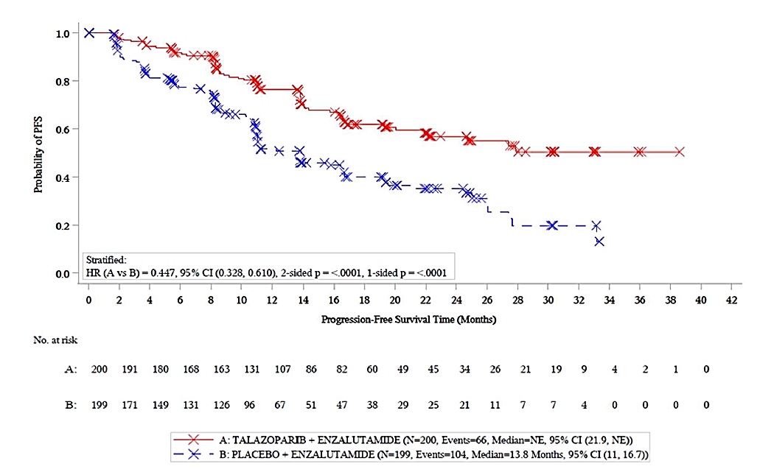 | 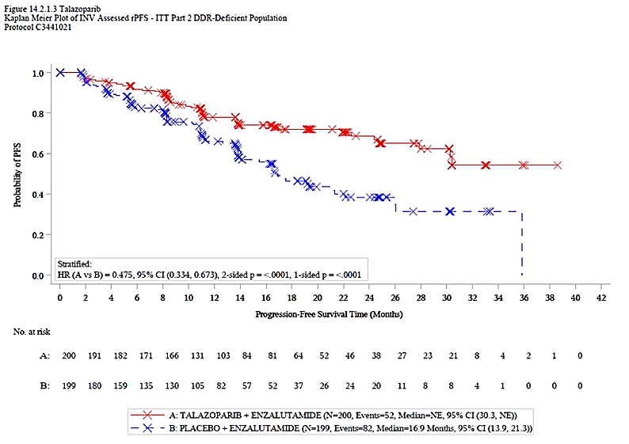
c. Cohort 2, BRCA1/2 subgroup (BICR-assessed) | d. Cohort 2, non-BRCA1/2 subgroup (BICR-assessed)
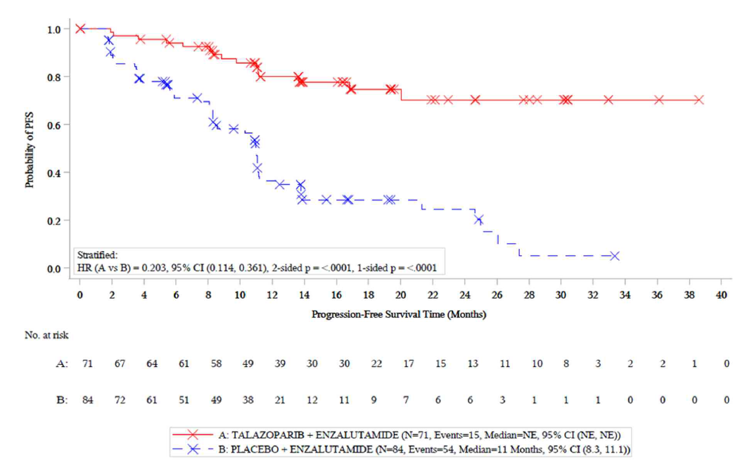 | 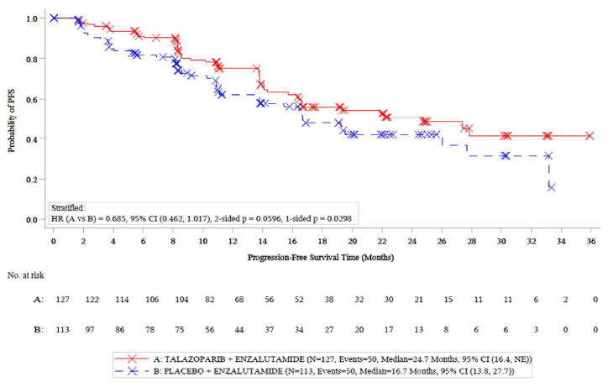
Source: Figure 2.5-1, p83 and Figure 2.6.1, p99 of the submission and Figure 4, p86 and Figure 17, p115 of the CSR, data cut-off 3OCT2022.
BRCA=Breast cancer gene; BICR= blinded independent central review; rPFS=radiographic progression-free survival
  - BICR rPFS was significantly longer in the talazoparib + enzalutamide arm compared to placebo + enzalutamide in Cohort 2 (median not able to be estimated (NE) versus 13.8 months). The size of the estimated benefit was larger in the BRCA1/2 subgroup (HR = 0.20; 95% CI: 0.11, 0.36) versus Cohort 2 (HR = 0.45; 95% CI: 0.33, 0.61).
  - The presented rPFS data was however immature with only 33% of patients in the talazoparib + enzalutamide arm having progressed at DCO 3 October 2022. The clinical trial protocol indicated that final rPFS and OS are to be reported in Analysis 4 which is event driven and planned for approximately July 2024.
  - Exploratory subgroup analyses of BICR-assessed rPFS in Cohort 2 including various covariates (i.e., age at randomisation, race, ECOG performance status, Gleason score, stage at diagnosis, type of progression, baseline PSA value, metastasis site and prior docetaxel or NHA treatment), demonstrated generally consistent treatment effect of talazoparib + enzalutamide versus enzalutamide monotherapy across these subgroups.
  - Figure 2 presents the KM plots of overall survival (OS) in the BRCA1/2 subgroup, its complement, and the overall Cohort 2 at DCOs 3 October 2022 and 28 March 2023.
Figure 2: Kaplan-Meier plot of OS in TALAPRO-2 Cohort 2 (DCOs 3 October 2022 and 28 March 2023)
a. Cohort 2, all HRR genes (3 October 2022) | b. Cohort 2, all HRR genes (28 March 2023)
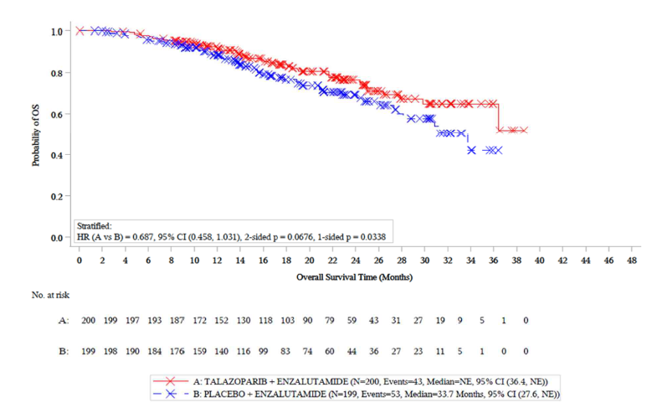 | 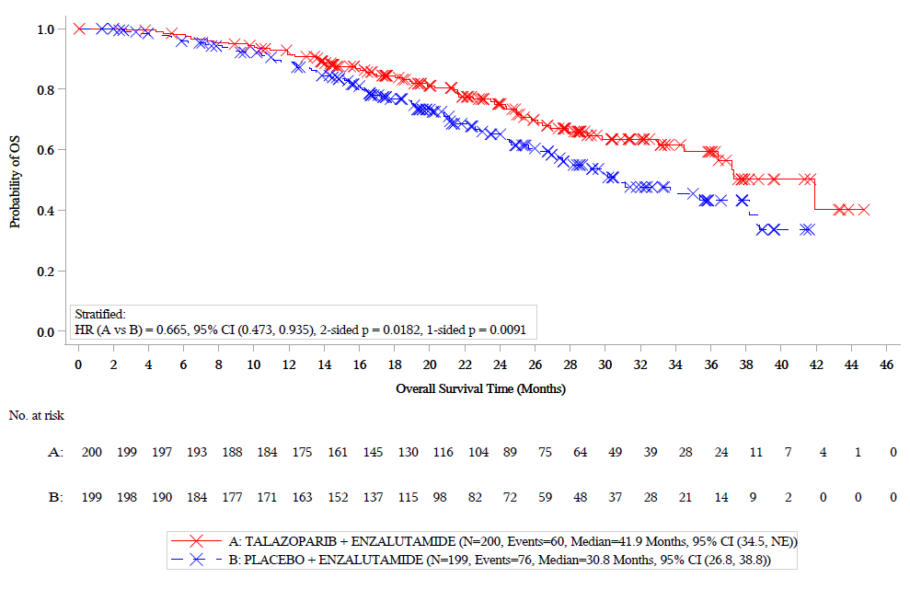
c. Cohort 2, BRCA1/2 subgroup (3 October 2022) | d. Cohort 2, BRCA1/2 subgroup (28 March 2023)
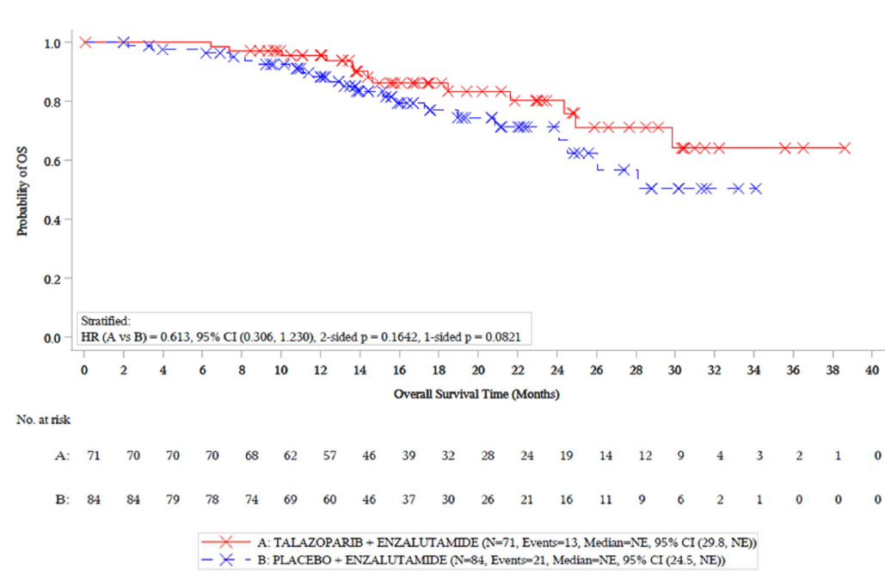 | 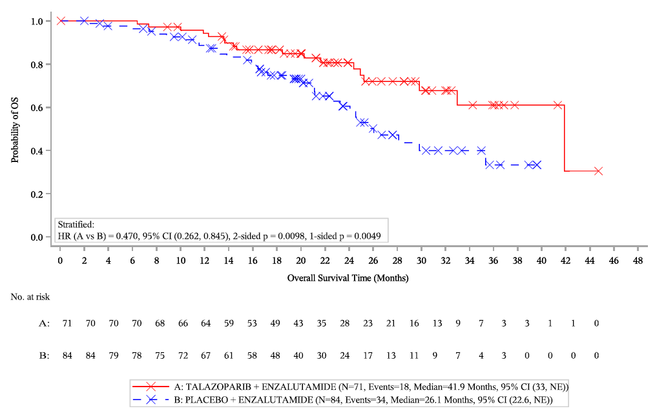
e. Cohort 2, non-BRCA1/2 subgroup (3 October 2022) | f. Cohort 2, non-BRCA1/2 subgroup (28 March 2023)
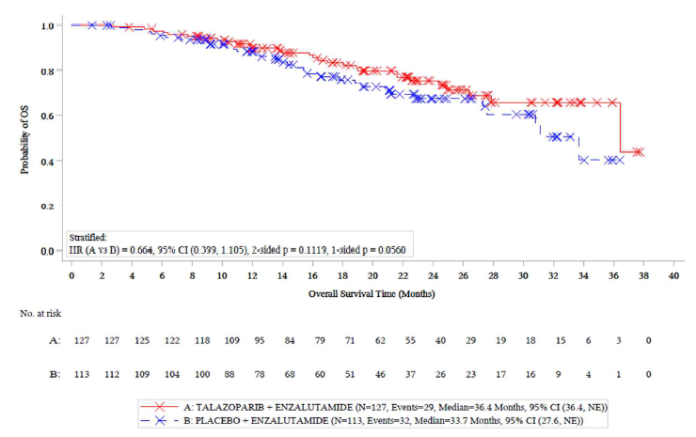 | 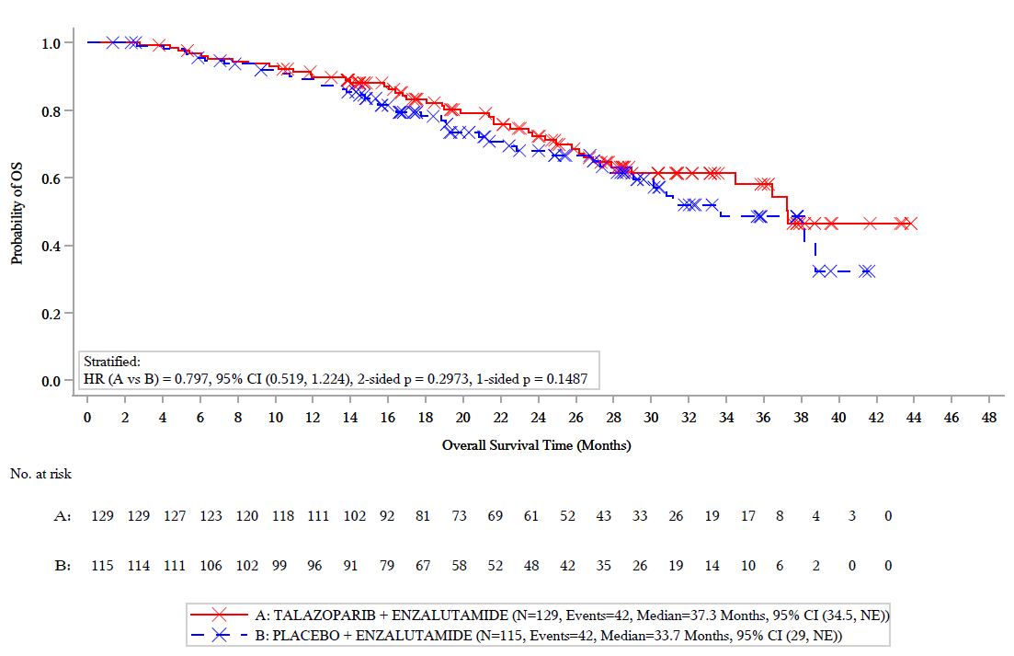
Source: Figure 2.5-2, p84 and Figure 2.6-2, p101 and Figure 2.6-3, p102 of the submission and Figure 14.2.2.4a, p15 of the ‘28MAR23 DATACUT_C344101 OS update DDR.pdf’ document received on 29/11/2023.
BRCA= Breast Cancer gene; CI=confidence interval; DCO=data cut off, HR=hazard ratio; NE=not estimated; OS=overall survival.
  - At DCO 3 October 2022, 96 deaths were observed in Cohort 2 (24% data maturity). Among these, 43 and 53 deaths occurred in the talazoparib + enzalutamide and the placebo + enzalutamide arms, respectively (HR = 0.69; 95% CI: 0.46, 1.03). In the BRCA1/2 subgroup, 34 deaths were observed, 13 in the talazoparib + enzalutamide arm and 21 in the placebo + enzalutamide arm (HR = 0.61; 95% CI: 0.306, 1.23).
  - At DCO 28 March 2023, 136 deaths were observed in Cohort 2 (34% data maturity), with 60 and 76 deaths in the talazoparib + enzalutamide and placebo + enzalutamide arms respectively. The estimated median OS was 41.9 months and 30.8 months respectively, statistically significantly in favour of the talazoparib + enzalutamide arm (HR = 0.66; 95% CI: 0.47, 0.93). The survival benefit was driven by benefits in the BRCA1/2 subgroup, with 52 deaths (33.5% data maturity), of which 18 occurred in the talazoparib + enzalutamide group and 34 occurred in the placebo + enzalutamide arm, indicating benefit for those treated with talazoparib + enzalutamide (HR = 0.47; 95% CI: 0.262, 0.845). The median OS in the BRCA1/2 subgroup was 41.9 months (95% CI: 33, NR) in the talazoparib + enzalutamide arm and 26.1 months (95% CI: 22.6, NR) in the placebo + enzalutamide arm with an estimated incremental benefit of 15.8 months. There were no significant differences in deaths across the two treatment arms for the non-BRCA subgroup at either DCO 3 October 2022 or DCO 28 March 2023.
  - With only 52 events observed out of a total 155 patients within the BRCA1/2 subgroup OS data was still immature. Given the small sample size, the subgroup analysis also appeared to lack the statistical power to confidently detect robust differences, thereby increasing the potential for spurious findings.
  - The submission also reported BICR-assessed objective response rates for patients with measurable disease at baseline, with favourable results observed in both the talazoparib + enzalutamide arm in Cohort 2 (RD = 27.1%; 95% CI: 11.1%, 43.2%) and in the BRCA1/2 subgroup (RD = 48.1%; 95% CI: 26.4%, 69.9%). The results for time to second progression also favoured talazoparib + enzalutamide versus placebo + enzalutamide in Cohort 2 (HR = 0.57; 95% CI: 0.39, 0.85) and the BRCA1/2 subgroup (HR = 0.43; 95% CI: 0.2, 0.8). No significant differences in objective response rate or time to second progression were observed for the non BRCA1/2 subgroup.
  - The submission presented a summary of key patient-reported outcomes in Cohort 2 of TALAPRO-2 (DCO 3 October 2022). Results showed that treatment with talazoparib + enzalutamide was associated with significantly longer time to definitive clinically meaningful deterioration for Global Health State (GHS)/QoL compared to placebo + enzalutamide (27.1 months versus 19.3 months, p=0.032), and time to definitive deterioration in urinary symptoms (not estimated versus 30.2 months, p=0.0216), reflecting improved disease control. These data were not presented for the BRCA1/2 subgroup.
  - The submission presented EQ-5D utility data for Cohort 2 and the BRCA1/2 subgroup estimated using the UK value set for DCO 3 October 2022 and 28 March 2023 (see Table 5).
Table 5: Marginal Mean Health State Utility Values-UK Value Set
 |  | Cohort 2, all HRR genes |  |  | Cohort 2, BRCA1/2 subgroup
DCO  Date | Health state | TAL+ENZ | PBO+ENZ | Overall | TAL+ENZ | PBO+ENZ | Overall
3 October 2022 | Pre-progression | 0.82  (0.81-0.84) | 0.80  (0.79-0.82) | 0.81  (0.80-0.83) | 0.82  (0.81-0.84) | 0.80  (0.78-0.81) | 0.81  (0.80-0.82)
3 October 2022 | Post-progression | 0.80  (0.77-0.83) | 0.75  (0.73-0.78) | 0.77  (0.76-0.79) | 0.82  (0.78-0.85) | 0.73  (0.70-0.75) | 0.76  (0.74-0.78)
28 March 2023 | Pre-progression | 0.82  (0.80-0.84) | 0.78  (0.77-0.81) | 0.80  (0.79-0.82) | 0.81  (0.78-0.84) | 0.78  (0.75-0.80) | 0.79  (0.77-0.81)
28 March 2023 | Post-progression | 0.83  (0.79-0.87) | 0.72  (0.69-0.75) | 0.76  (0.73-0.78) | 0.83  (0.76-0.89) | 0.69  (0.65-0.72) | 0.72  (0.69-0.75)
Bold: used in the economic evaluation
Source: Table 3.6-1, p162 and compiled during the evaluation from Table 7, p30, Table F2, pF-2, Table F3, pF3 and Table F-4, pF3 of Appendix 3-8 (RTI-HS _TP-2_Utility Analysis Cohort 1 Cohort 2 (UK US Can Aus Neth) 02October2023)
DCO=data cut-off, ENZ=enzalutamide; PBO=placebo; TAL=talazoparib
  - In the TALAPRO-2 trial, estimated treatment specific health state utilities were similar between the intervention and the comparator arm at both DCOs. Notably, data from Cohort 2 and the BRCA1/2 subgroup from both DCOs indicated that disease progression had either no effect or a positive impact in the treatment arm, while showing a negative association in the comparative arm. These were considered unreliable by the submission and alternate literature sourced post progression utilities were used in the economic evaluation. No statistical comparison was made between the comparative arms.
  - EQ-5D-5L to EQ-5D-3L mapping value set developed by the NICE Decision Support Unit (Hernandez-Alava 2017) was used rather than the specific EQ-5D-5L value set (Devlin et al. 2018). This may not be appropriate, given EuroQoL noted that mapping EQ-5D-5L to EQ-5D-3L places an artificial floor effect on the values of EQ-5D-5L, and EQ-5D-5L when valued directly might be lower than when compared to the EQ-5D-3L level system. Moreover, the Australian value set for the EQ-5D-5L was already published by the time the submission was prepared, and could have been used. Therefore, there was the potential for utility values in the submission to be higher than values reported if using the appropriate Australian value set for the EQ-5D-5L. Utilities estimated using the Australian value-set results were reported for Cohort 2 but not for the BRCA1/2 subgroup.

Comparative harms
  - Table 6 presents a summary of key AEs in Cohort 2 of the TALAPRO-2 trial.
Table 6: Summary of key adverse events in TALAPRO-2, Cohort 2 (DCO 3 October 2022)
AE category | TAL+ENZ n/N (%) | PBO+ENZ n/N (%)
Any TEAE | 196/198 (99.0) | 191/199 (96.0)
Serious TEAE | 60/198 (30.3) | 40/199 (20.1)
TEAE Grade 3 or 4, n (%) | 131/198 (66.2) | 74/199 (37.2)
Grade 5 TEAE | 3/198 (1.5) | 5/199 (2.5)
TEAE leading to discontinuation*, n (%) | 3/198 (1.5) | 5/199 (2.5)
Participants discontinued from ONLY TAL/PBO due to TEAE | 9/198 (4.5) | 1/199 (0.5)
Participants with dose reduction on ONLY TAL/PBO due to TEAE | 100/198 (50.5) | 8/199 (4.0)
Participants with dose interruption on ONLY TAL/PBO due to TEAE | 81/198 (40.9) | 13/199 (6.5)
Dose modifications due to AEs
Dose interruptions | 114 (57.6%) | 31 (15.6%)
Dose reductions | 103 (52.0%) | 12 (6.0%)
Discontinuations | 20 (10.1%) | 14 (7.0%)
Common (≥2%) treatment-emergent SAEs
With any adverse event | 23/198 (11.6) | 6/199 (3.0)
Anaemia | 17/198 (8.6) | 2/199 (1.0)
Urinary tract infection | 4/198 (2.0) | 3/199 (1.5)
Syncope | 4/198 (2.0) | 1/199 (0.5)
AEs of Grade ≥3
Anaemia | 81/198 (40.9%) | 9/199 (4.5%)
Neutropenia | 37/198 (18.7%) | 2/199 (1.0%)
Hypertension | 16/198 (8.1%) | 16/199 (8.0%)
Thrombocytopenia | 14/198 (7.1%) | 1/199 (0.5%)
Leukopenia | 11/198 (5.6%) | 0/199 (0.0%)
Lymphocytopenia | NR** (4.5%) | NR** (3.0%)
Asthenia or fatigue | 4/198 (2.0%) | 0/199 (1.0%)
Fall | 4/198 (2.0%) | 3/199 (1.5%)
Infection | 4/198 (2.0%) | 3/199 (1.5%)
Nausea | 3/198 (1.5%) | 1/199 (0.5%)
Back pain | 3/198 (1.5%) | 2/199 (1.0%)
Venous thromboembolic event | 3/198 (1.5%) | 2/199 (1.0%)
Source: Table 2.5-5, p90, Table 2.5-6, p91, Table 2.5-7, p92 and Table 3.6-1, p161 of the submission and Table 28, p141, Table 31, p146 and Table 14.3.1.2.7, p553 of the CSR. AE=adverse event; ENZ=enzalutamide; n=number of participants reporting events; N=total participants in group; NR=not reported; PBO=placebo; SAE=serious adverse event; TAL=talazoparib; TEAE=treatment-emergent adverse events.
* Participants who have an AE record that indicates that the AE caused the participants to be discontinued from the study.
** Number of patients with Lymphocytopenia was not found in the CSR.
  - The submission reported that the frequency of treatment-emergent adverse events (TEAEs) of any Grade was 99.0% in the talazoparib + enzalutamide arm and 96.0% in the placebo + enzalutamide arm. The frequency of Grade 3/4 TEAEs was 66.2% and 37.2% in the talazoparib + enzalutamide and the placebo + enzalutamide arms, respectively. Notably, anaemia Grade ≥3 occurred in 40.9% and 4.5% of patients in the intervention and the comparator arms, respectively. Anaemia was the most commonly reported treatment-related serious adverse event (SAE) in the talazoparib + enzalutamide arm, reported for 8.6% of patients. There were no reports of fatal anaemia.
  - In Cohort 2, 10.1% and 7.0% of patients in treatment and comparator arms experienced AEs leading to discontinuation of talazoparib or placebo, respectively. Overall, the most frequently reported AEs for talazoparib leading to a dose modification were haematologic AEs, including anaemia, neutropenia, leukopenia, lymphocytopenia, and thrombocytopenia. For enzalutamide, the primary AEs leading to dose modifications were anaemia and decreased neutrophil count. Anaemia was the most frequently reported adverse event leading to permanent discontinuation in both treatment arms. Data from Cohort 2 (all HRR genes) was used in the economic model. The submission indicated that Grade ≥ 3 adverse events from Cohort 2 with prevalence of ≥2% as well as back pain and venous thrombolytic event (as summarised in Table 6), were included in the economic evaluation.

Benefits/harms
  - A summary of the comparative benefits and harms for talazoparib + enzalutamide versus enzalutamide monotherapy is presented in Table 7.
Table 7: Summary of comparative benefits and harms for talazoparib + enzalutamide versus enzalutamide
Benefits – TALAPRO-2 BRCA1/2 subgroup |  |  | TAL+ENZ  N=71 | ENZ  N=84 |  | Absolute difference |  | HR (95% CI)
rPFS DCO 3 October 2022ª (BICR-assessed)
Event n/N (%) |  |  | 15/71 (21.1) | 54/84 (64.3) |  | - |  | 0.20  (0.11, 0.36)
Median months to rPFS (95% CI) |  |  | NE (NE, NE) | 11.0 (8.3, 11.1) |  | NE |  | 0.20  (0.11, 0.36)
% not progressed at 12 months ^ |  |  | 80% | 35% |  | 45% |  | 0.20  (0.11, 0.36)
% not progressed at 24 months ^ |  |  | 70% | 25% |  | 45% |  | 0.20  (0.11, 0.36)
OS DCO 28 March 2023ª
Died n (%) |  |  | 18/71 (25.4) | 34/84 (40.5) |  | - |  | 0.47  (0.26, 0.85)
Median months to death (95% CI) |  |  | 41.9 (33, NE) | 26.1 (22.6, NE) |  | 15.8 |  | 0.47  (0.26, 0.85)
% Alive at 12 months ^ |  |  | 95% | 90% |  | 5% |  | 0.47  (0.26, 0.85)
% Alive at 24 months ^ |  |  | 80% | 60% |  | 20% |  | 0.47  (0.26, 0.85)
% Alive at 36 months ^ |  |  | 60% | 30% |  | 30% |  | 0.47  (0.26, 0.85)
Harms – TALAPRO-2 Cohort 2
AEs (Grade≥3, prevalence≥2%, RD≥0.02) | TAL+ENZ  N=198 | ENZ  N=199 | RR  (95% CI) * |  | Events/100 patients |  |  | RD  (95% CI) *
 |  |  |  |  | TAL+ENZ |  | ENZ | RD  (95% CI) *
TEAE Grade 3 or 4, n/N (%) | 131/198 (66.2) | 74/199 (37.2) | 1.78 (1.44, 2.19) |  | 66 |  | 37 | 0.29 (0.20, 0.38)
Anaemia | 81/198 (40.9) | 9/199 (4.5) | 9.04 (4.65, 17.41) |  | 41 |  | 4.5 | 0.36 (0.29, 0.44)
Neutrophil count decreased | 37/198 (18.7) | 2/199 (1.0) | 18.59 (4.54, 76.10) |  | 19 |  | 1 | 0.18 (0.12, 0.23)
Platelet count decreased | 14/198 (7.1) | 1/199 (0.5) | 14.07  (1.87, 105.98) |  | 7 |  | 0.5 | 0.06 (0.29, 0.10)
WBC decreased | 11/198 (5.6) | 0/199 (0) | 23.12  (1.37, 389.60) |  | 5.5 |  | 0 | 0.06 (0.02, 0.09)
Asthenia or fatigue | 4/198 (2.0) | 0/199 (1.0) | 9.04  (0.49, 166.90) |  | 2 |  | 0 | 0.02 (-0.01, 0.04)
Source: compiled during the evaluation, RR, RD and confidence intervals generated using RevMan.5.4.1.
BRCA=breast cancer gene, BICR=blinded independent central review; CI=confidence interval; DCO=data cut-off; ENZ=enzalutamide; HR=hazard ratio; RD=risk difference; TAL=talazoparib; TEAE=treatment-emergent adverse event, WBC=white blood cell count
^ Estimated from KM curves presented in the submission.
* Calculated during evaluation
ª Median follow-up period was reported to be 17 and 26 months in Cohort 2 as of DCO 3 October 2022 and 28 March 2023, respectively (Table 3.9-1, p175 of the submission). This was not reported for the BRCA1/2 subgroup.
  - On the basis of direct evidence for the BRCA1/2 subgroup from Cohort 2 of the TALAPRO- 2 trial, for every 100 patients treated with talazoparib + enzalutamide in comparison with enzalutamide:
- Approximately 45 additional patients at 12 months and 24 months will remain progression free.
- Approximately 5, 20, and 30 additional patients will remain alive after 12, 24 and 36 months, respectively.
- Approximately 29 additional patients would experience Grade 3/4 TEAEs, and 36, 18, 6, 6 and 2 additional patients would experience Grade ≥3 anaemia, neutrophil, platelet and white blood cell decreases and asthenia, respectively up to a maximum treatment duration of 39 months.

Summary of matching-adjusted indirect comparisons
  - The submission also presented two unanchored matching-adjusted indirect comparisons (MAICs) to evaluate the relative efficacy of talazoparib + enzalutamide compared to olaparib + abiraterone and abiraterone alone. The MAICs used individual patient-level data from TALAPRO-2 and published summary-level data from PROpel and COU-AA-302, respectively. In the MAIC approach, indirect treatment comparisons of efficacy outcomes (i.e., rPFS, OS, progression-free survival on next line of therapy (PFS2), ORR, PSA response, time to PSA progression, and time to cytotoxic chemotherapy) were performed by “matching” and “adjusting” patients from TALAPRO-2 to match the marginal distribution of covariates in patients who received the comparator intervention.
  - A number of important prognostic factors including time to mCRPC from continuous androgen deviation therapy (ADT), BRCA status and presence of liver metastases (for MAIC versus abiraterone) were not able to be adjusted in the analyses. The data from PROpel was also based on only 38 subjects with BRCA1/2, thus any indirect comparison relying on this data are likely to be highly unreliable.
  - BRCA1/2 status was not ranked as a key prognostic factor in the adjusting step, and was only analysed on an exploratory basis. Given the varied distribution of this subgroup across trials, it could be identified as a potential confounder. Exploratory analyses adjusting for BRCA1/2 pathogenic variants were claimed to yield consistent results with the primary analysis (see Table 8).
Table 8. Summary of efficacy results between TALAPRO-2 and comparator trials, from the MAIC
Outcome |  | TAL+ ENZ vs OLA+ABI  TALAPRO-2 vs PROpel | TAL+ENZ vs abiraterone  TALAPRO-2 vs COU-AA-302
rPFS (BICR) | HR (95% CI) | 0.73 (0.56, 0.93) | 0.26 (0.18, 0.36) ª
OS | HR (95% CI) | 0.85 (0.67, 1.08) | 0.56 (0.40, 0.77)
PFS2 | HR (95% CI) | 1.14 (0.85, 1.54) | NE
Time to cytotoxic chemotherapy | HR (95% CI) | NE | 0.29 (0.19, 0.43)
Time to PSA Progression | HR (95% CI) | NE ^{b} | 0.41 (0.31, 0.56)
PSA Response | OR (95% CI) | 1.66 (1.10, 2.51) | 3.27 (1.74, 6.14)
ORR | OR (95% CI) | 1.11 (0.65, 1.90) | 3.92 (2.02, 7.63)
Bold: Shows statistically significant results.
Source: Table 2.5.1, p9 of Appendix 2.1 of the submission.
ABI=abiraterone; BICR=blinded independent central review; CI=confidence interval; ENZ=enzalutamide; HR=hazard ratio; OLA=olaparib; OR=odds ratio; ORR=objective response rate; OS=overall survival; PFS2=progression-free survival on next line of therapy; NE=not estimable; PSA=prostate-specific antigen; rPFS=radiographic progression-free survival; TAL=talazoparib.
Note: An HR below 1.0 and an OR above 1.0 indicates an improved outcome for talazoparib + enzalutamide relative to comparator treatment.
ª Only rPFS by investigator review was reported in COU-AA-302.The analysis compared rPFS by investigator review in TALAPRO-2 with rPFS by investigator review in COU-AA-302.
^{b} Kaplan–Meier curve required to perform MAIC analysis was not reported for time to PSA progression in the PROpel trial.
  - Overall, the submission’s MAIC comparing TALAPRO-2 versus COU-AA-302 showed superiority of talazoparib + enzalutamide compared to abiraterone for efficacy outcomes. This was consistent with the results of TALAPRO-2 versus enzalutamide. The PBAC had previously accepted non-inferiority of abiraterone and enzalutamide for treatment of mCRPC.
  - The results of the submission’s MAIC comparing TALAPRO-2 versus PROpel suggested superiority of talazoparib + enzalutamide versus olaparib + abiraterone for rPFS and PSA response but not for OS. However as discussed given small numbers of patients with BRCA1/2 in PROpel, this analysis was considered highly uncertain and not robust for decision making.
  - Safety outcomes were not compared in the MAICs. A systematic review and meta-analysis of PARP inhibitor trials (including TALAPRO-2 and PROpel) by Sayyid et al. 2023 noted that addition of PARP inhibitors to first line NHA treatments was associated with a 45% relative risk increase in Grade ≥3 TEAEs, including a 6.22-fold increase for Grade ≥3 anaemia (31.9% versus 4.9%). The authors concluded that the additional toxicity raised concerns as to whether routine first-line addition of PARP inhibitors for mCRPC patients should be considered standard of care therapy, even in patients with homologous recombination repair gene pathogenic variants, in the absence of a clear OS benefit.

Clinical claim
  - The submission described talazoparib + enzalutamide as superior in terms of effectiveness and inferior in terms of safety when compared to enzalutamide alone in patients with a BRCA1/2 pathogenic variant.
  - The ESC considered that the claim of superior efficacy was supported by evidence presented; however, the magnitude of effect was uncertain. For rPFS and OS, the submission relied on data from the BRCA1/2 subgroup of Cohort 2 and while this was an appropriate population, the evidence was from a small subgroup and so was not subject to the same hypothesis testing as the overall trial. Furthermore, the trial data were immature, thus the chance of spurious findings could not be wholly excluded.
  - In addition, the ESC noted that the benefit of first line talazoparib + enzalutamide compared to sequential NHA followed by PARP inhibition (olaparib currently approved in this setting) in the mCRPC setting was unknown as no evidence was presented for this comparison. The ESC noted that a small number of patients in the enzalutamide monotherapy arm of the BRCA1/2 subgroup (n=17/84, 20.2% or 17/49, 34.7% of patients who progressed and received another therapy) received subsequent PARP inhibition, but that efficacy data were not presented for this group of patients. The ESC noted that the applicability of the trial results in the enzalutamide monotherapy arm to Australian clinical practice was potentially limited as it would be expected that more than 20% of patients would receive subsequent olaparib in clinical practice.
  - The PBAC considered that the claim of superior comparative effectiveness was reasonable, but that the magnitude of the benefit was uncertain.
  - The PBAC agreed with ESC in considering that the claim of inferior safety, which was based on data from the entire Cohort 2 of TALAPRO-2 as a proxy for patients with a BRCA1/2 pathogenic variant, was reasonable.

Economic analysis
  - The submission presented a modelled economic evaluation based on the TALAPRO-2 trial. The modelled economic evaluation was a cost-utility analysis using a partitioned survival model with three health states: progression free (PF), progressed disease (PD), and death. PD health state was split by time spent receiving second-line treatment (PDa) and time spent receiving palliative care (PDb), by approximating a survival curve for second-line time-to-treatment discontinuation that fell between the rPFS and OS survival curves. The proportion of time in PDa was calculated as the weighted average duration of second-line treatments (estimated based on the literature and assumptions) divided by the estimated median time in PD in the model, the remainder time in PD was then assumed to be spent in PDb. The estimated proportional splits in time between PDa and PDb were 70:30 for the talazoparib + enzalutamide arm and 41:59 for the enzalutamide monotherapy arms. The ESC noted that previous models presented to the PBAC in the prostate cancer setting did not differentiate PD into sub-states with different utilities and costs, but agreed that ‘progressed disease’ in practice is a heterogeneous state consisting of multiple lines of treatment and disease progressions. The model structure is shown in Figure 3.
Figure 3: Structure of the economic model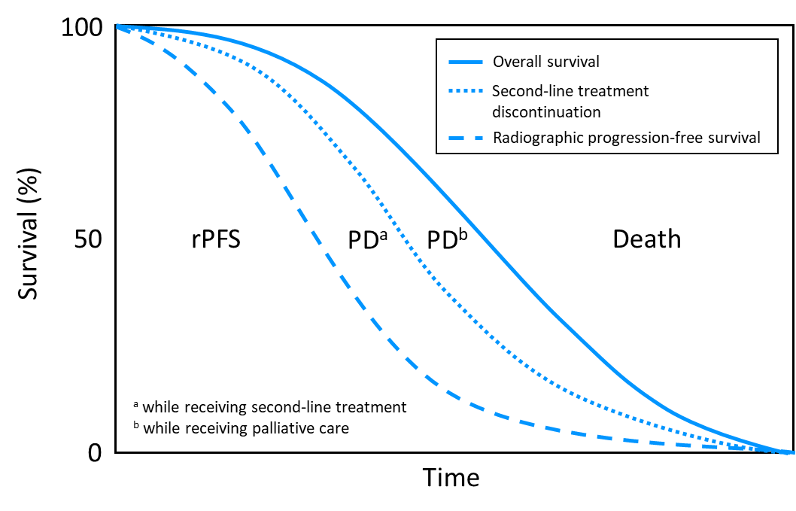
Source: Figure 3.2-1, p 134 of the submission
  - Table 9 provides a summary of the model components.
Table 9: Summary of model structure, key inputs and rationale
Component | Summary
Treatments | TAL+ ENZ vs ENZ monotherapy
Time horizon | 10 years in the model base case vs. trial-reported 41 and 28.1 months (median OS follow-up in BRCA1/2 subgroup) in the intervention and comparison arms, respectively. The time horizon was reduced to 7.5 years in the pre-PBAC response.
Outcomes | Life-years gained; quality-adjusted life years gained.
Methods used to generate results | Partitioned survival model.
Health states | - PF  - PD (proportional time in PDa and PDb: 70:30 for TAL+ENZ arm and 41:59 PBO+ENZ arm),  - Death.
Cycle length | Monthly.
Transition probabilities or  Allocation to health states | Health state allocation was determined by rPFS and OS curves from the BRCA1/2 subgroup of Cohort 2 in the TALAPRO-2 trial.
Extrapolation method | Parametric models independently fitted to each treatment arm based on statistical (AIC and BIC), visual fit and clinical plausibility. Censoring rules applied to prohibit rPFS and OS curves crossing. KM data was applied from time zero to median follow-up, with extrapolation based on the full K-M data applied from that time point. rPFS and OS effects were assumed to be lost gradually over 36 months.  - OS: modelled by treatment arm (stratified) with Gamma distribution, KM data extrapolated from 26 months,  - rPFS: modelled by treatment arm (stratified) with Weibull distribution, extrapolated from 17 months, and  - TTD: Log-normal distribution for TAL, and modelled with treatment as a covariate, with log-logistic distribution for ENZ (both when used as monotherapy and when used in combination with TAL), extrapolated from 17 months. In the pre-PBAC response, the TTD for the enzalutamide component of the combination therapy was assumed to equal rPFS.
Health related quality of life | PF, TAL+ENZ arm = 0.811 (BRCA1/2 subgroup of Cohort 2 in TALAPRO-2)  PF, ENZ arm = 0.777 (BRCA1/2 subgroup of Cohort 2 in TALAPRO-2)  In the pre-PBAC response, the overall utility value of 0.793 was applied to the pre-progression health state, rather than treatment specific values.  PDa (on 2L treatment) = 0.635 (Sullivan et al. 2007 cohort study)  PDb (on palliative care) = 0.560 (Sullivan et al. 2007 cohort study)
Source: Compiled during the evaluation.
2L=second line; AIC=Akaike information criterion, BIC=Bayesian information criterion, ENZ=enzalutamide; KM=Kaplan-Meier; OS=overall survival, PD=progressive disease, PF=progression free, rPFS=radiographic progression-free survival, TAL=talazoparib; TTD=time to treatment discontinuation.
  - The submission nominated a time horizon of 10 years in the base case (7.5 and 15 years in sensitivity analyses). The submission argued that this was selected to capture the costs and consequences of treating the proposed population in the context of the first line treatment of metastatic disease in a cohort entering the model at a median age of 69.8 years. The chosen 10-year time horizon was not entirely consistent with previous PBAC recommendations for advanced prostate cancer. The PBAC had previously recommended a 5-year time horizon for olaparib in the second line BRCA1/2-positive mCRPC (para 6.83, olaparib, PSD, November 2021), and a 10-year time horizon for darolutamide in nmCRPC (para 5.9, darolutamide, PSD, July 2021). As the requested therapy for talazoparib + enzalutamide is for the first line mCRPC, the ESC considered that a time horizon of 7.5 years would be reasonable, considering the poorer prognosis of patients with BRCA1/2 pathogenic variants.
  - Figure 4 presents how the incremental cost effectiveness ratio (ICER) increases as the time horizon was reduced from 10 years in the base case, to 7.5 and 5 years.
Figure 4: ICER changes over modelled time horizon (years)
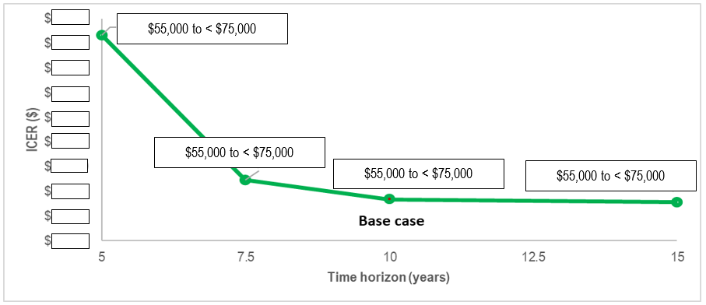
Source: Compiled during the evaluation
ICER=incremental cost-effectiveness ratio
  - Outcomes in the model were based on BRCA1/2 subgroup of Cohort 2 in TALAPRO-2; however, safety outcomes were sourced from Cohort 2. The model was also informed by data from two DCOs, 3 October 2022 and 28 March 2023, but these were used inconsistently in the model, i.e., rPFS, TTD and safety data were informed by data from DCO 3 October 2022, while OS and utility values were obtained from DCO 28 March 2023.
  - Kaplan-Meier data from TALAPRO-2 are presented in Figure 5.
Figure 5: Kaplan-Meier data used in the economic evaluation (BRCA1/2 subgroup of TALAPRO-2 trial)
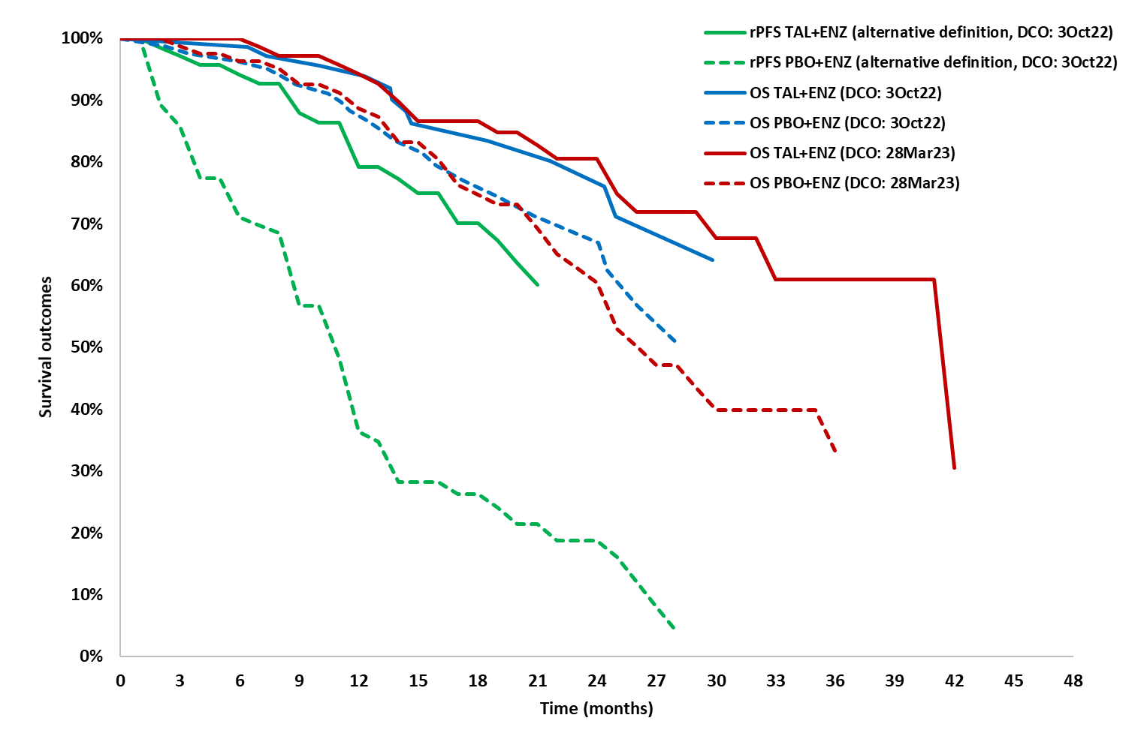
Source: Compiled during the evaluation
ENZ=enzalutamide; DCO=data cut-off; KM=Kaplan-Meier; OS=overall survival; PBO=placebo; rPFS=radiographic progression free survival; TAL=talazoparib
  - The submission indicated that TTD was derived from patient-level data from the BRCA1/2 subgroup of TALAPRO-2. Treatment exposure in the BRCA1/2 subgroup was not presented in the submission and was not able to be independently verified.
Figure 6: A comparison between TTD and rPFS curves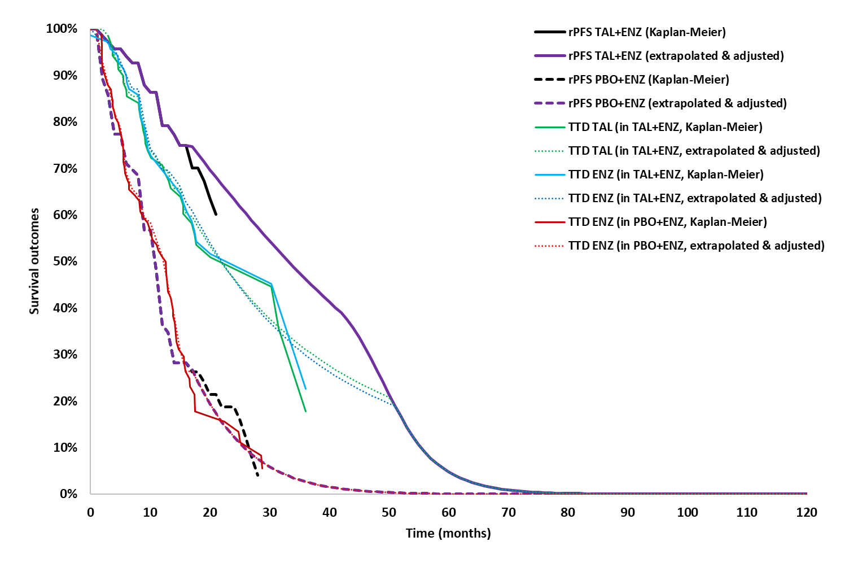
Source: Compiled during the evaluation
ENZ=enzalutamide; DCO=data cut-off; KM=Kaplan-Meier; OS=overall survival; PBO=placebo; rPFS=radiographic progression free survival; TAL=talazoparib; TTD=time to treatment discontinuation
  - Based on the submission’s extrapolated TTD curve for the talazoparib + enzalutamide arm, a significant gap was evident between the TTD and rPFS curves until 50 months when the curves converged (modelled median rPFS=33 months and modelled median TTD=22 months). This meant treatment discontinuation was approximately 1 year prior to progression. Therefore, the model likely underestimated treatment duration and costs for talazoparib + enzalutamide in the rPFS health state. A similar gap was not observed for the enzalutamide arm. The PSCR stated that the TTD curve for the talazoparib + enzalutamide arm lagged behind the rPFS curve because, although many patients dose reduced or discontinued talazoparib (but not enzalutamide), they continued to receive a benefit from treatment.
  - The model was sensitive to assumptions around TTD with a sensitivity analysis conducted during the evaluation using rPFS data as proxy for TTD increasing the ICER by | |% to $75,000 to < $95,000, from a base case of $55,000 to < $75,000 per QALY gained.
  - For the enzalutamide monotherapy arm, the TTD Kaplan-Meier curve exceeded the rPFS Kaplan-Meier curve in the first 5 months and then again between 10 and 15 months. This suggested that some patients in the enzalutamide arm of TALAPRO-2 continued treatment after experiencing disease progression, which did not reflect the trial protocol nor the proposed restriction, in which patients are to cease treatment upon disease progression.
  - The modelled median duration of treatment in the enzalutamide arm was 12 months. While this was aligned with the mean NHA treatment duration on a recent DUSC analysis in April 2022 indicating the average PBS treatment durations for abiraterone and enzalutamide were 9 and 12 months, respectively, or 11.8 months combined (assuming zero treatment breaks), the DUSC estimates were not specific to a BRCA1/2 population (paragraph 6.26, apalutamide PSD, July 2022).
  - The model extrapolated the rPFS and OS Kaplan-Meier curves in the BRCA1/2 subgroup from the median follow-ups of 17 and 26 months, respectively, using independently fitted parametric extrapolations which were based on the full Kaplan-Meier data. The submission claimed that testing of the proportional hazards (PH) assumption for both rPFS and OS showed that the PH assumption cannot be rejected (p-value=0.912 in rPFS and p-value=0.736 in OS). Both stratified and unstratified models were considered.
  - For rPFS, the submission explained that as the first interim OS analysis (DCO 3 October 2022) showed that the Kaplan-Meier curves for OS and rPFS crossed towards the end of the trial follow-up, resulting from the application of censoring rules, an alternative rPFS definition was adopted by the submission. This incorporated the progression or death event into the rPFS endpoint for patients previously censored. The submission was not completely clear about the new definition; however, using the primary definition in the sensitivity analysis had minimal impact on the ICER (-| |% change).
  - rPFS extrapolations modelled by treatment arm (stratified) using the alternate rPFS definition are presented in Figure 7.
Figure 7: Extrapolations of rPFS (alternative definition, DCO: 3 October 2022)
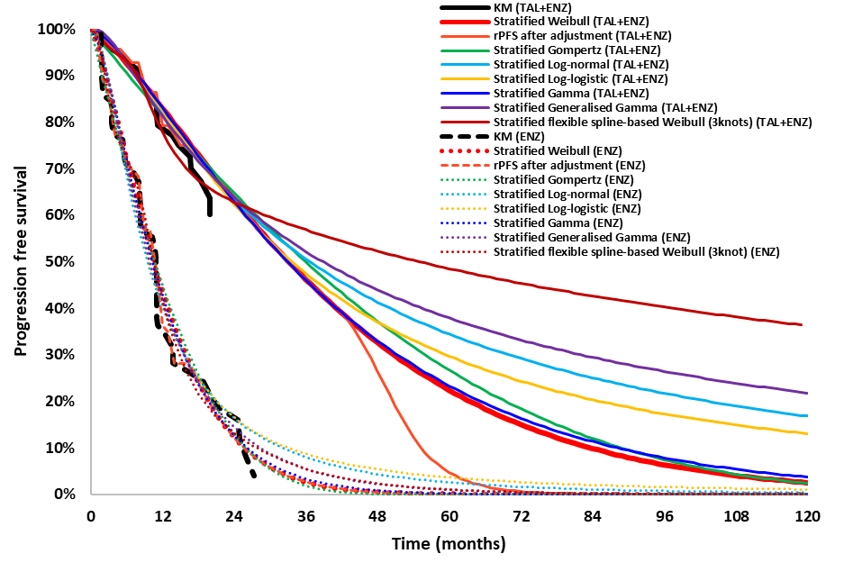
Source: Compiled during the evaluation
ENZ=enzalutamide; DCO=data cut-off; KM=Kaplan-Meier, rPFS=radiographic progression free survival; TAL=talazoparib
  - For rPFS, the submission selected the Weibull function based on clinical plausibility (despite it not having the best visual fit or AIC/BIC statistics). While the Weibull function showed good visual fit in the enzalutamide arm it was not a good fit beyond approximately 12 months (up to 20 months of Kaplan-Meier data) in the talazoparib + enzalutamide arm. However, a gap between the rPFS Kaplan-Meier and the extrapolation curves was evident for many of the extrapolation functions (except the flexible spline-based Weibull, 3 knots). The observed discrepancy may be attributed to the immaturity of the rPFS data, with the number of events falling short of the target number of events in the protocol and the median not being reached.
  - OS extrapolations modelled by treatment arm (stratified) are presented in Figure 8.
Figure 8: Extrapolations of OS (DCO: 28 March 2023)
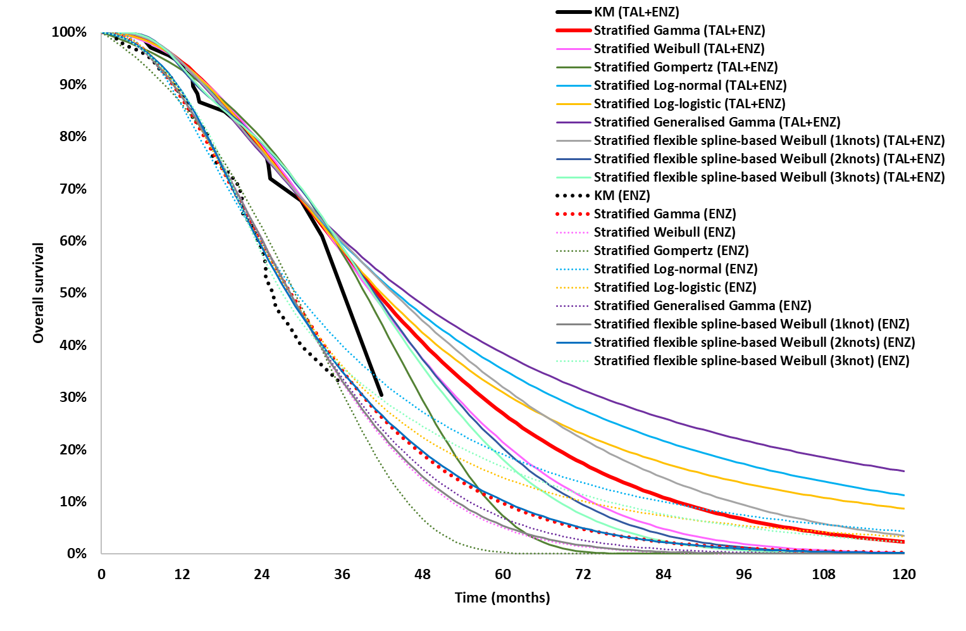
Source: compiled during the evaluation
ENZ=enzalutamide; DCO=data cut-off; KM=Kaplan-Meier; OS=overall survival; TAL=talazoparib
  - For OS, the submission selected the Gamma distribution (based on goodness of visual fit and the lowest AIC/BIC values). A separation was evident between all extrapolated OS curves and the Kaplan-Meier data for the talazoparib + enzalutamide arm with an increasing gap from month 33 onwards. A sensitivity analysis conducted during the evaluation using stratified modelling and the Gompertz function resulted in a | |% increase in the ICER ($75,000 to < $95,000, as compared to the base case of $55,000 to < $75,000 per QALY gained). It should be noted that the gaps between the OS and rPFS Kaplan-Meier and extrapolated curves were less apparent when the less mature data from DCO 03 October 2022 were used. This disparity may be due to the comparatively immature OS data in the talazoparib + enzalutamide arm.
  - The submission assumed that rPFS and OS effects would gradually diminish over 36 months. This assumption lacked justification as it wasn't grounded in trial-reported or published data. However, eliminating the efficacy tapering assumption and having the treatment effects dissipate immediately at the end of the trial follow-up had a less than 1% effect on the ICER.
  - Health state treatment-specific utility values were derived from EQ-5D-5L data collected from the BRCA1/2 subgroup in TALAPRO-2. The analysis was conducted using data from DCO 28 Mar 2023, using the UK value set. Specifically, the EQ-5D-5L to EQ-5D-3L mapping value set developed by the NICE Decision Support Unit (Hernandez-Alava 2017) was used even though an Australian value set for the EQ-5D- 5L was published at the time the submission was prepared. The PSCR stated that the UK value set was used to derive the utility values for the progression free health state to align with the literature-based estimates used post progression. Health state utility values for the BRCA1/2 subgroup are shown in Table 10.
Table 10: Health State Utility Values -BRCA1/2 subgroup
 | Mean (SE) | 95% CI | Reference
Progression free (Trial-based, EQ-5D)
Overall sample | 0.793 (0.010) | 0.773-0.812 | UK Value Set  DCO 28 March 2023
TAL + ENZ | 0.811 (0.014) | 0.783-0.839 | UK Value Set  DCO 28 March 2023
PBO + ENZ | 0.777 (0.013) | 0.751-0.803 | UK Value Set  DCO 28 March 2023
Progressed disease (Cohort study, EQ-5D)
PDa (2-L treatment) | 0.635 | NR | Sullivan et al. 2007
PDb (palliative care) | 0.560 | NR | Sullivan et al. 2007
Bold: used in the base case.
Source: Table 3.6-1, p162 and Excel worksheet ‘Utility Wight Inputs’ in the Cost Effectiveness Model.
2L=second line; DCO=data cut-off date, ENZ=enzalutamide; NR=not reported; PBO=placebo; PD=progressed disease; TAL=talazoparib
  - In the progression free health state, the submission presented treatment-specific utility values as well as an overall utility value pooled across the two treatment arms. Treatment specific utility values were used in the base case (0.811 and 0.777 in the talazoparib + enzalutamide and enzalutamide monotherapy arms, respectively). The ESC considered that use of treatment specific utilities in the progression free health state was not appropriate, particularly as talazoparib + enzalutamide reported higher incidence of adverse events. Sensitivity analysis conducted during the evaluation demonstrated that the model was sensitive to changes in utility values. Changing the utility values from ‘treatment-specific’ to ‘overall’ and incorporating AE disutilities increased the ICER by | |% to $55,000 to < $75,000 per QALY gained from a base case of $55,000 to < $75,000 per QALY gained. In general, the progression free health state utilities provided in the submission were higher than utility values used in previous prostate cancer economic evaluations presented to the PBAC, including submissions in earlier stages of disease. For example, the assumed utility value for the progression free health state in the apalutamide submission for mHSPC was 0.79 .
  - In the progressed disease health state, the submission explained that due to limited data from TALAPRO-2 to inform utility values, estimates were obtained from previous PBAC submissions in prostate cancer and the literature. This approach was considered appropriate, given that there were concerns with the accuracy of trial-reported post-progression utility values, which were higher than the progression free health state utility weights in the intervention arm. Progressed disease utility values were based on the darolutamide submission for nmCRPC, with the utility reported for the post-discontinuation health state (i.e. mCRPC) being applied (value=0.635, paragraph 6.43, darolutamide PSD, March 2021). This value was derived from an observational study of 280 patients with mCRPC, showing a baseline EQ-5D value of 0.635, with subsequent deterioration to 0.560 at 3, 6, and 9 months (Sullivan 2007). The submission used the value of 0.635 in PDa for patients receiving 2nd line treatment, and 0.560 in PDb for patients in palliative care. The submission argued the application of 0.635 for progressed mCRPC patients was reasonable because Sullivan 2007 more likely reflected a contemporary second line cohort given the study predated the availability of novel hormonal agents and the cohort described was likely treated with cytotoxic chemotherapy with poorer prognosis. Overall, the submission's approach was generally reasonable. Lower utility in PDb appeared plausible acknowledging the impact of declining quality of life as patients close to the end of life. A sensitivity analysis conducted during the evaluation showed that having a constant utility value of 0.635 for both PDa and PDb marginally increased the ICER by | |% to $55,000 to < $75,000 from a base case of $55,000 to < $75,000 per QALY gained.
  - Costs applied in the model were reasonably estimated. The proposed effective ex-manufacturer price (EMP) of talazoparib was $| |. For enzalutamide, an estimated effective EMP of $| | (28-day pack) was used.
  - Model traces presented in Figure 9 demonstrate that differences between the two treatment arms were primarily due to extrapolated differences in progression-free survival, with greater numbers of patients treated with talazoparib + enzalutamide in progression free health state compared to enzalutamide monotherapy. Given the importance of the rPFS to the modelled results, a main source of uncertainty in the model was the immaturity of observed rPFS from TALAPRO-2 Cohort 2, BRCA1/2 subgroup, with median rPFS not reached and only 33% of patients having progressed at DCO 3 October 2022 in the talazoparib + enzalutamide arm.
Figure 9: Survival traces for talazoparib + enzalutamide and enzalutamide monotherapy arms of the model Source: ‘Deterministic Results Graphical’ worksheet in the Excel workbook ‘Talazoparib (TALZENNA)_mCRPC_CEM_01NOV2023
ENZ=enzalutamide, TAL=talazoparib
  - Key drivers of the model are described in Table 11.
Table 11: Key drivers of the model
Description | Method/Value | Impact
rPFS benefit | The submission extrapolated rPFS KM data from the BRCA1/2 subgroup. Since the median time to rPFS in the talazoparib + enzalutamide arm of the BRCA1/2 subgroup in TALAPRO-2 was not reached, the extrapolation carried a high level of uncertainty. This uncertainty was visually evident in the rPFS KM and extrapolation curves, where the extrapolated TAL+ENZ curves deviated from the KM curve from approximately 15 months. This uncertainty was difficult to test in the model given the lack of data. | High, favours TAL+ENZ
Time on treatment | TTD estimates were very uncertain due to 1) unclear source, 2) unexplained gap between TTD and rPFS in the TAL+ENZ arm, and 3) TTD that exceeded rPFS in the ENZ arm. The ICER increased to $|||¹ per QALY gained from a base case of $|||² when treatment duration was assumed to follow rPFS. | High, favours TAL+ENZ
Time horizon | The submission used a 10-year time horizon. However, given the poor prognosis in this patient population, the immaturity of OS data from TALAPRO-2 (approx. 33.5% mature at 28 March 2023 data-cut), and previous PBAC recommendations, a shorter time-horizon may have been more appropriate. Reducing the time horizon to 5 years increased the ICER by |||% to $|||² per QALY gained. | Moderate to high, favours TAL+ENZ
Subsequent treatment use | The submission assumed that 71.3% of patients receiving enzalutamide monotherapy would receive subsequent therapy. All of these patients were assumed to receive olaparib monotherapy as subsequent treatment. This scenario was inconsistent with trial data and may not be fully reflective of Australian practice. Some patients may choose to have alternate treatments and some may not be fit enough to receive treatment in second line. Decreasing use of 2nd line olaparib to 80% (and assuming DTX 14% and 6% CBZ) increased the ICER to $|||² per QALY gained. | Moderate to high, favours TAL+ENZ
Utilities | Treatment-specific utility values were derived from EQ-5D-5L data in Cohort 2 and mapped to EQ-5D-3L, instead of using the EQ-5D-5L Australian value set. Overall, these values were likely overestimated. | Moderate, favours TAL+ENZ
Source: compiled during the evaluation
CBZ=cabazitaxel; DTX=docetaxel; ENZ=enzalutamide; KM=Kaplan-Meier; OS=overall survival; rPFS=radiographic progression-free survival; PH=proportional hazard, TAL=talazoparib; TTD=time to treatment discontinuation.
The redacted values correspond to the following ranges:
¹ $75,000 to < $95,000
² $55,000 to < $75,000
  - The results of the stepped analysis are presented in Table 12. The estimated base case ICER for the proposed scenario (talazoparib + enzalutamide) versus current scenario (enzalutamide monotherapy) was $55,000 to < $75,000 per QALY gained.
Table 12: Results of the stepped economic evaluation
Step and component | Talazoparib + enzalutamide |  | Enzalutamide monotherapy | Increment
Step 1: Trial based to median follow up for OS (26 months)
Costs | $| | $| |  | $|
LYs | 1.97 | 1.80 |  | 0.17
Incremental cost/extra LY gained |  |  |  | $|¹
Step 2: Extrapolation of rPFS, OS and TTD to horizon
Costs | $| | $| |  | $|
LYs | 3.65 | 2.71 |  | 0.95
Incremental cost/extra LY gained |  |  |  | $|²
Step 3: Transformation of LYs to QALYs
Costs | $| | $| |  | $|
QALYs | 2.78 | 1.79 |  | 0.98
Incremental cost/QALY gained |  |  |  | $|²
Step 4: Discounting costs and QALYs at 5%
Costs (all costs, discounted) | $| |  | $| | $|
QALY | 2.50 |  | 1.65 | 0.85
Incremental discounted cost/extra QALY gained |  |  |  | $|²
Source: Table 3.9-3, p176 of the submission
ENZ=enzalutamide, LY=life year, OS=overall survival, QALY=quality adjusted life year, rPFS=radiographic progression-free survival, TAL=talazoparib, TTD=time to treatment discontinuation.
Note: the numbers have been rounded.
The redacted values correspond to the following ranges:
¹ $155,000 to < $255,000
² $55,000 to < $75,000
  - It should be noted that the model heavily relied on rPFS benefits. A key concern for the model was the immaturity the rPFS data informing the model, with the median rPFS not reached in the intervention arm and approximately 33% maturity. Poor visual fit to the KM data was evident in the extrapolations from approximately 15 months onward. Similar uncertainty in the source of data and goodness of fit of extrapolations to KM data was also evident for TTD.
  - The results of key univariate and multivariate sensitivity analyses are summarised in Table 13.
Table 13: Key sensitivity analyses
Model assumption/parameter | Inc costs | Inc QALYs | ICER | Inc %
Base case | $| | 0.85 | $ | ¹ | -
Time horizon (base case 10 years)
7.5 years | $| | 0.84 | $|¹ | | %
5 years | $| | 0.76 | $|¹ | | %
rPFS extrapolations (base case: stratified, Weibull)
Covariate, Gamma | $| | 0.85 | $|¹ | | %
rPFS primary definition (base case: alternative) | $| | 0.91 | $|¹ | -||%
OS modelling & extrapolation (base case: stratified, Gamma)
Covariate, Gamma | $| | 0.86 | $|¹ | -||%
Next best-fitted distribution: Stratified, log-logistic | $| | 0.91 | $|¹ | -|||9%
Next best distribution: Covariate, Log-logistic | $| | 0.89 | $|¹ | -||%
Treatment duration (base case: based on TTD, one curve per drug, TAL: Log-normal, ENZ: covariate, Log-logistic)
Modelling based on rPFS | $| | 0.85 | $|² | | %
Modelling based on TTD, one curve per treatment regimen | $| | 0.85 | $|¹ | | %
ENZ in TAL+ENZ arm = rPFS | $| | 0.85 | $|¹ | | %
Discount rate (base case: 5%)
3.5% for costs and QALYs | $| | 0.89 | $|¹ | -||%
Utilities (base case rPF, TAL+ENZ: 0.811 and ENZ: 0.777; PDa: 0.635, PDb: 0.560)
Using lower 95% CI of utilities in rPF: TAL+ENZ=0.783, ENZ=0.751 | $| | 0.81 | $|¹ | | %
Trial-reported overall utility in rPF (0.793), with AEs disutility | $| | 0.79 | $|¹ | | %
Trial-reported overall in rPF (0.793 + AEs disutility), and PDa,b (0.721) | $| | 0.67 | $|² | | %
NICE-reported (TA391) utilities for rPF (0.76) and PDa utility (0.63) | $| | 0.74 | $|² | | %
Same utilities for PDa and PDb (0.635) | $| | 0.80 | $|¹ | | %
Subsequent treatments (base case, TAL+ENZ: 70% DTX and 30% CBZ- ENZ: 100% OLA)
Post ENZ arm: 80% OLA, 14% DTX and 6% CBZ | $| | 0.85 | $|¹ | | %
Post ENZ arm: 63.1% OLA, 26% DTX and 11% CBZ | $| | 0.86 | $|² | | %
Multivariate analyses
Time horizon=7.5; treatment duration=rPFS | $| | 0.84 | $|² | | %
Time horizon=7.5; ENZ in TAL+ENZ arm treatment duration=rPFS | $| | 0.84 | $|¹ | | %
Time horizon=7.5; rPF utilities=overall | $| | 0.78 | $|¹ | | %
Time horizon=7.5; rPF utilities=overall; PDb utilities=PDa utilities | $| | 0.73 | $|² | | %
Time horizon=7.5; treatment duration=rPFS; rPF utilities=overall | $| | 0.77 | $|³ | | %
Time horizon=7.5; ENZ in TAL+ENZ arm treatment duration=rPFS; rPF utilities=overall | $| | 0.779 | $|² | | %
Time horizon=7.5; ENZ in TAL+ENZ arm treatment duration=rPFS; rPF utilities=overall and incorporating disutilities | $| | 0.775 | $|² | | %
Source: Table 3.10-1, p180 of the submission and compiled during the evaluation
AE=adverse event, CBZ=cabazitaxel, DTX=docetaxel, DPMQ=dispensed price for maximum quantity, ICER=incremental cost-effectiveness ratio, Inc=incremental, KM=Kaplan-Meier, OLA=Olaparib, OS=overall survival, PD=progressed disease, QALY=quality-adjusted life year, rPF=radiographic progression-free, TAL=talazoparib, TTD=time to treatment discontinuation.
The redacted values correspond to the following ranges:
¹ $55,000 to < $75,000
² $75,000 to < $95,000
³ $95,000 to < $115,000
  - The model was most sensitive to changes in assumptions regarding treatment duration, health state utilities, subsequent treatment mix, and time horizon. Noting the explanation provided in the PSCR regarding TTD in the talazoparib + enzalutamide arm (see paragraph 6.51), the ESC considered that the multivariate analysis that included a 7.5-year time horizon, TTD as modelled in the submission for the talazoparib proportion of the talazoparib + enzalutamide arm but with TTD equalling rPFS for the enzalutamide proportion, and the application of the overall utility and incorporating adverse event related disutilities in the progression free health state (as reported by TALAPRO-2) was a reasonable revised base case. The ESC noted that the ICER for this analysis increased by | |% to $75,000 to < $95,000 per QALY compared to the base case of $55,000 to < $75,000 per QALY. The pre-PBAC response accepted the ESC proposed revised base case stating that (i) a 7.5 year time horizon was reasonable given the poor prognosis of BRCA1/2 patients; (ii) the modelling of enzalutamide in the talazoparib + enzalutamide arm to equal rPFS was acceptable and reduced residual uncertainty in the estimated TTD; and (iii) although the use of the overall utility may fail to capture some of the benefit of treatment with talazoparib + enzalutamide, this revision may reduce uncertainty in the analysis. In addition, the pre-PBAC response proposed a revised effective EMP for talazoparib of $| | (compared to $| | presented in the submission) which reduced the ICER to $55,000 to < $75,000 per QALY.
  - It was noted that the revised economic model for talazoparib + enzalutamide resulted in a more reasonable incremental benefit (QALYs gained in the talazoparib + enzalutamide arm = 2.44; QALYs gained in the enzalutamide monotherapy arm = 1.66; increment = 0.78) compared to the base case model presented in November 2023 for olaparib + abiraterone model (QALYs gained in the olaparib + abiraterone arm = 4.67; QALYs gained in the NHA monotherapy arm = 1.87; increment = 2.79). The incremental benefit for the olaparib + abiraterone model remained high with the changes proposed in its pre-PBAC response i.e. when the time horizon was reduced from 15 years to 10 (2.24) and when Weibull distributions were applied to the PFS arm (2.77) and OS arms (2.61) (Tables 11 and 12 pp25-26, olaparib +abiraterone PSD, November 2023).
  - The smaller incremental benefit in the talazoparib + enzalutamide model was primarily due to the smaller QALY gain in the talazoparib + enzalutamide arm. This appeared to be due to:
  - less favourable OS results in the BRCA1/2 pathogenetic variant subgroup in the talazoparib + enzalutamide submission (HR = 0.47; 95% CI: 0.26, 0.85) compared to the olaparib + abiraterone submission (HR = 0.29; 95% CI: 0.14, 0.56) (Table 4, p8, olaparib + abiraterone PSC, November 2023); and
  - the extrapolations chosen. In the talazoparib + enzalutamide model the Gamma distribution resulted in less than 5% of talazoparib + enzalutamide patients remaining alive at 10 years; whereas, in the olaparib + abiraterone model, the exponential distribution, which was applied in the base case, resulted in approximately 40% of olaparib + abiraterone patients remaining alive at 10 years and the Weibull distribution resulted in approximately 30% of patients remaining alive (Figure 9, p21, olaparib + abiraterone PSD, November 2023).
  - The ESC noted that the effects of combination versus sequential therapy could not be explored in the economic model as the clinical inputs required are not available. Further, the ESC noted that the current model structure does not allow differences in subsequent therapies to be explored appropriately. Changing the proportions of subsequent therapy received changes the time spent in PDa and PDb, but does not affect overall survival. The pre-PBAC response noted that clinical evidence was not available to inform the relative efficacy of combination versus sequential therapy.

Drug cost/patient/course: $|||| (assuming a treatment duration of 22 months)
  - Table 14 outlines the drug cost per patient for both talazoparib + enzalutamide and enzalutamide monotherapy across the model and the financial estimates, based on the effective DPMQ proposed in the submission (i.e $| |).
Table 14: Drug cost per patient (BRCA1/2 subgroup) for proposed and comparator drugs
 | Talazoparib + enzalutamide |  |  | Enzalutamide monotherapy
 | Trial dose / duration | Model | Financial estimates | Trial dose / duration | Model | Financial estimates
Mean dose | TAL: 0.5 mg/day, ENZ: 160 mg/day |  |  | ENZ: 160 mg/day
Mean treatment duration, months (days) | NR ª | TAL=27.53 ^{b}  (838 days), ENZ=27.41 ^{b}  (834 days) | Not used | NR ª | ENZ=13.45 ^{b}  (409 days) | Financial estimates were not conducted for the enzalutamide monotherapy scenario. ^{g}
Median treatment duration, months (days) | NR ª | 22 months (669.63 days) | 22 months  (669.63 days) | NR ª | 12 months  (365.25 days)
Total mg administered | NC | TAL: 335 mg ^{c}  ENZ: 107,141 mg | TAL: 254 mg ^{d}  ENZ: not included | NC | ENZ: 107,141 mg
Cost/patient/ month | NR | TAL: $|  ENZ: $ | *  Total: $ | | TAL: $|  ENZ: not included | NR | ENZ: $|
Cost/patient/  course | NR | $| ^{e} | $| ^{f, g} | NR | $| ^{e}
Source: Table 3.7-1, p164, Table 4.1-9, p195, and Table 4.1-12, p197 of the submission and compiled during the evaluation
ENZ=enzalutamide, NR=not reported; TAL=talazoparib.
* Cost per month of enzalutamide based on an assumed effective EMP of $|| ||
ª The submission did not present treatment duration or discontinuations in the BRCA1/2 subgroup of the Cohort 2 of TALAPRO-2
^{b} It was calculated as the sum of per cycle survival from cycle 1, from the TTD data for adjustment for crossing with the rPFS curve (‘TTD Calcs’ Worksheet, economic model).
^{c} The submission indicated (p165) that “relative dose intensity for TAL and ENZ was set at 100% in the base case. In TALAPRO-2 Cohort 2, the median ENZ relative dose intensity was 100%. For TAL, the median RDI was expressed in terms of the 0.5 mg dose and was 81.05%. However, in the context of flat pricing across strengths, it is more appropriate to apply the ENZ RDI of 100% to TAL in the calculation of drug acquisition costs”. Therefore, the total mg administered in TAL arm was calculated using the following formula: (dose, TAL=0.5mg & ENZ=160mg) × (dose intensity=100%, in both) × (median treatment duration).
^{d} The submission used relative dose intensities from the BRCA1/2 subgroup of TALAPRO-2 (Table 4.1-9, p195). The weighted mean dose based on the indicated relative dose intensities will be 0.38 mg/day; which will yield a total mg administered of 254mg in 669.63 days.
^{e} This was calculated based on treatment cost/patient/ month × median treatment duration (22 months).
^{f} This was calculated based on TAL (only) cost/patient/30-day month × number of scripts (22.34 scripts, calculated through median treatment duration in Section 4 of the submission).
^{g} Enzalutamide cost, as a combination or monotherapy, was not included in the financial analysis.
  - The cost per patient per course of treatment was derived from the cost/patient/month and median treatment duration (22 months) in the BRCA1/2 subgroup. Median treatment duration was used in the calculations as the submission used this value for financial estimates; however, using the mean treatment duration would have been more reasonable.
  - The cost per patient per course differed between the economic model and the financial estimates as the submission did not include the cost of enzalutamide, either as combination therapy with talazoparib or monotherapy, in the in the financial estimates.

Estimated PBS usage & financial implications
  - This submission was not considered by DUSC. A market share approach was used to determine the number of NHA-naïve mCRPC patients and an epidemiological approach was employed to estimate the number of incident mCRPC patients with BRCA1/2 pathogenic variants eligible for treatment with talazoparib + enzalutamide.
  - Table 15 summarises the key parameters and data sources applied in the financial analysis.
Table 15: Key inputs for financial estimates
Parameter | Value applied and source | Comment
Eligible population
Incident patients  (based on total ENZ & ABI initiations in 1L mCRPC in 2023) | * From a base of ||¹ in year 2023.  Estimated using PBS-reported NHA initiations in 2023 (data were extrapolated from July), assuming a decline in utilisation over time from 0.5% to 2.0%, due to NHA listings for earlier stages of prostate cancer. | A decreasing growth rate was reasonable, given PBS listings of NHAs (darolutamide, apalutamide & enzalutamide) in nmCRPC and in mHSPC and use of ENZ & ABI is likely to decrease in mCRPC over time. However, uncertainties surround the specific values for the growth rate. A sensitivity analysis conducted during the evaluation indicated that employing a -5% growth rate over the years would decrease the financial impact by 13%. The PSCR provided revised estimates which applied a decreasing growth rate of -5% to Years 2024-2026, -4% to Years 2027-2028 and -3% to Year 2029.
   | 2024 | 2025 | 2026 | 2027 | 2028 | 2029
  Growth (%) | -0.5* | -0.5 | -1.0 | -1.5 | -2.0 | -2.0
  n | ||¹ | ||¹ | ||¹ | ||¹ | ||¹ | ||¹
BRCA1/2 positive, mCRPC patients (Eligible) | The 7% prevalence rate was derived from the olaparib PSD (para 4.4, olaparib, PSD, November 2021). The submission argued that, given the influence of the availability of targeted treatments like OLA and TAL on PBS in driving genetic testing rates in mCRPC, it might be reasonable to anticipate an increase in the prevalence estimate over the next six years. | This was uncertain, increased testing is unlikely to increase true prevalence of patients with BRCA1/2. The estimated 7% prevalence rate from PROfound was based on everyone in the trial getting tested for BRCA1/2. The PSCR provided revised estimates that applied a constant BRCA1/2 prevalence of 7%.
   | 2024 | 2025 | 2026 | 2027 | 2028 | 2029
  Prevalence (%) | 7.0 | 8.0 | 8.5 | 9.0 | 10.0 | 10.5
  n | ||² | ||² | ||² | ||² | ||² | ||²
Treatment utilisation
Uptake rate | Assumption. This was made assuming no PBS listing for olaparib in 1L mCRPC setting. | The PSCR provided revised estimates in which the uptake rates were increased to |||% in 2025, |||% in 2026 and |||% in Years 2027 to 2029. The ESC considered that the assumed uptake rates were high considering the lack of evidence versus sequential treatment. Further, the ESC noted that that age of the population meant that the use of combination therapy, with its increased toxicity, may not be desirable.
   | 2024 | 2025 | 2026 | 2027 | 2028 | 2029
  Uptake (%) | || | || | || | || | || | |
  n | |||² | |||² | |||² | |||² | ||² | |²
Number initiating & continuing treatment | *Grandfathered patients.  Assuming 100% of patients will continue treatment based on time on treatment. Time on treatment was informed by TTD Kaplan-Meier curves from the economic evaluation. | A 100% treatment persistence rate was justified because discontinuations were already accounted for in the TTD. However, as discussed below, TTD applied in the model was uncertain.
   | 2024 | 2025 | 2026 | 2027 | 2028 | 2029
  Initiating (100%) | |||*² | ||² | | ² | |||² | |||² | |||²
  Persistent | |||² | ||*² | ||*² | |||² | |||² | |||²
Scripts dispensed  (TAL, all strengths) | The median treatment duration for TAL was estimated from extrapolated TTD curves reported in the economic evaluation (median TTD: 669.63 days or 22 months), assuming 22.32 scripts. This was then split into initiation and continuing scripts based on the split of OLA initiating to continuing scripts on PBS in 2L mCRPC (33.9: 66.1 based on service volumes in 2023 year). Dose intensity was assumed to be 100%. | TTD extrapolated data were used to estimate median treatment duration of TAL (22 months). As discussed above, the source of TTD in the BRCA1/2 subgroup could not be verified. Using the median rPFS (33 months) increased the financial impact by 67.5%. The PSCR provided revised estimates in which the mean TTD of 27.5 months from the economic model, plus waning assumptions, was applied.
   | 2024 | 2025 | 2026 | 2027 | 2028 | 2029
  PBS | ||¹ | | ¹ | ||¹ | ||³ | ||³ | ||³
  RPBS | ||² | | ² | ||² | ||² | ||² | ||²
  Total | ||¹ | | ¹ | ||¹ | ||³ | ||³ | ||³
  Total 12.2/yr | ||¹ | | ¹ | ||³ | ||³ | ||³ | ||³
Patients starting subsequent treatment (n) | Progressed patients were sourced from the extrapolated rPFS curves from the economic model. It was assumed 71.3% of the progressed patients will start on 2L subsequent treatments (source: ePAD). The submission assumed that 71.3% patients in the current scenario (i.e. ENZ) would receive subsequent therapy with OLA (7.4 months) and patients in the proposed scenario (i.e. TAL + ENZA) would receive DTX (70%, 5.9 months) and CBZ (30%, 5.1 months), respectively, based on OLA PSD March 2021, p7 DUSC analysis. Median treatment durations were sourced from the PROfound, de Wit et al. (2019) and CARD trials. | - TAL treatment duration data were sourced from TTD curves (median=22 months; revised to mean=27.5 months in the PSCR); whereas the initiation of subsequent treatments was based on the extrapolated rPFS curves (median=33 months).  - The submission used median treatment durations from various trials to determine the time on 2L treatment, departing from the methodology used in the economic model, which assumed a calculation based on the treatment-specific weighted average duration of second-line treatment relative to the difference between the treatment-specific median rPFS and OS.  - Although 2L treatment mix was aligned with the economic model, assuming that all patients electing to receive subsequent therapy following ENZ monotherapy would receive olaparib may not completely reflect the real-world practice.  - Additionally, the reference cited in the submission (i.e., Table 2, olaparib PSD, March 2021) for the proportional use of CBZ and DTX could not be verified. Instead, the reference indicated that ESC relied on the data from DUSC (Table 2) which indicated that a large proportion of patients did not receive any subsequent treatment post progression with 1L mCRPC therapy. Considering this, ESC deemed a distribution of 75% best supportive care, 15% docetaxel and 10% cabazitaxel to be more appropriate (paragraphs 5.2-5.3, olaparib, PSD, March 2021 PBAC meeting).  - Moreover, the submission did not discuss any change to the use of ABI and ENZ monotherapy, following the introduction of TAL+ENZ.
   | 2024 | 2025 | 2026 | 2027 | 2028 | 2029
  DTX | |||² | |||¹ | |||¹ | |||¹ | |||¹ | |||¹
  CBZ | |||² | |||² | |||¹ | |||¹ | |||¹ | |||¹
  OLA | (|||²) | (|||¹) | (|||¹) | (|||¹) | (|||¹) | (|||¹)
Changes in MBS services | Changes in the number of parenteral administrations of DTX and CBZ and number of the FBE required for TAL and 2L OLA initiation were included. 80% benefit was applied to costs in the model. | MBS costs due to the management of adverse events were not included in this calculation.
   | 2024 | 2025 | 2026 | 2027 | 2028 | 2029
  FBE (TAL) | (|||¹) | (|||¹) | (|||¹) | (|||¹) | ||¹) | (|||¹)
  FBE (OLA) | ||¹ | ||¹ | ||¹ | ||³ | ||³ | ||³
  IV Adm. | ||¹ | ||¹ | ||¹ | ||³ | ||³ | ||³
PBS/RPBS Costs
TAL | $||| per 30-day supply (proposed effective DPMQ) | This was aligned with the economic model and with the price proposed in the submission.
Taxanes | DTX: $161.42, CBZ: $293.21  Weighted average costs (69% private, 31% public) per prescription, based on Cabazitaxel Authority mCRPC PBS scripts, 2022 were calculated. | There were minor inconsistencies between the prices used in the economic model, the financial estimates and the correct calculated price, as at the time of evaluation.
PBS/RPBS split | PBS: 95.78%, RPBS: 4.22% | Based on existing PBS/RPBS Item statistics for ABI and ENZ in 1L mCRPC (2022). The split was consistent with PBS data for olaparib monotherapy (item 12929L, 95.98% / 4.02%).
Patient co-payment | PBS: $9.91, RPBS: $4.92
Source: Table 4.1.1, p186, Table 4.1-3, p191, Table 4.1-4 & Table 4.1-5, p192, Table 4.1-6 & Table 4.1-7, p193, Table 4.1-8, p194, Table 4.1-9, p195, Table 4.1-10, p195, Table 4.1-11, p196, Table 4.1-12, p197, Table 4.1-13, p198, Table 4.1-14, p199, Table 4.1-15, p200, Table 4.1-16, p200, Table 4.1-17, p201, Table 4.2-3, p202, and Table 4.3-2, p206 of the submission.
1L=first line, 2L=second line, ABI=abiraterone, AE=adverse event, BRCA=breast cancer gene, CBZ=cabazitaxel; DTX=docetaxel; EAP= expanded access program; ePAD=Electronic Prostate cancer Australian Database; ENZ=enzalutamide, FBE=full blood evaluation; IV Adm.=intravenous administration; m0CRPC=non-metastatic castrate resistant prostate cancer, mHSPC=metastatic hormone sensitive prostate cancer; MBS=Medicare Benefits Schedule, mCRPC=metastatic castrate resistant prostate cancer, NHA=novel hormonal agent, OLA=olaparib, PBS=Pharmaceutical Benefits Scheme, RDI=relative dose intensity, RPBS=Repatriation Schedule of Pharmaceutical Benefits; SST=subsequent treatment; TAL=talazoparib..
The redacted values correspond to the following ranges:
¹ 500 to < 5,000
² < 500
³ 5,000 to < 10,000
  - Table 16 presents the estimated use and financial impact of listing talazoparib (for use in combination with enzalutamide).
Table 16: Estimated use and financial implications
 | 2024 | 2025 | 2026 | 2027 | 2028 | 2029 | Total
Estimated extent of use
NHA initiations in 1L mCRPC | |¹ | |¹ | |¹ | |¹ | |¹ | |¹ | |⁴
BRCA1/2-positive patients | |² | |² | |² | |² | |² | |² | |¹
Newly initiating patients | |² | |² | |² | |² | |² | |² | |¹
Total persisting patients | | || ² | ||| ² | | | ² | |² | |² | |² | |¹
Total patients on TAL | |² | |² | |² | |¹ | |¹ | |¹ | |¹
Total TAL scripts (PBS/RPBS) | |¹ | |¹ | |¹ | |³ | |³ | |³ | |⁵
Estimated financial implications of talazoparib (in talazoparib + enzalutamide combination therapy)
Net cost of TAL to PBS/RPBS | $ | ⁸ | $ | ⁸ | $ | ⁹ | $ | ⁹ | $ | ⁹ | $ | ⁹ | $|⁷
Estimation changes in financial impact of currently listed treatments
Change in NHAs (scripts) | Not included | Not included | Not included | Not included | Not included | Not included | Not included
Change in OLA-2L (scripts) | -|² | -|¹ | -|¹ | -|¹ | -|¹ | -|¹ | -|³
Change in DTX-2L (scripts) | |² | |¹ | |¹ | |¹ | |¹ | |¹ | |⁶
Change in CBZ-2L (scripts) | |² | |² | |¹ | |¹ | |¹ | |¹ | |¹
Net cost offsets to PBS/RPBS | $ | ⁸ | $ | ⁸ | $ | ⁸ | $ | ⁸ | $ | ⁸ | $ | ⁸ | $|⁹
Net financial implications
Net cost to PBS/RPBS | $ | ⁸ | $ | ⁸ | $ | ⁸ | $ | ⁹ | $ | ⁹ | $ | ⁹ | $|¹⁰
Net cost to MBS | $|⁸ | $|⁸ | $|⁸ | $|⁸ | $|⁸ | $|⁸ | $|⁸
Net change to health budget | $ | ⁸ | $ | ⁸ | $ | ⁸ | $ | ⁹ | $ | ⁹ | $ | ⁹ | $|¹⁰
Source: Table 4.2-2, p202, Table 4.2-3, p202, Table 4.2-5, p204, Table 4.3-1, p20, Table 4.3-2, p206, Table 4.3-4, p207, Table 4.4-2, p208, Table 4.5-1, p209, Table 4.5-2, p209, and Table 4.5-3, p210 of the submission.
1L=first line, 2L=second line, ABI=abiraterone, CBZ=cabazitaxel; DTX=docetaxel; ENZ=enzalutamide, FBE=full blood evaluation; GF=grandfathered; MBS=Medicare Benefits Schedule, mCRPC=metastatic castrate resistant prostate cancer, OLA=olaparib, PBS=Pharmaceutical Benefits Scheme, RPBS=Repatriation Schedule of Pharmaceutical Benefits; TAL=talazoparib.
The redacted values correspond to the following ranges:
¹ 500 to < 5,000
² < 500
³ 5,000 to < 10,000
⁴ 20,000 to < 30,000
⁵ 30,000 to < 40,000
⁶ 10,000 to < 20,000
⁷ $70 million to < $80 million
⁸ $0 to < $10 million
⁹ $10 million to < $20 million
¹⁰ $50 million to < $60 million
  - The submission estimated a net cost of $50 million to < $60 million and $50 million to < $60 million to the PBS/RPBS and government’s health budget, respectively, over the first six years of listing for talazoparib (for use in combination with enzalutamide) in first line treatment of mCRPC.
  - The financial estimates were uncertain for the following reasons:
- The eligible patient population was likely overestimated. The reduction in market size (-0.5% to -2.0% in 6 years) due to the recent listing of NHAs in earlier stages of prostate cancer may be an underestimation. The PSCR provided revised estimates in which the market size was reduced by 5% to 3% over the first 6 years.
- The assumed uptake rates were high, particularly in the later years (| |% in 2028 and | |% in 2029) considering the lack of evidence for combination talazoparib + enzalutamide versus sequential treatment. Further, that age of the population meant that the use of combination therapy, with its increased toxicity, may not be desirable. The PSCR provided revised estimates in which the assumed uptake rates were increased.
- The cost of talazoparib treatment per patient was likely underestimated as: i) median TTD was estimated from extrapolated Kaplan-Meier TTD in the BRCA1/2 subgroup of TALAPRO-2. It would have been more appropriate to apply mean TTD. In addition, the median TTD had an unclear source and was considerably shorter than rPFS (TTD median=22 months vs. rPFS median=33 months). This led to reduced medication consumption and consequently lower PBS/RPBS costs; ii) talazoparib TTD was not consistent with the time to initiation of subsequent treatments, which were included based on time to disease progression. Additionally, the lack of a trial-reported talazoparib dose intensity may contribute to the aforementioned uncertainties. The PSCR provided revised estimates in which the mean TTD of 27.5 months, with treatment waning assumptions, was applied.
- The assumption that of the 71.3% of patients who would receive subsequent therapy following enzalutamide monotherapy, 100% would receive olaparib monotherapy may have resulted in an overestimation of cost-offsets and an underestimation of the financial impact. As discussed, some patients may choose alternate treatments and some patients may not be well enough to receive subsequent active treatment.
- The prevalence of patients with BRCA1/2 pathogenic variants was assumed to grow from 7% to 10.5% over the estimates due to the availability of PARP inhibitors which would drive genetic testing rates. The PSCR provided revised estimates which applies a constant 7% prevalence rate of BRCA1/2 variants.
  - The PSCR provided revised financial estimates, with the inputs amended as outlined in Table 17. The changes resulted in a net cost to the government of $50 million to < $60 million over the first 6 years of listing, as compared to a cost of $50 million to < $60 million in the submission.
Table 17: Revised utilisation and financial impact estimate inputs as per the PSCR
 | 2024 | 2025 | 2026 | 2027 | 2028 | 2029 | Total
Submission based estimates
Growth rate of the NHA naïve mCRPC population | -0.5% | -0.5% | -1.0% | -1.5% | -2.0% | -2.0%
BRCA1/2 prevalence rate | 7.0% | 8.0% | 8.5% | 9.0% | 10.0% | 10.5%
Uptake rate | |% | |% | |% | |% | |% | |%
Treatment duration | 22 months | 22 months | 22 months | 22 months | 22 months | 22 months
Net cost to health budget | $|¹ | $|¹ | $|¹ | $|² | $|² | $|² | $|³
PSCR based estimates
Growth rate of the NHA naïve mCRPC population | -5% | -5% | -5% | -4% | -4% | -3%
BRCA1/2 prevalence rate | 7.0% | 7.0% | 7.0% | 7.0% | 7.0% | 7.0%
Uptake rate | |% | |% | |% | |% | |% | |%
Treatment duration | 27.5 months | 27.5 months | 27.5 months | 27.5 months | 27.5 months | 27.5 months
Net cost to health budget | $|¹ | $|¹ | $|² | $|² | $|² | $|² | $|³
Source: pp3-4 of the PSCR
BRCA=breast cancer gene, mCRPC=metastatic castration resistant prostate cancer; NHA=novel hormonal agent
The redacted values correspond to the following ranges:
¹ $0 to < $10 million
² $10 million to < $20 million
³ $50 million to < $60 million
  - The ESC considered that the uptake rates applied after Year 2 were high, particularly considering the lack of evidence versus sequential treatment and the age of the population.
  - In addition, the ESC noted that the submission did not include the costs of enzalutamide, either as combination therapy with talazoparib or as monotherapy, in the financial impact estimates and hence, the full cost of the combination could not be assessed. The ESC noted that this exclusion did not align with the economic model and was not justified in the submission. The pre-PBAC response provided revised financial estimates that included the cost of enzalutamide and that were based on the PSCR estimates, the pre-PBAC proposed published DPMQ of talazoparib and the published DPMQs of enzalutamide and olaparib. The net cost to the PBS/RPBS over the first 6 years of listing talazoparib + enzalutamide was estimated to be $100 million to < $200 million. Revised estimates using the pre-PBAC proposed effective DPMQ of talazoparib ($| |) and the assumed effective DPMQs of enzalutamide ($| |) and olaparib ($| |) are presented below and resulted in an estimated net cost to the PBS/RPBS for listing talazoparib + enzalutamide over 6 years of $60 million to < $70 million.
Table 18: Pre-PBAC response revised financial estimates that include the cost of enzalutamide
 | 2024 | 2025 | 2026 | 2027 | 2028 | 2029 | Total
Submission estimates
Total patients on TAL | |¹ | |¹ | |¹ | |² | |² | |² | |²
Total TAL scripts (PBS/RPBS) | |² | |² | |² | |³ | |³ | |³ | |⁴
Net cost of TAL to PBS/RPBS | $|⁵ | $|⁵ | $|⁶ | $|⁶ | $|⁶ | $|⁶ | $ | ¹²
Net cost offsets to PBS/RPBS | $|⁵ | $|⁵ | $|⁵ | $|⁵ | $|⁵ | $|⁵ | $|⁶
Net cost to PBS/RPBS | $|⁵ | $|⁵ | $|⁵ | $|⁶ | $|⁶ | $|⁶ | $|⁷
Pre-PBAC response estimates (including PSCR revisions)
Total patients on TAL+ENZA | |¹ | |¹ | |¹ | |¹ | |¹ | |¹ | |²
Total TAL+ENZA scripts (PBS/RPBS) | |² | |³ | |³ | |³ | |¹⁰ | |¹⁰ | |¹¹
Net cost to PBS/RPBS | $|⁵ | $|⁶ | $|⁶ | $|⁶ | $|⁶ | $|⁶ | $|⁸
Net cost offsets to PBS/RPBS | $|⁵ | $|⁵ | $|⁵ | $|⁵ | $|⁵ | $|⁵ | $|⁶
Net cost to PBS/RPBS | $|⁵ | $|⁵ | $|⁶ | $|⁶ | $|⁶ | $|⁶ | $|⁹
Source: Updated_Talazoparib (TALZENNA)_mCRPC_UCM_06MAR2024.xlsx model provided with pre-PBAC response.
ENZ=enzalutamide, PBS=Pharmaceutical Benefits Scheme, RPBS=Repatriation Schedule of Pharmaceutical Benefits; TAL=talazoparib.
The redacted values correspond to the following ranges:
¹ < 500
² 500 to < 5,000
³ 5,000 to < 10,000
⁴ 30,000 to < 40,000
⁵ $0 to < $10 million
⁶ $10 million to < $20 million
⁷ $50 million to < $60 million
⁸ $80 million to < $90 million
⁹ $60 million to < $70 million
¹⁰ 10,000 to < 20,000
¹¹ 40,000 to < 50,000
¹² $70 million to < $80 million
For more detail on PBAC’s view, see section 7 PBAC outcome.
- PBAC Outcome
  - The PBAC did not recommend talazoparib, for use in combination with enzalutamide, for the treatment of metastatic castration resistant prostate cancer (mCRPC) in patients with breast cancer gene (BRCA) 1/2 pathogenic variants who have not received prior treatment with a novel hormonal agent (NHA). Although the PBAC considered that talazoparib + enzalutamide was likely superior to enzalutamide alone, it noted that the precise magnitude of the benefit in clinical practice was uncertain given that the results were based on a small, post-hoc subgroup of patients with BRCA1/2 pathogenetic variants. Additionally, the PBAC considered that the incremental cost-effectiveness ratio (ICER) presented in the pre-PBAC response was high and uncertain and that utilisation was likely overestimated.
  - The PBAC noted that a request for an amendment of MBS item numbers 73303 and 73304 for the evaluation of BRCA1/2 pathogenic variants for access to talazoparib was also submitted for consideration by MSAC at its April 2024 meeting.
  - The primary reason for this outcome was due to the economic evaluation.
  - The PBAC noted the input from organisations which supported the submission and acknowledged that the Medical Oncology Group of Australia (MOGA) expressed its support for the submission.
  - The PBAC considered that the nomination of enzalutamide monotherapy as the main comparator was reasonable. However, the PBAC also agreed with the ESC that a comparison with sequential treatment, consisting of a NHA followed by olaparib (which is currently listed on the PBS as a second line therapy in mCRPC), would be useful and would better align with the current clinical algorithm.
  - The PBAC noted that the submission placed talazoparib, a polyadenosine 5’diphosphoribose polymerase (PARP) inhibitor, plus enzalutamide as a first line option for mCRPC patients with BRCA1/2 pathogenic variants who had not received prior NHA treatment. The PBAC considered that use of talazoparib + enzalutamide in this setting would likely be low as the majority of mCRPC patients would have received NHA therapy in the metastatic hormone sensitive or non-metastatic castration resistant settings and thus, would not be eligible for treatment with the talazoparib combination. Further, the PBAC noted that olaparib, another PARP inhibitor, was available as monotherapy in the mCRPC setting following progression on treatment with a NHA.
  - The PBAC noted that the submission was based on a subgroup of patients from the TALAPRO-2 trial, which compared talazoparib + enzalutamide to placebo + enzalutamide, with BRCA1/2 pathogenetic variants. The PBAC noted that although the results of the subgroup should be interpreted with caution as the sample size was small (n = 155) compared to the Cohort 2 intention-to-treat (ITT) population (n = 399) and the subgroup was post hoc (i.e. not pre-specified), the baseline demographic and disease characteristics were well balanced between the treatment groups with respect to potential confounders.
  - The PBAC noted that for patients from the BRCA1/2 pathogenetic variant subgroup, talazoparib + enzalutamide was associated with a benefit over enzalutamide monotherapy in terms of both radiographic progression free survival (rPFS; HR = 0.20, 95% CI: 0.11, 0.36) and overall survival (OS; HR = 0.47; 95% CI: 0.26, 0.85), However, the PBAC noted that the data from BRCA1/2 subgroup for both results were immature, which added to the uncertainty associated with the small sample size.
  - Overall, the PBAC considered that although the claim that talazoparib was superior compared to enzalutamide monotherapy in terms of efficacy, the magnitude of the benefit was uncertain as the BRCA1/2 subgroup was post hoc, small and the outcomes were informed by immature data.
  - In terms of safety, the PBAC considered that the claim that talazoparib + enzalutamide was inferior compared to enzalutamide monotherapy was reasonable, particularly as the combination therapy was associated with more Grade 3 and 4 adverse events and more serious adverse events, including anaemia.
  - The PBAC noted that the uncertainty associated with the magnitude of the clinical benefit in patients with a BRCA1/2 pathogenic variant impacted on the economic evaluation (see paragraph 6.69). The PBAC considered that the base case ICER of $55,000 to < $75,000 per quality adjusted life year (QALY) was likely underestimated. The PBAC noted that in the pre-PBAC response the sponsor accepted the revised base case proposed by the ESC in which: (i) the time horizon was reduced from 10 to 7.5 years, (ii) the time to treatment discontinuation (TTD) for the enzalutamide component of the combination therapy was assumed to equal rPFS; and (iii) the overall, rather than treatment specific, utility value was applied to the progression free health state and disutilities associated with adverse events were incorporated. The PBAC noted that the revised base case included more conservative inputs, and resulted in an ICER of $75,000 to < $95,000 per QALY. The PBAC considered that the incremental benefit modelled in the revised base case of 0.78 QALYs was clinically plausible, particularly when compared to that from the olaparib + abiraterone model which was considered in November 2023 (incremental QALYs = 2.79; see paragraphs 6.72 and 6.73).
  - The PBAC considered, given the uncertainties associated with both the clinical data presented and the clinical need for combination therapy, that for talazoparib + enzalutamide to be considered cost effective the ICER should be no more than $55,000 to < $75,000 per QALY.
  - The PBAC considered that the financial impact estimates provided in the submission, were highly uncertain for the reasons outlined in paragraph 6.82. The PBAC particularly noted that: (i) the eligible patient population would likely decrease over the forward estimates due to the listing of NHAs earlier in the treatment algorithm; and (ii) the assumed uptake rates of talazoparib + enzalutamide were high considering the age of the population and the increased toxicity associated with combination therapy and the uncertain benefit compared to sequential therapy. The PBAC considered that an uptake rate of no more than | |% would be more reasonable. The PBAC also noted that the estimates did not include the costs of enzalutamide either in combination with talazoparib or as monotherapy (see paragraph 6.85).
  - Noting the uncertainties related to the benefit of combination versus sequential treatment, the extent of use of combination treatment and the treatment duration of combination therapy, the PBAC considered that it would be appropriate for talazoparib to join the existing olaparib monotherapy risk sharing arrangement (RSA).
  - The PBAC considered that the phase agnostic restriction proposed by the Secretariat amendments was reasonable.
  - The PBAC considered the outstanding issues could be easily resolved in a simple resubmission for talazoparib using the early re-entry pathway. If the sponsor accepts this pathway, the following changes may address these outstanding issues without requiring further re-evaluation.
  - Noting that the final analyses were expected in July 2024, present any additional available rPFS and OS data.
  - The price of talazoparib should be reduced to result in an ICER of no more than $55,000 to < $75,000 per QALY for the revised base case analysis as per paragraph 7.11. The PBAC noted that if additional clinical data were available these should be included as a sensitivity analysis;
  - The utilisation and financial impact estimates should be revised as per paragraph 7.13, appropriately include the costs associated with enzalutamide and apply any cost offsets consistently with the economic model;
  - A proposal to join the current olaparib RSA should be included.
  - The early re-entry resubmission must be lodged by week 7 of the current PBAC cycle or the next cycle. If the issues cannot be addressed by the sponsor in a simple resubmission and the early re-entry timing is not acceptable, a standard re-entry pathway is available. The PBAC noted that this submission is eligible for an Independent Review.
Outcome:
Not recommended
- Context for Decision
The PBAC helps decide whether and, if so, how medicines should be subsidised through the Pharmaceutical Benefits Scheme (PBS) in Australia. It considers applications regarding the listing of medicines on the PBS and provides advice about other matters relating to the operation of the PBS in this context. A PBAC decision in relation to PBS listings does not necessarily represent a final PBAC view about the merits of the medicine or the circumstances in which it should be made available through the PBS. The PBAC welcomes applications containing new information at any time.
- Sponsor’s Comment
The sponsor had no comment.

Genetic testing, PeterMac 2023. Accessed on 4/01/2024: https://www.petermac.org/health-professionals/services-for-health-professionals/genetic-testing
Cherny NI, Dafni U, Bogaerts J, et al: ESMO-Magnitude of Clinical Benefit Scale version 1.1. Annals of Oncology 28:2340-2366, 2017
NICE. National Institute for Health and Care Excellence. NICE health technology evaluations: the manual. 31 January 2022. www.nice.org.uk/process/pmg36. Accessed 15 December 2022.
Hernández-Alava M. et al. Econometric modelling of multiple self-reports of health states: The switch from EQ-5D-3L to EQ-5D-5L in evaluating drug therapies for rheumatoid arthritis. J Health Econ. 2017 Sep. 55:139-152.
Devlin N. et al. Valuing health-related quality of life: An EQ-5D-5L value set for England. Health Econ. 2018 Jan;27(1):7-22.
Interim value sets for the EQ-5D-5L. 2017. Accessed on 01/08/2023: https://euroqol.org/wp-content/uploads/2017/02/EQ-5D-5L_Crosswalk_model_and__methodology.pdf
Norman R. et al. The Use of a Discrete Choice Experiment Including Both Duration and Dead for the Development of an EQ-5D-5L Value Set for Australia. Pharmacoeconomics. 2023 Apr;41(4):427-38.
Sayyid RK, et al. PARP Inhibitor Combinations in First Line mCRPC: A Systematic Review and Meta-Analysis. BJU Int. 2023 Jul 17. Online ahead of print.
Sullivan P. et al., Quality of life findings from a multicentre, multinational, observational study of patients with metastatic hormone-refractory prostate cancer. Qual Life Res. 2007 May;16(4):571-5.
Sullivan P. et al., Quality of life findings from a multicentre, multinational, observational study of patients with metastatic hormone-refractory prostate cancer. Qual Life Res. 2007 May;16(4):571-5.
Hernández-Alava M. et al. Econometric modelling of multiple self-reports of health states: The switch from EQ-5D-3L to EQ-5D-5L in evaluating drug therapies for rheumatoid arthritis. J Health Econ. 2017 Sep. 55:139-152.
Norman R. et al. The Use of a Discrete Choice Experiment Including Both Duration and Dead for the Development of an EQ-5D-5L Value Set for Australia. Pharmacoeconomics. 2023 Apr;41(4):427-38.
Sullivan P. et al., Quality of life findings from a multicentre, multinational, observational study of patients with metastatic hormone-refractory prostate cancer. Qual Life Res. 2007 May;16(4):571-5.
see Table 9, apalutamide, PSD, July 2022
Sullivan, P. et al. 2007. Quality of life findings from a multicentre, multinational, observational study of patients with metastatic hormone-refractory prostate cancer." Qual Life Res 16 (4):571-5.

