7.02 ANIFROLUMAB,
Solution concentrate for I.V. infusion 300 mg in 2 mL,
Saphnelo®,
AstraZeneca Pty Ltd.
- Purpose of submission
  - The Standard Re-Entry resubmission requested a complex authority required (CAR) Section 100 Highly Specialised Drugs (S100 HSD) Authority Required (In Writing/HPOS) listing of anifrolumab for the treatment of patients with severe systemic lupus erythematosus (SLE) with high disease activity despite standard of care (SOC). This was the third submission for anifrolumab, the previous submissions were considered by the PBAC in July 2022 and March 2023.
  - As with the previous submissions, the listing was requested on a cost-utility basis versus SOC alone. Table 1 summarises the components of the overall clinical claim addressed by this resubmission.
Table 1: Key components of the clinical issue addressed by the resubmission
Component | Description
Population | Adult patients with severe SLE with a high degree of disease activity (SLEDAI-2K ≥10) despite SOC (triple therapy).
Intervention | Anifrolumab 300 mg intravenous infusion every four weeks added to SOC.
Comparator | SOC alone (placebo).
Outcomes | SLE Responder Index (SRI(4)) (a composite outcome consisting of SLEDAI-2K, PGA, BILAG), BICLA response (a composite outcome consisting of BILAG, PGA, SLEDAI-2K), reduction in OCS use, LLDAS response (a composite of SLEDAI-2K, OCS reductions, PGA, medication use and organ damage), annualised flare rate, SDI, CLASI, active (swollen and tender) joint count, HRQoL and adverse events.
Clinical claim | In patients with SLE and a high degree of disease activity (SLEDAI-2K ≥10) despite SOC (triple therapy comprising of an antimalarial, immunosuppressant (MTX, AZA, or mycophenolate) and 7.5 mg/day prednisone (or equivalent)), anifrolumab 300 mg IV Q4W added to SOC has superior effectiveness and inferior (manageable) safety compared to SOC alone.
Source: Table 1-6, p40 of the resubmission.
AZA=azathioprine; BICLA=BILAG–Based Composite Lupus Assessment; BILAG=British Isles Lupus Assessment Group; CLASI=Cutaneous Lupus Erythematosus Disease Area and Severity Index; HRQoL=health related quality of life; LLDAS=low lupus disease activity state; MTX=methotrexate; OCS=oral corticosteroids; PGA=physician’s global assessment; SDI=SLICC/ACR (Systemic Lupus International Collaborating Clinics/American College of Rheumatology) Damage Index; SLE=Systemic Lupus Erythematosus; SLEDIA-2K=Systemic Lupus Erythematosus Disease Activity Index 2000; SOC=standard of care; SRI(4)=4-point reduction on the SLE Responder Index; Q4W=every 4 weeks.
  - The focus of this resubmission was to align the requested restriction for SLE patients who have disease activity that is refractory despite SOC triple therapy, with the updated European League Against Rheumatism (EULAR 2023) guideline recommendation known as the treat-to-target strategy, aiming for low lupus disease activity state (LLDAS). This resubmission presented clinical outcomes on the attainment of LLDAS as well as a new modelled economic evaluation based on LLDAS health states. EULAR 2023 recommended treatment target aiming at remission, or if this was not possible, low disease activity (such as LLDAS).
- Background

Registration status
  - Anifrolumab was registered by the TGA on 29 March 2022 for the following indication:
“SAPHNELO (anifrolumab) is indicated as add on treatment of adult patients with moderate to severe, active systemic lupus erythematosus (SLE), despite standard therapy. The safety and efficacy of SAPHNELO have not been evaluated in patients with severe active lupus nephritis or severe active central nervous system lupus.”

Previous PBAC consideration
  - Anifrolumab was previously considered by the PBAC in July 2022 and March 2023. In July 2023, the PBAC convened a clinical consultation meeting to seek further information about SLE treatments and the related aspects of clinical efficacy and measures of benefits from treatments. The clinical consultation meeting was attended by clinicians with significant expertise in the management of SLE. The clinicians noted challenges with SLE related to the current management and assessment of outcomes, clinical experience with belimumab and anifrolumab and the clinical relevance of LLDAS. The clinicians indicated that the achievement and maintenance of LLDAS as a clinical outcome would be relevant for a future PBAC submission to consider and could be incorporated into economic models.
  - Table 2 summarises the key concerns identified in the March 2023 submission and the response taken by this resubmission.
Table 2: Summary of key matters of concern and how the resubmission addressed them
Component | Matter of concern raised at the March 2023 PBAC meeting | How the resubmission addresses the concerns
Clinical evidence & clinical claim | The PBAC remained concerned that the magnitude of benefit associated with anifrolumab was uncertain. The PBAC noted that while TULIP LTE demonstrated sustained benefit with anifrolumab treatment in terms of reduction in SLEDAI-2K, the results for other outcomes were less certain. The PBAC noted on balance, the new evidence was not sufficient to alter the clinical conclusions from the previous consideration (para 7.1 and 7.4, anifrolumab PSD, March 2023).  Consistent with the July 2022 consideration, the PBAC considered the claim of superiority to SOC alone in terms of effectiveness was supported based on improvement in disease activity for some patients; however, the magnitude of benefit was modest and uncertain. The PBAC considered the claim of inferior safety to SOC alone was reasonable (para 7.5, anifrolumab PSD March 2023). | This resubmission presented a new post hoc analysis of attainment of LLDAS composite outcome and remission from TULIP-1, TULIP-2 and TULIP LTE trials. This was based on the EULAR guidelines (2023) which recommend management of SLE should pursue a treatment target aiming at remission (defined by the DORIS criteria) or state of low disease activity such as LLDAS. The resubmission claimed that anifrolumab added to SOC (triple therapy) was superior in terms of comparative effectiveness and inferior but manageable in terms of safety compared with SOC alone. The additional data were intended to address the previous PBAC concerns, however issues were noted during the evaluation regarding the post hoc analysis of LLDAS presented in the resubmission.
Economic evaluation | Overall, the PBAC considered that the model did not provide robust estimates for decision making in the Australian context. The PBAC noted that the resubmission presented a largely unchanged microsimulation model and the majority of concerns about the economic model identified at the July PBAC 2022 consideration had not been adequately addressed, including that (para 7.7, anifrolumab PSD March 2023):  The PBAC considered that a revised economic model that addressed the ESC’s concerns, along with a price reduction, would be required to achieve acceptable cost-effectiveness (para 7.8, anifrolumab PSD March 2023). | This resubmission presented a new model structure, which included:  - Markov cohort model based on evidence from the TULIP trials and extrapolations using evidence from the TULIP LTE and the Asia Pacific Lupus Collaboration (APLC)  - Lifetime time horizon (59 years) vs 30 years in the March 2023 resubmission  - Response rate according to LLDAS at 26 weeks in the TULIP trials rather than SLEDAI-2K score  - As with the March 2023 resubmission patients who discontinue anifrolumab in the anifrolumab arm modelled placebo arm of the TULIP trials, by response at 26 weeks.  - Effective DPMQ (public) $|||| (lower than $|||| in the March 2023 resubmission but higher than | that was offered in the pre-PBAC response).  - The resubmission addressed some concerns raised by the PBAC, but the model was still not robust to many of the underlying assumptions.
Financial estimates & risk share | The resubmission had revised the financial estimates based on the PBAC and DUSC’s feedback in July 2022 meeting. The resubmission also stated that to address any areas of uncertainty to the PBS and the government, the sponsor was willing to consider a RSA.  The PBAC considered that the utilisation estimates for anifrolumab remained high despite the revised inputs in the  pre-PBAC response (para 7.9, anifrolumab PSD March 2023). | The financial estimates were revised incorporating the proposed effective price, total patient years, proportion of eligible patients, reduction in the uptake rates and grandfathered patients in Year 1. Uptake rates were unchanged from the pre-PBAC response and the financial estimates remained sensitive to utilisation estimates.  This resubmission also proposed a 2-tier RSA, given the uncertain size of the patient population and the response rates in clinical practice is also unknown.
Source: Table 0-1, pp10-23 of the resubmission.
APLC=Asia Pacific Lupus Collaboration; DORIS=definition of remission in SLE; ICER=incremental cost-effectiveness ratio; IV=intravenous; LLDAS=low lupus disease activity state; RSA=risk sharing agreement; SDI=SLICC/ACR (Systemic Lupus International Collaborating Clinics/American College of Rheumatology) Damage Index; SLE=systemic lupus erythematosus; SLEDAI-2K=Systemic Lupus Erythematosus Disease Activity Index 2000; SOC=standard of care; SRI(4)=4-point reduction in SLE Responder Index; PSD= Public Summary Document
For more detail on PBAC’s view, see section 7 PBAC outcome.
- Requested listing
  - Suggestions and additions proposed by the Secretariat are added in italics and suggested deletions are crossed out with strikethrough.
MEDICINAL PRODUCT  medicinal product pack | Dispensed Price for Max. Qty |  | Max. qty packs | Max. qty units | №.of  Rpts | Available brands
Initial / grandfathered | Published | Effective |  |  |  | SAPHNELO®
Anifrolumab  Single dose vial, concentration for infusion 300 mg  anifrolumab 300 mg/2 mL injection, 2 mL vial | $1,448.00 (public)  $1,496.37 (private) | Submission:  $ | (public)  $ | (private)  Pre-PBAC response:  $ | (public)  $ | (private) | 1 | 1 | 6 | SAPHNELO®
Continuing/ grandfathered |  |  |  |  |  | SAPHNELO®
Anifrolumab  Single dose vial, concentration for infusion 300 mg  anifrolumab 300 mg/2 mL injection, 2 mL vial | $1,448.00 (public)  $1,496.37 (private) | Submission:  $ | (public)  $ | (private)  Pre-PBAC response:  $ | (public)  $ | (private) | 1 | 1 | 6 | SAPHNELO®
Initial and Continuing – balance of supply |  |  |  |  |  | SAPHNELO®
Anifrolumab  Single dose vial, concentration for infusion 300 mg  anifrolumab 300 mg/2 mL injection, 2 mL vial | $1,448.00 (public)  $1,496.37 (private) | Submission:  $ | (public)  $ | (private)  Pre-PBAC response:  $ | (public)  $ | (private) | 1 | 1 | 1 | SAPHNELO®
Grandfather treatment
anifrolumab 300 mg/2 mL injection, 2 mL vial | $1,448.00 (public)  $1,496.37 (private) | Submission:  $ | (public)  $ | (private)  Pre-PBAC response:  $ | (public)  $ | (private) | 1 | 1 | 6
Source: Tables 1-9, 1-10 and 1-11, pp49-51 of the resubmission.
Initial treatment
Category / Program: Section 100 – Highly Specialised Drugs Program
Prescriber type: Medical Practitioners
Restriction Level / Method:
Authority Required – In Writing/HPOS upload or Online PBS Authorities immediate assessment
Episodicity: Active
Condition: Systemic lupus erythematosus
Indication: Active Systemic lupus erythematosus
Treatment Phase: Initial / Grandfathered
Treatment criteria:
Must be treated by a rheumatologist; or
Must be treated by a clinical immunologist; or
Alternatively
Must be treated by a specialist physician experienced in the management of this condition
Clinical criteria:
Patient must have a confirmed and documented diagnosis of systemic lupus erythematosus (SLE) according to the American College of Rheumatology (ACR)/European League Against Rheumatism (EULAR) SLE Classification Criteria 2019
AND
Clinical criteria:
Patient must have persistent disease activity as supported by a SLE Disease Activity Index 2000 (SLEDAI-2K) score of at least 10 points
AND
Clinical criteria:
Patient must be currently receiving hydroxychloroquine and must have received this for at least 12 weeks unless either (i) contraindicated, or (ii) intolerant necessitating treatment withdrawal
AND
Clinical criteria:
Patient must be currently receiving immunosuppressant medication and must have received this for at least 12 weeks (minimum dose of methotrexate 20 mg per week, azathioprine 100 mg per day, or mycophenolate 1,000 mg per day) unless either (i) contraindicated, or (ii) intolerant necessitating treatment withdrawal
AND
Clinical criteria:
Patient must be currently receiving prednisolone or equivalent ≥ 7.5 mg per day and must have received this for at least 4 weeks unless either (i) contraindicated, or (ii) intolerant necessitating treatment withdrawal
AND
Clinical criteria:
Patient must not have either (i) severe active lupus nephritis or (ii) severe active central nervous system systemic lupus erythematosus
Population criteria:
Patient must be aged 18 years or older.
Prescribing Instructions:
If prednisolone or equivalent is contraindicated according to the Therapeutic Goods Administration (TGA)-approved Product Information or cannot be tolerated at ≥ 7.5 mg per day, the patient must include have received at least 12 weeks of continuous treatment with each of at least 2 of the following: (i) hydroxychloroquine; AND (ii) methotrexate at a dose of at least 20 mg per week; or (iii) azathioprine at a dose of at least 100 mg per day; or (iv) mycophenolate at a dose of at least 1,000 mg per day;
OR
Where two of: (i) hydroxychloroquine; AND (ii) methotrexate at a dose of at least 20 mg per week; or (iii) azathioprine at a dose of at least 100 mg per day; or (iv) mycophenolate at a dose of at least 1,000 mg per day, are either contraindicated according to the relevant TGA-approved Product Information or cannot be tolerated at the doses specified above in addition to having a contraindication or intolerance to prednisolone or equivalent: at least one of the remaining tolerated therapyies must be trialled at a minimum dose as mentioned above;
OR
If the Ppatient must have has a contraindication/severe intolerance to each of: (i) prednisolone or equivalent ≥ 7.5 mg per day; (ii) hydroxychloroquine; (iii) methotrexate at a dose of at least 20 mg per week; (iv) azathioprine at a dose of at least 100 mg per day; (v) mycophenolate at a dose of at least 1,000 mg per day; in such cases, provide details for each of the contraindications/severe intolerances claimed in the authority application.

Alternatively:
Prescribers should refer to the relevant TGA-approved product information for dosing schedules where there is a contraindication or severe intolerance.
Prescribing Instructions:
The authority application must be made via the Online PBS Authorities (real time assessment), or in writing via HPOS form upload or mail and must include:

- details of the ACR/EULAR SLE Classification Criteria 2019 confirming diagnosis of SLE
- details (date and score) of the completed SLEDAI-2K score sheet
- details of current systemic therapy used (dosage, date of commencement and duration of therapy or
- details of contraindication/intolerances to prior therapies including (drug name, the degree of toxicity and dose).

All the reports must be documented in the patient’s medical records.

The name of the specialist consulted must be provided at the time of application for initial supply.
Prescribing Instructions:
If the application is submitted through HPOS form upload or mail, it must include:

- a completed authority prescription form; and
- a completed authority application form relevant to the indication and treatment phase (the latest version is located on the website specified in the Administrative Advice)
Prescribing Instructions:
History of systemic lupus erythematosus medication therapy should be based on documented use of treatment prescribed by a physician.

Standard of care for this condition is a combination of an antimalarial medicine, a corticosteroid (at least 7.5 mg per day prednisolone or equivalent) and a systemic immunosuppressive medicine.

Where intolerance to standard of care of a severity necessitating permanent treatment withdrawal has occurred or is expected to occur, details of the degree of this toxicity must be provided at the time of application.

If treatment with standard of care therapy is contraindicated according to the relevant TGA approved Product Information, details of the contraindication must be provided at the time of application.
Administrative Advice:
SLEDAI-2K can be accessed via Gladman 2002 J. Rheumatol. 29 (2) 288-291 or from AstraZeneca Medical Information on 1800 805 342.
Administrative Advice:
Any queries concerning the arrangements to prescribe may be directed to the Services Australia on 1800 700 270 (hours of operation 8 a.m. to 5 p.m. Monday to Friday).

Prescribing information (including Authority Application forms and other relevant documentation as applicable) is available on the Services Australia website at servicesaustralia.gov.au

Applications for authorisation under this restriction should be made in real time using the Online PBS Authorities system (see www.servicesaustralia.gov.au/hpos)

Alternatively, applications for authority to prescribe can be submitted online using the form upload facility in Health Professional Online Services (HPOS) at www.servicesaustralia.gov.au/hpos

Or mailed to:
Services Australia
Complex Drugs
Reply Paid 9826
HOBART TAS 7001
Administrative Advice:
No increase in the maximum number of repeats may be authorised.
Administrative Advice:
No increase in the maximum quantity or number of units may be authorised.

Continuing treatment/recommencement of treatment
Category / Program: Section 100 – Highly Specialised Drugs Program
Prescriber type: Medical Practitioners
Restriction Level / Method:
Authority Required – Telephone/Online PBS Authorities immediate assessment
Episodicity: Active
Condition: Systemic lupus erythematosus
Indication: Active systemic lupus erythematosus
Treatment Phase: Continuing or recommencement of treatment after a break (within 12 months of a treatment break)
Treatment criteria:
Must be treated by a rheumatologist; or
Must be treated by a clinical immunologist; or
Alternatively
Must be treated by a specialist physician experienced in the management of this condition
Clinical criteria:
Patient must have previously been issued with an authority prescription for this drug for this condition. [phase out 18091, 19469, 23815 draft]
AND
Clinical criteria:
Patient must have attained an adequate response to this drug which is a Lupus Low Disease Activity State (LLDAS) defined below and maintained this state while on treatment with this drug for this condition
Prescribing Instructions:
Lupus Low Disease Activity State (LLDAS) is defined as:
- Total SLEDAI-2K of not greater than ≤4, with no major activity in major organ systems (renal, central nervous system (CNS), cardiopulmonary, vasculitis, fever); and
- No new features of lupus disease activity compared with the previous assessment, and
- Physician Global Assessment (PGA) of not greater than ≤1, and
- Current prednisolone (or equivalent) dose of not greater than ≤ 7.5 mg daily, and
- Well tolerated Sstandard maintenance doses of anti-malarial and immunosuppressive drugs are allowed
Administrative Advice:
SLEDAI-2K can be accessed via Gladman 2002 J. Rheumatol. 29 (2) 288-291 or from AstraZeneca Medical Information on 1800 805 342.
Administrative Advice:
PGA can be accessed via Petri 2005 M, Kim MY, Kalunian KC, et al. Combined oral contraceptives in women with systemic lupus erythematosus. N Engl J Med 2005; 353: 2550-8.
Prescribing Instruction:
Where re-treatment with anifrolumab after a break in PBS-subsidised treatment with anifrolumab is being sought, the date of cessation of the previous treatment course with anifrolumab must be included in the application. Re-commencement of treatment with anifrolumab for severe SLE is within 12 months from the date that treatment was ceased
Administrative Advice:
No increase in the maximum number of repeats may be authorised.
Administrative Advice:
No increase in the maximum quantity or number of units may be authorised.
Administrative Advice:
Note
[Complex Authority Required flag] Any queries concerning the arrangements to prescribe may be directed to the Department of Human Services on 1800 700 270 (hours of operation 8 a.m. to 5 p.m. Monday to Friday).

Balance of supply treatment
Category / Program: Section 100 – Highly Specialised Drugs Program
Prescriber type: Medical Practitioners
Restriction Level / Method:
Authority Required – Telephone/Online PBS Authorities immediate assessment
Condition: Systemic lupus erythematosus
PBS Indication: Systemic lupus erythematosus
Treatment Phase: Balance of Supply
Treatment criteria:
Must be treated by a specialist physician experienced in the management of this condition
Clinical criteria:
Patient must have received insufficient therapy under either the (i) initial treatment phase; (ii) continuing treatment phase
AND
Clinical criteria:
Patient must not have met the 6-month assessment of treatment response criteria due to either:
- intercurrent illness (e.g. viral infection)
- oral corticosteroid dose temporarily increased above 7.5mg/day (e.g. comorbid asthma, allergic reaction)
Administrative Advice:
No increase in the maximum number of repeats may be authorised.
Administrative Advice:
No increase in the maximum quantity or number of units may be authorised.
Administrative Advice:
Note
[Complex Authority Required flag] Any queries concerning the arrangements to prescribe may be directed to the Department of Human Services on 1800 700 270 (hours of operation 8 a.m. to 5 p.m. Monday to Friday).
Grandfather treatment
Category / Program: Section 100 – Highly Specialised Drugs Program
Prescriber type: Medical Practitioners
Restriction Level / Method:
Authority Required – In Writing/HPOS upload or Online PBS Authorities immediate assessment
Episodicity: Active
Condition: Systemic lupus erythematosus
PBS Indication: Active systemic lupus erythematosus
Treatment Phase: Transitioning from non-PBS to PBS-subsidised supply - Grandfather arrangements
Initial (‘grandfather’ patients) – transitioning from non-PBS to PBS subsidised supply
Treatment criteria:
Must be treated by a rheumatologist; or
Must be treated by a clinical immunologist; or
Alternatively
Must be treated by a specialist physician experienced in the management of this condition
Clinical criteria:
Patient must have received prior non-PBS-subsidised treatment with this drug for this condition in this treatment cycle prior to [date of PBS listing]
Patient must have received non-PBS-subsidised treatment with this drug for this PBS indication prior to [listing date],
AND
Clinical criteria:
Prior to commencing therapy for this condition the patient had:
Patient must have had a confirmed and documented diagnosis of systemic lupus erythematosus (SLE) according to the American College of Rheumatology (ACR)/European League Against Rheumatism (EULAR) SLE Classification Criteria 2019 prior to commencing therapy with this drug for this condition
AND
Clinical criteria:
Patient must have had persistent disease activity as supported by a SLE Disease Activity Index 2000 (SLEDAI-2K) score of at least 10 points prior to commencing therapy with this drug for this condition
AND
Clinical criteria:
Patient must have been be currently receiving hydroxychloroquine and must have received this for at least 12 weeks prior to commencing therapy with this drug for this condition
AND
Clinical criteria:
Patient must have been be currently receiving immunosuppressant medication and must have received this for at least 12 weeks (minimum dose of methotrexate 20 mg per week, azathioprine 100 mg per day, or mycophenolate 1,000 mg per day) prior to commencing therapy with this drug for this condition unless either (i) contraindicated, or (ii) intolerant necessitating treatment withdrawal
AND
Clinical criteria:
Patient must have been be currently receiving prednisolone or equivalent ≥ 7.5 mg per day and must have received this for at least 4 weeks prior to commencing therapy with this drug for this condition unless either (i) contraindicated, or (ii) intolerant necessitating treatment withdrawal
AND
Clinical criteria:
Patient must not have either (i) severe active lupus nephritis or (ii) severe active central nervous system systemic lupus erythematosus
Population criteria:
Patient must be aged 18 years or older.
Prescribing Instructions:
A patient may only qualify for PBS-subsidised treatment under this restriction once only.
Prescribing Instructions:
For continuing PBS-subsidised treatment, a Grandfathered patient must qualify under the Continuing treatment criteria.
Prescribing Instructions:
[Instructions regarding contraindication/severe intolerance - as above]
Prescribing Instructions:
[Instructions regarding lodging of authority application - as above]
Prescribing Instructions:
[Instructions regarding HPOS form upload or mail - as above]
Prescribing Instructions:
If the application is submitted through HPOS form upload or mail, it must include:
- a completed authority prescription form; and
- a completed authority application form relevant to the indication and treatment phase (the latest version is located on the website specified in the Administrative Advice)
Prescribing Instructions:
History of systemic lupus erythematosus medication therapy should be based on documented use of treatment prescribed by a physician.

Standard of care for this condition is a combination of an antimalarial medicine, a corticosteroid (at least 7.5 mg per day prednisolone or equivalent) and a systemic immunosuppressive medicine.

Where intolerance to standard of care of a severity necessitating permanent treatment withdrawal has occurred or is expected to occur, details of the degree of this toxicity must be provided at the time of application.

If treatment with standard of care therapy is contraindicated according to the relevant TGA approved Product Information, details of the contraindication must be provided at the time of application.
Administrative Advice:
SLEDAI-2K can be accessed via Gladman 2002 J. Rheumatol. 29 (2) 288-291 or from AstraZeneca Medical Information on 1800 805 342.
Administrative Advice:
Any queries concerning the arrangements to prescribe may be directed to the Services Australia on 1800 700 270 (hours of operation 8 a.m. to 5 p.m. Monday to Friday).

Prescribing information (including Authority Application forms and other relevant documentation as applicable) is available on the Services Australia website at servicesaustralia.gov.au

Applications for authorisation under this restriction should be made in real time using the Online PBS Authorities system (see www.servicesaustralia.gov.au/hpos)

Alternatively, applications for authority to prescribe can be submitted online using the form upload facility in Health Professional Online Services (HPOS) at www.servicesaustralia.gov.au/hpos

Or mailed to:
Services Australia
Complex Drugs
Reply Paid 9826
HOBART TAS 7001

[Instructions regarding Services Australia contact information - as above]
Administrative Advice:
No increase in the maximum number of repeats may be authorised.
Administrative Advice:
No increase in the maximum quantity or number of units may be authorised.

  - In addition to the initial and continuing supply restrictions, the resubmission requested 1-2 months balance of supply for initial and continuing treatment to allow for situations when patients could not meet the 6-month assessment of treatment response criteria. For example, at the time the patient is due for assessment, the patient had intercurrent illness (e.g. viral infection), comorbid asthma or allergic reaction, where oral corticosteroids (OCS) dose temporarily increased above 7.5 mg/day.
  - The additional exploratory and post hoc analysis showed that LLDAS attainment increased over 52 weeks and while the difference between anifrolumab and placebo group was maintained over time, in the pooled TULIP-1/TULIP-2 analyses (ITT population) more patients achieved LLDAS at 52 weeks (30% vs 19.6%) than at 24 weeks (23.1% vs 11.2%). The requested restriction for continuing treatment beyond six months requires the patient to have attained LLDAS; however, data from the TULIP-1/TULIP-2 trials indicate additional responders have been reported beyond six months. Alternative response criteria at six months, and/or a later assessment time for the LLDAS such as 12 months, may be relevant for consideration to avoid inadvertent exclusion of patients that have achieved some improvement at six months, but not sufficient for the LLDAS criteria.
  - It may be more difficult for patients with severe SLE (with high disease activity, SLEDAI-2K ≥10) who require more reduction in disease activity score to achieve LLDAS criteria of SLEDAI-2K ≤4. Further, using LLDAS as a stopping rule may disadvantage severe patients, who would be required to stop treatment even if they have some improvement. In addition, the updated EULAR 2023 recommendation for the threshold of OCS to be lowered to ≤5 mg/day, which is also a criterion for remission, may be difficult for some patients to attain.
  - The requested restriction, whilst similar to that proposed in the March 2023 resubmission, was modified in the following aspects:
- Clinical criteria wording for initial treatment in patients who were “contraindicated or intolerant necessitating treatment withdrawal” of one, two or three of the SOC therapies (hydroxychloroquine (HCQ), OCS and immunosuppressive agent).
- Additional criteria to state that patients who were contraindicated or intolerant to OCS ≥ 7.5 mg must be treated with at least two SOC therapies (HCQ and one immunosuppressive agent). Alternatively, if patients were contraindicated or intolerant to SOC triple therapy (HCQ, OCS and immunosuppressive agent), then cycling/switching to another immunosuppressive agent was permitted. The submission proposed that details must be provided in the authority application for patients with a contraindication or severe intolerance to all specified SOC therapies. This was informed by the PBS listing for abatacept (item 11693K) for severe rheumatoid arthritis.
- Revised continuation criteria which required patients to demonstrate adequate response on LLDAS defined by a) total SLE Disease Activity Index 2000 (SLEDAI-2K) ≤4, with no activity in major organ systems (renal, CNS, cardiopulmonary, vasculitis, fever), and b) no new features of lupus disease activity compared with the previous assessment, and c) Physician global assessment (PGA) ≤1, and d) current prednisolone (or equivalent) dose ≤7.5 mg daily, and e) standard anti-malarial and immunosuppressive drugs allowed.
  - The requested eligibility criteria were unchanged with respect to the requirement for persistent disease activity defined by a SLEDAI-2K score of at least 10 points, corresponding to a subgroup of the overall TULIP-1 and TULIP-2 trial populations (which were required to have SLEDAI-2K ≥6 at baseline). However, the requested criteria were less restrictive compared to previous submissions as patients were no longer required to be on triple therapy SOC if there was evidence of either contraindication or severe intolerance to one or more agents. It was noted that the updated EULAR 2023 guidelines also did not require prior failure to one or more standard therapies before initiating biological drug (e.g., anifrolumab), although it stated that for the majority of cases at least one conventional immunosuppressive should be tried. In the main trial evidence, enrolled patients were taking either one or any combination of OCS, antimalarial or immunosuppressants (baseline characteristics of patients with SLEDAI-2K ≥10 showed 70.4% had antimalarial, 82.4% OCS, 50.4% immunosuppressive). The Pre-Sub-Committee Response (PSCR) noted the proposed restriction would allow some patients to optimise their therapy with one or two immunosuppressive therapies due contraindication or intolerance to prespecified triple therapy SOC. This change would allow more patients to access anifrolumab on the PBS, including those not optimised on SOC.
  - The requested response criteria also did not require maintenance of response on LLDAS following the first follow-up assessment for continuing treatment. Patients who achieved LLDAS after 6 months of initial treatment (or up to 8 months with balance of supply) could potentially continue anifrolumab indefinitely even if LLDAS was not maintained in the long term. The PSCR clarified that the sponsor had intended that patients only continue to have access to anifrolumab if they maintain LLDAS every 6 months beyond the first assessment for continuing treatment. An amendment to the continuation and recommencement criteria was proposed.
  - The resubmission maintained its request for a grandfathering restriction for < 500 patients treated with anifrolumab on a Patient Access Program (PAP), initiated early in 2023. The resubmission indicated that the financial estimates implicitly captured the patients anticipated to be grandfathered in the estimated prevalent population.
  - The PSCR stated that the sponsor opposed the suggested changes by the Secretariat on the Prescriber Instruction: “Prescribers should refer to the relevant TGA-approved product information for dosing schedules where there is a contraindication or severe intolerance” on the basis that the proposed restriction includes sufficient directions on how to optimise SOC in patients who have experienced contraindications or intolerance to one or more components of triple therapy.
  - The PSCR indicated that the sponsor accepted the Secretariat’s proposed wording in the LLDAS definition for the requested PBS continuation criteria: “Well tolerated standard maintenance doses of anti-malarial and immunosuppressive drugs are allowed”.
For more detail on PBAC’s view, see section 7 PBAC outcome.
- Population and disease
  - SLE is a complex chronic autoimmune disease with clinical manifestations that are diverse and systemic. The overall goals of treatment are to ensure long-term patient survival, prevention of organ damage and minimise drug side-effects. Management of SLE should aim for remission of disease symptoms and signs (or low disease activity) to improve long-term patient outcomes. The target population in the proposed restriction was adult patients (aged ≥18 years) with diagnosed severe SLE who have a high degree of disease activity (SLEDAI-2K ≥10) despite triple therapy SOC (i.e. an antimalarial [HCQ], an immunosuppressant, and 7.5 mg/day prednisone or equivalent).
  - The PBAC considered that the proposed clinical place for anifrolumab, which was in patients with persistent disease activity despite receiving SOC, was appropriate (paragraph 7.3, anifrolumab Public Summary Document (PSD) July 2022 and paragraph 7.3, anifrolumab March 2023).
  - Anifrolumab is a human immunoglobulin G1 kappa monoclonal antibody which is administered by intravenous (IV) infusion as add-on treatment to SOC (triple therapy). The recommended dose of anifrolumab is 300 mg IV over a 30-minute period, every four weeks (Q4W). The approved product information (PI) also recommends discontinuation of treatment with anifrolumab if there is no improvement in disease control after 6 months of treatment. Anifrolumab is not recommended for use in combination with other biologic therapies.
  - The updated EULAR 2023 guideline recommended early diagnosis, monitoring and treatment target aiming at remission (Definition of Remission in SLE (DORIS) criteria) or low disease activity if this is not possible such as LLDAS. In addition, EULAR 2023 recommended HCQ for all patients at a target dose 5 mg/kg real body weight/day, considering the individual's risk for flares and retinal toxicity. Glucocorticoids are used as 'bridging therapy' during periods of disease activity; for maintenance treatment, they should be minimised to equal or less than 5 mg/day (prednisone equivalent) and, when possible withdrawn, as compared with 7.5 mg/day in the 2019 recommendations. As discussed (see paragraph 3.4), the resubmission’s requested restriction and clinical evidence was based on LLDAS definition with less stringent maintenance dose of OCS ≤ 7.5 mg/day.
  - The PBAC previously noted that there were no core outcomes set for SLE (paragraph 7.6, anifrolumab PSD, July 2022) and instruments used to assess disease activity include the British Isles Lupus Assessment Group (BILAG) 2004 index, SLEDAI-2K and PGA. Two composite outcomes presented in previous submissions were the SLE Responder Index (SRI) and the BILAG-Based Composite Lupus Assessment (BICLA). An additional outcome relevant for the resubmission was the LLDAS, a composite of SLEDAI-2K, PGA and OCS reduction.
  - LLDAS was designed to take into account validated measures of disease activity and treatment burden, given that treatment especially with glucocorticoids, is known to contribute to poor long-term outcomes in SLE. It refers to a desired clinical state, rather than a treatment response or change in disease activity. LLDAS as a measure stratifies clinically diverse disease manifestations to a binary outcome, i.e. a patient is either in LLDAS or not. Whereas measures of disease activity alone, such as the SLEDAI-2K or the BILAG, do not take into account treatment burden and therefore omit consideration of treatment effects as a contributor to long-term morbidity in SLE. Similarly, composite measures of treatment response such as the SRI, although they combine different measures of disease activity, do not represent a target state and do not include treatment variables (Golder et al 2016).
  - The definition of LLDAS response was not entirely consistent between the requested restriction (informed by Golder et al 2019) the clinical evidence (based on either Franklyn et al 2016 or modified Golder et al 2019) and EULAR 2023 (based on Franklyn et al 2016 plus specifying a maintenance dose of OCS ≤ 5 mg/day) in terms of assessment of haematological or gastrointestinal activity (criteria 1), maintenance OCS dose (criteria 4) and permitted drugs (criteria 5).
  - LLDAS has been tested as a clinical outcome in several post hoc analyses of SLE RCTs including of anifrolumab, atacicept, belimumab, baricitinib, and deucravacitinib. The results generally show odds ratios in favour of active treatment compared with placebo. For belimumab, Oon et al 2019 reported significantly more patients attained LLDAS (defined by Franklyn et al 2016) in patients receiving belimumab compared to placebo at Week 52 (12.5% vs 5.8%, OR 2.32, p=0.02 for BLISS-52; 14.4% vs 7.8%, OR 1.98, p=0.04 for BLISS-76). Additional subgroup analysis showed difference in LLDAS attainment at Week 52 between belimumab and placebo was greater in patients with higher disease activity (SLEDAI-2K ≥10) compared to the overall patient population . For anifrolumab, the results were mixed and varied with the LLDAS definition. Using the LLDAS definition from Franklyn et al 2016, the results in the post hoc analyses of MUSE was significantly in favour of anifrolumab, but the pre-specified exploratory analyses in TULIP-1 and TULIP-2 showed no difference between groups. However, using the LLDAS definition by Golder et al 2019 in the post hoc analyses of TULIP-1 and TULIP-2, the results significantly favoured anifrolumab. See Table 5, Comparative effectiveness. The PSCR stated that irrespective of LLDAS definition and adjustment for response in the statistical analysis, LLDAS was consistently attained more frequently compared with placebo, and that the adjusted LLDAS definition used in the post-hoc analysis reflected new research findings (Golder et al. 2019 Validation study; see paragraph 6.17).
For more detail on PBAC’s view, see section 7 PBAC outcome.
- Comparator
  - The resubmission maintained that SOC alone (placebo) was the main comparator comprising triple therapy with: i) HCQ, ii) an immunosuppressant (minimum dose of MTX 20 mg per week, AZA 100 mg per day or mycophenolate 1000 mg per day) for at least 12 weeks, and iii) prednisone ≥ 7.5 mg per day (or equivalent) for at least 4 weeks.
  - The PBAC previously considered the nominated comparator was appropriate (paragraph 7.4, anifrolumab PSD, July 2022).
For more detail on PBAC’s view, see section 7 PBAC outcome.
- Consideration of the evidence

Sponsor hearing
  - The sponsor requested a hearing for this item. The clinician discussed the clinical significance of the LLDAS as a treatment goal in SLE. In addition, the clinician discussed the evolution of the LLDAS definition; clarification of standard of care with respect to immunosuppressant dosing; and the impact of LLDAS on patients. The PBAC considered that the hearing was informative as it provided a clinical perspective on the impact of SLE on mortality, organ damage, and HRQoL and the challenges associated with measurement of treatment effect in this heterogeneous disease.

Consumer comments
  - The PBAC noted and welcomed the input from individuals (3), health care professionals (8) and organisations (5) via the Consumer Comments facility on the PBS website. The PBAC noted that this input was additional to the consumer comments submitted during the previous considerations of anifrolumab at the July 2022 meeting which included input from individuals (128), a health care professional (1) and organisations (5); and the March 2023 meeting which included input from individuals (11), health care professionals (2) and organisations (5).
  - The PBAC noted the consumer input was consistent with the previously considered comments. Health professionals supported the proposed listing and described an unmet clinical need for the group of patients who have refractory disease, despite other therapies. Individuals described the significant impact of SLE on patient quality of life and noted that anifrolumab treatment would be unavailable to most, in the absence of PBS listing due to cost.
  - The PBAC noted the advice received from the Australasian Society of Clinical Immunology and Allergy (ASCIA), the Australian Rheumatology Association (ARA), Lupus WA, CreakyJoints Australia (and parent organisation, Global Healthy Living Foundation Australia), and Dragon Claw Charity Ltd. All organisations supported the proposed listing. The ARA and ASCIA input noted the limitations of current therapies, and the need for new therapies to improve disease control. The input from Lupus WA, CreakyJoints Australia, and Dragon Claw Charity Ltd described the patient impact of the condition including substantial impact on quality of life and a desire for PBS listing to enable equitable access to high cost therapies which have been approved by the TGA for SLE, such as anifrolumab. The PBAC noted that the advice from organisations was supportive of the evidence provided in the submission.

Clinical trials
  - The resubmission presented results in the total trial population with moderate to severe SLE (SLEDAI-2K ≥6) and for the post hoc subgroup of patients with baseline SLEDAI-2K ≥10. The resubmission stated that the subgroup with SLEDAI-2K ≥ 10 enrolled in the trials would be a reasonable proxy for the requested PBS population, given these patients have high disease activity. The resubmission claimed that, in the trials, the numbers of patients meeting all three PBS eligibility criteria (i.e. SLEDAI-2K ≥10 and receiving triple therapy, consisting of HCQ, an immunosuppressant and OCS ≥7.5 mg/day) were too small for any meaningful and robust analyses. The PBAC previously noted that the exploratory subgroup analysis of patients in the TULIP trials with SLEDAI-2K ≥10, reflected the proposed PBS population (paragraph 7.6, anifrolumab PSD March 2023).
  - Compared to the March 2023 resubmission, the main change to the clinical data presented in this resubmission was the inclusion of additional results for the outcome LLDAS attainment from the included trials (MUSE (post hoc) and TULIP-1, TULIP-2 and TULIP-LTE (pre-specified exploratory analysis and post hoc analysis with adjustment for immunosuppressant discontinuation/non-standard dosing as responders)).
  - The resubmission’s clinical claims were based on the results at 52 and 208 weeks. In comparison, the economic analysis was based on LLDAS response for the post hoc subgroup of patients with baseline SLEDAI-2K ≥10 at 26 weeks.
  - The clinical evidence (Table 3) was based on:
- three head-to-head randomised controlled trials (RCTs) comparing anifrolumab 300 mg IV Q4W to SOC alone (also referred to as placebo in the resubmission) in adults with moderate to severe SLE: TULIP 1, TULIP 2, MUSE;
- two treatment extension studies (MUSE LTE and TULIP LTE).
Table 3: Trials and associated reports presented in this resubmission
Trial ID | Protocol title/ Publication title | Publication citation
TULIP-1 (Study 05)  NCT02446912 | A Multicentre, Randomised, Double-blind, Placebo-controlled, Phase 3 Study Evaluating the Efficacy and Safety of Two Doses of Anifrolumab in Adult Subjects with Active Systemic Lupus Erythematosus | 20 May 2019
TULIP-1 (Study 05)  NCT02446912 | Furie, R. A., et al. Type I interferon inhibitor anifrolumab in active systemic lupus erythematosus (TULIP-1): a randomised, controlled, phase 3 trial. | The Lancet Rheumatology 2019; 1(4): e208-e219.
TULIP-2 (Study 04)  NCT02446899 | A Multicentre, Randomised, Double-blind, Placebo-controlled, Phase 3 Study Evaluating the Efficacy and Safety of Anifrolumab in Adult Subjects with Active Systemic Lupus Erythematosus.  Morand, E. F., et al. Trial of anifrolumab in active systemic lupus erythematosus. | 16 December 2019
TULIP-2 (Study 04)  NCT02446899 |  | New England Journal of Medicine 2020; 382(3): 211-221.
MUSE  NCT01438489 | A Phase 2, Randomized Study to Evaluate the Efficacy and Safety of MEDI-546 in Subjects with Systemic Lupus Erythematosus. | April 2015.
MUSE  NCT01438489 | Furie, R., et al. Anifrolumab, an Anti–Interferon-α Receptor Monoclonal Antibody, in Moderate to Severe Systemic Lupus Erythematosus. | Arthritis and Rheumatology 2017; 69(2): 376-386.
MUSE LTE  NCT01753193 | A Phase 2, Open-label Extension Study to Evaluate Long-term Safety of MEDI-546 in Adults with Systemic Lupus Erythematosus | 05 December 2018
MUSE LTE  NCT01753193 | Chatham, W. W., et al. Long-Term Safety and Efficacy of Anifrolumab in Adults With Systemic Lupus Erythematosus: Results of a Phase II Open-Label Extension Study. | Arthritis and Rheumatology 2021; 73(5): 816-825.
TULIP LTE  NCT02794285 | A Multicentre, Randomised, Double-blind, Placebo-Controlled Phase 3 Extension Study to Characterise the Long-term Safety and Tolerability of Anifrolumab in Adult Subjects with Active Systemic Lupus Erythematosus. Study D3461C00009 Clinical Study Protocol v2.0 | 6th May 2016
TULIP LTE  NCT02794285 | A Multicentre, Randomised, Double-blind, Placebo-Controlled Phase 3 Extension Study to Characterise the Long-term Safety and Tolerability of Anifrolumab in Adult Subjects with Active Systemic Lupus Erythematosus. Study D3461C00009 Clinical Study Report v2.0 | 9th November 2022 (LTE CSR 9.11.22)
TULIP LTE  NCT02794285 | Kalunian K, et al. A randomized, placebo-controlled phase III extension trial of the long-term safety and tolerability of anifrolumab in active systemic lupus erythematosus. | Arthritis and Rheumatology 2023. 75(2): 253-265.
Source: Table 2-4, pp77-79 of the resubmission.

Comparative effectiveness
  - LLDAS attainment was a post hoc analysis in MUSE and a pre-specified exploratory outcome in the TULIP trials based on the Franklyn et al 2016 definition (comprised of SLEDAI-2K ≤4, PGA<1, no new disease activity, OCS dose ≤7.5mg and standard maintenance doses of immunosuppressants, approved biologics and antimalarials).
  - The resubmission also presented post hoc analysis of LLDAS using the Golder et al 2019 definition in the TULIP trials, in which assessment of haematological or gastrointestinal activity (criterion 1) other than through PGA are not required, and new activity is specified using SLEDAI-2K (criterion 2), simplifying the definition by Franklyn et al 2016. The post hoc analysis also ‘corrected’ or adjusted for LLDAS non-response i.e. did not disqualify patients who discontinued immunosuppressants from achieving LLDAS, and did not carry non-response over for all subsequent visits. The resubmission reviewed the statistical analysis of the LLDAS criteria of “well tolerated standard immunosuppressive drugs and approved biological agents” and stated that the exploratory analysis had ‘erroneously implemented’: i) additional criterion for “discontinuation of immunosuppressants” which resulted in LLDAS non-response, and ii) violations of “standard dose of immunosuppressants” which resulted in LLDAS non-response for all subsequent visits. Adjusting the definition for response in relation to immunosuppressants (due to discontinuation and non-standard doses of immunosuppressant) resulted in more patients fulfilling this criterion and being classified as LLDAS responders.
  - In contrast to the analyses for LLDAS discussed in paragraph 6.10, the resubmission did not present results that ‘correct’ or adjust for response due to discontinuation or non-standard dose of immunosuppressant in the primary analysis of SRI(4) and BICLA.
  - Table 4 presents the key outcomes of SRI(4), BICLA response at Week 52 and Table 5 presents the pre-specified exploratory and post hoc analyses of LLDAS. LLDAS response from a post hoc analysis of the pooled TULIP-1/TULIP-2 data over 52 weeks as reported in Morand et al 2021 (abstract) was presented in March 2022. Results for the post hoc unadjusted analysis of LLDAS and DORIS remission (from Morand 2023 abstract and Morand 2022 abstract) to Week 208, in which responders included patients who could discontinue or use non-standard dosing of immunosuppressive drugs were also extracted during the evaluation and summarised in Table 5.
  - The requested restriction would permit LLDAS assessment within 8 months of initial treatment with anifrolumab, and the economic model used data from Week 24 of the TULIP trials. In contrast, the resubmission presented summary LLDAS at Week 52 and Week 208 (12 and 48 months) in the clinical evaluation. LLDAS over time is presented in Figure 1.
Table 4: SRI(4) and BICLA plus medication rules at Week 52 (ITT population)
 | Anifrolumab 300 mg  n/N (%) | Placebo (SOC)  n/N (%) | RD (95%CI)
SRI(4) response
TULIP-1 (original med rules)^{# a} | 65/180 (36.2) | 74/184 (40.4) | –4.2 (–14·2, 5·8)^{b}
TULIP-1 (revised med rules)^{# c} | 84/180 (46.9) | 79/184 (43.0) | 3.9 (–6·3, 14·1)^{b}
TULIP-2# | 100/180 (55.5) | 68/182 (37.3) | 18.2 (8.1, 28.3)^{b}
TULIP 1 & 2 pooled^{d} | 184/360 (52.2) | 147/366 (40.2) | 11 (4, 18)^{e}
MUSE (incl. OCS taper) | 51/99 (51.5) | 26/102 (25.5) | 26 (13, 39)^{f}
MUSE (excl. OCS taper) | 62/99 (62.6) | 41/102 (40.2) | 22 (9, 36)^{f}
BICLA response
TULIP-1 (original med rules)^{# a} | 67/180 (37.1) | 49/184 (27.0) | 10.1 (0.6, 19.7)
TULIP-1 (revised med rules)^{# c} | 83/180 (46.1) | 54/184 (29.6) | 16.8 (7.0, 26.6)
TULIP-2# | 86/180 (47.8) | 57/182 (31.3) | 16.4 (6.6, 26.3)
TULIP 1 & 2 pooled^{d} | 169/360 (46.9) | 111/366 (30.3) | 17 (10, 24)^{e}
MUSE (incl. OCS taper) | 43/99 (43.4) | 17/102 (16.8) | 27 (15, 39)^{f}
MUSE (excl. OCS taper) | 53/99 (53.5) | 26/102 (25.7) | 28 (15, 41)^{f}
Bold text designates statistical significance.
Source: Table 2-19,pp133-134, Table 2-20, p1384 of the resubmission, Table 11.2.3.2.2 and 11.2.3.2.2a, pp315-322, Tables 11.2.3.2.3 and 11.2.3.2.4, pp327-328 of TULIP-1 CSR Section 11 Tables, Table 11.2.1.1, pp199-201, Table 11.2.1.3, p203 and Table 11.2.3.1.2, pp291-292, Table 11.2.3.1.4, p294 of TULIP-2 CSR Section 11 Tables, Table 14.2.2.3.4, pp283-285, Table 14.2.2.4.17, pp374-376, Table 14.2.2.5.5, pp395-397 of MUSE CSR Errata List, Figure 4, Morand 2018 (MUSE post hoc)
BICLA=BILAG-Based Composite Lupus Assessment; CI=confidence interval; CMH=Cochran-Mantel-Haenszel; OCS=oral corticosteroids; RD=risk difference; SLE=Systemic Lupus Erythematosus; SLEDAI-2K=Systemic Lupus Erythematosus Disease Activity Index 2000; SOC=standard of care; SRI(4)=4-point reduction on SLE Responder Index.
# The responder/non-responder rates (percentages), the difference in estimates and associated 95% CI are weighted and calculated using a stratified CMH approach, with stratification factors (SLEDAI-2K score at screening [<10 vs ≥10 points], Week 0 OCS dose [<10 vs ≥10 mg/day prednisone or equivalent] and type I IFN gene signature test result at screening [high vs low]).
a Original prespecified restricted medication rules.
b Unadjusted p-value.
c Post hoc revised restricted medication rules.
d Pooled analysis excluded the 150 mg group from TULIP-1. Results are based on the revised restricted medication rules.
e Recalculated by the resubmission in RevMan v5.3 using Mantel-Haenszel (fixed effects) model.
f MUSE presented odds ratio (90% CI) and nominal p-values based on a logistic regression model for comparisons of each anifrolumab group versus placebo adjusted for randomization stratification factors.
Table 5: LLDAS attainment and DORIS remission plus revised medication rules at Week 52 and Week 208 (ITT population)
 | Anifrolumab 300 mg  n/N (%) | Placebo (SOC)  n/N (%) | RD (95%CI) | OR (95%CI)
LLDAS (Franklyn 2016)ª at Week 52 in TULIP-1/TULIP-2 (pre-specified exploratory) and MUSE (post hoc)
TULIP-1 (original med rules)# ^{b}, 52 wks | 27/180 (15.0) | 19/184 (10.4) | 4.6 (-2.9, 12.1) | -
TULIP-1 (revised med rules)^{# c}, 52 wks | 35/180 (19.5) | 22/184 (11.9) | 7.6 (-0.4, 15.5) | -
TULIP-2#, 52 wks | 27/180 (14.9) | 16/182 (8.8) | 6.1 (-1.2, 13.4) | -
TULIP 1 & 2 pooled^{d} at 52 wks | 62/360 (17.2) | 38/366 (10.4) | 7 (2, 12)^{f} | 1.7 (1.1, 2.4)^{f}
MUSE (post hoc) at 52 wks | 39/99 (39.4) | 17/102 (16.7) | 23 (11, 35)^{g} | 3.41 (1.73, 6.76)^{l}
LLDAS (Golder 2019)^{h} at Week 52/208 in TULIP-1/TULIP-2 and TULIP LTE, post hoc
TULIP-1, 52 wks | 58/180 (32.2) | 40/184 (21.7) | 10 (1, 20) | -
TULIP-2, 52 wks | 50/180 (27.8) | 32/182 (17.6) | 10 (2, 19) | -
TULIP 1 & 2 pooled (adjusted^{j})^{d} at 52 wks | 108/360 (30.0) | 72/366 (19.6) | 10.3 (4.1, 16.6) | 1.8 (1.3, 2.5)^{k}
TULIP-1, 52 wks | 34/124 (27.4) | 5/61 (8.2) | 19 (9, 30) | -
TULIP-2, 208 wks | 33/133 (24.8) | 6/51 (11.8) | 13 (2, 25) | -
TULIP LTE (adjusted^{j}) at 208 wks | 67/257 (26.7) | 11/112 (9.9) | 16.3 (8.6, 23.9) | 3.2 (1.6, 6.4)^{k}
TULIP LTE (unadjusted^{n}) at 208 wks | 55/257 (21.3) | 10/112 (9.1) | 12 (5, 20) | 2.7 (1.3, 5.6)^{m}
%Cumulative time in LLDAS (Golder 2019)^{h} in TULIP trials and LLDAS (by Franklyn 2016) in MUSE, post hoc
TULIP 1 & 2 pooled (adjusted^{j}) 0-52 wks | 20.0% (SE 1.34) | 11.9% (SE 1.33) | NR | p<0.0001^{k}
TULIP LTE (adjusted^{j}) 0-208 wks | 30.7% (SE 2.11) | 20.7% (SE 2.91) | 10.0 (3.9, 16.1) | p=0.0013^{k}
MUSE (post hoc) 0-52 weeks | 24.0% (SD 28.7) | 12.4% (SD 22.0) | 11.6 (4.5, 18.7)^{g} | -
LLDAS-20 (Golder 2019)^{h} in TULIP trials and LLDAS-20 (Franklyn 2016) in MUSE, post hoc
TULIP 1 & 2 pooled (adjusted^{j}) 0-52 wks | NR | NR | - | 2.1 (1.5, 2.9)^{k}
TULIP LTE (adjusted^{j}) 0-208 wks | 136/257 (54.0) | 39/112 (34.8) | - | 2.1 (1.3, 3.4)^{k}
TULIP LTE (unadjusted^{n}) 0-208 wks | NR | NR | - | 2.2 (1.4, 3.5)^{m}
MUSE (post hoc) 0-52 wks | 44/99 (44.4) | 23/102 (22.5) | - | 2.9 (1.5, 5.6)^{l}
LLDSA-50 (Golder 2019)^{h} in TULIP trials and LLDAS-20 (Franklyn 2016) in MUSE, post hoc
TULIP 1 & 2 pooled (adjusted^{j}) 0-52 wks | NR | NR | - | 2.6 (1.6, 4.3)^{k}
TULIP LTE (adjusted^{j}) 0-208 wks | 68/257 (27.7) | 22/112 (19.1) | - | 1.5 (0.9, 2.7)^{k}
TULIP LTE (unadjusted^{n}) 0-208 wks | NR | NR | - | 1.4 (0.8, 2.4)^{m}
MUSE (post hoc) 0-52 wks | 24/99 (24.2) | 10/102 (9.8) | - | 3.0 (1.3, 6.9)^{l}
LLDAS-70 (Golder 2019)^{h} in TULIP trials and LLDAS-20 (Franklyn 2016) in MUSE, post hoc
TULIP 1 & 2 pooled (adjusted^{j}) 0-52 wks | NR | NR | - | 3.0 (0.9, 9.7)^{k}
TULIP LTE (adjusted^{j}) 0-208 wks | 25/257 (10.9) | 8/112 (7.5) | - | 1.4 (0.6, 3.3)^{k}
MUSE (post hoc) 0-52 wks | 10/99 (10.1) | 4/102 (3.9) | - | 2.8 (0.8, 9.6)^{l}
≥3 consecutive visits in LLDAS (Golder 2019)^{h} in TULIP trials, post hoc
TULIP 1 & 2 pooled (adjusted^{j}) 0-52 wks | NR | NR | - | 2.0 (1.4, 2.8)^{k}
TULIP LTE (adjusted^{j}) 0-208 wks | 128/257 (50.9) | 40/112 (36.0) | - | 1.8 (1.1, 2.9)^{k}
TULIP LTE (unadjusted^{n}) 0-208 wks | NR (49.4) | NR (35.1) | - | 1.8 (1.1, 2.8)^{m}
≥5 consecutive visits in LLDAS (Golder 2019)^{h} in TULIP trials and LLDAS (Franklyn 2016) in MUSE, post hoc
TULIP 1 & 2 pooled (adjusted^{j}) 0-52 wks | NR | NR | - | 2.1 (1.4, 3.3)^{k}
TULIP LTE (adjusted^{j})^{d} 0-208 wks | 80/257 (32.9) | 24/112 (21.1) | - | 1.7 (1.0, 2.9)^{k}
TULIP LTE (unadjusted^{n}) 0-208 wks | (32.6) | (20.1) | - | 1.8 (1.0, 3.1)^{m}
MUSE (post hoc) 0-52 wks | 22/99 (22.2) | 12/102 (11.8) | - | 2.3 (1.0, 4.9)^{l}
≥7 consecutive visits in LLDAS (Golder 2019)^{h} in TULIP trials and LLDAS (Franklyn 2016) in MUSE, post hoc
TULIP 1 & 2 pooled (adjusted^{j}) 0-52 wks | NR | NR | - | 2.8 (1.6, 4.9)^{k}
TULIP LTE (adjusted^{j}) 0-208 wks | 55/257 (22.9) | 14/112 (12.6) | - | 2.0 (1.0, 3.8)^{k}
TULIP LTE (unadjusted^{n}) 0-208 wks | (22.2) | (11.6) | - | 2.1 (1.1, 4.1)^{m}
MUSE (post hoc) 0-52 wks | 13/99 (13.1) | 3/102 (2.9) | - | 5.5 (1.5, 20.5)^{l}
LLDAS-BICLA response at Week 52, post hoc
TULIP 1 & 2 pooled (adjusted^{j}) 0-52 wks | 100/360 (27.8) | 61/366 (16.7) | - | 2.0 (1.4, 2.8)^{k}
LLDAS-SRI(4) response at Week 52, post hoc
TULIP 1 & 2 pooled (adjusted^{j}) 0-52 wks | 108/360 (30.0) | 70/366 (19.1) | - | 1.8 (1.3, 2.6)^{k}
DORIS remission at Week 52, post hoc^{q}
TULIP 1 & 2 pooled (adjusted^{j})^{d} 0-52 wks | 55/360 (15.3) | 28/366 (7.6) | - | 2.2 (1.4, 3.6)^{k}
TULIP 1 & 2 pooled (unadjusted^{n})^{d} 0-52 wks | 35/360 (9.8)^{r} | 16/366 (4.3)^{r} | - | 2.4 (1.3, 4.3)^{p}
Difference in response rate was calculated using Review Manager (version 5.4.1). Bold text designates statistical significance.
Source: Table 2-19, pp133-134, Table 2-20, p1384, Tables 2-23 and 2-24, pp144-145 of the resubmission, Attachment 2.12 subgroup analysis LLDAS_Anifrolumab modelling Tables 20230907.xlsx,
CI=confidence interval; CMH=Cochran-Mantel-Haenszel; DORIS=Definition of Remission In SLE; LLDAS=low lupus disease activity state; LLDAS-x=attaining LLDAS for at least x (=20%, 50% and 70%) of the observed period; LOCF=last observation carried forward; NR=not reported; OCS=oral corticosteroids; OR=odds ratio; PGA=physician’s global assessment; RD=risk difference; SLE=Systemic Lupus Erythematosus; SLEDAI-2K=SLE Disease Activity Index 2000; SOC=standard of care.
# The responder/non-responder rates (percentages), the difference in estimates and associated 95% CI are weighted and calculated using a stratified CMH approach, with stratification factors (SLEDAI-2K score at screening [<10 vs ≥10 points], Week 0 OCS dose [<10 vs ≥10 mg/day prednisone or equivalent] and type I IFN gene signature test result at screening [high vs low]).
a LLDAS based on Franklyn 2016 definition was a pre-specified exploratory outcome in TULIP-1/TULIP-2 but a post hoc analysis in MUSE.
b Original pre-specified restricted medication rules.
c Post hoc revised restricted medication rules.
d Pooled analysis excluded the 150 mg group from TULIP-1. Results are based on the revised restricted medication rules.
f Analysis conducted during the evaluation using LLDAS response from TULIP-1/TULIP-2 with revised medication rules. The resubmission reported TULIP-1/TULIP-2 pooled results (difference: 5.4 (6.7, 10.2)) based on LLDAS with the original pre-specified restricted medication rules in TULIP-1.
g Analysis conducted during the evaluation from proportion in LLDAS reported in MUSE (post hoc, Morand 2018).
h Post hoc LLDAS outcome based on Golder 2019 definition, which was simplified from Franklyn 2016 to remove the requirement for assessment of haematological or gastrointestinal activity (criterion 1), and SLEDAI-2K is specified for new activity (criterion 2).
j Post hoc statistical analysis adjusted for response due to discontinuation or non-standard dose of immunosuppressant. The pre-specified exploratory analysis of LLDAS included: i) additional criterion for “discontinuation of immunosuppressants” resulted in LLDAS non-response, and ii) violations of “standard dose of immunosuppressants” resulted in LLDAS non-response for all subsequent visits.
k Percentages were calculated using stratified CMH approach with stratification factors; OR, 95% CIs, and nominal P-values were calculated using logistic regression with the same factors as for the CMH approach.
l A logistic regression model was used to adjust for randomisation stratification factors to compare the percentages of LLDAS attainment over time and evaluate the ability of LLDAS to discriminate between treatments.
m Post hoc (unadjusted) analysis of LLDAS responders derived from Morand 2023 (abstract DOI: 10.1136/annrheumdis-2023-eular.1568); responder required to have no use of restricted medications (considered only during pooled TULIP-1/TULIP-2 but not during TULIP LTE) and no discontinuation of study drug. Percentages and cumulative time in LLDAS compared using CMH approach, and response rates compared using logistic regression. LOCF used to impute missing data for TULIP-1/TULIP-2, but not for LTE. All p-values are nominal.
n Unadjusted analysis included additional criterion for “discontinuation of immunosuppressants” resulting in LLDAS non-response, and violations of “standard dose of immunosuppressants” resulting in LLDAS non-response for all subsequent visits.
p Remission rates (unadjusted) derived from Figure in Morand 2022 (abstract Arthritis Rheumatol. 74 (suppl 9)).
q Corrections to the DORIS remission data included in the anifrolumab PBAC application from Morand EF, Abreu G, Furie RA, et al. Lupus low disease activity state attainment in the phase 3 TULIP trials of anifrolumab in active systemic lupus erythematosus. Annals of the Rheumatic Diseases 2023;82:639-645 have been superseded as noted in an erratum published in 2024
Figure 1: post hoc analysis of attainment of LLDAS# and DORIS remission over 52 weeks of treatment across TULIP-1 and TULIP-2 and LLDAS over 208 weeks in TULIP LTE (adjusted and unadjusted analysis) (ITT population)ª
A. LLDAS attainment to Wk 52 of TULIP-1/TULIP-2 pooled (adjusted analysis) | B. DORIS remission attainment to Wk 52 of TULIP-1/TULIP-2 pooled (adjusted analysis)
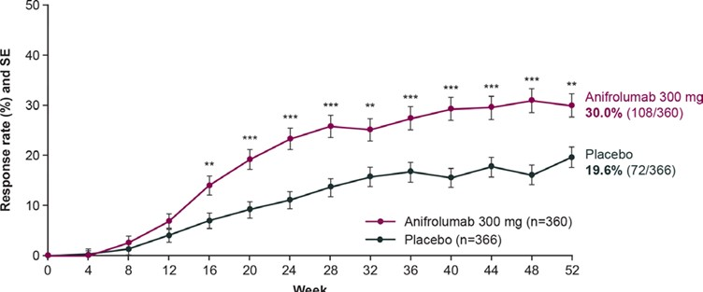 | 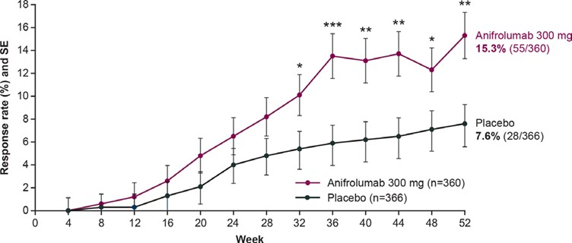
C. LLDAS attainment to Wk 208 (unadjusted vs adjusted analysis)^ of TULIP-1/TULIP-2 pooled and TULIP LTE
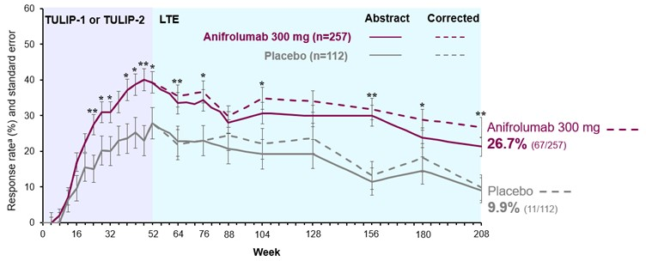
Source: Figure 2-16, p145, Figure 2-21, p150 and Figure 2-22, p152 of the resubmission.
DORIS=Definition of Remission In SLE; LLDAS=low lupus disease activity state; SE=standard error; SLEDAI-2K=Systemic Lupus Erythematosus Disease Activity Index 2000; SOC=standard of care; SOC=standard of care;
Responder rates (percentages) were weighted and calculated using a stratified Cochran-Mantel- Haenszel approach, with stratification factors SLEDAI-2K score at screening, day 1 glucocorticoid dose, type I IFN gene signature test result at screening and study. Nominal p values calculated using logistic regression with the same stratification factors. **p<0.01; ***p<0.001.
# Post hoc LLDAS outcome based on Golder 2019 definition, which was simplified to remove the requirement for assessment of ‘no gastrointestinal and haematological activity’ (in criterion 1).
^ The solid lines represent unadjusted analysis in which patients were classified as LLDAS non-response if they meet additional criterion for “discontinuation of immunosuppressants” or breach the permitted “standard dose of immunosuppressants” criteria resulting in LLDAS non-response for all subsequent visits. The dashed lines represent the analysis adjusted for these criteria, which resulted in more patients classified as responders.
ª Corrections to the DORIS remission data included in the anifrolumab PBAC application from Morand EF, Abreu G, Furie RA, et al. Lupus low disease activity state attainment in the phase 3 TULIP trials of anifrolumab in active systemic lupus erythematosus. Annals of the Rheumatic Diseases 2023;82:639-645 have been superseded as noted in an erratum published in 2024
  - The PBAC previously considered that anifrolumab likely conferred a small reduction in disease activity in terms of SRI(4), noting the large placebo response compared to anifrolumab arm. However, the PBAC also considered the magnitude of benefit was uncertain (paragraph 7.5, anifrolumab, PSD July 2022 and paragraph 6.15, anifrolumab PSD, March 2023).
  - The prespecified exploratory analysis of LLDAS showed that based on LLDAS defined by Franklyn et al 2016, there was significantly higher LLDAS attainment at Week 52 in the anifrolumab 300 mg group compared to placebo in the pooled TULIP-1/TULIP-2 data (17.2% vs 10.4%, p<0.05) and MUSE (39.4% vs 16.7%, OR = 3.41, 95% CI: 1.73, 6.76, p<0.001). However, separately in TULIP-1 and TULIP-2, the pre-specified exploratory analysis showed no significant differences between anifrolumab and placebo treated patients for LLDAS attainment at Week 52.
  - Based on LLDAS defined by Golder et al 2019 and amending the response rule so those who discontinued immunosuppressant(s) or taking non-standard doses of immunosuppressants can also be classified as an LLDAS responder, found overall higher LLDAS attainment in the anifrolumab 300 mg group compared to placebo, this was nominally significant in the pooled TULIP-1/TULIP-2 analyses at Week 52 (30.0% vs 19.6%, OR = 1.8, 95% CI: 1.3, 2.5, p=0.0011) and Week 208 (26.7% vs 9.9%, OR = 3.2, 95% CI: 1.6, 6.4, p=0.0004). The commentary considered this adjustment did not appear to be reasonable as it potentially included patients who increased their dosage of concomitant drugs including immunosuppressants due to lack of response.
  - The PSCR stated that LLDAS was attained more frequently in the anifrolumab group compared with placebo, irrespective of the LLDAS definition and the adjustment for response in the statistical analysis. The PSCR noted that pooling of exploratory data from the individual TULIP trials demonstrated a significantly greater proportion of patients with LLDAS (mean difference (MD) = 5.4; 95% CI: 6.7, 10.2; p < 0.05). The PSCR stated that the adjusted LLDAS definition used in the post-hoc analysis reflected new research findings (Golder et al. 2019 Validation study), however the ESC noted that this analysis was based on LLDAS with inconsistent restricted medication rules between TULIP-1 (original pre-specified restricted medication rules) and TULIP-2 (post hoc revised restricted medication rules).
  - LLDAS was achieved earlier for patients treated with anifrolumab compared to placebo (median months (range): 5.7 (1.8-12.2) vs 6.46 (1.0-12.2), HR = 1.76, 95% CI: 1.35, 2.30, p<0.0001). Anifrolumab treated patients also had significantly more cumulative time (p<0.001), percentage of time (p<0.001) and sustained or consecutive visits (p<0.001) spent in LLDAS compared to placebo to Week 52 and Week 208. Significantly more patients treated with anifrolumab compared to placebo had cumulative time spent in LLDAS at thresholds of ≥20% (LLDAS-20) over 52 weeks and 208 weeks. While significantly more anifrolumab treated patients also attained LLDAS-50 (i.e. LLDAS for 50% of cumulative time) over 52 weeks, this trend was not significant to 208 weeks, and there were no differences between groups for LLDAS-70 (i.e. LLDAS for 70% of cumulative time) over at 52 or 208 weeks. LLDAS attainment was maintained for up to 3 years (up to Week 156) and decreased in Year 4, likely due to the proportion of patients who discontinued study drugs over time (69.3% vs 48.2% of patients from the anifrolumab and placebo arms had completed the TULIP LTE study).
  - Agnostic to treatment, a high proportion of patients who attained LLDAS at Week 52 were also BICLA and SRI(4) responders in TULIP-1/TULIP-2 and MUSE. In TULIP-1/TULIP-2, there was a significantly higher proportion of patients treated with anifrolumab compared to placebo who had dual LLDAS-BICLA response and LLDAS-SRI(4) response at Week 52. However, the total number of BICLA and SRI(4) responders included patients treated with anifrolumab 150 mg in TULIP-1.
  - DORIS remission generally increased over time, with a significant difference in the proportion of patients in remission at Week 52 between anifrolumab and placebo (15.3% vs 7.6%, OR = 2.2, 95%CI: 1.4, 3.6, p=0.0013).
  - The resubmission presented post hoc analysis of sustained glucocorticoid taper response in the subgroup of patients with OCS ≥ 10 mg/day at baseline of TULIP-1/TULIP-2 (Bruce et al 2023). The results showed that significantly more patients treated with anifrolumab (50.5%) achieved glucocorticoid taper (defined as OCS dose reduction to ≤7.5 mg/day by Week 40, which was sustained to Week 52) compared to the placebo group (31.9%). Anifrolumab treated patients also had numerically (8%) lower cumulative dose of glucocorticoids use during the 52 weeks of treatment compared to placebo.
  - In the TULIP LTE subgroup with SDI global score ≥1, anifrolumab treated patients had a longer mean (SD) time to first SDI worsening compared with the combined placebo (925.0 days (553.0) vs 754.2 days (523.3)). The mean SDI global scores at the TULIP baseline for the combined anifrolumab 300 mg group and combined placebo group were 1.6 and 1.4, respectively. At Week 52 (start of the extension study), mean SDI scores were 1.8 and 1.5, respectively. There was no difference between groups in the mean change from baseline in SDI global score in the subgroup of patients with SDI global score ≥1 at Week 52 to Week 208.
  - In TULIP LTE extension study, mean change from the baseline of TULIP trials to Week 208 for EQ-5D-5L score was 0.088 (from baseline of 0.615) in the combined anifrolumab group vs 0.017 (from baseline of 0.614) in the combined placebo group. There were no significant differences between the anifrolumab group and placebo in terms of improvement in quality of life (EQ-5D-5L) at Week 208. Additional post hoc analysis in MUSE and TULIP-1/TULIP-2, showed that patients who attained LLDAS also showed improvement in patient reported disease specific health related quality of life outcome seen on Lupus QoL domains (including physical health and fatigue) compared to patients who did not attain LLDAS.
  - Table 6 presents the attainment of LLDAS by the subgroup with SLEDAI-2K ≥10 in the post hoc analyses of TULIP-1/TULIP-2 and TULIP LTE.
Table 6: LLDAS by the ITT and subgroup with SLEDAI-2K ≥10# in TULIP-1/TULIP-2 and TULIP LTE (post-hoc)
 | Anifrolumab 300 mg  n/N (%) | Placebo (SOC)  n/N (%) | RD (95%CI) | OR (95%CI)
LLDAS (Golder 2019)^{a b} at Week 52
Whole trial population (SLEDAI-2K ≥6)
TULIP-1 | 58/180 (32.2) | 40/184 (21.7) | 10 (1, 20) | -
TULIP-2 | 50/180 (27.8) | 32/182 (17.6) | 10 (2, 19) | -
TULIP-1 & 2 pooled^{c} | 108/360 (30.0) | 72/366 (19.6) | 10.3 (4.1, 16.6) | 1.8 (1.3, 2.5)
SLEDAI-2K ≥10
TULIP-1# | 34/129 (26.4) | 25/135 (18.5) | 8 (-2, 18) | -
TULIP-2 | 34/129 (26.4) | 18/131 (13.7) | 13 (3, 22) | -
TULIP-1 & 2 pooled^{c} | 68/258 (26.4) | 43/266 (16.2) | 10.2 (3.2, 17.2) | 1.9 (1.2, 2.9)^{d}
LLDAS (Golder 2019)^{a b} at Week 208
Whole trial population (SLEDAI-2K ≥6)
TULIP-1 LTE | 34/124 (27.4) | 5/61 (8.2) | 19 (9, 30) | -
TULIP-2 LTE | 33/133 (24.8) | 6/51 (11.8) | 13 (2, 25) | -
TULIP-1 & 2 LTE pooled^{c} | 67/257 (26.7) | 11/112 (9.9) | 16.3 (8.6, 23.9) | 3.2 (1.6, 6.4)
SLEDAI-2K ≥10
TULIP-1 LTE | 19/90 (21.1) | 1/41 (2.4) | 19 (9, 28) | -
TULIP-2 LTE | 25/94 (26.6) | 4/39 (10.3) | 16 (3, 29) | -
TULIP-1 & 2 LTE pooled^{c} | 44/184 (23.9) | 5/80 (6.3) | 17.7 (9.5, 25.8) | 4.7 (1.8, 12.5)^{d}
Bold text designates statistical significance.
Source: Tables 2-49 and 2-50, p186 of the resubmission, Anifrolumab versus Placebo for SLE.rm5 (Attachment 2.5), and Attachment 2.12 subgroup analysis LLDAS_Anifrolumab modelling Tables 20230907.xlsx.
CI=confidence interval; RD=risk difference; CMH=Cochran-Mantel-Haenszel; LLDAS=low lupus disease activity state; OR=odds ratio; SLE=Systemic Lupus Erythematosus; SLEDIA-2K=SLE Disease Activity Index 2000; SOC=standard of care.
Analysis was on the TULIP-1/TULIP-2 revised restricted medications rules.
# The resubmission reported that in TULIP-1, patients with SLEDAI-2K ≥10 at baseline and screening was n=125 (see Furie 2019 (TULIP-1)), however the subgroup analysis was based on n=129, which could not be verified. Analysis conducted during the evaluation showed that this difference had minor impact on the treatment effect (response difference 11 (4, 18) and OR 1.9 (1.2, 2.9)).
a Post hoc LLDAS outcome based on Golder 2019 definition, which was simplified from Franklyn 2016 to remove the requirement for assessment of haematological or gastrointestinal activity (criterion 1), and SLEDAI-2K is specified for new activity (criterion 2).
b Post hoc statistical analysis adjusted for response due to discontinuation or non-standard dose of immunosuppressant. The pre-specified exploratory analysis of LLDAS included: i) additional criterion for “discontinuation of immunosuppressants” resulted in LLDAS non-response, and ii) violations of “standard dose of immunosuppressants” resulted in LLDAS non-response for all subsequent visits.
c Pooled analysis excluded the 150 mg group from TULIP-1. Results are based on the revised restricted medication rules.
d Post hoc analysis by the resubmission using Chi Square analysis.
  - The results of the subgroup analyses from TULIP-1 and TULIP-2 showed LLDAS attainment in patients with severe disease activity (SLEDAI-2K ≥10 at baseline) was similar to the whole trial population (SLEDAI-2K ≥6 at baseline). LLDAS attainment increased over the 52 weeks treatment period, which was generally maintained in TULIP LTE to Week 156 and decreased thereafter to Week 208. There were significantly higher proportions of patients in the anifrolumab group who attained LLDAS compared to placebo at Week 52 and Week 208.

Comparative harms
  - No new comparative safety data were presented in this resubmission. Table 7 summarises the key AEs across the included trials.
Table 7: Summary of key adverse events (AEs) across the included trials (ITT population).
 | Anifrolumab 300 mg  n/N (%) | Placebo  n/N (%) | RR (95%CI) | RD (95%CI)
TULIP-1
Any AEs | 161/180 (89.4) | 144/184 (78.3) | 1.14 (1.04, 1.25) | 0.11 (0.04, 0.19)
SAE | 25/180 (13.9) | 30/184 (16.3) | 0.85 (0.52, 1.39) | -0.02 (-0.10, 0.05)
Death due to AEs | 1/180 (0.6)ª | 0 | 3.07 (0.13, 74.78) | 0.01 (-0.01, 0.02)
Discontinuation of study drugs due to AEs | 11/180 (6.1) | 5/184 (2.7) | 2.25 (0.80, 6.34) | 0.03 (-0.01, 0.08)
AEs of interest | 22/180 (12.2) | 15/184 (8.2) | 1.50 (0.80, 2.80) | 0.04 (-0.02, 0.10)
Non-opportunistic serious infections | 9/180 (5.0) | 8/184 (4.3) | 1.15 (0.45, 2.91) | 0.01 (-0.04, 0.05)
Herpes Zoster | 10/180 (5.6) | 3/184 (1.6) | 3.41 (0.95, 12.18) | 0.04 (0.00, 0.08)
Infusion-related reaction | 16/180 (8.9) | 13/184 (7.1) | 1.26 (0.62, 2.54) | 0.02 (-0.04, 0.07)
TULIP-2
Any AEs | 159/180 (88.3) | 153/182 (84.1) | 1.06 (0.98, 1.16) | 0.05 (-0.02, 0.12)
SAE | 15/180 (8.3) | 31/182 (17.0) | 0.49 (0.28, 0.88) | -0.09 (-0.15, -0.02)
Death due to AEs | 1/180 (0.6)^{b} | 0 | 3.07 (0.13, 74.78) | 0.01 (-0.01, 0.02)
Discontinuation of study drugs due to AEs | 5/180 (2.8) | 13/182 (7.1) | 0.39 (0.14, 1.08) | -0.04 (-0.09, 0.00)
AEs of interest | 25/180 (13.9) | 18/182 (9.9) | 1.42 (0.80, 2.51) | 0.04 (-0.03, 0.11)
Non-opportunistic infections | 5/180 (2.8) | 10/182 (5.5) | 0.51 (0.18, 1.47) | -0.03 (-0.07, 0.0)]
Herpes Zoster | 13/180 (7.2) | 2/182 (1.1) | 6.64 (1.52, 29.03) | 0.06 (0.02, 0.10)
Infusion-related reaction | 25/180 (13.9) | 14/182 (7.7) | 1.83 (0.98, 3.40) | 0.06 (-0.00, 0.13)
TULIP LTE (Weeks 52-216)
Any AEs | 226/257 (87.9) | 94/112 (83.9) | 1.05 (0.95, 1.15) | 0.04 (-0.04, 0.12)
SAE | 58/257 (22.6) | 28/112 (25.0) | 0.90 (0.61, 1.34) | -0.02 (-0.12, 0.07)
Death due to AEs | 3/257 (1.2) | 1/112 (0.9) | 1.31 (0.14, 12.43) | 0.00 (-0.02, 0.02)
Discontinuation of study drugs due to AEs | 17/257 (6.6) | 8/112 (7.1) | 0.93 (0.41, 2.08) | -0.01 (-0.06, 0.05)
AEs of interest | 75/257 (29.2) | 24/112 (21.4) | 1.36 (0.91, 2.04) | 0.08 (-0.02, 0.17)
Non-opportunistic infections | 25/257 (9.7) | 9/112 (8.0) | 1.21 (0.58, 2.51) | 0.02 (-0.05, 0.08)
Herpes Zoster | 23/257 (8.9) | 7/112 (6.3) | 1.43 (0.63, 3.24) | 0.03 (-0.03, 0.08)
Major acute cardiovascular event | 5/257 (1.9) | 3/112 (2.7) | 0.73 (0.18, 2.99) | -0.01 (-0.04, 0.03)
Infusion-related reaction | 17/257 (6.6) | 6/112 (5.4) | 1.23 (0.50, 3.05) | 0.01 (-0.04, 0.06)
MUSE^{c}
Any AEs | 84/99 (84.8) | 78/101 (77.2) | 1.10 (0.96, 1.26) | 0.08 (-0.03, 0.18)
SAE | 16/99 (16.2) | 19/101 (18.8) | 0.86 (0.47, 1.57) | -0.03 (-0.13, 0.08)
Death due to AEs | 0 | 0 | - | -
Discontinuation of study drugs due to AEs | 3/99 (3.0) | 8/101 (7.9) | 0.38 (0.10, 1.40) | -0.05 (-0.11, 0.01)
AEs of interest | 10/99 (10.1) | 12/101 (11.9) | 0.85 (0.39, 1.88) | -0.02 (-0.10, 0.07)
Non-opportunistic infections | NR | NR | - | -
Herpes Zoster | 5/99 (5.1)^{d} | 2/101 (2.0) | 2.55 (0.51, 12.84) | 0.03 (-0.02, 0.08)
Infusion-related reaction | 2/99 (2.0) | 6/101 (5.9) | 0.34 (0.07, 1.64) | -0.04 (-0.09, 0.0)]
MUSE LTE
≥1 SAE | 50/218 (22.9) | - | - | -
Death | 1/218 (0.5) | - | - | -
Discontinuation of study drugs due to AEs | 17/218 (7.8) | - | - | -
AEs of interest | 24/218 (11.0) | - | - | -
Non-opportunistic infections | NR | NR | - | -
Herpes Zoster | 11/218 (5.0) | - | - | -
Infusion-related reaction | 4/218 (1.8) | - | - | -
Bold text designates statistical significance.
Source: Tables 2-38 to 2-43, pp170-177 of the resubmission.
AE=adverse event; SAE=serious AE; RR=relative risk; RD=risk difference; NR=not reported; CI=confidence interval.
a Death due to pneumonia; patient received two doses of anifrolumab 300 mg.
b Death due to pneumonia.
c The safety population consisted of patients who received at least 1 dose of study drug. One patient randomized to the placebo group mistakenly received a single dose of anifrolumab 1000 mg and was included in anifrolumab 1000 mg group for the safety analyses.
d One patient also had transverse myelitis with a quantitatively positive test result for varicella-zoster virus in the cerebrospinal fluid.
  - In all trials, the incidence of any AEs was higher in the anifrolumab group compared to placebo group during treatment to Week 52. The majority of AEs were non-serious, mild or moderate in intensity and did not lead to discontinuation of study drugs. The long-term safety data from TULIP LTE and MUSE LTE (from 52 weeks to approximately 4 years) was consistent with the included trials to 52 weeks, with no new safety signals. The PBAC had previously considered that a claim of inferior safety to SOC was reasonable (paragraph 7.5, anifrolumab PSD March 2023 and paragraph 7.7, anifrolumab PSD July 2022).

Benefits/harms
  - The comparative benefits and harms for anifrolumab versus placebo (i.e. SOC alone) in patients with SLE can be drawn from Table 4, Table 5, and Table 7 above. On the basis of direct evidence presented in the submission, for every 100 patients treated with anifrolumab in comparison with placebo (SOC alone):
- Approximately 4 fewer patients to 26 additional patients will achieve SRI(4) response at Week 52 depending on the trial and analysis used.
- Approximately 10 to 28 additional patients will achieve BICLA response at Week 52 depending on the trial and analysis used.
- Approximately 4 to 23 additional patients will achieve LLDAS (based on Franklyn et al 2016) at Week 52.
- Approximately 10 additional patients will achieve LLDAS (based on Golder et al 2019) at Week 52 and 12 to 19 additional patients will achieve LLDAS (based on Golder et al 2019) at Week 208.
- Approximately 5 to 11 additional patients will experience any AEs at Week 52, and 4 additional patients will experience any AEs between Weeks 52-216.
- Approximately 2 to 9 fewer patients will experience SAEs at Week 52, and 2 fewer patients will experience SAEs between Weeks 52-216.
- Approximately 3 to 6 additional patients will experience herpes zoster at Week 52, and 3 additional patients will experience herpes zoster between Weeks 52-216.
The above statements are based on the total trial populations, whereas the resubmission has targeted a patient subgroup (SLEDAI-2K ≥10 and receiving triple therapy, consisting of HCQ, an immunosuppressant and OCS ≥7.5 mg/day) that the PBAC previously considered to have the greatest clinical need (paragraph 7.4, belimumab PSD November 2019 and paragraph 3.4, anifrolumab PSD July 2022).

Clinical claim
  - The resubmission described anifrolumab added to SOC as superior in terms of effectiveness and inferior, but with manageable safety, compared to SOC alone. This claim was based on results of both the ITT as well as the post hoc subgroup of patients with SLEDAI ≥10 in the included trials, the latter was used as a proxy for the requested PBS population (SLEDAI-2K ≥10 and on SOC triple therapy).
  - In March 2023, consistent with the July 2022 consideration, the PBAC had considered the claim of superiority to SOC alone in terms of effectiveness was supported based on improvement in disease activity for some patients; however, the magnitude of benefit was modest and uncertain. The PBAC considered the claim of inferior safety to SOC alone was reasonable (paragraph 7.5, anifrolumab PSD March 2023). The ESC considered that a claim of inferior, but manageable, safety was reasonable compared to SOC alone.
  - The basis of the clinical claim of superior effectiveness in this resubmission also included the post hoc analyses on LLDAS and remission, given the clinical guideline (EULAR 2023) recommendation to treat to target with a goal of remission or low disease activity. However, the following issues were noted:
- Differences in LLDAS definition: The resubmission’s post hoc analysis of LLDAS used the Golder et al 2019 definition, whereas the pre-specified exploratory analysis of the TULIP trials and the post hoc analysis of MUSE was based on the Franklyn et al 2016 definition. While the pooled TULIP-1/TULIP-2 results for the two definitions of LLDAS had favoured anifrolumab, separately, the individual trial results had showed no difference for LLDAS based on the Franklyn et al 2016 definition. The PSCR stated that LLDAS was attained more frequently in the anifrolumab group compared with placebo, irrespective of the LLDAS definition and the adjustment for response in the statistical analysis.
  - Adjustment for response: The resubmission’s post hoc analysis of LLDAS used an amended response rule so patients who discontinued or were taking non-standard doses of immunosuppressive drugs could be classified as LLDAS responders, resulting in more patients being classified as LLDAS responders, favouring anifrolumab. This would not be reasonable for example if patients had increased their dosage of concomitant drugs. Based on Franklyn et al 2016 and Golder et al 2019, patients must be taking standard ‘maintenance doses’ of immunosuppressive drugs (criteria 5) if they are to be classified as LLDAS responder. The ESC noted that the submission’s adjustment for response was not consistent with the intended usage of anifrolumab in the PBS population because, according to the PBS restriction (and published LLDAS criteria), patients taking increased doses of concomitant drugs (above standard ‘maintenance doses’) would not be classified as LLDAS responders, but they were classified as such by the submission. The PSCR stated that the “LLDAS definition from the clinical evidence is included in the economic model and is reflected in the PBS restriction thus maintaining internal consistency”; however, this is not correct as described above. The PSCR maintained that the adjustment was appropriate, but did not address the specific concern raised in the commentary about patients treated with increased doses of immunosuppressive drugs being inappropriately counted as responders. The Pre-PBAC response indicated there were no patients in this category classed as responders in the post hoc analysis of the TULIP trials. The ESC considered that the clinical interpretation remained unchanged from the March 2023 PBAC consideration, in that the claim that anifrolumab was superior to SOC alone in terms of effectiveness was supported based on improvement in disease activity for some patients; however, the magnitude of benefit remained uncertain. The ESC considered that the LLDAS results provided additional confidence in the clinical benefit of anifrolumab compared with SOC but did not address the question of magnitude of benefit.
  - The PBAC considered that the claim of superior comparative effectiveness was reasonable, compared to SOC alone.
  - The PBAC considered that the claim of inferior but manageable safety was reasonable, compared to SOC alone.

Economic analysis
  - The resubmission presented a new stepped economic evaluation starting with a trial-based cost per responder analysis informed by TULIP 1 and 2 and then implementing a modelled cost-utility analysis using evidence from TULIP 1 and 2, TULIP LTE and the Australian cohort of the Asia-Pacific Lupus Collaboration (APLC). Response in the resubmission was for the subgroup with baseline SLEDAI-2K ≥10 and was based on LLDAS attainment at Week 26, rather than a reduction in SLEDAI-2K of at least 4 which was used in the July 2022 and March 2023 submissions. The type of economic evaluation was a Markov cohort model with a lifetime (59 years in the base case) time horizon.
  - The March 2023 resubmission presented an ICER of $75,000 to < $95,000 per additional QALY gained. The PBAC had previously expressed concern that the March 2023 model did not provide robust estimates and had not adequately addressed the concerns with the July 2022 model (paragraph 7.7, anifrolumab PSD, March 2023).
  - The PBAC’s key concerns of the March 2023 economic evaluation (paragraphs 7.7, 7.8 anifrolumab PSD, March 2023) and how the resubmission addressed them are provided below:
- Trial follow-up was short (4 years) relative to the model time horizon (30 years). This was not addressed by the current resubmission. The resubmission had no additional trial follow up and lengthened the time horizon to lifetime (59 years in the base case). The ESC had previously considered that a model with a substantially shorter time horizon would reduce the issues associated with extrapolation and may be more clinically valid and this was proposed as a potential modelling approach (paragraph 6.63, anifrolumab PSD March 2023). The ESC noted that the time horizon was close to double that considered in March 2023, and agreed with the commentary that this was not justified.
- Lack of direct evidence on longer term clinical outcomes. The PBAC considered there was limited data on organ damage and mortality. This resubmission based its estimates of organ damage and mortality primarily on LLDAS attainment. LLDAS attainment was informed by the TULIP trials and LTE data, whereas the relationship between ‘LLDAS’ and ‘Not-LLDAS’ on organ damage and mortality was primarily informed by data from the Asian Pacific Lupus Cohort (APLC). The effect of ‘LLDAS’ on mortality compared to average SLE survival however was an assumption and therefore was uncertain. Organ damage accrual was similar across treatment arms and no longer a significant driver of the ICER. The PSCR stated that downstream benefits of achieving LLDAS were likely underestimated as LLDAS benefits were only applied within the LLDAS health states, when the sources informing these benefits (Golder 2019, Kandane‑Rathnayake 2022a) showed benefits in patients who had ever achieved LLDAS. The ESC noted that this was incorrect, as ‘LLDAS’ as based on Golder 2019, which informed SDI increases and flares, was based on patients achieving LLDAS for at least 50% of the time. As the ever-LLDAS mortality reduction from Kandane‑Rathnayake 2022a only applied to patients in the ‘LLDAS’ health state, the survival in ‘Not LLDAS’ arm (which included ever-LLDAS patients) was likely underestimated. Therefore, the benefit for anifrolumab was potentially overestimated.
- Reverse causality within regression analyses, appropriateness of model fit and the extrapolation of the regression coefficients across the time horizon and the high chance of double counting. The resubmission presented a new model structure that did not rely on regression analyses, which was appropriate. The ESC previously considered that a simpler Markov cohort model structure would provide more transparency and may be more appropriate (paragraph 6.63, anifrolumab PSD, March 2023). While the revised model presented a Markov cohort model, it included 48 alive health states modelling treatment, treatment response (anifrolumab arm only), LLDAS status, and SDI score (0-5+). The ESC considered that the revised model had introduced unnecessary complexity due to the large number of health states.
- Plausibility and robustness of the model’s results. Average utility in the absence of organ damage was < 0.3 across the time horizon in the March 2023 resubmission compared to > 0.8 in the July 2022 submission, based on minor changes between submissions. The July 2022 ICER was driven by survival, the March 2023 resubmission ICER was driven by utility benefit and in this resubmission, it was driven by both. A different model structure was adopted in this resubmission compared to previous submissions and so they were not entirely comparable, but average utility over time in this new model was between 0.59 and 0.71, with an initial increase followed by steady decline to 0.63 in both arms. This was similar to results from TULIP LTE at Year 4, which reported a utility of ~0.7 for both anifrolumab and SOC. While the revised model was less sensitive to some model inputs (e.g. parameters informing organ damage), the model was not robust to assumptions concerning the impact of LLDAS on mortality and utility.
- Price reduction. The PBAC considered a price reduction in addition to a revised economic model would be necessary to achieve acceptable cost-effectiveness. The resubmission increased the effective DPMQ of anifrolumab to $| | per 300 mg vial of anifrolumab compared to $| | presented in the March 2023 pre-PBAC response (but this was lower than the DPMQ proposed in the March 2023 resubmission of $| |).
  - See Table 8 for a summary of the key components of the economic evaluation.
Table 8: Key components of the economic evaluation
Component | March 2023 resubmission | Resubmission Justification/comments
Type of analysis | Cost-utility | Unchanged. Appropriate.
Outcomes | Quality adjusted life years (QALYs) | Life years and OCS use also presented. Appropriate, but disaggregated QALYs were presented by SDI health state, rather than LLDAS, which gave the incorrect impression the SDI was a key driver of the benefits. LLDAS drove differences in both life years and quality of life, rather than SDI score.
Time horizon | 30 years in the model base case vs. 52 weeks in TULIP 1 and 2, plus 3 years follow up from TULIP LTE (total 4 years) | Lifetime (to age 100). In the base case this was equal to 59 years. Trial evidence remained short relative to the 59-year time horizon of the model.
Methods used to generate results | Individual patient microsimulation. | Markov cohort model. ESC had previously considered that a simpler Markov cohort model may be more reasonable and provide greater transparency in the underlying assumptions (para 6.63, anifrolumab PSD, March 2023).
Health states | - Anifrolumab arm: alive on treatment, alive off treatment, dead.  - SOC arm: alive, dead.  Each cycle patients could also experience events such as flares, organ damage, OCS use, and change in SLEDAI-2K. Some events were associated with ongoing costs and disutilities, effectively making these a different health state. | Dead plus 48 alive health states defined by treatment (anifrolumab on treatment, anifrolumab responder off treatment responder [LLDAS at 26 weeks], anifrolumab non-responder off treatment [not LLDAS at 26 weeks], SOC), LLDAS state (LLDAS, not LLDAS), and SDI score (0, 1, 2, 3, 4, ≥5). Response in the economic model was equivalent to achievement of LLDAS by week 24 (modelled as week 26) and anifrolumab non-responders discontinued treatment beyond this point. Patients discontinued anifrolumab each cycle from week 26 if they failed to maintain LLDAS. See Figure 2.  Each cycle patients could also experience events such as flares (estimated from APLC data, Golder 2019), herpes zoster and infusion related reactions (estimated from pooled TULIP data).  Health states and events were reasonable, but were potentially complex with 49 possible health states. However, movement between the SDI health states of the model had little effect upon the ICER.
Cycle length | 6 months (26 weeks). | Unchanged. Reasonable, though LLDAS attainment may vary over 6 months and may be assessed on average every 3.4 months (Golder 2019). Therefore, the model cycle length may not capture all events.  A half cycle correction was applied to life years, QALYs and health state costs, but not to treatment costs.
Transition probabilities | - Treatment discontinuation rates from TULIP 1 and 2 and TULIP LTE.  - Mortality rates derived from survival model based on JHLC adjusted by standardised mortality ratios for SLE patients.  - Cycle dependent event regression models based on evidence from the TULIP trials (including TULIP LTE) and JHLC.  - QALYs, SLEDAI-2K and OCS use were restricted to not fall below 0 | Treatment continuation for anifrolumab based on achieving LLDAS response within 6 months and maintaining LLDAS beyond 6 months. Patients receiving SOC were assumed to receive SOC for the entirety of the time horizon.  Transition between ‘Not LLDAS’ and ‘LLDAS’  Cycles 1-2: pooled TULIP 1 and 2 rates at 24 weeks and 52 weeks.  Cycle 3-8: TULIP LTE.  Cycle 9 onwards: average rate of maintaining LLDAS in TULIP LTE between weeks 104 and 208. Highest in patients receiving anifrolumab (0.8740), then anifrolumab non-responders (0.8129), then SOC patients (0.7708), then anifrolumab responders who discontinued treatment (0.6878).  From Cycle 2, patients in the anifrolumab arm who did not achieve/maintain LLDAS were modelled as SOC, by response at 24 weeks. SOC arm was not modelled by response.  OCS dose was modelled according to LLDAS status, based on pooled TULIP data. Background mortality based on Australian lifetables, adjusted for SLE mortality (Bernatsky 2006) and LLDAS (Kandane-Rathnayake 2022, APLC data). Organ damage related to LLDAS sourced from APLC data (Golder 2019)
Software package | Excel 2010 with @RISK. | Excel 2021 (resubmission claimed to have used Excel 2016)
Source: Table 3-1, p237 of the March 2023 resubmission and Table 3-1 and 3-2 of the March 2024 resubmission
ICER = incremental cost-effectiveness ratio, JHLC=John Hopkins Lupus cohort, OCS = oral corticosteroids, QALYs = quality adjusted life years, SLEDAI-2K= Systemic Lupus Erythematosus Disease Activity Index 2000, SOC = standard of care
  - In line with the new model structure, the model mechanics differed to the March 2023 resubmission. The new economic model utilised a Markov cohort structure according to treatment, LLDAS status and SDI score. In the anifrolumab arm, patients were also divided into those receiving anifrolumab, responders who had discontinued treatment (patients who achieved LLDAS at 26 weeks, but lost LLDAS afterwards); and non-responders who had discontinued treatment at 26 weeks. Patients entered the model not in LLDAS, with SDI score distributed as per the pooled TULIP trials. Each cycle patients could move between ‘LLDAS’ and ‘Not LLDAS’, and could remain in their current SDI score or SDI score could worsen by 1 (until maximum state of SDI≥5). Transition between LLDAS was dictated by what treatment patients were receiving and, in the anifrolumab arm, whether they achieved LLDAS status by week 26. Patients could die in any state. The new model structure is presented in Figure 2.
Figure 2: Summary of the submitted model structure (compiled during the evaluation)
Patient allocation as defined in the model
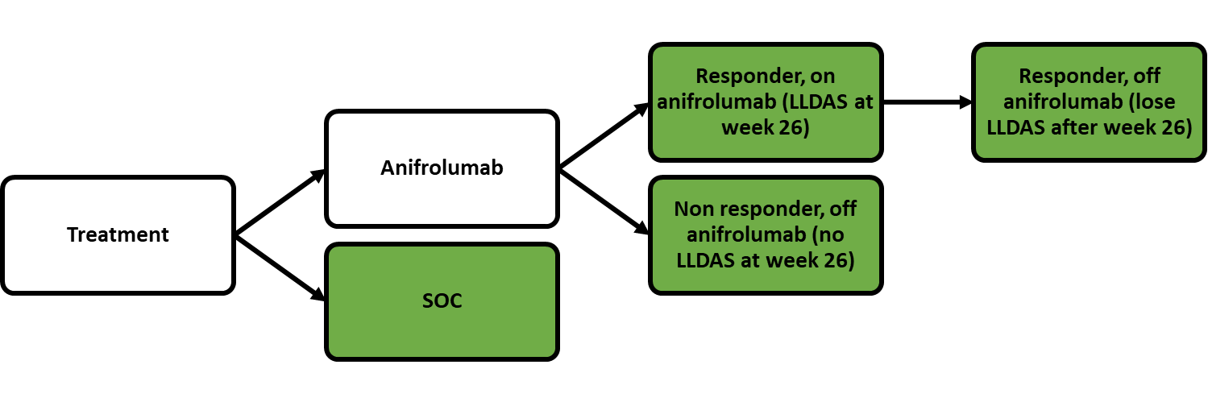
The status of patients in the green boxes dictates the transition probabilities for the Markov health states below
Markov heath states each cycle
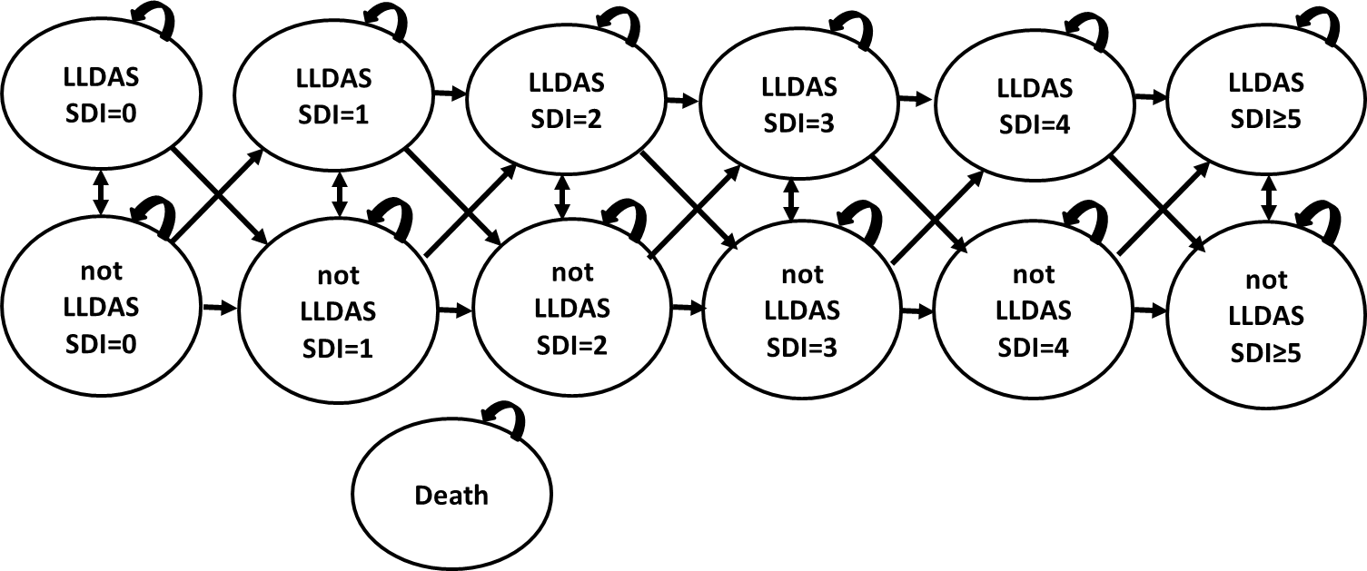
Source: complied during the evaluation based on Figures 3-1, 3-2, 3-3, 3-4 and 3-6 of the March 2024 resubmission
OCS = oral corticosteroids; QALYs = quality-adjust life year; SDI = Systemic Lupus International Collaborating Clinics/American College of Rheumatology (SLICC/ACR) Damage Index; SLEDAI-2K = Systemic Lupus Erythematosus Disease Activity Index.
Flares, OCS use and adverse events could occur in any alive state and rates were dependent on health state allocation.
  - The general approach to calculation of probabilities each cycle for LLDAS, disease flares, OCS dose, organ damage, and mortality were estimated from patient characteristics and current health state occupation. Different transition probabilities for LLDAS were applied for Cycles 1-8, based on TULIP-1 and 2 and TULIP LTE data (Weeks 24, 76 and 180 of the TULIP trials and LTE data proxies for Weeks 26, 78 and 182 in the model) with the extrapolation from Cycle 9 onwards based on the average probability of maintaining LLDAS in Cycles 5-8. Transition through SDI health states was based on current health state and LLDAS status. Transitions differed according to treatment, plus responder status in the anifrolumab arm. In total 36 transition matrices for LLDAS and SDI were presented in the base case. These were applied to the proportion of patients alive each cycle (with mortality dependent on age and LLDAS status) and flares and OCS use were calculated separately according to LLDAS status. Adverse events rates were sourced from TULIP-1 and -2 and TULIP LTE. Anifrolumab discontinuation occurred when LLDAS was not achieved or lost from Cycle 2 onwards. Data sources were similar to the March 2023 resubmission except for:
- Organ damage in ‘Not LLDAS’ and HR for ‘LLDAS’ were based on Golder et al 2019 (APLC data, patients with <50% time in LLDAS as proxy for not in LLDAS). Organ damage HR if SDI>0 from Ugarte-Gil et al 2022 (Systemic Lupus International Collaborating Clinics cohort, multinational not restricted to HDAS patients)
- Risk of flare by LLDAS status calculated from Golder et al 2019 (APLC data, not restricted to Australian or HDAS patients). Flares were modelled as events with costs and disutilities applied for 3 months.
- Mortality was still SLE age-related mortality from Bernatsky et al 2006 (used in the belimumab submission to NICE 2016) applied to Australian general population mortality. However, the mortality hazard ratio for non-LLDAS health states taken from Kandane-Rathnayake et al 2022 (APLC data, patients never achieving LLDAS). The mortality hazard ratio for ‘LLDAS’ versus general SLE was calculated to give overall life expectancy in the model of 64.5 years for SOC arm.
- OCS dose by LLDAS status was based on TULIP trial data, but not TULIP LTE.
- John Hopkins Lupus Cohort and ALRB data, which were included in organ damage and mortality estimated in the March 2023 resubmission were no longer included in the model.
  - The following table summarises transition probabilities in the modelled economic evaluation.
Table 9: Transition probabilities in the modelled economic evaluation
Variable | Approach | Source
LLDAS | Probability of achieving and maintaining LLDAS estimated each cycle. Anifrolumab arm was split into ‘on treatment’, ‘non-responders off treatment’, and ‘responders off treatment’. Anifrolumab arm ‘not on treatment’ modelled using SOC arm, by response at Week 24. SOC arm modelled as composite.  Cycles 1-8 allowed movement in and out of ‘LLDAS’ (achieving and maintaining LLDAS), though in the base case patients did not move to ‘LLDAS’ after Cycle 2 in the SOC arm and Cycle 4 in the anifrolumab arm (non-responders). Cycle 9 onwards allowed only maintenance of LLDAS. | Cycle 1: 24 week follow up of TULIP trials, SLEDAI-2K ≥10 subgroup.  Cycle 2: 52 week follow up of TULIP trials, SLEDAI-2K ≥10 subgroup for responders in the anifrolumab arm and all patients in SOC arm. Non-responders in the anifrolumab arm 52 week follow up of TULIP LTE placebo arm, SLEDAI-2K ≥10 subgroup.  Cycle 3-8: Week 76-208 follow up from TULIP LTE, SLEDAI-2K ≥10 subgroup.  Cycle 9+: Average LLDAS maintenance between Weeks 104 and 208 of the TULIP LTE, SLEDAI-2K ≥10 subgroup.
Organ damage | At baseline 34.8% patients were expected to have SDI score >0.  Probability of additional organ damage each cycle was estimated based on organ damage and LLDAS status in the previous cycle.  Organ damage was not body system dependent and SDI score could increase by a maximum of 1 each cycle. | Baseline organ damage: TULIP 1 trials, SLEDAI-2K ≥10 subgroup  Organ damage by LLDAS: Golder 2019 (APLC data)  Organ damage by SDI score (0 vs 1+) Ugarte-Gil 2022
Mortality | Annual hazard rates were adjusted for age-related mortality in SLE patients applied to background mortality of the Australian population converted to 6 monthly probability.  ‘LLDAS’ vs average SLE HR = 0.7 (assumed)  ‘Not LLDAS’ vs average SLE HR = 0.7x4.98=3.49 | Age-related SLE mortality based on standardised mortality ratios for SLE patients as reported in NICE belimumab submission (Bernatsky 2006).  Background mortality based on Australian life tables.  ‘Never LLDAS’ HR versus ‘ever LLDAS’ HR of 4.98 from Kandane-Rathnayake 2022
Flares | The risk of a flare each cycle was 29.3% for patient ‘Not LLDAS’ and 13.2% for ‘LLDAS’ patients (RR 0.45). Flares were assumed to last 3 months and only one flare per cycle could occur. | Golder 2019 (APLC data) Figure 1, patients with LLDAS <50% of the time, proportion in first 6 months
OCS dose | Least square mean regression by treatment and LLDAS status.  ‘LLDAS’: 4.968mg/day anifrolumab, 5.669mg/day SOC  ‘Not LLDAS’: 8.055mg/day both arms (based on SOC arm) | Pooled TULIP trials (not TULIP LTE).
Treatment discontinuation | 79.2% patients discontinued anifrolumab in Cycle 1 (cycle length =26 weeks).  From Cycle 2 onwards anifrolumab discontinuation rate was modelled according to loss of LLDAS. By Year 2, <10% patients remained on anifrolumab.  Aside from OCS use, SOC treatments were constant over time in both arms | Cycle 1: 24 week follow up of LLDAS in TULIP trials, SLEDAI-2K ≥10 subgroup.  Cycle 2 onwards: Loss of LLDAS as modelled.
Adverse events | Herpes Zoster and infusion related reactions. Other infections no longer included. | Cycle 1-2: Pooled rates in TULIP trials  Cycle 3+: TULIP LTE  0% infusion related reactions in the SOC arm was assumed.
  Adverse event | Per cycle probability
  Adverse event | Anifrolumab | SOC
  Herpes zoster | 3.2% | 0.7%
  Herpes zoster | 1.6% | 1.1%
  Infusion related reaction | 5.9% | 0.0%
  Infusion related reaction | 1.1% | 0.0%
Source: constructed during the evaluation
ALRB= Australian Lupus Registry and Biobank, APLC=Asia-Pacific Lupus Collaboration, JHLC=John Hopkins Lupus Cohort, NICE=National Institute for Health and Care Excellence UK, OCS=oral corticosteroid, SLE= Systemic Lupus Erythematosus, SLEDAI-2K= Systemic Lupus Erythematosus Disease Activity Index 2000, SDI=SLICC/ACR (Systemic Lupus International Collaborating Clinics/American College of Rheumatology) Damage Index
  - The resubmission was driven by LLDAS which was used to estimate mortality, flares, OCS dose and anifrolumab discontinuation. Unlike the March 2023 resubmission, the current resubmission did not model SLEDAI-2K, organ damage by body system or general ‘infections’.
  - In the resubmission, data from TULIP LTE as well as TULIP 1 and 2 were used. However, none of the included trials (including TULIP LTE) had reported any difference with respect to organ damage or mortality. The resubmission presented literature to support the relationship between LLDAS and clinical outcomes but did not describe whether the studies also controlled for other factors, in particular time in LLDAS and whether the studies considered patients with severe disease. Similar to SLEDAI-2K in the previous submissions, the ESC considered that it remained uncertain whether the resubmission had accurately quantified the relationship between LLDAS and final outcomes.
  - The following table presents a summary of LLDAS transition probabilities applied each cycle. This was based on data for the post hoc subgroup of patients with SLEDAI-2K ≥10 at baseline in the TULIP trials. The SOC arm and patients receiving anifrolumab in the anifrolumab arm were informed by the pooled TULIP-1 and TULIP-2 trials and the TULIP LTE data (applied to the pooled TULIP trial data). The analysis did not account for patients missing at each follow up. The resubmission stated that patients who discontinued anifrolumab (either as non-responders at 26 weeks or who lost LLDAS after 26 weeks) were informed by the pooled SOC arms of the TULIP-1 and TULIP-2 trials and the TULIP LTE data, by LLDAS response at 26 weeks.
Table 10: LLDAS transition probabilities each cycle for patients with SLEDAI-2K ≥10 at baseline
 | Anifrolumab arm |  |  |  |  |  | SOC arm
 | On anifrolumab |  | Off anifrolumab (26 week responder) |  | Off anifrolumab (26 week non-responder)
Week* | Maintain LLDAS | Move to LLDAS | Maintain LLDAS | Move to LLDAS | Maintain LLDAS | Move to LLDAS | Maintain LLDAS | Move to LLDAS
0-26 | 0.0% | 20.9% | 0.0% | 0.0% | 0.0% | 0.0% | 0.0% | 9.0%
26-52 | 70.4% | 0.0% | 0.0% | 0.0% | 0.0% | 11.6% | 100.0% | 7.9%
52-78 | 67.8% | 0.0% | 100.0% | 23.7% | 100.0% | 4.0% | 88.9% | 0.0%
78-104 | 100.0% | 0.0% | 80.0% | 0.0% | 100.0% | 1.5% | 100.0% | 0.0%
104-130 | 80.1% | 0.0% | 100.0% | 0.0% | 100.0% | 0.0% | 100.0% | 0.0%
130-156 | 100.0% | 0.0% | 100.0% | 0.0% | 67.1% | 0.0% | 75.0% | 0.0%
156-182 | 90.6% | 0.0% | 75.1% | 0.0% | 87.3% | 0.0% | 83.3% | 0.0%
182-208 | 78.9% | 0.0% | 0.0% | 0.0% | 70.8% | 0.0% | 50.0% | 0.0%
209+ | 87.4% | 0.0% | 68.8%** | 0.0% | 81.3% | 0.0% | 77.1% | 0.0%
Source: Table 3-11 and Sheet ‘Clinical inputs’ Excel workbook ‘Saphelo SLE CEA_final.xlsx’ of the March 2024 resubmission. LLDAS values over time could not be verified.
LLDAS=Lupus low disease activity state, SOC=standard of care
* Weeks 26, 78 and 182 were equal to Weeks 24, 76 and 180 of the TULIP trials and LTE data. Weeks 209+ were constant based on the average transition probabilities in Weeks 104-208.
** While probability of maintaining LLDAS was >0%, the model assumed all anifrolumab responders were ‘Not LLDAS’ beyond Week 208 (see Figure 4).
Anifrolumab arm patients off treatment were modelled using SOC arm probabilities, by LLDAS response at Week 26. SOC arm was not modelled by response at 26 weeks.
  - The TULIP LTE data by response did not appear to be adjusted for the TULIP-1 and 2 data for the patients who discontinued anifrolumab and, as such, the model assumed an increase in LLDAS beyond 52 weeks for non-responders (refer weeks 52-78 and 78-104 in Table 10), which did not occur in the SOC arm. Anifrolumab non-responders also had the second highest probability of maintaining LLDAS from Week 209 (81.3%), higher than the combined SOC arm (77.1%). As the extrapolated transition probabilities were based on the average of maintaining LLDAS in Weeks 104-208 of the TULIP LTE, this may reflect the delayed time to achieving LLDAS in the SOC non-responders rather than a true continued maintenance of LLDAS. Further, there are no data available to estimate the effect of discontinuing anifrolumab on a patient’s ability to achieve LLDAS post discontinuation.
  - The model did not consider continuous time in LLDAS for patients in the TULIP trials. Instead, the proportion of patients in LLDAS at each follow up were compared to the proportion in the previous follow up, and if the proportion was higher, 100% patients from the previous follow up were assumed to have maintained LLDAS, plus an additional proportion of patients moving to LLDAS. In reality, the proportion of patients in LLDAS at each follow up may not overlap so completely, and as such the downstream effects of being in LLDAS in the previous cycle will not carry forward to the next. This is demonstrated in the figure below where patients in the TULIP LTE who achieved LLDAS at week 26 began to lose LLDAS by Week 52, while the total proportion of patients in LLDAS continued to increase.
Figure 3: Pooled TULIP and LTE LLDAS data and modelled LLDAS
Anifrolumab | SOC
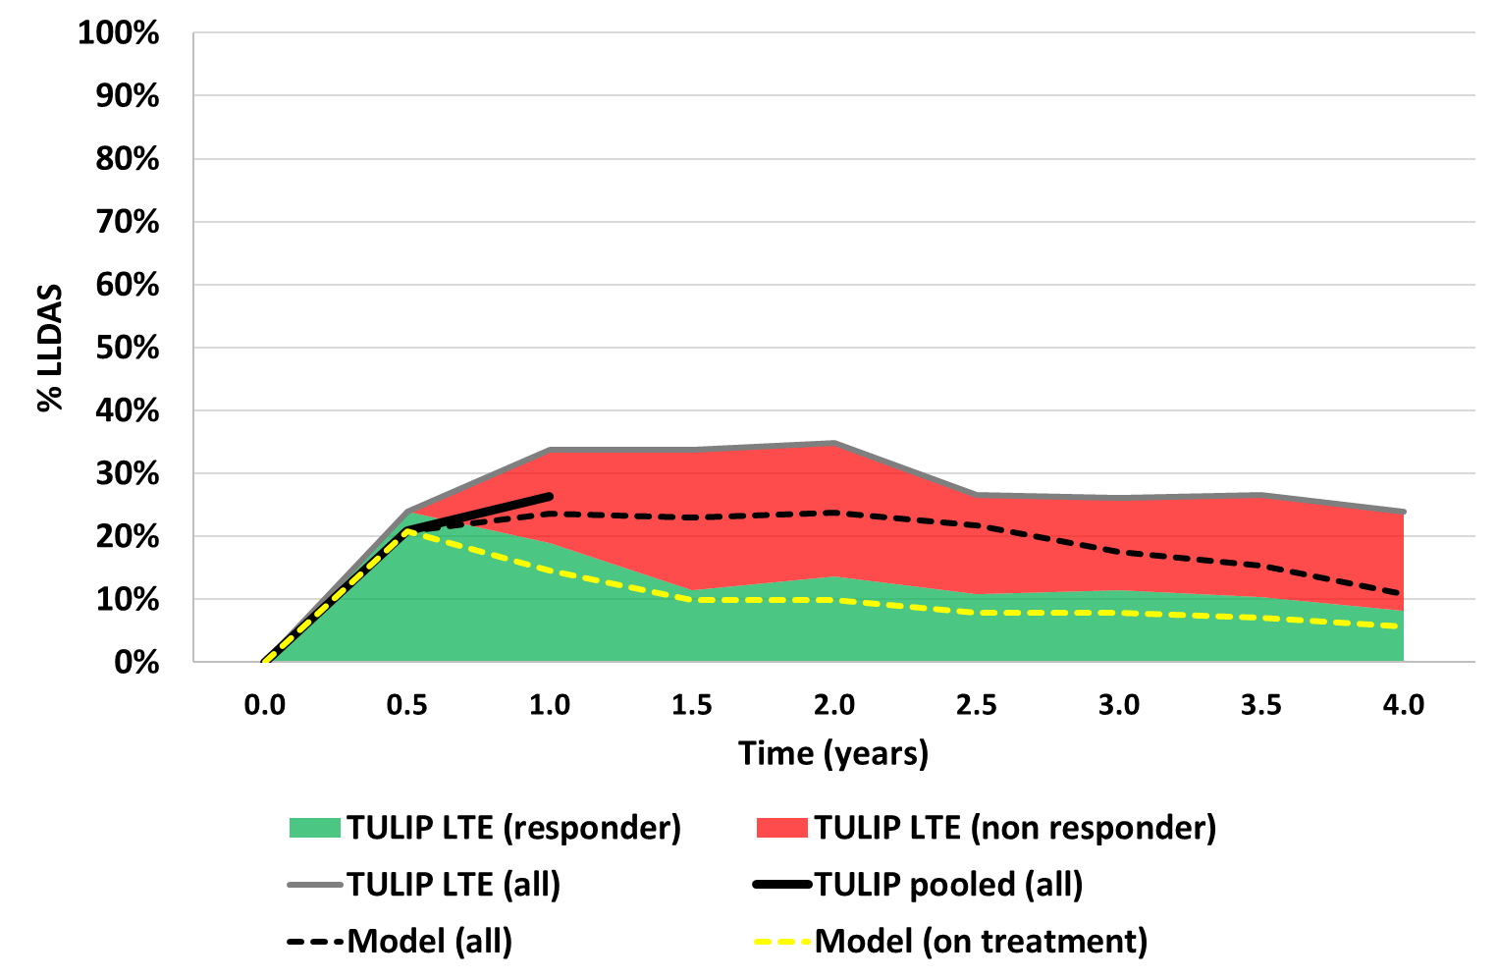 | 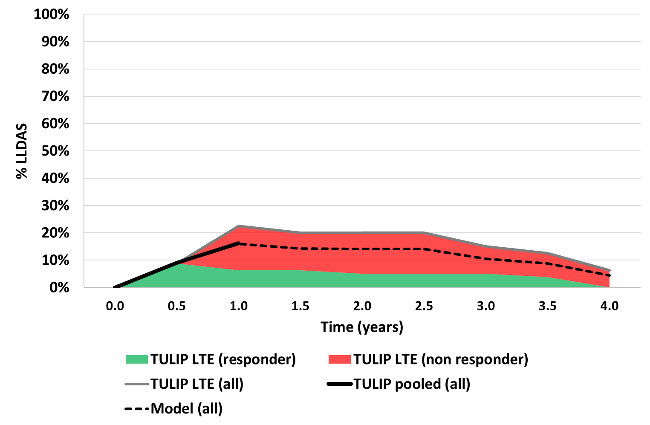
Source: compiled during the evaluation
SOC=standard of care, responder=patient achieved LLDAS at week 24
Weeks 24, 76 and 180 used as proxy for 26, 78 and 182 respectively
The anifrolumab arm used SOC transition probabilities for non-responders and patients who did not maintain LLDAS beyond 26 weeks. Patients in LTE had better response at 52 weeks in both arms.
  - Figure 3 presents a summary of the LLDAS data used in the economic model, as well as modelled estimates over the first 4 years of the model. It should be noted that response rates in the TULIP LTE were better in both the anifrolumab and SOC arms compared to the pooled TULIP trials and therefore it was appropriate for the modelled arms to lie below the total LLDAS in the TULIP LTE. Further, the modelled anifrolumab arm applied SOC transition probabilities to patients who discontinued anifrolumab, also resulting in lower rates of LLDAS than observed in the anifrolumab arm of the TULIP LTE. As missing patients were excluded from the analysis, the long term LLDAS attainment may be overestimated in both arms if patients achieving LLDAS were less likely to be lost to follow up.
  - Beyond 4 years, the model applied a constant transition probability based on the average of maintaining LLDAS status over weeks 104-208 of the TULIP LTE data. As described above, this resulted in a higher probability of maintaining LLDAS for anifrolumab non-responders, compared to SOC. The ESC advised that the absence of treatment effect waning over the time horizon was unlikely and favoured anifrolumab. Modelled time in LLDAS is presented in the following figure with the anifrolumab arm broken down by response and treatment discontinuation status.
Figure 4: Base case modelled extrapolations
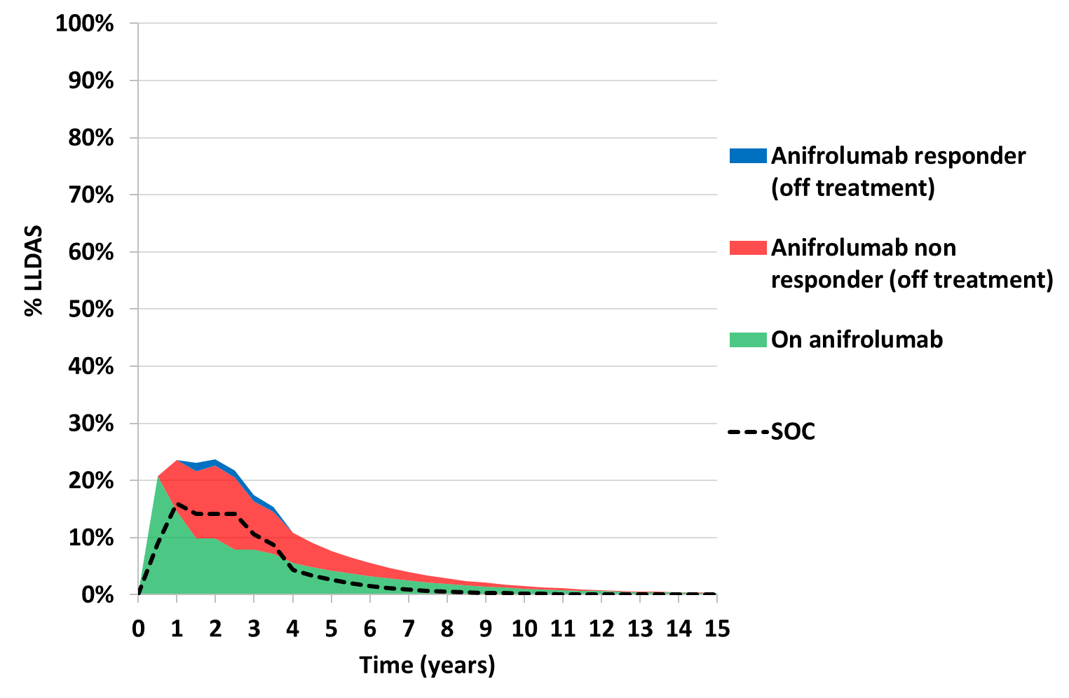
Source: compiled during the evaluation
Responder= patient achieves LLDAS by end of stopping rule, SOC=standard of care
  - As Figure 4 demonstrates, a large proportion of the LLDAS benefit for anifrolumab was accrued during the extrapolated period, and in the base case by the anifrolumab non-responders (LLDAS not achieved at Week 26). Therefore, the anifrolumab arm accrued additional LLDAS benefit from week 26 without the additional cost of anifrolumab. The trajectory of the proportion of patients in LLDAS prior to the extrapolation period appeared to trend towards zero in both arms, making the long modelled LLDAS tail unlikely. Further, patients are expected to achieve and lose LLDAS multiple times throughout the course of their disease and therefore the model is unlikely to reflect true patient experience. Overall, the extrapolation of LLDAS was uncertain, and the ICER was very sensitive to its inclusion. If LLDAS was not extrapolated beyond 4 years (i.e. 0% patients in both arms have LLDAS from Year 4.5), the discounted incremental QALYs reduced from 0.129 in the base case to 0.082 and the ICER increased to $95,000 to < $115,000 per QALY gained compared to $55,000 to < $75,000 in the base case. The ESC advised that due to the uncertainty in these extrapolations, and their subsequent impact on costs and outcomes, a 10 year time horizon would be more appropriate in the base case analysis.
  - Table 11 presents the transition probabilities through the SDI health states, flares and daily OCS dose each cycle, according to LLDAS status. The ESC noted that the submission cited retrospective observational studies to support that LLDAS is associated with lower morbidity and mortality, higher QOL and reduced resource utilisation. However, the ESC noted that these studies did not adjust for potential confounders (e.g. time in LLDAS, disease severity/status) and were therefore unreliable for quantifying the impact on final patient outcomes. While the LLDAS is a validated measure that has been associated with better patient outcomes (paragraph 4.6), as with the use of SLEDAI-2K in the economic model of the previous resubmission, the ESC considered that there was a lack of evidence as to relationship between changes in LLDAS and changes in long term outcomes that is sufficiently reliable for long-term modelling (see paragraph 6.43).
Table 11: Probabilities for organ damage accrual, flare incidence and OCS dose each cycle
Health state | Probability each cycle
Health state | Increase SDI score by +1 each cycle |  | Flares | Daily OCS dose
Health state | From SDI=0 | From SDI>0 | Flares | Anifrolumab | SOC
LLDAS | 2.6% | 2.9% | 13.2% | 4.968mg/day | 5.669mg/day
Not LLDAS | 4.2% | 4.6% | 29.3% | 8.055mg/day
Source | ‘Not LLDAS’: 22.5% per 3 years in Golder 2019 among LLDAS <50% time; adjusted by IRR of 1.12 from Ugarte-Gil 2022 for patients with SDI>0  ‘LLDAS’: ‘Not LLDAS’ adjusted for ‘LLDAS’ vs ‘Not LLDAS’ OR 0.59 from Golder 2019 |  | ‘Not LLDAS’: Golder 2019 Figure 1A LLDAS<50% curve, first 6 months  ‘LLDAS’: ‘Not LLDAS’ with HR 0.45 applied from Golder 2019 (severe flare) | Pooled TULIP-1 and TULIP-2 data, SLEDAI-2K≥10 subgroup, TULIP LTE not included.
Source: Table 3-14, Tables 3-17, Table 3-18, of the March 2024 resubmission
LLDAS= lupus low disease activity state, HR=hazard ratio, IRR=incident rate ratio, OR=odds ratio, SDI=SLICC/ACR (Systemic Lupus International Collaborating Clinics/American College of Rheumatology) Damage Index, OCS=oral corticosteroid, SOC=standard of care
  - Unlike the March 2023 resubmission, the ICER was not sensitive to organ damage. If organ damage accrual was removed from the model, the ICER increased only slightly to $55,000 to < $75,000 per QALY gained, compared to $55,000 to < $75,000 in the base case.
  - Compared to the March 2023 resubmission, flares in the current resubmission did not affect disease progression. However, flares were still a key driver of the results, and there was some inconsistency with the modelling of flares throughout the model. Flare incidence HR was based on severe flares, costs were based on mild/moderate flares, and flare disutilities were based on a distribution of all severity flares. If the flare incidence hazard ratio was set to 0.65 (any flares) the ICER increased to $55,000 to < $75,000 per QALY gained compared to $55,000 to < $75,000 in the base case.
  - Daily OCS dose was higher in both arms in the current resubmission compared to the March 2023 resubmission and appeared to overestimate OCS usage in the long term compared to the ALRB data (Figure 5). The incremental reduction in OCS use was 0.032 mg per day in the anifrolumab arm compared to SOC and OCS costs contributed little to the incremental costs (an incremental undiscounted cost of - $2.79 for the anifrolumab arm versus SOC arm). OCS dose no longer affected future organ damage or survival but the fixed OCS disutility in the ‘Not LLDAS’ health states was a moderate driver of the ICER.
Figure 5: Modelled OCS dose adjusted for mortality over 30 years
March 2023 resubmission | March 2024 resubmission
 | 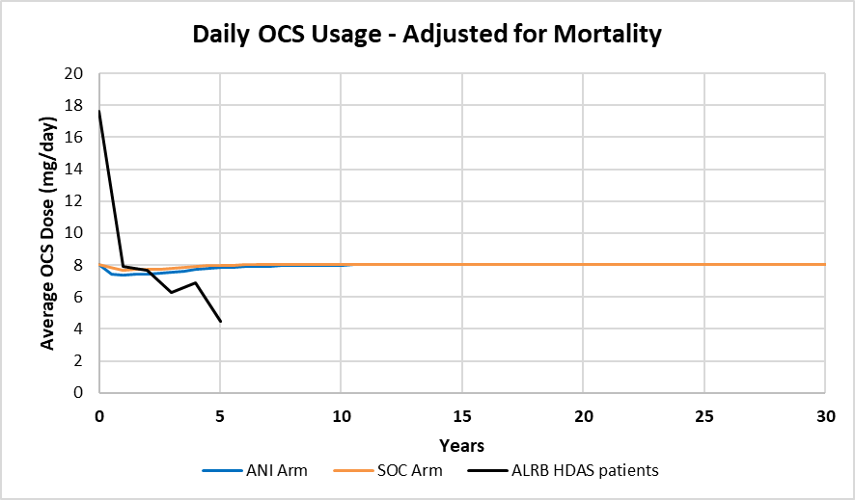
Source: compiled from, Sheet ‘Summary’ of the Excel workbook ‘CE model_anifrolumab_SLE_Nov2022.xlsm’ March 2023 resubmission, Sheet ‘Deterministic results’ of the Excel workbook ‘Saphnelo SLE CEA_final.xlsx’ March 2024 resubmission.
OCS=oral corticosteroid, SOC=standard of care, ALRB= Australian Lupus Registry and Biobank, HDAS=high disease activity status
March 2024 figure truncated to 30 years for comparison, but time horizon was 59 years
  - The resubmission claimed the mortality HR for ‘LLDAS’ versus an average SLE patient (0.7) was chosen to produce an overall life expectancy of 64.5 years in the SOC arm of the model. It was unclear how this value was estimated as it was hard coded in the model, and would likely be incorrect if different base case assumptions affecting mortality in the SOC arm were adjusted (e.g. age of patients at entry, proportion female, underlying SLE mortality, proportion of patients in LLDAS). The ESC considered that the assumption of a survival benefit for LLDAS patients over other SLE patients was uncertain and not well justified.
  - The estimated average SLE survival far exceeded the modelled survival in both the SOC and anifrolumab arms (Figure 6). While the modelled population was a higher risk group with expected higher mortality than ‘average’ SLE patients, there appeared to be no validation of this modelled survival curve. Modelled survival also appeared to exceed general population mortality at times. In the base case, the ‘LLDAS’ survival curve (if patients never lose LLDAS status) exceeded general population mortality at 91 years (see Figure 6).
Figure 6: Survival by age in the model
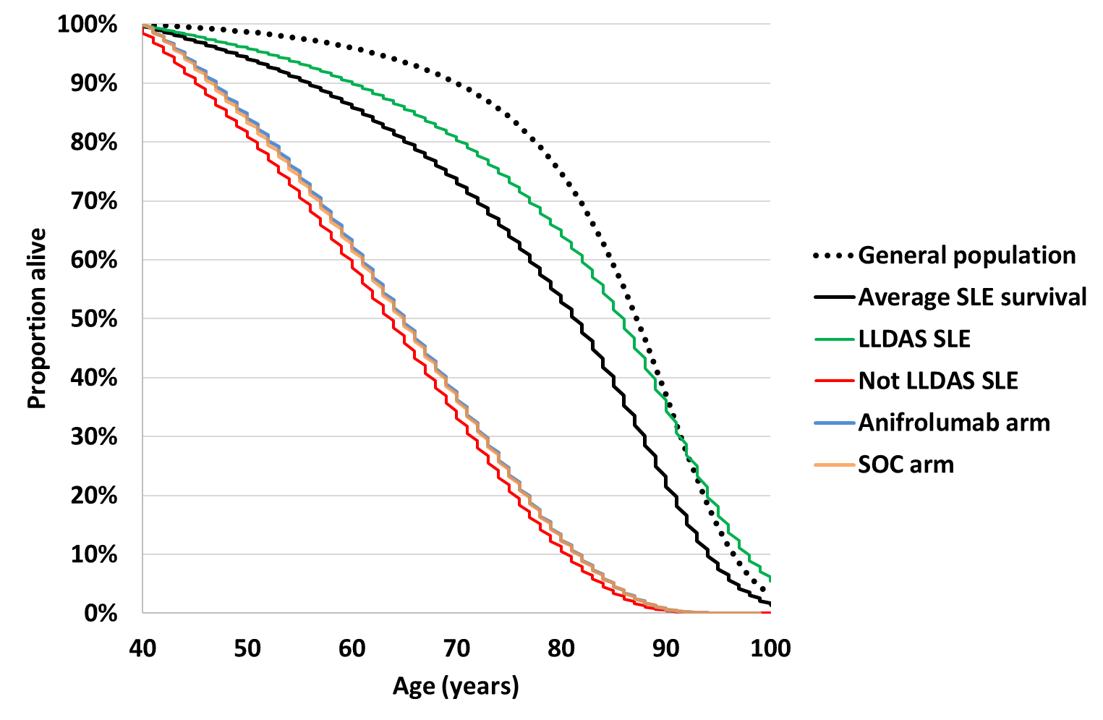
Source: compiled during the evaluation
Modelled lines appear stepped due to age rounding in the model. Average SLE survival based on Bernatsky 2006 age related ratios applied to Australian general population mortality. LLDAS and not LLDAS curves are for comparison purposes only. They assume patients maintain that state across their lifetime and therefore are unlikely to represent actual patient experience.
  - Figure 7 compares the modelled survival over 30 years in the current resubmission compared to the March 2023 resubmission.
Figure 7: Modelled survival over 30 years
March 2023 resubmission | March 2024 resubmission*
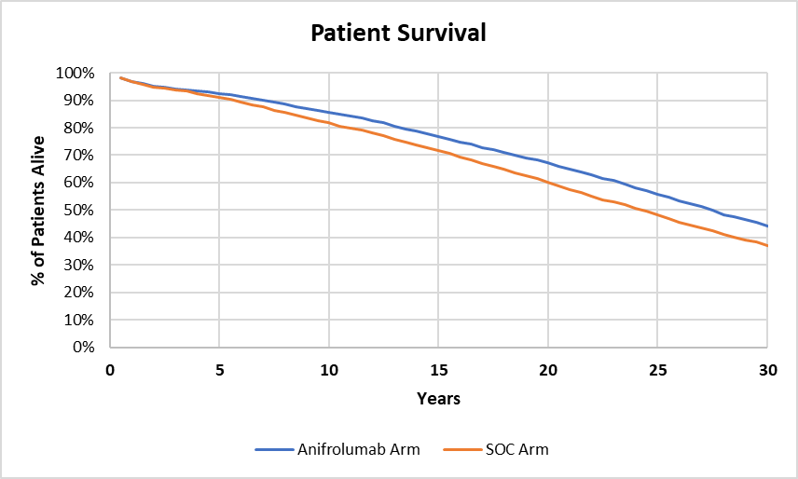 | 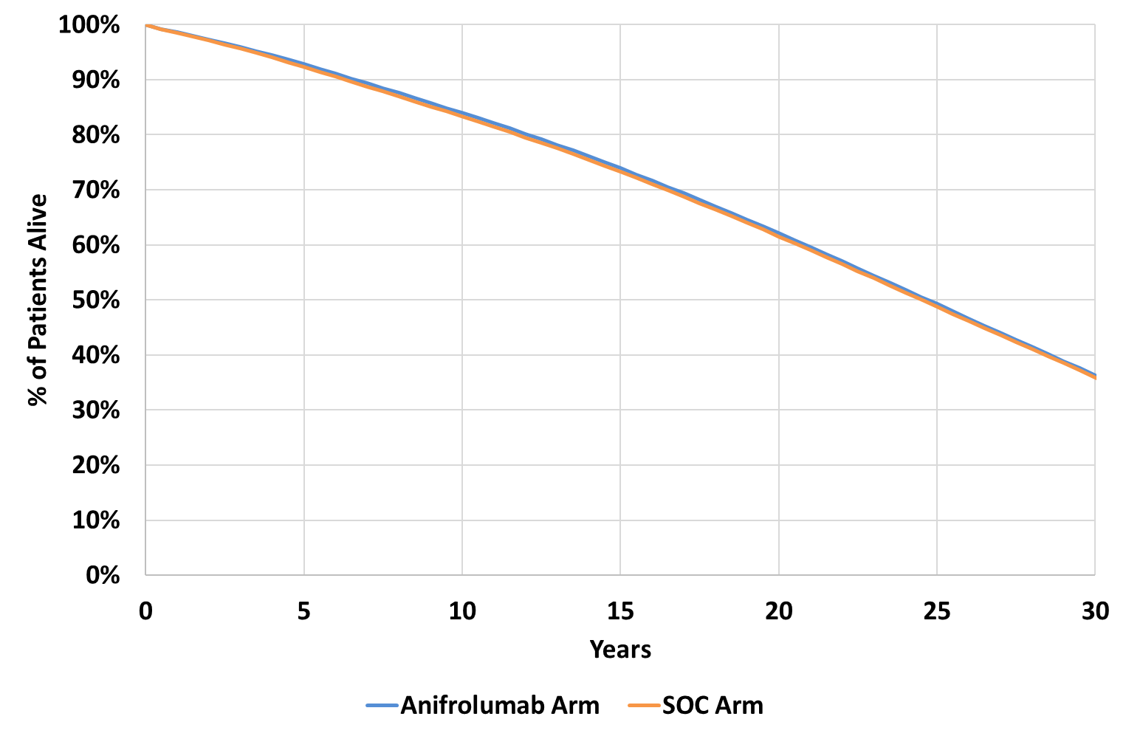
Source: Figure 3.7-8 of the March 2023 resubmission and compiled during the evaluation from Sheets ‘Ani cal’ ‘SOC cal’ of the Excel Workbook ‘Saphnelo SLE CEA_final.xlsx’ of the March 2024 resubmission
SOC=standard of care
* The figure has been truncated to 30 years for comparison, but the current (March 2024) resubmission modelled survival to 59 years.
  - Compared to the March 2023 resubmission, overall survival was similar in the SOC arm (~35% alive by the end of the 30 years) with anifrolumab slightly reduced from the March 2023 resubmission (~35% alive at 30 years reduced from 45% in the March 2023 resubmission). The incremental survival of anifrolumab over SOC was significantly reduced, though a small persistent benefit was maintained to the end of the 59-year time horizon. Despite the small benefit, incremental life years was a driver of the model results. If no survival benefit was assumed, the ICER increased to $75,000 to < $95,000 per QALY gained compared to $55,000 to < $75,000 in the base case.
  - Treatment discontinuation in the model occurred as patients failed to achieve LLDAS at Week 26 or maintain LLDAS post-Week 26. The model did not use any discontinuation data from the trials. Further, the model did not allow for retrial with anifrolumab. Retrial of anifrolumab would be permitted according to the requested restrictions and was included in the financial estimates. Overall, treatment duration was likely underestimated in this resubmission. The PSCR stated that the modelled treatment duration was appropriate given the new response criteria and that only a small proportion of patients would access the balance of supply. If 5% patients met Balance of Supply criteria, the PSCR stated this would increase incremental costs by $| | and the ICER by $0 to < $5,000. The full calculations for these results were not presented, and could not be exactly reproduced. Two months of additional treatment (equal to 2.17 treatment doses) for 5% patients would be an extra $| | ($| | without administration), resulting in an ICER of $55,000 to <$75,000 per QALY gained ($0 to < $5,000 more than the base case ICER of $55,000 to < $75,000 per QALY gained).
  - As shown in Figure 8, patients were estimated to remain on anifrolumab longer in the March 2023 resubmission than in the current resubmission. At 1 year, only 10% of patients remained on treatment, though benefits persisted across the time horizon. Mean time on treatment was estimated to be 1.11 years.
Figure 8: Modelled proportion of patients on treatment
March 2023 resubmission | March 2024 Resubmission
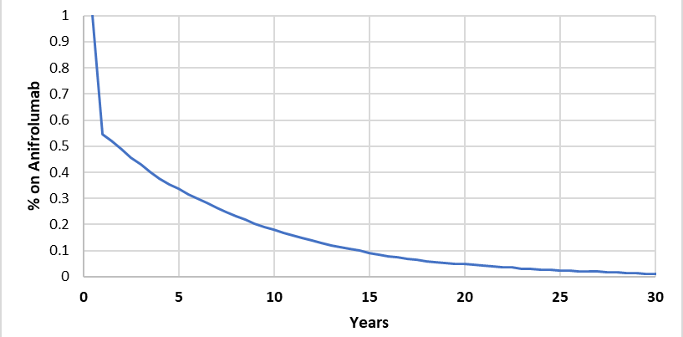 | 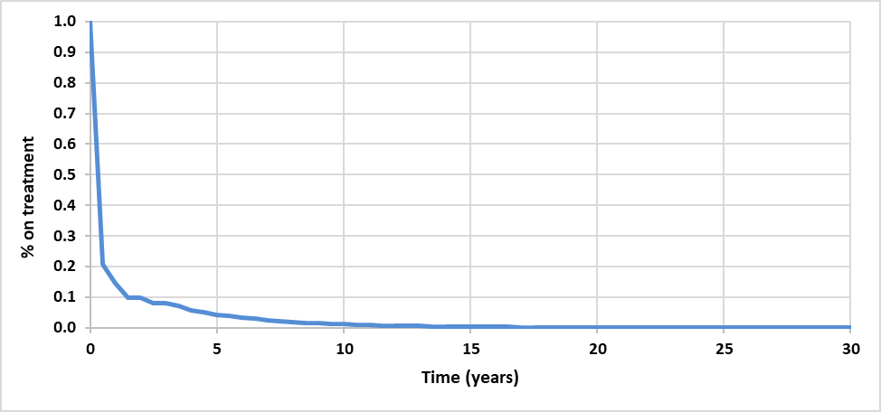
Source: Sheet ‘Summary’ of the Excel workbook ‘CE model_anifrolumab_SLE_Nov2022.xlsm’ March 2023 resubmission and adapted from Figure 3-10 in the March 2024 resubmission
  - The resubmission estimated health state utilities by LLDAS status based on a linear regression of patient characteristics and response to treatment from pooled ITT data from TULIP 1 and 2 trials. The base case applied the estimates from the anifrolumab arm (0.888 ‘LLDAS’, 0.810 ‘Not LLDAS’). It was unclear why the placebo arm was excluded. Disutilities were applied each cycle for organ damage (-0.012 per SDI unit increase), flares (-0.159), OCS use in the not LLDAS state (-0.03), and adverse events (herpes zoster -0.0195, infusion related reactions -0.0017). The health state utilities according to LLDAS status did not adjust for organ damage or OCS use and therefore the health state utilities may implicitly capture these disutilities. The additional disutilities may therefore result in a double counting of the effect of achieving LLDAS. If the OCS disutility was removed from the base case, the ICER increased to $55,000 to < $75,000 per QALY gained.
  - Despite little difference in the number of flares in the results (the anifrolumab arm resulted in 0.08 fewer flares over the model time horizon compared to the SOC arm), flares accounted for 12.6% of the discounted QALY gains (5.8% undiscounted), and therefore the disutility of flares remained a key driver of the results. Removing disutility for flares increased the ICER to $75,000 to < $95,000 per QALY gained compared to $55,000 to < $75,000 in the base case.
  - The unit costs and methods for calculating treatment costs were largely unchanged from the March 2023 resubmission, except for updating the PBS and MBS costs to current schedule fees. Health state costs were estimated differently, with average cost per cycle based on published mean costs, rather than regressing over patient characteristics.
  - The per cycle cost of anifrolumab was based on the proposed DPMQ of $||| ||| per 300 mg single dose vial (the requested DPMQ was $| | per 300 mg in the March 2023 submission, and $| | in the pre-PBAC response), at a dose of 300 mg every 28 days (estimated as 13 administrations per year, 6.5 administration per cycle, except for Cycle 1 where 6 administrations were assumed) until treatment discontinuation.
  - The cost of administration for anifrolumab was $199 in Cycle 1 (6 administrations) and $215 per cycle from Cycle 2 onwards (6.5 administrations) at a cost of $33.09 per administration (MBS item 105 $47.80 adjusted assuming 9 out of 13 administrations would incur an additional cost, with 4 specialist visits a year assumed to be standard practice). This was significantly reduced from the March 2023 resubmission, which utilised a cost of $103.55 per administration (MBS item 14245), and the resubmission claimed was appropriate for a 30 minute anifrolumab infusion. If the cost of administration was based on MBS item 14245 as previously (currently $107.85), the ICER increased to $75,000 to < $95,000 per QALY gained compared to $55,000 to < $75,000 in the base case.
  - Cost in ‘LLDAS’ was assumed to be $95.60 per cycle (two specialist visits MBS item 105). No other costs were associated with the ‘LLDAS’ health states, which may not be reasonable. Patients accrued additional costs if they experienced flares, adverse events or had SDI>0, but the ICER was insensitive to these costs.
  - The ‘Not LLDAS’ health state was estimated to cost $5,976 per cycle based on total annual cost for patients in LLDAS<50% of the time in Yeo et al 2020 . If the incremental cost from Yeo 2020 was used instead of total cost (equal to $2,203 per cycle), the ICER increased to $75,000 to < $95,000 per QALY gained, compared to $55,000 to < $75,000 in the base case. As with the ‘LLDAS’ states, patients accrued additional costs if they experienced flares, adverse events, or had SDI>0, but the ICER was insensitive to these costs.
  - The resubmission presented a health state allocation figure by LLDAS status. This is presented below along with a health state allocation by SDI score, and a health allocation by treatment plot truncated to 30 years to compare to the health state allocation in the March 2023 resubmission.
Figure 9: Health state allocation in the economic evaluation
By receipt of treatment (to 30 years)
March 2023 resubmission | March 2024 resubmission
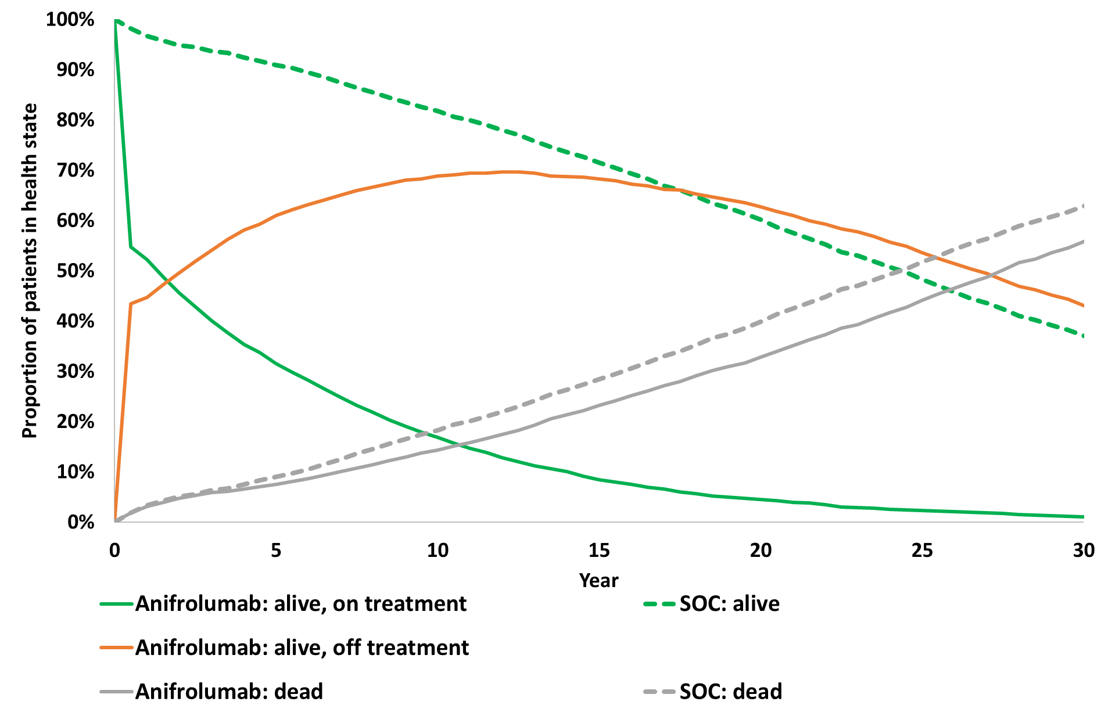 | 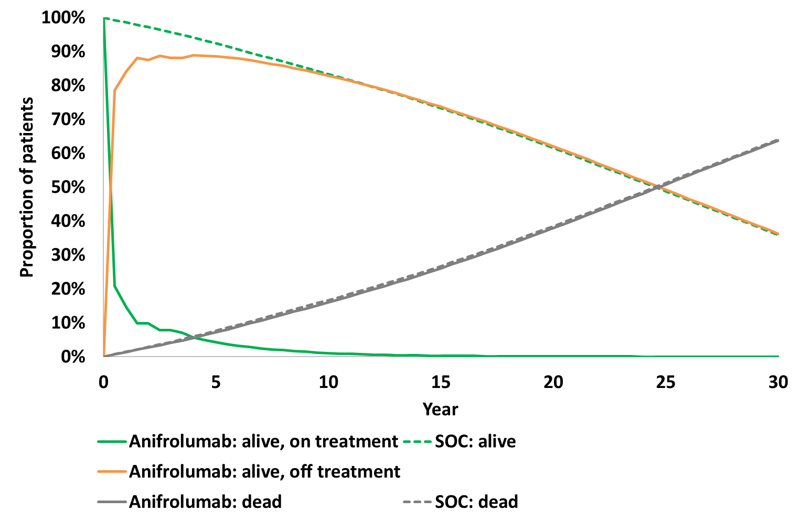
By LLDAS status (March 2024 resubmission) | By SDI score (March 2024 resubmission)
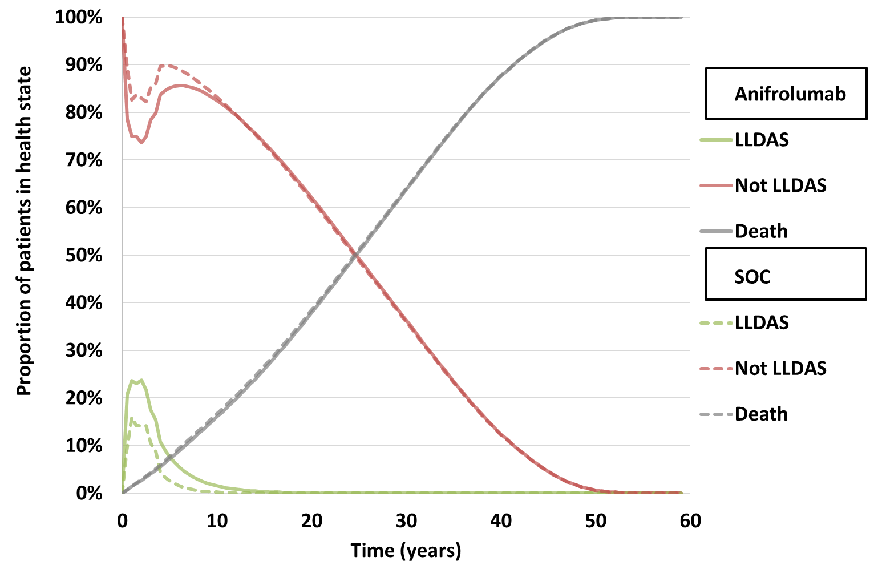 | 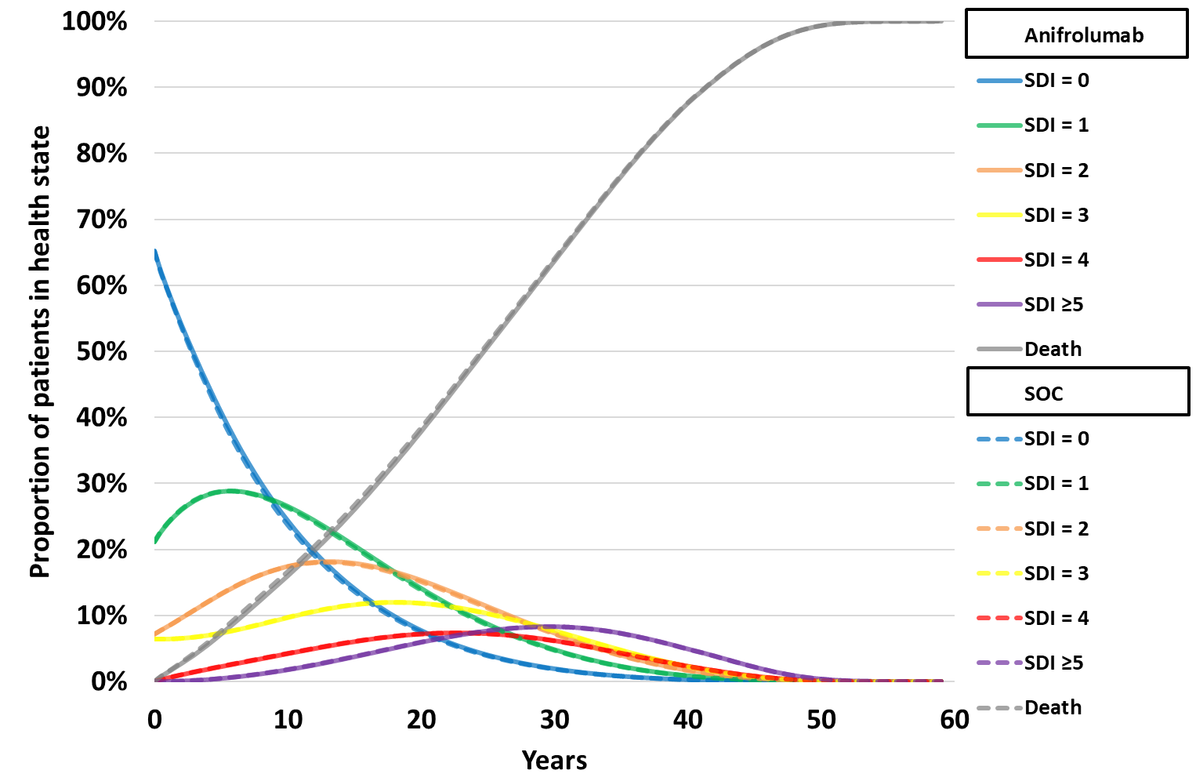
Source: adapted from Figure 3-13 of the March 2024 resubmission and compiled during the evaluation
Anifrolumab = anifrolumab arm; LLDAS = lupus low disease activity state; SOC = standard of care arm; SDI = SLICC/ACR (Systemic Lupus International Collaborating Clinics/American College of Rheumatology) Damage Index
Note: On and off treatment only refers to whether patients were receiving anifrolumab. Patients in the anifrolumab arm received treatment with SOC for the entirety of the modelled time horizon.
  - In the anifrolumab arm, the majority of patients were alive and off-treatment by Year 1. The health state allocation plots demonstrate the reduced survival in the anifrolumab arm compared to the March 2023 resubmission in both arms, plus the reduced survival benefit of anifrolumab over SOC and a much shorter time on treatment. The health state allocation by LLDAS and SDI figures demonstrate that incremental life years gained in LLDAS was the main driver of benefits in the model. SDI health state allocation was near identical across the treatment arms. Most patients spent their time in the ‘No LLDAS’ health states for the entire duration of the model. The resubmission considered modelled life expectancy estimates (SOC arm 40 years at baseline plus 24.5 years accrued in the model) similar to published estimates. No identified studies specifically reported life expectancy in patients with high disease activity and no survival curves were presented for comparison.
  - The key drivers of the model are summarised in Table 12.
Table 12: Key drivers of the model
Description | Method/Value | Impact  Base case: $|¹/QALY gained.
LLDAS transition probabilities | Transition probabilities based on pooled TULIP data, including TULIP LTE up to Week 208 (Cycle 8). Anifrolumab arm divided into on anifrolumab, off treatment non-responder and off treatment responder. Patients who discontinue anifrolumab modelled as per SOC responder arm. | High, favoured anifrolumab. If 95% CI for risk differences in LLDAS in first year (at weeks 26 and 52) were implemented the ICER ranged from $||||¹ to $||||² per QALY gained.
Extrapolation of treatment effect | From Cycle 9 onwards, constant probability of maintaining LLDAS applied each cycle based on Weeks 104 to 208 in the TULIP LTE | High, favoured anifrolumab. If extrapolation was removed (i.e. no LLDAS patients from Year 4.5), the ICER increased to $||||³ per QALY gained.
Mortality | Age adjusted SLE mortality was adjusted by LLDAS status (HR 0.7 LLDAS vs average SLE, HR 3.49 not LLDAS vs average SLE) | High, favoured anifrolumab. If average SLE survival improved (e.g. equal to general population), ICER increased to $||||² per QALY gained. If survival benefit for LLDAS removed, the ICER increased to $||||² per QALY gained.
Utility | LLDAS status utility based on the anifrolumab arm of the TULIP trials, with additional disutility of 0.03 in the not LLDAS state for extra OCS use, to give 0.89 LLDAS, 0.78 not LLDAS  Additional disutility for flares of 0.16 per cycle | High, favoured anifrolumab. If utility based on placebo arm and OCS disutility removed (0.88 LLDAS, 0.82 not LLDAS), ICER increased to $||||²/QALY gained.  If flare disutility removed (health state utilities not adjusted for flares), the ICER increased to $||||²/QALY gained.
Anifrolumab stopping rule | Patients stop anifrolumab if non-responder at 26 weeks, or if they lose LLDAS beyond 26 weeks. A proportion of patients who discontinued anifrolumab at or after Week 26 achieved LLDAS beyond Week 26. | High, favoured anifrolumab. If all patients continued treatment to 52 weeks, ICER increased to $||||³/QALY gained. The model did not permit LLDAS and treatment discontinuations to be modelled separately beyond the three scenarios presented in the submission (response at 26 weeks [base], response at 52 weeks and anifrolumab never discontinued).
Source: compiled during the evaluation
ICER=incremental cost-effectiveness ratio; OCS=oral corticosteroids; QALY=quality adjusted life year; SLE=Systemic Lupus Erythematosus; SOC=standard of care, HR=hazard ratio
The redacted values correspond to the following ranges:
¹ $55,000 to < $75,000
² $75,000 to < $95,000
³ $95,000 to < $115,000
  - Table 13 summarises the stepped economic evaluation. The base case ICER was $55,000 to < $75,000 per QALY gained compared to $75,000 to < $95,000 per QALY gained in the March 2023 resubmission ($55,000 to < $75,000 per QALY gained with the pre-PBAC response price of $| |). The steps differed slightly between the current resubmission and the March 2023 resubmission. Compared to the March 2023 resubmission, Step 3: ‘cost per QALY at 1 year, all costs’ was replaced with ‘cost per QALY at 4 years, drug costs only’. Step 5 was updated to reflect the lifetime time horizon (30 years in the March 2023 resubmission). Where possible the Steps from both resubmissions have been calculated for completeness. The 1 and 4-year analyses were corrected during the evaluation to represent a 1- and 4-year time horizon, rather than estimating them from the lifetime time horizon. The results showed the majority of the survival benefits for anifrolumab versus SOC were predicted to occur after 4 years (i.e., beyond available clinical data).
Table 13: Results of the stepped economic evaluation
 | March 2023 resubmission |  |  | Resubmission
Step and component | Anifrolumab arm | SOC arm | Increment | Anifrolumab arm | SOC arm | Increment
Step 1: Cost per responder at 24 weeks, no discounting
Costs (at 6 months) | $| | $0 | $ | | $ | | $0 | $ |
Respondersª | 55.4% | 47.4% | 8.0% | 20.9% | 9.0% | 11.9%
Incremental cost/extra responder |  |  | $ | ¹ |  |  | $||²
Step 2: Cost per QALY at 1 year, anifrolumab costs, no discounting
Costs | $| | $0 | $ | | $ | | $0 | $ |
QALYs gained | 0.597 | 0.564 | 0.033 | 0.696^{b} | 0.685 ^{b} | 0.011 ^{b}
Incremental cost/extra QALY gained |  |  | $ | ³ |  |  | $||⁴
Step 3 (March 2023): ICER at 1 year, all costs, no discounting
Costs^{b,c} | $| | $3,907 | $ | | $ | | $14,431 | $ |
LYG | 0.983 | 0.983 | 0.0003 | 0.993 | 0.992 | 0.0002
Incremental cost/LYG |  |  | $ | ⁵ |  |  | $||⁵
QALYs gained | 0.597 | 0.564 | 0.033 | 0.696 | 0.685 | 0.011
Incremental cost/extra QALY gained |  |  | $ | ³ |  |  | $||⁶
Step 3 (March 2024): ICER at 4 year, anifrolumab costs, 5% discounting for costs and benefits
Costs^{b,c} | - | - | - | $ | | $0 | $ |
LYG | - | - | - | 3.582 | 3.575 | 0.006
Incremental cost/LYG |  |  | - |  |  | $||⁵
QALYs gained | - | - | - | 2.531^{b} | 2.482^{b} | 0.049^{b}
Incremental cost/extra QALY gained |  |  | - |  |  | $||⁷
Step 4: ICER at 4 years, all costs, 5% discounting for costs and benefits
Costs | $| | $15,103c | $ | | $ | | $0 | $ |
LYG | 3.474 | 3.463 | 0.011 | 3.582 | 3.575 | 0.006
Incremental cost/LYG |  |  | $ | ⁵ |  |  | $||⁵
QALYs gained | 1.694 | 1.481 | 0.213 | 2.531^{b} | 2.482^{b} | 0.049^{b}
Incremental cost/extra QALY gained |  |  | $ | ⁸ |  |  | $||⁷
Step 5: ICER at 30 years (March 2023), 59 years (March 2024), 5% discounting for costs and benefits (base case)
Costs | $| | $90,363 | $ | | $ | | $224,630 | $ |
LYG | 12.667 | 12.082 | 0.585 | 13.169 | 13.088 | 0.081
Incremental cost/LYG |  |  | $ | ⁹ |  |  | $||¹
QALYs gained | 3.853 | 3.189 | 0.664 | 8.934 | 8.805 | 0.129
Incremental cost/extra QALY gained (base case) |  |  | $ | ⁹ |  |  | $||¹⁰
Source: Table 3.8-1 of the March 2023 resubmission, Table 3-34 of the March 2024 resubmission and compiled during the evaluation. LYG have been included in Steps 3-5.
ICER=incremental cost-effectiveness ratio, QALY=quality adjusted life year, LYG=life years gained, SOC=standard of care
ª Responders were hard coded into the model based on trial results. Response in the SOC arm was not modelled. Costs were based on 6 month estimates in the model. In the March 2023 resubmission response referred to patients reducing their SLEDAI-2K score by at least 4. In the March 2024 resubmission response referred to achieving LLDAS.
^{b} Table 3-34 read off results at 1 and 4 years from the lifetime horizon model. Results presented here restrict the time horizon to 1 and 4 years, incorporating the modelled half cycle correction for life years and QALYs
^{c} SOC costs were reported at 1 year in the March 2023 resubmission, corrected to 4 years here.
c OCS costs corrected from those reported in Table 3.8-1 of the July 2022 submission
d SOC costs were reported at 1 year in the resubmission, corrected to 4 years here.
The redacted values correspond to the following ranges:
¹ $95,000 to < $115,000
² $45,000 to < $55,000
³ $355,000 to < $455,000
⁴ $655,000 to < $755,000
⁵ > $1,055,000
⁶ $555,000 to < $655,000
⁷ $155,000 to < $255,000
⁸ $135,000 to < $155,000
⁹ $75,000 to < $95,000
¹⁰ $55,000 to < $75,000
  - The main driver of costs was the cost of anifrolumab ($||| ||| for a course of treatment plus administration, equivalent to | |% of the incremental costs). However, this cost was greatly reduced compared to the March 2023 resubmission of $| | for a course of treatment plus administration, due to shorter time on treatment (1.11 years versus 4.88 years in the March 2023 resubmission) and reduced unit cost ($| | per 300 mg vial compared to $| | in the March 2023 resubmission). The PSCR stated that average treatment duration is much lower in the resubmission because the continuation criteria is both harder to achieve (response rates decreased from 55.4% to 20.9%) and to maintain. The duration of treatment for a responder was reported to be 3.41 years in the current model vs. 8.32 years in the previous model.
  - The main cost offset was avoiding costs in the ‘Not LLDAS’ health states (saving of $4,547, equivalent to -| |% of total incremental costs). Incremental organ damage costs changed compared the March 2023 resubmission, with a cost-offset of $13 compared to $9,092 in the March 2023 resubmission. This change was driven by the similarity of time in the SDI heath states across the treatment arms.
  - Compared the March 2023 resubmission, absolute QALYs in each arm were greatly increased (e.g., anifrolumab arm was expected to accrue 5.8 undiscounted QALYs in the March 2023 resubmission, but 16.4 undiscounted QALYs in the current resubmission). This was not driven by the longer time horizon, but by the higher mean utilities (average 0.670 for the anifrolumab arm, 0.667 for the SOC arm across the time horizon compared to 0.281 and 0.252 in the absence of organ damage in the March 2023 resubmission). If the time horizon was set to 30 years as per the March 2023 resubmission the anifrolumab arm of the current resubmission was expected to accrue 14.5 undiscounted QALYs.
  - In the previous belimumab submission (Table 14, belimumab PSD, July 2020) discounted LYs were estimated as 15.60 for belimumab, 15.39 for SOC (0.20 incremental LYG) and discounted QALYs were estimated as 10.49 in the belimumab arm and 9.95 in the SOC arm (0.54 incremental QALYs gained) were accrued across a 60-year time horizon. The PBAC considered that the resulting ICER was likely underestimated, and the model assumptions likely favoured belimumab (paragraph 7.6, belimumab PSD, July 2020). In comparison to the March 2023 resubmission, the incremental life years and QALYs presented in the current resubmission did not exceed those seen in the belimumab submission.
  - Given the uncertainty of the ICER across a lifetime time horizon, Step 4 of the stepped economic evaluation which results in an ICER of $155,000 to < $255,000 per QALY gained was particularly informative as it was based on the duration of the trial follow up (i.e. 4 years). However, as the 4 year analysis did not use data directly from the trial (particularly for patients in the anifrolumab arm discontinuing treatment), a trial-based cost-effectiveness analysis, using the individual patient data directly from the TULIP trials and TULIP LTE may be more robust.
  - The PSCR stated that the PBAC had previously accepted SOC data to inform event rates for patients that discontinued active treatment, i.e. non-responders (paragraph 6.50, belimumab July 2020, PSD). However, the belimumab submissions and anifrolumab resubmission differ both in how response was measured, (≥4-point reduction in SLEDAI-2K in the belimumab submissions, LLDAS in the current anifrolumab resubmission) and what data drove disease progression in the SOC arm (SDI transitions modelled based on SLICC cohort data in the belimumab submission, LLDAS transitions from the TULIP trials in the anifrolumab resubmission). Given the differences between these submissions, the ESC considered that it was appropriate to consider the uncertainty of modelling patients who discontinue anifrolumab using the SOC arm of the TULIP trials.
  - The ESC noted that the current model was more transparent in comparison with the March 2023 model; however, some of the economic issues were not adequately addressed by the resubmission and the modelling of LLDAS was unlikely to reflect true disease trajectory. Further, the way that rates of LLDAS in non-responders in the SOC arm were applied to the anifrolumab arm, resulted in a large proportion of the benefit of the anifrolumab arm occurring in non-responders. In other words, benefits continued to accrue over the time horizon in the anifrolumab arm without ongoing treatment costs (see paragraph 6.45). The ESC noted that the extrapolations for both treatment arms were not evidence based, and they had not been validated against external data.
  - A summary of sensitivity analyses is presented in Table 14. The ICER was most sensitive to: treatment effect on LLDAS, inclusion of LLDAS extrapolation, inclusion of flares (and effect of LLDAS upon flares, anifrolumab costs, LLDAS health state costs and utilities, mortality adjustments.
Table 14: Results of sensitivity analyses
Analyses | Incremental cost ($) | Incremental QALY | ICER | %change
Submitted base case | | | | 0.129 | ||¹ | -
Discount rate (base case 5% costs and outcomes)  - 0% costs and outcomes  - 3.5% costs and outcomes | |  | | 0.210  0.146 | ||²  ||¹ | -||  -||
Time horizon (base case 59 years)
- 10 years | | | | 0.090 | ||³ | ||
- 20 years  - 30 years | |  | | 0.116  0.126 | ||¹  ||¹ | ||  ||
LLDAS risk difference anifrolumab vs SOC in Year 1 (base 26 weeks 20.9%, 52 weeks 26.4%)
Lower 95%CI (26 weeks 14.9%, 52 weeks 19.4%) | | | 0.093 | ||³ | |
Upper 95%CI (26 weeks 27.0%, 52 weeks 33.3%) | | | | 0.165 | ||¹ | -||
LLDAS extrapolation (base case constant probabilities from Cycle 9)
- No extrapolation | | | 0.082 | ||⁴ | |
Flare HR, LLDAS vs not LLDAS (base HR=0.45)
- Any flares (HR=0.65) | | | 0.120 | ||¹ | |
- No effect (HR=1) | | | 0.105 | ||³ | |
Flare rate in ‘not LLDAS’ states (base 29.3%)
- 0% (flares removed from the model) | | | 0.113 | ||³ | |
Anifrolumab related cost (base anifrolumab AEMP = $|||| (DPMQ = $||||) per 300 mg, administration $33.09 per admin, 6 admins Cycle 1, 6.5 Cycle 2 onwards)
- Anifrolumab AEMP = $|||| (DPMQ = $||||) | | | 0.129 | ||¹ | -||
- Administration $107.85 (MBS 14245) | | | 0.129 | ||³ | |
- 8 administrations Cycle 1 (requested Balance of Supply) | | | 0.129 | ||³ | |
LLDAS states related cost (base LLDAS $96, not LLDAS $5,976)
- Decrease ‘not LLDAS’ 20% | | | 0.129 | ||³ | |
- Increase ‘not LLDAS’ 20% | | | 0.129 | ||¹ | -||
- Incremental cost ‘not LLDAS’ vs LLDAS group, Yeo 2020 ($2,203) | | | 0.129 | ||³ | |
- LLDAS from Yeo 2020 ($3,773) | | | 0.129 | ||³ | |
Utility LLDAS (base TULIP anifrolumab arm 0.89 LLDAS, 0.78 not LLDAS, including 0.03 OCS disutility)
- Wang 2014 (LLDAS 0.85, not LLDAS 0.62) | | | 0.171 | ||² | -||
- No OCS disutility | | | 0.117 | ||¹ | |
- TULIP placebo arm (LLDAS 0.88, not LLDAS 0.82 no OCS disutility) | | | 0.110 | ||³ | |
Flare disutility (base 0.16 per cycle)
- No disutility | | | 0.113 | ||³ | |
Mortality inputs (base gen pop adjusted for SLE age based mortality, adjusted for LLDAS status)
- Average SLE mortality equal to general population | | | 0.091 | ||³ | |
- Not adjusted for LLDAS, adjusted for SDI score | | | 0.082 | ||³ | |
- No LLDAS or SDI mortality adjustment (no survival benefit) | | | 0.076 | ||³ | |
LLDAS status related mortality HRs (base case LLDAS vs average SLE HR=0.7, not LLDAS vs average SLE HR=3.49
- not LLDAS vs average SLE 1.45 (Lower 95% CI not LLDAS vs LLDAS 2.07) | | | 0.094 | ||³ | |
- Not LLDAS vs average SLE 8.40 (upper 95% CI not LLDAS vs LLDAS 12.0) | | | 0.179 | ||¹ | -||
- LLDAS vs average SLE HR=1 | | | 0.142 | ||¹ | -||
- LLDAS vs average SLE HR=0.25 | | | 0.101 | ||³ | |
LLDAS rates for responders after anifrolumab discontinuation (base placebo responders)
- Placebo non-responders | | | 0.124 | ||¹ | |
Anifrolumab stopping rule (base 26 weeks)
- 52 weeksª | | | 0.145 | ||⁴ | |
- No stopping rule (anifrolumab continued until death) | | | 0.272 | ||⁵ | |
ESC multivariate sensitivity analyses
1. Time horizon = 10 years  2. LLDAS states related costs from Yeo ($3,773)  3. No LLDAS mortality benefit  4. Anifrolumab discontinuers move into placebo non-responder state | | | 0.071 | ||⁶ | ||
ESC MSA with price proposed in pre-PBAC response | | | 0.071 | ||⁷ | |||
Pre-PBAC Response revised base case
1. Reduction in effective EMP to $|||| (DPMQ=$||||)  2. LLDAS health state cost increased from $95.60 to $340.10  3. LLDAS rates for ANI non-responders equal to SOC (anifrolumab discontinuers move into placebo non-responder state)  4. No change to LLDAS or SLE mortality adjustment  5. Model time horizon to 15 years | | | 0.1025 | ||¹ | |
PBAC Additional multivariate sensitivity analyses
Alternative 1: Pre-PBAC response settings but remove mortality benefit | | | 0.071 | ||³ | |
Alternative 2:  Pre-PBAC Response settings but remove mortality benefit and apply Wang 2014 utility values (LLDAS of 0.85 (vs 0.89) and non-LLDAS of 0.62 (vs 0.78)) | | | 0.124 | ||² | -||
Alternative 3:  Pre-PBAC Response settings but remove mortality benefit and apply Wang 2014 utility values (LLDAS of 0.85 (vs 0.89) and non-LLDAS of 0.62 (vs 0.78)) and assume LLDAS cost from Yeo 2020 ($3,773) | | | 0.124 | ||³ | |
Alternative 4:  Pre-PBAC Response settings but remove mortality benefit and apply Wang 2014 utility values (LLDAS of 0.85 (vs 0.89) and non-LLDAS of 0.62 (vs 0.78)) and assume 50% of LLDAS cost from Yeo 2020 ($1,887) | | | 0.124 | ||¹ | -||
Source: Table 3-43 of the March 2024 resubmission and compiled during the evaluation
APLC=Asia Pacific Lupus Collaboration, OCS = oral corticosteroids; HR = hazard ratio; CI = confidence interval; NR = not reported; yr = year; SOC = standard of care; QALY = quality adjusted life year; ICER = incremental cost-effectiveness ratio
a The resubmission presented alternate transition probability matrices, assuming all patients in the anifrolumab arm received anifrolumab until Week 52.
The redacted values correspond to the following ranges:
¹ $55,000 to < $75,000
² $45,000 to < $55,000
³ $75,000 to < $95,000
⁴ $95,000 to < $115,000
⁵ $555,000 to < $655,000
⁶ $155,000 to < $255,000
⁷ $135,000 to < $155,000
  - The ESC advised that a more appropriate respecified base case would include a 10-year time horizon; this increased the ICER to $75,000 to < $95,000 per QALY gained. The ESC further advised that multivariate sensitivity analyses should be explored that: removed the LLDAS and SLE mortality adjustment (i.e. there should be no survival benefit); increased the costs associated with the LLDAS health state in line with Yeo 2020; and assumed LLDAS rates for anifrolumab non-responders were equal to SOC non-responders. The ESC noted that when all these changes were combined the ICER was $155,000 to < $255,000 per QALY gained.
  - The pre-PBAC response proposed a revised base case which resulted in an ICER of $55,000 to < $75,000 per QALY gained (Table 14). The pre-PBAC response stated that the costs associated with the LLDAS state estimate in Yeo 2020 were not consistent with the definition of the health state in the model. The pre-PBAC response stated this was because the analysis in Yeo 2020 reported on patients that spent at least 50% of their time in LLDAS during the follow-up period, whereas the modelled LLDAS health state assumed patients spent 100% of the cycle in LLDAS. The pre-PBAC response proposed a cost of $340.10 per 6-month cycle, based on the assumption that patients would receive 3 specialists visits (MBS item 105: $47.80) twice per cycle and blood and serum tests (MBS Item 66512: $9.70 and MBS Item 65070: $16.95) twice per cycle.
  - The PBAC noted that the model was sensitive to a range of inputs as shown in Table 14, and considered that a range of alternative scenarios could be considered.

Anifrolumab cost/patient/year
Table 15: Drug cost per patient for anifrolumab
 | Trial dose and duration | Model^{b} |  | Financial estimates^{c}
 | Trial dose and duration | March 2023 | Resubmission | March 2023 | Resubmission
Mean dose anifrolumab | 300 mg | 300 mg | 300 mg | 300 mg | 300 mg
Mean number of administrations/year | 13.04 | 13.00 | 13.00^{d} | 12.39e | 12.39e
Mean duration anifrolumab | NRª | 4.88 years  (30 year time horizon) | 1.11 years  (59 year time horizon) | NE | NE
Cost/patient/month ($) | NA | | | | | | | |
Cost/patient/year ($) | NA | | | | | | | |
Source: compiled during the evaluation
NA=not applicable, NE=not estimable, NR=not reported
SOC costs not included as anifrolumab used in addition to SOC. In the financial estimates no SOC costs were included. In the model OCS costs differed between the anifrolumab and SOC arms but was not vastly different
Financial estimates used weighted public/private cost.
Mean duration multiplied by per year cost does not give total cost reported in the model as model assumed half a cycle treatment costs for patients who discontinued treatment during that cycle.
a The proportion of patients with at least 48 weeks of treatment was 81.1% in TULIP-1, 85.6% in TULIP-2 and 87.9% in MUSE.
b The economic model assumed patients could initiate anifrolumab only once
c The financial estimates did not exclude patients from initiating anifrolumab again in subsequent years once they had discontinued treatment, but also did not follow continuing patients remaining on treatment beyond their initial year.
d In the first year of the model 12.5 administrations were assumed.
e For a patient who does not discontinue, assuming 95% compliance (13.04 x 0.95).

Estimated PBS usage & financial implications
  - This resubmission was not considered by DUSC. As for the March 2023 submission, the resubmission used an epidemiological approach to estimate the financial impact of listing anifrolumab on the PBS. Table 16 summarises the sources of data and assumptions used in the financial estimates including changes versus the March 2023 resubmission.
Table 16: Key inputs for financial estimates
Data | Mar 2023 | Mar 2024 | Source | Comment
Eligible population
Prevalent patients with SLE | Yr 1: ||||¹  Yr 2: |||| ²  Yr 3: |||| ²  Yr 4: ||||²  Yr 5: ||||²  Yr 6: ||||² | Yr 1: ||||²  Yr 2: |||| ²  Yr 3: ||||²  Yr 4: ||||²  Yr 5: ||||²  Yr 6: ||||² | Australian adult population estimates (2024-2029) multiplied by prevalence of 94.33 in 100,000 based on Australian estimates. | Updated to 2024-2029 numbers but otherwise unchanged from previous resubmission.  DUSC considered this estimate to be appropriate.
Eligible population: patients with SLEDAI-2K≥10 on triple therapy | Yr 1: ||||³  Yr 2: ||||³  Yr 3: ||||³  Yr 4: ||||³  Yr 5: ||||³  Yr 6: ||||³ | Yr 1: ||||³  Yr 2: ||||³  Yr 3: ||||³  Yr 4: ||||³  Yr 5: ||||³  Yr 6: ||||³ | Prevalent patients multiplied by 15.83% to represent patients with SLEDAI-2K ≥10 whilst on triple therapy. Adapted from the 2022 IQVIA report commissioned by the sponsor (Attachment 4.3 of the March 2023 resubmission). | In the IQVIA report 11.7% patients were SLEDAI-2K ≥10 whilst on triple therapy and clinically eligible to receive treatment (and 11.0% where clinician was willing to prescribe treatment). As such eligibility proportion may be overestimated.  The ESC agreed with the commentary that the data suggested an estimate of 11.7% would be more appropriate.
Grandfathered patients | Yr 1: ||||⁴ | ||||⁴ | Assumed to be implicitly included in prevalent population | While it was reasonable to not count grandfathered patients separately (to avoid discounting in the prevalent population), no adjustment for response at 26 weeks or time on treatment was made for the grandfathered population.
Treatment utilisation
Uptake rate | Yr 1: ||||%  Yr 2: ||||%  Yr 3: ||||%  Yr 4: ||||%  Yr 5: ||||%  Yr 6: ||||% | Yr 1: ||||%  Yr 2: ||||%  Yr 3: ||||%  Yr 4: ||||%  Yr 5: ||||%  Yr 6: ||||% | Assumption. decreased from the March 2023 resubmission (but identical to rates proposed in the March 2023 pre-PBAC response). | Uptake rates remained uncertain. While patients who are on triple therapy do not have other treatments available, the PBAC previously considered lower uptake rates for belimumab (15-40%) were more reasonable than higher uptake rates, given use of IV belimumab was low, treatment effect was modest and there as potential for severe adverse events (para 7.10, belimumab PSD, July 2020).  Uptake is very important to the financial estimates as the current anifrolumab resubmission presented a tiered RSA based on utilisation rates.  The ESC noted that the proposed uptake rates (||||% to ||||%) were higher than the rates previously considered for belimumab (15-40%).
Initiating patients | Yr 1: ||||³  Yr 2: ||||³  Yr 3: ||||³  Yr 4: ||||³  Yr 5: ||||³  Yr 6: ||||³ | Yr 1: ||||³  Yr 2: ||||³  Yr 3: ||||³  Yr 4: ||||³  Yr 5: ||||³  Yr 6: ||||³ | Eligible population x uptake rate. | Appropriate calculation.
Continuing patients | Yr 1: ||||³  Yr 2: ||||³  Yr 3: ||||³  Yr 4: ||||³  Yr 5: ||||³  Yr 6: ||||³ | Yr 1: ||||⁴  Yr 2: ||||⁴  Yr 3: ||||⁴  Yr 4: ||||⁴  Yr 5: ||||⁴  Yr 6: ||||⁴ | This resubmission assumed a continuation rate at 6 months of 20.9% for those that initiate anifrolumab each year based on LLDAS response at 24 weeks in the TULIP trials. The resubmission’s approach did not follow patients past the initiation year and implicitly allowed for retrials of anifrolumab, which was reasonable and permitted based on the requested restrictions. | Reasonable.
Total number patient-years treated | Yr 1: ||||³  Yr 2: ||||³  Yr 3: ||||³  Yr 4: ||||³  Yr 5: ||||³  Yr 6: ||||³ | Yr 1: ||||³  Yr 2: ||||³  Yr 3: ||||³  Yr 4: ||||³  Yr 5: ||||³  Yr 6: ||||³ | Calculations assume patients who discontinue treatment did so after 6 months | This was as per methodology outlined in the DUSC advice.
Scripts dispensed | Yr 1: ||||²  Yr 2: ||||²  Yr 3: ||||²  Yr 4: ||||⁶  Yr 5: |||| ⁶  Yr 6: ||||⁶ | Yr 1: ||||⁵  Yr 2: ||||⁵  Yr 3: ||||⁵  Yr 4: ||||¹  Yr 5: ||||¹  Yr 6: ||||¹ | 12.39 scripts per patient-year (13.04 scripts assuming 95% compliance). | Calculations arithmetically correct. As with previous resubmission this differed to the assumed 100% compliance in the model with 13 scripts per patient year.
Costs
Public/private split | Public: 65.96%  Private: 34.04% | Public: 55.98%  Private:44.02% | Infliximab use 2022 (PBS items 6397Q, 11483J, 11487N, 5757B, 11481G, 11490R) | Rituximab is now unrestricted on the PBS. However, as the year the data was taken from (2022) was not updated, it was unclear why the estimates would no longer be applicable. Difference in splits does not have a significant effect on the financial estimates.
PBS/RPBS split | PBS: 98.28%  RPBS: 1.72% | PBS: 98.99%  RPBS: 1.01% | Infliximab use 2022 (PBS items 6397Q, 11483J, 11487N, 5757B, 11481G, 11490R)
Anifrolumab | $|||| | $|||| | Revised requested price weighted public $||||, private $||||, based on infliximab weights. | Reasonable, although the March 2023 pre-PBAC response requested price was $|||| (public).
Patient copayment | PBS $18.03  RPBS $6.36 | PBS $20.58  RPBS $6.60 | Calculation based on infliximab PBS copayment weights using updated PBS copayments. | Reasonable.
MBS costs | $82.84 | $25.90 | MBS fees for item 105 (specialist visit) at 80% rebate ($47.80 full fee), adjusted for 0.68 additional MBS services per script (4 out of 12.39 consultations per year assumed to be routine; 8.39/12.39=0.68) | The infusion duration for anifrolumab was anticipated to take a maximum of 30 mins and therefore the resubmission argued that this could be done at a specialist visit (rather than the previous resubmission fee of $82.84 based on MBS item 14245 for IV infusion of immunomodulating agent of at least 2 hours)
Source: Tables 4-1, 4-2, 4-3, 4-4, 4-5, 4-13 and Section 4.2.2-4.2.3, pp309-310 of the resubmission and complied during the evaluation
ALRB=Australian Lupus Registry and Biobank; IV=intravenous; PAP=patient access program; RSA=risk share arrangement, SLEDAI-2K=Systemic Lupus Erythematosus Disease Activity Index 2000; SOC=standard of care consisting of triple therapy, Yr = year; mth = month
Table 4-12 of the March 2024 resubmission was not updated to report the cost of MBS item 105, instead reporting MBS item 14245. The resubmission used item 105 throughout in its analysis.
The redacted values correspond to the following ranges:
¹ 10,000 to < 20,000
² 20,000 to < 30,000
³ 500 to < 5,000
⁴ <500
⁵ 5,000 to < 10,000
⁶ 30,000 to < 40,000
  - A summary of the financial impact of anifrolumab for SLE is presented in Table 17. The pre-PBAC response provided revised estimates which were based on the revised proposed price of anifrolumab.
Table 17: Estimation of number of treated patients and prescriptions
 | Year 1 | Year 2 | Year 3 | Year 4 | Year 5 | Year 6 | Total
March 2024 resubmission
Patients
SLE pop. | | ¹ | | ¹ | | ¹ | | ¹ | | ¹ | | ¹ | |²
Eligible pop. | | ³ | | ³ | | ³ | | ³ | | ³ | | ³ | |⁶
Uptake rate | | % | | % | | % | | % | | % | | % | | %
Initiating patients | | ³ | | ³ | | ³ | | ³ | | ³ | ||³ | |⁵
Continuing patients | | ⁴ | | ⁴ | | ⁴ | | ⁴ | | ⁴ | | ⁴ | |³
Total patient years | | ³ | | ³ | | ³ | | ³ | ||³ | | ³ | |⁵
Scripts
Number of anifrolumab scripts
PBS | | ⁵ | | ⁵ | | ⁵ | | ⁶ | | ⁶ | | ⁶ | |⁷
RPBS | | ⁴ | | ⁴ | | ⁴ | | ⁴ | | ⁴ | | ⁴ | |³
Total | | ⁵ | | ⁵ | | ⁵ | | ⁶ | | ⁶ | | ⁶ | | ⁷
Change in no. of authorities
PBS | | ³ | | ³ | | ³ | | ³ | | ³ | | ³ | | ⁵
RPBS | | ⁴ | | ⁴ | | ⁴ | | ⁴ | | ⁴ | | ⁴ | | ⁴
Total | | ³ | | ³ | | ³ | | ³ | | ³ | | ³ | | ⁵
Costs
Anifrolumab ⁸
PBS | | ⁸ | | ⁸ | | ⁸ | | ⁹ | | ⁹ | | ⁹ | | ¹⁰
RPBS | | ⁸ | | ⁸ | | ⁸ | | ⁸ | | ⁸ | | ⁸ | |⁸
Less co-pay | | ¹¹ | | ¹¹ | | ¹¹ | | ¹¹ | | ¹¹ | | ¹¹ | | ¹¹
Net cost | | ⁸ | | ⁸ | | ⁸ | | ⁹ | | ⁹ | | ⁹ | | ¹⁰
Net cost MBS item
105 | | ⁸ | | ⁸ | | ⁸ | | ⁸ | | ⁸ | | ⁸ | |⁸
Total net cost to Govt. | | ⁸ | | ⁸ | | ⁹ | | ⁹ | | ⁹ | | ⁹ | | ¹⁰
March 2024 pre-PBAC response - Revised base case (effective EMP = $||||)
Net cost PBS/RPBS | | ⁸ | | ⁸ | | ⁸ | | ⁹ | | ⁹ | | ⁹ | | ¹²
March 2023 resubmission
Patients
SLE pop. | | ⁶ | | ¹ | | ¹ | | ¹ | | ¹ | | ¹ | |²
Eligible pop. | | ³ | | ³ | | ³ | | ³ | | ³ | | ³ | |⁶
Uptake rate | | % | | % | | % | | % | | % | | % | -
Initiating patients | | ³ | | ³ | | ³ | | ³ | | ³ | | ³ | |⁶
Continuing patients | | ³ | | ³ | | ³ | | ³ | | ³ | | ³ | |⁶
Total patient years | ||||³ | | ³ | | ³ | | ³ | | ³ | | ³ | | ⁶
Scripts
Number of anifrolumab scripts
PBS | | ¹ | | ¹ | | ¹ | | | | | | | |²
RPBS | | ⁴ | | ⁴ | | ⁴ | | ³ | | ³ | | ³ | | ³
Total | | ¹ | | ¹ | | ¹ | | | | | | | | ²
Change in no. of authorities
PBS | | ³ | | ³ | | ³ | | ³ | | ³ | | ⁵ | |¹
RPBS | | ⁴ | | ⁴ | | ⁴ | | ⁴ | | ⁴ | | ⁴ | |⁴
Total | | ³ | | ³ | | ³ | | ³ | | ³ | | ⁵ | | ¹
Costs
Anifrolumab
PBS | | ¹³ | | ¹³ | | ¹⁴ | | ¹⁴ | | ¹⁴ | | ¹⁵ | | ¹³
RPBS | | ⁸ | | ⁸ | | ⁸ | | ⁸ | | ⁸ | | ⁸ | |⁸
Less copay | | ¹¹ | | ¹¹ | | ¹¹ | | ¹¹ | | ¹¹ | | ¹¹ | | ¹¹
Net cost | | ¹³ | | ¹³ | | ¹⁴ | | ¹⁴ | | ¹⁴ | | ¹⁵ | | ¹⁶
Net cost MBS item
14245 | | ⁸* | | ⁸ | | ⁸ | | ⁸ | | ⁸ | | ⁸ | |⁹
Total net cost to Govt. | | ¹³ | | ¹³ | | ¹⁴ | | ¹⁴ | | ¹⁵ | | ¹⁵ | | ¹⁷
Source: Tables 4-2, 4-3, 4-5, 4-7, 4-8 4-10. 4-11, 4-14, 4-15 of the March 2024 resubmission and compiled during the evaluation
pop = population, pt = patient; yr = year, 14245= infusion cost for immunotherapy, 105=cost of specialist consultation.
^ Note despite accounting grandfather patients (n=127) in total patient years in Year 1, continuing treatment scripts for these patients after 6mth in Yr 1 have not been included in the March 2023 resubmission’s estimates.
* The March 2023 resubmission’s estimates did not include MBS infusion costs for grandfathered patients.
The redacted values correspond to the following ranges:
¹ 20,000 to < 30,000
² 100,000 to < 200,000
³ 500 to < 5,000
⁴ < 500
⁵ 5,000 to < 10,000
⁶ 10,000 to < 20,000
⁷ 60,000 to < 70,000
⁸ $0 to < $10 million
⁹ $10 million to < $20 million
¹⁰ 60,000 to < 70,000
¹¹ net cost saving
¹² $50 million to < $60 million
¹³ $20 million to < $30 million
¹⁴ $30 million to < $40 million
¹⁵ $40 million to < $50 million
¹⁶ $100 million to < $200 million
¹⁷ $200 million to < $300 million
  - The total net cost to government over the first six years of use was reduced from the estimated $200 million to < $300 million ($100 million to < $200 million PBS/RPBS costs, $10 million to < $20 million MBS costs) in the March 2023 resubmission to $60 million to < $70 million ($60 million to < $70 million PBS/RPBS costs, $0 to < $10 million MBS costs). The ESC considered that the changes were generally consistent with previous DUSC advice.
  - The financial impact was uncertain for the following reasons:
- Eligibility: The resubmission revised the patient eligibility criteria in the requested restrictions allowing patients to access anifrolumab without one or more concomitant triple therapy in case of intolerance. This may increase the likelihood of leakage outside the intended target patients (i.e. more than the 15.83% of SLE patients estimated to have SLEDAI-2K ≥10 and be receiving triple therapy). However, if restricting to clinically eligible patients, the IQVIA 2022 report presented eligibility estimates of 11.7%. The IQVIA report notably did not assess actual patients but was a survey of clinicians. In the ALRB, 14.42% patients had SLEDAI-2K ≥10 and were receiving triple therapy with OCS dose ≥7.5mg/day. The IQVIA report also noted that knowledge and use of the SLEDAI-2K scoring system was rare: 16% specialists were had little to no familiarity with SLEDAI-2K, 55% were aware of it, but had never used it; and of the 29% who had used it, over half had not used it in the year prior to the IQVIA survey. Eligibility for anifrolumab will therefore also require a practice change in clinicians, which may limit access. The ESC agreed with the commentary that the data suggested an estimate of 11.7% would be more appropriate, compared with 15.8% that was assumed by the submission.
- Uptake: This resubmission adopted identical uptake rates to those used in the pre-PBAC response of the March 2023 resubmission, plus higher uptake rates in sensitivity analysis and proposed as second tier caps in a risk share agreement. There are limited treatment options for SLE patients, which may lead to high uptake. However, the PBAC previously considered that lower uptake rates for belimumab (15-40%) were more reasonable than higher uptake rates, given use of IV belimumab was low, treatment effect was modest and there was potential for severe adverse events (para 7.10, belimumab PSD, July 2020). The PBAC also considered anifrolumab to have modest benefit (paragraph 7.5, anifrolumab PSD, March 2023), and safety concerns may be similar to belimumab (plus higher risk of infections compared to belimumab),, these would suggest lower uptake rates for anifrolumab. As noted under eligibility, clinician ability to assess SLEDAI-2K and therefore LLDAS may also limit patient uptake of anifrolumab. The ESC noted that the proposed uptake rates (| |% to | |%) were higher than the rates previously considered for belimumab (15-40%).
- Grandfathered patients: This resubmission included grandfathered patients in the prevalent population. As these patients will have already received anifrolumab, their time on PBS treatment might be different to patients who commence initial treatment with anifrolumab on PBS.
- Adverse events: The financial estimates did not include the cost of adverse events, particularly injection site reactions (SOC was comprised of primarily oral therapies).
- Cost of administration: The resubmission greatly reduced the cost of administration to $25.90 compared to $82.84 in the March 2023 resubmission. It was unclear whether it was more appropriate to assume the cost of a specialist visit or intravenous infusion of immunomodulating agent. If costed as per the March 2023 resubmission the total cost to government increased to $60 million to < $70 million across the first 6 years of listing (an increase of 5.9%).
- Treatment duration: The financial estimates did not capture the costs of patients continuing treatment beyond their initialising year but did capture patients who regained their HDAS status and became eligible for reinitialising in a later year. In the economic model (where patients initiate anifrolumab once only), the average time on treatment was 1.11 years (3.42 years for responders at 6 months). The resubmission has also requested a Balance of Supply, potentially increasing the time on treatment to 8 months for all initiating patients. The PSCR stated that if 5% of patients met the Balance of Supply restrictions, the net PBS costs would increase by 1.1% to 1.6% over years 1 to 6. Full results were not presented, and the results could not be replicated.
  - The resubmission estimated that there would be 10,000 to < 20,000 anifrolumab scripts dispensed in Year 6, which was similar to the number estimated for belimumab in July 2020, with the PSD stating: “the redacted table shows that at Year 6, the estimated total number of belimumab scripts was 10,000 to < 20,000 to 20,000 to < 30,000 (page 39, belimumab PSD, July 2020).” The PBAC had considered these estimates for belimumab were likely overestimated (para 7.10 belimumab PSD, July 2020). Given the requested populations for anifrolumab and belimumab were identical, there would be little reason to expect a significant difference in script number for the two treatments.
  - The financial estimates were sensitive to inputs that affected the number of patients, including proportion eligible, uptake rates and the assumed proportion of patients continuing treatment (Table 18).
Table 18: Sensitivity analyses of total net cost to government
 | Year 1 | Year 2 | Year 3 | Year 4 | Year 5 | Year 6 | Total | ∆% Total
Base case | | ¹ | |¹ | | ² | | ² | | ² | | ² | | ³ | -
Uptake rate (base Yr 1=||||%, Yr2=||||%, Yr3=||||%, Yr4=||||%, Y5=||||%, Yr6=||||%)
||||%ª | | ¹ | |² | | ² | | ² | | ² | | ² | | ⁴ | 29%
||||%^{b} | | ¹ | | ¹ | | ² | | ² | | ² | | ² | | ³ | -4%
||||%^{c} | | ² | | ² | | ² | | ⁹ | | ⁹ | | ⁹ | | ⁵ | 85%
||||%^{d} | | ¹ | |¹ | | ¹ | | ¹ | | ¹ | | ² | | ⁶ | -35%
Proportion continuing therapy (base=20.9%)
41.8% | | ¹ | |² | | ² | | ² | | ² | | ² | | ⁷ | 17%
Time on treatment (base 12 months)
13.3 mths | | ¹ | |¹ | | ² | | ² | | ² | | ² | | ⁷ | 11%
Administration of anifrolumab (base MBS item 105, 8.39 additional admins per year)
12.39 admin | | ¹ | |¹ | | ² | | ² | | ² | | ² | | ³ | 1.2%
MBS 14245 | | ¹ | |¹ | | ² | | ² | | ² | | ² | | ³ | 5.9%
Cost anifrolumab (base public DPMQ $||||)
| | | ¹ | |¹ | | ¹ | | ² | | ² | | ² | | ⁸ | -11%
Eligible % (base 15.83%)
14.42%^{f} | | ¹ | |¹ | | ¹ | | ² | | ² | | ² | | ⁸ | -9%
11.7%^{g} | | ¹ | |¹ | | ¹ | | ¹ | | ¹ | | ² | | ⁶ | -26%
11.0%^{h} | | ¹ | |¹ | | ¹ | | ¹ | | ¹ | | ² | | ⁶ | -31%
20.2%^{i} | | ¹ | |² | | ² | | ² | | ² | | ² | | ⁴ | 28%
Source: compiled during the evaluation
Table 4-17 of the resubmission presented net cost to PBS/RPBS. To be able to explore uncertainty of MBS costs, net cost to government is presented here
a Yr 1=| |%, Yr2=| |%, Yr3=| |%, Yr4=| |%, Y5=| |%, Yr6=| |%
b Yr 1=| |%, Yr 2=| |%, Yr 3=| |%, Yr 4=| |%, Yr 5=| |%, Yr 6=| |%, anifrolumab July 2022 submission
c Yr 1=| |%, Yr 2=| |%, Yr 3=| |%, Yr 4=| |%, Yr 5= | |%, Yr 6=| |%, anifrolumab March 2023 resubmission
d Yr 1=| |%, Yr 2=| |%, Yr 3=| |%, Yr4=| |%, Yr 5=| |%, Yr 6=| |% based on 15-40% range proposed in paragraph 7.10, belimumab PSD, July 2020. Actual uptake for each year were not presented.
e proposed in March 2023 pre-PBAC response
f ALRB patients HDAS, triple therapy on ≥7.5mg/day OCS dose
g proportion patients clinically eligible, on triple therapy in IQVIA February 2022 report
h proportion patients clinically eligible, on triple therapy and who clinician would willingly prescribe, IQVIA February 2022 report
i proportion patients with SLEDAI-2K≥10, IQVIA February 2022 report. With triple therapy restrictions relaxed in the proposed restriction, this may represent an upper bound of patients
The redacted values correspond to the following ranges:
¹ $0 to < $10 million
² $10 million to < $20 million
³ $60 million to < $70 million
⁴ $80 million to < $90 million
⁵ $100 million to < $200 million
⁶ $40 million to < $50 million
⁷ $70 million to < $80 million
⁸ $50 million to < $60 million
⁹ $20 million to < $30 million

Quality Use of Medicines
  - There were no material changes in quality use of medicine compared to the March 2023 resubmission. The resubmission referred to the AstraZeneca Global Patient Safety group which manages pharmacovigilance activities locally. The resubmission stated that there was minimal risk of incorrect administration as anifrolumab is administered by health care professionals with a flat 300 mg dosage.
  - The resubmission also mentioned plans to provide educational materials to patients and healthcare professionals including a website and text message reminders for infusions.

Financial Management – Risk Sharing Arrangements
  - The resubmission proposed a risk sharing arrangement based on tiered expenditure caps. For use between Tier 1, which was based on the resubmission’s utilisation estimates, and Tier 2 a rebate of | |% was proposed. The submission stated that the Tier 2 utilisation cap was proposed based on the high potential for increased uptake among SLE patients, and proposed a | |% rebate for use above this threshold. The proposed Tier 2 cap thresholds were approximately | |% higher than the resubmission’s utilisation estimates.
For more detail on PBAC’s view, see section 7 PBAC outcome.
- PBAC Outcome
  - The PBAC recommended a complex authority required (CAR) Section 100 Highly Specialised Drugs (S100 HSD) Authority Required (In Writing/HPOS) listing of anifrolumab for the treatment of patients with severe systemic lupus erythematosus (SLE) with high disease activity despite standard of care (SOC). The PBAC was satisfied that anifrolumab provides, for some patients, a significant improvement in efficacy over SOC alone for the management of SLE in the requested population. The PBAC’s recommendation for listing was based on, among other matters, its assessment that the resubmission sufficiently addressed the concerns raised with the previous resubmission, and that the cost-effectiveness of anifrolumab would be acceptable at the price proposed in the pre-PBAC response. The PBAC considered that the financial impact estimates were reasonable and that a risk sharing arrangement (RSA) would mitigate any risks related to variability of patient treatment patterns and use outside of that intended.
  - The PBAC noted that the impact of SLE is significant for patients and considered there is a clinical need for effective treatments in the requested population. The PBAC noted the strong consumer support for this item and considered that some of the impacts described are difficult to measure in clinical trials, such as quality of life impacts associated with fluctuating disease severity.
  - The PBAC recalled it had previously acknowledged that the low level of certainty in the evidence and the modest and uncertain incremental benefit between anifrolumab and placebo likely reflected, in part, the complex and variable nature of the condition and the challenges associated with assessing outcomes in SLE (paragraph 7.10, anifrolumab PSD, March 2023). The PBAC noted that the submission had incorporated the advice from clinical experts provided at the clinical consultation meeting that was convened by the PBAC in July 2023 (see paragraph 2.2). The PBAC considered that LLDAS response was a clinically meaningful outcome, and the additional analyses of LLDAS provided by the resubmission were informative.
  - Consistent with its March 2023 and July 2022 advice, the PBAC considered that the proposed clinical place for anifrolumab, which was in patients with persistent disease activity despite receiving SOC, was appropriate.
  - The PBAC provided the following advice with regards to the proposed restrictions:
  - The PBAC noted that the requested listing was less restrictive compared to that included in the previous submissions as it no longer required patients to be on triple therapy SOC if there was evidence of either contraindication or severe intolerance to one or more agents. The PBAC considered that provisions to allow for contraindications and severe intolerance would be consistent with other PBS restrictions and were reasonable.
  - The PBAC noted that the PSCR opposed the suggested changes by the Secretariat on the Prescriber Instruction: “Prescribers should refer to the relevant TGA-approved product information for dosing schedules where there is a contraindication or severe intolerance” (paragraph 3.9). However, the PBAC considered that an instruction to refer to the relevant product information documents would be more appropriate than the detailed instructions proposed as anifrolumab prescribing would be limited to relevant specialists.
  - The PBAC considered that it was not necessary to limit prescribing to specific prescriber types (e.g. rheumatologists or immunologists) and that a simplified restriction stating that the patient “Must be treated by a specialist physician experienced in the management of this condition,” was appropriate given that prescribing would be performed primarily by rheumatologists and immunologists, but may include other specialties such as dermatologists and nephrologists, given the complexity of SLE.
  - The requested restriction for initial treatment specified that the name of the specialist consulted must be provided at the time of application. The PBAC advised that it was not necessary to provide this as all relevant source records must be kept in each patient’s medical records.
  - The PBAC noted that the use of LLDAS as a stopping rule at 6 months as proposed by the resubmission may disadvantage some patients, particularly those with more severe SLE, who would be required to stop treatment even if they were experiencing improvement (see paragraph 3.4). Therefore, the PBAC considered that the continuing supply restriction should require evidence of progress towards LLDAS for patients who have received less than 12 months treatment but allow up to 12 months for attainment of LLDAS. The PBAC noted that this was consistent with the clinical trial data which showed more patients achieved LLDAS at 52 weeks compared with 24 weeks (paragraph 3.3). The PBAC considered the balance of supply restriction was no longer required.
  - The proposed continuing restriction does not mandate that anifrolumab be continued as add-on therapy, despite the TGA registered indication stating that it should be. The PBAC considered it was reasonable for the continuing restriction to remain silent on the requirement for anifrolumab to be used as add-on therapy because these patients would be managed by specialists in the condition.
  - Consistent with previous advice, the PBAC considered that patients should be able to discontinue anifrolumab without preventing future use as SLE is a fluctuating disease. Therefore, the continuing treatment phase allows for recommencement of treatment after a break. The PSCR proposed recommencement within 24 rather than 12 months to align with biologics for rheumatoid arthritis. The PBAC considered a treatment break of up to 12 months was reasonable, and if more than 12 months has passed since the date that the treatment was ceased, then the patient should recommence treatment via the initial supply restriction if they meet all the criteria.
  - The evidence to support the clinical claim was again drawn from three head-to-head randomised controlled trials comparing anifrolumab to SOC alone in adults with moderate to severe SLE (TULIP 1, TULIP 2, and MUSE) and an extension study (MUSE LTE), with additional clinical data from the TULIP extension study (TULIP LTE). Compared to the March 2023 resubmission, the main change to the clinical data presented in this resubmission was the inclusion of results for the outcome LLDAS attainment from the included trials.
  - The PBAC considered that the clinical interpretation remained unchanged from the March 2023 PBAC consideration. Consistent with its March 2023 and July 2022 advice, the PBAC considered the claim of superiority to SOC alone in terms of effectiveness was supported based on improvement in disease activity for some patients; however, the magnitude of benefit was modest and uncertain. The PBAC agreed with the ESC that the LLDAS results provided additional confidence in the clinical benefit of anifrolumab compared with SOC but did not address the question of magnitude of benefit given the issues relating to the LLDAS definition applied and the use of an amended response rule in the resubmission’s post hoc analyses.
  - The PBAC noted that a Markov cohort model was provided by the resubmission, which was based on previous advice that a simpler model structure may be more reasonable and provide greater transparency in the underlying assumptions compared with the individual patient microsimulation model provided by the March 2023 resubmission (paragraph 6.63, anifrolumab PSD, March 2023).
  - The PBAC considered the current model was more transparent in comparison with the March 2023 model; however, some of the economic issues were not adequately addressed by the resubmission and the modelling of LLDAS was unlikely to reflect true disease trajectory (see paragraph 6.77). In addition, the PBAC considered that the revised model had remained unnecessarily complex due to the large number of health states and that the modelled benefit for anifrolumab associated with LLDAS attainment was highly uncertain.
  - The PBAC noted that the pre-PBAC response had proposed a revised base case ICER of $55,000 to < $75,000 per QALY by making the following adjustments to the model:
  - The effective ex-manufacturer price was reduced to $| |.
  - The LLDAS health state cost was increased from $95.60 to $340.10. The PBAC noted that this cost remained significantly lower than that proposed by the ESC of $3,773 (from Yeo 2020). The PBAC acknowledged that the cost from Yeo 2020 was likely higher than would be expected in the modelled LLDAS state as the analysis in Yeo 2020 reported on patients that spent at least 50% of their time in LLDAS during the follow-up period, whereas the modelled LLDAS health state assumed patients spent 100% of the cycle in LLDAS.
  - Patients who discontinued anifrolumab moved into the placebo non-responder state. The PBAC considered that this was reasonable;
  - The time horizon was reduced from 59 years to 15 years. The PBAC considered that a 15 year time horizon was reasonable.
  - The PBAC noted that the revised base case assumed a mortality benefit for patients who attained LLDAS. The PBAC considered that the modelling of the benefit was uncertain and that its removal, as suggested by ESC, was conservative. The PBAC noted that the resubmission provided evidence supporting an association between LLDAS and reduced mortality; however, considered that the modelling of survival in the model was uncertain.
  - The PBAC noted the additional multivariate sensitivity analyses which were based on the pre-PBAC revised model, and which (i) removed the assumed mortality benefit associated with LLDAS, (ii) applied alternate utility values from Wang 2014, and (iii) varied the cost applied to the LLDAS health state. The PBAC considered that the larger utility difference for LLDAS versus no LLDAS from Wang 2014 was an informative exploratory analysis, given the strong input from consumers regarding the wide-ranging negative impacts of the condition which could be improved by effective treatment. The PBAC noted that these analyses resulted in ICERs that ranged from $45,000 to < $55,000 per QALY to $75,000 to < $95,000 per QALY. Overall, the PBAC considered anifrolumab could be considered cost effective at the ex-manufacturer price of $| | proposed in the pre-PBAC response.
  - The PBAC noted the economic model incorporated a 6-month continuation rule; however, advised allowing up to 12 months of treatment in patients with evidence of progress towards LLDAS at 6 months (paragraph 7.5). The PBAC considered that this change was unlikely to substantially impact on the cost-effectiveness of anifrolumab. In addition, the PBAC noted the risk of extended use beyond 6 months in a large proportion of patients would be managed through the RSA as outlined in paragraph 7.15.
  - The PBAC noted that the revised financial estimates were generally consistent with July 2022 DUSC advice which was appropriate. The PBAC noted that the net cost to the PBS/RPBS over the first 6 years of listing was $50 million to < $60 million when using the anifrolumab effective price proposed in the pre-PBAC response (Table 17), and that this was substantially lower than that estimated in the March 2023 resubmission.
  - The PBAC considered the utilisation estimates as presented in the Table 17 would be appropriate for use in a RSA. The PBAC advised that a RSA with a | |% rebate for expenditure above this level, applied as a single tier cap, would be appropriate. The PBAC considered that greater precision of the estimates was unlikely to be possible due to lack of data in relation to the proportion of patients stopping and restarting treatment after a treatment break, and the length of treatment (pattern of attainment/retainment of LLDAS), given that SLE is a fluctuating condition. The PBAC considered a | |% rebate would mitigate financial risks associated with variability of patient treatment patterns and use outside of that intended.
  - The PBAC advised that anifrolumab should not be treated as interchangeable with any other drugs.
  - The PBAC advised that anifrolumab is not suitable for prescribing by nurse practitioners.
  - The PBAC recommended that the Early Supply Rule should apply.
  - The PBAC found that the criteria prescribed by the National Health (Pharmaceuticals and Vaccines – Cost Recovery) Regulations 2022 for Pricing Pathway A were not met. Specifically, the PBAC found that in the circumstances of its recommendation for anifrolumab:
  - The treatment is not expected to provide a substantial and clinically relevant improvement in efficacy, over standard of care, because while relevant for patients experiencing a treatment response, the magnitude of treatment benefit compared with current treatment options is uncertain;
  - The treatment is expected to address a high and urgent unmet clinical need because there are limited current treatment options for the condition;
  - It was not necessary to make a finding in relation to whether it would be in the public interest for the subsequent pricing application to be progressed under Pricing Pathway A because one or more of the preceding tests had failed.
  - The PBAC noted that this submission is not eligible for an Independent Review as it received a positive recommendation.
Outcome:
Recommended
- Recommended listing
  - Add new item:
Initial treatment
MEDICINAL PRODUCT  medicinal product pack | PBS item code | Max. qty (packs) | Max. qty (units) | №. of repeats
ANIFROLUMAB  Injection | NEW (Public)  NEW (Private) | 1 | 1 | 5
Available brands
Saphnelo
anifrolumab 300 mg/2 mL injection, 2 mL vial
Category / Program: Section 100 – Highly Specialised Drugs Program
Prescriber type: Medical Practitioners
Restriction Level / Method: Authority Required – In Writing only via post/HPOS upload
Administrative Advice:
Special Pricing Arrangements apply
Administrative Advice:
No increase in the maximum number of repeats may be authorised.
Administrative Advice:
No increase in the maximum quantity or number of units may be authorised.
Restriction Summary [New] / Treatment of Concept: [New]
Indication: Systemic lupus erythematosus
Treatment Phase: Initial treatment
Clinical criteria:
Patient must have a confirmed and documented diagnosis of systemic lupus erythematosus (SLE) according to the American College of Rheumatology (ACR)/European League Against Rheumatism (EULAR) SLE Classification Criteria 2019
AND
Clinical criteria:
Patient must have persistent disease activity as supported by a SLE Disease Activity Index 2000 (SLEDAI-2K) score of at least 10 points
AND
Clinical criteria:
Patient must be currently receiving hydroxychloroquine, with treatment received for at least 12 weeks, unless contraindicated/intolerant necessitating treatment withdrawal
AND
Clinical criteria:
Patient must be currently receiving immunosuppressant medication, with treatment received for at least 12 weeks, with either (i) minimum dose of methotrexate 20 mg per week, (ii) azathioprine 100 mg per day, (iii) mycophenolate 1,000 mg per day unless contraindicated/intolerant necessitating treatment withdrawal
AND
Clinical criteria:
Patient must be currently receiving prednisolone or equivalent of at least 7.5 mg per day, with treatment received for at least 4 weeks, unless contraindicated/intolerant necessitating treatment withdrawal
AND
Clinical criteria:
Patient must not have either (i) severe active lupus nephritis, (ii) severe active central nervous system systemic lupus erythematosus
AND
Treatment criteria:
Must be treated by a specialist physician experienced in the management of this condition
Prescribing Instructions:
Prescribers should refer to the relevant TGA-approved product information for dosing schedules where there is a contraindication or severe intolerance.
Prescribing Instructions:
The authority application must be made in writing via HPOS form upload or mail and must include:

- details of the ACR/EULAR SLE Classification Criteria 2019 confirming diagnosis of SLE
- details (date and score) of the completed SLEDAI-2K score sheet
- details of current systemic therapy used (dosage, date of commencement and duration of therapy including prior anifrolumab use)
- details of contraindication/intolerances to prior therapies (drug name, the degree of toxicity and dose).

All the reports must be documented in the patient’s medical records.
Prescribing Instructions:
If the application is submitted through HPOS form upload or mail, it must include:

- a completed authority prescription form; and
- a completed authority application form relevant to the indication and treatment phase (the latest version is located on the website specified in the Administrative Advice)
Administrative Advice:
SLEDAI-2K can be accessed via Gladman 2002 J. Rheumatol. 29 (2) 288-291 or from AstraZeneca Medical Information on 1800 805 342.
Administrative Advice:
Any queries concerning the arrangements to prescribe may be directed to Services Australia on 1800 700 270 (hours of operation 8 a.m. to 5 p.m. Monday to Friday).
Prescribing information (including Authority Application forms and other relevant documentation as applicable) is available on the Services Australia website at www.servicesaustralia.gov.au
Applications for authority to prescribe should be submitted online using the form upload facility in Health Professional Online Services (HPOS) at www.servicesaustralia.gov.au/hpos
Or mailed to:
Services Australia
Complex Drugs
Reply Paid 9826
HOBART TAS 700
Restriction Summary [New] / Treatment of Concept: [New]
Indication: Systemic lupus erythematosus
Treatment Phase: Transitioning from non-PBS to PBS-subsidised supply – ‘Grandfather’ arrangements
Clinical criteria:
Patient must have received non-PBS-subsidised treatment with this drug for this PBS indication prior to [listing date]
AND
Clinical criteria:
Patient must have had a confirmed and documented diagnosis of systemic lupus erythematosus (SLE) according to the American College of Rheumatology (ACR)/European League Against Rheumatism (EULAR) SLE Classification Criteria 2019 prior to commencing therapy with this drug for this condition
AND
Clinical criteria:
Patient must have had persistent disease activity as supported by a SLE Disease Activity Index 2000 (SLEDAI-2K) score of at least 10 points prior to commencing therapy with this drug for this condition
AND
Clinical criteria:
Patient must have been receiving hydroxychloroquine for at least 12 weeks prior to commencing therapy with this drug for this condition
AND
Clinical criteria:
Patient must have been receiving immunosuppressant medication for at least 12 weeks with either (i) minimum dose of methotrexate 20 mg per week (ii) azathioprine 100 mg per day (iii) mycophenolate 1,000 mg per day, prior to commencing therapy with this drug for this condition unless contraindicated/intolerant necessitating treatment withdrawal
AND
Clinical criteria:
Patient must have been receiving prednisolone or equivalent of at least 7.5 mg per day for at least 4 weeks prior to commencing therapy with this drug for this condition unless contraindicated/intolerant necessitating treatment withdrawal
AND
Clinical criteria:
Patient must not have either (i) severe active lupus nephritis (ii) severe active central nervous system systemic lupus erythematosus
AND
Treatment criteria:
Must be treated by a specialist physician experienced in the management of this condition
Prescribing Instructions:
Prescribers should refer to the relevant TGA-approved product information for dosing schedules where there is a contraindication or severe intolerance.
Prescribing Instructions:
For continuing PBS-subsidised treatment, a Grandfathered patient must qualify under the Continuing treatment criteria.
Prescribing Instructions:
The authority application must be made in writing via HPOS form upload or mail and must include:

- details of the ACR/EULAR SLE Classification Criteria 2019 confirming diagnosis of SLE
- details (date and score) of the completed SLEDAI-2K score sheet
- details of current systemic therapy used (dosage, date of commencement and duration of therapy, including prior anifrolumab use).
- details of contraindication/intolerances to prior therapies (drug name, the degree of toxicity and dose).

All the reports must be documented in the patient’s medical records.
Prescribing Instructions:
If the application is submitted through HPOS form upload or mail, it must include:
(a) a completed authority prescription form; and
- a completed authority application form relevant to the indication and treatment phase (the latest version is located on the website specified in the Administrative Advice)
Administrative Advice:
SLEDAI-2K can be accessed via Gladman 2002 J. Rheumatol. 29 (2) 288-291 or from AstraZeneca Medical Information on 1800 805 342.
Administrative Advice:
Any queries concerning the arrangements to prescribe may be directed to Services Australia on 1800 700 270 (hours of operation 8 a.m. to 5 p.m. Monday to Friday).
Prescribing information (including Authority Application forms and other relevant documentation as applicable) is available on the Services Australia website at www.servicesaustralia.gov.au
Applications for authority to prescribe should be submitted online using the form upload facility in Health Professional Online Services (HPOS) at www.servicesaustralia.gov.au/hpos
Or mailed to:
Services Australia
Complex Drugs
Reply Paid 9826
HOBART TAS 700

Continuing treatment/recommencement of treatment
MEDICINAL PRODUCT  medicinal product pack | PBS item code | Max. qty (packs) | Max. qty (units) | №. of repeats
ANIFROLUMAB  Injection | NEW | 1 | 1 | 5
Available brands
Saphnelo
anifrolumab 300 mg/2 mL injection, 2 mL vial
Category / Program: Section 100 – Highly Specialised Drugs Program
Prescriber type: Medical Practitioners
Restriction Level / Method:
Authority Required – Telephone/Online PBS Authorities immediate assessment
Administrative Advice:
Special Pricing Arrangements apply.
Administrative Advice:
No increase in the maximum number of repeats may be authorised.
Administrative Advice:
No increase in the maximum quantity or number of units may be authorised.
Restriction Summary [New] / Treatment of Concept: [New]
Indication: Systemic lupus erythematosus
Treatment Phase: Continuing or recommencement of treatment (within 12 months of a treatment break)
Clinical criteria:
Patient must have previously been issued with an authority prescription for this drug for this condition.
AND
Clinical criteria:
Patient must be responding to treatment if they have received less than 12 months of treatment with this drug for this condition; OR
Patient must have attained a Lupus Low Disease Activity State (LLDAS) and maintained this state while on treatment
AND
Treatment criteria:
Must be treated by a specialist physician experienced in the management of this condition
Prescribing Instructions:
Lupus Low Disease Activity State (LLDAS) is defined as:
- Total SLEDAI-2K of not greater than 4, with no major activity in major organ systems (renal, central nervous system (CNS), cardiopulmonary, vasculitis, fever); and
- No new features of lupus disease activity compared with the previous assessment, and
- Physician Global Assessment (PGA) of not greater than 1, and
- Current prednisolone (or equivalent) dose of not greater than 7.5 mg daily, and
- Well tolerated standard maintenance doses of anti-malarial and immunosuppressive drugs are allowed
Administrative Advice:
SLEDAI-2K can be accessed via Gladman 2002 J. Rheumatol. 29 (2) 288-291 or from AstraZeneca Medical Information on 1800 805 342.
Administrative Advice:
PGA can be accessed via Petri 2005 N Engl J Med 353: 2550-8.
Prescribing Instruction:
Where re-treatment with anifrolumab after a break in PBS-subsidised treatment with anifrolumab is being sought, the date of cessation of the previous treatment course with anifrolumab must be included in the application. Re-commencement of treatment with anifrolumab for severe SLE is within 12 months from the date that treatment was ceased
Administrative Advice:
Any queries concerning the arrangements to prescribe may be directed to Services Australia on 1800 700 270 (hours of operation 8 a.m. to 5 p.m. Monday to Friday).
This restriction may be subject to further review. Should there be any changes made to the restriction the Sponsor will be informed.
- Context for Decision
The PBAC helps decide whether and, if so, how medicines should be subsidised through the Pharmaceutical Benefits Scheme (PBS) in Australia. It considers applications regarding the listing of medicines on the PBS and provides advice about other matters relating to the operation of the PBS in this context. A PBAC decision in relation to PBS listings does not necessarily represent a final PBAC view about the merits of the medicine or the circumstances in which it should be made available through the PBS. The PBAC welcomes applications containing new information at any time.
- Sponsor’s Comment
The sponsor had no comment.

Fanouriakis A, Kostopoulou M, Andersen J, et al. EULAR recommendations for the management of systemic lupus erythematosus: 2023 update. Annals of the Rheumatic Diseases. 2023. 0:1-15. doi: 10.1136/ard-2023-224762
Golder, V., Kandane-Rathnayake, R., Hoi, A.YB. et al. Frequency and predictors of the lupus low disease activity state in a multi-national and multi-ethnic cohort. Arthritis Research & Therapy. 2016. 18(260).
Oon S, Huq M, Golder V, Ong PX, Morand EF, Nikpour M. Lupus Low Disease Activity State (LLDAS) discriminates responders in the BLISS-52 and BLISS-76 phase III trials of belimumab in systemic lupus erythematosus. Annals of Rheumatic Diseases. 2019. 78(5):629-633.
Note that the results presented in Paragraph 4.8 are derived from post-hoc analyses conducted during the evaluation by the ESC specifically for the purposes of informing the PBAC consideration. These analyses were not part of the pre-specified statistical plan for BLISS-52 and BLISS-76. Interpretation of the results and their application should therefore be limited to seeking to understand the basis for the PBAC outcome and should not be used for any other purpose.
Morand EF, Van Vollenhoven R, Furie R, Kalunian K, Yavuz S, Abreu G, Lindholm C, Al-Mossawi H. OP0051 Lupus Low Disease Activity State: Attainment in the Phase 3 Placebo-Controlled TULIP Long-Term Extension Trial of Anifrolumab. Annals of the Rheumatic Diseases. 2023. 82:33-34.
Van Vollenhoven R, Morand E, Furie R, Bruce I, Abreu G, Tummala R, Al-Mossawi H, Lindholm C. Attainment of Remission with Anifrolumab: A Post Hoc Analysis of Pooled TULIP-1 and TULIP-2 Datasets [abstract]. Arthritis Rheumatol. 2022. 74 (suppl 9). Available from: https://acrabstracts.org/abstract/attainment-of-remission-with-anifrolumab-a-post-hoc-analysis-of-pooled-tulip-1-and-tulip-2-datasets/. Accessed 22 November 2023.
Bruce IN, van Vollenhoven RF, Morand EF, Furie RA, Manzi S, White WB, Abreu G, Tummala R. Sustained glucocorticoid tapering in the phase 3 trials of anifrolumab: a post hoc analysis of the TULIP-1 and TULIP-2 trials. Rheumatology (Oxford). 2023. 62(4):1526-1534.
Yeo AL, Koelmeyer R, Kandane-Rathnayake R, Golder V, Hoi A, Huq M, Hammond E, Nab H, Nikpour M, Morand EF. Lupus Low Disease Activity State and Reduced Direct Health Care Costs in Patients With Systemic Lupus Erythematosus. Arthritis Care Res (Hoboken). 2020 Sep;72(9):1289-1295. doi: 10.1002/acr.24023. PMID: 31282076.
Bruce IN, O'Keeffe AG, et al. Factors associated with damage accrual in patients with systemic lupus erythematosus: results from the Systemic Lupus International Collaborating Clinics (SLICC) Inception Cohort. Ann Rheum Dis. 2015 Sep;74(9):1706-13. doi: 10.1136/annrheumdis-2013-205171. Epub 2014 May 16.
Kirou KA, Dall`Era M, Aranow C and Anders H-J (2022) Belimumab or anifrolumab for systemic lupus erythematosus? A risk-benefit assessment. Front. Immunol. 13:980079. doi: 10.3389/fimmu.2022.980079
Chan, J., Walters, G.D., Puri, P. et al. Safety and efficacy of biological agents in the treatment of Systemic Lupus Erythematosus (SLE). BMC Rheumatol 7, 37 (2023). https://doi.org/10.1186/s41927-023-00358-3

