6.09 OSIMERTINIB,
Tablet 40 mg,
Tablet 80 mg,
Tagrisso®,
AstraZeneca Pty Ltd.
- Purpose of submission
  - The Category 2 submission requested Authority Required listing for osimertinib for Stage IB to IIIA non-small cell lung cancer (NSCLC) in patients with a confirmed epidermal growth factor receptor (EGFR) pathogenic variant as adjuvant therapy after surgical resection.
  - Listing was requested on the basis of a cost-utility analysis versus standard of care (watch and wait).
Table 1: Key components of the clinical issue addressed by the submission (as stated in the submission)
Component | Description
Population | EGFR mutation-positive Stage IB to IIIA resected NSCLC
Intervention | Osimertinib 80 mg orally once daily
Comparator | Standard of care (watch and wait)
Outcomes | DFS, OS, CNS recurrence, HRQoL and time to subsequent treatments
Clinical claim | In people with EGFR mutation-positive Stage IB to IIIA resected NSCLC, osimertinib is more effective than standard of care (watch and wait) at improving DFS, OS, CNS recurrence, and time to subsequent treatments, with non-inferior HRQoL and inferior but manageable safety.
Source: Table 1.1-1, p19 of the submission.
CNS = central nervous system; DFS = disease-free survival; EGFR = epidermal growth factor receptor; HRQoL = health-related quality of life; NSCLC = non-small cell lung cancer; OS = overall survival.
- Background

Registration status
  - Osimertinib was TGA registered on 20 April 2021 for:
“adjuvant therapy after tumour resection in patients with non-small cell lung cancer (NSCLC) whose tumours have activating epidermal growth factor receptor (EGFR) mutations, as detected by a validated test”
  - Osimertinib is also TGA registered for “first-line treatment of patients with locally advanced or metastatic NSCLC whose tumours have EGFR mutations, as detected by a validated test” (approved July 2018), and “treatment of patients with locally advanced or metastatic NSCLC that is EGFR T790M mutation-positive, as detected by a validated test” (approved February 2017).

Previous PBAC consideration
  - This was the first submission for adjuvant treatment for EGFR positive early-stage NSCLC. Osimertinib is PBS listed for use in first-line treatment of locally advanced and metastatic NSCLC in people who exhibit EGFR activating pathogenic variants, and second-line treatment of locally advanced and metastatic NSCLC in patients who have progressed on a first or second generation EGFR tyrosine kinase inhibitor (TKI) (erlotinib, gefitinib, afatanib) and whose tumours have the resistance variant, T790M. Under the requested restriction, patients who use osimertinib for adjuvant therapy would not be eligible for PBS-subsidised osimertinib on disease recurrence.
- Requested listing
  - Suggestions and additions proposed by the Secretariat are added in italics and suggested deletions are crossed out with strikethrough.
MEDICINAL PRODUCT  medicinal product pack | Dispensed price for maximum quantity | Max. qty packs | Max. qty units | №.of  Rpts | Available brands
OSIMERTINIB
Osimertinib 80mg tablets, 30 | $7,971.28 published  $| effective | 1 | 30 | 5 | Tagrisso
Osimertinib 40mg tablets, 30 | $7,971.28 published  $| effective | 1 | 30 | 5 | Tagrisso

Category / Program: General Schedule
Prescriber type: Medical Practitioners
Restriction type: Authority Required (telephone/online PBS Authorities system)
Severity: Stage IB, II or IIIA
Condition: non-small cell lung cancer
Indication: Resected early stage (Stage IB, II or IIIA) non-small cell lung cancer
Treatment Phase: Initial treatment
Clinical criteria:
Patient must not have received PBS-subsidised treatment with an EGFR-TKI for non-small cell lung cancer
AND
The treatment must be for the purpose of adjuvant therapy following surgical resection
AND
Patient must have a WHO performance status of no greater than 2 at treatment initiation of this drug for this condition
AND
The condition must have, prior to initiating treatment with drug, evidence of an activating epidermal growth factor receptor (EGFR) mutation known to confer sensitivity to treatment with EGFR tyrosine kinase inhibitors
AND
The treatment must be the sole PBS-subsidised therapy for this condition
Treatment criteria:
Patient must be undergoing treatment with this drug at a dosing regimen specified in this drug's approved Australian Product Information

AND
The treatment must be commenced within 26 weeks of surgery
Category / Program: General Schedule
Prescriber type: Medical Practitioners
Restriction type: Authority Required (telephone/online PBS Authorities system)
Severity: Stage IB, II or IIIA
Condition: non-small cell lung cancer
Indication: Resected early stage (Stage IB, II or IIIA) non-small cell lung cancer
Treatment Phase: Continuing treatment
Clinical criteria:
Patient must have previously received PBS-subsidised treatment with this drug for this condition
AND
Patient must not have experienced radiological disease recurrence/ progression
AND
The treatment must be the sole PBS-subsidised systemic anti-cancer therapy for this condition
Treatment criteria:
Patient must be undergoing treatment that does not extend beyond the following, whichever comes first: (i) disease progression/recurrence, (ii) 3 years in total for this condition (dosing regimen in accordance with the Product Information); mark any remaining repeat prescriptions with the words ‘cancelled’ where (i)/(ii) has occurred
Category / Program: General Schedule
Prescriber type: Medical Practitioners
Restriction type: Authority Required (telephone/online PBS Authorities system)
Severity: Stage IB, II or IIIA
Condition: non-small cell lung cancer
Indication: Stage IB, II or IIA non-small cell lung cancer
Treatment Phase: Adjuvant therapy (Grandfather patients)
Clinical criteria:
Patient must have NSCLC stage IB, II or IIIA
AND
Patient must have undergone surgical resection
AND
Patient must have a WHO performance status of 2 or less
Treatment criteria:
The treatment must be the sole PBS-subsidised therapy for this condition
AND
The treatment must have been commenced within 26 weeks of surgery
AND
Patient must not have previously received PBS-subsidised treatment with this drug for this condition
AND
Patient must not receive more than 3 years treatment under this restriction
Population criteria:
Patient must have evidence of an activating epidermal growth factor receptor (EGFR) gene mutation known to confer sensitivity to treatment with EGFR tyrosine kinase inhibitors in tumour material

  - The submission proposed a special pricing arrangement (SPA) with an effective approved ex-manufacturer (AEMP) of $| |. The effective AEMP was | |% higher than the effective AEMP for osimertinib for first-line treatment of locally advanced or metastatic setting ($| |) but was lower than the effective AEMP for second line treatment ($| |).
  - The requested restriction was narrower than osimertinib’s TGA approved indication in the adjuvant setting, but was broader than the pivotal trial population from ADAURA, specifically:
- the TGA registration was agnostic on disease stage, whereas the requested restriction, Stage IB-IIIA, was consistent with ADAURA. Use outside the restriction in patients with Stage IA disease is possible: a trial assessing osimertinib in resected EGFR variant positive Stage IA2-IA3 NSCLC (NCT05120349) is currently underway.
- ADAURA was restricted to patients with centrally confirmed EGFR pathogenic variants (Exon 19 deletion (Ex19del) or Exon 21 L858R substitution (L858R)) whereas the proposed restriction is for any EGFR pathogenic variant. Public insurance coverage of osimertinib adjuvant therapy in the UK and Canada are limited to patients with Ex19del or L858R pathogenic variants,. The PBAC and MSAC in their prior considerations of the erlotinib, gefitinib and afatinib submissions for NSCLC had accepted the advice from the October 2012 EGFR/TKI stakeholder meeting that a PBS restriction should not specify the specific EGFR activating mutations, noting that the strongest evidence is limited to the EGFR mutations of Ex19del and L858R, which are estimated to account for about 70% of detected EGFR mutations (erlotinib Public Summary Document (PSD), July 2013; gefitinib PSD, November 2012; afatinib PSD, July 2103 PBAC meeting). The ESC considered it remained appropriate to not refer to specific mutations in the restriction criteria.
- ADAURA required patients to have negative margins after complete resection, consistent with the NCCN guidelines for adjuvant osimertinib (NCCN 2023), whereas the TGA approved indication and the proposed PBS restriction do not specify a requirement for negative margins. Use in patients with positive margins is likely despite lack of clinical evidence. It was noted a clinical trial is currently underway investigating the use of osimertinib after stereotactic body radiation therapy (SBRT) in a subgroup of early stage unresected EGFR mutation positive NSCLC patients (NCT03833154), and another study is investigating osimertinib after chemoradiation in patients with Stage III unresectable NSCLC (NCT03521154).
- ADAURA was also restricted to patients with primary non-squamous NSCLC and World Health Organisation (WHO) performance status less than 2, which were narrower than the proposed restriction which was unrestricted in histology and included patients with WHO performance status of 2. These were however consistent with the current PBS restriction for osimertinib in first-line treatment of locally advanced/metastatic NSCLC (where trial evidence (FLAURA) was restricted to primary non-squamous NSCLC and WHO performance status of 0 or 1, but the PBS restriction is silent on histology and includes WHO performance status of 2).
  - The requested restriction stipulated that osimertinib is to be continued for up to a maximum 3 years or ceased earlier if there is disease recurrence or unacceptable toxicity. In the ADAURA trial, 57% (43/75) of patients in the osimertinib arm who had disease recurrence used a TKI as their first subsequent treatment and more than half of those patients (24/43) used osimertinib. The ESC noted use of an EGFR-TKI after disease recurrence would not be permitted based on either the requested restriction or the current restrictions of TKIs.
  - The submission proposed a separate initial, continuing and grandfathering restriction. The submission stated approximately < 500 patients are currently enrolled in the part-pay program and these patients will be eligible for PBS-subsidised osimertinib when it is listed. Additionally, the sponsor intends to provide access to adjuvant osimertinib via a compassionate access program before PBS listing occurs, with an estimated < 500 patients eligible for PBS-subsidised osimertinib once it is PBS listed. The Secretariat noted that it may be possible to have a single restriction that covers initial, continuing and transition to PBS-subsidised treatment for simplicity.
  - The proposed restriction included the clinical criteria: ‘Patient must have a WHO performance status of no greater than 2 at treatment initiation of this drug’. This is not consistent with inclusion criteria for the ADAURA trial which enrolled patients with a WHO performance state of 0 or 1.
For more detail on PBAC’s view, see section 7 PBAC outcome.
- Population and disease
  - In Australia, lung cancer accounts for 9% of all new cancer diagnoses and 17% of cancer deaths. In 2022, approximately 14,529 Australians were diagnosed with lung cancer, and an estimated 8,664 Australians died of the disease (Cancer Australia 2023). NSCLC is the most common type of lung cancer, representing approximately 85% of all lung cancer diagnoses in Australia (Stirling 2019). EGFR pathogenic variants are found in approximately 17.5% of NSCLC patients (Mead 2021). Early-stage NSCLC includes Stage I-IIIA and is considered potentially curable. The primary treatment for NSCLC patients with resectable disease is surgical removal of the tumour (National Comprehensive Cancer Network (NCCN) 2023). An estimated 25-30% of patients present with early-stage, resectable disease at diagnosis (Le Chevalier 2010). 5-year survival remains poor after resection and worsens with increasing disease severity, from 58%-73% of Stage I to 19%-24% of Stage IIIA tumours (Liang 2013). Causes of death are mainly due to disease recurrence, which occurs at distant sites in almost 70% of patients with post-resection recurrence. The CNS is a common site of distant metastases which is associated with a high treatment burden and poor quality of life and survival (De Carlo 2022). The use of adjuvant chemotherapy after surgical resection improves survival, with an absolute benefit of approximately 5% (Pignon 2008). Due to the toxicity associated with chemotherapy and the small perceived benefit, not all patients receive adjuvant chemotherapy (Chouaid 2018).
  - Lung cancers with an EGFR pathogenic variant depend on EGFR signalling for growth and survival, which confers sensitivity to treatment with EGFR TKIs (Tan 2018). EGFR pathogenic variants are commonly detected in adenocarcinoma, the most common form of non-squamous cell NSCLC, with higher rates amongst Asian populations (30%-64%) than amongst Western populations (5%-18%), in women and never smokers (Rybarczyk-Kasiuchnicz 2021, Yoon 2020, Tan 2018). EGFR pathogenic variants are less common in squamous cell carcinoma (2-10%), and response to EGFR-TKIs may be lower than for tumours with non-squamous histology (Joshi 2017). The most frequent EGFR pathogenic variants are Ex19del (40–50%) and L858R (30–40%).
  - Osimertinib is a third generation, orally administered TKI that selectively and irreversibly inhibits EGFR sensitising pathogenic variants and the TKI resistance-conferring EGFR pathogenic variant, T790M, leading to inhibition of cell growth and tumour shrinkage, with significantly less activity against wild-type cell lines. (Osimertinib approved product information (PI)).
- Comparator
  - The submission nominated standard of care (watch and wait) as the main comparator. Clinical practice guidelines recommend early-stage NSCLC patients with surgical resection are monitored for disease recurrence through active surveillance irrespective of whether or not they received adjuvant chemotherapy, and adjuvant osimertinib is recommended after surgical resection irrespective of the use of chemotherapy (NCCN 2023). The ESC considered the nominated comparator was reasonable. The ESC noted that although atezolizumab is available in the adjuvant setting for patients with PD-L1 expression ≥ 50%, the PBS listing excludes patients with EGFR expression.
  - If osimertinib is PBS listed for adjuvant treatment as requested, it is likely to replace some osimertinib use in more progressed NSCLC due to patients not progressing or being cured due to adjuvant osimertinib. Since being listed as first line therapy for locally advanced and metastatic EGFR pathogenic variant NSCLC osimertinib has become the most common PBS subsidised treatment for EGFR pathogenic variant NSCLC (DUSC 2022). The PBS listings of osimertinib in locally advanced or metastatic NSCLC including the second line listing (for patients with T790M EGFR pathogenic variant who have progressed on or after prior treatment with an EGFR TKI) require patients not to have previously received PBS-subsidised treatment with osimertinib.
- Consideration of the evidence

Sponsor hearing
  - There was no hearing for this item.

Consumer comments
  - The PBAC noted and welcomed the input from an individual (1) and organisations (2) via the Consumer Comments facility on the PBS website. The comments described the effectiveness of osimertinib in terms of reducing the risk of recurrence and death and described the side effects as manageable. Input described the positive impacts on quality of life. The comments noted the significant expense associated with paying for osimertinib privately and importance of including it on the PBS.
  - The Lung Foundation Australia stated the inclusion of osimertinib on the PBS for use in the adjuvant treatment setting will provide patients and clinicians with an additional therapy for NSCLC, improve patient well being, extend survival and reduce the burden of lung cancer in the community.
  - The Medical Oncology Group of Australia (MOGA) also expressed its strong support for the use of osimertinib in the adjuvant treatment setting categorising it as one of the therapies of ‘highest priority for PBS listing’. The PBAC noted that the MOGA presented a European Society for Medical Oncology Magnitude of Clinical Benefit Scale (ESMO-MCBS) for osimertinib the highest grade ‘A’, categorising it as a treatment with substantial benefit in the curative setting.

Clinical trial
  - The submission was based on one placebo-controlled head-to-head trial (ADAURA) comparing osimertinib to placebo for standard of care (watch and wait) (placebo from herein) following surgical resection with or without adjuvant chemotherapy in people with primary Stage IB-IIIA NSCLC of predominately non-squamous histology and EGFR pathogenic Ex19del or L858R (n=682).
  - Details of the trial presented in the submission are provided in Table 2.
Table 2 : Trials and associated reports presented in the submission
Trial ID | Protocol title/ Publication title | Publication citation
ADAURA  NCT02511106 | A Phase III, Double-blind, Randomized, Placebo Controlled Multicentre, Study to Assess the Efficacy and Safety of AZD9291 versus Placebo, in Patients with Epidermal Growth Factor Receptor Mutation Positive Stage IBIIIA Non-small Cell Lung Carcinoma, following Complete Tumour Resection With or Without Adjuvant Chemotherapy (ADAURA). | DCO1: January 2020  DCO2: April 2022  DCO3: January 2022
ADAURA  NCT02511106 | Wu et al, ADAURA: Phase III, Double-blind, Randomized Study of Osimertinib Versus Placebo in EGFR Mutation positive Early-stage NSCLC After Complete Surgical Resection. | Clin Lung Cancer 2018; 19 (4): e533e536
ADAURA  NCT02511106 | Wu et al, Osimertinib in Resected EGFR Mutated Non-Small Cell Lung Cancer. | New Engl J Med 2020; 383 (18): 1711-1723
ADAURA  NCT02511106 | Majem et al, Health-Related Quality of Life Outcomes in Patients with Resected Epidermal Growth Factor Receptor-Mutated Non-Small Cell Lung Cancer Who Received Adjuvant Osimertinib in the Phase III ADAURA Trial. | Clin Cancer Res 2022; 28 (11): 2286-2296
ADAURA  NCT02511106 | Wu et al, Postoperative Chemotherapy Use and Outcomes From ADAURA: Osimertinib as Adjuvant Therapy for Resected EGFR-Mutated NSCLC. | J Thoracic Oncol 2022; 17 (3): 423-433
ADAURA  NCT02511106 | Herbst et al, Adjuvant Osimertinib for Resected EGFR-Mutated Stage IB-IIIA Non-Small Cell Lung Cancer: Updated Results From the Phase III Randomized ADAURA Trial. | J Clin Oncol 2023; 41 (10): 1830-1840
ADAURA  NCT02511106 | Tsuboi et al, Overall Survival with Osimertinib in Resected EGFR-Mutated NSCLC. | New Engl J Med 2023; 389 (2): 137-147
Source: Table 2.2-1, p37 of the submission.
EGFR = epidermal growth factor receptor; NSCLC = non-small cell lung cancer
  - The key features of the direct randomised trial are summarised in Table 3.
Table 3: Key features of the included evidence
Trial | N | Design/treatment duration  (max follow up) | Risk of bias | Patient population | Outcome(s) | Use in modelled evaluation
osimertinib vs standard of care (watch and wait)
ADAURA | 682 | P3, MC, R, DB/  3y (5.5y for DFS^{c}, 7.5 y for OS) | Low | Resectedª early stage (IB-IIIA) NSCLC with EGFR pathogenic variants^{b} | DFS, HRQoL, OS, Safety | DFS, HRQoL
Source: Section 2.3, p38 of the submission.
DB = double blind; DFS = disease free survival; EGFR = epidermal growth factor receptor; HRQoL = health-related quality of life; MC = multi-centre; NSCLC = non-small cell lung cancer; OS = overall survival; P3 = phase 3; R = randomised. Y=years
ª Completely resected with negative margins
^{b} Exon 19 deletion or exon 21 L858R substitution
^{c} latest timepoint for which observed DFS from ADAURA were available.
  - Patients were randomised 1:1 to receive either osimertinib 80 mg orally once daily (n=339) or placebo (n=343) for 3 years, until disease recurrence or meeting a treatment discontinuation criterion, whichever occurred first. Randomisation was stratified based on disease stage (IB, II, IIIA), variant type (Ex19del, L858R), and race (Asian, non-Asian).

Comparative effectiveness
  - Table 4 summarises key time to event outcomes from ADAURA. The corresponding Kaplan-Meier curves are presented in Figure 1. There were three data cut-off (DCO) points for ADAURA. The final analysis of disease-free survival (DFS), the primary outcome for ADAURA, was conducted at DCO2 (April 2022) and final analysis of overall survival (OS) was reported at DCO3 (January 2023). ADAURA reported results for the primary trial population (Stage II-IIIA) and the overall population (Stage IB-IIIA).
Table 4: Summary of time to event outcomes from ADAURA
 | Primary population (Stage II-IIIA) |  | Overall population (Stage IB-IIIA)
 | Osimertinib  N=233 | Placebo  N=237 | Osimertinib  N=339 | Placebo  N=343
DCO3 (27 January 2023)
Median follow-up, months | 59.9 | 56.2 | 60.4 | 59.4
OS
Number of events, n / N (%) | 35/233 (15.0) | 65/237 (27.4) | 42/339 (12.4) | 82/343 (23.9)
Median OS, months (95% CI) | NC (NC, NC) | NC (NC, NC) | NC (NC, NC) | NC (NC, NC)
Osimertinib vs placebo, HR (95%CI) | 0.49 (0.33, 0.73); p = 0.0004 |  | 0.49 (0.34, 0.70); p < 0.0001
TFST^
Number of events, n / N (%) | NR | NR | 88/339 (26.0) | 198 343 (57.7)
Median TFST, months (95% CI) | NR | NR | NC (NC, NC) | 35.4 (29.0, 45.1)
Osimertinib vs placebo, HR (95% CI) | NR |  | 0.28 (0.22, 0.36); p < 0.0001
DCO2 (11 April 2022)
Median follow-up, months | 44.2 | 19.6 | 44.2 | 27.7
DFS -primary trial outcome
Number of events, n/N (%) | 75/233 (32.2) | 167/237 (70.5) | 94/339 (27.7) | 211/343 (61.5)
Median DFS, months (95% CI) | 65.8 (54.4, NC) | 21.9 (16.6, 27.5) | 65.8 (61.7, NC) | 28.1 (22.1, 35.0)
Osimertinib vs placebo, HR (95%CI) | 0.23 (0.18, 0.30) |  | 0.27 (0.21, 0.34)
Disease recurrence, n (%) | 74/233 (31.8) | 164/237 (69.2) | 93/339 (27.4) | 205/343 (59.8)
Local/regional only | 33/233 (14.2) | 61/237 (25.7) | 42/339 (12.4) | 78/343 (22.7)
Distant only | 38/233 (16.3) | 88/237 (37.1) | 45/339 (13.3) | 107/343 (31.2)
Local/regional and distant | 3/233 (1.3) | 15/237 (6.3) | 6/339 (1.8) | 20/343 (5.8)
Death | 1/233 (0.4) | 3/237 (1.3) | 1/339 (0.3) | 6/343 (1.7)
Treatment status at recurrence or death, n/N (%)
On treatment | 25/75 (33.3) | 145/167 (86.8) | 35/94 (37.2) | 176/211 (83.4)
Discontinued treatment | 15/75 (20.0) | 10/167 (6.0) | 18/94 (19.1) | 13/211 (6.2)
Completed treatment | 35/75 (46.7) | 12/167 (7.2) | 41/94 (43.6) | 22/211 (10.4)
CNS DFS^
Number of events, n/N (%) | 22/233 (9.4) | 41/237 (17.3) | 25/339 (7.4) | 50/343 (14.6)
Median CNS DFS, months (95% CI) | NC (65.8, NC) | NC (NC, NC) | NC (65.8, NC) | NC (NC, NC)
Osimertinib vs placebo, HR (95%CI) | 0.24 (0.14, 0.42); p < 0.0001 |  | 0.36 (0.23, 0.57); p < 0.0001
TFST^
Number of events, n/N (%) | NR | NR | 71/339 (20.9) | 189/343 (55.1)
Median TFST, months (95% CI) | NR | NR | NC (NC, NC) | 38.4 (30.1, 46.2)
Osimertinib vs placebo, HR (95% CI) | NR |  | 0.26 (0.20, 0.33); p < 0.0001
TSSTª^
Number of events, n/N (%) | NR | NR | 44/339 (13.0) | 106/343 (30.9)
Median TSST, months (95% CI) | NR | NR | NC (NC, NC) | NC (NC, NC)
Osimertinib vs placebo, HR (95% CI) | NR |  | 0.37 (0.26, 0.50); p < 0.0001
Source: Tables 2.5-1, p 55, 2.5-4, p58, 2.5-5, p60, 2.5-7, p63 and 2.5-8, p64 of the submission, Table 6, p34 and Table 7, pp37-38 of ADAURA CSR DCO2, Tables14.2.5.1, p298, 14.2.5.2, p299 and 14.2.5.3, p300 ADAURA CSR DCO3 Tables and Figures,
CI = confidence interval; CNS = central nervous system; DCO= data cut-off; DFS = disease-free survival; HR = hazard ratio; NC = not calculable; OS = overall survival; TFST = time to first subsequent treatment; TSST = time to second subsequent treatment; Bold indicates statistically significant results.
ª At DCO3, prespecified TSST analyses were not produced because TSST data were deemed too immature for meaningful analysis (ADAURA CSR DCO3, Table 2, p20).
^ exploratory outcome.

Figure 1: Kaplan-Meier curves for time to event outcomes from ADAURA
OS (DCO3 27 January 2023)
A. Primary population (Stage II-IIIA) | B. Overall population (Stage IB-IIIA)
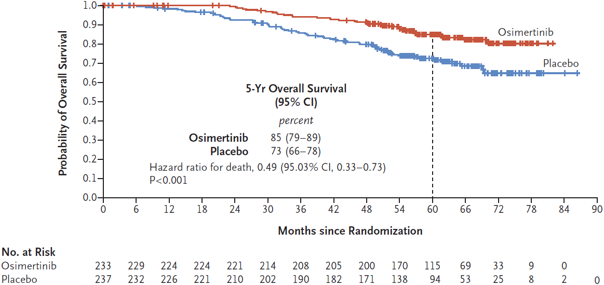 | 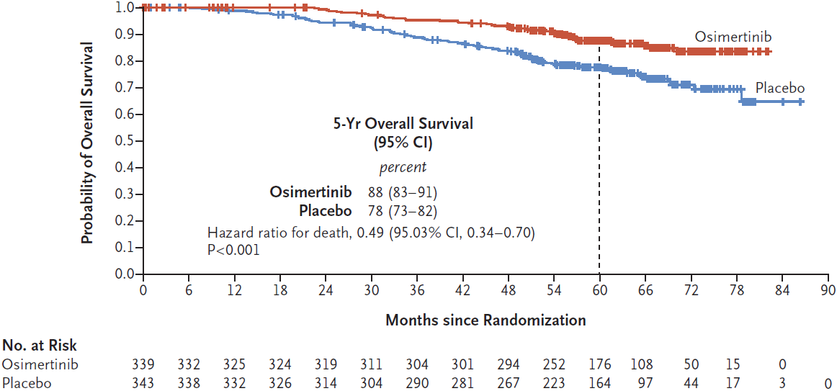
DFS* (DCO2 11 April 2022)
C. Primary population (Stage II-IIIA) | D. Overall population (Stage IB-IIIA)
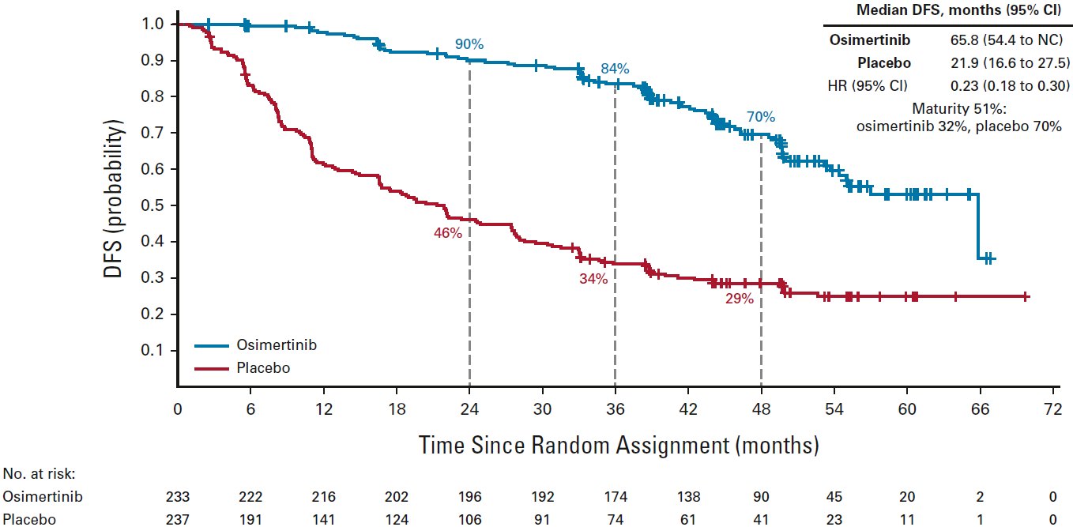 | 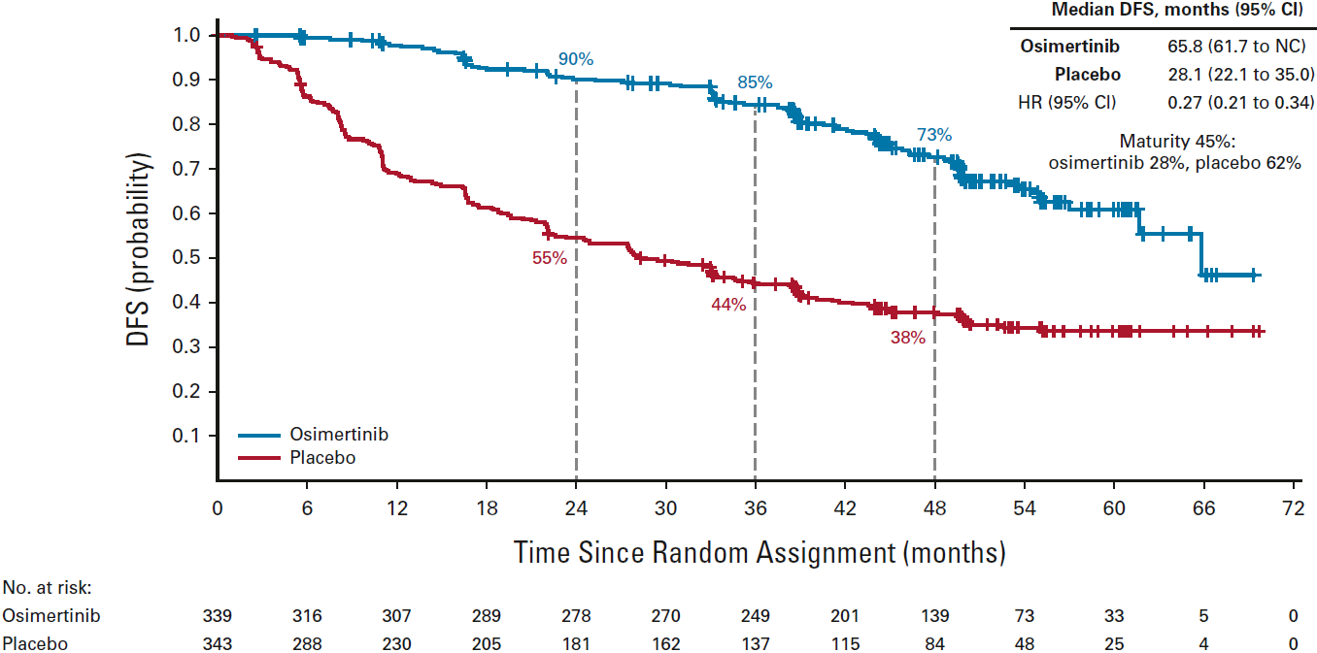
Secondary and exploratory outcomes
E. CNS DFS (DCO2 11 April 2022) | F. TFST at DCO3 (27 January 2023)
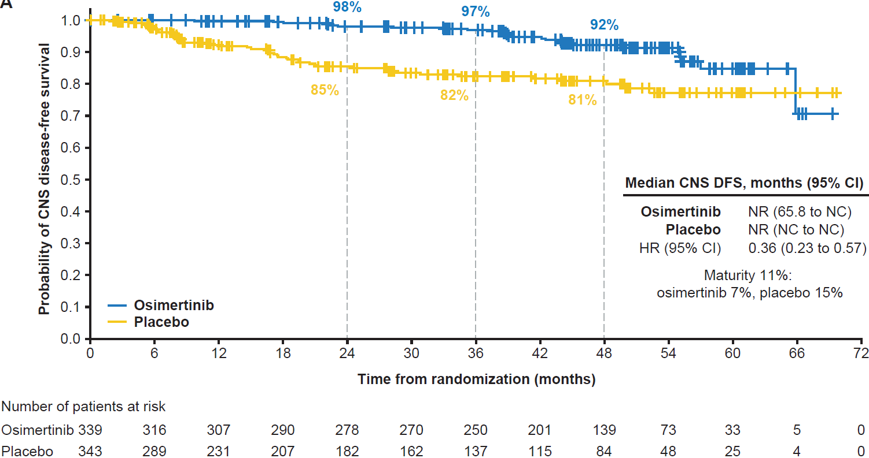 | 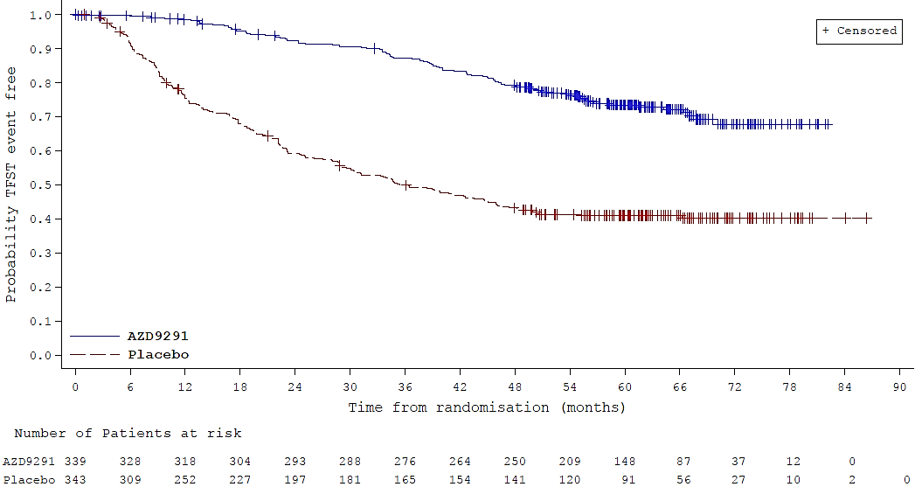
G. TSSTª at DCO2 (11 April 2022) | H. TFST at DCO2 (11 April 2022)
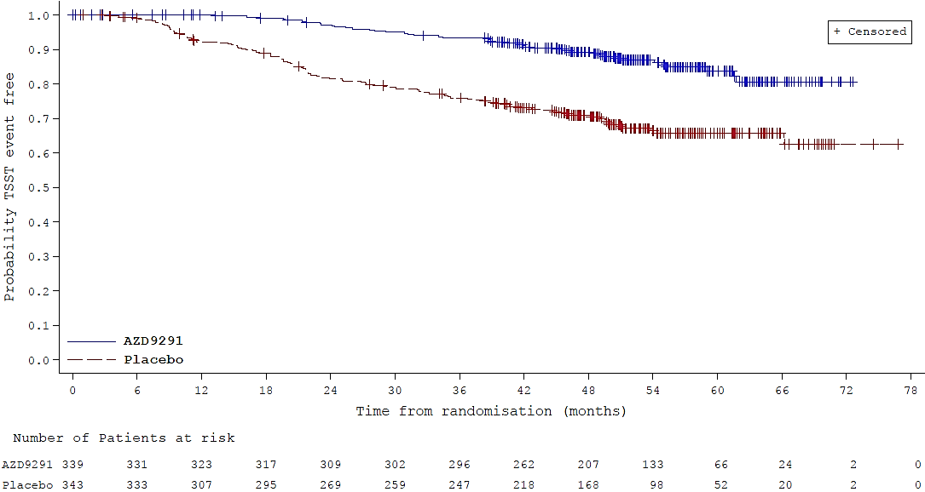 | 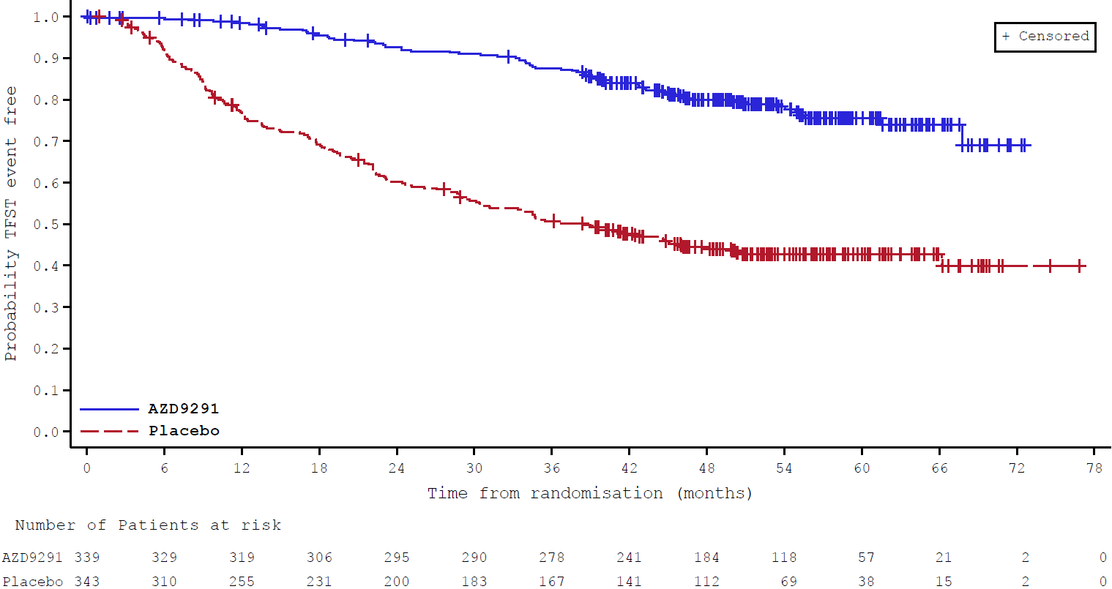
Source: A Figure 1B, Tsuboi 2023; B Figure 1A, Tsuboi 2023; C Figure 1A, Herbst 2023; D Figure 1B, Herbst 2023; E Figure A5A, Herbst 2023; F Figure 14.2.6.3, p303 ADAURA CSR DCO3 Tables and Figures; G Figure 14.2.7.3, p464 ADAURA CSR DCO2 Tables and Figures; H Figure 14.2.6.3, p455 ADAURA CSR DCO2 Tables and Figures. ADZ9291 = osimertinib; CI = confidence interval; CNS = central nervous system; DCO = data cut-off; DFS = disease-free survival; HR = hazard ratio; OS = overall survival; TFST = time to first subsequent anticancer treatment; TSST = time to second subsequent anticancer treatment. * primary trial outcome ª TSST was not reported at DCO3
  - DFS was the primary outcome of ADAURA, final DFS was analysed at DCO2 when all patients had completed or discontinued study treatment. No additional DFS data were reported at DCO3. At DCO2, the median follow-up was 44.2 months in the osimertinib arm and 27.7 and 19.6 months in the placebo arm for the overall and primary populations respectively. In both populations, osimertinib treated patients reported statistically significantly better DFS compared to those treated with placebo, with slightly better results in the primary population (Stage II-IIIA) versus the overall population (Stage IB-IIIA) (hazard ratio (HR) (95% confidence interval (CI)): 0.23 (0.18, 0.30) versus 0.27 (0.21, 0.34)). Results of the overall population is considered more applicable to the requested PBS population given it includes patients with Stage IB disease. Of those who experienced a DFS event, a higher proportion of patients in the placebo arm was on treatment at the time of recurrence (83.4% versus 37.2%, in the overall population). The highest proportion of DFS events in the osimertinib arm occurred after patients had completed treatment (43.6% in the overall population). An open label study investigating 5-year adjuvant therapy with osimertinib in people with resected Stage II-IIIB NSCLC with EGFR pathogenic variants, including uncommon variants, is currently recruiting (NCT05526755). All subgroups of patients experienced a statistically significant DFS benefit with osimertinib versus placebo treatment.
  - At the time of the planned final OS analysis for ADAURA (DCO3, 27 Jan 2023), after a median follow up of approximately 5 years, OS was significantly better in patients randomised to osimertinib treatment compared to placebo, in both the primary (Stage II-IIIA) and the overall populations (Stage IB-IIIA) of ADAURA. However, the OS data was still immature with median OS not reached. In the overall population (i.e., the population closest to the requested PBS population) the estimated risk of death was 51% lower in those randomised to osimertinib versus placebo treatment (HR: 0.49, 95% CI: 0.34, 0.70; p < 0.0001), with 87.6% and 77.7% of patients still alive in the osimertinib and placebo arms, respectively. Based on the updated ADAURA trial protocol provided by the sponsor upon request during the evaluation, it appeared that long-term survival follow-up of up to 10 years is also underway in patients from the ADAURA trial who provided additional consent (Revised Clinical Study Protocol, Edn 6, p68).
  - Table 5 summarises subgroup analyses from ADAURA on the estimated OS benefit.
Table 5: Subgroup analysesª OS - ADAURA Overall population DCO3 (27 Jan 2023) (HR<1 favour osimertinib)
Subgroup | Osimertinib n/N (%) | Placebo n /N (%) | Forest plot HR^{b} (95% CI) | HR (95% CI)
All patients |  |  | 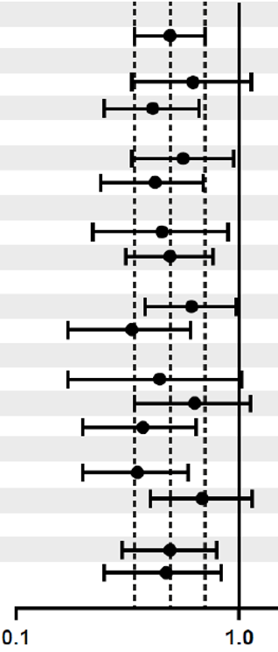  Favours osimertinib
Stratified log-rank | 42/339 (12.4) | 82/343 (23.9) |  | 0.49 (0.34, 0.70)
Sex
Male | 18/109 (16.5) | 24/95 (25.3) |  | 0.62 (0.33, 1.13)
Female | 24/230 (10.4) | 58/248 (23.4) |  | 0.41 (0.25, 0.66)
Age
<65 | 22/185 (11.9) | 38/195 (19.5) |  | 0.56 (0.33, 0.94)
≥65 | 20/154 (13.0) | 44/148 (29.7) |  | 0.42 (0.24, 0.69)
Smoking history
Yes | 13/108 (12.0) | 21/86 (24.4) |  | 0.45 (0.22, 0.89)
No | 29/231 (12.6) | 61/257 (23.7) |  | 0.49 (0.31, 0.76)
Race
Asian | 29/216 (13.4) | 44/218 (20.2) |  | 0.61 (0.38, 0.97)
Non-Asian | 13/123 (10.6) | 38/125 (30.4) |  | 0.33 (0.17, 0.61)
Stage
IB | 7/106 (6.6) | 17/106 (16.0) |  | 0.44 (0.17, 1.02)
II | 18/118 (15.3) | 28/118 (23.7) |  | 0.63 (0.34, 1.12)
IIIA | 17/115 (14.8) | 37/119 (31.1) |  | 0.37 (0.20, 0.64)
EGFR variant
Ex19del | 18/187 (9.6) | 47/191 (24.6) |  | 0.35 (0.20, 0.59)
L858R | 24/152 (15.8) | 35/152 (23.0) |  | 0.68 (0.40, 1.14)
Adjuvant chemo
Yes | 26/203 (12.8) | 48/207 (23.2) |  | 0.49 (0.30, 0.79)
No | 16/136 (11.8) | 34/136 (25.0) |  | 0.47 (0.25, 0.83)
Bold indicates statistically significant result. Source: Compiled during the evaluation from Table 7, pp32-33 ADAURA CSR DCO3 and Figure S3, Tsuboi 2023. Chemo = chemotherapy; CI = confidence interval; EGFR = epidermal growth factor receptor; Ex19del = exon 19 deletion; HR = hazard ratio; n = number of participants reporting data; N = total participants in group; OR = odds ratio; RD = risk difference; RR = relative risk ª The subgroup analysis was performed with the use of a Cox proportional-hazards model that included treatment group, subgroup, and the treatment-by-subgroup interaction term (Tsuboi 2023 Supplementary appendix). ^{b} The middle vertical dashed line indicates the median and the outer dashed lines indicate the 95% confidence interval for the overall hazard ratio (all patients).

  - In subgroup analyses for OS, all analyses conducted favoured osimertinib but variations in size of benefit were observed. The ESC noted the subgroup results by EGFR mutation and considered it may be appropriate to monitor any suggested differences in outcome by variant.
  - CNS recurrence was an exploratory outcome in the ADAURA trial. In the overall population, patients taking osimertinib gained a 64% benefit in CNS recurrence compared to those in the placebo arm (HR 0.36; 95% CI: 0.23, 0.57). At the time of CNS recurrence, 35/50 (70.0%) people experiencing the event in the placebo arm were on treatment, and 14/25 (56.0%) people in the osimertinib arm had completed treatment.
  - DFS observed in ADAURA by recurrence type (local/regional or distant) was used to inform transition probabilities in the economic model. Figure 2 shows DFS by type of recurrence. A larger difference in time to recurrence was observed between osimertinib and placebo for distant metastasis (without or without local/regional recurrence).
Figure 2: DFS-ADAURA DCO2 11 April 2022 by type of recurrence
Local/regional recurrence only | Distant metastasis  (with or without local/regional recurrence)
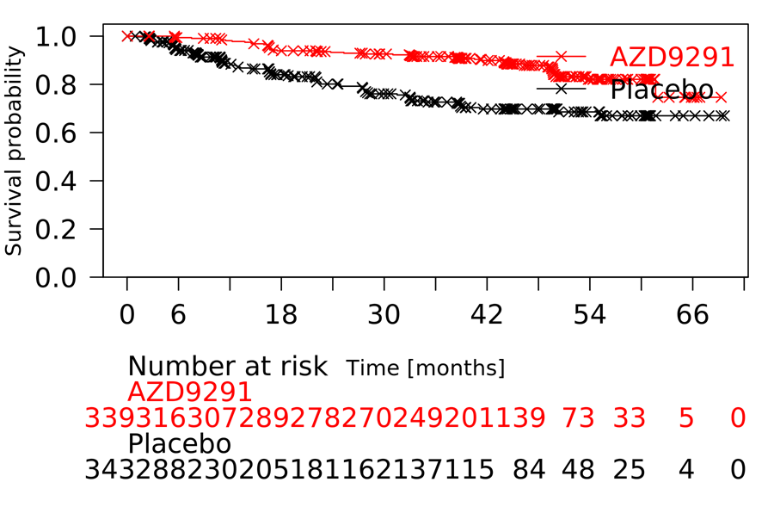 | 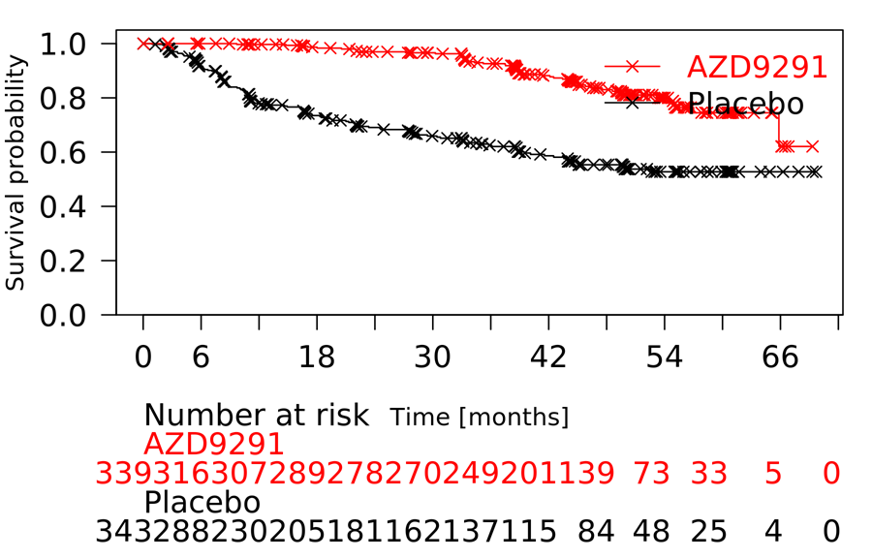
Source: Figure 3.4-1, p 124 and Figure 3.4-6, p130 of the submission, LR All Data and ADAURA.doc and DM All Data ADAURA.doc (Attachment 3.2)

  - Reduced time to first (TFST) and second subsequent treatment (TSST) were observed for those in the osimertinib arm versus placebo treatment in ADAURA (TFST: HR 0.28 [95% CI 0.22, 0.36]) and TSST (HR 0.37 [95%CI 0.26, 0.50] in the overall population). At DCO3, January 2023, patients taking osimertinib were 72% less likely to have received a first subsequent treatment or die than those in the placebo arm. Of those who did receive a first subsequent treatment, there was a higher proportion of responders in the placebo group (25.0% versus 18.3%), possibly due to those patients being EGFR-TKI treatment naïve. In non-responders, a higher proportion of patients in the osimertinib arm had stable disease compared to placebo arm (33/47 (70.2%) versus 42/90 (46.7%)) and fewer patients had progressive disease (3/47 (6.4%) versus 22/90 (24.4%)), however, these data should be interpreted with caution due to the low number of TFST events. TSST analyses were planned at DCO3, however, investigators deemed the data too immature for meaningful analysis and did not update results from DCO2. The TGA delegate was concerned about whether use of osimertinib in the adjuvant setting leads to treatment-resistant disease if recurrence occurs after cessation of adjuvant osimertinib, and requested assessment of this in the final study report (Revised TGA Delegate Overview, March 2021, p30). The ESC noted there is currently no evidence for or against the occurrence of treatment resistance and considered the final study report for ADUARA (expected mid 2024) may be informative.
  - Treatments given after disease recurrence were at the discretion of the treating physicians. Following an interim analysis of ADAURA in 2020, patients in both arms had access to open label osimertinib after disease recurrence. Table 6 summarises the most frequently used first and second subsequent anti-cancer therapies. 40.8% of patients in the osimertinib arm (31 of 76 patients who received a first subsequent therapy) had continued osimertinib post progression and overall 69.7% of patients treated with osimertinib in ADAURA (53 of 76 patients who received a first subsequent therapy) continued with a TKI in subsequent treatment. These would not be permitted on PBS. The ESC considered that, aside from the use of subsequent TKIs, the distribution of use of subsequent therapies in both arms was largely consistent with clinical practice. The ESC noted the number of patients in the osimertinib arm who received subsequent TKIs in ADAURA was small and considered this was unlikely to influence clinical applicability to the Australian setting.
Table 6: Most frequently usedª first and second subsequent anti-cancer therapies
ATC classification/ Generic term |  | N (%)^{b}
ATC classification/ Generic term | Osimertinib  (N=339) | Placebo (N=343) | Total  (N=682)
DCO3 (27 January 2023)
Number of patients with first subsequent anticancer therapy^{c} | 76 (22.4) | 184 (53.6) | 260 (38.1)
EGFR - TKIs | 53 (69.7) | 154 (83.7) | 207 (79.6)
Afatinib | 3 (3.9) | 25 (13.6) | 28 (10.8)
Erlotinib | 6 (7.9) | 21 (11.4) | 27 (10.4)
Gefitinib | 11 (14.5) | 53 (28.8) | 64 (24.6)
Icotinib | 2 (2.6) | 13 (7.1) | 15 (5.8)
Osimertinib | 31 (40.8) | 50 (27.2) | 81 (31.2)
Folic acid analogues (Pemetrexed) | 10 (13.2) | 8 (4.3) | 18 (6.9)
PD-1/PDL-1 inhibitors | 3 (3.9) | 1 (0.5) | 4 (1.5)
Durvalumab | 2 (2.6) | 1 (0.5) | 3 (1.2)
Platinum compounds | 17 (22.4) | 18 (9.8) | 35 (13.5)
Carboplatin | 13 (17.1) | 10 (5.4) | 23 (8.8)
Cisplatin | 3 (3.9) | 7 (3.8) | 10 (3.8)
Pyrimidine analogues | 3 (3.9) | 3 (1.6) | 6 (2.3)
Taxanes | 5 (6.6) | 7 (3.8) | 12 (4.6)
Paclitaxel | 4 (5.3) | 5 (2.7) | 9 (3.5)
Unspecified herbal and traditional medicine | 2 (2.6) | 2 (1.1) | 4 (1.5)
Radiotherapy^{d} | 28 (36.8) | 47 (25.5) | 75 (28.8)
DCO2 (11 April 2022)^{e}
Number of patients with second subsequent anticancer therapy | 23 (6.8) | 70 (20.4) | 93 (13.6)
EGFR - TKIs | 8 (2.4) | 38 (11.1) | 46 (6.7)
Osimertinib | 3 (0.9) | 16 (4.7) | 19 (2.8)
Folic acid analogues | 2 (0.6) | 7 (2.0) | 9 (1.3)
Monoclonal antibodies | 4 (1.2) | 3 (0.9) | 7 (1.0)
Platinum compounds | 2 (0.6) | 13 (3.8) | 15 (2.2)
Taxanes (docetaxel) | 2 (0.60 | 1 (0.3) | 3 (0.4)
Uncoded | 7 (2.1) | 15 (4.4) | 22 (3.2)
Bold type indicates the total for each category.
Source: Table 9, ADAURA CSR DCO3, p37 and Table 14.2.7.5, pp466-468 ADAURA CSR DCO2 Tables and Figures.
EGFR = epidermal growth factor receptor; PD-1 = programmed cell death protein 1; PD-L1 = programmed death-ligand 1; TKI = Tyrosine kinase inhibitor
ª Reported in ≥2% of patients in either treatment arm
^{b} Percentages calculated from the number of patients with a first subsequent anti-cancer therapy.
^{c} First subsequent anticancer therapies were defined by medical review, and includes anticancer therapy or radiotherapy started on or after the date of discontinuation of study treatment and started before withdrawal from study.
^{d} Confirmed through medical review.
^{e} Second subsequent anti-cancer therapies were not reported after DCO2.
Note 1: Procedures/surgeries are not included in this table.
  - Note 2: Some patients received subsequent therapy without a disease recurrence (Table 8, p35 ADAURA CSR DCO2).Health-related quality of life (HRQoL) outcomes from ADAURA are summarised in Figure 3. HRQoL in the primary population was a pre-specified secondary outcome in the ADAURA protocol reported up to DCO2. In the overall population HRQoL were exploratory analyses conducted post hoc at DCO1, 17 January 2020, after a median follow-up of 22.1 and 16.6 months in the osimertinib and placebo arms, respectively, and reported in Majem 2022.
Figure 3: Patient reported outcomes – Overall Population (Stage IB-IIIA) ADAURA DCO1 (17 Jan 2020)
Time to deterioration or death by component summary score
A. PCS | B. MCS
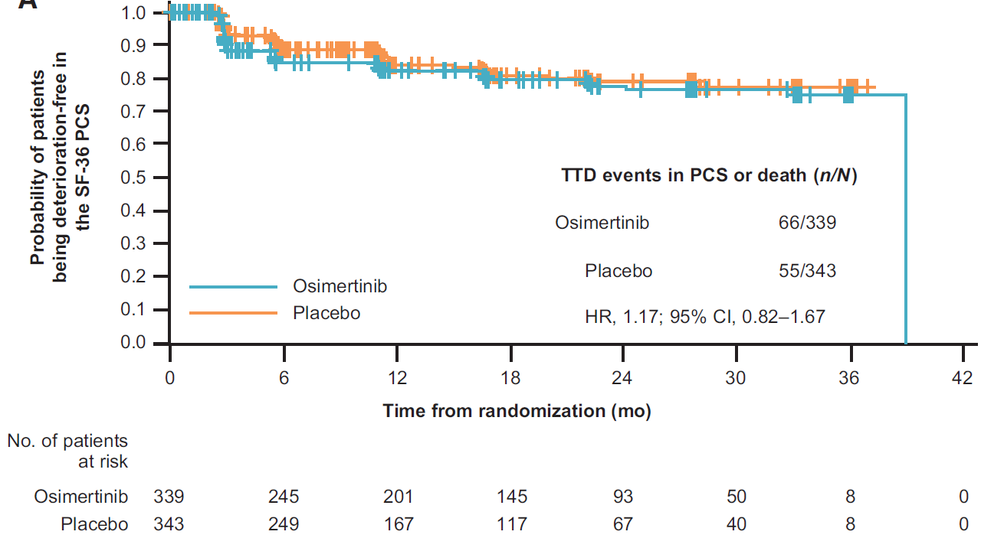 | 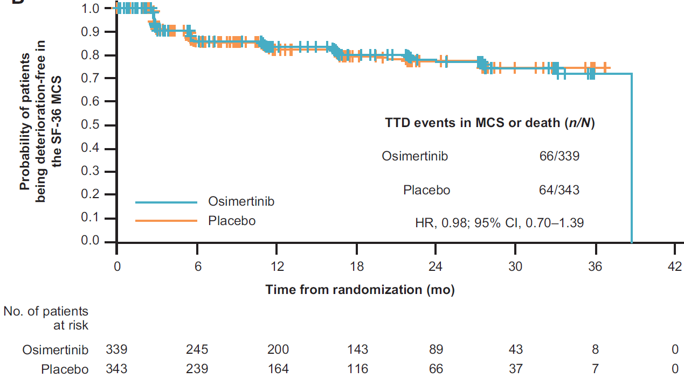
Source: A Fig 4A, Majem 2022; B Fig4B, Majem 2022.
CI = confidence interval; HR = hazard ratio; HRQoL = health-related quality of life; MCS = mental component summary; mo = months; n = number of events; N = overall population; PCS = physical component summary; SF-36 = Short Form-36 health survey.
  - There were no clinically meaningful or statistically significant differences in patient-reported HRQoL outcomes between patients taking osimertinib or placebo in ADAURA.

Comparative harms
  - Key adverse event (AEs) from ADAURA are summarised in Table 7.
Table 7: Summary of key adverse events in the ADAURA trial (DCO2 11 April 2022)
AE category | Osimertinib  N=337  n with event (%) | Placebo  N=343  n with event (%) | RD (95% CI)
Any AE | 330 (97.9) | 309 (90.1) | 0.08 (0.04, 0.11)
Any AE causally related to treatment | 308 (91.4) | 199 (58.0) | 0.33 (0.27, 0.39)
Any AE of CTCAE grade 3 or higher | 79 (23.4) | 48 (14.0) | 0.09 (0.04, 0.15)
Any AE of CTCAE grade 3 or higher causally related to treatment | 36 (10.7) | 7 (2.0) | 0.09 (0.05, 0.12)
Death | 1 (0.3) | 2 (0.6) | -0.00 (-0.01, 0.01)
Death causally related to treatmentª | 0 | 0 | 0.00 (-0.01, 0.01)
Any SAE | 68 (20.2) | 47 (13.7) | 0.06 (0.01, 0.12)
Any SAE causally related to treatmentª | 10 (3.0) | 2 (0.6) | 0.02 (0.00, 0.04)
Any AE leading to discontinuation of treatment | 43 (12.8) | 9 (2.6) | 0.10 (0.06, 0.14)
Any AE leading to discontinuation of treatment causally related to treatment | 35 (10.4) | 5 (1.5) | 0.09 (0.05, 0.12)
Any AE leading to dose modification | 115 (34.1) | 45 (13.1) | 0.21 (0.15, 0.27)
Any AE leading to dose reduction | 42 (12.5) | 3 (0.9) | 0.12 (0.08, 0.15)
Any AE leading to dose interruption | 91 (27.0) | 43 (12.5) | 0.14 (0.09, 0.20)
Source: Table 2.5-9, p70 of the submission.
AE = adverse event; CI = confidence interval; CTCAE = common terminology criteria for adverse events; n = number of participants reporting data; N = total participants in group; RD = risk difference; SAE = serious adverse event; SoC = standard of care.
ª As assessed by investigator
  - Most AEs reported in ADAURA were of mild to moderate severity (76.6% in the osimertinib arm and 86% in the placebo arm). The most common AEs of common terminology criteria for adverse events (CTCAE) ≥ Grade 3 were diarrhoea, stomatitis, pneumonia, and prolonged QT interval in the osimertinib arm; and pneumonia and hypertension in the placebo arm. Of the 36 patients (10.7%) who had CTCAE AEs ≥ Grade 3 considered by the investigator to be causally related to osimertinib treatment, including paronychia (nail fold infection) (n=3), stomatitis (inflammation of oral mucosa such as mouth ulcers) (n=5), diarrhoea (n=7), prolonged QT interval (n=4), decreased left ventricular ejection fraction (n=2), and decreased appetite (n=2) were reported as causally related in ≥ 2 patients. These AEs (except for decreased appetite and decreased ejection fraction) were consistent with the known osimertinib safety profile. The PI was updated to include a special warning for changes in cardiac contractility (Section 4.4, Tagrisso PI).

Benefits/harms
  - A summary of the comparative benefits and harms for osimertinib versus placebo (for standard of care) is presented in Table 8.
Table 8: Summary of comparative benefits and harms for osimertinib and placebo from ADAURA
Benefits
Disease-free survival (DCO2 11 April 2022ª)
Event | Osimertinib | Placebo | Absolute Difference | HR (95% CI)
Disease recurrence or death, n (%) | 94/339 (27.7) | 211/343 (61.5) | - | 0.27 (0.21, 0.34)
Median DFS, months (95% CI) | 65.8 (61.7, NC) | 28.1 (22.1, 35.0) | 37.7 months | 0.27 (0.21, 0.34)
% disease-free at 3 years (95% CI) | 84.5 (79.9, 88.1) | 44.4 (39.0, 49.7) | 40.1% | 0.27 (0.21, 0.34)
% disease-free at 5 years (95% CI) | 60.9 (53.1, 67.8) | 33.6 (28.0, 39.2) | 27.3% | 0.27 (0.21, 0.34)
Overall survival (DCO3 27 January 2023^{b})
Deaths, n/N (%) | 42/339 (12.4) | 82/343 (23.9) | - | 0.49 (0.34, 0.70)
Median OS, months (95% CI) | NC (NC, NC) | NC (NC, NC) |  | 0.49 (0.34, 0.70)
% Alive at 3 years (95% CI) | 95.3 (92.3, 97.1) | 88.8 (84.9, 91.8) | 6.5% | 0.49 (0.34, 0.70)
% Alive at 5 years (95% CI) | 87.6 (83.3, 90.9) | 77.7 (72.7, 81.9) | 9.9% | 0.49 (0.34, 0.70)
Harms^{c}
AE Grade ≥ 3 | Osimertinib  N=337 | Placebo  N=343 | RR (95% CI) | Event rate/100 patients* |  | RD (95% CI)
 |  |  |  | Osimertinib | Placebo | RD (95% CI)
Any Grade ≥3 | 79/337 | 48/343 | 1.66 (1.20, 2.29) | 23 | 14 | 0.09 (0.04, 0.15)
Diarrhoea | 9/337 | 1/343 | 9.16 (1.17, 72.0) | 3 | 0.3 | 0.02 (0.01, 0.04)
Stomatitis | 6/337 | 0/343 | 13.23 (0.75, 234.0) | 2 | 0 | 0.02 (0.00, 0.03)
Pneumonia | 4/337 | 4/343 | 1.02 (0.27, 4.04) | 1 | 1 | 0.00 (-0.02, 0.02)
Prolonged QT interval | 4/337 | 1/343 | 4.07 (0.46, 36.2) | 1 | 0.3 | 0.01 (-0.00, 0.02)
Hypertension | 3/337 | 4/343 | 0.76 (0.17, 3.39) | 1 | 1 | -0.00 (-0.02, 0.01)
Italics indicate results calculated during the evaluation. Bold indicates statistically significant results.
Source: Tables 2.5-1, p55; 2.5-2, p57, 2.5-4, p58 and Table 2.5-12, p73 of the submission.
AE = adverse event; CI = confidence interval; DFS = disease-free survival; HR = hazard ratio; ILD = interstitial lung disease; n = number of participants reporting data; N = total participants in group; NC = not calculable; OS = overall survival; RD = risk difference; RR = risk ratio; SoC = standard of care
ª Median duration of DFS follow-up: osimertinib 44.2 months; placebo 27.7 months
^{b} Median duration of OS follow-up: osimertinib 60.4 months; placebo 59.4 months
^{c} as reported at DCO2, median duration of follow up osimertinib 44.2 months; placebo 27.7 months
  - On the basis of direct evidence from the ADAURA trial, presented by the submission, for every 100 patients treated with osimertinib for up to three years in comparison with placebo (for standard of care):
- Approximately 27 more patients will remain disease-free after 5 years;
- Approximately 10 more patients would remain alive after 5 years;
- Approximately 9 more patients would experience a grade ≥ 3 adverse event.

Clinical claim
  - The submission described osimertinib as superior in terms of effectiveness, but inferior in terms of safety compared to placebo (for standard of care) with non-inferior HRQoL. The ESC considered the efficacy and safety conclusions were reasonable based on the data from ADAURA. However, the longer-term consequences of adjuvant therapy remained unknown, particularly durability of DFS and OS after ceasing adjuvant therapy, and the potential for treatment-resistant recurrences. OS data from ADAURA was still immature with only 15% of total possible death events observed in the osimertinib arm. The evaluation considered the likely size of the OS benefit in Australian practice may be smaller than those observed in ADAURA due to differences in active treatments received post progression (as discussed in paragraph 6.17).
  - The PBAC considered that the claim of superior comparative effectiveness and inferior safety was reasonable.

Economic analysis
  - The submission presented a stepped economic evaluation comparing adjuvant osimertinib versus standard of care (placebo from herein) based on ADAURA and implementing a modelled evaluation using external data including CancerLinQ (a US based cancer patient registry), and the FLAURA trial (comparing osimertinib to erlotinib or gefitinib for first-line treatment of EGFRm-positive advanced NSCLC). The base case included patients with Stage IB, II or IIIA NSCLC as per the overall population of ADAURA and the requested restriction. The key components of the economic evaluation are summarised in Table 9. The model structure is presented in Figure 4.
Figure 4: Structure of the economic model
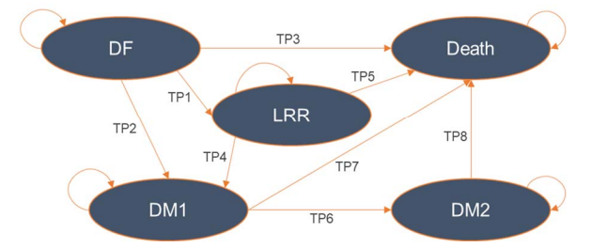
Source: compiled during the evaluation based on Figure 3.2-3, p112 of the submission.
DF = disease-free; DM1 = 1st line treatment for distant metastatic NSCLC; DM2 = 2nd line treatment for distant metastatic NSCLC; LRR = local/regional recurrence.

Table 9: Summary of model structure, key inputs and rationale
Component | Summary
Treatments | Adjuvant osimertinib vs placebo
Time horizon | 25 years in the model base case versus 5.5 years (66 months) in ADAURA DF follow up.
Outcomes | LYs gained and QALYs gained.
Methods used to generate results | Semi-Markov model with time-varying transition probabilities.
Health states | Five health states: disease-free survival (DF), loco/regional recurrence (LRR), first-line treatment for distant metastatic NSCLC (DM1), second-line treatment for distant metastatic NSCLC (DM2), and Death.
Cycle length | 30.4 days (monthly)
Transition probabilities | - DF to LRR (TP1) & DF to DM1(TP2): based on ADAURA DFS data for osimertinib and placebo.  - LRR to DM1 (TP4): CancerLinQ registry data used due to a paucity of data from ADAURA, same data applied in both model arms (with adjustment, see below).  - DM1 to DM2 (TP6): based on FLAURA (osimertinib data used in the placebo arm and SoC data used in the osimertinib arm, with adjustment, see below).  - DM1 to Death (TP7): pooled FLAURA data/ABS life tablesª used, same data applied in both model arms.  - DM2 to Death (TP8): based on post progression survival from FLAURA (osimertinib data used in the placebo arm and SoC data used in the osimertinib arm, with adjustment, see below).  - Background mortality from DF (TP3) and LRR (TP5): ABS life tables.
Adjustments made to transition probabilities | - TP4: LRR →DM1: Applied HR of 0.75 to KM CancerLinQ data. Applied to slow progression from LRR to DM1 to match progression in ADAURA. Without adjustment, the model over predicts progression in ADAURA. However, with adjustment, progression in the model (42%) still exceeded ADAURA (37%).
Adjustments made to transition probabilities | - TP6: DM1 → DM2: Data from FLAURA was used to estimate progression from DM1to DM2. However, as SoC in FLAURA consisted of first generation TKIs (gefitinib or erlotinib), this differed to treatment assigned to patients in DM1 in the osimertinib arm where only chemotherapy was administered. The submission cited results of a NMA of 13 trials (Holleman et al 2019) that reported a HR on PFS for gefitinib versus chemotherapy of 0.43 (95% Cr: 0.37, 0.49), an adjustment of 0.43 for gefitinib versus chemotherapy was applied (applying 1/0.43 to FLAURA SoC data in DM1 of the osimertinib arm) to approximate progression on chemotherapy. T
Adjustments made to transition probabilities | - TP8: DM2 → Death: Due to the adjustment for TP6, time to death from onset of metastatic disease based on FLAURA (sum of time in DM1 and DM2) is shortened in the osimertinib arm. The submission stated given that the literature suggests no difference for OS for treatment with TKI and chemotherapy in advanced NSCLC, it is appropriate to apply an additional adjustment (HR of 2 for gefitinib versus chemotherapy; applied as the inverse 0.5) to the TP8 parametric curve in the osimertinib arm of the model to ensure that time to death has not been unnecessarily shortened. The model was not very sensitive to this adjustment, removing the adjustments for DM1 to DM2 and DM2 to Death increased the ICER to ||¹/QALY gained from a base case of |||¹.
Extrapolation method | Proportional hazard was tested and in base case independent parametric survival models were fitted to both treatment arms. Model selection was made on statistical fit (AIC/BIC), visual inspection and clinical plausibility. In the base case, the generalised gamma model was selected for TP1 (DF to LRR) and TP2 (DF to DM1), lognormal for TP4 (LRR to DM1), Weibull for TP6 (DM1 to DM2) and exponential for TP8 (DM2 to Death). 55% and 47% of QALYs (and 15% and 28% of costs) in the osimertinib and placebo arms, respectively were accrued in the extrapolated period. In the model, KM data were used until 15% of patients remained at risk, beyond this point, extrapolated data were used.
Health related quality of life | - DF 0.825 based on ADAURA (SF-36 responses mapped to EQ-5D-3L)  - DM1: 0.794 based on the FLAURA trial  - DM2: 0.64 from Labbe et al 2017 (EQ-5D-3L utilities in 475 Canadian EGFRm NSCLC Canadian patients who experienced disease progression)  - LRR: 0.8095, an assumption (being mid-way between DF and DM1)
Cure assumptions – DF health state | From Year 4 increasing linearly (from 0%) to a maximum cure rate of 92% by Year 5 (i.e., transition to cure period = 1 year).  Same assumptions for both arms of the model.
Cure assumptions – LRR health state | 25% at 5 years after entering the health state. Note no transition to cure period was assumed.  Same assumptions for both arms of the model.
Source: Table 3.1-1; Table 3.2-8, pp.88, 120 of the submission.
AIC/BIC= Akaike/Baysian information criterion, Cr=credible interval, DF = disease-free; DM1 = first-line treatment for distant metastatic NSCLC; DM2 = second-line treatment for distant metastatic, EGFRm= epidermal growth factor receptor mutation, EQ-5D-xL= EuroQoL 5 Dimensions (number) of levels, ICER=incremental cost effectiveness ratio, KM=Kaplan Meier, NSCLC; LRR = loco/regional recurrence; Lys=life years, NSCLC=non=small cell lung carcinoma; PD-L1=programmed cell death Ligand-1; QALY=quality adjusted life years, SF-36 = Short Form-36 health survey, SoC=Standard of care, TKI=tyrosine kinase inhibitor; TP = transition probability.
ª constrained so it cannot fall below background mortality.
The redacted values correspond to the following ranges
¹ 35,000 to < $45,000
  - The model was a semi-Markov cohort model with 5 health states: disease-free (DF), local/regional recurrence (LRR), DM1 (1st line treatment for metastatic NSCLC), DM2 (2nd line treatment for distant metastatic NSCLC), and Death. Transition probabilities were allowed to vary based on the time since entering each health state. The submission argued this was preferred over a partitioned survival approach given OS data from ADAURA was immature and any extrapolated OS would be uncertain. Overall, the model structure was reasonable.
  - The economic model assumed a 25-year time horizon in the base case. The PBAC had previously considered atezolizumab for a similar place in therapy as osimertinib for resected Stage II-IIIA NSCLC. In this population, the PBAC had recommended 15 years to be the more appropriate time horizon (paragraph 6.37, atezolizumab PSD, July 2022). A shorter model horizon would be more conservative, this is important given 83% of the incremental QALYs for osimertinib versus placebo were accrued during the extrapolated period of the model. Figure 5 illustrates the variation in ICER by time horizon. The model was very sensitive to the assumed time horizon, reducing the ICER from 25 years in the base case to 15 years would increase the ICER to $45,000 to < $55,000 per QALY gained from a base case of $35,000 to < $45,000. The pre-PBAC response noted the median follow-up for the atezolizumab trial was 29.5 months compared to 60 months for the osimertinib trial which supported a longer time horizon than 15 years. The pre-PBAC response stated that, despite this, to facilitate resolution, a revised base case incorporating a 15 year time horizon was proposed (see paragraph 6.45).
Figure 5: ICER changes over modelled time horizon (years)
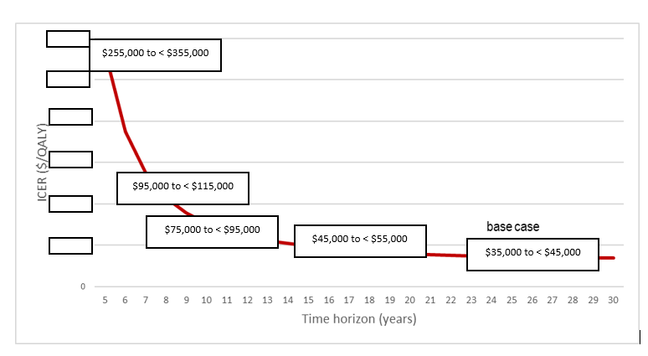
Source: Compiled during the evaluation
ICER=incremental cost-effectiveness ratio.

  - Transition probabilities in the DF health state were based on ADAURA DFS data, separated by transitions to LRR (TP1) and DM1 (TP2) and incorporating background mortality (TP3). Due to limited post-recurrence follow-up data in ADAURA, transitions from the LRR health state (TP4) were based on external data from CancerLinQ (a US based cancer patient registry) and background mortality (TP5), and transition probabilities from DM1 (TP6, TP7) and DM2 (TP8) health states were sourced from the FLAURA trial (which is a randomised controlled trial comparing osimertinib to standard EGFR-TKIs (erlotinib or gefitinib) in previously untreated advanced NSCLC with a EGFR pathogenic variant). The data sources were generally reasonable, however as only DFS data from ADAURA was used, a large proportion of the model transitions were informed by data external to ADAURA.
  - To derive time dependent transition probabilities for TP1, TP2, TP4, TP6 and TP8, the submission fitted six parametric curves (lognormal, loglogistic, exponential, generalised gamma, Gompertz and Weibull) to each set of KM curves. In the base case, models were fitted independently for each treatment arm as some were found to violate the proportional hazards assumption. The best fitting function was selected based on statistical fit (both the Akaike (AIC) and Bayesian information criteria (BIC)), visual inspection and clinical plausibility. The parametric functions chosen by the submission did not always have the best fit statistics (e.g., for TP1 the Log normal function fitting osimertinib data had a better fit on AIC and BIC versus the chosen generalised gamma function). However, the ICER was generally not sensitive to the selection of parametric function for extrapolation.
  - The following treatments were assigned in the progressed health states model base case:
- LRR health state: all patients assumed to receive chemoradiotherapy.
- DM1 health state: osimertinib arm: chemotherapy (pemetrexed + cisplatin); placebo arm: 100% receive osimertinib.
- DM2 health state: all patients assumed to receive pemetrexed monotherapy.
  - The submission presented a sensitivity analysis where 50% of LRR patients in the placebo arm used osimertinib and showed minimal impact of the assumption on ICER ($35,000 to < $45,000 per QALY gained). The submission noted that durvalumab and TKIs (erlotinib, gefitinib and osimertinib) are also PBS listed for Stage III NSCLC, but due to complexity and uncertainty with staging distribution these were excluded as treatment options in LRR. Durvalumab can be accessed via PBS after platinum based chemoradiation as a sole treatment provided the condition has not progressed. Cost and benefits of added durvalumab in LRR was not explored in the submission, but as durvalumab can be used in both treatment arms, it would have minimal effect on the ICER. A sensitivity analysis was conducted during the evaluation assuming that 83.7% of patients in the placebo arm will receive osimertinib in DM1 (rather than 100% in the base case) (matching proportion that received a TKI on disease progression in ADAURA), the ICER was $35,000 to < $45,000 per QALY.
  - No other targeted therapies were included in the model for treatment in DM1. The evaluation considered this was not appropriate and favoured osimertinib. Atezolizumab and bevacizumab in combination with platinum doublet chemotherapy (ABDC) is PBS listed for Stage IV NSCLC following progression with an EGFR TKI and thus would be available to some patients who have failed adjuvant osimertinib (need to have had prior platinum doublet chemotherapy either post resection or in LRR). Use of ABDC is expected to be greater in the osimertinib arm versus placebo since PBS eligibility requires patients to have previously failed an EGFR TKI. Assuming 100% use of ABDC in the osimertinib arm in DM1 (cost only) increased the ICER to $45,000 to < $55,000 per QALY gained from a base case of $35,000 to < $45,000 The Pre-Sub-Committee Response (PSCR) noted ABDC would be available for patients in both the adjuvant osimertinib arm (in the DM1 heath state) and the placebo arm (in the DM2 health state after osimertinib in DM1). The PSCR presented a sensitivity analysis assuming 25% of patients in both treatment arms receive ABDC (based on PBS prescription utilisation estimates) which resulted in an ICER of $35,000 to < $45,000 per QALY. The ESC agreed with the PSCR that ABCD would likely be used in both treatment arms and it was unlikely 100% of patients in the osimertinib arm would be treated with ABDC in DM1; however, it considered 25% was an underestimate. The ESC noted assuming 60% of osimertinib patients and 25% of placebo patients would receive ABDC in DM1 increased the ICER to $35,000 to < $45,000 per QALY.
  - An important assumption in the model was the assumption that patients in the DF and LRR health states can be cured from NSCLC. In the DF health state patients can be cured from Year 4, increasing linearly each monthly cycle starting from 0% at 48 months to a maximum of 92% at Year 5 (i.e., transition to cure period). The same cure assumption was applied in both model arms. Disease management costs were also assumed to stop at Year 4 in the model i.e., at the start of the transition-to-cure period.
  - Patients who were cured remained in the DF health state and were assumed to no longer be at risk of transitioning from DF to LRR or DM1 and followed general population mortality for the remainder of the model duration. 47% of the model’s estimated QALY gain were the result of this cure assumption and when removed the total discounted QALY gained reduced from 1.956 to 1.035. The total discounted life years (LYs) gained reduced from 2.30 to 1.32 (43% reduction).
  - The submission did not discuss the source of the estimated maximum cure proportion, however noted that a maximum cure proportion of 91.5% was applied in the atezolizumab submission for adjuvant treatment in resected NSCLC (Paragraph 6.42, atezolizumab PSD, July 2022 PBAC meeting). The 91.5% cure was based on clinical studies where the majority of the participants had Stage I NSCLC before resection (78% in Maeda 2010 and 53% in Sonoda 2019). As with the atezolizumab submission, in the requested population for osimertinib only a minority of patients are expected to be Stage I (approx. 19% Stage IB at diagnosis). For the atezolizumab submission, the PBAC considered the assumptions regarding the proportion of patients achieving sustained DFS (i.e., ‘cured’) were not well justified in the submission (paragraph 7.7, atezolizumab PSD, July 2022 PBAC meeting).
  - It was also noted that the osimertinib submissions to CADTH, NICE and SMC had also included a cure assumption (maximum 95%) but the assumed transition to cure time frame for osimertinib and placebo varied. In the CADTH submission, different transition to cure periods of 5 years for osimertinib and 2 years for placebo treatment were assumed. The justification for the longer transition to cure period for osimertinib was to account for the 3 years patients would be receiving active treatment in the osimertinib arm, whereas in the placebo arm, patients were not taking any active treatments. The NICE pessimistic sensitivity analysis also assumed a declaration of cure to only be possible after 5 years of no active treatment, this translated to after 8 years for osimertinib and 5 years for active monitoring. The model was very sensitive to the cure assumption in the DF health state. Assuming a later declaration of cure for those treated with adjuvant osimertinib (from Year 7 allowing a one year transition to a maximum of cure of 92% in Year 8 to allow for some inter-clinician variation) and maintaining the base case assumptions for the placebo arm, increased the ICER to $115,000 to < $135,000 per QALY gained from a base case of $35,000 to < $45,000 . The PSCR did not consider this analysis appropriate because it included a conservative extrapolation of DFS in which the curve for osimertinib drops below DFS for placebo and results in a higher proportion of osimertinib patients (61.8%) entering the DM1 health state compared to placebo (61.5%) which implies adjuvant treatment with osimertinib is worse than having no adjuvant treatment. The ESC considered it was reasonable to only start to consider someone ‘cured’ if they were disease-free 5 years after cessation of their most recent active treatment i.e., Year 8 for osimertinib and Year 5 for the placebo arm. The ESC considered that adjuvant osimertinib may be controlling undetectable, low grade disease, and once therapy is ceased, that disease is then able to grow, which will take time to be detectable. The ESC noted assuming a cure from Year 8 for osimertinib and from Year 5 for the placebo arm with no transition period resulted in an ICER of $95,000 to < $115,000 per QALY and allowing a one year transition period from Year 8 for osimertinib and Year 5 for placebo resulted in an ICER of $95,000 to < $115,000 per QALY. The pre-PBAC response noted applying the cure assumptions used by the ESC resulted in 63.8% of patients in the osimertinib arm entering the DM1 health state, compared to 64.5% in the placebo arm, a difference of 0.7%. The pre-PBAC response noted this should be considered pessimistic given the large magnitude of DFS benefit observed in ADAURA.
  - 25% of patients in the LRR health state were also assumed to be cured 5 years after entering the health state (with no transition to cure period). The model assumed patients in the DM1 and DM2 health states cannot be cured. The cure assumption in the LRR health state had minimal impact on the ICER. The ESC considered an assumption of cure in the LRR health state was not well justified.
  - Model Markov traces are presented in Figure 6 for the base case and for the scenario where the cure assumption was removed from the DF health state. The model traces illustrate a large benefit for osimertinib versus placebo with respect to DFS and OS. A larger proportion of patients treated with adjuvant osimertinib in the model remained in DF compared to placebo, with the separation between the two arms widening at Year 4 (with the onset of the cure assumption). This translated to fewer patients transiting to the DM1 and fewer deaths in the osimertinib arm compared to placebo. Smaller differences between the two treatment arms were observed for LRR and DM2 comparatively. Without the cure assumption small differences in time spent in DF health state and in numbers of deaths were noted between osimertinib and placebo and a greater number of patients in osimertinib in DM2 compared to those in the placebo arm of the model beyond Year 5.
Figure 6: Markov traces
Base case | Cure assumption removed
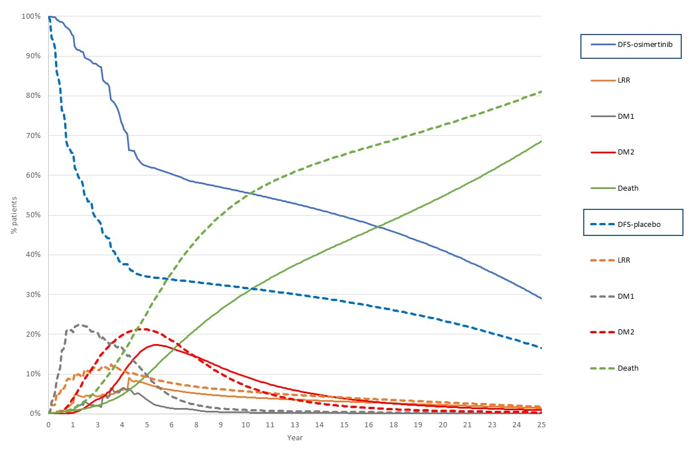 | 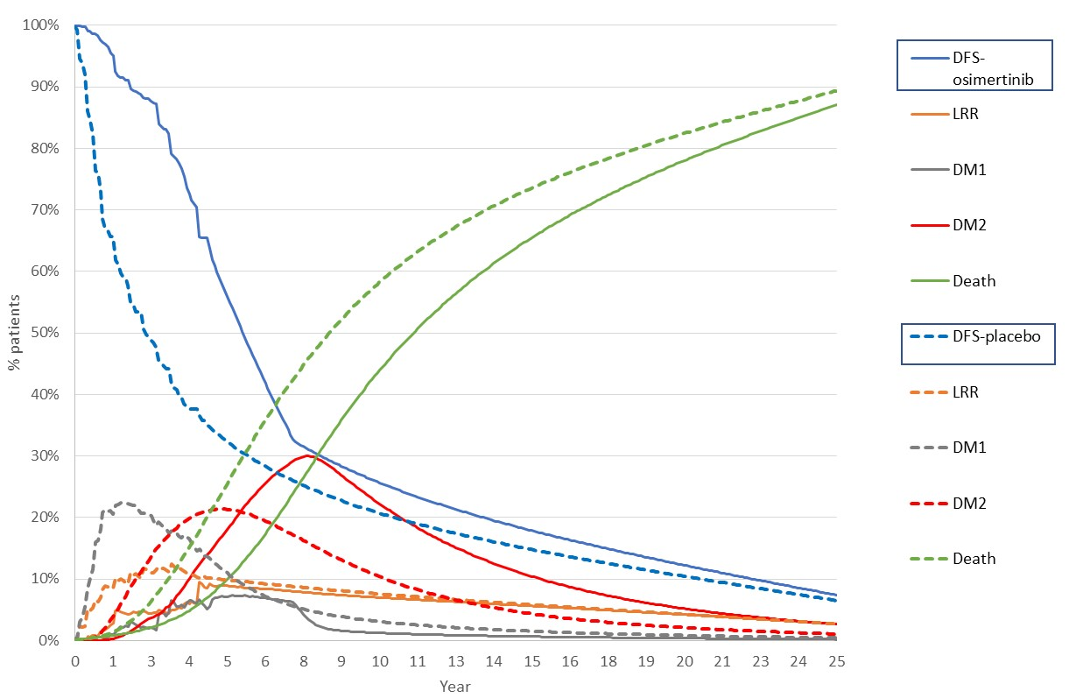
Source: constructed using Tagrisso (osimertinib) Adjuvant CEA EXCEL file.
DFS = disease-free; DM1 = first-line treatment for distant metastatic NSCLC; DM2 = second-line treatment for distant metastatic NSCLC; LRR = loco/regional recurrence; NSCLC=non=small cell lung carcinoma.
  - A summary of the key drivers of the model is given in Table 10.
Table 10: Key drivers of the model
Description | Method/Value | Impact  Base case: |¹ /QALY gained
Time horizon | Model adopted a 25-year time horizon. May not be reasonable. For atezolizumab in resected Stage II-IIIA PD-L1 positive NSCLC the PBAC considered 15 years to be the more appropriate time horizon in this population (para 6.37, atezolizumab PSD, July 2022) | High, favoured osimertinib.  Time horizon of 15 years, increased the ICER to $||||⁴/QALY gained.
Cure assumptions | The model allowed a proportion of patients in the DF health state to be “cured” increasing linearly starting from 48 months to a maximum of 92% at Year 5. The same assumption was applied in both treatment arms of the model. | High, favoured osimertinib.  Removing the cure assumption for the DF health state, increased the ICER to ||||² /QALY. Assuming cure can only be declared once patients have had been off all active treatments for 5 years (and maintaining the assumed 1 year transition to cure period) therefore transition to cure from Year 7 up to 92% in Year 8 in the osimertinib arm and maintaining the base case assumptions for the placebo arm, increased the ICER to ||||³ per QALY gained.
Source: compiled during the evaluation.
DF = disease-free; DM1 = first-line treatment for distant metastatic NSCLC; DM2 = second-line treatment for distant metastatic NSCLC; LRR = loco/regional recurrence; NSCLC=non=small cell lung carcinoma.
The redacted values correspond to the following ranges:
¹ $35,000 to < $45,000
² $75,000 to < $95,000
³ $115,000 to < $135,000
⁴ $45,000 to < $55,000
  - The results of the stepped economic evaluation presented in the submission are summarised in Table 11.
Table 11: Results of the stepped economic evaluation
Step and component | Osimertinib | Placebo | Increment
Step 1: Trial-based analysis: incremental cost per DF year gained, time horizon of 5.5 years (66 months). Including costs of osimertinib and treatment of adverse events
Costs (undiscounted) | | | $47 | |
DF years (undiscounted)* | 4.53 | 2.87 | 1.66
Incremental cost/extra DF year gained |  |  | |¹
Step 2: Trial based analysis: as per Step 1 and estimating cost per life year gained
Costs (undiscounted) | | | $47 | |
LYG (undiscounted)ª | 5.20 | 4.93 | 0.27
Incremental cost/extra LYG gained |  |  | |²
Step 3: Modelled analysis: time horizon 25 years. Including costs of subsequent anti-cancer therapy, administration (IV infusion & monitoring), disease management (including CNS), adverse events and terminal care
Costs (undiscounted) | | | $142,322 | |
Costs (discounted) | | | $110,471 | |
LYG (undiscounted) | 16.50 | 12.21 | 4.29
LYG (discounted) | 10.59 | 8.30 | 2.30
Incremental cost/extra LYG gained |  |  | |^{3,}*
Step 5: utility weights applied
Costs (undiscounted) | | | $142,322 | |
Costs (discounted) | | | $110,471 | |
QALYs (undiscounted) | 13.32 | 9.73 | 3.59
QALYs (discounted) | 8.55 | 6.59 | 1.96
Incremental cost/extra QALY gained (base case) |  |  | |⁴
Source: Table 3.8-1, p179 of the submission.
CNS = central nervous system; DF = disease-free.
* correcting minor error in aggregating cells in cell I37 in ‘Results’ worksheet in EXCEL file ‘Tagrisso (Osimertinib) Adjuvant CEA’.
ª Life years were calculated using an Area Under the Curve approach from ADAURA survival curves.
The redacted values correspond to the following ranges:
¹$75,000 to < $95,000
²$455,000 to < $555,000
³$25,000 to < $35,000
⁴ $35,000 to < $45,000
  - The extension of the time horizon from 5.5 years in the trial-based analyses to 25 years had a significant impact on the ICER, increasing the incremental undiscounted LYG from 0.27 to 4.29. Additionally, the extension of the time horizon resulted in a decrease in incremental undiscounted costs from $115,000 to < $135,000 to $55,000 to < $75,000 , which was primarily due to inclusion of costs of subsequent therapies.
  - The results of key univariate / multivariate sensitivity analyses are summarised in Table 12.

Table 12: Results of key sensitivity analyses
Analyses | Incr  Cost ($) | Incr QALY | ICER | % change
Base case | || | 1.956 | |||¹ | -
Discount rate (base case 5% costs and outcomes)
- 0% costs and outcomes | || | 3.594 | ||² | -||%
- 3.5% costs and outcomes | || | 2.320 | || ³ | -||%
Time horizon (base case 25 years)
- 15 years (#1) | || | 1.398 | ||⁴ | +||%
- 30 years | || | 2.058 | ||³ | -||%
Costs
Treatments in DM1^ in osimertinib arm
- 100% receive ABDC ^{b} (base case 100% pemetrexed+cisplatin) | || | 1.956 | ||⁴ | +||%
Treatments in DM1^ in osimertinib arm and DM2 in placebo arm
- 60% receive ABDC in DM1 in osimertinib and 25% in DM2 in placebo | || | 1.956 | ||¹ | +||%
Treatments in DM1^ in osimertinib arm and DM2 in placebo arm
- 25% receive ABDC in DM1 in osimertinib and 25% in DM2 in placebo | NR | NR | ||¹ | +||%
Treatments in LRR and DM1^ in osimertinib arm  - Assume 40.8% of patients continue osimertinib post progression for one year (replacing post-progression treatments in base case) | || | 1.956 | ||¹ | +||%
Treatments in DM1^ placebo arm (base case 100% initiate osimertinib)  - Assume 83.7% of patients initiate osimertinib as per proportion initiating subsequent EGFR TKI in ADAURA placebo arm (the remainder are on pemetrexed and cisplatin) | || | 1.956 | ||¹ | +||%
Cure assumptions
DF health state
- Removing cure assumption in DF state | || | 1.035 | ||⁵ | +||%
- Cure starts Year 8 for osimertinib and Year 5 for placebo with no transition to cure period | || | 0.833 | ||⁶ | +||%
- Cure starts Year 8 for osimertinib and Year 5 for placebo with a one year transition to cure period (#2) | || | 0.865 | ||⁶ | +||%
- Cure starts Year 4 for osimertinib with a two year transition to cure period and Year 4 for placebo with a one year transition to cure period (#4) | || | 1.706 | ||¹ | +||%
- Cure starts Year 5 for osimertinib with a two year transition to cure period and Year 4 for placebo with a one year transition to cure period (#5) | || | 1.262 | ||⁷ | +||%
LRR health state
- Cure in LRR not assumed (#3) | || | 1.965 | ||¹ | -||%
- No adjustment to CancerLinQ transition probabilities (base case HR=0.75) | || | 2.013 | ||³ | -||%
Multivariate analysis
- #1 + #2 + #3 (ESC ADV scenario) | || | 0.824 | ||⁶ | +||%
- #1 + #3 + #4 (pre-PBAC response scenario, using DPMQ of $||||) | || | 1.259 | ||¹ | +||%
- #1 + #3 + $5 (PBAC scenario, using DPMQ of $||||) | || | 1.014 | ||⁴ | +||%
Source: Table 3.9-1, pp.182-184 of the submission.
ABDC = atezolizumab bevacizumab doublet chemotherapy; DF = disease-free; DM1 = first-line treatment for distant metastatic NSCLC; DM2 = second-line treatment for distant metastatic NR = not reported; NSCLC; Inre=incremental, LRR = loco/regional recurrence; NSCLC=non=small cell lung carcinoma; QALY = quality adjusted life year.
^ Assuming no change to efficacy. ª This was assumed to match the proportion treated with adjuvant platinum doublet chemotherapy in ADAURA. ^{b} Changes made in the ‘Clinical inputs’ worksheet of the Section 3 model (Table in cells E24 to L28). The costs for atezolizumab, bevacizumab, carboplatin and paclitaxel calculated in the Section 3 model, were used in this sensitivity.
The redacted values correspond to the following ranges:

¹ $35,000 to < $45,000
²$15,000 to < $25,000
³ $25,000 to < $35,000
⁴ $45,000 to < $55,000
⁵$75,000 to < $95,000
⁶ $95,000 to < $115,000
⁷ $55,000 to < $75,000
  - The ESC noted revising the economic model to (i) include a 15 year time horizon (ii) remove cure assumption from LRR health state and (iii) assume cure starts Year 8 for osimertinib and Year 5 for placebo with a one year transition to cure period was $95,000 to < $115,000 per QALY. The ESC considered that, while the cure assumption may be conservative, given the uncertainty regarding the longer-term consequences of adjuvant therapy, it might be a more reasonable estimate of the cost effectiveness of osimertinib.
  - The pre-PBAC response proposed a revised base-case economic model with (i) a 15 year time horizon (ii) removal of the cure assumption from the LRR health state (iii) the transition to cure period extended to 24 months in the osimertinib arm, with no change to the placebo arm and (iv) a | |% reduction in the price per pack of osimertinib (resulting in a DMPQ of $| |). The pre-PBAC response stated these changes resulted in an ICER of $35,000 to < $45,000 per QALY.

Drug cost/patient/course
  - The submission estimated that the drug acquisition cost would be $||| ||| per year (accounting for a dose intensity of 98.9%), with a total cost of $| | assuming a treatment duration of 3 years. A comparison of the drug cost estimated in the economic evaluation and in the financial analysis is presented in Table 13.
Table 13: Drug cost per patient for adjuvant osimertinib
 | Trial dose and duration | Model | Financial estimates
Mean dose | 80 mg/day | 80 mg/day | 80 mg/day
Mean duration | 28.4 months | 28.7 months | 28.7 months
Cost/patient/year | - | $|* | |
Cost/patient/treatment course (mean duration) | - | $|* | |
Source: compiled during the evaluation from Section 3 and financial models.
* The model assumed a dose intensity of 98.9% based on the FLAURA trial, the submission stated that dose intensity data was not available from ADAURA.

Estimated PBS usage & financial implications
  - This submission was not considered by DUSC. The financial analysis used an epidemiological approach to estimate the financial impacts of the proposed listing of adjuvant osimertinib. The key inputs in the financial analysis are summarised in Table 14.
Table 14: Key inputs for financial estimates
Data | Value | Source | Comment
Eligible population
Incident cases of lung cancer | 15,378 in Yr 1 (2024) to 17,772 in Yr 6 | AIHW Cancer Data in Australia 2022 web report and supplementary data tables for 2017-2022 data. | Appropriate.
Annual growth rates for incident cases of lung cancer | Males: 1.7%  Females: 4.2% |  | Appropriate.
Proportion of incident lung cancer patients with NSCLC | 85.5% | VLCR 2019 annual report | An updated estimate from the VLCR 2020 annual report was 81.6%.
Proportion of NSCLC with Stage IB-IIIA disease | 26% | Data from VLCR for 2018-2021 on 5,688 patients; Sponsor-commissioned data | Reasonable.
Proportion of Stage IB-IIIA NSCLC who receive surgical resection | 54.3% |  | Reasonable, and generally consistent with adjuvant atezolizumab PBAC submission (Table 20, atezolizumab PSD, July 2022 PBAC Meeting) which assumed 55.8% of early stage (Stage II-IIIA) NSCLC patients received surgical resection.
Proportion of patients with EGFR pathogenic variant | 17.9% | DUSC review of TKIs for NSCLC (2017); prevalence of activating EGFR pathogenic variant in the tested and treated NSCLC population. | Reasonable.
Proportion of patients with WHO performance status (PS) 0-2 | 100% | Assumption based on retrospective chart audit of 96 patients with resected Stage IB-IIIA, EGFR pathogenic variant; ECOG 0-2 at diagnosis, indicating 99% had WHO PS 0-1.). | Reasonable.
Proportion of patients within the 6-month timeframe from receiving surgery (proposed listing) | 60% | Assumption. | Uncertain, no references or justifications were provided for this assumption. The ESC noted this assumption resulted in 192 prevalent patients eligible for treatment in Year 1 of listing
Number of grandfathered patients – part-pay program | ||||¹ | Sponsor estimates (final number eligible to be confirmed). Potentially double counted in patients treated. | Assumption of 14.5 scripts per patient (i.e. 50% of maximum course).
Number of grandfathered patients – free access program | ||||¹ | Assumption based on sponsor estimates. Potentially double counted in patients treated. | Assumption of 23 scripts per patient (i.e. 79% of maximum course) not justified.
Reduced use of osimertinib in the metastatic setting: proportion of patients transitioning to DM1 from DF or LRR health states | Yr 1: 20%  Yr 2: 14%  Yr 3: 9%  Yr 4: 8%  Yr 5: 4%  Yr 6: 1% | Economic model | The submission stated these were sourced from the accumulated proportion of patients transitioning to the DM1 health state (either from DF or LRR health states) in the placebo arm of the economic model.
Treatment utilisation
Uptake rate of adjuvant osimertinib | 100% | Assumption, based on clinical need and high tolerability. | Area of uncertainty.  The submission stated that uptake in Y1 of listing was 95% in the first line metastatic setting but this cannot be verified. The July 2019 osimertinib submission assumed a maximum uptake of 90% and the July 2020 osimertinib submission assumed a maximum uptake of 85%. The ESC considered an uptake of 100% was overestimated.
Osimertinib (adjuvant setting) scripts dispensed per patient | Yr 1: 12  Yr 2: 12  Yr 3: 5 | Economic model’s mean treatment duration (based on KM curve for time to treatment discontinuation from ADAURA) | Reasonable. However, this data did not include use of osimertinib as subsequent treatment beyond disease progression.
Osimertinib (metastatic setting) scripts dispensed per patient | First year of treatment: 12.18  Second year of treatment: 8.82 | FLAURA (21 months treatment duration reimbursed through RSA). This was consistent with the osimertinib PBAC submissions for 1L treatment in advanced NSCLC (July 2019 and July 2020) | Reasonable.
Drug cost
Substituted PBS costs | Osimertinib (metastatic setting) | Assumption. | The submission only costed osimertinib (metastatic) scripts expected to be offset by adjuvant osimertinib and did not cost chemotherapy scripts or scripts for targeted therapies such as atezolizumab + bevacizumab (in Stage IV) or durvalumab (in Stage III) post progression with osimertinib..
Osimertinib (metastatic setting) effective DPMQ | $|||| | Current effective DPMQ | Appropriate, consistent with Section 3 model.
MBS costs
Substituted MBS costs | Costs of radiation therapy | Assumption | The submission did not include cost for drug administration, monitoring and disease management outside of radiation therapy (e.g., regular specialist check-ups, chest and brain scans). These costs are expected to be higher due to adjuvant osimertinib in the DF health state but reduced in the LRR and DM health states due to fewer disease progression.
Source: Table 4.2-1, p186 of the submission
AIHW = Australian Institute of Health and Welfare; DF = disease-free; DM1 = first-line treatment for distant metastatic NSCLC; DM2 = second-line treatment for distant metastatic NSCLC; DPMQ=dispensed price for maximum quantity, ECOG = Eastern Cooperative Oncology Group; EGFR = epidermal growth factor receptor; KM = Kaplan-Meier; LRR = loco/regional recurrence; MBS = Medicare Benefits Schedule; NSCLC = non-small cell lung cancer; PBS = Pharmaceutical Benefits Scheme; RPBS = Repatriation Pharmaceutical Benefits Scheme; RSA = risk-share arrangement; WHO = World Health Organisation; VLCR = Victorian Lung Cancer Registry, Yr=year.
The redacted values correspond to the following ranges:
¹ < 500
  - The predicted use of adjuvant osimertinib and financial implications associated with the proposed listing are summarised in Table 15.
Table 15: Estimated use and financial implications
 | Year 1 | Year 2 | Year 3 | Year 4 | Year 5 | Year 6
Estimated extent of use
Number of patients treated | | ^{1,b} | |² | |² | |² | |² | |²
Number of scripts dispensedª | |³ | |⁴ | |⁴ | |⁴ | |⁴ | |⁴
Estimated financial implications of adjuvant osimertinib
Cost to PBS/RPBS less copayments | |⁵ | |⁶ | |⁷ | |⁷ | |⁷ | |⁷
Estimated financial implications for osimertinib scripts in first-line metastatic setting
Change in patients in first-line metastatic setting^{c} | - | ² | - | ² | - | ² | - | ² | - | ² | - | ²
Cost to PBS/RPBS less copayments^{d} | |⁸ | |⁸ | |⁸ | |⁸ | |⁸ | |⁸
Net financial implications
Net cost to PBS/RPBS | |⁵ | |⁷ | |⁵ | |⁵ | |⁵ | |⁵
Net cost to MBS | |⁸ | |⁸ | |⁸ | |⁸ | |⁸ | |⁸
Net cost to PBS/RPBS/MBS | |⁵ | |⁷ | |⁵ | |⁵ | |⁵ | |⁵
Source: Table 4.3-2 to 4.9-5, pp.189-200 of the submission.
DF = disease-free; DM1 = first-line treatment for distant metastatic NSCLC; LRR = loco/regional recurrence;
ª Assuming 29 scripts per patient (12 in the first year, 12 in the second year, and 5 in the third year) as estimated by the submission.
^{b} Assuming < 500 incident patients, < 500 prevalent patients, and < 500 grandfathered patients (< 500 currently enrolled in the part-pay program and < 500 to be eligible from the free access program).
^{c} Assumed proportion of patients transitioning to DM1 from DF or LRR health states in the placebo arm of the economic model.
^{d} Only osimertinib (metastatic) scripts expected as cost offsets; assumed 21 months treatment duration for osimertinib use (metastatic).
The redacted values correspond to the following ranges:
¹ 500 to < 5,000
² < 500
³ 5,000 to < 10,000
⁴ 10,000 to < 20,000
⁵ $30 million to < $40 million
⁶ $50 million to < $60 million
⁷ $40 million to < $50 million
⁸ net cost saving
  - The total net cost to the PBS/RPBS of listing adjuvant osimertinib was estimated to be $30 million to < $40 million in Year 6, and a total of $200 million to < $300 million in the first 6 years of listing, based on the effective price of adjuvant osimertinib.
  - The evaluation considered the main uncertainties were the cost for adjuvant osimertinib due to uncertainties in the uptake of osimertinib and use beyond recurrence/ progression. The ESC considered an uptake of 100% was overestimated and while use beyond recurrence/ progression could not be quantified, it was unlikely to have a significant impact.

Financial Management – Risk Sharing Arrangements
  - No risk-sharing arrangements were proposed by the submission. The Sponsor stated that they were willing to work with the PBAC and Department of Health to determine appropriate terms for listing that share the risk of uncertainty in utilisation and budget impact. The ESC considered it may be reasonable to add the incremental cost of listing osimertinib on the PBS for adjuvant treatment to the current osimertinib RSA.
For more detail on PBAC’s view, see section 7 PBAC outcome.
- PBAC Outcome
  - The PBAC recommended the listing of osimertinib for the treatment of Stage IB to IIIA epidermal growth factor receptor (EGFR) mutation positive non-small cell lung cancer (NSCLC) as adjuvant therapy after surgical resection. The PBAC considered that osimertinib provided a substantial benefit in terms of disease free survival compared to standard of care but the magnitude of overall survival benefit remained uncertain. The PBAC considered osimertinib would be cost effective at a price lower than offered in the pre-PBAC response. The PBAC advised the net cost of listing osimertinib in the adjuvant treatment setting (accounting for reduced use in the metastatic treatment setting) could be added to the risk sharing arrangement currently in place for osimertinib.
  - The PBAC acknowledged the consumer comments and noted the benefits of osimertinib included reducing the risk of recurrence and death and the manageable safety profile.
  - The PBAC is satisfied that osimertinib provides, for some patients, a significant improvement in efficacy over standard of care.
  - The PBAC noted the submission nominated standard of care as the comparator and considered this was reasonable.
  - The PBAC noted the submission was based on the ADAURA study, a double-blind, randomised controlled trial comparing osimertinib and placebo in patients (n=682) with EGFR mutation positive Stage IB - IIIA NSCLC following complete tumour resection. The PBAC noted median disease-free survival (DFS) in the osimertinib arm was 65.8 months compared to 28.1 months in the placebo arm [HR 0.27 (95%CI: 0.21, 0.34)]. The PBAC noted the overall survival data was immature with an event rate of 15% in the osimertinib arm and 27.4% in the placebo arm. The PBAC noted the hazard ratio for OS was 0.27 (95%CI: 0.21,0.34). The PBAC considered DFS may not be a reliable surrogate for OS in this population but acknowledged DFS is a patient-relevant outcome. The PBAC considered the durability of the DFS benefit, particularly after ceasing adjuvant therapy, remained uncertain.
  - The PBAC noted of the 184/343 patients in the placebo arm that received a first subsequent anticancer therapy, most received an EGFR TKI (154/184) but less than a third (50/154) received osimertinib. The PBAC considered this does not reflect Australian clinical practice where osimertinib would be standard of care in the first line metastatic setting and the overall survival benefit observed in the ADAURA study may not be realised in clinical practice. However, the PBAC noted the economic model does not rely on data from ADAURA to model overall survival rather it uses external data that incorporates the effectiveness of osimertinib in the metastatic setting.
  - The PBAC noted the substantial DFS benefit observed in the ADAURA trial and considered the claim of superior effectiveness was supported, despite the uncertainties raised in the paragraphs above.
  - The PBAC noted the adverse events observed in the ADAURA trial were largely consistent with the known safety profile of osimertinib, with the exception of decreased appetite and decreased ejection fraction. The PBAC considered the claim of inferior safety was reasonable.
  - The PBAC noted the submission presented a cost utility analysis based on the DFS outcomes of the ADAURA study with extrapolation to 25 years and a base case ICER was $35,000 to < $45,000 per QALY. The base case model assumed that patients in the disease free (DF) and local regional recurrence (LRR) health states could be cured of NSCLC. The model assumed that, from Year 4 in both treatment arms, patients in the DF health state would be cured with a maximum of 92% cured at Year 5 and 25% of patients in the LRR health state would be cured from Year 5. Patients who were cured remained in the DF health state and were assumed to no longer be at risk of transitioning from DF to LRR or DM1 and followed general population mortality for the remainder of the model duration. The PBAC agreed with the ESC that the time horizon and cure assumptions in the base case model were not well supported and the model was sensitive to these parameters. The PBAC noted the ESC proposed revising the model to (i) include a 15 year time horizon (ii) remove the cure assumption from the LRR health state and (iii) assume a cure for patients in the DF health state at Year 8 for osimertinib and Year 5 for placebo with a maximum of 92% cured at Year 9 and Year 6, respectively. The PBAC noted this resulted in an ICER of $95,000 to < $115,000 per QALY. The PBAC noted the pre-PBAC response stated the cure assumptions proposed by the ESC were highly conservative and resulted in an absolute difference of only 0.7% in the proportion of patients developing distant recurrence over the modelled time horizon. The pre-PBAC response proposed a revised base case that assumed (i) a 15 year time horizon (ii) removal of the cure assumption from the LRR health state (iii) assumed a cure in the DFS health state at Year 4 with maximum cure at Year 6 in the osimertinib arm, with no change to the placebo arm (cure at Year 4 with maximum cure at Year 5) and (iv) a 22% reduction in the price per pack of osimertinib to maintain an ICER consistent with that presented in the submission.
  - The PBAC agreed with the ESC that, from a clinical perspective, a patient would only be considered cured if disease-free 5 years after ceasing active treatment i.e., from Year 8 for patients treated with osimertinib (as discussed in paragraph 6.37). However, the PBAC considered an absolute difference of 0.7% in the proportion of patients developing distant recurrence over the modelled time horizon (when applying a cure from Year 8) was conservative in the context of the DFS benefit observed in ADAURA. The PBAC noted the absolute difference in the proportion of patients developing distant recurrence over a time horizon of 15 years assuming a cure from Year 4 with the maximum at Year 6 (as proposed in the pre-PBAC response) was 20% which it considered was likely to be an overestimate of the benefit. The PBAC considered assuming a cure from Year 5 with the maximum cure at Year 7, which resulted in an absolute difference in the proportion of patients developing distant recurrence of 11% was more reasonable in the context of the remaining uncertainties associated with the durability of the DFS response (as discussed in paragraph 7.5). The PBAC noted applying this cure assumption to the economic model proposed in the pre-PBAC response (i.e., 15 year time horizon, no cure assumption in the LRR health state) resulted in an ICER of $45,000 to < $55,000 per QALY. The PBAC considered osimertinib would be cost effective in the adjuvant treatment setting with a price reduction to maintain an ICER of $35,000 to < $45,000 per QALY.
  - The PBAC noted that the submission took an epidemiological approach to estimating the utilisation and financial implications of listing osimertinib for the adjuvant treatment of NSCLC. The PBAC considered that the estimated number of eligible patients was reasonable but the uptake (100%) was overestimated. The PBAC considered an uptake of 85% in Year 1, increasing to 95% in Year 6 would be reasonable. The PBAC noted the net financial implications appropriately accounted for reduced use of osimertinib in the metastatic treatment setting. The PBAC noted the proportion of patients with reduced use of osimertinib in the metastatic setting should be recalculated using the revised economic model. The PBAC considered any outstanding uncertainty regarding utilisation (including the extent of offsets) would be managed by inclusion in the risk share arrangement (RSA) (see next paragraph).
  - The PBAC advised the net cost of listing osimertinib in the adjuvant treatment setting (accounting for reduced use in the metastatic treatment setting) could be added to the RSA currently in place for osimertinib with an increase in the expenditure caps.
  - The PBAC advised the following with regards to the restriction criteria:
- A single restriction, rather than separate initial, continuing and grandfather criteria, as proposed by the Secretariat in Section 3 was appropriate.
- The clinical criterion ‘Patient must have a WHO performance status of no greater than 2 at treatment initiation of this drug’ should be amended to ‘Patient must have/have had a WHO performance status score of no greater than 1 at treatment initiation with this drug’, consistent with the inclusion criteria of the ADAURA trial.
  - The PBAC considered it would be appropriate to include the Prescriber Instruction: ‘PBS subsidised treatment with this drug is restricted to one line of therapy at any disease staging for NSCLC (i.e. if therapy has been prescribed for early disease, subsidy under locally advance or metastatic disease is no longer available)’ in the current restrictions for osimertinib in the metastatic treatment setting to limit sequential use.
  - The PBAC found that the criteria prescribed by the National Health (Pharmaceuticals and Vaccines – Cost Recovery) Regulations 2022 for Pricing Pathway A were not met. Specifically the PBAC found that in the circumstances of its recommendation for osimertinib:
  - The treatment is expected to provide a substantial and clinically relevant improvement in efficacy (disease free survival), over standard of care, on the basis of the ADAURA trial;
  - The treatment is not expected to address a high and urgent unmet clinical need given osimertinib is available in the metastatic treatment setting;
  - It was not necessary to make a finding in relation to whether it would be in the public interest for the subsequent pricing application to be progressed under Pricing Pathway A because one or more of the preceding tests had failed.
  - The PBAC noted that this submission is not eligible for an Independent Review as it was recommended for listing.
Outcome:
Recommended
- Recommended listing
  - Add new item:
MEDICINAL PRODUCT  medicinal product pack |  | PBS item code | Max. qty packs | Max. qty units | №.of  Rpts | Available brands
OSIMERTINIB
Osimertinib 80mg tablets, 30 |  | NEW | 1 | 30 | 5 | Tagrisso
Category / Program:
GENERAL – General Schedule (Code GE)
 | Prescriber type: Dental Medical Practitioners Nurse practitioners Optometrists Midwives
Restriction Type – assessment time by Services Australia
Authority Required – immediate/real time assessment by Services Australia (telephone/online application avenues)
 | Category / Program: General Schedule
 | Prescriber type: Medical Practitioners
 | Restriction type: Authority Required (telephone/online PBS Authorities system)
 | Severity: Stage IB, II or IIIA
 | Condition: non-small cell lung cancer
 | Indication: Stage IB, II or IIA non-small cell lung cancer
 | Treatment Phase: Adjuvant therapy
 | Population criteria:
 | Patient must be both: (i) initiating treatment, (ii) untreated with EGFR-TKI for non small cell lung cancer; or
 | Patient must be continuing existing PBS-subsidised treatment with this drug; or
 | Patient must be both: (i) transitioning from existing non-PBS to PBS subsidised supply of this drug, (ii) untreated with EGFR-TKI at the time this drug was initiated
 | AND
 | Clinical criteria:
 | The treatment must be for the purpose of adjuvant therapy following surgical resection
 | AND
 | Clinical criteria:
 | Patient must have evidence of an activating epidermal growth factor receptor (EGFR) gene mutation known to confer sensitivity to treatment with EGFR tyrosine kinase inhibitors in tumour material
 | AND
 | Clinical criteria:
 | Patient must have/have had a WHO performance status score of no greater than 1 at treatment initiation with this drug
 | AND
 | Treatment criteria:
 | The treatment must be commenced within 26 weeks of surgery
 | AND
 | Treatment criteria:
 | The treatment must be the sole PBS-subsidised systemic anti-cancer therapy for this condition
 | AND
 | Treatment criteria:
 | Patient must be undergoing treatment that does not occur beyond the following, whichever comes first: (i) the first instance of disease progression/recurrence, (ii) 3 years in total for this condition from the first administered dose; mark any remaining repeat prescriptions with the words ‘cancelled’; where (i)/(ii) has occurred
Prescribing instructions:
PBS subsidised treatment with this drug is restricted to one line of therapy at any disease staging for NSCLC (i.e. if therapy has been prescribed for early disease, subsidy under locally advance or metastatic disease is no longer available).
 | Administrative Advice: No increase in the maximum quantity or number of units may be authorised.
 | Administrative Advice: No increase in the maximum number of repeats may be authorised.
Administrative Advice:
Applications for authorisation under this restriction may be made in real time using the Online PBS Authorities system (see www.servicesaustralia.gov.au/HPOS) or by telephone by contacting Services Australia on 1800 888 333.

MEDICINAL PRODUCT  medicinal product pack |  | PBS item code | Max. qty packs | Max. qty units | №.of  Rpts | Available brands
OSIMERTINIB
Osimertinib 40mg tablets, 30 |  | NEW | 1 | 30 | 5 | Tagrisso
Category / Program:
GENERAL – General Schedule (Code GE)
 | Prescriber type: Dental Medical Practitioners Nurse practitioners Optometrists Midwives
Restriction Type – assessment time by Services Australia
Authority Required – immediate/real time assessment by Services Australia (telephone/online application avenues)
 | Category / Program: General Schedule
 | Prescriber type: Medical Practitioners
 | Restriction type: Authority Required (telephone/online PBS Authorities system)
 | Severity: Stage IB, II or IIIA
 | Condition: non-small cell lung cancer
 | Indication: Stage IB, II or IIA non-small cell lung cancer
 | Treatment Phase: Adjuvant therapy
 | Population criteria:
 | Patient must be continuing existing PBS-subsidised treatment with this drug; or
 | Patient must be both: (i) transitioning from existing non-PBS to PBS subsidised supply of this drug, (ii) untreated with EGFR-TKI at the time this drug was initiated
 | AND
 | Clinical criteria:
 | The treatment must be for the purpose of adjuvant therapy following surgical resection
 | AND
 | Clinical criteria:
 | Patient must have evidence of an activating epidermal growth factor receptor (EGFR) gene mutation known to confer sensitivity to treatment with EGFR tyrosine kinase inhibitors in tumour material
 | AND
 | Clinical criteria:
 | Patient must have/have had a WHO performance status score of no greater than 1 at treatment initiation with this drug
 | AND
 | Treatment criteria:
 | The treatment must be commenced within 26 weeks of surgery
 | AND
 | Treatment criteria:
 | The treatment must be the sole PBS-subsidised systemic anti-cancer therapy for this condition
 | AND
 | Treatment criteria:
 | Patient must be undergoing treatment that does not occur beyond the following, whichever comes first: (i) the first instance of disease progression/recurrence, (ii) 3 years in total for this condition from the first administered dose; mark any remaining repeat prescriptions with the words ‘cancelled’; where (i)/(ii) has occurred
Prescribing instructions:
PBS subsidised treatment with this drug is restricted to one line of therapy at any disease staging for NSCLC (i.e. if therapy has been prescribed for early disease, subsidy under locally advance or metastatic disease is no longer available).
 | Administrative Advice: No increase in the maximum quantity or number of units may be authorised.
 | Administrative Advice: No increase in the maximum number of repeats may be authorised.
Administrative Advice:
Applications for authorisation under this restriction may be made in real time using the Online PBS Authorities system (see www.servicesaustralia.gov.au/HPOS) or by telephone by contacting Services Australia on 1800 888 333.

Insert the following prescriber instructions into the current locally advanced (stage IIIb) and metastatic (stage IV) osimertinib listings to limit sequential use in the later line therapy for NSCLC:
Prescribing instructions:
PBS subsidised treatment with this drug is restricted to one line of therapy at any disease staging for NSCLC (i.e. if therapy has been prescribed for early disease, subsidy under locally advance or metastatic disease is no longer available).

Item codes affected include: 11620N & 11622Q (second line setting); and 12232T & 12233W (first line setting).

This restriction may be subject to further review. Should there be any changes made to the restriction the Sponsor will be informed.
- Context for Decision
The PBAC helps decide whether and, if so, how medicines should be subsidised through the Pharmaceutical Benefits Scheme (PBS) in Australia. It considers applications regarding the listing of medicines on the PBS and provides advice about other matters relating to the operation of the PBS in this context. A PBAC decision in relation to PBS listings does not necessarily represent a final PBAC view about the merits of the medicine or the circumstances in which it should be made available through the PBS. The PBAC welcomes applications containing new information at any time.
- Sponsor’s Comment
The sponsor had no comment.

As per recommendations by the National Institute for Health and Care Excellence (NICE) https://www.nice.org.uk/guidance/ta761/chapter/1-Recommendations, accessed 24 August 2023.
As per recommendation by Canada’s Drug and Health Technology Agency (CADTH), https://www.cadth.ca/sites/default/files/DRR/2022/PC0246-Tagrisso-rec%20Final.pdf , accessed 24 August 2023
Note: The sponsor has since advised that the compassionate access program could not be initiated.
Cancer Australia 2023. Lung Cancer. Available at https://www.canceraustralia.gov.au/cancer-types/lung-cancer/statistics
Stirling R, Martin C, Brand M, Smith S, McNeil J, Zalcberg J on behalf of the Victorian Lung Cancer Registry. The Victorian Lung Cancer Registry Annual Report, 2019. Monash University, Department of Epidemiology and Preventive Medicine, Report No 5, pages 47.
Mead S, Lucas M, Pang JM, et al. EGFR mutation profile in Australian patients with non-small cell lung cancer. Pathology 2021;53:933-936.
National Comprehensive Cancer Network (NCCN) (2023). NCCN Clinical practice guidelines in oncology. Non-small cell lung cancer. Version 3.2023.
Le Chevalier T. Adjuvant chemotherapy for resectable non-small-cell lung cancer: where is it going? Annals of Oncology 2010;21:vii196-vii198.
Liang, Y. (2013). Adjuvant chemotherapy of completely resected early stage non-small cell lung cancer (NSCLC). Transl Lung Cancer Res, 2(5), 403-410.
De Carlo, E. (2022). Brain Metastases Management in Oncogene-Addicted Non-Small Cell Lung Cancer in the Targeted Therapies Era. Int J Mol Sci, 23(12).
Pignon JP, Tribodet H, Scagliotti GV, et al. 2008. Lung adjuvant cisplatin evaluation: a pooled analysis by the LACE Collaborative Group. J Clin Oncol 2008;26:3552-3559.
Chouaid, C. (2018). Adjuvant treatment patterns and outcomes in patients with stage IB-IIIA non-small cell lung cancer in France, Germany, and the United Kingdom based on the LuCaBIS burden of illness study. Lung Cancer, 124, 310-316.
Tan L. (2018). Survival difference according to mutation status in a prospective cohort study of Australian patients with metastatic non-small-cell lung carcinoma. Intern Med J. 2018 Jan;48(1):37-44.
Rybarczyk-Kasiuchnicz A. (2021). Treatment of Brain Metastases of Non-Small Cell Lung Carcinoma. Int J Mol Sci 2021;22.
Yoon H-Y. (2020) Clinical significance of EGFR mutation types in lung adenocarcinoma: A multi-centre Korean study. PLoS ONE 15(2): e0228925.
Joshi A. 2017. EGFR mutation in squamous cell carcinoma of the lung: does it carry the same connotation as in adenocarcinomas? Onco Targets Ther. 2017 Mar 28;10:1859-1863.
National Comprehensive Cancer Network (NCCN) (2023). NCCN Clinical practice guidelines in oncology. Non-small cell lung cancer. Version 3.2023.
Drug Utilisation sub-committee (DUSC) 2022. Analysis of medicines for the treatment of non-small cell lung cancer, including a predicted versus actual analysis of durvalumab. Public Release Document, September 2022 DUSC meeting.
Cherny NI, Dafni U, Bogaerts J, et al: ESMO-Magnitude of Clinical Benefit Scale version 1.1. Annals of Oncology 28:2340-2366, 2017.
Maeda, R. 2010. Late Recurrence of Non-Small Cell Lung Cancer More Than 5 Years After Complete Resection: Incidence and Clinical Implications in Patient Follow-up. Chest, 138, 145-150.
Sonoda, D. 2019. Ultra-late recurrence of non-small cell lung cancer over 10 years after curative resection. Cancer Management and Research, 11, 6765-6774.
https://vlcr.org.au/wp-content/uploads/2018/05/VLCR20-Report-Web.pdf

