An addendum to this Public Summary Document (PSD) has been included at the end of the document.

5.02 TIXAGEVIMAB AND CILGAVIMAB
Pack containing 1 vial of tixagevimab 150 mg in 1.5 mL and 1 vial of cilgavimab 150 mg in 1.5 mL,
Evusheld®,
AstraZeneca Pty Ltd.
- Purpose of submission
  - The Category 1 submission requested Authority Required (telephone or online authorisation) listing for tixagevimab and cilgavimab for pre-exposure prophylaxis (PrEP) of COVID-19 in adults and adolescents aged 12 years and older who are severely immunocompromised or in whom vaccination with all currently authorised COVID-19 vaccines is contraindicated.
  - The original submission was received by the Department of Health and Aged Care (hereafter, the Department) on 4 July 2022. A revised submission was received by the Department on 29 July 2022. The Commentary was primarily based on the revised submission, with reference to the original submission where appropriate.
  - Listing was requested on the basis of a cost-effectiveness analysis versus placebo (representative of a no PrEP scenario).
- Background

Registration status
  - TGA status at time of PBAC consideration: Provisionally approved for PrEP for individuals aged 12 years and older, however an application to increase the dose for this use is under evaluation.
  - Tixagevimab and cilgavimab was granted provisional approval for PrEP by the TGA on 24 February 2022. The dose recommended in the provisionally approved product information is administration of separate 1.5 mL sequential intramuscular injections of 150 mg of tixagevimab and 150 mg of cilgavimab.
  - The provisionally approved product information notes that tixagevimab and cilgavimab has “only been studied in single-dose studies” and that “no safety and efficacy data are available with repeat dosing”.
  - The Sponsor’s headquarters released a statement on 14 July 2022 indicating there had been a revision of its recommended dosage regimen for tixagevimab and cilgavimab when used for PrEP of COVID-19. The statement advises that the Sponsor’s updated recommended dosage regimen involves separate IM administration of 300 mg tixagevimab and 300 mg cilgavimab every six months (i.e., a doubling of the dose and a recommendation for repeat administration every six months). The statement does not provide a detailed rationale for the revised dosing recommendation other than to say that the “update is based on the latest information available, including new safety and efficacy data from the ongoing PROVENT Phase III trial, emerging real-world evidence in immunocompromised patients who received 600 mg (tixagevimab 300 mg and cilgavimab 300 mg) during Omicron and modelling assessments against BA.2, BA.4 and BA.5 based on neutralisation activity”.
  - The Sponsor’s application to increase the dose for pre-exposure prophylaxis for individuals aged 12 years and older is under evaluation by the TGA and the submission was made under the TGA/PBAC Parallel Process.

Previous PBAC consideration
  - The PBAC considered the suitability of the PBS as a mechanism to make tixagevimab and cilgavimab available for individuals in the community for pre-exposure prophylaxis of COVID-19 on 18 January 2022. The PBAC was provided with information from a rapid Health Technology Assessment commissioned by the Department in November 2021 using data provided by AstraZeneca.
  - At that time, the PBAC advised it considered this drug is suitable for supply to patients through the PBS, subject to approval by the TGA and the requirements of the National Health Act 1953 being met.

Advance purchase agreement
  - Under an advance purchase agreement signed in February 2022, the Department secured 36,000 treatment courses of tixagevimab 150 mg and cilgavimab 150 mg for the National Medical Stockpile (NMS).
  - The agreed cost per course under the advance purchase agreement was $|||| ||||. The expectation of the Department, based on the rapid HTA, which reviewed evidence from the PROVENT trial available at that time, was that tixagevimab 150 mg and cilgavimab 150 mg reduced the risk of symptomatic COVID-19 and the risk of severe or critical COVID-19 in severely immunocompromised patients by at least 77.4% for a minimum of six months and, potentially, up to one year or longer. The Department understood the Sponsor shared this expectation.
  - Tixagevimab and cilgavimab supplied under the advance purchase agreement has been made available to all state and territory governments through the NMS.
  - The PBAC noted data on the usage of tixagevimab and cilgavimab from the NMS provided to the Committee in confidence suggests the uptake to date has been low. The PBAC noted the reasons for this may include differences in the access criteria between states and territories, uncertainty about the clinical place, and a lack of knowledge about access and eligibility amongst consumers.
For more detail on PBAC’s view, see section 7 PBAC outcome.
- Requested listing
MEDICINAL PRODUCT  medicinal product pack | Dispensed Price for Max. Qty* | Max. qty packs | Max. qty units | №.of  Rpts | Available brands
TIXAGEVIMAB (&) CILGAVIMAB
Pack containing 1 vial of tixagevimab 150 mg in 1.5 mL and 1 vial of cilgavimab 150 mg in 1.5 mL | $|||||| published  $|||||| effective | 2 | 2 | 0 | EVUSHELD®
* dispensed prices corrected during the evaluation to reflect prices on 1 Jul 2022 based on the proposed published and effective approved ex-manufacturer prices of $||| ||| and $||| ||| per pack, respectively.

Category / Program: {General Schedule/Section 100/Section 100 – Efficient Funding of Chemotherapy}
Prescriber type: Dental Medical Practitioners Nurse practitioners Optometrists
Restriction type: Authority Required (telephone/online PBS Authorities system)
Indication: Pre-exposure prevention of SARS-CoV-2
Clinical criteria:
Patient must be severely immunocompromised OR
Patient must be contraindicated to all TGA registered COVID-19 vaccines
AND
Clinical criteria:
Patient must not have received Evusheld in the past 6 months
Population criteria:
Patient must be aged 12 years or older
For the purpose of administering this restriction, "severely immunocompromised" patients are those with any of the following conditions:
  - Any primary or acquired immunodeficiency including:
- Haematologic neoplasms (on immunotherapies): leukaemias, lymphomas, myelodysplastic syndromes, multiple myeloma and other plasma cell disorders,
- Post-transplant: solid organ (on immunosuppressive therapy), haematopoietic stem cell transplant (within 24 months),
- Primary immunodeficiency including combined immunodeficiency and syndromes, major antibody deficiency (e.g. common variable immune deficiency (CVID) or agammaglobulinemia), defects of innate immunity (including phagocytic cells), defects of immune regulation, complement deficiencies and phenocopies of primary immunodeficiencies
- Advanced or untreated HIV, or those unable to be established on effective anti-retroviral therapy
- On long term dialysis
OR
  - High-dose corticosteroids, defined as ≥20 mg of prednisone per day, or equivalent, for at least 14 days in a month and on 6 or more treatment courses in the last 12 months,
OR
  - Any other significantly immunocompromising condition(s) where, in the last 3 months the patient has received any of the following:
- Chemotherapy or whole-body radiotherapy
- Biological agents and other treatments that deplete or inhibit B cell or T cell function (anti-CD20 antibodies, BTK inhibitors, JAK inhibitors, sphingosine 1-phosphate receptor modulators, anti-CD52 antibodies, anti-complement antibodies, anti-thymocyte globulin),
- Selected conventional synthetic disease-modifying anti-rheumatic drugs (csDMARDs) including mycophenolate, methotrexate (more than 0.4 mg/kg/week), leflunomide, azathioprine (at least 3mg/kg/day), 6-mercaptopurine (at least 1.5 mg/kg/day), alkylating agents (e.g. cyclophosphamide, chlorambucil), and systemic calcineurin inhibitors (e.g. cyclosporin, tacrolimus)
- Any significantly immunocompromising condition(s) where, in the last 12 months the patient has received anti-CD20 therapy

Details of the patients' medical condition necessitating use of this drug must be recorded in the patients' medical records.
Access to this drug through this restriction is permitted irrespective of vaccination status.
This drug is not PBS-subsidised for the treatment of SARS-CoV-2 infection.
Administrative Advice: No increase in the maximum quantity or number of units may be authorised

  - The evaluation noted there are some differences between the proposed population for PBS subsidy and the population recruited to the PROVENT trial, which raises the potential for issues in regard to the applicability of the results observed in the PROVENT trial to the population for whom PBS-listing is proposed (see also Section 6).
  - The evaluation noted the intent of the listing is to identify patients who are severely immunocompromised and at risk of suboptimal or non-response to vaccination, based on criteria outlined by the Australian Technical Advisory Group on Immunisation (ATAGI). ATAGI recognises that people who are severely immunocompromised, due to medical conditions or treatments, may have a sub-optimal response to vaccination, and recommends additional COVID-19 vaccine doses for such patients. The definitions of “severely immunocompromised” patients proposed by the sponsor are largely consistent with the most recent ATAGI advice (version 2.5, dated 7 July 2022)⁶.
  - The PBAC noted the comments received from the ATAGI, particularly and consistent with the Sponsor’s view, that very few patients would truly be contraindicated to vaccination.
  - The PBAC also noted some patients who are contraindicated to vaccines will also be contraindicated to this drug. In regard to the risk of cross-hypersensitivity with COVID-19 vaccines, the FDA’s fact sheet for HCPs states “EVUSHELD contains polysorbate 80, which is in some COVID-19 vaccines and is structurally similar to polyethylene glycol (PEG), an ingredient in other COVID-19 vaccines”.
For more detail on PBAC’s view, see section 7 PBAC outcome.
- Population and disease
  - The virus that causes COVID-19 is designated severe acute respiratory syndrome coronavirus 2 (SARS-CoV-2).
  - Accumulating evidence from basic science, imaging and clinical observations, has clarified the picture of COVID-19 as a vascular disease.
  - The spectrum of illness associated with COVID-19 is wide, ranging from asymptomatic infection to life-threatening illness.
  - At 12 August 2022, over 95% of the adult Australian population have received at least two doses of a COVID-19 vaccine, 72% of those eligible for a 3rd dose have received at least 3 doses, and 38% of those eligible for a 4th dose have received 4 doses.
  - Like other viruses, SARS-CoV-2 is evolving over time. Certain variants have garnered widespread attention because of their rapid emergence within populations and evidence for transmission or clinical implications; these are considered ‘variants of concern (VOC)’.
  - According to the Communicable Diseases Genomic Network (CDGN), in the 4 weeks between 20 Jun 2022 and 18 Jul 2022, 100% of sequenced samples have been of the Omicron variant. No Delta sequences were identified in the 12 weeks ending 18 Jul 2022. Of the samples sequenced in that period, approximately 60%, 10% and 30% of sequenced samples were for the BA.2, BA.4 and BA.5 sub-lineages of Omicron, respectively,. In the week between 18 Jul 2022 and 25 Jul 2022, 33%, 11% and 56% of sequenced samples sequenced samples detected the BA.2, BA.4 and BA.5 sub-lineages of Omicron, respectively. Thus, the Omicron BA.5 sub-variant has outcompeted the other circulating variants and is, currently, the most prevalent variant in Australia.
  - From the start of the Omicron wave in mid-December 2021 to 3 July 2022, there were 2,843 COVID-19 cases admitted to ICUs participating in the sentinel surveillance system, Short Period Incidence Study of Severe Acute Respiratory Infection (SPRINT-SARI). Three quarters of the 2,146 patients for whom information on co-morbidities is available had a least one co-morbidity and half had two or more co-morbidities. Immunocompromise was recorded as a co-morbidity in 18% (or 511 of 2,843 patients). The PBAC considered this data provided relevant context for estimating the number needed to treat to avoid one ICU admission (see paragraph 7.10).
For more detail on PBAC’s view, see section 7 PBAC outcome.
- Comparator
  - The PBAC agreed placebo (representative of a no PrEP scenario) was an appropriate main comparator, however considered an estimate of the incremental benefit over the four dose vaccine schedule recommended for immune-compromised people would be informative for decision making.
  - The PBAC agreed the use of tixagevimab and cilgavimab for PrEP of COVID-19 would likely reduce the need for downstream treatments for COVID-19 (assuming it retains neutralising activity against future variants. However, it was noted that the economic analysis does not incorporate the impact of treatments for COVID-19. There are both costs and benefits associated with the use of treatments for symptomatic COVID-19 downstream. Given that antivirals have been deemed sufficiently cost-effective for inclusion on the PBS, it is likely that the omission of the impact of treatments for COVID-19 in the model likely biases the results of the economic analyses in favour of tixagevimab and cilgavimab.
- Consideration of the evidence

Sponsor hearing
  - The sponsor requested a hearing for this item. The clinician invited by the sponsor presented clinical case studies, discussed the natural history of the disease, how the drug would be used in practice and addressed other matters in response to the Committee’s questions. The PBAC noted the clinician’s opinion that access to tixagevimab and cilgavimab is currently variable, and that individuals receiving B cell depleting therapies are at high risk of severe infection, are least likely to respond adequately to active vaccination, and may therefore be most likely to benefit from tixagevimab and cilgavimab as pre-exposure prophylaxis.

Clinical trials
  - The primary source of evidence presented in the submission is a head-to-head trial comparing tixagevimab and cilgavimab to placebo (PROVENT; N= 5,254). This trial assessed efficacy and safety of a single dose of tixagevimab 150 mg and cilgavimab 150 mg. A substudy examined repeat administration of the same dose after approximately 12 months.
  - Details of the PROVENT trial presented in the submission are provided in Table 1.
Table 1: PROVENT trial and associated reports presented in the submission
Trial ID | Protocol title/ Publication title | Publication citation
PROVENT  NCT04625725. | Clinical Study Report (CSR). A Phase III Randomized, Double-blind, Placebo-controlled, Multi-center Study in Adults to Determine the Safety and Efficacy of AZD7442, a Combination Product of Two Monoclonal Antibodies (AZD8895 and AZD1061), for Pre-exposure Prophylaxis of COVID-19. Primary Report. | 12 Jan 2022
PROVENT  NCT04625725. | PROVENT High-level Data Summary. EVUSHELD (tixagevimab and cilgavimab; AZD7442), for the Prophylaxis of COVID-19 in Adults A Phase III Randomized, Double-blind, Placebo-controlled, Multi-center Study in Adults to Determine the Safety and Efficacy of AZD7442, a Combination Product of Two Monoclonal Antibodies (AZD8895 and AZD1061), for Pre-exposure Prophylaxis of COVID-19. High-level Data Summary, Data Cut 13 April 2022 | 24 Jun 2022
PROVENT  NCT04625725. | Levin, M. J., Ustianowski, A., et al. (2022). Intramuscular AZD7442 (Tixagevimab–Cilgavimab) for Prevention of Covid-19. https://doi.org/10.1056/NEJMoa2116620 | New England Journal of Medicine, 386(23), 2188–2200.
Source: Section 3 of the submission
  - The key features of the PROVENT trial are summarised in Table 2.
Table 2: Key features of the included evidence
Trial | N | Design/ duration | Risk of bias | Patient population | Outcome(s) | Use in modelled evaluation
Tixagevimab 150 mg and cilgavimab 150 mg versus placebo
PROVENT | 5,254 | R, DB, MC  Median follow up at time of primary report (Aug 21 DCO): 6 mths  Median follow-up at time of Apr 2022 DCO: 12 mths | Low | Unvaccinated, medically stable, adults (aged ≥18 years) assessed as potentially benefitting from passive immunisation with antibodies due to either: (i) being at increased risk of inadequate response to active immunisation or (ii) being at increased risk of SARS-CoV-2 infection because of their circumstances. | Proportion of patients developing PCR-confirmed symptomatic SARS-CoV-2 illness | Yes
Source: Constructed during the evaluation.
DB = double blind; DCO = data cut-off; MC = multi-centre; PCR = polymerase chain reaction; mths = months; R = randomised;
SARS-CoV-2 = severe acute respiratory syndrome coronavirus 2.
  - Eligibility for recruitment to the PROVENT trial was limited to unvaccinated, medically stable, adults (aged ≥ 18 years) who were candidates for benefit from passive immunisation with antibodies, defined as either:
    - increased risk for inadequate response to active immunisation (predicted poor responders to vaccines), defined as:
      - elderly, i.e., ≥ 60 years old
      - obese, i.e., BMI ≥ 30
      - congestive heart failure
      - chronic obstructive pulmonary disease
      - chronic kidney disease, i.e., GFR < 30 mL/min/1.73 m² (Lamb et al 2013)
      - chronic liver disease
      - immunocompromised state from solid organ transplant, blood or bone marrow transplant, immune deficiencies, HIV, use of corticosteroids, or use of other immunosuppressive medicines
      - intolerant of vaccine, defined as previous history of severe adverse event or serious adverse event after receiving any approved vaccine
or
    - increased risk for SARS-CoV-2 infection, defined as those whose locations or circumstances put them at appreciable risk of exposure to SARS-CoV-2 and COVID-19, based on available risk assessment at time of enrolment. Examples include:
      - health care workers, including staff of long-term care facilities (including skilled nursing facilities, assisted living facilities, and independent living facilities for senior adults)
      - workers in industrial settings shown to have been at high risk for SARS-CoV-2 transmission, including but not limited to meatpacking plants
      - military personnel residing or working in high density settings including but not limited to barracks, ships, or close-quarters working environments
      - students living in dormitory settings
      - others living in settings of similar close or high-density proximity
  - The population for whom tixagevimab and cilgavimab has been provisionally registered constitutes a small subgroup of patients recruited to the PROVENT trial.
  - The PROVENT trial was conducted at a time prior to the emergence of the Omicron SARS-CoV-2 variant. The predominant SARS-CoV-2 variants circulating at the time the PROVENT study was conducted were Alpha, Beta, Gamma, Delta, and Epsilon.

Comparative effectiveness

PROVENT trial
  - A total of 5,254 participants were randomised in a 2:1 ratio to tixagevimab 150 mg and cilgavimab 150 mg or placebo. 5,197 patients received an investigational product and are included in the full and safety analysis sets. 25 participants were found to have a positive SARS-CoV-2 PCR test at baseline. These patients were excluded from the efficacy analyses but are included in the safety analyses. The analysis set with these exclusions (5172 patients) is referred to as the full pre-exposure analysis set.
  - The key demographics and baseline clinical characteristics of patients who received an investigational product in the PROVENT trial are summarised in Table 3. The demographics and baseline characteristics, including risk factors for progression to severe COVID-19, were relatively well-balanced between the tixagevimab and cilgavimab arm and the placebo arm.
Table 3: Demographic and baseline characteristics of patients recruited to the PROVENT trial (full analysis set)
Parameter | Tixagevimab and cilgavimab  (N=3,460) | Placebo  (N=1737) | Total  (N=5197)
Age, mean (SD), years | 53.6 (15.0) | 53.3 (14.9) | 53.5 (15.0)
Age ≥65 years, n (%) | 817 (23.6) | 409 (23.5) | 1226 (23.6)
Female, n (%) | 1595 (46.1) | 802 (46.2) | 2397 (46.1)
Race, n (%)
White | 2545 (73.6) | 1249 (71.9) | 3794 (73.0)
Black/African American | 597 (17.3) | 302 (17.4) | 899 (17.3)
Asian | 110 (3.2) | 60 (3.5) | 170 (3.3)
American Indian/Alaska Native | 19 (0.5) | 10 (0.6) | 29 (0.6)
Native Hawaiian/Pacific Islander | 4 (0.1) | 4 (0.2) | 8 (0.2)
Unknown/not reported/multiple/missing | 185 (5.3) | 112 (6.4) | 297 (5.7)
BMI, mean (SD), kg/m² | 29.6 (6.9) | 29.6 (7.0) | 29.6 (6.9)
Resident in long-term care facility, n (%) | 14 (0.4) | 12 (0.7) | 26 (0.5)
Increased risk of inadequate response to active immunisation, n (%)† | 2546 (73.6) | 1264 (72.8) | 3810 (73.3)
Increased risk of exposure to SARS-CoV-2, n (%)‡ | 1820 (52.6) | 909 (52.3) | 2729 (52.5)
Comorbidities placing participants at high risk for severe COVID-19, n (%)
Any high risk | 2666 (77.1) | 1362 (78.4) | 4028 (77.5)
Obesity (BMI ≥30 kg/m²) | 1456 (42.1) | 712 (41.0) | 2168 (41.7)
Hypertension | 1229 (35.5) | 637 (36.7) | 1866 (35.9)
Smoking | 720 (20.8) | 370 (21.3) | 1090 (21.0)
Diabetes | 492 (14.2) | 242 (13.9) | 734 (14.1)
Cardiovascular disease | 272 (7.9) | 151 (8.7) | 423 (8.1)
Cancer | 250 (7.2) | 133 (7.7) | 383 (7.4)
COPD | 179 (5.2) | 95 (5.5) | 274 (5.3)
Chronic kidney disease | 184 (5.3) | 86 (5.0) | 270 (5.2)
Chronic liver disease | 149 (4.3) | 91 (5.2) | 240 (4.6)
Immunosuppressive treatment | 109 (3.2) | 63 (3.6) | 172 (3.3)
Immunosuppressive disease | 15 (0.4) | 9 (0.5) | 24 (0.5)
Sickle cell disease | 1 (<0.1) | 1 (0.1) | 2 (<0.1)
Source: Table 1, Levin 2022
Abbreviations: BMI = body mass index; COPD = chronic obstructive pulmonary disease; SD = standard deviation.
† Participants classified as elderly (≥60 years old), obese (BMI ≥30 kg/m2), immunocompromised, or intolerant of vaccines; or as having congestive heart failure, COPD, chronic kidney disease, or chronic liver disease
‡ Including but not limited to: health care workers (including staff working in long-term care facilities), workers in industrial settings shown to be at high risk for SARS-CoV-2 transmission (e.g., meat-packing plants), military personnel, students living in dormitory accommodation, or others living in settings of similar close or high-density proximity
  - Table 3 shows the majority of patients recruited to PROVENT were eligible because they were at increased risk for SARS-CoV-2 infection due to their circumstances putting them at high risk of exposure to SARS-CoV-2. Over 70% of the population was considered to have an increased risk of inadequate response to active immunisation defined by a range of parameters including elderly (≥60 years), obesity (BMI ≥30 kg/m²), and others. Only 3.8% of patients recruited to PROVENT had immunosuppressive disease or were on immunosuppressive treatment.
  - The PBAC noted the applicability of the results from the PROVENT trial to the population for whom listing of tixagevimab and cilgavimab is sought is highly uncertain because: (i) patients recruited to the PROVENT trial were all unvaccinated at baseline whereas it is proposed that tixagevimab and cilgavimab should be used in addition to vaccination; (ii) only a small subgroup of patients recruited to the PROVENT trial would be considered representative of the narrow population of patients for whom tixagevimab and cilgavimab is being sought i.e., patients who are severely immunocompromised or in whom vaccination with all currently authorised COVID-19 vaccines is contraindicated; (iii) the PROVENT trial was conducted at a time prior to the Omicron variant becoming prevalent; and (iv) the dosage administered in the PROVENT trial was tixagevimab 150 mg and cilgavimab 150 mg as a single dose.
  - Patients recruited to the PROVENT trial were contacted by telephone on a weekly basis. The primary endpoint used to assess efficacy was the proportion of patients developing PCR-confirmed symptomatic SARS-CoV-2 illness within 183 days of enrolment. The primary analysis censored patients at unblinding or receipt of COVID-19 vaccine. Supportive analyses that reported PCR-confirmed symptomatic SARS-CoV-2 illness within 183 days of enrolment in the trial regardless of unblinding or receipt of vaccination were also conducted. The supportive analyses are relevant given the proposed positioning of tixagevimab and cilgavimab as an adjunct to vaccination.
  - Results from the PROVENT trial were analysed at four data cut-offs (DCOs) as summarised in Table 4. Some key participant disposition statistics at each DCO are also presented. At each DCO, there was no statistically significant difference across the two arms of the trial in proportion of participants discontinuing. The most common reasons for discontinuation of participants from the trial were loss to follow-up and participants electing to withdraw from the trial. Similarly, there was no significant difference across the two arms of the trial in proportion of patients unblinded. The predominant reason for unblinding was participants electing to be unblinded to make an informed decision about receiving a COVID-19 vaccine. There was a significant difference at each DCO in the proportion of participants receiving COVID-19 vaccination after unblinding, with more patients in the placebo arm electing to be vaccinated. The differences in proportion of patients receiving vaccination for COVID-19 could potentially bias results of analyses that include these patients against tixagevimab and cilgavimab if the effect of tixagevimab and cilgavimab is additive to the effect of vaccination.
Table 4: Primary and key supportive efficacy endpoints from the PROVENT trial
 | Date of data cut-off
 | 5 May 2021 | 29 Jun 2021 | 29 Aug 2021 | 13 Apr 2022
Median follow up, days (range) | 83 (4 – 66) | 137 (4 – 221) | 196 (4 -282) | 414 (4 -509)
Number randomised | 5,254 | 5,254 | 5,254 | 5,254
Number not dosed (%) | 57 (1.1%) | 57 (1.1%) | 57 (1.1%) | 57 (1.1%)
Number discontinuing early (%)ª | 145 (2.8%) | 223 (4.2%) | 263 (5.0%) | 599 (11.4%)
Number unblinded (%)^{b} | 1555 (29.6%) | 1933 (36.8%) | 2162 (41.1%) | 2574 (49.0%)
Participant received COVID-19 vaccination, % | 12.2% in tixagevimab and cilgavimab arm 30.7% in placebo arm | 21.2% in tixagevimab and cilgavimab arm 41.8% in placebo arm | 33.2% in tixagevimab and cilgavimab arm 48.6% in placebo arm | 52.1% in tixagevimab and cilgavimab arm 59.9% in placebo arm
Source: Table 2, PROVENT High-level Data Summary
  - The May 2021 DCO was defined as the primary analysis for efficacy. This analysis was planned to be conducted when 24 primary endpoint events had been confirmed or 30% of study participants had become unblinded. The August 2021 DCO represented the six-month DCO. The median follow-up at that time was 196 days and, therefore, not all patients had reached Day 183 (6 months) at that time. By the time of the April 2022 DCO, all patients had reached Day 183 after randomisation. The top-line 6-month analyses for the primary endpoint, key secondary endpoints, and AE occurrence were repeated using data from the latest DCO. In addition, the top-line analyses 12 months after last participant dosed were conducted and are presented.
  - Table 5 summarises the results for the primary outcome and key secondary and exploratory outcomes from the PROVENT trial at the May 2021 DCO (primary analysis), the August 2021 DCO (six month DCO) and the April 2022 DCO (when all patients had completed Day 183 follow-up). Results at 6 months are consistent regardless of DCO.
  - As shown in Figure 1, results appear to have been consistent across subgroups.
  - Figure 2 shows the cumulative incidence of symptomatic COVID-19 through to Day 366 for the full pre-exposure analysis set in the PROVENT trial. There is divergence of the Kaplan-Meier estimates through to approximately 180 days and the Kaplan-Meier curves then appear to start converging. The hazard ratio at 6 months was 0.17 (95% CI: 0.09, 0.33). It deteriorates to 0.52 (95% CI: 0.36, 0.75) at 12 months. Notwithstanding issues in relation to the predominant SARS-CoV-2 variants circulating at the time of the conduct of the PROVENT trial, the analysis suggests the benefit of tixagevimab and cilgavimab in terms of impact on incidence of symptomatic COVID-19 is maintained through to six months but then reduced beyond six months. The submission claims that the observation supports a re-dosing interval of 6 months to provide ongoing prophylaxis from symptomatic SARS-CoV-2. However, demonstration of waning of treatment effect in terms of rates of symptomatic COVID-19 after a period of time is, typically, not an adequate support for re-administration. Evidence demonstrating safety and efficacy of redosing would typically be required in addition to assessment of the duration of treatment effect after a single dose.
  - Figure 3 shows the cumulative incidence of severe or critical COVID-19. In contrast to the effect on symptomatic COVID-19, the benefit observed at six months appears to be maintained through to 12 months. At 12 months, the absolute risk of severe or critical COVID-19 was significantly reduced in the tixagevimab and cilgavimab arm compared to the control arm (0.1% vs 0.6%; RRR = 91.3%; 95% CI = 60.7% – 98.1%). However, the results of this analysis should be interpreted with caution given that the number of cases of severe or critical COVID-19 was low in both arms of the trial.
  - The economic analysis assumes that patients who develop symptomatic COVID-19 while receiving PrEP with tixagevimab and cilgavimab will have a lower risk of hospitalisation than those who were not receiving tixagevimab and cilgavimab as PrEP. This assumption appears validated by the analyses of the incidence of severe or critical COVID-19 in the latest analyses of data from the PROVENT trial.
  - At the time of the April 2022 DCO, there was no significant difference in proportion of patients dying across the two arms of the PROVENT trial. 3 of the 21 (14%) deaths in the tixagevimab and cilgavimab arm and 4 of the 10 (40%) deaths in the placebo arm of the PROVENT trial were adjudicated as being related to COVID-19.
Table 5: Primary and key supportive efficacy outcomes from the PROVENT trial
Endpoint | May 2021 DCO  (Primary analysis) |  |  | August 2021 DCO  (~ 6.4 month median follow-up) |  |  | April 2022 DCO  (~ 13.6-month median follow-up)
Endpoint | Tixagevimab and cilgavimab |  | Placebo | Tixagevimab and cilgavimab |  | Placebo | Tixagevimab and cilgavimab |  | Placebo
Primary: Patients with a symptomatic confirmed SARS-CoV-2 infection by Day 183 (censored at unblinding or receipt of COVID-19 vaccine)
n/N (%) | 8/3441 (0.2) |  | 17/1731 (1.0) | 11/3441 (0.3) |  | 31/1731 (1.8) | 12/3441 (0.3) |  | 33/1731 (1.9)
RRR (95% CI) | 76.7% (46.0 - 90.0) |  |  | 82.8% (65.8 - 91.4) |  |  | 82.4% (66.0 – 90.9)
Primary: Patients with a symptomatic confirmed SARS-CoV-2 infection by Day 366 (censored at unblinding or receipt of COVID-19 vaccine)
n/N (%) |  | Not assessable |  |  | Not assessable |  |  | 61/3441 (1.8) |  | 55/1731 (3.2)
RRR (95% CI) |  |  |  |  |  |  |  | 47.3% (24.4 – 63.2)
Key supportive: Patients with a symptomatic confirmed SARS-CoV-2 infection by Day 183 regardless of unblinding or receipt of COVID-19 vaccine (i.e., full pre-exposure analysis set)
n/N (%) | 10/3441 (0.3) |  | 22/1731 (1.3) | 20/3441 (0.6) |  | 44/1731 (2.5) | 21/3441 (0.6) |  | 46/1731 (2.7)
RRR (95% CI) | 77.3% (52.0 - 89.3) |  |  | 77.4% (61.7 - 86.7) |  |  | 77.4% (62.1 – 86.5)
Primary: Patients with a symptomatic confirmed SARS-CoV-2 infection by Day 366 regardless of unblinding or receipt of COVID-19 vaccine (i.e., full pre-exposure analysis set)
n/N (%) | Not assessable |  |  | Not assessable |  |  | 281/3441 (8.2) |  | 164/1731 (9.5)
RRR (95% CI) |  |  |  |  |  |  | 15.7% (-1.8 – 30.2)
Key secondary: Patients with severe or critical confirmed COVID-19 by Day 183 (full pre-exposure analysis set)
n/N (%) |  |  |  |  |  |  | 0/3441 (0) |  | 6/1731 (0.3)
RRR (95% CI) |  |  |  |  |  |  | Not calculated
Key secondary: Patients with severe or critical confirmed COVID-19 by Day 366 (full pre-exposure analysis set)
n/N (%) | Not reported |  |  | Not reported |  |  | 2/3441 (0.1) |  | 11/1731 (0.6)
RRR (95% CI) |  |  |  |  |  |  | 91.3% (60.7 – 98.1)
Deaths (full analysis set)
n/N (%) | 4/3461 (0.1) |  | 4/1736 (0.2) | 9/3461 (0.3) |  | 7/1736 (0.4) | 21/3461 (0.6) |  | 10/1736 (0.6)
RR (95% CI) | 0.50 (0.13, 2.00) |  |  | 0.64 (0.24, 1.73) |  |  | 1.05 (0.50, 2.23)
Source: Tables 2, 3, 4, 7, 8, and Section 2.2.4 of the PROVENT high-level data summary
Abbreviations: CI = confidence interval; DCO = data cut-off; RR = risk ratio; RRR = relative risk reduction
Bolded text indicates statistically significant difference

Figure 1: Forest Plot for efficacy for symptomatic confirmed COVID-19 by subgroup, April 2022 DCO
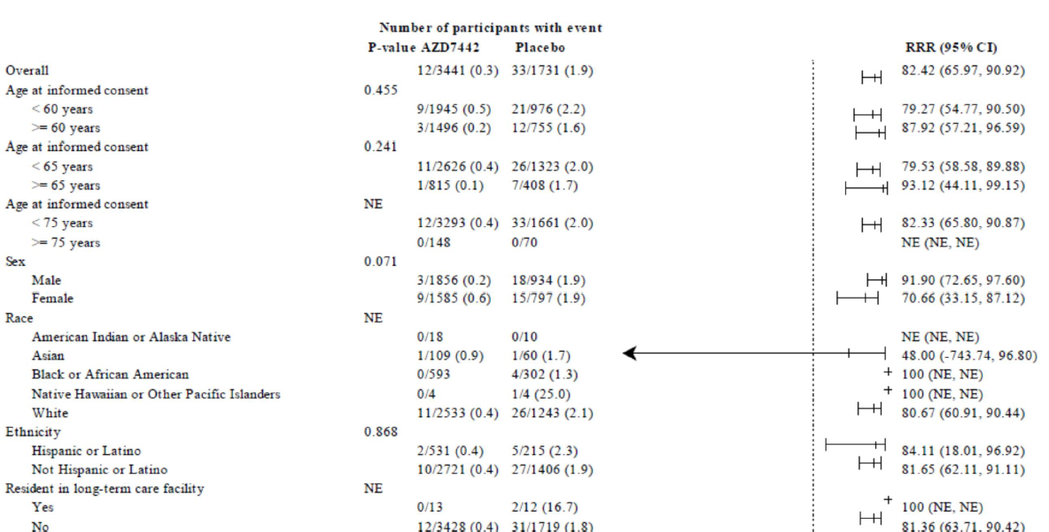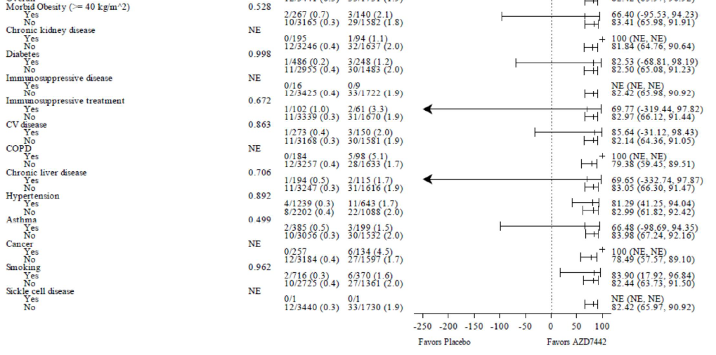
Source: Figure 2 of the PROVENT high-level data summary
Figure 2: Kaplan-Meier time to confirmed symptomatic COVID-19 in PROVENT (Full Pre-Exposure Analysis Set), April 2022 DCO
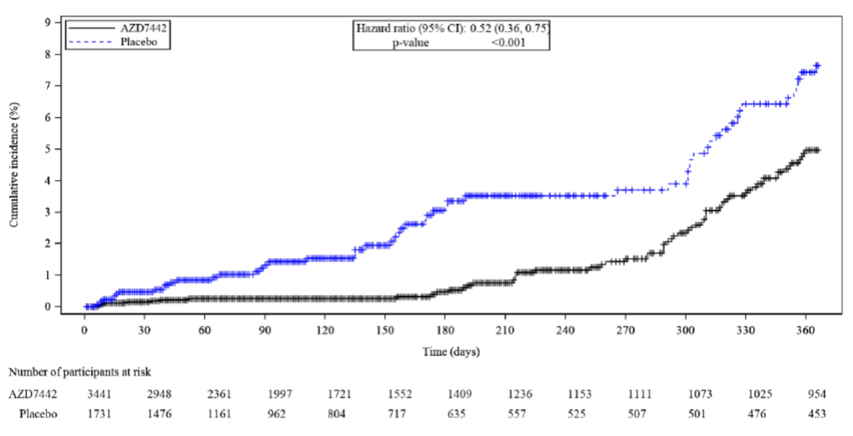
Source: Figure 6 of the PROVENT high-level data summary

Figure 3: Kaplan-Meier time to severe or critical COVID-19 illness in PROVENT (Full Pre-Exposure Analysis Set), April 2022 DCO
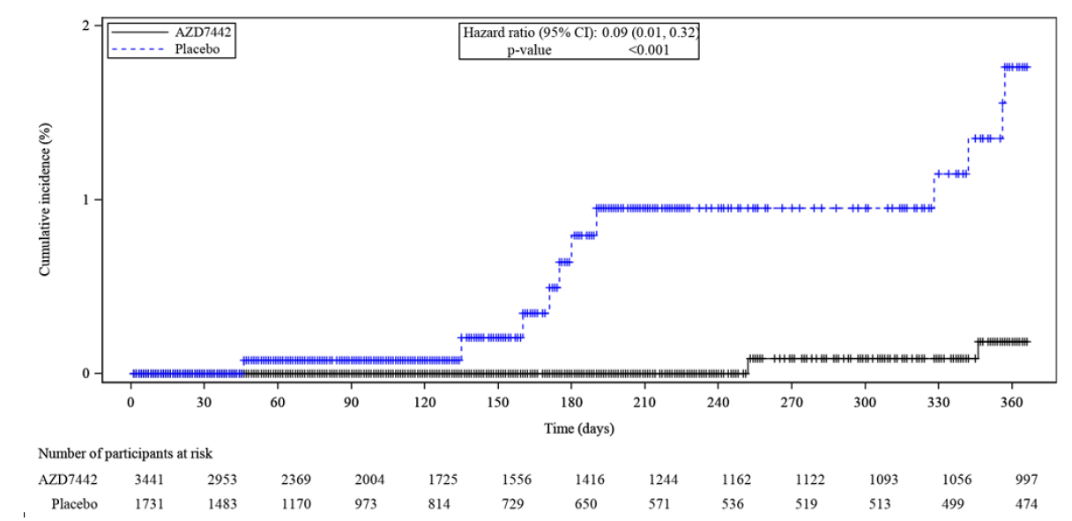
Source: Figure 5 of the PROVENT high-level data summary
  - 306 patients administered tixagevimab and cilgavimab in the PROVENT trial were recruited to a substudy of PROVENT where they received a second dose of tixagevimab 150 mg and cilgavimab 150 mg at 12 ± 2 months post-dose in the PROVENT trial. Only analyses of safety data from that substudy are reported i.e., no analyses of effectiveness after administration of a second dose of tixagevimab 150 mg and cilgavimab 150 mg are reported.
  - The cumulative dose over 12 months for which PBS-listing of tixagevimab and cilgavimab has been proposed in the revised submission is, effectively, quadruple the cumulative dose over 12 months as examined by the PROVENT trial and its substudy.
  - The Sponsor has advised the Department that, as part of its commitment to the FDA to evaluate repeat dosing regimens, a randomised, open-label, dose-ranging trial, known as the ENDURE study is currently recruiting patients. The intent of the trial is to assess the safety, immunogenicity, pharmacokinetics, and pharmacodynamics of tixagevimab and cilgavimab for pre-exposure prophylaxis of COVID-19. It does not appear that effectiveness is being assessed by this trial. 200 participants are planned to be randomised to two groups in the trial. Group 1 will receive an initial administration of tixagevimab 300 mg and cilgavimab 300 mg followed by 3-monthly redosing with tixagevimab 150 mg and cilgavimab 150 mg. Group 2 will receive an initial administration of tixagevimab 600 mg and cilgavimab 600 mg followed by 6-monthly redosing with tixagevimab 300 mg and cilgavimab 300 mg.

Observational evidence to support effectiveness of tixagevimab 300 mg and cilgavimab 300 mg as PrEP against COVID-19 in immunocompromised patients
  - The revised submission claims that two observational studies (Young-Xu 2022 and Al Jurdi 2022) conducted in the USA support the efficacy and safety of dosing with tixagevimab 300 mg and cilgavimab 300 mg in immunocompromised patients. In addition to the observational studies referenced by the revised submission, two additional observational studies have been reported in the literature that report outcomes of use of tixagevimab and cilgavimab in immunocompromised patients (Kertes 2022 and Nguyen 2022).
  - A pre-print (not peer reviewed) report by Young-Xu 202213 describes the results of a retrospective cohort study estimating the effectiveness of tixagevimab and cilgavimab for the prevention of SARS-CoV-2 infection and severe disease among immunocompromised adult veterans receiving care under the U.S. Department of Veterans Affairs (VA) healthcare system. Outcomes in a cohort of 1,848 patients who were administered at least one dose of intramuscular tixagevimab and cilgavimab between 1 January 2022 and 30 April 2022 were compared to outcomes in matched controls who were immunocompromised or otherwise at high risk for COVID-19. Most (69%) subjects were ≥65 years old, 92% were identified as immunocompromised in electronic data, and 73% had received ≥3 mRNA vaccine doses or two doses of Ad26.COV2 vaccine (by Janssen). Tixagevimab 150 mg and cilgavimab 150 mg was initially administered to patients. On February 24, 2022, in response to concerns regarding effectiveness of the tixagevimab 150 mg and cilgavimab 150 mg against the Omicron variant, the FDA increased the recommended dose to tixagevimab 300 mg and cilgavimab 300 mg. Patients who received the previously authorised (lower) dose were advised to receive an additional dose. As shown in Figure 4, compared to propensity-matched controls, patients administered tixagevimab and cilgavimab had a lower incidence of the composite outcome of SARS-CoV-2 infection, COVID-19-related hospitalisation, or all-cause mortality (17/1733 [1.0%] vs 206/6354 [3.2%]; HR 0.31; 95% CI, 0.18-0.53). Reductions in the incidence of each of the components of the composite outcome were also statistically significant. The hazard ratio observed in this study of vaccinated, immunocompromised patients is slightly lower than that observed in the PROVENT trial however the results give some confidence that a single administration of tixagevimab 300 mg and cilgavimab 300 mg patients is effective for up to 100 days in vaccinated, immunocompromised patients in a scenario where the predominant circulating variants are Omicron BA.1 or early BA.2 subvariants. The applicability of the evidence to environments where the Omicron BA.4 or BA.5 variants are circulating is uncertain. The authors report that future longitudinal analyses will focus on the newer Omicron variants. The rates of adverse events associated with a single administration of tixagevimab and cilgavimab are not reported by the authors and there is no indication that patients were redosed with tixagevimab and cilgavimab in this study.
Figure 4: Cumulative risk of composite outcome of SARS-CoV-2 infection, COVID-19-related hospitalisation, or all-cause mortality in immunocompromised US veterans receiving tixagevimab and cilgavimab for PrEP compared to untreated controls
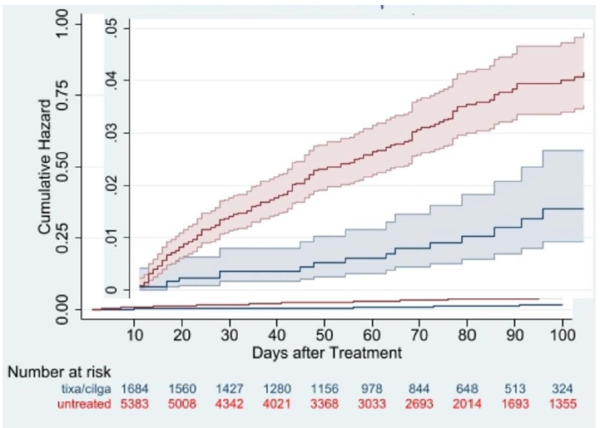
Source: Figure 3, Young-Xu 202213
  - Al Jurdi 202214 report the results of a retrospective cohort study comparing outcomes in a sample of 222 solid organ transplant recipients who received tixagevimab and cilgavimab for PrEP between 28 December 2021 and 13 April 13 2022 and 222 vaccine-matched solid organ transplant recipients who did not receive tixagevimab and cilgavimab. The median age of the recipients of tixagevimab and cilgavimab was 65 years, 39% were female and the median time from transplantation to tixagevimab/cilgavimab administration was 3.8 years. 7% had a history of prior SARS-CoV-2 infection and > 99% had received at least one dose of SARS-CoV-2 vaccine. The control group had similar characteristics to the tixagevimab and cilgavimab group, with the exception of a higher proportion of patients in the control arm reporting prior SARS-CoV-2 infection (19% vs. 7%, p < .001). Of the patients who were administered tixagevimab and cilgavimab, 90 (40.5%) received a 150-150 mg dose, 131 (59.0%) received a 300–300 mg dose and one (0.5%) received a 450–450 mg dose. As shown in Figure 5, at a mean follow-up of 87 ± 30 days after tixagevimab and cilgavimab administration, 11 (5%) subjects developed breakthrough SARS-CoV-2 infections, of whom one required hospitalisation and none died. In the control group, 32 (14%) subjects developed SARS-CoV-2 infections, of whom six were hospitalised and three died at a mean follow-up of 82 ± 28 days. As shown in Figure 6, In the tixagevimab and cilgavimab group, the incidence rate of breakthrough SARS-CoV-2 infection was higher in those who received the lower (150–150 mg) dose of tixagevimab and cilgavimab compared to those who received the higher dose of 300–300 mg (log-rank p = 0.025). As with the study reported by Young-Xu 202213, the results from this study give some confidence that a single administration of tixagevimab 300 mg and cilgavimab 300 mg patients is effective for up to 100 days in vaccinated, immunocompromised patients in an environment where the predominant circulating variants are Omicron BA.1 or early BA.2 subvariants. However, it is not clear that the evidence is directly applicable to environments where the Omicron BA.5 variant is circulating. There is also no indication that patients were redosed with tixagevimab and cilgavimab in this study.
Figure 5: Cumulative risk of SARS-CoV-2 infection in solid organ transplant recipients administered tixagevimab and cilgavimab for PrEP compared to untreated controls
Source: Figure 1A, Al Jurdi 202214
Figure 6: Cumulative risk of SARS-CoV-2 infection in solid organ transplant recipients administered tixagevimab and cilgavimab for PrEP compared to untreated controls stratified by dose of tixagevimab and cilgavimab
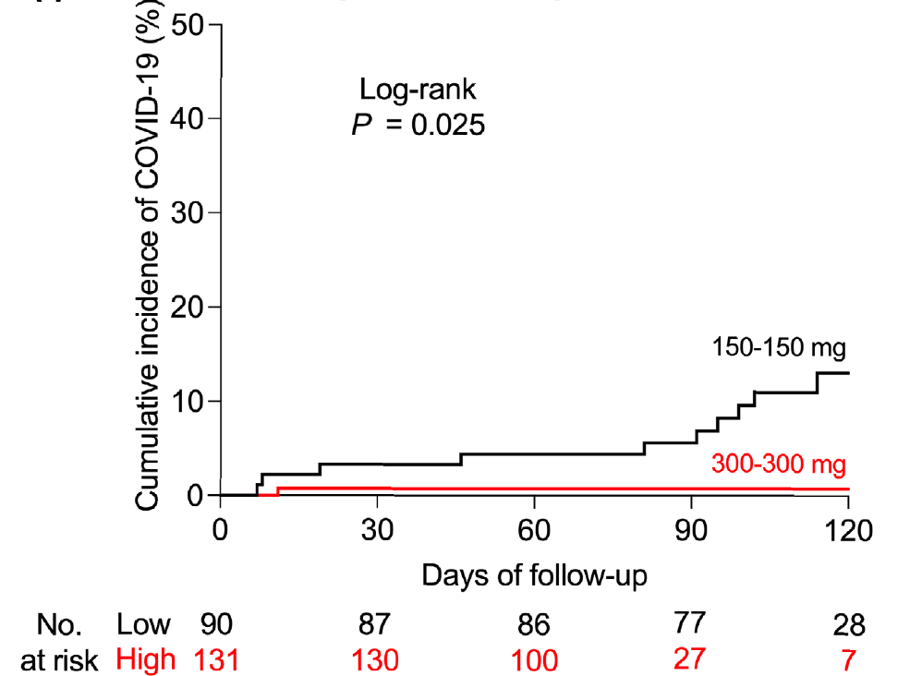
Source: Figure 1I, Al Jurdi 202214
  - Kertes 202215 report the results of a retrospective cohort study comparing outcomes in a sample of 825 immunosuppressed patients who accepted an invitation from Maccabi HealthCare Services (the second-largest health maintenance organisation in Israel) to receive tixagevimab 150 mg and cilgavimab 150 mg for PrEP between 23 February 2022 and 26 May 2022 and 4,299 immunosuppressed patients who declined the invitation. Results from this study are shown in Figure 7. After adjustment for differences in baseline characteristics between the two groups, the group who received tixagevimab and cilgavimab were half as likely to become infected with SARS-CoV-2 than the group who did not receive tixagevimab and cilgavimab (OR: 0.51, 95% CI: 0.30-0.84). One person (0.1%) in the tixagevimab and cilgavimab group was hospitalised for COVID-19 compared to 27 (0.6%) in the non-administered group (p=0.07). No mortality was recorded among the group who received tixagevimab and cilgavimab, compared to 40 deaths (0.9%) in the non-administered group (p=0.005). After adjustment, immunocompromised individuals administered tixagevimab and cilgavimab were 92% less likely to be hospitalised/die than those not administered tixagevimab and cilgavimab (OR: 0.08, 95% CI: 0.01-23 0.54). The results from this study suggest that tixagevimab 150 mg and cilgavimab 150 mg may be less effective in preventing SARS-CoV-2 infection due to the Omicron variants (BA.1 and BA.2) that were circulating in early 2022 than was observed over a similar time horizon in the PROVENT trial and also suggests, that protection against severe or critical COVID-19 persists for approximately 3 months.
Figure 7: Cumulative risk of SARS-CoV-2 infection and severe COVID-19 in immunocompromised patients administered tixagevimab 150 mg and cilgavimab 150 mg for PrEP compared to untreated controls
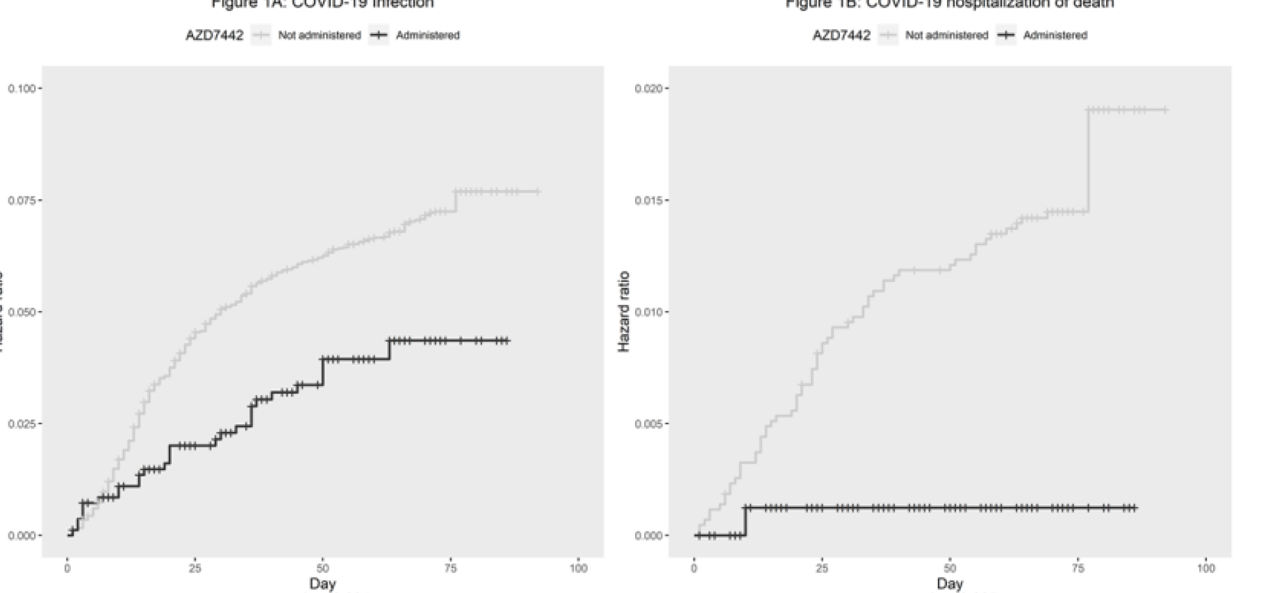
Source: Figure 1A and 1B, Kertes 202215
  - Nguyen 202216 report the results of a retrospective cohort study examining outcomes in 1,112 immunocompromised patients in three hospitals located in Ile-de-France (a region in north-central France that surrounds Paris) who received tixagevimab 150 mg and cilgavimab 150 mg for PrEP against infection with SARS-CoV-2 Omicron sub-lineages BA.1 and BA.2 between 28 December 2021 and 31 March 2022. Patients were followed up for a median of 63 days (range: 49 – 73 days). COVID-19 was confirmed in 49/1112 (4.4%) at least 5 days following treatment. Among infected patients, 43/49 (88%) had a mild-to moderate form and 6/49 (12%) had a moderate-to-severe form of COVID-19. 2/49 (4%) patients died from COVID-19. No control group of immunocompromised patients was defined for this study therefore no estimate of the incremental benefit of tixagevimab and cilgavimab is reported by this study.

In vitro susceptibility studies as evidence of effectiveness of tixagevimab and cilgavimab vs Omicron subvariants
  - Several in vitro studies have examined the susceptibility of Omicron subvariants to tixagevimab and cilgavimab. Results of these studies are summarised in Table 6. As noted above the predominant Omicron sub-variant circulating in Australia (at 25 Jul 2022) is the BA.5 variant. The EC₅₀ is the concentration of tixagevimab and cilgavimab that is required in vitro to generate a half of the maximal protection against an Omicron variant after a specified exposure time. Table 6 indicates EC₅₀ values ranged from 40 to 609 ng/mL, which corresponds to a 19 to 149-fold reduction in susceptibility of Omicron subvariants BA.4 or BA.5 to tixagevimab and cilgavimab compared to pre-Omicron reference SAR-CoV-2 variants, noting that no susceptibility data for authentic BA.4 or BA.5 subvariants are available (the studies reporting susceptibility data conducted neutralisation assays using virus-like particles [VLP] that were pseudotypes with the S protein of the BA.4/BA.5 subvariant). Two of the studies reporting susceptibility data for BA.4/BA.5 were conducted using parental monoclonal antibodies (pmAbs) rather than tixagevimab and cilgavimab.
  - The susceptibility data presented in Table 6 consistently suggests that the Omicron BA.4 and BA.5 subvariants are less susceptible to tixagevimab and cilgavimab however there is considerable uncertainty around the magnitude of this reduced susceptibility.
  - The clinical significance of the observed in vitro reductions in susceptibility of the SARS-CoV-2 variants to tixagevimab and cilgavimab is unknown. Measures of neutralising activity do not necessarily correlate with clinical outcomes.
Table 6: Susceptibility of Omicron subvariants to tixagevimab and cilgavimab
Data Source | Target¹ | mAb² | Concentration required to achieve 50% neutralisation (ng/mL) [Fold-Change from Reference]³
Data Source | Target¹ | mAb² | BA.1 | BA.1.1 | BA.2 | BA.2.12.1 | BA.4/BA.5
AZ (Monogram/FDA) | VLP | EVU | 171 [132] | 466 [424] | 9.8 [3.2] | 10.7 [5] | 69.4 [33]
Tuekprakhon 2022 | VLP | EVU | 232 [232] | 806 [806] | 8 [8] |  | 65 [65]
Yamasoba 2022 | VLP | EVU |  |  | 33 [8] | 135 [33] | 609 [149]
Cao 2022 | VLP | pmAbs | 491 [230] | 8090 [3900] | 8.2 [3.9] | 18 [8.6] | 40 [19]
Takashita 2022 | VLP | pmAbs | 351 | 1297 | 35 | 38 | 38/193
Source: Table 1, FDA Center for Drug Evaluation and Research Review Memorandum re: Emergency Use Authorization for EVUSHELD (29 Jun 2022). Available at: https://www.fda.gov/media/159767/download [Accessed: 30 Jun 2022], Tuekprakhon 2022, Yamasoba 2022, Cao 2022 and Takashita 2022
¹ Neutralisation assay conducted using authentic virus (Virus) or virus-like particles pseudotyped with the S protein of the indicated Omicron subvariant (VLP)
² Monoclonal antibodies (mAb) used in the assay. EVUSHELD (EVU; tixagevimab and cilgavimab) or its parental monoclonal antibodies (pmAbs), COV2-2196 and COV2-2130
³ Reference virus/VLP were pre-Omicron variants susceptible to both tixagevimab and cilgavimab
  - A secondary issue raised by some of the neutralisation studies is that, as shown in Table 7, it appears that only one of the two antibodies (cilgavimab) retains some neutralising activity against the BA.2, BA.4 and BA.5 Omicron subvariants. This potentially raises issues in regard the extent of the benefit of the combination product over a single agent in some circumstances.
Table 7: Susceptibility of selected Omicron subvariants to tixagevimab and cilgavimab administered separately and in combination (concentration required to achieve 50% neutralisation, in ng/mL)
Data Source | BA.2 |  |  | BA.4* |  |  | BA.5
Data Source | TIXA | CIL | TIXA + CIL | TIXA | CIL | TIXA + CIL | TIX | CIL | TIXA + CIL
Tuekprakhon 2022 | 1333 | 8 | 8 | >10,000 | 15 | 65 | Not reported
Yamasoba 2022 | >2750 | 19 | 33 | >2750 | 443 | 609 | Column with BA.4 reports results for BA.4/5
Cao 2022 | 4312 | 6.3 | 8.2 | >10,000 | 23 | 40
Takashita 2022 | 2757 | 17 | 35 | >50,000 | 54 | 38 | >50,000 | 57 | 193
Source: Tuekprakhon 202217, Yamasoba 202218, Cao 202219 and Takashita 202220
CIL = cilgavimab; TIXA = tixagevimab
* BA.4/5 reported by Yamasoba 2022 and Cao 2022;

Pharmacokinetic modelling to support effectiveness of administration of tixagevimab 300 mg and cilgavimab 300 mg and redosing every 6 months
  - Given: (i) the absence of clinical evidence supporting a claim of effectiveness of tixagevimab 300 mg and cilgavimab 300 mg as PrEP against COVID-19 in a scenario where Omicron BA.5 is circulating; and (ii) the absence of clinical evidence to support repeat administration of tixagevimab and cilgavimab every 6 months, the revised submission presents results from pharmacokinetic modelling to support claims of effectiveness and safety of the revised regimen.
  - The key inputs to pharmacokinetic modelling are: (i) assumptions in regard to the serum concentration of tixagevimab and cilgavimab required to achieve 80% neutralisation of the virus (which is derived from the EC₅₀ shown in Table 6); and (ii) the extent to which there is penetration of tixagevimab and cilgavimab from the serum into target tissue (assumed to be the respiratory tract). By combining these factors, the pharmacokinetic modelling predicts the serum concentrations of tixagevimab and cilgavimab to achieve distribution of the treatments in the target tissue.
  - The pharmacokinetic modelling conducted recognises that the in vitro neutralisation activity of tixagevimab and cilgavimab against Omicron subvariants BA.4 and BA.5 is lower than against the original SARS-CoV-2 variants as well as the BA.2 subvariants (as shown in Table 6 and Table 7). The modelling assumes an EC₅₀ of 65 ng/mL for tixagevimab and cilgavimab is applicable. As can be seen from Table 6, an EC₅₀ of 609 ng/mL was estimated by one of the four in vitro studies (Yamasoba 2022) assessing susceptibility of the Omicron BA.4/5 variants to tixagevimab and cilgavimab. The EC₅₀ reported by this study was dismissed as an ‘outlier’ by the pharmacokinetic modellers. Given that there are only four studies assessing the in vitro neutralisation activity of tixagevimab and cilgavimab against Omicron BA.4/5, it may not be reasonable to dismiss the results of this study.
  - The modelling assumes that, at worst, the rate of penetration of tixagevimab and cilgavimab into target tissues is 1.8%. This estimate was based on the human nasal lining fluid (in the upper respiratory tract) to serum ratio of tixagevimab and cilgavimab concentrations observed in the Phase 1 first-time-in-human study conducted in healthy volunteers. The modelling is also conducted assuming higher (i.e., less conservative) rates of penetration into target tissues in the lower respiratory tract. The less conservative estimate (6.5%) is based on published lung penetration ratios. It is unclear which target site is most relevant (e.g., lower or upper respiratory tract or other tissue) for predicting outcomes of PrEP with tixagevimab and cilgavimab.
  - The predicted serum concentration of tixagevimab and cilgavimab over time and the predicted proportion of individuals that will have tixagevimab and cilgavimab concentrations greater than a target-site-adjusted minimum protective concentration against Omicron subvariants BA.4 and BA.5 assuming an EC₅₀ of 65 ng/mL and target site penetration ratios of 1.8% (upper respiratory tract) or 6.5% (lower respiratory tract) for tixagevimab mg and cilgavimab 300 mg administered every 6 months is shown in Figure 8. Based on this pharmacokinetic modelling, the submission suggests that the median serum concentrations of tixagevimab 300 mg and cilgavimab 300 mg exceed the modelled minimum protective concentration for the BA.2/3/4/5 subvariants for 6 months.
Figure 8: Predicted serum concentration of tixagevimab 300 mg and cilgavimab 300 mg administered every 6 months for Omicron BA.4 and BA.5 subvariants
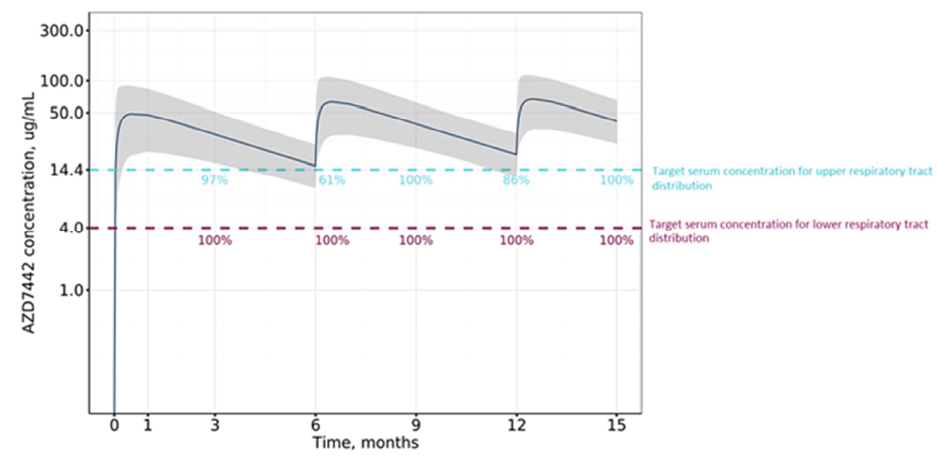
Source: Figure 4, Addendum to the Clinical Overview of EVUSHELD for prophylaxis of COVID-19 (provided with the revised submission)
% number next to blue dashed line represent % subjects predicted to be above serum target level 14.4 μg/mL (using 1.8% penetration ratio) for BA.4 and BA.5, assuming upper respiratory tract distribution.
% number next to purple dashed line represent % subjects predicted to be above serum target level 4 ug/ml (using 6.5% penetration ratio) for BA.4 and BA.5, assuming lower respiratory tract distribution.
  - As noted in the FDA’s Center for Drug Evaluation and Research Review Memorandum dated 29 June 2022 (which relates to the FDA’s decision to recommend a dose of tixagevimab 300 mg and cilgavimab 300 mg every six months), in reference to assumptions underpinning the pharmacokinetic modelling, states “it should be acknowledged that there are still uncertainties as to whether 1.8% [target-site penetration ratio] in combination with EC₈₀ is the best predictor for efficacy”.
  - Although the target site for tixagevimab and cilgavimab is assumed to be the respiratory tract, the possibility that adverse events arise due to exposure of off-target sites to tixagevimab and cilgavimab cannot be excluded.
  - As with any monoclonal antibody, there is a potential for development of anti-drug antibodies that confer resistance to treatment and, potentially, for new SARS-CoV-2 variants to emerge as a consequence of development of viral mutations in response to exposure to tixagevimab and cilgavimab.

Comparative harms
  - The key safety outcomes from the PROVENT trial in which patients were given a single administration of tixagevimab 150 mg and cilgavimab 150 mg and then followed up for 12 months are summarised in Table 8. Results are presented at the time of the April 2022 DCO.
Table 8: Summary of key adverse events in the PROVENT trial at April 2022 DCO
PROVENT trial | Tixagevimab 150 mg and cilgavimab 150 mg arm  N = 3461  Exposure = 3781.5 person-years  n (incidence rate per person-year) | Placebo arm  N = 1736  Exposure =.1878.6 person-years  n (incidence rate per person-year) | Rate ratio (95% CI)
Participants with ≥ 1 AE | 1969 (0.521) | 979 (0.521) | 1.00  (0.92, 1.08)
Participants with ≥1 medically attended AE | 957 (0.253) | 416 (0.221) | 1.14  (1.02, 1.29)
Participants with ≥ 1 SAE | 209 (0.055) | 96 (0.051) | 1.08  (0.85, 1.39)
Participants with AEs with outcome of death | 21 (0.0056) | 10 (0.0053) | 1.04  (0.47, 2.48)
Source: Table 10 of the PROVENT high-level data summary. Rate ratios calculated during the evaluation.
AE = adverse event; CI = confidence interval; DCO = data cut-off; mg = milligrams; n = number of participants reporting data; N = total participants in group; SAE = serious adverse event
  - Overall, the rates of adverse events were similar across the two arms of the trial. However, given that COVID-19 is recorded as an adverse event in the PROVENT trial and given that there was a higher rate of symptomatic COVID-19 in the placebo arm of the trial, it is important to compare rates of serious adverse events in each arm of the trial. The incidence rates of serious adverse events where ≥ 10 participants in either arm of the PROVENT trial experienced the event and where a substantial difference in rates across the arms was detected are presented in Table 9. As can be seen, the lack of difference in overall rates of serious adverse events between the group receiving tixagevimab and cilgavimab and the group receiving placebo for PrEP in the PROVENT trial shown in Table 8 appears to be due to the higher rates of serious cardiac disorders in the tixagevimab and cilgavimab arm being offset by lower rates of serious COVID-19-related events (as can be seen in Table 9).
Table 9: Summary of incidence of serious adverse events where ≥ 10 participants in either arm of the PROVENT trial experienced the event and where a difference in rates across the arms was detected (April 2022 DCO)
PROVENT trial | Tixagevimab 150 mg and cilgavimab 150 mg arm  N = 3461  Exposure = 3781.5 person-years  n (incidence rate per person-year) | Placebo arm  N = 1736  Exposure =.1878.6 person-years  n (incidence rate per person-year) | Rate ratio (95% CI)
Cardiac disorders | 38 (0.0100) | 8 (0.0043) | 2.36  (1.08, 5.86)
COVID-19 pneumonia | 3 (0.0008) | 18 (0.0096) | 0.08  (0.02, 0.28)
Source: Table 14 of the PROVENT high-level data summary. Rate ratios calculated during the evaluation.
CI = confidence interval; DCO = data cut-off; mg = milligrams; n = number of participants reporting data; N = total participants in group
  - The relative risk of cardiac events at 6 months was similar to the relative risk observed at 12 months: 23/3461 (0.7%) in the tixagevimab and cilgavimab arm and 5/1736 (0.3%) in the placebo arm (at 6 months, risk ratio = 2.31; 95% CI: 0.88, 6.06).
  - Table 10 lists the serious cardiac disorders observed in the PROVENT trial. The PROVENT high level data summary provided with the revised submission notes that all participants who experienced cardiac disorder serious adverse events had at least one cardiac risk factor.
Table 10: Incidence of cardiac serious adverse events in the PROVENT trial at April 2022 DCO
PROVENT trial | Tixagevimab 150 mg and cilgavimab 150 mg arm  N = 3461  Exposure = 3781.5 person-years  n (incidence rate per person-year) | Placebo arm  N = 1736  Exposure =.1878.6 person-years  n (incidence rate per person-year)
Cardiac disorders | 38 (0.0100) | 8 (0.0043)
Acute myocardial infarction | 6 (0.0016) | 3 (0.0016)
Myocardial infarction | 8 (0.0021) | 1 (0.0005)
Congestive cardiac failure | 6 (0.0016) | 0
Atrial fibrillation | 3 (0.0008) | 2 (0.0011)
Coronary artery disease | 2 (0.0005) | 1 (0.0005)
Acute left ventricular failure | 1 (0.0003) | 1 (0.0005)
Unstable angina | 2 (0.0005) | 0
Atherosclerosis coronary artery | 1 (0.0003) | 1 (0.0005)
Angina pectoris | 1 (0.0003) | 0
Arrhythmia | 1 (0.0003) | 0
Atrioventricular block complete | 1 (0.0003) | 0
Bradycardia | 1 (0.0003) | 0
Cardiac failure | 1 (0.0003) | 0
Cardiac failure acute | 1 (0.0003) | 0
Cardio-respiratory arrest | 1 (0.0003) | 0
Cardiogenic shock | 1 (0.0003) | 0
Cardiomegaly | 1 (0.0003) | 0
Cardiomyopathy | 1 (0.0003) | 0
Left ventricular failure | 1 (0.0003) | 0
Mitral valve disease | 1 (0.0003) | 0
Paroxysmal atrioventricular block | 1 (0.0003) | 0
Stress cardiomyopathy | 0 | 1 (0.0005)
Ventricular arrhythmia | 1 (0.0003) | 0
Source: Table 14.3.2.1.1C of the PROVENT high-level data summary
Note: Some participants had more than one serious cardiac adverse event. 38 patients in the tixagevimab and cilgavimab arm experienced 43 serious cardiac disorders. 8 patients in the placebo arm experienced 10 serious cardiac disorders. Participants with events in more than one preferred term are counted once in each of those preferred terms
CI = confidence interval; DCO = data cut-off; mg = milligrams; n = number of participants reporting data; N = total participants in group
  - Only interim safety results are available from the PROVENT substudy in which 305 people originally randomised to receive tixagevimab 150 mg and cilgavimab 150 mg in the parent study received a second dose of tixagevimab 150 mg and cilgavimab 150 mg. Median follow up of this group at the time of reporting of results was only 17.0 days (range: 1 to 36 days). 44 (14.4%) of the subjects experienced at least one adverse event.
- Of these, 2 (0.7%) subjects experienced cardiac disorders.
- 12 of 49 (24.5%) patients in the substudy that were considered evaluable for anti-drug antibodies were positive for antidrug antibodies. The report of the substudy suggests that there was no evidence the administration of a second dose of tixagevimab and cilgavimab resulted in a meaningfully stronger anti-drug antibody response as compared to after the first dose.
The PBAC noted that given the short duration of follow-up (17 days) at the time of reporting of results from the substudy, the results from the substudy should be interpreted with caution.
  - Although a causal relationship between tixagevimab and cilgavimab and these events has not been established, the possibility of a relationship between tixagevimab and cilgavimab and these events cannot be excluded.
  - The submission suggests that support of the safety of tixagevimab 300 mg and cilgavimab 300 mg can be drawn from the Phase I first-time-in-human (FTIH) study in which doses up to tixagevimab 1500 mg and cilgavimab 1500 mg (administered by intravenous infusion) were studied in 60 healthy adult volunteers aged 18 to 55 years. One placebo cohort of 10 subjects and five tixagevimab and cilgavimab cohorts (150-150 mg IM, 150-150 mg IV, 250-250 mg IV, 1,500-1,500 mg by sequential IV infusion, 1,500-1,500 mg as a single combination IV infusion), with 10 subjects in each cohort, were recruited to the study. Subjects in the tixagevimab and cilgavimab cohorts had pharmacokinetic measurements conducted periodically over 1 year (blood samples for serum pharmacokinetic analysis were collected at baseline (pre-dose), mid-infusion (IV), end of dosing (IV), 8 hours post-dose, Day 2 (discharge), and post-dose follow-up Days 4, 6, 8, 15, 31 61, 91, 151, 211, 271, and 361. The submission states that no dose limiting toxicity was observed in this study. The Sponsor did not provide a report of this study to permit review of the data from this study. Thus, the Sponsor’s claim no dose limiting toxicity was observed in this study could not be confirmed. Regardless, given the incidence rate of cardiac disorders was 0.01 per person-year in the PROVENT trial, it would be unlikely that a study with only 60 subjects would show a difference in the incidence of cardiac disorders.
  - The revised submission also suggests that the clinical safety of tixagevimab 300 mg and cilgavimab 300 mg is supported by safety data from the TACKLE trial. TACKLE is a Phase III treatment study in which a total of 452 non-hospitalised adult patients with mild to moderate COVID-19 were treated with tixagevimab 300 mg and cilgavimab 300 mg via intramuscular injection. The revised submission suggests that the overall safety profile in patients who received tixagevimab 300 mg and cilgavimab 300 mg for the treatment of mild to moderate COVID-19 was similar to that reported in participants who received tixagevimab 150 mg and cilgavimab 150 mg in the prophylaxis studies. The Sponsor did not provide a report to permit review of the data from this study, however a published report is available. 452 patients were recruited to the tixagevimab and cilgavimab arm of the trial and 451 patients were recruited to the placebo arm of the trial. According to Supplementary Table 4 of the published report, the number of patients reporting serious cardiac disorders was 2 (0.4%) in the tixagevimab and cilgavimab arm of the trial and 1 (0.2%) in the placebo arm at a median follow-up of 84 days. The incidence of serious cardiac disorders was numerically approximately double in the tixagevimab and cilgavimab arm compared to the placebo arm of the PROVENT trial so results for serious cardiac disorder adverse events observed in the TACKLE trial could be considered approximately consistent with those observed in the PROVENT trial however, as acknowledged by the authors of the published report of the TACKLE trial, the duration of available data limited interpretation of the safety of tixagevimab 300 mg and cilgavimab 300 mg.
  - The Pre-PBAC response provided a summary of cardiac SAEs reported for PROVENT and three other Phase III clinical studies (Table 10). The Pre-PBAC response stated that all PROVENT participants who experienced a cardiac SAE had ≥1 baseline cardiovascular risk factor or prior history of cardiac events, however did not indicate whether the risk factors and prior history were identified in advance, or if they were determined retrospectively upon investigation after the SAEs were reported. The PBAC also noted that an imbalance of risk factors between groups was not demonstrated in PROVENT. While COVID infection may increase the risk of cardiac events, this did not appear to be consistent with the higher incidence of cardiac SAEs in the intervention group in PROVENT.
  - In regard to the data presented in Table 11, the PBAC noted the incidence of cardiac SAEs in the placebo group of PROVENT was similar to the control arms of other trials (STORMCHASER, TACKLE, and ACTIV-3). However, these other trials recruited smaller numbers of patients and follow-up was shorter than in PROVENT.
Table 11: Cardiac SAEs occurring in Phase 3 trials of tixagevimab/cilgavimab
 | Number of participants |  |  | Case Numbers, (%) |  | EVUSHELD  Dose | Follow up, median days | DCO
 | EVUSHELD | PBO | Total | EVUSHELD | PBO
PROVENT | 3,461 | 1,736 | 5,197 | 38 (1.1) | 8 (0.5) | 150-150mg | 414 | 13 April 22
STORMCHASER | 749 | 372 | 1,121 | 0 | 0 | 150-150mg | 182 | 19 Aug 21
TACKLE¹ | 452 | 451 | 903 | 2 (0.4) | 3 (0.7) | 300-300mg | 170 | 14 Jan 22
ACTIV-3² | 710 | 707 | 1417 | 5 (0.7) | 4 (0.6) | 300-300 mg | 90 | N/A
Source: Pre-PBAC response Table 1.
¹ The Pre-PBAC response stated that data for TACKLE had been updated since the publication described in paragraph 6.51.
² Study was not identified in the submission.

Benefits/harms
  - A summary of the comparative benefits and harms for tixagevimab 150 mg and cilgavimab 150 mg for PrEP against severe or critical COVID-19 versus placebo over 12 months is presented in Table 12. The table indicates that although the benefits of treatment with tixagevimab and cilgavimab are substantial on a relative scale, the benefits are relatively small in absolute terms. Depending on the objective of PrEP (e.g., whether the objective to prevent symptomatic COVID-19 [including mild illness] or is it to prevent serious or critical COVID-19), the benefits associated with administration of tixagevimab and cilgavimab may be largely outweighed by harms, particularly in people with risk factors for cardiac disorders.
Table 12: Summary of comparative benefits and harms for tixagevimab and cilgavimab and placebo in the PROVENT trial
 | Tixagevimab 150 mg and cilgavimab 150 mg arm |  |  |  |  |  |  | Placebo arm |  | Risk ratio  (95% CI) |  | Event rate per 10,000 patient-years* |  |  | Rate difference per 10,000 patient-years  (95% CI)
 |  |  |  |  |  |  |  |  |  |  |  | Tixagevimab 150 mg and cilgavimab 150 mg arm | Placebo arm
Benefits in the PROVENT trial at 6 months (as per the August 2021 DCO)
Symptomatic COVID-19 by 6 months (regardless of unblinding or receipt of COVID-19 vaccine)
PROVENT |  |  |  |  | 20/3441  (0.6%) |  | 44/1731  (2.5%) |  | 0.229  (0.135, 0.387) |  | 107.1 |  |  | 472.0 |  | -364.8  (-512.0, -217.8
Serious or critical COVID-19 by 6 months (regardless of unblinding or receipt of COVID-19 vaccine)
PROVENT |  |  | 0/3441  (0) |  |  |  | 6/1731  (0.3%) |  | Not calculable |  | 0 |  |  | 64.4 |  | -64.4  (-115.9, -12.9)
Harms in the PROVENT trial at 6 months
Serious cardiac disorder adverse events
PROVENT |  |  |  | 23/3461  (0.7%) |  |  | 5/1736  (0.3%) |  | 2.31  (0.88, 6.06) |  | 123.1 |  |  | 53.6 |  | 69.5  (0.6, 138.3)
Benefits in the PROVENT trial at 12 months
Symptomatic COVID-19 by 12 months (regardless of unblinding or receipt of COVID-19 vaccine)
PROVENT |  |  | 281/3441  (8.2%) |  |  | 164/1731  (9.5%) |  |  | 0.862  (0.717, 1.04) |  | 743.1 |  |  | 873 |  | -129.9  (-289.3, 29.5)
Serious or critical COVID-19 by 12 months (regardless of unblinding or receipt of COVID-19 vaccine)
PROVENT | 2/3441  (0.1%) |  |  |  |  |  |  | 11/1731  (0.6%) |  | 0.091  (0.020, 0.412) |  | 5.3 | 58.6 |  | -53.3  (-88.6, -17.9)
Harms in the PROVENT trial at 12 months
Serious cardiac disorder adverse events
PROVENT |  | 38/3461  (1.1%) |  |  |  |  |  | 8/1736  (0.5%) |  | 2.38  (1.11, 5.10) |  | 100.5 |  | 42.6 |  | 57.9  (14.4, 101.4)
Source: Table 5 and Table 9, Table 49 of the PROVENT primary CSR
* Exposure at the August 2021 DCO = 1868.1 person-years in the tixagevimab and cilgavimab arm and 932.3 person-years in the placebo arms of the PROVENT trial, respectively. Exposure at the April 2022 DCO = 3781.5 person-years in the tixagevimab and cilgavimab arm and = 1878.6 person-years in the placebo arm of the PROVENT trial
  - On the basis of the results from the PROVENT trial, the primary source of evidence presented by the submission, for every 10,000 patients receiving tixagevimab 150 mg and cilgavimab 150 mg as PrEP against COVID-19 in comparison with placebo and followed for 6 months:
- Approximately 365 fewer patients would develop symptomatic COVID-19.
- Approximately 64 fewer patients would develop serious or critical COVID-19.
- Approximately 70 additional patients would experience a serious cardiac disorder adverse event.
  - On the basis of the results from the PROVENT trial, the primary source of evidence presented by the submission, for every 10,000 patients receiving tixagevimab 150 mg and cilgavimab 150 mg as PrEP against COVID-19 in comparison with placebo and followed for 1 year:
- Approximately 130 fewer patients would develop symptomatic COVID-19.
- Approximately 53 fewer patients would develop serious or critical COVID-19.
- Approximately 58 additional patients would experience a serious cardiac disorder adverse event.
  - As can be seen from the statistics in paragraphs 6.55 and 6.56, the benefit of tixagevimab and cilgavimab, in terms of the rate of cases of symptomatic COVID-19 cases avoided, at 6 months is large but is not maintained at 12 months. In contrast, there is a smaller incremental benefit in terms of the rate of cases of severe or critical COVID-19 (as opposed to symptomatic COVID-19) at 6 months but the benefit observed at 6 months in PROVENT trial was maintained through to 12 months.
  - The PBAC noted that the incidence of symptomatic COVID-19 in the control arm of PROVENT was 9.5% (Table 12). The PBAC acknowledged that the balance of benefits and harms may be improved when high levels of the virus are circulating and when the virus circulating is highly pathogenic (if efficacy is assumed to be as observed in PROVENT).

Clinical claim
  - The submission implicitly suggests that tixagevimab 300 mg and cilgavimab 300 mg administered every 6 months is superior in terms of effectiveness compared to placebo for PrEP against symptomatic COVID-19 caused by any SARS-CoV-2 variant.
  - The submission does not make any explicit claim in regard to the safety of tixagevimab 300 mg and cilgavimab 300 mg administered every 6 months.
  - The PBAC considered that safety and effectiveness of the proposed dosing regimen tixagevimab 300 mg and cilgavimab 300 mg every 6 months had not been established.
For more detail on PBAC’s view, see section 7 PBAC outcome.

Economic analysis
  - A modelled cost-utility analysis was conducted to inform consideration of the performance of tixagevimab and cilgavimab for PrEP against COVID-19, relative to placebo (as a proxy for no PrEP) from an economic perspective. The submission did not present its own model but did provide comment on the model included in the rapid HTA commissioned by the Department in late November 2021. The same model, with some updated inputs, was presented for this PBAC consideration.
  - The analysis captures the following benefits of treatment with tixagevimab and cilgavimab:
- Reduced risk of developing symptomatic COVID-19
- Reduced probability of hospitalisation through Day 28, which is assumed to correspond to a reduced probability of death through Day 28
  - Patients who develop symptomatic COVID-19 are distributed across a number of health states according to time to sustained symptom alleviation by Day 7, Day 14 and Day 21 after initiation of treatment. As no evidence of reduced time to symptom alleviation is presented for tixagevimab and cilgavimab, the distribution of patients across these health states is the same in both arms of the model (though the proportion of patients developing symptomatic COVID-19 is lower in the tixagevimab and cilgavimab arm in the model).
  - Patients who require hospitalisation for severe or critical COVID-19 are distributed across health states that reflect length of stay in hospital (1-8 days, 9-15 days, 16 to 22 days, ≥ 23 days) and length of stay in an intensive care unit (ICU) (1-8 days, 9-15 days, 16 to 22 days, ≥ 23 days). Again, as no evidence of differential length of stay in hospital or ICU is presented in the materials provided by the Sponsor, the distribution of patients across these health states is identical in both arms of the model (though the proportion of patients requiring hospitalisation is assumed to be reduced).
  - The key drivers of outcomes generated by the model are: (i) the difference between tixagevimab and cilgavimab and placebo in risk of developing symptomatic COVID-19; and (ii) for patients who develop COVID-19, the differential relative risk of hospitalisation (or death), which is estimated based on incidence of severe or critical COVID-19.
  - The model is used to run two base-case economic analyses.
  - One model assesses costs and outcomes assuming the treatment effect for tixagevimab 300 mg and cilgavimab 300 mg lasts for only 6 months when used in an environment where the majority of SARS-CoV-2 infections are due to Omicron subvariants BA.4 and BA.5. This analysis applies outcomes as observed at 6 months with tixagevimab 150 mg and cilgavimab 150 mg in the PROVENT trial. This model is hereafter referred to as the “6-month model”.
  - The other model assesses costs and outcomes assuming the treatment effect for tixagevimab 300 mg and cilgavimab 300 mg, when used in an environment where the majority of SARS-CoV-2 infections are due to Omicron subvariants BA.4 and BA.5, is the same as the treatment effect observed at 12 months with tixagevimab 150 mg and cilgavimab 150 mg in the PROVENT trial. Essentially, this model assumes that redosing with tixagevimab 300 mg and cilgavimab 300 mg would not occur at an interval less than annually. This model is hereafter referred to as the “12-month model”.
  - Neither of the models incorporate costs of managing adverse events. The exclusion of these costs means that the results of the economic analyses are biased in favour of tixagevimab and cilgavimab.
  - Both of these analyses could be considered favourable to tixagevimab and cilgavimab given the lack of evidence to support the assumption that tixagevimab 300 mg and cilgavimab 300 mg will be as effective and safe in an environment where the majority of SARS-CoV-2 infections are due to Omicron subvariants BA.4 and BA.5 compared to tixagevimab 150 mg and cilgavimab 150 mg in the PROVENT trial, which was conducted at a time when the Omicron variant was not yet circulating.
  - The decision tree shown in Figure 9 is used to conduct the analyses. Cohort expected value analysis is used to generate the results of the analysis.

Figure 9: Structure of the decision tree used to conduct the economic evaluation comparing costs and outcomes associated with tixagevimab 300 mg and cilgavimab 300 mg (EVUSHELD) to those for no treatment added to supportive care for PrEP of symptomatic COVID-19
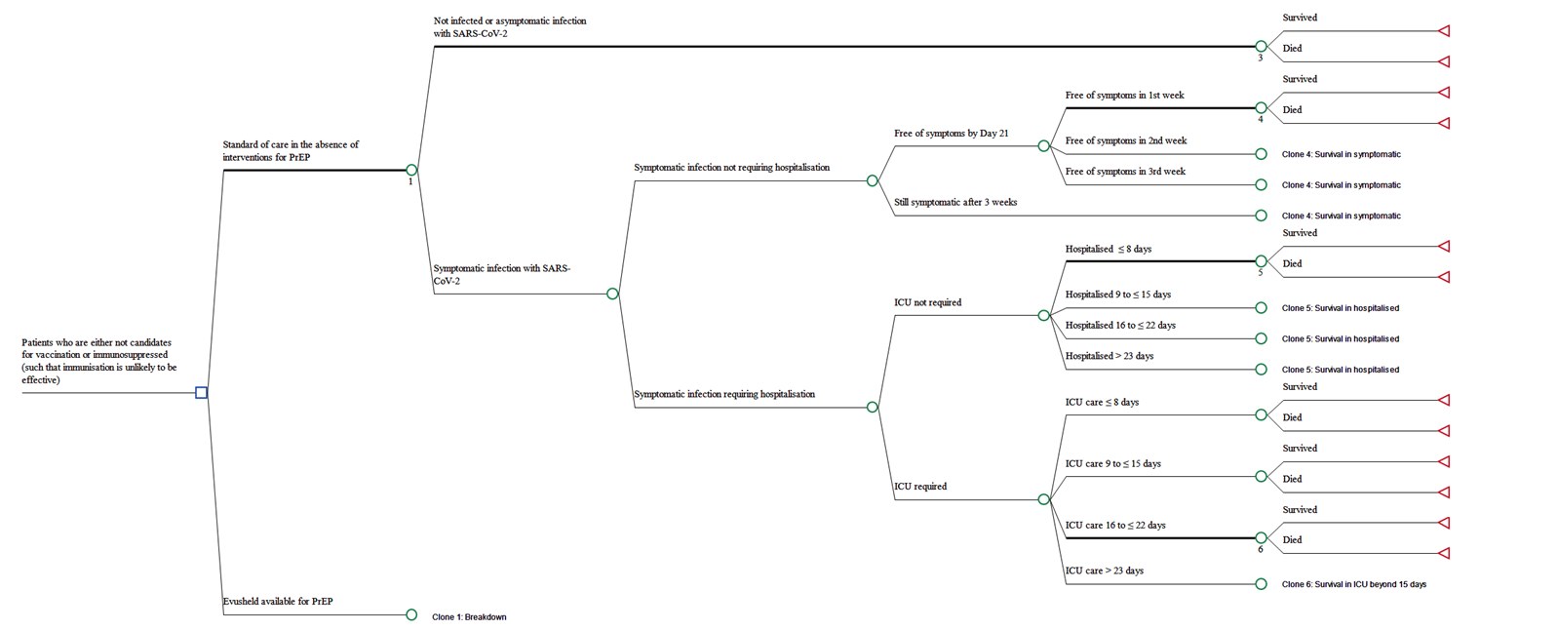

  - The baseline risk of developing symptomatic COVID-19 in the PROVENT trial was 2.7% over a median follow up of 6 months and 9.5% over a median follow up of 12 months (considering outcomes regardless of unblinding and receipt of COVID-19 vaccine). Given that the clinical positioning proposed for tixagevimab and cilgavimab is as an adjunct to vaccination, these rates are more appropriate to consider than rates that censor patients who were unblinded and received a vaccine through the follow-up period of the PROVENT trial.
  - The risk of developing symptomatic COVID-19 over 6 months in Australia will vary depending on the SARS-CoV-2 variant circulating and depending on which section of a wave of an outbreak is being considered (e.g., risk at the peak of a wave will be higher than the risk at the tail of a wave). An estimate that 8.3% of people who are either not candidates for vaccination or are immunosuppressed (such that immunisation is unlikely to be effective) will be diagnosed with COVID-19 over 6 months was applied in the rapid HTA conducted in late 2021. The revised submission notes there has been a substantial increase in the total number of Australians infected with SARS-CoV-2 with the emergence of the Omicron variants. The Sponsor suggests that, even with restrictive social life and vaccination, the rate of infection was approximately 25% among lung transplant recipients in Adelaide. The time horizon over which 32 of South Australia’s 130-odd (~25%) lung transplant recipients contracted COVID-19 is not reported in the article cited by the Sponsor. Furthermore, it is not reported whether these patients were all symptomatic. The model, consistent with the primary endpoint of the PROVENT trial, is based only on symptomatic COVID-19.
  - The revised submission also refers to the latest serosurvey, conducted by the Kirby Institute, which assessed presence of antibodies in a sample of 5,139 blood donors and which estimated that 46.2% of adults in Australia had been infected with SARS-CoV-2 by June 2022. Again, the time horizon over which blood donors would have been diagnosed with SARS-CoV-2 infection is not clear but, more importantly, it should be recognised that the estimate includes people who would have had asymptomatic COVID-19. In addition, the Kirby note that the rate of past infection was not uniform among donors and that past infection was highest among donors in the 18-29 year age group, at 61.7%, declining with increasing age to 25.7% in donors aged 70–89 years. The majority of patients who are immunocompromised are likely to be in the older age categories than the younger age categories.
  - Regardless, it is acknowledged that the model is highly sensitive to the baseline risk of an immunocompromised patient developing symptomatic COVID-19. With the BA.5 variant that is currently the predominant variant circulating in Australia, it is acknowledged that the subvariant has been associated with increased transmissibility however the Omicron variant has also been associated with reduced pathogenicity. It is therefore appropriate to assume higher rates of contracting symptomatic COVID-19 in the model but also to assume a reduction in the likelihood of developing severe or critical COVID-19 in the model and to update the average age of patients dying from COVID-19. The risk of patients contracting symptomatic COVID-19 in the control arm of PROVENT was 2.7% at 6 months and 9.5% at 12 months. Fan 202223 estimate that transmissibility of the Omicron variant is approximately 3.2 fold the transmissibility of the Delta variant. Increased transmissibility does not necessarily equate to increased rates of symptomatic infection. Regardless, the rates observed in the control arm of the PROVENT trial at 12 months were increased by this factor from ~9.5% to 30% (9.5% x 3.2), such that the risk of contracting symptomatic COVID-19 applied in the control arm of the model is 15% and 30% at 6 months and 12 months, respectively.
  - The relative risk of developing symptomatic COVID-19 after use of tixagevimab 300 mg and cilgavimab 300 mg as PrEP versus placebo-treated patients applied in the 6-month model is as observed at 6 months in the PROVENT trial regardless of unblinding and administration of a COVID-19 vaccine (see Table 5: 0.226). Given that the clinical positioning proposed for tixagevimab and cilgavimab is as an adjunct to vaccination, these relative risks are more appropriate to consider than relative risks based on censoring of patients who were unblinded and received a vaccine through the follow-up period of the PROVENT trial.
  - The relative risk of developing symptomatic COVID-19 after use of tixagevimab 300 mg and cilgavimab 300 mg as PrEP versus placebo-treated patients applied in the 12-month model is as observed at 12 months in the PROVENT trial regardless of unblinding and administration of a COVID-19 vaccine (see Table 5: 0.843). Given that the clinical positioning proposed for tixagevimab and cilgavimab is as an adjunct to vaccination, these relative risks are more appropriate to consider than relative risks based on censoring of patients who were unblinded and received a vaccine through the follow-up period of the PROVENT trial.
  - The model that was included in the rapid HTA that was commissioned by the Department in late November 2021 estimated the background risk of hospitalisation in patients diagnosed with COVID-19 in Australia based on a series of assumptions and data from the series of COVID-19 Australia: Epidemiology Reports. The risk of hospitalisation assumed in immunocompromised patients in whom infection with SARS-CoV-2 was detected was estimated to be 19.1%. Due to the current lack of accuracy in counting cases of COVID-19 and due to the Epidemiology Reports no longer reporting rates of hospitalisation by cases of COVID-19 detected, an alternative approach to estimating proportion of immunocompromised patients who develop symptomatic COVID-19 that would require hospitalisation was required.
  - The proportion of patients in the control arm of PROVENT that were assessed as having severe or critical COVID-19 (full pre-exposure analysis set) was 20% (11/55 cases – see Table 5). Severe or critical COVID-19 was defined in PROVENT by a minimum of either pneumonia (fever, cough, tachypnea or dyspnea, and lung infiltrates) or hypoxemia (SpO₂ < 90% in room air and/or severe respiratory distress) and a WHO progression scale score of 5 or higher. Patients with severe or critical COVID-19 were not necessarily hospitalised. The proportion hospitalised is not reported by the PROVENT high-level data summary. For the purposes of the model, it was assumed that patients with severe or critical COVID-19 patients would require hospitalisation. However, given the trial was conducted prior to the emergence of the Omicron subvariant and given that the Omicron variant has been associated with reduced pathogenicity23 compared to the variants that were in circulation at the time of the conduct of the PROVENT trial, the proportion observed in the PROVENT trial was deemed to require adjustment. Fan 202223 estimate that the probability of severe illness with the Omicron variant is reduced by between 25% and 73% compared to the earlier variants. On this basis, to account for the emergence of less pathogenic Omicron variant compared to the variants circulating at the time of the PROVENT trial, the risk of severe or critical COVID-19 observed in the control arm of PROVENT as a proxy for hospitalisation (which favours tixagevimab and cilgavimab in the analysis) was adjusted by application of a risk reduction of 30% (which is at the lower end of the range reported by Fan 2022 and is more favourable to tixagevimab and cilgavimab than values at the higher end). Thus, the proportion of immunocompromised patients who develop symptomatic COVID-19 and require hospitalisation in the absence of availability of tixagevimab and cilgavimab applied in the model is 14% (20% x (1-30%)).
  - The relative risk of hospitalisation in patients developing symptomatic COVID-19 for tixagevimab and cilgavimab versus placebo-treated patients applied in both models is as observed in the PROVENT trial at 12 months (See Table 5: 0.087).
  - Patient-level data for patients admitted to hospital with confirmed COVID-19 were provided on an in-confidence basis by the National Health Reform Branch of the Department. These data permitted the derivation of transition probabilities for use in the model. Consistent with death rates reported in Australia during the Omicron wave (the period between 15 Dec 2021 and 3 Jul 2022), patients who die due to COVID-19 through the course of the economic model are assumed to have an average age of 81.3 years. It is assumed these patients would have had an average life expectancy of 9 years had they not contracted COVID-19. These future life years are assumed to have been lived with an average utility weight of 0.83 and are discounted at 5% per annum such that a total of 6.1 QALYs are lost per patient dying with COVID-19 in the model.
  - Costs of treatment are applied only to the tixagevimab and cilgavimab arm.
  - As tixagevimab and cilgavimab is administered by two intramuscular injections, it is assumed that a nurse or a general practitioner would be needed to administer the injection. An administration cost of $39.10, as proposed in the Sponsor’s submission, is applied in the economic analysis (MBS Item 23).
  - Regarding the costs of management by health state, the same costs are applied for time spent in equivalent health states regardless of the arm of the analysis.
  - Discounting is not applied to costs as these are primarily incurred within a 12-month time horizon.
  - The submission notes that the emergence of COVID-19 has heightened the need for immunocompromised patients to retract from social contact and interaction, with impacts on employment, mental health and health-related quality of life (HRQoL). The submission notes that these impacts have not been captured in the cost-effectiveness evaluation of tixagevimab and cilgavimab. The submission does not provide evidence that quantifies whether, and if so, to what extent, immunocompromised patients using tixagevimab and cilgavimab for PrEP are less likely to retract from social contact and interaction. No adjustments have been made to the model to capture such potential benefits.
  - The submission also suggests that the model does not capture longer-term health impacts, cost savings or productivity gains associated with the avoidance of COVID-19 infection (such as post-acute COVID-19 sequelae [‘long COVID’]). It appears the majority of people who develop COVID-19 fully recover but current evidence suggests approximately 10%-20% of people experience a variety of mid- and long-term effects after they recover from their initial illness. It is currently impractical to attempt to quantify any such benefits in the economic analysis given the lack of evidence that permits a clear understanding of which patients develop sequelae (e.g., to what extent people with asymptomatic COVID-19 can be subject to post-COVID-19 sequelae), the duration of sequelae, etc. Attempts to try to quantify such benefits would introduce further uncertainty around the estimates of cost-effectiveness.
  - Similarly, reducing the risk of symptomatic COVID-19 in an immunocompromised person may reduce the likelihood that their contacts develop COVID-19. Again, attempts to try to quantify such benefits would introduce further uncertainty around the of estimates of cost-effectiveness.
  - Table 13 summarises the key features of the model used to conduct the economic evaluation of tixagevimab and cilgavimab versus placebo for PrEP against COVID-19.
Table 13: Summary of model structure, key inputs and rationale
Component | Summary
Treatments | Tixagevimab and cilgavimab for PrEP of COVID-19 versus placebo (for no PrEP)
Time horizon | Treatment effect observed in the trial either at 6 or 12 months with deaths averted valued over a lifetime
Outcomes | QALYs
Methods used to generate results | Decision analysis
Health states | - Alive and not developing COVID-19  - For those developing COVID-19:  - Alive and not hospitalised throughout the period to a median follow-up of 6 months; this state is broken down by time to alleviation of symptoms  - Alive and required hospitalisation; this state is broken into those who did and those who did not require care in an ICU and by length of stay  - Dead
Transition probabilities | PROVENT trial results at 6 or 12 months, depending on the model are used to estimate transition probabilities for developing symptomatic COVID-19 and for developing severe or critical COVID-19 (which is assumed to require hospitalisation). Given that the clinical positioning proposed for tixagevimab and cilgavimab is as an adjunct to vaccination, outcomes did not apply censoring of patients who were unblinded and received a vaccine through the follow-up period of the PROVENT trial. Transitions from the hospitalised health states are based on patient-level data for patients admitted to hospital with confirmed COVID-19 were provided on an in-confidence basis by the National Health Reform Branch of the Department
Extrapolation method | Consistent with death rates reported in Australia during the Omicron wave patients who die due to COVID-19 through the course of the economic model are assumed to have an average age of 81.3 years, consistent with the average age of Australian patients who died with COVID-19 in the period between 15 Dec 2021 and 3 Jul 2022. It is assumed these patients would have had an average life expectancy of 9 years had they not contracted COVID-19. These future life years are assumed to have been lived with an average utility weight of 0.83 and are discounted at 5% per annum such that a total of 6.1 QALYs are lost per patient dying with COVID-19 in the model.
Health related quality of life | Utilities by health state are estimates.  Free of COVID-19: 0.85  Symptomatic in the community: 0.75  Hospitalised: 0.60  ICU care: 0.40
Hospitalisation costs | Patient-level data for patients admitted to hospital with confirmed COVID-19 were provided on an in-confidence basis by the National Health Reform Branch of the Department. These data permitted the derivation of hospitalisation costs with and without ICU care by length of stay.

  - The results of the 6-month model (which assumes that retreatment with tixagevimab and cilgavimab is required after six months) are summarised in Table 14.
Table 14: Results of the 6-month modelled economic evaluation
 | Tixagevimab and cilgavimab | Placebo | Increment
Drug costs | $ | ¹ | $ | ¹ | $||¹
Drug administration costs | $39.10 | $0 | $39.10
Costs of symptom management | $ | ¹ | $ | ¹ | - $|||¹
Costs of hospitalisation (excluding ICU care) | $ | ¹ | $ | ¹ | - $|||¹
Costs of ICU care | $ | ¹ | $ | ¹ | - $|||¹
Total costs | $ | ¹ | $ | ¹ | $ | ¹
QALYs (discounted) | 0.4350 | 0.4220 | 0.0130
Incremental cost per discounted QALY gained |  |  | $ | ²
QALY = quality adjusted life year.
The redacted values correspond to the following ranges:
¹$0 to < $5,000
²$115,000 to < $135,000
  - The results of the 12-month model (which assumes that retreatment with tixagevimab and cilgavimab is not required before 12 months) are summarised in Table 15.
  - A higher number of deaths over 12 months compared to 6 months means that the absolute QALYs in both arms are reduced. The assumption that the treatment effect in terms of impact on the incidence of severe or critical COVID-19 lasts for 12 months, however, means that the incremental benefit improves over 12 months. Costs in the tixagevimab and cilgavimab are substantially reduced in the 12 month model because patients are only assumed to require one administration of tixagevimab and cilgavimab to achieve a benefit that lasts for 12 months (whereas the 6-month model assumes the treatment effect lasts for only 6 months.
Table 15: Results of the 12-month modelled economic evaluation
 | Tixagevimab and cilgavimab | Placebo | Increment
Drug costs | $ | ¹ | $ | ¹ | $||¹
Drug administration costs | $39.10 | $0 | $39.10
Costs of symptom management | $ | ¹ | $ | ¹ | - $|||¹
Costs of hospitalisation (excluding ICU care) | $ | ¹ | $ | ¹ | - $|||¹
Costs of ICU care | $ | ¹ | $ | ¹ | - $|||¹
Total costs | $ | ¹ | $ | ¹ | $ | ¹
QALYs (discounted) | 0.4295 | 0.4081 | 0.0214
Incremental cost per discounted QALY gained |  |  | $ | ²
QALY = quality adjusted life year.
The redacted values correspond to the following ranges:
¹$0 to < $5,000
²$55,000 to < $75,000
  - The 6-month economic analysis is most sensitive to the probability that a symptomatic immunocompromised person with COVID-19 will require hospitalisation; and the baseline probability (in the absence of availability of tixagevimab and cilgavimab) that an immunocompromised person will contract symptomatic COVID-19.
  - Consistent with the sensitivity of results around the 6-month model, the 12-month economic analysis is most sensitive to the baseline probability (in the absence of availability of tixagevimab and cilgavimab) that an immunocompromised person will contract symptomatic COVID-19 and the probability that a symptomatic immunocompromised person with COVID-19 will require hospitalisation.

Drug cost/patient
  - The effective dispensed drug cost/patient/administration is $|||| ||||. If tixagevimab and cilgavimab needs to be administered every six months then the effective dispensed drug cost/patient/year will be $| |.
  - The Pre-PBAC response stated that the sponsor was proposing an effective AEMP of $| | per dose of tixagevimab and cilgavimab, regardless of whether the 150-150 mg dose or the 300-300 mg dose is recommended, therefore the effective AEMP would be $| | per pack if the 300-300 mg dose is recommended, otherwise it would be $| | per pack.

Estimated PBS usage & financial implications
  - The following usage and financial estimates are based on the AstraZeneca proposed dosing regimen of tixagevimab 300 mg and cilgavimab 300 mg given every 6 months unless indicated otherwise.
  - This submission was not considered by DUSC.
  - The submission proposes access to tixagevimab and cilgavimab for individuals with severe immunocompromise broadly aligned with the ATAGI recommendations for a third primary dose of a COVID-19 vaccine. In addition, the submission proposes access to tixagevimab and cilgavimab for individuals in whom vaccination is contraindicated. The 14 subgroups identified by the submission are listed in Table 16.

Table 16: Population groups with severe immune compromise proposed as eligible for treatment with tixagevimab and cilgavimab
 | - Population categories | Data source (PBS/ Epi)
- A | - Organ transplant on treatment | Epi
- B | - HSCT transplant last 2 years | Epi
- C | - Haematologic malignancies on treatment | 10% PBS data sample
- D | - Anti-CD20-non Haematological indications | 10% PBS data sample
- E | - Primary immunodeficiency | Epi
- F | - HIV/AIDS resistant to anti-retroviral therapy | Epi
- G | - High dose corticosteroids , 6+ scripts | 10% PBS data sample
- H | - Solid malignancies on treatment | 10% PBS data sample
- I | - CD52 antibodies +Anti-complement antibodies | 10% PBS data sample
- J | - S1-PRM | 10% PBS data sample
- K | - JAK-Inhibitors | 10% PBS data sample
- L | - csDMARDs other indications | 10% PBS data sample
- M | - Dialysis | Epi
- N | - Contraindicated to COVID-19 vaccines | Assumption
Source Table 7, Evusheld PBAC submission 4 July 2022, Main Body.
  - The submission uses a mixed approach to estimating the number of individuals in each of the 14 subgroups. The submission presents both the estimated number of individuals in each group and a cumulative total in which duplicates are removed.
  - The submission’s estimates of use and financial implications for the first 3 years of listing are reproduced in Table 17.
Table 17: Estimated use and financial implications
 | Year 1 | Year 2 | Year 3
Estimated extent of use
Number of patients treated | ||||||¹ | ||||||¹ | ||||||¹
Number of scripts dispensedª | ||||||² | ||||||² | ||||||²
Estimated financial implications of tixagevimab and cilgavimab
Cost to the PBS including co-payments^{b} | $||||||³ | $||||||³ | $||||||³
Cost to PBS less co-payments^{b} | $||||||³ | $||||||³ | $||||||³
Estimated financial implications for other medicines
Cost to PBS less co-payments | $0 | $0 | $0
Net financial implications
Net cost to PBS | $||||||³ | $||||||³ | $||||||³
Source: Section 4 spreadsheet provided with submission addendum on 29 July 2022.
ª Assuming 2 per year as estimated by the submission.
^{b} Updated to use correct DPMQ of $||| ||| for each tixagevimab 300 mg and cilgavimab 300 mg dose.
The redacted values correspond to the following ranges:
¹300,000 to < 400,000
²600,000 to < 700,000
³> $1 billion
  - The total cost to the PBS, less co-payments, of listing tixagevimab 300 mg and cilgavimab 300 mg was estimated by the submission to be > $1 billion in Year 3, and > $1 billion across the first 3 years of listing.
  - The Sponsor notes the submission does not include an estimate of the cost to the RPBS as the PBS 10% sample was the source for 95% of the estimates of use. The Department considers it would be appropriate to increase the final estimates by 2.7% to take account of use through the RPBS.
  - The evaluation considered the submission likely overestimates the usage and financial estimates for the following main reasons:
- The assumption that 75% of all eligible patients will take up treatment is uncertain,
- The assumptions that 100% of prevalent patients will commence treatment in the first 6 months of PBS listing and that 100% of incident patients will commence treatment in the first 6 months of the PBS year in which they become eligible is overly optimistic,
- The assumptions that 100% of patients who commence treatment will continue with treatment and will be dosed at regular 6 monthly intervals are overly optimistic.
  - The evaluation undertook a number of sensitivity analyses to examine the impact of varying these assumptions on the financial estimates. The pre-PBAC accepted the revised assumptions derived from one of these alternative analyses, as presented in Table 18.
Table 18: Sensitivity analysis: usage and financial estimates at |||| |||| DPMQ (no adjustment for co-payment)
 |  |  | Year 1 | Year 2 | Year 3 | Total
Sponsor base case | Assumptions:  75% uptake, 100% in first 6 months of the year, 100% continuation | Units | | ³ | | ³ | | ³ | |⁴
Sponsor base case |  | Cost | $ | ⁶ | $ | ⁶ | $ | ⁶ | $ | ⁶
Sensitivity analysis accepted by pre-PBAC response | Assumptions:  75% uptake, spread 50:50 across first and second half of the year, 95% continuing to second dose, 98% continuing to each dose thereafter | Units | | ¹ | | ² | | ² | |⁴
Sensitivity analysis accepted by pre-PBAC response |  | Cost | $||⁵ | $ | ⁶ | $ | ⁶ | $ | ⁶
Unit = single dose of Evusheld.
Source: Section 4 spreadsheet provided with submission addendum on 29 July 2022; additional calculations during evaluation; Pre-PBAC response.
The redacted values correspond to the following ranges:
¹400,000 to < 500,000
²500,000 to < 600,000
³600,000 to < 700,000
⁴1,000,000 to < 2,000,000
⁵$900 million to < $1 billion
⁶> $1 billion
For detail on PBAC’s view, see section 7 PBAC outcome.

Financial Management – Risk Sharing Arrangements
  - The revised submission did not make any reference to a risk sharing arrangement.
  - The evaluation identified the following potential clinical and financial risks:
- Lower than expected reductions in symptomatic COVID-19 due to SARS-CoV-2 infection or in severe or critical COVID-19 due to SARS-CoV-2 infection;
- Loss of effectiveness against future virus variants;
- Use outside the requested restriction; and
- Use of higher or more frequent doses in clinical practice.
  - The Sponsor previously advised the Department it plans to collect additional follow-up data from the “PROVENT Repeat Dose Substudy” (D8850C002A01) will be collected as it is ongoing. It also plans one additional clinical trial: the ENDURE study (see paragraph 6.23 above).
  - The Pre-PBAC response acknowledged there are uncertainties with the data and proposed a conditional listing, whereby the continued PBS listing of tixagevimab and cilgavimab is reviewed periodically by the PBAC. The Pre-PBAC response claimed the on-going collection of observational and other data, and post-market surveillance could provide further effectiveness and safety analyses in the future.
  - The Sponsor also indicated it could agree to annual expenditure caps.
For detail on PBAC’s view, see section 7 PBAC outcome.
- PBAC Outcome
  - The PBAC did not recommend PBS listing of tixagevimab and cilgavimab for use as pre-exposure prophylaxis against COVID-19 infection because of uncertainty about the clinical place in prevention and appropriate PBS eligibility criteria; uncertainty about the dose and duration of protection against the Omicron variants of the SARS-CoV-2 virus; a lack of information on the safety and effectiveness of the proposed repeat dosing regimen; a high and highly uncertain incremental cost-effectiveness ratio; and a very high overall cost as requested by the sponsor.
  - The PBAC acknowledged concerns regarding the negative effects of shielding behaviour in severely immunocompromised individuals, which may include withdrawal from social contact, as well as detrimental impacts on employment, mental health and quality of life. The PBAC considered these concerns important and relevant, however there were no data presented to demonstrate tixagevimab and cilgavimab would lead to changes in shielding behaviour. The PBAC noted severely immunocompromised individuals are vulnerable to all circulating viruses and bacteria in the community and offering protection against one virus alone may not change recommendations regarding infectious contact precautions or behaviour. An additional issue is that some treated individuals may not protect themselves from a new SARS-CoV-2 variant ahead of data demonstrating tixagevimab with cilgavimab is effective against the new variant.
  - The PBAC noted that limited clinical data were available to support the Sponsor’s clinical claim including one randomised controlled trial, four observational studies, in vitro susceptibility studies, and pharmacokinetic modelling. The PBAC considered the data limitations particularly problematic for establishing effectiveness against the Omicron variant and in relation to the effectiveness and safety of the proposed dosing regimen (tixagevimab 300 mg and cilgavimab 300 mg administered every 6 months).
  - The PBAC noted the 6-month results of the PROVENT trial demonstrated significant reductions in the risk of symptomatic COVID-19 and in the risk of severe or critical COVID-19, for patients treated with a single dose of tixagevimab 150 mg and cilgavimab 150 mg compared with placebo. The effect on symptomatic disease was not maintained after 6 months; a reduction in severe and critical disease appeared to be maintained for up to 12 months although the size of the effect was uncertain. However, the PROVENT trial was conducted prior to the emergence of the Omicron SARS-CoV-2 variant, COVID-19 vaccination, and antivirals.
  - The PBAC agreed with the Sponsor that tixagevimab 150 mg and cilgavimab 150 mg is likely to be less effective in preventing symptomatic infection due to the Omicron variants circulating in 2022 compared with the SARS-CoV-2 variants circulating during the PROVENT study. The duration of any protection given by tixagevimab 150 mg and cilgavimab 150 mg is also likely to be shorter for the Omicron variants than it was for earlier variants of the SARS-CoV-2 virus. At the current TGA approved dose, the duration of any protection against symptomatic disease could be as little as three months.
  - The PBAC noted the Sponsor proposed these issues can be addressed by 6-monthly repeat dosing with a higher dose of tixagevimab 300 mg and cilgavimab 300 mg. The PBAC considered the results from the observational studies reported by Young-Xu 2022 and Al Jordi 2022 provide some evidence of the effectiveness of single dosing with this higher dose against Omicron variant sub-lineages. The PBAC also noted there are limited data establishing the safety of a single dose of tixagevimab 300 mg and cilgavimab 300 mg. Most importantly, however, there are no clinical data available to support the effectiveness and safety of repeat dosing with the higher dose proposed for PBS subsidy.
  - Overall, the PBAC considered that the evidence provided some limited support for the translation of the treatment effect of a single dose of tixagevimab 150 mg and cilgavimab 150 mg as observed in the PROVENT trial to a scenario where tixagevimab 300 mg and cilgavimab 300 mg is used where the predominant SARS-CoV-2 variants in circulation are the BA.2, BA.4 and BA.5 sub-lineages of the Omicron variant, however this translation was reliant on optimistic bridging using pharmacokinetic modelling, and provides little reassurance of efficacy against future variants.
  - The PBAC noted that the rates of adverse events were similar across the two arms of the PROVENT trial (Table 8). However, higher rates of serious cardiac disorders were seen in the tixagevimab and cilgavimab arm compared with the placebo arm (Table 9). The PBAC considered that although a causal relationship between tixagevimab and cilgavimab and these events has not been established, the possibility of a relationship between tixagevimab and cilgavimab and these events cannot be excluded.
  - The PBAC noted that, with the caveats noted above, on the basis of the results from the PROVENT trial, for every 10,000 patients receiving tixagevimab 150 mg and cilgavimab 150 mg as PrEP against COVID-19 in comparison with placebo and followed for 6 months:
  - Approximately 365 fewer patients would develop symptomatic COVID-19.
  - Approximately 64 fewer patients would develop serious or critical COVID-19.
  - Approximately 70 additional patients would experience a serious cardiac disorder adverse event.
The PBAC agreed with the Sponsor that the benefits from PrEP with tixagevimab and cilgavimab may be increased if a highly virulent and pathogenic variant of the SARs-COV-2 virus emerges. However, the PBAC also noted the benefits might be reduced in vaccinated patients (PROVENT was conducted in unvaccinated patients) and in light of the availability of the oral antivirals for acute treatment.
  - The PBAC noted that from the start of the Omicron wave in mid-December 2021 to 3 July 2022, there were 2,843 COVID-19 cases admitted to ICUs participating in the sentinel surveillance system, Short Period Incidence Study of Severe Acute Respiratory Infection (SPRINT-SARI). Three quarters of the 2,146 patients for whom information on co-morbidities is available had a least one co-morbidity and half had two or more co-morbidities. Immunocompromise was recorded as a co-morbidity in 18% (or 511 of 2,843 patients). Even in the most optimistic scenario that assumes all ICU admissions in patients with immunocompromise would have been avoided if PrEP with tixagevimab and cilgavimab was available, and using the Sponsor’s estimate of 400,000 eligible patients under the proposed PBS listing, then approximately 800 patients would have needed to be treated to avoid one ICU admission. The PBAC considered the true number needed to treat to avoid an ICU admission may be considerably higher, noting that ICU admissions are typically for patients with critical disease (as compared with serious or critical disease).
  - The PBAC noted that the PBS indication proposed by the sponsor was: “Pre-exposure prevention of SARS-CoV-2”. The PBAC considered that the treatment goal of preventing severe or critical COVID-19 due to SARS-CoV-2 infection may be more important than preventing SARS-CoV-2 infection altogether or preventing symptomatic COVID-19. The PBAC considered that concerns regarding a potential risk of new mutations of the SARS-CoV-2 virus arising in the severely immunocompromised population in Australia are speculative.
  - The PBAC considered it was not appropriate to include individuals contraindicated to current vaccines in the proposed PBS listing, unless they also have severe immunocompromise. The PBAC noted ATAGI has advised very few patients would fulfil the criterion of being truly contraindicated to all TGA registered COVID-19 vaccines.
  - In regard to the proposed place in therapy, the PBAC considered that the population proposed for listing was a large group in the context of a high-cost preventative drug (over 400,000 eligible individuals) with an uncertain ratio of risk to benefit. The categories of individuals described in the submission (Table 16) represent a heterogeneous group. Patient age and comorbidities were not considered by the submission. It was not clear to PBAC that all individuals who would be eligible under the proposed restriction would have the same risk of developing severe COVID-19. Overall, the PBAC considered that the population most likely to benefit from pre-exposure prophylaxis in the context of an evolving and cyclic disease was not well defined, creating the potential the proposed PBS-eligible population would include many individuals who will gain little benefit and exclude other individuals who would benefit.
  - The PBAC was moreover concerned that pre-exposure prophylaxis based on a drug treatment with an uncertain, but likely short, duration of effect against the SARS-CoV-2 Omicron variant and uncertain effectiveness against potential new SARS-CoV-2 variants may not be an effective strategy in the context of a chronic health condition and a highly epidemic disease, especially considering the availability of two PBS listed antiviral treatments.
  - In summary, the following key clinical concerns were noted by the PBAC:
- Highly uncertain effectiveness against symptomatic disease caused by pre-Omicron variants beyond 6 months
- Unproven effectiveness for Omicron B.4/5 (or subsequent) variants
- Uncertain incremental benefit in the context of current boosted vaccine strategies and anti SARS CoV-2 agents available
- Highly uncertain future risk of SARS-CoV-2 infection in the proposed population
- Highly uncertain pathogenicity (risk of hospitalization/death) of future variants
- Uncertain safety : benefit profile
- Unknown safety or effectiveness of repeat doses.
  - The PBAC noted two economic analyses were presented in the evaluation commentary. Both analyses assumed a single treatment is administered, and repeat treatments would have the same cost-effectiveness as the first administration (i.e. the same effect is assumed following each administration). The first model assumed 6-monthly treatment (the 6-month model), whilst the second model assumed 12-monthly treatment (the 12-month model), with both models assuming a dose of tixagevimab 300 mg and cilgavimab 300 mg. The PBAC noted the evaluation presented these alternatives as the TGA has not completed its assessment of the Sponsor’s proposed 6-monthly dosing regimen, and as the results of the PROVENT study demonstrated symptomatic disease was reduced for 6 months, whereas severe and critical disease was reduced for at least 12 months.
  - In regard to the model drivers, the PBAC noted the following:
  - The assumed baseline risk for symptomatic COVID 19 was 15% risk in the 6-month model and 30% risk in the 12-month model. The PBAC considered that these risk estimates were higher than currently anticipated by Australian experts based on analysis of recent infection trends, however the future course of the virus remains uncertain. The PBAC also noted that PrEP efficiency varies substantially with incidence/infectivity/severity of SARS CoV2. In this context, the assumption of 15% risk in the 6-month model was considered reasonable.
  - The assumed risk of severe or critical COVID 19 (assumed to require hospitalisation) amongst immunocompromised patients who develop symptomatic COVID 19 was 14% i.e.,~1 in 7. The PBAC considered that 14% risk was uncertain but may be appropriate for individuals with profound immunosuppression (i.e. those who may not derive any benefit from vaccination).
  - The PBAC agreed the modelled economic evaluation relied on strong assumptions regarding the effectiveness and safety of tixagevimab 300 mg and cilgavimab 300 mg compared with placebo in immunocompromised patients and considered the available evidence did not provide an adequate basis upon which to assume a treatment effect against symptomatic disease caused by the Omicron variant beyond 3 months.
  - Overall, the PBAC considered that although the economic modelling used assumptions that were favourable to tixagevimab 300 mg and cilgavimab 300 mg given 6-monthly, the dosing regimen proposed by the Sponsor, the ICER at the proposed price was unacceptably high at over $115,000 to < $135,000 per QALY gained at the price requested by the Sponsor.
  - The PBAC noted the Sponsor’s assumption that an average of 75% of the eligible population would commence treatment with tixagevimab and cilgavimab and the majority of treatment initiators would continue treatment. However, the PBAC considered these were overestimates of both uptake and continuation.
  - The PBAC considered uptake as low as 10-25% of the population identified by the Sponsor may be more realistic, given the uptake of NMS stock to date, the limited clinical evidence available and the uncertain role of this treatment in Australian clinical practice. The PBAC noted that the National COVID-19 Clinical Evidence Taskforce recommends that it should only be considered for use as PrEP in ‘exceptional circumstances.’
  - The PBAC also considered the need to receive four separate 1.5 mL intramuscular injections on each dosing occasion (if the proposed new dosing regimen is approved by the TGA) may affect many individuals willingness to have more than one treatment with tixagevimab and cilgavimab.
  - The PBAC considered the following issues important for a future submission:
- Clinical place: Justification of the proposed clinical position given the combination of relevant clinical uncertainties, including the limited duration of effect (3-6 months) in the context of a potentially chronic immunocompromising condition (years), the epidemic risk of COVID-19. Further justification is also required with respect to continuing use in the context of uncertain future risk of SARS-CoV-2 infection in the proposed population and the uncertain pathogenicity (risk of hospitalization/death) of future variants.
- Dosage: Provide further data regarding the effectiveness and safety of the proposed 300-300 mg repeat dosing, taking into account the progress of the current TGA evaluation of this dosing regimen.
- Restrictions: Either provide further justification for the proposed patient population which takes account of the heterogenous risk profiles of the individuals, or propose a population which is limited to the group(s) with the highest clinical needs. For example., this may include the groups at highest risk of severe disease, and/or little or no response to vaccination and/or or inadequate response to acute therapy.
- Effectiveness: applicability of evidence for use in immunocompromised individuals (or proposed group), current variants of concern, incremental benefit over four dose vaccine, use of symptomatic treatment.
- Benefit/harms: Address concerns about comparative benefits and harms in the context of the proposed patient population, noting that the benefit-harm trade-off may be improved when high levels of the virus are circulating and when the virus circulating is highly pathogenic. Further consideration of potential for serious cardiac adverse events is required.
- Economics: Reduce price to achieve an ICER of <30k/QALY gained, with inputs and structure in model consistent with empiric efficacy data (single dose). Assume no more than 15% risk of infection over a 6 month period, no more than a 69% reduction in risk of hospitalization to 3 months, no benefit thereafter.
- Financials: Reduce uptake and continuation estimates taking into account NMS uptake and uptake in international jurisdictions.
- Agree to time-limit the PBS subsidy period given uncertainty over the future role of this drug against the evolving nature of the SARS-CoV-2 virus.
  - A resubmission may be lodged at a future date agreed with the Department and the Chair of the PBAC.
  - The PBAC noted that this submission is eligible for an Independent Review.
Outcome:
Not recommended
- Context for Decision
The PBAC helps decide whether and, if so, how medicines should be subsidised through the Pharmaceutical Benefits Scheme (PBS) in Australia. It considers applications regarding the listing of medicines on the PBS and provides advice about other matters relating to the operation of the PBS in this context. A PBAC decision in relation to PBS listings does not necessarily represent a final PBAC view about the merits of the medicine or the circumstances in which it should be made available through the PBS. The PBAC welcomes applications containing new information at any time.
- Sponsor’s Comment
AstraZeneca are committed to addressing the concerns raised by the PBAC and we welcome the opportunity to work with the Department of Health and Aged Care to ensure a timely reassessment of Evusheld. AstraZeneca acknowledges the PBAC assessment process requires a high degree of certainty for therapies to be listed on the PBS. We note the status of the updated dosing regimen which is currently under evaluation by the TGA. AstraZeneca will continue to collect data as new variants evolve and work with the PBAC to further define the appropriate patient population.

Addendum to the September 2022 PBAC PSD:

4.01 TIXAGEVIMAB AND CILGAVIMAB
Pack containing 1 vial of tixagevimab 150 mg in 1.5 mL and 1 vial of cilgavimab 150 mg in 1.5 mL,
Evusheld®,
AstraZeneca Pty Ltd.
- Background
  - TGA status at time of PBAC consideration: Provisionally approved for PrEP for individuals aged 12 years and older, however an application to increase the dose for this use is under evaluation by the TGA, as described in paragraphs 2.1 to 2.5. At the time of PBAC consideration, the TGA Delegate’s Overview and the Advisory Committee on Medicines (ACM) minutes were available.
  - The resubmission provided responses to the issues raised by the PBAC in September 2022 as summarised in Tables 19 and 20.
Table 19: Summary of resubmission proposed eligible patient populations
Population 1
Any patient over 12 years of age who meets any of the following clinical criteria:
      - Recipient of a haematopoietic stem cell transplant (HSCT) within the previous two years
      - Recipient of an organ transplant and on treatment
      - Diagnosed with a haematologic malignancy and on treatment
      - Diagnosed with chronic lymphocytic leukaemia (including those not receiving treatment)
      - On treatment with an anti-CD20 agent (eg rituximab) and/or a Bruton Tyrosine Kinase (BTK) inhibitor (eg. ibrutinib)
      - Diagnosed with primary immunodeficiency
      - Receiving dialysis
      - Diagnosed with HIV/AIDS and resistant to anti-retroviral therapy
Population 2
Patients who are 70 years or older who meet any of the following clinical criteria:
      - Received at least 6 prescriptions for high dose systemic corticosteroids in previous 12 months
      - Diagnosed with a malignancy of a solid organ tumour and on treatment
      - On treatment with a CD52 antibody (eg alemtuzumab) and/or an anti-complement antibody (eg. eculizumab)
      - On treatment with a sphingosine-1-phosphate receptor modulator (S1-PRM eg fingolimod)
      - On treatment with a Janus Kinase (JAK) inhibitors (eg baricitinib)
      - On treatment with a conventional synthetic disease modifying antirheumatic drug (eg. Leflunomide, methotrexate)
AND who have been diagnosed with at least one of the following comorbidities:
      - cardiac disease
      - respiratory disease
      - neurological disease
      - renal disease
      - diabetes
      - cirrhosis

Table 20: Resubmission responses to clinical, economic, financial and risk management issues
PBAC request | Additional/revised information provided by the resubmission
Clinical issues
Further data regarding the effectiveness and safety of the proposed 300-300 mg repeat dosing | The resubmission advised that no additional efficacy and safety data for the repeat dosing of tixagevimab 300 mg and cilgavimab 300 mg were available.
Further data demonstrating the applicability of evidence for use in immunocompromised individuals (or proposed group) | The resubmission claimed that observational data suggests that tixagevimab and cilgavimab provides up to 6 months effectiveness across a highly vaccinated, immunocompromised cohort. Longer term follow-up data was provided from patients administered tixagevimab and cilgavimab in an observational study reported by Al Jurdi 2022 and results of a study reported by Moon 2022 were presented.
Further data demonstrating the applicability of evidence for current variants of concern | The resubmission claimed that tixagevimab and cilgavimab provides protection against the BA.4/5 variants, which were the dominant variants of concern in Australia as of 1 November 2022.
Further data demonstrating incremental benefit over four-dose vaccine regimen | The resubmission noted that severely immunocompromised patients have a greater risk of COVID-19-related severe illness and have sub-optimal or no response to vaccination. It noted that the observational studies considered by the PBAC in September 2022 included patients who were vaccinated and claimed that these studies support a claim of incremental benefit over vaccination.
Further data demonstrating incremental benefit in terms of use of symptomatic treatment | The submission claimed that very few patients for whom PBS listing of tixagevimab and cilgavimab as PrEP was proposed can rely on the PBS-listed oral treatments to prevent serious illness, if infected. It suggested that nirmatrelvir + ritonavir is contraindicated for the majority of the proposed patient population and that molnupiravir has limited effectiveness.
Address concerns about comparative benefits and harms in the context of the proposed patient population | The resubmission did not discuss the comparative benefits and harms in terms of the PBAC’s concerns regarding the number needed-to-treat versus number needed-to-harm.
Further consideration of the potential for serious cardiac adverse events | The resubmission did not discuss the potential for serious cardiac adverse events with tixagevimab and cilgavimab.
Economic issues
Reduce price to achieve an ICER of <$||||||¹/QALY gained | The resubmission proposed a reduction in the effective DPMQ from $|||||| to $|||||| (ex-manufacture price per 150-150 mg pack $||||||, proposed Max Quantity 2). The corresponding ICER for the proposed DPMQ was $||||||¹/QALY gained in the resubmission’s base case.
Inputs and structure in model consistent with empiric efficacy data (single dose) | The PBAC requested that the empiric efficacy data (single dose) be applied in the resubmission. On this basis, the resubmission changed the risk reduction for symptomatic infection from 0.226 as reported at 6 months in the PROVENT study, as applied in the original model to 0.34 as reported for the COVID-19 infection component of the composite endpoint reported by Young-Xu 2022.
Assume no more than 15% risk of [infection] over a 6-month period | A 15% baseline risk of infection over the 6-month time horizon of the economic model was applied, consistent with PBAC advice.
No more than a 69% reduction in risk of hospitalisation to 3 months, no benefit thereafter | The model considered in September 2022 applied a 91.3% reduction in risk of hospitalisation (RR: 0.087) based on the results from the PROVENT trial. The PBAC advised that a 69% reduction in risk of hospitalisation (RR: 0.31) should be applied for 3 months, consistent with the composite outcome considering the 3 component outcomes of: SARS-CoV-2 infection, COVID-19-related hospitalisation, or all-cause mortality as reported by Young-Xu 2022. Instead of applying the reduction in risk of hospitalisation for only 3 months as requested by the PBAC (which would have resulted in a 34.5% reduction in risk of hospitalisation over 6 months in patients treated with tixagevimab and cilgavimab), the resubmission applied an 87% reduction in risk of hospitalisation for 6 months, claiming this was consistent with the component of hospitalisation that was part of the composite outcome reported in Young-Xu 2022
Financial issues
Reduce uptake and continuation estimates taking into account NMS uptake and uptake in international jurisdictions. | The resubmission presented financial estimates based on uptake of a single dose by 50% of the total eligible population in each of listing at a total estimated cost of $|||||| ||||||² over 2 years. The resubmission varied its uptake estimates in the pre-PBAC response to 50-80% initial, with 80% continuing in Population 1, and 10-25% initial with 50% continuing in Population 2, without providing a revised estimate of total cost.
Risk sharing
Mitigate against  - Lower than expected reductions in symptomatic COVID-19 in severe or critical COVID-19;  - Loss of effectiveness against future virus variants;  - Use outside the requested restriction; and  - Use of higher or more frequent doses in clinical practice. | The resubmission proposed a 24-month listing and electronic authority approvals as measures to address these risks. The pre-PBAC response noted the commentary suggested additional measures to manage the risks with regards to patient safety and public health perspective and indicated AstraZeneca was open to collaborating with Government and Key Stakeholders to understand the most appropriate and feasible approach to managing this risk.
The redacted values correspond to the following ranges:
¹$25,000 to < $35,000
²$100 million to < $200 million
- Consideration of the evidence

Sponsor hearing
  - The sponsor requested a hearing for this item. The sponsor representative noted that the company had made its best possible price offer in the resubmission. A clinician invited by the sponsor to address the PBAC, described the experience of patients hospitalised with severe COVID-19 including long stays in hospital with periods of isolation. The clinician noted that a variety of clinical factors lead to increased risk of worse outcomes and need for inpatient care, such as haematologic malignancies, treatment with anti-CD20 agents and other factors consistent with those described in the submission as Population 1. The clinician also described challenges faced by hospitals and aged care facilities with respect to managing the dual responsibilities of caring for these individuals once diagnosed with COVID-19 and minimising the risk of infection for others. The clinician’s experience with the clinical use of tixagevimab and cilgavimab was discussed and other matters were addressed in response to the Committee’s questions.

Eligible Patient Population
  - The submission stated the proposed “Population 1” eligibility criteria were based on expert clinical opinion that individuals meeting these criteria have the poorest immune function and are therefore at greatest risk of severe illness related to COVID-19. A literature review included in the submission provided limited support for this claim. Additionally, some overseas jurisdictions, for example Ontario, have eligibility criteria that are broadly aligned with Population 1.
  - For Population 2 however, the submission did not adequately support its assertion that the proposed eligibility criteria define a group at uniquely high risk who are unlikely to benefit from vaccination. Specifically, the FluCAN and SPRINT-SARI analyses of hospitalisation and intensive care admissions respectively, presented by the submission do not support the submission’s claim that age over 70 and presence of a co-morbidity are good determinants of who will benefit from tixagevimab and cilgavimab. An alternative explanation is that the higher proportions of patients with these characteristics in the two COVID-19 patient data sets resemble the higher proportions of all patients with these characteristics. For example, in SPRINT-SARI, the proportion of patients with malignancy who are 70+ years of age, at 54%, begins to resemble the proportion of Australian cancer patients who are 70+ years of age.

Clinical evidence
  - The resubmission presented an additional 3 months of follow-up data from the study reported by Al Jurdi 2022, however data were only provided for the cohort who received PrEP with tixagevimab and cilgavimab. The resubmission claimed that the updated data “shows infection rates in the Evusheld arm are stable and demonstrates continued protection for 6 months”. Although the data may demonstrate stable rates of infection over 6 months, it is not reasonable to infer that there is “continued protection for 6 months” in the absence of data demonstrating that there were also stable rates of infection in the cohort of patients who did not receive PrEP with tixagevimab and cilgavimab. If, for example, rates of infection fell in control cohort in the additional 3 months (e.g., if the peak of a wave had passed), then continued protection could not be concluded.
  - The resubmission also presented results from a recently published study by Moon 2022. Moon 2022 report the results from a retrospective series of cases where tixagevimab and cilgavimab was administered to 2,352 immunocompromised patients. Within 180 days of administration 4.3% of patients had a positive SARS-COV-2 results. 13 patients (0.6%) required hospital admission for COVID-19, and no deaths were reported in hospitalised patients with COVID-19 disease. However, as no control cohort was examined in this study, the study was of limited usefulness in determining extent of comparative effect of tixagevimab and cilgavimab as PrEP against COVID-19.
  - Evolution of the Omicron variant is leading to a rapid emergence of numerous subvariants with mutations on their receptor-binding domain (RBD) that potentially cause evasion of available monoclonal antibody drugs.
  - In November 2022, the FDA, in response to advice from AstraZeneca, updated data relating to the neutralisation activity of tixagevimab and cilgavimab against SARS-CoV- 2 variants in the authorised Fact Sheets for tixagevimab and cilgavimab. The updated fact sheet states that there is a potential risk of treatment failure due to the development of viral variants that are resistant to tixagevimab and cilgavimab. Table 21 summarises the results of tests of neutralising activity of tixagevimab and cilgavimab (in combination) against pseudotyped virus-like particles and/or authentic SARS-CoV-2 variant strains as reported by the FDA.
Table 21: Tixagevimab and cilgavimab pseudotyped virus-like particles (VLPs) and authentic SARS-CoV-2 neutralisation data for SARS-CoV-2 variants
Lineage with spike protein substitution | WHO nomenclature | Fold reduction in susceptibility*  (pseudotyped VLPs†) | Fold reduction in susceptibility*  (authentic virus‡)
B.1.1.7 | Alpha | 0.5- to 5.2-fold | No change§
B.1.351 | Beta | No change§ | No change§
P.1 | Gamma | No change§ | No change§
B.1.617.2 | Delta | No change§ | No change§
AY.1/ AY.2 | Delta [+K417N] | No change§ | No change§
BA.1 | Omicron (BA.1) | 132- to 183-fold# | 12- to 30-fold
BA.1.1 | Omicron (BA.1.1) [+R346K] | 424-fold | 176-fold
BA.2 | Omicron (BA.2) | No change§ | 5.4-fold
BA.2.12.1 | Omicron (BA.2.12.1) | 5-fold | ND
BA.2.7.5 | Omicron (BA.2.75) | 2.4- to 15-fold | ND
BA.2.75.2 | Omicron (BA.2.75.2) | >5000-fold^{Þ} | ND
BA.3 | Omicron (BA.3) | 16-fold | ND
BA.4 | Omicron (BA.4) | 33- to 65-fold | ND
BA.4.6 | Omicron (BA.4.6) | >1000-fold^{Þ} | ND
BA.5 | Omicron (BA.5) | 33- to 65-fold | 2.8- to 16-fold
BF.7 | Omicron (BF.7) | >5000-fold^{Þ} | ND
BJ.1 | Omicron (BJ.1) | 228- to 424-fold | ND
BQ.1 | Omicron (BQ.1) | >2000-fold^{Þ} | ND
BQ.1.1 | Omicron (BQ.1.1) | >2000-fold^{Þ} | ND
B.1.525 | Eta | No change§ | ND
B.1.526 | Iota | No change§ | No change§
B.1.617.1 | Kappa | No change§ | No change§
C.37 | Lambda | No change§ | ND
B.1.621 | Mu | 7.5-fold | ND
B.1.427 / B.1.429 | Epsilon | No change§ | No change§
R.1 | - | No change§ | ND
B.1.1.519 | - | No change§ | ND
C.36.3 | - | No change§ | ND
B.1.214.2 | - | No change§ | ND
B.1.619.1 | - | No change§ | ND
P.2 | Zeta | No change§ | ND
B.1.616 | - | No change§ | ND
A.23.1 | - | No change§ | ND
A.27 | - | No change§ | ND
AV.1 | - | 5.9-fold | ND
* Range of reduced potency across multiple variants of each lineage using research-grade pseudotyped VLP neutralization assays; mean fold change in half maximal effective concentration (EC50) of mAb required for a 50% reduction in infection compared to wild type reference strain
† Pseudotyped virus-like particles expressing the entire SARS-CoV-2 spike variant protein and individual characteristic spike substitutions except L452Q were tested including Alpha (+L455F, E484K, F490S, Q493R, and/or S494P), and Delta (+K417N) harboring additional indicated RBD substitutions that are no longer detected or detected at extremely low levels within these lineages
‡ Authentic SARS-CoV-2 expressing the entire variant spike protein were tested including Alpha (+E484K or S494P) harboring additional indicated RBD substitutions that are no longer detected or detected at extremely low levels within these lineages
§ No change: <5-fold reduction in susceptibility
# EC50 value = 1.13 – 1.83 nM (171 - 277 ng/mL)
^{Þ} Tixagevimab and cilgavimab together are unlikely to be active against this variant.
Abbreviations: ND = not determined; RBD = receptor binding domain
  - Additionally, AstraZeneca has advised that although the examination of the neutralising activity of tixagevimab and cilgavimab against the XBB & BR.2 variants has not been completed by its two independent laboratories, the mutation profiles of these strains suggest that it is unlikely that Evusheld will retain neutralisation activity against these variants.
  - Figure 10 depicts the proportion of variants with substantially reduced neutralising activity against tixagevimab and cilgavimab in NSW over the six weeks to 19 November 2022.
Figure 10: Variants of concern (VOCs) identified by whole genome sequencing (WGS) of virus from people who tested positive for SARS CoV-2 by PCR, by test date, NSW, in the six weeks to 19 Nov 2022 (orange shades are used for subvariants for which substantially reduced neutralising activity of tixagevimab and cilgavimab has been reported, grey for subvariants with unknown neutralising activity)
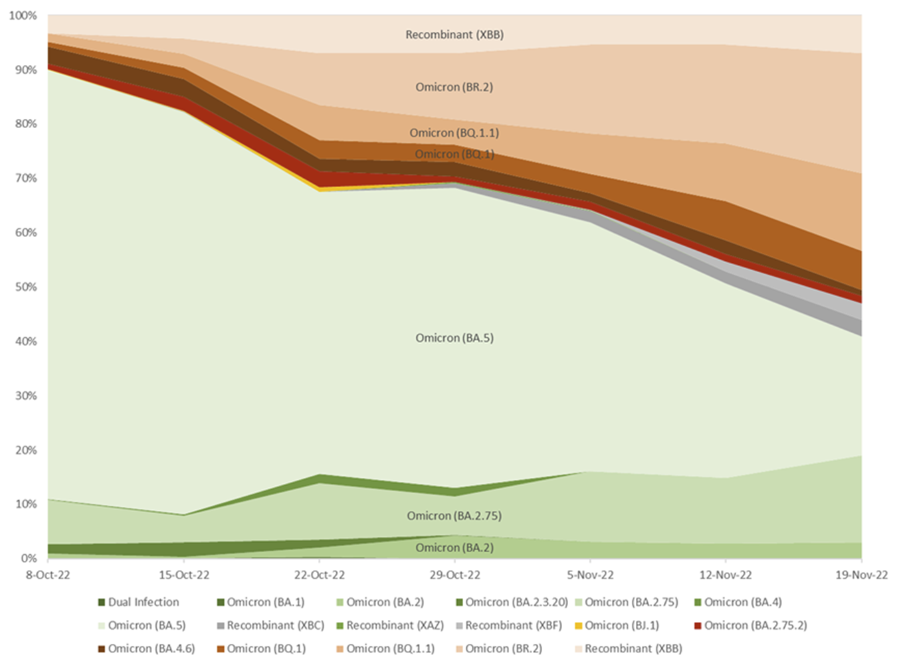
  - With respect to antiviral treatments available for high risk patients infected with COVID-19, the resubmission overestimated the proportion of the tixagevimab and cilgavimab target population who cannot take Paxlovid, by including all drug-drug interactions with a precautionary warning rather than an absolute contraindication, and by not taking account of best practice with regard to pausing medicines (that can be temporarily held) during the 5-day course of Paxlovid. The submission also undervalued molnupiravir (see PBAC Outcome Statement, COVID-19 antiviral restrictions, November 2022) and made no reference to the use of remdesivir as a treatment option in patients with mild to moderate infection at high risk of progression to severe disease.
  - Overall, the PBAC considered the resubmission did not adequately address the clinical issues the Committee had raised in its September 2022 consideration (see paragraph 7.15). Moreover, the emergence and growing prevalence of strains of virus that are likely to be resistant to tixagevimab and cilgavimab since then, increases the uncertainty about the future effectiveness of this treatment for PrEP.

Economic Analysis
  - The PBAC recalled it had advised any resubmission should base its economic analysis on the following, consistent with the available evidence for tixagevimab and cilgavimab against the Omicron variant of SARS-CoV-2.
    - A reduced price to achieve an ICER of <$25,000 to < $35,000/QALY gained, with inputs and structure in model consistent with empiric efficacy data (single dose).
    - No more than 15% risk of infection over a 6 month period.
    - No more than a 69% reduction in risk of hospitalisation to 3 months and no benefit thereafter.
    - No benefits in risk of symptomatic COVID-19 beyond 3 months.
  - The resubmission argued the base case economic analysis should use different assumptions to those proposed by the PBAC in September 2022. The pre-PBAC response further argued it was not appropriate to adjust the economic analysis to take account for the likely resistance of new strains of Omicron to tixagevimab and cilgavimab. The pre-PBAC response did not propose any alternative method for taking account of the impact of resistance on the cost-effectiveness of tixagevimab and cilgavimab (for example, a rebate type risk share arrangement).
  - The resubmission changed the risk reduction for symptomatic infection from 0.226 as reported at 6 months in the PROVENT study, as applied in the original model to 0.34 as reported for the COVID-19 infection component of the composite endpoint reported by Young-Xu 2022 as requested by the PBAC in September. However, the resubmission applied this risk reduction over 6 months instead of for the 3 month period requested by the PBAC.
  - The resubmission also applied the individual components of the composite endpoint in Young-Xu 2022 in the base case economic analysis.
  - The resubmission argued that “it is implausible to assume Evusheld effectiveness will cease at the end of a three-month period” and the “HR of 0.31 suggested in the ratified minutes for hospitalisation is more than 2 times the hazard ratio of 0.13 observed in the [Young-Xu 2022] study.” However, very small numbers of component events were reported in the tixagevimab and cilgavimab arm (so small that they are not reported to protect patient information), which results in very wide confidence limits around the point estimates of hazard ratios (see Table 22).
Table 22: Relative effectiveness of tixagevimab and cilgavimab versus untreated controls as reported by Young-Xu 2022
Outcome in overall cohort | Recipients of tixagevimab and cilgavimab  N=1,733 | Matched controls  N=6,354 | Hazard ratio (95% CI)
Composite outcome (COVID-19 infection, COVID-19 hospitalisation, and all-cause mortality) | 17 (1.0%) | 206 (3.2%) | 0.31 (0.18 – 0.53)
COVID-19 infection | (< 0.5%)& | 69 (1%) | 0.34 (0.13 – 0.87)
COVID-19-related hospitalisation | (< 0.5%)& | 38 (0.5%) | 0.13 (0.02 – 0.99)
All-cause mortality | (< 0.5%)& | 99 (2%) | 0.36 (0.18 – 0.73)
Source: Table 2, Young-Xu 2022
& Numbers not shown to protect patient information.
  - The results for the resubmission’s economic analysis are summarised in Table 23. This analysis applies (i) a reduction in the effective DPMQ to $| |; (ii) a 66% reduction in the risk of infection in patients receiving tixagevimab 300 mg and cilgavimab 300 mg for PrEP against symptomatic COVID-19 over 6 months (risk is reduced from 15% to 5.1% over 6 months); and (iii) an 87% reduction in the risk of hospitalisation in patients receiving tixagevimab 300 mg and cilgavimab 300 mg for PrEP against symptomatic COVID-19 (risk is reduced from 14% to 1.8% over 6 months).
  - Results of a respecified economic analysis that corresponds to the changes requested by the PBAC in September 2022, are summarised in Table 24. This analysis applies (i) a reduction in the effective DPMQ to $| | as proposed in the resubmission; (ii) a 69% reduction in the risk of infection in patients receiving tixagevimab 300 mg and cilgavimab 300 mg for PrEP against symptomatic COVID-19 over 3 months and then no difference (risk is reduced from 15% to 9.8% over 6 months); and (iii) a 69% reduction in the risk of hospitalisation in patients receiving tixagevimab 300 mg and cilgavimab 300 mg for PrEP against symptomatic COVID-19 over 3 months and then no difference (risk is reduced from 14% to 9.2% over 6 months). The analysis generates an ICER of $75,000 to < $95,000/QALY gained.
Table 23: Results of the resubmission’s modelled base case analysis over 6 months
 | Tixagevimab and cilgavimab | Placebo | Increment
Drug costs | $ | | $ | | $ |
Drug administration costs | $39.10 | $0 | $39.10
Costs of symptom management | $ | | $ | | $-$$||
Costs of hospitalisation (excluding ICU care) | $ | | $ | | $-$$||
Costs of ICU care | $ | | $ | | $-$$||
Total costs | $ | | $ | | $ |
QALYs (discounted) | 0.4344 | 0.4220 | 0.0124
Incremental cost per discounted QALY gained |  |  | $ | ¹
Source: Table 10 of the commentary.
The redacted values correspond to the following ranges:
¹$25,000 to < $35,000

Table 24: Results of the respecified modelled base case analysis over 6 months applying the changes requested by the PBAC in September 2022
 | Tixagevimab and cilgavimab | Placebo | Increment
Drug costs | $ | | $ | | $ |
Drug administration costs | $39.10 | $0 | $39.10
Costs of symptom management | $ | | $ | | $-$$||
Costs of hospitalisation (excluding ICU care) | $ | | $ | | $-$$||
Costs of ICU care | $ | | $ | | $-$$||
Total costs | $ | | $ | | $ |
QALYs (discounted) | 0.4293 | 0.4220 | 0.0073
Incremental cost per discounted QALY gained |  |  | $ | ¹
Source: Table 11 of the commentary.
The redacted values correspond to the following ranges:
¹$75,000 to < $95,000

  - The PBAC did not accept the new evidence presented by the resubmission sufficiently supported the change in duration of effect (see paragraph 11.12) or application of components of the composite endpoint (infection, hospitalisation and all-cause mortality) in the base case economic analysis.
  - The PBAC noted the modelled cost-effectiveness analyses presented in Tables 23 and 24 do not include any adjustments for potential resistance of the newer Omicron strains to tixagevimab and cilgavimab. However, the impact of this was examined in two sensitivity analyses within the Commentary (Figures 11 and 12).
Figure 11: Results of sensitivity analysis around the PBAC respecified base case varying the effectiveness of tixagevimab and cilgavimab to account for the prospect that a significant fraction of circulating SARS-CoV-2 could be resistant to tixagevimab and cilgavimab
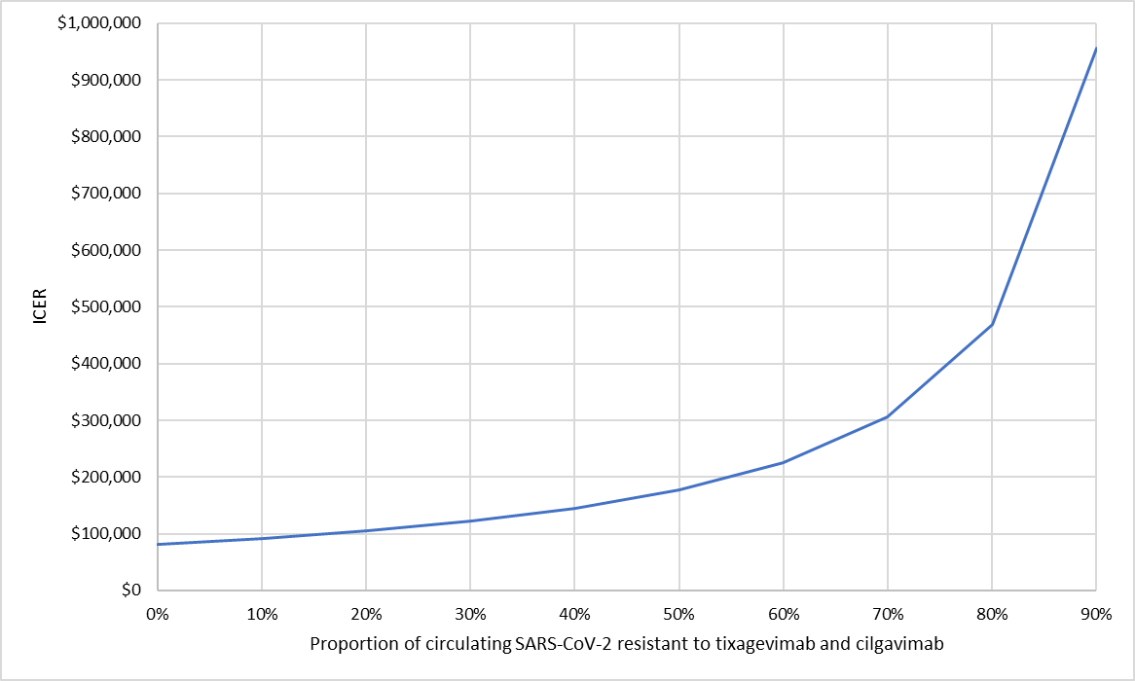
Source: Figure 6 of the commentary.

Figure 12: Results of sensitivity analysis around the submitted resubmission base case varying the effectiveness of tixagevimab and cilgavimab to account for the prospect that a significant fraction of circulating SARS-CoV-2 could be resistant to tixagevimab and cilgavimab
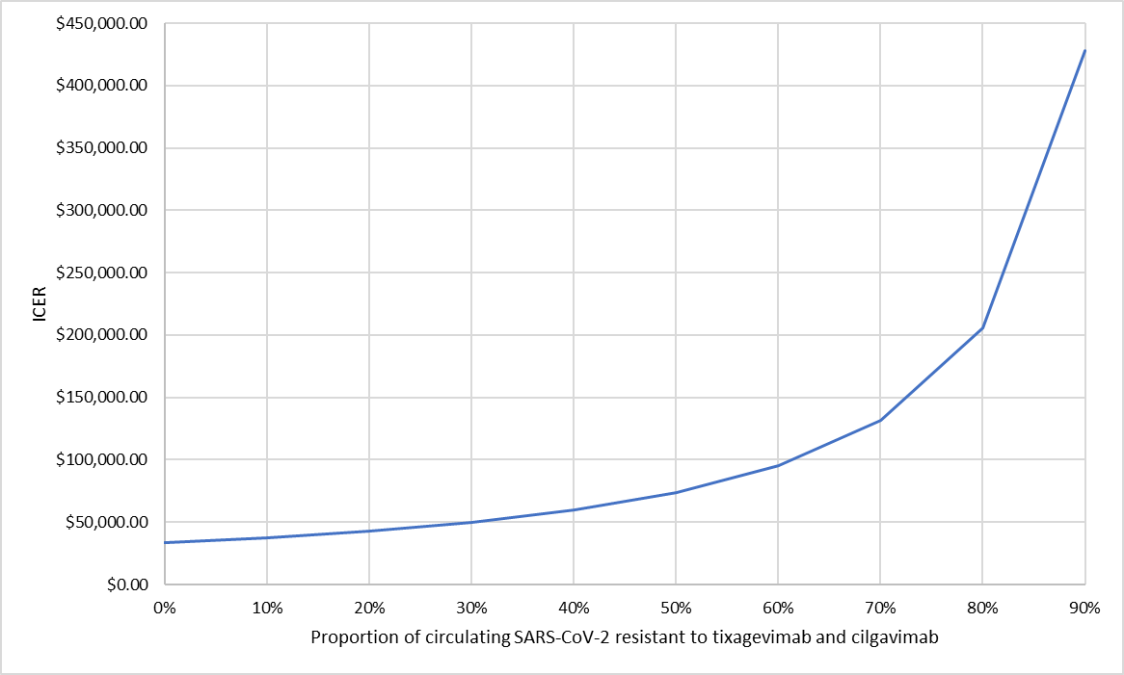
Source: Figure 7 of the commentary.
  - The PBAC noted the respecified base case it requested in September was conservative but considered this appropriate in the context of the very limited available evidence for the effectiveness of tixagevimab and cilgavimab against the Omicron variant of SARS-COV-2. The PBAC also considered the fraction of circulating SARS-CoV-2 stains that are likely resistant to tixagevimab and cilgavimab are relevant for the estimates of efficacy of tixagevimab and cilgavimab for PrEP and the economic analysis needs to be adjusted to account for this. The PBAC noted the ICER per QALY increases significantly when potential resistance is accounted for.

Cost Estimates and Risk Sharing
  - The resubmission’s estimates of the total eligible population are presented in Table 25. This table also provides the Department’s proposed revisions to these estimates. The reasons for the large differences in the estimates of the high dose systemic corticosteroid or conventional DMARDs populations were not able to be established in the context of the expedited consideration of this listing application.

Table 25: Eligible population estimates for the base year (2021) without adjustment for age or comorbidity
Population categories |  | Base eligible population estimates
 |  | Resubmission* | DUSC Secretariat analysis#
Population 1
A | Organ transplant on treatment | |¹ | |¹
B | HSCT transplant last 2 years | |²
C | Haematologic malignancies on treatment & CLL patients | |³ | |³
D | Anti-CD20- non haematological indications | |⁴ | |⁵
E | Primary immunodeficiency | |²
F | HIV/AIDS -3% resistant to anti-retroviral therapy | |²
G | Dialysis | |⁵
Population 2 - ≥70 years and one other comorbidity^{b}
H | High dose corticosteroids, 6+ scripts | |⁶ | |¹
I | Solid malignancies on treatment | |¹ | |⁶
J | CD52 antibodies +Anti-complement antibodies | |⁷ | |⁷
K | S1-PRM | |⁷ | |⁷
L | Jak-Inhibitors | |² | |²
M | csDMARDs other indications | |⁶ | |⁵
 | Total eligible patient count (with duplicates) | |⁸  |⁸ | |^{8 a}
 | Total eligible patient count (unique count no duplicates) | |⁹ | |⁹ ª
Source:
* Table 16 from the main resubmission.
# 100% R/PBS data was used for populations A,C and D. Due to the large number of PBS listings included in the analysis of patients with a comorbidity, a 10% PBS sample was used for populations H-M.
Note:
ª Includes estimates for all sub-populations A-M.
^{b} Details of PBS listings used to identify a comorbidity, based on information provided in Attachment 1 of the resubmission, ‘Evusheld PBS analysis methodology’, Table 4.

The redacted values correspond to the following ranges:
¹20,000 to < 30,000
²500 to < 5,000
³50,000 to < 60,000
⁴5,000 to < 10,000
⁵10,000 to < 20,000
⁶30,000 to < 40,000
⁷< 500
⁸200,000 to < 300,000
⁹100,000 to < 200,000
  - The PBAC noted the resubmission estimated the total cost of listing tixagevimab with cilgavimab over 2 years as $100 million to < $200 million by assuming that 50% of the total eligible population would receive one dose of tixagevimab and cilgavimab in each listing year. If this same assumption was applied to the Department’s population estimate, the total cost of the listing reduces to $100 million to < $200 million.
  - The PBAC noted the pre-PBAC response proposed the uptake estimates be changed to 50%-80% in Population 1 and 10%-25% in Population 2. The pre-PBAC response noted the financial estimates in the resubmission are based on a single dose per year, and indicated that in the event that the PBAC approves repeat dosing, it is expected that the uptake rate for the repeat dose will be 80% in Population 1 and 50% in Population 2, with the higher uptake of a repeat dose expected in Population 1 because these patients are more likely to have chronic immunosuppression compared to Population 2. The pre-PBAC response did not provide an estimate of the total cost of the listing under these revised assumptions.
  - The pre-PBAC response acknowledged there is a significant amount of uncertainty related to the use and ongoing effectiveness of tixagevimab and cilgavimab because of the changing nature of the COVID-19 virus. The pre-PBAC response restated that the resubmission proposed a 2 year listing, based on the PBAC’s recommendation to time-limit the PBS subsidy period to manage this risk. The pre-PBAC response reiterated the sponsor’s suggestion of a review of the cost-effectiveness of tixagevimab and cilgavimab be conducted to determine ongoing listing beyond this 2 years. The pre-PBAC response noted the evaluation had suggest several additional measures to manage the risks with regards to patient safety and public health and indicated the sponsor was open to collaborating with Government and Key Stakeholders to understand the most appropriate and feasible approach to managing this risk.
  - The pre-PBAC response did not comment on the evaluation’s proposals to manage the financial risks to Government and taxpayers arising from the uncertainty relating to the use and ongoing effectiveness of tixagevimab and cilgavimab because of the changing nature of the COVID-19 virus.
- PBAC Outcome
  - The PBAC did not recommend PBS listing of tixagevimab and cilgavimab for use as pre-exposure prophylaxis against COVID-19 infection. The PBAC considered there was a limited clinical place for Evusheld in the current therapeutic landscape. The PBAC considered that the resubmission had not adequately addressed the clinical, economic, financial and risk management issues that had been raised in its September 2022 consideration. Moreover, the emergence and growing prevalence of strains of virus that are likely to be resistant to tixagevimab and cilgavimab since then, increased the uncertainty about the future effectiveness of this treatment for PrEP.
  - The PBAC acknowledged the need for effective preventative strategies for those at highest risk of severe COVID-19, especially where vaccination may be ineffective in the group of patients who are unable to mount an effective immune response to vaccination.
  - The PBAC noted the advice from the sponsor’s clinical expert panel and at the hearing on the most appropriate target population (Population 1) and that this population aligns with targeted high-risk populations in other jurisdictions. The PBAC noted the evidence presented in support of Population 2 did not clearly demonstrate this group represents a population at uniquely high risk who are unlikely to benefit from vaccination.
  - The PBAC noted the additional 3 months of follow-up data from the study reported by Al Jurdi 2022 (paragraph 11.4) and additional publication by Moon 2022 (paragraph 11.5), however considered that the resubmission did not adequately address the clinical issues the Committee had raised in its September 2022 consideration (see paragraph 7.15).
  - The resubmission claimed that tixagevimab and cilgavimab provides up to 6 months effectiveness in a vaccinated, immunocompromised cohort. The resubmission did not make any explicit claim in regard to safety. Consistent with the September 2022 meeting, the PBAC considered that safety and effectiveness of the proposed dosing regimen tixagevimab 300 mg and cilgavimab 300 mg every 6 months had not been established. The PBAC did not accept that new evidence presented by the resubmission sufficiently supported a 6 month duration of effect.
  - The PBAC recalled it had proposed in September 2022 that the high uncertainty regarding the future cost-effectiveness of tixagevimab and cilgavimab might be able to be managed through targeting access to those at greatest need, a lower price, and reasonable assumptions regarding future effectiveness and duration of protection.
  - The PBAC noted the sponsor’s advice in its hearing before the PBAC that it had made its best possible price offer in the resubmission. However, the PBAC considered the resubmission’s assumptions regarding future effectiveness and duration of the future average protective effect to be overly optimistic, with the result that the resubmission’s estimate of the incremental cost-effectiveness ratio per quality adjusted life-year (ICER per QALY) estimated was unrealistically low at this price. The PBAC considered its respecified base case ICER per QALY of approximately $75,000 to < $95,000 (Table 24) provides a better estimate of the cost-effectiveness of using this therapy for PrEP, but without taking account of the recent emergence of resistant strains of the virus.
  - The PBAC further noted the emergence and growing prevalence of strains of virus that are likely to be resistant to tixagevimab and cilgavimab since it first considered tixagevimab and cilgavimab for PBS listing in September 2022. This compounds the uncertainty about the transmission and pathogenicity of future COVID-19 strains. The PBAC noted the sensitivity analyses in Figures 11 and 12 demonstrate the ICER per QALY increases dramatically when resistance is taken into account.
  - The PBAC noted the risks to individuals who have received, or are considering receiving, tixagevimab and cilgavimab for PrEP, arising from the potential resistance of some COVID-19 strains to this therapy and acknowledged the sponsor’s commitment to working with Government and stakeholders to manage this risk.
  - The PBAC however considered the sponsor’s risk management proposal insufficient to address the very significant risks to Government that arise from the uncertainty about the expected size and duration of the future average protective effect of tixagevimab and cilgavimab. The PBAC considered it will not be possible to begin to devise an approach to managing these risks without the sponsor changing its stated position on price.
  - The PBAC noted that this submission is eligible for an Independent Review.
Outcome
Not recommended
- Corrigendum
Paragraph 7.23 of the PSD incorrectly states “Assume no more than 15% annual risk of hospitalization over a 6 month period”. This statement should read “Assume no more than a 15% risk of infection over a 6 month period.”
- Context for Decision
The PBAC helps decide whether and, if so, how medicines should be subsidised through the Pharmaceutical Benefits Scheme (PBS) in Australia. It considers applications regarding the listing of medicines on the PBS and provides advice about other matters relating to the operation of the PBS in this context. A PBAC decision in relation to PBS listings does not necessarily represent a final PBAC view about the merits of the medicine or the circumstances in which it should be made available through the PBS. The PBAC welcomes applications containing new information at any time.
- Sponsor’s Comment
The sponsor had no comment.

AstraZeneca. Update to Evusheld recommended dosage regimen for pre-exposure prophylaxis of COVID-19. Available at https://www.astrazeneca.com/media-centre/statements/2022/update-to-evusheld-recommended-dosage-regimen-for-pre-exposure-prophylaxis-of-covid-19.html [Accessed: 22 Jul 2022]
ATAGI (2022). Version 2.5, 7 July 2022. Recommendations on the use of a 3rd primary dose of COVID-19 vaccine in individuals who are severely immunocompromised. https://www.health.gov.au/resources/publications/atagi-recommendations-on-the-use-of-a-third-primary-dose-of-covid-19-vaccine-in-individuals-who-are-severely-immunocompromised [Accessed: 12 Aug 2022]
https://www.fda.gov/media/154701/download [accessed 15-Aug-2022]
Siddiqi, H. K., Libby, P., & Ridker, P. M. (2021). COVID-19 – A vascular disease. Trends in Cardiovascular Medicine, 31(1), 1–5. https://doi.org/10.1016/j.tcm.2020.10.005
Dept of Health and Aged Care. COVID-19 vaccines. Available at: https://www.health.gov.au/initiatives-and-programs/covid-19-vaccines [Accessed: 13 Aug 2022]
CDGN (2022, July 18). Variants of concern - Jul 2022. Available at: https://web.archive.org/web/20220724072138/https://www.cdgn.org.au/variants-of-concern [Accessed: 24 Jul 2022]
CDGN. (2022, June 20). Variants of concern - Jun 2022. Available at: https://web.archive.org/web/20220624134327/https://www.cdgn.org.au/variants-of-concern [Accessed: 24 Jul 2022]
CDGN (2022, July 25). Variants of concern - Jul 2022. Available at: https://web.archive.org/web/20220730101402/https://www.cdgn.org.au/variants-of-concern [Accessed 30 Jul 2022]
Communicable Diseases Intelligence - COVID-19 Australia: Epidemiology Report 63 COVID-19 Australia: Epidemiology Report 63 - Reporting period ending 3 July 2022 (health.gov.au)
Table 7, Communicable Diseases Intelligence - COVID-19 Australia: Epidemiology Report 63 COVID-19 Australia: Epidemiology Report 63 - Reporting period ending 3 July 2022 (health.gov.au)
Lamb, E. J., Levey, A. S., & Stevens, P. E. (2013). The Kidney Disease Improving Global Outcomes (KDIGO) Guideline Update for Chronic Kidney Disease: Evolution not Revolution. Clinical Chemistry, 59(3), 462–465. https://doi.org/10.1373/clinchem.2012.184259
ENDURE study. https://clinicaltrials.gov/ct2/show/NCT05375760 [Accessed: 6 Aug 2022]
Young-Xu, Y., Epstein, L., et al. (2022). Tixagevimab/Cilgavimab for Prevention of COVID-19 during the Omicron Surge: Retrospective Analysis of National VA Electronic Data. medRxiv. https://doi.org/10.1101/2022.05.28.22275716
Al Jurdi, A., Morena, L., et al. (2022). Tixagevimab/cilgavimab pre‐exposure prophylaxis is associated with lower breakthrough infection risk in vaccinated solid organ transplant recipients during the omicron wave. American Journal of Transplantation, ajt.17128. https://doi.org/10.1111/ajt.17128
Kertes, J., David, S. S. B., et al. (2022). Association between AZD7442 (tixagevimab-cilgavimab) administration and SARS-CoV-2 infection, hospitalization and mortality. Clinical Infectious Diseases, Accepted manuscript. https://doi.org/10.1093/cid/ciac625
Nguyen, Y., Flahault, A., et al. (2022). Pre-exposure prophylaxis with tixagevimab and cilgavimab (Evusheld©) for COVID-19 among 1112 severely immunocompromised patients. Clinical Microbiology and Infection, Pre-proof. https://doi.org/10.1016/j.cmi.2022.07.015
Tuekprakhon, A., Huo, J., et al. (2022). Further antibody escape by Omicron BA.4 and BA.5 from vaccine and BA.1 serum [Preprint]. Microbiology. https://doi.org/10.1101/2022.05.21.492554 (supplementary table 1B)
Yamasoba, D., Kosugi, Y., et al. (2022). Neutralisation sensitivity of SARS-CoV-2 omicron subvariants to therapeutic monoclonal antibodies. The Lancet Infectious Diseases, 22(7), 942–943. https://doi.org/10.1016/S1473-3099(22)00365-6
Cao, Y., Yisimayi, A., et al. (2022). BA.2.12.1, BA.4 and BA.5 escape antibodies elicited by Omicron infection. Nature. https://doi.org/10.1038/s41586-022-04980-y
Takashita, E., Yamayoshi, S., et al. (2022). Efficacy of Antibodies and Antiviral Drugs against Omicron BA.2.12.1, BA.4, and BA.5 Subvariants. New England Journal of Medicine, NEJMc2207519. https://doi.org/10.1056/NEJMc2207519
Montgomery, H., Hobbs, F. D. R., et al. (2022). Efficacy and safety of intramuscular administration of tixagevimab–cilgavimab for early outpatient treatment of COVID-19 (TACKLE): a phase 3, randomised, double-blind, placebo-controlled trial. The Lancet Respiratory Medicine, Published online 7 Jun 2022. https://doi.org/10.1016/S2213-2600(22)00180-1
https://www.adelaidenow.com.au/news/how-sas-lung-transplant-team-defied-global-fatality-rates-during-covid/news-story/ac53da34cd20ee57a83b9f810391ca3f [Accessed: 7 Aug 2022]
Fan, Y., Li, X., et al. (2022). SARS-CoV-2 Omicron variant: recent progress and future perspectives. Signal Transduction and Targeted Therapy, 7(1). https://doi.org/10.1038/s41392-022-00997-x
Table 9, COVID-19 National Incident Room Surveillance Team. (2022). COVID-19 Australia: Epidemiology Report 63 Reporting period ending 3 Jul 2022. Communicable Diseases Intelligence, 46. Available at: https://www1.health.gov.au/internet/main/publishing.nsf/Content/C50CAE02452A48A7CA2587320081F7BF/$File/covid_19_australia_epidemiology_report_63_reporting_period_ending_3_july_2022.pdf
ATAGI recommendations on the use of a third primary dose of COVID-19 vaccine in individuals who are severely immunocompromised | Australian Government Department of Health and Aged Care; accessed 9 August 2022.
Derived using PBS/RPBS data for Paxlovid (12996B) and Lagevrio (12910L) for 1 March 2022 – 30 June 2022, Services Australia - Statistics - Pharmaceutical Benefits Schedule Item Statistics (humanservices.gov.au); accessed 16 August 2022.
Communicable Diseases Intelligence - COVID-19 Australia: Epidemiology Report 63COVID-19 Australia: Epidemiology Report 63 - Reporting period ending 3 July 2022 (health.gov.au)
Table 7, Communicable Diseases Intelligence - COVID-19 Australia: Epidemiology Report 63COVID-19 Australia: Epidemiology Report 63 - Reporting period ending 3 July 2022 (health.gov.au)
Ontario Health Information about Evusheld (Tixagevimab and Cilgavimab) Reference for health care providers who may be prescribing or administering Evusheld. Last updated: October 3, 2022. Available at: https://www.ontariohealth.ca/sites/ontariohealth/files/2022-05/Information%20for%20health%20care%20providers%20-%20Evusheld.pdf
The resubmission presented results of an interim analysis provided to AstraZeneca by the investigators from the Jurdi et al. 2022 study.
Moon, RH. et al. Safety and Efficacy of Intramuscular Tixagevimab-Cilgavimab in Prevention of COVID-19 in Immunocompromised Patients. Preprint available at SSRN: https://ssrn.com/abstract=4248012.
PBAC – Outcome Statement Item 14.04 - COVID-19 Antiviral Restrictions, PBAC November 2022. Available at: https://www.pbs.gov.au/industry/listing/elements/pbac-meetings/pbac-outcomes/2022-11/covid-19-oral-treatments-outcome-nov-2022.pdf
The model runs for 6 months while the risk reduction is applied over 3 months.
The model runs for 6 months while the risk reduction is applied over 3 months.

