6.01 ATEZOLIZUMAB,

Solution concentrate for I.V. infusion 840 mg in 14 mL,

Solution concentrate for I.V. infusion 1,200 mg in 20 mL,

Tecentriq®,

Roche Products Pty Ltd.
- Purpose of submission
  - The Category 2 submission requested a Section 100 (Efficient Funding of Chemotherapy Program) Authority Required (STREAMLINED) listing of atezolizumab (ATZ) as adjuvant treatment in patients with Stage II-IIIA programmed cell death Ligand-1 (PD-L1) positive non-small cell lung cancer (NSCLC) following complete resection and platinum-based chemotherapy. The submission noted that the PD-L1 expression threshold proposed for the target PBS population (PD-L1 ≥ 1% or PD-L1 ≥ 50%) would ultimately depend on the threshold specified in the final approved Therapeutic Goods Administration (TGA) indication.
  - Listing was requested on the basis of a cost-effectiveness analysis versus observation (referred to herein as best supportive care, BSC) alone. The key components of the clinical issue are summarised below.
Table 1: Key components of the clinical issue addressed by the submission
Component | Description
Population | Patients with Stage II-IIIA NSCLC whose tumours express PD-L1 ≥ 1% or PD-L1 ≥ 50%ª who had received complete resection and platinum-based adjuvant chemotherapy
Intervention | Atezolizumab as adjuvant therapy (1,200 mg IV Q3W or 1,680 mg IV Q4W) for up to one year unless there was disease recurrence or unacceptable toxicity.
Comparator | Observation (BSC)
Outcomes | Disease-free survival  Overall survival  Safety
Clinical claim | In patients with PD-L1 positive stage II-IIIA NSCLC, adjuvant treatment with atezolizumab, following complete resection and adjuvant platinum-based chemotherapy, is superior in effectiveness and inferior in safety compared with observation (BSC).
Source: Table 1.1, p3 of the submission.
BSC = best supportive care; PD-L1=programmed cell death-ligand 1; NSCLC = non-small cell lung cancer; Q3W or Q4W = every 3 weeks or every 4 weeks; IV = intravenous
ª The submission noted that the PD-L1 expression threshold proposed for the target PBS population (PD-L1 ≥ 1% or PD-L1 ≥ 50%) would ultimately depend on the threshold specified in the final approved Therapeutic Goods Administration (TGA) indication.
- Background

Registration status
  - The submission was made under the TGA/PBAC Parallel Process. The TGA Delegate’s Overview was received prior to ESC consideration and the Delegate proposed to approve atezolizumab for the following indication:
TECENTRIQ as monotherapy, is indicated as adjuvant treatment following complete resection and no progression after platinum-based adjuvant chemotherapy for adult patients with Stage II to IIIA* NSCLC whose tumours have PD-L1 expression on ≥ 50% of tumour cells.
*According to American Joint Committee on Cancer, 7th edition.
  - ATZ is currently registered for advanced NSCLC, small cell lung cancer, urothelial cancer, triple negative breast cancer and hepatocellular cancer.

Previous PBAC consideration
  - The PBAC had not previously considered ATZ as an adjuvant treatment for early stage NSCLC. ATZ is PBS listed for the first and second line treatment of advanced or metastatic NSCLC.
- Requested listing
  - The requested listing and suggested changes proposed by the Secretariat (additions are in italics, deletions in strikethrough) are presented below.

Name, Restriction,  Manner of administration and form | Max.  Amt | №.of  Rpts | Dispensed Price Max Amt | Proprietary Name and Manufacturer
Atezolizumab  Solution for IV infusion  1200 mg in 20 mL vial, 1 unit | 1,680 1,200 mg | 15 8 | Published price  $7,188.77 (public)  $7,329.23 (private)  Effective price  $| (public)  $| (private) | TECENTRIQ®  Roche Products Pty Ltd
Atezolizumab  Solution for IV infusion  840 mg in 14 mL vial, 2 units | 1,680 mg | 11 5 | Published price  $10,029.76 (public)  $10,210.00 (private)  Effective price  $| (public)  $| (private) | TECENTRIQ®  Roche Products Pty Ltd
Category / Program | Section 100 – Efficient funding of Chemotherapy  Private Hospital/Private Clinic Authority Required  Public Hospital Authority Required
Prescriber type: | Dental Medical Practitioners Nurse practitioners Optometrists Midwives
Severity: | Resected early stage (Stage II to IIIA) II-IIIA
Condition: | Non-small cell lung cancer (NSCLC)
PBS Indication: | Resected early stage (Stage II to IIIA) non-small cell lung cancer stage II-IIIA NSCLC
Treatment phase: | Initial treatment
Restriction: | Restricted benefit  Authority Required - In Writing  Authority Required – Telephone/Electronic/Emergency  Streamlined
Clinical criteria: | Patient must not have received prior treatment with a programmed cell death-1 (PD-1) inhibitor or a programmed cell death ligand-1 (PD-L1) inhibitor for non-small cell lung cancer, AND  The treatment must be for the purpose of adjuvant therapy following all of: follow complete (i) surgical resection, (ii) and platinum-based chemotherapy, AND  Patient must have a WHO performance status of 0 or 1 prior to initiation of treatment with this drug for this condition 1 or less, AND  The condition must have, prior to initiating treatment with this drug, an absence of each of the following gene abnormalities confirmed via tumour material sampling: (i) an activating epidermal growth factor receptor (EGFR) gene mutation, (ii) an anaplastic lymphoma kinase (ALK) gene rearrangement not have evidence of an activating epidermal growth factor receptor (EGFR) gene or an anaplastic lymphoma kinase (ALK) gene arrangement in tumour material, AND  The condition must have, prior to initiating treatment with this drug, confirmation of express programmed cell death ligand 1 (PD-L1) expression on with a tumour score of at least 1%ª in the of tumour cells, AND sample  The condition is each of: (i) untreated with this drug as a PBS-benefit, (ii) yet to experience disease recurrence following the above prior therapies, AND  The treatment must be the sole PBS-subsidised systemic anti-cancer therapy for this condition
Treatment criteria | The treatment must be as monotherapy, AND  Patient must not have experienced disease recurrence  Patient must be undergoing treatment with this drug at a dosing regimen (dose plus frequency) specified in this drug’s approved Australian Product Information
Administrative advice | No increase in the maximum quantity or number of units may be authorised.  No increase in the maximum number of repeats may be authorised  Special Pricing Arrangements apply.
Category / Program | Section 100 – Efficient funding of Chemotherapy  Private Hospital/Private Clinic Authority Required  Public Hospital Authority Required
Severity: | Resected early stage (Stage II to IIIA) II-IIIA
Condition: | Non-small cell lung cancer (NSCLC)
PBS Indication: | Resected early stage (Stage II to IIIA) non-small cell lung cancer stage II-IIIA NSCLC
Treatment phase: | Continuing adjuvant Grandfathering treatment
Restriction: | Restricted benefit  Authority Required - In Writing  Authority Required – Telephone/Electronic/Emergency  Streamlined
Clinical criteria: | Patient must have previously received PBS-subsidised treatment with this drug for this condition, AND  Patient must not have experienced disease recurrence, AND  The treatment must be the sole PBS-subsidised systemic anti-cancer therapy for this condition
Treatment criteria | Patient must have received treatment with this drug for this condition prior to the [PBS listing date], AND  Patient must not have experienced disease recurrence.  Patient must be undergoing treatment with this drug at a dosing regimen (dose plus frequency) specified in this drug’s approved Australian Product Information, AND  Patient must be undergoing treatment that does not extend beyond the following, whichever comes first: (i) disease progression/recurrence, (ii) 12 months in total for this condition (dosing regimen in accordance with the Product Information); mark any remaining repeat prescriptions with the words ‘cancelled’ where (i)/(ii) has occurred
Source: Tables 1.6-1.9, pp17-20 of the submission.
ª Or Stage II-IIIA PD-L1 ≥ 50% if the final TGA indication restricts use of atezolizumab to this subgroup

  - The requested PBS restriction was for Stage II-IIIA PD-L1 ≥ 1% NSCLC patients who are epidermal growth factor receptor (EGFR) wild type or anaplastic lymphoma kinase (ALK) gene arrangement negative, with a World Health Organisation (WHO) performance status of 0 or 1. The ESC noted the restriction criteria will need to be amended to state PD-L1 ≥ 50% to reflect the likely TGA indication. The ESC considered that a clinical criterion related to WHO performance status was likely not required for this indication. The PBAC noted the performance status of some patients may deteriorate after a complete resection and chemotherapy due to the toxicity of therapy and considered it was appropriate to retain the WHO performance status in the criteria.
  - The submission proposed a special pricing arrangement (SPA). The proposed effective ex-manufacturer prices for ATZ 1,200 mg vial and the 840 mg vial as adjuvant therapy are the same as the current effective ATZ prices for previously untreated metastatic NSCLC, and are 21%-22% lower than the current effective ATZ prices when used as second-line therapy for NSCLC.
  - In the IMpower010 trial, 1,200 mg ATZ was administered every three weeks (Q3W). However, the submission proposed that an additional less frequent dosing regimen of ATZ - 1,680 mg every four weeks (Q4W) – should be considered for listing for the target PBS population to improve patient convenience, particularly for those living in rural or remote areas. The recommended dosage in the draft product information document provided with the submission is 840 mg every 2 week, 1,200 mg every 3 weeks or 1,680 mg every 4 weeks.
  - The submission proposed one restriction to cover both initial and continuing treatment and one restriction for grandfathering treatment with separate maximum quantity and up to 15 repeats for each form. The PBAC did not agree with the Secretariat’s proposed change into initial and continuing criteria and considered a single listing, as proposed in the submission, was appropriate. However, the PBAC considered the single listing could consolidate multiple dosing regimens. The PBAC considered each script should provide a maximum of 6 months of treatment and 15 repeats was too many.
  - The submission requested a grandfathering restriction for < 500 patients (for the PD-L1 ≥ 1% population) estimated to be receiving ATZ via an early access scheme at the time of PBS listing. The Secretariat noted that, with the proposed changes to the criteria outlined above, a separate ‘Grandfather’ restriction was not necessary, as such patients would meet the ‘Initial treatment’ criteria.
  - The submission stated that, consistent with the current ‘once per lifetime’ approach for immunotherapies, patients who receive adjuvant ATZ in the early-stage NSCLC setting would not be eligible to receive subsequent PBS listed anti-PD-(L)1 inhibitors in the event of relapse to advanced or metastatic disease. The PBAC considered no additional wording was required to account for the once per lifetime approach.
  - The PBAC agreed with the ESC that the Secretariat’s proposed addition to the criteria limiting treatment to 12 months was appropriate.
  - The Secretariat noted multiple existing non-small cell lung cancer listings for ATZ and proposed an option to combine all the existing NSCLC listings into one universal ‘non small cell lung cancer’ listing for simplification in terms of reader usability. The pre-PBAC response stated a universal listing was not supported as it would negate special pricing arrangements that exist for ATZ in the first and second line NSCLC setting. The PBAC was generally supportive of simplifying restrictions where possible by condensing the large number of NSCLC restrictions into a single restriction through grouping the various indications/patient populations. However, advice from the Department was that the administration of existing Deeds of Agreement would be complicated and potentially lead to confounding in the tracking of PBS drug utilisation.
For more detail on PBAC’s view, see section 7 PBAC outcome.
- Population and disease
  - In 2021, an estimated 13,810 Australians were diagnosed with lung cancer with 8,693 Australians expected to die from the disease. NSCLC represents the main histological type of lung cancer, accounting for approximately 85% of lung cancer cases.
  - For Stage II to III NSCLC, adjuvant treatment with platinum-based chemotherapy following surgery is recommended to improve survival outcomes. However, the proportion of patients who experience disease recurrence or who may die from the disease remains high, ranging from approximately 32% of patients with Stage IB disease to 68% of patients with Stage III disease.
  - The submission stated that PBS listing of ATZ would result in a reduction in the prescribing of pembrolizumab in combination with chemotherapy, as a representative proxy for cancer immunotherapy utilisation, in patients with metastatic NSCLC.
  - ATZ is a humanised monoclonal anti-PD L1. ATZ binds selectively to PD-L1 on the surface of the tumour and immune cells, inhibiting the interactions between PD-L1 and its receptors, thereby restoring anti-cancer T-cell activity in the tumour microenvironment.
- Comparator
  - The submission nominated observation or best supportive care (BSC) as the main comparator. Based on current guidelines, the standard of care for early stage NSCLC patients after complete resection, and followed by adjuvant platinum-based chemotherapy, is monitoring for disease recurrence.
For more detail on PBAC’s view, see section 7 PBAC outcome.
- Consideration of the evidence

Sponsor hearing
  - There was no hearing for this item.

Consumer comments
  - The PBAC noted and welcomed the input from two organisations, the Lung Foundation Australia and the Medical Oncology Group of Australia, via the Consumer Comments facility on the PBS website.
  - The Lung Foundation supported the listing of ATZ for NSCLC, noting that this listing would provide an additional choice of treatment, timely access, individualised treatment, reduced healthcare cost and improved lung cancer survival.
  - The Medical Oncology Group of Australia (MOGA) also expressed its strong support for the ATZ for the adjuvant treatment of patients with PD-L1 positive NSCLC, categorising it as one of the therapies of “highest priority for PBS listing” on the basis of the IMpower 010 trial. The PBAC noted that the MOGA presented the European Society for Medical Oncology Magnitude of Clinical Benefit Scale (ESMO-MCBS) for atezolizumab, which was a Grade A. This is the highest grade (out of C, where A and B represent the grades with substantial improvement for new approaches to adjuvant therapy or new potentially curative therapies), based on a comparison with placebo in the Impower 010 trial.

Clinical trials
  - The submission was based on one head-to-head open-label randomised controlled trial (IMpower010) comparing ATZ to BSC following adjuvant cisplatin-based chemotherapy in patients with completely resected Stage IB-IIIA NSCLC (intention to treat (ITT) population).
  - PBS listing was requested for Stage II-IIIA NSCLC patients whose tumours express PD-L1 ≥ 1%. This was consistent with the proposed TGA indication (draft PI) provided with the submission and represented a subgroup of the IMpower010 ITT population. The pre-specified primary analysis of DFS was based on this subgroup.
  - The submission also noted that the PD-L1 threshold in the proposed restriction may require re-specification should the final TGA indication restrict use of ATZ to a narrower subgroup of patients with high PD-L1 expression (PD-L1 ≥ 50%). Analysis of DFS for this subgroup was a pre-specified key secondary analysis in IMpower010.
  - Details of the IMpower010 trial are provided in the table below.
Table 2: Trials and associated reports presented in the submission
Trial ID | Protocol title/ Publication title | Publication citation
IMpower010  (NCT02486718) | IMpower010 Clinical Study Report: A Phase III, Open-Label, Randomized Study to Investigate the Efficacy and Safety of Atezolizumab (Anti-PD-L1 Antibody) Compared with Best Supportive Care Following Adjuvant Cisplatin-Based Chemotherapy in Patients with Completely Resected Stage IB-IIIA Non-Small Cell Lung Cancer. Report No. 1106726. May, 2021. | Report No. 1106726. May, 2021
IMpower010  (NCT02486718) | Felip E, Altorki N, Zhou C, et al. Adjuvant atezolizumab after adjuvant chemotherapy in resected stage IB-IIIA non-small-cell lung cancer (IMpower010): a randomised, multicentre, open-label, phase 3 trial. | Lancet 2021; 398(10308):1344-571.
IMpower010  (NCT02486718) | Felip E et al. IMpower010: Sites of relapse and subsequent therapy from a phase III study of atezolizumab vs best supportive care after adjuvant chemotherapy in stage IB–IIIA NSCLC | Annals of Oncology 2021; 32 (Suppl. 5):S1283-S1346.
Source: Table 2.4, p28 of the submission.

  - The key features of the direct randomised trial are summarised in the table below.
Table 3: Key features of the included evidence
Trial | N | Design/ duration | Risk of bias | NSCLC patient population  (Adjuvant setting) | Outcomes | Use in modelled evaluation
IMpower010 | 1005 | ATZ vs. BSC  R, OL  Median follow-up for OS ~32 months (January 2021 data cut-off) | Lowª | ITT: Stage IB-IIIA^{b,c} | DFS, OS, Safety | DFS and safety outcomes
Source: Sections 2.3 and 2.4 of the submission and the IMpower010 Clinical Study Report.
ATZ = atezolizumab; BSC = best supportive care; OL = open label; OS = overall survival; DFS = disease-free survival; R = randomised
ª Considered generally low. However, given the open-label design of the trial, there was potential for both performance and detection bias particularly for outcomes with some degree of subjectivity such as adverse events.
^{b} The requested population for ATZ listing was either the Stage II-IIIA PD-L1 ≥ 1% subgroup (N=476) or the Stage II-IIIA PD-L1 ≥ 50% (N=229) subgroup contingent on the PD-L1 threshold specified in the final TGA approved indication. The Stage II-IIIA PD-L1 ≥ 1% subgroup was considered the main PBS target population for the economic evaluation.
^{c} Stage II-IIIA subgroup ((N=882), Stage II-IIIA PD-L1 ≥ 1% (N=476), Stage II-IIIA PD-L1 ≥ 50% (N=229)
  - The ITT population (Stage IB-IIIA) in IMpower010 consisted of 1,005 patients. The requested population for ATZ listing was either the Stage II-IIIA PD-L1 ≥ 1% subgroup (N=476) or the Stage II-IIIA PD-L1 ≥ 50% (N=229) subgroup contingent on the PD-L1 threshold specified in the final TGA approved indication. The ESC noted the population of patients with Stage II-IIIA PD-L1 ≥ 50% comprised 23% of the overall Impower010 population.
  - In a protocol amendment in February 2020 (approximately one year before the interim analysis was conducted), the primary analysis in IMpower010 was specified as the assessment of DFS, tested hierarchically first in the Stage II–IIIA PD-L1 ≥ 1% subgroup, then in the Stage II–IIIA subgroup (regardless of PD-L1 status), and finally in the ITT Stage IB–IIIA population (regardless of PD-L1 status). Analysis of DFS in the Stage II-IIIA PD-L1 ≥ 50% NSCLC population was a pre-specified key secondary analysis.
  - Stratification factors at randomisation were Sex (female vs. male), Tumour histology (squamous vs. non-squamous), Extent of disease (stage IB vs. stage II vs. stage IIIA), and PD-L1 expression status by tumour cell (TC) and immune cell (IC): TC2/3 and any IC vs. TC0/1 and IC2/3 vs. TC0/1 and IC0/1 using the SP142 IHC assay.
  - In the February 2020 protocol amendment, the analysis of DFS based on the PD-L1 positive population was amended to PD-L1 expression on 1% or more of tumour cells as defined by the SP263 assay. PD-L1 subgroups defined by the SP263 assay (TC <1%, 1%-49%, ≥ 50%) were reasonably balanced between the ATZ and BSC treatment arms despite their initial stratification by SP142 PD-L1 status.

Comparative effectiveness
  - Results for the pre-specified primary analysis of IMpower010 are summarised in Table 4. The corresponding Kaplan-Meier (KM) curves are depicted in Figure 1, Figure 2, and Figure 3.
Table 4: IMpower010 - Primary analysis of DFS
 | ATZ | BSC
Stage II-IIIA PD-L1 ≥ 1% NSCLC subgroup
 | N=248 | N=228
Patients with event, n (%)  Deaths (earliest event)  Disease recurrence (earliest event) | 88 (35.5%)  15 (6.0%)  73 (29.4%) | 105 (46.1%)  3 (1.3%)  102 (44.7%)
Median time to event, months, (95% CI) | NE (36.1, NE) | 35.3 (29.0, NE)
Stratified Hazard Ratio (95% CI) | 0.66 (0.50, 0.88); p-value (log-rank)=0.0039
DFS rate at 3 years, % | 60.0 | 48.2
Difference, % (95% CI) | 11.8 (1.4, 22.1)
Stage II-IIIA NSCLC subgroup (regardless of PD-L1 expression status)
 | N=442 | N=440
Patients with event, n (%)  Deaths (earliest event)  Disease recurrence (earliest event) | 173 (39.1%)  26 (5.9%)  147 (33.3%) | 198 (45.0%)  9 (2.0%)  189 (43.0%)
Median time to event, months, (95% CI) | 42.3 (36.0, NE) | 35.3 (30.4, 46.4)
Stratified Hazard Ratio (95% CI) | 0.79 (0.64, 0.96); p-value (log-rank)=0.0205
DFS rate at 3 years, % | 55.7 | 49.4
Difference, % (95% CI) | 6.3 (-1.4, 14.0)
ITT (Stage IB-IIIA NSCLC regardless of PD-L1 expression status)
 | N=507 | N=498
Patients with event, n (%)  Deaths (earliest event)  Disease recurrence (earliest event) | 187 (36.9%)  31 (6.1%)  156 (30.8%) | 212 (42.6%)  9 (1.8%)  203 (40.8%)
Median time to event, months, (95% CI) | NE (36.1, NE) | 37.2 (31.6, NE)
Stratified Hazard Ratio (95% CI) | 0.81 (0.67, 0.99); p-value (log-rank)=0.0395
DFS rate at 3 years, % | 57.9 | 52.6
Difference, % (95% CI) | 5.3 (-1.79, 12.52)
Source: Tables 18-20, pp 65-69 of the IMpower010 CSR.
NE = not estimable; NSCLC = non-small cell lung cancer; ATZ = atezolizumab; BSC = best supportive care; ITT = intention to treat; DFS = disease free survival; PD-L1 = programmed cell death ligand 1
Data cut-off January 2021; PD-L1 status was based on SP263 assay; Summaries of DFS duration (median) are Kaplan-Meier estimates; 95% CIs for the median were computed using the method of Brookmeyer and Crowley; Hazard ratios were estimated by Cox regression; Stratification factors: stage (II vs. IIIA), sex (female vs. male), and histology (squamous vs. non-squamous). There was inadequate follow-up for 5-year DFS rates.

Figure 1: Kaplan-Meier plot of DFS in IMpower010 - Stage II-IIIA PD-L1 ≥ 1% NSCLC subgroup
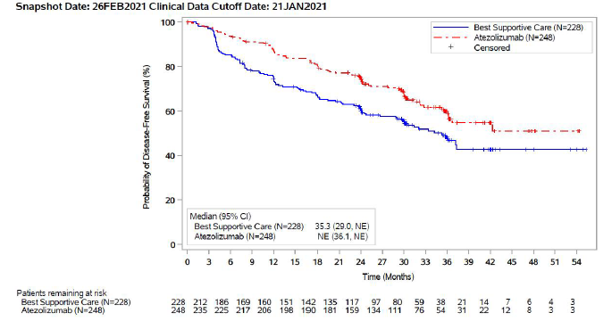
Source: IMpower010 CSR, Figure 3, p66.
NSCLC = non-small cell lung cancer; DFS = disease free survival; PD-L1 = programmed cell death ligand 1

Figure 2: Kaplan-Meier plot of DFS in IMpower010 - Stage II-IIIA NSCLC subgroup (regardless of PD-L1 status)
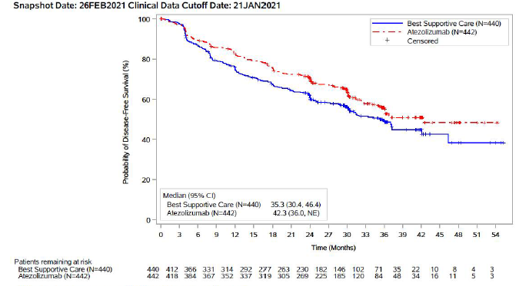
Source: IMpower010 CSR, Figure 4, p68
NSCLC = non-small cell lung cancer; DFS = disease free survival; PD-L1 = programmed cell death ligand 1

Figure 3: Kaplan-Meier plot of DFS in IMpower010 – ITT population (Stage IB-IIIA NSCLC)
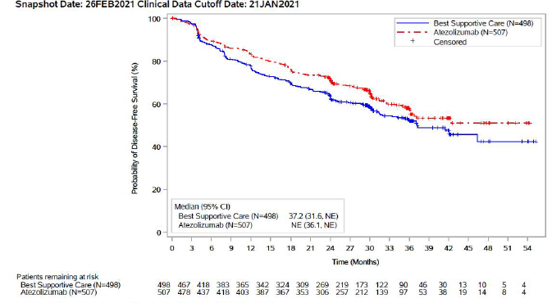
Source: IMpower010 CSR, Figure 5, p70.
NSCLC = non-small cell lung cancer; DFS = disease free survival; PD-L1 = programmed cell death ligand 1
  - In the Stage II-IIIA PD-L1 ≥ 1% NSCLC subgroup, treatment with ATZ was associated with a statistically significant 34% reduction in the hazard of disease recurrence or death compared to BSC (HR=0.66; 95% CI: 0.50, 0.88; p-value=0.0039). The KM estimated median DFS was not reached in the ATZ arm and was 35.3 months in the BSC arm. A higher proportion of patients in the BSC arm (46.1%) compared to the ATZ arm (35.5%) had experienced disease recurrence or death. The difference in DFS rates at 3 years, between the ATZ arm (60.0%) and the BSC arm (48.2%) was approximately 12% which was statistically significant. The KM curves appear to have separated at approximately 4 months in favour of the ATZ treatment arm.
  - Results of pre-specified key secondary (OS in the ITT population and DFS in the Stage II-IIIA PD-L1 ≥ 50% subgroup) and exploratory (OS in the Stage II-IIIA PD-L1 ≥ 1% subgroup) analyses are summarised in Table 5, Table 6, and Table 7. The corresponding KM curves are presented in Figure 4 and Figure 5.
Table 5: IMpower010 – Secondary analysis of OS in the ITT population (Stage IB-IIIA NSCLC population)
 | ATZ  N=507 | BSC  N=498
Patients with event, death, (%) | 97 (19.1%) | 90 (18.1%)
Median OS (95% CI), months | NE (NE) | NE (NE)
Stratified HR (95% CI) | 1.07 (0.80, 1.42)
Event free rate at 3 years, % | 78.6 | 81.2
Source: IMpower010 CSR, Table 23 p73.
ATZ = atezolizumab; BSC = best supportive care; ITT = intention to treat; NE = not estimable (not reached); NSCLC = non-small cell lung cancer
Data cut-off January 2021, Median duration of follow up approximately 32 months.
Median OS are Kaplan-Meier estimates; 95% CIs for the median were computed using the method of Brookmeyer and Crowley; hazard ratios were estimated by Cox regression; stratification factors: stage (IB/II vs. IIIA), sex (female vs. male), histology (squamous vs. non-squamous)
  - For OS in the ITT population, data were immature as of the January 2021 data cut-off (median duration of follow up approximately 32 months) with a low number of death events having occurred across the ATZ and BSC arms (approximately 19%). The median duration of OS was not reached for both arms. Thus, the OS results were not formally tested. Survival at 3 years was similar.
Table 6: IMpower010 – Secondary analysis of DFS in the Stage II-IIIA PD-L1 ≥50% NSCLC subgroup
 | ATZ  N=115 | BSC  N=114
Patients with event (%) | 28 (24.3%) | 52 (45.6%)
Median DFS, months, (95% CI) | NE (42.30, NE) | 35.7 (29.70, NE)
Stratified HR (95% CI) | 0.47 (0.29, 0.75); p-value=0.0012
Event free rate at 3 years, % | 73.8 | 48.6
Absolute difference in event free rate %, (95%CI) | 25.2 (11.0, 39.4)
Source: IMpower010 CSR, Table 25 p 77.
ATZ = atezolizumab; BSC = best supportive care; DFS = disease free survival; NSCLC = non-small cell lung cancer; NE = not estimable (not reached).
Data cut-off January 2021.
PD-L1 tumour expression status by SP263 IHC assay; Median DFS are Kaplan-Meier estimates; 95% CIs for the median are computed using the method of Brookmeyer and Crowley; hazard ratios were estimated by Cox regression; stratification factors: stage (IB/II vs. IIIA), sex (female vs. male), histology (squamous vs. non-squamous).

Figure 4: Kaplan-Meier plot of DFS in the Stage II-IIIA PD-L1 ≥ 50% NSCLC subgroup from IMpower010
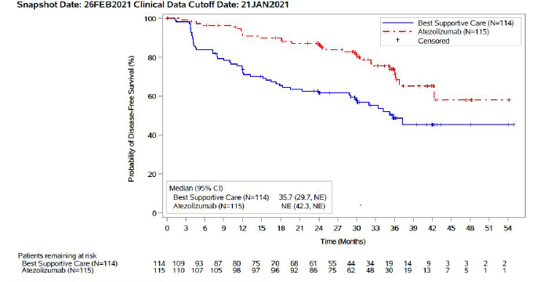
Source: IMpower010 CSR, Figure 7, p78
DFS = disease free survival; NSCLC = non-small cell lung cancer; ITT = intention to treat
  - For DFS in the Stage II-IIIA PD-L1 ≥ 50% NSCLC subgroup (data cut-off January 2021), treatment with ATZ was associated with a 53% reduction in the hazard of disease recurrence or death compared to BSC that was statistically significant (stratified HR=0.47; 95% CI: 0.29, 0.75; p-value=0.0012). The KM estimated median DFS was not reached in the ATZ arm and was 35.7 months in the BSC arm. The difference in DFS rates at 3 years was approximately 25% which was statistically significant, despite the smaller sample size. The KM curves appear to have separated at approximately 4 months in favour of the ATZ treatment arm.
  - Table 7 summarises OS results for the Stage II-IIIA PD-L1 ≥1% NSCLC subgroup.
Table 7: IMpower010 – Secondary analysis of OS in the Stage II-IIIA PD-L1 ≥1% NSCLC subgroup
 | ATZ  N=248 | BSC  N=228
Patients with event n (%) | 42 (16.9) | 48 (21.1)
Median OS, months, (95% CI) | NE (NE, NE) | NE (NE, NE)
Stratified HR (95% CI) | 0.77 (0.51, 1.2)
Event free rate at 3 years, % | 82.0 | 78.5
Absolute difference in event free rate %, (95%CI) | 3.5 (-4.3, 11.3)
Source: IMpower010 CSR, Table 27, p86.
ATZ = atezolizumab; BSC = best supportive care; NSCLC = non-small cell lung cancer; OS = overall survival; NE = not estimable (not reached).
Data cut-off January 2021.
PD-L1 tumour expression status by SP263 IHC assay; Median OS are Kaplan-Meier estimates; 95% CIs for the median are computed using the method of Brookmeyer and Crowley; hazard ratios were estimated by Cox regression; stratification factors: stage (IB/II vs. IIIA), sex (female vs. male), histology (squamous vs. non-squamous).
Figure 5: Kaplan-Meier plot of OS in Stage II-IIIA PD-L1≥1% NSCLC subgroup from IMpower010
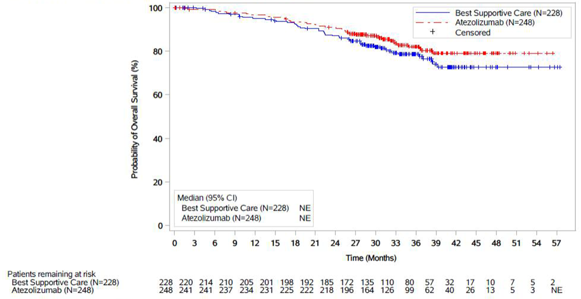
Source: IMpower010 CSR, Figure 10, p 87
NSCLC = non-small cell lung cancer; OS = overall survival; NE = not estimable (not reached)
January 2021 data cut-off

  - For OS in the Stage II-IIIA PD-L1 ≥1 % NSCLC subgroup (January 2021 data cut-off), data were immature with a low number of deaths across the ATZ (16.9%) and BSC (21.1%) arms. The stratified HR was 0.77 (95% CI: 0.51, 1.17). The median OS duration was not reached in either arm.
  - The OS results in the Stage II-IIIA PD-L1 1-49% and PD-L1 ≥ 50% expression subgroups are summarised in Table 8. The OS survival data were immature as of the January 2021 data cut-off (provided in the submission) with a low number of deaths having occurred across the ATZ and BSC arms for the PD-L1 1-49% (23.3% and 19.3%, respectively) and the PD-L1 ≥ 50% (9.6% and 22.8%, respectively) subgroups. The median duration of OS was not reached for both arms in either of the subgroups.
Table 8: Results of OS in Stage II-IIIA PD-L1 1-49% and PD-L1 ≥ 50% subgroups from IMpower010
 | January 2021 data cut off |  | April 2022 data cut off
 | ATZ | BSC | ATZ | BSC
Stage II-IIIA PD-L1 1-49% NSCLC subgroup
 | N=133 | N=114 | Not reported
Patients with event n (%) | 31 (23.3) | 22 (19.3)
Median OS, months, (95% CI) | NE (NE, NE) | NE (NE, NE)
Stratified HR (95% CI); log-rank p-value | 1.17 (0.67, 2.03); p=0.580
Event free rate at 3 years, % | 74.0 | 80.4
Absolute difference in event free rate %, (95% CI) | -6.4 (-18.1, 5.2)
Stage II-IIIA PD-L1 ≥ 50% NSCLC subgroup
 | N=115 | N=114 | N=115 | N=114
Patients with event n (%) | 11 (9.6) | 26 (22.8) | 16 (13.9) | 32 (28.1)
Median OS, months, (95% CI) | NE (NE, NE) | NE (NE, NE) | NE (NE, NE) | NE (NE, NE)
Stratified HR (95% CI); log-rank p-value | 0.40 (0.20, 0.81); p=0.009 |  | 0.47 (0.25, 0.86); p=0.0126
Event free rate at 3 years, % | 90.9 | 76.7 | 89.1 | 77.8
Absolute difference in event free rate %, (95% CI) | 14.3 (4.2, 24.4) |  | 11.3 (1.56, 21.1)
Event free rate at 5 years, % | - |  | 85.1 | 68.7
Absolute difference in event free rate %, (95% CI) | - |  | 16.4 (4.86, 28.0)
Source: IMpower010 CSR, p386 and the TGA Delegate’s Overview for atezolizumab, Figure 15, p36 (PM-2021-02705-1-4), IMpower010 interim OS results.pdf provided with pre-PBAC response.
ATZ = atezolizumab; BSC = best supportive care; NSCLC = non-small cell lung cancer; OS = overall survival; NE = not estimable (not reached); PD-L1 = programmed cell death Ligand 1; TGA = Therapeutic Goods Administration
PD-L1 tumour expression status by SP263 IHC assay; Median OS are Kaplan-Meier estimates; 95% CIs for the median are computed using the method of Brookmeyer and Crowley; Hazard ratios and absolute differences for ATZ versus BSC and corresponding 95% CIs are rounded to two decimal places. HR was estimated by Cox regression; stratification factors: stage (II vs. IIIA), sex (female vs. male), and histology (squamous vs. non-squamous).
  - Based on a data cut-off of January 2021, in the PD-L1 ≥ 50% expression subgroup, the reduction in the hazard of death associated with ATZ compared with BSC was 60% which was statistically significant (HR=0.40; 95% CI: 0.20, 0.81; p-value=0.009). However, in the PD-L1 1-49% expression subgroup, the HR was 1.17 (95% CI: 0.67, 2.03; p-value=0.580) with numerically more patients having died in the ATZ arm (23.3%) than in the BSC arm (19.3%). The TGA Delegate noted that although the data is immature, a potential detrimental treatment effect associated with ATZ in the PD-L1 1-49% expression subgroup cannot be excluded (page 4, TGA Delegate’s Overview).
  - The pre-PBAC response provided the first pre-specified interim analysis for OS from IMpower010 which provided an additional 13.1 months of follow-up (clinical cut-off 18 April 2022; median follow up: 45.3 months) compared to the primary analysis presented in the submission (clinical cut-off 21 January 2021; median follow-up: 32.2 months). This interim analysis was limited to an OS update only. The updated results showed that OS continues to mature in favour of atezolizumab in all three primary analysis populations. The pre-PBAC response noted that clinically meaningful OS benefit continued to be observed from atezolizumab treatment in the resected PD-L1 ≥50% stage II-IIIA NSCLC population. The Kaplan-Meier curves begin to separate at approximately 4 months after randomisation (corresponding to the first scheduled tumour assessment) and continue to separate thereafter in favour of atezolizumab (Figure 7).
Figure 6: Kaplan-Meier plot of overall survival in the PD-L1 ≥50% stage II-IIIA NSCLC subgroup from IMpower010 (data cut-off April 2022)

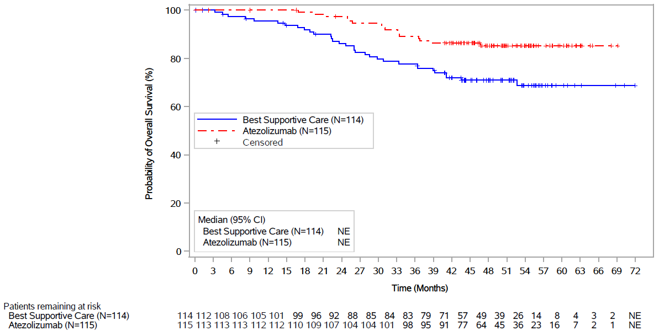

Source: IMpower010 interim OS results.pdf
Data cut-off January 2021. Median OS are based on Kaplan-Meier estimates; NSCLC = non-small cell lung cancer; NE = not estimable (not reached); PD-L1 = programmed cell death Ligand 1

Comparative harms
  - Overall adverse events (AEs) from IMpower010 are summarised in Table 9.
Table 9: Overview of adverse events and deaths in IMpower010
Number of patients with | Number of patients |  | RR, (95% CI) | RD, % (95% CI)
Number of patients with | ATZ (N=495) | BSC (N=495) | RR, (95% CI) | RD, % (95% CI)
At least one adverse event, n, (%) | 459 (92.7) | 350 (70.7) | 1.31 (1.23, 1.40) | 22 (17, 27)
At least one, n, (%):  Grade ≥3 adverse eventª | 116 (23.4) | 60 (12.1) | 1.93 (1.45, 2.57) | 11 (7, 16)
Serious adverse event | 87 (17.6) | 42 (8.5) | 2.07 (1.46, 2.93) | 9 (5, 13)
Adverse event leading to treatment discontinuation | 90 (18.2) | NA | NC | 18 (15, 22)
At least one, n, (%):  Treatment-related adverse event | 335 (67.7) | NA | NC | 68 (64, 72)
Treatment-related grade ≥3 adverse event^{b} | 57 (11.5) | NA | NC | 12 (9, 14)
Treatment-related serious adverse event | 37 (7.5) | NA | NC | 7 (5,10)
Source: Modified from Table 2.18, p44 of the submission.
ATZ = atezolizumab; BSC = best supportive care; NA = not applicable (BSC); NC = not calculable; RR = relative risk (estimates above 1 favours BSC); RD = risk difference (estimates above zero favours BSC).
Safety evaluable population.
ª Grade 3-4 events plus grade 5 events (AE with fatal outcome);
^{b} Drug related grade 3-4 AEs plus drug related AEs with fatal outcome
  - The proportion of patients with at least one AE was higher in the ATZ arm (92.7%) than in the BSC arm (70.7%). The frequency of AEs was approximately two-fold with ATZ compared with BSC for Grade ≥3 AEs (23.4% vs. 12.1%) and serious adverse events (SAEs: 17.6% vs. 8.5%). ATZ-related AEs (67.7%) included Grade ≥3 AEs (11.5%), SAEs (7.5%), AEs leading to discontinuation (10.5%) or dose modification/interruption (11.7%).
  - The most common ATZ-related AEs were hypothyroidism (10.7%), pruritus (8.7%), rash (8.1%), and increased aspartate aminotransferase (AST (7.5%)) and alanine aminotransferase (ALT (7.3%)) levels.
  - The majority of adverse events of special interest (AESIs) were of Grade 1-2 severity. Frequencies were substantially higher in the ATZ versus BSC arms for any Grade 3-4 AESI (7.9% vs. 0.6%), any grade rash (18.4% vs. 1.4%), hepatitis (diagnosis and laboratory abnormalities: 17.4% vs. 4.4%), and hypothyroidism (17.4% vs. 0%). There were two patients with fatal (Grade 5) AESIs (myocarditis and interstitial lung disease (ILD)) reported for the ATZ arm.

Benefits/harms
  - A summary of the comparative benefits and harms for ATZ compared with BSC is presented in Table 10.
Table 10: Summary of comparative benefitsª and harms
 | ATZ  1,200 mg every three weeks.  Median exposure 10.4 months (safety population) | BSC
Median duration of follow up across both arms: approximately 32 months.
Stage II-IIIA PD-L1 ≥ 50% NSCLC subgroup (January 2021 data cut-off)
BENEFITS: DFS
 | N=115 | N=114
Events (recurrence or death), n (event rate per 100 patients, %) | 28 (24.3) | 52 (45.6)
Median DFS duration, months (95% CI) | NE (42.30, NE) | 35.7 (29.70, NE)
Stratified HR (95% CI); p-value | 0.47 (0.29, 0.75); p-value=0.0012
DFS rate at 3 years, % | 73.8 | 48.6
Difference between ATZ and BSC, %, (95% CI) | 25.2 (11.0, 39.4)
BENEFITS: OS
 | N=115 |  | N=114
Patients with event n (%) | 11 (9.6) |  | 26 (22.8)
Median OS, months, (95% CI) | NE (NE, NE) |  | NE (NE, NE)
Stratified HR (95% CI); log-rank p-value | 0.40 (0.20, 0.81); p=0.009
Event free rate at 3 years, % | 90.9 |  | 76.7
Difference between ATZ and BSC, %, (95% CI) | 14.3 (4.2, 24.4)
HARMS: (event rate per 100 patients), Safety evaluable population
 | N=495 | N=495
With drug related Grade 3-5 AEs, n (%) | 57 (11.5) | NA
Difference between ATZ and BSC | 11.5%
With drug related serious AEs, n (%) | 37 (7.5) | NA
Difference between ATZ and BSC | 7.5%
Any AESI, Grade 3-4, n (%) | 39 (7.9) | 5 (0.6)
Difference between ATZ and BSC | 7.3%
Source: Section 2.5.2 of the submission and Section 5.2 of the IMpower010 Clinical Study Report.
ATZ = atezolizumab; BSC = best supportive care; CI = confidence interval; HR = hazard ratio; n = number of patients; NA = not applicable as arm is BSC; NE = not estimable (not reached); OS = overall survival; DFS = Disease free survival; AEs = adverse events; AESI = adverse events of special interest
ª Overall survival data remain immature at the data cut-off date January 2021 and thus only DFS is presented.
Bolded results are statistically significant
Median duration of follow up approximately 32 months.
  - On the basis of the direct evidence from IMpower010 (data cut-off 21 January 2021; median follow up of approximately 32 months), for every 100 patients treated with ATZ 1,200 mg Q3W in comparison with BSC alone:
- In the Stage II-IIIA PD-L1 ≥ 50% NSCLC subgroup, 25 additional patients will remain disease free at 3 years and 14 additional patients would be alive.
- Approximately 12 additional patients will experience a Grade 3-5 drug-related AE, 8 additional patients will experience a serious drug-related AE, and 7 additional patients will experience a Grade 3-4 AESI.

Clinical claim
  - The submission described ATZ as superior in terms of effectiveness and inferior in terms of safety compared to observation (BSC).
  - Notably, there was potential underutilisation of immunotherapy in the BSC arm of IMpower010. Treatment switching from BSC to ATZ was not permitted per protocol. For the Stage II-IIIA PD-L1 ≥ 1% subgroup in IMpower010 (data cut-off 21 January 2021), a total of 73 patients in the ATZ arm and 102 patients in the BSC experienced disease recurrence. Of patients who experienced disease recurrence, 11% of patients in the ATZ arm and 35% of patients in the BSC arm received subsequent immunotherapy. This potential underutilisation of immunotherapy upon disease recurrence in the BSC arm suggests there might be an overestimation of the incremental OS benefit associated with adjuvant ATZ, as compared to what would occur in Australian clinical practice. The ESC noted similar data regarding subsequent treatment with immunotherapy for the PD-L1 ≥ 50% population was not provided with the submission.
  - For DFS, the claim of superior effectiveness for the PD-L1 ≥ 1% subgroup was only partially supported. The data from IMpower010 suggested that the observed DFS benefit associated with ATZ versus BSC, in the Stage II-IIIA PD-L1 positive NSCLC patient population, was likely driven by the benefit in patients whose tumours had high PD-L1 expression (≥ 50% of tumour cells). The ESC considered a claim of super effectiveness for the PD-L1 ≥ 50% subgroup would likely be supported.
  - The PBAC considered that the claim of superior comparative effectiveness in the population of patients with PD-L1 ≥ 50% was reasonable and adequately supported by the data.
  - The PBAC considered the claim of inferior safety was reasonable. However, most AESI were of low grade and the safety data were consistent with the known safety profile for ATZ.

Economic analysis
  - The submission presented a stepped economic evaluation based on the key trial IMpower010 and implemented a modelled evaluation comparing adjuvant ATZ versus BSC for treatment of patients with Stage II-IIIA, PD-L1 positive NSCLC, following complete resection and platinum-based chemotherapy. The base case economic evaluation included patients with Stage II-IIIA, PD-L1 ≥ 1% NSCLC. A scenario analysis was performed including patients with Stage II-IIIA, PD-L1 ≥ 50% NSCLC, which the ESC noted is relevant given the final TGA indication is likely to restricted use of ATZ to this subgroup. The ESC noted the structural issues and points of uncertainty that applied to the PD-L1 ≥ 1% group also applied to the ≥ 50% group, but the ICER is relatively more favourable in the latter. The key components of the economic evaluation are summarised in Table 11.
Table 11: Summary of model structure, key inputs and rationale
Component | Summary
Treatments | Adjuvant atezolizumab vs. best supportive care
Outcomes | LYs gained and QALYs gained
Time horizon | 25 years in the model base case vs. median follow-up of 32.2 months in Trial IMpower010
Methods used to generate results | Markov model
Health states | Five health states: disease-free survival, locoregional recurrence (LRR), first-line distant recurrence (1L DR), second-line distant recurrence (2L DR), and death
Cycle length | 1 week
Transition probabilities | IMpower010 was the data source for the transition probabilities from DFS to LRR, from DFS to 1L DR and from DFS to death in the early stage NSCLC setting.  The transition probabilities from LRR to 1L DR were sourced from Nakamichi 2017.  Three other immunotherapy studies (KN189, IMpower150 and OAK) were used to estimate the transition probabilities for NSCLC distant recurrence (e.g. from 1L DR to 2L DR, from 1L DR to death and from 2L DR to death).  Australian age-specific background mortality from ABS Life Tables was also taken into account in the economic model.
Extrapolation method | The DFS curves from the IMpower010 trial were extrapolated from 32.2 months, using an independent log-logistic distribution. The submission stated that an adjustment for time limited treatment effect was applied to the economic model by assuming that the treatment effect of atezolizumab over BSC decreased linearly between Year 5 and Year 10. Then an adjustment for sustained DFS was applied by assuming that the proportion of “cured” patients (i.e. no disease recurrence) increased linearly from Year 2 to a maximum of 91.5% in Year 5. Neither of these adjustments was well justified (see detailed discussion below).  The submission assumed that the per cycle transition probabilities between the post-DFS health states (i.e. LRR, 1L DR, 2L DR and death) would be constant over the entire time horizon.
Health related quality of life | The submission assumed identical utilities between the two treatment arms in each health state. The health state utilities were derived from the literature.  DFS: 0.81 (Grutters 2010)  LRR: 0.72 (Grutters 2010)  1L DR: 0.69 (KN189)  2L DR: 0.667 (OAK)
Source: Table 3.2, pp64-65 and Table 3.9, p83 of the submission.
BSC = best supportive care; LY = life year; NSCLC = non-small cell lung cancer; QALY = quality-adjusted life year
  - The economic model assumed a 25-year time horizon. This was longer than the time horizon used in the durvalumab economic models (10 years in the model base case vs. 50 months in the key PACIFIC trial) for the treatment of Stage III unresectable NSCLC after platinum-based chemoradiation therapy, which represents a more advanced disease stage than the proposed indication for ATZ (Durvalumab public summary documents (PSDs), November 2018 and July 2019 PBAC meetings). The Pre-Sub-Committee Response (PSCR) stated that for a more advanced disease setting, such as that modelled in the durvalumab submission, a shorter time horizon would suffice to reflect the shorter lifetime time horizon expected in patients with incurable disease. The ESC considered a better prognosis might justify a longer time horizon, but less clinical data makes the extrapolation more uncertain.
  - Although a lifetime time horizon allows capturing differences between adjuvant ATZ and BSC with regard to costs and outcomes incurred throughout the disease course of early stage NSCLC after complete resection and platinum-based chemotherapy, the trial data did not provide a reliable basis for a long-term extrapolation. Around 92% of the incremental quality-adjusted life years (QALYs) between the treatment arms accumulated during the extrapolation period; whilst the incremental costs dropped during this period, primarily due to the cumulative cost savings from treatment in the first-line distant recurrence (1L DR) setting (chemotherapy in the ATZ arm vs. 80% pembrolizumab + chemotherapy and 20% chemotherapy in the BSC arm). The time horizon is a key driver of the result favouring ATZ. The PBAC agreed with ESC that, based on the duration of follow-up in the clinical trials and the extent of extrapolation required, a 15 year time horizon was more reasonable in this population.
  - The DFS curves from the Stage II-IIIA, PD-L1 ≥ 1% subgroup of IMpower010 were used in the economic model. As the locoregional recurrence (LRR) and 1L DR survival curves in IMpower010 were not available, the transition probabilities from DFS to LRR and from DFS to 1L DR at each model cycle were calculated by applying the split of LRR events versus 1L DR events in patients who experienced disease recurrence, as reported in IMpower010, to the per cycle transition probabilities of disease recurrence (based on the DFS curves). The submission effectively assumed a constant probability of LRR events versus DR events in patients having disease recurrence throughout the entire model time horizon, no matter how long the patients stayed in the DFS health state or whether the patients were on or off adjuvant ATZ. The submission did not provide clinical evidence to support is assumption.
  - DFS was extrapolated from the pooled median follow-up in IMpower010, i.e. 32.2 months. This was the median follow-up in the ITT population whereas the modelled population was the subgroup of patients with Stage II-IIIA, PD-L1 ≥ 1% patients. The PBAC guidelines (version 5.0) recommends use of observed time-to-event data in preference to modelled data up to the time point at which the observed data become unreliable as a result of small numbers of patients remaining event-free. Visual inspection of the DFS curves for the Stage II-IIIA, PD-L1 ≥ 1% subgroup (Figure 1) suggests that there were still reasonable number of patients at risk between Month 33 and Month 37 (e.g. at Month 36: n = 38 in the ATZ arm and n = 54 in the BSC arm); thereafter, the Kaplan-Meier curves became flat. The PSCR stated the median follow-up in the population of patients with PD-L1 ≥ 1% was 32.84 months and using this as the extrapolation time point made minimal difference to the incremental cost effectiveness ratio (ICER). The ESC noted there remained a sufficient number of patients at risk (10% of the cohort) for a truncation point of 37 months to be considered appropriate. The ESC noted the use of the later truncation point increased the ICER from $15,000 to < $25,000/ QALY to $25,000 to < $35,000/ QALY.
  - The selection of an independent log-logistic parametric function to extrapolate DFS in the base case was based on the goodness of fit statistics, graphical inspection and assessment of clinical plausibility. This was reasonable.
  - The economic model assumed that the treatment effect of ATZ versus BSC would decrease linearly between Year 5 and Year 10. The submission stated that “a correction for a time limited treatment effect is applied so that the modelled DFS curves converge from a defined time point in the economic evaluation”. This assertion was incorrect. Based on the Kaplan-Meier DFS estimates followed by independent log-logistic extrapolation, the DFS survival probability for ATZ at each weekly cycle after Month 57 was lower than that for BSC. The submission’s method of adjusting the treatment effect from Year 5 to Year 10 resulted in a divergence, not convergence, of the DFS curves of the two treatment arms.
  - The economic model allowed the proportion of patients in the DFS health state who are “cured” (i.e. achieving sustained DFS) to increase linearly from Year 2 to a maximum 91.5% at Year 5. The maximum cure rate of 91.5% was based on the clinical studies where the majority of the participants had Stage I NSCLC before resection, and so were outside the proposed PBS population (78% in Maeda 2010 and 53% in Sonoda 2019). An early disease stage is a good prognostic factor for disease recurrence. In addition, in Sonoda 2019, the cause of death was not clear in 169 cases (12% of the study patients). The authors acknowledged that there was a possibility that recurrence developed in these cases and was overlooked. Overall, while the rationale for the adjustment for sustained DFS appeared reasonable, the time point when the patients achieving sustained DFS and the magnitude of the change in the proportion of patients with sustained DFS over time were not well justified by the submission. The ESC noted the study by Sonoda et al 2019 reported that 6% and 2.5% of recurrences occur at 5-10 years, and 10+ years, respectively, in patients with NSCLC who underwent curative resection and systematic lymph node dissection. The ESC considered it was uncertain if this data supported 91.5% being cured at 5 years.
  - The ESC noted the comparison of the trial-based DFS, parametric extrapolated DFS and modelled DFS after adjustments for time limited treatment effect and for sustained DFS (without incorporating background mortality) as shown in Figure 9.

Figure 7: Modelled DFS with adjustments for time limited treatment effect and sustained remission (without incorporating background morality)
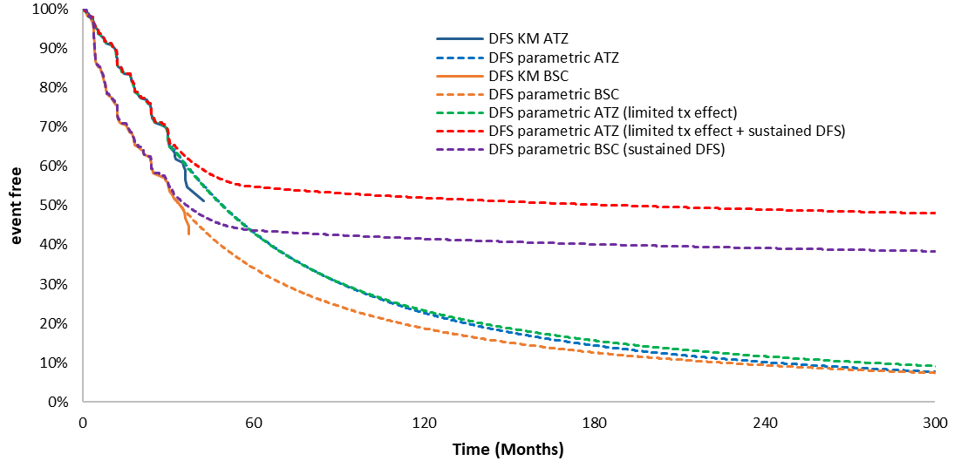
Source: Figure constructed during the evaluation, based on the “Economic Evaluation” Excel workbook.
ATZ = atezolizumab; BSC = best supportive care; DFS= disease-free survival; KM = Kaplan-Meier

  - To estimate the transition probability from DFS to death, the submission used the pooled pre-recurrence death data from IMpower010 due to lack of statistically significant difference between the ATZ group and the BSC group. As the treatment-specific pre-recurrence death probability was higher for ATZ than for BSC (weekly probability: 0.0004 vs. 0.0001), the use of a pooled value in the economic evaluation resulted in a more favourable ICER.
  - The economic model assumed that 80% of the patients in the BSC arm would receive pembrolizumab combination therapy in the 1L DR setting, with the remaining 20% treated with chemotherapy alone. Patients who had received adjuvant ATZ were allocated the outcomes of the KN189 chemotherapy only treatment arm since PBS listed PD-(L) inhibitors can only be accessed once in a lifetime for a patient with NSCLC. The assumption of a high proportion of patients receiving pembrolizumab combination therapy for metastatic NSCLC in the BSC arm was in line with previous PBAC advice for NSCLC treatments (paragraph 7.4, tepotinib PSD, November 2021 PBAC meeting).
  - The transition probabilities between post-DFS health states, e.g. LRR to 1L DR, 1L DR to second-line distant recurrence (2L DR) and 1L DR or 2L DR to death, were based on external studies, including Nakamichi 2017, KN189, IMpower150 and OAK. There were transitivity issues between the populations of these trials and the proposed patient population, in terms of PD-L1 positivity (regardless of PD-L1 expression level vs. PD-L1 ≥ 1%), tumour histology (non-squamous vs. all NSCLC histologies) and/or other factors which might affect the health outcomes in the post-DFS health states. The results reported in these clinical trials might not be applicable to the requested PBS population. In addition, the submission assumed time constant transition probabilities between the post-DFS health states throughout the time horizon. No evidence has been provided by the submission to justify this assumption. Costs and health outcomes in the 1L DR health state varied by model arm as pembrolizumab combination therapy was assumed to be used in 80% of the patients in the BSC arm who experienced metastatic recurrence, whilst use of adjuvant ATZ was assumed to preclude use of any PD-(L)1 inhibitors in the 1L DR setting. A comparison of the PFS Kaplan-Meier curves from KN189 with the modelled 1L DR to 2L DR curves showed a poor fit of the parametric distribution for the pembrolizumab + chemotherapy arm. The modelled survival estimates were generally lower than the trial data. The ESC noted that this, in addition to the other issues in the submission’s approach to model metastatic recurrences, resulted in a scenario where pembrolizumab combination therapy was not cost-effective with an ICER over $95,000 to < $115,000/QALY. This influenced the ICER in favour of ATZ over BSC in the NSCLC adjuvant setting.
  - Markov traces of the proportion of patients in the DFS health state and alive over time are presented in Figure 8. The Markov traces of LRR, 1L DR and 2L DR in the ATZ arm and in the BSC arm are presented in Figure 9. Time spent in the DFS state was the key driver of the clinical benefit in the model. It was noted that the modelled 5-year OS in the BSC arm (57%) was substantially greater than the 5-year survival of 32.3% (95% CI: 28.5%, 36.2%) for Stage II lung cancer in 2011-2016 as published by the Australian Institute of Health and Welfare (AIHW). Although some improvement would be expected (due to the availability of PD-(L)1 inhibitors for treatment of distant recurrence), the submission’s modelled survival estimates might be optimistic.
Figure 8: Modelled DFS and OS for patients treated with adjuvant ATZ and BSC
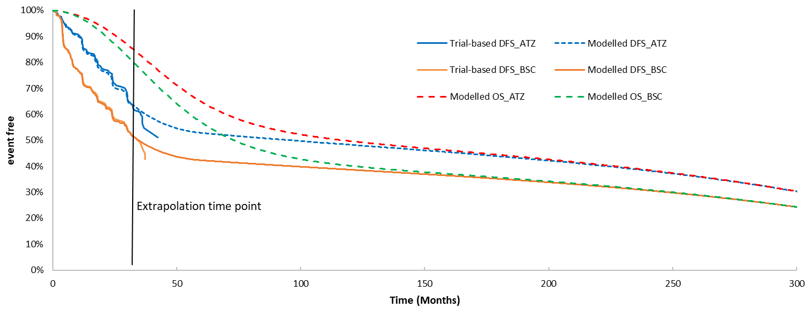
Source: Revised from Figure 3.8, p91 of the submission.
ATZ = atezolizumab; BSC = best supportive care; DFS = disease-free survival; OS= overall survival.

Figure 9: Modelled LRR, 1L DR and 2L DR health states for patients treated with adjuvant ATZ and BSC
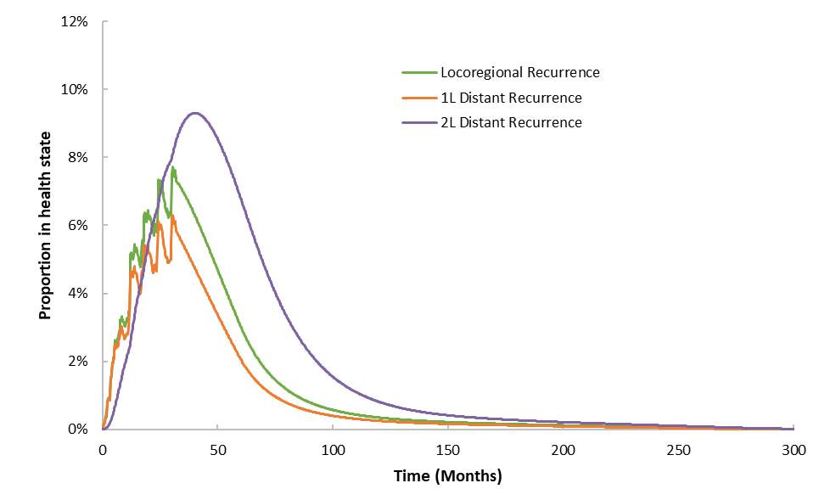 | 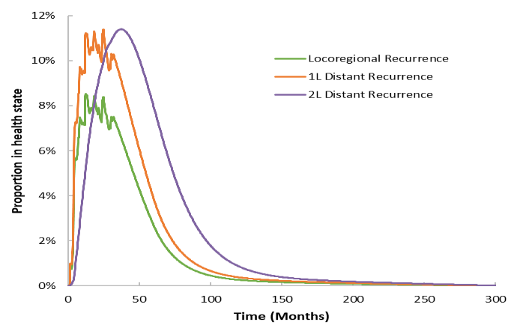
- ATZ | - BSC
Source: Revised from Figure 3.9, p92 of the submission.
1L DR = first-line distant recurrence; 2L DR = second-line distant recurrence; ATZ = atezolizumab; BSC = best supportive care

  - The health state utilities applied to the economic model and their sources are summarised in Table 12. As the key trial IMpower010 did not collect patient-reported outcomes, the health state utility values were derived from external studies. The utility value of 0.81 for DFS from Grutters 2010 represented the median utility score in subgroups with a better quality of life (e.g. patients without severe AEs and patients with Stage I disease at initial diagnosis). The median LRR utility reported in this study was 0.74, not 0.72 as used in the submission. It was also noted that the 1L DR utility value applied to the economic model (0.69) was effectively the utility value in patients who experienced disease progression after first-line therapy for metastatic NSCLC (i.e. 2L DR setting) as reported in KN189. The higher utility value for PFS (i.e. 1L DR setting) reported in KN189 compared with the utilities for Stage II NSLCLC and for LRR from Grutters (2010) (0.765 vs. 0.76 and 0.74) was incongruent with the expected relative values for these health states. This implied that the data sources for health state utility estimates used in the model may not be reasonable. However, the results from sensitivity analysis indicated that the change in health state utility values did not affect the result greatly. AE-related disutilities were not taken into account in the economic model. This had a minimal impact on the result, given the low incidence of the ATZ-related AEs of Grade 3-4 and the short duration of the AEs in comparison with the mean time in the DFS health state (12.1 years (undiscounted) in the ATZ arm).
Table 12: Utility values used in the economic evaluation
Health state | Utility | Source of estimate
Disease free survival | 0.810 in both arms | Grutters 2010
Locoregional recurrence | 0.720 in both arms | Grutters 2010
First-line distant recurrence | 0.690 in both arms | KN189 trial, Huang 2018
Second-line distant recurrence | 0.667 in both arms | OAK trial, Roche data on file
Source: Table 3.9, p83 of the submission
  - A summary of the key drivers of the model is given in Table 13.
Table 13: Key drivers of the model
Description | Method/Value | Impact  Base case: $|¹/QALYª
Time horizon | Model adopted a 25-year time horizon. | Moderate, favoured ATZ.  Time horizon of 15 years, increased the ICER to $||||²/QALY
Extrapolation time point | 32.2 months | Moderate, favoured ATZ  Trial data extrapolated from 37 months, the ICER increased to $||||²/QALY
Adjustment for sustained DFS | Proportion of patients with sustained DFS started to increase from Year 2 and achieve maximum of 91.5% at Year 5 | Moderate, favoured ATZ  Without adjustment for sustained DFS, the ICER increased to $||||²/QALY  Maximum 75% achieving sustained DFS, the ICER increased to $||||¹/QALY  Proportion of patients with sustained DFS started to increase from Year 4 and achieved the maximum at Year 10, the ICER increased to $||||²/QALY
Use of pembrolizumab combination therapy in 1L DR setting^{b} | 80% of patients who experienced distant recurrence in the BSC arm (20% on chemotherapy) and 0% in the ATZ arm (100% on chemotherapy) | Moderate-high, favoured ATZ  60% use of pembrolizumab combination therapy in the 1L DR setting after BSC, the ICER increased to $||||²/QALY  0% use of pembrolizumab combination therapy in the 1L DR setting after BSC, the ICER increased to $||||³/QALY
Source: Compiled during the evaluation, based on Section 3.9 of the submission and the sensitivity analyses performed during the evaluation
1L DR = first-line distant recurrence; DFS = disease-free survival; ICER = incremental cost-effectiveness ratio; QALY = quality-adjusted life year
ª The economic evaluation results presented in this table are the revised results after correcting the following the errors identified during the evaluation (see the table notes under Table 14).
^{b} Assuming the effective price of pembrolizumab with a | |% rebate off the published ex-manufacturer price
The redacted values correspond to the following ranges:
¹ $15,000 to < $25,000
² $25,000 to < $35,000
³ $35,000 to < $45,000

  - The results of the stepped economic evaluation presented in the submission are summarised in Table 14. A number of errors were identified during the evaluation in the submission’s model Excel workbook (see table notes under Table 14) and revised results are presented in the table.
Table 14: Results of the stepped economic evaluation (base case, Stage II-IIIA PD-L1 ≥ 1% NSCLC)
Step and component | Atezolizumab | Best supportive care | Increment
Step 1: trial-based costs and outcomes (42.3 months)
Costs | $| | $18,080 | $|
LYG | 2.455 | 2.407 | 0.047
Incremental cost/LYG |  |  | $|¹
Step 2: time horizon extrapolated to 25 years
Costs | $| | $33,400 | $|
LYG | 6.513 | 5.988 | 0.524
Incremental cost/LYG |  |  | $|²
Step 3: Applying time limited treatment effect adjustment to the DFS curves
Costs | $| | $33,400 | $|
LYG | 6.579 | 5.988 | 0.591
Incremental cost/LYG |  |  | $|³
Step 4: Applying sustained DFS adjustment
Costs | $| | $24,887 | $|
LYG | 8.712 | 7.655 | 1.056
Incremental cost/LYG |  |  | $|³
Step 5: Incorporation of MRU costs
Costs | $| | $40,990 | $|
LYG | 8.712 | 7.655 | 1.056
Incremental cost/LYG |  |  | $|³
Step 6: Incorporation of AE related costs
Costs | $| | $41,041 | $|
LYG | 8.712 | 7.655 | 1.056
Incremental cost/LYG |  |  | $|³
Step 7: Inclusion of end of life costs
Costs | $| | $42,229 | $|
LYG | 8.712 | 7.655 | 1.056
Incremental cost/LYG |  |  | $|³
Step 8: Incorporation of utility values to determine QALYs (base-case analysis)
Costs | $| | $42,229 | $|
QALYs gained | 6.950 | 6.050 | 0.900
Incremental cost/QALY gained (base case) |  |  | $|³
Source: Table compiled during the evaluation, based on Tables 3.15 to 3.21, pp93-96 of the submission.
AE = adverse event; DFS = disease-free survival; LYG = life year gained; MRU = medical resource use; NSCLC = non-small cell lung cancer; PD-L1 = programmed cell death ligand 1; QALY= quality-adjusted life year.
Notes: the following the errors were identified during the evaluation and corrected results are presented above:
1) the omission of costs in the second-line distant recurrence health state in calculating the total costs (Cells G37 and J37 in the ‘Results’ spreadsheet);
2) errors in the formulas calculating the MRU costs during the off-treatment period in the DFS health state (Cells AV9:AV2097 in both the ‘Atezolizumab’ spreadsheet and the ‘Best Supportive Care’ spreadsheet)
3) double counting the MRU costs in the DFS health state in the best supportive care arm (Cells AU9:AU2097 in the ‘Best Supportive Care’ spreadsheet);
4) referencing errors in the formulas calculating the weights of hospital admissions due to major disorders vs. hospital admissions due to minor disorders associated with management of rash and hypertension (Cells M13:M14 and Cells M19:M20 in the ‘Adverse Events Costs’ spreadsheet); and
5) referencing errors in the formulas calculating the weighted drug cost for pembrolizumab per administration (Cells K44 and K48 in the ‘Drug Doses & Acquisition Costs’ spreadsheet).
The redacted values correspond to the following ranges:
¹ $455,000 to < $555,000
² $25,000 to < $35,000
³ $15,000 to < $25,000

  - The health outcome in Step 1 (trial-based) of the economic evaluation was life year gained (LYG). The proportion of PD-L1 ≥ 1% patients with a recurrence event (excluding pre-recurrence death) during the trial observation period was 29.4% (73/248) for ATZ and 44.7% (102/228) for BSC. The cost per recurrence avoided was estimated to be $| | (=$| |/(44.7%-29.4%)) in Step 1. The proportion of PD-L1 ≥ 1% patients who died in the trial was 16.9% (42/248) for ATZ and 21.1% (48/228) for BSC. The cost per death avoided was estimated to be $| |.
  - The extension of the time horizon to 25 years (Step 2) had a significant impact on the ICER, increasing the incremental LYG from 0.047 to 0.524. Additionally, the extension of the time horizon resulted in a decrease in incremental costs from $| | to $| |, which was primarily due to the accumulated cost savings from treatment in the 1L DR setting (chemotherapy in the ATZ arm vs. 80% pembrolizumab + chemotherapy and 20% chemotherapy in the BSC arm). Applying a sustained DFS adjustment in Step 4 increased the incremental LYG from 0.591 to 1.056, accompanied by an increase in the incremental costs, but to a lesser extent. The resulting ICER reduced from $15,000 to < $25,000/LYG to $15,000 to < $25,000/LYG. The other steps did not result in remarkable changes in incremental costs and incremental LYG. Applying quality of life transformations in Step 8 increased the ICER to $15,000 to
< $25,000/QALY gained.
  - Table 15 summarises the number of LRR events, 1L DR events and deaths avoided in the economic model over the 25-year time horizon together with a comparison of the number of events avoided in the IMpower010 trial.
Table 15: Average events per patient in the trial versus the economic model (Stage II-IIIA, PD-L1 ≥ 1% NSCLC)
 | IMpower010  (median follow-up of 32.2 months) |  |  | Economic model  (time horizon of 25 years)
 | ATZ | BSC | Difference | ATZ | BSC | Difference
Any recurrence (from DFS) | 29.4% (73/248)ª | 44.7% (102/228)ª | -15.3% | 47.4%^{i} | 57.6%^{i} | -10.3%
LRR events | 14.5% (36/248)ª | 19.7% (45/228)ª | -5.2% | 23.4%^{e} | 25.4%^{e} | -2.1%
1L DR events | 14.9% (37/248)^{a,b} | 25.0% (57/228)^{a,b} | -10.1% | 46.9%^{f} | 57.4%^{f} | -10.5%
Deaths | 16.9% (42/248)^{c} | 21.1% (48/228)^{c} | -4.2% | 69.6%^{g} | 75.7%^{g} | -6.0%
Life years (undiscounted) | 2.556^{d} | 2.505^{d} | 0.051 | 13.184^{h} | 11.310^{h} | 1.874
Source: Table compiled during the evaluation, based on the “Economic Evaluation” Excel workbook”
1L DR = first-line distant recurrence; ATZ = atezolizumab; BSC = best supportive care; DFS = disease-free survival; LRR = locoregional recurrence; NSCLC = non-small cell lung cancer; PD-L1 = programmed cell death ligand 1
ª Data derived from Cells C12:D18 in the ‘Transition Inputs’ spreadsheet
^{b} Only including patients transitioning from DFS directly to 1L DR. Data on the number of 1L DR events from LRR during the trial period of IMpower010 were not available.
^{c} Data sourced from Table 2.17, p43 of the submission.
^{d} Mean life years: Cells G14 and J14 in the ‘Results’ spreadsheet, after changing Cell D5 ‘Results’ (step selection) into “Step 1’ and Cell E9 ‘Model Inputs’ (discounting rate for health outcomes) into 0%.
^{e} Sum(U9:U1313) in the ‘Atezolizumab’ spreadsheet or in the ‘Best Supportive care’ spreadsheet (accumulated transitions from DFS to LRR)
^{f} Sum(T9:T1313)+Sum(X9:X1313) in the ‘Atezolizumab’ spreadsheet or in the ‘Best Supportive care’ spreadsheet (accumulated transitions from DFS to 1L DR plus accumulated transitions from LRR to 1L DR)
^{g} Cell AD1313 in the ‘Atezolizumab’ spreadsheet or in the ‘Best Supportive care’ spreadsheet (cumulative death at Cycle 1304 (= end of 25-year time horizon))
^{h} Mean life years: Cells G14 and J14 in the ‘Results’ spreadsheet, after changing Cell D5 ‘Results’ (step selection) into “Step 8’ and Cell E9 ‘Model Inputs’ (discounting rate for health outcomes) into 0%.
^{i} Sum(T9:T1313)+Sum(U9:U1313) in the ‘Atezolizumab’ spreadsheet or in the ‘Best Supportive care’ spreadsheet (accumulated transitions from DFS to LRR plus accumulated transitions from DFS to 1L DR). Of note, in the economic model, any recurrence is not the sum of LRR and 1L DR, as patients who experience a LRR could later develop a 1L DR.
  - The proportion of patients who experienced a LRR event in the ATZ arm increased from 14.5% in IMpower010 (median follow-up of 32.2 months) to 23.4% by the end of the 25-year time horizon. The corresponding proportion in the BSC arm increased from 19.7% in the trial to 25.4% in the economic model. The absolute difference between the two treatment arms was smaller at the end of the model time horizon than in the trial because over time a higher proportion of patients transitioned from DFS to LRR in the ATZ arm, compared with the BSC arm, due to a higher proportion of patient at risk (i.e. remaining in DFS) (Figure 8). The results of 1L DR events between the trial and the model were difficult to interpret, as IMpower010 only provided the number of patients transitioning from DFS to 1L DR; and the trial data on the number of patients developed DR via LRR following adjuvant ATZ and BSC were not available. The proportion of patients who died increased from 16.9% to 69.6% in the ATZ arm and from 21.1% to 75.7% in the BSC arm during the extrapolation period. A comparison of the trial results and the model results suggested that the main benefit of adjuvant ATZ relative to BSC over the 25-year time horizon was delaying and preventing disease recurrence, and thus death events. The incremental LYG increased from 0.051 during the trial period to an extrapolated 1.874 at Year 25.
  - Results of univariate and multivariate sensitivity analyses specified by the submission and additional analyses conducted during the evaluation are presented in Figure 10 and Table 16.
Figure 10: Change in ICER over time (Stage II-IIIA, PD-L1 ≥ 1% NSCLC)
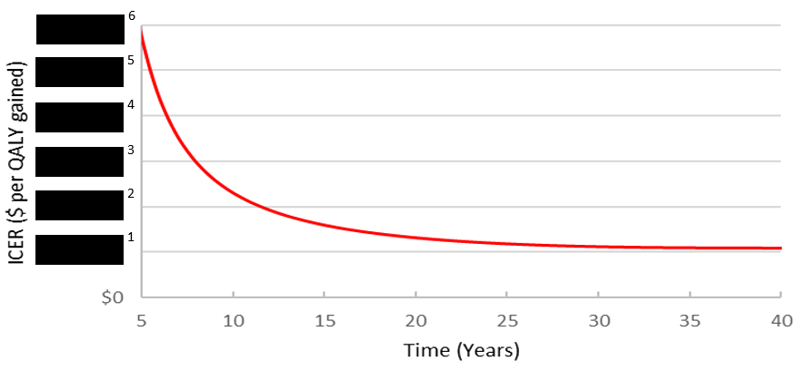
ICER = incremental cost-effectiveness ratio; NSCLC = non-small cell lung cancer; PD-L1 = programmed cell death ligand 1; QALYs = quality-adjusted life years
Source: Figure constructed during the evaluation, based on the “Economic Evaluation” Excel workbook
The redacted values correspond to the following ranges:
¹ $15,000 to < $25,000
² $35,000 to < $45,000
³ $55,000 to < $75,000
⁴ $75,000 to < $95,000
⁵ $95,000 to < $115,000
⁶ $115,000 to < $135,000

Table 16: Results of key sensitivity analyses (Stage II-IIIA, PD-L1 ≥ 1% NSCLC)ª
Sensitivity analyses |  | Base case | Incr costs | Incr QALYs | Incr cost per QALY | % change
Base case |  | – | $||| | 0.900 | $||¹ | –
SA.1 | 15-year time horizon | 25 years | $|| | 0.658 | $||² | 35%
SA.2^{b} | 20-year time horizon | 25 years | $|| | 0.804 | $||² | 11%
SA.3 | Utility values of 0.74 for DFS, 0.65 for LRR, 0.544 for 1L DR and 0.528 for 2L DR (Koide 2010 & Sari 2020) | Utility values of 0.81 for DFS, 0.72 for LRR, 0.69 for 1L DR and 0.667 for 2L DR (Grutters 2010 & KN189/OAK trials) | $|| | 0.849 | $||¹ | 6%
SA.4^{b} | Utility values of 0.76 for DFS and 0.74 for LRR (Grutters 2010)^{c} |  | $|| | 0.828 | $||¹ | 9%
SA.5 | 70% use of pembrolizumab combination therapy in the 1L DR setting after BSC | 80% | $|| | 0.914 | $||² | 10%
SA.6^{b} | 60% use of pembrolizumab combination therapy in the 1L DR setting after BSC | 80% | $|| | 0.927 | $||² | 19%
SA.7 | 0% use of pembrolizumab combination therapy in the 1L DR setting after BSC | 80% | $|| | 0.981 | $||³ | 76%
SA.8^{b} | No adjustment for time limited treatment effect | Incorporating adjustment for time limited treatment effect | $|| | 0.885 | $||¹ | 2%
SA.9^{b} | No adjustment for sustained DFS | Incorporating adjustment for sustained DFS, proportion of patients with sustained DFS starts to increase from Year 2 and achieve maximum of 91.5% at Year 5 | $|| | 0.517 | $||² | 20%
SA.10^{b} | Maximum 75% achieving sustained DFS (arbitrary value) |  | $|| | 0.800 | $||¹ | 3%
SA.11^{b} | Proportion of patients with sustained DFS starts to increase from Year 4 and achieve the maximum (91.5%) at Year 10 |  | $|| | 0.659 | $||² | 11%
SA.12^{b} | Truncation time point for trial-based DFS estimates: 33 months | 32.2 months | $|| | 0.785 | $||² | 15%
SA.13^{b} | Truncation time point for trial-based DFS estimates: 35 months | 32.2 months | $|| | 0.870 | $||¹ | 4%
SA.14^{b} | Truncation time point for trial-based DFS estimates: 37 months | 32.2 months | $|| | 0.711 | $||² | 25%
SA.15^{b} | Using treatment specific pre-recurrence death rate (weekly probability: 0.0004 for ATZ and 0.0001 for BSC) | Pooled weekly probability of 0.0003 | $|| | 0.671 | $||² | 26%
SA.8+SA.9^{b} |  |  | $|| | 0.461 | $||² | 35%
SA.2+SA.14^{b} |  |  | $|| | 0.639 | $||² | 38%
SA.2+SA.14+SA.8^{b} |  |  | $|| | 0.630 | $||² | 40%
SA.2+SA.14+SA.8+SA.9^{b} |  |  | $|| | 0.323 | $||³ | 90%
SA.2+SA.14+SA.8+SA.10+SA.11^{b} |  |  | $|| | 0.399 | $||³ | 73%
SA.2+SA.14+SA.8+SA.10+SA11+SA.15^{b} |  |  | $|| | 0.205 | $||⁴ | 199%
SA.2+SA.14+SA.8+SA.9+SA.15^{b} |  |  | $|| | 0.148 | $||⁵ | 251%
Source: Table 3.23, p98 of the submission and calculated during the evaluation.
1L DR = first-line distant recurrence; 2L DR = second-line distant recurrence; ATZ = atezolizumab; BSC = best supportive care; DFS = disease-free survival; LRR = locoregional recurrence
ª The economic evaluation results presented in this table are the revised results after correcting the following the errors identified during the evaluation:
1) the omission of costs in the second-line distant recurrence health state in calculating the total costs (Cells G37 and J37 in the ‘Results’ spreadsheet);
2) errors in the formulas calculating the MRU costs during the off-treatment period in the DFS health state (Cells AV9:AV2097 in both the ‘Atezolizumab’ spreadsheet and the ‘Best Supportive Care’ spreadsheet);
3) double counting the MRU costs in the DFS health state in the best supportive care arm (Cells AU9:AU2097 in the ‘Best Supportive Care’ spreadsheet);
4) referencing errors in the formulas calculating the weights of hospital admissions due to major disorders vs. hospital admissions due to minor disorders associated with management of rash and hypertension (Cells M13:M14 and Cells M19:M20 in the ‘Adverse Events Costs’ spreadsheet); and
5) referencing errors in the formulas calculating the weighted drug cost for pembrolizumab per administration (Cells K44 and K48 in the ‘Drug Doses & Acquisition Costs’ spreadsheet).
^{b} Sensitivity analyses performed during the evaluation.
^{c} Utilities for the other two health states, i.e. 1L DR and 2L DR, remained unchanged from the base case estimates.
The redacted values correspond to the following ranges:
¹ $15,000 to < $25,000
² $25,000 to < $35,000
³ $35,000 to < $45,000
⁴ $55,000 to < $75,000
⁵ $75,000 to < $95,000

  - Examining the relationship between the ICER and the time horizon of the model revealed that the ICER dropped substantially until levelling out at around 10 years at about $45,000 to < $55,000/QALY gained. Then the ICER decreased gradually to less than $25,000 to < $35,000/QALY gained at around 21 years.
  - The ICER was moderately sensitive to removal of the sustained remission adjustment (increasing to $25,000 to < $35,000/QALY gained) and assuming trial-based DFS truncated at a later time point (base case: 32.2 months), e.g. 37 months (increasing to $25,000 to < $35,000).
  - The model was sensitive to the change in the proportion of patients receiving pembrolizumab + chemotherapy (vs. chemotherapy alone) in the 1L DR setting for patients in the comparator BSC arm. The ICER increased by 19% if the use of pembrolizumab combination therapy reduced from 80% in the base to 60% of patients experiencing distant recurrence in the BSC arm. If the modelled non-cost-effective use of pembrolizumab combination therapy was removed from the economic evaluation (i.e. assuming 0% patients treated with pembrolizumab combination therapy for metastatic recurrence in both arms), the ICER increased by 76% to $35,000 to < $45,000 per QALY gained.
  - It is noted that there was inherent uncertainty with the assumptions and methodology the submission used to estimate the split of LRR events and DR events in patients who experienced disease recurrence, and the per cycle transition probabilities from LRR to 1L DR, from 1L DR to 2L DR, and from 1L DR or 2L DR to death over the entire time horizon. The impacts of these model inputs on the ICER cannot be fully assessed based on the available clinical evidence. Of note, the submission’s approach to model metastatic recurrences resulted in the benefits and costs of pembrolizumab combination therapy may have resulted in a more favourable ICER for ATZ versus BSC in the adjuvant setting.
Scenario analysis in patients with Stage II-IIIA, PD-L1 ≥ 50% NSCLC patients

  - The economic model was replicated to assess the cost-effectiveness of adjuvant ATZ versus BSC for treatment of Stage II-IIIA, PD-L1 ≥ 50% NSCLC patients. In this scenario analysis, changes were made in the DFS cures for ATZ and BSC, the extrapolation distribution parameters, the split of LRR versus 1L DR in patients experienced disease recurrence and death (without recurrence) rates, based on the relevant data in the Stage II-IIIA, PD-L1 ≥ 50% subgroup of IMpower010. In addition, transition inputs from 1L DR to 2L DR in patients receiving pembrolizumab combination therapy and those treated with chemotherapy alone were derived from the median PFS data from the KN-189 trial for the PD-L1 ≥ 50% patient subgroup. Other model inputs remained the same as the base case analysis. All of the uncertainties identified in the base case economic model remained in the scenario analysis of ATZ compared with BSC in patients with Stage II-IIIA, PD-L1 ≥ 50% NSCLC, except for the transitivity concern regarding the KN189 trial population and the PBS target population in terms of PD-L1 expression (regardless of PD-L1 expression level vs. PD-L1 ≥ 1% in the base case model; both PD-L1 ≥ 50% in the scenario analysis). The results of stepped economic evaluation for the Stage II-IIIA, PD-L1 ≥ 50% patient subgroup are summarised in Table 17.
Table 17: Results of the stepped economic evaluation (Stage II-IIIA, PD-L1 ≥ 50%)
Step and component | Atezolizumab | Best supportive care | Increment
Step 1: trial-based costs and outcomes (42.3 months)
Costs | $| | $| | $|
LYG | 2.518 | 2.421 | 0.097
Incremental cost/LYG |  |  | $|¹
Step 2: time horizon extrapolated to 25 years
Costs | $| | $| | $|
LYG | 7.537 | 6.354 | 1.183
Incremental cost/LYG |  |  | $|²
Step 3: Applying time limited treatment effect adjustment to the DFS curves
Costs | $| | $32,829 | $|
LYG | 7.730 | 6.354 | 1.376
Incremental cost/LYG |  |  | $|²
Step 4: Applying sustained DFS adjustment
Costs | $| | $| | $|
LYG | 10.229 | 8.065 | 2.164
Incremental cost/LYG |  |  | $|²
Step 5: Incorporation of MRU costs
Costs | $| | $| | $|
LYG | 10.229 | 8.065 | 2.164
Incremental cost/LYG |  |  | $|²
Step 6: Incorporation of AE related costs
Costs | $| | $| | $|
LYG | 10.229 | 8.065 | 2.164
Incremental cost/LYG |  |  | $|²
Step 7: Inclusion of end of life costs
Costs | $| | $| | $|
LYG | 10.229 | 8.065 | 2.164
Incremental cost/LYG |  |  | $|²
Step 8: Incorporation of utility values to determine QALYs (base-case analysis)
Costs | $| | $| | $|
QALYs | 8.204 | 6.386 | 1.818
Incremental cost/QALY gained (base case) |  |  | $|²
Source: Table compiled during the evaluation, based on Tables 3.25, p101 of the submission; the “PDL1 high_Economic Evaluation” Excel workbook.
AE = adverse event; DFS = disease-free survival; LYG = life year gained; MRU = medical resource use; PD-L1 = programmed cell death ligand 1; QALY= quality-adjusted life year.
Notes: the following the errors were identified during the evaluation and corrected results are presented above:
1) the omission of costs in the second-line distant recurrence health state in calculating the total costs (Cells G37 and J37 in the ‘Results’ spreadsheet);
2) errors in the formulas calculating the MRU costs during the off-treatment period in the DFS health state (Cells AV9:AV2097 in both the ‘Atezolizumab’ spreadsheet and the ‘Best Supportive Care’ spreadsheet)
3) double counting the MRU costs in the DFS health state in the best supportive care arm (Cells AU9:AU2097 in the ‘Best Supportive Care’ spreadsheet);
4) referencing errors in the formulas calculating the weights of hospital admissions due to major disorders vs. hospital admissions due to minor disorders associated with management of rash and hypertension (Cells M13:M14 and Cells M19:M20 in the ‘Adverse Events Costs’ spreadsheet); and
5) referencing errors in the formulas calculating the weighted drug cost for pembrolizumab per administration (Cells K44 and K48 in the ‘Drug Doses & Acquisition Costs’ spreadsheet).
The redacted values correspond to the following ranges:
¹ $155,000 to < $255,000
² $5,000 to < $15,000

  - The health outcome in Step 1 (trial-based) of the economic evaluation was LYG. The proportion of PD-L1 ≥ 50% patients with a recurrence event (excluding pre-recurrence death) during the trial observation period was 21.7% (25/115) for ATZ and 43.9% (50/114) for BSC. The cost per recurrence avoided was estimated to be $| | (=$| |/(43.9%-21.7%)) in Step 1.
  - The ESC noted the comparison of the trial-based DFS, parametric extrapolated DFS and modelled DFS after adjustments for time limited treatment effect and for sustained DFS (without incorporating background mortality) for this population as shown in Figure 11.
Figure 11: Modelled DFS with adjustments for time limited treatment effect and sustained remission (without incorporating background morality) in the PD-L1 ≥ 50% subgroup
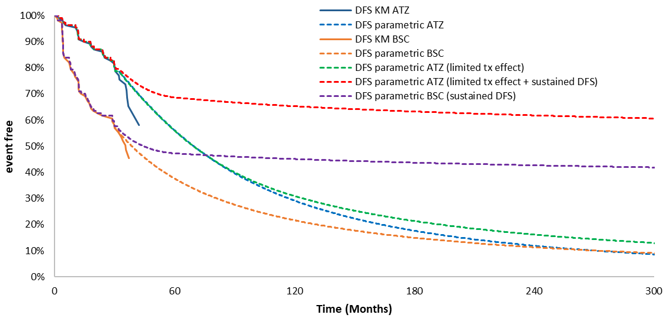
Source: Figure constructed during the evaluation, based on the “PDL1 high_Economic Evaluation” Excel workbook.
ATZ = atezolizumab; BSC = best supportive care; DFS= disease-free survival; KM = Kaplan-Meier; PD-L1 = programmed cell death ligand

  - Markov traces of the proportion of patients in the DFS health state and alive over time are presented in Figure 12.
Figure 12: Modelled DFS and OS for patients treated with adjuvant ATZ and BSC (Stage II-IIIA, PD-L1 50%)
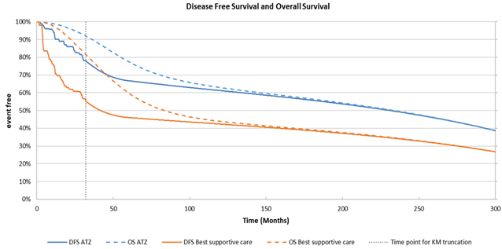

  - Results of the scenario analysis demonstrated that adjuvant treatment with ATZ would be more cost-effective in patients with Stage II-IIIA, PD-L1 ≥ 50% NSCLC, with an ICER of $5,000 to < $15,000/QALY gained, compared with $15,000 to < $25,000/QALY gained in the base case analysis of patients with a lower level of PD-L1 expression (i.e. ≥ 1%). This was consistent with the clinical evidence which showed more favourable treatment effects of ATZ in the PD-L1 ≥ 50% subgroup than in the PD-L1 ≥ 1% subgroup in terms of DFS.
  - Results showed that the main uncertainties regarding the variables/assumptions in the scenario analysis model, to which the model was sensitive, included: time horizon, use of pembrolizumab combination therapy in the 1L DR setting following BSC, inclusion/exclusion of adjustment for sustained DFS and the extrapolation time point (Table 18). The ESC noted the sensitivity analyses for this population resulted in similar changes in the ICER to those observed in sensitivity analyses for the PD-L1 ≥ 1% population.
Table 18: Results of sensitivity analyses (Stage II-IIIA, PD-L1 ≥ 50% NSCLC)
Sensitivity analyses |  | Base case | Incr costs | Incr QALYs | Incr cost per QALY | % change
Base case |  | – | $||| | 1.818 | $|||¹ | –
SA.1 | 15-year time horizon | 25 years | $|| | 1.340 | $||² | 32%
SA.2 | 20-year time horizon | 25 years | $|| | 1.629 | $||¹ | 10%
SA.3 | 70% use of pembrolizumab combination therapy in the 1L DR setting after BSC | 80% | $|| | 1.840 | $||¹ | 9%
SA.4 | 60% use of pembrolizumab combination therapy in the 1L DR setting after BSC | 80% | $|| | 1.858 | $||¹ | 17%
SA.5 | 0% use of pembrolizumab combination therapy in the 1L DR setting after BSC | 80% | $|| | 1.928 | $||² | 70%
SA.6 | No adjustment for time limited treatment effect | Incorporating adjustment for time limited treatment effect | $|| | 1.777 | $||¹ | 3%
SA.7 | No adjustment for sustained DFS | Incorporating adjustment for sustained DFS, proportion of patients with sustained DFS starts to increase from Year 2 and achieve maximum of 91.5% at Year 5 | $|| | 1.163 | $||¹ | 13%
SA8 | Truncation time point for trial-based DFS estimates: 37 months | 32.2 months | $|| | 1.518 | $||¹ | 16%
SA.1+SA.6+SA.7+SA.8 |  |  | $|| | 0.762 | $||² | 169%
Source: Table compiled during the evaluation, based on Tables 3.25, p101 of the submission; the “PDL1 high_Economic Evaluation” Excel workbook.
1L DR = first-line distant recurrence; BSC = best supportive care; DFS = disease-free survival; PD-L1 = programmed cell death ligand 1; QALY= quality-adjusted life year.
The redacted values correspond to the following ranges:
¹ $5,000 to < $15,000
² $15,000 to < $25,000

  - The ESC considered it would be informative for the PBAC to be provided with a summary of key clinical data and economic and financial assumptions for submissions associated with adjuvant treatments. The PBAC noted it had previously considered an ICER of less than $25,000 to < $35,000/ QALY to be reasonable in an adjuvant treatment setting (paragraph 5.11, nivolumab PSD, July 2019 PBAC meeting).

Drug cost/patient/course
  - The submission estimated that the drug acquisition cost would be $35,000 to < $45,000 for a complete treatment course of 16 cycles of ATZ 1,200 mg Q3W in 93% of patients and 12 cycles of ATZ 1,680 mg Q4W in the remaining 7% patients, using a public/private setting split of 38.7% versus 61.3%. If the trial-based time to off treatment (TTOT) (for the Q3W regimen) and DFS (for the Q4W regimen) data are used, the drug cost would be $35,000 to < $45,000 per patient per course. A comparison of the drug cost estimated based on the IMpower0101 trial data, in the economic evaluation and in the financial analysis is presented in Table 19.
Table 19: Drug cost per patient for atezolizumab as adjuvant therapy
 | Trial dose and duration | Model | Financial estimates
Dose | 1,200 mg Q3W | 1,200 mg Q3W (93%) and  1,680 mg Q4W (7%) | 1,200 mg Q3W (93%) and  1,680 mg Q4W (7%)
Mean duration | 12.4 cycles | 1,200 mg Q3W: 12.9 cyclesª  1,680 mg Q4W: 11.36 cycles^{b} | 1,200 mg Q3W: 12.4 cycles  1,680 mg Q4W: 11.31 cycles^{c}
Cost/patient/cycle | $ | per cycle^{d} | 1,200 mg Q3W: $| per cycle^{d}  1,680 mg Q4W: $| per cycle^{d}
Cost/patient/course | $| | $| | $|
Source: Table constructed during the evaluation, based on Table 4.10, p117 of the submission; Table 15, p60 the IMpower010 clinical study report; and the “Economic Evaluation” Excel workbook
Q3W = every 3 weeks; Q4W = every 4 weeks
ª Based on the time to off treatment curve for atezolizumab in IMpower010
^{b} Based on the disease-free survival curve for atezolizumab in IMpower010.
^{c} Estimated using the median treatment duration for atezolizumab in IMpower010 (10.4 months), with a conversion from Q3W to Q4W.
^{d} Assuming 38.7% of the atezolizumab scripts will be dispensed in a public hospital setting, and 61.3% in a private hospital setting.

Estimated PBS usage & financial implications
  - This submission was not considered by DUSC. The financial analysis took an epidemiological approach to estimate the financial impacts of the proposed listing of adjuvant ATZ. The key inputs in the financial analysis are summarised in Table 20.
Table 20: Key inputs for financial estimates
Parameter | Value applied | Source and comment
Incident cases of lung cancer | 14,502 in Year 1 (2023) to 16,088 in Year 6 | AIHW ACIM books 2021, linear extrapolation.
Proportion of incident lung cancer patients with NSCLC | 85.5% | Updated Victorian Cancer Registry data reported by Stirling et al 2019.  Reasonable data source
Proportion of NSCLC with Stage II-IIIA disease | Stage IIA: 2.5%  Stage IIB: 6.0%  Stage IIIA: 10.0%
Proportion of early stage NSCLC who receive surgical resection | 55.8% | Adjuvant NSCLC market research report (IQVIA 2021).  The PBAC considered it was unknown whether the 30 medical oncologists who completed this research (of the 500 contacted) can represent the spectrum of Australian clinical practice. The PBAC noted the % of patients with PD-L1 ≥ 50% in IMpower010 (an enriched population) was 23% and other sources report 10% to 30%. Overall, the PBAC considered this assumption was reasonable.
Proportion of Stage II-IIIA NSCLC who receive adjuvant chemotherapy | Stage IIA: 64.0%  Stage IIB: 63.4%  Stage IIIA: 72.8%
Proportion of patients with PD-L1 ≥1% | 60.7%
Proportion of patients with PD-L1 ≥50% | 26.6%
Proportion of patients with WHO PS 1 or less | 63.29% | Victorian Cancer Registry data reported by Mitchell et al 2013. The PBAC noted the registry data recorded performance status at baseline rather than after conclusion of adjuvant treatment. The PBAC considered it would be more appropriate to assume 80% of patients would have a WHO PS of 1 or less in the adjuvant treatment setting.
Uptake rate of adjuvant ATZ | 80% | Sponsor internal assumption. The PBAC considered this was an underestimate and an uptake of 90% would be more reasonable.
Treatment duration of ATZ | 12.4 doses of ATZ Q3W  11.3 doses of ATZ Q4W | IMpower010 CSR  The estimated number of doses of ATZ Q3W was slightly lower in the financial analysis than in the economic model (12.4 cycles vs. 12.9 cycles).
Proportion of ATZ Q3W vs. Q4W | 93.02% vs. 6.98% | 2021 PBS utilisation data for ATZ as second-line therapy for locally advanced or metastatic NSCLCª.
Treatment duration of PEMBR + CARBO + PEME | PEMBR Q3W: 13.4 doses  PEMBR Q6W: 6.7 doses  CARBO Q3W: 3.6 doses  PEMET Q3W: 11.2 doses | KN189, Nivolumab + ipilimumab PSD, November 2020 PBAC meeting.  The truncated mean duration of treatment in all patients in KN189 (regardless PD-L1 expression level) may not reflect the extent of use of pembrolizumab combination therapy in the proposed PD-L1 positive patients.
Proportion of PEMBR Q3W vs. Q6W | 93.0% vs. 7.0% | 2021 PBS utilisation data for PEMBO as first-line treatment for metastatic NSCLC^{b}
Administration of antineoplastic agent | $112.40 | MBS item 13950
Source: Table 4.3, pp110-111 of the submission
ACIM = Australian Cancer Incidence and Mortality; AIHW = Australian Institute of Health and Welfare; ATZ = atezolizumab; CARBO = carboplatin; CSR = clinical study report; MBS = Medicare Benefits Schedule; NSCLC = non-small cell lung cancer; PBS = Pharmaceutical Benefits Scheme; PD-L1 = programmed cell death ligand 1; PEMBR = pembrolizumab; PEMET = pemetrexed; PS = performance status; PSD = public summary document; Q3W = every 3 weeks; Q4W = every 4 weeks; Q6W = every 6 weeks; RPBS = Repatriation Pharmaceutical Benefits Scheme; WHO = World Health Organisation
ª PBS items 11284X, 11309F, 11931Y, 11940K
^{b} PBS items 11492W, 11494Y, 12119W, 12121Y
  - The predicted use of ATZ and financial implications associated with the proposed listing in the base case PBS population, i.e. patients with Stage II-IIIA, PD-L1 ≥ 1% NSCLC, are summarised in Table 21.
Table 21: Estimated use and financial implications in patients with Stage II-III, PD-L1 ≥ 1% NSCLC
 | Year 1 | Year 2 | Year 3 | Year 4 | Year 5 | Year 6
Estimated extent of use
Number of patients treated | | ^{1,a} | | ¹ | | ¹ | | ¹ | | ¹ | | ¹
Number of scripts dispensed^{b} | | ² | | ² | | ² | | ² | | ² | | ²
Estimated financial implications of atezolizumab
Cost to PBS/RPBS less copayments | $ | ³ | $ | ⁴ | $ | ⁴ | $ | ³ | $ | ³ | $ | ³
Estimated financial implications for pembrolizumab^{c}
Cost to PBS/RPBS less copayments^{d} | -$||||⁴ | -$ | ⁴ | -$ | ⁴ | -$ | ⁴ | -$ | ⁴ | -$ | ⁴
Net financial implications
Net cost to PBS/RPBS^{d} | $ | ⁴ | $ | ⁴ | $ | ⁴ | $ | ⁴ | $ | ⁴ | $ | ⁴
Net cost to MBS^{d} | $ | ⁴ | $ | ⁴ | $ | ⁴ | $ | ⁴ | $ | ⁴ | $ | ⁴
Net cost to PBS/RPBS/MBS^{d} | $ | ⁴ | $ | ⁴ | $ | ⁴ | $ | ⁴ | $ | ⁴ | $ | ⁴
Source: Table 4.10, p117, Table 4.14, p120, Table 4.19, p124 and Table 4.25, p126 of the submission.
ª Including < 500 grandfathered patients in Year 1.
^{b} Assuming that 93.02% of the patients would receive atezolizumab 1,200 mg every 3 weeks (number of scripts per patient: 12.40 in incident patients and 5.18 in grandfathered patients). The remaining 6.98% would be treated with atezolizumab 1,680 mg every 4 weeks (number of scripts per patient: 11.31 in incident patients and 5.99 in grandfathered patients).
^{c} The submission assuming a | |% rebate on the published ex-manufacturer price for pembrolizumab as a rebate in the form of a special pricing arrangement.
^{d} Revised by assuming: 1) the proportion of patients with distant recurrence being 16.43% in the first year, 13.28% in the second year, 11.24% in the third year, 6.67% in the fourth year, 3.56% in the fifth year, and 1.76% in the sixth year; and 2) 80% of patients with distant recurrence receiving pembrolizumab. Changes in chemotherapy costs were removed from the analysis.
The redacted values correspond to the following ranges:
¹ < 500
² 500 to < 5,000
³ $10 million to < $20 million
⁴ $0 to < $10 million

  - The submission assumed that the listing of ATZ would result in cost savings to both the PBS/RPBS ($0 to < $10 million in Year 1 and $0 to < $10 million in Years 2-6) and the MBS ($0 to < $10 million thousand in Year 1 and $0 to < $10 million in Years 2-6). The cost savings to the PBS/RPBS and MBS were attributable to the reduced use of pembrolizumab + chemotherapy in the DR setting due to the listing of adjuvant ATZ. The submission assumed that, in current clinical practice without the availability of ATZ, all patients with early stage NSCLC would experience DR within the first year of diagnosis and would receive pembrolizumab combination therapy in the DR setting. This assumption was unreasonable and was not consistent with the economic evaluation provided in the submission.
  - The accumulated proportion of patients transitioning into the 1L DR health state (either from DFS or from LRR) in the BSC arm of the base case economic model was 52.9% within the first 6 years, with 16.4% in the first year, 13.3% in the second year, 11.2% in the third year, 6.7% in the fourth year, 3.6% in the fifth year, and 1.8% in the sixth year. In the economic evaluation, 80% of these patients in the comparator BSC arm would receive pembrolizumab, in combination with chemotherapy, in the DR setting, with the remaining 20% ineligible for pembrolizumab due to poor performance status or other reasons. Based on the above revised assumptions (Table 22), the listing of adjuvant ATZ would result in net additional costs to the PBS/RPBS ($0 to < $10 million in Year 1 of listing and $0 to < $10 million in Years 2-6) and to the MBS ($0 to < $10 million in Year 1 and $0 to < $10 million in Years 2-6). Of note, costs of chemotherapy to the PBS/RPBS were not included in the revised analysis, as chemotherapy would be used either as stand-alone therapy or in combination with pembrolizumab in both treatment arms. Although the proportion of patients experiencing DR differed between the two treatment arms in each year, it would have minimal impacts to the net PBS/RPBS costs, given the low cost of chemotherapy in comparison with ATZ and pembrolizumab.
Table 22: Estimated number of patients with Stage II-IIIA, PD-L1 ≥ 1% NSCLC eligible for pembrolizumab in the distant recurrence settingª
 |  | Year 1 | Year 2 | Year 3 | Year 4 | Year 5 | Year 6
Number of patients in the adjuvant setting in each year of listing^{b} | -||||¹ | -|||¹ | - | ¹ | -|||¹ | -|||¹ | - | ¹ | -|||¹
 | -||||¹ |  | - | ¹ | -|||¹ | -|||¹ | - | ¹ | -|||¹
 | -||||¹ |  |  | -|||¹ | -|||¹ | - | ¹ | -|||¹
 | -||||¹ |  |  |  | -|||¹ | - | ¹ | -|||¹
 | -||||¹ |  |  |  |  | - | ¹ | -|||¹
 | -||||¹ |  |  |  |  |  | -|||¹
Total with distant recurrence |  | -||¹ | -||¹ | -||¹ | -||¹ | -||¹ | -||¹
Total treated with pembrolizumab (80%) |  | -||¹ | -||¹ | -||¹ | -||¹ | -||¹ | -||¹
Source: Table compiled during the evaluation
NSCLC = non-small cell lung cancer; PD-L1 = programmed cell death ligand 1
ª The proportion of patients with distant recurrence was assumed to be 16.43% in the first year, 13.28% in the second year, 11.24% in the third year, 6.67% in the fourth year, 3.56% in the fifth year, and 1.76% in the sixth year.
The redacted values correspond to the following ranges:
¹ < 500

  - The PSCR agreed with the evaluator’s revised estimated number of patients who would receive pembrolizumab in the distant recurrence setting to inform downstream cost offset (as outlined in Table 22).
  - The MBS costs associated with PD-L1 testing were not included in the submission’s financial analysis. The submission argued that IHC testing for PD-L1 would occur universally for all patients upstream of the clinical choice of patients with Stage II-IIIA, PD-L1 positive NSCLC to receive adjuvant ATZ treatment; and, thus, the utilisation of IHC testing would not be impacted by the PBS listing of ATZ. Costs associated with disease monitoring and management of treatment related AEs were not considered in the financial analysis.
  - The financial implications of listing ATZ as adjuvant therapy for treatment of patients with Stage II-IIIA, PD-L1 ≥ 50% NSCLC are summarised in Table 23. The results were revised by applying the proportion of patients with DR in each year from the BSC arm of the economic model for the Stage II-IIIA, PD-L1 ≥ 50% NSCLC subgroup and assuming that 80% of the DR patients would be treated with pembrolizumab combination therapy. The reduced number of patients using pembrolizumab combination therapy for this population would be < 500 less in Year 1 and < 500 less in Year 6 (Table 23).
Table 23: Estimated use and financial implications in patients with Stage II-III, PD-L1 ≥ 50% NSCLC
 | Year 1 | Year 2 | Year 3 | Year 4 | Year 5 | Year 6
Estimated extent of use
Number of patients treated | | ^{1,a} | | ¹ | | ¹ | | ¹ | | ¹ | | ¹
Number of scripts dispensed^{b} | | ² | | ² | | ² | | ² | | ² | | ²
Estimated financial implications of atezolizumab
Cost to PBS/RPBS less copayments | $ | ³ | $ | ³ | $ | ³ | $ | ³ | $ | ³ | $ | ³
Estimated financial implications for pembrolizumab^{c}
Cost to PBS/RPBS less copayments^{d}  Reduction in pembrolizumab patients | -$ | ³  | ¹ | -$ | ³  | ¹ | -$ | ³  | ¹ | -$ | ³  | ¹ | -$ | ³  | ¹ | -$ | ³  | ¹
Net financial implications
Net cost to PBS/RPBS^{d} | $ | ³ | $ | ³ | $ | ³ | $ | ³ | $ | ³ | $ | ³
Net cost to MBS^{d} | $ | ³ | $ | ³ | $ | ³ | $ | ³ | $ | ³ | $ | ³
Net cost to PBS/RPBS/MBS^{d} | $ | ³ | $ | ³ | $ | ³ | $ | ³ | $ | ³ | $ | ³
Source: Table 4.28, p130, Table 4.29, p130, Table 4.31, p131, Table 4.34, p133 and Table 4.40, 136 of the submission.
ª Including < 500 grandfathered patients in Year 1 (and appropriately assumed a reduced treatment duration.
^{b} Assuming that 93.02% of the patients would receive atezolizumab 1,200 mg every 3 weeks (number of scripts per patient: 12.40 in incident patients and 5.18 in grandfathered patients). The remaining 6.98% would be treated with atezolizumab 1,680 mg every 4 weeks (number of scripts per patient: 11.31 in incident patients and 5.99 in grandfathered patients).
^{c} The submission assuming a | |% rebate on the published ex-manufacturer price for pembrolizumab as a rebate in the form of a special pricing arrangement
^{d} Revised by assuming: 1) the proportion of patients with distant recurrence being 17.40% in the first year, 13.04% in the second year, 9.14% in the third year, 6.22% in the fourth year, 3.27% in the fifth year, and 1.58% in the sixth year; and 2) 80% of patients with distant recurrence receiving pembrolizumab. Changes in chemotherapy costs were removed from the analysis.
The redacted values correspond to the following ranges:
¹ < 500
² 500 to < 5,000
³ $0 to < $10 million

Financial Management – Risk Sharing Arrangements
  - No risk-sharing arrangements were proposed by the submission. The evaluation noted that the proposed listing of ATZ as adjuvant therapy would affect the extent of use of other PD-1 inhibitors for treatment of advanced or metastatic NSCLC.
For more detail on PBAC’s view, see section 7 PBAC outcome.
- PBAC Outcome
  - The PBAC recommended the listing of atezolizumab (ATZ) for the adjuvant treatment of patients with Stage II to IIIA non-small cell lung cancer (NSCLC) whose tumours have programmed cell death ligand-1 (PD-L1) expression on ≥ 50% of tumour cells and following a complete resection and no progression after platinum-based adjuvant chemotherapy. The PBAC’s recommendation for listing was based on, among other matters, its assessment that the cost-effectiveness of ATZ would be acceptable at the price proposed in the submission. The PBAC recommended that the additional expenditure associated with ATZ in this population (taking into account the reduced use of immunotherapy in the advanced/ metastatic setting) could be added to the current risk sharing arrangement in place for immunotherapies for NSCLC.
  - The PBAC noted that the submission requested listing for patients with PD-L1 positive NSCLC and included relevant clinical, economic and financial information for both the PD-L1 ≥ 1% and PD-L1 ≥ 50% populations. The submission was made under the TGA/PBAC Parallel Process and the submission stated the final PBS listing would depend on the approved TGA indication. The PBAC noted that the TGA Delegate supported the approval of atezolizumab as an adjuvant treatment for only the PD-L1 ≥ 50% population. The PBAC therefore focused its consideration on the PD-L1 ≥ 50% population.
  - The PBAC considered there was a high clinical need for ATZ as the recurrence rate following resection of early lung cancer is high and there are currently no immunotherapy treatments available for this population.
  - The PBAC noted the submission nominated best supportive care as the comparator and considered this was appropriate. The PBAC considered the clinical claim that ATZ was superior in effectiveness with inferior safety compared to BSC was reasonable. The PBAC noted the submission was based on one randomised control trial (IMpower010) comparing ATZ to BSC following adjuvant platinum-based chemotherapy in patients with completely resected Stage IB-IIIA NSCLC. The PBAC noted the population of patients with Stage II-IIIA PD-L1 ≥ 50% comprised 23% of the overall Impower010 population. The PBAC considered the clinical data presented in the submission supported an improvement in disease free survival with a hazard ratio of 0.47 (95% CI: 0.29, 0.75) and 74% of patients disease free at 3 years in the ATZ treatment arm compared to 49% in the BSC arm (January 2021 data cut off, median 32 months follow up). The PBAC noted that, while the event rate was low (10% in the ATZ arm, 23% in the BSC arm), there was an improvement in overall survival with a hazard ratio of 0.40 (95% CI: 0.20, 0.81) and 91% of patients alive at 3 years in the ATZ treatment arm compared to 77% in the BSC arm (January 2021 data cut off). The PBAC noted the clinical data with longer follow up provided in the pre-PBAC response (April 2022 data cut off, median 45 months follow up) supported the continued OS benefit of ATZ.
  - The PBAC noted patients experienced more adverse events with ATZ compared with BSC (92.7% vs 70.7%), and the frequency of events was approximately two-fold in the ATZ treatment arm compared with BSC for Grade ≥3 adverse events (23.4% vs. 12.1%) and serious adverse events (17.6% vs. 8.5%). The PBAC considered the adverse event profile was consistent with the known safety profile of ATZ and events were manageable.
  - The PBAC noted the corrected base case ICER presented in the submission for the population of patients with PD-L1 ≥ 50% was $5,000 to < $15,000 / QALY. The PBAC considered the base case model was unreliable (as discussed in paragraph 7.7) and the ICER was underestimated. However, noting the sensitivity analyses, including the multivariate analysis, the PBAC was moderately certain the ICER would be below
$25,000 to < $35,000/ QALY, the threshold previously considered reasonable for adjuvant treatments. Further, the PBAC noted the high clinical need and small population of patients with Stage II to IIIA NSCLC with PD-L1 ≥ 50%.
  - The PBAC considered a 25 year time horizon was not adequately justified in the submission and a 15 year time horizon would have been more appropriate in this population. The PBAC noted the economic model was sensitive to the proportion of BSC patients that receive immunotherapy (assumed to be pembrolizumab in the submission) in the advanced/ metastatic setting (as discussed in paragraph 6.58). Additionally, the assumptions regarding the costs and benefits of immunotherapy in the advanced/ metastatic setting may have resulted in the ICER being underestimated (paragraph 6.46). The PBAC considered the assumptions regarding the proportion of patients achieving sustained DFS (i.e., ‘cured’) were not well justified in the submission.
  - The PBAC considered it would be appropriate to increase the proportion of patients with a WHO PS of 1 or less from 63.39% to 80% and to increase the uptake rate of ATZ from 80% to 90%. The PBAC considered that, overall, with these adjustments, the estimated number of treated patients was reasonable and the methodology for calculating the estimated cost of listing ATZ on the PBS was appropriate. The PBAC noted the financial estimates included < 500 patients that would transition to PBS treatment in Year 1 at a reduced treatment cost and considered this was reasonable.
  - The PBAC noted that the financials provided in the submission assumed that, in the absence of ATZ being available in the adjuvant treatment setting, all patients expected to be treated with ATZ would have experienced disease recurrence within 12 months and would have been treated with immunotherapy in the advanced/ metastatic setting. The PBAC considered this was likely to have overestimated the cost offsets (and therefore resulted in cost savings to the PBS) and it was reasonable to instead apply the cumulative proportion of patients transitioning into the first line distant recurrence health state in the BSC arm from the economic model as discussed in paragraph 6.71. The PBAC noted that in the population of patients with PD-L1 ≥ 50%, 17.40% would experience distant recurrence in the first year, 13.04% in the second year, 9.14% in the third year 6.22% in the fourth year, 3.27% in the fifth year and 1.58% in the sixth year of listing. The PBAC considered it would be more reasonable to assume 90% of recurrent patients would be treated with immunotherapy. The PBAC considered the additional expenditure associated with ATZ in this population, taking into account the revised offsets for reduced use of subsequent immunotherapy (and using effective prices), could be added to the current risk sharing arrangement in place for non-small cell lung cancer.
  - The PBAC noted the following changes to the restriction criteria provided in the submission would be required:
- Add the treatment criteria ‘The treatment must be prescribed with up to a certain number of repeat prescriptions dependent on the frequency of dosing as follows: (i) up to 5 repeats for dosing occurring once every 4 weeks, (ii) up to 7 repeats for dosing occurring once every 3 weeks’.
- Amend the clinical criteria ‘The condition must have, prior to initiating treatment with this drug, confirmation of programmed cell death ligand 1 (PD-L1) expression on at least 1% of tumour cells’ to ‘The condition must have, prior to initiating treatment with this drug, confirmation of programmed cell death ligand 1 (PD-L1) expression on at least 50% of tumour cells’.
- Delete the treatment criteria ‘The treatment must be as monotherapy’ and add the clinical criteria ‘The treatment must be the sole PBS-subsidised systemic anti-cancer therapy for this condition’.
- Add the treatment criteria ‘Patient must be undergoing treatment that does not occur beyond the following, whichever comes first: (i) the first instance of disease progression/recurrence, (ii) 12 months in total for this condition from the first administered dose; mark any remaining repeat prescriptions with the words ‘cancelled’ where (i)/(ii) has occurred’.
  - The PBAC advised that atezolizumab is not suitable for prescribing by nurse practitioners.
  - The PBAC recommended that the Early Supply Rule should not apply as this is a Section 100 listing.
  - The PBAC found that the criteria prescribed by the National Health (Pharmaceuticals and Vaccines – Cost Recovery) Regulations 2022 for Pricing Pathway A were met. Specifically, the PBAC found that in the circumstances of its recommendation for atezolizumab:
- The treatment is expected to provide a substantial and clinically relevant improvement in efficacy, over best supportive care;
- The treatment is expected to address a high and urgent unmet clinical need given the high rate of recurrence and limited treatment options for early stage resected lung cancer;
- It would be in the public interest for the subsequent pricing application to be progresses under Pricing Pathway A on the basis of the preceding findings.
  - The PBAC noted that this submission is not eligible for an Independent Review as it received a positive recommendation.

Outcome:
Recommended

- Recommended listing
  - Add new indication:

MEDICINAL PRODUCT  Form |  | PBS item code | Max. Amount | №.of Rpts
ATEZOLIZUMAB  Injection |  | NEW (Public)  NEW (Private) | 1,680 mg | 7
Available brands
Tecentriq
(atezolizumab 1.2 g/20 mL injection, 20 mL vial)
Tecentriq
(atezolizumab 840 mg/20 mL injection, 20 mL vial)
Restriction Summary New 1 / ToC: New 2
 | Category / Program: Section 100 – Efficient Funding of Chemotherapy Public/Private hospitals
 | Prescriber type: Medical Practitioners
 | Restriction type: Authority Required (STREAMLINED) [New 2]
 | Administrative Advice: No increase in the maximum number of repeats may be authorised.
 | Administrative Advice: Special Pricing Arrangements apply.

Episodicity: [blank]
Severity: Resected early stage (Stage II to IIIA)
Condition: non-small cell lung cancer
Indication: Resected early stage (Stage II to IIIA) non-small cell lung cancer
Treatment Phase: [blank]
Patient population:
Patient must be both: (i) initiating treatment, (ii) untreated with programmed cell death-1/ligand 1 (PD-1/PD-L1) inhibitor therapy; or
Patient must be continuing existing PBS-subsidised treatment with this drug; or
Patient must be both: (i) transitioning from existing non-PBS to PBS subsidised supply of this drug, (ii) untreated with programmed cell death-1/ligand 1 (PD-1/PD-L1) inhibitor therapy at the time this drug was initiated
Clinical criteria:
Patient must have/have had a WHO performance status score of no greater than 1 at treatment initiation with this drug
AND
Clinical criteria:
The treatment must be for the purpose of adjuvant therapy following all of: (i) surgical resection, (ii) platinum-based chemotherapy
AND
Clinical criteria:
The condition must have/have had, at treatment commencement, an absence of each of the following gene abnormalities confirmed via tumour material sampling: (i) an activating epidermal growth factor receptor (EGFR) gene mutation, (ii) an anaplastic lymphoma kinase (ALK) gene rearrangement
AND
Clinical criteria:
The condition must have/have had, at treatment commencement, confirmation of programmed cell death ligand 1 (PD-L1) expression on at least 50% of tumour cells
AND
Clinical criteria:
The treatment must be the sole PBS-subsidised systemic anti-cancer therapy for this condition
AND
Clinical criteria:
The treatment must be prescribed with up to a certain number of repeat prescriptions dependent on the frequency of dosing as follows: (i) up to 5 repeats for dosing occurring once every 4 weeks, (ii) up to 7 repeats for dosing occurring once every 3 weeks
Treatment criteria:
Patient must be undergoing treatment that does not occur beyond the following, whichever comes first: (i) the first instance of disease progression/recurrence, (ii) 12 months in total for this condition from the first administered dose; mark any remaining repeat prescriptions with the words ‘cancelled’ where (i)/(ii) has occurred

This restriction may be subject to further review. Should there be any changes made to the restriction the sponsor will be informed.
- Context for Decision
The PBAC helps decide whether and, if so, how medicines should be subsidised through the Pharmaceutical Benefits Scheme (PBS) in Australia. It considers applications regarding the listing of medicines on the PBS and provides advice about other matters relating to the operation of the PBS in this context. A PBAC decision in relation to PBS listings does not necessarily represent a final PBAC view about the merits of the medicine or the circumstances in which it should be made available through the PBS. The PBAC welcomes applications containing new information at any time.
- Sponsor’s Comment
Roche welcomes the PBAC’s decision to recommend PBS listing of atezolizumab as adjuvant treatment in patients with stage II-IIIA PD-L1 ≥50% NSCLC following complete resection and platinum-based chemotherapy. Roche are working with the Department of Health towards a PBS listing at the earliest opportunity.

ATZ in combination with bevacizumab, paclitaxel and carboplatin, is indicated for the first-line treatment of adult patients with metastatic NSCLC. In patients with EGFR mutant or ALK-positive NSCLC, ATZ in combination with bevacizumab, paclitaxel and carboplatin, is indicated only after failure of appropriate targeted therapies. ATZ in combination with nanoparticle albumin-bound paclitaxel (nab-paclitaxel) and carboplatin, is indicated for first-line treatment of patients with metastatic who do not have tumour EGFR or ALK genomic aberrations. ATZ as monotherapy is indicated for the treatment of adult patients with locally advanced or metastatic NSCLC after prior chemotherapy. Patients with EGFR mutant or ALK-positive NSCLC should also have received targeted therapies before receiving ATZ.
Cherny NI, Dafni U, Bogaerts J, et al: ESMO-Magnitude of Clinical Benefit Scale version 1.1. Annals of Oncology 28:2340-2366, 2017
Felip E et al. Adjuvant atezolizumab after adjuvant chemotherapy in resected stage IB–IIIA non-small-cell lung cancer (IMpower010): A randomised, multicentre, open-label, phase 3 trial. The Lancet, 2021;398(10308):1344-57.
Remon J, Besse B. Adjuvant immunotherapy for NSCLC—does treating earlier mean treating better? Nature Reviews Clinical Oncology, 2022;19(1):7-8.
Maeda R, Yoshida J, et al. Late recurrence of non-small cell lung cancer more than 5 years after complete resection: incidence and clinical implications in patient follow-up. Chest. 2010;138(1):145-50. Sonoda D, Matsuura Y, et al. Ultra-late recurrence of non-small cell lung cancer over 10 years after curative resection. Cancer Management and Research. 2019;11:6765-74.
Nakamichi S, Horinouchi H, et al. Comparison of radiotherapy and chemoradiotherapy for locoregional recurrence of non-small-cell lung cancer developing after surgery. Clinical Lung Cancer. 2017;18(6):e441-e8.
https://www.aihw.gov.au/reports/cancer/cancer-data-in-australia/contents/cancer-incidence-and-survival-by-stage-data-visualisation
Grutters JP, Joore MA, et al. Health-related quality of life in patients surviving non-small cell lung cancer. Thorax. 2010;65(10):903-7.

