5.08 GILTERITINIB,
Tablet 40 mg (as fumarate),
Xospata®,
Astellas Pharma Australia Pty Ltd.
- Purpose of submission
  - The Category 2 submission requested a Section 85 Authority Required (Telephone/Electronic) listing for gilteritinib for the treatment of patients with relapsed or refractory acute myeloid leukaemia (AML) with an FMS-like tyrosine kinase 3 (FLT3) mutation.
  - Listing was requested on the basis of a cost-effectiveness analysis versus salvage chemotherapy.
Table 1: Key components of the clinical issue addressed in the submission
Component | Description
Population | FLT3 mutation-positive relapsed or refractory acute myeloid leukaemia
Intervention | Gilteritinib 120 mg (3 x 40 mg oral tablets) once daily, increased to 200 mg daily (5 x 40 mg) if no response achieved within 4 weeks, decreased to 80 mg (2 x 40 mg) daily to manage adverse events.
Comparator | Salvage chemotherapy (low intensity: low dose cytarabine or azacitidine; high intensity: MEC induction chemotherapy or FLAG-IDA induction chemotherapy).
Outcomes | Overall survival, remission rate, event free survival, HSCT rate, potential for cure.
Clinical claim | Gilteritinib is superior to salvage chemotherapy in terms of clinical efficacy and safety and tolerability.
Source: Table 1, p4 of the submission.
FLAG-IDA; G-CSF, fludarabine, cytarabine, idarubicin; FLT3, FMS-like tyrosine kinase 3; HSCT, haematopoietic stem cell transplantation; MEC, mitoxantrone, etoposide, cytarabine.
- Background

Registration status
  - Gilteritinib was designated by the TGA delegate for priority review on 5 June 2019 and was approved on 26 March 2020 for the treatment of adult patients who have relapsed or refractory AML with a FLT3 mutation.
- Requested listing

Name, restriction, manner of administration, form |  | Maximum quantity (packs) | Maximum quantity (units) | No. of repeats | Dispensed price for maximum quantity | Proprietary name and manufacturer
Gilteritinib  Tablet, 40 mg |  | 1 | 84 | 2 | $'''''''''''''''''''''' published  $''''''''''''''''''''''' effective | Xospata ®  Astellas
Category / Program: | GENERAL – General Schedule (Code GE)
Prescriber type: | Medical practitioners
Condition: | Acute Myeloid Leukaemia
PBS Indication: | FLT3 mutation-positive relapsed or refractory acute myeloid leukaemia
Restriction: | Authority Required – Telephone, Electronic
Treatment phase: | Initial treatment
Treatment criteria: | The treatment must be as monotherapy
Clinical criteria: | The patient must have relapsed or refractory acute myeloid leukaemia  AND  The condition must be internal tandem duplication (ITD) and/or tyrosine kinase domain (TKD) FMS tyrosine kinase 3 (FLT3) mutation positive before initiating this drug for this condition  AND  The condition must not be acute promyelocytic leukaemia  AND  Progressive disease monitoring via a complete blood count must be taken at the end of each cycle.  If abnormal blood counts suggest the potential for relapsed AML, a bone marrow biopsy must be performed to confirm the absence of progressive disease for the patient to be eligible for further cycles.  Progressive disease is defined as the presence of any of the following:  - Leukaemic cells in the CSF;  - Re-appearance of circulating blast cells in the peripheral blood, not attributable to overshoot following recovery from myeloablative therapy;  - Greater than 5 % blasts in the marrow not attributable to bone marrow regeneration or another cause;  - Extramedullary leukaemia.  A patient who has progressive disease when treated with this drug is no longer eligible for PBS-subsidised treatment with this drug.
Treatment phase: | Continuing PBS-subsidised treatment
Treatment criteria: | The treatment must be as monotherapy  AND  The patient must have previously received PBS-subsidised treatment with this drug for this condition.
Clinical criteria: | Patient must not have developed disease progression while receiving PBS-subsidised treatment with this drug for this condition  Progressive disease monitoring via a complete blood count must be taken at the end of each cycle.  If abnormal blood counts suggest the potential for relapsed AML, a bone marrow biopsy must be performed to confirm the absence of progressive disease for the patient to be eligible for further cycles.  Progressive disease is defined as the presence of any of the following:  - Leukaemic cells in the CSF;  - Re-appearance of circulating blast cells in the peripheral blood, not attributable to overshoot following recovery from myeloablative therapy;  - Greater than 5 % blasts in the marrow not attributable to bone marrow regeneration or another cause;  - Extramedullary leukaemia.  A patient who has progressive disease when treated with this drug is no longer eligible for PBS-subsidised treatment with this drug.
Administrative Advice: | Special Pricing Arrangements Apply
Source: Table 9, pp26-27 of the submission.
  - The submission requested a special pricing arrangement, with an effective approved ex manufacturer price (AEMP) of $''''''''''''' per pack, and a published AEMP of $''''''''''''''. The pre-PBAC response indicated that the sponsor would be proposing a price reduction, but was unable to do so in the timeframe prior to the PBAC meeting.
  - A dose increase to 200 mg/day is recommended when response has not been achieved after 4 weeks of treatment at 120 mg/day. For these patients, an increase in the maximum quantity would be required. The ESC noted that in the ADMIRAL trial, 31.6% (78/247) patients required a dose increase to 200 mg/day and 23.5% (58/247) required a dose reduction to 80 mg/day. The ESC considered it would be appropriate for the initial gilteritinib listing to align with a response assessment at 4 weeks (i.e. max qty 1, with 0 repeats). The ESC considered that a corresponding increase in the number of repeats for the continuing phase (i.e. max qty 1, with 4 repeats) may also be appropriate and noted that a maximum quantity multiplier of 2 applied to the continuing treatment restriction, would be sufficient to allow a maximum quantity of 168 tablets for patients needing a 200 mg dose. However, a maximum quantity multiplier of 2 would provide more than 28 days’ supply per prescription. Equally, the supply of 84 tablets, as per the maximum quantity specified in the restriction, would result in more than 28 days’ supply for patients who require a dose reduction.
  - The requested restrictions were narrower than the TGA indication, in that the requested restrictions exclude patients with acute promyelocytic leukaemia (APML). The ESC considered the exclusion of patients with APML was reasonable and noted this was consistent with the ADMIRAL trial.
  - The proposed restriction did not specify an Eastern Cooperative Oncology Group (ECOG) Performance Status range, whereas the ADMIRAL trial (the primary source of evidence presented in the submission) included only patients with ECOG status of 0 to 2 (with 83.8% of patients with baseline ECOG status of 0 or 1).
  - On all phases of listing, the submission included the midostaurin PBS listing prescriber instructions about monitoring for progressive disease and cessation of therapy.
  - The requested PBS continuation phase listing was intended to also allow for maintenance therapy post-haematopoietic cell transplant (HSCT), in patients who had received prior treatment with gilteritinib in the relapsed/refractory setting. The submission stated this would be consistent with the ADMIRAL trial and the TGA Product Information. However, the ESC had considered that a treatment benefit was not supported in these patients. Thus, the pre-PBAC response proposed to withdraw the request for maintenance use post-HSCT at this time.
  - The PBAC noted that the midostaurin ‘Induction/Consolidation therapy’ restriction was an Authority Required (Telephone/Electronic) listing. Whereas the ‘maintenance therapy – initial treatment’ listing required prescribers to seek Authority via an application form submitted online or via post, which was recommended to manage the risk of use outside the intended population, including in patients post stem cell transplant and with FLT3 wild type AML (paragraphs 2.7 and 6.65, midostaurin Public Summary Document (PSD), July 2018 PBAC meeting). Noting the withdrawal of the request for gilteritinib maintenance use post-HSCT, the PBAC considered an Authority Required (Telephone/Electronic) listing likely appropriate.
  - The submission proposed a grandfathering restriction for an estimated < 500 patients.
For more detail on PBAC’s view, see section 7 PBAC outcome
- Population and disease
  - AML is a type of blood cancer which develops when the body makes too many immature white blood cells known as myeloid blasts. These immature and abnormal blast cells are also known as leukaemia cells. They do not perform the usual infection-fighting function of white blood cells, but also crowd out normal white blood cells, impairing their function. When the bone marrow is filled with leukaemia cells, there is less room for healthy red blood cells and platelets to be produced. Patients with AML typically experience fatigue, weakness or breathlessness, memory loss, bruising, bleeding, and frequent infections.
  - AML is the most common type of acute leukaemia in adults. The disease becomes more common with age, mostly occurring after 65 years, and affects more males than females. AML is associated with rapid progression and poor prognosis, with a 5-year relative survival in all ages of 26.3% (2013-2017 period, AIHW Cancer data in Australia, 2021). The majority of cases occur de novo, however, there are a minority of cases with subtypes of AML, including APML and secondary AML, which is associated with prior myelodysplastic syndrome, myeloproliferative disease, prior cytotoxic chemotherapy or radiation for an unrelated malignancy. These subtypes are biologically and clinically distinct variants, which are associated with relatively poorer treatment response and prognosis and are treated differently to de novo AML. The submission’s proposed population excluded patients with APML as this subtype was excluded from the pivotal trial for gilteritinib (ADMIRAL).
  - AML is initially diagnosed by bone marrow aspirate and biopsy using morphologic, cytochemical, immunophenotypic and cytogenetic/molecular analyses. An AML diagnosis requires patients to have a bone marrow or peripheral blood blast count of at least 20% and blast forms identified as cells of the myeloid lineage (rather than lymphoid). The presence of specific cytogenetic abnormalities is used to classify patients into favourable, intermediate and poor-risk categories. Treatment recommendations and outcomes are also influenced by patient characteristics such as age and ECOG Performance Status.
  - The target population in the submission was patients with relapsed or refractory AML with FLT3 mutation. Mutations in FLT3 are the most common genetic alteration in AML, identified in approximately one third of newly diagnosed patients (De Kouchkovsky 2016). The PBAC has previously accepted a FLT3-mutation positivity of 34% for newly diagnosed AML (para 6.54, midostaurin PSD, July 2018 PBAC Meeting). The most frequently occurring FLT3 mutations are the internal tandem duplication (ITD) and the tyrosine kinase domain (TKD) point mutations. FLT3/ITD mutations are more common than TKD mutations and appear to have a greater negative influence on disease prognosis, including shorter remission durations and poorer survival outcomes compared to patients who have wild-type FLT3. The impact of the TKD point mutation on disease trajectory is less clear (National Comprehensive Cancer Network guidelines for AML, NCCN v3.2021). FLT3 mutation status has been shown to change between diagnosis and relapse, with one study reporting 30% FLT3/ITD mutation at diagnosis, increasing to 38% at first relapse (McCormick et al 2010).
  - In Australia, the mean age at diagnosis of all types of AML is 66 years (median 71 years, 2017 data, AIHW 2021). The submission argued that it is very likely that the FLT3-positive AML population is at a younger age at diagnosis, reporting that that the mean age of 184 Australian FLT3-positive patients at the time of first relapse or refractory event was 57 years (from Australasian Leukaemia and Lymphoma Group (ALLG) 2020, an Australian registry study). The ALLG study authors noted that the study primarily recruited younger patients and that the results may not be generalisable to elderly patients.
  - The clinical management algorithm was broadly based on US NCCN guidelines for AML (v3.2021), with consideration of Australian registered and reimbursed treatments (eviQ – Acute Myeloid Leukaemia), other international guidelines (European LeukemiaNET, European Society for Medical Oncology), and expert opinion. The PBAC agreed with the ESC that the clinical management algorithm was largely consistent with current Australian practice, with the exception that response is assessed at 28 days rather than after 14-21 days.
  - Gilteritinib, an FLT3 inhibitor administered as an oral tablet, was positioned as an alternative to salvage chemotherapy or enrolment in a clinical trial for relapsed or refractory FLT3 positive patients, regardless of the number or type of prior chemotherapy regimens received. The proposed algorithm positioned gilteritinib as a means of achieving remission in order to continue to potentially curative HSCT, but also as an ongoing treatment to be continued until relapse or disease progression. Patients may have received prior treatment with high-intensity chemotherapy (with or without midostaurin) or low-intensity chemotherapy. Some patients requiring treatment with gilteritinib may have relapsed after a prior HSCT. The proposed algorithm did not nominate specific salvage chemotherapy treatment regimens. The submission referred to NCCN guidelines, which recommend repeat induction therapy or HSCT in patients who have relapsed a year or more after treatment, and HSCT or a chemotherapy regimen not previously trialled for patients whose relapse comes less than 12 months after treatment. As noted above, the submission also proposed the resumption of treatment with gilteritinib in patients achieving complete remission after HSCT, however this request was withdrawn in the pre-PBAC response.
For more detail on PBAC’s view, see section 7 PBAC outcome
- Comparator
  - The submission appropriately nominated salvage chemotherapy as the main comparator. Treatment options for patients with relapsed/refractory AML are dependent on a number of patient- and disease-related factors, including age, comorbidities, performance status, cytogenetic and molecular abnormalities, prior lines of chemotherapy, history of prior HSCT, and time to relapse after previous complete remission. Younger ‘fit’ patients who have not received prior HSCT have the option of receiving high-intensity chemotherapy, and if adequate response is obtained, HSCT with curative intent. Older patients or those who have already relapsed after HSCT are treated with a variety of lower intensity options, with the goal of achieving a durable remission.
  - The submission proposed a blended comparator based on the treatment regimens administered in the salvage chemotherapy arm of the key gilteritinib trial, ADMIRAL, as follows: low dose cytarabine, azacitidine monotherapy, MEC induction chemotherapy (mitoxantrone, etoposide, cytarabine) and FLAG-IDA induction chemotherapy (fludarabine, cytarabine, idarubicin, G-CSF). The submission claimed the distribution of use of these regimens in the trial (13.7% low dose cytarabine, 25.8% azacitidine, 26.6% MEC and 33.9% FLAG-IDA) was representative of use in the proposed PBS population. The ESC considered the salvage chemotherapy regimens and distribution of use in the ADMIRAL trial was applicable to the proposed PBS population.
  - The evaluation considered that best supportive care (e.g. symptom management, blood transfusions and infection control) may also be a relevant comparator. Some patients may not opt for active treatment, for a variety of reasons including age, fitness, tolerability or treatment burden.
For more detail on PBAC’s view, see section 7 PBAC outcome
- Consideration of the evidence

Sponsor hearing
  - The sponsor requested a hearing for this item. The clinician discussed the natural history of the disease, stating that AML patients with FLT3 mutation are generally younger than those without FLT3 mutation. The clinician noted that a high proportion of patients will relapse or are refractory to initial treatment, indicating a high clinical need for new effective treatment options. The clinician then outlined the expected benefits for gilteritinib use in terms of improved response rates, overall survival, and greater delivery to HSCT compared with standard of care, noting that HSCT is currently the only potentially curative option for AML patients. The clinician also considered that there was a strong biological rationale for the use of FLT3 inhibitors post HSCT. Furthermore, it was suggested that patients who have had prior FLT3 inhibitor treatment would also be expected to receive substantial clinical benefit from gilteritinib. The clinician highlighted that gilteritinib had a convenient and well-tolerated oral administration, which would be expected to provide hospital day bed savings.

Consumer comments
  - The PBAC noted and welcomed the input from health care professionals (2) and organisations (1) via the Consumer Comments facility on the PBS website. The comments described a range of benefits of treatment with gilteritinib including its method of administration (oral therapy), which would allow patients to be treated at home rather than in a hospital setting and its manageable side effect profile compared to salvage chemotherapy. The comments from the Leukaemia Foundation highlighted the potential for improvements in quality of life and suggested there was a high unmet need for alternative treatment options for patients with this condition.

Clinical trials
  - The submission was based on one head-to-head randomised trial comparing gilteritinib to salvage chemotherapy (ADMIRAL), in patients with relapsed/refractory FLT3 mutation positive AML, with a median duration of follow up of 17.8 months.
  - Additional data from one year after the primary cut-off date (September 2019, median duration of follow-up 29.2 months) included:
- overall survival (OS) for both treatment arms one year after the primary analysis;
- patient characteristics and treatment response in 49 patients from the gilteritinib arm of the trial who had an overall survival duration of 18 months or longer (termed “long-term survivors”), 20 of whom remained on gilteritinib at the time of the analysis;
- subsequent AML therapies received after study treatment discontinuation;
- long-term safety outcomes (Perl 2020).
  - A further analysis of data two years after the primary cut-off date (September 2020, median duration of follow-up 37.1 months) included:
- OS for both treatment arms two years after the primary analysis;
- duration of response and cumulative relapse rates in the gilteritinib arm;
- descriptions of gilteritinib-treated patients relapse-free for at least 2 years;
- outcomes in patients who underwent HSCT;
- post-HSCT gilteritinib maintenance treatment;
- long-term safety outcomes (Perl 2021).
  - Details of the trial presented in the submission are provided in the table below.
Table 2: Trial and associated reports presented in the submission
Trial ID | Protocol title/ Publication title | Publication citation
ADMIRAL | A phase 3 open-label, multicenter, randomized study of ASP2215 versus salvage chemotherapy in patients with relapsed or refractory acute myeloid leukaemia (AML) with FLT3 mutation (NCT02421939) | Clinical Study Report, 24 January 2019
ADMIRAL | Perl AE, Martinelli G, Cortes JE, Neubauer A, Berman E, Paolini S, et al. Gilteritinib or chemotherapy for relapsed or refractory FLT3-mutated AML. | New Engl J Med 2019; 381(18):1728-40.
ADMIRAL | Perl AE, Martinelli G, Neubauer A, et al. Long-term survivors and gilteritinib safety beyond one year in FLT3-mutated R/R AML: ADMIRAL trial follow-up. | J Clin Oncol 2020; 38 (suppl 15); Abstract 7514
ADMIRAL | Perl AE, Larson RA, Podoktsev NA, et al. Follow-up of patients with FLT3-Mutated R/R AML in the Phase 3 ADMIRAL trial. | J Clin Oncol 2021; 39 (suppl 15); Abstract 7013
Source: Table 13, pp38-40 of the submission.
  - The key features of the ADMIRAL trial are summarised in the table below.
Table 3: Key features of the included evidence
Trial | N | Design/ duration | Risk of bias | Patient population | Outcome(s) | Use in modelled evaluation
ADMIRAL | 371 | Phase 3, multi-centre, open-label, parallel-group, randomised controlled trial (median follow-up duration of 17.8 months for OS, 17 September 2018 data cut).  Long-term analyses at 1 year (September 2019) and 2 years (September 2020) after the primary cut-off date | High | Adults with FLT3 mutation positive AML who were refractory to or had relapsed after first-line AML therapy, ECOG PS ≤ 2 and eligible for preselected chemotherapy | Primary: OS, CR/CRh ª  Secondary: EFS, LFS, CR, duration of remission, rate of HSCT,  EQ-5D-5L | HSCT rates, average time to HSCT, OS and EFS in No HSCT subgroup, post-HSCT OS, adverse events, EQ-5D-5L data, gilteritinib treatment duration, salvage chemotherapy treatment duration, subsequent therapies treatment duration
Source: Section 2.2.1, p35; Section 2.3.1, p42 of the submission
AML, acute myeloid leukaemia; CR, complete remission; CRh, complete remission with partial haematologic recovery; ECOG PS, Eastern Cooperative Oncology Group Performance Status; HSCT, haematopoietic stem cell transplant; LFS, leukaemia free survival; OS, overall survival.
ª Results of the co-primary outcome of CR/CRh were only calculated at an interim analysis, for the gilteritinib-treated patients only, to determine whether the trial should continue. Results of the interim analysis met the pre-specified criteria for continuation.

  - The open-label trial design for ADMIRAL has the potential to introduce bias as knowledge of treatment assignment may affect disease management decisions as well as the reporting of subjective outcomes that were not centrally assessed during the trial. The last timepoint for central laboratory assessment was within seven days after treatment discontinuation, after which only investigator-reported adverse events, survival, and subsequent anti-leukaemia therapies and their outcomes were recorded during long-term follow-up. The ESC considered the potential for bias with the open-label design of the ADMIRAL study was reduced by the objective nature of the majority of the key outcomes investigated.
  - The ESC noted the treatment duration in the salvage chemotherapy arm was short, with most patients completing only one 28-day cycle. This ESC considered that a short treatment duration with salvage chemotherapy was consistent with current clinical practice, although many patients would be expected to complete two 28-day cycles. The ESC was concerned that approximately 40% of salvage chemotherapy patients had no evaluable post-baseline response assessment, meaning secondary outcomes such as event free survival (EFS) or duration of response were unable to be reliably assessed in the comparator arm.
  - Gilteritinib-treated patients who underwent HSCT could re-start treatment with gilteritinib post-transplant.
  - While all randomised patients were included in the main analyses of efficacy endpoints, there was differential discontinuation from the treatment arms in terms of patient-initiated withdrawals (2.0% gilteritinib versus 19.4% salvage chemotherapy) and physician decision to withdraw patients (4.5% versus 8.9%). The submission suggested that the higher proportion of patient-initiated withdrawals from treatment in the salvage chemotherapy arm compared to the gilteritinib arm appeared to include 14 of the 15 patients who did not receive therapy at all, which may be a reflection of other experimental treatments being available that were more desirable for those randomised to standard salvage chemotherapy in the trial. Whether these patients who withdrew from the study would have a similar treatment response to those remaining in the study is unknown.
  - The patients in the ADMIRAL trial were younger (mean age 58.5 years, median 62 years, median 5.60 months since diagnosis) than Australian patients with AML (age at diagnosis 66 years, median 71 years, 2017 data, AIHW 2021). The submission argued that FLT3 mutation-positive patients are younger than the general AML population based on published sources (ALLG 2020, Chua 2020). The Pre-Sub-Committee response (PSCR) argued that the single arm AMLSG 16-10 study by Schlenk 2019 (mean age 54.1 years) and the RATIFY trial (mean age 45 years), both of midostaurin use in FLT3-positive patients, supported the claim that FLT3 mutation-positive patients were younger than the general AML population. The ESC noted the age of eligible participants in these studies was capped – 64 years for Chua (2020), 59 years for RATIFY, and 70 years for Schlenk (2019). The ESC also noted the ALLG study primarily recruited younger patients (see paragraph 4.5). As such, the ESC considered the populations recruited in these studies may not be applicable to the PBS population in terms of age.
  - Overall, the ADMIRAL trial population may be younger and fitter compared to the PBS population. The magnitude of benefit with gilteritinib treatment is likely to differ as age and fitness are known prognostic factors for treatment response and survival. There may also be differences in treatment options for Australian patients who have failed multiple lines of therapy, including best supportive care.
  - Prior use of FLT3 inhibitors, including midostaurin, may generate resistance to FLT3-targeted therapy and subsequently alter gilteritinib activity (Perl 2019). The ESC noted that only a very small number of patients in the ADMIRAL trial had been treated with an FLT3 inhibitor prior to entering the trial (6.5% sorafenib, 5.7% midostaurin). The use of midostaurin in Australian clinical practice is likely to be more widespread than in the trial, and the potential impact of prior FLT3 inhibitor use on the efficacy of gilteritinib in the Australian patient population is unclear (see paragraph 6.24 and 6.25).
  - The submission argued that HSCT rates in the Australian setting are likely to be higher overall than observed in the ADMIRAL trial (gilteritinib 25.5%; salvage chemotherapy 15.3%) based on expert opinion that 60% of patients with composite complete remission (CRc) would receive HSCT (derived HSCT rates: gilteritinib 32.6%; salvage chemotherapy 13.1%). The expert opinion was not provided in the submission. The submission also claimed HSCT rates in the ALLG (2020) registry study suggest higher rates in the Australian setting, based on 31% of relapsed or refractory patients receiving HSCT. The ALLG study population was relatively young (mean age 57 years) with few FLT3 mutation-positive patients who received HSCT (2 of 9 patients). The ESC considered these data may not be applicable to the PBS population, which may be older and less fit compared to participants in the registry.
  - Overall, the applicability of HSCT rates from the trial to Australian practice was unclear. It is also possible that the younger, fitter population in the ADMIRAL trial may have permitted higher rates of HSCT than would be observed in the Australian population. HSCT is the only potentially curative treatment for AML and a higher rate of HSCT in the trial may have resulted in more favourable treatment outcomes than would be observed in the Australian population.

Comparative effectiveness

Overall survival
  - The figure below presents the Kaplan-Meier plot of OS in the ITT population at the primary data cut (September 2018). The median duration of follow-up for OS was 17.8 months.
Figure 1: Kaplan-Meier plot of overall survival, ITT population of ADMIRAL trial (September 2018 data cut)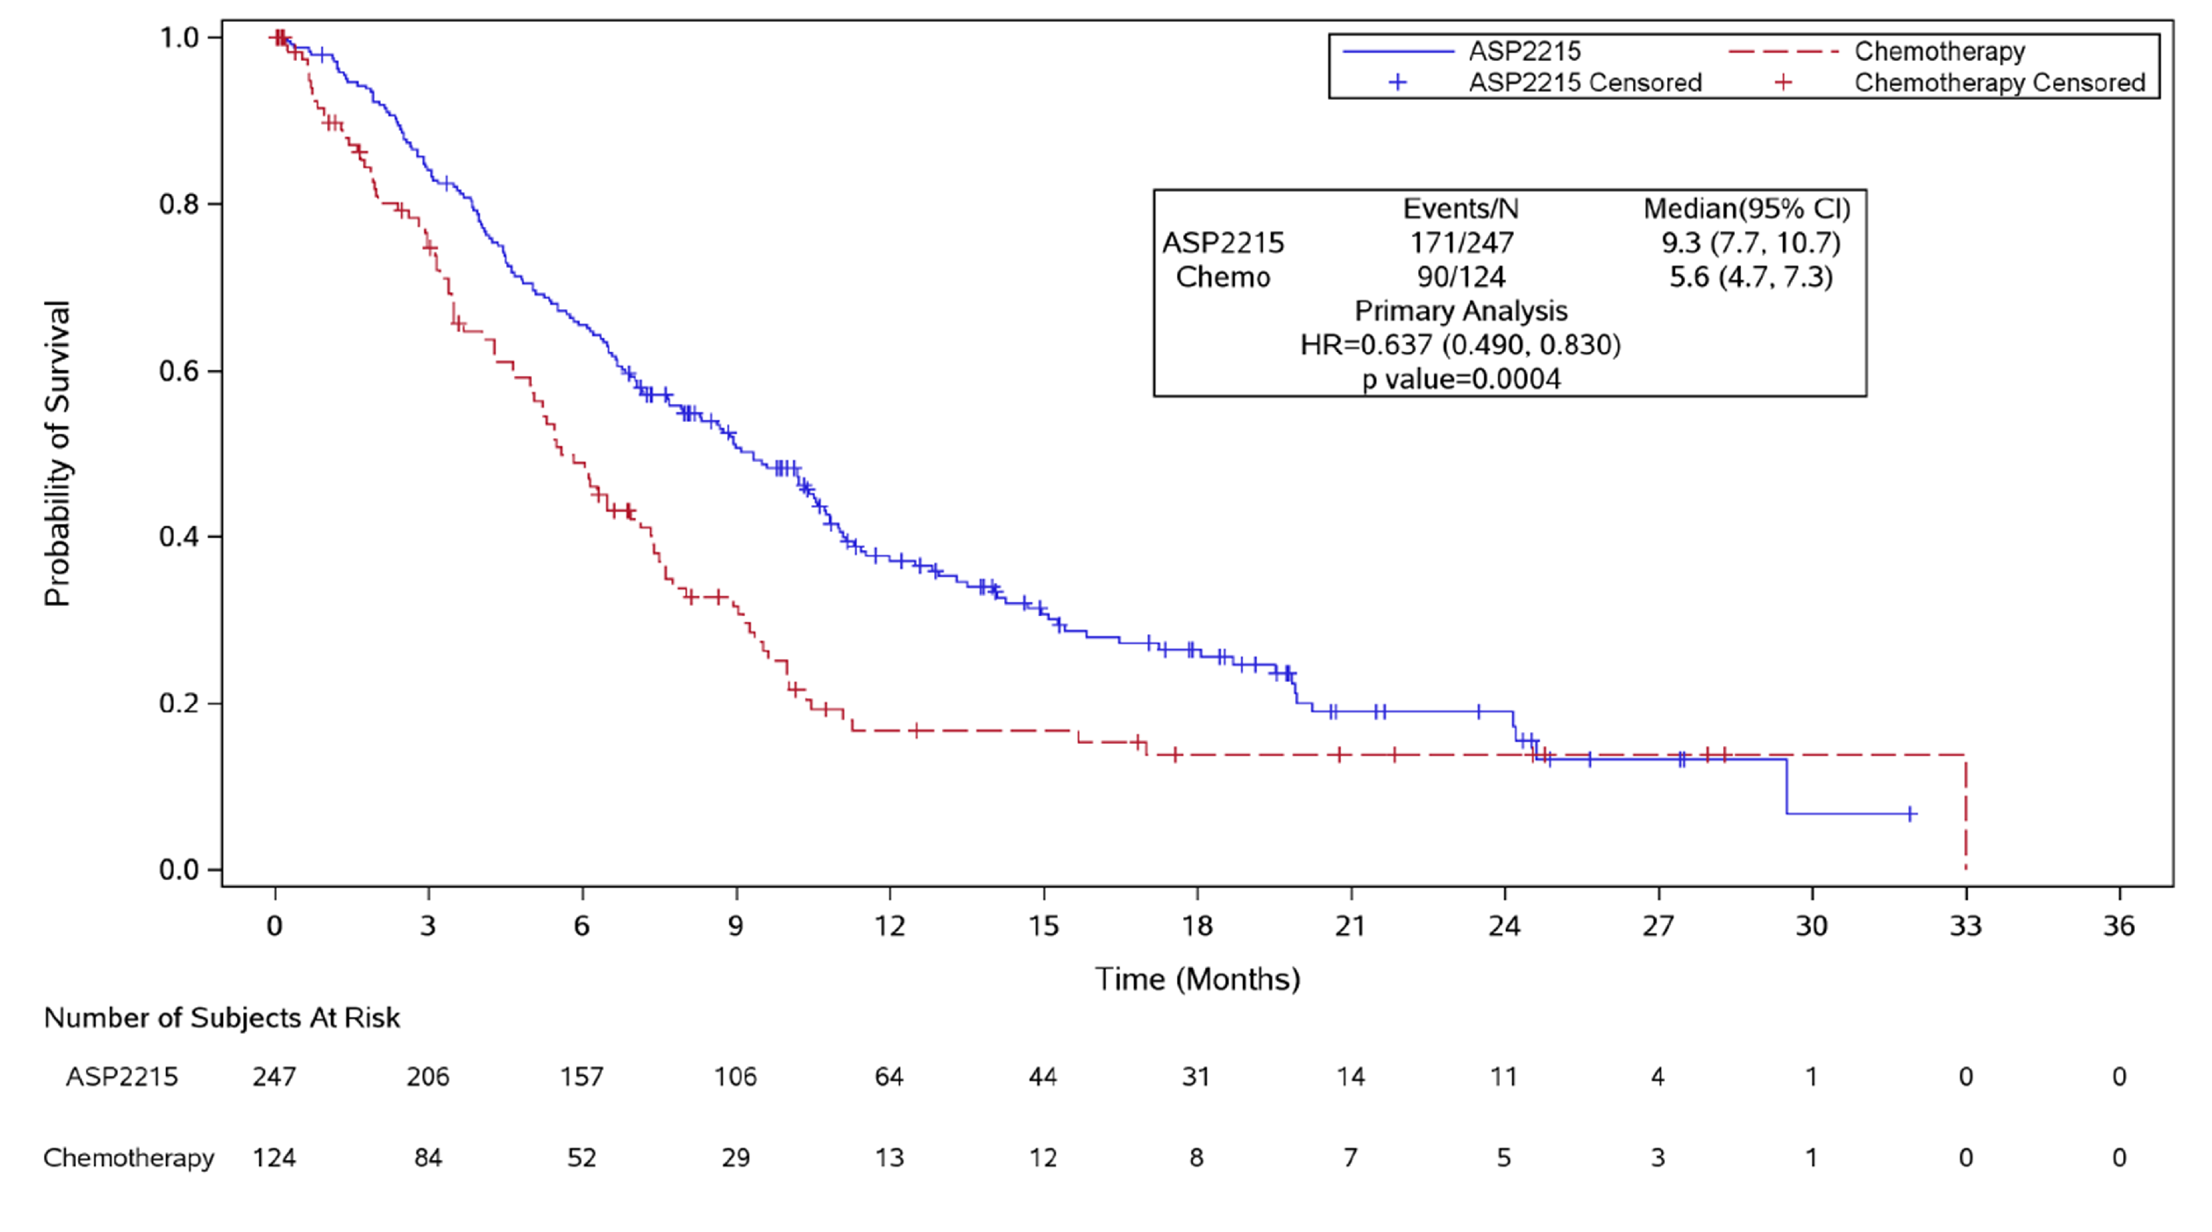Source: Figure 5, p66 of the submission.
ASP2215, gilteritinib; Chemo, salvage chemotherapy; HR, hazard ratio.
  - OS was statistically significantly longer for patients in the gilteritinib arm (median OS 9.3 months) than in the salvage chemotherapy arm (median OS 5.6 months; HR 0.637, 95% CI 0.49, 0.83).
  - OS may be subject to confounding due to differential use of subsequent therapies. In particular, more patients in the gilteritinib arm received HSCT (25.5%) compared to patients in the salvage chemotherapy arm (15.3%). The results of pre-specified sensitivity analyses, censoring patients who underwent HSCT (HR 0.575, 95% CI 0.434, 0.762), and censoring patients at the time of receiving any new anti-leukaemia therapy after study drug discontinuation (HR 0.447, 95% CI 0.312, 0.639) were consistent with the overall ITT population. The submission and PSCR suggested that these results indicate the survival benefit associated with gilteritinib was also apparent in patients who did not undergo HSCT or those who did not receive any subsequent anti-leukaemia therapies. The ESC agreed with the evaluation that it was unclear whether there were potential differences in patient or disease characteristics that may be contributing to differences in OS between arms. Subgroup characteristics by HSCT and by subsequent therapies were not provided in the submission.
  - Supplementary analyses of OS were performed on updated data cuts at one year (September 2019) and two years (September 2020) after the primary analysis (Perl 2020, Perl 2021). Comparisons of OS rates at 6, 12, and 24 months for the original data cut (September 2018), and later data cuts (September 2019, September 2020) are summarised in the table below.
Table 4: Overall survival in ITT population at data-cut off points (September 2018, September 2019, and September 2020)
 | September 2018 |  | September 2019 |  | September 2020
 | GILT | SC | GILT | SC | GILT | SC
Median follow-up | 17.8 months |  | 29.2 months |  | 37.1 months
Median OS | 9.3 months | 5.6 months | 9.3 months | 5.6 months | 9.3 months | 5.6 months
OS HR (95% CI) | 0.637 (0.490, 0.830) |  | 0.679 (0.527, 0.875) |  | 0.665 (0.518, 0.853)
OS rate, % (95% CI)
6 months | 65.5 (59.2, 71.1) | 48.9 (39.3, 57.8) | NR | NR | NR | NR
12 months | 37.1 (30.7, 43.6) | 16.7 (9.9, 25.0) | 36.6 (30.6, 42.7) | 19.2 (12.4, 27.2) | 36.6 | 19.2
18 months | NR | NR | 27 (21.1, 32.2) | 15 (9.1, 22.8) | NR | NR
24 months | 19.0 (12.8, 26.0) | 13.8 (7.5, 22.0) | 20 (15.4, 25.7) | 14 (8.3, 21.6) | 20.6 | 14.2
Source: Table 22, p67; Table 40, p96 of the submission; Perl 2020; Perl 2021
CI, confidence interval; GILT, gilteritinib; HR, hazard ratio; ITT, intent-to-treat; NR, not reported; OS, overall survival; SC, salvage chemotherapy

  - The median OS remained longer with gilteritinib than with salvage chemotherapy at the later data cut points. The submission noted that the median OS did not change as the data were already reasonably mature by the initial September 2018 data cut, however survival in the later periods was more robust.
  - These analyses suggest a survival benefit for gilteritinib over salvage chemotherapy. However, long-term survival data may be confounded by the introduction of subsequent leukaemia therapies in some patients after discontinuing study treatment, and small patient numbers at later timepoints.
  - The PSCR argued that two large RCTs with gilteritinib had demonstrated an OS gain, and long-term survivors, over salvage chemotherapy: ADMIRAL and COMMODORE. The PSCR argued the ADMIRAL trial demonstrated superior OS at primary analysis, and one and two-year updates. The PSCR reiterated the submission’s comment that the survival benefit of gilteritinib has also been observed in the COMMODORE phase 3 RCT (n=234) confirmatory trial (NCT03182244), which met its primary end point of improving OS compared with chemotherapy in patients with R/R FLT3 AML, as reported in a sponsor press release. The ESC noted that limited published information was available on the COMMODORE trial but considered the ADMIRAL trial data supported the submissions superior efficacy claim in terms of an OS gain.
  - There was no increase in OS with gilteritinib treatment compared to salvage chemotherapy for patients previously treated with an FLT3 inhibitor (HR 0.71; 95% CI 0.35, 1.44), although small patient numbers (32 gilteritinib treated patients and 14 salvage chemotherapy patients), and limited use of midostaurin (21 total patients) may limit the generalisability of these results to the Australian patient population.
  - The submission also included a retrospective analysis of results from relapsed/refractory AML patients treated with FLT3 inhibitors midostaurin or sorafenib, before receiving 120 mg or 200 mg gilteritinib in the phase 1 CHRYSALIS study (n=33 patients, all who received prior sorafenib), or before receiving 120 mg gilteritinib in the ADMIRAL trial (Perl 2020b). Results suggested that similar proportions of patients achieved composite complete remission with and without prior FLT3 inhibitor use. The ESC considered that in current practice almost 100% of patients would be using midostaurin in the first line treatment setting. The ESC considered that due to small patient numbers in both the ADMIRAL and CHRYSALIS trials, the impact of prior FLT3 inhibitor use (particularly of midostaurin) on the efficacy of gilteritinib was unclear.

Event free survival
  - EFS was defined in the ADMIRAL trial as time from randomisation until date of documented relapse, treatment failure or death from any cause within 30 days after the last dose of study drug. A Kaplan-Meier plot of EFS is presented in the figure below.
Figure 2: Kaplan-Meier plot of event free survival, ITT population of ADMIRAL trial (September 2018 data cut)
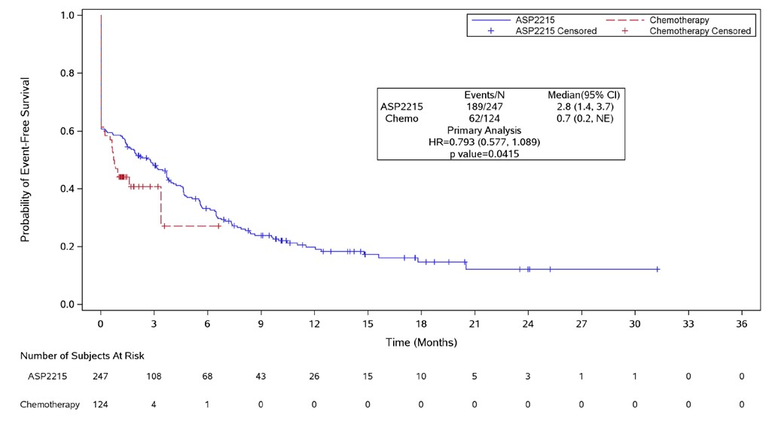
Source: Figure 8, p75 of the submission.
ASP2215, gilteritinib; Chemo, salvage chemotherapy; CI, confidence interval; HR, hazard ratio
Note: EFS drops to approximately 60% in both treatment arms on Day 0 (randomisation date) because patients who discontinued treatment and failed to achieve a response during their treatment period (having either partial or no response) were defined as having an EFS event related to treatment failure and the event date was set at the date of randomisation.

  - There was a trend toward longer EFS in the gilteritinib arm (median EFS 2.8 months) compared to the salvage chemotherapy arm (0.7 months, HR 0.79; 95% CI 0.58, 1.09), but the endpoint did not meet the pre-specified criteria for statistical significance. EFS could not be reliably estimated in the salvage chemotherapy arm as the majority of salvage chemotherapy patients finished the study before cycle 2 of treatment, and so there was limited follow-up of response (with no systematic/standard measurement of disease for relapse) and high censoring.
  - An ad hoc sensitivity analysis was performed that also considered investigator-reported events (relapse and deaths off treatment and new AML therapy). The number of censored events was reduced in this analysis compared to the ITT analysis. A nominally greater median EFS of 2.3 months was observed in the gilteritinib arm compared to 0.7 months in the chemotherapy arm (HR 0.50, 95% CI 0.39, 0.64). However, the evaluation considered that these results should also be interpreted with caution given the lack of central assessment of response or relapse after treatment discontinuation and the differences in treatment duration between gilteritinib and salvage chemotherapy arms.
  - The submission also presented results for leukaemia-free survival, but noted similar censoring of salvage chemotherapy patients as in the EFS analysis, which made the survival curve estimate unreliable for this treatment arm.

Response to treatment
  - Response outcomes at the final analysis were summarised descriptively for both treatment arms (see table below).
Table 5: Best overall response rates in ADMIRAL trial, ITT population, September 2018 data cut
Response rate | Gilteritinib  (N = 247), n (%) | Chemotherapy  (N = 124), n (%) | Adjusted treatment difference (95% CI)ª
CR | 52 (21.1) | 13 (10.5) | 10.6 (2.8, 18.4)
CR/CRh | 84 (34.0) | 19 (15.3) | 18.6 (9.8, 27.4)
CRc^{b} | 134 (54.3) | 27 (21.8) | 32.5 (22.3, 42.6)^{c}
Partial response | 33 (13.4) | 5 (4.0) | NR
No response | 66 (26.7) | 43 (34.7) | NR
Not evaluable | 14 (5.7) | 49 (39.5) | NR
Treatment response prior to HSCT (patients achieving CR or CRh prior to HSCT at any post-baseline visit)
CR | 34 (13.8) | 13 (10.5) | 3.3 (-4.0. 10.5)
CR/CRh | 65 (26.3) | 19 (15.3) | 10.9 (2.4, 19.5)
Source: Table 24, p72 of the submission, ADMIRAL CSR
CI, confidence intervals; CR, complete remission; CRc, composite complete remission; CRh, complete remission with partial haematological recovery; HSCT, haematopoietic stem cell transplant; NR, not reported
ª Based on stratified Cochran-Mantel-Haenszel test. Stratification factors were response to first-line AML therapy and preselected salvage chemotherapy. Treatment differences were adjusted based on pooled strata (including relapse/refractory to first line therapy, HSCT/no HSCT, high/low intensity chemotherapy).
^{b} CRc defined as the combination of complete remission, complete remission with incomplete haematologic recovery and complete remission with incomplete platelet recovery.
^{c} Stratified analysis was not conducted, results from unstratified analysis shown. Treatment difference = gilteritinib - chemotherapy. 95% CI were asymptotic confidence limits using the normal approximation to the binomial distribution. P value based on 2-sided Fisher's exact test.

  - In the ITT population, rates of complete remission with or without partial haematological recovery and composite complete remission were numerically higher in the gilteritinib arm than the salvage chemotherapy arm. Fewer patients in the gilteritinib arm achieved complete remission prior to HSCT, but rates remained numerically higher than in the salvage chemotherapy arm. Results of these comparisons were nominal rather than confirmatory as a prior analysis of EFS was not statistically significant in the pre-planned hierarchical testing procedure. Furthermore, the ESC noted the majority of salvage chemotherapy patients (74.2%) had either no response during treatment, or no evaluable post-baseline assessment of response, and considered this limited the usefulness of the comparison.
  - In the gilteritinib arm, median duration of complete remission (CR) was 14.8 months (95% CI 11.0, not estimable) and median duration of CR with or without partial haematologic recovery was 11 months (95% CI 4.6, not estimable). Duration of remission could not be reliably estimated in the salvage chemotherapy arm, given the limited follow-up of response to treatment and high censoring rate.
  - The submission presented a post hoc analysis of duration of remission in long-term survivors in the gilteritinib arm of the ADMIRAL trial (September 2019 data cut). A total of 63/247 (25.5%) patients treated with gilteritinib were alive for at least 18 months and were considered long-term survivors, of whom 47.6% (n=30) achieved complete remission with or without partial haematological recovery (CR/CRh) and 71.4% (n=45) achieved composite complete remission (CRc). Based on the Kaplan-Meier plot for duration of remission, approximately 60-65% of long-term survivors who had achieved remission (CR or CR/CRh) remained in remission at 18 months. The submission stated the median durations of CR or CR/CRh in long-term survivors had not been reached and the data indicated a plateau in survival risk. This claim could not be verified due to poor documentation in the submission. The available data were presented in a poster format only with limited reporting regarding the method of analysis and duration of follow-up. During the evaluation, the estimated proportion of long-term survivors remaining in remission at 18 months was calculated as 30% in CR and 46% in CR/CRh. These estimates were consistent with an analysis of subsequent therapies in long-term survivors provided in the Perl 2020 poster, with 50% of patients receiving treatments due to relapse and/or treatment failure following gilteritinib treatment. The data suggested the majority of long-term survivors were likely to have some form of active disease (e.g. relapsed or treatment failure).
  - A post hoc analysis of treatment response in the ADMIRAL trial was also provided at the September 2020 data cut (Perl 2021 poster). At the time of this analysis, 49 patients in the gilteritinib arm and 14 patients in the salvage chemotherapy arm remained alive for at least 2 years after randomisation. Of the 49 patients who were alive in the gilteritinib arm, 26 patients were relapse-free. No relapse outcomes were available for the salvage chemotherapy arm. The data were consistent with analyses based on the September 2019 data cut, suggesting that approximately half of long-term survivors had experienced disease relapse. The median duration of CR for gilteritinib-treated patients at the September 2020 data cut was 23.0 months (interquartile range: 4.9, not evaluable), and the median duration of CRc was 4.6 months (interquartile range: 1.9, 24.0). The 2-year cumulative relapse rates in patients who achieved CR or CRc were 52.6% and 75.7%, respectively. The analysis suggested that most relapses after CRc occurred within 12 months and few events occurred after 18 months. The evaluation advised that results of this post hoc analysis should be interpreted with caution as data beyond 18 months were informed by a relatively small number of patients.
  - The ESC noted that a post hoc analysis of response rates was reported for the 55% (136/247) of patients who either had their gilteritinib dose increased to 200 mg (n=78) or decreased to 80 mg (n=58). The ESC noted that response rates were lower in patients whose gilteritinib dose was increased to 200 mg (CR 7 (9.0%), CR/CRh 12 (15.4%), CRc 25 (32.1%)) compared to those reported for gilteritinib ITT population in Table 5, potentially reflecting that the dose was increased in patients not responding to treatment. The ESC also noted that a dose reduction to 80 mg did not appear to adversely affect response rates (CR 14 (24.1%), CR/CRh 24 (41.4%), CRc 32 (55.2%)).

Quality of life
  - Patient-reported outcomes were measured using the Brief Fatigue Inventory and the EQ-5D-5L. Results indicated little change from baseline on both measures in each treatment group during the first cycle of treatment. There were very limited data for salvage chemotherapy patients by the second cycle of treatment, and the comparative impact of treatment on long-term quality of life is unknown.

Post-HSCT survival and gilteritinib maintenance therapy
  - A post hoc analysis of OS was presented for patients who underwent HSCT during the trial, using updated data from the September 2019 data cut (see figure below). There were 63 gilteritinib treated patients (25.5%) and 19 salvage chemotherapy patients (15.3%) who underwent HSCT.
Figure 3: Post hoc analysis of survival after HSCT (ITT population, September 2019 data cut)
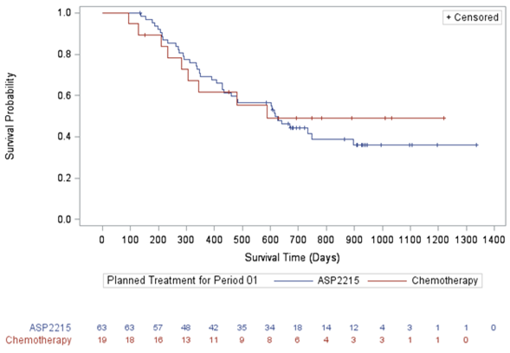
Source: Figure 11, p98 of the submission
ASP2215, gilteritinib; HSCT, haematopoietic stem cell transplant; ITT, intent-to-treat

  - Median OS was longer in post-HSCT patients receiving gilteritinib (610 days) compared to those receiving salvage chemotherapy (482 days, HR 1.11, 95% CI 0.54, 2.30), but the result was not statistically significant. The submission noted the crossing Kaplan-Meier survival curves, suggesting unreliable HR and median OS estimates. The analysis could not be adequately assessed as the source was not provided with the submission. A further analysis of post-HSCT survival was conducted using updated data from the September 2020 data cut reported in the Perl 2021 abstract. Median post-HSCT OS landmarked to HSCT date was similar across arms (gilteritinib, 16.1 months; salvage chemotherapy, 15.3 months; HR 1.08; 95% CI: 0.54, 2.16). There was no corresponding Kaplan-Meier plot in the abstract. The results were difficult to interpret due to limited reporting. The submission claimed there was a trend in favour of gilteritinib compared to salvage chemotherapy in terms of OS following HSCT. The ESC considered the data were inconclusive, with the updated analysis using the most recent cut-off (September 2020) indicating no difference in median OS between arms.
  - The figure below presents a post hoc analysis of OS in patients in the gilteritinib arm who restarted gilteritinib after HSCT, compared with those who did not restart, based on the September 2019 data cut of the ADMIRAL trial. Of the 63 patients in the gilteritinib arm who proceeded to HSCT, 40 (63.5%) re-started gilteritinib while 23 (36.5%) did not.
Figure 4: Post-HSCT overall survival in gilteritinib restarters versus non-restarters in the ADMIRAL trial (September 2019 data cut)
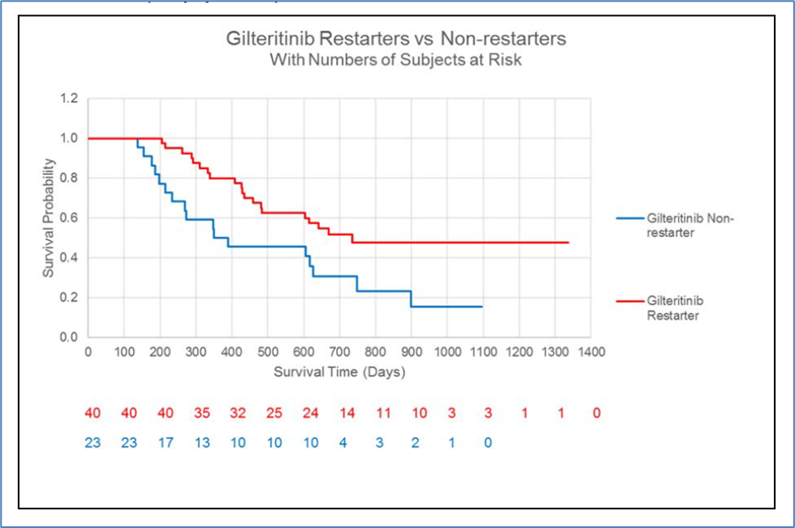
Source: Figure 12, p99 of the submission

  - The hazard ratio for OS in restarters versus non-restarters was 0.46 (95% CI 0.24, 0.88). The submission claimed that this supported improved survival benefit with gilteritinib maintenance therapy after HSCT. The analysis could not be adequately assessed during the evaluation as the source was not provided in the submission. The submission acknowledged the analysis was limited by the relatively small patient numbers in the non-restarter group making the reliability of treatment estimates uncertain. The results were also difficult to compare with survival estimates in the salvage chemotherapy arm, which were also limited by small patient numbers. It was unclear whether the subgroups of gilteritinib patients who did or did not resume gilteritinib after HSCT were comparable. Only those patients who were in composite complete remission after HSCT and who did not have Grade 2 or higher acute graft versus host disease were able to recommence gilteritinib. Differences in survival between gilteritinib restarters and non-restarters may therefore be due to differences between groups in response to HSCT, rather than the effects of post-gilteritinib treatment.
  - The PSCR reported on the use of FLT3 inhibitors post HSCT to reduce the risk of relapse explored in a phase 2 RCT of sorafenib (SORMAIN, Burchert et al 2020, n = 83, n = 43 treated with sorafenib) and a large retrospective chart review (Griffin et al 2021, n = 1,208, where 18.1% of patients (n = 219) received FLT3 inhibitors post HSCT). The PSCR argued that together these studies suggest that maintenance therapy with FLT3 inhibitors post HSCT in FLT3-positive patients is clinically feasible and associated with prolonged relapse free survival.
  - The ESC agreed with the evaluation that the differences between gilteritinib restarters and non-restarters could be due to differences between the patient groups rather than due to a treatment effect with gilteritinib (see paragraph 6.40). The ESC considered the benefit of post HSCT gilteritinib maintenance therapy was not supported by the evidence presented in the submission or PSCR. As mentioned above, the pre-PBAC response withdrew the request for listing in this setting.

Survival without HSCT
  - The following OS data were included in the economic evaluation section of the submission, derived from a post hoc analysis of individual patient data from the ADMIRAL trial based on the ITT population who did not receive subsequent HSCT (gilteritinib, 184 patients; salvage chemotherapy, 105 patients). The data cut used in the analyses was not specified in the submission.
Figure 5: Kaplan-Meier plot of overall survival in the subgroup who did not receive HSCT (data cut not reported)
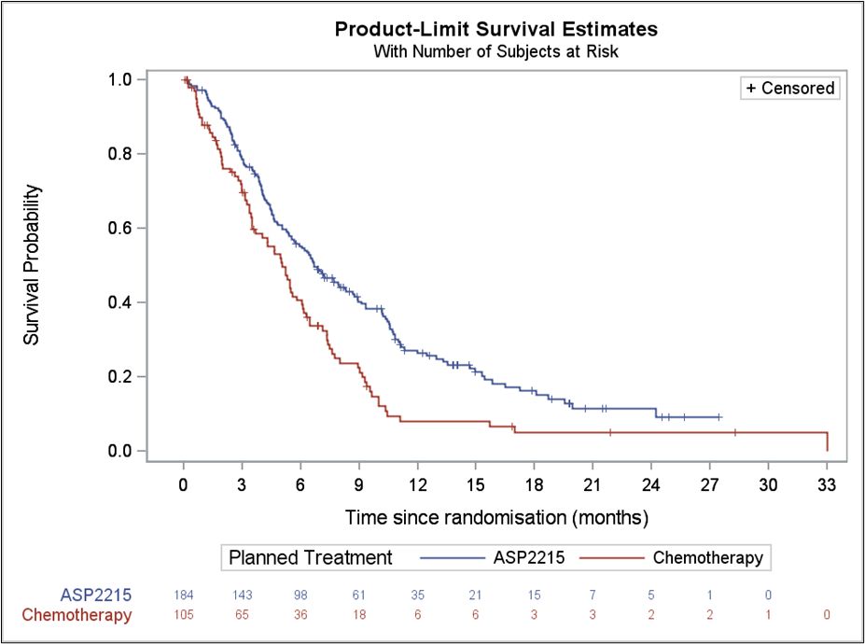
Source: Figure 24, p 145 of the submission
Note: ASP2215 is gilteritinib

  - Based on treatment effect estimates, gilteritinib treatment was associated with improved OS compared to salvage chemotherapy in patients who did not receive HSCT during the trial follow-up (HR 0.662, 95% CI: 0.507, 0.863). The results appeared consistent with results from the overall ITT population. However, the evaluation advised that the analysis should be interpreted with caution given the lack of details required for adequate assessment including the data cut used, duration of follow-up, number of events and censoring, median OS estimates and patient characteristics. In addition, the ESC considered there was insufficient data to determine if OS plateaus from 24 months.

Long-term survival and cure
  - In the economic model, the submission assumed all patients remaining alive at 2 years (subdivided by No HSCT and With HSCT cohorts) were cured, irrespective of disease status or treatment status. The submission claimed that gilteritinib treatment was associated with sustained remission, which was likely to translate to cure and ongoing survival benefit. The submission claimed the ongoing survival benefit was driven by long-term survivors who had undergone HSCT. No data were presented on long-term survivors stratified by those with and without HSCT in the ADMIRAL trial.
  - The ESC considered that overall, long-term survival benefits and the likely proportion achieving cure due to gilteritinib treatment were uncertain. Data based on later data cuts of the ADMIRAL trial suggested that not all long-term survivors achieved durable remission and at 2 years, a substantial proportion surviving patients had experienced an event (relapse or treatment failure). The ESC advised that patients with ongoing disease cannot be considered cured.
  - The submission argued that a cure assumption was reasonable in patients receiving HSCT as it is a potentially curative treatment, particularly in relapsed/refractory AML patients who have no other effective therapeutic options. The submission claimed the cure assumption was supported by post hoc analyses of post-HSCT OS in the ADMIRAL trial (see figure below). The submission used pooled data to predict OS after HSCT in the economic model, claiming no difference in post-HSCT survival between treatment arms.
Figure 6: Kaplan-Meier plot of overall survival post-HSCT, pooled across treatment arms (September 2019 data cut-off)
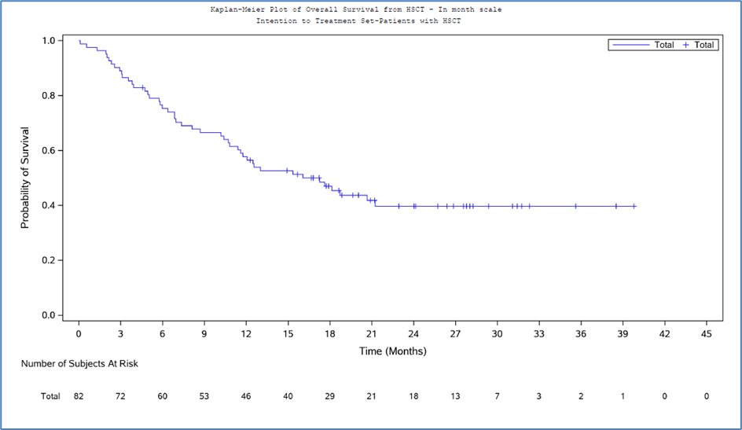
Source: Figure 31, p 152 of the submission

  - The submission also claimed the plateau at the tail-end of the Kaplan-Meier plot of pooled post-HSCT OS beginning at 22 months was representative of cure in 39.7% of patients remaining alive at that timepoint (see figure above, September 2019 data cut). The plateau was informed by a relatively small number of patients with unknown follow-up duration. Corresponding pooled post-HSCT OS data using a more recent data cut (September 2020) were not provided in the submission.
  - No justification was provided in support of a cure assumption in the No HSCT cohort of the model, and it was inconsistent with the submission’s claim that there were no other effective therapeutic options apart from HSCT. The economic model assumed a difference in cure rates between treatment arms leading to survival benefit with gilteritinib treatment in patients who do not undergo HSCT.
  - The submission acknowledged that the analysis of OS in the subgroup receiving HSCT was limited as the data were informed by a small number of patients (82 patients, 63 in the gilteritinib arm and 19 in the salvage chemotherapy arm). To support the ADMIRAL data, the submission conducted a review of the published literature, which identified 13 publications reporting post-HSCT survival in AML patients. There was substantial variance in survival estimates across the included studies in the submission, which were difficult to interpret and compare. The assessment of the evidence was challenging due to numerous issues surrounding heterogeneity and applicability to the PBS population (e.g. age of study, study design, population and disease characteristics, and healthcare settings).
  - The Poire 2018 study provided a subgroup analysis of OS after HSCT in patients who were FLT3-ITD mutation positive, aged ≥60 years who were in second complete remission (i.e. relapsed). The study reported a 2-year OS of 29% following HSCT. Overall, there was no clear consensus on the impact of FLT3 mutation status on survival outcomes after HSCT, particularly in patients who are relapsed/refractory. In general, both relapsed/refractory patients and FLT3 mutation positive patients have poorer prognosis and are more likely to relapse following subsequent therapies.
  - The submission claimed that despite the diversity across the identified studies, the data support a plateau in the risk of death at approximately 2 years after HSCT. A selection of survival curves from the most recent of the identified studies is presented in the figure below.
Figure 7: Comparison of post-HSCT overall survival in the ADMIRAL trial (pooled data) and published studies
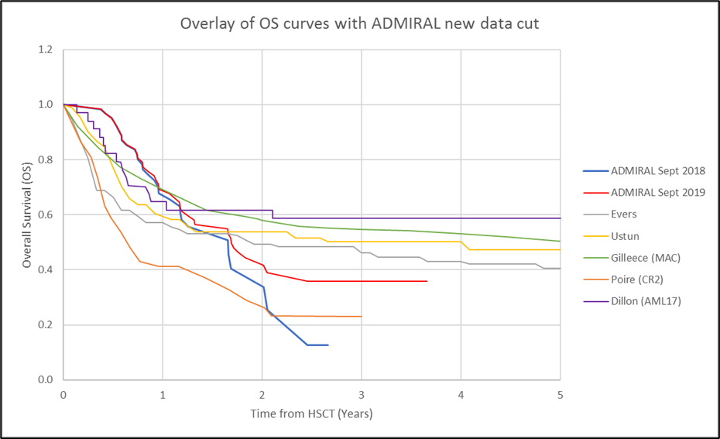
Source: Figure 38, p 162 of the submission
CR2, second complete remission; MAC, myeloablative conditioning
Note: The Dillon study was based on patients enrolled in the NCRI AML17 study in the UK. The OS plot appeared to be based on overall survival in the subgroup of patients who were FLT-ITD mutation positive.
  - Post-HSCT survival estimates in the Poire study, which included a subgroup of FLT3-ITD mutation positive refractory patients, appeared lower than that observed in the ADMIRAL trial. The reasons for this difference were unclear. While the Poire study was aimed at older patients, the median age in this study was similar to the ITT population in the ADMIRAL trial (64 years versus 62 years, respectively).
  - The submission claimed that the post-HSCT survival curves generally flatten at the 18- to 24-month timepoint, supporting 2 years as a suitable cure timepoint for patients following HSCT. In general, the plateaus were informed by relatively few patients remaining at risk, and may not be a reasonable representation of cure. In addition, reported leukaemia-free survival estimates were consistently lower than OS estimates across the identified studies. The assumption of cure based on OS alone appeared optimistic given the estimates included patients with active disease.
  - The ESC considered that the cure of all patients alive at 2 years was not supported by the evidence presented. The ESC considered that only patients who are alive at 2 years and disease free could be considered to be cured, more so if they are post HSCT. However, the ESC advised that in clinical practice 5 years disease free is generally a more accepted definition of a cure. The ESC noted that such patients’ morbidity and mortality will be greater than the general population due to complications of treatment. The ESC advised that patients with ongoing disease cannot be considered cured.

Comparative harms
  - Due to the longer duration of treatment exposure in the ADMIRAL trial (gilteritinib median 126 days; salvage chemotherapy median 28 days), adverse event data were presented with adjustment for treatment exposure. The table below presents the incidence of adverse events unadjusted and adjusted for patient years of exposure, based on the primary analysis data cut (September 2018).
Table 6: Summary of key adverse events in the trials
Adverse events | Gilteritinib  N = 246, PY = 121.7 |  | Salvage chemotherapy  N = 109, PY = 11.9
Adverse events | Patients, n (%) | Events (E/PY) | Patients, n (%) | Events (E/PY)
TEAE | 246 (100) | 8464 (69.6) | 107 (98.2) | 1596 (134.1)
Serious TEAE | 205 (83.3) | 865 (7.1) | 34 (31.2) | 110 (9.2)
TEAE leading to death | 71 (28.9) | 87 (0.7) | 16 (14.7) | 23 (1.9)
TEAE leading to withdrawals | 58 (23.6) | 80 (0.7) | 13 (11.9) | 18 (1.5)
NCI-CTCAE Grade 3 or higher TEAE | 236 (95.9) | 2354 (19.3) | 94 (86.2) | 505 (42.4)
Any death after first dose of study drug | 170 (69.1) | 170 (1.40) | 81 (74.3) | 81 (6.81)
Source: Table 36, pp85-86 of the submission.
E, events; NCI-CTCAE, National Cancer Institute - Common Terminology Criteria for Adverse Events; PY, patient-year; TEAE, treatment emergent adverse event
  - A greater proportion of gilteritinib patients experienced all key treatment-emergent adverse event types compared to salvage chemotherapy patients, with the exception of any death after the first dose of study drug. However, when adjusted for treatment exposure time, overall treatment emergent adverse events per patient year were lower in the gilteritinib arm (69.6 events/patient year) than the salvage chemotherapy arm (134.1 events/patient year), and for all other treatment emergent adverse event measures, regardless of severity or relatedness to treatment. The safety profiles of gilteritinib and salvage chemotherapy were difficult to compare due to differences in treatment modality. Gilteritinib is used as ongoing treatment until disease progression whereas the use of salvage chemotherapy differed depending on high-intensity (1-2 cycles) or low-intensity (ongoing until discontinuation criteria met) regimens. No adverse event data were presented comparing gilteritinib with salvage chemotherapies by subgroups of high- and low-intensity regimens.
  - All patients in the gilteritinib arm and 98.2% in the salvage chemotherapy arm experienced an adverse event. The most common adverse events in the gilteritinib arm were anaemia (47.2%), febrile neutropenia (46.7%), pyrexia (42.7%), alanine aminotransferase increased (41.9%), aspartate aminotransferase increased (40.2%), diarrhoea (32.9%), and nausea (32.1%). In the salvage chemotherapy arm, the most common adverse events included febrile neutropenia (36.7%), anaemia (34.9%), nausea (33.0%), hypokalaemia (31.2%), pyrexia (29.4%), and diarrhoea (29.4%).
  - The most frequently reported serious adverse events in gilteritinib-treated patients were febrile neutropenia (30.9% of patients), pyrexia (13.0%) and pneumonia (10.6%); and in salvage chemotherapy treated patients were febrile neutropenia (8.3%) and sepsis (6.4%).
  - There were 170 (69.1%) total deaths in gilteritinib treated patients (1.40 events/patient year) and 81 (74.3%) in salvage chemotherapy treated patients (6.81 events/patient year). Treatment-emergent adverse events leading to death were recorded in 71 (28.9%) gilteritinib patients and 16 (14.7%) salvage chemotherapy patients. In the gilteritinib arm, deaths were most frequently due to AML (11.4%), septic shock (2.8%), sepsis (2.0%), cardiac arrest (1.6%), lung infection (1.6%) and pneumonia (1.2%). In the salvage chemotherapy arm, deaths were most frequently due to AML (3.7%), sepsis (2.8%), and respiratory failure (1.8%).
  - Several events of special safety interest were defined in the ADMIRAL trial, including liver toxicity, cardiac failure, arrhythmia, muscle injury and gastrointestinal events, as well as posterior reversible encephalopathy syndrome (PRES), differentiation syndrome, and squamous cell skin cancer. In the gilteritinib arm, these events (unadjusted for treatment duration) were experienced by 73.2% of patients, including ALT increased (41.9%), AST increased (40.2%), creatine phosphokinase increased (26.0%), blood bilirubin increased (8.5%), muscle weakness (8.1%), arrhythmia due to QT prolongation (14.2%), and blood creatine phosphokinase increased (5.3%). PRES was recorded in 3.3% of gilteritinib patients. Withdrawal of treatment was reported for patients experiencing increased ALT (1.2%), AST (1.6%), and blood bilirubin (0.4%). In the salvage chemotherapy arm, 33% of patients experienced an event of special safety interest, including ALT increased (9.2%), AST increased (11.9%) and blood bilirubin increased (6.4%). Arrhythmia due to QT prolongation was noted in 1.8%, and PRES in 3.7% of chemotherapy patients. No patients in either treatment arm experienced differentiation syndrome. The submission noted that the different treatment durations across treatment arms should be considered when interpreting these results.
  - Long-term safety data (from later data cuts) indicated a lower incidence of adverse events with gilteritinib treatment, but the evaluation advised that small patient numbers remaining alive for up to two years after the primary analysis may limit the generalisability of these results. There was no information regarding safety in post-HSCT gilteritinib patients or comparative safety in patients with or without HSCT in the available published sources.
  - Important identified risks from the gilteritinib Periodic Safety Update Report (May 2021) included: PRES and differentiation syndrome. Important potential risks include Torsade de Pointes (and implicit prolonged QT), eye disorders, serious gastrointestinal disorders (including bleeding, perforation and paralysis), serious hepatotoxicity, pulmonary adverse events, pancreatitis, embryo-foetal lethality, suppressed foetal growth and teratogenicity. Missing information included the long-term safety profile for gilteritinib, and safety in patients with renal impairment.

Benefits/harms
  - On the basis of direct evidence presented in the submission (ADMIRAL whole trial population), after approximately 3 years, patients treated with gilteritinib compared to salvage chemotherapy had:
- longer OS of approximately 4.3 months.
For every 100 patients treated with gilteritinib compared to salvage chemotherapy:
- 17 additional patients would be alive after 1 years.
- 6 additional patients would be alive after 2 years.
- 33 additional patients would achieve complete remission (with or without incomplete haematologic or platelet recovery).
  - It was not possible to reliably determine the difference between treatments in the duration of EFS or duration of remission.
  - A comparison of safety was not possible due to significant differences in treatment modality (see paragraph 6.57).

Clinical claim
  - The submission described gilteritinib as superior in terms of effectiveness compared to salvage chemotherapy. The ESC agreed with the evaluation that the submission’s efficacy claim may be reasonable in terms of OS versus salvage chemotherapy. However, long-term survival data may be confounded by the introduction of subsequent leukaemia therapies in some patients after ceasing study treatment, and small patient numbers at later time points. The magnitude of survival benefit in subgroups of patients who do or do not proceed to HSCT was uncertain. The evaluation advised that the following issues should be considered:
- Salvage chemotherapy treatment duration was considerably shorter than for gilteritinib, and central assessment of response was only performed while on study treatment. Although response rates for gilteritinib treated patients were nominally higher than for salvage chemotherapy patients, measures of duration of response, including EFS, were unreliable due to a lack of long-term follow up of response in salvage chemotherapy patients, and a large proportion of patients with no evaluable post-baseline response assessments in the salvage chemotherapy arm.
- The applicability of the ADMIRAL trial results to the Australian patient population was highly uncertain, with patients in the trial likely younger and fitter, and with less prior midostaurin use, than the Australian population. The ESC considered that in current practice almost 100% of patients would be using midostaurin in the first line treatment setting and that the impact of prior FLT3 inhibitor use on the efficacy of gilteritinib was uncertain (see paragraph 6.25). The applicability of HSCT rates from the trial to Australian practice was also unclear. It is possible that the younger, fitter population in the ADMIRAL trial may have permitted higher rates of HSCT than would be observed in the Australian population.
- The ESC considered a treatment benefit for gilteritinib in the post-HSCT maintenance setting was not supported, with a lack of documentation and small patient numbers limiting the usefulness of the submission’s analysis. Patients in the trial were only able to resume gilteritinib treatment after a favourable response to HSCT, and it was unclear whether the post-HSCT survival was influenced by differing responses to HSCT rather than resumption of gilteritinib. The PBAC agreed with this assessment.
- There was limited evidence to support the submission’s claim of cure in all patients who remain alive at 2 years, regardless of disease or HSCT status. There may be potential for cure in patients who maintain durable remission, however available data for gilteritinib patients suggested that a proportion of long-term survivors have some form of active disease (i.e. relapse or treatment failure). Therefore, the assumption that all patients who are alive at 2 years achieve cure appeared optimistic. Long-term survivor outcomes in the salvage chemotherapy arm were limited and there was a lack of remission and relapse outcomes due to limited follow-up in the ADMIRAL trial. No data were presented on long-term survivors stratified by those with and without HSCT in the ADMIRAL trial.
  - The submission described gilteritinib as superior in terms of safety over a comparable time period compared to salvage chemotherapy. Comparison of safety was difficult due to differences in treatment modality. The comparative safety of gilteritinib versus high and low intensity treatments is likely to be different, however, no data were provided in the submission.
  - The ESC considered the safety profiles of gilteritinib and salvage chemotherapy were similar in intensity but with some important differences in both type and incidence of adverse effects encountered. Overall, the ESC considered the claim of superior safety was not supported by the data presented in the submission. The PBAC agreed with this assessment.
  - The PBAC considered that the claim of superior comparative effectiveness was likely reasonable in terms of improved OS over the trial duration, however agreed with the ESC that the magnitude of benefit over the long term was uncertain due to issues described above. The PBAC also considered that the long-term remission and relapse outcomes were unclear, although there was a trend towards longer EFS.

Economic analysis
  - The submission presented a modelled economic evaluation of gilteritinib monotherapy compared to salvage chemotherapy for the treatment of patients with relapsed or refractory AML who have FLT3 mutation. The economic evaluation was based on data from the ADMIRAL trial as well as other modelled variables. The economic evaluation was presented as a cost-utility analysis.
Table 7: Key components of the economic evaluation
Component | Summary
Treatments | Gilteritinib monotherapy versus salvage chemotherapy (weighted based on distribution of use in the ADMIRAL trial of 13.7% low dose cytarabine, 25.8% azacitidine, 26.6% MEC and 33.9% FLAG-IDA)
Time horizon | 40 years in the model base case versus median follow-up of 30 months in the ADMIRAL trial
Outcomes | Life years, quality-adjusted life years
Methods used to generate results | Hybrid decision-tree and partitioned survival analysis
Health states | Decision-tree stratified patients to With HSCT and No HSCT cohorts, followed by two separate partitioned survival analyses with three states (event-free, post-event and dead).
Cycle length | 1 month
Allocation to health states | After initiating treatment with gilteritinib or salvage chemotherapy, patients were subdivided into two groups (With HSCT and No HSCT) according to whether they received HSCT after initial treatment in the ADMIRAL trial (gilteritinib 25.5%, salvage chemotherapy, 15.3%). For each treatment option, separate partitioned survival analyses were used to estimate health state occupancy in three states (event-free, post-event and dead). The probability of entering/remaining in these states was dependent on cumulative probabilities derived from separately modelled EFS and OS survival curves for the No HSCT and With HSCT cohorts. To determine health state occupancy for the overall population, HSCT rates in the ADMIRAL trial were used to combine the With HSCT and No HSCT cohorts into a single model trace. This trace formed the basis for the cost and QALY calculations for each treatment group.  No HSCT OS was modelled using individual arm KM data from the ADMIRAL trial (data cut unreported) until 12 months in the gilteritinib arm and 9 months in the salvage chemotherapy arm, then extrapolated using the log-logistic function to 2 years. From 2 years to 40 years, OS was informed by general population mortality adjusted using a standardised mortality ratio (SMR) of 2.0.  No HSCT EFS was modelled using individual arm KM data from the ADMIRAL trial (data cut unreported, adjusted for treatment failures at Day 0) until 6 months, then extrapolated to 40 years using the log-logistic function in the gilteritinib arm and the log-normal function in the salvage chemotherapy arm.  In the With HSCT cohort, no deaths or events were assumed to occur from baseline to 4 months in the gilteritinib arm and to 3 months in the salvage chemotherapy arm (fixed intervals based on an analysis of ADMIRAL trial data, source not provided).  Following the fixed interval, With HSCT OS was modelled using pooled treatment arm KM data from the ADMIRAL trial (Sept 2019 data cut) until 2 years. In the gilteritinib arm, OS estimates were adjusted with the inclusion of post-HSCT gilteritinib maintenance treatment benefit (removed in the pre-PBAC response). From 2 years to 40 years, OS was informed by general population mortality adjusted using an SMR of 2.0.  Following the fixed interval, With HSCT EFS was synthesised based on a hazard ratio of 0.89 derived from external data (Ustun 2017 study) applied to the modelled With HSCT OS curve. The hazard ratio was applied until 2 years. Beyond this timepoint, EFS was assumed to remain constant (i.e. no events or deaths) until the EFS and OS curves converge at 10 years in the gilteritinib arm and at 11 years in the salvage chemotherapy arm. From those convergence points until 40 years, EFS and OS were equivalent.  The model assumed that all patients who remain alive at 2 years are cured, irrespective of whether they are event-free and irrespective of whether they have received HSCT. This was adjusted in the pre-PBAC response. The subsequent survival prognosis for these patients was modelled based on a two-fold increase in general population mortality. All costs and utilities applied after 2 years to surviving patients were based on long-term survivor estimates. The application of the cure assumption overrides all other modelled inputs.  All of the incremental costs (103%) occurred during the trial period while the majority of incremental QALYs (78%) were accrued in the extrapolated period beyond 30 months in long-term survivors.
Health state and event costs | Once-off costs for diagnostic testing, drug acquisition and administration for gilteritinib and all comparators, adverse events and HSCT were included in the model. Subsequent therapy drug and administration costs were applied to all incident patients experiencing an event. Monthly costs were included for disease management by health state (event-free, post-event) and for long-term survivors. Once-off terminal care costs were also included.
Health related quality of life | No HSCT event-free state 0.801; No HSCT post-event state 0.696; With HSCT event-free state 0.818; With HSCT post-event state 0.746. Based on EQ-5D-3L (UK value set) utilities cross-walked from EQ-5D-5L data from the ADMIRAL trial (Cella 2020 abstract).  HSCT recovery EQ-5D-5L utility of 0.750 applied for 6 months after HSCT based on published literature (Joshi 2019). Long-term survivor EQ-5D-5L utilities based on the McCaffrey 2016 study (55-64 years 0.89; 65-74 years 0.87; 75+ years 0.830). HSCT procedure disutility of -0.210 (one-month duration assumed) based on Joshi 2019 study. Adverse event disutilities based on multiple publications (Swinburn 2010, Lloyd 2006, Nafees 2008; one-month duration assumed) and incidence of severe (≥ Grade 3) adverse events in the ADMIRAL trial.
Discount rate | 5% discounting per annum, applied to some costs and outcomes only.
Source: Table 47, p 125 of the submission
EFS, event free survival; HSCT, haematopoietic stem cell transplant; KM, Kaplan-Meier; OS, overall survival; QALY, quality-adjusted life year
  - The model structure was comprised of a decision-tree component to stratify patients based on their subsequent HSCT status, followed by two separate three-state partitioned survival models; presented in the figure below. The ESC considered the separate modelling of patients receiving subsequent HSCT was reasonable.
Figure 8: Model structure and health states of the economic model
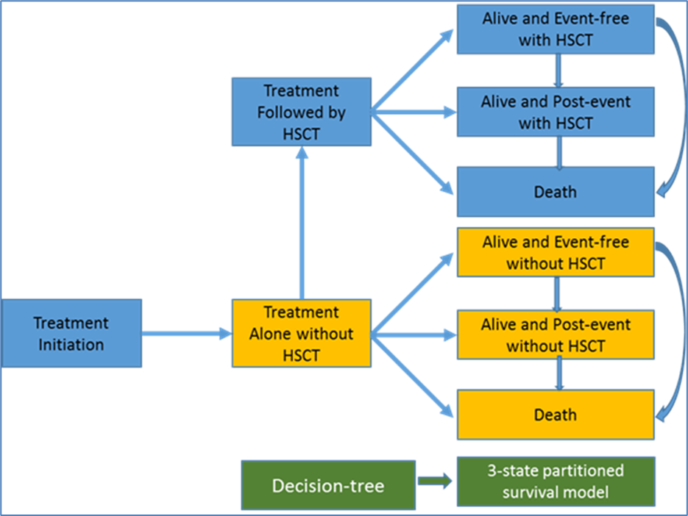
Source: Figure 22, p132 of the submission
  - The submission claimed the decision-tree component of the model was necessary to account for the waiting time of patients prior to receiving a stem cell transplant. During the waiting period before HSCT (4 months in the gilteritinib arm and 3 months in the salvage chemotherapy arm), all patients who subsequently receive HSCT were assumed to remain alive and event-free. After this period, the cumulative probabilities of EFS and OS were based on modelled survival curves in the partitioned survival analysis. In the No HSCT subgroup of patients, the cumulative probabilities of EFS and OS were based on modelled survival curves from baseline.
  - The appropriateness of the structural assumption of HSCT at a fixed timepoint was unclear to the evaluator. The timing of HSCT is likely to be variable as it is dependent on multiple factors including disease status and donor availability. The applicability of mean time to transplant estimates (with no measures of variance) from the ADMIRAL trial could not be adequately assessed during the evaluation as the source was not provided in the submission. The evaluation considered that the implementation of the hybrid decision-tree and partitioned survival analysis model structure may have contributed to the apparent inconsistencies between the model-predicted OS and observed OS in the ADMIRAL trial (see Table 8 below).
  - The submission claimed the partitioned survival analysis allowed the direct use of time-to-event outcomes from the ADMIRAL trial to estimate health state occupancy, thereby avoiding the need for assumptions regarding transitions between health states. Modelled outcomes were not fully reliant on ADMIRAL trial data, particularly in the With HSCT cohort. There, the model included additional survival benefit due to post-HSCT gilteritinib treatment that was applied to OS in the gilteritinib arm of the With HSCT cohort (removed in the pre-PBAC response) and used external data to inform EFS in both arms of the With HSCT cohort.
  - The application of the fixed cure point within a partitioned survival analysis meant that all patients surviving up to that timepoint were assumed to be cured, irrespective of whether they were event-free and whether they received HSCT. This appeared clinically implausible and was a consequence of the inability to specify mortality risk separately for each health state, which is a structural limitation of partitioned survival analyses. The application of the fixed cure point and fixed time to HSCT resulted in cure points earlier than 2 years after HSCT which was inadequately justified in the submission. Further, the ESC noted the cure assumption caused a significant point of inflection in the survival curve (see Figure 9 and Figure 10), which was thought to be a strong indication that the implementation of the assumption led to unrealistic extrapolation.
Figure 9: Overall survival and event free survival curves in the No HSCT cohort of the model
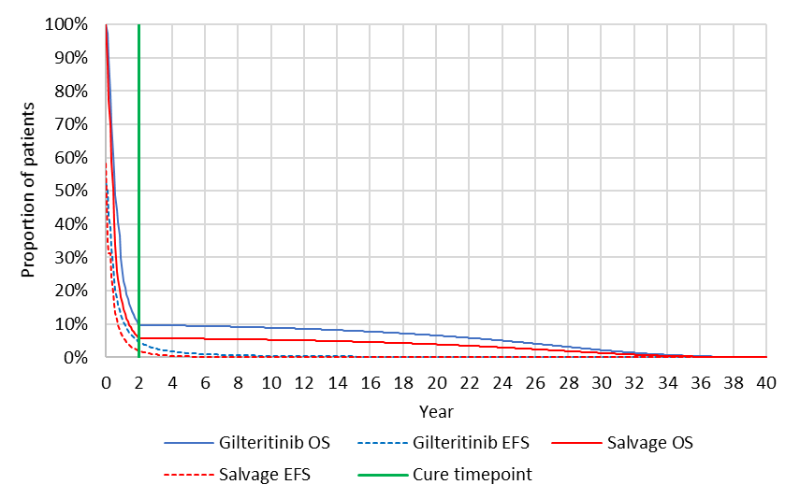
Source: Constructed during the evaluation using the Xospata Economic Model Excel spreadsheet of the submission
EFS, event free survival; OS, overall survival

Figure 10: Overall survival and event free survival curves in the With HSCT cohort of the model
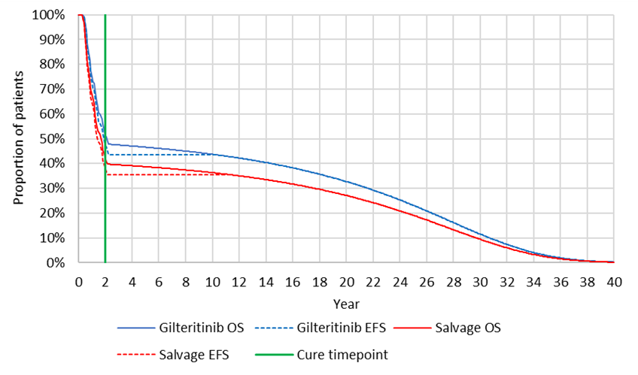
Source: Constructed during the evaluation using the Xospata Economic Model Excel spreadsheet of the submission
EFS, event free survival; OS, overall survival

  - The ESC noted there was a rapid decline in OS in both treatment arms until the point of the cure assumption (2 years). The introduction of the cure assumption substantially decreased the risk of mortality for the remainder of the model. The ESC considered this approach resulted in substantial post-event survival that did not appear clinically plausible given the majority of patients in both arms had experienced an event at that timepoint. Treatment benefit with gilteritinib was primarily driven by survival benefit in patients who received HSCT.
  - The submission presented the results of a validation exercise comparing modelled OS with estimates from the ADMIRAL trial. In the gilteritinib arm, the model appeared to overestimate survival at the 6- and 12-month timepoints, was similar to trial-based estimates at the 18- and 24-month timepoints and was overestimated at the 30- and 36-month timepoints. Modelled survival in the salvage chemotherapy arm appeared overestimated up to 18 months in the model, was underestimated at 24 months and was similar to the September 2020 data cut at the 30- and 36-month timepoints.
  - The apparent discrepancy between the trial data and modelled OS was a consequence of multiple factors including the use of a fixed timepoint for HSCT instead of a time-to-event distribution, the inclusion of additional post-HSCT survival benefit due to maintenance therapy with gilteritinib and the 2-year cure assumption.
  - Long-term survival in the model was driven by the cure assumption introduced at 2 years from baseline in the model, and post-HSCT gilteritinib survival benefit (the latter removed in the pre-PBAC response). The table below was constructed during the evaluation, summarising the probability of being cured in the base case and in sensitivity analyses using a 3-year cure assumption and without post-HSCT gilteritinib survival benefit.
Table 8: Probability of being cured in the economic model (unweighted no HSCT and with HSCT cohorts, half-cycle corrected)
Cohort | Health state | Gilteritinib | Salvage chemotherapy
2-year cure assumption with post- HSCT gilteritinib treatment benefit (base case)
No HSCT | Event-free | 4.8% | 2.1%
No HSCT | Post-event | 5.3% | 3.9%
No HSCT | Cure rate | 10.1% | 6.0%
With HSCT | Event-free | 47.6% | 38.6%
With HSCT | Post-event | 4.0% | 4.2%
With HSCT | Cure rate | 51.6% | 42.8%
3-year cure assumption with post-HSCT gilteritinib treatment benefit (sensitivity analysis)
No HSCT | Event-free | 2.7% | 0.9%
No HSCT | Post-event | 2.5% | 2.2%
No HSCT | Cure rate | 5.2% | 3.1%
With HSCT | Event-free | 38.7% | 30.0%
With HSCT | Post-event | 4.2% | 4.2%
With HSCT | Cure rate | 42.9% | 34.2%
2-year cure assumption without post-HSCT gilteritinib treatment benefit (sensitivity analysis)
No HSCT | Event-free | 4.8% | 2.1%
No HSCT | Post-event | 5.3% | 3.9%
No HSCT | Cure rate | 10.1% | 6.0%
With HSCT | Event-free | 39.5% | 38.6%
With HSCT | Post-event | 4.2% | 4.2%
With HSCT | Cure rate | 43.7% | 42.8%
Source: Constructed during the evaluation using the Xospata FLT3AML Economic Model Excel spreadsheet of the submission
  - The model assumed that all patients remaining alive at 2 years were cured, irrespective of disease status or HSCT status. Based on this assumption, 10.1% of patients in the gilteritinib arm and 6.0% of patients in the salvage chemotherapy arm who did not receive HSCT were cured. This appeared clinically implausible given the majority of patients had experienced an event at this timepoint.
  - In the With HSCT cohort, the modelled cure rate was 51.6% in the gilteritinib arm and 42.8% in the salvage chemotherapy arm. The assumed difference in the cure rate was primarily due to the inclusion of additional treatment benefit due to post-HSCT gilteritinib maintenance therapy. The removal of the additional treatment benefit resulted in more similar cure rates between treatment arms, however, the estimates remained higher than the 2-year cure rate estimated in pooled post-HSCT survival data from the ADMIRAL trial of 39.7%. The difference was due to the structural assumption of fixed time to HSCT which resulted in the 2-year cure assumption being applied at 20 months after HSCT in the gilteritinib arm and 21 months after HSCT in the salvage chemotherapy arm.
  - Modelled cure rates in the With HSCT arm appeared optimistic given some patients had experienced an event at that timepoint. While the proportion in the post-event health state appeared relatively small, this was based on a synthesised EFS curve assuming a hazard ratio for EFS to OS of 0.89. The submission claimed no post-HSCT EFS data were available from the ADMIRAL trial despite the availability of response outcomes, relapse and subsequent therapy use in the gilteritinib arm.
  - The 3-year cure assumption sensitivity analysis yielded more conservative estimates of cure, however, there remained a substantial difference in cure rates in the With HSCT cohort due to the inclusion of additional gilteritinib treatment benefit.
  - Overall, modelled estimates of cure appeared optimistic based on OS that included patients with some form of active disease. Long-term relapse data from the ADMIRAL trial suggested 10.5% (26/247) of patients in the gilteritinib arm were living without relapse for at least 2 years. This was lower than the proportion of patients remaining alive at 2 years in the model (21%) who were assumed to be cured.
  - Due to the model structure, alternative cure assumptions (e.g. applied to patients who are event-free only or applied to patients in the With HSCT cohort only) could not be tested during the evaluation. The PSCR noted that in the model submitted, 20% and 11% were predicted alive in the gilteritinib and chemotherapy arms, respectively, hence 9% more patients entered cure-point survival in the base-case. Similarly, there were respectively 16% versus 7% event free at 2 years, meaning an additional 9% more patients. Hence, the PSCR argued that the same incremental proportion is impacted by the alternate cure-point definition (EFS only). The ESC noted that the differences in the outcomes were marginal because EFS in the model was largely driven by EFS in the With HSCT cohort that was synthesised using a hazard ratio of 0.89 applied to modelled OS. Furthermore, the ESC considered 2 years was a very early time point to be considered cured of AML (see paragraph 6.55). The ESC considered that for plausibility and face validity, cure should only be applied to disease free patients but noted that this may not be possible in this model due to the partitioned analysis structure.
  - Key drivers of the economic model are summarised in the table below.
Table 9: Key drivers of the model
Description | Method/Value | Impact
Model structure | The appropriateness of the model structure and validity of predicted outcomes in the model was unclear to the evaluation. Structural assumptions implemented using a fixed time to HSCT resulted in cured proportions that were higher than predicted using trial data. | High, favours gilteritinib
Baseline age | The submission claimed the age of patients in the ADMIRAL trial (mean 59 years) was applicable to the PBS population. Overall, the ADMIRAL trial population is likely to be younger and fitter than the PBS population. These differences are likely to impact on the magnitude of treatment benefit with gilteritinib. | High, favours gilteritinib
Cure assumption | The submission assumed that all patients remaining alive at 2 years in the model were cured, irrespective of disease status or HSCT status. Overall, long-term survival benefits and the likely proportion achieving cure due to gilteritinib treatment were uncertain. A summary of cure rates in the model was presented during the evaluation, suggesting that modelled cure rates were optimistic (see Table 8 above). | High, favours gilteritinib
Post-HSCT gilteritinib maintenance treatment benefit (removed in the pre-PBAC response) | The base case of the economic model assumed an additional survival benefit in the gilteritinib arm in the With HSCT cohort, based on 63.5% of the gilteritinib arm patients who restarted gilteritinib after HSCT. The clinical claim of treatment benefit with post-HSCT gilteritinib maintenance therapy was inadequately supported by the trial data.  The submission calculated a hazard ratio of 0.686, representing improved OS in patients receiving gilteritinib maintenance therapy after HSCT in the ADMIRAL trial compared with patients who received HSCT after second complete remission (CR2) in the Evers 2017 study (source not provided). The approach used to derive the hazard ratio was inappropriate as it is an unanchored naïve comparison between groups with no adjustment for differences in patient characteristics between studies. The cross-over between the survival curves suggests the proportional hazards assumption was violated. | High, favours gilteritinib
Other cost inputs driving cost offsets | There were multiple cost inputs that were inadequately justified in the submission, which resulted in substantial cost offsets in the economic analysis including drug administration costs in the salvage chemotherapy arm, adverse event costs, HSCT procedure costs, subsequent chemotherapy administration drug and administration costs and disease management hospitalisation costs. The cumulative impact of these inputs on the economic analysis was likely to be substantial. | High, favours gilteritinib
Long-term survivor costs and utilities | Long-term survivors were assumed to have no costs other than a monthly long GP visit (MBS item 44, $110.50). This assumption was inadequately justified given some patients were in post-event health states at 2 years, suggestive of some form of active disease.  Long-term survivors were attributed the same quality of life as the general population. This assumption was inadequately justified given some patients may have long-term consequences following multiple lines of chemotherapy including HSCT and nearly all patients have had major hospitalisation events. The application of these utility values to all patients remaining alive at 2 years did not meet face validity given the values are more optimistic than estimates used for patients remaining in the event-free health states prior to the 2-year cure point. | High, favours gilteritinib
Time horizon | The time horizon used in the economic model was 40 years. The submission claimed this was appropriate to capture the long-term costs and consequences of the disease. A lifetime horizon may be considered reasonable for this disease given the possibility of cure with treatment. However, a modelled time horizon of 40 years appears optimistic as it exceeds the average life expectancy of the general population aged 59 years (modelled population baseline age). | Moderate, favours gilteritinib
Source: constructed during the evaluation
HSCT, haematopoietic stem cell transplant; SMR, standardised mortality ratio
  - The ESC noted the inclusion of additional survival benefits due to post-HSCT gilteritinib maintenance therapy was a key driver of the model. The ESC considered this approach was inappropriate as modelled post-HSCT survival was based on ADMIRAL trial data that already accounts for the use of post-HSCT gilteritinib. The ESC noted that the inclusion of a treatment benefit for gilteritinib maintenance therapy resulted in improved post-HSCT OS in the gilteritinib arm that exceeded observed estimates in the trial. The use of post-HSCT maintenance therapy was removed in the pre-PBAC response.
  - The evaluation considered the use of mean treatment durations from the trial was likely to underestimate gilteritinib drug costs, as it does not capture longer-term use of gilteritinib beyond the trial follow-up. The PSCR claimed the mean observed gilteritinib treatment duration from the one-year follow up after the primary analysis of the ADMIRAL trial was based on sufficiently mature data that captured the majority of the expected treatment use. The PSCR noted that at 2-years follow-up after the primary analysis, only 6.5% (16/247) of patients in the gilteritinib arm were still on treatment. The ESC agreed with the PSCR that this was likely to have a small impact on the mean treatment duration.
  - The ESC noted that a 40-year time horizon was used. The ESC noted that in a previous consideration of midostaurin for newly diagnosed FLT3 mutation AML, the PBAC had considered that 25 years was a reasonable time horizon in patients aged ≥ 60 years, and 40 years in patients < 60 years of age (para 6.32, midostaurin PSD, July 2018 PBAC meeting). The ESC also noted that in a previous consideration of gemtuzumab for newly diagnosed AML, the PBAC had noted the time horizon of 40 years was optimistic for the modelled population aged 62 years and that the pre-PBAC response had accepted a revised base case using a time horizon of 25 years (para 6.73 and 7.13, gemtuzumab PSD, March 2021 PBAC meeting). The ESC considered a 25-year time horizon may be more appropriate, although noted the model results were similar with the reduced time horizon.
  - The results of the modelled economic evaluation are summarised below.
Table 10: Results of the economic evaluation
 | Gilteritinib | Salvage chemotherapy | Increment
Costs ($) | '''''''''''''''''''''''' | $179,664 | ''''''''''''''''''
Life years | 3.21 | 1.97 | 1.25
QALYs | 2.66 | 1.61 | 1.05
Incremental cost per life year gained |  |  | ''''''''''''''''¹
Incremental cost per QALY gained |  |  | '''''''''''''''''²
Source: Table 92, p207 of the submission
Abbreviation: QALY, quality adjusted life year
The redacted values correspond to the following ranges:
¹ $55,000 to < $75,000
² $75,000 to < $95,000

  - Based on the economic model, treatment with gilteritinib was associated with a cost of $75,000 to < $95,000 per QALY gained compared to salvage chemotherapy for the treatment of FLT3 mutation positive relapsed/refractory AML.
  - The difference in costs was primarily driven by gilteritinib drug costs which were partially offset by a substantial decrease in hospitalisation costs for treatment administration (first-line and subsequent line treatment) and disease management. The ESC noted that no administration costs were assumed for gilteritinib whereas salvage chemotherapy costs were based on an assumption of 100% hospitalisation over a fixed treatment duration. The ESC advised that the low-intensity salvage chemotherapy options used in this condition are administered in an outpatient setting. The ESC considered the assumption of 100% hospitalisation was inconsistent with data from the ADMIRAL trial which indicated that 58.9% (73/124) of all patients in the salvage arm were hospitalised for chemotherapy administration.
  - The difference in health outcomes was primarily driven by time spent in the With HSCT event-free health state and time spent in the No HSCT post-event health state.
  - The results of key sensitivity analyses presented in the submission and conducted during the evaluation and for the ESC advice are summarised below.
Table 11: Results of sensitivity analyses
Analysis | Incremental cost ($) | Incremental QALY | ICER
Base case | ''''''''''''''''' | 1.05 | ''''''''''''''''¹
Time horizon (base case 40 years)
15 yearsª | ''''''''''''''''''' | 0.81 | '''''''''''''''''''''''²
25 yearsª | '''''''''''''''''' | 1.00 | '''''''''''''''''¹
Baseline age (base case 59 years)
54 years (median age, Chua 2020) | ''''''''''''''''' | 1.15 | ''''''''''''''''''¹
65 years (mean age, AIHW 2020) | '''''''''''''''''''' | 0.91 | '''''''''''''''''²
HSCT rates (base case ADMIRAL trial rates of 25.5% gilteritinib, 15.3% salvage chemotherapy)
Based on expert opinion, 60% of patients with composite complete remission receive HSCT (gilteritinib 32.6%, salvage chemotherapy 13.1%)^{b} | '''''''''''''''''''' | 1.46 | ''''''''''''''''''''³
HSCT rates, calculated based on the ALLG registry study (gilteritinib 51.7%, salvage chemotherapy 31%) | '''''''''''''''''' | 1.58 | ''''''''''''''''''''³
Post-HSCT maintenance therapy with gilteritinib (base case 63% receive gilteritinib, gilteritinib drug costs based on 2.00 x 28-day cycles, with modelled survival benefit based on hazard ratio of 0.69)
No post-HSCT maintenance therapy drug costs, no additional treatment benefit | '''''''''''''''''' | 0.82 | ''''''''''''''''''³
Include post-HSCT maintenance therapy drug costs without additional treatment benefitª | ''''''''''''''''' | 0.82 | '''''''''''''''''''''²
Cure assumption (base case 2 years)
No cure assumptionª | '''''''''''''''''''' | 0.74 | ''''''''''''''''''''⁴
3 yearsª | '''''''''''''''''''' | 0.88 | '''''''''''''''''''''''²
4 yearsª | '''''''''''''''''''' | 0.80 | '''''''''''''''''''''''²
5 yearsª | '''''''''''''''''' | 0.76 | '''''''''''''''''''''''⁴
Excess mortality adjustment (base case SMR 2.0)
No adjustment | '''''''''''''''''' | 1.16 | '''''''''''''''''''¹
SMR 1.5 | ''''''''''''''''' | 1.10 | ''''''''''''''''''¹
SMR 2.5 | ''''''''''''''''''' | 1.01 | '''''''''''''''''''¹
SMR 4.0ª | ''''''''''''''''' | 0.93 | ''''''''''''''''''²
Gilteritinib dose (base case 120 mg daily)
124 mg daily based on mean dose in the ADMIRAL trialª | ''''''''''''''''''''' | 1.05 | '''''''''''''''''''''¹
Gilteritinib treatment duration (base case 7.85 treatment cycles)
5% increase (8.24 treatment cycles)ª | '''''''''''''''''''' | 1.05 | '''''''''''''''''¹
10% increase (8.64 treatment cycles)ª | ''''''''''''''''''''''' | 1.05 | ''''''''''''''''''''''''²
Drug administration costs (base case gilteritinib no costs; salvage chemotherapy 100% hospitalisation)
58.9% of patients hospitalised for salvage chemotherapyª | '''''''''''''''''''''' | 1.05 | '''''''''''''''''''''''²
Long-term survivor utilities (base case general population age-adjusted EQ-5D-5L utility values from McCaffrey 2016)
Fixed utility of 0.94 based on Joshi 2019 long-term follow up after stem cell transplant | '''''''''''''''''' | 1.12 | '''''''''''''''''''''¹
90% of base case age-adjusted utilitiesª | ''''''''''''''''''''' | 0.96 | '''''''''''''''''''¹
80% of base case age-adjusted utilitiesª | ''''''''''''''''''' | 0.88 | ''''''''''''''''''''''²
Discount rate (base case 5.0%)
0% | '''''''''''''''''' | 1.75 | ''''''''''''''''''''⁵
3.5% | ''''''''''''''''''''' | 1.20 | '''''''''''''''''''''³
Revised base case proposed in PSCR using 1 October 2021 price of azacitidine (salvage chemotherapy administration costs at 100% hospitalisation, post-HSCT gilteritinib maintenance therapy costs and treatment benefit, 40 year time horizon, 2 year cure assumption, long-term survivor utilities based on age-adjusted general population estimates)^{c}
PSCR proposed base case | '''''''''''''''''' | 1.05 | '''''''''''''''''¹
Salvage chemotherapy administration costs at 58.9% hospitalisation AND post-HSCT gilteritinib maintenance therapy costs without treatment benefit (Scenario (A)) | ''''''''''''''''''''''' | 0.82 | ''''''''''''''''''''''''⁶
Scenario (A) AND 25-year time horizon | '''''''''''''''''''''' | 0.79 | ''''''''''''''''''''⁶
Scenario (A) AND 25-year time horizon AND 3-year cure assumption | ''''''''''''''''''''''' | 0.63 | ''''''''''''''''''''''''⁷
Scenario (A) AND 25-year time horizon AND 5-year cure assumption | '''''''''''''''''''''' | 0.52 | '''''''''''''''''''''''⁷
Scenario (A) AND 25-year time horizon AND 5-year cure assumption AND long-term survivor utilities at 90% of age-adjusted general population estimates | ''''''''''''''''''''' | 0.49 | ''''''''''''''''''''''''⁷
Revised sensitivity analysis proposed in PSCR using 1 October 2021 price of azacitidine, excluding post-HSCT gilteritinib maintenance therapy drug costs, no additional treatment benefit^{c}
PSCR proposed sensitivity analysis | ''''''''''''''''''' | 0.82 | '''''''''''''''''''''³
Salvage chemotherapy administration costs at 58.9% hospitalisation AND no post-HSCT gilteritinib maintenance therapy costs or treatment benefit (Scenario (B)) | '''''''''''''''''' | 0.82 | ''''''''''''''''''¹
Scenario (B) AND 25-year time horizon | ''''''''''''''''''''' | 0.79 | '''''''''''''''''''''¹
Scenario (B) AND 25-year time horizon AND 3-year cure assumption | ''''''''''''''''''' | 0.63 | ''''''''''''''''''''''⁴
Scenario (B) AND 25-year time horizon AND 5-year cure assumption | ''''''''''''''''''' | 0.52 | ''''''''''''''''''''⁶
Scenario (B) AND 25-year time horizon AND 5-year cure assumption AND long-term survivor utilities at 90% of age-adjusted general population estimates | '''''''''''''''''' | 0.49 | '''''''''''''''''''''⁶
Source: Table 95, p 210 of the submission, Table 4, p6 and Table 5, p6 of the Pre-Sub-Committee Response
AE, adverse events; EFS, event free survival; OS, overall survival; PSCR, Pre-Sub-Committee Response; SMR, standardised mortality ratio
ª Analysis undertaken during the evaluation
^{b} Calculated based on number of patients achieving composite complete remission, CRc (complete remission, complete remission with incomplete haematologic recovery and complete remission with incomplete platelet recovery) in the ITT population. Alternative HSCT rate for gilteritinib was calculated as 60% x 54.3% = 32.6%. Alternative HSCT rate for salvage chemotherapy was calculated as 60% x 21.8% = 13.1%.
^{c} Analyses undertaken for the ESC advice.
The redacted values correspond to the following ranges:
¹ $75,000 to < $95,000
² $95,000 to < $115,000
³ $55,000 to < $75,000
⁴ $115,000 to < $135,000
⁵ $45,000 to < $55,000
⁶ $135,000 to < $155,000
⁷ $155,000 to < $255,000

  - The results were most sensitive to the time horizon, the cure assumption, drug administration costs for salvage chemotherapy, post-HSCT gilteritinib maintenance treatment costs and treatment benefit, gilteritinib (dose and treatment duration) and long-term survivor utilities. The results were moderately sensitive to baseline age and the standardised mortality ratio applied to long-term survival.
  - The results were moderately sensitive to multiple cost inputs (including drug administration costs in the salvage chemotherapy arm, adverse event costs, HSCT procedure costs, subsequent chemotherapy administration drug and administration costs and disease management hospitalisation costs).
  - The ESC noted the PSCR provided a revised base case ICER accounting for the 38.61% azacitidine price reduction from 1 October 2021 with an accompanying revised sensitivity analysis which excluded post-HSCT gilteritinib maintenance therapy cost and benefits. The ESC noted the incorporation of the reduced azacitidine price had a small impact on the ICER (reduced from $75,000 to < $95,000 to $75,000 to < $95,000).
  - The ESC considered that a respecified base case incorporating the following amendments was required to address concerns identified:
- 58.9% of patients hospitalised for salvage chemotherapy as per the ADMIRAL trial;
- post-HSCT gilteritinib maintenance therapy costs included without treatment benefit;
- a 25-year time horizon;
- a 3-year cure assumption.
  - The ESC noted that incorporating the above amendments, along with the 1 October 2021 azacitidine price reduction, increased the base case ICER from $75,000 to < $95,000/QALY to $155,000 to < $255,000/QALY. The ESC noted that this further increased to $155,000 to < $255,000/QALY if a 5-year cure assumption was used.
  - The ESC considered that if post-HSCT gilteritinib maintenance therapy was excluded from the restriction, it would be reasonable to remove post-HSCT gilteritinib maintenance therapy costs. The ESC noted that amending the economic model to incorporate 58.9% of patients hospitalised for salvage chemotherapy, a 25-year time horizon and a 3-year cure assumption would result in an ICER of $115,000 to < $135,000/QALY. The ESC noted that the ICER for this scenario increased to $135,000 to < $155,000/QALY if a 5-year cure assumption was applied.
  - The pre-PBAC response presented an alternative revised base case analysis, which it stated applied a cure point only to the patients in event-free survival at 2 years (with other parameters as per the ESC revised base case, and excluding both costs and benefits of gilteritinib maintenance therapy post HSCT). The resulting ICER was $55,000 to < $75,000/QALY, but was unable to be verified and it was unclear why this ICER was substantially lower than that for the ESC scenarios in the paragraph above. The PBAC therefore did not rely on this analysis in its considerations of the cost-effectiveness of gilteritinib.

Drug cost/patient
  - The estimated cost per patient for gilteritinib was approximately $'''''''''''''' based on the 7.85 cycles of treatment included in the economic model (that is, incorporating post-HSCT maintenance use). The ESC noted the PSCR provided revised financial estimates in which the mean overall treatment duration was increased from 6.49 to 7.85 cycles (see paragraph 6.109). The ESC also noted that if the cost of maintenance therapy was removed the estimated cost per patient for gilteritinib was $'''''''''''''''.
  - Differing approaches to calculating drug costs in salvage chemotherapy resulted in substantial differences in estimated costs for the comparator. In estimating the financial impact, the submission did not properly account for the underlying doses of each salvage chemotherapy agent. In general, the cost for each script was assumed to be the DPMQ/DPMA, which resulted in a substantial overestimation of the cost of each treatment. The costs below were not updated to account for the 1 October 2021 azacitidine price reduction.
Table 12: Drug cost per patient for gilteritinib and salvage chemotherapy
 | Trial dose and duration | Economic model | Financial estimates
Gilteritinib
Dose | Median: 120 mg daily  Mean: 124 mg daily | 120 mg daily | 120 mg daily
Treatment duration (28-day cycles) | 6.85 cycles (Sept 2018 data cut)  7.84 cycles (Sept 2019 data cut) | Initial treatment: 5.84 cyclesª  Post-HSCT maintenance:  2.00 cyclesª  (Mean overall treatment duration: 7.84 cycles) | Initial scripts: 3.00 cycles^{b}  Continuing scripts: 4.85 cycles^{b}  (Mean overall treatment duration: 6.49 cycles)
Adherence | Not reported | 99.2%^{c} | 100%^{d}
Cost per 28-day script (DPMQ) ($) | - | ''''''''''''''''''''''''' | ''''''''''''''''''''''''''
Total cost per 28-day cycle ($) | - | '''''''''''''''''''''''' | ''''''''''''''''''''''''
Cost per patient ($) | - | Initial treatment: ''''''''''''''''''''''''  Post-HSCT maintenance: ''''''''''''''''''''  Total: ''''''''''''''''''''''' | Initial scripts: '''''''''''''''''''  Continuing scripts: ''''''''''''''''''  Total: '''''''''''''''''''''''
Salvage chemotherapy
Azacitidine cost | - | $3,583 (2.24 cycles)^{e} | $35,128 (2.24 cycles)^{f}
LoDAC cost | - | $237 (1.68 cycles)^{e} | -
FLAG-IDA cost | - | $4,015 (1.02 cycles)^{e} | -
MEC cost | - | $2,944 (1.13 cycles)^{e} | -
Component costs | - | - | CYT: $1,612 (1.18 cycles)^{f,g}  ETOP: $1,609 (1.13 cycles)^{f}  MIT: $1,038 (1.13 cycles)^{f}  IDA: $817 (1.02 cycles)^{f}  FLU: $780 (1.02 cycles)^{f}  FIL: $277 (1.02 cycles)^{f}
Distribution | 25.8% azacitadine, 13.7% LoDAC, 33.9% FLAG-IDA and 26.6% MEC. | 25.8% azacitadine, 13.7% LoDAC, 33.9% FLAG-IDA and 26.6% MEC. | 25.8% azacitadine, 13.7% LoDAC, 33.9% FLAG-IDA and 26.6% MEC.
Weighted cost/patient | - | $3,100 | $11,601^{h}
Source: Table 75, p165 of the submission; Table 12.2.1, pp584-589 of the ADMIRAL final clinical study report; ‘4a. Scripts – affected’ and ‘4b Impact – affected (pub)’ worksheets of the ‘Attachment 12 - Xospata FLT3_Financial Estimates_vFinal’ Excel workbook, Attachment 12 of the submission.
CYT, cytarabine; DPMQ, dispensed price for maximum quantity; ETO, etoposide; FIL, filgrastim; FLAG-IDA, fludarabine + cytarabine + filgrastim + idarubicin; FLU, fludarabine; HSCT, haematopoietic stem cell transplant; IDA, idarubicin; LoDAC, low dose anthracycline; MEC, mitozantrone + etoposide + cytarabine; MIT, mitozantrone.
ª The mean initial treatment duration was 5.84 treatment cycles based on an analysis of average treatment duration excluding use of gilteritinib after HSCT in the ADMIRAL trial (Sept 2019 cut off). The mean post-HSCT treatment duration based on 63% of patients receiving gilteritinib after HSCT was estimated as 7.85 cycles minus 5.84 cycles = 2.00 cycles.
^{b} The submission assumed that all patients would receive initial treatment and 72% of patients would receive continuing treatment. This resulted in an overall mean treatment duration that was shorter than reported in the ADMIRAL trial (6.49 cycles versus 7.85 cycles).
^{c} Based on the mean relative dose intensity reported for gilteritinib in the ADMIRAL trial.
^{d} Based on the median relative dose intensity reported for gilteritinib in the ADMIRAL trial.
^{e} Drug costs per patient per course of salvage chemotherapy regimen used in the economic model were estimated based on recommended doses, mean treatment duration and relative dose intensities in the ADMIRAL trial.
^{f} Derived by multiplying the estimated scripts per patient by the applicable DPMQ assuming an 87.2%:12.8% public/private split for cytarabine, etoposide, mitozantrone, idarubicin, fludarabine and filgrastim, and a 100%:0% public/private split for azacitidine.
^{g} The cost for cytarabine was based on the average number of cycles and doses across FLAG-IDA, MEC and LoDAC regimens, weighted by utilisation in the ADMIRAL trial.
^{h} Estimated by dividing the total cost of salvage chemotherapy treatment by the number of treated patients. The higher weighted cost/patient compared to the economic model was largely due to the higher cost of azacitidine assumed in the financial estimates, which was based on the PBS maximum quantity (1,400 mg) per dose compared to an assumed dose of 135 mg in the economic model.

Estimated PBS usage & financial implications
  - This submission was not considered by DUSC. The submission used an epidemiological approach to estimate the utilisation and financial impacts associated with the PBS listing of gilteritinib, for the treatment of adult patients with FLT3 mutation positive relapsed or refractory AML.
  - Key inputs used to derive the financial estimates are presented in the table below.
Table 13: Key inputs for financial estimates
Parameter | Value applied and source | Comment
Incident AML patients | 4.3 cases per 100,000 population. Based on extrapolation of the age-specific incidence of AML published by the Australian Institute of Health and Welfare (AIHW, 2020). | Updated AIHW estimates published in 2021 reported an age-specific AML incidence of 3.9 cases per 100,000 in 2017, a projected incidence of 4.2 cases per 100,000 in 2018 to 2020, and a projected incidence of 4.1 cases per 100,000 in 2021. The incidence of AML may be slightly lower than estimated in the submission.
Proportion of AML that is not APL | 93.7%. Based on a retrospective study of 898 patients with AML in Western Australia which reported that 57 / 898 (6.3%) patients had the APL subtype of AML (Gangatharan et al., 2013). | The study was based on patients diagnosed with AML between 1991 to 2005 at a single treatment centre in Western Australia. It is unclear whether the results are representative of all patients in Australia.
Proportion of patients considered fit for intensive treatment | 61%. Based on a retrospective study of 734 patients with AML in Western Australia (Gangatharan et al., 2013). The study reported that 447 (61%) patients received intensive first-line therapy. | The study was based on patients diagnosed with AML between 2009 to 2018 at a single treatment centre in Western Australia. Younger patients, patients with de novo AML and patients with favourable or intermediate cytogenetics were more likely to receive aggressive therapy.
Proportion of patients receiving induction treatment | Fit patients: 98% based on Griffin et al. (2019).  Unfit patients: 70% based on average across multiple published estimates. | The proportion assumed for unfit patients was considered uncertain due to the substantial differences between the identified estimates.
CR or CRi after induction among fit patients. | Fit patients: 77.5% based on average of estimates reported by Taylor et al. (2017) and Stone et al. (2017).  Unfit patients: 50% based on average of estimates reported by Dombret et al. (2015) and Arthur et al. (2020). | The assumed proportions were considered uncertain due to substantial differences between the identified published estimates.
Subsequent relapse following response | Fit patients: 50% based on average of estimates reported by Taylor et al. (2017) and Stone et al. (2017).  Unfit patients: 60% based on average across multiple published estimates. | The assumed proportions were considered uncertain due to substantial differences between the identified published estimates. Relapse rates are likely to be impacted by transplantation rates.
Proportion of fit patients surviving to second line | Fit patients: 87% based on Stone et al. (2017).  Unfit patients: 57% based on average across multiple published estimates. | The estimate for unfit patients was considered uncertain given the substantial differences between the estimates identified in the submission.
Patients tested for FLT3 mutation | ''''''% in Year 1 increasing to ''''''''''% by Year 5 based on sponsor assumption. | The submission argued that PBS listing of gilteritinib is expected to increase the rate of testing in the relapsed/refractory setting.
Proportion of relapsed/refractory patients who are FLT3 mutation positive | 38% based on McCormick et al. (2010). | The study was based on a relatively small sample size (50 patients) and was limited to patients who had relapsed following completion of induction chemotherapy.
Number of FLT3 mutation tests | 2.63. The submission assumed that approximately 2.63 patients (1 ÷ 0.38) would need to be tested to identify one FLT3 mutation positive patient. | This proportion was considered uncertain.
Gilteritinib uptake rate | '''''% based on sponsor assumption. | Uptake is likely to be high due to the lack of alternative targeted treatments for patients with FLT3 mutation positive AML. However, the assumed uptake rate may be an overestimate, given that a proportion of patients surviving to the relapsed/refractory setting may no longer be suitable for active treatment.
Displaced therapy utilisation | LoDAC: 13.71%; azacitidine: 25.81%; MEC: 26.61%; FLAG-IDA: 33.87%; based on the proportions of patients receiving each individual chemotherapy regimen in the ADMIRAL trial. | There are limited data on the utilisation of treatments in patients who have FLT3 mutation positive AML with relapsed/refractory disease, although the ESC had considered the distribution was reasonably applicable to the PBS population.
Gilteritinib scripts | Initiating patients: 3 per patient, based on the assumption that all treated patients would receive 3 cycles of treatment.  Continuing patients: 4.85 per patient, based on the mean treatment duration for gilteritinib in the economic model (7.85 cycles, inclusive of post-HSCT maintenance use). The submission assumed 100% treatment adherence based on the median dose intensity reported in the ADMIRAL trial. | The submission assumed that only 72% of patients would continue treatment after 84 days (3 cycles), based on the proportion of patients who had discontinued treatment with gilteritinib due to progressive disease at the final analysis of the ADMIRAL trial. This resulted in a mean treatment duration that was shorter than reported in the ADMIRAL trial (6.49 cycles versus 7.85 cycles). The relative dose intensity reported in the ADMIRAL trial did not appear to be a reasonable proxy for treatment adherence as, based on the definitions included in the trial, individual patient dose intensities could exceed 100% (range 38.6% to 160.3%). This was revised in the PSCR (see paragraph 6.108 below).
Cytarabine scripts | 1.81 per patient | Treatment regimens and number of treatment cycles based on the ADMIRAL trial. Treatment adherence based on reported dose intensities in the ADMIRAL trial. The relative dose intensity reported in the ADMIRAL trial did not appear to be a reasonable proxy for treatment adherence as, based on the definitions included in the trial, individual patient dose intensities could exceed 100%. Utilisation in the PBS population (including number of cycles and treatment adherence) may differ from the ADMIRAL trial.
Etoposide scripts | 5.65 per patient
Mitozantrone scripts | 5.65 per patient
Idarubicin scripts | 3.02 per patient
Fludarabine scripts | 5.04 per patient
Azacitidine scripts | 15.68 per patient
Filgrastim scripts | 0.44 per patient
Source: Table 97, pp198-199 of the submission; ‘Attachment 12 - Xospata FLT3_Financial Estimates_vFinal’ Excel workbook, Attachment 12 of the submission.
AML, Acute myeloid leukaemia; APL, acute promyelocytic leukaemia; AIHW, Australian Institute of Health and Welfare; CR, complete response; CRi, complete response with incomplete blood recovery; DPMQ, dispensed price for maximum quantity; FLAG-IDA, fludarabine + cytarabine + filgrastim + idarubicin; FLT3, FMS-like tyrosine kinase 3; HSCT, haematopoietic stem cell transplant; LoDAC, low dose anthracycline; MBS, Medicare Benefits Scheme; MEC, mitozantrone + etoposide + cytarabine; US, United States; Y, Year.
  - The table below presents the estimated financial impact of listing gilteritinib.

Table 14: Estimated use and financial implications
 | Year 1 | Year 2 | Year 3 | Year 4 | Year 5 | Year 6
Eligible patients
AML incidence (4.3 / 100,000) | 1,149 | 1,167 | 1,185 | 1,203 | 1,220 | 1,237
Proportion not APL (93.7%) | 1,077 | 1,094 | 1,111 | 1,127 | 1,143 | 1,159
Induction treatment status  - Fit for treatment (61%)  - Unfit for treatment (39%) | 657  420 | 667  427 | 677  433 | 687  440 | 697  446 | 707  452
Fit for induction treatment
Total refractory / relapsed patients ª | 394 | 400 | 407 | 413 | 419 | 424
Proportion surviving to second line (87%) | 343 | 348 | 354 | 359 | 364 | 369
Unfit for induction treatment
Total refractory / relapsed patients ^{b} | 235 | 239 | 243 | 246 | 250 | 253
Proportion surviving to second line (57%) | 134 | 136 | 138 | 140 | 142 | 144
FLT3 mutation testing
Total fit and unfit patients | 477 | 485 | 492 | 499 | 506 | 513
Patients tested for FLT3 mutation | '''''''''¹ ('''''%) | '''''''''¹ (''''''''''%) | ''''''''''¹ (''''''%) | ''''''''''¹ (''''''%) | ''''''''''² ('''''''''%) | ''''''''''² (''''''''''%)
FLT3 mutation positive patients (38%) | 154 | 161 | 168 | 180 | 192 | 195
Cost of gilteritinib to the PBS/RPBS
Initiating scripts (3 per patient) | '''''''''¹ | '''''''''¹ | '''''''''¹ | '''''''''² | '''''''''² | '''''''''²
Continuing scripts (4.85 per patient) | '''''''''² | '''''''''² | '''''''''² | ''''''''''² | ''''''''''² | '''''''''²
Total PBS/RPBS scripts | '''''''''''''² | '''''''''² | '''''''''''''² | '''''''''''''² | ''''''''''''''² | '''''''''''''²
Net PBS/RPBS cost ''''''''''''''''''''''''''''' per script) – less co-payments | '''''''''''''''''''''''''''''³ | '''''''''''''''''''''''''''''''³ | '''''''''''''''''''''''''''''³ | ''''''''''''''''''''''''''''''''³ | ''''''''''''''''''''''''''''''''³ | ''''''''''''''''''''''''''''³
Net PBS/RPBS cost (mean 7.85 cycles) – less co-payments; updated in PSCR |  | ''''''''''''''''''''''''''''''³ | ''''''''''''''''''''''''''''''³ | '''''''''''''''''''''''''''''³ | '''''''''''''''''''''''''''''''³ | '''''''''''''''''''''''''''''³
  ''''''''''''''''''''''''''''³
Changes in utilisation of other medicines
Net cost of displaced cytarabine | ''''''''''''''''''''''⁴ | '''''''''''''''''''''''⁴ | ''''''''''''''''''''''⁴ | ''''''''''''''''''''''⁴ | '''''''''''''''''''''''⁴ | ''''''''''''''''''''''⁴
Net cost of displaced etoposide | '''''''''''''''''''⁴ | ''''''''''''''''''''⁴ | '''''''''''''''''''⁴ | ''''''''''''''''''''⁴ | '''''''''''''''''''⁴ | '''''''''''''''''''''⁴
Net cost of displaced mitozantrone | '''''''''''''''''''''⁴ | ''''''''''''''''''''⁴ | ''''''''''''''''''''⁴ | ''''''''''''''''''''''⁴ | '''''''''''''''''''''⁴ | '''''''''''''''''⁴
Net cost of displaced idarubicin | '''''''''''''''''''''⁴ | ''''''''''''''''''⁴ | ''''''''''''''''''''''⁴ | ''''''''''''''''''⁴ | '''''''''''''''''⁴ | ''''''''''''''''''''⁴
Net cost of displaced fludarabine | ''''''''''''''''''⁴ | '''''''''''''''''''⁴ | ''''''''''''''''''⁴ | '''''''''''''''''''⁴ | ''''''''''''''''''''⁴ | '''''''''''''''''''''⁴
Net cost of displaced azacitidine | ''''''''''''''''''''''''''''⁴ | ''''''''''''''''''''''''⁴ | '''''''''''''''''''''''''⁴ | '''''''''''''''''''''''⁴ | '''''''''''''''''''''''''⁴ | ''''''''''''''''''''''''''⁴
Net cost of displaced filgrastim | ''''''''''''''''''⁴ | '''''''''''''''''''⁴ | ''''''''''''''''''''⁴ | '''''''''''''''''''⁴ | ''''''''''''''''''⁴ | '''''''''''''''''''''⁴
Total saving to the PBS/RPBS | '''''''''''''''''''''''''''''⁴ | '''''''''''''''''''''''⁴ | ''''''''''''''''''''''''⁴ | ''''''''''''''''''''''''''⁴ | '''''''''''''''''''''''''''⁴ | ''''''''''''''''''''''''''⁴
Total saving to the PBS/RPBS (with reduced azacitadine price) updated in PSCR | '''''''''''''''''''''''''⁴ | ''''''''''''''''''''''''''⁴ | ''''''''''''''''''''''''''''⁴ | '''''''''''''''''''''''''''''⁴ | ''''''''''''''''''''''''⁴ | ''''''''''''''''''''''''''⁴
Net financial implications
Net cost to the PBS/RPBS | ''''''''''''''''''''''''''''⁵ | '''''''''''''''''''''''''''''⁵ | ''''''''''''''''''''''''''''''⁵ | '''''''''''''''''''''''''''''''³ | '''''''''''''''''''''''''''''³ | '''''''''''''''''''''''''''''''³
Net cost to the MBS | ''''''''''''''''''''⁴ | ''''''''''''''''''''⁴ | '''''''''''''''''''⁴ | '''''''''''''''''''''⁴ | '''''''''''''''''''⁴ | ''''''''''''''''''''⁴
Net cost to the PBS/RPBS/MBS | ''''''''''''''''''''''''''''''''³ | '''''''''''''''''''''''''''''⁵ | '''''''''''''''''''''''''''''''''⁵ | ''''''''''''''''''''''''''''³ | '''''''''''''''''''''''''''''³ | ''''''''''''''''''''''''''''''³
Net financial implications (updated in PSCR)
Net cost to the PBS/RPBS | '''''''''''''''''''''''''''''''''³ | ''''''''''''''''''''''''''''''''³ | '''''''''''''''''''''''''''''''³ | '''''''''''''''''''''''''''''''³ | ''''''''''''''''''''''''''''''³ | ''''''''''''''''''''''''''''''³
Net cost to the MBS | ''''''''''''''''''⁴ | '''''''''''''''''''''⁴ | ''''''''''''''''''''⁴ | '''''''''''''''''''''⁴ | '''''''''''''''''''⁴ | ''''''''''''''''''''⁴
Net cost to the PBS/RPBS/MBS | '''''''''''''''''''''''''''''''³ | ''''''''''''''''''''''''''''''³ | ''''''''''''''''''''''''''''''''³ | ''''''''''''''''''''''''''''''''³ | '''''''''''''''''''''''''''''''³ | ''''''''''''''''''''''''''''''''³
Source: Table 99, pp201-202; Table 100, pp202-203; Table 101, p204; Table 102, p206; Table 103, p207 of the submission.
AML, acute myeloid leukaemia; APL, acute promyelocytic leukaemia; FMS-like tyrosine kinase 3; MBS, Medicare Benefits Scheme.
ª The submission assumed that 98% of fit patients receive induction treatment, 22.5% are refractory to induction treatment, and 50% of patients with an initial response experience relapse.
^{b} The submission assumed that 70% of unfit patients receive induction treatment, 50% are refractory to induction treatment, and 60% of patients with an initial response experience relapse.
The redacted values correspond to the following ranges:
¹ < 500
² 500 to < 5,000
³ $20 million to < $30 million
⁴ $0 to < $10 million
⁵ $10 million to < $20 million

  - The submission estimated net cost to the PBS/RPBS was $20 million to < $30 million in Year 1 of listing, increasing to $20 million to < $30 million in Year 6, a total of $100 million to < $200 million over the first six years.
  - The utilisation estimates were considered uncertain due to the following reasons:
- There was substantial variation among many of the published estimates used to derive the eligible patient population, which affected the reliability of the eligible population estimates. The PSCR argued that multiple sensitivity analyses were presented in the submission to test the reliability of the eligible population estimates. The ESC noted PBS prescription data provided by the DUSC Secretariat which indicated 96 patients initiated therapy with midostaurin for AML in 2019, 111 patients in 2020 and 63 patients up to the end of September 2021. The ESC considered the proposed number of patients treated with gilteritinib was likely overestimated. The PBAC considered this data may not be applicable as midostaurin is used in fit patients only, however agreed that the estimates were uncertain.
- The treatment duration for gilteritinib was based on the mean treatment duration for patients in the ADMIRAL trial. As treatment with gilteritinib was ongoing for some patients at the time of the final analysis, the mean treatment duration in the ADMIRAL trial is likely to increase with additional follow-up. Patients receiving gilteritinib maintenance therapy after HSCT are likely to receive treatment over a longer duration than those patients who do not undergo HSCT. The use of post-HSCT maintenance therapy was removed in the pre-PBAC response.
- The submission’s assumption that only 72% of patients would continue treatment after 84 days (3 cycles) and receive an additional 4.85 cycles, resulted in a mean treatment duration that was shorter than reported in the ADMIRAL trial (6.49 cycles versus 7.85 cycles). The PSCR acknowledged that to achieve an overall mean treatment duration of 7.85 cycles, where a specified proportion of patients receive continuing treatment, the duration of continuing treatment needs to be longer. The PSCR noted that this change (189 days of continuing treatment instead of 135.80 days in the submission’s estimates) resulted in a 21% increase of the Net Cost to the PBS / RPBS at the effective price for gilteritinib (not considering any chemotherapy cost offsets). The PSCR proposed that this be the new base case for the estimates. The ESC noted the revised base case proposed in the PSCR resulted in an estimated net cost to the PBS/RPBS of $20 million to < $30 million in Year 1 of listing, increasing to $20 million to < $30 million in Year 6, a total of $100 million to < $200 million of the first six years. The PBAC noted that the pre-PBAC response estimates applied an overall mean of 5.84 cycles, which was consistent with removing the request for post-HSCT maintenance therapy.
- Gilteritinib utilisation in Australian clinical practice (including dose and treatment duration) may differ from utilisation among patients in the ADMIRAL trial. The assumed 100% treatment adherence for patients treated with gilteritinib was not reasonable.
- Cost offsets associated with displaced salvage chemotherapy treatments were overestimated, as the submission’s estimates were based on PBS maximum quantities/amounts, which were generally higher than what is required for the specified treatment regimens, and chemotherapy drug costs for patients treated as inpatients in public hospitals will be funded by hospital (state government) budgets rather than the PBS.
- There is potential for use of gilteritinib outside of the proposed restriction either in combination with other chemotherapy agents, or beyond disease progression. The PSCR argued the Authority Required (telephone/electronic) listing requested and the restriction wording stating that gilteritinib treatment must be as monotherapy would mean there is very little, to no potential for use outside the proposed restriction.

Quality Use of Medicines
  - The submission listed a number of internal company policies and general activities that aim to support the quality use of medicines (management responsibilities, quality risk management, change control, deviations and corrective and preventive actions, personnel and training, documentation, storage and transport, and product security). No specific quality use of medicines relating to gilteritinib were identified and no specific initiatives to support the quality use of gilteritinib were proposed in the submission.

Financial Management – Risk Sharing Arrangements
  - No risk sharing arrangements (RSA) proposed. The pre-PBAC response indicated a willingness to enter an RSA if required.
For more detail on PBAC’s view, see section 7 PBAC outcome
- PBAC Outcome
  - The PBAC did not recommended the listing of gilteritinib for the treatment of relapsed or refractory FLT3 mutation-positive acute myeloid leukaemia (AML). The PBAC considered that the clinical claim of superior effectiveness over salvage chemotherapy may be reasonable, but that long-term survival was uncertain based on the available evidence. The PBAC considered that revisions to the inputs for the economic model were required, including, among other matters, removing use as maintenance therapy post hematopoietic stem-cell transplantation (HSCT), reducing the time horizon, and adjusting the point at which patients can be considered cured. A price reduction would be required to achieve cost-effectiveness under this revised scenario, and a resubmission would need to make corresponding updates and other changes to the financial estimates.
  - In terms of clinical need, the PBAC agreed with the sponsor hearing that a high proportion of patients are expected to relapse or be refractory to initial treatment for FLT3 mutation-positive AML, and hence there was a need for new effective regimens. The PBAC also noted the suggestion from the sponsor hearing and consumer comments that there would be quality of life and financial benefits associated with the oral administration of gilteritinib, as fewer hospital admissions would be required to administer salvage chemotherapy in these patients. However, the PBAC considered that this may not extend to all patients as low-intensity regimens may be delivered in outpatient settings.
  - With respect to the requested PBS restriction, the PBAC:
- Noted that the pre-PBAC response had withdrawn its request for use as maintenance therapy post-HSCT in patients previously treated with gilteritinib, and that these patients would need to be excluded from the restriction.
- Considered that a General Schedule Authority Required (Telephone/Electronic) listing would likely be appropriate (see paragraph 3.7).
- Agreed with the ESC that it would be appropriate for the initial gilteritinib listing to have zero repeats and for the continuing phase listing to have 4 repeats as outlined in paragraph 3.2. The PBAC considered there would be no need to permit increases in repeats, however patients needing a 200 mg dose would require an increase to the maximum quantity (a maximum quantity multiplier of 2 would provide sufficient supply).
- Noted that the ADMIRAL trial included only patients with ECOG status of 0 to 2, and considered that it would be appropriate for the proposed listing to be restricted to these patients.
- Considered that further refinements to the wording and requirements around monitoring of disease and cessation of therapy would likely be required (see paragraph 3.5).
  - The PBAC considered the nominated “blended” comparator of salvage chemotherapy was appropriate, noting that only a minority of patients would be treated with best supportive care. The PBAC agreed with the ESC that the distribution of regimens as per the salvage chemotherapy arm of the key gilteritinib trial, ADMIRAL, was likely applicable to the proposed PBS population.
  - In terms of the clinical evidence presented, the PBAC noted that the submission was based primarily on the open-label head-to-head randomised controlled trial ADMIRAL, with poster/abstract reports of additional data cuts at one and two years after the primary data cut. The PBAC did not consider the open-label design introduced a high risk of bias as most of the key outcomes were objective in nature. Key issues with the ADMIRAL trial and analyses noted by the PBAC included: (i) concerns about the applicability of the data to the PBS population in terms HSCT rates during the trial, prior FLT3 inhibitor use, as well as age and general fitness; (ii) the potential for confounding of overall survival (OS) results due to differential use of subsequent therapies; (iii) the short treatment duration in the salvage chemotherapy arm limiting the reliability of response assessments including event free survival (EFS); (iv) small numbers, a lack of documentation, and study design limitations making the post-HSCT maintenance use analysis difficult to interpret; (v) limited data to support a survival benefit in patients who did not receive HSCT during the trial follow up; and (vi) likely evidence of ongoing disease in patients whom the submission claimed were “cured”. The safety analysis was limited by, among other issues, the lack of comparison between low and high-intensity salvage chemotherapy regimens, which the PBAC noted have different safety profiles.
  - Overall, the PBAC agreed with the ESC that the submission’s claim of superior comparative effectiveness was likely reasonable in terms of improved OS over the trial duration, noting that OS was statistically significantly longer for patients in the gilteritinib arm than in the salvage chemotherapy arm, with more robust results at later data cuts (Table 4), and that there was consistency of benefit seen across primary and secondary outcomes. However, the range of issues noted in the previous paragraph meant that the magnitude of survival benefit over the long term was uncertain, particularly in the subgroups of patients who do and do not proceed to HSCT. The PBAC also deemed that the long-term remission and relapse outcomes were unclear, although noted there was a trend towards longer EFS. Importantly, the PBAC also agreed with the ESC that the treatment benefit in the post-HSCT maintenance setting was unsupported, and considered it appropriate that the pre-PBAC response had withdrawn this aspect of the requested listing.
  - The PBAC agreed with the ESC that the safety profiles of gilteritinib and salvage chemotherapy were similar in intensity but with some important differences in both type and incidence of adverse effects encountered, which meant that the claim of superior comparative safety was not adequately supported by the data presented in the submission.
  - In terms of the economic analysis, the PBAC noted the wide range of concerns raised by the evaluation and the ESC, particularly the 40-year time horizon, the assumption of 100% hospitalisation in the salvage chemotherapy arm, the modelled post-HSCT gilteritinib maintenance treatment benefit, and the impact of the 2-year cure assumption. The PBAC noted the ESC’s respecified base case which: reduced the time horizon to 25 years (consistent with previous models in similar AML populations); reduced hospitalisation in the salvage chemotherapy arm to 58.9 (consistent with ADMIRAL, and more reflective of different intensity regimens used); excluded post-HSCT maintenance use benefits; and applied a 3-year cure assumption (yielded a more conservative estimate of cure in sensitivity analyses). The PBAC noted the pre-PBAC response withdrawal of the request for gilteritinib maintenance use post-HSCT and considered that both the costs and benefits of such use should be excluded from the economic model. The PBAC considered that the economic model could be relied upon for decision making with the following amendments:
- use of the current azacitidine price;
- 58.9% of patients hospitalised for salvage chemotherapy;
- post-HSCT gilteritinib maintenance therapy costs and benefits excluded;
- a 25-year time horizon;
- a clinically appropriate and justified cure assumption.
With the changes described here, the PBAC considered that a price reduction would be required to achieve an acceptable ICER in the range of $70,000 to $80,000 per QALY gained, and to help mitigate remaining uncertainty associated with the clinical inputs and model results.
  - In consideration of the financial impact, the PBAC acknowledged the concerns raised with the published estimates, the uncertainty around the duration of treatment and the potential for use outside of the proposed restriction in combination with other chemotherapy agents or beyond disease progression. The PBAC considered that the incidence of AML had been slightly overestimated, and that a rate of 4.2 per 100,000 was the most up-to-date estimate. The uptake was also likely to be lower than '''''%, given that a proportion of patients surviving to the relapsed/refractory setting may no longer be suitable for active treatment. At the same time, the PBAC considered concerns regarding treatment duration were reduced with the pre-PBAC response removal of the request for post-HSCT maintenance therapy. The PBAC also considered that the restriction wording around use as monotherapy and the proposed Authority Required (Telephone/Electronic) listing would likely reduce the potential for use in combination with other treatments or beyond disease progression. The PBAC noted the pre-PBAC response estimates applied an overall mean of 5.84 cycles, which was consistent with removing the request for post-HSCT maintenance therapy and considered that a resubmission would also need to update the financial estimates according to a revised price as outlined in paragraph 7.8, and with reduced AML incidence and gilteritinib uptake. The PBAC advised that, given the overall uncertainty regarding the estimated patient numbers, a Risk Sharing Arrangement (RSA) would be required.
  - The PBAC considered the outstanding issues could be easily resolved in a simple resubmission for gilteritinib using the early re-entry pathway. If the sponsor accepts this pathway, the following changes may address these outstanding issues:
- a price reduction to achieve an ICER of $70,000 to $80,000 per QALY gained based on the scenario outlined in paragraph 7.8;
- the revised financial estimates presented in the pre-PBAC response updated with the price reduction outlined in paragraph 7.8, reduced AML incidence and reduced gilteritinib uptake.
- A proposal for an RSA.
The PBAC noted that for an early re-entry pathway these analyses should not require further re-evaluation. In particular, the PBAC advised that for an early re-entry pathway the amended cure assumption applied should not result in the model requiring evaluation, and noted if evaluation is required then a standard re-entry pathway would be appropriate.
  - The early re-entry resubmission must be lodged by week 7 of the current PBAC cycle or the next cycle. If the issues cannot be addressed by the sponsor in a simple resubmission and the early re-entry timing is not acceptable, a standard re-entry pathway is available.
  - The PBAC noted that this submission is eligible for an Independent Review.
Outcome:
Not recommended

- Context for Decision
The PBAC helps decide whether and, if so, how medicines should be subsidised through the Pharmaceutical Benefits Scheme (PBS) in Australia. It considers applications regarding the listing of medicines on the PBS and provides advice about other matters relating to the operation of the PBS in this context. A PBAC decision in relation to PBS listings does not necessarily represent a final PBAC view about the merits of the medicine or the circumstances in which it should be made available through the PBS. The PBAC welcomes applications containing new information at any time.
- Sponsor’s Comment
Astellas Pharma Australia appreciates the PBAC feedback and recognition of the need for new effective regimens and will avidly continue to work with the PBAC towards enabling patients in Australia with refractory or relapsed FLT3 mutation AML to benefit from gilteritinib being available through the PBS.
Astellas Pharma Australia wishes to clarify that the post-HSCT maintenance use was withdrawn in response to ESC's proposed base case (refer to para 3.6, 4.7, Table 9 and para 6.42).

