6.03 BRENTUXIMAB VEDOTIN,
Powder for I.V. infusion 50 mg,
Adcetris®,
Takeda Pharmaceuticals Australia Pty Ltd
- Purpose of submission
  - The submission requested a Section 100 listing (Efficient Funding of Chemotherapy) for brentuximab vedotin (BV) in combination with cyclophosphamide, doxorubicin, and prednisone (CHP) for use as an intravenous (IV) injection once every three weeks for the treatment of patients with previously untreated CD30 positive peripheral T-cell lymphoma (PTCL).
  - Listing was requested on the basis of a cost-effectiveness analysis versus cyclophosphamide, doxorubicin, vincristine and prednisone (CHOP). The key components addressed by the submission are presented in Table 1.
Table 1: Key components of the clinical issue addressed by the submission (as stated in the submission)
Component | Description
Population | Patients with previously untreated CD30 positive PTCL including sALCL.
Intervention | Brentuximab vedotin 1.8 mg/kg (to a maximum of 180 mg) in combination with chemotherapy (CHP) is administered as an intravenous infusion over 30 minutes in 6 to 8 cycles for every 3 weeks.
Comparator | CHOP
Outcomes | PFS, OS, PFS for patients with centrally confirmed sALCL, ORR, patient reported outcomes for health-related quality of life.
Clinical claim | BV+CHP for untreated CD30+ PTCL is superior in effectiveness (response, PFS and OS) to the CHOP regimen and non-inferior in safety but with known and generally manageable side effects.
Source: Table 1.1, pp32-33, of the submission.
BV = brentuximab vedotin; BV+CHP = brentuximab vedotin with cyclophosphamide, doxorubicin and prednisone; CHOP = cyclophosphamide, doxorubicin, vincristine and prednisone; CHP = cyclophosphamide, doxorubicin and prednisone; ORR = objective response rate, OS = overall survival; PBS = Pharmaceutical Benefits Scheme; PFS = progression free survival; sALCL = systemic anaplastic large cell lymphoma.

- Background

Registration status
  - BV was approved by the TGA (30 April 2020) for the following indication: treatment of adult patients with previously untreated CD30 positive PTCL in combination with CHP.
  - The current TGA-approved indications are as follows.
  - Treatment of adult patients with relapsed/refractory CD30 positive Hodgkins lymphoma (HL):
      - following autologous stem cell transplant (ASCT) or
      - following at least two prior therapies when ASCT or multi-agent chemotherapy is not a treatment option.
  - Treatment of adult patients with CD30 positive HL at a higher risk of relapse or progression following ASCT.
  - Treatment of adult patients with relapsed/refractory systemic anaplastic large cell lymphoma (sALCL).
  - Treatment of adult patients with CD30 positive cutaneous T-cell lymphomas (CTCL) after at least one prior systemic therapy.
  - BV was approved by the US Food and Drug Administration (FDA) for first-line use in combination with chemotherapy for CD30-expressing PTCL on 16 November 2018. BV+CHP was approved by the EMA in previously untreated sALCL patients (26 March 2020).

Previous PBAC Considerations
  - A summary of the details of the application to the PBS for BV in the second-line setting for relapsed/refractory sALCL compared to this submission are presented in Table 2.
Table 2: Summary of evidence submitted for BV
 | First-line setting - BV+CHP  (March 2021) |  | Second-line (later-line) setting  BV monotherapy  (March and Jul 2014)
 | ITT | sALCL | sALCL
PBS restrictions (requested) | Previously untreated CD30 positive patients with PTCL | Previously untreated CD30 positive patients with sALCL | Adult patients with relapsed or refractory systemic anaplastic large cell lymphoma (sALCL) who are suitable for further systemic curative-intent salvage therapy
TGA indication | Treatment of adult patients with previously untreated CD30 positive PTCL in combination with CHP. |  | Treatment of adult patients with relapsed or refractory sALCL
Dosage. | 1.8 mg/kg IV on Day of 21 day cycle |  | 1.8 mg/kg IV on Day of 21 day cycle
Main comparator | CHOP |  | multi-agent salvage chemotherapy (ICE: ifosfamide, carboplatin, etoposide; DHAP: dexamethasone, cytarabine, cisplatin; ESHAP: etoposide, methylprednisolone, cytarabine, cisplatin)
Clinical evidence
Trial/Study | RCT: ECHELON-2 (BV+CHP vs CHOP) |  | Indirect comparison:  BV: Study 0004 (single arm);  Multi-agent salvage chemotherapy: extraction of sample of relapsed and refractory sALCL patients from British Columbia lymphoma registry.
Key outcomes | PFS, OS, ORR, HRQoL, Safety | PFS for sALCL | OS, PFS, ORR, DCR
OS | HR = 0.66 (0.46, 0.95);  p-value = 0.0244;  Median OS not reached | HR = 0.54 (0.34,0.87) | Indirect comparison of Study 0004 vs BC lymphoid cancer register at 24/36 months: 0.38 (0.12,0.64); p-value NR
PFS (latest data presented) | HR= 0.71 (95%CI: 0.54, 0.93);  p-value = 0.0110  Median PFS  BV+CHP: 48.2 months, CHOP 27.4 months | HR= 0.59 (95%CI: 0.42, 0.95);  p-value = 0.0031  Median PFS  BV+CHP: 55.66 months, CHOP 54.18 months | Indirect comparison of Study 0004 vs BC lymphoid cancer register at 36 months: 0.33  (95% CI: -0.01, 0.59) p-value NR
Clinical claim | BV+CHP is superior to CHOP in terms of comparative effectiveness and non-inferior in safety but with known and generally manageable side effects. |  | BV is being associated with significant additional OS and patient relevant efficacy as well as less toxicity relative to multi-agent salvage chemotherapy.
Economic analysis
Type | CUA |  | CUA
Comparator | CHOP |  | Multi-agent chemotherapies
Time horizon | 45 years |  | 20 years
ICER (from the latest round) | $''''''''''''''''¹ per QALY gained | $''''''''''''''''² per QALY gained | $'''''''''''''''''³ per QALY gained
Financial impact
Approach | Mixed epidemiological and market share |  | NR
Patient number/ Scripts | Number of patients:  Yr 1: ''''''⁴  Yr 2: '''''⁴  Yr 3: ''''''⁴  Yr 4: ''''''⁴  Yr 5: '''''''⁴  Yr 6: ''''''⁴ | Number of patients:  Yr 1: '''''⁴  Yr 2: ''''''⁴  Yr 3: ''''''⁴  Yr 4: '''''''⁴  Yr 5: ''''''⁴  Yr 6: '''''''⁴ | Number of patients:  Yr 1: '''''''⁴  Yr 2: ''''''⁴  Yr 3: '''''⁴  Yr 4: ''''''⁴  Yr 5: ''''''⁴
Net cost to the PBS/RPBS | Yr 1: $'''''''''''''''''''''⁵  Yr 2: $''''''''''''''''''''''⁵  Yr 3: $''''''''''''''''''''''''⁵  Yr 4: $'''''''''''''''''''''⁵  Yr 5: $'''''''''''''''''''''''⁵  Yr 6: $''''''''''''''''''''''''⁵ | Yr 1: $''''''''''''''''''''⁵  Yr 2: $''''''''''''''''''⁵  Yr 3: $''''''''''''''''''⁵  Yr 4: $'''''''''''''''''''''⁵  Yr 5: $''''''''''''''''''⁵  Yr 6: $'''''''''''''''''''''⁵ | Yr 1: $''''''''''''''''''''''''⁵  Yr 2: $'''''''''''''''''''''''⁵  Yr 3: $'''''''''''''''''''''''''⁵  Yr 4: $''''''''''''''''''''''''⁵  Yr 5: $'''''''''''''''''''''''⁵
Source: compiled during evaluation from brentuximab vedotin Public Summary Document (PSD), March 2014 and July 2014 PBAC meeting; BV+CHP submission March 2021.
BV+CHP = brentuximab vedotin with cyclophosphamide, doxorubicin and prednisone; CHOP = cyclophosphamide, doxorubicin, vincristine and prednisone; CI=confidence interval; CUA = cost utility analysis; DCR= disease control rate; HR = hazard ratio; HRQoL = health related quality of life; NR = not reported; ORR = objective response rate; OS=overall survival; PBS = Pharmaceutical Benefits Scheme; PFS=progression free survival; PRO = patient reported outcomes; PTCL = peripheral T-cell lymphoma; QALY = quality Adjusted Life Years; RCT = randomised control trial; RPBS = Repatriated Pharmaceutical Benefits Scheme; sALCL = systemic anaplastic large cell lymphoma.
The redacted values correspond to the following ranges:
¹ $25,000 to < $35,000
² $35,000 to < $45,000
³ $55,000 to < $75,000
⁴ < 500
⁵ $0 to < $10 million

For more detail on PBAC’s view, see section 7 PBAC outcome.
- Requested listing
  - The requested listing for BV as proposed in the submission is summarised below. Suggestions and additions proposed by the Secretariat are added in italics and suggested deletions are crossed out with strikethrough.

MEDICINAL PRODUCT  Form |  |  | PBS item code | Max.  Amount | №.of  Rpts | Dispensed Price for Max. Amt | Manufacturer
BRENTUXIMAB VEDOTIN  Injection |  |  | NEW (Public)  NEW (Private) | 200 mg | 5 | Published prices:  Public hospital - $18,705.78  Private hospital - $19,007.09  Effective prices:  Public hospital- $''''''''''''''''''''''''  Private hospital - $'''''''''''''''''''''' | Takeda Pharmaceuticals Australia Pty Ltd
Available brands
Adcetris
(brentuximab vedotin 50 mg injection, 1 vial)
Restriction Summary [new] / Treatment of Concept: [new]
 | Category / Program: Section 100 – Efficient Funding of Chemotherapy Public/Private hospitals
 | Prescriber type: Medical Practitioners
Restriction type:
Unrestricted benefit
Restricted benefit
Authority Required – Streamlined [new/existing code]
Authority Required – immediate/real-time assessment by Services Australia (telephone/electronic)
Authority Required – non-immediate/delayed assessment by Services Australia (In-writing only via mail/postal service or electronic submission)
Administrative Advice:
No increase in the maximum quantity or number of units may be authorised.
Administrative Advice:
No increase in the maximum number of repeats may be authorised.
Administrative Advice:
Special Pricing Arrangements apply.
 | Episodicity: blank
 | Severity: blank
 | Condition: CD30 positive peripheral T-cell lymphoma, non-cutaneous type
 | Indication: CD30 positive peripheral T-cell lymphoma, non-cutaneous type
 | Treatment Phase: Initial
 | Clinical criteria:
 | Patient must have histological confirmation of CD30 expression.
 | AND
 | Clinical criteria:
 | The treatment must be for first line therapy for this condition.
 | AND
 | Clinical criteria:
 | The treatment must be for curative intent.
 | AND
 | Clinical criteria:
 | Patient must not have received prior treatment with curative intent chemotherapy for this condition.
 | Clinical criteria:
 | The treatment must be in combination with cyclophosphamide, doxorubicin and prednisone.
 | AND
 | Clinical criteria:
 | The treatment must not be more than 6 treatment cycles under this restriction in a lifetime.
 | Treatment criteria:
 | Treatment must be in combination with cyclophosphamide, doxorubicin and prednisone
 | Population criteria:
 | Patient must have histological confirmation of CD30 expression
Prescribing Instructions:
Applications for authorisation of initial treatment must be in writing and must include:
(a) a completed authority prescription form; and
(b) a completed Peripheral T cell lymphoma Brentuximab PBS Authority Application - Supporting Information Form which includes the following:
(i) a histology report including evidence of the tumour's CD30 positivity;
(ii) The date of initial diagnosis of Peripheral T cell lymphoma cell lymphoma;

 | Administrative Advice: This product is not PBS-subsidised for the treatment of CD30 positive cutaneous T-cell lymphoma.
Administrative Advice:
A maximum quantity and number of repeats to provide for a total course of brentuximab vedotin of six initial cycles will be authorised.
Administrative Advice:
Any queries concerning the arrangements to prescribe may be directed to Services Australia 1800 700 270 (hours of operation 8 a.m. to 5 p.m. EST Monday to Friday).
Prescribing information (including Authority Application forms and other relevant documentation as applicable) is available on the Services Australia website at www.servicesaustralia.gov.au
Applications for authority to prescribe should be submitted online using the form upload facility in Health Professional Online Services (HPOS) at www.servicesaustralia.gov.au/hpos
Or mailed to:
Services Australia
Complex Drugs
Reply Paid 9826
HOBART TAS 7001

MEDICINAL PRODUCT  Form |  |  | PBS item code | Max.  Amount | №.of  Rpts | Dispensed Price for Max. Amt | Manufacturer
BRENTUXIMAB VEDOTIN  Injection |  |  | NEW (Public)  NEW (Private) | 200 mg | 1 | Published prices:  Public hospital - $18,705.78  Private hospital - $19,007.09  Effective prices:  Public hospital- $''''''''''''''''''''''  Private hospital - $'''''''''''''''''''''' | Takeda Pharmaceuticals Australia Pty Ltd
Available brands
Adcetris
(brentuximab vedotin 50 mg injection, 1 vial)
Restriction Summary [new] / Treatment of Concept: [new]
 | Category / Program: Section 100 – Efficient Funding of Chemotherapy Public/Private hospitals
 | Prescriber type: Medical Practitioners
Restriction type:
Unrestricted benefit
Restricted benefit
Authority Required – Streamlined [new/existing code]
Authority Required – immediate/real-time assessment by Services Australia (telephone/electronic)
Authority Required – non-immediate/delayed assessment by Services Australia (In-writing only via mail/postal service or electronic submission)
Administrative Advice:
No increase in the maximum quantity or number of units may be authorised.
Administrative Advice:
No increase in the maximum number of repeats may be authorised.
Administrative Advice:
Special Pricing Arrangements apply.
 | Episodicity: blank
 | Severity: blank
 | Condition: CD30 positive peripheral T-cell lymphoma, non-cutaneous type
 | Indication: CD30 positive peripheral T-cell lymphoma, non-cutaneous type
 | Treatment Phase: Continuing
 | Clinical criteria:
 | The treatment must be in combination with cyclophosphamide, doxorubicin and prednisone.
 | AND
 | Clinical criteria:
 | Patient must have completed 6 initial cycles of this PBS-subsidised treatment with this drug for this indication.
 | AND
 | Clinical criteria:
 | Patient must have obtained achieved at least a partial response to the 6 initial treatment cycles of treatment with a combination of this drug and cyclophosphamide, doxorubicin and prednisone for this indication.
 | AND
 | Clinical criteria:
 | The condition must have not progressed while being treated with this drug for this condition.
 | AND
 | Clinical criteria:
 | The treatment must not be more than 2 treatment cycles under this restriction in a lifetime.
 | Treatment criteria:
 | Treatment must be in combination with cyclophosphamide, doxorubicin and prednisone
Prescribing Instructions:
Applications for authorisation under this restriction may be made in real time using the Online PBS Authorities system (see www.servicesaustralia.gov.au/HPOS) or by telephone by contacting Services Australia on 1800 700 270 (hours of operation 8 a.m. to 5 p.m. EST Monday to Friday).
Administrative Advice:
A maximum quantity and number of repeats to provide for a total course of brentuximab vedotin of two continuing cycles will be authorised.
 | Administrative Advice: This product is not PBS-subsidised for the treatment of CD30 positive cutaneous T-cell lymphoma.

  - The submission proposed the application of a Special Pricing Arrangement (SPA) resulting in published and effective prices for BV that are consistent with the current ''''''''''% rebate applied to BV in the current PBS listed indication for relapsed/refractory sALCL.
  - The submission proposed that patients have a histological confirmation of CD30 expression but did not specify the threshold level for positivity. The PBAC has previously noted that an explicit definition of CD30 positivity in CTCL was desirable to minimise the potential for inconsistency in determining patient eligibility across Australian pathology practice (paragraph 2.3, brentuximab vedotin Public Summary Document (PSD), July 2018 PBAC meeting). The submission suggested that a quantitative threshold of at least 3% malignant cells, in line with the criterion applied to the current listing of BV in relapsed/refractory CTCL, could be applied if required. The PBAC noted that this does not reflect the entry criterion for ECHELON-2 of CD30 expression in 10% or greater of malignant cells. However, the PBAC considered that as a standard definition of an appropriate level of CD30 expression across all PTCL subtypes is not available it would be reasonable for the threshold of positivity to be consistent with the 3% specified in the relapsed/refractory CTCL restriction.
  - The submission requested an Authority Required (Streamlined) restriction for the initiation and continuation treatments. The latest listing for BV, in the treatment of CD30 positive CTCL, has an Authority Required – In Writing restriction. Additionally, the restriction for the initial treatment with BV in relapsed/refractory sALCL listing is written only. Given the nature of this therapy, and to avoid any inconsistencies across indications, the evaluation considered this would also be appropriate in this setting. The PBAC considered an Authority Required (Written) listing appropriate for initial treatment followed by an Authority Required (Telephone) listing for continuing treatment.
  - The PBAC noted that no cutaneous-type lymphomas were included in the ECHELON-2 trial and agreed with the pre-PBAC response that the initial treatment restriction should include a criterion stating ‘This product is not PBS-subsidised for the treatment of previously untreated CD30 positive cutaneous T-cell lymphoma’.
  - The restriction proposed that patients undergo interim re-staging during the first six cycles of treatment and may continue to eight cycles if at least a partial response (PR) is evident. However, the clinical criterion in the proposed restriction did not stipulate the definition of PR that would be required. Within the submission, two different definitions of PR are referenced: those applied in ECHELON-2 (based on the Revised Response Criteria for Malignant Lymphoma (Cheson et al., 2007)) and the Lugano Response Criteria. A retrospective comparison of Cheson 2007 and Lugano classification criteria in an independent review assessment of FDG-avid lymphomas (Narang et al., 2019) concluded that using the Lugano classification criteria showed better duration of complete response, duration of response and progression free survival as compared to Cheson 2007. The Pre-Sub-Committee Response (PSCR) stated that not all patients who achieve a PR (or better) after six cycles will go on to receive a further two cycles of treatment. However, a patient should demonstrate at least a PR after the initial six cycles of treatment to continue for the additional two cycles. The ESC agreed with the PSCR that the Lugano Criteria would be a reasonable basis on which to define a PR to treatment. The PBAC considered inclusion of the Lugano response criteria in the continuing restriction appropriate as this criteria is routinely used for lymphoma assessment.
  - The PSCR stated that it is not the intention of the criteria that patients who achieve complete remission following the first six cycles would cease treatment. It may be clinically appropriate for some patients with complete remission to continue to eight cycles. As such, the PSCR argued that there is no need to define complete response in the PBS restriction.
  - The proposed listing capped the maximum treatment duration for continuing patients at 8 cycles (6 initial treatment cycles, and 2 continuing cycles). The ESC agreed with the PSCR that, consistent with the ECHELON-2 trial, the maximum number of treatment cycles for patients with previously untreated PTCL should be eight.
  - The submission did not address how the capped maximum treatment duration for PTCL might be interpreted with respect to the treatment of patients who might seek to continue treatment with BV monotherapy for relapsed/refractory sALCL; the current PBS listing in that setting has a maximum lifetime total of 16 cycles. The submission included treatment with BV monotherapy in second-line in both arms in the economic model, however, excluded treatment with BV monotherapy after BV+CHP in the financial estimates. The PSCR stated that in the absence of effective treatment options in the relapse setting, it is appropriate for sALCL patients who achieve objective response with BV in the front-line setting to be eligible for retreatment with BV as monotherapy, upon relapse. As outlined in paragraph 6.17, the ESC considered that the limited data available on such use indicated treatment with BV monotherapy for relapsed/refractory sALCL may be a viable option for patients who achieve a response to front-line BV containing therapy. The PBAC agreed with the ESC and in addition advised that subsequent treatment with BV monotherapy for relapsed/refractory sALCL should exclude patients who are primary refractory to BV-CHP for CD30 positive PTCL.
  - The ESC noted the current relapsed/refractory sALCL listing is based on Study 0004 which excluded patients if they had previously received treatment with BV (paragraph 6.3, brentuximab vedotin PSD, March 2014 PBAC meeting). The ESC noted that if the maximum lifetime total of 16 cycles remained the number of cycles available in the relapsed/refractory setting would be reduced by up to 50% in those who received BV-CHP as front-line therapy. The ESC considered that there was no evidence of efficacy of restricting use to 8 cycles in the relapsed/refractory sALCL setting and advised it may be appropriate to allow the maximum lifetime total to increase to 24 cycles to allow BV use in the first and second-line settings. The pre-PBAC response argued that two prospective observational studies (Fukuhara et al 2020 and Bartlett et al 2014) provided evidence for the use of BV beyond a cumulative lifetime total of 16 cycles. The PBAC agreed with the pre-PBAC response that it was appropriate to remove the criterion stating ‘The treatment must not exceed a lifetime total of 16 cycles’ in the current relapsed/refractory sALCL continuing treatment restriction and advised that it should be replaced with ‘The treatment must not be more than 12 treatment cycles under this restriction in a lifetime’.
  - The PSCR stated that a compassionate access program was in place in Australia and requested a grandfathering restriction for an estimated 10 patients. The PSCR stated that the enrolment criteria of the program aligned with the proposed PBS restriction but did not provide specific criteria for a grandfathering restriction. The pre-PBAC response clarified that, as noted by the ESC, due to the short duration of BV treatment in this setting those patients currently receiving BV will likely have ceased treatment by the time BV is PBS listed for CD30 positive PTCL and as such a grandfathering restriction is not required.
For more detail on PBAC’s view, see section 7 PBAC outcome.
- Population and disease
  - PTCL is an aggressive non-Hodgkins lymphoma (NHL) that develops in the mature T cells within the lymphoid tissues of the lymph nodes, spleen, gastrointestinal tract and skin. Worldwide, PTCL represents approximately 5-10% of all newly diagnosed cases of NHL (Anderson et al.,1998; d’Amore et al., 2015).
  - Lymphoma Australia describes four main types of PTCL: nodal, extra-nodal, cutaneous and leukaemic. The subtypes within each of these classifications include:
  - Nodal: angioimmunoblastic T-cell lymphoma (AITL), follicular T-cell lymphoma, and peripheral T-cell lymphoma, PTCL not otherwise specified (PTCL-NOS); anaplastic large cell lymphomas (ALCLs; including sALCL).
  - Extra-nodal: nasal natural killer (NK)/T-cell lymphoma (NKTCL), hepatosplenic TCL, enteropathy-associated TCL (EATL); monomorphic epitheliotropic intestinal TCL (MEITL).
  - Cutaneous: CTCL; Sezary syndrome.
  - Leukaemic: adult T-cell leukaemia/lymphoma (ATLL); T-cell lymphoblastic lymphoma (LL).
  - PTCL-NOS is the most common subtype (26% of PTCL; Vose et al., 2008); sALCL is a CD30-expressing subtype that accounts for 12% of PTCL. 70% of patients recruited into ECHELON-2 had sALCL. The ESC noted that data from the International T-Cell lymphoma Project (Vose et al. 2008) presented in the submission highlighted that the proportion of patients with each PTCL subtypes can vary by geographical region.
  - The submission proposed that the place in therapy for BV+CHP is for previously untreated CD30 positive PTCL patients.
  - Expression of the transmembrane receptor, CD30, is generally restricted to PTCL and select lymphomas (Sotomayor et al. 2015). BV is a monoclonal antibody-drug conjugate with antineoplastic activity that targets the cell membrane protein CD30.
  - The clinical management algorithm for the intended use of BV+CHP is presented in Figure 1. The submission stated that the algorithm was based on the NCCN (January 2020) and ESMO (d’Amore 2015) guidelines. According to the guidelines, for first-line treatment, CHOP is a standard of care regimen. The ESC agreed that, while variants are often used, CHOP followed by interim restaging is standard of care in Australia.
  - The sources of the presented algorithms appear to be appropriate, however the algorithm is limited to first-line treatment regimens and does not specify the treatments used in the relapsed/refractory settings. In ECHELON-2, both treatment arms received second-line treatment with BV based regimens. This was included in the economic analysis, but not accounted for in the financial estimates of the submission.
  - The submission included the use of stem cell transplants (SCT) after BV+CHP in the economic model, as per ECHELON-2, however the use of SCT was not discussed in the financial estimates. The submission did not comment as to whether the rate of SCT would increase as a result of listing of BV+CHP. The PBAC considered that the role of SCT in PTCL was controversial with recommendations regarding appropriateness varying depending on the PTCL subtype.
Figure 1: Proposed previously untreated CD30 positive PTCL treatment algorithm
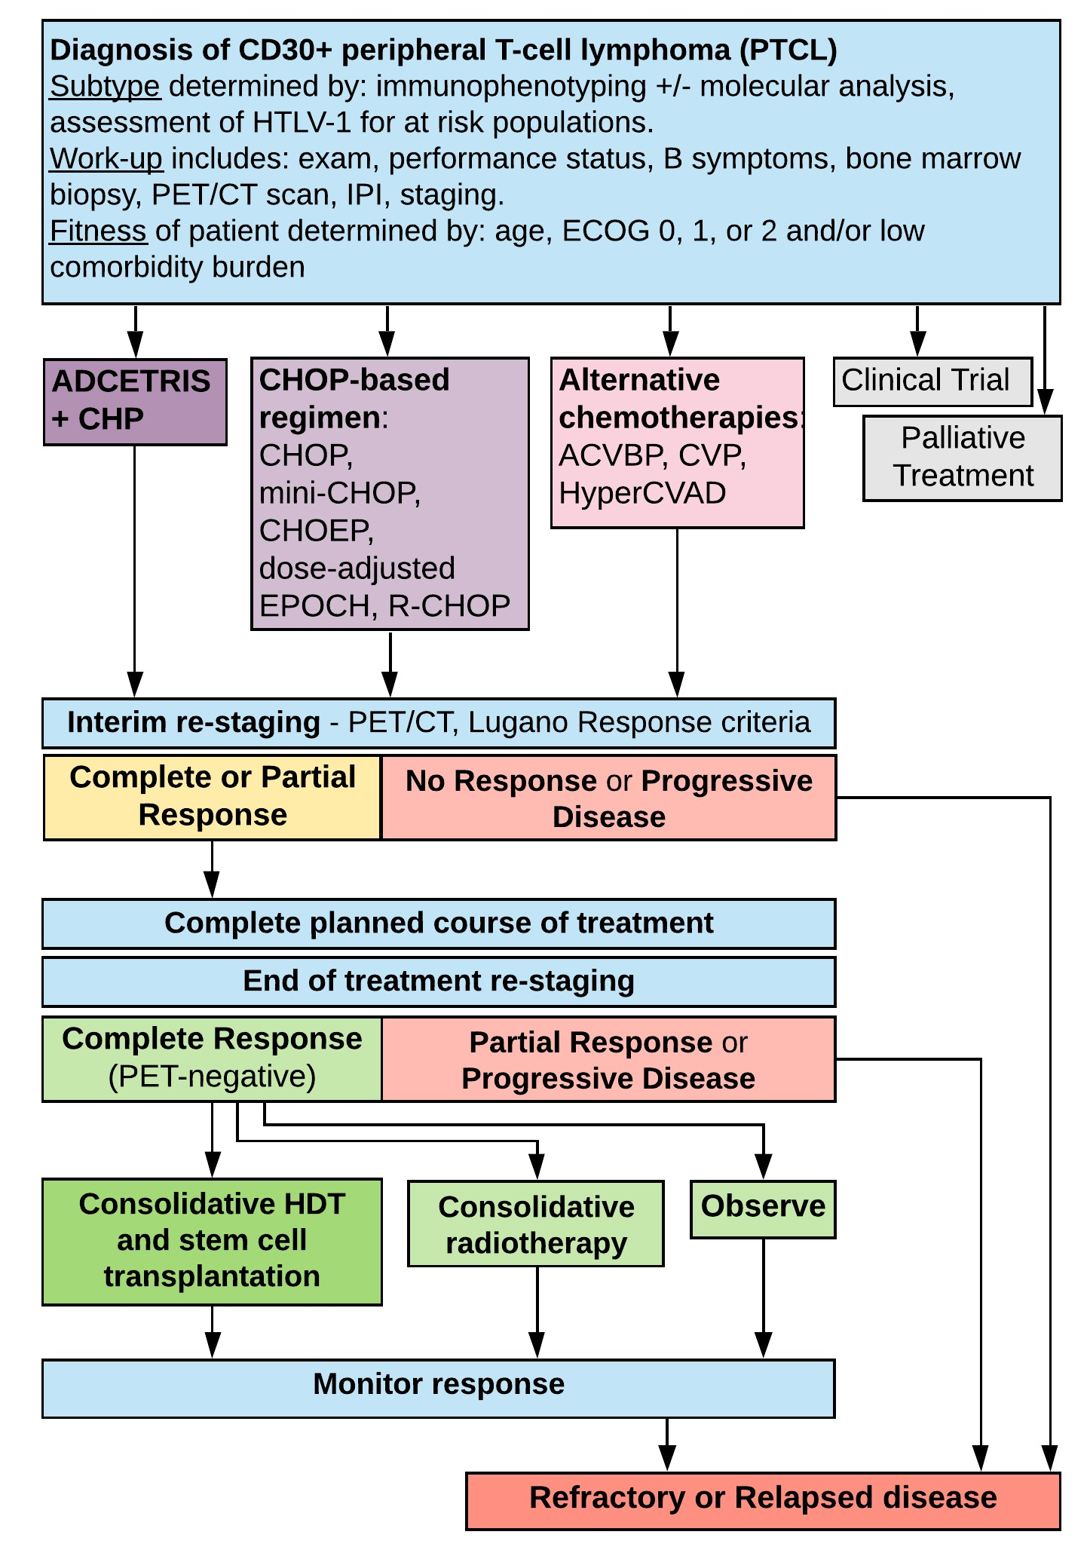
Source: Figure 1.8, p62 of the submission.
Subtypes included: PTCL–NOS= PTCL= not otherwise specified; AITL= angioimmunoblastic T-cell lymphoma; ALCL= anaplastic large cell lymphoma; anaplastic lymphoma kinase (ALK)-positive and ALK-negative; EATL= enteropathy-associated T-cell lymphoma; MEITL= monomorphic epitheliotropic intestinal T-cell lymphoma; nodal peripheral T-cell lymphoma with T follicular helper (TFH) phenotype (PTCL, TFH); FTCL= follicular T-cell lymphoma.
Regimens: ACVBP= doxorubicin, cyclophosphamide, vindesine, bleomycin and prednisone; CHOP= cyclophosphamide, doxorubicin, vincristine and prednisone; CHOEP= cyclophosphamide, doxorubicin, vincristine, etoposide and prednisone; CVP= cyclophosphamide, vincristine and prednisolone; dose-adjusted EPOCH= etoposide, prednisone, vincristine, cyclophosphamide and doxorubicin; HyperCVAD= cyclophosphamide, vincristine, doxorubicin, dexamethasone, alternating with high-dose methotrexate and cytarabine; R-CHOP, rituximab, cyclophosphamide, doxorubicin, vincristine and prednisone.
Other Abbreviations: CT= computed tomography; ECOG= Eastern Cooperative Oncology Group; HDT= high-dose therapy; HTV-1= human T-cell lymphotropic virus; IPI= International Prognostic Indicator; PET= positron emission tomography; SCT= stem cell transplantation

For more detail on PBAC’s view, see section 7 PBAC outcome.
- Comparator
  - The submission nominated CHOP as the main comparator based on the published guidelines (NCCN (January 2020), ESMO (d’Amore 2015 and Buske et al., 2018) and market research among 40 Australian clinicians (Takeda Adcetris PTCL Market Research Report, 22 October 2018) that indicated that CHOP is the commonly used first-line treatment in patients with PTCL.
  - The submission stated that the addition of etoposide to CHOP (CHOEP) had been considered as a comparator, however it was not independently associated with improvements in event-free survival or OS and was associated with additional toxicity that includes longer hospitalisations and more frequent cytopenia requiring transfusion (Kim et al., 2017, Ellin et al., 2014). The Takeda Market Research report (22 October 2018) showed that of the 40 Australian clinicians surveyed, 45% would prefer CHOEP and 38% CHOP as first-line therapy for fit patients; while 32% prefer CHOP and 25% prefer mini-CHOP for unfit patients. The ESC considered the choice of comparator, CHOP, was reasonable.
For more detail on PBAC’s view, see section 7 PBAC outcome.
- Consideration of the evidence

Sponsor hearing
  - There was no hearing for this item.

Consumer comments
  - The PBAC noted and welcomed the input from health care professionals (2) and organisations (3) via the Consumer Comments facility on the PBS website. The comments from health care professionals, Rare Cancers Australia and the Leukaemia Foundation described a range of benefits of treatment with BV including improvements in quality of life by avoiding burdensome chemotherapy regimens and fewer side effects.
  - The PBAC noted the advice received from the Haematology Society of Australia and New Zealand (HSANZ) and the Australasian Leukaemia and Lymphoma Group (ALLG) clarifying the likely use of BV in clinical practice. The PBAC specifically noted the advice that for this rare disease current standard chemotherapy with CHOP has a low complete remission rate and high relapse rate, and the high treatment burden for those progressing to second-line therapy.

Clinical trial
  - The submission was based on one head-to-head trial comparing BV+CHP to CHOP (N=452), ECHELON-2. Details of the trial presented in the submission are provided in Table 3.
Table 3: Trial and associated reports presented in the submission
Trial ID | Protocol title/ Publication title | Publication citation
ECHELON-2  (NCT01777152) | NCT01777152: ECHELON-2: A Comparison of Brentuximab Vedotin and CHP With Standard-of-care CHOP in the Treatment of Patients With CD30-positive Mature T-Cell Lymphomas. | 15 October 2018
 | DRKS00005496: A Randomized, double-blind, placebo-controlled, phase 3 study of brentuximab vedotin and CHP (A+CHP) versus CHOP in the Frontline treatment of patients with CD30-positive Mature T-cell Lymphomas. | 15 October 2018
 | Horwitz, S. et al. Brentuximab vedotin with chemotherapy for CD30-positive peripheral T-cell lymphoma (ECHELON-2): a global, double-blind, randomised, phase 3 trial. doi:10.1016/S0140-6736(18)32984-2 (2019) | Lancet (London, England) 393, 229‐240,
Source: Table 2.2, p76 of the submission.

  - The key features of the direct randomised trial are summarised in Table 4.
Table 4: Key features of the included evidence
Trial | N | Design/ duration | Risk of bias | Patient population | Outcome(s) | Use in modelled evaluation
BV+CHP vs CHOP
ECHELON-2 | 452 | R, DB  42 mths | Low | Previously untreated CD30 positive PTCL patients | Primary endpoint: PFS  Secondary endpoints: PFS for patients with sALCL, ORR, OS, safety; PROs: (QLQ-C30, EQ5D-3L, FACT/GOG-NTX) | PFS, OS, EQ-5D-3L, safety and PFS for patients with sALCL
Source: compiled during evaluation.
BV+CHP = brentuximab vedotin with cyclophosphamide, doxorubicin and prednisone; CHOP = cyclophosphamide, doxorubicin, vincristine and prednisone; CI=confidence interval; DB = double blind; EQ5D-3L = European Quality of Life 5-Dimension 3-level Questionnaire; FACT/GOG-NTX = Functional Assessment of Cancer Therapy/Gynaecologic Oncology Group – Neurotoxicity subscale; ORR=objective response rate; OS=overall survival; PFS=progression free survival; PRO = patient reported outcomes; PTCL = peripheral T-cell lymphoma; QLQ-C30 = Quality of Life Questionnaire – Core 30; R = randomised; sALCL = systemic anaplastic large cell lymphoma.

  - Overall, ECHELON-2 had a low risk of bias.
  - There were 70% of patients with a diagnosis of sALCL in ECHELON-2. The preponderance of the sALCL subtype reflects a regulatory requirement incorporated into the trial rather than the underlying distribution of disease histology in PTCL (in the financial estimates the submission assumed that 17% of all diagnosed patients were sALCL but that these represented 70% of those utilising BV on the PBS). The ESC considered that while the patient demographics and treatment characteristics reported in ECHELON-2 generally reflect the Australian setting the high proportion of sALCL patients may limit the applicability of the trial results to the proposed PBS population.
  - Approximately 11.5% of patients in the BV+CHP arm of ECHELON-2 received BV monotherapy therapy as second-line; compared to approximately 25% of patients in the CHOP arm. While the second-line use of BV is consistent with the PBS listing for BV monotherapy for the treatment of relapsed/refractory sALCL patients, there is the potential for the difference in the proportion of such use to have favoured the CHOP arm.

Comparative effectiveness
  - A summary of the PFS and OS results is presented in Table 5, with the corresponding Kaplan-Meier curves in Figure 2 to Figure 4, respectively.
  - BV+CHP treatment was associated with a 29% reduction in the risk of progression, death or subsequent anti-cancer therapy (HR = 0.71; 95% CI: 0.54, 0.93, p-value = 0.0110) in the ITT population, and a gain in median PFS of 27.4 months. The PBAC noted the gain in PFS was robust to three sensitivity analysis: censoring of new anticancer therapy (HR = 0.75; 95%CI 0.56, 1.00, p-value = 0.0484); using EMA censoring guidelines (HR = 0.73; 95% CI 0.56, 0.95, p-value = 0.017); censoring for SCT/consolidative radiotherapy (HR = 0.71, 95% CI 0.53, 0.94, p-value = 0.0167).
  - The ITT population results demonstrated a statistically significant difference in OS in favour of BV+CHP. The median duration of follow-up for the trial was 42 months and the median OS in the BV+CHP and CHOP arms was not reached, with only 23% (BV+CHP) and 32% (CHOP) of patients having experienced an event. The PSCR argued that despite a considerable median OS follow-up of 42 months the approximately parallel OS curves from 36 to 66 months suggest the median may not be reached for some time. The ESC considered that a clear plateau of the OS curves had not been reached by the end of the study. The pre-PBAC response stated that median OS had not been reached in either treatment arm in a landmark analysis conducted at 5 years follow-up (median follow-up: 66.8 months). In addition, the pre-PBAC response stated that the survival curves had not converged over the additional 24 months of follow-up.
  - PFS for sALCL was a secondary endpoint in ECHELON-2 with the results reported in Table 5.
  - The submission noted that due to the rarity of individual subtypes, ECHELON-2 was not powered to detect differences in efficacy between the treatment arms for the non-sALCL subtypes. The submission stated the small number of patients enrolled with some PTCL subtypes limits interpretation of these data. The evaluation considered this was reasonable, as the subgroup analyses other than for sALCL were not prespecified in the trial.
  - Although the number of non-sALCL patients in ECHELON-2 is low the results show a decrease in risk of progression and death, although not statistically significant. The ESC considered that more mature data may assist interpretation of the results reported for non-sALCL patients. The pre-PBAC response argued the ECHELON-2 OS point estimates favour treatment for non-ALCL overall, AITL, and PTCL-NOS, while PFS point estimates do so for overall non-ALCL and PTCL-NOS. In addition, the pre-PBAC response argued that durable responses were observed even at the lowest CD30 expression levels.
  - As all patients in ECHELON-2 were CD30 positive the evaluation considered there is no biologically plausible reason for BV+CHP not to be effective in non-sALCL subtypes.
Table 5: Results of PFS and OS in the ECHELON-2 trial
ECHELON-2 | Proposed medicine |  | Main comparator |  | Difference in median | Hazard ratio (95% CI) | P value  (log rank test)
Outcomes | n with event / N (%) | Median time to event (95% CI) | n with event / N (%) | Median time to event (95% CI) | Difference in median | Hazard ratio (95% CI) | P value  (log rank test)
ITT population
PFS | 95/226 (42) | 48.20 months (35.15, -) | 124/226 (55) | 20.80 months (12.68,47.57) | 27.4 months | 0.71ª  (0.54, 0.93) | 0.0110
OS | 51/226 (23) | NE | 73/226 (32) | NE (54.2; NE) | NE | 0.66ª  (0.46, 0.95) | 0.0244
sALCL patients
PFS according to IRF Centrally Confirmed Patients | 56/163 (34) | 55.66 | 73/151 (48) | 54.18 | 1.48 | 0.59 ª (0.42,0.84) | 0.0031
OS | 29/162 (18) | NR | 44/154 (29) | NR | NE | 0.54  (0.34, 0.87) | NR
Non-sALCL patients
PFS | 40/64 (67) | NR | 48/72 (67) | NR | NE | 0.96  (0.62, 1.46) | NR
OS | 22/64 (35) | NR | 29/72 (40) | NR | NE | 0.82  (0.47, 1.45) | NR
Source: Table 2-12, p123, Table 2.14, p99 of the submission; Table 14.2.4.1, p556 and 456 of the ECHELON-2 – sgn35-014 – Supplement tables.
ALK= anaplastic lymphoma kinase; BV = brentuximab vedotin; BV+CHP = brentuximab vedotin with cyclophosphamide, doxorubicin and prednisone; CHOP = cyclophosphamide, doxorubicin, vincristine and prednisone; CI=confidence interval; HR = hazard ratio; IPI = International Prognostic Indicator; ITT = intention to treat; n = number of participants reporting data; N = total participants in group; NE = not estimable; NR = not reported; OS = overall survival; PFS =progression free survival; sALCL = systemic anaplastic large cell lymphoma.
Note: Bold indicates statistically significant difference. a = From stratified log-rank test with stratification factors (ALK-positive sALCL: Yes/No and IPI score: 0-1/2-3/4-5) at randomization. OS rate is estimated using Kaplan-Meier methods and 95% CI is calculated using the complementary log-log transformation method (Collett, 1994).
Figure 2: Kaplan-Meier curve PFS, ECHELON-2
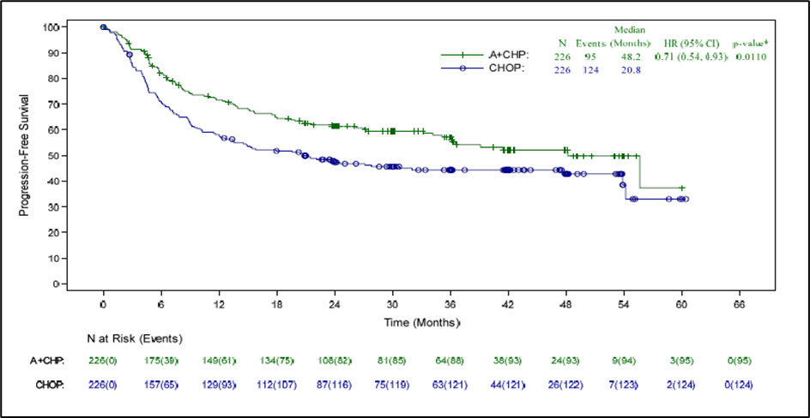
Source: Figure 2-4, p100 of the submission.
A+CHP = brentuximab vedotin with cyclophosphamide, doxorubicin and prednisone; CHOP = cyclophosphamide, doxorubicin, vincristine and prednisone; HR = hazard ratio; CI=confidence interval; IRF = independent review facility; ITT=intention-to-treat; PFS = progression free survival. Note: * Computed from log-rank test using stratification factors (ALK-positive sALCL: Yes/No and IPI score: 0-1/2-3/4-5) at randomisation.

Figure 3: Kaplan-Meier curve OS, ECHELON-2
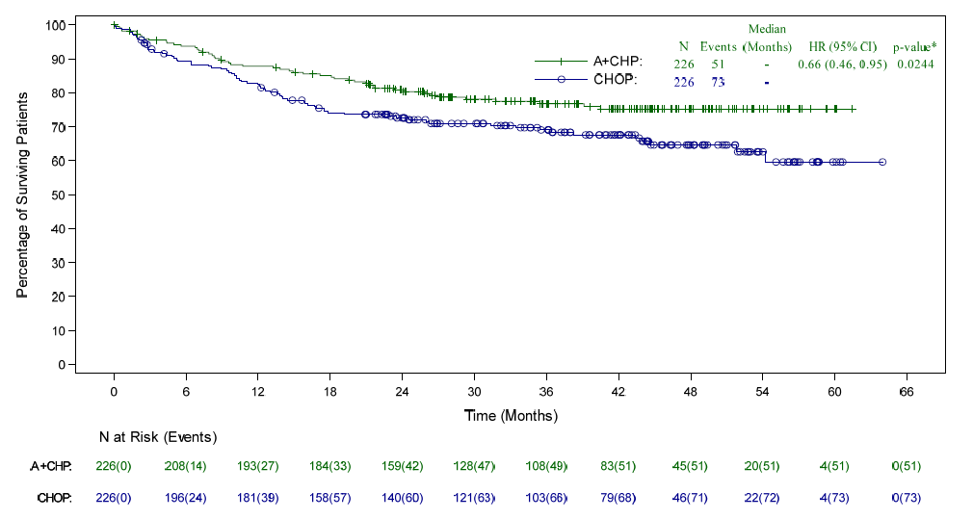
Source: Figure 2-6, p105 of the submission.
A+CHP = brentuximab vedotin with cyclophosphamide, doxorubicin and prednisone; CHOP = cyclophosphamide, doxorubicin, vincristine and prednisone; CI=confidence interval; HR = hazard ratio; ITT=intention-to-treat. Note: * Computed from log-rank test using stratification factors (ALK-positive sALCL: Yes/No and IPI score: 0-1/2-3/4-5) at randomisation
Figure 4: Kaplan-Meier curve PFS for sALCL, ECHELON-2
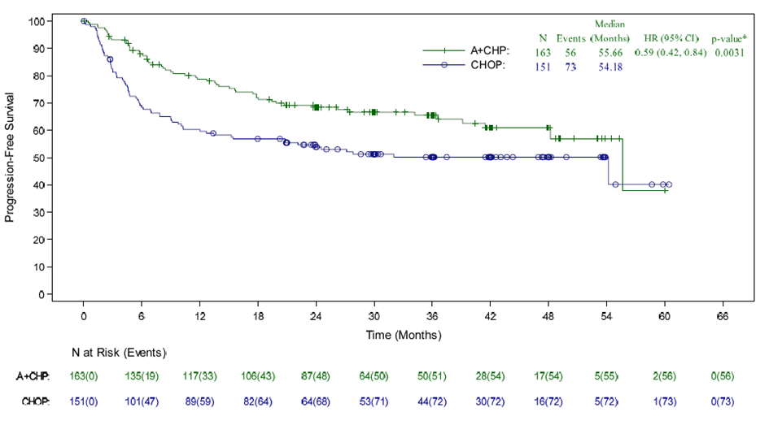
Source: Figure 2-19, p122 of the submission.
A+CHP = brentuximab vedotin with cyclophosphamide, doxorubicin and prednisone; CHOP = cyclophosphamide, doxorubicin, vincristine and prednisone; CI=confidence interval; HR = hazard ratio; IRF = independent review facility; ITT=intention-to-treat.; sALCL = systemic anaplastic large cell lymphoma.
Note:* Computed from log-rank test using stratification factors (ALK-positive sALCL: Yes/No and IPI score: 0–1/2–3/4–5) at randomisation.

  - A summary of the objective rate of response (ORR) results in the ITT population is presented in Table 6. The results demonstrated a statistically significant difference in ORR in favour of BV+CHP. A higher proportion of patients achieved confirmed complete remission (CR) in the BV+CHP arm (68%) compared to the CHOP arm (56%), while the rate of partial remission (PR) was similar across the two arms (PR: 15% vs. 16%).
Table 6: Results of objective response rate, ECHELON-2
Outcome | BV+CHP  N=226 | CHOP (N=226) | Odds ratio  (95% CI) | Risk difference (95% CI) | P value
Outcome | n (%)  (95% CI) | n (%)  (95% CI) | Odds ratio  (95% CI) | Risk difference (95% CI) | P value
CR | 153 (68) | 126 (56) | 1.66 (1.13, 2.44)* | 11.9 (3.1, 20.8) | 0.0066
ORR | 188 (83) | 163 (72) | 1.91 (1.21, 3.01)* | 11.1 (3.4, 18.7) | 0.0032
Source: Table 2.15, p103 of the submission
BV+CHP = brentuximab vedotin with cyclophosphamide, doxorubicin and prednisone; CHOP = cyclophosphamide, doxorubicin, vincristine and prednisone; CI=confidence interval; CR = complete remission; ORR = objective rate of response.
Note: Bold indicates statistically significant difference.
*Values estimated during evaluation using ReviewManager 5.3 software

  - The PSCR stated that in the BV+CHP arm, 10.2% (23/226) of patients received a BV-containing regimen in a later line, of which 17 (74%) were sALCL subtype. For patients receiving a BV-containing regimen in a later line of therapy, 87% achieved an objective response to front-line treatment, and the median time from front-line BV treatment to retreatment was 12.3 months (range: 3, 50). The PSCR also stated that overall, 57% (13/23) of patients achieved an objective response (per investigator) following retreatment with BV. The ESC agreed with PSCR that, while limited, the data presented indicated that BV monotherapy for relapsed/refractory sALCL may be a viable treatment option for patients who achieve a response to front-line BV containing therapy.
  - Patient reported outcomes in the ITT population were presented in ECHELON-2 using three health-related quality of life (HRQoL) measures: European Organisation for Research and Treatment of Cancer Quality of Life Questionnaire – Core 30 (EORTC QLQ-C30), the European Quality of Life 5-Dimension Questionnaire (EQ-5D-3L) and Functional Assessment of Cancer Therapy/Gynaecologic Oncology Group – Neurotoxicity subscale (FACT/GOG-NTX). The scores from the three instruments appeared to follow a similar trend with the mean score improving and being maintained during follow-up for both treatment arms. The submission used the scores derived from the EQ-5D-3L instrument for utility values for the health states in the modelled economic evaluation.

Comparative harms
  - A summary of the key adverse events (AE) data is presented in Table 7. Overall, the occurrence of the majority of key AEs was not statistically significantly different between BV+CHP and CHOP. The exception was AEs resulting in dose delay, with a higher incidence of such events for BV+CHP (RR = 2.14; 95% CI: 1.42, 3.22).
  - The submission stated that the most commonly occurring treatment emergent adverse events (TEAEs) were gastrointestinal symptoms (nausea, diarrhoea, vomiting), pyrexia (not related to neutropenia), asthenia and decreased weight which appeared to occur more frequently in the BV+CHP arm. However, as estimated during the evaluation, only diarrhoea (RD = 0.18; 95% CI: 0.10, 0.26) and vomiting (RD = 0.08; 95% CI: 0.01, 0.16) showed a statistically significant difference between the two treatment arms. The submission presented results for the occurrence of ‘BV or vincristine-related AEs’. The most frequently occurring of these AEs reported for ≥ 10% of patients showed that only diarrhoea (RD = 0.09; 95% CI: 0.03, 0.15) was statistically significantly different in the BV+CHP arm compared to CHOP. The submission reported that a statistically significant difference in Grade 3 or higher AEs occurring in ≥ 2% of patients was only reported for diarrhoea (RD = 0.05; 95%CI: 0.02, 0.08).
  - The submission stated that Grade 3 or higher AEs occurring in ≥ 10% of patients (neutropenia, febrile neutropenia and anaemia) were consistent in incidence and severity between the treatment arms.
  - The submission stated that peripheral sensory neuropathy and peripheral motor neuropathy were the most common causes of dose reductions in both treatment arms of ECHELON-2 (5% and 2%, respectively, in the BV+CHP arm and 2% and 4% in the CHOP arm, respectively). Peripheral neuropathy led to treatment discontinuations in three patients (1%) in the BV+CHP arm and five patients (2%) in the CHOP arm. The submission stated that the peripheral neuropathy observed with BV+CHP was manageable with dose modifications without a clinically meaningful impact on the overall dose intensity and appeared largely reversible within the observation period.
  - The submission stated that both BV+CHP and CHOP had similar rates of treatment-emergent neutropenia (38% vs 38%, respectively), febrile neutropenia (18% vs 15%, respectively) and infections (52% vs 45%, respectively). Primary prophylaxis with G-CSF was administered to 75 (34%) patients in the BV+CHP treatment arm and 61 (27%) patients in the CHOP arm. Grade 3 febrile neutropenia was observed in 36/41 (88%) patients on BV+CHP and in 26/33 (79%) on CHOP. One fatal (Grade 5) event was reported in the CHOP treatment arm.
  - The submission stated that Grade 3 and above anaemia occurred in 30 (13%) BV+CHP patients and 23 (10%) CHOP patients. However, there was only one SAE of anaemia in each arm, both of which resulted in discontinuation.
Table 7: Summary of key adverse events in ECHELON-2
Trial ID | BV+CHP  n with event/N (%) | CHOP  n with event/N (%) | RD (95% CI) | RR (95% CI)
Patients with any TEAE | 221/223 (99) | 221/226 (98) | 0.01 (-0.01, 0.04) | 1.01 (0.99, 1.04)
Patients with any BV or vincristine-related event | 201/223 (90) | 193/226 (85) | 0.05 (-0.01, 0.11) | 1.06 (0.98, 1.13)
Patients with any CHP treatment-related event | 198/223 (89) | 205/226 (91) | -0.02 (-0.08, 0.04) | 0.98 (0.92, 1.04)
Patients with any Grade 3 or higher TEAE | 147/223 (66) | 146/226 (65) | 0.01 (-0.07, 0.10) | 1.02 (0.89, 1.17)
Patients with any Grade 3 or higher BV or vincristine-related event | 116/223 (52) | 104/226 (46) | 0.06 (-0.03, 0.15) | 1.13 (0.94, 1.37)
Patients with any SAE | 87/223 (39) | 87/226 (38) | 0.01 (-0.08, 0.10) | 1.01 (0.80, 1.28)
Patients with any BV or vincristine-related SAE | 58/223 (26) | 45/226 (20) | 0.06 (-0.02, 0.14) | 1.31 (0.93, 1.84)
Patients with any CHP treatment-related SAE | 62/223 (28) | 53/226 (23) | 0.04 (-0.04, 0.12) | 1.19 (0.86, 1.63)
Patients who discontinued treatment due to AE | 14/223 (6) | 15/226 (7) | -0.00 (-0.05, 0.04) | 0.95 (0.47, 1.91)
Source: Table 2.18, p 111 of the submission.
AE =adverse events; BV+CHP = brentuximab vedotin with cyclophosphamide, doxorubicin and prednisone; CHOP = cyclophosphamide, doxorubicin, vincristine and prednisone; CI = confidence interval; n = number of participants reporting data; N = total participants in group; RD = risk difference; RR = relative risk; SAE = serious adverse events; TEAE = treatment emerging adverse events.

  - Based on the TEAE reported for 10% of patient with sALCL in the BV+CHP arm the rates of adverse events were similar to those in ITT population, including the statistically significant risk of diarrhoea (RD = 0.12; 95%CI:0.02, 0.22). Additionally, there was a statistically significantly higher rate of weight decrease in BV+CHP patients compared to CHOP (RD = 0.07; 95%CI:0.01, 0.13).

Benefits/harms
  - A summary of the comparative benefits and harms for BV+CHP versus CHOP is presented in Table 8.
Table 8: Summary of comparative benefits and harms for BV+CHP and CHOP
Benefits
Progression free survival (median duration of follow up 42 months)
Event | BV+CHP | CHOP | Absolute Difference | HR (95% CI)
Progressed, n (%) | 95/226 (42) | 124/226 (55) | -
Median PFS, months (95% CI) | 48.20 months (35.15, -) | 20.80 months (12.68,47.57) | 27.4 months
% not progressed at 6 months (95% CI) | 82.1% (76.4, 86.6) | 70.8% (64.3, 76.3) | 11.3%
% not progressed at 12 months (95% CI) | 71.7% (65.1, 77.2) | 58.2% (51.4, 64.3) | 13.5% | 0.71ª (0.54, 0.93)  P=0.0110
% not progressed at 24 months (95% CI) | 61.4% (54.4, 67.6) | 47.4% (40.6, 53.8) | 14.0%
% not progressed at 36 months (95% CI) | 57.1% (49.9, 63.7) | 44.4% (37.6, 50.9) | 12.7%
Overall survival (median duration of follow up 42 months)
Deaths, n/N (%) | 51/226 (23%) | 73/226 (32%) | -
Median OS, months (95% CI) | NE | NE (54.2; NE) | NE
% Alive at 6 months (95% CI) | 93.7% (89.6, 96.2) | 89.2% (84.4, 92.7) | 4.5%
% Alive at 12 months (95% CI) | 87.8% (82.8, 91.5) | 82.4% (6.7, 86.8) | 5.4% | 0.66ª (0.46, 0.95)  P=0.0244
% Alive at 24 months (95% CI) | 80.8% (75.0,85.5) | 72.6% (66.2,78.0) | 8.2%
% Alive at 36 months (95% CI) | 76.8% (70.4,82.0) | 69.1% (62.3,74.9) | 7.7%
% Alive at 48 months (95% CI) | 75.2% (68.5,80.6) | 64.6% (57.2,71.2) | 10.6%
Harms
 | BV+CHP  n/N | CHOP  n/N | RR  (95% CI) | Event rate/100 patients* |  | RD  (95% CI)
 |  |  |  | BV+CHP | CHOP | RD  (95% CI)
The most frequently reported TEAEs in ≥10% or more (by preferred term) of patients in the BV+CHP and CHOP
Diarrhoea | 85/223 | 46/226 | 1.87 (1.38, 2.55) | 38.1 | 20.4 | 0.18 (0.10, 0.26)
Vomiting | 57/223 | 39/226 | 1.48 (1.03, 2.13) | 25.6 | 17.3 | 0.08 (0.01, 0.16)
Grade 3 or higher AEs occurring in ≥ 2% of patients
Diarrhoea | 13/223 | 2/226 | 6.59 (1.5, 28.86) | 5.8 | 0.9 | 0.05 (0.02, 0.08)
Source: Table 2.14, p99 and Table 2.23, p114 of the submission; Table 14.2.4.1, p556 of the ECHELON-2 – sgn35-014 – Supplement tables.
AE = adverse events; BV+CHP = brentuximab vedotin with cyclophosphamide, doxorubicin and prednisone; CHOP = cyclophosphamide, doxorubicin, vincristine and prednisone; CI = confidence interval; NE = not evaluable; OS = overall survival; p =p-value; RD = risk difference; RR = risk ratio.
Note:*Median duration of follow-up: 42 months. Bold indicates statistical significance.
a = From stratified log-rank test with stratification factors (ALK-positive sALCL: Yes/No and IPI score: 0-1/2-3/4-5) at randomization. OS rate is estimated using Kaplan-Meier methods and 95% CI is calculated using the complementary log-log transformation method (Collett, 1994).

  - On the basis of direct evidence presented by the submission, for every 100 patients treated with BV+CHP in comparison with CHOP:
- Approximately 14 additional patients will be alive or free from disease progression at 12 months,
- Approximately 5 additional patients will be alive at 12 months.
Over a median duration of follow-up of 42 months:
- Approximately 18 additional patients would experience diarrhoea of any grade, and 5 additional patients would experience Grade 3 diarrhoea.
- Approximately 8 additional patients would experience vomiting.

Clinical claim
  - The submission described BV+CHP as superior in terms of effectiveness compared to CHOP. The ESC agreed with the evaluation that this claim was adequately supported showing a longer duration of PFS. However, while the available data show a benefit for BV+CHP with respect to OS, these data are immature.
  - The submission stated that a significant treatment benefit for BV+CHP in PFS and OS was observed for the sALCL subgroup. The submission noted that the point estimates for PFS and OS favoured BV+CHP treatment for all other non-ALCL subtypes, with the exception of PFS in AITL. The submission also stated that the small number of non-sALCL patients enrolled in ECHELON-2 limits interpretation of the treatment benefit for BV+CHP in this setting. The PSCR stated that individual PTCL subtypes are rare and difficult to study in their own right in controlled clinical trials. The ESC noted the OS and PFS point estimates reported for non-ALCL patients and considered that more mature data may assist in interpretation of the results reported. The PBAC considered that while more mature data may assist in further interpretation of the results there was no biologically plausible reason for BV+CHP not to be effective in CD30 positive non-sALCL subtypes.
  - The submission described BV+CHP as non-inferior in terms of safety, with a manageable safety and tolerability profile, compared to CHOP. The ESC agreed with the evaluation that this claim was adequately supported by the clinical data. Additionally, data on HRQoL demonstrate no significant difference in the quality of life experienced between treatment groups over the course of the study.
  - The submission argued that the AE profile observed for sALCL subtype does not differ from that of the overall population. The ESC considered this was reasonable.
  - The PBAC considered that the claim of superior comparative effectiveness was reasonable.
  - The PBAC considered that the claim of non-inferior comparative safety was reasonable.

Economic analysis
  - The submission presented a stepped economic evaluation based on evidence from ECHELON-2 and implemented a modelled cost-utility analysis for BV+CHP versus CHOP. The model structure and rationale are summarised in Table 9. The submission also presented results of the economic model for sALCL patients based on the data from ECHELON-2.
Table 9: Summary of model structure, key inputs and rationale
Component | Summary
Treatments | BV+CHP vs CHOP
Time horizon | 45 years in the model base case versus 42 months in trial
Outcomes | Life-years gained (LYG) and quality-adjusted life-years (QALY) gained
Methods to generate results | Partitioned-survival cohort analysis (area under the curve)
Health states | Three: progression-free disease, progressive disease and death.
Cycle length | 21 days
Allocation to health states | Health state allocation over time determined by PFS and OS curves from ECHELON-2.
Extrapolation method | The model applied an extrapolation, based on all available KM data, from the start of the analysis period. The model was fitted to each treatment arm with a log-normal distribution selected as base case for OS and gamma selected for PFS. The same distributions were applied to both treatment arms.
Health related quality of life | Calculated from EQ-5D data collected in the ECHELON-2.  The utility values applied: Progression-free = 0.79; Progressed = 0.768
Post-progression cost | Costs for consolidative chemotherapy, radiotherapy and stem cell transplant were included in the base case model. The evidence was based on ECHELON-2.
Source: Table 3.1. p136 of the submission and data compiled during evaluation
BV+CHP = brentuximab vedotin with cyclophosphamide, doxorubicin and prednisone; CHOP = cyclophosphamide, doxorubicin, vincristine and prednisone; KM = Kaplan Meier; OS = overall survival; PFS =progression free survival QALY = quality-adjusted life year.
  - The submission utility values for progression free health state were estimated by using a linear prediction model with the baseline EQ5D of 0.679. The utility for PD health state was estimated by adding post-progression decrement to the utility of PFS. The submission presented a sensitivity analysis using a utility value for PD health state of 0.670 based on Swinburn et. al., (2015), which showed that the ICER was not sensitive to a lower value. The ESC considered the approach taken and the utilities reported were appropriate.
  - The submission used extrapolated PFS and OS curves (presented in Figure 5) from the start of the time horizon. This was not appropriate since the first 42 months of KM data from ECHELON-2 should have been used in the model. A sensitivity analysis was conducted during the evaluation which applied the extrapolation of PFS and OS curves from the median follow-up of 42 months (with the KM data prior to that point), the effect on the ICER was moderate, increasing to $35,000 to < $45,000 per QALY gained.
Figure 5: Parametric extrapolations for BV+CHP and CHOP arms for OS and PFS presented in the submission.
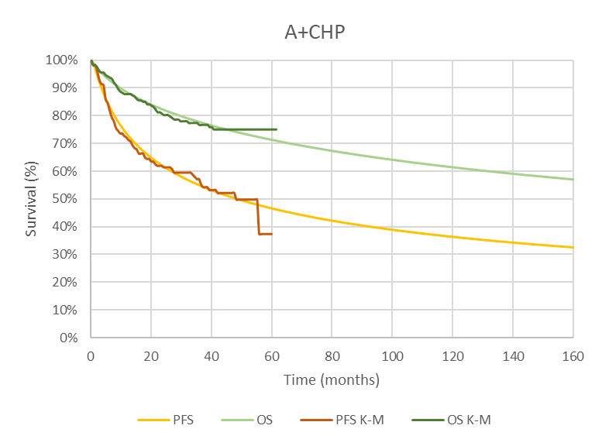
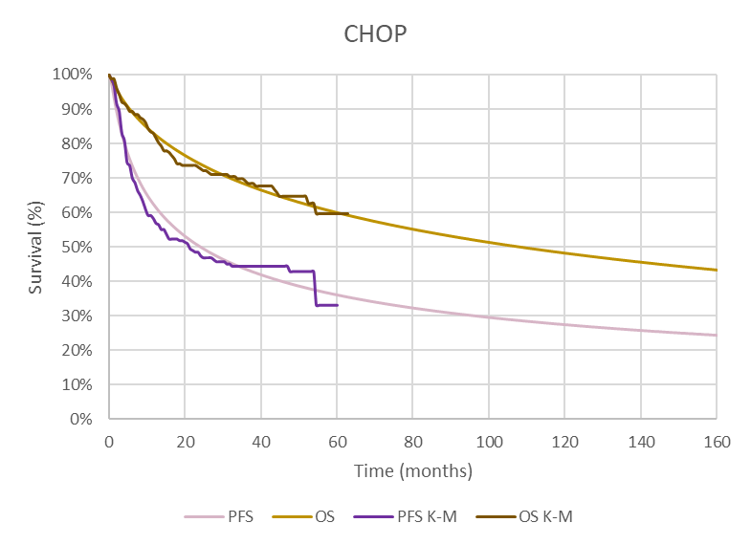

Source: Attachment 14 - ADCETRIS PTCL Financial Model.xlsx, worksheet: Key results of the submission.
A+CHP = brentuximab vedotin with cyclophosphamide, doxorubicin and prednisone; CHOP = cyclophosphamide, doxorubicin, prednisone and vincristine; K=M = Kaplan Meier; OS = overall survival; PFS = progression free survival.

  - The post-progression costs included treatment with BV monotherapy in the second-line in both arms. This is consistent with the current PBS listing for relapsed/refractory sALCL patients.
  - The model did not incorporate convergence of the extrapolated curves and assumed that the treatment effect for BV+CHP relative to CHOP was ongoing. A sensitivity analysis conducted during evaluation by assuming convergence of OS BV+CHP curve from 60 months to 120 months (with no difference in OS assumed thereafter) showed that the ICER was sensitive to the convergence of curves, favouring BV+CHP. The PSCR stated the sponsor was able approximate the convergence of the curves from 5 years to 10 years applied by the evaluator using a linear decrement in the BV+CHP arm (see Figure 6). The PSCR argued that the approach proposed by the evaluators seemed implausible given the relatively steep survival risk post 5 years needed to achieve convergence. The PSCR proposed a new sensitivity analysis with convergence of the BV+CHP OS curve from year 5 to year 20 (see Figure 7). The ESC considered that convergence of the BV+CHP OS curves was appropriate given the immaturity of the OS data in ECHELON-2 (see paragraph 6.11) and advised that convergence from year 5 to year 15 may be reasonable given the median age of patients in the trial (see paragraph 6.40) and the aggressive nature of the disease.
Figure 6. Convergence of OS from Year 5 to Year 10
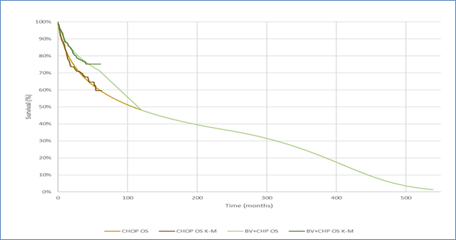
Source: Figure 2, p3, PSCR

Figure 7. Convergence of OS from Year 5 to Year 20
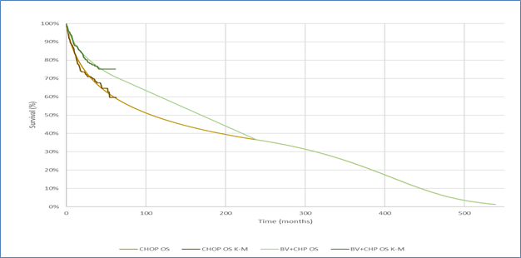
Source: Figure 3, p4, PSCR

  - For each treatment arm, PFS and OS were extrapolated out to 45 years. The submission justified the 45 year time horizon for the base case on the following basis:
- BV being associated with improved survival and quality of life over the lifetime of the individual.
- At the 42-month follow-up point of ECHELON-2, 76% of patients in the BV treatment arm were still alive, of which 52% remained progression-free. The submission did not justify why it believed extrapolation to a lifetime horizon was justified on the basis of these data from ECHELON-2.
- Two published economic models from the US and Canada which used similar time horizons (life-time horizons).
  - The submission incorporated additional aspects of survival into the model by including increased mortality associated with PTCL and adjusting survival for background mortality based on the Australian population. Application of these factors resulted in the estimated proportion of patients alive at 45 years, the end of the model time horizon, decreasing from approximately 40% (log-normal extrapolation) in the BV+CHP arm and 20% (log-normal extrapolation) in the CHOP arm to 2% and 1%, respectively. While the end result of the proportion of patients alive might be reasonable, it relies on the application of external adjustment factors that do not reflect the treatment effects of BV+CHP or its comparator. The ESC noted that the median age of patients in ECHELON-2 was 58 years and with the 45 year time horizon the median age patient would be followed to 103 years. The ESC considered that this is not justified in the setting of CD30 positive PTCL, which, as an aggressive lymphoid neoplasm, often presents in the advanced stages.
  - Univariate sensitivity analyses presented in the submission show the impact on the ICER for time horizons of 3.5, 10, 20 and 30 years (see Figure 8). These analyses show that the ICER becomes relatively stable at approximately twenty years. Approximately 5.84/7.96 (73%) of the QALYs gained and $5,000 to < $15,000/$135,000 to < $155,000 (8.9%) of the costs incurred in the BV+CHP arm were accumulated over the extrapolation period (from 42 months to 45 years). For the CHOP arm, 4.53/6.48 (69.9%) of the QALYs gained and $5,000 to < $15,000/$95,000 to < $115,000 (14.7%) of the costs incurred were accumulated over the extrapolation period. The ESC considered that, given the potential immaturity of the OS data (median not yet reached at 42 months), the use of a shorter time horizon was more appropriate than a 45 year time horizon.
Figure 8: ICER and time horizon, BV+CHP vs CHOP
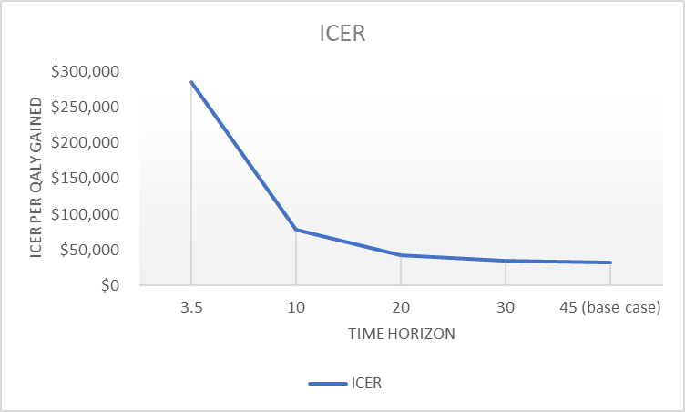
Source: compiled during evaluation using results in sensitivity analysis of Section 3 in the submission.
ICER = incremental cost-effectiveness ratio; QALY = quality adjusted life years.
  - A summary of key drivers of the economic model is shown in Table 10. The key relevant drivers with an impact on the ICER of more than 10% included the time horizon, the treatment effect, the use of extrapolation curves from the start of the time period, patient time on treatment, and assumption of treatment with BV regiment in second-line.
Table 10: Key drivers of the model
Description | Method/Value | Impact  Base case: $'''''''''''''''¹/QALY gained.
Time horizon | ECHELON-2 data extrapolated from 42 months to 45 years | High, favours BV+CHP  ICER: $''''''''''''''''''''² for 42 months trial based.  ICER: $''''''''''''''''³ for 10 years  ICER: $''''''''''''''''⁴ for 20 years
Treatment effect | Ongoing treatment effect for BV+CHP compared with CHOP (no convergence) | High, favours BV+CHP  ICER: $'''''''''''''''''''⁵ if convergence is included starting from 60 months to 120 months.
Time on treatment | Applied ECHELON-2 based duration on treatment across all administered treatment cycles | Moderate, favours BV+CHP  ICER: $'''''''''''''''''⁶ if all patients received 8 cycles.
Second-line treatment with BV regiment | Distribution of subsequent BV and salvage chemotherapies based on ECHELON-2, in BV+CHP arm 0.32, in CHOP arm 0.53 | Moderate, favours CHOP  ICER: $''''''''''''''''⁷, assuming no BV treatment in BV+CHP arm, and use in 56% of patients in CHOP arm
Extrapolation | Extrapolation applied from the start of the period | Moderate, favours BV+CHP  Use of extrapolation from the median follow-up of 42 months increased the ICER to $''''''''''''''''⁴/QALY gained.
Source: Table 3.57 of the submission. Data in italics was estimated during evaluation based on the numbers provided in the submission.
BV+CHP= brentuximab vedotin, cyclophosphamide, doxorubicin and prednisone; BV= brentuximab vedotin; ICER = incremental cost-effectiveness ratio.
The redacted values correspond to the following ranges:
¹ $25,000 to < $35,000
² $255,000 to < $355,000
³ $75,000 to < $95,000
⁴ $35,000 to < $45,000
⁵ $95,000 to < $115,000
⁶ $45,000 to < $55,000
⁷ $15,000 to < $25,000
  - The results of the stepped economic evaluation are summarised in Table 11. Step 1 was based on the ECHELON-2 time horizon (limiting the data to the 42 months of median follow-up in the trial) and incorporating an extrapolated parameterised function (Gamma for PFS and Log-normal for OS) as the basis of the model. The analysis included drug costs, concomitant medication cost and drug administration costs. Step 1 was thus based on modelled data for the entirety of the time horizon and did not directly incorporate the ECHELON-2 KM data; this was not appropriate. Step 2 included additional costs within the trial-based time-horizon. Step 3 included the utility data to estimate quality adjusted life years (QALYs) as well as various costs of subsequent BV and salvage chemotherapy. Step 4 extrapolated the time horizon to 45 years, including utility increments post-SCT and disutility associated with treatment related AEs.
Table 11: Results of the stepped economic evaluation
Step and component | BV+CHP | CHOP | Increment
Step 1: Trial setting ECHELON-2, time horizon 42 months, extrapolated OS and PFS from the start of the period, costs of treatment drugs and administration, and concomitant medication
Costs | $'''''''''''''''' | $4,587 | $'''''''''''''''''
LY | 2.919 | 2.680 | 0.240
Incremental cost/extra LY gained |  |  | $'''''''''''''''''''¹
Step 2: As in Step 1, plus cost of consolidative ASCT and AEs with frequency of ≥5%
Costs | $''''''''''''''' | $23,334 | $'''''''''''''''''
LY | 2.919 | 2.680 | 0.240
Incremental cost/extra LY gained |  |  | $'''''''''''''''''''''¹
Step 3: Estimation of QALYs based on total LYs: As in Step 2, plus trial-based utility and age-related disutility, cost of subsequent BV and salvage chemotherapiesª
Costs | $''''''''''''''''''' | $61,578 | $''''''''''''''''''
QALY | 2.285 | 2.094 | 0.192
Incremental cost/extra LY gained |  |  | $''''''''''''''''''''¹
Base case Step 4: As in Step 3, plus cost associated with health states (PFS, PD and death), extrapolated parametric function (OS, PFS), include utility increment post-SCT and disutility associated with treatment related AEs, extrapolated costs and outcomes to a 45 years’ time horizon, discount cost and outcomes.
Costs | $''''''''''''''''''' | $96,708 | $''''''''''''''''
QALY | 7.961 | 6.478 | 1.483
Incremental cost/extra QALY gained^{b, c} |  |  | $'''''''''''''''''²
Source: Table 3.49 of the submission.
AE = adverse events; ASCT = autologous stem cell transplant; BV+CHP= brentuximab vedotin, cyclophosphamide, doxorubicin and prednisone; CHOP= cyclophosphamide, doxorubicin, prednisone and vincristine; ITT = intention to treat; LY= Life-year; OS = overall survival PD = progressed disease; PFLY= Progression Free Life-year; PFS = progression free survival; QALY= Quality-Adjusted Life-year.
Note: a=does not include the cost of subsequent therapy and medical resource use costs associated with health states.
b= adjusting for updates in new MBS item 13950 used in the estimated cost the ICER was $''''''''''''''''''².
c= the economic model had an error in the share of private/public hospital use applied (the proportions were swapped in estimating the per vial price); the correction of the proportions had a negligible impact on the ICER at $'''''''''''''''''² per QALY gained.
The redacted values correspond to the following ranges:
¹ $255,000 to < $355,000
² $25,000 to < $35,000
  - The estimated ICER presented by the submission for the sALCL patients in the sensitivity analysis was similar to the ICER in the ITT population, with an ICER of $35,000 to < $45,000 per QALY gained. The analysis for the sALCL patients was based on extrapolation of the PFS and OS KM curves for the sALCL population from ECHELON-2. The data for the sALCL population was also applied for the proportion of patients per treatment cycle, proportion of patients receiving subsequent BV monotherapy, frequency of salvage chemo, proportion of patient receiving SCT and radiotherapy. The utilities, AEs rates, cost of medical resource use and concomitant medications were based on the ITT population from ECHELON-2. The evaluation considered this seems reasonable.
  - The results of key univariate sensitivity analyses are summarised in Table 12. The results from these analyses show that the ICER was most sensitive to variations in the time horizon, the treatment duration and the assumed use of subsequent BV and salvage chemotherapies. An additional sensitivity analysis was conducted during the evaluation to include the use of the KM data for the within trial period (up to 42 months and extrapolated curves thereafter). The ICER was moderately sensitive to how the KM and modelled data were applied.
Table 12: Key results of sensitivity analyses (effective price BV+CHP)
Base Case setting | Scenario Setting | Incremental |  | ICER
Base Case setting | Scenario Setting | Costs | QALYs | ICER
Base case model |  | $''''''''''''' | 1.48 | $'''''''''''''¹
ITT population | sALCL population | $''''''''''''''' | 1.37 | $'''''''''''''''²
Time horizon: 45 years | Time horizon: Trial based (3.5 years) | $'''''''''''''''''' | 0.18 | $'''''''''''''''''''''³
Time horizon: 45 years | Time horizon: 10 years | $'''''''''''''''' | 0.62 | $'''''''''''''''''⁴
Time horizon: 45 years | Time horizon: 20 years | $'''''''''''''''' | 1.13 | $'''''''''''''''²
Time horizon: 45 years | Time horizon: 25 years** | $''''''''''''''' | 1.30 | $'''''''''''''''²
Time horizon: 45 years | Time horizon: 30 years | $'''''''''''''''' | 1.40 | $''''''''''''''''¹
Time on treatment: Distributed as per ECHELON-2 | Distributed as per ECHELON-2, capped at 6 cycles | $''''''''''''''' | 1.48 | $''''''''''''''''''¹
Time on treatment: Distributed as per ECHELON-2 | 6 cycles (100% patients in cycles 1 to 6) | $'''''''''''''''' | 1.48 | $''''''''''''''''¹
Time on treatment: Distributed as per ECHELON-2 | 8 cycles (100% patients in cycles 1 to 8) | $''''''''''''''''' | 1.48 | $'''''''''''''''''⁵
Distribution of subsequent BV and salvage chemotherapies based on ECHELON-2, in BV+CHP arm 0.32, in CHOP arm 0.53 | Distribution of subsequent BV and salvage chemotherapies based on Australian setting, in BV+CHP arm 0, in CHOP arm 0.56. | $''''''''''''''' | 1.48 | $'''''''''''''''''⁶
Extrapolated OS and PFS from the start of the period* | Using KM data for PFS and OS up to 42 months median follow up time point, and extrapolated data thereafterª. | $''''''''''''''''' | 1.30 | $''''''''''''''''''²
No convergence of OS curves* | Applied convergence of BV+CHP curve from 60 months to 120 months, assuming no difference in OS from 120 months onwards^{b}. | $'''''''''''''''' | 0.47 | $''''''''''''''''''⁷
No convergence of OS curves** | Applied convergence of BV+CHP curve from 60 months to 180 months, assuming no difference in OS between BV+CHP from 180 months onwards^{c}. | $'''''''''''''''' | 0.62 | $''''''''''''''''⁴
No convergence of OS curves** | Applied convergence of BV+CHP curve from 60 months to 240 months, assuming no difference in OS from 240 months onwards^{d}. | $'''''''''''''''' | 0.77 | $'''''''''''''''⁸
Time horizon 45 years with NO OS convergence** | Time horizon 25 years,  with applied convergence of BV+CHP curve from 60 months to 180 months, assuming no difference in OS between BV+CHP from 180 months onwards^{c}. | $'''''''''''''''' | 0.62 | $''''''''''''''''⁴
Time horizon 45 years with NO OS convergence** | Time horizon 30 years,  with applied convergence of BV+CHP curve from 60 months to 180 months, assuming no difference in OS between BV+CHP from 180 months onwards^{c.} | $''''''''''''''' | 0.62 | $''''''''''''''''⁴
Additional sensitivity analysis presented in PSCR
No convergence of OS curves | Applied convergence of BV+CHP curve from 60 months to 240 months, assuming no difference in OS from 240 months onwards | $'''''''''''''''' | 0.88 | $''''''''''''''''''⁸
Source: Table 3.57 of the submission. Table 1 PSCR
*Estimated during evaluation based on the numbers provided in the submission.
**Estimated during the development of the ESC Advice
BV+CHP= brentuximab vedotin, cyclophosphamide, doxorubicin and prednisone; CHOP= cyclophosphamide, doxorubicin, prednisone and vincristine BV= brentuximab vedotin; PFS= Progression-free survival; OS= Overall survival; sALCL = systemic anaplastic large cell lymphoma
Note:
a=the values in italics were estimated using Workbook ‘ADCENTRIS_PTCL_CEM_Final’, worksheet ‘Health states’, for BV+CHP for PFS cells AR20:AR79 were linked to cells H20:H79; for OS cells AS:20:AS79 were replaced with cells Z20:Z79, additionally cells in columns O and P were adjusted to exclude correction for long-term mortality for the period of five years; for CHOP arm the PFS values in cells AT20:AT79 were replaced with values in cells Q20:Q79, OS column cells AU20:AU79 were replaced with values in cells AI20:AI79, additionally cells in columns O and P were adjusted to exclude correction for long-term mortality for the period of five years.
b= the analysis of convergence of OS curves was based on the exponential interpolation of the estimated convergence slope (1.062) and convergence index (-0.0066) based on the survival values of BV+CHP at 60 months (0.71) and CHOP at 120 months (0.48), additionally an amendment in worksheet Engine_A+CHP. Column P, cells P326:P794 to value of zero.
c= the analysis of convergence of OS curves was based on the exponential interpolation of the estimated convergence slope (0.939) and convergence index (-0.0046) which were based on the survival values of BV+CHP at 60 months (0.71) and CHOP at 180 months (0.4130) the results for OS for BV+CHP are estimated in column AV in worksheet: ‘Health states’; additionally an amendment in worksheet Engine_A+CHP. Column P, cells P326:P794 to value of zero.
d= the analysis of convergence of OS curves was based on the exponential interpolation of the estimated convergence slope (0.892) and convergence index (-0.0037) which were based on the survival values of BV+CHP at 60 months (0.71) and CHOP at 240 months (0.3648) the results for OS for BV+CHP are estimated in column AV in worksheet: ‘Health states’; additionally an amendment in worksheet Engine_A+CHP. Column P, cells P326:P794 to value of zero.
The redacted values correspond to the following ranges:
¹ $25,000 to < $35,000
² $35,000 to < $45,000
³ $255,000 to < $355,000
⁴ $75,000 to < $95,000
⁵ $45,000 to < $55,000
⁶ $15,000 to < $25,000
⁷ $95,000 to < $115,000
⁸ $55,000 to < $75,000

  - The ESC noted the ICER of $55,000 to < $75,000/QALY reported in the PSCR, for convergence of the BV+CHP curve from 60 months to 240 months assuming no difference in OS from 240 months onwards, was unable to be reproduced. Instead, the ESC noted that during the preparation of the ESC Advice an ICER of $55,000 to < $75,000/QALY was reported.
  - As outlined in paragraphs 6.38 and 6.41, the ESC advised that convergence of the BV+CHP OS curves from year 5 to year 15 and a shorter time horizon were appropriate given the immaturity of the OS data in ECHELON-2. The ESC noted that a 20 year time horizon was used in the July 2014 consideration of BV for relapsed/refractory sALCL (see Table 2) and considered that a time horizon greater than 20 years may be appropriate in the first-line setting. The ESC advised a respecified base case with convergence of OS survival from year 5 to year 15 was appropriate. With convergence at 15 years, the ICER was similar for a time horizon of 15 years or longer.

BV+CHP cost/patient/course
  - The cost per patient per course is presented in Table 13. Taking account of the anticipated mean dose based on the patient characteristics in ECHELON-2 (mean BSA of 1.85 m²) the cost of BV per patient per course of treatment was $''''''''''''. This was based on the effective price of BV, for a mean duration of six cycles.
  - The costs presented exclude the CHP component of the two treatment arms, as they were excluded in the financial estimates. However, based on the small difference in mean duration of treatment between BV+CHP and CHOP, the cost of the CHP component in the economic model would be higher for BV+CHP treatment arm, although the difference would also be small.
Table 13: Drug cost per patient for proposed and comparator drugs
 | BV  Trial dose and duration | BV  Model | BV  Financial estimates | Vincristine  Trial dose and duration | Vincristine  Model | Vincristine  Financial estimates
Mean dose | Dose of 150 mg assumed (actual dose:  126.1ª mg) | Dose of 150 mg assumed (actual dose: 133.9^{b} mg) | Dose of 150 mg assumed | Dose of 2 mg assumed, 2 vials, (actual dose:1.95^{c} mg) | Dose of 3 mg assumed, 3 vials,(actual dose: 2.6 mg) | Vincristine 2 mg (2 vials)
Mean duration (cycles) | 6 | 6 | 6 | 5.8 | 5.8 | 6
Cost/patient/cycle | $''''''''''''''''''''''^{d} | $'''''''''''''''''''''''^{d,e} | $''''''''''''''''''''''''^{d,e} | $119.70^{f} | $128.74^{g} | $119.70e
Cost/patient/course | $'''''''''''''''''''''' | $''''''''''''''''''''''' | $''''''''''''''''''''''''' | $694.65 | $746.67 | $718.58
Source: Table 14.3.1.2, p1385 and Table 14.3.1.5, p 1393 of the ECHELON-2 CSR supplement tables; data accumulated during evaluation.
Note:
a=the mean dose for BV was estimated from the mean cumulative dose of 756.4 mg divided by mean of 6 cycles.
b= the mean dose used in the economic model was based on the BSA of 1.85 m² calculated for an average ECHELON-2 patient of 74.4 kg, and 169.3 cm height.
c=the mean dose for vincristine was estimated based on mean cumulative dose administered (11.3 mg) divided by the 5.8 (mean) cycles on treatment.
d= $'''''''''''''''''''''' was based on BV (DPMA public $'''''''''''''''''''''''' *60.5% (public) + DPMA private $''''''''''''''''''''''''' *39.5% (private) calculated for 3 vials.
e= the amount was corrected during evaluation, as the economic model had an error in the private/public hospital share, where swapped values were applied.
f= $119.7 was based on the vincristine (DPMA public $103.62 *60.5% + DPMA private $144.49*39.5%) for 2 vials.
g = estimated by the submission for 3 vials, based on ex-man per pack.

Estimated PBS usage & financial implications
  - This submission was not considered by DUSC.
  - The submission used a mixed epidemiological and market share approach to estimate the expected impact associated with the listing of BV+CHP based on published and effective prices.
  - The submission assumed that BV+CHP would replace CHOP in first-line treatment. The submission stated that 85% of those patients who would otherwise be relapsed/refractory sALCL patients would be treated with BV+CHP in the first-line setting and these patients will not receive second-line BV monotherapy. The ESC considered this may be not reasonable, since 11.7% of sALCL patients in ECHELON-2 in the BV+CHP arm received BV therapy in the second-line setting. This was also inconsistent with the economic model in which patients received second-line treatment, including treatment with BV monotherapy. The PSCR acknowledged that there was the potential for fewer cost-offsets for BV to occur in the second-line setting as a result of BV being made available first-line and presented updated financial estimates (see paragraph 6.57).
  - The key inputs used by the submission in forming the financial estimates are summarised in Table 14.
Table 14: Key inputs for financial estimates
Parameter | Value applied and source | Comment
Incident NHL patients | Total NHL patients based on cancer incidence projections in Australia for males and females (AIHW 2020). NHL incidence in 2020 of ''''''''''¹ (''''''''''¹–''''''''''¹) for males and ''''''''''¹ (''''''''''¹–''''''''''¹) for females. | The source appears to be reasonable.
PTCL proportion | 5.9% of NHL is mature PTCL or T/NK cell lymphomas, Australia 2015 (AIHW 2019). | Other rates from different Australian sources were tested in the sensitivity analysis.
CD30-positve PTCL patients | CD30 positive expression estimated from Sabattini et al. 2013, Bossard et al. 2014.  Proportion of PTCL cases by subtype: PTCL–NOS, AITL, ALCL ALK+, ALCL ALK-ATLL, HSTCL, EATL from Vose 2008 | This appears to be reasonable.
Uptake rate | Overall uptake: ''''''''''%, varied by subtype: sALCL (''''''%), AITL (''''''%), PTCL-NOS (''''''%), ATLL (''''%) and EATL (''''%)  . | The submission did not present a source for the expected uptake rates by each PTCL subtype.
Source: Table 4.1, Table 4.2 compiled from data presented in Section 4 of the submission.
AIHW =Australian Institute of Health Welfare; ALCL = anaplastic large cell lymphoma; AITL = angioimmunoblastic T-cell lymphoma; ATLL = adult T-cell leukaemia/lymphoma; ALK= anaplastic lymphoma kinase; DPMA = dispensed price per maximum amount; EATL= enteropathy-associated T-cell lymphoma; HSTCL = hepatosplenic T-cell lymphoma; NHL = non-Hodgkin lymphoma; PBS =Pharmaceutical Benefits Scheme; PTCL = peripheral T-cell lymphoma; PTCL–NOS = peripheral T-cell lymphoma not otherwise specified; sALCL = systemic anaplastic large cell lymphoma.
The redacted values correspond to the following ranges:
¹ < 500

  - The financial estimates of the use of BV+CHP (effective price) are presented in Table 15.

Table 15: Estimated use and financial implications (effective BV price)
 | Year 1 | Year 2 | Year 3 | Year 4 | Year 5 | Year 6
Estimated extent of use
Number of patients treated | ''''''¹ | '''''¹ | ''''''¹ | ''''''¹ | ''''''¹ | ''''''¹
sALCL patients (70% of total) | '''''¹ | ''''''¹ | ''''''¹ | ''''''¹ | ''''''¹ | ''''''¹
Number of scripts dispensedª | '''''''''' ¹ | '''''''''' ¹ | '''''''' ¹ | '''''''''' ¹ | '''''''''' ¹ | '''''''''' ¹
Estimated financial implications of BV+CHP
Cost to PBS less copayments | $''''''''''''''''''''''''''² | $'''''''''''''''''''''''''² | $''''''''''''''''''''''''''² | $'''''''''''''''''''''² | $'''''''''''''''''''''''² | $'''''''''''''''''''''''²
Estimated financial implications for PBS for BV used in sALCL and displaced vincristine (from CHOP)
BV monotherapy | $''''''''''''''''''''''² | $'''''''''''''''''''''''² | $''''''''''''''''''''''² | $''''''''''''''''''''''''² | $'''''''''''''''''''''''² | $'''''''''''''''''''''''²
Vincristine | $''''''''''''''''² | $''''''''''''''''² | $'''''''''''''''² | $''''''''''''''''² | $''''''''''''''''² | $''''''''''''''''²
Net financial implications
Net cost to PBS | $''''''''''''''''''''² | $'''''''''''''''''''² | $'''''''''''''''''''''² | $''''''''''''''''''² | $'''''''''''''''''''''² | $'''''''''''''''''''''²
Estimated financial implications for PBS for BV used in sALCL and displaced vincristine (from CHOP) per PSCR
BV monotherapy^{b} | $''''''''''''''''''''''''''² | $''''''''''''''''''''''² | $''''''''''''''''''''''² | $''''''''''''''''''''''''''² | $''''''''''''''''''''''² | $''''''''''''''''''''''²
Vincristine | $'''''''''''''''² | $''''''''''''''''² | $''''''''''''''''² | $''''''''''''''''² | $'''''''''''''''² | $'''''''''''''''²
Net financial implications per PSCR^{b}
Net cost to PBS | $''''''''''''''''''''''''² | $''''''''''''''''''''''''² | $''''''''''''''''''''''''² | $'''''''''''''''''''''''² | $'''''''''''''''''''''''² | $'''''''''''''''''''''''²
Source: Table 4.5, Table 4.6, Table 4.8, Table 4.16 of the submission, Table 3 of PSCR
BV = brentuximab vedotin; BV+CHP= brentuximab vedotin, cyclophosphamide, doxorubicin and prednisone; PBS = Pharmaceutical Benefits Scheme; sALCL = systemic anaplastic large cell lymphoma.
ª Assuming mean 6 cycles per patient by the submission.
^{b} The PSCR estimated that there would be a 43.1% reduction in BV for relapsed/refractory sALCL patients based on data from the whole ECHELON-2 cohort.
The redacted values correspond to the following ranges:
¹ < 500
² $0 to < $10 million

  - The univariate sensitivity analyses presented in the submission and conducted during the evaluation showed that the estimates were most sensitive to the change in the assumed uptake rate and the assumed proportion of patients with PTCL. Increasing the overall uptake rate from ''''''''% to ''''''''% increased the estimated net cost to the PBS of listing BV+CHP to between $0 to < $10 million in Year 1 and $0 to < $10 million in Year 6. Estimating the impact of a higher proportion (8.2% as reported in a retrospective study conducted in Queensland; Wright et al., (2018)) of NHL that is PTCL, resulted in an increase in the estimated net cost to the PBS of between $0 to < $10 million in Year 1 and $0 to < $10 million in Year 6.
  - The submission stated that based on the current use of BV for relapsed/refractory sALCL all usage of BV will be via the PBS. However, the submission presented PBS/RPBS services for vincristine, therefore use for RPBS patients may be underestimated. In addition, the evaluation considered the net cost to the PBS may be underestimated as the submission assumed that all vincristine use in first-line will be replaced rather than displaced. The PSCR agreed that patients who relapse following BV+CHP will receive subsequent treatments including vincristine. However, the PSCR noted that the savings from replacement/displacement of vincristine in the budget impact model was less than $50,000 per annum.
  - As outlined in paragraph 6.52, the PSCR presented updated financial estimates based on an assumption that the use of BV in the second-line setting post BV first-line would mirror that in ECHELON-2. As per the submission, the PSCR estimated the BV script volume in relapsed/refractory sALCL patients from existing PBS item service volumes for this indication with an annual growth rate of 2.5% applied. While the submission assumed that 85% of relapsed/refractory sALCL patients would not receive second-line BV monotherapy with the availability of first-line BV, the updated financial estimates provided in the PSCR noted that there was a reduction of '''''''''% of use of BV for relapsed/refractory sALCL patients based on data from the whole ECHELON-2 cohort. As such, the updated financial estimates reported the net cost to the PBS of listing BV+CHP to be between $0 to < $10 million and $0 to < $10 million per year in Year 1 to Year 6 with a total of $10 million to < $20 million in the first 6 years of listing (see Table 15). The ESC considered the approach taken to update the financial estimates reasonable.
  - The ESC noted the updated financial estimates did not included grandfathered patients (see paragraph 3.11). The ESC considered this was reasonable given the proposed restriction allows a maximum treatment duration of 8 cycles and as such it is likely these patients would have completed, or be close to completing their treatment course.

Quality Use of Medicines
  - The submission stated that the sponsor is committed to ensuring the quality use of BV in clinical practice. Should BV be approved for funding in the requested PBS population, appropriate education materials will be developed for treating clinicians and patients.

Financial Management – Risk Sharing Arrangements
  - The submission did not propose a risk sharing arrangement (RSA). However, the current listing of BV monotherapy in relapsed/refractory sALCL is subject to an RSA with subsidisation caps. The submission did not estimate the impact of the proposed listing for BV+CHP on the current RSA caps established for BV monotherapy in relapsed and refractory sALCL. The PSCR argued that with an estimated < 500 to < 500 patients per year, an annual estimated net impact to the PBS of less than $0 to < $10 million and a written authority listing (see paragraph 3.4) a RSA may not be required for the proposed PTCL indication. '''' ''''''''''''''''' '''''' ''''''''''' '''''''' '''''''''''' ''''''''' ''''' ''' ''''''''''''''''' '''''''''''''''''''''''' '''''''''''' ''''''' '''''''''''''''''' ''''''''' ''''''''''''''''''''''' '''''''' ''''''''''''''''''' '''''''' ''' ''''''''' '''''' '''''''''''''''''''''' '''' '''''''''''''''' ''''''''''''''''''''''''''' '''''' '''''''''''''' '''''''''''''''''''''''''''' '''''''''''' '''''' '''''' '''''''''''' ''''' '''''' ''''''' '''''' '''''' ''''''''''' '''''''' ''''''''' '''''''''''''''''''. The pre-PBAC response argued that given the authority of initial treatment is in writing, patients must meet the diagnostic criteria for CD30 positivity, and there is a limit on the number of treatment cycles administered under an initial authority, the risk of leakage is low.
For more detail on PBAC’s view, see section 7 PBAC outcome.
- PBAC Outcome
  - The PBAC recommended the listing of brentuximab vedotin (BV), for use in combination with cyclophosphamide, doxorubicin, and prednisone (CHP) for the treatment of patients with previously untreated CD30 positive peripheral T-cell lymphoma (PTCL), on the basis that it should be available only under special arrangements under section 100 – Efficient Funding of Chemotherapy. The PBAC accepted the substantial clinical benefit of BV+CHP in terms of progression free survival (PFS) and that the immature overall survival (OS) data also suggest a clinical benefit. The PBAC considered the incremental cost-effectiveness ratio (ICER) was high but acceptable at the proposed price in the context of this rare disease with a high clinical need and the certainty of the estimated ICER. The PBAC recommended a risk sharing arrangement (RSA) to mitigate any residual uncertainties regarding the financial estimates.
  - The PBAC was satisfied that BV provides, for some patients, a significant improvement in efficacy over cyclophosphamide, doxorubicin, vincristine and prednisone (CHOP).
  - The PBAC noted the input from the Leukaemia Foundation, Rare Cancers Australia, the Haematology Society of Australia and New Zealand and the Australasian Leukaemia and Lymphoma Group supporting the listing of BV-CHP for CD30 positive PTCL. The PBAC acknowledged that there was a high clinical need for alternative treatment options to currently available chemotherapy regimens for this rare group of clinically aggressive non-Hodgkin lymphomas.
  - The PBAC considered the following appropriate for the requested listing:
- exclusion of cutaneous-type lymphomas (see paragraph 3.5);
- an Authority Required (Written) listing for initial treatment followed by an Authority Required (Telephone) listing for continuing treatment (see paragraph 3.4);
- a requirement for histological confirmation of CD30 expression in at least 3% of malignant cells in the initial restriction (see paragraph 3.3);
- inclusion of the Lugano response criteria in the continuing restriction (see paragraph 3.6);
- no grandfathering restriction (paragraph 3.11).
  - The PBAC considered CHOP to be an appropriate comparator.
  - The PBAC noted that the claim of superior clinical effectiveness compared to CHOP was based on objective response rate (ORR), OS and PFS from the ECHELON-2 trial (n=452). The PBAC noted a statistically significant difference in favour of BV+CHP for ORR (OR = 1.91; 95% CI: 1.21, 3.01, p-value = 0.032). The PBAC considered that while the available data show a benefit with respect to OS (HR = 0.66; 95% CI: 0.46, 0.95, p-value = 0.0244), the data are immature. However, the PBAC agreed with the ESC that the clinical effectiveness claim was adequately supported by the significant improvement in the primary outcome of PFS for patients receiving BV+CHP versus CHOP (HR = 0.71; 95% CI: 0.54, 0.93; p-value = 0.0110) with a gain in median PFS of 27.4 months.
  - The majority of the patient population in ECHELON-2 was of the systemic anaplastic large cell lymphoma (sALCL) subtype (70% of the total population). The PBAC noted the PFS results for the sALCL subtype were statistically significant (HR = 0.59; 95% CI: 0.42, 0.84; p-value = 0.0031) with those for the non-sALCL subtype showing a difference that was not statistically significant (HR = 0.96; 95% CI: 0.62, 1.46). The PBAC noted the small number of non-sALCL subtype patients in ECHELON-2 and that the trial was not powered for analyses within histological subtypes. The PBAC agreed with the evaluation that there was a biologically plausible reason for BV+CHP to be effective in CD30 positive non-sALCL subtypes. Hence, rather than restricting use to the sALCL subtype, the PBAC considered use in previously untreated CD30 positive PTCL appropriate.
  - The PBAC considered that the claim of non-inferior safety for BV-CHP compared to CHOP was adequately supported by the data. In addition, the PBAC agreed with the ESC that it was reasonable to conclude that the adverse event profile observed for the sALCL subtype does not differ from that of the overall population.
  - The PBAC noted that the cost-utility analysis for BV+CHP versus CHOP assumed maintenance of the treatment effect (a difference in OS between treatment arms) over the 45 year time horizon of the model. The PBAC considered that a 45 year time horizon was not appropriate given CD30 positive PTCL is an aggressive lymphoid neoplasm. In addition, the PBAC considered the assumed maintenance of the treatment effect over the lifetime of the analysis was not appropriate given the immaturity of the OS data in ECHELON-2. The PBAC advised that convergence of the OS curves was appropriate and agreed with the ESC that it may be reasonable for this to occur from year 5 to year 15 given the median age of patients in the trial (58 years) and the aggressive nature of the disease. As such, the PBAC considered the respecified base case proposed by ESC appropriate (see paragraph 6.47) and noted the ICER increased from $25,000 to < $35,000/QALY (base case) to $75,000 to < $95,000/QALY (respecified base case) with a time horizon of 45 years. The PBAC noted with convergence at 15 years, the ICER was similar for a time horizon of 15 years or longer. The PBAC advised that with a respecified base case ICER of $75,000 to < $95,000/QALY, while high, BV was cost-effective at the price proposed in the submission in the context of this rare disease with a high clinical need and the certainty of the estimated ICER.
  - The PBAC noted that updated financial estimates were provided in the Pre-Sub-Committee Response (PSCR) that assumed the use of BV in the second-line setting, post BV first-line, would mirror that in ECHELON-2 where there was a reduction of ''''''''% of use of BV for relapsed/refractory sALCL patients (see paragraph 6.57). The PBAC agreed with the ESC that the approach taken to update the financial estimates was appropriate and that there was no need to include grandfathered patients in the estimates (see paragraphs 6.60 and 6.61).
  - The PBAC noted the current listing of BV monotherapy in relapsed/refractory sALCL is subject to a risk sharing arrangement (RSA) ''''''''' '''''''''''''''''''''''''' '''''''''' '''''''' ''''''''' ''''''''''''''''''''''''' '''''''' '''''' '''''' '''''''''''''''''''' ''''''''''''''''' ''''''''' ''''' ''''''''''''''' ''' ''''''' ''''''''''''' '''''''' '''''' ''''' '''''''''''''''''''''''''''' '''' '''''''''''''''''''''''''''''''''''''' ''''''''''' '''' '''''''''''''' ''''''' ''''''''''''''' '''''''''''''''''''''''' '''''''' ''''''' ''''''''''''''''' ''''''''''''''''''''' ''''''''''''''''''' ''''''' '''''''''''''''''''' '''' '''''' '''''' '''' ''''' '''' ''''''' ''''''''''''''''''''''''''''''''''''''' ''''''''''''' ''''''' '''''''''' '''''''''''''''' ''''''' ''''''' ''''''''''''''''' ''''''''''''' ''''''''''''''''''''''' ''''''''' '''''''''''''' ''''' '''''''''''' '''' '''''''''''''''' '''''' '''' ''''''' ''''''' '''' ''''' '''' ''' '''''''' ''''''' ''''''''''''''''''' '''''' '''''''''' ''''''' ''''' '''''' '''''''''''''''' '''''''' ''''' ''''' '''''' ''''''' '''''''''''''''''''' '''' ''''''''''''''''''''''''''''''''''''''' ''''''''''''' ''''''''''' ''''' '''''' '''''''''''''' ''''''''''''''' ''''''''''''''''''' '''''''''''''''' '''' '''''' ''''''''' '''''''' ''''''''''''''''' ''''''''''
  - The PBAC advised that BV is not suitable for prescribing by nurse practitioners.
  - The PBAC recommended that the Early Supply Rule should not apply.
  - The PBAC noted the flow-on restriction changes required to the BV monotherapy listing for relapsed/refractory sALCL [10166C, 10171H, 10172J, 10180T]:
- Amendment of the clinical criteria to ensure patients who are primary refractory to BV-CHP for previously untreated PTCL do not receive BV in the second-line setting (see paragraph 3.9).
- Amendment of the number of cycles allowed in a lifetime to enable use of BV monotherapy for relapsed/refractory sALCL patients who achieve a response to front-line BV containing therapy (see paragraph 3.10).
  - The PBAC found that the criteria prescribed by the National Health (Pharmaceuticals and Vaccines – Cost Recovery) Regulations 2009 for Pricing Pathway A were met. Specifically the PBAC found that in the circumstances of its recommendation for BV:
- The treatment is expected to provide a substantial and clinically relevant improvement in efficacy, over alternative therapies (see paragraph 7.6);
- The treatment is expected to address a high and urgent unmet clinical need due to the rare and clinically aggressive nature of PTCL (see paragraph 7.3);
- It would be in the public interest for the subsequent pricing application to be progressed under Pricing Pathway A on the basis of the preceding findings.
  - The PBAC noted that this submission is not eligible for an Independent Review as it received a positive recommendation.
Outcome:
Recommended
- Recommended listing
  - Amend existing/recommended listing:
MEDICINAL PRODUCT  Form |  |  | PBS item code | Max.  Amount | №.of  Rpts | Manufacturer
BRENTUXIMAB VEDOTIN  Injection |  |  | NEW (Public)  NEW (Private) | 200 mg | 5 | Takeda Pharmaceuticals Australia Pty Ltd
Available brands
Adcetris
(brentuximab vedotin 50 mg injection, 1 vial)
Restriction Summary [new] / Treatment of Concept: [new]
 | Category / Program: Section 100 – Efficient Funding of Chemotherapy Public/Private hospitals
 | Prescriber type: Medical Practitioners
Restriction type:
Authority Required – non-immediate/delayed assessment by Services Australia (In-writing only via mail/postal service or electronic submission)
Administrative Advice:
No increase in the maximum quantity or number of units may be authorised.
Administrative Advice:
No increase in the maximum number of repeats may be authorised.
Administrative Advice:
Special Pricing Arrangements apply.
 | Episodicity: blank
 | Severity: blank
 | Condition: CD30 positive peripheral T-cell lymphoma, non-cutaneous type
 | Indication: CD30 positive peripheral T-cell lymphoma, non-cutaneous type
 | Treatment Phase: Initial
 | Clinical criteria:
 | Patient must have histological confirmation of CD30 expression in at least 3% of malignant cells.
 | AND
 | Clinical criteria:
 | The treatment must be for first line therapy for this condition.
 | AND
 | Clinical criteria:
 | The treatment must be for curative intent.
 | AND
 | Clinical criteria:
 | The treatment must be in combination with cyclophosphamide, doxorubicin and prednisone.
 | AND
 | Clinical criteria:
 | The treatment must not be more than 6 treatment cycles under this restriction in a lifetime.
Prescribing Instructions:
Applications for authorisation of initial treatment must be in writing and must include:
(a) a completed authority prescription form; and
(b) a completed Peripheral T cell lymphoma Brentuximab PBS Authority Application - Supporting Information Form which includes the following:
(i) a histology report including evidence of the tumour's CD30 positivity;
(ii) The date of initial diagnosis of Peripheral T cell lymphoma cell lymphoma.

 | Administrative Advice: This product is not PBS-subsidised for the treatment of previously untreated CD30 positive cutaneous T-cell lymphoma.
Administrative Advice:
Any queries concerning the arrangements to prescribe may be directed to Services Australia 1800 700 270 (hours of operation 8 a.m. to 5 p.m. EST Monday to Friday).
Prescribing information (including Authority Application forms and other relevant documentation as applicable) is available on the Services Australia website at www.servicesaustralia.gov.au
Applications for authority to prescribe should be submitted online using the form upload facility in Health Professional Online Services (HPOS) at www.servicesaustralia.gov.au/hpos
Or mailed to:
Services Australia
Complex Drugs
Reply Paid 9826
HOBART TAS 7001

MEDICINAL PRODUCT  Form |  |  | PBS item code | Max.  Amount | №.of  Rpts | Manufacturer
BRENTUXIMAB VEDOTIN  Injection |  |  | NEW (Public)  NEW (Private) | 200 mg | 1 | Takeda Pharmaceuticals Australia Pty Ltd
Available brands
Adcetris
(brentuximab vedotin 50 mg injection, 1 vial)
Restriction Summary [new] / Treatment of Concept: [new]
 | Category / Program: Section 100 – Efficient Funding of Chemotherapy Public/Private hospitals
 | Prescriber type: Medical Practitioners
Restriction type:
Authority Required – immediate/real-time assessment by Services Australia (telephone/electronic)
Administrative Advice:
No increase in the maximum quantity or number of units may be authorised.
Administrative Advice:
No increase in the maximum number of repeats may be authorised.
Administrative Advice:
Special Pricing Arrangements apply.
 | Episodicity: blank
 | Severity: blank
 | Condition: CD30 positive peripheral T-cell lymphoma, non-cutaneous type
 | Indication: CD30 positive peripheral T-cell lymphoma, non-cutaneous type
 | Treatment Phase: Continuing
 | Clinical criteria:
 | The treatment must be in combination with cyclophosphamide, doxorubicin and prednisone.
 | AND
 | Clinical criteria:
 | Patient must have completed 6 initial cycles of PBS-subsidised treatment with this drug for this indication.
 | AND
 | Clinical criteria:
 | Patient must have achieved at least a partial response to the 6 initial cycles of treatment with a combination of this drug and cyclophosphamide, doxorubicin and prednisone for this indication.
 | AND
 | Clinical criteria:
 | The condition must have not progressed while being treated with this drug for this condition.
 | AND
 | Clinical criteria:
 | The treatment must not be more than 2 treatment cycles under this restriction in a lifetime.
Prescribing Instructions:
Partial response is defined using Lugano Response Criteria for Non-Hodgkin Lymphoma as:
(a) Positron emission tomography-based response: lymph nodes and extralymphatic sites - a score of 4 (uptake moderately > liver), or 5 (uptake markedly higher than liver and/or new lesions), with reduced uptake compared with baseline and residual mass(es) of any size; nonmeasured lesions – not applicable; organ enlargement – not applicable; new lesions – none; bone marrow – residual uptake higher than uptake in normal marrow but reduced compared with baseline (diffuse uptake compatible with reactive changes from chemotherapy allowed). If there are persistent focal changes in the marrow in the context of a nodal response, consideration should be given to further evaluation with MRI or biopsy or an interval scan.
(b) Computed tomography-based response: lymph nodes and extralymphatic sites - ≥50% decrease in the sum of the product of the perpendicular diameters for multiple lesions, of up to six (6) target measurable nodes and extranodal sites; non-measured lesions – absent/normal, regressed but no increase; new lesions – none; bone marrow – not applicable.

Prescribing Instructions:
Applications for autho risation under this restriction may be made in real time using the Online PBS Authorities system (see www.servicesaustralia.gov.au/HPOS) or by telephone by contacting Services Australia on 1800 700 270 (hours of operation 8 a.m. to 5 p.m. EST Monday to Friday).
 |  | Administrative Advice: This product is not PBS-subsidised for the treatment of previously untreated CD30 positive cutaneous T-cell lymphoma.

  - Flow on changes to brentuximab vedotin listing for CD30 positive systemic anaplastic large cell lymphoma as outlined in paragraph 7.14.
Add the following to Initial treatment restriction (10166C, 10172J):
Clinical criteria:
Patient must have responded to PBS-subsidised treatment with this drug if previously used for initial treatment of CD30 positive peripheral T-cell lymphoma, non-cutaneous type.

Make the following changes to the Continuing treatment (10171H, 10180T):
Prescribing instructions
The treatment must not exceed a lifetime total of 16 cycles
Prescribing instructions
The treatment must not be more than 12 treatment cycles under this restriction in a lifetime.

This restriction may be subject to further review. Should there be any changes made to the restriction the Sponsor will be informed.

- Context for Decision
The PBAC helps decide whether and, if so, how medicines should be subsidised through the Pharmaceutical Benefits Scheme (PBS) in Australia. It considers applications regarding the listing of medicines on the PBS and provides advice about other matters relating to the operation of the PBS in this context. A PBAC decision in relation to PBS listings does not necessarily represent a final PBAC view about the merits of the medicine or the circumstances in which it should be made available through the PBS. The PBAC welcomes applications containing new information at any time.
- Sponsor’s Comment
Takeda Pharmaceuticals Australia welcomes the PBAC’s decision to recommend ADCETRIS as a front-line treatment for patients with peripheral T-cell lymphoma. We would like to particularly thank the patients, clinicians, and organisation who took time to provide their experience and insight during the evaluation.

Cheson, B. D. et al. Recommendations for initial evaluation, staging, and response assessment of Hodgkin and non-Hodgkin lymphoma: the Lugano classification. J Clin Oncol 2014;32: 3059-3068

