Utilisation analysis of dasatinib and nilotinib for chronic myeloid leukaemia (CML)

Drug utilisation sub-committee (DUSC)

October 2024

## Abstract

### Purpose

The PBAC recommended that DUSC conduct a review on the utilisation of dasatinib and nilotinib following a reduction in restriction levels to Authority Required (Telephone) for initial treatment and Authority Required (STREAMLINED) for first and subsequent continuing treatment which was implemented in March 2022.

### Date of listing on the Pharmaceutical Benefits Scheme (PBS)

* Imatinib was first listed on the PBS for CML on 1st November 2003.
* Dasatinib was first listed on the PBS for CML on 1st August 2007.
* Nilotinib was first listed on the PBS for CML on 1st August 2008.
* Ponatinib was first listed on the PBS for CML on 1st November 2015.

### Data Source / methodology

PBS dispensing data was extracted from the PBS data maintained by the Department of Health and Aged Care, processed by Services Australia.

### Key Findings

* The utilisation of nilotinib and dasatinib had remained at a similar level following the restriction change in 2022 relative to utilisation prior to the change.
* The majority of patients start on imatinib before moving primarily to dasatinib and less to nilotinib. The number of patients supplied third and later line therapy are small with nilotinib more commonly supplied than dasatinib in later lines of therapy.
* Expenditure for 2023 was $79 million which had progressively decreased from a peak of approximately $138 million in 2015.
* Imatinib had resulted in a PBS expenditure of $1 billion for the CML indication since listing in 2003 followed by dasatinib at $543 million and nilotinib at $384 million.
* Imatinib expenditure as at 2023 was lower than dasatinib and nilotinib which represented the majority of the $79 million expenditure.

# Purpose of analysis

The PBAC recommended that DUSC conduct a review on the utilisation of dasatinib and nilotinib following a reduction in restriction levels to Authority Required (Telephone) for initial treatment and Authority Required (STREAMLINED) for first and subsequent continuing treatment which was implemented in March 2022.

# Background

## Clinical situation

Chronic myeloid leukaemia is a cancer where the bone marrow produces too many granulocytes which interfere with normal blood cell production causing immune dysfunction and anaemia.[1]

Treatment is dependant on the health of the person and stage of the disease however drug therapy primarily consists of tyrosine kinase inhibitors (TKIs).1

## Pharmacology

Imatinib, dasatinib, nilotinib and ponatinib are tyrosine kinase inhibitors (TKIs).

Imatinib inhibits the activity of the breakpoint cluster region-Ableson (BCR-ABL) tyrosine kinase as well as KIT, the receptor for stem cell factor (SCF) coded for by the KIT proto-oncogene, the discoidin domain receptors, the colony stimulating factor receptor (CSF-1R) and the platelet-derived growth factor receptors alpha and beta (PDGFR-alpha and PDGFR-beta).[2]

Dasatinib inhibits the activity of the BCR-ABL kinase and SRC-family kinases at low nanomolar or subnanomolar concentrations. Dasatinib also inhibits a number of other kinases including c-KIT, the EPHA2 receptor and the PDGFβ receptor.[3]

Nilotinib inhibits BCR-ABL tyrosine kinase activity in the nanomolar range by binding to the ATP-binding site.[4]

Ponatinib inhibits the tyrosine kinase activity of BCR-ABL and T315I mutant BCR-ABL. Ponatinib inhibits the in vitro activity of other kinases, including RET, FLT3, and KIT and members of the FGFR, PDGFR, VEGFR, EPH and SRC families of kinases.[5]

## Therapeutic Goods Administration (TGA) approved indications

Following were the approved indications for imatinib, dasatinib and nilotinib at the time of reporting.

Imatinib:

* treatment of patients with CML.
* treatment of adult and paediatric patients with newly diagnosed Philadelphia chromosome positive acute lymphoblastic leukaemia (Ph+ ALL) integrated with chemotherapy.
* treatment of adult patients with relapsed or refractory Ph+ ALL as monotherapy.
* treatment of adult patients with myelodysplastic/myeloproliferative diseases. (MDS/MPD) associated with platelet-derived growth factor receptor (PDGFR) gene rearrangements, where conventional therapies have failed.
* treatment of adult patients with aggressive systemic mastocytosis (ASM), where conventional therapies have failed.
* treatment of adult patients with hypereosinophilic syndrome (HES) and/or chronic eosinophilic leukaemia (CEL).
* treatment of patients with KIT (CD117) positive unresectable and/or metastatic malignant gastrointestinal stromal tumours (GIST).
* adjuvant treatment of adult patients at high risk of recurrence following complete gross.
* resection of KIT (CD117)-positive primary GIST.
* treatment of adult patients with unresectable, recurrent and/or metastatic dermatofibrosarcoma protuberans (DFSP).

Dasatinib:

* newly diagnosed Philadelphia chromosome positive (Ph+) chronic myeloid leukaemia in the chronic phase.
* chronic, accelerated or myeloid or lymphoid blast phase chronic myeloid leukaemia with resistance or intolerance to prior therapy including imatinib.
* newly diagnosed Philadelphia chromosome positive acute lymphoblastic leukaemia integrated with chemotherapy.
* Philadelphia chromosome positive acute lymphoblastic leukaemia with resistance or intolerance to prior therapy.

Nilotinib:

* treatment of adult patients with newly diagnosed Philadelphia chromosome positive CML in chronic phase.
* treatment of adults with chronic phase and accelerated phase Philadelphia chromosome positive CML resistant to or intolerant of prior therapy including imatinib.

Ponatinib is approved for the following indications:

* Chronic phase (CP), accelerated phase (AP), or blast phase (BP) CML whose disease is resistant to, or who are intolerant of at least two prior tyrosine kinase inhibitors; or where there is a T315I mutation.
* Philadelphia chromosome positive acute lymphoblastic Ieukaemia (Ph+ ALL) whose disease is resistant to, or who are intolerant of dasatinib and for whom subsequent treatment with imatinib is not clinically appropriate; or where there is a T315I mutation.

## Dosage and administration

Dosage varies between products based on the indication. The Product Information (PI) and Consumer Medicine Information (CMI) available from [the TGA (Product Information)](http://tga.gov.au/hp/information-medicines-pi.htm) and [the TGA (Consumer Medicines Information)](http://www.tga.gov.au/consumers/information-medicines-cmi.htm) contain the dosage information.

## PBS listing details

Details of the PBS listings are available from the [PBS Website](https://www.pbs.gov.au/browse/body-system?depth=4&codes=l01ea#l01ea).

### Date of listing on PBS

* Imatinib was first listed on the PBS for CML on 1st November 2003.
* Dasatinib was first listed on the PBS for CML on 1st August 2007.
* Nilotinib was first listed on the PBS for CML on 1st August 2008.
* Ponatinib was first listed on the PBS for CML on 1st November 2015.

## Relevant aspects of consideration by the Pharmaceutical Benefits Advisory Committee (PBAC)

The PBAC considered the written authority level of the following medicines for CML: dasatinib, imatinib, nilotinib, ponatinib as part of the Review of the PBS Authority Required (Written) listings: Tranche 1 (The Review).

* The PBAC recalled that its recommendation for Authority Required (Written) authorisation for initial therapy for dasatinib was due to the safety of the medicine. For dasatinib and nilotinib, comparative effectiveness in imatinib treatment resistant patients was of concern. For ponatinib, the PBAC recalled it was concerned with risk of leakage outside the proposed indication.
* The PBAC acknowledged the administrative burden for CML was one of the highest of the Tranche 1 indications, with over 3,000 written authorisations granted in the 2019-20 financial year.
* The PBAC noted that the market for CML was growing. This growth was due to improved sensitivity of molecular diagnostic testing and emerging new clinical evidence to suggest patients should be molecular negative for five years, rather than three to four years, prolonging time on TKI therapy. Further, the overall survival rates of newly diagnosed patients with CML has improved significantly.
* Overall, PBS expenditure on CML was declining, reflecting imatinib-associated price reductions. The PBAC noted that in 2018-19, imatinib patient numbers increased by 11%, coinciding with the September 2019 reduction in restriction level. The PBAC were concerned that a similar increase in utilisation may occur if the dasatinib and nilotinib restrictions were revised, along with a concurrent increase in expenditure (i.e. without an associated price reduction).
* The PBAC noted nilotinib and ponatinib utilisation was stable while dasatinib usage increased by 10% over 2018-20.
* The PBAC recommended a reduction in the restriction levels for dasatinib and nilotinib to Authority Required (Telephone) for initial treatment and Authority Required (STREAMLINED) for first and subsequent continuing treatment which was implemented in March 2022.
* The PBAC did not recommend an amendment to the restrictions for ponatinib (third-line treatment) due to the high risk of leakage into other indications and different toxicity profile to second-line treatments (dasatinib and nilotinib).
* The PBAC recommended that DUSC conduct a future review on the utilisation of dasatinib and nilotinib.

# Methods

Data from 1 January 2004 to 31 July 2024 were extracted from the PBS data maintained by Department of Health and Aged Care, processed by Services Australia on or before   
10 August 2024 for the PBS item codes corresponding to chronic myeloid leukaemia for dasatinib, imatinib, nilotinib and ponatinib. The PBS prescription data were used to determine the number of prescriptions supplied and the PBS expenditure based on the published list prices. These data were also used to count the number of patients, both incident (new to treatment) and prevalent (number treated in each time period, i.e. year or quarter). PBS prescription data also contains age and gender information. This information was used to perform a breakdown of patients by age and gender at initiation of TKI therapy.

The Kaplan-Meier method was used to determine the length of treatment for patients. A break in treatment was defined as a gap of more than three times the median time between supplies which was found to be 30-33 days depending on medication. A patient was deemed to be continuing treatment (classified as censored in the Kaplan-Meier analysis) at the end of the data period (i.e. the end of July 2024) if their last prescription was within three times the median time to resupply of this end date. Otherwise the patient was deemed to have ceased treatment with the treatment coverage end date being the supply date of their last prescription plus a median time to resupply. If a patient’s supply was after a gap of more than three times the median time to resupply, then the patient was deemed to have been re-treated.

The Sankey diagram (Figure 7) was created based on all patients as they progress through treatments.

# Results

## Analysis of drug utilisation

### Overall utilisation

**Figure 1: Prevalent patient numbers of TKIs for CML**

Figure 1 shows the overall utilisation in prevalent patient numbers for TKIs for CML. Imatinib was first listed in 2003 and utilisation increased before plateauing in 2012 and began to decrease in 2021Q3. Dasatinib and nilotinib were listed in 2007 and 2008 respectively and experienced a similar growth to that of imatinib when first listed. Nilotinib plateaued at approximately 800 prevalent patients per quarter while dasatinib appeared to be nearing a plateau. Ponatinib was listed in 2015 and had maintained approximately 50 prevalent patients per quarter.

**Figure 2: Initiating patient numbers of TKIs for CML**

Figure 2 shows the number of initiating patients for TKIs for CML. In recent quarters the number of initiating patients to nilotinib and ponatinib remained steady at 30-40 new initiators per quarter and 5, respectively. The number of imatinib initiators reduced per quarter from 2019 to 80 initiators in 2024Q2 while initiators to dasatinib steadily increased from 2021Q3 from 60 to 96 in 2024Q2.

**Figure 3: Prescription numbers of TKIs for CML**

Figure 3 shows the number of prescriptions supplied per quarter for TKIs for CML. The number of prescriptions per quarter largely mirrored that of the number of prevalent patients seen in Figure 1 with a slow decline in use of imatinib while dasatinib increased and nilotinib and ponatinib plateaued.

**Figure 4: Prescription numbers of dasatinib and nilotinib for CML by month. Dotted line at March 2022 represents the restriction changes to Telephone and STREAMLINED for initial and continuing treatment respectively.**

In March 2022 changes were made to the restriction of dasatinib and nilotinib as a result of recommendations from the PBAC following the written authority review. The number of prescriptions per month for dasatinib and nilotinib can be seen in Figure 4 and indicate that the change in restriction levels did not result in significant changes to utilisation. An interrupted time series analysis was attempted however no model could be established with any statistical significance to suggest that the restriction change had meaningfully impacted utilisation.

### Utilisation by relevant sub-populations/regions or patient level analysis

Figure 5 illustrates the distribution of the proportion of male patients initiating onto their first TKI for CML by age. The majority of males initiating on to nilotinib, imatinib and dasatinib were aged between 50-70 years old with a peak primarily seen at 60 years old. Ponatinib had peaks at 40 years old and 65 years old, however it should be noted that the initiating cohort was very small as the analysis was based on first initiation so would not include patients initiating ponatinib as a second and subsequent line therapy.

Figure 6 represents the same analysis as Figure 5 however shows the distributions seen in female initiators. The trends for female initiators were similar to males and the same caveat to the ponatinib data from Figure 5 also applies to this analysis.

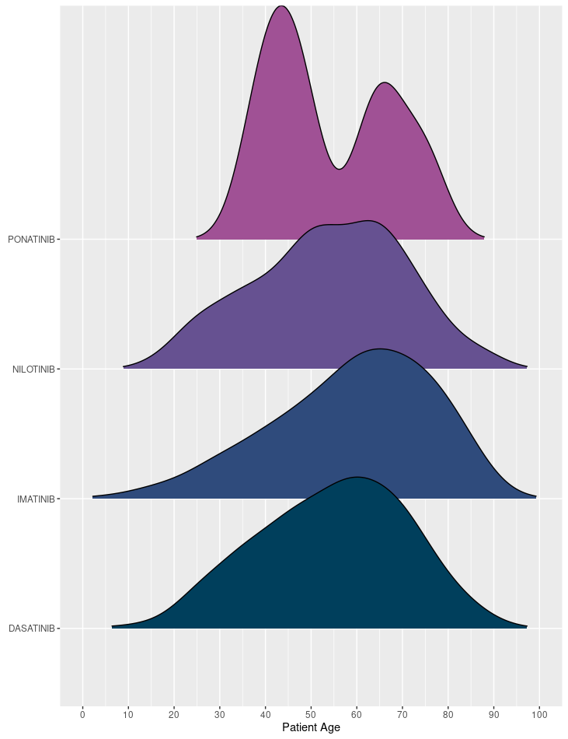

**Figure 5: Distribution of patient age at initiation of first TKI for CML in males since listing**

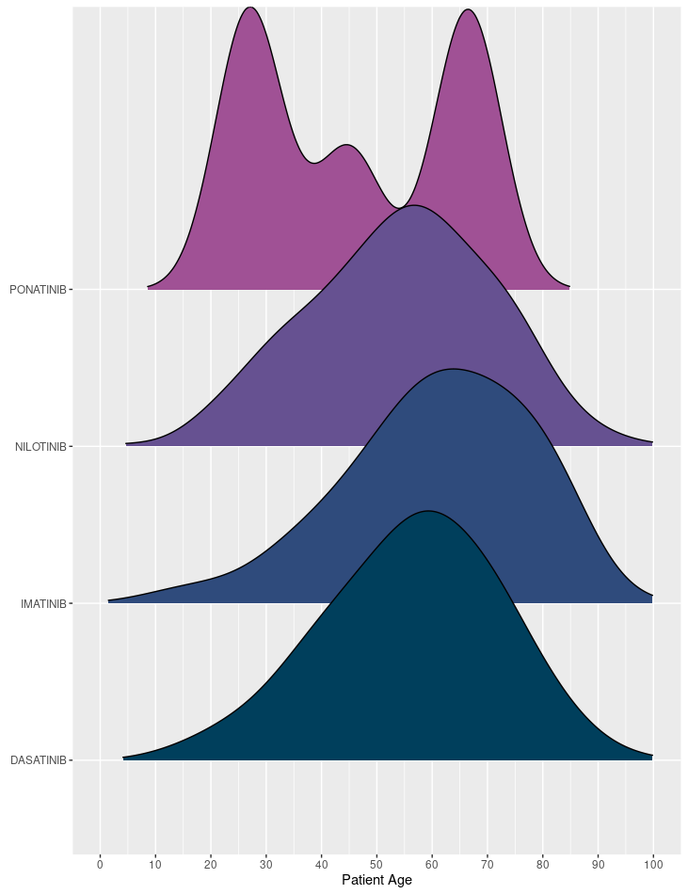

**Figure 6: Distribution of patient age at initiation of first TKI for CML in females since listing**

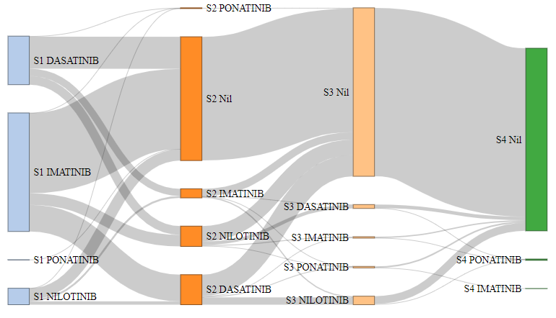

**Figure 7: Sankey diagram of patient pathways following initiation of first TKI for CML**

Figure 7 shows a Sankey diagram and illustrates patient pathways from their first initiation on to a TKI for CML. The majority of patients can be seen to start on imatinib before moving primarily to dasatinib and less to nilotinib. The number of patients supplied third and later line therapy are small with nilotinib more commonly supplied than dasatinib in later lines of therapy.

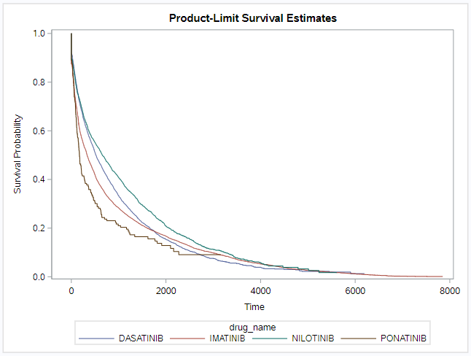  
**Figure 8: Time on treatment for TKIs for CML in days including breaks**

Figure 8 shows the time on treatment in days for TKIs for CML including treatment breaks. This analysis used prescription data at any line of therapy. The time on treatment curves were similar for all TKIs however dasatinib and nilotinib showed less cessation initially while imatinib maintained a long tail of use. The median treatment duration for dasatinib was 1303 days with 37% of patients censored. For imatinib the median was 993 days with 21% censored. For nilotinib it was 1693 days with 35% censored and for ponatinib it was 409 days with 25% censored.

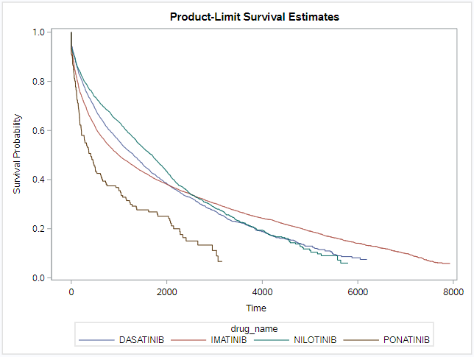  
**Figure 9: Time on treatment for TKIs for CML excluding breaks**

Figure 9 shows the time on treatment for TKIs for CML excluding treatment breaks. The trends largely mirror Figure 8 with nilotinib and dasatinib having the highest median treatment durations of 656 and 521 respectively with 20% of patients censored. Imatinib had a median treatment duration of 334 days with 7% censored however maintained the same lengthy tail for supply.

## Analysis of expenditure

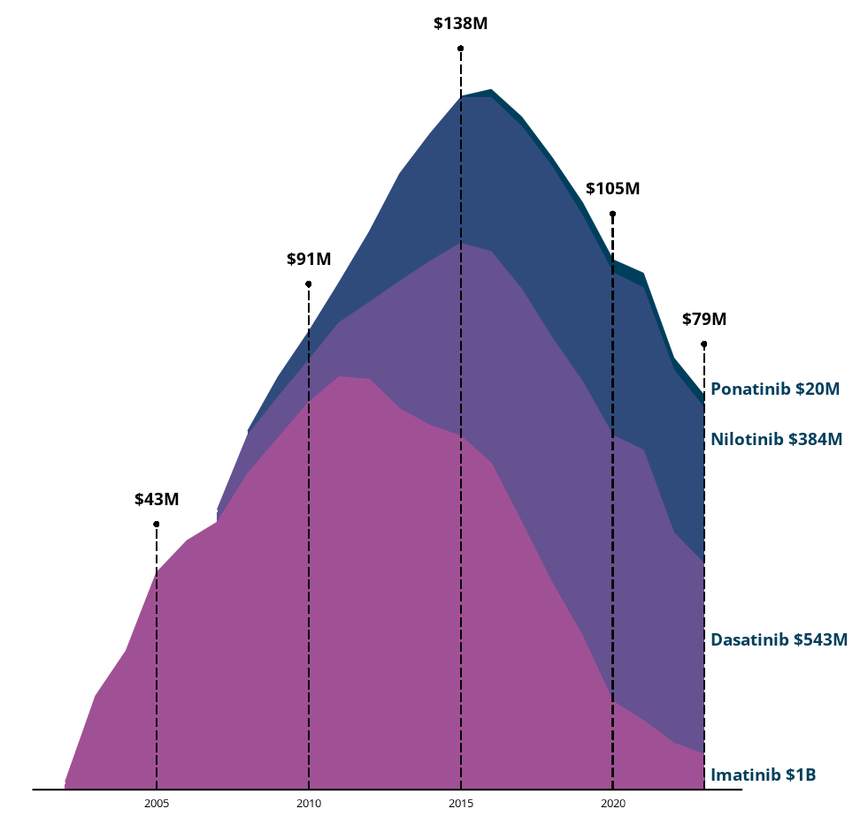  
**Figure 10: Overall expenditure for all TKIs for CML since listing**

Figure 10 shows the overall expenditure for TKIs for CML since listing based on the published prices. Expenditure for 2023 was $79 million which had progressively decreased from a peak of approximately $138 million in 2015. Imatinib had a PBS expenditure of $1 billion for the CML indication since listing in 2003 followed by dasatinib at $543 million and nilotinib at $384 million. Imatinib expenditure as at 2023 was lower than dasatinib and nilotinib which represented the majority of the $79 million expenditure.

# Discussion and DUSC Consideration

The utilisation of nilotinib and dasatinib had remained largely the same following the restriction change in 2022 relative to utilisation prior to the change. The PBAC recommended a reduction in restriction levels for dasatinib and nilotinib to Authority Required (Telephone) for initial treatment and Authority Required (STREAMLINED) for first and subsequent continuing treatment which was implemented in March 2022. This change appeared to result in an increase in initiators on to dasatinib however the number of prescriptions per month had not changed substantively and expenditure remained similar.

DUSC considered the slight increase in dasatinib utilisation over nilotinib was likely due to the more favourable safety profile with clinicians preferring to use nilotinib in younger patients.

# DUSC actions

DUSC requested that the report be provided to the PBAC for consideration.

# Context for analysis

The DUSC is a Sub Committee of the Pharmaceutical Benefits Advisory Committee (PBAC). The DUSC assesses estimates on projected usage and financial cost of medicines.

The DUSC also analyses data on actual use of medicines, including the utilisation of PBS listed medicines, and provides advice to the PBAC on these matters. This may include outlining how the current utilisation of PBS medicines compares with the use as recommended by the PBAC.

The DUSC operates in accordance with the quality use of medicines objective of the National Medicines Policy and considers that the DUSC utilisation analyses will assist consumers and health professionals to better understand the costs, benefits and risks of medicines.

The utilisation analysis report was provided to the pharmaceutical sponsors of each drug and comments on the report were provided to DUSC prior to its consideration of the analysis.

# Sponsors’ comments

Alphapharm Pty Ltd: The sponsor had no comment.

Bristol-Myers Squibb Australia Pty Ltd: The sponsor had no comment.

Dr Reddy's Laboratories (Australia) Pty Ltd: The sponsor had no comment.

Novartis Pharmaceuticals Australia Pty Limited: The sponsor had no comment.

Sandoz Pty Ltd: The sponsor had no comment.

Sun Pharma Anz Pty Ltd: The sponsor had no comment.

# Disclaimer

The information provided in this report does not constitute medical advice and is not intended to take the place of professional medical advice or care. It is not intended to define what constitutes reasonable, appropriate or best care for any individual for any given health issue. The information should not be used as a substitute for the judgement and skill of a medical practitioner.

The Department of Health and Aged Care has made all reasonable efforts to ensure that information provided in this report is accurate. The information provided in this report was up-to-date when it was considered by the Drug Utilisation Sub-committee of the Pharmaceutical Benefits Advisory Committee. The context for that information may have changed since publication.

To the extent provided by law, the Department of Health and Aged Care makes no warranties or representations as to accuracy or completeness of information contained in this report.

To the fullest extent permitted by law, neither the Department of Health and Aged Care nor any Department of Health and Aged Care employee is liable for any liability, loss, claim, damage, expense, injury or personal injury (including death), whether direct or indirect (including consequential loss and loss of profits) and however incurred (including in tort), caused or contributed to by any person’s use or misuse of the information available from this report or contained on any third party website referred to in this report.

1. Chronic Myeloid Leukaemia [revised 2024, May] Leukaemia Foundation. Available from https://www.leukaemia.org.au/blood-cancer/types-of-blood-cancer/leukaemia/chronic-myeloid-leukaemia/
2. Product Information imatinib (tga.gov.au)
3. Product Information dasatinib (tga.gov.au)
4. Product Information nilotinib (tga.gov.au)
5. Product Information ponatinib (tga.gov.au)