Brentuximab vedotin for CD30 positive cutaneous and peripheral T-cell lymphoma

Drug utilisation sub-committee (DUSC)

***June 2024***

## Abstract

### Purpose

At its February 2024 meeting, DUSC requested a review of brentuximab vedotin for CD30 positive cutaneous T-cell lymphoma (CTCL) and previously untreated CD30 positive peripheral T-cell lymphoma (PTCL).

### Date of listing on the Pharmaceutical Benefits Scheme (PBS)

Brentuximab vedotin for CD30 positive CTCL was PBS listed on 1 April 2019. Brentuximab vedotin for previously untreated CD30 positive PTCL was PBS listed on 1 September 2021.

### Data Source / methodology

Data extracted from the PBS and Authorities database maintained by Department of Health and Aged Care, processed by Services Australia were used for the analyses.

### Key Findings

* In the 2022-23 financial year, there were 25 written authority approvals and 36 patients were supplied 207 prescriptions for brentuximab vedotin for CD30 positive CTCL.
* In the 2022-23 financial year, there were 113 written authority approvals and 113 patients were supplied 428 prescriptions for brentuximab vedotin for CD 30 positive PTCL. Utilisation of brentuximab vedotin for CD30 positive PTCL has been increasing over time.
* Utilisation of brentuximab vedotin for the treatment of PTCL was different from estimated.
* The median age of patients initiating treatment with PTCL was 62 years. The median age for males was 61 years, whereas for females this was 66 years.

# Purpose of analysis

At its February 2024 meeting, DUSC requested a 24 month predicted versus actual review of brentuximab vedotin for previously untreated CD30 positive peripheral T-cell lymphoma (PTCL).

As a subtype of PTCL, utilisation of brentuximab for CD30 positive systemic anaplastic large cell lymphoma (sALCL) will be included as part of this review.

# Background

## Clinical situation

Peripheral T-Cell Lymphoma is a rare type of non-Hodgkin Lymphoma (NHL) found in the lymph nodes and/or throughout other parts of the body.

There are various types of PTCL, which include[1]:

* Nodal: angioimmunoblastic T-cell lymphoma (AITL), follicular T-cell lymphoma, and peripheral T-cell lymphoma, PTCL not otherwise specified (PTCL-NOS); anaplastic large cell lymphomas (ALCLs; including sALCL).
* Extra-nodal: nasal natural killer (NK)/T-cell lymphoma (NKTCL), hepatosplenic TCL, enteropathy-associated TCL (EATL); monomorphic epitheliotropic intestinal TCL (MEITL).
* Leukaemic: adult T-cell leukaemia/lymphoma (ATLL); T-cell lymphoblastic lymphoma (LL).
* CTCL (T-cell lymphomas which primarily affect the skin).

## Pharmacology

Brentuximab vedotin belongs to a group of medicines known as antibody-drug conjugates, which work differently from traditional anticancer agents (chemotherapy). Chemotherapy enters the blood and kills both cancer cells and healthy cells that divide rapidly. Whereas brentuximab vedotin is made up of a monoclonal antibody (protein which recognises certain cancer cells) and a substance intended to kill cancer cells that express CD30.[2],[3]

## Therapeutic Goods Administration (TGA) approved indications

Brentuximab vedotin is TGA-approved for the following indications:

* Hodgkin lymphoma
* Treatment of patients with previously untreated CD30 positive Stage III or Stage IV Hodgkin lymphoma in combination with doxorubicin, vinblastine, and dacarbazine.
* Treatment of adult patients with CD30 positive Hodgkin lymphoma at higher risk of relapse or progression following autologous stem cell transplant (ASCT).
  + Treatment of adult patients with relapsed or refractory CD30 positive Hodgkin lymphoma following ASCT; or following at least 2 prior therapies when ASCT or multi-agent chemotherapy is not a treatment option.
* Peripheral T-cell lymphoma
  + Treatment of adult patients with previously untreated CD30 positive peripheral T-cell lymphoma in combination with cyclophosphamide, doxorubicin and prednisone (CHP).
  + Treatment of adult patients with relapsed or refractory systemic anaplastic large cell lymphoma.
* Cutaneous T-cell lymphoma
  + Treatment of adult patients with CD30 positive cutaneous T-cell lymphoma after at least 1 prior systemic therapy.

## Dosage and administration

Brentuximab vedotin is administered by intravenous infusion over 30 minutes under the supervision of a physician experienced in the use of anti-cancer agents.

CD30 positive CTCL: The recommended dose when it is given alone is 1.8 mg/kg, given every 3 weeks, up to 16 cycles.

Previously untreated CD30 positive PTCL: The recommended dose in in combination with chemotherapy – CHP is 1.8 mg/kg given every 3 weeks for 6 to 8 cycles.

The current Product Information (PI) and Consumer Medicine Information (CMI) are available from [the TGA (Product Information)](http://tga.gov.au/hp/information-medicines-pi.htm) and [the TGA (Consumer Medicines Information)](http://www.tga.gov.au/consumers/information-medicines-cmi.htm).

## PBS listing details (as at April 2024)

Table 1: PBS listing of brentuximab vedotin for CD30 positive CTCL

| Item code | Name, form & strength, pack size | Max. amt. | Rpts | DPMA | Brand name and manufacturer |
| --- | --- | --- | --- | --- | --- |
| 11651F | brentuximab vedotin 50 mg injection, 1 vial | 180 mg | 3 | $19,012.59 | Adcetris®  Takeda Pharmaceuticals Australia Pty. Ltd. |
| 11660Q | brentuximab vedotin 50 mg injection, 1 vial | 180 mg | 3 | $18,708.62 |
| 11661R | brentuximab vedotin 50 mg injection, 1 vial | 180 mg | 11 | $19,012.59 |
| 11664X | brentuximab vedotin 50 mg injection, 1 vial | 180 mg | 11 | $18,708.62 |

Source: the [PBS website](http://www.pbs.gov.au/pbs/home).

Notes:

* No increase in the maximum quantity or number of units may be authorised.
* No increase in the maximum number of repeats may be authorised.
* Special Pricing Arrangements apply.

Table 2: PBS listing of brentuximab vedotin for previously untreated CD30 positive PTCL

| Item code | Name, form & strength, pack size | Max. amt. | Rpts | DPMA | Brand name and manufacturer |
| --- | --- | --- | --- | --- | --- |
| 12656D | brentuximab vedotin 50 mg injection, 1 vial | 200 mg | 5 | $19,012.59 | Adcetris®  Takeda Pharmaceuticals Australia Pty. Ltd. |
| 12646N | brentuximab vedotin 50 mg injection, 1 vial | 200 mg | 5 | $18,708.62 |
| 12632W | brentuximab vedotin 50 mg injection, 1 vial | 200 mg | 1 | $19,012.59 |
| 12657E | brentuximab vedotin 50 mg injection, 1 vial | 200 mg | 1 | $18,708.62 |

Source: the [PBS website](http://www.pbs.gov.au/pbs/home).

Notes:

* No increase in the maximum quantity or number of units may be authorised.
* No increase in the maximum number of repeats may be authorised.
* Special Pricing Arrangements apply.
* This product is not PBS-subsidised for the treatment of previously untreated CD30 positive cutaneous T-cell lymphoma.

### Restriction (abridged)

Table 3: Abbreviated PBS clinical restriction criteria for CD30 positive CTCL and PTCL

| **Indication** | **Abbreviated PBS clinical criteria** |
| --- | --- |
| CD30 positive CTCL | Initial treatment:   * pathologically confirmed CD30 positive cutaneous T-cell lymphoma * CD30 positivity of at least 3% of malignant cells * Diagnosis of mycosis fungoides or Sezary syndrome or primary cutaneous anaplastic large cell lymphoma * Received prior systemic treatment for this condition * Must be relapsed or refractory * Must not exceed 4 cycles under this restriction in a lifetime * Sole PBS-subsidised systemic anti-cancer therapy for this condition   Continuing treatment:   * Must have previously received PBS-subsidised treatment with this drug for this condition * Must have achieved an objective response with this drug * Must not have developed disease progression * Must be the sole PBS-subsidised systemic anti-cancer therapy * Must not exceed 12 cycles under this restriction in a lifetime |
| CD30 positive PTCL | Initial treatment:   * histological confirmation of CD30 expression in at least 3% of malignant cells * must be for first line therapy * must be for curative intent * must be in combination with cyclophosphamide, doxorubicin and prednisone * must not be more than 6 treatment cycles under this restriction in a lifetime   Continuing treatment:   * must be in combination with cyclophosphamide, doxorubicin and prednisone * have completed 6 initial PBS cycles * have achieved a partial response to the 6 initial cycles * not developed disease progression while on this treatment * must not be more than 2 treatment cycles under this restriction in a lifetime |

Table 4: Summary of current authority requirements for CD30 positive CTCL and PTCL

| **Indication** | **Current restriction level** | **Supporting documentation** |
| --- | --- | --- |
| CD30 positive CTCL | Initial treatment: Authority Required (Written)  Continuing treatment:  Authority Required (Telephone) | (a) details (date, unique identifying number/code or provider number) of the histopathology report from an Approved Pathology Authority demonstrating the patient has a diagnosis of either mycosis fungoides, Sezary syndrome or primary cutaneous anaplastic large cell lymphoma; and  (b) details (date, unique identifying number/code or provider number) of a histology report on the tumour sample or of a flow cytometric analysis of lymphoma cells of the blood showing CD30 positivity of at least 3% of malignant cells; and  (c) Date of commencement and completion of the most recent prior systemic treatment. |
| CD30 positive PTCL | Initial treatment: Authority Required (Written)  Continuing treatment:  Authority Required (Telephone) | a) details (date, unique identifying number/code or provider number) of a histology report on the tumour sample from an Approved Pathology Authority showing CD30 positivity of at least 3% malignant cells; and  (b) The date of initial diagnosis of Peripheral T-cell lymphoma. |

For details of the current PBS listing refer to the PBS website.

### Changes to listing

On 1 September 2022 the initial listings of brentuximab vedotin for CD30 positive CTCL and PTCL were updated as part of the Department of Health and Aged Care’s digital transformation of Authority Required (Written) PBS listings. Real time assessment of authority requests became available through Services Australia’s Online PBS Authorities (OPA) system, via Health Professional Online Services (HPOS).[4]

Current PBS listing details are available from the PBS website.

## Relevant aspects of consideration by the Pharmaceutical Benefits Advisory Committee (PBAC)

**CD30 positive CTCL - July 2018:**The submission requested a Section 100 (Efficient Funding of Chemotherapy) listing for brentuximab vedotin for the treatment of relapsed or refractory CD30 positive CTCL in patients who have previously used systemic therapy. This was the first brentuximab vedotin submission for this indication. The requested listing was based on cost-effectiveness analyses and a cost-utility analysis comparing brentuximab vedotin to its main comparator, vorinostat, and to its supplementary comparator, methotrexate.

The PBAC did not recommend the listing of brentuximab vedotin in relapsed or refractory CD30 positive CTCL in patients who have previously used systemic therapy, due to major reservations regarding the naïve comparison with vorinostat, which meant that cost-effectiveness against vorinostat was unable to be assessed. The PBAC also considered that brentuximab vedotin was not cost-effective compared with methotrexate at the proposed price. The PBAC noted that the incremental cost-effectiveness ratio (ICER) presented was unacceptably high based on previous PBAC decisions, even in the context of difficult to treat and relatively rare diseases.

The PBAC considered that overall the estimated budget impact was relatively low, due to the small number of patients eligible for treatment. However, the PBAC considered the estimates to be uncertain as there was a substantial risk of use of brentuximab vedotin outside the restriction particularly for use as a first line therapy.

For further details refer to the [Public Summary Document](https://www.pbs.gov.au/info/industry/listing/elements/pbac-meetings/psd/2018-07/Brentuximab-psd-july-2018) from the July 2018 PBAC meeting.

**CD30 positive CTCL - November 2018 :** The minor resubmission requested a Section 100 (Efficient Funding of Chemotherapy) Authority Required listing for the treatment of refractory or relapsed CD30 positive CTCL. The minor resubmission provided a revised price for brentuximab vedotin along with a revised proposal for the PBS restriction and additional information to support the listing including lymphomatoid papulosis (LyP) and Sézary syndrome (SS).

The PBAC recommended a Section 100 (Efficient Funding of Chemotherapy) Authority Required listing of brentuximab vedotin for the treatment of RR CTCL. The PBAC recognised the clinical need for effective treatments in this population. The PBAC was satisfied that brentuximab vedotin provides, for some patients with the mycosis fungoides (MF), SS and primary cutaneous anaplastic large cell lymphoma (pcALCL) subtypes of CTCL, a significant improvement in efficacy over methotrexate.

The PBAC noted the amendments to the proposed restriction (restricting use first line or in combination with other CTCL therapies) and considered that it was now reasonable to accept the financial estimates as the basis of a risk sharing arrangement (RSA). The PBAC considered that a RSA remained appropriate to mitigate any residual uncertainties regarding the potential use of brentuximab vedotin outside the proposed restriction.

For further details refer to the [Public Summary Document](https://www.pbs.gov.au/info/industry/listing/elements/pbac-meetings/psd/2018-11/Brentuximab-Vedotin-psd-november-2018) from the November 2018 PBAC meeting.

**CD30 positive PTCL - March 2021:** The submission requested a Section 100 listing (Efficient Funding of Chemotherapy) for brentuximab vedotin in combination with CHP for use as an intravenous injection once every three weeks for the treatment of patients with previously untreated CD30 positive PTCL. Listing was requested on the basis of a cost-effectiveness analysis versus cyclophosphamide, doxorubicin, vincristine and prednisone (CHOP).

The PBAC recommended the listing of brentuximab vedotin, for use in combination with CHP for the treatment of patients with previously untreated CD30 positive PTCL, on the basis that it should be available only under special arrangements under section 100 – Efficient Funding of Chemotherapy. The PBAC accepted the substantial clinical benefit of BV+CHP in terms of progression free survival (PFS) and that the immature overall survival (OS) data also suggest a clinical benefit. The PBAC considered the ICER was high but acceptable at the proposed price in the context of this rare disease with a high clinical need and the certainty of the estimated ICER.

The submission requested an Authority Required (Streamlined) restriction for the initiation and continuation treatments. The latest listing for BV, in the treatment of CD30 positive CTCL, has an Authority Required – In Writing restriction. Additionally, the restriction for the initial treatment with BV in relapsed/refractory sALCL listing is written only. Given the nature of this therapy, and to avoid any inconsistencies across indications, the evaluation consideredthis was appropriate in this setting. The PBAC considered an Authority Required (Written) listing appropriate for initial treatment followed by an Authority Required (Telephone) listing for continuing treatment.

The PBAC recommended a RSA to mitigate any residual uncertainties regarding the financial estimates.

For further details refer to the [Public Summary Document](https://www.pbs.gov.au/info/industry/listing/elements/pbac-meetings/psd/2021-03/brentuximab-vedotin-powder-for-iv-infusion-50-mg-adcetri) from the March 2021 PBAC meeting.

# Methods

Data extracted from the PBS claims and Authorities Approvals database maintained by the Department of Health and Aged Care and processed by Services Australia were used for the analyses. Prescription and Authorities data were extracted from 1 July 2018 up to and including 31 March 2024.

Prescription data were used to determine the prescription and patient counts by financial year for brentuximab vedotin for CD30 positive CTCL, PTCL and sALCL. An initiating patient was defined based on first date of supply of brentuximab vedotin for their respective indication. Authorities data were used to determine written authority approval counts. Counts for each indication were based on their corresponding item codes.

Additional analyses of the age and gender distribution and treatment duration of brentuximab vedotin for CD30 positive PTCL were conducted. Kaplan-Meier curves were generated to present the treatment duration of patients who initiated treatment during the first two years of PBS-listing, with and without accounting for treatment breaks. A patient was considered to be on a treatment break if they did not receive a supply in more than three sets of standard treatment days. The median standard treatment days was calculated to be 21 days. These patients were followed until 31 March 2024, with patients censored if they were supplied a prescription within 63 days of the analysis end date.

As this analysis uses date of supply prescription data, there may be small differences compared with publicly available Services Australia Medicare date of processing data.[5] The publicly available Services Australia Medicare data only includes subsidised R/PBS prescriptions with prescriptions under the patient co-payment not included. The Services Australia Medicare data used in this report includes under co-payment prescriptions from 1 April 2012.

# Results

## Analysis of drug utilisation

In Tables 5 and 6 and Figures 1 and 2 below, the number of treated and initiating CD30 positive PTCL patients had been increasing since its PBS listing, with a greater proportion of patients being treated with brentuximab vedotin for CD30 positive PTCL compared to the other indications.

There was an average of 50 patients treated for CD30 positive CTCL in the 2019/20 and 2020/21 financial years. However, from 2021/22 onwards, the number of patients had decreased to an average of approximately 33 patients per financial year. The number of patients treated for CD30 positive sALCL had been slightly decreasing over time.

Table 5: Number of prevalent patients by indication and financial year

|  |  |  |  |
| --- | --- | --- | --- |
| **Financial year** | **CTCL** | **PTCL** | **sALCL** |
| **2019/20** | 50 | - | 48 |
| **2020/21** | 51 | - | 46 |
| **2021/22** | 31 | 64 | 47 |
| **2022/23** | 36 | 113 | 38 |
| **2023/24** | 32 | 114 | 25 |

Note: The 2023/24 financial year includes nine months of data, from July 2023 to March 2024 inclusive.

Figure 1: Number of prevalent patients by indication and financial year

Note: The 2023/24 financial year includes nine months of data, from July 2023 to March 2024 inclusive.

Table 6: Number of initiating patients by indication and financial year

|  |  |  |  |
| --- | --- | --- | --- |
| **Financial year** | **CTCL** | **PTCL** | **sALCL** |
| **2019/20** | 39 | - | 35 |
| **2020/21** | 33 | - | 34 |
| **2021/22** | 16 | 64 | 29 |
| **2022/23** | 27 | 94 | 25 |
| **2023/24** | 21 | 90 | 16 |

Note: The 2023/24 financial year includes nine months of data, from July 2023 to March 2024 inclusive.

Figure 2: Number of initiating patients by indication and financial year

Note: The 2023/24 financial year includes nine months of data, from July 2023 to March 2024 inclusive.

In Table 7 and Figure 3 below, the number of written authority approvals for brentuximab vedotin for CD30 positive PTCL had been increasing since PBS-listing, increasing from 80 approvals in the 2021/22 financial year to 113 approvals in the 2022/23 financial year. For CD30 positive CTCL, the number of approvals had slightly varied across financial years, ranging from 18 to 35 approvals per financial year. The number of written authority approvals for CD30 positive sALCL had been steadily decreasing over time, with 31 approvals in 2019/20 financial year to 22 approvals in 2022/23 financial year.

Table 7: Volume of written authority approvals and prescriptions by indication and financial year

|  |  |  |  |
| --- | --- | --- | --- |
| **Financial year** | **CTCL** | **PTCL** | **sALCL** |
| **2019/20** | 35 | - | 30 |
| **2020/21** | 29 | - | 31 |
| **2021/22** | 18 | 80 | 22 |
| **2022/23** | 25 | 113 | 22 |
| **2023/24** | 20 | 118 | 10 |

Note: The 2023/24 financial year includes nine months of data, from July 2023 to March 2024 inclusive.

Figure 3: Volume of written authority approvals and prescriptions by indication and financial year

Note: The 2023/24 financial year includes nine months of data, from July 2023 to March 2024 inclusive.

In Table 8 and Figure 4 below, similar trends were observed in the number of prescriptions supplied by indication as the number of written authority approvals by indication.

Table 8: Volume of prescriptions supplied by indication and financial year

|  |  |  |  |
| --- | --- | --- | --- |
| **Financial year** | **CTCL** | **PTCL** | **sALCL** |
| **2019/20** | 226 | - | 205 |
| **2020/21** | 289 | - | 198 |
| **2021/22** | 137 | 252 | 225 |
| **2022/23** | 207 | 428 | 225 |
| **2023/24** | 148 | 455 | 107 |

Note: The 2023/24 financial year includes nine months of data, from July 2023 to March 2024 inclusive.

Figure 4: Number of brentuximab vedotin prescriptions by indication and financial year

Note: The 2023/24 financial year includes nine months of data, from July 2023 to March 2024 inclusive.

## Analysis of expenditure

In Table 9 and Figure 5 below, similar trends were observed in expenditure based on published prices as the number of prescriptions supplied by indication.

Table 9: Net cost to PBS/RPBS at published listed price by indication and financial year

|  |  |  |  |
| --- | --- | --- | --- |
| **Financial year** | **CTCL** | **PTCL** | **sALCL** |
| **2019/20** | $3,230,534 | - | $2,866,253 |
| **2020/21** | $4,323,214 | - | $2,834,296 |
| **2021/22** | $1,804,868 | $3,763,992 | $3,132,583 |
| **2022/23** | $2,839,634 | $6,497,011 | $3,148,279 |
| **2023/24** | $1,758,506 | $6,215,969 | $1,291,805 |

Note: The 2023/24 financial year includes nine months of data, from July 2023 to March 2024 inclusive. Special Pricing Arrangements apply, presented figures do not reflect actual cost to Government.

Figure 5: Net cost to PBS/RPBS at published listed price by indication and financial year

Note: The 2023/24 financial year includes nine months of data, from July 2023 to March 2024 inclusive. Special Pricing Arrangements apply, presented figures do not reflect actual cost to Government.

## Additional analyses of brentuximab vedotin for previously untreated CD30 positive PTCL

Analysis of actual versus predicted utilisation of brentuximab vedotin for previously untreated CD30 positive PTCL

**Approach taken to estimate utilisation**

The submission used a mixed epidemiological and market share approach to estimate the expected impact associated with the listing of brentuximab vedotin (BV) +CHP based on published and effective prices.

The key inputs used by the submission in forming the financial estimates are summarised in below in Table 10.

Table 10: Key inputs for financial estimates

| Parameter | Value applied and source |
| --- | --- |
| Incident NHL patients | Total NHL patients based on cancer incidence projections in Australia for males and females (AIHW 2020). NHL incidence in 2020 of ||(||–||) for males and || (||–||) for females. |
| PTCL proportion | ||% of NHL is mature PTCL or T/NK cell lymphomas, Australia 2015 (AIHW 2019). |
| CD30-positive PTCL patients | CD30 positive expression estimated from Sabattini et al. 2013, Bossard et al. 2014.  Proportion of PTCL cases by subtype: PTCL–NOS, AITL, ALCL ALK+, ALCL ALK-ATLL, HSTCL, EATL from Vose 2008 |
| Uptake rate | Overall uptake: ||%,  Varied by subtype: sALCL (　|　%), AITL (　|　%), PTCL-NOS (　|　%), ATLL (　|　%) and EATL (　|　%). |

Source: |||||||||||||||||||||||||||||||||||||||||||||| compiled from data presented in Section 4 of the submission.

AIHW =Australian Institute of Health Welfare; ALCL = anaplastic large cell lymphoma; AITL = angioimmunoblastic T-cell lymphoma; ATLL = adult T-cell leukaemia/lymphoma; ALK= anaplastic lymphoma kinase; DPMA = dispensed price per maximum amount; EATL= enteropathy-associated T-cell lymphoma; HSTCL = hepatosplenic T-cell lymphoma; PTCL–NOS = peripheral T-cell lymphoma not otherwise specified

Table 11: Predicted versus actual analysis of brentuximab vedotin for CD30 positive PTCL

|  |  |  |  |  |
| --- | --- | --- | --- | --- |
|  |  | **Year 1** | **Year 2** | **Year 3** |
|  |  | **1 September 2021-**  **31 August 2022** | **1 September 2022-**  **31 August 2023** | **1 September 2023-**  **31 August 2024** |
| Patients | Predicted | | | | | | |
| Actual | 83 | 117 | 100 |
| Difference | | | | | | |
| Prescriptions | Predicted | | | | | | |
| Actual | 330 | 447 | 358 |
| Difference | | | | | | |

Note: Year 3 only includes data up to and including March 2024 and is not representative of a full listing year.

In the first two years of PBS listing, utilisation of brentuximab vedotin for the treatment for CD30 positive PTCL was different from estimated. There was a greater percentage difference observed in between the predicted and actual patient numbers compared to the predicted and actual prescription volume.

In the first year of listing, the number of patients treated with brentuximab vedotin for PTCL was |||||||||||||||||||| than estimated, whereas the number of prescriptions supplied was |||||||||||||| than estimated. In the second year of listing, the number of patients |||||||| treated with brentuximab vedotin and prescriptions |||||||| supplied were |||||||||||||||| than estimated.

Figure 6: Age and gender distribution of initiating patients treated with brentuximab vedotin for CD30 positive PTCL since PBS listing

Figure 6 shows the age and gender distribution of initiating patients treated with brentuximab vedotin for CD30 positive PTCL since PBS listing. Overall, the median age of patients initiating treatment was 62 years. Across all age groups, a greater proportion of males initiated treatment compared to females. The median age for males was 61 years, whereas for females this was 66 years.

Table 12: Estimated length of treatment from Kaplan Meier analysis in patients who initiated brentuximab vedotin treatment for CD30 positive PTCL, with and without accounting for breaks

|  |  |  |  |  |  |  |  |
| --- | --- | --- | --- | --- | --- | --- | --- |
|  | **Number of patients** | **Censored** | **Median (weeks)** | **Mean (weeks)** | **Standard error** | **95% confidence interval (weeks)** | |
| **Lower limit** | **Upper limit** |
| Without accounting for breaks | 177 | | | 17.4 | 15.4 | 0.6 | 14.3 | 16.5 |
| Accounting for breaks | 177 | | | 16 | 14.3 | 0.4 | 13.5 | 15.2 |

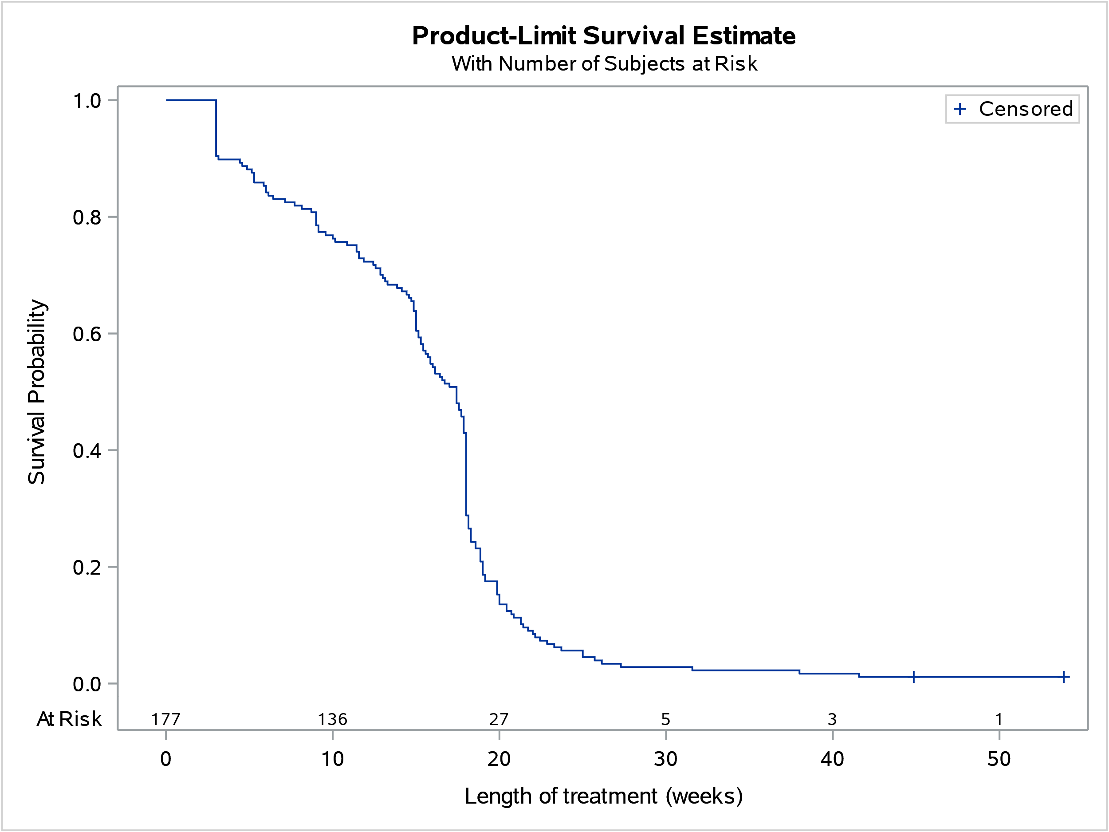

Figure 7: Estimated length of treatment from Kaplan Meier analysis in patients who initiated brentuximab vedotin treatment for CD30 positive PTCL, without accounting for breaks

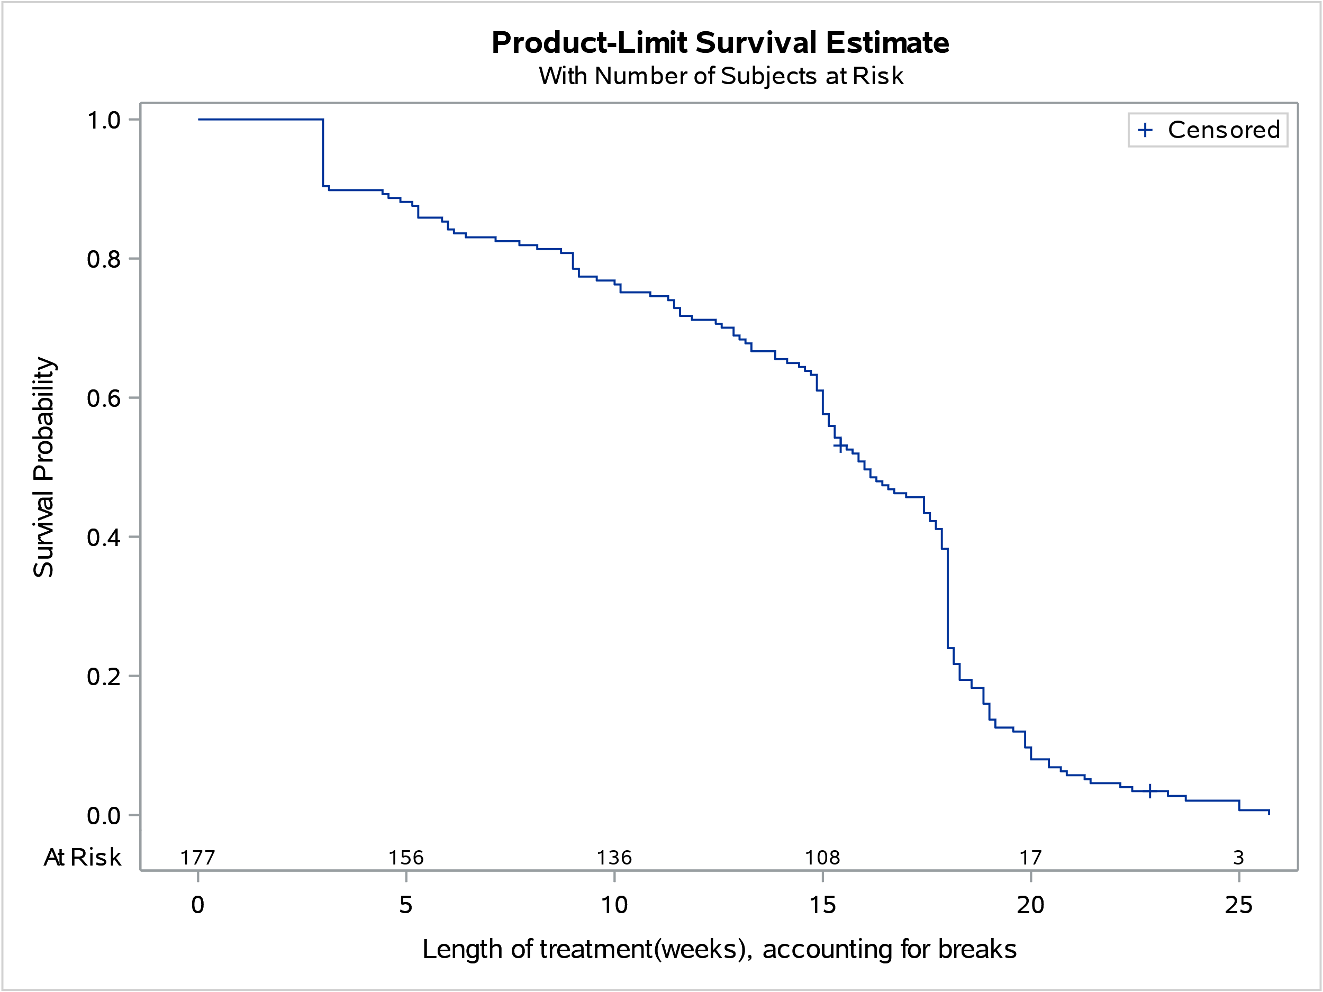

Figure 8: Estimated length of treatment from Kaplan Meier analysis in patients who initiated brentuximab vedotin treatment for CD30 positive PTCL, accounting for breaks

The PBS restriction for brentuximab vedotin for CD30 positive PTCL stated for the initial treatment phase, patients must not exceed 6 treatment cycles (18 weeks), and for continuing treatment patients must not exceed only 2 cycles (6 weeks). As shown in Table 12 and Figure 7 above, the median treatment duration for patients who initiated treatment during the first two years of listing was 17.4 weeks. When accounting for breaks, median treatment duration was 16 weeks (Table 12 and Figure 8).

# Discussion

At the time of this review, the PBS listings of brentuximab vedotin for the initial treatment of CD30 positive CTCL and PTCL were both Authority Required (Written) listings. The number of written authority approvals for CTCL had slightly varied across financial years, ranging from 18 to 35 approvals per financial year, with the lowest of 18 approvals during the 2021/22 financial year, which may have been due to the impacts of the COVID-19 pandemic.

In contrast, the number of written authority approvals for previously untreated CD30 positive PTCL had increased since PBS listing, from 80 approvals in 2021/22 to 113 approvals in 2022/23. Utilisation of brentuximab vedotin was different from estimated, with a |||||||| percentage difference in the number of patients treated compared to the number of prescriptions supplied. In its second year of listing, both the actual number of patients treated and prescriptions supplied were |||||||| than estimated.

The financial estimates assumed ||% of NHL patients would have PTCL and the treatment uptake rate would be ||||%. The univariate sensitivity analyses presented in the submission and conducted during the evaluation showed that the financial estimates were sensitive to the assumed proportion of NHL patients with PTCL and the treatment uptake rates (paragraph 6.55 brentuximab vedotin, Public Summary Document, March 2021 PBAC Meeting). Findings from a 5 year update from the ECHELON-2 trial showed that brentuximab vedotin had continued to provide an improvement in progression-free survival and overall survival[6] and may have contributed to the greater than estimated treatment uptake rates.

# DUSC consideration

DUSC noted the increase in utilisation of brentuximab vedotin for PTCL over time and noted the number of patients treated was |||||||| in the first year of listing and both the number of patients treated and prescriptions supplied were |||||||| than estimated in the second year of listing. DUSC noted the Authority Required (Written) PBS listing and considered use outside of the indication to be unlikely. DUSC noted findings from a 5 year update from the ECHELON-2 trial6 were published following PBS listing and may have contributed to the increased treatment uptake rate. Additionally, DUSC considered the lack of CD30+ treatment options for PTCL may have contributed to the high treatment uptake of brentuximab vedotin.

DUSC noted the PTCL submission estimated an overall treatment uptake rate of ||||% based on treatment uptake rates from several PTCL subtypes: sALCL (　|　%), angioimmunoblastic T-cell lymphoma (　|　%), peripheral T-cell lymphoma not otherwise specified (　|　%), adult T-cell leukaemia/lymphoma (　|　%) and enteropathy-associated T-cell lymphoma (　|　%). DUSC commented on the complex approach used and noted 43.22% of patients showed a CD30+ expression score of ≥2+ which could have been used to estimate the treatment uptake rate.[7]

DUSC considered the impact of the COVID-19 pandemic on the delay on the diagnosis and treatment of patients and noted the decrease in the number of patients initiating CTCL treatment in the 2022/23 financial year as well as the lower percentage difference in the actual number of PTCL patients treated in the first year (1 September 2021- 31 August 2022) compared to the second year of listing (1 September 2022- 31 August 2023).

DUSC noted CTCL and sALCL are subtypes of PTCL and currently PBS-listed as second-line therapies. DUSC noted the submission assumed there would be a ||||% reduction in the use of brentuximab vedotin for relapsed/refractory sALCL patients. DUSC noted a 19% decrease in the number of patients treated for sALCL between the 2021/22 and 2022/23 financial years. DUSC considered patients would more likely initiate treatment in the first line setting following the listing of brentuximab vedotin for PTCL. However, DUSC noted that the review was only based on 30 months of data and considered that the market had not yet stabilised.

# DUSC actions

DUSC requested that the report be provided to the PBAC for consideration.

# Context for analysis

The DUSC is a Sub Committee of the Pharmaceutical Benefits Advisory Committee (PBAC). The DUSC assesses estimates on projected usage and financial cost of medicines.

The DUSC also analyses data on actual use of medicines, including the utilisation of PBS listed medicines, and provides advice to the PBAC on these matters. This may include outlining how the current utilisation of PBS medicines compares with the use as recommended by the PBAC.

The DUSC operates in accordance with the quality use of medicines objective of the National Medicines Policy and considers that the DUSC utilisation analyses will assist consumers and health professionals to better understand the costs, benefits and risks of medicines.

The utilisation analysis report was provided to the pharmaceutical sponsors of each drug and comments on the report were provided to DUSC prior to its consideration of the analysis.

# Sponsors’ comments

Takeda Pharmaceuticals Australia Pty. Ltd.: The sponsor has no comment.

# Disclaimer

The information provided in this report does not constitute medical advice and is not intended to take the place of professional medical advice or care. It is not intended to define what constitutes reasonable, appropriate or best care for any individual for any given health issue. The information should not be used as a substitute for the judgement and skill of a medical practitioner.

The Department of Health and Aged Care has made all reasonable efforts to ensure that information provided in this report is accurate. The information provided in this report was up-to-date when it was considered by the Drug Utilisation Sub-committee of the Pharmaceutical Benefits Advisory Committee. The context for that information may have changed since publication.

To the extent provided by law, the Department of Health and Aged Care makes no warranties or representations as to accuracy or completeness of information contained in this report.

To the fullest extent permitted by law, neither the Department of Health and Aged Care nor any Department of Health and Aged Care employee is liable for any liability, loss, claim, damage, expense, injury or personal injury (including death), whether direct or indirect (including consequential loss and loss of profits) and however incurred (including in tort), caused or contributed to by any person’s use or misuse of the information available from this report or contained on any third party website referred to in this report.

1. Lymphoma Australia. Peripheral T-cell Lymphoma (PTCL). Accessed from: https://www.lymphoma.org.au/types-of-lymphoma/non-hodgkin-lymphoma/lymphoma-t-cell/peripheral-t-cell-lymphoma-ptcl/
2. Adcetris (brentuximab vedotin). Australian Approved Product Information. Sydney: Takeda Pharmaceuticals Australia Pty. Ltd. Approved day 20 December 2013, updated 9 January 2024. Available from < https://www.tga.gov.au/product-information-pi.>
3. Adcetris (brentuximab vedotin). Australian Approved Consumer Medicines Information. Sydney: Takeda Pharmaceuticals Australia Pty. Ltd. Approved day 20 December 2013, updated 9 January 2024. Available from < https://www.tga.gov.au/product-information-pi.>
4. Department of Health and Aged Care. PBS News: 1 September 2022 updates as part of the Digital Transformation of Authority Required (Written) listings. Accessed from: https://www.pbs.gov.au/info/news/2022/08/1-september-2022-updates-as-part-of-the-digital-transformation
5. PBS statistics. Australian Government Services Australia. Canberra. Available from <<http://www.medicareaustralia.gov.au/provider/pbs/stats.jsp>>.
6. Horwitz S, O'Connor OA, Pro B, et al. The ECHELON-2 Trial: 5-year results of a randomized, phase III study of brentuximab vedotin with chemotherapy for CD30-positive peripheral T-cell lymphoma. *Ann Oncol*. 2022;33(3):288-298. doi:10.1016/j.annonc.2021.12.002
7. Sabattini E, Pizzi M, Tabanelli V, et al. CD30 expression in peripheral T-cell lymphomas. Haematologica 2013;98(8):e81-e82; doi:10.3324/haematol.2013.084913.