**5.05 ELRANATAMAB  
Solution for subcutaneous injection 44 mg in 1.1 mL (40 mg per mL),**

**Solution for subcutaneous injection 76 mg in 1.9 mL (40 mg per mL)Elrexfio®,  
PFIZER AUSTRALIA PTY LTD**

1. Purpose of submission
   1. This Category 1 submission requested a Section 100 (Efficient Funding of Chemotherapy Program), Authority Required listing for elranatamab for the treatment of adult patients with relapsed/refractory multiple myeloma (RRMM) who have received at least 3 prior therapies including a proteasome inhibitor (PI), an immunomodulatory drug (IMiD) and an anti-CD38 monoclonal antibody (mAb).
   2. Listing was requested on the basis of a cost-effectiveness analysis versus standard of care (SOC).
   3. The key components of the clinical issues addressed by this submission are outlined in Table 1.

Table 1: **Key components of the clinical issue addressed by the submission (as stated in the submission)**

| Component | Description |
| --- | --- |
| Population | Patients with RRMM who have received at least 3 prior therapies, including a proteasome inhibitor, an immunomodulatory agent, and an anti-CD38 monoclonal antibody. |
| Intervention | Elranatamab SC injection 12 mg on Day 1 and 32 mg on Day 4 followed by a full treatment dose of 76 mg weekly, from Week 2 to Week 24. After Week 24, for patients who have achieved a response, the dosing interval should transition to 76 mg every two-weeks. |
| Comparator | The main comparator is SOC comprising a basket of therapies confirmed by analysis of PBS10% dataset and the Australian & New Zealand Myeloma and Related Diseases Registry (MRDR) data. The SOC basket includes Cd, Pd, ELd, Cd+cyclo, PBd and Ld. |
| Outcomes | Primary Outcome: ORR by BICR per IMWG  Secondary Outcomes: PFS, OS, DOCR, DOR, CRR, TTR, Safety  Patient-reported outcomes: EORTC QLQ-C30 and MY20, EORTC QLQ CIPN20, EQ-5D and PGIS/PGIC |
| Clinical claim | The clinical claim for efficacy and safety is based on the outcomes of the phase 2, single arm MagnetisMM-3 trial and an external control arm using data from 2 US-based oncology electronic health record databases, Flatiron Health and COTA  • Elranatamab is superior in terms of efficacy compared with SOC  • Elranatamab has a non-inferior, albeit different safety profile compared with SOC |

Source: Table 1.1 p3 of the submission.

BCMA = B-cell maturation antigen; BICR = blinded independent central review; BsAb = bispecific antibody; Cd = carfilzomib + dexamethasone; cyclo = cyclophosphamide; CIPN20 = Chemotherapy-Induced Peripheral Neuropathy 20-item scale; CRR = complete response rate; DOCR = duration of complete response; DOR = duration of response; ELd = elotuzumab + lenalidomide + dexamethasone; EORTC QLQ C-30 = European Organisation for Research and Treatment of Cancer core Quality of Life Questionnaire 30-item scale; EQ-5D = EuroQol 5 Dimension; EHR = electronic health record; IMWG = international myeloma working group; Ld = lenalidomide + dexamethasone; MM20 = multiple myeloma questionnaire; ORR = objective response rate; OS = overall survival; PBd = pomalidomide + bortezomib + dexamethasone; Pd = pomalidomide + dexamethasone; PFS = progression-free survival; PGIC = Patient Global Impression of Change; PGIS = Patient Global Impression of severity; SC = subcutaneous; SOC = standard of care; RRMM = relapsed or refractory multiple myeloma; TTR = time to response; US = United States.

1. Background

Registration status

* 1. Elranatamab was provisionally registered on 28 June 2024 for the following indication:

“The treatment of adult patients with relapsed or refractory multiple myeloma, who have received at least 3 prior therapies, including a proteasome inhibitor, an immunomodulatory agent and an anti-CD38 antibody and have demonstrated disease progression on the last therapy.”

* 1. The ESC noted the confirmatory study for registration is MagnetisMM-5, an open-label, 3-arm, multicentre, randomised Phase 3 study evaluating the efficacy and safety of elranatamab monotherapy vs elranatamab + daratumumab vs daratumumab + pomalidomide + dexamethasone in patients with RRMM who have received at least 1 prior line of therapy including lenalidomide and a proteasome inhibitor[1].
  2. The Food and Drug Administration (FDA) has approved elranatamab for adult patients with relapsed for refractory multiple myeloma who have received at least four prior line of therapy including a proteasome inhibitor, an immumodulatory agent and anti-CD38 monoclonal antibody[2].
  3. The European Medicines Agency (EMA) has approved elranatamab for adult patients with relapsed and refractory multiple myeloma, who have received at least three prior therapies, including an immunomodulatory agent, a proteasome inhibitor, and an anti-CD38 antibody and have demonstrated disease progression on the last therapy[3].

1. Requested listing

|  |  |  |  |
| --- | --- | --- | --- |
| MEDICINAL PRODUCT  Form | Dispensed Price Max Amt | Max. Amount | №. of Rpts |
| Elranatamab  Each single-dose vial contains 44 mg of elranatamab in 1.1 mL | Published price  $| (Public)  $| (Private)  Effective price  $| (Public)  $| (Private) | 44 mg | Initial: 1 |
| Elranatamab  Each single-dose vial contains 76 mg of elranatamab in 1.9 mL | Published price  $| (Public)  $| (Private)  Effective price  $| (Public)  $| (Private) | 76 mg | Continuing 1:10  Continuing 2: 11  Continuing 3: 5  Grandfather: 11 |
| **Available brands** | | | |
| Elrexfio 40 mg/mL solution for injection Pfizer Australia  Elrexfio 76 mg/mL solution for injection Pfizer Australia | | | |

|  |
| --- |
| **Category / Program:** {General Schedule/Section 100/Section 100 – Efficient Funding of Chemotherapy} |
| **Restriction type:** Authority Required (telephone/online PBS Authorities system) |
| **Indication:** Relapsed or refractory multiple myeloma |
| **Treatment Phase:** Initial – Dose requirement of 12 mg on Day 1 and 32 mg on Day 4 |
| **Clinical criteria:** |
| The condition must be confirmed by a histological diagnosis |
| **AND** |
| Patient must have received at least 3 prior therapies, including a proteasome inhibitor, an immunomodulatory agent, and an anti-CD38 monoclonal antibody |
| **AND** |
| Patient must not have previously received this drug for this condition |
| **Treatment criteria:** |
| Progressive disease is defined as at least 1 of the following:   1. at least a 25% increase and an absolute increase of at least 5 g per L in serum M protein (monoclonal protein); or 2. at least a 25% increase in 24-hour urinary light chain M protein excretion, and an absolute increase of at least 200 mg per 24 hours; or 3. in oligo-secretory and non-secretory myeloma patients only, at least a 50% increase in the difference between involved free light chain and uninvolved free light chain; or 4. at least a 25% relative increase and at least a 10% absolute increase in plasma cells in a bone marrow aspirate or on biopsy; or 5. an increase in the size or number of lytic bone lesions (not including compression fractures); or 6. at least a 25% increase in the size of an existing or the development of a new soft tissue plasmacytoma (determined by clinical examination or diagnostic imaging); or 7. development of hypercalcaemia (corrected serum calcium greater than 2.65 mmol per L not attributable to any other cause).   Oligo-secretory and non-secretory patients are defined as having active disease with less than 10 g per L serum M protein.  Details of: the histological diagnosis of multiple myeloma; prior treatments including name(s) of drug(s) and date of most recent treatment cycle; the basis of the diagnosis of progressive disease or failure to respond; and which disease activity parameters will be used to assess response, must be documented in the patient's medical records.  Confirmation of eligibility for treatment with current diagnostic reports of at least one of the following must be documented in the patient's medical records:   1. the level of serum monoclonal protein; or 2. Bence-Jones proteinuria - the results of 24-hour urinary light chain M protein excretion; or 3. the serum level of free kappa and lambda light chains; or 4. bone marrow aspirate or trephine; or 5. if present, the size and location of lytic bone lesions (not including compression fractures); or 6. if present, the size and location of all soft tissue plasmacytomas by clinical or radiographic examination i.e. MRI or CT-scan; or 7. if present, the level of hypercalcaemia, corrected for albumin concentration.   As these parameters must be used to determine response, results for either (a) or (b) or (c) should be documented for all patients. Where the patient has oligo-secretory or non-secretory multiple myeloma, either (c) or (d) if relevant (e), (f) or (g) must be documented in the patient's medical records. Where the prescriber plans to assess response in patients with oligo-secretory or non-secretory multiple myeloma with free light chain assays, evidence of the oligo-secretory or non-secretory nature of the multiple myeloma (current serum M protein less than 10 g per L) must be documented in the patient's medical records.  Refractory disease is defined as less than or equal to a 25% response to therapy, or progression during or within 60 days after completion of therapy |

|  |
| --- |
| **Treatment Phase:** Continuing 1 and Continuing 2 -Dose requirement of 76 mg every week for 11 weeks  Continuing 3 – Dose requirement of 76 mg every 2 weeks until disease progression or unacceptable toxicity |
|  |
| **Clinical criteria:** |
| Patient must have previously received initial treatment with this drug for this condition, |
| **AND** |
| **Clinical criteria:** |
| Patient must not have developed disease progression while receiving treatment with this drug for this condition. |
| **Treatment criteria:** |
| Progressive disease is defined as at least 1 of the following:   1. at least a 25% increase and an absolute increase of at least 5 g per L in serum M protein (monoclonal protein); or 2. at least a 25% increase in 24-hour urinary light chain M protein excretion, and an absolute increase of at least 200 mg per 24 hours; or 3. in oligo-secretory and non-secretory myeloma patients only, at least a 50% increase in the difference between involved free light chain and uninvolved free light chain; or 4. at least a 25% relative increase and at least a 10% absolute increase in plasma cells in a bone marrow aspirate or on biopsy; or 5. an increase in the size or number of lytic bone lesions (not including compression fractures); or 6. at least a 25% increase in the size of an existing or the development of a new soft tissue plasmacytoma (determined by clinical examination or diagnostic imaging); or 7. development of hypercalcaemia (corrected serum calcium greater than 2.65 mmol per L not attributable to any other cause). |

|  |
| --- |
| **Treatment Phase:** Grandfather treatment - Transitioning from non-PBS to PBS-subsidised supply - Dose requirement of 76 mg every week OR every two weeks |
|  |
| **Clinical criteria:** |
| Patient must have received non-PBS-subsidised treatment with this drug for this condition prior to [PBS-listing date] |
| **AND** |
| Patient must have met all initial treatment PBS eligibility criteria applying to a non-grandfathered patient prior to having commenced treatment with this drug, which are:  (a) the condition was confirmed by histological diagnosis,  (b) the patient must have received at least 3 prior therapies, including a proteasome inhibitor, an immunomodulatory agent, and an anti-CD38 monoclonal antibody OR the condition progressed (see definition of progressive disease below)  (c) the patient had never been treated with this drug |
| **AND** |
| Patient must not have developed disease progression while receiving treatment with this drug for this condition. |
|  |
| **Treatment criteria:** |
| Progressive disease is defined as at least 1 of the following:   1. at least a 25% increase and an absolute increase of at least 5 g per L in serum M protein (monoclonal protein); or 2. at least a 25% increase in 24-hour urinary light chain M protein excretion, and an absolute increase of at least 200 mg per 24 hours; or 3. in oligo-secretory and non-secretory myeloma patients only, at least a 50% increase in the difference between involved free light chain and uninvolved free light chain; or 4. at least a 25% relative increase and at least a 10% absolute increase in plasma cells in a bone marrow aspirate or on biopsy; or 5. an increase in the size or number of lytic bone lesions (not including compression fractures); or 6. at least a 25% increase in the size of an existing or the development of a new soft tissue plasmacytoma (determined by clinical examination or diagnostic imaging); or 7. development of hypercalcaemia (corrected serum calcium greater than 2.65 mmol per L not attributable to any other cause).   Oligo-secretory and non-secretory patients are defined as having active disease with less than 10 g per L serum M protein. |
| **Note:**  This grandfather restriction will cease to operate from 12 months after the date specified in the clinical criteria. |

* 1. The submission proposed a special pricing arrangement for elranatamab, with an effective ex-manufacturer price (EMP) of $| | for 1 x 44 mg vial and $| | for 1 x 76 mg vial.
  2. The submission proposed 5 restrictions: initial (doses 1 and 2), continuing 1 (Weeks 2 to 13), continuing 2 (Weeks 14 to 24), continuing 3 (Weeks 24+) and grandfather supply. The Secretariat proposed that the continuing 1 and 2 restrictions be merged with 11 repeats to allow treatment from Weeks 2 to 24. A prescribing instruction is suggested to direct prescribers to adjust the number of repeats to either 10 or 11 in line with the stage of treatment. The pre-PBAC response agreed with the Secretariat’s suggestion that the continuing 1 and 2 supply restrictions could be merged.
  3. The DUSC noted that the proposed restriction wording was different to the eligibility requirements of the pivotal clinical study as it allowed elranatamab to be initiated in patients who are triple class exposed; whereas, the MAGNETISMM-3 study included triple class refractory patients.
  4. In the proposed restriction for grandfathering treatment, the submission proposed the following: ‘(b) the patient must have received at least 3 prior therapies, including a proteasome inhibitor, an immunomodulatory agent, and an anti-CD38 monoclonal antibody OR the condition progressed’. The DUSC noted that this may imply that some patients who are currently using elranatamab in the grandfathering program may not be triple class exposed (TCE) but are receiving elranatamab because the condition progressed. The pre-PBAC response agreed with the deletion of ‘OR the condition progressed’ as proposed by the Secretariat.
  5. The Product Information states that elranatamab should be administered by a healthcare provider with adequately trained medical personnel and appropriate medical equipment to manage severe reactions, including cytokine release syndrome (CRS) and Immune effector cell-associated neurotoxicity syndrome (ICANS). Due to the risk of severe reactions, hospitalisation is recommended for 48 hours after administration of the first step-up dose, and for 24 hours after administration of the second step-up dose. The economic evaluation and financial estimates assumed the first 2 doses would be given via in-patient administration. The Secretariat proposed adding a Prescribing Instruction to the initial supply restriction stating that elranatamab is not PBS-subsidised if it is administered to an in-patient in a public hospital setting.
  6. The submission requested a Section 100 Program (Efficient Funding of Chemotherapy (EFC)), Authority Required (telephone/online) listing for elranatamab, which is administered via subcutaneous (SC) injection.
  7. Previously, the PBAC has recommended dual General Schedule and Section 100 Program (EFC – Related Benefits) Schedule 2, Authority Required listings for subcutaneous forms of rituximab (November 2014 PBAC meeting), trastuzumab (July 2015 PBAC meeting) and daratumumab (July 2021 PBAC meeting). The Secretariat considered that as elranatamab is a subcutaneous injection, it should be listed under the General Schedule and the Section 100 Program (EFC – Related Benefits) Schedule 2. The pre-PBAC response welcomed a dual General Schedule and Section 100 Program (EFC – Related Benefits) listing.
  8. The submission relied on the efficacy outcomes from Cohort A of the MagnetisMM-3 trial, which included BCMA-naïve patients only. The PBAC advised a criterion should be added to the initial supply restriction preventing use in patients who have received a prior BCMA directed therapies.

*For more detail on PBAC’s view, see section 7 PBAC outcome.*

1. Population and disease
   1. Elranatamab is an immunoglobulin G2 kappa (IgG2K) BsAb derived from two mAbs; a bispecific B-Cell maturation antigen (BCMA) mAb targeting myeloma cells and a CD3 mAb targeting T cells[4]. Elranatamab represents a new treatment option with a different mechanism of action.
   2. The requested listing is for use in patients who have received at least 3 prior therapies, i.e., TCE. TCE refers to patients who have been treated with a PI, IMiD, and anti-CD38 mAb. While patients may have progressed they may not be refractory to all of these therapies. Triple class refractory (TCR) MM is a subset of the TCE MM population who have a disease that is refractory to a PI, an IMiD, and an anti-CD38 mAb.The submission stated that approximately 63-73% of patients with TCE MM are TCR. PIs include bortezomib and carfilzomib; IMiDs include thalidomide, lenalidomide and pomalidomide and the only anti-CD38 monoclonal antibody currently PBS listed is daratumumab. These agents are usually given in combination doublet or triplet regimens.
   3. The submission claimed that the majority of patients will be TCE (to one PI, one IMiD and one anti-CD38 mAb) after completion of two lines of treatment. This claim relied on the assumption that after two lines treatment, most patients would have been treated with 3 classes of therapies.
   4. The proposed place in therapy aligns with the TGA indication but is broader than the population treated in the pivotal study MagnetisMM-3, which required patients to be triple-class refractory (TCR i.e., refractory to at least one PI, one IMiD, and one anti-CD38 mAb) and in which the majority (75.4%) of patients were penta-drug exposed and a significant portion were penta-drug refractory (45.5%). Therefore, the submission proposed that elranatamab be listed for use in earlier lines of therapy than was used in MagnetisMM-3. The Pre-Sub-Committee Response (PSCR) stated that 96.8% of patients in MagnetisMM-3 were triple class exposed and that elranatamab resulted in a strong response across different lines of therapy (ORR = 73% in patients who had received 2-3 prior lines of therapy and ORR = 58% in patients who had received at least 4 prior lines of therapy). The pre-PBAC response stated that the optimal treatment pathway for patients should be determined by which therapies they have received previously and the degree of refractoriness to the main classes of drugs, as opposed to the number of prior lines of therapy. The pre-PBAC response noted that the approved TGA indication includes patients who are TCE and TCR and does not specify that patients must have received a specific number of therapy lines. Further, the pre-PBAC response stated that patients who are less heavily pre-treated experience better treatment outcomes, and this is consistent with other MM trials.
   5. The National Comprehensive Cancer Network (NCNN) guidelines for MM nominate bispecific antibodies (including elranatamab) and CAR-T therapies, as the preferred regimens for patients with RRMM who relapse after 4 prior lines of therapy.[5]
   6. Ciltacabtagene autoleucel (cilta-cel), is a B-cell maturation antigen-(BCMA) directed Chimeric Antigen Receptor T-cell (CAR-T) therapy that is TGA approved for the treatment of adult patients with relapsed or refractory multiple myeloma, who have received at least three prior lines of therapy, including a proteasome inhibitor, an immunomodulatory agent and an anti-CD38 antibody. Cilta-cel was recommended by the Medicare Services Advisory Committee (MSAC) in April 2024 (see paragraph 5.5).

*For more detail on PBAC’s view, see section 7 PBAC outcome.*

1. Comparator
   1. The submission nominated SOC as the main comparator. The submission proposed the SOC would consist of Cd (34%), Pd (18%), ELd (18%), Cd + cyclo (11%), PBd (11%) and Ld (8%). The submission acknowledged that CLd and SBd had been recently PBS listed but considered given both therapies were listed on a CMA basis with existing therapies that this would not materially impact the outcomes reported for SOC in Australia.
   2. The main arguments provided by the submission in support of the SOC basket nomination were:

* There is no established SOC for TCE MM, with various therapies and combination regimens used.
* The likely basket of therapies representing SOC in Australia was informed by two datasets.
  + An analysis of the PBS 10% dataset to determine the most common treatments used by 42 patients who were TCR (to at least one from each of the three classes of treatments: IMiDs, PIs and anti-CD38) and receiving third line or later treatment. The analysis was based on a data access period of October 2013 to June 2023, with patients who became TCR eligible between 1 January 2021 and 30 June 2023 included in the analysis (noting daratumumab was listed on the PBS 1 January 2021). The most commonly used treatments were Cd (13/42, 31%), Pd (7/42, 17%), ELd (7/42, 17%).
  + The submission also commissioned an analysis of the Australian & New Zealand Myeloma and Related Diseases Registry (MRDR) data, identifying 89 patients with TCR MM and the most commonly used therapies in this population after becoming TCR. The analysis was based on a data access period of January 2013 to November 2023. The most commonly used treatments were Cd (19/89, 21%) and Pd (9/89, 10%).
  1. Since the PBS listing of DBd for use as a second line treatment (recommended July 2020, PBS listed 1 January 2021), the PBAC has considered applications for the listing of Eld (recommended July 2021, PBS listed 1 May 2022), CLd (recommended March 2022, PBS listed 1 October 2023) and SBd (recommended November 2022, PBS listed 1 June 2023) for RRMM. For all of these submissions the comparator was Cd.
  2. Cilta-cel was recommended at the April 2024 MSAC meeting, for the treatment of patients with RRMM in the fifth line setting[6]. MSAC accepted Cd, Pd and Sd as comparators in this treatment setting. It was a requirement that patients enrolled in CARTITUDE-1, the clinical study which was the key source of evidence in that submission, did not receive prior BCMA directed therapies. Therefore, if this requirement forms part of the eligibility criteria for cilta-cel, it is possible that patients who are prescribed elranatamab would not be eligible for cilta-cel in the fifth line setting.[7] The PSCR noted that if both items were listed, there may be some impact on uptake of cilta-cel, but that cilta-cel, due to its intensive nature, is only suitable for a limited population of RRMM patients who meet the organ, cardiac and pulmonary function requirements.
  3. The National Institute for Health and Care Excellence (NICE)[8] has issued draft guidance recommending elranatamab as an option for treating RRMM in adults after 3 or more lines of treatment (including an immunomodulatory agent, a proteasome inhibitor and an anti-CD38 antibody) when the myeloma has progressed on the last treatment (with a note that it is only recommended if Pd would otherwise be offered). The submission to NICE proposed Pd as the comparator in the fourth line setting.
  4. The Canadian Agency for Drugs and Technology in Health (CADTH) recommended elranatamab for the treatment of adult patients with relapsed or refractory multiple myeloma who have received at least 3 prior lines of therapy including a proteasome inhibitor, an immunomodulatory agent, and an anti-CD38 monoclonal antibody, and who have demonstrated disease progression on the last therapy[9]. While relevant comparators included Pd, Cd and SBd, the assessment was based on a comparison of elranatamab and a basket of real-world physicians’ choice of treatment, using a similar evidence base to that presented in this submission.

*For more detail on PBAC’s view, see section 7 PBAC outcome.*

1. Consideration of the evidence

Sponsor hearing

* 1. The sponsor requested a hearing for this item. The clinician discussed the progression of patients with RRMM through the current treatment algorithm and described usage of treatments currently available on the PBS. The clinician presented updated data from the MagnetisMM-3 trial and discussed the potential survival benefits of elranatamab treatment. The clinician also discussed the adverse event profile of elranatamab, which was described as manageable, and addressed other matters in response to the Committee’s questions. The PBAC considered that the hearing was informative.

Consumer comments

* 1. The PBAC noted and welcomed the input from individuals (14), health care professionals (1) and organisations (3) via the Consumer Comments facility on the PBS website. The comments from individuals described the clinical need for effective treatments for multiple myeloma. The individuals stated that elranatamab is a beneficial treatment option and potentially results in improved progression free and overall survival outcomes. The side effect profile was described as acceptable and manageable, and individuals expressed a hope that elranatamab would result in an improved quality of life. The health professional stated that elranatamab was an effective and fast-acting treatment that produced a sustained response in those undergoing treatment. They also noted that elranatamab does not require concomitant dexamethasone treatment and commented that adverse events were manageable.
  2. Myeloma Australia’s Medical and Scientific Advisory Group (MSAG) provided input. The PBAC noted that MSAG supported the listing of elranatamab in the fourth-line setting, stating that elranatamab significantly enhances survival rates for heavily pre-treated RRMM patients who have reached the fourth line of therapy. MSAG stated that these patients are usually TCR, face limited treatment options and have poor survival outcomes. MSAG noted BCMA directed CAR-T or bispecific T cell engagers are not currently available in Australia and that the subcutaneous delivery of elranatamab provides a readily available treatment option. MSAG also stated that the side effect profile of elranatamab is manageable and predictable and that MSAG plans to write a guideline of the management of T-cell redirection therapies, including the clinical management of CRS and ICANs, in collaboration with the National CAR-T Patient Prioritisation Committee.
  3. Input was also received from the Leukaemia Foundation and Rare Cancers Australia. The Leukaemia Foundation stated that elranatamab was a new class of therapy which was efficacious and well tolerated. Rare Cancers Australia stated that PBS listing of elranatamab would provide a more equitable and accessible treatment pathway for patients. Both organisations described the need for additional treatment options for patients with RRMM.

Clinical studies

* 1. The submission relied on data from one cohort, Cohort A, of a single arm study, MagnetisMM-3 (N = 123). MagnetisMM-3 Cohort A enrolled patients with RRMM aged 18 years and older who were naïve to BCMA-directed therapies, refractory to at least one IMiD, one PI, and one anti-CD38 antibody, who had relapsed or had been refractory to their last anti-myeloma regimen.
  2. The submission also presented two retrospective cohort studies, C1071024 and C1071031, which compared outcomes in patients receiving elranatamab from MagnetisMM-3 Cohort A with patients receiving SOC from two external control arms. Patients for the external control arms were derived from 2 US-based oncology electronic health record databases, COTA (N = 239) and Flatiron Health (hereafter Flatiron) (N = 152). Eligibility criteria used in MagnetisMM-3 Cohort A were applied to identify patients in COTA and Flatiron. Propensity score (PS) estimation and inverse probability of treatment weighting (IPTW) were used to balance the characteristics of patients according to the identified confounding variables across MagnetisMM-3 Cohort A and the observational cohorts.
  3. Details of the studies presented in the submission are provided in Table 2.

Table 2: **Studies and associated reports presented in the submission.**

| **Trial ID** | **Protocol title/Publication title** | **Publication citation** |
| --- | --- | --- |
| **NCT04649359**  **MagnetisMM-3** | Clinical Study Report C1071003 An Open-Label, Multicenter, Non-Randomized Phase 2 Study of Elranatamab (PF-06863135) Monotherapy in Patients With Multiple Myeloma Who Are Refractory to at Least One Proteasome Inhibitor, One Immunomodulatory Drug and One Anti-CD38 Antibody. Report Date: 14.12.2022. Median follow-up 9 months (Data cutoff date 14.10.22). | 14 December 2022 |
| Clinical Study Report. Summary of Results for Study C1071003. An Open-Label, Multicenter, Non-Randomized Phase 2 Study Of Elranatamab (Pf-06863135) Monotherapy In Patients With Multiple Myeloma Who Are Refractory To At Least One Proteasome Inhibitor, One Immunomodulatory Drug And One Anti-Cd38 Antibody. Report date: 29.08.2023. Median follow-up 15 months (Data cutoff date 14.03. 23) | 29 August 2023 |
| Tomasson M. Iida S. Niesvizky R. et al. 2023. Long-Term Efficacy and Safety of Elranatamab Monotherapy in the Phase 2 Magnetismm-3 Trial in Relapsed or Refractory Multiple Myeloma (RRMM). | *Blood.* Conference: 65th ASH Annual Meeting. San Diego United States. 142(Supplement 1) (pp 3385), 2023. Date of Publication: 28 Nov 2023. |
| Lesokhin A et al. 2023 Elranatamab in relapsed or refractory multiple myeloma: phase 2 MagnetisMM-3 trial results. | *Nature Medicine*. 29(9):2259-2267, 2023 09. |
| Mohty et al. 2024 Impact of Elranatamab on Quality of Life: Patient-Reported Outcomes from MagnetisMM-3. | Br J Haematol, DOI:10.1111/bjh.19346 |
| Larson et al. 2023 Efficacy and safety of elranatamab in patients with high-risk relapsed/refractory multiple myeloma (RRMM): A subgroup analysis from MagnetisMM-3. | *Journal of Clinical Oncology*. Conference: 2023 American Society of Clinical Oncology Annual Meeting, ASCO. Chicago, IL United States. 41(16 Supplement) (pp e20017), 2023. Date of Publication: June 2023. |
| Bahlis N.J.et al 2023. Genomic analysis to identify determinants of inherent response and resistance to elranatamab in MagnetisMM-3 cohort A. | *Journal of Clinical Oncology*. Conference: 2023 American Society of Clinical Oncology Annual Meeting, ASCO. Chicago, IL United States. 41(16 Supplement) (pp 8045), 2023. Date of Publication: June 2023. |
| Quach H et al 2023. Identification of cytokines associated with response and cytokine release syndrome: Analysis of MagnetisMM-3 cohort A. | *Journal of Clinical Oncology*. Conference: 2023 American Society of Clinical Oncology Annual Meeting, ASCO. Chicago, IL United States. 41(16 Supplement) (pp 8044), 2023. Date of Publication: June 2023. |
| Mohty M. et al 2023. Elranatamab, a B-cell maturation antigen (BCMA)-CD3 bispecific antibody, for patients (pts) with relapsed/refractory multiple myeloma (RRMM): Extended follow up and biweekly administration from the MagnetisMM-3 study. | *Journal of Clinical Oncology*. Conference: 2023 American Society of Clinical Oncology Annual Meeting, ASCO. Chicago, IL United States. 41(16 Supplement) (pp 8039), 2023. Date of Publication: June 2023. |
| Bahlis et al 2022. Efficacy and Safety of Elranatamab in Patients with Relapsed/Refractory Multiple Myeloma Naive to B-Cell Maturation Antigen (BCMA)-Directed Therapies: Results from Cohort A of the Magnetismm-3 Study. | *Blood*. Conference: 64th ASH Annual Meeting. New Orleans United States. 140(Supplement 1) (pp 391-393), 2022. Date of Publication: 15 Nov 2022. |
| Raje N et al 2023. Efficacy and Safety of Elranatamab by Age and Frailty in Patients With Relapsed/Refractory Multiple Myeloma (RRMM): Subgroup Analysis From MagnetisMM-3. | *Clinical Lymphoma, Myeloma and Leukemia*. Conference: Society of Hematologic Oncology 2023 Annual Meeting. Houston United States. 23(Supplement 1) (pp S497), 2023. Date of Publication: September 2023. |
| Shay G et al 2023. Efficacy and safety of elranatamab in patients with relapsed/refractory multiple myeloma: Cohort a of MagnetisMM-3. | *British Journal of Haematology*. Conference: 63rd Annual Scientific Meeting of the British Society for Haematology. Birmingham United Kingdom. 201(Supplement 1) (pp 16-17), 2023. Date of Publication: April 2023. |
| **NCT05565391**  **C1071024** | NON-INTERVENTIONAL (NI) FINAL STUDY REPORT C1071024. Comparative Effectiveness of Elranatamab (PF‑06863135) in Clinical Study C1071003 Versus Standard of Care (SOC) in Real-World (RW) External Control Arms in Patients with Triple-Class Refractory (TCR) Multiple Myeloma (MM). Report Date:07.12.2022. | 7 December 2022 |
| **NCT05932290**  **C1071031** | NON-INTERVENTIONAL (NI) FINAL STUDY REPORT C1071031. Comparative Effectiveness of Elranatamab (PF‑06863135) in Clinical Study C1071003 Versus Standard of Care (SOC) in Real-World (RW) External Control Arms in Patients with Triple-Class Refractory (TCR) Multiple Myeloma (MM). Report Date:08.08.2023.  Supplementary file: Complete results for ECA Analysis. C1071003, C1071013, C1071014, COTA, and Flatiron Health. Report Date: 07.08.2023. | 8 August 2023 |
| Costa, LeBlanc, Tesch et al.2024. Elranatamab efficacy in MagnetisMM-3 compared with real-world control arms in triple-class refractory multiple myeloma. | *Future Oncol*. (epub) |

Source: Table 2.4, pp44-45 of the submission.

ASCO = American Society of Clinical Oncology; BCMA = B-cell maturation antigen; MM = multiple myeloma; RRMM = relapsed and/or refractory myeloma; RW = real-world; SOC = standard of care; TCR = triple class refractory.

* 1. MagnestisMM-3 enrolled two independent and parallel cohorts: Cohort A, being patients naïve to BCMA-directed therapies (123 patients), and Cohort B patients previously exposed to BCMA-directed therapy (64 patients). The submission relied on the results from Cohort A, as representative of those anticipated in the proposed PBS population, to support its clinical claim. As BCMA-directed therapies are not currently funded in Australia, the submission did not rely on the results from Cohort B to support its efficacy claim. The outcomes for patients in Cohort A were better than the outcomes for patients in Cohort B.
  2. The results from the 31 March 2023 data cutoff (with median follow-up 15 months) from MagnestisMM-3 Cohort A were used to inform the efficacy analyses. Although the submission also presented efficacy data from an 18-month data cutoff for the MagnestisMM-3 Cohort A (11 September 2023), these later data were not used in the retrospective cohort studies.
  3. MagnetisMM-3 Cohort A, COTA, and Flatiron included heavily pre-treated patient populations (mean = 5.2 prior therapies in MagnetisMM-3 Cohort A, 4.9 in COTA, and 4.0 in Flatiron). Due to the extensive prior treatments, the evaluation considered these study populations were not fully representative of PBS patients who are likely to be less heavily pretreated.
  4. The treatments used in COTA and Flatiron do not fully reflect the nominated Australian SOC basket (Cd, Pd, ELd, Cd+cyclo, PBd and Ld); only 11% of treatments in COTA and 29% in Flatiron correspond to the nominated SOC therapies. Moreover, a substantial proportion of patients in those databases had no treatment information available (52% in COTA and 38% in Flatiron).
  5. The key features of the studies are summarised in Table 3.

**Table 3: Key features of the included evidence – indirect comparison**

| Trial | N | Design/duration | Risk of bias | Patient population | Outcomes | Use in modelled evaluation |
| --- | --- | --- | --- | --- | --- | --- |
| Elranatamab | | | | | | |
| MagnetisMM-3 Cohort A | 123 | Phase II, single arm, OL 15-month follow-up | High | Refractory to at least one IMiD, one PI, and one anti-CD38 antibody; BCMA-naive | ORR a, PFS, OS, QoL | PFS, OS, QoL |
| SOC | | | | | | |
| COTA | 239 | Retrospective 8.8-month follow-up | High | Refractory to at least one IMiD, one PI, and one anti-CD38 antibody | ORR a, PFS, OS | PFS, OS |
| Flatiron | 152 | Retrospective 7.7-month follow-up | High | Refractory to at least one IMiD, one PI, and one anti-CD38 antibody | ORR a, PFS, OS | Not used |

Source: Developed during the evaluation (risk of bias in all studies was assessed using ROBINs I)

IMiD = immunomodulatory drug; OL = open label; ORR = objective response rate; OS = overall survival; PFS = progression free survival; PI = proteasome inhibitor; QoL = quality of life.

a As the proportion of patients with an objective response according to the International Myeloma Working Group criteria (i.e., those who achieved stringent complete response; sCR, complete response; CR, very good partial response; VGPR, or partial response; PR)

* 1. The comparison of single-arm data from MagnetisMM-3 Cohort A and data from COTA and Flatiron was likely to have a high risk of bias. Further, the data in the retrospective cohorts from COTA and Flatiron reflect 'older practice' (back to 2015) compared to that from MagnetisMM-3 (commencing in 2021), which increases the risk for potential differences in clinical practice.
  2. There were several differences between the baseline demographic and clinical characteristics of patients in MagnetisMM-3 Cohort A compared to COTA and Flatiron which were likely to be clinically relevant and affect transitivity. Specifically, patients in MagnetisMM-3 Cohort A had a:
     + higher proportion of early-stage disease based on the International Staging System (ISS) (28.5% for Stage I), compared to COTA (13.0%) and Flatiron (7.2%).
     + lower proportion of an Eastern Cooperative Oncology Group (ECOG) performance status of 2 (5.7%), compared to COTA (16.3%) and Flatiron (15.8%).
     + longer time between initial MM diagnosis and study enrolment (hereafter time to enrolment; 6.6 years), compared to COTA (5.4 years) and Flatiron (4.1 years).
     + higher percentage of patients with a previous stem cell transplant (SCT) (70.7%), compared to COTA (57.3%) and Flatiron (36.2%).
     + higher percentage of patients who were penta-drug refractory (42.3%) compared to COTA (18.8%) and Flatiron (15.1%), and a higher number of prior lines of therapy (5.2) compared to Flatiron (4.0).
     + higher serum albumin (36.1 g/dL) and a higher creatine clearance (74.2 mL/min), compared to COTA (34.5 g/dL and 74.5 mL/min) and Flatiron (34.1 g/dL and 62.5 mL/min). Additionally, they also had lower lactate dehydrogenase (LDH) (278.7 U/L) compared to COTA (370 U/L).
  3. The retrospective cohort studies aimed to utilise the same critical eligibility criteria as MagnetisMM-3 Cohort A to select patients from COTA and Flatiron. However, incomplete data from COTA and Flatiron limited the ability to fully align patient selection. In particular:
* There was a large proportion of patients with unknown or unassessed ISS diseases stages in COTA (66.9%) and Flatiron (67.8%).
* ECOG performance status and ISS disease stages could be backdated by up to 90 days in COTA and Flatiron. This differs from MagnetisMM-3 Cohort A, where these variables were assessed at the time patients started treatment. Due to the rapid progression of RRMM, using data that reflects status up to 90 days prior might overstate the health of patients in the COTA and Flatiron databases compared to patients in MagnetisMM-3 Cohort A.
* There was an absence of data on extramedullary disease (EMD) for Flatiron, and incomplete data for comorbidity data for COTA and Flatiron.
  1. Overall, whilst the available data indicate poorer health for patients in the COTA and Flatiron cohorts compared to MagnetisMM-3 Cohort A, limitations in the data, particularly in variables relating to severity, may still underestimate the true extent of their poorer health status, potentially leading to unmeasured confounding biases. The PSCR noted that although patients in MagnetisMM-3 Cohort A had a lower proportion of ECOG 2 patients than COTA and Flatiron, the MagnetisMM-3 study had a higher proportion of patients with ISS Stage II and III disease, a higher average number of prior treatment lines and more patients with penta-refractory status.
  2. After application of the IPTW, patient characteristics between MagnetisMM-3 Cohort A and Flatiron showed residual imbalance in several variables (e.g. ECOG performance status).
  3. In MagnetisMM-3 Cohort A, the IPTW adjustment (i) increased the weighting for patients with unknown ISS disease stages (from 14.6% to 46.5%); and (ii) decreased the weighting for patients with known disease stages, with Stage II (from 36.6% to 20.8% and III (from 20.3% to 12.0%) showing the largest relative decreases. The PSCR stated that the IPTW balanced the groups with respect to the confounders of interest and eliminated, rather than introduced, bias, e.g., prior to balancing, the rate of Stage III was 20.3% (MagnestisMM-3) versus 9.2% (COTA) and 12.5% (Flatiron), whereas post IPTW, the rate for Stage III was 12%, 11.9% and 10.5% respectively. The ESC noted that the concern about the large proportion of patients who had an ‘unknown’ disease stage from COTA and Flatiron was not addressed.

Comparative effectiveness

* 1. A summary of the unanchored, unadjusted results for objective response rate (ORR), progression free survival (PFS) and overall survival (OS) in MagnetisMM-3 Cohort A, and in COTA and Flatiron is presented in Table 4.

Table 4:ORR, PFS, and OS between elranatamab in MagnetisMM-3 Cohort A (15-month data cutoff), and SOC in COTA and Flatiron.

|  |  |  |  |
| --- | --- | --- | --- |
|  | Elranatamab (N = 123) | SOC: COTA (N = 239) | SOC: Flatiron (N = 152) |
| ORR | | | |
| Patients with OR, n/N | 75/123 | 73/233 a | 46/152 |
| % (95% CI) | 61.0 (51.8, 69.6) | 31.3 (25.4, 37.7) | 30.3 (23.1, 38.2) |
| PFS | | | |
| Events, n/N (%) | 53/123 (43.1) | 136/239 (56.9) | 88/152 (57.9) |
| Median PFS, months (95% CI) | NE (9.9, NE) | 4.70 (3.09, 5.98) | 3.71 (3.02, 7.13) |
| **OS** | | | |
| Events, n/N (%) | 55/123 (44.7) | 171/239 (71.5) | 90/152 (59.2) |
| Median OS, months (95% CI) | NE (13.9, NE) | 11.24 (9.36, 14.75) | 11.24 (7.75, 13.21) |

Source: Figure 2.9, p94; Figure 2.10, p85; Table 2.45, p162; Table 2.64, p199; Table 2.65, p200; Table 2.66, p202 of the submission.

CI = confidence interval; n = number of patients with event; N = total number of patients; NE = not estimable; NR = not reported; OR = objective response; ORR = objective response rate; OS = overall survival; PFS = progression free survival; SOC = standard of care.

a N = 233 as per Table 2.45 of the submission. This number differs from respective publication Cost et al., 2024 which reported N = 239 patients.

* 1. Kaplan-Meier curves of unadjusted PFS for elranatamab from MagnetisMM-3 Cohort A (15-month data cutoff), versus SOC from COTA (left) and Flatiron (right) are presented in Figure 1. At the 15-month data cutoff, PFS results in MagnetisMM-3 Cohort A were immature (median PFS had not been reached), with high censoring and a low number of patients at risk at the later time points. At the subsequent 18-month data cutoff, the median PFS of elranatamab was 17.2 months (95% confidence interval; CI: 9.8, NE).

Figure 1**: Kaplan-Meier curves of unadjusted PFS of elranatamab versus SOC in COTA (left) and Flatiron (right).**

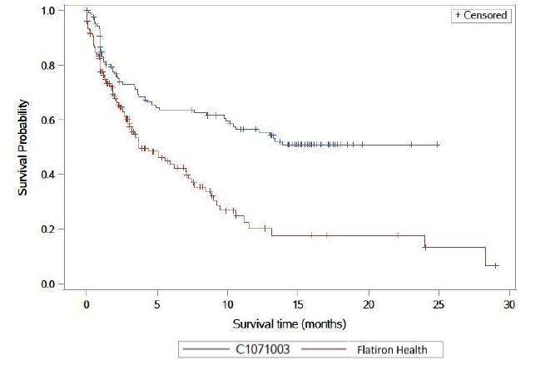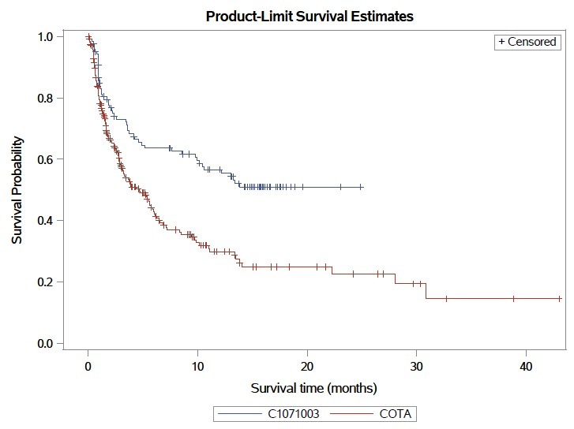

Source: Figure 2.23 A, p203; Figure 2.24 A, p204 of the submission.

PFS = progression free survival; SOC = standard of care.

15-month data cutoff (31 March 2023) for MagnetisMM-3 Cohort A. The number of patients at risk in MagnetisMM-3 Cohort A was reported as follows: 123 (month 0), 78 (month 3), 67 (month 6), 62 (month 9), 52 (month 12), 37 (month 15), 6 (month 18), 2 (month 21), 1 (month 24), and 0 (month 27) (Figure 2.9, p95 of the submission; 15-month data cutoff; 14 March 2023).

* 1. Kaplan-Meier curves of unadjusted OS for elranatamab from MagnetisMM-3 Cohort A (15-month data cutoff), versus SOC from COTA (left) and Flatiron (right) are presented in Figure 2. At the 15-month data cutoff, OS results in MagnetisMM-3 Cohort A were immature, with high censoring and a low number of patients at risk at the later time points. At the 18-month data cutoff, the median OS of elranatamab was 21.9 months (95% CI: 13.4, NE).

Figure 2: **Kaplan-Meier curves of unadjusted OS of elranatamab versos SOC in COTA (left) and Flatiron (right).**

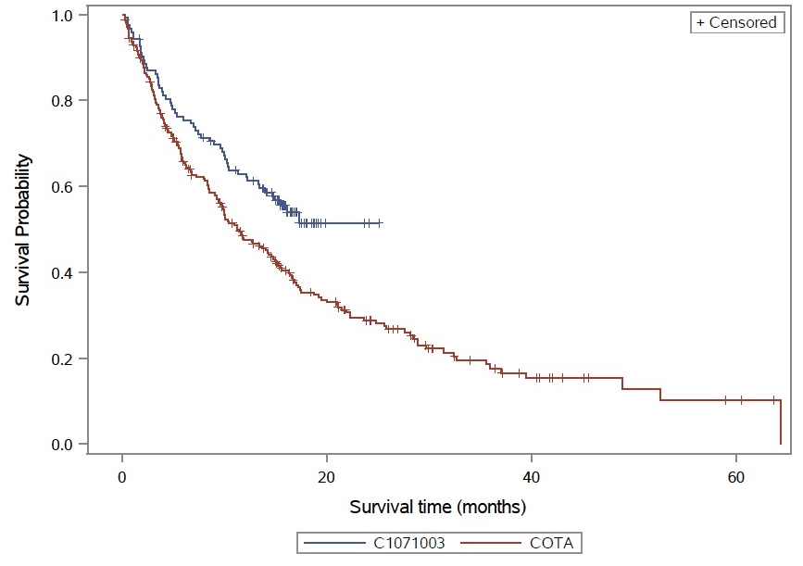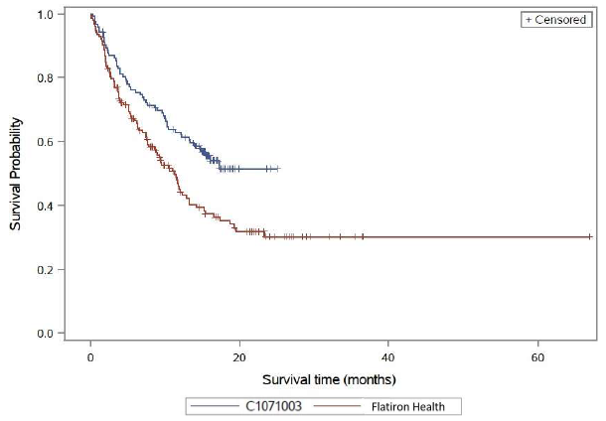

Source: Figure 2.26 A, p206; Figure 2.27 A, p207 of the submission.

CI = confidence interval; NE = not estimable; OS = overall survival; SOC = standard of care.

15-month data cutoff (31 March 2023) for MagnetisMM-3. The number of patients at risk in MagnetisMM-3 Cohort A was reported as follows: 123 (month 0), 106 (month 3), 92 (month 6), 83 (month 9), 74 (month 12), 58 (month 15), 12 (month 18), 3 (month 21), 2 (month 24), and 0 (month 27) (Figure 2.10, p95 of the submission; 15-month data cutoff; 14 March 2023).

* 1. The PSCR presented further updated OS results from data with a 24 month data cutoff that indicated that the median OS for elranatamab was 24.6 months (95% CI: 13.4, NE).

Figure 3: Overall survival of patients in MagnetisMM-3 Cohort A at 24 month data cutoff

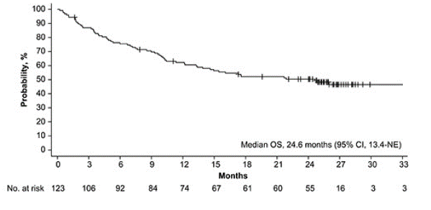

Source: Figure 1 of EHA abstract June 2024 provided with the PSCR.

CI = confidence interval; NE = not estimable; No. = number of patients; OS = overall survival

* 1. Patients who achieved a persistent response (defined as a partial response (PR) or better lasting for at least 2 months) after six cycles of treatment were to switch from a weekly dosing schedule to a less frequent dosing interval of once every 2 weeks (Q2W). The evaluation noted that 50 out of 75 persistent responders in Cohort A (67%) switched to the Q2W dosing schedule, while the remaining 33% continued with the weekly dosing regimen.
  2. Samples for minimal residual disease (MRD) testing were available for 48 patients in Cohort A. There were 20 (16.3% [95% CI: 10.22, 23.99]) patients who were MRD-negative at a sensitivity of 10-5. Among participants with an sCR/CR, 58.8% (95% CI: 40.70, 75.35) were MRD-negative at a sensitivity of 10-5.

Indirect comparison

* 1. A summary of the unadjusted and IPTW-adjusted analyses of ORR results for elranatamab from MagnetisMM-3 Cohort A and SOC from COTA and Flatiron is presented in Table 5.

Table 5: **Unadjusted and IPTW-adjusted** analyses for ORR between MagnetisMM-3 Cohort A and SoC in COTA and Flatiron.

|  |  |  |  |
| --- | --- | --- | --- |
|  | n/N | ORR (95% CI) | RR (95%CI) |
| Unadjusted analysis | | | |
| Elranatamab | 75/123 | 61.0 (51.8, 69.6) |  |
| SOC: COTA | 73/233 | 31.3 (25.4, 37.7) |
| Indirect comparison elranatamab vs. SOC | | | **1.95 (1.54, 2.47)** |
| SOC: Flatiron | 46/152 | 30.3 (23.1, 38.2) |  |
| Indirect comparison elranatamab vs. SOC | | | **2.01 (1.52, 2.67)** |
| **IPTW-adjusted analysis:** MagnetisMM-3 Cohort A versus COTA | | | |
| Elranatamab | N=123 | 75.7 (65.6, 87.4) |  |
| SOC: COTA | N=213a | 34.2 (27.2, 43.0) |
| Indirect comparison elranatamab vs. SOC | | | **2.22 (1.69, 2.90)** |
| **IPTW-adjusted analysis:** MagnetisMM-3 Cohort A versus Flatiron | | | |
| Elranatamab | N=122b | 56.0 (41.1, 76.2) |  |
| SOC: Flatiron | N=149 a | 31.3 (19.4, 50.4) |
| Indirect comparison elranatamab vs. SOC | | | **1.79 (1.01, 3.15)** |

Source: Tables 2.47 and 2.48, pp163-164 of the submission;

CI = confidence interval; IPTW = inverse probability of treatment weighting; n = number of patients with event; N = total patients in group; NR = not reported; ORR = objective response rate; RR = risk ratio; SOC = standard of care.

a As per Table 2.48 of the submission, some patients were excluded from the RW samples in the IPT weighted analysis due to missing values for variables included in the propensity score model.

b As per Table 2.48 of the submission, one participant from Study C1071003 Cohort A was not included in the comparison with the Flatiron Health sample due to having missing creatinine clearance

**Bold** indicates statistically significant results.

* 1. A summary of the unadjusted and IPTW-adjusted analyses of PFS results for elranatamab from MagnetisMM-3 Cohort A and SOC from COTA is presented in Table 6.

Table 6: **Unadjusted and IPTW-adjusted** analyses for PFS between MagnetisMM-3 Cohort A and SoC in COTA.

|  |  |  |  |
| --- | --- | --- | --- |
|  | Outcome | | HR (95%CI) |
| Unadjusted analysis | | | |
| Elranatamab | Events, n/N (%) | 53/123 (43.1%) |  |
| Median PFS, months (95% CI) | NE (9.9, NE) |
| SOC: COTA | Events, n/N (%) | 136/239 (56.9%) |
| Median PFS, months (95% CI) | 4.70 (3.09, 5.98) |
| Indirect comparison elranatamab vs. SOC | | | **0.51 (0.37, 0.71)** |
| **IPTW-adjusted analysis** | | | |
| Elranatamab | Events, n/N (%) | NR |  |
| Median PFS, months (95% CI) | NE |
| SOC: COTA | Events, n/N (%) | NR |
| Median PFS, months (95% CI) | 5.26 (3.25, 6.28) |
| Indirect comparison elranatamab vs. SOC | | | **0.37 (0.22, 0.64)** |

Source: Figure 2.9, p94; Table 2.64, p199; Table 2.66, p202 of the submission.

CI = confidence interval; IPTW = inverse probability of treatment weighting; n = number of patients with event; N = total patients in group; NE = not estimable; NR = not reported; PFS = progression free survival; HR = hazard ratio; SOC = standard of care.

**Bold** indicates statistically significant results.

* 1. The submission stated that because the proportional hazard assumption was violated, hazard ratios (HR) for PFS were not estimated based on MagnetisMM-3 Cohort A and Flatiron. Instead, the submission reported the difference in restricted mean survival time (RMST) as summarised in Table 7.

Table 7: **Unadjusted and IPTW-adjusted** analyses for PFS between MagnetisMM-3 Cohort A and SOC in Flatiron.

|  |  |  |  |  |  |  |
| --- | --- | --- | --- | --- | --- | --- |
| **Time period** | **Unadjusted analysis** | | | **IPTW-adjusted analysis** | | |
| **RMST estimate, month (95%CI)** | | **Difference in RMST estimate, month (95%CI)** | **RMST estimate, month (95%CI)** | | **Difference in RMST estimate, month (95%CI)** |
| **Elranatamab**  **(N = 123)** | **SOC: Flatiron**  **(N=152)** | **Elranatamab** | **SOC: Flatiron** |
| 9-month | 6.41 (5.77, 7.06) | 4.89 (4.27, 5.51) | **1.52 (0.63, 2.42)** | 5.90 (4.84, 6.97) | 4.36 (3.48, 5.23) | **1.55 (0.17, 2.93)** |
| 12-month | 8.17 (7.28, 9.06) | 5.65 (4.83, 6.47) | **2.52 (1.31, 3.73)** | 7.55 (6.09, 9.00) | 5.07 (3.93, 6.21) | **2.48 (0.63, 4.33)** |
| 15-month | 9.76 (8.62, 10.90) | 6.21 (5.19, 7.23) | **3.55 (2.02, 5.08)** | 9.04 (7.20, 10.88) | 5.46 (4.12, 6.80) | **3.58 (1.31, 5.85)** |
| 18-month | 11.29 (9.90, 12.68) | 6.74 (5.49, 7.99) | **4.55 (2.67, 6.42)** | 10.49 (8.27, 12.72) | 5.75 (4.20, 7.30) | **4.74 (2.03, 7.46)** |
| 24-month | 14.34 (12.41, 16.28) | 7.81 (6.04, 9.58) | **6.54 (3.92, 9.16)** | 13.40 (10.35, 16.45) | 6.33 (4.24, 8.42) | **7.07 (3.38, 10.76)** |

Source: Figure 2.24 of the submission.

CI = confidence interval; IPTW = inverse probability of treatment weighting; N = total patients in group; PFS = progression free survival; HR = hazard ratio; RMST = restricted mean survival time; SOC = standard of care.

**Bold** indicates statistically significant results.

* 1. Kaplan-Meier curves for adjusted PFS of elranatamab compared with SOC in COTA (left) and Flatiron (right) are presented Figure 5.

**Figure 4: Kaplan-Meier curves of adjusted PFS of elranatamab versos SOC in COTA (left) and Flatiron (right).**

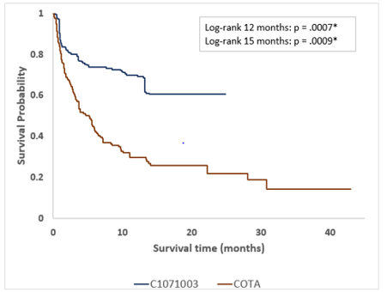 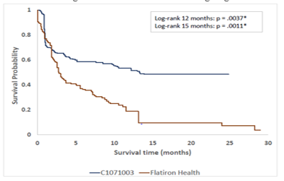

Source: Figure 2.23 B, p203; Figure 2.24 B, p204 of the submission.

PFS = progression free survival; SOC = standard of care.

* 1. A summary of the unadjusted and IPTW-adjusted analyses of OS results for elranatamab from MagnetisMM-3 Cohort A and SOC from COTA is presented in Table 8. Results for the RMST comparison of OS between elranatamab from MagnetisMM‑3 Cohort A and SOC from Flatiron are presented in Table 9.

Table 8: **Unadjusted and IPTW-adjusted analyses** for OS between MagnetisMM-3 Cohort A and SOC in COTA.

|  |  |  |  |
| --- | --- | --- | --- |
|  | Outcome | | HR (95%CI) |
| Unadjusted analysis | | | |
| Elranatamab | Died, n/N (%) | 55/123 (44.7) |  |
| Median OS, months (95%CI) | NE (13.9, NE) |
| SOC: COTA | Died, n/N (%) | 171/239 (71.5) |
| Median OS, months (95%CI) | 11.24 (9.36, 14.75) |
| Indirect comparison elranatamab vs. SOC | | | **0.65 (0.47, 0.88)** |
| **Adjusted IPTW analysis** | | | |
| Elranatamab | Died, n/N (%) | NR |  |
| Median OS, months (95%CI) | NE |
| SOC: COTA | Died, n/N (%) | NR |
| Median OS, months (95%CI) | 11.24 (8.51, 14.29) |
| Indirect comparison elranatamab vs. SOC | | | **0.46 (0.27, 0.77)** |

Source: Figure 2.10, p95; Table 2.65, p200; Table 2.67, p205 of the submission.

CI = confidence interval; IPTW = inverse probability of treatment weighting; n = number of patients with event; N = total patients in group; NE = not estimable; NR = not reported; OS = overall survival; HR = hazard ratio; SOC = standard of care.

**Bold** indicates statistically significant results.

Table 9: **Unadjusted and IPTW-adjusted analyses** for OS between MagnetisMM-3 Cohort A and SOC in Flatiron.

|  |  |  |  |  |  |  |
| --- | --- | --- | --- | --- | --- | --- |
| **Time period** | **Unadjusted analysis** | | | **IPTW-adjusted analysis** | | |
| **RMST estimate, month (95%CI)** | | **Difference in RMST estimate, month (95%CI)** | **RMST estimate, month (95%CI)** | | **Difference in RMST estimate, month (95%CI**) |
| **Elranatamab**  **(N=123)** | **SOC: Flatiron**  **(N=152)** | **Elranatamab** | **SOC: Flatiron** |
| 9-month | 7.39 (6.90, 7.89) | 6.68 (6.19, 7.18) | 0.71 (0.01, 1.41) | 6.70 (5.77, 7.64) | 6.68 (5.92, 7.45) | 0.02 (-1.19, 1.23) |
| 12-month | 9.36 (8.66, 10.07) | 8.22 (7.52, 8.93) | 1.14 (0.14, 2.13) | 8.52 (7.23, 9.81) | 8.21 (7.13, 9.28) | 0.31 (-1.36, 1.99) |
| 15-month | 11.16 (10.23, 12.09) | 9.46 (8.56, 10.36) | 1.70 (0.41, 2.99) | 10.18 (8.55, 11.81) | 9.46 (8.09, 10.82) | 0.72 (-1.41, 2.85) |
| 18-month | 12.78 (11.63, 13.94) | 10.56 (9.46, 11.67) | 2.22 (0.62, 3.82) | 11.73 (9.75, 13.71) | 10.59 (8.93, 12.24) | 1.14 (-1.44, 3.73) |
| 24-month | 15.87 (14.21, 17.53) | 12.50 (10.98, 14.02) | 3.37 (1.12, 5.62) | 14.76 (12.04, 17.48) | 12.42 (10.22, 14.61) | 2.34 (-1.15, 5.84) |

Source: Figure 2.27, p207 of the submission.

CI = confidence interval; IPTW = inverse probability of treatment weighting; N = total patients in group; OS = overall survival; HR = hazard ratio; RMST = restricted mean survival time; SOC = standard of care.

* 1. Kaplan-Meier curves for adjusted OS of elranatamab compared with SOC in COTA (left) and Flatiron (right) are presented Figure 5.

Figure 5: **Kaplan-Meier curves of adjusted OS of elranatamab versos SOC in COTA (left) and Flatiron (right).**

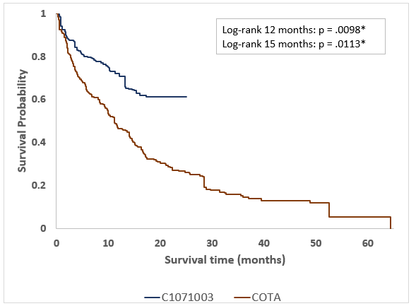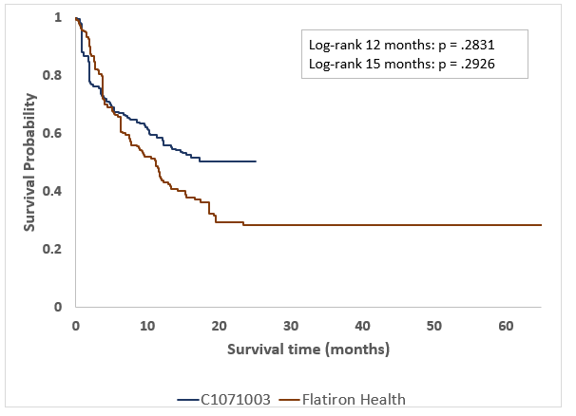

Source: Figure 2.26 B, p206; Figure 2.27 B, p207 of the submission.

OS = overall survival; SOC = standard of care.

* 1. The adjusted results show a numerical improvement in the PFS and OS effect size for elranatamab compared to SOC in COTA. The hazard ratio for OS decreased from 0.65 (95% CI: 0.47, 0.88) unadjusted to 0.46 (95% CI: 0.27, 0.77) adjusted and the hazard ratio for PFS decreased from 0.51 (95% CI: 0.37, 0.71) to 0.37(95% CI: 0.22, 0.64).
  2. Results with respect to the IPTW analyses comparing elranatamab with SOC in Flatiron were somewhat different from those using the COTA data. The adjusted ORR and OS responses for SOC in Flatiron remained largely unchanged, while PFS decreased. For elranatamab, the adjusted ORR was similar, PFS increased, but OS decreased. These results suggest a lack of consistent directional changes within the treatment effects (as PFS and OS within the treatment arm do not align) after application of the IPTW. As a result, the adjusted comparative analysis for elranatamab showed a numerical decrease in the risk ratio for ORR and an improvement in PFS, with no significant differences in OS. This inconsistency in results across outcomes using the Flatiron data raises concerns about the internal validity of the findings and suggests unaddressed unmeasured confounding biases in the analysis.
  3. Given the potential for differences across the databases, the submission presented two analyses to address confounding in PFS and OS outcomes; a doubly robust analysis and a propensity score (PS) matched analysis (based on the most comparable characteristics of 89 pairs of patients in MagnetisMM-3 Cohort A and COTA, and 69 pairs of patients in MagnetisMM-3 Cohort A and Flatiron). A comparison of those results against those from the IPTW and unweighted analyses are presented in Figure 6. While the results from these analyses were generally consistent with those from the main analysis, their effect sizes (hazard ratios) are numerically smaller than those based on the COTA (IPTW) which yielded the most optimistic (lowest) hazard ratio for both PFS and OS (noting that all the confidence intervals on the respective hazard ratios overlap). The results from the COTA (IPTW) analyses were used to inform the economic model.

Figure 6: Hazard ratios for PFS (top) and OS (bottom) across different approaches of analyses

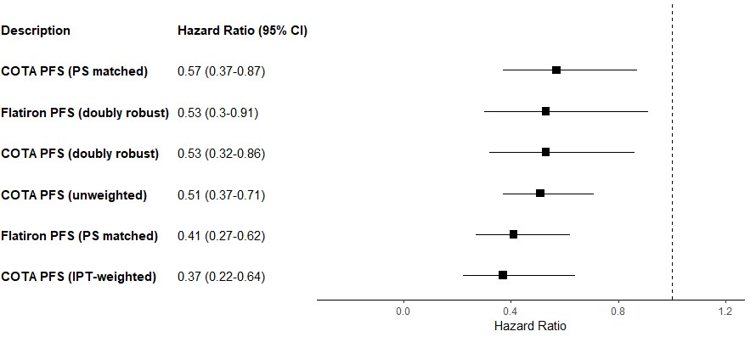

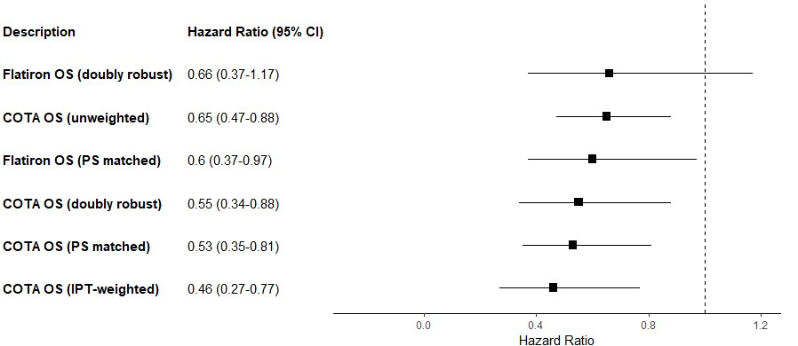

Source: Figure 2.22, p201; Figure 2.25, p205 of the submission.

CI = confidence interval; IPT = inverse-probability treatment; PFS = progression free survival; PS = propensity score; OS = overall survival

The PS matched analyses included about 89 pairs of participants of MagnetisMM-3 Cohort A and COTA patients, 69 matched pairs of participants of MagnetisMM-3 Cohort A and patients from Flatiron Health matched 1 to 1 on the 0.2 standard deviations of the logit of the PS.

* 1. The submission presented health-related quality of life (HRQoL) results evaluating HRQoL over time in patients from MagnetisMM-3, utilising various questionnaires, including the European Quality of Life Five Dimension (EQ-5D-5L). Results for the PROs indicated that quality of life of patients in MagnetisMM-3 was maintained. Specifically, for Cohort A (N=116), the EQ-5D-5L index score showed no deviation from the baseline throughout the initial nine cycles. The EQ-5D-5L results from MagnetisMM-3 Cohort A and B (N = 180), were also compared against those available for SOC patients from COTA and Flatiron (N = 45; no prior CAR-T therapy). The submission claimed that this unanchored, unmatched comparison of EQ-5D-5L results showed no significant difference in HRQoL outcomes between the elranatamab and SOC groups. This claim is subject to the same biases and confounders as described above for the other outcomes.

Comparative harms

* 1. A summary of treatment-emergent adverse events (TEAEs) in MagnetisMM-3 from the 18-month median follow-up data cutoff is presented Table 10.

**Table 10: TEAEs in MagnetiMM-3 (Cohort A)**

|  |  |  |
| --- | --- | --- |
| **TEAE** | **Any grade n (%)** | **Grade 3/4 n (%)** |
| **Any** | 123 (100) | 88 (71.5) |
| **Haematologic** |  |  |
| Neutropenia | 61 (49.6) | 61 (49.6) |
| Anaemia | 60 (48.8) | 46 (37.4) |
| Thrombocytopenia | 39 (31.7) | 29 (23.6) |
| Lymphopenia | 33 (26.8) | 31 (25.2) |
| Leukopenia | 20 (16.3) | 16 (13.0) |
| **Nonhaematologic** |  |  |
| Cytokine release syndrome | 71 (57.7) | 0 |
| Diarrhoea | 55 (44.7). | 4 (3.3) |
| Fatigue | 45 (36.6) | 5 (4.1) |
| Decreased appetite | 41 (33.3) | 1 (0.8) |
| Pyrexia | 40 (32.5) | 5 (4.1) |
| Nausea | 33 (26.8) | 0 |
| Injection site reaction | 33 (26.8) | 0 |
| Hypokalaemia | 33 (26.8) | 14 (11.4) |
| Cough | 34 (27.6) | 1 (0.8) |
| **TEAEs of special interest** |  |  |
| ICANS | 6 (4.9) | 0 |
| Infections | 86 (69.9) | 50 (40.7) |

Source: Table 2.41, p137 of the submission.

n = number of patients with event; N = total patients in group; ICANS = Immune cell-associated neurotoxicity syndrome; TEAEs = Treatment-emergent adverse events.

a 18-month data cutoff (11 September 2023).

* 1. The submission provided an unadjusted, unanchored comparison of Grade 3/4 adverse events (AEs) between elranatamab and SOC in COTA, as presented in Table 11. Overall, the MagnetisMM-3 study reported higher rates of grade 3/4 AEs compared to COTA, particularly in terms of anaemia, thrombocytopenia, lymphopenia, and leukopenia.

**Table 11:** **Incidence of Grade 3/4 adverse events (AEs)**

|  |  |  |  |
| --- | --- | --- | --- |
| **AE (grade 3/4)** |  | **MagnetisMM-3** | **COTA** |
| Blood and lymphatic system disorders | Anaemia | 37.4% | 16.1% |
| Neutropenia | 48.8% | 48.5% |
| Thrombocytopenia | 23.6% | 17.2% |
| Lymphopenia | 25.2% | 7.1% |
| Leukopenia | 13.0% | 7.6% |
| Febrile neutropenia | 3.3% | 6.1% |
| Infections and infestations | Infection | 10.6% | 6.7% |
| Pneumonia | 8.1% | 9.4% |
| Sepsis | 6.5% | 0.0% |
| Investigations | Alanine aminotransferase increased | 5.7% | 0.0% |
| Hypokalaemia | 10.6% | 0.0% |
| Renal and urinary disorders | Renal and urinary disorders | 5.7% | 0.0% |
| Vascular disorders | Hypertension | 6.5% | 0.0% |

Source: Table 2.86 p247 of the submission.

AEs = adverse events.

* 1. Elranatamab resulted in a higher incidence of Grade 3/4 TEAEs related to haematologic conditions compared to SOC. Elranatamab was associated with CRS (57.7% all Grades) and ICANS (4.9% all Grades); however, none of the reported CRS events were ≥ Grade 3 in severity. Based on the TGA Delegate’s Overview, elranatamab can cause potentially life-threatening CRS and ICANS. This has led to the inclusion of a Boxed Warning in the Product Information with respect to these events.

Benefits/harms

* 1. The indirect comparison of single arm studies presented in this submission was not considered to provide reliable estimates of the magnitude of the benefits and harms. Accordingly, a benefits/harms table has not been presented.

Clinical claim

* 1. The submission described elranatamab as superior in terms of effectiveness compared to SOC. The ESC considered that this claim was likely supported; however, the magnitude of benefit for PFS and OS were unknown.
  2. The ESC considered that the retrospective cohort studies and the additional analyses were highly uncertain, as after the IPTW adjustment, transitivity issues remained, including:
* Imbalanced patient characteristics. As the data related to disease severity variables in COTA and Flatiron were incomplete, the adjustment for patient characteristics across the studies were limited. This likely underestimated the poorer health status of patients in COTA and Flatiron (relative to that in MagnetisMM-3 Cohort A). The PSCR noted that although patients in MagnetisMM-3 Cohort A had a lower proportion of ECOG 2 patients than COTA and Flatiron, the MagnetisMM-3 study had a higher proportion of patients with ISS Stage II and III disease, a higher average number of prior treatment lines and more patients with penta-refractory status.
* A high proportion of patients in COTA had an unknown ISS disease stage.
* Temporal difference between the time periods reflected in the datasets (for COTA and Flatiron data collection commenced in 2015, whereas the MagnetisMM-3 study commenced in 2021).
* Differences in follow-up, with data for elranatamab subject to greater censoring and a lower number of patients at risk.
  1. The ESC considered the clinical evidence presented in the submission (i.e., in heavily pre-treated patients) had limited generalisability to the third line treatment setting proposed.
  2. The PBAC considered that the claim of superior comparative effectiveness was likely reasonable, but that the magnitude of the benefit was not able to be determined.
  3. The submission described elranatamab as non-inferior in terms of safety compared to SOC. The ESC noted that elranatamab had higher rates of most grade 3/4 adverse events compared to COTA. Furthermore, the higher rates of adverse events with elranatamab, particularly CRS and ICANS, distinguish its safety profile from that of SOC and the PBS-listed RRMM treatments available. Overall, the ESC considered that elranatamab was inferior in terms of safety compared to SOC.
  4. The PBAC considered that the claim of non-inferior comparative safety was not adequately supported by the data.

Economic analysis

* 1. The submission presented a modelled economic evaluation in the form of a partitioned survival analysis, based on the results from the MagnetisMM-3 study and the IPTW-adjusted analyses using the COTA data. The type of economic evaluation was a cost-utility analysis.
  2. A summary of the key components of the economic model is presented in Table 12.

Table 12: **Summary of model structure, key inputs and rationale**

| Component | Summary |
| --- | --- |
| Treatments | Elranatamab vs SOC (represented by a basket of therapies used by patients with TCR MM) |
| Time horizon | 7 years in the model base case versus 14.7 months in trial (median follow-up) |
| Outcomes | LYs and QALYs gained |
| Methods used to generate results | Partitioned survival model incorporating a cohort expected value analysis |
| Health states | PFS, PPS and death  Time spent in PFS was partitioned according to on or off treatment based on TTD curves from MagnetisMM-3 (elranatamab) and COTA (SOC) |
| Cycle length | 1 week with half-cycle correction |
| Transition probabilities (area under curve) | For elranatamab, OS, PFS and TTD KM curves from MagnetisMM-3 were used until median follow-up (14.7 months), then extrapolated using standard parametric curves.  For SOC, HRs for OS and PFS (relative to elranatamab) were derived from the IPTW analysis using COTA. For TTD, a KM curve was calculated using patient-level data from COTA to median follow up (8.8 months), then extrapolated using standard parametric curves. |
| Extrapolation method | Best parametric fits were decided based on both visual checks and AIC/BIC statistics. |
| Health related quality of life | Trial-based utility values from MagnetisMM-3, derived from EQ-5D-5L with Australian tariffs  PFS = 0.8422, PPS= 0.7814 |
| Costs of SOC and post-progression costs | Based on PBS 10% dataset analysis and published prices for PBS medicines. |

Source: Table 3.1, p253 of the submission.

AIC = Akaike information criterion; BIC = Bayesian information criterion; IPTW = inverse probability of treatment weighting; KM = Kaplan-Meier; LYs = life years; MM = multiple myeloma; OS = overall survival; PBS = Pharmaceutical Benefits Scheme; PFS = progression-free survival; PPS = post-progression survival; QALYs = quality-adjusted life years; SOC = standard of care; TCR = triple class refractory; TTD = time-to-treatment discontinuation

* 1. The economic model used results from the unanchored IPTW analysis of MagnetisMM-3 vs COTA to inform the efficacy of SOC. The treatments used in COTA were not representative of the basket of treatments nominated as SOC in the submission (see paragraph 6.11). Additionally, while COTA informed the efficacy in the model, the costs were based on SOC treatments nominated in the submission. The model does not contain functionality to allow an assessment of the direction of bias that may result from the mismatch of treatments informing efficacy and SOC informing costs.
  2. In the base case, the economic evaluation used a 7-year time horizon. Results of a sensitivity analysis using a 5-year time horizon are presented in Table 15.
  3. Traces for the predicted time to event outcomes of OS, PFS and time-to-treatment discontinuation (TTD) for elranatamab and SOC in the base case economic evaluation are presented in Figure 7. As noted by the submission, the difference between TTD and PFS curves is greater than would have been expected in the context of previous trials in RRMM. The submission attributed this to the observed proportion of patients in MagnetisMM-3 that achieved MRD-negativity at the 10-5 threshold. The ESC noted that data on MRD results were available for 48/123 (39%) patients from MagnetisMM-3 and that data on the PFS and OS outcomes in these patients were not presented.

Figure 7: Estimated OS, PFS and TTD for elranatamab and SOC in base case

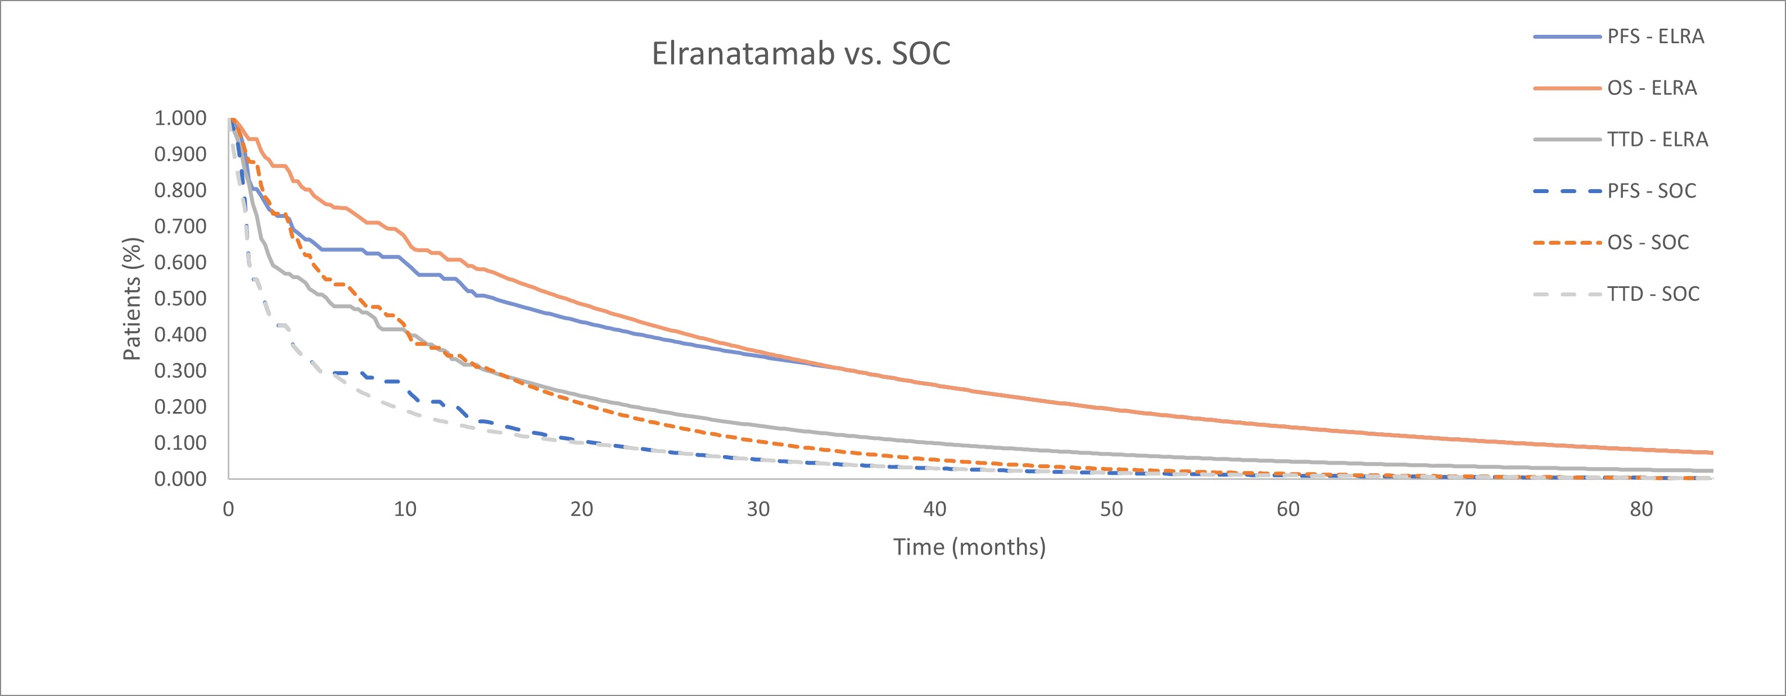

Source: Amended figure from sheet ‘Australia Results’ from the economic workbook.

ELRA = elranatamab; OS = overall survival; PFS = progression-free survival; SOC = standard of care; TTD = time-to-treatment discontinuation.

* 1. The model applied standard parametric extrapolation functions, with the base case analysis including the observed Kaplan-Meier data up to the point of median follow-up (14.7 months). The submission applied the Weibull functional form for extrapolation of all variables (PFS, OS, TTD).
  2. The submission stated the fitted PFS curves were capped by the fitted OS curves so that the PFS curves were never higher than the OS curves. From 35 months, PFS was the same as OS and so all patients died without experiencing progression. The model also predicted that approximately 10% of elranatamab patients would be alive at month 84 (i.e. after 7 years). Overall, the approach to the extrapolation of OS and PFS favoured elranatamab (see Table 15, paragraph 6.60). The PSCR stated that longer follow-up data indicated that the estimates of treatment benefit in MagnetisMM-3 were likely conservative, and that the convergence in the OS and PFS curves was likely a function of underestimation of OS, rather than overestimation of PFS. Data from the 24- month data cutoff indicates a median OS of 24.6 months (as compared to the modelled median OS of 19.2 months).
  3. The ESC noted that the updated OS data suggested an ongoing survival benefit but also noted that the data beyond 27 months were highly uncertain given the decreasing proportion of patients at risk (13% at Month 27, 2.4% at Month 30).
  4. Utility values for the progression free (PF; utility = 0.8422) and post-progression survival (PPS; utility = 0.7814) health states were sourced from MagnetisMM-3; while those for AEs were sourced from the literature. The ESC noted that the submission stated that the utility values applied were higher than those applied in other RRMM submissions which ranged from 0.65 to 0.75 for the PF health state and 0.57 to 0.67 for the PPS state. The ESC considered that the disutility applied for progression (-0.061) was less than would be expected with a progression event but noting that was within the range applied to similar submissions (-0.018 to -0.11), considered that the values applied were likely reasonable.
  5. The model estimated a mean time for PFS and OS of 2.36 and 2.53 years respectively (PPS of 0.17) for patients treated with elranatamab compared to a mean of 0.63 and 1.05 years (PPS of 0.42) for patients treated with SOC (Figure 8).

Figure 8**:** Summary of average health state occupancy over the 7-year time horizon in economic model (base case)

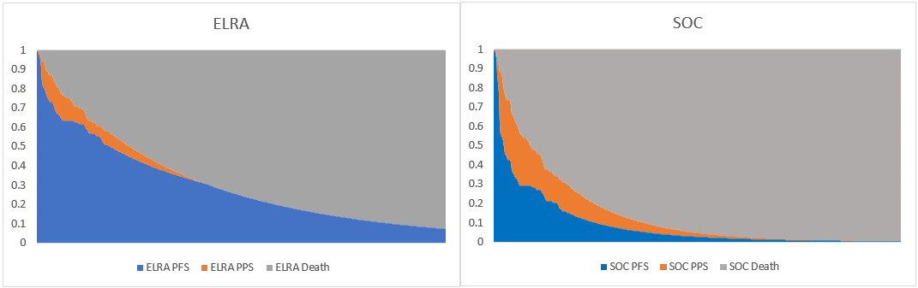

Source: Figure 3.12 p292 of the submission.

ELRA = elranatamab; PFS = progression-free survival; PPS = post progression survival; SOC = standard of care

* 1. The following were noted with respect to the assessment of costs:
     + costs of step-up dosing were based on inpatient administration (2 doses), costed using relevant Australian Refined-Diagnosis Related Group cost weights. This aligned with the Product Information.
     + there was a difference in the relative dose intensity (RDI) applied for elranatamab (78%, sourced from MagnetisMM-3) and SOC (91%, derived from an analysis of 3 randomised controlled trials, using Cd as a proxy for the total basket of treatments). The evaluation conducted a sensitivity analysis applying the same RDI to both treatment arms (see Table 15). The ESC noted RDI was also applied to the administration costs for elranatamab and SOC which was not appropriate. Removal of RDI associated with administration was tested in a sensitivity analysis.
     + the submission assumed that all progressing patients received the same basket of post-progression therapies. Given the assumed differences in the average time spent in the PFS and PPS health states (see paragraph 6.54), the model resulted in a lower per patient average cost for post-progression therapies for those in the elranatamab arm ($| |) relative to SOC arm ($29,262).
     + costs for the treatment of AEs were applied once at the start of the model, based on the assumed incidence of events, and a combination of medical and inpatient hospital treatment for those events. This resulted in higher costs per patient on average for elranatamab ($| |) relative to SOC ($7,112). This reflected the higher incidence and different profile of AEs for elranatamab compared with SOC (noting the magnitude of the actual difference is unknown given the indirect and unanchored nature of the comparison of safety data).
     + the ESC noted half cycle correction was applied to drug costs which was not appropriate as these costs are incurred for the full model cycle. The ESC noted that, given the one-week model length, this was unlikely to have a substantial impact on the ICER.
  2. A summary of the key drivers of the economic model is presented in Table 13.

Table 13: **Key drivers of the model**

| Description | Method/Value | Impact  Base case: $|1/QALY gained |
| --- | --- | --- |
| Source of HR | Derived from IPTW analysis using COTA.  OS = 0.46 (95% CI: 0.27, 0.77) | Application of lower 95% CI (0.27) decreased the ICER to $||||1/QALY (-|%)  Application of upper 95% CI (0.77) increased the ICER to $||||2/QALY (+|%) |
| Extrapolation Functions | Applied Weibull function to TTD for elranatamab | High, favoured elranatamab: application of generalised gamma function increased the ICER to $||||3/QALY (+|%) |
| Applied Weibull function to PFS for elranatamab | High, favoured elranatamab: application of exponential function increased the ICER to $||||3/QALY (+|%) |
| Dose change elranatamab | Refers to the proportion of patients who transition from QW to Q2W dosing after 24 weeks.  Assumed to be 100% in the economic model; however, was 67% in MagnetisMM-3 | High, favoured elranatamab: assuming 67% transitioned to Q2W dosing after 24 weeks increased the ICER to $||||3/QALY (+|%) |
| Convergence of OS curves | No convergence was applied in the model | High, favoured elranatamab: converging the OS curves from Month 15 to Month 72 increased the ICER to $||||3 (+|%) |

Source: compiled during the evaluation from sensitivity analyses.

Cd = carfilzomib and dexamethasone; CI = confidence interval; HR = hazard ratio; ICER = incremental cost-effectiveness ratio; IPTW = inverse probability of treatment weighting; OS = overall survival; PFS = progression-free survival; QALY = quality-adjusted life year; QW = weekly; Q2W = every 2nd week; SOC = standard of care.

*The redacted values correspond to the following ranges:*

*1 $75,000 to < $95,000*

*2 $155,000 to < $255,000*

*3 $115,000 to < $135,000*

* 1. The results of the stepped economic evaluation are presented in Table 14. These results were based on the proposed effective price of elranatamab and the published prices of the comparators and therefore the ICER is underestimated.

Table 14: **Results of the stepped economic evaluation**

| Step and component | Elranatamab | SOC | Increment |
| --- | --- | --- | --- |
| Step 1: trial-based costs and outcomes (to median follow up of 14.7 months) | | | |
| Costs | $| | $53,612 | $| |
| LYs | 0.904 | 0.666 | 0.238 |
| Incremental cost/LY gained | | | $|1 |
| Step 2: Extrapolation of PFS, OS and TTD to 7-year time horizon | | | |
| Costs | $| | $80,129 | $| |
| LYs | 2.287 | 1.040 | 1.247 |
| Incremental cost/LY gained | | | $|2 |
| Step 3: Transformation of LYs to QALYs | | | |
| Costs | $| | $80,129 | $| |
| QALYs | 1.910 | 0.847 | 1.063 |
| Incremental cost/QALY gained | | | $|2 |
| Step 4: Discounting costs and outcomes at 5% p.a. | | | |
| Costs | $| | $77,101 | $| |
| QALYs | 1.727 | 0.802 | 0.926 |
| **Incremental cost/QALY gained** | | | **$|**2 |

Source: Table 3.39, p292 of the submission.

LYs = life years; OS = overall survival; PFS = progression-free survival; QALYs = quality-adjusted life years; SOC = standard of care; TTD = time-to-treatment discontinuation.

*The redacted values correspond to the following ranges:*

*1 $155,000 to < $255,000*

*2 $75,000 to < $95,000*

* 1. In the base case, treatment with elranatamab resulted in estimated incremental costs of $| | and incremental QALYs of 0.926, compared to treatment with SOC, resulting in an ICER of $75,000 to < $95,000/QALY gained.
  2. The results of key univariate sensitivity analyses are summarised in Table 15.

**Table 15: Sensitivity analyses**

| Analyses | Incremental cost ($) | Incremental QALY | ICER | % change to ICER |
| --- | --- | --- | --- | --- |
| **Base case** | **|** | **0.926** | **|　1** | **-** |
| **Time horizon (base case 7 years)** | | | |  |
| 5 years | | | 0.80 | |　2 | +||% |
| 10 years | | | 1.00 | |　**1** | -||% |
| **Discount rate (base case 5%)** | | | | |
| 0% | | | 1.06 | |　**1** | -||% |
| 3.5% | | | 0.96 | |　**1** | -||% |
| **RDI- SOC (base case 91%)** | | | | |
| Same RDI as elranatamab: 78% | | | 0.93 | |　2 | +||% |
| **Dose change elranatamab a (base case 100% transition to Q2W dosing after 24 weeks)** | | | | |
| Proportion recorded from MagnetisMM-3: 67% | | | 0.93 | |　3 | +||% |
| **OS SOC HR (base case 0.46)** |  |  |  |  |
| Lower 95% CI: 0.27 | | | 1.27 | |　**1** | -||% |
| Upper 95% CI: 0.77 | | | 0.41 | |　4 | +||% |
| **PFS SOC HR (base case 0.37)** |  |  |  |  |
| Lower 95% CI: 0.22 | | | 0.95 | |　2 | +||% |
| Upper 95% CI: 0.64 | | | 0.90 | |　2 | +||% |
| **OS extrapolation – elranatamab (base case Weibull)** | | | | |
| Exponential | | | 0.84 | |　2 | +||% |
| **PFS extrapolation - elranatamab (base case Weibull)** | | | | |
| Exponential | | | 0.91 | |　3 | +||% |
| **TTD extrapolation - elranatamab (base case Weibull)** | | | | |
| Generalised gamma | | | 0.93 | |　3 | +||% |
| **TTD extrapolation - SOC (base case Log-logistic)** | | | | |
| Exponential | | | 0.93 | |　2 | +||% |
| **Convergence of OS curves (excluded in base case)** | | | | |
| Applying convergence from Month 15 to Month 72 | | | 0.72 | |　3 | +||% |
| **RDI applied to administration (base case applied)** | | | | |
| Removed | | | 0.926 | |　2 | +||% |

Source: Adapted from Table 3.43, p296 and Table 3.44, p 297 of the submission.

HR = hazard ratios; ICER = incremental cost per QALY gained; OS = overall survival; PFS = progression-free survival; PPS = post progression survival; QALY = quality adjusted life year; RDI = relative dose intensity; SOC = standard of care; TTD = time-to-treatment discontinuation.

a refers to the proportion of patients changing from QW to Q2W after 24 weeks of treatment

*The redacted values correspond to the following ranges:*

*1 $75,000 to < $95,000*

*2 $95,000 to < $115,000*

*3 $115,000 to < $135,000*

*4 $155,000 to < $255,000*

* 1. The model was sensitive to applying the upper 95% CI of the hazard ratio for OS to the SOC arm which resulted in a |% increase in the ICER. The PBAC noted that the HR applied in the model was very uncertain given it was based on a comparison of studies with significant transitivity issues (see paragraph 6.40) and further considered the 95% CIs were unlikely to reflect the extent of uncertainty with the estimate. Varying the extrapolation functions applied also affected the ICER. Application of the generalised gamma function to the elranatamab TTD curve increased the ICER by |%; application of the exponential function to the elranatamab PFS curve increased the ICER by |%. Assuming the proportion of patients receiving two weekly dosing of elranatamab after Week 25 was 67%, as compared with 100% in the base case, increased the ICER by |%. Applying convergence to the OS curves from Month 15 to Month 72 increased the ICER by |%.

Elranatamab cost/patient/course

* 1. The drug cost/patient/week and drug cost/patient/course for elranatamab and SOC are presented in Table 16. The application of a basket of comparators for SOC in the economic model resulted in a lower cost per patient for the comparator in the economic model than applied in the financial estimates where use of Cd only was included. Published prices were used for comparators which will overestimate the cost per patient.

Table 16: **Drug cost per patient for elranatamab and SOC**

|  | Elranatamab | | | SOC | | |
| --- | --- | --- | --- | --- | --- | --- |
| Trial dose and duration | Model | Financial estimates | Trial dose and durationa | Modela | Financial estimatesb |
| Mean duration | 6.35 months  (27.6 weeks) | 61.7 weeks | 66 weeks | NR | 30.5 weeks | 39.9 weeksc |
| Cost/patient/weekd | Week 1: $|  Weeks 2-24: $|  Weeks 25+: $| | | | Week 1: $1,294.15  Weeks 2-4: $1,439.34  Weeks 5-8: $1,693.78  Weeks 9+: $1,404.25 | | Week 1: $1,026.16  Weeks 2-4: $1,455.21  Weeks 5+: $2,196.51 |
| Cost/patient/course | $　| | $　| | $　| | NA | $44,006 | $84,247 |

Source: Sheet ‘Detailed calculations’ of the economic workbook.

BIW = twice weekly; Cd = carfilzomib and dexamethasone; Cyclo = cyclophosphamide; ELd = elotuzumab, lenalidomide and dexamethasone; Ld = lenalidomide and dexamethasone; NA = not applicable; NR = not reported; PBd = pomalidomide, bortezomib and dexamethasone; Pd = pomalidomide and dexamethasone; QW = once weekly

a Weighted basket of treatments consisting of Cd 34.2% (20.5% QW, 13.7% BIW), Pd 18.4%, ELd 18.4%, Cd +cyclo 10.5%, PBd 10.5%, Ld 7.9%, published prices

b Cd only (63% QW, 37% BIW), assumed effective price 50% below published price

c Sourced from the ENDEAVOUR trial (NCT01568866)

d RDI of 78% was applied in estimating the weekly costs of elranatamab. For SOC, RDI was estimated at 91% in the model based on Cd as a proxy for the basket of treatments and a weighting of the reported RDI from an analysis of 3 pivotal RCTs (ARROW - NCT02412878; CHAMPION-1 - NCT01677858; ENDEAVOR - NCT01568866) according to PBS statistics for QW (92.7%) vs BIW (87%).

* 1. The mean duration of treatment in the elranatamab trial was truncated, i.e., there were still patients receiving treatment at the end of the trial, and therefore the mean duration in clinical practice will be longer than observed over the trial period. The estimated mean treatment in the economic model was 61.7 weeks which accounted for treatment received up to 7 years (the economic model time horizon). The estimated mean treatment duration in the financial model was longer (66 weeks) as this accounted for treatment assumed to be received beyond 7 years.
  2. In the financial model it was assumed that all patients receive elranatamab weekly (i.e., the more costly dose regimen) in the first 24 weeks. This overestimates the cost as some patients discontinue during the first 24 weeks. The economic model estimated only 50% of patients are on treatment at week 24, and the estimated cost per patient accounted for this.

Estimated PBS usage & financial implications

* 1. This submission was considered by DUSC.
  2. The submission used an epidemiological approach to estimate the financial implications associated with the proposed listing. A summary of the key inputs used in the financial estimates is provided in Table 17. The submission only considered the costs of Cd (the most prevalent treatment regimen for patients with TCR MM, as analysed by the PBS 10% sample) in substitution and displacement calculations as a result of the proposed PBS listing of elranatamab.

Table 17: **Key inputs for financial estimates**

| Data | Value | Source | Comments |
| --- | --- | --- | --- |
| Eligible population | | | |
| Prevalent patients (MM) | Yr 1: ||||1  Yr 2: ||||1  Yr 3: ||||1  Yr 4: ||||1  Yr 5: ||||1  Yr 6: ||||1 | ABS population projections (Series B) x AIHW 5-year MM prevalence rate (0.028%) | DUSC considered that the estimates were appropriate. |
| Proportion of MM patients that are TCE | Yr 1: ||||2  Yr 2: ||||2  Yr 3: ||||2  Yr 4: ||||2  Yr 5: ||||2  Yr 6: ||||2 | Prospection analysis of PBS10% dataset (2.90%) | The PBS10% dataset was favoured over the MRDR dataset (3.4%), which included all treatment regimens irrespective of funding source and may be an overestimate.  DUSC considered that the estimates were a marked underestimate. DUSC considered that the PBS10% estimates did not reflect the entire TCE patient population. |
| Proportion of TCE patients proceeding to a subsequent line of treatment | Yr 1: ||||2  Yr 2: ||||2  Yr 3: ||||2  Yr 4: ||||2  Yr 5: ||||2  Yr 6: ||||2 | Prospection analysis of PBS10% dataset (66.7%) | The PBS10% dataset was favoured over the MRDR dataset (73%), which included all treatment regimens irrespective of funding source and may be an overestimate.  DUSC considered that the estimates were uncertain given the PBS10% analysis under-estimated numbers, thus it may not have estimated lines of treatment correctly. |
| **Treatment utilisation** | | | |
| Uptake rate | Yr 1: 40%  Yr 2: 45%  Yr 3: 50%  Yr 4: 55%  Yr 5: 60%  Yr 6: 60% | Assumption (no source provided) | Justified as elranatamab initiation requires hospital admission, and then weekly attendance for subcutaneous administration for 6 months before transitioning to fortnightly subcutaneous administrations. This contrasts with some of the regimens in current SOC which are oral administration only. Uptake may be high given the potential limited availability of CAR-T therapy for RRMM.  DUSC considered that the estimates are an underestimate particularly if the population being considered is TCE as opposed to TCR. |
| Number treated | Yr 1: ||||2  Yr 2: ||||2  Yr 3: ||||2  Yr 4: ||||2  Yr 5: ||||2  Yr 6: ||||2 | Proportion of TCE patients proceeding to a subsequent line of treatment x uptake rate | This does not include an estimated 50 grandfathered patients who were included separately.  DUSC considered that the estimates were underestimated. Further, DUSC considered that the grandfathered patients are not relevant in a prevalent approach. |
| Scripts dispensed | Yr 1: ||||1  Yr 2: ||||1  Yr 3: ||||1  Yr 4: ||||1  Yr 5: ||||1  Yr 6: ||||1 | Treated patients receive 2 doses of 44 mg as initiation (1 week), then 23 doses of 76 mg at QW (23 weeks), then 21 doses of Q2W (42 weeks). Total treatment duration 66 weeks. | Accounts for median RDI of 78% for elranatamab (sourced from MagnetisMM-3) and the proportion of patients who will receive step-up dosing in a public hospital inpatient setting (outside PBS funding).  The submission did not apply a separate factor for discontinuations but assumed that treatment discontinuations were captured in the mean treatment duration. The PBAC noted an inconsistency regarding dosing assumptions between the economic and financial model (see paragraph 6.63). |
| **Costs** | | | |
| Elranatamab | Effective EMP:  44 mg: $||||  76 mg: $|||| | Prices proposed by Sponsor in submission |  |
| Carfilzomib + dexamethasone (representing SOC) | AEMP  Carfilzomib (BIW): $2,576.65  Carfilzomib (QW): $3,391.57  Dexamethasone: $4.84 | PBS item numbers:  Carfilzomib (BIW) - Injection, MA 120 mg (1229B and 11230C)  Carfilzomib (QW) Injection, MA 160 mg (12243J and 12244K)  Dexamethasone: 4 mg tablets (2507Y) | Published prices used for carfilzomib with 50% rebate assumed  Average dose according to patient BSA used to develop a dispensed cost per dose.  Dose and regimen according to eviQ protocols.  DUSC considered that elranatamab will displace, rather than replace, Cd in the treatment algorithm. |
| Patient copayment | $18.36 | Medicare Australia; PBS Statistics. PBS utilisation of carfilzomib, Authority Required scripts for treatment of multiple myeloma January 2023 to December 2023. | - |
| MBS costs | $118.90  (100% benefit) | MBS Item 13950 (parenteral chemotherapy) | Cost of administration for elranatamab or SOC.  DUSC considered that 75% benefit should have been applied |

Source: Table 1, pp6-8 of the elranatamab DUSC ADV 07-2024.

ABS = Australian Bureau of Statistics; AEMP = approved ex-manufacturer price; AIHW = Australian Institute of Health and Welfare; BIW = twice weekly; Cd = carfilzomib and dexamethasone; EMP = ex-manufacturer price; MM = multiple myeloma; MRDR = Myeloma and Related Diseases Registry; QW = weekly; Q2W = every 2nd week; RDI = relative dose intensity; RRMM = relapsed and/or refractory multiple myeloma; SOC = standard of care; TCE = triple class exposed; TCR = triple class refractory; Yr = year

*The redacted values correspond to the following ranges*

*1 5,000 to < 10,000*

*2 < 500*

* 1. The estimated extent of use and financial implications of listing elranatamab are presented in Table 18. These results use the proposed effective price of elranatamab and an assumed effective price of carfilzomib (50% less than published AEMP).

Table 18: **Estimated extent of use and financial implications (effective price)**

|  | Year 1 | Year 2) | Year 3 | Year 4 | Year 5 | Year 6 |
| --- | --- | --- | --- | --- | --- | --- |
| Estimated extent of use | | | | | | |
| Patients with MM | |　1 | |　1 | |　1 | |　1 | |　1 | |　1 |
| Proportion of MM patients who are TCE (2.9%) | |　2 | |　2 | |　2 | |　2 | |　2 | |　2 |
| Proceeding to active treatment post TCE (66.7%) | |　2 | |　2 | |　2 | |　2 | |　2 | |　2 |
| Uptake rate | 40% | 45% | 50% | 55% | 60% | 60% |
| Number of treated patients | |　2a | |　2 | |　2 | |　2 | |　2 | |　2 |
| Number of scripts dispensedb | |　3 | |　3 | |　3 | |　3 | |　3 | |　3 |
| Estimated financial implications elranatamab | | | | | | |
| **Cost to PBS/RPBS less copayments** | **|** 4 | **|** 4 | **|** 4 | **|** 5 | **|** 5 | **|** 5 |
| **Estimated financial implications for Cd** | | | | | | |
| Cost to PBS/RPBS less copayments | |　6 | |　6 | |　6 | |　6 | |　6 | |　6 |
| Net financial implications | | | | | | |
| **Net cost to PBS/RPBS** | **|** 4 | **|** 4 | **|** 4 | **|** 4 | **|** 4 | **|** 5 |
| Net cost to MBS | |　6 | |　6 | |　6 | |　6 | |　6 | |　6 |
| Net cost to Australian Health System | |　4 | |　4 | |　4 | |　4 | |　4 | |　4 |

Source: Table 4.6, p307, Table 4.11, p309, Table 4.14, p311, Table 4.16, p314, Table 4.17, p316, Table 4.19, p317, Table 4.21, p318 of the submission.

MM = multiple myeloma; TCE = triple class exposed

a Includes an additional 50 grandfathered patients

b Assuming 39 scripts per year as estimated by the submission.

*The redacted values correspond to the following ranges*

*1 5,000 to < 10,000*

*2 < 500*

*3 500 to < 5,000*

*4 $0 to < $10 million*

*5 $10 million to < $20 million*

*6 net cost saving*

* 1. The cost to the PBS/RPBS of listing elranatamab (net of copayments) was estimated to be $10 million to < $20 million in Year 6, and a total of $60 million to < $70 million over the first 6 years of listing.
  2. The financial estimates may be underestimated due to the following reasons:
     + data from a DUSC Secretariat analysis of all PBS data (2015-2023) on fourth-line MM treatment identified 113 patients initiating treatment in 2021, 244 in 2022, and 316 in 2023. These data in the fourth-line treatment setting suggest that the submission had underestimated the eligible patient pool in the third-line treatment setting. The higher number of patients identified in the DUSC data compared to the Prospection analysis used in the submission may be due to a number of reasons including the use of more comprehensive PBS data, the inclusion of selinexor prescriptions from late 2022 to 2023 and different methodology.
     + the submission did not include additional use of MBS items associated with hospital inpatient admission for step-up dosing of elranatamab. While costs of hospital inpatient admissions for public patients would fall outside the scope of the MBS, this is not the case for private patients. In the economic model and financial estimates, the submission used a | |%/| |% private/public patient mix (based on PBS10% analysis) and it was assumed that | |% of private patients and | |% of public patients will receive step-up dosing in an inpatient setting. The unit cost for inpatient admission for step-up dosing applied in the economic model was $| | per patient.
  3. The PBAC noted the mean treatment duration of elranatamab applied in the financial estimates (66 weeks) was overestimated relative to that applied in the economic evaluation (61.7 weeks).
  4. The submission anticipated that there will be a small number of patients who will receive access to elranatamab prior to PBS listing through a planned expanded access program (EAP). It estimated that there will be approximately < 500 grandfathered patients, who will have received 12 weeks of treatment prior to transiting to PBS listed elranatamab. For the financial estimates, grandfathered patients were included by the submission as being in addition to the prevalent population which was not appropriate and would double count those patients given that they would already form part of the eligible, prevalent, patient pool. The pre-PBAC response stated that in the prevalence approach applied, a new cohort becomes eligible for treatment initiation in each calendar year. As the grandfather patients were initiated in the previous, unfunded calendar year, the pre-PBAC response stated that they represent additional patients to those counted in Year 1 to 6 of the estimates and noted that they accrue continuing scripts only. The PBAC noted DUSC considered it was not appropriate to include grandfather patients in a prevalent approach.
  5. In the PSCR the sponsor adjusted the financial estimates to incorporate the updated patient numbers provided by the DUSC Secretariat from the 100% PBS data. As a result, the overall eligible proportion of prevalent MM patients, when adjusted to match the number provided by DUSC for the year 2023 was 5.42% and resulted in a tripling of the estimated number of treated patients. Additionally, the number of grandfathered patients assumed to initiate PBS subsidised treatment in Year 1 was revised to < 500 patients. The DUSC noted that the financial impact in the PSCR was higher but considered that the concerns regarding other variables, such as the displacement of other therapies and the underestimation of uptake, remain. The revised financials were not evaluated.

Quality Use of Medicines

* 1. The submission outlined activities that will be undertaken by the Sponsor to support the quality use of medicines including holding training certification courses for to upskill clinicians and haematologists in the use of elranatamab, working with Myeloma Australia to identify outreach gaps and deliver training in regional centres for haematology nurses and other healthcare professionals, provision of patient wallet cards to ensure appropriate management of potential side effects and risks associated with step-up dosing and a website with materials for both healthcare professionals and patients.
  2. The DUSC considered that CRS and ICANS are novel complications in the context of MM, and that education in management would be needed. These complications may limit initial therapy to centres with experience in these complications and limit the use of elranatamab in rural and remote centres. The PBAC noted the ACM advised a boxed warning for CRS and ICANS should be included for all BCMA-directed therapies and encouraged the inclusion of management protocols for CRS and ICANS in relevant guidelines.

*For more detail on PBAC’s view, see section 7 PBAC outcome.*

1. PBAC Outcome
   1. The PBAC did not recommend the PBS listing of elranatamab for the treatment of relapsed and/or refractory multiple myeloma (RRMM). The PBAC noted the proposed listing was for patients who have received at least 3 prior therapies, including a proteasome inhibitor (PI), an immunomodulatory agent (IMiD), and an anti-CD38 mAb, and that this likely reflected use as a third or later line treatment. The PBAC noted in the clinical evidence supporting the submission very few patients were treated third line with 75% of patients having received at least 5 prior therapies. The PBAC considered that the data presented likely supported a listing in a later line than that proposed in the submission. The PBAC noted that the submission nominated a basket of therapies, referred to as standard of care (SOC) as the comparator. The PBAC considered that the nominated therapies, and their extent of use, did not reflect contemporary clinical practice, and that the use of a basket of therapies was inconsistent with the comparators included in recently recommended PBAC submissions for MM treatments. The PBAC noted that although elranatamab was likely to be effective, the substantial transitivity and applicability issues with the indirect comparisons presented meant that the magnitude of its benefit was highly uncertain. Due to the uncertainty related to the clinical evidence presented, the PBAC considered that the economic model was highly uncertain.
   2. The primary reason for this outcome was due to the comparative clinical evidence.
   3. The PBAC noted that elranatamab has a different mechanism of action compared with the MM therapies currently listed on the PBS. Specifically, the PBAC noted that elranatamab is a bispecific antibody derived from two monoclonal antibodies (mAbs), a bispecific B-Cell maturation antigen (BCMA) mAb targeting myeloma cells and a CD3 mAb targeting T cells. The PBAC noted ciltacabtagene autolecel (cilta-cel), a BCMA-directed Chimeric Antigen Receptor T-cell (CAR-T) therapy, was recommended by MSAC at its April 2024 meeting (see paragraph 4.6).
   4. The PBAC acknowledged the input received from individuals, health care professionals and organisations which highlighted the need for new, effective, and well tolerated therapies for patients with RRMM. The PBAC also noted the input from Myeloma Australia’s Medical and Scientific Advisory Group which supported use of elranatamab in patients who are triple class refractory (TCR) and have reached the fourth line of therapy.
   5. The PBAC noted the submission proposed a listing for patients with RRMM who are triple class exposed (TCE) i.e., have received at least 3 prior therapies, including a PI, an IMiD, and an anti-CD38 mAb. The submission claimed that the majority of treated patients will be TCE after completion of two lines of treatment, and thus patients will be eligible for elranatamab as a third or subsequent line of treatment. The PBAC noted use in the third line setting was consistent with the TGA indication however, in the clinical evidence supporting the submission most patients were treated at a later line with 75.4% of patients being penta-drug exposed and 45.5% being penta-drug refractory. The PBAC further noted that elranatamab was approved as a fifth-line treatment by the US Food and Drug Administration (FDA) and similarly the National Comprehensive Cancer Network (NCCN) guidelines for MM nominate BCMA-directed therapies (including elranatamab), as the preferred regimen for patients with RRMM who relapse after four prior lines of therapy (i.e., fifth line treatment setting). Elranatamab was recommended for reimbursement after at least three prior lines of therapy (i.e., fourth line treatment setting) by Canada’s Drug and Health Technology Agency (CADTH). The PBAC considered the submission had not adequately supported a listing in the third line setting, and that the data presented likely supported a listing in a later line.
   6. The PBAC acknowledged that the optimal treatment pathway for RRMM patients should account for which therapies have been received previously and the likelihood of remaining responsive to the main classes of drugs, rather than specified lines of therapy. The PBAC noted there are a number of drugs from the same class available (see paragraph 4.2) which further complicates treatment decisions.
   7. The PBAC noted that the key cilta-cel study, CARTITUDE-1, enrolled patients who had not received a prior BCMA-directed therapy and that the submission only presented elranatamab data from the BCMA-naïve population of the MagnetisMM-3 study (see paragraph 7.11). The PBAC considered the role of elranatamab and cilta-cel, both BCMA directed therapies, in the treatment algorithm for RRMM was unclear.
   8. The PBAC noted that the submission nominated standard of care (SOC), represented by a basket of therapies as the comparator (Cd: 34%, Pd: 18%, ELd 18%, Cd + cyclo 11%, PBd 11% and Ld 8%). The PBAC noted that the nominated SOC did not reflect contemporary clinical practice with CLd and SBd not captured, and impact of DBd as a second line only treatment not fully accounted for (see paragraph 5.3). Further, the PBAC noted that the weighting nominated for each SOC therapy may not reflect the pattern of replacement or displacement with elranatamab.
   9. The PBAC noted that since the PBS listing of DBd for use only as a second line treatment, Cd has been the comparator for new treatments recommended for RRMM (ELd recommended July 2021; CLd recommended March 2022; SBd recommended November 2022). For Sd which was recommended (March 2022) for the treatment of triple class refractory and penta-refractory MM, the comparator was salvage chemotherapy, represented by dexamethasone + cyclophosphamide + etoposide + cisplatin (DCEP). The PBAC noted the comparators for the cilta-cel MSAC application (recommended April 2024) were Cd, Pd and Sd.
   10. Overall, the PBAC considered the nominated basket of therapies, and the individual weightings applied to each therapy, did not reflect contemporary clinical practice and was inconsistent with the comparators used in recently recommended submissions. The PBAC noted the proposed line of therapy for elranatamab in any future submission will impact on the appropriate comparator.
   11. The PBAC noted that the clinical evidence for elranatamab was sourced from Cohort A of the single arm study, MagnestisMM-3 (N = 123). The PBAC noted Cohort A patients were naïve to BCMA-directed therapies and refractory to at least one IMiD, one PI and one anti-CD38 antibody, i.e., TCR, rather than TCE as proposed in the requested restriction. The PBAC noted that the SOC evidence was based on two retrospective cohort studies (C1071024 and C1071031) derived from two US-based databases, COTA (N = 239) and Flatiron (N = 152). The PBAC noted that at baseline, patients in MagnestisMM-3, COTA and Flatiron were heavily pretreated (mean prior lines of therapy = 5.2, 4.9 and 4.0 respectively).
   12. The PBAC noted that the treatments received by the COTA and Flatiron patients did not fully reflect the nominated SOC, with only 11% of treatments in COTA and 29% in Flatiron corresponding to nominated SOC therapies. The PBAC noted that there were several other differences between the baseline demographics and clinical characteristics for patients in MagnetisMM-3 versus COTA and Flatiron which were likely to be clinically relevant and affect transitivity (see paragraphs 6.14 and 6.15). Further, the PBAC noted that a recent retrospective population-based study by Visram, et al 2023[10] reported that real world MM patients experience 44% worse progression free survival (PFS) and 75% worse overall survival (OS) compared to randomised controlled trial patients. The PBAC considered that comparing the outcomes from MagnetisMM-3 with other clinicals trials may reduce the transitivity issues.
   13. The PBAC noted that the data from the MagnetisMM-3 study were immature (median follow up = 15 months), there was high censoring and a low number of patients at risk at the later time points. The PBAC noted the overall response rate (ORR) with elranatamab was 61%, with 35% achieving a complete response. The PSCR presented updated overall survival (OS) results with a 24 month data cutoff, and reported a median OS of 24.6 months.
   14. The PBAC noted that adjustments using propensity score matching and inverse probability of treatment weighting (IPTW) were applied to improve the balance in patient characteristics across the studies used in the comparisons. The PBAC noted that this was only partially successful due to incomplete disease severity data (including disease stage) in the COTA and Flatiron databases. The PBAC noted that elranatamab appeared to be more effective than SOC in terms of ORR, PFS and OS based on the unanchored unadjusted comparisons between MagnetisMM-3 and COTA and Flatiron (see Table 4) but noted that the impact of the adjustments with the IPTW analyses was not consistent across outcomes or comparisons (i.e. similar results for unadjusted and adjusted analyses for ORR, larger benefit with elranatamab for PFS for the adjusted analyses using both the COTA and Flatiron databases, larger benefit with elranatamab for OS for the adjusted analysis using the COTA database but smaller benefit when using the Flatiron database, see Table 5 to Table 9)). The PBAC considered that these inconsistencies raised concerns about the internal validity of the results, and that bias remained despite the adjustments due to unaddressed and unmeasured confounding. Overall, the PBAC considered that the claim that elranatamab was superior to SOC in terms of efficacy was likely reasonable, but that the magnitude of the benefit was difficult to determine. Further, the PBAC considered that the data presented had limited applicability to the proposed third line treatment setting.
   15. The PBAC noted the high rates of cytokine release syndrome and immune-effector cell-associated neurotoxicity syndrome (ICANS) associated with elranatamab treatment. The PBAC also noted the high rates of anaemia, thrombocytopaenia and lymphopenia compared to SOC. Overall, the PBAC considered that elranatamab was inferior in terms of safety compared to SOC.
   16. The PBAC considered that the economic analysis presented in the submission was highly uncertain due to the treatment effect in the model, which was informed by the IPTW analysis of MagnetisMM-3 and COTA, being highly uncertain given the substantive transitivity issues across the studies, and the limited applicability to the proposed third line setting. The PBAC noted the comparator arm was costed based on the basket of therapies and weightings as per paragraph 7.8 which may not reflect the pattern of replacement/displacement with elranatamab, and there was likely limited overlap of the basket of therapies with the treatments used in COTA. The PBAC noted that the base case incremental cost effectiveness ratio (ICER) presented in the submission was high and highly sensitive to a number of inputs including the treatment effect, the extrapolations of the treatment effect over time and the assumption that all patients would transition to dosing elranatamab every 2 weeks even though only two-thirds of patients transitioned to the less frequent dosing in MagnetisMM-3.
   17. The PBAC considered that the utilisation and financial impact estimates presented in the submission were underestimated, but highly uncertain considering the aforementioned concerns regarding the appropriate place in therapy. The PBAC considered that the DUSC Secretariat analyses of the 100% PBS data provided a more reasonable base for future utilisation estimates and noted that the potential introduction of CAR-T therapies may alter the uptake of elranatamab.
   18. The PBAC considered a resubmission for elranatamab should address the issues described above relating to the place in therapy, nominated comparator, comparative clinical evidence, economic model and utilisation estimates. The PBAC advised any resubmission should clearly identify the appropriate place in therapy and relevant comparator(s), and present a comparison versus the clinical trial evidence for the comparator(s). The resubmission may be lodged at any future standard due date for PBAC submissions using the standard re-entry pathway.
   19. The PBAC noted that this submission is eligible for an Independent Review.

**Outcome:**

Not recommended

1. Context for Decision

The PBAC helps decide whether and, if so, how medicines should be subsidised through the Pharmaceutical Benefits Scheme (PBS) in Australia. It considers applications regarding the listing of medicines on the PBS and provides advice about other matters relating to the operation of the PBS in this context. A PBAC decision in relation to PBS listings does not necessarily represent a final PBAC view about the merits of the medicine or the circumstances in which it should be made available through the PBS. The PBAC welcomes applications containing new information at any time.

1. Sponsor’s Comment

The sponsor had no comment.

1. https://clinicaltrials.gov/study/NCT05020236
2. https://www.accessdata.fda.gov/drugsatfda_docs/label/2023/761345Orig1s000lbl.pdf
3. https://www.ema.europa.eu/en/medicines/human/EPAR/elrexfio
4. Elranatamab Product Information
5. NCCN Clinical Practice Guidelines in Oncology, Multiple Myeloma Version 2.204, J Natl Compr Canc Netw 2023;21(12):1281–1301 doi:10.6004/jnccn.2023.0061
6. MSAC PSD, Application No. 1690.1 – Ciltacabtagene autoleucel, a B-cell maturation antigen-directed chimeric antigen receptor T cell to treat refractory or relapsed multiple myeloma. April 2024 MSAC meeting.
7. https://www.clinicaltrials.gov/study/NCT03548207#participation-criteria
8. https://www.nice.org.uk/guidance/indevelopment/gid-ta10918
9. https://www.cadth.ca/elranatamab
10. Visram A, et al. Comparison of the efficacy in clinical trials versus effectiveness in the real-world of treatments for multiple myeloma: A population-based cohort study. American Society of Haematology Annual Meeting and Exposition. 2023;541.