6.08 OFATUMUMAB,  
Solution for injection 20 mg in 0.4 mL pre-filled pen,  
Kesimpta®,  
Novartis Pharmaceuticals Australia Pty Limited.

1. Purpose of submission
   1. The purpose of the Category 2 submission was to request separating the current higher efficacy disease modifying therapies (DMT) tier into two distinct efficacy tiers.
   2. Ofatumumab received a positive Pharmaceutical Benefits Advisory Committee (PBAC) recommendation for the treatment of relapsing remitting (RR) multiple sclerosis (MS) in March 2021 on a cost-minimisation basis to fingolimod, and was listed on the Pharmaceutical Benefits Scheme (PBS) in October 2021.
   3. Currently, PBS-listed DMTs used for the treatment of RRMS are categorised into two efficacy tiers (‘high’ and ‘low’). The high-efficacy tier includes fingolimod, cladribine, ozanimod, natalizumab, alemtuzumab, ocrelizumab and ofatumumab and the low-efficacy tier includes the interferons, dimethyl fumarate, glatiramer acetate and teriflunomide. The submission proposed that the current PBS-listed DMTs should be divided into a low-efficacy tier (with the DMTs remaining unchanged from the current low-efficacy tier), a new mid-efficacy tier comprising fingolimod, cladribine and ozanimod and a modified high-efficacy tier comprising ofatumumab, ocrelizumab, alemtuzumab and natalizumab as shown in Figure 1.

Figure 1: Proposed tiers of equi-effective treatments for RRMS on the PBS

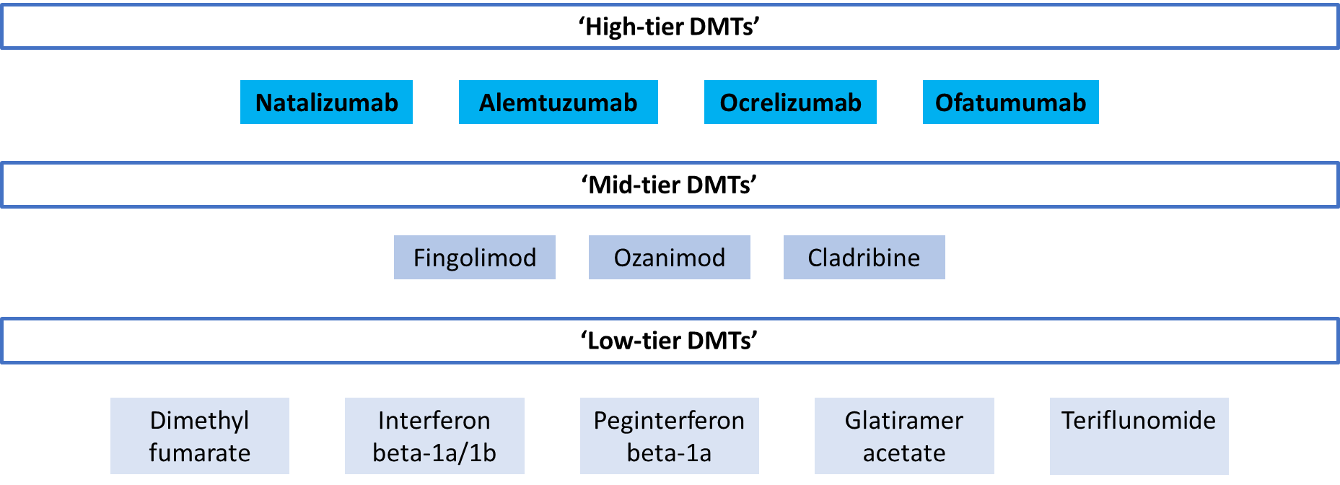

DMTs = disease modifying therapies; RRMS = relapsing remitting multiple sclerosis

Source: Figure ES ,1 of the submission

* 1. The submission stated that it did not expect the proposed new tier structure to impact the current price of any DMTs, including ofatumumab, but that it would delink the proposed high-tier group from the proposed mid-tier group from a pricing perspective. i.e. reference pricing between the high-tier and mid-tier groups would not be possible.
  2. The submission stated that it expected that, with generic entry and the associated subsequent price disclosure price cuts associated with fingolimod, the prices of other high-efficacy DMTs could be affected in the near future. In December 2022 the price of fingolimod on the PBS was reduced by 25% and the submission estimated that the price was likely to be reduced further due to upcoming price disclosure reductions, with the submission having estimated a total price reduction of around 52% by 1 October 2024. While the magnitude of price reductions for future price disclosure cycles are unknown, Novartis Pharmaceuticals Australia Pty Limited are also the sponsor of a brand of fingolimod.
  3. The request was made on the basis of a cost-effectiveness analysis versus fingolimod as described in Table 1.

Table 1: **Key components of the clinical issue addressed by the submission**

|  |  |
| --- | --- |
| Component | Description |
| Population | Patients with relapsing remitting multiple sclerosis |
| Intervention | Ofatumumab (20 mg SC monthly, following initial doses at week 0, 1,2 and week 4), as a proxy for other proposed high-efficacy DMTs including ocrelizumab, natalizumab and alemtuzumab. |
| Comparator | Fingolimod as a proxy for the proposed medium efficacy DMTs including cladribine and ozanimod. |
| Outcomes | ARR; proportion (%) free from relapse; 3- and 6-month confirmed disability progression/worsening; and safety (any adverse event) |
| Clinical claim | Ofatumumab, as a high-efficacy tier treatment, is considered superior to fingolimod, as proxy for the mid-efficacy tier, in terms of clinical effectiveness with a different but non-inferior safety profile.a |

ARR = annualised relapse rate; DMT = disease modifying therapy; mg = milligram; SC = subcutaneous

a Page 149 of the submission

Source: Table 2, p 24 and p 149 of the submission.

1. Background

Registration status

* 1. Ofatumumab was TGA registered on 4 March 2020 for the treatment of adult patients with relapsing forms of multiple sclerosis (RMS) to delay the progression of physical disability and reduce the frequency of relapse.

Previous PBAC consideration

* 1. Ofatumumab was recommended on a cost-minimisation basis versus fingolimod at the March 2021 PBAC meeting. “The PBAC’s recommendation for listing was based on, among other matters, its assessment that the cost-effectiveness of ofatumumab would be acceptable if it were cost minimised to the least costly therapy of either fingolimod, natalizumab, alemtuzumab, ocrelizumab, cladribine or ozanimod (the higher tier agents)” (paragraph 7.1, ofatumumab public summary document [PSD], March 2021 PBAC meeting).

1. Requested listing

|  |  |  |  |  |  |
| --- | --- | --- | --- | --- | --- |
| **MEDICINAL PRODUCT**  **medicinal product pack** | **Dispensed Price for Max. Qty** | **Max. qty packs** | **Max. qty units** | **№.of**  **Rpts** | **Available brands** |
| OFATUMUMAB | | | | | |
| 20mg/0.4ml injection (pen device), initial treatment | Published:$6,337.02  Effective:$　| | 3 | 3 | 0 | Kesimpta |
| 20mg/0.4ml injection (pen device), continuing treatment | Published: $2,184.33  Effective: $　| | 1 | 1 | 5 | Kesimpta |

* 1. The submission proposed no changes to the current price or PBS restriction for ofatumumab.

1. Population and disease
   1. MS is a chronic, immune-mediated disease of the central nervous system (CNS) characterised by inflammation, demyelination and axonal/neuronal destruction, ultimately leading to severe disability. The symptoms of MS vary significantly across patients depending on where in the brain or spinal cord lesions develop. Symptoms can manifest in any combination of the following five major health problems: motor control, fatigue, other neurological symptoms, continence problems and neuropsychological symptoms.
   2. There are three main forms of MS: RRMS; secondary progressive (SP) MS; and primary progressive (PP) MS. RRMS is the most common type of MS and is estimated to affect 85% of newly diagnosed MS patients. RMS is a term used to describe patients with RRMS and those with SPMS who still experience relapse events. Patients with RRMS experience exacerbations (‘flare-ups’ or relapses) of symptoms, followed by remission of symptoms. Patients with RRMS typically develop irreversible disability over time.
   3. The submission did not seek to change the current clinical treatment algorithm for RRMS in Australia.

*For more detail on PBAC’s view, see section 7 PBAC outcome.*

1. Comparator
   1. The submission nominated fingolimod as the main comparator. The submission stated that fingolimod would act as a proxy for the other DMTs proposed to make up the mid-efficacy tier (i.e. cladribine and ozanimod), and that ofatumumab would act as a proxy for the DMTs proposed to make up the high-efficacy tier. The evaluation and ESC considered that fingolimod likely remained an appropriate comparator for ofatumumab. However, as acknowledged by the submission, the other proposed mid-tier DMTs cladribine and ozanimod may also be considered appropriate comparators.
   2. The submission claimed that fingolimod was nominated as the main comparator as it was the most commonly used treatment for RRMS in Australia. However, the October 2020 DUSC report of ocrelizumab for the treatment of RRMS reported that while fingolimod was the DMT used to treat the most patients with RRMS from 2012 to 2020, the number of patients receiving fingolimod was decreasing and may be overtaken by other DMTs such as ocrelizumab in subsequent years.

*For more detail on PBAC’s view, see section 7 PBAC outcome.*

1. Consideration of the evidence

Sponsor hearing

* 1. The sponsor requested a hearing for this item. The clinician stated that the submission’s proposed high-efficacy tier comprised monoclonal antibodies which in his clinical experience eliminate relapses in most patients. Further, the clinician stated that the therapies that the submission proposed for inclusion in the mid-efficacy tier comprised oral therapies, which in his clinical experience generally do not control MS to the same degree.

Consumer comments

* 1. The PBAC noted and welcomed the input from an organisation, MS Australia, via the Consumer Comments facility on the PBS website. MS Australia outlined the importance of enabling access to a range of treatment options for patients with MS given individual variability in treatment response, concomitant conditions and circumstances (including access to health services for treatment, administration and monitoring).

Clinical trials

* 1. No head-to-head randomised controlled trials (RCTs) comparing ofatumumab with fingolimod for the treatment of RRMS were available. Instead, the submission was based on indirect treatment comparisons (ITCs) using:
* Two RCTs comparing ofatumumab with teriflunomide (ASCLEPIOS I and ASCLEPIOS II) and a pooled analysis of ASCLEPIOS I and II (Hauser 2020);
* Two RCTs comparing fingolimod versus placebo (FREEDOMS I and FREEDOMS II) and one versus interferon beta-1a (TRANSFORMS); and
* Two RCTs comparing teriflunomide and placebo (TEMSO and TOWER).
  1. These trials allowed a two-step ITC to be conducted between ofatumumab and fingolimod using the Bucher method with teriflunomide and placebo as the common comparators and TEMSO and TOWER as bridging trials. The PBAC had previously considered all the included trials in the March 2021 ofatumumab submission, as well as the results from this specific two-step ITC.
  2. Additionally, an inverse propensity treatment weighted (IPTW) comparison and a simulated treatment comparison (STC) were presented. These had not previously been considered by the PBAC.
  3. Details of the trials presented in the submission are provided in Table 2.

Table 2: **Trials and associated reports presented in the submission**

| **Trial ID** | **Protocol title/ Publication title** | **Publication citation** |
| --- | --- | --- |
| **Ofatumumab** | | |
|  | COMB157G2301. A randomized, double-blind, double-dummy, parallel-group study comparing the efficacy and safety of ofatumumab versus teriflunomide in patients with relapsing multiple sclerosis (ASCLEPIOS I). | December 2019 |
| ASCLEPIOSI/II | COMB157G2302. A randomized, double-blind, double-dummy, parallel-group study comparing the efficacy and safety of ofatumumab versus teriflunomide in patients with relapsing multiple sclerosis (ASCLEPIOS II) | December 2019 |
|  | COMB157G2301: A randomized, double-blind, double-dummy, parallel-group study comparing the efficacy and safety of ofatumumab versus teriflunomide in patients with relapsing multiple sclerosis (ASCLEPIOS I/II) | NR |
|  | Hauser, S. L., et al. Ofatumumab versus Teriflunomide in Multiple Sclerosis. | NEJM. 2020; 383(6): 546-557 |
| **Fingolimod** |  |  |
| FREEDOMS I | FTY720D2301. A 24-month double-blind, randomized, multicenter, placebo controlled, parallel-group study comparing the efficacy and safety of FTY720 1.25 mg and 0.5 mg administered orally once daily versus placebo in patients with relapsing-remitting multiple sclerosis. | NR |
|  | Kappos, L., et al. A placebo-controlled trial of oral fingolimod in relapsing multiple sclerosis. | NEJM. 2010; 362(5): 387-401 |
| FREEDOMS II | FTY720D2309. A 24-month double-blind, randomized, multicenter, placebo controlled, parallel-group study comparing the efficacy and safety of 0.5 mg and 1.25 mg fingolimod (FTY720) administered orally once daily versus placebo in patients with relapsing-remitting multiple sclerosis. | 13 January 2012 |
|  | Calabresi, P. A., et al. Safety and efficacy of fingolimod in patients with relapsing-remitting multiple sclerosis (FREEDOMS II): a double-blind, randomised, placebo-controlled, phase 3 trial. | Lancet. Neurology. 2014; 13(6): 545‐556. |
| TRANSFORMS | Cohen, J. A., et al. Oral fingolimod or intramuscular interferon for relapsing multiple sclerosis. | NEJM. 2010; 362(5): 402-415. |
| **Teriflunomide** |  |  |
| TEMSO | O'Connor, P., et al. Randomized trial of oral teriflunomide for relapsing multiple sclerosis. | NEJM. 2011; 365(14): 1293-1303. |
| TOWER | Confavreux, C., et al. Oral teriflunomide for patients with relapsing multiple sclerosis (TOWER): a randomised, double-blind, placebo-controlled, phase 3 trial. | The Lancet. 2014; Neurology 13(3): 247‐256 |

NR = not reported

Blue shaded cells indicate trials previously considered by the PBAC

Source: Table 10 of the submission

* 1. The submission also presented results from a network meta-analysis (NMA) by Samjoo 2023 to inform the relative effectiveness of the PBS-listed RRMS DMTs to support the proposed division of the current high-efficacy DMT tier into the proposed mid- and high-efficacy tiers. Additionally, a review of published NMAs including ofatumumab in RRMS was provided to support the results from Samjoo 2023.
  2. The key features of the included trials are summarised in Table 3.

**Table 3: Key features of the included evidence**

| **Trial** | **N** | | | **Design/ duration** | **Risk of bias** | | **Patient population** | | **Outcome(s)** |
| --- | --- | --- | --- | --- | --- | --- | --- | --- | --- |
| **Ofatumumab vs. teriflunomide** | | | | | | | | | |
| ASCLEPIOS I | 927 | | | R, DB, 30 months | Low | | RMS (RRMS or SPMS)  (94% RRMS) | | ARR, 3/6 month CDPa, proportion relapse free |
| ASCLEPIOS II | 955 | | | R, DB, 30 months | Low | | RMS (RRMS or SPMS)  (94% RRMS) | |
| **Teriflunomide versus placebo (bridging comparison)** | | | | | | | | | |
| TEMSO | 1088 | | | R, DB, 96 weeks | High | | RMS (RRMS, SPMS, or PRMS)  (91% RRMS) | | ARR, proportion relapse free |
| TOWER | 1169 | | | R, DB, 48+ weeks | High | | RMS (RRMS, SPMS, or PRMS)  (97% RRMS) | |
| **Fingolimod versus placebo** | | | | | | | | | |
| FREEDOMS I | 1272 | | | R, DB, 24 months | Low | | RRMS | | ARR, 3/6 month CDP, proportion relapse free |
| FREEDOMS II | 1083 | | | R, DB, 24 months | Low | | RRMS | |
| Fingolimod versus interferon‑beta-1a | | | | | | | | | |
| TRANSFORMS | | 1,292 | DB, DD, MC, R  ≥ 12 months | | | Low | | RMS | ARR, disability progression, MS related lesions |

ARR = annualised relapse rate; CDP = confirmed disability progression DB = double blind; PRMS = progressive-relapsing multiple sclerosis; R = randomised; RMS = relapsing multiple sclerosis; RRMS = relapsing-remitting multiple sclerosis; SPMS = secondary progressive multiple sclerosis

a The ASCLEPIOS I/II trials and the submission referred to this as confirmed disability worsening (CDW).

Blue shading indicates that the PBAC have previously reviewed these trials.

Source: Table 3, ofatumumab PSD, March 2021 PBAC meeting and Table 3, ozanimod PSD, March 2020 PBAC meeting.

* 1. In its March 2021 consideration of ofatumumab, the PBAC considered that the TEMSO and TOWER trials (comparing teriflunomide to placebo) had a high overall risk of bias. The PBAC considered that the TEMSO trial had a high risk of detection bias (as relapse outcomes identified by a blinded assessor had to be confirmed by an unblinded treating neurologist, meaning that the assessment was effectively unblinded), an unknown risk of attrition bias and a high risk of reporting bias. The TOWER trial had a similar assessment of risk of bias except it had an unknown risk of detection bias, a high risk of attrition bias and a low risk of reporting bias (paragraph 6.15, ofatumumab PSD, March 2021). The evaluation and the ESC considered that the high risk of bias with these trials may limit the interpretability of the ITC (paragraph 6.16, ofatumumab PSD, March 2021).
  2. While ASCLEIPOS I and II and FREEDOMS I and II had low risk of within trial bias, their use in the ITC was possibly confounded by several potential sources of intransitivity.
  3. With regards to baseline characteristics, patients in FREEDOMS II had a higher mean age, included a higher proportion of females, had a longer time since onset of MS symptoms, a longer time since MS diagnosis, a lower mean EDSS and a higher proportion of prior DMT use compared to patients in the other trials. Patients in FREEDOMS I and II also had a lower mean EDSS compared to patients in the other trials but a similar mean EDSS to patients in FREEDOMS II. Moreover, the mean number of relapses in the one year prior to enrolment was higher in FREEDOMS I and II (1.5) than in ASCLEPIOS I and II (1.2-1.3).
  4. With regards to prior DMT treatment, the majority of patients in ASCLEPIOS I and II had previously been treated with a DMT (58.9-61.8%), with interferon beta (37.6-38.3%) and glatiramer acetate (22.9-31.4%) most commonly used. Prior use of DMTs was lower in FREEDOMS I (40.4-42.6%), TEMSO (24.8-28.4%) and TOWER (34.0-35.0%) but was higher in FREEDOMS II (73.0-73.7%).
  5. The submission noted that the ofatumumab trials were conducted between 2016 and 2019, the fingolimod trials were conducted between 2006 and 2011 and the teriflunomide trials were published in 2011 and 2014. Consequently, the trials were conducted over a long time span which likely reduced their comparability due to the evolution of the diagnosis and treatment of MS during this period. This could be observed in the types of prior DMTs used. For example, only patients from the more recent ASCLEPIOS I and II reported any prior use of fingolimod, and the prior use of any high-efficacy tier DMT (based on the current definition) was higher in ASCLEPIOS I and II (13-17%) than FREEDOMS I and II (0.5-6.5%) or TEMSO (0%) and TOWER (0%).
  6. There were also differences in the diagnostic criteria used in the trials. ASCLEPIOS I and II required a diagnosis of MS using the 2010 McDonald criteria, whereas FREEDOMS I and II and TRANSFORMS required a diagnosis of MS using the 2005 McDonald criteria. In the TEMSO and TOWER teriflunomide trials, the MS diagnosis was made according to the 2001 and 2005 McDonald criteria, respectively. Gelfand 2014[1], in a review of the diagnosis of MS, noted that the result of revised versions of the McDonald criteria has been to successively encourage earlier diagnosis.
  7. Overall, given the differences between the baseline characteristics of the patients enrolled in each trial, and the differences in the time period at which each trial was conducted (which affected the diagnostic criteria and also the types of prior DMT used), there were a large number of transitivity issues with the ITC presented.

Comparative effectiveness

Two-step indirect treatment comparison

* 1. The annualised response rate (ARR) results for the included RCTs and the two-step ITC are presented in Table 4.

Table 4: **Ofatumumab vs teriflunomide vs placebo vs fingolimod: ARR of the included trials and ITC**

|  |  |  |  |  |  |
| --- | --- | --- | --- | --- | --- |
|  | Adjusted ARR (95%CI) | | |  | RR (95% CI); p-value |
| Trial | Ofatumumab | Teriflunomide | Placebo | **Fingolimod** |
| **Step 1** | | | | | |
| ASCLEPIOS I | 0.11 (0.09,0.14) | 0.22 (0.18,0.26) | - |  | **0.495 (0.374, 0.654); <0.001** |
| ASCLEPIOS II | 0.11 (0.08,0.13) | 0.25 (0.21,0.30) | - |  | **0.415 (0.308, 0.559); <0.001** |
| ASCLEPIOS I/II  pooled | 0.11 (0.09,0.13) | 0.24 (0.21,0.27) | - |  | **0.460 (0.380, 0.570); <0.001** |
| TEMSO | - | 0.37 (0.31, 0.44) | 0.54 (0.47, 0.62) |  | **0.68 (0.550, 0.850); 0.0005** |
| TOWER | - | 0.32 (0.27, 0.38) | 0.50 (0.43, 0.58) |  | **0.640 (0.510, 0.790); 0.0001** |
| TEMSO/TOWER  meta-analysis | - | - | - |  | **0.66 (0.56, 0.77); <0.00001 a** |
| **Indirect comparison (ofatumumab vs placebo)** | | | | | **0.303 (0.0.235, 0.390); <00001** |
| **Step 2** | | | | | |
| FREEDOMS I |  |  | 0.469 (0.412, 0.533) | 0.211 (0.178, 0.250) | **0.450 (0.365, 0.556); <0.0001** |
| FREEDOMS II |  |  | 0.394 (0.336, 0.462) | 0.204 (0.168, 0.249) | **0.519 (0.404, 0.667); <0.0001** |
| FREEDOMS I/II pooled |  |  | 0.438 (0.396, 0.485) | 0.209 (0.184, 0.238) | **0.477 (0.406, 0.561); <0.0001** |
| **Indirect comparison (ofatumumab vs fingolimod)** | | | | | **0.635 (0.470, 0.858); 0.0031** |

ARR = annualised relapse rate; CI = confidence interval; ITC = indirect treatment comparison; RR = relative risk

Source: Tables 38, 41, 44, 51, 52 pp 94, 99, 109 of the submission.

For ARR, RR< 1 favours ofatumumab

a As these figures show the RR for teriflunomide vs placebo, their inverse was used in order to include results for placebo vs teriflunomide in the ITC (RR (95% CI) = 1.520 (1.310, 1.770)).

Blue shading indicates values previously considered by the PBAC.

* 1. The ITC calculations and results were identical to those presented in the March 2021 ofatumumab submission. Previously, the PBAC considered that “(given the multiple steps in the indirect comparison and the differences in trial design, particularly in reference to the bridging comparator teriflunomide trials, these results must be interpreted with caution. All point estimates of the multi-step indirect comparisons favoured treatment with ofatumumab compared to treatment with fingolimod, cladribine, natalizumab or ocrelizumab (albeit with wide confidence margins), and overall there does not appear to be any evidence to suggest that treatment with ofatumumab would be inferior to fingolimod, cladribine, natalizumab or ocrelizumab” (paragraph 6.31, ofatumumab PSD, March 2021 PBAC meeting).
  2. The ARR results of the common reference teriflunomide arm in ASCLEPIOS I and II differed substantially with TEMSO and TOWER, with the upper 95% confidence interval (CI) of the ARR in ASCLEPIOS I and II (upper bound 95% CI 0.26 and 0.30) not overlapping with lower 95% confidence interval of TEMSO (lower bound 95% CI 0.31). Similarly, in the placebo arms, the ARR results in TEMSO and TOWER differed compared with FREEDOMS I and II, with the upper 95% confidence interval of the ARR in FREEDOMS II (0.394, 95% CI 0.336, 0.462) not overlapping with the lower 95% confidence interval of TEMSO (0.54, 95% CI 0.47, 0.62). The evaluation and the ESC considered that this suggested potential transitivity issues between the trials, and thus the results of the ITC may not be reliable.
  3. As for ARR, a two-step ITC was conducted to compare ofatumumab and fingolimod for the outcome of time to confirmed disability progression at three months (3mCDP). The results for the individual RCTs and the two-step ITC are presented in Table 5.

Table 5: Ofatumumab vs teriflunomide vs placebo vs fingolimod: Time to 3mCDP of the included trials and ITC

|  |  |  |  |  |  |  |  |  |  |
| --- | --- | --- | --- | --- | --- | --- | --- | --- | --- |
|  | Time to 3mCDP | | | | | |  | | HR (95% CI); p-value |
| Trial | Ofatumumab  n/N (%) | | | Teriflunomide  n/N (%) | | Placebo  n/N (%) | Fingolimod  **n/N (%)** | |
| **Step 1** | | | | | | | | | |
| ASCLEPIOS I | 45/465 (9.7) | | | 63/459 (13.7) | | - |  | | **0.652 (0.445, 0.957); p=0.029** |
| ASCLEPIOS II | 43/479 (9.0) | | | 62/472 (13.1) | | - |  | | **0.660 (0.447, 0.974); p=0.036** |
| ASCLEPIOS I/II pooled | 88/944 (9.3) | | | 125/931 (13.4) | | - |  | | **0.656 (0.499, 0.862); p=0.002** |
| TEMSO | - | | | 73/359 (20.0) | | 99/363 (28.0) |  | | **0.70 (0.51, 0.97); p=0.0279** |
| TOWER | - | | | 59/372 (27.0) | | 77/389 (39.0) |  | | **0.68 (0.47, 1.00); p=0.0442** |
| TEMSO/TOWER pooled a | - | | | 132/731 (23.6) | | 176/752 (31.7) |  | | **0.70 (0.54, 0.89); p=0.0029 b** |
| Indirect comparison (ofatumumab vs placebo) | | | | | | |  | | **0.459 (0.317, 0.665); p<0.00001** |
| **Step 2** | | | | | | | | | |
| FREEDOMS I | | - |  | | 89/415 (21.4) | | 62/421 (14.7) | **0.64 (0.46, 0.89); p=0.0071** | |
| FREEDOMS II | | - |  | | 84/353 (23.8) | | 71/357 (19.9) | 0.80 (0.58, 1.09); p=0.1559 | |
| FREEDOMS I/II meta-analysis | | - |  | | - | | - | **0.72 (0.57, 0.90); 0.005c** | |
| Indirect comparison (ofatumumab vs fingolimod) | | | | | | | | **0.638 (0.413, 0.985); p=0.0426** | |
| Indirect comparison (ofatumumab vs fingolimod, March 2021) d | | | | | | | | OR: 0.669 (0.422, 1.06), p=0.0870 | |

3mCDP = confirmed disability progression at 3 months; CI = confidence interval; HR = hazard ratio; ITC = indirect treatment comparison; n = number of patients with event; N = number of patients in the analysis.

Source: Tables 39, 42, 45, 51, 52 pp 95, 98, 99 and 109 of the submission.

a These figures could not be independently verified as the data source was not listed in the submission.

b As these figures show the HR for teriflunomide vs placebo, their inverse was used in order to include results for placebo vs teriflunomide in the ITC (RR (95% CI) = 1.43 (1.85, 1.12)).

c The results for the meta-analysis varied slightly from the FREEDOMS I and II 3mCDP pooled analysis (HR = 0.71 (95% CI 0.57, 0.89); p-value 0.0028.)

d In March 2021, the odds ratio rather than hazard ratio was used

Blue shading indicates values previously considered by the PBAC.

* 1. As for ARR, there were substantial differences between the results in the common reference arms, with differences in the proportion of patients treated with teriflunomide who experienced 3mCDP in ASCLEPIOS I and II (13.1% to 13.7%) and TEMSO (20.0%) and TOWER (27.0%). Similarly, the proportion of patients treated with placebo who experienced 3mCDP also differed substantially between TEMSO (28.0%), TOWER (39.0%) and FREEDOMS I and II (21.4 to 23.8%). Notably, the upper bound of the 95% confidence interval (95% CI) for the time to 3mCDP HR for ofatumumab compared to placebo (HR: 0.459, 95% CI: 0.317, 0.665) overlaps with the lower bound of the 95% CI for fingolimod compared to placebo (HR: 0.72, 95% CI: 0.57, 0.90). The evaluation and the ESC considered that this suggested that there may be transitivity issues between the trials, and thus the results of the ITC may not be reliable.
  2. In the March 2021 ofatumumab submission results for time to 3mCDP were presented as an odds ratio (OR), while the current submission presented results as a hazard ratio (HR). The change from OR to HR changed the conclusion, as the 3mCDP result with OR (OR = 0.669, 95% CI 0.422, 1.06; p-value = 0.0870) was not statistically significantly different at the 5% level unlike the results with HR as presented in the current submission.
  3. For time to confirmed disability progression at six months (6mCDP), a two-step ITC could not be conducted to compare ofatumumab vs fingolimod as results were not available for teriflunomide vs placebo. The available results for time to 6mCDP from the included trials are presented in Table 6.

Table 6: Ofatumumab vs placebo: Time to 6mCDP of the included trials

|  |  |  |  |  |  |
| --- | --- | --- | --- | --- | --- |
|  | Time to 6mCDP | | |  | HR (95% CI); p-value |
| Trial | Ofatumumab  n/N (%) | Teriflunomide  n/N (%) | Placebo  n/N (%) | Fingolimod  **n/N (%)** |
| ASCLEPIOS I | 35/465 (7.5) | 53/459 (11.5) | - | - | 0.607 (0.396, 0.930); 0.022 |
| ASCLEPIOS II | 36/479 (7.5) | 46/472 (9.7) | - | - | 0.756 (0.489, 1.170); 0.209 |
| ASCLEPIOS I/II pooled | 71/944 (7.5) | 99/931 (10.6) | - | - | 0.675 (0.498, 0.916);0.012 |
| TEMSO | - | NR | NR | - | NE |
| TOWER | - | NR | NR | - | NE |
| TEMSO/TOWER meta-analysis | - | NR | NR | - | NE |
| FREEDOMS I | - | - | 69/415 (16.6) | 42/421 (10.0) | 0.56 (0.38, 0.83); 0.0035 |
| FREEDOMS I | - | - | 49/353 (13.9) | 35/357 (9.8) | 0.67 (0.43, 1.03); 0.0671 |
| FREEDOMS I/II meta-analysis | - | - | - | - | 0.61 (0.45, 0.81); 0.0007 |
| Indirect comparison (Ofatumumab vs fingolimod) | | | |  | NE |

6mCDP = confirmed disability progression at 6 months; CI = confidence interval; HR = hazard ratio; ITC = indirect treatment comparison; n = number of subjects with event; N = number of subjects in the analysis; NE = not estimable; NR = not reported.

Blue shading indicates values previously considered by the PBAC.

Source: Tables 40, 43, 51, ,52 pp 96, 98, 100, and 109 of the submission.

* 1. Though not presented in the current submission, the March 2021 ofatumumab submission also presented the outcomes for proportion (%) relapse free for ofatumumab versus fingolimod (OR 1.498, 95% CI: 0.973, 2.306; p-value = 0.0667) which did not support the claim that ofatumumab was superior to fingolimod. As the PBAC has previously expressed a preference for the outcome of proportion relapse free as a basis for assessing durability of effect, the evaluation and the ESC considered this to be a relevant outcome.

Unanchored, unadjusted indirect comparison

* 1. The submission claimed that, based on an unanchored, unadjusted (naïve) indirect comparison, the absolute difference in ARR between fingolimod and ofatumumab based on ASCLEPIOS I/II (0.11, 95% 0.09, 0.13) and FREEDOMS I/II (0.21, 95%CI 0.18, 0.24) was 0.10, in favour of ofatumumab. This exceeded the minimally clinical important difference (MCID) defined in the submission of >0.04 which was proposed because “[t]he PBAC considered it reasonable to conclude that the absolute difference in ARR of 0.04 observed in the ITT analysis and 0.01 in the post-hoc subgroup was not clinically relevant…” (p4, teriflunomide PSD, July 2013 PBAC meeting). The submission therefore claimed “from this it may be inferred that an absolute difference of >0.04 in ARR represents a clinically important difference, hence between group differences greater than 0.04 were used to confirm superiority in the current submission.”
  2. The evaluation considered this was not a reasonable justification for a MCID. The PBAC had considered that a difference of 0.04 was not clinically meaningful, not that any difference greater than 0.04 was clinically meaningful. For example, a theoretical MCID of 0.20 (as this is greater than 0.04) would still be supported by the quote provided in paragraph 6.25. No MCID was provided for other outcomes (RR for ARR or HR for time to 3mCDP or 6mCDP).
  3. Further, the MCID was applied to a naïve unanchored ITC between trials with significant transitivity issues (see paragraphs 6.11 to 6.15), which increased the uncertainty of the result and likely precluded a meaningful conclusion.

Unanchored adjusted comparisons (IPTW and STC)

* 1. The submission presented unanchored propensity score analyses using IPTW to compare ofatumumab to fingolimod by balancing their trial populations through reweighting patients in the ofatumumab cohort to become more similar to the fingolimod cohort. This process accounted for the following variables that were identified from a published STC (Samjoo 2022):
* Tier 1 variables: age, body mass index, normalised brain volume, number of gadolinium enhancing T1 lesions, volume of T2 lesions; and
* Tier 2 variables: EDSS score at baseline, number of relapses in the past year, prior DMT experience , sex, race/ethnicity, and time since MS diagnosis.
  1. The base case presented in the submission adjusted for both Tier 1 and Tier 2 variables.
  2. In the propensity score analyses using IPTW, the effective sample size (ESS) was calculated to assess the impact of weighting on the IPD. Overall, the loss of information in the ofatumumab arm from propensity matching (for all outcomes) appeared to have been considerable when comparing the ESS of around 285 to an unadjusted sample size of 945 (i.e. an almost 70% loss).
  3. A summary of the base case IPTW results is presented in Table 7. The results of the IPTW presented were generally consistent with the Bucher two step ITC, though the point estimates were more favourable for ofatumumab in the IPTW.

Table 7: IPTW indirect comparison of ofatumumab vs fingolimod

|  |  |
| --- | --- |
| **Outcome** | **Ofatumumab vs fingolimod a** |
| ARR (RR [95% CI]) | 0.60 (0.45, 0.81) |
| Time to 3mCDP (HR [95% CI]) | 0.54 (0.29, 0.99) |
| Time to 6mCDP (HR [95% CI]) | 0.59 (0.31, 1.12) |

ARR = annualised relapse rate; CDP = confirmed disease progression; CI = confidence interval; HR = hazard ratio; IPD = individual patient data; IPTW = inverse probability treatment weighting; RR = relative risk.

a The propensity score analyses used pooled IPD for two ofatumumab trials (ASCLEPIOS I/II) and pooled IPD for three fingolimod trials (FREEDOMS I, FREEDOMS II, and TRANSFORMS).

Source: Table 54, p112 of the submission.

* 1. The submission stated that the IPTW and STC were conducted to, at least in part, overcome the issues of transitivity. However, the evaluation and the ESC considered that the analyses were associated with an unknown amount of bias due to the potential for missing observed or unobserved effect modifiers and/or prognostic variables. For example, the analyses did not adjust for the types of prior DMTs used (e.g. prior experience with a high-efficacy therapy) and comorbidities as the data were not available. Further, these analyses were unable to address issues related to the trials being conducted at different times (see paragraph 6.13 and 6.13).
  2. The National Institute for Health and Care Excellence (NICE) decision support unit (DSU) technical support document 18[2] stated that “an unanchored matching adjusted indirect comparison (MAIC) or STC effectively assumes that absolute outcomes can be predicted from the covariates; that is, it assumes that all effect modifiers and prognostic factors are accounted for. This assumption is very strong, and largely considered impossible to meet. Failure of this assumption leads to an unknown amount of bias in the unanchored estimate.”
  3. For the STC, multivariable regression models were specified using baseline characteristics as covariates and were fitted using IPD from ASCLEPIOS I/II. The models permitted outcomes to be estimated for the hypothetical situation where an average patient from the comparator trial received ofatumumab instead of fingolimod by predicting outcomes at the means of the covariates reported in the fingolimod trial. These predicted outcomes were then compared with published outcomes from the fingolimod trial to derive point estimates of ofatumumab relative to fingolimod.
  4. The same variables as used in the IPTW were included in the STC, with the base case including all Tier 1 and Tier 2 adjustment variables.
  5. A summary of the base case STC results is presented in Table 8.

Table 8**: STC results for the comparison of ofatumumab vs fingolimod**

|  |  |  |  |  |  |
| --- | --- | --- | --- | --- | --- |
|  |  | Ofatumumab vs fingolimod  < 1 favours ofatumumab | | |  |
|  | FREEDOMS I | | FREEDOMS II | TRANSFORMS | |
| Outcome |  | |  |  | |
| ARR, RR (95% CI) | 0.58 (0.41, 0.82) | | 0.51 (0.34, 0.76) | 0.66 (0.44, 0.98) | |
| % with 3mCDP, HR (95% CI) | 0.39 (0.24, 0.63) | | 0.29 (0.17, 0.49) | 0.63 (0.35, 1.12) | |
| % with 6mCDP, HR (95% CI) | 0.45 (0.27, 0.75) | | 0.49 (0.28, 0.84) | NR | |

3mCDP = 3-month confirmed disability progression; 6mCDP =, 6-month confirmed disability progression; ARR = annualised relapse rate; CI = confidence interval; HR = hazard ratio; NR = not reported; RR = rate ratio; STC = simulated treatment comparison.

Source: Table 55, p114 of the submission.

* 1. The submission concluded that the results from the STC analyses were consistent with those of the IPTW and the two-step ITC, demonstrating ofatumumab to be superior to fingolimod in the treatment of RRMS with respect to ARR and proportion with 3mCDP and 6mCDP. However, given the potential issues with the unanchored nature of the IPTW and STC introducing an unknown amount of bias, the evaluation and the ESC considered that all of the indirect analyses should be interpreted with caution. Further, the STC results were not consistent across analyses, with the proportion with 3mCDP not being statistically significantly different using the TRANSFORMS population, though it was statistically significant using the FREEDOMS I and II populations. The point estimate for ARR was also less favourable in the STC using TRANSFORMS.

Network meta-analysis

* 1. The submission additionally presented the results of a published systematic review and NMA by Samjoo (2023) that compared the efficacy of therapies for RMS. This represented an update of the NMA previously considered by the PBAC as part of the March 2021 ofatumumab submission (Samjoo 2020). The submission identified eight published NMAs and it was unclear why Samjoo 2023 was the only one highlighted in the submission.
  2. The Samjoo 2023 NMA included 41 trials, including five trials that were not included in the Samjoo 2020 NMA. The literature review for the NMA identified RCTs assessing the efficacy (and safety) of DMTs used for the treatment of patients with RRMS. While most of the RCTs included in the NMA were conducted specifically in patients with RRMS, 12 RCTs included patients with RMS (i.e. RRMS, SPMS or PRMS).
  3. Figure 2 presents the results of the NMA reported in Samjoo 2023 for ARR. The trials included for the direct network path from ofatumumab to fingolimod via teriflunomide 14mg and placebo were identical to the Bucher two-step ITC presented in the submission.

Figure 2: Forest plot for treatments compared with placebo for ARR analysis a

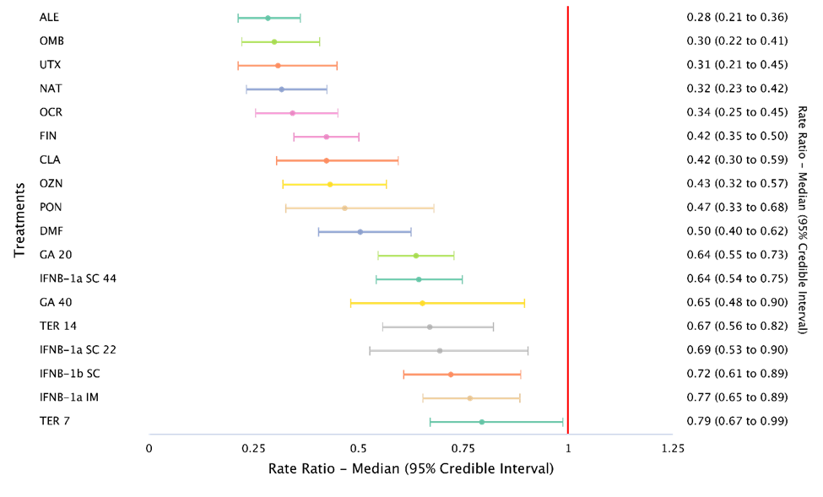

ALE = alemtuzumab; CLA = cladribine; DMF = dimethyl fumarate; FIN = fingolimod; GA = glatiramer acetate; IFN = interferon; IM = intramuscular; NAT= natalizumab; OCR = ocrelizumab; OMB = ofatumumab; OZN = ozanimod; PON = ponesimod; SC = subcutaneous; TER =, teriflunomide; UTX = ublituximab.

a Note The forest plot presents ARR results for individual DMTs compared with placebo, which contrasts with Samjoo 2020 where the forest plots presented ofatumumab compared to the individual DMTs.

Source: Figure 14 of the submission.

* 1. The submission claimed that the NMA results for the ARR, which was based on 39 RCTs and connected 19 treatments including placebo, showed that alemtuzumab, natalizumab, ocrelizumab, ofatumumab and ublituximab were the most efficacious treatments compared with placebo (RR: 0.28 to 0.34) and that these DMTs may be considered to represent top tier DMTs for ARR in RRMS.
  2. The evaluation and the ESC considered that the allocation of high and mid efficacy was not adequately justified and appeared somewhat arbitrary. The submission did not justify why the top five drugs (i.e. with highest efficacy for the outcome of ARR) were allocated to the high-efficacy tier. If the top six drugs were to be considered as “high-efficacy”, then both fingolimod and ofatumumab would be included in this tier. The evaluation and the ESC considered this would have been plausible given the overlapping confidence intervals. The submission also did not justify why ARR should be used to determine the tiers rather than another efficacy outcome.
  3. The ESC noted that the first eight drugs in Figure 1 (i.e. up to OZN = ozanimod) are included in the current high-efficacy DMT tier, and the drugs below this are included in the current low efficacy tier. The ESC re-iterated that there was no clear rationale provided for splitting the first eight drugs into different tiers.
  4. The submission presented the relative risks as reported by Samjoo 2023 for all the DMTs listed on the PBS relative to placebo for ARR grouped according to the proposed tiering (Figure 2).

Figure 2: ARR – subgroup analyses of the proposed high-, mid-, and low-efficacy tier DMTs versus placebo

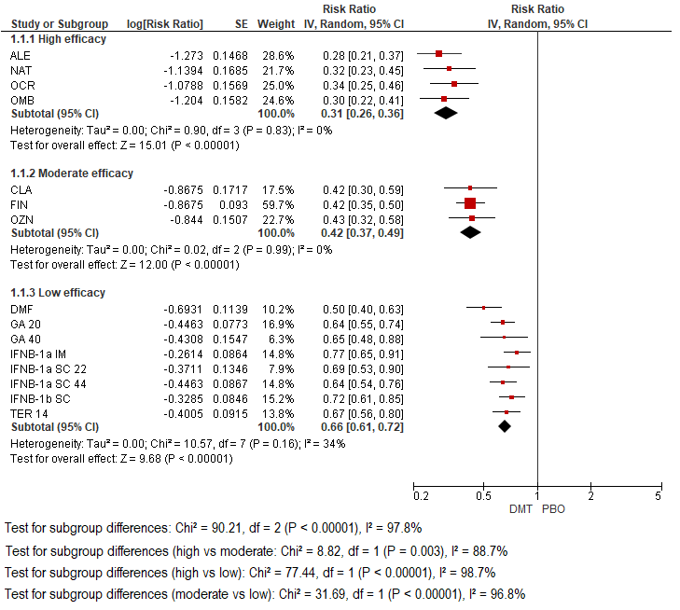

ALE = alemtuzumab; CLA = cladribine; DMF = dimethyl fumarate; FIN = fingolimod; GA = glatiramer acetate; IFN = interferon; IM = intramuscular; NAT= natalizumab; OCR = ocrelizumab; OMB = ofatumumab; OZN = ozanimod; PON = ponesimod; SC = subcutaneous; TER = teriflunomide.

Source: Figure 15 of the submission.

* 1. The submission and the pre-PBAC response claimed that the ARR treatment effect of the high-efficacy tier DMTs versus placebo (RR: 0.31 (95% CI: 0.26, 0.36)) was statistically significantly superior to that of the mid-efficacy tier DMTs versus placebo (RR: 0.42 (95% CI: 0.37, 0.49)). The submission claimed that this observation was confirmed by the test for subgroup differences between high- and mid-efficacy tier subgroups (I2=88.7%; p=0.003). Similarly, the submission reported the ARR treatment effect in the mid-efficacy tier DMTs versus placebo (RR: 0.42 (95% CI: 0.37, 0.49)) was statistically significantly superior to that of the low-efficacy tier DMTs versus placebo (RR : 0.66 (95% CI: 0.61, 0.72)), with this observation confirmed by the test for subgroup differences between mid- and low-efficacy tier subgroups being highly statistically significant (I2=96.8%; p<0.00001).
  2. While there appears to be a general trend that DMTs in the proposed high-efficacy tier have a better ARR than DMTs in the proposed mid-efficacy tier, and that DMTs in the mid-efficacy tier have a better ARR than DMTs in the low-efficacy tier, the 95% CIs for many drugs overlap including between drugs of different tiers. In fact, the 95% CI of each of the DMTs in the high-efficacy tier overlaps with the 95% CI of each of the DMTs in the mid-efficacy tier. This includes an overlap between the 95% CIs of ofatumumab and fingolimod.
  3. Further, the evaluation and the ESC considered that the robustness of comparing these trials is likely to be compromised due to the different time frames over which they were conducted. The use of DMTs and methods of diagnosis of MS have evolved considerably over time, thereby diminishing the comparability of the trials for different DMTs.
  4. The NMA results in Samjoo 2023 for time to 3mCDP for DMTs compared with placebo, which was based on 28 RCTs and connected 18 treatments including placebo, are presented in Figure 3.

Figure 3: Forest plot for treatments compared with placebo for time to 3mCDP analysis

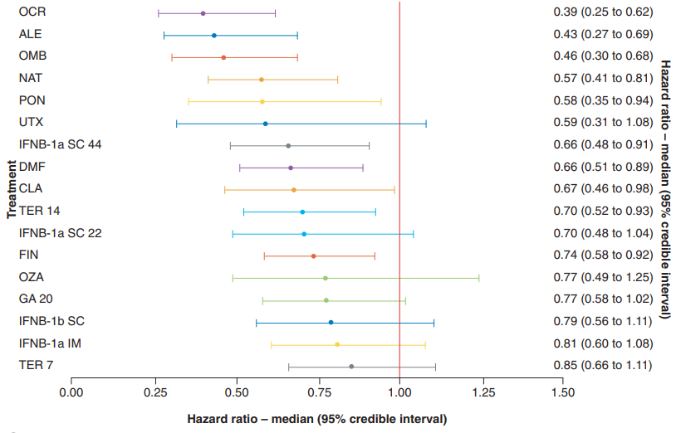

ALE = alemtuzumab; CDP = complete disease progression; CLA = cladribine; DMF = dimethyl fumarate; FIN = fingolimod; GA = glatiramer acetate; IFNB = interferon beta; IM = intramuscular; NAT= natalizumab; OCR = ocrelizumab; OMB = ofatumumab; OZN = ozanimod; PON = ponesimod; SC = subcutaneous; TER =, teriflunomide; UTX = ublituximab.

a Note The forest plot presents ARR results for individual DMTs compared with placebo, which contrasts with Samjoo 2020 where the forest plots presented ofatumumab compared to the individual DMTs.

Source: Figure 16 of the submission.

* 1. The HRs for all the DMTs listed on the PBS relative to placebo for time to 3mCDP were grouped according to the proposed tiering in the submission (Figure 4). The proposed efficacy tiers, particularly between proposed low- and mid- efficacy tiers, did not correlate with the time to 3mCDP results. As for ARR, the confidence intervals of the individual DMTs in the proposed high- and mid- efficacy tiers appear to substantially overlap.

Figure 4: Time to 3mCDP – subgroup analyses of the proposed high-, mid-, and low-efficacy tier DMTs versus placebo

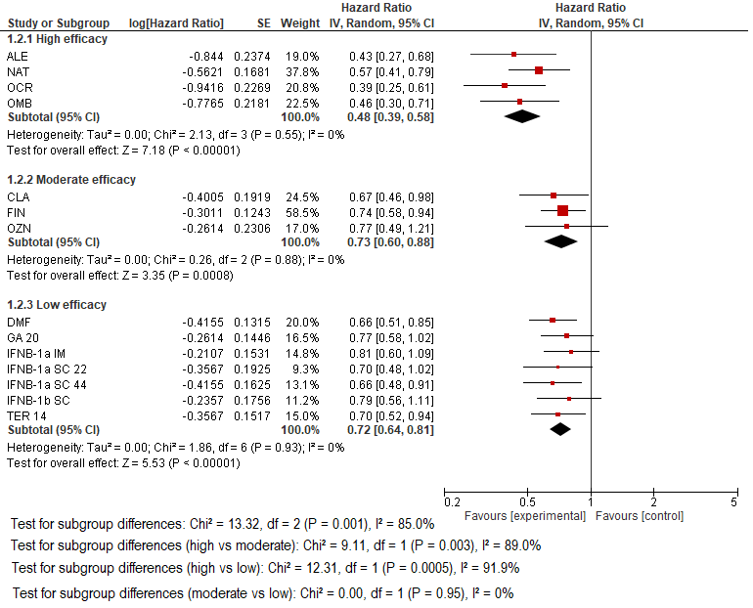

ALE = alemtuzumab; CLA = cladribine; DMF = dimethyl fumarate; FIN = fingolimod; GA = glatiramer acetate; IFN = interferon; IM = intramuscular; NAT= natalizumab; OCR = ocrelizumab; OMB = ofatumumab; OZN = ozanimod; PON = ponesimod; SC = subcutaneous; TER = teriflunomide.

Source: Figure 18 of the submission.

* 1. The results from the Samjoo 2023 for time to 6mCDP, which was based on 25 RCTs and connected 16 treatments including placebo, is provided in Figure 5.

Figure 5: Forest plot for treatments compared with placebo for time to 6mCDP analysis

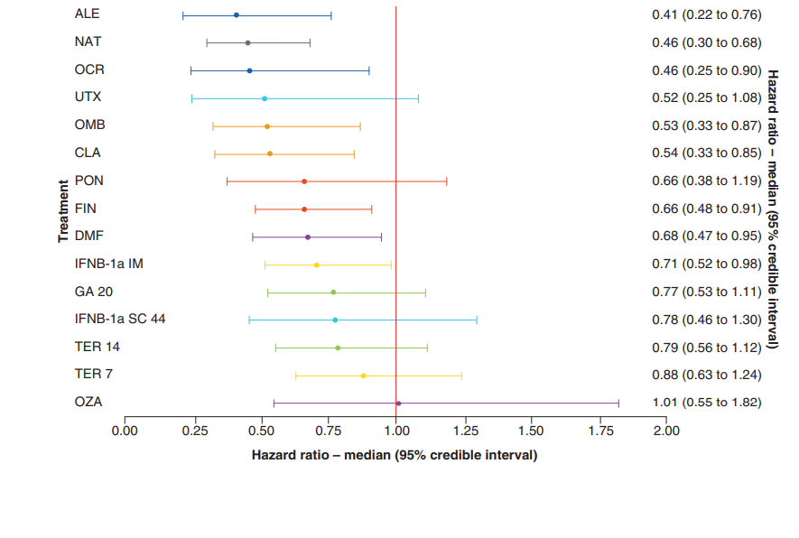

ALE = alemtuzumab; CDP = complete disease progression; CLA = cladribine; DMF = dimethyl fumarate; FIN = fingolimod; GA = glatiramer acetate; IFNB = interferon beta; IM = intramuscular; NAT= natalizumab; OCR = ocrelizumab; OMB = ofatumumab; OZN = ozanimod; PON = ponesimod; SC = subcutaneous; TER =, teriflunomide; UTX = ublituximab.

Source: Figure 19 of the submission.

* 1. All of the issues regarding the interpretation of the NMA for ARR (paragraphs 6.44 to 6.46) remain relevant to the NMAs for time to 3mCDP and 6mCDP i.e. the 95% CIs for many drugs overlap including between drugs of different tiers; the relevance of comparing pooled results between these groups remains unclear; and the robustness of comparing these DMT trials may be compromised due to the different time frames over which they were conducted.
  2. The submission also presented the results of a systematic literature review that identified seven other recently published NMAs in addition to Samjoo 2023 that included ofatumumab and other DMTs for the treatment of RRMS (Asha 2021, Chen 2023, Drudge 2022, I.C.E.R. 2023, Liu 2021, Śladowska 2022 and Wu 2022).
  3. The submission reported that all the published NMAs that included fingolimod as a comparator (Chen 2023, I.C.E.R. 2023, Liu 2021) reported statistically significantly superior risk reduction in ARR for ofatumumab versus fingolimod, however this was not the case for Drudge 2022 (RR: 0.84 (95% CI: 0.20, 3.39)) and Samjoo 2023 (RR: 0.70 (95% CI 0.51, 1.03)).
  4. Only Chen 2023, I.C.E.R. 2023 and Samjoo 2023 reported NMA results for time to 3mCDP. For these three studies, the HR for ofatumumab versus fingolimod was 0.59-0.62, although these results were not always statistically significant (Chen 2023 (HR (95% CI) = 0.60 (0.41, 0.88)), I.C.E.R. 2023 (HR (95% CI) = 0.59 (0.34,1.02)) and Samjoo 2023 (HR (95% CI) =0.62 (0.38 1.00)).

Comparative harms

* 1. The submission considered that a two-step ITC was not appropriate for safety, and instead presented a naïve indirect comparison of adverse events associated with ofatumumab versus fingolimod. The submission considered that the safety profiles of ofatumumab and fingolimod are different, typically relating to the differences in the mode of action and method of administration.
  2. In its March 2021 consideration of ofatumumab, the PBAC “noted that whilst it was difficult to evaluate the comparative safety of ofatumumab and the comparators due to the differences in the overall safety profiles, mechanisms of action, treatment regimens, routes of administration and other factors, the Committee considered the overall adverse event profile was likely non-inferior to ocrelizumab and comparable to that of any of the other higher tier agents and that there were no specific signals which would indicate ofatumumab is of inferior safety to these therapies” (paragraph 7.9, ofatumumab PSD, March 2021 PBAC meeting). As no new comparative safety data were provided, the evaluation and the ESC considered that these comments remained applicable.

Benefits/harms

* 1. The ESC considered that the comparisons presented in the submission were not sufficiently reliable to allow for a robust quantitative comparison of the benefits and harms of ofatumumab versus fingolimod. Accordingly, a benefits/harms table has not been presented.

Clinical claim

* 1. The submission claimed that oofatumumab (as a high-efficacy tier treatment) is superior to fingolimod (as proxy for the mid-efficacy tier) in terms of clinical effectiveness with a different but non-inferior safety profile. The evaluation and the ESC considered the claim of superior effectiveness was not adequately supported by the evidence presented in the submission because:
* The claim relied on a two-step indirect comparison, a network meta-analysis and two unanchored, adjusted (IPTW and STC) comparisons. There were substantial transitivity and exchangeability issues between the trials that were included in the two-step indirect comparison in terms of baseline characteristics (e.g. proportion with prior DMT use, types of prior DMT used, number of relapses in the previous year, and longer time since onset of MS symptoms in FREEDOMS II). Further, the included trials were conducted over a wide time period. This was likely to have reduced the comparability of the trials due to the evolution of the treatment of MS (i.e. introduction of high-efficacy DMTs) and the diagnosis of MS (e.g. changes in the McDonald diagnostic criteria) during this period. The ESC considered that the transitivity issues were evidenced by the differences between the ARR rates in the two common reference arms.
* The unanchored IPTW and STC analyses were associated with an unknown amount of bias due to the potential for missing observed or unobserved effect modifiers and/or prognostic variables (including the type of prior DMT and the time at which each trial was conducted)..
* A statistically significant difference was not consistently observed across all approaches. For example, the time to 3mCDP results using OR rather than HR (OR = 0.669, 95% CI 0.422, 1.06, p = 0.087) were not statistically significantly different between ofatumumab and fingolimod. Further, the proportion relapse free result (OR = 1.498, 95% CI: 0.973, 2.306; p-value = 0.0667), which the PBAC had previously considered to be the preferred outcome for sustained benefit (paragraph 6.10, alemtuzumab PSD, November 2018 PBAC meeting), were not statistically significantly different between ofatumumab and fingolimod, based on results presented in the March 2021 ofatumumab submission.
  1. The two-step ITC (via teriflunomide and placebo) was previously seen by the PBAC in the March 2021 ofatumumab submission. At this consideration, the PBAC did not accept that ofatumumab provided a significant improvement in efficacy over fingolimod (paragraph 7.4, ofatumumab PSD, March 2021 PBAC meeting). The PSCR stated that the previous claim of non-inferiority versus fingolimod was a conservative approach to enable faster access, and that new adjusted analyses (IPTW and STC) with consistent results were now provided to help address the transitivity issues with the two-step ITC. However, the ESC considered that the new evidence was also associated with the potential for bias and did not sufficiently support a claim of superiority.
  2. Additionally, the evaluation and the ESC considered that the proposed classification of ofatumumab, alemtuzumab, ocrelizumab and natalizumab as high-efficacy tier DMTs and fingolimod, cladribine and ozanimod as mid-tier DMTs was not reasonable as the classification appeared arbitrary. It was unclear why the top five drugs (i.e. with highest efficacy for the outcome of ARR) in the Samjoo 2023 network meta-analysis were allocated to the high-efficacy tier, noting fingolimod was “ranked” sixth and that the results for ofatumumab and fingolimod were similar for ARR in this analysis versus placebo, with overlapping 95% confidence intervals (ofatumumab 0.30 (95% CI: 0.22, 0.41); fingolimod 0.42 (95% CI 0.35, 0.50).
  3. Overall, the PBAC considered that the claim of superior comparative effectiveness was not adequately supported by the data.
  4. Further, the nomination of alemtuzumab and ocrelizumab as higher efficacy disease DMTs than fingolimod would contradict the PBAC’s previous decisions, given:
* At the July 2014 PBAC meeting, the PBAC considered that a claim of superiority for alemtuzumab compared to fingolimod was not supported though a claim of non-inferiority was appropriate. The evidence provided by the sponsor of alemtuzumab included both mixed treatment comparisons and indirect comparisons (similar to the current submission) which the PBAC noted was uncertain due to the high risk of bias of such comparisons (paragraph 6.25, alemtuzumab PSD, July 2014 PBAC meeting). As such the evaluation and the ESC considered that, in the absence of further evidence, it would be unreasonable for alemtuzumab to be classified as a higher efficacy drug than fingolimod; and
* At the July 2017 PBAC meeting, the PBAC considered that ocrelizumab was non-inferior to fingolimod (paragraph 7.6, ocrelizumab PSD, July 2017 PBAC meeting). There was no statistically significant difference in relapse outcomes between ocrelizumab and fingolimod (results favoured ocrelizumab), with the indirect estimate of effect for annualised relapse rate meeting the nominated non-inferiority margin (the upper CI was less than 1.23) for one comparison but not for the other comparison (paragraph 6.15, ocrelizumab PSD, July 2017 PBAC meeting). As such the evaluation and the ESC considered that, in the absence of further evidence, it would be unreasonable for ocrelizumab to be classified as a higher efficacy drug than fingolimod.
  1. The evaluation and the ESC considered the claim of a different but non-inferior safety profile was likely reasonable. The PBAC had previously considered that “the overall adverse event profile [of ofatumumab] was likely comparable to that of any of the other higher tier agents and that there were no specific signals which would indicate ofatumumab is of inferior safety to these therapies” (paragraph 7.9, ofatumumab PSD, March 2021 PBAC meeting).
  2. The PBAC considered that the submission’s claim that ofatumumab has a different but non-inferior safety profile compared with fingolimod was reasonable.

Economic analysis

* 1. The current listing of ofatumumab was determined on a cost-minimisation basis with fingolimod but, by virtue of a price reduction for fingolimod in December 2022, ofatumumab currently has a price premium relative to fingolimod.
  2. The submission presented a cost-utility analysis (CUA) to compare ofatumumab versus fingolimod. The submission stated that this comparison was intended to reflect the difference in cost-effectiveness between the proposed high-efficacy tier DMTs (natalizumab, alemtuzumab, ocrelizumab, ofatumumab) and the proposed mid-efficacy tier DMTs (fingolimod, cladribine, ozanimod). Through the economic evaluation the submission sought to demonstrate that the current price premium of ofatumumab versus fingolimod (i.e. the price difference due to fingolimod having undergone a 25% price reduction in December 2022, refer to paragraph 1.5) is cost-effective and that the current ofatumumab price is a reasonable benchmark for high-efficacy tier DMTs versus mid-efficacy tier MS DMTs.
  3. A CUA was only appropriate if a claim of superior efficacy was accepted. However as discussed in paragraphs 6.57, the ESC considered that the available evidence did not adequately support a claim of superiority of ofatumumab (or any of the proposed high-efficacy DMTs) compared to fingolimod and as such the CUA presented may not be appropriate.
  4. Table 9 presents the key components and assumptions of the economic analysis.

Table 9**: Key components of the economic evaluation**

| Component | Description | Justification/comments |
| --- | --- | --- |
| Time horizon | Lifetime horizon: base case starting age of 37 years; time horizon: 63 years (assumes 100% mortality for patients aged 100 years). | Lifetime time horizon was consistent with published CUAs identified in the submission. The mean patient age at baseline in the identified clinical trials and database sources was usually in the range of 36 to 38 years. |
| Methods used to generate results | Markov cohort model with annual cycles | This was reasonable. |
| Health states | 31 Health States:   * 10 health states=RRMS EDSS 0 - 9, DMT * 10 health states=RRMS EDSS 0 - 9, BSC * 10 health states=SPMS EDSS 0 - 9, BSC * 1 health state=Death | The health states did not allow patients to receive subsequent lines of DMT after discontinuation of first-line ofatumumab or fingolimod, which was not in line with clinical practice. |
| Transition Probabilities | * Transitions within RRMS EDSS health states for BSC were informed by placebo data from the FREEDOMS trial for time to 3mCDP. * EDSS progression was delayed in the DMT arms by application of HRs of time to 3mCDP (see Table 5 and S). * Transitions from RRMS to SPMS (varied by EDSS health state) and transitions within SPMS EDSS health states were informed by London Ontario MS registry data. * Transitions from first-line treatment to BSC were informed by treatment persistence curves for fingolimod in the Australian setting published by Spelman (2017) (assumed to apply to all DMTs) and treatment discontinuation upon progression SPMS health states. However, discontinuation was not associated with worsening of EDSS. * Treatment efficacy was based on delaying progression to higher RRMS EDSS health states and lower rates of relapse. | In the model, patients received first-line ofatumumab or fingolimod and then transitioned to BSC upon discontinuation. The evaluation and the ESC considered this was inconsistent with Australian clinical practice where patients can receive subsequent lines of DMT.  The FREEDOMS trials were conducted between 2006 and 2011, prior to the widespread use of DMTs for the treatment of RRMS. Consequently, the evaluation and the ESC considered there may be applicability issues when using the data from FREEDOMS as the basis to inform the current model. |
| Mortality rates | Transitions to death were based on relative risk of mortality by EDSS health state from Pokorski 1997, applied to Australian lifetables. | The Pokorski 1997 data was sourced ~40 to 50 years ago. The ESC considered it was unlikely that these mortality estimates are applicable given changes in MS treatment.  The calculated relative risk of death compared to the general population was not specific to RRMS or SPMS. This was unlikely to be consistent with current clinical practice as patients with SPMS have a more advanced for of MS. |
| Utility values | Health state utility values (base case) were based on published data (Orme 2007), which were specific for the patient’s type of MS (RRMS or SPMS) and EDSS status.   |  |  |  | | --- | --- | --- | | EDSS | RRMS | SPMS | | 0 | 0.870 | 0.825 | | 1 | 0.799 | 0.754 | | 2 | 0.705 | 0.660 | | 3 | 0.574 | 0.529 | | 4 | 0.610 | 0.565 | | 5 | 0.518 | 0.473 | | 6 | 0.460 | 0.415 | | 7 | 0.297 | 0.252 | | 8 | -0.049 | -0.094 | | 9 | -0.195 | -0.240 | | 10 | 0.000 | 0.000 |   Disutility (-0.071) was associated with a relapse event which was also based on Orme 2007. No disutility was applied for adverse events. | The evaluation considered this was reasonable. |

3mCDP = 3-month confirmed disability progression; 6mCDP = 6-month confirmed disability progression; AMSLS = Australian MS Longitudinal study; BSC = best supportive care; CUA = cost utility analysis; DMT = disease modifying therapy; EDSS = Expanded Disability Status Scale; HR = hazard ratio; QALYs = quality-adjusted life years; RRMS = relapsing remitting multiple sclerosis; SPMS = secondary progressive multiple sclerosis

Source: Table 71 of the submission.

* 1. The model was based on the Markov model for fingolimod versus interferon beta-1a that was submitted to PBAC in March 2011. The Markov model structure allowed different health state transition probabilities, cost and utility inputs to be applied depending on MS type and the treatment being received. The model differentiated MS subtypes (RRMS and SPMS) by EDSS health states and by whether patients were receiving DMT (ofatumumab or fingolimod) or best supportive care (BSC).
  2. Figure 6 provides a simplified decision tree diagram of the Markov model structure.

Figure 6: Simplified decision tree diagram

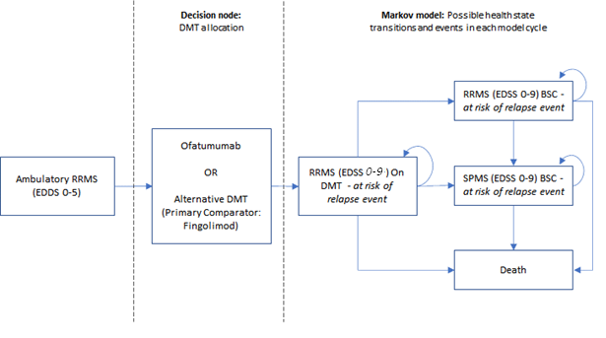

DMT = disease modifying therapy; EDSS = Expanded Disability Status Scale; RRMS = relapsing remitting multiple sclerosis; SPMS = secondary progressive multiple sclerosis

Text in italics indicate correction made during evaluation to show that patients with RRMS could remain on DMT if EDSS was 0 to 9.

Source: Figure 23 of the submission.

* 1. The model assumed that all patients commenced treatment with either ofatumumab or fingolimod and then transitioned to BSC, without the option to receive a subsequent DMT which was inconsistent with Australian clinical practice and limited the applicability of the model results. While the submission claimed that it was unclear whether patients would receive further DMTs after discontinuing a first-line treatment in MS, the evaluation and the ESC considered that at least a proportion of RRMS patients would likely receive second or subsequent line DMT as the PBS restrictions do not preclude such use, which is supported by treatment guidelines. For example, in the DUSC consideration of ocrelizumab in October 2020, it was reported that 52.5% of MS patients had at least one drug switch from 1 January 2004. (Table 4, Item 7.6 DUSC October 2020). The exclusion of second-and subsequent lines of DMT likely favoured ofatumumab in the model. The pre-PBAC response stated that the submission included a sensitivity analysis in which patients persisted on a high-efficacy (ofatumumab) or mid-efficacy tier treatment (fingolimod) until progression to SPMS or death, which resulted in an ICER of $5,000 to < $15,000/QALY. The pre‑PBAC response stated that this represented a scenario where patients would either persist on one, or switch between multiple, high-efficacy tier treatments in the ofatumumab arm and mid-efficacy tier treatments in the fingolimod arm.
  2. For transitions between EDSS health states within RRMS, the model used a reference transition matrix based on the placebo arm of the FREEDOMS trials and then applied treatment effect estimates based on the time to 3mCDP results of the ITC (ofatumumab vs placebo) and FREEDOMS I/II (fingolimod vs placebo). In patients with RRMS, at each cycle the model allowed patients to either move to a higher EDSS health state (disease progression), move to a lower EDSS health state (improvement in disability) or to remain in the same EDSS health state.
  3. Unlike the fingolimod March 2011 submission, the current submission did not assume that patients who progress to EDSS ≥6 will discontinue DMT which was more aligned to clinical practice and addressed a concern the PBAC had with the fingolimod March 2011 model. However, in March 2011, the PBAC had considered that the derivation and application of trial-based transition probabilities to the modelled economic evaluation may not be appropriate, given the use of whole point EDSS transitions… and no more than one transition per year may not appropriately reflect MS progressions in real life and DMT treatment on the PBS (pp5-6, fingolimod PSD, March 2011 PBAC meeting). The evaluation and the ESC considered this issue had not been adequately addressed.
  4. The submission’s model base case used natural history data from the London Ontario dataset (Scalfari 2010), which comprised registry data from the 1980s, to inform the probability of progression from RRMS to SPMS as well as the transition between EDSS in SPMS patients. The evaluation and the ESC considered that these probabilities may be associated with uncertainty as:
* The probability of progression from RRMS to SPMS was dependent on EDSS but not in a progressive manner, as the risk was highest at EDSS 5 (30%) and then subsequently decreasing at EDSS 6 (24%), EDSS 7 (25%) and EDSS 8 (15%) before increasing again such that all patients who moved to the RRMS EDSS 9 health state automatically moved to SPMS (probability = 100%) which was based on an assumption. This may not accurately reflect the natural history of MS.
* The data could not be independently verified.
  1. The evaluation and the ESC considered that the some of the transition probabilities used in the model were outdated and presented an applicability issue. In the model, half of all patients were considered to have progressed from RRMS to SPMS at 13.5 and 12.5 years for ofatumumab and fingolimod, respectively. However, Fambiatos 2020, a longitudinal study of 15,717 MS patients, reported that “over the course of almost two decades, the reported median time from MS onset to SPMS has increased from just under 15 years to over 30 years” and the rate of progression of RRMS to SPMS appears to have slowed considerably over time with the widespread use of DMTs. Nonetheless, the base case of the model does not appear to be sensitive to the assumed transition from RRMS to SPMS.
  2. The key drivers of the model are highlighted in Table 10.

Table 10: **Key drivers of the model**

| Description | Method/Value | Impact  Base case: ofatumumab dominant over fingolimod |
| --- | --- | --- |
| Transition probabilities, efficacy (time to 3mCDP) | The base case model and the sensitivity analyses presented in the submission used point estimates from the ITC (ofatumumab versus placebo) and FREEDOMS (fingolimod versus placebo) to represent the DMT treatment effect estimates applied to EDSS progression in patients with RRMS. | High, favoured ofatumumab. The evaluation and the ESC considered that the evidence provided did not support superior efficacy or justify a cost utility analysis. Additional sensitivity analyses conducted during the evaluation to investigate the 95% CIs for the time to 3mCDP HRs found that if the ofatumumab upper 95% CI and the fingolimod lower 95% CI were used, the results of the economic analysis flipped such that fingolimod dominated ofatumumab. The ESC considered this analysis highlighted the uncertainties associated with the clinical data. |
| Model duration | Lifetime model duration assumed, as in the fingolimod 2011 model. | High, favoured ofatumumab.  Use of a 2-year model duration resulted in an ICER of $||||1 QALY gained and use of a 10-year time horizon resulted in an ICER of $||||2/QALY gained. |
| Drug costs, price of fingolimod | The PBS price of fingolimod was reduced by 25% in December 2022 and the submission considered it was likely to be reduced further due to price disclosure. | High, favoured ofatumumab.  Inclusion of a 20% fingolimod price reduction resulted in an ICER of $||||2/QALY gained.. |
| Drug costs, ofatumumab doses | The submission included 14 doses of ofatumumab in Year 1 and 12 doses of ofatumumab in subsequent years. While these figures were included in the ofatumumab March 2021 cost-minimisation, they were not accepted by the PBAC who found it appropriate to include ofatumumab doses based on ASCLEPIOS I/II (15 doses in Year 1 and 13 doses in subsequent years.) with the difference due to monthly versus 4-weekly dosing. | Moderate, favoured ofatumumab.  Inclusion of 15 ofatumumab doses in Year 1 and 13 ofatumumab doses in subsequent years resulted in an ICER of $||||3. |
| EDSS health state costs | The model incorporated published EDSS health state costs for RRMS and SPMS (Ahmad 2018). DMTs costs were removed from within the health state cost for patients with RRMS, but these costs were included for patients with SPMS despite no efficacy of DMTs being applied. | Moderate, favoured ofatumumab.  Assuming the health state costs based on EDSS to be the same for patients with RRMS and SPMS resulted in an ICER of $||||3/QALY gained. |

BSC = best supportive care; CDP = confirmed disability progression; EDSS = Expanded Disability Status Scale; ICER = incremental cost-effectiveness ratio; ITC = indirect treatments comparison; QALY = quality-adjusted life year; RRMS = relapsing remitting multiple sclerosis; SPMS = secondary progressive multiple sclerosis.

Source: Constructed during the evaluation using Kesimpta_Section 3_model November 2023 deadline.xls.

*The redacted values correspond to the following ranges:*

*1 $155,000 to < $255,000*

*2 $15,000 to < $25,000*

*3 $5,000 to < $15,000*

* 1. The submission claimed that the stepped economic evaluation demonstrated that the current price premium of ofatumumab versus fingolimod is cost-effective at a base case incremental cost effectiveness ratio (ICER) that was dominant. The results of the stepped economic evaluation are presented in Table 11.

Table 11: **Results of the stepped economic evaluation**

|  |  |  |  |  |  |  |
| --- | --- | --- | --- | --- | --- | --- |
| Analysis | Outcome | Costs | Horizon | Incremental cost ($) | Incremental outcome | ICER ($) |
| Step 1: Trial-based economic evaluation (DMT costs only) | Number of relapses avoided | DMT costs | 2-years | | | 0.11 | ||1 |
| 1-point EDSS improvement | DMT costs | 2-years | | | 0.07 | ||2 |
| Step 2: Trial-based economic evaluation (total costs) | Number of relapses avoided | Total costs | 2-years | | | 0.11 | ||3 |
| 1-point EDSS improvement | Total costs | 2-years | | | 0.07 | ||1 |
| Step 3: Trial-based outcomes extrapolation to lifetime model | Number of relapses avoided | Total costs | Lifetime | -　| | 0.29 | Dominant |
| 1-point EDSS improvement | Total costs | Lifetime | -　| | 0.07 | Dominant |
| Step 4: Transformation of modelled outcomes to QALYs | QALYs | Total costs | Lifetime | -　| | 0.47 | Dominant |

DMT = disease modifying therapy; EDSS, Expanded Disability Status Scale; ICER, incremental cost-effectiveness ratio; QALYs, quality-adjusted life years.

Source: Table 115 of the submission.

*The redacted values correspond to the following ranges:*

*1 $35,000 to < $45,000*

*2 $45,000 to < $55,000*

*3 $25,000 to < $35,000*

* 1. The base case results of the economic model is presented in Table 12.

Table 12 Disaggregated results of the base case of the economic model

|  |  |  |  |
| --- | --- | --- | --- |
| **Cost category** | **Ofatumumab** | **Fingolimod** | **Incremental:** |
| **Drug costs** | $| | $51,063 | $| |
| Administration costs | $20 | $89 | -$69 |
| EDSS health state healthcare resource costs | $248,805 | $259,422 | -$10,617 |
| Relapse event costs | $10,312 | $10,506 | -$194 |
| Total cost | $| | $321,079 | -$| |
| **Outcome** |  |  |  |
| Life Years | 16.66 | 16.60 | 0.07 |
| Total QALYs | 7.89 | 7.41 | 0.47 |
| **Base case ICER** | **-** | **-** | **Ofatumumab Dominant** |

Source: Table 116 and 117 of the submission.

* 1. The results of key sensitivity analyses presented by the submission and conducted during the evaluation are summarised in Table 13.

Table 13: Key sensitivity analyses

| **Category** | **Parameter** | **Base case input** | **Sensitivity input** | **Incr. Cost ($)** | **Incr.**  **QALY** | **ICER ($)** |
| --- | --- | --- | --- | --- | --- | --- |
| **Base case** | **-** | **-** | **-** | **-||** | **0.473** | **Ofatumumab Dominant** |
| **Model structure** | Model duration | 63 years | 2 years | || | 0.019 | |　1 |
| 10 years | || | 0.155 | |　2 |
| **Transition probabilities – efficacy** | Efficacy: EDSS progression (3mCDP), ofatumumab | ITC point estimate, HR = 0.459 | ITC ofatumumab upper 95% CI, HR=0.665 | || | 0.111 | |　3 |
| Samjoo 2023 ofatumumab upper 95% CI, HR=0.71 | || | 0.063 | |　4 |
| Efficacy: EDSS progression (3mCDP), fingolimod | HR = 0.72  (trial point estimate) | ITC fingolimod lower 95% CI, HR = 0.57 | || | 0.219 | |　2 |
| Samjoo 2023 fingolimod lower 95% CI, HR=0.58 | || | 0.229 | |　2 |
| Efficacy: EDSS progression (3mCDP), Ofatumumab and fingolimod | 3mCDP HR vs PBO: Ofatumumab 0.459; fingolimod 0.72 | ITC ofatumumab upper 95% CI, HR=0.665  ITC fingolimod lower 95% CI, HR = 0.57 | || | -0.14 | Fingolimod dominant |
| **Transition probabilities - efficacy** | Efficacy: EDSS progression | 3mCDP HR vs PBO: Ofatumumab 0.459; fingolimod 0.72 | 6mCDP HR vs PBO (Samjoo 2023): Ofatumumab 0.53; fingolimod 0.72 | || | 0.245 | |　5 |
| **Drug costs** | Price of fingolimod | Dec 2022 price | 20% fingolimod reduction | || | 0.473 | |　2 |
| Two fingolimod 20% price reductions | || | 0.473 | |　6 |
| Number of doses of ofatumumab | Year 1: 14;  Year 2+: 12 | Year 1: 15;  Year 2+: 13 as in ASCLEPIOS | || | 0.473 | |　5 |
| Ofatumumab doses in year 1 (6 months after half cycle correction) | 7 | 8 | || | 0.473 | |　7 |
| **Health care resource costs** | Drug costs in EDSS health states | Drug costs removed from RRMS health state costs, but included for SPMS | Drug costs with EDSS health states removed for both RRMS and SPMS | || | 0.473 | |　5 |
| **Discontin-uation** | Proportion who discontinued | Based on Spelman 2017 | Assume no discontinuation | || | 1.27 | |　5 |

CDP = confirmed disability progression; EDSS = Expanded Disability Status Scale; ICER = incremental cost-effectiveness ratio; Incr = incremental; ITC = indirect treatments comparison; MS = multiple sclerosis; NDIS = National Disability Insurance Scheme; NMA = network meta-analysis; QALY = quality-adjusted life year; RCT = randomised controlled trial; RRMS = relapsing remitting multiple sclerosis; SPMS = secondary progressive multiple sclerosis; STC = simulated treatment comparison.

Source: Table 120 of the submission.

*The redacted values correspond to the following ranges:*

*1 $155,000 to < $255,000*

*2 $15,000 to < $25,000*

*3 $45,000 to < $55,000*

*4 $95,000 to < $115,000*

*5 $5,000 to < $15,000*

*6 $35,000 to < $45,000*

*7 $0 to < $5,000*

* 1. The submission claimed that ofatumumab was dominant (less expensive and better outcomes) compared to fingolimod, however the evaluation and the ESC considered this was associated with a high degree of uncertainty due to the following factors:
* The claim of superiority was not adequately supported, which would preclude a cost-effectiveness or cost-utility analysis;
* Switching between DMTs was not accounted for in the model, which was not an accurate reflection of the current clinical management for MS. The pre-PBAC response stated that a sensitivity analysis that attempted to address this issue, in which patients persisted on a high-efficacy (ofatumumab) or mid-efficacy tier treatment (fingolimod) until progression to SPMS or death, resulted in an ICER of $5,000 to < $15,000 /QALY;
* The EDSS health state costs applied in the model were the same for RRMS and SPMS except for DMT costs, which were removed for patients with RRMS (to avoid double-counting) but included for patients with SPMS. Consequently, the model assumed that when patients move from RRMS to SPMS they receive DMTs which contributed a large proportion of the SPMS EDSS health state cost but inappropriately no efficacy benefit was applied for this treatment cost incurred, which favoured ofatumumab. The pre-PBAC response stated that an indicative sensitivity analysis that removed drug cost for the SPMS health states resulted in an ICER of $5,000 to < $15,000 /QALY. No sensitivity analyses were conducted that included both the cost and efficacy of DMTs (i.e. siponimod) in the SPMS health state;
* Drug costs were a key driver of the model and the model had multiple issues related to ofatumumab costs that favoured ofatumumab:
  + It was assumed that patients receiving ofatumumab received 14 (years 1) and 12 (years 2+) doses per year based on monthly dosing, per the Product Information. However, the PBAC had previously found it appropriate to include 15 (year 1) and 13 doses (year 2+) per year in line with ASCLEPIOS I/II which used a four-weekly dosing schedule (paragraph 6.52, ofatumumab PSD, March 2021 PBAC meeting). The inclusion of 15 (year 1) and 13 (year 2+) doses of ofatumumab annually resulted in ofatumumab no longer being dominant over fingolimod;
  + The half cycle correction did not appropriately account for loading doses. The cycle length was one year and the model assumed only 7 doses of ofatumumab were used in year 1 (half of the 14 doses in year 1 to account for the first six months of treatment) when 8 doses should be used (3 loading doses by week 4, then 1 dose every month till six months), based on the monthly dosing schedule in the Product Information (or nine doses based on the dosing used in the clinical trial). The inclusion of 8 doses in Year 1 (first 6 months) resulted in ofatumumab no longer being dominant over fingolimod; and
  + The submission considered it likely that the price of fingolimod will be reduced further due to price disclosure. While the submission’s base case model found ofatumumab to be dominant over fingolimod, this result may change if fingolimod were to undergo further price reductions.
* The following assumptions regarding the disease progression of patients with RRMS in the model may also have contributed to the uncertainty of the results:
  + The model used the point estimates for ARR and time to 3mCDP from the two-step indirect comparison. These figures were associated with considerable uncertainty due to the two step ITC process. The 95% CIs for ARR and time to 3mCDP were used in sensitivity analyses conducted during the evaluation which found that it was possible for fingolimod to be dominant over ofatumumab. While the PSCR stated this scenario was highly unlikely, the ESC considered that it highlighted the uncertainty with the clinical data informing the model, which were derived from a two-step indirect comparison;
  + The progression from RRMS to SPMS was dependent on EDSS but not in a progressive manner with a higher likelihood of progression for patients in the EDSS 5 health state than patients in the EDSS 6, EDSS 7 or EDSS 8 health state;
  + The model used FREEDOMS time to 3mCDP data to inform EDSS progression. Use of time to 6mCDP data from Samjoo 2023 resulted in ofatumumab no longer being dominant over fingolimod;
  + The available trial data could not fully inform the transition probabilities necessary to complete the disease progression up to EDSS score of 9 because the trials did not have sufficient follow-up to report progression for EDSS scores of 6 or more. Therefore, an annual probability of disease progression of 10% was used for RRMS EDSS scores of 6-8 with no EDSS regression. Also, patients with RRMS EDSS score of 9 were automatically assumed to move to SPMS; and
  + The model assumed that patients can only enter the model with EDSS 0 to 5, whereas this is not a requirement for initiating PBS listed ofatumumab (or fingolimod).
  1. The ESC noted that, in a sensitivity analysis using the upper 95% CI for the HR for time to 3mCDP for ofatumumab versus placebo (0.665) and lower 95% CI for fingolimod versus placebo (0.57) based on the submission’s ITC, the results of the economic analysis turned around, such that fingolimod dominated ofatumumab (ofatumumab costs $| | more and provides 0.14 fewer QALYs).
  2. The pre-PBAC response stated that some of the key issues raised by ESC (e.g. use of subsequent DMT treatments, DMT costs in SPMS health states and the number of ofatumumab doses) were tested in sensitivity analyses and resulted in ‘low’ ICER values, and that the majority of univariate sensitivity analyses resulted in ICERs less than $25,000 to < $35,000/QALY. However, the PBAC considered there were other substantial issues (raised in paragraph 6.79) that were not able to be tested in sensitivity analyses (e.g. some of the transition probabilities applied in the model appeared to be outdated/did not reflect clinical practice and some of the assumptions regarding disease progression in patients with RRMS were uncertain). Further, the PBAC considered the uncertainties with the clinical data were highlighted by a sensitivity analysis that resulted in fingolimod becoming dominant (when the trial-based upper/lower bounds of the 95% confidence intervals were used). Overall, the PBAC considered the cost-utility analysis was not informative given the claim of superior comparative efficacy was not adequately supported by the data.

Drug cost/patient/year

* 1. Table 14 presents the drug patient costs per year for ofatumumab and fingolimod based on inputs and assumptions from the relevant trial data, the economic model and financial estimates.

Table 14: **Drug cost per patient for proposed and comparator drugs**

|  |  |  |  |  |  |  |
| --- | --- | --- | --- | --- | --- | --- |
|  | **Ofatumumab**  **Trial dose and duration** | **Ofatumumab**  **model** | **Ofatumumab**  **Financial estimates** | **Fingolimod**  **Trial dose and duration** | **Fingolimod**  **model** | **Fingolimod**  **Financial estimates** |
| Mean dose | 20mg doses on weeks 0,1,2 and 4 and every 4 weeks thereafter | 20mg doses on weeks 0,1,2 and 4 and 20mg monthly thereafter | Scripts based on market share approach from 2021 ofatumumab submission (supplementary analysis). | 0.5mg daily | | NA |
| Number of injections /packs over 2 years | 28 injections:  15 in year 1  13 in year 2 | 26 injections:  14 in year 1,  12 in year 2 | 13.04 packs per year = 26.08 over 2 years | | NA |
| Annual cost, Year 1 | $| | $| | $14,029 | | NA |
| Annual cost, Year 2+ | $| | $| | $13,852 | | NA |

NA = not applicable

Source: Table 111 of the submission.

* 1. Previously, the PBAC noted that the number of injections of ofatumumab used in the cost-minimisation analysis was inconsistent with the ASCLEPIOS I and II trials, which had a dosing frequency of every 4 weeks (13 doses per year) as opposed to the monthly frequency (12 doses per year) [for years 2+]. Previously the PBAC previously found it appropriate to include 15 (year 1) and 13 doses (year 2+) per year in line with ASCLEPIOS I/II (paragraph 6.52, ofatumumab PSD, March 2021 PBAC meeting).

Estimated PBS usage & financial implications

* 1. This submission was not considered by DUSC.
  2. The submission stated that no changes to the current PBS restriction or PBS price for ofatumumab were requested and there are no foreseen price changes for ofatumumab in the near future and as such, there would be no direct impact to the subsidised usage or costs for ofatumumab.
  3. For completeness, the estimated extent of ofatumumab use and associated costs over the next six years at current prices were presented in the submission. The submission stated that, as ofatumumab was listed on the PBS in October 2021, only 19 months of utilisation data were available, and therefore the submission used the estimated script numbers from the March 2021 submission. Specifically, the submission used script numbers from a supplementary analysis in the March 2021 submission that only included RRMS medicines considered to be in the ‘higher efficacy tier’ in the market share approach.
  4. Table 15 presents the estimated extent of ofatumumab costs on the PBS/RPBS.

Table 15: Estimated extent of ofatumumab costs on the PBS / RPBS in Year 1 – 6, based on ofatumumab effective price

|  |  |  |  |  |  |  |
| --- | --- | --- | --- | --- | --- | --- |
| **Year** | **Year 1** | **Year 2** | **Year 3** | **Year 4** | **Year 5** | **Year 6** |
| **Script numbers based on March 2021 ofatumumab submission supplementary analysis** | | | | | | |
| Initiating scripts a | |　1 | |　1 | |　1 | |　1 | |　1 | |　1 |
| Continuing scripts a | |　2 | |　3 | |　3 | |　4 | |　5 | |　5 |
| Total scripts b | |　2 | |　3 | |　4 | |　4 | |　5 | |　5 |
| **Costs based on the current ofatumumab effective price** | | | | | | |
| **Net cost PBS / RPBS** | **|**6 | **||**7 | **||**8 | **|**9 | **||**10 | **||**10 |

a Disaggregation into initiation and continuation was performed in the submission based on the usage split from the base case analysis.

b Total scripts based on March 2021 ofatumumab submission sensitivity analysis (supplementary analysis) which included only RRMS medicines considered ‘higher efficacy tier’ in the market share approach used to derive ofatumumab script estimates The high-efficacy tier excluded ABCR and other low cost therapies. (ABCR includes Avonex (Interferon beta-1a), Betaseron (Interferon beta-1b), Copaxone (glatiramer acetate) and Rebif (Interferon beta-1a); low cost therapies included dimethyl fumarate and teriflunomide.)

Source: Tables 123, 124 of the submission, Kesimpta_Section 4_workbook November 2023 deadline.xlsx”

*The redacted values correspond to the following ranges:*

*1 500 to < 5,000*

*2 20,000 to < 30,000*

*3 30,000 to < 40,000*

*4 40,000 to < 50,000*

*5 50,000 to < 60,000*

*6 $30 million to < $40 million*

*7 $40 million to < $50 million*

*8 $50 million to < $60 million*

*9 $60 million to < $70 million*

*10 $70 million to < $80 million*

* 1. The submission noted that fingolimod underwent a price reduction in December 2022 and could be subject to further price reductions, and that there would be a price impact on ofatumumab if a new product is listed in F1 on the PBS (likely using fingolimod as the lowest cost comparator, see paragraph 1.5). However, the timing and magnitude of any such price reduction was unknown and the financial impact figures presented are based on the current price of ofatumumab.

*For more detail on PBAC’s view, see section 7 PBAC outcome.*

1. **PBAC Outcome**
   1. The PBAC did not recommend separating the current higher efficacy disease modifying therapies (DMT) tier into two distinct efficacy tiers on the basis that the clinical evidence presented did not adequately support the submission’s underlying claim that ofatumumab (proposed as a high-efficacy tier DMT) has superior comparative effectiveness versus fingolimod (as a proxy for the proposed mid-efficacy tier DMTs). In the absence of direct comparative evidence or randomised controlled trials with a common reference arm, the submission included a two-step indirect comparison; however, the PBAC considered there were substantial transitivity issues between the studies included in this comparison. The PBAC further considered the unanchored adjusted comparisons presented were associated with an unknown amount of bias and did not sufficiently address the transitivity issues between the studies. Overall, the PBAC considered the clinical evidence was not sufficiently reliable for the purposes of establishing superiority.
   2. The PBAC considered the nominated comparator of fingolimod was reasonable, noting the submission used this as a proxy for the other DMTs proposed to make up the mid-efficacy tier (i.e. cladribine and ozanimod).
   3. The PBAC noted there was no direct comparative evidence, and the available randomised controlled trials did not share a common reference arm. Instead, the submission relied on:

* an indirect comparison using a Bucher two-step approach (using teriflunomide and placebo as common comparators). However, the PBAC considered that there were substantial transitivity issues between the included studies (e.g. differences in the proportion of patients with prior DMT use, types of prior DMT used, number of relapses in the previous year and time since onset of MS symptoms). Further, the included trials were conducted over a wide time period (e.g. the ofatumumab trials were conducted between 2016 and 2019, while the fingolimod trials were conducted between 2006 and 2011). This is likely to have reduced the comparability of the trials due to the evolution of the treatment of MS (i.e. introduction of high-efficacy DMTs) and the diagnosis of MS (e.g. changes in the McDonald diagnostic criteria) during this period. The PBAC considered that the transitivity issues were evidenced by the differences between the ARR rates in the two common reference arms. Overall, the PBAC considered that the indirect comparison had a high risk of bias and was not sufficiently reliable to support a claim of superiority.
* Unanchored inverse probability of treatment weighting (IPTW) and simulated treatment comparison (STC) analyses. The PBAC considered these were associated with an unknown amount of bias due to the potential for missing observed or unobserved effect modifiers and/or prognostic variables (including the type of prior DMT and the time at which each trial was conducted).
  1. Further, the PBAC noted that a statistically significant difference was not consistently observed across all approaches. For example, the time to 3-month confirmed disease progression (3mCDP) results using the OR rather than the HR were not statistically significantly different between ofatumumab and fingolimod (OR = 0.67, 95% CI: 0.42, 1.06, p = 0.09, while HR = 0.64, 95% CI: 0.41, 0.98, p=0.04). In addition, the proportion of patients who were relapse free was not statistically significantly different between ofatumumab and fingolimod based on results presented in the March 2021 ofatumumab submission (OR = 1.498, 95% CI: 0.973, 2.306; p-value = 0.0667).
  2. Overall, the PBAC considered that the claim that ofatumumab is superior to fingolimod in terms of clinical effectiveness was not adequately supported by the data. The PBAC recalled that ofatumumab was recommended (in March 2021) for listing on the basis of non-inferiority versus fingolimod and considered that the additional analyses presented in the submission were not sufficient to support a change to this previous conclusion.
  3. In addition, the PBAC considered that the proposed classification of ofatumumab, alemtuzumab, ocrelizumab and natalizumab as ‘high-efficacy tier’ DMTs and fingolimod, cladribine and ozanimod as ‘mid-efficacy tier’ DMTs appeared arbitrary. The PBAC considered that it was unclear why the top five drugs (i.e. with highest efficacy for the outcome of annualised relapse rate (ARR)) in the Samjoo 2023 network meta-analysis were allocated to the high-efficacy tier, noting fingolimod was ‘ranked’ sixth. Further, the ARR results for ofatumumab versus placebo were similar to those for fingolimod versus placebo with overlapping 95% confidence intervals (ofatumumab RR: 0.30 (95% CI: 0.22, 0.41); fingolimod RR: 0.42 (95% CI 0.35, 0.50). Overall, the PBAC considered the proposed new high- and mid-efficacy tiers were not adequately supported by the evidence presented.
  4. The PBAC recalled that it had previously considered that “the overall adverse event profile [of ofatumumab] was likely comparable to that of any of the other higher tier agents [fingolimod, natalizumab, ocrelizumab and cladribine] and that there were no specific signals which would indicate ofatumumab is of inferior safety to these therapies” (paragraph 7.9, ofatumumab PSD, March 2021 PBAC meeting). Consistent with this previous consideration of ofatumumab, the PBAC considered that the submission’s claim that ofatumumab has a different but non-inferior safety profile versus fingolimod was reasonable.
  5. The submission presented a cost-utility analysis for ofatumumab versus fingolimod. However, the PBAC considered this was not informative given the claim of superior comparative efficacy was not adequately supported.
  6. Further, the PBAC noted and agreed with the other issues with the economic model that were raised by the evaluation and the ESC in paragraph 6.79. While the pre-PBAC response stated that some of the key issues raised by the ESC had been tested in sensitivity analyses (e.g. use of subsequent DMT treatments, and the number of ofatumumab doses), the PBAC considered that there were other substantial issues that were not able to be tested in sensitivity analyses (e.g. some of the transition probabilities applied in the model appeared to be outdated/did not reflect clinical practice). Further, the PBAC considered the uncertainties with the clinical data were highlighted by a sensitivity analysis that resulted in fingolimod becoming dominant (when the trial-based upper/lower bounds of the 95% confidence intervals were used).
  7. The PBAC noted that this submission is not eligible for an Independent Review as it was not seeking a change to the listing that includes a new indication, objectively different subtype of disease or new population.

**Outcome:**

Not recommended

8 Context for Decision

The PBAC helps decide whether and, if so, how medicines should be subsidised through the Pharmaceutical Benefits Scheme (PBS) in Australia. It considers applications regarding the listing of medicines on the PBS and provides advice about other matters relating to the operation of the PBS in this context. A PBAC decision in relation to PBS listings does not necessarily represent a final PBAC view about the merits of the medicine or the circumstances in which it should be made available through the PBS. The PBAC welcomes applications containing new information at any time.

9 Sponsor’s Comment

The sponsor had no comment.

1. Gelfand JM (2014). Evolving diagnostic criteria for the relapsing-form of multiple sclerosis. Handbook of Clinical Neurology. 122:269-290
2. Phillippo D. M., et al. NICE DSU Technical support document 18: Methods for population-adjusted indirect comparisons in submissions to NICE, report by the Decision Support Unit, December 2016. *TSD18 Population-adjustment-TSD-FINAL.pdf