5.25 BUDESONIDE  
Capsule (enteric) 3 mg,  
Budenofalk®,  
Dr Falk Pharma Australia Pty Ltd

1. Purpose of Submission
   1. The Category 4 submission requested the General Schedule Authority Required (STREAMLINED) Pharmaceutical Benefits Scheme (PBS) listing of budesonide 3 mg enteric capsules, 2 x 50 capsules (Budenofalk® 100 capsules hereafter) for the treatment of mild to moderately active Crohn disease (CD) affecting the ileum and/or the ascending colon, on a cost minimisation (CM) basis to budesonide 3 mg modified release capsules, 90 capsules (Entocort® 90 capsules hereafter).
2. Background
   1. Budenofalk 100 capsules was Therapeutic Goods Administration (TGA) registered on 12 June 2012 for the induction of remission in patients with mild to moderately active CD affecting the ileum and/or the ascending colon. The product information (PI) indicated that the Budenofalk brand was TGA registered with 9, 10, 50 and 90 capsule pack sizes.
   2. At its March 2019 meeting, the PBAC recommended the listing of budesonide 3 mg enteric capsules, 90 capsules (Budenofalk® 90 capsules from hereafter) for the treatment mild to moderately active CD on a CM basis to Entocort 90 capsules (the only brand of budesonide 3 mg modified release capsules listed on the PBS).
   3. In November 2021 the sponsor of Budenofalk 90 capsules, Orphan Australia Pty Ltd, advised the PBAC that it did not wish to progress the listing of their product. Subsequently, at its November 2021 meeting, the PBAC rescinded its recommendation for Budenofalk 90 capsules.
3. Requested listing
   1. The requested listing for Budenofalk 100 capsules was largely consistent with the recommended listing for Budenofalk 90 capsules from the March 2019 PBAC meeting.
   2. Suggestions and additions proposed by the Secretariat to the requested listing are added in italics and suggested deletions are crossed out with strikethrough.

|  |  |  |  |  |  |
| --- | --- | --- | --- | --- | --- |
| **MEDICINAL PRODUCT**  **medicinal product pack** | **PBS item code** | **Max. qty packs** | **Max. qty units** | **№.of**  **Rpts** | **Available brands** |
| **BUDESONIDE** | | | | | |
| Budesonide 3 mg modified release capsule, 90 | [12915R](https://www.pbs.gov.au/medicine/item/12915r) | 1 | 90 | 2 | Entocort |
| Budesonide 3 mg enteric capsule, 50 | NEW | 2 | 100 | 1 | Budenofalk |

|  |  |
| --- | --- |
| **Restriction Summary 12607 / ToC: 12607: Authority Required: Streamlined** | |
| **Concept ID** | **Category / Program:** GENERAL – General Schedule (Code GE) |
| **Prescriber type:** Medical Practitioners, Nurse Practitioners |
| **Restriction type:** Authority Required – Streamlined |
|  | **Administrative Advice:**  **Continuing Therapy Only:** |
| For prescribing by nurse practitioners as continuing therapy only, where the treatment of, and prescribing of medicine for, a patient has been initiated by a medical practitioner. Further information can be found in the Explanatory Notes for Nurse Practitioners. |
|  | **Administrative Advice:** Special pricing arrangements apply. |
|  | **Indication:** Mild to moderate Crohn disease |
|  | **Clinical criteria:** |
|  | The condition must affect the ileum; or |
|  | The condition must affect the ascending colon; or |
|  | The condition must affect the ileum and ascending colon |
|  | **Prescribing Instructions:** |
| The total duration of therapy should be no more than 10 weeks in any single course. |

* 1. The PI noted the treatment of mild to moderately active CD with Budenofalk 100 capsules would require 189 capsules (3 capsules/day for 8 weeks; and a tapering period of 2 capsules/day for 1 week then 1 capsule/day for 1 week). It was noted that this would result in 11 capsules of medicine wastage per 10-week course of treatment. In comparison, one 12-week course of treatment with Entocort 90 capsules results in 49 capsules of medicine wastage, and a 10-week course of treatment with Budenofalk 90 capsules would have resulted in 81 capsules of medicine wastage.
  2. The proposed maximum quantity and number of repeats would provide 200 capsules, sufficient for 10 weeks of treatment. The March 2019 submission for Budenofalk 90 capsules also requested a maximum quantity and number of repeats sufficient for 10 weeks of treatment (270 capsules total).
  3. The proposed prescribing instructions included ‘the total duration of therapy should be no more than 10 weeks in any single course’ and this was consistent with the PBAC’s March 2019 recommendation of Budenofalk 90 capsules (paragraph 7.08, Budesonide Public Summary Document (PSD) March 2019).
  4. It was noted that the submission has the Australian Medicines Terminology (AMT) form of enteric capsule for Budenofalk 100 capsules whereas Entocort 90 capsules has the AMT form of modified release capsules. This is because Budenofalk 100 capsules is described as an enteric capsule in the approved PI (p1), whereas Entocort 90 capsules is described as a “hard gelatine capsule filled with gastric acid-resistant, prolonged release granules for oral use. The granules are practically insoluble in gastric juice and have prolonged release properties adjusted to release budesonide in the ileum and the ascending colon” (Entocort approved PI, p1). As such, the capsule formulations are different.
  5. The submission requested that Budenofalk 100 capsules and Entocort 90 capsules not be ‘a’-flagged as the capsule formulations are different. The submission noted that the TGA’s Clinical Evaluation Report of Budenofalk 100 capsules states “in order to prevent complete dissolution of Entocort in proximal parts of the small intestine, the release of budesonide is additionally retarded by an ethylcellulose membrane … the absorption of budesonide from Entocort may not be sufficiently delayed and there is the possibility that the therapeutic effects of Entocort may be delayed via systemic rather than local effect, which may not be the case with Budenofalk” (page 19, TGA Clinical Evaluation Report of Budenofalk, June 2011). The submission claimed that:
* there were differences in the pharmacokinetics and pharmacodynamics of the two medicines which might influence the prescribing habits of gastroenterologists, where product selection ought to be based on the phenotype of the patient and with the overriding objective of achieving high therapeutic levels of budesonide to address the transmural nature of the pathology in CD. The submission stated that:
* Entocort 90 capsules granules were coated with methacrylic acid polymers, L100-155 eudragit. The submission noted that this polymer is slightly acidic and soluble at a lower pH (i.e. pH, 5.5). The submission argued that this polymer would make the budesonide in Entocort 90 capsules commence dissolving at the proximal to mid-segments of the small intestine (duodenum and jejunum), with approximately 80% of the budesonide dose being made available. Further information is depicted in Figures 1 and 2.
* Budenofalk 100 capsules’ granules were coated with a combination of L-, S-, LS- and RS- eudragit polymers, making Budenofalk 100 capsules soluble at the more neutral pH of 6.4. The submission argued the dissolution of budesonide in Budenofalk 100 capsules would occur primarily in the distal segment of the small intestine at the ileum, and/or in the proximal segment of the large intestine, at the caecum, with approximately 20% of the budesonide dose being released in the duodenum and jejunum, and approximately 60% in distal small bowel (ileum). Further information is depicted in Figure 1 and 2.
* Delaying the start of the dissolution of budesonide using Budenofalk 100 capsules would prevent the metabolism of budesonide until the granules reach the distal segment of the small intestine and would achieve predictable therapeutic levels of budesonide at the ileum or ascending colon.
* Commencing the dissolution of budesonide in the proximal small bowel would significantly reduce the amount of budesonide delivered to the site of the pathology in patients with disease in the ascending colon.
* there were differences in the duration of dosing regimens for Budenofalk 100 capsules and Entocort 90 capsules (10 versus 12 weeks, respectively) including differences in the tapering schedule (2 weeks versus 2-4 weeks, respectively). The submission stated that the substitution of products at the point of dispensing might create confusion for the patient and place them at risk of dosing-related errors, especially if they have been initiated on one product and have their repeat prescription filled for the other product.
* the proposed maximum quantity was different (100 versus 90 units of Budenofalk and Entocort, respectively). If listed, Budenofalk 100 capsules would be the only budesonide item available in a 100 capsule form (two packs of 50 capsules) on the PBS. If listed with a maximum quantity of 100 capsules, it would not be eligible for substitution (‘a’-flagging) with Entocort 90 capsules due to the difference in maximum quantity. To allow Budenofalk 100 capsules to be ‘a’-flagged with Entocort 90 capsules, Budenofalk 100 capsules would need to be listed with a maximum quantity of 90 units (1.8 packs) and a broken pack fee would apply for each dispensing of less than 100 units. Dispensing a quantity of 90 capsules would contravene the dosing and treatment duration Budenofalk if the maximum number of repeats is maintained as the patient would only be supplied 180 capsules for a 10-week course that requires 189 capsules. Alternatively, if the number of repeats were increased to 2, therefore supplying a total of 270 capsules, there would be a medicine wastage of 81 capsules.

Figure 1: Predicted Site of initial dissolution of budesonide from Budenofalk 100 capsules enteric capsules or Entocort 90 capsules

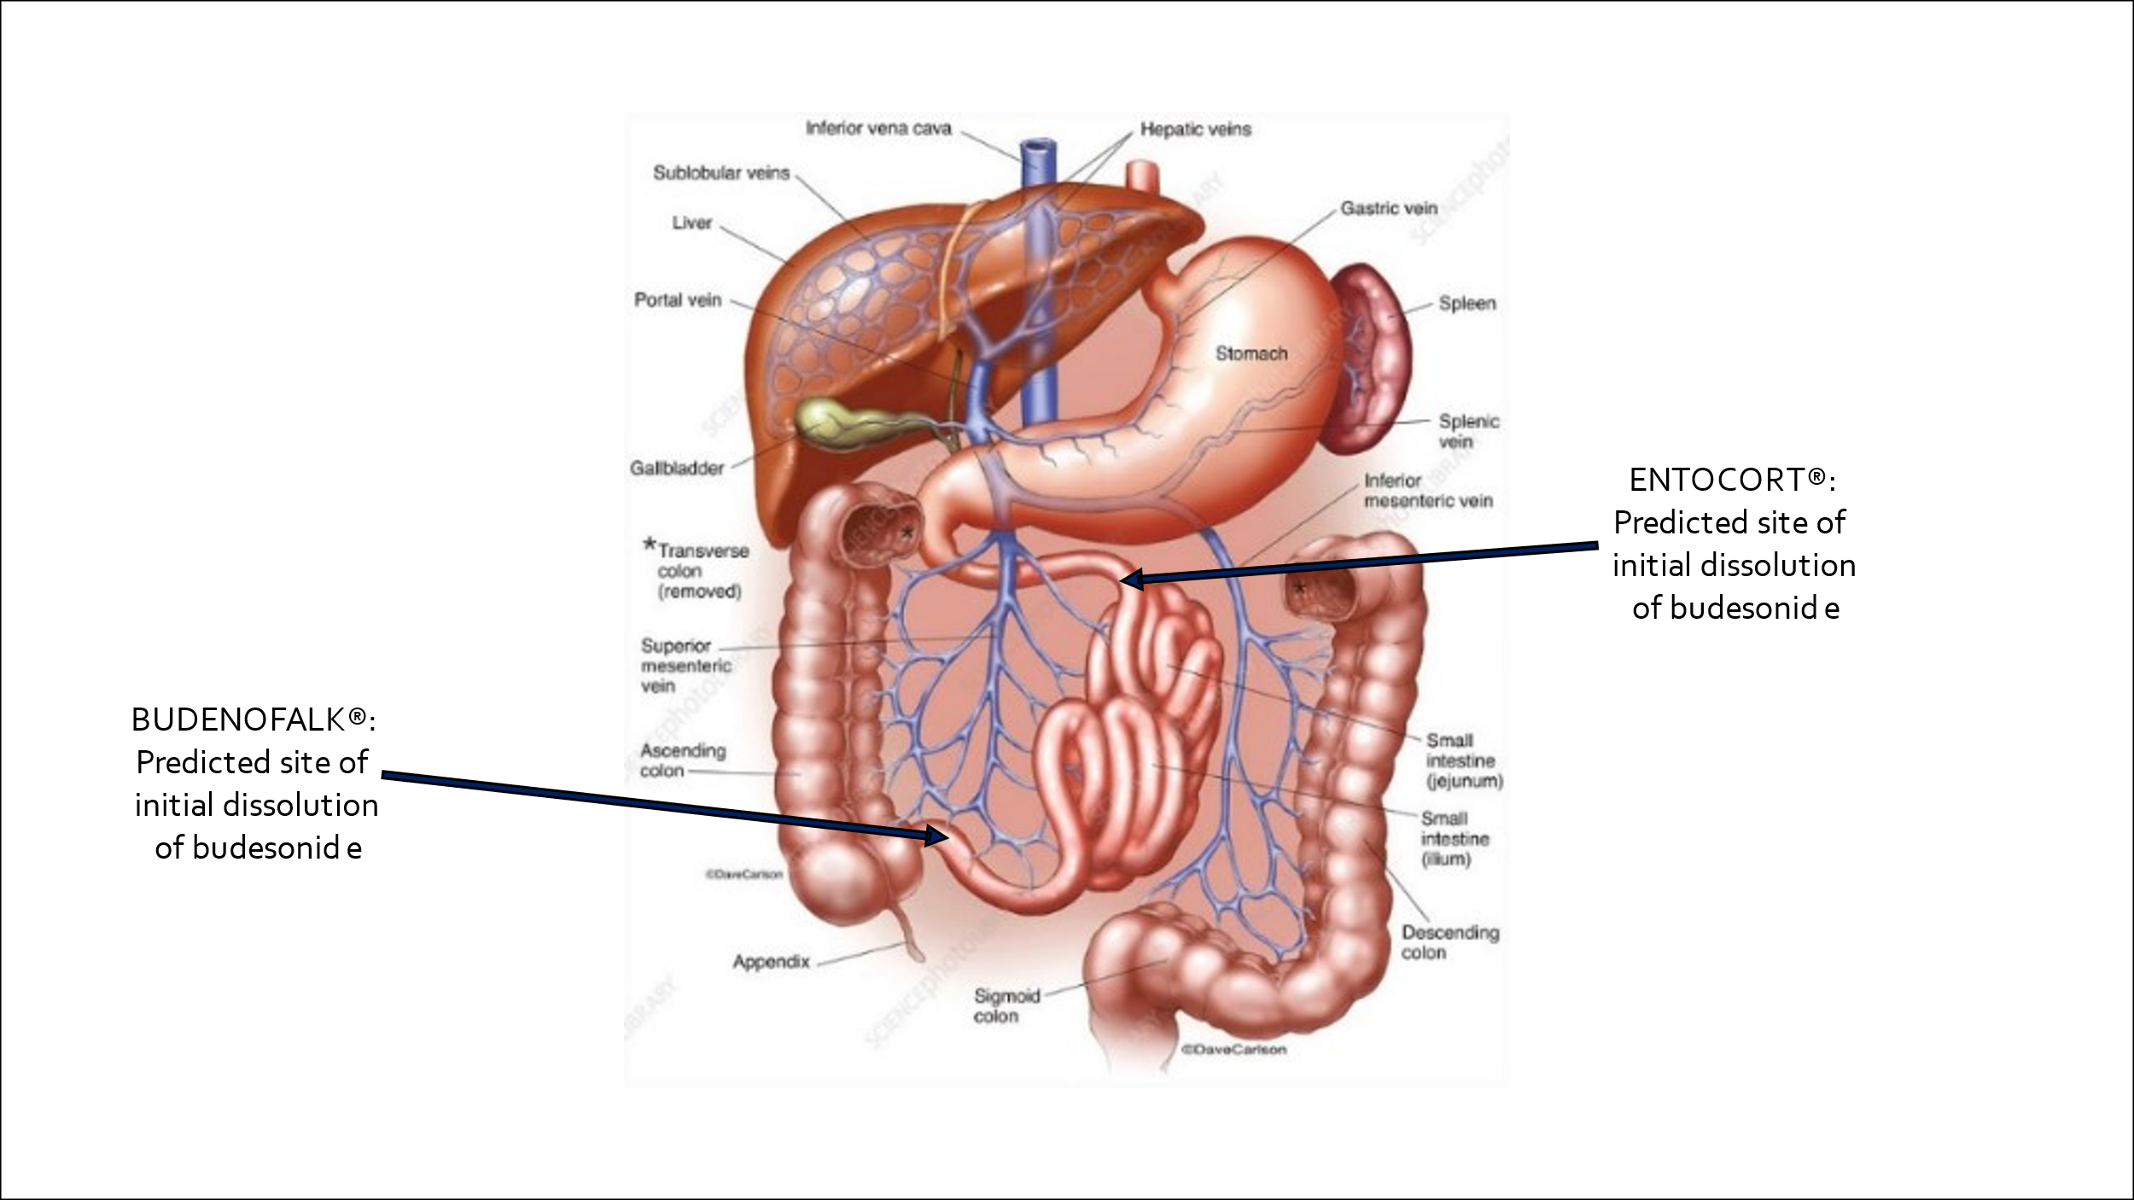

Source: Figure 2 of the submission

Figure 2: Dissolution of Budesonide from Budenofalk 100 capsules and Entocort 90 capsules in 0.1 M HCl for 2 hr followed by physiological bicarbonate buffer under dynamic pH conditions (pH 5.6 to 7.4 and then 6.5), controlled by the auto pH system

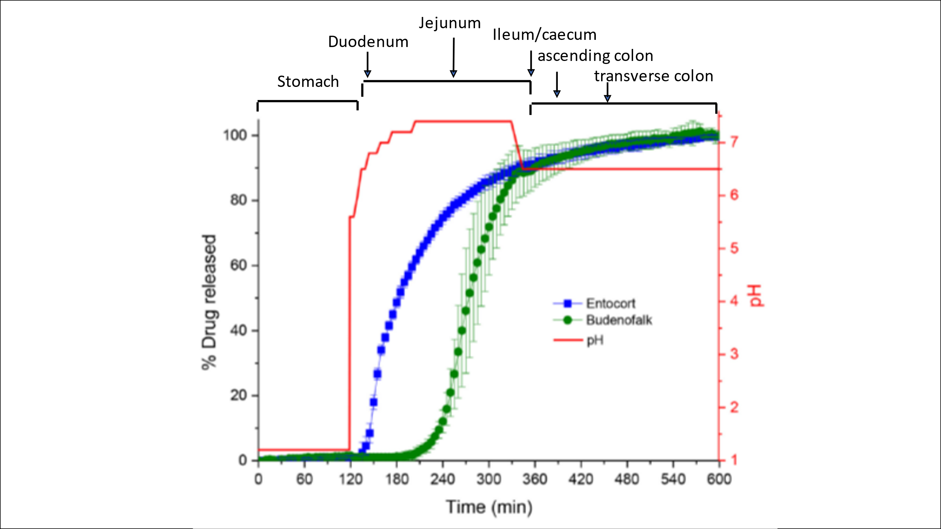

Source: Figure 3 of the submission.

* 1. At its March 2019 meeting, the PBAC recommended that Budenofalk 90 Capsules and Entocort 90 Capsules (both of which shared the same maximum quantity) be considered equivalent for the purposes of substitution by the pharmacist at the point of dispensing (i.e. ‘a’-flagged in the Schedule). The PBAC considered ‘a’-flagging was appropriate based on its consideration that the formulation differences between Budenofalk 90 capsules and Entocort 90 capsules were not expected to result in differences in outcomes (paragraph 7.11 Budesonide PSD March 2019).

1. Comparator
   1. The submission nominated Entocort 90 capsules as the main comparator. At its March 2019 meeting, the PBAC considered Entocort 90 capsules was an appropriate comparator to Budenofalk 90 capsules.
2. Consideration of the evidence

Sponsor hearing

* 1. There was no hearing for this item.

Consumer comments

* 1. The PBAC noted and welcomed the input from an individual and from Crohn’s & Colitis Australia via the Consumer Comments facility on the PBS website. Both expressed their support for the listing of Budenofalk 100 capsules on the PBS as another treatment option for mild to moderate CD.

Clinical trials

* 1. The submission presented no clinical evidence to support the listing of Budenofalk 100 capsules.

Clinical claim

* 1. The submission noted that at its March 2019 meeting, the PBAC advised that Budenofalk 90 capsules was non-inferior in comparative effectiveness and safety to Entocort 90 capsules. The submission therefore claimed that by extension Budenofalk 100 capsules is also non-inferior to Entocort 90 capsules in comparative effectiveness and safety.

Economic analysis

* 1. The submission requested the listing of Budenofalk 100 capsules for the treatment of mild to moderate CD affecting the ileum and/or ascending colon on a CM basis to Entocort 90 capsules.
  2. At its March 2019 meeting, the PBAC had considered the equi-effective doses to be:
* Budenofalk 9 mg/day for 8 weeks followed by 6 mg/day for 1 week, and then 3 mg/day for 1 week;
* Entocort 9 mg/day for 9 weeks followed by 4.5 mg/day for 3 weeks;
* Pentasa® brand of mesalazine 4 g/day for 12 weeks;
* Salofalk® brand of mesalazine 4.5 g/day for 8 weeks followed by a 3 g/day for 4 weeks; and
* prednisolone 25 mg/day for 8 weeks followed by 5 mg/day for 4 weeks.
  1. Table 1 presents the method used by the submission to derive the proposed approved ex-manufacturer price (AEMP) of $25.18 per 50 pack of Budenofalk and cost per course incl. wastage of $100.72.

Table 1: Proposed ex-manufacturer price of Budenofalk 100 capsules

|  |  |  |  |
| --- | --- | --- | --- |
| **Row** | **Parameter** | **Input** | **Source / calculation** |
| **Entocort 90 capsules** | | | |
| A | Price (AEMP) per pack | $38.85 | [https://www.pbs.gov.au/info/industry/pricing/ex-manufacturer-price (October 2023)](https://www.pbs.gov.au/info/industry/pricing/ex-manufacturer-price%20(October%202023)). This is consistent with AEMP as at February 2024. |
| B | Capsules per pack | 90 | <https://www.pbs.gov.au/medicine/item/12915R> |
| C | Capsules per course | 221 | Equi-effective dose: 9 mg/day for 9 weeks followed by 4.5 mg/day for 3 weeks (PBAC PSD Budenofalk 90 capsules March 2019, para 7.5) |
| D | Packs per patient | 2.45 | C/B |
| E | Cost per capsule | $0.43 | A/B |
| F | Cost per course | $95.18 | C*E |
| G | Cost per course incl. wastage | $116.55 | A*3 packs |
| **Budenofalk 100 capsules** | | | |
| H | Capsules per pack | 50 | Proposed pack size |
| I | Capsules per course | 189 | Equi-effective dose: 9 mg/day for 8 weeks followed by 6 mg/day for 1 week, and then 3 mg/day for 1 week (PBAC PSD Budenofalk 90 capsules March 2019, para 7.5) |
| J | Packs per patient | 3.78 | I/H |
| K | Cost per capsule | $0.50 | F/I |
| L | Cost per course | $95.18 | I*K |
| **M** | **Proposed AEMP per pack** | **$25.18** | **L/J** |
| N | Cost per course incl. wastage | $100.72 | M*4 packs |

Source: Table 8 of the submission

* 1. At its March 2019 meeting, the PBAC recalled its recommendation for Entocort from its July 2018 meeting where it recommended the weighted average price of Entocort to be calculated as one-fifth to one quarter, but closer to one-fifth of use in which mesalazine is the alternative therapy, with the corresponding weighting for prednisolone applied accordingly. Therefore, the PBAC considered that the price of Budenofalk should be calculated using the same methodology. This submission priced Budenofalk 100 capsules using the cost per course divided by the packs per patient, rather than the previously recommended approach.

Drug cost/patient/course: $100.72

* 1. The estimated Budenofalk 100 capsules cost/patient/course would be $100.72 (for 200 capsules inclusive of medicine wastage), based on a 10-week course which includes 2 weeks of tapering treatment.

Estimated PBS usage and financial implications

* 1. Table 2 presents the estimated use and financial implications of Budenofalk 100 capsules.
  2. The submission estimated that the listing of Budenofalk 100 capsules was expected to result in an overall net saving to the PBS/RPBS of $0 to < $10 million over six years, due to the expected corresponding decrease in utilisation of Entocort 90 capsules, which has a higher cost per course including wastage than Budenofalk 100 capsules ($116.55 compared to $100,72, respectively).

Table 2: Estimated use and financial implications of Budenofalk 100 capsules

|  | Year 1 | Year 2 | Year 3 | Year 4 | Year 5 | Year 6 |
| --- | --- | --- | --- | --- | --- | --- |
| Estimated extent of use | | | | | | |
| Estimated volume of proposed medicine | |　1 | |　1 | |　2 | |　2 | |　2 | |　2 |
| Estimated financial implications of Budenofalk the proposed medicine | | | | | | |
| Cost to PBS/RPBS less co-payment | |　3 | |　3 | |　3 | |　3 | |　3 | |　3 |
| Estimated financial implications of comparator, Entocort | | | | | | |
| Cost to PBS/RPBS less co-payment | |　4 | |　4 | |　4 | |　4 | |　4 | |　4 |
| Net financial implications | | | | | | |
| Net cost to PBS/RPBS | |　4 | |　4 | |　4 | |　4 | |　4 | |　4 |

Source: tab 5. Impact – net Budesonide Financial table workbook.xlxs provided in the submission

PBS = Pharmaceutical Benefits Scheme; RPBS = Repatriation Pharmaceutical Benefits Scheme.

*The redacted values correspond to the following ranges:*

1 500 to < 5,000

2 5000 to < 10,000

3 $0 to < $10 million

4 net cost saving

* 1. As a Category 4 submission, the economic analysis has not been independently evaluated.

1. PBAC Outcome
   1. The PBAC recommended the listing of Budenofalk 100 capsules for the treatment of mild to moderately active CD affecting the ileum and/or the ascending colon, on a CM basis to Entocort 90 capsules.
   2. The PBAC noted the submission presented no clinical evidence to support the listing of Budenofalk 100 capsules. The PBAC considered that its March 2019 meeting clinical recommendation that Budenofalk 90 capsules was non-inferior in terms of comparative effectiveness and safety to Entocort 90 capsules was appropriate to extend to Budenofalk 100 capsules and recommended that the equi-effective doses for Budenofalk 100 capsules be:

* Budenofalk® brand of budesonide 9 mg/day for 8 weeks followed by 6 mg/day for 1 week, and then 3 mg/day for 1 week;
* Entocort® brand of budesonide 9 mg/day for 9 weeks followed by 4.5 mg/day for 3 weeks;
* Pentasa® brands of mesalazine 4 g/day for 12 weeks;
* Salofalk® brands of mesalazine 4.5 g/day for 8 weeks followed by a 3 g/day for 4 weeks; and
* prednisolone 25 mg/day for 8 weeks followed by 5 mg/day for 4 weeks.
  1. The PBAC noted the proposed restriction wording was consistent with its recommendation for Budenofalk 90 capsules and considered this appropriate.
  2. The PBAC considered the proposed maximum repeats of 1 and maximum quantity of 100 capsules were appropriate.
  3. The PBAC noted that Budenofalk has a 10-week treatment duration (which includes a 2-week tapering period) which is different to Entocort’s 12-week treatment duration (which includes a 2-4 week tapering period). Therefore, the PBAC considered that the proposed maximum duration of therapy in the prescriber instruction of the restriction was appropriate.
  4. The PBAC advised the Minister that it considered under Section 101 (4AACD) of the *National Health Act*, that Budenofalk capsules and Entocort 90 capsules brands of budesonide should not be considered equivalent for the purposes of substitution (i.e. ‘a’-flagged in the Schedule) as the proposed maximum quantity was different (100 and 90 units of Budenofalk and Entocort, respectively).
  5. The PBAC considered the method used to derive the cost of Budenofalk 100 capsules (i.e., cost per course) was appropriate. The PBAC also considered that the listing of Budenofalk 100 capsules was likely to result in a small save to the PBS due to the decreased medicine wastage per course of treatment with Budenofalk 100 capsules compared to Entocort.
  6. The PBAC noted that its recommendation was on a CM basis and advised that, because the new form of budesonide is not expected to provide a substantial and clinically relevant improvement in efficacy, or reduction of toxicity over the currently listed form, or not expected to address a high and urgent unmet clinical need given the presence of an alternative therapy, the criteria prescribed by the *National Health (Pharmaceuticals and Vaccines – Cost Recovery) Regulations 2009* for Pricing Pathway A were not met.
  7. The submission is not eligible for an Independent Review, because the PBAC has made a positive recommendation.

**Outcome:**

Recommended

1. Recommended listing
   1. Add new item:

|  |  |  |  |  |  |
| --- | --- | --- | --- | --- | --- |
| **MEDICINAL PRODUCT**  **medicinal product pack** | **PBS item code** | **Max. qty packs** | **Max. qty units** | **№.of**  **Rpts** | **Available brands** |
| BUDESONIDE | | | | | |
| Budesonide 3 mg enteric capsule, 50 | NEW | 2 | 100 | 1 | Budenofalk |
|  | | | | | |

|  |  |
| --- | --- |
| **Restriction Summary 12607 / ToC: 12607: Authority Required (STREAMLINED)** | |
| **Concept ID**  (for internal Dept. use) | **Category / Program:** GENERAL – General Schedule (Code GE) |
| **Prescriber type:** Medical Practitioners Nurse practitioners |
| **Restriction type:**  Authority Required – Streamlined |
|  | **Administrative Advice:** |
| Continuing Therapy Only: For prescribing by nurse practitioners as continuing therapy only, where the treatment of, and prescribing of medicine for, a patient has been initiated by a medical practitioner. Further information can be found in the Explanatory Notes for Nurse Practitioners. |
|  | **Administrative Advice:** Special pricing arrangements apply. |
|  | **Indication:** Mild to moderate Crohn disease |
|  | **Clinical criteria:** |
|  | The condition must affect the ileum; or |
|  | The condition must affect the ascending colon; or |
|  | The condition must affect the ileum and ascending colon |
|  | **Prescribing Instructions:** |
| The total duration of therapy should be no more than 10 weeks in any single course. |

***This restriction may be subject to further review. Should there be any changes made to the restriction the Sponsor will be informed.***

1. Context for Decision

The PBAC helps decide whether and, if so, how medicines should be subsidised through the Pharmaceutical Benefits Scheme (PBS) in Australia. It considers applications regarding the listing of medicines on the PBS and provides advice about other matters relating to the operation of the PBS in this context. A PBAC decision in relation to PBS listings does not necessarily represent a final PBAC view about the merits of the medicine or the circumstances in which it should be made available through the PBS. The PBAC welcomes applications containing new information at any time.

1. Sponsor’s Comment

Dr Falk Pharma Australia welcomes the PBAC decision to recommend the PBS listing of budesonide 3mg 100 Capsules (Budenofalk®) for the treatment of mild to moderately active CD affecting the ileum and/or the ascending colon. We look forward to working with the Department to finalise the pricing offer requirements to ensure this medication is listed as soon as possible for the benefit of patients suffering from this condition.