_____________________________________________Contemporary pharmacological management of Pulmonary Arterial Hypertension in Australia: A Cross-sectional analysis of cases from the
Pulmonary Hypertension Society
of Australia & New Zealand Registry

A/Prof Geoff Strange^{1,2,3}, Dr Edmund Lau^{1,2&4}, A/Prof Eugene Kotlyar^{1, 4 & 5} Prof Simon Stewart⁶ Dr Eleni Giannoulatou⁷ and Dr Melanie Lavender⁸ for the Pulmonary Hypertension Society of Australia and New Zealand Inc.

¹Pulmonary Hypertension Society of Australia and New Zealand
²Royal Prince Alfred Hospital, Sydney, NSW
³University of Notre Dame, Perth WA
⁴University of New South Wales, NSW
⁵St Vincent Hospital, Sydney NSW
⁶University of Adelaide, South Australia
⁷Victor Chang Cardiac Research Institute, Sydney NSW
⁸Fiona Stanley Hospital, Perth WA

SUMMARY FINDINGS
A cross-sectional analysis of data pertaining to Australian patients with the most common forms of Pulmonary Arterial Hypertension (PAH) collected via the Pulmonary Hypertension Society of Australian and New Zealand Registry was performed. Key findings were as follows:
- Approximately 42% of the ~3,500 cases of all-cause pulmonary hypertension captured have died – reinforcing
the fact that this is a deadly condition.
- A total of 1,071 surviving cases with three of the most commonly treated forms of PAH had treatment data available and were included in this report. More than two-thirds of whom were women and 7.8% were aged
<18 years at the time of diagnosis.
- Patients who are on therapy continue to experience a large burden of symptoms and high levels of functional impairment (> 90% assessed as either WHO FC II, III or IV at last follow-up).
- Overall, 49.8%, 39.8% and 10.4% of cases were prescribed monotherapy, dual therapy and triple therapy
respectively.
- Despite high quality evidence to support combination therapy to treat PAH, due to PBS restrictions, many patients do not have access to such therapy.
- This gap between the evidence and clinical practice will undoubtedly magnify pre-existing issues relating to
equitable access to gold-standard therapy (e.g. lack of personal finances to fund second and/or third PAH therapy in the setting of ongoing clinical instability).

BACKGROUND
Pulmonary arterial hypertension (PAH) is a relatively rare disease affecting 15-150 people per million at any one point in time. (1-4) The importance of registry data to characterise the natural history of uncommon conditions such as PAH, with clear potential to monitor the cost-efficacy of new therapeutic strategies, (5) was initially realised in the 1980s when the first PAH-related registry was conducted by the National Institute of Health (NIH).(6, 7) Since then, multiple national and international registries have reported baseline characteristics and outcomes in the era of targeted PAH therapy. (8-10) From a local perspective, the Pulmonary Hypertension Society of Australian and New Zealand (PHSANZ) Registry (see Methods) was established in 2011 to generate equivalent management and outcome data to guide clinical practice. (11) The importance of maintaining and examining registry data is particularly important when considering the rapidly evolving management of PAH since the early 2000’s. Combination therapy is almost universally considered the standard of care for the majority of PAH patients, which is discordant with current arrangements for the subsidy of PAH-specific therapeutics in Australia (see below). (12)
Pharmacological management of PAH (given the high expense of most treatments) is predominantly dictated by those agents supported via the Pharmaceutical Benefits Scheme (PBS) – see text box below – with specific criteria for the sub-type of PAH and functional class of affected patients.(13)

Endothelin Receptor Antagonists (ERA) – oral agent
- Ambrisentan
- Bosentan monohydrate
- Macitentan
Prostacyclin Analogues (PGI2) - multi-mode
- Epoprostenol sodium
- Iloprost trometamol
Phosphodiesterase type 5 inhibitors (PDE5i) – oral agent
- Sildenafil citrate,
- Tadalafil
Soluble Guanylate Cyclase Stimulator (sGCs) – oral agent
- Riociguat

A key feature of subsidised PAH-therapy in Australia is the requirement for management to be delivered via designated PAH hospitals. It is also largely predicated on “monotherapy” without formal subsidisation of combination therapy – either prescribed initially or on a sequential basis: “Patients can change to an alternate PAH agent at any time, once an authority for initial treatment with the first PBS subsidised PAH agent is approved. Patients do not have to re-qualify for treatment with the alternate agent, irrespective of

the severity of their disease at the time the application to swap therapy is submitted, as long as they meet the alternate agent restriction criteria.” (13)

STUDY AIMS
In a representative, cohort of patients initially diagnosed with the three most common forms of pulmonary arterial hypertension (Idiopathic / Heritable / Drug induced PAH; Connective Tissue Disease PAH; Congenital Heart Disease PAH) being actively managed via specialist PAH centres in Australia, we sought to characterise the following:
- Clinical and Demographic characteristics and status of patients overall and according to their sub- type of PAH.
- Most current World Health Organisation modified Ney York Heart Association Functional Class and 6 Minute Walk Test.
- Pattern of monotherapy versus combination therapy of the major classes of PAH-specific therapy being prescribed overall and according the sub-type of PAH.

METHODS
Study design: Data were derived from the Pulmonary Hypertension Society of Australian and New Zealand (PHSANZ) Registry to generate a cross-sectional report from a pre-specified group of registry cases (applying standardized diagnostic criteria).
The registry was established in 2011 to delineate the clinical characteristics, management, and outcomes of pulmonary hypertension (PH) patients treated at specialist centres across Australia and New Zealand. (11) Registry data collection commenced in December 2011; including both incident and prevalent cases being managed by participating centres (16 in Australia and 2 in New Zealand). All data were entered into the Registry via a dedicated PHSANZ bespoke software platform.
Registry Data: Data were collected by the treating centre and the primary diagnosis of PAH subtype was based on current recommendations for the clinical classification of PAH. (12) Consistent with recommended guidelines for the diagnosis of PAH and the criteria for government subsidisation for PAH therapy (via the PBS), all patients with PAH underwent right heart catheterisation (RHC), a six-minute walk distance (6MWD) and transthoracic echocardiography at baseline. Presence of PAH is defined hemodynamically by a mean pulmonary artery pressure ≥25 mmHg and pulmonary artery wedge pressure or left ventricular end diastolic pressure ≤18 mmHg, as per the previous PBS prescribing criteria.
Standardised profiling of registered patients includes demographics profile, date of diagnosis, subtype of PAH, invasive haemodynamics from right heart catheter, functional status according to the World Health Organisation Functional Class (WHO-FC), 6MWD, and prescribed pharmacological therapy at the discretion of the treating physician.

Broad and Specific Inclusion Criteria: As shown in Figure 1 (study flow-chart), all patients currently registered with the PHSANZ Registry (N=3,535) were potentially eligible for inclusion. Using a census date of 31st December 2017, the following inclusion criteria were applied to generate the analysis dataset.
- Alive at the census point of 31 December 2017
- Data including current medication details updated since 1 June 2017
- Initially diagnosed (at time of diagnosis) with the following subgroups of PAH:
  - Idiopathic PAH (iPAH), heritable PAH (hPAH), or drug-induced PAH (dPAH)
  - PAH associated with connective tissue disorder (CTD-PAH)
  - PAH associated with congenital heart disease (CHD-PAH)
- Registered via one of the 16 participating Australian institutions
Otherwise eligible cases with clinical profiling were subsequently excluded if no medication data were available for study analyses. Specifically, PH due to other aetiologies were excluded from this analysis set.

Figure 1 Study Schema

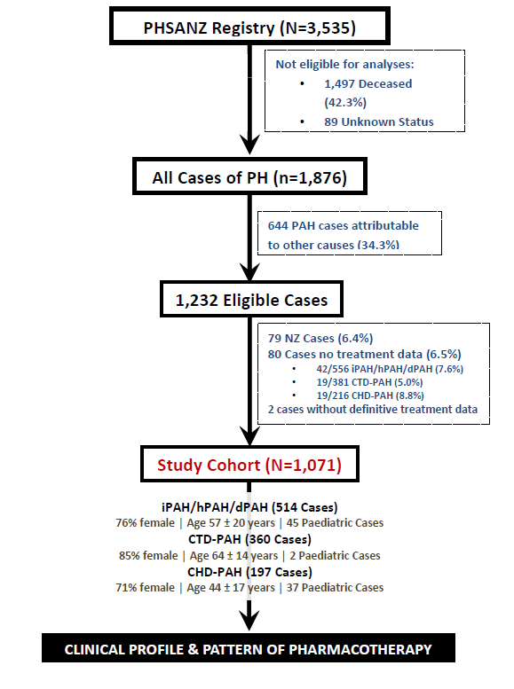

Ethics Approval/Patient Consent: The PHSANZ Registry is conducted according to the principals of Declaration of Helsinki for ethical practice. Ethical approval of the Registry protocol was reviewed and approved by the relevant Human Research Ethics Committees (HREC) at each participating centre.
Statistical Analyses: All data from eligible registry cases were analysed collectively and then according to three pre-specified subgroups: 1) iPAH, hPAH and dPAH combined, 2) CTD-PAH and 3) CHD-PAH. Given the purpose and cross-sectional nature of the study, no inferential analyses were undertaken; with discrete variables presented as a frequency and proportion and continuous variables according to their central tendency including mean and standard deviation. All analyses were performed with R statistical package.

FINDINGS
Registry cohort: As reported previously (11), the epidemiology and prognosis of PAH cases captured by the PHSANZ Registry is consistent with equivalent North American and European cohorts. Figure 1 shows that at point of study census, a total of 3535 patients were registered in the PHSANZ registry, of which 1497 (42%) were deceased cases. Overall, the three most common forms of PAH among patients still “active” were iPAH (28%); CTD-PAH (20%) and mostly associated with systemic sclerosis; and CHD-PAH (12%). Patients with CTEPH (group 4 pulmonary hypertension) were not included in report since management often involves surgical or percutaneous interventions and thus differing from PAH. Similarly, patients with pulmonary hypertension not belonging to the 3 main pre-specified diagnostic groups were also excluded from analyses. Cohort profile: A total of 1,071, of which 84 were paediatric cases (7.8%) were included in study analyses; with 80 otherwise eligible cases (evenly distributed across the 3 study groups) with incomplete medication data excluded. Consistent with the overall profile of other contemporary international registries and randomised controlled trial populations, (8-10) the most predominant subtype of PAH was iPAH (with very few cases of hPAH and dPAH contributing to that diagnostic group).
Table 1 shows the characteristics of the study cohort at the point of diagnosis according to the PAH subtypes examined. As expected, females were predominant (particularly among those diagnosed with CTD-PAH) and there was a clear age-gradient with the youngest cohort being those diagnosed with CHD-PAH and the oldest with PAH-CTD. For the overall cohort, mean time from initial diagnosis was 7.6 ± 6.6 years and current mean age was 57.0 ± 18.7 years; with the equivalent figures being 6.9 ± 4.8 and 57.1 ± 19.7 years, 6.7 ± 6.4 and
64.2 ± 13.6 years, and 10.9 ± 9.5 and 43.6 ± 16.6 years for those diagnosed with iPAH/hPAH/dPAH, CTD-PAH and CHD-PAH, respectively. The pattern of comorbidity largely reflected the age and gender profile of each diagnostic group.

7

Table 1 Demographic & Clinical Profile at Time of Diagnosis

 | Total Cohort (N=1,071) | iPAH/hPAH/dPAH (n=514) | CTD-PAH (n=360) | CHD-PAH (n=197)
Demographic Profile
Age (years) at diagnosis | 49.9±.20.4 | 50.4±20.8 | 58.1±14.1 | 33.1±19.1
Female | 838 (78.1%) | 392 (76.3%) | 308 (85.5%) | 138 (70.5%)
Aged <18 years | 84 (7.8%) | 45 (8.9%) | 2 (0.6%) | 37 (18.8%)
Clinical Profile
Systemic Hypertension | 306 (28.5%) | 143 (27.8%) | 139 (38.4%) | 24 (12.2%)
BMI (kg/m2)  Obese (BMI >30 kg/m2) | 26.8±6.2  225 (20.9%) | 28.1±6.3  142 (27.6%) | 26.8±5.7  69 (19.2%) | 22.8±4.6  10 (5.1%)
Sleep Apnoea | 146 (13.6%) | 76 (14.8%) | 43 (11.9%) | 27 (13.7%)
Coronary Artery Disease | 115 (10.7%) | 53 (10.9%) | 53 (14.7%) | 9 (4.6%)
Diabetes  Non-insulin Dependent | 91 (8.5%)  76 (7.1%) | 55 (10.7%)  47 (9.1%) | 26 (7.2%)  19 (5.3%) | 10 (5.1%)  10 (5.1%)
Peripheral Vascular Disease | 33 (3.1%) | 14 (2.7%) | 18 (5.0%) | 1 (0.5%)
World Health Organisation Functional Status
Class I | 1.1% | 1.4% | 0.83% | 1.0%
Class II | 19.6% | 15.0% | 24.0% | 23.4%
Class III | 66.6% | 70.2% | 61.6% | 66.5%
Class IV | 5.9% | 6.2% | 6.4% | 4.1%
6-minute walk distance (m) | 360±131 | 354±136 | 355±125 | 383±124
Invasive Haemodynamic Status
Mean Pulmonary Arterial Pressure, mmHg | 43.2 ± 17.2 | 45.6 ± 15.3 | 33.1 ± 12.7 | 57.2 ± 20.1
Right Atrial Pressure, mmHg | 8.6 ± 4.7 | 9.1 ± 4.9 | 8.2 ± 4.5 | 7.7 ± 4.4
Pulmonary Arterial Wedge Pressure, mmHg | 10.9 ± 5.0 | 11.1 ± 4.8 | 10.8 ± 5.2 | 10.5 ± 5.1
Cardiac Output, L/min | 4.8 ± 1.7 | 4.6 ± 1.6 | 5.2 ± 1.7 | 5.0 ± 2.0
Cardiac Index, L/min/m^2 | 2.7 ± 0.9 | 2.5 ± 0.8 | 3.0 ± 0.9 | 3.2 ± 1.2
Pulmonary Vascular Resistance, dynes/sec/cm5 | 633 ± 475 | 712 ± 475 | 412 ± 302 | 906 ± 613

8

At the point of initial diagnosis, around two-thirds of cases were assessed as WHO-FC III, with a further one in five assessed as WHO FC II; the three diagnostic groups being broadly similar in this regard. Haemodynamic profiling at the point of diagnosis largely reflects what we understand about the haemodynamic and clinical presentations with PAH; with pulmonary arterial pressures, possibly reflecting nature and timing of diagnosis, highest among those presenting with CHD-PAH and lowest in those with CTD-PAH who may be diagnosed earlier as a result of screening.
As noted, the majority of cases (>90%) in the first diagnostic group of interest (n=514) were diagnosed with iPAH with a small contribution of hPAH and dPAH. Among those diagnosed with CTD-PAH, the majority of cases were associated with systemic sclerosis, systemic lupus erythematosus and/or a combination of connective tissue disease. The most common forms of CHD among those diagnosed with CHD-PAH were atrial septal defect, complex lesions and ventricular septal defect.
Changes in Functional status and Exercise capacity: Figure 2 (WHO FC) and Figure 3 (6MWD) show the change in functional status and exercise capacity from initial diagnosis to last functional assessment. For entire cohort see Appendix IV.

Figure 2 Change in WHO FC (left panel) and 6MWD (right panel) - Diagnosis to Last Assessment

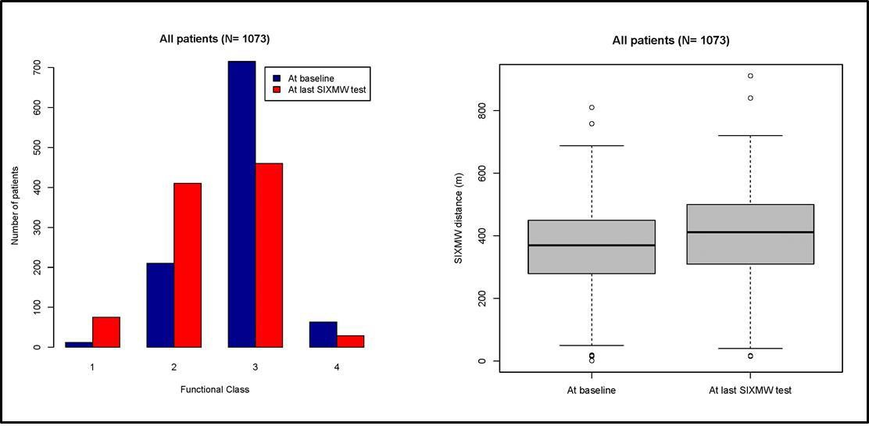
Overall, there was a broad redistribution of cases initially assessed as WHO FC III (decline from 67% to 47%) to WHO FC II. However, in all three PAH sub-groups more than 90% of cases were assessed as either WHO FC II or III at their last point of assessment. The 6MWD assessed on therapy at last follow-up was approximately 40m greater than initial diagnosis (from 363 ± 130 to 403 ± 135m)

Pharmacological management: Figures 3-5 summarise the overall proportion of patients treated with monotherapy, dual therapy and triple therapy in the course of their management at the time of censoring according to the three main PAH diagnostic subgroups analysed.

Figure 3 Pattern of PAH-specific pharmacotherapy for iPAH/hPAH/drug-induced PAH (n=514)
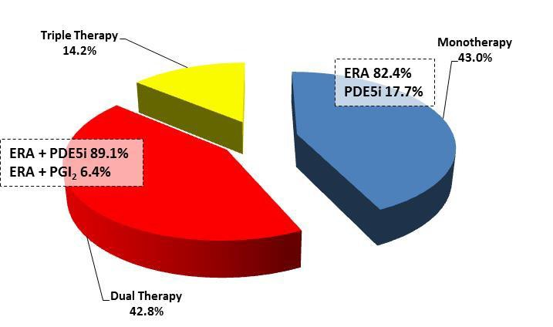
Figure 4 Pattern of PAH-specific pharmacotherapy for CTD-PAH (n=360)
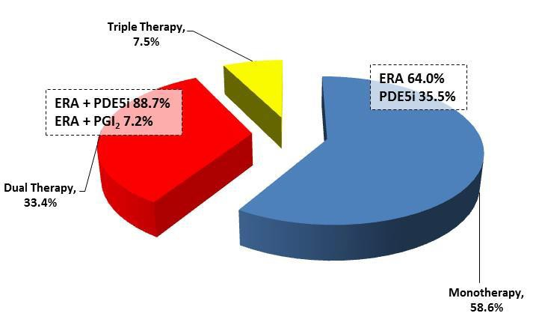
Figure 5 Pattern of PAH-specific pharmacotherapy for CHD-PAH (n=197)

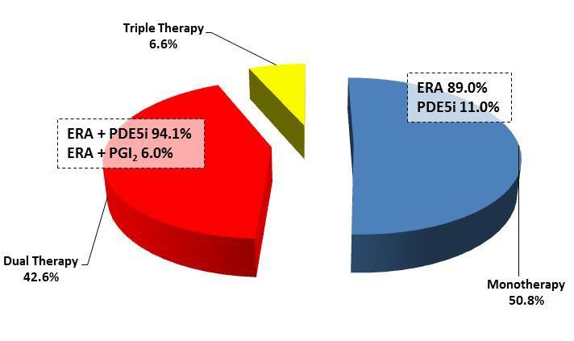

Monotherapy: Overall, 533/1,071 (49.8%) of all PAH cases were prescribed single PAH specific monotherapy. In all but one case (the sGCs agent riociguat), monotherapy comprised ERA (bosentan [42.4% of cases], macitentan [21.0%] or ambrisentan [12.9%]) or PDE5i (sildenafil [16.9%] or tadalafil [6.4%]) therapy (see Appendix I). CTD-PAH patients were more likely to be on monotherapy (58.6%, two thirds of which comprised ERA therapy) than those diagnosed with iPAH/hPAH/dPAH (43.0% - approximately 8 in 10 patients receiving ERA therapy) or CHD-PAH (50.8% - approximately 9 in 10 patients receiving ERA therapy). No patients were on monotherapy with Epoprostenol or prostanoid therapy.
Dual therapy: A further 426/1,071 (39.8%) of cases were prescribed dual PAH designated pharmacotherapy (Figure 6). All but 9% of cases, were prescribed a combination of ERA plus PDE5i therapy – the five most commonly prescribed combinations being macitentan + sildenafil (144/426 [33.8%] cases prescribed dual therapy), bosentan + sildenafil (19.0%), macitentan + tadalafil (15.0%), ambrisentan + tadalafil (12.7%) and ambrisentan + sildenafil (7.0%). The majority of other cases comprised ERA or PDE5i therapy combined with PGI2 therapy (see Appendix II). PDE5i used in combination with another agent is not reimbursed and therefore combinations including sildenafil require funding by the patient, hospital or compassionate pharmaceutical programmes, which may have resulted in inconsistent patterns of prescription access. Overall, 123 patients were on dual therapy consisting of ERA plus tadalafil (31.7% of that form of combination therapy); this agent being predominantly accessed via pharmaceutically funded compassionate access programs.

Figure 6 Pattern of Dual Pharmacotherapy (n=426)
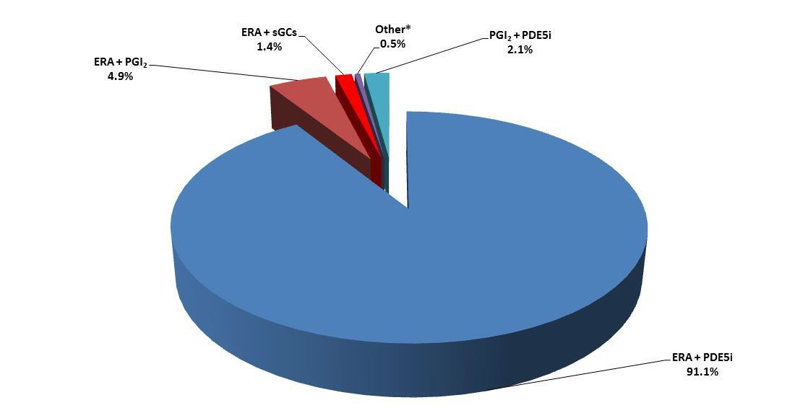

Across the three diagnostic subgroups, the most commonly prescribed combination of macitentan plus sildenafil was broadly equivalent in all 3 diagnostic groups (approximately one third of those prescribed dual therapy). Alternatively, perhaps reflective of clinical trial results specifically relating to CHD-PAH, the commonly prescribed combination of bosentan plus sildenafil was twice as more likely to be prescribed in those with CHD-PAH versus the other two groups (~40% versus 14-17%), perhaps reflective of the clinical trial data specifically relating to CHD-PAH.
Triple therapy: With the exception of only 2 cases (where a combination of ERA plus PGI2 plus sGCs therapy was prescribed), those prescribed triple therapy (n=112) representing 10.4% of the cohort, were prescribed a combination of ERA plus PGI2 plus PDE5i therapy. The most common combinations of prescribed triple therapy were macitentan/epoprostenol/Sildenafil (35.7%) and bosentan/epoprostenol/Sildenafil (25.0%) – see Appendix III.

DISCUSSION POINTS
These data derived from a representative cohort (Idiopathic / Heritable / Drug induced PAH; Connective Tissue Disease PAH; Congenital Heart Disease PAH) of Australian patients with PAH being managed by specialist centres and physicians highly experienced in the diagnosis and management of the condition and associated diseases (including CTD and CHD) highlight a number of key challenges surrounding the contemporary management of PAH.
Firstly, despite the availability of an increasing armoury of PAH-specific agents and regardless of the underlying aetiology, PAH represents a life-threatening condition with a substantive portion of patients enrolled in the PHSANZ Registry now deceased (42.3%). Among survivors being actively managed (the major characteristic of the study cohort), despite the encouraging improvement in functional status among many individuals (as reflected in WHO-FC and 6MWT assessments), the functional impairment and likely adverse effects on quality of life is common (14). Overall, one in two cases were assessed as WHO-FC III or IV during active management.
Secondly, the ongoing threat of death and high levels of disability in this “real world” cohort of PAH is highly relevant to the interpretation of prescribed pharmacotherapy. As noted by recent expert guidelines published by the European Society of Cardiology and the European Respiratory Society (ESC/ERS) (12), the treatment of PAH has evolved progressively in the past decade. With development of new therapies and publication of large event- driven randomised controlled trials, there is now high-quality evidence for clinical efficacy of PAH drugs, including incremental benefit when used in combination. The range and complexity of pharmacological agents available to PAH specialists has steadily increased. In Australia this includes ERA, PGI2, PDE5i and sGCs therapy, although these are only funded as monotherapy. However, management of PAH is not merely defined by an orderly prescription of available agents, but encompasses a complex
strategy that includes an ongoing evaluation of response to treatment and achievement of specific

treatment goals for each individual patient. It is the latter in particular, that explains the overall heterogeneity of prescribed treatment observed in this cohort; with combination therapy underprescribed in many PAH patients.
The routine application of sequential combination therapy is not unprecedented in the management of cardiovascular disorders with the treatment of systemic hypertension and left heart failure being characterised by combination therapy to achieve therapeutic goals. It is also a logical option for the management of PAH since pathological changes in three separate signalling pathways are known contribute to disease progression. Accordingly, in order of historical recognition and development of trial evidence, specific agents have been developed to target the prostacyclin pathway (PGI2 and the prostanoid, Iloprost), the endothelin pathway (ERAs) and the nitric oxide pathway (PDE-5is and sGCs). (12) In support of the application of combination therapy in PAH, a meta-analysis of 858 patients enrolled in six randomised controlled trials demonstrated that compared to monotherapy, therapy targeting multiple pathways was associated with a significant reduction in the risk of clinical worsening, an increase in 6MWD and improved haemodynamic profile. (15) These composite findings support those of an Australian study by Keogh and colleagues examining the benefits of combination therapy in 112 patients with iPAH and CTD-PAH assessed as WHO FC II-IV and not responding to varying periods of monotherapy (mean 19 months). Accompanying functional and haemodynamic improvements following the therapeutic change, subsequent survival on combination therapy was 88%, 71% and 61% at 1, 2 and 3-years, respectively. (16, 17)
Consistent with the underlying premise that a disease with multiple underlying pathological pathways should be immediately, rather than sequentially, treated with therapeutic strategies targeting those multiple pathways has been tested in the setting of PAH. In a double-blind randomised study, Galié and colleagues treated 500 treatment naïve patients with PAH with 10mg/day of Ambrisentan (ERA) monotherapy, 40mg/day Tadalafil monotherapy (PDE5i) or a combination of both. (17) The composite primary endpoint of clinical failure (death, hospitalisation for worsening PAH, disease progression or unsatisfactory long-term clinical response) occurred in 18% (combination), 34% (Ambrisentan) and 28% (Tadalafil) of patients, respectively; pooled hazard reduction of 0.5 (95% CI 0.35 to 0.72; p<0.001) in favour of the combination therapy group. As a counter-balance to improved clinical outcomes, those assigned to combination therapy were more likely to develop peripheral oedema, headache, nasal congestion and anaemia. (16) With reference to therapeutic success of combination therapy in chronic left heart failure, a recent randomised trial showed that the combination of neprilysin inhibitor/angiotensin receptor blocker compared to an angiotensin converting enzyme inhibitor alone reduced the primary composite outcome of death from cardiovascular causes or hospitalization for heart failure. (17) A meta-analysis of trials of combination therapy has suggested that the use of multiple targeted therapies improves outcomes in PAH (18).

In recognition of the potential of combination PAH therapy to improve outcomes (particularly when applied in a “goal-orientated” manner involving assessment of functional and haemodynamic status), the ESC guidelines make two key recommendations: 1) initial application of approved oral drugs as combination therapy in treatment naïve and low-to-intermediate risk patients with PAH (Evidence Level IB) and 2) sequential drug combination (route not specified) with an inadequate treatment response to initial therapy (Evidence Level IB) (12) As noted earlier, government subsidies for the pharmacological management of PAH in Australia are based on a “monotherapy” treatment strategy. Therefore, it appears that although the individual physicians who contributed to the overall pattern of pharmacotherapy observed in this study were following an appropriate clinical pathway (to sequentially apply increasingly complex therapy targeting multiple pathways in PAH) to achieve clinical stability in just over 50% of the study cohort, they would have done so using non-PBS supported strategies. Although the majority of patient in this analysis were adult patients, it is important to recognise that lung transplantation was not readily available to all children in Australian throughout the period of data collection and outcomes are worse than for adults. Therefore, paediatric physicians, in particular, are have also been keen to use combination therapy in children who have failed PAH targeted monotherapy. In practice, this would have likely involved sourcing combination therapy from pharmaceutical industry compassionate access programmes, hospital formularies and/or privately funded by the patient. Combined, these circumstances lead to inequitable access to clinically indicated combination therapy (e.g. if an individual patient is unable to afford incremental therapy). At the same time, sourcing of agents from overseas may invoke issues of quality of control.

Limitations/Caveats: These data were derived from a Registry with diagnostic criteria determined by the treating physicians and not subject to central review. Purposefully, these data reflect the management of PAH cases via specialist centres (as per expert recommendations). They do not reflect therefore, the management of PAH beyond these centres. As a cross-sectional, snap-shot survey, we cannot report on a number of crucial issues/factors that influence the clinical management of PAH and any interpretation of prescribed pharmacological therapy. These include – 1) information on what agent(s) were prescribed initially and in what combination, 2) whether or not agents were prescribed sequentially or purposefully combined at one time-point, 3) specific drug dosages, 4) the lack inferential analyses examining the potential correlation between clinical status (including functional status and haemodynamic profile) and prescribed therapy and 5) the lack of any outcome data. It is also important to note that the study cohort was purposefully selected for them being alive/actively managed and being diagnosed with iPAH, hPAH, dPAH, CTD-PAH or CHD-PAH and the potential survival bias this constitutes.

In conclusion, our findings highlight the challenge of effectively managing a progressive, disabling and potentially fatal condition with discordance between government subsidisation of (often highly expensive) forms of monotherapy for the therapeutic management of PAH and the need (based on residual high levels of functional impairment/lack of therapeutic response) for combination therapy. Expert recommendations for the application combination therapy (particularly oral combinations) in PAH both as initial therapy and sequentially as part of a goal-orientated strategy are based on an increasing volume of evidence and reflected clinical practice (12). On this basis, there is a cogent argument for determining how best to ensure equitable access to combination therapy for all patients with PAH. This may well include a review of government subsidies for such therapy linked to a goal-orientated approach to clinical outcomes.
7

REFERENCES
- Peacock AJ, Murphy NF, McMurray JJ, Caballero L, Stewart S. An epidemiological study of pulmonary arterial hypertension. The European respiratory journal. 2007;30(1):104-9.
- Humbert M, Sitbon O, Chaouat A, Bertocchi M, Habib G, Gressin V, et al. Pulmonary arterial hypertension in France: results from a national registry. American journal of respiratory and critical care medicine. 2006;173(9):1023- 30.
- Ling Y, Johnson MK, Kiely DG, Condliffe R, Elliot CA, Gibbs JS, et al. Changing demographics, epidemiology, and survival of incident pulmonary arterial hypertension: results from the pulmonary hypertension registry of the United Kingdom and Ireland. American journal of respiratory and critical care medicine. 2012;186(8):790-6.
- Strange G, Playford D, Stewart S, Deague JA, Nelson H, Kent A, et al. Pulmonary hypertension: prevalence and mortality in the Armadale echocardiography cohort. Heart. 2012;98(24):1805-11.
- Lau EMT, Giannoulatou E, Celermajer DS, Humbert M. Epidemiology and treatment of pulmonary arterial hypertension. Nature reviews Cardiology. 2017;14(10):603-14.
- D'Alonzo GE, Barst RJ, Ayres SM, Bergofsky EH, Brundage BH, Detre KM, et al. Survival in patients with primary pulmonary hypertension. Results from a national prospective registry. Annals of internal medicine. 1991;115(5):343-9.
- <D'Alonzo et al_Ann Intern Med 1991.pdf>.
- Badesch DB, Raskob GE, Elliott CG, Krichman AM, Farber HW, Frost AE, et al. Pulmonary arterial hypertension: baseline characteristics from the REVEAL Registry. Chest. 2010;137(2):376-87.
- Thenappan T, Shah SJ, Rich S, Tian L, Archer SL, Gomberg-Maitland M. Survival in pulmonary arterial hypertension: a reappraisal of the NIH risk stratification equation. The European respiratory journal. 2010;35(5):1079-87.
- Hoeper MM, Huscher D, Ghofrani HA, Delcroix M, Distler O, Schweiger C, et al. Elderly patients diagnosed with idiopathic pulmonary arterial hypertension: results from the COMPERA registry. International journal of cardiology. 2013;168(2):871-80.
- Strange G, Lau EM, Giannoulatou E, Corrigan C, Kotlyar E, Kermeen F, et al. Survival of Idiopathic Pulmonary Arterial Hypertension Patients in the Modern Era in Australia and New Zealand. Heart, lung & circulation. 2017.
- Galie N, Humbert M, Vachiery JL, Gibbs S, Lang I, Torbicki A, et al. 2015 ESC/ERS Guidelines for the diagnosis and treatment of pulmonary hypertension: The Joint Task Force for the Diagnosis and Treatment of Pulmonary Hypertension of the European Society of Cardiology (ESC) and the European Respiratory Society (ERS): Endorsed by: Association for European Paediatric and Congenital Cardiology (AEPC), International Society for Heart and Lung Transplantation (ISHLT). Eur Heart J. 2016;37(1):67-119.
- https://www.humanservices.gov.au/organisations/health-professionals/enablers/pulmonary-arterial- hypertension [Internet]. 2018 [cited Accessed January 2018]. Available from: https://www.humanservices.gov.au/organisations/health-professionals/enablers/pulmonary-arterial-hypertension
- Keogh A, Wlodarczyk J. Idiopathic- and scleroderma-related pulmonary arterial hypertension: outcomes and QOL on bosentan. Expert Rev Pharmacoecon Outcomes Res. 2004;4(5):505-13.
- Keogh A, Strange G, Kotlyar E, Williams T, Kilpatrick D, Macdonald P, et al. Survival after the initiation of combination therapy in patients with pulmonary arterial hypertension: an Australian collaborative report. Internal medicine journal. 2011;41(3):235-44.
- Galie N, Barbera JA, Frost AE, Ghofrani HA, Hoeper MM, McLaughlin VV, et al. Initial Use of Ambrisentan plus Tadalafil in Pulmonary Arterial Hypertension. The New England journal of medicine. 2015;373(9):834-44.
- McMurray JJ, Packer M, Desai AS, Gong J, Lefkowitz MP, Rizkala AR, et al. Angiotensin-neprilysin inhibition versus enalapril in heart failure. The New England journal of medicine. 2014;371(11):993-1004.
- Lajoie AC, Lauziere G, Lega JC, Lacasse Y, Martin S, Simard S, et al. Combination therapy versus monotherapy for pulmonary arterial hypertension: a meta-analysis. Lancet Respir Med. 2016;4(4):291-305.
16

Appendix I (Monotherapy)

Monotherapy | ALL  533 | % | i/d/hPAH 221 | % | CTD-PAH 212 | % | CHD-PAH 100 | %
Total
Ambrisentan | 69 | 12.9 | 39 | 17.6 | 25 | 11.8 | 5 | 5.0
Bosentan | 227 | 42.6 | 90 | 40.7 | 68 | 32.1 | 69 | 69.0
Macitentan | 112 | 21.0 | 53 | 24.0 | 44 | 20.8 | 15 | 15.0
Riociguat | 1 | 0.2 | 0 | 0.0 | 1 | 0.5 | 0 | 0.0
Sildenafil | 90 | 16.9 | 26 | 11.8 | 54 | 25.5 | 10 | 10.0
Tadalafil | 34 | 6.4 | 13 | 5.9 | 20 | 9.4 | 1 | 1.0

Appendix II (Dual Therapy)

Dual Therapy | ALL  426 | % | i/d/hPAH 221 | % | CTD-PAH 121 | % | CHD-PAH  84 %
Total
Ambrisentan Epoprostenol | 1 | 0.2 | 1 | 0.5 | 0 | 0.0 | 0 | 0.0
Ambrisentan Iloprost | 3 | 0.7 | 2 | 0.9 | 1 | 0.8 | 0 | 0.0
Bosentan Iloprost | 1 | 0.2 | 1 | 0.5 | 0 | 0.0 | 0 | 0.0
Ambrisentan Treprostinil | 1 | 0.2 | 0 | 0.0 | 1 | 0.8 | 0 | 0.0
Bosentan Treprostinil | 2 | 0.5 | 2 | 0.9 | 0 | 0.0 | 0 | 0.0
Bosentan Epoprostenol | 3 | 0.7 | 3 | 1.4 | 0 | 0.0 | 0 | 0.0
Epoprostenol Macitentan | 5 | 1.2 | 4 | 1.8 | 1 | 0.8 | 0 | 0.0
Iloprost Macitentan | 1 | 0.2 | 1 | 0.5 | 0 | 0.0 | 0 | 0.0
Macitentan Treprostinil | 4 | 0.9 | 2 | 0.9 | 1 | 0.8 | 1 | 1.2
Ambrisentan Sildenafil | 30 | 7.0 | 21 | 9.5 | 7 | 5.8 | 2 | 2.4
Ambrisentan Tadalafil | 54 | 12.7 | 35 | 15.8 | 17 | 14.0 | 2 | 2.4
Bosentan Sildenafil | 81 | 19.0 | 30 | 13.6 | 20 | 16.5 | 31 | 36.9
Macitentan Sildenafil | 154 | 36.1 | 75 | 34.1 | 43 | 34.6 | 35 | 41.7
Macitentan Tadalafil | 64 | 15.0 | 30 | 13.6 | 25 | 20.7 | 9 | 10.7
Ambrisentan Tadalafil | 5 | 1.2 | 2 | 0.9 | 3 | 2.5 | 0 | 0.0
Ambrisentan Riociguat | 2 | 0.5 | 2 | 0.9 | 0 | 0.0 | 0 | 0.0
Macitentan Riociguat | 4 | 0.9 | 2 | 0.9 | 1 | 0.8 | 1 | 1.2
Epoprostenol Sildenafil | 4 | 0.9 | 4 | 1.8 | 0 | 0.0 | 0 | 0.0
Iloprost Sildenafil | 3 | 0.7 | 2 | 0.9 | 0 | 0.0 | 1 | 1.2
Sildenafil Treprostinil | 2 | 0.5 | 1 | 0.5 | 0 | 0.0 | 1 | 1.2
Other | 2 | 0.5 | 0 | 0.0 | 1 | 0.8 | 1 | 1.2

Appendix III (Triple Therapy)

Triple Therapy | ALL  112 | % | i/d/hPAH  72 | % | CTD-PAH 27 | % | CHD-PAH  13 %
Total
Ambrisentan Epoprostenol | 7 | 6.3 | 5 | 6.9 | 2 | 7.4 | 0 | 0.0
Sildenafil
Ambrisentan Epoprostenol
Tadalafil | 1 | 0.9 | 1 | 1.4 | 0 | 0.0 | 0 | 0.0
Ambrisentan Iloprost Sildenafil | 4 | 3.6 | 2 | 2.8 | 1 | 3.7 | 1 | 7.7
Ambrisentan Iloprost Tadalafil | 1 | 0.9 | 0 | 0.0 | 1 | 3.7 | 0 | 0.0
Ambrisentan Sildenafil Treprostinil | 2 | 1.8 | 2 | 2.8 | 0 | 0.0 | 0 | 0.0
Bosentan Epoprostenol Sildenafil | 28 | 25.0 | 24 | 33.3 | 3 | 11.1 | 1 | 7.7
Bosentan Iloprost Sildenafil | 6 | 5.4 | 1 | 1.4 | 2 | 7.4 | 3 | 23.1
Bosentan Sildenafil Treprostinil | 3 | 2.7 | 2 | 2.8 | 1 | 3.7 | 0 | 0.0
Iloprost Macitentan Tadalafil | 2 | 1.8 | 1 | 1.4 | 1 | 3.7 | 0 | 0.0
Epoprostenol Macitentan
Sildenafil | 40 | 35.7 | 29 | 40.3 | 8 | 29.6 | 3 | 23.1
Iloprost Macitentan Sildenafil | 15 | 13.4 | 5 | 6.9 | 6 | 22.2 | 4 | 30.8
Ambrisentan Tadalafil Treprostinil | 1 | 0.9 | 0 | 0.0 | 1 | 3.7 | 0 | 0.0
Epoprostenol Macitentan
Riociguat | 1 | 0.9 | 0 | 0.0 | 0 | 0.0 | 1 | 7.7
Macitentan Riociguat Tadalafil | 1 | 0.9 | 0 | 0.0 | 1 | 3.7 | 0 | 0.0

Appendix IV (Baseline and Census characteristics)

Baseline Characteristics (At time of diagnosis)
 |  | Population (N=1073) | Idiopathic, heritable & drugs and toxins induced (N=514) | CTD (N=362) | CHD (N=197)
Age,y |  | 49.85 (20.39) | 50.37 (20.83) | 58.08 (14.09) | 33.1 (19.18)
Gender | Female:Male | 838:235 | 392:122 | 308:54 | 138:59
 | Female, % | 78.1 | 76.26 | 85.08 | 70.05
 | Female:male ratio | 3.56:1 | 3.21:1 | 5.7:1 | 2.34:1
BMI |  | 26.78 (6.19) | 28.05 (6.31) | 26.78 (5.66) | 22.8 (4.61)
Co-morbidities, Yes:No | Obesity BMI > 30 | 225:626 | 142:269 | 69:217 | 10:140
 | Hypertension | 306:590 | 143:264 | 139:175 | 24:151
 | Diabetes (Insulin-dependent) | 15:888 | 8:396 | 7:314 | 0:178
 | Diabetes (Non-insulin-dependent) | 76:832 | 47:361 | 19:303 | 10:168
 | CAD | 115:762 | 53:348 | 53:250 | 9:164
 | Sleep apnea | 146:693 | 76:310 | 43:240 | 27:143
 | Peripheral vascular disease | 33:830 | 14:377 | 18:285 | 1:168
NYHA FC, % | 1 | 1.12 | 1.36 | 0.83 | 1.02
 | 2 | 19.57 | 14.98 | 24.03 | 23.35
 | 3 | 66.64 | 70.23 | 61.6 | 66.50
 | 4 | 5.87 | 6.23 | 6.35 | 4.06
 | Missing | 6.8 | 7.20 | 7.18 | 5.08
6MWD, m |  | 359.83 (130.51) | 354.27 (135.85) | 355.31 (125.31) | 383.14 (123.76)
Haemodynamics | mPAP, mmHg | 43.16 (17.23) | 45.62 (15.33) | 33.37 (12.65) | 57.22 (20.08)
 | RAP, mmHg | 8.59 (4.72) | 9.08 (4.87) | 8.19 (4.54) | 7.74 (4.43)

PAWP, mmHg |  | 10.92 (4.98) | 11.11 (4.81) | 10.82 (5.18) | 10.47 (5.11)
CO, L/min |  | 4.81 (1.69) | 4.55 (1.59) | 5.18 (1.67) | 4.97 (1.97)
CI, L/min/m^2 |  | 2.73 (0.91) | 2.48 (0.77) | 2.96 (0.87) | 3.16 (1.17)
PVR, dynes/sec/cm |  | 633.01 (475.18) | 711.96 (475.03) | 411.58 (302.32) | 906.15 (613.31)
Current Census Characteristics (on "mortality as of" date)
Time Since Diagnosis, y |  | 7.55(6.61) | 6.92 (4.79) | 6.66 (6.39) | 10.91 (9.53)
Age,y |  | 57.02 (18.66) | 57.08 (19.66) | 64.23 (13.61) | 43.63 (16.6)
6MWD, m |  | 403.22 (136.19) | 413.72 (141.49) | 382.81 (136) | 412.06 (117.29)
NYHA FC, % | 1 | 7.70 | 6.68 | 11.93 | 2.38
 | 2 | 42.09 | 41.34 | 39.14 | 50
 | 3 | 47.23 | 49.48 | 45.26 | 44.64
 | 4 | 2.98 | 2.51 | 3.67 | 2.98

