14.7 POST-MARKET REVIEW OF TYPE 2 DIABETES MEDICINES

The Review

  - Following a request from the Drug Utilisation Sub-Committee (DUSC) of the Pharmaceutical Benefits Advisory Committee (PBAC), the PBAC recommended a review of the utilisation and cost-effectiveness of type 2 diabetes medicines in March 2012. The PBAC endorsed the Terms of Reference (ToR) for the Post-market Review of Products used in the Management of Diabetes (Diabetes Review) in August 2012.

  - The objective of the Diabetes Review was to ensure that patients are using medicines and products effectively and safely to achieve optimal health outcomes and support quality use of medicines.

  - The Diabetes Review was divided into three stages:
    - Blood glucose test strips use in people with type 2 diabetes not using insulin.
    - Insulin pumps for people with type 1 diabetes, and the Insulin Pump Programme.
    - Medicines used in the management of type 2 diabetes.

  - The purpose of the Review of Type 2 Diabetes Medicines (Stage 3) was to examine and characterise the complexity and heterogeneity of PBS listings for type 2 diabetes medicines to inform an assessment of their effectiveness in terms of clinical outcomes and cost. Further information is available on the Diabetes Review website.

Terms of Reference

  - Describe the utilisation and patterns of treatment of PBS listed drugs for type 2 diabetes, and compare these with PBS restrictions.

  - Consider if the utilisation of PBS listed drugs in current clinical practice represents expected cost-effective use.

  - Consolidate the clinical trial evidence used to support PBS listings of diabetes medicines listed since 2002.

  - Collate and evaluate any additional clinical studies or meta-analyses for drugs currently PBS listed for type 2 diabetes that the PBAC has not seen and that would inform their consideration.

Background

  - In February 2012, the DUSC recommended that the PBAC request a complete review of type 2 diabetes medicines, following its consideration of a number of changes to diabetes products listed on the PBS. These included amended restrictions, additional indications for existing medicines, and the listing of new medicines. The DUSC noted that there was use of medicines outside the PBS restrictions, that the PBS restrictions have become complex and somewhat inconsistent with emerging guidance on best practice over time, and that safety concerns have arisen for some medicines. The PBAC considered the DUSC advice and recommended a review of type 2 diabetes medicines in March 2012.

  - The Review of Type 2 Diabetes Medicines was conducted during 2013–14, following the Post-market Review framework. A Departmental Working Group and an expert Reference Group provided guidance an input to the Review. The Reference Group included experts in endocrinology, diabetes education, general practice, consumer advocacy, pharmacy, economics, nutrition, and psychology.

  - The Review included:
- A review of the utilisation of the newer classes of type 2 diabetes medicines, including patterns of co-administration and use of other diabetes medicines prior to initiation addressing Terms of Reference 1 and 2. The analyses were undertaken by the University of Adelaide and the Department.
- Development of a report addressing Term of Reference 3 by the University of Newcastle consolidating the clinical trial evidence used to support PBS listings of type 2 diabetes medicines in submissions between 2002 and January 2014.
- A review of pharmacotherapy algorithms in Australian and international guidelines for the management of type 2 diabetes by Griffith University.
- Development of a report addressing Term of Reference 4 by Griffith University involving a systematic review and network meta-analysis of the comparative safety and effectiveness of type 2 diabetes medicines, focussing on triple therapy.
- Public consultation, including a written submission process, stakeholder forum, and the opportunity to comment on the draft Report.

Main Findings of the Review

Terms of Reference 1 and 2: Utilisation analysis
- Overall Government expenditure on type 2 diabetes medicines increased from around $130 million per annum in 2000 to $501 million per annum in 2013.
- Metformin and sulfonylureas were the most commonly prescribed oral type 2 diabetes medicines between January 2000 and April 2014.
- In patients initiating diabetes pharmacotherapy between 2003–04 and 2009–10, metformin was the most common first line medicine, in line with clinical guidelines.
- For patients initiating a third line agent (a dipeptidyl peptidase 4 (DPP-4) inhibitor, thiazolidinedione (TZD), or exenatide) between July and December 2011, 47.7% had not received a supply of both metformin and a sulfonylurea in the two years prior. The PBS restrictions at the time required prior use of metformin and a sulfonylurea, except where contraindicated.
- Use outside the restrictions in patients initiating a third line agent, was highest for those initiating a DPP-4 inhibitor + metformin fixed dose combination (FDC) (55%), a DPP-4 inhibitor (49%), or rosiglitazone + metformin FDC (46%). The DUSC considered that the availability of FDCs may be contributing to use outside of the PBS restrictions.
- Of patients prescribed a third line agent between February 2011 and May 2012, 27.9% were co-prescribed a regimen of medicines that did not comply with PBS subsidy criteria. The use of a DPP-4 inhibitor with both metformin and a sulfonylurea (triple oral therapy) contributed the most. Some use of DPP-4 inhibitor monotherapy was also evident.
- Of patients prescribed exenatide, 29.6% were prescribed the medicine in a regimen of co-prescribed therapies that did not comply with PBS subsidy criteria, primarily use in combination with insulin (16.1% of patients).
- The DUSC considered that the overall rate of use beyond the PBS restrictions in relation to third line agents is at least 30%, and that this is a conservative estimate of non-cost-effective use.

Term of Reference 3: PBS listing of type 2 diabetes medicines
- A total of 177 clinical studies/systematic reviews assessing the newer type 2 diabetes medicines or the nominated comparators were identified from 47 PBAC submissions.
- Only 17 submissions provided direct head-to-head evidence against the main comparator.
- The newer diabetes medicines have been positioned after the use of metformin and/or a sulfonylurea based on a series of non-inferiority comparisons originating from a comparison with insulin as the expected medicine to be replaced in practice.
- No submission received a positive recommendation on the basis of a clinical claim of superiority, although the PBAC has acknowledged marginal differences in change of HbA_{1c} between medicines. When presented in submissions to the PBAC, the nominated HbA_{1c} non-inferiority margin was generally 0.3–0.4% (3–4 mmol/mol). This was accepted by the PBAC.
- The PBAC has acknowledged that there may be differences between treatments in weight management and hypoglycaemia outcomes, but the magnitude and clinical importance of these differences has not been adequately demonstrated.
- None of the newer diabetes medicine submissions has presented microvascular/ macrovascular events as a key outcome.
- The PBAC has noted the lack of long term safety data for many of these medicines, particularly given the safety issues that arose after the listing of rosiglitazone. The PBAC has considered additional cardiovascular safety data for two DPP-4 inhibitors.
- TGA-approved indications not subsidised by the PBS include use of newer type 2 diabetes medicines as:
  - monotherapy;
  - TZD + DPP-4 inhibitor/sodium-glucose linked transporter-2 (SGLT2) inhibitor combinations;
  - triple therapy with metformin + sulfonylurea + DPP-4 inhibitor/SGLT2 inhibitor;
  - insulin + DPP-4 inhibitor/SGLT2 inhibitor/glucagon-like peptide-1 (GLP-1) receptor agonist combinations; and
  - initial use of a DPP-4 inhibitor/SGLT2 inhibitor with metformin.
- The utilisation analyses noted that there was some use of newer type 2 diabetes medicines in combination.

Term of Reference 4: New clinical trial evidence
- The systematic literature review on the safety and efficacy of type 2 diabetes medicines identified 87 publications covering 72 randomised controlled trials (RCTs), including 43 trials not seen by the PBAC previously.
- No long term macrovascular or microvascular outcome data for acarbose, insulin, SGLT2 inhibitors and GLP-1 receptor agonists was identified. Limited trial data are available with a duration of over six months.
- One dual therapy trial considered a combination not yet seen by the PBAC. Compared to TZD monotherapy, TZD + DPP-4 inhibitor reduced HbA_{1c} (-0.9%; 95% CI: -1.1, -0.7) and increased weight (1.1 kg; p-value not reported).¹ The results may not be applicable to Australian practice as the patients were treatment naïve.
- All triple therapy combinations of medicines identified in the trials provided a significantly better reduction in HbA_{1c} at six months compared to metformin + sulfonylurea dual therapy, in the range of 0.7–1.1%, except for metformin + TZD + DPP-4 inhibitor. This improvement was clinically relevant when GLP-1 receptor agonists or insulin were added to metformin + sulfonylurea (upper CI >0.3%). Refer to Figure 1.
- None of the triple therapy combinations demonstrated clinically relevant differences in HbA_{1c} at six months compared with other triple therapies. However, metformin + sulfonylurea + GLP-1 receptor agonist was significantly better at reducing HbA_{1c} than metformin + TZD + DPP-4 inhibitor. Refer to Figure 2.
- Compared to metformin + sulfonylurea, metformin + sulfonylurea + SGLT2 inhibitor/ GLP-1 receptor agonist showed a significant reduction in weight after six months treatment (SGLT2 inhibitors: MD: -2.4 kg; 95% CI: -4.1, -0.6; and GLP-1 receptor agonists: MD:-1.5 kg; 95% CI: -2.4, -0.6). All other combinations caused similar or more weight gain than metformin + sulfonylurea (-0.3 to 3.5 kg). Refer to Figure 3.
- Four trials were identified that examined long term outcomes when a sulfonylurea, TZD or DPP-4 inhibitor was added to existing therapy. All showed a statistically significant increase in the risk of hypoglycaemia (in trials of greater than two years duration) compared to existing medication. Trial populations and outcome definitions varied between trials precluding meta-analysis.
- The addition of a sulfonylurea to existing medication reduced major microvascular events (HR: 0.86; 95% CI: 0.77, 0.97).
- The addition of TZDs to existing medication reduced major macrovascular events (HR: 0.84; 95% CI: 0.72, 0.98), but increased the risk of heart failure.
- DPP-4 inhibitors increased the risk of hospitalisation due to heart failure in one trial.

Figure 1. Forest plot of mean difference in HbA_{1c} (%) (95% CI) at six months for triple therapy combinations compared to metformin + sulfonylurea dual therapy – network analysis.
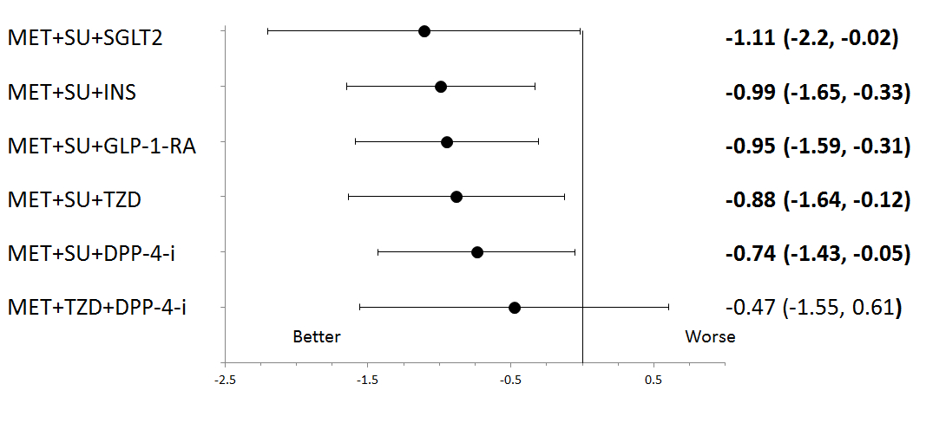
Statistically significant difference are marked in bold.
Abbreviations: DPP-4-i = dipeptidyl peptidase-4 inhibitor; GLP-1-RA = glucagon-like peptide-1 receptor agonist; INS = insulin; MET = metformin; SGLT2 = sodium glucose co-transporter 2 inhibitor; and SU = sulfonylurea.

Figure 2. Forest plot of mean difference in HbA_{1c} (%) (95% CI) at six months for triple therapy combinations compared to each other – network analysis.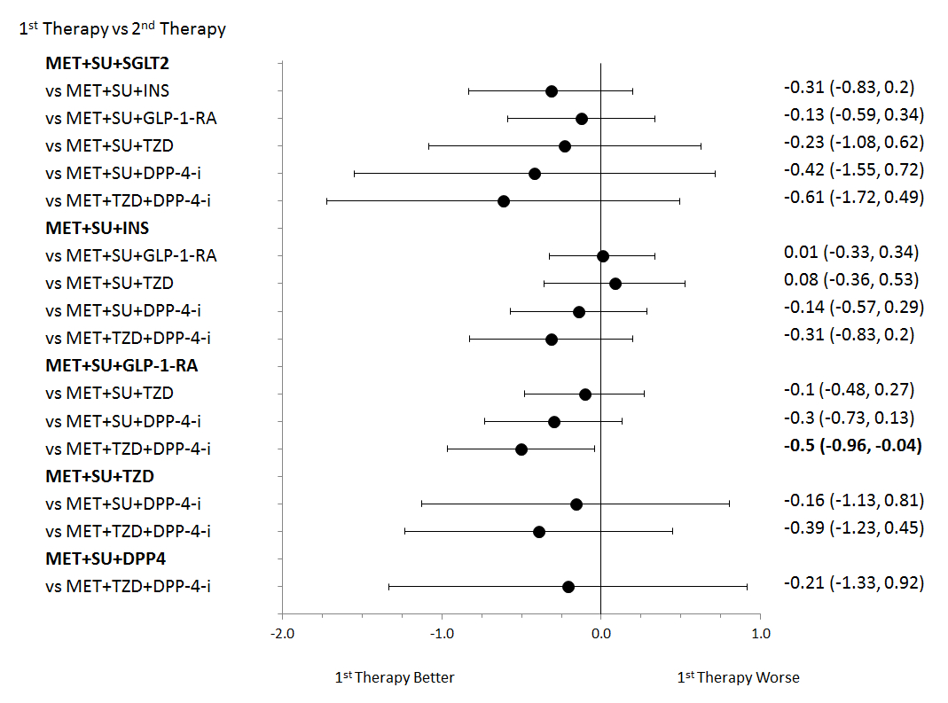
Statistically significant difference are marked in bold.
Abbreviations: DPP-4-i = dipeptidyl peptidase-4 inhibitor; GLP-1-RA = glucagon-like peptide-1 receptor agonist; INS = insulin; MET = metformin; SGLT2 = sodium glucose co-transporter 2 inhibitor; and SU = sulfonylurea.

Figure 3. Forest plot of mean difference in change in body weight (kg) (95% CI) at six months for different triple therapy combinations compared to metformin + sulfonylurea dual therapy – network analysis.
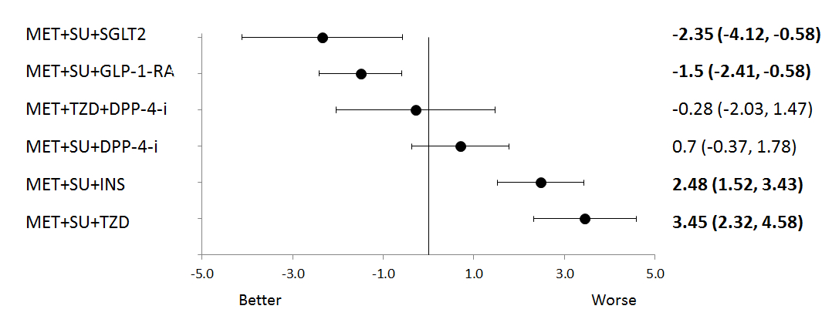
Statistically significant difference are marked in bold.
Abbreviations: DPP-4-i = dipeptidyl peptidase-4 inhibitor; GLP-1-RA = glucagon-like peptide-1 receptor agonist; INS = insulin; MET = metformin; SGLT2 = sodium glucose co-transporter 2 inhibitor; and SU = sulfonylurea.

Stakeholder Views
Stakeholder submissions addressing the Terms of Reference, and the stakeholder forum summary, were published on the Medicines Review Public Consultation website. Key viewpoints expressed included:
- Patient-centred, individualised treatment is important to quality care, optimal patient outcomes and adherence to prescribed medicines. HbA_{1c} targets and choice of medicine should be determined for an individual that take account of factors such as: time since diagnosis, age, symptoms, cardiovascular profile, weight, risk of hypoglycaemia, side effects, comorbidities and features that may facilitate patient compliance.
- Patients should be involved in treatment choice and provided with information by their clinician to assist in this decision. Some patients may prefer a treatment strategy that involves earlier intervention and lower HbA_{1c} targets.
- The NHMRC-endorsed guidelines should be regularly reviewed and updated.
- PBS restrictions are increasingly inconsistent with best practice and clinical need.
- Most third line agents are comparable to sulfonylureas in terms of HbA_{1c} lowering.
- Diabetes outcomes should not be measured by HbA_{1c} levels alone. Other important outcomes include avoidance of hypoglycaemia, weight, side effects, hospitalisations, long term health outcomes, and development of microvascular and macrovascular complications.
- It is important to try to minimise hypoglycaemic events due to their multi-dimensional effect on patients, including quality of life, productivity, risk of falls in the elderly, and for severe hypoglycaemia, limiting expensive hospital admissions.
- Treatment pathways need to consider prevention, education and lifestyle factors.
- Concern over Review processes, including transparency and appropriate consultation.

PBAC Consideration and Advice to the Minister for Health

  - The PBAC considered the draft Report, the stakeholder comments and the studies undertaken for each Term of Reference.

  - The PBAC noted the stakeholder comments including the desire for access to type 2 diabetes medicines to align with clinical guidelines allowing greater individualisation of treatment, and concerns about the post-market review process.

  - The PBAC noted that recent clinical guidelines recommend individualisation of HbA_{1c} targets, which may be less than 7% in some patients. However, the clinical trial evidence seen by the PBAC required patients to have an HbA_{1c} greater than 7% before initiation with newer type 2 diabetes medicines. The PBAC considered that the current HbA_{1c} requirements were still appropriate, as patients with targets below 7% are generally able to be controlled by diet and exercise, or are pregnant. In both cases, these classes of type 2 diabetes medicines would not be prescribed.

  - In terms of HbA_{1c}, the PBAC noted that there were no significant differences between the triple therapy combinations presented in the network meta-analysis, with the exception of metformin + TZD + DPP-4 inhibitor. The meta-analysis showed that the combination of metformin + TZD + DPP-4 inhibitor resulted in a significantly lower reduction in HbA_{1c} than metformin + sulfonylurea + GLP-1 receptor agonist. Compared to other triple therapy combinations, the combination of metformin + sulfonylurea + SGLT2 inhibitor resulted in the lowest mean difference in HbA_{1c} (MD: -1.11; CI: -2.2, -0.02), although this difference was not significantly different.

  - With regard to body weight change, the PBAC noted that there were three broad groups in terms of triple therapy in combination with metformin + sulfonylurea:
- SGLT2 inhibitors and GLP-1 receptor agonists caused weight loss.
- DPP-4 inhibitors were relatively weight neutral or caused a small amount of weight gain.
- Insulin and TZDs resulted in weight gain.

  - In terms of hypoglycaemia, there were no significant differences between the triple therapy combinations included in the network meta-analysis, with the exception of the combination of metformin + sulfonylurea + GLP-1 receptor agonist. This combination resulted in a statistically significantly lower rate of any hypoglycaemia than metformin + sulfonylurea + insulin. There were no statistically significant differences in severe hypoglycaemia between triple therapies in trials that reported these outcomes.

  - Overall, the PBAC considered that the report provided useful data for the comparison of triple therapy combinations. The review indicates that of the triple oral therapy options, metformin + sulfonylurea + SGLT2 inhibitor provided the largest reductions in HbA_{1c} and likely important weight loss. The Committee also noted small reductions in systolic and diastolic blood pressure associated with the use of SGLT2 inhibitors. The PBAC noted that to date it had not received any submissions for PBS subsidy for this combination. The PBAC would welcome submissions for PBS listing of the triple oral therapy combination of metformin + sulfonylurea + SGLT2 inhibitor. The process and evaluation of any submissions would follow the standard PBAC processes.

  - The PBAC recommended that the evidence presented in the Review did not support subsidy of the combination of metformin + TZD + DPP-4 inhibitor. This combination was not significantly better than metformin + sulfonylurea dual therapy in lowering HbA_{1c}. The PBAC also recommended that the following combinations should not be PBS-subsidised on the basis that no trial data demonstrating efficacy was available at this time:
- Metformin + DPP-4 inhibitor + SGLT2 inhibitor.
- Metformin + DPP-4 inhibitor + GLP-1 receptor agonist
- Metformin + DPP-4 inhibitor + insulin.
- Sulfonylurea + DPP-4 inhibitor + SGLT2 inhibitor
- Sulfonylurea + DPP-4 inhibitor + GLP-1 receptor agonist
- Sulfonylurea + DPP-4 inhibitor + insulin.
- Metformin + SGLT2 inhibitor + GLP-1 receptor agonist
- Sulfonylurea + SGLT2 inhibitor + GLP-1 receptor agonist.
- Any triple therapy combination of the following medicines: DPP-4 inhibitor, TZD, SGLT2 inhibitor, insulin, and GLP-1 receptor agonist.
- Any combination of insulin with three oral therapies.

  - The PBAC noted the need expressed by stakeholders for updated clinical guidelines and that the new Australian Diabetes Society pharmacotherapy algorithm for the treatment of type 2 diabetes was scheduled to be published in the December 2014 issue of the Medical Journal of Australia.

  - The PBAC noted that acarbose is also PBS subsidised for triple oral therapy with metformin + sulfonylurea. This was considered a relatively inexpensive combination with low usage. Although 20% of patients were intolerant of the side-effects of acarbose, the PBAC considered it a useful combination that should be considered as an option for therapy in more patients. Increased awareness of the benefits could be promoted through prescriber education focussing on evidence and cost-effectiveness. The PBAC considered that this could be combined with education on the new SI units for HbA_{1c} (mmol/mol) and the recent subsidisation of HbA_{1c} as a test for the diagnosis of type 2 diabetes.

  - The PBAC noted that there were limited treatment options for patients on dialysis. The PBAC noted that there is anecdotal evidence of off-label use of low dose DPP-4 inhibitors for this indication. It was considered that this may partly explain the DPP-4 inhibitor monotherapy use seen in the DUSC analysis of type 2 diabetes medicines utilisation.

Outcome Statement

The PBAC considered the Report, supporting studies and stakeholder submissions to the Post-market Review of Type 2 Diabetes Medicines (Terms of Reference 1–4). The PBAC noted that while most dual therapy combinations are PBS subsidised, there are currently limited options for subsidised triple therapy. However, a number of triple therapy combinations are being used in practice. There is limited evidence of benefit in reduction of HbA_{1c}, reduced rates of hypoglycaemia and weight loss associated with most combinations that are not currently subsidised. The exception is metformin + sulfonylurea + SGLT2 inhibitor. The PBAC would welcome submissions for this combination.

