PBS PRICING FORUM DECEMBER 2018

Statutory Price Reductions and Ministerial Discretion
Penny Lovell, Director, PBS Pricing
Penny.lovell@health.gov.au / (02) 6289 9422 / pbs.pricing@health.gov.au

OVERVIEW

Changes to the National Health Act that have occurred in 2018 and what they mean for the prices of medicines on the Pharmaceutical Benefits Scheme (PBS).
Starting with: a pricing refresher discussing F1, F2 and the Combination Drugs List.
Moving to: (1) anniversary reductions; (2) new presentation exemptions; (3) sliding scale first new brand reductions.
Finishing with: questions.

F1/F2, FIRST NEW BRAND AND 25%
Formulary or New Brand | Brand/  Drug | MOA  (Manner of Administration) | What  happens? | Then?
F1 | ABCOriginal | Oral | 25% SPR | F2 – subject to price disclosure
New | ABCGeneric | Oral | Must list at 25% lower price | F2 – subject to price disclosure
F1 | ABCOriginal | Injection | No SPR until new brand with same MOA and bioequivalent  /biosimilar | F2 – must report for price disclosure but no reduction until bioequivalent brand lists or  >10% discounting

FIRST NEW BRAND, 25% AND CDL
Formulary or New Brand | Brand/ Drug | MOA  (Manner of Administratio n) | What happens?
F1 | ABCOriginal ($10) | Oral | 25% = $7.50. Drug  moves to F2 and PD applies.
New | ABCGeneric | Oral | List price = $7.50. F2 and PD applies to single ingredient drug.
CDL | ABCOriginal ($10) & XYZOriginal ($5) | Oral | Drug combination remains in CDL. ABC - 25% = $7.50. XYZ = $5.  Total price = $12.50

F1/F2/FIRST NEW CDL BRAND AND 25%
Formulary or New Brand | Brand/ Drug | MOA  (Manner of Administration) | What happens?
CDL | ABCOriginal ($7.50) &  XYZOriginal  ($5.00) | Oral | XYZOriginal - 25% =  $3.75.  No further reduction to  ABCOriginal.  Entire CD moves to F2 and PD applies. New price = $11.25.
New CD | ABCGeneric &  XYZGeneric | Oral | List price = $11.25.  In F2 and PD applies.

F1 ANNIVERSARY REDUCTIONS – 2018
How many years has the  drug been on F1? | Reduction that applied in 2018
5 years but less than 10 years | 5%  Applied on 1 April 2018
10 years but less than 15 years | 10% (“catch-up”)  Applied on 1 June 2018
15 years or more | 14.5% (“catch-up” of 10%+5%)  Applied on 1 June 2018

MINISTERIAL DISCRETION - TWO STEP PROCESS
Step 1: Decision by Minister or delegate to exercise discretion
If Yes – Go to Step 2.
If No – reduction occurs by operation of the Act.
Before the final decision is made, an indicative decision will be communicated and you have the opportunity to respond.
Step 2: Decision by Minister or delegate on the reduction that applies
A further exercise of discretion will be made as to whether a full or
partial waiver is applied.
Before the final decision is made, an indicative decision will be communicated and you have the opportunity to respond.

NEW PRESENTATIONS
Threshold questions:
- Is the Sponsor bringing forward the new pharmaceutical item (PI) the same Sponsor that has the existing PI on the PBS?
  - Yes (go to 2)/ No (first new brand reduction applies).

Is the new PI a new presentation?
  - Yes (go to 3)/ No (first new brand reduction
applies).
NEW PRESENTATIONS
Threshold questions:

- How long has the existing PI been on the PBS?

- 5 years or less = exemption from the first new brand reduction. Will remain exempt as there is no exercise of discretion that expires.

- Between 5 and 10 years = Ministerial discretion can be requested. Will remain exempt until the 10 year anniversary, when in effect the discretion “expires”.

- 10 years or more = first new brand reduction applies.

NEW PRESENTATION EXEMPTION

New brand is  (a) brought to the PBS by the same Sponsor and is (b) a new presentation | What happens?
Within 5 years of the original PI listing on the PBS | No reduction.  Will remain in F1 until there is a first new brand that is not a new presentation.
Between 5 years and 10 years of the original PI listing on the PBS | Discretion to exempt from first new brand reduction.  Lapses at 10 years.  Once the discretion has lapsed it will trigger an SPR and move to F2.
10 years plus of the original PI listing on the PBS | Automatically takes the reduction for a first new brand.

NEW PRESENTATIONS

Encouraging innovation that contributes to better outcomes for patients.

Does not intend to incentivise new formulations of existing drugs which will simply delay or reduce brand competition.

Examples of ‘new presentations’ include:
- Auto injector (new) vs vial and a syringe (old)
- Effervescent tablet (new) vs capsule (old)
Reduction off  AEMP since 1  January 2016 | Reduction that  applies to both  the existing and new brand | Examples
40% or more | 0% | Drug has been subject to reference pricing which has reduced the  price by 60%, therefore it will have no further reductions. No exercise of discretion is required.
>15% and <40% | Up to 24.99% | Price on 1/1/2016 = $100  Drug has been reduced by 14.5% in anniversary price reductions and a subsequent 15% reference pricing reduction resulting in a current price of $72.68  The drug will be reduced to 60% of the 1 January 2016 price, which is $60 (17% reduction from current price) unless Ministerial discretion is exercised.
<15% | Up to 25% | Drug has taken 10% due to an anniversary price reduction. It will  take 25% unless the Minister exercises discretion to apply a lower percentage.

25% FIRST NEW BRAND ‘SLIDING SCALE’

25% FIRST NEW BRAND REDUCTION

- Even if your drug has been reduced by 40% or more the Minister may still accept an administrative lower price offer.

OTHER QUESTIONS

- What happens when a first new brand reduction would coincides with an anniversary reduction?

- Can statutory price reductions be altered retrospectively?

- What is the impact of caretaker conventions?

PBS PRICE CHANGES SECTION

- Any other questions

- Penny Lovell, Director, PBS Pricing

- Penny.lovell@health.gov.au / (02) 6289 9422 / pbs.pricing@health.gov.au

New PBS payment arrangements for medicines
with special pricing arrangements
- David Nott, Director, PBS Subsidy Taskforce
- david.nott@health.gov.au / (02) 6289 7903 / pbs.subsidy@health.gov.au

Overview - the Budget measure

- 2018-19 Budget measure - Improving Access to Medicines – additional funding for new medicines and improved payment administration
- Government to pay a ‘net’ price for medicines (F1 formulary) with special pricing arrangements, rather than paying the higher published price and receiving rebates from manufacturers
- Will reduce PBS revenue and expenditure ($5.4 billion estimated)
- First 12 months from 1 July 2019 will involve a smaller sub-set of the medicines with special pricing arrangements being included in new payment arrangements

Purpose
The measure seeks to address issues raised by the Independent Review of Pharmacy Remuneration and Regulation by:

  - Increasing consumer access to high cost medicines

  - Addressing cash flow concerns from pharmacists and wholesalers

  - Addressing the financial risks associated with the payment of large rebates to the Australian Government for some high cost medicines

Activity to date
- Late 2017 – discussions commence on potential new arrangements
- Early 2018 – discussions expand to include specific companies and other parts of the supply chain (wholesalers, compounders, pharmacy etc)
- March 2018 – large-scale stakeholder forum, focusing on
reconciliation and payment
- May 2018 – Budget measure announced
- May – November 2018:
  - Technical working groups held, providing advice to Project Advisory Board
– multiple meetings with a range of stakeholders
  - Several Project Advisory Board meetings
  - Significant work to develop systems specifications, legislation, administrator role and other architecture and processes

New payment arrangements – describing the activities
- As the medicine passes through the supply chain, existing arrangements for invoicing (at the public price) and payment are expected to continue
- Terms of trade are matters for the parties concerned, but may be subject to re-negotiation
- DHS will make two payments – one to the pharmacy comprising the sum of fees and mark-ups, and one to a manufacturer at the effective price of a medicine
- As Government will have paid for the medicine cost in full, any outstanding invoice will need to be dealt with – through a rebate, payment, credit (etc). The arrangements for this will be matters for parties to negotiate

New payment arrangements – describing the activities
- Dispense and Department of Human Services systems will pass information to an administrator, ensuring data is available for reconciliation if needed
- Importantly, systems changes are being developed and deployed to enable automatic transmission of payment requests. This is expected to extend to all systems, including your own, enabling payment to be automated
- The systems changes are being designed to enable any approach to reconciliation or payment to operate

Models for reconciliation and payment
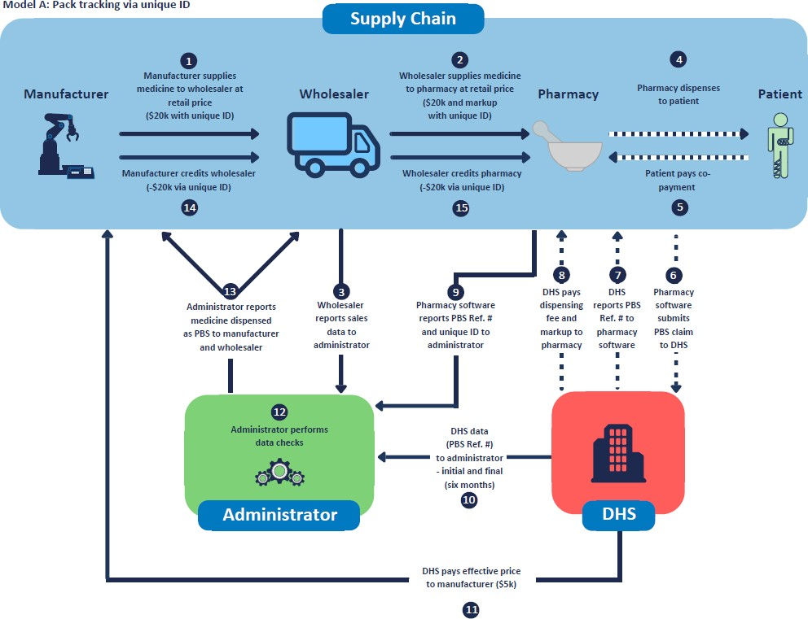

Models for reconciliation and payment
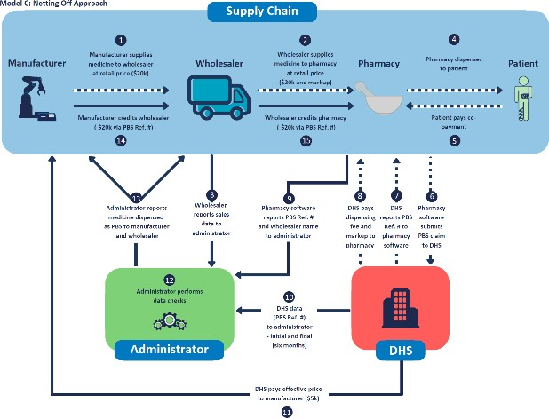

Models for reconciliation and payment
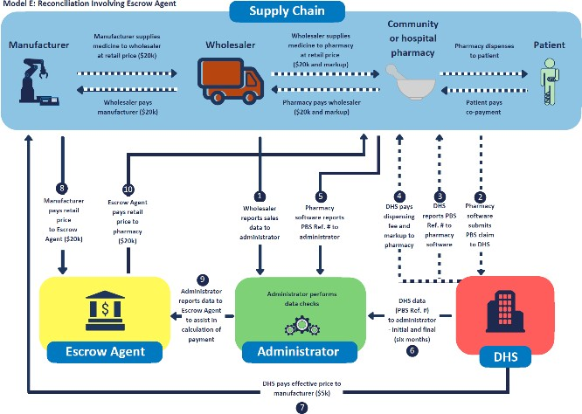

Models for reconciliation and payment – a combined view

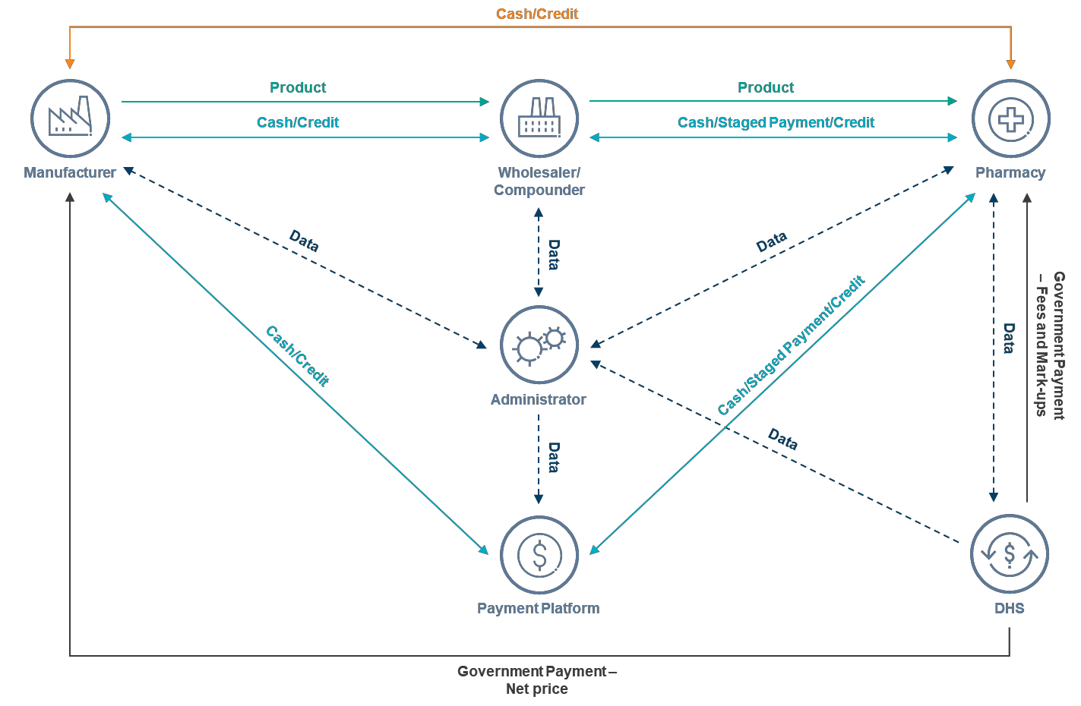

Models for reconciliation and payment – a combined view

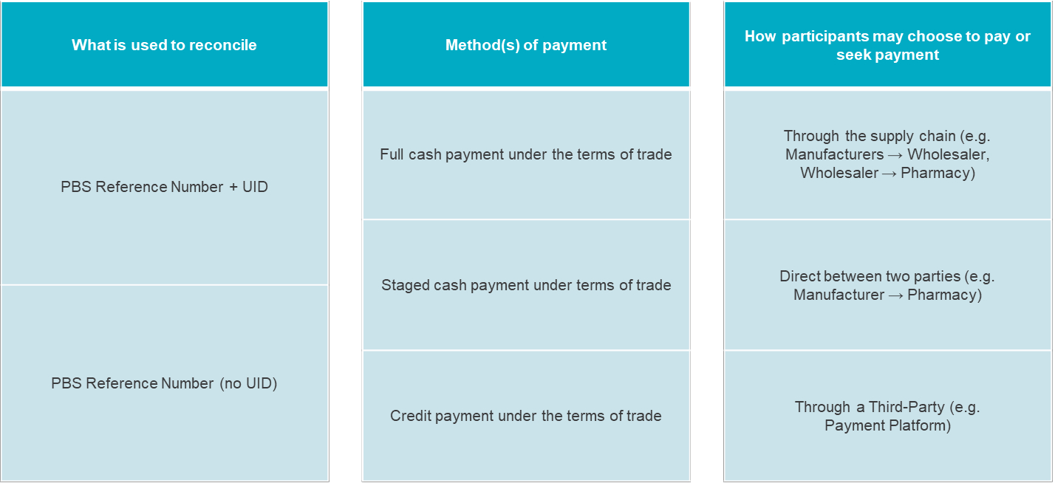

Role of administrator
- Centralise data, enabling common view across parties
- Expected to give net view of credits/payments, with functionality to
give different breakdowns, such as:
  - Amount payable by medicine by day, week, month, year
  - Amount payable by pharmacy (private sales)
  - Total payable vs paid (if functionality/connectivity allows)
- Provide a back-up to automated processes; i.e. it is not expected administrator data will necessarily be accessed by each business daily
- Will not be funded to take over business functions i.e. will not send
credit or cash payment requests on your behalf
- Note: for your IT systems people, we have an expected language to use when talking to administrator systems (JSON)

What does this mean for a manufacturer with a F1 medicine that has aSPA or a medicine that may have a SPA?

A range of implications have been discussed with some sponsors and
with peak bodies – for example:
  - Timing of inclusion of medicines – some are slated for 2020 (including EFC medicines), and some are not aimed for inclusion due to the smaller scale of initial roll-out
  - GST
  - Revenue recognition
  - Systems changes to accommodate reporting and payment changes
  - Training in administrator system/s (once an administrator is brought in)
  - Reconciliation and payment approaches and any resulting negotiation
We cannot formally advise on some of these matters, but we recommend you seek information from your peak body as appropriate

SPA or a medicine that may have a SPA?
- Department will initiate contact with companies (January onwards)
about involving your medicine in new arrangements from 1 July 2019
– this would require a change to an existing Deed
- For those companies not requested to be involved in the first phase, we are happy to discuss the measure and its implications
- We are updating our website with information as we progress in implementation
- We also continue to have regular discussions with peak bodies
- Take-home message: keep in touch with your peak body, and with the
Department via the website or directly (pbs.subsidy@health.gov.au)

Questions
Contacts

Contacting the PBS Subsidy Taskforce
- Email: pbs.subsidy@health.gov.au
- Telephone (David Nott): (02) 6289 7903
Contacting the Pricing team
- General pricing: pbspricing@health.gov.au
- Price Disclosure: pricedisclosure@health.gov.au / (02) 6289 2303
- PBS Statutory Price Reductions: PBSSPR@health.gov.au
- Price Increases: PBSPriceIncreases@health.gov.au

