First New Brand Statutory Price Reductions Policy
Division 3A of Part VII of the National Health Act 1953 (the Act) contains the legal basis for first new brand statutory price reductions (FNB SPR), applying to new listings on and from 1 July 2022. The purpose of this note is to provide a detailed statement of the Australian Government’s FNB SPR policy, and meet the Australian Government’s commitment to publish such a policy in the Strategic Agreement between Medicines Australia and the Australian Government dated 6 September 2021 and relevantly commencing on 1 July 2022.

Nothing in this Policy in any way limits the operation of the Act or affects or fetters any function or power of the Minister or any other person or body under the Act.

First new brand statutory price reductions
A FNB SPR will apply when the first new brand (new brand) of a pharmaceutical item (trigger item) that is bioequivalent or biosimilar and has the same manner of administration (MoA) as an existing pharmaceutical item (existing item) is listed on the Pharmaceutical Benefits Scheme (PBS). For combination items, the drug in the combination item and existing item must also have the same component drugs.

A FNB SPR will not apply if any one of the following has occurred:

- if a listed brand of a pharmaceutical item that has the same drug (or component drugs) and MoA as the new brand of the trigger item, has been subject to a fifteen-year anniversary price reduction or certain other now repealed statutory price reductions;
- if the trigger item or another pharmaceutical item that has the same drug and MoA as the new brand of the trigger item is in a class of pharmaceutical items to which a 12.5%, 16% or 25% administrative price reduction has applied;
- if the approved ex-manufacturer price (AEMP) of a listed brand of the existing item on 1 January 2016 or if the pharmaceutical item listed after 1 January 2016, the original AEMP of the first listed brand of the existing item, has by virtue of previous price reductions, been reduced by 60% or more (except where this reduction was due to the removal of a Deed of Agreement that gave effect to an effective price); and
- if the new brand of the trigger item is a new presentation of an existing listed brand of a pharmaceutical item. See the New presentation listing without triggering a FNB SPR section below.

What percentage reduction will apply
Except where the existing brand has an effective price, the price of the first new brand on the date it is listed will be based on the AEMP and previous price reductions that have occurred to the pharmaceutical item, determined as follows:

- if the AEMP on 1 January 2016 or, if the pharmaceutical item listed after 1 January 2016, the AEMP on the date the pharmaceutical item was first listed on the PBS, has reduced by 35% or less, the price of the new brand must not exceed the AEMP of the existing brand reduced by 25%;

- if the AEMP on 1 January 2016 or, if the pharmaceutical item listed after 1 January 2016, the AEMP on the date the pharmaceutical item was first listed on the PBS, has been reduced by more than 35% but less than 60%, the price of the new brand must not exceed 40% of the AEMP of a listed brand of the existing item on 1 January 2016 or, if the pharmaceutical items listed after 1 January 2016, of the AEMP on the date the pharmaceutical item was first listed on the PBS;

- if the AEMP on 1 January 2016 or, if the pharmaceutical item listed after 1 January 2016, the AEMP on the date the pharmaceutical item was first listed on the PBS, has been reduced by 60% or more, the new brand of the trigger item will not be subject to a FNB SPR and the price of the new brand will be the same as the current AEMP of the existing brand.

Please refer to the diagram at figure 1. Unless an even lower price is offered by a responsible person, the other responsible person will be required to agree the same price as the new brand, and that price will become the AEMP for both brands.

Where the existing brand has an effective price
Where the existing brand of pharmaceutical item is subject to a Deed of Agreement under section 85E of the Act, and that Deed provides for an effective price for the brand, under a Special Pricing Arrangement (SPA) and/or Risk Sharing Arrangement (RSA), the price at the date of listing for the first new brand will be determined by reference to the effective ex-manufacturer price of the existing brand, rather than the AEMP.

Before the effective price is disclosed, the responsible person of the new brand will be requested to execute a Deed of Confidentiality. The responsible person of the existing brand will be notified that confidential information will be disclosed and, prior to the new brand listing, will be asked to terminate the Deed of Agreement by agreement with the Department.

Once the Deed of Confidentiality is executed, the responsible person of the new brand will be advised of the effective price and if applicable, any reductions that have occurred since 1 January 2016. As a matter of policy, to obtain listing of the new brand the responsible person will be required to offer a price, which will become the AEMP, consistently with the principles described above for brands without an effective price, that:

- does not exceed the effective price of the existing brand, reduced by 25%; or
- does not exceed 40% of the effective price of the existing brand on 1 January 2016 or, later date of listing; or
- is equal to the current effective price of the existing brand.

Please refer to the diagram at figure 1.

Automatic flow-on of FNB SPR
When a FNB SPR is triggered, as described above:

- the AEMP of an existing brand of the same pharmaceutical item will be taken to be reduced to an amount equal to the approved ex‑manufacturer price of the new brand; and
- the AEMP of any related brands will also be automatically reduced by the percentage by which the AEMP for the existing brand of the trigger item is reduced.

Related brands include any of the following provided they are not exempt items:

- listed pharmaceutical items that contain the same drug and MoA as the new item;
- if the drug in the new item is in a therapeutic group, a listed brand of a pharmaceutical item that has another drug in that group and the same MoA as the new brand of the new item.

A FNB SPR will automatically flow-on to combination items if they contain a component drug that is subject to the FNB SPR and has the same MoA as the combination item. The FNB SPR applies to the component of the combination item only, which means a lesser reduction may apply. For example, instead of a 25% FNB SPR applying to the AEMP of a combination item, the combination item may be subject to a 12.5% reduction. Any components in a combination item that are not PBS listed will be subject to the same FNB SPR as the listed component. The formula for flow-on reductions to combination items under section 99ACC of the Act are set out in regulation 65A of the National Health (Pharmaceutical Benefits) Regulations 2017. Further information about flow-on reductions to combination items can be found on the PBS website.
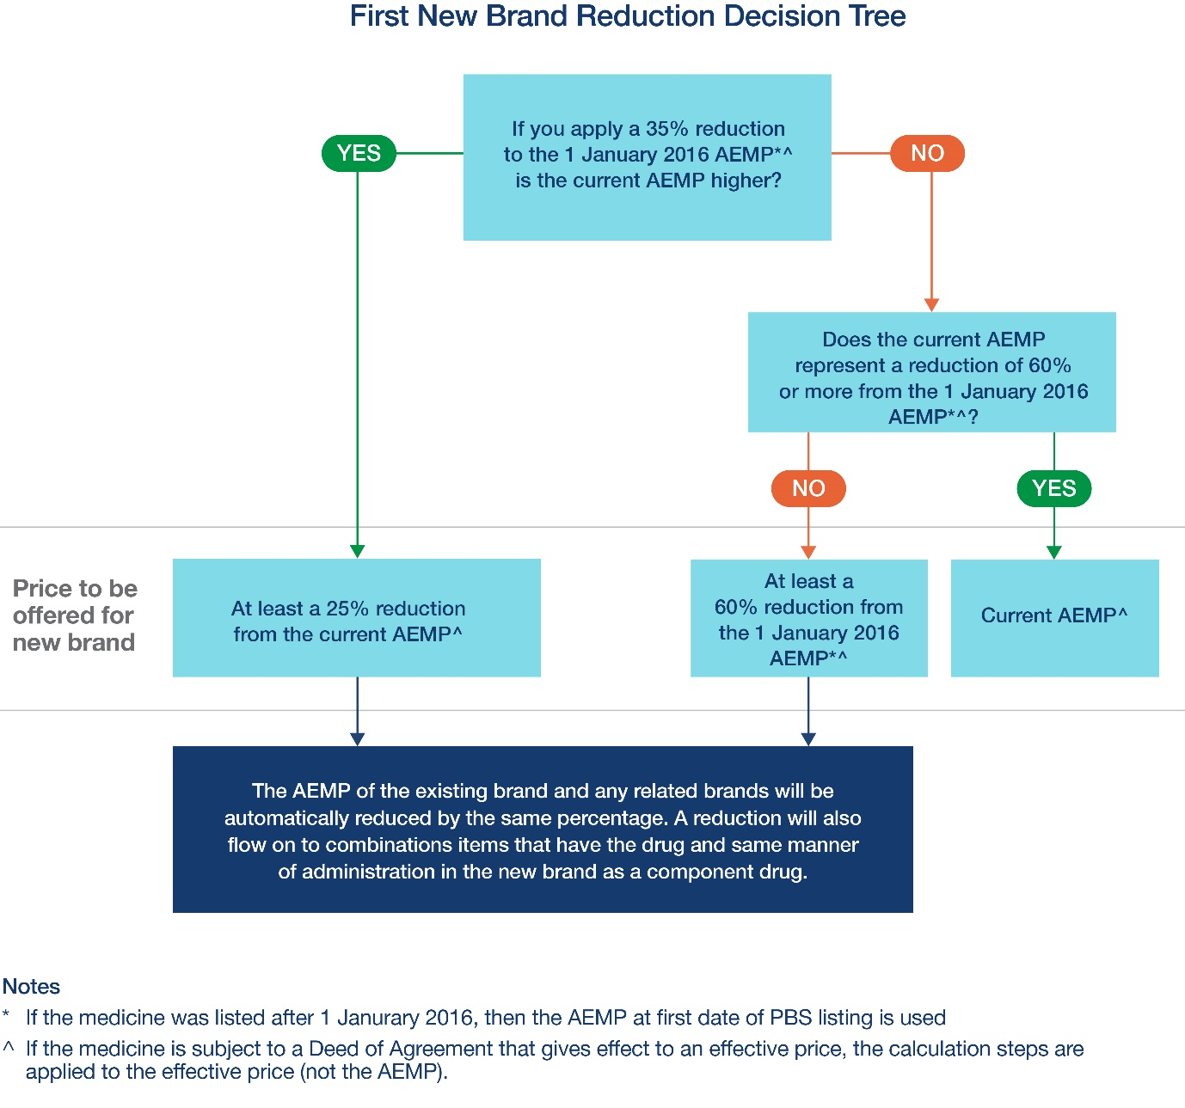

Figure 1: Application of a FNB SPR

FNB application process
Applications to list a first new bioequivalent brand of a PBS-listed item should be made via an application to list a FNB through the Health Products Portal (HPP). Listing requirements for a new brand can be found in section 5.8 of the Procedure guidance for listing medicines on the Pharmaceutical Benefits Scheme. Refer to the published timeframes on the PBS website for deadlines for applying for listing of a FNB that will trigger a FNB SPR.

The HPP will guide applicants on the documentation required for listing a FNB. A submission for the FNB of an existing pharmaceutical item must include a statement from the Therapeutic Goods Administration (TGA) to show that it is appropriate for an equivalence indicator to be shown on the PBS Schedule for the new brand and currently listed brands that can be prescribed. In some instances, the new brand may not have TGA approval for all indications of the currently listed brands. In this event, the applicant should only apply for PBS listing for the TGA approved indications, and the new brand will only be listed for the approved indications. If there is no evidence of equivalence to a brand that can be prescribed, an application to list the new brand should be made to the Pharmaceutical Benefits Advisory Committee (PBAC).

Submissions to seek listing of a new biosimilar brand of a PBS-listed item should be made via an application to the PBAC, generally through a Category 3 submission made through the HPP. Information about the types of submissions made to the PBAC can be found on the PBS website. Refer to the PBAC Cycle Timeframe for application deadlines.

Following a positive PBAC recommendation, applications to list a new biosimilar brand should be made via an application for Pricing Services through the HPP. Procedures for a positive recommendation to list can be found in section 8 of the Procedure guidance for listing medicines on the Pharmaceutical Benefits Scheme.

Patent status and disputes
The existence or status of a patent relating to a drug, or the existence of a dispute (including litigation) over the validity or infringement of a patent, is not a matter that the Department considers when processing an application for the listing of a FNB. Even if there is infringement litigation between companies ongoing with respect to the proposed FNB the Department will progress the application for listing in the ordinary way unless and until the application is withdrawn.

FNB triggering movement of a drug to the F2 formulary
The criteria for a FNB SPR applies irrespective of the formulary status of the drug. When the FNB is listed for a drug that is in F1, the drug becomes multi-branded and moves from F1 to the F2 formulary. Some older drugs in F2 may also meet the criteria for a FNB SPR. Responsible persons can email pbspricing@health.gov.au for information about whether an item meets the criteria for a FNB SPR.

Determining an ‘Originator Brand’
When the listing of a FNB triggers the movement of the drug from F1 to F2, the Minister may decide to determine an ‘originator brand’ under subsection 99ADB(6B) of the Act. Further information about originator brand determination is available in the Price Disclosure Guidelines.

Timeframes associated with applications for listing of a FNB
Listing of new brands which cause a FNB SPR usually only occur six times a year (1 February, 1 April, 1 June, 1 August, 1 October and 1 December). The deadlines which apply for each of these listing dates can be found on the PBS Calendar.

Responsible persons of existing brands which will be impacted by a FNB SPR will be notified within five business days from the Department receiving the application to list the new brand. In some instances where the brand is subject to a Deed of Agreement it may not be possible to notify the new AEMP within five business days. In these instances, responsible persons will be notified that an application has been received within five business days and will be notified of the new AEMP as soon as possible.

Requesting a lower reduction

Ministerial Discretion
The Minister can exercise discretion to not apply or reduce the magnitude of a FNB SPR. Responsible persons of new brands can submit an application for the exercise of Ministerial discretion at the same time that they submit a new brand listing application through the HPP. Responsible persons of existing brands can also apply for the exercise of Ministerial discretion once they are notified of the new listing by the Department and will have an opportunity to apply for the exercise of Ministerial discretion before the price for the trigger item takes effect.

For more information on the types of information and the matters that might be considered relevant to the exercise of Ministerial Discretion in relation to FNB SPR and the timeframes for making such an application, refer to the Ministerial Discretion Guidance Material for Statutory Price Reductions.

New presentation listing without triggering a FNB SPR
As noted above, if a proposed new brand is a new presentation of an existing listed medicine, it will not trigger a FNB SPR if the new listing takes effect up to the fifth anniversary of the medicine being listed on the PBS. Guidance on the operation of the new presentation exemption, including how to ask the Department to recognise a new brand as a new presentation of an existing medicine, can be found in the New Presentation Ministerial Discretion Guidance Material. If a responsible person seeks to list a new presentation of an existing medicine on a date which is more than five years but less than ten years after the medicine was originally listed, the responsible person can apply for the Minister to exercise a discretion not to apply the FNB SPR to the listing. Refer to the Ministerial Discretion Guidance for further information.

Guarantee of supply
Guarantee of supply requirements apply to newly listed brands that are bioequivalent or biosimilar to an existing listed brand and have the same drug and MoA.

Suppliers of a guaranteed brand of a guaranteed item are required to ensure that they are able to supply any order from a wholesaler or approved pharmacy within a reasonable period of time after receiving the order. The guarantee of supply period for the guaranteed brand of the pharmaceutical item will be up to 24 months from the date of listing. If a responsible person is unable to supply or does fail to supply the guaranteed brand, they must notify the Minister in writing as soon as practicable of that failure or inability. Section 99AEH of the Act details powers the Minister may exercise if a responsible person fails to supply, or is unable to supply, a guaranteed brand. Please refer to the Guarantee of supply webpage for further information.

More information
A list of drugs and their respective manners of administration that have been subject to a FNB SPR is available on the PBS website. The Department endeavours to update that list each time a new FNB SPR takes effect.

Exceptions may apply to FNB listed prior to 1 April 2023, see subsections 99ACB(3) and 99ACD(2A) of the Act. Generally pharmaceutical items that were subject to a 26.1% or 30% SPR on the fifteenth anniversary of the drug listing on the PBS or a catch-up SPR on 1 April 2023, will not be subject to a FNB SPR.
See subsections 99ACB(3) and 99ACD(2A) of the Act.
See subsections 99ACB(2) and 99ACD(1A) of the Act.
Clause 9.4.2 of the Strategic Agreement.
See section 99ACQ of the Act.
See section 99ACR of the Act.
A list of therapeutic groups can be found at: www.legislation.gov.au/Details/F2020L00307
See sections 99ACC and 99ADHB of the Act.
It should be noted that different deadlines may apply to these listing application dates.
See sections 99AEB, 99AEE and 99AEF of the Act.

