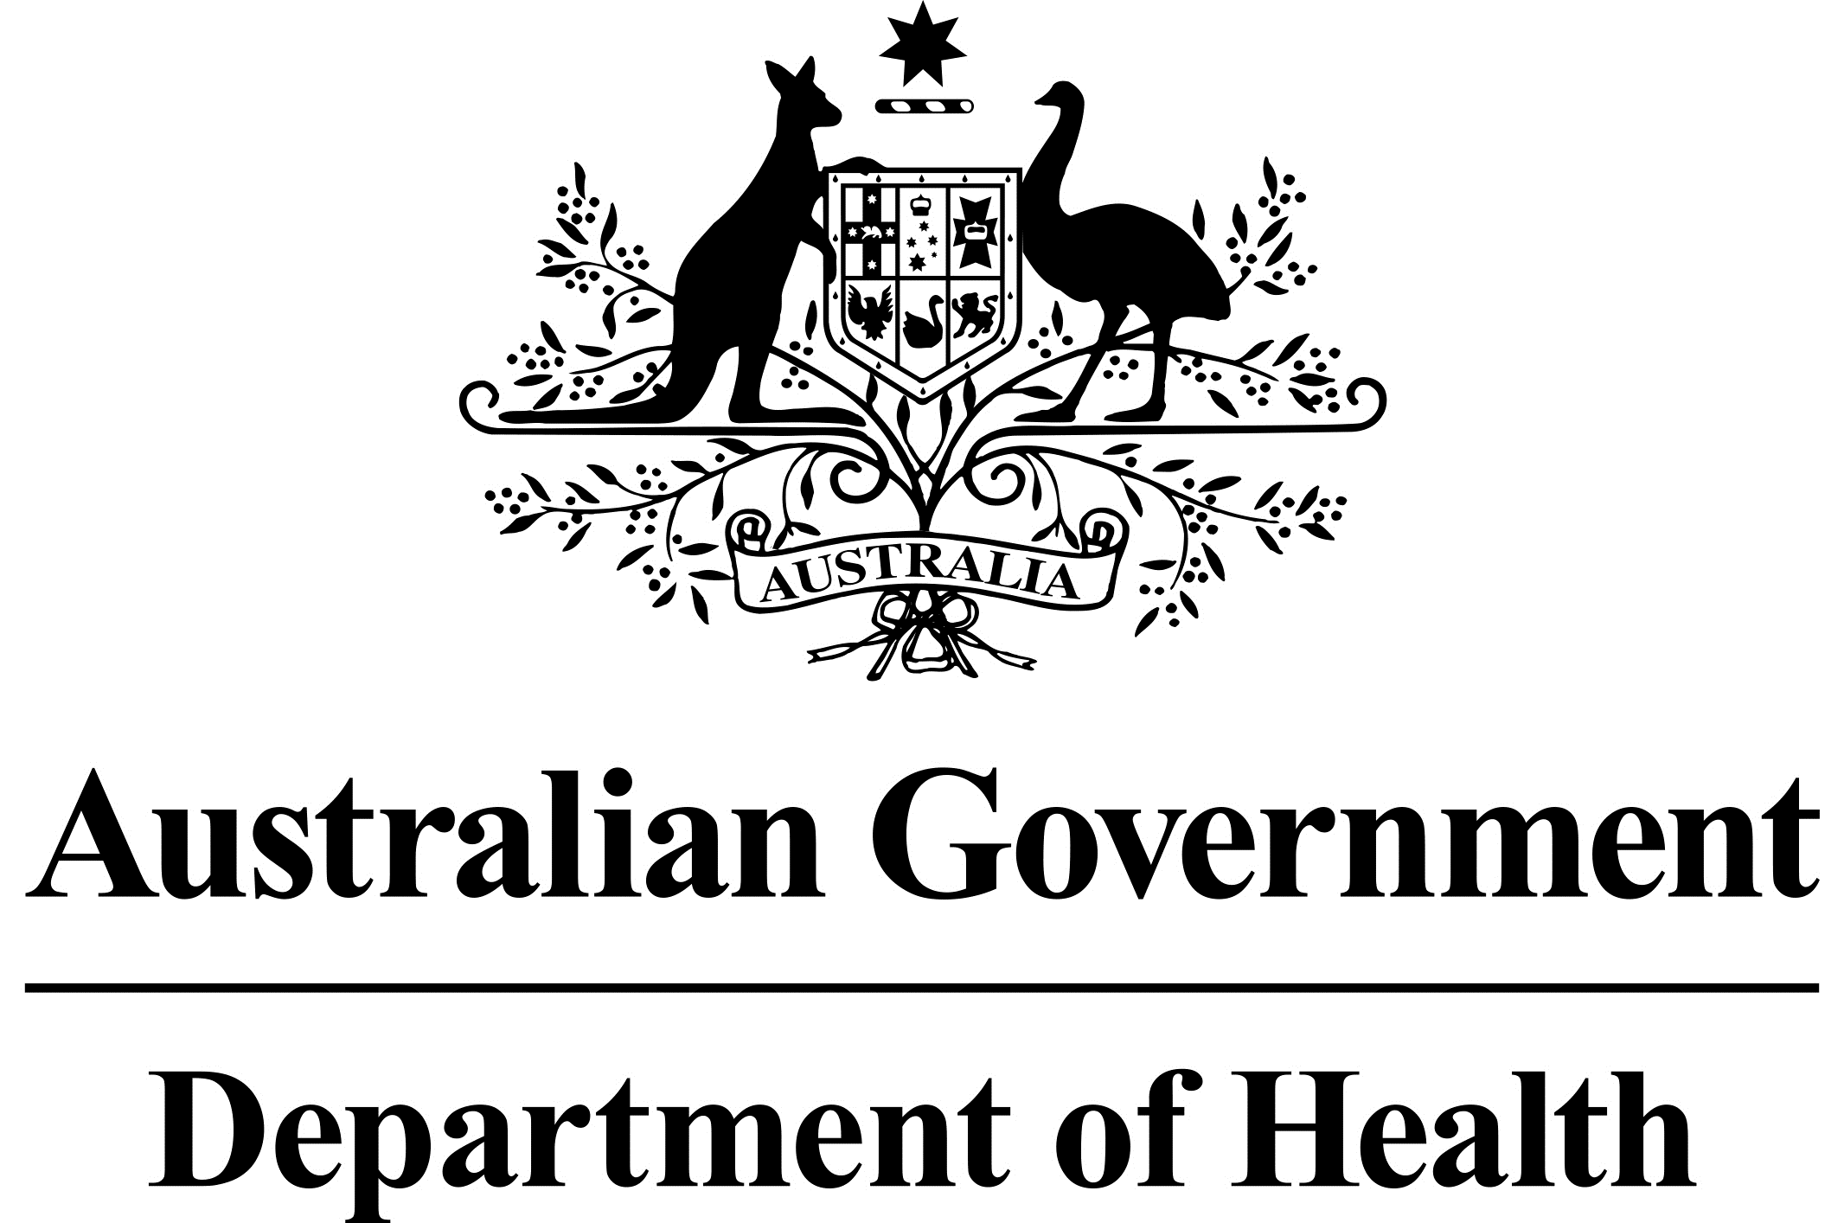

Biosimilar Uptake Drivers

A biosimilar is a highly similar copy of an original or reference biological medicine. More information about biosimilar medicines is available on the Department’s Biosimilar Awareness Initiative webpage.

What are the biosimilar uptake drivers?
The Australian Government supports initiatives to increase the use of biosimilar medicines.
As part of the 2017 Budget process the Government reached agreement with Medicines Australia, the Generic and Biosimilar Medicines Association and the Pharmacy Guild of Australia to implement biosimilar uptake drivers.
Two specific biosimilar uptake drivers are being implemented:
- encouraging prescribing of a biosimilar brand rather than the reference biological brand for treatment naïve patients; and
- providing for a simpler and faster approval process for prescribing biosimilar brands (e.g. streamlined authority) while maintaining an existing higher level authority requirement for the reference biological brand (e.g. written authority).
These uptake drivers are designed to supplement existing activities by the Department of Health to improve awareness of, and confidence in, biosimilars for both healthcare professionals and consumers.

What are the key principles underpinning the uptake drivers?
The uptake drivers will be implemented with the following principles in mind:
- Doctors and other prescribers will retain, in consultation with their patient, the ability to choose which brand to prescribe. Prescribers can also continue to tick the ‘no substitution’ box on a prescription which means the prescribed brand must be dispensed when an equivalent brand could otherwise be substituted by the pharmacist;
- The uptake drivers will be considered by the Pharmaceutical Benefits Advisory Committee on a case by case basis, with regard to the evidence for, and context of the particular medicine and the clinical setting in which it will be used;
- Existing authority requirements to prescribe reference brands will not be increased;
- Greater use of biosimilars is beneficial for supporting access to clinically and cost effective medicines in Australia.

Why are the uptake drivers being implemented?
The uptake drivers are intended to result in increased use of biosimilars, supporting a viable long term market for these medicines in Australia. A healthy competitive market that includes biosimilar brands is expected to result in a lower cost for subsidising access to biological medicines through the Pharmaceutical Benefits Scheme (PBS). This will help the Government subsidise access to new expensive health treatments.

How does increased use of the biosimilar brand result in lower costs?
Existing PBS pricing mechanisms under the National Health Act 1953 will reduce the cost of subsidising all brands of a biological medicine if biosimilars are introduced and they generate price competition.
A mandatory reduction applies to the Government subsidised price for all brands of a biological medicine when its first biosimilar lists (currently by 16%, increasing to 25% from October 2018).
Further price reductions apply under PBS price disclosure arrangements if there is significant market competition on price. The Government pays the same price for all brands of the same biological medicine. However, the PBS price is reduced if market competition results in significant average discounts in the price charged by pharmaceutical companies.

What consultation has occurred about the uptake drivers?
The Government reached agreement for initiatives to encourage use of biosimilars with Medicines Australia, the Generic and Biosimilar Medicines Association and the Pharmacy Guild of Australia.
The Department of Health sought input from key organisations on implementing the initiatives. This included representative bodies for prescribers, pharmacy and pharmacists, pharmaceutical industry, software vendors and consumers.

The uptake drivers include changes to the authority requirements - what is an ‘authority’?
Some medicines require prior authorisation or approval for prescribing on the PBS.
There are three broad types of authority requirement for prescribing PBS medicines:
Written Authority – the prescriber is required to obtain from the Department of Human Services an authority approval in writing for prescribing the medicine. The application for authority to prescribe is sent by post or email, and can also require provision of diagnostic test results responding to eligibility criteria for the medicine. The prescription is then either:
- posted back to the patient or the doctor once the approval is marked on the prescription; or
- details of the approval are emailed back to the doctor after consideration by the Department of Human Services, for marking on the prescription.
Immediate Authority – the prescriber can get the authority to prescribe either online or by phone (which can occur during a consultation). .
Streamlined Authority –if the prescriber is satisfied that the specific eligibility criteria and rules for prescribing on the PBS are met, they mark a ‘streamlined authority code’ on the prescription. The relevant code is included as part of the Schedule of Pharmaceutical Benefits listing for the medicine when this type of authority is permitted.
A ‘streamlined authority’ provides the simplest and fastest method for demonstrating authority to prescribe the medicine. More details about authority requirements are set out on the Department of Human Services website.

To which medicines will the uptake drivers apply?

Role of the PBAC
The independent expert Pharmaceutical Benefits Advisory Committee will provide advice on a case by case basis about whether there would be any clinical or other concerns about appropriate use of medicines if the uptake drivers were applied, and it will review the existing authority requirements for prescribing the relevant medicines.
This Pharmaceutical Benefits Advisory Committee advice will be given whenever a request is made:
- to list a new biosimilar medicine on the PBS,
- to extend PBS listed indications for a biosimilar, or
- for application of the uptake drivers to an existing PBS listed biosimilar.
The PBAC will make recommendations based on the evidence and context for the particular medicine.

The decision to apply the uptake drivers
After the Pharmaceutical Benefits Advisory Committee provides advice, a decision will be made by the Minister or Departmental delegate about applying the drivers to encourage uptake of biosimilars.
It is likely that all biosimilars for the same drug will be treated the same under these uptake measures. This is consistent with the policy to increase the uptake of biosimilars, not particular brands. If there are particular reasons why the brands should not be treated the same, the Pharmaceutical Benefits Advisory Committee will advise on those matters.
The first application of the biosimilar uptake drivers was for the biosimilar Brenzys® brand of etanercept, effective from 1 December 2017. Since that time the drivers have been applied to further biosimilars. Fact Sheets are available on the PBS website giving practical information about the changes.

The first uptake driver refers to ‘treatment naïve patients’ – what does that mean?
For the purpose of this uptake driver a patient is ‘treatment naïve’ if they have not previously taken the biological medicine intended to be prescribed. That is, they have not taken either the reference or biosimilar brand of the particular biological medicine.
Continued use of a biosimilar brand after it is first taken by a patient is a matter for the patient in consultation with their prescriber and pharmacist.
A patient is not treatment naïve if they took any brand of the particular biological medicine in the past, even if that treatment occurred some time ago.
To work out whether a patient is treatment naïve prescribers may rely on their usual sources for taking a patient history.

How will the ‘biosimilars for treatment naïve patients’ driver be applied?
The following administrative Note will be included in the Schedule of Pharmaceutical Benefits for affected biological medicines:
Biosimilar prescribing policy
Prescribing of the biosimilar brand(s) (Brand Name®) is encouraged for treatment naïve patients.
Encouraging biosimilar prescribing for treatment naïve patients is Government policy. A viable biosimilar market is expected to result in reduced costs for biological medicines, allowing the Government to reinvest in new treatments. Further information can be found on the Biosimilar Awareness Initiative webpage (www.health.gov.au/biosimilars).
Where there are different prescribing restrictions for the initial and continuing stages of treatment with a medicine, the administrative note will appear along with the initial prescribing restriction.
It is not mandatory to prescribe the biosimilar brand for treatment naïve patients.
The Department will also continue its awareness activities which assist healthcare professionals and consumers to understand how the choice of biosimilar brands of medicines is supported by the evidence regarding their safety and effectiveness.
Changes to prescribing software may in future also provide reminders or hints during the prescribing process (in addition to or instead of the Note mentioned above).

Does the uptake driver mean that use of biosimilars is limited to treatment naïve patients?
No. While the uptake driver is specifically intended to encourage use of biosimilars for treatment naïve patients, this does not mean that use of a biosimilar for patients who have previously taken the reference brand or a different biosimilar brand is inappropriate.
Biosimilars have been found in studies to be as safe and effective as the reference biological brand.

How will the ‘lower authority’ driver be applied?
Changes to the authority requirements for prescribing a medicine will be made in accordance with the usual processes for amending PBS medicine listings.
Following consideration by the Pharmaceutical Benefits Advisory Committee, amendments to apply the uptake drivers for biosimilars will be considered by the Minister for Health or delegate for approval, and, if approved, incorporated into the data for prescribing and dispensing software and the Schedule of Pharmaceutical Benefits. The changes also require formal amendment to the legal instruments that underpin the PBS for each affected medicine.
The change to authority requirements may apply to all or only some of the stages for treating a patient with the relevant medicines. For example, if there are different criteria and rules (restrictions) for initial treatment to those that apply for continuing treatment with a medicine, the lower authority uptake driver might be applied only for continuing treatment.
The prescription will include information that identifies the type of authority used for approval to prescribe, and the specific PBS listing item under which the medicine was prescribed.
Information about the consideration by the Pharmaceutical Benefits Advisory Committee of the uptake drivers is available on the PBS website. Details of the PBS listing changes to apply the uptake drivers for biosimilars are set out in fact sheets available on the PBS website. The fact sheets include useful information to assist healthcare professionals and consumers and their carers to understand how the uptake drivers are being applied.
Further information about the current restrictions for prescribing particular medicines is available in the Schedule of Pharmaceutical Benefits.

Do the biosimilar uptake drivers make prescribing of biosimilars mandatory?
No. Prescribers retain, in consultation with their patient, the ability to choose which brand to prescribe.

For how long will the uptake drivers apply?
The uptake drivers are expected to be time-limited initiatives to support biosimilar brand(s) to gain acceptance and increased use.
PBS data on the uptake of biosimilars, and the market behaviour of affected products, will be monitored by the Department of Health for each affected medicine.
The Department will work with the pharmaceutical industry to identify indicators for success of the drivers.

More Information
Fact Sheets providing information tailored to assist healthcare professionals and consumers to understand listings changes to implement the biosimilars uptake drivers are published on the PBS website.
Information about prescribing restrictions for biosimilar medicines is set out in the Schedule of Pharmaceutical Benefits, and reflected in prescribing and dispensing software commencing from the first application of the uptake drivers on 1 December 2017.
Information about PBS authorities to prescribe is available on the Australian Government Department of Human Services website.
The Biosimilars Awareness Initiative webpage on the Australian Government Department of Health website provides information about biosimilar medicines.
The biosimilars regulation page on the Therapeutic Goods Administration website explains the process for approval of biosimilar medicines for use in Australia.
The Strategic Agreements between Government and Industry referring to the biosimilar uptake drivers are available on the Australian Government Department of Health website.

